Communicable Diseases Intelligence, Year 2023, Volume 47
https://doi.org/10.33321/cdi.2023.47.43
Publication date: 27/7/2023
http://health.gov.au/cdi

Report on influenza viruses received and tested by the Melbourne WHO Collaborating Centre for Reference and Research on Influenza during 2022
Tanya R Diefenbach-Elstob, Presa Chanthalavanh, Monica E Bobbitt, Sook Kwan Brown, Cleve Rynehart, Natalie Spirason, Heidi Peck, Yi-Mo Deng, Clyde Dapat, Kanta Subbarao, Ian G Barr

Abstract
As part of its role in the World Health Organization’s (WHO) Global Influenza Surveillance and Response System (GISRS), the WHO Collaborating Centre for Reference and Research on Influenza in Melbourne received a record total of 12,073 human influenza positive samples during 2022. Viruses were analysed for their antigenic, genetic and antiviral susceptibility properties. Selected viruses were propagated in qualified cells or embryonated hen’s eggs for potential use in seasonal influenza virus vaccines.
In 2022, influenza A(H3N2) viruses predominated over influenza A(H1N1)pdm09 and B viruses, accounting for 77% of all viruses analysed. The majority of A(H1N1)pdm09, A(H3N2) and influenza B viruses analysed at the Centre were found to be antigenically and genetically similar to the respective WHO recommended vaccine strains for the southern hemisphere in 2022. Of 3,372 samples tested for susceptibility to the neuraminidase inhibitors oseltamivir and zanamivir, two A(H1N1)pdm09 viruses showed highly reduced inhibition against oseltamivir.
Keywords: influenza; vaccine; GISRS; surveillance; laboratory; annual report; WHO

Introduction
The WHO Collaborating Centre for Reference and Research on Influenza in Melbourne (the Centre) is part of the World Health Organization (WHO) Global Influenza Surveillance and Response System (GISRS). GISRS is a global network of laboratories that was established in 1952 to monitor changes in influenza viruses circulating in the human population, with the aim of reducing influenza’s impact through the use of vaccines and antiviral drugs.^{1,2} The Centre in Melbourne, designated by WHO in 1992, is one of five Collaborating Centres (with the others located in Atlanta, Beijing, London, and Tokyo). These Centres monitor antigenic and genetic changes in circulating human influenza viruses, and participate in making the WHO bi-annual recommendations on which influenza strains should be included in the vaccine for the upcoming influenza season in the northern or southern hemisphere. This report summarises the results of virological surveillance activities undertaken at the Centre in Melbourne during 2022. Influenza activity during 2020–2021 was sharply reduced by government restrictions and non-pharmaceutical interventions that were introduced in response to the coronavirus disease 2019 (COVID-19) pandemic, with only 21,350 laboratory-confirmed influenza notifications in 2020 and 749 notifications in 2021, compared to 313,658 notifications in 2019.^{3,4} However, there was substantially increased influenza activity during 2022, with 233,370 notifications.⁴
Two types of influenza viruses (A and B) cause significant disease in humans. Influenza A viruses are further classified into subtypes, based on their haemagglutinin (HA) and neuraminidase (NA) surface proteins. Globally, there are currently two influenza A subtypes circulating in the human population: A(H1N1)pdm09 and A(H3N2). Influenza B viruses are not classified into subtypes, although in past years there have been two distinct co-circulating lineages: B/Victoria/2/1987 (B/Victoria lineage) and B/Yamagata/16/1988 (B/Yamagata lineage). However, no B/Yamagata viruses have been isolated since March 2020, and it has been postulated that during the COVID-19 pandemic this lineage may have become extinct.⁵ Influenza C viruses are also detected each year from humans, but these viruses do not cause severe disease and are not a major focus of influenza surveillance.

Methods
The Centre receives influenza-positive samples for surveillance purposes from submitting laboratories predominantly in Australia and other countries in the Asia-Pacific region. This report includes all surveillance samples received by the Centre in 2022; thus a small number of viruses collected in earlier years are included.

Virus isolation
All A(H1N1)pdm09 and influenza B original clinical specimens and viral isolates received at the Centre were passaged in cell culture using Madin-Darby Canine Kidney (MDCK) cells, while all A(H3N2) original clinical specimens and viral isolates were passaged in MDCK-SIAT-1 cells.⁶ Untyped influenza A viruses were passaged in MDCK-SIAT-1 cells. A subset of influenza positive original clinical samples were directly inoculated into eggs and a qualified cell line to generate potential candidate influenza vaccine viruses.

Antigenic analysis
The antigenic properties of influenza viral isolates were analysed using the haemagglutination inhibition (HI) assay as previously described,⁷ and a subset of A(H3N2) viruses were additionally analysed by the focus reduction assay (FRA). HI assays were performed manually, or using the TECAN Freedom EVO200 robot platform which incorporates a camera (SciRobotics, Kfar Saba, Israel) and imaging software (FluHemaTM) for analysis. In HI assays, viruses were tested for their ability to agglutinate red blood cells (RBC) in the presence of receptor-destroying enzyme (RDE)-treated post-infection ferret antisera raised against several reference viruses. Turkey RBCs were used for A(H1N1)pdm09 and B viruses, and guinea pig RBCs were used for A(H3N2) viruses. Isolates were identified as antigenically similar to the reference strain if the test samples had a titre that was no more than fourfold higher than the titre of the homologous reference strain. In 2022, results were reported with reference to the viruses that were recommended for inclusion in the 2022 southern hemisphere influenza vaccine (Table 1).
Table 1: Southern hemisphere influenza vaccine reference strains used for reporting purposes by the Centre, 2022
Subtype/lineage | 2022 cell | 2022 egg
A(H1N1)pdm09 | A/Victoria/2570/2019 (H1N1pdm09)-like | A/Victoria/2570/2019 (H1N1pdm09)-like
A(H3N2) | A/Darwin/6/2021 (H3N2)-like | A/Darwin/9/2021 (H3N2)-like
B/Victoria lineage | B/Austria/1359417/2019 (B/Victoria lineage)-like | B/Austria/1359417/2019 (B/Victoria lineage)-like
B/Yamagata lineage | B/Phuket/3073/2013 (B/Yamagata lineage)-like | B/Phuket/3073/2013 (B/Yamagata lineage)-like

In recent years (including 2022), HI assays involving A(H3N2) viruses have been performed in the presence of 20 nM oseltamivir carboxylate (OC) to reduce non-specific binding of the NA protein.⁸ The addition of OC can reduce the number of influenza virus isolates that could be tested by HI, as viruses may lose the ability to bind RBC. This was not the case in 2022, as none of the H3N2 viruses lost their ability to bind to RBC, and all isolates were able to be tested using the HI assay. The Centre still tested a subset of H3N2 viruses using the FRA, a microneutralisation assay which is more sensitive than the HI assay and does not require binding to RBCs.⁶ The FRA utilised the same ferret antisera as the HI assay and was performed as previously described,⁷ but with 1.2% Avicell RC591 (IMCD Mulgrave, Australia) replacing carboxymethyl cellulose.

Genetic analysis
For influenza-positive samples that failed to grow in MDCK cells, real-time reverse transcription polymerase chain reaction (RT-PCR) was performed to determine the influenza type/subtype/lineage using the CDC Influenza Virus Real-Time RT-PCR PCR kit.^{,9,10} A subset of influenza viruses underwent genetic analysis by sequencing of viral RNA genes, usually of HA and NA genes as well as, for influenza A viruses, the matrix gene. Whole genome sequencing (WGS) of a smaller subset of viruses was performed by next generation sequencing (NGS).
For sequencing, RNA was extracted from isolates or original clinical specimens using either a manual QIAGEN QIAamp Viral RNA kit or the automated QIAGEN QIAXtractor platform. For Sanger sequencing, RT-PCR with the BIOLINE MyTaq one step reverse transcription PCR kit and gene-specific primers (primer sequences available on request) were used to amplify the HA, NA, and matrix protein (MP) genes, and then sequencing was carried out on purified PCR products using an Applied Biosystems 3500XL Genetic Analyzer (Applied Biosystems, Foster City, CA, USA) as previously described.¹¹ Sequence assembly was performed using Geneious Prime software version 9.0.4 (Biomatters Ltd, Auckland, New Zealand).
NGS was used for either WGS or sequencing of the HA, NA, and MP genes for influenza A, or the HA and NA genes for influenza B, as described previously.^{12,13} NGS was conducted using an Illumina iSeq 100 according to the manufacturer’s recommendations. Sequence data were analysed using an adapted pipeline IRMA.^{13,14} Phylogenetic analysis was performed using the Augur pipeline.¹⁵ In this pipeline, trees were constructed using the IQ-TREE 2,¹⁶ with 1,000 bootstrap replicates and generalised-time reversible (GTR) model; trees were visualised using ggtree.¹⁷ Some viruses were sequenced externally with results provided by the submitting laboratory.
HA clade nomenclature was updated for A(H1N1)pdm09 and A(H3N2) viruses during 2022. Consequently, all clades were verified against data uploaded to Nextclade, and/or against internal or external sequencing results (for viruses not uploaded to Nextclade).

Antiviral drug susceptibility testing
Circulating viruses were tested for their susceptibility to the currently used neuraminidase inhibitors oseltamivir (Tamiflu) and zanamivir (Relenza). Virus isolates were tested for antiviral susceptibility using a fluorescence-based neuraminidase inhibition assay (NAI) with the substrate MUNANA. The susceptibility of test viruses to the antiviral drugs was measured in terms of the drug concentration needed to reduce the influenza neuraminidase enzymatic activity by 50% (IC₅₀) and was compared to values obtained with reference viruses of the same subtype or lineage. NAI assays were performed as previously described,¹⁸ with the incorporation of a robotic platform by TECAN EVO200 and Infinite 200 Pro for liquid handling and fluorescence measurements respectively (Tecan Australia). For reporting purposes, highly reduced susceptibility of influenza A viruses has been defined by WHO as a ≥ 100-fold increase in IC₅₀ compared to normally susceptible influenza A viruses in an NAI assay.¹⁹ For influenza B viruses, this figure was a ≥ 50-fold-increase compared to normal influenza B viruses.¹⁹ However, it should be noted that the relationship between the IC₅₀ value and the clinical effectiveness of a neuraminidase inhibitor is not yet well understood and a small or moderate reduction in inhibition may not be clinically significant.
Viruses found to have highly reduced susceptibility to either oseltamivir or zanamivir underwent genetic analysis using pyrosequencing, Sanger sequencing or NGS to determine the presence of amino acid substitutions in the NA protein that are associated with reduced inhibition by neuraminidase inhibitors. For example, a change from histidine to tyrosine at position 275 (H275Y) of the NA protein of A(H1N1)pdm09 viruses is known to significantly reduce inhibition by oseltamivir, as does the H273Y NA mutation in B viruses.¹⁸ Pyrosequencing was also performed on original clinical specimens of selected A(H1N1)pdm09 viruses to detect the presence of the H275Y mutation if no isolate was available for phenotypic testing. Pyrosequencing was performed as previously described,²⁰ using the MyTaq One-Step RT-PCR Kit (QIAGEN, Hilden, Germany) for virus amplification, with pyrosequencing reactions performed using the PyroMark instrument (QIAGEN, Hilden, Germany).
Genetic evidence of reduced susceptibility to baloxavir was identified using pyrosequencing (for I38 mutations of the PA gene only),²¹ or Sanger sequencing or NGS of the PA gene, as well as from mutations identified in external sequencing results provided by submitting laboratories.

Candidate vaccine strains
The viruses used to produce human influenza vaccines are required by regulatory authorities to be isolated and passaged in embryonated hen’s eggs or qualified cell lines^{22–24} directly from human clinical respiratory samples. The Centre has undertaken primary isolation of selected viruses from clinical samples directly into eggs, using previously-described methods.²⁵ Briefly, the viruses were inoculated into the amniotic cavity of embryonated eggs and once virus growth was established, isolates were passaged in the allantoic cavity until a sufficient titre was obtained. Egg incubation conditions differed slightly, with A(H1N1)pdm09 and A(H3N2) viruses incubated at 35 °C for three days, and influenza B viruses incubated at 33 °C for three days. In addition, selected clinical samples were inoculated into the qualified cell line MDCK 33016PF (Seqirus Limited, Holly Springs, NC, USA)²⁶ and incubated at 35 °C for three days, with viral growth monitored by haemagglutination of turkey or guinea pig RBC. These isolates were then analysed by HI assay, real time RT-PCR and genetic sequencing using the methods described above.

Results
During 2022, the Centre received 12,073 samples (including 11,152 clinical specimens, 538 virus isolates, 379 specimen and isolate pairs, and four RNA/DNA samples) from 43 laboratories in 15 countries (Figure 1). Australian laboratories sent the highest number of samples to the Centre (n = 10,691; 88.6%), followed by laboratories in Timor-Leste (n = 330; 2.7%), Malaysia (n = 209; 1.7%), and Fiji (n = 203; 1.7%). Of the 12,073 samples received, 11,828 (98%) were collected in 2022. The majority of samples collected in 2022 were received by the Centre in May and June (n = 6,725, 57%), with 80% (n = 9,409) received during the April to July period, somewhat earlier than the typical influenza season for temperate regions in Australia. Figure 2 depicts the weekly temporal distribution of samples sent to the Centre in 2022 by type and subtype/lineage. During 2022, A(H3N2) was the predominant circulating strain, followed by A(H1N1)pdm09 and B/Victoria. No lineage-confirmed influenza B samples were identified as B/Yamagata viruses.
Overall, isolation and re-passaging was attempted for 8,146 (67%) of the samples received, yielding 4,499 isolates (overall isolation rate of 55%). Isolation rates were lower for clinical specimens (51%) than for virus re-isolations (94%). Of the viruses for which type and subtype could be confirmed, isolation rates by cell propagation were 71% (3,513/4,948) for influenza A(H3N2), 70% (817/1,166) for A(H1N1)pdm09 and 53% (144/273) for B/Victoria. However, 0.8% (27/3,513) of A(H3N2) and 1.8% (15/817) of A(H1N1)pdm09 virus isolates did not reach sufficient titres for antigenic analysis.

Figure 1: Geographic distribution of influenza laboratories sending viruses to the Centre in 2022
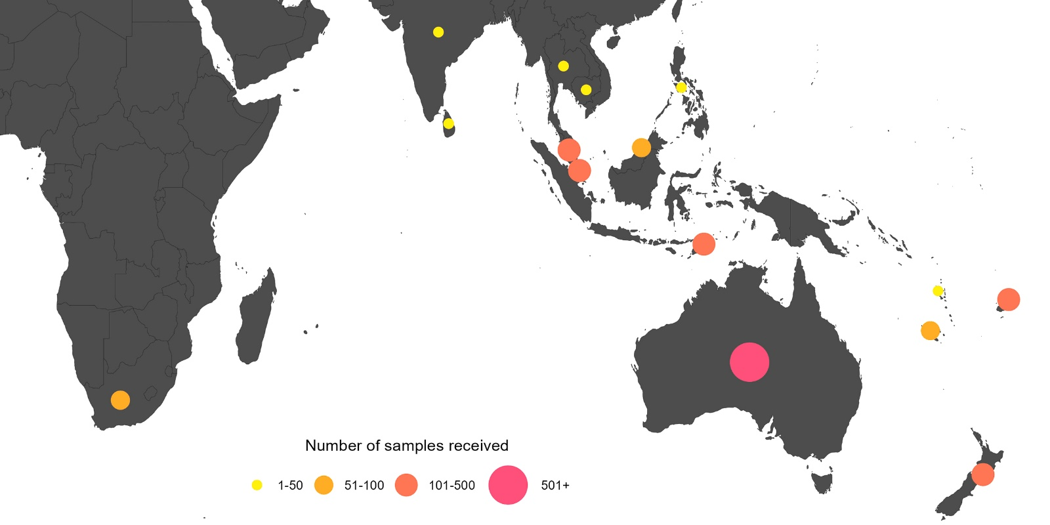
A total of 4,328 viral isolates were successfully characterised by HI assay, and compared to the 2022 reference viruses (Table 2). In addition, real-time RT-PCR was attempted on 848 samples to determine their type/subtype or lineage. Sanger sequencing and/or NGS techniques were used to attempt sequencing of the HA genes of 2,371 viruses. The full genomes of 738 viruses were obtained using NGS. Of the samples for which antigenic or genetic analysis was undertaken (n = 5,390), influenza A(H3N2) viruses predominated, comprising 77% (n = 4,137) of viruses received and analysed.

Table 2: Antigenic analysis of viruses received by the Centre in 2022, by geographic region of origin
 | A(H1N1)pdm09 ª reference strain: |  | A(H3N2)ª reference strain: |  | B/Victoria reference strain: |  | B/Yamagata reference strain:
 | A/Victoria/2570/2019 (cell) |  | A/Darwin/6/2021 (cell) |  | B/Austria/1359417/2021 (cell) |  | B/Phuket/3073/2013 (cell)
Region | Like | Low reactor (%) | Like | Low reactor (%) | Like | Low reactor (%) | Like | Low reactor (%)
Africa | 23 | 13 (36) | 7 | 13 (65) | 22 | 0 (0) | — | —
Australasia | 628 | 91 (13) | 2,929 | 15 (1) | 33 | 0 (0) | — | —
South Asia | 17 | 0 (0) | 14 | 0 (0) | 7 | 4 (36) | — | —
South East Asia | 2 | 0 (0) | 356 | 29 (8) | 64 | 0 (0) | — | —
South Pacific | — | — | 61 | 0 (0) | — | — | — | —
Total | 670 | 104 (13) | 3,367 | 57 (2) | 126 | 4 (3) | — | —
a Note that a small number of A(H1N1)pdm09 and A(H3N2) virus isolates that were obtained could not be analysed by HI assay due to low haemagglutination assay (HA) titre in turkey red blood cells (for A(H1N10pdm09) or guinea pig red blood cells in the presence of oseltamivir (for A(H3N2)).

Figure 2: Number of samples received at the Centre by week of sample receipt
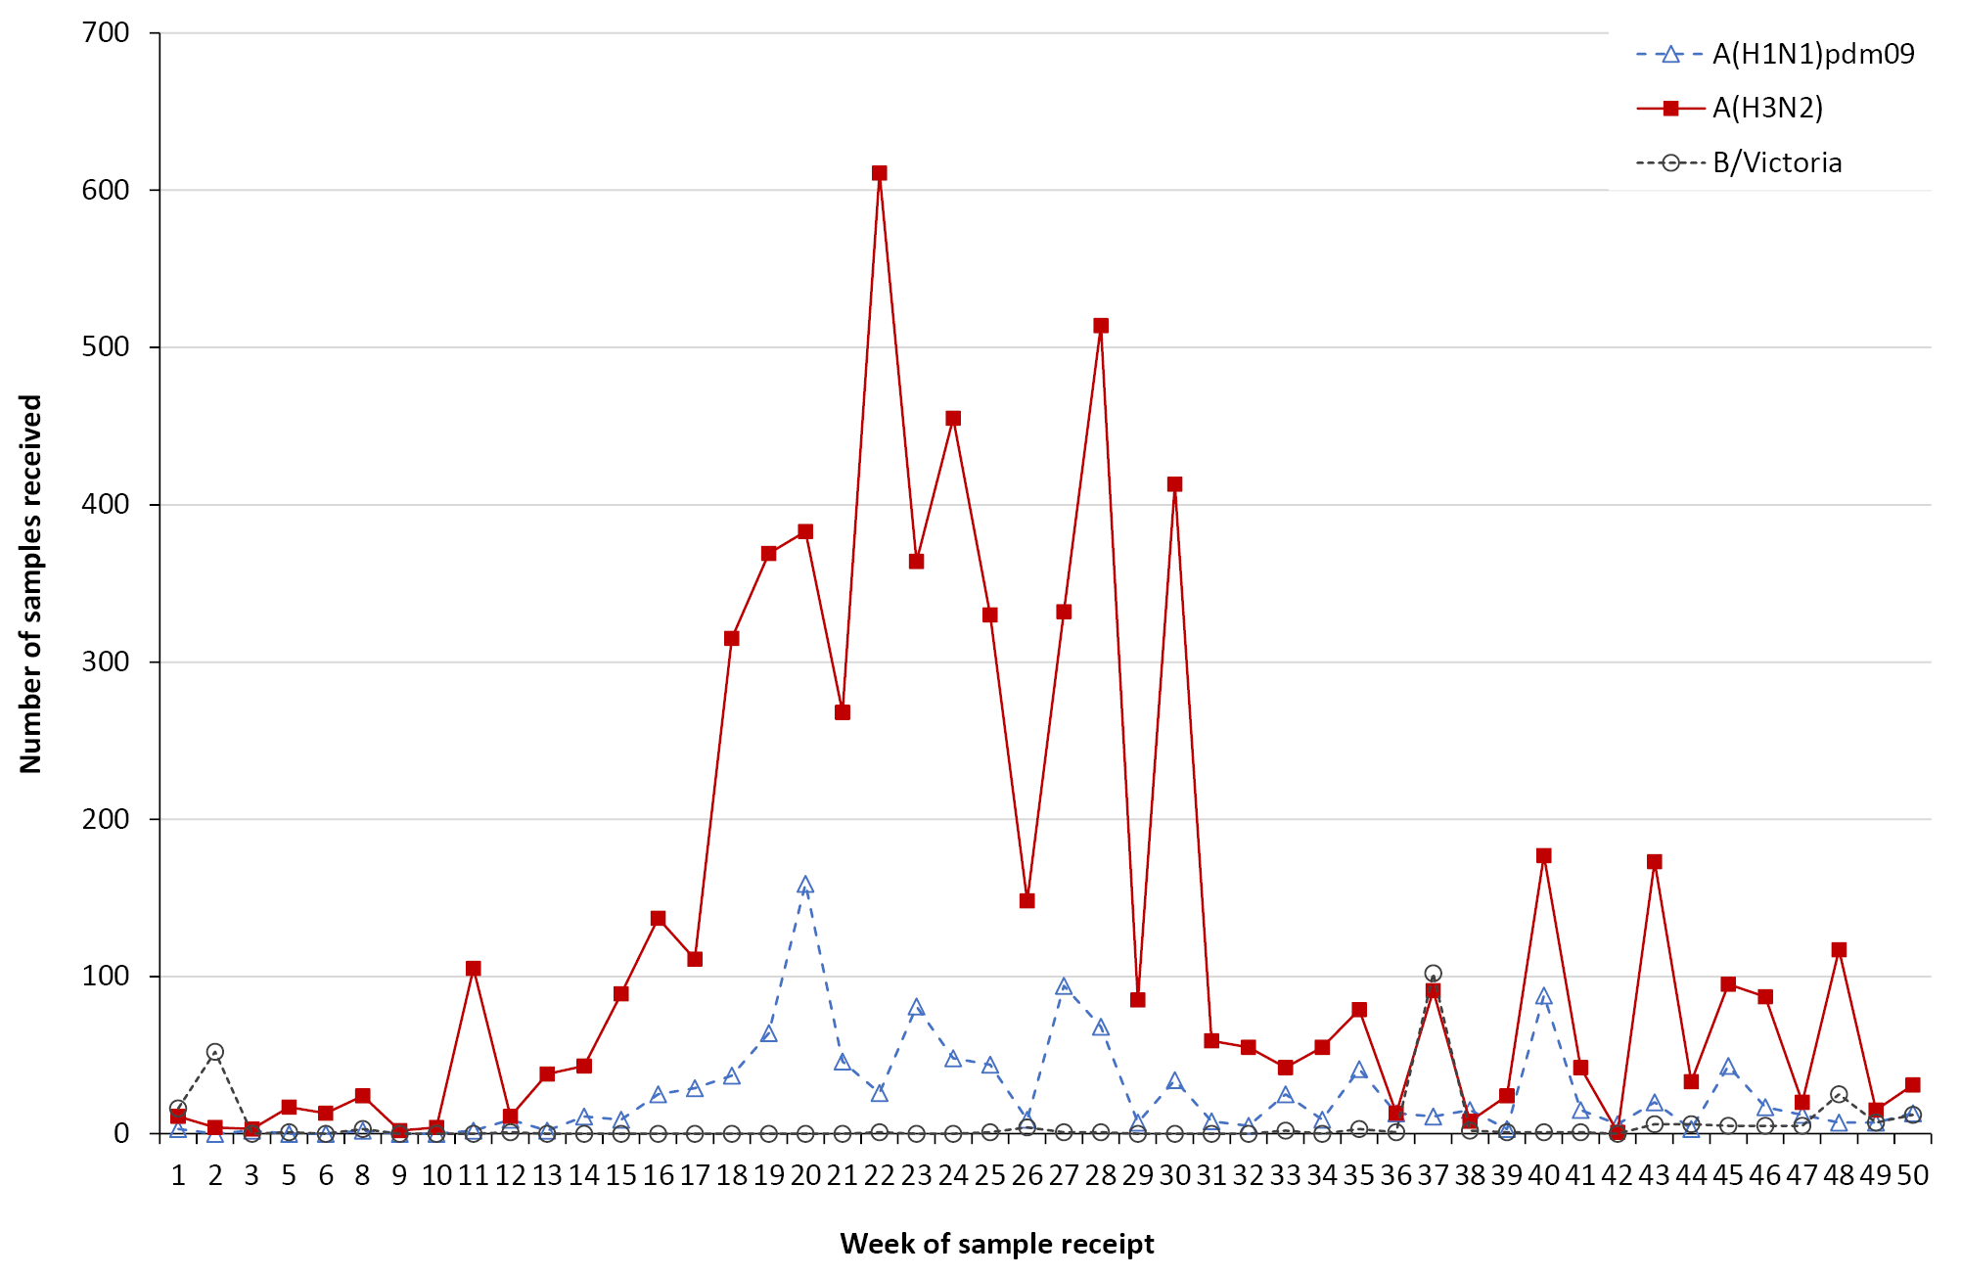

A(H1N1)pdm09
Of the 774 A(H1N1)pdm09 isolates analysed by HI assay using ferret antisera in 2022, the majority (87%) were antigenically similar to the cell-propagated vaccine reference strain A/Victoria/2570/2019 (Table 2). There were 15 A(H1N1)pdm09 viruses isolated by cell culture that did not reach sufficient titres for antigenic analysis, and a further two viruses were successfully isolated but did not reach sufficient titres when tested by HI assay.
Sequencing was attempted on 655 viruses, with results obtained for 609 viruses. Sequencing and phylogenetic analysis of HA genes from 610 viruses (including one virus sequenced externally) showed that the A(H1N1)pdm09 viruses received during 2022 and able to be sequenced fell into the 6B.1A.5 clade, and into subclades 6B.1A.5a.1 (n = 82; 13%), 6B.1A.5a.2a (n = 498; 82%), and 6B.1A.5a.2a.1 (n=30; 5%) (Figure 3), while the 2022 southern hemisphere vaccine reference strain, A/Victoria/2570/2019, was in subclade 6B.1A.5a.2.

Figure 3: Phylogenetic tree of haemagglutinin (HA) genes of A(H1N1)pdm09 viruses received by the Centre during 2022
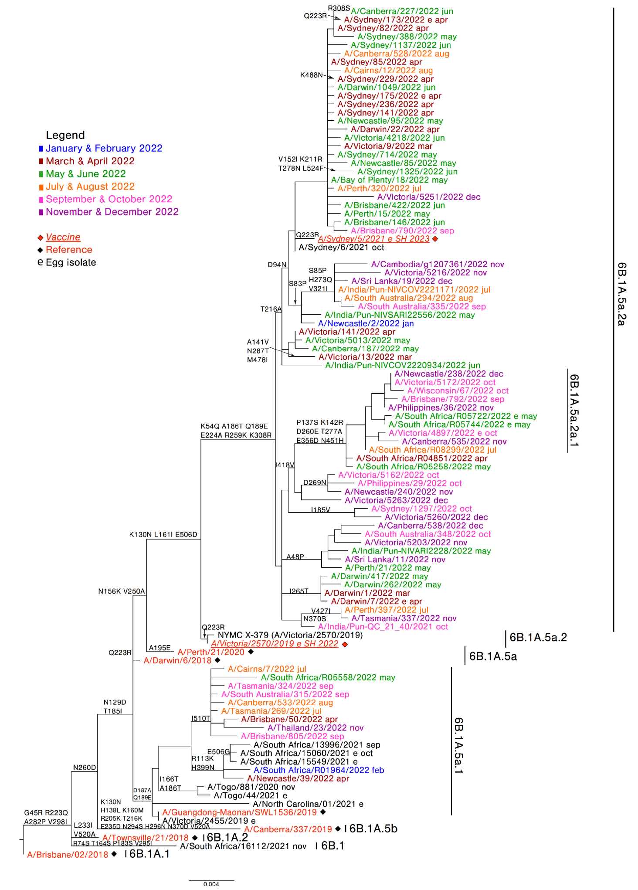
Twenty A(H1N1)pdm09 viruses were inoculated into eggs for isolation of candidate vaccine viruses, with 17 (85%) successfully isolated. Successful isolations included seven viruses from genetic subclade 6B.1A.5a.1, three from 6B.1A.5a.2a, and seven from 6B.1A.5a.2a.1. Twenty-two viruses were inoculated into the qualified cell line MDCK 33016PF, of which 18 (82%) grew successfully, consisting of seven viruses from genetic subclade 6B.1A.5a.1, seven from 6B.1a.5a.2a, and four from 6B.1A.5a.2a.1.
Of the 797 A(H1N1)pdm09 viruses tested, two viruses (both from Australia) exhibited highly reduced inhibition by oseltamivir and had the NA H275Y mutation (known to cause high-level inhibition). No viruses exhibited reduced susceptibility to zanamivir. Furthermore, no viruses were identified with genetic evidence of baloxavir resistance (based on sequencing of 383 viruses for I38 mutations and of 268 viruses for E23 mutations).

A(H3N2)
Antigenic analysis of 3,424 A(H3N2) subtype isolates using the HI assay showed that 98% were antigenically similar to the cell-propagated reference strain A/Darwin/6/2021 (Table 2). There were 27 A(H3N2) viruses isolated by cell culture that did not reach sufficient titres for antigenic analysis, and a further six viruses were successfully isolated but did not reach sufficient titres when tested by HI assay in the presence of OC.
A total of 108 A(H3N2) viruses that could not be characterised by HI assay were analysed using FRA. The FRA indicated that five of these viruses (5%) showed greater than fourfold difference in titre compared to the cell-propagated reference strain A/Darwin/6/2021, while 19 (18%) of these viruses had a greater than fourfold difference in titre compared to the egg-propagated reference strain A/Darwin/9/2021.
Sequencing was attempted on the HA genes of 1,592 A(H3N2) viruses, with 1,366 yielding results (Figure 4). Phylogenetic analysis of the HA gene of 1,411 viruses sent to the Centre (including viruses sequenced externally) indicated that the majority of circulating viruses fell into subclade 3C.2a1b.2a.2a.1 (n = 1,022; 72%), while the 2022 southern hemisphere vaccine reference strain A/Darwin/6/2021 was in subclade 3C.2a1b.2a.2a. The remaining viruses fell into subclades 3C.2a1b.1a (n = 1; 0.1%), 3C.2a1b.2a.1 (n = 16; 1%), 3C.2a1b.2a.2a (n=81, 6%), 3C.2a1b.2a.2a.1a (n = 32; 2%), 3C.2a1b.2a.2a.1b (n = 14; 1%), 3C.2a1b.2a.2a.2 (n = 3; 0.2%), 3C.2a1b.2a.2a.3 (n = 96; 7%), 3C.2a1b.2a.2a.3a (n = 41; 3%), 3C.2a1b.2a.2a.3a.1 (n = 66; 5%), 3C.2a1b.2a.2a.3b (n = 10; 0.7%), 3C.2a1b.2a.2b (n = 18; 1%), and 3C.2a1b.2a.2c (n = 11; 0.8%).
Eighteen viruses were inoculated into eggs, of which 11 (61%) grew successfully, consisting of two viruses from genetic subclade 3C.2a1b.2a.2a.1, two from 3C.2a1b.2a.2a.1a, three from 3C.2a1b.2a.2a.3, one from 3C.2a1b.2a.2a.3a.1, one from 3C.2a1b.2a.2a.3b, one from 3C.2a1b.2a.2b, and one from 3C.2a1b.2a.2c. Thirty-one viruses were inoculated into the qualified cell line MDCK 33016PF, of which 24 (77%) grew successfully, with one virus from genetic subclade 3C.2a1b.1b, one from 3C.2a1b.2a.2a, five from 3C.2a1b.2a.2a.1, two from 3C.2a1b.2a.2a.1a, seven from 3C.2a1b.2a.2a.3, three from 3C.2a1b.2a.2a.3a.1, three from 3C.2a1b.2a.2a.3b, one from 3C.2a1b.2a.2b, and one from 3C.2a1b.2a.2c.
None of the 2,432 A(H3N2) viruses tested with the NAI assay showed highly reduced susceptibility to oseltamivir or zanamivir. Likewise, no viruses were identified with genetic evidence of resistance to baloxavir (based on sequencing of 649 viruses for I38 mutations and of 453 viruses for E23 mutations).

Figure 4: Phylogenetic tree of haemagglutinin (HA) genes of A(H3N2) viruses received by the Centre during 2022
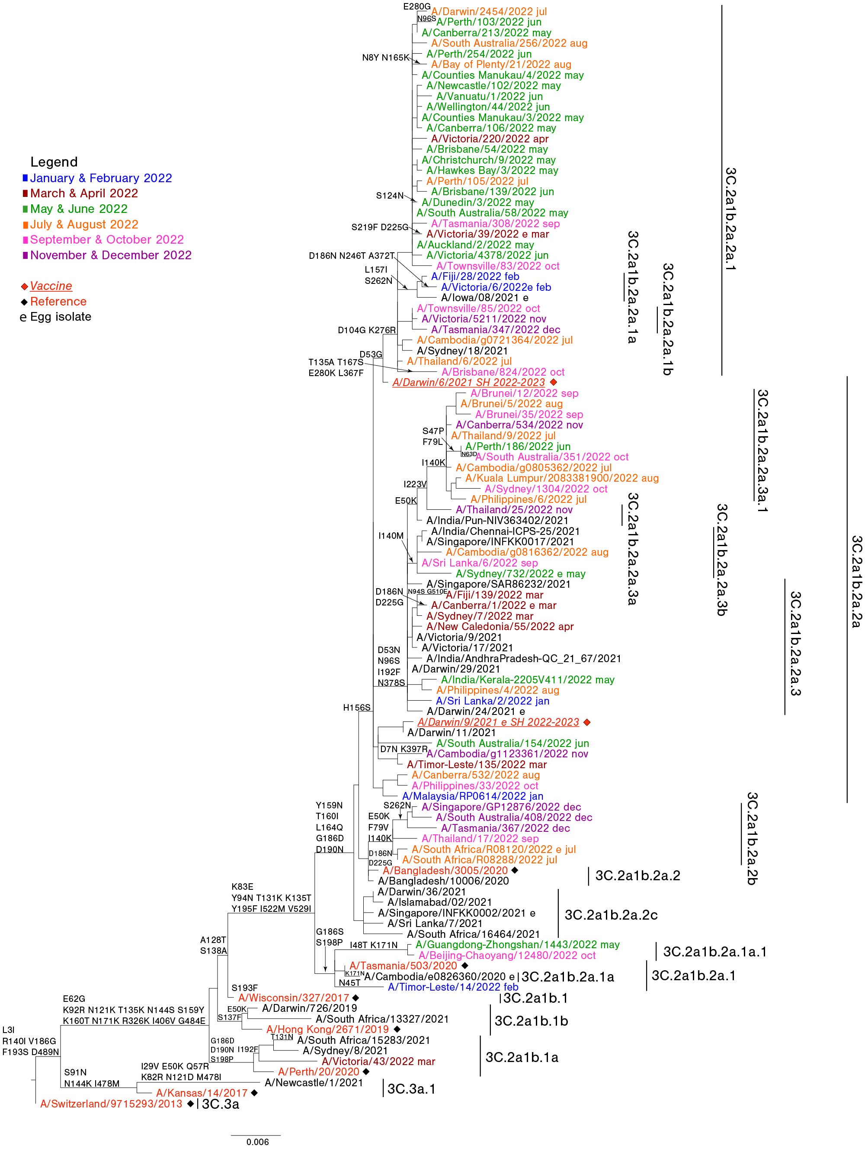

Figure 5: Phylogenetic tree of haemagglutinin (HA) genes of B/Victoria-lineage viruses received by the Centre during 2022
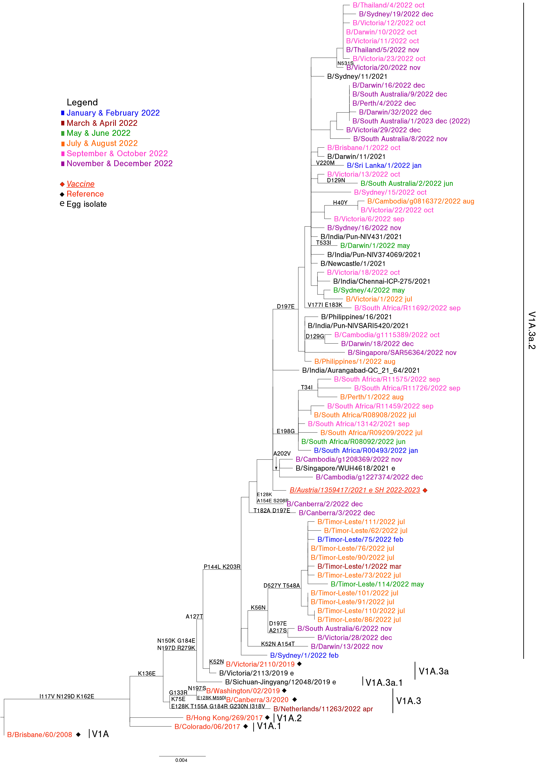

Influenza B
A total of 130 B/Victoria viruses were characterised by HI assay (Table2), with 97% (n = 126) found to be antigenically similar to the cell-propagated B/Austria/1359417/2021 vaccine virus.
Sequencing was attempted on 119 B/Victoria viruses, with 96 yielding results. Phylogenetic analysis on the HA gene of 149 viruses (including viruses sequenced externally) indicated that all circulating B/Victoria viruses received by the Centre fell into clade V1A.3a.2, which included the 2022 vaccine strain B/Austria/1359417/2021.
Egg and cell inoculation were not attempted for any B/Victoria-lineage viruses.
Of the 143 B/Victoria viruses tested with the NAI assay, none showed highly reduced susceptibility to oseltamivir or zanamivir, and no viruses were identified with genetic evidence of resistance to baloxavir (based on testing of 51 viruses for I38 mutations and of 44 viruses for E23 mutations).

Discussion
During 2022, the Centre received the highest number of samples since annual reporting commenced in 1997.^{27–48} Substantially more samples were received than during 2020 and 2021, which were heavily impacted by the global reduction in influenza activity that occurred following the emergence of SARS-CoV-2 and the COVID-19 pandemic and the introduction of non-pharmaceutical interventions by many countries.^{3,47,49} The high number of samples received in 2022 correlated with the large number of laboratory-confirmed influenza notifications in Australia (n = 233,370) during the 2022 Australian influenza season.⁴ The 2022 Australian influenza season was characterised by early activity, with a sharp increase in notifications in May, peaking in June, and subsequent low levels of activity for the remainder of the year.⁵⁰ Consequently, the Centre saw a dramatic increase in samples received during May and June, with 57% of all samples received during those two months alone.
Geographically, the largest number of notifications of laboratory-confirmed influenza was recorded in New South Wales, which saw 107,521 notifications during the May–July period.⁴ Lower numbers of notifications were made in Queensland (n = 39,882) and Victoria (n = 32,796) for the same period.⁴ However, notifications increased earlier in Victoria, which saw 1,729 notifications in April compared to 1,288 in July. The timing of the influenza season was similar in South Australia, where there were 10,171 notifications during the May–July period.⁴ There were a large number of notifications in the Northern Territory during May and June (n = 4,447), while influenza occurred later in Western Australia, with 3,798 notifications in June and 6,336 in July.⁴ In the Australian Capital Territory, most notifications were made in May and June (n = 1,543), while in Tasmania most influenza occurred during June and July (n = 2,352).⁴
The predominant circulating virus reported to the Australian National Notifiable Diseases Surveillance System (NNDSS) was influenza A (82.7%), with A(H3N2) predominant in samples that could be subtyped.⁵⁰ This is in agreement with samples from Australia received by the Centre, with A(H3N2) viruses accounting for the majority of viruses analysed. Globally, influenza A(H1N1)pdm09, A(H3N2), and influenza B viruses co-circulated in varying proportions, although influenza A was predominant.^{51,52} During the February to August period, influenza A(H3N2) was predominant in the temperate zones of the southern hemisphere.⁵¹
In general, older populations tend to be more affected by influenza in years when A(H3N2) viruses predominate, with younger populations usually more affected by A(H1N1)pdm09.⁵³ However, in 2022, higher notification rates were observed among children aged 5–9 years (2,154 notifications per 100,000 population) and < 5 years (1,859 per 100,000 population), while the lowest notifications rates were among adults aged 70–74 years (320 per 100,000 population) and those aged 65–69 years (335 per 100,000 population).⁵⁰ Possible reasons for this pattern include lower levels of influenza among older populations due to lockdowns, restricted visiting, and non-pharmaceutical interventions in aged care facilities associated with the COVID-19 pandemic, as well as effectiveness of the influenza vaccine in a population with high vaccine uptake. There were 308 influenza-associated deaths notified to the NNDSS, with a median age at death of 82 years (range 1–106 years).⁵⁰
Antigenic analysis of influenza A(H1N1)pdm09 viruses indicated that the majority of viruses (87%) displayed similar antigenic characteristics to the cell-propagated vaccine strain, A/Victoria/2570/2019. There were two distinct genetic subclades among circulating A(H1N1)pdm09 viruses, 6B.1A.5a.1 and 6B.1A.5a.2, with ongoing diversification of viruses in the 6B.1A.5a.2 subclade. As a result, the 2023 southern hemisphere A(H1N1)pdm09 vaccine component was updated to an A/Sydney/5/2021-like virus.⁵¹
Most influenza A(H3N2) viruses received by the Centre were antigenically similar to the cell-propagated vaccine reference strain, A/Darwin/6/2021, and were part of the same genetic group (3C.2a1b.2a.2), although most viruses fell into the minor subclade 3C.2a1b.2a.2a.1. In spite of the overall genetic diversity seen amongst A(H3N2) viruses received, there was no change to the recommended vaccine strain for 2023, as the existing A/Darwin/6/2021 strain gave the best overall coverage of the different clades.⁵¹
All influenza B isolates that were analysed at the Centre belonged to the B/Victoria lineage. Most of these viruses were antigenically similar to the B/Austria/1359417/2021 vaccine strain, and all belonged to the same genetic subgroup (V1A.3a.2). There was no change to the recommended vaccine strain for B/Victoria for 2023.⁵¹ Globally, no B/Yamagata viruses have been detected since March 2020, and it is hypothesised that this strain is now extinct.^{5,52,54,55} However, B/Phuket/3073/2013 (B/Yamagata-lineage)-like virus continued to be recommended for quadrivalent vaccines in case there are remaining isolated pockets with ongoing circulation of B/Yamagata-lineage viruses.⁵¹
With the ongoing evolution of seasonal influenza viruses and the absence of an effective universal vaccine, it is essential that influenza surveillance and regular updating of seasonal influenza vaccines continues. The work performed at the Centre in Melbourne contributes to the ongoing efforts of the WHO GISRS to better control the disease burden of influenza, and to provide effective countermeasures, such as vaccines, to reduce the impact of influenza on the human population.

Acknowledgements
The authors would like to thank all the National Influenza Centres and other contributing laboratories who sent influenza positive samples to the Centre during 2022. The Melbourne WHO Collaborating Centre for Reference and Research on Influenza is supported by the Australian Government Department of Health and Aged Care.

Author details
Dr Tanya R Diefenbach-Elstob, Epidemiologist, WHO Collaborating Centre for Reference and Research on Influenza
Mr Presa Chanthalavanh, Medical Scientist, WHO Collaborating Centre for Reference and Research on Influenza
Ms Monica E Bobbitt, Medical Scientist, WHO Collaborating Centre for Reference and Research on Influenza
Mrs Sook Kwan Brown, Medical Scientist, WHO Collaborating Centre for Reference and Research on Influenza
Mr Cleve Rynehart, Medical Scientist, WHO Collaborating Centre for Reference and Research on Influenza
Mrs Natalie Spirason, Medical Scientist, WHO Collaborating Centre for Reference and Research on Influenza
Ms Heidi Peck, Head – Serology, WHO Collaborating Centre for Reference and Research on Influenza
Dr Yi-Mo Deng, Head – Genetic analysis, WHO Collaborating Centre for Reference and Research on Influenza
Dr Clyde Dapat, Head – Bioinformatics, WHO Collaborating Centre for Reference and Research on Influenza
Prof Kanta Subbarao, Director, WHO Collaborating Centre for Reference and Research on Influenza
Prof Ian G Barr, Deputy Director, WHO Collaborating Centre for Reference and Research on Influenza

Corresponding author
Dr Tanya R Diefenbach-Elstob, Epidemiologist, WHO Collaborating Centre for Reference and Research on Influenza
email: Tanya.DiefenbachElstob@Influenzacentre.Org

References
- Hay AJ, McCauley JW. The WHO global influenza surveillance and response system (GISRS)—a future perspective. Influenza Other Respir Viruses. 2018;12(5):551–7. doi: https://doi.org/10.1111/irv.12565.
- Monto AS. Reflections on the global influenza surveillance and response system (GISRS) at 65 years: an expanding framework for influenza detection, prevention and control. Influenza Other Respir Viruses. 2018;12(1):10–2. doi: https://doi.org/10.1111/irv.12511.
- Sullivan SG, Carlson S, Cheng AC, Chilver MB, Dwyer DE, Irwin M et al. Where has all the influenza gone? The impact of COVID-19 on the circulation of influenza and other respiratory viruses, Australia, March to September 2020. Euro Surveill. 2020;25(47):2001847. doi: https://doi.org/10.2807/1560-7917.ES.2020.25.47.2001847.
- Australian Government Department of Health and Aged Care. National communicable disease surveillance dashboard. [Webpage.] Canberra: Australian Government Department of Health and Aged Care; 2023. [Accessed on 29 May 2023.] Available from: https://nindss.health.gov.au/pbi-dashboard/.
- Koutsakos M, Wheatley AK, Laurie K, Kent SJ, Rockman S. Influenza lineage extinction during the COVID-19 pandemic? Nat Rev Microbiol. 2021;19(12):741–2. doi: https://doi.org/10.1038/s41579-021-00642-4.
- Oh DY, Barr IG, Mosse JA, Laurie KL. MDCK-SIAT1 cells show improved isolation rates for recent human influenza viruses compared to conventional MDCK cells. J Clin Microbiol. 2008;46(7):2189–94. doi: https://doi.org/10.1128/JCM.00398-08.
- Hobson D, Curry RL, Beare AS, Ward-Gardner A. The role of serum haemagglutination-inhibiting antibody in protection against challenge infection with influenza A2 and B viruses. J Hyg (Lond). 1972;70(4):767–77. doi: https://doi.org/10.1017/s0022172400022610.
- Lin YP, Gregory V, Collins P, Kloess J, Wharton S, Cattle N et al. Neuraminidase receptor binding variants of human influenza A(H3N2) viruses resulting from substitution of aspartic acid 151 in the catalytic site: a role in virus attachment? J Virol. 2010;84(13):6769–81. doi: https://doi.org/10.1128/JVI.00458-10.
- Shu B, Kirby MK, Davis WG, Warnes C, Liddell J, Liu J et al. Multiplex real-time reverse transcription PCR for influenza A virus, influenza B virus, and severe acute respiratory syndrome coronavirus 2. Emerg Infect Dis. 2021;27(7):1821–30. doi: https://doi.org/10.3201/eid2707.210462.
- Shu B, Wu KH, Emery S, Villanueva J, Johnson R, Guthrie E et al. Design and performance of the CDC real-time reverse transcriptase PCR swine flu panel for detection of 2009 A (H1N1) pandemic influenza virus. J Clin Microbiol. 2011;49(7):2614–9. doi: https://doi.org/10.1128/JCM.02636-10.
- Deng YM, Spirason N, Iannello P, Jelley L, Lau H, Barr IG. A simplified Sanger sequencing method for full genome sequencing of multiple subtypes of human influenza A viruses. J Clin Virol. 2015;68:43–8. doi: https://doi.org/10.1016/j.jcv.2015.04.019.
- Zhou B, Donnelly ME, Scholes DT, St George K, Hatta M, Kawaoka Y et al. Single-reaction genomic amplification accelerates sequencing and vaccine production for classical and swine origin human influenza A viruses. J Virol. 2009;83(19):10309–13. doi: https://doi.org/10.1128/JVI.01109-09.
- Zhou B, Deng YM, Barnes JR, Sessions OM, Chou TW, Wilson M et al. Multiplex reverse transcription-PCR for simultaneous surveillance of influenza A and B viruses. J Clin Microbiol. 2017;55(12):3492–501. doi: https://doi.org/10.1128/JCM.00957-17.
- Shepard SS, Meno S, Bahl J, Wilson MM, Barnes J, Neuhaus E. Viral deep sequencing needs an adaptive approach: IRMA, the iterative refinement meta-assembler. BMC Genomics. 2016;17(1):708. doi: https://doi.org/10.1186/s12864-016-3030-6.
- Hadfield J, Megill C, Bell SM, Huddleston J, Potter B, Callender C et al. Nextstrain: real-time tracking of pathogen evolution. Bioinformatics. 2018;34(23):4121–3. doi: https://doi.org/10.1093/bioinformatics/bty407.
- Minh BQ, Schmidt HA, Chernomor O, Schrempf D, Woodhams MD, von Haeseler A et al. IQ-TREE 2: new models and efficient methods for phylogenetic inference in the genomic era. Mol Biol Evol. 2020;37(5):1530–4. doi: https://doi.org/10.1093/molbev/msaa015.
- Yu G. Using ggtree to visualize data on tree-like structures. Curr Protoc Bioinformatics. 2020;69(1):e96. doi: https://doi.org/10.1002/cpbi.96.
- Hurt AC, Besselaar TG, Daniels RS, Ermetal B, Fry A, Gubareva L et al. Global update on the susceptibility of human influenza viruses to neuraminidase inhibitors, 2014–2015. Antiviral Res. 2016;132:178–85. doi: https://doi.org/10.1016/j.antiviral.2016.06.001.
- World Health Organization (WHO) Global Influenza Programme. Laboratory methodologies for testing the antiviral susceptibility of influenza viruses: Neuraminidase inhibitor (NAI). [Webpage.] Geneva: WHO; 2023. [Accessed on 29 March 2023.] Available from: https://www.who.int/teams/global-influenza-programme/laboratory-network/quality-assurance/antiviral-susceptibility-influenza/neuraminidase-inhibitor.
- Deng YM, Caldwell N, Barr IG. Rapid detection and subtyping of human influenza A viruses and reassortants by pyrosequencing. PLoS One. 2011;6(8):e23400. doi: https://doi.org/10.1371/journal.pone.0023400.
- Koszalka P, Farrukee R, Mifsud E, Vijaykrishna D, Hurt AC. A rapid pyrosequencing assay for the molecular detection of influenza viruses with reduced baloxavir susceptibility due to PA/I38X amino acid substitutions. Influenza Other Respir Viruses. 2020;14(4):460–4. doi: https://doi.org/10.1111/irv.12725.
- Gerdil C. The annual production cycle for influenza vaccine. Vaccine. 2003;21(16):1776–9. doi: https://doi.org/10.1016/s0264-410x(03)00071-9.
- Stöhr K, Bucher D, Colgate T, Wood J. Influenza virus surveillance, vaccine strain selection, and manufacture. Methods Mol Biol. 2012;865:147–62. doi: https://doi.org/10.1007/978-1-61779-621-0_9.
- Weir JP, Gruber MF. An overview of the regulation of influenza vaccines in the United States. Influenza Other Respir Viruses. 2016;10(5):354–60. doi: https://doi.org/10.1111/irv.12383.
- WHO Global Influenza Surveillance Network. Manual for the laboratory diagnosis and virological surveillance of influenza. Geneva: WHO; I January 2011. Available from: https://www.who.int/publications/i/item/manual-for-the-laboratory-diagnosis-and-virological-surveillance-of-influenza.
- Roth B, Mohr H, Enders M, Garten W, Gregersen JP. Isolation of influenza viruses in MDCK 33016PF cells and clearance of contaminating respiratory viruses. Vaccine. 2012;30(3):517–22. doi: https://doi.org/10.1016/j.vaccine.2011.11.063.
- Curran M, Hampson A. National influenza surveillance 1997. Commun Dis Intell. 1998;22(5):69–74.
- Halliday L, Roberts L, Hampson A. Annual report of the National Influenza Surveillance Scheme, 1998. Commun Dis Intell. 1999;23(7):185–92.
- Thomson J, Lin M, Hampson A. Annual report of the National Influenza Surveillance Scheme, 1999. Commun Dis Intell. 2000;24(6):145–52.
- Firestone SM, Barr IG, Roche PW, Walker JC. Annual report of the National Influenza Surveillance Scheme, 2005. Commun Dis Intell Q Rep. 2006;30(2):189–200.
- Li J, Hampson A, Roche PW, Yohannes K, Spencer JD. Annual report of the National Influenza Surveillance Scheme, 2004. Commun Dis Intell Q Rep. 2005;29(2):125–36.
- Roche P, Spencer J, Hampson A. Annual report of the National Influenza Surveillance Scheme, 2001. Commun Dis Intell Q Rep. 2002;26(2):204–13.
- Roche P, Spencer J, Merianos A, Hampson A. Annual report of the National Influenza Surveillance Scheme, 2000. Commun Dis Intell Q Rep. 2001;25(3):107–12.
- Yohannes K, Roche P, Hampson A, Miller M, Spencer J. Annual report of the National Influenza Surveillance Scheme, 2003. Commun Dis Intell Q Rep. 2004;28(2):160–8.
- Yohannes K, Roche P, Spencer J, Hampson A. Annual report of the National Influenza Surveillance Scheme, 2002. Commun Dis Intell Q Rep. 2003;27(2):162–72.
- O’Brien K, Barr IG. Annual report of the National Influenza Surveillance Scheme, 2006. Commun Dis Intell Q Rep. 2007;31(2):167–79.
- Owen R, Barr IG, Pengilley A, Liu C, Paterson B, Kaczmarek M et al. Annual report of the National Influenza Surveillance Scheme, 2007. Commun Dis Intell Q Rep. 2008;32(2):208–26.
- Kaczmarek M, Owen R, Barr IG. Annual report of the National Influenza Surveillance Scheme, 2008. Commun Dis Intell Q Rep. 2010;34(1):8–22.
- Pennington K, Owen R, Mun J. Annual report of the National Influenza Surveillance Scheme, 2009. Commun Dis Intell Q Rep. 2017;41(4):E383–454.
- Gavin K, Owen R, Barr IG. Annual report of the National Influenza Surveillance Scheme, 2010. Commun Dis Intell Q Rep. 2017;41(4):E348–68.
- Sullivan SG, Chow MK, Barr IG, Kelso A. Influenza viruses received and tested by the Melbourne WHO Collaborating Centre for Reference and Research on Influenza annual report, 2014. Commun Dis Intell Q Rep. 2015;39(4):E602–11.
- Leung VK, Deng YM, Kaye M, Buettner I, Lau H, Leang SK et al. Annual report on influenza viruses received and tested by the Melbourne WHO Collaborating Centre for Reference and Research on Influenza in 2016. Commun Dis Intell (2018). 2019;43. doi: http://doi.org/10.33321/cdi.2019.43.3.
- Leung VK, Spirason N, Lau H, Buettner I, Leang SK, Chow MK. Influenza viruses received and tested by the Melbourne WHO Collaborating Centre for Reference and Research on Influenza annual report, 2015. Commun Dis Intell Q Rep. 2017;41(2):E150–60.
- Peck H, Moselen J, Brown SK, Triantafilou M, Lau H, Grau M et al. Report on influenza viruses received and tested by the Melbourne WHO Collaborating Centre for Reference and Research on Influenza in 2019. Commun Dis Intell (2018). 2021;45. doi: https://doi.org/10.33321/cdi.2021.45.43.
- Roe M, Kaye M, Iannello P, Lau H, Buettner I, Tolosa MX et al. Report on influenza viruses received and tested by the Melbourne WHO Collaborating Centre for Reference and Research on Influenza in 2017. Commun Dis Intell (2018). 2019;43. doi: https://doi.org/10.33321/cdi.2019.43.25.
- Price OH, Spirason N, Rynehart C, Brown SK, Todd A, Peck H et al. Report on influenza viruses received and tested by the Melbourne WHO Collaborating Centre for Reference and Research on Influenza in 2018. Commun Dis Intell (2018). 2020;44. doi: https://doi.org/10.33321/cdi.2020.44.16.
- O’Neill G, Aziz A, Kuba M, Brown SK, Lau H, Soppe S et al. Report on influenza viruses received and tested by the Melbourne WHO Collaborating Centre for Reference and Research on Influenza during 2020–2021. Commun Dis Intell (2018). 2022;46. doi: https://doi.org/10.33321/cdi.2022.46.63.
- Communicable Disease Epidemiology and Surveillance Section. Report of the National Influenza Surveillance Scheme, 2011 to 2018. Commun Dis Intell (2018). 2022;46. doi: https://doi.org/10.33321/cdi.2022.46.12.
- WHO Global Influenza Programme. Influenza Update N° 384: 04 January 2021, based on data up to 20 December 2020. Geneva: WHO; 4 January 2021. Available from: https://cdn.who.int/media/docs/default-source/influenza/influenza-updates/2020/2021_01_04_surveillance_update_384.pdf.
- Australian Government Department of Health and Aged Care. National 2022 influenza season summary Reporting period: 01 January to 09 October 2022. Canberra: Australian Government Department of Health and Aged Care; December 2022. Available from: https://www.health.gov.au/sites/default/files/2022-12/aisr-2022-national-influenza-season-summary.pdf.
- WHO. Recommended composition of influenza virus vaccines for use in the 2023 southern hemisphere influenza season. Geneva: WHO; 23 September 2022. Available from: https://www.who.int/publications/m/item/recommended-composition-of-influenza-virus-vaccines-for-use-in-the-2023-southern-hemisphere-influenza-season.
- WHO. Recommended composition of influenza virus vaccines for use in the 2023-2024 northern hemisphere influenza season. Geneva: WHO; 24 February 2023. Available from: https://www.who.int/publications/m/item/recommended-composition-of-influenza-virus-vaccines-for-use-in-the-2023-2024-northern-hemisphere-influenza-season.
- Thompson WW, Shay DK, Weintraub E, Brammer L, Bridges CB, Cox NJ et al. Influenza-associated hospitalizations in the United States. JAMA. 2004;292(11):1333–40. doi: https://doi.org/10.1001/jama.292.11.1333.
- Dhanasekaran V, Sullivan S, Edwards KM, Xie R, Khvorov A, Valkenburg SA et al. Human seasonal influenza under COVID-19 and the potential consequences of influenza lineage elimination. Nat Commun. 2022;13(1):1721. doi: https://doi.org/10.1038/s41467-022-29402-5.
- Paget J, Caini S, Del Riccio M, van Waarden W, Meijer A. Has influenza B/Yamagata become extinct and what implications might this have for quadrivalent influenza vaccines? Euro Surveill. 2022;27(39):2200753. doi: https://doi.org/10.2807/1560-7917.ES.2022.27.39.2200753.

Communicable Diseases Intelligence
ISSN: 2209-6051 Online

Communicable Diseases Intelligence (CDI) is a peer-reviewed scientific journal published by the Office of Health Protection, Department of Health and Aged Care. The journal aims to disseminate information on the epidemiology, surveillance, prevention and control of communicable diseases of relevance to Australia.

Editor: Christina Bareja
Deputy Editor: Simon Petrie
Design and Production: Kasra Yousefi
Editorial Advisory Board: David Durrheim, Mark Ferson, Clare Huppatz, John Kaldor, Martyn Kirk, Meru Sheel and Steph Williams

Website: http://www.health.gov.au/cdi

Contacts
CDI is produced by the Office of Health Protection, Australian Government Department of Health and Aged Care, GPO Box 9848, (MDP 6) CANBERRA ACT 2601

Email: cdi.editor@health.gov.au

Submit an Article
You are invited to submit your next communicable disease related article to the Communicable Diseases Intelligence (CDI) for consideration. More information regarding CDI can be found at: http://health.gov.au/cdi.
Further enquiries should be directed to: cdi.editor@health.gov.au.

This journal is indexed by Index Medicus and Medline.

Creative Commons Licence - Attribution-NonCommercial-NoDerivatives CC BY-NC-ND
© 2023 Commonwealth of Australia as represented by the Department of Health and Aged Care
This publication is licensed under a Creative Commons Attribution-NonCommercial-NoDerivatives 4.0 International Licence from https://creativecommons.org/licenses/by-nc-nd/4.0/legalcode (Licence). You must read and understand the Licence before using any material from this publication.

Restrictions
The Licence does not cover, and there is no permission given for, use of any of the following material found in this publication (if any):
- the Commonwealth Coat of Arms (by way of information, the terms under which the Coat of Arms may be used can be found at www.itsanhonour.gov.au);
- any logos (including the Department of Health and Aged Care’s logo) and trademarks;
- any photographs and images;
- any signatures; and
- any material belonging to third parties.

Disclaimer
Opinions expressed in Communicable Diseases Intelligence are those of the authors and not necessarily those of the Australian Government Department of Health and Aged Care or the Communicable Diseases Network Australia. Data may be subject to revision.

Enquiries
Enquiries regarding any other use of this publication should be addressed to the Communication Branch, Department of Health and Aged Care, GPO Box 9848, Canberra ACT 2601, or via e-mail to: copyright@health.gov.au

Communicable Diseases Network Australia
Communicable Diseases Intelligence contributes to the work of the Communicable Diseases Network Australia.
http://www.health.gov.au/cdna

The CDC Influenza Virus Real-Time RT-PCR Influenza A/B Typing Panel (RUO) (Catalog No. FluRUO-01), FR-198, was obtained through the International Reagent Resource, Influenza Division, WHO Collaborating Center for Surveillance, Epidemiology and Control of Influenza, Centers for Disease Control and Prevention, Atlanta, GA, USA. Website: https://www.internationalreagentresource.org/.
20-(4-methylumbelliferyl)-a-D-N-acetylneuraminic acid.

