Communicable Diseases Intelligence, Year 2023, Volume 47
https://doi.org/10.33321/cdi.2023.47.36
Publication date: 26/06/2023
http://health.gov.au/cdi

Evolving epidemiology of Q fever in Wide Bay
Matthew Roughan, Emma Hodge, Arifuzzaman Khan, Josette Chor

Abstract
Q fever is a notifiable disease in Australia due to its public health significance. Recent data in the Wide Bay region (Queensland, Australia) suggests a rising number and changing geographical distribution of Q fever cases. This study aims to evaluate these changes through analysis of data from Queensland Health’s Notifiable Conditions System (NoCS) over a ten-year period. A comparison was made between the recent five-year period (2018–2022) and the preceding five-year period (2013–2017) with reference to incidence rates, location of cases and likely exposures. Incidence rates of Q fever showed an upward trend over time, particularly in urban areas. This highlights the need for increased clinical suspicion, improved awareness among the community and healthcare providers, and potentially broadening of vaccination recommendations in the future.
Keywords: Q fever; zoonoses; rural health; vaccination; urbanisation

Introduction
Q fever, caused by the bacterium Coxiella burnetii,¹ is a zoonotic disease which is notifiable in Australia due to its public health significance. It is a vaccine preventable disease, with Australia the only country currently vaccinating at-risk populations.² Previous outbreaks have often been associated with workplaces involved in the processing of animals, such as abattoirs and farms,^{3,4} and it is within these industries where vaccination efforts have been focused. Previous Queensland serosurveillance data has suggested direct contact with animals and living in a rural area are both independent risk factors for Q fever infection,⁵ which is in keeping with its known main reservoirs including sheep, cattle and goats. Recent Q fever case data within the Wide Bay region showed an even division between those living in rural areas and the more urban centres of the Wide Bay region, which may suggest an evolving trend, and may impact future public health measures including vaccination guidelines.
Q fever can manifest as an acute or chronic infection. Most commonly, acute Q fever presents as a self-limiting systemic illness characterised by fever and associated with a broad range of symptoms including headache, myalgia, malaise, and gastrointestinal symptoms.⁶ More severe cases can result in pneumonia, hepatitis, haematological and neurological complications. An estimated 1–5% of Q fever cases result in chronic infection, including endocarditis, osteoarticular infections, and vascular infections.⁷ Transmission of C. burnetii is primarily through the airborne route, with aerosolisation occurring via the birthing of livestock or through dust generation during herding, heavy transport or mowing.³ Notification of confirmed Q fever cases requires either laboratory definitive evidence, or laboratory suggestive evidence along with a clinically compatible disease.⁸
Q fever has been an ongoing public health concern within the Wide Bay region.⁹ Routine observation work within the Wide Bay Public Health Unit (PHU) in 2022 noted a 40% increase in incidence rate of Q fever compared to the previous year, with 13 cases reported. This is in the context of overall stability in Queensland’s state-wide case numbers, with 238 cases recorded in 2022 compared to the five-year average (2018–2022) of 235 cases per annum.¹⁰ Initial assessment of the pattern of distribution of these cases suggested a need to consider diagnosis and prevention of Q fever beyond the traditional risk factors of direct animal contact and workplace exposure. As such, a thorough review of Q fever notifications within the Wide Bay region over the past decade was conducted, with the aim of evaluating recent changes in incidence rates and assessing the need for expansion of traditional risk factors for this vaccine preventable disease.

Methods
Q fever data from 2013 to 2022 was extracted from the Queensland Health Notifiable Conditions System (NoCS). The case definition was in keeping with that defined by the Communicable Diseases Network Australia (CDNA) guidelines.⁸ Data from the recent five-year period (2018–2022) was compared with the preceding five-year period (2013–2017) with reference to demographics and likely exposure source. The Modified Monash Model was utilised to classify the location of residence as either a regional town (MM2 or 3) or rural (MM > 3).¹¹ To assess the significance of the differences observed, statistical tests including the Wilcoxon rank sum test, Fisher’s exact test, and Pearson’s chi-squared test were employed as appropriate. Additionally, yearly incidence rates (per 100,000 population at risk) and incidence risk ratios between 2013 and 2022 were calculated based on population data from the Queensland Statistician’s Office.¹²
Ethical exemption for review and publication of this data was provided by the Central Queensland HHS Human Research Ethics Committee.

Results
There were a total of 87 cases of Q fever detected in the Wide Bay region in 2013–2022. Tables 1 and 2 show the baseline characteristics of these cases, and compares the risk factors associated with the cases in the recent five-year period (2018–2022) with the preceding five-year period (2013–2017).
A number of interesting trends emerged from analysis of the data. Although not statistically significant, an increase in case numbers in urban (MM 2 or 3) compared to rural areas (MM > 3) was observed. The urban case numbers in the recent five-year period demonstrated an increase of 40% compared to the previous five years, while only a 16.6% increase was noted in rural areas. Figure 1 illustrates the annual Q fever cases in urban and rural areas from 2013 to 2022. The graph reveals a notable difference in the rate of increase between urban and rural cases, with urban cases exhibiting a steeper incline compared to rural cases on the pictured regression model.
Significant difference is observed in exposure history between the two five-year periods. Of note, exposures related to land clearing, mowing, or earthmoving demonstrated a notable increase in the recent five years (8/79, 10%) compared to the preceding five years (0%). Other exposure categories did not exhibit substantial variations; however, the occurrence of the commonest exposure (i.e. lives on a farm) was seen to decrease in the recent period.
Increased overall case numbers in the Wide Bay region were also noted. Comparison of incident rates between the recent five years and the preceding five years revealed a significant increase of 25% (incidence rate ratio 1.25 [95% confidence interval (95% CI): 1.24–1.25]). Table 3 provides a detailed overview of the incidence rates and incidence rate ratios (IRR) for each year from 2013 to 2022, as well as a comparison between the two five-year periods.

Figure 1: Historic Q fever infections in Wide Bay region by residential location with trend over time
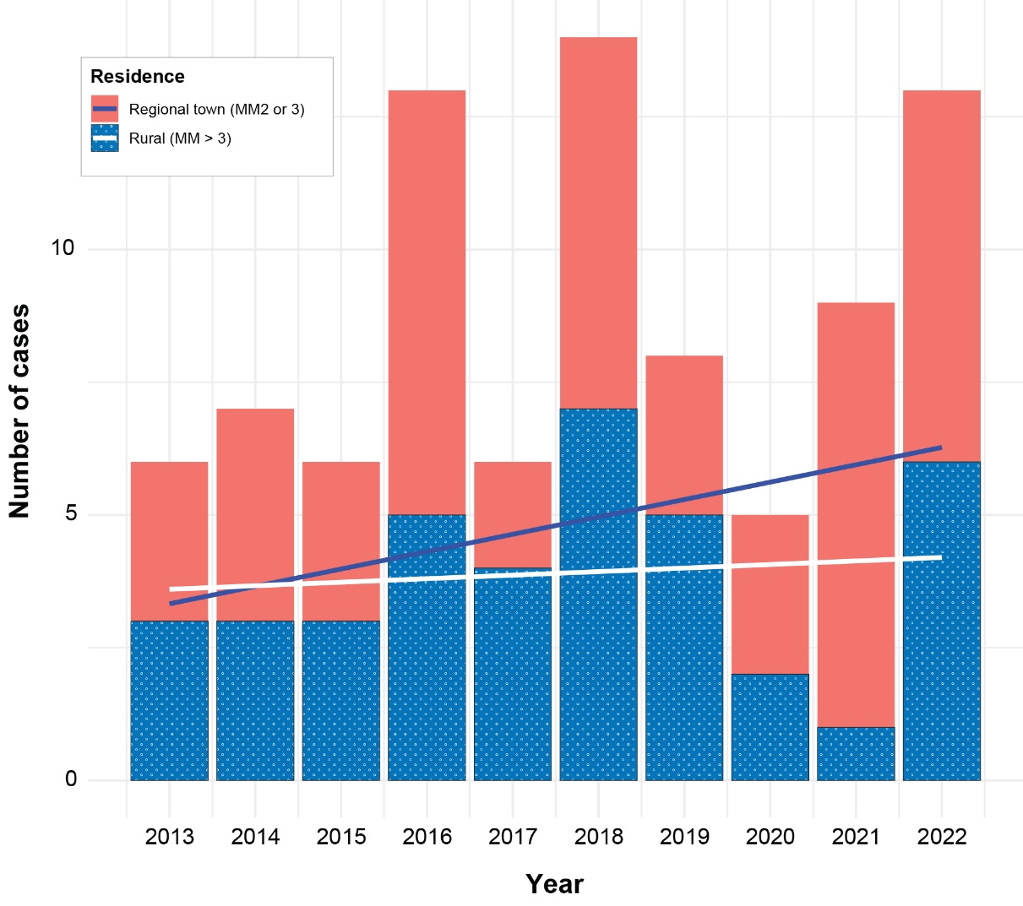

Public health response
The PHU responded to the rise in notifications in 2022 by closely reviewing all Q fever cases and investigating for a possible common source of exposure. Subsequent case interviews focused on potential sites of exposure, including place of residence, workplace, and high-risk activities. It was noted that many cases were centred around the townships in the Wide Bay region, rather than in the expected rural areas. This may reflect the rapid population growth experienced in the Wide Bay region,¹³ with previous farm land being converted to residential estates. There were no cases associated with typical high-risk industries such as animal processing in 2022; however, there were a number associated with mowing, gardening and land clearing. Given the widespread nature of the cases, case finding was limited to raising awareness with local medical practitioners. Education was provided on the recommended antibiotic course for cases, as well as vaccination advice for contacts with similar exposures.
The second component of the public health response involved communication via Queensland Health and mainstream media. This included raising awareness for the role of Q fever vaccination, which is currently recommended for all people who are working in, or intend to work in, a high-risk occupation such as those whose work exposes them to animals, animal products, and animal waste. High-risk workplaces should have a vaccination program to protect their workforce; however, people who partake in relevant activities recreationally may not be aware of this recommendation. Additional preventative strategies were also communicated, including washing hands when encountering animals or their faeces, as well as use of P2 masks when undertaking outdoor activities with obvious animal droppings. This was extended to mowing or land clearing activities in any areas that may have contact with wildlife including kangaroos, which includes more urban locations around Hervey Bay and Bundaberg.
Table 1: Overall and comparative demographic characteristics of Q fever cases (N = 87) notified in 2013–2022
Characteristic | Value | Overall  N = 87 | Previous five years  (2013–2017)  n = 38 | Recent five years  (2018–2022)  n = 49 | p valueª
Age group | 0–25 years | 9/83 (11%) | 5/37 (14%) | 4/46 (8.7%) | 0.8
 | 26–50 years | 29/83 (35%) | 12/37 (32%) | 17/46 (37%)
 | 51–75 years | 45/83 (54%) | 2/37 (54%) | 25/46 (54%)
 | Unknown | 4 | 1 | 3
Sex | Female | 23/87 (26%) | 7/38 (18%) | 16/49 (33%) | 0.14
 | Male | 64/87 (74%) | 31/38 (82%) | 33/49 (67%)
Residence location category | Regional town (MM2 or 3) | 48/87 (55%) | 20/38 (53%) | 28/49 (57%) | 0.7
 | Rural (MM > 3) | 39/87 (45%) | 18/38 (47%) | 21/49 (43%)
a Pearson’s Chi-squared test or Fisher’s exact test, as appropriate.
Table 2: Overall and comparative exposure history of Q fever cases (N = 87) notified in 2013–2022
Exposure history | Overall  N = 87 | Previous five years  (2013–2017)  n = 38 | Recent five years  (2018–2022)  n = 49 | p valueª
Animal contact not otherwise specified | 3/79 (3.8%) | 1/33 (3.0%) | 2/46 (4.3%) | 0.039
Assisted or observed an animal birth | 12/79 (15%) | 5/33 (15%) | 7/46 (15%)
Exposure to livestock transport | 3/79 (3.8%) | 2/33 (6.1%) | 1/46 (2.2%)
Hunting or butchering animals | 8/79 (10%) | 4/33 (12%) | 4/46 (8.7%)
Land clearing, mowing, or earthmoving | 8/79 (10%) | 0/33 (0%) | 8/46 (17%)
Lives on a farm | 27/79 (34%) | 13/33 (39%) | 14/46 (30%)
Lives/works near abattoir/animal grazing area/saleyard | 5/79 (6.3%) | 2/33 (6.1%) | 3/46 (6.5%)
Lives/works within 300 m of bush/scrub/forest area | 2/79 (2.5%) | 2/33 (6.1%) | 0/46 (0%)
Unpasteurised milk consumption | 2/79 (2.5%) | 1/33 (3.0%) | 1/46 (2.2%)
Visited a farm or rural area | 5/79 (6.3%) | 0/33 (0%) | 5/46 (11%)
Works in abattoir | 1/79 (1.3%) | 1/33 (3.0%) | 0/46 (0%)
Works in livestock transport | 2/79 (2.5%) | 2/33 (6.1%) | 0/46 (0%)
Works on a farm | 1/79 (1.3%) | 0/33 (0%) | 1/46 (2.2%)
Unknown | 8 | 5 | 3
a Pearson’s Chi-squared test or Fisher’s exact test, as appropriate.

Table 3: Incidence rates and incidence rate ratios (IRR) of Q fever cases per 100,000 population, by year and five-year comparison (2013–2022)
Comparison period | Interval | Number of Q fever  cases notified | Incidence rate  per 100,000 population at risk | IRR (95% CI) ª  compared to previous interval | % change
Yearly | 2013 | 6 | 2.8 | — | —
 | 2014 | 7 | 3.3 | 1.2 (0.4–2.7) | 20%
 | 2015 | 6 | 2.8 | 0.9 (0.7–2.4) | -10%
 | 2016 | 13 | 6.1 | 2.2 (0.7–3.6) | 120%
 | 2017 | 6 | 2.8 | 0.5 (0.1–1.9) | -50%
 | 2018 | 14 | 6.4 | 2.3 (0.9–3.7) | 130%
 | 2019 | 8 | 3.6 | 0.6 (0.7–1.9) | -40%
 | 2020 | 5 | 2.3 | 0.6 (0.1–2.3) | -40%
 | 2021 | 9 | 4.1 | 1.8 (0.2–3.4) | 80%
 | 2022 | 13 | 5.9 | 1.4 (0.2-2.7) | 40%
Five yearly | Preceding 5 years (2013–2017) | 38 | 3.6 | — | —
 | Recent 5 years (2018–2022) | 49 | 4.4 | 1.25 (1.24–1.25) | 25%
a 95% CI: 95% confidence interval.

Discussion and conclusion
Q fever is a significant public health issue for several reasons. Although most cases of Q fever can be successfully treated with a two-week course of doxycycline, chronic cases require complex management and have a profound impact on both the patient and healthcare system.⁶ Furthermore, it is one of the notifiable diseases with an effective vaccine which can significantly reduce the incidence when there is broad uptake across high-risk settings. While Q fever is rarely transmitted between people,¹⁴ clusters of cases may be associated with a common exposure; identifying increasing trends can help to address unmitigated risks and potential areas with indications for vaccination. As residence in close proximity to wildlife such as kangaroos and wallabies is a known risk factor for Q fever, the increase in cases in this instance was deemed to be potentially associated with the local suburb expansion,¹⁵ as well as with persistent dry and windy conditions which can increase the risk of transmission to humans.
While this study is limited by the relatively small total number of cases as well as limited specific population data, the overall trend of increasing cases outside of the typical rural locations is notable. Wide Bay was the fastest growing regional Queensland SA4 in 2020–2021,¹³ suggesting urban expansion is likely to continue. A continuing trend of a broader section of the population being at risk of Q fever may suggest a need to increase clinical suspicion of the diagnosis, as well as broadening of vaccination recommendations, though economic evaluation should be considered. Improving awareness among the community and medical practitioners of the evolving risk factors for Q fever and the role of vaccinations can help to facilitate further disease prevention, and a reduced incidence across the population.

Acknowledgments
The authors would like to acknowledge Wide Bay Public Health Unit staff who have interviewed and followed up Q Fever cases in the region.

Author details
Dr Matthew Roughan¹
Dr Emma Hodge¹
Dr Arifuzzaman Khan^{1,2}
Dr Josette Chor¹
- Wide Bay Public Health Unit (Wide Bay Hospital and Health Service)
- ORCID-ID (0000-0003-4770-8308)

Corresponding author
Dr Matthew Roughan
Wide Bay Public Health Unit (Wide Bay Hospital and Health Service)
Email: Matthew.roughan@health.qld.gov.au

References
- Derrick EH. “Q” fever, a new fever entity: clinical features, diagnosis and laboratory investigation. Med J Aust. 1937;2(8):281–99. (Reprinted as Rev Infect Dis. 1983;5(4):790–800. doi: https://doi.org/10.1093/clinids/5.4.790.)
- Gidding HF, Peng CQ, Graves S, Massey PD, Nguyen C, Stenos J et al. Q fever seroprevalence in Australia suggests one in twenty people have been exposed. Epidemiol Infect. 2020;148:e18. doi: https://doi.org/10.1017/S0950268820000084.
- Heymann DL, ed. Control of Communicable Diseases Manual: an official report of the American Public Health Association. 20th ed. Fort Worth: APHA Press, 2015.
- Parker NR, Barralet JH, Bell AM. Q fever. Lancet. 2006;367(9511):679–88. doi: https://doi.org/10.1016/S0140-6736(06)68266-4.
- Gidding HF, Faddy HM, Durrheim DN, Graves SR, Nguyen C, Hutchinson P et al. Seroprevalence of Q fever among metropolitan and non-metropolitan blood donors in New South Wales and Queensland, 2014–2015. Med J Aust. 2019;210(7):309–15. doi: https://doi.org/10.5694/mja2.13004.
- Patil SM, Regunath H. Q Fever. [Internet.] Treasure Island, Florida: StatPearls; 18 November 2022. Available from: https://www.statpearls.com/ArticleLibrary/viewarticle/28128.
- Kampschreur LM, Wegdam-Blans MC, Wever PC, Renders NH, Delsing CE, Sprong T et al. Chronic Q fever diagnosis— consensus guideline versus expert opinion. Emerg Infect Dis. 2015;21(7):1183–8. doi: https://doi.org/10.3201/eid2107.130955.
- Australian Government Department of Health and Aged Care. Q fever – CDNA National Guidelines for Public Health Units. Canberra: Australian Government Department of Health and Aged Care, Communicable Diseases Network Australia; 27 November 2018. Available from: https://www.health.gov.au/resources/publications/q-fever-cdna-national-guidelines-for-public-health-units.
- Queensland Government Department of Health (Queensland Health). Notifiable conditions annual reporting. [Webpage.] Brisbane: Queensland Health; 2022. Available from: https://www.health.qld.gov.au/clinical-practice/guidelines-procedures/diseases-infection/surveillance/reports/notifiable/annual.
- Queensland Health. Notifiable conditions weekly totals. [Webpage.] Brisbane: Queensland Health; 2022. Available from: https://www.health.qld.gov.au/clinical-practice/guidelines-procedures/diseases-infection/surveillance/reports/notifiable/weekly.
- Australian Government Department of Health and Aged Care. Modified Monash Model. [Webpage.] Canberra: Australian Government Department of Health and Aged Care; 14 December 2021. Available from: https://www.health.gov.au/topics/rural-health-workforce/classifications/mmm.
- Queensland Government Statistician’s Office (QGSO). Population Estimates 2023. Estimated resident population by SA1 (ABS consultancy) (table). [Webpage.] Brisbane: QGSO; 20 April 2023. Available from: https://www.qgso.qld.gov.au/statistics/theme/population/population-estimates/regions#current-release-estimated-resident-population-abs-consultancy.
- QGSO. Population growth highlights and trends, Queensland regions, 2022 edition. Brisbane: Queensland Government, QGSO; 29 March 2022. Available from: https://www.qgso.qld.gov.au/issues/3061/population-growth-highlights-trends-qld-regions-2022-edn.pdf.
- Miceli MH, Veryser AK, Anderson AD, Hofinger D, Lee SA, Tancik C. A case of person-to-person transmission of Q fever from an active duty serviceman to his spouse. Vector Borne Zoonotic Dis. 2010;10(5):539–41. doi: https://doi.org/10.1089/vbz.2009.0101.
- Proboste T, Clark NJ, Tozer S, Wood C, Lambert SB, Soares Magalhães RJ. Profiling risk factors for household and community spatiotemporal clusters of Q fever notifications in Queensland between 2002 and 2017. Pathogens. 2022;11(8):830. doi: https://doi.org/10.3390/pathogens11080830.

Communicable Diseases Intelligence
ISSN: 2209-6051 Online

Communicable Diseases Intelligence (CDI) is a peer-reviewed scientific journal published by the Office of Health Protection, Department of Health and Aged Care. The journal aims to disseminate information on the epidemiology, surveillance, prevention and control of communicable diseases of relevance to Australia.

Editor: Christina Bareja
Deputy Editor: Simon Petrie
Design and Production: Kasra Yousefi
Editorial Advisory Board: David Durrheim, Mark Ferson, Clare Huppatz, John Kaldor, Martyn Kirk, Meru Sheel and Steph Williams

Website: http://www.health.gov.au/cdi

Contacts
CDI is produced by the Office of Health Protection, Australian Government Department of Health and Aged Care, GPO Box 9848, (MDP 6) CANBERRA ACT 2601

Email: cdi.editor@health.gov.au

Submit an Article
You are invited to submit your next communicable disease related article to the Communicable Diseases Intelligence (CDI) for consideration. More information regarding CDI can be found at: http://health.gov.au/cdi.
Further enquiries should be directed to: cdi.editor@health.gov.au.

This journal is indexed by Index Medicus and Medline.

Creative Commons Licence - Attribution-NonCommercial-NoDerivatives CC BY-NC-ND
© 2023 Commonwealth of Australia as represented by the Department of Health and Aged Care
This publication is licensed under a Creative Commons Attribution-NonCommercial-NoDerivatives 4.0 International Licence from https://creativecommons.org/licenses/by-nc-nd/4.0/legalcode (Licence). You must read and understand the Licence before using any material from this publication.

Restrictions
The Licence does not cover, and there is no permission given for, use of any of the following material found in this publication (if any):
- the Commonwealth Coat of Arms (by way of information, the terms under which the Coat of Arms may be used can be found at www.itsanhonour.gov.au);
- any logos (including the Department of Health and Aged Care’s logo) and trademarks;
- any photographs and images;
- any signatures; and
- any material belonging to third parties.

Disclaimer
Opinions expressed in Communicable Diseases Intelligence are those of the authors and not necessarily those of the Australian Government Department of Health and Aged Care or the Communicable Diseases Network Australia. Data may be subject to revision.

Enquiries
Enquiries regarding any other use of this publication should be addressed to the Communication Branch, Department of Health and Aged Care, GPO Box 9848, Canberra ACT 2601, or via e-mail to: copyright@health.gov.au

Communicable Diseases Network Australia
Communicable Diseases Intelligence contributes to the work of the Communicable Diseases Network Australia.
http://www.health.gov.au/cdna

SA4: Statistical Area 4, the largest type of sub-State spatial unit defined under the Australian Statistical Geography Standard.

