2024 • Volume 48 • https://doi.org/10.33321/cdi.2024.48.1 • Electronic publication date: 24/06/2024

Surveillance of adverse events following immunisation in Australia annual report, 2021
Catherine Glover, Lucy Deng, Claire Larter, Catherine Brogan, Olivia Richardson, Yuanfei Anny Huang, Elspeth Kay, Kristine Macartney and Nicholas Wood

Abstract
This report summarises Australia’s spontaneous surveillance data for adverse events following immunisation (AEFI) for 2021 reported to the Therapeutic Goods Administration (TGA) and describes reporting trends over the 22-year period 1 January 2000 to 31 December 2021. This report excludes AEFI reports featuring pandemic coronavirus disease 2019 (COVID-19) vaccines, which are reported separately.
There were 3,452 AEFI reports for non-COVID-19 vaccines administered in 2021, an annual AEFI reporting rate of 13.4 per 100,000 population compared with 14.9 per 100,000 population in 2020. This small decrease in the AEFI reporting rate in 2021 could potentially be related to an increased focus on COVID-19 vaccines and related AEFI, which are not included in this report. AEFI reporting rates for individual vaccines in 2021 were similar to 2020, as were the most commonly reported adverse events. Of the six deaths following vaccination in 2021 reported to the TGA, none were found to have a causal relationship with vaccination.
Keywords: AEFI; adverse events; vaccines; surveillance; immunisation; vaccine

Introduction
An adverse event(s) following immunisation (AEFI) is defined as any untoward medical occurrence which follows immunisation and which does not necessarily have a causal relationship with the usage of the vaccine.¹ The AEFI may be an unfavourable or unintended sign, abnormal laboratory finding, symptom or disease. AEFI can be caused by the vaccine(s) or can be a coincidental event. Events can be classified into the following categories:¹

- vaccine product-related reaction;
- vaccine quality defect-related reaction;
- immunisation error-related reaction;
- immunisation anxiety-related reaction; or
- coincidental event.
Ongoing post-marketing AEFI surveillance through a national spontaneous (passive) surveillance system is important in detecting unexpected AEFI that may not have been detected in pre-registration vaccine trials.
In Australia, AEFI are reported to the Therapeutic Goods Administration (TGA) by state and territory health departments, health professionals, vaccine companies and members of the public.² All reported AEFI are entered into the Australian Adverse Event Management System (AEMS) database. Where the initial report contains insufficient information, the TGA may contact the reporter or relevant state or territory health department to elicit further information. The TGA continually analyses AEFI data to detect new potential safety issues, or changes to known safety issues, that may require regulatory action. Select serious adverse events are assessed using internationally consistent criteria,^{3,4} to identify whether there may be a link between the medical condition(s) involved and vaccination that indicates potential new safety information.
Reports summarising Australian national spontaneous AEFI surveillance have been published regularly since 2003.^{5–20} Trends in reported AEFI are influenced by many factors, including changes to the National Immunisation Program (NIP), vaccine introduction and availability, media coverage, awareness campaigns, and efforts to facilitate reporting. Changes to the NIP since 2005 are summarised in Appendix A, Table A.1, and the impacts of these NIP changes on reported AEFI trends are described in previous reports.^{5–19} There were no changes to the NIP in 2021 to highlight, with the only notable change to vaccine availability being the commencement of private supply of the recombinant zoster vaccine.
This report summarises national spontaneous (passive) surveillance data for non-COVID-19 vaccine AEFI reported to the TGA. The report focuses on AEFI reported for vaccines administered in 2021 and on trends in AEFI reporting over the 22-year period 1 January 2000 – 31 December 2021.

Methods

AEFI data
De-identified data on all AEFI reported to the TGA from 1 January 2000 to 31 December 2021 and stored in the AEMS database were released to the National Centre for Immunisation Research and Surveillance (NCIRS) in May 2022. Please refer to previous reports for a detailed description of the surveillance system.^{6,9}

Vaccine data
Vaccines were identified by trade name (standardised term in the TGA reference dataset), and where the trade name was not specified, the generic name (active ingredients associated with a trade name) and reported product name (product name used by the reporter). Individual vaccines were grouped by antigen and, for seasonal influenza and zoster vaccines, by type (for influenza, standard-formulation vs high-dose or adjuvanted; for zoster, live virus vs recombinant adjuvanted). Only vaccines with a role of ‘suspect’, in relation to the reported adverse event, were included in analysis. In addition, only accepted reports were included. To be accepted, the report must contain sufficient information to be valid, which includes four key elements: a reporter, a patient, one or more suspected medicines or vaccines, and one or more reaction terms. Valid reports are accepted by the TGA with a default decision type of ‘causality possible’. Reports that included both non-COVID-19 and COVID-19 vaccines as ‘suspect’ are included in the COVID-19 vaccine AEFI report²¹ and were excluded from this analysis.

Adverse event data
AEFI reports include reaction terms that are symptoms, signs and/or diagnoses that have been coded by TGA staff from the reporter’s description into lower level terms, which are mapped to associated preferred terms (PT) using the Medical Dictionary for Regulatory Activities (MedDRA®).^{22,23}
Standardised MedDRA queries (SMQ) are sets of MedDRA terms that have been grouped after extensive testing, analysis, and expert discussion to facilitate pharmacovigilance investigation.²⁴ For this analysis, the MedDRA Browser SMQ Analysis tool was used to group related PT to their SMQ in order to reduce the number of unique PT under analysis while providing meaningful results. As individual PT may map to zero, one, or more than one SMQ, the term reported was chosen as described in Appendix A, Table A.2.
The PT/SMQ were numerically ranked by frequency, and the 50 most frequent PT/SMQ were reported, with ties determined using the minimum method (i.e. PT/SMQ reported the same number of times received the same minimum ranking possible).

AEFI report data
AEFI reports were defined by unique identifiers provided by the TGA. Each report was assigned a date based on the earliest vaccine date associated with the report; where a vaccine date was missing, the earliest symptom onset date was used; and where dates for both vaccine and symptom onset were missing, the received date (the date when the sender (reporter) of the case first received the minimum valid information as described above from the primary source) was used. Where the date of birth was available, it was used to calculate age at time of vaccination, symptom onset, or received date; where it was missing, the age at symptom onset provided by the TGA was used. Reports were grouped by age into < 7 years; 7–17 years; 18–64 years; and ≥ 65 years. Reports with a vaccination, symptom onset, or received date (as described above) prior to 2021 were excluded from the 2021 specific analysis.

Reported deaths
All AEFI reports where a fatal outcome is reported are reviewed by the TGA. This review is designed to assess whether the medical condition(s) that caused death represent an emerging safety concern with a vaccine. For each report the TGA receives, a team of staff, including doctors and nurses, consider the strength of the evidence for a link between vaccination and the condition that caused the death, using a standardised process based on the World Health Organization (WHO) guidelines.²⁵ When another cause for the events that resulted in death is not medically obvious, not stated, and cannot be determined from the initial report, the TGA requests further information from the reporter, which may include the results of investigations relating to the death or past medical history, post-mortem examination findings, the death certificate, and/or results of a Coronial Office investigation.

Serious and non-serious AEFI
AEFI reports are coded as ‘serious’ or ‘non-serious’ based on criteria used by the WHO³ and by the United States (US) Vaccine Adverse Events Reporting System,²⁶ where an adverse event report is defined as ‘serious’ if it meets one or more of the following criteria:
- results in death;
- is life-threatening;
- requires inpatient hospitalisation or prolongation of existing hospitalisation;
- results in persistent or significant disability/incapacity;
- is a congenital anomaly/birth defect; or
- is a medically important event or reaction.
The seriousness classification is applied by Australian sponsors (vaccine companies) to vaccine AEFI reports to ensure they meet legislated requirements. For other AEFI reports submitted to the TGA, the seriousness classification either reflects the view of the reporter or may have been applied following review by the TGA.

Data analysis
All data cleaning and analyses were performed using R version 4.0.3. Average annual population-based AEFI reporting rates were calculated for each state and territory, and by age group, using June 2021 population estimates obtained from the Australian Bureau of Statistics.²⁷ The AEFI reporting rates per 100,000 administered doses were estimated where information was available on the number of doses administered. The number of administered doses of each of the vaccines given was obtained from the Australian Immunisation Register (AIR), a national population-based register.²⁸ Confidence intervals presented are 95% exact binomial confidence intervals (95% CI) for proportions. Reporting rates per 100,000 population were used in preference to reporting rates per 100,000 doses to compare between years, due to incomplete recording in the AIR of non-COVID-19 vaccines administered.
AEFI reports following COVID-19 vaccination are analysed and presented in a separate report.

Notes on interpretation
The data reported here are provisional, particularly for the fourth quarter of 2021, due to reporting delays and the late onset of some reported AEFI. In addition, AEFI may have been reported in 2021 for vaccinations occurring in previous years. Numbers have therefore been updated for previous years and may not match those provided in previous reports.
As this report analyses data from the AEMS database, the numbers published in this report may be different to the numbers found in the Database of Adverse Event Notifications (DAEN) – medicines, a public online database maintained by the TGA that contains reports of adverse events for all medicines and vaccines.²⁹ The AEMS database includes more detailed information on each AEFI report and incorporates amendments and updates to reports when additional information is made available to the TGA. As the data for this analysis was extracted from AEMS in May 2022, there may be discrepancies with the DAEN – medicines, which is a live database that reflects new information made available to the TGA.

Results
There were 3,452 reports in the AEMS database where the date of vaccination (or onset of adverse event or received date, if vaccination date was not reported) was between 1 January and 31 December 2021. Of reports with sex reported (N = 3,383), there were 1,927 (57.0%%) in females and 1,456 (43.0%) in males; 69 reports (2.0% of total) did not report sex. Of reports with Indigenous status reported (N = 1,715), there were 121 AEFI reports (7.1%) for people identified as Aboriginal and/or Torres Strait Islander; Indigenous status was not reported in 1,737 reports (50.3%).
Of reports with age or date of birth reported (N = 3.321), there were 1,707 (51.4%) for children aged < 7 years and 1,614 (48.6%) for people aged ≥7 years, while 131 AEFI reports (3.8% of total) did not report age information.
The majority of AEFI reports (2,733, 79.2%) were reported by a regional pharmacovigilance centre (i.e. state or territory health department reports), while 12.4% (429) were reported by health professionals, 6.4% (221) were reported by consumers, and 1.9% (67) were reported by pharmaceutical companies. One report each (0.03%) was reported by a regulatory authority and distributor or other organisation.
There were 133 reports excluded from this analysis where suspect non-COVID-19 vaccines were reported together with suspect COVID-19 vaccines; these are included in the separate COVID-19 vaccine AEFI report.

Reporting trends
The overall AEFI reporting rate for 2021 was 13.4 per 100,000 population, compared with 14.9 per 100,000 population in 2020 and 15.5 per 100,000 population in 2019. The highest reporting rate during the period 2000–2021 was observed in 2010 (17.4 per 100,000 population), due primarily to reported AEFI in children following vaccination with the pandemic and 2010 seasonal trivalent influenza vaccines (Figure 1).¹⁵
Similar to previous years, most AEFI reports in 2021 (93.5%) were coded as non-serious (Figure 1).^{13,14,19} Figures 2–5 demonstrate variations in AEFI reports in all age groups associated with changes to the NIP. The decrease in reports in 2021, compared with 2020, was mainly attributable to a more than 15% reduction in the number of AEFI reports following 23vPPV, standard-formulation seasonal influenza vaccine, monovalent Hib vaccine, MenACWY, MMRV vaccine, and DTPa-IPV. By age group, the highest numbers of AEFI reports in 2021 followed 13vPCV in children aged < 7 years (Table 1, Figure 2); HPV vaccine in children and adolescents aged 7–17 years (Table 1, Figure 3); standard-formulation seasonal influenza vaccine in people aged 18–64 years (Table 1, Figure 4); and high-dose or adjuvanted seasonal influenza vaccine in people aged ≥ 65 years (Table 1, Figure 5).
The decrease in reports in 2021, compared with 2020, was mainly attributable to a more than 15% reduction in the number of AEFI reports following 23vPPV, standard-formulation seasonal influenza vaccine, monovalent Hib vaccine, MenACWY, MMRV vaccine, and DTPa-IPV. By age group, the highest numbers of AEFI reports in 2021 followed 13vPCV in children aged < 7 years (Table 1, Figure 2); HPV vaccine in children and adolescents aged 7–17 years (Table 1, Figure 3); standard-formulation seasonal influenza vaccine in people aged 18–64 years (Table 1, Figure 4); and high-dose or adjuvanted seasonal influenza vaccine in people aged ≥ 65 years (Table 1, Figure 5).
Figure 1: Adverse event following immunisation reports in the Adverse Event Management System database from 2000 to 2021 (excluding COVID-19 vaccines),a by year
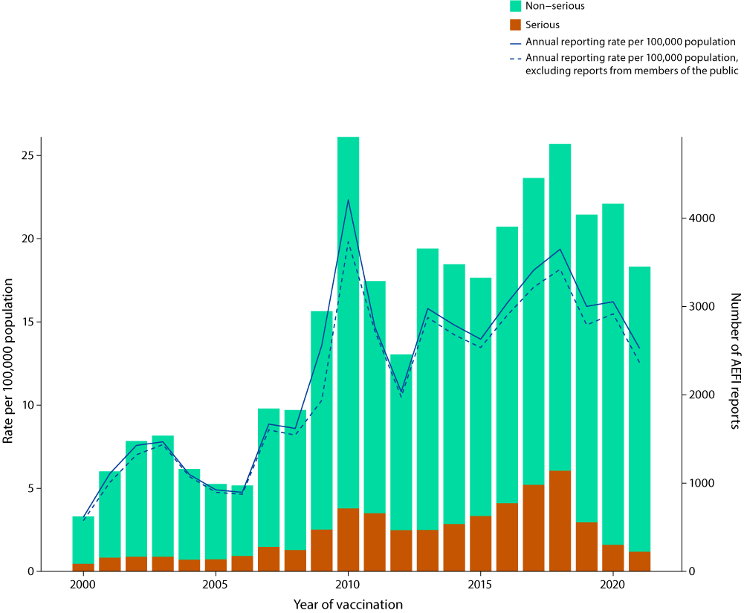
a For reports where the date of vaccination was not recorded, the date of symptom onset or the received date (when the event was reported to the sender of the case) was used. For more details on changes to the National Immunisation Program, please refer to Appendix A, Table A.1.
Table 1: Vaccines listed as ‘suspected’ in reports of adverse events following immunisation (AEFI) in the Adverse Event Management System database in 2021 (excluding COVID-19 vaccines), by age group
Age group | Vaccinea | AEFI reports (n)b | Vaccine  dosesc | Reporting rate per 100,000 doses  (95% CI)d
< 7 years | 13vPCV | 510 | 859,483 | 59.3 (54.3–64.7)
 | DTPa-HepB-IPV-Hib | 429 | 855,998 | 50.1 (45.5–55.1)
 | DTPa-IPV | 389 | 296,896 | 131 (118.3–144.7)
 | Rotavirus | 313 | 549,984 | 56.9 (50.8–63.6)
 | DTPa | 263 | 283,344 | 92.8 (81.9–104.7)
 | MMR | 233 | 284,999 | 81.8 (71.6–92.9)
 | MenACWY | 221 | 298,060 | 74.1 (64.7–84.6)
 | MenB | 219 | 291,858 | 75.0 (65.4–85.7)
 | Influenza (sf) | 217 | 526,332 | 41.2 (35.9–47.1)
 | MMRV | 192 | 284,193 | 67.6 (58.3–77.8)
 | Hib | 186 | 283,905 | 65.5 (56.4–75.6)
 | 23vPPV | 26 | 9,368 | 277.5 (181.4–406.4)
 | HepA | 7 | 16,027 | 43.7 (17.6–90.0)
 | Influenza (hd/a) | 6 | 450 | 1333.3 (490.8–2879.4)
 | HepB | 3 | 34,740 | 8.6 (1.8–25.2)
 | Hib and MenC | 1 | 200 | 500.0 (12.7–2754.2)
7–17 years | HPV | 196 | 507,848 | 38.6 (33.4–44.4)
 | dTpa | 125 | 290,044 | 43.1 (35.9–51.3)
 | MenACWY | 60 | 229,005 | 26.2 (20.0–33.7)
 | Influenza (sf) | 51 | 507,526 | 10.0 (7.5–13.2)
 | MenB | 26 | 40,001 | 65.0 (42.5–95.2)
 | 23vPPV | 8 | 1,687 | 474.2 (204.9–932.2)
 | Influenza (hd/a) | 4 | 1,431 | 279.5 (76.2–714.1)
 | HepB | 4 | 14,234 | 28.1 (7.7–71.9)
 | MMR | 4 | 7,870 | 50.8 (13.9–130.1)
 | MMRV | 4 | 3,348 | 119.5 (32.6–305.6)
 | 13vPCV | 2 | 1,600 | 125.0 (15.1–450.8)
18–64 years | Influenza (sf) | 482 | 4,589,723 | 10.5 (9.6–11.5)
 | dTpa | 94 | 709,124 | 13.3 (10.7–16.2)
 | Influenza (hd/a) | 37 | 41,710 | 88.7 (62.5–122.3)
 | HepB | 32 | 210,625 | 15.2 (10.4–21.4)
 | MMR | 26 | 89,679 | 29.0 (18.9–42.5)
 | 23vPPV | 23 | 12,847 | 179.0 (113.5–268.5)
 | HPV | 21 | 43,562 | 48.2 (29.8–73.7)
 | Zoster (RZV) | 11 | 5,699 | 193.0 (96.4–345.1)
 | Zoster (ZVL) | 9 | 8,091 | 111.2 (50.9–211.1)
 | MenACWY | 7 | 20,278 | 34.5 (13.9–71.1)
 | 13vPCV | 7 | 28,879 | 24.2 (9.7–49.9)
 | MMRV | 6 | 2,160 | 277.8 (102.0–603.6)
 | MenB | 5 | 16,582 | 30.2 (9.8–70.4)
 | HepA | 4 | 31,853 | 12.6 (3.4–32.1)
 | HepA and HepB | 4 | 34,682 | 11.5 (3.1–29.5)
 | dTpa-IPV | 2 | 7,357 | 27.2 (3.3–98.2)
 | Rabies | 2 | 6,800 | 29.4 (3.6–106.2)
 | Typhoid and HepA | 2 | 3,868 | 51.7 (6.3–186.7)
 | Yellow fever | 2 | 2,453 | 81.5 (9.9–294.2)
 | Japanese encephalitis | 1 | 4,251 | 23.5 (0.6–131.0)
 | Typhoid | 1 | 10,135 | 9.9 (0.2–55.0)
≥ 65 years | Influenza (hd/a) | 164 | 2,871,155 | 5.7 (4.9–6.7)
 | 13vPCV | 144 | 414,672 | 34.7 (29.3–40.9)
 | Zoster (ZVL) | 96 | 177,269 | 54.2 (43.9–66.1)
 | Influenza (sf) | 41 | 232,483 | 17.6 (12.7–23.9)
 | 23vPPV | 20 | 27,964 | 71.5 (43.7–110.4)
 | Zoster (RZV) | 16 | 9,535 | 167.8 (95.9–272.4)
 | dTpa | 11 | 112,293 | 9.8 (4.9–17.5)
 | MenB | 2 | 1,986 | 100.7 (12.2–363.3)
 | HepB | 1 | 10,798 | 9.3 (0.2–51.6)
a See Appendix A, Table A.3 for a listing of vaccine abbreviations used in this report.
b Number of AEFI reports in which the vaccine was coded as ‘suspected’ of causal involvement in the reported adverse event and the vaccination was administered between 1 January and 31 December 2021. More than one vaccine may be coded as ‘suspected’ if several were administered or reported at the same time.
c Number of vaccine doses recorded on the Australian Immunisation Register and administered between 1 January and 31 December 2021.
d 95% CI: 95% confidence interval.
Figure 2: Adverse event following immunisation reports for children aged < 7 years in the Adverse Event Management System database from 2000 to 2021 (excluding COVID-19 vaccines),a by year and vaccine
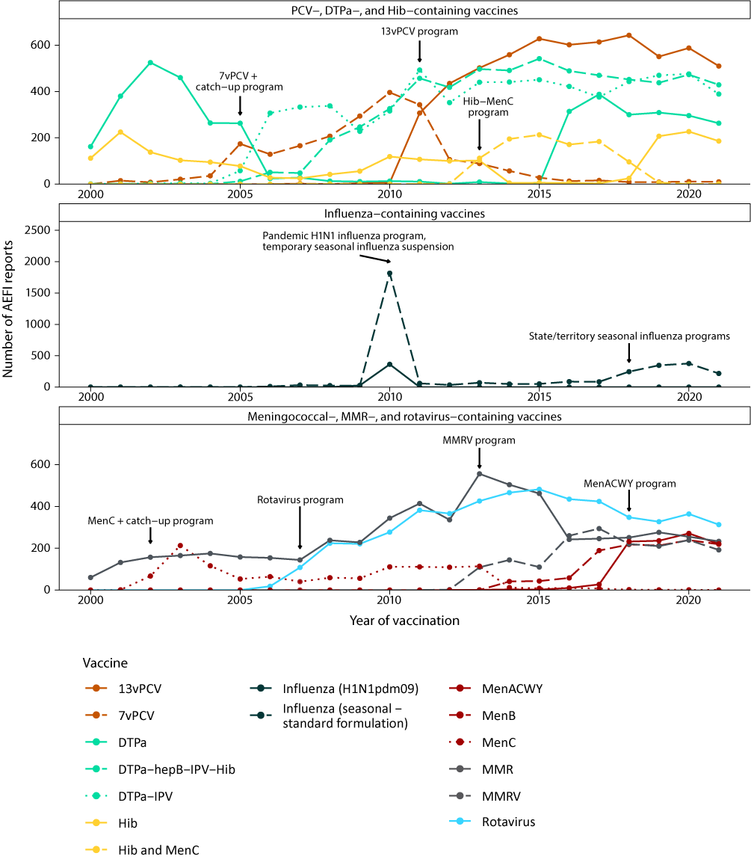
a For reports where the date of vaccination was not recorded, the date of symptom onset or the received date (when the event was reported to the sender of the case) was used. For more details on changes to the National Immunisation Program, please refer to Appendix A, Table A.1.
Figure 3: Adverse event following immunisation reports for people aged 7 to 17 years in the Adverse Event Management System database from 2000 to 2021 (excluding COVID-19 vaccines),a by year and vaccine
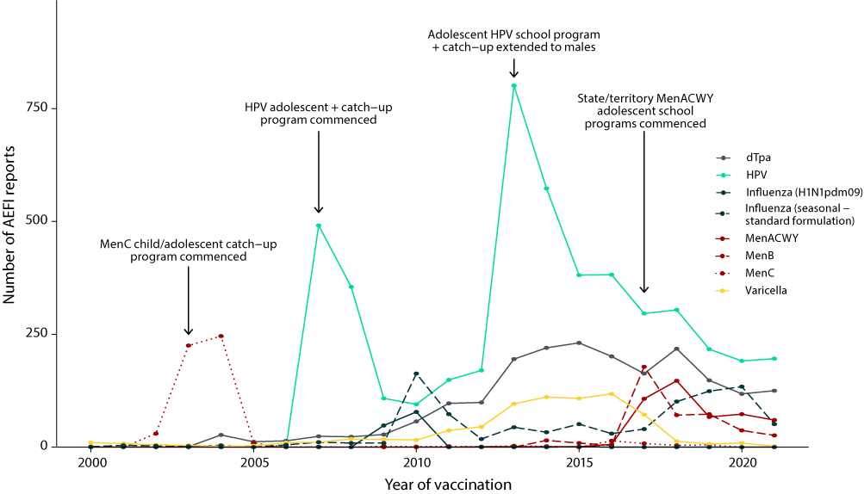
a For reports where the date of vaccination was not recorded, the date of symptom onset or the received date (when the event was reported to the sender of the case) was used. For more details on changes to the National Immunisation Program, please refer to Appendix A, Table A.1.
Figure 4: Adverse event following immunisation reports for people aged 18 to 64 years in the Adverse Event Management System database from 2000 to 2021 (excluding COVID-19 vaccines),a by year and vaccine
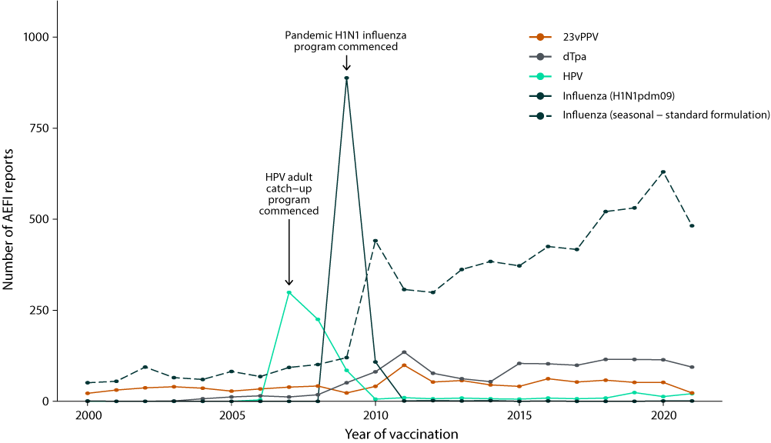
a For reports where the date of vaccination was not recorded, the date of symptom onset or the received date (when the event was reported to the sender of the case) was used. For more details on changes to the National Immunisation Program, please refer to Appendix A, Table A.1.
Figure 5: Adverse event following immunisation reports for people aged ≥ 65 years in the Adverse Event Management System database from 2000 to 2021 (excluding COVID-19 vaccines),a by year and vaccine
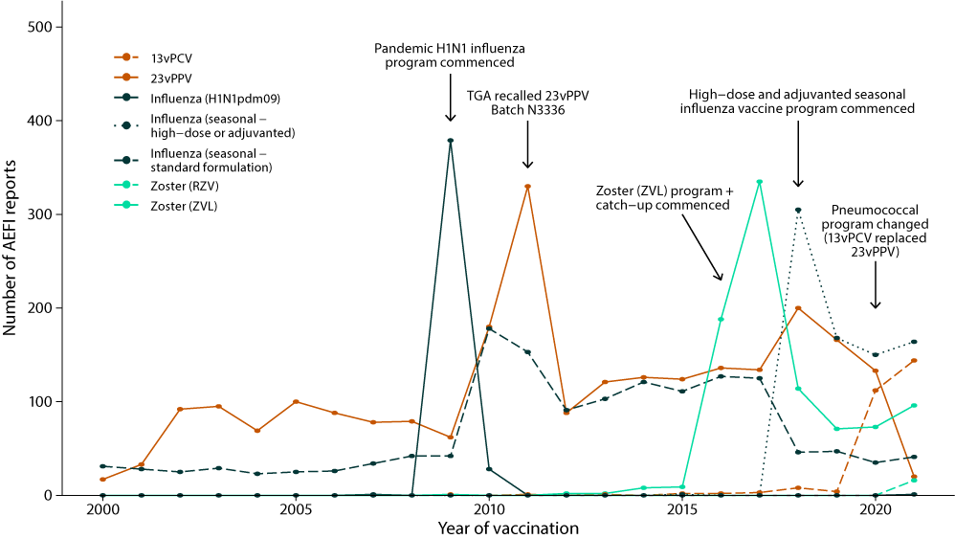
a For reports where the date of vaccination was not recorded, the date of symptom onset or the received date (when the event was reported to the sender of the case) was used. For more details on changes to the National Immunisation Program, please refer to Appendix A, Table A.1.

Age distribution
The highest age-specific AEFI reporting rate per 100,000 population occurred in children aged < 7 years (Figure 6). Compared with 2020, reporting rates of AEFI decreased in all age groups in 2021 (Figure 6).
Figure 6: Reporting rates of adverse events following immunisation per 100,000 population in the Adverse Event Management System database from 2000 to 2021 (excluding COVID-19 vaccines),a by year and age group
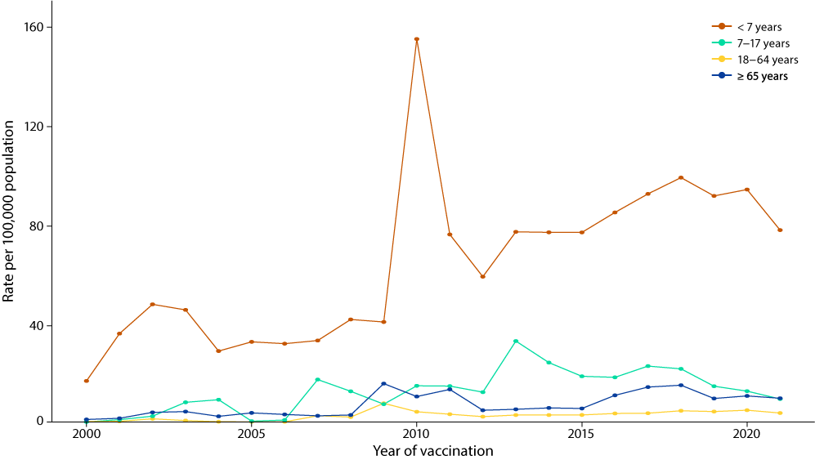
a For reports where the date of vaccination was not recorded, the date of symptom onset or the received date (when the event was reported to the sender of the case) was used. For more details on changes to the National Immunisation Program, please refer to Appendix A, Table A.1.

Geographical distribution
Population-based AEFI reporting patterns varied between states and territories in 2021. Victoria, New South Wales and Queensland had the highest numbers of AEFI reports, whilst the highest AEFI reporting rates were in Victoria, the Northern Territory and the Australian Capital Territory (Table 2).
Table 2: Adverse event following immunisation reports in the Adverse Event Management System database in 2021 (excluding COVID-19 vaccines), by jurisdiction
Jurisdictiona | AEFI reports  n (%) | Annual reporting rate per 100,000 populationb
 |  | Overall (95% CI)c | Aged < 7 yearsd | Aged ≥ 7 yearsd | Serious AEFIe
ACT | 69 (2.0) | 16.0 (12.4–20.2) | 61.7 | 10.2 | 0.7
NSW | 618 (17.9) | 7.5 (7.0–8.2) | 38.6 | 4.4 | 1.1
NT | 49 (1.4) | 19.9 (14.7–26.3) | 73.0 | 14.0 | 2.0
Qld | 485 (14.0) | 9.3 (8.5–10.2) | 47.2 | 5.7 | 0.4
SA | 202 (5.9) | 11.4 (9.9–13.1) | 53.4 | 7.5 | 0.5
Tas. | 32 (0.9) | 5.9 (4.0–8.3) | 29.2 | 3.8 | 0.0
Vic. | 1,585 (45.9) | 23.8 (22.7–25.0) | 165.3 | 10.1 | 0.5
WA | 342 (9.9) | 12.8 (11.4–14.2) | 70.2 | 6.6 | 0.7
Unknown | 70 (2.0) | — | — | — | —
Australia | 3,452 (100) | 13.4 (13.0–13.9) | 78.4 | 6.9 | 0.9
a ACT: Australian Capital Territory; NSW: New South Wales; NT: Northern Territory; Qld: Queensland; SA: South Australia; Tas.: Tasmania; Vic.: Victoria; WA: Western Australia.
b Average annual rates per 100,000 population calculated using June 2021 population estimates from the Australian Bureau of Statistics.
c 95% CI: 95% confidence interval.
d Includes only AEFI reports where an age or date of birth has been reported.
e An adverse event report is defined as ‘serious’ if it meets one or more of the following criteria: (1) results in death; (2) is life-threatening; (3) requires inpatient hospitalisation or prolongation of existing hospitalisation; (4) results in persistent or significant disability/incapacity; (5) is a congenital anomaly/birth defect or; (6) is a medically important event or reaction.

Vaccines
The vaccine most frequently reported in 2021 AEFI reports was standard-formulation seasonal influenza vaccine (840 reports; 24.3% of total 2021 reports), followed by 13vPCV (680 reports; 19.7%), DTPa-IPV-HepB-Hib (448 reports; 13%), DTPa-IPV (402 reports; 11.6%) and rotavirus vaccine (324 reports; 9.4%) (Table 3). Of the 840 AEFI reports following standard-formulation seasonal influenza vaccination, 65 (7.7%) were classified as serious and 217 (27.7%) were reported in children aged < 7 years (Table 3).
Table 3: Vaccines listed as ‘suspected’ in reports of adverse events following immunisation in the Adverse Event Management System (AEMS) database in 2021 (excluding COVID-19 vaccines)
Vaccinea | AEFI reports  n (%)b | One suspected vaccine only  n (%)c,d | Aged < 7 years  n (%)d,e | Aged ≥ 7 years  n (%)d,e | Serious AEFI  n (%)d,f
Influenza (sf) | 840 (24.3) | 685 (81.5) | 217 (25.8) | 574 (68.3) | 65 (7.7)
13vPCV | 680 (19.7) | 145 (21.3) | 510 (75.0) | 153 (22.5) | 45 (6.6)
DTPa-HepB-IPV-Hib | 448 (13.0) | 89 (19.9) | 429 (95.8) | 4 (0.9) | 35 (7.8)
DTPa-IPV | 402 (11.6) | 334 (83.1) | 389 (96.8) | 8 (2.0) | 8 (2.0)
Rotavirus | 324 (9.4) | 36 (11.1) | 313 (96.6) | 1 (0.3) | 44 (13.6)
MenACWY | 294 (8.5) | 61 (20.7) | 221 (75.2) | 68 (23.1) | 12 (4.1)
DTPa | 286 (8.3) | 81 (28.3) | 263 (92.0) | 18 (6.3) | 16 (5.6)
MMR | 269 (7.8) | 48 (17.8) | 233 (86.6) | 31 (11.5) | 22 (8.2)
MenB | 259 (7.5) | 123 (47.5) | 219 (84.6) | 33 (12.7) | 19 (7.3)
dTpa | 238 (6.9) | 103 (43.3) | 5 (2.1) | 230 (96.6) | 12 (5.0)
Influenza (hd/a) | 226 (6.5) | 205 (90.7) | 6 (2.7) | 205 (90.7) | 19 (8.4)
HPV | 223 (6.5) | 102 (45.7) | 2 (0.9) | 217 (97.3) | 9 (4.0)
MMRV | 205 (5.9) | 28 (13.7) | 192 (93.7) | 10 (4.9) | 7 (3.4)
Hib | 189 (5.5) | 12 (6.3) | 186 (98.4) | 2 (1.1) | 4 (2.1)
Zoster (ZVL) | 115 (3.3) | 102 (88.7) | 1 (0.9) | 107 (93) | 8 (7.0)
23vPPV | 82 (2.4) | 47 (57.3) | 26 (31.7) | 51 (62.2) | 4 (4.9)
HepB | 41 (1.2) | 24 (58.5) | 3 (7.3) | 37 (90.2) | 4 (9.8)
Varicella | 40 (1.2) | 18 (45.0) | 20 (50.0) | 20 (50.0) | 6 (15.0)
DT | 29 (0.8) | 26 (89.7) | 3 (10.3) | 25 (86.2) | 4 (13.8)
Zoster (RZV) | 29 (0.8) | 28 (96.6) | 0 (0.0) | 27 (93.1) | 5 (17.2)
Tuberculosis | 17 (0.5) | 14 (82.4) | 16 (94.1) | 0 (0.0) | 1 (5.9)
Pneumococcal (unspecified) | 15 (0.4) | 6 (40.0) | 8 (53.3) | 7 (46.7) | 4 (26.7)
HepA | 13 (0.4) | 4 (30.8) | 7 (53.8) | 5 (38.5) | 0 (0.0)
7vPCV | 11 (0.3) | 0 (0.0) | 10 (90.9) | 0 (0.0) | 2 (18.2)
HepA and HepB | 6 (0.2) | 2 (33.3) | 1 (16.7) | 4 (66.7) | 0 (0.0)
Meningococcal (unspecified) | 6 (0.2) | 3 (50.0) | 4 (66.7) | 2 (33.3) | 4 (66.7)
DTPa-Hib | 5 (0.1) | 2 (40.0) | 5 (100.0) | 0 (0.0) | 1 (20.0)
Polio | 5 (0.1) | 2 (40.0) | 1 (20.0) | 4 (80.0) | 0 (0.0)
DTP | 4 (0.1) | 1 (25.0) | 3 (75.0) | 1 (25.0) | 1 (25.0)
Influenza (H1N1pdm09) | 3 (0.1) | 2 (66.7) | 0 (0.0) | 2 (66.7) | 1 (33.3)
Hib and MenCY | 3 (0.1) | 0 (0.0) | 2 (66.7) | 0 (0.0) | 2 (66.7)
Pertussis | 3 (0.1) | 3 (100.0) | 0 (0.0) | 3 (100.0) | 2 (66.7)
Rabies | 3 (0.1) | 2 (66.7) | 1 (33.3) | 2 (66.7) | 0 (0.0)
Tetanus | 3 (0.1) | 3 (100.0) | 0 (0.0) | 2 (66.7) | 0 (0.0)
Typhoid and HepA | 3 (0.1) | 2 (66.7) | 0 (0.0) | 3 (100.0) | 0 (0.0)
Yellow fever | 3 (0.1) | 3 (100.0) | 1 (33.3) | 2 (66.7) | 0 (0.0)
dTpa-IPV | 2 (0.1) | 1 (50.0) | 0 (0.0) | 2 (100.0) | 0 (0.0)
Q fever | 2 (0.1) | 2 (100.0) | 0 (0.0) | 2 (100.0) | 0 (0.0)
Typhoid | 2 (0.1) | 1 (50.0) | 0 (0.0) | 1 (50.0) | 0 (0.0)
Cholera | 1 (0.03) | 1 (100.0) | 0 (0.0) | 1 (100.0) | 0 (0.0)
DTPa-HepB-IPV-Hib (Hexaxim) | 1 (0.03) | 0 (0.0) | 1 (100.0) | 0 (0.0) | 1 (100.0)
Hib and MenC | 1 (0.03) | 0 (0.0) | 1 (100.0) | 0 (0.0) | 1 (100.0)
Hib and tetanus | 1 (0.03) | 0 (0.0) | 1 (100.0) | 0 (0.0) | 0 (0.0)
Japanese encephalitis | 1 (0.03) | 1 (100.0) | 0 (0.0) | 1 (100.0) | 0 (0.0)
Measles and mumps | 1 (0.03) | 0 (0.0) | 1 (100.0) | 0 (0.0) | 0 (0.0)
Tick-borne encephalitis | 1 (0.03) | 1 (100.0) | 0 (0.0) | 1 (100.0) | 0 (0.0)
a See Appendix A, Table A.3 for abbreviations used.
b Number of AEFI reports in which the vaccine was coded as ‘suspected’ of causal involvement in the reported adverse event and the vaccination was administered between 1 January and 31 December 2021. More than one vaccine may be coded as ‘suspected’ if several were administered or reported at the same time.
c AEFI reports where only one vaccine was suspected of causal involvement in a reported adverse event.
d Percentages are calculated for the number of AEFI reports where the vaccine was suspected of causal involvement in the event.
e Includes only AEFI reports where an age or date of birth has been reported.
f An adverse event report is defined as ‘serious’ if it meets one or more of the following criteria: (1) results in death; (2) is life-threatening; (3) requires inpatient hospitalisation or prolongation of existing hospitalisation; (4) results in persistent or significant disability/incapacity; (5) is a congenital anomaly/birth defect or; (6) is a medically important event or reaction.

Adverse events
The most frequently reported PT or SMQ in 2021 were injection site reactions (904 reports; 26.2%), hypersensitivity (676 reports; 19.6%), pyrexia (490 reports; 14.2%), gastrointestinal non-specific symptoms and therapeutic procedures (472 reports; 13.7%) and medication (vaccination) errors (390 reports; 11.3%) (Table 4).
Table 4: The 50 most frequently reported adverse events classified by MedDRA Preferred Terms (PT) or Standardised MedDRA queries (SMQ) in reports of adverse events following immunisation in the Adverse Event Management System database in 2021 (excluding COVID-19 vaccines)
PT or SMQ | AEFI reports  n (%)a | One PT only  n (%)b,c | Aged  < 7 years  n (%)c,d | Aged  ≥ 7 years  n (%)c,d | Serious AEFI  n (%)c,e
Injection site reaction | 904 (26.2) | 493 (54.5) | 517 (57.2) | 359 (39.7) | 11 (1.2)
Hypersensitivity | 676 (19.6) | 288 (42.6) | 433 (64.1) | 229 (33.9) | 16 (2.4)
Pyrexia | 490 (14.2) | 20 (4.1) | 337 (68.8) | 137 (28.0) | 23 (4.7)
Gastrointestinal nonspecific symptoms and therapeutic procedures | 472 (13.7) | 45 (9.5) | 227 (48.1) | 229 (48.5) | 33 (7.0)
Medication errors | 390 (11.3) | 319 (81.8) | 175 (44.9) | 204 (52.3) | 4 (1.0)
Headache | 236 (6.8) | 4 (1.7) | 20 (8.5) | 205 (86.9) | 15 (6.4)
Haemodynamic oedema, effusions and fluid overload | 156 (4.5) | 43 (27.6) | 102 (65.4) | 53 (34.0) | 7 (4.5)
Lethargy | 153 (4.4) | 2 (1.3) | 91 (59.5) | 58 (37.9) | 9 (5.9)
Pain in extremity | 127 (3.7) | 20 (15.7) | 20 (15.7) | 99 (78.0) | 2 (1.6)
Myalgia | 107 (3.1) | 4 (3.7) | 1 (0.9) | 94 (87.9) | 5 (4.7)
Convulsions | 99 (2.9) | 49 (49.5) | 75 (75.8) | 18 (18.2) | 36 (36.4)
Syncope | 99 (2.9) | 64 (64.6) | 10 (10.1) | 85 (85.9) | 8 (8.1)
Irritability | 97 (2.8) | 3 (3.1) | 91 (93.8) | 3 (3.1) | 5 (5.2)
Dizziness | 94 (2.7) | 4 (4.3) | 1 (1.1) | 87 (92.6) | 3 (3.2)
Fatigue | 87 (2.5) | 2 (2.3) | 14 (16.1) | 64 (73.6) | 6 (6.9)
Dyspnoea | 85 (2.5) | 3 (3.5) | 21 (24.7) | 61 (71.8) | 13 (15.3)
Arthralgia | 79 (2.3) | 5 (6.3) | 0 (0.0) | 73 (92.4) | 9 (11.4)
Malaise | 69 (2.0) | 2 (2.9) | 9 (13.0) | 57 (82.6) | 1 (1.4)
Chills | 60 (1.7) | 1 (1.7) | 8 (13.3) | 50 (83.3) | 3 (5.0)
Cough | 60 (1.7) | 1 (1.7) | 31 (51.7) | 28 (46.7) | 3 (5.0)
Paraesthesia | 56 (1.6) | 6 (10.7) | 0 (0.0) | 51 (91.1) | 5 (8.9)
Angioedema | 53 (1.5) | 10 (18.9) | 20 (37.7) | 32 (60.4) | 4 (7.5)
Decreased appetite | 53 (1.5) | 0 (0.0) | 31 (58.5) | 18 (34.0) | 3 (5.7)
Erythema | 50 (1.4) | 4 (8.0) | 32 (64.0) | 18 (36.0) | 2 (4.0)
Pruritus | 48 (1.4) | 2 (4.2) | 13 (27.1) | 34 (70.8) | 1 (2.1)
Anaphylactic/anaphylactoid shock conditions | 46 (1.3) | 29 (63.0) | 13 (28.3) | 30 (65.2) | 9 (19.6)
Pallor | 45 (1.3) | 0 (0.0) | 25 (55.6) | 19 (42.2) | 3 (6.7)
Lymphadenopathy | 44 (1.3) | 11 (25.0) | 8 (18.2) | 35 (79.5) | 2 (4.5)
Rhinorrhoea | 43 (1.2) | 0 (0.0) | 26 (60.5) | 14 (32.6) | 2 (4.7)
Influenza like illness | 40 (1.2) | 13 (32.5) | 7 (17.5) | 29 (72.5) | 5 (12.5)
Oropharyngeal allergic conditions | 40 (1.2) | 8 (20.0) | 24 (60.0) | 15 (37.5) | 0 (0.0)
Hypotonic-hyporesponsive episode | 39 (1.1) | 22 (56.4) | 35 (89.7) | 4 (10.3) | 6 (15.4)
Injection site pain | 37 (1.1) | 8 (21.6) | 7 (18.9) | 27 (73.0) | 0 (0.0)
Presyncope | 37 (1.1) | 24 (64.9) | 4 (10.8) | 33 (89.2) | 0 (0.0)
Chest pain | 29 (0.8) | 5 (17.2) | 0 (0.0) | 28 (96.6) | 6 (20.7)
Pain | 28 (0.8) | 1 (3.6) | 6 (21.4) | 21 (75.0) | 1 (3.6)
Hyperhidrosis | 25 (0.7) | 0 (0.0) | 3 (12.0) | 21 (84.0) | 3 (12.0)
Respiratory failure | 25 (0.7) | 7 (28.0) | 21 (84.0) | 3 (12.0) | 3 (12.0)
Neonatal disorders | 23 (0.7) | 5 (21.7) | 19 (82.6) | 0 (0.0) | 4 (17.4)
Tachycardia | 23 (0.7) | 0 (0.0) | 10 (43.5) | 13 (56.5) | 4 (17.4)
Hypoaesthesia | 22 (0.6) | 5 (22.7) | 1 (4.5) | 18 (81.8) | 2 (9.1)
Herpes zoster | 20 (0.6) | 11 (55.0) | 0 (0.0) | 18 (90.0) | 4 (20.0)
Hypotonia | 20 (0.6) | 2 (10.0) | 19 (95.0) | 1 (5.0) | 2 (10.0)
Injected limb mobility decreased | 20 (0.6) | 0 (0.0) | 2 (10.0) | 16 (80.0) | 1 (5.0)
Injection site nodule | 20 (0.6) | 7 (35.0) | 16 (80.0) | 4 (20.0) | 0 (0.0)
Flushing | 19 (0.6) | 0 (0.0) | 5 (26.3) | 14 (73.7) | 0 (0.0)
Injection site erythema | 19 (0.6) | 5 (26.3) | 14 (73.7) | 5 (26.3) | 1 (5.3)
Somnolence | 19 (0.6) | 0 (0.0) | 12 (63.2) | 7 (36.8) | 3 (15.8)
Tremor | 19 (0.6) | 0 (0.0) | 5 (26.3) | 14 (73.7) | 1 (5.3)
Blister | 18 (0.5) | 2 (11.1) | 9 (50.0) | 9 (50.0) | 0 (0.0)
Gastrointestinal haemorrhage | 18 (0.5) | 5 (27.8) | 17 (94.4) | 1 (5.6) | 1 (5.6)
Insomnia | 18 (0.5) | 0 (0.0) | 2 (11.1) | 14 (77.8) | 0 (0.0)
a Number of AEFI reports in which the PT or SMQ was reported. More than one PT/SMQ may be recorded on the same report.
b AEFI reports where only one PT or SMQ was reported.
c Percentages are calculated for the number of AEFI reports where the PT or SMQ was reported.
d Includes only AEFI reports where an age or date of birth has been reported.
e An adverse event report is defined as ‘serious’ if it meets one or more of the following criteria: (1) results in death; (2) is life-threatening; (3) requires inpatient hospitalisation or prolongation of existing hospitalisation; (4) results in persistent or significant disability/incapacity; (5) is a congenital anomaly/birth defect or; (6) is a medically important event or reaction.

Serious adverse events
The proportion of AEFI reports where the outcome was categorised as serious remained low in 2021, with 6.5% of all AEFI reports coded as serious. The proportion of serious AEFI reports for the vaccines with the highest numbers of serious reports were: 65/840 (7.7%) following standard-formulation seasonal influenza vaccine; 45/680 (6.6%) following 13vPCV; 44/324 (13.6%) following rotavirus vaccine; 35/448 (7.8%) following DTPa-IPV-HepB-Hib; and 22/269 (8.2%) following MMR vaccine (Table 3).

Death following vaccination
Six adverse events with a fatal outcome were reported to the TGA where the reporter considered a causal link between vaccination and the event was possible. Following assessment of available information, there was insufficient evidence to establish a causal link between vaccination and the condition that caused the death for any of the six cases. There were three cases in adults aged > 70 years who died following complications of their existing underlying medical conditions. There were three cases in children: one case who died of complications from COVID-19 infection, one who died from a congenital condition, and one who died from a condition not associated with the vaccines the child received.

Discussion
In 2021, there was a decrease in both the number of AEFI reports and the overall AEFI reporting rate compared with previous years.^{19,20} While 133 AEFI reports with both non-COVID-19 and COVID-19 vaccines were excluded from this analysis, the number of AEFI reports and overall AEFI reporting rate with the inclusion of these reports (3,585 reports; 13.9 per 100,000 population) is still lower than for 2020 (4,165 reports; 16.2 per 100,000 population, Figure 1). This decrease in the AEFI reporting rate in 2021 could be related to the focus on COVID-19 vaccines and on AEFI reporting for COVID-19 vaccines in 2021.
In children aged < 7 years, there was a decrease in the number of AEFI reports for all vaccines. While there were fewer AEFI reports following standard-formulation seasonal influenza vaccines in 2021 than in 2020, there were also fewer doses administered to this age group in 2021,³⁰ and the reporting rate was similar: 41.2 per 100,000 doses (95% CI: 35.9–47.1) in 2021 and 38.0 per 100,000 doses (95% CI: 34.2–42.0) in 2020. There were six AEFI reports, out of 450 recorded doses of high-dose or adjuvanted seasonal influenza vaccines in this age group where the vaccine is not recommended, with an AEFI reporting rate of 1333.3 per 100,000 doses (95% CI: 490.8–2879.4) compared to 41.2 per 100,000 doses (95% CI: 35.9–47.1) for standard-formulation seasonal influenza vaccines. This higher AEFI reporting rate could reflect an increased risk of adverse events when administering high-dose or adjuvanted seasonal influenza vaccines in children, or an error in the reporting of the vaccine brand administered.
Among people aged 7 to 17 years, there was also a decrease in the number of AEFI reports for all vaccines, whilst AEFI reporting rates remained similar between 2021 and 2020. The decrease in AEFI reports may be a reflection of modestly lower vaccine uptake, possibly as a result of ongoing impacts of COVID-19 restrictions and/or infection delaying vaccinations or access to vaccinations via school-based programs.³¹ The AEFI reporting rate for MenACWY in this age group (26.2 per 100,000 doses [95% CI: 20–33.7]) has decreased and stabilised following vaccine introduction to the state/territory immunisation programs in 2017 and comparatively high AEFI reporting rates (63.2 per 100,000 doses [95% CI: 53.4–74.2]) in 2018.³²
In people aged 18 to 64 years, the majority of AEFI reports followed standard-formulation seasonal influenza vaccine. The AEFI reporting rate for standard-formulation seasonal influenza vaccine was similar in 2021 to that seen in the previous year: 10.5 per 100,000 doses (95% CI: 9.6–11.5) in 2021 and 12.3 per 100,000 doses (95% CI: 11.3–13.3) in 2020.
Finally, in people aged ≥ 65 years, high-dose or adjuvanted seasonal influenza vaccine, 13vPCV and zoster vaccine (ZVL) had the highest numbers of AEFI reports, reflecting the NIP recommendations for this age group. The AEFI reporting rate following 13vPCV decreased from 43.6 per 100,000 doses (95% CI: 35.8–52.6) in 2020 to 34.7 per 100,000 doses (95% CI 29.3–40.9) in 2021. As the NIP recommendation changes from 23vPPV to 13vPCV only occurred in 2020, an increase in AEFI reporting is expected before a reduction and stabilisation of reporting rates over time as providers and consumers are more familiar with the use of the vaccine in this age group.
Overall, injection site reactions remain the most frequently reported AEFI (26.2%), followed by hypersensitivity (19.6%) and pyrexia (14.2%), consistent with previous years. The proportion of serious AEFI reports has also remained low. Finally, of the six deaths following vaccination, none contained sufficient information to be considered to be causally related to vaccination.
These national spontaneous surveillance data are complemented by AusVaxSafety, an active sentinel vaccine safety surveillance system which also monitors the safety of vaccines used in the NIP.³³ While the data from both systems cannot be directly compared due to differences in methodology, they provide complementary data on the safety of vaccines used in Australia.
There are some limitations to this analysis. AEFI reports can vary significantly in the amount of detail, completeness, and quality of information, and are not always verified against clinical notes. AEFI reports can include multiple vaccines, vaccination dates, AEFI, and AEFI onset dates. Based on the information provided, it not always possible to associate specific vaccines to specific AEFI and AEFI onset dates. The seriousness criteria for AEFI reports can be applied differently based on the report source and classification is not always based on verified clinical data, so it may not capture all medically important events, and in addition may capture non-serious events; therefore, the seriousness classification of an AEFI report cannot be directly interpreted as an indicator of safety. While AEFI reporting rates can be estimated, they cannot be interpreted as incidence rates due to potential under-reporting, biased reporting, stimulated reporting (from increased awareness of potential adverse events of vaccines newly introduced to the NIP or covered in the media), and the variable quality and completeness of information provided in individual notifications^{.6–17,34,35} Indigenous status is not always reported in all AEFI reports and therefore AEFI rates in Aboriginal and Torres Strait Islander people are likely to be underestimates. Finally, the AEFI reported here are not necessarily causally related to vaccination. The TGA strongly encourages consumers and health professionals to report suspected adverse events, even if there is only a very small chance a vaccine was the cause. With large scale vaccination programs, it is inevitable by chance that some people will experience a new illness or will die within a few days or weeks of vaccination. These events are often coincidental, rather than being caused by the vaccine.

Conclusion
Overall, AEFI reporting rates for non-COVID-19 vaccines decreased in 2021 compared with 2020; the majority of reported AEFI were common, expected adverse events. The data reported here are consistent with an overall high level of safety for vaccines included in the NIP schedule when administered according to clinical recommendations.

Acknowledgments
We would like to acknowledge and thank Aditi Dey, Han Wang, Alexandra Hendry, and Tristan Franks at NCIRS for providing historical context and code and vaccine dose data from the Australian Immunisation Register.

Author details
Catherine Glover,¹
Lucy Deng,¹
Claire Larter,²
Catherine Brogan,²
Olivia Richardson,²
Yuanfei Anny Huang,¹
Elspeth Kay,²
Kristine Macartney,¹
Nicholas Wood¹
- National Centre for Immunisation Research and Surveillance, The University of Sydney and The Children’s Hospital at Westmead, Sydney, Australia
- Pharmacovigilance Branch, Therapeutic Goods Administration, Department of Health and Aged Care, Canberra, Australia
Corresponding author
Yuanfei Anny Huang
National Centre for Immunisation Research and Surveillance, Locked Bag 4001, Westmead NSW 2145, Sydney, Australia
Phone: +61 2 9391 9267
Email: yuanfei.huang@health.nsw.gov.au

References
- Council for International Organizations of Medical Sciences (CIOMS) c/o World Health Organization (WHO). Definition and Application of Terms for Vaccine Pharmacovigilance: Report of CIOMS/WHO Working Group on Vaccine Pharmacovigilance. Geneva: CIOMS; 2012. Available from: https://www.who.int/vaccine_safety/initiative/tools/CIOMS_report_WG_vaccine.pdf.
- Australian Technical Advisory Group on Immunisation (ATAGI). Australian Immunisation Handbook. Canberra: Australian Government Department of Health and Aged Care; 2020. Available from: https://immunisationhandbook.health.gov.au/.
- Uppsala Monitoring Centre. WHO Collaborating Centre for International Drug Monitoring. [Website.] Uppsala: Uppsala Monitoring Centre; 2020. Available from: http://www.who-umc.org/.
- Uppsala Monitoring Centre. The use of the WHO-UMC system for standardised case causality assessment. Uppsala: Uppsala Monitoring Centre; 6 April 2018. Available from: https://who-umc.org/media/164200/who-umc-causality-assessment_new-logo.pdf.
- Dey A, Wang H, Quinn H, Hill R, Macartney K. Surveillance of adverse events following immunisation in Australia annual report, 2014. Commun Dis Intell Q Rep. 2016;40(3):E377–90.
- Lawrence G, Boyd I, McIntyre P, Isaacs D. Surveillance of adverse events following immunisation: Australia 2002 to 2003. Commun Dis Intell Q Rep. 2004;28(3):324–38.
- Lawrence G, Boyd I, McIntyre P, Isaacs D. Annual report: surveillance of adverse events following immunisation in Australia, 2005. Commun Dis Intell Q Rep. 2006;30(3):319–33.
- Lawrence G, Gold MS, Hill R, Deeks S, Glasswell A, McIntyre PB. Annual report: surveillance of adverse events following immunisation in Australia, 2007. Commun Dis Intell Q Rep. 2008;32(4):371–87.
- Lawrence G, Menzies R, Burgess M, McIntyre P, Wood N, Boyd I et al. Surveillance of adverse events following immunisation: Australia, 2000–2002. Commun Dis Intell Q Rep. 2003;27(3):307–23.
- Lawrence GL, Aratchige PE, Boyd I, McIntyre PB, Gold MS. Annual report on surveillance of adverse events following immunisation in Australia, 2006. Commun Dis Intell Q Rep. 2007;31(3):269–82.
- Lawrence GL, Boyd I, McIntyre PB, Isaacs D. Annual report: surveillance of adverse events following immunisation in Australia, 2004. Commun Dis Intell Q Rep. 2005;29(3):248–62.
- Mahajan D, Cook J, Dey A, Macartney K, Menzies R. Supplementary report: surveillance of adverse events following immunisation among children aged less than seven years in Australia, 1 January to 30 June 2012. Commun Dis Intell Q Rep. 2013;37(2):E130–4.
- Mahajan D, Cook J, Dey A, Macartney K, Menzies RI. Annual report: surveillance of adverse events following immunisation in Australia, 2011. Commun Dis Intell Q Rep. 2012;36(4):E315–32.
- Mahajan D, Cook J, McIntyre P, Macartney K, Menzies R. Supplementary report: surveillance of adverse events following immunisation among children aged less than seven years in Australia, 1 January to 30 June 2011. Commun Dis Intell Q Rep. 2012;36(1):114–9.
- Mahajan D, Cook J, McIntyre PB, Macartney K, Menzies RI. Annual report: surveillance of adverse events following immunisation in Australia, 2010. Commun Dis Intell Q Rep. 2011;35(4):263–80.
- Mahajan D, Roomiani I, Gold MS, Lawrence GL, McIntyre PB, Menzies RI. Annual report: surveillance of adverse events following immunisation in Australia, 2009. Commun Dis Intell Q Rep. 2010;34(3):259–76.
- Menzies R, Mahajan D, Gold MS, Roomiani I, McIntyre P, Lawrence G. Annual report: surveillance of adverse events following immunisation in Australia, 2008. Commun Dis Intell Q Rep. 2009;33(4):365–81.
- Mahajan D, Dey A, Cook J, Harvey B, Menzies R, Macartney K. Surveillance of adverse events following immunisation in Australia annual report, 2013. Commun Dis Intell Q Rep. 2015;39(3):E369–86.
- Dey A, Wang H, Quinn H, Pillsbury A, Glover C, Hickie M et al. Surveillance of adverse events following immunisation in Australia annual report, 2019. Commun Dis Intell (2018). 2021;45. doi: https://doi.org/10.33321/cdi.2021.45.23.
- Dey A, Wang H, Quinn H, Pillsbury A, Hickie M, Deng L et al. Surveillance of adverse events following immunisation in Australia annual report, 2020. Commun Dis Intell (2018). 2022;46. doi: https://doi.org/10.33321/cdi.2022.46.47.
- Glover C, Deng L, Larter C, Brogan C, Richardson O, Huang YA et al. Surveillance of adverse events following immunisation in Australia, COVID-19 vaccines, 2021. Commun Dis Intell (2018). 2024;48. doi: https://doi.org/10.33321/cdi.2024.48.2.
- Brown EG. Using MedDRA: implications for risk management. Drug Saf. 2004;27(8):591–602. doi: https://doi.org/10.2165/00002018-200427080-00010.
- Brown EG, Wood L, Wood S. The medical dictionary for regulatory activities (MedDRA). Drug Saf. 1999;20(2):109–17. doi: https://doi.org/10.2165/00002018-199920020-00002.
- Medical Dictionary for Regulatory Activities (MedDRA). Standardised MedDRA Queries. [Webpage.] Herndon VA: MedDRA: 2023. Available from: https://www.meddra.org/standardised-meddra-queries.
- WHO. Causality assessment of an adverse event following immunization (AEFI): user manual for the revised WHO classification, 2nd ed., 2019 update. Geneva: WHO; 16 April 2021. Available from: https://www.who.int/publications/i/item/9789241516990.
- Zhou W, Pool V, Iskander JK, English-Bullard R, Ball R, Wise RP et al. Surveillance for safety after immunization: Vaccine Adverse Event Reporting System (VAERS)—United States, 1991–2001. MMWR Surveill Summ. 2003;52(1):1–24.
- Australian Bureau of Statistics. National, state and territory population. Reference period: June 2021. [Webpage.] Canberra: Australian Bureau of Standards; 16 December 2021. Available from: https://www.abs.gov.au/statistics/people/population/national-state-and-territory-population/jun-2021.
- Australian Government: Services Australia. Australian Immunisation Register. [Webpage.] Canberra: Services Australia. Available from: https://www.servicesaustralia.gov.au/australian-immunisation-register.
- Australian Government Department of Health and Aged Care, TGA. Database of Adverse Event Notifications. [Internet.] Canberra: Australian Government Department of Health and Aged Care. [Accessed on 26 March 2013.] Available from: http://www.tga.gov.au/safety/daen.htm.
- Hull B, Hendry A, Dey A, Brotheron J, Macartney K, Beard F. Annual Immunisation Coverage Report 2021. Commun Dis Intell (2018). 2023;47. doi: https://doi.org/10.33321/cdi.2023.47.47.
- Hull BP, Hendry AJ, Dey A, Bryant K, Radkowski C, Pellissier S et al. The impact of the COVID-19 pandemic on routine vaccinations in Victoria. Med J Aust. 2021;215(2):83–4. doi: https://doi.org/10.5694/mja2.51145.
- Dey A, Wang H, Quinn H, Pillsbury A, Glover C, Hickie M et al. Surveillance of adverse events following immunisation in Australia annual report, 2018. Commun Dis Intell (2018). 2020;44. doi: https://doi.org/10.33321/cdi.2020.44.12.
- Australian Government Department of Health and Aged Care. Vaccine safety in Australia: AusVaxSafety summary report 2021. Canberra: Australian Government Department of Health and Aged Care; 29 September 2022. Available from: https://www.health.gov.au/resources/publications/vaccine-safety-in-australia-ausvaxsafety-summary-report-2021.
- Varricchio F, Iskander J, Destefano F, Ball R, Pless R, Braun MM et al. Understanding vaccine safety information from the Vaccine Adverse Event Reporting System. Pediatr Infect Dis J. 2004;23(4):287–94. doi: https://doi.org/10.1097/00006454-200404000-00002.
- Mahajan D, Reid S, Cook J, Macartney K, Menzies R. NSW annual report describing adverse events following immunisation, 2011. NSW Public Health Bull. 2012;23(9–10):187–200. doi: https://doi.org/10.1071/NB12081.

Appendix A
Table A.1: Changes in immunisation policy and the National Immunisation Program (2005–2021)ª
Year | Month | Jurisdictionb | Change
2020 | July | NT, Qld, SA, WA | Funded schedule expanded for Aboriginal and Torres Strait Islander children from 13vPCV at 2, 4, 6 and 12 months (3+1) to include an additional dose of 23vPPV at 4 years of age and a second dose 5–10 years later
 | July | All | A single dose of 13vPCV is recommended and funded for Aboriginal and Torres Strait Islander adults at 50 years of age, followed by a dose of 23vPPV 12 months later and a second dose of 23vPPV 5–10 years after that.
 |  |  | A single dose of 13vPCV is recommended and funded for non- Aboriginal and Torres Strait Islander adults at 70 years of age, replacing the previously funded dose of 23vPPV at 65 years of age.
 |  |  | MenB vaccine funded for all Aboriginal and Torres Strait Islander children (age < 12 months) and individuals of any age with specified high risk medical conditions. Catch-up available for all Aboriginal and Torres Strait Islander children < 2 years of age (up to 23 months) for three years, until 30 June 2023.
 | March | All | All children aged 6 months to < 5 years funded for influenza vaccine under NIP.
 |  |  | First enhanced quadrivalent influenza vaccine (adjuvanted) funded nationally for adults aged 65 years and over.
2019 | December | SA | Multicomponent recombinant MenB vaccine catch-up for children aged 12–47 months (< 4 years) ceased on 31 December 2019.
 | April | All | MenACWY conjugate vaccine funded under the NIP for adolescents aged 14–16 years delivered through a school-based program and adolescents aged 15–19 years delivered through primary care providers as part of an ongoing catch-up program.
 | March | NT | Annual seasonal influenza vaccination program funded for all children aged 6–59 months (< 5 years).
 | February | All | Annual seasonal influenza vaccination funded on the national childhood vaccination schedule for all Australian children aged 6–59 months  (< 5 years).
 |  |  | Aboriginal and Torres Strait Islander children and adolescents aged 5–14 years of age funded for influenza vaccine under NIP.
2018 | October | SA | Multicomponent recombinant MenB vaccine funded for children 6 weeks to 12 months of age, with catch-up for children aged 12–47 months (< 4 years).
 | July | All | MenACWY conjugate vaccine funded for all children at 12 months of age, replacing Hib-MenC.
 |  |  | Hib dose moved to 18 months and given as monovalent Hib vaccine.
 |  |  | Schedule for routine childhood vaccination with 13vPCV changed from 2, 4 and 6 months of age to 2, 4 and 12 months of age.
 | April | All | Enhanced trivalent influenza vaccines (high-dose and adjuvanted) funded nationally for all adults aged 65+ years.
 | April | ACT, NSW, Qld, SA, Tas., Vic. | Annual seasonal influenza vaccination funded for all children aged 6–59 months (< 5 years).
 | April | SA | MenACWY conjugate vaccine funded for Aboriginal and Torres Strait Islander children and adolescents aged 12 months to 19 years living in the Eyre and Far North, and Flinders and Upper North regions.
 | February | ACT | MenACWY conjugate vaccine funded for grade 10 students and persons aged 16–19 years who no longer attend school.
 | February | All | A two-dose schedule of 9vHPV funded for adolescents aged 12–14 years, delivered through a school-based program; 4vHPV ceased to be used in the program.
 | January | WA | MenACWY conjugate vaccine funded for children aged aged 12–59 months (< 5 years).
 | January | NSW | MenACWY school-based vaccination program funded for all secondary school students in Years 10 and 11, as well as adolescents aged 15 to 19 years who have not received the vaccine at school.
2017 | January to December | Tas., Vic., WA | MenACWY conjugate vaccine funded for grade 10–12 students.c
 |  | NSW | MenACWY conjugate vaccine funded for grade 11–12 students.c
 |  | Qld | MenACWY conjugate vaccine funded for grade 10 students and persons aged 15–19 years who no longer attend school.c
 |  | NT | MenACWY conjugate vaccine funded for at-risk people aged 1–19 years living in specified remote regions and all children aged 12 months.c
 | April | SA | MenB vaccine study commenced for grade 10–12 students at participating schools.
2016 | November | All | Zoster vaccine (Zostavax) provided free for people aged 70 years under the NIP, with a five-year catch-up program for people aged 71–79 years.
 | March | All | Free booster dose of DTPa at 18 months of age.
2015 | March to June | ACT, NSW, SA, Tas., Vic., WA | dTpa vaccine funded for women during the third trimester of pregnancy.
 | April | All | New immunisation requirements for family assistance payments were announced by the federal government (the ‘No Jab, No Pay’ policy), to come into effect on 1 January 2016. Only parents of children (aged less than 20 years) who are ‘fully immunised’ or on a recognised catch-up schedule remain eligible to receive the Child Care Benefit, Child Care Rebate, and/or the Family Tax Benefit Part A end-of-year supplement.
 | March | All | Seasonal influenza vaccine funded for Aboriginal and Torres Strait Islander children aged 6 months to less than 5 years.  Booster dose of DTPa vaccine recommended at 18 months of age (funded in March 2016).
2014 | December | All | 4vHPV vaccine catch-up program for males aged 14–15 years ceased.
 | July | Qld | dTpa vaccine was funded for women during the third trimester of pregnancy.
2013 | December | All | Secondary school Year 7 HepB vaccine catch-up program ceased, as all younger age cohorts were eligible for infant immunisation under the NIP (commenced 2000).
 | September | NT | dTpa vaccine funded for women during the third trimester of pregnancy and for parents of infants aged < 7 months under cocoon strategy.
 | July | All | Second dose of MMR vaccine, previously given at 4 years, was brought forward to 18 months of age and delivered as MMRV vaccine.
 |  |  | Combined Hib-MenC vaccine, Menitorix, funded for infants aged 12 months. This combination vaccine replaced the single dose of monovalent MenC conjugate vaccine (MenCCV) and booster dose of monovalent Hib vaccine previously scheduled at 12 months of age.
 | February | All | 4vHPV vaccine was extended to males aged 12–13 years, delivered through a school-based program, with a catch-up program for males aged 14–15 years in 2013 and 2014.
2012 | October | NT, Qld, SA, WA | A fourth dose of Prevenar 13, (13vPCV, a 13-valent pneumococcal conjugate vaccine) was listed on the NIP for Indigenous children aged 12-18 months. This replaced the booster dose of Pneumovax23, (23vPPV, a 23-valent pneumococcal polysaccharide vaccine) administered between 18 and 24 months of age for Indigenous children from these jurisdictions.
2011 | March to December | All | 25 March: TGA issued a recall of Batch N3336 of the 23 valent pneumococcal polysaccharide vaccine 23vPPV, Pneumovax 23.
 |  |  | April: Health professionals were advised not to administer a second or subsequent dose of Pneumovax 23 vaccine.
 |  |  | December: Revised recommendations regarding which patients should be re-vaccinated under the NIP were provided.
 | October | All | (to end of September 2012) All children aged 12–35 months who had completed a primary pneumococcal vaccination course with 7vPCV were eligible to receive a free supplementary dose of Prevenar 13.
 | October | NT | Prevenar 13 (13vPCV) replaced Prevenar on the NIP for children at 2, 4 and 6 months of age.
 | July | ACT, NSW, Qld, SA, Tas., Vic., WA | Prevenar 13 (13vPCV) replaced Prevenar on the NIP for children at 2, 4 and 6 months of age.
2010 |  | All | Annual vaccination with seasonal trivalent influenza vaccine (TIV, containing 3 influenza strains: A/H1N1, A/H3N2 and B) was funded under the NIP for people aged 6+ months with medical risk factors (previously subsidised through the Pharmaceutical Benefits Scheme) and all Indigenous people aged 15+ years (previously all Indigenous adults aged 50+ years and those aged 15–49 years with medical risk factors).
 | April to August | All | 23 April: Use of the 2010 seasonal TIV in children 5+ years of age was suspended by Australia’s Chief Medical Officer due to an increased number of reports of fever and febrile convulsions post vaccination. A subsequent investigation identified that Fluvax and Fluvax junior (CSL Biotherapies), but neither of the other two available brands registered for use in young children, were associated with an unacceptably high risk of febrile convulsions.
 |  |  | August: Recommendation to resume the use of seasonal influenza vaccine in children aged 6 months to 5 years, using brands other than Fluvax and Fluvax junior.
2009 | (Late 2009) | All | Single hexavalent DTPa-IPV-Hib-HepB (Infanrix hexa) vaccine in use for all children at 2, 4 and 6 months of age, due to an international shortage of Haemophilus influenzae type b (Hib) (PedvaxHib [monovalent] and Comvax [Hib-HepB]) vaccines.
 | December | All | Pandemic H1N1 2009 influenza vaccine (Panvax) made available to children aged 6 months to 10 years.
 | September | All | 30 September: Panvax rolled out across Australia for people aged 10+ years.
2008 | April | WA | Seasonal influenza vaccination program commenced for all children aged 6–59 months (< 5 years; born after 1 April 2003).
2007 | March | Qld, SA, Vic. | These jurisdictions changed from using two combination vaccines (quadrivalent DTPa-IPV and Hib-HepB) to the single hexavalent DTPa-IPV-HepB-Hib vaccine.
 | July | All | Universal funded immunisation against rotavirus at 2 and 4 months of age (Rotarix) or at 2, 4 and 6 months of age (Rotateq).
 | April | All | Funded immunisation against human papillomavirus for all Australian girls aged 12–13 years delivered through a school-based program, with a temporary catch-up program (to December 2009) through schools or primary care providers for females aged 13–26 years.
2005 |  | All | Universal 23-valent pneumococcal polysaccharide vaccine (23vPPV) for adults aged 65+ years replaced previous subsidy through the Pharmaceutical Benefits Scheme.
 | November | All | Universal funded immunisation against varicella at 18 months of age with a school-based catch-up program for children at 10–13 years of age not previously vaccinated and without a history of varicella infection (no funded catch-up for children 2–10 years of age).
 |  |  | IPV was funded to replace OPV, in combination vaccines.
 | January | All | Universal funded infant 7-valent pneumococcal conjugate vaccine (7vPCV) program replaced the previous targeted childhood program, with a catch-up program for children aged < 2 years.
a For documentation, please refer to references 5–20. For abbreviations used, please refer to Table A.3.
b ACT: Australian Capital Territory; NSW: New South Wales; NT: Northern Territory; Qld: Queensland; SA: South Australia; Tas.: Tasmania; Vic.: Victoria; WA: Western Australia.
c For more details see the meningococcal vaccination history table at http://ncirs.org.au/sites/default/files/2019-04/Meningococcal-history-April-2019.pdf.

Table A.2: Description of PT to SMQ mapping
Number of SMQs mapped | Term reported
0 | PT
1 | SMQ
> 1 (different levels) | SMQ of highest level (most descriptive)
> 1 (same level) | SMQ preferred following clinician review and adjudication, or PT if preferred SMQ could not be chosen
Table A.3: Abbreviations of vaccine types and other terms
Abbreviation | In full
13vPCV | 13-valent pneumococcal conjugate vaccine
23vPPV | 23-valent pneumococcal polysaccharide vaccine
7vPCV | 7-valent pneumococcal conjugate vaccine
AEFI | adverse event following immunisation
AEMS | Adverse Event Management System
CI | confidence interval
DAEN | Database of Adverse Event Notifications
DTPa | diphtheria-tetanus-pertussis (acellular) – paediatric formulation
dTpa | diphtheria-tetanus-pertussis (acellular) – adolescent and adult formulation
DTPa-Hib | combined diphtheria-tetanus-pertussis (acellular) and Haemophilus influenzae type b vaccine
DTPa-IPV | combined diphtheria-tetanus-pertussis (acellular) and inactivated poliovirus (quadrivalent) – paediatric formulation
DTPa-IPV-HepB-Hib | combined diphtheria-tetanus-pertussis (acellular), inactivated poliovirus, hepatitis B and Haemophilus influenzae type b vaccine (hexavalent)
dTpa-IPV | combined diphtheria-tetanus-pertussis (acellular) and inactivated poliovirus (quadrivalent) – adolescent and adult formulation
H1N1pdm09 | pandemic H1N1 influenza 2009
HepA | hepatitis A
HepB | hepatitis B
Hib | Haemophilus influenzae type b
Hib and MenC | combined Haemophilus influenzae type b and meningococcal C conjugate vaccine
Hib and MenCY | combined Haemophilus influenzae type b and meningococcal C and Y conjugate vaccine
Hib-HepB | combined Haemophilus influenzae type b and hepatitis B
HPV | human papillomavirus
Inflenza (hd/a) | influenza (seasonal – high-dose or adjuvanted)
Influenza (sf) | influenza (seasonal - standard formulation)
MenACWY | quadrivalent meningococcal (serogroups A, C, W-135, Y) conjugate vaccine
MenB | meningococcal B vaccine
MenC | meningococcal C conjugate vaccine
MMR | measles-mumps-rubella
MMRV | measles-mumps-rubella-varicella
NCIRS | National Centre for Immunisation Research and Surveillance
NIP | National Immunisation Program
PT | preferred terms
SMQ | standardised MedDRA query
TGA | Therapeutic Goods Administration
WHO | World Health Organization
Zoster (RZV) | recombinant zoster vaccine
Zoster (ZVL) | live-attenuated zoster vaccine

About Communicable Diseases Intelligence
Communicable Diseases Intelligence (CDI) is a peer-reviewed scientific journal published by the Health Protection Policy & Surveillance Division, Department of Health and Aged Care. The journal aims to disseminate information on the epidemiology, surveillance, prevention and control of communicable diseases of relevance to Australia.
© 2024 Commonwealth of Australia as represented by the Department of Health and Aged Care
ISSN: 2209-6051 Online
This journal is indexed by Index Medicus and Medline.
This publication is licensed under a Creative Commons Attribution-NonCommercial-NoDerivatives 4.0 International Licence (CC BY-NC-ND) available from https://creativecommons.org/licenses/by-nc-nd/4.0/legalcode (Licence). You must read and understand the Licence before using any material from this publication.
Restrictions
The Licence does not cover, and there is no permission given for, use of any of the following material found in this publication (if any):
- the Commonwealth Coat of Arms (by way of information, the terms under which the Coat of Arms may be used can be found at www.pmc.gov.au/resources/commonwealth-coat-arms-information-and-guidelines);
- any logos (including the Department of Health and Aged Care’s logo) and trademarks;
- any photographs and images;
- any signatures; and
- any material belonging to third parties.
Disclaimer
Opinions expressed in Communicable Diseases Intelligence are those of the authors and not necessarily those of the Australian Government Department of Health and Aged Care or the Communicable Diseases Network Australia. Data may be subject to revision.
Enquiries
Enquiries regarding any other use of this publication should be addressed to the CDI Editor at: cdi.editor@health.gov.au
Communicable Diseases Network Australia
Communicable Diseases Intelligence contributes to the work of the Communicable Diseases Network Australia. www.health.gov.au/cdna
Editor: Christina Bareja • Deputy Editor: Simon Petrie • Design and Production: Lisa Thompson/Kasra Yousefi
Editorial Advisory Board: David Durrheim, Mark Ferson, Clare Huppatz, John Kaldor, Martyn Kirk, Meru Sheel and Stephanie Williams
Contacts
CDI is produced by:
Health Protection Policy & Surveillance Division, Australian Government Department of Health and Aged Care,
GPO Box 9848, (MDP 6) CANBERRA ACT 2601
Website: www.health.gov.au/cdi
Email: cdi.editor@health.gov.au
Submit an Article
You are invited to submit your next communicable disease related article to the Communicable Diseases Intelligence (CDI) for consideration. More information regarding CDI can be found at: www.health.gov.au/cdi.
Further enquiries should be directed to: cdi.editor@health.gov.au

