COVID-19, Australia: Epidemiology Report 7:
Reporting week ending 19:00 AEDT 14 March 2020
COVID-19 National Incident Room Surveillance Team

Summary
This is the seventh epidemiological report for coronavirus disease 2019 (COVID-19), reported in Australia as at 19:00 Australian Eastern Daylight Time [AEDT] 14 March 2020. It includes data on COVID-19 cases diagnosed in Australia, the international situation and a review of current evidence.
Keywords: SARS-CoV-2; novel coronavirus; 2019-nCoV; coronavirus disease 2019; COVID-19; acute respiratory disease; case definition; epidemiology; Australia
The following epidemiological data are subject to change both domestically and internationally due to the rapidly evolving situation. Australian cases are still under active investigation. While every effort has been made to standardise the investigation of cases nationally, there may be some differences between jurisdictions.
In Australia:
- 295 COVID-19 cases, including three deaths, were notified up until 19:00 AEDT 14 March 2020;
  - In the National Notifiable Diseases Surveillance System (NNDSS), 86% (n = 253) of all cases have a reported place of acquisition and 14% (n = 42) remain under investigation;
  - Of reported places of acquisition, 66% (n = 166) had a recent overseas travel history and 34% (n = 87) were locally acquired. 14% (n = 42) are pending investigation;
  - Of reported recent overseas travel history:
    - 22% (n = 36) have a direct link to USA;
    - 11% (n = 18) have a direct link to Italy;
    - 9% (n = 15) have a direct link to Iran;
    - 8% (n = 13) have a direct link to the UK;
    - 8% (n = 13) have a direct to China;
    - 6% (n = 10) are associated with the ‘Diamond Princess’ cruise ship passengers repatriated from Japan;
    - 37% (n = 61) have a recent travel history to other countries;
- Of the three reported deaths, one was associated with the ‘Diamond Princess’ cruise ship, and two were part of the same aged care facility cluster; and
- Since the last report, AHPPC have provided further recommendations on public events, travel restrictions, work restrictions for health and aged care workers, and public gatherings and testing.
Internationally:
- 142,539 infections have been confirmed globally, with 5,393 deaths;
- The majority of confirmed infections (57%; n = 81,021) and deaths (59%; n = 3,194) have been reported in mainland China;
- Outside of mainland China, cases (n = 61,518) have been reported in 134 countries, territories and areas, with approximately 60% of those cases reported from three countries: Italy, the Islamic Republic of Iran and Republic of Korea;
- Outside of mainland China, 2,199 deaths were reported by 35 countries, territories and areas; and
- The number of daily new cases reported in mainland China has continued to decrease as cases increase in other countries, territories and areas globally.

Domestic cases
There were 295 confirmed cases, including three deaths, reported in Australia as at 19:00 AEDT 14 March 2020 (Table 1). Of the 295 confirmed cases, 51.5% (n = 152) were reported in NSW, 18.6% (n = 55) from Qld, 15.6% (n = 46) from Vic, 7.1% (n = 21) from SA, 4.7% (n = 14) from WA, 2% (n = 6) from Tas, and 0.3% (n = 1) from ACT (Figure 1).

Figure 1: Confirmed cases of COVID-19 infection by date of illness onset, Australia, 2020 (n = 295)^{a,b}
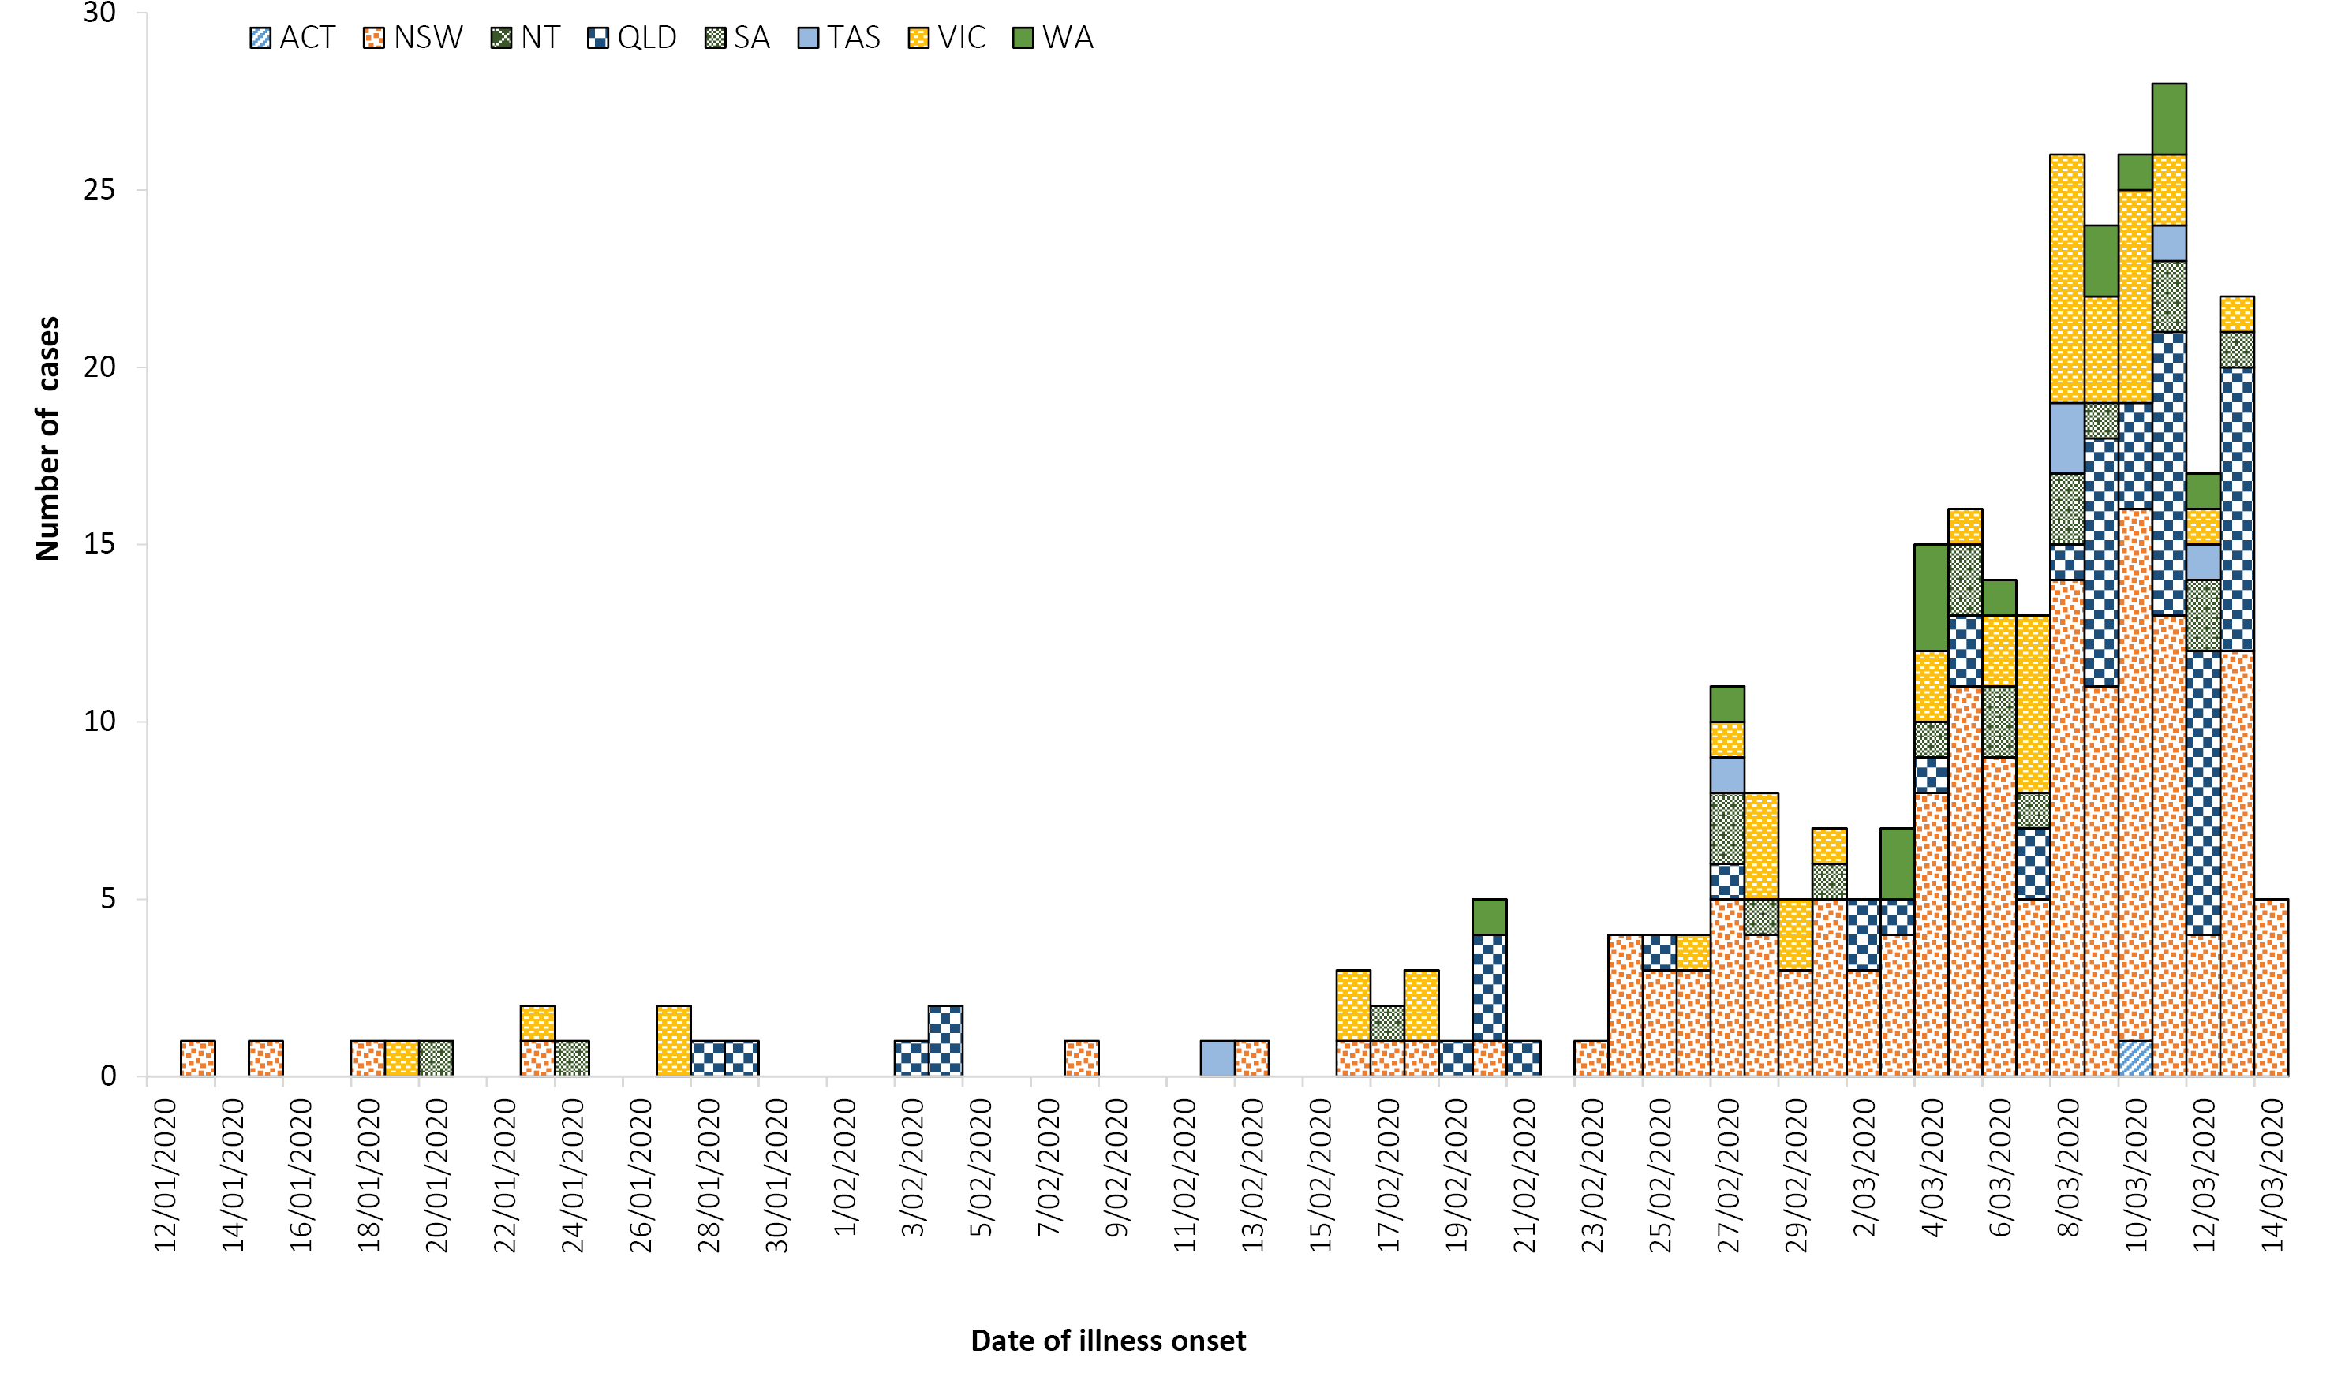
a Diagnosis date used for eight cases where date of illness onset is unavailable.
b Cases associated with the Diamond Princess cruise ship repatriation are included with their respective jurisdictions.

Table 1: Cumulative notified cases of confirmed COVID-19 by jurisdiction, Australia, 2020 (n = 295)
Jurisdictionª | This week^{b}  (19:00 AEDT 7 March to 14 March 2020)  No. of new cases | Total cases^{b}  (to 19:00 AEDT 14 March 2020)
NSW | 74 | 152
Vic | 20 | 46
Qld | 35 | 55
WA | 6 | 14
SA | 8 | 21
Tas | 4 | 6
NT | 0 | 0
ACT | 1 | 1
Total cases | 148 | 295
a NSW = New South Wales, Vic = Victoria, Qld = Queensland, WA = Western Australia, SA = South Australia, Tas = Tasmania, NT = Northern Territory, ACT = Australian Capital Territory.
b Case totals for this report, and ongoing, use data in the NNDSS to ensure systematic management of information. There may be differences in case numbers from last week due to changes in reporting methods for this report and future reports.
Of the 295 confirmed cases reported in the National Notifiable Diseases Surveillance System (NNDSS), 86% (n = 253) reported a place of acquisition and 14% (n = 42) remain under investigation. Of reported place of acquisition, 66% (n = 166) had a recent travel history and 34% (n = 87) were locally acquired. Of cases that reported recent travel history, 22% (n = 36) have a direct link to USA, 11% (n = 18) have a direct link to Italy, 9% (n = 15) have a direct link to Iran, 8% (n = 13) have a direct link to the UK, 8% (n = 13) have a direct link to China, 6% (n = 10) were passengers on the ‘Diamond Princess’ cruise ship repatriated from Japan, and 37% (n = 61) have a recent travel history to other countries.
Of the 34% (n = 87) of cases that were locally acquired, 75% (n = 65) were from NSW, 9% (n = 8) from Qld, 9% (n = 8) from SA, 2% (n = 2) from WA, 2% (n = 2) from Vic, 1% (n = 1) from ACT and 1% (n = 1) from Tas.
There were three reported deaths as of 14 March 2020, one associated with the ‘Diamond Princess’ cruise ship, and two who were part of the same aged care facility cluster in NSW.
The median age of all 295 reported Australian cases was 47 years (range 0–94 years), with the highest proportion of cases aged 50–59 and 60–69 years (Figure 2). The male-to-female ratio was approximately 1:1. All three cases that were reported to have died were aged over 70 years.

Figure 2: Age distribution of COVID-19 cases, by sex, Australia, 2020 (n = 295)
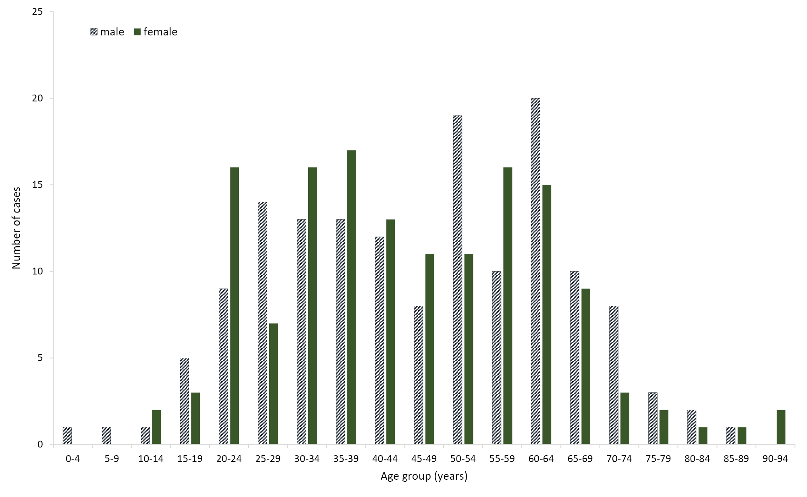
Of the 295 confirmed cases, 76% (n = 225) had hospitalisation data reported (Figure 3). Of those cases, 36% (n = 80) were hospitalised, 43% (n = 97) were not hospitalised, and hospitalisation status for 21% (n = 48) was unknown. The 60–64 age group reported the highest proportion of hospitalisation at 13% (n = 10), followed by the 30–34 and 35–39 age groups both reporting 11% (n = 9), and the 40–44 and 50–54 age groups both reporting 10% (n = 8).

Figure 3: Age distribution of hospitalisation status of COVID-19 cases, Australia, 2020 (n = 225)ª
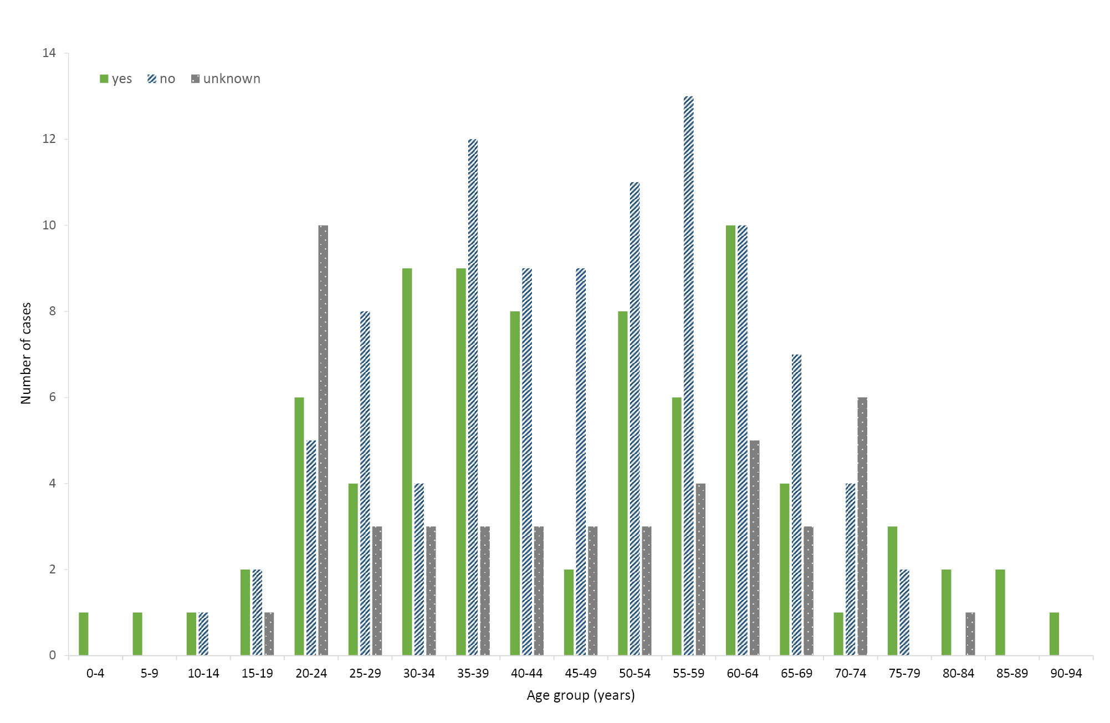
a Hospitalisation data was missing for 26% (n = 70) of all cases
Of the 295 confirmed cases, 53% (n = 156) reported symptoms (Table 2). A total of fifteen symptoms were reported with fever being the most commonly reported by 69% of cases (n = 108). Fifty-four percent (n = 84) reported cough, 46% (n = 72) reported sore throat, 35% (n = 55) reported shortness of breath, and 31% (n = 48) reported diarrhoea. Only 1% of all cases reported either joint pain, pneumonia or acute respiratory disease (ARD).

Table 2: COVID-19 symptoms in confirmed cases in Australia, 2020 (n = 156)
Symptom | n | %
Fever | 108 | 69%
Cough | 84 | 54%
Sore throat | 72 | 46%
Runny nose | 62 | 40%
Shortness of breath | 55 | 35%
Diarrhoea | 48 | 31%
Nausea/vomiting | 34 | 22%
Headache | 31 | 20%
Irritability/confusion | 27 | 17%
Muscular pain | 22 | 14%
Chest pain | 9 | 6%
Abdominal pain | 6 | 4%
Joint pain | 1 | 1%
Pneumonia | 1 | 1%
Acute respiratory disease (ARD) | 1 | 1%

Of the 295 confirmed cases, 14% (n = 42) did not report place of acquisition and 2% (n = 5) reported overseas acquisition but with country unknown. Of the 248 cases with reported place of acquisition and country level data, 65% (n = 161) were overseas acquired. Table 3 shows the most common places of acquisition for returned travellers were from countries in the European Region (n = 54), Region of the Americas (n = 39) and Western Pacific Region (n = 33). No place of acquisition was reported from the African Region. 4% of cases were acquired from the ‘Diamond Princess’ cruise ship under international conveyance.
Eighty-seven cases in Australia (35%) were locally acquired.
Table 3: Place of acquisition of confirmed COVID-19 cases in Australia, by WHO regions, international conveyance, and local acquisition, 2020 (n = 248)ª
WHO regions | % | n
European Region (EURO) | 22% | 54
Region of the Americas (PAHO) | 16% | 39
Western Pacific Region (WPRO) | 13% | 33
Eastern Mediterranean Region (EMRO) | 6% | 16
South-East Asia Region (SEARO) | 4% | 9
International conveyance | 4% | 10
African Region (AFRO) | 0% | 0
Locally acquired | 35% | 87
Total | 100% | 248
a Five cases that reported overseas travel to an unknown country are included as under investigation.

International cases
As at 19:00 AEDT 14 March 2020, the number of confirmed COVID-19 cases reported to the World Health Organization (WHO) was 142,539 globally.¹ The proportion of total cases reported from mainland China has continued to decrease, from 79% on 7 March 2020 to 57% (n = 81,021) on 14 March 2020.^{1,2} On 26 February 2020, the number of new cases reported outside of mainland China (n = 459) exceeded the number reported from mainland China (n = 412) for the first time and this trend has continued to date (Figure 4). The total number of confirmed COVID-19 cases reported by 134 countries, territories and areas outside of mainland China in the current reporting week has increased almost threefold (n = 61,518) compared to the preceding week (n = 21,110).^{1,3} Italy reported 29% (n = 17,660) of all cases outside of mainland China; the Islamic Republic of Iran reported 18% (n = 11,364); the Republic of Korea reported 13% (n = 8,086) and Spain reported 7% (n = 4,231). Thirty-eight countries, territories and areas reported cases of COVID-19 for the first time in the past seven days. Of all the countries, territories and areas outside of mainland China with known transmission classification (n = 134), fifty-eight percent (n = 78) have reported local transmission of COVID-19.

Figure 4. Cases of COVID-19 reported to WHO; and number of countries, territories and areas from 21 January to 14 March 2020¹
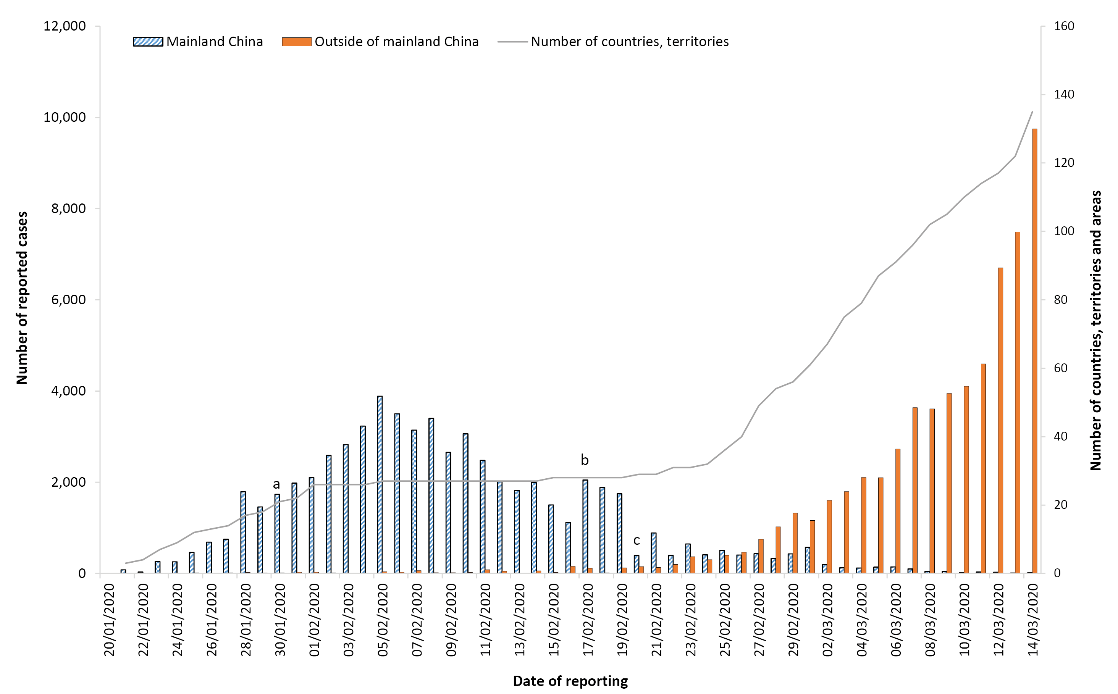
a WHO declares the outbreak of COVID-19 a Public Health Emergency of International Concern (30/01/2020)
b WHO start reporting both laboratory confirmed and clinically diagnosed cases from Hubei Province (17/02/2020)
c Hubei Province cease reporting clinically diagnosed cases (20/02/2020)
Globally, 5,393 deaths have been reported, with 57% (n = 3,075) reported from Hubei Province, China and 119 deaths reported from elsewhere within mainland China. The remaining 2,199 deaths were reported by 35 countries, territories and areas outside of mainland China.¹
The current estimates on epidemiological parameters including severity, transmissibility and incubation period are uncertain. Estimates are likely to change as more information becomes available.

Country in focus: Italy
Data on confirmed cases of COVID-19 in Italy have not been made publicly available. The following is therefore a brief summary based on information obtained from WHO situation reports and the Italian Ministry of Health.
Italy reported its first two confirmed cases of COVID-19 on 31 January 2020.⁴ Cases increased rapidly with 6 new cases reported on 22 February 2020 up to 17,660 cases on 14 March 2020. Reported deaths increased more than sixfold (n = 197) on 7 March to 1268 on 14 March 2020.^{1,2} Among the cases reported as at 14 March 2020, 51% (n = 9,059) were reported in Lombardia, 13% (n = 2,349) in Emilia Romagna and 10% (n = 1,775) in Veneto.⁵ Italy is now the epicentre outside of mainland China with the most rapid growth of COVID-19 cases, surpassing the Republic of Korea and the Islamic Republic of Iran (Figure 5).
Based on confirmed cases up to 14 March 2020, the case fatality rate (CFR) for Italy has been calculated at 7.8%. As the outbreak continues, the confirmed CFR may change. The current calculated CFR does not include the number of cases with mild infections that may be missed from current surveillance, nor does it account for the recently confirmed cases that may subsequently develop severe disease and die.
On 9 March 2020, Italy became the first European country to place a nationwide travel ban from all travel unless certified as justified on professional or health grounds.⁶ The nationwide restrictions will be in effect until 3 April 2020. On 11 March 2020, the Italian Prime Minister imposed new restrictions by closing non-essential commercial activities in the country, with the exception of basic necessities and pharmacies. The new restrictions will be valid for two weeks.⁷

Figure 5: Number of COVID-19 cases by country and days since passing 100 cases, up to 14 March 2020
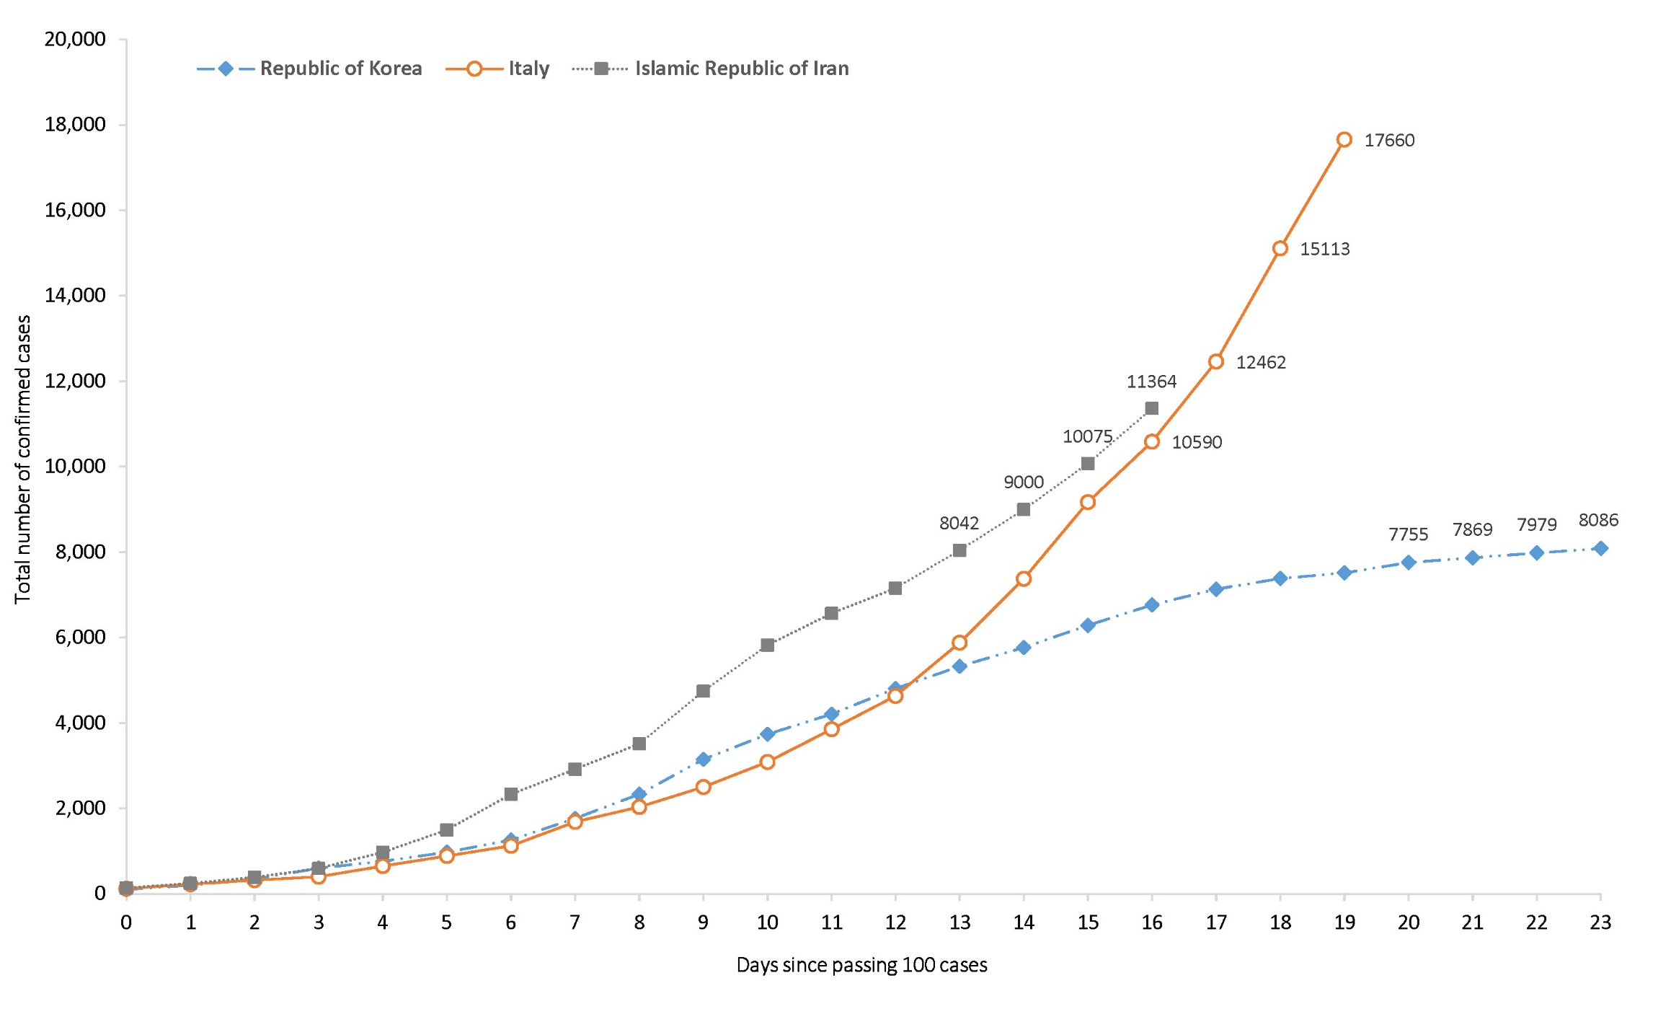

Transmission
Human-to-human transmission of SARS-CoV-2 is via droplets and fomites from an infected person to a close contact.⁸ A study of cases and their close contacts in China supports this. Household contacts and those who travelled with a confirmed COVID-19 case were strongly associated with an increased risk of infection.⁹ The study also examined the average time from symptom onset to disease confirmation among cases who were identified through symptom-based surveillance (i.e. symptomatic screening at airports, community fever monitoring and testing of hospital patients) and contact-based surveillance (i.e. monitoring and testing of close contacts of confirmed COVID-19 cases). Compared to cases identified through symptom-based surveillance, cases identified through contact-based surveillance were associated with a 2.3 day decrease from symptom onset to disease confirmation, and a 1.9 day decrease from symptom onset to isolation. Based on modelling, researchers have found that effective contact tracing increases the probability of control.⁹ A virological analysis of nine hospitalised cases found proof of active virus replication in upper respiratory tract tissues, with pharyngeal virus shedding very high during the first week of symptoms.¹⁰ COVID-19 can often present as a common cold-like illness where the virus is shed for a prolonged time after symptoms end, including in stools.¹⁰ This may have implications for current case definitions and re-evaluation of the prospects of outbreak containment.¹⁰
Current evidence does not support airborne or faecal-oral spread as major factors in transmission.⁸

Incubation period
Estimates of median incubation period, based on seven published studies, are 5 to 6 days (ranging from 0 to 14 days).¹¹ Patients with long incubation periods do occasionally occur and have been reported, however medical experts have described these patients as ‘outliers’ who should be studied further and do not represent a significant shift in thinking about the virus.¹¹

Clinical features
Ongoing evidence, including a recently published meta-analysis, supports previous research that COVID-19 presents as mild illness in the majority of cases with fever and cough being the most commonly reported symptoms. Severe or fatal outcomes tend to occur in the elderly or those with comorbid conditions.^{8,12} Some COVID-19 patients show neurological signs such as headache, nausea and vomiting. A study identified increasing evidence that coronaviruses are not always confined to the respiratory tract and may also invade the central nervous system inducing neurological symptoms.¹³ As such, it is likely that the potential invasion of SARS-CoV2 to the central nervous system is partially responsible for the acute respiratory failure of COVID-19 patients.¹³ Examination of cases and their close contacts in China found a positive association between age and time from symptom onset to recovery. Median time to recovery was estimated to be 27 days in 20–29 year olds, 32 days in 50–59 year olds, and 36 days in those aged over 70 years. The study also found an association between clinical severity and time from symptom onset to time to recovery. Compared to people with mild disease, those with moderate and severe disease were associated with a 19% and 58% increase in time to recovery, respectively.⁹ A retrospective cohort study looking at risk factors for mortality among patients with COVID-19 who have experienced a definite outcome found an increase in the odds of in-hospital death associated with older age, higher sequential organ failure assessment score and elevated blood d-dimer levels on admission.¹⁴ Detectable SARS-CoV-2 RNA persisted for a median of 20 days in survivors and sustained until death in non-survivors.¹⁴

Molecular epidemiology
Based on modelling, researchers estimated that initial human SARS-CoV-2 infection was in November to early December 2019.¹⁵ An analysis based on 86 genomic sequences of SARS-CoV-2, obtained from the Global Initiative on Sharing All Influenza Data (GISAID), found many mutations.¹⁶ This suggests that SARS-CoV-2 will continue to evolve as the outbreak occurs. Ongoing surveillance of sequences and shared mutations will assist with understanding the spread of the virus globally and within Australia.

Treatment
Current clinical management of COVID-19 cases focuses on early recognition, isolation, appropriate infection control measures and provision of supportive care.¹⁷ Whilst there is no specific antiviral treatment currently recommended for patients with suspected or confirmed SARS-CoV-2 infection, multiple clinical trials are underway to evaluate a number of therapeutic agents, including remdesivir, lopinavir/ritonavir, and chloroquine.¹⁸

Comparison between COVID-19, SARS and MERS
Coronaviruses are a group of viruses that can cause upper respiratory tract infections in humans. Coronaviruses can occasionally cause severe diseases such as Middle East Respiratory Syndrome (MERS), Severe Acute Respiratory Syndrome (SARS) and more recently COVID-19. Similar to MERS-CoV and SARS-CoV, SARS-CoV-2 is thought to have originated from bats, and to have been transmitted to humans via an intermediate animal host. The intermediate animal host responsible for COVID-19 is currently unknown.¹⁹ Table 4 provides an overview of characteristics of COVID-19, MERS and SARS.
Table 4: Characteristics of COVID-19, MERS and SARS^{20–22}
 | COVID-19 | MERS | SARS
Median incubation period | 5–6 days | 5 days | 4–5 days
Mode of transmission | Respiratory droplet, close contact, fomites | Respiratory droplet, close contact | Respiratory droplet, close contact, fomites
Symptoms | Fever, cough, fatigue and difficulty with breathing (dyspnoea) | Fever, cough and shortness of breath | Fever, malaise, myalgia, headache, diarrhoea and shivering (rigors)
Number of countries and regions affected | 134 | 27 | 29
Regions severely affected | Mainland China, Republic of Korea, Italy and Islamic Republic of Iran | Saudi Arabia | Mainland China, Hong Kong SAR, Taiwan, Canada, Singapore
Number of cases globally | 142,539 | 2,519 | 8,422
Number of deaths globally | 5,393 | 866 | 916
Global case fatality rate | 3.8% | 34.3% | 10.9%
Prophylaxis available | No | No | No

Public health response
The Report of the WHO-China Joint Mission on Coronavirus Disease 2019 (COVID-19) describes some of the key aspects associated with the evolving outbreak in mainland China, including transmission dynamics, disease progression and severity, mainland China’s response and knowledge gaps. As part of the report, the following major recommendations were made for countries with imported cases and/or outbreaks of COVID-19:⁸
- Immediately activate the highest level of national Response Management protocols to ensure the all-of-government and all-of-society approach needed to contain COVID-19 with non-pharmaceutical public health measures;
- Prioritise active, exhaustive case finding and immediate testing and isolation, painstaking contact tracing and rigorous quarantine of close contacts;
- Fully educate the general public on the seriousness of COVID-19 and their role in preventing its spread;
- Immediately expand surveillance to detect COVID-19 transmission chains, by testing all patients with atypical pneumonias, conducting screening in some patients with upper respiratory illnesses and/or recent COVID-19 exposure, and adding testing for the COVID-19 virus to existing surveillance systems (e.g. systems for influenza-like-illness); and
- Conduct multi-sector scenario planning and simulations for the deployment of even more stringent measures to interrupt transmission chains as needed (e.g. the suspension of large-scale gatherings and the closure of schools and workplaces).

Background
On 31 December 2019, the World Health Organization (WHO) was notified about a large number of cases of pneumonia of unknown origin in Wuhan City, Hubei Province, China. Chinese authorities isolated and identified a novel coronavirus on 7 January 2020.²³ WHO declared the outbreak of COVID-19 a Public Health Emergency of International Concern (PHEIC) on 30 January 2020.⁸
From 1 February 2020, Australia denied entry to anyone who had left or transited through mainland China, with the exception of Australian citizens, permanent residents and their immediate family and air crew who have been using appropriate personal protective equipment (Figure 4).²⁴ The Australian Health Protection Principal Committee (AHPPC) have reviewed these restrictions weekly, and on 4 March 2020, they released a statement recommending current travel restrictions for mainland China and the Islamic Republic of Iran remain in place for a further seven days.²⁵ On 5 March 2020, the Prime Minister announced new travel restrictions for travellers coming from the Republic of Korea, and implementation of enhanced health screening for arrivals from Italy. From 5 March 2020, foreign nationals (excluding permanent residents of Australia) will be prevented from coming to Australia until 14 days after leaving the Republic of Korea.²⁶ On 8 March 2020, AHPPC recommended that people who have been a close contact of a confirmed COVID-19 case, or who returned from or transited through a listed higher risk country*, must not attend public gatherings until 14 days after leaving the country or having contact with a confirmed case even if they are completely symptom free.²⁷ Those undergoing COVID-19 testing also must not attend public gatherings until they have received their result.²⁷ On March 11, AHPPC recommended that the government continue to direct primary focus toward domestic containment and preparedness of COVID-19, and that enhanced border measures and travel restrictions be maintained for a further 7 days.²⁸ On March 12, AHPPC provided recommendations on testing and work restriction for health and aged care workers. In addition to the other suspect case criteria, AHPPC recommended testing for any health care worker (HCW) who provides direct care AND who has a fever (> 37.5 °C) AND an acute respiratory infection (e.g. shortness of breath, cough, coryza, and/or sore throat), are classified as a suspect case and should be tested for COVID-19. Recommendations for exclusion from work for HCW were also provided.²⁹ On 13 March, AHPPC provided recommendations for public gatherings and testing by putting in place social distancing measures to mitigate spread.³⁰ This includes:
- Limiting non-essential organised gatherings to fewer than 500 people;
- Limiting non-essential meetings or conferences of critical workforce e.g. healthcare professionals and emergency services;
- Encouraging all Australians to exercise personal responsibility for social distancing measures; and
- Initiating measures to protect vulnerable populations, such as reducing visitors to all residential care facilities and remote Aboriginal and Torres Strait Islander communities.
AHPPC acknowledges that diagnostic testing issues are related to an emerging global shortage and are reviewing the case definition. The current situation emphasises the need for testing to be limited to the current recommendations.³⁰
AHPPC acknowledged that Australia’s border measures may no longer be able to prevent the importation of COVID-19, and the primary focus should now be directed at domestic containment and preparedness.²⁴ Local transmission of COVID-19 has occurred in Australia, highlighting the need of effective containment measures to limit spread. Early isolation of identified cases and quarantine of suspected cases and close contacts is a key measure to minimise transmission of COVID-19 in the community. However, as COVID-19 presents as mild illness in the majority of cases, early identification and isolation of cases may be difficult to achieve.

Methods
Data for this report were current as at 19:00 hours AEDT, 14 March 2020.
This report outlines what is known epidemiologically on COVID-19 in Australia and from publicly available data from WHO Situation Reports, other countries’ official updates and the scientific literature. Data on domestic cases in this report were collected from the National Notifiable Diseases Surveillance System (NNDSS) and jurisdictional health department media releases. The Communicable Diseases Network Australia (CDNA) developed the case definition for suspect and confirmed cases, which was modified at different time points during the outbreak (Table 5). Data were analysed using Stata to describe the epidemiology of COVID-19 in Australia and the progress of the epidemic.
Table 5: Australian COVID-19 case definition as of 14 March 2020³¹
Version | Date of development | Suspect Case | Confirmed Case
1.18 | 13 March 2020 | A. If the patient satisfies epidemiological and clinical criteria, they are classified as a suspect case.  Epidemiological criteria  - International travel in the 14 days before illness onset.  OR  - Close contact in 14 days before illness onset with a confirmed case of COVID-19.  Clinical criteria  - Fever  OR  - Acute respiratory infection (e.g. shortness of breath, cough, sore throat) with or without fever.  B. If the patient has severe community-acquired pneumonia (critically ill) and no other cause is identified, with or without recent international travel, they are classified as a suspect case.  C. If any healthcare worker with direct patient contact has a fever (≥ 37.5°C) AND an acute respiratory infection (e.g. shortness of breath, cough, sore throat), they are classified as a suspect case. | A person who tests positive to a validated specific SARS-CoV-2 nucleic acid test or has the virus identified by electron microscopy or viral culture.
Data for the international cases of COVID-19 by country were compiled from the latest WHO Situation Report. Case definitions may vary by country making comparisons difficult. Rapid reviews of the current state of knowledge on COVID-19 were conducted from the literature using PubMed.

Acknowledgements
This report represents surveillance data reported through CDNA as part of the nationally-coordinated response to COVID-19. We thank public health staff from incident emergency operations centres in state and territory health departments, and the Australian Government Department of Health, along with state and territory public health laboratories.

Author details

Corresponding author
Malinda V Chea
NIR Surveillance Team, Communicable Disease Epidemiology and Surveillance Section, Health Protection Policy Branch, Australian Government Department of Health, GPO Box 9484, MDP 14, Canberra, ACT 2601.
Email: epi.coronavirus@health.gov.au

References
- World Health Organization (WHO). Coronavirus disease 2019 (COVID-19) situation report – 54: 14 March 2020. Geneva: WHO; 2020. [Accessed on 15 March 2020.] Available from: https://www.who.int/docs/default-source/coronaviruse/situation-reports/20200314-sitrep-54-covid-19.pdf.
- WHO. Coronavirus disease 2019 (COVID-19) situation report – 47: 07 March 2020. Geneva: WHO; 2020. [Accessed on 15 March 2020.] Available from: https://www.who.int/docs/default-source/coronaviruse/situation-reports/20200307-sitrep-47-covid-19.pdf.
- WHO. Coronavirus disease 2019 (COVID-19) situation report – 40: 29 February 2020. Geneva: WHO; 2020. [Accessed on 15 March 2020.] Available from: https://www.who.int/docs/default-source/coronaviruse/situation-reports/20200229-sitrep-40-covid-19.pdf.
- WHO. Novel Coronavirus (2019-nCoV) situation report – 11: 31 January 2020. Geneva: WHO; 2020. [Accessed on 15 March 2020.] Available from: https://www.who.int/docs/default-source/coronaviruse/situation-reports/20200131-sitrep-11-ncov.pdf.
- Ministry of Health. COVID-19 cases in Italy at 6 pm on March 14th. [Internet.] Rome: Italian Government Ministry of Health; 2020. [Accessed on 15 March 2020.] Available from: http://www.salute.gov.it/imgs/C_17_pagineAree_5351_12_file.pdf.
- Ministry of Health. COVID-19 COVID-19, closed cinemas, pubs, discos throughout Italy. [Internet.] Rome: Italian Government Ministry of Health; 2020. [Accessed on 12 March 2020.] Available from: http://www.salute.gov.it/portale/news/p3_2_1_1_1.jsp?lingua=italiano&menu=notizie&p=dalministero&id=4175.
- Ministry of Health. COVID-19, close non-essential commercial activities. [Internet.] Rome: Italian Government Ministry of Health; 2020. [Accessed on 12 March 2020.] Available from: http://www.salute.gov.it/portale/news/p3_2_1_1_1.jsp?lingua=italiano&menu=notizie&p=dalministero&id=4212.
- WHO. Report of the WHO-China joint mission on coronavirus disease 2019 (COVID-19). Geneva: WHO; 2020. [Accessed on 1 March 2020.] Available from: https://www.who.int/docs/default-source/coronaviruse/who-china-joint-mission-on-covid-19-final-report.pdf.
- Bi Q, Wu Y, Mei S, Ye C, Zou X, Zhang Z et al. Epidemiology and transmission of COVID-19 in Shenzhen China: analysis of 391 cases and 1286 of their close contacts. medRxiv. 2020. doi: https://doi.org/10.1101/2020.03.03.20028423.
- Zhou F, Yu T, Du R, Fan G, Liu Y, Liu Z et al. Clinical course and risk factors for mortality of adult inpatients with COVID-19 in Wuhan, China: a retrospective cohort study. Lancet. 2020. doi: https://doi.org/10.1016/S0140-6736(20)30566-3.
- WHO. Coronavirus disease 2019 (COVID-19) situation report – 29: 18 February 2020. Geneva: WHO; 2020. [Accessed on 15 March 2020.] Available from: https://www.who.int/docs/default-source/coronaviruse/situation-reports/20200218-sitrep-29-covid-19.pdf.
- Sun P, Qie S, Liu Z, Ren J, Xi JJ. Clinical characteristics of 50466 patients with 2019-nCoV infection. medRxiv. 2020. doi: https://doi.org/10.1101/2020.02.18.20024539.
- Li Y, Bai W, Hashikawa T. The neuroinvasive potential of SARS-CoV2 may be at least partially responsible for the respiratory failure of COVID-19 patients. J. Med. Virol. 2020. doi: https://doi.org/10.1002/jmv.25728.
- Woelfel R, Corman VM, Guggemos W, Seilmaier M, Zange S, Mueller MA et al. Clinical presentation and virological assessment of hospitalized cases of coronavirus disease 2019 in a travel-associated transmission cluster. medRxiv. 2020. doi: https://doi.org/10.1101/2020.03.05.20030502.
- Bedford T, Neher R, Hadfield J, Hodcroft E, Ilcisin M, Müller N. Genomic analysis of nCOV spread. Situation report 2020-01-30. [Internet.] 2020. Available from: https://nextstrain.org/narratives/ncov/sit-rep/2020-01-30.
- Phan T. Genetic diversity and evolution of SARS-CoV-2. Infect Genet Evol. 2020. doi: https://doi.org/10.1016/j.meegid.2020.104260.
- WHO. Clinical management of severe acute respiratory infection when novel coronavirus (nCoV) infection is suspected. [Internet.] Geneva: WHO; 2020. [Accessed on 23 February 2020.] Available from: https://www.who.int/publications-detail/clinical-management-of-severe-acute-respiratory-infection-when-novel-coronavirus-(ncov)-infection-is-suspected.
- Harrison, C. Coronavirus puts drug repurposing on the fast track. Nat Biotechnol. 2020. doi: https://doi.org/10.1038/d41587-020-00003-1.
- WHO. Novel coronavirus (2019-nCoV) situation report – 22: 11 February 2020. Geneva: WHO; 2020. [Accessed on 12 February 2020.] Available from: https://www.who.int/docs/default-source/coronaviruse/situation-reports/20200211-sitrep-22-ncov.pdf.
- World Health Organization Regional Office for the Eastern Mediterranean. MERS situation update, January 2020. [Internet.] Egypt: World Health Organization Regional Office for the Eastern Mediterranean; 2020. [Accessed on 7 March 2020.] Available from: http://www.emro.who.int/pandemic-epidemic-diseases/mers-cov/mers-situation-update-january-2020.html.
- Centers for Disease Control and Prevention (CDC). MERS clinical features. [Internet.] Atlanta: United States Department of Health and Human Services, CDC; 2019. [Accessed on 7 March 2020.] Available from: https://www.cdc.gov/coronavirus/mers/clinical-features.html.
- WHO. Consensus document on the epidemiology of severe acute respiratory syndrome (SARS). [Internet.] Geneva: WHO; 2003. [Accessed on 7 March 2020.] Available from: https://www.who.int/csr/sars/WHOconsensus.pdf.
- WHO. Novel coronavirus (2019-nCoV) situation report – 1: 21 January 2020. Geneva: WHO; 2020. [Accessed on 22 January 2020.] Available from: https://www.who.int/docs/default-source/coronaviruse/situation-reports/20200121-sitrep-1-2019-ncov.pdf.
- Australian Government Department of Health. Australian Health Protection Principal Committee (AHPPC) novel coronavirus statement on 1 February 2020. [Internet.] Canberra: Australian Government Department of Health; 2020. [Accessed on 7 February 2020.] Available from: https://www.health.gov.au/news/australian-health-protection-principal-committee-ahppc-novel-coronavirus-statement-on-1-february-2020.
- Australian Government Department of Health. Australian Health Protection Principal Committee (AHPPC) coronavirus (COVID-19) statement on 4 March 2020. [Internet.] Canberra: Australian Government Department of Health; 2020. [Accessed on 7 March 2020.] Available from: https://www.health.gov.au/news/australian-health-protection-principal-committee-ahppc-coronavirus-covid-19-statement-on-4-march-2020.
- Australian Government Department of the Prime Minister and Cabinet. Update on novel coronavirus (COVID-19) in Australia. [Internet.] Canberra: Australian Government Department of the Prime Minister and Cabinet; 2020. [Accessed on 7 March 2020.] Available from: https://www.pm.gov.au/media/update-novel-coronavirus-covid-19-australia-0.
- Australian Government Department of Health. Australian Health Protection Principal Committee (AHPPC) coronavirus (COVID-19) statement on 8 March 2020. [Internet.] Canberra: Australian Government Department of Health; 2020. [Accessed on 11 March 2020.] Available from: https://www.health.gov.au/news/australian-health-protection-principal-committee-ahppc-coronavirus-covid-19-statement-on-8-march-2020.
- Australian Government Department of Health. Australian Health Protection Principal Committee (AHPPC) coronavirus (COVID-19) statement on 11 March 2020. [Internet.] Canberra: Australian Government Department of Health; 2020. [Accessed on 13 March 2020.] Available from: https://www.health.gov.au/news/australian-health-protection-principal-committee-ahppc-coronavirus-covid-19-statement-on-11-march-2020.
- Australian Government Department of Health. Australian Health Protection Principal Committee (AHPPC) coronavirus (COVID-19) statement on 12 March 2020. [Internet.] Canberra: Australian Government Department of Health; 2020. [Accessed on 15 March 2020.] Available from: https://www.health.gov.au/news/australian-health-protection-principal-committee-ahppc-coronavirus-covid-19-statement-on-12-march-2020.
- Australian Government Department of Health. Australian Health Protection Principal Committee (AHPPC) coronavirus (COVID-19) statement on 13 March 2020. [Internet.] Canberra: Australian Government Department of Health; 2020. [Accessed on 15 March 2020.] Available from: https://www.health.gov.au/news/australian-health-protection-principal-committee-ahppc-coronavirus-covid-19-statement-on-13-march-2020.
- Australian Government Department of Health. Novel coronavirus 2019 (2019-nCoV) - CDNA national guidelines for public health units. [Internet.] Canberra: Australian Government Department of Health; 2020. [Accessed on 15 March 2020.] Available from: https://www1.health.gov.au/internet/main/publishing.nsf/Content/7A8654A8CB144F5FCA2584F8001F91E2/$File/interim-COVID-19-SoNG-v2.0.pdf.

Communicable Diseases Intelligence
ISSN: 2209-6051 Online

Communicable Diseases Intelligence (CDI) is a peer-reviewed scientific journal published by the Office of Health Protection, Department of Health. The journal aims to disseminate information on the epidemiology, surveillance, prevention and control of communicable diseases of relevance to Australia.

Editor: Tanja Farmer
Deputy Editor: Simon Petrie
Design and Production: Kasra Yousefi
Editorial Advisory Board: David Durrheim, Mark Ferson, John Kaldor, Martyn Kirk and Linda Selvey

Website: http://www.health.gov.au/cdi

Contacts
Communicable Diseases Intelligence is produced by:
Health Protection Policy Branch, Office of Health Protection, Australian Government Department of Health
GPO Box 9848, (MDP 6) CANBERRA ACT 2601

Email: cdi.editor@health.gov.au

Submit an Article
You are invited to submit your next communicable disease related article to the Communicable Diseases Intelligence (CDI) for consideration. More information regarding CDI can be found at: http://health.gov.au/cdi.
Further enquiries should be directed to: cdi.editor@health.gov.au.

This journal is indexed by Index Medicus and Medline.

Creative Commons Licence - Attribution-NonCommercial-NoDerivatives CC BY-NC-ND
© 2019 Commonwealth of Australia as represented by the Department of Health
This publication is licensed under a Creative Commons Attribution-NonCommercial-NoDerivatives 4.0 International Licence from https://creativecommons.org/licenses/by-nc-nd/4.0/legalcode (Licence). You must read and understand the Licence before using any material from this publication.

Restrictions
The Licence does not cover, and there is no permission given for, use of any of the following material found in this publication (if any):
- the Commonwealth Coat of Arms (by way of information, the terms under which the Coat of Arms may be used can be found at www.itsanhonour.gov.au);
- any logos (including the Department of Health’s logo) and trademarks;
- any photographs and images;
- any signatures; and
- any material belonging to third parties.

Disclaimer
Opinions expressed in Communicable Diseases Intelligence are those of the authors and not necessarily those of the Australian Government Department of Health or the Communicable Diseases Network Australia. Data may be subject to revision.

Enquiries
Enquiries regarding any other use of this publication should be addressed to the Communication Branch, Department of Health, GPO Box 9848, Canberra ACT 2601, or via e-mail to: copyright@health.gov.au

Communicable Diseases Network Australia
Communicable Diseases Intelligence contributes to the work of the Communicable Diseases Network Australia.
http://www.health.gov.au/cdna

