COVID-19 Australia: Epidemiology Report 57
Reporting period ending 16 January 2022
COVID-19 National Incident Room Surveillance Team
This report (Epidemiology Report 57) covers a six-week period, including the Christmas period. Future reports, commencing with Epidemiology Report 58, will then be produced on a four-weekly schedule

Summary

Six-week reporting period (6 December 2021 – 16 January 2022)

The case data provided in this report includes confirmed cases reported to the National Interoperable Disease Surveillance System (NINDSS), which does not include cases that are positive on rapid antigen tests (RAT) only. Therefore, case numbers, particularly in recent weeks, will under-represent the incidence of disease in the community.
Trends – In the last six weeks, there were over 1 million confirmed cases of coronavirus disease 2019 (COVID-19) reported in Australia, with fortnightly new cases increasing considerably over this period. In the most recent fortnight, a total of 800,642 confirmed cases were notified (an average of 57,189 cases per day), compared to 203,270 in the previous fortnight (14,519 cases per day), and 33,083 cases (2,363 cases per day) in the two weeks prior to that.
Local cases – More than 99% (1,036,067/1,036,995) of COVID-19 cases reported over the six-week period were locally acquired (including cases under initial investigation and those missing a source of acquisition). In 2021, Victoria had the highest notification rate for locally-acquired cases with 2,431 notifications per 100,000 population, followed by New South Wales with a rate of 2,015 notifications per 100,000 population. In all jurisdictions, the notification rate for locally-acquired cases has been higher in 2022 to date than in the entirety of 2021.
Aboriginal and Torres Strait Islander persons – During the reporting period, there were 20,322 new cases notified in Aboriginal and Torres Strait Islander people, with fortnightly new cases increasing over the six-week period. Since the beginning of 2021, there have been 29,169 confirmed cases of COVID-19 notified in Aboriginal and Torres Strait Islander people, including 31 deaths, representing 2% (29,169/1,226,505) of all confirmed cases. Of the locally-acquired cases notified in Aboriginal and Torres Strait Islander people from 1 January 2021 to date, 41% (11,974/29,148) resided in a regional or remote area.
Overseas-acquired cases – There were 928 overseas-acquired cases this reporting period, with the largest number of such cases reported in New South Wales (39%; 364/928), followed by Victoria (31%; 292/928).
Age group - Over the six-week reporting period, there was a shift in the age groups of cases. In the fortnight ending 19 December 2021, the highest notification rate was in children aged 5–11 years (225 per 100,000 population), while in the most recent fortnight (fortnight ending 16 January 2022), the highest notification rate was in adults aged 18–29 years (6,526 per 100,000 population).
Severity – For 6–26 December 2021, the national notification rate of cases with severe illness (defined as cases admitted to ICU or died) was relatively stable at approximately 0.4 per 100,000 population. However, in the most recent severity reporting week (week ending 2 January 2022), the rate of severe illness has more than doubled to 0.9 per 100,000 nationally, associated with an increase in the overall case notification rate to 903 per 100,000 in the same period. The current rate of severe illness remains lower than during the peak of the Delta outbreak, when the rate of severe illness reached 1.2 per 100,000 population. Given the delay between illness onset and severe illness, cases with an onset in the last two weeks were excluded from the analysis on severity. During the six-week reporting period, 398 new COVID-19-associated deaths were notified.
Vaccinations – As at 16 January 2022, a total of 45,954,013 doses of COVID-19 vaccine had been administered in Australia. Nationally, 19,597,960 people aged 16 years or over (95%) had received at least one dose, including 19,082,286 people aged 16 years or over (92.5%) who were fully vaccinated. Among people aged 12–15 years, 1,012,626 people (81.4%) had received at least one dose, including 933,566 (75%) who were fully vaccinated. Among people aged 5–11 years, 295,106 (12.9%) had received at least one dose.
Testing – There has been an overall increase in PCR testing rates since early December 2021. In the last two weeks of the reporting period, PCR testing rates have decreased slightly, which is likely the result of an increased uptake of rapid antigen tests for COVID-19 diagnosis. Over the six-week period, while PCR testing rates remained high, the percent positivity increased considerably across all jurisdictions, with the percent positivity reaching above 20% for all jurisdictions except Northern Territory, South Australia and Western Australia during the week ending 9 January 2022.
Virology – On 26 November 2021, a new variant, B.1.1.529 (Omicron) was designated as a SARS-CoV-2 variant of concern (VOC) by the WHO. In the six-week reporting period, the number of cases identified as Omicron in Australia has increased considerably. AusTrakka actively monitors and reports on VOCs and has so far identified 30,411 samples of Delta (B.1.617.2); 5,402 samples of Omicron (B.1.1.529); 515 samples of Alpha (B.1.1.7); 84 samples of Beta (B.1.351); and six samples of Gamma (P.1) in Australia. While the significant rise in case numbers nationally has resulted in a drop in the overall proportion of cases that were sequenced during this reporting period (1.1%), the overall number of cases sequenced per week remains similar to, or higher than, previous reporting periods. Nationally, SARS-CoV-2 strains from 4% of COVID-19 cases have been sequenced during the pandemic.
International situation – According to the WHO, cumulative global COVID-19 cases stood at more than 325 million, with over 5.5 million deaths reported globally, as of 16 January 2022. In Australia’s near region, the South East Asia and Western Pacific Regions reported over 4.6 million newly-confirmed cases and over 15,000 deaths in the four-week period to 16 January 2022.

Severity – For 6–26 December 2021, the national notification rate of cases with severe illness (defined as cases admitted to ICU or died) was relatively stable at approximately 0.4 per 100,000 population. However, in the most recent severity reporting week (week ending 2 January 2022), the rate of severe illness has more than doubled to 0.9 per 100,000 nationally, associated with an increase in the overall case notification rate to 903 per 100,000 in the same period. The current rate of severe illness remains lower than during the peak of the Delta outbreak, when the rate of severe illness reached 1.2 per 100,000 population. Given the delay between illness onset and severe illness, cases with an onset in the last two weeks were excluded from the analysis on severity. During the six-week reporting period, 398 new COVID-19-associated deaths were notified.
Vaccinations – As at 16 January 2022, a total of 45,954,013 doses of COVID-19 vaccine had been administered in Australia. Nationally, 19,597,960 people aged 16 years or over (95%) had received at least one dose, including 19,082,286 people aged 16 years or over (92.5%) who were fully vaccinated. Among people aged 12–15 years, 1,012,626 people (81.4%) had received at least one dose, including 933,566 (75%) who were fully vaccinated. Among people aged 5–11 years, 295,106 (12.9%) had received at least one dose.
Testing – There has been an overall increase in PCR testing rates since early December 2021. In the last two weeks of the reporting period, PCR testing rates have decreased slightly, which is likely the result of an increased uptake of rapid antigen tests for COVID-19 diagnosis. Over the six-week period, while PCR testing rates remained high, the percent positivity increased considerably across all jurisdictions, with the percent positivity reaching above 20% for all jurisdictions except Northern Territory, South Australia and Western Australia during the week ending 9 January 2022.
Virology – On 26 November 2021, a new variant, B.1.1.529 (Omicron) was designated as a SARS-CoV-2 variant of concern (VOC) by the WHO. In the six-week reporting period, the number of cases identified as Omicron in Australia has increased considerably. AusTrakka actively monitors and reports on VOCs and has so far identified 30,411 samples of Delta (B.1.617.2); 5,402 samples of Omicron (B.1.1.529); 515 samples of Alpha (B.1.1.7); 84 samples of Beta (B.1.351); and six samples of Gamma (P.1) in Australia. While the significant rise in case numbers nationally has resulted in a drop in the overall proportion of cases that were sequenced during this reporting period (1.1%), the overall number of cases sequenced per week remains similar to, or higher than, previous reporting periods. Nationally, SARS-CoV-2 strains from 4% of COVID-19 cases have been sequenced during the pandemic.
International situation – According to the WHO, cumulative global COVID-19 cases stood at more than 325 million, with over 5.5 million deaths reported globally, as of 16 January 2022. In Australia’s near region, the South East Asia and Western Pacific Regions reported over 4.6 million newly-confirmed cases and over 15,000 deaths in the four-week period to 16 January 2022.

Keywords: SARS-CoV-2; novel coronavirus; 2019-nCoV; coronavirus disease 2019; COVID-19; acute respiratory disease; epidemiology; Australia
This reporting period covers the six-week period 6 December 2021 – 16 January 2022. Within this period, data for the most recent two weeks (3–16 January 2022) is compared to that from the two previous two-weekly periods (20 December 2021 – 2 January 2022 and 6–19 December 2021, respectively). The focus of this report is on the epidemiological situation in Australia since the beginning of 2021. Readers are encouraged to consult prior reports in this series for information on the epidemiology of COVID-19 in Australia in 2020.
Included in this report, also with a reporting period of six weeks, are sections on genomic surveillance and virology, acute respiratory illness, testing, public health response measures, and the international situation. The reporting period for these topics is 6 December 2021 – 16 January 2022. The previous reporting period is the preceding four weeks (8 November – 5 December 2021).¹
From report 46 onward, and unless otherwise specified, tabulated data and data within the text are extracted from the National Interoperable Notifiable Diseases Surveillance System (NINDSS) based on ‘notification received date’ rather than ‘diagnosis date’ (see the Technical Supplement for definitions).² As a case’s diagnosis date can be several days prior to the date of its notification, there is potential for newly-notified cases to be excluded from the case count in the current reporting period when reporting by ‘diagnosis date’. Using ‘notification received date’ ensures that the case count for the reporting period better reflects the number of newly-notified cases. As the graphs presented in this report, based on NINDSS data, reflect a longer time period (i.e. year to date and entire pandemic), these will continue to be based on diagnosis date to enable a more accurate understanding of infection risk and local transmission.
The case data provided in this report includes confirmed cases reported to the NINDSS, which—as per the COVID-19 National Guidelines for Public Health Units (SoNG)³—does not include cases which are positive on rapid antigen tests (RAT) only. At the time of data extraction, RAT positive cases were yet to be captured in the NINDSS.

Background and data sources
See the Technical Supplement for general information on COVID-19 including modes of transmission, common symptoms and severity.²

Activity

COVID-19 trends

(NINDSS and jurisdictional reporting to NIR)
The number of confirmed cases has increased considerably during the six-week period. A total of 800,642 confirmed cases were notified in the most recent two weeks (an average of 57,189 cases per day), compared to 203,270 in the previous fortnight (14,519 cases per day), and 33,083 cases (2,363 cases per day) in the two weeks prior to that (Table 1). Overall, New South Wales reported the highest number of new cases in the last six weeks (42%; 431,450/1,036,995), followed by Victoria (33%; 346,383/1,036,995). The rate of increase over the six weeks has been highest in Tasmania and Queensland.
Prior to December 2021, the number of cases diagnosed each week had peaked in October 2021, at approximately 15,000 cases diagnosed per week. Since December, confirmed case numbers have increased steeply, to over 420,000 cases diagnosed in the week ending 9 January 2022 (Figure 1). In total in 2021, there were 465,277 confirmed cases of COVID-19 diagnosed. In 2022 to date, there have been 761,147 COVID-19 confirmed cases reported nationally. Cumulatively, since the beginning of the pandemic, there have been 1,254,909 COVID-19 confirmed cases reported in Australia to 16 January 2022. As trends are presented using diagnosis date rather than notification date, case numbers for the most recent week are likely an underestimate as additional cases may be identified in the coming week that have a diagnosis date in these periods. In addition, case numbers for the previous month are an underestimate as RAT positive cases are excluded from these counts.

Table 1: COVID-19 notifications by jurisdiction and source of acquisition, by date of notification, 6 December 2021 – 16 January 2022ª
Source^{b} | ACT | NSW | NT | Qld | SA | Tas. | Vic. | WA | Australia
6 December 2021 – 19 December 2021
Overseas | 12 | 206 | 13 | 18 | 11 | 2 | 157 | 3 | 422
Locally acquired – acquired within jurisdiction of notification | 61 | 10,763 | 50 | 78 | 370 | 0 | 6,965 | 0 | 18,287
Locally acquired – acquired interstate | 53 | 95 | 3 | 40 | 47 | 2 | 0 | 0 | 240
Under initial investigation | 3 | 3,111 | 0 | 37 | 30 | 6 | 10,933 | 0 | 14,120
Missing source of acquisition | 0 | 0 | 0 | 11 | 3 | 0 | 0 | 0 | 14
Total new cases | 129 | 14,175 | 66 | 184 | 461 | 10 | 18,055 | 3 | 33,083
20 December 2021 – 2 January 2022
Overseas | 11 | 131 | 9 | 16 | 35 | 16 | 125 | 16 | 359
Locally acquired – acquired within jurisdiction of notification | 547 | 14,217 | 203 | 1,792 | 4,056 | 543 | 12,559 | 15 | 33,932
Locally acquired – acquired interstate | 170 | 150 | 194 | 106 | 527 | 114 | 0 | 9 | 1,270
Under initial investigation | 7 | 86,574 | 37 | 366 | 205 | 97 | 40,023 | 0 | 127,309
Missing source of acquisition | 2,455 | 0 | 0 | 24,998 | 11,938 | 1,008 | 0 | 1 | 40,400
Total new cases | 3,190 | 101,072 | 443 | 27,278 | 16,761 | 1,778 | 52,707 | 41 | 203,270
3 January 2022 – 16 January 2022
Overseas | 0 | 27 | 15 | 1 | 75 | 2 | 10 | 17 | 147
Locally acquired - acquired within jurisdiction of notification | 119 | 12,974 | 293 | 1,263 | 1,537 | 303 | 56,998 | 18 | 73,505
Locally acquired - acquired interstate | 33 | 35 | 257 | 40 | 1,901 | 18 | 0 | 53 | 2,337
Under initial investigation | 0 | 303,167 | 329 | 61 | 666 | 15 | 218,613 | 0 | 522,851
Missing source of acquisition | 15,579 | 0 | 44 | 146,757 | 31,507 | 7,912 | 0 | 2 | 201,801
Total new cases | 15,731 | 316,203 | 938 | 148,122 | 35,686 | 8,250 | 275,621 | 91 | 800,642
a Source: NINDSS, extract from 17 January 2022 for notifications from 6 December 2021 to 16 January 2022.
b ACT: Australian Capital Territory; NSW: New South Wales; NT: Northern Territory; Qld: Queensland; SA: South Australia; Tas.: Tasmania; Vic.: Victoria; WA: Western Australia.

Figure 1: Confirmed COVID-19 notified cases by source of acquisition and diagnosis date, 2 March 2020 – 16 January 2022^{a,b}
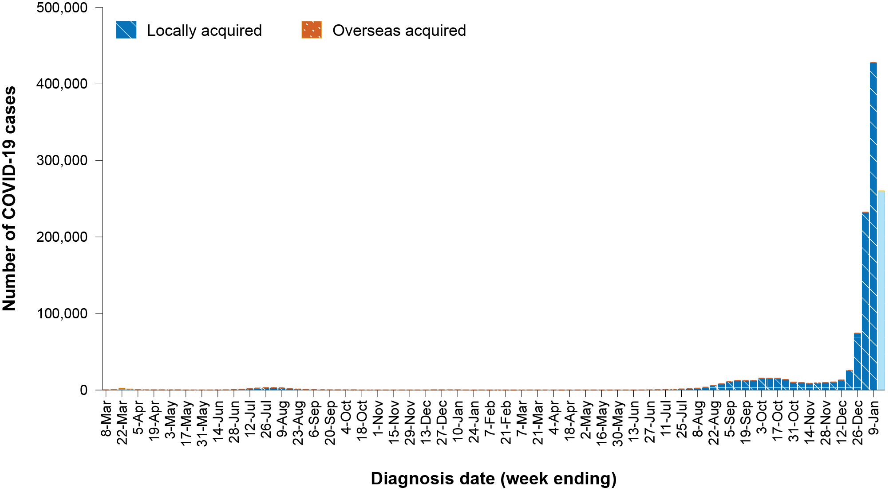
a Source: NINDSS, extract from 17 January 2022 for notifications to 16 January 2022.
b The lighter bar at the right represents the most recent reporting week and should be interpreted with caution as additional cases may be identified in the coming week that have a diagnosis date during this period.

Source of acquisition

(NINDSS)
As case numbers have increased, the capacity to identify the source of acquisition has been reduced across all jurisdictions. In the last six weeks, 12% (125,724/1,036,995) cases were categorised as acquired within the reporting jurisdiction; 3,847 (< 1%) were categorised as interstate acquired; 928 (< 0.1%) were categorised as overseas acquired; 64% (664,280/1,036,995) were under initial investigation and 23% (242,216/1,036,995) were missing a source of acquisition (Table 1). For the purposes of this report, all cases other than those that were categorised as overseas acquired are considered to be locally acquired.
In the fortnight ending 19 December 2021, Victoria reported the majority of locally-acquired cases (55%; 17,898/32,661). In the two most recent fortnightly periods, New South Wales reported the most locally acquired cases: 50% (100,941/202,911) in the fortnight ending 2 January and 39% (316,176/800,494) in the fortnight ending 16 January 2022.
In 2021, Victoria had the highest notification rate for locally-acquired cases with 2,431 notifications per 100,000 population, followed by New South Wales with a rate of 2,015 notifications per 100,000 population. In all jurisdictions, the locally-acquired case notification rate has been higher in 2022 to date than in the entirety of 2021 (Table 2).
Table 2: Locally-acquired COVID-19 case numbers and rates per 100,000 population by jurisdiction and reporting period, Australia, by date of notification, 1 January 2021 to 16 January 2022ª
Jurisdiction | Reporting period |  |  | 2022 |  | 2021
 | 3–16 January 2022 | 20 December 2021 – 2 January 2022 | 6–19 December 2021 | 1 January – 16 January 2022 |  | 1 January – 31 December 2021
 | Number of cases^{b} | Number of cases^{b} | Number of cases^{b} | Number of cases^{b} | Rate per 100,000 population^{c} | Number of cases^{b} | Rate per 100,000 population^{c}
ACT | 15,731 | 3,179 | 117 | 16,661 | 3,862.7 | 4,401 | 1,020.3
NSW | 316,176 | 100,941 | 13,969 | 343,426 | 4,204.6 | 164,619 | 2,015.4
NT | 923 | 434 | 53 | 1,100 | 446.6 | 392 | 159.2
Qld | 148,121 | 27,262 | 166 | 158,097 | 3,054.4 | 17,756 | 343.0
SA | 35,611 | 16,726 | 450 | 40,495 | 2,287.2 | 12,376 | 699.0
Tas. | 8,248 | 1,762 | 8 | 9,079 | 1,678.9 | 946 | 174.9
Vic. | 275,611 | 52,582 | 17,898 | 291,186 | 4,348.2 | 162,821 | 2,431.4
WA | 73 | 25 | 0 | 78 | 2.9 | 36 | 1.4
Australia | 800,494 | 202,911 | 32,661 | 860,122 | 3,347.0 | 363,347 | 1,413.9
a Source: NINDSS, extract from 17 January 2022 for notifications from 1 January 2021 to 16 January 2022.
b This total includes cases under initial investigation and those with a missing source of acquisition; it excludes overseas-acquired cases and with a missing source of acquisition. In reports prior to report 52, cases under initial investigation or missing a source of acquisition were excluded from this total.
c Population data based on Australian Bureau of Statistics (ABS) Estimated Resident Population (ERP) as at June 2020. The ABS June 2020 ERP was ACT: 431,325; NSW: 8,168,893; NT: 246,283; Qld: 5,176,044; SA: 1,770,494; Tas.: 540,781; Vic.: 6,696,630; WA: 2,663,976; Australia: 25,698,093.
In the six-week reporting period, New South Wales reported the largest number of overseas-acquired cases (39%; 364/928), followed by Victoria (31%; 292/928) (Table 1). Of the 928 overseas acquired cases in the last six weeks, 34% (315/928) of confirmed overseas-acquired cases reported to the NINDSS had an unknown country of acquisition. Cases acquired in the United Kingdom (23%; 142/613) were the most numerous of those with an identified country of acquisition in the past six weeks, followed by the United States of America (16%; 95/613).
Since May 2021, the proportion of air arrivals diagnosed with COVID-19 has remained at less than 1%. On 1 November 2021, several states changed quarantine requirements for vaccinated arrivals. Since then, there has been a substantial increase in the number of air arrivals; however, the proportion of overseas-acquired cases amongst these arrivals has remained less than 1%. The number of cases acquired in different countries is influenced by travel patterns of returning Australians, travel restrictions, and the prevalence of COVID-19 in the country of travel.

Demographic features

(NINDSS)
Over the six-week reporting period, there was a shift in the age group most commonly notified. In the fortnight ending 19 December 2021, the highest notification rate was in children aged 5–11 years (225 per 100,000 population), while in the most recent fortnight (fortnight ending 16 January 2022), the highest notification rate (6,526 per 100,000 population) was in adults aged 18–29 years. Over the entire six-week reporting period, more than a third of cases occurred in people aged 18 to 29 years (35%; 360,228/1,036,995) (Appendix A, Table A.1). From 1 January 2021 to 16 January 2022, the highest notification rates were among adults aged 18 to 29, which is mainly reflective of the high levels of transmission in this age group in the last six weeks (Figure 2). Prior to 6 December 2021, the highest notification rate was in children aged 5 to 11 years. The median age of cases in this reporting period was 29 years (range: 0 to 110 years; interquartile range, IQR: 21 to 45 years).
Figure 2: Cumulative COVID-19 cases for 2021–2022, by age group and sex, Australia, 1 January 2021 – 16 January 2022^{a,b}
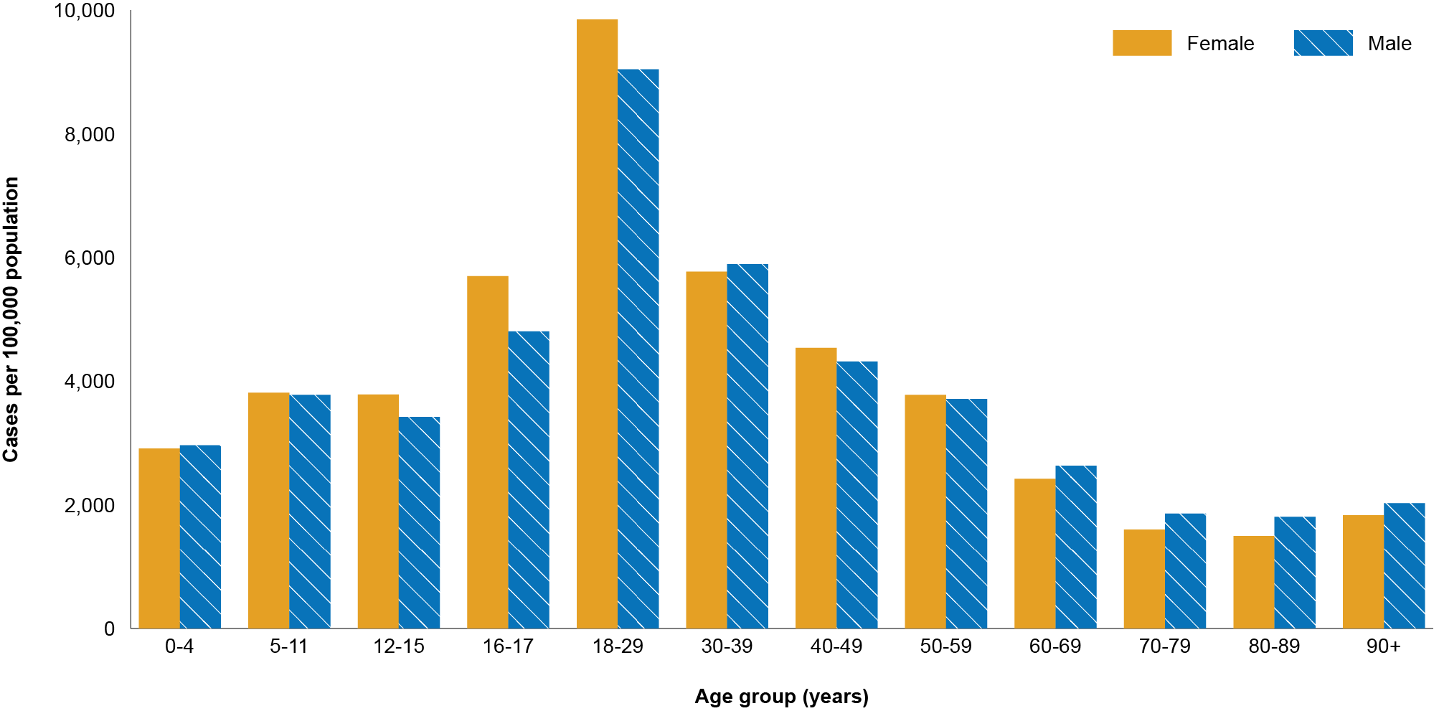
a Source: NINDSS, extract from 17 January 2022 for notifications from 1 January 2021 to 16 January 2022.
b Note that, from Epidemiology Report 55 onwards, the age groups have been changed to match those used to report severity.

Aboriginal and Torres Strait Islander persons

(NINDSS)
During the reporting period, there were 20,322 new cases notified in Aboriginal and Torres Strait Islander people. The number of notified cases increased markedly over the six weeks, in line with increases in the general community. There were 829 cases reported in the fortnight ending 19 December 2021, a further 3,855 cases reported in the fortnight ending 2 January 2022 and 15,638 cases reported in the fortnight ending 16 January 2022 (Table 3). In particular, the latest six-week reporting period has seen large numbers of cases notified in Aboriginal and Torres Strait Islander people in jurisdictions such as Queensland, Tasmania and South Australia, where the caseload had previously been much lower.

Table 3: Confirmed cases of COVID-19 among Aboriginal and Torres Strait Islander peoples by jurisdiction and calendar year, by date of notification, 1 January 2021 – 16 January 2022ª
State | 3–16 January 2022 | 20 December 2021 – 2 January 2022 | 6–19 December 2021 | 2022 to date | 2021
Australian Capital Territory | 239 | 62 | 3 | 254 | 287
New South Wales | 7,937 | 2,282 | 569 | 8,567 | 9,124
Northern Territory | 64 | 102 | 49 | 85 | 184
Queensland | 4,613 | 753 | 4 | 4,888 | 497
South Australia | 759 | 227 | 1 | 828 | 160
Tasmania | 172 | 22 | 1 | 182 | 14
Victoria | 1,852 | 407 | 202 | 1,967 | 2,129
Western Australia | 2 | 0 | 0 | 2 | 1
Total | 15,638 | 3,855 | 829 | 16,773 | 12,396
a Source: NINDSS, extract from 17 January 2022 for notifications from 1 January 2021 to 16 January 2022.
Since the beginning of 2021, there have been 29,169 confirmed cases of COVID-19 notified in Aboriginal and Torres Strait Islander people, representing 2% (29,169/1,226,505) of all confirmed cases. Of the locally-acquired cases notified in Aboriginal and Torres Strait Islander people from 1 January 2021 to date, 41% (11,974/29,148) resided in a regional or remote area (Table 4).
Table 4: Confirmed cases of COVID-19 among Aboriginal and Torres Strait Islander peoples by place of acquisition and area of remoteness, 1 January 2021 – 16 January 2022ª
 | Locally acquired, Australia^{b} |  |  |  |  |  | Overseas acquired | Total
Jurisdiction | Major city | Inner regional | Outer regional | Remote^{c} | Overseas resident | Unknown
ACT | 524 | 11 | 4 | 0 | 0 | 2 | 0 | 541
NSW | 10,744 | 4,882 | 1,483 | 467 | 9 | 93 | 13 | 17,691
NT | 0 | 0 | 56 | 196 | 0 | 14 | 3 | 269
Qld | 2,343 | 974 | 1,634 | 333 | 1 | 97 | 3 | 5,385
SA | 703 | 92 | 109 | 54 | 7 | 23 | 0 | 988
Tas. | 2 | 132 | 59 | 3 | 0 | 0 | 0 | 196
Vic. | 2,604 | 1,097 | 388 | 0 | 0 | 6 | 1 | 4,096
WA | 2 | 0 | 0 | 0 | 0 | 0 | 1 | 3
Australia | 16,922 | 7,188 | 3,733 | 1,053 | 17 | 235 | 21 | 29,169
a Source: NINDSS, extract from 17 January 2022 for notifications from 1 January 2021 to 16 January 2022.
b ‘Locally acquired’ includes cases under initial investigation and missing a source of acquisition. Note, in reports prior to report 52, ‘locally acquired’ excluded cases under initial investigation.
c ‘Remote’ here also includes areas classified as ‘very remote’.
Since the start of the pandemic, up to 16 January 2022, there have been 29,328 confirmed cases of COVID-19 reported in Aboriginal and Torres Strait Islander people, representing 2% (29,328/1,254,909) of all confirmed cases. In the past four weeks, the completeness of the Indigenous status field in NINDSS has decreased, corresponding with a rapid increase in case numbers, resulting in detailed epidemiological information not being available for all cases. Therefore, the number of cases classified as in Aboriginal and Torres Strait Islander people is likely an underrepresentation. Overall, since the start of the pandemic, Indigenous status is unknown for approximately 49% (616,378/1,254,909) of confirmed cases.
To date, the vast majority of Aboriginal and Torres Strait Islander cases have been reported as locally acquired (> 99%; 29,275/29,328), with 53 cases that were overseas acquired. The median age of locally-acquired Aboriginal and Torres Strait Islander cases was 23 years old (range: 0 to 99 years; IQR: 14 to 36 years). Overall, 53% of cases were female.
Nationally, there have been 31 deaths reported in Aboriginal and Torres Strait Islander people since the start of the pandemic, with 26 from New South Wales, three from Victoria, and one each from the Northern Territory and Queensland. An additional 116 Aboriginal and Torres Strait Islander cases have been admitted to intensive care units (ICU) nationally and 1,376 have been admitted to hospital.
Given the delay between onset and the development of severe illness, cases with an illness onset in the last two weeks are excluded from analyses on the rates of severe illness. From late October to mid-December 2021, the notification rate of cases with severe illness (measured as those who were admitted to ICU or died) among Aboriginal and Torres Strait Islander people remained steady in most jurisdictions. Notification rates of severe cases have increased in the most recent data period (week ending 2 January 2022). Between 1 January 2021 and 2 January 2022, 0.2% of cases in Aboriginal and Torres Strait Islander people were reported to have died, 0.7% of cases required intensive care and a further 7.2% were admitted to hospital (Table 5). Note that hospitalisation data in NINDSS should be interpreted with caution: hospitalisation is not always reflective of severe illness, as cases may be hospitalised for reasons other than clinical COVID-19-related care; additionally, hospitalisation and ICU status in NINDSS is likely incomplete.

Table 5. COVID-19 cases in Aboriginal and Torres Strait Islander people by age and highest level of illness severity, Australia, 1 January 2021 to 2 January 2022^{a,b}
Age group | Count |  |  |  |  | % of total cases by age group
 | Not severe | Hospitalised only  (not ICU or died) | ICU  (but not died) | Died | Total cases | Hospitalised only  (not ICU or died) | ICU  (but not died) | Died
0–4 | 1,417 | 91 | 0 | 0 | 1,508 | 6.0% | 0.0% | 0.0%
5–11 | 2,394 | 65 | 2 | 0 | 2,461 | 2.6% | 0.1% | 0.0%
12–15 | 1,179 | 49 | 2 | 0 | 1,230 | 4.0% | 0.2% | 0.0%
16–17 | 598 | 31 | 3 | 0 | 632 | 4.9% | 0.5% | 0.0%
18–29 | 4,476 | 299 | 17 | 0 | 4,792 | 6.2% | 0.4% | 0.0%
30–39 | 2,052 | 206 | 19 | 0 | 2,277 | 9.0% | 0.8% | 0.0%
40–49 | 1,236 | 168 | 20 | 3 | 1,427 | 11.8% | 1.4% | 0.2%
50–59 | 838 | 104 | 24 | 6 | 972 | 10.7% | 2.5% | 0.6%
60–69 | 331 | 80 | 15 | 8 | 434 | 18.4% | 3.5% | 1.8%
70–79 | 126 | 41 | 7 | 5 | 179 | 22.9% | 3.9% | 2.8%
80–89 | 29 | 14 | 0 | 4 | 47 | 29.8% | 0.0% | 8.5%
90+ | 2 | 2 | 0 | 1 | 5 | 40.0% | 0.0% | 20.0%
Unknown | 47 | 0 | 0 | 0 | 47 | 0.0% | 0.0% | 0.0%
Total | 14,725 | 1,150 | 109 | 27 | 16,011 | 7.2% | 0.7% | 0.2%
a Excludes cases with a symptom onset within the last two weeks given the delay between onset and severe illness. Cases with no symptoms reported have been excluded if the date of swab collection was within the previous two weeks.
b Data includes all cases reported to be hospitalised, including those that may be hospitalised for reasons other than clinical COVID-19 related care, so should be interpreted with caution when inferring severity.

Vaccinations

(Department of Health)
As of 16 January 2022, a total of 45,954,013 doses of COVID-19 vaccine had been administered (Table 6), including 1,184,475 doses provided to aged care and disability residents. Nationally, 19,597,960 people aged 16 years or over (95%) had received at least one dose. This includes 19,082,286 people aged 16 years or over (92.5%) who were fully vaccinated (Table 6). Among people aged 12–15 years, 1,012,626 people (81.4%) had received at least one dose, including 933,566 (75%) who were fully vaccinated. Among people aged 5–11 years, 295,106 (12.9%) had received at least one dose. Nationally, 4,998,093 people aged 18 and over had received more than two doses.

Table 6: Total number of vaccinations administered, by jurisdiction, Australia, 16 January 2022ª
Jurisdiction | Total number of doses administered | Percentage of people aged 16 and over who have had at least one dose^{b} | Percentage of people aged 16 and over who are fully vaccinated
ACT | 1,115,357 | > 99% | > 99%
NSW | 14,668,888 | 95.2% | 93.8%
NT | 451,683 | 90.0% | 86.0%
Qld | 8,924,242 | 91.5% | 88.7%
SA | 3,133,091 | 93.1% | 86.7%
Tas. | 1,013,343 | 98.7% | 95.2%
Vic. | 12,102,240 | 94.0% | 92.7%
WA | 4,545,169 | 94.1% | 87.6%
Aged care and disability facilities^{c} | 1,184,475 | NA | NA
Primary care^{d} | 26,727,590 | NA | NA
Total | 45,954,013 | 95.0% | 92.5%
a Source: Australian Government Department of Health website.⁴
b Includes people who are fully vaccinated.
c Commonwealth vaccine doses administered in aged care and disability facilities.
d Commonwealth vaccine doses administered in primary care settings.

Severity

(NINDSS, SPRINT-SARI)
Given the delay between illness onset and severe illness, to provide a more accurate assessment of severity, cases with an onset in the last two weeks were excluded from the analysis. From the start of the reporting period to 26 December 2021, the national notification rate of cases with severe illness (defined as cases admitted to ICU or died) was relatively stable at approximately 0.4 per 100,000 population. However, in the most recent severity reporting week (week ending 2 January 2022), the rate of severe illness has more than doubled to 0.9 per 100,000 nationally, associated with an increase in the overall case notification rate to 903 per 100,000 in the same period. The current rate of severe illness remains lower than during peak of the Delta outbreak, when the rate of severe illness reached 1.2 per 100,000. The recent increase in the rate of severe disease has been highest in people aged 70 and over (Figure 3).
From 1 February 2021 to 16 January 2022, there were 2,769 COVID-19 cases admitted to ICUs participating in the sentinel surveillance system, Short Period Incidence Study of Severe Acute Respiratory Infection (SPRINT-SARI),⁵ with 518 of these admitted during this reporting period (6 December 2021 – 16 January 2022).

Risk factors for severe disease
Comorbidity data extracted from SPRINT-SARI reflect the sickest patients with COVID-19 managed in ICU; data are therefore not generalisable to all cases (Table 7). In patients admitted to ICU with COVID-19 since 1 February 2021, the most prevalent comorbidity was obesity (a body mass index of > 30 or weight over 120 kg), followed by diabetes. Of those adult patients admitted to ICU since 1 February 2021 for whom comorbidity data was known, 65% (1,495/2,299) had at least one comorbidity; 35% (804/2,299) of patients had none of the listed comorbidities recorded.

Figure 3: Age-specific rates of COVID-19 cases admitted to ICU or died, by date of diagnosis, Australia, 28 December 2020 to 2 January 2022ª
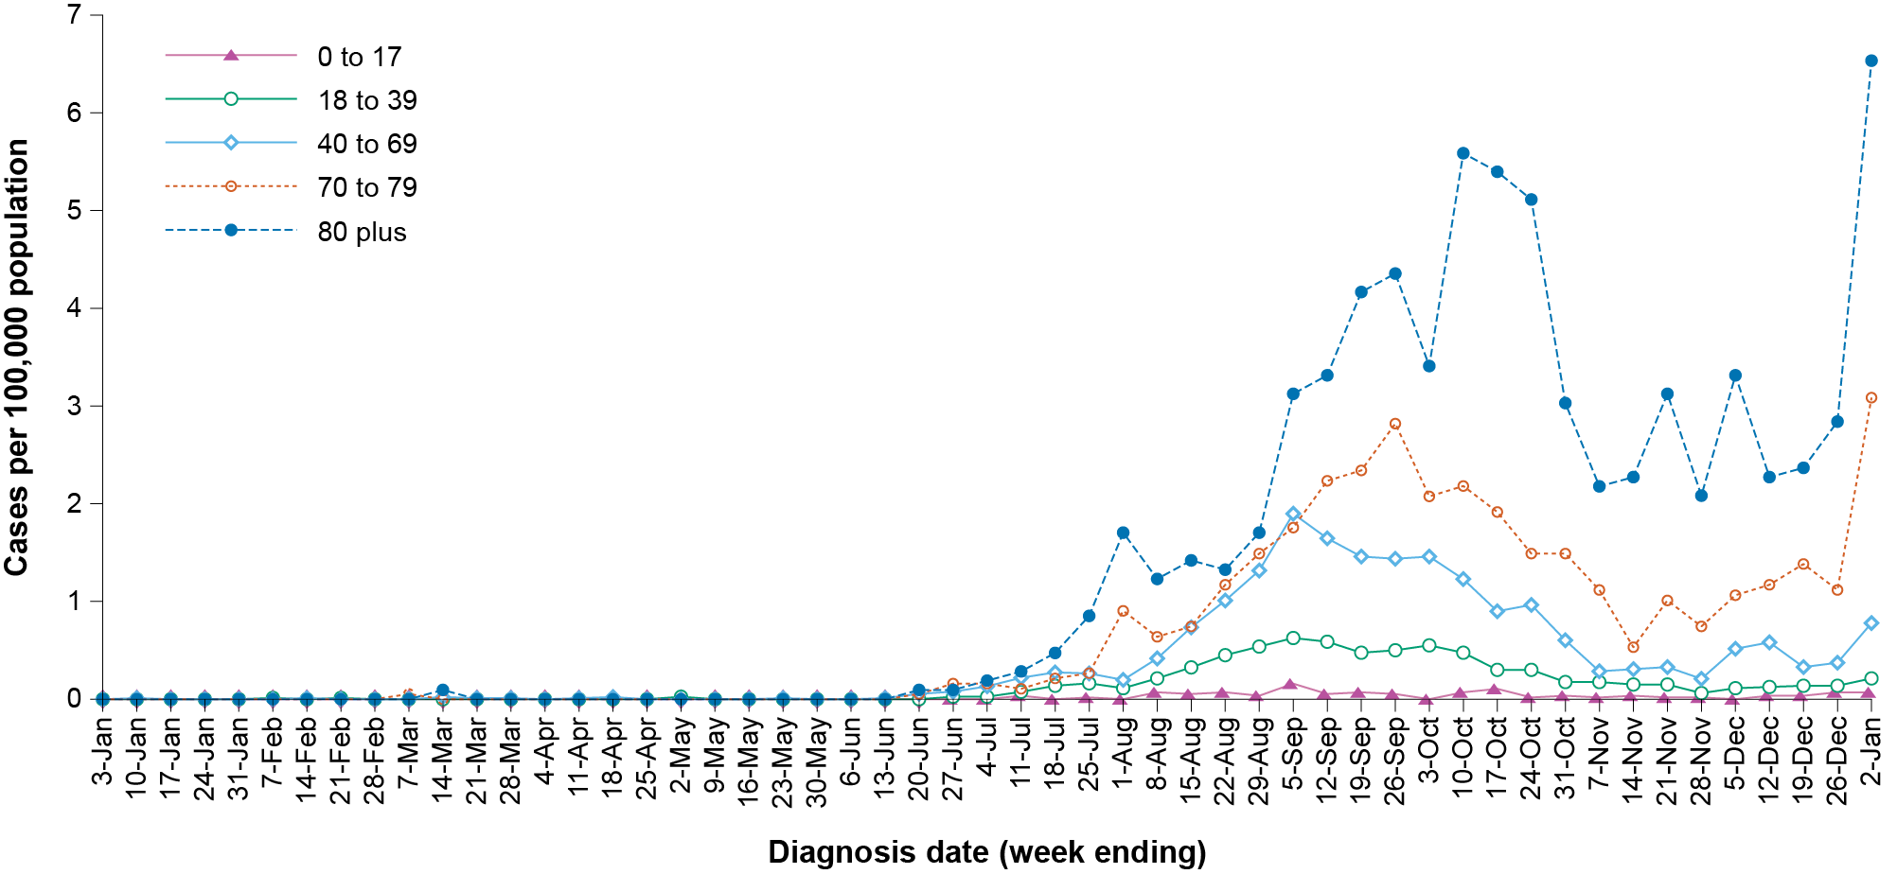
a NINDSS, extract from 17 January 2022. Includes cases notified from 1 January 2021, with an illness onset up to 2 January 2022; cases with an illness onset in the last two weeks (3 -16 January 2022) were excluded to account for the delay between onset and development of severe illness.
Table 7: Comorbidities for adult COVID-19 cases (aged greater than or equal to 18 years) amongst those admitted to ICU, Australia, 1 February 2021 – 16 January 2022ª
Comorbidity | ICU casesª (n = 2,299) (%)
Cardiac disease (n = 2,283) | 290 (13)
Chronic respiratory condition (n = 2,286) ^{b} | 383 (17)
Diabetes (n = 2,280) | 676 (30)
Obesity (n = 2,233) | 736 (33)
Chronic renal disease (n = 2,281) | 150 (7)
Chronic neurological condition (n = 2,281) | 71 (3)
Malignancy (n = 2,285) | 88 (4)
Chronic liver disease (n = 2,285) | 59 (3)
Immunosuppression (n = 2,279) | 128 (6)
Number of specified comorbidities (n = 2,299) ^{a,b,c}
One or more | 1,495 (65)
Two or more | 704 (31)
Three or more | 180 (11)
No comorbidities | 804 (35)
a Source: SPRINT-SARI.⁵ Only includes adult cases (≥ 18 years old) and excludes those with missing data on comorbidities or where comorbidity is unknown.
b Includes asthma.
c Includes chronic respiratory conditions, cardiac disease (excluding hypertension), immunosuppressive condition/therapy, diabetes, obesity, liver disease, renal disease and neurological disorder.

COVID-19 deaths
In the most recent reporting fortnight (3–16 January 2022), there were 246 deaths associated with COVID-19: 166 in New South Wales, 45 in Victoria, 20 in South Australia, 13 in Queensland and two in the Australian Capital Territory. The number of deaths associated with COVID-19 has increased over the last six weeks, with 61 deaths reported in the fortnight of 6–19 December 2021 and 91 in the fortnight of 20 December 2021 – 2 January 2022. This brings the total number of COVID-19-associated deaths among cases reported in NINDSS to 2,608 (Table 8).
Table 8: Deaths associated with COVID-19 by reporting period, Australia, 1 January 2020 – 16 January 2022ª
Reporting period | Number of deaths
Reporting period 6–19 December 2021 | 61
Reporting period 20 December 2021 – 2 January 2022 | 91
Reporting period 3–16 January 2022 | 246
Year to date (2022) 1 January – 16 January 2022 | 264
1 January – 31 December 2021 | 1,319
1 January – 31 December 2020 | 908
Epidemic to date 1 January – 16 January 2022^{b} | 2,608
a Source: NINDSS, extract from 17 January 2022 for deaths to 16 January 2022.
b Due to 117 cases with a missing date of death, the number of deaths by year will not sum to the total number of deaths.

Genomic surveillance and virology

(Communicable Disease Genomics Network, AusTrakka and jurisdictional sequencing laboratories)
Nationally, 4.05% of COVID-19 cases have had SARS-CoV-2 isolates sequenced since the start of the pandemic, based on jurisdictional reporting (Table 9). Case numbers and sequencing proportion are based on polymerase chain reaction (PCR) results only, as rapid antigen tests do not allow for sequencing. The significant rise in case numbers nationally during this reporting period has required jurisdictional laboratories to sample isolates to sequence for surveillance purposes, resulting in a drop in the proportion sequenced. However, overall output of number of cases sequenced per reporting period remains similar to, or higher than, previous reporting periods (Figure 4).

Table 9: Australian SARS-CoV-2 genome sequences and proportion of positive cases sequenced, 6 December 2021 – 16 January 2022 and cumulative to date
Measure | Reporting period  6 December 2021 – 16 January 2022 | Cumulative  23 January 2020 – 16 January 2022
SARS-CoV-2 cases sequencedª | 14,811 | 62,102
Percentage of positive cases sequenced^{b} | 1.07% | 4.05%
a Based on individual jurisdictional reports of sequences and case numbers. Calculations of the percentage of cases sequenced based on the number of sequences available in AusTrakka may not always be up-to-date, since this may include duplicate samples from cases and may not represent all available sequence data.
b Total SARS-CoV-2 case numbers as reported by jurisdictional laboratories based on PCR results only. Cases identified via rapid antigen testing are reported differently by each jurisdiction and cannot be followed up for sequencing. They are therefore not included in the sequencing proportions reported here. Sequencing of samples from cases identified in the reporting period may be in process at the time of reporting. Remaining unsequenced samples may be due to jurisdictional sequencing strategy, or where samples have been deemed unsuitable for sequencing (typically because viral loads were too low for sequencing to be successful).

Figure 4: Samples in AusTrakka from 2 August 2021 to 16 January 2022, by lineage and date of collectionª
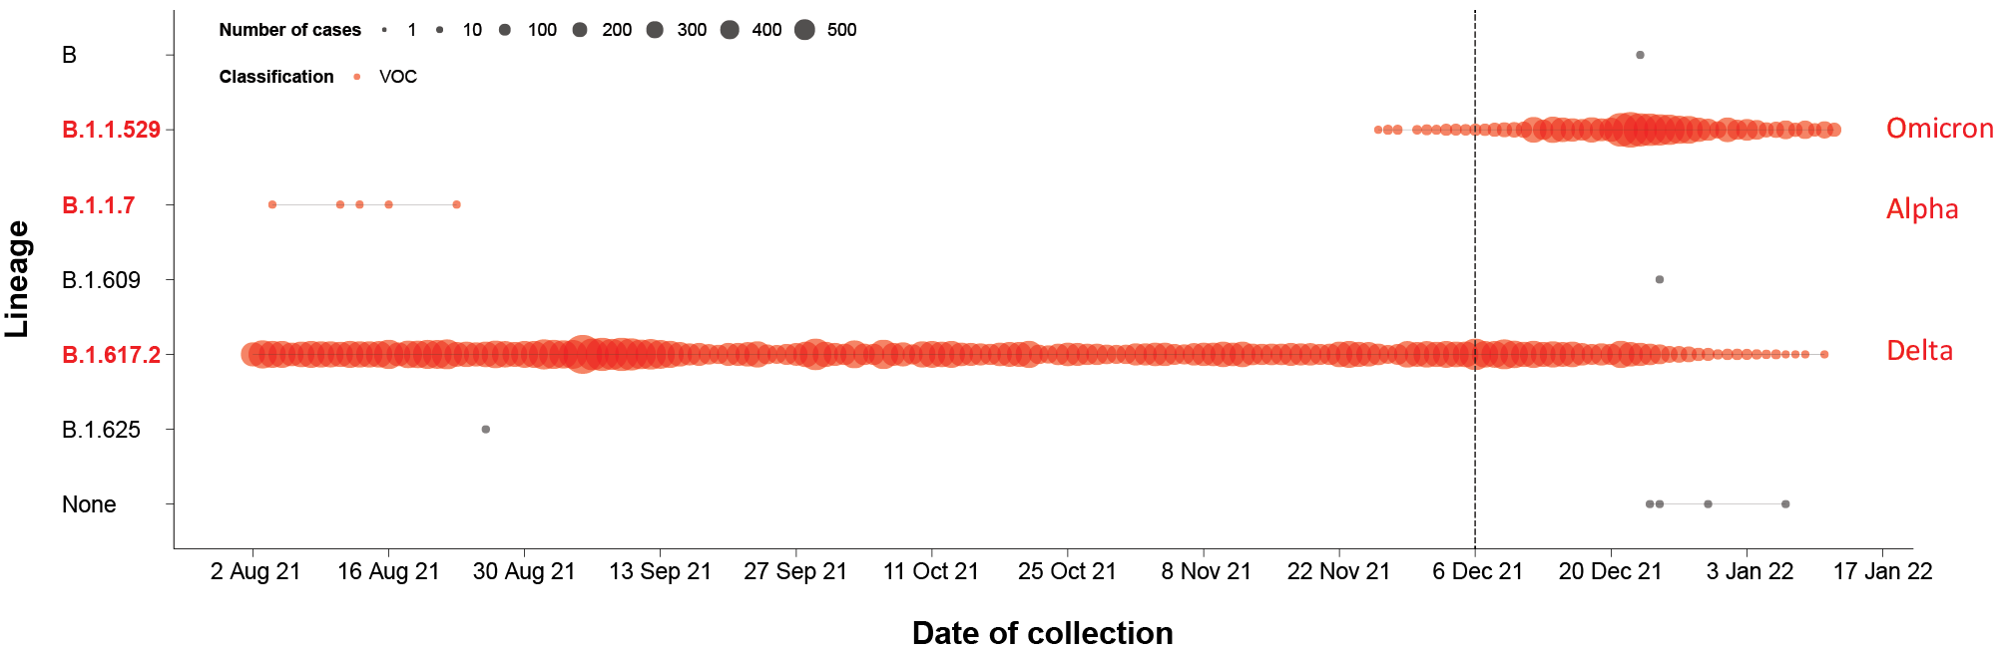
a Source: testing data provided by jurisdictions to the NIR daily, current to 16 January 2022; population data based on Australian Bureau of Statistics (ABS) Estimated Resident Population (ERP) as at June 2020.

Variants of concern
AusTrakka is actively monitoring and reporting on the five lineages designated VOCs by international organisations, including the World Health Organization: Alpha (B.1.1.7); Beta (B.1.351); Gamma (P.1); Delta (B.1.617.2) and Omicron (B.1.1.529) (Table 10). Omicron emerged in Southern Africa in November 2021,⁷ and was designated a VOC by the WHO on 26 November 2021.⁸ All five variants display characteristic sets of mutation, including a number of variations in the genomic region encoding the spike protein thought to have the potential to increase transmissibility and/or immune evasion.^{9,10} On 1 June 2021, WHO announced a new nomenclature system for VOCs, using letters of the Greek alphabet,¹¹ to facilitate communication and reduce stigmatisation associated with geography-based colloquial terms. On 27 September 2021, Kappa (B.1.617.1), which had been classified as a VOC in Australia, was reclassified as a Variant of Interest (VOI) by the Communicable Diseases Genomics Network Variants of Concern Taskforce. As such, Kappa is no longer included in AusTrakka VOC reporting.
Further information on variants is available in the Technical Supplement.²
Table 10: Australian SARS-CoV-2 genome sequences in AusTrakka identified as variants of concern, 23 January 2020 – 16 January 2022ª
VOC lineage | Number of samples
B.1.1.7 (Alpha)^{b} | 515
B.1.351 (Beta) | 84
P.1 (Gamma) | 6
B.1.617.2 (Delta)^{c} | 30,411
B.1.1.529 (Omicron)^{d} | 5,402
a The number of sequences may have reduced from previous reports due to de-duplication and the adoption of a new genomic coverage threshold.
b Includes Q sublineages.
c Includes AY sublineages.
d Includes Omicron-like sequences.

Testing

(State and territory reporting)
From the commencement of the pandemic to 16 January 2022, over 58 million COVID-19 PCR tests have been conducted nationally. From 6 December 2021 to 16 January 2022, over 10 million tests were conducted, with over 1.2 million PCR tests conducted each week. Jurisdictional testing rates are driven by current case numbers, testing policies and numbers of people experiencing symptoms.
There has been an increase in PCR testing rates since early December 2021 (Figure 5). In the last two weeks of the reporting period, PCR testing rates have decreased slightly, which is likely the result of the increased use of RATs for COVID-19 diagnosis.
From the week ending 12 December 2021 to the week ending 9 January 2022, while testing rates remained high, the percent positivity increased considerably across all jurisdictions, with the percent positivity reaching above 20% for all jurisdictions except Northern Territory, South Australia and Western Australia (Figure 6). In the week ending 16 January 2021, there was a decrease in the percent positivity across most jurisdictions, which may be due to changes in testing policies in which a PCR test was no longer required following a positive RAT.

Figure 5: SARS-CoV-2 polymerase chain reaction (PCR) testing rates per 1,000 population per week by jurisdiction, by date of notification, 28 December 2020 – 16 January 2022ª
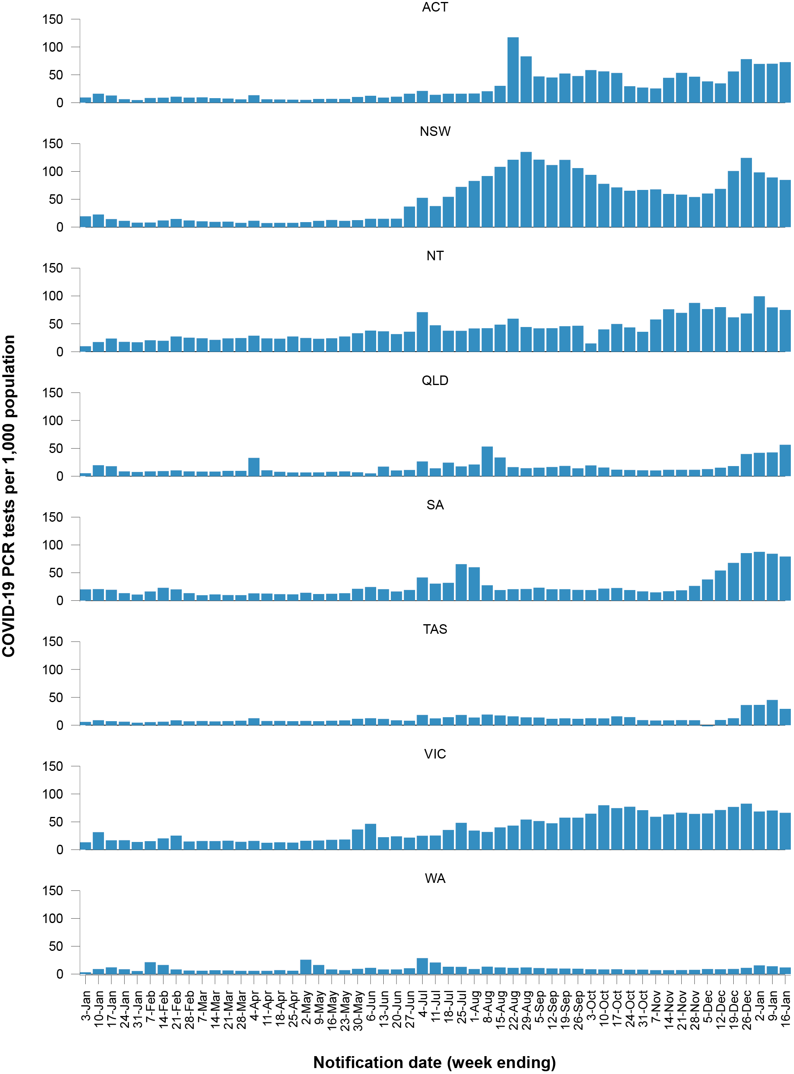
a Source: testing data provided by jurisdictions to the NIR daily, current to 16 January 2022; case data extracted from NINDSS on 17 January 2022 for cases with a notification date up to 16 January 2022; population data based on Australian Bureau of Statistics (ABS) Estimated Resident Population (ERP) as at June 2020.
Figure 6: Percent positivity of SARS-CoV-2 polymerase chain reaction (PCR) tests by date of notification, Australia, 28 December 2020 – 16 January 2022ª
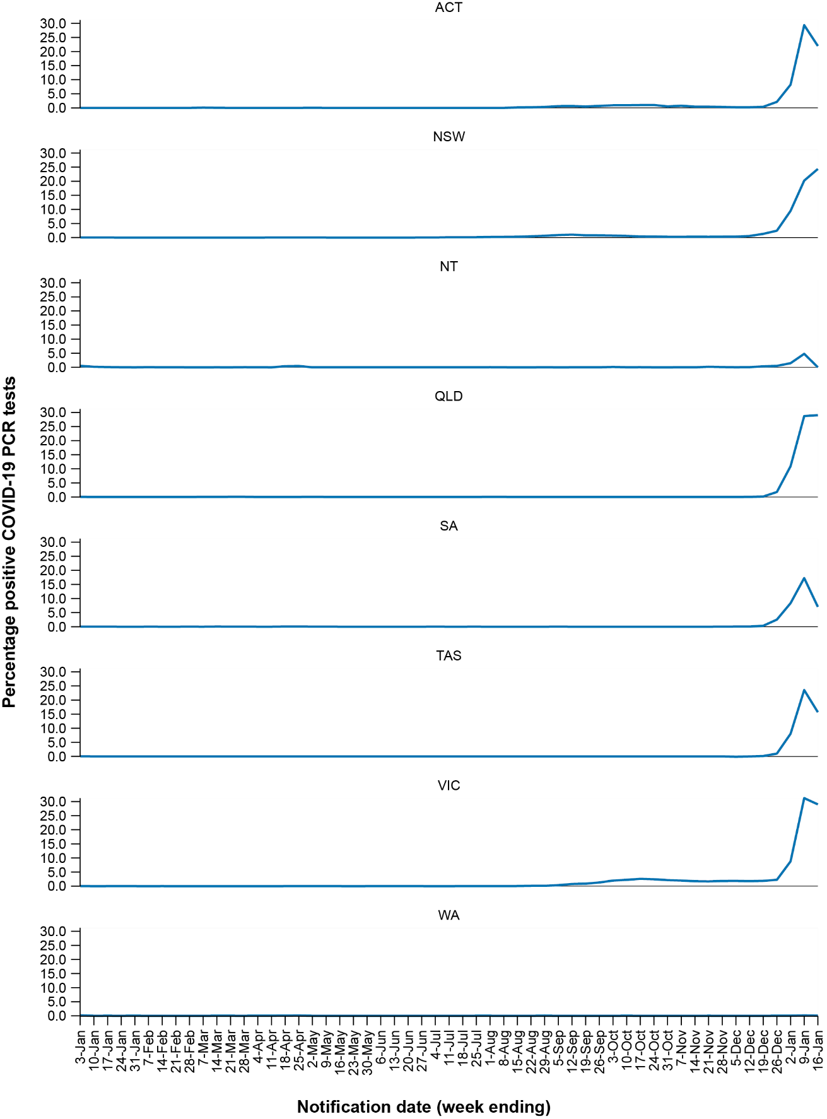

Acute respiratory illness

(FluTracking, ASPREN, and Commonwealth Respiratory Clinics)
Based on self-reported FluTracking data,¹² prevalence of fever and cough in the community increased since mid-December 2021 from 0.35% in the week ending 12 December 2021 to 1.06% the week ending 16 January 2022 (Figure 7). Pertinently, the prevalence of fever and cough in the community reached 1.55% during the week ending 09 January 2022, which is the highest rate of fever and cough since early March 2020. Runny nose and sore throat symptoms in the community increased to 0.98% during the week ending 9 January 2022, prior to decreasing to 0.68% at the end of the reporting period.
In this reporting period, acute respiratory illness was highest in those aged 20 to 39 years, based on both self-reported FluTracking data and presentations to Commonwealth Respiratory Clinics. Overall, females reported respiratory illness more frequently than males. Rates of runny nose and sore throat were higher amongst females than males, at 9.5 per 1000 FluTracking participants to 6.2 per 1000 FluTracking participants respectively, although rates of fever and cough were slightly higher amongst males. Rates of fever and cough by jurisdiction ranged from 2.2 per 1,000 FluTracking participants in Western Australia to 11.5 per 1,000 participants in New South Wales. Rates of runny nose and sore throat ranged from 4.4 per 1,000 FluTracking participants in Western Australia to 10.0 per 1,000 FluTracking participants in the Victoria.
From the week ending 12 December 2021, FluTracking data indicated that 57% of those in the community with ‘fever and cough’ were tested for SARS-CoV-2 with a PCR test and 50% were tested using a RAT. Of those with ‘runny nose and sore throat’, 32% were tested for SARS-CoV-2 using a PCR test and 38% were tested using a RAT. In the most recent four-week period (20 December 2021 to 16 January 2022), testing rates for fever and cough were highest in Victoria for PCR (71%) and in New South Wales for RATs (64%), and lowest in Western Australia for both testing methodologies. Testing rates for runny nose and sore throat were highest in South Australia for PCR (54%)
and in New South Wales for RATs (52%), and lowest in Western Australia for both tests. It is important to acknowledge that there may be legitimate reasons why people did not get tested, including barriers to accessing testing. Symptoms reported to FluTracking are not specific to COVID-19 and may also be due to chronic diseases.
From 20 December 2021, there were 307,587 assessments at Commonwealth Respiratory Clinics. Of these, there were 278,500 assessments with consent to share information, with 95% (264,775/278,500) tested for SARS-CoV-2.

Figure 7: Weekly trends in respiratory illness amongst FluTracking survey participants (age-standardised) compared to the average of the previous five years, Australia, by epidemiological week,ª 1 March 2020 – 16 January 2022^{b}
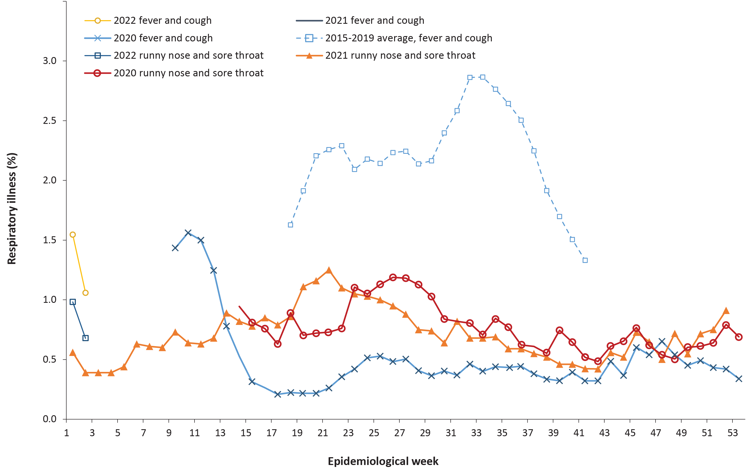
a Epidemiological weeks are a standardised method for numbering weeks across years, with the first epidemiological week of any year ending on the first Saturday in January.
b In years prior to 2020, FluTracking was activated during the main Influenza season from May to October. A historical average beyond the week ending 11 October (epidemiological week 41) is therefore not available. In 2020, FluTracking commenced ten weeks early to capture data for COVID-19. Data on runny nose and sore throat were only collected systematically after 29 March 2020, therefore a historical average for this symptom profile is unavailable.

Figure 8: COVID-19 notifications in Australia by week of diagnosis and jurisdiction, 30 August 2021 – 16 January 2022, with timing of key public health measures
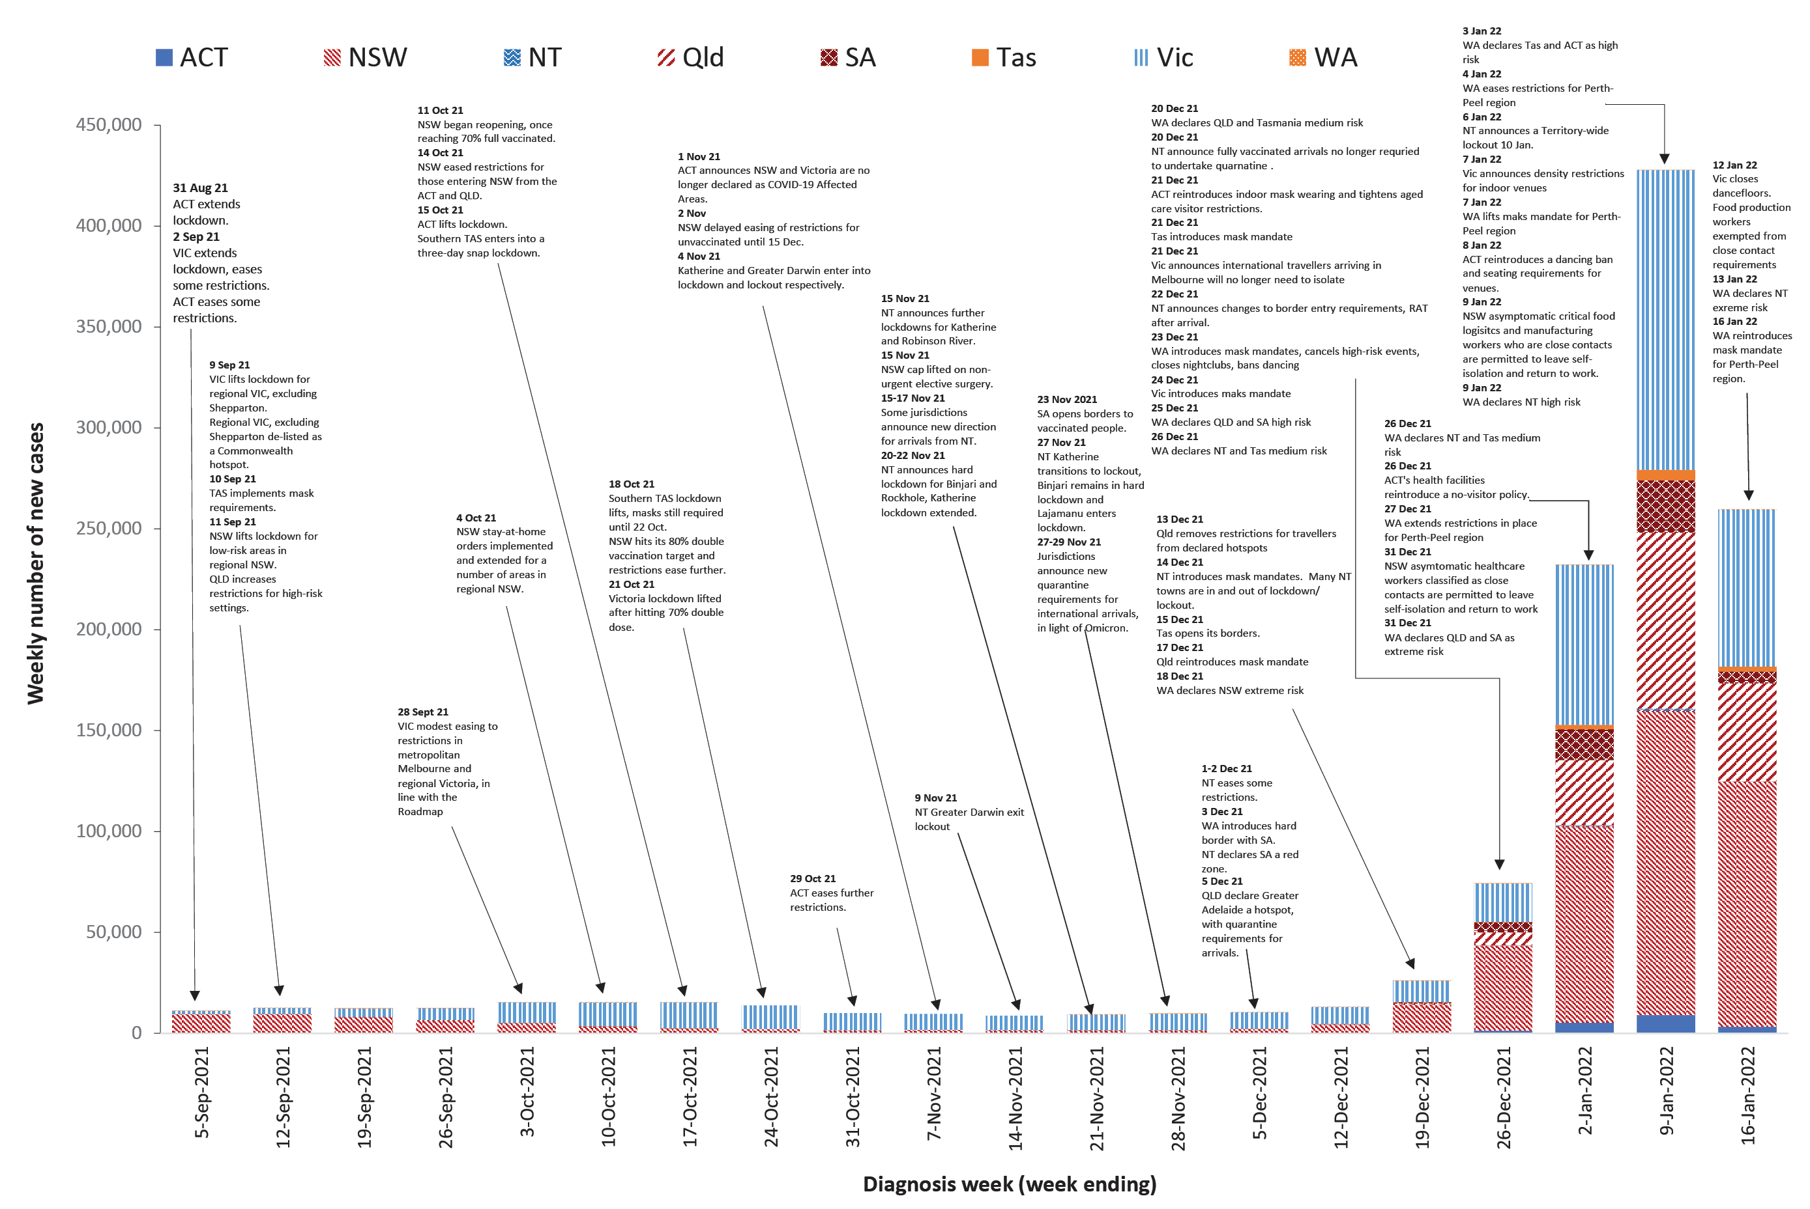

Public health response measures
Since COVID-19 first emerged internationally, Australia has implemented public health measures informed by the disease’s epidemiology. States and territories have decision making authority in relation to public health measures and have implemented or eased restrictions at different times (Figure 8; Appendix A, Table A.3), depending on the local public health and epidemiological situation, and in line with the ‘Framework for National Reopening’.¹³ Nationwide requirements regarding air travel, including pre-flight testing for travellers entering Australia and requirements to wear face masks when flying domestically or internationally, remain in place.

Countries and territories in Australia’s near region
According to WHO, countries and territories in the South East Asian and Western Pacific regions reported 4,934,388 newly-confirmed cases and 21,573 deaths in the four-week period to 16 January 2022, bringing the cumulative cases in the two regions to over 60 million, and cumulative deaths in these regions to over 889,000.¹⁴ Case numbers in the South East Asian region have increased considerably this reporting period, driven by increasing cases in India. However, the number of new deaths in the last four weeks has declined in the South East Asian region compared to the previous four weeks. Similarly, the number of new cases in the Western Pacific region in the past four weeks has increased compared to the previous four-week period, while the number of new deaths has decreased. The increase of new cases in the Western Pacific region during the four-week period to 16 January 2022 has largely been driven by cases in Australia.¹⁵
Table 11 outlines the new cases and deaths in the four-week period to 16 January 2022 and cumulative cases and deaths for the pandemic in selected countries with the highest number of new cases in the South East Asian region and the Western Pacific region.
As of 16 January 2022, over 323 million COVID-19 cases and 5.5 million deaths have been reported globally since the start of the pandemic, with a global case fatality rate (CFR) of 1.7%. The two regions reporting the largest burden of disease over the past four weeks were the European region (49% of cases) and the region of the Americas (37% of cases).
Table 11: Cumulative cases and deaths, and new cases and deaths reported in the four-week period to 16 January 2022 for selected countries in Australia’s near region according to WHOª
Country | Cumulative cases | New cases reported in the last 4 weeks | Change in new cases in the last 4 weeks^{b} | Cumulative deaths | New deaths reported in the last 4 weeks | Change in new deaths in the last 4 weeks^{b}
South East Asian region
India | 37,122,164 | 2,381,889 | +936% | 486,066 | 8,644 | -26%
Thailand | 2,324,485 | 132,957 | +5% | 21,925 | 548 | -45%
Bangladesh | 1,617,711 | 36,628 | +424% | 28,144 | 96 | +1%
Nepal | 853,738 | 28,002 | +317% | 11,620 | 47 | -39%
Sri Lanka | 596,347 | 16,662 | -28% | 15,211 | 459 | -27%
Western Pacific region
Australia | 1,323,217 | 1,076,443 | +2061% | 2,633 | 491 | +141%
Viet Nam | 2,007,862 | 483,494 | +10% | 35,480 | 6129 | +8%
Philippines | 3,168,242 | 330,868 | +2408% | 52,858 | 2,183 | -42%
Republic of Korea | 692,173 | 127,077 | -15% | 6,310 | 1,588 | +10%
Japan | 1,852,958 | 123,181 | +3477% | 18,431 | 52 | +63%
a Source: World Health Organization Coronavirus (COVID-19) Dashboard,14 accessed 18 January 2022.
b Percent change in the number of newly confirmed cases/deaths in the most recent four-week period compared to the four weeks prior.

Acknowledgements
We thank public health staff from incident emergency operations centres and public health units in state and territory health departments, and the Australian Government Department of Health, along with state and territory public health laboratories. We thank those who have provided data from surveillance systems, such as Commonwealth respiratory clinics, ASPREN, FluTracking, FluCAN, SPRINT-SARI, Communicable Disease Genomics Network, AusTrakka and jurisdictional sequencing laboratories.

Author details

Corresponding author
COVID-19 National Incident Room Surveillance Team
Australian Government Department of Health, GPO Box 9484, MDP 14, Canberra, ACT 2601. Email: epi.coronavirus@health.gov.au

References
- COVID-19 National Incident Room Surveillance Team. COVID-19 Australia: Epidemiology Report 56: Reporting period ending 5 December 2021. Commun Dis Intell (2018). 2021;45. doi: https://doi.org/10.33321/cdi.2021.45.69.
- COVID-19 National Incident Room Surveillance Team. Technical supplement. COVID-19 Australia: Epidemiology reporting. Commun Dis Intell (2018). 2021;45. doi: https://doi.org/10.33321/cdi.2021.45.2.
- Australian Government Department of Health. Coronavirus disease 2019 (COVID-19): CDNA national guidelines for public health units. [Internet.] Canberra: Australian Government Department of Health; 14 January 2022. [Accessed on 21 January 2022.] Available from: https://www1.health.gov.au/internet/main/publishing.nsf/Content/cdna-song-novel-coronavirus.htm.
- Australian Government Department of Health. Vaccination numbers and statistics. [Internet.] Canberra: Australian Government Department of Health; 2022. [Accessed on 17 January 2022.] Available from: https://www.health.gov.au/initiatives-and-programs/covid-19-vaccines/numbers-statistics.
- Australian and New Zealand Intensive Care Research Centre (ANZIC-RC). SPRINT-SARI: Short period incidence study of severe acute respiratory infection. [Internet.] Melbourne: Monash University, ANZIC-RC; 2020. Available from: https://www.monash.edu/medicine/sphpm/anzicrc/research/sprint-sari.
- Communicable Diseases Genomics Network (CDGN). AusTrakka. [Website.] Melbourne: CDGN; 2020. Available from: https://www.cdgn.org.au/austrakka.
- Network for Genomic Surveillance in South Africa (NGS-SA). Recording: Briefing on COVID-19 and vaccination programme developments 25 November 2021. [Video recording.] Durban: NGS-SA; 25 November 2021. [Accessed on 10 December 2021.] Available from: https://sacoronavirus.co.za/2021/11/25/recording-briefing-on-covid-19-and-vaccination-programme-developments-25-november-2021/.
- World Health Organization (WHO). Classification of Omicron (B.1.1.529): SARS-CoV-2 Variant of Concern. [Internet.] Geneva: WHO; 26 November 2021. [Accessed on 10 Decmber 2021.] Available from: https://www.who.int/newsroom/statements/26-11-2021-classification-of-omicron-(b.1.1.529)-sars-cov-2-variant-of-concern.
- World Health Organization (WHO). Coronavirus disease (COVID-19) Weekly Epidemiological Update and Weekly Operational Update. [Internet.] Geneva: WHO; June 2021. [Accessed on 14 October 2021.] Available from: https://www.who.int/emergencies/diseases/novel-coronavirus-2019/situation-reports/.
- Allen H, Vusirikala A, Flannagan J, Twohig KA, Zaidi A, Groves N et al. Increased household transmission of COVID-19 cases associated with SARS-CoV-2 Variant of Concern B.1.617.2: a national case-control study. Knowledge Hub (khub); 2021. [Accessed on 14 October 2021.] Available from: https://khub.net/documents/135939561/405676950/Increased+Household+Transmission+of+COVID-19+Cases+-+national+case+study.pdf/7f7764fb-ecb0-da31-77b3-b1a8ef7be9aa.
- WHO. Tracking SARS-CoV-2 variants. [Internet.] Geneva: WHO; 15 June 2021. [Accessed on 14 October 2021.] Available from: https://www.who.int/en/activities/tracking-SARS-CoV-2-variants/.
- Dalton C, Durrheim D, Fejsa J, Francis L, Carlson S, d’Espaignet ET et al. Flutracking: a weekly Australian community online survey of influenza-like illness in 2006, 2007 and 2008. Commun Dis Intell Q Rep. 2009;33(3):316–22.
- Australian Government Department of Health. Framework for national reopening – October 2020. [Internet.] Canberra: Australian Government Department of Health; 23 October 2020. [Accessed on 10 November 2020.] Available from: https://www.health.gov.au/resources/publications/framework-for-national-reopening-october-2020.
- WHO. WHO Coronavirus Disease (COVID-19) dashboard. [Internet.] Geneva: WHO; 2021. Available from: https://covid19.who.int/.
- WHO. Weekly epidemiological update on COVID-19 – 18 January 2022. [Internet.] Geneva: WHO; 18 January 2022. [Accessed on 19 January 2022.] Available from: https://www.who.int/publications/m/item/weekly-epidemiological-update-on-covid-19---18-january-2022.
- Australian Capital Territory Government. Updates to requirements for COVID-19 close contacts and travel. [Internet.] Canberra: Australian Capital Territory Government; 15 December 2021. [Accessed on 18 January 2022.] Available from: https://www.covid19.act.gov.au/news-articles/updates-to-requirements-for-covid-19-close-contacts-and-travel-to-the-act.
- Australian Capital Territory Government. ACT reintroduces indoor mask wearing and aged care visitor restrictions. [Internet.] Canberra: Australian Capital Territory Government; 21 December 2021. [Accessed on 18 January 2022.] Available from: https://www.covid19.act.gov.au/news-articles/act-reintroduces-indoor-mask-wearing-and-aged-care-visitor-restrictions.
- Australian Capital Territory Government. Hospital visitor restrictions to tighten after Christmas. [Internet.] Canberra: Australian Capital Territory Government; 23 December 2021. [Accessed on 18 January 2022.] Available from: https://www.covid19.act.gov.au/news-articles/hospital-visitor-restrictions-to-tighten-after-christmas.
- Australian Capital Territory Government. ACT COVID-19 Update – 28 December 2021. [Internet.] Canberra: Australian Capital Territory Government; 28 December 2021. [Accessed on 18 January 2022.] Available from: https://www.covid19.act.gov.au/news-articles/act-covid-19-update-28-december-2021.
- Australian Capital Territory Government. National Cabinet meeting - 30 December 2021. [Internet.] Canberra: Australian Capital Territory Government; 30 December 2021. [Accessed on 18 January 2022.] Available from: https://www.covid19.act.gov.au/news-articles/act-chief-minister-statement-on-national-cabinet-meeting-30-december-2021.
- Australian Capital Territory Government. Changes to quarantine requirements for close contacts. [Internet.] Canberra: Australian Capital Territory Government; 30 December 2021. [Accessed on 18 January 2022.] Available from: https://www.covid19.act.gov.au/news-articles/changes-to-quarantine-requirements-for-close-contacts.
- Australian Capital Territory Government. ACT COVID-19 Update – 31 December 2021. [Internet.] Canberra: Australian Capital Territory Government; 31 December 2021. [Accessed on 18 January 2022.] Available from: https://www.covid19.act.gov.au/news-articles/act-covid-19-update-31-december-2021.
- Australian Capital Territory Government. Additional COVID-19 public health measures. [Internet.] Canberra: Australian Capital Territory Government; 7 January 2022. [Accessed on 18 January 2022.] Available from: https://www.covid19.act.gov.au/news-articles/additional-covid-19-public-health-measures.
- Australian Capital Territory Government. Rapid Antigen Test results now reportable through ACT COVID-19 website. [Internet.] Canberra: Australian Capital Territory Government; 12 January 2022. [Accessed on 18 January 2022.] Available from: https://www.covid19.act.gov.au/news-articles/rapid-antigen-test-results-now-reportable-through-act-covid-19-website.
- Government of New South Wales Department of Health (NSW Health). Quarantine requirement for travellers from southern Africa removed. [Internet.] Sydney: Government of New South Wales, NSW Health; 14 December 2021. [Accessed on 18 January 2022.] Available from: https://www.health.nsw.gov.au/news/Pages/20211214_02.aspx.
- NSW Health. Modified COVID-19 isolation guidelines for healthcare staff. [Internet.] Sydney: Government of New South Wales, NSW Health; 27 December 2021. [Accessed on 18 January 2022.] Available from: https://www.health.nsw.gov.au/news/Pages/20211227_01.aspx.
- NSW Health. Isolation exemption for health workers. [Internet.] Sydney: Government of New South Wales, NSW Health; 31 December 2021. [Accessed on 18 January 2022.] Available from: https://www.health.nsw.gov.au/news/Pages/20211231_02.aspx.
- NSW Health. Isolation exemption for workers critical to food supply. [Internet.] Sydney: Government of New South Wales, NSW Health; 9 January 2022. [Accessed on 18 January 2022.] Available from: https://www.health.nsw.gov.au/news/Pages/20220109_00.aspx.
- NSW Health. Isolation exemption for critical workers expanded. [Internet.] Sydney: Government of New South Wales, NSW Health; 14 January 2022. [Accessed on 18 January 2022.] Available from: https://www.health.nsw.gov.au/news/Pages/20220114_00.aspx.
- Northern Territory Government. Three new cases recorded in the NT, Katherine lockout extended. [Internet.] Darwin: Northern Territory Government; 6 December 2021. [Accessed on 9 December 2021.] Available from: https://coronavirus.nt.gov.au/updates/items/201-12-06-three-new-cases-recorded-in-the-nt,-katherine-lockout-extended.
- Northern Territory Government. No new cases recorded in the NT, Lajamanu exits lockout. [Internet.] Darwin: Northern Territory Government; 7 December 2021. [Accessed on 19 January 2022.] Available from: https://coronavirus.nt.gov.au/updates/items/2021-12-07-no-new-cases-recorded-in-the-nt,-lajamanu-exits-lockout.
- Northern Territory Government. Keeping Territorians Safe as the Territory Prepares to Reopen. [Internet.] Darwin: Northern Territory Government; 9 December 2021. [Accessed on 19 January 2022.] Available from: https://coronavirus.nt.gov.au/updates/items/2021-12-09-keeping-territorians-safe-as-the-territory-prepares-to-reopen.
- Northern Territory Government. COVID-19 Update: One new case recorded, positive wastewater. [Internet.] Darwin: Northern Territory Government; 11 December 2021. [Accessed on 19 January 2022.] Available from: https://coronavirus.nt.gov.au/updates/items/2021-12-11-covid-19-update-one-new-case-recorded,-positive-wastewater.
- Northern Territory Government. NT COVID-19 update. [Internet.] Darwin: Northern Territory Government; 14 December 2021. [Accessed on 19 January 2022.] Available from: https://coronavirus.nt.gov.au/updates/items/2021-12-14-nt-covid-19-update.
- Northern Territory Government. Kalkarindji, Daguragu & Timber Creek, Gilwi to enter lockout. [Internet.] Darwin: Northern Territory Government; 14 December 2021. [Accessed on 19 January 2022.] Available from: https://coronavirus.nt.gov.au/updates/items/2021-12-14-kalkarindji,-daguragu-and-timber-creek,-gilwi-to-enter-lockout.
- Northern Territory Government. NT COVID-19 update. [Internet.] Darwin: Northern Territory Government; 17 December 2021. [Accessed on 19 January 2022.] Available from: https://coronavirus.nt.gov.au/updates/items/2021-12-17-nt-covid-19-update.
- Northern Territory Government. NT COVID-19 update. [Internet.] Darwin: Northern Territory Government; 19 December 2021. [Accessed on 19 January 2022.] Available from: https://coronavirus.nt.gov.au/updates/items/2021-12-19-nt-covid-19-update.
- Northern Territory Government. NT COVID-19 update: Ali Curung in lockdown. [Internet.] Darwin: Northern Territory Government; 19 December 2021. [Accessed on 19 January 2022.] Available from: https://coronavirus.nt.gov.au/updates/items/2021-12-19-nt-covid-19-update-ali-curung-in-lockdown.
- Northern Territory Government. NT COVID-19 update. [Internet.] Darwin: Northern Territory Government; 20 December 2021. [Accessed on 19 January 2022.] Available from: https://coronavirus.nt.gov.au/updates/items/2021-12-20-nt-covid-19-update.
- Northern Territory Government. NT COVID-19 update. [Internet.] Darwin: Northern Territory Government; 22 December 2021. [Accessed on 19 January 2022.] Available from: https://coronavirus.nt.gov.au/updates/items/2021-12-22-nt-covid-19-update.
- Northern Territory Government. NT COVID-19 update. [Internet.] Darwin: Northern Territory Government; 31 December 2021. [Accessed on 19 January 2022.] Available from: https://coronavirus.nt.gov.au/updates/items/2021-12-31-nt-covid-19-update.
- Northern Territory Government. NT COVID-19 update. [Internet.] Darwin: Northern Territory Government; 4 January 2022. [Accessed on 19 January 2022.] Available from: https://coronavirus.nt.gov.au/updates/items/2022-01-04-nt-covid-19-update.
- Northern Territory Government. NT COVID-19 update. [Internet.] Darwin: Northern Territory Government; 6 January 2022. [Accessed on 19 January 2022.] Available from: https://coronavirus.nt.gov.au/updates/items/2022-01-06-nt-covid-19-update.
- Northern Territory Government. NT COVID-19 update. [Internet.] Darwin: Northern Territory Government; 10 January 2022. [Accessed on 19 January 2022.] Available from: https://coronavirus.nt.gov.au/updates/items/2022-01-10-nt-covid-19-update.
- Northern Territory Government. NT COVID-19 update. [Internet.] Darwin: Northern Territory Government; 13 January 2022. [Accessed on 19 January 2022.] Available from: https://coronavirus.nt.gov.au/updates/items/2022-01-13-nt-covid-19-update.
- Northern Territory Government. NT COVID-19 update. [Internet.] Darwin: Northern Territory Government; 14 January 2022. [Accessed on 19 January 2022.] Available from: https://coronavirus.nt.gov.au/updates/items/2022-01-14-nt-covid-19-update.
- Northern Territory Government. NT COVID-19 update. [Internet.] Darwin: Northern Territory Government; 16 January 2022. [Accessed on 19 January 2022.] Available from: https://coronavirus.nt.gov.au/updates/items/2022-01-16-nt-covid-19-update.
- Queensland Government. Queensland Borders Re-open. [Internet.] Brisbane: Queensland Government, Department of the Premier and Cabinet; 6 December 2021. [Accessed on 19 January 2022.] Available from: https://statements.qld.gov.au/statements/93994.
- Queensland Government. Masks mandated to prevent the spread of COVID-19. [Internet.] Brisbane: Queensland Government, Department of the Premier and Cabinet; 17 December 2021. [Accessed on 19 January 2022.] Available from: https://statements.qld.gov.au/statements/94137.
- Queensland Government. Quarantine period for close contacts halved to 7 days. [Internet.] Brisbane: Queensland Government, Department of the Premier and Cabinet; 21 December 2021. [Accessed on 19 January 2022.] Available from: https://statements.qld.gov.au/statements/94168.
- Queensland Government. Day 5 testing requirement changes in Queensland. [Internet.] Brisbane: Queensland Government, Department of the Premier and Cabinet; 28 December 2021. [Accessed on 19 January 2022.] Available from: https://statements.qld.gov.au/statements/94192.
- Queensland Government. Rapid Antigen Tests. [Internet.] Brisbane: Queensland Government, Department of the Premier and Cabinet; 29 December 2021. [Accessed on 19 January 2022.] Available from: https://statements.qld.gov.au/statements/94196.
- Queensland Government. Mask up indoors. [Internet.] Brisbane: Queensland Government, Department of the Premier and Cabinet; 1 January 2022. [Accessed on 19 January 2022.] Available from: https://statements.qld.gov.au/statements/94209.
- Queensland Government. Non-urgent elective surgeries postponed. [Internet.] Brisbane: Queensland Government, Department of the Premier and Cabinet; 8 January 2022. [Accessed on 19 January 2022.] Available from: https://statements.qld.gov.au/statements/94231.
- Queensland Government. 2022 school year to start on February 7. [Internet.] Brisbane: Queensland Government, Department of the Premier and Cabinet; 9 January 2022. [Accessed on 19 January 2022.] Available from: https://statements.qld.gov.au/statements/94234.
- Queensland Government. Rule change to ensure critical work goes ahead. [Internet.] Brisbane: Queensland Government, Department of the Premier and Cabinet; 9 January 2022. [Accessed on 19 January 2022.] Available from: https://statements.qld.gov.au/statements/94235.
- Queensland Government. Queensland’s border changes. [Internet.] Brisbane: Queensland Government, Department of the Premier and Cabinet; 13 January 2022. [Accessed on 19 January 2022.] Available from: https://statements.qld.gov.au/statements/94253.
- SA Health. COVID-19 update 397. [Internet.] Adelaide: Government of South Australia, SA Health; 7 December 2021. [Accessed on 20 January 2022.] Available from: https://www.sahealth.sa.gov.au/wps/wcm/connect/public+content/sa+health+internet/conditions/infectious+diseases/covid-19/about+covid-19/latest+updates/covid-19+round+up+reports/covid-19+update+397.
- SA Health. COVID-19 update 400. [Internet.] Adelaide: Government of South Australia, SA Health; 10 December 2021. [Accessed on 20 January 2022.] Available from: https://www.sahealth.sa.gov.au/wps/wcm/connect/public+content/sa+health+internet/conditions/infectious+diseases/covid-19/about+covid-19/latest+updates/covid-19+round+up+reports/covid-19+update+400.
- SA Health. COVID-19 update 401. [Internet.] Adelaide: Government of South Australia, SA Health; 14 December 2021. [Accessed on 20 January 2022.] Available from: https://www.sahealth.sa.gov.au/wps/wcm/connect/public+content/sa+health+internet/conditions/infectious+diseases/covid-19/about+covid-19/latest+updates/covid-19+round+up+reports/covid-19+update+401.
- SA Health. COVID-19 update 403. [Internet.] Adelaide: Government of South Australia, SA Health; 15 December 2021. [Accessed on 20 January 2022.] Available from: https://www.sahealth.sa.gov.au/wps/wcm/connect/public+content/sa+health+internet/conditions/infectious+diseases/covid-19/about+covid-19/latest+updates/covid-19+round+up+reports/covid-19+update+403.
- SA Health. COVID-19 update 405. [Internet.] Adelaide: Government of South Australia, SA Health; 21 December 2021. [Accessed on 20 January 2022.] Available from: https://www.sahealth.sa.gov.au/wps/wcm/connect/public+content/sa+health+internet/conditions/infectious+diseases/covid-19/about+covid-19/latest+updates/covid-19+round+up+reports/covid-19+update+405.
- SA Health. COVID-19 update 406. [Internet.] Adelaide: Government of South Australia, SA Health; 22 December 2021. [Accessed on 20 January 2022.] Available from: https://www.sahealth.sa.gov.au/wps/wcm/connect/public+content/sa+health+internet/conditions/infectious+diseases/covid-19/about+covid-19/latest+updates/covid-19+round+up+reports/covid-19+update+406.
- SA Health. COVID-19 update 407. [Internet.] Adelaide: Government of South Australia, SA Health; 24 December 2021. [Accessed on 20 January 2022.] Available from: https://www.sahealth.sa.gov.au/wps/wcm/connect/public+content/sa+health+internet/conditions/infectious+diseases/covid-19/about+covid-19/latest+updates/covid-19+round+up+reports/covid-19+update+407.
- SA Health. COVID-19 update 408. [Internet.] Adelaide: Government of South Australia, SA Health; 29 December 2021. [Accessed on 20 January 2022.] Available from: https://www.sahealth.sa.gov.au/wps/wcm/connect/public+content/sa+health+internet/conditions/infectious+diseases/covid-19/about+covid-19/latest+updates/covid-19+round+up+reports/covid-19+update+408.
- SA Health. COVID-19 update 409. [Internet.] Adelaide: Government of South Australia, SA Health; 15 December 2021. [Accessed on 20 January 2022.] Available from: https://www.sahealth.sa.gov.au/wps/wcm/connect/public+content/sa+health+internet/conditions/infectious+diseases/covid-19/about+covid-19/latest+updates/covid-19+round+up+reports/covid-19+update+409.
- SA Health. COVID-19 update 410. [Internet.] Adelaide: Government of South Australia, SA Health; 4 January 2022. [Accessed on 20 January 2022.] Available from: https://www.sahealth.sa.gov.au/wps/wcm/connect/public+content/sa+health+internet/conditions/infectious+diseases/covid-19/about+covid-19/latest+updates/covid-19+round+up+reports/covid-19+update+410.
- SA Health. COVID-19 update 417. [Internet.] Adelaide: Government of South Australia, SA Health; 13 January 2022. [Accessed on 20 January 2022.] Available from: https://www.sahealth.sa.gov.au/wps/wcm/connect/public+content/sa+health+internet/conditions/infectious+diseases/covid-19/about+covid-19/latest+updates/covid-19+round+up+reports/covid-19+update+417.
- SA Health. COVID-19 update 418. [Internet.] Adelaide: Government of South Australia, SA Health; 14 January 2022. [Accessed on 20 January 2022.] Available from: https://www.sahealth.sa.gov.au/wps/wcm/connect/public+content/sa+health+internet/conditions/infectious+diseases/covid-19/about+covid-19/latest+updates/covid-19+round+up+reports/covid-19+update+418.
- SA Health. COVID-19 update 419. [Internet.] Adelaide: Government of South Australia, SA Health; 17 January 2022. [Accessed on 20 January 2022.] Available from: https://www.sahealth.sa.gov.au/wps/wcm/connect/public+content/sa+health+internet/conditions/infectious+diseases/covid-19/about+covid-19/latest+updates/covid-19+round+up+reports/covid-19+update+419.
- Premier of Tasmania. PRESS CONFERENCE - 10 DECEMBER 2021. [Internet.] Hobart: Tasmanian Government, Office of the Premier; 10 December 2021. [Accessed on 20 January 2022.] Available from: https://www.premier.tas.gov.au/covid-19_updates/press_conference_-_10_december_2021.
- Premier of Tasmania. PRESS CONFERENCE - 16 DECEMBER 2021. [Internet.] Hobart: Tasmanian Government, Office of the Premier; 16 December 2021. [Accessed on 20 January 2022.] Available from: https://www.premier.tas.gov.au/covid-19_updates/press_conference_-_16_december_2022.
- Premier of Tasmania. Masks to be mandatory for indoor settings. [Internet.] Hobart: Tasmanian Government, Department of the Premier and Cabinet; 19 December 2021. [Accessed on 20 January 2022.] Available from: https://www.coronavirus.tas.gov.au/media-releases/masks-to-be-mandatory-for-indoor-settings.
- Tasmanian Government. COVID-19 testing changes for Tasmania. [Internet.] Hobart: Tasmanian Government, Department of the Premier and Cabinet; 31 December 2021. [Accessed on 20 January 2022.] Available from: https://www.coronavirus.tas.gov.au/media-releases/covid-19-testing-changes-for-tasmania.
- Victoria State Government Department of Health and Human Services (DHHS). Coronavirus update for Victoria – 12 December 2021. [Internet.] Melbourne: Victoria State Government, DHHS; 12 December 2021. [Accessed on 21 January 2022.] Available from: https://www.health.vic.gov.au/media-releases/coronavirus-update-for-victoria-12-december-2021.
- DHHS. Public health update. [Internet.] Melbourne: Victoria State Government, DHHS; 15 December 2021. [Accessed on 21 January 2022.] Available from: https://www.health.vic.gov.au/media-releases/public-health-update.
- Premier of Victoria. Updated Public Health Protections To Keep Victorians Safe. [Internet.] Melbourne: Victoria State Government, Office of the Premier; 15 December 2021. [Accessed on 21 January 2022.] Available from: https://www.premier.vic.gov.au/updated-public-health-protections-keep-victorians-safe-0.
- DHHS. Coronavirus update for Victoria – 18 December 2021. [Internet.] Melbourne: Victoria State Government, DHHS; 18 December 2021. [Accessed on 21 January 2022.] Available from: https://www.health.vic.gov.au/media-releases/coronavirus-update-for-victoria-18-december-2021.
- DHHS. Coronavirus update for Victoria – 24 December 2021. [Internet.] Melbourne: Victoria State Government, DHHS; 24 December 2021. [Accessed on 21 January 2022.] Available from: https://www.health.vic.gov.au/media-releases/coronavirus-update-for-victoria-24-december-2021.
- Premier of Victoria. Testing Changes To Focus On Highest-Risk Victorians. [Internet.] Melbourne: Victoria State Government, Office of the Premier; 31 December 2021. [Accessed on 21 January 2022.] Available from: https://www.premier.vic.gov.au/testing-changes-focus-highest-risk-victorians.
- DHHS. Coronavirus update for Victoria – 6 January 2022. [Internet.] Melbourne: Victoria State Government, DHHS; 6 January 2022. [Accessed on 21 January 2022.] Available from: https://www.health.vic.gov.au/media-releases/coronavirus-update-for-victoria-6-january-2022.
- DHHS. Coronavirus update for Victoria – 7 January 2022. [Internet.] Melbourne: Victoria State Government, DHHS; 7 January 2022. [Accessed on 21 January 2022.] Available from: https://www.health.vic.gov.au/media-releases/coronavirus-update-for-victoria-7-january-2022.
- Premier of Victoria. Keeping Victorian Workers In Key Sectors Safe. [Internet.] Melbourne: Victoria State Government, Office of the Premier; 10 January 2022. [Accessed on 21 January 2022.] Available from: https://www.premier.vic.gov.au/keeping-victorian-workers-key-sectors-safe.
- DHHS. Coronavirus update – 13 January 2022. [Internet.] Melbourne: Victoria State Government, DHHS; 13 January 2022. [Accessed on 21 January 2022.] Available from: https://www.health.vic.gov.au/media-releases/coronavirus-update-13-january-2022.
- Government of Western Australia. WA to proceed with Safe Transition Plan from February 5, 2022. [Internet.] Perth: Government of Western Australia, Department of the Premier and Cabinet; 13 December 2021. [Accessed on 21 January 2022.] Available from: https://www.wa.gov.au/government/announcements/wa-proceed-safe-transition-plan-february-5-2022.
- Government of Western Australia. New South Wales to transition to an ‘extreme risk’ jurisdiction. [Internet.] Perth: Government of Western Australia, Department of the Premier and Cabinet; 15 December 2021. [Accessed on 21 January 2022.] Available from: https://www.wa.gov.au/government/announcements/new-south-wales-transition-extreme-risk-jurisdiction.
- Government of Western Australia. Queensland and South Australia elevated to extreme risk under WA’s controlled border. [Internet.] Perth: Government of Western Australia, Department of the Premier and Cabinet; 30 December 2021. [Accessed on 21 January 2022.] Available from: https://www.wa.gov.au/government/announcements/queensland-and-south-australia-elevated-extreme-risk-under-was-controlled-border.
- Government of Western Australia. Border controls strengthened with Queensland and Tasmania. [Internet.] Perth: Government of Western Australia, Department of the Premier and Cabinet; 17 December 2021. [Accessed on 21 January 2022.] Available from: https://www.wa.gov.au/government/announcements/border-controls-strengthened-queensland-and-tasmania.
- Government of Western Australia. Public health and social measures introduced for Perth and Peel. [Internet.] Perth: Government of Western Australia, Department of the Premier and Cabinet; 23 December 2021. [Accessed on 21 January 2022.] Available from: https://www.wa.gov.au/government/announcements/public-health-and-social-measures-introduced-perth-and-peel.
- Government of Western Australia. Qld and SA to transition to ‘high risk’ from 12.01am Saturday. [Internet.] Perth: Government of Western Australia, Department of the Premier and Cabinet; 24 December 2021. [Accessed on 21 January 2022.] Available from: https://www.wa.gov.au/government/announcements/qld-and-sa-transition-high-risk-1201am-saturday.
- Government of Western Australia. WA introduces hard border with Tasmania and the Northern Territory. [Internet.] Perth: Government of Western Australia, Department of the Premier and Cabinet; 22 December 2021. [Accessed on 21 January 2022.] Available from: https://www.wa.gov.au/government/announcements/wa-introduces-hard-border-tasmania-and-the-northern-territory.
- Government of Western Australia. Public health and social measures to continue until 6:00am, Tuesday 4 January, 2022. [Internet.] Perth: Government of Western Australia, Department of the Premier and Cabinet; 27 December 2021. [Accessed on 21 January 2022.] Available from: https://www.wa.gov.au/government/announcements/public-health-and-social-measures-continue-until-600am-tuesday-4-january-2022.
- Government of Western Australia. Tasmania and ACT elevated to high risk under WA’s controlled border. [Internet.] Perth: Government of Western Australia, Department of the Premier and Cabinet; 1 January 2022. [Accessed on 21 January 2022.] Available from: https://www.wa.gov.au/government/announcements/tasmania-and-act-elevated-high-risk-under-was-controlled-border.
- Government of Western Australia. Tasmania and the ACT elevated to extreme risk under WA’s controlled border. [Internet.] Perth: Government of Western Australia, Department of the Premier and Cabinet; 5 January 2022. [Accessed on 21 January 2022.] Available from: https://www.wa.gov.au/government/announcements/tasmania-and-the-act-elevated-extreme-risk-under-was-controlled-border.
- Government of Western Australia. Eased public health measures from 6am, Tuesday 4 January. [Internet.] Perth: Government of Western Australia, Department of the Premier and Cabinet; 3 January 2022. [Accessed on 21 January 2022.] Available from: https://www.wa.gov.au/government/announcements/eased-public-health-measures-6am-tuesday-4-january.
- Government of Western Australia. Mask mandate eased for Perth and Peel. [Internet.] Perth: Government of Western Australia, Department of the Premier and Cabinet; 7 January 2022. [Accessed on 21 January 2022.] Available from: https://www.wa.gov.au/government/announcements/mask-mandate-eased-perth-and-peel.
- Government of Western Australia. Northern Territory to move to ‘high risk’ under controlled border. [Internet.] Perth: Government of Western Australia, Department of the Premier and Cabinet; 8 January 2022. [Accessed on 21 January 2022.] Available from: https://www.wa.gov.au/government/announcements/northern-territory-move-high-risk-under-controlled-border.
- Government of Western Australia. Northern Territory to move to ‘extreme risk’ under WA’s controlled border. [Internet.] Perth: Government of Western Australia, Department of the Premier and Cabinet; 12 January 2022. [Accessed on 21 January 2022.] Available from: https://www.wa.gov.au/government/announcements/northern-territory-move-extreme-risk-under-was-controlled-border.
- Government of Western Australia. New quarantine arrangements under WA’s controlled border. [Internet.] Perth: Government of Western Australia, Department of the Premier and Cabinet; 13 January 2022. [Accessed on 21 January 2022.] Available from: https://www.wa.gov.au/government/announcements/new-quarantine-arrangements-under-was-controlled-border.
- Government of Western Australia. Masks mandatory for Perth and Peel. [Internet.] Perth: Government of Western Australia, Department of the Premier and Cabinet; 16 January 2022. [Accessed on 21 January 2022.] Available from: https://www.wa.gov.au/government/announcements/masks-mandatory-perth-and-peel.

Appendix A: Supplementary figures and tables
Table A.1: COVID-19 cases and rates per 100,000 population, by age group, sex, and notification received date, Australia, 6 December 2021 – 16 January 2022^{a,b}
Age group^{c} | Reporting period |  |  |  |  |  | Reporting period |  |  |  |  |  | Reporting period
 | 3–16 January 2022 |  |  |  |  |  | 20 December 2021 – 2 January 2022 |  |  |  |  |  | 6–19 December 2021
 | Cases |  |  | Rate per 100,000 population |  |  | Cases |  |  | Rate per 100,000 population |  |  | Cases |  |  | Rate per 100,000 population
 | Male | Female | People | Male | Female | People | Male | Female | People | Male | Female | People | Male | Female | People | Male | Female | People
0–4 | 13,057 | 12,054 | 25,262 | 1,629.9 | 1,595.5 | 1,622.9 | 3,308 | 3,032 | 6,371 | 412.9 | 401.3 | 409.3 | 678 | 563 | 1,250 | 84.6 | 74.5 | 80.3
5–11 | 22,383 | 21,297 | 43,975 | 1,916.1 | 1,921.7 | 1,931.8 | 6,046 | 5,935 | 12,059 | 517.6 | 535.5 | 529.7 | 2,612 | 2,475 | 5,128 | 223.6 | 223.3 | 225.3
12–15 | 12,484 | 13,266 | 25,943 | 1,954.1 | 2,192.7 | 2,085.7 | 3,081 | 3,479 | 6,591 | 482.3 | 575.0 | 529.9 | 593 | 568 | 1,168 | 92.8 | 93.9 | 93.9
16–17 | 8,918 | 10,601 | 19,687 | 2,975.7 | 3,733.2 | 3,373.0 | 2,405 | 2,808 | 5,235 | 802.5 | 988.9 | 896.9 | 228 | 224 | 455 | 76.1 | 78.9 | 78.0
18–29 | 131,631 | 141,611 | 276,032 | 6,107.3 | 6,827.0 | 6,526.2 | 36,700 | 37,748 | 74,886 | 1702.8 | 1819.8 | 1770.5 | 4,597 | 4,690 | 9,310 | 213.3 | 226.1 | 220.1
30–39 | 71,717 | 73,497 | 146,434 | 3,861.8 | 3,866.1 | 3,896.4 | 18,941 | 18,338 | 37,524 | 1019.9 | 964.6 | 998.5 | 2,378 | 2,320 | 4,708 | 128.1 | 122.0 | 125.3
40–49 | 45,830 | 51,158 | 97,587 | 2,810.4 | 3,071.2 | 2,960.4 | 10,811 | 11,360 | 22,282 | 663.0 | 682.0 | 675.9 | 1,800 | 1,769 | 3,580 | 110.4 | 106.2 | 108.6
50–59 | 37,598 | 41,175 | 79,307 | 2,468.7 | 2,576.9 | 2,541.2 | 8,953 | 9,700 | 18,730 | 587.9 | 607.1 | 600.2 | 1,319 | 1,334 | 2,666 | 86.6 | 83.5 | 85.4
60–69 | 23,114 | 22,667 | 46,034 | 1,768.8 | 1,630.6 | 1,706.9 | 5,317 | 5,217 | 10,589 | 406.9 | 375.3 | 392.6 | 895 | 913 | 1,817 | 68.5 | 65.7 | 67.4
70–79 | 11,067 | 9,814 | 20,991 | 1,214.0 | 1,013.9 | 1,116.8 | 2,690 | 2,584 | 5,300 | 295.1 | 267.0 | 282.0 | 562 | 557 | 1,126 | 61.6 | 57.5 | 59.9
80–89 | 4,177 | 4,337 | 8,578 | 1,126.2 | 915.3 | 1,015.5 | 1,046 | 1,106 | 2,172 | 282.0 | 233.4 | 257.1 | 227 | 237 | 468 | 61.2 | 50.0 | 55.4
90 and over | 968 | 1,605 | 2,618 | 1,322.6 | 1,161.7 | 1,238.7 | 223 | 366 | 591 | 304.7 | 264.9 | 279.6 | 44 | 71 | 118 | 60.1 | 51.4 | 55.8
a Source: NINDSS, extract from 17 January 2022 for notifications up to 16 January 2022. Excludes cases where age or sex data is missing.
b Population data based on Australian Bureau of Statistics (ABS) Estimated Resident Population (ERP) as at June 2020.
c From report 55, the age groups have been changed to match those used to report severity.

Table A.2: COVID-19 cases and rates per 100,000 population, by age group, sex, and notification received date, Australia, 2021 and 2022^{a,b}
Age group^{c} | 2022 |  |  |  |  |  | 2021
 | 1 January 2022 – 16 January 2022 |  |  |  |  |  | 1 January 2021 – 31 December 2021
 | Cases |  |  | Rate per 100,000 population |  |  | Cases |  |  | Rate per 100,000 population
 | Male | Female | People | Male | Female | People | Male | Female | People | Male | Female | People
0–4 | 14,062 | 12,978 | 27,201 | 1,755.3 | 1,717.8 | 1,747.4 | 9,682 | 9,009 | 18,778 | 1,208.6 | 1,192.4 | 1,206.3
5–11 | 24,045 | 22,857 | 47,216 | 2,058.3 | 2,062.5 | 2,074.2 | 20,113 | 19,417 | 39,772 | 1,721.7 | 1,752.1 | 1,747.1
12–15 | 13,430 | 14,263 | 27,897 | 2,102.2 | 2,357.5 | 2,242.8 | 8,437 | 8,632 | 17,143 | 1,320.6 | 1,426.8 | 1,378.2
16–17 | 9,568 | 11,374 | 21,116 | 3,192.6 | 4,005.5 | 3,617.9 | 4,832 | 4,808 | 9,681 | 1,612.3 | 1,693.2 | 1,658.7
18–29 | 142,204 | 152,512 | 297,685 | 6,597.9 | 7,352.5 | 7,038.2 | 52,771 | 51,860 | 105,022 | 2,448.4 | 2,500.1 | 2,483.0
30–39 | 77,155 | 79,046 | 157,513 | 4,154.7 | 4,158.0 | 4,191.2 | 32,317 | 30,686 | 63,270 | 1,740.2 | 1,614.1 | 1,683.5
40–49 | 48,987 | 54,585 | 104,205 | 3,004.0 | 3,276.9 | 3,161.1 | 21,429 | 21,005 | 42,577 | 1,314.1 | 1,261.0 | 1,291.6
50–59 | 40,282 | 44,182 | 85,017 | 2,645.0 | 2,765.1 | 2,724.2 | 16,251 | 16,189 | 32,552 | 1,067.1 | 1,013.2 | 1,043.1
60–69 | 24,721 | 24,309 | 49,303 | 1,891.7 | 1,748.7 | 1,828.1 | 9,685 | 9,331 | 19,092 | 741.1 | 671.2 | 707.9
70–79 | 11,897 | 10,646 | 22,660 | 1,305.0 | 1,099.9 | 1,205.6 | 5,047 | 4,833 | 9,924 | 553.6 | 499.3 | 528.0
80–89 | 4,515 | 4,700 | 9,283 | 1,217.3 | 991.9 | 1,098.9 | 2,178 | 2,385 | 4,594 | 587.2 | 503.3 | 543.8
90 and over | 1,053 | 1,735 | 2,833 | 1,438.8 | 1,255.8 | 1,340.5 | 431 | 797 | 1,233 | 588.9 | 576.9 | 583.4
a Source: NINDSS, extract from 17 January 2022 for notifications up to 16 January 2022. Excludes cases where age or sex data is missing.
b Population data based on Australian Bureau of Statistics (ABS) Estimated Resident Population (ERP) as at June 2020.
c From report 55, the age groups have been changed to match those used to report severity.

A.3: State and territory changes to COVID-19 restrictions, Australia (covering 6 December 2021 – 16 January 2022)
ACT
- On 15 December 2021, ACT Government advised close contacts of Omicron variant cases were required to follow the same quarantine requirements as all other close contacts of COVID-19 cases (fully vaccinated close contacts required to quarantine for seven days). Additionally, household secondary contacts of Omicron close contacts will no longer be required to quarantine as secondary contacts.¹⁶
  - While quarantine requirements are being eased, fully vaccinated close contacts are asked to limit their movement in the community from days 8–14 following exposure.
- As of 11:59 pm on 21 December 2021, mask wearing is mandatory in indoor settings:¹⁷
  - Indoor retail settings
  - Public transport
  - Hospitality venues (except when seated, or eating or drinking)
  - Indoor workplaces
  - Visitors and staff in residential aged care facilities
- As of 11:59 pm on 21 December 2021, residents are restricted to five visitors per day with a maximum of five visitors at any one time. There is no daily limit on the number of visitors for end-of-life visits. Masks are mandatory for staff and visitors.
- As of 12:01 am on 26 December 2021, no visitors are permitted to enter health care facilities other than in exceptional circumstances such as end-of-life, birthing or for paediatric care.¹⁸
- On 28 December 2021, changes were made following ACT Government’s review of the risk assessment process for exposure locations to re-focus on locations that have the highest risk of transmission, including:¹⁹
  - Many locations that had been identified as casual contact are reclassified as “monitor for symptoms”. Symptom-free individuals who have been to a “monitor for symptoms” location at the specified time no longer need to quarantine and do not require a COVID-19 test.
- On 30 December, ACT Government asked Canberrans to work from home where possible.²⁰
- As of 12:01 am on 31 December 2021, changes were made to quarantine requirements for close contacts. ACT Government announced:^{21,22}
  - All close contacts, including unvaccinated individuals, must quarantine for 7 days from their date of exposure and have received a negative result from their day 1 and day 6 rapid antigen test to leave quarantine. Close contacts should still stay out of high-risk settings, for another 7 days.
  - A confirmed COVID-19 case must isolate for 7 days from the date their test was collected.
- From midday, Saturday 8 January 2022, hospitality and licensed businesses (including cafes, bars and nightclubs, and indoor entertainment venues) must ensure that patrons are seated while eating and drinking, and dancing at these venues will not be permitted.²³
- As of 12 January 2022, positive rapid antigen test can now be recorded via the ACT COVID-19 website.²⁴
NSW
- On 14 December 2021, NSW Government announced that from 6:00 am on 15 December, fully vaccinated arrivals from the eight southern African countries of concern no longer have to enter 14 days hotel quarantine, bringing all international arrivals under the same requirements.²⁵
- On 27 December 2021, NSW Government announced essential healthcare workers, who are close contacts of a COVID-19 case in the household can leave isolation and return to work after seven days (previously 14 days). Staff are required to have a negative PCR test on day six.²⁶
- On 31 December 2021, NSW Government announced asymptomatic healthcare workers in NSW’s public and private facilities who are classified as close contacts will in exceptional circumstances be permitted to leave self-isolation.²⁷
- On 9 January 2022, NSW Government announced critical workers in the food logistics and manufacturing sectors furloughed as close contacts will be permitted to leave self-isolation to attend work if they have no symptoms of COVID-19. The exemption from isolation also applies to emergency services workers.²⁸
- On 14 January 2022, the isolation exemption for critical workers was expanded to:²⁹
  - utilities which include electricity services, operation of energy systems, gas services, liquid fuels, water supply, sewerage, sanitation and drainage services and waste and resource recovery services (including collection, treatment and disposal services)
  - information and telecommunications
  - social assistance and welfare services
  - funeral, crematorium and cemetery services
  - seaport operations
  - air and sea freight and logistics
  - the operation of correctional centres and community corrections
  - a person employed by Resilience NSW, a member of Surf Life Saving New South Wales, Volunteer Marine Rescue NSW, or New South Wales Volunteer Rescue Association Inc.
NT
- On 6 December 2021, the lockout for the Municipality of Katherine, including Rockhole, was extended for 24 hours until midday on Wednesday, 8 December.³⁰
- As of midday, 7 December 2021, Lajamanu exited lockout. A mask mandate remains in place in for Katherine, Binjari and Rockhole until midday on Wednesday, December 15, 2021.³¹
- On 9 December, NT Government announced from 20 December fully vaccinated arrivals will no longer have to undertake home quarantine when entering the NT. However, arrivals are required to stay in a high-vaccination zone for 14 days.³²
- From 2:00 pm on 11 December 2021, Beswick entered a 72-hour lockout. Under a lockout, fully vaccinated residents are able to live normally within the lockout area. Everyone must wear a mask outside of their place of residence. Unvaccinated residents, must stay at home during a lockout period and are only permitted to leave for the following five reasons:³³
  - Medical treatment, including COVID testing or vaccination
  - For essential goods and services, like groceries and medications
  - For work that is considered essential and can’t be done at home
  - For one hour of outdoor exercise a day within 5 km from your home with one other person or people from your house
  - To provide care and support to a family member or person who cannot support themselves.
- On 14 December 2021, the NT Government announced a mask mandate until 2:00 pm on 17 December 2021, for Barunga, Beswick, Bulla, Daguragu, Katherine, Kalkarindji, Lajamanu, Manyallaluk, Pigeon Hole, Tennant Creek and Timber Creek.³⁴
- On 14 December 2021, the NT Government announced Kalkarindji, Daguragu, Timber Creek and Gilwi will enter into a lockout immediately until 2:00 pm on 17 December 2021.³⁵
- On 17 December 2021, NT Government announced Tennant Creek will enter lockdown immediately until 5:00 pm on 20 December 2021 (later extended until 5pm 23 December 2021 and transitioned to a lockout until 5pm 29 December). This meant residents must stay at home for the lockdown period and people are only permitted to leave for the following five reasons (outlined above)._{36,37}
- On 17 December 2021, NT Government announced a mask mandate will remain in place until 5:00 pm on 20 December 2021 for Barkly LGA, Barunga, Beswick, Bulla, Daguragu, Gilwi, Katherine, Kalkarindji, Lajamanu, Manyallaluk, Pigeon Hole and Timber Creek.³⁶
- On 19 December 2021, NT Government announced Ali Curung will enter into a lockdown immediately until 5:00 pm on 22 December 2021 (later extended until 5:00 pm on 23 December 2021).³⁸
- On 19 December 2021, NT Government announced changes to quarantine requirements for close contacts. Close contacts who are fully vaccinated against COVID-19 are now able to undertake seven days quarantine instead of 14 days, effective immediately.³⁷
- On 20 December 2021, NT Government announced the mask mandate for the Barkly LGA had been extended until 5:00 pm on 23 December 2021 (later extended to 29 December 2021). The mask mandate in the following communities will be lifted immediately: Barunga, Beswick, Bulla, Daguragu, Gilwi, Katherine, Kalkarindji, Lajamanu, Manyallaluk, Pigeon Hole and Timber Creek.³⁹
- On 22 December 2021, NT Government announced a 48-hour mask mandate has been introduced for the Municipality of Alice Springs and Amoonguna community, requiring masks to be worn when inside public places and venues. The mandate is in place until 5:00 pm on 24 December 2021.⁴⁰
- On 22 December 2021, NT Government announced border entry requirements to the NT have bene updated. The changes include undertaking a rapid antigen test after arrival in the NT, rather than a PCR. NT still require arrivals to show a negative PCR test taken within three days before arrival in the NT.⁴⁰
- On 31 December 2021, NT Government announced it is adopting a revised definition of a close contact being as someone who lives in a household with or is an intimate contact having spent four or more hours with a COVID-19 positive person.⁴¹
- On 31 December 2021, an indoor mask wearing mandate was introduced. A person must wear a mask while inside any premises, vehicle or vessel where they cannot maintain a distance of 1.5 metres from other people.⁴¹
- On 4 January 2022, NT Government announced a pre-arrival PCR is no longer required upon entering NT. All arrivals are required to undertake a rapid antigen test within two hours of arriving in the NT if travelling by air and within two hours of reaching a rapid antigen test Distribution Centre if traveling by road. All arrivals are still required to undertake a rapid antigen test on Day 3 and Day 6 after arrival.⁴²
- As of 1:00 pm on 6 January 2022, NT Government announced a Territory-wide lockout until noon, 10 January 2022. On 10 January 2022, a Vaccine Pass system will come into effect requiring all people to show proof of their vaccination status to attend certain venues.⁴³
- On 10 January 2022, NT Government announced that while the Territory-wide lockout is ending, a lockout will continue in Yuendumu and Yuelamu for at least five days (later extended until midday 20 January).⁴⁴
- On 13 January 2022, NT Government announces Amoonguna will enter a lockout from midday for at least five days.⁴⁵
- On 14 January 2022, NT Government announces changes to direction for children who are close contacts. Children who are close contacts undertaking isolation, may leave isolation to attend childcare, pre-school or school if they:⁴⁶
- Have no symptoms of COVID-19
- The child has a daily Rapid Antigen Test before entering childcare, pre-school or school.
- As of 3pm 16 January 2022, Alice Springs will enter a lockout until 3pm on Sunday 23 January 2022.⁴⁷
Qld.
- On 6 December 2021, Qld Government announced Qld borders will re-open to domestic hotspots from 1:00 am on 13 December 2021:⁴⁸
  - Travellers from interstate hotspots can arrive by road or air
  - They must be fully vaccinated
  - They must provide a negative COVID test in the previous 72 hours
  - No quarantine is required for the fully vaccinated
  - International arrivals must be fully vaccinated and return a negative COVID test within 72 hours of departure
  - They will be required to get a test on arrival
  - They must go into home or hotel quarantine for 14 days.
- On 17 December 2021, Qld Government announced from 1:00 am on 18 December 2021, mask-wearing requirements would apply to all of Queensland. Masks are required in:⁴⁹
  - public transport, including taxis and rideshare
  - indoor retail, such as shopping centres, supermarkets and retail shops
  - vulnerable facilities, including hospitals, residential aged care facilities, disability care accommodation and correctional facilities.
- As of 1:00 am on 22 December 2021, fully vaccinated close contacts will need to quarantine for seven days, not 14 days. They will need to return negative tests on day one and day five.⁵⁰
- On 28 December 2021, Qld Government announced the day 5 testing requirement for arrivals into Queensland has been lifted. The requirement for a negative PCR test 72 hours prior to entry into Queensland remains in place (on 29 December 2021, Qld Government announced a rapid antigen test will be accepted in place of a PCR test).^{51,52}
- From 2 January 2022, in additional to the places where masks are already required, masks are required in:⁵³
- Workplaces (unless it is unsafe to do so)
- Pubs, clubs and cafes (except when seated)
- Indoors stadiums and sports arenas (except when seated)
- Libraries
- Hairdressers and nail salons
- Waiting rooms at a medical centre
- In addition, employers are urged to return to work-from-home arrangements where possible.
- On 8 January 2022, Qld Government announced Qld public hospitals are postponing all non-urgent elective surgeries until 1 March 2022.⁵⁴
- On 9 January 2022, Qld Government announced the start of the 2022 school year in Queensland will move from 24 January to 7 February 2022.⁵⁵
  - On 9 January 2022, Qld Government announced critical Qld workers are able to provide essential services while classified as close contacts. Those who are eligible and able to work during the usual close contact quarantine period are required to:⁵⁶
  - travel to and from work in a private vehicle
  - while travelling and working, wear appropriate PPE
  - maintain personal hygiene (hand washing etc)
  - undertake regular symptom surveillance
  - undertake a rapid antigen test on Day 6, consistent with the requirements for all close contacts.
- On 13 January 2022, Qld Government announced that from 1:00 am on 15 January, the Qld domestic border restrictions will be lifted.⁵⁷
SA
- On 7 December 2021, the SA Government announced new guidelines for visitors to public hospitals and healthcare centres. All visitors must provide proof of COVID-19 vaccination upon entry, unless they have an approved medical exemption, or they are aged 12 years and under. All visitors must wear a mask when visiting and must not attend if they are unwell or have been unwell in the past 72 hours.⁵⁸
- On 10 December 2021, SA removed special provisions relating to cross border arrivals from Nhill and the requirement for Level 3 arrivals to test and quarantine until negative test result.⁵⁹
- From 14 December 2021, health care settings are able to undertake rapid antigen testing. The use of rapid antigen tests was previously prohibited.⁶⁰
- From 15 December 2021, all international travellers were required to quarantine as directed for a period of 7 days after arrival. International arrivals must also:⁶¹
  - COVID-19 test within 72 hours before departure
  - COVID-19 test within 24 hours of arrival in SA
  - COVID-19 test on days 6 and 13
  - Daily symptom check for 14 days after arrival using HealthCheck SA
  - No entry to high risk settings for 14 days after arrival
  - No entry to COVID Management Plan events for 14 days after arrival.
- As of 21 December 2021, vaccinated people arriving from Victoria, NSW or ACT were no longer required to be tested upon arrival or on day 6. The requirement for a negative COVID-19 test result in the 72 hours prior to arrival remains.⁶²
- On 22 December 2021, people coming from Low Risk areas were no longer required to symptom check via the HealthCheck SA App. Additionally, people who are, or who are travelling with, persons less than 12 years and 2 months of age are required to have a negative test result 72 hours prior to arrival.⁶³
- On 22 December 2021, the testing and quarantine requirements for vaccinated and unvaccinated individuals were updated with vaccinated close contacts required to isolate for 7 days and unvaccinated close contacts 14 days.⁶³
- From 24 December 2021, Rapid Antigen Tests, previously prohibited outside of health care settings, were made available to the general public for use at home.⁶⁴
- On 27 December 2021, the SA Government announced new activity restrictions.⁶⁵
  - People can have a maximum of 10 people in their home (including residents). If more than 10 people live at a residence, all can reside there.
  - For hospitality, the following density requirements apply:
    - Indoors: Seated only - 1 person per 4 square metres
    - Outdoors: Seated only - 1 person per 2 square metres
  - For gyms/fitness or recreation activities, the following density requirements apply:
    - Indoors: 1 person per 7 square metres
    - Outdoors: 1 person per 2 square metres.
- On 27 December 2021, all travellers to South Australia, except very low risk arrivals, need to obtain a negative COVID-19 rapid antigen or PCR test 72 hours prior to arrival. High risk and international arrivals are required to quarantine and test on day 1 of arrival, on day 6 after arrival, and on day 13 after arrival.⁶⁵
- On 30 December, visitor restrictions for public hospitals were updated with visits permitted for end of life and palliative care, compassionate reasons, maternity, neonatal, and paediatric services (one visitor per day).⁶⁶
- On 4 January 2022, the SA Government updated the definition and treatment of close contacts to:⁶⁷
  - household members or an intimate partner of a COVID-19 case during their infectious period
  - people who have had close personal interaction with a COVID-19 case during their infectious period
  - people who have been notified by SA Health that they are a close contact
  - people who have been at an exposure site at the specified date and time.
- Close contacts must:⁶⁷
  - quarantine for 7 days
  - get an initial PCR test and test again on day 6 (a negative test is required to be released from quarantine
  - get a PCR test if symptoms develop
  - wear a surgical mask when around others
  - avoid contact with vulnerable people, non-essential activities and shared spaces as well as maintaining physical distancing on days 8 to 14 after exposure.
- From 13 January 2022 rapid antigen tests can be used to diagnose COVID-19 without PCR confirmation.⁶⁸
- As of 14 January 2022, a person who has tested positive for COVID-19, other than a domestic violence arrival, is not permitted to enter South Australia until their isolation period has ended.^{69,70}
Tas.
- On 15 December 2021 Tasmania opened its borders. All travellers to Tasmania are required to use the Tas e-travel system and confirm they are fully vaccinated and have had a negative COVID test if travelling from a high-risk area listed on the Tasmanian Coronavirus website.⁷¹
- Tasmanians returning from high-risk areas within 7 days of departure will be required to quarantine on arrival until a negative test result is received. Tasmanians returning after more than seven days interstate will need to provide a negative test result 72 hours before return.⁷¹
- International arrivals to Tasmania form high-risk southern African countries are required to quarantine for two weeks. Arrivals from other international jurisdictions are required to quarantine for one week with testing on day one and again on day 5-6.⁷¹
- Masks are required by visitors to aged care facilities, and unvaccinated visitors are required to test negative prior to entering the facility.⁷¹
- On 16 December 2021, the Tasmanian Government updates to high-risk areas of NSW and Victoria, requiring travellers from these areas to provide a negative test result 72 hours prior to travelling.⁷²
- From 12:01 am on 21st of December 2021 masks were made mandatory for all indoor settings, except an individual’s place of residence.⁷³
- On 30 December 2021, the Tasmanian Premier, Peter Gutwein, announced changes to testing and isolation requirements, including:^{74.}
  - Close contacts, regardless of vaccination status, must quarantine for seven days must undergo rapid antigen testing on day one and day 6 and test negative before release on day 7.
  - Depending on circumstances, isolation for positive cases can be reduced from 10 to seven days
- From 1 January 2022 people travelling to Tasmania will need to provide confirmation of a negative rapid antigen test undertaken 24 hours prior to travel. A PCR tests 72 hours prior to travelling is no longer required.⁷⁴
Victoria
- On 12 December 2021, the Victorian Government lifted restrictions for fully vaccinated travellers from Southern African countries. Travellers from these countries will be required to follow the rules applying to all international arrivals.⁷⁵
- On 15 December 2021, the Victorian Department of Health provided a public health update on a positive Omicron case. Patrons who attended the Sircuit Bar, Fitzroy from 9:00 pm on till midnight and the Peel Hotel, Collingwood form 11:30pm and 3:00 am on (approximately 730 in total) between specified times on 10 December 2021 were required to quarantine for 7 days (14 if unvaccinated) and get a PCR test as soon as possible.⁷⁶
- On 15 December 2021 new pandemic orders came into effect. These included:⁷⁷
  - people under 18 no longer required to show proof of their vaccination status at all venues
  - mandatory vaccination requirement removed for customers in retail, except hair and beauty services, and removed in real estate, places of worship, weddings and funerals
  - face masks no longer need to be worn at weddings, funerals, or ceremonial settings
  - workplaces exposed to a positive coronavirus case will no longer need to be deep cleaned.
- From 21 December 2021, international travellers and aircrew arriving in Melbourne will no longer need to isolate for 72 hours.⁷⁸
- On 24 December 2021, the Victorian Government announced that masks were required to be worn indoors, except for the home.⁷⁹
- From 30 December 2021 new testing and isolation of close contacts came into effect:⁸⁰
  - Victorians who test positive are required to isolate for 7 days (rather than 10) from the date of their test.
  - Asymptomatic household contacts in quarantine are required to take a rapid antigen test on day 1 and day 6
  - PCR tests are available for symptomatic individuals or people that have returned a positive rapid antigen test
  - International travellers have the option of completing a rapid antigen test on arrival and day 5-7 instead of a PCR test, and they will not be required to isolate.
- From 6 January 2022, Victorians who test positive to a rapid antigen test will be considered probable cases of COVID-19 and be subject to the same requirements as confirmed cases from a PCR test. They must report their result, isolate immediately for seven days and notify their contacts.⁸¹
- From 7 January 2022, a density quotient of one person per two square metres was applied to all indoor entertainment and hospitality venues (except cinemas and theatres).⁸²
- From 12 January 2022 under new pandemic orders:⁸³
  - indoor dancefloors at entertainment and hospitality venues will be closed.
  - Residents at aged care centres will continue to be permitted up to five visitors per day, but visitors must return a negative rapid antigen test before entering.
  - Visitors in hospitals must have received two doses of the vaccine or must return a negative rapid antigen test result before entering. Adult visitors who are not fully vaccinated must wear an N95 mask during their visit.
  - Food production sector workers are exempted from close contact requirements but must be asymptomatic undertake daily rapid antigen testing for 5 days and return a negative test prior to attending work.
- In line with food production workers, from 18 January 2022, a range of other critical workers in emergency services, critical utilities, custodial services, transport and freight are eligible for exemption from quarantine as close contacts of people diagnosed with COVID-19.⁸⁴
WA
- On 13 December 2021, WA Government announced that as of 12:01 am on 5 February 2022, WA will ease interstate and international borders.⁸⁵
- From 12:01 am on 18 December 2021, NSW was elevated to the ‘extreme’ risk category under WA’s controlled border arrangements.86 Under the ‘extreme’ risk category, the list of approved travellers is significantly reduced.⁸⁷
- From 12:01 am on 20 December 2021, Qld and Tasmania were elevated to the ‘medium’ and ‘low’ risk categories respectively, limiting travel to WA.⁸⁸
- From 6:00 pm on 23 December 2021 until 6:00 am on 28 December 2021, the following public health and social measures were applied in the Perth and Peel region:⁸⁹
  - Mandatory mask wearing for all public indoor settings and on public transport;
  - Certain high-risk large-scale events, such as music festivals, were cancelled and nightclubs closed; dancing is banned except for weddings; and
  - Anyone who has been in Perth and Peel since December 16 who enters another regional area is required to wear a mask as per requirements in Perth-Peel. Travel to remote Aboriginal communities remain restricted.
- From 12:01 am on 25 December, Qld and SA were elevated to the ‘high’ risk category under WA’s controlled border arrangements. Travel is not permitted unless you are an approved traveller and receive approval through the G2G Pass system.⁹⁰
- From 12:01 am on 26 December 2021, Tasmania and NT were both elevated to the ‘medium’ risk category, meaning travel from Tasmania and NT will not be permitted unless the individual is an approved traveller and receive approval to enter via G2G Pass.⁹¹
- On 27 December 2021, WA Government announced Perth and Peel regions will continue with the public health and social measures until 6:00 am on 4 January 2022:⁹²
  - masks are mandatory for indoor public venues, including in the workplace and on public transport. Exemptions apply including when undertaking vigorous exercise, for medical reasons and primary school aged children or younger people should use common sense and take a mask with them whenever they leave home
  - mask-wearing is recommended for large outdoor public events when you cannot physically distance
  - anyone who has been in Perth and Peel since December 16 and enters another regional area is required to wear a mask as per requirements in Perth and Peel
  - seated food and beverage consumption only for all licensed venues and events
  - music festivals and certain high-risk music events remain cancelled, dancing (except for weddings) dancing is banned and nightclubs remained closed
  - travel to remote Aboriginal communities remain restricted.
- From 6:00 pm on 31 December 2021, Qld and SA were elevated to ‘extreme’ risk under WA’s controlled border arrangements. Under the ‘extreme’ risk category, the list of approved travellers is significantly reduced, limited travel to WA^{.87}
- From 12:01 am on 3 January 2022, Tasmania and ACT were elevated to ‘high risk’ jurisdictions (and later from 12:01 am on 8 January, were elevated to ‘extreme risk’), meaning travel into WA from Tasmania or the ACT is not permitted, unless the individual is an approved traveller and receive approval to enter via the G2G Pass system.^{93,94}
- The following public health and social measures in place in Perth and Peel were eased at 6:00 am on 4 January 2022, with following activities allowed to resume/reopen:⁹⁵
  - Standing consumption of food and drink
  - Dancing
  - Music festivals
  - Major events
  - Nightclubs
  - Measures including mask wearing, ongoing proof of vaccination requirements and restricted travel to remote aboriginal communities would stay in place until 6:00 pm on 7 January 2022.
- From 6:00 pm on 7 January 2022, the mask mandate for all indoor public settings in Perth and Peel was lifted, with masks only required in higher risk or vulnerable environments.⁹⁶
- From 12:01 am on 9 January 2022, NT was elevated to ‘high’ risk under WA’s controlled border arrangements. This means travel from NT will not be permitted unless a person is an approved traveller and has received approval through the G2G Pass system.⁹⁷
- From 12:01 am on 13 January 2022, NT transitioned from ‘high’ to ‘extreme’ risk. Travel under the ‘extreme’ risk category is significantly reduced.⁹⁸
On 13 January 2022, WA Government announced double dose vaccinated travellers who test negative for COVID-19 in hotel quarantine will be able to move to a suitable premise on day 8 to self-quarantine for the remainder of their 14-day quarantine period.⁹⁹
From 6:00 pm on 16 January 2022, masks will be mandatory in all indoor public venues within the Perth and Peel region. Anyone who has been in the Perth or Peel region from 6 January 2022 is also required to wear a mask in indoor public places when travelling to another regional area.¹⁰⁰

Communicable Diseases Intelligence
ISSN: 2209-6051 Online

Communicable Diseases Intelligence (CDI) is a peer-reviewed scientific journal published by the Office of Health Protection and Response, Department of Health. The journal aims to disseminate information on the epidemiology, surveillance, prevention and control of communicable diseases of relevance to Australia.

Editor: Jennie Hood
Deputy Editor: Simon Petrie
Design and Production: Kasra Yousefi
Editorial Advisory Board: David Durrheim, Mark Ferson, John Kaldor, Martyn Kirk and Linda Selvey

Website: http://www.health.gov.au/cdi

Contacts
CDI is produced by the Office of Health Protection and Response, Australian Government Department of Health, GPO Box 9848, (MDP 6) CANBERRA ACT 2601

Email: cdi.editor@health.gov.au

Submit an Article
You are invited to submit your next communicable disease related article to the Communicable Diseases Intelligence (CDI) for consideration. More information regarding CDI can be found at: http://health.gov.au/cdi.
Further enquiries should be directed to: cdi.editor@health.gov.au.

This journal is indexed by Index Medicus and Medline.

Creative Commons Licence - Attribution-NonCommercial-NoDerivatives CC BY-NC-ND
© 2022 Commonwealth of Australia as represented by the Department of Health
This publication is licensed under a Creative Commons Attribution-NonCommercial-NoDerivatives 4.0 International Licence from https://creativecommons.org/licenses/by-nc-nd/4.0/legalcode (Licence). You must read and understand the Licence before using any material from this publication.

Restrictions
The Licence does not cover, and there is no permission given for, use of any of the following material found in this publication (if any):
- the Commonwealth Coat of Arms (by way of information, the terms under which the Coat of Arms may be used can be found at www.itsanhonour.gov.au);
- any logos (including the Department of Health’s logo) and trademarks;
- any photographs and images;
- any signatures; and
- any material belonging to third parties.

Disclaimer
Opinions expressed in Communicable Diseases Intelligence are those of the authors and not necessarily those of the Australian Government Department of Health or the Communicable Diseases Network Australia. Data may be subject to revision.

Enquiries
Enquiries regarding any other use of this publication should be addressed to the Communication Branch, Department of Health, GPO Box 9848, Canberra ACT 2601, or via e-mail to: copyright@health.gov.au

Communicable Diseases Network Australia
Communicable Diseases Intelligence contributes to the work of the Communicable Diseases Network Australia.
http://www.health.gov.au/cdna

Previously known as the National Notifiable Diseases Surveillance System (NNDSS).
It is acknowledged that since changes to quarantine requirements for vaccinated overseas arrivals were introduced on 1 November 2021, and changes to the methodology for case ascertainment and classification of a case’s source were introduced during the recent increase in cases, some unidentified overseas-acquired cases may be categorised as locally acquired. This may result in a small overestimation of the number of cases acquired in Australia and a corresponding underestimation of the number of cases acquired overseas. Given the changes in the methods for ascertaining and categorising source of acquisition in this report, comparison of locally-acquired case numbers and case rates from this report with values tabulated in previous reports should be undertaken with care.
These data are provided by the national pathogen genomic sequence and analysis platform, AusTrakka,6 and from jurisdictional pathogen sequencing laboratories to summarise the genomic epidemiology of SARS-CoV-2 in Australia. Numbers are subject to change retrospectively and sequences are not able to be obtained from all samples (see Technical Supplement).2

