COVID-19 Australia: Epidemiology Report 27
Fortnightly reporting period ending 11 October 2020
COVID-19 National Incident Room Surveillance Team

Summary
Nationally, there was a continuing downward trend in notifications of COVID-19. The daily average number of cases for this reporting period was 14 compared to an average of 23 cases per day in the previous fortnight. There were 192 cases of COVID-19 and 23 deaths this fortnight, bringing the cumulative case count to 27,344 and 898 deaths. While the majority of cases in this reporting period were from Victoria (60%; 116/192), there continues to be a decrease in cases in this state resulting from public health interventions. During this fortnight, 66% (127/192) of all cases were reported as locally acquired, with the majority reported from Victoria (108/127). The highest proportion of overseas-acquired cases was reported in New South Wales (75%; 38/51), followed by Western Australia (22%; 11/51). Although testing rates declined, they remain high overall at 9.2 tests per week per 1,000 persons. There was variability in the testing rate by jurisdiction, with testing rates depending on the epidemic context. The overall positivity rate for the reporting period was 0.05%, with Victoria reporting a positivity rate of 0.08% for this reporting period. In all other jurisdictions the positivity rate was ≤ 0.06%.
Keywords: SARS-CoV-2; novel coronavirus; 2019-nCoV; coronavirus disease 2019; COVID-19; acute respiratory disease; epidemiology; Australia

Introduction
Coronavirus disease 19 (COVID-19), caused by the novel severe acute respiratory syndrome coronavirus 2 (SARS-CoV-2), was first identified in humans in Wuhan, China, in December 2019. Subsequently, the disease spread rapidly, leading to a global pandemic.¹ The predominant modes of transmission for COVID-19 are through direct or close contact with an infected person via respiratory droplets, or indirectly via contact with contaminated fomites.² The median incubation period of COVID-19 is 5–6 days, ranging from 1–14 days.^{3,4} The infectious period remains uncertain; however, it has recently been estimated to be from 48 hours before symptoms develop until two weeks from symptom onset^{3,5} The predominant symptoms reported in COVID-19 cases are cough, sore throat, fatigue, runny nose and fever.⁶ The majority of cases recover from the disease without clinical intervention; however, approximately 20% of cases result in more severe outcomes, such as shortness of breath and pneumonia, necessitating hospitalisation and the requirement of additional oxygen or ventilation.^{7,8} Severe or fatal outcomes are generally more common among elderly cases or those with comorbid conditions.⁸
The epidemiology of COVID-19 in Australia has continued to evolve since cases were first detected in the country in late January 2020. This report provides an overview of the Australian COVID-19 epidemic, and compiles data from a variety of sources to describe cases and clusters, testing patterns, disease severity, public health response measures and the international situation. The report addresses indicators listed in the Australian National Disease Surveillance Plan for COVID-19,⁴ which describes a national approach for disease surveillance for COVID-19 and its causative agent, SARS-CoV-2.

Data sources

Notifications to health departments
The majority of data presented in this report were derived from the National Notifiable Diseases Surveillance System (NNDSS). COVID-19 is a notifiable disease under public health legislation in all states and territories and is listed on the National Notifiable Diseases List under the National Health Security Act (2007). Accordingly, all jurisdictions reported confirmed and probable cases of COVID-19 through the NNDSS. The national case definition for surveillance is available in the COVID-19 Series of National Guidelines.⁹ Due to the dynamic nature of the NNDSS, numbers presented in this report may be subject to revision and may vary from numbers previously reported and from case notifications released by states and territories. Case numbers for the most recent dates of illness onset may be subject to revision, due to reporting delays. Data for the current report were extracted from the NNDSS on 13 October 2020 for notifications received up to 11 October 2020. Data for COVID-19 deaths were extracted from daily notifications from state and territory health departments to the National Incident Room received up to 11 October 2020.

Acute respiratory illness
We report data from surveillance systems that monitor trends in the number of people reporting symptoms of mild respiratory illnesses in the community and in primary care settings. These systems gathered information from across Australia and include the online FluTracking syndromic surveillance system,¹⁰ the Commonwealth General Practice (GP) Respiratory Clinics, and the Australian Sentinel Practice Research Network (ASPREN) and Victorian Sentinel Practice Influenza Network (VicSPIN) GP sentinel surveillance systems. These systems capture data on any respiratory illness experienced by participants, including pathogens such as SARS-CoV-2.

Hospitalisations
To present data on severity of COVID-19, we included data on hospitalisations and intensive care unit (ICU) admissions provided from two sentinel surveillance systems: Influenza Complications Alert Network (FluCAN)¹¹ and the Short Period Incidence Study of Severe Acute Respiratory Infection Study (SPRINT-SARI).¹² FluCAN is a real-time hospital sentinel surveillance system for acute respiratory disease requiring hospitalisation. Established to monitor for seasonal influenza, FluCAN was modified to include surveillance for COVID-19. Participating sites collected detailed clinical and laboratory information from all hospitalised patients with a confirmed diagnosis of COVID-19. SPRINT-SARI is a sentinel system that collects detailed data on the characteristics and outcomes of and interventions for patients admitted to ICUs or High Dependency Units with COVID-19 at participating sites across Australia. Data on severity is presented in the report each month, rather than on a fortnightly basis.

Viral genomics
The Global Initiative on Sharing All Influenza Data (GISAID) is an international virus sequence database that provides open access to SARS-CoV-2 genomic data.¹³ Phylogenetic analyses are publicly available through the Nextstrain platform, which uses virus sequence data from GISAID to track the global evolution and spread of SARS-CoV-2.¹⁴

Testing data
Aggregated testing data were reported daily to the National Incident Room by jurisdictions. Testing data by demographic breakdown were also reported on a weekly basis by jurisdictions.

Denominators
We used population data from the Australian Bureau of Statistics (ABS) Estimated Resident Population (as at 30 December 2019) to estimate rates of infection by jurisdiction, age group, sex and Indigenous status.

International
All data reported in the international section were extracted from the World Health Organization (WHO) Dashboard on 12 October 2020 unless otherwise specified.¹⁵

Activity

Acute respiratory illness

(FluTracking and Commonwealth Respiratory Clinics)
Based on self-reported FluTracking data, fever and cough in the community continues to be low nationally, four-fold lower than the historical average for this time of year (Figure 1). Runny nose and sore throat symptoms in the community remained stable across this reporting period.
Figure 1. Weekly trends in respiratory illness amongst FluTracking survey participants (age-standardised) compared to the average of the previous five years, Australia, 1 March to 11 October 2020ª
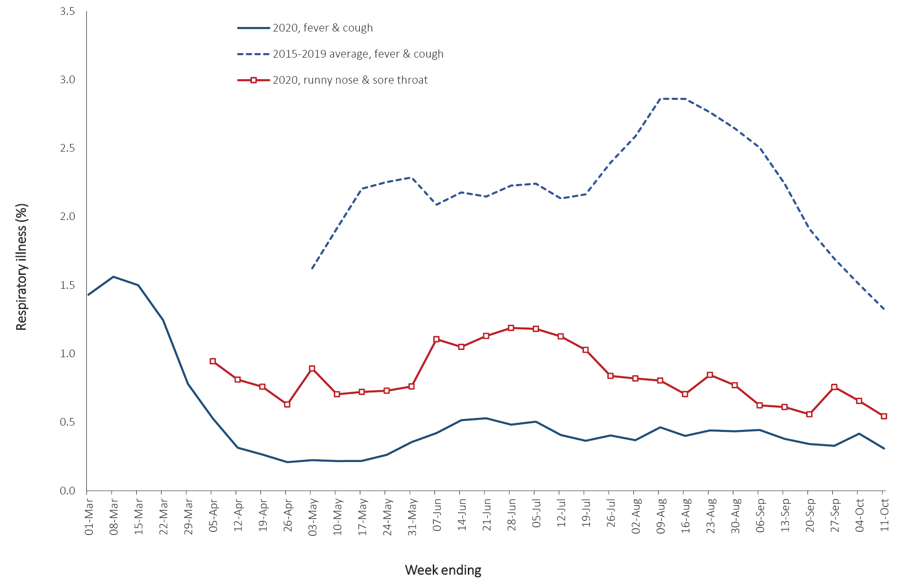
a In previous years, FluTracking was activated during the main Influenza season from May to October. In 2020, FluTracking commenced 10 weeks early to capture data for COVID-19. Data on runny nose and sore throat were only collected systematically after 29 March 2020, therefore a historical average for this symptom profile is unavailable.
Acute respiratory illness was highest in those 0–9 and 30–39 years of age, based on both self-reported FluTracking data and presentations to Commonwealth Respiratory Clinics. Females reported respiratory illness more frequently than males. Rates of fever and cough by jurisdiction were generally similar to the rates reported in the previous fortnight, ranging from 1.0/1,000 FluTracking participants in Victoria to 4.9/1,000 participants in Western Australia.
FluTracking data indicate that 48% of those in the community with ‘fever and cough’ and 24% of those with ‘runny nose and sore throat’ were tested for SARS-CoV-2. Testing rates varied by jurisdiction, being lowest in Western Australia and the Northern Territory and highest in New South Wales and Victoria. It is important to acknowledge that there may be legitimate reasons why people did not get tested, including barriers to accessing testing. Symptoms reported to Flutracking were not specific to COVID-19 and may also be due to chronic diseases.
During the fortnight, there were 30,352 assessments at Commonwealth Respiratory Clinics with > 95% tested for SARS-CoV-2. The positivity of SARS-CoV-2 tests in these Clinics was 0.02% for this reporting period, which is consistent with previous reporting periods.
In patients experiencing influenza-like illness in the last fortnight and tested through the ASPREN and VicSPIN GP sentinel surveillance systems, the most frequent respiratory viruses detected were rhinoviruses.
The rate of self-reported fever and cough among Aboriginal and Torres Strait Islander peoples over the reporting fortnight was 2.5 times that observed in all other participants based on FluTracking data, which is consistent with trends observed in previous weeks.
Rates of respiratory illness in health care worker populations were similar to those observed in the wider community, based on FluTracking data.
Based on all presentations to Commonwealth Respiratory Clinics to date, the principal symptoms reported in COVID-19 cases were cough, sore throat, tiredness, runny nose, and fever.

Transmission trends of confirmed COVID-19

(NNDSS and jurisdictional reporting to NIR)
As at 11 October 2020, there were 27,344 COVID-19 cases including 898 deaths reported nationally, with two distinct peaks in March and July (Figure 2). In the current reporting period, there were 192 cases and 23 deaths reported. On average, 14 cases were notified each day over this reporting period, a decrease from the average of 23 cases reported per day over the previous reporting period. The majority of cases diagnosed this fortnight were from Victoria (60%; 116/192), followed by New South Wales (30%; 58/192).

Figure 2. COVID-19 notified cases by source of acquisition and diagnosis date, Australia, week ending 11 October 2020 (Source: NNDSS)
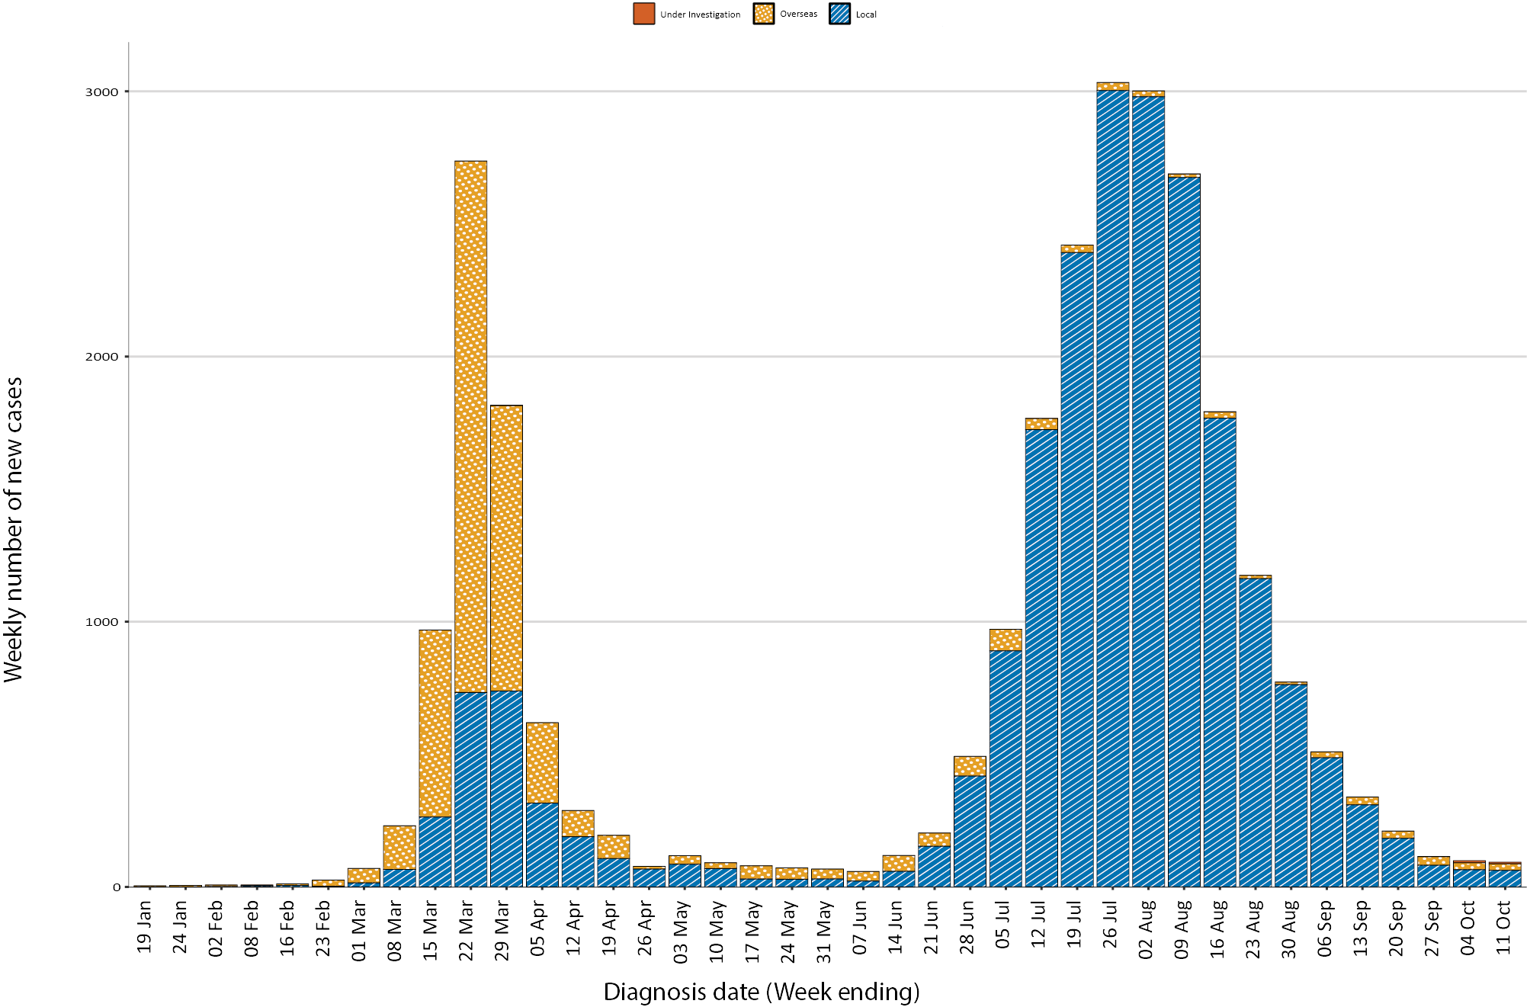
A small number of cases were reported in Western Australia (11), South Australia (4) and Queensland (3). No new cases were reported in Tasmania, the Northern Territory or the Australian Capital Territory.

Source of acquisition

(NNDSS)
In this reporting period, 66% (127/192) of all cases were reported as locally acquired. The source of acquisition for 13% (16/127) of these cases could not be identified, which is higher than the previous reporting period (5%; 17/264). In total, 7% (14/192) of cases reported this fortnight were under investigation at the time of reporting and 27% (51/192) were reported as overseas acquired (Table 1).

Table 1. COVID-19 notifications by jurisdiction and source of acquisition, Australia, 28 September–11 October 2020
Source | NSW | Vic | Qld | WA | SA | Tas | NT | ACT | Australia
Overseas | 38 | 0 | 2 | 11 | 0 | 0 | 0 | 0 | 51
Local — source known | 13 | 98 | 0 | 0 | 0 | 0 | 0 | 0 | 111
Local — source unknown | 6 | 10 | 0 | 0 | 0 | 0 | 0 | 0 | 16
Under investigation | 1 | 8 | 1 | 0 | 4 | 0 | 0 | 0 | 14
Total | 58 | 116 | 3 | 11 | 4 | 0 | 0 | 0 | 192

In the current reporting period, the majority of overseas-acquired cases were reported in New South Wales (75%; 38/51), followed by Western Australia (22%; 11/51). A further 15 cases in Western Australia were acquired at sea among freight ship workers. The higher number of overseas-acquired cases reported in New South Wales reflects the number of returned travellers managed there. Victoria had the highest proportion of locally-acquired cases with known source (88%; 98/111) and locally-acquired cases with unknown source (63%; 10/16).
Nationally, there were 0.6 locally-acquired cases per 100,000 population in this reporting period, compared to 1.0 per 100,000 population in the previous period (Table 2). The rate of locally-acquired cases in Victoria decreased to 1.8 per 100,000 population, from 3.9 per 100,000 population in the previous period.
Table 2. Locally-acquired COVID-19 case numbers and rates per 100,000 population by jurisdiction and reporting period, Australia, 11 October 2020
Jurisdiction | Reporting period  28 September – 11 October |  | Cumulative cases
 | Number of cases | Rate per 100,000 population | Number of cases | Rate per 100,000 population
NSW | 20 | 0.2 | 1,921 | 23.8
Vic | 116 | 1.8 | 19,308 | 292.8
Qld | 1 | 0 | 301 | 5.9
WA | 0 | 0 | 98 | 3.7
SA | 4 | 0.2 | 155 | 8.8
Tas | 0 | 0 | 149 | 27.9
NT | 0 | 0 | 6 | 2.4
ACT | 0 | 0 | 29 | 6.8
Australia | 141 | 0.6 | 21,967 | 86.6
Cumulatively, the infection rate to date for all locally-acquired cases was highest in Victoria with 292.8 infections per 100,000 population. The rate of infection in Tasmania was 27.9 infections per 100,000 population, largely as a result of an outbreak in North West Tasmanian hospitals in April 2020. Tasmania reported their most recent case in the fortnight ending 16 August 2020. That case was associated with interstate travel.

Demographic features

(NNDSS)
In this reporting period, the largest number of cases occurred in those aged 20–29 years (39 cases). For all notifications to date, the highest rate of infection was in those aged ≥ 90 years old with a rate of 387.3 per 100,000 population (Appendix A, Table A.1). Children aged 0–9 years old had the lowest rate of infection (43.0 cases per 100,000 population), despite comparable testing rates to other age groups.
Cumulatively, the male to female rate ratio was approximately 1:1 in most age groups, except in the 20–29 years age group and those aged ≥ 80 years old where rates were higher among females (Figure 3). The largest difference in cumulative rates was in the ≥ 90 years age group, where the cumulative rate among males was 335.2 cases per 100,000 population and among females 413.3 cases per 100,000 population (Appendix A, Table A.1).
Figure 3. Cumulative COVID-19 cases, by age group and sex, Australia, 23 January 2020 to 11 October 2020
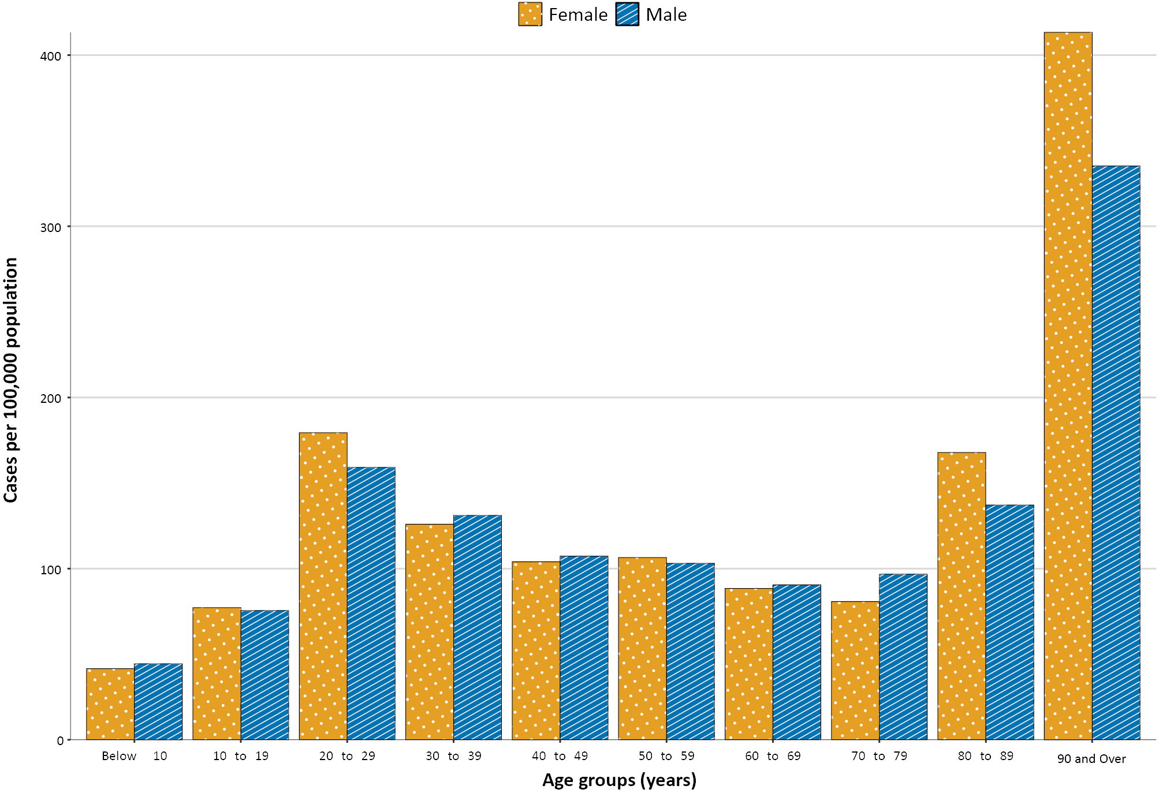
Since the beginning of the epidemic in Australia, the median age of all cases was 37 years old (interquartile range, IQR: 25–57) which has not changed since the beginning of August. Prior to 1 June 2020, COVID-19 cases were slightly older with a median age of 46 years old (IQR: 29–62), associated with a high proportion of cases having a recent travel history or acquisition on a cruise ship. In cases reported after 1 June 2020, the median age was 35 years (IQR: 23–53) reflecting transmission in the community and across a range of settings, especially in Victoria. The median age of cases in this reporting fortnight was 32 years (IQR: 19–46).

Aboriginal and Torres Strait Islander persons

(NNDSS)
There have been 146 cases of COVID-19 notified in Aboriginal and Torres Strait Islander persons since the beginning of the epidemic. This represents approximately 0.5% of all confirmed cases. There were no cases among Aboriginal and Torres Strait Islander persons in the past four weeks. Table 3 compares the remoteness of cases in Aboriginal and Torres Strait Islander persons with those in the Non-Indigenous population. No new overseas-acquired cases have been reported among Aboriginal and Torres Strait Islander persons since the end of August.
Table 3. COVID-19 notifications by Aboriginal and Torres Strait Islander status by jurisdiction, source of acquisition and remoteness classification, Australia, 11 October 2020
 | Locally-acquired |  |  |  | Interstate acquired | Overseas acquired | Unknownª | Total
 | Major Cities of Australia | Inner Regional Australia | Outer Regional Australia | Remote / Very Remote Australia
Aboriginal and  Torres Strait Islander^{b} | 88 | 15 | 6 | 1 | 4 | 31 | 1 | 146
Non-Indigenous | 20,291 | 903 | 220 | 20 | 154 | 5,355 | 221 | 27,229
a Includes 29 Non-Indigenous cases classified as overseas residents who were diagnosed in Australia, 221 Non-Indigenous cases and one Aboriginal and Torres Strait Islander case with an unknown remoteness classification.
b Excludes 1 probable Aboriginal and Torres Strait Islander case.
The median age of COVID-19 cases in Aboriginal and Torres Strait Islander persons was 31 years (IQR: 21–48), which was younger than for Non-Indigenous cases where the median age was 37 years (IQR: 25–57).
The notification rate across all age groups was higher in Non-Indigenous persons than in Aboriginal and Torres Strait Islander persons (Figure 4). The age-standardised notification rate ratio was 0.2, indicating that the Aboriginal and Torres Strait Islander population generally had a lower COVID-19 case rate than the Non-Indigenous population after accounting for differences in age structure. Amongst Aboriginal and Torres Strait Islander cases, the highest notification rate was in those aged 70–79 years (36.0 cases per 100,000 population), followed by the 60–69 years age group (34.4 cases per 100,000 population). Similar to Non-Indigenous cases, children aged 0–9 years had the lowest notification rate for Aboriginal and Torres Strait Islander cases (6.4 cases per 100,000 population).

Figure 4. National COVID-19 notification rate per 100,000 population by age group, Aboriginal and Torres Strait Islander persons and Non-Indigenous persons, Australia, 23 January 2020 to 11 October 2020
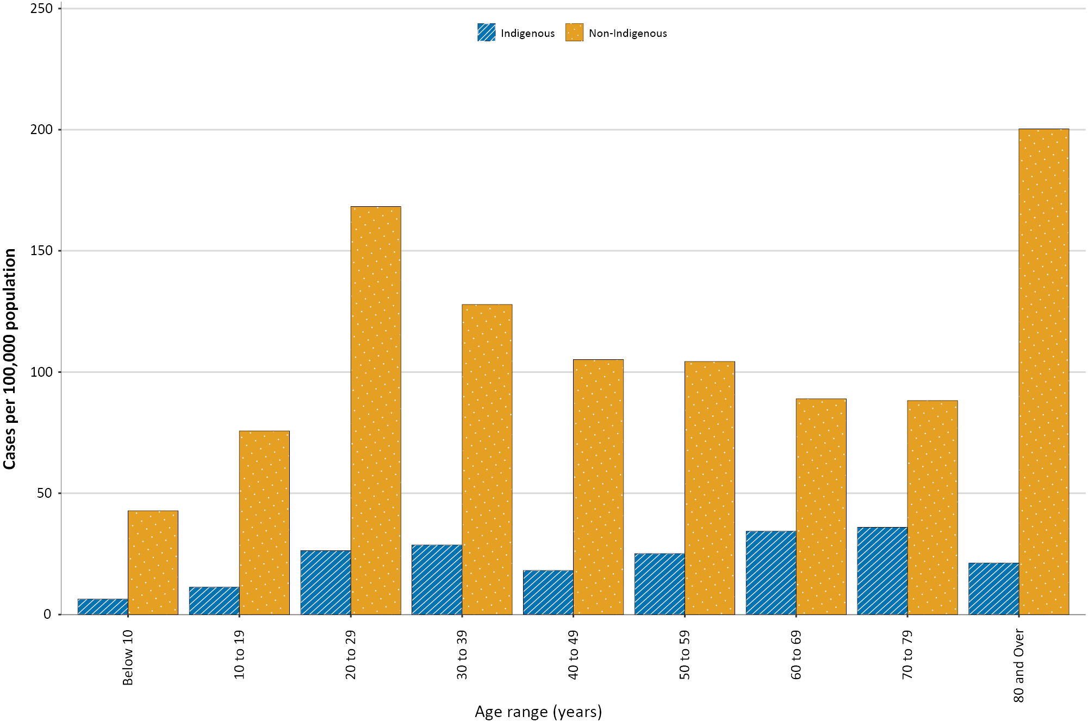

Clusters and outbreaks

(State and territory reporting)
Nationally, for the fortnight ending 11 October 2020, there was a total of 24 open outbreaks where a new epidemiologically-linked case was identified in the previous 14 days. Of these, 19 (79%) were reported in Victoria, three (13%) in New South Wales, one (4%) in Queensland and one (4%) in Western Australia. Outbreaks were reported most frequently from residential aged care settings (9), followed by hospitals (4), workplaces (4) and healthcare facilities (2). Outbreaks varied in size, with the largest outbreak encompassing 260 cases in a residential aged care facility.
As at 11 October 2020, there have been 4,280 cases of COVID-19 associated with 218 residential aged care facilities, with 3,577 recoveries and 677 deaths. 2,050 of these cases occurred in aged care residents, with the remaining 2,230 cases occurring in care staff. The Commonwealth has actively supported services with reported incidents and outbreaks of COVID-19 providing access to personal protective equipment and additional staffing resources where required. Advice and guidelines have been provided to aged care services, including the release of an outbreak management guide.^{16,17}

Virology (GISAID)
At the time of this report, there were 11,887 SARS-CoV-2 genome sequences available from Australian cases on the global sequence repository, GISAID.¹³ These sequences were dispersed throughout the global lineages, reflecting multiple concurrent introductions into Australia.^{1,18,19} Recent Australian SARS-CoV-2 sequences from the last month include 127 collected from Victoria and 11 from New South Wales. Most of these sequences from the last month belong to the B.1.1.25 lineage, reflecting ongoing local transmission of this lineage.

Public health response measures
Since COVID-19 first emerged internationally, Australia has implemented public health measures informed by the disease’s epidemiology (Figure 5). On 8 May, the Australian Government announced a three-step framework for easing COVID-19 restrictions. Building on this framework, on 4 September, the Australian Government announced a plan to develop a ‘Roadmap for Recovery’ to reopen by Christmas.²⁰ States and territories ease restrictions at their own pace depending on the local public health and epidemiological situation (Table 4). During the current reporting period, New South Wales, Queensland, South Australia and the Australian Capital Territory continued to ease restrictions.

Figure 5. COVID-19 notifications in Australia by week of diagnosis and jurisdiction to 11 October 2020 with timing of key public health measures
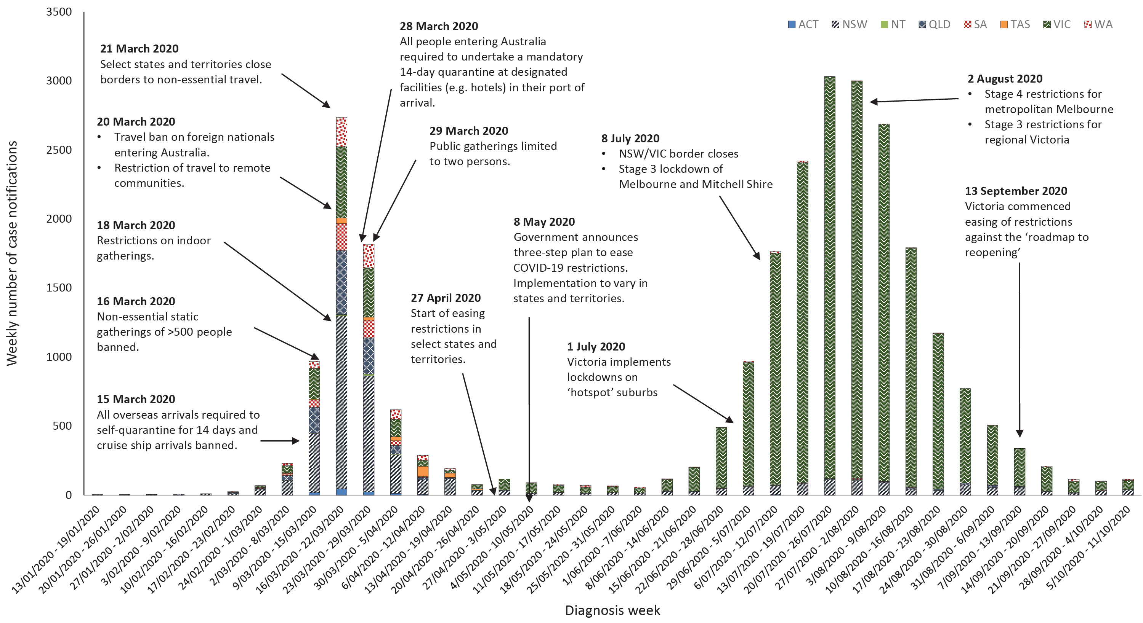

Table 4. State and territory changes to COVID-19 restrictions, Australia, 28 September to 11 October 2020
Jurisdiction | Summary of changes to COVID-19 restrictions
New South Wales | From 2 October, boarding school students permitted to cross the NSW-Victorian border and travel restrictions for Lord Howe Island lifted.21
Victoria | No further easing of restrictions during this reporting period.22
Queensland | From 1 October the following restrictions were eased:23  - Stage 4 of the Queensland Roadmap came into effect  - Queensland border zone no longer exists, New South Wales border zone extended  - Up to 1000 people permitted at outdoor events  - Density restrictions reduced to two square metres for outdoor venues  - Up to 75% seating capacity at outdoor stadiums and amphitheatres
Western Australia | No further easing of restrictions during this reporting period.24
South Australia | From 3 October 2020, minor easing of restrictions to permit dancing at events and standing consumption of food outdoors.25  From 8 October 2020, the Cross Border Community buffer with Victoria extended to 70km.25
Tasmania | No further easing of restrictions during this reporting period.26
Australian Capital Territory | From 9 October the following restrictions were eased:27  - Up to 200 permitted at all gatherings  - Up to 50% capacity permitted in cinemas, large indoor seating (up to 1000) and stadiums  - Workplaces may commence returning to work
Northern Territory | No further easing of restrictions during this reporting period.28

Testing

(State and territory reporting)
As at 11 October 2020, a total of 8,008,111 tests have been conducted in Australia. The cumulative nationwide proportion of positive tests remains low at < 0.4% (Table 5). With the exception of Victoria, the cumulative testing positivity in individual jurisdictions is < 0.25%.

Table 5. Diagnostic tests performed, by jurisdiction, Australia, 11 October 2020
Jurisdiction | Tests performed 14–27 September |  |  | Tests performed 28 September – 11 October |  |  | Cumulative tests performed to 11 October
 | N | Positivity (%) | Per 100,000 population a | N | Positivity (%) | Per 100,000 population a | N | Positivity (%) | Per 100,000 population a
NSW | 191,554 | 0.03 | 2,369 | 139,135 | 0.04 | 1,721 | 2,811,527 | 0.15 | 34,773
Vic | 173,216 | 0.18 | 2,627 | 178,697 | 0.08 | 2,710 | 2,840,686 | 0.71 | 43,081
Qld | 75,066 | 0.01 | 1,474 | 59,609 | 0.01 | 1,171 | 1,157,573 | 0.10 | 22,731
WA | 38,793 | 0.01 | 1,480 | 35,681 | 0.02 | 1,361 | 497,477 | 0.10 | 18,974
SA | 32,888 | 0.05 | 1,877 | 32,128 | 0.06 | 1,833 | 442,299 | 0.16 | 25,241
Tas | 7,152 | 0.00 | 1,338 | 6,466 | 0.00 | 1,210 | 108,745 | 0.21 | 20,341
NT | 5,526 | 0.00 | 2,245 | 4,868 | 0.00 | 1,978 | 51,346 | 0.06 | 20,864
ACT | 5,938 | 0.00 | 1,393 | 5,304 | 0.00 | 1,245 | 98,458 | 0.11 | 23,104
Australia | 530,133 | 0.08 | 2,091 | 461,888 | 0.05 | 1,822 | 8,008,111 | 0.34 | 31,581
a Population data based on Australian Bureau of Statistics (ABS) Estimated Resident Population (ERP) as at 30 December 2019.

During this reporting period 461,888 tests were conducted nationally, with a positivity rate of 0.05%. This represents a 15% decrease in testing numbers compared to the last reporting period. Testing rates decreased to 9.2 tests per 1,000 population per week during this reporting period, from a peak of 19.4 tests per 1,000 population per week in early August. Jurisdictional testing rates are driven by both current case numbers and numbers of people experiencing symptoms. All states except Victoria reported a positivity rate of < 0.06%. Victoria reported a positivity rate of 0.08%, which is a decrease from the previous reporting period (0.18%). The low national positivity rate, along with high rates of testing, indicates a low prevalence of COVID-19 nationally.
For the fortnight ending 9 October 2020, testing rates continued to decline across most age groups (Figure 6). Testing rates were lowest in those aged 0–19 years old.
Figure 6. SARS-CoV-2 polymerase chain reaction (PCR) testing rates per 1,000 population per week by age group, Australia, 1 May to 9 October 2020 ^{a,b}
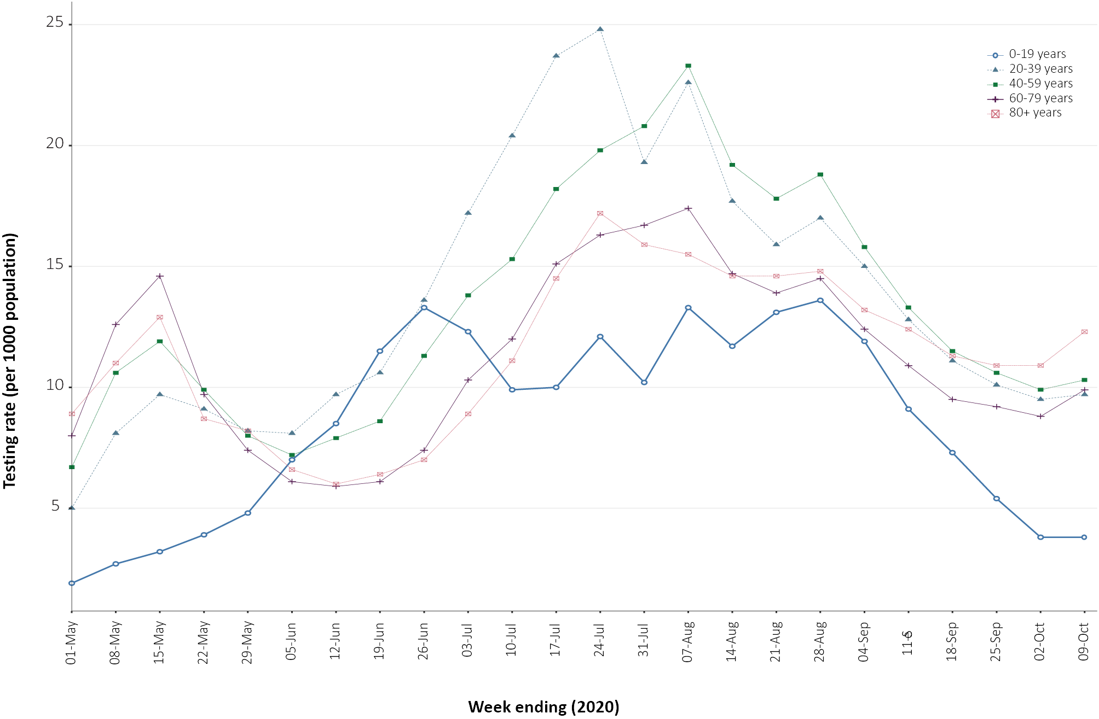
a Data provided by jurisdictions to the National Incident Room (NIR) weekly.
b The jurisdictions reporting each week (i.e. the denominator population) may vary.

International situation (World Health Organization)
On 11 October 2020, more than 216 countries, regions and areas had reported 37,109,113 COVID-19 cases, a 13.2% increase in cumulative global cases in the past fortnight. Cumulative global deaths increased by 7.9% in the past fortnight, with deaths reported to WHO passing one million. Globally, while the rate of new cases each fortnight was relatively stable since late July, there was considerable variation from country to country and across regions.
The largest proportions of new cases globally were in the Americas (36%), Europe (28%), and South East Asia (27.5%). In the past fortnight, several countries in Central and Eastern Europe experienced sharp increases in cases, or experienced a second wave, such as France (37.3% increase) and the United Kingdom (37.6% increase).
The Americas represent approximately 48% of cumulative cases and 55% of cumulative deaths. Cases in the South East Asia Region now represent 21.3% of the cumulative global burden of cases and 11.9% of deaths. Europe’s cumulative caseload represents 18.6% and deaths 23% of the respective global totals. The global Case Fatality Rate (CFR) is approximately 2.9%, which has been decreasing as ascertainment of cases improves. The global cumulative per capita rates are 483.1 cases and 13.9 deaths per 100,000 population.

Western Pacific Region
There was a total of 651,841 cases (1.8% of the global total) in the Western Pacific region, along with 14,265 deaths (1.3% of the global total). In this reporting period, 50,590 new cases were reported, representing a decrease in fortnightly reported cases. The rate of COVID-19 cases in the region was 34.4 cases per 100,000 people and the mortality rate was 0.7 deaths per 100,000 population.
The Philippines has reported the highest number of cumulative cases in the region reaching 336,926 cases, followed by China (91,305 cases) and Japan (88,912 cases). In this reporting period, the Philippines reported 35,670 cases, representing 70% of new regional cases. Japan reported 7,222 cases, representing 14.2% of new regional cases. Malaysia experienced a surge of cases, with 4,327 cases in the past fortnight representing 8.5% of new regional cases. China reported 339 new cases, representing 0.7% of new regional cases.
As at 11 October 2020, New Zealand reported 38 cases in the previous fortnight, all of which were linked to overseas travel and were being managed in isolation. New Zealand has returned to Alert Level 1 throughout the country.^{29,30}

South East Asia Region
The South East Asia region has continued to experience large increases in new case numbers. In total, the region reported approximately 7.91 million cases (21.3% of the global total) and 126,917 deaths (11.9% of the global total), with 1.19 million new cases in this reporting period.
New cases in the region remain largely concentrated in India, where 1.06 million new cases were reported in the past fortnight, comprising 89.2% of new cases reported regionally in this period (Figure 7). The Republic of the Union of Myanmar continued to experience a sharp increase in case numbers with 16,073 cases reported in the past fortnight, an increase of 160% in cases reported from the previous reporting period. This prompted a renewed strategy for making testing more widely available. The majority of cases were locally transmitted in the Yangon region where the government has extended restriction of movement until 31 October 2020.³¹

Figure 7. Number of COVID-19 cases (logarithmic scale) by selected country and days since passing 100 cases, 11 October 2020
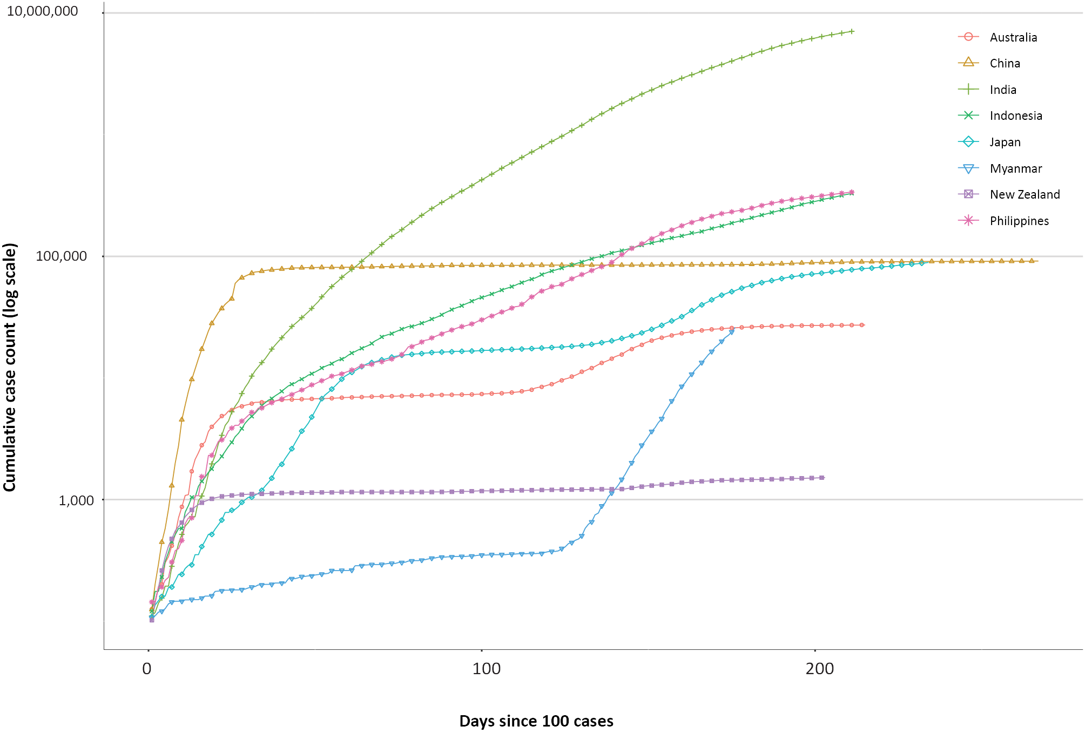
Indonesia reported 57,613 new cases in the past fortnight, which was similar to the previous fortnight. Although largely concentrated in Jakarta, COVID-19 has spread to all 34 provinces. Stay-at-home restrictions and business closure measures were put in place on 14 September 2020 and remain until further notice.³²
The Australian Government’s recent budget announcement, on 6 October 2020, included $304.7 million for a COVID-19 Response Package — support to the Pacific and Timor-Leste, which will deliver critical, temporary, economic support to address the costs of the pandemic. The supplementary funding is for two years and is separate from Australia’s $4 billion Partnerships for Recovery official development assistance program. It also announced $23.2 million to fund the COVID-19 Vaccine Access and Health Security Program focusing on Pacific island countries, Timor-Leste and Southeast Asian countries.^{33,34}

Interpretation
Since the first cases of COVID-19 were identified in Australia, all states and territories have reported cases of COVID-19, with some jurisdictions experiencing higher numbers and more substantial community-associated transmission. These differences arise from factors including state demographics, population size, and patterns of overseas arrivals. Australia continues to experience low levels of community transmission of COVID-19 in some jurisdictions.
Nationally, there has been an overall downward trend in cases following a secondary peak in late July 2020. The majority of locally-acquired cases in the last fortnight occurred in Victoria, most of which were associated with localised outbreaks or clusters. Victoria has continued to report declines in case numbers due to interventions and intensive investigations of all cases and outbreaks. New South Wales has continued to report the highest proportion of overseas-acquired cases, all of which were in quarantine.
This fortnight, there was a shift in the age group most affected, with those aged 20–29 years having the highest rate of notification; however, people aged ≥ 90 years old continue to have the highest rate overall. Other demographic trends remain largely unchanged, with children aged 0–9 years old having the lowest rate of infection, and cases in Aboriginal and Torres Strait Islander persons accounting for fewer than 1% of all confirmed cases. The local and national epidemiology of COVID-19 continues to inform the public health measure implemented, with a number of jurisdictions easing restrictions this fortnight as COVID-19 case number declined or were sustained at low levels.
As Australian states and territories are at different stages in managing the epidemic of COVID-19, there is significant variation in the public health measures implemented. It is important to note that changes in notifications over time are strongly influenced by a range of factors other than disease incidence. These factors include changes in testing policies; screening programs, including the preferential testing of high-risk populations; and periodic awareness campaigns.

Definitions
“Cluster” in relation to COVID-19 refers to two or more cases (who do not reside in the same household) that are epidemiologically related in time, place or person where a common source (such as an event or within a community) of infection is suspected but not yet established.
“COVID-19” is the disease caused by a novel coronavirus—SARS-CoV-2—that emerged in China in late 2019. ‘CO’ stands for corona-, ‘V’ stands for virus, ‘ID’ stands for infectious disease, and ‘-19’ refers to the year that this disease was first reported.
“COVID-19 associated death” is defined for surveillance purposes as a death in a probable or confirmed COVID-19 case, unless there is a clear alternative cause of death that cannot be related to COVID-19 (e.g. trauma).³⁷ There should be no period of complete recovery from COVID-19 between illness and death. Where a Coroner’s report is available, these findings are to be observed.
“Date of illness onset” is derived from data collected by the NNDSS and represents the diagnosis date, or reported true onset of disease date. If unknown, the earliest of specimen collection date, notification date or notification receive date is used.
“Notification received date” is reported in the NNDSS and represents the date the case is first notified on the NNDSS. As notification can only occur after testing is completed and information processed, counts for a defined period will vary according to the date type used.
“Outbreak” in relation to COVID-19 refers to two or more cases (who do not reside in the same household) among a specific group of people and/or over a specific period of time where illness is associated with a common source (such as an event or within a community). Some states and territories may report a single case associated with a residential aged care facility as an outbreak.
“SARS-CoV-2” is the virus that causes the disease COVID-19. It is a betacoronavirus genetically related to the 2003 Severe acute respiratory syndrome coronavirus (SARS-CoV).
“This reporting period” refers to the period covered by this report, i.e. 28 September–11 October 2020.

Acknowledgements
This report represents surveillance data reported through Communicable Diseases Network Australia (CDNA) as part of the nationally-coordinated response to COVID-19. We thank public health staff from incident emergency operations centres and public health units in state and territory health departments, and the Australian Government Department of Health, along with state and territory public health laboratories. We thank those who provided data from surveillance systems, such as Commonwealth respiratory clinics, SPRINT-SARI, Flutracking, and FluCan.

Author details

Corresponding author
COVID-19 National Incident Room Surveillance Team, Australian Government Department of Health, GPO Box 9484, MDP 14, Canberra, ACT 2601. Email: epi.coronavirus@health.gov.au

References
- Rockett RJ, Arnott A, Lam C, Sadsad R, Timms V, Gray KA et al. Revealing COVID-19 transmission in Australia by SARS-CoV-2 genome sequencing and agent-based modeling. Nat Med. 2020. doi: https://doi.org/10.1038/s41591-020-1000-7.
- World Health Organization (WHO). Transmission of SARS-CoV-2: implications for infection prevention precautions. Scientific brief. [Internet.] Geneva: WHO; 9 July 2020. [Accessed on 14 October 2020.] Available from: https://www.who.int/news-room/commentaries/detail/transmission-of-sars-cov-2-implications-for-infection-prevention-precautions.
- McAloon C, Collins Á, Hunt K, Barber A, Byrne AW, Butler F et al. Incubation period of COVID-19: a rapid systematic review and meta-analysis of observational research. BMJ Open. 2020;10(8). doi: https://doi.org/10.1136/bmjopen-2020-039652.
- Australian Government Department of Health. Australian National Disease Surveillance Plan for COVID-19. [Internet.] Canberra: Australian Government Department of Health; 30 May 2020. Available from: https://www.health.gov.au/resources/publications/australian-national-disease-surveillance-plan-for-covid-19.
- Yuan Z, Xiao Y, Dai Z, Huang J, Zhang Z, Chen Y. Modelling the effects of Wuhan’s lockdown during COVID-19, China. Bull World Health Organ. 2020;98(7):484–94.
- Rothan HA, Byrareddy SN. The epidemiology and pathogenesis of coronavirus disease (COVID-19) outbreak. J Autoimmun. 2020;109. doi: https://doi.org/10.1016/j.jaut.2020.102433.
- Hu Y, Sun J, Dai Z, Deng H, Li X, Huang Q et al. Prevalence and severity of corona virus disease 2019 (COVID-19): A systematic review and meta-analysis. J Clin Virol. 2020; 127. doi: https://doi.org/10.1016/j.jcv.2020.104371.
- WHO. Report of the WHO-China Joint Mission on Coronavirus Disease 2019 (COVID-19). Geneva: WHO; 2020. [Accessed on 14 October 2020.] Available from: https://www.who.int/docs/default-source/coronaviruse/who-china-joint-mission-on-covid-19-final-report.pdf.
- Australian Government Department of Health. Coronavirus Disease 2019 (COVID-19): CDNA National guidelines for public health units. Canberra: Australian Government Department of Health; 9 October 2020. [Accessed on 13 October 2020.] Available from: https://www1.health.gov.au/internet/main/publishing.nsf/Content/7A8654A8CB144F5FCA2584F8001F91E2/$File/COVID-19-SoNG-v3.9.pdf.
- Dalton C, Durrheim D, Fejsa J, Francis L, Carlson S, d’Espaignet ET et al.Flutracking: a weekly Australian community online survey of influenza-like illness in 2006, 2007 and 2008. Commun Dis Intell Q Rep. 2009;33(3):316–22.
- Monash Health. FluCAN (Influenza surveillance): FluCAN (The Influenza Complications Alert Network) [Internet.] Melbourne: Monash Health; 2020. Available from: https://monashhealth.org/services/monash-infectious-diseases/research/influenza-research/flucan-influenza-surveillance-2/.
- Australian and New Zealand Intensive Care Society (ANZICS). SPRINT-SARI: Short period incidence study of severe acute respiratory infection. [Internet.] Camberwell: ANZICS; 2020. Available from: https://www.anzics.com.au/current-active-endorsed-research/sprint-sari/.
- Global Initiative on Sharing All Influenza Data (GISAID). [Website.] Berlin: Federal Republic of Germany, Freunde von GISAID e.V.; 2020. [Accessed on 15 October 2020.] Available from: https://www.gisaid.org/.
- Bedford T, Neher R, Hadfield J, Hodcroft E, Sibley T, Huddleston J et al. Nextstrain: Genomic epidemiology of novel coronavirus - Oceania-focused subsampling. [Internet.] Nextstrain; 2020. [Accessed on 15 October 2020.] Available from: https://nextstrain.org/ncov/oceania.
- World Health Organization (WHO). WHO Coronavirus Disease (COVID-19) dashboard. [Internet.] Geneva: WHO; 12 October 2020. [Accessed on 12 October 2020.] Available from: https://covid19.who.int/.
- Australian Government Department of Health. Coronavirus (COVID-19) advice for the health and aged care sector. [Internet.] Canberra: Australian Government Department of Health; 2020. [Accessed 13 August 2020.] Available from: https://www.health.gov.au/news/health-alerts/novel-coronavirus-2019-ncov-health-alert/coronavirus-covid-19-advice-for-the-health-and-aged-care-sector.
- Communicable Diseases Network Australia (CDNA). Coronavirus disease 2019 (COVID-19) outbreaks in residential care facilities: CDNA national guidelines for the prevention, control and public health management of COVID-19 outbreaks in residential care facilities in Australia. Canberra: Australian Government Department of Health, CDNA; 13 March 2020. [Accessed on 13 August 2020.] Available from: https://www.health.gov.au/sites/default/files/documents/2020/03/coronavirus-covid-19-guidelines-for-outbreaks-in-residential-care-facilities.pdf.
- Seemann T, Lane CR, Sherry NL, Duchene S, Goncalves da Silva A, Caly L et al. Tracking the COVID-19 pandemic in Australia using genomics. Nat Commun. 2020;11(1):4376. doi: https://doi.org/10.1038/s41467-020-18314-x.
- Eden JS, Rockett R, Carter I, Rahman H, de Ligt J, Hadfield J et al. An emergent clade of SARS-CoV-2 linked to returned travellers from Iran. Virus Evol. 2020;6(1):veaa027. doi: https://doi.org/10.1093/ve/veaa027.
- Prime Minister of Australia. Media statement: 04 Sep 2020. [Internet.] Canberra: Australian Government, Department of Prime Minister and Cabinet; 4 September 2020. [Accessed on 16 September 2020.] Available from: https://www.pm.gov.au/media/national-cabinet-040920.
- Government of New South Wales. What you can and can’t do under the rules: recent and upcoming changes. [Internet.] Sydney: Government of New South Wales; 2020. [Accessed on 14 October 2020.] Available from: https://www.nsw.gov.au/covid-19/what-you-can-and-cant-do-under-rules#recent-and-upcoming-changes.
- Victoria State Government Health and Human Services (DHHS). Coronavirus: Victoria’s restriction levels. [Internet.] Melbourne: Victoria State Government, DHHS; 2020. [Accessed on 14 October 2020.] Available from: https://www.dhhs.vic.gov.au/victorias-restriction-levels-covid-19.
- Queensland Government. Roadmap to easing restrictions. [Internet.] Brisbane: Queensland Government; 2020. [Accessed on 14 October 2020.] Available from: https://www.covid19.qld.gov.au/government-actions/roadmap-to-easing-queenslands-restrictions.
- Government of Western Australia. COVID-19 coronavirus: WA Roadmap. [Internet.] Perth: Government of Western Australia; 2020. [Accessed on 14 October 2020.] Available from: https://www.wa.gov.au/organisation/department-of-the-premier-and-cabinet/covid-19-coronavirus-wa-roadmap.
- Government of South Australia. COVID-19 response: COVID response updates. [Internet.] Adelaide: Government of South Australia; 2020. [Accessed on 14 October 2020.] Available from: https://www.covid-19.sa.gov.au/recovery.
- Tasmanian Government. Coronavirus disease (COVID-19): important community updates. [Internet.] Hobart: Tasmanian Government; 2020. [Accessed on 14 October 2020.] Available from: https://coronavirus.tas.gov.au/facts/important-community-updates.
- Australian Capital Territory Government. Canberra’s recovery plan: COVID-19 Easing of Restrictions Roadmap as at 09 October 2020. Canberra: Australian Capital Territory Government; 2020. [Accessed on 14 October 2020.] Available from: https://www.covid19.act.gov.au/__data/assets/pdf_file/0009/1640961/PICC0050-COVID-Recovery-Plan-09102020.pdf.
- Northern Territory Government. Roadmap to the new normal. [Internet.] Darwin: Northern Territory Government; 2020. [Accessed on 14 October 2020.] Available from: https://coronavirus.nt.gov.au/roadmap-new-normal.
- New Zealand Government Ministry of Health. COVID-19: Current cases. Wellington: New Zealand Government Ministry of Health; 13 October 2020. [Accessed on 13 October 2020.] Available from: https://www.health.govt.nz/our-work/diseases-and-conditions/covid-19-novel-coronavirus/covid-19-current-situation/covid-19-current-cases#managed-isolation
- New Zealand Government. Current alert level. [Internet.] Wellington: New Zealand Government; 2020. [Accessed on 12 October 2020.] Available from: https://covid19.govt.nz/alert-system/current-alert-level/
- Ministry of Health and Sports (Myanmar) Department of Public Health Central Epidemiology Unit. Situation Report 184: 8 October 2020. Naypyidaw: Government of Myanmar Ministry of Health and Sports; 2020. [Accessed on 12 October 2020.] Available from: http://mohs.gov.mm/su/nheh5826NH.
- Kementerian Kesehatan Republik Indonesia. Infeksi Emerging. [Internet.] Jakarta: Indonesian Government Ministry of Health; 2020. [Accessed on 11 October 2020.] Available from: https://infeksiemerging.kemkes.go.id/download/Situasi_Terkini_111020.pdf
- Australian Government Department of Foreign Affairs and Trade (DFAT). Budget Highlights 2020-21. [Internet.] Canberra: Australian Government, DFAT; 2020. [Accessed on 14 October 2020.] Available at: https://www.dfat.gov.au/about-us/corporate/portfolio-budget-statements/pbs-2020-21-dfat-budget-highlights.
- Australian Government Department of Foreign Affairs and Trade. Partnerships for recovery 2020-2021. Canberra: Australian Government, DFAT; 2020. [Accessed on 14 October 2020.] Available at: https://www.dfat.gov.au/sites/default/files/pbs-2020-21-dfat-aid-budget-summary.pdf.

Appendix A: Supplementary figures and tables
Table A.1. COVID-19 case notifications and rates per 100,000 population,ª by age group and sex, 11 October 2020 Australia
Age Group | This reporting period |  |  |  |  |  |  | Cumulative
 | Cases |  |  |  | Rate per 100,000 population |  |  | Cases |  |  | Rate per 100,000 population
 | Male | Female | People | Male |  | Female | People | Male | Female | People |  | Male | Female | People
0 to 9 | 11 | 12 | 23 | 0.7 |  | 0.8 | 0.7 | 727 | 643 | 1,370 |  | 44.4 | 41.5 | 43.0
10 to 19 | 10 | 19 | 29 | 0.6 |  | 1.3 | 0.9 | 1,186 | 1,146 | 2,332 |  | 75.5 | 77.2 | 76.3
20 to 29 | 21 | 18 | 39 | 1.1 |  | 1.0 | 1.1 | 2,956 | 3,230 | 6,210 |  | 159.1 | 179.4 | 169.7
30 to 39 | 19 | 18 | 37 | 1.0 |  | 1.0 | 1.0 | 2,382 | 2,337 | 4,734 |  | 131.0 | 125.9 | 128.8
40 to 49 | 15 | 7 | 22 | 0.9 |  | 0.4 | 0.7 | 1,737 | 1,722 | 3,487 |  | 107.3 | 104.0 | 106.5
50 to 59 | 11 | 11 | 22 | 0.7 |  | 0.7 | 0.7 | 1,555 | 1,673 | 3,236 |  | 103.1 | 106.4 | 105.1
60 to 69 | 3 | 6 | 9 | 0.2 |  | 0.4 | 0.3 | 1,151 | 1,187 | 2,340 |  | 90.5 | 88.4 | 89.5
70 to 79 | 3 | 2 | 5 | 0.3 |  | 0.2 | 0.3 | 841 | 744 | 1,585 |  | 96.7 | 80.7 | 88.4
80 to 89 | 3 | 2 | 5 | 0.8 |  | 0.4 | 0.6 | 490 | 774 | 1,264 |  | 137.1 | 167.8 | 154.4
90 and over | 1 | 0 | 1 | 1.5 |  | 0.0 | 0.5 | 230 | 552 | 783 |  | 335.2 | 413.3 | 387.3

Appendix B: Frequently asked questions
Q: Can I request access to the COVID-19 data behind your CDI fortnightly reports?
A: National notification data on COVID-19 confirmed cases is collated in the National Notifiable Disease Surveillance System (NNDSS) based on notifications made to state and territory health authorities under the provisions of their relevant public health legislation.
Normally, requests for the release of data from the NNDSS requires agreement from states and territories via the Communicable Diseases Network Australia, and, depending on the sensitivity of the data sought and proposed, ethics approval may also be required.
Due to the COVID-19 response, unfortunately, specific requests for NNDSS data have been put on hold. We are currently looking into options to be able to respond to data requests in the near future.
We will continue to publish regular summaries and analyses of the NNDSS dataset and recommend the following resources be referred to in the meantime:
- NNDSS summary tables: http://www9.health.gov.au/cda/source/cda-index.cfm
- Daily case summary of cases: https://www.health.gov.au/news/health-alerts/novel-coronavirus-2019-ncov-health-alert/coronavirus-covid-19-current-situation-and-case-numbers
- Communicable Diseases Intelligence COVID-19 epidemiology report: https://www1.health.gov.au/internet/main/publishing.nsf/Content/novel_coronavirus_2019_ncov_weekly_epidemiology_reports_australia_2020.htm
- State and territory public health websites.
Q: Can I request access to data at post-code level of confirmed cases?
A: Data at this level cannot be released without ethics approval and permission would need to be sought from all states and territories via the Communicable Diseases Network Australia. As noted above, specific requests for NNDSS data are currently on hold.
Where current or recent reported case numbers are high enough to justify it, a GIS/mapping analysis of cases will be included in the Communicable Diseases Intelligence COVID-19 epidemiology report. In order to protect privacy of confirmed cases, data in this map will be presented at SA3 level.
Q: Where can I find more detailed data on COVID-19 cases?
A: We are currently looking into ways to provide more in-depth epidemiological analyses of COVID-19 cases, with regard to transmission and severity, including hospitalisation. These analyses will continue to be built upon in future iterations of the Communicable Diseases Intelligence report.
Q: Where do I find the COVID-19 background information which was included as Appendix A in previous fortnightly epidemiology reports?
A: This information was most recently published in Epidemiology Report 24 (https://doi.org/10.33321/cdi.2020.44.75). Additional information can be found in the CDNA Series of National Guidelines (SoNG) for COVID-19. (https://www1.health.gov.au/internet/main/publishing.nsf/Content/cdna-song-novel-coronavirus.htm).

Communicable Diseases Intelligence
ISSN: 2209-6051 Online

Communicable Diseases Intelligence (CDI) is a peer-reviewed scientific journal published by the Office of Health Protection, Department of Health. The journal aims to disseminate information on the epidemiology, surveillance, prevention and control of communicable diseases of relevance to Australia.

Editor: Tanja Farmer
Deputy Editor: Simon Petrie
Design and Production: Kasra Yousefi
Editorial Advisory Board: David Durrheim, Mark Ferson, John Kaldor, Martyn Kirk and Linda Selvey

Website: http://www.health.gov.au/cdi

Contacts
Communicable Diseases Intelligence is produced by:
Health Protection Policy Branch, Office of Health Protection, Australian Government Department of Health
GPO Box 9848, (MDP 6) CANBERRA ACT 2601

Email: cdi.editor@health.gov.au

Submit an Article
You are invited to submit your next communicable disease related article to the Communicable Diseases Intelligence (CDI) for consideration. More information regarding CDI can be found at: http://health.gov.au/cdi.
Further enquiries should be directed to: cdi.editor@health.gov.au.

This journal is indexed by Index Medicus and Medline.

Creative Commons Licence - Attribution-NonCommercial-NoDerivatives CC BY-NC-ND
© 2020 Commonwealth of Australia as represented by the Department of Health
This publication is licensed under a Creative Commons Attribution-NonCommercial-NoDerivatives 4.0 International Licence from https://creativecommons.org/licenses/by-nc-nd/4.0/legalcode (Licence). You must read and understand the Licence before using any material from this publication.

Restrictions
The Licence does not cover, and there is no permission given for, use of any of the following material found in this publication (if any):
- the Commonwealth Coat of Arms (by way of information, the terms under which the Coat of Arms may be used can be found at www.itsanhonour.gov.au);
- any logos (including the Department of Health’s logo) and trademarks;
- any photographs and images;
- any signatures; and
- any material belonging to third parties.

Disclaimer
Opinions expressed in Communicable Diseases Intelligence are those of the authors and not necessarily those of the Australian Government Department of Health or the Communicable Diseases Network Australia. Data may be subject to revision.

Enquiries
Enquiries regarding any other use of this publication should be addressed to the Communication Branch, Department of Health, GPO Box 9848, Canberra ACT 2601, or via e-mail to: copyright@health.gov.au

Communicable Diseases Network Australia
Communicable Diseases Intelligence contributes to the work of the Communicable Diseases Network Australia.
http://www.health.gov.au/cdna

