COVID-19 Australia: Epidemiology Report 23
Fortnightly reporting period ending 16 August 2020
COVID-19 National Incident Room Surveillance Team
Unless indicated, the source of all data, including notified cases of COVID-19 and associated deaths, is the National Notifiable Diseases Surveillance System (NNDSS) to 16 August 2020. Due to the dynamic nature of NNDSS data, data in this report are subject to retrospective revision and may vary from data reported in published NNDSS reports and reports of notification data by states and territories. Case numbers for the most recent dates of illness onset may be subject to revision, due to reporting delays.
Confirmed cases in Australia | Last reporting period  20 July — 2 Augustª | This reporting period  3—16 Augustª | Cumulative^{b}  As at 16 August 2020
Notifications | 5,944 | 3,767 | 23,696
Deaths | 181 | 54 | 428

- Based on diagnosis date
- Based on notification date

Summary (3—16 August):
- The number of new cases reported nationally this fortnight was 3,767, a 37% decrease from the previous fortnight (5,944). On average this represented 269 cases diagnosed each day over the reporting period, a decrease from 425 cases per day over the previous reporting period.
- 3,628 (96%) of all cases were reported in Victoria, with a smaller number of cases reported from NSW (125), Qld (2), WA (5), SA (6) and Tas (1).
- In Victoria, the majority of cases (3,284; 90%) were locally acquired, with a further 344 (10%) under investigation at the time of analysis, but likely also to be locally acquired.
- Of the remaining 139 cases reported, 26 (19%) were overseas acquired; 110 (80%) were locally acquired, predominantly in NSW, and 3 (2%) were reported as under investigation.
- The decrease in new cases observed this fortnight in Victoria is likely associated with the enhanced public health measures that are currently in place in Victoria.
- A total of 54 deaths were reported, all from Victoria: 52 (96%) were aged 70 years and over, and 2 (4%) were aged 30 to 69 years.
- Testing rates remain high across all jurisdictions, with an overall positivity rate for the reporting period of 0.6%. Victoria reported a positivity rate of 1.7% for this reporting period; in all other jurisdictions the positivity rate was 0.05% or lower.
Keywords: SARS-CoV-2; novel coronavirus; 2019-nCoV; coronavirus disease 2019; COVID-19; acute respiratory disease; epidemiology; Australia
Figure 1. New and cumulative COVID-19 notifications by diagnosis date, ª Australia
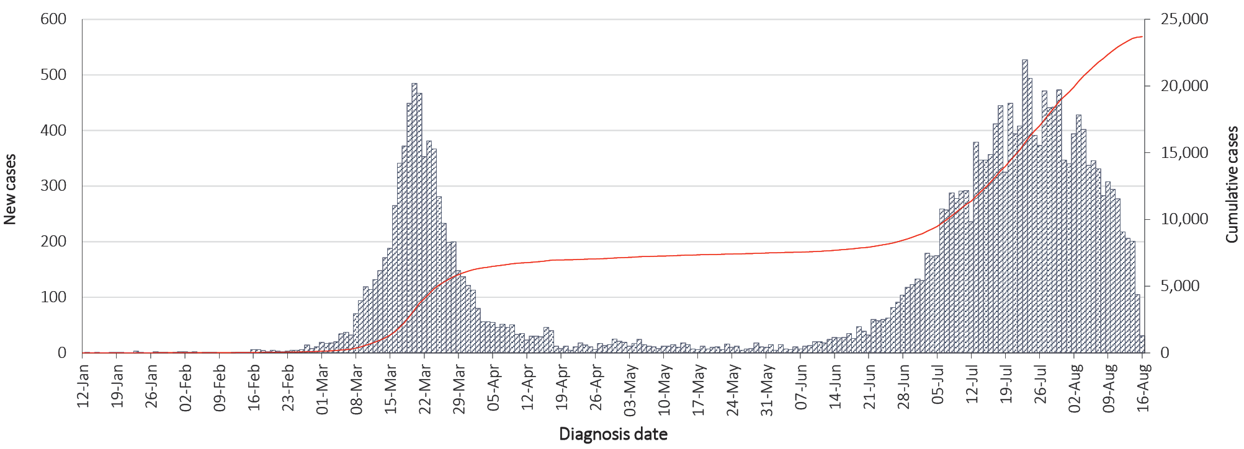
a Illnesses that began within 7 days prior to 16 August may not yet be reported and interpretation of trends during this period should be undertaken with caution.

In focus: community and primary care surveillance
Our current understanding of COVID-19 indicates that approximately 80% of infections are mild and that the most common symptoms are consistent with an acute respiratory illness (ARI) and/or influenza-like illness (ILI). It is therefore important to monitor trends in the number of people reporting symptoms of mild respiratory illnesses (syndromic surveillance) in the community and in primary care settings.
At a national level, the surveillance systems and programs that provide this information within Australia are the internet-based FluTracking syndromic surveillance system, the Australian Sentinel Practices Research Network (ASPREN) and Victoria Sentinel Practice Influenza Network (VicSPIN) general practice (GP) sentinel surveillance systems, and the Commonwealth GP Respiratory Clinics. These systems are not specific to COVID-19; they monitor any respiratory illness experienced in the reporting period.
FluTracking is an online syndromic surveillance system which monitors ILI in the community. During the influenza season, participants receive a weekly email survey which collects data on the rate of ILI-related symptoms and healthcare seeking behaviour in communities. The survey usually commences at the beginning of May each year but commenced at the end of February in 2020 to support the COVID-19 response. Approximately 70,000 to 85,000 people participate in FluTracking across Australia each week.
Based on self-reported FluTracking data, fever and cough in the community continues to be low nationally, much lower than the historical average for this time of year (Figure 2).
Rates of fever and cough in self-reported health care worker populations over the last fortnight were similar to those observed in the wider community.

Figure 2. Weekly trends in respiratory illness amongst FluTracking survey participants (age standardised), 2020 and average of the previous five yearsª

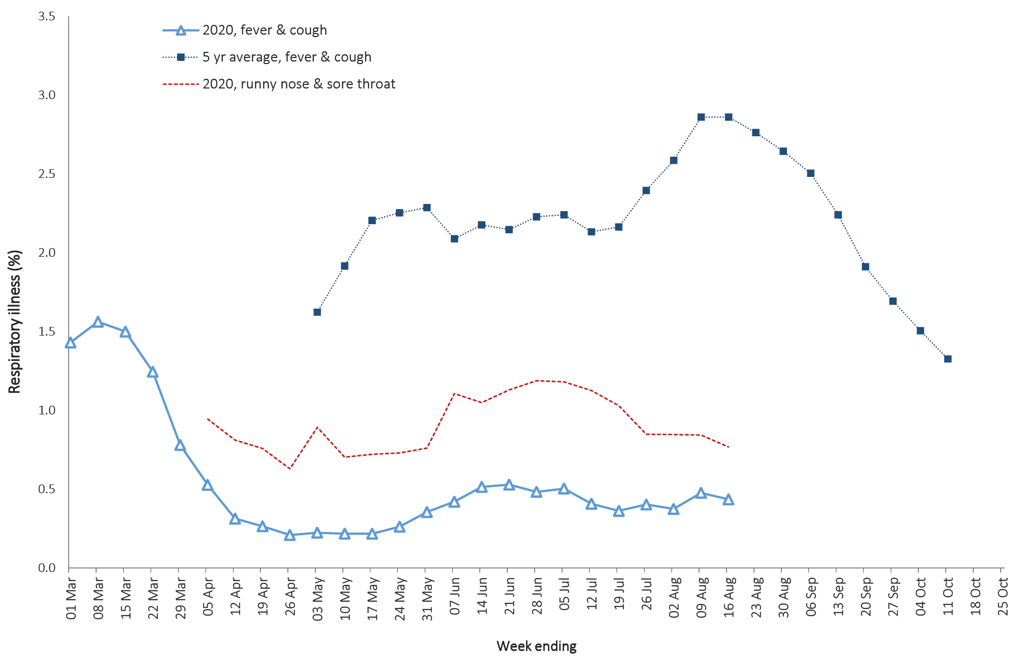
a FluTracking commenced 10 weeks early in 2020 in response to COVID-19. Historical data are not available for the ‘runny nose and sore throat’ syndrome.
Based on data from FluTracking, a higher proportion of those in the community with ‘fever and cough’, compared to those with ‘runny nose and sore throat’, presented to a health service. Regardless of symptom profile, the majority of these healthcare presentations were tested for SARS-CoV-2. Both presentation and testing rates were highest in those jurisdictions with active community transmission.
It is recommended that anyone experiencing cold- or flu-like symptoms, such as a cough, fever, sore throat, shortness of breath or runny nose, even if these are mild, should get tested for COVID-19 as soon as possible.
ASPREN is a year-round sentinel GP surveillance system in which general and nurse practitioners report de-identified information on the number of ILI patient presentations seen in participating practices each week. Swab tests are also systematically conducted on a nominated proportion of the patients who present with ILI. In patients experiencing ILI in the last fortnight, the most frequent respiratory viruses detected through the ASPREN and VicSPIN sentinel system were rhinoviruses (Figure 3).

Figure 3. Respiratory virus detection by week of 2020 through ASPREN/VicSPIN.
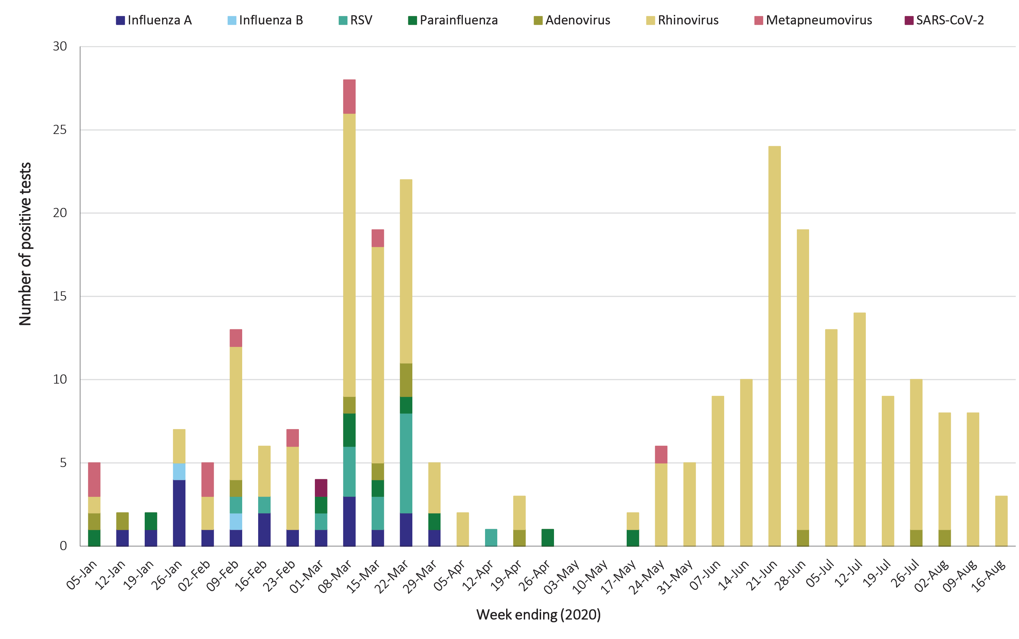
In response to COVID-19, the Australian Government rapidly established GP Respiratory Clinics throughout Australia for clinical assessment of people with mild to moderate respiratory symptoms and/or fever. While these clinics diagnose only a small proportion of COVID-19 cases in Australia, the case histories obtained by these clinics are comprehensive and also offer a unique opportunity to compare and contrast COVID-19 and non-COVID-19 respiratory illness. For surveillance purposes a relatively strict case definition of ARI is used: ‘acute onset of at least one of the following: shortness of breath, cough, sore throat, runny nose or fever’. However, to ensure access to care and testing, clinics are open to those with other symptoms such as tiredness, joint pains and muscle aches.
Over the two-week reporting period, 68,845 assessments were recorded for patients who consented to share information, of whom 66,873 (97.1%) had tests taken, 107 of which were positive for COVID-19 (numbers were correct as at 2 am 18 August 2020). Patients are given the option of whether they consent to share de-identified information on their consultation (including demographics, clinical presentation and details on tests taken). During the reporting period, there were 76,694 assessments recorded for the reporting period; 89.7% of assessments had patient consent to share information. Of these assessments and positive cases, 63,363 assessments and 81 cases met the ARI surveillance case definition (above).
Based on all respiratory presentations to these clinics to date, the principal symptoms reported in COVID-19 cases were cough (44%), sore throat (35%), tiredness (31%), runny nose (26%), and fever (22%) (Figure 4). Other symptoms reported include headache (18%), pain (any kind) (11%), myalgia (9%), shortness of breath (7%), loss of taste or smell (5%), nausea (3%), arthralgia (3%), diarrhoea (2%), chest pain (2%), or sneezing (1%).
It is recommended that anyone experiencing cold- or flu-like symptoms, such as a cough, fever, sore throat, shortness of breath or runny nose, even if these are mild, should get tested for COVID-19 as soon as possible.
Figure 4. Symptom profile in COVID-19 vs non-COVID-19 presentations, Australia, epidemic to date
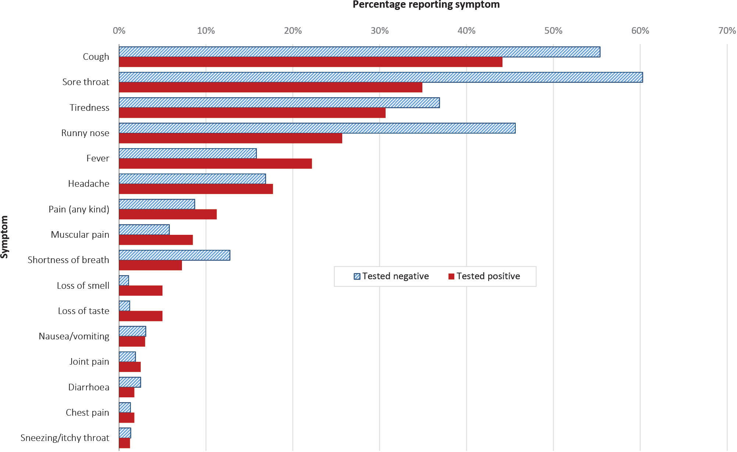

Australian cases: descriptive epidemiology

Transmission trends
Up to 16 August 2020 there were 23,696 COVID-19 cases, including 428 deaths, reported nationally with two distinct peaks in March and July (Figure 1). During this reporting period, there were 3,767 cases, including 54 deaths. The majority of the recently-diagnosed cases were from Victoria (96.3%), followed by New South Wales (3.3%). A small number of cases were also reported in Queensland, South Australia, Tasmania and Western Australia (0.4%). On average, 269 cases were diagnosed each day over the reporting period, a decrease from 425 cases per day over the previous reporting period.
The national rate of infection in this reporting period was 14.8 cases per 100,000 population, which is a decrease from the rate observed in the previous reporting period (23.2 cases per 100,000 population). For Victoria, the rate of infection in this reporting period was 55 cases per 100,000 population in this reporting period, a decrease from 86.3 cases per 100,000 population in the previous reporting period.
Since the first case of COVID-19 was identified in Australia, all states and territories have experienced COVID-19 cases, with some jurisdictions experiencing higher numbers and more community-associated transmission. These differences arise from factors including state demographics, population size, and patterns of overseas arrivals in the beginning of the pandemic, and ongoing repatriation flights. Cases in Victoria are currently driven by community transmission, with numerous outbreaks occurring across a range of settings and locations in Greater Melbourne.

Source of acquisition
As at 16 August 2020, Australia has recorded 23,696 cases of COVID-19 and 428 deaths: 75% of cases are reported as locally acquired; 22% are reported as overseas acquired; and 3% remain under investigation.
Of all locally-acquired cases in this reporting period, the source of acquisition for 15% of cases could not be identified, a decrease from 20% which could not be identified in the previous reporting period. This included 6 cases in this reporting period where a contact could not be identified but interstate travel had occurred.
In this reporting period, 97% of cases have been reported from Victoria (3,628). Of these cases, 75% are reported as locally acquired with known source, 15% as locally acquired with unknown source; 9% as under investigation, though likely locally acquired; and no cases reported as overseas acquired (Table 1, Figure 5).
For all other cases (139) in this reporting period: 68% of cases are reported as locally acquired with known source; 12% of cases are reported as locally acquired with unknown source; 19% of cases are reported as overseas acquired; and 2% of cases reported are under investigation (Table 1). These proportions are similar to the previous reporting period. For cases excluding those reported in Victoria, the majority (90%) were reported by NSW.
Overseas-acquired cases in this fortnight were reported from NSW (17), SA (4), WA (3), and Qld (2) (Table 1). These cases were travellers in hotel quarantine from repatriation flights.
Table 1. COVID-19 notifications by jurisdiction and source of acquisition, 3—16 August
Source | NSW | Vic | Qld | WA | SA | Tas | NT | ACT | Australia
Overseas | 17 | 0 | 2 | 3 | 4 | 0 | 0 | 0 | 26
Local—source known | 93 | 2,734 | 0 | 0 | 1 | 0 | 0 | 0 | 2,828
Local—source unknown | 15 | 550 | 0 | 0 | 0 | 1 | 0 | 0 | 566
Under investigation | 0 | 344 | 0 | 2 | 1 | 0 | 0 | 0 | 347
Total | 125 | 3,628 | 2 | 5 | 6 | 1 | 0 | 0 | 3,767

For locally-acquired cases, compared to the previous reporting period, the rate of infection in Victoria decreased from 86.3 per 100,000 population to 55.0 per 100,000 population. For this reporting period, the infection rate in NSW is 1.3 per 100,000 population with all other jurisdictions (excluding Victoria) reporting an infection rate of less than 0.5 per 100,000. More broadly, the infection rate to date for all locally-acquired cases in Victoria is 245.5 per 100,000 population with Tasmania having the second highest rate of 27.9 cases per 100,000 and NSW following with 21.3 infections per 100,000 (Table 2).

Figure 5. COVID-19 notifications Victoria, and all other jurisdictions, by week and source of acquisition, as at 16 August 2020
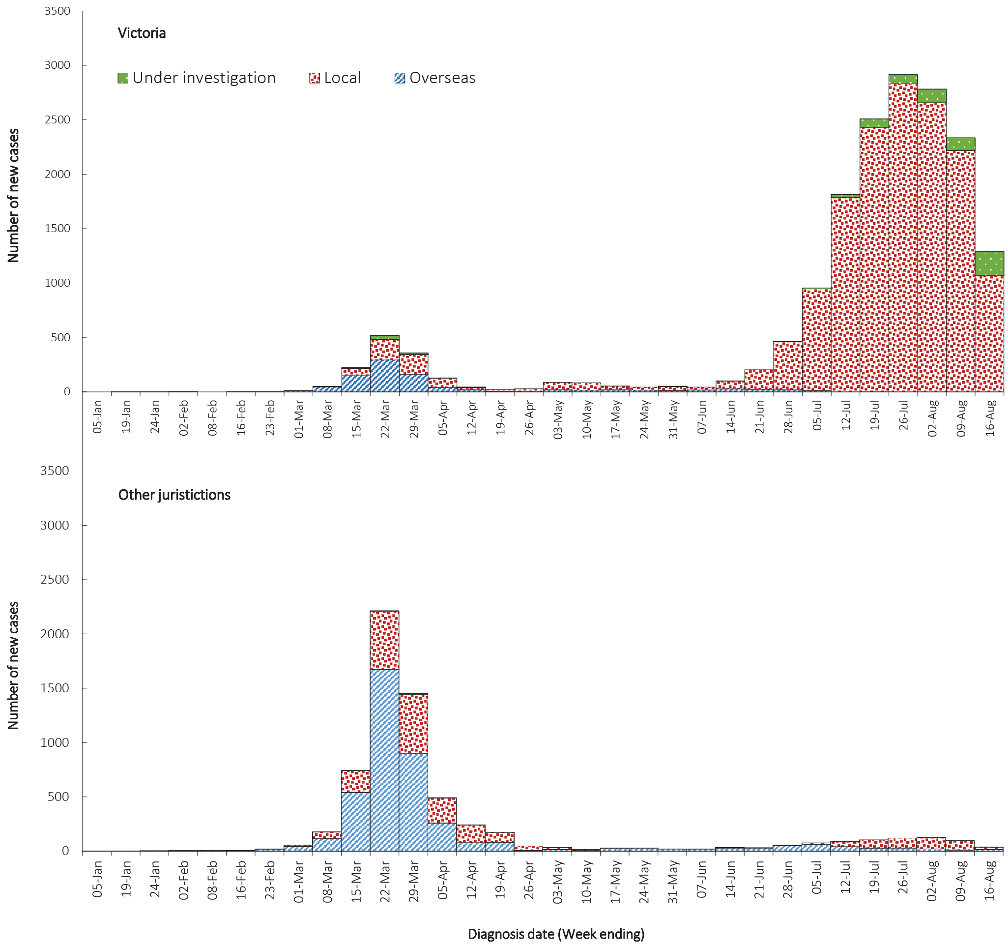

Table 2: Locally-acquired COVID-19 cases by jurisdiction, as at 16 August 2020
Jurisdiction | Reporting period  20 July — 2 August |  | Reporting period  3—16 August |  | Cumulative cases
 | Number of cases | Rates per 100,000 population | Number of cases | Rates per 100,000 population | Number of cases | Rates per 100,000 population
NSW | 180 | 2.2 | 108 | 1.3 | 1,723 | 21.3
Vic | 5,695 | 86.3 | 3,628 | 55 | 16,195 | 245.5
Qld | 7 | 0.1 | 0 | 0 | 249 | 4.9
WA | 0 | 0 | 2 | 0.1 | 98 | 3.7
SA | 7 | 0.4 | 2 | 0.1 | 150 | 8.6
Tas | 1 | 0.2 | 1 | 0.2 | 149 | 27.9
NT | 2 | 0.8 | 0 | 0 | 6 | 2.4
ACT | 0 | 0 | 0 | 0 | 29 | 6.8
Australia | 5,892 | 23.2 | 3,741 | 14.8 | 18,599 | 73.3

Clusters and outbreaks
For the fortnight ending 16 August, there were a total of 298 open outbreaks nationally (defined as those where a new epidemiologically-linked case was identified in the previous 14 days). Of these, most were reported from Victoria, with open outbreaks also reported from NSW and SA. Outbreaks were reported most frequently from residential aged care settings (97) followed by workplaces (88), educational facilities (47), and healthcare facilities (42). Outbreaks ranged in size, with the largest outbreak encompassing 210 cases in a school setting. Prominent workplace settings included meat processing facilities, food distribution centres, construction worksites, warehouses, and retail stores.
Residents of aged care facilities are at increased risk of COVID-19 infection due to the environment of communal living facilities and are more vulnerable to serious complications if they do become infected. As of 16 August 2020, there have been 2,846 cases of COVID-19 associated with 195 residential aged care facilities, with 143 recoveries and 228 deaths. Of these cases, 1,492 occurred in aged care residents, with the remaining 1,354 cases occurring in care staff.

Testing
A total of 5,297,558 tests have been conducted in Australia. High rates of testing have continued across the country, with the cumulative proportion of positive tests remaining low at less than 0.5% (Table 3). In most jurisdictions the cumulative testing positivity is lower than 0.3%. The low positivity rate indicates widespread testing in the community and supports the observation of low levels of disease in these areas.

Table 3: Diagnostic tests performed in Australia, by jurisdiction, as at 16 August 2020ª
Jurisdiction | Tests performed |  |  | Tests performed |  |  |  | Cumulative tests performed
 | 20 July—2 August |  |  | 3—16 August |  |  |  | to 16 August
 | N | Positivity (%) | Per 100,000 population ^{a,b} | N | Positivity (%) |  | Per 100,000 population ^{a,b} | N | Positivity (%) |  | Per 100,000 population ^{a,b}
NSW | 326,955 | 0.07 | 4,042 | 324,940 |  | 0.05 | 4,017 | 1,832,980 |  | 0.22 | 22,658
Vic | 348,526 | 1.67 | 5,284 | 305,590 |  | 1.71 | 4,633 | 1,959,302 |  | 0.85 | 29,704
Qld | 101,468 | 0.01 | 1,992 | 164,787 |  | 0.00 | 3,235 | 725,394 |  | 0.15 | 14,239
WA | 57,732 | 0.02 | 2,202 | 74,366 |  | 0.01 | 2,837 | 320,526 |  | 0.14 | 12,227
SA | 30,031 | 0.03 | 1,714 | 35,279 |  | 0.01 | 2,014 | 285,068 |  | 0.23 | 16,271
Tas | 9,026 | 0.01 | 1,689 | 8,770 |  | 0.01 | 1,641 | 78,753 |  | 0.29 | 14,735
NT | 5,304 | 0.04 | 2,157 | 5,316 |  | 0.00 | 2,162 | 30,527 |  | 0.11 | 12,413
ACT | 10,636 | 0.00 | 2,493 | 12,369 |  | 0.00 | 2,899 | 65,008 |  | 0.17 | 15,235
Australia | 889,678 | 0.68 | 3,508 | 931,417 |  | 0.58 | 3,673 | 5,297,558 |  | 0.44 | 20,889

a Data in this table are based on reports of notification by states and territories.
b Population data based on Australian Bureau of Statistics (ABS) Estimated Resident Population (ERP) as at 30 June 2019.
During this reporting period 931,417 tests were conducted nationally, with an overall positivity rate of 0.58%. All states except Victoria reported a period positivity of 0.05% or lower. Victoria reported a positivity rate of 1.71% for this period, which is an increase from the previous reporting period (1.67%).
For the fortnight 1 to 14 August 2020, SARS-CoV-2 polymerase chain reaction (PCR) testing rates nationally were highest in those aged 20 to 49 years and were lowest in those 70 years and older (Figure 6).

Figure 6. SARS-CoV-2 (PCR) testing rates per 1000 population per week in Australia, by age group,^{a,b} 1 May to 14 August 2020
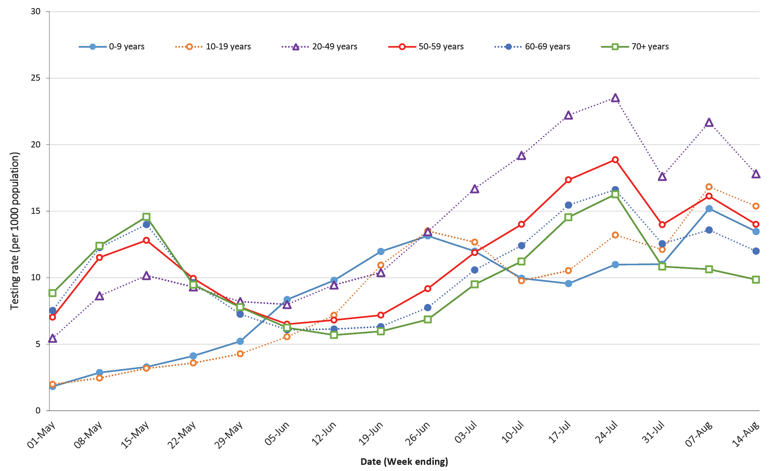
a Data provided by jurisdictions to NIR weekly.
b The jurisdictions reporting each week (i.e. the denominator population) may vary.

Demographics of cases
Historically, cases of COVID-19 have been reported in all age groups. In this reporting period, the largest number of cases occurred in those aged 20–29 years (852), with the highest rate of infection for this period occurring in the 90 years and older age group (82.9 per 100,000 population). Additionally, for all notifications to date, the highest rate of infection has occurred in those aged 90 years and over with a rate of 304.4 per 100,000 population (Appendix B, Table B.1).
Children aged 0–9 years continue to have the lowest rate of infection (33.8 cases per 100,000 population), with testing rates comparable to other age groups (Figure 6). In this reporting period, school-aged children accounted for 11% of all cases, which is a higher proportion than they comprise in cumulative cases (8%).
Cumulatively, all cases show a median age of 37 years (IQR: 25 to 57). The median age has decreased by 1 year since the previous report. During the first wave of cases, the population diagnosed was slightly older, with a median age of 47 years (IQR: 29 to 62) reflecting the primary source of acquisition via cruise ships and overseas travel. In cases since the first wave, the median age is 35 years (IQR: 23 to 53) reflecting household, possibly family-based, transmission in Victoria. The age distribution of cases in this reporting period remains consistent with previous reporting.
Cumulatively, males show a higher per capita rate in more age groups than females (Figure 7), although females now account for a majority of cases aged 80 years and over. The largest difference between the two categories is seen in the 90 years and over age group where males report a rate of 271.1 cases per 100,000 population and females report a higher rate of 320.8 cases per 100,000 population (Table B.1). In this reporting period higher rates in each age group are predominantly seen in females.
Figure 7. COVID-19 cases, by age group and sex, at 16 August 2020, Australia

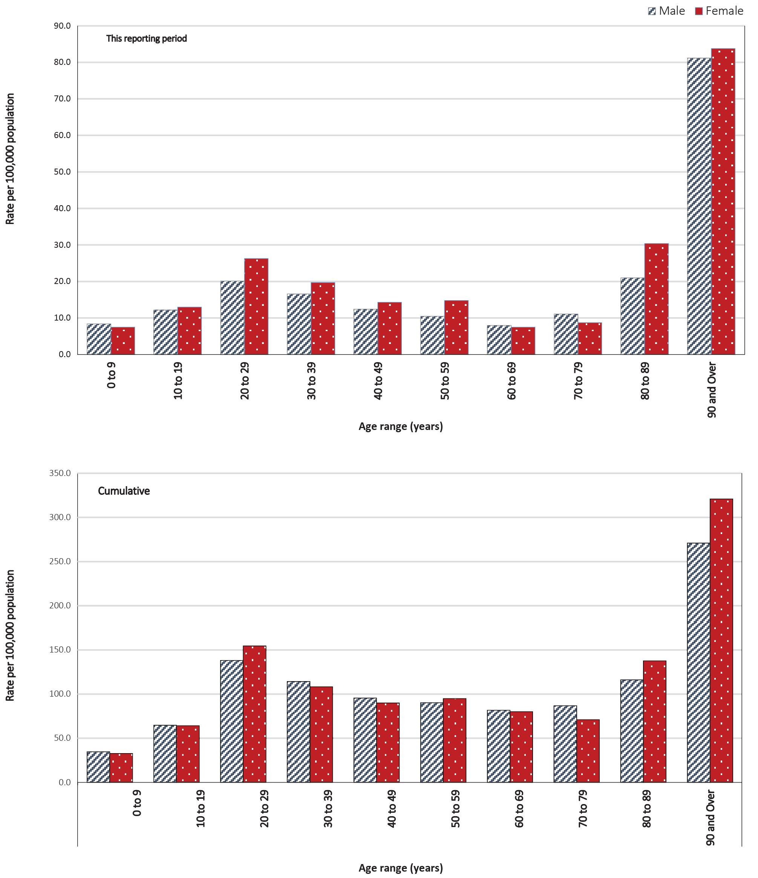

Comorbidities
Within the NNDSS the completeness of the comorbidity field is 94%. However, only 37% of cases report a known comorbidity (the remainder record a comorbidity listed as unknown). Comorbidity data must be interpreted with caution due to the low reliability of data reported in this field. Of those comorbidities specified within the NNDSS, the most common was cardiac disease (2.8%). Of the COVID-19 cases reported to the NNDSS where comorbidity data were available (n = 8,845), 24.8% reported at least one comorbidity. This proportion increased to 47.2% of hospitalised cases; 56.1% of patients admitted to ICU; and 67.1% of cases that died due to COVID-19. The most common comorbidities reported included cardiac disease (7.4% of all cases with data available), diabetes (6.9% of all cases with data available), and asthma (5.9% of all cases with data available) (Table 4).
Table 4. Proportion of comorbidities among those with known comorbidities for cases and deaths, 16 August 2020
Description | All cases  (n= 8,845)  N (%) | Deaths  (n = 155)  N (%)
Asthma | 525 (5.9%) | 5 (3.2%)
Chronic respiratory condition (excluding asthma) | 227 (2.6%) | 17 (11%)
Cardiac disease (excluding hypertension) | 655 (7.4%) | 52 (33.5%)
Immunosuppressive condition/therapy | 204 (2.3%) | 24 (15.5%)
Diabetes | 606 (6.9%) | 39 (25.2%)
Obesity | 262 (3%) | 7 (4.5%)
Liver disease | 52 (0.6%) | 2 (1.3%)
Renal disease | 82 (0.9%) | 9 (5.8%)
Neurological disorder | 151 (1.7%) | 24 (15.5%)
Pregnancy | 77 (0.9%) | 0 (0%)

Aboriginal and Torres Strait Islander persons
There have been 132 cases of COVID-19 notified in Aboriginal and Torres Strait Islander persons. This represents approximately 0.6% of all confirmed cases. Table 5 compares the remoteness of cases in Aboriginal and Torres Strait Islander persons with those in the non-Indigenous population. Approximately 23% (30) of all cases notified in Aboriginal and Torres Strait Islander persons are reported as acquired overseas, with almost half of these (13 cases) associated with cruise ships.
The median age of COVID-19 cases in Aboriginal and Torres Strait Islander persons is 34 years (IQR: 23–51), which is younger than for non-Indigenous cases where the median age is 37 years (IQR: 25–57).
By sex, there is a higher proportion of cases in Aboriginal and Torres Strait Islander females (57%, 76 cases) than in non-Indigenous females (51%, 12,218 cases). The differences observed in sex for Aboriginal and Torres Strait Islander people likely reflect the small number of cases rather than any specific transmission pattern.
Overall, Aboriginal and Torres Strait Islander males are reporting a slightly higher proportion of cases in the 20–29 year age group (26%) compared to non-Indigenous cases (22%), but a lower proportion of cases in both the 40–49 and 50–59 year age groups (11% and 9% respectively) compared to non-Indigenous males (14% and 12% respectively) (Figure 8). Aboriginal and Torres Strait Islander females are reporting a higher proportion of cases in the 10–19 year and 50–59 year age groups (15% and 17% respectively) than is seen among non-Indigenous females (8% and 12% respectively). However, rates in females aged 70 and over are much lower than those in non-Indigenous females aged 70 and over (Figure 8).
Table 5. COVID-19 notifications by Aboriginal and Torres Strait Islander status by jurisdiction, source of acquisition and remoteness classification as at 16 August 2020ª
 | Locally acquired |  |  |  | Overseas acquired | Unknown^{b} | Total
 | Major Cities of Australia | Inner Regional Australia | Outer Regional Australia | Remote / Very Remote Australia
Aboriginal and Torres Strait Islander | 75 | 16 | 7 | 3 | 30 | 1 | 132
Non-Indigenous | 17,027 | 805 | 229 | 21 | 5,067 | 415 | 23,564
a Excludes 1 probable Aboriginal and Torres Strait Islander case.
b Includes 29 cases classified as overseas residents who were diagnosed in Australia.

Figure 8. National COVID-19 notifications by age group and sex, Aboriginal and Torres Strait Islander persons and non-Indigenous Australiansª
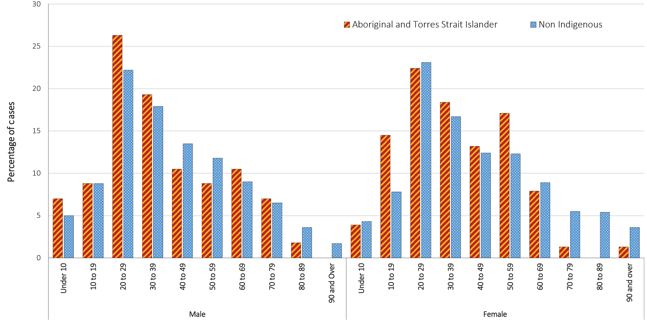
a ‘Non-Indigenous’ includes one person identified as gender X, and 88 non-Indigenous Australians with unknown gender.

Public health response measures
Since COVID-19 first emerged internationally, Australia has implemented public health measures informed by the disease’s epidemiology (Figure 9). On Friday 8 May, the Australian Government announced a three-step framework for easing COVID-19 restrictions, with states and territories easing restrictions at their own pace depending on the current public health situation and local epidemiology.
During the current reporting period no new measures were introduced and no changes were made to measures already in place.^{1–9} States and territories continued to apply existing measures including use of facemasks (Victoria and New South Wales) and domestic border restrictions (Queensland, South Australia and Tasmania).
Key aspects of Australia’s evolving public health response are summarised in previous reports.

Figure 9: COVID-19 notifications in Australia by week of diagnosis and jurisdiction to 16 August 2020 with timing of key public health measures
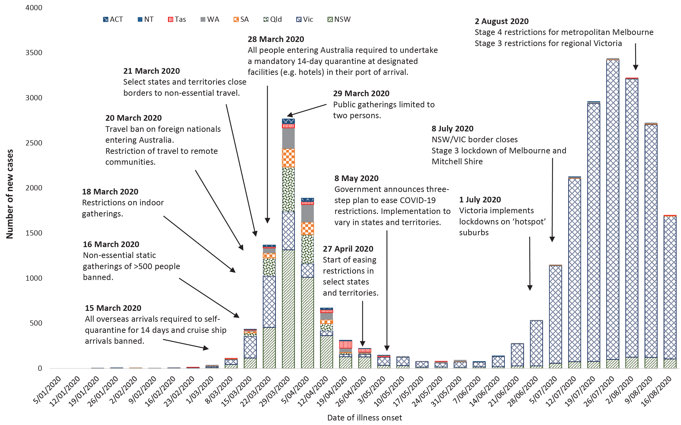

International situation
On 16 August 2020, more than 216 countries, regions and areas had reported 21,028,995 COVID-19 cases and 761,160 deaths to WHO.¹⁰ All data reported below are drawn from the WHO Dashboard extracted on 19 August 2020 unless otherwise specified. The Americas and Europe continue to be the epicentres of the pandemic with the former representing approximately 54% of cumulative cases and cumulative deaths, and the latter representing 18% of cases and 29% of deaths. The global case fatality rate (CFR) is approximately 3.6% and is decreasing as case identification improves. The global cumulative per capita rates are 273.8 cases and 9.9 deaths per 100,000 population.
- By country, the largest numbers of cases are from: the United States of America (5,203,206); Brazil (3,224,876); and India (2,526,192).
- By country, the largest numbers of deaths are from: the United States of America (165,995); Brazil (105,463); and Mexico (55,293).
In the previous fortnight the largest number of cases were reported by the Americas (54%) and the South East Asian (25%) regions, led predominantly by the countries highlighted above.

Western Pacific Region
To date, the Western Pacific Region is the least-affected region on the globe, reporting the lowest number of COVID-19 cases and deaths. The cumulative number of cases in this region stands at approximately 403,000, with approximately 91,000 new cases reported in the previous fortnight (a 29% increase). This represents 2.5% of the global total number of new cases reported in the period. Cumulatively, the Western Pacific region accounts for 1.9% of all cases globally and 1.2% of all deaths. This region reports a cumulative rate of 21.3 cases per 100,000 people and a mortality rate of 0.5 deaths per 100,000 population, which is low when compared to the global rates.
The highest numbers of cases in the region have been observed in the Philippines, China and Singapore (Figure 10). However, in the past fortnight the highest numbers of new cases have been observed in the Philippines (67% of regional cases) and Japan (20% of regional cases). Only Lao People's Democratic Republic did not report any new cases in this reporting period.
In the region, many countries are seeing a resurgence in cases where rates had previously been low. In the past fortnight, New Zealand has reported local transmission in and around the Auckland region. Investigation is ongoing regarding the method of transmission into the community. The cluster has been named the ‘Auckland August Cluster’ and on 20 August 2020 a total of 78 cases had been linked to this cluster.¹¹ Auckland has returned to Alert Level 3 while the rest of New Zealand is at Alert Level 2.¹²
In Papua New Guinea, widespread community transmission has been confirmed in the National Capital District and as of 16 August 2020 the nation had reported 323 cases and 3 deaths.¹³ In the previous fortnight 212 new cases were reported (282% growth). Cases have been reported from 10 provinces, half of which reported their first case in the previous fortnight. Due to low compliance with the non-pharmaceutical interventions within the country, case number are expected to increase.

South East Asia Region
In this fortnight, the South East Asia region has seen a large growth in new case numbers. Cumulatively the region has reported approximately 2.97 million cases and 58,800 deaths, with approximately 899,000 cases reported in the last fortnight (a 43% increase). Cumulatively, the region accounts for 14.1% of global cumulative cases and 7.7% of global cumulative deaths. Regionally, the per capita burden of disease is relatively low, compared to the global rates, at 148.9 cases and 2.9 deaths per 100,000 population. The per capita case rate has increased by more than 40 cases per 100,000 population in the region in this reporting period.
The majority of the cases in this region have been observed almost exclusively in India, Bangladesh and Indonesia, which also comprise the greatest proportion of new cases in the previous fortnight, at 92%, 4% and 3% respectively. Their epidemic trajectories are shown in Figure 10. Together, the remaining countries in this region have reported a cumulative total of only 7,739 cases. India reported the greatest rise in case count, increasing by 49% over the reporting period. The Maldives is the most affected country in the region per capita, reporting 1,029.9 cases per 100,000 population (increased from 701.1 cases per 100,000 population in the last reporting period). Timor-Leste reported one case in the past fortnight.
Figure 10. Number of COVID-19 cases (logarithmic scale) by selected country and days since passing 100 cases, up to 16 August 2020
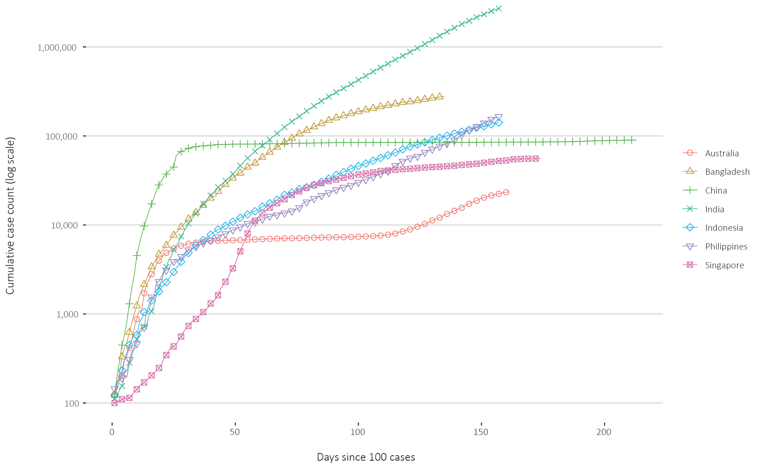

Data considerations
Data were extracted from the NNDSS on 19 August 2020 for notifications received up to 16 August. Due to the dynamic nature of the NNDSS, numbers presented in this report are subject to revision and may vary from numbers previously reported and from case notifications released by states and territories.

Definitions
‘COVID-19’ is the disease caused by a novel coronavirus that emerged in China in late 2019. ‘CO’ stands for corona-, ‘V’ stands for virus, ‘ID’ stands for infectious disease, and ‘-19’ refers to the year that this disease was first reported.
‘SARS-CoV-2’ is the virus that causes the disease COVID-19. It is a betacoronavirus genetically related to the 2003 Severe acute respiratory syndrome coronavirus (SARS-CoV).
‘Date of illness onset’ is derived from data collected by the NNDSS and represents the diagnosis date, or reported true onset of disease date. If unknown, the earliest of specimen collection date, notification date or notification receive date is used.
‘Notification received date’ is reported in the NNDSS and represents the date the case is first notified on the NNDSS. As notification can only occur after testing is completed and information processed, counts for a defined period will vary according to the date type used.
‘Cluster’ in relation to COVID-19 refers to two or more cases (who do not reside in the same household) that are epidemiologically related in time, place or person where a common source (such as an event or within a community) of infection is suspected but not yet established.
‘Outbreak’ in relation to COVID-19 refers to two or more cases (who do not reside in the same household) among a specific group of people and/or over a specific period of time where illness is associated with a common source (such as an event or within a community). Some states and territories may report a single case associated with a residential aged care facility as an outbreak.

Acknowledgements
This report represents surveillance data reported through CDNA as part of the nationally-coordinated response to COVID-19. We thank public health staff from incident emergency operations centres in state and territory health departments, and the Australian Government Department of Health, along with state and territory public health laboratories.

Author details

Corresponding author
COVID-19 National Incident Room Surveillance Team, Australian Government Department of Health, GPO Box 9484, MDP 14, Canberra, ACT 2601. Email: epi.coronavirus@health.gov.au

References
  - Government of New South Wales. What you can and can't do under the rules: outdoor public gatherings. [Internet.] Sydney: Government of New South Wales; 2020. [Accessed on 4 August 2020.] Available from: https://www.nsw.gov.au/covid-19/what-you-can-and-cant-do-under-rules#outdoor-public-gatherings.
  - Government of New South Wales. Health advice update on masks. [Internet.] Sydney: Government of New South Wales; 2 August 2020. [Accessed on 4 August 2020.] Available from: https://www.nsw.gov.au/media-releases/health-advice-update-on-masks.
  - Department of Health and Human Services (DHHS). Stage 4 restrictions. [Internet.] Melbourne: Victoria State Government, DHHS; 2020. [Accessed on 4 August 2020.] Available from: https://www.nsw.gov.au/media-releases/health-advice-update-on-masks.
  - Queensland Government. Border restrictions. [Internet.] Brisbane: Queensland Government; 2020. [Accessed on 4 August 2020.] Available from: https://www.qld.gov.au/health/conditions/health-alerts/coronavirus-covid-19/current-status/public-health-directions/border-restrictions.
  - Government of Western Australia. COVID-19 coronavirus: WA Roadmap. [Internet.] Perth: Government of Western Australia; 2020. [Accessed on 4 August 2020.] Available from: https://www.wa.gov.au/organisation/department-of-the-premier-and-cabinet/covid-19-coronavirus-wa-roadmap.
  - Government of South Australia. Recovery from COVID-19. [Internet.] Adelaide: Government of South Australia; 2020. [Accessed on 4 August 2020.] Available from: https://www.covid-19.sa.gov.au/recovery.
  - Tasmanian Government. Roadmap to recovery. [Internet.] Hobart: Tasmanian Government; 2020. [Accessed on 4 August 2020.] Available from: https://coronavirus.tas.gov.au/families-community/roadmap-to-recovery.
  - Australian Capital Territory Government. Canberra’s recovery plan: easing of restrictions. [Internet.] Canberra: Australian Capital Territory Government; 2020. [Accessed on 4 August 2020.] Available from: https://www.covid19.act.gov.au/community/canberra-recovery.
  - Northern Territory Government. Roadmap to the new normal: other information. [Internet.] Darwin: Northern Territory Government; 2020. [Accessed on 4 August 2020.] Available from: https://coronavirus.nt.gov.au/roadmap-new-normal#section2.
  - World Health Organization (WHO). WHO Coronavirus Disease (COVID-19) dashboard. [Internet.] Geneva: WHO; 2020. [Accessed on 19 August 2020.] Available from: https://covid19.who.int/.
  - New Zealand Government Ministry of Health. COVID-19 - Significant clusters. [Internet.] Wellington: New Zealand Government, Ministry of Health; 2020. [Accessed on 20 August 2020.] Available from: https://www.health.govt.nz/our-work/diseases-and-conditions/covid-19-novel-coronavirus/covid-19-current-situation/covid-19-current-cases/covid-19-significant-clusters.
  - New Zealand Government. Current alert level. [Internet.] Wellington: New Zealand Government; 2020. [Accessed on 20 August 2020.] Available from: https://covid19.govt.nz/covid-19/current-alert-level/.
  - Papua New Guinea National Department of Health, WHO Representative Office for Papua New Guinea. Papua New Guinea Coronavirus Disease 2019 (COVID-19) Health Situation Report #34: 17 August 2020. Port Moresby: Papua New Guinea National Department of Health; 2020. [Accessed on 20 August 2020.] Available from: https://covid19.info.gov.pg/files/Situation%20Report/PNG%20COVID-19%20Health%20Situation%20Report%2034%20(2020-08-17)_FINAL.pdf.
  - WHO. Report of the WHO-China joint mission on coronavirus disease 2019 (COVID-19). [Internet.] Geneva: WHO; 2020. [Accessed 1 Mar 2020.] Available from: https://www.who.int/docs/default-source/coronaviruse/who-china-joint-mission-on-covid-19-final-report.pdf.
  - Harding H, Broom A, Broom J. Aerosol-generating procedures and infective risk to healthcare workers from SARS-CoV-2: the limits of the evidence. J Hosp Infect. 2020;105(4):717–25.
  - Morawska L, Milton DK. It is time to address airborne transmission of COVID-19. Clin Infect Dis. 2020;ciaa939. doi: https://doi.org/10.1093/cid/ciaa939.
  - WHO. Transmission of SARS-CoV-2: implications for infection prevention precautions. [Internet.] Geneva: WHO; 9 July 2020. [Accessed on 28 July 2020.] Available from: https://www.who.int/news-room/commentaries/detail/transmission-of-sars-cov-2-implications-for-infection-prevention-precautions.
  - Pulinx B, Kieffer D, Michiels I, Petermans S, Strybol D, Delvaux S et al. Vertical transmission of SARS-CoV-2 infection and preterm birth. Eur J Clin Microbiol Infect Dis. 2020. doi: https://doi.org/10.1007/s10096-020-03964-y.
  - ECDC. Rapid risk assessment: Paediatric inflammatory multisystem syndrome and SARS-CoV-2 infection in children – 15 May 2020. Solna: ECDC; 2020. [Accessed on 19 May 2020.] Available from: https://www.ecdc.europa.eu/sites/default/files/documents/covid-19-risk-assessment-paediatric-inflammatory-multisystem-syndrome-15-May-2020.pdf.
  - WHO. Coronavirus disease 2019 (COVID-19) situation report – 29. [Internet.] Geneva: WHO; 2020. [Accessed 22 Feb 2020.] Available from: https://www.who.int/docs/default-source/coronaviruse/situation-reports/20200218-sitrep-29-covid-19.pdf.
  - Pung R, Chiew CJ, Young BE, Chin S, Chen M, Clapham HE. Investigation of three clusters of COVID-19 in Singapore: implications for surveillance and response measures. Lancet. 2020;395(10229):1039–46.
  - Park M, Cook AR, Lim JT, Sun Y, Dickens BL. A systematic review of COVID-19 epidemiology based on current evidence. J Clin Med. 2020;9(4):967.
  - WHO. Coronavirus disease 2019 (COVID-19) situation report – 73. [Internet.] Geneva: WHO; 2020. [Accessed on 4 August 2020.] Available from: https://www.who.int/docs/default-source/coronaviruse/situation-reports/20200402-sitrep-73-Covid-19.pdf.
  - WHO. Criteria for releasing COVID-19 patients from isolation: scientific brief. [Internet.] Geneva: WHO; 17 June 2020. [Accessed on 4 August 2020.] Available from: https://www.who.int/news-room/commentaries/detail/criteria-for-releasing-covid-19-patients-from-isolation.
  - Wölfel R, Corman VM, Guggemos W, Seilmaier M, Zange S, Müller MA et al. Virological assessment of hospitalized patients with COVID-2019. Nature. 2020. doi: https://doi.org/10.1038/s41586-020-2196-x.
  - He X, Lau EHY, Wu P, Deng X, Wang J, Hao X. Temporal dynamics in viral shedding and transmissibility of COVID-19. Nat Med. 2020;26(5):672-675.
  - WHO Regional Office for the Eastern Mediterranean. Transmission of COVID-19 by asymptomatic cases. [Internet.] Geneva: WHO; 11 June 2020. [Accessed on 4 August 2020.] Available from: http://www.emro.who.int/health-topics/corona-virus/transmission-of-covid-19-by-asymptomatic-cases.html.
  - Lennon NJ, Bhattacharyya RP, Mina MJ, Rehm HL, Hung DT, Smole S et al. Comparison of viral levels in individuals with or without symptoms at time of COVID-19 testing among 32,480 residents and staff of nursing homes and assisted living facilities in Massachusetts. medRxiv. 2020. doi: https://doi.org/10.1101/2020.07.20.20157792.
  - Cheng HY, Jian SW, Liu DP, Ng TC, Huang WT, Lin HH. Contact tracing assessment of COVID-19 transmission dynamics in Taiwan and risk at different exposure periods before and after symptom onset. JAMA Intern Med. 2020. doi: https://doi.org/10.1001/jamainternmed.2020.2020.
  - Chandrashekar A, Liu J, Martinot AJ, McMahan K, Mercado NB, Peter L et al. Deng W, Bao L, Liu J, Xiao C, Liu J, Xue J et al. SARS-CoV-2 infection protects against rechallenge in rhesus macaques. Science. 2020;eabc4776. doi: https://doi.org/10.1126/science.abc4776.
  - Deng W, Bao L, Liu J, Xiao C, Liu J, Xue J et al. Primary exposure to SARS-CoV-2 protects against reinfection in rhesus macaques. Science. 2020;eabc5343. doi: https://doi.org/10.1126/science.abc5343.
  - Seow J, Graham C, Merrick B, Acors S, Steel KJA, Hemmings O et al. Longitudinal evaluation and decline of antibody responses in SARS-CoV-2 infection. medRxiv. 2020. doi: https://doi.org/10.1101/2020.07.09.20148429.
  - Korea Centers for Disease Control and Prevention (KCDC). Division of risk assessment and international cooperation. Findings from investigation and analysis of re-positive cases. [Internet.] Cheongju: Government of South Korea, KCDC; 2020. [Accessed on 24 May 2020.] Available from: https://www.cdc.go.kr/board/board.es?mid=a30402000000&bid=0030&act=view&list_no=367267&nPage=1.
  - Rockett RJ, Arnott A, Lam C, Sadsad R, Timms V, Gray KA et al. Revealing COVID-19 transmission in Australia by SARS-CoV-2 genome sequencing and agent-based modeling. Nat Med. 2020. doi: https://doi.org/10.1038/s41591-020-1000-7.
  - Seemann T, Lane C, Sherry N, Duchene S, Goncalves da Silva A, Caly L et al. Tracking the COVID-19 pandemic in Australia using genomics. medRxiv. 2020 doi: https://doi.org/10.1101/2020.05.12.20099929.
  - Eden JS, Rockett R, Carter I, Rahman H, de Ligt J, Hadfield J et al. An emergent clade of SARS-CoV-2 linked to returned travellers from Iran. Virus Evol. 2020;6(1):veaa027. doi: https://doi.org/10.1093/ve/veaa027.
  - Sun P, Qie S, Liu Z, Ren J, Li K, Xi JJ. Clinical characteristics of hospitalized patients with SARS-CoV-2 infection: A single arm meta-analysis. J Med Virol. 2020;92(6):612–7. doi: https://doi.org/10.1002/jmv.25735.
  - Li B, Bai W, Hashikawa T. The neuroinvasive potential of SARS-CoV-2 may be at least partially responsible for the respiratory failure of COVID-19 patients. J Med Virol. 2020. doi: https://doi.org/10.1002/jmv.25728.
  - Mao L, Jin H, Wang M, Hu Y, Chen S, He Q et al. Neurological manifestations of hospitalized patients with coronavirus disease 2019 in Wuhan, China. JAMA Neurol. 2020;e201127. doi: https://doi.org/10.1001/jamaneurol.2020.1127.
  - Drew DA, Nguyen LH, Steves CJ, Menni C, Freydin M, Varsavsky T et al. Rapid implementation of mobile technology for real-time epidemiology of COVID-19. Science. 2020;368(6497):1362–7. doi: https://doi.org/10.1126/science.abc0473.
  - Ellul MA, Benjamin L, Singh B,Lant S, Michael BD, Easton A et al. Neurological associations of COVID-19. Lancet Neurol. 2020. doi: https://doi.org/10.1016/S1474-4422(20)30221-0.
  - Venkatakrishnan AJ, Puranik A, Anand A, Zemmour D, Yao X, Wu X et al. Knowledge synthesis of 100 million biomedical documents augments the deep expression profiling of coronavirus receptors. Elife. 2020;9:e58040. doi: https://doi.org/10.7554/eLife.58040.
  - Brann DH, Tsukahara T, Weinreb C, Lipovsek M, Van den Berge K, Gong B et al. Non-neural expression of SARS-CoV-2 entry genes in the olfactory epithelium suggests mechanisms underlying anosmia in COVID-19 patients. Sci Adv. 2020;6(31):eabc5801. doi: https://doi.org/10.1126/sciadv.abc5801.
  - Inciardi RM, Lupi L, Zaccone G, Italia L, Raffo M, Tomasoni D et al. Cardiac involvement in a patient with coronavirus disease 2019 (COVID-19). JAMA Cardiol. 2020. doi: https://doi.org/10.1001/jamacardio.2020.1096.
  - Guo T, Fan Y, Chen M, Wu X, Zhang L, He T et al. Cardiovascular implications of fatal outcomes of patients with coronavirus disease 2019 (COVID-19). JAMA Cardiol. 2020. doi: https://doi.org/10.1001/jamacardio.2020.1017.
  - Madjid M, Safavi-Naeini P, Solomon SD, Vardeny O. Potential effects of coronaviruses on the cardiovascular system: a review. JAMA Cardiol. 2020. doi: https://doi.org/10.1001/jamacardio.2020.1286.
  - Riphagen S, Gomez X, Gonzalez-Martinez C, Wilkinson N, Theocharis P. Hyperinflammatory shock in children during COVID-19 pandemic. Lancet. 2020. doi: https://doi.org/10.1016/S0140-6736(20)31094-1.
  - Morand A, Urbina D, Fabre A. COVID-19 and Kawasaki like disease: the known-known, the unknown-known and the unknown-unknown. Preprints. 2020;2020050160. doi: https://doi.org/10.20944/preprints202005.0160.v1.
  - WHO. Clinical management of severe acute respiratory infection when novel coronavirus (nCoV) infection is suspected. [Internet.] Geneva: WHO; 2020. [Accessed 23 Feb 2020.] Available from: https://www.who.int/publications-detail/clinical-management-of-severe-acute-respiratory-infection-when-novel-coronavirus-(ncov)-infection-is-suspected.
  - Harrison C. Coronavirus puts drug re-purposing on the fast track. Nat Biotechnol. 2020. doi: https://doi.org/10.1038/d41587-020-00003-1.
  - Wang M, Cao R, Zhang L, Yang X, Liu J, Xu M et al. Remdesivir and chloroquine effectively inhibit the recently emerged novel coronavirus (2019-nCoV) in vitro. Cell Research. 2020;30;269–71.
  - Tang W, Cao Z, Han M, Wang Z, Chen W, Sun W et al. Hydroxychloroquine in patients with mainly mild to moderate coronavirus disease 2019: open label, randomised controlled trial. BMJ. 2020. doi: https://doi.org/10.1136/bmj.m1849.
  - Cao B, Wang Y, Wen D, Liu W, Wang J, Fan G et al. A trial of lopinavir–ritonavir in adults hospitalized with severe Covid-19. N Engl J Med. 2020;382:1787–99.
  - WHO. “Solidarity” clinical trial for COVID-19 treatments. [Internet.] Geneva: WHO; 2020. [Accessed on 4 August 2020.] Available from: https://www.who.int/emergencies/diseases/novel-coronavirus-2019/global-research-on-novel-coronavirus-2019-ncov/solidarity-clinical-trial-for-covid-19-treatments.
  - National Institute of Allergy and Infectious Diseases (NIAID). NIH Clinical Trial Shows Remdesivir Accelerates Recovery from Advanced COVID-19. [Internet.] Bethesda: Government of the United States of America, National Institutes of Heath, NIAID; 2020. [Accessed on 19 May 2020.] Available from: https://www.niaid.nih.gov/news-events/nih-clinical-trial-shows-remdesivir-accelerates-recovery-advanced-covid-19.
  - Wang Y, Zhang D, Du G, Du R, Zhao J, Jin Y et al. Remdesivir in adults with severe COVID-19: a randomised, double-blind, placebo-controlled, multicentre trial. Lancet. 2020;395(10236);1569–78.
  - Therapeutic Goods Administration (TGA). Australia's first COVID treatment approved. [Internet.] Canberra: Australian Government Department of Health, TGA; 10 July 2020. [Accessed on 4 August 2020.] https://www.tga.gov.au/media-release/australias-first-covid-treatment-approved.
  - WHO. Draft landscape of COVID-19 candidate vaccines. [Internet.] Geneva: WHO; 2020. [Accessed on 4 August 2020.] Available from: https://www.who.int/publications/m/item/draft-landscape-of-covid-19-candidate-vaccines.
  - University of Oxford. Low-cost dexamethasone reduces death by up to one third in hospitalised patients with severe respiratory complications of COVID-19. [News release.] Oxford: University of Oxford; 16 June 2020. [Accessed on 24 June 2020.] Available from: https://www.recoverytrial.net/files/recovery_dexamethasone_statement_160620_final.pdf.

Appendix A: Background
Last updated 4 August 2020
Epidemiological parameters of SARS-CoV-2 infection and COVID-19 disease are under investigation and are likely to change as more information becomes available. The information provided in this Appendix comes from peer-reviewed and official sources. Pre-prints that have not been peer reviewed have been referenced and are identified in the text.

Modes of transmission
Human-to-human transmission of SARS-CoV-2 is primarily via droplets and fomites from an infected person to a close contact.¹⁴
Airborne transmission may occur through medical aerosol generating procedures, and although there are limited studies in the literature to evaluate the risk of specific procedures, it is prudent for health care workers to continue to undertake appropriate precautions.¹⁵ The potential for transmission by aerosols in other settings is the subject of discussion.¹⁶
SARS-CoV-2 may cause intestinal infection and viral shedding in faeces has been reported, but there are no reports of faecal-oral transmission.¹⁷
There is limited information about the potential for vertical transmission; however, SARS-CoV-2 RNA has been detected in placental tissue and amniotic fluid associated with a stillbirth in Belgium,¹⁸ suggesting it may be possible under some circumstances.
Several studies suggest that children do not play a key role in transmission and are unlikely to be the primary source of infections.¹⁹ Studies from the EU have suggested that child-to-adult transmission is uncommon.^{20,21}

Incubation period
A systematic review of published and preprint studies has estimated the median incubation period of COVID-19 as between 5 and 6 days (ranging from 1 to 14 days).^{22,23}

Infectious period
The infectious period is not well described due to a lack of studies using virus isolation to assess the presence of viable SARS-CoV-2 over time following infection.²⁴
Viral RNA has been identified in respiratory tract specimens 1–2 days prior to symptom onset, and has been observed after symptom cessation.²⁵ A retrospective analysis of 77 pairs of primary and secondary cases suggested that infectiousness may commence from 2.3 days before symptom onset, peaking at 0.7 days before symptom onset. It also suggested 44% of secondary cases may have been infected before the primary case was symptomatic.²⁶
Cases can be infectious while not displaying symptoms, although it is not clear whether these individuals are pre-symptomatic or truly asymptomatic. Current World Health Organization (WHO) advice is that asymptomatic individuals are less infectious than people who display symptoms.²⁷ However, a cross-sectional study in Massachusetts USA of residents and staff in aged care settings demonstrated that viral shedding was similar between people who were symptomatic and not symptomatic at the time of sampling.²⁸ This study has not yet been peer reviewed.
Viral RNA levels peak in the first week of illness, suggesting transmission is most likely to occur early with infectivity gradually decreasing over time.²⁵ In a Taiwanese study examining over 2,500 close contacts of 100 patients with COVID-19, all 22 secondary cases had their first exposure to the index case within six days of symptom onset. No infections were documented in the 850 contacts whose exposure was after six days.²⁹

Immunology
No correlates of immunity have been established but two challenge trials of rhesus macaques suggest that individuals with neutralising antibody titres between 8 and 200 were protected from clinical signs of disease (but not viral shedding) when exposed to SARS-CoV-2 at 28 and 35 days after initial challenge.^{30,31} Cell-mediated immunity has also been demonstrated in recovered people, but the importance of cell-mediated and humoral immunity in clinical recovery and protection against infection and disease requires further study.
In a study of nine cases in Germany, around 50% of the patients seroconverted occurred seven days after symptom onset, and all patients had seroconverted by 14 days. Infectious virus was not able to be isolated from naso/oropharyngeal and sputum samples after the first 8 days of illness.²⁵
The duration of humoral antibody response is not well characterised. A cohort study of 96 SARS-CoV-2 infected people in the United Kingdom demonstrated that serum neutralising antibody responses waned after 40 days post infection, and individuals who had experienced milder symptoms had no neutralisation response at around 60 days post infection.³² This study has not been peer reviewed.
The potential for reinfection or recrudescence of infection is also unclear. However, analysis from the Korea Centres for Disease Control and Prevention, of 108 cases who tested positive after previously being cleared from isolation, found live virus was unable to be cultured from any cases selected for testing.³³

Viral genomics
Since December 2019, the virus has diversified into multiple lineages as it has spread globally, with some degree of geographical clustering. There are currently 2,884 SARS-CoV-2 genome sequences available from Australian cases on the global sequence repository, GISAID. These sequences are dispersed throughout the global lineages, reflecting multiple concurrent introductions into Australia.^{34–36} Recent Australian SARS-CoV-2 sequences from the last month include 96 collected from NSW and 11 from South Australia. Most of these sequences belong to the B.1.1.25 lineage, reflecting ongoing local transmission of this lineage. Genomic epidemiology continues to be used to support epidemiological investigations, particularly for confirming presumed transmission pathways. It has proven particularly useful for linking those cases classified as ‘locally-acquired – contact not identified’ to known genomic clusters, highlighting the utility of virus sequencing to informing the public health response.^{34,35}

Clinical features
COVID-19 presents as mild illness in the majority of cases, with cough and fever the most commonly reported symptoms (see Appendix B). Severe or fatal outcomes are more likely to occur in the elderly or those with comorbid conditions.^{14,37}
Some COVID-19 patients show neurological signs such as headache, nausea and vomiting. There is evidence that SARS-CoV-2 viruses are not always confined to the respiratory tract and may invade the central nervous system causing neurological signs and symptoms. As such, it is possible that invasion of the central nervous system is partially responsible for the acute respiratory failure of COVID-19 patients.³⁸
Impairment or loss of the sense of smell (hyposmia/anosmia) or taste (hypoguesia/aguesia) is commonly associated with COVID-19.^{39–41} This is supported by research finding a biological mechanism for the SARS-CoV-2 virus to cause olfactory dysfunction.^{42,43} Case reports have also linked SARS-CoV-2 infection with less common neurological syndromes including encephalopathy, encephalitis, Guillian-Barré syndrome and acute cerebrovascular disease.⁴¹
Several studies have also identified linked cardiovascular diseases to COVID-19.^{44–46} Vascular inflammation has been observed in a number of cases and may be a potential mechanism for myocardial injury which can result in cardiac dysfunction and arrhythmias.
COVID-19 disease in children is more likely to be mild and self-limiting, compared to adults. Internationally, children make up a small proportion of confirmed COVID-19 cases, with those shown to be infected either presenting with milder symptoms than adults or remaining asymptomatic. However, the greater likelihood of mild clinical presentation in children may result in lower testing and case detection in this cohort. Studies have also shown that hospital admission is inversely related to age. From European reporting, death associated with COVID-19 has been rare among those aged less than 15 years, with 4 deaths reported from 44,695 cases, as at 13 May 2020.¹⁹
There have been reports of a rare clinical presentation of paediatric inflammatory multisystem syndrome resembling Kawasaki disease temporally associated with SARS-CoV-2 infection in children. However, evidence of the association between COVID-19 and the development of a Kawasaki-like disease is currently inconclusive and further investigation is needed due to variability in clinical presentations in reported paediatric cases.^{47,48}

Treatment
Current clinical management of COVID-19 cases focuses on early recognition, isolation, appropriate infection control measures and provision of supportive care.⁴⁹ Whilst there is no specific antiviral treatment currently recommended for patients with suspected or confirmed SARS-CoV-2 infection, multiple clinical trials are underway to evaluate a number of therapeutic agents, including remdesivir, lopinavir/ritonavir, and chloroquine or hydroxychloroquine.^{50,51}
An open-label randomised controlled trial did not find a significant impact of hydroxychloroquine treatment on disease progression for hospitalised patients with mild to moderate COVID-19, with those receiving treatment also reporting a higher number of adverse events.⁵²Similarly, an open-label randomised controlled trial of lopinavir/ritonavir among hospitalised patients found no benefit for time to clinical improvement.⁵³ WHO announced the interruption of clinical trials of hydroxychloroquine and lopinavir/ritonavir under the ‘Solidarity Trial’ on 4 July 2020.⁵⁴
Results for remdesivir treatment have been mixed, with one randomised double-blind placebo-controlled trial finding patients recovered 31% faster and a lower mortality rate (8.0% compared with 11.6% among placebo patients),⁵⁵ while another found no effect.⁵⁶ The Therapeutic Goods Administration has granted provisional approval for use of remdesivir in hospitalised adults and adolescents with severe COVID-19 symptoms.⁵⁷
As at 27 July 2020, the WHO reports that at least 25 candidate vaccines are in clinical trials and 139 are in preclinical evaluation.⁵⁸
Research from the UK has found dexamethasone could significantly reduce death in critically ill patients.⁵⁹ Yet to be published, the preliminary findings announcing by Oxford University reported a 30% reduction in deaths for patients with severe respiratory symptoms. Reduced mortality was observed in ventilated cases and cases requiring oxygen support. No benefit was observed for mild to moderate cases. There are no barriers to the use of dexamethasone in Australian patients who are critically ill, such as cases who require ventilation or oxygen support.⁵⁹

Appendix B: Supplementary figures and tables
Table B.1: COVID-19 case notifications and rates per 100,000 population, by age group and sex, 16 August 2020, Australiaª
Age Group | This reporting period 3—16 August 2020 |  |  |  |  |  | Cumulative
 | Cases |  |  | Rate per 100,000 population |  |  | Cases |  |  | Rate per 100,000 population
 | Male | Female | Total | Male | Female | Total | Male | Female | Total | Male | Female | Total
0—9 | 138 | 116 | 254 | 8.4 | 7.5 | 8.0 | 567 | 509 | 1,077 | 34.7 | 32.8 | 33.8
10—19 | 191 | 193 | 385 | 12.2 | 13.0 | 12.6 | 1,019 | 953 | 1,973 | 64.9 | 64.1 | 64.5
20—29 | 375 | 474 | 852 | 20.1 | 26.3 | 23.2 | 2,569 | 2,790 | 5,388 | 138.0 | 154.6 | 146.9
30—39 | 302 | 365 | 668 | 16.6 | 19.7 | 18.2 | 2,077 | 2,008 | 4,106 | 114.2 | 108.2 | 111.8
40—49 | 201 | 236 | 439 | 12.4 | 14.3 | 13.4 | 1,547 | 1,488 | 3,067 | 95.6 | 89.9 | 93.7
50—59 | 158 | 232 | 390 | 10.5 | 14.8 | 12.7 | 1,362 | 1,492 | 2,864 | 90.3 | 94.9 | 93.0
60—69 | 102 | 101 | 204 | 8.0 | 7.5 | 7.8 | 1,037 | 1,074 | 2,114 | 81.6 | 80.0 | 80.9
70—79 | 97 | 80 | 179 | 11.1 | 8.7 | 10.0 | 755 | 655 | 1,412 | 86.8 | 71.0 | 78.8
80—89 | 75 | 140 | 215 | 21.0 | 30.4 | 26.3 | 415 | 635 | 1,050 | 116.1 | 137.7 | 128.3
90 + | 56 | 112 | 168 | 81.2 | 83.8 | 82.9 | 187 | 429 | 617 | 271.1 | 320.8 | 304.4
a Cases and rates for persons include 5 cases with unknown gender.

Figure B.1: Variation in combinations of COVID-19 symptoms in confirmed cases as at 16 August 2020, Australiaª

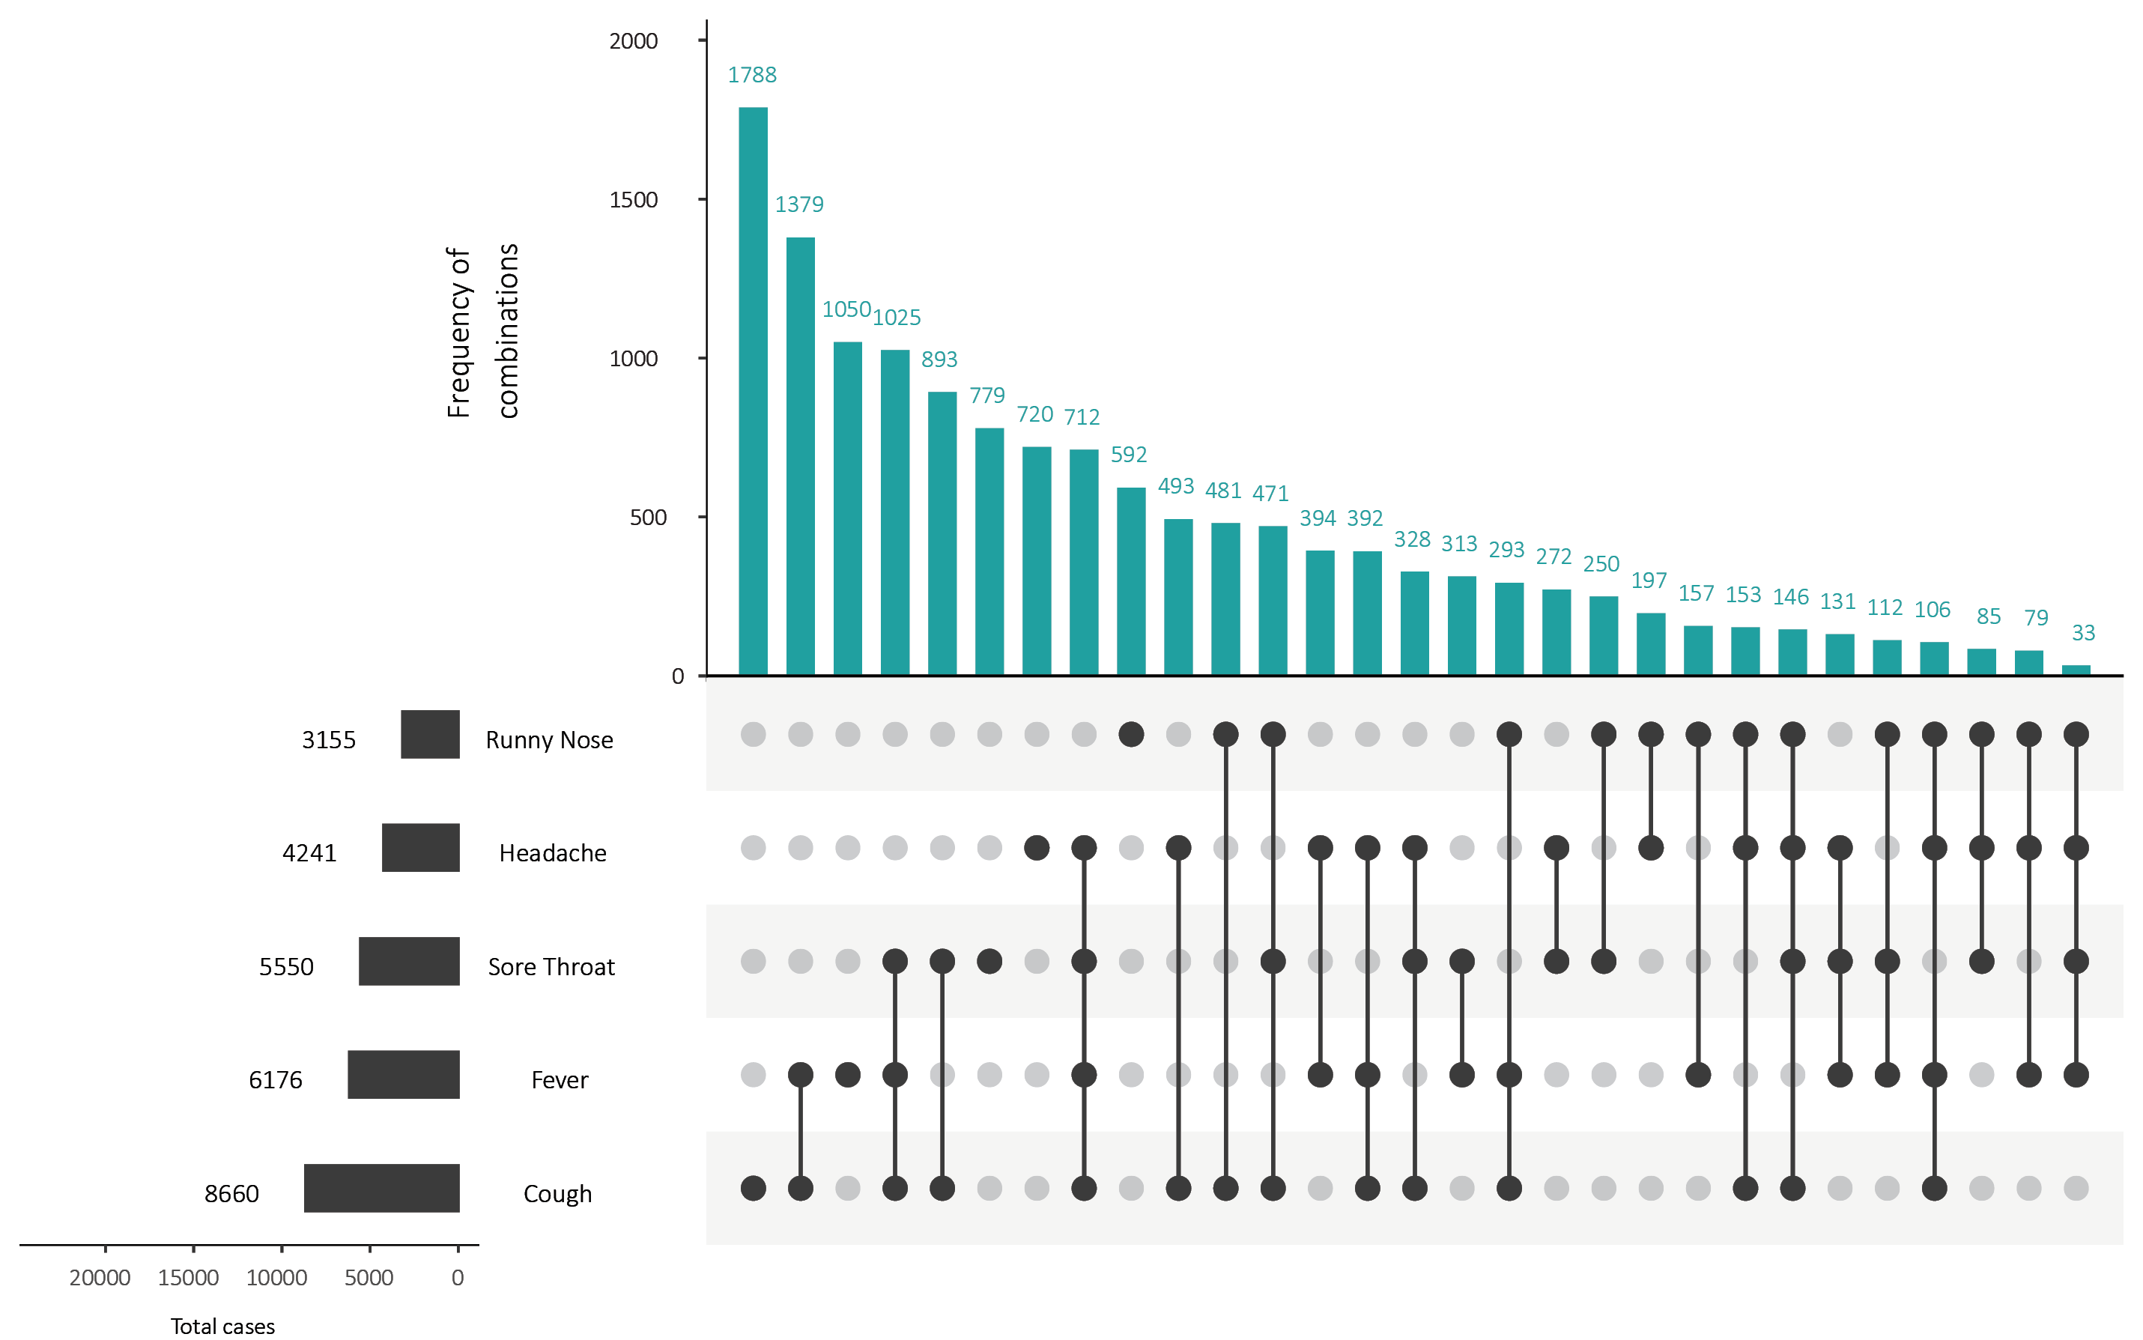
a This figure shows the variation in combinations of symptoms observed in reported cases (n = 12,636) for the five most frequently observed symptoms (cough, fever, headache, sore throat, runny nose). The horizontal bars on the left show the frequency of symptom occurrence in any combination with other symptoms. The circles and lines indicate particular combinations of symptoms observed in individual patients. The vertical green bars indicate the frequency of occurrence of the corresponding combination of symptoms.

Appendix C: Frequently asked questions
Q: Can I request access to the COVID-19 data behind your CDI fortnightly reports?
A: National notification data on COVID-19 confirmed cases is collated in the National Notifiable Disease Surveillance System (NNDSS) based on notifications made to state and territory health authorities under the provisions of their relevant public health legislation.
Normally, requests for the release of data from the NNDSS requires agreement from states and territories via the Communicable Diseases Network Australia, and, depending on the sensitivity of the data sought and proposed, ethics approval may also be required.
Due to the COVID-19 response, unfortunately, specific requests for NNDSS data have been put on hold. We are currently looking into options to be able to respond to data requests in the near future.
We will continue to publish regular summaries and analyses of the NNDSS dataset and recommend the following resources be referred to in the meantime:
- NNDSS summary tables: http://www9.health.gov.au/cda/source/cda-index.cfm
- Daily case summary of cases: https://www.health.gov.au/news/health-alerts/novel-coronavirus-2019-ncov-health-alert/coronavirus-covid-19-current-situation-and-case-numbers
- Communicable Diseases Intelligence COVID-19 epidemiology report: https://www1.health.gov.au/internet/main/publishing.nsf/Content/novel_coronavirus_2019_ncov_weekly_epidemiology_reports_australia_2020.htm
- State and territory public health websites.
Q: Why have the reports changed from weekly to fortnightly?
A: The change to fortnightly reporting is to allow more time for an in-depth analysis of the NNDSS data, therefore enhancing the contents of the report.
Q: Can I request access to data at post-code level of confirmed cases?
A: Data at this level cannot be released without ethics approval and permission would need to be sought from all states and territories via the Communicable Diseases Network Australia. As noted above, specific requests for NNDSS data are currently on hold.
Where current or recent reported case numbers are high enough to justify it, a GIS/mapping analysis of cases will be included in the Communicable Diseases Intelligence COVID-19 epidemiology report. In order to protect privacy of confirmed cases, data in this map will be presented at SA3 level.
Q: Where can I find more detailed data on COVID-19 cases?
A: We are currently looking into ways to provide more in-depth epidemiological analyses of COVID-19 cases, with regard to transmission and severity, including hospitalisation. These analyses will continue to be built upon in future iterations of the Communicable Diseases Intelligence report.

Communicable Diseases Intelligence
ISSN: 2209-6051 Online

Communicable Diseases Intelligence (CDI) is a peer-reviewed scientific journal published by the Office of Health Protection, Department of Health. The journal aims to disseminate information on the epidemiology, surveillance, prevention and control of communicable diseases of relevance to Australia.

Editor: Tanja Farmer
Deputy Editor: Simon Petrie
Design and Production: Kasra Yousefi
Editorial Advisory Board: David Durrheim, Mark Ferson, John Kaldor, Martyn Kirk and Linda Selvey

Website: http://www.health.gov.au/cdi

Contacts
Communicable Diseases Intelligence is produced by:
Health Protection Policy Branch, Office of Health Protection, Australian Government Department of Health
GPO Box 9848, (MDP 6) CANBERRA ACT 2601

Email: cdi.editor@health.gov.au

Submit an Article
You are invited to submit your next communicable disease related article to the Communicable Diseases Intelligence (CDI) for consideration. More information regarding CDI can be found at: http://health.gov.au/cdi.
Further enquiries should be directed to: cdi.editor@health.gov.au.

This journal is indexed by Index Medicus and Medline.

Creative Commons Licence - Attribution-NonCommercial-NoDerivatives CC BY-NC-ND
© 2020 Commonwealth of Australia as represented by the Department of Health
This publication is licensed under a Creative Commons Attribution-NonCommercial-NoDerivatives 4.0 International Licence from https://creativecommons.org/licenses/by-nc-nd/4.0/legalcode (Licence). You must read and understand the Licence before using any material from this publication.

Restrictions
The Licence does not cover, and there is no permission given for, use of any of the following material found in this publication (if any):
- the Commonwealth Coat of Arms (by way of information, the terms under which the Coat of Arms may be used can be found at www.itsanhonour.gov.au);
- any logos (including the Department of Health’s logo) and trademarks;
- any photographs and images;
- any signatures; and
- any material belonging to third parties.

Disclaimer
Opinions expressed in Communicable Diseases Intelligence are those of the authors and not necessarily those of the Australian Government Department of Health or the Communicable Diseases Network Australia. Data may be subject to revision.

Enquiries
Enquiries regarding any other use of this publication should be addressed to the Communication Branch, Department of Health, GPO Box 9848, Canberra ACT 2601, or via e-mail to: copyright@health.gov.au

Communicable Diseases Network Australia
Communicable Diseases Intelligence contributes to the work of the Communicable Diseases Network Australia.
http://www.health.gov.au/cdna

This report addresses indicators listed in the CDNA National Surveillance Plan 2020.

