COVID-19, Australia: Epidemiology Report 6:
Reporting week ending 1900 AEDT 7 March 2020
COVID-19 National Incident Room Surveillance Team

Summary
This is the sixth epidemiological report for coronavirus disease 2019 (COVID-19), reported in Australia as at 19:00 Australian Eastern Daylight Time [AEDT] 7 March 2020. It includes data on COVID-19 cases diagnosed in Australia, the international situation and a review of current evidence.
Keywords: SARS-CoV-2; novel coronavirus; 2019-nCoV; coronavirus disease 2019; COVID-19; acute respiratory disease; case definition; epidemiology; Australia
The following epidemiological data are subject to change both domestically and internationally due to the rapidly evolving situation. Australian cases are still under active investigation. While every effort has been made to standardise the investigation of cases nationally, there may be some differences between jurisdictions.
In Australia:
- Seventy-one COVID-19 cases, including two deaths, were notified up until 19:00 AEDT 7 March 2020;
  - Sixteen cases had direct or indirect links to mainland China;
  - Ten cases, including one death, were among the ‘Diamond Princess’ cruise ship passengers repatriated from Japan;
  - Sixteen cases had direct or indirect links to the Islamic Republic of Iran;
  - Fourteen had a recent travel history to other countries;
  - Fifteen cases, including one death, had no recent history of overseas travel;
- On 4 March 2020, the Australian Health Protection Principal Committee (AHPPC) recommended that the current travel restrictions for mainland China and the Islamic Republic of Iran remain in place for a further seven days; and
- On 5 March 2020, travel restrictions were announced for travellers from Republic of Korea and enhanced health screening for travellers from Italy.
Internationally:
- 101,927 infections have been confirmed globally, with 3,486 deaths;
- The majority of confirmed infections (79%; n = 80,651) and deaths (88%; n = 3,070) have been reported in mainland China;
- Outside of mainland China, cases (n = 21,276) have been reported in 96 countries, territories and areas, with approximately 78% of those cases reported from three countries: Italy, the Islamic Republic of Iran and Republic of Korea; and
- Outside of mainland China, 416 deaths were reported by 16 countries, territories and areas.

Domestic cases
There were 71 confirmed cases, including two deaths, reported in Australia as at 19:00 AEDT 7 March 2020 (Table 1). Of the 71 confirmed cases, 10 (14%) were among the ‘Diamond Princess’ cruise ship passengers repatriated from Japan (n = 164) to the Northern Territory on 20 February 2020. The remaining cases were reported in New South Wales (n = 33), Victoria (n = 8), Queensland (n = 12), Western Australia (n = 1), South Australia (n = 6) and Tasmania (n = 1) (Figure 1).
Figure 1: Confirmed cases of COVID-19 infection by date of illness onset, Australia, 2020 (n = 68)ª
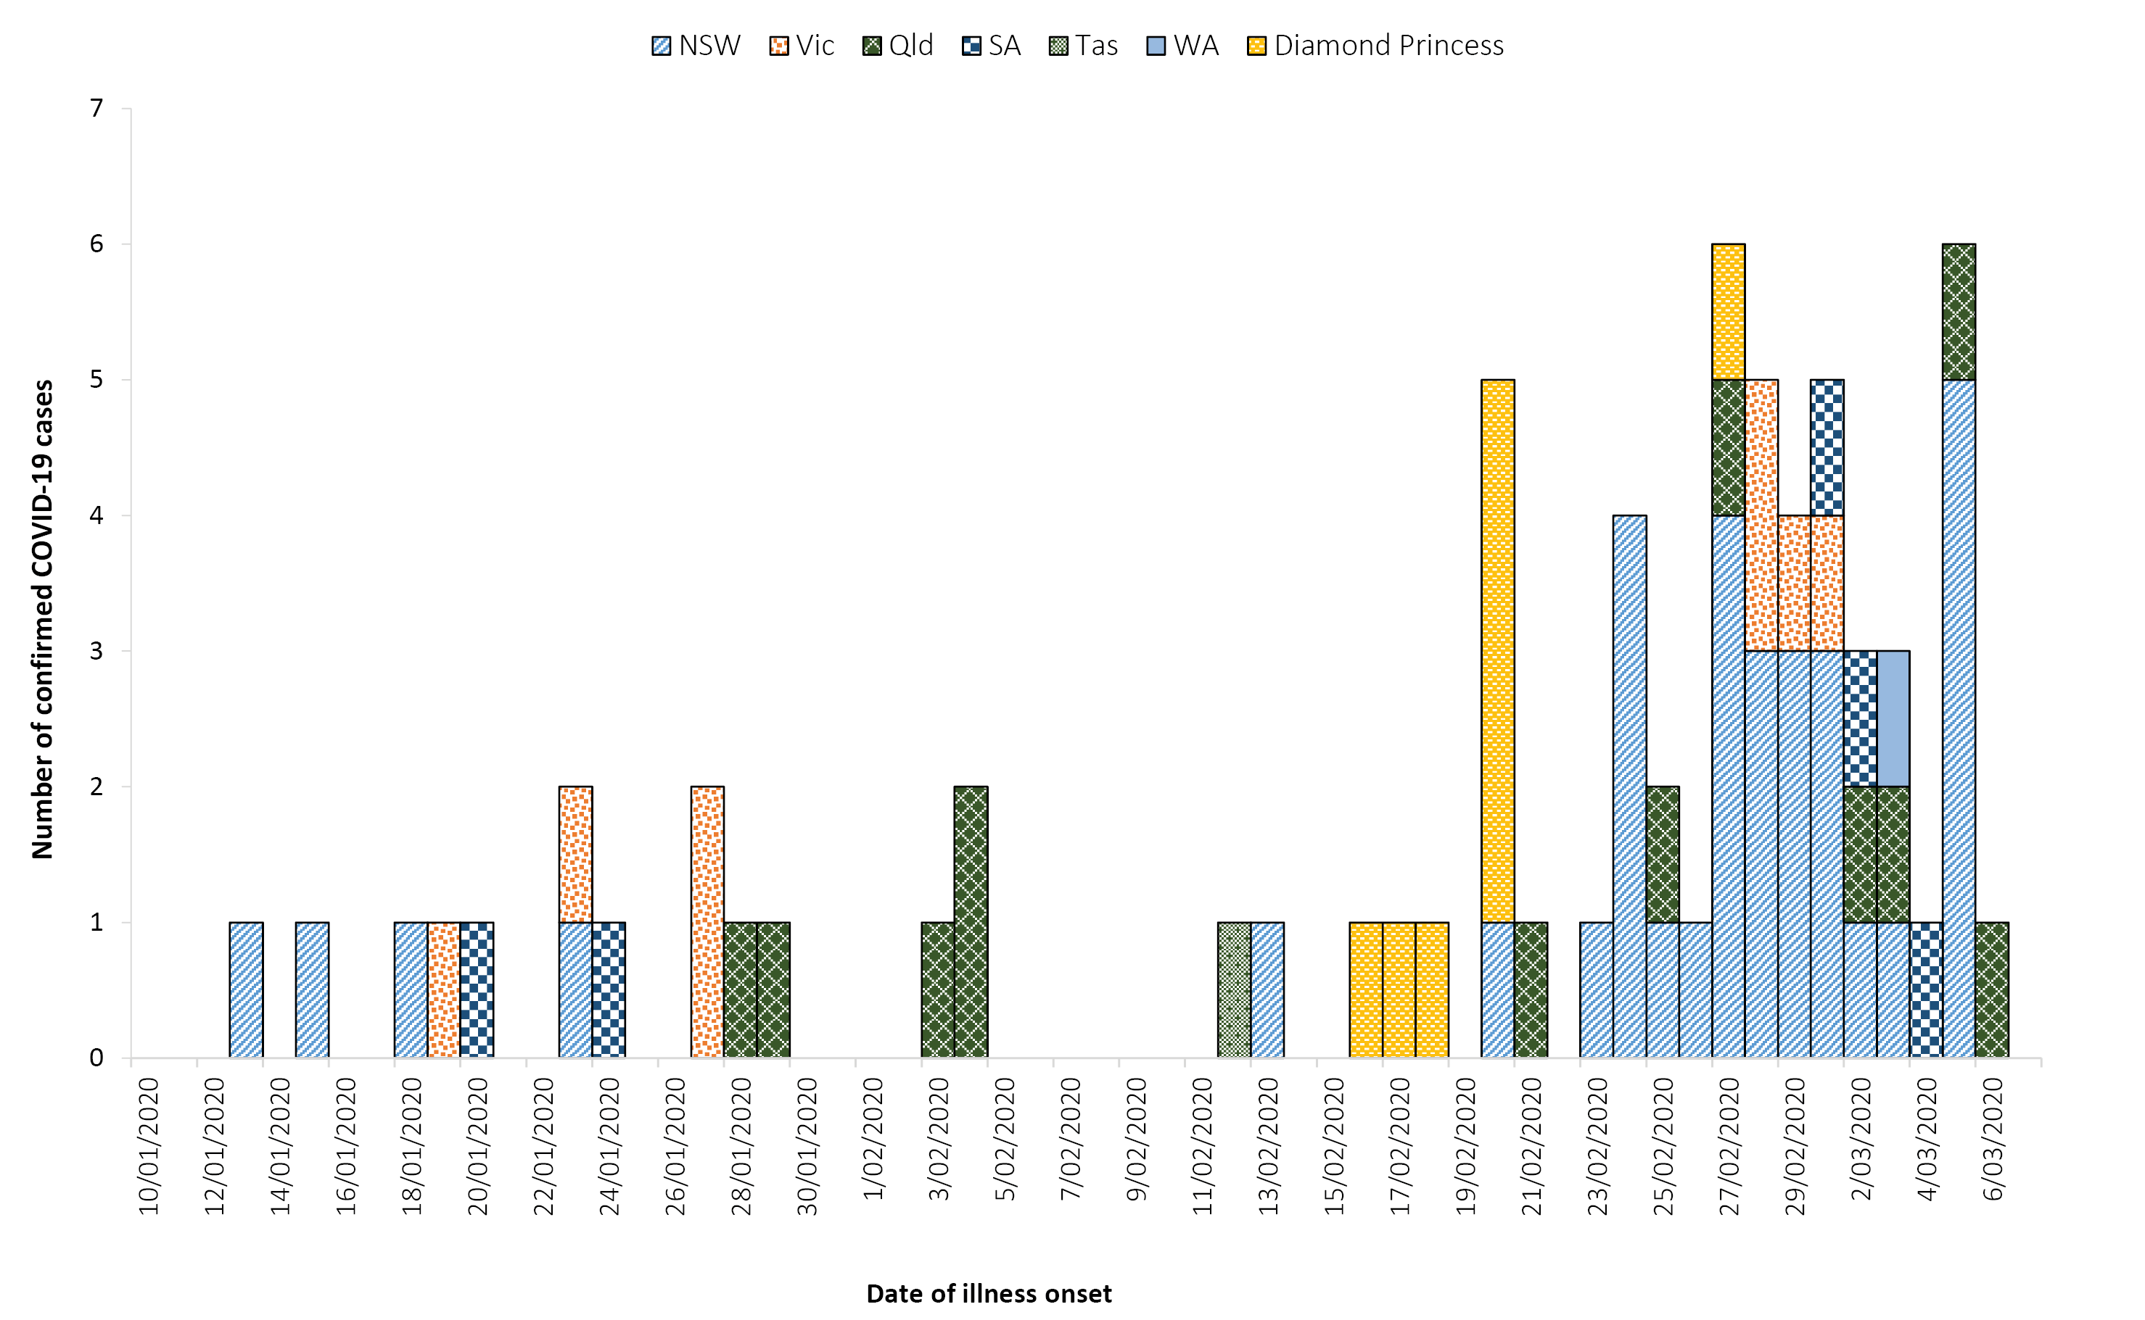
a Date of symptom onset not available for three cases.

Table 1: Cumulative notified cases of confirmed COVID-19 by jurisdiction, Australia, 2020 (n = 71)
Jurisdiction | This week  (to 19:00 AEDT 7 Mar)  No. of new cases | Last week  (to 19:00 AEDT 29 Feb)  No. of new cases | Total cases  (to 19:00 AEDT 7 Mar 2020)  No. of cases
NSW | 29 | 0 | 33
Vic | 4 | 0 | 8
Qld | 6 | 1 | 12
WA | 1 | 0 | 1
SA | 4 | 0 | 6
Tas | 1 | 0 | 1
NT | 0 | 0 | 0
ACT | 0 | 0 | 0
Repatriation (Diamond Princess) | 1 | 2 | 10
Total cases | 46 | 3 | 71

Of the 71 confirmed cases, 16 (23%) had direct or indirect links to mainland China, 10 (14%) were associated with the ‘Diamond Princess’ cruise ship, 16 (23%) had direct or indirect links to the Islamic Republic of Iran, 14 (20%) had a recent travel history to other countries and 15 (21%) had no recent history of overseas travel. Of the 15 cases who had no recent history of overseas travel, these were all reported in New South Wales. Twelve of the cases were associated with an aged care facility, including four residents, three staff members and several close contacts outside of the facility. A further two cases were associated with a workshop and the source of infection/exposure for the remaining case was under investigation at the time of writing. The identification of COVID-19 clusters in New South Wales with no recent history of overseas travel in any of the primary/index cases suggests that there has potentially been some very limited local transmission within New South Wales.
The median age of all 71 reported Australian cases was 45 years (range 0–94 years), with the highest proportion of cases aged 50–59 years (Table 2). Male-to-female ratio was approximately 1:1. Twenty-two cases have been reported to have cleared their infections, and two cases were reported to have died. Of the two cases that died, both were aged over 65 years.
Table 2: Age distribution of confirmed COVID-19 cases, Australia, 2020 (n = 71)
Age group | Number of cases | %
0–9 | 2 | 3
10–19 | 2 | 3
20–29 | 13 | 18
30–39 | 11 | 15
40–49 | 11 | 15
50–59 | 14 | 20
60–69 | 8 | 11
70–79 | 6 | 8
80+ | 4 | 6
Of the 71 confirmed cases, 34 (48%) had symptoms recorded. Cough was the most commonly reported symptom (Table 3) and no cases reported irritability/confusion, abdominal pain or acute respiratory disease.

Table 3: Symptoms of confirmed COVID-19 cases, Australia, 2020 (n = 34)
Symptom | Number of cases | %
Cough | 24 | 71
Fever | 22 | 65
Sore throat | 17 | 50
Headache | 12 | 35
Runny nose | 10 | 29
Diarrhoea | 9 | 26
Muscular pain | 6 | 18
Joint pain | 6 | 18
Shortness of breath | 3 | 9
Nausea/vomiting | 2 | 6
Chest pain | 2 | 6
Pneumonia | 2 | 6

International cases
As at 19:00 AEDT 7 March 2020, the number of confirmed COVID-19 cases reported to the World Health Organization (WHO) was 101,927 globally.¹ The proportion of new cases reported from mainland China has continued to decrease, from 98% on 22 February 2020 to 79% (n = 80,651) on 7 March 2020.^{1,2} On 26 February 2020, the number of new cases outside of mainland China exceeded the number reported from mainland China for the first time and this trend has continued to date (Figure 2). The total number of confirmed COVID-19 cases reported by 96 countries, territories and areas outside of mainland China in the current reporting week have increased almost four-fold (n = 21,276) compared to the preceding week (n = 5,447), where 696 confirmed cases were associated with the cruise ship ‘Diamond Princess’.^{1,3} The Republic of Korea reported 33% (n = 6,767) of all cases outside of mainland China, Italy reported 23% (n = 4,636), the Islamic Republic of Iran 23% (n = 4,747) and Japan 2% (n = 408). Thirty-five new countries, territories and areas reported cases of COVID-19 in the past seven days. Of all the countries, territories and areas outside of mainland China with known transmission classification (n = 87), 45 (52%) have reported local transmission of COVID-19. Cambodia, Nepal and Sri Lanka have not reported any new cases for at least 14 days.¹

Figure 2. Cases of COVID-19 reported to WHO; and number of countries, territories and areas reporting outside mainland China from 21 January to 7 March 2020⁴
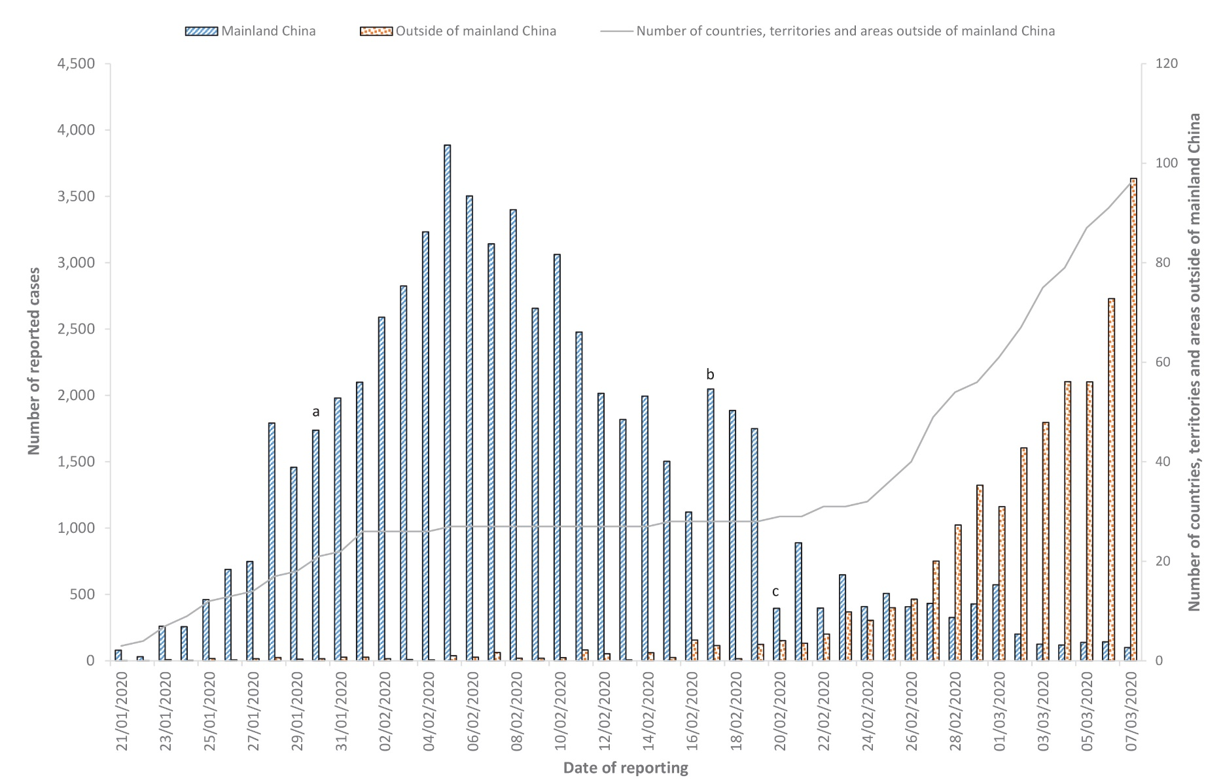
a WHO declares the outbreak of COVID-19 a Public Health Emergency of International Concern
b WHO starts reporting both laboratory confirmed and clinically diagnosed cases from Hubei Province
c Hubei Province cease reporting clinically diagnosed cases

Globally, 3,486 deaths have been reported, with 85% (n = 2,959) reported from Hubei Province, China and 111 deaths reported from elsewhere within mainland China. The remaining 416 deaths were reported by 16 countries, territories and areas outside of mainland China.¹

Country in focus: the Islamic Republic of Iran
Data on confirmed cases of COVID-19 in the Islamic Republic of Iran have not been made publicly available. The following is therefore a brief summary based on information obtained from WHO situation reports.
The Islamic Republic of Iran reported its first confirmed case of COVID-19 on 20 February 2020. From then, reported cases in the Islamic Republic of Iran increased rapidly, from two confirmed cases on 20 February 2020 to 4,747 on 7 March 2020. Among the cases reported as at 7 March 2020, 30% (n = 1,413) were reported in Tehran, 11% (n = 523) in Qom and 9% (n = 424) in Gilan. The Islamic Republic of Iran is one of the countries outside of mainland China with the most rapid growth of COVID-19 cases (Figure 3).
Based on confirmed cases up to 7 March 2020, the case fatality rate (CFR) for the Islamic Republic of Iran has been calculated at 2.6%. As the outbreak continues, the confirmed CFR may change. The current calculated CFR does not include the number of cases with mild infections that may be missed from current surveillance, nor does it account for the recently confirmed cases that may subsequently develop severe disease and die.

Figure 3: Number of COVID-19 cases by country and days since passing 100 cases, up to 7 March 2020
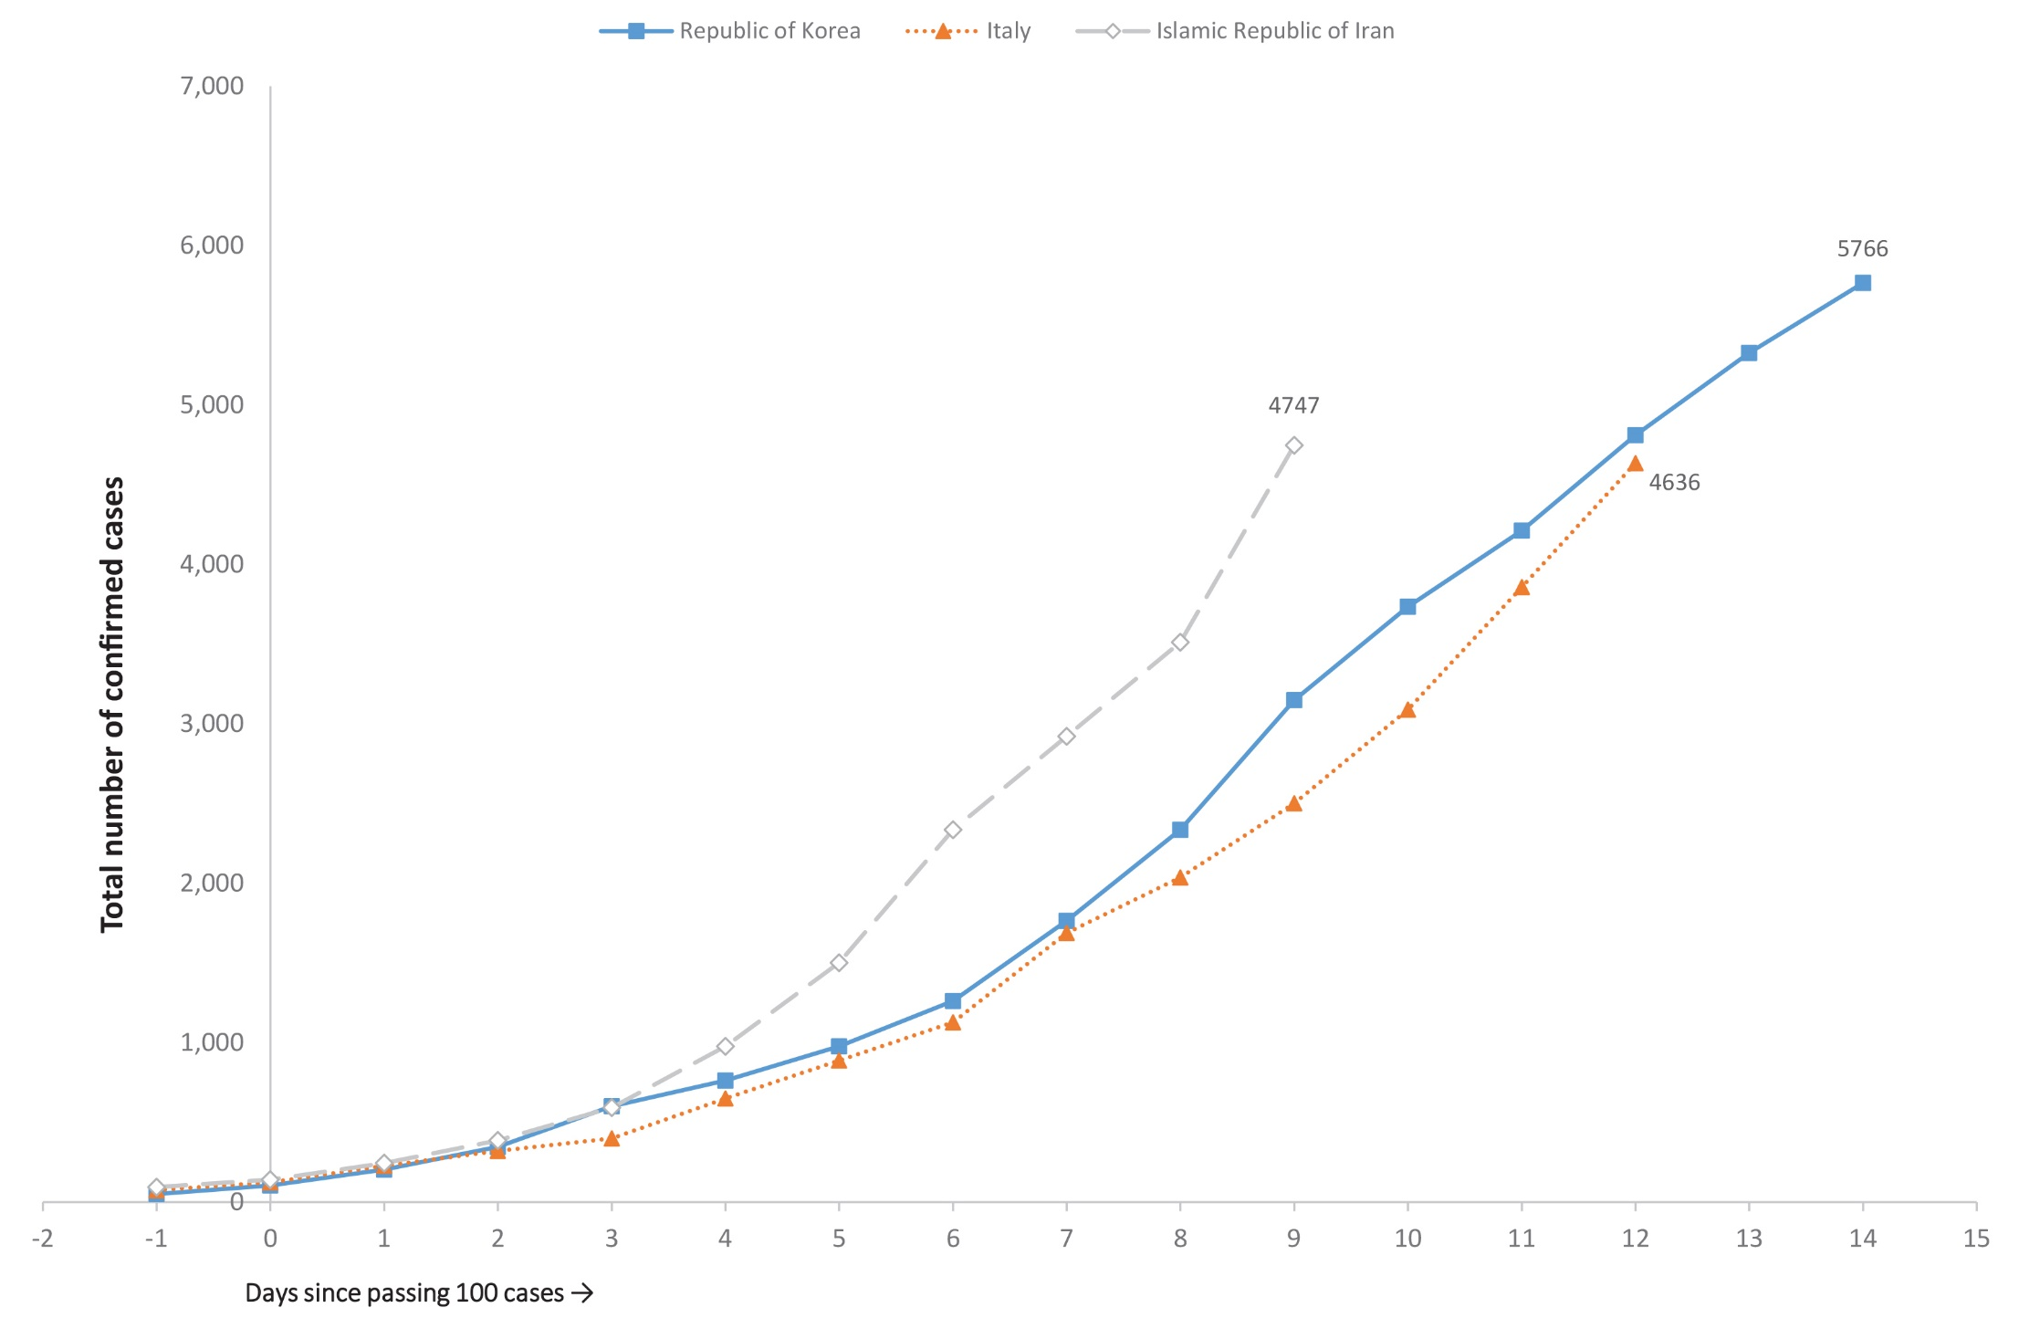

Background
On 31 December 2019, the World Health Organization (WHO) was notified about a large number of cases of pneumonia of unknown origin in Wuhan City, Hubei Province, China. Chinese authorities isolated and identified a novel coronavirus on 7 January 2020.⁵ WHO declared the outbreak of COVID-19 a Public Health Emergency of International Concern (PHEIC) on 30 January 2020.⁶
From 1 February 2020, Australia denied entry to anyone who had left or transited through mainland China, with the exception of Australian citizens, permanent residents and their immediate family and air crew who have been using appropriate personal protective equipment (Figure 4).⁷ The Australian Health Protection Principal Committee (AHPPC) have reviewed these restrictions weekly, and on 4 March 2020, they released a statement recommending current travel restrictions for mainland China and the Islamic Republic of Iran remain in place for a further seven days.⁸ On 5 March 2020, the Prime Minister announced new travel restrictions for travellers coming from Republic of Korea, and implementation of enhanced health screening for arrivals from Italy. From 5 March 2020, foreign nationals (excluding permanent residents of Australia) will be prevented from coming to Australia until 14 days after leaving Republic of Korea.⁹

Figure 4: A timeline of key events in the COVID-19 outbreak, Australia, up to 7 March 2020
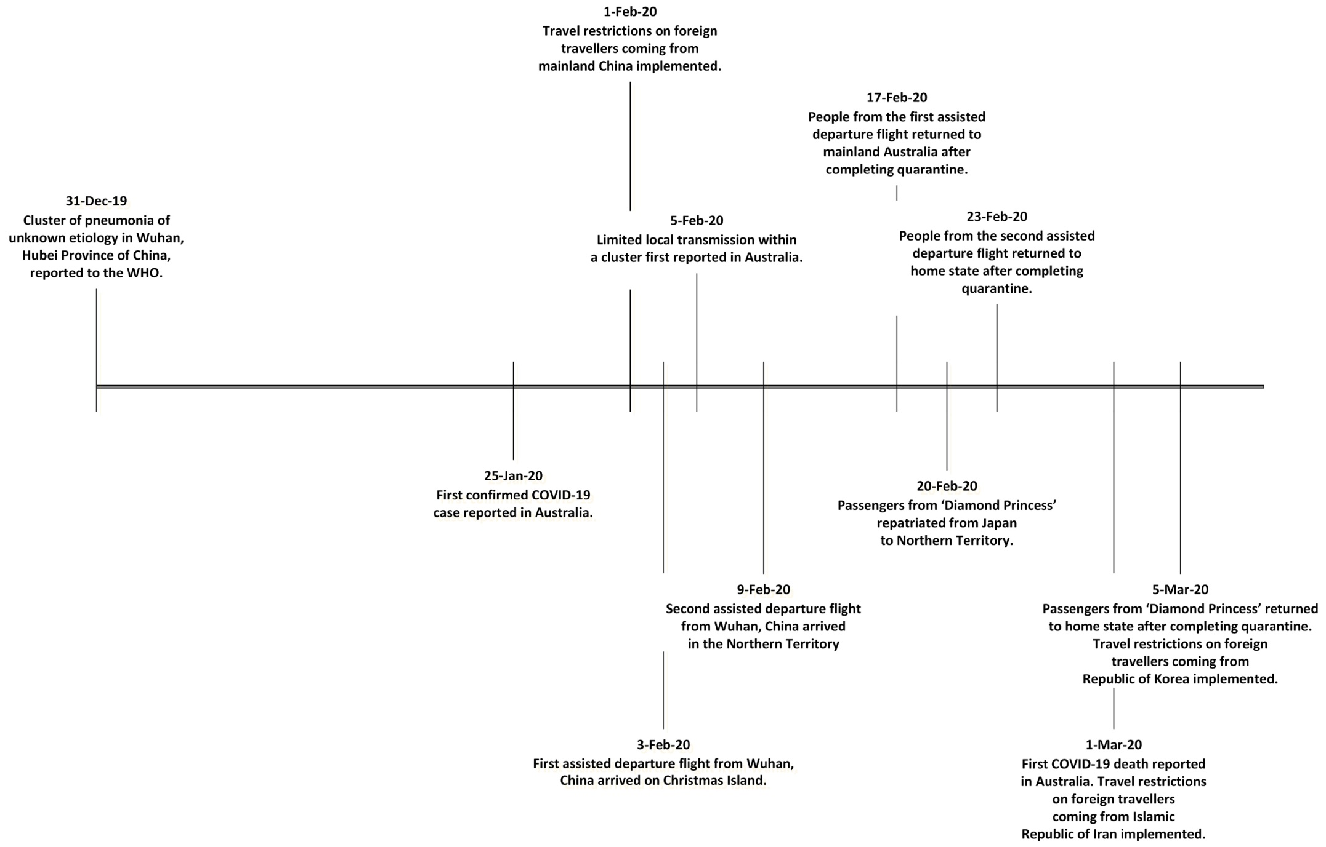

The AHPPC acknowledged that Australia’s border measures may no longer be able to prevent the importation of COVID-19, and the primary focus should now be directed at domestic containment and preparedness.⁸ Local transmission of COVID-19 has occurred in Australia, highlighting the need of effective containment measures to limit spread. Early isolation of identified cases and quarantine of suspected cases and close contacts is a key measure to minimise transmission of COVID-19 in the community. However, as COVID-19 presents as mild illness in the majority of cases, early identification and isolation of cases may be difficult to achieve.
The current estimates on epidemiological parameters including severity, transmissibility and incubation period are uncertain. Estimates are likely to change as more information becomes available.

Severity
Ongoing evidence, including a recently published meta-analysis, supports previous research that COVID-19 presents as mild illness in the majority of cases with fever and cough being the most commonly reported symptoms. Severe or fatal outcomes tend to occur in the elderly or those with comorbid conditions.^{10,11} Examination of cases and their close contacts in China found an association between age and time from symptom onset to recovery. Median time to recovery was estimated to be 27 days in 20–29 year olds, 32 days in 50–59 year olds, and 36 days in those aged over 70 years. The study also found an association between clinical severity and time from symptom onset to recovery. Compared to people with mild disease, those with moderate and severe disease were associated with a 19% and 58% increase in recovery time, respectively.¹²

Transmission
Human-to-human transmission of SARS-CoV-2 is via droplets and fomites from an infected person to a close contact.¹⁰ Examination of cases and their close contacts in China supports this. Household contacts and those who travelled with a confirmed COVID-19 case were strongly associated with an increased risk of infection.¹² The study also examined the average time from symptom onset to disease confirmation and isolation among cases identified through symptom-based (i.e. symptomatic screening at airports, community fever monitoring and testing of hospital patients) and contact-based (i.e. monitoring and testing of close contacts of confirmed COVID-19 cases) surveillance. Compared to cases identified through symptom-based surveillance, cases identified through contact-based surveillance were associated with a 2.3 day decrease from symptom onset to disease confirmation, and a 1.9 day decrease from symptom onset to isolation. Based on modelling, researchers have found that effective contact tracing increases the probability of control.¹²
Current evidence does not support airborne or faecal-oral spread as major factors in transmission.¹⁰

Incubation period
No new research has been published on the incubation period for COVID-19. Please refer to COVID-19, Australia: Epidemiology Report 4 for the most recently published summary.¹³

Treatment
Current clinical management of COVID-19 cases focuses on early recognition, isolation, appropriate infection control measures and provision of supportive care.¹⁴ Whilst there is no specific antiviral treatment currently recommended for patients with suspected or confirmed SARS-CoV-2 infection, multiple clinical trials are underway to evaluate a number of therapeutic agents, including remdesivir and lopinavir/ritonavir.¹⁵

Virology
Based on modelling, researchers estimated that initial human SARS-CoV-2 infection was in November to early December 2019.¹⁶ An analysis based on 86 genomic sequences of SARS-CoV-2, obtained from the Global Initiative on Sharing All Influenza Data (GISAID), found many mutations.¹⁷ This suggests that SARS-CoV-2 has rapidly evolved since the outbreak occurred. Ongoing surveillance of sequences and shared mutations will assist with understanding of the global spread of the virus.

Comparison between COVID-19, SARS and MERS
Coronaviruses are a group of viruses that can cause upper respiratory tract infections in humans. Coronaviruses can occasionally cause severe diseases such as Middle East Respiratory Syndrome (MERS), Severe Acute Respiratory Syndrome (SARS) and more recently COVID-19. Similar to MERS and SARS, COVID-19 is thought to have originated from bats, and transmitted to humans via an intermediate animal host. The intermediate animal host is currently unknown.¹⁸ Table 4 provides an overview of characteristics of COVID-19, MERS and SARS.
Table 4: Characteristics of COVID-19, MERS and SARS^{19–21}
 | COVID-19 | MERS | SARS
Median incubation period | 5–6 days | 5 days | 4–5 days
Mode of transmission | Respiratory droplet, close contact, fomites | Respiratory droplet, close contact | Respiratory droplet, close contact, fomites
Symptoms | Fever, cough, fatigue and difficulty with breathing (dyspnoea) | Fever, cough and shortness of breath | Fever, malaise, myalgia, headache, diarrhoea and shivering (rigors)
Number of countries and regions affected | 97 | 27 | 29
Regions severely affected | Mainland China, Republic of Korea, Italy and Islamic Republic of Iran | Saudi Arabia | Mainland China, Hong Kong SAR, Taiwan, Canada, Singapore
Number of cases globally | 101,927 | 2,519 | 8,422
Number of deaths globally | 3,486 | 866 | 916
Global case fatality rate | 3.4% | 34.3% | 10.9%
Prophylaxis available | No | No | No

Public health response
The Report of the WHO-China Joint Mission on Coronavirus Disease 2019 (COVID-19) describes some of the key aspects associated with the evolving outbreak in mainland China, including the outbreaks transmission dynamics, disease progression and severity, mainland China’s response and knowledge gaps. As part of the report, the following major recommendations were made for countries with imported cases and/or outbreaks of COVID-19:¹⁰
- Immediately activate the highest level of national Response Management protocols to ensure the all-of-government and all-of-society approach needed to contain COVID-19 with non-pharmaceutical public health measures;
- Prioritise active, exhaustive case finding and immediate testing and isolation, painstaking contact tracing and rigorous quarantine of close contacts;
- Fully educate the general public on the seriousness of COVID-19 and their role in preventing its spread;
- Immediately expand surveillance to detect COVID-19 transmission chains, by testing all patients with atypical pneumonias, conducting screening in some patients with upper respiratory illnesses and/or recent COVID-19 exposure, and adding testing for the COVID-19 virus to existing surveillance systems (e.g. systems for influenza-like-illness); and
- Conduct multi-sector scenario planning and simulations for the deployment of even more stringent measures to interrupt transmission chains as needed (e.g. the suspension of large-scale gatherings and the closure of schools and workplaces).

Methods
Data for this report were current as at 19:00 hours AEDT, 7 March 2020.
This report outlines what is known epidemiologically on COVID-19 in Australia and from publicly available data from WHO Situation Reports, other countries’ official updates and the scientific literature. Data on domestic cases in this report were collected from the National Notifiable Diseases Surveillance System (NNDSS) and jurisdictional health department media releases. The Communicable Diseases Network Australia (CDNA) developed the case definition for suspect and confirmed cases, which was modified at different time points during the outbreak (Table 5). Data was analysed using Stata to describe the epidemiology of COVID-19 in Australia and the progress of the epidemic.
Data for the international cases of COVID-19 by country were compiled from the latest WHO Situation Report. Case definitions may vary by country making comparisons difficult. Rapid reviews of the current state of knowledge on COVID-19 were conducted from the literature using PubMed.

Acknowledgements
This report represents surveillance data reported through CDNA as part of the nationally-coordinated response to COVID-19. We thank public health staff from incident emergency operations centres in state and territory health departments, and the Australian Government Department of Health, along with state and territory public health laboratories.

Author details

Corresponding author
Tracy Tsang
NIR Surveillance Team, Communicable Disease Epidemiology and Surveillance Section, Health Protection Policy Branch, Australian Government Department of Health, GPO Box 9484, MDP 14, Canberra, ACT 2601.
Email: epi.coronavirus@health.gov.au

Table 5: Australian COVID-19 case definition as of 7 March 2020²²
Version | Date of development | Suspect Case | Confirmed Case
1.17 | 5 March 2020 | A. If the patient satisfies epidemiological and clinical criteria, they are classified as a suspect case.  Epidemiological criteria  - Travel to (including transit through) a country considered to pose a risk of transmissiona in the 14 days before onset of illness.  OR  - Close or casual contact in 14 days before illness onset with a confirmed case of COVID-19.  Clinical criteria  - Fever  OR  - Acute respiratory infection (e.g. shortness of breath or cough) with or without fever.  B. If the patient has severe community-acquired pneumonia (critically ill) and no other cause is identified, with or without recent international travel, they are classified as a suspect case.  C. If the patient has moderate or severe community-acquired pneumonia (hospitalised) and is a healthcare worker, with or without international travel, they are classified as a suspect case. | A person who tests positive to a validated specific SARS-CoV-2 nucleic acid test or has the virus identified by electron microscopy or viral culture.
a Higher risk of transmission: mainland China, Iran (Islamic Republic of), Italy, Republic of Korea; moderate risk: Cambodia, Hong Kong SAR, Indonesia, Japan, Singapore and Thailand

References
- World Health Organization (WHO). Coronavirus disease 2019 (COVID-19) situation report – 47: 07 March 2020. Geneva: WHO; 2020. [Accessed on 8 March 2020.] Available from: https://www.who.int/docs/default-source/coronaviruse/situation-reports/20200307-sitrep-47-covid-19.pdf.
- WHO. Coronavirus disease 2019 (COVID-19) situation report – 33: 22 February 2020. Geneva: World Health Organization; 2020. [Accessed on 23 February 2020.] Available from: https://www.who.int/docs/default-source/coronaviruse/situation-reports/20200222-sitrep-33-covid-19.pdf.
- WHO. Coronavirus disease 2019 (COVID-19) situation report – 40: 29 February 2020.. Geneva: WHO; 2020. [Accessed on 1 March 2020.] Available from: https://www.who.int/docs/default-source/coronaviruse/situation-reports/20200229-sitrep-40-covid-19.pdf.
- WHO. Coronavirus disease 2019 (COVID-19) situation reports. [Internet.] Geneva: WHO; 2020. [Accessed on 3 March 2020.] Available from: https://www.who.int/emergencies/diseases/novel-coronavirus-2019/situation-reports/.
- WHO. Novel coronavirus (2019-nCoV) situation report – 1: 21 January 2020. Geneva: WHO; 2020. [Accessed on 22 January 2020.] Available from: https://www.who.int/docs/default-source/coronaviruse/situation-reports/20200121-sitrep-1-2019-ncov.pdf.
- WHO. Statement on the second meeting of the International Health Regulations (2005) Emergency Committee regarding the outbreak of novel coronavirus (2019-nCoV). [Internet.] Geneva: WHO; 2020. [Accessed on 31 January 2020.] Available from: https://www.who.int/news-room/detail/30-01-2020-statement-on-the-second-meeting-of-the-international-health-regulations-(2005)-emergency-committee-regarding-the-outbreak-of-novel-coronavirus-(2019-ncov).
- Australian Government Department of Health. Australian Health Protection Principal Committee (AHPPC) novel coronavirus statement on 1 February 2020. [Internet.] Canberra: Australian Government Department of Health; 2020. [Accessed on 7 February 2020.] Available from: https://www.health.gov.au/news/australian-health-protection-principal-committee-ahppc-novel-coronavirus-statement-on-1-february-2020.
- Australian Government Department of Health. Australian Health Protection Principal Committee (AHPPC) coronavirus (COVID-19) statement on 4 March 2020. [Internet.] Canberra: Australian Government Department of Health; 2020. [Accessed on 7 March 2020.] Available from: https://www.health.gov.au/news/australian-health-protection-principal-committee-ahppc-coronavirus-covid-19-statement-on-4-march-2020.
- Australian Government Department of the Prime Minister and Cabinet. Update on novel coronavirus (COVID-19) in Australia. [Internet.] Canberra: Australian Government Department of the Prime Minister and Cabinet; 2020. [Accessed on 7 March 2020.] Available from: https://www.pm.gov.au/media/update-novel-coronavirus-covid-19-australia-0.
- WHO. Report of the WHO-China joint mission on coronavirus disease 2019 (COVID-19). Geneva: World Health Organization; 2020. [Accessed on 1 March 2020.] Available from: https://www.who.int/docs/default-source/coronaviruse/who-china-joint-mission-on-covid-19-final-report.pdf.
- Sun P, Qie S, Liu Z, Ren J, Xi JJ. Clinical characteristics of 50466 patients with 2019-nCoV infection. medRxiv. 2020. doi: https://doi.org/10.1101/2020.02.18.20024539.
- Bi Q, Wu Y, Mei S, Ye C, Zou X, Zhang Z et al. Epidemiology and transmission of COVID-19 in Shenzhen China: analysis of 391 cases and 1286 of their close contacts. medRxiv. 2020. doi: https://doi.org/10.1101/2020.03.03.20028423.
- COVID-19 National Incident Room Surveillance Team. COVID-19, Australia: Epidemiology Report 4. Reporting week ending 19:00 AEDT 22 February 2020. Commun Dis Intell (2018). 2020;44. doi: https://doi.org/10.33321/cdi.2020.44.17.
- WHO. Clinical management of severe acute respiratory infection when novel coronavirus (nCoV) infection is suspected. [Internet.] Geneva: WHO; 2020. [Accessed on 23 February 2020.] Available from: https://www.who.int/publications-detail/clinical-management-of-severe-acute-respiratory-infection-when-novel-coronavirus-(ncov)-infection-is-suspected.
- WHO. Coronavirus disease 2019 (COVID-19) situation report – 41: 01 March 2020. Geneva: WHO; 2020. [Accessed on 7 March 2020.] Available from: https://www.who.int/docs/default-source/coronaviruse/situation-reports/20200301-sitrep-41-covid-19.pdf.
- Bedford T, Neher R, Hadfield J, Hodcroft E, Ilcisin M, Müller N. Genomic analysis of nCOV spread. Situation report 2020-01-30. [Internet.] 2020. Available from: https://nextstrain.org/narratives/ncov/sit-rep/2020-01-30.
- Phan T. Genetic diversity and evolution of SARS-CoV-2. Infect Genet Evol. 2020. doi: https://doi.org/10.1016/j.meegid.2020.104260.
- WHO. Novel coronavirus (2019-nCoV) situation report – 22: 11 February 2020. Geneva: WHO; 2020. [Accessed on 12 February 2020.] Available from: https://www.who.int/docs/default-source/coronaviruse/situation-reports/20200211-sitrep-22-ncov.pdf.
- World Health Organization Regional Office for the Eastern Mediterranean. MERS situation update, January 2020. [Internet.] Egypt: World Health Organization Regional Office for the Eastern Mediterranean; 2020. [Accessed on 7 March 2020.] Available from: http://www.emro.who.int/pandemic-epidemic-diseases/mers-cov/mers-situation-update-january-2020.html.
- Centers for Disease Control and Prevention. MERS clinical features. [Internet.] Atlanta: CDC; 2019. [Accessed on 7 March 2020.] Available from: https://www.cdc.gov/coronavirus/mers/clinical-features.html.
- WHO. Consensus document on the epidemiology of severe acute respiratory syndrome (SARS). [Internet.] Geneva: WHO; 2003. [Accessed on 7 March 2020.] Available from: https://www.who.int/csr/sars/WHOconsensus.pdf?ua=1.
- Australian Government Department of Health. Novel coronavirus 2019 (2019-nCoV) - CDNA national guidelines for public health units. [Internet.] Canberra: Australian Government Department of Health; 2020. [Accessed on 28 February 2020.] Available from: https://www1.health.gov.au/internet/main/publishing.nsf/Content/cdna-song-novel-coronavirus.htm.

Communicable Diseases Intelligence
ISSN: 2209-6051 Online

Communicable Diseases Intelligence (CDI) is a peer-reviewed scientific journal published by the Office of Health Protection, Department of Health. The journal aims to disseminate information on the epidemiology, surveillance, prevention and control of communicable diseases of relevance to Australia.

Editor: Cindy Toms
Deputy Editor: Simon Petrie
Design and Production: Kasra Yousefi
Editorial Advisory Board: David Durrheim, Mark Ferson, John Kaldor, Martyn Kirk and Linda Selvey

Website: http://www.health.gov.au/cdi

Contacts
Communicable Diseases Intelligence is produced by:
Health Protection Policy Branch, Office of Health Protection, Australian Government Department of Health
GPO Box 9848, (MDP 6) CANBERRA ACT 2601

Email: cdi.editor@health.gov.au

Submit an Article
You are invited to submit your next communicable disease related article to the Communicable Diseases Intelligence (CDI) for consideration. More information regarding CDI can be found at: http://health.gov.au/cdi.
Further enquiries should be directed to: cdi.editor@health.gov.au.

This journal is indexed by Index Medicus and Medline.

Creative Commons Licence - Attribution-NonCommercial-NoDerivatives CC BY-NC-ND
© 2019 Commonwealth of Australia as represented by the Department of Health
This publication is licensed under a Creative Commons Attribution-NonCommercial-NoDerivatives 4.0 International Licence from https://creativecommons.org/licenses/by-nc-nd/4.0/legalcode (Licence). You must read and understand the Licence before using any material from this publication.

Restrictions
The Licence does not cover, and there is no permission given for, use of any of the following material found in this publication (if any):
- the Commonwealth Coat of Arms (by way of information, the terms under which the Coat of Arms may be used can be found at www.itsanhonour.gov.au);
- any logos (including the Department of Health’s logo) and trademarks;
- any photographs and images;
- any signatures; and
- any material belonging to third parties.

Disclaimer
Opinions expressed in Communicable Diseases Intelligence are those of the authors and not necessarily those of the Australian Government Department of Health or the Communicable Diseases Network Australia. Data may be subject to revision.

Enquiries
Enquiries regarding any other use of this publication should be addressed to the Communication Branch, Department of Health, GPO Box 9848, Canberra ACT 2601, or via e-mail to: copyright@health.gov.au

Communicable Diseases Network Australia
Communicable Diseases Intelligence contributes to the work of the Communicable Diseases Network Australia.
http://www.health.gov.au/cdna

