The first 2 months of COVID-19 contact tracing in the Northern Territory of Australia, March-April 2020
Anthony DK Draper, Karen E Dempsey, Rowena H Boyd, Emma M Childs, Hayley M Black, Laura A Francis, Peter G Markey, Vicki L Krause

Abstract
The Northern Territory (NT) Centre for Disease Control (CDC) undertook contact tracing of all notified cases of coronavirus disease 2019 (COVID-19) within the NT. There were 28 cases of COVID-19 notified in the NT between 1 March and 30 April 2020. In total 527 people were identified as close contacts over the same period; 493 were successfully contacted; 445 were located in the NT and were subsequently quarantined and monitored for disease symptoms daily for 14 days after contact with a confirmed COVID-19 case. Of these 445 close contacts, 4 tested positive for COVID-19 after developing symptoms; 2/46 contacts who were cruise ship passengers (4.3%, 95% CI 0.5–14.8%) and 2/51 household contacts (3.9%, 95% CI 0.5–13.5%). None of the 326 aircraft passengers or 4 healthcare workers who were being monitored in the NT as close contacts became cases.
Key words: Coronavirus disease 2019; COVID-19; contact tracing; Northern Territory; Australia.

Background
On 31 December 2019, the World Health Organization (WHO) China Country Office was alerted to a cluster of pneumonia cases of unknown aetiology in Wuhan, Hubei Province, Peoples’ Republic of China.¹ On 7 January 2020, a novel coronavirus was identified as the cause of the outbreak.² This novel coronavirus has since been named severe acute respiratory syndrome coronavirus 2 (SARS-CoV-2); the disease it causes is named coronavirus disease 2019 (COVID-19).³ The disease has rapidly spread to countries around the world. On 30 January the WHO declared the outbreak a Public Health Emergency of International Concern,⁴ and on 11 March 2020 it was declared a global pandemic.⁵
In Australia, the most commonly reported symptoms of COVID-19 have been cough (69%), fever (47%), sore throat (40%) and headache (36%). Pneumonia or acute respiratory disease has been reported in less than 3% of cases.⁶ The proportion of COVID-19 cases requiring intensive care unit (ICU) admission was 2.4% (124/5,074) and the mortality rate was 1.4% (98/6,971) as at 10 May 2020.⁶
The Northern Territory made COVID-19 a notifiable condition on 6 February 2020.⁷ The first cases of COVID-19 notified in the NT were 8 passengers from the Diamond Princess cruise ship who were repatriated to Australia from Japan and cared for by members of an Australian Medical Assistance Team and by staff at the Royal Darwin Hospital in a dedicated quarantine facility. None of these cases were NT residents.
On 4 March 2020, the first case of COVID-19 was notified in the NT community: a traveller who had come to Darwin from Indonesia, via Sydney. In response to the growing COVID-19 threat, a Public Health Emergency was declared in the NT on 18 March 2020.⁸ From 14 March 2020, all arrivals to the NT were required to undertake quarantine for 14 days at a location of their choice. On 28 March 2020, all overseas arrivals were required to undertake their quarantine in a hotel. Ultimately, from 3 April 2020, all arrivals to the NT, including residents, were required to undertake quarantine in hotels.

Aim
This paper aims to briefly describe (i) the contact tracing methods undertaken in response to cases of COVID-19 notified in the NT during the period 1 March to 30 April 2020 and (ii) the outcomes of those activities.

Methods
We undertook public health follow-up of cases according to Australian Government Department of Health guidelines.⁹ A confirmed case required detection of SARS-CoV-2 by a validated polymerase chain reaction assay from a nasal and/or oropharyngeal swab or sputum sample. Confirmed cases in the NT were isolated in a hospital facility at diagnosis. The strategy of Australian public health units to contain COVID-19 has been to rapidly detect and test suspected cases and isolate them to reduce the potential for community transmission.⁹ Rapid and thorough contact tracing of close contacts occurred to ensure quick entry into quarantine for 14 days and active daily monitoring for symptoms.⁹ A close contact was defined as anyone who had face-to-face contact with a confirmed COVID-19 case for more than 15 minutes cumulatively or continuously (e.g. household setting or healthcare setting without appropriate use of personal protective equipment) or who was in the same room with an infectious case for more than 2 hours (e.g. school room, workplace) while a case was symptomatic or during the 24 hours preceding symptom onset. Aircraft close contacts included passengers seated in the same row as, or in the two rows in front of or behind, an infectious case. If the case was a crew member, the passengers in the area in which the crew member worked were classified as close contacts. Passengers disembarking from cruise ships with high incidence of COVID-19 were also classified as close contacts for surveillance purposes.⁹
Where a confirmed case travelled on an aircraft or cruise ship, a passenger manifest was obtained directly from the airline or from the Australian Government Department of Health National Incident Room (NIR). A team of contact tracers telephoned identified contacts to confirm the time, place and duration of contact, to determine whether they had any symptoms suggestive of COVID-19, and to inform them of the requirement to undergo quarantine until 14 days after their last contact with any infectious COVID-19 case. Close contacts were required to quarantine at home or in a hotel and to respond daily to a short message service (SMS) so as to declare whether they were well or had developed fever or respiratory symptoms. Compliance officers conducted random visits to those in quarantine to ensure adherence to the NT’s legislated quarantine requirements.¹⁰
Close contacts’ information was entered into NetEpi©, an online epidemiological database available to jurisdictional public health units in Australia. Using NetEpi© we recorded the close contacts’ quarantine addresses and the outcomes of daily monitoring.
Data were extracted daily from NetEpi© for contact monitoring, reporting and analysis from 1 March to 30 April 2020. Analysis was performed using Intercooled Stata 13.1 (StataCorp, USA) and Microsoft Excel 2016 (Microsoft, USA). We calculated the proportion of contacts we monitored who became cases, with 95% confidence intervals. Daily extracts identified close contacts undergoing active monitoring for symptoms, their quarantine address (which was sent to compliance officers) and their mobile phone number. Close contacts were sent an initial SMS using Telstra Integrated Messaging at approximately 8:30 am every morning, a reminder at midday (if they were yet to respond) and a telephone call after 2 pm for those who had still not responded by that time. SMS and phone responses were recorded and testing for COVID-19 was arranged when symptoms consistent with acute respiratory infection or fever were reported.
Ethics approval was not sought as our activities were conducted under the auspices of public health legislation.¹⁰

Results
There were 28 cases of COVID-19 notified in the NT between 1 March and 30 April 2020 (Figure 1).
Figure 1. Epidemic curve of COVID-19 cases notified in the Northern Territory between 1 March and 30 April 2020,ª by notification date and by case type
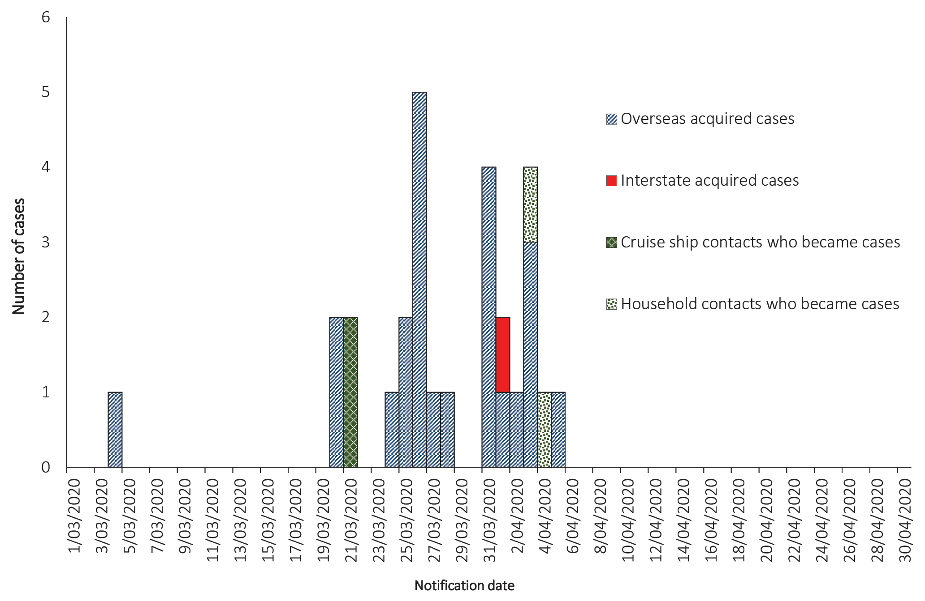
a Source: Northern Territory Notifiable Disease Surveillance System.
In total, we identified 527 close contacts of COVID-19 cases over the two-month period, of whom we were able to successfully contact 493 (94%). The majority were airline passengers (Table 1). The median interval between last exposure to a case and entry into quarantine was 7 days (interquartile range 4–8 days). This was skewed by the fact that 195 of the 493 contacts we were able to contact (40%) were from 2 flights for which there was a delay getting the manifests; for these 2 flights all passengers were deemed to be close contacts of an infectious crew member.

Table 1. Total number of close contacts identified by the NT CDC, 1 March – 30 April 2020
Category | Number of people | Percentage of total
Aircraft passengers | 389 | 74
Cruise ship passengers | 59 | 11
Household contacts | 52 | 10
Healthcare workers | 4 | < 1
Other | 23 | 4
Total | 527

The median number of contacts undergoing daily monitoring for COVID-19 symptoms was 19 per day (range 1–218 per day) (Figure 2).
Of the 34 close contacts we were unable to reach through contact tracing, 28 (82%) were from flights. Of those successfully contacted, 48/493 (10%) were located interstate or in military facilities/vessels overseas. These contacts were transferred to those authorities for daily monitoring during their quarantine period. Of the 445 people identified as residing in the NT for their quarantine period, the majority (334; 75%) were located in the Darwin urban area (Table 2).

Figure 2. Number of COVID-19 close contacts undergoing daily monitoring, Northern Territory, 1 March - 30 April 2020 by date of monitoring
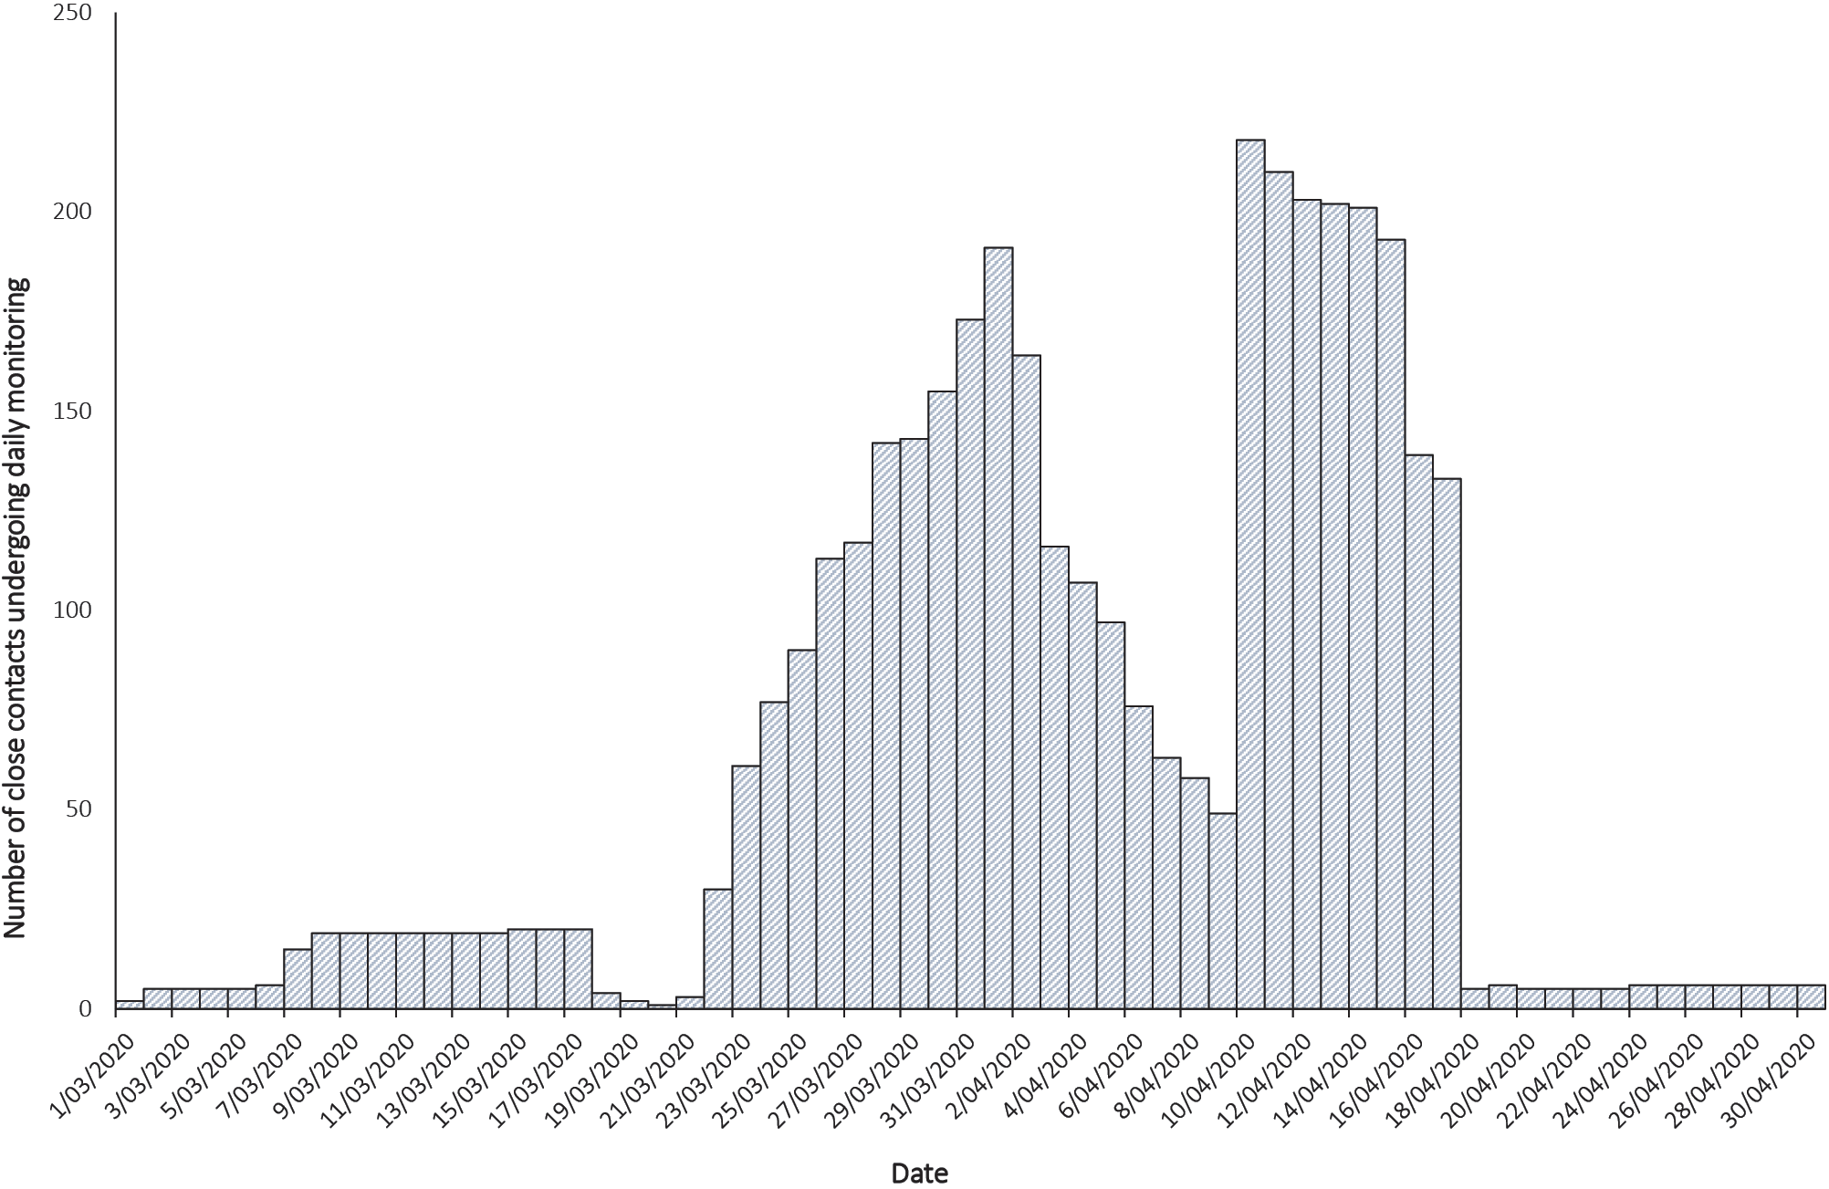
Table 2. Total number of close contacts monitored daily in the Northern Territory, by region, within the period 1 March – 30 April 2020
Region | Number of people | Percentage of total
Darwin urban area | 334 | 75
Alice Springs urban area | 68 | 15
Darwin rural area | 21 | 5
Katherine region | 13 | 3
East Arnhem region | 4 | < 1
Barkly region | 3 | < 1
Alice Springs rural area | 2 | < 1
Total | 445

There were 389 contacts on aircraft, with flights ranging from 1:25 hours to 4:35 hours in duration. Of these 389 contacts, 326 were monitored in the NT. There were 131 close contacts who were monitored because they were seated in the same row as, or in the two rows in front or behind, an infectious case (Table 3). The remaining 195 contacts were monitored because they were on two aircraft where flight crew who worked in the entire cabin were subsequently diagnosed as cases. None of the 326 aircraft passengers monitored in the NT became cases after being identified as close contacts (95% CI 0–1.1%).

Table 3. Summary of NT monitored contacts on flights where the case was a passenger, 1 March – 30 April 2020 (n = 131)
Flight | Duration  (hh:mm) | Case’s symptom onset in relation to flight | Number of close contacts | Number of contacts in same row as case | Number of contacts seated next to case
A | 04:00 | 4 days before flight | 19 | 4 | 2
B | 03:35 | 2 days before flight | 11 | 1 | 0
C | 02:32 | 10 days before flight | 12 | 0 | 0
D | 04:35 | 1 day before flight | 21 | 2 | 2
E | 04:00 | 13 days before flight | 10 | 1 | 0
F | 04:30 | 7 days before flight | 2 | 0 | 0
G | 04:34 | 2 days before flight | 2 | 0 | 0
H | 02:00 | 1 day after flight | 2 | 0 | 0
I | 02:49 | 1 day after flight | 15 | 2 | 0
J | 01:25 | 1 day after flight | 2 | 0 | 0
K | 04:00 | 1 day after flight | 18 | 3 | 2
L | 04:35 | 9 days before flight | 7 | 1 | 0
M | 04:00 | 1 day after flight | 5 | 1 | 0
N | 04:00 | 1 day after flight | 5 | 1 | 1
 |  |  | 131 | 16 | 7

Of the 445 contacts monitored in the NT, 80 (18%) developed symptoms and had swabs collected for COVID-19 testing. Only 4 were positive. Of the 46 close contacts from cruise ships that were monitored in the NT, 2 (4.3%; 95% CI 0.5–14.8%) became cases. These two cases boarded a flight while infectious after disembarking a cruise ship with known on-board transmission; however, they did not transmit disease to 21 close aircraft contacts or 1 household contact. They were telephoned by the NT CDC 2 days after arriving back to the NT and diagnosed with COVID-19 on the same day. There were 2/51 household close contacts monitored in the NT who became cases (3.9%; 95% CI 0.5–13.5%). Both were household contacts of the same case who returned from overseas. It cannot be determined whether both were co-exposed to the initial case in the household or whether 2 separate transmission events occurred in the household of 12 persons (Figure 3).
Figure 3. Diagram showing transmission of COVID-19 within one household of 12 persons in the Northern Territory, March–April 2020
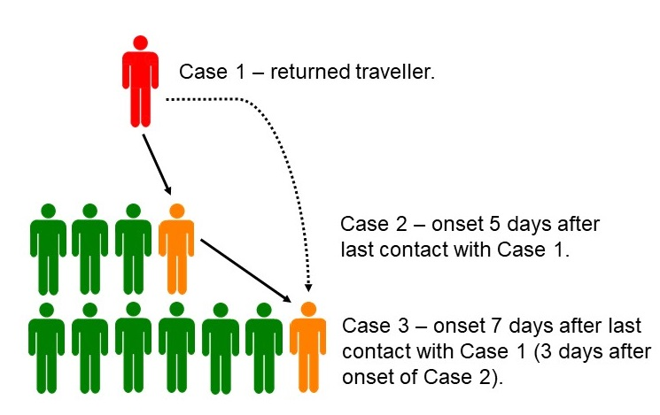

Discussion
We describe our experience in contact tracing in the early phase of the COVID-19 pandemic. We detected transmission of COVID-19 to household contacts and close contacts from a cruise ship with known on-board transmission. However, we did not observe inflight transmission of COVID-19 to 326 close contacts on flights.
With commercial aviation now beginning to resume regular flights, the issue of inflight transmission is pertinent. Some reports have suggested inflight transmission of SARS-CoV-2;^{11,12} for SARS-CoV, some studies have reported inflight transmission and others not.^{13,14,15}
With our contact tracing, the number of contacts undergoing daily monitoring fluctuated greatly; at one point all passengers from 2 flights needed to be rapidly placed into quarantine. It is important, particularly in smaller jurisdictions, to have surge capacity in the workforce to prevent delays in this process, in order to reduce the risk of community transmission of COVID-19.

Acknowledgements
We acknowledge contact tracing staff at the Northern Territory Public Health Unit, Top End Health Services and the Australian Defence Force personnel who provided much-needed assistance. We acknowledge the staff at the NIR and the staff at the airlines for providing passenger manifests to us. We also acknowledge the close contacts who were quarantined and thank them for their cooperation.

Author details
Anthony DK Draper^{1,2}
Karen E Dempsey^{1,2}
Rowena H Boyd¹
Emma M Childs¹
Hayley M Black¹
Laura A Francis¹
Peter G Markey¹
Vicki L Krause¹
- Centre for Disease Control, Public Health Unit, Top End Health Service, Northern Territory Government Department of Health, Darwin, Northern Territory, Australia.
- Menzies School of Health Research, Darwin, Northern Territory, Australia.

Corresponding author
Anthony Draper
Centre for Disease Control, Public Health Unit, Top End Health Service, Northern Territory Government Department of Health, PO Box 45096, Casuarina NT 0811.
Telephone: +61 8 8922 7635
Facsimile: +61 8 8922 8310
Email: anthony.draper@nt.gov.au.

References
- World Health Organization (WHO). Emergencies preparedness, response. Pneumonia of unknown cause – China. [Internet.] Geneva: WHO; 5 January 2020. Available from: https://www.who.int/csr/don/05-january-2020-pneumonia-of-unkown-cause-china/en/.
- WHO. Emergencies preparedness, response. Novel coronavirus – China. [Internet.] Geneva: WHO; 12 January 2020. Available from: https://www.who.int/csr/don/12-january-2020-novel-coronavirus-china/en/.
- WHO. Naming the coronavirus disease (COVID-19) and the virus that causes it. [Internet.] Geneva: WHO; 11 February 2020. Available from: https://www.who.int/emergencies/diseases/novel-coronavirus-2019/technical-guidance/naming-the-coronavirus-disease-(covid-2019)-and-the-virus-that-causes-it.
- WHO. Speeches detail: WHO Director-General’s statement on IHR Emergency Committee on Novel Coronavirus (2019-nCoV). [Internet.] Geneva: WHO; 30 January 2020. Available from: https://www.who.int/dg/speeches/detail/who-director-general-s-statement-on-ihr-emergency-committee-on-novel-coronavirus-(2019-ncov).
- WHO. Speeches detail: WHO Director-General’s opening remarks at the media briefing on COVID-19 - 11 March 2020. [Internet.] Geneva: WHO; 11 March 2020. Available from: https://www.who.int/dg/speeches/detail/who-director-general-s-opening-remarks-at-the-media-briefing-on-covid-19---11-march-2020.
- COVID-19 National Incident Room Surveillance Team. COVID-19, Australia: Epidemiology Report 15: Reporting week ending 23:59 AEST 10 May 2020. Commun Dis Intell (2018). 2020;44. doi: https://doi.org/10.33321/cdi.2020.44.43.
- Northern Territory Government. Declaration and notification of notifiable disease: novel coronavirus (2019-nCoV) infection. Northern Territory of Australia Government Gazette. No. S2, 6 February 2020. Available from: https://nt.gov.au/__data/assets/pdf_file/0007/792331/s2.pdf.
- Northern Territory Government. Declaration of a public health emergency. Northern Territory of Australia Government Gazette. No. S10, 18 March 2020. Available from: https://nt.gov.au/__data/assets/pdf_file/0003/804018/s10.pdf.
- Australian Government Department of Health. Coronavirus disease 2019 (COVID-19). CDNA National guidelines for public health units. [Internet.] Canberra: Australian Government Department of Health; 2020. Available from: https://www1.health.gov.au/internet/main/publishing.nsf/Content/cdna-song-novel-coronavirus.htm.
- Northern Territory Public and Environmental Health Act 2011. Darwin: Northern Territory of Australia Government. Available from: https://legislation.nt.gov.au/en/Legislation/PUBLIC-AND-ENVIRONMENTAL-HEALTH-ACT-2011.
- Eldin C, Lagier JC, Mailhe M, Gaudret P. Probable aircraft transmission of Covid-19 in-flight from the Central African Republic to France. Travel Med Infect Dis. 2020;101643. doi: https://doi.org/10.1016/j.tmaid.2020.101643.
- Qian GQ, Yang NB, Ding F, Ma AHY, Wang ZY, Shen YF et al. Epidemiologic and clinical characteristics of 91 hospitalized patients with COVID-19 in Zhejiang, China: a retrospective, multi-centre case series. QJM. 2020. doi: ttps://doi.org/10.1093/qjmed/hcaa089.
- Olsen SJ, Chang HL, Cheung TYY, Tang AFY, Fisk TL, Ooi SPL et al. Transmission of the severe acute respiratory syndrome on aircraft. N Engl J Med. 2003;349(25):2416–22.
- Vogt TM, Guerra MA, Flagg EW, Ksiazek TG, Lowther SA, Arguin PM. Risk of severe acute respiratory syndrome–associated coronavirus transmission aboard commercial aircraft. J Travel Med. 2006;13(5):268–72.
- Breugelmans JG, Zucs P, Porten K, Broll S, Niedrig M, Ammon A et al. SARS transmission and commercial aircraft. Emerg Infect Dis. 2004;10(8):1502–3.
Communicable Diseases Intelligence
ISSN: 2209-6051 Online

Communicable Diseases Intelligence (CDI) is a peer-reviewed scientific journal published by the Office of Health Protection, Department of Health. The journal aims to disseminate information on the epidemiology, surveillance, prevention and control of communicable diseases of relevance to Australia.

Editor: Tanja Farmer
Deputy Editor: Simon Petrie
Design and Production: Kasra Yousefi
Editorial Advisory Board: David Durrheim, Mark Ferson, John Kaldor, Martyn Kirk and Linda Selvey

Website: http://www.health.gov.au/cdi

Contacts
Communicable Diseases Intelligence is produced by:
Health Protection Policy Branch, Office of Health Protection, Australian Government Department of Health
GPO Box 9848, (MDP 6) CANBERRA ACT 2601

Email: cdi.editor@health.gov.au

Submit an Article
You are invited to submit your next communicable disease related article to the Communicable Diseases Intelligence (CDI) for consideration. More information regarding CDI can be found at: http://health.gov.au/cdi.
Further enquiries should be directed to: cdi.editor@health.gov.au.

This journal is indexed by Index Medicus and Medline.

Creative Commons Licence - Attribution-NonCommercial-NoDerivatives CC BY-NC-ND
© 2020 Commonwealth of Australia as represented by the Department of Health
This publication is licensed under a Creative Commons Attribution-NonCommercial-NoDerivatives 4.0 International Licence from https://creativecommons.org/licenses/by-nc-nd/4.0/legalcode (Licence). You must read and understand the Licence before using any material from this publication.

Restrictions
The Licence does not cover, and there is no permission given for, use of any of the following material found in this publication (if any):
- the Commonwealth Coat of Arms (by way of information, the terms under which the Coat of Arms may be used can be found at www.itsanhonour.gov.au);
- any logos (including the Department of Health’s logo) and trademarks;
- any photographs and images;
- any signatures; and
- any material belonging to third parties.

Disclaimer
Opinions expressed in Communicable Diseases Intelligence are those of the authors and not necessarily those of the Australian Government Department of Health or the Communicable Diseases Network Australia. Data may be subject to revision.

Enquiries
Enquiries regarding any other use of this publication should be addressed to the Communication Branch, Department of Health, GPO Box 9848, Canberra ACT 2601, or via e-mail to: copyright@health.gov.au

Communicable Diseases Network Australia
Communicable Diseases Intelligence contributes to the work of the Communicable Diseases Network Australia.
http://www.health.gov.au/cdna

