The effect of COVID-19 public health measures on nationally notifiable diseases in Australia: preliminary analysis
Amy Bright, Anna-Jane Glynn-Robinson, Stacey Kane, Rose Wright and Nathan Saul

Abstract
Since the introduction of COVID-19-related public health measures, notifications for most nationally notifiable diseases have declined when compared to previous years. Physical distancing, travel restrictions, and emphasis on hygiene are likely to have affected the number of expected notifications, with the greatest reductions observed among disease spread via person-to-person contact such as influenza, and among overseas-acquired infections such as dengue virus and measles. However, quantifying the magnitude of the effect of COVID-19 public health measures on communicable diseases in Australia will be difficult, due to confounding factors such as: changes in testing priorities in laboratories; diversion of resources to the COVID-19 response; changes in health-seeking behaviours; greater utilisation of telehealth practices; and financial impacts such as income loss and ability to afford healthcare. It is considered likely that these other factors will have also impacted notification numbers.
Keywords: Australia, communicable disease, COVID-19

Introduction/methods
Coronavirus disease 19 (COVID-19), caused by the novel severe acute respiratory syndrome coronavirus 2 (SARS-CoV-2), was first identified in early January 2020. Subsequently, the disease spread rapidly, leading to a global pandemic. Since the first case of COVID-19 was identified in Australia, all states and territories have reported cases of COVID-19 and Australia has implemented public health measures informed by the disease’s epidemiology. We analysed Nationally Notifiable Diseases Surveillance System (NNDSS) data to determine the effect of COVID-19 public health measures on other nationally notifiable diseases in Australia.
Notifications for the majority of diseases reported to the NNDSS have been lower than expected in the first 6 months of 2020, when compared to trends over the previous 5 years (2015–2019). Implementation of COVID-19-related public health measures in Australia from mid-March 2020,¹ such as physical distancing, travel restrictions and emphasis on hygiene, is likely to have contributed to the lower-than-expected notification numbers. The impact of other factors such as prioritisation of testing for COVID-19 and the introduction of Medicare Benefit Scheme (MBS) telehealth items, allowing people to access health services in their homes, must also be considered when examining these trends.
To further quantify the potential effect of COVID-19-related public health measures on NNDSS notifications, we selected several diseases that would most likely be effected and categorised them as:
- Social – diseases that are spread from person-to-person and commonly associated with social gatherings or interactions.
- Imported – diseases no longer endemically transmitted in Australia, with most cases either acquired overseas and imported, or epidemiologically or genetically linked to an imported case potentially causing localised outbreaks.
- Foodborne – enteric diseases that are potentially related to food.
The selected diseases are nationally notifiable in Australia and are monitored using the NNDSS. Medical practitioners, public health laboratories and other health professionals are required, under state and territory public health legislation, to report cases to jurisdictional health authorities. The National Health Security Act 2007 provides the legislative basis for the national notification of communicable diseases,² and authorises the exchange of health information between the Australian Government and state and territory governments. State and territory health departments transfer these notifications regularly to the NNDSS. The primary responsibility for public health action resulting from a notification resides with state and territory health departments.
Data analysed in this report were based on the date of disease diagnosis, a derived field within NNDSS. Diagnosis date represents the true onset date or where the onset date was not known, the earliest of the following dates: the specimen collection date, the notification date, or the notification received date.
Data were extracted from the NNDSS on 17 July 2020, with data reported to 30 June 2020. Due to the dynamic nature of the NNDSS, data in this extract are subject to retrospective revision and may vary from data reported in published NNDSS reports and reports of notification data by states and territories.
Data on testing for notifiable diseases, where available, were obtained from multiple sources. MBS item numbers 69316, 69317 and 69319, representing subsidised microbiological tests performed to diagnose chlamydia, were sourced from the Australian Government Services Australia website.³ MBS item numbers for culture of faeces for faecal pathogens, representing a subset of tests performed to diagnose foodborne diseases such as salmonellosis, were also sourced from the Services Australia website. Data on influenza testing were obtained from the influenza sentinel laboratory surveillance system.

Results
In the first 6 months of 2020 (1 January to 30 June), there were 50% fewer notifications reported to the NNDSS than in the same period in 2019 and 20% fewer notifications than the 5-year (2015–2019) average. During the same period, COVID-19 became a nationally notifiable disease in Australia, with 8,542 cases notified between 1 January and 30 June 2020.
Excluding COVID-19, decreases were observed across the majority of notifiable diseases and conditions, with proportional decreases compared to the preceding year and 5-year average variable across the disease groups (Table 1). Increases in notifications were observed for a small number of notifiable diseases including Barmah Forest virus infection, Ross River virus infection and legionellosis.

Table 1: Nationally notifiable conditions and diseases,ª by disease group, year and 5-year average, 1 January to 30 June, 2015–2020
Diseases | Notifications  1 January – 30 June |  |  | Percent difference
 | 2019 | 2020 | 5-year average | 2020 vs. 2019 | 2020 vs. 5-year average
Bloodborne diseases
Hepatitis B (newly acquired) | 84 | 58 | 79 | -31% | -26%
Hepatitis B (unspecified) | 2,908 | 2,536 | 3,036 | -13% | -16%
Hepatitis C (newly acquired) | 326 | 351 | 347 | 8% | 1%
Hepatitis C (unspecified) | 4,308 | 3,712 | 4,974 | -14% | -25%
Hepatitis D | 39 | 24 | 32 | -38% | -25%
Gastrointestinal diseases
Botulism | 1 | 0 | 1 | – | –
Campylobacteriosis^{b} | 16,921 | 14,845 | 13,389 | -12% | 11%
Cryptosporidiosis | 1,592 | 1,851 | 2,680 | 16% | -31%
Haemolytic uraemic syndrome (HUS) | 11 | 5 | 8 | -55% | -39%
Hepatitis A | 138 | 78 | 138 | -43% | -43%
Hepatitis E | 30 | 26 | 25 | -13% | 5%
Listeriosis | 27 | 15 | 41 | -44% | -63%
Paratyphoid | 81 | 38 | 49 | -53% | -22%
Salmonellosis | 8,126 | 7,995 | 9,578 | -2% | -17%
Shigellosis | 1,727 | 1,217 | 956 | -30% | 27%
Shiga toxin producing Escherichia coli (STEC) | 327 | 315 | 202 | -4% | 56%
Typhoid Fever | 118 | 76 | 89 | -36% | -15%
Listed human diseases
Cholera | 2 | 0 | 1 | – | –
Sexually transmissible infections
Chlamydial infection | 54,485 | 37,582 | 50,811 | -31% | -26%
Gonococcal infection | 17,448 | 15,970 | 13,742 | -8% | 16%
Syphilis < 2 years | 2,900 | 2,296 | 2,079 | -21% | 10%
Syphilis > 2 years or unspecified duration | 1,242 | 1,417 | 1,088 | 14% | 30%
Syphilis congenital | 2 | 9 | 2 | 350% | 463%
Vaccine preventable diseases
Diphtheria | 3 | 3 | 3 | 0% | -6%
Haemophilus influenzae type b | 13 | 7 | 8 | -46% | -15%
Influenza (laboratory confirmed) | 132,424 | 20,794 | 39,467 | -84% | -47%
Measles | 130 | 25 | 67 | -81% | -63%
Mumps | 86 | 109 | 320 | 27% | -66%
Pertussis | 5,711 | 3,084 | 6,941 | -46% | -56%
Pneumococcal disease (invasive) | 866 | 492 | 720 | -43% | -32%
Rotavirus | 1,347 | 1,101 | 1,508 | -18% | -27%
Rubella | 21 | 2 | 11 | -90% | -81%
Tetanus | 1 | 2 | 2 | – | 0%
Varicella zoster (chickenpox) | 1,801 | 1,203 | 1,437 | -33% | -16%
Varicella zoster (shingles) | 6,606 | 7,138 | 4,969 | 8% | 44%
Varicella zoster (unspecified) | 7,423 | 6,021 | 7,130 | -19% | -16%
Vectorborne diseases
Barmah Forest virus infection | 146 | 431 | 260 | 195% | 66%
Chikungunya virus infection | 25 | 25 | 40 | 0% | -37%
Dengue virus infection | 856 | 192 | 918 | -78% | -79%
Flavivirus infection (unspecified) | 2 | 16 | 19 | 700% | -18%
Japanese encephalitis virus infection | 0 | 1 | 1 | – | 67%
Malaria | 175 | 116 | 161 | -34% | -28%
Murray Valley encephalitis virus infection | 0 | 0 | 1 | – | –
Ross River virus infection | 1,936 | 4,898 | 3,958 | 153% | 24%
West Nile/Kunjin virus infection | 1 | 0 | 1 | – | –
Zoonotic diseases
Brucellosis | 3 | 11 | 9 | 267% | 25%
Leptospirosis | 56 | 49 | 77 | -13% | -36%
Creutzfeldt-Jakob disease | 16 | 4 | 19 | -75% | -79%
Ornithosis | 9 | 17 | 6 | 89% | 174%
Q fever | 289 | 236 | 272 | -18% | -13%
Tularaemia | 0 | 2 | 0 | – | –
Other diseases
Legionellosis | 190 | 273 | 195 | 44% | 40%
Leprosy | 4 | 1 | 4 | -75% | -76%
Meningococcal disease (invasive) | 89 | 49 | 100 | -45% | -51%
Tuberculosis | 710 | 721 | 646 | 2% | 12%
Total | 273,782 | 137,449 | 172,617 | -50% | -20%
a COVID-19 and diseases with no notifications during the reporting period are excluded.
b NSW commenced reporting of campylobacteriosis in April 2017.

Social diseases

Influenza
In the first half of 2020, overall notifications of laboratory-confirmed influenza (n = 20,794) have been lower compared with the 5-year average (n = 39,467) (Table 1). Between January and February, notifications of laboratory-confirmed influenza displayed a similar trend to that seen in 2019. However, from March 2020 notifications declined substantially, aligning with the implementation of a number of national COVID-19-related public health measures, including physical distancing (Figure 1).
Figure 1: Laboratory-confirmed influenza notifications by year, month, and 5-year average, 1 January to 30 June, 2015-2020
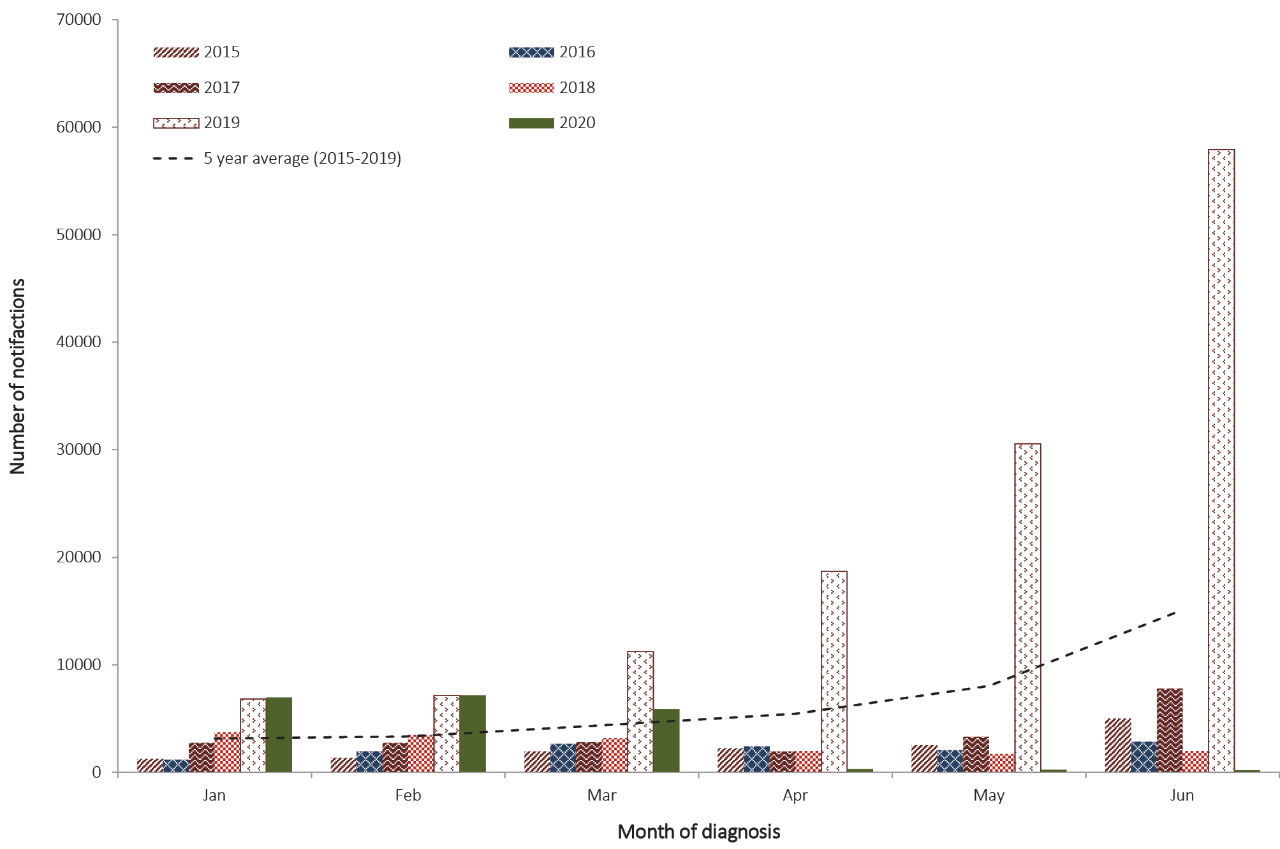
Notifications of laboratory-confirmed influenza have remained at exceptionally low levels in May and June. For the year to date (1 January to 28 June 2020), data on testing from the influenza sentinel laboratory surveillance system shows there have been 197,222 tests conducted for influenza, of which 1% (n = 1,968) have been positive for influenza. Influenza tests performed in 2020 were more than double the number performed over the same period in 2019 (n = 74,862), with 21% (n = 15,387) of those tests positive for influenza.
Comprehensive analyses on influenza for 2020 are published fortnightly in the Australian Influenza Surveillance Reports – 2020 Influenza Season in Australia.⁴

Invasive meningococcal disease (IMD)
There were 49 notifications of IMD reported between 1 January and 30 June 2020, 45% lower than in the same period in 2019 (n = 89) and 51% lower than the 5-year average (n = 100) (Table 1). Since March 2020, IMD notifications have been consistently lower than notifications in the corresponding month for each of the previous 5 years (Table 1, Figure 2).

Figure 2: IMD notifications by year, month, and 5-year average, 1 January to 30 June, 2015–2020
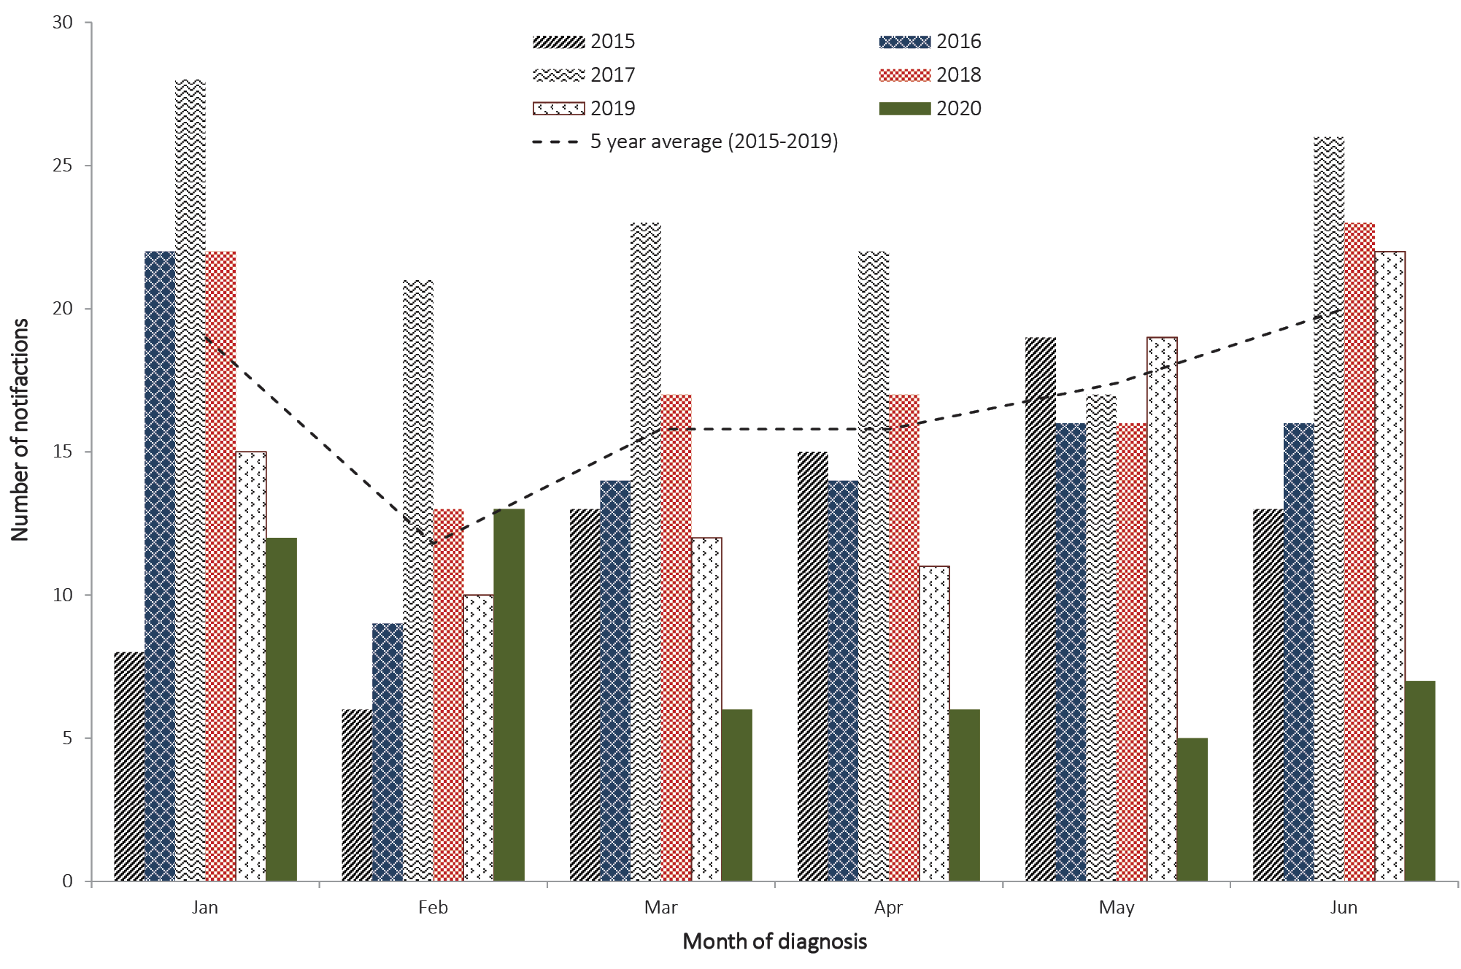

Chlamydia
There were 31% fewer notifications of chlamydia reported between 1 January and 30 June 2020 (n = 37,582) than were reported in the same period in 2019 (n = 54,485), and 26% fewer cases than the 5-year average for the same period (n = 50,811) (Table 1, Figure 3). It is important to note that there will be fluctuations in sexually transmissible infection (STI) notifications over time which may reflect changes in screening programs, the use of less invasive and more sensitive diagnostic tests, and periodic public awareness campaigns, rather than changes in overall prevalence.
Figure 3: Chlamydia notifications by year, month, and 5-year average, 1 January to 30 June, 2015–2020
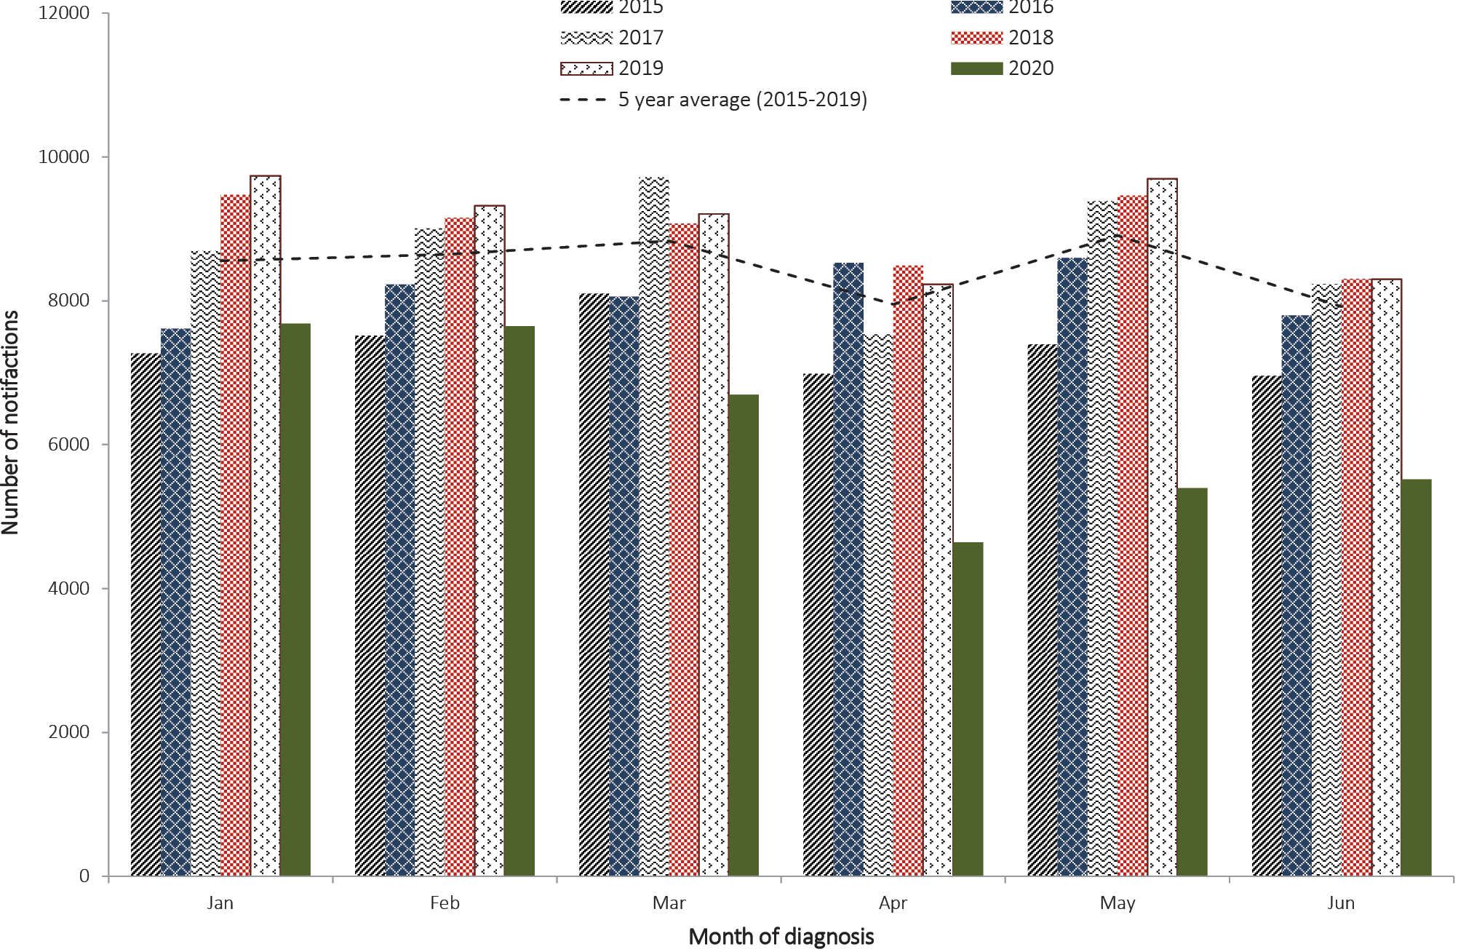
The average number of MBS-subsidised tests performed each month to diagnose chlamydia is approximately 121,000. Following the commencement of COVID-19-related public health measures, the number of MBS-subsidised tests declined, from 134,105 tests in March 2020 to 85,567 tests in April 2020, coinciding with the lowest number of cases reported in the first half of 2020. In May 2020, the number of tests increased by 17% (n = 100,047) from April but was still well below the expected number of monthly tests. Positivity for chlamydia remained stable between March and May at 5%, slightly less than the average (7%). It will be important to monitor these testing trends as new data becomes available.

Infectious syphilis
Overall, there were 21% fewer notifications notified between 1 January and 30 June 2020 (n = 2,296) than in the same period in 2019 (n = 2,900). Compared to the 5-year average (n = 2,079), notifications in 2020 were slightly higher (Table 1, Figure 4).
Figure 4: Infectious syphilis notifications by year, month, and 5-year average, 1 January to 30 June, 2015–2020
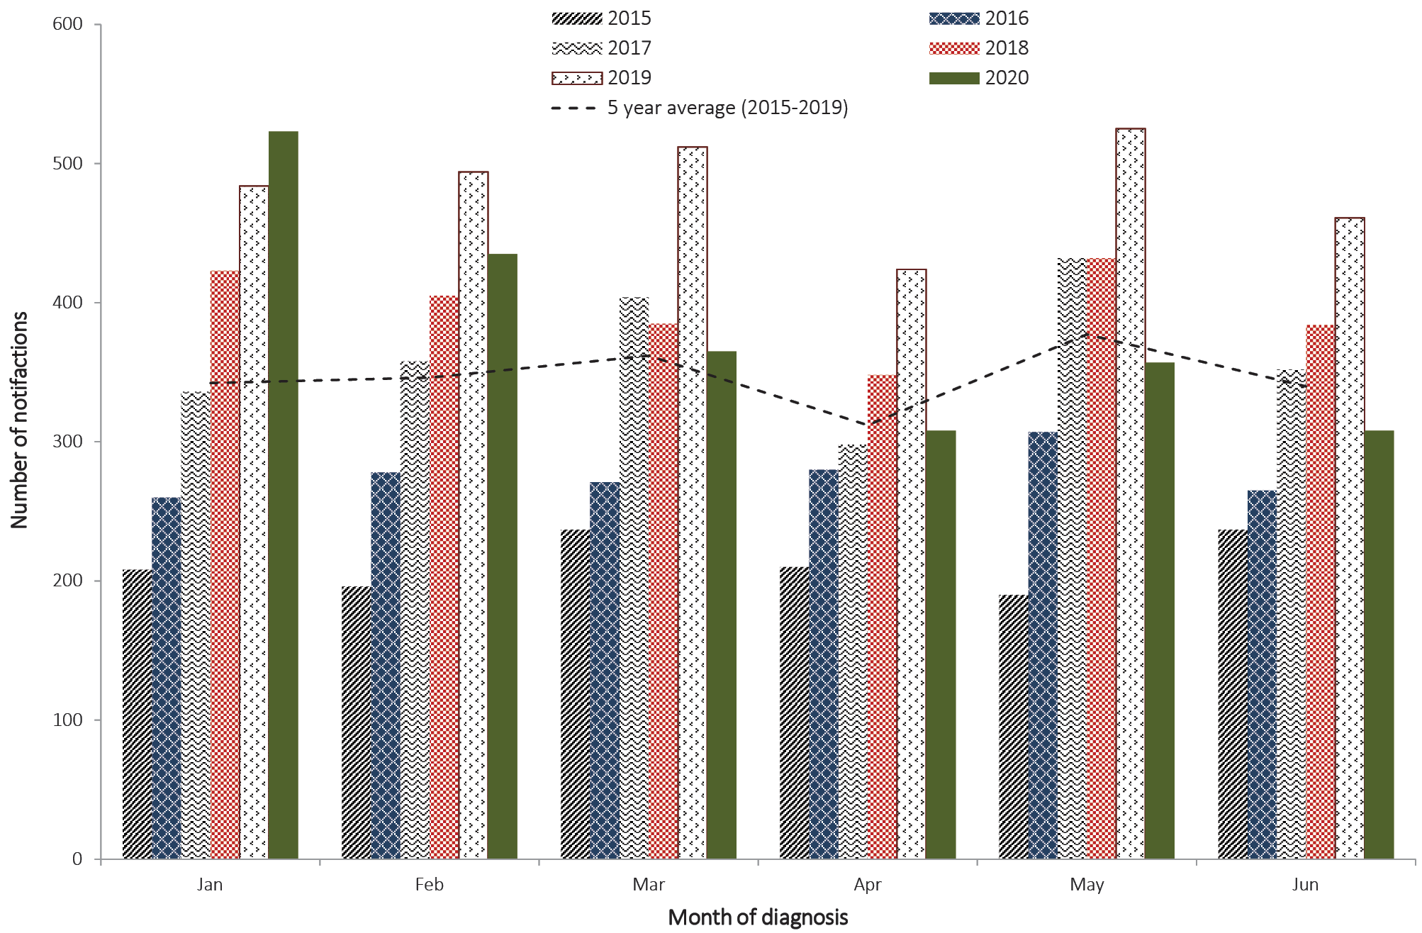
In 2019, the ongoing outbreak in Aboriginal and Torres Strait Islander peoples, rapid increases in notifications in non-Indigenous heterosexual women, and sustained high rates of infectious syphilis in men who have sex with men, all contributed to the highest number of reported cases to the NNDSS since infectious syphilis first became nationally notifiable in 2004. By Indigenous status, there were 18% fewer notifications among Aboriginal and Torres Strait Islander peoples in the first half of 2020 (n = 385) than in the same period in 2019 (n = 467). In non-Indigenous people, notifications reported between 1 January and 30 June declined by 27% between 2020 (n = 1,788) and 2019 (n = 2,433). When compared to the 5-year average, notifications in Aboriginal and Torres Strait Islander peoples and non-Indigenous people increased in 2020 by 11% and 2% respectively. As with chlamydia, there will be fluctuations over time in STI notifications as a result of screening programs, testing, and public awareness. Population-level syphilis testing data are not currently available; therefore, exploration of testing trends and inferences of health-seeking behaviours during the first six months of 2020 cannot be reported. However, as noted for other diseases where testing data are available, some changes in testing and health-seeking behaviours as a result of COVID-19 would be expected.
Despite declines in infectious syphilis notifications in the first 6 months of 2020, the number of congenital syphilis cases reported over the same period (n = 9) was the highest number reported since 2006. Given the 9 month gestation lead time to a congenital syphilis notification, it is unlikely that public health measures such as physical distancing would have an immediate impact on congenital syphilis notifications. The increase in congenital syphilis notifications in 2020 is likely a reflection of sustained high rates reported in preceding years.

Rotavirus
Overall, there were 18% fewer rotavirus notifications between 1 January and 30 June 2020 (n = 1,101) than in the same period in 2019 (n = 1,347), and 27% fewer than the 5-year average (n = 1,508) (Table 1, Figure 5).
Figure 5: Rotavirus notifications by year, month, and 5-year average, 1 January to 30 June, 2015–2020
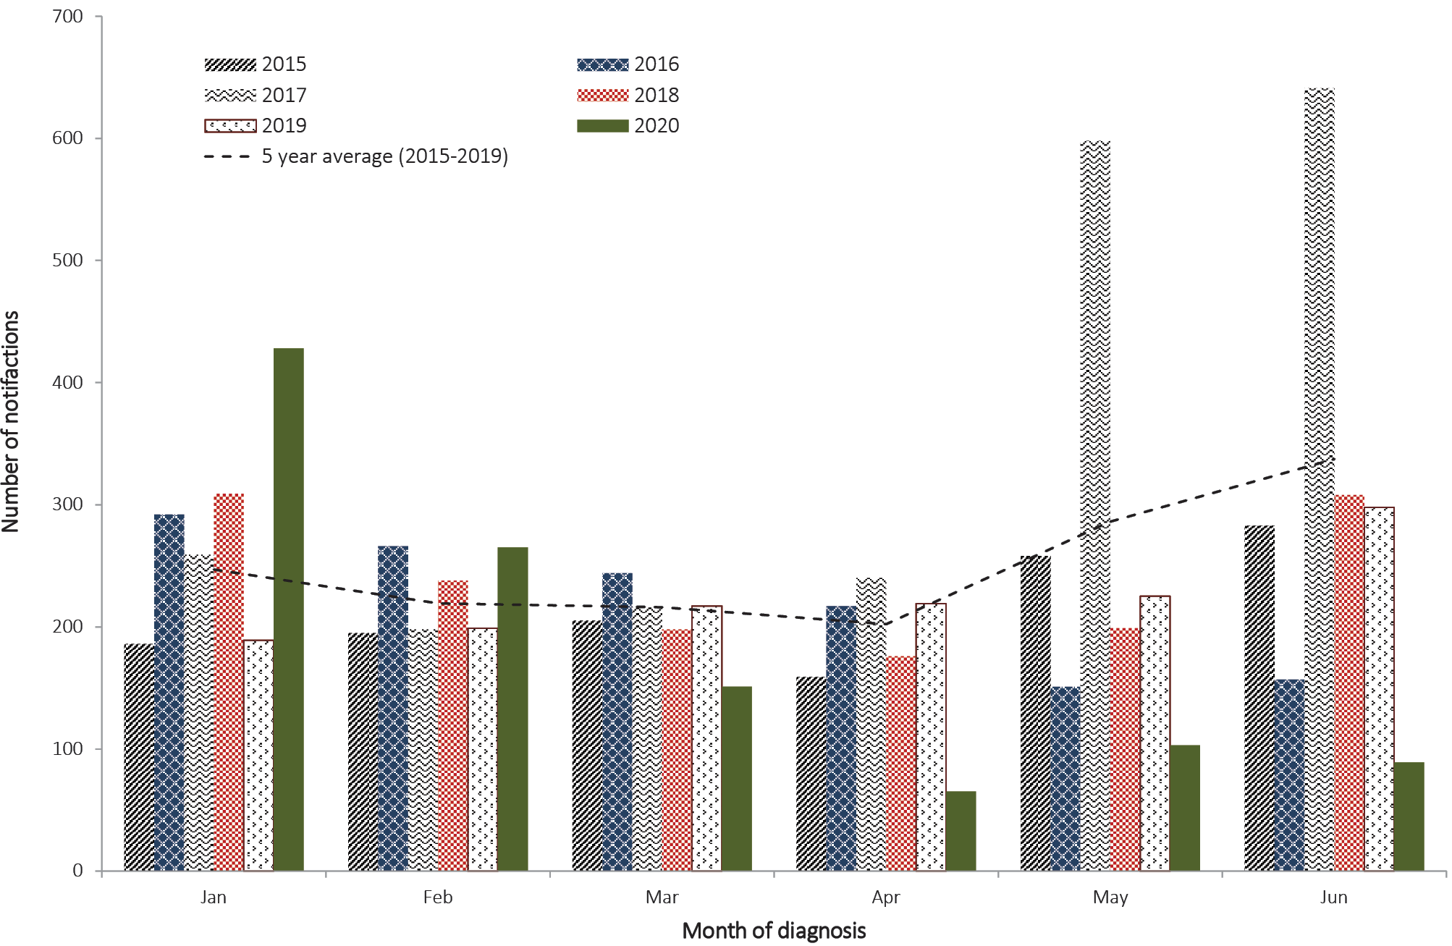
The vast majority of notified rotavirus cases are in children aged less than 5 years. Although early childhood centres and schools were not recommended to be closed as part of the COVID-19 public health measures, reductions in the attendance of these facilities during this period is likely to have contributed to a declined of rotavirus transmission.

Imported diseases

Measles
Measles notifications have substantially decreased in the first 6 months of 2020, with no cases notified since February 2020. Between 1 January and 30 June 2020, 25 cases of measles were notified to the NNDSS, 81% lower than for the same period in 2019 (n = 130) and 63% lower than the 5 year average (n = 67) (Table 1, Figure 6).
Figure 6: Measles notifications by year, month, and 5-year average, 1 January to 30 June, 2015–2020
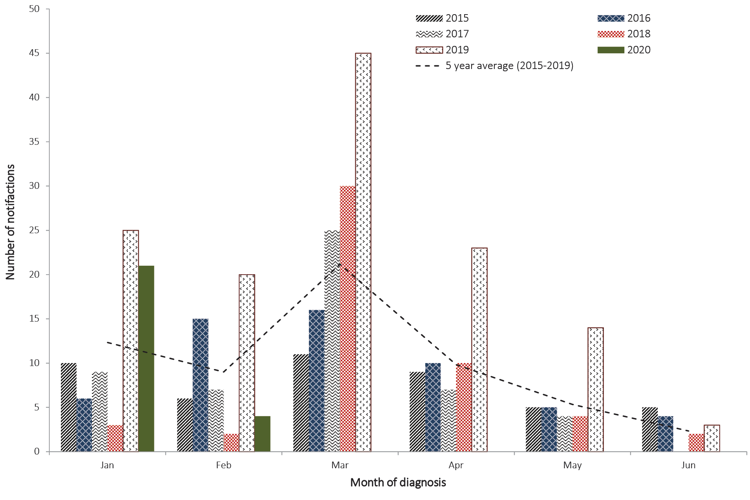
As Australia achieved endemic measles elimination in 2014, international travel restrictions as part of the COVID-19-related public health measures have likely reduced the number of measles importations occurring in Australia.

Dengue
There were 78% fewer notifications of dengue virus infection in 2020 (n = 192) than in the same period in 2019 (n = 856). Compared to the 5-year average for the same period (n = 918), there were 79% fewer notifications in 2020 (Table 1).
Between April and June 2020, there were 6 cases of dengue reported, 5 of which acquired the infection overseas (Figure 7). Over the same period in 2019 there were 434 cases of dengue reported, 421 of which were acquired overseas.
Figure 7: Dengue notifications by place of acquisition, year, month, and 5-year average, 1 January to 30 June, 2015–2020
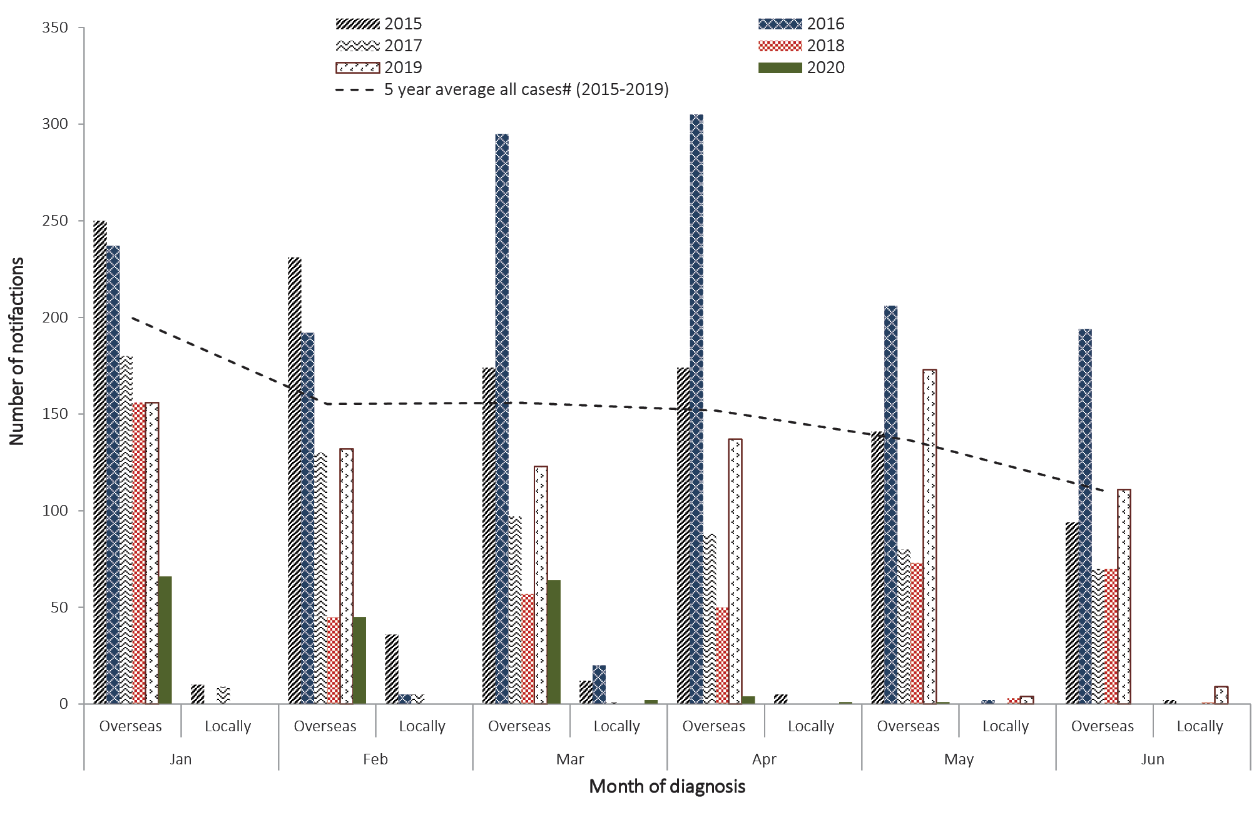
Notifications of dengue virus infection in Australia are predominantly due to diagnosis in returned travellers who acquired their infection overseas. Restrictions in international travel as a result of COVID-19 have likely contributed to the reduction in notified cases.

Foodborne diseases

Salmonellosis
Notifications of salmonellosis between 1 January and 30 June 2020 (n = 7,995) were 17% lower than the 5-year average for the same period (n = 9,578) and 2% lower than notifications for the same period in 2019 (n = 8,126) (Table 1, Figure 8). The majority of salmonellosis cases reported to the NNDSS in the first 6 months of 2020 were caused by Salmonella Typhimurium (n = 3,375; compared with the 5-year average of 3,583 Salmonella Typhimurium cases for the same period).
Figure 8: Salmonellosis notifications by year, month, and 5-year average, 1 January to 30 June, 2015–2020
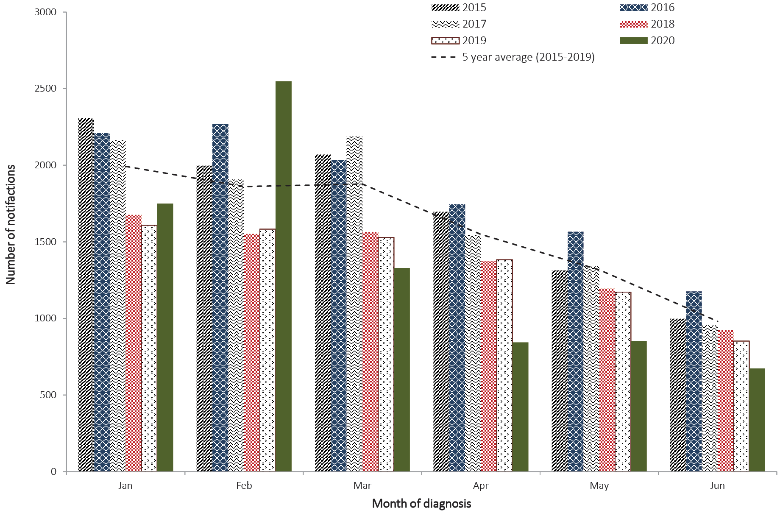
In February 2020, notifications of salmonellosis to the NNDSS were 61% higher than for the same month in 2019 (n = 2,545 and n = 1,583 respectively) and 36% higher than average notifications for February in the previous 5 years (n = 1,877). This increase is associated with a multi-jurisdictional outbreak of Salmonella Typhimurium investigated between late January and May 2020.
Aside from the increase in salmonellosis cases notified in February 2020, there was a decrease in salmonellosis cases notified compared with previous years observed between March and June 2020 (Figure 9). Declines in notifications of salmonellosis largely followed seasonal trends but were likely magnified by physical distancing measures that saw the closure of dine-in services at food businesses such as restaurants, cafés and bars, and the subsequent increases in people eating at home. In addition to these measures, it is important to acknowledge that changes in testing priorities, including laboratory resourcing for polymerase chain reaction (PCR) testing of faecal specimens shifting to COVID-19 PCR testing, along with changes in health-seeking behaviours and the encouraged use of telehealth services, are all also likely to have contributed to the decline in notified salmonellosis cases. Following the introduction of MBS telehealth items in March 2020, there was a decline in the number of MBS subsidised tests for MBS item number 69345 for culture of faeces for faecal pathogens compared to the 5-year average. The greatest reduction in the number of tests for this item, compared to the 5-year average, occurred in April 2020 (n = 31,326 versus a 5-year average (2015–2019) of n = 49,992, or a 37.4% decrease).

Discussion
This analysis indicates that COVID-19 public health measures, including physical distancing, an emphasis on hygiene, and travel restrictions, are likely to have affected the number of notifications reported to the NNDSS. It is important to note that this analysis is focused on national trends and it is expected that there will be variability across jurisdictions and over time reflecting locally-applied interventions and staged easing of restrictions.
Lower-than-expected numbers of laboratory-confirmed influenza, IMD and rotavirus notifications suggest restrictions on common social practices (closures of cafés, restaurants, cinemas, some retail stores, etc.), social and mass gatherings, lower attendance at early childhood centres/schools, and work from home practices may have curbed the incidence of diseases which are associated with close and prolonged contact. Declines in notifications of measles and dengue virus coincided with implementation of initial international travel restrictions and the eventual closure of Australia’s national borders. Closure of international borders will have also effected the influenza notifications, as influenza viruses circulating elsewhere in the world, but not yet in Australia, are less likely to be imported.
The rate of testing for influenza is almost three times the rate seen over the same period of 2019. This is likely due to the use of a multiplex respiratory panel (which includes influenza), implemented earlier in 2020, that is being used by a number of jurisdictions for COVID-19 testing. The low influenza positive results seen in the first 6 months of 2020 suggest that influenza is circulating at lower frequency than expected, based on the trends seen in previous years. There is some indication that, due to the surge in requests for COVID-19 tests, testing for other communicable diseases (such as chlamydia) may have decreased since March 2020. As laboratory resources are funnelled into the ongoing COVID-19 response, there have also been delays in testing for regular surveillance programs, such as the Australian Rotavirus Genotyping Surveillance Program, and as a result there may be backlogs in testing still yet to be undertaken.
While declines in notifications of salmonellosis reflected seasonal trends, physical distancing measures that saw the closure of dine-in services at food businesses also likely contributed to a reduction in case numbers. However it is also important to note that changes in testing priorities, changes in health-seeking behaviours, and encouraged use of telehealth services are likely to have contributed to the decline in notifications. MBS testing data for a subset of tests performed to diagnose foodborne diseases, such as salmonellosis, showed a decline following the introduction of telehealth items; but it is difficult to determine whether the introduction of telehealth led to fewer faecal samples being collected for testing, or whether there was a true decrease in cases.
At the time of writing, there were limited studies in the international arena quantifying reductions in notifiable communicable diseases in 2020 as a result of COVID-19 interventions. Broader global trends in influenza activity were however consistent with Australia, with lower-than-expected detections of influenza reported in 2020 across a number of countries, attributed, at least in part, to physical distancing and improved hygiene.^{5–7}
While initial analyses suggest COVID-19-related public health measures may have had an impact on the transmission of specific communicable diseases within the Australian community, quantifying the magnitude of this effect is not currently feasible. Other factors such as: changes in testing priorities in laboratories; diversion of resources to the COVID-19 response; changes in health-seeking behaviours; greater utilisation of telehealth practices; and financial impacts such as income loss and ability to afford healthcare, will have also impacted notification numbers, therefore confounding any potential effect of physical distancing.

Conclusion
Overall, nationally notifiable diseases in Australia declined in the first half of 2020, particularly those diseases associated with close contact and travel. Further investigation of COVID-19 public health measures and the impact of confounding factors on notification data is warranted.
To our knowledge, this is the first report to quantify reductions in notifiable diseases as a result of COVID-19-related public health measures in Australia.

Author details
Ms Amy Bright¹
Ms Anna-Jane Glynn-Robinson¹
Ms Stacey Kane¹
Ms Rose Wright¹
Dr Nathan Saul¹
- Epidemiologist, Office of Health Protection and Response, Australian Government Department of Health, Australia

Corresponding author
Amy Bright
Office of Health Protection and Response
Australian Government Department of Health, Canberra, Australia
CDESS@health.gov.au

References
- Australian Government Department of Health. Australian Health Protection Principal Committee (AHPPC). Statements: Coronavirus (COVID-19). [Internet.] Canberra: Australian Government Department of Health; 2020. [Accessed on 29 July 2020.] Available from: https://www.health.gov.au/committees-and-groups/australian-health-protection-principal-committee-ahppc#statements.
- Federal register of legislation. National Health Security Act 2007. No. 174, 2007. Compilation No. 15. [Legislation.] Canberra: Australian Government Federal Register of Legislation; 19 July 2016. Available from: https://www.legislation.gov.au/Details/C2016C00847.
- Australian Government Services Australia. Medicare item reports. [Internet.] Canberra: Australian Government Services Australia. Available from: http://medicarestatistics.humanservices.gov.au/statistics/mbs_item.jsp.
- Australian Government Department of Health. Australian influenza surveillance report and activity updates. [Internet.] Canberra: Australian Government Department of Health; 2020. Available from: https://www1.health.gov.au/internet/main/publishing.nsf/Content/cda-surveil-ozflu-flucurr.htm.
- World Health Organization (WHO). Influenza: surveillance and monitoring. [Internet.] Geneva: WHO; 2020. [Accessed on 29 July 2020.] Available from: https://www.who.int/influenza/surveillance_monitoring/en/.
- Liu M, Deng L, Wang D, Jiang T. Influenza activity during the outbreak of coronavirus disease 2019 in mainland China. Biosaf Health. 2020. doi: https://doi.org/10.1016/j.bsheal.2020.08.005.
- Olsen SJ, Azziz-Baumgartner E, Budd AP, Brammer L, Sullivan S, Pineda RF et al. Decreased influenza activity during the COVID-19 pandemic – United States, Australia, Chile, and South Africa, 2020. MMWR Morb Mortal Wkly Rep. 2020;69(37):1305–9.

Communicable Diseases Intelligence
ISSN: 2209-6051 Online

Communicable Diseases Intelligence (CDI) is a peer-reviewed scientific journal published by the Office of Health Protection, Department of Health. The journal aims to disseminate information on the epidemiology, surveillance, prevention and control of communicable diseases of relevance to Australia.

Editor: Tanja Farmer
Deputy Editor: Simon Petrie
Design and Production: Kasra Yousefi
Editorial Advisory Board: David Durrheim, Mark Ferson, John Kaldor, Martyn Kirk and Linda Selvey

Website: http://www.health.gov.au/cdi

Contacts
Communicable Diseases Intelligence is produced by:
Health Protection Policy Branch, Office of Health Protection, Australian Government Department of Health
GPO Box 9848, (MDP 6) CANBERRA ACT 2601

Email: cdi.editor@health.gov.au

Submit an Article
You are invited to submit your next communicable disease related article to the Communicable Diseases Intelligence (CDI) for consideration. More information regarding CDI can be found at: http://health.gov.au/cdi.
Further enquiries should be directed to: cdi.editor@health.gov.au.

This journal is indexed by Index Medicus and Medline.

Creative Commons Licence - Attribution-NonCommercial-NoDerivatives CC BY-NC-ND
© 2020 Commonwealth of Australia as represented by the Department of Health
This publication is licensed under a Creative Commons Attribution-NonCommercial-NoDerivatives 4.0 International Licence from https://creativecommons.org/licenses/by-nc-nd/4.0/legalcode (Licence). You must read and understand the Licence before using any material from this publication.

Restrictions
The Licence does not cover, and there is no permission given for, use of any of the following material found in this publication (if any):
- the Commonwealth Coat of Arms (by way of information, the terms under which the Coat of Arms may be used can be found at www.itsanhonour.gov.au);
- any logos (including the Department of Health’s logo) and trademarks;
- any photographs and images;
- any signatures; and
- any material belonging to third parties.

Disclaimer
Opinions expressed in Communicable Diseases Intelligence are those of the authors and not necessarily those of the Australian Government Department of Health or the Communicable Diseases Network Australia. Data may be subject to revision.

Enquiries
Enquiries regarding any other use of this publication should be addressed to the Communication Branch, Department of Health, GPO Box 9848, Canberra ACT 2601, or via e-mail to: copyright@health.gov.au

Communicable Diseases Network Australia
Communicable Diseases Intelligence contributes to the work of the Communicable Diseases Network Australia.
http://www.health.gov.au/cdna

The latest data available at time of writing.
The latest data available at the time of writing.
Infectious syphilis outbreak occurring in Queensland, the Northern Territory, Western Australia and South Australia. https://www1.health.gov.au/internet/main/publishing.nsf/Content/ohp-infectious-syphilis-outbreak.htm.
Prior to 2004, syphilis was reported as a single category: ‘syphilis (all)’.

