Retrospective analysis of multidrug-resistant tuberculosis case notifications in Australia (1999–2018)
Hendrik S Camphor, Kerri Viney, Ben Polkinghorne, Kate Pennington

Abstract
This study describes the epidemiology and treatment outcomes of multidrug-resistant tuberculosis (MDR-TB) cases notified in Australia between 1999 and 2018, and investigates whether current data fields in the national tuberculosis (TB) dataset allow description and measurement of surveillance information pertaining to the diagnosis and clinical management of MDR-TB. In May 2019, de-identified demographic, clinical, laboratory, drug susceptibility, treatment, risk factor and outcome data for all MDR-TB case notifications were extracted from the Australian National Notifiable Disease Surveillance System. The dataset included ten treatment outcome categories, which were aggregated to four categorical outcomes for descriptive and inferential analyses. The majority of cases were overseas-born (91%). Absolute case numbers increased over time; however, the MDR-TB notification rate remained fairly stable during the study period. Treatment success was achieved in nearly two-thirds of cases (62.1%). Whilst timeframes between initial presentation, specimen collection, case notification and treatment commencement were calculated, current data fields in the national dataset precluded measurement and description of other parameters deemed important for MDR-TB surveillance. This study demonstrates that while Australia’s MDR-TB burden is low, cases will continue to occur until TB control improves in countries with which Australia shares cultural and migration links. Australia should continue to support national and regional TB control programmes to sustain progress towards national elimination of TB. This study’s findings support a review of data fields in the national TB dataset with potential expansion or adjustment to improve national data reporting, including the monitoring of evidence-based recommendations for the prevention and management of MDR-TB.
Keywords: multidrug-resistant, tuberculosis, Australia, epidemiology, treatment, outcomes, national, dataset

Introduction
Multidrug-resistant tuberculosis (MDR-TB) is defined as tuberculosis (TB) resistant to at least rifampicin and isoniazid, the two most powerful first-line anti-TB drugs.^{1,2} Globally, 3.5% of new and 18% of previously-treated TB cases in 2017 were classified as MDR-TB. Three countries accounted for almost half of the world’s cases of rifampicin-resistant TB (RR-TB) or MDR-TB: India (24%), China (13%) and the Russian Federation (10%).³ Among MDR-TB cases in 2017, approximately 8.5% were estimated to have extensively drug-resistant TB (XDR-TB), a type of MDR-TB resistant to isoniazid, rifampicin, a fluoroquinolone and an injectable second-line drug.^{3,4} Proliferation of MDR-TB and XDR-TB threaten to derail progress towards achieving the goal of ending the global TB epidemic by 2030, as outlined in the World Health Organization’s (WHO) End TB Strategy.^{5,6}
Tuberculosis incidence rates in Australia are low by global standards, remaining around 5–6 cases per 100,000 per annum since the mid-1980s.⁷ However, further reductions in annual incidence rates (including MDR-TB) have been hampered by an increase in absolute case numbers associated with close geographic proximity to, and migration from high-burden countries in, the Asia-Pacific region.⁸ For example, MDR-TB is prevalent in Papua New Guinea (PNG), including the Western Province neighbouring Australia’s Torres Strait islands,^{4,9–11} with approximately 5% of PNG’s notified cases in 2017 classified as RR-TB or MDR-TB.³
Treatment regimens for MDR-TB and XDR-TB are prolonged, expensive, and are associated with poorer treatment outcomes compared to drug-susceptible TB.^{2–4} Optimising the care and prevention of MDR-TB therefore requires a thorough understanding of the epidemiology and treatment outcomes in the national context. Previous studies have reviewed the epidemiology of MDR-TB in Australia at state and territory levels^{12–16} and nationally, up to 2012.^{2,17} Against the backdrop of the renewed global commitment towards ending the TB epidemic by 2030,^{5,6,18} and eliminating TB in low-incidence countries such as Australia,¹⁹ this study provides an updated description of the epidemiology and treatment outcomes of MDR-TB cases notified in Australia from 1999 to 2018, and examines whether previously-identified trends of MDR-TB have continued.
Australia has committed to annually providing national TB data to WHO to fulfil international data reporting requirements to monitor global TB control efforts.²⁰ Therefore, a secondary objective of this study was to investigate whether current data fields in the national core and enhanced TB dataset of the Australian National Notifiable Disease Surveillance System (NNDSS) allow for description and measurement of surveillance information pertaining to the diagnosis and clinical management of MDR-TB. This includes timeframes between: initial presentation and case notification received; case notification and laboratory confirmation of MDR-TB based on phenotypic drug susceptibility testing (DST) or molecular diagnostics; specimen collection and treatment commencement; and case notification and treatment commencement. Other parameters of interest are distinction between primary acquisitions of a resistant strain versus development of drug resistance during TB treatment; the duration and type of treatment regimens initiated; and changes in treatment regimens over time.

Methods
In May 2019, de-identified demographic, clinical, laboratory, drug susceptibility, treatment, risk factor and outcome data for all TB case notifications in the core and enhanced TB dataset were extracted from the NNDSS. All MDR-TB cases with a notification received date between 1 January 1999 and 31 December 2018 were included in the analysis. The NNDSS dataset classified ten treatment outcome categories: cured; completed treatment; still under treatment; interrupted treatment; lost to follow-up; case transferred overseas; treatment failure; died of TB; died of another cause; or unknown. For descriptive analyses, these treatment outcomes were then aggregated to four categorical outcomes (treatment success, no treatment success, treatment outcome unknown, or still under treatment). A binary categorical outcome (treatment success or no treatment success) was used for inferential analyses, with remaining treatment outcomes excluded (Figure 1). Cases were classified by treatment outcome and demographic, clinical (pulmonary or extra-pulmonary TB, as per WHO definitions),²¹ laboratory, treatment, drug resistance profile and risk factors for TB acquisition. Where feasible, timeframes pertaining to diagnosis and clinical management were calculated. Data cleaning and statistical analysis were performed in StataTM version 13.²² Categorical data were compared using Fisher’s exact test, and continuous variables were compared using the Mann-Whitney U-test, with two-tailed p values < 0.05 considered statistically significant. For univariable analysis we calculated odds ratios (OR) and 95% confidence intervals (CIs) to identify possible associations between treatment success and demographic, clinical, treatment, drug resistance and risk factors for TB acquisition. Multivariable analysis employed stepwise logistic regression, with treatment success as the dependent variable, and exposure variables with a p value < 0.25 on univariable analysis included as independent variables, and excluded from the multivariable models in a backwards step-wise fashion. The study protocol was approved by the Science and Medical Delegated Ethics Review Committee of the Australian National University (Protocol number: 2019/217).

Figure 1: Reclassification of treatment outcomes for multidrug-resistant tuberculosis case notifications in Australia, 1999–2018
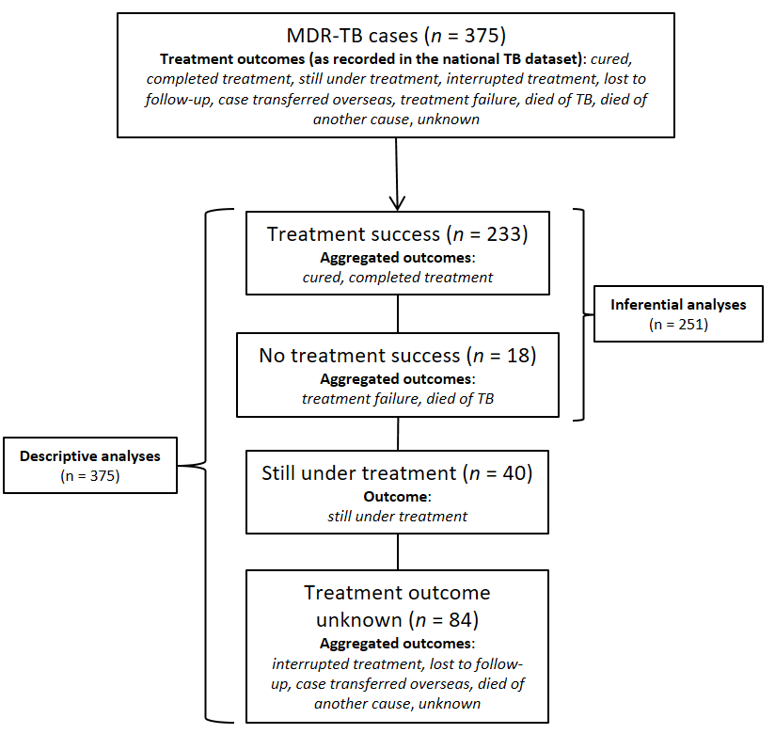

Results

Descriptive epidemiology
Between 1999 and 2018, there were 375 MDR-TB case notifications, representing 1.5% of all nationally notified TB cases (n = 24,443) in Australia. MDR-TB cases represented the majority (n = 375/430; 87%) of all notifications reporting rifampicin resistance. Of these, seven cases were classified as XDR-TB (1.9% of MDR-TB, and 0.03% of all TB case notifications, respectively). Annual MDR-TB case numbers increased over the study period, with a median of 21 cases notified per year across Australia (range: 5–31). The median annual incidence rate was 0.09 MDR-TB cases per 100,000 population per year (range: 0.03–0.14), compared to 5.7 cases per 100,000 population per year for all TB case notifications (range: 5.0–6.2) (Figure 2). The majority of cases (n = 290;77.3%), were classified as new, i.e. never treated or treated for less than one month, whereas 14.1% (n = 53) were relapsed cases who received full or partial treatment overseas, followed by relapsed cases following full treatment in Australia (n = 14; 3.7%).

Figure 2: Multidrug-resistant tuberculosis case notifications in Australia, by country of birth (1999–2018), and notification rate per 100,000 population of all tuberculosis and multidrug-resistant tuberculosis cases
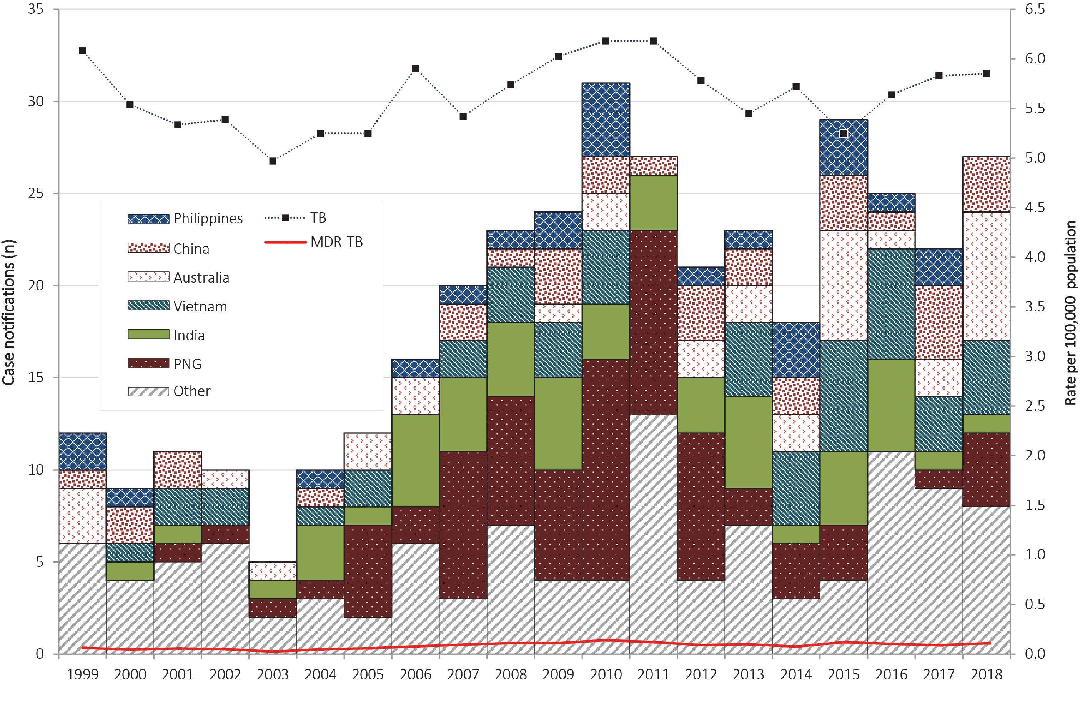
All states and territories reported MDR-TB case notifications. The median age at the time of notification was 31 years (range: 0–84 years). The majority of cases were overseas-born (n = 341; 90.9%). Of the Australian-born cases, 7/34 (20.6%) identified as Aboriginal and/or Torres Strait Islander. The five most commonly reported countries of birth were PNG (n = 75; 20.0%), India (n = 51; 13.6%), Vietnam (n = 48; 12.8%), China (n = 33; 8.8%), and the Philippines (n = 24; 6.4%) (Figure 2).
The majority of cases (n = 352; 93.9%) had the date of initial presentation (first health contact for TB-like symptoms, or asymptomatic screening) recorded. The majority of cases were diagnosed after presenting with symptomatic illness (n = 194; 51.7%), followed by asymptomatic screening activities (n = 45; 12.0%). Sputum smear microscopy was reported positive in 40.8% of all cases (n = 153). As for clinical presentation, the majority of cases were diagnosed with pulmonary TB (PTB) (n = 305; 81.3%). Of those with extra-pulmonary TB (EPTB), the most commonly reported forms were tuberculous lymphadenitis (n = 47/70; 67.1%) and pleural TB (n = 9/70; 12.9%). Of the five most commonly reported countries of birth, the highest proportion of pulmonary-only MDR-TB was reported for China (81.8%), the Philippines (79.2%) and Vietnam (72.9%); the highest proportion of extra-pulmonary-only MDR-TB was reported for India (47.1%) and Vietnam (22.9%); and the highest proportion of pulmonary and extra-pulmonary MDR-TB co-infections was reported for PNG (37.3%) and India (11.8%).
Only 2.7% of cases (n = 10) were human immunodeficiency virus (HIV) positive; however, HIV status was unknown for 33.6% of cases (n = 126). Of cases with unknown HIV status, 52/126 (41.3%) were tested for HIV, but with results remaining undisclosed, whereas 41/126 (32.5%) had an unknown HIV testing history, and 33/126 (26.2%) were not tested or refused testing.
A summary of MDR-TB case notifications by treatment outcomes as per the national TB dataset is provided (Table 1), as well as by selected demographic, clinical, laboratory, TB treatment, drug resistance profile and risk factors for TB acquisition (Table 2).
Table 1: Multidrug-resistant tuberculosis case notifications in Australia (1999–2018), categorised by treatment outcome, as at May 2019
Treatment outcome in the Australian national TB dataset | Number (n) | Percentage (%) | Aggregated treatment outcome
Completed treatment | 209 | 55.7 | Treatment success
Cured | 24 | 6.4
Sub-total | 233 | 62.1
Died of TB | 17 | 4.6 | No treatment success
Treatment failure | 1 | 0.3
Sub-total | 18 | 4.9
Case transferred overseas | 56 | 14.9 | Treatment outcome  unknown
Lost to follow-up | 15 | 4.0
Unknown | 7 | 1.9
Died of another cause | 4 | 1.1
Interrupted treatment | 2 | 0.5
Sub-total | 84 | 22.3
Still under treatment | 40 | 10.7 | Still under treatment
Sub-total | 40 | 10.7
Total | 375 | 100
Table 2: Multidrug-resistant tuberculosis case notifications in Australia (1999–2018) by selected demographic, clinical, laboratory, drug resistance profile characteristics and risk factors for tuberculosis acquisition
Characteristic | Total (n = 375)
 | Number (n) | Percentage (%)
Demographic
Sex
Male | 184 | 49.1
Female | 191 | 50.9
Age group (years)
Under 5 | 8 | 2.1
5–14 | 6 | 1.6
15–29 | 165 | 44.0
30–49 | 146 | 38.9
50–64 | 34 | 9.1
65 and over | 16 | 4.3
Indigenous status
Indigenous | 7 | 1.9
Non-indigenous | 367 | 97.9
Unknown | 1 | 0.2
Country of birth
Australia | 34 | 9.1
Papua New Guinea | 75 | 20.0
Other | 266 | 70.9
Notifying jurisdiction
Australian Capital Territory | 5 | 1.3
New South Wales | 117 | 31.2
Northern Territory | 6 | 1.6
Queensland | 115 | 30.7
South Australia | 17 | 4.5
Tasmania | 3 | 0.8
Victoria | 91 | 24.3
Western Australia | 21 | 5.6
Clinical
Diagnostic site
Pulmonary TB | 305 | 81.3
Extra-pulmonary TB | 70 | 18.7
HIV status
HIV-positive | 10 | 2.7
HIV-negative | 239 | 63.7
Unknown | 126 | 33.6
Laboratory
Acid-fast bacillus positive on sputum microscopy
Positive | 153 | 40.8
Negative | 113 | 30.1
Unknown | 109 | 29.1
TB treatment
Previous TB treatment
Yes | 73 | 19.5
No | 290 | 77.3
Unknown | 12 | 3.2
Treatment with one or more fluoroquinolones
Yes | 272 | 72.5
No | 103 | 27.5
Treatment with one or more second-line injectable agents
Yes | 270 | 72.0
No | 105 | 28.0
Combination therapy (fluoroquinolones and second-line injectable agent)
Yes | 228 | 60.8
No | 147 | 39.2
TB drug resistance profile
Resistant to one or more fluoroquinolones
Yes | 22 | 5.9
No | 353 | 94.1
XDR-TB
Yes | 7 | 1.8
No | 368 | 98.1
Selected risk factors for TB acquisition
TB high risk country: past travel or residence (not country of birth)
Yes | 245 | 65.3
No | 130 | 34.7
Close contact/household contact with a TB case
Yes | 46 | 12.3
No | 329 | 87.7
Health industry employment
Yes | 32 | 8.5
No | 343 | 91.5
Pertaining to the diagnosis and clinical management of MDR-TB, timeframes between initial presentation and notification received date, specimen collection and treatment commencement, and case notification and treatment commencement were calculated (Table 3). Current data fields precluded determination of other parameters outlined in the study objectives.

Table 3: Timeframe between initial presentation and case notification received date, specimen collection and treatment commencement, and case notification and treatment commencement, by selected immigration status at the time of diagnosis, in multidrug-resistant tuberculosis case notifications in Australia (1999–2018)
Immigration status | Timeframe (days)
 | Median (interquartile range)
Initial presentation to case notification received
Australian-born | 21 (3–114)
Permanent resident | 37 (10–92)
TSPZ residentsª | 66 (25–123)
Overseas student | 30 (10–92)
Visitor | 37 (16–67)
Other (undefined) | 36 (16–51)
Specimen collection to treatment commencement
Australian-born | 5 (2–10)
Permanent resident | 16 (2–42)
TSPZ residentsª | 10 (0–43)
Overseas student | 14 (3–26)
Visitor | 14 (2–31)
Other (undefined) | 25 (4–42)
Case notification to treatment commencement^{b}
Australian-born | 1 (-1–11)
Permanent resident | 1 (-1–10)
TSPZ residentsª | 1 (-9–36)
Overseas student | 1 (0–6)
Visitor | 0 (-2–8)
Other (undefined) | 0 (-6–8)
a Residents of the Torres Strait Protected Zone (TSPZ) accessing TB treatment in Queensland.
b Negative timeframes observed between case notification and treatment commencement likely reflect delays between treatment commencement and notification to health authorities.
Tuberculosis drugs received were recorded for the majority of cases (n = 355; 94.7%). Antimicrobial susceptibility profiles were recorded for all cases; the median number of TB drugs against which resistance was reported was four (range: 2–10). Isoniazid and rifampicin excluded, resistance was most commonly reported against streptomycin (n = 233; 62.1%), followed by ethionamide or prothionamide (n = 161; 42.9%) and rifabutin (n = 150; 40.0%). Only one case (0.27%) did not receive treatment and was transferred overseas. The majority of cases had a treatment commencement date recorded (n = 345; 92.0%); of those without a treatment commencement date, nearly half (14/30; 46.7%) were transferred overseas.
The most frequent risk factors for TB acquisition were: past travel to or residence in a TB high-risk country (defined by the Australian Government as countries with 60 or more incident cases per 100,000 population per annum) for a cumulative period of at least 3 months (other than the individual’s country of birth) (n = 245; 65.3%); close contact with, or being a household member of a confirmed TB case (n = 46; 12.3%); and previous or current employment in the health industry (including laboratories) overseas or in Australia (n = 32; 8.5%). Of Australian-born cases, 47% (16/34) had previous travel to or residence in a TB high-risk country.
Treatment outcomes in the largest cohort of overseas-born cases (PNG nationals) were further investigated. Treatment success was achieved in 20/75 cases (26.7%), whereas 29/75 (38.7%) had their treatment transferred overseas; 13/75 (17.3%) died due to TB; 9/75 (12.0%) were lost to follow-up; and 4/75 (5.3%) were still under treatment when the outcome was recorded. Queensland notified the majority of PNG-born cases (n = 74; 98.5%); of these, 69/74 (92.2%) were cross-border cases (i.e. PNG-born residents of the Torres Strait Protected Zone (TSPZ) accessing TB treatment in Queensland), and 58/74 (78.4%) were classified as new cases. The majority of deaths attributed to MDR-TB in the national dataset occurred in PNG-born cross-border cases (11/17; 64.7%).

Analytical epidemiology
Comparison groups were defined as cases with treatment success (n = 233), and cases with no treatment success (n = 18) (Figure 1). On univariable analysis, there was a statistically significant association between treatment success and case notifications from NSW, and receiving treatment with a fluoroquinolone, or a second-line injectable agent, as well as having received a combination of both. There was a statistically significant association between no treatment success and case notifications from Queensland, having PNG as country of birth, having pulmonary TB and having XDR-TB (Table 4). After adjusting for other factors, only case notifications from Queensland and XDR-TB cases remained associated with no treatment success, whereas treatment with fluoroquinolones remained significantly associated with treatment success (Table 5).
Table 4: Factors associated with treatment success on univariable analyses
Variables included | Treatment outcome (n = 251)
 | Univariable analysis
 | Crude OR (95% CI) | p value
Demographic
Male sex | 1.8 (0.66–5.01) | 0.247
Age group (years): 30–49 | 2.45 (0.78–7.68) | 0.123
Indigenous | 0.15 (0.13–1.7) | 0.125
Country of birth: PNG | 0.03 (0.01–0.11) | < 0.001ª
Notifying jurisdiction: Qld | 0.04 (0.012–0.159) | < 0.001ª
Notifying jurisdiction: NSW | 10.7 (1.4–81.79) | 0.022ª
Clinical
Pulmonary TB^{b} | 0.14 (0–0.89) | 0.034ª
HIV-positive | 0.18 (0.03–1.08) | 0.061
TB treatment
Previous TB treatment | 0.89 (0.28–2.86) | 0.858
Fluoroquinolone treatment | 3.85 (1.45–10.24) | 0.007ª
Second-line injectable treatment | 5.37 (2–14.39) | 0.001ª
Combination therapy (Fluoroquinolones and second-line injectable agents) | 3.66 (1.36–9.83) | 0.010ª
TB drug resistance profile
Fluoroquinolone resistance | 0.63 (0.17–2.32) | 0.458
Second-line injectable resistance | 0.63 (0.13–2.97) | 0.559
XDR-TB | 0.13 (0.02–0.82) | 0.029ª
Selected risk factors for TB acquisition
TB high risk country: past travel or residence | 1.04 (0.36–3.03) | 0.946
Close/household contact with TB case | 0.38 (0.12–1.26) | 0.115
Health industry employment | 1.68 (0.21–13.29) | 0.620
a Statistically significant at α = 0.05.
b Odds ratio, confidence interval and p value calculated using exact logistic regression.
Table 5: Factors associated with treatment success on multivariable analyses
Variables included | Treatment outcome (n = 251)
 | Multivariable analysis
 | Adjusted OR (95% CI) | p value
Demographic
Notifying jurisdiction: Qld | 0.06 (0.01–0.48) | 0.009ª
TB treatment
Fluoroquinolone treatment | 7.02 (1.77–27.86) | 0.006ª
TB drug resistance profile
XDR-TB | 0.06 (0.01–0.63) | 0.020ª
a Statistically significant at α = 0.05.
Box 1: Summary of data fields for proposed addition to the national TB dataset
- Date of laboratory confirmation of resistance, per drug
- Drug resistance detection method (DST or molecular diagnostics)
- Treatment start date, per drug
- Treatment end date, per drug
- Treatment completion date
- Treatment failure date
- Date of cure
- Date of death

Discussion
As a high income country with advanced health system core capacities, Australia has achieved excellent TB control in recent decades, and maintains one of the lowest TB incidence rates in the world.^{3,7,19} Similarly, MDR-TB notifications are low by international standards, consistently remaining under 2% of the total TB caseload per annum.⁷ However, Australia’s large migrant intake from high-burden countries in Asia means that despite pre-migration health screening, cases of imported MDR-TB will continue to occur until TB control improves globally.^{2,7} This trend is reflected in Australia’s increasing case numbers, despite the MDR-TB notification rate remaining fairly stable over the 20 year study period. Treatment success (defined as a composite of cases where treatment was either curative or completed)²¹ was achieved in nearly two-thirds of cases (62.1%), which is higher than the global average of successful MDR-TB treatment outcomes (55%).³
Although the proportion of Australian-born cases has increased over time, the majority of MDR-TB cases still originate from high-burden countries in the Asia-Pacific region, in line with previously described trends.^{2,4,7} Amongst overseas-born cases, it is noteworthy that the highest proportion (20%) were born in Australia’s nearest geographical neighbour (PNG). Queensland notified the majority of PNG-born cases; of these, cross-border cases contributed the largest proportion of all deaths attributed to MDR-TB during the study period (11/17; 64.7%). The poorer treatment outcomes in PNG-born case notifications from Queensland observed in this study are likely attributable to the unique and complex cross-border challenges to TB control in the TSPZ, which have been previously described,^{16,24} and in PNG’s Western Province more broadly.^{10,25} The transfer of cross-border TB case management from Queensland’s TB control program to PNG health authorities in 2011–2012 is reflected in a decreased reported incidence of MDR-TB case notifications in Queensland in 2013–2014.^{16,26,27}
Categorised by country of birth, observed differences in the proportions of pulmonary and extra-pulmonary TB in Australian MDR-TB cases are worthy of further research. It may be that the manifestation of active TB disease is influenced by risk factors for infection or disease development that may differ between geographic regions and populations, as has been suggested in previous studies.^{28–31} Such differences may influence considerations around pre-migration screening, diagnosis and clinical management of cases from TB high-burden countries from which Australia accepts a large migrant intake.
The proportion of HIV-positive MDR-TB cases (2.7%) was consistent with results from previous studies.^{2,32} However, a third of all MDR-TB cases (n = 126; 33.6%) had an unknown HIV status recorded in the NNDSS, including cases from Victoria (n = 39) and NSW (n = 13), where test results remained undisclosed due to jurisdictional legislation or policies in effect at the time.⁷ The true proportion of HIV-positive MDR-TB cases may therefore be under-reported in the national TB dataset. Although policy changes from 2015 onwards mean that all Australian jurisdictions may now report HIV status with TB notifications,⁷ missing data from earlier years could have biased results towards finding no significant association between HIV status and treatment success.³²
Consolidated, evidence-based policy recommendations for the management of drug-resistant TB were published in 2019.³³ Optimising the care and prevention of MDR-TB requires detailed data on treatment regimens used in the national context. Although this information is available to jurisdictional health authorities, the study identified several limitations in the national TB dataset which preclude measurement and description of relevant information pertaining to the diagnosis and clinical management of MDR-TB. The lack of a data field for laboratory confirmation date means that it is not currently possible to calculate timeframes between identification of MDR-TB (based on drug susceptibility testing or molecular diagnostics) relative to initial presentation, or case notification received. The majority of MDR-TB cases (77.3%) were classified as new, which suggests that infection was acquired through primary transmission of a resistant strain, as opposed to selection for resistance during TB treatment. This is consistent with findings from modelling studies in high-burden settings³⁴ and previous reviews of MDR-TB in Australia.² A previous Queensland study found that 26% of isolates from the TSPZ were defined as MDR-TB.¹⁰ The high prevalence and local transmission of MDR-TB in PNG’s Western Province⁹ bordering the Torres Strait islands is likely relevant, considering the high proportion of PNG-born cases in the Australian national TB dataset.
The majority of cases had TB medications received (94.7%) and treatment commencement date recorded (92%). The inferential analyses showed that the odds of treatment success were higher in cases treated with one or more second-line drugs, including a fluoroquinolone (in line with current WHO recommendations).³³ However, the lack of a data field for treatment completion date or date of cure, and dates for when drugs are initiated or discontinued, means that the duration or changes in treatment regimens for individual cases over time are not captured in the national TB dataset, and it is not possible to determine the number of cases undergoing treatment at any one point in time. This complicates monitoring of compliance with evidence-based recommendations from WHO, including new treatment regimens.³³ Similarly, 17/18 (94.4%) cases classified as having not had treatment success died from TB. The lack of a date of death field precludes determination of the duration of treatment, and identification of cases presenting late in the disease process and for whom treatment is initiated shortly prior to death, or not initiated at all. Considering that the majority (87%) of notifications reporting rifampicin resistance in Australia were MDR-TB cases, these findings may also be considered broadly applicable to RR-TB.
The national TB dataset only includes microbiologically confirmed multidrug-resistant cases. Furthermore, the NNDSS excludes cases initially diagnosed and notified abroad, but subsequently managed in Australia. Pre-migration screening targets active TB in immigrants from high-burden countries, meaning MDR-TB cases who are latently infected during screening or acquire their infection through other pathways (e.g. community transmission) may not be detected and notified.³⁴ The national TB dataset may therefore potentially underestimate the true burden of MDR-TB in Australia. Collinearity between TB treatments and resistance profiles as independent variables was somewhat mitigated by the backward stepwise approach to multivariable regression analysis. Other limitations include variable data quality and completeness in the NNDSS, including due to differences in historical data collection or provision by jurisdictions, and legislation or policy changes over time. Data captured in the NNDSS are dynamic in nature; therefore, the presented data represent a point-in-time analysis of MDR-TB case notifications, and may differ from jurisdictional reports covering the same period.⁷ In addition, the large number of treatment outcomes (n = 10) captured in the dataset meant that case outcomes grouped as ‘treatment outcome unknown’ were too diverse to include in detailed descriptive or inferential analyses.

Conclusion
While Australia’s MDR-TB burden is comparatively low, cases will continue to occur until TB control improves in countries with which Australia shares strong cultural and migration links. It is therefore imperative that Australia continues to contribute to strengthening regional TB control programmes. Continued vigilance is also required to sustain and further improve Australia’s TB control as the drive towards elimination in low-incidence countries gathers pace. This study’s findings support a review of data fields in the national TB dataset with potential expansion or adjustment to improve national data reporting, including the monitoring of evidence-based recommendations for the prevention and management of MDR-TB.

Acknowledgements
We would like to thank:
Australian Government Department of Health: Rose Wright and Mark Trungove
Victorian Department of Health and Human Services: Ee Laine Tay
Health Protection New South Wales: Ellen Donnan
Queensland Health: Chris Coulter and Bridget O’Connor

Author details
Dr Hendrik S. Camphor^{1, 2}
Dr Kerri Viney^{1,3}
Dr Ben Polkinghorne¹
Kate Pennington²
- Research School of Population Health, Australian National University, Canberra, Australia.
- Communicable Diseases Epidemiology and Surveillance Section, Office of Health Protection, Australian Government Department of Health
- Department of Public Health Sciences, Karolinska Institutet, Stockholm, Sweden.

Corresponding author
Hendrik S. Camphor
GPO Box 9848, Canberra ACT 2601, Scarborough House, MDP 14
Telephone: +61 2 62895435.
Email: hendrik.camphor@health.gov.au

References
- World Health Organization (WHO). Tuberculosis. [Internet.] Geneva: WHO; 2018. Available from: http://www.who.int/en/news-room/fact-sheets/detail/tuberculosis.
- Francis JR, Manchikanti P, Blyth CC, Denholm J, Lowbridge C, Coulter C et al. Multidrug-resistant tuberculosis in Australia, 1998–2012. Int J Tuberc Lung Dis. 2018;22(3):294–9.
- WHO. Global tuberculosis report 2018. Geneva: WHO; 2018. Available from: https://www.who.int/tb/publications/2018/en/.
- Trauer JM, Cheng AC. Multidrug-resistant tuberculosis in Australia and our region. Med J Aust. 2016;204(7):251–3.
- WHO. The End TB Strategy. [Internet.] Geneva: WHO; 2014. Available from: http://www.who.int/tb/strategy/en/.
- Uplekar M, Weil D, Lonnroth K, Jaramillo E, Lienhardt C, Dias HM et al. WHO’s new End TB strategy. Lancet. 2015;385(9979):1799–801.
- Toms C, Stapledon R, Coulter C, Douglas P. Tuberculosis notifications in Australia, 2014. Commun Dis Intell Q Rep. 2017;41(3):E247–63.
- National Tuberculosis Advisory Committee for the Communicable Diseases Network Australia. The strategic plan for control of tuberculosis in Australia, 2016–2020: towards disease elimination. Commun Dis Intell (2018). 2019;43. doi: https://doi.org/10.33321/cdi.2019.43.10.
- Gilpin CM, Simpson G, Vincent S, O’Brien TP, Knight TA, Globan M et al. Evidence of primary transmission of multidrug‐resistant tuberculosis in the Western Province of Papua New Guinea. Med J Aust. 2008;188(3):148–52.
- Simpson G, Coulter C, Weston J, Knight T, Carter R, Vincent S et al. Resistance patterns of multidrug-resistant tuberculosis in Western Province, Papua New Guinea. Int J Tuberc Lung Dis. 2011;15(4):551–2.
- Aia P, Kal M, Lavu E, John LN, Johnson K, Coulter C et al. The burden of drug-resistant tuberculosis in Papua New Guinea: results of a large population-based survey. PLoS One. 2016;11(3):e0149806.
- Lavender CJ, Brown LK, Johnson PDR. Multidrug-resistant tuberculosis in Victoria: a 10-year review. Med J Aust. 2009;191(6):315–8.
- Denholm JT, Leslie DE, Jenkin GA, Darby J, Johnson PDR, Graham SM et al. Long-term follow-up of contacts exposed to multidrug-resistant tuberculosis in Victoria, Australia, 1995–2010. Int J Tuberc Lung Dis. 2012;16(10):1320–5.
- Francis JR, Blyth CC, Colby S, Fagan JM, Waring J. Multidrug-resistant tuberculosis in Western Australia, 1998–2012. Med J Aust. 2014;200(6):328–32.
- Judge D, Krause V. Multidrug-resistant tuberculosis in the Northern Territory: A 10-year retrospective case series. Commun Dis Intell Q Rep. 2016;40(3):E334–9.
- Baird T, Donnan E, Coulter C, Simpson G, Konstantinos A, Eather G. Multidrug-resistant tuberculosis in Queensland, Australia: an ongoing cross-border challenge. Int J Tuberc Lung Dis. 2018;22(2):206–11.
- Teo SS, Tay EL, Douglas P, Krause VL, Graham SM. The epidemiology of tuberculosis in children in Australia, 2003–2012. Med J Aust. 2015;203(11):440.
- United Nations (UN). World leaders reaffirm commitment to end tuberculosis by 2030, as General Assembly adopts declaration outlining actions for increased financing, treatment access. [Internet.] New York City: UN; 28 September 2018. Available from: https://www.un.org/press/en/2018/ga12067.doc.htm.
- WHO. Towards TB Elimination: an action framework in low-incidence countries. Geneva: WHO; 2014. Available from: http://www.who.int/tb/publications/elimination_framework/en/.
- WHO. WHO resolutions on tuberculosis. [Internet.] Geneva: WHO; 2018. Available from: http://www.who.int/tb/publications/resolutions/en/.
- WHO. Definitions and reporting framework for tuberculosis. Geneva: WHO; 2014. Available from: https://www.who.int/tb/publications/definitions/en/.
- Stata Statistical Software: Release 13. [Software.] College Station, Texas: StataCorp LP; 2013.
- WHO. Joint external evaluation of IHR core capacities of Australia. Geneva: WHO; 2018. Available from: https://www.who.int/ihr/publications/WHO-WHE-CPI-REP-2018.8/en/.
- Donnan EJ, Coulter C, Simpson G, Clark J, Nourse C. Paediatric tuberculosis in Queensland, Australia: overrepresentation of cross-border and Indigenous children. Int J Tuberc Lung Dis. 2017;21(3):263–9.
- Diefenbach‐Elstob T, Graves P, Dowi R, Gula B, Plummer D, McBryde E et al. The epidemiology of tuberculosis in the rural Balimo region of Papua New Guinea. Trop Med Int Health. 2018;23(9):1022–32.
- Queensland Health. Tuberculosis in Queensland 2011-2012. Brisbane: Queensland Government, Queensland Health; 2015. Available from: https://www.health.qld.gov.au/clinical-practice/guidelines-procedures/diseases-infection/diseases/tuberculosis/surveillance.
- Queensland Health. Tuberculosis in Queensland 2013-2014. Brisbane: Queensland Government, Queensland Health; 2016. Available from: https://www.health.qld.gov.au/clinical-practice/guidelines-procedures/diseases-infection/diseases/tuberculosis/surveillance.
- Noertjojo K, Tam CM, Chan SL, Chan-Yeung MMW. Extra-pulmonary and pulmonary tuberculosis in Hong Kong. Int J Tuberc Lung Dis. 2002;6(10):879–86.
- Yang Z, Kong Y, Wilson F, Foxman B, Fowler AH, Marrs CF et al. Identification of risk factors for extrapulmonary tuberculosis. Clin Infect Dis. 2004;38(2):199–205.
- Musellim B, Erturan S, Sonmez Duman E, Ongen G. Comparison of extra-pulmonary and pulmonary tuberculosis cases: factors influencing the site of reactivation. Int J Tuberc Lung Dis. 2005;9(11):1220–3.
- Sreeramareddy CT, Panduru KV, Verma SC, Joshi HS, Bates MN. Comparison of pulmonary and extrapulmonary tuberculosis in Nepal-a hospital-based retrospective study. BMC Infect Dis. 2008;8(1):8.
- van den Hof S, Tursynbayeva A, Abildaev T, Adenov M, Pak S, Ismailov S. HIV and multidrug-resistant tuberculosis: overlapping risk factors. Eur Respir J. 2015;45(2):567–9.
- WHO. WHO consolidated guidelines on drug-resistant tuberculosis treatment. Geneva: WHO; 2019. Available from: https://www.who.int/tb/publications/2019/consolidated-guidelines-drug-resistant-TB-treatment/en/.
- Kendall EA, Fofana MO, Dowdy DW. Burden of transmitted multidrug resistance in epidemics of tuberculosis: a transmission modelling analysis. Lancet Respir Med. 2015;3(12):963–72.

Communicable Diseases Intelligence
ISSN: 2209-6051 Online

Communicable Diseases Intelligence (CDI) is a peer-reviewed scientific journal published by the Office of Health Protection, Department of Health. The journal aims to disseminate information on the epidemiology, surveillance, prevention and control of communicable diseases of relevance to Australia.

Editor: Tanja Farmer
Deputy Editor: Simon Petrie
Design and Production: Kasra Yousefi
Editorial Advisory Board: David Durrheim, Mark Ferson, John Kaldor, Martyn Kirk and Linda Selvey

Website: http://www.health.gov.au/cdi

Contacts
Communicable Diseases Intelligence is produced by:
Health Protection Policy Branch, Office of Health Protection, Australian Government Department of Health
GPO Box 9848, (MDP 6) CANBERRA ACT 2601

Email: cdi.editor@health.gov.au

Submit an Article
You are invited to submit your next communicable disease related article to the Communicable Diseases Intelligence (CDI) for consideration. More information regarding CDI can be found at: http://health.gov.au/cdi.
Further enquiries should be directed to: cdi.editor@health.gov.au.

This journal is indexed by Index Medicus and Medline.

Creative Commons Licence - Attribution-NonCommercial-NoDerivatives CC BY-NC-ND
© 2020 Commonwealth of Australia as represented by the Department of Health
This publication is licensed under a Creative Commons Attribution-NonCommercial-NoDerivatives 4.0 International Licence from https://creativecommons.org/licenses/by-nc-nd/4.0/legalcode (Licence). You must read and understand the Licence before using any material from this publication.

Restrictions
The Licence does not cover, and there is no permission given for, use of any of the following material found in this publication (if any):
- the Commonwealth Coat of Arms (by way of information, the terms under which the Coat of Arms may be used can be found at www.itsanhonour.gov.au);
- any logos (including the Department of Health’s logo) and trademarks;
- any photographs and images;
- any signatures; and
- any material belonging to third parties.

Disclaimer
Opinions expressed in Communicable Diseases Intelligence are those of the authors and not necessarily those of the Australian Government Department of Health or the Communicable Diseases Network Australia. Data may be subject to revision.

Enquiries
Enquiries regarding any other use of this publication should be addressed to the Communication Branch, Department of Health, GPO Box 9848, Canberra ACT 2601, or via e-mail to: copyright@health.gov.au

Communicable Diseases Network Australia
Communicable Diseases Intelligence contributes to the work of the Communicable Diseases Network Australia.
http://www.health.gov.au/cdna

