COVID-19 Australia: Epidemiology Report 58
Reporting period ending 13 February 2022
COVID-19 National Incident Room Surveillance Team

Summary

Four-week reporting period (17 January – 13 February 2022)
The case data provided in this report includes confirmed cases reported to the National Interoperable Disease Surveillance System (NINDSS). The case data does not include cases that are positive on rapid antigen tests (RAT) only. Therefore, case numbers, particularly in recent weeks, will under-represent the incidence of disease in the community.
Data are not available in NINDSS for the Northern Territory for cases notified since 10 January 2022.
Trends – In the last four weeks from 17 January to 13 February 2022, there were over 593,000 polymerase chain reaction (PCR) confirmed cases of coronavirus disease 2019 (COVID-19) reported in Australia, with a decrease in cases numbers observed each week. In the most recent fortnight, a total of 175,637 confirmed cases were notified (an average of 12,546 cases per day), compared to 418,218 in the previous fortnight (29,873 cases per day).
Age group - In the week ending 13 February 2022, PCR confirmed notification rates showed minor variations between age groups, with children aged 0 to 17 years having the highest weekly case rate of 273 per 100,000 population. The highest notification rate averaged across the four-week reporting period was in adults aged 30 to 39 years (2,883 per 100,000 population). Averaged across the entire Omicron wave to date (15 December 2021 – 13 February 2022), the highest PCR confirmed notification rate was in adults aged 18 to 29 years (1,431 per 100,000 population).
Aboriginal and Torres Strait Islander persons – Between 17 January and 13 February 2022, there were 16,907 new PCR confirmed cases notified in Aboriginal and Torres Strait Islander people. The number of notified cases decreased over the four weeks, in line with the reduction in new cases among the general community. The proportion of locally-acquired cases in Aboriginal and Torres Strait Islander people who are residents of regional or remote areas has steadily increased since mid-December 2021, from 31% in the week ending 19 December 2021, to 63% in the week ending 13 February 2022. In the current Omicron wave (15 December 2021 – 13 February 2022) there have been 38,829 confirmed cases of COVID-19 notified in Aboriginal and Torres Strait Islander people, representing 2.4% (38,829/1,639,839) of all confirmed cases; 46.4% (761,694/1,639,839) of cases notified in that same period had an unknown or missing Indigenous status. Therefore, the number of cases classified as Aboriginal and Torres Strait Islander people is likely an underestimate.
Vaccinations – As at 13 February 2022, a total of 52,321,535 doses of COVID-19 vaccine had been administered in Australia. Nationally, 20,351,405 people aged 12 years and over (93.1%; 20,351,405/21,863,949) had received two or more doses. Among children aged 5–11 years, 1,081,430 (47.5%) had received at least one dose, including 8,722 (0.4%) who were fully vaccinated. Nationally, 9,991,919 people aged 16 years and over (48.5%) had received more than two doses.
Severity – The weekly notification rate of cases developing severe illness (defined as cases subsequently admitted to ICU or died) reached an apparent peak in the weeks ending 9 January and 16 January 2022, at approximately 2.9 per 100,000 population per week, decreasing to 2.2 per 100,000 population for the week ending 23 January 2022 and to 1.2 per 100,000 population for the week ending 30 January 2022.
Using date of death, during the four-week reporting period, 1,245 new COVID-19-associated deaths were notified.
Virology –In the four-week reporting period, the number of cases identified as Omicron in Australia increased considerably. AusTrakka actively monitors and reports on and since the start of the pandemic has identified 30,879 samples of Delta (B.1.617.2) and 13,147 samples of Omicron (B.1.1.529). Between 17 January and 13 February 2022, 1.0% of cases (6,267 cases) were sequenced. Nationally, SARS-CoV-2 strains from 3.2% of COVID-19 cases have been sequenced from the start of the pandemic.
Testing – During the reporting period, there was an overall decrease in PCR testing rates. Over the four-week period, testing rates decreased in all jurisdictions except for Western Australia. A reduction in percent positivity was also observed during this reporting period, with all jurisdictions at less than 20% for the first time in 2022.
International situation – According to the World Health Organization (WHO), cumulative global COVID-19 cases stood at more than 410 million, with over 5.8 million deaths reported globally, as of 13 February 2022. In Australia’s near region, the South East Asia and Western Pacific Regions reported over 11.3 million newly-confirmed cases and over 35,000 deaths in the four-week period to 13 February 2022.
Keywords: SARS-CoV-2; novel coronavirus; 2019-nCoV; coronavirus disease 2019; COVID-19; acute respiratory disease; epidemiology; Australia
This reporting period covers the four-week period 17 January 2022 – 13 February 2022. Within this period, data for each week is compared.
The focus of this report is on the epidemiological situation in Australia since the beginning of the current Omicron wave. For the purposes of this report, 15 December 2021 is used as a proxy for the beginning of this wave. This date was chosen as, from this date onwards, the majority of sequenced cases were Omicron. Readers are encouraged to consult prior reports in this series for information on the epidemiology of COVID-19 in Australia in 2020 and 2021.
Included in this report, also with a reporting period of four weeks, are sections on genomic surveillance and virology, acute respiratory illness, testing, public health response measures, and the international situation. The reporting period for these topics is 17 January 2022 – 13 February 2022. The previous reporting period was the preceding six weeks (6 December 2021 – 16 January 2022).¹
From report 46 onward, and unless otherwise specified, tabulated data and data within the text are extracted from the National Interoperable Notifiable Diseases Surveillance System (NINDSS) based on ‘notification received date’ rather than ‘diagnosis date’ (see the Technical Supplement for definitions).² As a case’s diagnosis date can be several days prior to the date of its notification, there is potential for newly-notified cases to be excluded from the case count in the current reporting period when reporting by ‘diagnosis date’. Using ‘notification received date’ ensures that the case count for the reporting period better reflects the number of newly-notified cases. As the graphs presented in this report, based on NINDSS data, reflect a longer time period (i.e. year to date and entire pandemic), these will continue to be based on diagnosis date to enable a more accurate understanding of infection risk and local transmission.
Unless otherwise noted, the case data provided in this report includes confirmed cases reported to the NINDSS, which—as per the COVID-19 National Guidelines for Public Health Units (SoNG)³—does not include cases which are positive on rapid antigen tests (RAT) only. At the time of data extraction, RAT probable cases were yet to be captured in the NINDSS.
Data are not available in NINDSS for the Northern Territory for COVID-19 cases notified since 10 January 2022.

Background and data sources
See the Technical Supplement for general information on COVID-19 including modes of transmission, common symptoms and severity.²

Activity

COVID-19 trends

(NINDSS and jurisdictional reporting to the National Incident Centre)
Cumulatively, from the beginning of the pandemic to 13 February 2022, jurisdictions within Australia have reported 2,543,865 COVID-19 cases (PCR confirmed and RAT probable cases) to the National Incident Centre. In the same time period, there have been 1,874,367 PCR confirmed cases of COVID-19 reported to NINDSS nationally. The difference in these case numbers is largely due to the current exclusion of RAT probable cases from NINDSS. As noted above, analyses in this report are limited to PCR confirmed cases reported to NINDSS.
Of notifications in NINDSS, the number of confirmed cases nationally has decreased considerably during the four-week reporting period. Weekly case numbers decreased over the four-week period across all jurisdictions except Western Australia. (In Western Australia, weekly case numbers increased four-fold over the four weeks, from 99 cases during the week ending 23 January 2022 to 429 cases in the week ending 13 February 2022.) The greatest reduction in PCR confirmed case numbers over the four weeks was in New South Wales. In the most recent week, the highest PCR confirmed notification rate was in South Australia, while in the previous three weeks, the highest notification rate was observed in Queensland (Table 1).

Table 1: PCR confirmed COVID-19 cases by jurisdiction and date of notification, 15 December 2021 – 13 February 2022^{a,b}
Jurisdiction | Reporting period |  |  |  |  |  |  |  | Current ‘Omicron’ wave
 | 17–23 Jan 2022 |  | 24–30 Jan 2022 |  | 31 Jan 2022 – 6 Feb 2022 |  | 7–13 Feb 2022 |  | 15 Dec 2021 – 13 Feb 2022
 | No. of cases | Rate^{c} | No. of cases | Rate^{c} | No. of cases | Rate^{c} | No. of cases | Rate^{c} | No. of cases | Rate^{c}
ACT | 3,054 | 708.1 | 3,230 | 748.9 | 1,630 | 377.9 | 1,787 | 414.3 | 28,979 | 6,718.6
NSW | 103,004 | 1,261.1 | 62,972 | 771.0 | 32,988 | 403.9 | 23,392 | 286.4 | 659,792 | 8,077.9
NT^{d} | Not avail. | — | Not avail. | — | Not avail. | — | Not avail. | — | Not avail. | —
Qld | 69,088 | 1,334.8 | 43,322 | 837.0 | 28,438 | 549.4 | 16,958 | 327.6 | 337,174 | 6,514.1
SA | 14,731 | 832.0 | 10,974 | 619.8 | 7,912 | 446.9 | 7,799 | 440.5 | 107,197 | 6,054.6
Tas. | 2,189 | 404.8 | 1,524 | 281.8 | 1,182 | 218.6 | 936 | 173.1 | 16,448 | 3,041.5
Vic. | 63,226 | 944.1 | 40,647 | 607.0 | 30,900 | 461.4 | 21,074 | 314.7 | 486,617 | 7,266.6
WA | 99 | 3.7 | 137 | 5.1 | 211 | 7.9 | 429 | 16.1 | 1,058 | 39.7
Australia | 255,408 | 993.9 | 162,810 | 633.5 | 103,262 | 401.8 | 72,375 | 281.6 | 1,639,839 | 6,381.2
a Source: NINDSS, extract from 14 February 2022 for notifications from 15 December 2021 to 13 February 2022.
b ACT: Australian Capital Territory; NSW: New South Wales; NT: Northern Territory; Qld: Queensland; SA: South Australia; Tas.: Tasmania; Vic.: Victoria; WA: Western Australia.
c Rates are per 100,000 population for the given time period. Population data based on Australian Bureau of Statistics (ABS) Estimated Resident Population (ERP) as at June 2020. The ABS June 2020 ERP was ACT: 431,325; NSW: 8,168,893; NT: 246,283; Qld: 5,176,044; SA: 1,770,494; Tas.: 540,781; Vic.: 6,696,630; WA: 2,663,976; Australia: 25,698,093.
d Data are not available for the Northern Territory for cases notified since 10 January 2022.
Prior to December 2021, the number of cases diagnosed each week had peaked in October 2021, at approximately 15,000 cases diagnosed per week. From December 2021, confirmed case numbers increased steeply to a peak of over 450,000 cases diagnosed in the week ending 9 January 2022 (Figure 1). As trends are presented using diagnosis date rather than notification date, case numbers for the most recent week are likely an underestimate; additional cases may be identified in the coming week that have a diagnosis date in these periods. In addition, case numbers since January 2022 are an underestimate as RAT probable cases are excluded from these counts.

Figure 1: Confirmed daily COVID-19 notified cases by diagnosis date, 31 May 2021 – 13 February 2022^{a,b}
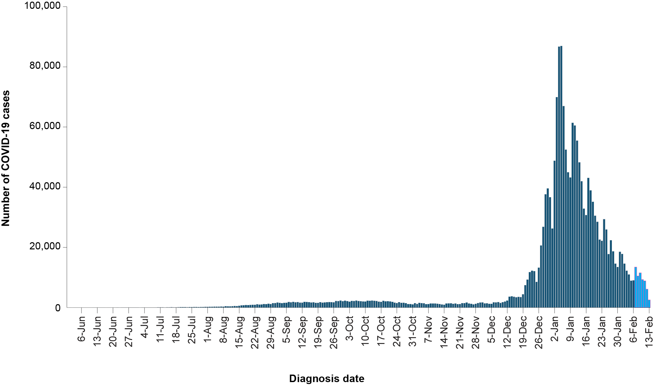
a Source: NINDSS, extract from 14 February 2022 for notifications to 13 February 2022.
b The lighter bars at the right represents the days in the most recent reporting week and should be interpreted with caution as additional cases may be identified in the coming week that have a diagnosis date during this period.

Source of acquisition

(NINDSS)
For the purposes of this report, all cases other than those that are reported as overseas acquired are assumed to have been acquired in Australia. This may include a small number of cases that were acquired overseas but have not been identified as such. As identifying overseas-acquired cases relies on interviewing cases, the capacity to identify overseas-acquired cases is reduced when case numbers increase.
During the Omicron wave to date (15 December 2021 to 13 February 2022), the national locally-acquired PCR confirmed notification rate was 6,376 per 100,000 population (1,638,482 cases). During the four-week reporting period, 593,360 locally-acquired PCR confirmed cases (> 99% of reported PCR confirmed cases) and 477 overseas acquired cases were reported to NINDSS.

Demographic features

(NINDSS)
For the entire Omicron wave to date (15 December 2021 – 13 February 2022), the highest PCR confirmed notification rate was in adults aged 18 to 29 years (Appendix A, Table A.1). For this age group, the notification rate peaked in the week ending 9 January 2022 at over 3,200 per 100,000 population and has since declined steeply to approximately 230 per 100,000 population in the week ending 13 February 2022 (Figure 2). PCR confirmed notification rates for all other age groups have also declined over the past five weeks; however, the decline was less steep than among adults aged 18 to 29 years. In the most recent week, PCR confirmed notification rates were similar among all age groups, with children aged 0 to 17 years having the highest notification rate of 273 per 100,000 population. Among children, the PCR confirmed notification rate in the week ending 13 February 2022 was highest in people aged 5 to 11 years, at 320 per 100,000 population for this week (Figure 3). During the current Omicron wave, the overall PCR confirmed notification rates for males and for females have been similar. However, age-specific rates vary by sex, with females aged 12 to 29 years having higher notification rates than males, and males aged 60 years and over having higher notification rates than females.
Figure 2: Locally-acquired COVID-19 case rates by age group by week, Australia, 29 November 2021 – 13 February 2022ª
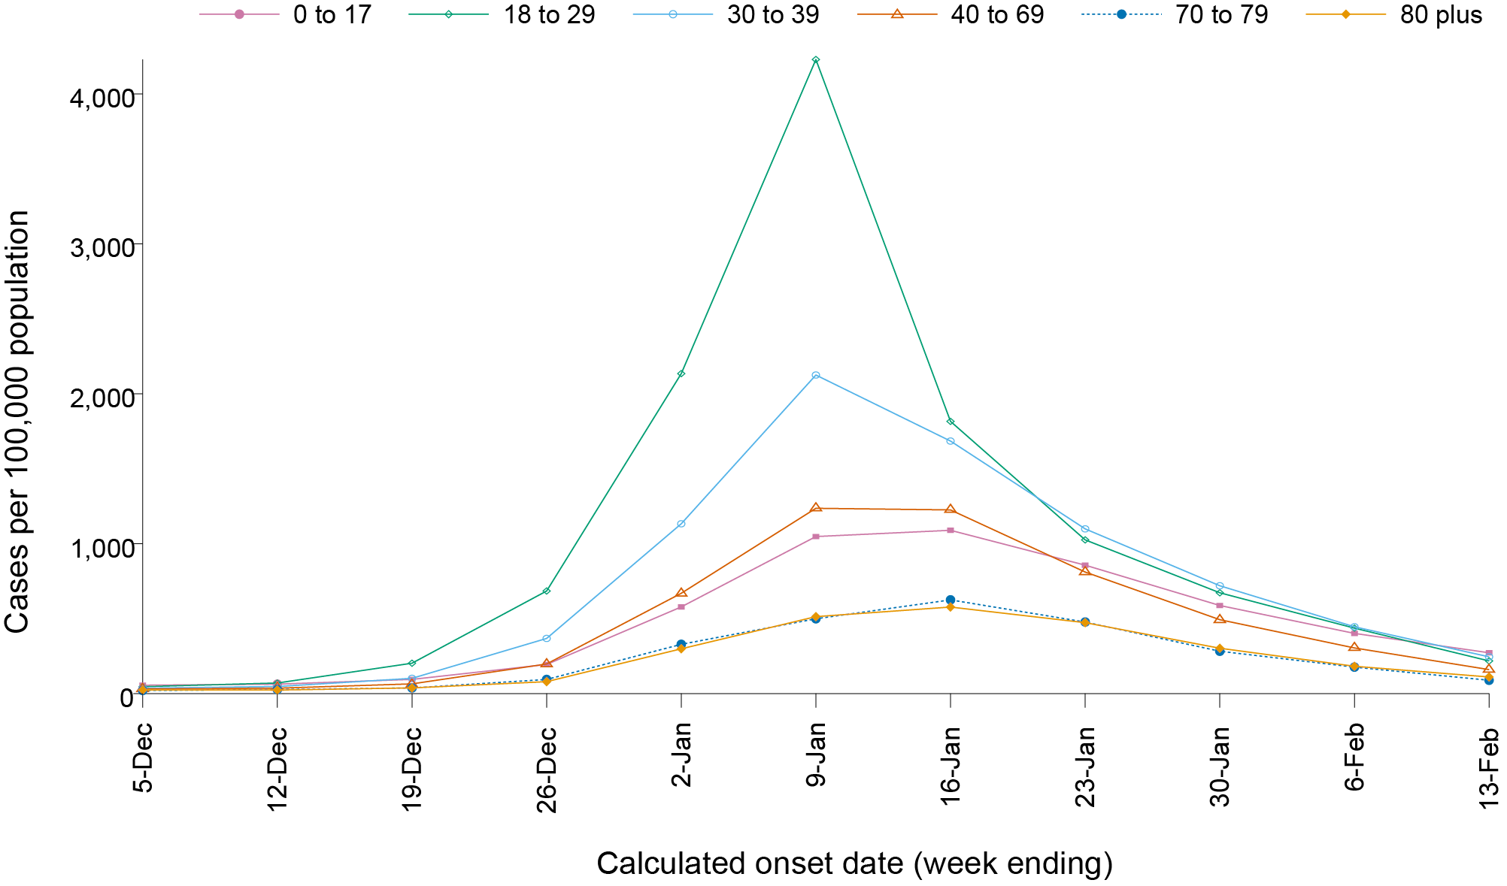
a Source: NINDSS, extract from 14 February 2022 for notifications from 29 November 2021 to 13 February 2022.

Figure 3: Locally-acquired COVID-19 case rates among children by age group by week, Australia, 29 November 2021 – 13 February 2022ª
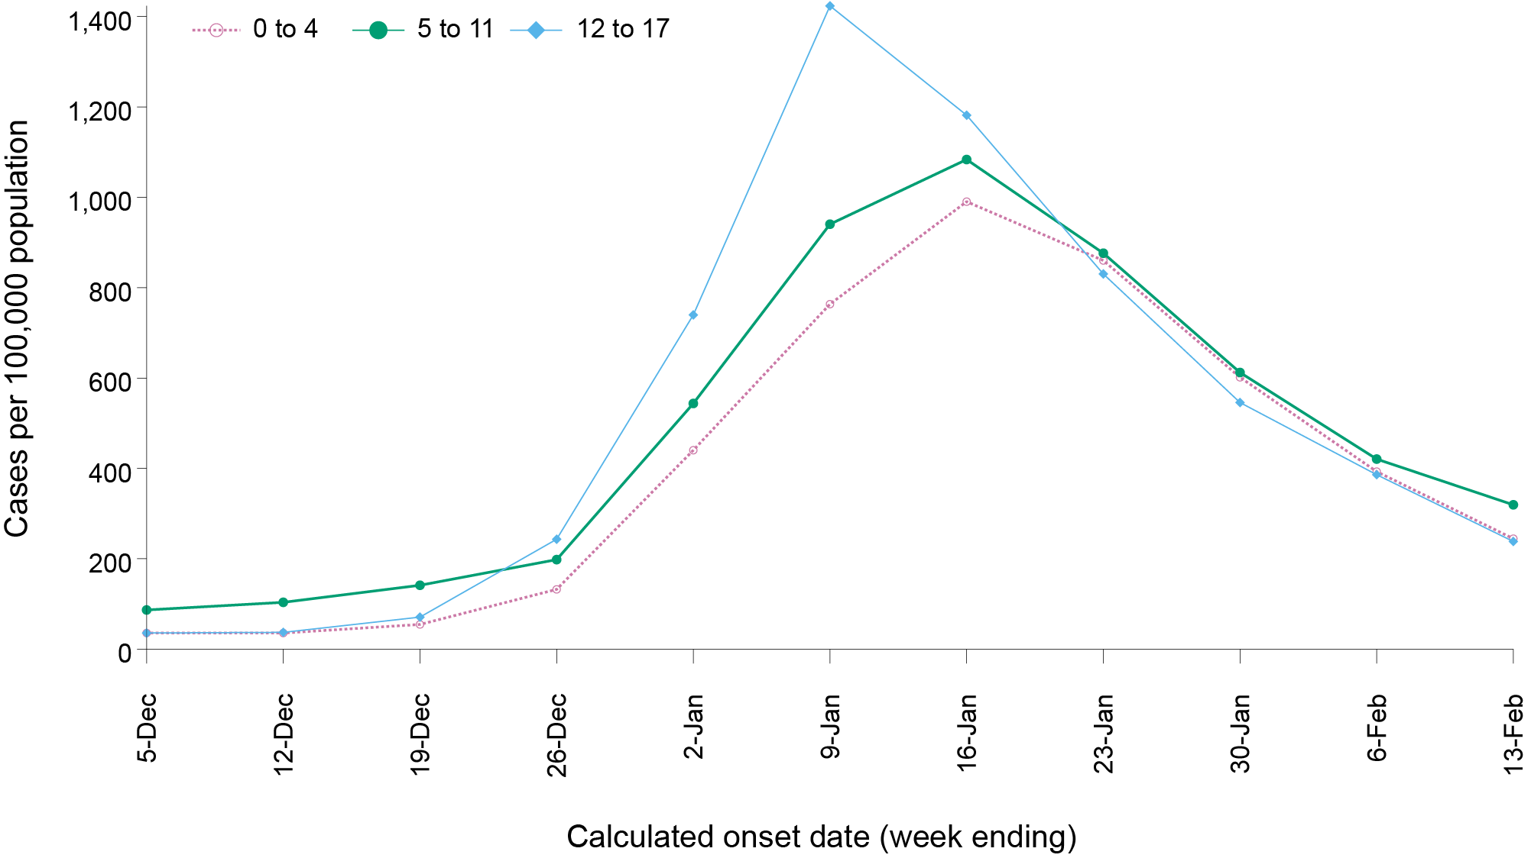
a Source: NINDSS, extract from 14 February 2022 for notifications from 29 November 2021 to 13 February 2022.

Aboriginal and Torres Strait Islander persons

(NINDSS)
During the reporting period, there were 16,907 new cases notified in Aboriginal and Torres Strait Islander people. The number of cases notified each week decreased over the four weeks, in line with decreases in the general community (Table 2). In the current Omicron wave (15 December 2021 – 13 February 2022) there have been 38,829 confirmed cases of COVID-19 notified in Aboriginal and Torres Strait Islander people, representing 2.4% (38,829/1,639,839) of all confirmed cases.

Table 2: Confirmed cases of COVID-19 among Aboriginal and Torres Strait Islander peoples by jurisdiction and calendar year, by date of notification, 31 December 2021 – 13 February 2022ª
State | 17–23 January 2022 | 24–30 January 2022 | 31 January – 6 February 2022 | 7–13 February 2022 | 15 December 2021 – 13 February 2022 (Omicron wave)
Australian Capital Territory | 54 | 86 | 40 | 24 | 515
New South Wales | 1,661 | 1,166 | 807 | 491 | 15,582
Northern Territory^{b} | Not avail. | Not avail. | Not avail. | Not avail. | 379^{b}
Queensland | 3,437 | 2,517 | 1,821 | 469 | 13,967
South Australia | 644 | 641 | 561 | 478 | 3,737
Tasmania | 70 | 46 | 44 | 34 | 462
Victoria | 627 | 480 | 400 | 273 | 4,166
Western Australia | 1 | 2 | 5 | 11 | 21
Total | 6,509 | 4,939 | 3,679 | 1,780 | 38,829
a Source: NINDSS, extract from 14 February 2022 for notifications from to 13 February 2022.
b Data are not available for the Northern Territory for cases notified since 10 January 2022. The number of cases reported for NT in the current wave will be incomplete.
Of the locally-acquired cases notified in Aboriginal and Torres Strait Islander people from 15 December 2021 to date, 49.2% (19,114/38,811) resided in a regional or remote area (Table 3). The proportion of locally-acquired cases in Aboriginal and Torres Strait Islander people who are residents of regional or remote areas has steadily increased since mid-December 2021, from 31.5% in the week ending 19 December 2021, to 63.4% in the week ending 13 February 2022. It should be noted that the reliance on RATs for diagnosing COVID-19 is greater in regional and remote areas than in major cities, resulting in a larger under-count of cases in regional and remote areas than in major cities when counting PCR confirmed cases only.

Table 3: Confirmed cases of COVID-19 among Aboriginal and Torres Strait Islander people by place of acquisition and area of remoteness, 15 December 2021 – 13 February 2022ª
 | Locally acquired, Australia^{b} |  |  |  |  |  | Overseas acquired | Total
Jurisdiction^{c} | Major city | Inner regional | Outer regional | Remote^{d} | Overseas resident | Unknown
ACT | 490 | 15 | 4 | 0 | 0 | 6 | 0 | 515
NSW | 8,860 | 4,662 | 1,523 | 414 | 7 | 105 | 11 | 15,582
NT^{e} | 0 | 0 | 155 | 200 | 0 | 21 | 3 | 379
Qld | 5,182 | 2,330 | 5,209 | 1,208 | 1 | 37 | 0 | 13,967
SA | 2,078 | 353 | 772 | 480 | 32 | 21 | 1 | 3,737
Tas. | 9 | 291 | 154 | 5 | 0 | 1 | 2 | 462
Vic. | 2,821 | 1,054 | 283 | 0 | 0 | 7 | 1 | 4,166
WA | 19 | 1 | 0 | 1 | 0 | 0 | 0 | 21
Australia | 19,459 | 8,706 | 8,100 | 2,308 | 40 | 198 | 18 | 38,829
a Source: NINDSS, extract from 14 February 2022 for notifications to 13 February 2022.
b ‘Locally acquired’ includes cases under initial investigation and missing a source of acquisition. Note, in reports prior to report 52, ‘locally acquired’ excluded cases under initial investigation.
c Cases are classified based on jurisdiction of notification not jurisdiction of residence. Some cases are notified to a different jurisdiction to their location of residence.
d ‘Remote’ here also includes areas classified as ‘very remote’.
e Data are not available for the Northern Territory for cases notified since 10 January 2022. The number of cases reported for NT in the current wave will be incomplete.
Since the start of the pandemic, up to 13 February 2022, there have been 48,391 confirmed cases of COVID-19 reported in Aboriginal and Torres Strait Islander people, representing 2.6% (48,391/1,874,367) of all confirmed cases. Overall, since the start of the pandemic, Indigenous status is unknown for 47.1% (882,404/1,874,367) of confirmed cases. Given the high proportion of cases with unknown Indigenous status, the number of cases classified as Aboriginal and Torres Strait Islander people is likely an underestimate, particularly in recent months. The median age of locally-acquired Aboriginal and Torres Strait Islander cases in the pandemic to date was 24 years old (range: 0 to 99 years; IQR: 14 to 38 years).
Nationally, there have been 57 deaths reported in Aboriginal and Torres Strait Islander people since the start of the pandemic, with 40 from New South Wales, eight from Queensland, four from Victoria, three from the Northern Territory and two from South Australia. An additional 178 Aboriginal and Torres Strait Islander cases have been admitted to intensive care units (ICU) nationally. During the current Omicron wave to date, the overall notification rate, to NINDSS, of severe cases (measured as those who were admitted to ICU or died) in Aboriginal and Torres Strait Islander people was 10.0 per 100,000 population (Table 4). Note that ICU status in NINDSS is likely incomplete.

Figure 4: COVID-19 PCR confirmed case rate per 100,000 population in Aboriginal and Torres Strait Islander people, by remoteness area, Australia, 31 May 2021 to 13 February 2022^{a,b}
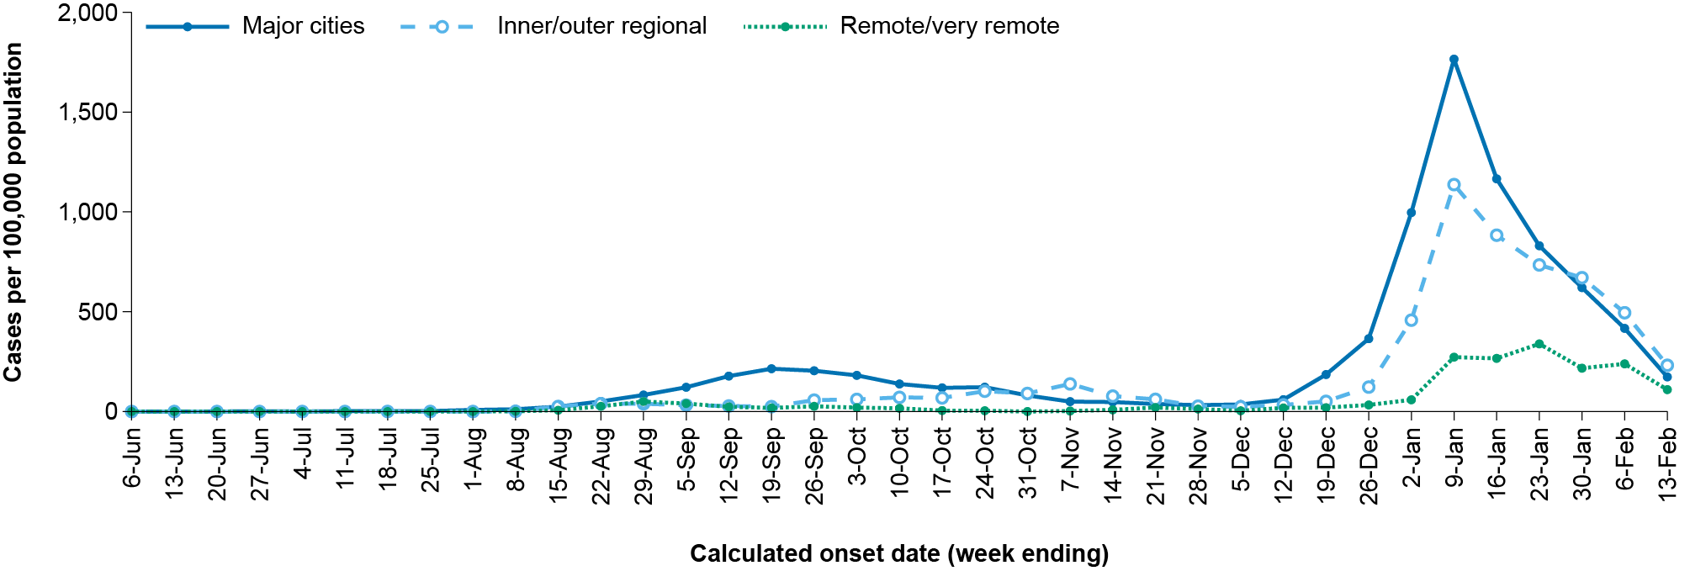
a Source: NINDSS, extract from 14 February 2022 for notifications to 13 February 2022.
b Case rates in regional and remote areas are likely underestimated as the proportion of cases identified through RATs is greater in regional and remote areas than in major cities.
Table 4: COVID-19 cases in Aboriginal and Torres Strait Islander people by age and highest level of illness severity, Australia, 1 January 2020 to 13 February 2022
Age groups | 15 Dec 2021 – 13 Feb 2022 (Omicron wave) |  |  |  | 16 Jun 2021 – 14 Dec 2021 (Delta wave) |  |  |  | 1 Jan 2020 – 13 Feb 2022 (Pandemic to date)
 | ICUª | Diedª | ICU or died^{b} | Rate ICU or died^{b} | ICUª | Diedª | ICU or diedª | Rate ICU or died^{b} | ICUª | Diedª | ICU or diedª | Rate ICU or died^{b}
0–17 | 4 | 1 | 5 | 1.5 | 8 | 0 | 8 | 2.5 | 12 | 1 | 13 | 4.0
18–59 | 29 | 9 | 35 | 8.4 | 86 | 11 | 90 | 21.6 | 116 | 20 | 126 | 30.2
60+ | 23 | 22 | 40 | 70.9 | 26 | 14 | 33 | 58.5 | 50 | 36 | 74 | 131.1
All | 56 | 32 | 80 | 10.0 | 120 | 25 | 131 | 16.4 | 178 | 57 | 213 | 26.7
a ICU and died are not mutually exclusive, died can include cases that died with or without prior admission to ICU. Therefore, the number of cases admitted to ICU or having died will not equal the sum of cases in ICU or died.
b Rate per 100,000 population for the given time period.

Vaccinations

(Department of Health)
As at 13 February 2022, a total of 52,321,535 doses of COVID-19 vaccine had been administered (Table 5), including 1,244,567 doses provided to aged care and disability residents. Nationally, 20,825,516 people aged 12 years or over (95.3%) had received at least one dose. This includes 20,351,405 people aged 12 years or over (93.1%) who were fully vaccinated. Among children aged 5–11 years, 1,081,430 (47.5%) had received at least one dose, including 8,722 (0.4%) who were fully vaccinated. Nationally, 9,991,919 people aged 16 years and over (48.5%) had received more than two doses.

Table 5: Total number of vaccinations administered, by jurisdiction, Australia, 13 February 2022ª
Jurisdiction | Total number of doses administered | Percentage of people aged 12 and over who have had at least one dose^{b} | Percentage of people aged 12 and over who have had two or more doses
ACT | 1,308,021 | >99% | >99%
NSW | 16,466,130 | 94.9% | 93.3%
NT | 505,990 | 90.3% | 86.8%
Qld | 10,014,812 | 91.4% | 89.0%
SA | 3,589,175 | 93.4% | 90.5%
Tas. | 1,157,078 | >99% | 96.1%
Vic. | 13,829,079 | 94.2% | 92.7%
WA | 5,451,250 | 95.9% | 92.2%
Aged care and disability facilities^{c} | 1,244,567 | NA | NA
Primary care^{d} | 31,362,636 | NA | NA
Total | 52,321,535 | 95.3% | 93.1%
a Source: Australian Government Department of Health website.⁴
b Includes people who are fully vaccinated.
c Commonwealth vaccine doses administered in aged care and disability facilities.
d Commonwealth vaccine doses administered in primary care settings.

Severity

(NINDSS, SPRINT-SARI)
Given the delay between illness onset and severe illness, to provide a more accurate assessment of severity, cases with an onset in the last two weeks were excluded from analyses on the weekly rate of cases with severe illness (defined as cases admitted to ICU or died) and on the proportion of cases admitted to ICU or died.
The notification rate of cases with severe illness reached an apparent peak in the weeks ending 9 January and 16 January 2022, at approximately 2.9 per 100,000 population per week. This is more than twice the peak rate of severe cases observed during the Delta wave, of approximately 1.2 per 100,000 population in the week ending 5 September 2021. For the weeks ending 23 January and 30 January 2022, the national notification rate of cases with severe illness progressively decreased, with rates of 2.2 per 100,000 population and 1.2 per 100,000 population for these respective weeks, associated with the overall case notification rates of 861 per 100,000 population and 554 per 100,000 population for the same weeks. The recent decrease in the rate of severe disease has been greatest in people aged 70 and over (Figure 6).

ICU admissions
From 1 February 2021 to 13 February 2022, there were 3,498 COVID-19 cases admitted to ICUs participating in the sentinel surveillance system, Short Period Incidence Study of Severe Acute Respiratory Infection (SPRINT-SARI),⁵ with 513 of these admitted during this reporting period (17 January – 13 February 2022).

Risk factors for severe disease
Comorbidity data extracted from SPRINT-SARI reflect the sickest patients with COVID-19 managed in ICU; data are therefore not generalisable to all cases (Table 6). In patients admitted to ICU with COVID-19 since 1 February 2021, the most prevalent comorbidity was obesity (a body mass index of > 30 or weight over 120 kg), followed by diabetes. Of those adult patients admitted to ICU since 1 February 2021 for whom comorbidity data was known, 68% (2,037/3,009) had at least one comorbidity; 32% of patients (972/3,009) had none of the listed comorbidities recorded.
Figure 5: COVID-19 cases, deaths and ICU admissions, Australia, by date of onset, Australia, 31 May 2021 to 13 February 2022^{a,b}
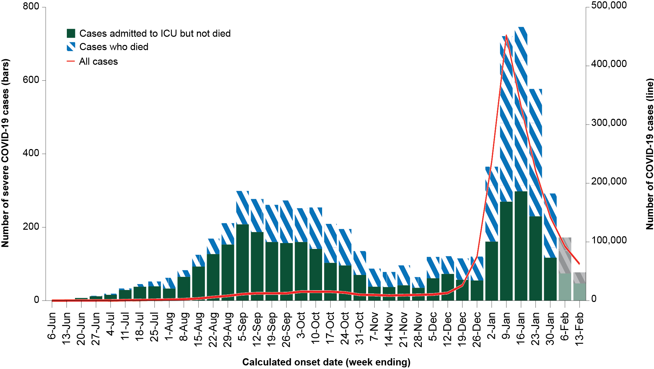
a NINDSS, extract from 14 February 2022, for cases notified to 13 February 2022.
b The shaded bars at the right represent the most recent two reporting weeks and should be interpreted with caution as cases with an illness onset in these weeks may not have yet developed severe disease.
Figure 6: Age-specific rates of COVID-19 cases admitted to ICU or died, by date of diagnosis, Australia, 31 May 2021 to 30 January 2022ª
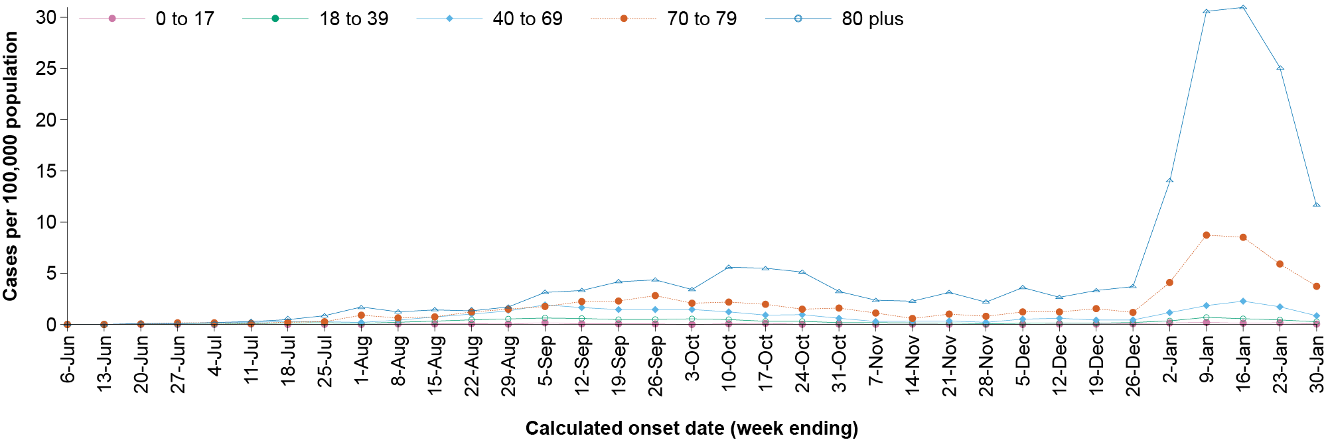
a NINDSS, extract from 14 February 2022. Includes cases with an illness onset up to 30 January 2022; cases with an illness onset in the last two weeks (31 January – 13 February 2022) were excluded to account for the delay between onset and development of severe illness.
Table 6: Comorbidities for adult COVID-19 cases (aged greater than or equal to 18 years) amongst those admitted to ICU, Australia, 1 February 2021 – 13 February 2022ª
Comorbidity | ICU casesª (n = 3,009) (%)
Cardiac disease (n = 2,980) | 472 (16%)
Chronic respiratory condition (n = 2,981) ^{b} | 548 (18%)
Diabetes (n = 2,976) | 941 (32%)
Obesity (n = 2,921) | 936 (32%)
Chronic renal disease (n = 2,966) | 252 (9%)
Chronic neurological condition (n = 2,968) | 100 (3%)
Malignancy (n = 2,977) | 162 (5%)
Chronic liver disease (n = 2,981) | 92 (3%)
Immunosuppression (n = 2,968) | 235 (8%)
Number of specified comorbidities (n = 3,009) ^{c}
One or more | 2,037 (68%)
Two or more | 1,039 (35%)
Three or more | 439 (15%)
No comorbidities | 972 (32%)
a Source: SPRINT-SARI.⁵ Only includes adult cases (≥ 18 years old) and excludes those with missing data on comorbidities or where comorbidity is unknown.
b Includes asthma.
c Includes chronic respiratory conditions, cardiac disease (excluding hypertension), immunosuppressive condition/therapy, diabetes, obesity, liver disease, renal disease and neurological disorder.

COVID-19 deaths
There have been 1,245 COVID-19 associated deaths notified during the reporting period. The weekly number of deaths has decreased over the last four weeks, with 149 deaths reported in the most recent week, compared with 418 in the week ending 23 January 2022. This brings the total number of COVID-19-associated deaths among cases reported in NINDSS to 4,149 (Table 7).
Table 7: Deaths associated with COVID-19 by reporting period, Australia, 1 January 2020 – 13 February 2022ª
Reporting period^{b} | Number of deaths
Week ending 23 January 2022 | 418
Week ending 30 January 2022 | 380
Week ending 6 February 2022 | 298
Week ending 13 February 2022 | 149
Epidemic to date 1 January 2020 – 13 February 2022 | 4,149
a Source: NINDSS, extract from 14 February 2022 for deaths to 13 February 2022.
b Deaths are categorised into time periods using date of death. Deaths with a missing date of death are classified using date of illness onset.
For people aged 70 years and over, the population mortality rate for the current Omicron wave has exceeded that of the entire Delta wave (Table 8). The overall crude case fatality rate appears lower than during the Delta wave, at 0.1% of confirmed cases in the current wave, compared to 0.6% of confirmed cases during the Delta wave. However, comparisons between waves should be undertaken with caution due to a large difference in case incidence rates between the two waves, increasing rates of vaccination among the general population over the course of the Delta wave, differences in case ascertainment between the two waves, and the shorter time period in the Omicron wave to date compared to the Delta wave.

Genomic surveillance and virology

(Communicable Disease Genomics Network, AusTrakka and jurisdictional sequencing laboratories)
Nationally, 3.2% of COVID-19 cases have had SARS-CoV-2 isolates sequenced since the start of the pandemic, based on jurisdictional reporting (Table 9). Case numbers and sequencing proportion are based on polymerase chain reaction (PCR) results only, as rapid antigen tests do not allow for sequencing. The significant rise in case numbers nationally during this reporting period has required jurisdictional laboratories to sample isolates to sequence for surveillance purposes, resulting in a drop in the proportion sequenced. However, overall output of number of cases sequenced per reporting period remains similar to, or higher than, previous reporting periods (Figure 7).

Table 8: COVID-19 associated deaths notified to NINDSS, by age group and date of onset, 1 January 2020 to 13 February 2022ª
 | 15 Dec 2021 – 13 Feb 2022 (Omicron wave) |  |  | 16 Jun 2021 – 14 Dec 2021 (Delta wave) |  |  | 1 Jan 2020 – 13 Feb 2022 (Pandemic to date)
Age group (years) | Deaths | Population mortality rate^{b} | Case fatality rate (%)^{c,d} | Deaths | Population mortality rate^{b} | Case fatality rate (%)^{c,d} | Deaths | Population mortality rate^{b} | Case fatality rate (%)^{c,d}
0–4 | 2 | 0.1 | < 0.05% (2/59,649) | 0 | 0.0 | 0.0% (0/13,909) | 2 | 0.1 | < 0.05% (2/74,407)
5–11 | 1 | < 0.05 | < 0.05% (1/99,124) | 1 | < 0.05 | < 0.05% (1/29,612) | 2 | 0.1 | < 0.05% (2/129,971)
12–15 | 0 | 0.0 | 0.0% (0/53,603) | 1 | 0.1 | < 0.05% (1/12,178) | 1 | 0.1 | < 0.05% (1/66,638)
16–17 | 0 | 0.0 | 0.0% (0/38,187) | 0 | 0.0 | 0.0% (0/5,703) | 0 | 0.0 | 0.0% (0/44,449)
18–29 | 4 | 0.1 | < 0.05% (4/453,029) | 8 | 0.2 | < 0.05% (8/48,487) | 14 | 0.3 | < 0.05% (14/509,150)
30–39 | 19 | 0.5 | < 0.05% (19/271,120) | 21 | 0.6 | 0.1% (21/35,069) | 42 | 1.1 | < 0.05% (42/311,702)
40–49 | 27 | 0.8 | < 0.05% (23/187,668) | 46 | 1.4 | 0.2% (46/25,702) | 75 | 2.3 | < 0.05% (71/217,355)
50–59 | 64 | 2.1 | < 0.05% (56/148,212) | 117 | 3.7 | 0.6% (117/18,714) | 196 | 6.3 | 0.1% (188/170,510)
60–69 | 150 | 5.6 | 0.1% (135/91,125) | 204 | 7.6 | 1.8% (204/11,254) | 393 | 14.6 | 0.4% (378/104,902)
70–79 | 401 | 21.3 | 0.8% (372/43,980) | 349 | 18.6 | 5.8% (349/6,009) | 908 | 48.3 | 1.7% (879/51,641)
80–89 | 730 | 86.4 | 3.7% (688/18,494) | 414 | 49.0 | 13.8% (414/3,004) | 1,522 | 180.2 | 6.5% (1,480/22,780)
90+ | 468 | 221.4 | 7.9% (439/5,540) | 207 | 97.9 | 25.1% (207/826) | 993 | 469.8 | 13.5% (964/7,153)
Unknown | 1 | N/A | 0.0% (0/7,715) | 0 | N/A | 0.0% (0/1,275) | 1 | N/A | 0.0% (0/8,997)
Total | 1,867 | 7.3 | 0.1% (1,739/1,477,446) | 1,368 | 5.3 | 0.6% (1,368/211,742) | 4,149 | 16.1 | 0.2% (4,021/1,719,655)
a Source: NINDSS, extract from 14 February 2022.
b Population mortality rates are presented per 100,000 population for the given time period.
c For calculation of the case fatality rate, cases with an onset date in the last two weeks have been excluded so as to account for the lag between illness onset and the development of severe illness.
d Denominator includes PCR confirmed cases only. Therefore, the actual case fatality rate, particularly during the current Omicron wave, is likely lower.

Table 9: Australian SARS-CoV-2 genome sequences and proportion of positive cases sequenced, 17 January 2022 – 13 February 2022 and cumulative to date
Measure | Reporting period  17 Jan 2022 – 13 Feb 2022 | Cumulative  23 Jan 2020 – 13 Feb 2022
SARS-CoV-2 cases sequencedª | 6,267 | 68,236
Percentage of positive cases sequenced^{b} | 1.0% | 3.2%
a Based on individual jurisdictional reports of sequences and case numbers. Calculations of the percentage of cases sequenced based on the number of sequences available in AusTrakka may not always be up-to-date, since this may include duplicate samples from cases and may not represent all available sequence data.
b Total SARS-CoV-2 case numbers as reported by jurisdictional laboratories based on PCR results only. Cases identified via rapid antigen testing are reported differently by each jurisdiction and cannot be followed up for sequencing. They are therefore not included in the sequencing proportions reported here. Sequencing of samples from cases identified in the reporting period may be in process at the time of reporting. Remaining unsequenced samples may be due to jurisdictional sequencing strategy, or where samples have been deemed unsuitable for sequencing (typically because viral loads were too low for sequencing to be successful).
Figure 7: Samples in AusTrakka from 30 August 2021 to 13 February 2022, by lineage and date of collectionª
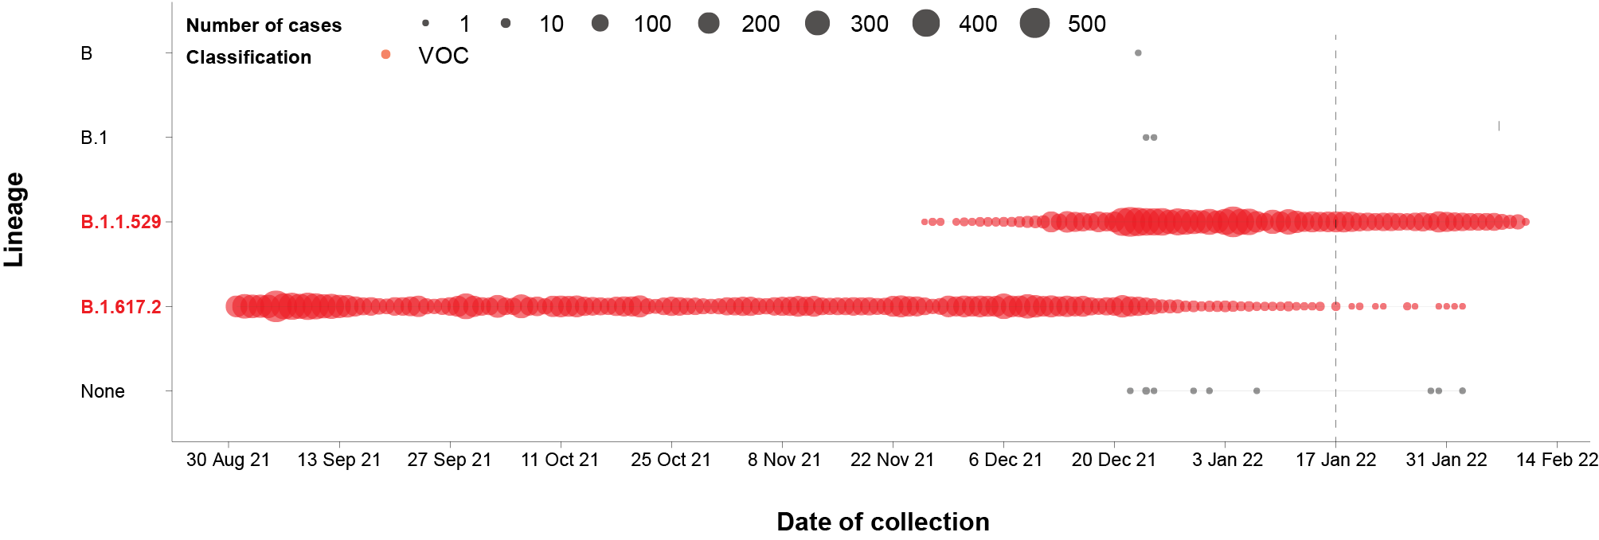
a The start of the current reporting period (17 January – 13 February 2022) is marked by the dotted line, and variant-of-concern samples are coloured red. The size of the circle is proportional to the number of samples in the lineage at each time point.
Table 10: Australian SARS-CoV-2 genome sequences in Austrakka identified as variants of concern, 23 January 2020 – 13 February 2022ª
VOC lineage | B.1.617.2 (Delta)^{b} | B.1.1.529 (Omicron)^{c}
Number of sequences | 30,879 | 13,147
a The number of sequences may have reduced from previous reports due to de-duplication and the adoption of a new genomic coverage threshold.
b Includes AY sublineages.
c Includes Omicron-like sequences.

Variants of concern
AusTrakka is actively monitoring and reporting on the two lineages currently designated Variants of Concern (VOC) by international organisations, including the World Health Organisation: Delta (B.1.617.2) and Omicron (B.1.1.529) (Table 10). Both variants display characteristic sets of mutation, including a number of variations in the genomic region encoding the spike protein thought to have the potential to increase transmissibility and/or immune evasion.^{7,8} On 31 January 2022, the Communicable Diseases Genomic Network (CDGN) VOC working group demoted three previously designated VOCs (Alpha (B.1.1.7); Beta (B.1.351) and Gamma (P.1)) due to the sustained absence of any cases in Australia, and very limited prevalence globally.
Further information on variants is available in the Technical Supplement.²

Testing

(State and territory reporting)
From the commencement of the pandemic to 13 February 2022, over 62 million COVID-19 PCR tests have been conducted nationally. Jurisdictional PCR testing rates are driven by current case numbers, testing policies and numbers of people experiencing symptoms. The number, rates and percent positivity of RATs cannot be calculated, as there is currently no reporting of negative RATs.
During the four-week reporting period from 17 January 2022 to 13 February 2022, over 3.5 million tests were conducted, with the national number of PCR tests almost halving in the final week of the period compared to the first. In all jurisdictions except Western Australia, PCR testing rates have decreased since late December 2021 (Figure 8). The decrease in these jurisdictions is likely due to the increased availability and use of RATs. In Western Australia, PCR testing rates have increased in the last four weeks. This increase may be due to increasing community transmission during this time period.
From the week ending 17 January 2022 to the week ending 13 February 2022, PCR percent positivity also declined in all jurisdictions except Western Australia (Figure 8). For the first time in 2022, the percent positivity in all jurisdictions was below 20% in the last week of the reporting period.

Figure 8: SARS-CoV-2 polymerase chain reaction (PCR) testing rates per 1,000 population and percent positivity by jurisdiction and date of notification, 31 May 2021 – 13 February 2022ª
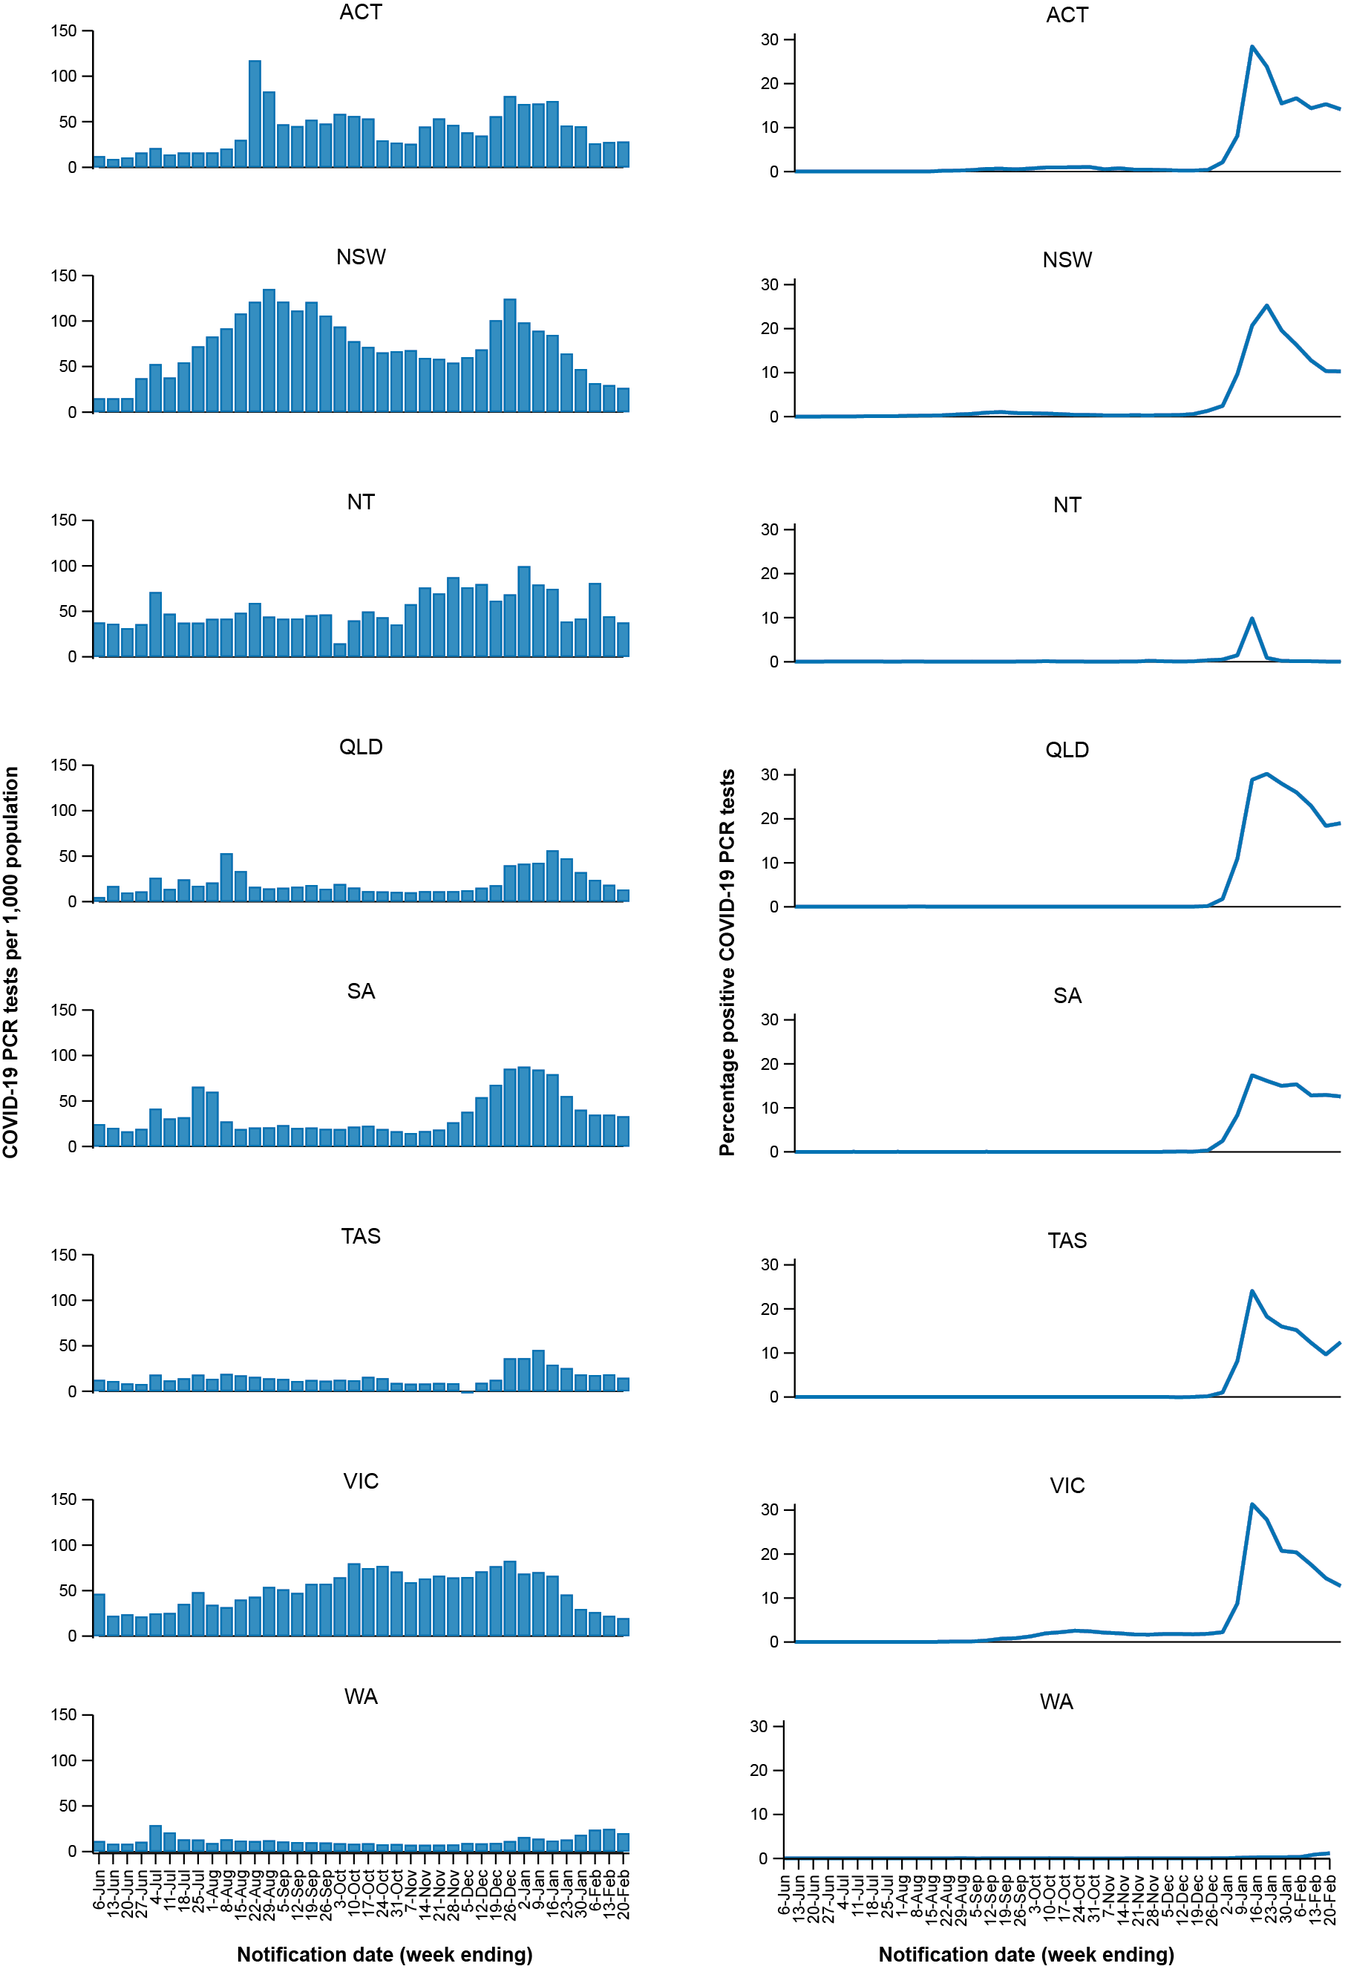
a Source: testing data provided by jurisdictions to the NIR daily, current to 13 February 2022; case data extracted from NINDSS on 14 February 2022 for cases with a notification date up to 13 February 2022; population data based on Australian Bureau of Statistics (ABS) Estimated Resident Population (ERP) as at June 2020.

Acute respiratory illness

(FluTracking, ASPREN, and Commonwealth Respiratory Clinics)
Based on self-reported FluTracking data,⁹ prevalence of fever and cough in the community over this reporting period decreased to 0.5% in the week ending 13 February 2022 (Figure 9). This decrease denotes a marked change in the prevalence of fever and cough in the community since reaching a peak of 1.4% during the week ending 9 January 2022, this peak representing the highest rate of fever and cough reported since early March 2020. Runny nose and sore throat symptoms were stable throughout the reporting period, at approximately 0.6% of participants each week.
Figure 9: Weekly trends in respiratory illness amongst FluTracking survey participants (age-standardised) compared to the average of the previous five years, Australia, by epidemiological week,ª 1 January 2021 – 13 February 2022^{b}
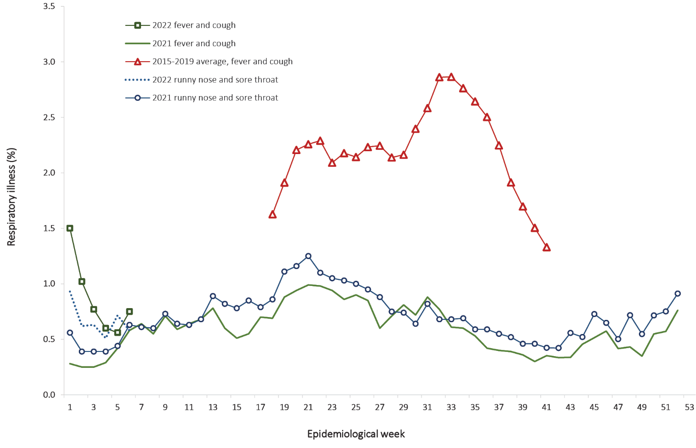
a Epidemiological weeks are a standardised method for numbering weeks across years, with the first epidemiological week of any year ending on the first Saturday in January.
b In years prior to 2020, FluTracking was activated during the main Influenza season from May to October. A historical average beyond the week ending 11 October (epidemiological week 41) is therefore not available. In 2020, FluTracking commenced ten weeks early to capture data for COVID-19. Data on runny nose and sore throat were only collected systematically after 29 March 2020, therefore a historical average for this symptom profile is unavailable.
In this reporting period, acute respiratory illness was highest in those aged 30 to 39 years, based on both self-reported FluTracking data and presentations to Commonwealth Respiratory Clinics. Overall, females reported respiratory illness more frequently than males. Rates of runny nose and sore throat were higher amongst females than males, at 6.9 per 1000 FluTracking participants compared to 4.4 per 1000 FluTracking participants respectively, although rates of fever and cough were slightly higher amongst males. Rates of fever and cough by jurisdiction ranged from 2.4 per 1,000 FluTracking participants in Western Australia to 8.7 per 1,000 participants in the Nothern Territory. Rates of runny nose and sore throat ranged from 4.1 per 1,000 FluTracking participants in Western Australia to 8.2 per 1,000 FluTracking participants in the Australian Capital Territory. Overall, rates for both sets of symptoms decreased from the previous reporting period.
From the week ending 23 January 2022, FluTracking data indicated that 46.2% of those in the community with ‘fever and cough’ were tested for SARS-CoV-2 with a PCR test and 67.1% were tested using a RAT (noting that in some instances RATs will be followed up by a PCR test for the same case). Of those with ‘runny nose and sore throat’, 24.7% were tested for SARS-CoV-2 using a PCR test and 58.5% were tested using a RAT. Of those with ‘fever and cough’ who tested for SAR-CoV-2, 59.5% who were tested with a PCR test, and 54.4% were were tested with a RAT, were positive. In comparison, of participants with ‘runny nose and sore throat’ who tested for SAR-CoV-2, only 0.6% of those tested by PCR, and 8.4% of those tested by RAT, tested positive. Note that participants with one set of symptoms are not excluded from having the other.
In the most recent four-week period, testing rates for fever and cough were highest in South Australia for PCR (69.5%) and in the Northern Territory for RATs (91.4%), whilst lowest in the Northern Territory for PCR (20.0%) and in Western Australia for RATs (15.0%). Testing rates for runny nose and sore throat were highest in South Australia for PCR (43.5%) and in the Northern Territory for RATs (81.3%), and lowest in the Australian Capital Territory for PCR (16.5%) and Western Australia for RATs (14.6%). It is important to acknowledge that there may be legitimate reasons why people did not get tested, including barriers to accessing testing. Symptoms reported to FluTracking are not specific to COVID-19 and may also be due to chronic diseases.
From 17 January to 13 February 2022, there were 143,225 assessments at Commonwealth Respiratory Clinics. Of these, there were 129,580 assessments with consent to share information, with 91% (117,459/129,580) tested for SARS-CoV-2. Of those who tested, 23% (26,834/117,459) were found to be positive.

Public health response measures
Since COVID-19 first emerged internationally, Australia has implemented public health measures informed by the disease’s epidemiology. States and territories have decision making authority in relation to public health measures and have implemented or eased restrictions at different times (Figure 10; Appendix A, Table A.2), depending on the local public health and epidemiological situation, and in line with the ‘Framework for National Reopening’.¹⁰ Nationwide requirements regarding air travel, including pre-flight testing for travellers entering Australia and requirements to wear face masks when flying domestically or internationally, remain in place.

Figure 10: COVID-19 notifications in Australia by week of diagnosis and jurisdiction, 27 September – 13 February 2022, with timing of key public health measures
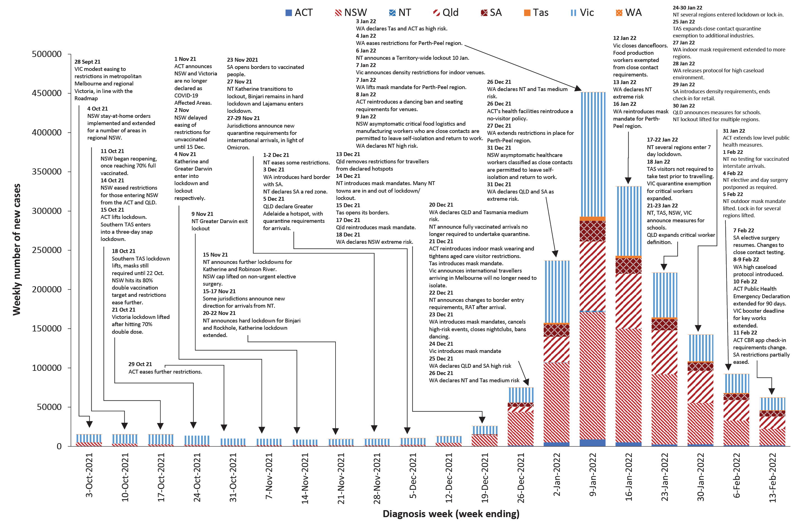

Countries and territories in Australia’s near region
According to WHO, countries and territories in the South East Asian and Western Pacific regions reported 12,120,153 newly-confirmed cases and 36,589 deaths in the four-week period to 13 February 2022, bringing the cumulative cases in the two regions to over 73 million, and cumulative deaths in these regions to over 926,000.¹¹ Case numbers in the South East Asian region have more than doubled this reporting period compared to the prior four weeks, despite cases dropping significantly for the last week of the reporting period. The number of new deaths in the last four weeks has also increased in the South East Asian region compared to the previous four weeks. The number of new cases in the Western Pacific region in the past four weeks has more than doubled compared to the previous four-week period, while the number of new deaths has decreased. The increase of new cases in the Western Pacific region during the four-week period to 13 February 2022 has largely been driven by cases in Japan, the Republic of Korea, and Australia.¹²
Table 11 outlines the new cases and deaths in the four-week period to 13 February 2022 and cumulative cases and deaths for the pandemic in selected countries with the highest number of new cases in the South East Asian region and the Western Pacific region.
As of 13 February 2022, over 410 million COVID-19 cases and 5.8 million deaths have been reported globally since the start of the pandemic, with a global case fatality rate (CFR) of 1.4%. The two regions reporting the largest burden of disease over the past four weeks were the European region (40% of cases) and the region of the Americas (35% of cases).
Table 11: Cumulative cases and deaths, and new cases and deaths reported in the four-week period to 13 February 2022 for selected countries in Australia’s near region according to WHOª
Country | Cumulative cases | New cases reported in the last 4 weeks | Change in new cases in the last 4 weeks^{b} | Cumulative deaths | New deaths reported in the last 4 weeks | Change in new deaths in the last 4 weeks^{b}
South East Asian region
India | 42,665,534 | 5,285,281 | +101% | 509,011 | 22,560 | +154%
Indonesia | 4,844,279 | 571,858 | +4769% | 145,321 | 1,147 | +612%
Bangladesh | 1,914,356 | 289,969 | +574% | 28,838 | 684 | +558%
Thailand | 2,608,227 | 276,813 | +102% | 22,462 | 524 | -1%
Nepal | 973,541 | 114,056 | +240% | 11,900 | 277 | +465%
Western Pacific region
Japan | 3,912,198 | 2,032,359 | +1256% | 20,359 | 1,926 | +3467%
Australia | 2,524,184 | 1,145,735 | +2% | 4,593 | 1925 | +269%
Republic of Korea | 1,405,244 | 709,214 | +465% | 7,102 | 769 | -51%
Viet Nam | 2,510,860 | 487,314 | +1% | 38,946 | 3,337 | -45%
Philippines | 3,637,212 | 431,908 | +17% | 54,930 | 2023 | -7%
a Source: World Health Organization Coronavirus (COVID-19) Dashboard,11 accessed 17 February 2022.
b Percent change in the number of newly confirmed cases/deaths in the most recent four-week period compared to the four weeks prior.

Acknowledgements
We thank public health staff from incident emergency operations centres and public health units in state and territory health departments, and the Australian Government Department of Health, along with state and territory public health laboratories. We thank those who have provided data from surveillance systems, such as Commonwealth respiratory clinics, ASPREN, FluTracking, FluCAN, SPRINT-SARI, Communicable Disease Genomics Network, AusTrakka and jurisdictional sequencing laboratories.

Author details

Corresponding author
COVID-19 National Incident Room Surveillance Team
Australian Government Department of Health, GPO Box 9484, MDP 14, Canberra, ACT 2601.
Email: epi.coronavirus@health.gov.au

References
- COVID-19 National Incident Room Surveillance Team. COVID-19 Australia: Epidemiology Report 57: Reporting period ending 16 January 2022. Commun Dis Intell (2018). 2022;46. doi: https://doi.org/10.33321/cdi.2022.46.4.
- COVID-19 National Incident Room Surveillance Team. Technical supplement. COVID-19 Australia: Epidemiology reporting. Commun Dis Intell (2018). 2021;45. doi: https://doi.org/10.33321/cdi.2021.45.2.
- Australian Government Department of Health. Coronavirus disease 2019 (COVID-19): CDNA national guidelines for public health units. [Internet.] Canberra: Australian Government Department of Health; 14 January 2022. [Accessed on 21 January 2022.] Available from: https://www1.health.gov.au/internet/main/publishing.nsf/Content/cdna-song-novel-coronavirus.htm.
- Australian Government Department of Health. Vaccination numbers and statistics. [Internet.] Canberra: Australian Government Department of Health; 2022. [Accessed on 14 February 2022.] Available from: https://www.health.gov.au/initiatives-and-programs/covid-19-vaccines/numbers-statistics.
- Australian and New Zealand Intensive Care Research Centre (ANZIC-RC). SPRINT-SARI: Short period incidence study of severe acute respiratory infection. [Internet.] Melbourne: Monash University, ANZIC-RC; 2020. Available from: https://www.monash.edu/medicine/sphpm/anzicrc/research/sprint-sari.
- Communicable Diseases Genomics Network (CDGN). AusTrakka. [Website.] Melbourne: CDGN; 2020. Available from: https://www.cdgn.org.au/austrakka.
- World Health Organization (WHO). Coronavirus disease (COVID-19) Weekly Epidemiological Update and Weekly Operational Update. [Internet.] Geneva: WHO; June 2021. [Accessed on 14 February 2022.] Available from: https://www.who.int/emergencies/diseases/novel-coronavirus-2019/situation-reports/.
- Allen H, Vusirikala A, Flannagan J, Twohig KA, Zaidi A, Groves N et al. Increased household transmission of COVID-19 cases associated with SARS-CoV-2 Variant of Concern B.1.617.2: a national case-control study. Knowledge Hub (khub); 2021. [Accessed on 14 February 2022.] Available from: https://khub.net/documents/135939561/405676950/Increased+Household+Transmission+of+COVID-19+Cases+-+national+case+study.pdf/7f7764fb-ecb0-da31-77b3-b1a8ef7be9aa.
- Dalton C, Durrheim D, Fejsa J, Francis L, Carlson S, d’Espaignet ET et al. Flutracking: a weekly Australian community online survey of influenza-like illness in 2006, 2007 and 2008. Commun Dis Intell Q Rep. 2009;33(3):316–22.
- Australian Government Department of Health. Framework for national reopening – October 2020. [Internet.] Canberra: Australian Government Department of Health; 23 October 2020. [Accessed on 10 November 2020.] Available from: https://www.health.gov.au/resources/publications/framework-for-national-reopening-october-2020.
- World Health Organization (WHO). WHO Coronavirus Disease (COVID-19) dashboard. [Internet.] Geneva: WHO; 2021. Available from: https://covid19.who.int/.
- WHO. Weekly epidemiological update on COVID-19 – 15 February 2022. [Internet.] Geneva: WHO; 15 February 2022. [Accessed on 17 February 2022.] Available from: https://www.who.int/publications/m/item/weekly-epidemiological-update-on-covid-19---15-february-2022.
- Australian Capital Territory Government. Changes to testing for high risk and household contacts. [Internet.] Canberra: Australian Capital Territory Government; 19 January 2022. [Accessed on 16 February 2022.] Available from: https://www.covid19.act.gov.au/news-articles/changes-to-testing-recommendations-for-high-risk-and-household-contacts.
- Australian Capital Territory Government. Face to face learning is back– with a new public school for the ACT. [Internet.] Canberra: Australian Capital Territory Government; 31 January 2022. [Accessed on 14 February 2022.] Available from: https://www.covid19.act.gov.au/news-articles/face-to-face-learning-is-back-with-a-new-public-school-for-the-act.
- Australian Capital Territory Government. Low level public health social measures extended. [Internet.] Canberra: Australian Capital Territory Government; 31 January 2022. [Accessed on 14 February 2022.] Available from: https://www.covid19.act.gov.au/news-articles/low-level-public-health-social-measures-extended.
- Australian Capital Territory Government. Check In CBR app changes: focus on higher risk settings. [Internet.] Canberra: Australian Capital Territory Government; 7 February 2022. [Accessed on 14 February 2022.] Available from: https://www.covid19.act.gov.au/news-articles/check-in-cbr-app-changes-focus-on-higher-risk-settings.
- Australian Capital Territory Government. Public Health Emergency Declaration extended. [Internet.] Canberra: Australian Capital Territory Government; 10 February 2022. [Accessed on 14 February 2022.] Available from: https://www.covid19.act.gov.au/news-articles/public-health-emergency-declaration-extended.
- Government of New South Wales. COVID-smart plan to start 2022 school year. [Internet.] Sydney: Government of New South Wales; 23 January 2022. [Accessed on 16 February 2022.] Available from: https://www.nsw.gov.au/media-releases/covid-smart-plan-to-start-2022-school-year.
- Northern Territory Government. NT COVID-19 update. [Internet.] Darwin: Northern Territory Government; 17 January 2022. [Accessed on 16 February 2022.] Available from: https://coronavirus.nt.gov.au/updates/items/2022-01-17-nt-covid-19-update.
- Northern Territory Government. NT COVID-19 update. [Internet.] Darwin: Northern Territory Government; 20 January 2022. [Accessed on 16 February 2022.] Available from: https://coronavirus.nt.gov.au/updates/items/2022-01-20-nt-covid-19-update.
- Northern Territory Government. NT COVID-19 update. [Internet.] Darwin: Northern Territory Government; 21 January 2022. [Accessed on 16 February 2022.] Available from: https://coronavirus.nt.gov.au/updates/items/2022-01-21-nt-covid-19-update.
- Northern Territory Government. NT COVID-19 update. [Internet.] Darwin: Northern Territory Government; 22 January 2022. [Accessed on 16 February 2022.] Available from: https://coronavirus.nt.gov.au/updates/items/2022-01-22-nt-covid-19-update.
- Northern Territory Government. NT COVID-19 update – Milikapiti enters 72 hour lockdown. [Internet.] Darwin: Northern Territory Government; 24 January 2022. [Accessed on 16 February 2022.] Available from: https://coronavirus.nt.gov.au/updates/items/2022-01-24-nt-covid-19-update-milikapiti-enters-72-hour-lockdown.
- Northern Territory Government. NT COVID-19 update. [Internet.] Darwin: Northern Territory Government; 27 January 2022. [Accessed on 14 February 2022.] Available from: https://coronavirus.nt.gov.au/updates/items/2022-01-27-nt-covid-19-update.
- Northern Territory Government. NT COVID-19 update. [Internet.] Darwin: Northern Territory Government; 28 January 2022. [Accessed on 14 February 2022.] Available from: https://coronavirus.nt.gov.au/updates/items/2022-01-28-nt-covid-19-update.
- Northern Territory Government. NT COVID-19 update. [Internet.] Darwin: Northern Territory Government; 29 January 2022. [Accessed on 14 February 2022.] Available from: https://coronavirus.nt.gov.au/updates/items/2022-01-29-nt-covid-19-update.
- Northern Territory Government. NT COVID-19 update. [Internet.] Darwin: Northern Territory Government; 30 January 2022. [Accessed on 14 February 2022.] Available from: https://coronavirus.nt.gov.au/updates/items/2022-01-30-nt-covid-19-update.
- Northern Territory Government. NT COVID-19 update – Lajamanu enters seven day lock-in. [Internet.] Darwin: Northern Territory Government; 31 January 2022. [Accessed on 14 February 2022.] Available from: https://coronavirus.nt.gov.au/updates/items/2022-01-31-nt-covid-19-update-lajamanu-enters-seven-day-lock-in.
- Northern Territory Government. NT COVID-19 update. [Internet.] Darwin: Northern Territory Government; 4 February 2022. [Accessed on 14 February 2022.] Available from: https://coronavirus.nt.gov.au/updates/items/2022-02-04-nt-covid-19-update.
- Northern Territory Government. NT COVID-19 Update. [Internet.] Darwin: Northern Territory Government; 5 February 2022. [Accessed on 14 February 2022.] Available from: https://coronavirus.nt.gov.au/updates/items/2022-02-05-nt-covid-19-update.
- Northern Territory Government. NT COVID-19 update. [Internet.] Darwin: Northern Territory Government; 6 February 2022. [Accessed on 14 February 2022.] Available from: https://coronavirus.nt.gov.au/updates/items/2022-02-06-nt-covid-19-update.
- Northern Territory Government. NT COVID-19 update. [Internet.] Darwin: Northern Territory Government; 7 February 2022. [Accessed on 14 February 2022.] Available from: https://coronavirus.nt.gov.au/updates/items/2022-02-07-nt-covid-19-update.
- Queensland Government, Minister for Health and Ambulance Services. More industries added to critically essential work list. [Internet.] Brisbane: Queensland Government, Department of Health; 23 January 2022. [Accessed on 16 February 2022.] Available from: https://statements.qld.gov.au/statements/94288.
- Queensland Government. COVID-safe back to school plan. [Internet.] Brisbane: Queensland Government; 30 January 2022. [Accessed on 14 February 2022.] Available from: https://statements.qld.gov.au/statements/94337.
- Government of South Australia Department of Health (SA Health). COVID-19 update 427. [Internet.] Adelaide: Government of South Australia, SA Health; 28 January 2022. [Accessed on 14 February 2022.] Available from: https://www.sahealth.sa.gov.au/wps/wcm/connect/public+content/sa+health+internet/conditions/infectious+diseases/covid-19/about+covid-19/latest+updates/covid-19+round+up+reports/covid-19+update+427.
- SA Health. COVID-19 update 432. [Internet.] Adelaide: Government of South Australia, SA Health; 4 February 2022. [Accessed on 14 February 2022.] Available from: https://www.sahealth.sa.gov.au/wps/wcm/connect/public+content/sa+health+internet/conditions/infectious+diseases/covid-19/about+covid-19/latest+updates/covid-19+round+up+reports/covid-19+update+432.
- SA Health. COVID-19 update 433. [Internet.] Adelaide: Government of South Australia, SA Health; 7 February 2022. [Accessed on 16 February 2022.] Available from: https://www.sahealth.sa.gov.au/wps/wcm/connect/public+content/sa+health+internet/conditions/infectious+diseases/covid-19/about+covid-19/latest+updates/covid-19+round+up+reports/covid-19+update+433.
- SA Health. COVID-19 update 436. [Internet.] Adelaide: Government of South Australia, SA Health; 10 February 2022. [Accessed on 14 February 2022.] Available from: https://www.sahealth.sa.gov.au/wps/wcm/connect/public+content/sa+health+internet/conditions/infectious+diseases/covid-19/about+covid-19/latest+updates/covid-19+round+up+reports/covid-19+update+436.
- SA Health. COVID-19 update 429. [Internet.] Adelaide: Government of South Australia, SA Health; 1 February 2022. [Accessed on 14 February 2022.] Available from: https://www.sahealth.sa.gov.au/wps/wcm/connect/public+content/sa+health+internet/conditions/infectious+diseases/covid-19/about+covid-19/latest+updates/covid-19+round+up+reports/covid-19+update+429.
- Premier of Tasmania. Changes to border entry requirements for vaccinated travellers. [Internet.] Hobart: Tasmanian Government, Department of the Premier and Cabinet; 18 January 2022. [Accessed on 16 February 2022.] Available from: https://www.coronavirus.tas.gov.au/media-releases/changes-to-border-entry-requirements-for-vaccinated-travellers.
- Tasmanian Government. COVID Safety in Schools Plan released. [Internet.] Hobart: Tasmanian Government, Department of the Premier and Cabinet; 21 January 2022. [Accessed on 16 February 2022.] Available from: https://www.coronavirus.tas.gov.au/media-releases/covid-safety-in-schools-plan-released.
- Premier of Tasmania. Additional industries eligible for close contact quarantine exemption. [Internet.] Hobart: Tasmanian Government, Department of the Premier and Cabinet; 25 January 2022. [Accessed on 16 February 2022.] Available from: https://www.coronavirus.tas.gov.au/media-releases/additional-industries-eligible-for-close-contact-quarantine-exemption.
- Tasmanian Government. Reduction of COVID escalation level. [Internet.] Hobart: Tasmanian Government, Department of the Premier and Cabinet; 2 Februaryuary 2022. [Accessed on 16 February 2022.] Available from: https://www.coronavirus.tas.gov.au/media-releases/reduction-of-covid-escalation-level-in-tasmanian-public-hospitals.
- Victoria State Government Department of Health. Coronavirus update – 18 January 2022. [Internet.] Melbourne: Victoria State Government, DHHS; 18 January 2022. [Accessed on 10 February 2022.] Available from: https://www.health.vic.gov.au/media-releases/coronavirus-update-18-january-2022.
- Victoria State Government Department of Health. Coronavirus update – 23 January 2022. [Internet.] Melbourne: Victoria State Government Department of Health; 23 January 2022. [Accessed on 14 February 2022.] Available from: https://www.health.vic.gov.au/media-releases/coronavirus-update-23-january-2022.
- Victoria State Government Department of Health. Coronavirus update for Victoria – 31 January 2022. [Internet.] Melbourne: Victoria State Government Department of Health; 31 January 2022. [Accessed on 16 February 2022.] Available from: https://www.health.vic.gov.au/media-releases/coronavirus-update-for-victoria-31-january-2022.
- Victoria State Government Department of Health. Coronavirus update for Victoria – 10 February 2022. [Internet.] Melbourne: Victoria State Government Department of Health; 10 February 2022. [Accessed on 14 February 2022.] Available from: https://www.health.vic.gov.au/media-releases/coronavirus-update-for-victoria-10-february-2022.
- Victoria State Government Department of Health. Coronavirus update for Victoria – 11 February 2022. [Internet.] Melbourne: Victoria State Government Department of Health; 11 February 2022. [Accessed on 16 February 2022.] Available from: https://www.health.vic.gov.au/media-releases/coronavirus-update-for-victoria-11-february-2022.
- Government of Western Australia. Masks mandatory in Wheatbelt and Great Southern. [Internet.] Perth: Government of Western Australia, Department of the Premier and Cabinet; 27 January 2022. [Accessed on 14 February 2022.] Available from: https://www.wa.gov.au/government/announcements/masks-mandatory-wheatbelt-and-great-southern.
- Government of Western Australia. New close contact definitions for school and childcare settings. [Internet.] Perth: Government of Western Australia, Department of the Premier and Cabinet; 28 January 2022. [Accessed on 14 February 2022.] Available from: https://www.wa.gov.au/government/announcements/new-close-contact-definitions-school-and-childcare-settings.
- Government of Western Australia. High COVID caseload settings under WA’s Updated Transition Plan. [Internet.] Perth: Government of Western Australia, Department of the Premier and Cabinet; 28 January 2022. [Accessed on 14 February 2022.] Available from: https://www.wa.gov.au/government/announcements/high-covid-caseload-settings-under-was-updated-transition-plan.
- Government of Western Australia. Critical worker definitions and protocols for very high caseload environment. [Internet.] Perth: Government of Western Australia, Department of the Premier and Cabinet; 28 January 2022. [Accessed on 14 February 2022.] Available from: https://www.wa.gov.au/government/announcements/critical-worker-definitions-and-protocols-very-high-caseload-environment.
- Government of Western Australia. Vaccine requirement for access to correctional facilities. [Internet.] Perth: Government of Western Australia, Department of the Premier and Cabinet; 1 February 2022. [Accessed on 14 February 2022.] Available from: https://www.wa.gov.au/government/announcements/vaccine-requirement-access-correctional-facilities.
- Government of Western Australia. Western Australia’s new hard border is now in effect. [Internet.] Perth: Government of Western Australia, Department of the Premier and Cabinet; 5 February 2022. [Accessed on 16 February 2022.] Available from: https://www.wa.gov.au/government/announcements/western-australias-new-hard-border-now-effect.
- Government of Western Australia. New COVID-19 protocols to commence in WA. [Internet.] Perth: Government of Western Australia, Department of the Premier and Cabinet; 7 February 2022. [Accessed on 14 February 2022.] Available from: https://www.wa.gov.au/government/announcements/new-covid-19-protocols-commence-wa.
- Government of Western Australia. High caseload measures for schools and childcare. [Internet.] Perth: Government of Western Australia, Department of the Premier and Cabinet; 7 February 2022. [Accessed on 14 February 2022.] Available from: https://www.wa.gov.au/government/announcements/high-caseload-measures-schools-and-childcare.
- Government of Western Australia. Rapid Antigen Tests for interstate and international arrivals. [Internet.] Perth: Government of Western Australia, Department of the Premier and Cabinet; 9 February 2022. [Accessed on 14 February 2022.] Available from: https://www.wa.gov.au/government/announcements/rapid-antigen-tests-interstate-and-international-arrivals.

Appendix A: Supplementary figures and tables
Table A.1: COVID-19 cases and rates per 100,000 population, by age group, sex, and notification received date, Australia, 15 December 2021 – 13 February 2022^{a,b}
Age group | Four week reporting period |  |  |  |  |  | Current ‘Omicron’ wave
 | 17 January – 13 February 2022 |  |  |  |  |  | 15 December 2021 – 13 February 2022
 | Cases |  |  | Rate per 100,000 population |  |  | Cases |  |  | Rate per 100,000 population
 | Male | Female | People | Male | Female | People | Male | Female | People | Male | Female | People
0–4 | 18,537 | 17,034 | 35,768 | 2,313.9 | 2,254.6 | 2,297.8 | 36,139 | 33,232 | 69,805 | 4,511.2 | 4,398.6 | 4,484.4
5–11 | 28,688 | 27,286 | 56,254 | 2,455.8 | 2,462.1 | 2,471.2 | 59,392 | 56,728 | 116,837 | 5,084.1 | 5,118.8 | 5,132.5
12–15 | 12,840 | 13,560 | 26,547 | 2,009.9 | 2,241.3 | 2,134.2 | 29,293 | 31,417 | 61,111 | 4,585.2 | 5,192.8 | 4,913.0
16–17 | 7,149 | 8,117 | 15,346 | 2,385.4 | 2,858.5 | 2,629.3 | 19,429 | 22,673 | 42,400 | 6,483.0 | 7,984.5 | 7,264.6
18–29 | 56,119 | 61,623 | 118,488 | 2,603.8 | 2,970.8 | 2,801.4 | 231,409 | 248,004 | 483,470 | 10,736.7 | 11,956.2 | 11,430.7
30–39 | 49,903 | 57,847 | 108,327 | 2,687.2 | 3,042.9 | 2,882.5 | 143,585 | 152,655 | 298,309 | 7,731.8 | 8,029.9 | 7,937.7
40–49 | 38,863 | 43,953 | 83,203 | 2,383.2 | 2,638.6 | 2,524.0 | 97,887 | 109,079 | 208,122 | 6,002.7 | 6,548.3 | 6,313.5
50–59 | 28,966 | 31,701 | 60,994 | 1,901.9 | 1,984.0 | 1,954.4 | 77,237 | 84,264 | 162,480 | 5,071.5 | 5,273.6 | 5,206.3
60–69 | 20,538 | 21,217 | 41,971 | 1,571.6 | 1,526.3 | 1,556.3 | 50,118 | 50,066 | 100,732 | 3,835.2 | 3,601.5 | 3,735.1
70–79 | 11,551 | 10,258 | 21,996 | 1,267.1 | 1,059.8 | 1,170.3 | 25,797 | 23,115 | 49,241 | 2,829.7 | 2,388.1 | 2,619.8
80–89 | 4,776 | 4,724 | 9,632 | 1,287.7 | 997.0 | 1,140.2 | 10,234 | 10,434 | 20,884 | 2,759.2 | 2,202.1 | 2,472.3
90 and over | 1,091 | 1,925 | 3,078 | 1,490.7 | 1,393.3 | 1,456.4 | 2,312 | 3,968 | 6,384 | 3,159.0 | 2,872.1 | 3,020.7
a Source: NINDSS, extract from 14 February 2022 for notifications up to 13 February 2022. Excludes cases where age or sex data is missing.
b Population data based on Australian Bureau of Statistics (ABS) Estimated Resident Population (ERP) as at June 2020.

Table A.2: State and territory changes to COVID-19 restrictions, Australia (covering 17 Jan 2022 – 13 Feb 2022)
ACT
- From 19 January 2022, high risk and household contacts no longer require further tests after the day 6 test, unless COVID-19 symptoms develop.¹³
- On 31 January 2022, the ACT Government confirmed that the return to school will follow a clear set of health guidelines – including masks, maximising outdoor learning, ventilation and staff and students will be provided with two rapid antigen tests (RATs) per week.¹⁴
- On 31 January 2022, the ACT Government extended the Territory’s current low level public health social measures until 25 February.¹⁵
- From 11:59 pm 11 February 2022, the Check In CBR requirements changed. Checking in is only required in licensed bars and pubs, registered clubs, nightclubs, strip clubs and brothels, organised events that are not ticketed or pre-registered, including conferences, markets, music and cultural events, and schools and early childhood education and care. Other businesses and settings are encouraged to continue displaying their QR codes for voluntary use by consumers.¹⁶
- On 10 February 2022, the ACT Government extended the Territory’s Public Health Emergency Declaration (PHED) for a further 90 days.¹⁷
NSW
- On 23 January 2022, the NSW Government announced their COVID-Smart Plan to start the 2022 school year. This included twice weekly surveillance testing for the first four weeks of term, for primary and high school students, school staff and early childhood staff. The NSW Government advised every student and teacher in NSW government and non-government schools would receive RAT kits before school returned.¹⁸
NT
- From 2:00 pm 17 January 2022, Wessel Islands Archipelago, encompassing Elcho Island including Galiwin’ku and Wessel Island including Martjanba, entered a lockdown for 7 days. Yirrkala also entered a lockdown for 72 hours from 2:00 pm 17 January.¹⁹
- At 2:00 pm 20 January 2022, the lockdown in Yirrkala was lifted.²⁰
- On 21 January 2022, the NT Government announced a range of measures for schools, including the use of air purifiers and masks. Remote school staff will be provided with three RATs upon their return to community and will be required to undertake testing on the day they enter the community and again on days 3 and 6. The NT Government also announced that from the beginning of term, all government school staff will be provided with three RATs a week to use as required.²¹
- From 2:00 pm 22 January 2022, Gunyangara, Wurrumiyanga and Utopia entered a 7 day lockdown until 2:00 pm 29 Saturday. NT Government also announced the lockdown in Wessel Islands Archipelago, encompassing Elcho Island including Galiwin’ku and Wessel Island including Martjanba, would be extended for 7 days until 2:00 pm Monday 31 January. The lockout in Alice Springs, Yuendumu, Yuelamu, and Amoonguna was extended for 7 days until 2:00 pm Sunday 30 January.²²
- From 3:00 pm 24 January 2022, Milikapiti entered a lockdown for 72 hours until 27 January.²³
- On 27 January 2022, the NT Government extended the lockdown in Milikapiti for 72 hours until 2:00 pm on Sunday, 30 January.²⁴
- From 2:00 pm 28 January 2022, Ampilatwatja entered a lockdown for at least 48 hours, until 29 January.²⁵
- From 6:00 pm 29 January 2022, a Territory-wide outdoor mask wearing mandate was introduced for 7 days.²⁶
- On 29 January 2022, the lockdown in Gunyangara, Wurrumiyanga and Utopia was lifted.²⁶
- From 2:00 pm 30 January 2022, Ampilatwatja, Palumpa, Milingimbi, Milikapiti and the Wessel Islands Archipelago, encompassing Elcho Island including Galiwin’ku and Wessel Island including Martjanba, entered a lock-in for 7 days until 6 February. During a lock-in, residents can move freely within the area, but are not able to leave unless it is for an authorised reason.²⁷
- On 30 January 2022, the lockout was lifted for Alice Springs, Amoonguna, Yuendumu and Yuelamu.²⁷
- From 1 February 2022, fully vaccinated interstate arrivals to the NT are no longer required to follow a COVID-19 testing regime or use the G2G Now app. All people entering the NT must complete a Border Entry Form before arrival.²⁷
- From 5:00 pm 31 January 2022, Lajamanu entered a lock-in until 7 February.²⁸
- On 4 February 2022, the NT Government announced that elective surgery and day surgery would be temporarily postponed at some NT Health hospitals as required.²⁹
- From 6:00 pm 5 February 2022, the outdoor mask mandate lifted. The Territory-wide indoor mask mandate remained in place.³⁰
- At 2:00 pm 6 February 2022, the lock-in for Ampilatwatja, Milikapiti, Galiwin’ku, Milingimbi Island and Palumpa lifted.³¹
- At 5:00 pm 7 February 2022, the lock-in at Lajamanu lifted.³²
Qld
- On 23 January 2022, Qld Government announced the definition of critical essential workers had been expanded, allowing those workers performing critically essential roles to continue working as close contacts. The Qld Government announced additional testing requirements were also added to ensure close contacts who were working were regularly monitored for COVID-19.³³
- On 30 January 2022, the Qld Government presented their Back to School plan, which included advice on masks, ventilation measures and limiting visitors on school sites.³⁴
  - Temporary measures for the first four weeks of term will include: RATs available in school for students and staff who develop symptoms while on site; Priority access to RATs for students and staff at Queensland Health clinics; RATs provided to staff entering remote communities.
SA
  - From 12:01 am 29 January 2022, SA Government announced hospitability venues will have a density requirement of 1 person per 2 square metres for indoor dining. The density requirement for outdoor dining would remain at 1 person per 2 square metres and seated consumption would also remain. COVID Safe Check-In would no longer be required for retail businesses, however, would remain in place for defined public activities.³⁵
  - From 12:01 am 7 February 2022, elective surgery resumed, with a staged plan to increase the number of procedures over the following four weeks.³⁶
  - On 7 February 2022, the SA Government updated the close contact testing requirements, including that close contacts with COVID-19 symptoms would now require a PCR test for their initial, and day 6 tests.³⁷
  - From 12:01 am 11 February 2022, the following changes to the Activities Direction came into effect:³⁸
    - gatherings at home cap increased from 10 to 50 people,
    - fitness sector density requirements increased to 1 person per 4 square metres,
    - outdoor hospitality density requirements increased to 3 people per 4 square metres,
    - stand up food and beverage consumption for outdoor dining.
    - Workplaces encouraged to increase to 50% return to work.
  - As of 13 February 2022, Metropolitan Fire Service workers must have had received their first dose of an approved COVID-19 vaccine, have received or evidence of a booking for a second dose and within the prescribed time have received or have evidence of a booking for a booster dose.³⁹

Tas
  - From midnight 18 January 2022, all vaccinated travellers are no longer be required to register their travel or take a COVID-19 test prior to travelling to Tas.⁴⁰
  - On 21 January 2021, Tas Government released their COVID Safety in Schools Plan advising parents will receive a Back to School COVID Care Package, with two RATs to have for use if their child was symptomatic and required a test. Schools would also be provided with a further two tests for every student per week to take home to test if required.⁴¹
  - On 25 January 2022, Tas Government announced additional industries, including health, welfare, care, and support, would be eligible for the close contact quarantine exemption.⁴²
  - From 8:00 am 2 February 2022, Tasmania’s four major public hospitals de-escalated from COVID Escalation Level 3 to Level 2. The decision to de-escalate was due to the reduced impact of the decreasing numbers of staff identified as COVID positive or close contacts, as well as reduced numbers of inpatients with COVID.⁴³
Vic
  - At 11:59 pm 18 January 2022, a range of critical workers in emergency services, education, critical utilities, custodial facilities, transport and freight, joined workers in the food distribution sector and healthcare workers as being potentially eligible for an exemption from quarantine as close contacts.⁴⁴
  - On 23 January 2022, the Vic Government announced a suite of measures to prepare for the start of school and early education, including mask requirements and the use of RATs for students for at least the first four weeks of term 1.45
  - On 31 January 2022, Vic Government announces they strongly recommend:⁴⁶
    - Mainstream primary and secondary staff and students: twice-a-week RAT on school days.
    - Specialist school staff and students: daily RAT on school days.
  - On 10 February 2022, Vic Government announced the deadline for key workers to have received their third dose would be extended by four weeks. By 12 March 2022, eligible healthcare workers will need to provide evidence of their third dose vaccination.⁴⁷
  - From 14 January 2022, a further increase to non-urgent elective surgery began. This included private hospitals being able to perform up to 50% of all elective surgery in metropolitan Melbourne and up to 75% of all elective surgery in regional areas. Public hospitals in regional Victoria would be able to resume all category two elective surgery, dependent on workforce availability.⁴⁸
WA
  - At 6:00 pm 27 January 2022, the mask requirements for all indoor public settings was extended to the Wheatbelt and Great Southern regions.⁴⁹
  - On 28 January 2022, WA Government announced that schools and childcare centres would have their own set of critical worker close contact protocols to reduce movement and minimise the risk of COVID-19 transmission, while also minimising the impact on student learning.⁵⁰
  - On 28 January 2022, WA Government released new protocols for when WA is in a high caseload environment, including updates to the definition of a close contact and testing and isolation protocols.^{51,52}
  - From 5 February 2022, all persons aged 18 and above requiring entry to correctional facilities (unless exempt) must provide proof of booster vaccination against COVID-19, if eligible. All persons aged 12-17 years of age must continue to provide proof of full vaccination against COVID-19.53
  - On 5 February 2022 Western Australia’s new hard border came into effect as part of WA’s Safe Transition Plan. The WA Government announced the new hard border setting allows for safe, compassionate travel into WA and the return of legitimate Western Australians.⁵⁴
  - At 12:01 am 8 February 2022, new high caseload environment COVID-19 protocols were introduced across WA.55 This included the new close contact definitions, new testing and isolation guidelines, specific school and childcare close contact protocols, and online registration of positive Rapid Antigen Test (RAT) results.⁵⁶
  - From 9 February 2022, the following was implemented:⁵⁶
    - Reduction in quarantine for approved international and interstate travellers to 7 days;
    - Travellers must wear a mask in indoor and outdoor settings for the following 7 days;
    - Vaccinated direct international travellers permitted to self-quarantine at a suitable premise, if eligible;
    - International arrivals cap doubling to 530 travellers per week;
    - Unvaccinated international arrivals required to complete 14 days in hotel quarantine;
    - Mandatory use of G2G Now still required by all arrivals in self-quarantine.
  - On Tuesday 8 February, WA Government introduced high caseload protocols for schools and childcare settings to help manage a higher number of COVID-19 vases while minimising the transmission of the virus.⁵⁶
  - On 9 February 2022, WA Government announced that all interstate and international travellers will be given two RATs on arrival at Perth Airport, so they can self-administer at home, as required under WA’s hard border settings.⁵⁷

Communicable Diseases Intelligence
ISSN: 2209-6051 Online

Communicable Diseases Intelligence (CDI) is a peer-reviewed scientific journal published by the Office of Health Protection and Response, Department of Health. The journal aims to disseminate information on the epidemiology, surveillance, prevention and control of communicable diseases of relevance to Australia.

Editor: Jennie Hood
Deputy Editor: Simon Petrie
Design and Production: Kasra Yousefi
Editorial Advisory Board: David Durrheim, Mark Ferson, John Kaldor, Martyn Kirk and Linda Selvey

Website: http://www.health.gov.au/cdi

Contacts
CDI is produced by the Office of Health Protection and Response, Australian Government Department of Health, GPO Box 9848, (MDP 6) CANBERRA ACT 2601

Email: cdi.editor@health.gov.au

Submit an Article
You are invited to submit your next communicable disease related article to the Communicable Diseases Intelligence (CDI) for consideration. More information regarding CDI can be found at: http://health.gov.au/cdi.
Further enquiries should be directed to: cdi.editor@health.gov.au.

This journal is indexed by Index Medicus and Medline.

Creative Commons Licence - Attribution-NonCommercial-NoDerivatives CC BY-NC-ND
© 2022 Commonwealth of Australia as represented by the Department of Health
This publication is licensed under a Creative Commons Attribution-NonCommercial-NoDerivatives 4.0 International Licence from https://creativecommons.org/licenses/by-nc-nd/4.0/legalcode (Licence). You must read and understand the Licence before using any material from this publication.

Restrictions
The Licence does not cover, and there is no permission given for, use of any of the following material found in this publication (if any):
- the Commonwealth Coat of Arms (by way of information, the terms under which the Coat of Arms may be used can be found at www.itsanhonour.gov.au);
- any logos (including the Department of Health’s logo) and trademarks;
- any photographs and images;
- any signatures; and
- any material belonging to third parties.

Disclaimer
Opinions expressed in Communicable Diseases Intelligence are those of the authors and not necessarily those of the Australian Government Department of Health or the Communicable Diseases Network Australia. Data may be subject to revision.

Enquiries
Enquiries regarding any other use of this publication should be addressed to the Communication Branch, Department of Health, GPO Box 9848, Canberra ACT 2601, or via e-mail to: copyright@health.gov.au

Communicable Diseases Network Australia
Communicable Diseases Intelligence contributes to the work of the Communicable Diseases Network Australia.
http://www.health.gov.au/cdna

Previously known as the National Notifiable Diseases Surveillance System (NNDSS).
These data are provided by the national pathogen genomic sequence and analysis platform, AusTrakka,⁶ and from jurisdictional pathogen sequencing laboratories to summarise the genomic epidemiology of SARS-CoV-2 in Australia. Numbers are subject to change retrospectively and sequences are not able to be obtained from all samples (see Technical Supplement).²

