Communicable Diseases Intelligence, Year 2023, Volume 47
https://doi.org/10.33321/cdi.2023.47.34
Publication date: 26/06/2023
http://health.gov.au/cdi

Lessons from a COVID-19 outbreak in the disability support sector, Australian Capital Territory, August 2021
Aruna Phabmixay, Ben Polkinghorne, Alexandra Marmor, Nevada Pingault, Timothy S Sloan-Gardner, Martyn D Kirk

Abstract
People with disability are at higher risk of severe outcomes from SARS-CoV-2 infection. Due to complex client needs and available staffing, disability support providers (DSP) were limited in their ability to mitigate the introduction of SARS-CoV-2 into disability support settings. This report describes the characteristics of a Delta variant outbreak associated with a single DSP in Canberra, Australian Capital Territory (ACT), in August 2021. We calculated attack rates for workplace exposure sites and households, using the number of people present at workplaces and households as the denominator.
Thirty confirmed cases were identified, comprised of 13 support workers, six clients, and 11 household and other contacts. The median age of cases was 30.5 years (range 1 to 80 years) and 5 cases (17%) were hospitalised. No cases were admitted to an intensive care unit (ICU) or died. Twenty-two percent of people in close contact with confirmed SARS-CoV-2 cases in this cluster (23/103) subsequently tested positive to SARS-CoV-2. Investigations identified multiple primary cases, with one primary case the likely infection source for at least 17 other cases. Despite the majority being eligible for vaccination, only two cases were fully vaccinated (two doses > 14 days before exposure). The mean secondary attack rate at workplace sites (15% or 12/80 close contacts infected) was lower than the tertiary attack rate (47.8% or 11/23 close contacts infected). The overall risk of contracting SARS-CoV-2 in DSP-related work sites was lower than for household settings (relative risk: 0.42; 95% confidence interval: 0.21–0.82).
These findings demonstrate the importance of ongoing collaboration between governments and the disability support sector. Development and delivery of targeted health messaging to people with disability and to disability support workers, regarding infection control in the home setting, and identification of enablers for vaccination, should be the highest priorities from this collaboration.
Keywords: COVID-19; SARS-CoV-2; people with disabilities; disability support; vaccination; Canberra; Australian Capital Territory; ACT

Introduction
An estimated 4.4 million Australians are living with a disability. ¹ Of these, 1.4 million are estimated to have a disability classified as ‘severe or profound’, and over 502,000 are registered as participants of the National Disability Insurance Scheme (NDIS). ² As of 25 March 2022, over 8,000 NDIS participants had a reported coronavirus disease 2019 (COVID-19) infection since 9 March 2020, with 68 deaths associated with COVID-19 within this group. ² At the time of writing, NDIS participation was the only formal means, among those diagnosed with COVID-19 in the Australian Capital Territory (ACT), of differentiating people with disability from the rest of the population, limiting our understanding of how COVID-19 has affected people with disability.
The COVID-19 pandemic poses a significant risk to the wellbeing of some people with disability in terms of health, financial and social impacts. ³ For example, people with disability tend to experience more severe outcomes and higher mortality due to higher rates of comorbid illnesses, and are more likely to experience a higher degree of socioeconomic disadvantage in comparison to people without disabilities. ^{3–6} They could also be at higher risk of infectious diseases transmission due to high-level care needs and group living arrangements, and consequential exposure to a high volume of people. ^{2,3}
Disability support workers must also be protected and supported in their role providing essential care to this vulnerable population, in acknowledgment of the inability to physically distance during work and of the potential risk of introducing SARS-CoV-2 into their workplaces as they provide services during the pandemic. ⁷ The disability support industry provides respite and around-the-clock specialised care to people with disability in residential facilities, group homes, independent homes and in the community. Therefore, people with disability and disability support workers were identified as a priority group in pandemic response plans, ⁸ including prioritisation for vaccination. ⁷
The first reported case of COVID-19 in the ACT was announced on 12 March 2020. Over this period, community transmission had been successfully mitigated until the incursion of the Delta variant of SARS-CoV-2 in the ACT community in early August 2021. ⁹ The ACT government enforced a lockdown from 12 August 2021, requiring non-essential workers to stay in their homes and requiring group settings such as schools to shut down face-to-face activities. ¹⁰
This outbreak investigation was initiated on 17 August 2021, following four cases being identified in workers of the same company providing disability support in Canberra, ACT. The disability support sector was considered an essential service, and as such remained functional throughout the lockdown period. At the time of this investigation, disability care staff and residents had been eligible for their first dose of COVID-19 vaccine since the beginning of the vaccination program on 22 February 2021 as a priority group. ¹¹ The general population aged 50 years or over became eligible for vaccination from early May 2021, and people aged 16–39 years were eligible from 19 August 2021. ¹¹ At 31 July 2021, COVID-19 vaccination coverage in the ACT was 47% for one dose and 22% for two doses across all age groups, or over 500,000 doses administered. ¹² This included 7,891 vaccines administered in aged care and residential disability settings in the ACT. ¹²
There are few documented investigations into the impact of outbreaks in disability care settings, outside of traditional residential disability care facilities. The objectives of this study were to identify the route(s) of transmission and to determine the risk of transmission at different exposure sites, thereby informing future outbreak prevention and response in disability support settings.

Methods
The outbreak investigation was undertaken in accordance with ACT’s Public Health Act 1997, ¹³ as part of the declared COVID-19 ACT Public Health Emergency response. The Australian National University Human Research Ethics Committee has a waiver of consent for research performed as part of an outbreak investigation under Protocol 2017/909.
In this retrospective study, we analysed data on COVID-19 cases reported to ACT Health between 11 and 30 August 2021 that were linked to a single disability support provider (DSP). A confirmed COVID-19 case was defined as a person who had laboratory evidence of SARS-CoV-2 detected by nucleic acid testing. ¹⁴ An outbreak-associated case was defined as a person who was a confirmed COVID-19 case and either:
- attended staff training or a group or independent living home operated by the specific DSP between 11 and 21 August 2021, or
- met the criteria of a ‘close contact’ in the ‘COVID-19 National Guidelines for Public Health Units’ version 4.7, ¹⁴ of a confirmed case who attended a workplace providing disability support between 11 and 21 August 2021.
We defined an outbreak exposure site as a DSP-related work site or a support worker household where exposure to a SARS-CoV-2 confirmed case occurred between 11 and 21 August 2021. ‘DSP-related work sites’ included group houses (where more than one client resided) and independent houses (a single client in a home not owned or run by the DSP).
Pathology laboratories reported all confirmed SARS-CoV-2 cases as required under the ACT Public Health Act 1997 . ¹³ ACT Health investigators conducted telephone interviews using a standardised form to collect personal and clinical information, close contact details and other information required for contact tracing. Interview data were entered and stored in ACT Health’s COVID-19 REDCap Database (RedCAP; Vanderbilt University).
Primary cases were defined as cases thought to have brought SARS-CoV-2 into the DSP during the study period. Primary cases did not have an identified source of infection from another case in the outbreak. Secondary cases likely acquired their infection from primary cases, and tertiary cases were most likely infected by secondary cases. The index case was the first outbreak case notified.
COVID-19 test results of close contacts associated with the outbreak exposure sites were identified through the ACT Health close contact information repositories. Close contacts were defined as employees of the DSP at work during the defined exposure period; people residing in a household with a confirmed case; and any close contacts (as defined under the ‘COVID-19 National Guidelines for Public Health Units’ version 4.7) ¹⁴ of confirmed cases while they were infectious. These contacts were required to obtain three polymerase chain reaction (PCR) tests during quarantine, which was mandatory for 14 days from the most recent contact with the confirmed case, regardless of initial test result. An exit PCR test on day 12–13 of quarantine (or the second to last day of quarantine, if ongoing household exposure resulted in quarantine being extended) was also required. ^{13,14}
We calculated attack rates for the exposure sites related to this outbreak by dividing the number of cases by the total number of exposed people (denominator) at each workplace (secondary attack rates) or household (tertiary attack rates). The denominator included any employees or clients present at the worksites on the same day as an infectious case, regardless of the time of shift. Some employees were included in multiple DSP denominators if they had been exposed to more than one confirmed case during their estimated infectious period. Each instance of contact with an infected case under the close contact definition was classified as an ‘exposure’ and was used to determine the denominator. Workplace and household mean attack rates were calculated to compare between these exposure sites.
Workplace and household relative risk (RR), 95% confidence intervals (95% CI), and p values were calculated using Stata SE17 (Stata Statistical Software: Release 17; StataCorp LLC). The odds ratio also was calculated for the staff workshop, which was identified as a potential superspreading event, using Stata SE17.

Results
In total, there were 30 cases linked to this outbreak between 11 and 30 August 2021. Of these, 43% (13/30) were disability support workers or people providing other services in multiple disability support homes; 20% (6/30) were disability support clients; and 37% (11/30) were household or otherwise related cases. The primary cases were not included in secondary and tertiary case numbers but were included in the denominator. The median age of cases was 30.5 years (range 1 to 80 years); 53% (16/30) were male. Disability support worker cases were predominantly in the 20–39 years age groups, while support-worker-related household cases were mostly aged under ten years. Overall, 57% (17/30) of cases reported being born overseas; the same number reported speaking a language other than English most often at home. Eighty close contacts were identified across the affected DSP worksites and 23 close contacts in outbreak case households. Twenty-two percent of total close contacts (23/103) tested positive.

Clinical characteristics
Commonly reported symptoms were cough (60%; 18/30), headache (27%; 8/30), and fever (23%; 7/30). Four cases were asymptomatic: three of these were children under ten years of age who were tertiary cases. Five cases were hospitalised, with a median length of stay of nine days (range: 4–15 days). Three hospitalised cases were clients with comorbidities and two were disability support workers. No hospitalised cases were vaccinated. None of the cases required admission to intensive care, and none died as a result of infection.
The epidemic curve shows two peaks (Figure 1). The first peak around August 15 occurred predominantly among support workers and clients. The second peak occurred one week later, mainly among household tertiary cases. This is consistent with the characteristics of a propagated source epidemic, where cases in the first peak became sources of infection for the second wave.
Almost all cases were unvaccinated (28/30, 93%), noting that six of the household-acquired cases were ineligible for vaccination at that time. Only two household-acquired cases were fully vaccinated which, at that time, was defined as vaccination with two doses of an approved vaccine and a second dose greater than 14 days before infection. The vaccination status of close contacts was not routinely collected.

Figure 1: Epidemic curve of symptom onset in a COVID-19 outbreak in disability case workers, clients and household cases, Australian Capital Territory, August 2021
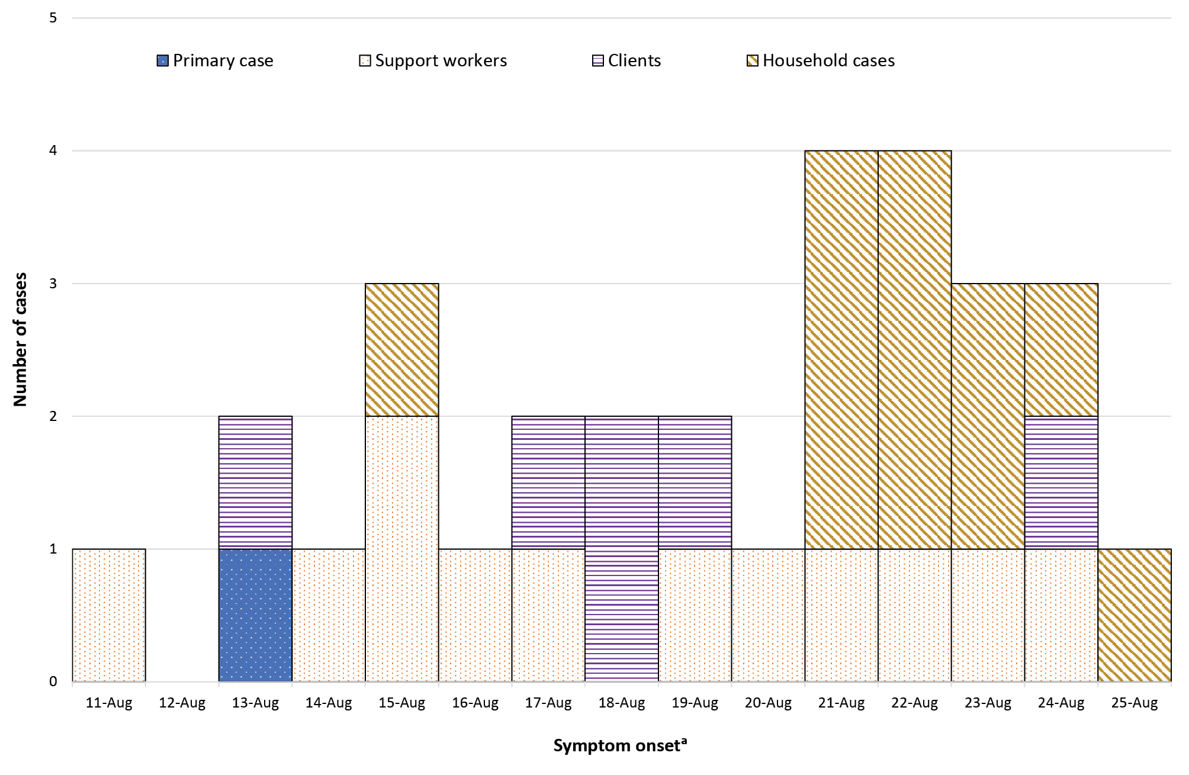
a Specimen collection date was used for cases who did not report symptoms at the time of testing.

Sources of acquisition
All cases in this outbreak were locally acquired, with no recent interstate or overseas travel reported. The index case, identified on 16 August 2021, was a disability support worker who provided in-home care at a group home run by the DSP two days before symptom onset. The first primary case identified was the likely source for at least 17 infections related to this outbreak. This ‘main primary case’ was a disability support worker who attended a staff training workshop on 11 August 2021 and worked shifts between 11 and 13 August 2021 while infectious.
However, no source was identified for a further six cases, suggesting possible multiple introductions of COVID-19 or intermediary cases that were not identified. Hence, a total of seven cases were classified as primary cases (see Appendix A for hypothesised sources of infection). The latter is unlikely due to the comprehensive contact tracing and testing, which was informed by both case interviews and staff rosters, resulting in 80 close contacts being identified. Only three of the seven primary cases resulted in onwards transmission.
Most cases in this cluster (26/30; 87%) were genomically classified as ACT.19, a Delta variant sub-lineage and the dominant local lineage circulating in the ACT at that time. Viral sequencing of six primary cases matched ACT.19. Due to the limited genetic diversity at this early stage of the outbreak, it was not possible to resolve where these cases were acquired. A total of three cases were classified under sub-lineage ACT.19.4, two of whom were disability support workers who had attended the 11 August 2021 staff training with the primary case; one of these two cases also worked with the third case (one of the seven with unknown source of infection) during their estimated infectious period. No other cases of ACT.19.4 were subsequently identified in the ACT. The specimen from one case was unable to be sequenced due to sequencing failure.

Exposure site attack rates and relative risk
We identified a total of 17 exposure sites for this cluster: seven DSP work sites and 12 households of disability support workers. Four DSP work sites were the main residence of client cases serviced by serviced by support workers (Table 1). Four households (i.e., the primary residence of some clients) were noted as workplace exposure sites, so were not included in the count for household exposure sites. A further two case households were not included in attack rate calculations, as one was a single-person household and the other had an unknown number of household contacts.
The highest secondary attack rate for workplace exposures sites was at an independent home (27.3%), and the lowest at one of three group homes (7.7%). Four households had attack rates of 100%; five had no secondary cases; and one household had a 50% attack rate. The staff training workshop had a lower risk of transmission than other workplace exposure sites (RR: 0.41; 95% CI: 0.14–1.25), despite initial investigations identifying that workshop as a potential superspreading event.
Despite a larger number of people being exposed at workplace sites, the mean secondary attack rate at workplace sites (15%; or 12/80 close contacts infected in total) was lower than in households (47.8%; or 11/23 total close contacts infected) (Table 1). People exposed to COVID-19 cases in DSP work sites had a lower risk of transmission than those exposed in household settings (RR: 0.42; 95% CI: 0.21–0.82).
Table 1: Disability support sector cluster workplace exposure site and case household mean attack rates
Exposure site type | Total exposure sites  (n) | Secondary and tertiary cases  (n) | Total exposed across exposure sites ª  (n) | Mean secondary attack rate  (%)
Disability support work site | 7 ^{b} | 12 | 80 | 15.0
Household | 10 ^{c} | 11 | 23 | 47.8
a Total exposed includes all people identified as close contacts to primary cases during the outbreak period of 11 to 21 August 2021. This total includes both people who became confirmed cases themselves (secondary and tertiary cases) and close contacts who did not test positive. Some of these close contacts were exposed to infectious cases more than once and/or at more than one exposure site, so each exposure was counted under this column.
b Includes four households that were classified at ‘worksites’.
c Two case households were not included in ‘Household’ and ‘Total’ exposure site numbers and attack rate calculations; one was a single-person household, and the other was a house with an unknown number of contacts that could not be verified through case interviews.

Discussion
In this outbreak of the COVID-19 Delta variant in the disability support sector, there was higher risk of COVID-19 transmission in households than at disability support work sites. Over 90% of cases in the outbreak were unvaccinated, despite targeted immunisation programs.
Our findings support previous studies reporting high risk of COVID-19 transmission in households. ^{15,16} We found attack rates were lower in worksites than in household settings, although use of masks and other personal protective equipment (PPE) may have also had an impact. Compared to workplace settings, household transmission dynamics are complex and likely exacerbate the spread of COVID-19. Some studies suggest that viral load and living density, ¹⁶ as well as the introduction of new virus lineages and low vaccine coverage, ¹⁵ can contribute to increased rates of household transmission of COVID-19. Familial responsibilities, availability of care and inability to isolate away from household members are other hypothesised factors. ¹⁶ This latter hypothesis was supported by our analysis, which found that the four out of 10 households with an attack rate of 100% had children under the age of 10 who acquired COVID-19 from their support worker parents. Separation of young children from COVID-19-positive parents may have been more difficult than for older children; however, the difficulty in distancing and maintaining COVID-19 safety measures in place in a high-dose exposure situation like a household is another suggested factor. This ability to distance from an infected person was potentially at play in workplaces, where close contacts may not have had direct or sustained contact with confirmed cases despite being on-site. We also note that children aged under 18 years were not eligible for vaccination at the time of this outbreak, increasing their susceptibility to infection.
Very few outbreak cases were vaccinated for COVID-19, despite identification of people with a disability and support workers within the highest-priority group for vaccination under Australia’s vaccination strategy and eligible for vaccination from 22 February 2021. ¹¹ Prior research in this area reported that disability support workers may not be willing to vaccinate due to fear of potential side effects and safety concerns around the rapid development of the COVID-19 vaccine. ^{17,18} A report found that these concerns may just relate to COVID-19 rather than vaccines more broadly. ⁷
After this outbreak, ACT Health put in place stronger public health requirements to ensure that vaccine uptake among disability support workers was high. From mid-December 2021, ACT legislation required support workers to be fully vaccinated to continue working. ¹⁹ Whilst this measure, alongside the existing targeted vaccination risk communication for disability support workers, will ensure vaccination coverage increases amongst this cohort, further research should be undertaken by both governments and industry to better understand the reasons for the low vaccination uptake among Australian disability support workers. This research could support future seasonal vaccination programs for COVID-19 and influenza.
No client cases in this outbreak were vaccinated. Two factors are commonly noted to impact on vaccination uptake by people with disability: vaccine accessibility and vaccine perception. COVID-19 vaccination accessibility was likely a key challenge for people with disability. ^{20,21} Vaccine promotion and education programs were scaled up in the ACT following this outbreak to ensure greater access and uptake by people with disability. Additionally, an ‘access and sensory clinic’ and an in-home vaccination program were also established. ²² Perceptions about vaccine safety and side effects, as well as ethnicity and demographic factors, ^{23–25} affect hesitancy among people with disability. Studies have shown that caregiver willingness to vaccinate and personal vaccination beliefs were also determining factors in COVID-19 vaccination levels. ^{25,26} As of 17 March 2022, 88.2% of NDIS participants living in disability accommodation nationally had received their first dose of COVID-19 vaccine; 86.5% were double-vaccinated; and 69.6% had obtained a booster (i.e. more than two doses). ²⁷ In the ACT, over 16,000 doses had been administered to NDIS participants living in disability accommodation by 30 March 2022, which was substantially higher than before August 2021. ²⁷ There has been no data published on vaccination coverage among disability support workers in Australia to date. Therefore, it will be essential for governments to keep abreast of the barriers to COVID-19 vaccination, to maintain momentum in vaccination coverage among the entire sector. Ongoing work through the Royal Commission into Violence, Abuse, Neglect and Exploitation of People with Disability has highlighted, and will continue to highlight, the challenges facing the disability sector. It will be important for governments and industry to acknowledge those challenges and work towards solutions to identified gaps.
This investigation had several limitations. The outbreak was relatively small, and data on close contacts’ vaccination status were unavailable at the time of investigation, making it difficult to generalise findings to the wider disability support sector. The denominator for workplace exposures may be inaccurate due to the defined scope, which included all people who attended work on the same day as a confirmed case, including those potentially not in direct contact with the case. The vaccination status of close contacts who did not contract SARS-CoV-2 would have been particularly useful to determine whether vaccination status was a factor in preventing disease transmission. We were also unable to access information on the layout of affected households and disability support-related work sites to inform potential analyses on ventilation, bedroom number and location, and bathroom access. The genomic divergence from ACT.19 to ACT.19.4 may indicate a source of infection outside of ACT, a mutation that occurred after initial transmission, or unknown community-acquired exposures.
This outbreak was resolved within two weeks, despite high levels of physical mixing between cases, other workers and clients, and within their households. The public health measures and previous planning for outbreaks in the sector may have contributed to the relatively effective containment of this outbreak in addition to swift testing, contact tracing, isolation and quarantine. The affected DSP had implemented mitigation measures and was supported by the ACT government to undertake planned and enhanced measures for minimising the impact of COVID-19. For example, ‘COVID Safe’ infection control plans were in place for every client and group home, and employee cases and their close contacts were taken off work duties for at least 14 days from positive test to isolate or quarantine as per ACT Health requirements. After infections in staff and clients were identified, additional changes were implemented, such as isolating COVID-positive clients away from uninfected clients in group homes, and support care being provided by staff trained in donning and doffing PPE.
The limited transmission that occurred in this outbreak demonstrates the importance of planning and strong partnerships in emergency response, and ongoing collaboration between government and industry, to properly target response measures towards a complex sector. It is recommended that governments and the disability support sector continue an open and supportive dialogue to maintain strong response plans and target communication to the sector effectively. Further research should seek to understand the barriers and perceptions to vaccination among people with disability and carers, to ensure the ongoing health and wellbeing of this vulnerable population.

Acknowledgements
We thank the cases and close contacts for assisting ACT Health with this outbreak investigation, and the DSP for their assistance. We especially thank the wider Epidemiology, Case Investigations and Medical Advisory teams in the COVID-19 Taskforce, ACT Health; Dr Karina Kennedy and the ACT Pathology team, Dr Benjamin Schwessinger and members of the Schwessinger lab from the Australian National University, and Dr Robyn Hall from CSIRO and ANU for genomic sequence data; and Department of Health MAE field supervisors Kate Pennington and Amy Black for their help with the investigation and comments on this manuscript.

Author details
Ms Aruna Phabmixay, ¹ ² ³
Dr Ben Polkinghorne, ¹ ² ³
Ms Alexandra Marmor, ³
Dr Nevada Pingault, ³
Mr Timothy Sloan-Gardner, ³
Prof. Martyn Kirk ¹ ² ³
- National Centre for Epidemiology and Public Health, Australian National University. Canberra, Australia.
- Office of Health Protection, Australian Government Department of Health and Aged Care. Canberra, Australia.
- Epidemiology, COVID-19 Response Coordination Centre, ACT Health. Canberra, Australia.

Corresponding author
Ms Aruna Phabmixay
National Centre for Epidemiology and Public Health, Australian National University
Phone: 0402 920 476
Email: Aruna.Phabmixay@anu.edu.au

References
- Australian Bureau of Statistics. Disability, Ageing and Carers, Australia: Summary of Findings. Reference period: 2018. [Webpage.] Canberra: Australian Bureau of Statistics; 24 October 2019. Available from: https://www.abs.gov.au/statistics/health/disability/disability-ageing-and-carers-australia-summary-findings/latest-release.
- Royal Commission into Violence, Abuse, Neglect and Exploitation of People with Disability (Disability Royal Commission). The impact of and responses to the Omicron wave of the COVID-19 pandemic for people with disability Issues paper . Canberra: Disability Royal Commission; 25 March 2022. Available from: https://disability.royalcommission.gov.au/publications/impact-and-responses-omicron-wave-covid-19-pandemic-people-disability-issues-paper.
- Boyle CA, Fox MH, Havercamp SM, Zubler J. The public health response to the COVID-19 pandemic for people with disabilities. Disabil Health J . 2020;13(3):100943. doi: https://doi.org/10.1016/j.dhjo.2020.100943.
- Schott W, Tao S, Shea L. COVID-19 risk: Adult Medicaid beneficiaries with autism, intellectual disability, and mental health conditions. Autism . 2022;26(4):975–87. doi: https://doi.org/10.1177/13623613211039662.
- Lunsky Y, Durbin A, Balogh R, Lin E, Palma L, Plumptre L. COVID-19 positivity rates, hospitalizations and mortality of adults with and without intellectual and developmental disabilities in Ontario, Canada. Disabil Health J . 2022;15(1):e101174. doi: https://doi.org/10.1016/j.dhjo.2021.101174.
- Henderson A, Fleming M, Cooper SA, Pell JP, Melville C, Mackay DF et al. COVID-19 infection and outcomes in a population-based cohort of 17 203 adults with intellectual disabilities compared with the general population. J Epidemiol Community Health . 2022;76(6):550–5. doi: https://doi.org/10.1136/jech-2021-218192.
- Kavanagh A, Dimov S, Dickinson H, McAllister A, Shields M, Alex S. Disability support workers: COVID-19 vaccine hesitancy and communication needs . [Online document.] Melbourne: University of Melbourne; 26 May 2021. [Accessed on 23 March 2022.] doi: https://doi.org/10.26188/14456577.
- Australian Government Department of Health. Management and Operational Plan for People with Disability: Australian Health Sector Emergency Response Plan for Novel Coronavirus (COVID-19) . Canberra: Australian Government Department of Health; September 2020. [Accessed on 23 December 2021.] Available from: https://www.health.gov.au/sites/default/files/documents/2020/09/management-and-operational-plan-for-people-with-disability.pdf.
- Sheel M, Voo TV, Pingault N, Sloan-Gardner TS, Marmor A, Kirk MD et al. Vaccine breakthrough infections in a highly vaccinated Australian population during a SARS-CoV-2 Delta outbreak. Commun Dis Intell (2018) . 2022;46. doi: https://doi.org/10.33321/cdi.2022.46.32.
- Australian Capital Territory (ACT) Government. Seven-day lockdown for the ACT. [Internet.] Canberra: ACT Government; 12 August 2021. [Accessed on 23 December 2021.] Available from: https://www.covid19.act.gov.au/news-articles/seven-day-lockdown-for-the-act.
- Australian Government. Australia’s COVID-19 vaccine national roll-out strategy . Canberra: Australian Government; 2021. [Accessed on 23 December 2021.] Available from: https://www.health.gov.au/sites/default/files/documents/2021/01/covid-19-vaccination-australia-s-covid-19-vaccine-national-roll-out-strategy.pdf.
- Australian Government Department of Health and Aged Care. COVID-19 vaccine rollout update – 31 July 2021 . Canberra: Australian Government Department of Health and Aged Care; 31 July 2021. Available from: https://www.health.gov.au/resources/publications/covid-19-vaccine-rollout-update-31-july-2021.
- ACT Government. Public Health Act 1997 . [Legislation.] Canberra: ACT Government, ACT Legislation Register; 2022. Available from: https://www.legislation.act.gov.au/a/1997-69.
- Australian Government Department of Health. Coronavirus Disease 2019 (COVID-19). CDNA National guidelines for public health units. Version 4.7. [Internet.] Canberra: Australian Government Department of Health; 2021. [Accessed on 23 December 2021.] Available from: https://www1.health.gov.au/internet/main/publishing.nsf/Content/cdna-song-novel-coronavirus.htm.
- Madewell ZJ, Yang Y, Longini IM, Halloran ME, Dean NE. Factors associated with household transmission of SARS-CoV-2: an updated systematic review and meta-analysis. JAMA Netw Open . 2021;4(8):e2122240. doi: https://doi.org/10.1001/jamanetworkopen.2021.22240.
- Denford S, Morton K, Horwood J, de Garang R, Yardley L. Preventing within household transmission of Covid-19: is the provision of accommodation to support self-isolation feasible and acceptable? BMC Public Health . 2021;21(1):e1641. doi: https://doi.org/10.1186/s12889-021-11666-z.
- Lunsky Y, Kithulegoda N, Thai K, Benham JL, Lang R, Desveaux L et al. Beliefs regarding COVID-19 vaccines among Canadian workers in the intellectual disability sector prior to vaccine implementation. J Intellect Disabil Res . 2021;65(7):617–25. doi: https://doi.org/10.1111/jir.12838.
- Kavanagh A, Dickinson H, Dimov S, Shields M, McAllister A. The COVID-19 vaccine intentions of Australian disability support workers. Aust N Z J Public Health . 2022;46(3):314–21. doi: https://doi.org/10.1111/1753-6405.13226.
- ACT Government. Public Health (Health Care and Support Workers COVID-19 Vaccination) Emergency Direction 2022 . [Legislation.] Canberra: ACT Government, ACT Legislation Register; 4 April 2022. Available from: https://legislation.act.gov.au/ni/2022-171/.
- Rotenberg S, Downer MB, Cooper J. Making COVID-19 vaccinations accessible for people with disabilities. Vaccine . 2021;39(40):5727–8. doi: https://doi.org/10.1016/j.vaccine.2021.08.062.
- Ryerson AB, Rice CE, Hung MC, Patel SA, Weeks JD, Kriss JL et al. Disparities in COVID-19 vaccination status, intent, and perceived access for noninstitutionalized adults, by disability status – National Immunization Survey Adult COVID Module, United States, May 30-June 26, 2021. MMWR Morb Mortal Wkly Rep . 2021;70(39):1365–71. doi: https://doi.org/10.15585/mmwr.mm7039a2.
- ACT Government. COVID-19: Information for people with disability and their carers. [Internet.] Canberra: ACT Government; 2021. [Accessed on 25 March 2022.] Available from: https://www.covid19.act.gov.au/services-and-support/disability/information-for-people-with-disability.
- Myers A, Ipsen C, Lissau A. COVID-19 vaccination hesitancy among Americans with disabilities aged 18-65: an exploratory analysis. Disabil Health J . 2022;15(1):101223. doi: https://doi.org/10.1016/j.dhjo.2021.101223.
- Aitken Z, Emerson E, Kavanagh AM. COVID-19 vaccination coverage and vaccine hesitancy among Australians with disability and long-term health conditions. Health Promot J Austr . 2022;10.1002/hpja.691. doi: https://doi.org/10.1002/hpja.691.
- Hatton C, Bailey T, Bradshaw J, Caton S, Flynn S, Gillooly A et al. The willingness of UK adults with intellectual disabilities to take COVID-19 vaccines. J Intellect Disabil Res . 2021;65(11):949–61. doi: https://doi.org/10.1111/jir.12884.
- Iadarola S, Siegel JF, Gao Q, McGrath K, Bonuck KA. COVID-19 vaccine perceptions in New York State’s intellectual and developmental disabilities community. Disabil Health J . 2022;15(1):e101178. doi: https://doi.org/10.1016/j.dhjo.2021.101178.
- Australian Government Department of Health and Aged Care. COVID-19 vaccine rollout update – 31 March 2022 . Canberra: Australian Government Department of Health and Aged Care; 31 March 2021. Available from: https://www.health.gov.au/resources/publications/covid-19-vaccine-rollout-update-31-march-2022.

Appendix A – Supplementary material
Figure A.1: Sources of acquisition of COVID-19 cases in a disability support outbreak, Australian Capital Territory, August 2021
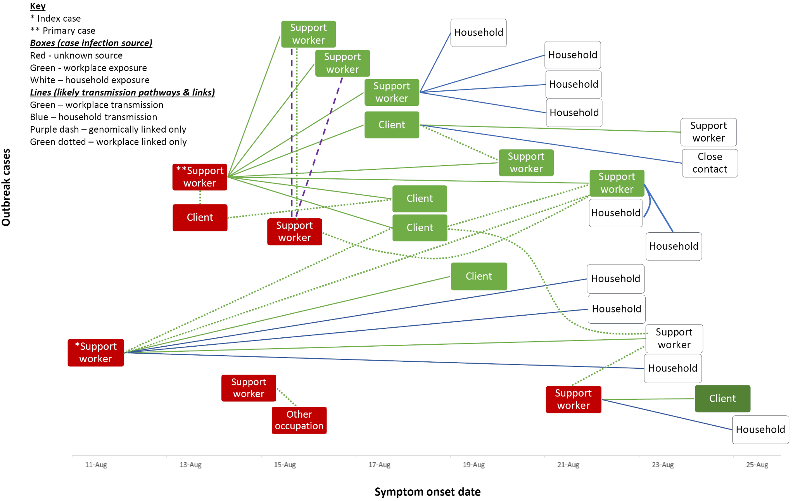

Communicable Diseases Intelligence
ISSN: 2209-6051 Online

Communicable Diseases Intelligence (CDI) is a peer-reviewed scientific journal published by the Office of Health Protection, Department of Health and Aged Care. The journal aims to disseminate information on the epidemiology, surveillance, prevention and control of communicable diseases of relevance to Australia.

Editor: Christina Bareja
Deputy Editor: Simon Petrie
Design and Production: Kasra Yousefi
Editorial Advisory Board: David Durrheim, Mark Ferson, Clare Huppatz, John Kaldor, Martyn Kirk, Meru Sheel and Steph Williams

Website: http://www.health.gov.au/cdi

Contacts
CDI is produced by the Office of Health Protection, Australian Government Department of Health and Aged Care, GPO Box 9848, (MDP 6) CANBERRA ACT 2601

Email: cdi.editor@health.gov.au

Submit an Article
You are invited to submit your next communicable disease related article to the Communicable Diseases Intelligence (CDI) for consideration. More information regarding CDI can be found at: http://health.gov.au/cdi.
Further enquiries should be directed to: cdi.editor@health.gov.au.

This journal is indexed by Index Medicus and Medline.

Creative Commons Licence - Attribution-NonCommercial-NoDerivatives CC BY-NC-ND
© 2023 Commonwealth of Australia as represented by the Department of Health and Aged Care
This publication is licensed under a Creative Commons Attribution-NonCommercial-NoDerivatives 4.0 International Licence from https://creativecommons.org/licenses/by-nc-nd/4.0/legalcode (Licence). You must read and understand the Licence before using any material from this publication.

Restrictions
The Licence does not cover, and there is no permission given for, use of any of the following material found in this publication (if any):
- the Commonwealth Coat of Arms (by way of information, the terms under which the Coat of Arms may be used can be found at www.itsanhonour.gov.au);
- any logos (including the Department of Health and Aged Care’s logo) and trademarks;
- any photographs and images;
- any signatures; and
- any material belonging to third parties.

Disclaimer
Opinions expressed in Communicable Diseases Intelligence are those of the authors and not necessarily those of the Australian Government Department of Health and Aged Care or the Communicable Diseases Network Australia. Data may be subject to revision.

Enquiries
Enquiries regarding any other use of this publication should be addressed to the Communication Branch, Department of Health and Aged Care, GPO Box 9848, Canberra ACT 2601, or via e-mail to: copyright@health.gov.au

Communicable Diseases Network Australia
Communicable Diseases Intelligence contributes to the work of the Communicable Diseases Network Australia.
http://www.health.gov.au/cdna

