Communicable Diseases Intelligence, Year 2023, Volume 47
https://doi.org/10.33321/cdi.2023.47.49
Publication date: 24/8/2023
http://health.gov.au/cdi

Epidemiology of Group A Streptococcal bacteraemia in Hunter New England Local Health District, 2008 to 2019
Kirsten M Williamson, Hemalatha Varadhan, Kylie Taylor, Kristy Crooks, Katie Brett, Charlee Law, Michelle Butler, Trent Butler, Emily Green, Joshua S Davis, Paul Wilson, Tambri Housen, Tony Merritt, David N Durrheim

Abstract
Invasive Group A Streptococcal infection (iGAS) is an uncommon but serious infection with Streptococcus pyogenes in a normally sterile body site. Manifestations include bacteraemia, necrotising fasciitis and toxic shock syndrome with attendant serious morbidity and mortality. An increasing incidence of iGAS has been observed in some regions of Australia. iGAS became a nationally notifiable condition from 1 July 2021.
To determine if regional incidence has increased, and to identify priority populations, we undertook a retrospective data analysis of Group A Streptococcal (GAS) bacteraemia cases in Hunter New England Local Health District (HNELHD), New South Wales, Australia, from 1 January 2008 to 31 December 2019, as identified by NSW Health Pathology, John Hunter Hospital.
A total of 486 cases were identified (age-standardised rate: 4.05 cases per 100,000 population per year). Incidence in HNELHD gradually increased over the study period (adjusted incidence rate ratio: 1.04; 95% confidence interval: 1.01–1.07) and was significantly higher in children under 5 years of age; in adults over 70 years of age; in males; and in First Nations peoples. A significant peak occurred in 2017 (9.00 cases per 100,000 population), the cause of which remains unclear.
GAS bacteraemia is uncommon but severe, and incidence in HNELHD has slowly increased. Public health and clinical guidelines must address the needs of priority populations, which include young children, older adults and First Nations peoples. Routine surveillance and genomic analysis will help improve our understanding of iGAS and inform best public health management.
Keywords: group A Streptococcus; Streptococcus pyogenes; iGAS; GAS; invasive; bacteraemia; sepsis; notifiable condition; infectious disease; epidemiology

Introduction
Streptococcus pyogenes, or Group A Streptococcus (GAS), is a gram-positive bacterium that colonises the skin and pharynx and can cause a range of illness in humans.^{1,2} Group A streptococci possess surface M-proteins, encoded by different emm genes, which are essential for virulence and for survival of the bacteria in human tissues.^{3,4}
Invasive Group A Streptococcal infection (iGAS) is a serious infection in a normally sterile body site.⁵ Manifestations of iGAS include bacteraemia; septic arthritis; pneumonia; puerperal sepsis; necrotising fasciitis; and streptococcal toxic shock syndrome (STSS).⁶ Treatment requires prompt administration of antibiotics and cases often need invasive therapies, including ventilation, dialysis and/or surgery.⁷ iGAS carries a case fatality ratio (CFR) of up to 15% in high-income countries and may result in long-term sequelae.^{8,9} Factors associated with mortality include older age, comorbidities, clinical manifestation and emm-types 1 and 3.^{10–13}
The incidence of iGAS varies by population, climate and country, and disproportionately impacts First Nations peoples across the globe.^{9,14–16} iGAS rates appear to be increasing internationally^{17,18} and within Australia.^{9,19} Clustering of cases within households and residential care facilities has been documented.^{12,20–23} The household attack rate of iGAS within 30 days of a primary case has been estimated at 0.66 to 3.22 cases per 1000 people,^{12,22} which equates to an approximately 2000-fold increased risk depending on background community incidence.²³
Previously, iGAS was only notifiable in two Australian states/territories: Northern Territory and Queensland;^{5,24} however, it became a nationally notifiable condition from 1 July 2021.²⁵ At time of writing this paper, state and territory public health guidelines for iGAS varied, particularly regarding antibiotic prophylaxis for household contacts, and national guidelines were in development.^{5,24,26} Routine genomic surveillance of iGAS was not available.
Hunter New England Local Health District (HNELHD) is situated in north-eastern New South Wales and encompasses an area of 131,785 square kilometres.²⁷ It has an estimated population of 920,370 and consists of metropolitan, regional and rural communities.²⁸ In HNELHD, 7.1% of the population identify as Aboriginal and/or Torres Strait Islander, compared to 3.3% across Australia.²⁹
An increase in GAS bacteraemia cases in HNELHD was observed through scoping review of public hospital laboratory data, including an increase in admissions from GAS pneumonia in two major HNELHD hospitals during the 2017 influenza season.³⁰
The purposes of this study were:
- to determine if the incidence of GAS bacteraemia in HNELHD has increased; and
- to identify priority populations and influencing factors for prevention and diagnosis of GAS bacteraemia in HNELHD.
A broader aim of this study was to help inform local and national guidelines relating to iGAS.

Methods

Study population
Retrospective data analysis was performed on GAS bacteraemia cases that occurred in HNELHD from 1 January 2008 to 31 December 2019. Cases of GAS bacteraemia were defined as patients with Group A Streptococcus (S. pyogenes) isolated from a blood culture specimen collected at an HNELHD hospital, as identified by NSW Health Pathology, John Hunter Hospital (hereafter NSW HP JHH). NSW HP JHH is a public hospital pathology provider that services 34 of 38 hospitals in HNELHD; however, general practices, private hospitals and some rural public hospitals are serviced by other laboratories. Given the severity of GAS bacteraemia, it was anticipated that most cases would present to public emergency departments rather than to practices.¹⁶ Therefore the NSW HP JHH dataset should capture the majority of cases.

Data collection
Cases were identified from ‘Auslab’, the NSW HP JHH laboratory database. Data were linked using laboratory specimen number, medical record number and collection date with data from HNELHD patient information system (iSoft Patient Manager [iPMS]) to obtain demographic details and the Admitted Patient Collection (APC) to obtain outcomes. (Figure 1) Annual influenza notification data was obtained from the New South Wales Notifiable Conditions Information Management System to compare trends in GAS bacteraemia and influenza cases over time, given an anecdotal increase in iGAS cases noted by local clinicians during the 2017 influenza season.
Figure 1: Data extraction and cleaning steps to identify GAS bacteraemia cases in HNELHD that occurred from 1 January 2008 to 31 December 2019ª
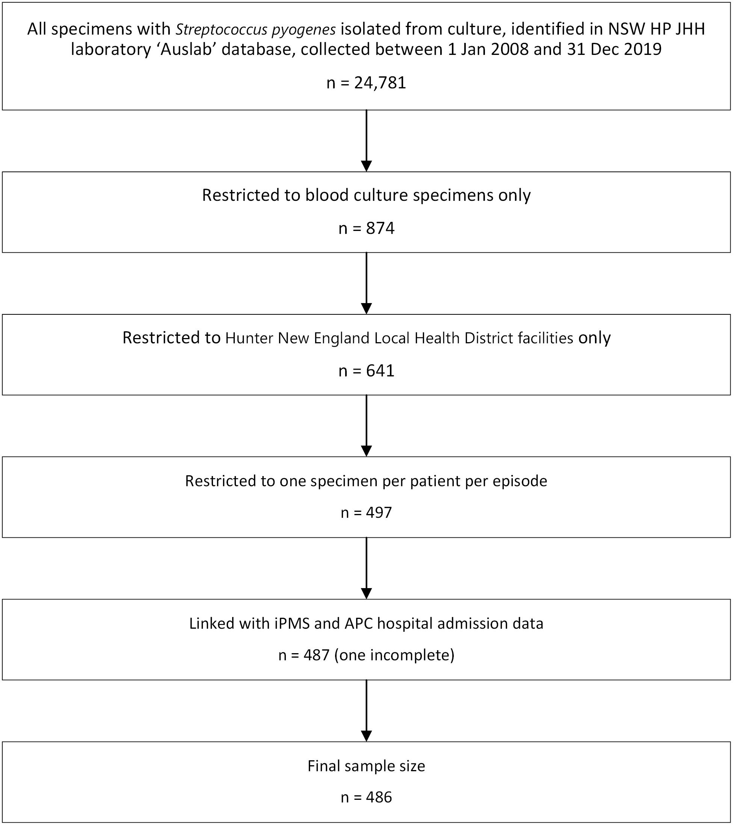
a NSW HP JHH = NSW Health Pathology, John Hunter Hospital; iPMS = iSoft Patient Manager patient information system; APC = Admitted Patient Collection.

Definitions
Date of infection was based on cases’ earliest positive specimen collection date. Geographic sectors were based on cases’ residential postcodes and 2016 local government areas (LGA). A potential cluster was defined as two or more GAS bacteraemia cases that occurred in the same household or residential care facility within 90 days.
First Nations status was extracted from iPMS records. Completeness of this field is largely dependent on healthcare staff asking and recording the Aboriginal and Torres Strait Islander status of patients during their presentation to the health service.³¹
Critical care was defined as admission to an intensive care unit (ICU) or high dependency unit (HDU) at any time during the admission episode. Death related to GAS bacteraemia was defined as death within 30 days of a case’s earliest positive specimen collection.

Data analysis
Data were extracted from the Auslab and iPMS databases to Excel spreadsheets (Microsoft Office 2013; USA) and datasets linked using SAS Enterprise Guide 7.1 (SAS Institute Inc. 2017; USA). Analyses were performed using Stata 14.0 (StataCorp 2018; USA). Denominators were based on the mid-year estimated resident populations (ERP) and projected populations for each year of the study period (ABS 2006, 2011, 2016).²⁸ Denominators for First Nations peoples involved ERP for 2008 to 2016; the 2016 population was repeated for 2017–2019 rather than using projections.
Age-standardised rates were calculated by the direct method using the 2001 Standard Australian Population.³² Incidence rate ratios were calculated using Poisson distribution. Chi-square test for trend and post-hoc goodness-of-fit analysis were used to assess incidence over time and Poisson regression to examine seasonality. Logistic regression was used to identify factors associated with outcomes. Multivariate analysis was performed using Poisson regression to estimate adjusted incidence rate ratios. Variables were included in the model if p < 0.25 in the initial univariate analyses.³³ Post-hoc analysis was performed using Pearson Chi-squared goodness-of-fit test.

Assessing the impact of GAS bacteraemia on First Nations peoples in HNELHD
Other GAS illnesses disproportionately impact First Nations peoples in Australia;^{9,16} therefore, it was considered important to assess the impact of GAS bacteraemia on First Nations peoples in HNELHD. Many studies describe the health of First Nations peoples in relation to non-First Nations populations, which can stigmatise, and which fails to acknowledge the strengths of First Nations peoples in Australia and the significant impact of colonisation and systemic racism on health.³⁴ Therefore, an in-depth, within-population analysis of GAS bacteraemia in First Nations peoples in HNELHD was performed rather than a between-populations comparison. However, there are circumstances where comparisons are useful to influence policy;^{34,35} and with the endorsement of the First Nations researchers, First Nations status was included in the multivariate analysis. Age-standardisation for First Nations peoples was not performed as small numbers within age groups can result in imprecise estimates.³⁶

Ethical considerations and cultural governance
Ethical approval was obtained from the Hunter New England Local Health District (Ref: 2019/ETH12208), Aboriginal Health & Medical Research Council of New South Wales (Ref: 1641/20) and Australian National University (Ref: 2019/778) Human Research Ethics Committees. Aboriginal research team members provided cultural governance throughout and an Aboriginal research advisory group contributed to the interpretation of results and study recommendations.

Results
Between 1 January 2008 and 31 December 2019, a total of 486 GAS bacteraemia cases were identified in HNELHD across 24 public healthcare facilities (Figure 1). Of these, 467 (96.1%) had S. pyogenes only, six (1.2%) had S. pyogenes plus a likely contaminant, and thirteen (2.7%) had co-infection with another bacterium (e.g. Staphylococcus aureus).
The mean number of cases per year was 40.5 (standard deviation, SD: 15.8; range: 22–83 cases), with crude and age-standardised incidence rates of 4.53 cases and 4.05 cases per 100,000 population per year, respectively. The median age was 61 years (inter-quartile range, IQR: 39–78 years) and 57.2% of cases were male (Table 1).
Table 1: Number of cases, incidence rates and incidence rate ratios (IRR) of GAS bacteraemia cases by sex and age groups in HNELHD, 1 January 2008 to 31 December 2019
Characteristic | Value or range | Number of cases (%) | Incidence rate  (per 100,000 per year) | IRR [95% CI]ª
Total cases |  | 486 (100.0) | 4.53 | —
Sex | Female | 208 (42.8) | 3.84 | Reference group
 | Male | 278 (57.2) | 5.22 | 1.36 [1.03–1.80]
Age group (years) | 0–9 | 46 (9.5) | 3.34 | 3.04 [1.73–5.36]
 | 10–19 | 15 (3.1) | 1.10 | Reference group
 | 20–29 | 23 (4.7) | 1.72 | 1.56 [0.88–2.79]
 | 30–39 | 42 (8.6) | 3.29 | 2.99 [1.60–5.57]
 | 40–49 | 38 (7.8) | 2.76 | 2.51 [1.44–4.40]
 | 50–59 | 70 (14.4) | 4.96 | 4.51 [2.66–7.64]
 | 60–69 | 62 (12.8) | 4.96 | 4.51 [2.46–8.29]
 | 70–79 | 87 (17.9) | 10.52 | 9.57 [5.57–16.47]
 | 80+ | 103 (21.2) | 20.03 | 18.23 [10.58–31.40]
Paediatric groups  (years) | 0–4 | 29 (6.0) | 4.22 | 4.76 [1.98–11.48]
 | 5–9 | 17 (3.5) | 2.47 | 2.78 [1.10–7.06]
 | 10–14 | 6 (1.2) | 0.89 | Reference group
 | 15–17 | 7 (1.4) | 1.70 | 1.91 [0.64–5.70]
 | Total paediatric | 59 (12.1) | 2.39 | —
a IRR: incidence rate ratio; 95% CI: 95% confidence interval. Significant IRR values (p < 0.05) are shown in italics.

Incidence in HNELHD over time
The incidence of GAS bacteraemia in HNELHD gradually increased over the study period, with a peak incidence in 2017 of 9.00 cases per 100,000 population. This peak was more than double the previous five-year average (4.18 cases per 100,000 population per year for 2012–2016; IRR: 2.15 [95% CI: 1.64–2.80]) (Figure 2).
The mean incidence rate was 39% higher in the latter half of the study period (2014–2019) than in the earlier half (2008–2013): 5.24 vs. 3.77 cases per 100,000 population per year, respectively; IRR: 1.39 [95% CI: 1.15–1.67]. Poisson regression showed a small increase in incidence each year (IRR: 1.05; 95% CI: 1.01–1.10). Chi-square test for trend showed a slight but significant upward trend (slope = 2.2 × 10⁻⁶; standard error, SE: 6.0 × 10⁻⁷; p < 0.001); however, post-hoc analysis showed deviation from linear trend, likely due to the 2017 peak. When 2017 data was replaced with the median annual case count for 2014–2019 (45.5 cases), incidence remained 21% higher in the latter half of the study period (2014–2019) than in the earlier half (2008–2013): (4.56 vs. 3.77 cases per 100,000 population per year, respectively; IRR: 1.21 [95% CI: 1.00–1.47].
Figure 2: Annual case numbers, three-year case average and incidence of GAS bacteraemia cases in HNELHD, 1 January 2008 to 31 December 2019
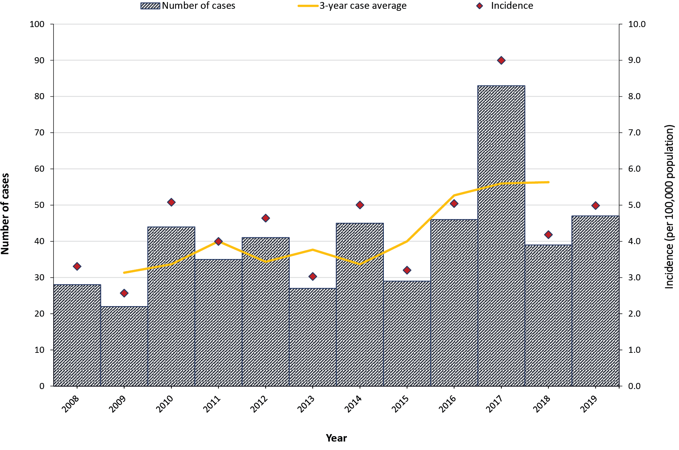

Incidence by age and sex
Incidence was higher in older age groups, particularly from 70 years upwards (≥ 10.52 cases per 100,000 population per year). Figure 3 shows that the highest age-specific incidence was in adults 80 years and over (20.0 cases per 100,000 population per year), particularly in males in this age group (30.6 cases per 100,000 population per year).
Overall, the incidence was higher in males than females (5.22 vs. 3.84 cases per 100,000 population per year; IRR: 1.36; 95% CI: 1.13–1.63) (Table 2). When stratified by ten-year age group, incidence was significantly higher in males than females aged 60 years and over. Incidence was slightly higher in females than males aged 20–29 years and 30–39 years; however, this was not statistically significant.

Table 2: Adjusted incidence rate ratios of GAS bacteraemia cases in HNELHD during 2008–2019 by year, ten-year age group, sex, and Indigenous status using multivariable analysis
Characteristic | Value or range | Adjusted IRR [95% CI]ª
Year (average annual change) |  | 1.04 [1.01–1.07]
Age group (years) | 0–9 | 2.99 [1.72–5.18]
 | 10–19 | Reference group
 | 20–29 | 1.63 [0.90–2.94]
 | 30–39 | 3.22 [1.73–6.01]
 | 40–49 | 2.75 [1.59–4.75]
 | 50–59 | 5.00 [2.96–8.44]
 | 60–69 | 5.07 [2.82–9.11]
 | 70–79 | 10.90 [6.40–18.56]
 | 80+ | 21.87 [12.96–36.93]
Sex | Female | Reference group
 | Male | 1.48 [1.21–1.82]
Indigenous status | First Nations people | 2.73 [1.98–3.76]
 | non-First Nations people | Reference group
a IRR: incidence rate ratio; 95% CI: 95% confidence interval. Significant adjusted IRR values (p < 0.05) are shown in italics.
Figure 3: Incidence of GAS bacteraemia (and 95% confidence intervals) by sex and ten-year age groups in HNELHD, 1 January 2008 to 31 December 2019
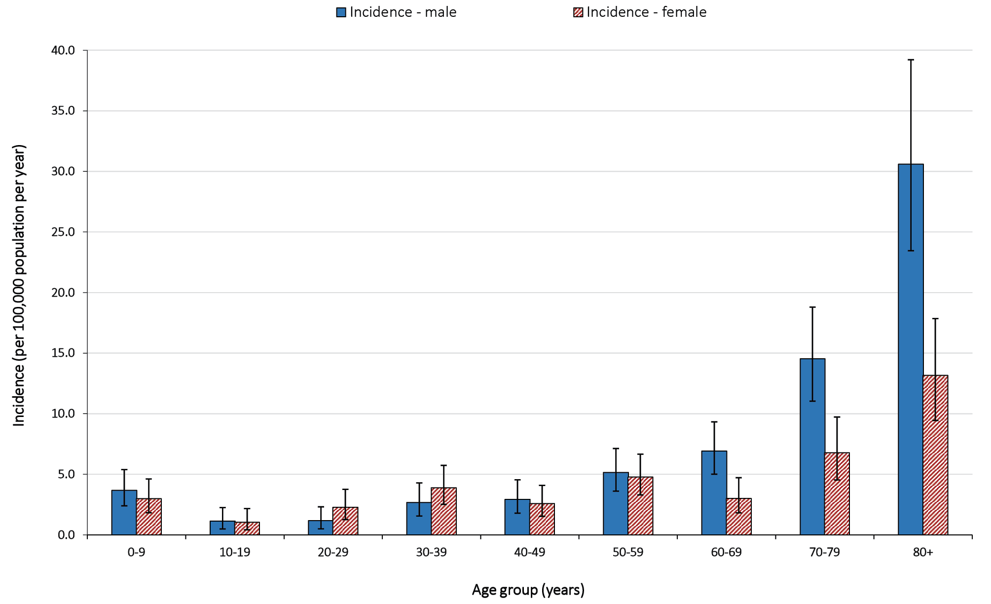

Seasonality and influenza
No statistically significant seasonal trend was found when examining aggregated data by quarters (p = 0.147). However, there was a notable increase in cases in late winter/early spring, particularly in 2017 (Appendix A, Figure A.1).
The number of GAS bacteraemia cases were compared with the number of influenza notifications in HNELHD over time. There appeared to be some visual association between GAS bacteraemia and influenza in later years, particularly in 2017 where high levels of both Influenza A and B were circulating (Figure 4). This was not seen in the earlier years of the study, notably in 2009, the year of the H1N1 ‘swine flu’ pandemic. Closer examination of years 2017 to 2019 demonstrated that the peak of GAS bacteraemia cases in 2017 mostly occurred in winter at a similar time to the peak in influenza notifications. GAS bacteraemia cases were less substantial in 2019, when Influenza A notifications were high but Influenza B notifications were not.
Figure 4: Number of annual influenza notifications and GAS bacteraemia cases in HNELHD, 1 January 2008 to 31 December 2019
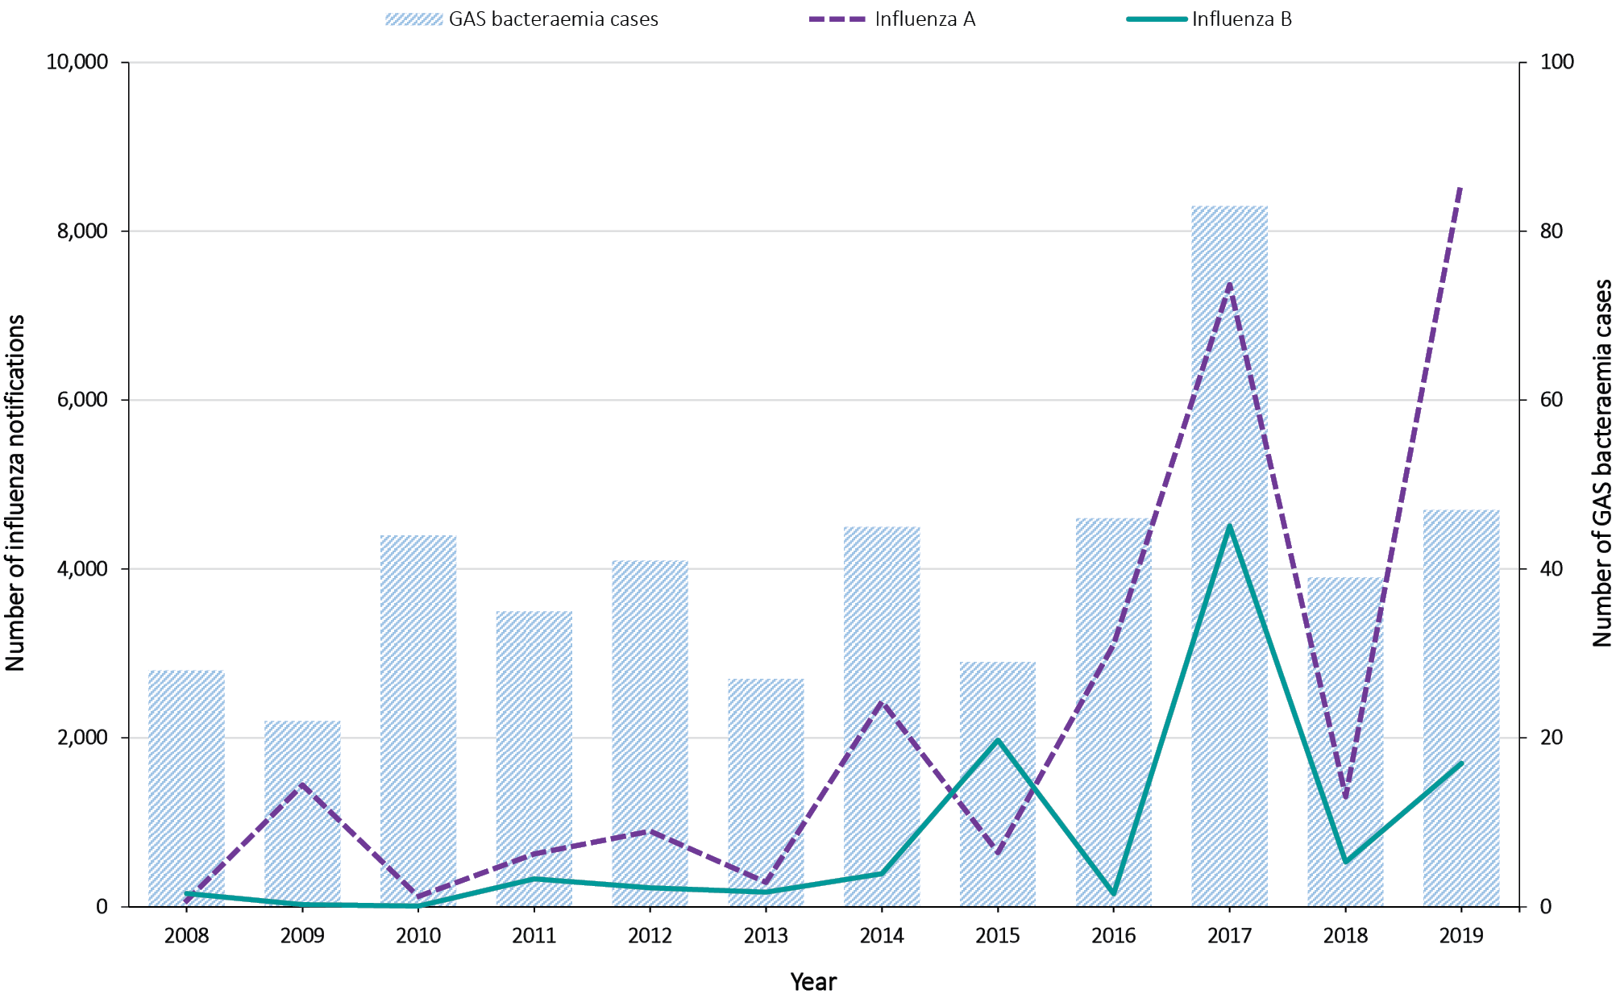

Clustering of cases and repeated episodes
There were only three separate instances where two cases occurred within the same residential care facilities. Two such case-pairs occurred within 30 days of each other, and one pair occurred within 90 days of each other.
Four patients each had two discrete episodes of GAS bacteraemia greater than 30 days apart with apparent recovery between episodes.

Severity and outcomes
Overall, 27.8% of cases (135/486) were admitted to a critical care unit and 12.6% of cases (61/486) died. There was no significant difference between females and males in outcomes of critical care admission or death (p = 0.96 and p = 0.81, respectively).
Mortality was significantly associated with older age (odds ratio, OR: 1.04; 95% CI: 1.02–1.05, for each year of age) (p < 0.001). Death occurred in approximately one-third of cases aged 80 years and over (31/103 [30.1%]); in approximately one-tenth of cases aged 40–59 year and 60–79 years (11/108 [10.2%] and 15/149 [10.1%] respectively); and in less than 4% of cases aged under 40 years.
Critical care admission was also significantly associated with age (p < 0.01). Approximately one-third of cases aged 40–59 year and 60–79 years (38/108 [35.2%] and 48/149 [32.2%] respectively), and one-quarter of cases aged 20–39 years and 80 years and over (17/65 [26.2%] and 26/103 [25.2%] respectively) were admitted to critical care. The proportion admitted was lowest in cases under 20 years but still substantial (6/61 [9.8%]).
When examined over time, the proportion of critical cases each year ranged from 11.4% to 37.9%, but was not significantly different (p = 0.23). The CFR was notably higher in 2010 (27.3%) but did not reach statistical significance (p = 0.11) (Figure 5).
Figure 5: Number and proportion of GAS bacteraemia cases who required critical care admission (ICU/HDU) or died in HNELHD, 1 January 2008 to 31 December 2019, by year
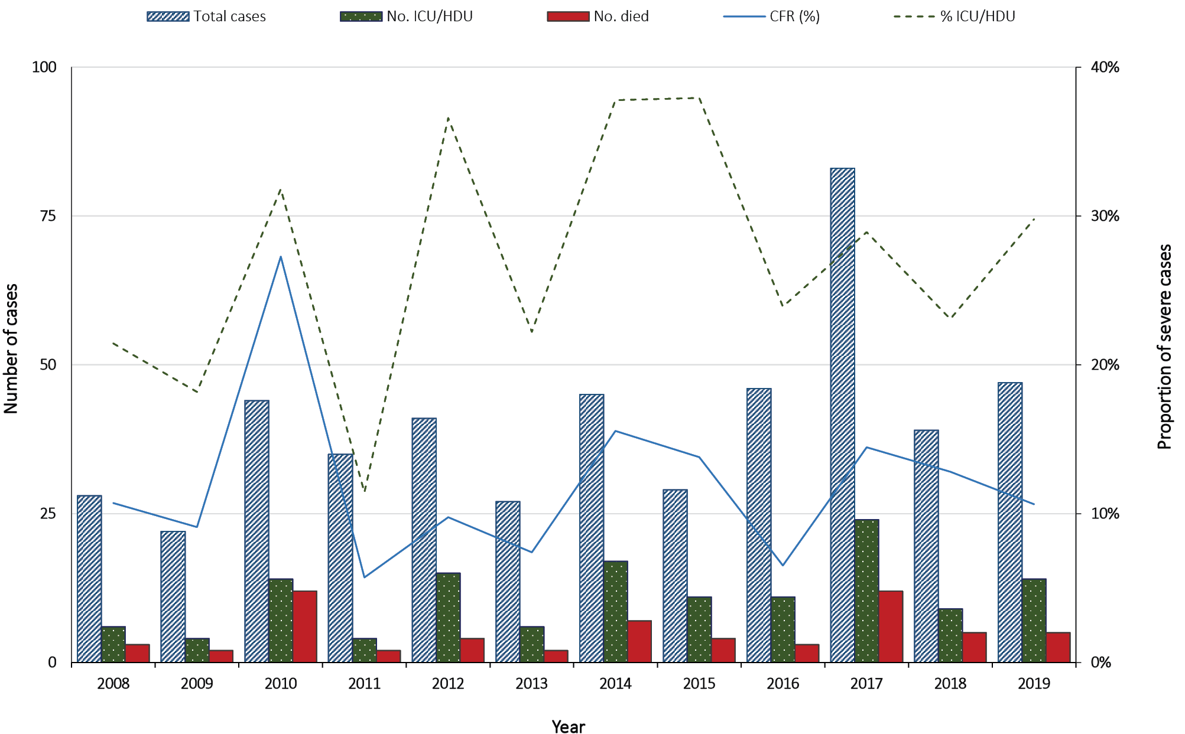

Impact of GAS bacteraemia on First Nations peoples in HNELHD
Of the 486 GAS bacteraemia cases in HNELHD between 1 January 2008 and 31 December 2019, forty-three cases (8.8%) identified as First Nations peoples. This gave a crude incidence rate of 7.25 cases per 100,000 population per year, with a peak of 18.9 cases per 100,000 population in 2017.
The median age was 36 years [IQR: 6–49 years]; 56% of cases were female. Incidence was not significantly different between females and males (8.09 vs 6.42 cases per 100,000 population per year; IRR: 0.79 [95% CI: 0.44–1.44]). Incidence was substantial across all age groups (≥ 4.98 cases per 100,000 population per year), with the highest age-specific incidence in children under 5 years old (12.02 cases per 100,000 population per year) and in adults 40 years and over (11.19 cases per 100,000 population per year) (Appendix A, Table A.1).
Twenty-one percent of cases were admitted to a critical care unit and 7% died. There were no significant differences in critical care admission or death by sex (p = 0.48 and p = 0.41, respectively) or age groups (p = 0.65 and p = 0.60, respectively). There was no statistically significant difference in outcomes of critical care admission (p = 0.62) or death (p = 0.66) between First Nations peoples and non-First Nations peoples when adjusted for age and sex; however, analysis was limited by small numbers.

Multivariate analysis for whole-of-study population
Year of infection, sex, age group, and First Nations status were included in the multivariate analysis and all were found to be significant predictors of incidence. Incidence gradually increased with each calendar year (adjusted IRR, aIRR: 1.04; 95% CI: 1.01–1.07). Incidence was higher in males than females (aIRR: 1.48; 95% CI: 1.21–1.82). Age overall was a significant predictor of incidence (p < 0.001). Incidence was significantly higher in the under 10 year age group, and in people aged 30 years and over, than in the 10–19 year age group. Incidence was highest in those aged 80 years and over, who were twenty times more likely to be diagnosed with GAS bacteraemia than 10–19 year olds (aIRR: 21.87; 95% CI: 12.96–36.93). First Nations peoples were more than two-and-a-half times as likely as non-First Nations peoples in HNELHD to be diagnosed with GAS bacteraemia (aIRR: 2.73; 95% CI: 1.98–3.76) (Table 2).

Discussion
The incidence of GAS bacteraemia in HNELHD gradually increased over the study period. Similar increases in iGAS have been seen in other Australian states and high-income countries.^{9,17–19} Where genotyping was available, it appeared that increases in other jurisdictions were not driven by a single emm-type.^{17,19} Further investigation is required to determine the cause of the HNELHD increase, and a follow-up genomic study of iGAS isolates in HNELHD is currently being conducted to explore potential virulence factors and to identify any genomic clustering.
The overall incidence rate of GAS bacteraemia in HNELHD (4.5 cases per 100,000 population per year) was higher than GAS bacteraemia and meningitis rates seen in Victoria (2.1 cases per 100,000 population per year),¹⁹ lower than GAS bacteraemia rates in the Northern Territory (15.2 cases per 100,000 population per year),⁹ and similar to iGAS notification rates in Queensland (4.5 cases per 100,000 population per year) and in other high-income countries.^{17,18,37} To ensure a consistent case definition, our study looked at blood culture specimens only; therefore, cases involving iGAS infections of other sterile sites (e.g. joint, deep tissue) without a concurrent bacteraemia were not captured. In a Canadian surveillance study, one-third of iGAS cases did not have bacteraemia, thus the incidence of all iGAS in HNELHD is likely to be higher than our estimate.¹²
Our study showed a significant peak in incidence in 2017, particularly over winter. A similar peak in 2017 was seen in Victoria and in a number of paediatric hospitals across Australia,^{19,38} and in the 2017/2018 winter in England.³⁹ While notification data suggested a possible association with influenza in HNELHD, this was unable to be fully explored.⁴⁰ This does support the consideration of promoting influenza vaccination to reduce the potential burden of iGAS.⁴¹ However, no obvious increase in GAS bacteraemia occurred in HNELHD in 2009, which was also a significant influenza year. A possible contributor may be the interaction between different GAS emm-types and influenza strains. Both influenza A (predominantly H3N2) and influenza B circulated at very high levels throughout the 2017 influenza season, while H1N1 was the major circulating strain during the 2009 ‘swine flu’ pandemic.^{42–44}
The overall proportion of cases admitted to critical care in HNELHD (27.8%) was similar to that reported in a study of GAS bacteraemia in the Northern Territory.⁹ The overall CFR of 12.6% in our study, and the association with age, were similar to findings in other studies in high-income countries.^{8–10,12} However, our study may have missed GAS bacteraemia cases who died before reaching hospital care and who did not have ante-mortem specimens available to confirm the diagnosis.⁴⁵ Also, our study did not capture non-bloodstream specimens from other sterile sites. Necrotising fasciitis, which carries a high mortality risk, is often diagnosed on deep tissue specimens obtained during surgical debridement while blood cultures may be negative.^{11,12}
The risk of GAS bacteraemia in HNELHD was higher in children under 5 years old, and in adults over 70 years old, particularly males, which is consistent with other studies.^{9,10,17,19,38} Similar age and sex distribution is also seen in sepsis from all causes in Australia.⁴⁶ While there are multiple reasons for increased susceptibility to serious bacterial infections at extremes of age,^{47,48} the reasons for the increased risk of GAS bacteraemia in males remain unclear.¹⁷⁻¹⁹
In HNELHD, First Nations peoples were significantly more likely to be affected by GAS bacteraemia. These findings were consistent with other Australian studies.^{9,16} Comparing First Nations peoples with a non-First Nations “reference group” is problematic, as discussed in the methods.³⁶ However, if policy-makers were to look at whole-of-population results alone, decisions regarding iGAS may prioritise older age groups only. Given the younger age distribution of First Nations populations in Australia generally, and the higher incidence of GAS bacteraemia across all ages within those populations, it is imperative that First Nations peoples of all ages are considered in guidelines and are not disempowered by policies that aim to reduce the impact of iGAS. Given the disproportionate impacts, a within-population focus is required to gain a better understanding of the epidemiology, and to guide the development of holistic models of care and implementation for First Nations peoples in Australia, led by First Nations peoples.
Prompt diagnosis and treatment is critical for improving outcomes from iGAS. Public health guidelines for the prevention, control and management of iGAS need to consider the priority populations identified in this study, and should be co-developed with First Nations peoples to ensure those guidelines serve their needs and priorities. Health services need to be culturally safe to ensure timely and appropriate care, and best outcomes. Culturally appropriate programs and approaches, determined by First Nations peoples, are needed to increase awareness of iGAS amongst community.
Currently, management of close contacts varies widely in Australia. Oliver et al. showed that the proportion of iGAS cases whose household contacts were offered prophylaxis, in selected paediatric hospitals, ranged from 0 to 81%.³⁸ National guidelines would improve the data needed to inform prophylaxis strategies and ensure consistent practice. Mandatory notification and routine genomic analysis should improve data; enable identification and investigation of outbreaks; and increase understanding of potential risk and virulence factors.
This study did not capture iGAS cases without concurrent bacteraemia nor those detected by private laboratories. Thus the true incidence and severity of iGAS in HNELHD is likely underestimated. The impact of GAS bacteraemia in First Nations peoples in HNELHD was also likely underestimated, as the study relied upon First Nations status completeness within public hospital admissions databases. Generally, inaccurate and incomplete recording of First Nations status is due to staff not asking the question, or asking inappropriately, or if patients do not wish to identify.^{29,31} Because GAS bacteraemia is uncommon, small case numbers meant that some differences between groups may not have been detected statistically. Data limitations restricted the exploration of other potential risk factors, such as comorbidities and influenza. Without typing of bacterial isolates, the clustering of cases could not be fully investigated.

Conclusions
GAS bacteraemia is uncommon but severe, and incidence in HNELHD has slowly increased. Risk of iGAS was higher in children under 5 years, adults over 70 years (particularly males), and First Nations peoples. Public health and clinical guidelines must address the physical, social and cultural needs of these priority populations. Routine surveillance and genomic analysis will help improve our understanding of iGAS and inform best public health management.

Acknowledgements
The authors gratefully acknowledge Amy Creighton, Leonie Garvey, Tara Harriden, Lesley Salem, Ann-Marie Thomas, and Belinda Tully for their wisdom and guidance; and Maree Buchanan, John Ferguson and Henry Han for providing data and advice.
KM Williamson undertook this study as part of the Australian National University Master of Philosophy in Applied Epidemiology (MAE) Program. The MAE Program is funded by Australian federal and state and territory health departments.

Declarations of interest
Nil conflicts of interest to declare.

Sources of funding
Nil sources of funding to declare.

Author details
Kirsten M Williamson^{1,2}
Hemalatha Varadhan³
Kylie Taylor¹
Kristy Crooks^{1,4}
Katie Brett¹
Charlee Law¹
Michelle Butler¹
Trent Butler³
Emily Green³
Joshua S Davis^{5,6}
Paul Wilson⁷
Tambri Housen^{2,6}
Tony Merritt¹
David N Durrheim^{1,6}
- Hunter New England Population Health, Hunter New England Local Health District, NSW, Australia
- National Centre for Epidemiology and Population Health, Australian National University, Acton, ACT, Australia
- NSW Health Pathology, John Hunter Hospital, Newcastle, NSW, Australia
- Menzies School of Health Research, Charles Darwin University, Darwin, NT, Australia
- Infectious Diseases, John Hunter Hospital, Newcastle, NSW, Australia
- School of Medicine and Public Health, University of Newcastle, Callaghan, NSW, Australia
- Calvary Mater Hospital, Newcastle, NSW, Australia

Corresponding author
Dr Kirsten M Williamson
Hunter New England Population Health, Locked Bag 10 Wallsend NSW Australia 2287
Email: Kirsten.Williamson@health.nsw.gov.au

References
- Johansson L, Thulin P, Low DE, Norrby-Teglund A. Getting under the skin: the immunopathogenesis of Streptococcus pyogenes deep tissue infections. Clin Infect Dis. 2010;51(1):58–65. doi: https://doi.org/10.1086/653116.
- Nobbs AH, Lamont RJ, Jenkinson HF. Streptococcus adherence and colonization. Microbiol Mol Biol Rev. 2009;73(3):407–50. doi: https://doi.org/10.1128/MMBR.00014-09.
- Metzgar D, Zampolli A. The M protein of group A Streptococcus is a key virulence factor and a clinically relevant strain identification marker. Virulence. 2011;2(5):402–12. doi: https://doi.org/10.4161/viru.2.5.16342.
- McMillan DJ, Drèze PA, Vu T, Bessen DE, Guglielmini J, Steer AC et al. Updated model of group A Streptococcus M proteins based on a comprehensive worldwide study. Clin Microbiol Infect. 2013;19(5):E222–9. doi: https://doi.org/10.1111/1469-0691.12134.
- Northern Territory Government Department of Health (NT Health). Public Health Management of Invasive Group A Streptococcal Disease in the Northern Territory Guideline. (Version 2.0.) Darwin: NT Health; 18 May 2022. Available from: https://health.nt.gov.au/__data/assets/pdf_file/0009/1111122/invasive-group-A-streptococcal-disease-northern-territory-guidelines.pdf.
- Walker MJ, Barnett TC, McArthur JD, Cole JN, Gillen CM, Henningham A et al. Disease manifestations and pathogenic mechanisms of group A Streptococcus. Clin Microbiol Rev. 2014;27(2):264–301. doi: https://doi.org/10.1128/CMR.00101-13.
- Therapeutic Guidelines (eTG). Directed therapy for bloodstream infections, including sepsis and septic shock. Streptococcus pyogenes bloodstream infections, including toxic shock syndrome. [Webpage.] West Melbourne: Therapeutic Guidelines Limited; April 2019. Available from: https://tgldcdp.tg.org.au/viewTopic?etgAccess=true&guidelinePage=Antibiotic&topicfile=bloodstream-infections-septic-shock-directed-therapy&guidelinename=Antibiotic&sectionId=toc_d1e1549#toc_d1e1549.
- Carapetis JR, Steer AC, Mulholland EK, Weber M. The global burden of group A streptococcal diseases. Lancet Infect Dis. 2005;5(11):685–94. doi: https://doi.org/10.1016/S1473-3099(05)70267-X.
- Gear RJ, Carter JC, Carapetis JR, Baird R, Davis JS. Changes in the clinical and epidemiological features of group A streptococcal bacteraemia in Australia’s Northern Territory. Trop Med Int Health. 2015;20(1):40–7. doi: https://doi.org/10.1111/tmi.12405.
- O’Loughlin RE, Roberson A, Cieslak PR, Lynfield R, Gershman K, Craig A et al. The epidemiology of invasive group A streptococcal infection and potential vaccine implications: United States, 2000–2004. Clin Infect Dis. 2007;45(7):853–62. doi: https://doi.org/10.1086/521264.
- Hollm-Delgado MG, Allard R, Pilon PA. Invasive group A streptococcal infections, clinical manifestations and their predictors, Montreal, 1995–2001. Emerg Infect Dis. 2005;11(1):77–82. doi: https://doi.org/10.3201/eid1101.030651.
- Davies HD, McGeer A, Schwartz B, Green K, Cann D, Simor AE et al. Invasive group A streptococcal infections in Ontario, Canada. Ontario Group A Streptococcal Study Group. N Engl J Med. 1996;335(8):547–54. doi: https://doi.org/10.1056/NEJM199608223350803.
- Nelson GE, Pondo T, Toews KA, Farley MM, Lindegran ML, Lynfield R et al. Epidemiology of invasive group A streptococcal infections in the United States, 2005–2012. Clin Infect Dis. 2016;63(4):478–86. doi: https://doi.org/10.1093/cid/ciw248.
- Bocking N, Matsumoto CL, Loewen K, Teatero S, Marchand-Austin A, Gordon J et al. High incidence of invasive group A streptococcal infections in remote Indigenous communities in Northwestern Ontario, Canada. Open Forum Infect Dis. 2016;4(1):ofw243. doi: https://doi.org/10.1093/ofid/ofw243.
- Hoge CW, Schwartz B, Talkington DF, Breiman RF, MacNeill EM, Englender SJ. The changing epidemiology of invasive group A streptococcal infections and the emergence of streptococcal toxic shock-like syndrome. A retrospective population-based study. JAMA. 1993;269(3):384–9. doi: https://doi.org/10.1001/jama.1993.03500030082037.
- Norton R, Smith HV, Wood N, Siegbrecht E, Ross A, Ketheesan N. Invasive group A streptococcal disease in North Queensland (1996 – 2001). Indian J Med Res. 2004;119(Suppl):148–51.
- Tyrrell GJ, Fathima S, Kakulphimp J, Bell C. Increasing rates of invasive group A streptococcal disease in Alberta, Canada; 2003–2017. Open Forum Infect Dis. 2018;5(8):ofy177. doi: https://doi.org/10.1093/ofid/ofy177.
- Public Health England. Laboratory surveillance of pyogenic and non-pyogenic streptococcal bacteraemia in England: 2019. (Health Protection Report: Volume 14 Number 24.) London: Government of the United Kingdom, Public Health England; 22 December 2020. Available from: https://webarchive.nationalarchives.gov.uk/ukgwa/20210216063045/https://www.gov.uk/government/publications/pyogenic-and-non-pyogenic-streptococcal-bacteraemia-annual-data-from-voluntary-surveillance.
- Oliver J, Wilmot M, Strachan J, St George S, Lane CR, Ballard SA et al. Recent trends in invasive group A Streptococcus disease in Victoria. Commun Dis Intell (2018). 2019;43. doi: https://doi.org/ 10.33321/cdi.2019.43.8.
- Vasant BR, Jarvinen KAJ, Fang NX, Smith HV, Jennison AV. Mass prophylaxis in an outbreak of invasive group A streptococcal disease in a residential aged care facility. Commun Dis Intell (2018). 2019;43. doi: https://doi.org/10.33321/cdi.2019.43.18.
- Mearkle R, Saavedra-Campos M, Lamagni T, Usdin M, Coelho J, Chalker V et al. Household transmission of invasive group A Streptococcus infections in England: a population-based study, 2009, 2011 to 2013. Euro Surveill. 2017;22(19):30532. doi: https://doi.org/10.2807/1560-7917.ES.2017.22.19.30532.
- Robinson KA, Rothrock G, Phan Q, Sayler B, Stefonik K, Van Beneden C et al. Risk for severe group A streptococcal disease among patients’ household contacts. Emerg Infect Dis. 2003;9(4):443–7. doi: https://doi.org/10.3201/eid0904.020369.
- Carapetis JR, Jacoby P, Carville K, Ang SJ, Curtis N, Andrews R. Effectiveness of clindamycin and intravenous immunoglobulin, and risk of disease in contacts, in invasive group A streptococcal infections. Clin Infect Dis. 2014;59(3):358–65. doi: https://doi.org/10.1093/cid/ciu304.
- Queensland Government Department of Health (Queensland Health). Invasive Group A Streptococcal Disease: Queensland Health Guidelines for Public Health Units. (Version 3.0.) [Webpage.] Brisbane: Queensland Health; October 2018. Available from: https://www.health.qld.gov.au/cdcg/index/igas.
- Australian Government Department of Health and Aged Care, Communicable Diseases Network Australia (CDNA). Invasive Group A Streptococcal (iGAS) Disease. Australian national notifiable diseases case definition. (Version 1.0.) Canberra: Australian Government Department of Health and Aged Care, CDNA; 1 July 2021. Available from: https://www.health.gov.au/sites/default/files/documents/2022/06/invasive-group-a-streptococcal-disease-igas-surveillance-case-definition.pdf.
- New South Wales Government Department of Health (NSW Health). Invasive group A streptococcal disease: NSW Control Guidelines for Public Health Units. (Version 2.0.) Sydney: NSW Health; 29 July 2022. Available from: https://www.health.nsw.gov.au/Infectious/controlguideline/Documents/invasive-group-a-streptococcus.pdf.
- NSW Health, Hunter New England Local Health District (HNELHD). Our District. [Webpage.] Sydney: NSW Health, HNELHD; 2020. Available from: http://www.hnehealth.nsw.gov.au/about/Pages/Our-District.aspx.
- Australian Bureau of Statistics. 2016 Census. [Webpage.] Canberra: Australian Bureau of Statistics; 11 April 2017. Available from: https://www.abs.gov.au/websitedbs/censushome.nsf/home/2016.
- HNELHD. Closing the Gap: Strategy and Performance Report 2018-2019. Sydney: NSW Health, HNELHD; 2019. Available from: https://www.hnehealth.nsw.gov.au/__data/assets/pdf_file/0017/401057/hne20closing20the20gap20report202018-19.pdf.
- Wilson PA, Varadhan H. Severe community-acquired pneumonia due to Streptococcus pyogenes in the Newcastle area. Commun Dis Intell (2018). 2020;44. doi: https://doi.org/10.33321/cdi.2020.44.82.
- NSW Health, Centre for Aboriginal Health. Policy Directive: Aboriginal and Torres Strait Islander Origin – Recording of Information of Patients and Clients. Sydney: NSW Health; 25 July 2012. Available from: https://www1.health.nsw.gov.au/pds/ActivePDSDocuments/PD2012_042.pdf.
- Australian Bureau of Statistics. Australian Standard Population 2001: Standard Population for use in Age-Standardisation - 30 June 2001. Canberra: Australian Bureau of Statistics; 20 March 2003. Available from: https://www.abs.gov.au/statistics/people/population/national-state-and-territory-population/dec-2022/31010DO003_200106.xlsx.
- Hosmer DW Jr, Lemeshow S. Applied Logistic Regression. New York: John Wiley & Sons, 1989.
- Thurber KA, Thandrayen J, Banks E, Doery K, Sedgwick M, Lovett R. Strengths-based approaches for quantitative data analysis: a case study using the Australian Longitudinal Study of Indigenous Children. SSM Popul Health. 2020;12:100637. doi: https://doi.org/10.1016/j.ssmph.2020.100637.
- Prussing E. Critical epidemiology in action: research for and by Indigenous peoples. SSM Popul Health. 2018;6:98–106. doi: https://doi.org/10.1016/j.ssmph.2018.09.003.
- Australian Government, Australian Institute of Health and Welfare (AIHW). Principles on the use of direct age-standardisation in administrative data collections: for measuring the gap between Indigenous and non-Indigenous Australians. Canberra: Australian Government, AIHW; September 2011. Available from: https://www.aihw.gov.au/getmedia/95237794-4b77-4683-9f00-77c4d33e0e7c/13406.pdf.
- Jayloni M, Wakefield A. Invasive Group A Streptococcal (iGAS) disease notifications in Queensland, 2006-2015. [Internal report; not available online.] Brisbane: Queensland Health; 2016.
- Oliver J, Thielemans E, McMinn A, Baker C, Britton PN, Clark JE et al. Invasive group A Streptococcus disease in Australian children: 2016 to 2018 – a descriptive cohort study. BMC Public Health. 2019;19(1):1750. doi: https://doi.org/10.1186/s12889-019-8085-2.
- Public Health England. Group A streptococcal infections: seasonal activity, 2017/18: second report. (Health Protection Report: Volume 12 Number 9.) London: Government of the United Kingdom, Public Health England; 9 March 2018. Available from: https://webarchive.nationalarchives.gov.uk/ukgwa/20220202090104/https:/www.gov.uk/government/publications/group-a-streptococcal-infections-activity-during-the-2017-to-2018-season.
- NSW Health. Guides and caveats for interpreting infectious diseases data. [Webpage.] Sydney: NSW Health, Communicable Diseases; 27 February 2017. Available from: https://www.health.nsw.gov.au/Infectious/diseases/Pages/guides-and-caveats.aspx.
- Lee SE, Eick A, Bloom MS, Brundage JF. Influenza immunization and subsequent diagnoses of group A streptococcus-illnesses among U.S. Army trainees, 2002–2006. Vaccine. 2008;26(27–28):3383–6. doi: https://doi.org/10.1016/j.vaccine.2008.04.041.
- NSW Health. Influenza Monthly Epidemiology Report, NSW: December 2017 (including a summary for the year 2017). Sydney: NSW Health; 2017. Available from: https://www.health.nsw.gov.au/Infectious/Influenza/Publications/2017/december-flu-report.pdf.
- Gilbert GL, Cretikos MA, Hueston L, Doukas G, O’Toole B, Dwyer DE. Influenza A (H1N1) 2009 antibodies in residents of New South Wales, Australia, after the first pandemic wave in the 2009 Southern Hemisphere winter. PLoS One. 2010;5(9):e12562. doi: https://doi.org/10.1371/journal.pone.0012562.
- NSW Health, Population Health Division. Influenza Monthly Epidemiology Report, NSW, Including H1N1 influenza 09, October 2009. Sydney: NSW Health; 2009. Available from: https://www.health.nsw.gov.au/Infectious/Influenza/publications/2009/october_report.pdf.
- Thompson KM, Sterkel AK, McBride JA, Corliss RF. The shock of strep: rapid deaths due to group A Streptococcus. Acad Forensic Pathol. 2018;8(1):136–49. doi: https://doi.org/10.23907/2018.010.
- Li L, Sunderland N, Rathnayake K, Westbrook JI. Epidemiology of Sepsis in Australian Public Hospitals: A Mixed Methods, National Longitudinal Study (2013–2018). Sydney: Australian Commission on Safety and Quality in Health Care; February 2020. Available from: https://www.safetyandquality.gov.au/sites/default/files/2020-05/epidemiology_of_sepsis_-_february_2020_002.pdf.
- Opal SM, Girard TD, Ely EW. The immunopathogenesis of sepsis in elderly patients. Clin Infect Dis. 2005;41(Suppl 7):S504–12. doi: https://doi.org/10.1086/432007.
- Randolph AG, McCulloh RJ. Pediatric sepsis: important considerations for diagnosing and managing severe infections in infants, children, and adolescents. Virulence. 2014;5(1):179–89. doi: https://doi.org/10.4161/viru.27045.

Appendix A: Supplementary materials
Figure A.1: Number of GAS bacteraemia cases in HNELHD, 1 January 2008 to 31 December 2019, by month and year
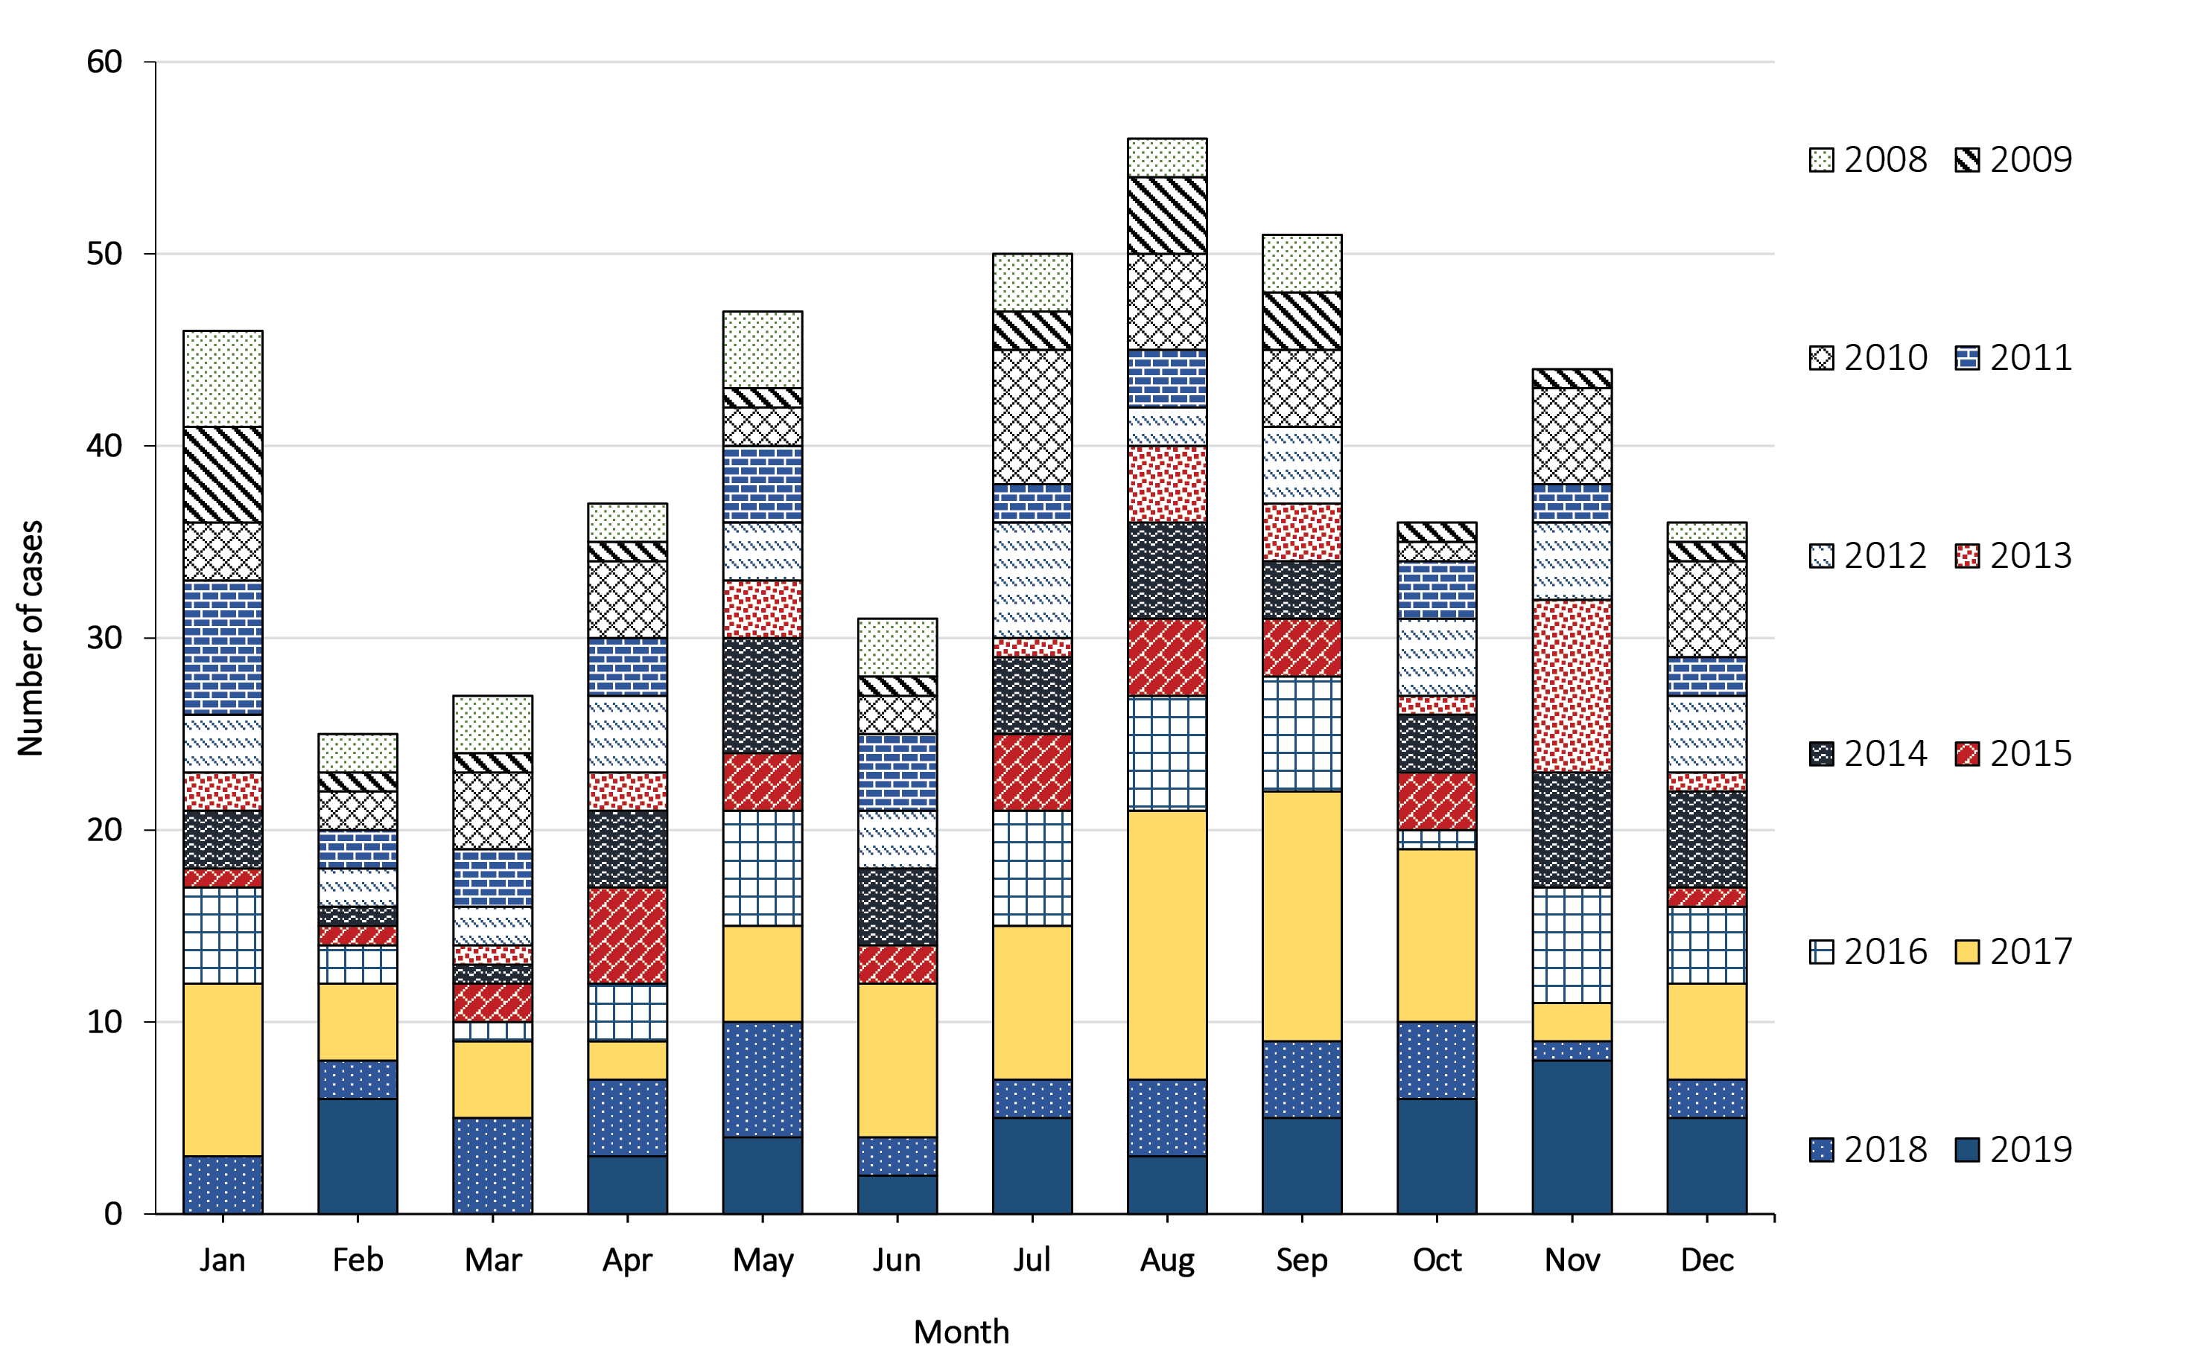

Table A.1: Number of cases, incidence rates and incidence rate ratios of GAS bacteraemia in First Nations peoples in HNELHD, 1 January 2008 to 31 December 2019, by sex and age group
Characteristic | Value or range | Number of cases (%) | Incidence rate  (per 100,000 per year) | IRR [95% CI]ª
Total cases |  | 43 (100.0) | 7.25 | —
Sex | Female | 24 (55.8) | 8.09 | Reference group
 | Male | 19 (44.2) | 6.42 | 0.79 [0.44–1.44]
Age group (years)^{b} | 0–19 | 14 (32.6) | 4.98 | Reference group
 | 20–49 | 19 (44.2) | 8.55 | 1.72 [0.86–3.42]
 | 50+ | 10 (23.3) | 11.22 | 2.25 [1.00–5.08]
a IRR: incidence rate ratio; 95% CI: 95% confidence interval. Significant IRR values (p < 0.05) are shown in italics.
b Age groups have been aggregated to minimise identification.

Communicable Diseases Intelligence
ISSN: 2209-6051 Online

Communicable Diseases Intelligence (CDI) is a peer-reviewed scientific journal published by the Office of Health Protection, Department of Health and Aged Care. The journal aims to disseminate information on the epidemiology, surveillance, prevention and control of communicable diseases of relevance to Australia.

Editor: Christina Bareja
Deputy Editor: Simon Petrie
Design and Production: Kasra Yousefi
Editorial Advisory Board: David Durrheim, Mark Ferson, Clare Huppatz, John Kaldor, Martyn Kirk, Meru Sheel and Steph Williams

Website: http://www.health.gov.au/cdi

Contacts
CDI is produced by the Office of Health Protection, Australian Government Department of Health and Aged Care, GPO Box 9848, (MDP 6) CANBERRA ACT 2601

Email: cdi.editor@health.gov.au

Submit an Article
You are invited to submit your next communicable disease related article to the Communicable Diseases Intelligence (CDI) for consideration. More information regarding CDI can be found at: http://health.gov.au/cdi.
Further enquiries should be directed to: cdi.editor@health.gov.au.

This journal is indexed by Index Medicus and Medline.

Creative Commons Licence - Attribution-NonCommercial-NoDerivatives CC BY-NC-ND
© 2023 Commonwealth of Australia as represented by the Department of Health and Aged Care
This publication is licensed under a Creative Commons Attribution-NonCommercial-NoDerivatives 4.0 International Licence from https://creativecommons.org/licenses/by-nc-nd/4.0/legalcode (Licence). You must read and understand the Licence before using any material from this publication.

Restrictions
The Licence does not cover, and there is no permission given for, use of any of the following material found in this publication (if any):
- the Commonwealth Coat of Arms (by way of information, the terms under which the Coat of Arms may be used can be found at www.itsanhonour.gov.au);
- any logos (including the Department of Health and Aged Care’s logo) and trademarks;
- any photographs and images;
- any signatures; and
- any material belonging to third parties.

Disclaimer
Opinions expressed in Communicable Diseases Intelligence are those of the authors and not necessarily those of the Australian Government Department of Health and Aged Care or the Communicable Diseases Network Australia. Data may be subject to revision.

Enquiries
Enquiries regarding any other use of this publication should be addressed to the Communication Branch, Department of Health and Aged Care, GPO Box 9848, Canberra ACT 2601, or via e-mail to: copyright@health.gov.au

Communicable Diseases Network Australia
Communicable Diseases Intelligence contributes to the work of the Communicable Diseases Network Australia.
http://www.health.gov.au/cdna

Hereafter, Aboriginal and/or Torres Strait Islander peoples are respectfully referred to as First Nations peoples of Australia, acknowledging that there are more than 500 First Nations across the country, each with its own diverse customs, culture and lore.

