Recent trends in invasive group A Streptococcus disease in Victoria
Jane Oliver, Mathilda Wilmot, Janet Strachan, Siobhan St George, Courtney R Lane, Susan A Ballard, Michelle Sait, Katherine Gibney, Benjamin P Howden and Deborah A Williamson

Abstract

Background
Invasive Group A Streptococcus (iGAS) disease can cause permanent disability and death. The incidence of iGAS has increased in many developed countries since the 1980s. iGAS disease is not nationally notifiable in Australia or at the state level in Victoria. The Victorian Hospital Pathogen Surveillance Scheme (VHPSS) is a voluntary laboratory-based surveillance system established in 1988. We assessed the trends and molecular epidemiology of iGAS disease in Victoria from 2007-2017.

Methods
A case of iGAS was defined as an individual for whom Group A Streptococcus (GAS) was isolated from a normally sterile body site. Data on all iGAS cases, as reported to the VHPSS, between 1 January 2007 and 31 December 2017 were examined.

Results
A total of 1,311 iGAS cases had associated isolates, and M Protein Gene (emm) typing was performed for 91.6%. The mean annual incidence was 2.1 (95% CI: 1.8-2.5) per 100,000 population per year, increasing 2.7-fold over the study period. In total, 140 different iGAS emm-types were observed, with the 10 most prevalent types comprising 63.1% of the sample.

Conclusions
Despite limitations in this surveillance data, we observed increasing rates of iGAS disease in Victoria. iGAS incidence exceeded the mean annual incidence for invasive meningococcal disease, calculated using Victorian data from the National Notifiable Diseases Surveillance System (2.1 vs. 0.6 cases per 100,000 population per year, respectively). Mandatory case notification could enhance disease control and prevention. Further, the diversity in emm-types emphasises the importance of effective secondary chemoprophylaxis in prevention, alongside GAS vaccine development.
Keywords: Invasive disease, group A Streptococcus, invasive group A Streptococcus disease, Victoria public health, disease control, surveillance, disease prevention, infectious diseases, epidemiology

Introduction
GAS is a major human pathogen. GAS infections are associated with considerable global morbidity and mortality. In particular, invasive Group A Streptococcus (iGAS) disease (when GAS is isolated from a normally sterile body site) has been associated with case fatality rates of around 15% in developed countries and higher still in developing countries.¹ Those at highest risk of iGAS disease include the very young and elderly, Indigenous populations, and patients with medical co-morbidities such as diabetes, immunosuppression, obesity and malignancy.^{1,2} Further, the incidence of iGAS disease varies geographically, with reported annual rates of between 2 and 4 cases per 100,000 population per year in developed countries, including Canada, the United Kingdom (UK) and the United States (USA).³⁻⁵ Data from several regions suggest that the incidence of iGAS disease has increased since the 1980s, following a decline over the previous century.⁶⁻¹³
A recent study from the UK demonstrated that household contacts of an iGAS case (defined as someone who had direct person-to-person contact with the case in their household during the 7 days before the case’s onset of illness ) have a considerably increased risk of subsequently developing iGAS themselves (secondary iGAS disease).¹⁴ These authors observed an approximately 2,000-times increased risk of iGAS disease in the close contacts of index cases (RR: 1,940, 95% CI; 1,240-2,880) compared with the background risk. Assuming that index cases were notified quickly and effective chemoprophylaxis could be provided, it was estimated that the number of close contacts needed to treat (NNT) in order to prevent one secondary iGAS case was 407 (95% confidence interval, CI: 273–807). The NNT was much lower for mother-neonate pairs and cohabitating couples aged 75+ years old, however, at 50 (95% CI: 27-393) and 82 (95% CI: 46-417) respectively.¹⁴
iGAS disease is notifiable to public health authorities in several developed countries, including Canada, Sweden, UK, and the USA.^{10,15-17} In Australia, iGAS disease is not nationally notifiable, although it is notifiable in Queensland and the Northern Territory. There are no national Australian guidelines regarding the prevention of secondary iGAS disease, and jurisdictional variation in chemoprophylaxis recommendations exists (Table 1).

Table 1. A summary of clinical guidelines concerning the management of household contacts of severe invasive group A Streptococcus disease index cases
Area guidelines are intended for use (Reference) | iGAS disease notifiable to public health authorities (Yes/No) | Guideline recommendations summary
Australian State Guidelines
Queensland¹⁸ | Yes | All household contacts should receive a fact sheet about iGAS symptoms. Chemoprophylaxis is recommended for mother-neonate pairs in the neonatal period (and for the neonatal twin, if applicable). If there are 2 or more cases of iGAS within a 30 day time period then the entire household (or all residents and staff of the affected institution) should be issued chemoprophylaxis and provided with the iGAS fact sheet.
New South Wales¹⁹ | No (Unless ≥2 related cases occur) | Close contacts should receive information about GAS (e.g. Maternal sepsis fact sheet (http://www.health.nsw.gov.au/Infectious/factsheets/Pages/maternalsepsis.aspx)) and have a heightened awareness of the signs and symptoms of GAS for 30 days after the diagnosis of invasive GAS in the index patient. They should be advised to seek medical advice if they develop symptoms. Chemoprophylaxis of index cases’ household contacts may be considered if there is:  - A household with 2 or more diagnoses of iGAS linked temporally,  - Close contacts with increased susceptibility to severe infection, such as injecting drug users.  - Close contacts with symptoms suggestive of localized GAS infection such as sore throat, fever, skin infection.
Victoria²⁰ | No²⁰ | At present, the role of antibiotic prophylaxis for close contacts of cases of invasive GAS infection is not established. In certain circumstances, antibiotic therapy may be appropriate for those at higher risk of infection (as left to clinical discretion). Some hospital guidelines recommend antibiotic prophylaxis for close contacts (e.g. Royal Children’s Hospital Melbourne).
Western Australia | No | No State guidelines identified.
Northern Territory²¹ | Yes²¹ | All close contacts of patients with iGAS infection should be advised that they are at increased risk of iGAS infection in the next 30 days, and should be aware of the symptoms and of the importance of seeking medical attention promptly should these occur. Chemoprophylaxis is recommended for iGAS cases’ household (and homeless) contacts when:  - Mother-neonatal pair is affected (or neonatal twins)  - iGAS index case has severe disease  - Last contact with case was during the period 7 days before onset of symptoms up until 24 hours after the case’s commencement of effective antibiotic treatment.
Tasmania | No | No State guidelines identified.
South Australia | No | No State guidelines identified.
National Guidelines
USA²² | Yes²³ | Active surveillance of iGAS needs to continue. No definite recommendations made regarding chemoprophylaxis for household contacts of persons with invasive GAS infection. More data needed to assess risk of subsequent cases and determine optimal chemoprophylaxis regimen. For now, clinicians should base chemoprophylatic decisions on their risk assessment of iGAS disease risk in household contacts for each individual case.
UK²⁴ | Yes²⁵ | Provide iGAS fact sheet to household contacts to inform them of iGAS disease symptoms to watch for and seek treatment if signs/symptoms of iGAS disease appear. If household contact has symptoms of GAS infection, or is mother-neonate pair, provide chemoprophylaxis (and hospitalisation, if symptoms of severe disease occur). If there are two or more cases of iGAS within a 30 day time period from index case presentation, then the entire household should be issued chemoprophylaxis and the iGAS fact sheet.
Canada⁴ | Yes²⁶ | Chemoprophylaxis should be offered to household contacts of severe iGAS disease cases if they have been exposed to the case during the period of 7 days before onset of symptoms up until 24 hours after the case’s commencement of antimicrobial therapy. Alert household contacts to signs/symptoms of iGAS disease (severe or otherwise), advise them to seek medical attention immediately should they develop clinical manifestations of GAS within 30 days of index case’s diagnosis.

The most recent epidemiological study of iGAS disease used 2002-2004 data to estimate a mean annual incidence of 2.7 (95% CI: 2.3–3.2) cases per 100,000 population per year in Victoria. This study identified a 2,011-times (95% CI: 413–5,929-times) increased risk of secondary infection for close contacts of cases, very similar to that identified by the UK study.^{14,27} An analysis of Victorian Hospital Pathogen Surveillance Scheme (VHPSS) data from 2005-2009 identified a mean annual total of 86 iGAS isolates, and the 5 most common emm-types ( emm- 1, -73, -41, -69, -89) comprised 54.7% of the total sample.²⁸
Of recent concern is an increase in paediatric iGAS disease in Victoria, with more children hospitalised during the winter of 2017 alone than were reported for either of the preceding 2 years.²⁹ To date however, there are no contemporary systematic data on temporal trends of iGAS disease in Victoria, and knowledge of the circulating GAS strains associated with iGAS disease is limited. Furthermore, the burden of secondary infection is unknown. Accordingly, using data from a longstanding laboratory-based surveillance system, we sought to assess the trends and molecular epidemiology of iGAS disease in Victoria, over an 11 year period, from 2007 to 2017.

Methods
Minimum risk ethics approval was obtained from the University of Melbourne Biomedical Sciences Human Ethics Advisory Group (ID: 1853000.1).

Setting, data sources and case definition
The VHPSS is a voluntary, laboratory-based surveillance system established at the Microbiological Diagnostic Unit Public Health Laboratory (MDU PHL) in 1988 to collect information on invasive cases of bacterial and fungal infections in the Victorian population. The VHPSS includes hospital- and community-acquired invasive infections detected in a range of public, private, metropolitan and regional laboratories using blood or cerebrospinal fluid specimens. At present, the VHPSS is the only public health surveillance system monitoring iGAS in Victoria. Basic data are available for cases reported through VHPSS, including age, sex, date of specimen collection, and name of the reporting laboratory. VHPSS coverage of all eligible blood cultures and cerebrospinal fluid isolates is estimated to have increased from around 60% in 2009²⁸ to around 80% in 2017.³⁰
A case of iGAS was defined as an individual for whom GAS was isolated from a blood or cerebrospinal fluid specimen. Data on iGAS cases reported to the VHPSS between 1 January 2007 and 31 December 2017 were extracted. All isolates which accompanied VHPSS reports underwent emm-typing at MDU PHL. VHPSS also collects data on invasive meningococcal disease (iMD) case isolates, which we obtained for the 11-year period. Data on iMD case notifications for Victoria was also obtained from the Australian National Notifiable Diseases Surveillance System (NNDSS).³¹

Microbiological analysis and molecular typing
Identification of GAS isolates was carried out at individual laboratories prior to specimens being sent to MDU PHL. Polymerase chain reaction (PCR) analysis and DNA sequencing of the emm gene was performed using previously described methods.³² Emm-types were assigned using the Blast- emm database at https://www2a.cdc.gov/ncidod/biotech/strepblast.asp

Statistical Analysis
Basic descriptive analyses were performed. When investigating whether there was a significant difference in reported proportions, the test of equal or given proportions was used. When calculating population-based iGAS and iMD incidence rates with 95% CI, population estimates based on census data (available from the Australian Bureau of Statistics website)³³ were used as denominator data. The Chi-squared test was used when investigating whether reported rates were significantly different. Differences in proportions and rates were considered statistically significant if p <0.05. Poisson regression models were used to investigate whether differences in the iGAS incidence varied according to age group, gender and year. Incidence rate ratios (IRR) were generated from univariate models, including univariate models stratified by age, and adjusted IRRs (aIRR) were generated from a multivariable model that included age group, gender and year (Stata v.14.³⁴).

Results

Descriptive epidemiology of cases and trends in iGAS incidence
Between 1 January 2007 and 31 December 2017, a total of 1,311 iGAS cases were identified through the VHPSS. The majority of patients (1,309/1,311; 99.8%) had bloodstream isolates and the remainder were from cerebrospinal fluid. Over one-quarter (27.9%) of cases were aged 70+ years old, with 20.4% of cases aged <20 years; 52.9% of cases were male. A statistically significant variation in the seasonal distribution of cases was not observed (p =0.0572, Chi-squared test).
The number of iGAS cases increased from 83 in 2007, to 220 in 2017 (Figure 1), an increase of 165%.
Figure 1. Annual numbers and incidence rates of invasive group A Streptococcus cases and invasive meningococcal disease cases, Victorian Hospital Pathogen Surveillance Scheme, 2007-2017
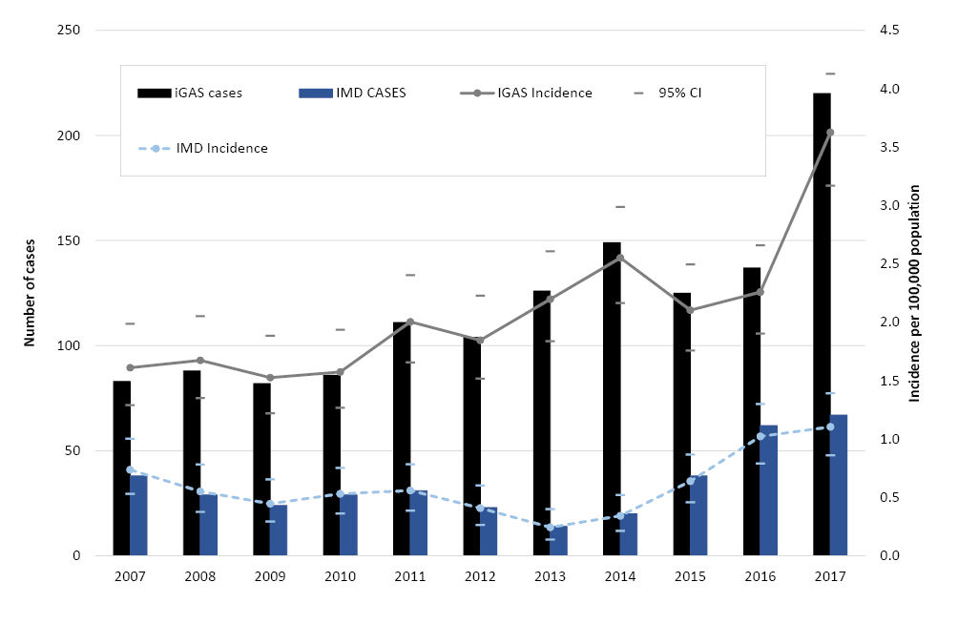
The peak annual incidence rate was 3.63 cases (95% CI: 3.17-4.13) per 100,000 population per year in 2017, a 67% increase from the previous year (p <0.05). The mean annual incidence was 2.11 cases (95% CI: 1.78-2.50) per 100,000 population per year. The incidence was 48% higher in the latter part of the study period (2013–2017) than earlier in the study period (2007–2012, IRR: 1.48, 95% CI: 1.33–1.66). People aged 60+ years had the highest iGAS incidence (4.7 per 100,000 population per year) followed by those aged <5 years (3.9 per 100,000 population per year). Overall, males had higher iGAS incidence than females (IRR: 1.14, 95% CI: 1.03-1.28), however this association was not consistent across age-groups. When stratified by age, among those aged 20–49 years, males had lower incidence than females (IRR: 0.57, 95% CI: 0.43-0.74). Conversely, among those aged 60+ years, males had higher incidence than females (IRR 1.54, 95% CI: 1.31-1.82; Figure 2, Table 2).
Figure 2. Age range and sex distribution of invasive group A Streptococcus cases as reported to the Victorian Hospital Pathogen Surveillance Scheme, 2007-2017
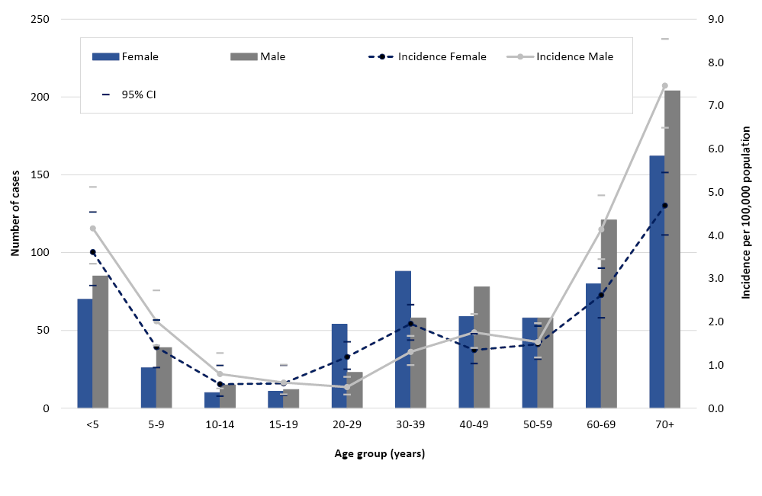

Table 2. Incidence rate ratio and 95% confidence interval of invasive group A Streptococcus disease isolates received at Victorian Hospital Pathogen Surveillance Scheme by year, age group and gender Abbreviations: IRR – incidence rate ratio, aIRR – adjusted incidence rate ratio, CI – confidence interval.
Factor¹ | Comparator | IRR (95% CI)
Univariate analysis
Year of isolate collection  2008  2009  2010  2011  2012  2013  2014  2015  2016  2017 | 2007 | 0.97 (0.72-1.31)  0.91 (0.68-1.24)  1.01 (0.75-1.35)  1.14 (0.85-1.51)  1.13 (0.85-1.50)  1.34 (1.02-1.76)  1.51 (1.16-1.97)  1.25 (0.95-1.65)  1.39 (1.06-1.82)  2.12 (1.65- 2.73)
Mean annual IRR change over study period | 1.07 (1.05-1.09)
Sex  Males (all ages)  Stratified by age-group  Males <5 years  Males 5-19 years  Males 20-39 years  Males 40-59 years  Males 60+ years | Female (all ages)  Females <5 years  Females 5-19 years  Females 20-39 years  Females 40-59 years  Females 60+ years | 1.14 (1.03-1.28)  1.15 (0.84-1.58)  1.33 (0.92-1.94)  0.57 (0.43-0.74)  1.20 (0.94-1.54)  1.54 (1.31-1.82)
Agegroup  5-19 years  20-39 years  40-59 years  60+ years | <5 years | 0.25 (0.20-0.32)  0.31 (0.26-0.39)  0.40 (0.33-0.49)  1.20 (1.00-1.43)
Multivariable analysis | aIRR (95% CI)
Year (average annual change)  Male  Age-group  5-19 years  20-39 years  40-59 years  60+ years | Female  <5 years | 1.07 (1.05-1.09)  1.18 (1.06-1.32)  0.26 (0.20-0.33)  0.32 (0.26-0.39)  0.41 (0.33-0.49)  1.20 (1.01-1.43)
Abbreviations: IRR – incidence rate ratio, aIRR – adjusted incidence rate ratio, CI – confidence interval.
1 Bold lettering indicates p<0.05.

Comparison with invasive meningococcal disease cases
In comparison to iGAS cases, the number of iMD cases reported to VHPSS (with blood and cerebrospinal fluid isolates only) increased from 38 cases in 2007 to 67 in 2017, a 76% increase, with the annual incidence rate peaking at 1.10 (95% CI: 0.86-1.39) per 100,000 population per year (Figure 1). The mean annual incidence rate for the whole study period was 0.60 cases (95% CI: 0.45-0.82) per 100,000 population per year. The annual number of iMD cases notified to the NNDSS for Victoria was also considerably lower than the number of iGAS cases reported to VHPSS throughout the study period, peaking at 89 cases in 2017 ( p <0.05).

Emm-type distribution by year
The majority of iGAS cases had emm-typing information available (N=1,202, 91.7%). A diverse array of 140 different emm-types was identified. The most common was emm-1 (n=274 isolates, 22.8%), followed by emm-89 (N=115, 9.6%, Figure 3).
Figure 3. Invasive group A Streptococcus emm types reported to the Victorian Hospital Pathogen Surveillance Scheme, 2007-2017
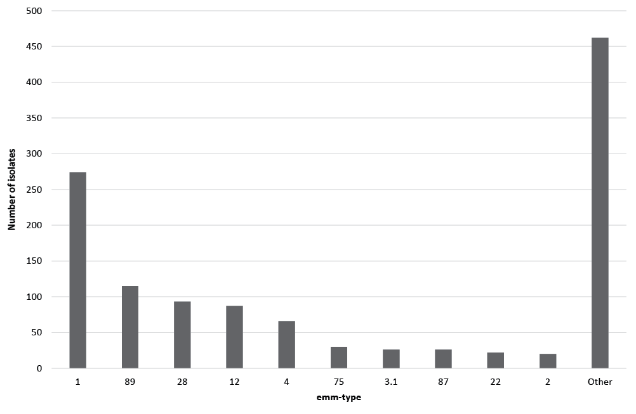
Emm-1 comprised the highest proportion of isolates each year. At most, 36.0% of all isolates were emm-1 in 2009. The lowest emm-1 prevalence was reached the following year (2010), at 16.9% (Supplementary Table 1).
The 10 most common emm-types (emm -1, -2, -3.1, -4, -12, -22, -28, -75, -87, -89) comprised 63.1% of the total sample (N=759). Despite the annual number of cases peaking in 2017 (Figure 1), this increase did not appear to be driven by any particular emm-type (Figure 4, Supplementary Table 1).

Figure 4. Invasive group A Streptococcus emm types as a proportion of the total annual emm types reported to the Victorian Hospital Pathogen Surveillance Scheme, 2007-2017
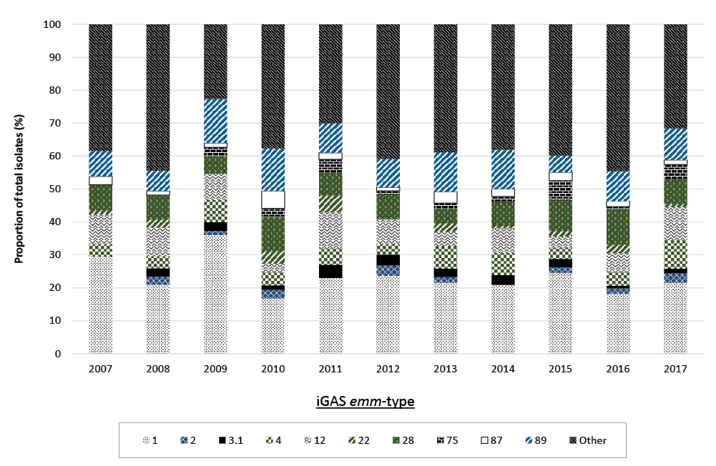

DISCUSSION
Based on data from the VHPSS, the iGAS incidence in Victoria increased over the period 2010-2017, peaking at 3.6 (95% CI: 3.2-4.2) per 100,000 population per year in 2017. This observation is consistent with increases in iGAS incidence across a range of countries with similar Human Development Indices to Australia, such as New Zealand, the US, UK, and Canada.^{4,9,11-13,35} The recent increase in iGAS disease is concerning, especially as our estimates likely undercount the true burden of disease by 20-40%, given the voluntary, passively collected surveillance data available from the VHPSS.²⁸ Why older males had the highest IRR of iGAS is unclear, but similar case distributions have been noted in a number of other studies.^{27,36,37}
Despite limitations in the surveillance data, in particular undercounting of iGAS cases, the annual incidence of iGAS exceeded the incidence of notified iMD over the entire study period. While case numbers for both conditions peaked in 2017, the number of iGAS cases was 2.5-times higher than iMD cases that year. This finding is consistent with Steer et al.’s 2012 observation that the rate of iGAS disease in industrialised countries is 2-4 times higher than the rate of meningococcal disease.³⁸ While both conditions share high case fatality rates and potential to cause lifelong disability^{39,40}, only iMD is presently notifiable in Victoria.⁴¹
Although efforts to develop a multivalent GAS vaccine targeting the M-protein (encoded by the emm gene) are in progress.^{42,43}, this study observed a diverse range of iGAS emm-types, with none in particular appearing to have driven the recent upsurge in cases. To illustrate, the 10 most prevalence emm-types comprised <60% of the total sample and 68% in 2017. These findings indicate the emergence of greater diversity in emm-types compared to the previous iGAS study that used VHPSS data from 2005-2009.²⁸ The emm-1 strain remained the most commonly identified in both studies.²⁸ Considerable diversity in GAS emm-types has also been reported for Africa and the Pacific region as a whole.⁴⁴ An iGAS study in Sydney in 2008 and 2010 identified somewhat greater diversity than our study, but was limited to 2 years of data collection. The authors identified 72 cases with 27 different emm-types ¹¹, while we identified 174 cases and 46 strains for the same years (Figure 4). Our results highlight the role of chemoprophylaxis in disease control, as an iGAS vaccine would need to have extremely broad coverage in order to effectively prevent all cases. The J8-DT vaccine may provide a promising means of generating broad protection against a diverse range of GAS strains.⁴⁵ This vaccine is still in development, but streptococcal infection following its administration in mice has been demonstrated to boost vaccine-induced immunity.⁴⁶ The recent data from the UK highlighted the potential benefits and challenges of chemoprophylaxis in preventing secondary iGAS cases.¹⁴ The evidence of increased risk of secondary disease among close contacts, in conjunction with rising incidence rates of iGAS, demonstrate the urgent public health need to make iGAS notifiable, both in Victoria and nationally. Potential benefits of making iGAS notifiable would include improved epidemiological surveillance; enhanced follow-up of cases - including contact tracing and chemoprophylaxis provision; and a requirement for laboratories to send isolates for additional characterisation. Ideally, this would encompass whole genome sequencing of isolates, which, in addition to in silico emm typing, would enable assessment of relatedness between isolates. This would provide a deeper understanding of possible outbreaks and/or transmission networks, as has been previously described overseas.¹⁴
In summary, high-quality surveillance information is needed to better inform effective control and prevention measures for this condition. Introducing a mandatory requirement for case notification, in conjunction with enhanced laboratory characterisation of isolates could facilitate such improvements.

Authors details and affiliations
Dr Jane Oliver (Epidemiologist)^{1,2}
Ms Mathilda Wilmot (Epidemiologist)¹
Ms Janet Strachan (Epidemiologist)¹
Ms Siobhan St George (Epidemiologist)¹
Ms Courtney R Lane (Epidemiologist)¹
Dr Susan A Ballard (Principal Scientist, Microbiological Diagnostic Unit Public Health Laboratory)¹
Dr Michelle Sait (Senior Scientist, Microbiological Diagnostic Unit Public Health Laboratory)¹
Dr Katherine Gibney (Infectious Diseases Physician and Medical Epidemiologist)^{1,3}
Prof. Benjamin P Howden (Director Of Microbiological Diagnostic Unit Public Health Laboratory)¹
Dr Deborah A. Williamson (Deputy Director of the Microbiological Diagnostic Unit Public Health Laboratory)¹
- Microbiological Diagnostic Unit Public Health Laboratory, Department of Microbiology and Immunology, The University of Melbourne at the Peter Doherty Institute for Infection and Immunity, 792 Elizabeth St, Melbourne, Victoria, Australia, 3000
- Murdoch Children’s Research Institute, Royal Children’s Hospital, 50 Flemington Rd, Parkville, Victoria, Australia, 3052
- The Royal Melbourne Hospital and The University of Melbourne, at the Peter Doherty Institute for Infection and Immunity, 792 Elizabeth St, Melbourne, Victoria, Australia, 3000

Corresponding author
Dr Deborah A. Williamson Email: deborah.williamson@unimelb.edu.au

References
- Carapetis JR, Steer AC, Mulholland EK, Weber M. The global burden of group A streptococcal diseases. Lancet Infect Dis. 2005;5(11):685-94.
- Factor SH, Levine OS, Schwartz B, Harrison LH, Farley MM, McGeer A, et al. Invasive group A streptococcal disease: risk factors for adults. Emerg Infect Dis. 2003;9(8):970-7.
- Lamagni TL, Neal S, Keshishian C, Alhaddad N, George R, Duckworth G, et al. Severe Streptococcus pyogenes infections, United Kingdom, 2003-2004. Emerg Infect Dis. 2008;14(2):202-9.
- Public Health Agency of Canada. Canada Communicable Disease Report. Guidelines for the Prevention and Control of Invasive Group A Streptococcal Disease. Ottawa, Canada: CCDR; 2006.
- O’Brien KL, Beall B, Barrett NL, Cieslak PR, Reingold A, Farley MM, et al. Epidemiology of invasive group a streptococcus disease in the United States, 1995-1999. Clin Infect Dis. 2002;35(3):268-76.
- Low DE, McGeer A, Schwartz B. The reemergence of severe group A streptococcal disease: an evolutionary perspective. Emerging Infections 1: American Society of Microbiology; 1998. p. 93-123.
- Moses AE, Ziv A, Harari M, Rahav G, Shapiro M, Englehard D. Increased incidence and severity of Streptococcus pyogenes bacteremia in young children. Pediatr Infect Dis J. 1995;14(9):767-70.
- Kaul R, McGeer A, Low DE, Green K, Schwartz B. Population-based surveillance for group A streptococcal necrotizing fasciitis: Clinical features, prognostic indicators, and microbiologic analysis of seventy-seven cases. Ontario Group A Streptococcal Study. Am J Med. 1997;103(1):18-24.
- Stockmann C, Ampofo K, Hersh AL, Blaschke AJ, Kendall BA, Korgenski K, et al. Evolving epidemiologic characteristics of invasive group a streptococcal disease in Utah, 2002-2010. Clin Infect Dis. 2012;55(4):479-87.
- National Collaborating Centre for Infectious Diseases. Disease Debrief: Group A Streptococcus. Winnipeg, Canada, 2018 [updated 2018 Feb 13]. Available from: https://nccid.ca/debrief/group-a-streptococcus/.
- Sivagnanam S, Zhou F, Lee AS, O’Sullivan MV. Epidemiology of invasive group A Streptococcus infections in Sydney, Australia. Pathology. 2015;47(4):365-71.
- Williamson DA, Morgan J, Hope V, Fraser JD, Moreland NJ, Proft T, et al. Increasing incidence of invasive group A streptococcus disease in New Zealand, 2002-2012: a national population-based study. J Infect. 2015;70(2):127-34.
- Environmental Science Research Ltd. Invasive Group A Streptococcal Infection in New Zealand, 2016. Porirua, New Zealand; 2017 Dec 13.
- Mearkle R, Saavedra-Campos M, Lamagni T, Usdin M, Coelho J, Chalker V, et al. Household transmission of invasive group A Streptococcus infections in England: a population-based study, 2009, 2011 to 2013. Euro Surveill. 2017;22(19).
- GOV.UK. Notifiable diseases and causative organisms: how to report. London, United Kingdom, 2010. Available from: https://www.gov.uk/guidance/notifiable-diseases-and-causative-organisms-how-to-report#list-of-notifiable-diseases.
- Centers for Disease Control and Protection. National Notifiable Diseases Surveillance System (NNDSS). Atlanta, United States, 2018. Available from: https://wwwn.cdc.gov/nndss/conditions/notifiable/2016/ .
- The Public Health Agency of Sweden. Notifiable diseases. Stockholm, Sweden, 2018 [updated 2018 Jul 10]. Available from: https://www.folkhalsomyndigheten.se/the-public-health-agency-of-sweden/communicable-disease-control/surveillance-of-communicable-diseases/notifiable-diseases/ .
- Queensland Government. Invasive Group A Streptococcal Disease. Queensland Health Guidelines for Public Health Units. Brisbane, Australia: Queensland Department of Health; 2017 [updated 2017 Aug 10; cited 2017 Aug 12]. Available from: https://www.health.qld.gov.au/cdcg/index/igas .
- New South Wales Government. Invasive Group A Streptococcus control guideline. Sydney, Australia, 2016 [updated 2016 Sep 16]. Available from: http://www.health.nsw.gov.au/Infectious/controlguideline/Pages/invasive-group-a-strep.aspx .
- Department of Health & Human Services. State Government of Victoria Australia. Streptococcal disease (Group A beta-haemolytic streptococcus). Melbourne, Australia, 2017. Available from: https://www2.health.vic.gov.au/public-health/infectious-diseases/disease-information-advice/streptococcal-disease.
- Centre for Disease Control, Northern Territory of Australia. Public health management of invasive group A streptococcal infection. Darwin, Australia, 2015 Nov. Available from: https://digitallibrary.health.nt.gov.au/prodjspui/bitstream/10137/1187/1/iGAS%20guidelines%20Nov%202015.pdf.
- The Working Group on Prevention of Invasive Group A Streptococcal Infections. Prevention of invasive group A streptococcal disease among household contacts of case-patients: is prophylaxis warranted? JAMA. 1998;279(15):1206-10.
- Centers for Disease Control and Protection. Group A Streptococcal (GAS) Disease. Atlanta, United States, 2016 [updated 2016 Sep 16]. Available from: https://www.cdc.gov/groupastrep/surveillance.html .
- Interim UK guidelines for management of close community contacts of invasive group A streptococcal disease. Commun Dis Public Health. 2004;7(4):354-61.
- Public Health England. Notifiable diseases and causative organisms: how to report. London, United Kingdom, 2010 [updated 2010 May 1]. Available from: https://www.gov.uk/guidance/notifiable-diseases-and-causative-organisms-how-to-report#list-of-notifiable-diseases.
- Public Health Agency of Canada. Reported cases of disease in Canada - Notifiable diseases on-line. 2017 [updated 2017 May 3]. Available from: http://diseases.canada.ca/notifiable/charts.
- O’Grady KA, Kelpie L, Andrews RM, Curtis N, Nolan TM, Selvaraj G, et al. The epidemiology of invasive group A streptococcal disease in Victoria, Australia. Med J Aust. 2007;186(11):565-9.
- Strachan J, Easton M, Zaia A, Tomita T, Hogg G. Group A streptococcal infections in Victoria 2005–2009. Vic Infect Dis Bull. 2010;13(3):78-81.
- Wong NX, Crawford N, Oliver J, McMinn A, Ching N, Baker C, et al. A cluster of paediatric invasive group A streptococcus disease in Melbourne, Australia coinciding with a high burden influenza season. J Ped Infect Dis. 2018;In press.
- St George S. Personal communication, May 26, 2018.
- Australian Government Department of Health. National Notifiable Diseases System. Canberra, Australia, 2018. [updated 2018 Jun 1]. Available from: http://www9.health.gov.au/cda/source/cda-index.cfm.
- Beall B, Facklam R, Thompson T. Sequencing emm-specific PCR products for routine and accurate typing of group A streptococci. J Clin Microbiol. 1996;34(4):953-8.
- Australian Bureau of Statistics. 3101.0 - Australian Demographic Statistics, Sep 2017 Canberra, Australia, 2017 [updated 2018 Mar 23; cited 2018 Apr 9]. Available from: http://www.abs.gov.au/AUSSTATS/abs@.nsf/DetailsPage/3101.0Sep%202017?OpenDocument.
- StataCorp. Stata Statistical Software: Release 14. College Station, TX: StataCorp LP; 2015.
- De Zoysa A, Coelho J, Daniel R, Dhami C, Kafatos G, Lamagni T, et al. Invasive group A streptococcal disease in the UK, 2008-2012 and molecular characterisation of isolates during enhanced surveillance. Int J Antimicrob Agents. 2013;42:S92.
- Rudolph K, Bruce MG, Bruden D, Zulz T, Reasonover A, Hurlburt D, et al. Epidemiology of Invasive Group A Streptococcal Disease in Alaska, 2001 to 2013. J Clin Microbiol. 2016;54(1):134-41.
- Nelson GE, Pondo T, Toews KA, Farley MM, Lindegren ML, Lynfield R, et al. Epidemiology of Invasive Group A Streptococcal Infections in the United States, 2005-2012. Clin Infect Dis. 2016;63(4):478-86.
- Steer AC, Lamagni T, Curtis N, Carapetis JR. Invasive group a streptococcal disease: epidemiology, pathogenesis and management. Drugs. 2012;72(9):1213-27.
- Parks T, Barrett L, Jones N. Invasive streptococcal disease: a review for clinicians. Br Med Bull. 2015;115(1):77-89.
- Pelton SI. The Global Evolution of Meningococcal Epidemiology Following the Introduction of Meningococcal Vaccines. J Adolesc Health. 2016;59(2 Suppl):S3-S11.
- Department of Health & Human Services. State Government of Victoria Australia. Notifiable conditions in Victoria Melbourne. Australia, 2016. Available from: https://webcache.googleusercontent.com/search?q=cache:9xsd-Fn4VT8J:https://www2.health.vic.gov.au/Api/downloadmedia/%257B727191F6-45C5-47B0-94F7-BDE2C9FCE7EF%257D+&cd=3&hl=en&ct=clnk&gl=au
- Baroux N, D’Ortenzio E, Smeesters P, Steer A. GAS emm-types probably involved in acute rheumatic fever. Glob Heart. 2014;(1):e37.
- Cannon J, Jack S, Wu Y, Zhang J, Geelhoed E, Baker M, et al. CANVAS Economic Evaluation of GAS Vaccine in Australia and New Zealand. Supplimentary Report, June 2016.
- Steer AC, Law I, Matatolu L, Beall BW, Carapetis JR. Global emm type distribution of group A streptococci: systematic review and implications for vaccine development. Lancet Infect Dis. 2009;9(10):611-6.
- Pandey M, Batzloff MR, Good MF. Mechanism of protection induced by group A Streptococcus vaccine candidate J8-DT: contribution of B and T-cells towards protection. PLoS One. 2009;4(4):e5147.
- Pandey M, Ozberk V, Langshaw EL, Calcutt A, Powell J, Batzloff MR, et al. Skin infection boosts memory B-cells specific for a cryptic vaccine epitope of group A streptococcus and broadens the immune response to enhance vaccine efficacy. NPJ Vaccines. 2018;3:15.

Supplementary Table
Supplementary Table 1. Number of iGAS emm-types received at the Victorian Hospital Pathogen Surveillance Scheme, 2007-2017
Year | Invasive GAS emm-type cases (N)
 | Emm-1 | Emm-2 | Emm-3.1 | Emm-4 | Emm-12 | Emm-22 | Emm-28 | Emm-75 | Emm-87 | Emm-89 | Other¹
2017 | 45 | 6 | 3 | 18 | 21 | 2 | 16 | 9 | 3 | 20 | 66
2016 | 22 | 2 | 1 | 5 | 7 | 3 | 13 | 1 | 2 | 11 | 54
2015 | 29 | 2 | 3 | 4 | 4 | 2 | 11 | 7 | 3 | 6 | 47
2014 | 28 | 0 | 4 | 9 | 10 | 1 | 10 | 2 | 3 | 16 | 51
2013 | 25 | 2 | 3 | 8 | 5 | 3 | 5 | 2 | 4 | 14 | 45
2012 | 22 | 3 | 3 | 3 | 7 | 0 | 7 | 1 | 1 | 8 | 38
2011 | 23 | 0 | 4 | 5 | 11 | 5 | 7 | 4 | 2 | 9 | 30
2010 | 13 | 2 | 1 | 3 | 2 | 3 | 8 | 2 | 4 | 10 | 29
2009 | 27 | 1 | 2 | 5 | 6 | 0 | 4 | 2 | 1 | 10 | 17
2008 | 17 | 2 | 2 | 3 | 7 | 2 | 6 | 0 | 1 | 5 | 36
2007 | 23 | 0 | 0 | 3 | 7 | 1 | 6 | 0 | 2 | 6 | 30
Total | 274 | 20 | 26 | 66 | 87 | 22 | 93 | 30 | 26 | 115 | 443
1 ‘Other’ includes 130 different emm-types, none of which were identified in >19 cases at most.

Communicable Diseases Intelligence
ISSN: 2209-6051 Online

Communicable Diseases Intelligence (CDI) is a peer-reviewed scientific journal published by the Office of Health Protection, Department of Health. The journal aims to disseminate information on the epidemiology, surveillance, prevention and control of communicable diseases of relevance to Australia.

Editor: Cindy Toms
Deputy Editor: Phil Wright
Editorial and Production Staff: Leroy Trapani and Kasra Yousefi
Editorial Advisory Board: David Durrheim, Mark Ferson, John Kaldor, Martyn Kirk and Linda Selvey

Website: http://www.health.gov.au/cdi

Contacts
Communicable Diseases Intelligence is produced by:
Health Protection Policy Branch, Office of Health Protection, Australian Government Department of Health
GPO Box 9848, (MDP 6) CANBERRA ACT 2601

Email: cdi.editor@health.gov.au

Submit an Article
You are invited to submit your next communicable disease related article to the Communicable Diseases Intelligence (CDI) for consideration. More information regarding CDI can be found at: http://health.gov.au/cdi.
Further enquiries should be directed to: cdi.editor@health.gov.au.

This journal is indexed by Index Medicus and Medline.

Creative Commons Licence - Attribution-NonCommercial-NoDerivatives CC BY-NC-ND
© 2019 Commonwealth of Australia as represented by the Department of Health
This publication is licensed under a Creative Commons Attribution-NonCommercial-NoDerivatives 4.0 International Licence from https://creativecommons.org/licenses/by-nc-nd/4.0/legalcode (Licence). You must read and understand the Licence before using any material from this publication.

Restrictions
The Licence does not cover, and there is no permission given for, use of any of the following material found in this publication (if any):
- the Commonwealth Coat of Arms (by way of information, the terms under which the Coat of Arms may be used can be found at www.itsanhonour.gov.au);
- any logos (including the Department of Health’s logo) and trademarks;
- any photographs and images;
- any signatures; and
- any material belonging to third parties.

Disclaimer
Opinions expressed in Communicable Diseases Intelligence are those of the authors and not necessarily those of the Australian Government Department of Health or the Communicable Diseases Network Australia. Data may be subject to revision.

Enquiries
Enquiries regarding any other use of this publication should be addressed to the Communication Branch, Department of Health, GPO Box 9848, Canberra ACT 2601, or via e-mail to: copyright@health.gov.au

Communicable Diseases Network Australia
Communicable Diseases Intelligence contributes to the work of the Communicable Diseases Network Australia.
http://www.health.gov.au/cdna

