Influenza epidemiology in patients admitted to sentinel Australian hospitals in 2017: the Influenza Complications Alert Network (FluCAN)
Allen C Cheng, Mark Holmes, Dominic E Dwyer, Sanjaya Senanayake, Louise Cooley, Louis B Irving , Graham Simpson, Tony Korman, Kristine Macartney, N Deborah Friedman, Peter Wark, Anna Holwell , Christopher C Blyth, Simon Bowler, John Upham, Grant W Waterer, Tom Kotsimbos and Paul M Kelly

Abstract
The Influenza Complications Alert Network (FluCAN) is a sentinel-hospital-based surveillance program that operates at sites in all jurisdictions in Australia. This report summarises the epidemiology of hospitalisations with laboratory-confirmed influenza during the 2017 influenza season.
In this observational surveillance system, cases were defined as patients admitted to any of the 17 sentinel hospitals with influenza confirmed by nucleic acid detection. Data are also collected on a frequency-matched control group of influenza-negative patients admitted with acute respiratory infection.
During the period 3 April to 31 October 2017 (the 2017 influenza season), 4,359 patients were admitted with confirmed influenza to one of 17 FluCAN sentinel hospitals. Of these, 52% were elderly (≥65 years), 14% were children (<16 years), 6.5% were Aboriginal and Torres Strait Islander peoples, 1.6% were pregnant and 78% had chronic comorbidities. A significant proportion were due to influenza B (31%). Estimated vaccine coverage was 72% in the elderly (≥65 years), 50% in non-elderly adults with medical comorbidities and 24% in children (<16 years) with medical comorbidities. The estimated vaccine effectiveness (VE) in the target population was 23% (95% CI: 7%, 36%).
There were a large number of hospital admissions detected with confirmed influenza in this national observational surveillance system in 2017, with case numbers more than twice that reported in 2016.
Keywords: Influenza, public health surveillance, influenza vaccines, vaccination coverage, vaccine effectiveness

Introduction
Influenza is a common respiratory virus that affects up to 5–10% of the population each year.¹ Although most infection with influenza results in a relatively mild self-limiting illness, the widespread transmission of this virus means that complications from influenza are a major cause of hospitalisation and death.^{2,3} In this report, we describe the epidemiology of hospitalisation with laboratory-confirmed influenza in the 2017 season in Australia.

Methods
The Influenza Complications Alert Network (FluCAN) is a national hospital-based sentinel surveillance system.⁴ Since 2011, the participating sites have been Canberra Hospital (ACT), Calvary Hospital (ACT), Westmead Hospital (NSW), John Hunter Hospital (NSW), Children’s Hospital at Westmead (NSW), Alice Springs Hospital (NT), Royal Adelaide Hospital (SA), Mater Hospital (Qld), Princess Alexandra Hospital (Qld), Cairns Base Hospital (Qld), Royal Hobart Hospital (Tas), The Alfred Hospital (Vic), Royal Melbourne Hospital (Vic), Monash Medical Centre (Vic), University Hospital Geelong (Vic), Royal Perth Hospital (WA), and Princess Margaret Hospital (WA). In 2017, additional specialist paediatric hospitals also participated, but data from these sites were not included in this report to facilitate comparisons with previous years. Ethical approval has been obtained at all participating sites and at Monash University. Hospital bed capacity statistics were obtained from each participating hospital, and national bed capacity was obtained from the last published AIHW report.⁵
An influenza case was defined as a patient admitted to hospital with influenza confirmed by nucleic acid testing (NAT). Surveillance is conducted from early April to the end of October (with follow-up continuing to the end of November) each year. Data on a frequency-matched group of test-negative controls were also collected. Admission or transfer to an intensive care unit (ICU) included patients managed in a high dependency unit (HDU). The onset date was defined as the date of admission except for patients where the date of the test was more than 7 days after admission, where the onset date was the date of the test. The presence of risk factors and comorbidities was ascertained from the patient’s medical record. Restricted functional capacity was defined as those who were not fully active and not able to carry out all activities without restriction prior to the acute illness.⁶
We examined factors associated with ICU admission using multivariable regression. Factors independently associated with ICU admission were determined using a logistic regression model with no variable selection process, as all factors were plausibly related to ICU admission.
The presentation delay was defined as the time from onset of illness to admission to hospital. The treatment delay was defined as the time from onset of illness to prescription of oseltamivir (in patients that received treatment). Patients were categorised into those that (a) did not receive oseltamivir (b) received oseltamivir within 2 days of symptom onset and (c) received oseltamivir more than 2 days of symptom onset. We modelled factors associated with length of hospital stay, including antiviral use, using a negative binomial regression. In this variant of a Poisson model, the coefficient represents the relative increase in hospital length of stay.
Vaccine coverage was estimated from the proportion of vaccinated individuals in test-negative controls in each age group, stratified by the presence of chronic comorbidities. Vaccine effectiveness was estimated from the odds ratio of vaccination in cases vs controls using the formula, with the odds ratio calculated from a conditional logistic regression, stratified by site and month and adjusted for age group, the presence of chronic comorbidities, pregnancy and Aboriginal or Torres Strait Islander ethnicity.

Results
During the period 3 April to 31 October 2017 (the 2017 influenza season), 4,259 patients were admitted with laboratory-confirmed influenza to the 17 FluCAN sentinel hospitals. The peak weekly number of admissions was in mid-August (week 35) (Figure 1). The majority of cases were due to influenza A (n=2,949, 69%). The proportion due to influenza B was similar across all jurisdictions, ranging from 19% in WA to 34% in NSW.

Figure 1: Date of admissionª in patients hospitalised with confirmed influenza
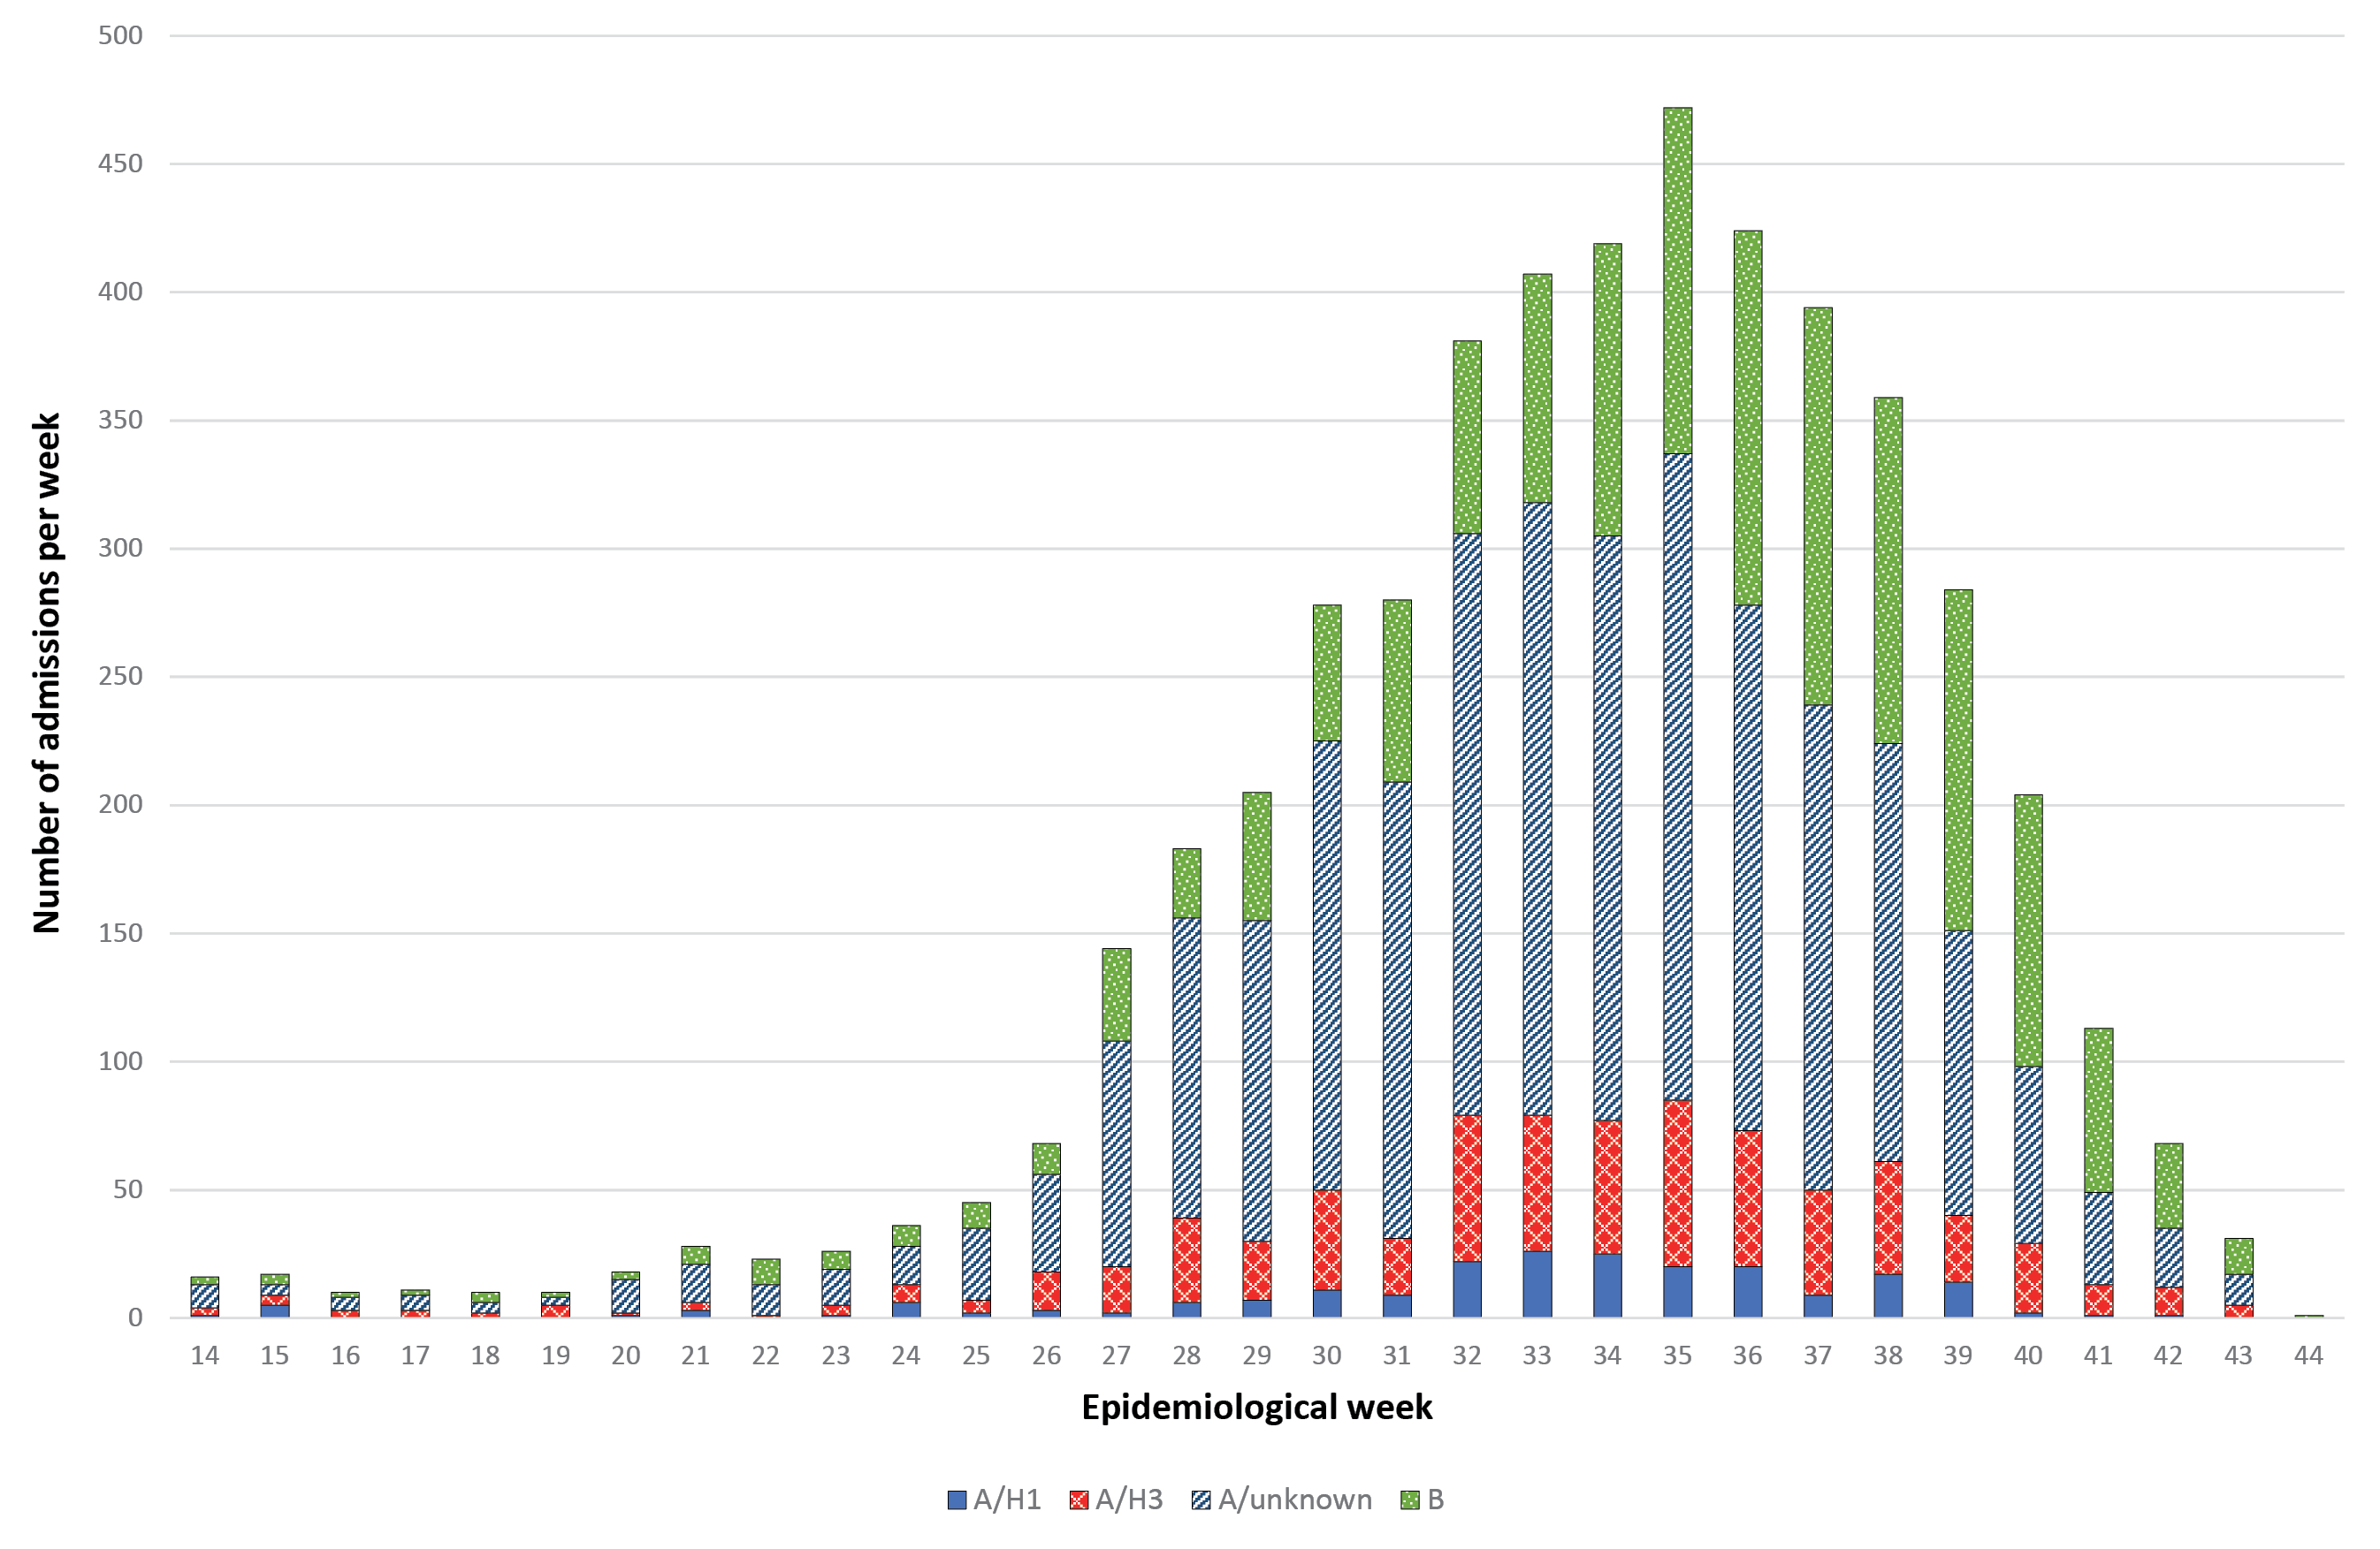
a By week beginning on listed date; representing date of admission (or date of influenza diagnosis if acquired >7 days in hospital).
Of these 4,259 patients admitted with confirmed influenza, 2,228 (52%) were >65 years of age, 587 (14%) were children (<16 years), 277 (6.5%) were Aboriginal and Torres Strait Islander peoples, and 3,310 (78%) had chronic comorbidities (Table 1; Table 2). There were 69 pregnant women which represented 16% of the 412 female patients aged 16–49, or 1.6% of the total. Of the 3,082 patients (73%) where influenza vaccination status was ascertained, 1,531 (50%) had been vaccinated.

Table 1: Demographic characteristics of hospitalised patients with confirmed influenza
 |  | Influenza type/subtype |  | Total
 | A/H1N1 | A/H3N2 | A/unknown | B
Number | 183 | 532 | 2,234 | 1,310 | 4,259
Age group
<16 years | 51 (27.9%) | 1 (0.2%) | 296 (13.2%) | 239 (18.2%) | 587 (13.8%)
16–49 years | 47 (25.7%) | 111 (20.9%) | 342 (15.3%) | 273 (20.8%) | 773 (18.1%)
50–64 years | 30 (16.4%) | 100 (18.8%) | 336 (15.0%) | 205 (15.6%) | 671 (15.8%)
65–79 years | 38 (20.8%) | 173 (32.5%) | 642 (28.7%) | 309 (23.6%) | 1,162 (27.3%)
80+ years | 17 (9.3%) | 147 (27.6%) | 618 (27.7%) | 284 (21.7%) | 1,066 (25.0%)
Maleª | 101 (55.2%) | 262 (49.2%) | 1,135 (50.8%) | 658 (50.3%) | 2,156 (50.6%)
Pregnant | 3 (1.6%) | 13 (2.4%) | 34 (1.5%) | 19 (1.5%) | 69 (1.6%)
Indigenous | 13 (7.1%) | 59 (11.1%) | 136 (6.1%) | 69 (5.3%) | 277 (6.5%)
Jurisdiction
ACT | 4 (2.2%) | 36 (6.8%) | 339 (15.2%) | 172 (13.1%) | 551 (12.9%)
NSW | 25 (13.7%) | 3 (0.6%) | 597 (26.7%) | 328 (25.0%) | 953 (22.4%)
NT | 10 (5.5%) | 59 (11.1%) | 57 (2.6%) | 57 (4.4%) | 183 (4.3%)
Qld | 30 (16.4%) | 61 (11.5%) | 282 (12.6%) | 120 (9.2%) | 493 (11.6%)
SA | 1 (0.5%) | 10 (1.9%) | 350 (15.7%) | 151 (11.5%) | 512 (12.0%)
Tas | 32 (17.5%) | 148 (27.8%) | 47 (2.1%) | 105 (8.0%) | 332 (7.8%)
Vic | 50 (27.3%) | 164 (30.8%) | 526 (23.5%) | 348 (26.6%) | 1,088 (25.5%)
WA | 31 (16.9%) | 51 (9.6%) | 36 (1.6%) | 29 (2.2%) | 147 (3.5%)
a Sex missing in two patients

Table 2: Risk factors, severity and outcomes in hospitalised adult patients with confirmed influenza
 | Not admitted to ICU | Admitted to ICU | Total
Pregnant | 64 (1.7%) | 5 (1.0%) | 69 (1.6%)
Chronic comorbidities | 2,903 (77.1%) | 407 (82.6%) | 3,310 (77.7%)
Chronic respiratory illness | 1,199 (31.8%) | 188 (38.1%) | 1,387 (32.6%)
Diabetes | 881 (23.4%) | 121 (24.5%) | 1,002 (23.5%)
Chronic liver disease | 156 (4.1%) | 22 (4.5%) | 178 (4.2%)
Immunosuppressed | 531 (14.1%) | 64 (13.0%) | 595 (14.0%)
Malignancy | 450 (11.9%) | 46 (9.3%) | 496 (11.6%)
Chronic cardiac disease | 1,408 (37.4%) | 170 (34.5%) | 1,578 (37.1%)
Obesity | 356 (9.5%) | 77 (15.6%) | 433 (10.2%)
Chronic neurological illness | 717 (19.0%) | 56 (11.4%) | 773 (18.1%)
Chronic renal disease | 453 (12.0%) | 67 (13.6%) | 520 (12.2%)
Nursing home resident | 270 (7.2%) | 15 (3.0%) | 285 (6.7%)
Received influenza vaccine | 1,395/2,752 (50.7%) | 136/330 (41.2%) | 1,531/3,082 (49.7%)
Influenza subtype
A/H1 | 152 (4.0%) | 31 (6.3%) | 183 (4.3%)
A/H3 | 486 (12.9%) | 46 (9.3%) | 532 (12.5%)
A/unk | 1,964 (52.2%) | 270 (54.8%) | 2,234 (52.5%)
B | 1,164 (30.9%) | 146 (29.6%) | 1,310 (30.8%)
In hospital mortality | 96/3,752 (2.6%) | 59/484 (12.2%) | 155/4,236 (3.7%)

Incidence of hospital admissions with influenza
Overall, the peak incidence of admissions with confirmed influenza was 5.9 per 100 hospital beds (Figure 2; in epidemiological week 35), but varied from a high of 14.5 per 100 hospital beds at the Royal Hobart Hospital to a low of 2.4 per 100 hospital beds at Royal Perth Hospital (Figure 3).

Figure 2: Incidence of confirmed influenza (per 100 hospital beds) by week
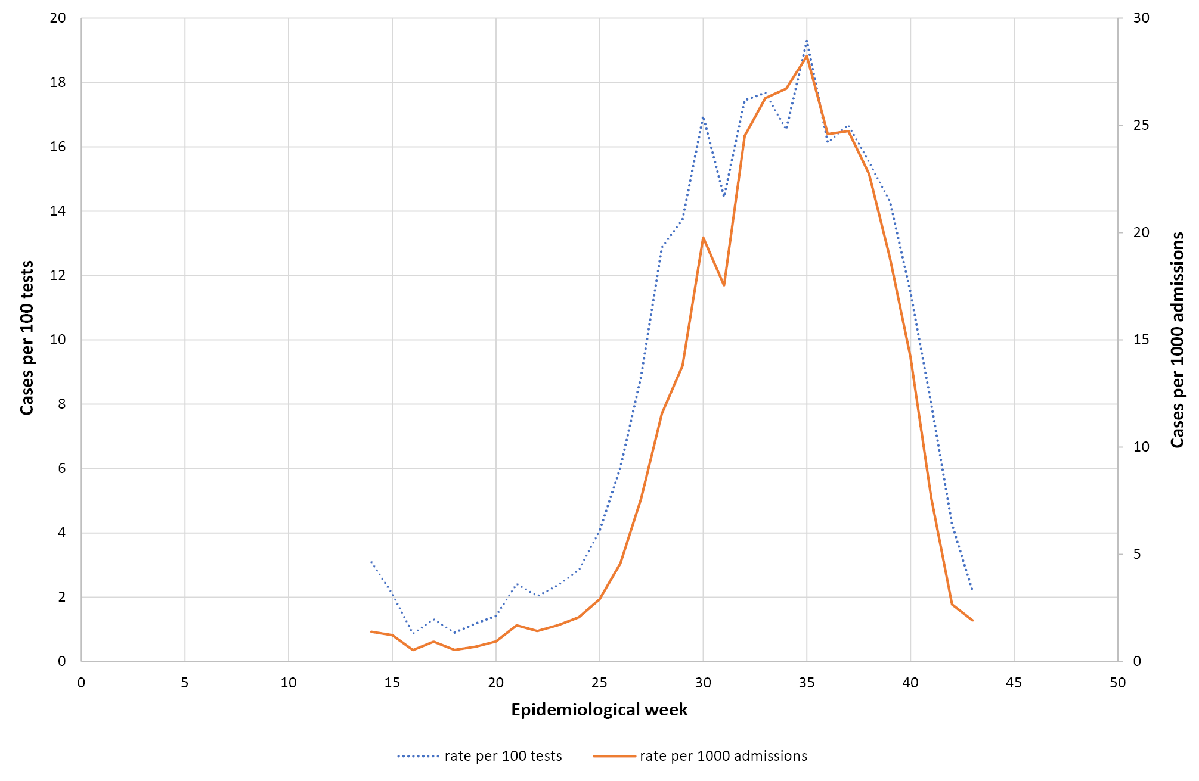

Figure 3: Peak incidence of confirmed influenza (per 100 hospital beds per week) by hospital
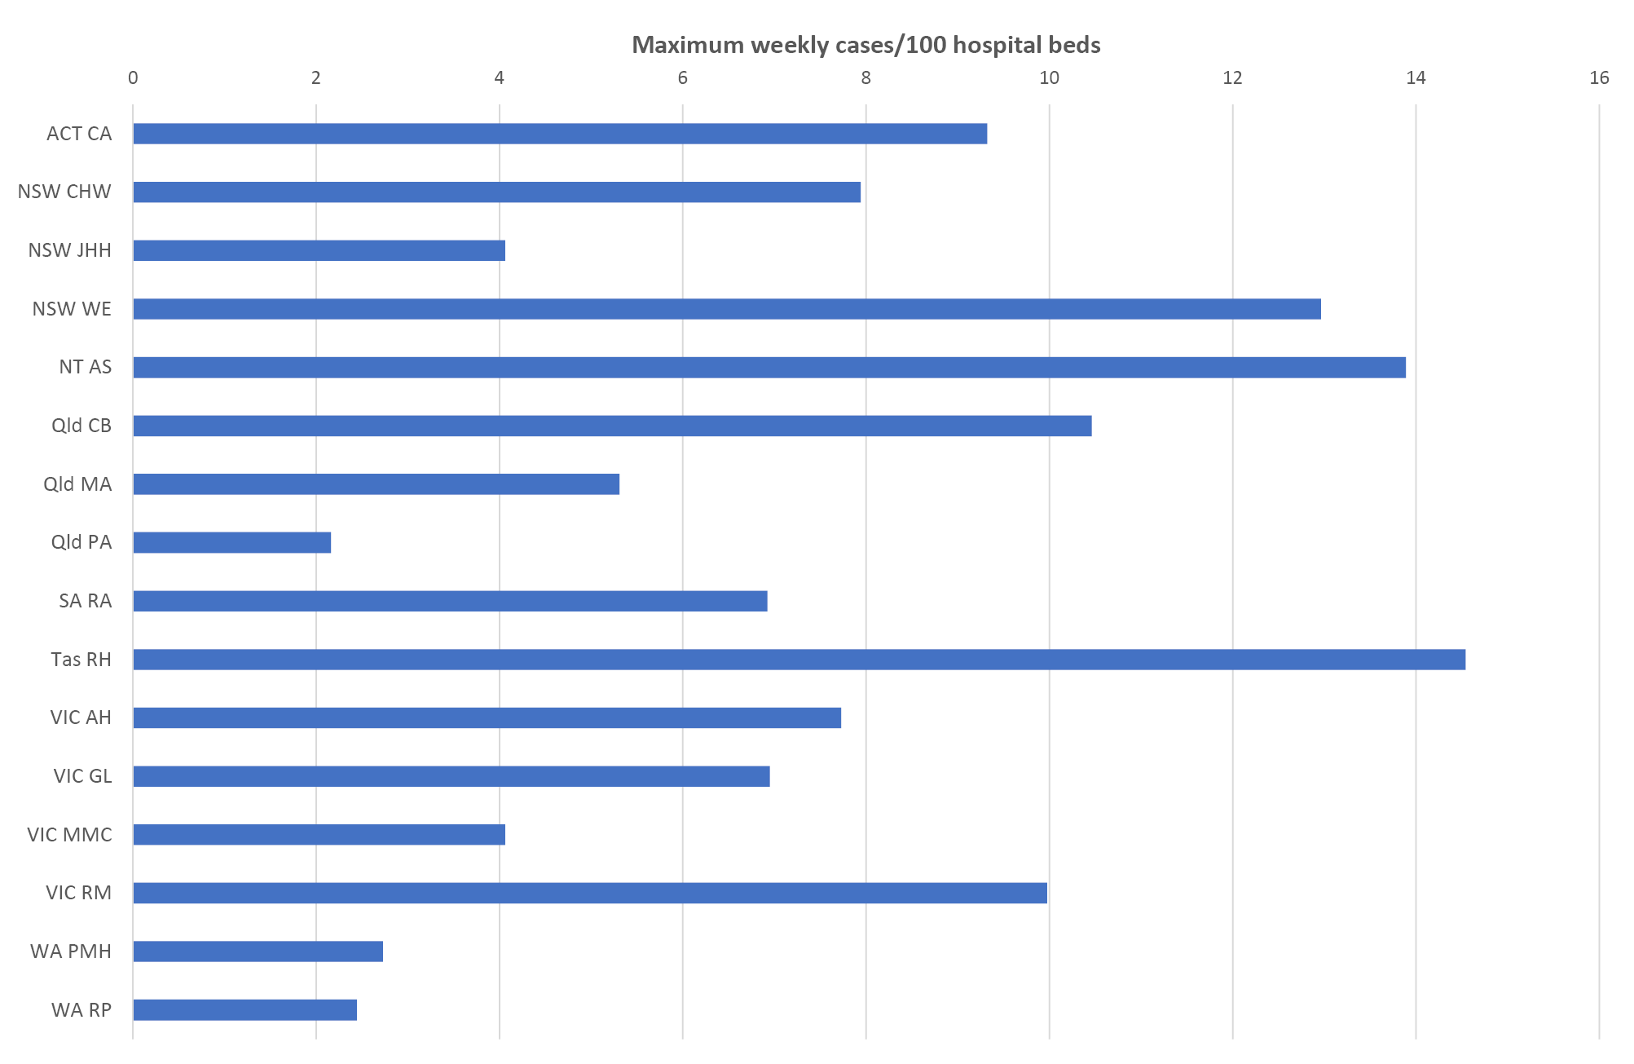
Hospital name abbreviation | Name
CA | Canberra and Calvary Hospitals
CHW | Children’s Hospital at Westmead
JHH | John Hunter Hospital
WE | Westmead Hospital
AS | Alice Springs Hospital
CB | Cairns Base Hospital
MA | Mater Hospital
PA | Princess Alexandra Hospital
RA | Royal Adelaide
RH | Royal Hobart Hospital
AH | Alfred Hospital
GL | University Hospital Geelong
MMC | Monash Medical Centre
RM | Royal Melbourne
PMH | Princess Margaret Hospital
RP | Royal Perth Hospital

Presentation and management
Of all cases, 3,920 patients had a known date of onset of illness documented. Of these, 263 cases (6.2%) were diagnosed more than 7 days after admission and therefore were likely to be hospital-acquired. For the remaining 3,657 patients with community-onset laboratory-confirmed influenza where the duration of symptoms was known, the median duration of symptoms prior to admission was 3 days (interquartile range (IQR): 2, 5 days). In these patients, the delay from onset of illness to admission was >2 days in 57%, and was similar in children (54%), non-elderly adults (58%) and the elderly (58%).
Radiological evidence of pneumonia was present in 754 patients (18%). Pneumonia was less common in children (11%) than in non-elderly adults (18%) and in the elderly (19%). A higher proportion of patients with pneumonia were admitted to ICU (25%) than those without pneumonia (8.7%).
Of all cases, 493 (11.6%) patients were admitted to ICU, including 408 patients (9.6%) initially admitted to ICU and a further 85 (2.0%) subsequently transferred to ICU after initial admission to a general ward. The elderly (>65 years) and residents of nursing homes were less likely, and those with chronic comorbidities were more likely to be admitted to intensive care. Compared to patients admitted to hospital with influenza B, patients admitted with confirmed A/H1 infection were more likely to be admitted to ICU after adjustment for age and other factors (Table 3).
Table 3: Factors associated with admission to intensive care in patients hospitalised with confirmed influenza
Variable | Crude OR | p value | Adjusted ORª | p value
Age
<16 years | 0.86 (0.65, 1.14) | 0.292 | 0.86 (0.61, 1.21) | 0.382
16–64 years | 1 (referent) |  | 1 (referent)
65+ years | 0.58 (0.47, 0.71) | <0.001 | 0.52 (0.42, 0.66) | <0.001
Medical comorbidities | 1.41 (1.10, 1.80) | 0.006 | 1.79 (1.37, 2.33) | <0.001
Aboriginal or Torres Strait Islander peoples | 1.00 (0.68, 1.46) | 0.99 | 0.89 (0.61, 1.32) | 0.575
Pregnancy | 0.59 (0.24, 1.48) | 0.262 | 0.42 (0.17, 1.07) | 0.069
Restricted functional status | 1.04 (0.87, 1.26) | 0.653 | 0.91 (0.72, 1.14) | 0.405
Nursing home resident | 0.41 (0.24, 0.69) | 0.001 | 0.44 (0.26, 0.76) | 0.003
Influenza type/subtype
A/H1 | 1.63 (1.07, 2.48) | 0.024 | 1.62 (1.05, 2.48) | 0.028
A/H3 | 0.75 (0.53, 1.07) | 0.113 | 0.80 (0.56, 1.15) | 0.226
A/unk | 1.10 (0.88, 1.36) | 0.401 | 1.15 (0.92, 1.42) | 0.215
B | 1 (referent) |  | 1 (referent)
a all variables included in multivariate model

Use of antivirals
Of patients where the date of onset was reported, 42% did not receive oseltamivir, 22% received oseltamivir within 2 days of symptom onset and 36% received oseltamivir more than 2 days after the onset of illness. Oseltamivir use was lower in children (6.7% within 2 days; 10% more than 2 days) than in non-elderly adults (22%, 37%) and the elderly (24%, 44%) (Table 4).

Table 4: Oseltamivir treatment, by age group in patients with confirmed influenza
Factor | Age <16 years | Age 16–64 years | Age 65+ years | p value
Number of patients | 528 | 1,273 | 1,899
Oseltamivir not received | 435 (83.2%) | 520 (41.1%) | 615 (32.5%) | <0.001
Oseltamivir received | 88 (16.8%) | 746 (58.9%) | 1,276 (67.5%) | <0.001
received <48h of onset | 35 (6.7%) | 278 (22.0%) | 452 (23.9%)
received ≥48h of onset | 53 (10.1%) | 468 (37.0%) | 824 (43.6%)
Delay between onset and admission, median (IQR) | 3 (1, 5) | 3 (2, 5) | 3 (2, 5) | 0.34
Delay between onset and treatment,ª median (IQR) | 3 (2, 6) | 3 (2, 5) | 3 (2, 5) | 0.74
Length of stay, median (IQR) | 2 (1, 3) | 3 (1, 5) | 4 (2, 7) | <0.001
a of patients who received oseltamivir

Outcome
The mean length of hospital stay for all patients was 6.2 days. Admission to ICU was associated with a mean hospital length of stay of 12.4 days, compared to those not admitted to ICU (5.5 days). Of the 4,236 patients where hospital mortality status was documented, 155 patients died (3.7%), which included 59 patients in ICU. Case fatality was higher in the elderly (5.8%) than in non-elderly adults (1.9%) and children (none). Of the 155 deaths, 151 (97%) occurred in patients with comorbidities. The case fatality of influenza-associated pneumonia was 10%, compared to 2.3% in those without pneumonia.
Length of hospital stay was shorter in patients that did not receive oseltamivir (median 2 days, IQR 1, 5 days), than those that received oseltamivir within 2 days (median 4 days, IQR 2, 8 days) or those who received oseltamivir after 2 days (median 4 days, IQR 2, 9 days; Kruskal-Wallis test p <0.001). In a multivariate negative binomial regression model, patients that received late antivirals had a longer length of hospital stay, after adjusting for other factors associated with length of stay including age group, chronic comorbidities and ICU admission (Table 5).
Table 5: Factors associated with length of stay in patients with confirmed influenza
Variable | Crude rate ratioª | p value | Adjusted rate ratio | p value
Oseltamivir treatment
no oseltamivir | 1 (referent) |  | 1 (referent)
received <48h of onset | 1.30 (1.12, 1.52) | 0.001 | 1.11 (0.98, 1.26) | 0.089
received ≥48h of onset | 1.54 (1.26, 1.89) | <0.001 | 1.21 (1.02, 1.44) | 0.028
Age group
<16 years | 0.69 (0.45, 1.05) | 0.085 | 0.78 (0.57, 1.06) | 0.112
16–64 years | 1 (referent) |  | 1 (referent)
65+ years | 1.28 (1.09, 1.50) | 0.003 | 1.30 (1.14, 1.49) | <0.001
Comorbidities | 1.70 (1.43, 2.03) | <0.001 | 1.43 (1.24, 1.66) | <0.001
ICU admission | 2.27 (1.82, 2.83) | <0.001 | 2.38 (1.91, 2.96) | <0.001
a Represents relative difference in length of stay; RR>1 indicates longer stay associated with factor
In the 3,669 patients where date of onset of illness and mortality status were reported, mortality was similar in patients that did not receive oseltamivir (44/1,566; 2.8%), those that received oseltamivir within 2 days (28/765; 3.7%) and those that received oseltamivir more than 2 days after onset (42/1,338; 3.14%).

Vaccine coverage and effectiveness
Vaccination status was ascertained in 3,082 of 4,259 cases (72 %) and 1,240 of 1,533 test-negative control patients (81%). Estimated vaccine coverage was 72 % (377/521) in the elderly (≥65 years), 50% (161/321) in non-elderly adults with medical comorbidities and 24% (33/140) in children (<16 years) with medical comorbidities. In the target population, the crude odds ratio of vaccination in cases vs controls was 0.81 (95% CI: 0.67, 0.97) and the adjusted odds ratio of vaccination was 0.77 (95% CI: 0.64, 0.93). The estimated vaccine effectiveness in the target population was therefore 23% (95% CI: 7%, 36%). In the elderly (>65 years), there was no evidence of vaccine effectiveness (estimated VE 8%; 95% CI: -19%, 30%)

Discussion
In the 2017 season, we have documented 4,259 cases of severe influenza, which represents more than twice the number of admissions in each of 2014 (n=2,097), 2015 (n=2,070) and 2016 (n=1,952). Based on the bed capacity of sentinel hospitals, this represents around 31,000 admissions with confirmed influenza nationally. However, as influenza testing is not performed on all patients with acute respiratory presentations, and influenza may also trigger delayed respiratory presentations (e.g. secondary bacterial pneumonia) and non-respiratory complications (eg acute myocardial infarction), this should be regarded as a minimum estimate. Estimates of the indirect burden of influenza complications, based on methods that examine excess admissions correlated with influenza activity, suggest that this gap is large.^{2,7}
The peak rate of influenza hospitalisations relative to hospital size provides a measure of impact. Based on the mean duration of hospital stay (6.2 days) and the peak incidence (5.9 per 100 hospital beds per week), we estimate that at the peak of the season, around 5.2% of Australian hospital beds were occupied by patients with confirmed influenza. At Royal Hobart Hospital, where the peak rate of admissions was 14.5 per 100 beds/week, around 12.8% of hospital beds were occupied by patients with confirmed influenza.
Our estimates of vaccine coverage have been similar over several years,^{8–11} and consistent with other studies estimating vaccine coverage in the Australian population.^{12,13} Of interest in 2018 will be the impact of new state-based pre-school influenza vaccination programs in Queensland, New South Wales, Victoria, Tasmania, South Australia and the Australian Capital Territory, in addition to the existing program in Western Australia and the national program for Indigenous children. The utility of an immunisation program for young children is reinforced by the high rate of hospitalisation in this age group¹⁴ and rare but clinically significant complications.¹⁵ Current programs that provide free vaccine for children with chronic comorbidities would not cover the majority of admissions that occur in otherwise healthy children (58% of the 287 children aged between 6 months and 5 years reported to FluCAN in 2017). Additionally, modelling studies in the UK suggest that the influenza campaigns targeting 2–3 year olds resulted in a reduction of 6.1–10.7% in influenza-attributable respiratory hospitalisations, and 5.7–9.4% in influenza-attributable deaths in all age groups.¹⁶
Our estimates of vaccine effectiveness were again relatively low in the target population (point estimate VE 23%) and in the elderly (VE 8%). By comparison, we estimated vaccine effectiveness in the target population in 2016 at 13% (95% CI: -4.7%, 27%), and in the elderly (>65 years) at -19% (95% CI: -52%, 8.0%). This is lower than interim estimates reported from Australian primary care surveillance systems (33%) but notably these systems focus on younger adults, and our estimates are more consistent with the primary care estimates of VE against A/H3 which was the predominant subtype in the elderly.¹⁷ Primary care surveillance in United States have made interim VE estimates for the 2017/18 season in the elderly at 18% (95% CI: -25% to 47%).¹⁸ Vaccine effectiveness against A/H3 in all population groups was estimated at 25% (13% to 36%) in US primary care, similar to Canadian interim estimates of 17% (95% CI: −14% to 40%).^{18,19}
A confluence of factors may be contributing to this finding; it has long been known that influenza vaccines are less immunogenic in the elderly,²⁰ and this group is disproportionately infected with A/H3N2 influenza subtypes, which are more genetically diverse.¹⁷ Compounding this problem are the well-documented problems associated with egg adaptation of A/H3N2 vaccine strains, which was unchanged from the 2016 vaccine.^{21–23}
The Australian government has recently announced access to two new vaccine formulations in the elderly for 2018. The high dose vaccine has been shown to be more immunogenic, and provide greater protection than standard inactivated influenza vaccine in clinical trials.^{24,25} However, estimates of incremental benefit over standard vaccines in vaccine effectiveness studies have been mixed and may depend on the circulating strains and the degree of match.²⁶ The MF-59 adjuvanted vaccine has also been shown to be more immunogenic in the elderly,²⁷ and one observational study suggests greater protection over several seasons against hospitalisations with influenza and pneumonia.²⁸ While the missing B strain in these trivalent vaccines would have been expected to have minimal impact in the 2017 season where other surveillance suggested that B/Yamagata lineage predominated, mismatch or co-circulation of B lineage strains has occurred previously, most recently in 2015 where more than half of admissions were due to influenza B and both Victorian and Yamagata lineages circulated.
The effectiveness of neuraminidase inhibitors in hospitalised patients remains a controversial topic. Current national guidelines recommend the use of oseltamivir in patients with severe influenza, and this is supported by systematic reviews of observational studies.²⁹ While we did not have sufficient statistical power to detect any impact of oseltamivir on the duration of hospitalisation or mortality, the clinical impact of oseltamivir is likely to be hampered by both under-utilisation and late administration (in turn attributable to late presentation to hospital). A trial of early oseltamivir in high risk patients in primary care (the ALIC4E trial)³⁰ has recently commenced in the UK and will provide more definitive evidence on the effectiveness of this strategy.
There are several limitations to the surveillance system used in the present work. Under-ascertainment of influenza cases may result from the lack of use of influenza laboratory testing or from poor quality sample collection. Delayed presentations or secondary bacterial pneumonia may be associated with false negative influenza tests as the influenza infection may be cleared by the time of presentation. Ascertainment in tropical regions is limited by surveillance in the winter/dry season only. Estimates of vaccine effectiveness may be biased if an unmeasured confounder disproportionately affects the probability of influenza, compared to non-influenza respiratory illnesses.³¹
In summary, we detected a large number of hospital admissions with laboratory-confirmed influenza in a national observational study in 2017, which was much larger than in any previous season under surveillance since 2010. A consistent finding over several years is that a high proportion of patients with severe influenza, and almost all deaths, occurred in patients with chronic comorbidities.

Acknowledgements
We thank Neela Joshi Rai, Ristilla Ram, Jo-Anne Thompson, Janette Taylor (Westmead Hospital); Cazz Finucane, Camille Gibson (Princess Margaret Hospital; Telethon Institute); Janine Roney, Jill Garlick, Virginia Cable, Amy Peachey, Nigel Pratt, Jess Costa (The Alfred Hospital); Kristof Boot, Megan Martin (Mater Hospital); Michelle Thompson, Casey McLeod, Adam Kadmon, Stewart Duncum, Gerri Shandler, Sarah Mclean (Royal Melbourne Hospital); Jocelynne McRae, Laura Rost, Nicole Dinsmore, Gemma Saravanos, Kathy Meredith (Children’s Hospital at Westmead); Wendy Beckingham, Sandra Root, Michelle Gordon, Gabriela Defries, Kris Farrelly (Canberra and Calvary Hospitals); Stella Green, Sue Richmond, Donna Kreuter (Cairns Base Hospital); Irene O’Meara, Sharon Troncoso, Maya Swift (Alice Springs Hospital; Menzies School of Health Research); Tina Collins, Michelle Towers (Princess Alexandra Hospital); Susan Wagg (Royal Hobart Hospital); Tiffany Perkins (University Hospital Geelong, Barwon Health); Doug Dorahy, Lorissa Hopkins, Jasmine Wark (John Hunter Hospital); Jenny McGrath, Louise Milazzo, Sarah Richards, Cathy Short, Cate Green, Mary McAlister, Eve Boxhall, Ashleigh Richardson, Catriona Doran, Nicole Gurrey, Sophie Whitehead, Jiayas Lin, Rebecca Glover, Segun Kandel, Monima Pamang, Kate Shelton (Royal Adelaide Hospital); Ellen MacDonald, Sophie Damianopoulos, Helen Hammersley and Fiona Seroney (Royal Perth Hospital). We also thank Rebecca Doyle, Sara Cook, Sonia Dougherty (Lady Cilento Children’s Hospital); Chris Heath, Mary Walker (Women & Childrens Hospital Adelaide); Laura Francis (Royal Darwin Hospital); Gowri Selvaraj and Karen Bellamy (Monash Children’s Hospital). We acknowledge the support of the Australian Government Department of Health for funding this system.

Author details
Prof Allen C Cheng¹
Prof Mark Holmes²
Prof Dominic E Dwyer³
A/Prof Sanjaya Senenayake⁴
Dr Louise Cooley⁵
A/Prof Louis Irving⁶
Dr Graham Simpson⁷
A/Prof Tony Korman⁸
Prof Kristine Macartney⁹
A/Prof N. Deborah Friedman¹⁰
Prof Peter Wark¹¹
Dr Anna Holwell¹²
A/Prof Christopher Blyth¹³
Dr Simon Bowler¹⁴
Prof John Upham¹⁵
Prof Grant Waterer¹⁶
A/Prof Tom Kotsimbos¹⁷
Adjunct Prof Paul Kelly¹⁸

- Alfred Health; Monash University
- University of Adelaide, Royal Adelaide Hospital
- University of Sydney, Westmead Hospital
- Australian National University, The Canberra Hospital
- Royal Hobart Hospital
- Royal Melbourne Hospital, University of Melbourne
- Cairns Base Hospital
- Monash Medical Centre; Monash University
- Children’s Hospital at Westmead
- University Hospital Geelong
- University of Newcastle, John Hunter Hospital
- Alice Springs Hospital
- Princess Margaret Hospital, University of Western Australia, Telethon Kids Institute
- Mater Hospitals
- Princess Alexandra Hospital, University of Queensland
- University of Western Australia, Royal Perth Hospital
- Alfred Health; Monash University
- ACT Government Health Directorate; Australian National University Medical School

Corresponding author
Prof Allen Cheng, Department of Epidemiology and Preventive Medicine, Monash University, Commercial Road, Melbourne Vic 3004. Email: allen.cheng@monash.edu

References
- Kuster SP, Coleman BL, Raboud J, McNeil S, De Serres G, Gubbay J, et al. Risk factors for influenza among health care workers during 2009 pandemic, Toronto, Ontario, Canada. Emerg Infect Dis. 2013;19(4):606–15.
- Newall AT, Wood JG, Macintyre CR. Influenza-related hospitalisation and death in Australians aged 50 years and older. Vaccine. 2008;26(17):2135–41.
- Iuliano AD, Roguski KM, Chang HH, Muscatello DJ, Palekar R, Tempia S, et al. Estimates of global seasonal influenza-associated respiratory mortality: a modelling study. Lancet. 2018;391(10127):1285–1300.
- Kelly PM, Kotsimbos T, Reynolds A, Wood-Baker R, Hancox B, Brown SGA, et al. FluCAN 2009: initial results from sentinel surveillance for adult influenza and pneumonia in eight Australian hospitals. Med J Aust. 2011;194(4):169–74.
- AIHW. Hospital resources 2015–16: Australian hospital statistics. Canberra; 2017. Available online: https://www.aihw.gov.au/reports/hospitals/ahs-2015-16-hospital-resources/contents/table-of-contents
- Oken MM, Creech RH, Tormey DC, Horton J, Davis TE, McFadden ET, et al. Toxicity and response criteria of the Eastern Cooperative Oncology Group. Am J Clin Oncol. 1982;5(6):649–55.
- Beard F, McIntyre P, Gidding H, Watson M. Influenza related hospitalisations in Sydney, New South Wales, Australia. Arch Dis Child. 2006;91(1):20–5.
- Cheng AC, Kotsimbos T, Kelly PM; FluCAN Investigators. Influenza vaccine effectiveness against hospitalisation with influenza in adults in Australia in 2014. Vaccine. 2015;33(51):7352–6.
- Cheng AC, Dwyer DE, Holmes M, Irving LB, Brown SG, Waterer GW, et al. Influenza epidemiology, vaccine coverage and vaccine effectiveness in sentinel Australian hospitals in 2013: the Influenza Complications Alert Network. Commun Dis Intell Q Rep. 2014;38(2):E143–9.
- Cheng AC, Holmes M, Dwyer DE, Irving LB, Korman TM, Senenayake S, et al. Influenza epidemiology in patients admitted to sentinel Australian hospitals in 2015: the Influenza Complications Alert Network. Commun Dis Intell Q Rep. 2016;40(4):E521–6.
- Blyth CC, Macartney KK, Hewagama S, Senenayake S, Friedman ND, Simpson G, et al. Influenza epidemiology, vaccine coverage and vaccine effectiveness in children admitted to sentinel Australian hospitals in 2014: the Influenza Complications Alert Network (FluCAN). Euro Surveill. 2016;21(30). https://doi.org/10.2807/1560-7917.ES.2016.21.30.30301
- Dyda A, Karki S, Hayen A, MacIntyre CR, Menzies R, Banks E, et al. Influenza and pneumococcal vaccination in Australian adults: a systematic review of coverage and factors associated with uptake. BMC Infect Dis. 2016;16(1):515.
- Coghlan B, Kelly HA, Carlson SJ, Grant KA, Leder K, Dalton CB, et al. Estimates of influenza vaccine coverage from Victorian surveillance systems based in the community, primary care and hospitals. Commun Dis Intell Q Rep. 2016;40(2):E204–6.
- Li-Kim-Moy J, Yin JK, Patel C, Beard FH, Chiu C, Macartney KK, et al. Australian vaccine preventable disease epidemiological review series: Influenza 2006 to 2015. Commun Dis Intell Q Rep. 2016;40(4):E482–95.
- Britton PN, Blyth CC, Macartney K, Dale RC, Li-Kim-Moy J, Khandaker G, et al. The spectrum and burden of influenza-associated neurological disease in children: combined encephalitis and influenza sentinel site surveillance from Australia, 2013–2015. Clin Infect Dis. 2017;65(4):653–60.
- Rajaram S, Wiecek W, Lawson R, Blak BT, Zhao Y, Hackett J, et al. Impact of increased influenza vaccination in 2–3-year-old children on disease burden within the general population: A Bayesian model-based approach. PLoS One. 2017;12(12):e0186739.
- Sullivan SG, Chilver MB, Carville KS, Deng YM, Grant KA, Higgins G, et al. Low interim influenza vaccine effectiveness, Australia, 1 May to 24 September 2017. Euro Surveill. 2017;22(43). https://doi.org/10.2807/1560-7917.ES.2017.22.43.17-00707.
- Flannery B, Chung JR, Belongia EA, McLean HQ, Gaglani M, Murthy K, et al. Interim estimates of 2017–18 seasonal influenza vaccine effectiveness – United States, February 2018. MMWR Morb Mortal Wkly Rep. 2018;67(6):180–5.
- Skowronski DM, Chambers C, De Serres G, Dickinson JA, Winter AL, Hickman R, et al. Early season co-circulation of influenza A(H3N2) and B(Yamagata): interim estimates of 2017/18 vaccine effectiveness, Canada, January 2018. Euro Surveill. 2018;23(5). https://doi.org/10.2807/1560-7917.ES.2018.23.5.18-00035.
- Restivo V, Costantino C, Bono S, Maniglia M, Marchese V, Ventura G, et al. Influenza vaccine effectiveness among high-risk groups: a systematic literature review and meta-analysis of case-control and cohort studies. Hum Vaccin Immunother. 2018;14(3):724–735.
- Skowronski DM, Chambers C, Sabaiduc S, De Serres G, Winter AL, Dickinson JA, et al. A perfect storm: impact of genomic variation and serial vaccination on low influenza vaccine effectiveness during the 2014–2015 season. Clin Infect Dis. 2016;63(1):21–32.
- Flannery B, Zimmerman RK, Gubareva LV, Garten RJ, Chung JR, Nowalk MP, et al. Enhanced genetic characterization of influenza A(H3N2) viruses and vaccine effectiveness by genetic group, 2014–2015. J Infect Dis. 2016;214(7):1010–9.
- Wu NC, Zost SJ, Thompson AJ, Oyen D, Nycholat CM, McBride R, et al. A structural explanation for the low effectiveness of the seasonal influenza H3N2 vaccine. PLoS Pathog. 2017;13(10):e1006682.
- Tsang P, Gorse GJ, Strout CB, Sperling M, Greenberg DP, Ozol-Godfrey A, et al. Immunogenicity and safety of Fluzone(®) intradermal and high-dose influenza vaccines in older adults ≥65 years of age: a randomized, controlled, phase II trial. Vaccine. 2014;32(21):2507–17.
- DiazGranados CA, Dunning AJ, Kimmel M, Kirby D, Treanor J, Collins A, et al. Efficacy of high-dose versus standard-dose influenza vaccine in older adults. N Engl J Med. 2014;371(7):635–45.
- Shay DK, Chillarige Y, Kelman J, Forshee RA, Foppa IM, Wernecke M, et al. Comparative effectiveness of high-dose versus standard-dose influenza vaccines among US Medicare beneficiaries in preventing postinfluenza deaths during 2012–2013 and 2013–2014. J Infect Dis. 2017;215(4):510–7.
- Ansaldi F, Bacilieri S, Durando P, Sticchi L, Valle L, Montomoli E, et al. Cross-protection by MF59-adjuvanted influenza vaccine: neutralizing and haemagglutination-inhibiting antibody activity against A(H3N2) drifted influenza viruses. Vaccine. 2008;26(12):1525–9.
- Mannino S, Villa M, Apolone G, Weiss NS, Groth N, Aquino I, et al. Effectiveness of adjuvanted influenza vaccination in elderly subjects in northern Italy. Am J Epidemiol. 2012;176(6):527–33.
- Muthuri SG, Venkatesan S, Myles PR, Leonardi-Bee J, Al Khuwaitir TS, Al Mamun A, et al. Effectiveness of neuraminidase inhibitors in reducing mortality in patients admitted to hospital with influenza A H1N1pdm09 virus infection: a meta-analysis of individual participant data. Lancet Respir Med. 2014;2(5):395–404.
- Butler CC, Coenen S, Saville BR, Cook J, van der Velden A, Homes J, et al. A trial like ALIC4E: why design a platform, response-adaptive, open, randomised controlled trial of antivirals for influenza-like illness? ERJ Open Res. 2018;4(2). pii: 00046-2018.
- Ainslie KEC, Shi M, Haber M, Orenstein WA. On the bias of estimates of influenza vaccine effectiveness from test-negative studies. Vaccine. 2017;35(52):7297–301.

Communicable Diseases Intelligence
ISSN: 2209-6051 Online

Communicable Diseases Intelligence (CDI) is a peer-reviewed scientific journal published by the Office of Health Protection, Department of Health. The journal aims to disseminate information on the epidemiology, surveillance, prevention and control of communicable diseases of relevance to Australia.

Editor: Cindy Toms
Deputy Editor: Simon Petrie
Design and Production: Kasra Yousefi
Editorial Advisory Board: David Durrheim, Mark Ferson, John Kaldor, Martyn Kirk and Linda Selvey

Website: http://www.health.gov.au/cdi

Contacts
Communicable Diseases Intelligence is produced by:
Health Protection Policy Branch, Office of Health Protection, Australian Government Department of Health
GPO Box 9848, (MDP 6) CANBERRA ACT 2601

Email: cdi.editor@health.gov.au

Submit an Article
You are invited to submit your next communicable disease related article to the Communicable Diseases Intelligence (CDI) for consideration. More information regarding CDI can be found at: http://health.gov.au/cdi.
Further enquiries should be directed to: cdi.editor@health.gov.au.

This journal is indexed by Index Medicus and Medline.

Creative Commons Licence - Attribution-NonCommercial-NoDerivatives CC BY-NC-ND
© 2019 Commonwealth of Australia as represented by the Department of Health
This publication is licensed under a Creative Commons Attribution-NonCommercial-NoDerivatives 4.0 International Licence from https://creativecommons.org/licenses/by-nc-nd/4.0/legalcode (Licence). You must read and understand the Licence before using any material from this publication.

Restrictions
The Licence does not cover, and there is no permission given for, use of any of the following material found in this publication (if any):
- the Commonwealth Coat of Arms (by way of information, the terms under which the Coat of Arms may be used can be found at www.itsanhonour.gov.au);
- any logos (including the Department of Health’s logo) and trademarks;
- any photographs and images;
- any signatures; and
- any material belonging to third parties.

Disclaimer
Opinions expressed in Communicable Diseases Intelligence are those of the authors and not necessarily those of the Australian Government Department of Health or the Communicable Diseases Network Australia. Data may be subject to revision.

Enquiries
Enquiries regarding any other use of this publication should be addressed to the Communication Branch, Department of Health, GPO Box 9848, Canberra ACT 2601, or via e-mail to: copyright@health.gov.au

Communicable Diseases Network Australia
Communicable Diseases Intelligence contributes to the work of the Communicable Diseases Network Australia.
http://www.health.gov.au/cdna

