Gaps in maternal influenza vaccine uptake in Northern Territory: A need for a year-round influenza vaccination campaign
Priya Darshene Janagaraj, Pari Shanmuga Raman Gurusamy and Rosalind Webby

Abstract

Introduction
Maternal influenza vaccination was introduced in 2010 due to the high morbidity and mortality associated with influenza in pregnancy. The aim of this study was to assess the maternal influenza vaccination uptake in Northern Territory public hospitals and identify gaps to improve uptake.

Methods
Birth data from Northern Territory (NT) public hospitals obtained from the Perinatal Register for deliveries in 2016 were merged with vaccination records from the NT immunisation register.

Results
There were 3,392 viable pregnancies in NT public hospitals in 2016 with 45.6% vaccination coverage against influenza. There was a statistically significant difference in coverage with 68.5% in Indigenous vs 31.7% in non-Indigenous deliveries (p<0.001), yielding an odds ratio of 4.67 (95% CI 4.02, 5.42) for maternal influenza vaccination across Indigenous status. Influenza vaccination coverage for preterm births (<37 weeks) was low especially in non–Indigenous mothers at 27.2% vs 65.05% in Indigenous mothers (p<0.001). A distinct immunisation administration pattern was noted for 2016 with 58.9% of vaccinations occurring between April and June regardless of Indigenous status and maternal gestational age. This correlated with the annual influenza immunisation campaign by the NT and Commonwealth.

Conclusion
A year-round maternal influenza vaccination campaign is crucial to avoid missed opportunities and increase vaccination protection for mother and baby. Antenatal influenza vaccination campaign with health care workers education and increasing patient awareness should continue throughout the year.
Keywords: Maternal, pregnancy, influenza, Aboriginal, vaccination, Northern Territory, uptake, gaps

Introduction
Maternal immunisation has a crucial role in protecting mothers and their newborn infants from influenza infection.¹⁻³ Influenza is a viral illness causing millions of hospitalisations and deaths globally.⁴ Influenza infection in pregnancy, especially in the 3rd trimester, is associated with increased morbidity and mortality.^{5–7} Pregnant women are at increased risk of influenza complications due to the physiological changes of pregnancy, including immune suppression.^{8,9} The only protection against influenza is the yearly seasonal influenza vaccine. In addition to protecting the mothers, the vaccine protects their newborn infants via antenatal in-utero-transplacental transfer of antibodies.^{2,10,11}
The World Health Organization (WHO) designated pregnant women as a priority group for influenza vaccination after the 2009 influenza pandemic, which resulted in severe influenza in pregnant women.¹² Maternal influenza vaccination was introduced in Australia in 2010 on the National Immunisation Program (NIP).¹³ Vaccination is currently available to pregnant women at any gestational age (GA) and is endorsed by The Royal Australian and New Zealand College of Obstetricians and Gynaecologists (RANZCOG).¹³ Additionally, the NIP provides an annual influenza vaccination for all Indigenous people 15 years and above.¹³ However, despite well-founded recommendations and a good safety profile, the uptake of influenza vaccination in pregnancy remains sub-optimal.
The aim of this study is to assess the coverage of maternal influenza vaccination in the Northern Territory (NT) and identify factors impacting coverage.

Methods

Population and Setting
NT has a population of 244,048, with the highest proportion of Indigenous residents in any Australian state at 25%.¹⁴ There are approximately 4,000 births annually in NT.¹⁵

Data Collection
We retrospectively reviewed the influenza immunisation coverage rates for all births in NT public hospitals in 2016. Birth data was obtained from the Northern Territory Perinatal Register (NTPR), which records all births in the NT. Influenza immunisation records were obtained from January 2015 to December 2017 for women aged between 13 to 55 years old from the NT immunisation register (NTIR), a state-based immunisation register. Data on postpartum vaccination up to 6 months post-delivery were also collected to analyse timing of vaccination. The mother’s name, age, hospital record number (HRN), Indigenous status, suburb of residency, date of delivery, place of delivery and GA at delivery were obtained from the perinatal register. These data were linked to the NTIR using a unique identifier (HRN) and cross checked manually to ensure data integrity. This allowed us to determine the vaccination status and timing of vaccine administration during pregnancy for each woman.

Ethics Approval
The study design and access to registry data was approved by and registered with the Human Research Ethics Committee (HREC) of the NT Department of Health and Menzies School of Health Research (reference number 2015/2485). The proposal was also approved by the Central Australian HREC (reference number HREC-16-436).

Definition for valid immunisation
As per the current RANZCOG and Australian Immunisation guidelines, a valid influenza vaccination status in pregnancy was defined as receiving 1 dose of inactivated influenza vaccine at any GA. Influenza vaccine was available in 2016 from April. Mothers who delivered from January to May 2016 were considered to have had a valid immunisation if they had received an influenza vaccine for the 2015 flu season, even if it was prior to their conception. Current guidelines do not recommend a second dose of influenza vaccination in pregnancy and therefore mothers who received 2015 influenza vaccine whilst pregnant were included. Post-partum vaccination was defined as an immunisation during the first 180 days following delivery, for women who did not receive a valid antenatal or pre-conception immunisation. Post-partum vaccination was not included in the coverage data but was used to assess trend in uptake, as there has been increasing evidence on the benefit of maternal vaccination in protecting infants up to 6 months of age via immunoglobulin A (IgA) transfer through breastmilk.

Statistical Analysis
Data were entered into SPSS v.25 and Microsoft Excel, and both were used to perform the statistical analysis.
Vaccinations received were coded into three categories based on time of vaccination related to pregnancy: pre-conception, during pregnancy and postpartum. Pre-conception vaccination is a valid 2015 influenza season vaccination (prior to conception) without a vaccine during pregnancy for mothers who delivered in January to May 2016, prior to active roll out of 2016 immunisation in late April. Mothers who did not receive any vaccination during pregnancy but received both 2015 and 2016 influenza vaccination were coded as the ‘pre-conception and postpartum vaccination’ group.
Residential location, obtained from the perinatal registry, was coded into the 4 regions of Darwin, Katherine, East Arnhem and Alice Springs. Births delivered in Barkly were coded as Alice Springs due to small sample size. Indigenous status was coded as Indigenous or non-Indigenous. Maternal age was grouped as under 25 years, 25–34 years, and 35 years and above.
Preterm births were defined as live births before 37 weeks of GA and sub-classified as extreme preterm (less than 28 weeks), very preterm (28 to 31 weeks) and moderate to late preterm (32 to 36 weeks) based on WHO classification.
Urban locality was defined as births in Alice Springs and Darwin with all other births classified as remote locality. The linkage of data obtained from the NTPR and NTIR allowed for calculation of maternal age at the time of delivery and gestational age of pregnancy during administration of the influenza vaccine.
Mean maternal age and gestational age at delivery in the vaccinated cohort were compared using two-sided t-tests assuming equal variances between Indigenous and non-Indigenous mothers. Coverage between Indigenous and non-Indigenous mothers was compared using a chi-squared test.
Socio-demographic factors affecting uptake of maternal influenza vaccination were explored using a binary logistic regression model. Individual binary logistic regression models were used for each variable and the data were controlled for Indigenous status to reduce the confounding effect. Adjusted odds ratios (AOR) and 95 % confidence intervals (CI) were calculated. A p-value of <0.05 was considered statistically significant.
Significance of the logistic regression model was tested using the chi-squared test.

Results
In 2016, there were 3,392 viable births (GA≥24), including 40 twin births, in NT public hospitals. Baseline socio-demographic characteristics of the mothers who delivered in 2016 are summarised in Table 1.

Table 1. Baseline characteristics of births in Northern Territory in 2016 based on maternal influenza vaccination status.
 |  | Vaccinated |  | Unvaccinated
 |  | n | % | n | %
Total participants |  | 1,547 | 45.6 | 1,845 | 54.4
Indigenous Status
 | Indigenous (n=1,281) | 877 | 68.5 | 404 | 31.5
 | Non Indigenous (n=2,111) | 670 | 31.7 | 1,441 | 68.3
GAª mean (SD) |  | 38.47 (2.15) | - | 38.64 (2.11) | -
Maternal Age
 | Median (IQR) | 27.77 (8.61) | - | 29.57 (7.62) | -
 | Below 25 years (n=935) | 525 | 56.1 | 410 | 43.9
 | 25-34 years (n=1,948) | 831 | 42.7 | 1,117 | 57.3
 | 35 years and above (n=509) | 191 | 37.5 | 318 | 62.5
Region
 | Alice Springs (n=820) | 433 | 52.7 | 387 | 47.3
 | East Arnhem (n=131) | 96 | 73.3 | 35 | 26.7
 | Katherine (n=240) | 104 | 43.3 | 136 | 56.7
 | Darwin (n=2,201) | 914 | 41.5 | 1,287 | 58.5
Timing of influenza vaccination
 | 1st trimester (GA ≤ 12+6) | 312 | 20.2 | - | -
 | 2nd trimester (13+0 ≤ GA ≤ 27+6) | 548 | 35.4 | - | -
 | 3rd trimester (GA ≥ 28+0) | 498 | 32.2 | - | -
 | Pre-conception | 90 | 5.8 | - | -
 | Pre-conception and Post-Partum | 99 | 6.4 | - | -
Twin Births (n=40) |  | 15 |  | 25
Indigenous Status
 | Indigenous (n=19) | 10 | 52.6 | 9 | 47.4
 | Non Indigenous (n=21) | 5 | 23.8 | 16 | 76.2
Maternal age
 | Below 25 years (n=11) | 5 | 45.5 | 6 | 54.5
 | 25-34 years (n=23) | 10 | 43.5 | 13 | 56.5
 | 35 years and above (n=6) | 0 | 0 | 6 | 100
Region
 | Alice Springs (n=9) | 5 | 55.6 | 4 | 44.4
 | Darwin (n=31) | 10 | 32.3 | 21 | 67.7
Preterm Births (<37 weeks)
 | Extreme: GA < 28+0 (n=23) | 11 | 47.8 | 12 | 52.2
 | Very: GA 28+0- 31+6 (n=53) | 24 | 54.7 | 29 | 45.3
 | Moderate: GA 32+0- 36+6 (n=246) | 123 | 50.0 | 123 | 50.0
Indigenous Status
 | Indigenous (n=186) | 121 | 65.1 | 65 | 34.9
 | Non Indigenous (n=136) | 37 | 27.2 | 99 | 72.8
a Mothers who received both 2015 and 2016 influenza vaccine were not plotted to reduce data duplication

Indigenous Status
1,547 (45.7%) women received valid influenza vaccine as per the current guidelines. In 2015, 39.3% of pregnant women received influenza vaccination. Vaccination coverage was significantly higher in Indigenous mothers (68.5%) than in non-Indigenous mothers (31.7%) with p<0.001. There was a significant increase in coverage in the non-Indigenous mothers from 23.2% in 2015 to 31.7% in 2016 (p<0.001).¹⁶
There was an increase in vaccine coverage in both Indigenous and non-Indigenous mothers with the inclusion of pre-conception vaccination as a valid vaccine dose for babies born between January to April 2016. The coverage increased from 56.51% to 68.46% in Indigenous women in comparison to 30.03% to 31.73% in non-Indigenous women.

Maternal Age
The highest vaccination coverage was noted in mothers below 25 years at 56.1%, followed by 42.7% for mothers aged between 25–34 years and 37.5% for mothers 35 years and above.
The mean age of vaccinated Indigenous mothers was 25.87 years and of vaccinated non-Indigenous mothers was 30.54 years (p<0.001 using a two-sided test of equal variance).

Preterm Delivery
In 2016 there were 322 preterm births in NT, representing 9.4% of all births. The difference in the rates of preterm births in Indigenous mothers (14.5%) and non-Indigenous mothers (6.44%) was significant with p<0.001 using a chi-squared test. The influenza vaccination coverage was significantly higher in Indigenous mothers (65.05%) than in non-Indigenous mothers (27.20%) with preterm delivery, p<0.001.
There were 19 postpartum vaccinations of mothers who delivered preterm infants, with 73.68% uptake in Indigenous women.

Plurality
There were 40 women who birthed twins in 2016 in the NT, constituting 1.2% of all births. Influenza coverage in this cohort was 37.5% (n=15), comprising coverage of 52.63% in Indigenous mothers and 26.32% in non-Indigenous mothers.

Timing of Influenza Vaccination
The majority of pregnant women vaccinated for influenza received their vaccine during April to June 2016. The peak uptake from April 2016 to June 2016 was consistent irrespective of the gestational age or Indigenous status (Figure 1). A much lower uptake of maternal influenza vaccination was noted during the peak 2016 Australian influenza season (July to August 2016) as shown in Figure 2. Despite higher uptake of maternal influenza vaccine between April to June 2016, percentages of infants born to vaccinated mothers, each month, were consistent through the year 2016 (Figure 3).

Figure 1. Maternal influenza vaccination uptake based on gestational age for mothers delivered in 2016 in Northern Territoryª
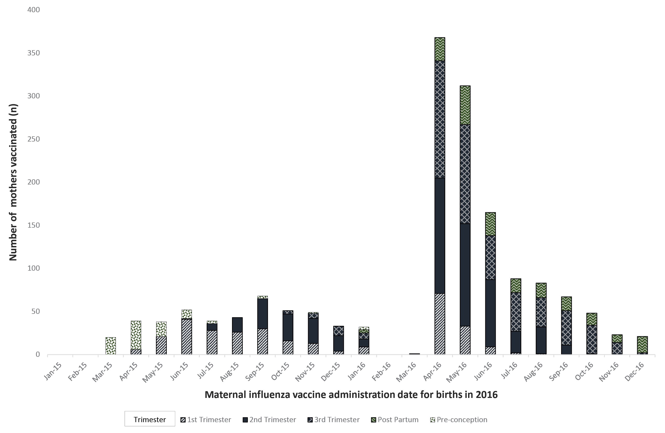
a Mothers who received both 2015 and 2016 influenza vaccine were not plotted to reduce data duplication.

Figure 2: Trend in influenza vaccination uptake in pregnancy based on Indigenous status and gestational age during 2016 Influenza seasonª
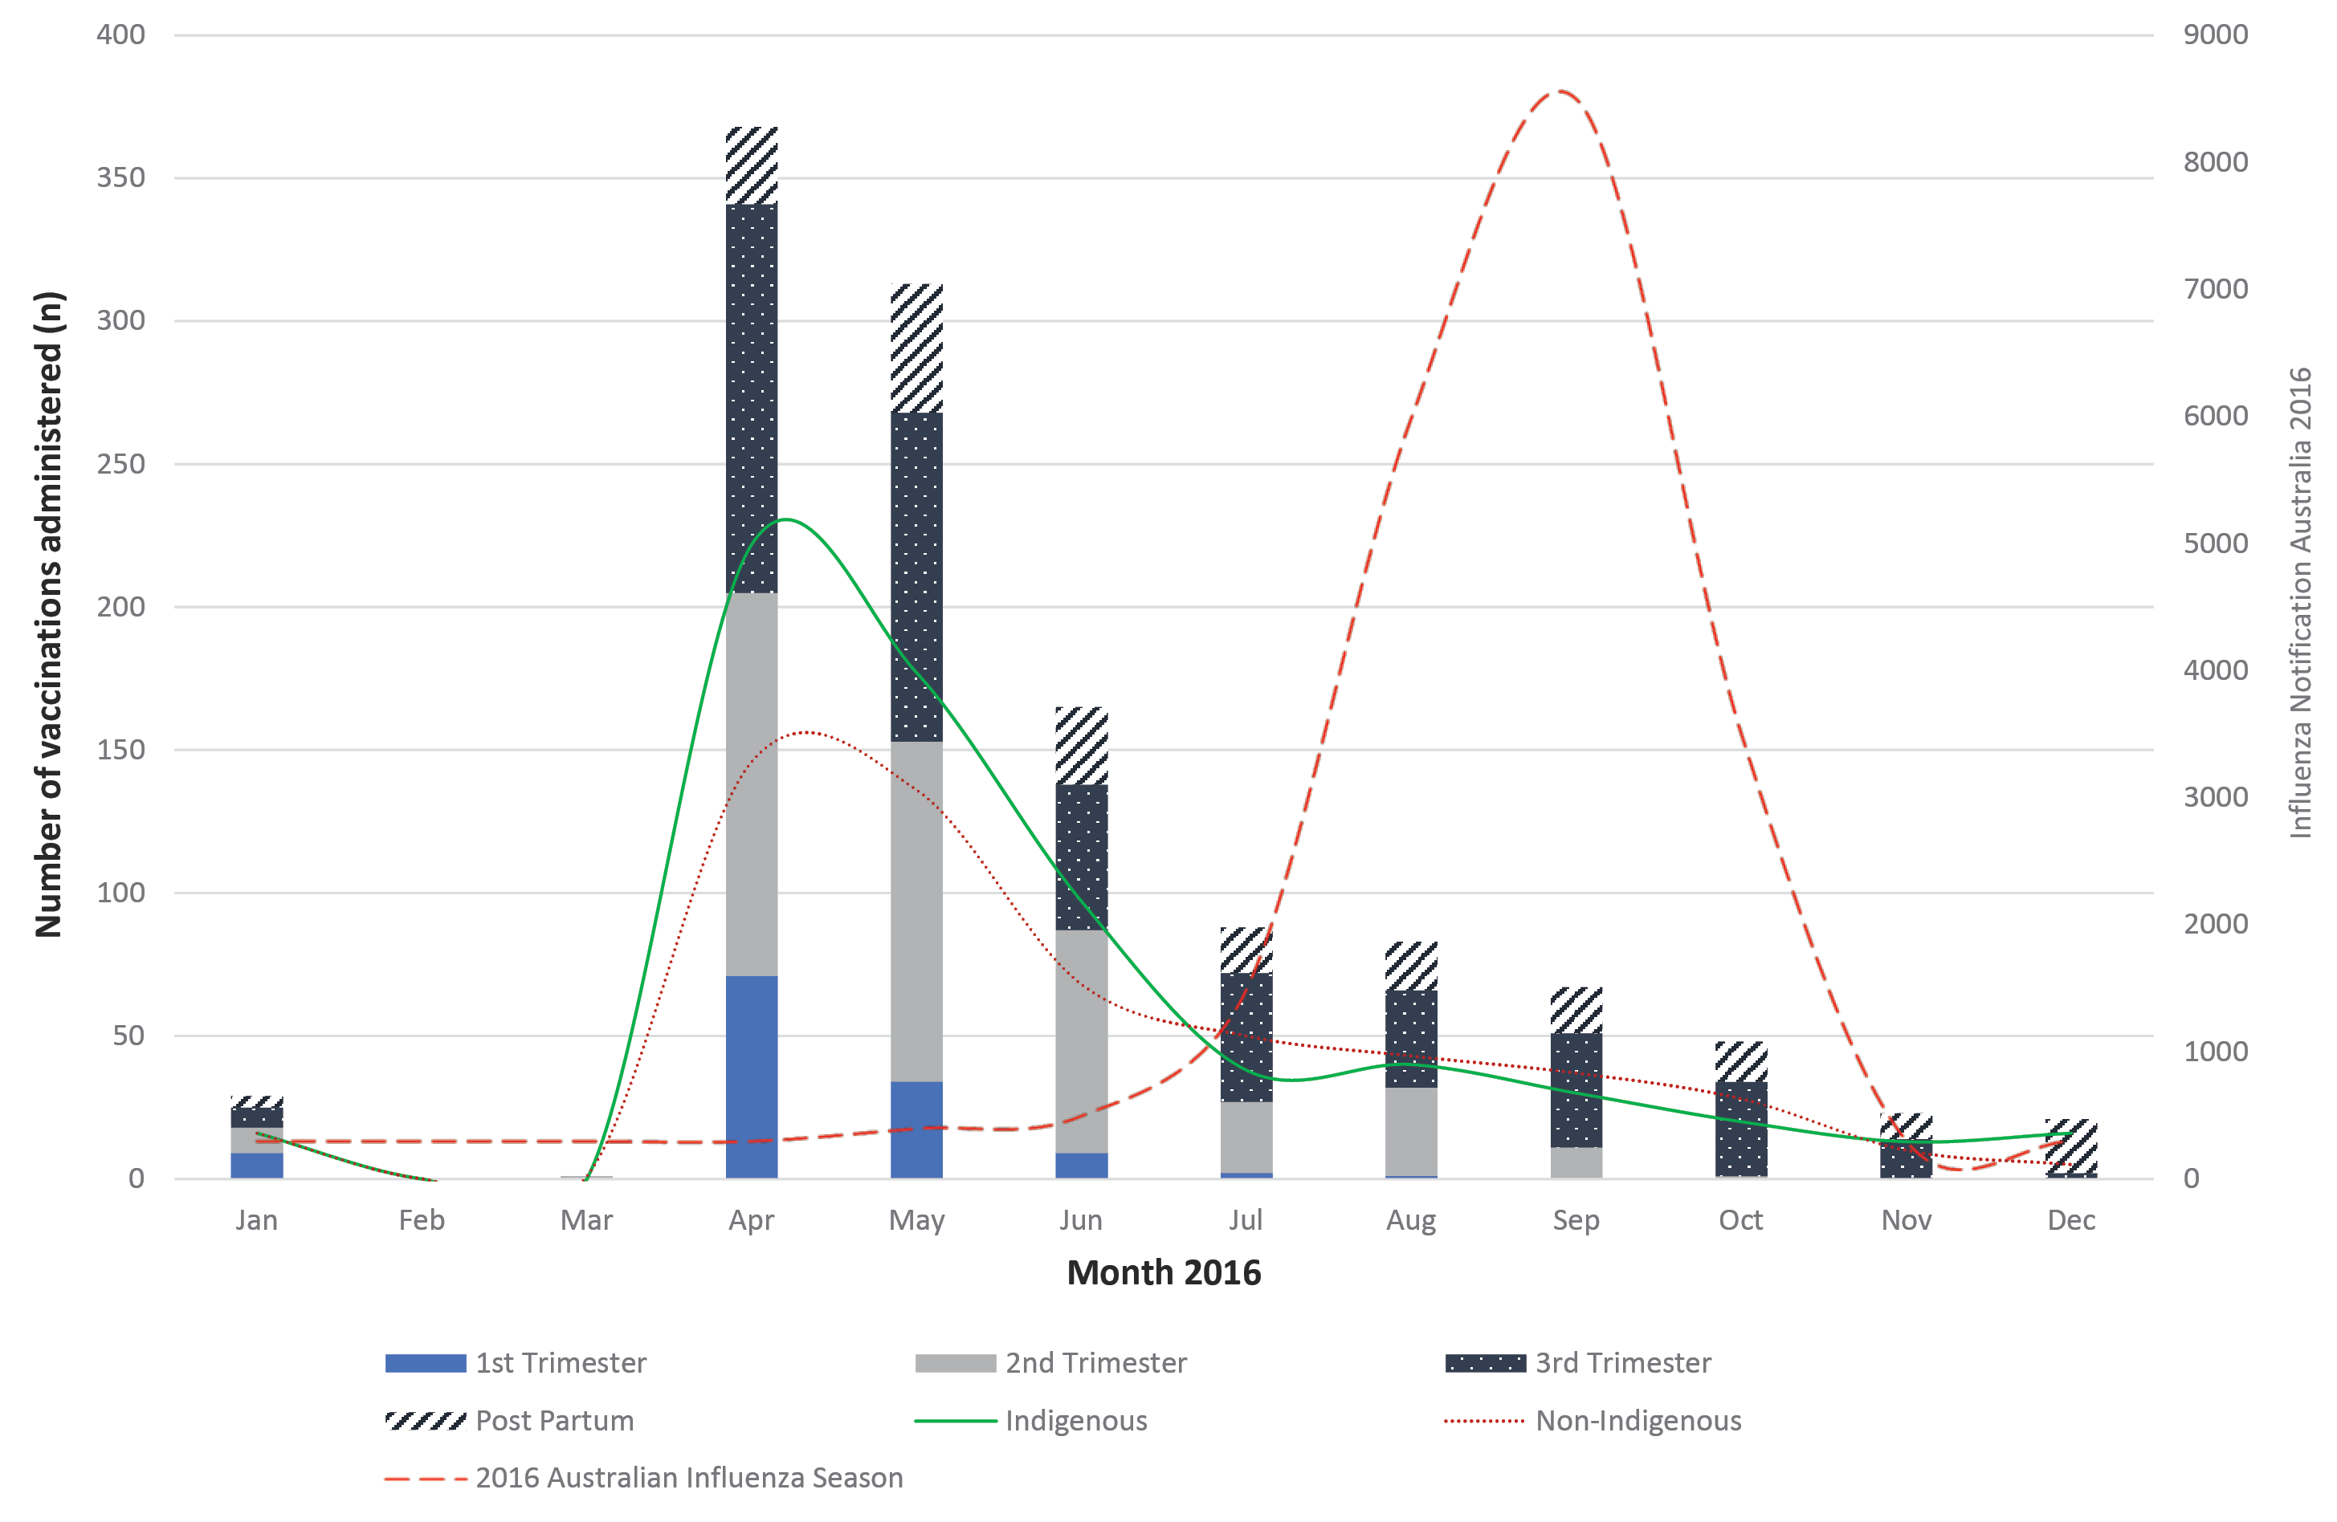
a Data for 2016 Influenza season was plotted from the 2016 Influenza Surveillance report from CDNA.¹⁷

Figure 3. Trend of babies born in 2016, based on month of birth, in Northern Territory to mothers vaccinated against influenza
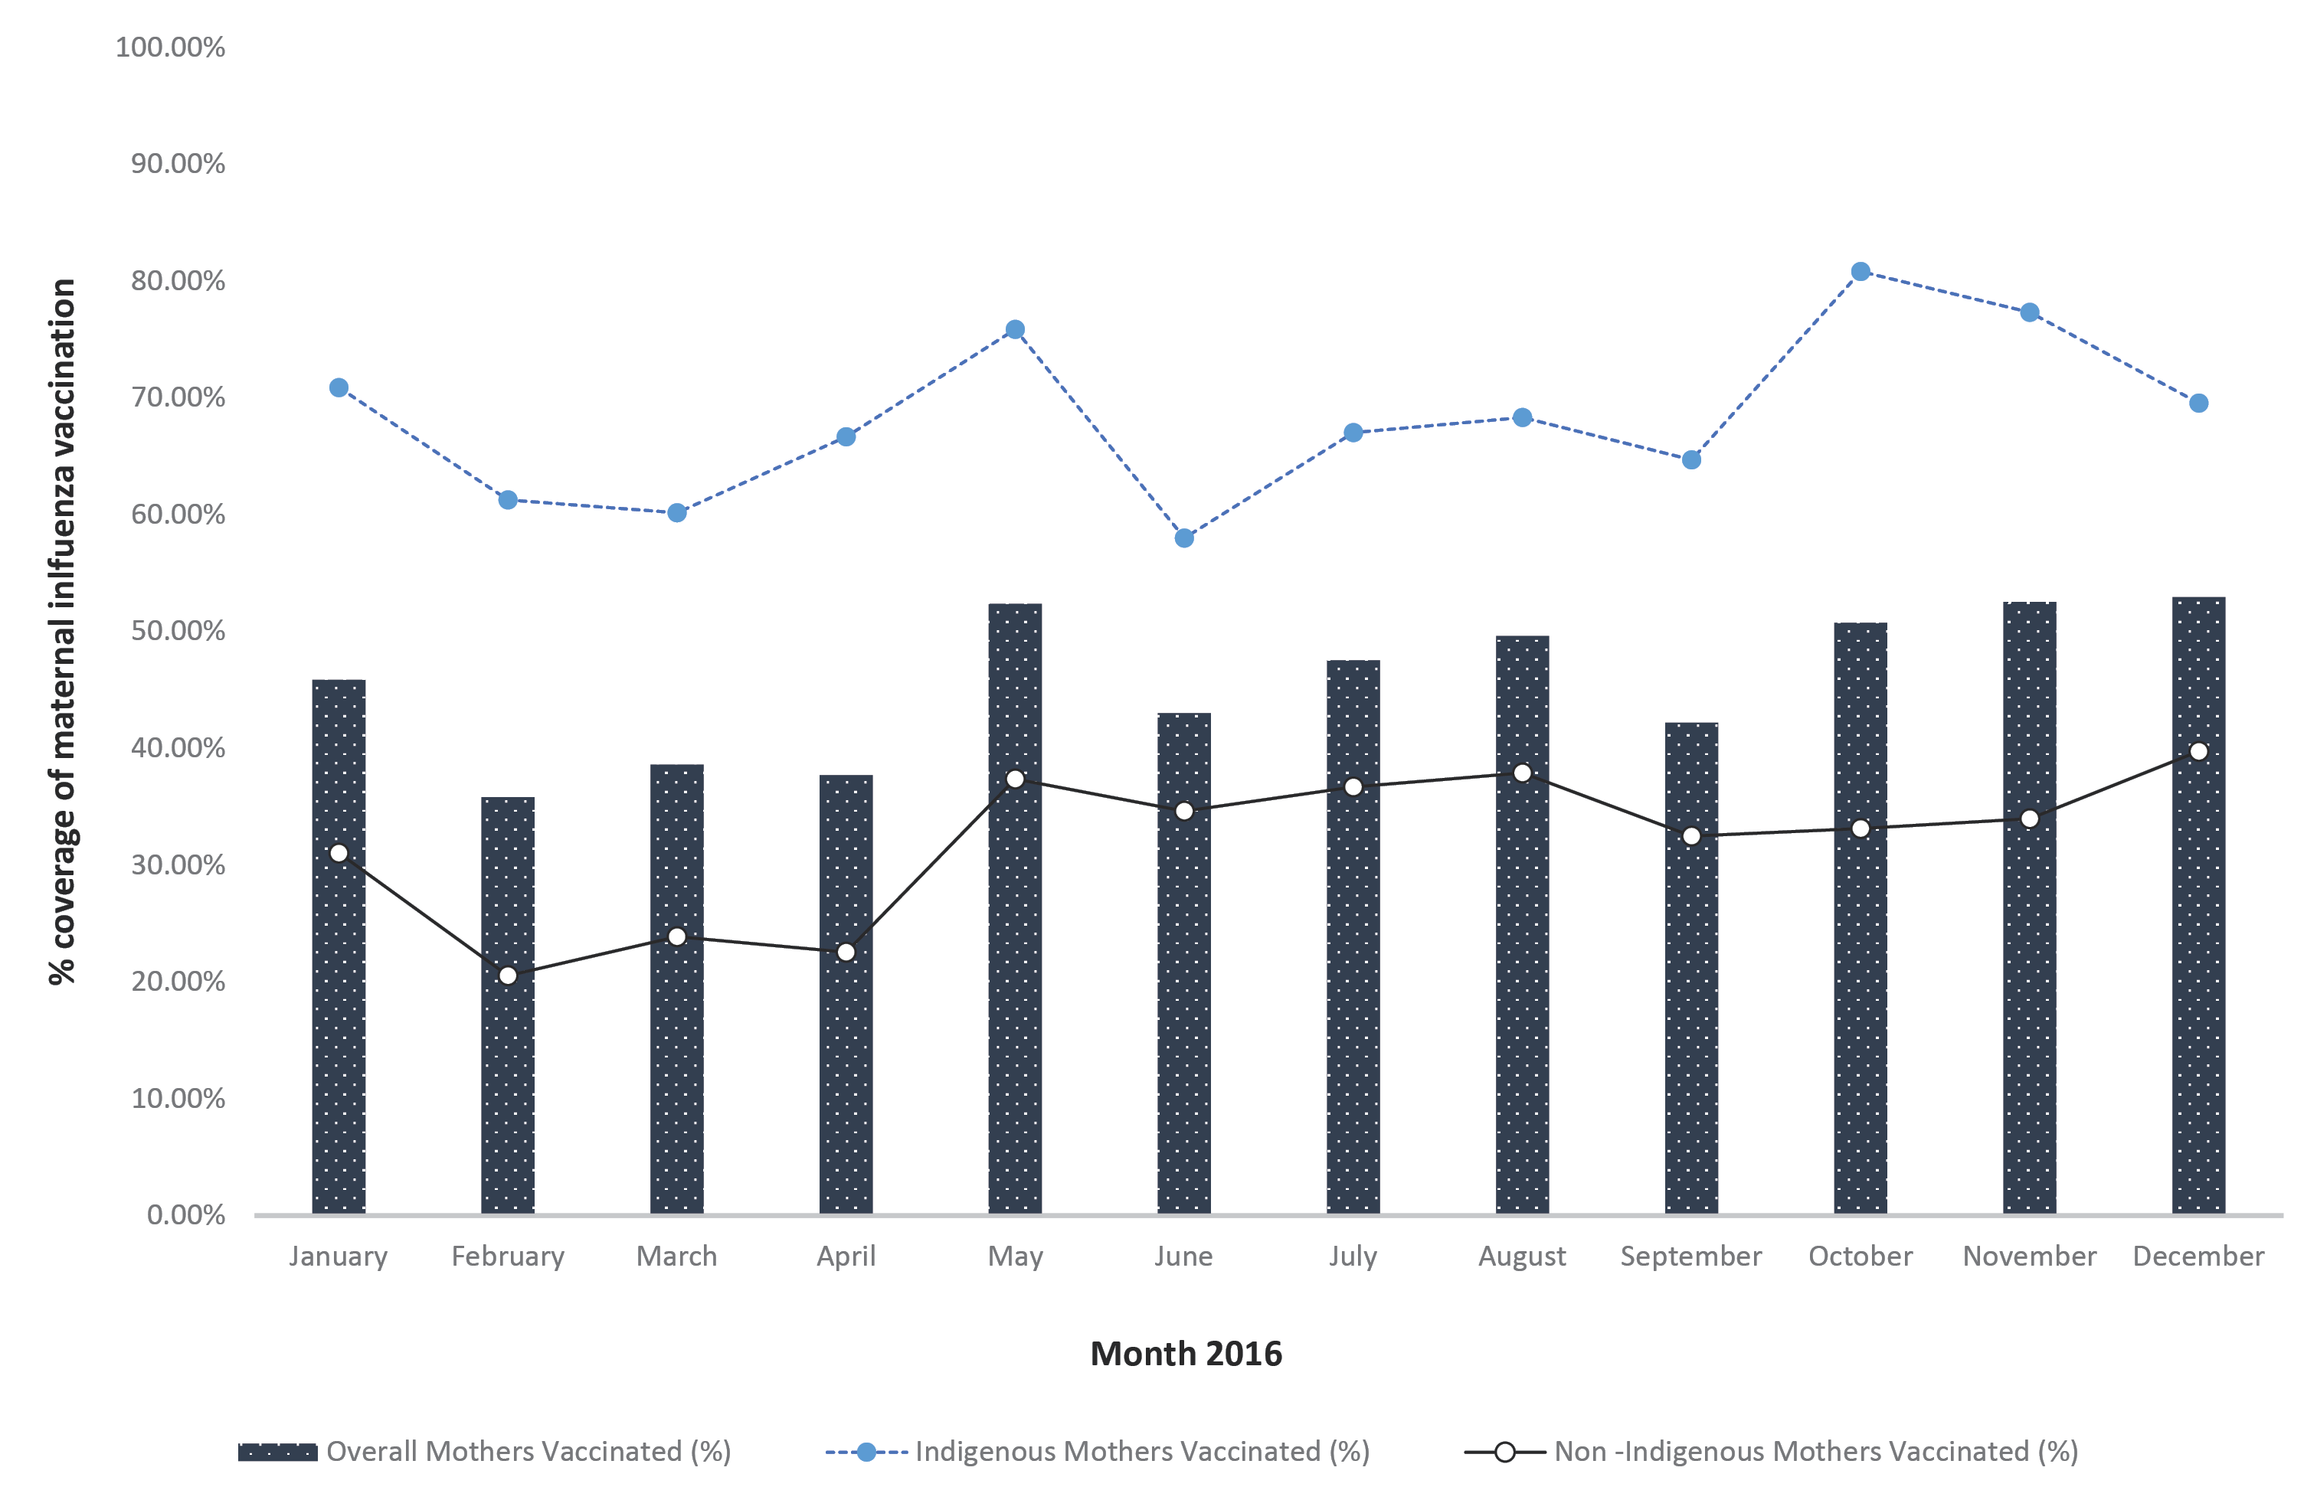

Postpartum Vaccination
A total of 194 mothers received postpartum influenza vaccination only. Of these postpartum vaccinations, 116 (59.7%) were administered to Indigenous mothers. This further increases the coverage in Indigenous mothers protecting postpartum women and infants with 77.5% (n=993) vs 35.4 % (n=748) in non-Indigenous women.

Factors affecting maternal influenza vaccination uptake
Initial logistic regression analysis revealed that remote location was associated with lower maternal influenza coverage (OR=1.46), but after adjusting for Indigenous status, remote location was not a significant predicator (AOR=0.93, 95% CI 0.74, 1.18, p=0.591). Higher maternal age was associated with lower maternal influenza coverage, similarly adjusting for Indigenous status was not a significant predictor for vaccination uptake (AOR=1.09, 95% CI 0.88, 1.34, p=0.402). Potential socio-demographic factors that may influence influenza vaccination are presented in Table 2.
Table 2. Binary logistical regression of categorical predictors of maternal influenza vaccination
Predictors of maternal influenza uptakeª | OR | 95% CI | AOR | 95%CI | p-value^{b}
Indigenous vs non -Indigenous mothers | 4.67 | 4.02, 5.42 | 4.67 | 4.02, 5.42 | <0.001
Singleton vs plurality | 1.40 | 0.73, 2.67 | 1.74 | 0.87, 3.48 | 0.108
Term vs preterm deliveries | 0.85 | 0.68, 1.07 | 1.22 | 0.95, 1.57 | 0.112
Maternal age below 35 vs 35 years old and above | 1.47 | 1.21, 1.79 | 1.09 | 0.88, 1.34 | 0.402
Remote location vs urban location | 1.46 | 1.17, 1.81 | 0.93 | 0.74, 1.18 | 0.591
Vaccination between April to June 2016 | 2.67 | 1.95, 3.66 | 2.78 | 2.02, 3.82 | <0.001
Central vs Top End birthing hospital | 1.46 | 1.25, 1.71 | 1.05 | 0.89, 1.25 | 0.510
a OR = odds ratio; CI = confidence interval. Adjusted odds ratio (AOR) was only adjusted for Indigenous status.
b p-value calculated on AOR using Wald chi-squared test.
The major predicators of increased maternal influenza coverage were Indigenous status and month of vaccination (during April to June) (see Figure 1).

Discussion
In Australia, the influenza season typically occurs from May to October, except in the tropical region, where circulating influenza is recorded year-round.¹⁸ In the tropical region, a bimodal influenza season is seen, with peaks during December to January and July to August.¹⁸ Each year, there is a range of seasonal inactivated influenza vaccines available for antenatal administration, as part of the NIP. The overall maternal influenza vaccination coverage in our cohort was 45.61%. However, there was a significant disparity in the distribution of the coverage among the Indigenous mothers (68.5%) and non-Indigenous mothers (31.7%). The odds ratio for Indigenous versus non-Indigenous mothers receiving influenza vaccine was 4.67 (95% CI 4.02, 5.42, p<0.001). This is in contrast to previously published literature that noted that Indigenous mothers had lower coverage of influenza vaccination.¹⁹ Higher rate of vaccination uptake in Indigenous mothers is likely to be linked to the annual free influenza vaccine offered to all Indigenous Australians from age 15 years old, regardless of their pregnancy status. The higher uptake in Indigenous mothers persisted in preterm births (65.05%) and multiple births (52.63%).
Amongst mothers with valid immunisation status, 20.2% (n=312) received the influenza vaccine in the first trimester, 35.4% (n=548) during the second trimester and 32.2% (n=498) in the third trimester.
In our study, factors associated with an increased uptake of maternal influenza vaccination (unadjusted for Indigenous status) were maternal age below 35 years, birthing at remote locations and birthing at Central Australian hospitals. The preponderance of vaccinations between April and June 2016 (58.9% of the 2016 total, p<0.001) strongly suggests the timing of presentation to a doctor was also a factor, with the probability of vaccination uptake influenced by concurrence with the national influenza campaign and/or greater vaccine availability at this time. Plurality and infant gestational age at delivery were not independent predictors of maternal influenza uptake.
Despite the differences in coverage based on Indigenous status and trimester of vaccination, our study identified timing of influenza vaccine administration was similar for all subgroups (pre-conception; during pregnancy; postpartum; and pre-conception and postpartum). This is consistent for all gestational ages, irrespective of Indigenous status.
After adjusting for Indigenous status, the odds ratio for 2016-vaccinated pregnant women receiving influenza vaccine between April and June 2016, against receiving it during the year’s other quarters, was 2.78 (95% CI 2.02, 3.82; p<0.001). This correlates with the annual influenza immunisation campaign by NT and the Australian Government. While the hypothesis of Indigenous Australians (including the subset of antenatal population) receiving the vaccine during the annual flu vaccination campaign seems a valid explanation for this trend, the data also highlight a similar peak in the uptake of influenza vaccine in non-Indigenous women from April to June 2016 (Figure 2).
In 2016, the Australian flu season was between July to October with a peak between late August and mid-September. The distinct pattern of the uptake regardless of Indigenous status highlights a low uptake during peak influenza season and an opportunity to continue to promote influenza vaccine. During April and May, there are intense promotional campaigns by governmental and non-governmental sectors promoting the influenza vaccine on various platforms including social media and electronic media such as radio and television. Health clinics and pharmacies offer walk-in vaccination clinics from April to May when the vaccines are rolled out and this has likely led to promotion of vaccine at this time. However, the vaccination drive is not sustained throughout the influenza season with dwindling advertisements later in the year. We postulate that this likely influenced the uptake of influenza vaccination in the maternal population in our cohort.
An analysis of the 2017 influenza season from NT highlighted that pregnancy remained a significant risk factor for influenza with an odds ratio of 3.5 (CI 2.46, 4.90, p<0.001).²⁰ There needs to be a targeted approach to address concerns of non-Indigenous mothers and increase vaccination uptake in these women due to the morbidity associated with influenza.
It is prudent to promote early influenza vaccination uptake, but it is crucial to continue to encourage influenza vaccination throughout the influenza season, especially for the maternal population.
In addition to protecting the mother, recent studies have shown great benefit from antenatal and postpartum influenza vaccination.^{1–3,10,21} A recent randomised control trial showed maternal immunisation protects newborn infants from hospitalisation associated with lower respiratory tract infections during the first 6 months with a vaccine efficacy of 43.1%.¹ There is transplacental transfer of influenza antibodies and breast milk transfer of immunoglobulin A and G protecting newborns up to 6 months of life.^{11,22} As the influenza vaccine only becomes available for use from 6 months of age onwards, infants rely on passive transfer maternal immunity for protection against influenza. Therefore, the most effective way to protect newborns from the adverse effects of influenza infection is through maternal vaccination.
However, as the exact timing of pregnancy cannot be accurately predicted, vaccination should be offered all year round with sustained vaccination health promotion campaigns specifically targeting the maternal population. The high uptake of the vaccine from April to June in both Indigenous and non-Indigenous women suggests acceptance towards the vaccine when linked to nationwide influenza health promotion campaigns.
Studies have shown that provider recommendation is a strong predictor of uptake for maternal immunisation.^{23–26} As there is an extremely high uptake during the initial roll out of the vaccine, we postulate that there is a waning of vaccine recommendation by health care providers during the second half of each year. The lack of uptake shows the need for greater awareness by healthcare providers on the availability of influenza vaccine and on the benefits of influenza vaccine for the maternal population, protecting the mother and baby throughout the year.
A nationwide year-round maternal immunisation campaign is essential to increase awareness. Education of healthcare workers on the availability of the influenza vaccine and the benefits to antenatal mothers beyond the pregnancy should be reinforced to ensure confidence in recommending influenza vaccine. Consistent recommendations from antenatal care providers are critical to improving influenza vaccine coverage in pregnant women. With the established safety of influenza vaccines, a year-round vaccination campaign is key to increase confidence in women and therefore improve uptake.^{1,27,28}

Strengths and limitations
A limitation in our study was the lack of data available from the private hospital in NT. In 2016 there were an estimated 550 births in the private hospital. There is a possibility that the inclusion of data of pregnant women who delivered in the private hospital may increase the coverage rate among non-Indigenous pregnant women. While this is feasible, the low coverage in non-Indigenous women delivering in the public hospitals in the NT needs to be addressed regardless. There may be missing data, not reflected in the NTIR, for non-Indigenous mothers that receive influenza vaccination as part of workplace vaccination campaigns.
All other antenatal influenza vaccination data from interstate and overseas have been based on surveys and a sampled cohort. Our study includes all pregnant women that delivered in the public hospitals in NT in 2016 with validated vaccination status, providing an accurate overview of the current behavioural pattern of maternal influenza uptake in the NT.

Conclusion
A nationwide robust year-round maternal influenza vaccination campaign is required to promote the benefits of influenza vaccination to both mothers and babies. The timing of influenza vaccine in relation to the gestational age of the pregnancy correlates with the availability of the vaccine and influenza promotional campaign. There should be a greater emphasis on targeting non-Indigenous pregnant women in the NT. Healthcare providers should be aware of the availability of flu vaccine and should promote the vaccine all year round. Antenatal care providers, including midwives, have a key role in providing evidence-based recommendations to pregnant women with a need to encourage uptake throughout the year. A year-round promotional campaign may address the gaps in maternal influenza vaccination, reduce missed opportunities and increase uptake in non-Indigenous mothers.

Acknowledgements
We acknowledge the Northern Territory Perinatal Register and Northern Territory Immunisation Register for their data contribution.

Declarations
The datasets generated and analysed during the current study are not publicly available due identifiable patient data.

Author contributions
PJ: Study concept and design, analysis or interpretation of data, drafting of the manuscript, critical revision of the manuscript for important intellectual content, statistical analysis.
PG: Analysis or interpretation of data, drafting of the manuscript, critical revision of the manuscript for important intellectual content, statistical analysis.
RW: Study concept and design, acquisition of data, analysis or interpretation of data, critical revision of the manuscript for important intellectual content.
PJ and PG are co-first authors.
Obtained funding: nil.
The authors declare that they have no competing interests.

Author details
Dr Priya Darshene Janagaraj¹
Dr Pari Shanmuga Raman Gurusamy ²
Dr Rosalind Webby³
- Public Health Registrar, NT Centre for Disease Control (CDC), Northern Territory Australia
- Obstetrics and Gynaecology Registrar, Department of Obstetrics and Gynecology, Top End Health Services, Northern Territory Australia
- Head of Immunisation, NT Centre for Disease Control (CDC), Northern Territory Australia

Corresponding Author
Dr. Priya Darshene Janagaraj
Centre for Disease Control (CDC), Northern Territory Australia
Building 4 Royal Darwin Hospital Rocklands Drive Tiwi NT 0810
+61889228044
Priya.Janagaraj@nt.gov.au
priyadarshene@gmail.com

References
- Nunes MC, Cutland CL, Jones S, Downs S, Weinberg A, Ortiz JR et al. Efficacy of maternal influenza vaccination against all-cause lower respiratory tract infection hospitalizations in young infants: results from a randomized controlled trial. Clin Infect Dis. 2017;65(7):1066–71.
- Tapia MD, Sow SO, Tamboura B, Tégueté I, Pasetti MF, Kodio M et al. Maternal immunisation with trivalent inactivated influenza vaccine for prevention of influenza in infants in Mali: a prospective, active-controlled, observer-blind, randomised phase 4 trial. Lancet Infect Dis. 2016;16(9):1026–35.
- Fell DB, Bhutta ZA, Hutcheon JA, Karron RA, Knight M, Kramer MS et al. Report of the WHO technical consultation on the effect of maternal influenza and influenza vaccination on the developing fetus: Montreal, Canada, September 30 – October 1, 2015. Vaccine. 2017;35(18):2279–87.
- Ghebrehewet S, MacPherson P, Ho A. Influenza. BMJ. 2016;355:i6258.
- Ravindran M, Gowtham S, Mehta P, Narayanan P. Retrospective analysis of maternal and foetal outcome of H1N1 influenza amongst antenatal mothers at a tertiary care hospital. J Patient Saf Infect Control. 2017;5(2):69–72.
- Louie JK, Salibay CJ, Kang M, Glenn-Finer RE, Murray EL, Jamieson DJ. Pregnancy and severe influenza infection in the 2013–2014 influenza season. Obstet Gynecol. 2015;125(1):184–92.
- Hartert TV, Neuzil KM, Shintani AK, Mitchel EF, Snowden MS, Wood LB et al. Maternal morbidity and perinatal outcomes among pregnant women with respiratory hospitalizations during influenza season. Am J Obstet Gynecol. 2003;189(6):1705–12.
- Van Kerkhove MD, Vandemaele KAH, Shinde V, Jaramillo-Gutierrez G, Koukounari A, Donnelly CA et al. Risk factors for severe outcomes following 2009 influenza A (H1N1) infection: a global pooled analysis. PLoS Med. 2011;8(7):e1001053.
- Becker R. The Immunology of Pregnancy. Science in the News. [Internet.] Harvard University, Graduate School of Arts and Sciences, 2012. [Accessed: 24 May 2018.] Available from: http://sitn.hms.harvard.edu/flash/2012/issue128/
- Madhi SA, Cutland CL, Kuwanda L, Weinberg A, Hugo A, Jones S, et al. Influenza vaccination of pregnant women and protection of their infants. N Engl J Med. 2014;371(10):918–31.
- van den Berg JP, Westerbeek EA, van der Klis FR, Berbers GA, van Elburg RM. Transplacental transport of IgG antibodies to preterm infants: a review of the literature. Early Hum Dev. 2011;87(2):67–72.
- World Helath Organization. Pandemic (H1N1) 2009 briefing note 5: Pandemic influenza in pregnant women. [Internet.] WHO, 2009. [Accessed: 24 May 2018.] Available from: https://www.who.int/csr/disease/swineflu/notes/h1n1_pregnancy_20090731/en/
- National Centre for Immunisation Research and Surveillance. Influenza fact sheet. [Internet.] National Centre for Immunisation Research and Surveillance, 2018. [Accessed: 24 May 2018.] Available from: http://www.ncirs.org.au/ncirs-fact-sheets-faqs/influenza-vaccines-australians
- Australian Bureau of Statistics. 2016 Census: Northern Territory. [Internet.] Australian Government, Australian Bureau of Statistics, 2018 [Accessed: 24 May 2018.] Available from: http://www.abs.gov.au/ausstats/abs%40.nsf/mediareleasesbyCatalogue/C73D7CC81CA1FD2FCA258148000A4067?OpenDocument
- Australian Institute of Health and Welfare. Mothers & babies: Overview. [Internet.] Australian Government, Australian Institute of Health and Welfare, 2018. [Accessed: 24 May 2018.] Available from: https://www.aihw.gov.au/reports-statistics/population-groups/mothers-babies/overview
- Overton K, Webby R, Markey P, Krause V. Influenza and pertussis vaccination coverage in pregnant women in the Northern Territory in 2015—new recommendations to be assessed. NT Dis Control Bull. 2016;23(4):1–8.
- Department of Health. Australian Influenza Surveillance Report and Activity Updates – 2016. [Internet.] Australian Government, Department of Health, 2016. [Accessed: 24 May 2018.] Available from: https://www1.health.gov.au/internet/main/publishing.nsf/Content/cda-ozflu-2016.htm
- Department of Health. Australian Influenza Surveillance Report and Activity Updates. [Internet.] Australian Government, Department of Health, 2018. [Accessed: 24 May 2018.] Available from: https://www1.health.gov.au/internet/main/publishing.nsf/content/cda-surveil-ozflu-flucurr.htm
- O’Grady K-A, Dunbar M, Medlin LG, Hall KK, Toombs M, Meiklejohn J et al. Uptake of influenza vaccination in pregnancy amongst Australian Aboriginal and Torres Strait Islander women: a mixed-methods pilot study. BMC Res Notes. 2015;8:169.
- Markey P, Webby R , Cook H. Territory influenza in 2017; worst since 2009. N T Dis Control Bull. 2018;25(1):24–28.
- Takeda S, Hisano M, Komano J, Yamamoto H, Sago H, Yamaguchi K. Influenza vaccination during pregnancy and its usefulness to mothers and their young infants. J Infect Chemother. 2015;21(4):238–46.
- Schlaudecker EP, Steinhoff MC, Omer SB, McNeal MM, Roy E, Arifeen SE et al. IgA and neutralizing antibodies to influenza a virus in human milk: a randomized trial of antenatal influenza immunization. PLoS One. 2013;8(8):e70867.
- Ellingson M, Chamberlain AT. Beyond the verbal: Pregnant women’s preferences for receiving influenza and Tdap vaccine information from their obstetric care providers. Hum Vaccin Immunother. 2018;14(3)767–71.
- Vishram B, Letley L, Hoek AJV, Silverton L, Donovan H, Adams C et al. Vaccination in pregnancy: Attitudes of nurses, midwives and health visitors in England. Hum Vaccin Immunother. 2018;14(1):179–88.
- Regan AK, Mak DB, Hauck YL, Gibbs R, Tracey L, Effler PV. Trends in seasonal influenza vaccine uptake during pregnancy in Western Australia: Implications for midwives. Women Birth. 2016;29(5):423–9.
- Maher L, Hope K, Torvaldsen S, Lawrence G, Dawson A, Wiley K et al. Influenza vaccination during pregnancy: Coverage rates and influencing factors in two urban districts in Sydney. Vaccine. 2013;31(47):5557–64.
- Fell DB, Platt RW, Lanes A, Wilson K, Kaufman JS, Basso O et al. Fetal death and preterm birth associated with maternal influenza vaccination: systematic review. BJOG. 2014;122(1):17–26.
- Zerbo O, Modaressi S, Chan B, Goddard K, Lewis N, Bok K et al. No association between influenza vaccination during pregnancy and adverse birth outcomes. Vaccine. 2017;35(24):3186–90.

Communicable Diseases Intelligence
ISSN: 2209-6051 Online

Communicable Diseases Intelligence (CDI) is a peer-reviewed scientific journal published by the Office of Health Protection, Department of Health. The journal aims to disseminate information on the epidemiology, surveillance, prevention and control of communicable diseases of relevance to Australia.

Editor: Cindy Toms
Deputy Editor: Simon Petrie
Design and Production: Kasra Yousefi
Editorial Advisory Board: David Durrheim, Mark Ferson, John Kaldor, Martyn Kirk and Linda Selvey

Website: http://www.health.gov.au/cdi

Contacts
Communicable Diseases Intelligence is produced by:
Health Protection Policy Branch, Office of Health Protection, Australian Government Department of Health
GPO Box 9848, (MDP 6) CANBERRA ACT 2601

Email: cdi.editor@health.gov.au

Submit an Article
You are invited to submit your next communicable disease related article to the Communicable Diseases Intelligence (CDI) for consideration. More information regarding CDI can be found at: http://health.gov.au/cdi.
Further enquiries should be directed to: cdi.editor@health.gov.au.

This journal is indexed by Index Medicus and Medline.

Creative Commons Licence - Attribution-NonCommercial-NoDerivatives CC BY-NC-ND
© 2019 Commonwealth of Australia as represented by the Department of Health
This publication is licensed under a Creative Commons Attribution-NonCommercial-NoDerivatives 4.0 International Licence from https://creativecommons.org/licenses/by-nc-nd/4.0/legalcode (Licence). You must read and understand the Licence before using any material from this publication.

Restrictions
The Licence does not cover, and there is no permission given for, use of any of the following material found in this publication (if any):
- the Commonwealth Coat of Arms (by way of information, the terms under which the Coat of Arms may be used can be found at www.itsanhonour.gov.au);
- any logos (including the Department of Health’s logo) and trademarks;
- any photographs and images;
- any signatures; and
- any material belonging to third parties.

Disclaimer
Opinions expressed in Communicable Diseases Intelligence are those of the authors and not necessarily those of the Australian Government Department of Health or the Communicable Diseases Network Australia. Data may be subject to revision.

Enquiries
Enquiries regarding any other use of this publication should be addressed to the Communication Branch, Department of Health, GPO Box 9848, Canberra ACT 2601, or via e-mail to: copyright@health.gov.au

Communicable Diseases Network Australia
Communicable Diseases Intelligence contributes to the work of the Communicable Diseases Network Australia.
http://www.health.gov.au/cdna

Since April 2019, influenza vaccine is funded for all Indigenous Australians above the age of 6 months under the National Immunisation Program
Since April 2019, ATAGI has recommended for women who received an influenza vaccine late in the 2018 influenza season to revaccinate if the 2019 influenza vaccine becomes available before the end of pregnancy

