Annual report on influenza viruses received and tested by the Melbourne WHO Collaborating Centre for Reference and Research on Influenza in 2016

Vivian K. Leung, Yi-Mo Deng, Matthew Kaye, Iwona Buettner, Hilda Lau, Sook-Kwan Leang, Leah Gillespie, and Michelle K. Chow

# Abstract

As part of its role in the World Health Organization’s (WHO) Global Influenza Surveillance and Response System (GISRS), the WHO Collaborating Centre for Reference and Research on Influenza in Melbourne received a total of 4,247 human influenza positive samples during 2016. Viruses were analysed for their antigenic, genetic and antiviral susceptibility properties and also propagated in qualified cells and hens eggs for potential seasonal influenza vaccine virus candidates. In 2016, influenza A(H3) viruses predominated over influenza A(H1)pdm09 and B viruses, accounting for a total of 51% of all viruses analysed. The vast majority of A(H1)pdm09, A(H3) and influenza B viruses analysed at the Centre were found to be antigenically similar to the respective WHO recommended vaccine strains for the Southern Hemisphere in 2016. However, phylogenetic analysis of a selection of viruses indicated that the majority of circulating A(H3) viruses had undergone some genetic drift relative to the WHO recommended strain for 2016. Of more than 3,000 samples tested for resistance to the neuraminidase inhibitors oseltamivir and zanamivir, six A(H1)pdm09 viruses and two B/Victoria lineage viruses showed highly reduced inhibition to oseltamivir.

# Introduction

The WHO Collaborating Centre for Reference and Research on Influenza in Melbourne is part of the World Health Organization Global Influenza Surveillance and Response System (WHO GISRS). The GISRS is a worldwide network of laboratories that was established in 1952 to monitor changes in influenza viruses circulating in the human population with the aim of reducing its impact through the use of vaccines and antiviral medications. The Centre in Melbourne is one of 5 such Collaborating Centres (the others being in Atlanta, Beijing, London and Tokyo) that monitor the antigenic and genetic changes in circulating human influenza viruses, and makes bi-annual recommendations on which influenza strains should be included in the influenza vaccine for the upcoming winter season in either the northern or southern hemisphere. This report summarises the results of virological surveillance activities undertaken at the Centre in Melbourne during 2016.

Two types of influenza cause significant disease in humans: types A and B. Influenza A viruses are further classified into subtypes, based on their haemagglutinin (HA) and neuraminidase (NA) surface proteins. Globally, there are currently 2 influenza A subtypes circulating in human populations A(H1N1)pdm09 and A(H3N2). Influenza B viruses are not classified into subtypes; however, there are 2 distinct co-circulating lineages of influenza B viruses – B/Victoria/2/87 (B/Victoria lineage) and B/Yamagata/16/88 (B/Yamagata lineage). In addition, each year influenza C viruses are detected from humans, but these viruses tend not to cause severe disease and are not a major focus of surveillance.

# Methods

## Virus isolation

All A(H1)pdm09 and all influenza B viral isolates received at the Centre were re-passaged in cell culture (Madin-Darby Canine Kidney (MDCK) cells), whilst all A(H3) viral isolates were re-passaged in MDCK-SIAT1 cells. 1 Virus isolation was also attempted from a selection of original clinical specimens received. In addition, influenza positive original clinical samples were directly inoculated into eggs as potential candidate vaccine viruses (CVVs).

## Antigenic analysis

The antigenic properties of influenza viral isolates were analysed using the haemagglutination inhibition (HI) assay as previously described. 2 The majority of the HI assays were performed using the TECAN Freedom EVO200 robot platform which incorporates a camera (Sci Robotics) and imaging software (FluHema) for automated analysis. In HI assays, viruses were tested for their ability to agglutinate red blood cells in the presence of ferret antisera previously raised against reference viruses. Isolates were identified as antigenically similar to the reference strain if the test samples had a titre that was no more than 4-fold different from the titre of the homologous reference strain. During 2016, results were reported by reference to the A/California/7/2009 (H1N1pdm09)-like, A/Hong Kong/4801/2014 (H3N2)-like, B/Brisbane/60/2008-like (Victoria lineage), and B/Phuket/3073/2013-like (Yamagata lineage) viruses that were recommended for the 2016 influenza vaccine. In recent years (including 2016), HI assays involving A(H3) viruses have been performed in the presence of oseltamivir carboxylate in order to reduce non-specific binding of the NA protein. 3

## Genetic analysis

For samples that failed to grow in MDCK cells, real-time RT-PCR was performed to determine the influenza type/subtype/lineage. The CDC Influenza Virus Real-Time RT-PCR kits were used for FluA, FluB, A(H1)pdm09, A(H3), B/Yamagata and B/Victoria identification. The kits were obtained through the International Reagent Resource (https://www.internationalreagentresource.org/), Influenza Division, WHO Collaborating Centre for Surveillance, Epidemiology and Control of Influenza, Centres for Disease Control and Prevention, Atlanta, GA, USA.

A substantial subset of all influenza viruses analysed at the Centre underwent genetic analysis by sequencing of viral RNA genes – usually HA and NA genes as well as the matrix (M) gene for influenza A viruses and non-structural protein (NS) gene for influenza B viruses. In addition, the full genomes (all 8 gene segments) of a smaller subset of viruses were sequenced.

For sequencing, RNA was extracted from isolates or original clinical specimens using either manual QIAGEN QIAamp spin columns method or the automated QIAGEN QIAXtractor robot, followed by reverse transcription PCR using the BIOLINE MyTaq one step reverse transcription PCR kit according to the manufacturer’s recommendations with gene specific primers (primer sequences available on request). Conventional Sanger sequencing was carried out on PCR products using an Applied Biosystems 3500 XL sequencer. Sequence assembly was performed using the Seqman Pro Module of DNASTAR Lasergene version 13 software (DNASTAR, Madison, WI, USA). Next generation sequencing (NGS) was performed on a selection of viruses using an Applied Biosystems Ion Torrent Personal Genome Machine (PGM) System according to the manufacturer’s recommendations. These sequences were analysed using a proprietary pipeline, FluLINE. Phylogenetic analysis was performed using Geneious 9.0.4 software (Biomatters Ltd, Auckland, New Zealand) and FigTree v1.3.1.

## Antiviral drug resistance testing

As there is potential for influenza viruses to develop resistance to antiviral drugs, circulating viruses were tested for their sensitivity to the currently used neuraminidase inhibitors oseltamivir (Tamiflu) and zanamivir (Relenza). The neuraminidase inhibition (NAI) assay used was a functional fluorescence-based assay using the substrate 20-(4-methylumbelliferyl)-a-D-N-acetylneuraminic acid (MUNANA) in which the susceptibility of test viruses to the antiviral drugs was measured in terms of the drug concentration needed to reduce the neuraminidase enzymatic activity by 50% (IC50), and compared to values obtained with sensitive reference viruses of the same subtype or lineage. NAI assays were performed as previously described4 with the incorporation of a robotic platform by TECAN EVO200 and Infinite 200Pro for liquid handling and plate reading (Tecan Australia). For the purposes of reporting, reduced inhibition of influenza A viruses was defined as a 10-99 fold increase in IC50, while highly reduced inhibition was defined as a ≥ 100-fold increase in IC50 in a neuraminidase inhibition assay. For influenza B viruses, these figures were 5-49 fold and ≥50 fold increases, respectively. However, it should be noted that the relationship between the IC50 value and the clinical effectiveness of a neuraminidase inhibitor is not well understood and a reduction in inhibition may not be clinically significant.

Viruses found to have highly reduced inhibition by either oseltamivir or zanamivir underwent further analysis to determine the presence of amino acid substitutions in the neuraminidase protein that were associated with the reduction of inhibition by NAIs. For example, a change from histidine to tyrosine at position 275 (H275Y) of the neuraminidase protein of A(H1N1)pdm09 viruses is known to reduce inhibition by oseltamivir, as does the H273Y neuraminidase mutation in B viruses. 5

## Candidate vaccine strains

The viruses used to produce human vaccines are required to be isolated and passaged in embryonated hen’s eggs or qualified cell lines. The Centre undertook primary isolation of selected viruses from clinical samples directly into eggs, using previously described methods 6, except for the following modifications. First, the viruses were initially inoculated into the amniotic cavity only, and once growth was established the isolates were then further passaged in the allantoic cavity. This was followed by harvest only from either the amniotic or allantoic cavity, depending on site of inoculation. Egg incubation conditions also differed slightly with A(H1)pdm09 and A(H3) viruses incubated at 35oC for 3 days, and influenza B viruses incubated at 33oC for 3 days. In addition, selected clinical samples were also inoculated into the qualified cell line MDCK 33016PF and incubated at 35oC for 3 days and viral growth was monitored by haemagglutination of turkey or guinea pig red blood cells. These isolates were then analysed by HI assay, real time RT-PCR and genetic sequencing.

# Results

During 2016, the Centre received 4,247 clinical specimens and/or virus isolates from 35 laboratories in 14 countries (Figure 1). As in previous years, most samples were submitted by laboratories in the Asia-Pacific region, including Australian laboratories7 and were received during the Southern Hemisphere influenza season. Figure 2 shows the temporal distribution of samples sent to the Centre by type/subtype and lineage.

Figure 1. Geographic spread of influenza laboratories sending viruses to the Centre during 2016.

Figure 2. Number of viruses received at the Centre by week of sample collection, 2016

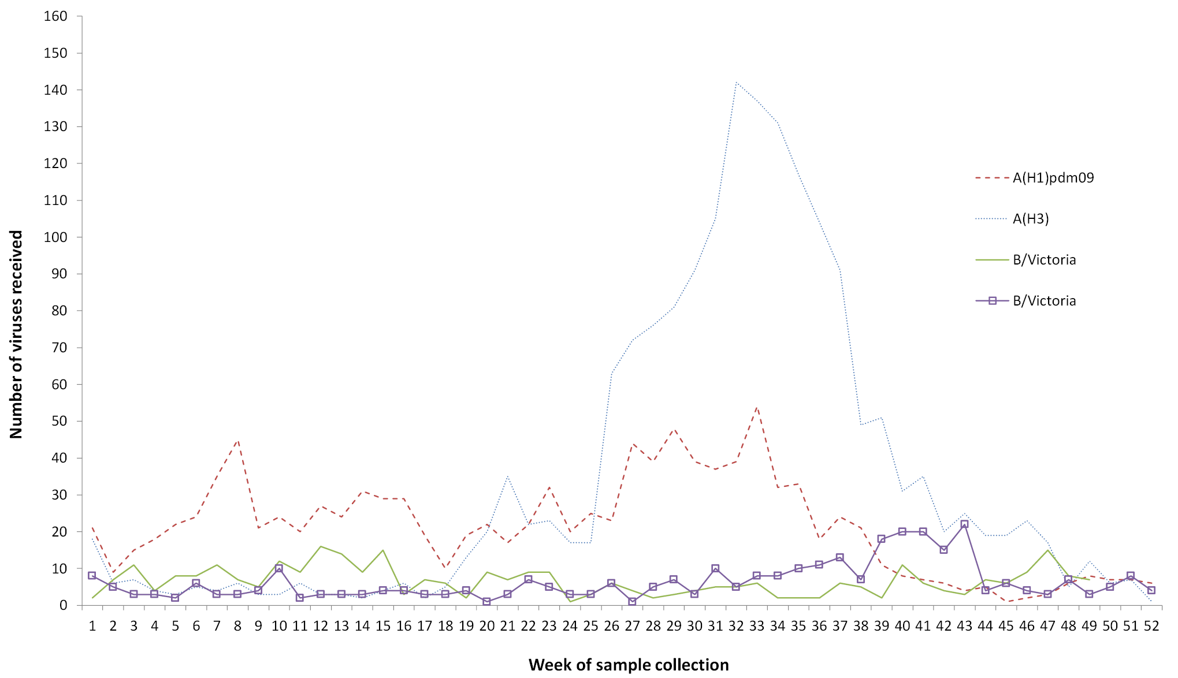

Isolation was attempted for 4,014 (95%) of the samples received, which yielded 3,250 isolates (81% isolation rate). In total, 998 A(H1)pdm09, 1594 A(H3) and 653 B viruses (90%, 92% and 97% respectively of viruses for which isolation was attempted) were obtained. However, 480 A(H3) isolates did not reach sufficient titres for antigenic analysis due to their low HA in the presence of oseltamivir carboxylate. A total of 2,473 viral isolates were successfully characterised by HI assay in comparison to the 2016 vaccine-like viruses (Table 1). In addition, 250 samples were characterised by real-time RT-PCR to determine their type/subtype or lineage. Sanger sequencing and NGS techniques were used to sequence the haemagglutinin genes of 955 viruses. The full genomes of 102 viruses were sequenced using either Sanger sequencing or NGS. Of the samples for which results could be obtained via antigenic or genetic analysis, (n=3,461), influenza A(H3) viruses predominated, comprising 51% of viruses analysed. The remaining portion of viruses were mostly A(H1) (30% of total number of viruses), followed by influenza B viruses (19%; comprising 10% B/Victoria and 9% B/Yamagata). There was one sample with mixed A(H1)/A(H3) viruses.

Table 1. Antigenic analysis of viruses received by the Centre in 2016, by geographic region of origin.

|  |  | A(H1N1)pdm09 reference strain: A/California/7/2009 (cell) | | A(H3N2)* reference strain: A/Hong Kong/4801/2014 (cell) | | B/Victoria reference strain: B/Brisbane/60/2008 (cell) | | B/Yamagata reference strain: B/Phuket/3073/2013 (cell) | |
| --- | --- | --- | --- | --- | --- | --- | --- | --- | --- |
| Region | | Like | Low reactor (%) | Like | Low reactor (%) | Like | Low reactor (%) | Like | Low reactor (%) |
| Australasia | | 637 | 34 | 588 | 119 | 76 | 0 | 124 | 0 |
| Pacific | | 73 | 0 | 8 | 1 | 92 | 0 | 67 | 0 |
| South East Asia | | 200 | 11 | 93 | 4 | 147 | 0 | 122 | 0 |
| East Asia | | 20 | 0 | 0 | 0 | 4 | 0 | 0 | 0 |
| South Asia | | 12 | 0 | 10 | 0 | 6 | 0 | 2 | 0 |
| Africa | | 3 | 0 | 7 | 0 | 13 | 0 | 0 | 0 |
| **Total** | | **945** | **45 (5%)** | **706** | **124 (15%)** | **338** | **0 (0%)** | **315** | **0 (0%)** |

* Note that many A(H3) virus isolates that were obtained could not be analysed by HI assay due to low haemagglutination assay (HA) titre in the presence of oseltamivir

## A(H1N1)pdm09

Of the 990 A(H1)pdm09 isolates analysed by HI assay using ferret antisera in 2016, the majority (95%) were antigenically similar to the vaccine reference strain A/California/7/2009 (Table 1).

Sequencing and phylogenetic analysis of HA genes from 250 viruses showed that A(H1)pdm09 viruses sent to the Centre during 2016 fell mainly into the 6B.1 subclade with a smaller number of viruses in subclade 6B.2 (Figure 3). No antigenic differences were detectable between viruses from the 6B, 6B.1 or 6B.2 genetic clades in ferret antisera HI assays and the majority of viruses reacted in a similar manner to the reference and 2016 vaccine virus A/California/7/2009.

Figure 3. Phylogenetic tree of representative haemagglutinin genes of A(H1)pdm09 viruses received by the Centre during 2016.

**Legend:**# 2016 SOUTHERN HEMISPHERE VACCINE STRAIN* Reference virus  
e: egg isolate  
Scale bar represents 0.3% nucleotide sequence difference between viruses  
Amino acid changes relative to the 2016 consensus sequence are shown  
(+) indicates gain of a potential glycosylation site  
} Braces indicate clades

49 viruses were inoculated into eggs for vaccine candidate strain isolation. Of these, 22 (45%) were successfully isolated, including viruses from each of the 2 emerging subclades (16 viruses from subclade 6B.1, five viruses from subclade 6B.2 and one virus from clade 6B).

Of 998 A(H1)pdm09 viruses tested, 6 exhibited highly reduced inhibition by oseltamivir. These viruses were from Singapore, Malaysia, Vietnam and Australia, and all contained the H275Y mutation in their NA genes. No A(H1)pdm09 viruses received during 2016 showed highly reduced inhibition to zanamivir.

## A(H3N2)

Antigenic analysis of 830 A(H3) subtype isolates using the HI assay showed that 15% were low reactors to the ferret antisera prepared against the cell-propagated reference strain A/Hong Kong/4801/2014 (Table 1). However, 48% of viruses were low reactors to the ferret antisera prepared against the egg-propagated strain A/Hong Kong/4801/2014 (data not shown). An additional 480 A(H3) viruses were inoculated and/or isolated by cell culture but did not reach sufficient titres for antigenic analysis, whilst a further 269 were successfully isolated but did not reach sufficient titres when tested by HI assay in the presence of oseltamivir carboxylate.

The HA genes of 555 A(H3) viruses were sequenced. Phylogenetic analysis indicated that the majority of circulating viruses fell into subclade 3C.2a1 based on their HA genes, which is genetically different to the 2016 vaccine strain A/Hong Kong/4801/2014 (clade 3C.2a) (Figure 4). A smaller proportion of A(H3) viruses fell into the 3C.2a and 3C.3a clades.

Figure 4. Phylogenetic tree of haemagglutinin genes of A(H3) viruses received by the Centre during 2016.

**Legend:**# 2016 SOUTHERN HEMISPHERE VACCINE STRAIN  
* Reference virus  
e: egg isolate  
Scale bar represents 0.2% nucleotide sequence difference between viruses  
Amino acid changes relative to the 2016 consensus sequence are shown  
(+/-) indicates gain/loss of a potential glycosylation site  
} Braces indicate clades

Figure 5. Phylogenetic tree of representative haemagglutinin genes of B/Victoria viruses received by the Centre during 2016

. 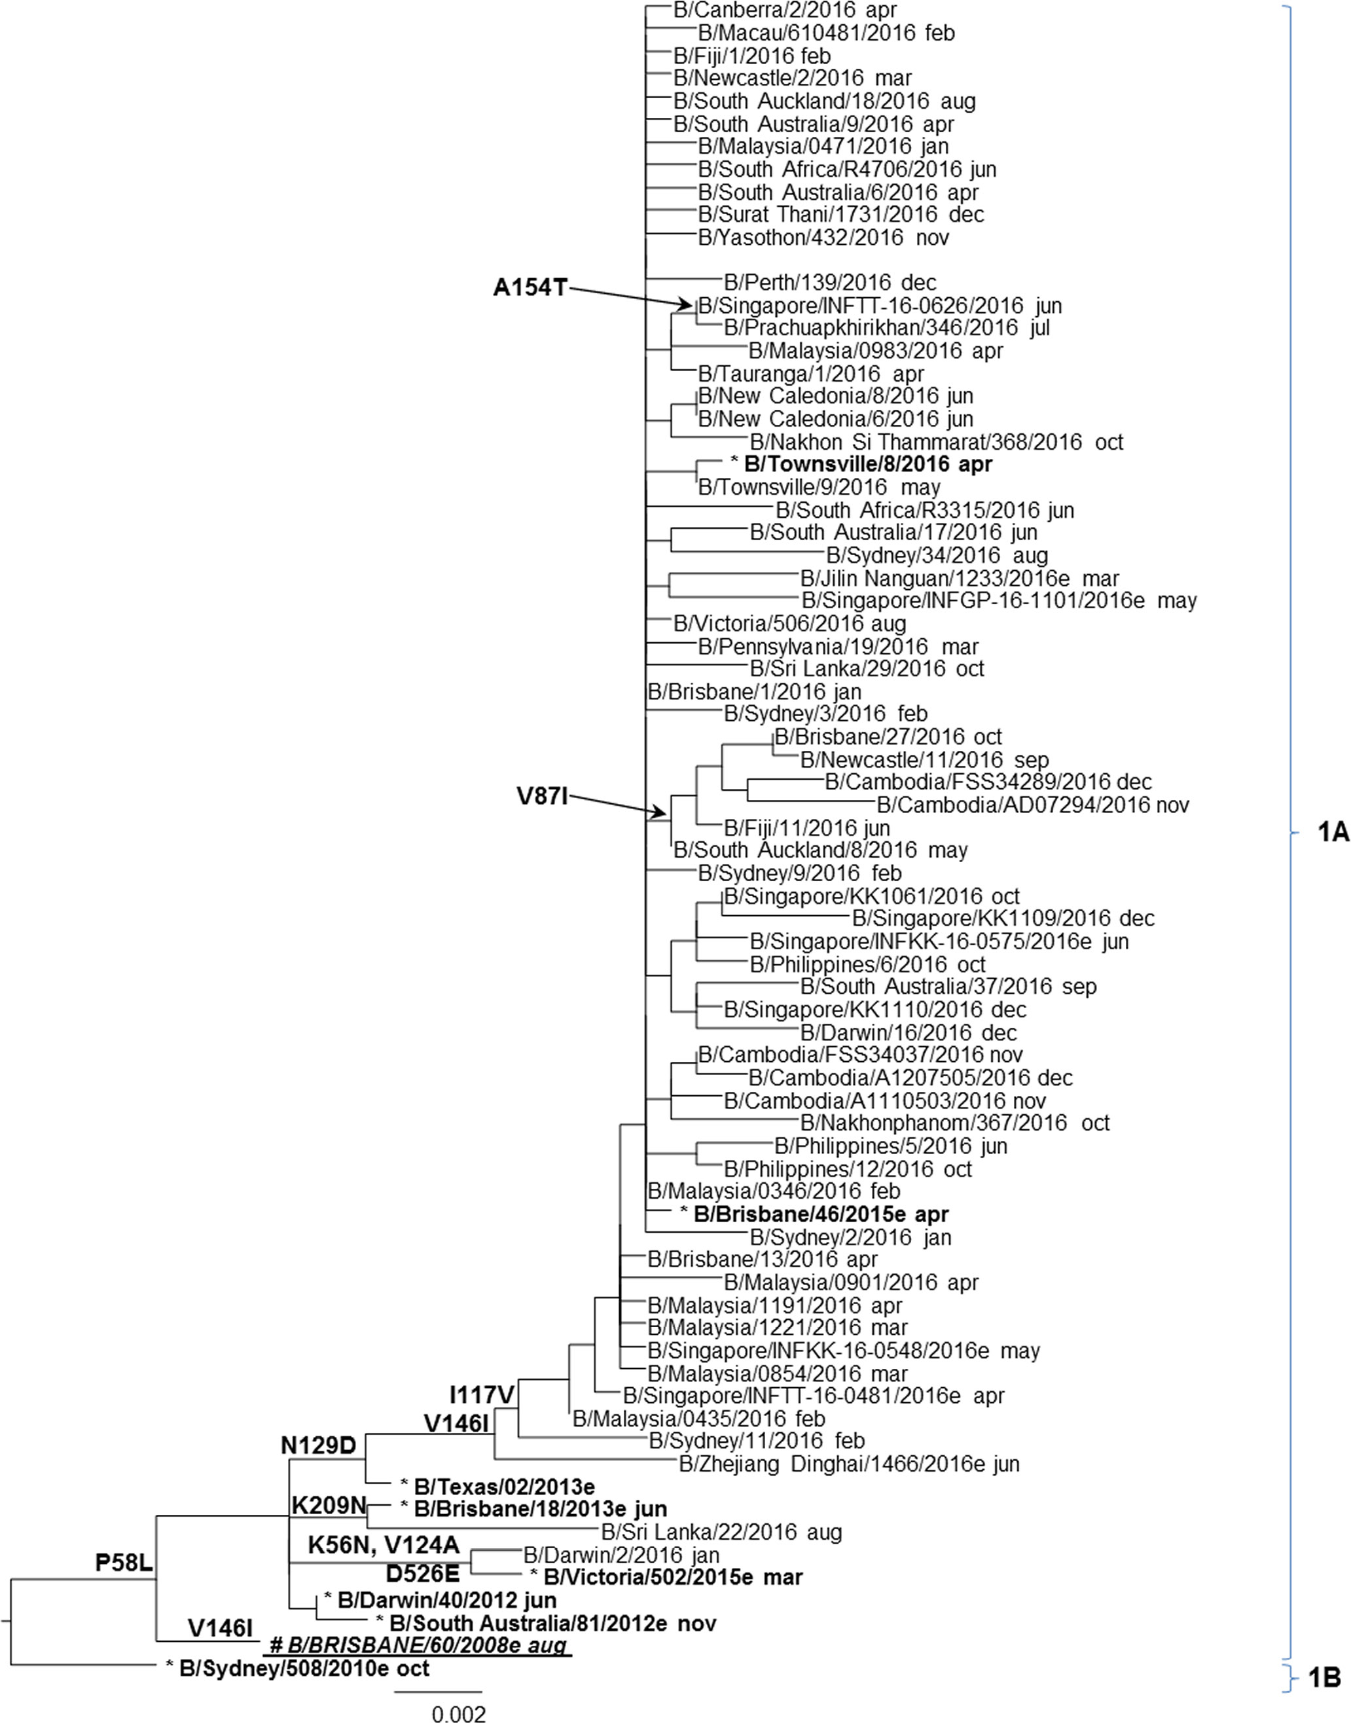

**Legend:**# 2016 SOUTHERN HEMISPHERE VACCINE STRAIN   
* Reference virus   
e: egg isolate   
Scale bar represents 0.2% nucleotide sequence difference between viruses   
Amino acid changes relative to the 2016 consensus sequence are shown   
} Braces indicate clades

**Figure 6. Phylogenetic tree of representative haemagglutinin genes of B/Yamagata viruses received by the Centre** during 2016.

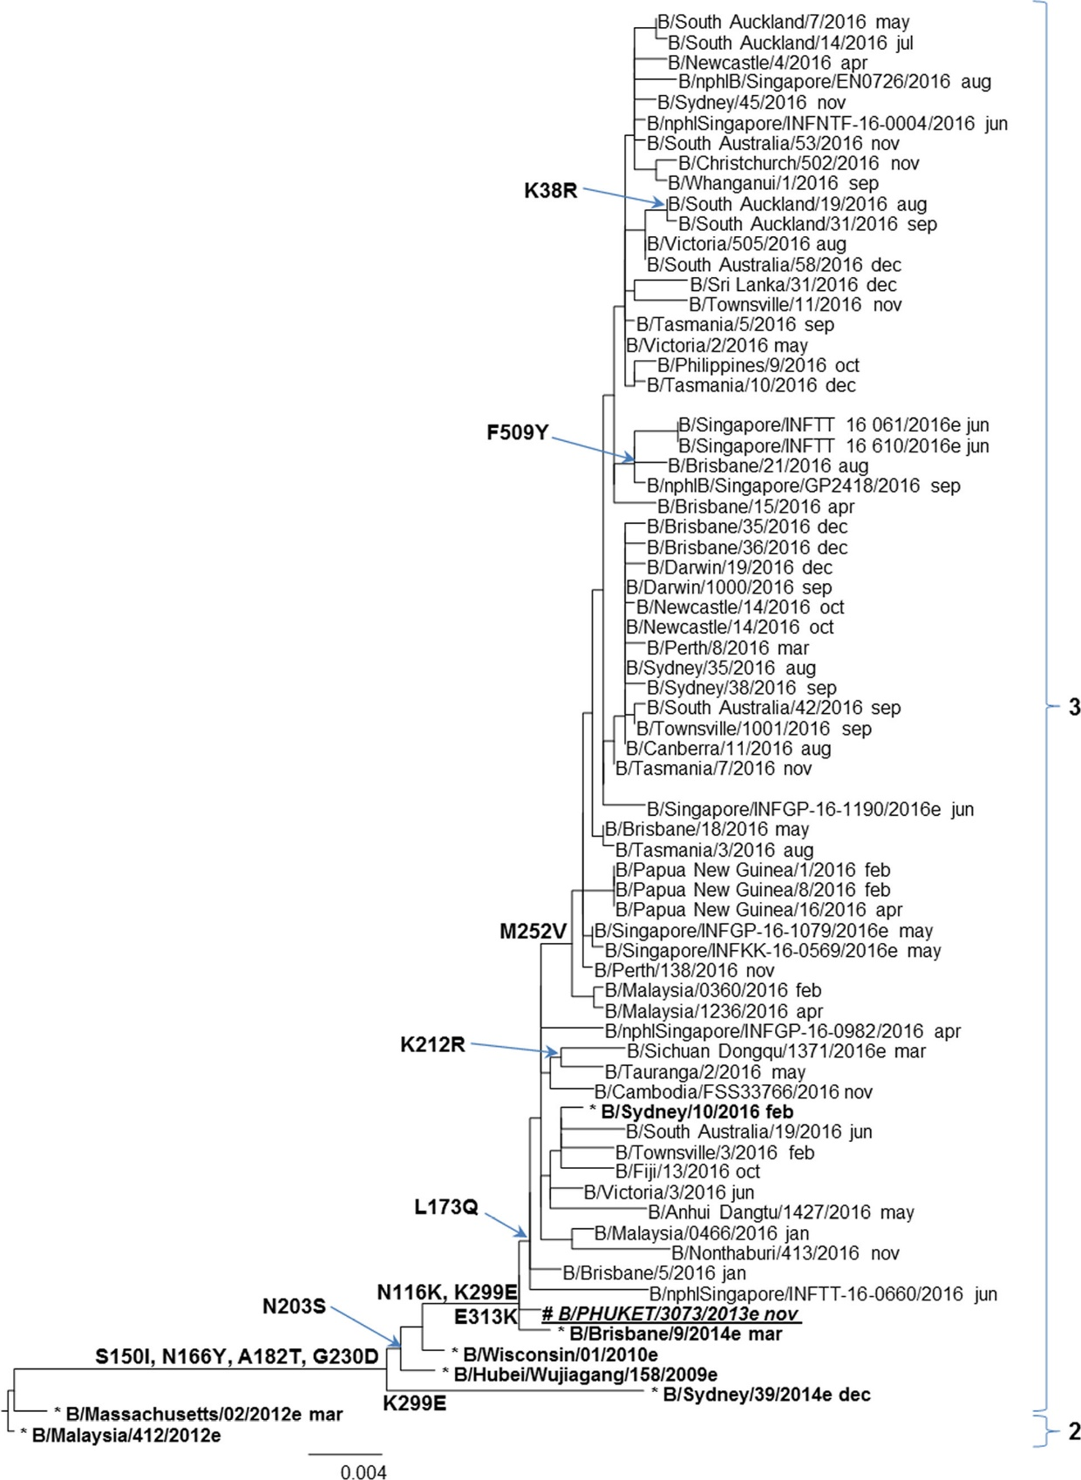

**Legend:**   
# 2016 SOUTHERN HEMISPHERE QUADRIVALENT VACCINE STRAIN   
* Reference virus   
e: egg isolate   
Scale bar represents 0.4% nucleotide sequence difference between viruses   
Amino acid changes relative to the 2016 consensus sequence are shown   
} Braces indicate clades

48 viruses were inoculated into eggs, of which 11 (23%) grew successfully. These included 2 viruses from clade 3C.3a, five viruses from clade 3C.2a and 4 viruses from subclade 3C.2a1.

None of the 1,584 A(H3) viruses tested had highly reduced inhibition with either oseltamivir or zanamivir.

## Influenza B

Similar proportions of viruses from both B lineages (B/Victoria and B/Yamagata) were received at the Centre during 2016. A total of 653 influenza B viruses were characterised by HI assay and all were antigenically similar to B/Brisbane/60/2008-like and B/Phuket/3073/2013-like vaccine viruses (Table 1).

Sequencing was performed on HA genes from 149 B viruses, with the majority being B/Victoria viruses. All of the viruses of B/Victoria lineage were genetically similar to the B/Brisbane/60/2008 reference virus (Figure 5). The majority of B/Yamagata lineage viruses belonged to Clade 3, which is the same genetic clade as the 2016 vaccine virus B/Phuket/3073/2013 (Figure 6).

Egg isolation was attempted for 5 B/Victoria and 9 B/Yamagata viruses, resulting in the successful isolation of 4 (80%) B/Victoria viruses and 4 (44%) B/Yamagata viruses. At least one representative from the major clades of both B lineages was amongst the successful egg isolates.

Of 340 B/Victoria and 315 B/Yamagata viruses tested, two B/Victoria viruses displayed highly reduced inhibition with oseltamivir and zanamivir. Both viruses were from Malaysia and contained the H431Y and G104E mutations in their NA genes respectively.

# Discussion

Similar to previous years, the samples received in 2016 were largely from Australia. 7,8 During the Australian 2016 season there was lower influenza activity with fewer laboratory-confirmed cases than in 2015, which had the highest activity since the pandemic in 2009. 9 Early interseasonal activity in 2016 was largely driven by A(H1)pdm09 viruses, followed by a rapid increase in the number of A(H3) viruses from July onwards. 10 This was also reflected in the samples received at the Centre during 2016, where viruses collected from late June onwards were predominated by A(H3). In years where A(H3) viruses predominate, the elderly are disproportionately affected11 and this was reflected in the higher number of notification rates in adults aged ≥75 years. 10

HI assays performed at the Centre showed that at least 85% of A(H3) viruses tested were antigenically similar to the cell-propagated reference strain A/Hong Kong/4801/2014. However, approximately half of the viruses analysed at the Centre were low reactors to the egg derived A/Hong Kong/4801/2014 reference strain (data not shown). In recent years there have been considerable challenges in the antigenic characterisation of A(H3) viruses. Evolutionary changes in this subtype have made it difficult to detect antigenic changes using the HI assay.3,12 A large number of A(H3) viruses isolated in MDCK-SIAT-1 cells cannot be assayed by HI in the presence of oseltamivir carboxylate and have to be antigenically tested using microneutralisation assays such as plaque reduction assays or focus reduction assays. Only 45% of all A(H3) viruses received by the Centre during 2016 could be analysed by the HI assay. The Centre is continuing to work on the development of other assays (e.g. virus neutralisation) to characterise the antigenicity of recent A(H3) viruses, however at this time, such assays remain time-and labour-intensive and would most likely complement rather than replace the HI assay. Genetic analysis has therefore become an increasingly important tool for detecting both minor and major changes in circulating A(H3) viruses.

Genetic data from the Centre indicated that many viruses in 2016 fell into clade 3C.2a1, a new subclade of 3C.2a in which the vaccine strain, A/Hong Kong/4801/2014 sits. Viruses in the subclade 3C.2a1 remain antigenically similar to other viruses in 3C.2a. However, the impact of the genetic drift of 3C.2a1 viruses and unwanted egg adaptions remains to be seen as suboptimal vaccine effectiveness (VE) estimates against A(H3) have been reported for the European 2016/17 season (VE: 38%, 95% CI: 21.3 – 51.2%).13 Similar estimates have also been reported in Canada (VE 42%; 95% CI: 18 – 59%)14 and the US (VE 43%; 95% CI: 29 – 54%).15 VE estimates for the 2016 season in Australia have not yet been reported but interim VE figures were similar to those in the Northern Hemisphere in 2016/7 (personal communication).

The majority of circulating A(H1)pdm09 viruses were antigenically similar to the cell derived A/California/7/2009 reference strain in the vaccine. However, genetic analysis indicated a number of changes in the HA protein resulting in genetic changes compared to the vaccine reference strain A/California/7/2009. Additional analyses at the WHO Collaborating Centre for the Surveillance, Epidemiology and Control of Influenza at the Centers for Disease Control and Prevention (CDC) in the USA found a reduced response in an age-related subset of post-vaccination human sera to recently circulating A(H1)pdm09 viruses. Taking into account this reduced responses in some adults and the genetic data from circulating viruses, a change in the A(H1N1)pdm09 vaccine virus was recommended for the southern hemisphere 2017 influenza vaccine from A/California/7/2009 to A/Michigan/45/2015, which lies in clade 6B.1, the same clade which contains the vast majority of 2016 Australian viruses.

Finally, antigenic and genetic data indicated that both influenza B lineage viruses analysed by the Centre were a good match with the recommended vaccine strains, B/Brisbane/60/2008 (Victoria lineage) and B/Phuket/3073/2013 (Yamagata lineage). This was also reflected in good vaccine effectiveness estimates from the northern hemisphere (VE 73%, 95% CI: 54-84%)15. The viral isolates of two B/Victoria viruses with highly reduced inhibition to both oseltamivir and zanamivir were each found to contain a single amino acid change in their respective NA sequences. However, the original clinical specimens of these isolates were not available for analysis. Therefore, it could not be determined whether these mutations were present in the original sample or whether they arose during virus propagation in cell culture.

With the continual change and evolution in influenza viruses and the absence of a universal vaccine, there remains a need for ongoing influenza surveillance and influenza vaccine updates. The work performed by the Centre in Melbourne is crucial to the efforts of the global surveillance community to ensure that viruses recommended for the influenza vaccine remain updated and as closely matched to the future circulating viruses as possible.

# Acknowledgements

The authors would like to thank all of the National Influenza Centres and other contributing laboratories who sent influenza positive samples to the Centre during 2016. We also thank Dr Kanta Subbarao and Dr Ian Barr for their comments and input to this report. The FluLINE was developed by October Sessions and Uma Kamaraj from Duke-NUS Medical School, Singapore. The Melbourne WHO Collaborating Centre for Reference and Research on Influenza is supported by the Australian Government Department of Health.

# ****Author details****

Ms Vivian K. Leung, Epidemiologist1, Dr Yi-Mo Deng, Head, Genetic Analysis1, Dr Matthew Kaye, Medical Scientist1, Mrs Iwona Buettner, Medical Scientist1, Ms Hilda Lau, Medical Scientist1, Ms Sook-Kwan Leang, Medical Scientist1, Ms Leah Gillespie, Medical Scientist1, Dr Michelle K. Chow, Communications Officer1,

1. WHO Collaborating Centre for Reference and Research on Influenza

## Corresponding author

Dr Michelle Chow WHO Collaborating Centre for Reference and Research on Influenza Peter Doherty Institute for Infection and Immunity 792 Elizabeth St Melbourne 3000 Email: michelle.chow@influenzacentre.org

# ****References****

1. Oh DY, Barr IG, Mosse JA, Laurie KL. MDCK-SIAT1 cells show improved isolation rates for recent human influenza viruses compared to conventional MDCK cells. J Clin Microbiol. 2008 Jul;46(7):2189-94. PubMed PMID: 18480230. Pubmed Central PMCID: 2446904. Epub 2008/05/16. eng.
2. Hobson D, Curry RL, Beare AS, Ward-Gardner A. The role of serum haemagglutination-inhibiting antibody in protection against challenge infection with influenza A2 and B viruses. J Hyg (Lond). 1972 Dec;70(4):767-77. PubMed PMID: 4509641. Pubmed Central PMCID: 2130285. Epub 1972/12/01. eng.
3. Lin YP, Gregory V, Collins P, Kloess J, Wharton S, Cattle N, et al. Neuraminidase receptor binding variants of human influenza A(H3N2) viruses resulting from substitution of aspartic acid 151 in the catalytic site: a role in virus attachment? Journal of virology. 2010 Jul;84(13):6769-81. PubMed PMID: 20410266. Pubmed Central PMCID: 2903250.
4. Hurt AC, Okomo-Adhiambo M, Gubareva LV. The fluorescence neuraminidase inhibition assay: a functional method for detection of influenza virus resistance to the neuraminidase inhibitors. Methods in molecular biology. 2012;865:115-25. PubMed PMID: 22528156.
5. Hurt AC, Besselaar TG, Daniels RS, Ermetal B, Fry A, Gubareva L, et al. Global update on the susceptibility of human influenza viruses to neuraminidase inhibitors, 2014-2015. Antiviral Res. 2016 Aug;132:178-85. PubMed PMID: 27265623. Pubmed Central PMCID: Pmc5357725. Epub 2016/06/07.eng.
6. WHO Global Influenza Surveillance Network. Manual for the laboratory diagnosis and virological surveillance of influenza. Geneva: World Health Organization; 2011.
7. Sullivan SG, Chow MK, Barr IG, Kelso A. Influenza viruses received and tested by the Melbourne WHO Collaborating Centre for Reference and Research on Influenza annual report, 2014. Communicable diseases intelligence quarterly report. 2015;39(4):E602-11. PubMed PMID: 26779736. Epub 2016/01/19.eng.
8. Leung VK, Spirason N, Lau H, Buettner I, Leang SK, Chow MK. Influenza viruses received and tested by the Melbourne WHO Collaborating Centre for Reference and Research on Influenza annual report, 2015. Communicable diseases intelligence quarterly report. 2017 June 2017;41(2):E150-E60.
9. Australian Government Department of Health. National Notifiable Diseases Surveillance System Canberra: Australian Government Department of Health; 2016 [cited 2017 18 April 2017]. Available from: http://www9.health.gov.au/cda/source/cda-index.cfm.
10. Health AGDo. Australian Influenza Surveillance Report No 11 - 15 September to 28 October 2016. 2016.
11. Thompson WW, Shay DK, Weintraub E, et al. Influenza-associated hospitalizations in the united states. JAMA. 2004;292(11):1333-40.
12. Barr IG, Russell C, Besselaar TG, Cox NJ, Daniels RS, Donis R, et al. WHO recommendations for the viruses used in the 2013-2014 Northern Hemisphere influenza vaccine: Epidemiology, antigenic and genetic characteristics of influenza A(H1N1)pdm09, A(H3N2) and B influenza viruses collected from October 2012 to January 2013. Vaccine. 2014 Aug 20;32(37):4713-25. PubMed PMID: 24582632. Epub 2014/03/04.eng.
13. Kissling E, Rondy M. Early 2016/17 vaccine effectiveness estimates against influenza A (H3N2): I-MOVE multicentre case control studies at primary care and hospital levels in Europe. Eurosurveillance. 2017;22(7).
14. Skowronski DM, Chambers C, Sabaiduc S, Dickinson JA, Winter AL, De Serres G, et al. Interim estimates of 2016/17 vaccine effectiveness against influenza A(H3N2), Canada, January 2017. Euro surveillance : bulletin Europeen sur les maladies transmissibles = European communicable disease bulletin. 2017 Feb 09;22(6). PubMed PMID: 28205503. Pubmed Central PMCID: Pmc5316907. Epub 2017/02/17.eng.
15. Flannery B, Chung JR, Thaker SN, Monto AS, Martin ET, Belongia EA, et al. Interim Estimates of 2016-17 Seasonal Influenza Vaccine Effectiveness - United States, February 2017. MMWR Morbidity and mortality weekly report. 2017 Feb 17;66(6):167-71. PubMed PMID: 28207689. Epub 2017/02/17.eng.

**Communicable Diseases Intelligence**

ISSN: 2209-6051 Online

**Communicable Diseases Intelligence (CDI) is a peer-reviewed scientific journal published by the Office of Health Protection, Department of Health. The journal aims to disseminate information on the epidemiology, surveillance, prevention and control of communicable diseases of relevance to Australia.**

**Editor:** Cindy Toms

**Deputy Editor:** Phil Wright

**Editorial and Production Staff:** Leroy Trapani and Kasra Yousefi

**Editorial Advisory Board:** David Durrheim, Mark Ferson, John Kaldor and Martyn Kirk

**Website**: <http://www.health.gov.au/cdi>

**Contacts**Communicable Diseases Intelligence is produced by:   
Health Protection Policy Branch, Office of Health Protection, Australian Government Department of Health  
GPO Box 9848, (MDP 6) CANBERRA ACT 2601

**Email:** [cdi.editor@health.gov.au](mailto:cdi.editor@health.gov.au)

**Submit an Article**You are invited to submit your next communicable disease related article to the Communicable Diseases Intelligence (CDI) for consideration. More information regarding CDI can be found at: <http://health.gov.au/cdi>.

Further enquiries should be directed to: [cdi.editor@health.gov.au](mailto:cdi.editor@health.gov.au).

This journal is indexed by Index Medicus and Medline.

Creative Commons Licence - Attribution-NonCommercial-NoDerivatives CC BY-NC-ND

© 2019 Commonwealth of Australia as represented by the Department of Health

This publication is licensed under a Creative Commons Attribution-NonCommercial-NoDerivatives 4.0 International Licence from <https://creativecommons.org/licenses/by-nc-nd/4.0/legalcode> (Licence). You must read and understand the Licence before using any material from this publication.

**Restrictions**The Licence does not cover, and there is no permission given for, use of any of the following material found in this publication (if any):

* the Commonwealth Coat of Arms (by way of information, the terms under which the Coat of Arms may be used can be found at [www.itsanhonour.gov.au](http://www.itsanhonour.gov.au/));
* any logos (including the Department of Health’s logo) and trademarks;
* any photographs and images;
* any signatures; and
* any material belonging to third parties.

**Disclaimer**Opinions expressed in Communicable Diseases Intelligence are those of the authors and not necessarily those of the Australian Government Department of Health or the Communicable Diseases Network Australia. Data may be subject to revision.

**Enquiries**Enquiries regarding any other use of this publication should be addressed to the Communication Branch, Department of Health, GPO Box 9848, Canberra ACT 2601, or via e-mail to: [copyright@health.gov.au](mailto:copyright@health.gov.au)

**Communicable Diseases Network Australia**Communicable Diseases Intelligence contributes to the work of the Communicable Diseases Network Australia.  
<http://www.health.gov.au/cdna>