Australia’s notifiable disease status, 2016: Annual report of the National Notifiable Diseases Surveillance System
NNDSS Annual Report Working Group

Abstract
In 2016, a total of 67 diseases and conditions were nationally notifiable in Australia. The states and territories reported 330,387 notifications of communicable diseases to the National Notifiable Diseases Surveillance System. Notifications have remained stable between 2015 and 2016. In 2016, the most frequently notified diseases were vaccine preventable diseases (139,687 notifications, 42% of total notifications); sexually transmissible infections (112,714 notifications, 34% of total notifications); and gastrointestinal diseases (49,885 notifications, 15% of total notifications). Additionally, there were 18,595 notifications of bloodborne diseases; 6,760 notifications of vectorborne diseases; 2,020 notifications of other bacterial infections; 725 notifications of zoonoses and one notification of a quarantinable disease.

Introduction
Australia’s notifiable diseases status, 2016 is an annual surveillance report of nationally-notifiable communicable diseases. Communicable disease surveillance in Australia operates at the national, jurisdictional and local levels. Primary responsibility for public health action lies with the state and territory health departments. The role of communicable disease surveillance at the national level includes:
- identifying national trends;
- providing guidance for policy development and resource allocation at the national level;
- monitoring the need for, and impact of, national disease control programs;
- informing the response to national or multi-jurisdictional outbreaks;
- describing the national epidemiology of communicable diseases;
- meeting international reporting requirements, such as providing disease statistics to the World Health Organization (WHO); and
- supporting quarantine activities, which are the responsibility of the Australian Government.

Methods
Australia is a federation of 6 states: New South Wales (NSW), Queensland (Qld), South Australia (SA), Tasmania (Tas.), Victoria (Vic.), and Western Australia (WA); and 2 territories: the Australian Capital Territory (ACT), and the Northern Territory (NT).
State and territory health departments collect notifications of communicable diseases under their respective public health legislations. In September 2007, the National Health Security Act 2007received royal assent.¹ This Act provides a legislative basis for and authorises the exchange of health information, including personal information, between jurisdictions and the Australian Government. The Act provides for the establishment of the National Notifiable Diseases List which specifies the diseases about which personal information can be provided.² TheNational Health Security Agreement,³ which was signed by Health Ministers in April 2008, establishes the operational arrangements to formalise and enhance existing surveillance and reporting systems, an important objective of the Act. Under the Agreement, in 2016 states and territories forwarded de-identified notification data on 67 communicable diseases and conditions to the Australian Government Department of Health for the purposes of national communicable disease surveillance. Not all 67 diseases were notifiable in each jurisdiction. Data were electronically updated daily from states and territories. The system was complemented by other surveillance systems, which provided information on various diseases, including three that are not reported to the National Notifiable Diseases Surveillance System (NNDSS): human immunodeficiency virus (HIV) and the classical and variant (v) forms of Creutzfeldt-Jakob disease (CJD).
The NNDSS core dataset requires the following mandatory data fields: a unique record reference number; the notifying state or territory; the disease code; confirmation status; and the date when the jurisdictional health department was notified (notification received date). In addition, the following data fields were supplied where available: date of birth; age at onset; sex; Indigenous status; postcode of residence; disease onset date; date of specimen collection; date when the pathology service authorised a report or when a medical practitioner signed the notification form (notification date); death status; and outbreak reference number (to identify cases linked to an outbreak). Where relevant, data on the species, serogroups/subtypes and phage types of organisms isolated, and on the immunisation status of the case were collected and reported to NNDSS. Data quality was monitored by the Office of Health Protection and Response and the National Surveillance Committee (NSC) and there was a continual process of improving the national consistency of communicable disease surveillance through daily, fortnightly and quarterly review of these data.
While not included in the core national dataset, enhanced surveillance information for some diseases (invasive pneumococcal disease, newly-acquired hepatitis B, newly-acquired hepatitis C, tuberculosis, donovanosis, gonococcal infection and syphilis < 2 years duration) was reported from states and territories to NNDSS. Enhanced data are not included in this report, except for newly-acquired hepatitis B and hepatitis C. These data, along with influenza enhanced data, are reported in separate (disease-specific) annual reports. Additional information concerning mortality and specific health risk factors for some diseases were obtained from states and territories and included in this annual report.
Newly-diagnosed HIV infection was a notifiable condition in each state or territory in 2016. These data were forwarded directly to the Kirby Institute for Infection and Immunity in Society (Kirby Institute) at the University of New South Wales by states and territories. Further information can be found in the Kirby Institute’s annual surveillance report.⁴
Surveillance for the classical and variant forms of CJD in Australia has been conducted through the Australian National Creutzfeldt-Jakob Disease Registry (ANCJDR) since its establishment in October 2003. CJD is a nationally notifiable disease and by June 2006, CJD was notifiable in all states and territories. Further surveillance information on CJD can be found in surveillance reports from the ANCJDR.⁵
Information on communicable disease surveillance is communicated through several avenues. The most up-to-date information on topics of interest is provided at the fortnightly teleconferences of the Communicable Diseases Network Australia (CDNA) and summarised online.⁶
The Communicable Diseases Intelligence (CDI) journal publishes surveillance data, annual surveillance reports, short reports, and articles on the epidemiology and control of communicable diseases in Australia.⁷
Notification rates for each notifiable disease were calculated using 2016 population data available in the September 2019 estimated resident population supplied by the Australian Bureau of Statistics (ABS) (Appendix A and Appendix B).⁸ Where diseases were not notifiable in a state or territory, national rates were adjusted by excluding the population of that particular jurisdiction from the denominator. For some diseases, age-adjusted rates were calculated using the direct method of standardisation with 2011 census data as the standard population. All rates are represented as the rate per 100,000 population unless stated otherwise.
Direct age-standardised notification rates, using the method described by the Australian Institute of Health and Welfare,⁹ were calculated for Aboriginal and Torres Strait Islander and non-Indigenous notifications for relevant sexually transmissible infections (STIs) for jurisdictions with Indigenous status data completed for more than 50% of notifications over the period from 2011 to 2016. Where the Indigenous status of a notification was not completed, these notifications were counted as non-Indigenous in the analyses. These data, however, should be interpreted with caution, as STI screening may occur predominantly in specific high-risk groups, including in remote Aboriginal and Torres Strait Islander populations. Studies have suggested that higher rates in Aboriginal and Torres Strait Islander populations may be attributable to higher prevalence and reinfection rates, while others have suggested that they may be due to increased testing and contact tracing.¹⁰
In the national case definitions for chlamydial infection, gonococcal infection and syphilis, the mode of transmission cannot be inferred from the site of infection. Infections in children may be acquired perinatally (e.g. congenital chlamydia).¹¹ As such, notifications of chlamydial, gonococcal and non-congenital syphilis infections were excluded from analysis of age and sex distribution where the case was aged less than 13 years and the infection was determined by public health follow-up to be non-sexually acquired.

Notes on interpretation
This report is based on 2016 data from each state and territory, agreed upon in July 2017; it represents a snapshot of the year after removal of duplicate records and incorrect or incomplete data. Totals in this report may vary slightly from the totals reported in CDI quarterly publications and state and territory reports.
Analyses in this report were based on the date of disease diagnosis to estimate disease activity within the reporting period. The date of diagnosis for most diseases is the onset date or, where the onset date was not known, the earliest of the following dates: the specimen collection date; the notification date; or the notification received date. However, for the chronic diseases hepatitis B (unspecified), hepatitis C (unspecified), leprosy, syphilis (unspecified) and tuberculosis, the diagnosis date is derived from the notification received date.
When referring to NNDSS notification data throughout the report, the term ‘cases’ or ‘notified cases’ are used to identify individuals for whom ‘notification’ of a condition has been received by NNDSS. These notifications can only represent a proportion (the ‘notified fraction’) of the total incidence (Figure 1) and this has to be taken into account when interpreting NNDSS data.

Figure 1: Communicable diseases notifiable fraction
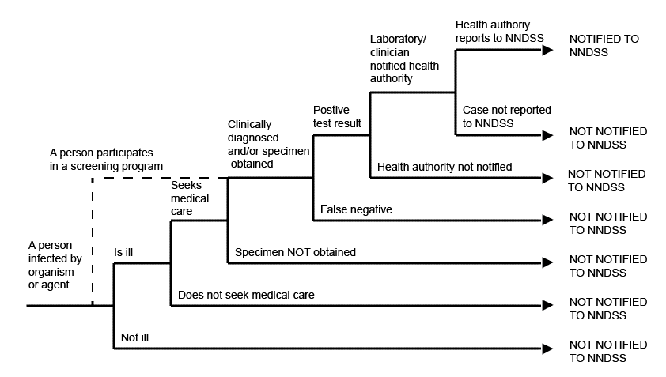

Moreover, the notified fraction varies by jurisdiction, over time, and by disease. This caveat is particularly relevant to STIs, many or most of which are identified through screening programs (Figure 1, dashed line).
The source of notification (“laboratory only”, “doctor only”, or both “laboratory and doctor”) was provided by the jurisdictions for 2016 (Table 1). Whilst most jurisdictions have data on laboratory notifications, the percentage of notifications attributed to doctor only and to both laboratory and doctor for each state and territory are based on estimates deduced from the data that are available, noting that fields for these data may be incomplete or may be notified from other sources.

Table 1: Percentage of notified cases from different sources in each jurisdiction,ª 2016
State or territory | Source of notifications (%)
 | Laboratory only | Doctor only | Laboratory and doctor
ACT^{b,c} | 97 | 2 | —
NSW | 99 | <1 | <1
NT | 98 | 1 | 1
Qld | 100 | <1 | <1
SA | 9 | 2 | 89
Tas. | 98 | <1 | 1
Vic.^{d} | 71 | 3 | 27
WA | 34 | 2 | 65
a Not all percentages add up to 100% due to rounding and/or other sources of notifications and/or incomplete data for laboratory and medical notification fields.
b Only the initial source is captured. Where a case is notified by more than one source, only the source of the first notification is recorded.
c Total does not include <1% of cases notified by other sources.
d Data from Victoria are preliminary.
Methods of surveillance vary between states and territories, each having different requirements for notification by medical practitioners, laboratories and hospitals. Although the National Notifiable Diseases List has been established,² some diseases are not notifiable in all 8 jurisdictions (Table 2).
Table 2: Diseases notified to the National Notifiable Diseases Surveillance System, Australia 2016
Disease | Data received from
Bloodborne diseases
Hepatitis B (newly acquired) | All jurisdictions
Hepatitis B (unspecified) | All jurisdictions
Hepatitis C (newly acquired) | All jurisdictions
Hepatitis C (unspecified) | All jurisdictions
Hepatitis D | All jurisdictions
Gastrointestinal diseases
Botulism | All jurisdictions
Campylobacteriosis | All jurisdictions except NSW
Cryptosporidiosis | All jurisdictions
Haemolytic uraemic syndrome | All jurisdictions
Hepatitis A | All jurisdictions
Hepatitis E | All jurisdictions
Listeriosis | All jurisdictions
Paratyphoid | All jurisdictions
Salmonellosis | All jurisdictions
Shigellosis | All jurisdictions
Shiga toxin-producing Escherichia coli | All jurisdictions
Typhoid fever | All jurisdictions
Quarantinable diseases
Cholera | All jurisdictions
Highly pathogenic avian influenza in humans | All jurisdictions
Middle East respiratory syndrome coronavirus | All jurisdictions
Plague | All jurisdictions
Rabies | All jurisdictions
Severe acute respiratory syndrome | All jurisdictions
Smallpox | All jurisdictions
Viral haemorrhagic fever | All jurisdictions
Yellow fever | All jurisdictions
Sexually transmissible infections
Chlamydial infections | All jurisdictions
Donovanosis | All jurisdictions
Gonococcal infection | All jurisdictions
Syphilis < 2 years duration | All jurisdictions
Syphilis > 2 years or unspecified duration | All jurisdictions
Syphilis – congenital | All jurisdictions
Vaccine preventable diseases
Diphtheria | All jurisdictions
Haemophilus influenzae type b | All jurisdictions
Influenza (laboratory confirmed) | All jurisdictions
Measles | All jurisdictions
Mumps | All jurisdictions
Pertussis | All jurisdictions
Pneumococcal disease (invasive) | All jurisdictions
Poliomyelitis | All jurisdictions
Rubella | All jurisdictions
Rubella – congenital | All jurisdictions
Tetanus | All jurisdictions
Varicella zoster (chickenpox) | All jurisdictions except NSW
Varicella zoster (shingles) | All jurisdictions except NSW
Varicella zoster (unspecified) | All jurisdictions except NSW
Vectorborne diseases
Barmah Forest virus infection | All jurisdictions
Chikungunya virus infection | All jurisdictions
Dengue virus infection | All jurisdictions
Flavivirus infection (unspecified) | All jurisdictions
Japanese encephalitis virus infection | All jurisdictions
Malaria | All jurisdictions
Murray Valley encephalitis virus infection | All jurisdictions
Ross River virus infection | All jurisdictions
West Nile/Kunjin virus infection | All jurisdictions
Zoonoses
Anthrax | All jurisdictions
Australian bat lyssavirus | All jurisdictions
Brucellosis | All jurisdictions
Leptospirosis | All jurisdictions
Lyssavirus (NEC)ª | All jurisdictions
Ornithosis | All jurisdictions
Q fever | All jurisdictions
Tularaemia | All jurisdictions
Other bacterial infections
Legionellosis | All jurisdictions
Leprosy | All jurisdictions
Meningococcal disease (invasive) | All jurisdictions
Tuberculosis | All jurisdictions
a NEC: Not elsewhere classified.
Changes in surveillance practices may have been introduced in some jurisdictions and not in others, and must be taken into consideration when comparing data between jurisdictions. In this report, some additional information was obtained from states and territories to assist in the interpretation of the 2016 data. These include changes in surveillance practices, screening practices, laboratory practices, and major disease control or prevention initiatives.
Postcode information reflects the residential location of the case, but this does not necessarily represent the place where the disease was acquired or where the case presented.
Indigenous status and place of acquisition were used to assess data completeness and reported as the proportion of complete notifications. The completeness of data in this report is summarised in the Results.
The percentage of data completeness was defined as:
Percentage of data completeness = (total notifications – missing or unknown) / total notifications × 100
The Indigenous status was defined by the following nationally accepted criteria:¹²
1 = Indigenous – (Aboriginal but not Torres Strait Islander origin)
2 = Indigenous – (Torres Strait Islander but not Aboriginal origin)
3 = Indigenous – (Aboriginal and Torres Strait Islander origin)
4 = Not Indigenous – (not Aboriginal or Torres Strait Islander origin)
9 = Not stated
For the purposes of this report, an Indigenous person includes responses 1, 2 or 3 with non-Indigenous including response 4 only.
Place of acquisition is where the disease is believed to have been acquired; either locally or overseas. The country of acquisition is determined by the Standard Australian Classification of Countries (SACC) from the ABS.¹³A notification is complete if a valid value from the SACC is entered.
In interpreting STI notification data, it is important to note that changes in notifications over time may not solely reflect changes in disease prevalence: changes in screening programs,^{14,15} the use of less invasive and more sensitive diagnostic tests,¹⁶ and periodic public awareness campaigns¹⁷ may influence the number of notifications that occur over time. Rates for STIs are particularly susceptible to overall rates of testing, with low testing rates resulting in an underestimation of disease and increased testing potentially causing an increase in notifications.¹⁸
The differences in rates between females and males for STIs should be interpreted with caution, as rates of testing, symptom status, health care-seeking behaviours, and partner notification differ between the sexes.¹⁹

Notes on case definitions
Each notifiable disease is governed by a national surveillance case definition for reporting to the NNDSS. These case definitions were agreed by CDNA and implemented nationally in January 2004, and were used by all jurisdictions for the first time in 2005. These case definitions are reviewed by the Case Definitions Working Group (CDWG) as required. In 2016, the following case definitions were updated:
- Barmah Forest virus infection
- Brucellosis
- Flavivirus infection (unspecified) including Zika virus infection
- Middle Eastern respiratory syndrome coronavirus (MERS-CoV)
- Ross River virus infection
- Salmonellosis
- Shiga toxin-producing Escherichia coli(STEC)
Further details on all Australian national notifiable diseases and cases definitions are available online.²⁰

Results
There were 330,387 communicable disease notifications received by NNDSS in 2016 (Table 3).
Table 3: Notifications to the National Notifiable Diseases Surveillance System, Australia, 2016, by disease category rank order
Disease category | Number | %
Vaccine preventable diseases | 139,687 | 42
Sexually transmissible infections | 112,714 | 34
Gastrointestinal diseases | 49,885 | 15
Bloodborne diseases | 18,595 | 6
Vectorborne diseases | 6,760 | 2
Other bacterial diseases | 2,020 | 1
Zoonoses | 725 | <1
Quarantinable diseases | 1 | <1
Total | 330,387 | 100

In 2016, the most frequently-notified diseases were vaccine preventable diseases (139,687 notifications, 42% of total notifications), sexually transmissible infections (112,714 notifications, 34% of total notifications), and gastrointestinal diseases (49,885 notifications, 15% of total notifications).
The number of notifications in 2016 has remained stable, with a small increase of 1% compared to the total number of notifications in 2015 (327,505) (Figure 2).

Figure 2: Trends in notifications received by the National Notifiable Diseases Surveillance System, Australia, 1991 to 2016
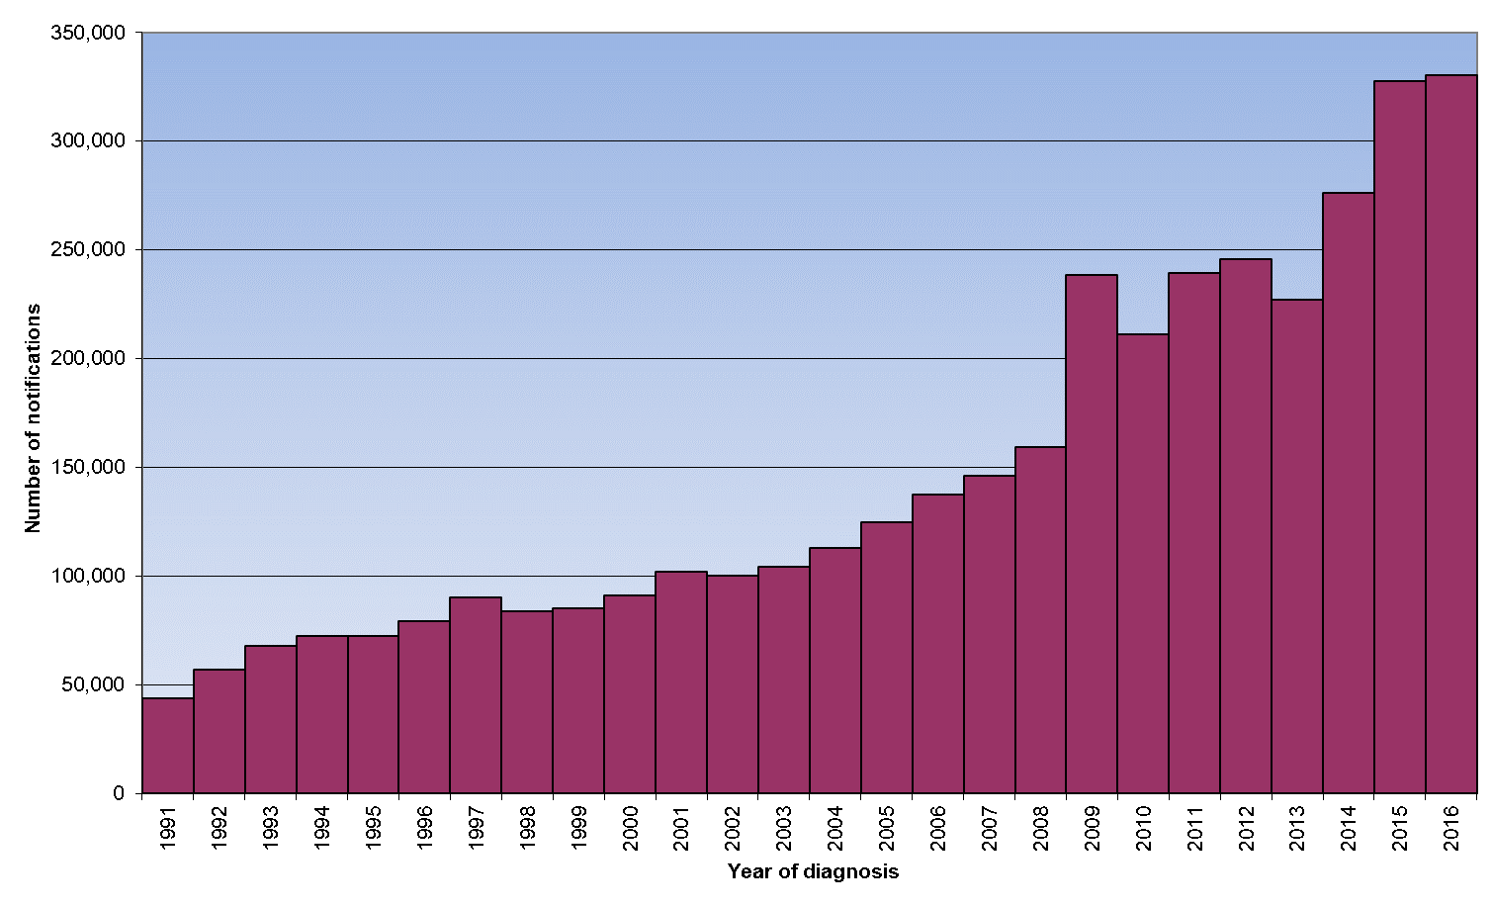
Table 4 and Table 5 show the number of notifications and notification rates, respectively, per 100,000 population for each disease by state or territory in 2016. Notifications and rates per 100,000 population, for the period 2011 to 2016, are shown in Table 6.
Table 4: Notified cases of communicable diseases, Australia, 2016, by state or territory
Disease | State or territory
 | ACT | NSW | NT | Qld | SA | Tas. | Vic. | WA | Australia
Bloodborne diseases
Hepatitis B (newly acquired)ª | 1 | 15 | 2 | 60 | 6 | 1 | 58 | 25 | 157
Hepatitis B (unspecified)^{b} | 88 | 2,376 | 107 | 993 | 300 | 39 | 1,825 | 649 | 6,404
Hepatitis C (newly acquired)ª | 15 | 22 | 3 | 366 | 40 | 22 | 120 | 120 | 717
Hepatitis C (unspecified)^{b} | 169 | 4,217 | 191 | 2,386 | 495 | 235 | 423 | 1,123 | 11,256
Hepatitis D | 0 | 20 | 2 | 11 | 9 | 0 | 17 | 1 | 61
Gastrointestinal diseases
Botulism | 0 | 0 | 0 | 0 | 0 | 0 | 0 | 0 | 0
Campylobacteriosis | 581 | NN^{c} | 442 | 7,161 | 3,194 | 1,061 | 8,274 | 3,409 | 24,164
Cryptosporidiosis | 48 | 1,203 | 280 | 2,361 | 432 | 32 | 811 | 245 | 5,419
Haemolytic uraemic syndrome | 0 | 4 | 0 | 4 | 0 | 2 | 2 | 3 | 15
Hepatitis A | 2 | 43 | 0 | 31 | 7 | 0 | 45 | 17 | 144
Hepatitis E | 2 | 14 | 1 | 7 | 3 | 0 | 12 | 2 | 42
Listeriosis | 0 | 34 | 0 | 13 | 4 | 1 | 26 | 6 | 84
Paratyphoid | 3 | 20 | 3 | 8 | 4 | 2 | 26 | 12 | 79
Salmonellosis | 268 | 4,490 | 658 | 4,787 | 1,570 | 282 | 4,040 | 1,951 | 18,088
Shigellosis | 5 | 312 | 187 | 182 | 29 | 12 | 589 | 93 | 1,406
Shiga toxin-producing Escherichia coli | 0 | 70 | 2 | 26 | 175 | 2 | 33 | 34 | 340
Typhoid fever | 3 | 35 | 1 | 18 | 6 | 1 | 27 | 12 | 104
Quarantinable diseases
Cholera | 0 | 0 | 0 | 0 | 0 | 0 | 1 | 0 | 1
Highly pathogenic avian influenza in humans | 0 | 0 | 0 | 0 | 0 | 0 | 0 | 0 | 0
Middle East respiratory syndrome coronavirus | 0 | 0 | 0 | 0 | 0 | 0 | 0 | 0 | 0
Plague | 0 | 0 | 0 | 0 | 0 | 0 | 0 | 0 | 0
Rabies | 0 | 0 | 0 | 0 | 0 | 0 | 0 | 0 | 0
Severe acute respiratory syndrome | 0 | 0 | 0 | 0 | 0 | 0 | 0 | 0 | 0
Smallpox | 0 | 0 | 0 | 0 | 0 | 0 | 0 | 0 | 0
Viral haemorrhagic fever | 0 | 0 | 0 | 0 | 0 | 0 | 0 | 0 | 0
Yellow fever | 0 | 0 | 0 | 0 | 0 | 0 | 0 | 0 | 0
Sexually transmitted infections
Chlamydial infection^{d,e} | 1,362 | 26,041 | 2,629 | 23,989 | 5,485 | 1,687 | 11,713 | 11,809 | 83,468
Donovanosis | 0 | 0 | 0 | 0 | 0 | 0 | 0 | 0 | 0
Gonococcal infection^{d,e} | 201 | 7,004 | 1,768 | 3,948 | 1,112 | 82 | 6,328 | 3,362 | 23,887
Syphilis – congenitald,^{e} | 0 | 0 | 0 | 2 | 0 | 0 | 0 | 0 | 2
Syphilis < 2 years duration^{a,e,f} | 13 | 878 | 229 | 681 | 89 | 5 | 1,138 | 335 | 3,367
Syphilis > 2 years or unspecified duration^{b,e} | 20 | 679 | 53 | 298 | 113 | 16 | 748 | 61 | 1,990
Vaccine preventable diseases
Diphtheria^{g} | 0 | 0 | 0 | 8 | 0 | 0 | 0 | 0 | 8
Haemophilus influenzae type b | 0 | 5 | 1 | 5 | 1 | 0 | 4 | 1 | 17
Influenza (laboratory confirmed) | 1,603 | 35,577 | 701 | 23,264 | 7,868 | 1,055 | 12,926 | 7,829 | 90,848
Measles | 2 | 18 | 0 | 14 | 11 | 3 | 39 | 11 | 99
Mumps | 1 | 67 | 137 | 61 | 20 | 4 | 33 | 481 | 805
Pertussis | 504 | 10,836 | 224 | 2,186 | 1,952 | 30 | 2,870 | 1,526 | 20,095
Pneumococcal disease (invasive) | 28 | 543 | 46 | 264 | 138 | 50 | 394 | 200 | 1,664
Poliomyelitis | 0 | 0 | 0 | 0 | 0 | 0 | 0 | 0 | 0
Rubella | 0 | 9 | 0 | 3 | 0 | 1 | 4 | 1 | 17
Rubella – congenital | 0 | 0 | 0 | 0 | 0 | 0 | 0 | 0 | 0
Tetanus | 0 | 0 | 0 | 3 | 0 | 0 | 2 | 1 | 7
Varicella zoster (chickenpox) | 100 | NN^{c} | 128 | 375 | 400 | 70 | 1,307 | 614 | 2,995
Varicella zoster (shingles) | 254 | NN^{c} | 366 | 74 | 2,289 | 307 | 2,423 | 1,686 | 7,398
Varicella zoster (unspecified) | 176 | NN^{c} | 5 | 7,400 | 505 | 140 | 5,942 | 1,570 | 15,734
Vectorborne diseases
Barmah Forest virus infection | 0 | 37 | 13 | 251 | 5 | 0 | 5 | 13 | 323
Chikungunya | 0 | 38 | 1 | 7 | 7 | 2 | 43 | 15 | 113
Dengue virus infection | 38 | 478 | 97 | 446 | 115 | 32 | 518 | 558 | 2,227
Flavivirus infection (unspecified) | 1 | 34 | 1 | 15 | 2 | 1 | 14 | 15 | 115
Japanese encephalitis virus infection | 0 | 0 | 0 | 0 | 0 | 0 | 0 | 0 | 0
Malaria | 9 | 59 | 17 | 76 | 9 | 3 | 78 | 57 | 305
Murray Valley encephalitis virus infection | 0 | 0 | 0 | 0 | 0 | 0 | 0 | 0 | 0
Ross River virus infection | 21 | 641 | 201 | 1,652 | 158 | 8 | 544 | 478 | 3,677
West Nile/Kunjin virus infection | 0 | 0 | 0 | 0 | 0 | 0 | 0 | 0 | 0
Zoonoses
Anthrax | 0 | 0 | 0 | 0 | 0 | 0 | 0 | 0 | 0
Australia bat lyssavirus | 0 | 0 | 0 | 0 | 0 | 0 | 0 | 0 | 0
Brucellosis | 0 | 8 | 0 | 7 | 0 | 0 | 0 | 2 | 18
Leptospirosis | 0 | 13 | 1 | 104 | 2 | 1 | 15 | 6 | 134
Lyssavirus (NEC)^{h} | 0 | 0 | 0 | 0 | 0 | 0 | 0 | 0 | 0
Ornithosis | 0 | 14 | 0 | 0 | 0 | 0 | 8 | 0 | 22
Q fever | 2 | 231 | 2 | 230 | 28 | 0 | 43 | 11 | 551
Tularaemia | 0 | 0 | 0 | 0 | 0 | 0 | 0 | 0 | 0
Other bacterial diseases
Legionellosis | 2 | 136 | 0 | 45 | 29 | 9 | 75 | 69 | 369
Leprosy | 0 | 6 | 1 | 4 | 0 | 1 | 2 | 7 | 21
Meningococcal infection^{i} | 2 | 71 | 2 | 42 | 27 | 5 | 79 | 21 | 252
Tuberculosis | 24 | 536 | 22 | 181 | 88 | 9 | 365 | 145 | 1,378
Total | 5,548 | 96,834 | 8,524 | 84,049 | 26,727 | 5,213 | 65,989 | 38,586 | 330,387
a Newly-acquired hepatitis and syphilis < 2 years duration include cases where the infection was determined to be acquired within 24 months prior to diagnosis.
b Unspecified categories of hepatitis and syphilis include cases where the duration of infection could not be determined or is greater than 24 months.
c NN: not notifiable.
d Includes Chlamydia trachomatis identified from cervical, rectal, urine, urethral and throat samples, except for South Australia, which reports only cervical, urine and urethral specimens.
e The national case definitions for chlamydial, gonococcal and syphilis diagnoses include infections that may be acquired through a non-sexual mode (especially in children – e.g. perinatal infections, epidemic gonococcal conjunctivitis).
f Data for all states and territories are reported by diagnosis date, except Queensland, which is reported by notification receive date.
g This number may underrepresent the number of diphtheria cases in Australia in 2016. For more details please see the summary of diphtheria in the Vaccine Preventable Diseases section of the 2016 NNDSS Annual Report.
h NEC: not elsewhere classified.
i Only invasive meningococcal disease is nationally notifiable. However, the Australian Capital Territory and New South Wales also report conjunctival cases.

Table 5: Notification rates per 100,000 population of nationally-notifiable communicable diseases, Australia, 2016, by state or territory
Disease | State or territory |  |  |  |  |  |  |  | Australia
 | ACT | NSW | NT | Qld | SA | Tas. | Vic. | WA
Bloodborne diseases
Hepatitis B (newly acquired)ª | 0.2 | 0.2 | 0.8 | 1.2 | 0.4 | 0.2 | 0.9 | 1.0 | 0.6
Hepatitis B (unspecified)^{b} | 21.8 | 30.7 | 43.6 | 2.0 | 17.5 | 7.5 | 29.6 | 25.4 | 26.5
Hepatitis C (newly acquired)ª | 3.7 | 0.3 | 1.2 | 7.6 | 2.3 | 4.3 | 1.9 | 4.7 | 3.0
Hepatitis C (unspecified)^{b} | 41.9 | 54.5 | 77.7 | 49.3 | 28.9 | 45.4 | 39.3 | 43.9 | 46.5
Hepatitis D | 0.0 | 0.3 | 0.8 | 0.2 | 0.5 | 0.0 | 0.3 | 0.0 | 0.3
Gastrointestinal diseases
Botulism | 0.0 | 0.0 | 0.0 | 0.0 | 0.0 | 0.0 | 0.0 | 0.0 | 0.0
Campylobacteriosis | 144.1 | NN^{c} | 179.9 | 147.9 | 186.5 | 205.0 | 134.0 | 133.4 | 146.8
Cryptosporidiosis | 11.9 | 15.6 | 114.0 | 48.8 | 25.2 | 6.2 | 13.1 | 9.6 | 22.4
Haemolytic uraemic syndrome | 0.0 | 0.1 | 0.0 | 0.1 | 0.0 | 0.4 | 0.0 | 0.1 | 0.1
Hepatitis A | 0.5 | 0.6 | 0.0 | 0.6 | 0.4 | 0.0 | 0.7 | 0.7 | 0.6
Hepatitis E | 0.5 | 0.2 | 0.4 | 0.1 | 0.2 | 0.0 | 0.2 | 0.1 | 0.2
Listeriosis | 0.0 | 0.4 | 0.0 | 0.3 | 0.2 | 0.2 | 0.4 | 0.2 | 0.3
Paratyphoid | 0.7 | 0.3 | 1.2 | 0.2 | 0.2 | 0.4 | 0.4 | 0.5 | 0.3
Salmonellosis | 66.5 | 58.1 | 267.8 | 98.8 | 91.7 | 54.5 | 65.4 | 76.3 | 74.8
Shigellosis | 1.2 | 4.0 | 76.1 | 3.8 | 1.7 | 2.3 | 9.5 | 3.6 | 5.8
Shiga toxin-producing Escherichia coli | 0.0 | 0.9 | 0.8 | 0.5 | 10.2 | 0.4 | 0.5 | 1.3 | 1.4
Typhoid fever | 0.7 | 0.5 | 0.4 | 0.4 | 0.4 | 0.2 | 0.4 | 0.5 | 0.4
Quarantinable diseases
Cholera | 0.0 | 0.0 | 0.0 | 0.0 | 0.0 | 0.0 | 0.0 | 0.0 | 0.0
Highly pathogenic avian influenza in humans | 0.0 | 0.0 | 0.0 | 0.0 | 0.0 | 0.0 | 0.0 | 0.0 | 0.0
Middle East respiratory syndrome coronavirus | 0.0 | 0.0 | 0.0 | 0.0 | 0.0 | 0.0 | 0.0 | 0.0 | 0.0
Plague | 0.0 | 0.0 | 0.0 | 0.0 | 0.0 | 0.0 | 0.0 | 0.0 | 0.0
Rabies | 0.0 | 0.0 | 0.0 | 0.0 | 0.0 | 0.0 | 0.0 | 0.0 | 0.0
Severe acute respiratory syndrome | 0.0 | 0.0 | 0.0 | 0.0 | 0.0 | 0.0 | 0.0 | 0.0 | 0.0
Smallpox | 0.0 | 0.0 | 0.0 | 0.0 | 0.0 | 0.0 | 0.0 | 0.0 | 0.0
Viral haemorrhagic fever | 0.0 | 0.0 | 0.0 | 0.0 | 0.0 | 0.0 | 0.0 | 0.0 | 0.0
Yellow fever | 0.0 | 0.0 | 0.0 | 0.0 | 0.0 | 0.0 | 0.0 | 0.0 | 0.0
Sexually transmitted infections
Chlamydial infection^{d,e} | 337.9 | 336.8 | 1,070.1 | 495.3 | 320.2 | 326.0 | 189.7 | 462.0 | 345.0
Donovanosis | 0.0 | 0.0 | 0.0 | 0.0 | 0.0 | 0.0 | 0.0 | 0.0 | 0.0
Gonococcal infection^{d,e} | 49.9 | 90.6 | 719.6 | 81.5 | 64.9 | 15.8 | 102.5 | 131.5 | 98.7
Syphilis – congenital^{d,e} | 0.0 | 0.0 | 0.0 | 0.0 | 0.0 | 0.0 | 0.0 | 0.0 | 0.0
Syphilis < 2 years duration^{a,e,f} | 3.2 | 11.4 | 93.2 | 14.1 | 5.2 | 1.0 | 18.4 | 13.1 | 13.9
Syphilis > 2 years or unspecified duration^{b,e} | 5.0 | 8.8 | 21.6 | 6.2 | 6.6 | 3.1 | 12.1 | 2.4 | 8.2
Vaccine preventable diseases
Diphtheria^{g} | 0.0 | 0.0 | 0.0 | 0.2 | 0.0 | 0.0 | 0.0 | 0.0 | 0.0
Haemophilus influenzae type b | 0.0 | 0.1 | 0.4 | 0.1 | 0.1 | 0.0 | 0.1 | 0.0 | 0.1
Influenza (laboratory confirmed) | 397.7 | 460.1 | 285.3 | 480.3 | 459.4 | 203.9 | 209.4 | 306.3 | 375.5
Measles | 0.5 | 0.2 | 0.0 | 0.3 | 0.6 | 0.6 | 0.6 | 0.4 | 0.4
Mumps | 0.2 | 0.9 | 55.8 | 1.3 | 1.2 | 0.8 | 0.5 | 18.8 | 3.3
Pertussis | 125.0 | 140.1 | 91.2 | 45.1 | 114.0 | 5.8 | 46.5 | 59.7 | 83.1
Pneumococcal disease (invasive) | 6.9 | 7.0 | 18.7 | 5.5 | 8.1 | 9.7 | 6.4 | 7.8 | 6.9
Poliomyelitis | 0.0 | 0.0 | 0.0 | 0.0 | 0.0 | 0.0 | 0.0 | 0.0 | 0.0
Rubella | 0.0 | 0.1 | 0.0 | 0.0 | 0.0 | 0.2 | 0.1 | 0.0 | 0.1
Rubella – congenital | 0.0 | 0.0 | 0.0 | 0.0 | 0.0 | 0.0 | 0.0 | 0.0 | 0.0
Tetanus | 0.0 | 0.0 | 0.0 | 0.1 | 0.0 | 0.0 | 0.0 | 0.0 | 0.0
Varicella zoster (chickenpox) | 24.8 | NN^{c} | 52.1 | 7.7 | 23.4 | 13.5 | 21.2 | 24.0 | 18.2
Varicella zoster (shingles) | 63.0 | NN^{c} | 149.0 | 1.5 | 133.6 | 59.3 | 39.3 | 66.0 | 45.0
Varicella zoster (unspecified) | 43.7 | NN^{c} | 2.0 | 152.8 | 29.5 | 27.1 | 96.3 | 61.4 | 95.6
Vectorborne diseases
Barmah Forest virus infection | 0.0 | 0.5 | 5.3 | 5.2 | 0.3 | 0.0 | 0.1 | 0.5 | 1.3
Chikungunya | 0.0 | 0.5 | 0.4 | 0.1 | 0.4 | 0.4 | 0.7 | 0.6 | 0.5
Dengue virus infection | 9.4 | 6.2 | 39.5 | 9.2 | 6.7 | 6.2 | 8.4 | 21.8 | 9.2
Flavivirus infection (unspecified) | 0.2 | 0.4 | 0.4 | 0.3 | 0.1 | 0.2 | 0.2 | 0.6 | 0.5
Japanese encephalitis virus infection | 0.0 | 0.0 | 0.0 | 0.0 | 0.0 | 0.0 | 0.0 | 0.0 | 0.0
Malaria | 2.2 | 0.8 | 6.9 | 1.6 | 0.5 | 0.6 | 1.3 | 2.2 | 1.3
Murray Valley encephalitis virus infection | 0.0 | 0.0 | 0.0 | 0.0 | 0.0 | 0.0 | 0.0 | 0.0 | 0.0
Ross River virus infection | 5.2 | 8.3 | 81.8 | 34.1 | 9.2 | 1.5 | 8.8 | 18.7 | 15.2
West Nile/Kunjin virus infection | 0.0 | 0.0 | 0.0 | 0.0 | 0.0 | 0.0 | 0.0 | 0.0 | 0.0
Zoonoses
Anthrax | 0.0 | 0.0 | 0.0 | 0.0 | 0.0 | 0.0 | 0.0 | 0.0 | 0.0
Australia bat lyssavirus | 0.0 | 0.0 | 0.0 | 0.0 | 0.0 | 0.0 | 0.0 | 0.0 | 0.0
Brucellosis | 0.0 | 0.1 | 0.0 | 0.1 | 0.0 | 0.0 | 0.0 | 0.1 | 0.1
Leptospirosis | 0.0 | 0.2 | 0.4 | 2.1 | 0.1 | 0.2 | 0.2 | 0.2 | 0.6
Lyssavirus (NEC)^{h} | 0.0 | 0.0 | 0.0 | 0.0 | 0.0 | 0.0 | 0.0 | 0.0 | 0.0
Ornithosis | 0.0 | 0.2 | 0.0 | 0.0 | 0.0 | 0.0 | 0.1 | 0.0 | 0.1
Q fever | 0.5 | 3.0 | 0.8 | 4.7 | 1.6 | 0.0 | 0.7 | 0.4 | 2.3
Tularaemia | 0.0 | 0.0 | 0.0 | 0.0 | 0.0 | 0.0 | 0.0 | 0.0 | 0.0
Other bacterial diseases
Legionellosis | 0.5 | 1.8 | 0.0 | 0.9 | 1.7 | 1.7 | 1.2 | 2.7 | 1.5
Leprosy | 0.0 | 0.1 | 0.4 | 0.1 | 0.0 | 0.2 | 0.0 | 0.3 | 0.1
Meningococcal infection^{i} | 0.5 | 0.9 | 0.8 | 0.9 | 1.6 | 1.0 | 1.3 | 0.8 | 1.0
Tuberculosis | 6.0 | 6.9 | 9.0 | 3.7 | 5.1 | 1.7 | 5.9 | 5.7 | 5.7
a Newly-acquired hepatitis and syphilis < 2 years duration include cases where the infection was determined to be acquired within 24 months prior to diagnosis.
b Unspecified categories of hepatitis and syphilis include cases where the duration of infection could not be determined or is greater than 24 months.
c NN: not notifiable.
d Includes Chlamydia trachomatis identified from cervical, rectal, urine, urethral and throat samples, except for South Australia, which reports only cervical, urine and urethral specimens.
e The national case definitions for chlamydial, gonococcal and syphilis diagnoses include infections that may be acquired through a non-sexual mode (especially in children – e.g. perinatal infections, epidemic gonococcal conjunctivitis).
f Data for all states and territories are reported by diagnosis date, except Queensland, which is reported by notification receive date.
g This number may underrepresent the number of diphtheria cases in Australia in 2016. For more details please see the summary of diphtheria in the Vaccine Preventable Diseases section of the 2016 NNDSS Annual Report.
h NEC: not elsewhere classified.
i Only invasive meningococcal disease is nationally notifiable. However, the Australian Capital Territory and New South Wales also report conjunctival cases.

Table 6: Notified cases and notification rate per 100,000 population for communicable diseases, Australia, 2011 to 2016
Disease | Number of notified cases |  |  |  |  |  | 5-year mean | Ratio (2016:  5-year mean) | Notification rate per 100,000 population
 | 2011 | 2012 | 2013 | 2014 | 2015 | 2016 |  |  | 2011 | 2012 | 2013 | 2014 | 2015 | 2016
Bloodborne diseases
Hepatitis B (newly acquired)ª | 190 | 193 | 173 | 169 | 139 | 157 | 172.8 | 0.9 | 0.9 | 0.8 | 0.7 | 0.7 | 0.6 | 0.6
Hepatitis B (unspecified)^{b} | 6,329 | 6,356 | 6,846 | 6,379 | 6,325 | 6,404 | 6,447.0 | 1.0 | 28.3 | 28.0 | 29.6 | 27.2 | 26.6 | 26.5
Hepatitis C (newly acquired)ª | 619 | 709 | 672 | 714 | 817 | 717 | 706.2 | 1.0 | 2.8 | 3.1 | 2.9 | 3.0 | 3.4 | 3.0
Hepatitis C (unspecified)^{b} | 9,620 | 9,365 | 10,004 | 9,862 | 9,899 | 11,256 | 9,750.0 | 1.2 | 43.1 | 41.2 | 43.3 | 42.0 | 41.6 | 46.5
Hepatitis D | 48 | 36 | 61 | 57 | 40 | 61 | 48.4 | 1.3 | 0.2 | 0.2 | 0.3 | 0.2 | 0.2 | 0.3
Gastrointestinal diseases
Botulism | 2 | 0 | 4 | 1 | 3 | 0 | 2.0 | 0.0 | 0.0 | 0.0 | 0.0 | 0.0 | 0.0 | 0.0
Campylobacteriosis | 17,722 | 15,705 | 14,689 | 19,945 | 22,549 | 24,164 | 18,122.0 | 1.3 | 117.2 | 101.8 | 93.4 | 124.9 | 139.2 | 146.8
Cryptosporidiosis | 1,811 | 3,142 | 3,852 | 2,408 | 4,063 | 5,419 | 3,055.2 | 1.8 | 8.1 | 13.8 | 16.7 | 10.3 | 17.1 | 22.4
Haemolytic uraemic syndrome | 13 | 20 | 15 | 21 | 18 | 15 | 17.4 | 0.9 | 0.1 | 0.1 | 0.1 | 0.1 | 0.1 | 0.1
Hepatitis A | 145 | 166 | 190 | 231 | 179 | 144 | 182.2 | 0.8 | 0.6 | 0.7 | 0.8 | 1.0 | 0.8 | 0.6
Hepatitis E | 41 | 32 | 34 | 58 | 41 | 42 | 41.2 | 1.0 | 0.2 | 0.1 | 0.1 | 0.2 | 0.2 | 0.2
Listeriosis | 70 | 93 | 76 | 80 | 70 | 84 | 77.8 | 1.1 | 0.3 | 0.4 | 0.3 | 0.3 | 0.3 | 0.3
Paratyphoid | 69 | 78 | 74 | 70 | 76 | 79 | 73.4 | 1.1 | 0.3 | 0.3 | 0.3 | 0.3 | 0.3 | 0.3
Salmonellosis | 12,197 | 11,166 | 12,724 | 16,283 | 17,001 | 18,088 | 13,874.2 | 1.3 | 54.6 | 49.1 | 55.0 | 69.4 | 71.4 | 74.8
Shigellosis | 493 | 548 | 537 | 1,034 | 1,037 | 1,406 | 729.8 | 1.9 | 2.2 | 2.4 | 2.3 | 4.4 | 4.4 | 5.8
Shiga toxin-producing Escherichia coli | 95 | 112 | 180 | 115 | 136 | 340 | 127.6 | 2.7 | 0.4 | 0.5 | 0.8 | 0.5 | 0.6 | 1.4
Typhoid fever | 135 | 122 | 150 | 117 | 114 | 104 | 127.6 | 0.8 | 0.6 | 0.5 | 0.6 | 0.5 | 0.5 | 0.4
Quarantinable diseases
Cholera | 6 | 5 | 3 | 2 | 2 | 1 | 3.6 | 0.3 | 0.0 | 0.0 | 0.0 | 0.0 | 0.0 | 0.0
Highly pathogenic avian influenza in humans | 0 | 0 | 0 | 0 | 0 | 0 | 0.0 | 0.0 | 0.0 | 0.0 | 0.0 | 0.0 | 0.0 | 0.0
Middle East respiratory syndrome coronavirus | 0 | 0 | 0 | 0 | 0 | 0 | 0.0 | 0.0 | 0.0 | 0.0 | 0.0 | 0.0 | 0.0 | 0.0
Plague | 0 | 0 | 0 | 0 | 0 | 0 | 0.0 | 0.0 | 0.0 | 0.0 | 0.0 | 0.0 | 0.0 | 0.0
Rabies | 0 | 0 | 0 | 0 | 0 | 0 | 0.0 | 0.0 | 0.0 | 0.0 | 0.0 | 0.0 | 0.0 | 0.0
Severe acute respiratory syndrome | 0 | 0 | 0 | 0 | 0 | 0 | 0.0 | 0.0 | 0.0 | 0.0 | 0.0 | 0.0 | 0.0 | 0.0
Smallpox | 0 | 0 | 0 | 0 | 0 | 0 | 0.0 | 0.0 | 0.0 | 0.0 | 0.0 | 0.0 | 0.0 | 0.0
Viral haemorrhagic fever | 0 | 0 | 0 | 0 | 0 | 0 | 0.0 | 0.0 | 0.0 | 0.0 | 0.0 | 0.0 | 0.0 | 0.0
Yellow fever | 0 | 0 | 0 | 0 | 0 | 0 | 0.0 | 0.0 | 0.0 | 0.0 | 0.0 | 0.0 | 0.0 | 0.0
Sexually transmissible infections
Chlamydial infection^{c,d} | 81,104 | 83,156 | 83,793 | 86,798 | 79,252 | 83,468 | 82,820.6 | 1.0 | 363.0 | 365.8 | 362.3 | 369.7 | 332.8 | 345.0
Donovanosis | 0 | 1 | 0 | 1 | 0 | 0 | 0.4 | 0.0 | 0.0 | 0.0 | 0.0 | 0.0 | 0.0 | 0.0
Gonococcal infection^{c,d} | 12,094 | 13,886 | 14,914 | 15,702 | 18,512 | 23,887 | 15,021.6 | 1.6 | 54.1 | 61.1 | 64.5 | 66.9 | 77.7 | 98.7
Syphilis – congenital^{c,d} | 6 | 0 | 8 | 3 | 3 | 2 | 4.0 | 0.5 | 0.0 | 0.0 | 0.0 | 0.0 | 0.0 | 0.0
Syphilis < 2 years duration^{a,d,e} | 1,256 | 1,539 | 1,769 | 2,070 | 2,739 | 3,367 | 1,874.6 | 1.8 | 5.6 | 6.8 | 7.6 | 8.8 | 11.5 | 13.9
Syphilis > 2 years or unspecified duration^{b,d} | 1,358 | 1,399 | 1,740 | 1,872 | 1,929 | 1,990 | 1,659.6 | 1.2 | 6.6 | 6.6 | 7.5 | 8.0 | 8.1 | 8.2
Vaccine preventable diseases
Diphtheria^{f} | 4 | 0 | 3 | 2 | 2 | 8 | 2.2 | 3.6 | 0.0 | 0.0 | 0.0 | 0.0 | 0.0 | 0.0
Haemophilus influenzae type b | 13 | 16 | 20 | 21 | 16 | 17 | 17.2 | 1.0 | 0.1 | 0.1 | 0.1 | 0.1 | 0.1 | 0.1
Influenza (laboratory confirmed) | 27,222 | 44,563 | 28,317 | 67,703 | 100,597 | 90,848 | 53,680.4 | 1.7 | 121.9 | 196.0 | 122.4 | 288.4 | 422.4 | 375.5
Measles | 194 | 199 | 158 | 339 | 74 | 99 | 192.8 | 0.5 | 0.9 | 0.9 | 0.7 | 1.4 | 0.3 | 0.4
Mumps | 153 | 201 | 216 | 186 | 645 | 805 | 280.2 | 2.9 | 0.7 | 0.9 | 0.9 | 0.8 | 2.7 | 3.3
Pertussis | 38,758 | 24,099 | 12,364 | 11,864 | 22,543 | 20,095 | 21,925.6 | 0.9 | 173.5 | 106.0 | 53.5 | 50.5 | 94.7 | 83.1
Pneumococcal disease (invasive) | 1,883 | 1,823 | 1,549 | 1,561 | 1,497 | 1,664 | 1,662.6 | 1.0 | 8.4 | 8.0 | 6.7 | 6.6 | 6.3 | 6.9
Poliomyelitis | 0 | 0 | 0 | 0 | 0 | 0 | 0.0 | 0.0 | 0.0 | 0.0 | 0.0 | 0.0 | 0.0 | 0.0
Rubella | 58 | 36 | 25 | 17 | 17 | 17 | 30.6 | 0.6 | 0.3 | 0.2 | 0.1 | 0.1 | 0.1 | 0.1
Rubella – congenital | 0 | 0 | 0 | 0 | 0 | 0 | 0.0 | 0.0 | 0.0 | 0.0 | 0.0 | 0.0 | 0.0 | 0.0
Tetanus | 3 | 7 | 4 | 3 | 2 | 7 | 3.8 | 1.8 | 0.0 | 0.0 | 0.0 | 0.0 | 0.0 | 0.0
Varicella zoster (chickenpox) | 2,100 | 1,989 | 2,123 | 2,103 | 2,475 | 2,995 | 2,158.0 | 1.4 | 13.9 | 12.9 | 13.5 | 13.2 | 15.3 | 18.2
Varicella zoster (shingles) | 4,022 | 4,507 | 5,006 | 5,523 | 6,341 | 7,398 | 5,079.8 | 1.5 | 26.6 | 29.2 | 31.8 | 34.6 | 39.1 | 45.0
Varicella zoster (unspecified) | 8,604 | 9,414 | 11,155 | 12,214 | 13,563 | 15,734 | 10,990.0 | 1.4 | 56.9 | 61.0 | 70.9 | 76.5 | 83.7 | 95.6
Vectorborne diseases
Barmah Forest virus infection | 1,867 | 1,730 | 4,237 | 742 | 629 | 323 | 1,841.0 | 0.2 | 8.4 | 7.6 | 18.3 | 3.2 | 2.6 | 1.3
Chikungunya virus infection | 39 | 19 | 134 | 110 | 111 | 113 | 82.6 | 1.4 | 0.2 | 0.1 | 0.6 | 0.5 | 0.5 | 0.5
Dengue virus infection | 821 | 1,539 | 1,841 | 1,721 | 1,715 | 2,227 | 1,527.4 | 1.5 | 3.7 | 6.8 | 8.0 | 7.3 | 7.2 | 9.2
Flavivirus infection (unspecified) | 13 | 6 | 16 | 21 | 11 | 115 | 13.4 | 8.6 | 0.1 | 0.0 | 0.1 | 0.1 | 0.0 | 0.5
Japanese encephalitis virus infection | 0 | 1 | 4 | 1 | 3 | 0 | 1.8 | 0.0 | 0.0 | 0.0 | 0.0 | 0.0 | 0.0 | 0.0
Malaria | 422 | 344 | 422 | 325 | 234 | 305 | 349.4 | 0.9 | 1.9 | 1.5 | 1.8 | 1.4 | 1.0 | 1.3
Murray Valley encephalitis virus infection | 16 | 1 | 0 | 0 | 2 | 0 | 3.8 | 0.0 | 0.1 | 0.0 | 0.0 | 0.0 | 0.0 | 0.0
Ross River virus infection | 5,134 | 4,682 | 4,317 | 5,314 | 9,555 | 3,677 | 5,800.4 | 0.6 | 23.0 | 20.6 | 18.7 | 22.6 | 40.1 | 15.2
West Nile/Kunjin virus infection | 2 |  | 2 | 1 | 1 | 0 | 1.2 | 0.0 | 0.0 | 0.0 | 0.0 | 0.0 | 0.0 | 0.0
Zoonoses
Anthrax | 0 | 0 | 0 | 0 | 0 | 0 | 0.0 | 0.0 | 0.0 | 0.0 | 0.0 | 0.0 | 0.0 | 0.0
Australian bat lyssavirus | 0 | 0 | 1 | 0 | 0 | 0 | 0.2 | 0.0 | 0.0 | 0.0 | 0.0 | 0.0 | 0.0 | 0.0
Brucellosis | 37 | 31 | 14 | 17 | 19 | 18 | 23.6 | 0.8 | 0.2 | 0.1 | 0.1 | 0.1 | 0.1 | 0.1
Leptospirosis | 216 | 114 | 87 | 86 | 72 | 134 | 115.0 | 1.2 | 1.0 | 0.5 | 0.4 | 0.4 | 0.3 | 0.6
Lyssavirus (NEC)^{g} | 0 | 0 | 0 | 0 | 0 | 0 | 0.0 | 0.0 | 0.0 | 0.0 | 0.0 | 0.0 | 0.0 | 0.0
Ornithosis | 89 | 76 | 47 | 41 | 16 | 22 | 53.8 | 0.4 | 0.4 | 0.3 | 0.2 | 0.2 | 0.1 | 0.1
Q fever | 359 | 368 | 489 | 475 | 606 | 551 | 459.4 | 1.2 | 1.6 | 1.6 | 2.1 | 2.0 | 2.5 | 2.3
Tularaemia | 2 | 0 | 0 | 0 | 0 | 0 | 0.4 | 0.0 | 0.0 | 0.0 | 0.0 | 0.0 | 0.0 | 0.0
Other bacterial infections
Legionellosis | 357 | 382 | 508 | 425 | 365 | 369 | 407.4 | 0.9 | 1.6 | 1.7 | 2.2 | 1.8 | 1.5 | 1.5
Leprosy | 9 | 8 | 14 | 10 | 13 | 21 | 10.8 | 1.9 | 0.0 | 0.0 | 0.1 | 0.0 | 0.1 | 0.1
Meningococcal infection^{h} | 241 | 223 | 147 | 168 | 182 | 252 | 192.2 | 1.3 | 1.1 | 1.0 | 0.6 | 0.7 | 0.8 | 1.0
Tuberculosis | 1,387 | 1,315 | 1,261 | 1,343 | 1,255 | 1,378 | 1,312.2 | 1.1 | 6.2 | 5.8 | 5.5 | 5.7 | 5.3 | 5.7
Total | 239,448 | 245,522 | 226,989 | 276,328 | 327,505 | 330,387
a Newly-acquired hepatitis and syphilis < 2 years duration include cases where the infection was determined to be acquired within 24 months prior to diagnosis.
b Unspecified categories of hepatitis and syphilis include cases where the duration of infection could not be determined or is greater than 24 months.
c Includes Chlamydia trachomatis identified from cervical, rectal, urine, urethral and throat samples, except for South Australia, which reports only cervical, urine and urethral specimens. From 1 July 2013 case definition changed to exclude all ocular infections.
d The national case definitions for chlamydial, gonococcal and syphilis diagnoses include infections that may be acquired through a non-sexual mode (especially in children – e.g. perinatal infections, epidemic gonococcal conjunctivitis).
e Data for all states and territories are reported by diagnosis date, except Queensland, which is reported by notification receive date.
f This number may underrepresent the number of diphtheria cases in Australia in 2016. For more details please see the summary of diphtheria in the Vaccine Preventable Diseases section of the 2016 NNDSS Annual Report.
g NEC: not elsewhere classified.
h Only invasive meningococcal disease is nationally notifiable. However, the Australian Capital Territory and New South Wales also report conjunctival cases.

Data completeness

Indigenous status
Indigenous status is usually obtained from clinical notifications and completeness varies by disease and by state and territory. This reflects differences in notification requirements (e.g. depending on the jurisdiction, some diseases are primarily or completely notified by pathology laboratories rather than clinicians) and the fact that it is not possible to follow up all cases for diseases with a large volume of notifications and/or not requiring specific case-based public health action.
Indigenous status was complete in 48% of all notifications reported to NNDSS in 2016. Indigenous status was complete in 94% of data reported in the Northern Territory and Western Australia; 89% in South Australia, 84% in the Australian Capital Territory; 50% in Queensland, 37% in Victoria, 24% in Tasmania; and 20% in New South Wales (Table 7).
Table 7: Indigenous status completeness of National Notifiable Diseases Surveillance System data, Australia, 2016, by state or territory
 | State or territory
 | ACT | NSW | NT | Qld | SA | Tas. | Vic. | WA | Australia
Total notifications | 5,548 | 96,834 | 8,524 | 84,049 | 26,727 | 5,213 | 65,989 | 38,586 | 330,387
Indigenous status
Unknown/ missing | 908 | 77,439 | 483 | 28,585 | 3,022 | 3,946 | 41,381 | 2,256 | 170,587
Percent complete | 84 | 20 | 94 | 66 | 89 | 24 | 37 | 94 | 48

Data completeness on Indigenous status also varied by disease as summarised in Appendix C. In 2009, CDNA set target thresholds of 95% completeness for 18 priority diseases (17 notifiable to NNDSS; and HIV, which is provided to the Kirby Institute) (Table 8) and 80% completeness for the remainder of the notifiable diseases as part of its ‘Closing the Gap’ strategy. There were 48 diseases with cases notified to the NNDSS in 2016; of these diseases, 31 (65%) equalled or exceeded 80% completeness for Indigenous status.

Table 8: Percentage completeness of priority diseases for Indigenous status completeness of National Notifiable Diseases Surveillance System data, Australia, 2016, by state or territory
Priority disease | ACT | NSW | NT | Qld | SA | Tas. | Vic. | WA | Australia
Congenital syphilis | No cases | No cases | No cases | 100 | No cases | No cases | No cases | No cases | 100
Dengue virus (locally acquired) | No cases | 100 | No cases | 100 | No cases | No cases | No cases | No cases | 100
Donovanosis | No cases | No cases | No cases | No cases | No cases | No cases | No cases | No cases | No cases
Gonococcal infection | 100 | 39 | 98 | 75 | 96 | 96 | 58 | 100 | 65
Haemophilus influenzae type b | No cases | 100 | 100 | 100 | 100 | No cases | 100 | 100 | 100
Hepatitis A | 100 | 98 | No cases | 87 | 100 | No cases | 100 | 100 | 99
Hepatitis B (newly acquired) | 100 | 100 | 100 | 98 | 100 | 100 | 90 | 100 | 95
Hepatitis C (newly acquired) | 100 | 95 | 100 | 99 | 100 | 95 | 87 | 100 | 96
Leprosy | No cases | 83 | 100 | 100 | No cases | 100 | 100 | 100 | 95
Measles | 100 | 100 | No cases | 100 | 100 | 100 | 92 | 100 | 97
Meningococcal disease (invasive) | 100 | 100 | 100 | 100 | 100 | 100 | 100 | 100 | 100
Pertussis < 5 years | 97 | 94 | 100 | 100 | 98 | 86 | 74 | 99 | 94
Pneumococcal disease < 5 years | 100 | 97 | 100 | 100 | 100 | 100 | 100 | 100 | 99
Pneumococcal disease ≥ 50 years | 100 | 97 | 100 | 100 | 100 | 100 | 96 | 100 | 98
Shigellosis | 100 | 86 | 99 | 99 | 100 | 75 | 89 | 99 | 92
Syphilis < 2 years | 100 | 86 | 100 | 99 | 100 | 80 | 84 | 100 | 90
Tuberculosis | 100 | 97 | 100 | 100 | 100 | 100 | 100 | 100 | 99

In 2016, 16 of the 18 priority diseases were notified to NNDSS; no cases of donovanosis were notified. Of those 16 notified to NNDSS in 2016, 12 had an Indigenous completeness of 95% or more (congenital syphilis; dengue virus (locally acquired); Haemophilus influenza type b; hepatitis A; hepatitis B (newly acquired); hepatitis C (newly acquired); leprosy; measles; meningococcal infection; pneumococcal disease less than 5 years; pneumococcal disease greater or equal to 50 years; and tuberculosis). Of the four diseases which did not meet the 95% target, three were greater than 90% (pertussis less than 5 years; shigellosis; infectious syphilis (less than 2 years)) (Table 8).

Place of acquisition
The place of acquisition is where the disease is determined to have been acquired, either locally or overseas, and is usually obtained through public health follow-up. Follow-up, and thus completeness, can vary by disease and by jurisdiction. It is not always possible to follow up all cases for diseases with a large volume of notifications. Place of acquisition is not usually completed for diseases unless overseas travel is known to be a risk factor. In this analysis, a notification is considered complete when a valid SACC is used, and this includes values for not stated. This differs from when the aim of the analysis on place of acquisition is to determine whether a disease has been acquired either locally or overseas.
Through the NSC, jurisdictions have agreed that completeness for place of acquisition should be 100% for the following 32 priority diseases:
- Anthrax
- Brucellosis
- Chikungunya virus infection
- Cholera
- Dengue virus infection
- Diphtheria
- Flavivirus infection (unspecified)
- Hepatitis A
- Hepatitis B (newly acquired)
- Hepatitis E
- Highly pathogenic avian influenza in humans (HPAIH)
- Japanese encephalitis virus infection
- Kunjin virus/West Nile virus infection
- Legionellosis
- Leprosy
- Malaria
- Measles
- Middle East respiratory syndrome coronavirus (MERS-CoV)
- Mumps
- Murray Valley encephalitis virus infection
- Plague
- Poliovirus infection
- Q fever
- Rabies
- Rubella
- Severe acute respiratory syndrome (SARS)
- Shigellosis
- Smallpox
- Tularaemia
- Typhoid fever
- Viral haemorrhagic fever (NEC)
- Yellow fever
In 2016, 18 of the 32 priority diseases had cases notified to NNDSS, with an overall mean percentage completeness of 88% for place of acquisition. Completeness was 100% in 2016 for four diseases: cholera, dengue virus infection, diphtheria and typhoid fever (Table 9).
Table 9: Percentage completeness of priority diseasesª for place of acquisition completeness of National Notifiable Diseases Surveillance System data, Australia, 2012 to 2016, by state or territory
Disease | 2012 | 2013 | 2014 | 2015 | 2016
Brucellosis | 35 | 100 | 100 | 100 | 94
Chikungunya virus infection | 95 | 100 | 98 | 99 | 99
Cholera | 100 | 100 | 100 | 100 | 100
Dengue virus infection | 98 | 100 | 99 | 98 | 100
Diphtheria | No cases | 67 | 100 | 100 | 100
Flavivirus infection (unspecified) | 50 | 56 | 90 | 91 | 95
Hepatitis A | 94 | 95 | 99 | 94 | 99
Hepatitis B (newly acquired) | 49 | 40 | 33 | 57 | 52
Hepatitis E | 97 | 94 | 86 | 90 | 93
Japanese encephalitis virus infection | 100 | 100 | 100 | 100 | No cases
West Nile/Kunjin virus infection | No cases | 100 | 100 | 100 | No cases
Legionellosis | 85 | 82 | 86 | 94 | 92
Leprosy | 100 | 93 | 100 | 100 | 86
Malaria | 97 | 99 | 99 | 99 | 99
Measles | 95 | 100 | 99 | 100 | 96
Mumps | 49 | 73 | 55 | 90 | 73
Murray Valley encephalitis virus infection | 100 | No cases | No cases | 100 | No cases
Q fever | 79 | 89 | 90 | 85 | 93
Rubella | 64 | 80 | 53 | 82 | 47
Shigellosis | 68 | 64 | 50 | 65 | 59
Typhoid | 98 | 99 | 97 | 99 | 100
a Only priority diseases notified to the National Notifiable Surveillance System in 2012 to 2016 are included.

Bloodborne diseases
In 2016, the bloodborne diseases reported to the NNDSS were hepatitis B, C, and D. Both hepatitis B and C infections were notified to the NNDSS either as ‘newly acquired’, where evidence was available that the infection was acquired in the 24 months prior to diagnosis, or as having a ‘greater than 2 years or unspecified’ period of infection. Determination of a case as ‘newly acquired’ is reliant on public health follow-up, with the method and intensity of follow-up varying by jurisdiction and over time.
When interpreting the data, it is important to note that changes in notified cases over time may not solely reflect changes in disease prevalence or incidence. National testing policies developed by the Australasian Society for HIV, Viral Hepatitis and Sexual Health Medicine and screening programs, including the preferential testing of high risk populations such as prisoners, injecting drug users and persons from countries with a high prevalence of hepatitis B or C infection, may contribute to these changes.^{21,22}
Information on exposure factors relating to the most likely source(s) of infection for hepatitis B and C were reported in a subset of newly-acquired infections. The collection of enhanced data is dependent on the level of public health follow-up, which is variable by jurisdiction and over time.
Notifications of HIV diagnoses were reported directly to the Kirby Institute, which maintains the National HIV Registry. Information on national HIV surveillance can be obtained from the Kirby Institute (http://www.kirby.unsw.edu.au/).

Hepatitis B

- There were 6,561 cases of hepatitis B (both newly acquired and unspecified) notified in 2016.
- After declining rates from 2011 to 2015, notifications of newly-acquired hepatitis B have remained stable in 2016.
Hepatitis B is a potentially life-threatening liver infection caused by the hepatitis B virus. Major modes of transmission include unprotected sexual contact, needle sharing with an infected person, and perinatal transmission from mother to child. Symptoms of acute infection include abdominal pain, nausea and vomiting progressing to jaundice. Outcomes vary inversely with age: infected infants are more likely to progress to chronic infection, whereas people who are infected as adults often clear the virus. Chronic infection can lead to liver complications including cirrhosis, cancer and liver failure.²³
Hepatitis B notifications are classified as being either ‘newly acquired’ (evidence that infection was acquired within the 24 months prior to diagnosis) or ‘unspecified’ (infection acquired more than 24 months prior to diagnosis or not able to be specified).

Epidemiological situation in 2016
In 2016, there were 6,561 notified cases of hepatitis B (both newly acquired and unspecified), representing an overall rate of 27.1 cases per 100,000 population (Figure 3).

Figure 3. Notification rates for hepatitis B (newly acquired and unspecified), Australia, 2011 to 2016, by year
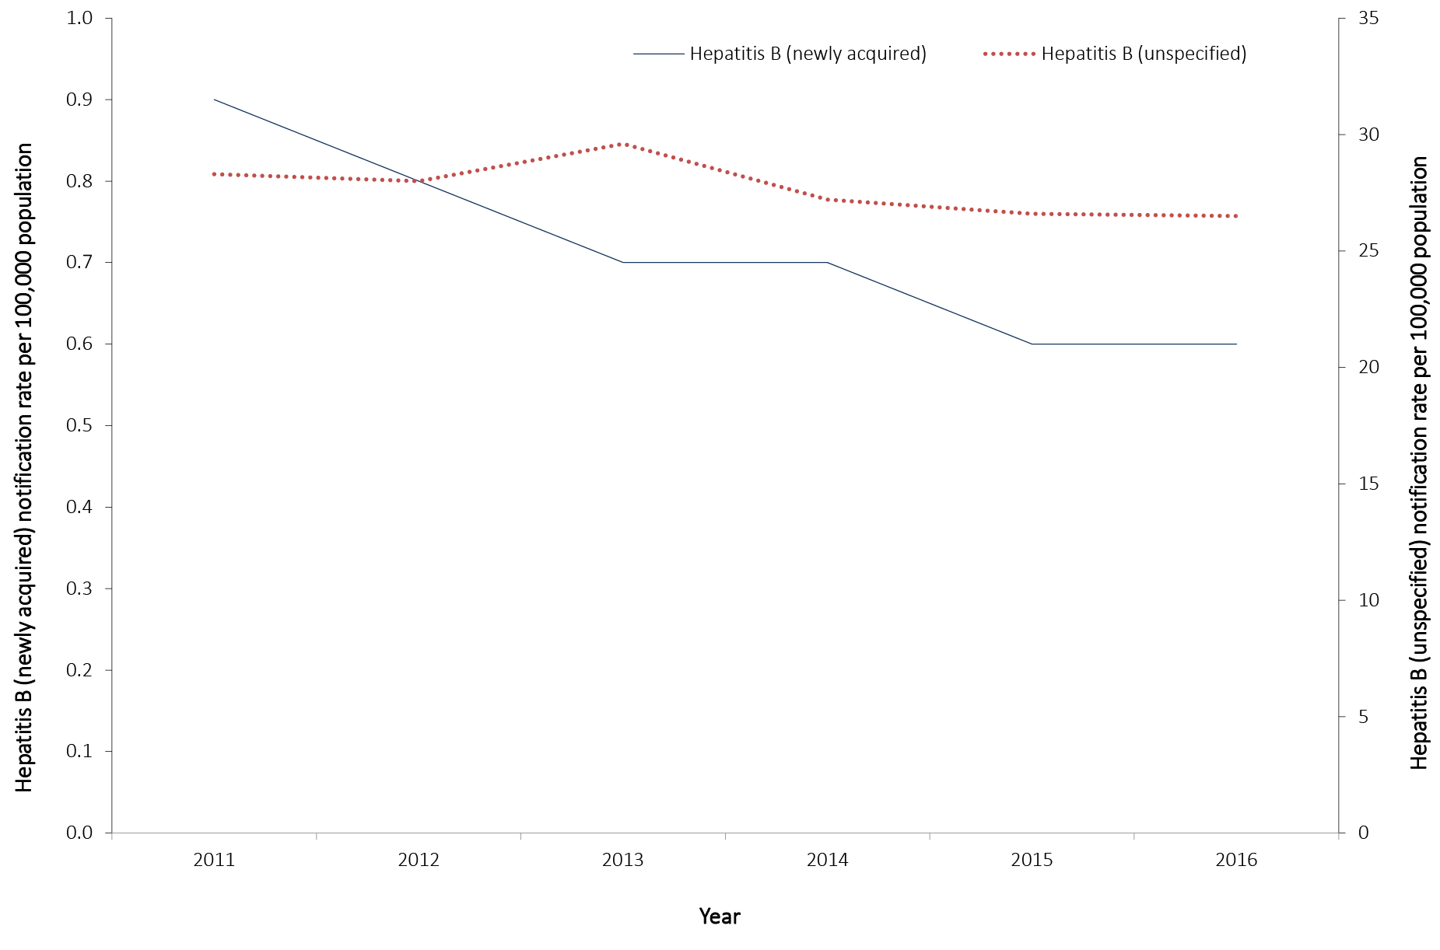
Between 2011 and 2016, rates of newly-acquired hepatitis B have declined by 24% from 0.9 to 0.6 per 100,000 population. After declining rates between 2011 and 2015, rates of newly-acquired hepatitis B have remained stable in 2016 (0.6 per 100,000) (Figure 3). The decline in newly-acquired hepatitis B notifications may be attributed to the universal hepatitis B infant immunisation program, introduced in 2000, and the adolescent hepatitis immunisation programs, introduced from 1997 depending on the jurisdiction.²⁴
A 2007 study, comparing two national serosurveys for the years 1996–1999 and 2002, showed significant improvements in immunity to hepatitis B for the 12–17 years age group in jurisdictions with established school-based programs compared to those jurisdictions without such programs.²⁵
From the 1980s, hepatitis B immunisation was recommended for certain at-risk adults in Australia. Consequentially, some jurisdictions implemented immunisation programs to target the identified at-risk adults in a variety of settings and over different time periods.²⁴The full impact of Australian immunisation programs should be reflected in trends in chronic infection and reductions in hepatitis-B-related complications in the future.
Between 2011 and 2016, rates of unspecified hepatitis B declined by 7% from 28.3 to 26.5 per 100,000 population. It is important to note the significant impact of immigration on rates of unspecified hepatitis B. For example, in 2015, Western Australia reported a decline in asylum seeker boat arrivals coinciding with a decline in unspecified hepatitis B notifications in the state, particularly in the Kimberley region (which includes the postcode for Christmas Island where there is a detention centre). An Australian study estimated more than 95% of new cases of chronic hepatitis B virus infection were diagnosed in new migrants in 2011.²⁶

Newly-acquired hepatitis B

- There were 157 cases of newly-acquired hepatitis B notified in 2016.
- The highest rate of notification was among males aged 50–54 years.

Epidemiological situation in 2016
In 2016, 157 cases of newly-acquired hepatitis B infection were notified to the NNDSS, a rate of 0.6 per 100,000 population, increasing from 139 cases (0.6 per 100,000 population) reported in 2015.

Geographical distribution
Both Queensland and Western Australia reported the highest rate (1.0 per 100,000 population) in 2016 (Table 5). This may be due to population differences between the jurisdictions, with hepatitis B disproportionately affecting a number of marginalised groups in Australia including migrant communities with origins in Asia, the Pacific and Africa; and Aboriginal and Torres Strait Islander people.^{26,27}

Age and sex distribution
In 2016, males accounted for 75% of newly-acquired hepatitis B notifications. The highest rate of newly-acquired hepatitis B infection was observed among males aged 50–54 years (2.8 per 100,000 population). For females, the highest rate (1.0 per 100,000 population) was reported in two age categories, 35–39 years and 40–44 years (Figure 4). Exposure to hepatitis B may be more common in certain high risk groups, including immigrants from endemic regions; people who inject drugs; prisoners; Aboriginal and Torres Strait Islander peoples; and men who have sex with men.^{23,26} The greater representation of males in some of these groups may contribute to the higher notification rates among males.
Figure 4. Notification rate for newly-acquired hepatitis B, Australia, 2016, by age group and sex
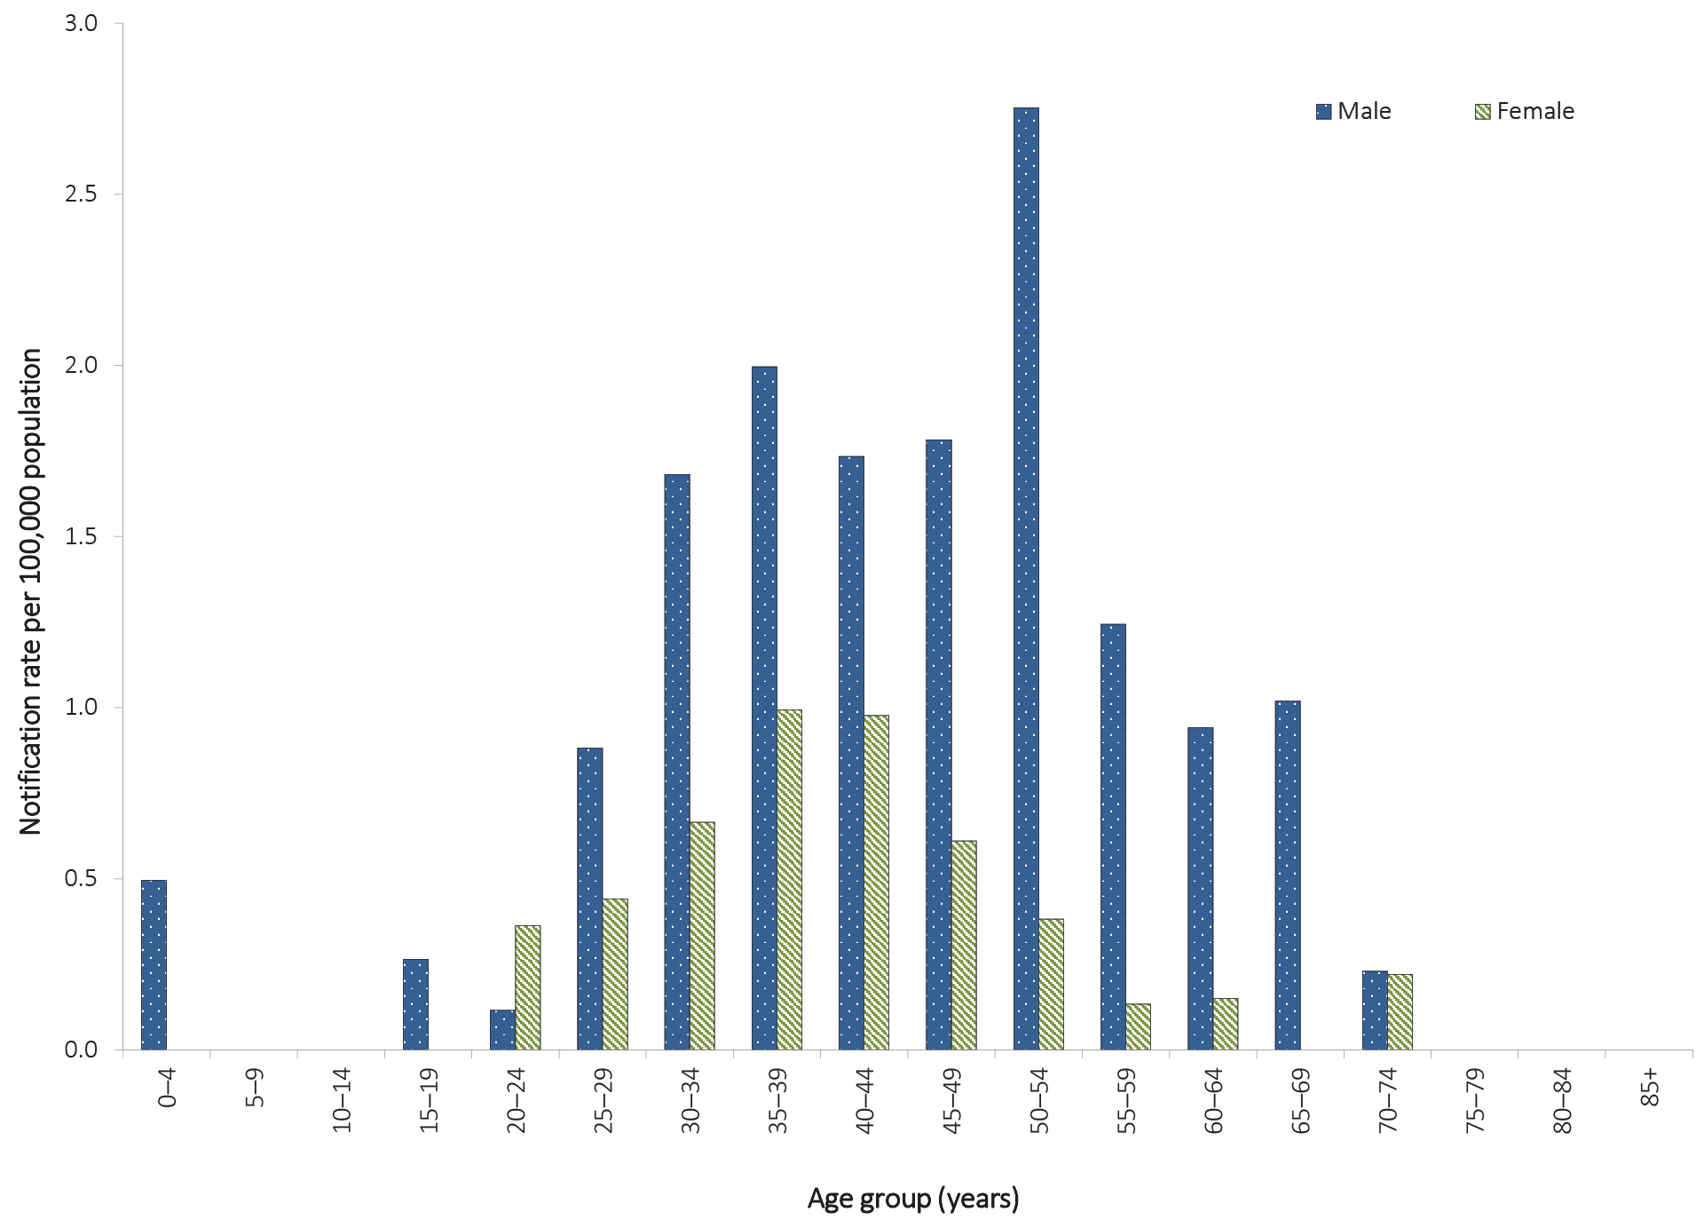
Between 2011 and 2016, most age-specific notification rates remained stable or trended downwards. The most marked decreases occurred among those aged 15–39 years. During this period, notification rates declined by 41% for those aged 30–39 years (from 2.2 to 1.3 per 100,000 population), 67% for those aged 20–29 years (from 1.5 to 0.5 per 100,000 population) and 75% for those aged 15–19 years (from 0.4 to 0.1 per 100,000 population) (Figure 5). These declines are likely attributable to the hepatitis B immunisation program.²⁴

Figure 5. Notification rate for newly-acquired hepatitis B, Australia, 2011 to 2016, by year and selected age groups
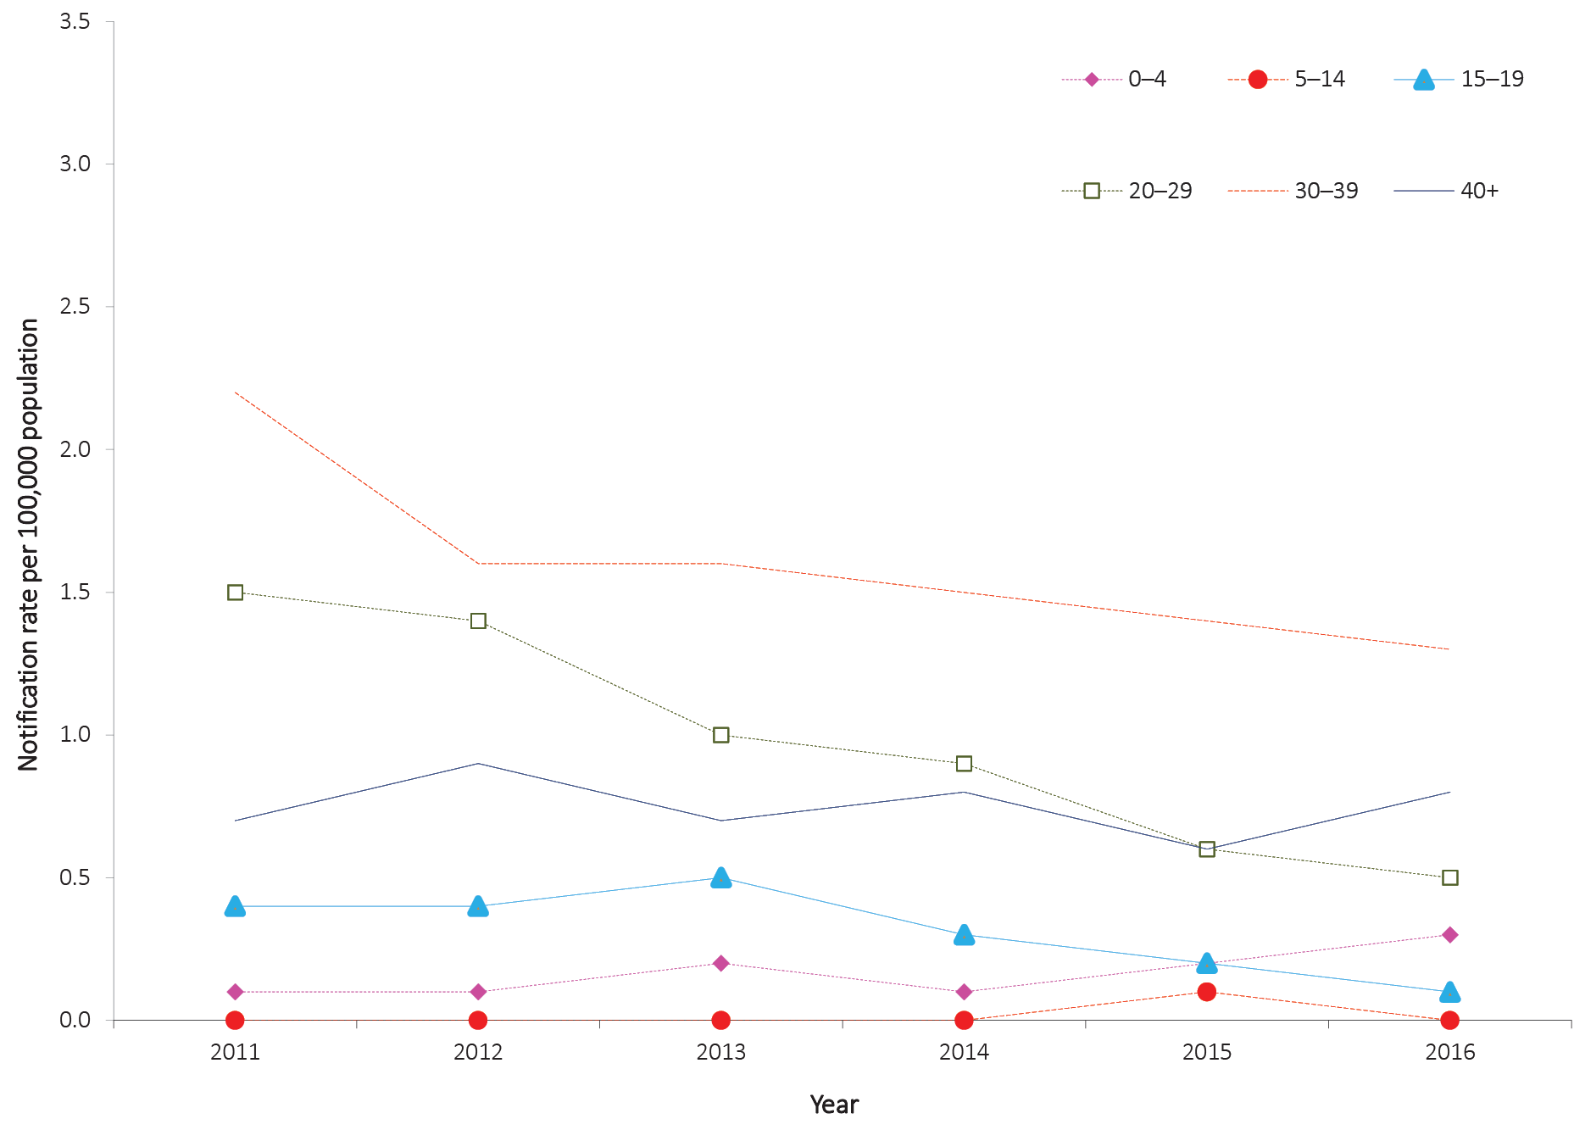

Risk groups
Enhanced hepatitis B data, including injecting drug use and other risk exposures, were available from five jurisdictions (Australian Capital Territory, New South Wales, Tasmania, Victoria and Western Australia) (Table 10). Of the cases for which the risk exposure information was reported, sexual exposure was the most frequently reported potential source of infection (42/92; 46%), followed by injecting drug use (32/92; 35%).
Of the 85 cases for which country of birth was reported, 65 (76%) were in Australian-born persons and 20 cases were born overseas (six from Europe, 13 from Asia and one from the Middle East).

Table 10. Enhanced risk factor data on notifications of newly-acquired hepatitis B cases in selected jurisdictions,ª 2016, by sex and risk factors^{b,c}
Exposure category | Number of exposure factors reported |  |  | Percentage of total cases (n = 92)^{a,d}
 | Male | Female | Total
Sexual exposure | 32 | 10 | 42 | 46
- Sexual contact (hepatitis B partner status unknown) – opposite sex | 1 | 0 | 1 | 1
- Sexual contact (hepatitis-B-positive partner) – opposite sex | 6 | 8 | 14 | 15
- Sexual contact – not further classified | 21 | 2 | 23 | 25
- Sexual contact (hepatitis-B-partner status unknown) – same sex | 0 | 0 | 0 | 0
- Sexual contact (hepatitis B positive partner) – same sex | 4 | 0 | 4 | 4
Injecting drug use | 21 | 11 | 32 | 34
Skin penetration procedure | 7 | 6 | 13 | 14
- Tattoos | 5 | 2 | 7 | 8
- Ear or body piercing | 1 | 3 | 4 | 4
- Acupuncture | 1 | 1 | 2 | 2
Household contact | 3 | 5 | 8 | 9
Major dental surgery work | 3 | 2 | 5 | 5
Imprisonment | 2 | 1 | 3 | 3
Surgical work | 1 | 0 | 1 | 1
Needlestick/biohazardous injury | 0 | 0 | 0 | 0
Perinatal transmission | 3 | 0 | 3 | 3
Health care worker with no documented exposure | 0 | 1 | 1 | 1
Other | 18 | 3 | 21 | 23
Undetermined | 2 | 1 | 3 | 3
Unknown (not recorded) | 0 | 1 | 1 | 1
Total exposure factors reported | 92 | 41 | 133
Total number of cases | 68 | 24 | 92
a Cases from the Australian Capital Territory, New South Wales, Tasmania, Victoria and Western Australia.
b More than 1 exposure category for each case could be recorded.
c Analysis and categorisation of these exposures are subject to interpretation and may vary between reports.
d The denominator used to calculate the percentage is based on the cases with recorded enhanced data from the Australian Capital Territory, New South Wales, Tasmania, Victoria and Western Australia. As more than 1 exposure category for each notification could be recorded, the total percentage does not equate to 100%.

Unspecified hepatitis B

- There were 6,404 cases of unspecified hepatitis B notified in 2016.
- Notification rates were highest in males aged 30–39 years and females 30–34 years.

Epidemiological situation in 2016
In 2016, there were 6,404 cases of unspecified hepatitis B infection notified to the NNDSS, representing a rate of 26.5 per 100,000 population, compared with 6,325 cases (26.6 per 100,000 population) reported in 2015 (Figure 3).

Geographical distribution
In 2016, the Northern Territory had the highest rate of unspecified hepatitis B infection (43.6 per 100,000 population) (Table 5).

Age and sex distribution
In 2016, males accounted for a higher proportion of unspecified hepatitis B notifications (54%). The overall rate of unspecified hepatitis B in males was 28.6 per 100,000 population and 24.2 per 100,000 population for females. Notification rates were highest in males 30–34 years and 35–39 years (62.3 and 62.2 per 100,000 population respectively); the highest rate reported in females was for those aged 30–34 years (60.6 per 100,000 population) (Figure 6).
Between 2011 and 2016, notification rates for unspecified hepatitis B have decreased or remained stable across all age groups (Figure 7). The decrease in rates for the younger age groups is likely explained by the introduction of the infant and adolescent hepatitis B immunisation programs. The adolescent immunisation program commenced in some jurisdictions from 1997 and the infant immunisation program commenced nationally from 2000.²⁴
Figure 6. Notification rate for unspecified hepatitis B, Australia, 2016, by age group and sexª
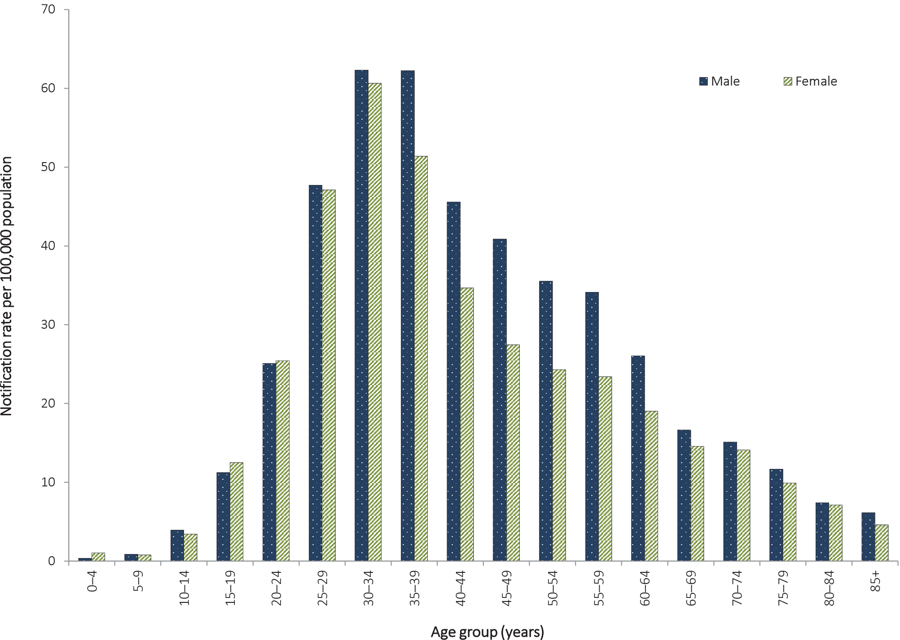
a Excludes 28 cases where age and/or sex were not reported.

Figure 7. Notification rate for unspecified hepatitis B, Australia, 2011 to 2016, by year and selected age groupsª
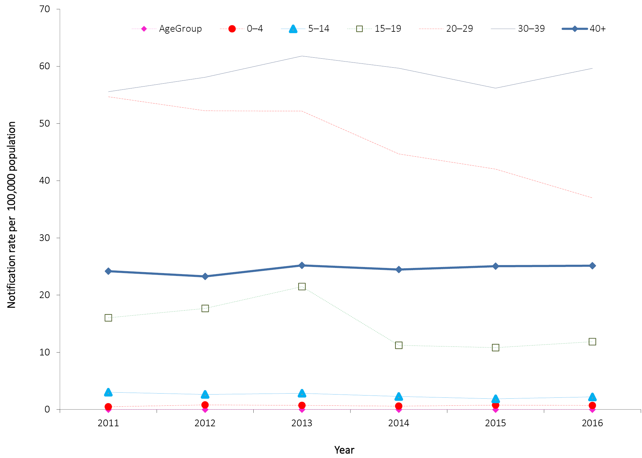
a Excludes 19 cases where age was not reported.

Hepatitis C

- There were 11,973 cases of hepatitis C (both newly acquired and unspecified) notified in 2016.
- The majority of newly-acquired hepatitis C cases had a history of injecting drug use.
Infection with hepatitis C virus causes inflammation of the liver. In more than 90% of cases, initial infection with hepatitis C virus is asymptomatic or mildly symptomatic. Approximately 50–80% of cases will go on to develop a chronic infection. Of those who develop a chronic infection, approximately half will eventually develop cirrhosis or cancer of the liver.²³ There is no vaccine to prevent hepatitis C infection.
Hepatitis C notifications are classified as being either ‘newly acquired’ (evidence that infection was acquired within the 24 months prior to diagnosis) or ‘unspecified’ (infection was acquired more than 24 months prior to diagnosis or was not able to be specified).

Epidemiological situation in 2016
Of the 11,973 cases of hepatitis C notified in 2016, 6% of cases (717/11,973) were classified as newly-acquired infections. The proportion of hepatitis C notifications classified as newly acquired has remained stable since 2011 (range 6–8%).
Between 2011 and 2016, hepatitis C notifications (both newly acquired and unspecified) have increased by 17%, from 10,239 in 2011 to 11,973 reported in 2016 (Figure 8).
Figure 8. Notification rates for hepatitis C (newly acquired and unspecified), Australia, 2011 to 2016, by year
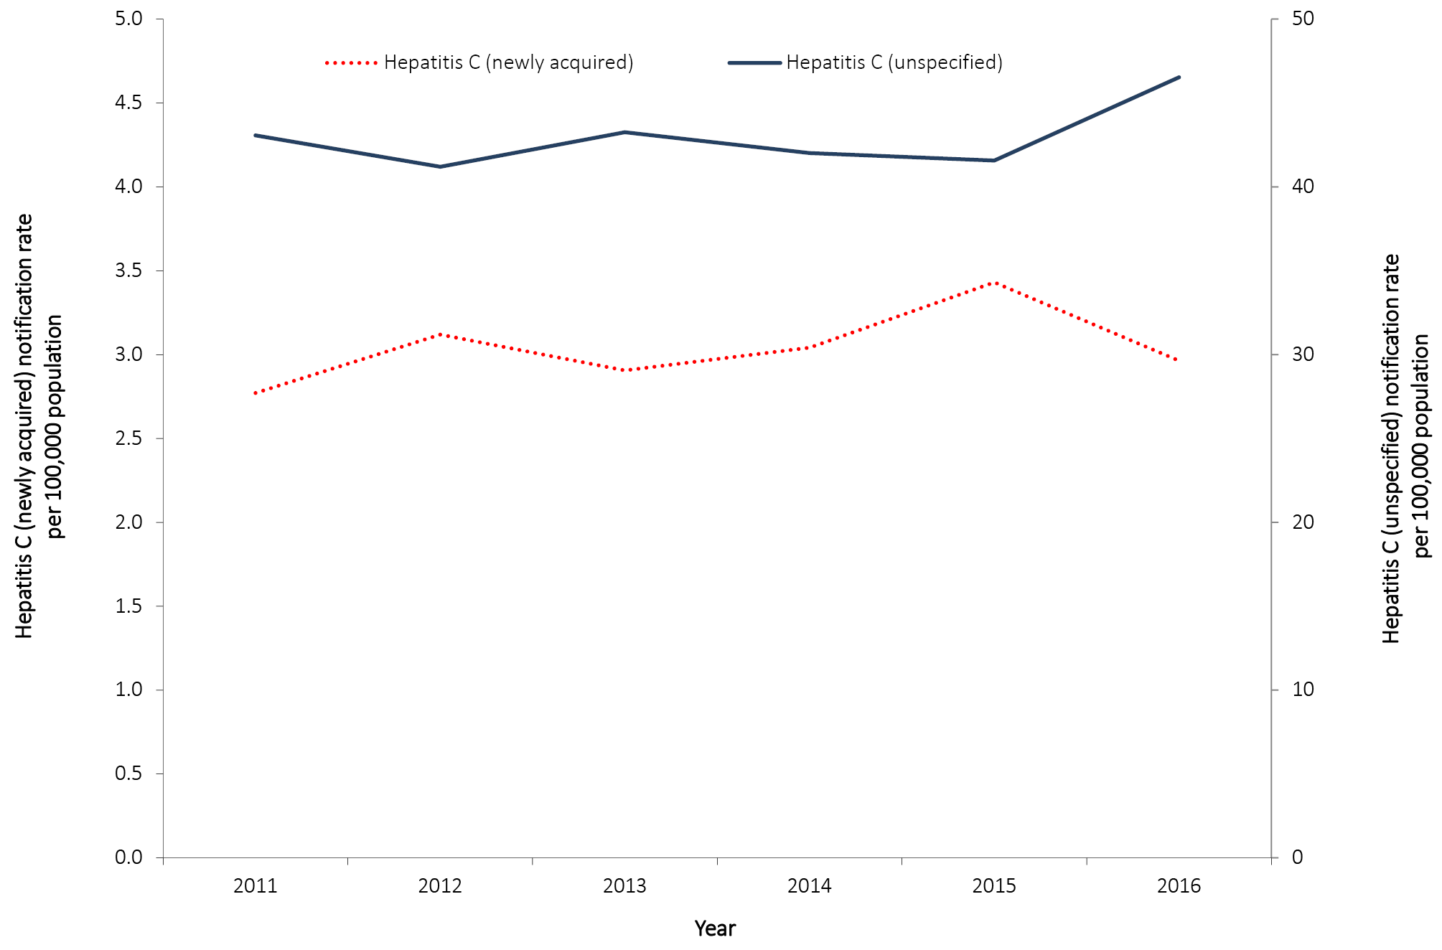

Newly-acquired hepatitis C

- There were 717 cases of newly-acquired hepatitis C notified in 2016.
- Eighty-one per cent of newly-acquired hepatitis C cases had a history of injecting drug use.
- The highest notification rate was among males aged 20–34 years.

Epidemiological situation in 2016
This is the first NNDSS Annual Report to include notifications of newly-acquired hepatitis C infection from all states and territories. Previously, Queensland reported all cases of hepatitis C infection as unspecified. Queensland data has been updated retrospectively, making annual comparisons possible.
There has been a 12% decrease in the number of notifications of newly-acquired hepatitis C between 2015 and 2016 (817 to 717 notifications). Nationally, the notification rate in 2016 was 3.0 per 100,000 population, compared with 3.4 per 100,000 population in 2015 (Figure 8).

Geographical distribution
In 2016, Queensland reported the highest jurisdiction-specific rate of newly-acquired hepatitis C infection (7.7 per 100,000 population) (Table 5).

Age and sex distribution
In 2016, males accounted for 74% of newly-acquired hepatitis C notifications and the highest notification rate was observed among males aged 20–24 years (15.8 per 100,000 population). For females, the highest notification rate was in those aged 20–24 years (5.2 per 100,000 population) (Figure 9).

Figure 9. Notification rate for newly-acquired hepatitis C, Australia, 2016, by age group and sex
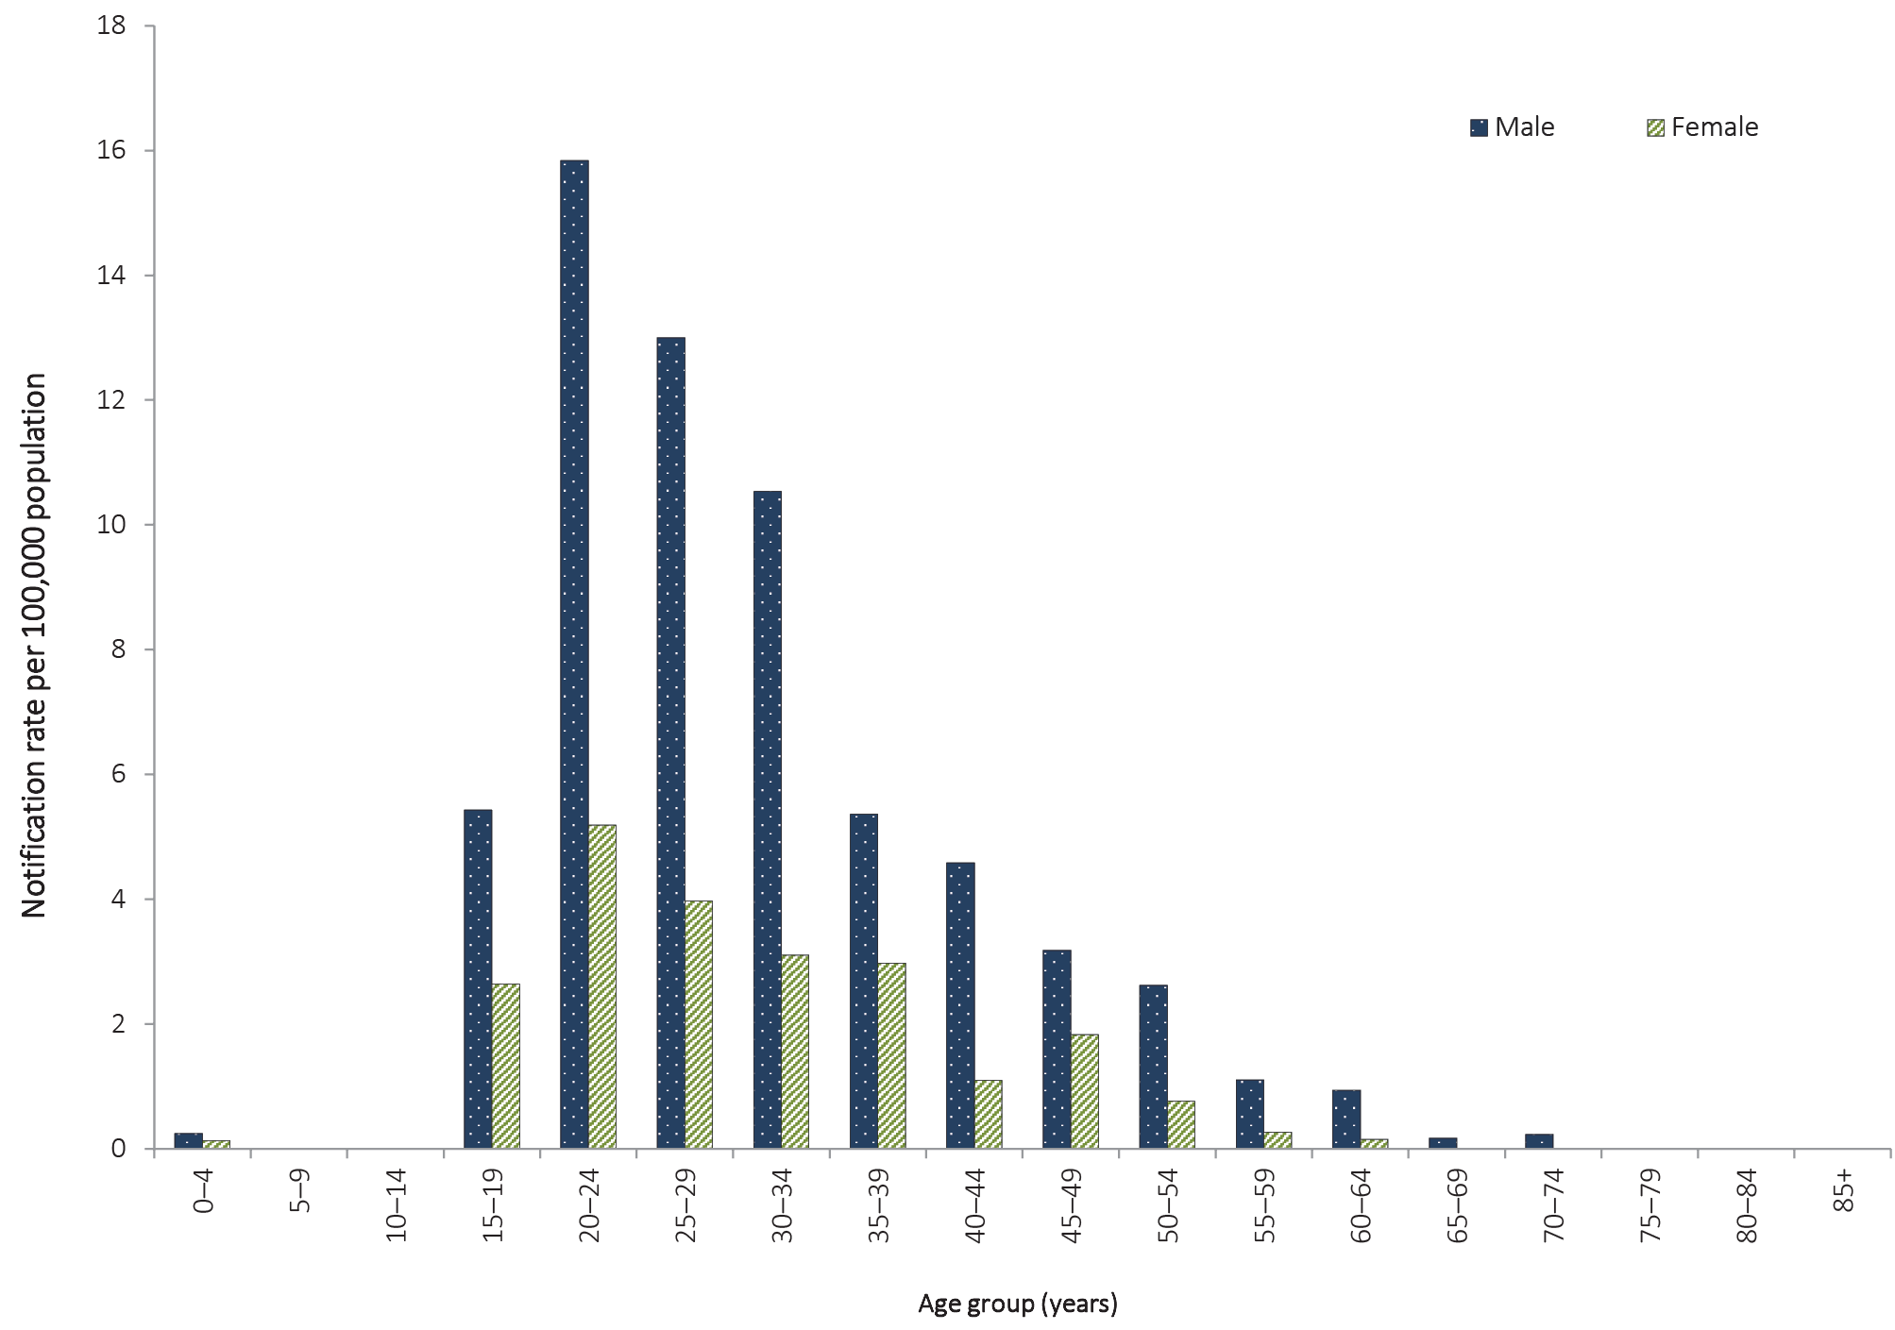
Previously, between 2011 and 2015, notification rates for newly-acquired hepatitis C infection had increased in all age groups 15 years or more (15–19, 20–29, 30–39, 40 years or more). However, between 2015 and 2016, these four age groups all remained stable or decreased. Notification rates of newly-acquired hepatitis C did not change for two age groups, 15–19 years (4.1 per 100,000 population) and 40 years or more (1.2 per 100,000 population), between 2015 and 2016, but decreased in those aged 20–29 years (from 11.9 to 9.5 per 100,000 population) and in the 30–39 years age group (from 6.3 to 5.6 per 100,000 population) (Figure 10).

Figure 10. Notification rate for newly-acquired hepatitis C, Australia, 2011 to 2016, by year and selected age groups
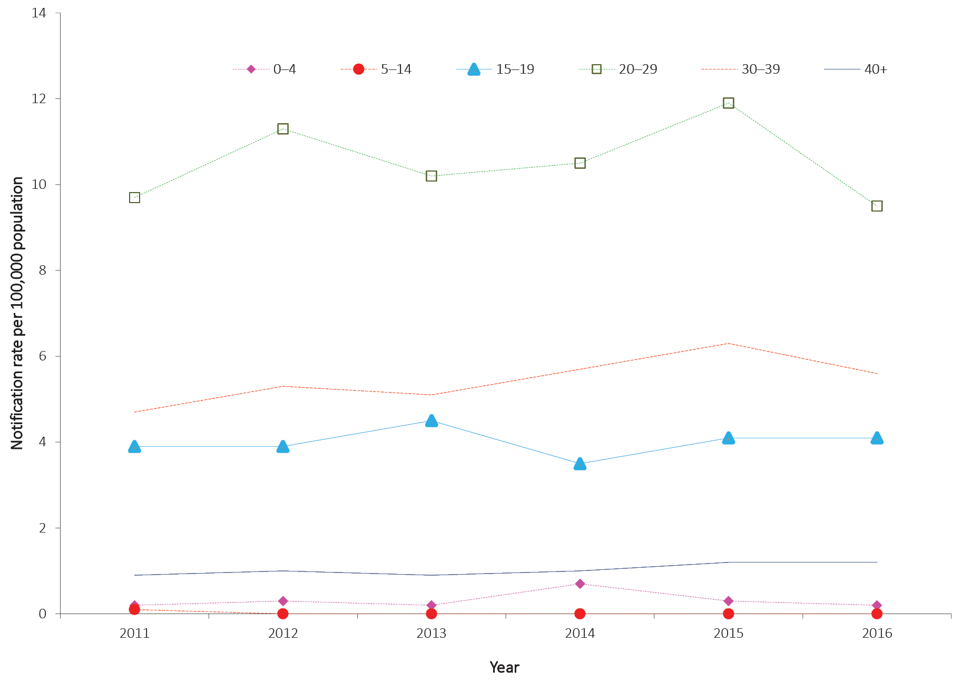

Risk groups
Enhanced hepatitis C data including injecting drug use and other risk exposure was available from five jurisdictions (Australian Capital Territory, New South Wales, Tasmania, Victoria and Western Australia) (Table 11). Of the cases for which the risk exposure information was reported, 81% of cases (157/195) had a history of injecting drug use and 24% (47/195) reported possible sexual exposure.
More than one quarter (28%; n = 54) of cases with risk exposure data reported being imprisoned in the 24 months prior to diagnosis. Of these cases, 91% (n = 49) also reported a history of injecting drug use. However, it is important to note that screening rates are generally higher in the prison entry population than the general population. A screening survey of prison entrants conducted over a two-week period found that the prevalence of hepatitis C infection, based on hepatitis C antibody detection, was 22% in 2016, a decrease from 31% in 2013.²⁸
Of the 192 cases for which country of birth was reported, 173 were Australian born (90%) and 19 cases were born overseas (6 from Europe, 5 from the Pacific, 6 from Asia, 1 from the Middle East and 1 from Southern Africa).

Table 11. Enhanced risk factor data on notifications of newly-acquired hepatitis C infection in selected jurisdictions,ª 2016, by sex and risk factors^{b,c}
Exposure category | Number of exposure factors reported |  |  | Percentage of total cases (n = 195)^{a,d}
 | Male | Female | Total
Injecting drug use | 120 | 37 | 157 | 81
Imprisonment | 49 | 5 | 54 | 28
Sexual exposure | 26 | 21 | 47 | 24
- Sexual contact (hepatitis-C-positive partner) – opposite sex | 16 | 13 | 29 | 15
- Sexual contact (hepatitis-C-positive partner) – same sex | 8 | 5 | 13 | 7
- Sexual contact – not further classified | 2 | 2 | 4 | 2
- Sexual contact (hepatitis C partner status unknown) – same sex | 0 | 1 | 1 | 1
- Sexual contact (hepatitis C partner status unknown) – opposite sex | 0 | 0 | 0 | 0
Skin penetration procedure | 27 | 29 | 56 | 29
- Tattoos | 15 | 16 | 31 | 16
- Ear or body piercing | 9 | 10 | 19 | 10
- Acupuncture | 3 | 3 | 6 | 3
Perinatal transmission | 12 | 10 | 22 | 11
Household contact | 8 | 9 | 17 | 9
Non-IDU remote risk (> 24 months prior to diagnosis) | 2 | 2 | 4 | 2
Surgical work | 8 | 10 | 18 | 9
Needlestick/biohazardous injury | 1 | 3 | 4 | 2
Blood/blood products/tissues in Australia | 0 | 2 | 2 | 1
Major dental surgery work | 5 | 2 | 7 | 4
Other | 17 | 6 | 23 | 12
Undetermined | 2 | 1 | 3 | 2
Unknown (not recorded) | 8 | 3 | 11 | 6
Total exposure factors reported | 285 | 140 | 425
Total number of cases | 147 | 48 | 195
a Cases from the Australian Capital Territory, New South Wales, Tasmania, Victoria and Western Australia.
b More than 1 exposure category for each case could be recorded.
c Analysis and categorisation of these exposures are subject to interpretation and may vary between reports.
d The denominator used to calculate the percentage is based on the cases with recorded enhanced data from the Australian Capital Territory, New South Wales, Tasmania, Victoria and Western Australia. As more than 1 exposure category for each notification could be recorded, the total percentage does not equate to 100%.

Unspecified hepatitis C

- There were 11,256 cases of unspecified hepatitis C infection notified in 2016.
- The highest notification rate was among males in the 25–64 years age groups.

Epidemiological situation in 2016
As described above, Queensland previously reported all cases of hepatitis C infection as unspecified. However, this is the first NNDSS Annual Report to separate Queensland hepatitis C data as unspecified or newly acquired, in a similar manner to the other states and territories. Queensland data has been updated retrospectively, making annual comparisons possible.
There has been a 14% increase in the number of notifications of unspecified hepatitis C between 2015 and 2016. In 2016, there were 11,256 cases of unspecified hepatitis C infections notified to the NNDSS (46.5 per 100,000 population) compared with 9,899 cases in 2015 (41.6 per 100,000 population) (Figure 8).

Geographical distribution
Since 2011, the Northern Territory has reported the highest jurisdiction-specific notification rate for unspecified hepatitis C. In 2016, the Northern Territory’s notification rate was 77.7 per 100,000 population (Table 5) which is a 3% decrease compared to 2015 (80.1 per 100,000 population) and a 12% decreased compared to 2011 (88.6 per 100,000 population).

Age and sex distribution
Nationally in 2016, 67% of unspecified hepatitis C notifications were in males (for cases where the sex was reported). The notification rate in males was 62.1 per 100,000 population and in females 30.9 per 100,000 population; equating to a male-to-female rate ratio of 2:1. Notification rates in males exceeded those in females across the age groups 20 to 74 years. The notification rates were highest among males aged 25 to 64 years (range 71.8 to 126.6 per 100,000 population) with the highest rate reported in those aged 35–39 years (126.6 per 100,000 population). The highest notification rates among females were for those aged 35–39 years and 40–44 years (61.4 and 55.5 per 100,000 respectively) (Figure 11).
Figure 11. Notification rate for unspecified hepatitis C, Australia, 2016, by age group and sexª
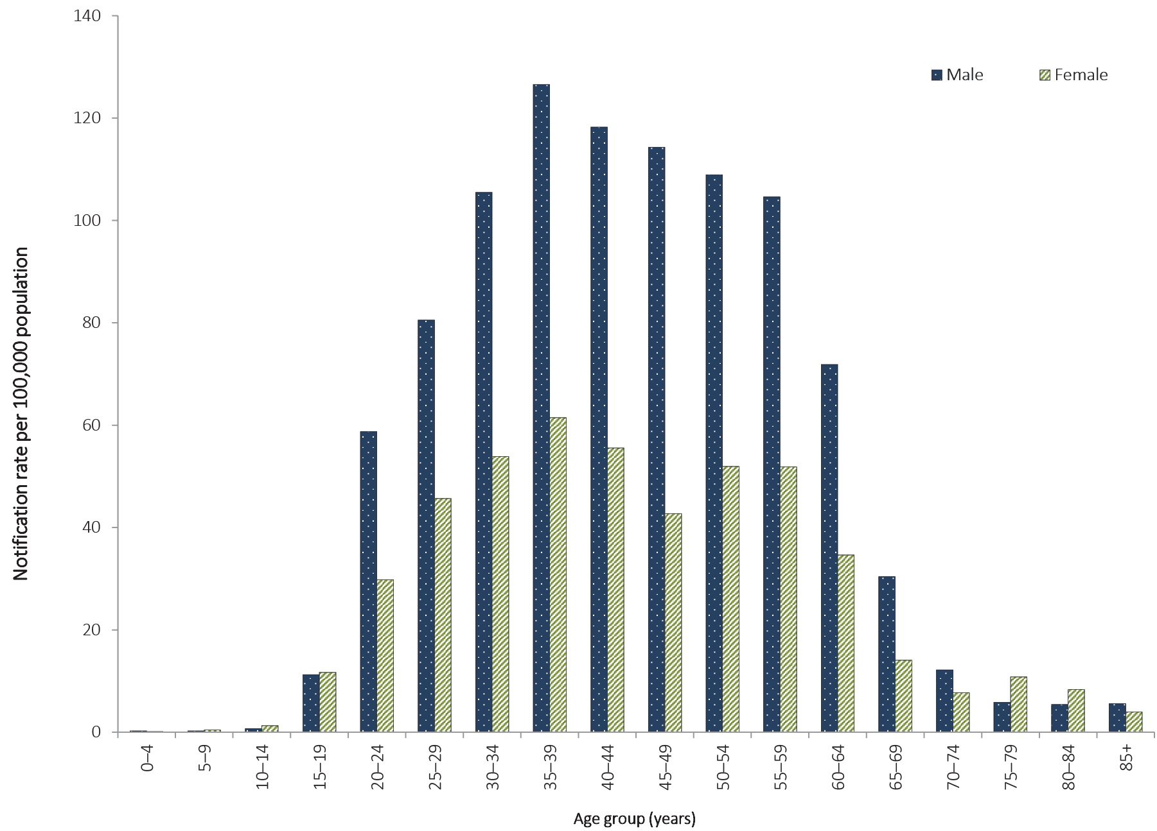
a Excludes 34 cases where age and/or sex were missing or unknown.
Between 2011 and 2015, notification rates for unspecified hepatitis C infection remained stable or declined. However, between 2015 and 2016 three age groups reported increased notification rates: those aged 40 years or more (from 47.1 to 55.2 per 100,000 population); those aged 30–39 years (from 81.1 to 86.7 per 100,000 population) and those aged 20–29 years (from 51.8 to 54.3 per 100,000 population). The other age groups (0–4 years, 5–14 years and 15–19 years) remained stable between 2015 and 2016 (Figure 12).

Figure 12. Notification rate for unspecified hepatitis C, Australia, 2011 to 2016, by year and selected age groupsª
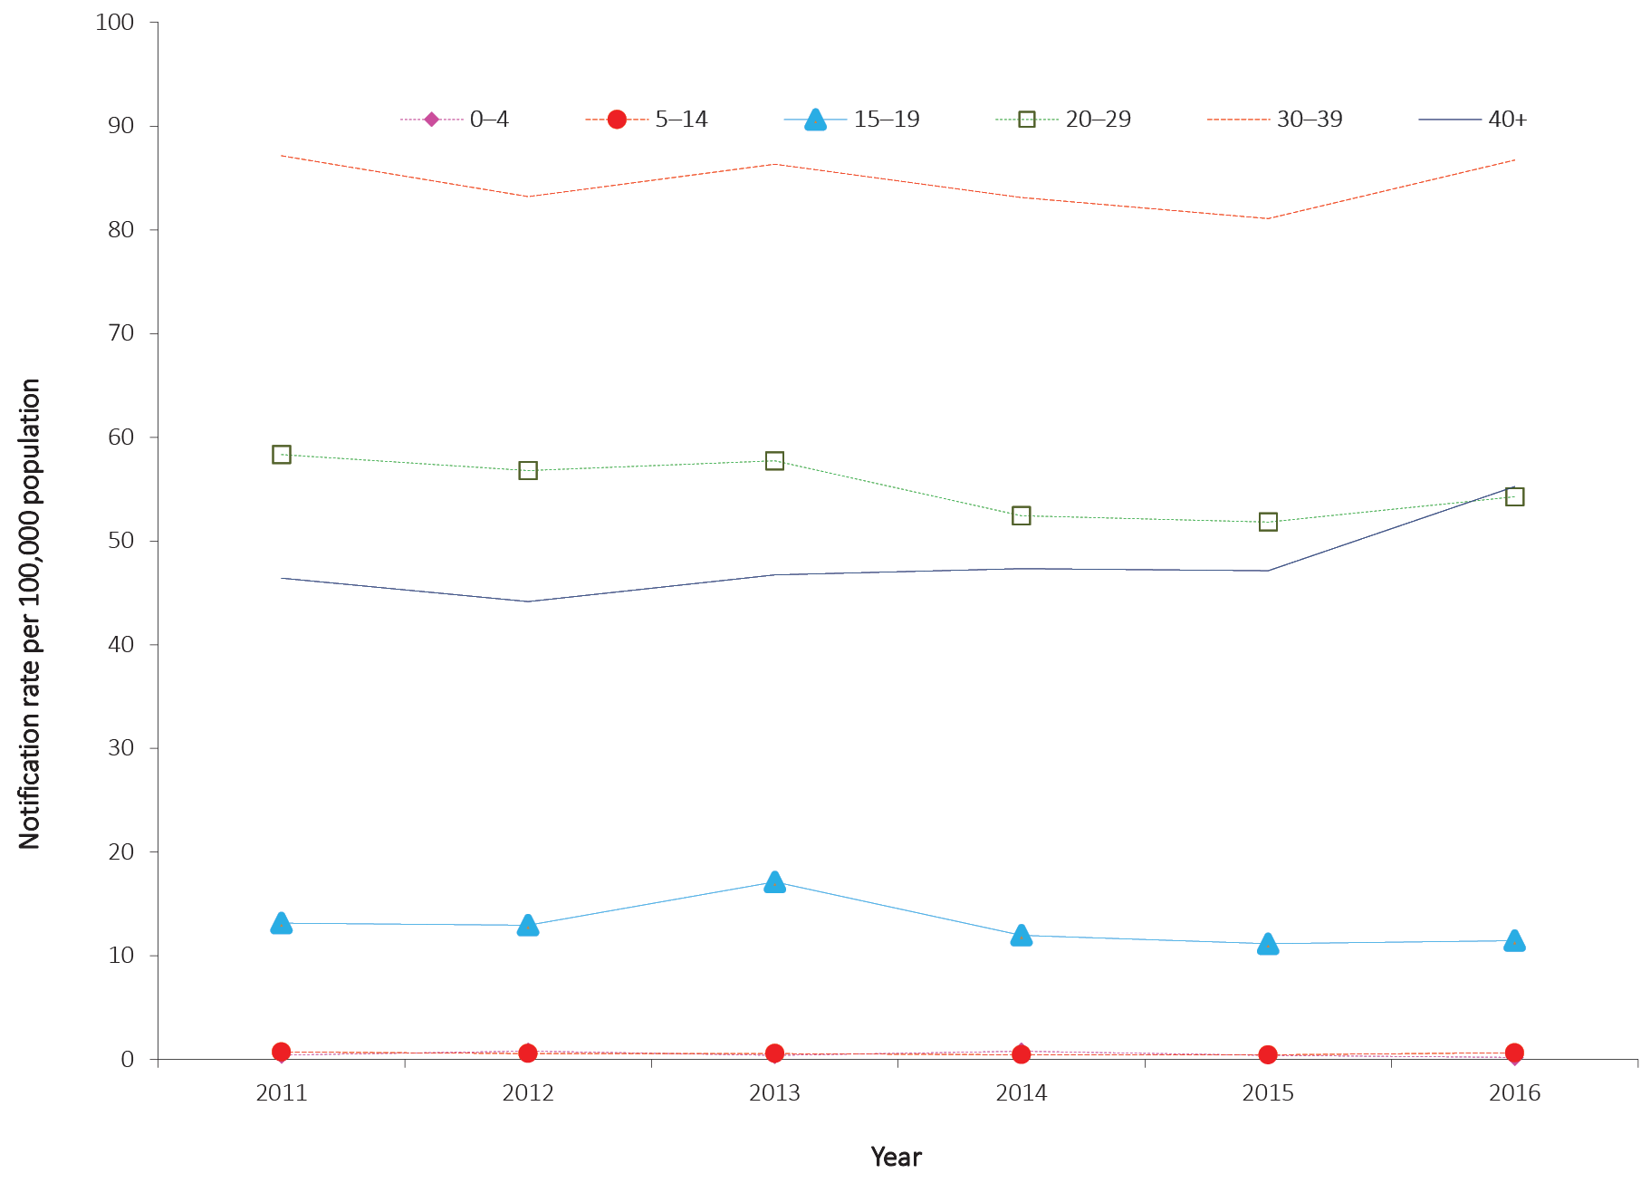
a Excludes 73 cases where age was not reported.

Hepatitis D

- There were 61 cases of hepatitis D notified in 2016.
- Hepatitis D is always associated with hepatitis B co-infection.
Hepatitis D is a defective single-stranded RNA virus that replicates in the presence of the hepatitis B virus. Hepatitis D infection can occur as either an acute co-infection with hepatitis B or as a super-infection with chronic hepatitis B infection. The modes of hepatitis D transmission are comparable to hepatitis B.²³

Epidemiological situation in 2016
In Australia, the notification rate for hepatitis D infection remains low. In 2016, there were 61 notified cases of hepatitis D, representing a rate of 0.3 per 100,000 population (Table 5). Over the preceding 5 years, notifications of hepatitis D in Australia have remained relatively low, with an average of 48 cases notified per year (range 36–61).

Geographical distribution
In 2016, New South Wales reported the highest number of cases (n = 20), followed by Victoria (n = 17), Queensland (n = 12), South Australia (n = 9), Northern Territory (n = 2) and Western Australia (n = 1). No cases were reported from the Australian Capital Territory or Tasmania in 2016.

Age and sex distribution
Hepatitis D notifications in males exceeded those in females each year from 2011 to 2016. In 2016, 69% of notifications were in males. This represented a male to female notification ratio of 2.2:1, which is greater than the average notification ratio of 1.9:1 over the preceding 5 years (Figure 13).
Figure 13. Notifications of hepatitis D, Australia, 2007 to 2016, by year and sex
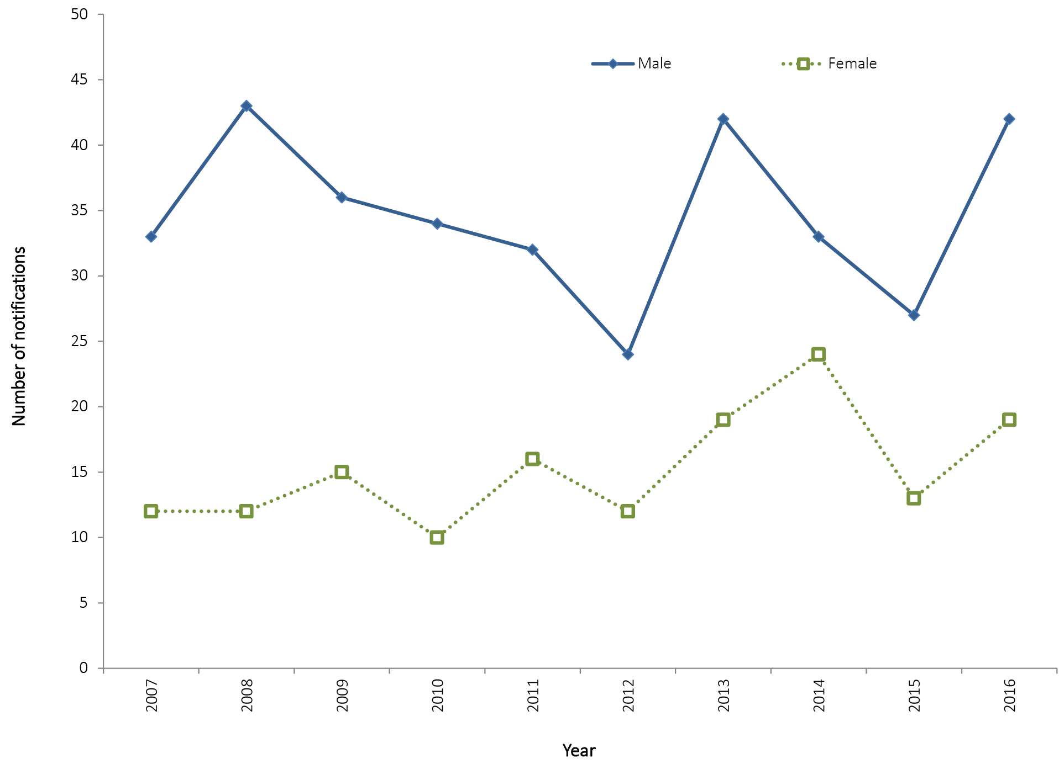

Gastrointestinal diseases
In 2016, gastrointestinal diseases notified to NNDSS and discussed in this section were: botulism; campylobacteriosis; cryptosporidiosis; haemolytic uraemic syndrome (HUS); hepatitis A; hepatitis E; listeriosis; paratyphoid; salmonellosis; shigellosis; Shiga toxin-producing Escherichia coli(STEC) infections; and typhoid.
From January 2016, paratyphoid has been recorded in NNDSS as a separate condition from salmonellosis. The separation of paratyphoid from salmonellosis has been applied to data in NNDSS retrospectively. From 2015, paratyphoid has been included as a separate disease in the NNDSS annual reports. Please note the NNDSS data reports for salmonellosis in earlier years will no longer match previously published data.²⁹
Overall, notified cases of gastrointestinal diseases increased by 10%, from 45,287 in 2015 to 49,885 in 2016. Notifications for campylobacteriosis (n = 24,164), and salmonellosis (n = 18,088) were at the highest levels since NNDSS records began in 1991. It should be noted that culture-independent nucleic-acid-based testing methods were introduced by diagnostic laboratories around the country from late 2013 onwards; which may partially explain this increase. These testing methods have increased sensitivity compared to traditional techniques, such as culture; however, the full effect on notifications has not been quantified.

Surveillance systems overview
The Australian Government established OzFoodNet—Australia’s enhanced foodborne disease surveillance system—in 2000, as a collaborative network of epidemiologists and microbiologists who conduct enhanced surveillance, epidemiological outbreak investigations and applied research into foodborne diseases across Australia. OzFoodNet’s mission is to apply concentrated effort at the national level to investigate and understand foodborne disease, to describe its epidemiology more effectively and to identify ways to minimise foodborne illness in Australia. The data and results summarised in the following sections will be reported in more detail in the OzFoodNet 2016 annual report,³⁰ once available.

Botulism

- There were no cases of botulism notified in 2016.
Botulism is a rare but extremely serious intoxication, resulting from accidental or intentional exposure to toxins produced by Clostridium botulinum (commonly toxin types A, B and E; rarely type F). All toxins can cause flaccid paralysis by blocking the neuromuscular junction. There are four recognised forms of botulism: infant; foodborne; wound; and adult intestinal toxaemia.²³

Epidemiological situation in 2016
There were no notified cases of botulism in 2016. This marks a decrease in notifications of botulism compared to the three cases notified in 2015.

Campylobacteriosis

- There were 24,164 cases of campylobacteriosis notified in 2016.
- Campylobacteriosis was the most frequently notified enteric infection in 2016.
The bacterium Campylobacteris a common cause of foodborne illness (campylobacteriosis) in humans. The severity of this illness varies and is characterised by diarrhoea (often bloody), abdominal pain, fever, nausea and vomiting.²³ Campylobacteriosis is notifiable in all Australian states and territories except New South Wales.

Epidemiological situation in 2016
There were 24,164 notified cases of campylobacteriosis in 2016, making it the most frequently-notified enteric infection (146.9 per 100,000 population). There has been a 7% increase on the number of notifications received for 2015 (n = 22,549) (Figure 14) and an increase of 33% on the previous five-year historical mean, 2011 to 2015 (n = 18,122) (Table 6). This rise may be associated with the increased use of culture-independent diagnostic testing.
Figure 14: Notifications and notification rate for campylobacteriosis,ª Australia, 2011 to 2016, by year
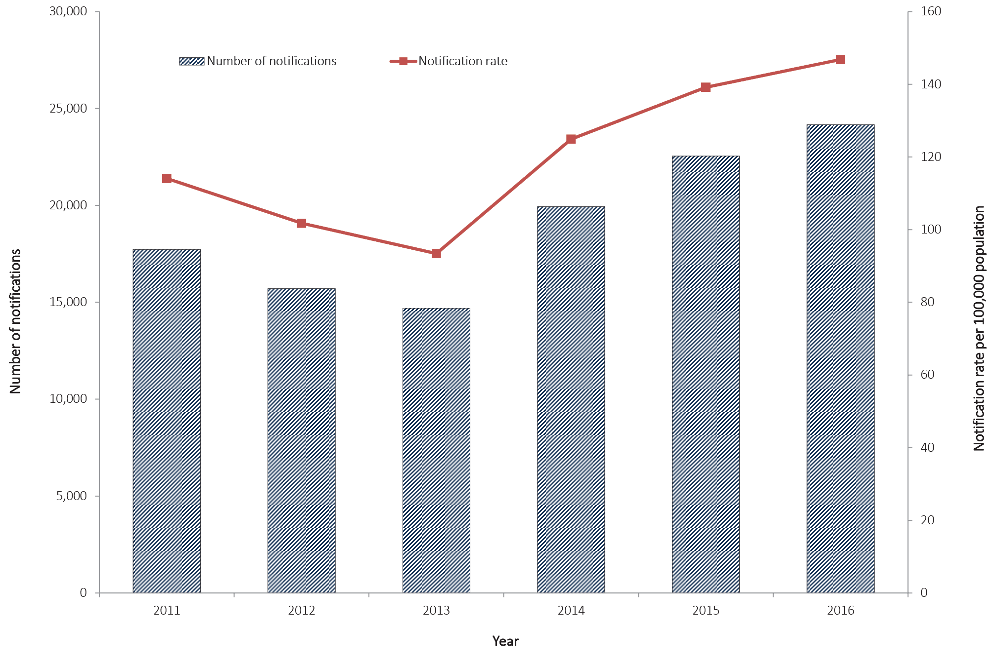
a Excludes New South Wales.

Geographical distribution
Notification rates for campylobacteriosis ranged from 133.4 per 100,000 population in Western Australia to 205.0 per 100,000 population in Tasmania. The notification rate in Tasmania was approximately 1.5 times higher than the national rate (146.9 per 100,000 population) (Table 5).

Age and sex distribution
The highest rates of campylobacteriosis in males have been reported in those aged 0–4 years (251.1 per 100,000 population) followed by those aged 80–84 years (233.6 per 100,000 population). For females, the highest rates have been reported in those aged 70–74 years (191.2 per 100,000 population). Males accounted for 54% of notifications of campylobacteriosis in 2016 and the median age of notified cases in males was 36 years (range 0 to 103 years). For females, the median age of notified cases of campylobacteriosis was 38 years (range 0 to 99 years). Notification rates were higher among males in all age groups except for the 20–24 years age group, where notifications for females were slightly higher (174.5 per 100,000 versus 168.4 per 100,000 population) (Figure 15).
Figure 15: Notification rate for campylobacteriosis,ª Australia, 2016, by age group and sex^{b}
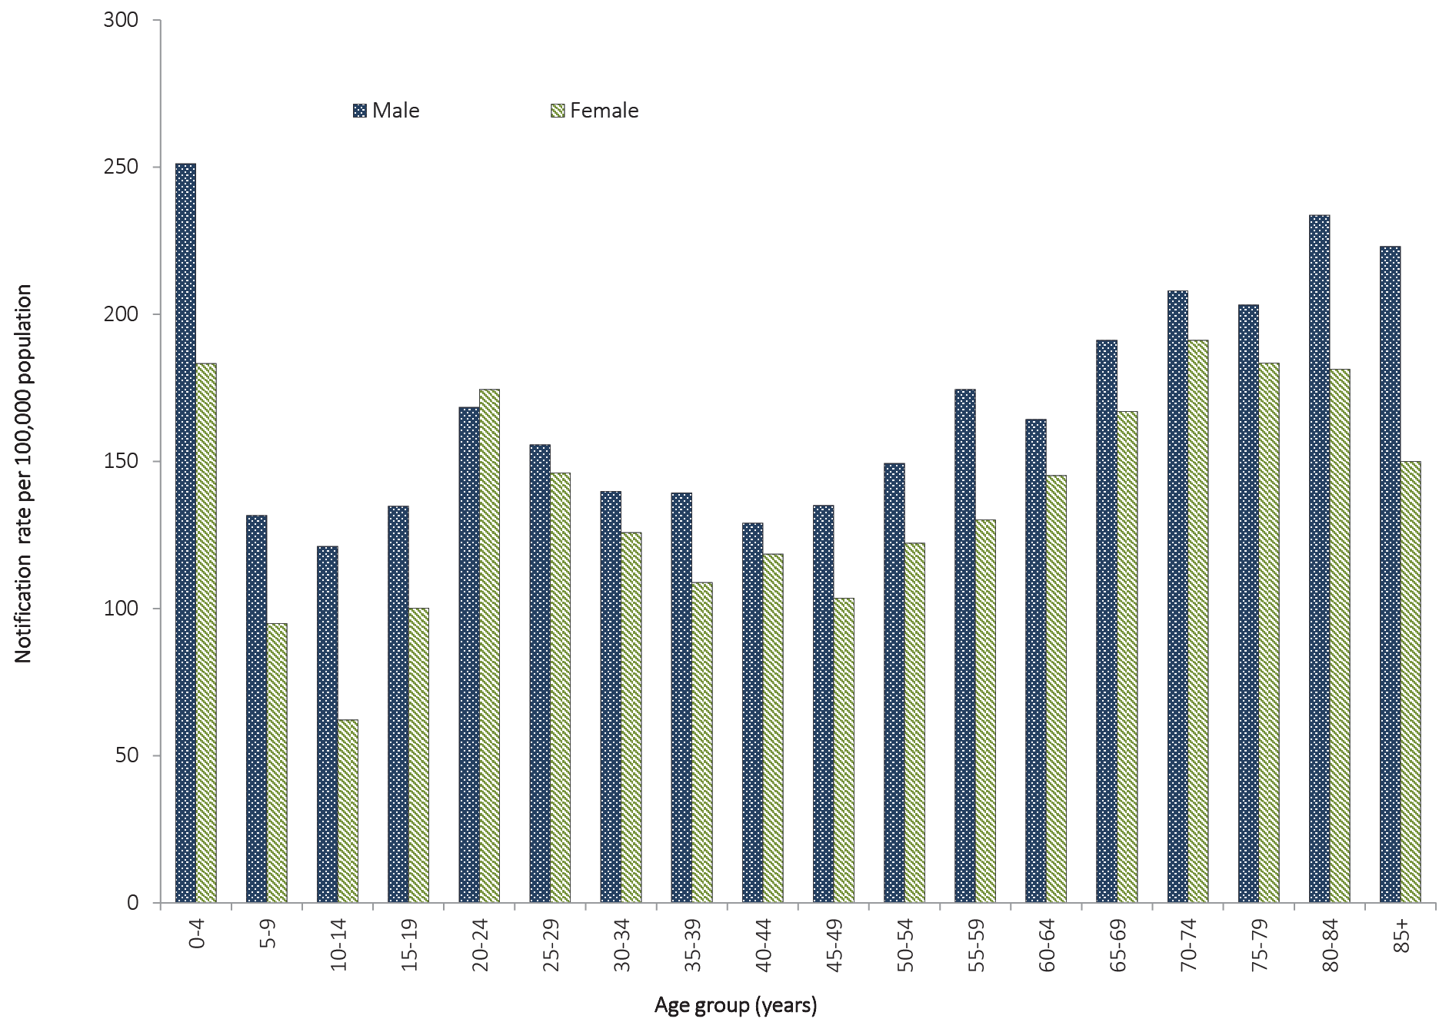
a Excludes New South Wales.
b Excludes 19 notifications where age (n = 11) or sex (n = 8) was not reported.

Cryptosporidiosis

- There were 5,419 cases of cryptosporidiosis notified in 2016.
Cryptosporidiosis is a parasitic infection characterised by abdominal cramping and, usually, a large volume of watery diarrhoea. Ingestion of contaminated water, typically from a recreational source such as a community swimming pool or lake, is a major risk factor for infection.²³

Epidemiological situation in 2016
There were 5,419 notified cases of cryptosporidiosis in 2016 (22.4 per 100,000 population). This represents a 33% increase on the number of notifications received for 2015 (n = 4,063) and a 77% increase on the five-year historical mean, 2011 to 2015 (n = 3,055) (Figure 16).
Figure 16: Notifications and notification rate for cryptosporidiosis, Australia, 2011 to 2016, by year
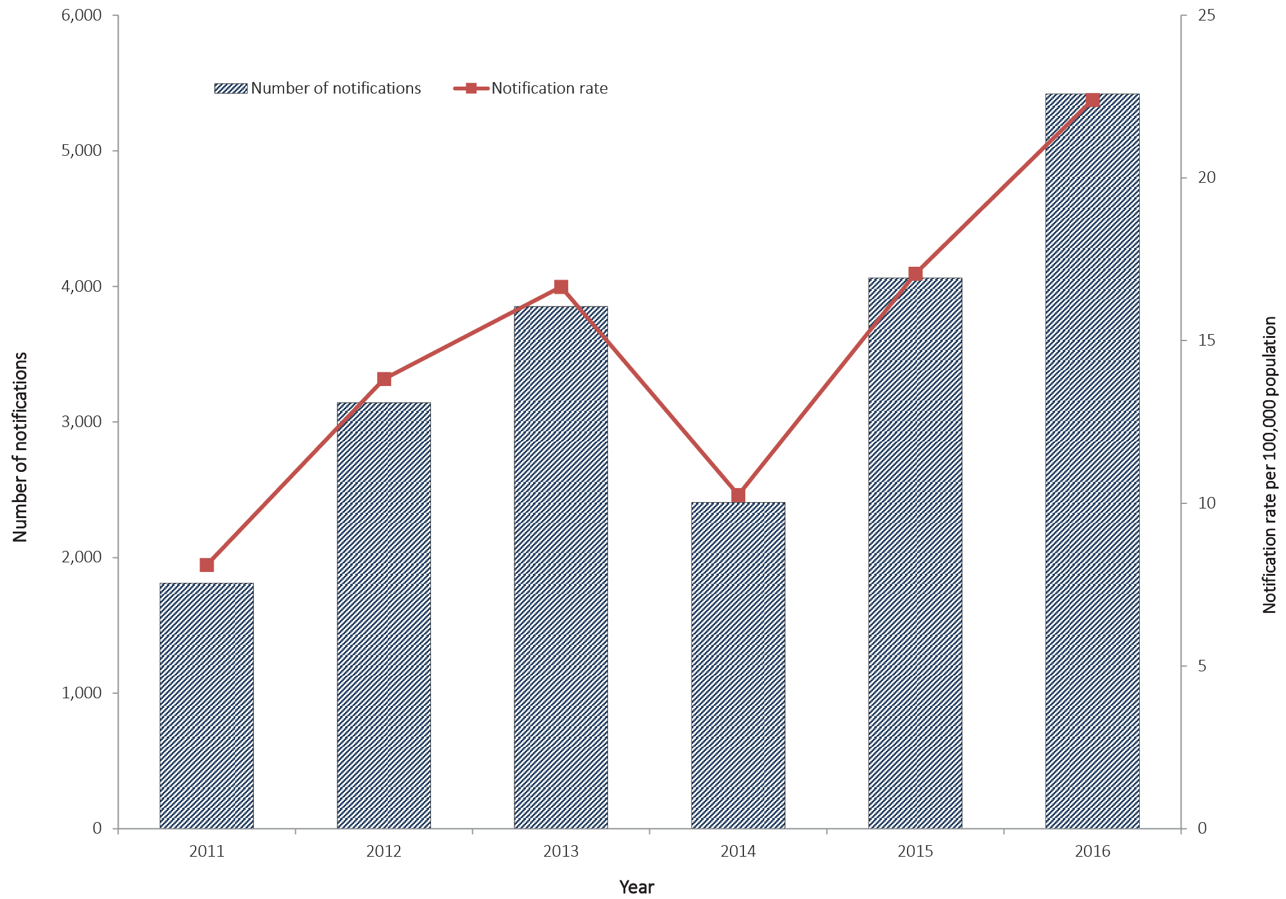

Geographical distribution
Notification rates for cryptosporidiosis ranged from 6.2 per 100,000 population in Tasmania to 114.0 per 100,000 population in the Northern Territory. The Northern Territory rate was five times higher than the national rate (22.4 per 100,000 population) (Table 5).

Age and sex distribution
In 2016, notified cases of cryptosporidiosis were most frequent among males and females aged 0–4 years (males: 132.1 per 100,000 population; females: 101.1 per 100,000). The overall median age of notified cases was 12 years (range 0 to 104 years). Females accounted for 52% of the notifications of cryptosporidiosis (2,825/5,419). The median age of notified cases in females was 22 years (range 0 to 104 years), whilst for males the median age of notified cases was six years (range 0 to 93 years) (Figure 17).
Figure 17: Notifications of cryptosporidiosis, Australia, 2016, by age group and sex
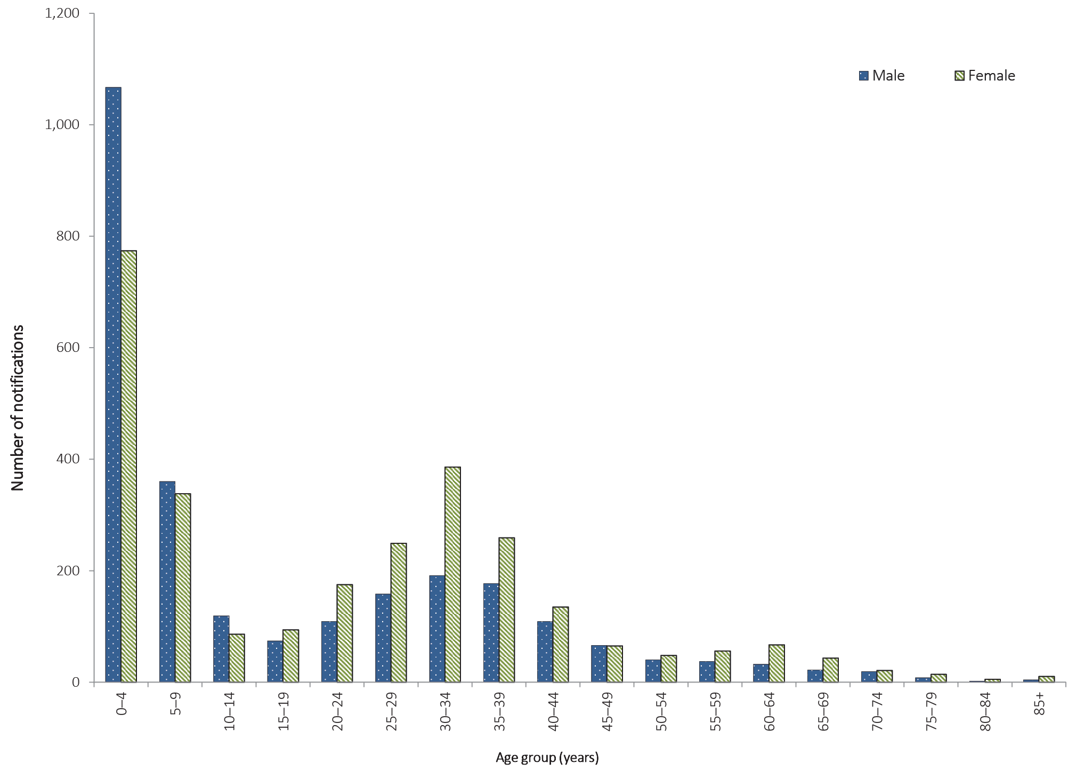

Haemolytic uraemic syndrome

- There were 15 cases of haemolytic uraemic syndrome notified in 2016.
- Cases were more frequently notified among the 0–4 years age group in 2016.
Haemolytic uraemic syndrome (HUS) is a rare but serious illness that is characterised by acute renal impairment, with 50% of patients requiring dialysis and approximately 5% of patients dying.²³ Not all diagnoses of HUS are related to enteric pathogens; however, cases in Australia are commonly associated with Shiga toxin-producing Escherichia coli (STEC) infection.³¹

Epidemiological situation in 2016
There were 15 notified cases of HUS in 2016, which is a decrease in reported notifications when compared to the 18 cases reported in 2015 and the five-year historical mean (n = 17). In 2016, ten cases (66%) of HUS were positive for STEC.

Geographical distribution
In 2016, Queensland and New South Wales each reported four notifications of HUS, Western Australia reported three notifications and Tasmania and Victoria each reported two cases.

Age and sex distribution
In 2016, HUS was most frequently notified among the 0–4 years age group (9/15; 60%) (Figure 18). In 2016, eight notifications were reported in females and seven notifications in males.
Figure 18: Notifications of HUS, Australia, 2016, by age group and sex
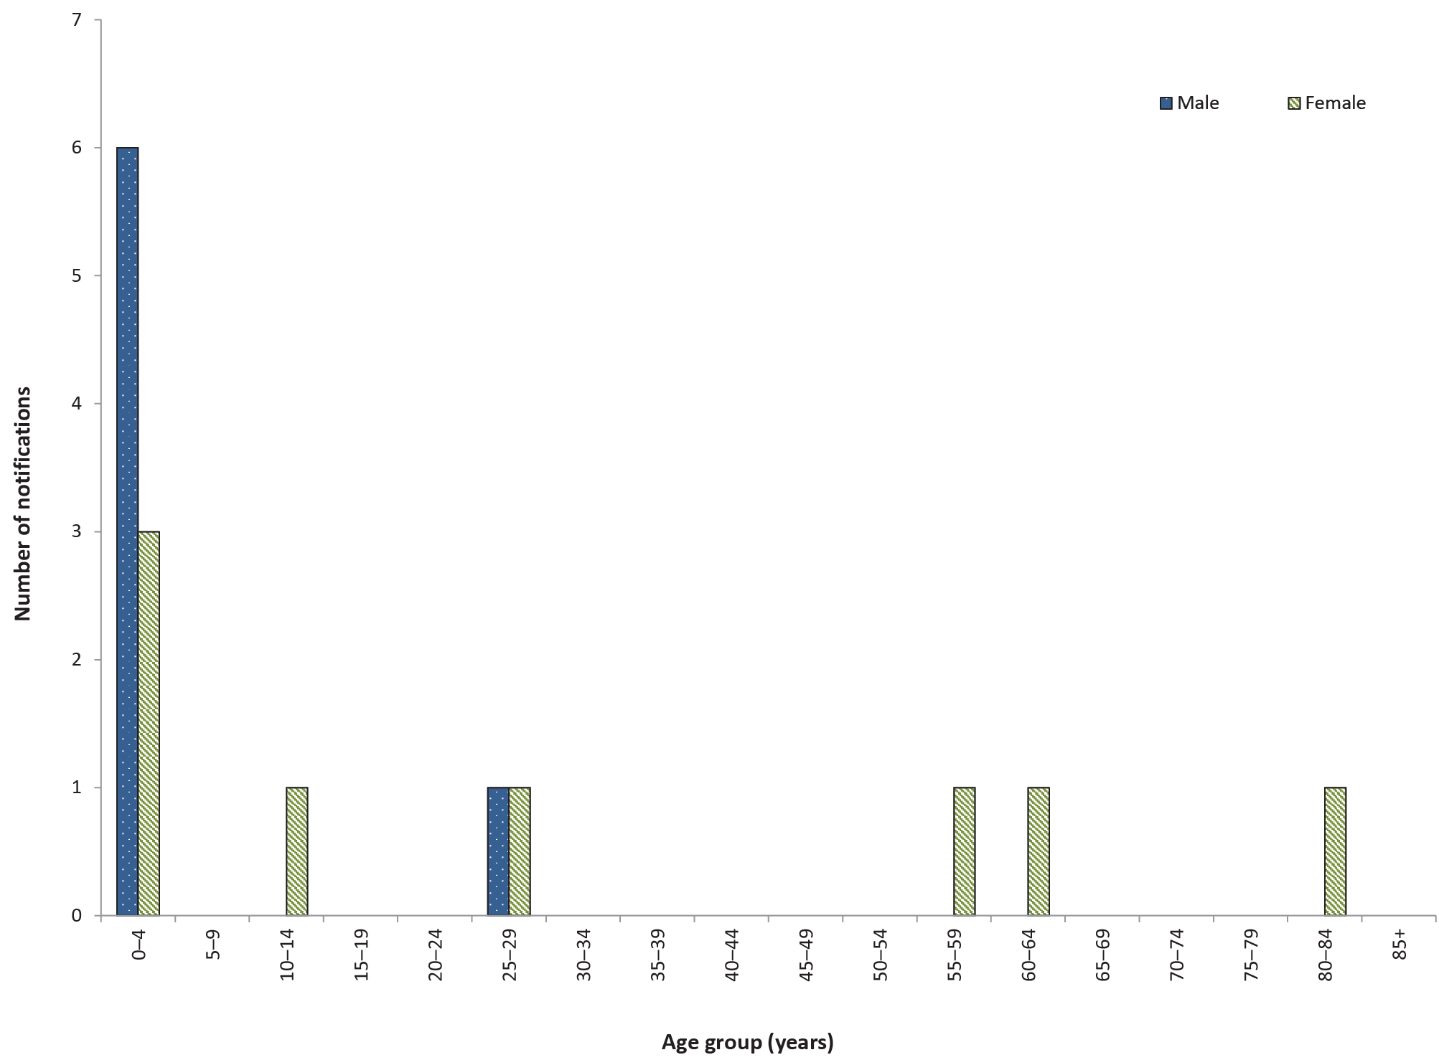

Hepatitis A

- There were 144 cases of hepatitis A infection notified in 2016.
- Overseas travel was the primary risk factor for notified cases.
Hepatitis A is an acute viral infection primarily affecting the liver. It is characterised by fever, malaise, anorexia, nausea and abdominal discomfort followed by jaundice. The disease is usually asymptomatic in young children and varies from a mild illness to a severely disabling disease that can last for several months in older children and adults. Infection is usually spread from person to person via the faecal-oral route but can also be foodborne or waterborne.²³

Epidemiological situation in 2016
There were 144 notified cases of hepatitis A in 2016 (0.6 per 100,000 population). This is a 20% decrease on the number of notified cases in 2015 (n = 179) and a 21% decrease on the five-year historical mean (n = 182) (Figure 19).

Figure 19: Notifications and notification rate for hepatitis A infection, Australia, 2011 to 2016, by year and place of acquisition
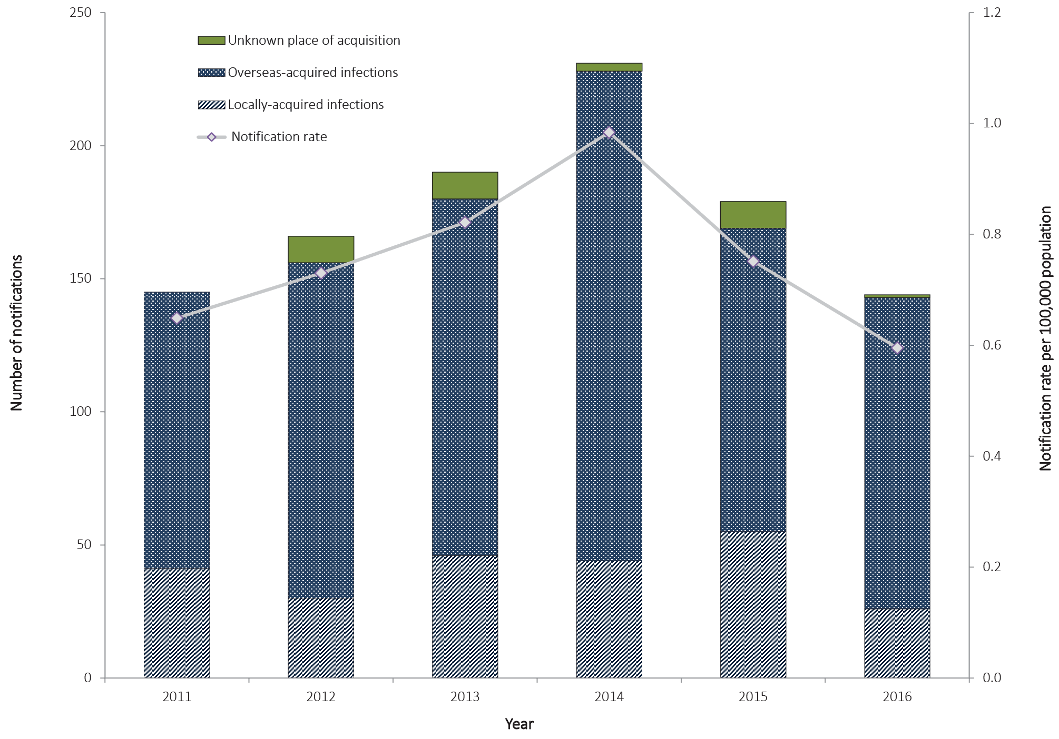

Geographical distribution
Victoria reported the highest number of hepatitis A notifications (45/144), with a rate of 0.7 per 100,000 population, followed by New South Wales (43/144; 0.6 per 100,000 population), and Queensland (30/144; 0.6 per 100,000 population).

Age and sex distribution
Whilst the highest number of hepatitis A notifications was reported in males aged 20–24 years (n = 14), overall the 25–29 years age group accounted for the highest number of notifications in total (n=23: 12 notifications in males, 11 in females) (Figure 20). The median age of notified cases was 24 years (range 1 to 79 years), and 54% of all cases (78/144) were male.

Figure 20: Notifications of hepatitis A infection, Australia, 2016, by age group and sex
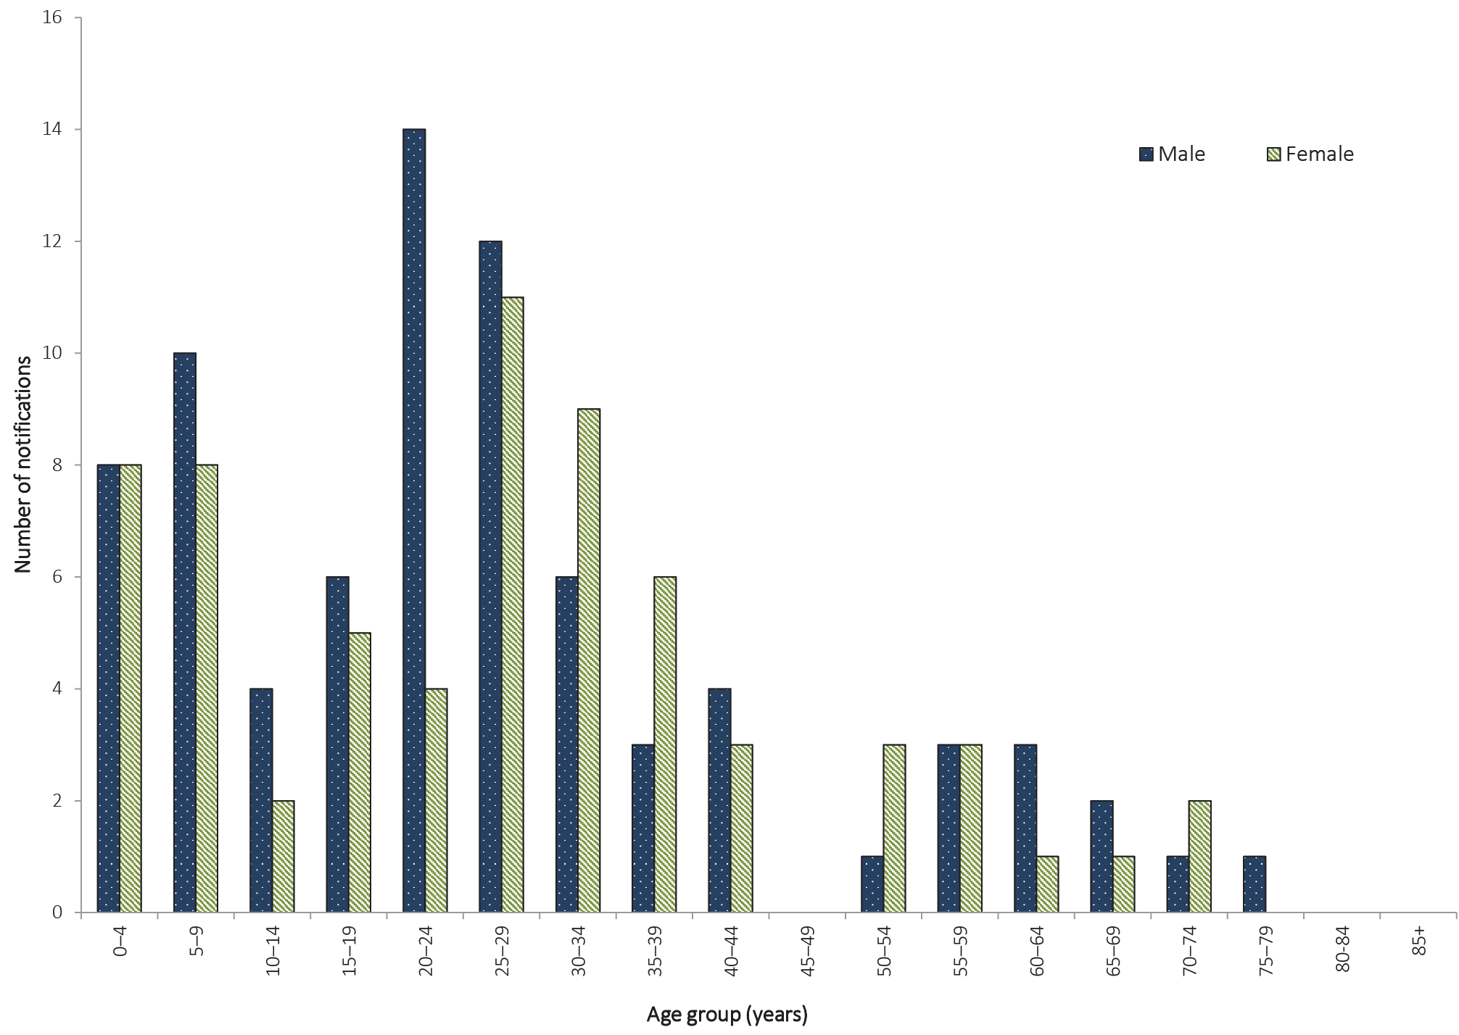

Indigenous status
In 2016, Indigenous status was known for 94% (136/144) of notified cases of hepatitis A. In 2016, no cases were identified as occurring in Aboriginal and Torres Strait Islander persons. Immunisation programs for Aboriginal and Torres Strait Islander children were established initially in north Queensland in 1999 for children aged 18 months. The hepatitis A immunisation program was expanded in 2005 to include all Aboriginal and Torres Strait Islander children aged 12 to 24 months in the Northern Territory, Queensland, South Australia and Western Australia.³² These programs led to a sharp decline in the number of cases of hepatitis A in Aboriginal and Torres Strait Islander people,³³ and numbers have remained low in this population group.

Place of acquisition
In 2016, place of acquisition was reported for 99% of hepatitis A cases (143/144). Of those reporting place of acquisition, 82% (117/143) reported overseas travel during their period of acquisition and were considered to have been overseas acquired (Table 12). The top four countries of acquisition were India (n = 19), Pakistan (n = 13), Iraq (n = 8) and Vanuatu (n = 7).
In 2016, 18% of hepatitis A notifications, where place of acquisition was known, were locally acquired (n = 26). This is the lowest number of locally acquired cases since 2011 (Table 12).

Table 12: Notifications of hepatitis A infection, Australia, 2011 to 2016, by place of acquisition
Year | Locally  acquired |  | Overseas  acquired | Unknown | Total
 | n | %ª | n | n
2011 | 41 | 28 | 104 | 0 | 145
2012 | 30 | 19 | 126 | 10 | 166
2013 | 46 | 26 | 134 | 10 | 190
2014 | 44 | 19 | 184 | 3 | 231
2015 | 55 | 33 | 114 | 10 | 179
2016 | 26 | 18 | 117 | 1 | 144
a Excludes cases where the place of acquisition was unknown or not supplied.

Hepatitis E

- There were 42 cases of hepatitis E infection notified in 2016.
Hepatitis E infection is an acute viral infection primarily affecting the liver. The virus is transmitted via the faecal-oral route, most often via food or water.²³ The infection is usually acquired overseas among travellers to endemic areas.

Epidemiological situation in 2016
There were 42 notified cases of hepatitis E in 2016 (0.2 per 100,000 population), comparable to the 41 notified cases in 2015 (0.2 per 100,000 population) and the five-year historical mean, 2011 to 2015 (n = 41).

Geographical distribution
New South Wales reported the highest number of hepatitis E notifications (n = 14), followed by Victoria (n = 12) and Queensland (n = 8).

Age and sex distribution
In 2016, hepatitis E was most frequently notified among people aged 20 to 34 years (Figure 21). In 2016, 74% of notified hepatitis E cases were in males (31/42). The median age of notified cases was 31 years (range 11 to 70 years).
Figure 21: Notifications of hepatitis E infection, Australia, 2016, by age group and sex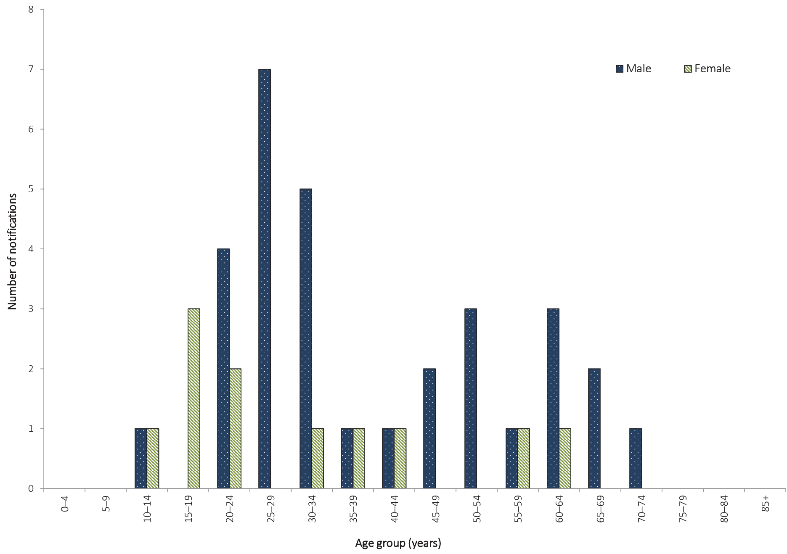

Place of acquisition
Hepatitis E in Australia has traditionally been associated with overseas travel. In 2016, place of acquisition was recorded for 39 cases, of which 29 reported overseas travel during their period of acquisition and were considered to have acquired infection overseas. The most commonly reported countries of acquisition were: India (13/29; 45%), Pakistan (5/29; 17%) and Bangladesh (3/29; 10%). In 2016, 26% (10/39) of cases were locally acquired.

Listeriosis

- There were 84 cases of listeriosis notified in 2016.
- Notifications were highest in those aged 80 years or more.
Invasive listeriosis is caused by a bacterial infection that commonly affects the elderly or immunocompromised, and typically occurs among people with serious underlying illnesses. Listeriosis can also affect pregnant women and infect the unborn baby.³⁴ Nearly all cases of listeriosis result from foodborne transmission. Laboratory-confirmed infections in a mother and her unborn child or neonate are notified separately in the NNDSS.

Epidemiological situation in 2016
There were 84 notified cases of listeriosis in 2016 (0.3 per 100,000 population). This was a 20% increase on the number of notified cases in 2015 (n = 70) and an 8% increase on the five-year historical mean, 2011 to 2015 (n = 78).

Geographical distribution
New South Wales had the highest number of listeriosis notifications (n = 34; 40%), followed by Victoria (n = 26; 31%) and Queensland (n = 13; 15%).

Age and sex distribution
- Notifications of listeriosis were highest in those aged 80 years or more, who accounted for 31% of notifications in 2016 (n = 26) (Figure 22).
- Overall, 54% of notifications were reported in females (n = 45).
Figure 22: Notifications of listeriosis, Australia, 2016, by age group and sex
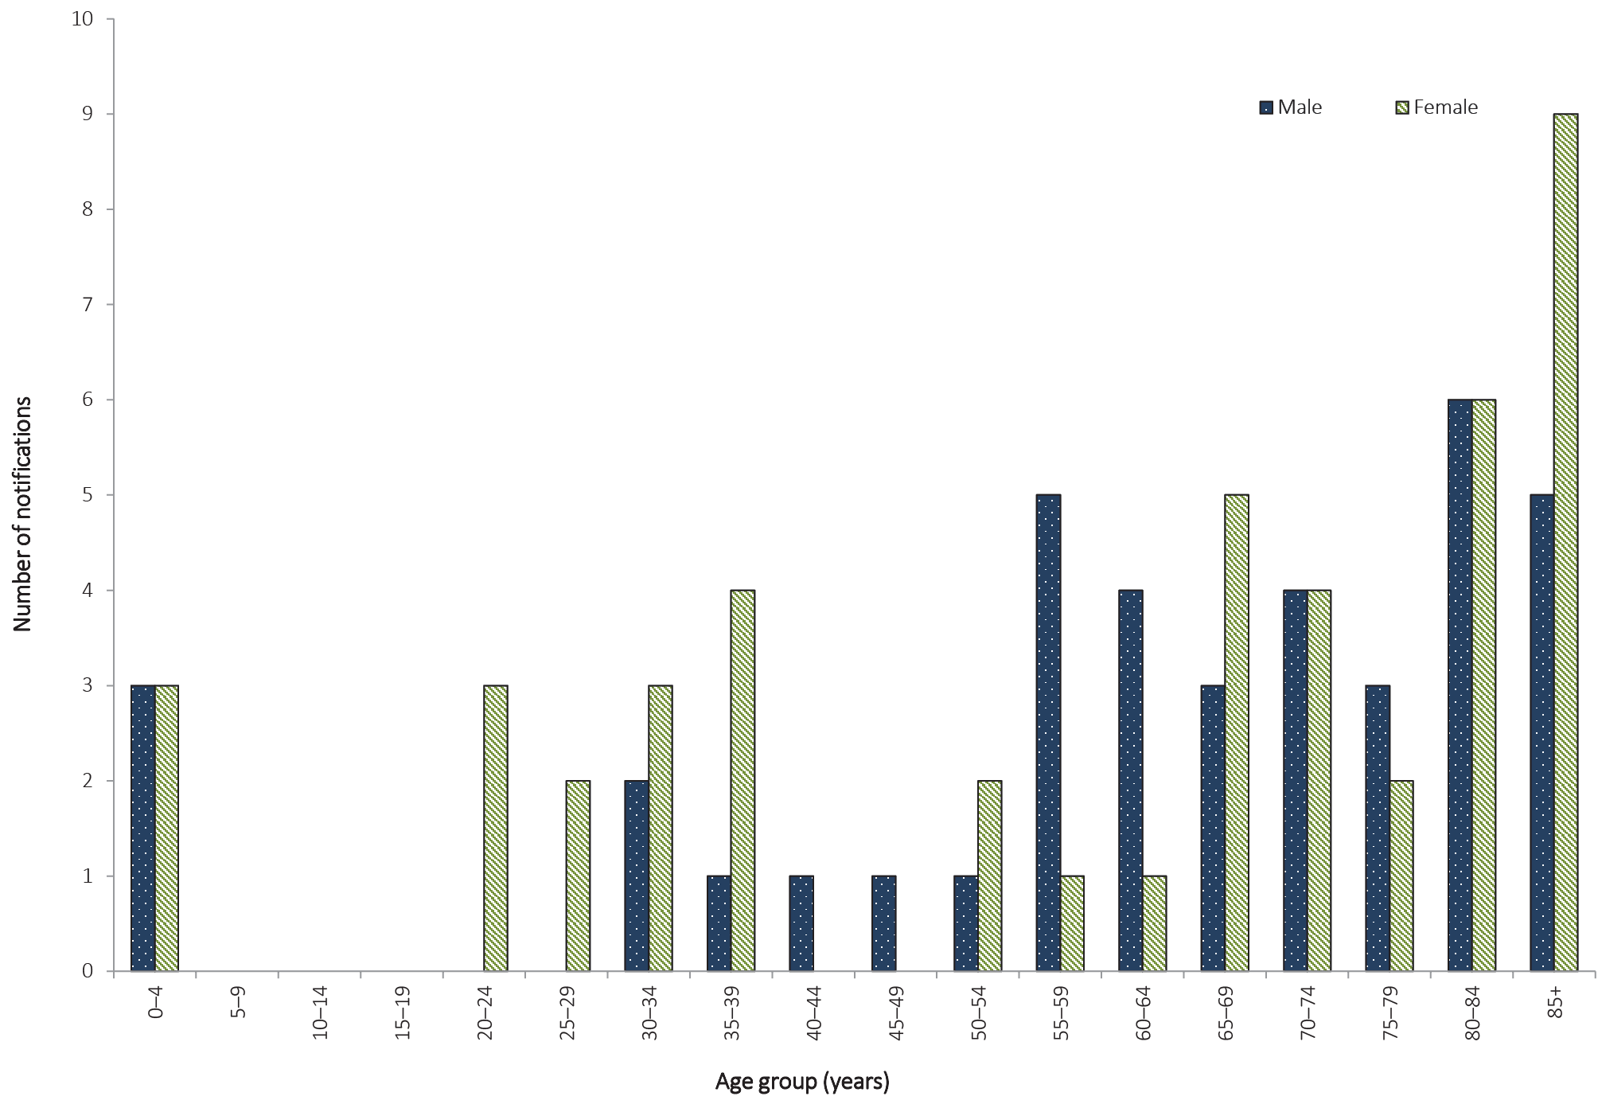

Paratyphoid

- There were 79 cases of paratyphoid notified in 2016.
- Overseas travel remains the primary risk factor.
This is the second NNDSS Annual Report to include paratyphoid as a separate notifiable condition from salmonellosis, as paratyphoid was only listed as a separate condition from 1 January 2016. As was stated in the 2015 NNDSS Annual Report,³⁵ data has been updated retrospectively for all years, making annual comparisons possible.
Paratyphoid is a bacterial disease caused by S. enterica serovars Paratyphi A, Paratyphi B, or Paratyphi C, which typically produce symptoms similar to typhoid, known commonly as “enteric fever”. Please note: S.enterica Paratyphi B biovar Java does not cause an enteric fever and is included under salmonellosis.

Epidemiological situation in 2016
There were 79 notified cases of paratyphoid in 2016 (0.3 per 100,000 population). This is an increase of 4% on 2015 (n = 76) (Figure 23) and an 8% increase on the five-year historical mean, 2011 to 2015 (n = 73).
Figure 23: Notifications and notification rate for paratyphoid, Australia, 2011 to 2016, by year
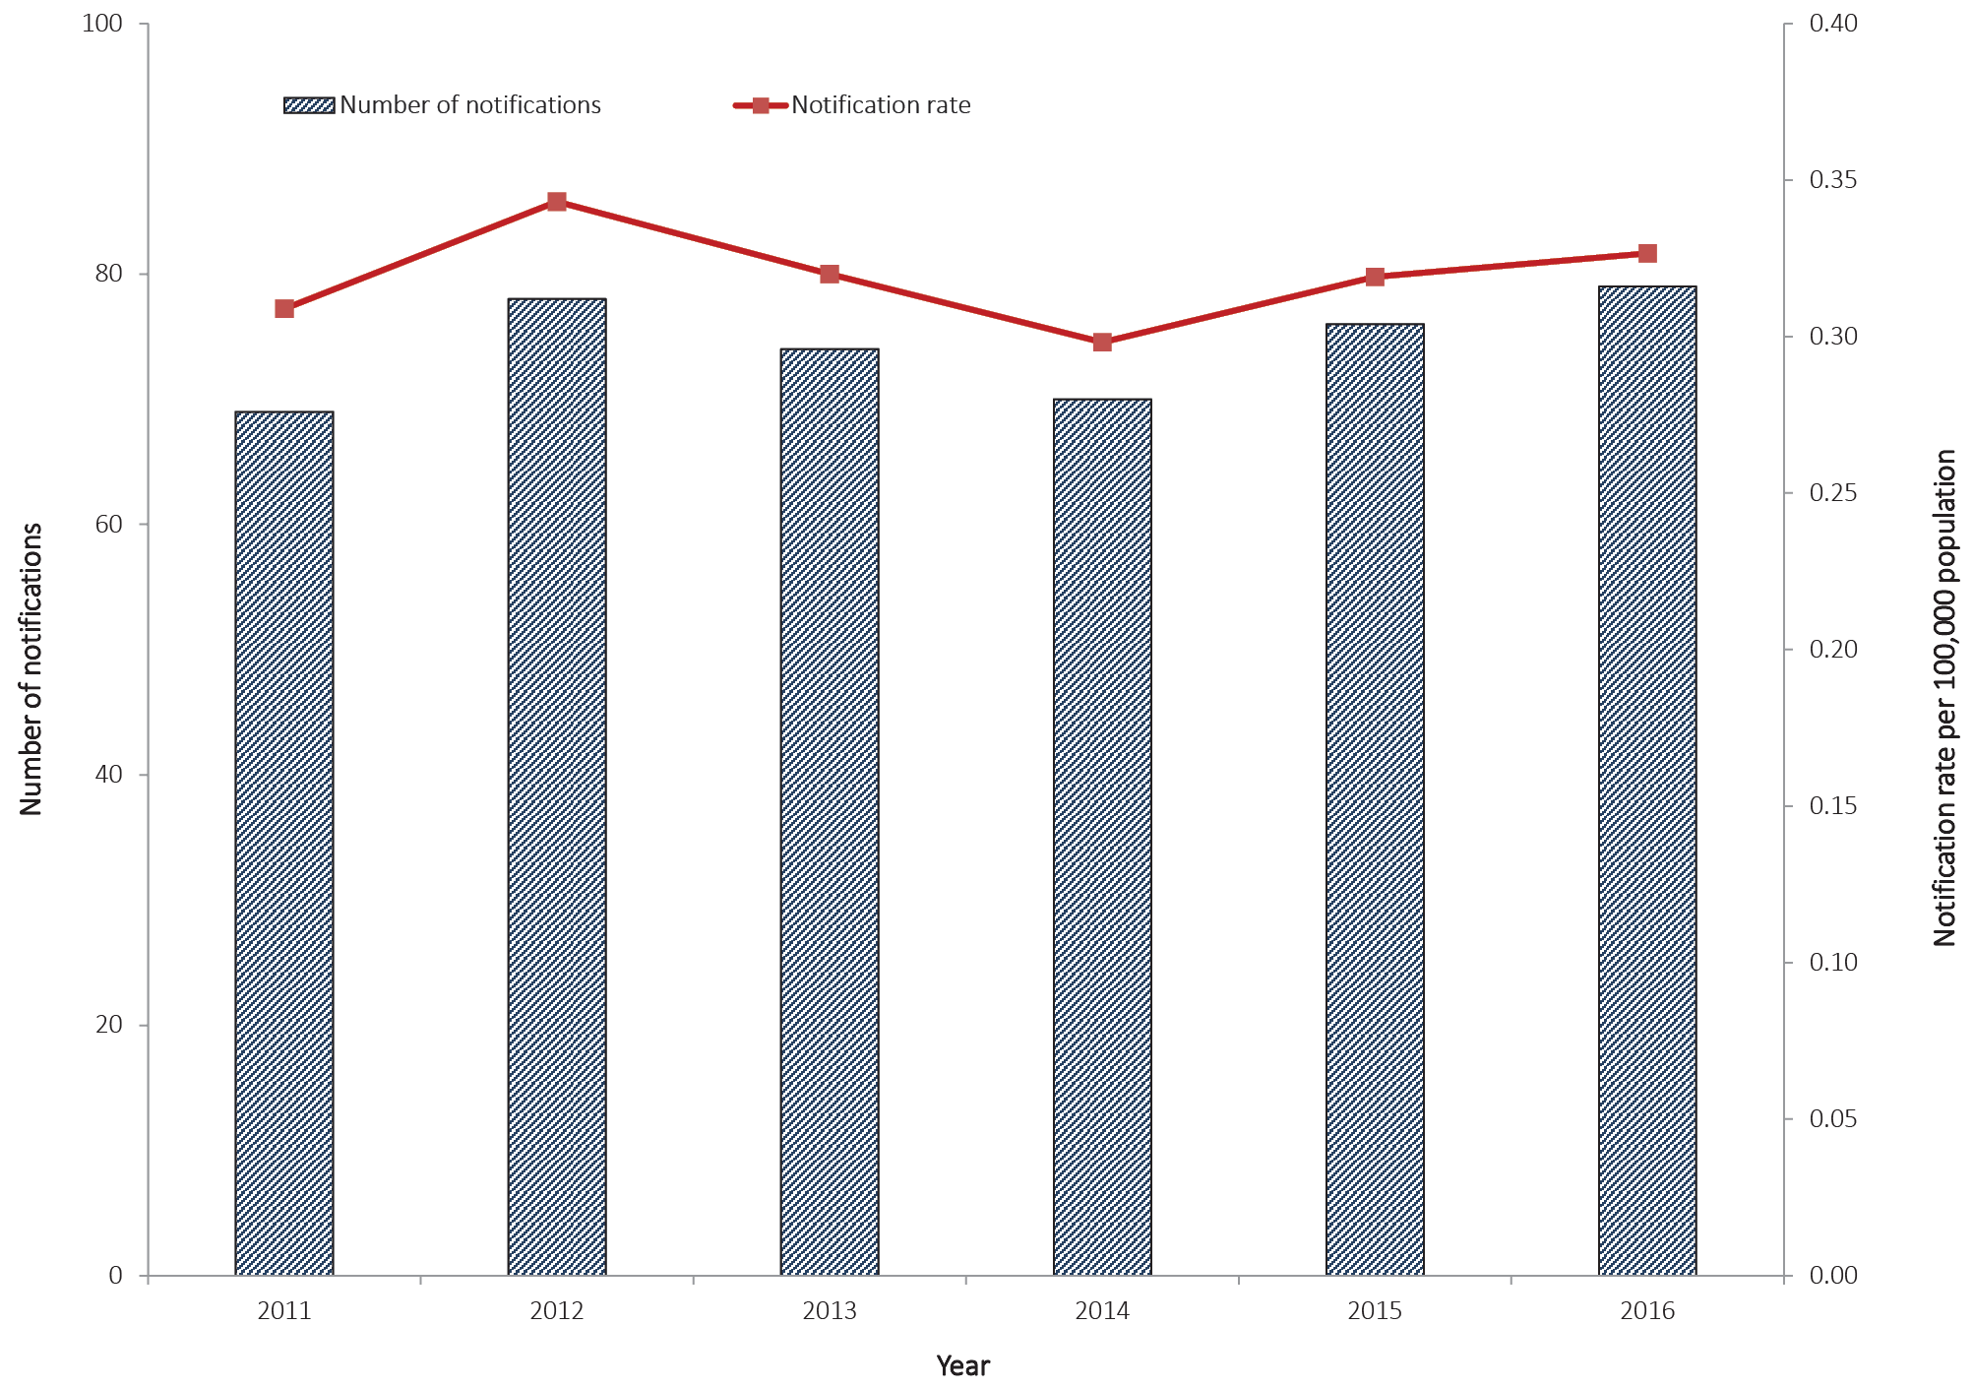

Geographical distribution
The highest number of notifications were in residents of Victoria (n = 26; 33%), followed by New South Wales (n = 20; 25%), Western Australia (n = 12; 15%) and Queensland (n = 9; 11%).

Age and sex distribution
Paratyphoid was most frequently notified among persons aged 25–29 years (n=17; 22%), followed by those aged 30–34 years (n=12; 15%) and 20–24 years (n=11; 14%). The highest number of paratyphoid notifications among females was reported in the 20–24 years age group (n=9; 26%). For males, the highest number of notifications was reported among those aged 25–29 years (n=9; 20%) (Figure 24). The median age of notified cases was 28 years (range 0 to 82 years), and males accounted for a higher proportion of the total notifications (n = 44; 56%).

Figure 24: Notifications of paratyphoid, Australia, 2016, by age group and sex
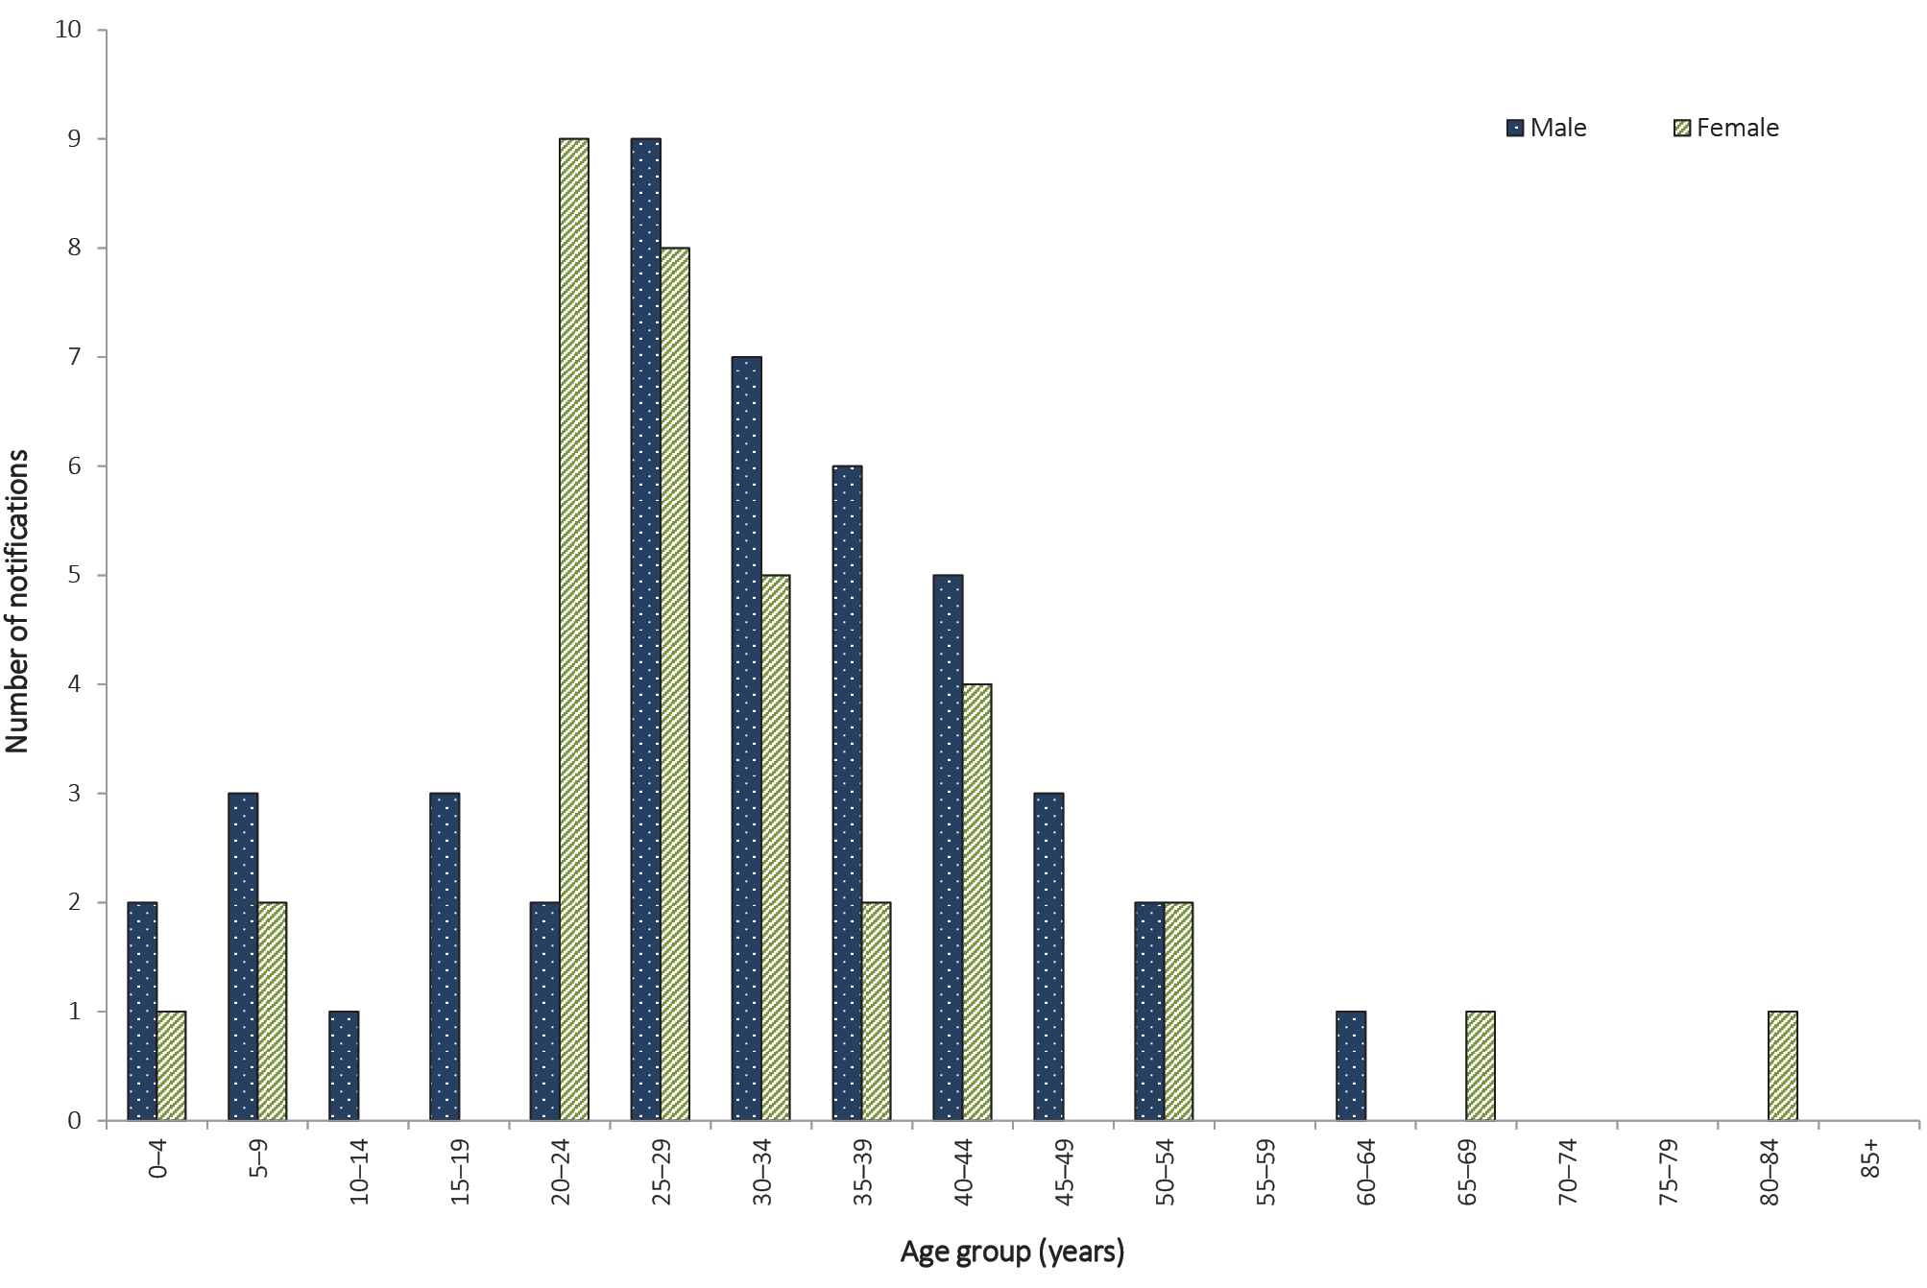

Place of acquisition
Overseas travel is the primary risk factor for notified cases of paratyphoid. In 2016, place of acquisition was reported for 91% of notified cases of paratyphoid (72/79). Of these, 93% (67/72) reported overseas travel during their exposure period and were considered overseas acquired. The most frequently reported country of acquisition was India (n = 34; 47%), followed by Indonesia (n = 14; 19%). Five cases were reported as locally acquired; two cases each in New South Wales and Queensland, and one case in Victoria (Table 13).
Table 13: Notifications of paratyphoid, Australia, 2011 to 2016, by place of acquisition
Year notified | Locally  acquired |  | Overseas  acquired | Unknown | Total
 | n | %ª | n | n
2011 | 4 | 6 | 65 | 0 | 69
2012 | 1 | 1 | 67 | 10 | 78
2013 | 1 | 1 | 66 | 7 | 74
2014 | 2 | 3 | 57 | 11 | 70
2015 | 6 | 9 | 63 | 7 | 76
2016 | 5 | 7 | 67 | 7 | 79
a Excludes cases where the place of acquisition was not supplied or unknown.

Salmonellosis (non-typhoidal)

- There were 18,088 cases of salmonellosis notified in 2016.
- Salmonellosis was the second-most-frequently notified enteric infection in 2016.
- This was the highest number of salmonellosis notifications recorded in NNDSS since 1991.
Salmonellosis is a bacterial disease characterised by the rapid development of symptoms including abdominal pain, fever, diarrhoea, muscle pain, nausea and/or vomiting. The predominant mode of transmission is contaminated food, mainly of animal origin;²³ however, people can also become infected via faecal-oral transmission, through animal contact and from environmental exposures.

Epidemiological situation in 2016
There were 18,088 notified cases of salmonellosis in 2016 (74.8 per 100,000 population). This is the highest annual number of notifications recorded in NNDSS since salmonellosis became nationally notifiable in 1991. This represents a 6% increase on the number of cases reported in 2015 (n = 17,001) (Figure 25), and a 30% increase on the five-year historical mean, 2011 to 2015 (n = 13,874). This rise may be associated with the increased use of culture-independent diagnostic testing.
Figure 25: Notifications and notification rate for salmonellosis, Australia, 2011 to 2016, by year
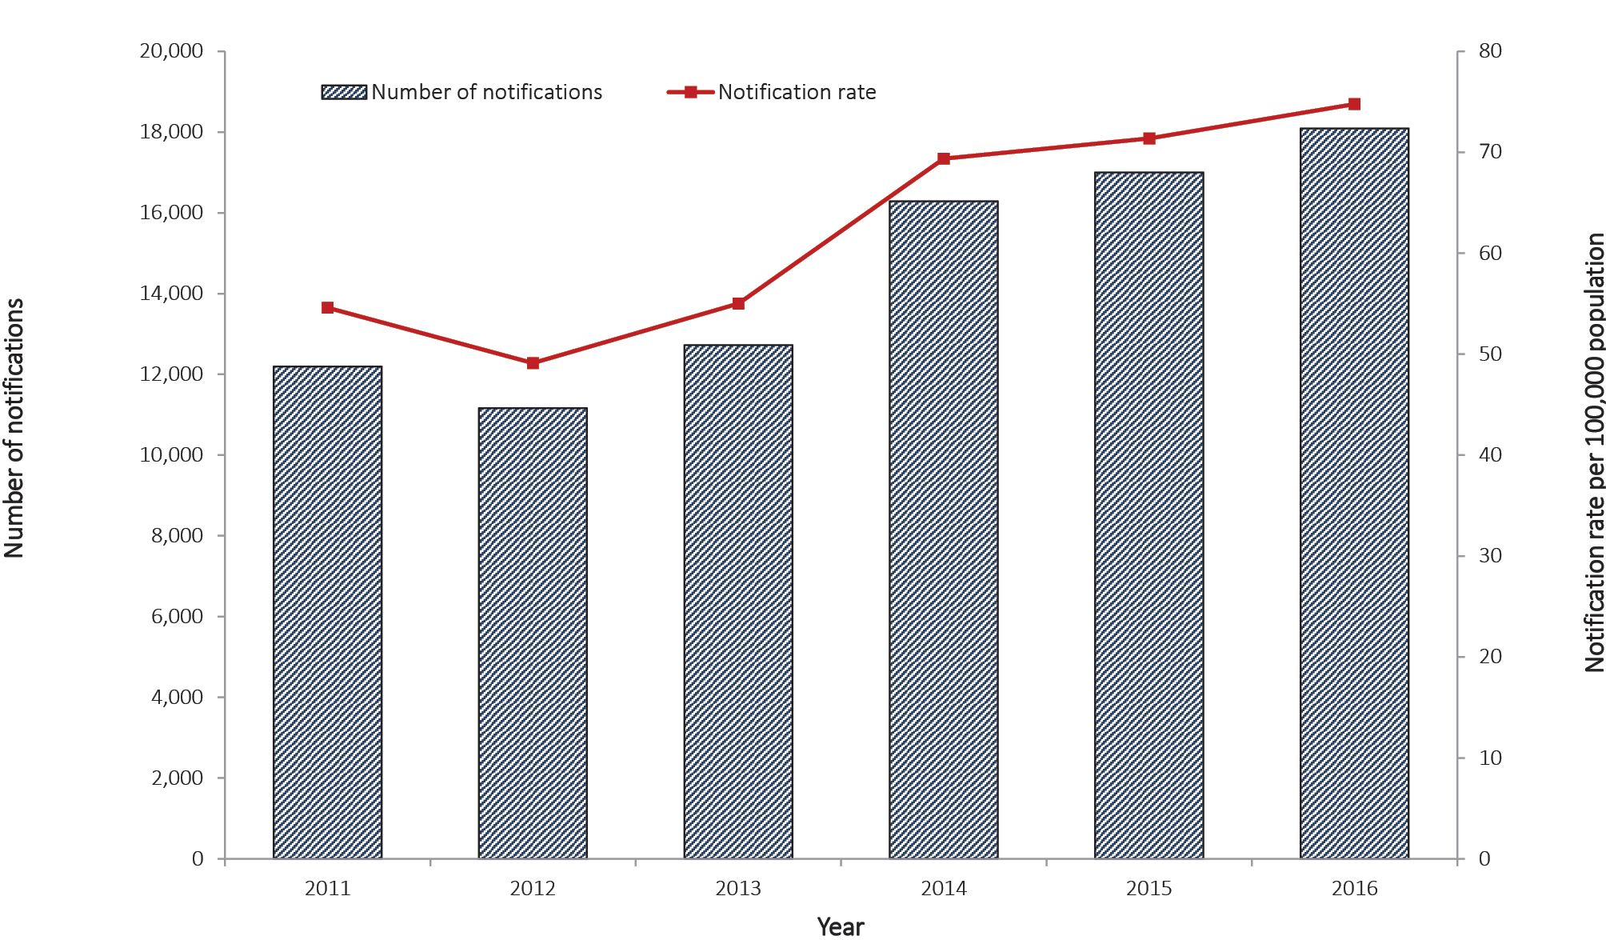

Geographical distribution
Rates ranged from 54.5 per 100,000 population in Tasmania to 267.8 per 100,000 population in the Northern Territory (Table 5).

Age and sex distribution
Salmonellosis was most frequently notified among the 0–4 years age group, who accounted for 23% of all notifications in 2016, and for whom the notification rate was 261.2 per 100,000 population (Figure 26). The median age of notified cases was 27 years (range 0 to 104 years) and, where sex was recorded, over half of cases were female (n = 9,489; 52%).
Figure 26: Notification rate for salmonellosis, Australia, 2016, by age group and sexª
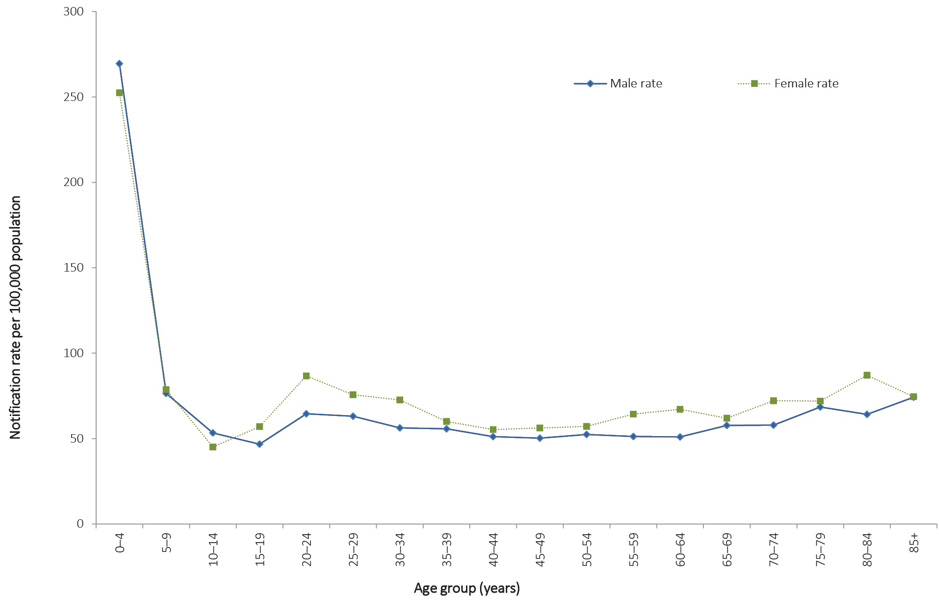
a Excludes notifications where age (n = 8) and/or sex (n = 3) were not reported.

Shigellosis

- There were 1,406 cases of shigellosis notified in 2016.
Shigellosis is a bacterial disease characterised by acute abdominal pain and fever, small-volume loose stools, vomiting and tenesmus. Shigellais transmitted via the faecal-oral route, either directly (such as male-to-male sexual contact) or indirectly through contaminated food or water.²³

Epidemiological situation in 2016
There were 1,406 notified cases of shigellosis in 2016 (5.8 per 100,000 population). This is an increase of 36% compared with 2015 (n = 1,037) (Figure 27), and a 93% increase on the five-year historical mean, 2011 to 2015 (n = 730). This rise may be associated with the increased use of culture-independent diagnostic testing. The current culture-independent diagnostic testing methods are unable to differentiate between infection caused by the notifiable Shigellaand the non-notifiable entero-invasive Escherichia coli.³⁶
Figure 27: Notifications and notification rate for shigellosis, Australia, 2011 to 2016, by year
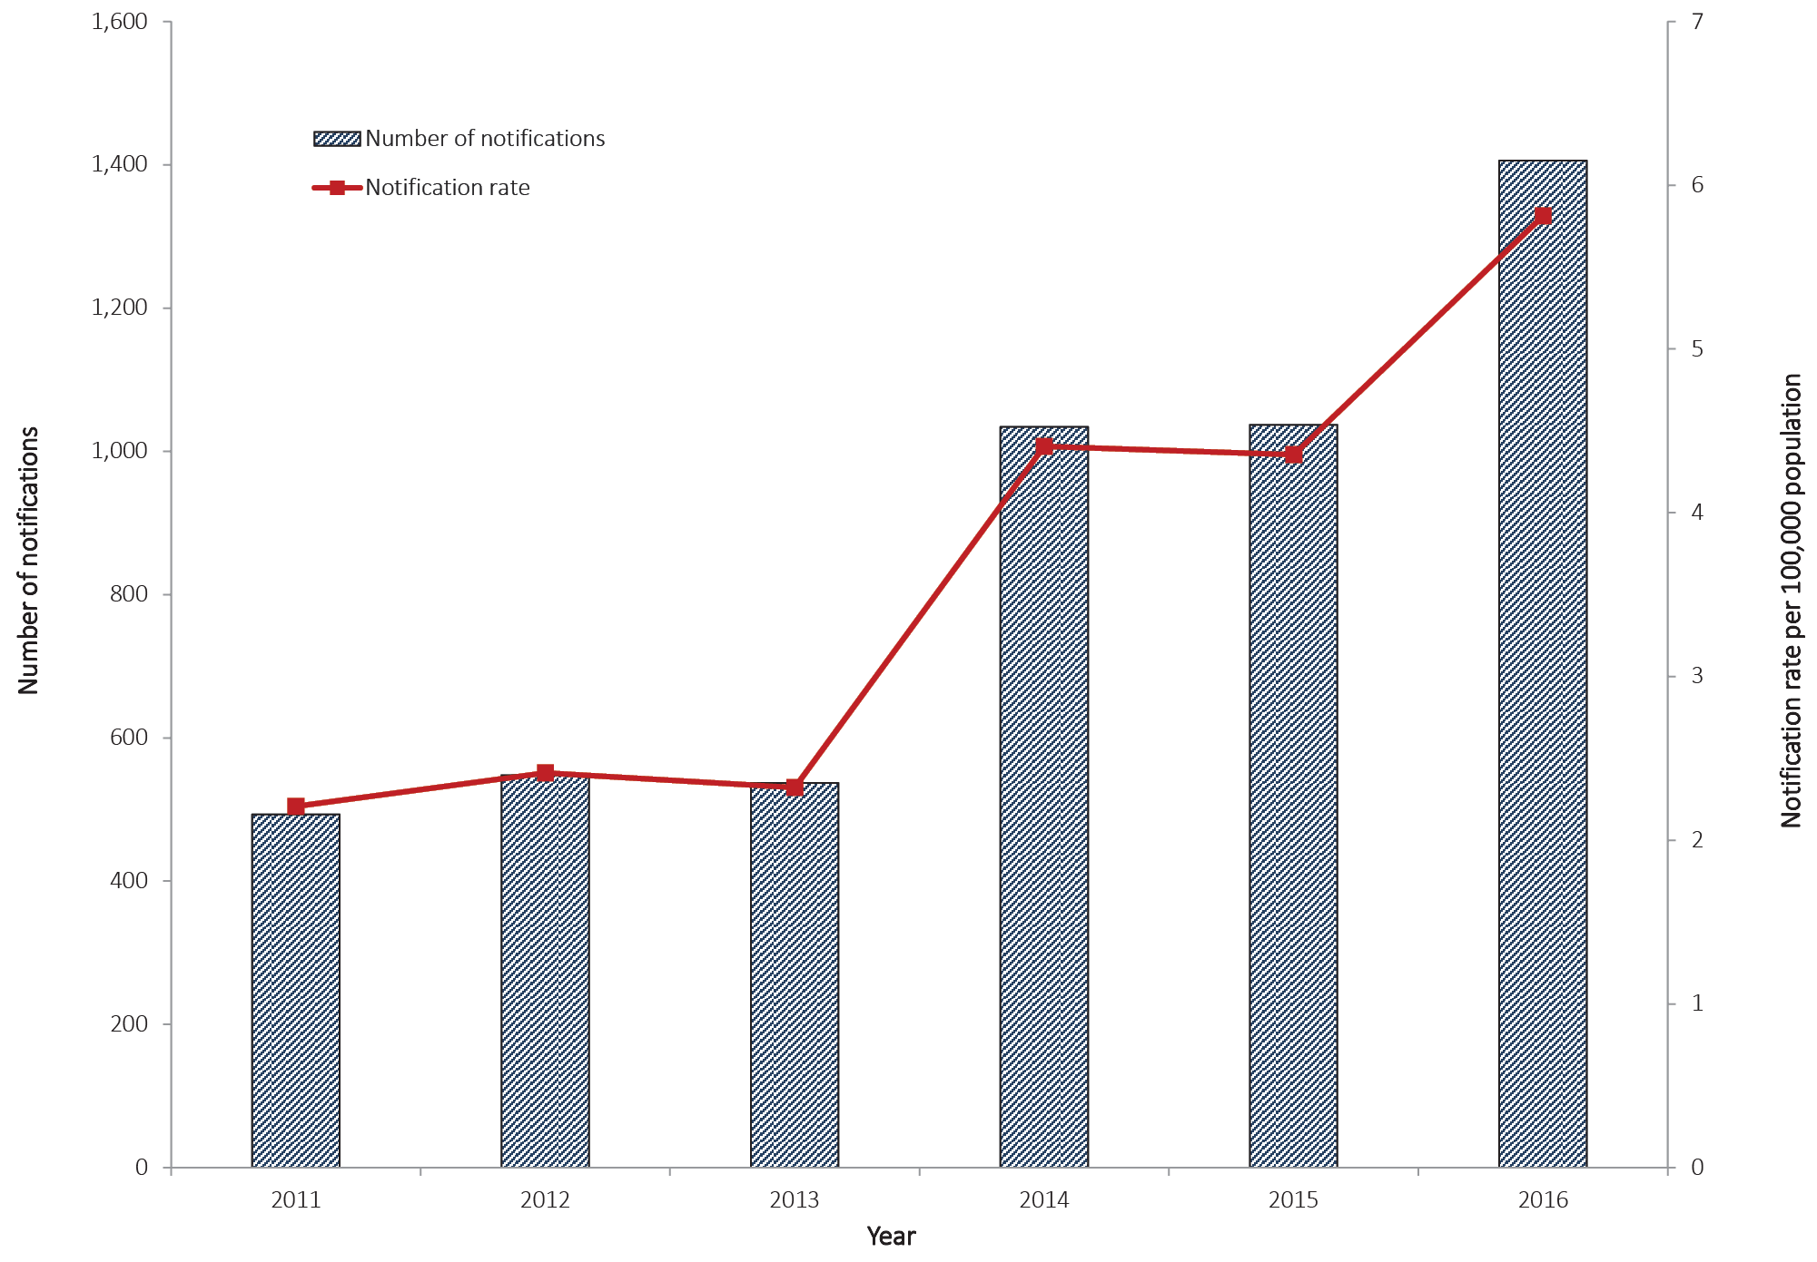

Geographical distribution
Notification rates ranged from 1.2 per 100,000 population in the Australian Capital Territory to 76.1 per 100,000 population in the Northern Territory. State and territory rates for 2016 should be interpreted with caution as some jurisdictions require culture-independent diagnostic testing positive samples to be confirmed by culture, whilst others do not.

Age and sex distribution
Notifications of shigellosis were highest in males 25 to 39 years of age who accounted for 23% of all notifications in 2016 (324/1,406) (Figure 28). The highest notifications in females were in those aged 0–4 years (n = 90); with males in the same age group reporting a similar number of notifications (n = 88). In 2016, the median age of notified cases was 31 years (range 0 to 95 years) and almost two-thirds of cases were male (887/1,406; 63%).

Figure 28: Notifications of shigellosis, Australia, 2016, by age group and sex
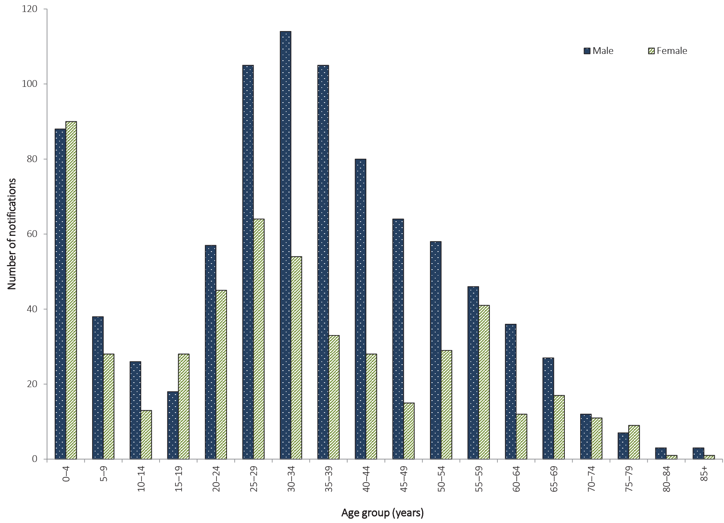

Indigenous status
Information on Indigenous status was available for 92% (1,291/1,406) of shigellosis cases. The proportion of notified cases in people who identified as being of Aboriginal and Torres Strait Islander origin was 16% (201/1,291).

Place of acquisition
In 2016, place of acquisition was reported for 59% (835/1,406) of notified cases of shigellosis. Of these cases, 64% (533/835) reported overseas travel during their exposure period and were considered overseas acquired (Table 14). The top five countries of acquisition were Indonesia (n = 128), India (n = 95), Thailand (n = 37), Vietnam (n = 22) and Cambodia (n = 20).

Table 14: Notifications of shigellosis, Australia, 2011 to 2016, by place of acquisition
Year notified | Locally acquired |  | Overseas acquired | Unknown | Total
 | n | %ª | n | n | n
2011 | 169 | 53 | 149 | 175 | 493
2012 | 171 | 46 | 201 | 176 | 548
2013 | 136 | 40 | 208 | 193 | 537
2014 | 187 | 36 | 334 | 513 | 1,034
2015 | 243 | 36 | 433 | 361 | 1,037
2016 | 302 | 36 | 533 | 571 | 1,406
a Excludes cases with unknown place of acquisition.

Shiga toxin-producing Escherichia coli

- There were 340 cases of Shiga toxin-producing Escherichia coli infection notified in 2016.
Shiga toxin-producing Escherichia coli (STEC) is a common cause of diarrhoeal illness in humans. People can become infected via faecal-oral transmission, ingesting contaminated food, through animal contact and from environmental exposures. Severe illness can progress to HUS. Children under five years of age are most frequently diagnosed with infection and are at greatest risk of developing HUS.²³

Epidemiological situation in 2016
There were 340 notified cases of STEC in 2016 (1.4 per 100,000 population). The number of notifications in 2016 is 2.5 times greater than the number of notifications in 2015 (n = 136) and 2.7 times greater than the five-year historical mean, 2011 to 2015 (n = 128). This rise may be associated with the increased use of culture-independent diagnostic testing.

Geographical distribution
Detection of STEC infection is strongly influenced by jurisdictional practices regarding the screening of stool specimens.³¹ South Australia continues to test all bloody stools for STEC using Polymerase Chain Reaction (PCR) and has the most comprehensive screening practices across all jurisdictions. As a result of these testing practices, South Australia has the highest notification rate in the country: 10.2 cases per 100,000 population, compared with between 0.0 and 1.4 cases per 100,000 population reported in other states and territories. The differences in testing practices among states and territories render comparison of notification data by jurisdiction and over time invalid.

Age and sex distribution
Notifications of STEC were highest in the 0–4 years age group (40/340; 12%) (Figure 29). In 2016, the median age of notified cases was 41 years (range 0 to 94 years), and 53% of notified cases (181/340) were female.

Figure 29: Number of notifications of Shiga toxin-producing Escherichia coli infection, Australia, 2016, by age group and sex
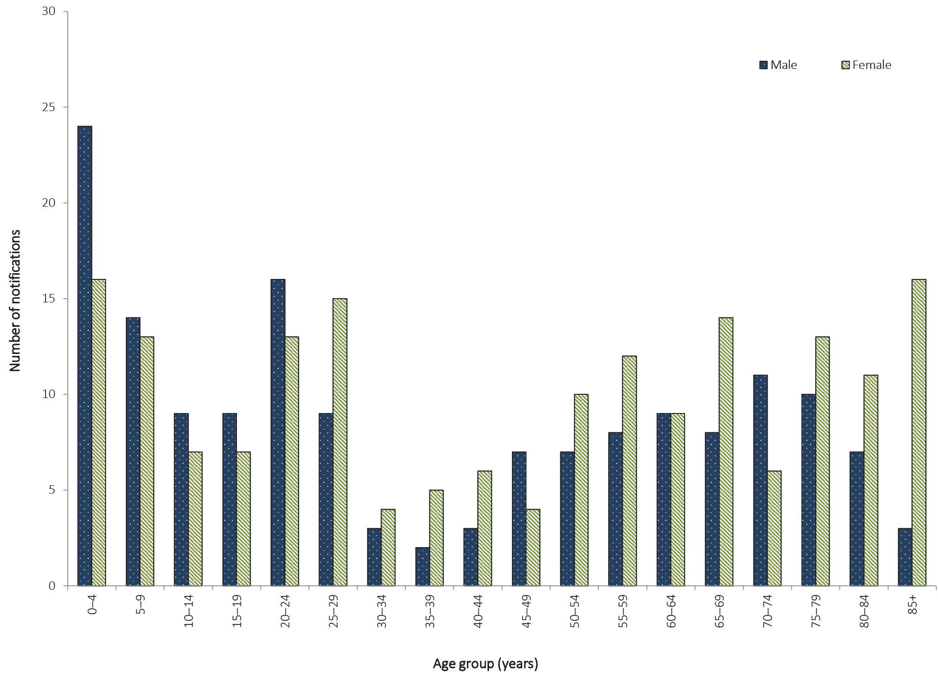

Microbiological trends
A partial or complete serotype was available for 45% of STEC notifications (152/340) in 2016. The most common serogroups were: O157 (71/152; 47%), O26 (38/152; 25%), O113 (17/152; 11%) and O111 (8/152; 5%).

Typhoid

- There were 104 cases of typhoid notified in 2016.
- Of these, 95% were acquired overseas.
Typhoid is a bacterial disease caused by S. enterica serovar Typhi. Symptoms include sustained fever, marked headache, malaise and constipation more often than diarrhoea in adults. The transmission mode is the same as for salmonellosis; however, typhoid differs in that humans are the reservoir for the bacterium.²³

Epidemiological situation in 2016
There were 104 notified cases of typhoid in 2016 (0.4 per 100,000 population). This is a decrease of 9% on the number of cases reported in 2015 (n = 114) (Figure 30) and a decrease of 18% on the five-year historical mean, 2011 to 2015 (n = 128).
Figure 30: Notifications and notification rate for typhoid, Australia, 2011 to 2016, by year
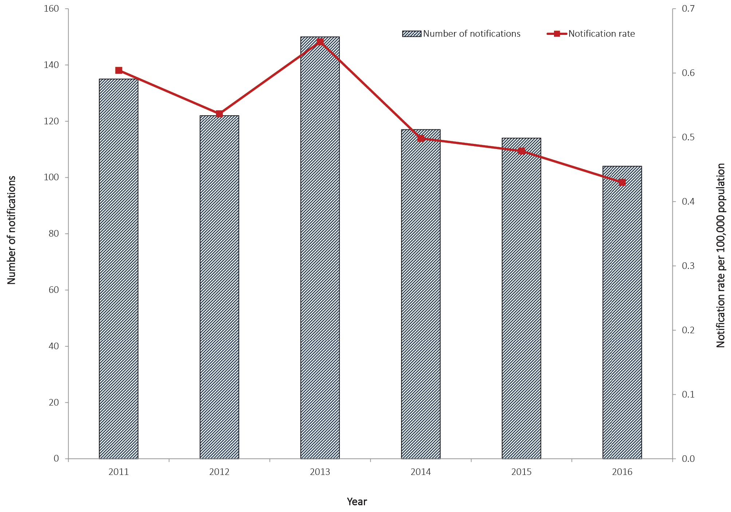

Geographical distribution
New South Wales reported the highest number of notifications of typhoid (n = 35), followed by Victoria (n = 27), Queensland (n = 19) and Western Australia (n = 12).

Age and sex distribution
Typhoid was most frequently notified in persons aged 0–4 years (18/104; 17%) and persons aged 25–29 years (18/104; 17%) (Figure 31). In 2016, the median age of notified cases was 26 years (range 0 to 78 years), and males accounted for more than half of all cases (56/104; 54%).

Figure 31: Notifications of typhoid, Australia, 2016, by age group and sex
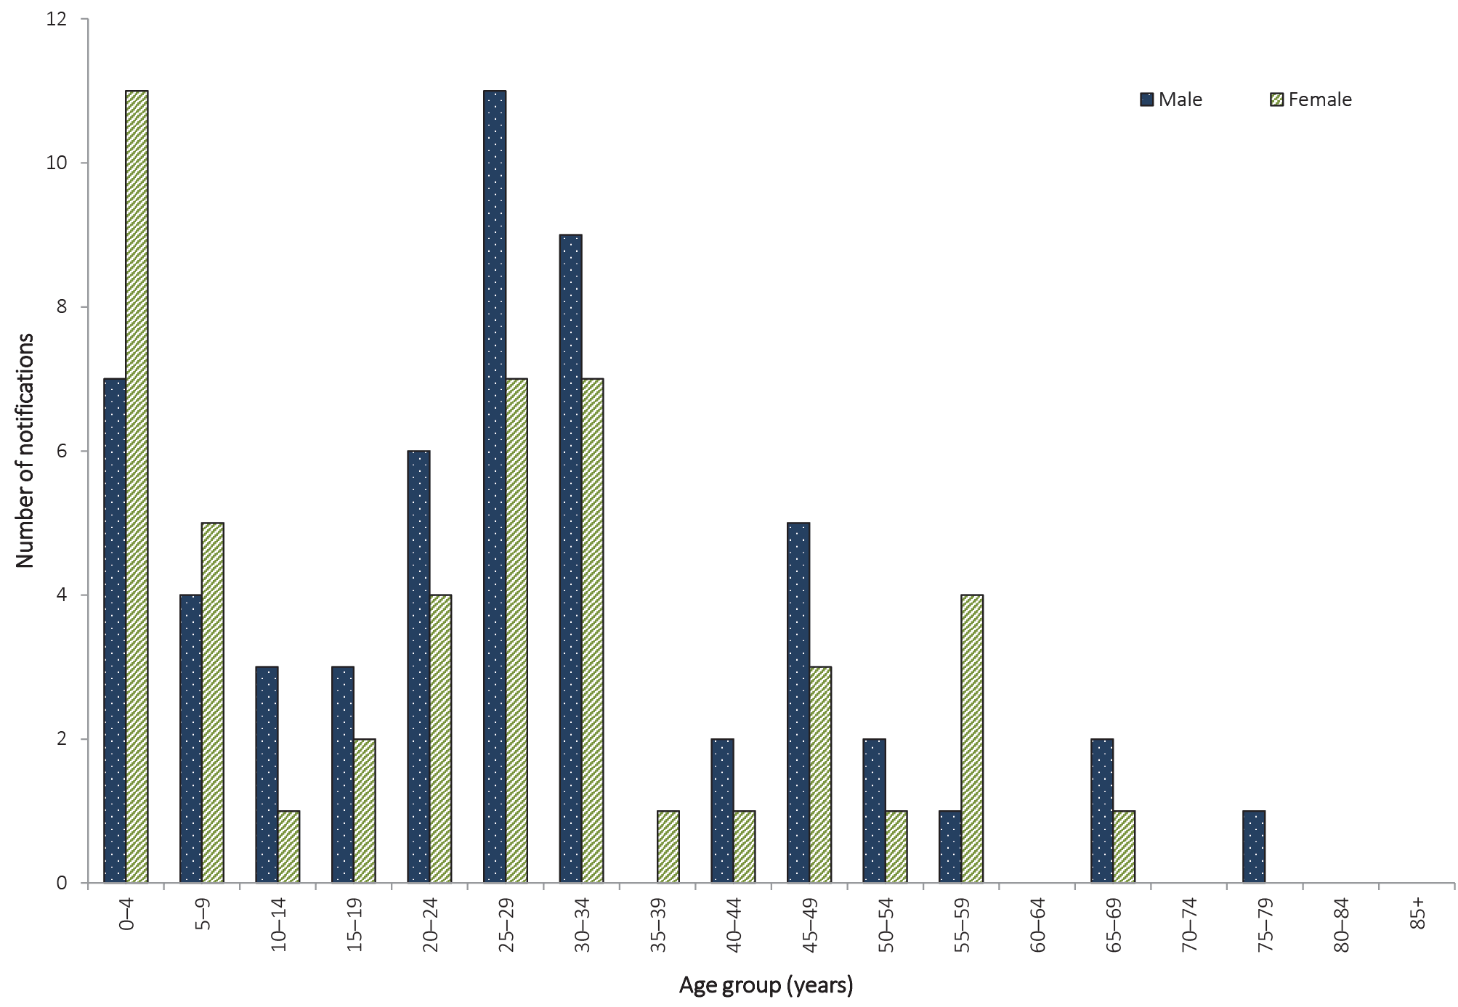

Place of acquisition
As in previous years, overseas travel was the primary risk factor for notified cases. In 2016, 95% of notifications (99/104) reported overseas travel during their period of acquisition and were considered overseas acquired. India continues to be the most frequently-reported country of acquisition, accounting for half of overseas-acquired cases in 2016 (52/99; 53%). Five cases were listed as locally acquired (5%) (Table 15).
Table 15: Notifications of typhoid, Australia, 2011 to 2016, by place of acquisition
Year notified | Locally  acquired |  | Overseas acquired | Unknown | Total
 | n | %ª | n | n | n
2011 | 6 | 5 | 126 | 3 | 135
2012 | 3 | 3 | 117 | 2 | 122
2013 | 8 | 5 | 141 | 1 | 150
2014 | 6 | 5 | 107 | 4 | 117
2015 | 4 | 4 | 109 | 1 | 114
2016 | 5 | 5 | 99 | 0 | 104
a Excludes cases where the place of acquisition was unknown or not supplied.

Quarantinable diseases
Human diseases covered by the Quarantine Act 1908,and notifiable in Australia and to the WHO in 2016, were cholera, plague, rabies, yellow fever, smallpox, highly pathogenic avian influenza in humans (HPAIH), severe acute respiratory syndrome (SARS) and four viral haemorrhagic fevers (Ebola, Marburg, Lassa and Crimean–Congo). These diseases are of international public health significance.
There were no cases of plague, rabies, smallpox, SARS, HPAIH or viral haemorrhagic fevers reported in Australia in 2016. While there was one case of overseas-acquired cholera in 2016, Australia remains free of all the listed quarantinable diseases (Table 16).
Table 16: Australia’s status for human quarantinable diseases, 2016
Disease | Status | Date of last record and notes
Cholera | Free | Small number of cases reported annually related to overseas travel. Very rare instances of local acquisition as described under the section ‘Cholera’.
Plague | Free | Last case recorded in Australia in 1923.³⁹
Rabies | Free | Last case (overseas acquired) recorded in Australia in 1990.⁴⁰
Smallpox | Free | Last case recorded in Australia in 1938, last case world-wide in 1977, declared eradicated by the World Health Organization 1980.^{41,42}
Yellow fever | Free | Two cases in 2011 were the first recorded, related to overseas travel.⁴³
SARS | Free | Last case recorded in Australia in 2003.⁴⁴
HPAIH | Free | No cases recorded.⁴⁵
Viral haemorrhagic fevers
Ebola | Free | No cases recorded.
Marburg | Free | No cases recorded.
Lassa | Free | No cases recorded.
Crimean–Congo | Free | No cases recorded.

Cholera

- There was one case of cholera notified in 2016.
- Between 2011 and 2016, there have been a total of 19 reported cholera notifications in Australia.
Cholera is an acute diarrhoeal disease caused by strains of the bacterium Vibrio choleraeand is more commonly acquired in parts of Africa, Asia, South America, the Middle East and the Pacific islands. V. choleraeis found in the faeces of infected people, and is spread by drinking contaminated water, eating food washed with contaminated water or prepared with soiled hands, or eating fish or shellfish caught in contaminated water. Person-to-person spread of cholera is less common. Most people do not develop symptoms or have only mild illness, but a small proportion of people will develop severe symptoms. Symptoms typically start between two hours and five days (usually two to three days) after ingesting the bacteria. Symptoms can include characteristic ‘rice water’ faeces (profuse, watery diarrhoea); nausea and vomiting; and signs of dehydration, such as weakness, lethargy and muscle cramps.²³ Only toxigenic V. choleraeO1 or O139 are notifiable in Australia.

Epidemiological situation in 2016
In 2016, there was one notification of cholera in Australia. The case, a 32 year old male, acquired the infection whilst travelling in the Philippines.
A total of 19 cases of cholera were notified in Australia between 2011 and 2016. All cases of cholera reported since the commencement of the NNDSS in 1991, to 2016, have been acquired outside Australia, except for one case of laboratory-acquired cholera in 1996,⁴⁶ three cases in 2006 linked to imported whitebait,⁴⁷ and one laboratory-acquired case in 2013.⁴³

Sexually transmissible infections
In 2016, the STIs reported to the NNDSS were chlamydial infection, donovanosis, gonococcal infection, and congenital and non-congenital syphilis. Other national surveillance systems that monitor STIs in Australia include the Australian Gonococcal Surveillance Programme (AGSP), which is a network of specialist laboratories monitoring antimicrobial susceptibility patterns of gonococcal infection; and the National HIV Registry maintained by the Kirby Institute at the University of New South Wales.

Chlamydial infection

- There were 83,468 cases of chlamydial infection notified in 2016.
- In 2016, 44% of chlamydial infection notifications were in females aged 15–29 years.
Genital chlamydial infection is caused by the bacterium Chlamydia trachomatis serogroups D to K. Screening is important in detecting chlamydial infection, as a large proportion of infections are asymptomatic. Chlamydial infection is highly treatable, although reinfection is common.⁴⁸ If left untreated, complications such as epididymitis in males and infertility and pelvic inflammatory disease in females can arise.²³
In the 2015 NNDSS Annual Report,³⁵ chlamydial infection notification data was incomplete for Victoria. However, this has been rectified and the 2016 NNDSS Annual Report contains data for all states and territories. Data has been updated retrospectively for all years, making annual comparisons possible.

Epidemiological situation in 2016
In 2016, there were 83,468 reported cases of chlamydial infection, representing a notification rate of 345.0 per 100,000 population. There has been a 5% increase on the number of notifications received for 2015 (n = 79,252, notification rate 332.8 per 100,000 population) but the number of notifications remains similar to the historical five-year mean, 2011 to 2015 (n = 82,821) (Figure 32).

Figure 32. Notifications and notification rate for chlamydial infection, Australia, 2011 to 2016, by year
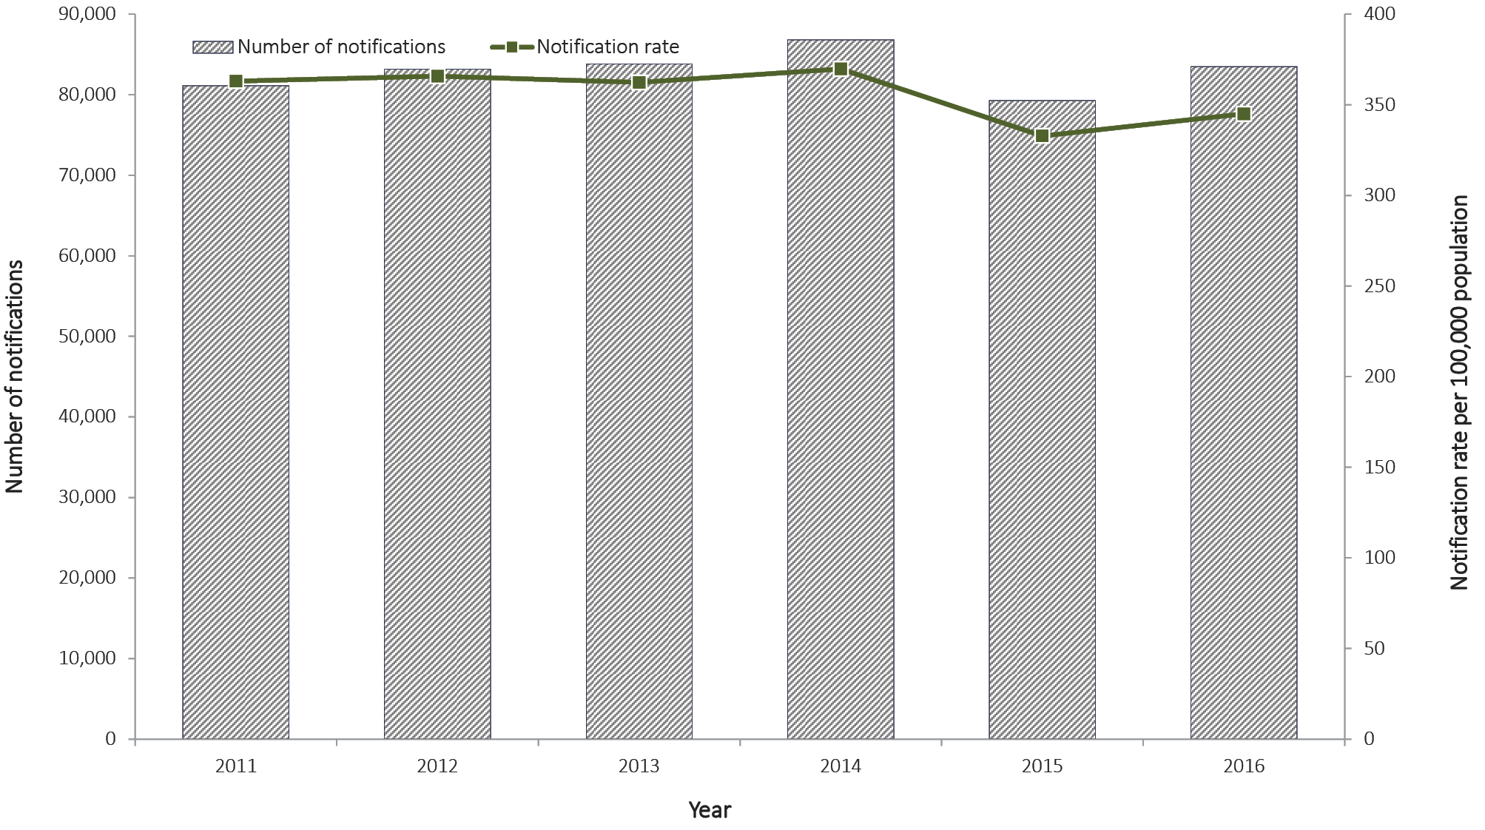

Geographical distribution
In 2016, the notification rate for chlamydial infection remained approximately three times higher in the Northern Territory (1,070.1 per 100,000 population) than the national rate (345.0 per 100,000 population) (Figure 33). This is likely due to the disproportionate representation of Aboriginal and Torres Strait Islander women in the chlamydial infection notification data, particularly in regional and remote areas (Figure 36).¹⁰

Figure 33. Notifications and notification rate for chlamydial infection, Australia, 2016, by state or territory
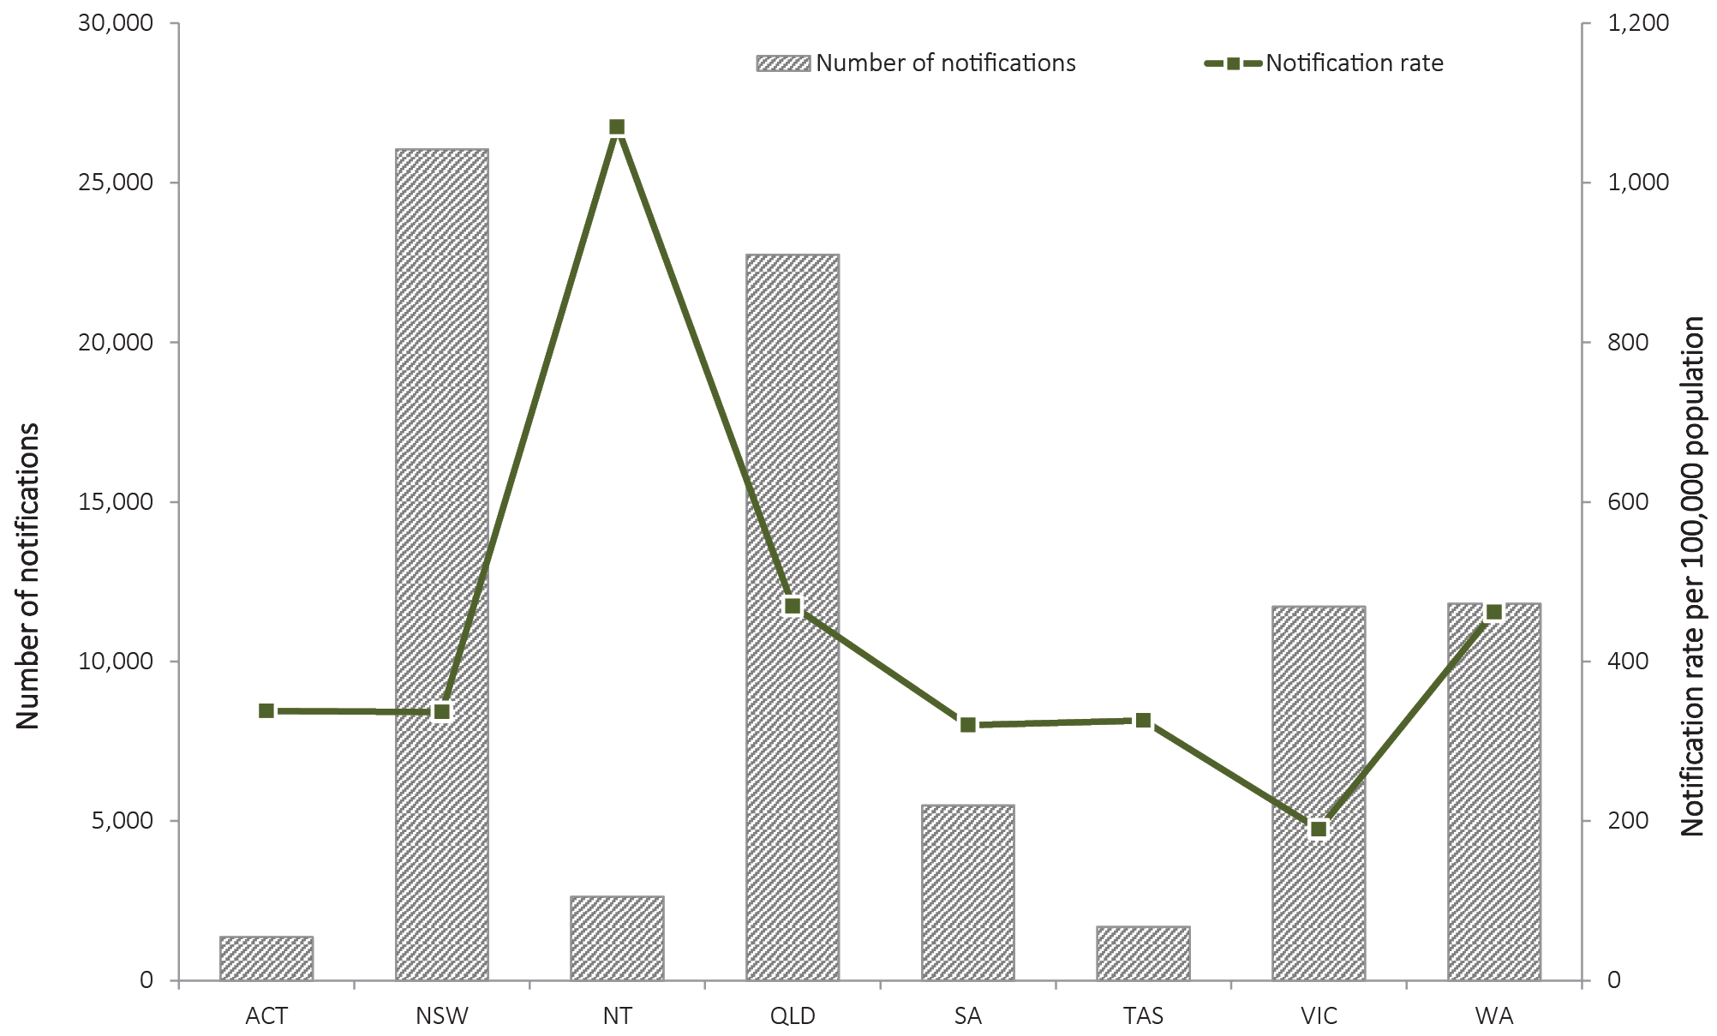

Age and sex distribution
In 2016, chlamydial infection occurred predominately in females aged 15–29 years, who accounted for 44% of all chlamydial infection notifications (Figure 34). The national notification rate for chlamydial infection in 2016 was 320.0 per 100,000 population in males and 369.0 per 100,000 population in females. The higher notifications rate of chlamydial infection in females may be partly attributable to preferential testing of women attending health services compared with men.¹⁰ Notification rates for both males and females aged 25–39 years increased between 2011 and 2016. For males in this age group, there was an increase of 41%, from n = 12,150 (507.8 per 100,000 population) in 2011 to n = 17,124 (658.2 per 100,000 population) in 2016 and for females, there was an increase of 22%, from n = 11,440 (481.5 per 100,000 population) in 2011 to n = 13,967 (534.3 per 100,000 population) in 2016. Notification rates for both males and females aged 15–24 years decreased between 2011 and 2016, declining by 11% in males, from n = 17,720 (1,128.6 per 100,000 population) in 2011 to n = 15,785 (974.1 per 100,000 population) in 2016; and by 16% in females, from n = 33,829 (2,262.7 per 100,000 population) in 2011 to n = 28,564 (1,844.4 per 100,000 population) in 2016 (Figure 35).

Figure 34. Notification rate for chlamydial infection, Australia, 2016, by age group and sexª
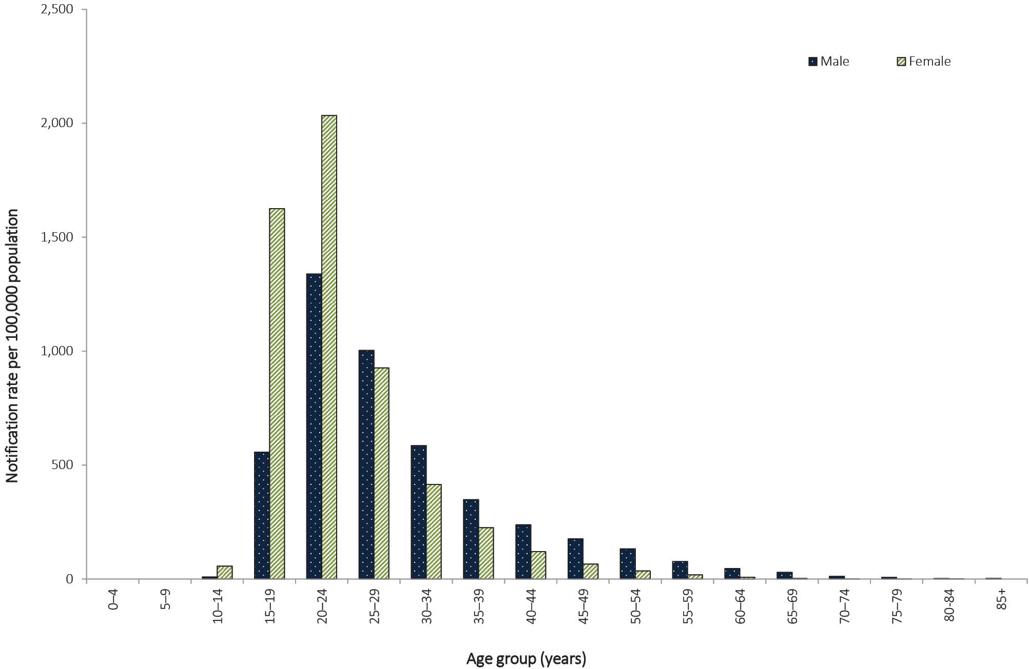
a Excludes notifications for whom age and/or sex were not reported (n = 85) and notifications where the case was aged less than 13 years.

Figure 35. Notification rate for chlamydial infection, Australia, 2011 to 2016, by year, sex and selected age groupsª
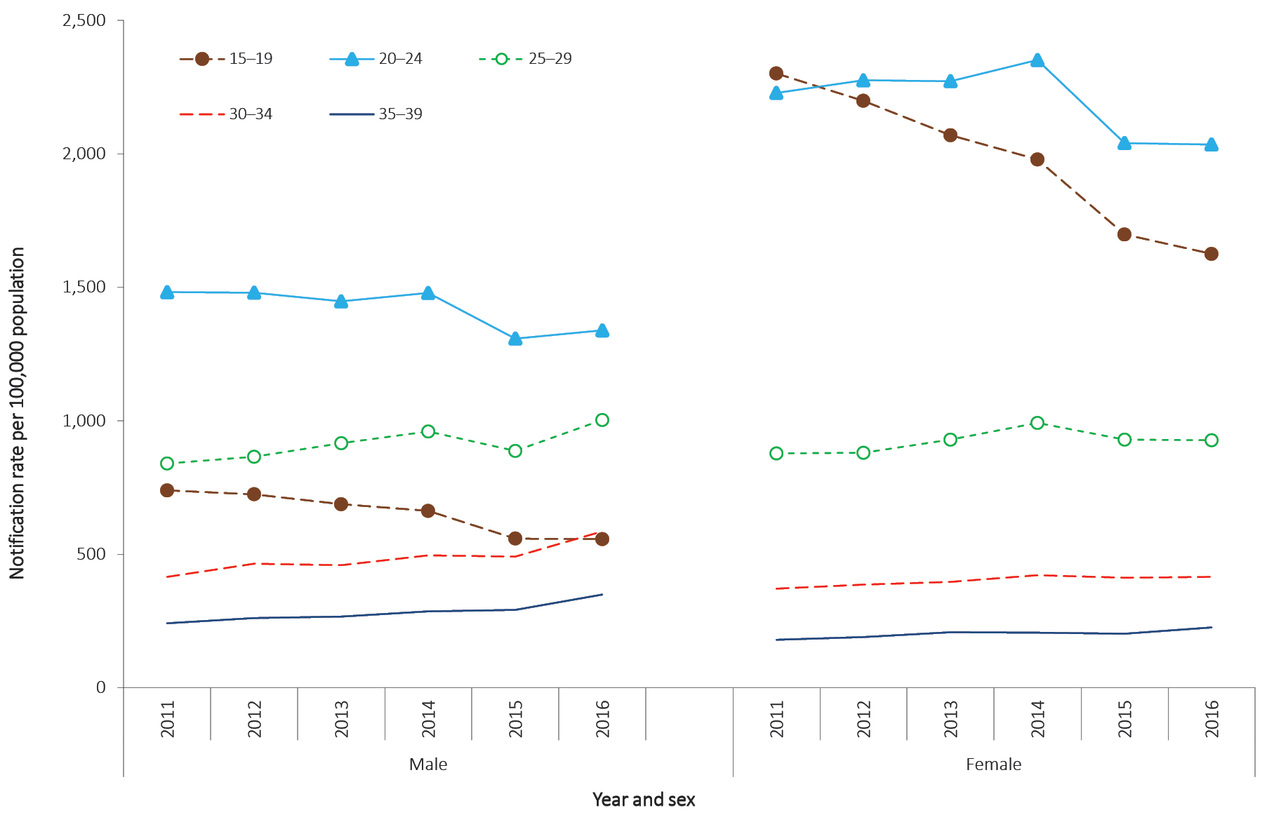
a Excludes notifications for whom age and/or sex were not reported (n = 85) and notifications where the case was aged less than 13 years.
The completeness of Indigenous status for chlamydial infection notification data varies by year and jurisdiction. In 2016, Indigenous status was complete for 43% (n = 36,103) of chlamydial infection notifications, which was lower than the historical five-year mean, 2011 to 2015 (46%; range: 40%–52%). Four jurisdictions had greater than 50% completeness of the Indigenous status field in each year during the 2011–2016 period: Northern Territory, Queensland, South Australia, and Western Australia, and are included in age-standardised notification rates below.
Between 2015 and 2016, the age-standardised notification rate for Aboriginal and Torres Strait Islander people in the four state and territories with more than 50% Indigenous status completeness has remained stable (1,298.7 per 100,000 population in 2015 to 1,327.0 per 100,000 population in 2016); there has been a 9% decrease between 2011 and 2016 (from 1,460,4 to 1,327.0 per 100,000 population).
Between 2015 and 2016, age-standardised notification rates among the non-Indigenous population increased 6%, from 394.9 per 100,000 population in 2015 to 417.0 per 100,000 population in 2016. There has also been an increase of 10% between 2011 and 2016 (from 377.8 to 417.0 per 100,000 population).
Between 2015 and 2016, age-standardised notification rates for chlamydial infection in Aboriginal and Torres Strait Islander persons decreased by 13% in South Australia (from 852.0 to 738.0 per 100,000 population) and by 3% in the Northern Territory (from 1,691.4 to 1,645.8 per 100,000 population). Conversely, the notification rate increased by 2% in Queensland (from 1,234.3 to 1,263.0 per 100,000 population) and in Western Australia by 12% (from 1,260.3 to 1,410.8 per 100,000 population).
Between 2015 and 2016, age-standardised notification rates for chlamydial infection in the non-Indigenous population decreased by 7% in the Northern Territory (from 664.0 to 618.3 per 100,000 population). However, rates increased by 7% in Queensland (from 407.8 to 436.8 per 100,000 population); by 6% in Western Australia (from 397.9 to 420.9 per 100,000 population); and by 3% in South Australia (from 323.1 to 332.3 per 100,000 population) during the same time period (Figure 36).
Figure 36. Age-standardised notification rates for chlamydial infection, selected states and territories,ª 2011 to 2016, by year and Indigenous status
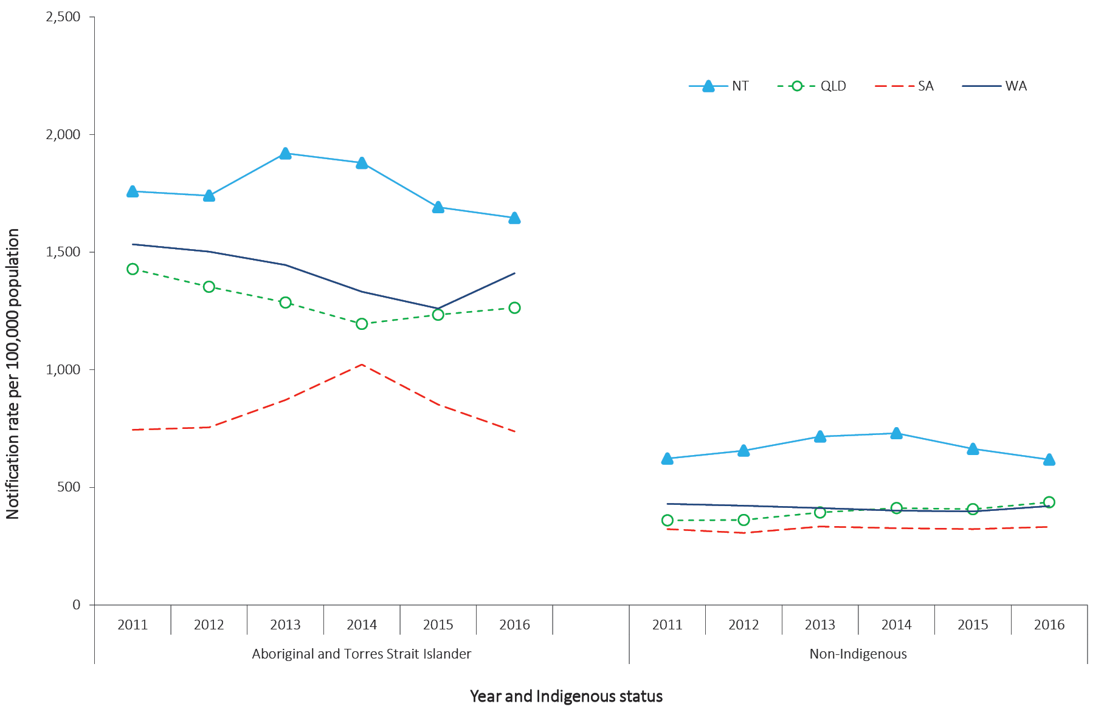
a Includes the states and territories where Indigenous status was reported for more than 50% of cases between 2011 and 2016: Northern Territory, Queensland, South Australia and Western Australia.

Donovanosis

- There were no cases of donovanosis notified in 2016.
- Donovanosis remains rare in Australia.
Donovanosis, caused by the bacterium Klebsiella granulomatis, is a chronic, progressively destructive infection that is primarily transmitted through sexual exposure. It affects the skin and mucous membranes of the external genitalia, inguinal and anal regions.⁴⁹ Once diagnosed, donovanosis is treated with a series of antibiotics.⁵⁰
All donovanosis notifications in Australia since 1991 were reported in the Northern Territory, Western Australia or Queensland and have predominately occurred in Aboriginal and Torres Strait Islander people living in remote areas in northern and central Australia.
Donovanosis was targeted for elimination in Australia through the National Donovanosis Elimination Project 2001–2004.⁵¹It is now rare, with fewer than 17 cases notified each year since 2002, and fewer than 5 cases notified each year since 2007 (Figure 37).

Epidemiological situation in 2016
In 2016, no cases of donovanosis were notified in Australia (Figure 37).
Figure 37. Notified cases of donovanosis, Australia, 1991 to 2016, by year
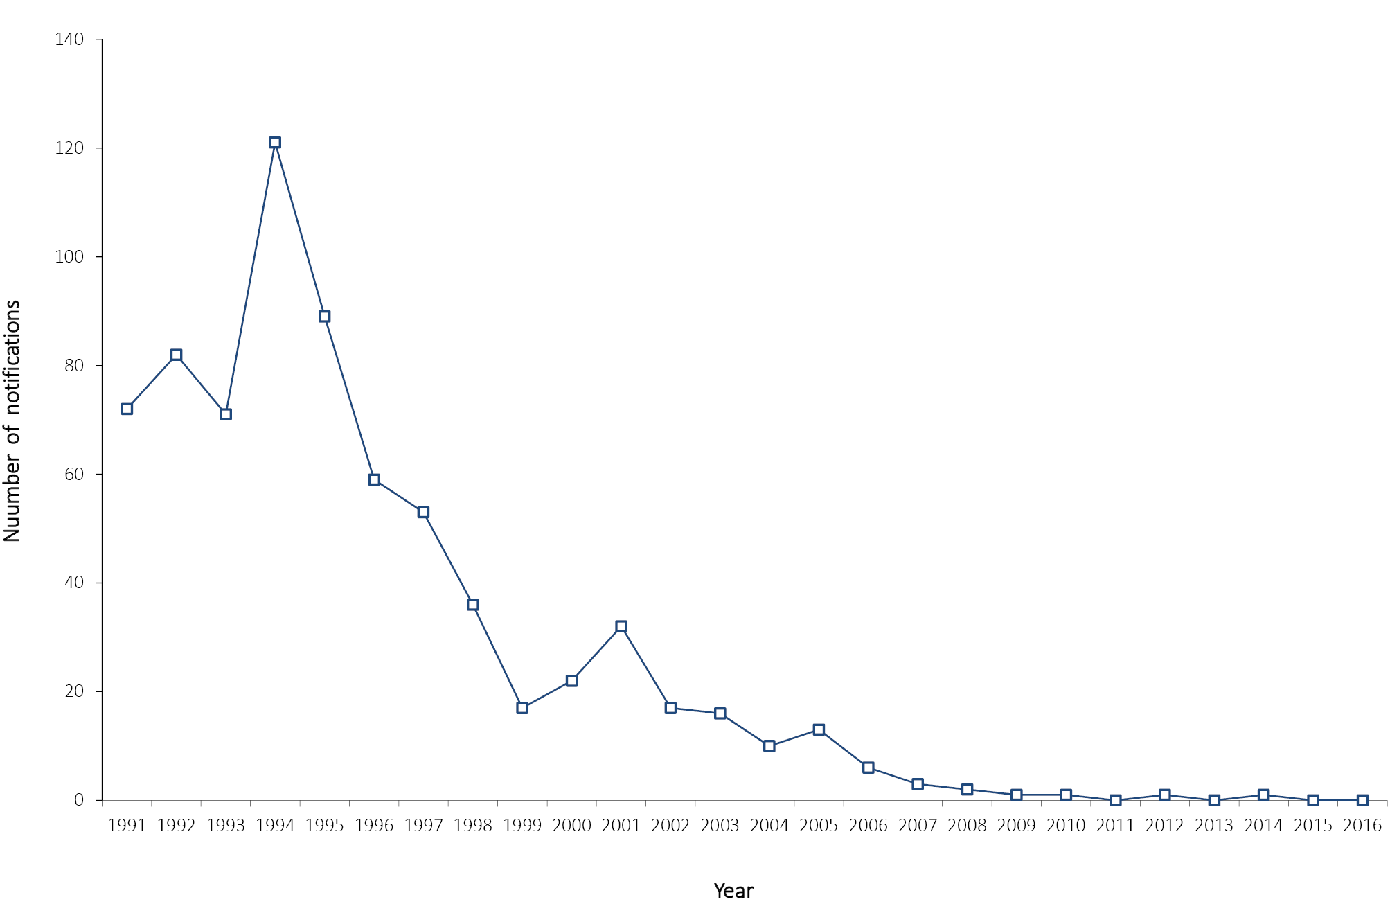

Gonococcal infection

- There were 23,887 cases of gonococcal infection notified in 2016, a 29% increase on the number of notifications in 2015.
- Notification rates for gonococcal infection continue to increase.
- Notifications occurred predominately in males aged 20–39 years.
Gonococcal infection is caused by the bacterium Neisseria gonorrhoeae, which affects the mucous membranes, causing symptomatic and asymptomatic genital and extragenital tract infections. The most common source of transmission is via unprotected sexual intercourse with an infected person.²³ If left untreated, infection can lead to pelvic inflammatory disease in women and infertility in both men and women. Gonococcal infection also increases the risk of both acquisition and transmission of HIV.⁵²

Epidemiological situation in 2016
In 2016, there were 23,887 notified cases of gonococcal infection (notification rate 98.7 per 100,000 population) which is a 29% increase on the number of notifications reported in 2015 (n = 18,512; 77.7 per 100,000 population), and a 59% increase on the historical five-year mean, 2011 to 2015 (n = 15,022). Overall, gonococcal infection notification rates have increased by 98% from 2011 to 2016, from 54.1 to 98.7 per 100,000 population (Figure 38). Increases in gonorrhoea notifications, particularly in females from 2012, are most likely due to the increased practice of dual testing for both chlamydia and gonorrhoea.⁵³
Figure 38. Notifications and notification rate for gonococcal infection, Australia, 2011 to 2016, by year
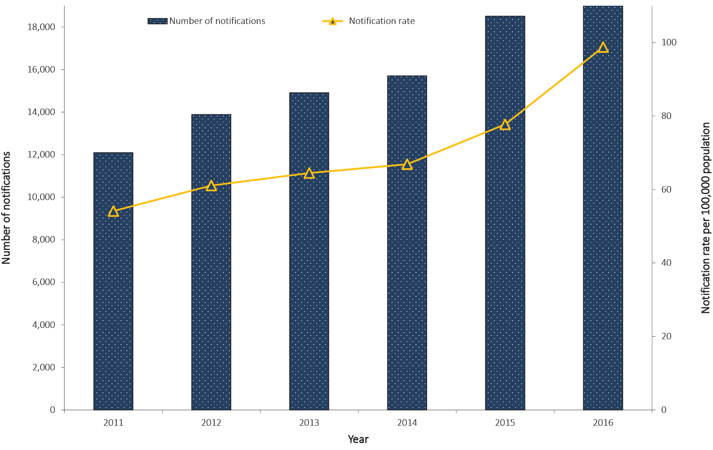

Geographical distribution
In 2016, the notification rate for gonococcal infection was approximately seven times higher in the Northern Territory (719.6 per 100,000 population) than was the national rate (98.7 per 100,000 population) (Figure 39).
Figure 39. Notifications and notification rate for gonococcal infection, Australia, 2016, by state or territory
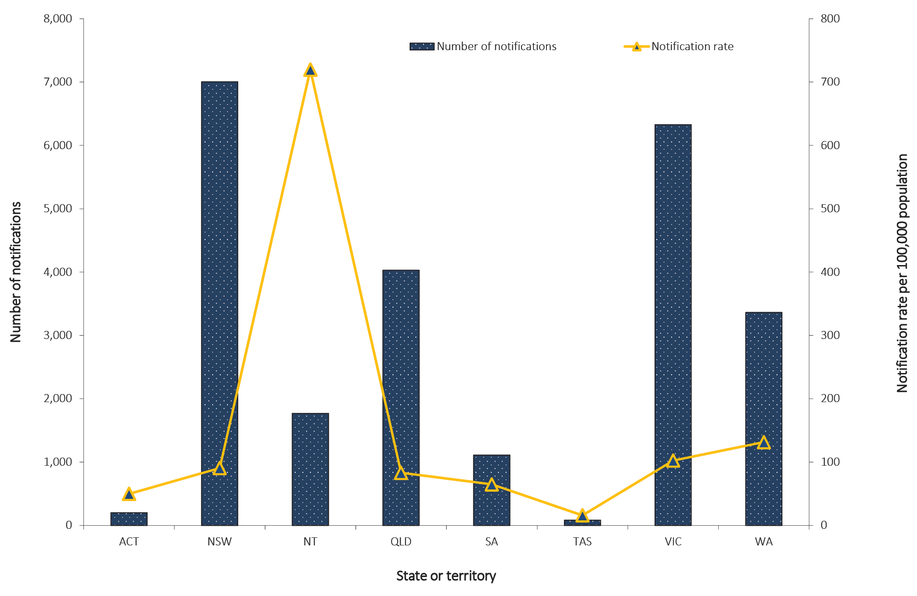

Age and sex distribution
In 2016, the notification rate for gonococcal infection was 144.3 per 100,000 population in males and 53.3 per 100,000 population in females. Notification rates increased by 24% in males and 35% in females compared to 2015 (for which the rates were 116.2 and 39.6 per 100,000 population respectively). In 2016, 66% of all notifications of gonococcal infection occurred in males in the 15–49 years age group. Notification rates in males exceeded those in females across all age groups above 20 years (Figure 40). This was consistent with previous years where, with the exception of Aboriginal and Torres Strait Islander people, notifications were largely reported in men who have sex with men (MSM).⁵⁴

Figure 40. Notification rate for gonococcal infection, Australia, 2016, by age group and sexª
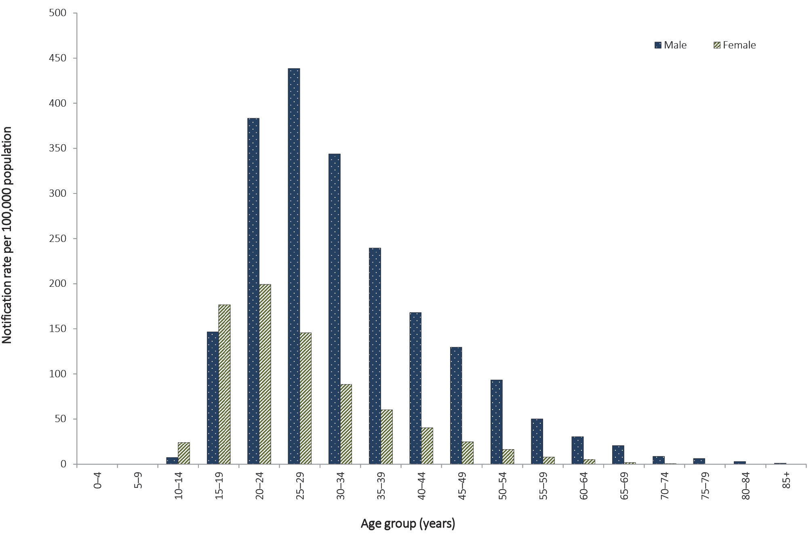
a Excludes notifications where age and/or sex were not reported (n = 67) and those less than 13 years of age.
Between 2011 and 2016, notification rates of gonococcal infection increased annually for males aged 20–49 years. The greatest increase in notification rate from 2011 to 2016 was observed in males aged 35–39 years, increasing by 151% (from 95.4 to 239.4 per 100,000 population), followed by males aged 30–34 years, increasing by 145% (140.3 to 343.7 per 100,000 population). Among females, those aged 15–19 years consistently had the highest rate between 2011 and 2014 (with notification rates ranging from 143.8 to 181.9 per 100,000 population); however, females aged 20–24 years have since 2015 surpassed the 15–19 age group (with notification rates of 156.2 and 199.1 per 100,000 population for 2015 and 2016 respectively) (Figure 41).

Figure 41. Notification rate for gonococcal infection, Australia, 2011 to 2016, by year, sex and selected age groupsª
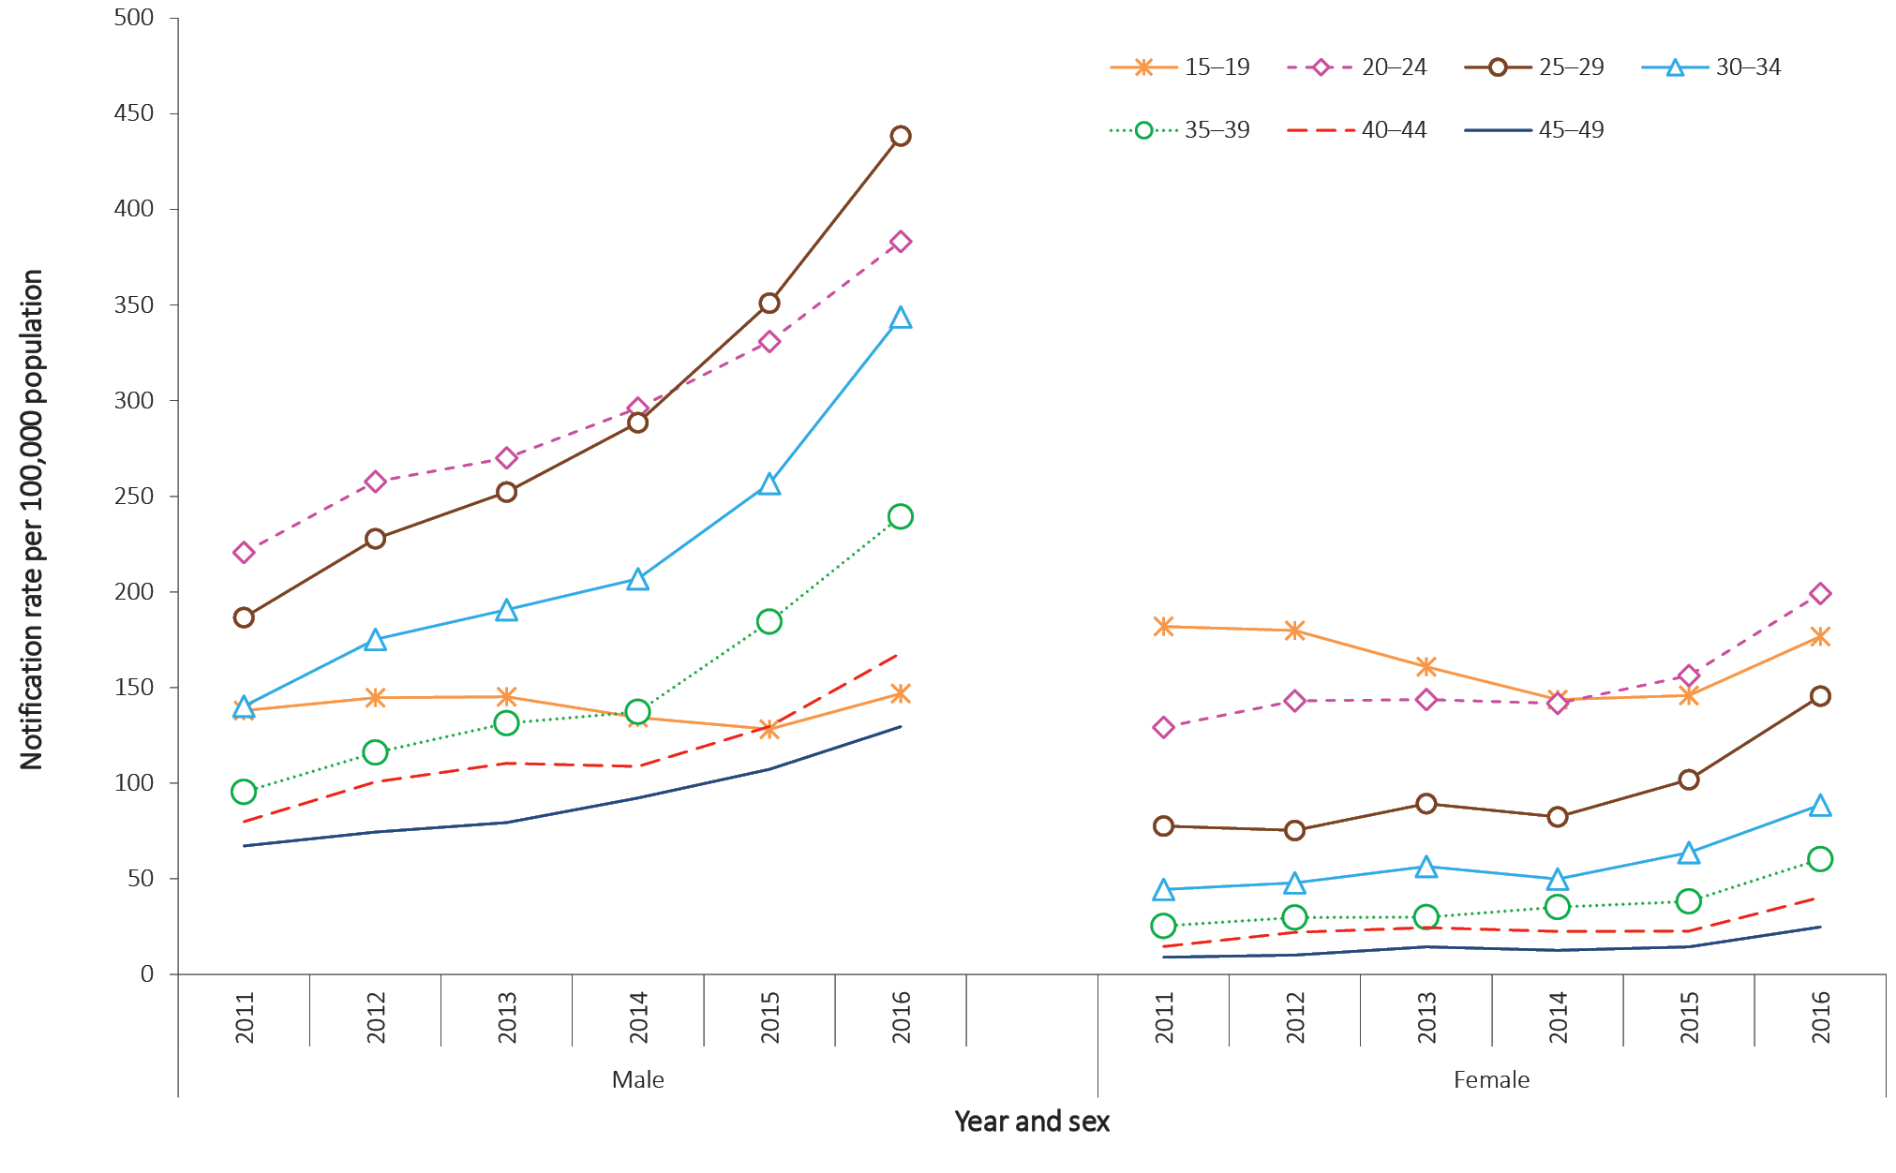
a Excludes notifications where age and/or sex (n = 172) were not reported.

Indigenous status
The completeness of Indigenous status identification in the notification data varies by year and by jurisdiction. In 2016, Indigenous status was complete for 65% of gonococcal infection notifications, which was lower than the historical five-year mean, 2011 to 2015, of 70% (range: 68% to 73%). All states and territories except New South Wales had greater than 50% completeness of the Indigenous status field across all years, 2011 to 2016, and are included in the age-standardised gonococcal infection rates reported below. Completeness is variable between jurisdictions and over time due to the reliance on public health follow-up to determine Indigenous status.
The combined age-standardised notification rate ratio between Aboriginal and Torres Strait Islander and non-Indigenous populations in 2016 was 11.5:1.0, decreasing from 15.0:1.0 in 2015. Overall, the age-standardised rate ratio of gonococcal infection has declined by 72% from 2011 to 2016 (from 40.7:1.0 to 11.5.0:1.0).
Between 2015 and 2016, the age-standardised notification rate increased by 9% in the Aboriginal and Torres Strait Islander population, from 599.3 to 653.3 per 100,000 population, respectively. Between 2011 and 2016, the age-standardised rate in Aboriginal and Torres Strait Islander people declined by 25%, from 875.5 to 653.3 per 100,000 population.
In 2016, the non-Indigenous age-standardised rate of gonococcal infection was 56.9 per 100,000 population, which is a 42% increase on the rate of 40.0 per 100,000 population reported in 2015. The age-standardised notification rate of gonococcal infection in the non-Indigenous population increased by 165% between 2011 and 2016 (from 21.5 to 56.9 per 100,000 population).
Between 2015 and 2016, the age-standardised notification rate of gonococcal infection in Aboriginal and Torres Strait Islander people increased in the Australian Capital Territory (by 71%, from 43.6 to 74.4 per 100,000 population); Queensland (by 3%, from 328.2 to 336.7 per 100,000 population); South Australia (by 478%, from 94.3 to 545.2 per 100,000 population); Tasmania (from 0.0 to 6.4 per 100,000 population); Victoria (by 66%, from 68.1 to 113.1 per 100,000 population); and Western Australia (by 18%, from 795.1 to 895.9 per 100,000 population). The age-standardised notification rate of gonococcal infection decreased in the Northern Territory by 5% (from 1799.5 to 1716.6 per 100,000 population) (Figure 42).
Figure 42. Age-standardised notification rates for gonococcal infection, selected states and territories,ª 2011 to 2016, by Indigenous status and year
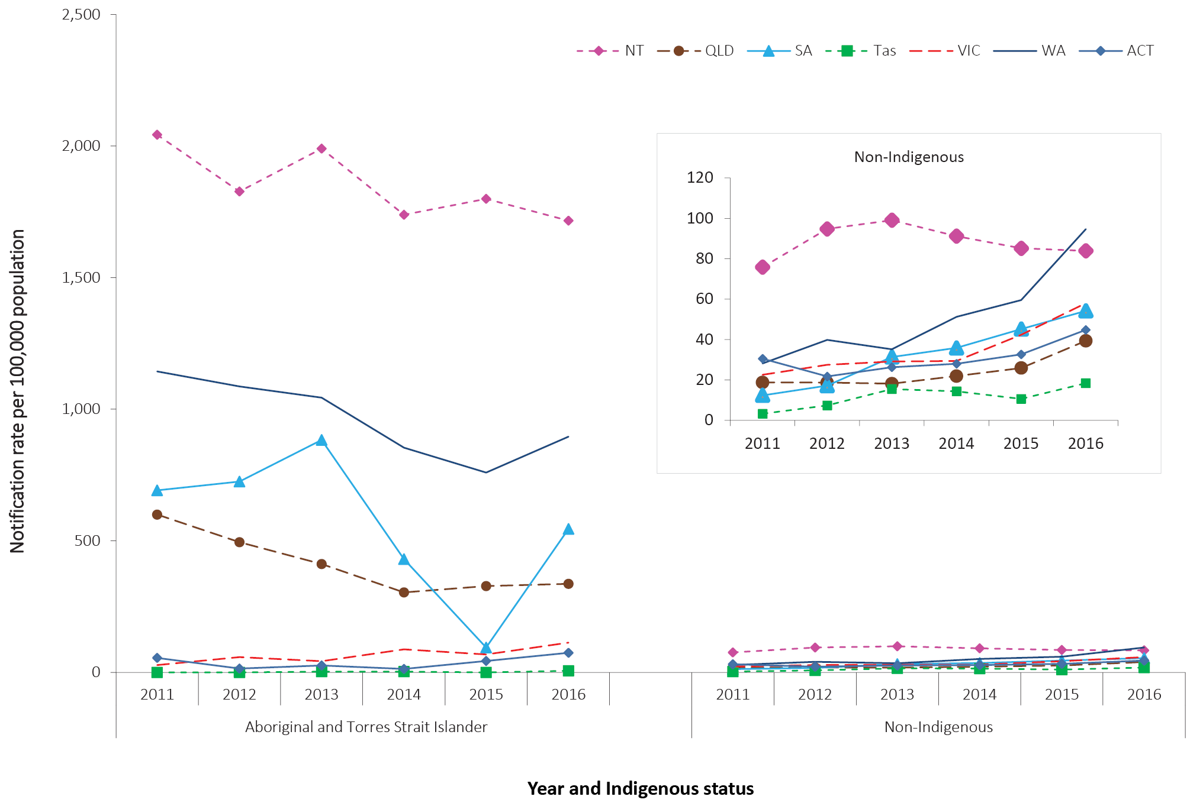
a Includes the states and territories where Indigenous status was reported for more than 50% of cases between 2011 and 2016: Australian Capital Territory, Northern Territory, Queensland, South Australia, Tasmania, Victoria, and Western Australia.

Microbiological trends
The Australian Gonococcal Surveillance Program (AGSP) is the national surveillance system for monitoring the antimicrobial resistance of N. gonorrhoeae isolates. These results are published in detail in the AGSP annual reports in CDI.⁵⁵

Syphilis (non-congenital categories)

- There were 5,357 cases of syphilis (non-congenital categories) notified in 2016, which is a 15% increase on the number of notifications in 2015 (n = 4,668).
- Between 2011 and 2016, notification rates of non-congenital syphilis have increased by 89% (from 11.7 to 22.1 per 100,000 population).
Syphilis is a sexually transmitted infection caused by the bacterium Treponema palladium. Infection is characterised by a primary lesion, a secondary eruption involving skin and mucous membranes, long periods of latency, and late lesions of skin, bone, viscera, cardiovascular and nervous systems.²³
In 2004, all jurisdictions except South Australia began reporting non-congenital syphilis infections to the NNDSS separately categorised as: infectious syphilis (primary, secondary or early latent) of less than two years duration; and syphilis of more than two years or unknown duration. From 2004 to 2011, South Australia reported only cases of infectious syphilis, and then commenced reporting syphilis of more than two years or unknown duration in 2012.

Epidemiological situation in 2016
In 2016, a total of 5,357 cases of syphilis (non-congenital) were reported to the NNDSS, which is a 15% increase on the number of notifications in 2015 (n = 4,668). In 2016, 63% (n = 3,367) of syphilis notifications were categorised as infectious syphilis, and 37% (n = 1,990) of cases were categorised as greater than two years or unknown duration. Between 2011 and 2016, notification rates of non-congenital syphilis increased by 89% (from 11.7 to 22.1 per 100,000 population) (Figure 43).

Figure 43. Notification rate for non-congenital syphilis infection (all categories),ª Australia, 2011 to 2016, by category and year
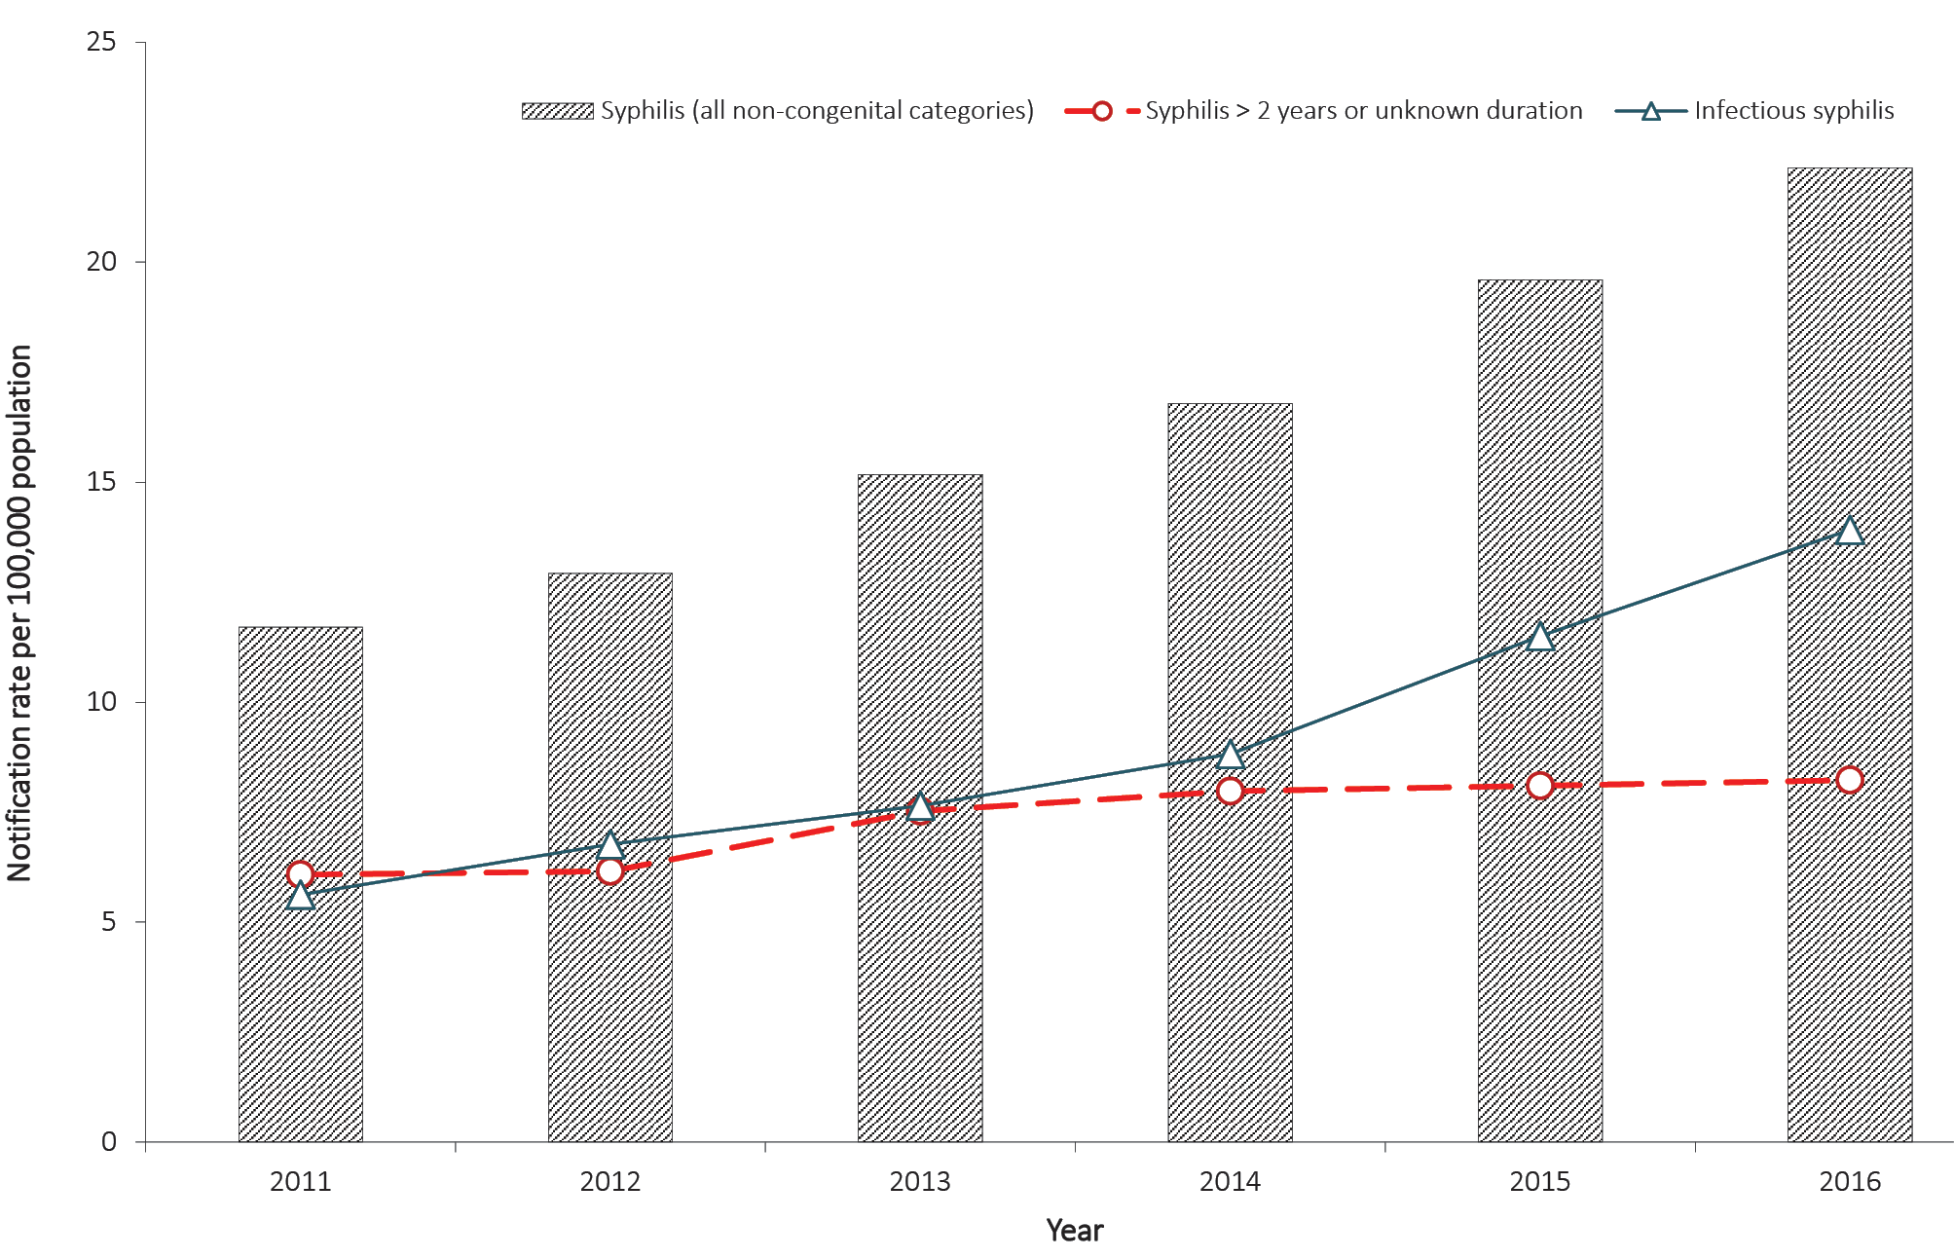
a For syphilis of more than two years or unknown duration, excludes South Australia in 2011.

Syphilis – infectious (primary, secondary and early latent), less than two years duration

- There were 3,367 cases of infectious syphilis notified in 2016, which is a 23% increase on the number of notifications reported in 2015 (n = 2,739).
- Eighty-four per cent of notifications in 2016 occurred in males aged 20–59 years, indicating continued transmission through male-to-male sex.
- Notifications continued to increase in Aboriginal and Torres Strait Islander people due to the ongoing outbreak in northern, central and southern Australia.

Epidemiological situation in 2016
In 2016, a total of 3,367 notified cases of infectious syphilis less than two years duration were reported to the NNDSS, which is a 23% increase on the number of notifications reported in 2015 (n = 2,739). The notification rate of infectious syphilis in 2016 was 13.9 per 100,000 population, which is a 21% increase on the rate reported in 2015 (11.5 per 100,000 population) and a 148% increase on 2011 (5.6 per 100,000 population) (Table 5).
In 2015, the infectious syphilis case definition was changed to include both probable and confirmed infectious syphilis cases.⁵⁶ Of the cases notified in 2016, 13% (n = 443) were reported as probable.

Geographical distribution
In 2016, notification rates for infectious syphilis were highest in the Northern Territory (93.2 per 100,000 population), followed by Victoria (18.4 per 100,000 population), Queensland (14.0 per 100,000 population) and Western Australia (13.1 per 100,000 population) (Table 5). This likely reflects the ongoing outbreaks of infectious syphilis in Aboriginal and Torres Strait Islander people living in northern, central and southern Australia,⁵⁷ and in MSM in Victoria.⁵⁸

Age and sex distribution
In 2016, the notification rate for infectious syphilis in males was 24.5 per 100,000 population and 3.4 per 100,000 population in females, representing a male-to-female rate ratio of 7.3:1. In 2016, notification rates of infectious syphilis for males increased by 19% compared with 2015 (20.7 per 100,000 population) and for females, increased by 40% compared with 2015 (2.4 per 100,000 population). In 2016, 84% of all notifications (2,820/3,367) occurred in males aged 20–59 years (Figure 44).
Notification rates for males and females for all age groups 15 years and older increased overall between 2011 and 2016. Between 2015 and 2016, all age groups 15 years and older reported increased notification rates of infectious syphilis in both males (range 2% to 34%) and females (range 22% to 110%) (Figure 45).

Figure 44. Notification rate for infectious syphilis (primary, secondary and early latent), less than 2 years duration, Australia, 2016, by age group and sexª
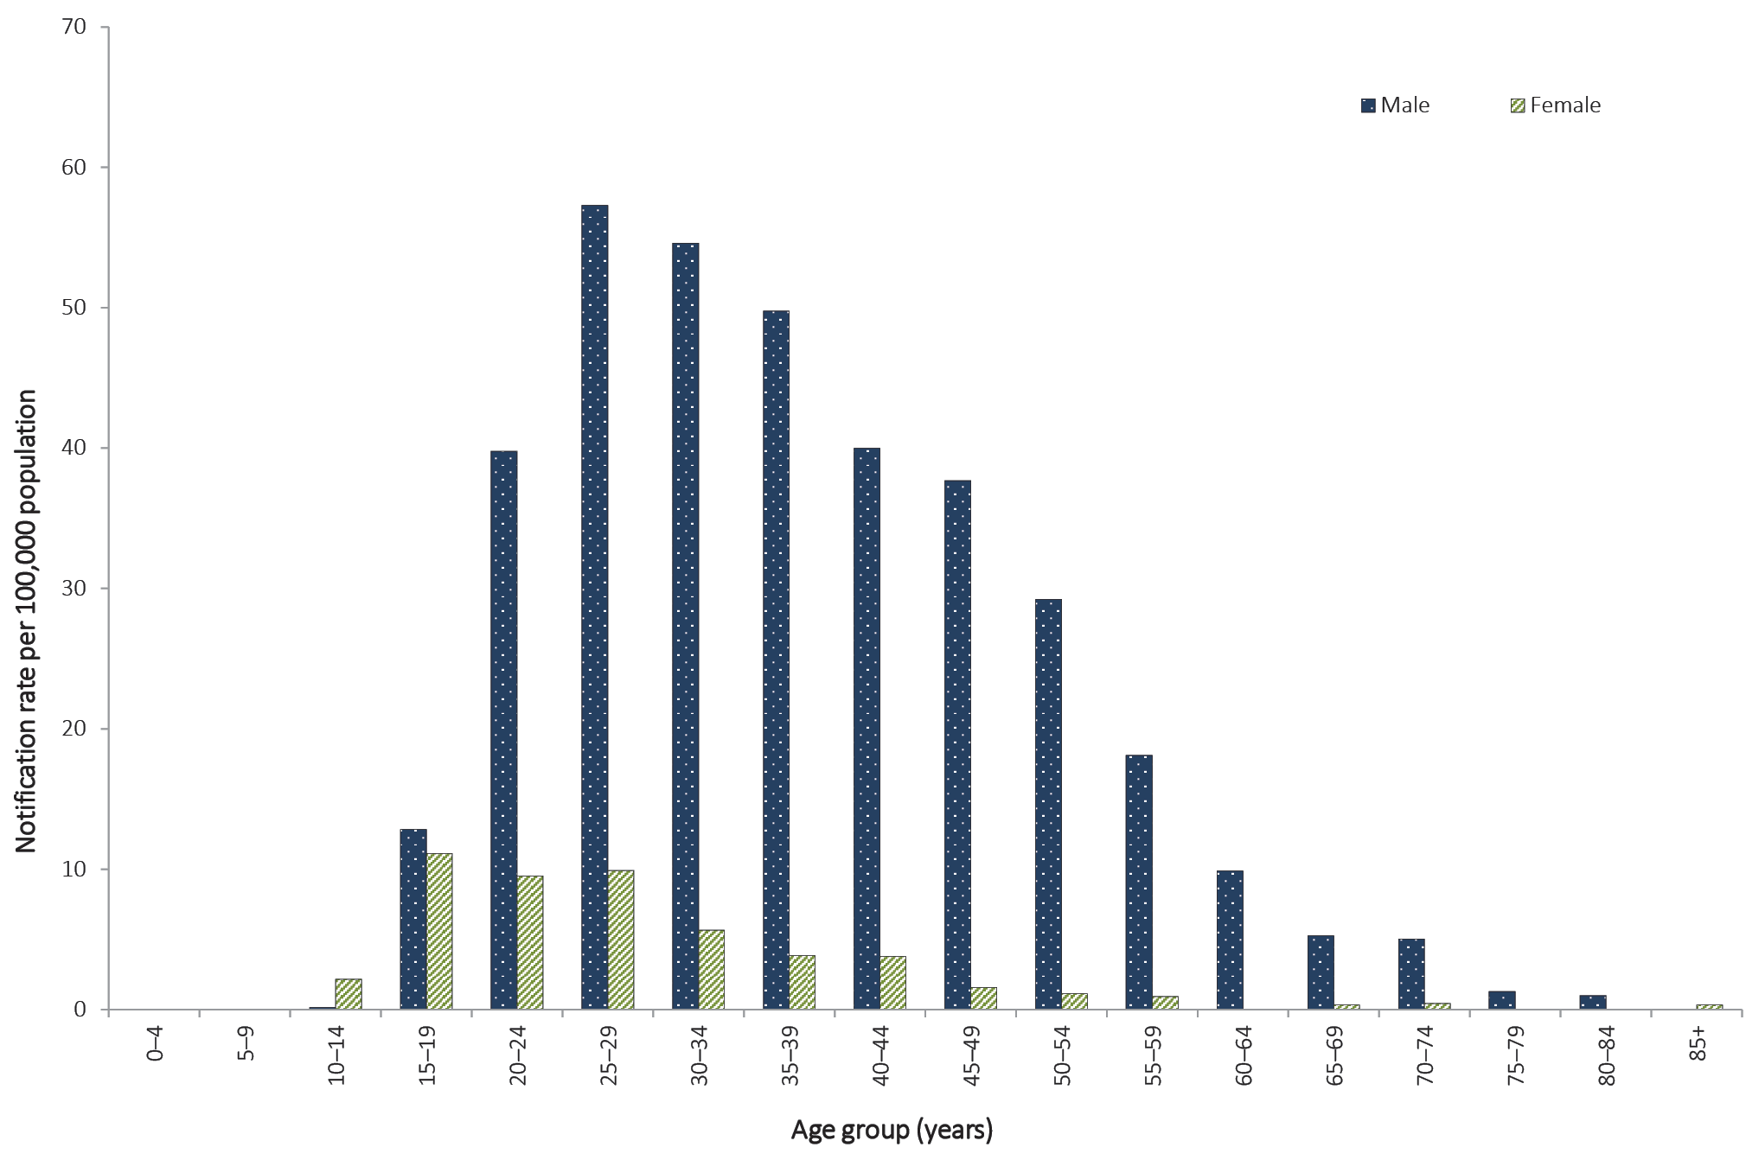
a Excludes 13 notifications where age and/or sex were not reported and those less than 13 years of age.

Figure 45. Notification rate for infectious syphilis (primary, secondary and early latent), less than 2 years duration, Australia, 2011 to 2016, by year, sex and selected age groupsª
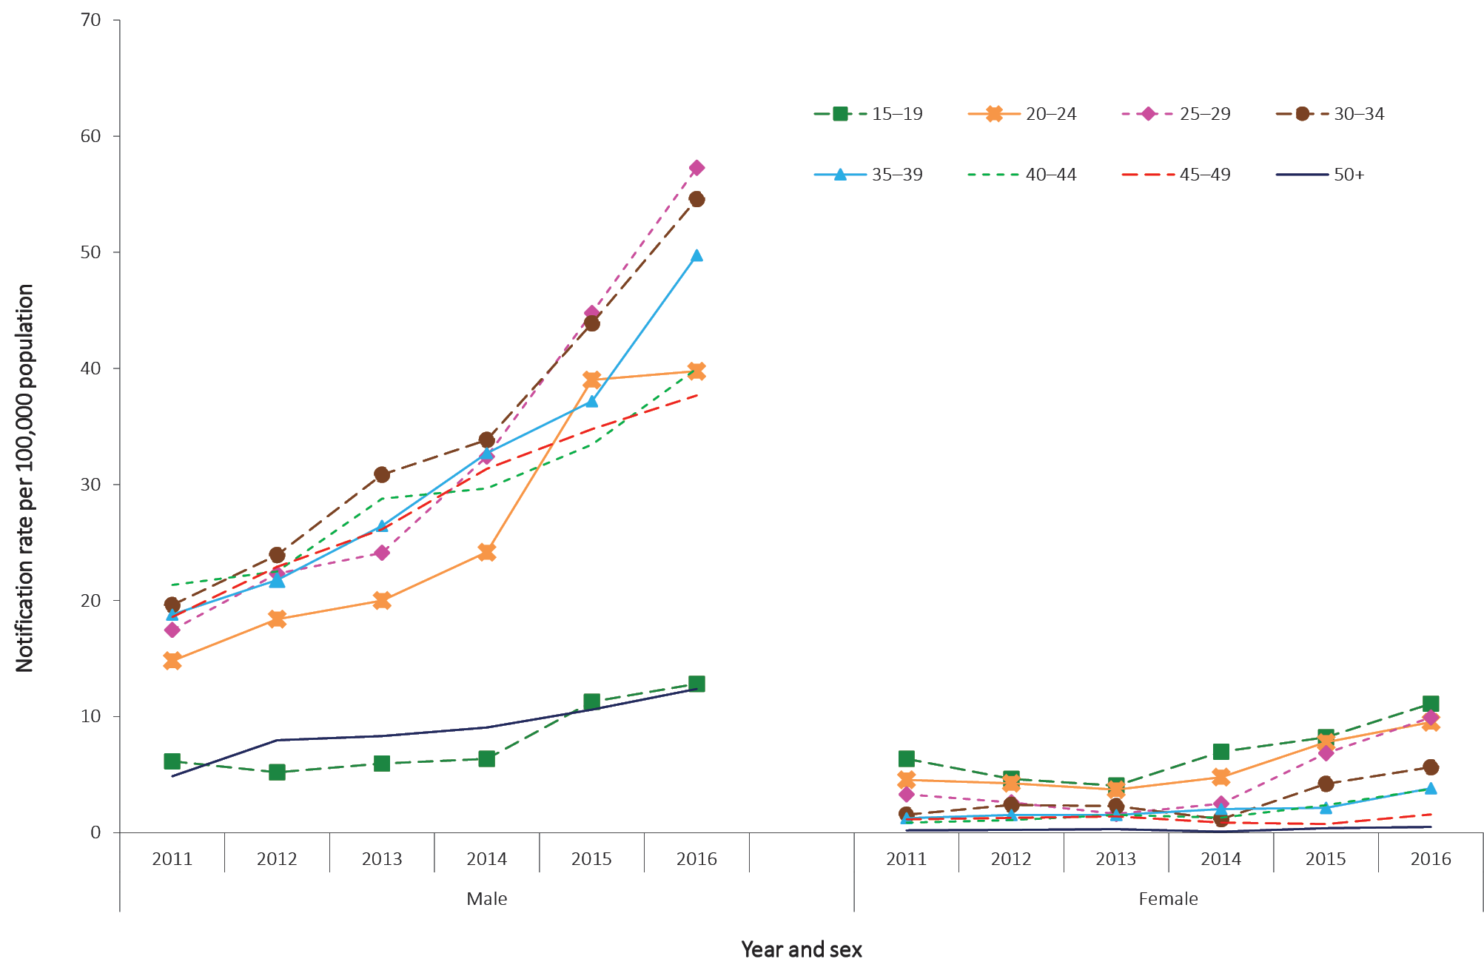
a Excludes notifications where age and/or sex were not reported and those less than 15 years of age (91 notifications).

Indigenous status
The completeness of Indigenous status identification in the notification data varies by year and jurisdiction. In 2016, data on Indigenous status were complete for 90% of all notifications of infectious syphilis, which is comparable to 2015 (92%) and 4% less than the historical five-year mean, 2011 to 2015 (94%, range: 92% to 96%). All states and territories had greater than 50% completeness of the Indigenous status field in the years 2011 to 2016 and are therefore included in the age-standardised rates below.
In 2016, where Indigenous status was reported, the age-standardised rates were higher for Aboriginal and Torres Strait Islander people than for non-Indigenous persons in all jurisdictions, with the exceptions of the Australian Capital Territory and Tasmania (Figure 46). For all states and territories, the combined age-standardised notification rate ratio between the Aboriginal and Torres Strait Islander and non-Indigenous populations in 2016 was 7.2:1, which was higher than the historical five-year mean, 2011 to 2015 (5.2:1, range: 3.3:1 to 7.0:1). In 2016, for jurisdictions where Indigenous status was reported, the age-standardised notification rate ratio between Aboriginal and Torres Strait Islander and non-Indigenous populations was highest in the Northern Territory (18.3:1), followed by Queensland (11.7:1) and Western Australia (7.2:1).

Figure 46. Age-standardised notification rate for infectious syphilis (primary, secondary and early latent), less than 2 years duration, 2011 to 2016, by Indigenous status, state or territory and year
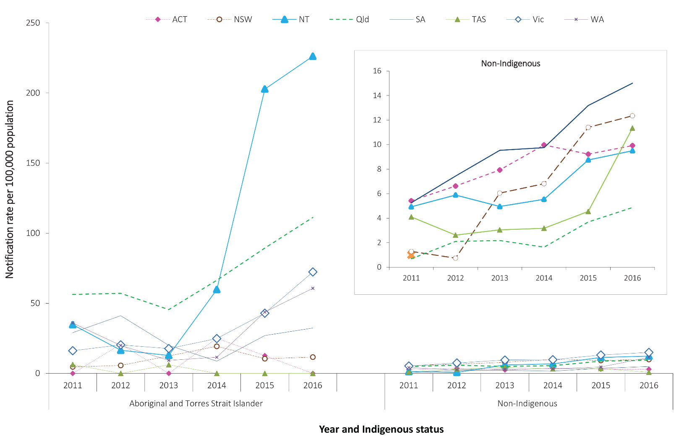

Between 2015 and 2016, the age-standardised notification rate of infectious syphilis in Aboriginal and Torres Strait Islander people increased in New South Wales (by 11%, from 10.5 to 11.6 per 100,000 population); the Northern Territory (by 12%, from 202.8 to 226.3 per 100,000 population); Queensland (by 24%, from 89.4 to 111.3 per 100,000 population); South Australia (by 20%, from 27.0 to 32.4 per 100,000 population); Victoria (by 69%, from 42.9 to 72.3 per 100,000 population); and Western Australia (by 39%, from 43.8 to 60.7 per 100,000 population). The age-standardised notification rate of infectious syphilis decreased in the Australian Capital Territory from 2015 to 2016 (from 12.7 to 0.0 per 100,000 population); Tasmania reported no change (0.0 per 100,000 population) (Figure 46).
For non-Indigenous people over the same time period, 2015 and 2016, the age-standardised rates of infectious syphilis have increased in all jurisdictions (by proportions ranging from 8% in both New South Wales and the Northern Territory to 149% in Western Australia), except for Tasmania and the Australian Capital Territory (Figure 46).

Outbreaks
There is an ongoing outbreak of infectious syphilis affecting young Aboriginal and Torres Strait Islander people, predominately aged between 15 and 29 years, living in northern, central and southern Australia. Increased notifications associated with the outbreak in northern Australia were first reported in January 2011 in northwest Queensland, followed by the Northern Territory in July 2013, and the Kimberley region of Western Australia in June 2014. In March 2017, South Australia declared an outbreak in the Far North, Western and Eyre regions from November 2016.⁵⁷
Increased transmission, along with targeted and opportunistic syphilis screening in each of these jurisdictions, is likely to have contributed to an increase in Aboriginal and Torres Strait Islander age-standardised rates for Queensland, the Northern Territory, South Australia and Western Australia between 2011 and 2016. Further information about the infectious syphilis outbreak, including monthly surveillance reports, is available at the Australian Government Department of Health website.⁵⁷

Syphilis of more than two years or unknown duration

- There were 1,990 cases of syphilis of more than 2 years or unknown duration notified in 2016.
- In 2016, males aged 20 years or more accounted for 73% of all notifications, indicating continued transmission through male-to-male sex.

Epidemiological situation in 2016
In 2016, there were 1,990 cases of syphilis of more than 2 years or unknown duration reported to the NNDSS, which is a 3% increase on the number of cases reported in 2015 (n = 1,929). In 2016, the notification rate of syphilis of more than two years or unknown duration was 8.2 per 100,000 population which is a 2% increase on the 2015 notification rate (8.1 per 100,000 population) and a 35% increase on the 2011 notification rate (6.1 per 100,000 population) (Table 5).

Geographical distribution
In 2016, notification rates for syphilis of more than 2 years or unknown duration were highest in the Northern Territory (21.6 per 100,000 population), followed by Victoria (12.1 per 100,000 population) (Table 5). As with infectious syphilis, this likely reflects the ongoing outbreaks of infectious syphilis in Aboriginal and Torres Strait Islander people living in northern, central and southern Australia,⁵⁷ and in MSM in Victoria.⁵⁸

Age and sex distribution
In 2016, the notification rate for syphilis of more than 2 years or unknown duration was 12.0 per 100,000 population in males and 4.3 per 100,000 population in females, which is a male-to-female rate ratio of 2.9:1. Between 2015 and 2016, the notification rate in males increased by 3% (from 11.9 to 12.2 per 100,000 population); there was no change in females (4.3 per 100,000 population for both 2015 and 2016). In 2016, among notifications where sex was reported, 73% (1,446/1,990) of notifications occurred in males aged 20 years or more, indicating continued transmission through male-to-male sex (Figure 47).

Figure 47. Notification rate for syphilis of more than 2 years or unknown duration, Australia, 2016, by age group and sexª
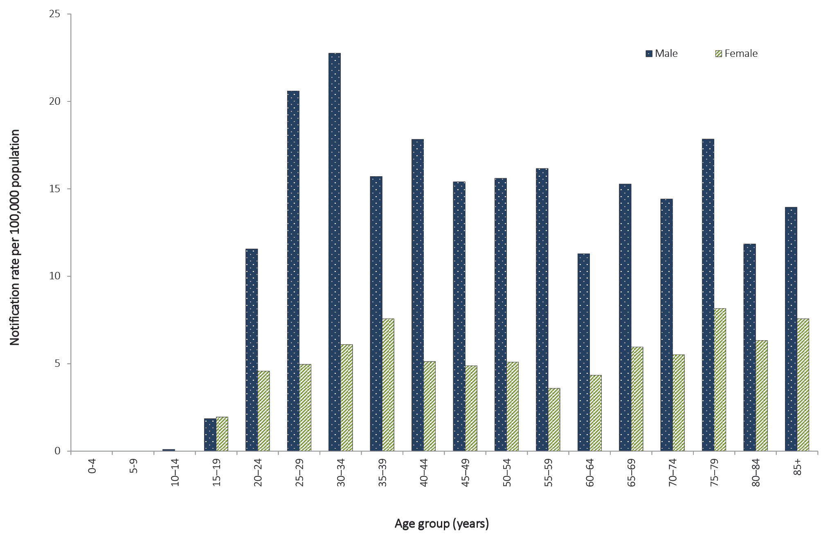
a Excludes 10 notifications where age and/or sex were not reported and notifications where the case was aged less than 13 years.
Notification rates of syphilis of more than 2 years or unknown duration increased in males for all age groups over 20 years of age between 2011 and 2016 (Figure 48). For females over the same time period, 2011 to 2016, notification rates decreased for those aged 15–39 years but increased in females aged 40 years and older (Figure 48). For males, between 2015 and 2016, decreased notification rates of syphilis of more than 2 years or unknown duration were reported in those aged 15–19 years (from 2.7 per 100,000 in 2015 to 1.9 per 100,000 population in 2016) and 30–39 years (from 21.8 per 100,000 in 2015 to 19.4 per 100,000 population in 2016) whilst an increase was observed in all other age groups (Figure 48). For females, notification rates decreased in those aged 15–19 years (from 2.1 per 100,000 in 2015 to 1.9 per 100,000 population in 2016) and 30–39 years (from 7.6 per 100,000 in 2015 to 6.8 per 100,000 population in 2016), remained the same for those aged 20–29 years (4.8 per 100,000 population in both 2015 and 2016) and increased in those aged 40 years or more (Figure 48).

Figure 48. Notification rate for syphilis of more than 2 years or unknown duration, Australia,ª 2011 to 2016, by year, sex and selected age groups^{b}
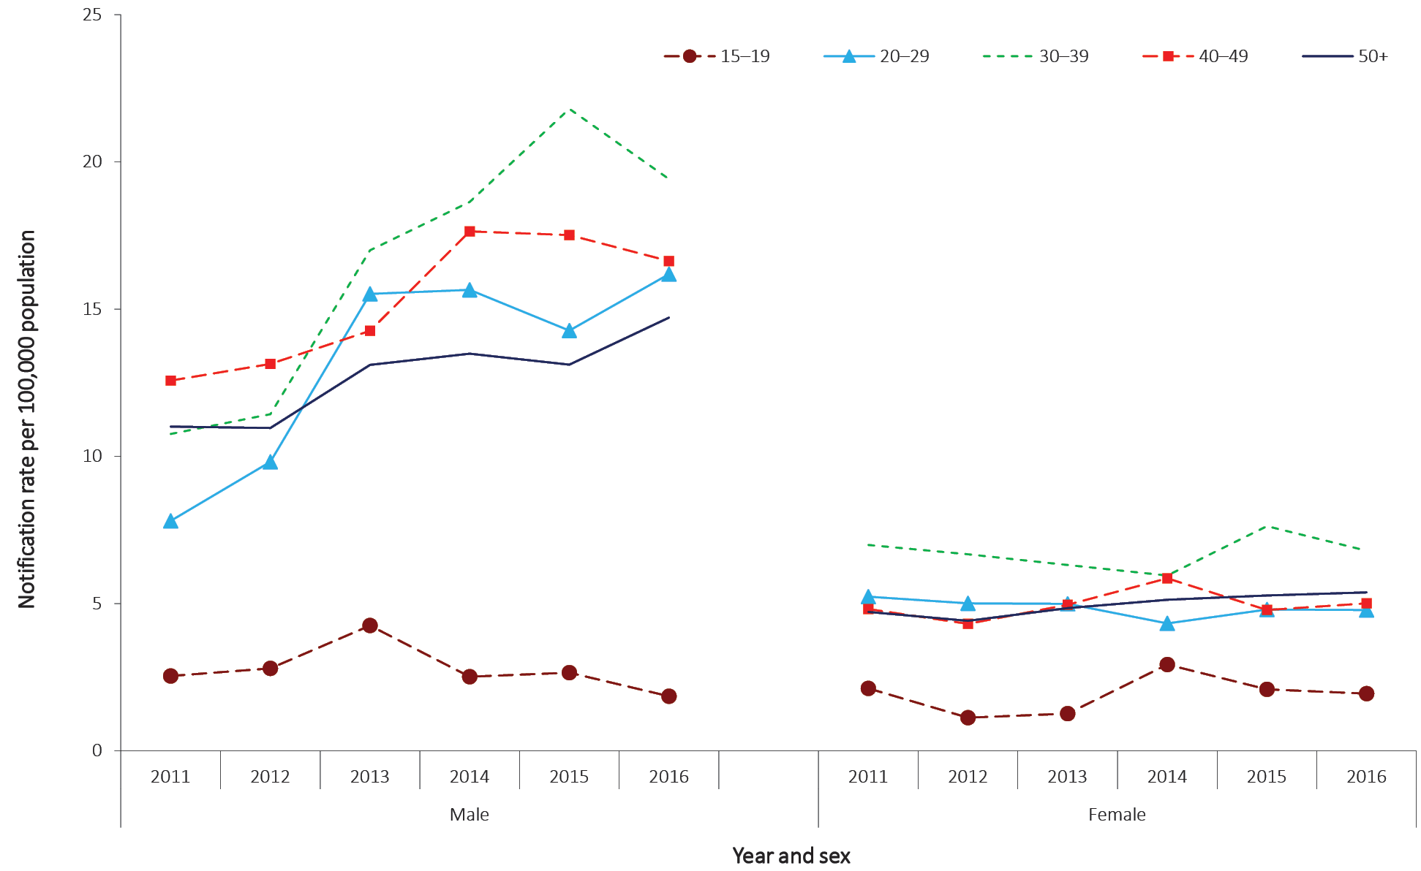
a Data from all states and territories except South Australia in 2011.
b Excludes notifications where age and/or sex were not reported and those aged less than 15 years (58 notifications).

Congenital syphilis

- In 2016, two cases of congenital syphilis were notified to the NNDSS.
- Congenital syphilis remains rare in Australia.
Congenital syphilis is caused by fetal infection with the bacterium T. pallidum. Syphilis is acquired by infants eitherin uteroor at birth from women with untreated infection. Infections commonly result in abortion or stillbirth and may cause the death of a newborn infant. Congenital syphilis can be asymptomatic, especially in the first weeks of life.²³

Epidemiological situation in 2016
Two notifications of congenital syphilis were reported in 2016: one case was reported in an Aboriginal and Torres Strait Islander and was associated with the infectious syphilis outbreak in northern Australia, and one case was reported in a non-Indigenous person. Eight of the 22 congenital syphilis cases reported since 1 January 2011 have been associated with the infectious syphilis outbreak in northern, central and southern Australia,⁵⁷ described above. This reflects the increased risk to neonates and mothers that outbreak situations pose.^{16,17} Despite recent increases, the overall number of notifications of congenital syphilis remains low in Australia (Figure 49). Routine antenatal screening for syphilis with follow-up and adequate treatment is considered to be a contributor to historical declines and sustained low case numbers.⁵⁹ Congenital syphilis, particularly in the Aboriginal and Torres Strait Islander population, is targeted for elimination. This target is stated in the Fifth National Aboriginal and Torres Strait Islander Blood-borne Viruses and Sexually Transmissible Infections Strategy, 2018–2022,⁶⁰ and the Fourth National Sexually Transmissible Infections Strategy, 2018–2022.⁶¹
Figure 49. Notifications of congenital syphilis, Australia, 2006 to 2016
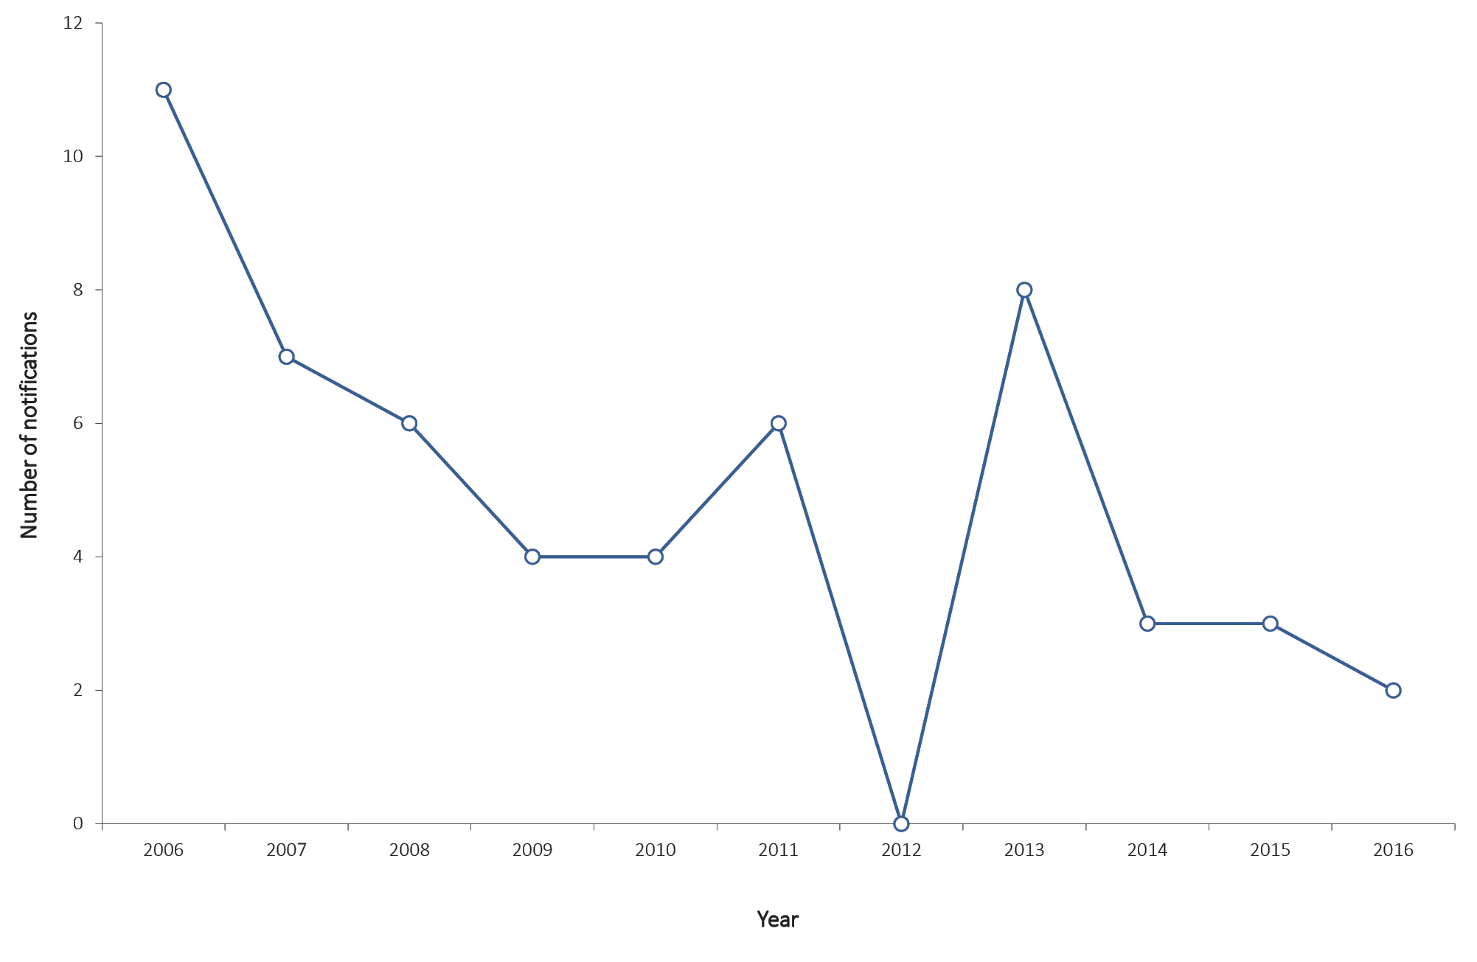

Vaccine preventable diseases
This section summarises the national surveillance data for notifiable diseases targeted by the National Immunisation Program (NIP) in 2016.⁶²These include diphtheria; invasive Haemophilus influenza type b infection; laboratory-confirmed influenza; measles; mumps; pertussis; invasive pneumococcal disease; poliomyelitis; rubella; congenital rubella; tetanus; and varicella zoster infections (unspecified; chickenpox; and shingles). Data on hepatitis B and invasive meningococcal disease, which are also targeted by the NIP, can be found in this report under the ‘Bloodborne diseases’ and ‘Other bacterial infections’ sections respectively. Other vaccine preventable diseases (VPDs) presented in this report include hepatitis A, within the ‘Gastrointestinal diseases’ section; and Q fever which can be found under the ‘Zoonoses’ section.
In 2016, there were 139,687 VPD notifications reported to the NNDSS, representing 42% of all disease notifications and amounting to a 5% decrease on 2015 (n = 147,772). Influenza reported the highest number of VPD notifications (65%; n = 90,848), followed by pertussis (15%; n = 20,095). The number of notifications and the notification rates for VPDs in Australia are shown in Table 4, Table 5 and Table 6.
Immunisation coverage is an important factor influencing the incidence of VPDs. Since commencement of the Australian Childhood Immunisation Register in 1996 (expanded to whole-of-life Australian Immunisation Register in 2016), immunisation coverage of children has been high by international standards. As no vaccine is 100% effective, infections with these diseases sometimes do occur in fully vaccinated people. However, evidence shows vaccines substantially lower the risk of disease, reduce the severity of disease, and can provide community protection through herd immunity.^{63–67}
Information on a case’s immunisation history was previously recorded in the NNDSS using the ‘immunisation status’ field (fully or partially vaccinated for age, or unvaccinated); fields capturing the number of doses; the last immunisation date; and how the immunisation information was validated. In January 2008, more detailed fields were incorporated for recording ‘vaccine type’ and ‘immunisation date’ for each dose of vaccine given. The new fields were intended to replace the old fields, with a transition period allowing either field to be utilised. In this report the immunisation status of a case is interpreted according to the data provided by the states and territories from the two different formats. A case is described as fully vaccinated if they have received, at least 14 days prior to disease onset, all doses of the relevant vaccine according to the most recent edition of the Australian Immunisation Handbook.⁶⁸

Diphtheria

- There were eight cases of diphtheria notified in 2016.
- Diphtheria remains rare in Australia.
- Immunisation against diphtheria provides prolonged but not lifelong protection against infection.
Diphtheria is an acute pharyngeal or cutaneous infection caused mainly by toxigenic strains of Corynebacterium diphtheriae. Disease is caused by the exotoxin the bacilli produce. Pharyngeal infections typically progress to membranous inflammation of the pharynx, tonsils or larynx, which can result in death due to airway obstruction. The bacterial exotoxin can also damage the myocardium, nervous system and kidneys. Diphtheria is spread by respiratory droplets or direct contact with nasopharyngeal secretions or skin lesions. Non-toxigenic strains of C.diphtheriaeare not nationally notifiable.²³

Epidemiological situation in 2016
In 2016, there were eight notifications of diphtheria. All eight cases were reported in Queensland. Seven cases were acquired overseas (two in the Philippines, two in the Solomon Islands and one each in Vanuatu, Papua New Guinea, and Indonesia); one case was locally acquired in Australia. Site of infection was known in half of the cases: three cases (38%) were cutaneous and one case (13%) was pharyngeal. Five cases (63%) were vaccinated and the remaining three cases were of unknown vaccination status.
Diphtheria remains rare in Australia, with most cases associated with sporadic importations from countries in which the disease remains endemic. From 2001 to 2015 there were 12 cases of diphtheria reported to the NNDSS, comprising one case in 2001; a cluster of three cases and a sporadic case in 2011; three cases in 2013; two cases in 2014; and two sporadic cases in 2015. Of these, eight were imported; two were linked to an imported case; one was acquired in Australia; and the place of acquisition for one case was unknown.

Haemophilus influenzae type b (invasive)

- There were 17 cases of invasive Haemophilus influenza type b (Hib) reported in 2016.
- Seventy-six percent (n = 13) of cases in 2016 were in females.
- Approximately half (53%) of cases (n = 9) were in children aged less than 15 years, of which 78% (n = 7) were among infants less than one year of age.
Haemophilus influenza type b (Hib) is a gram-negative bacterium which causes disease with symptoms dependent on which part of the body is affected. Clinical categories of invasive disease caused by Hib include septicaemia (infection of the blood stream), meningitis (inflammation of the membranes around the brain and spinal cord); epiglottitis (severe swelling of the epiglottis at the back of the throat), and a range of other infections. Hib is mostly carried as a commensal organism (present without causing symptoms) in the nasopharynx of healthy individuals and is spread by respiratory secretions, including aerosol transmission or contact with articles soiled with discharges from the nose or throat.⁶⁷ The case fatality rate of Hib meningitis is at least 3% in developed countries, even with treatment. Approximately 15% to 30% of survivors have permanent neurological sequelae.⁶⁹

Epidemiological situation in 2016
In 2016, there were 17 notifications of invasive Hib infection in Australia, which is comparable to the number of notifications in 2015 (n = 16) and to the historical five-year mean, 2011 to 2015 (n = 17.2). The notification rate of Hib in 2016 was 0.1 per 100,000 population, consistent with the very low rates reported since the introduction of the vaccine on the NIP in July 1993 (Figure 50). Cases occurred in all states and territories, except the Australian Capital Territory and Tasmania, with five cases each reported in Queensland and New South Wales, four cases in Victoria and one case each in the Northern Territory, South Australia and Western Australia. In 2016, notification rates of invasive Hib in the states and territories ranged from < 0.1 per 100,000 population in Western Australia to 0.4 per 100,000 population in the Northern Territory. There were no Hib-associated deaths reported in 2016.
Figure 50: Notifications and notification rate for invasive Haemophilus influenzae type b, Australia, 1993 to 2016, by year
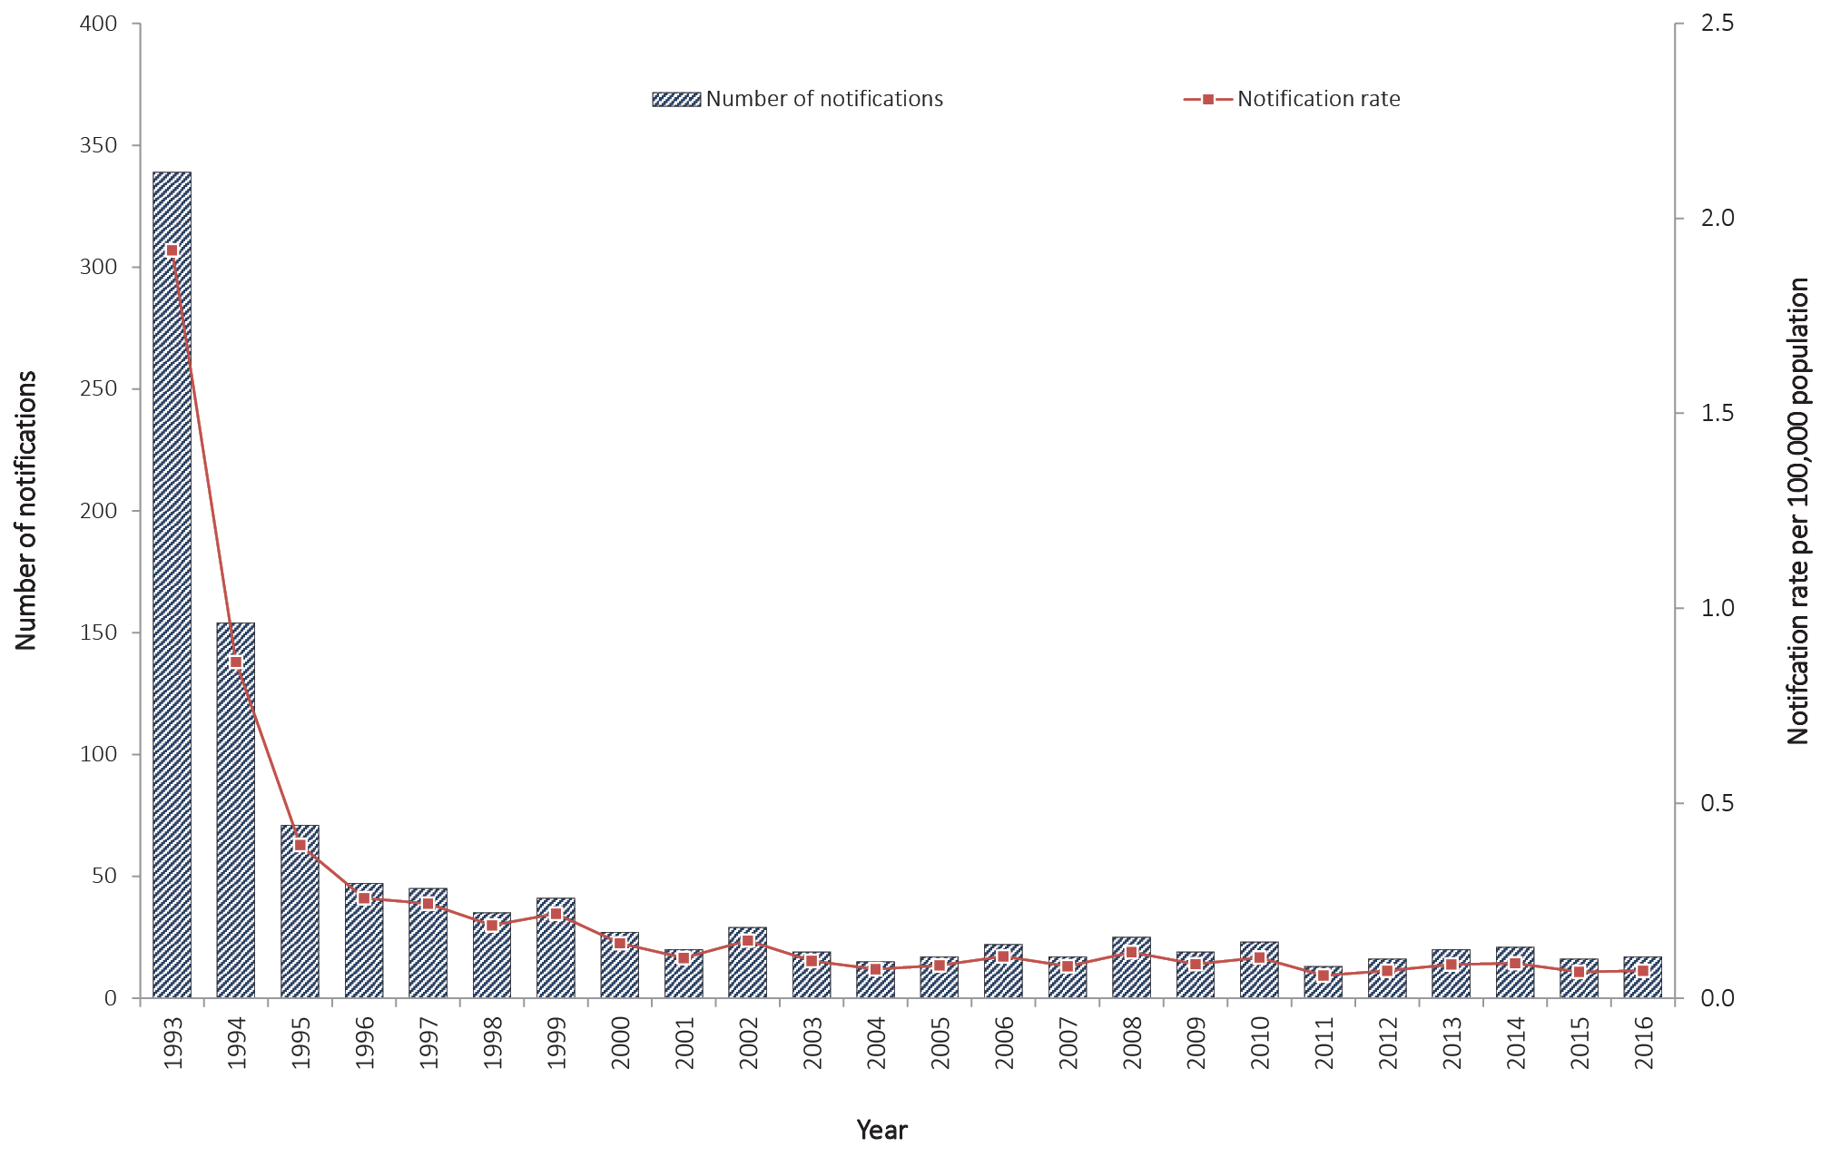

Age and sex distribution
In 2016, 76% of notified invasive Hib cases were female (n = 13). Approximately half of cases (53%; n = 9) were in children aged less than 15 years, of which 78% (n = 7) were among infants less than one year of age (Figure 51). Consistent with previous years, the 0–4 years age group had the highest notification rate at 0.5 per 100,000 population.

Figure 51: Notifications for invasive Haemophilus influenzae type b infection, Australia, 2016, by age group and sex
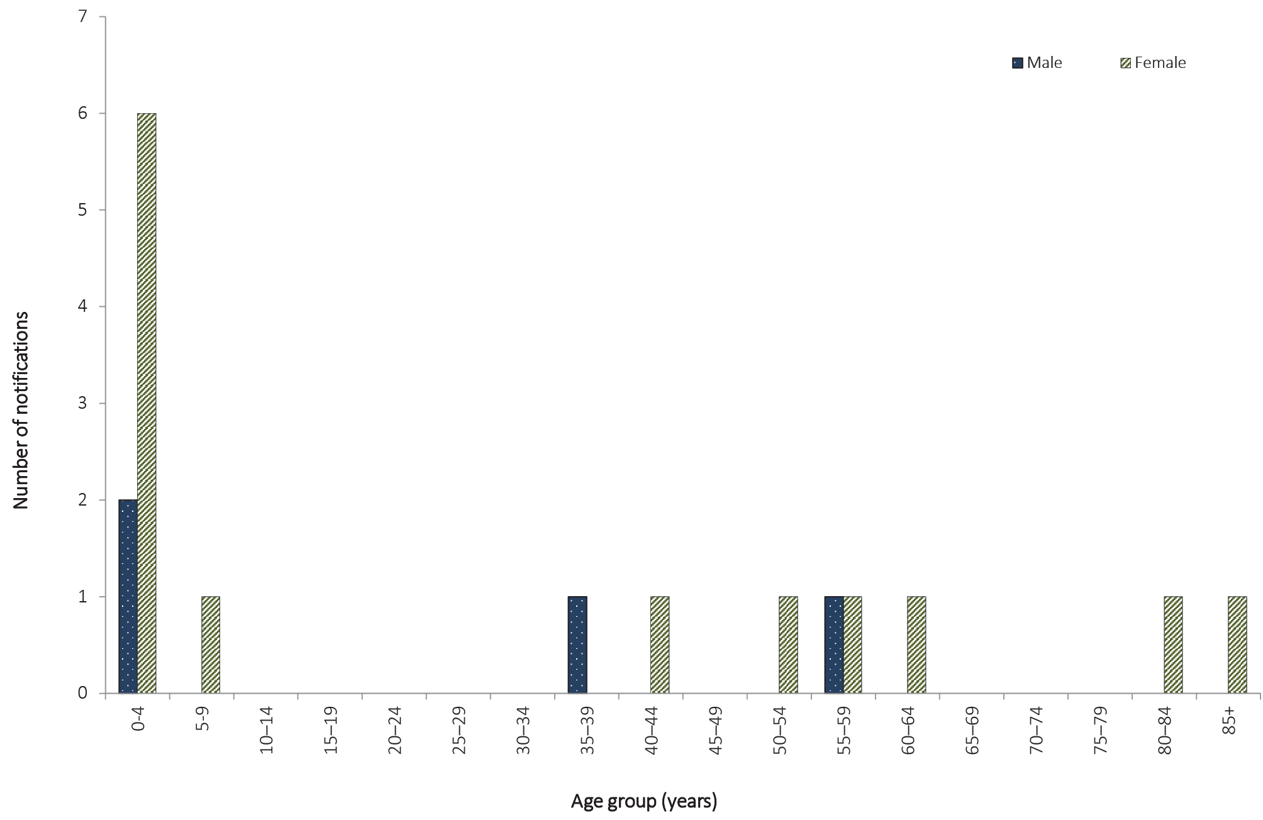

Indigenous Status
Indigenous status was reported for all notified invasive Hib cases in 2016. One case was reported in an Aboriginal person in 2016.

Immunisation status
Persons born after February 1993 (currently less than 24 years of age) were eligible for Hib immunisation under the NIP during their infancy. Of the 17 Hib cases reported in 2016, nine were eligible for immunisation. Three of these cases were 12 months of age or older, and therefore eligible for the full primary vaccine course and the booster, and all cases had received the full primary course. The remaining six cases eligible for immunisation were less than 12 months of age, of which three were reported as fully vaccinated for age; one was not vaccinated; one was too young (five weeks of age); and one was of unknown vaccination status.

Influenza (laboratory confirmed)

- There were 90,848 notifications of laboratory-confirmed influenza, a 10% decrease compared to the number of notifications reported in 2015.
- Influenza notifications during the 2015–2016 inter-seasonal period (December–March) were the highest on record, with an average of 1,649 notifications per month.
- Nationally, influenza A was the predominant influenza virus type in circulation, with distribution relatively similar across jurisdictions.
- Where subtype information was available, influenza A (H3N2) was the predominant influenza A subtype; the proportion of notifications attributed to influenza A (H3N2) and influenza A (H1N1) varied across jurisdictions.
Influenza is a common, highly infectious acute respiratory disease caused by infection with influenza viruses. The virus is transmitted from person to person by airborne droplets of exhaled respiratory secretions, especially by coughing or sneezing.⁷⁰ The disease ranges from asymptomatic through to mild upper respiratory tract illness, to severe disease, including complications such as pneumonia.⁷¹ The severity of disease is determined by features intrinsic to the virus and by host factors including age, level of immunity, and the presence of chronic medical conditions.^{72,73}
Annual influenza immunisation is the primary means of preventing or attenuating influenza and its complications, and is included in the NIP for individuals who are at increased risk of complications from influenza infection. The NIP funds influenza immunisation for all Aboriginal and Torres Strait Islander people aged six months and over; all adults aged 65 years and over; all people aged six months and over with medical conditions placing them at risk of serious complications due to influenza; and pregnant women (during any stage of pregnancy).⁶²

Epidemiological situation in 2016
In 2016, there were 90,848 notifications of laboratory-confirmed influenza, representing a notification rate of 375.5 per 100,000 population, which is a 10% decrease from the number of notifications reported in 2015 (n = 100,597; rate 422.4 per 100,000 population) (Figure 52).

Figure 52: Notifications of laboratory-confirmed influenza, Australia, 1 January 2011 to 31 December 2016, by week
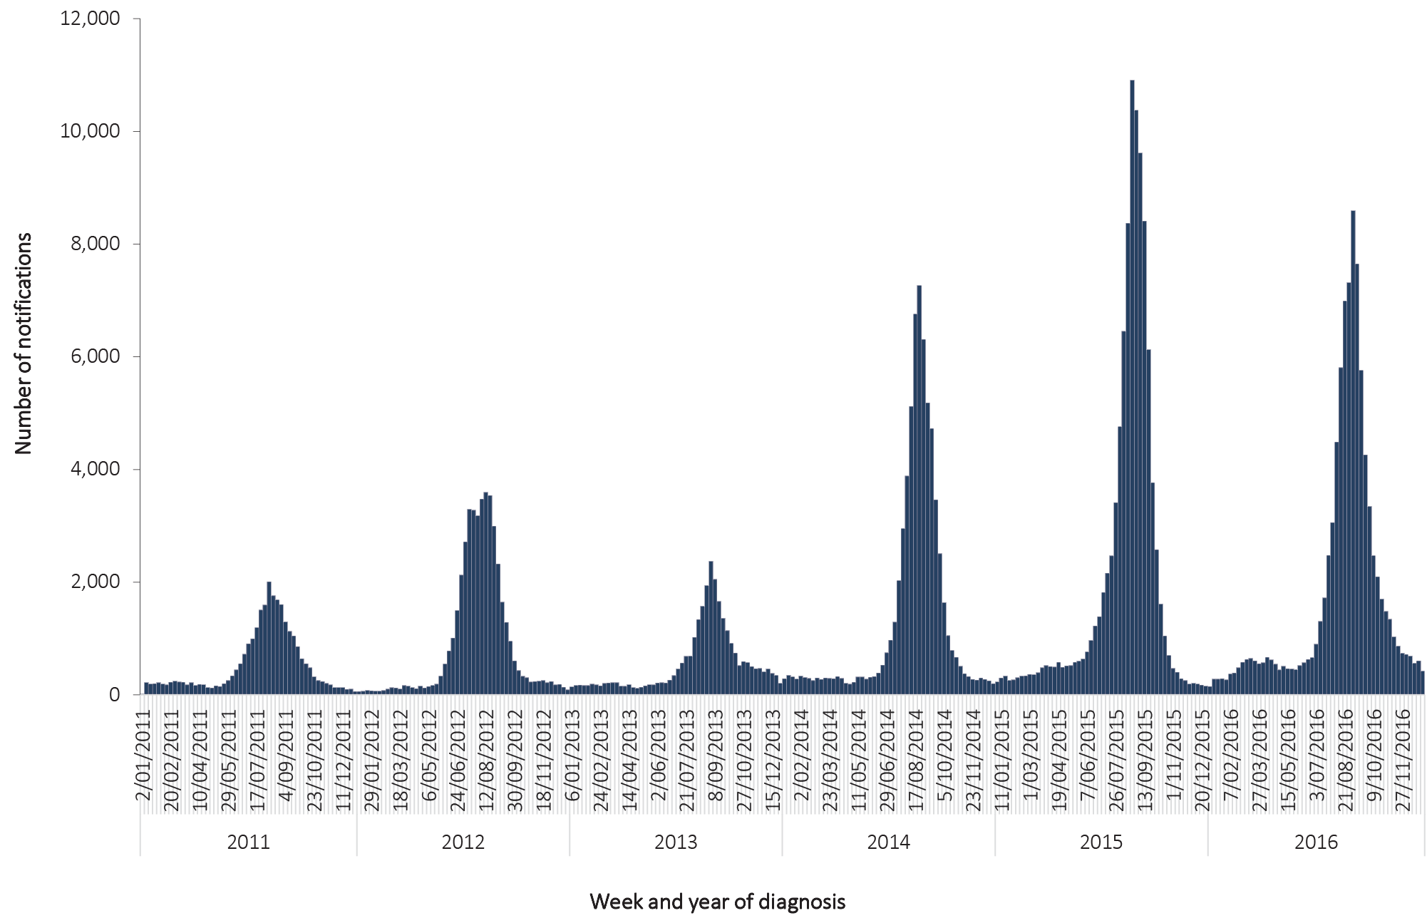

Geographical distribution
The notification rate was highest in Queensland (480.7 per 100,000 population), followed by New South Wales (460.1 per 100,000 population), South Australia (459.4 per 100,000 population) and the Australian Capital Territory (397.7 per 100,000 population). Notifications rates in all other jurisdictions were lower than the national notification rate of 375.5 per 100,000 population.
New South Wales reported the highest number of influenza cases of any jurisdiction (n = 35,577), comprising 39% of all notifications nationally (Figure 53); followed by Queensland (n = 23,289), accounting for 28% of notifications nationally; and Victoria (n = 12,926), 14% of the national total in 2016.

Figure 53: Notifications of laboratory-confirmed influenza, Australia, 2016, by week and state or territory
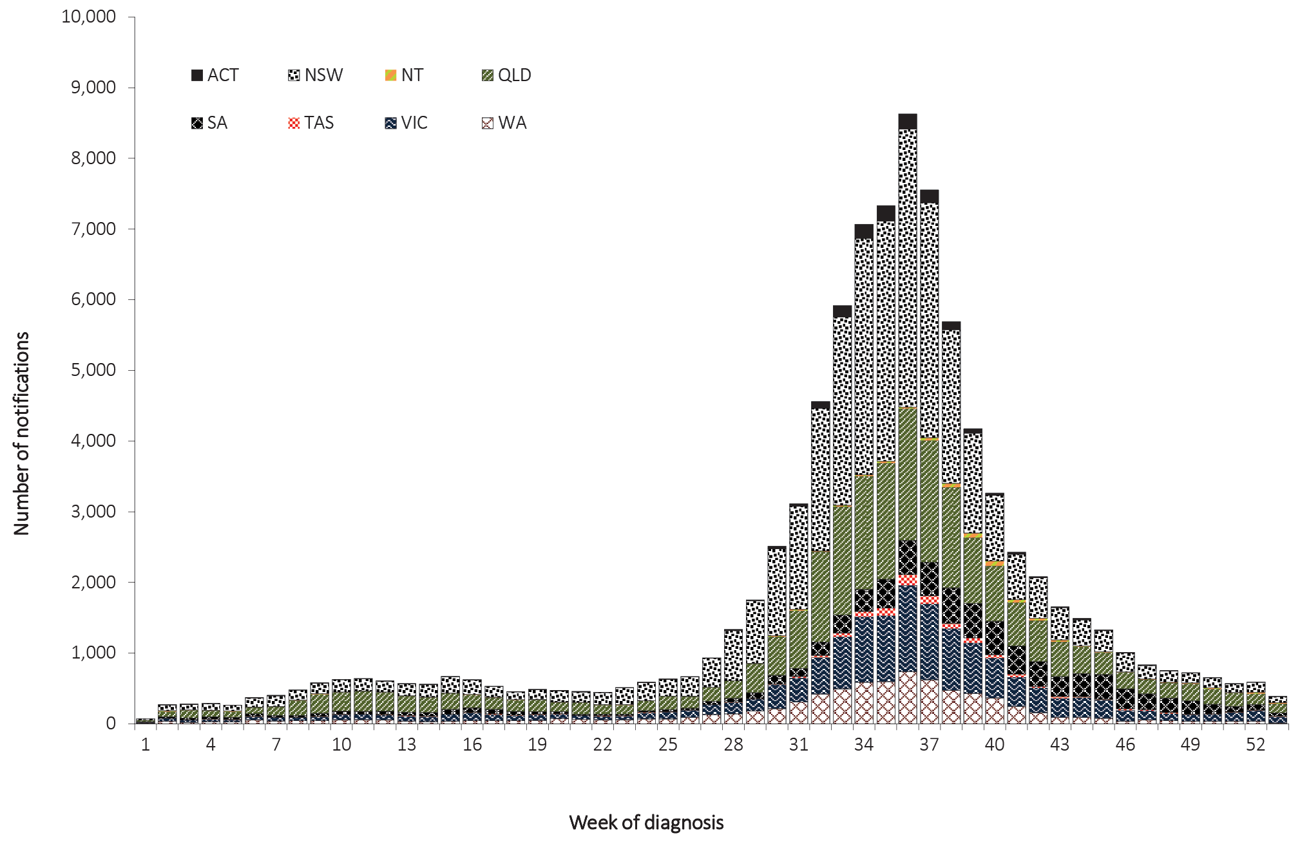

Age and sex distribution
The highest number of influenza notifications occurred in the 0–4 years and 5–9 years age groups (n = 8,757 and 7,252, respectively), which together accounted for 18% of all notifications in 2016 (Figure 54). The notification rate was highest in those aged 85 years and older (1,235.4 per 100,000 population), followed by those aged 80–84 years (753.9 per 100,000 population) and 75–79 years (566.8 per 100,000 population) (Figure 54).
In 2016, females accounted for 55% (n = 49,517) of the influenza notifications for which sex was reported. The age-group-specific rate of influenza in males exceeded that in females in age groups less than 15 years and those people aged 80–84 years, while for females in all other age groups, the rate exceeded that in males.
Influenza types and subtypes affect different age profiles, with the predominant virus in circulation influencing the age distribution of influenza notification rates. For example, in seasons dominated by the influenza A (H1N1) pdm09 virus, such as 2011, the age distribution of influenza notification rates showed a downward trend with increasing age (Figure 55). For comparison, in 2012, which was dominated by influenza A (H3N2), the age distribution of influenza notifications was bimodal with peaks in those aged less than 10 years and in those aged 70 years and over. In 2016, the influenza season was bimodal in distribution, with peaks in the 0–4 years and 75 years and over age groups.

Figure 54: Notifications and notification rate for laboratory-confirmed influenza, Australia, 2016, by age group and sex
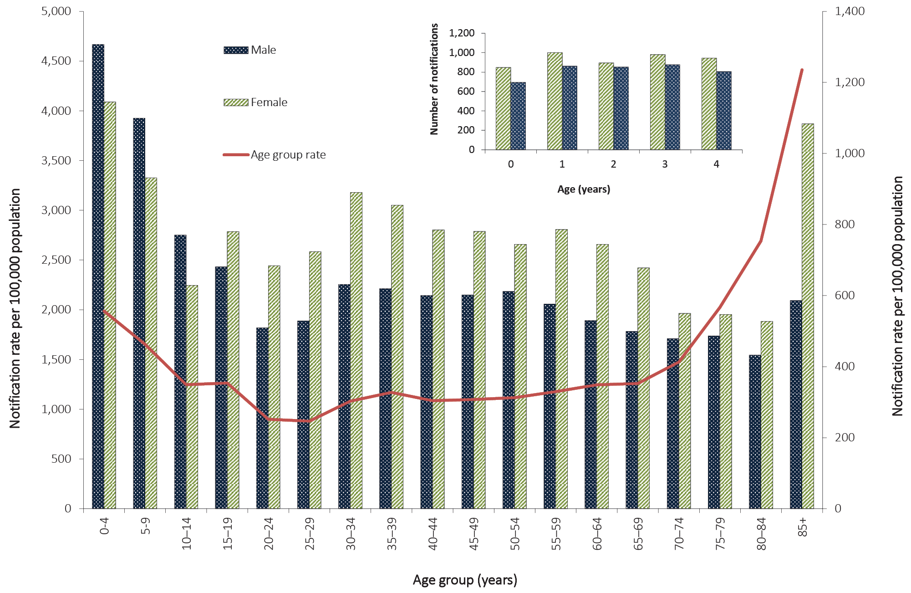

Figure 55: Notification rate for laboratory-confirmed influenza, Australia, 2011 to 2016, by age group and year

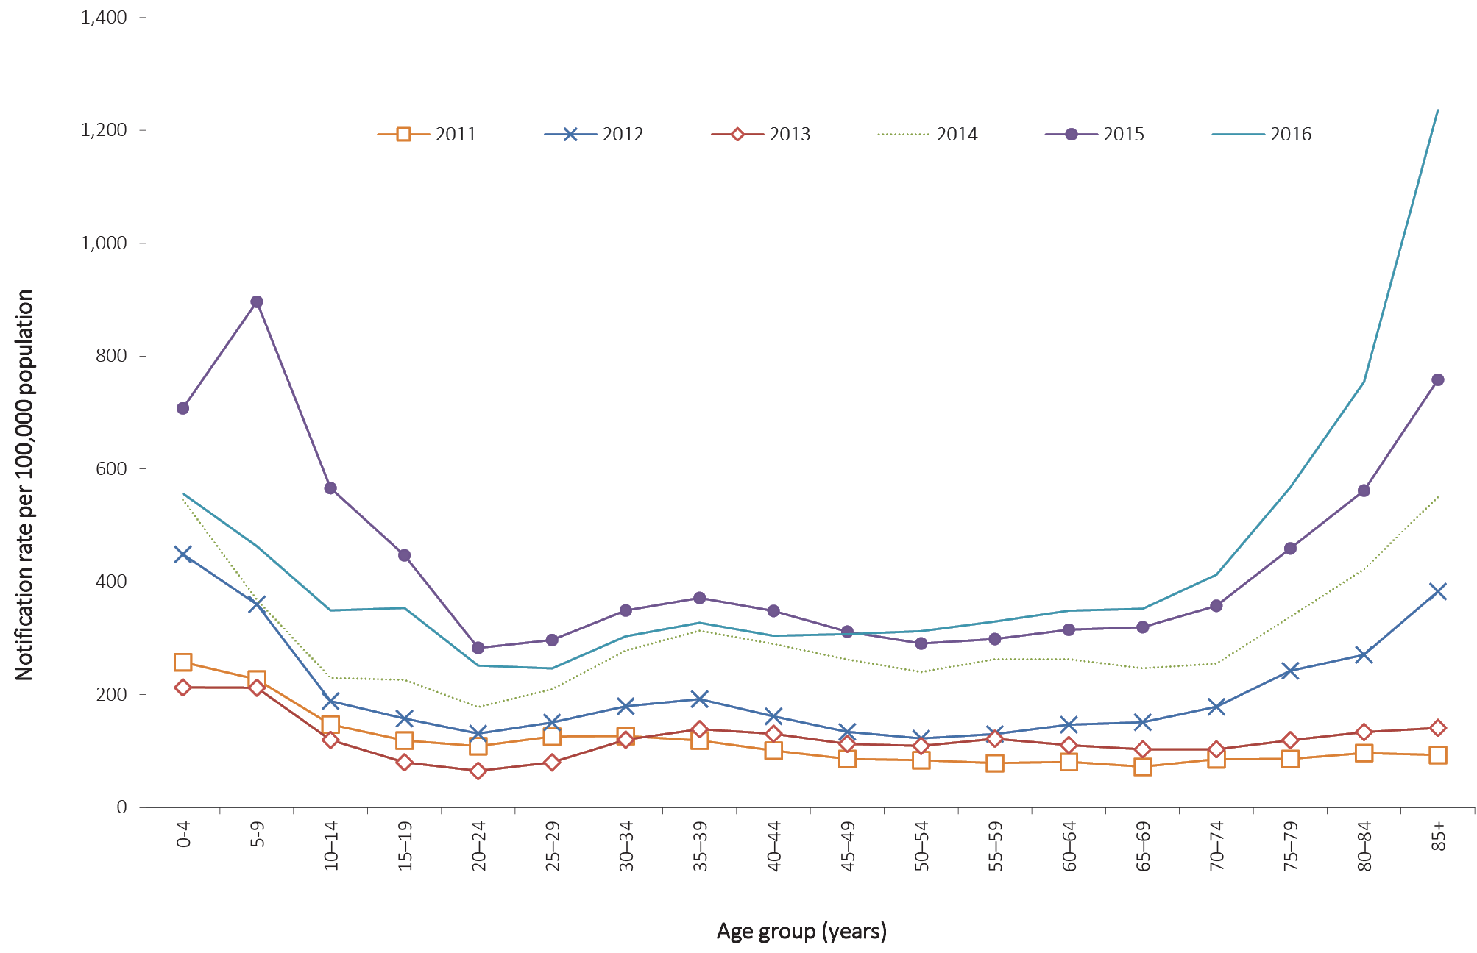

Seasonality
Influenza notifications during the 2015–2016 inter-seasonal period (Dec-Mar) were the highest on record with an average of 1,649 notifications per month, higher than in the same period in 2014–2015 (n = 1,423). Queensland reported the largest number of inter-seasonal influenza notifications (n = 2,551), followed by New South Wales (n = 1,880).
The seasonal increase of influenza notifications in 2016 started in July, rose sharply, and peaked in early September (Figure 52, Figure 56). Most of the activity in the jurisdictions peaked around early September, followed by a steady decline back to inter-seasonal levels by late October. The exceptions were South Australia and the Northern Territory, with heightened activity continuing two to four weeks later than the other jurisdictions.

Figure 56: Notifications of laboratory-confirmed influenza, Australia, 2011 to 2016, by month and year
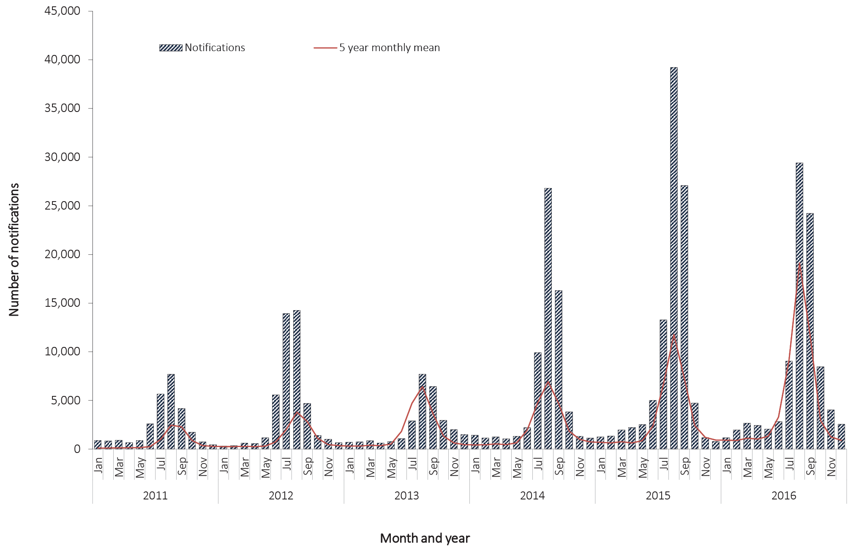

Indigenous status
Nationally in 2016, Indigenous status was reported in 36% (n = 32,527) of laboratory-confirmed notifications of influenza. Indigenous status completeness was greater than 50% in four jurisdictions: Northern Territory (97%), Western Australia (94%), South Australia (83%) and the Australian Capital Territory (86%). Among these jurisdictions, the combined notification rate for influenza in the Aboriginal and Torres Strait Islander population was 384.1 per 100,000 population and 322.6 per 100,000 population among the non-Indigenous population, representing a notification rate ratio of 1.2:1 (Aboriginal and Torres Strait Islander: non-Indigenous).

Mortality
Nationally, there were 150 influenza-associated deaths notified to the NNDSS, with a median age of 83 years (range 3 to 104 years). Most deaths (n = 131; 87%) were associated with influenza A infections and of these, 90 were associated with A (unsubtyped) infections, 35 were associated with A(H3N2), six were associated with A (H1N1) pdm09. Indigenous status was reported for 83% (n = 125) of the influenza-associated deaths; and Aboriginal and Torres Strait Islander people accounted for 7% (n = 11) of these deaths. The number of influenza-associated deaths reported to the NNDSS is reliant on the follow up of cases to determine the outcome of their infection and most likely underestimates the true mortality associated with this disease.

Microbiological trends
In 2016, typing data were reported for all laboratory-confirmed influenza notifications. The season was characterised by the predominant circulation of influenza A viruses (Figure 57). Influenza A viruses accounted for 89% (n = 80,980) of all notifications reported in 2016 and influenza B viruses accounted for 11% (n = 9,733) of all notifications. Whilst most notifications of influenza A were reported as unsubtyped (81%; n = 65,817), influenza A(H3N2) was detected at higher levels than influenza A(H1N1)pdm09 (11%, n = 9,773; and 6%, n = 5,390 respectively). There were <1% of cases of mixed influenza type A and B infections (n = 101), influenza type C (n = 4), and 30 notifications were unknown.
The predominance of influenza A in the 2016 season was in contrast to 2015 when influenza B dominated the season, but is similar to the earlier years 2011 to 2014 (Figure 58). In 2016, the ratio of influenza A (H1N1)pdm09 viruses reported to influenza A(H3N2) viruses was 1:1.8 which is consistent with 2015 (1:1.28) and 2012 (1:24), but different to 2011, 2013 and 2014 where influenza A(H1N1)pdm09 was the predominant influenza A subtype notified.
The predominance of influenza A viruses was consistent across jurisdictions and ranged from 71% of notifications in Western Australia up to 99% in Tasmania. Where subtype information was available, influenza A (H3N2) was the predominant influenza A virus notified in all jurisdictions except Victoria, where A (H1N1) was predominant. For those jurisdictions where A(H3N2) was more prevalent than A(H1N1), the ratio (A (H3N2):A(H1N1)pdm09) varied, ranging from 1.1:1 in Tasmania to 11.0:1 in Queensland. For Victoria, the ratio (A (H3N2):A(H1N1)) was 0.4:1.
Figure 57: Notifications of laboratory-confirmed influenza, Australia, 2016, by week and subtype
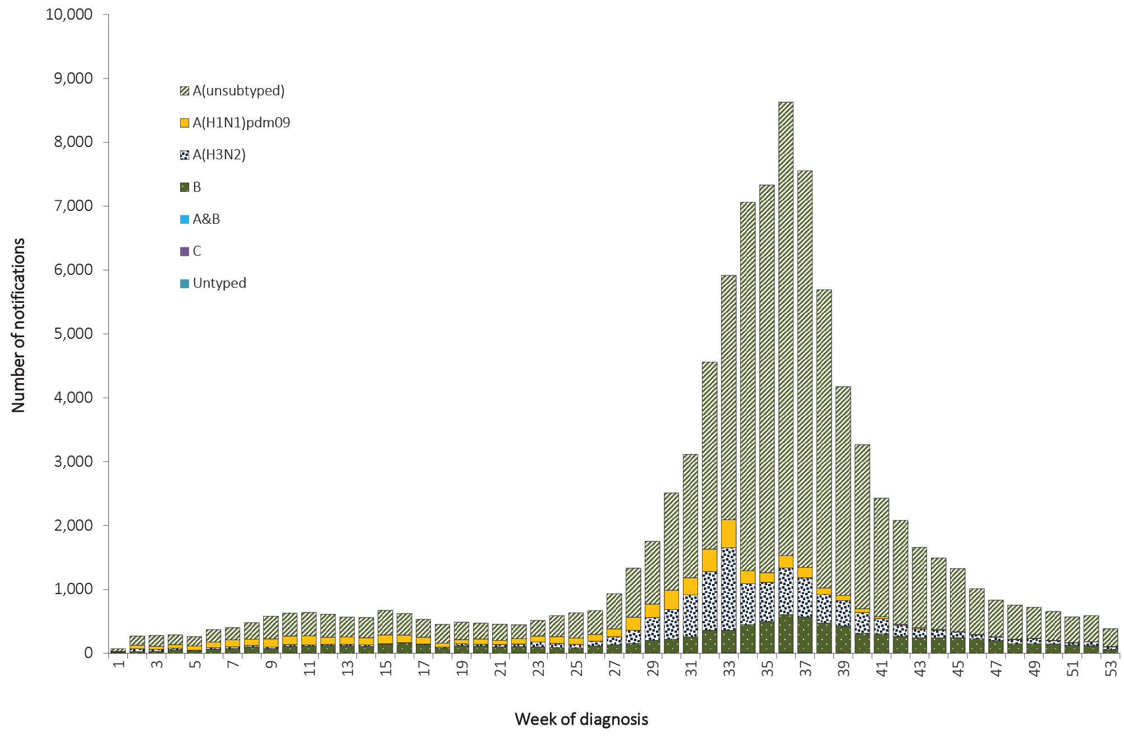

Figure 58: Percent of annual notifications of laboratory-confirmed influenza, Australia, 2011 to 2016, by subtype
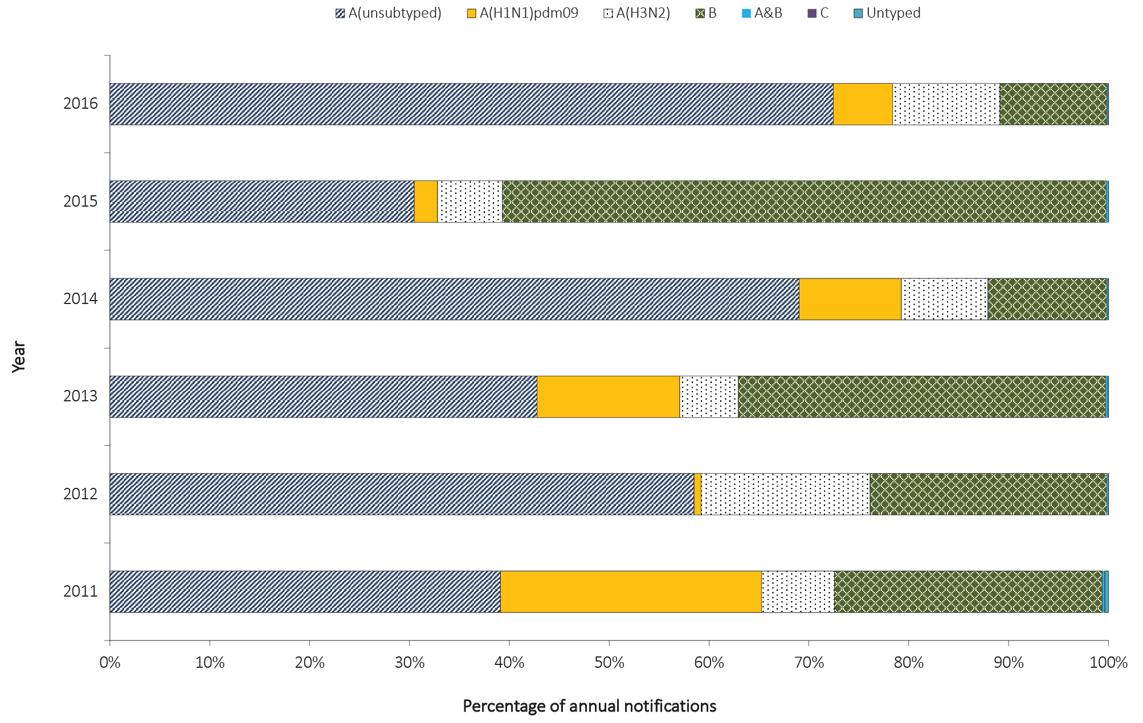

WHO Collaborating Centre for Reference and Research on Influenza
The WHO Collaborating Centre for Reference and Research on Influenza (WHOCC) analyses specimens from influenza cases identified in Australia. Specimens are submitted to the WHOCC from laboratories according to guidelines that aim for successful isolation of viruses and likelihood of obtaining a vaccine candidate. Further information on the specimens collected in 2016 is available in the WHOCC 2016 Annual Report.⁷⁴

Enhanced surveillance data sets
In addition to NNDSS data, a series of targeted influenza surveillance systems operated during 2016. Together these systems collected data which were used to describe the season with respect to epidemiology, morbidity, mortality and virology and supported the conclusions drawn from analyses of NNDSS notification data. Enhanced influenza surveillance was based on the following additional sources of data:
- the number and proportion of calls to a national health call centre network for influenza or influenza-like illness (ILI)
- rates of ILI from a community survey
- consultation rates for ILI identified by sentinel general practitioners
- consultation rates for ILI identified by hospital emergency departments in selected states and territories
- hospitalised cases of influenza from sentinel hospitals (adult and paediatric) across Australia
- mortality data from the Registry of Births, Deaths and Marriages for selected jurisdictions
- typing and subtyping for influenza from sentinel laboratories in selected jurisdictions
These data sources were used to inform the overall picture of influenza activity in Australia. Comprehensive analysis of these data is provided in the fortnightly Australian Influenza Surveillance Report, which was published during the season, and in the annual National Influenza Surveillance Scheme report published in CDI.⁷⁵

Discussion
The 2016 influenza season in Australia was characterised by the predominant circulation of influenza A viruses throughout the season, accounting for 89% of notified cases of laboratory-confirmed influenza. Rates of influenza were highest among children aged less than 10 years and the elderly aged 75 years and older, resulting in a bimodal age distribution.
The seasonal increase in notifications of laboratory-confirmed influenza began in July and reached a peak in early September. A record number of notifications was reported in the 2015–2016 inter-seasonal period.

Measles

- Australia has maintained the interruption of endemic measles transmission in 2016.
- There were 99 cases of measles notified in 2016, representing a national notification rate of 0.4 per 100,000 population.
- Fifty-six percent of cases (n = 55) were either imported or import-related.
- There were 15 outbreaks reported in 2016, with few cases (median of 3, range 2 to 22) and short in duration (range 2 to 54 days).
- The largest outbreak of measles in 2016 consisted of 22 cases and lasted 54 days.
Measles is a highly infectious acute viral illness, caused by the measles virus, that is spread by respiratory secretions, including aerosol transmission.⁷⁶ Initial symptoms last two to four days and are characterised by fever and malaise, followed by a cough, coryza, and conjunctivitis. It is usually followed by a red blotchy rash, which typically begins on the face, and then becomes generalised. Measles is often a severe disease with complications more common in the chronically ill, including otitis media, pneumonia, diarrhoea and acute encephalitis.⁷⁷ Subacute sclerosing panencephalitis is a late complication of measles and occurs, on average, seven years after infection.⁷⁸ Complications are more common in children less than five years of age, adults and people who are chronically ill.⁶⁸

Epidemiological situation in 2016
In 2016, there were 99 notifications of measles, representing a notification rate of 0.4 per 100,000 population. In 2016, measles notifications increased by 34% from notifications in 2015 (n = 74) (Figure 59) and were below the historical five-year mean, from 2011 to 2015, of 192 cases. Measles cases occurred in all states and territories in 2016, except for the Northern Territory; 39% of cases occurred in Victoria (n = 39) (Figure 59).

Figure 59: Notifications and notification rate for measles, Australia, 1998 to 2016, by year
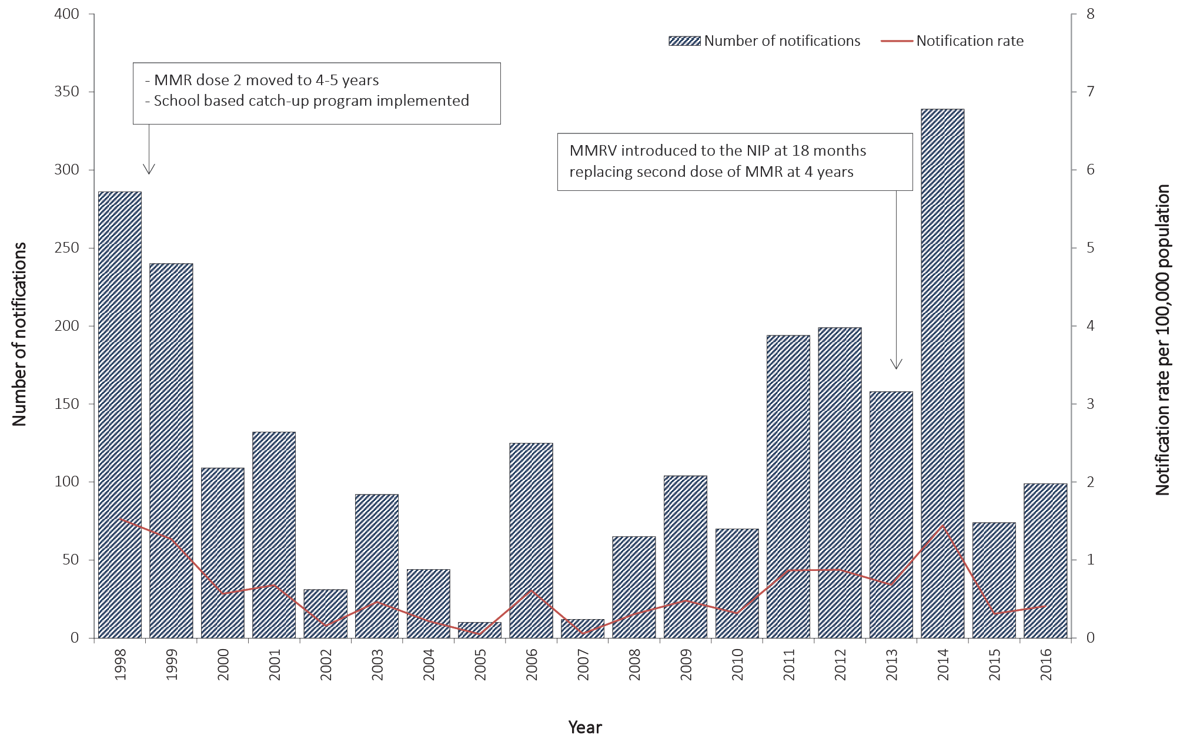

Age and sex distribution
In 2016, more than half of measles cases were female (61%; n = 60). As in 2015, there was a wide variation in the male-to-female rate ratio across age groups. (Figure 61). In 2016, age at diagnosis ranged from 0 to 50 years with a median of 21 years.

Figure 61: Notification rate for measles, Australia, 2016 by age group and sex
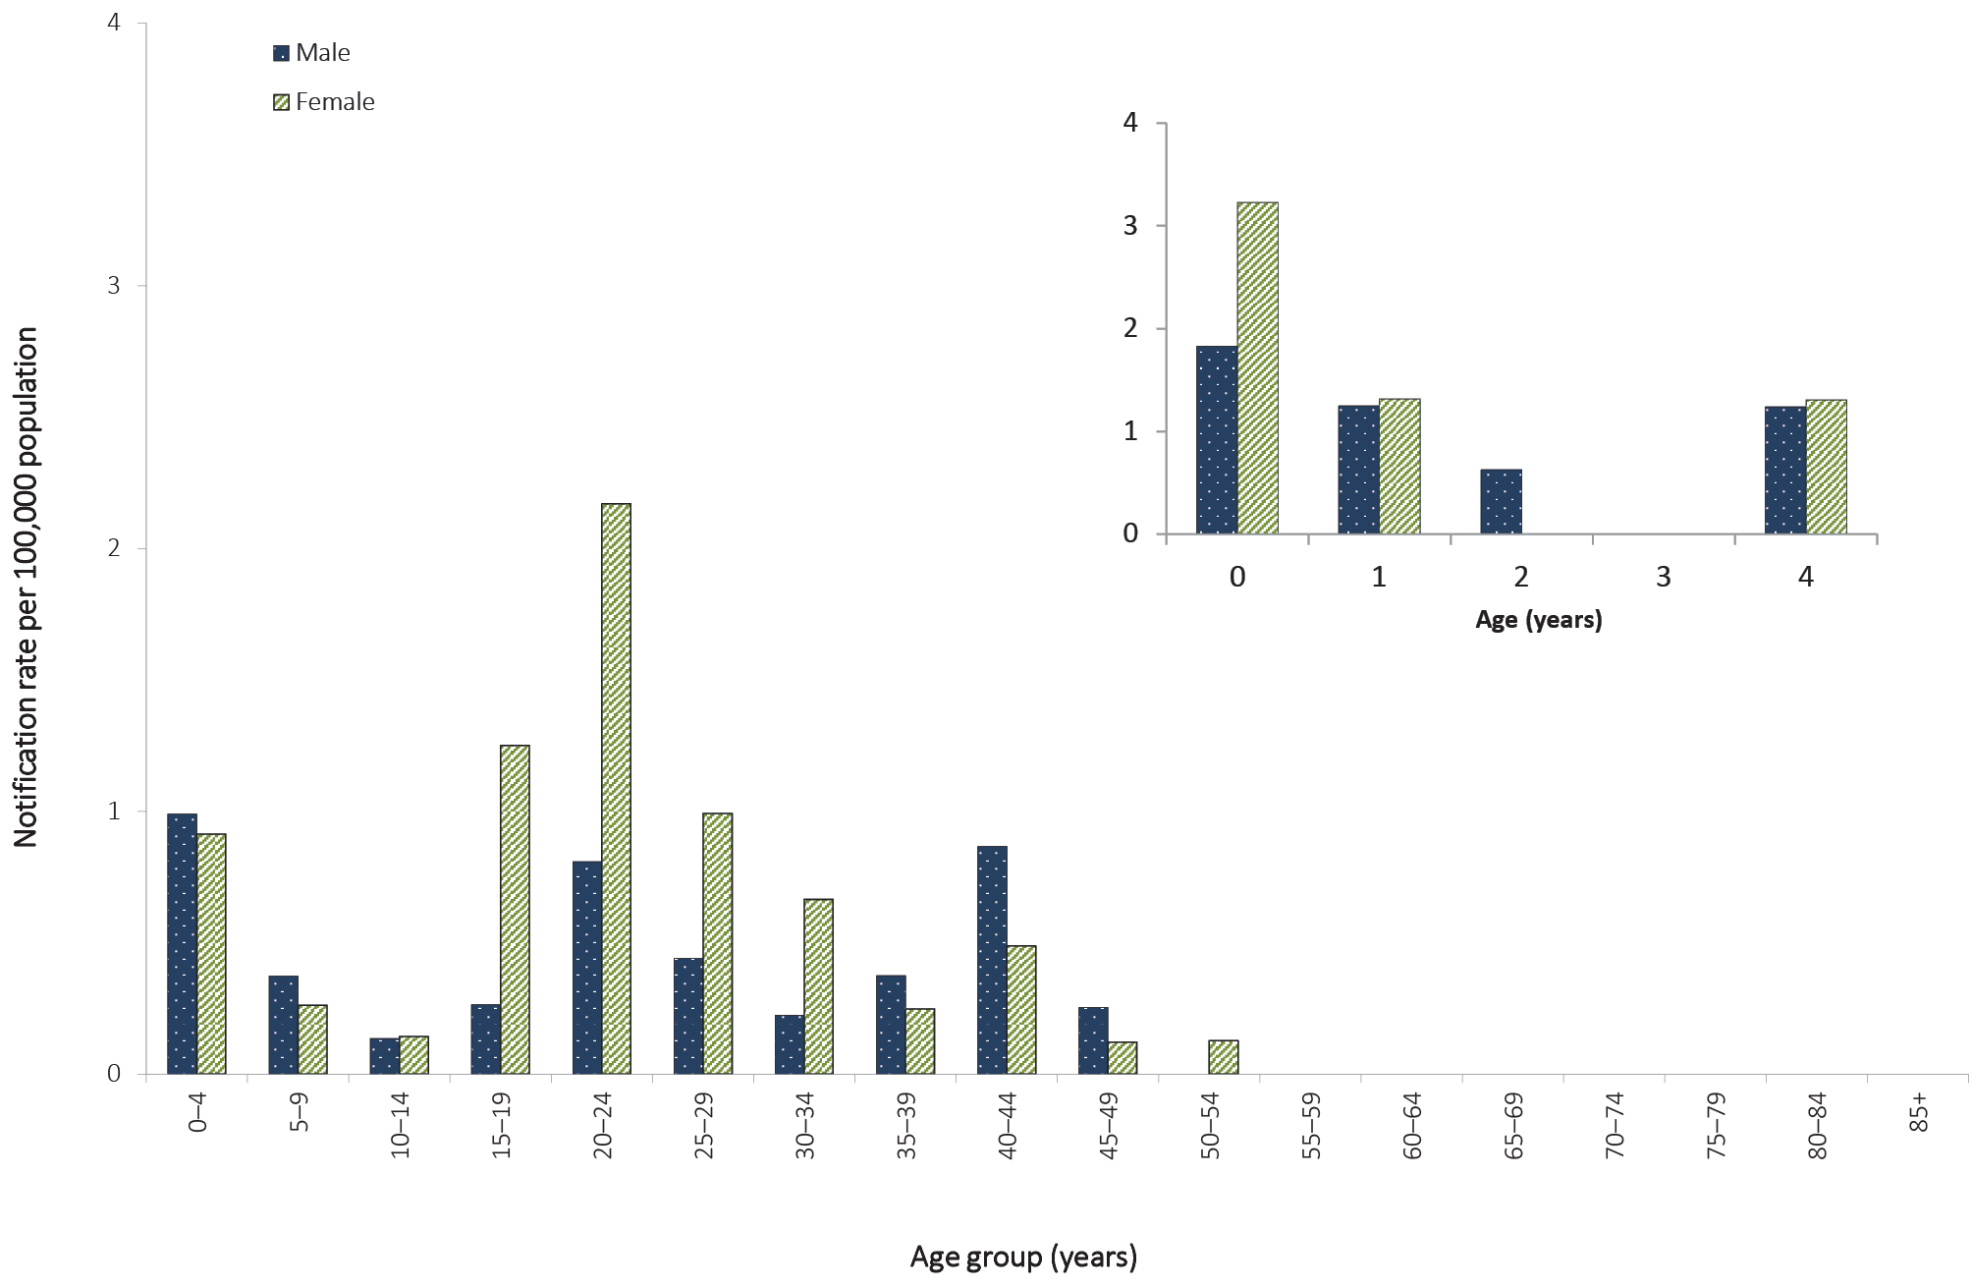
One quarter (25%) of notifications of measles cases in 2016 were in those aged 20–24 years. Among females, those aged 20–24 years had the highest number of notifications (n = 18) and highest notification rate (2.2 per 100,000 population) of all age groups. For males, the highest number of notifications and highest notification rate were reported in those aged 0–4 years (n = 8; 1.0 per 100,000 population). Overall, rates have remained below 2.5 per 100,000 population in all age groups between 2011 and 2016, with the exception of those aged less than one year during the same time period; and those aged 10–19 years in 2014 (Figure 62).

Figure 62: Notification rate for measles, Australia, 2011 to 2016, by year and selected age groups

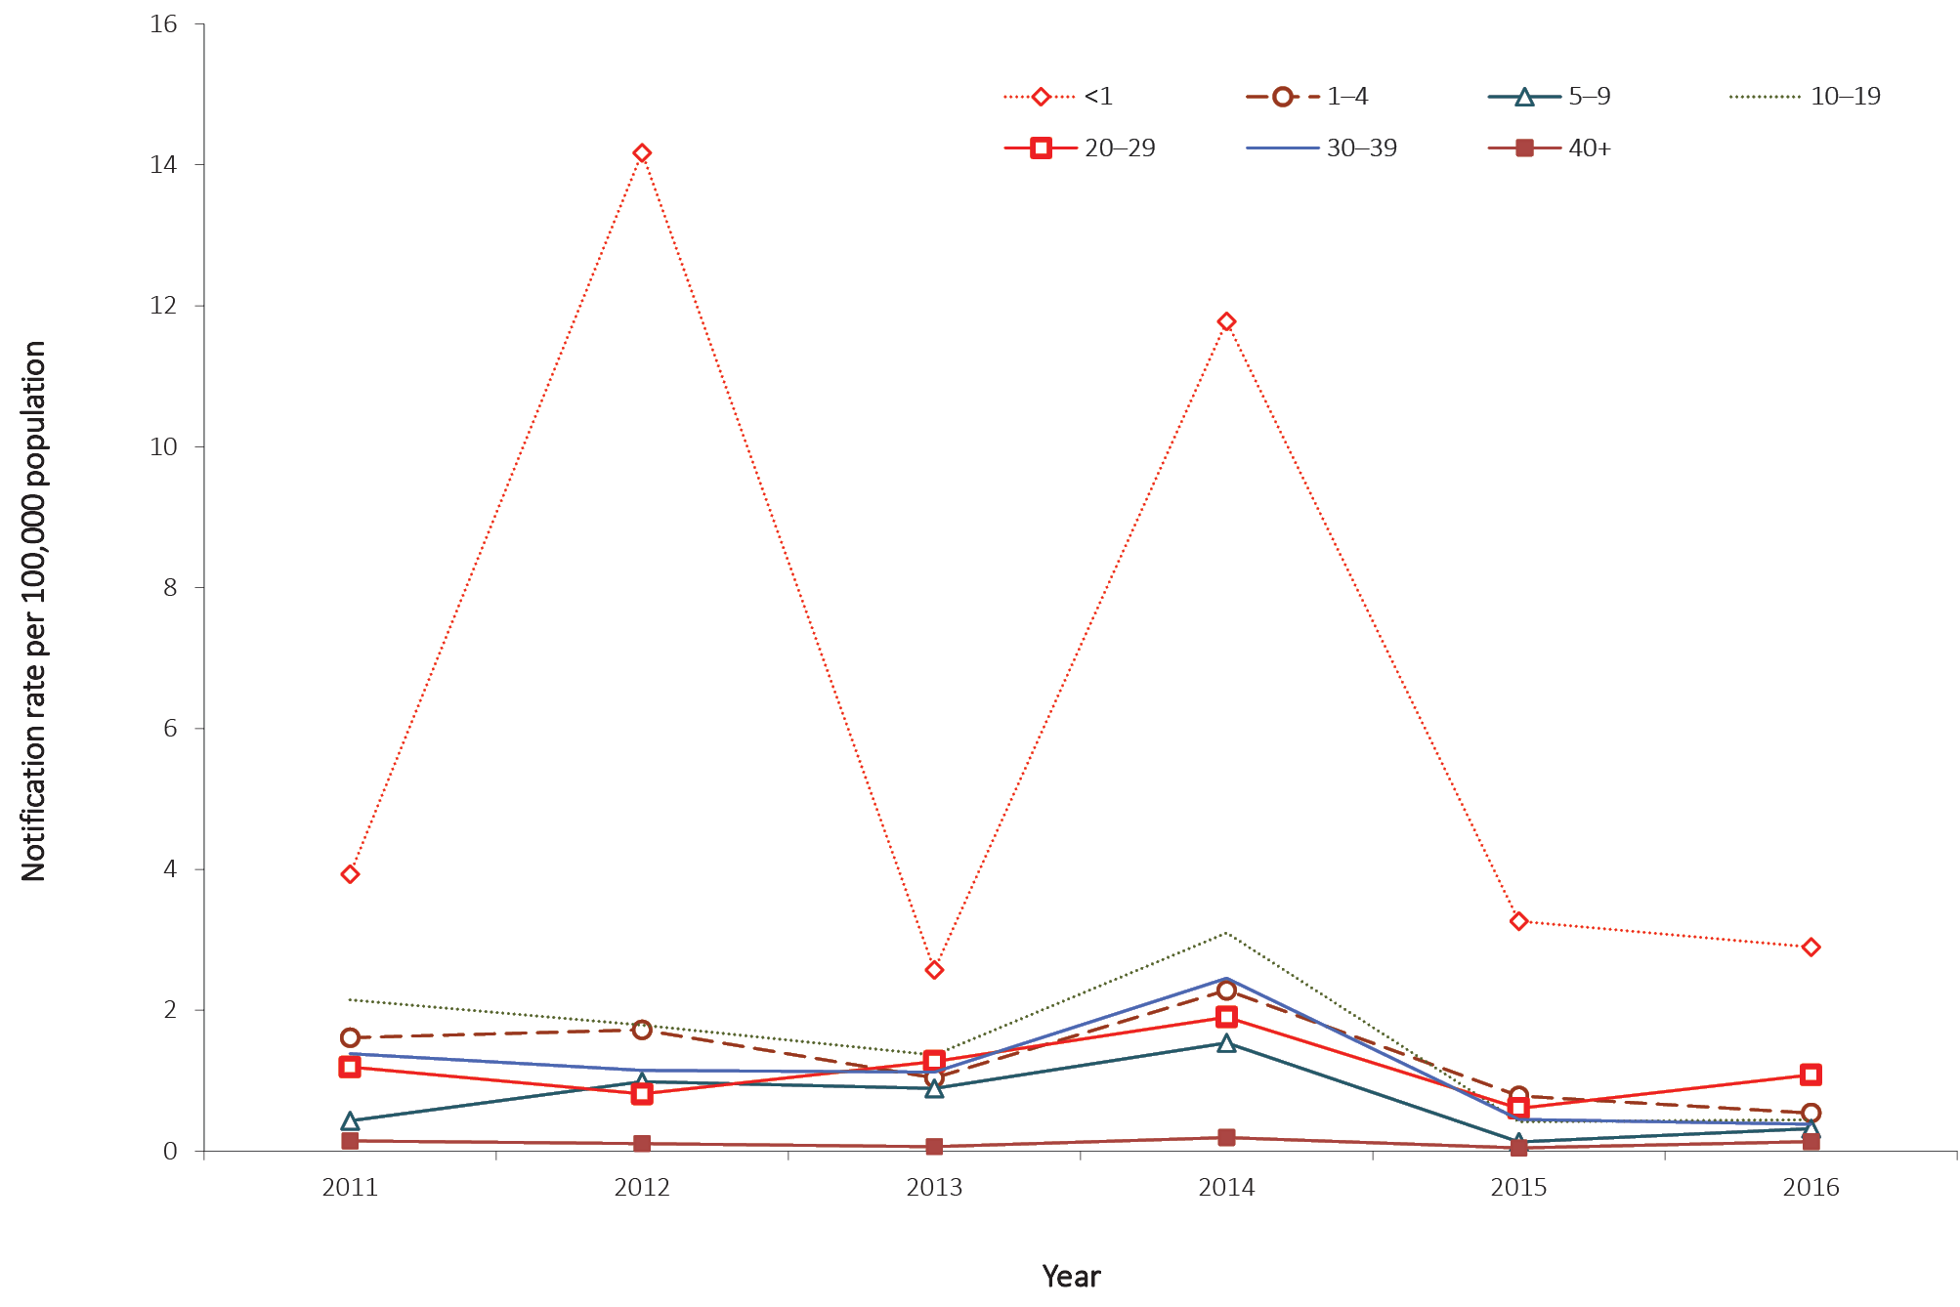
There were 13 cases (13%) of measles in people born between 1974 and 1980 (36 to 42 years old in 2016), a cohort previously identified as susceptible to measles infection.⁷⁹ In 2016, there was one case born before 1966, a cohort that is considered to have high levels of natural immunity.⁶⁸

Immunisation status
In 2016, the measles vaccine was provided in the combined Measles Mumps Rubella (MMR) or Measles Mumps Rubella Varicella (MMRV) vaccines. The MMR and MMRV vaccines each induce long-term measles immunity in 95% of recipients after a single dose and in 99% of recipients after the second dose.⁶⁸ Two doses of measles-containing vaccine are recommended for all persons born during or after 1966.⁶⁸
Of the 99 cases notified in 2016, 91% (n = 90) were born after 1965 or were 12 months of age or older, and therefore were eligible for at least one funded dose of a measles-containing vaccine. Eighty-eight percent (n = 79) of eligible cases were reported as either unvaccinated (54%; 49/90) or of unknown immunisation status (33%; 30/90). The remaining 12% (n = 11) of vaccine-eligible cases were reported as vaccinated, of which four were fully vaccinated with two doses of a measles-containing vaccine and seven were partially vaccinated with one dose (Figure 63). In 2016, all cases aged less than 15 years (n = 14) were reported with an immunisation status. In contrast, 39% (30/76) of cases aged 15 years and older, and born after 1965, were reported with an unknown immunisation status (Figure 63).

Figure 63: Notifications of measles, Australia, 2016, by immunisation status and age groups
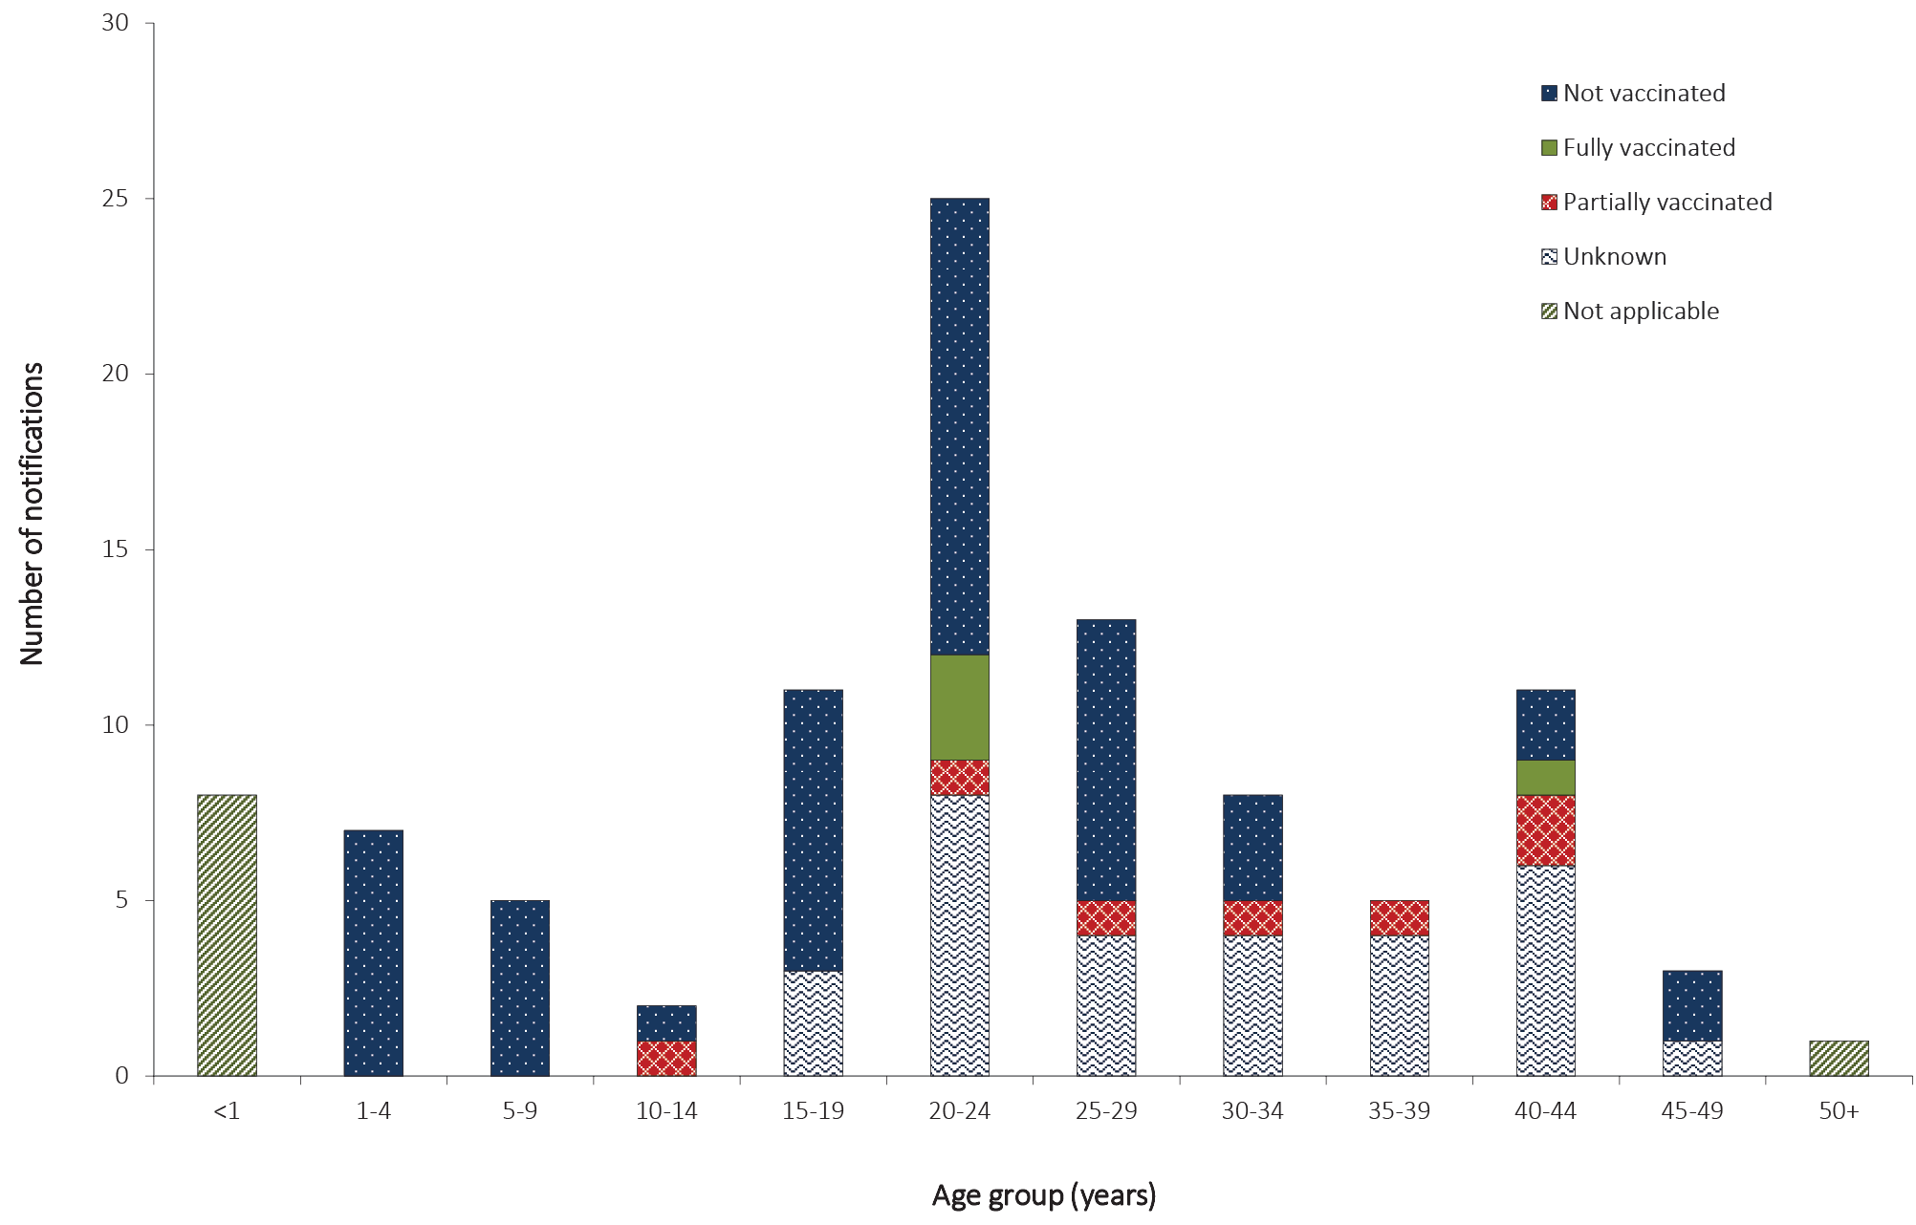

Indigenous status
In 2016, Indigenous status was completed for 97% of measles cases, a decrease in completeness compared with 100% of cases in 2015 (n = 74). There were no cases of measles reported among Aboriginal and Torres Strait Islander people in 2016.

Sources of infection and outbreaks
Fifty-six percent of cases in 2016 were either imported (n = 33) or import-related (n = 22), with the remaining 44% (n = 44) of unknown source. Most of the unknown cases (68%; n = 26) were locally acquired and linked to three outbreaks, in which the source of infection of the index case could not be determined.
In total, there were 15 outbreaks reported in 2016. These outbreaks reported few cases (median of 3, range 2–22) and were short in duration (range 2 to 54 days). The largest outbreak was reported in Victoria and consisted of 22 cases and lasted 54 days.

Microbiological trends
Multiple genotypic lineages of measles—B3, D4, and D8—were detected in 2016, from at least nine different overseas source countries, with no single genotype persisting.

Discussion
Evidence suggests endemic measles has been eliminated in Australia since at least 2005,⁸⁰ with this being verified by the WHO in 2014.^{81,82} However, the increasing prevalence of measles in some parts of the world, and the continued circulation of the virus in countries of close geographical proximity to Australia, provide a continual risk of the virus being imported into Australia.
Compared to 2015, the number of reported measles cases increased by 34% (from 74 cases in 2015 to 99 cases in 2016). None of the 15 outbreaks persisted for more than 12 months (the longest was 54 days) and there was no evidence of the continuous circulation of a single genotype. In 2016, 88% of cases eligible for vaccination (n = 90) were either unvaccinated (54%) or of unknown immunisation status (33%).
Figure 60: Notifications of measles, Australia, 2011 to 2016, by month, year and state or territory
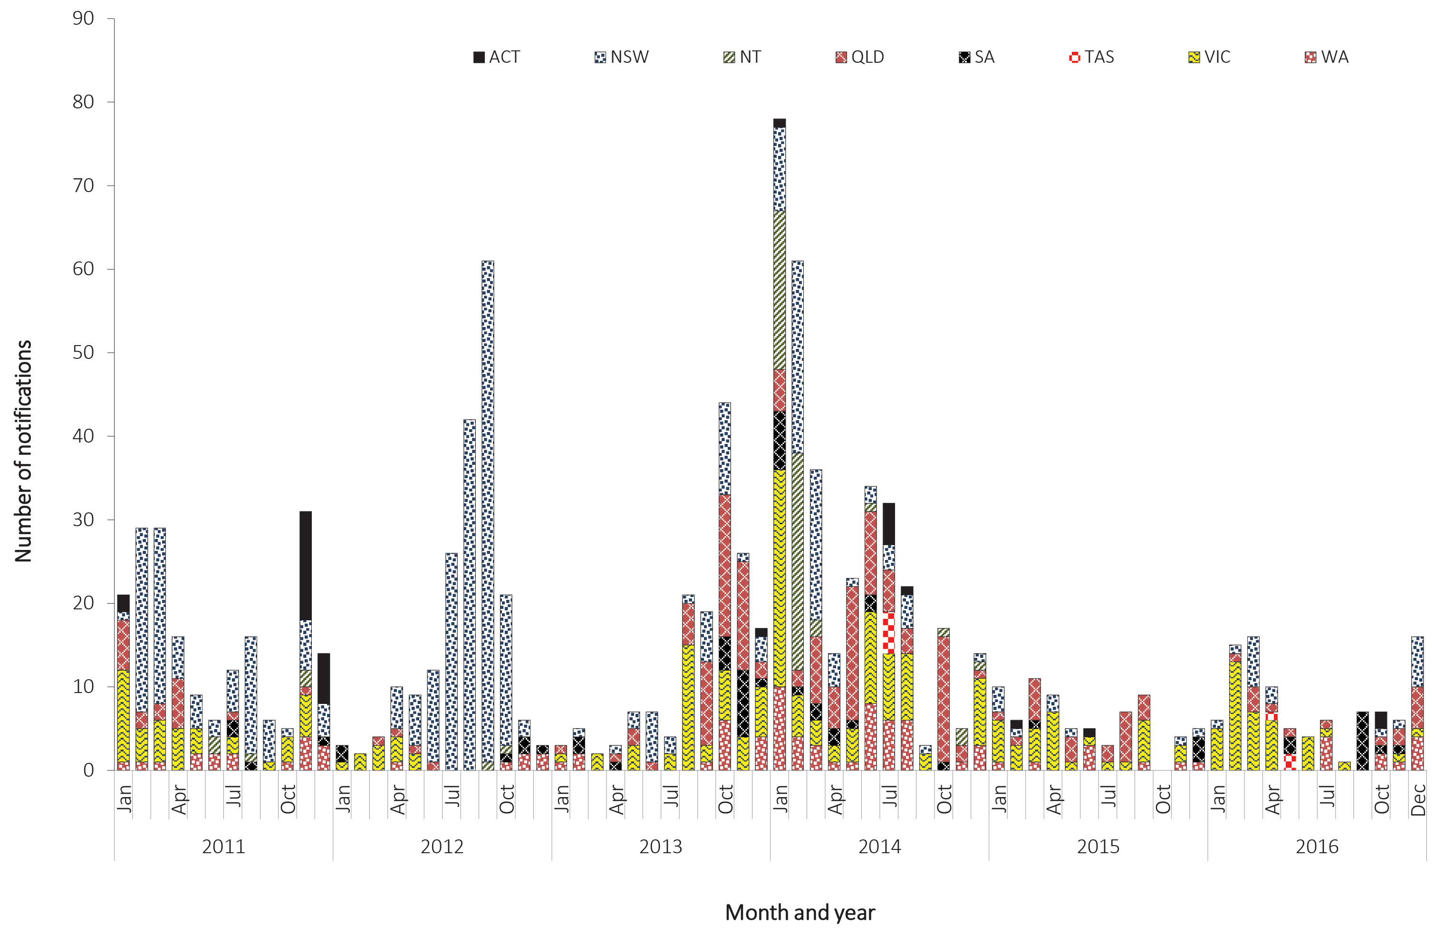

Mumps

- There were 805 cases of mumps notified in 2016, which is a 25% increase on the number of notifications in 2015 (n = 645).
- In 2016, there were 549 cases of mumps in Aboriginal and Torres Strait Islander people, with the majority of these cases (n = 413) notified from Western Australia.
- Increased notifications of mumps in 2016 were associated with an outbreak in Aboriginal and Torres Strait Islander people.
Mumps is an acute viral illness caused by the mumps virus. Transmission is usually by respiratory secretions, including aerosol transmission, or by direct contact with saliva. Asymptomatic infections occur in one third of cases. Symptomatic disease ranges from mild upper respiratory tract infections to systemic involvement. The characteristic bilateral, or occasionally unilateral, parotid swelling occurs in 60% to 70% of clinical cases; however, a high proportion have non-specific symptoms including fever, headache, malaise, myalgia and anorexia.⁸³ Mumps encephalitis has been estimated to occur in one to two per 10,000 cases, with a case fatality rate of around 1%.²³

Epidemiological situation in 2016
In 2016, there were 805 notifications of mumps, a 25% increase on the 645 cases reported in 2015 and a ratio of 2.9:1 compared to the historical five-year mean, 2011 to 2015 (n = 280.2) (Figure 64). The national notification rate of mumps remained below 1.0 per 100,000 population between 2011 and 2014, however, the rate increased in 2015 (2.7 per 100,000 population) and again in 2016 (3.3 per 100,000 population).

Figure 64: Notifications of mumps, Australia, 2011 to 2016, by month, and year and state or territory
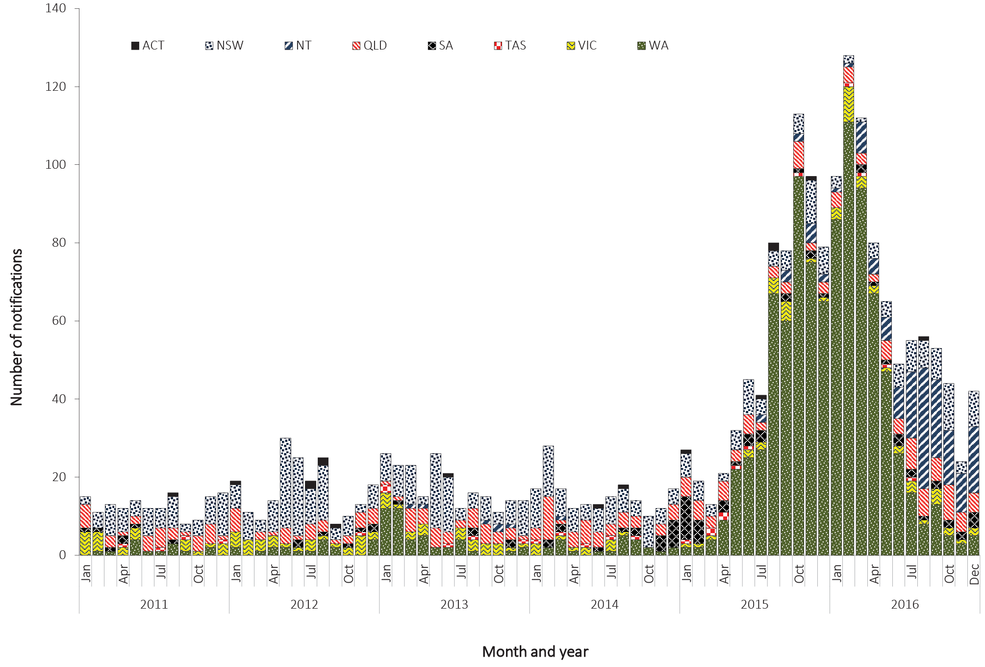

Geographical distribution
Cases of mumps were reported from all states and territories in 2016, with the highest rates occurring in the Northern Territory (55.8 per 100,000 population) and Western Australia (18.8 per 100,000 population).
Place of acquisition was complete for 73% (n = 587) of cases in 2016, of which 5% (29/587) were imported from overseas. Seven cases were acquired in Fiji; four cases in Brazil; three cases in Vietnam; two cases each for Bangladesh, India, Indonesia, Japan, Philippines and Thailand; and one case each in Germany, Singapore and South Africa. The remaining 558 cases were reported as locally acquired in Australia.

Age and sex distribution
In 2016, males accounted for 52% of cases of mumps (n = 415) and females for 48% (n = 390) (Figure 65). The highest number of cases, for both males and females, occurred in the 15–19 years age group (males n = 58, females n = 69) with a total of 127 cases in this age group, representing 16% of all notified mumps cases in 2016. The next highest number of cases was in those aged 10–14 years, with 110 notifications (14%) reported (males n = 56; females n = 54).
Since 2011, there has been a steady increase in age-specific rates across all age groups, which became particularly evident in 2015 (Figure 66). In 2016, these increases have continued across all age groups, with the greatest increase in those aged one to four years (1.33 per 100,000 population in 2015 to 2.16 per 100,000 population in 2016) and those aged less than one year (0.73 per 100,000 population in 2015 to 1.09 per 100,000 population). Rates in all other age groups also increased, ranging from 9% in those aged 5–9 years to 34% in those aged 30–39 years (Figure 66).
Figure 65: Notifications of mumps, Australia, 2016, by age group and sex

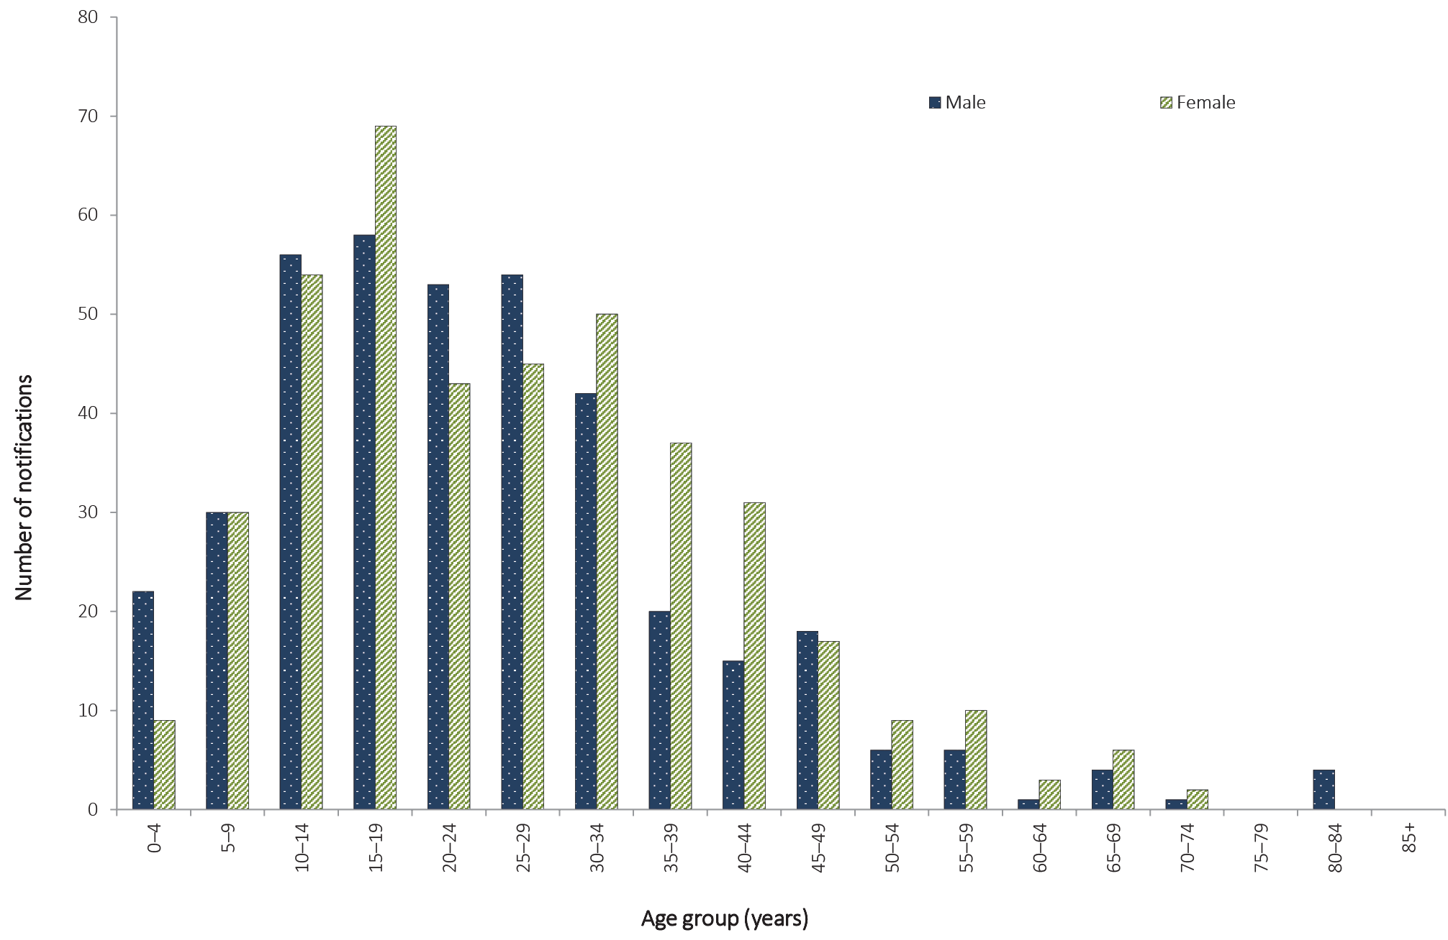

Figure 66: Notification rate of mumps, Australia, 2011 to 2016, by year and selected age groups
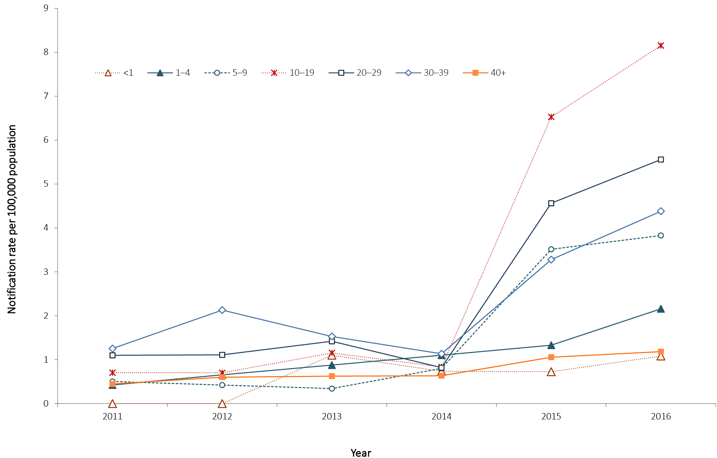

Immunisation status
In 2016, the mumps vaccine was provided in the combined MMR or MMRV vaccines. The mumps vaccine was first funded on the NIP schedule in 1982 for infants at 12 months of age, with people born after 1980 eligible for at least one dose of a mumps-containing vaccine. Of the 805 cases notified in 2016, 79% (n = 636) were eligible for at least one dose of NIP-funded mumps-containing vaccine. Of these, 59% (373/636) were fully vaccinated, having received two doses of a mumps containing vaccine; 14% (86/636) were partially vaccinated, having received one dose; 9% (57/636) were unvaccinated; and 19% (120/636) were of unknown vaccination status.

Indigenous status
Indigenous status was reported for 97% (n = 777) of notified mumps cases in 2016. This is higher than the mean completeness of the historical five-year period, 2011 to 2015 (78%, range 64% to 94%). Of the cases with a known Indigenous status in 2016, 68% (549/777) were reported as Aboriginal and Torres Strait Islander, with most of these cases linked to a large outbreak that occurred in Western Australia.

Discussion
The majority of mumps notifications in 2015 and 2016 were associated with an outbreak of mumps in Aboriginal and Torres Strait Islander people, between 1 March 2015 and 31 December 2016.⁸⁴ It is unclear why this outbreak has disproportionately affected Aboriginal and Torres Strait Islander people in Western Australia. A number of factors that may have contributed to widespread transmission of the virus within this population include: differences in household density and mobility patterns; waning immunity; and potential immune escape due to the mismatch between the wild type and the vaccine virus genotypes.⁸⁵
The mumps component of the MMR vaccine is considered the least effective of the three components, with the reported one-dose vaccine effectiveness varying between 60% and 90%.^{86–88} While protection is greater in two-dose vaccine recipients, recent outbreaks have been reported in two-dose recipients, particularly in young adults who received their vaccines more than 10 years previously.^{89,90} Reduced effectiveness of the mumps vaccine over time may partially account for the proportion of vaccinated cases notified and may also contribute to mumps outbreaks in older vaccinated populations.⁹¹

Pertussis

- Pertussis remains highly prevalent in Australia.
- There were 20,095 notifications of pertussis in 2016, which is an 11% decrease on 2015 (n = 22,543).
- In 2016, children under 15 years of age had a notification rate 4.7 times higher than those 15 years or older.
Pertussis, commonly known as whooping cough, is a highly infectious acute respiratory disease caused by the bacterium Bordetella pertussis. Spread by respiratory droplets, infection is often characterised by paroxysmal cough with inspiratory whoop.⁷⁶ The highest risk morbidity and mortality from pertussis occurs in infants who are too young to have received at least two doses of a pertussis-containing vaccine.⁶⁸ Complications include pneumonia, atelectasis, seizures, encephalopathy, and hernias, with pneumonia as the most common cause of death.²³

Epidemiological situation in 2016
In 2016, there were 20,095 notifications of pertussis, which is an 11% decrease on 2015 (n = 22,543). Notifications of pertussis in 2016 show a 48% decrease on 2011 (n = 38,758), the peak of the last epidemic period (2008–2012); and a 17% decrease on 2012 (n = 24,099). However, the notifications in 2016 are higher than those in 2013 (63% increase, n = 12,364) and 2014 (69% increase, n = 11,864) (Figure 67). There were two pertussis-related deaths reported in 2016; one death was in an infant approximately three months of age and therefore not able to be fully immunised. The other death was in a male aged 55–59 years with unknown vaccination status.

Figure 67: Notifications of pertussis, Australia, 2011 to 2016, by month, year, and state or territory
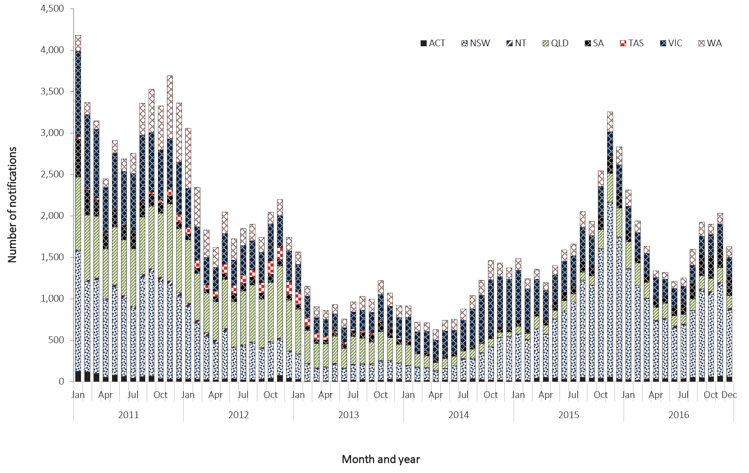

Geographical distribution
Between 2015 and 2016, notification rates increased in the Northern Territory (from 24.1 per 100,000 population in 2015 to 91.2 per 100,000 population in 2016), South Australia (from 78.3 per 100,000 population to 114.0 per 100,000 population), Queensland (from 39.0 per 100,000 population to 44.4 per 100,000 population) and the Australian Capital Territory (from122.8 per 100,000 population to 125.0 per 100,000 population) (Figure 68). Notification rates decreased in New South Wales (from 160.8 per 100,000 population in 2015 to 140.1 per 100,000 population in 2016), Victoria (from 77.4 per 100,000 population to 46.5 per 100,000 population), Western Australia (from 73.5 per 100,000 population to 59.7 per 100,000 population) and Tasmania (from 6.0 per 100,000 population to 5.8 per 100,000 population). The national notification rate of pertussis in 2016 decreased by 12% (83.1 per 100,000 population) compared to 2015 (94.7 per 100,000 population).

Figure 68: Notification rates for pertussis, Australia, 2011 to 2016, by year and state or territory
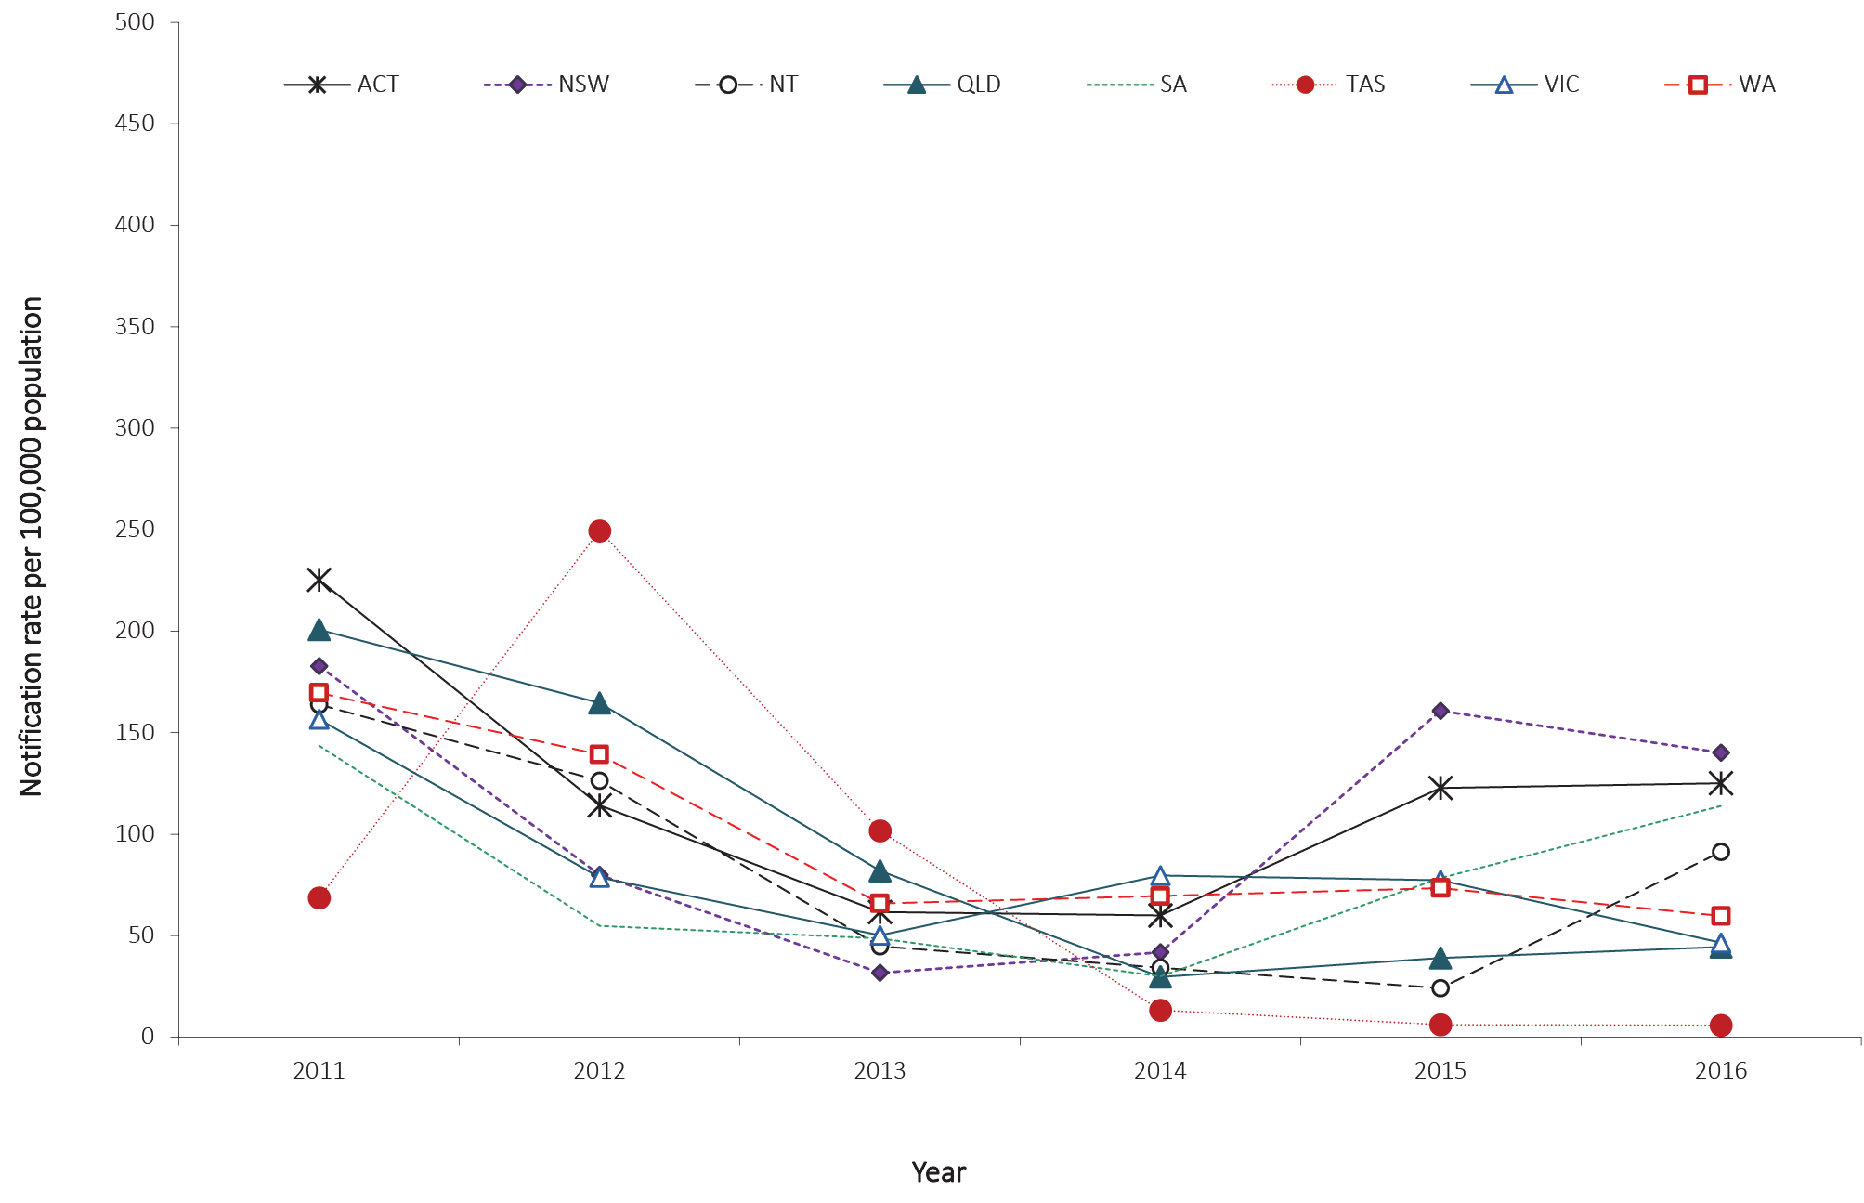

Age and sex distribution
Females accounted for 55% of cases (n = 10,977) in 2016 and had higher rates across all age groups except those aged 85 years or older (Figure 69). The highest age-specific notification rates for both males and females occurred in the 5–9 years age group, at 253.7 per 100,000 population and 265.1 per 100,000 population respectively.

Figure 69: Notification rate for pertussis, Australia, 2016, by age group and sexª
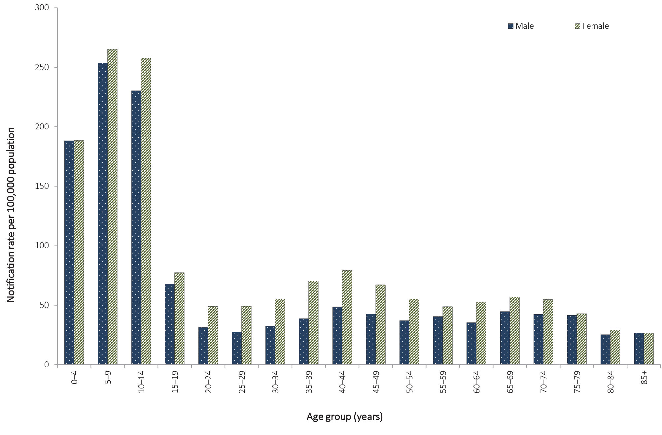
a Excludes cases missing age (n = 16) and sex (n = 12).
Between 2011 and 2014, the notification rates of pertussis in those less than 15 years of age declined steeply and the ratio of cases less than 15 years: cases over 15 years fell from 3.7:1 in 2011 to 2.5:1 in 2014. Between 2014 and 2015 this ratio increased, with notification rates for those less than 15 years 4.6 times higher than those 15 years and older. In 2016, the ratio (cases less than 15 years:cases 15 years and older) was 4.7:1, comparable to the ratio reported in 2015 (4.6:1). The highest age-specific rate in 2016 occurred in the 5–9 years age group (259.3 per 100,000 population), followed by those 10–14 years of age (243.7 per 100,000 population) and those less than one year old (216.3 per 100,000 population) (Figure 70).

Figure 70: Notification rates for pertussis, Australia, 2011 to 2016, by selected age groupsª
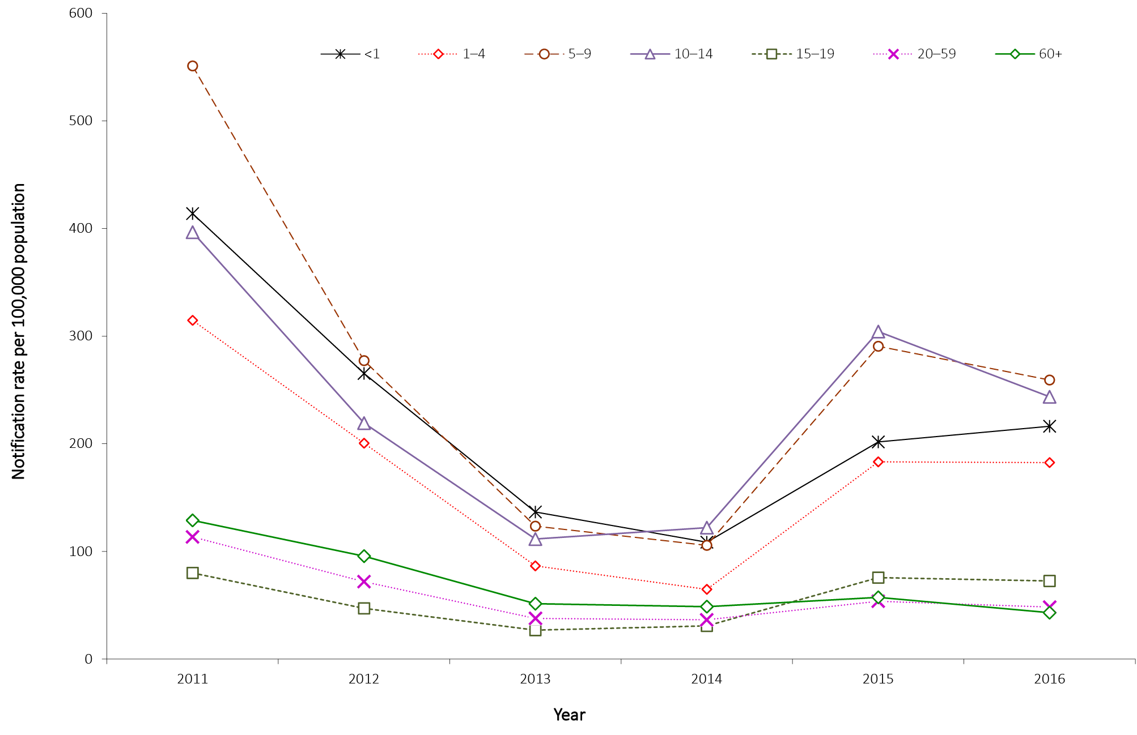
a Excludes 12 cases where age was not reported.

Immunisation status
The NIP schedule in 2016 included a primary course of three doses of vaccine for children at two, four and six months of age, with additional booster doses at 18 months, four years and between 12 to 17 years of age.⁹² The booster dose at 18 months of age has been funded under the NIP since March 2016.⁹³ Immunity to disease decreases over time post-immunisation, with estimates that protection remains for 4 to 12 years.^{94–96} While pertussis can affect people of any age, infants are at highest risk of severe disease.⁹⁷
In order to determine the immunisation status of cases, public health follow-up is required. As per the pertussis national guidelines for public health units, jurisdictions prioritise case follow-up to those less than 5 years of age.⁹⁸ During 2016, those aged less than 5 years accounted for 15% (n = 2,965) of all notified cases of pertussis, with information about immunisation status available for 91% of these (2,685/2,965).
Of the 2,211 children with pertussis aged between six months and less than four years in 2016, 26% (578/2,211) had received the full primary course of three doses or more (Table 17). Of the 462 cases aged four to five years, 20% (91/462) had received the full scheduled course of four doses. Twenty-eight percent (770/2,790) of cases eligible for two doses of vaccine (4 months to less than 5 years) had received at least two doses of a pertussis-containing vaccine in 2016.

Table 17: Notifications of pertussis in children aged less than 5 years, Australia, 2016, by age groupª
Age group | Number of vaccine doses |  |  |  |  | Unknown | Total
 | 0 | 1 | 2 | 3 | 4
Less than 6 weeks of age (not eligible for immunisation) | 33 | 1 | 0 | 0 | 0 | 2 | 36
6 weeks to < 4 months (eligible for one dose of vaccine) | 85 | 29 | 1 | 1 | 0 | 22 | 138
4 to < 6 months (eligible for two doses of vaccine) | 54 | 11 | 27 | 2 | 0 | 23 | 117
6 months to < 4 years (eligible for three doses of vaccine) | 1,397 | 8 | 41 | 548 | 30 | 187 | 2,211
4 to < 5 years (eligible for four doses of vaccine) | 294 | 1 | 0 | 31 | 91 | 45 | 462
Total | 1,863 | 50 | 69 | 582 | 121 | 279 | 2,964ª
a Excludes one notification in a baby aged 0, where age in weeks was unable to be calculated.

Discussion
Epidemics of pertussis have historically occurred at regular intervals of approximately four years on a background of endemic circulation in Australia, with the two most recent epidemics peaking in 2011 and 2015. The total number of notifications of pertussis in 2016 is consistent with historical data and was less than the peak in 2015.

Pneumococcal disease (invasive)

- There were 1,664 cases of invasive pneumococcal disease notified in 2016, an 11% increase on the total compared with 2015 (n = 1,497).
Invasive pneumococcal disease (IPD) is a condition wherein Streptococcus pneumonia is isolated from a normally-sterile site such as blood, cerebrospinal fluid, or pleural fluid. Transmission of the bacterium from person to person is usually via the inhalation of respiratory droplets from an infected person. Many of the signs and symptoms of IPD are non-specific including fever, chills, headache, neck stiffness and a general malaise. Severe symptoms can include seizures and occasionally coma.²³

Epidemiological situation in 2016
In 2016, there were 1,664 notifications of IPD, which is an increase of 11% on the number of notifications in 2015 (n = 1,497). The notification rate of IPD in 2016 was 6.9 per 100,000 population compared with 6.3 per 100,000 population in 2015.
In July 2011, the childhood immunisation program replaced the 7-valent pneumococcal conjugate vaccine (7vPCV) with the 13-valent pneumococcal conjugate vaccine (13vPCV).⁹⁹ Between 2011 and 2016, there has been an 18% reduction in the notification rate of IPD, from 8.4 per 100,000 population in 2011 to 6.9 per 100,000 population in 2016. Declines have been greatest amongst children aged less than 2 years targeted by the new vaccine, and for those IPD cases caused by the six additional vaccine serotypes.⁶⁸

Geographic distribution
In 2016, the highest notification rate of IPD was reported in the Northern Territory (18.7 per 100,000 population) which was a decrease on the rate reported in 2015 (24.9 per 100,000 population). All other jurisdictions reported increased notification rates of IPD in 2016 compared to 2015 (Australian Capital Territory (4.3 per 100,000 population to 6.9 per 100,000 population); New South Wales (6.4 per 100,000 population to 7.0 per 100,000 population); Queensland (5.1 per 100,000 population to 5.5 per 100,000 population); South Australia (7.4 per 100,000 population to 8.1 per 100,000 population); Tasmania (8.3 per 100,000 population to 9.7 per 100,000 population); Victoria (5.9 per 100,000 population to 6.4 per 100,000 population); and Western Australia (6.5 per 100,000 population to 7.8 per 100,000 population).

Age and sex distribution
In 2016, males (54%; n = 898) continued to account for a higher proportion of cases than females (46%; n = 766). The notification rates of IPD in males exceeded those in females across all age groups, except the 20–24 and 60–64 years age groups (Figure 71). Overall, the notification rate continued to be highest in older Australians and young children, with an age distribution of cases comparable to that observed in 2014 and 2015. In adult Australians, the highest notification rate was among those aged 85 years and over (34.0 per 100,000 population), while in children, it was amongst those aged less than five years of age (14.9 per 100,000 population). The notification rate among those aged less than two years was 22.1 per 100,000 population.
Figure 71: Notification rate for invasive pneumococcal disease, Australia, 2016, by age group and sex
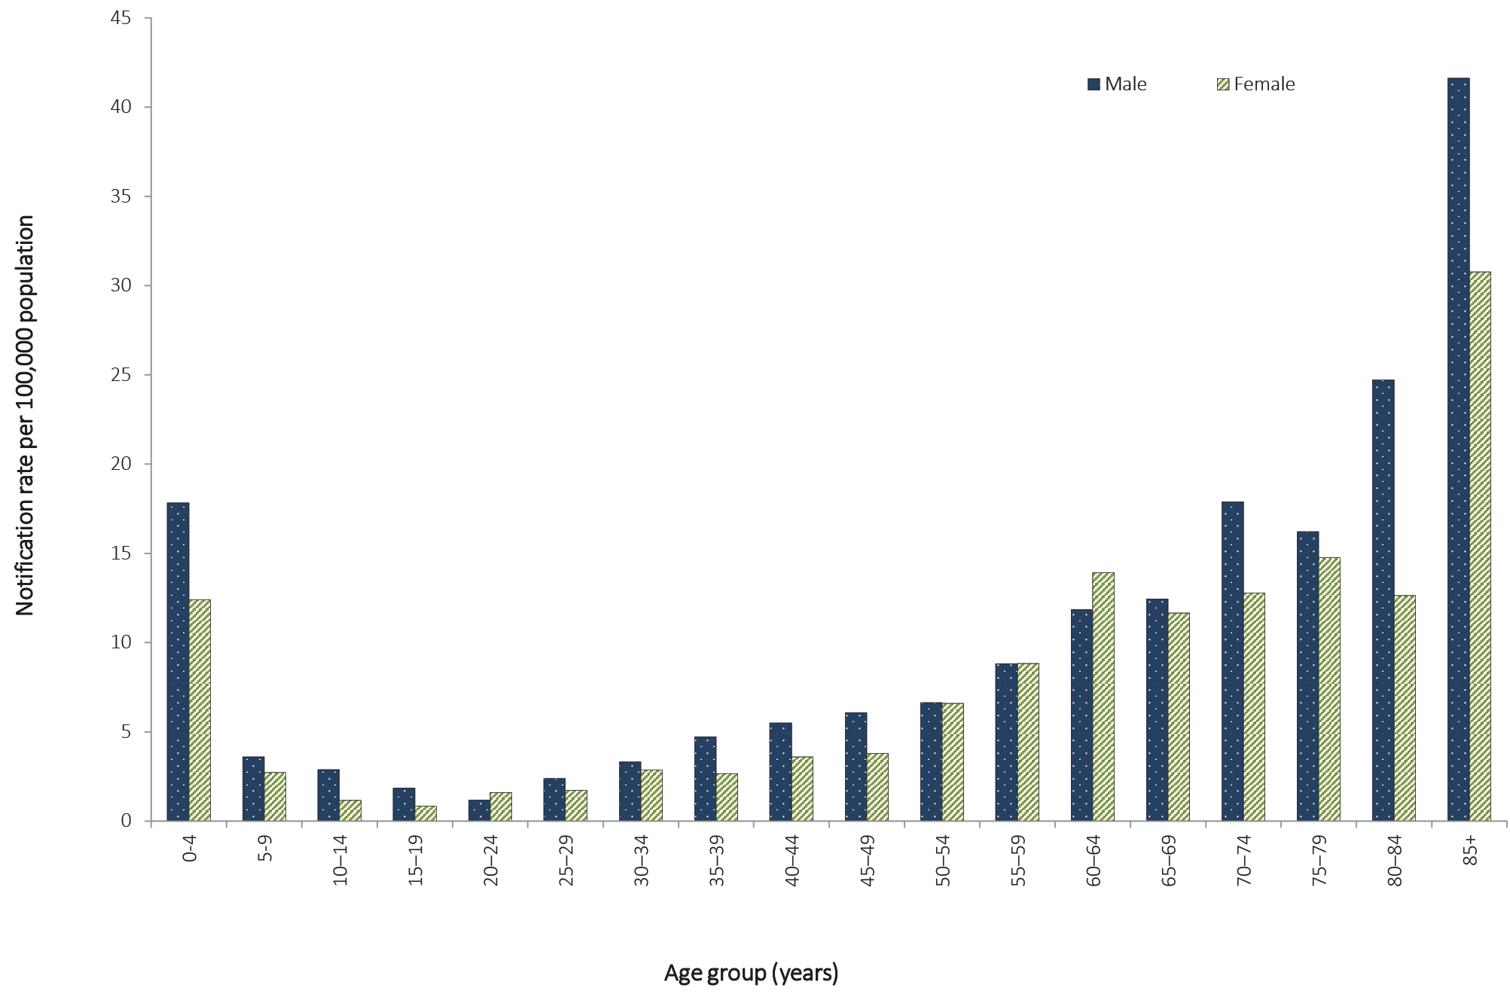

Figure 72: Age-standardised notification rates for invasive pneumococcal disease, Australia, 2007–2016, by Indigenous statusª
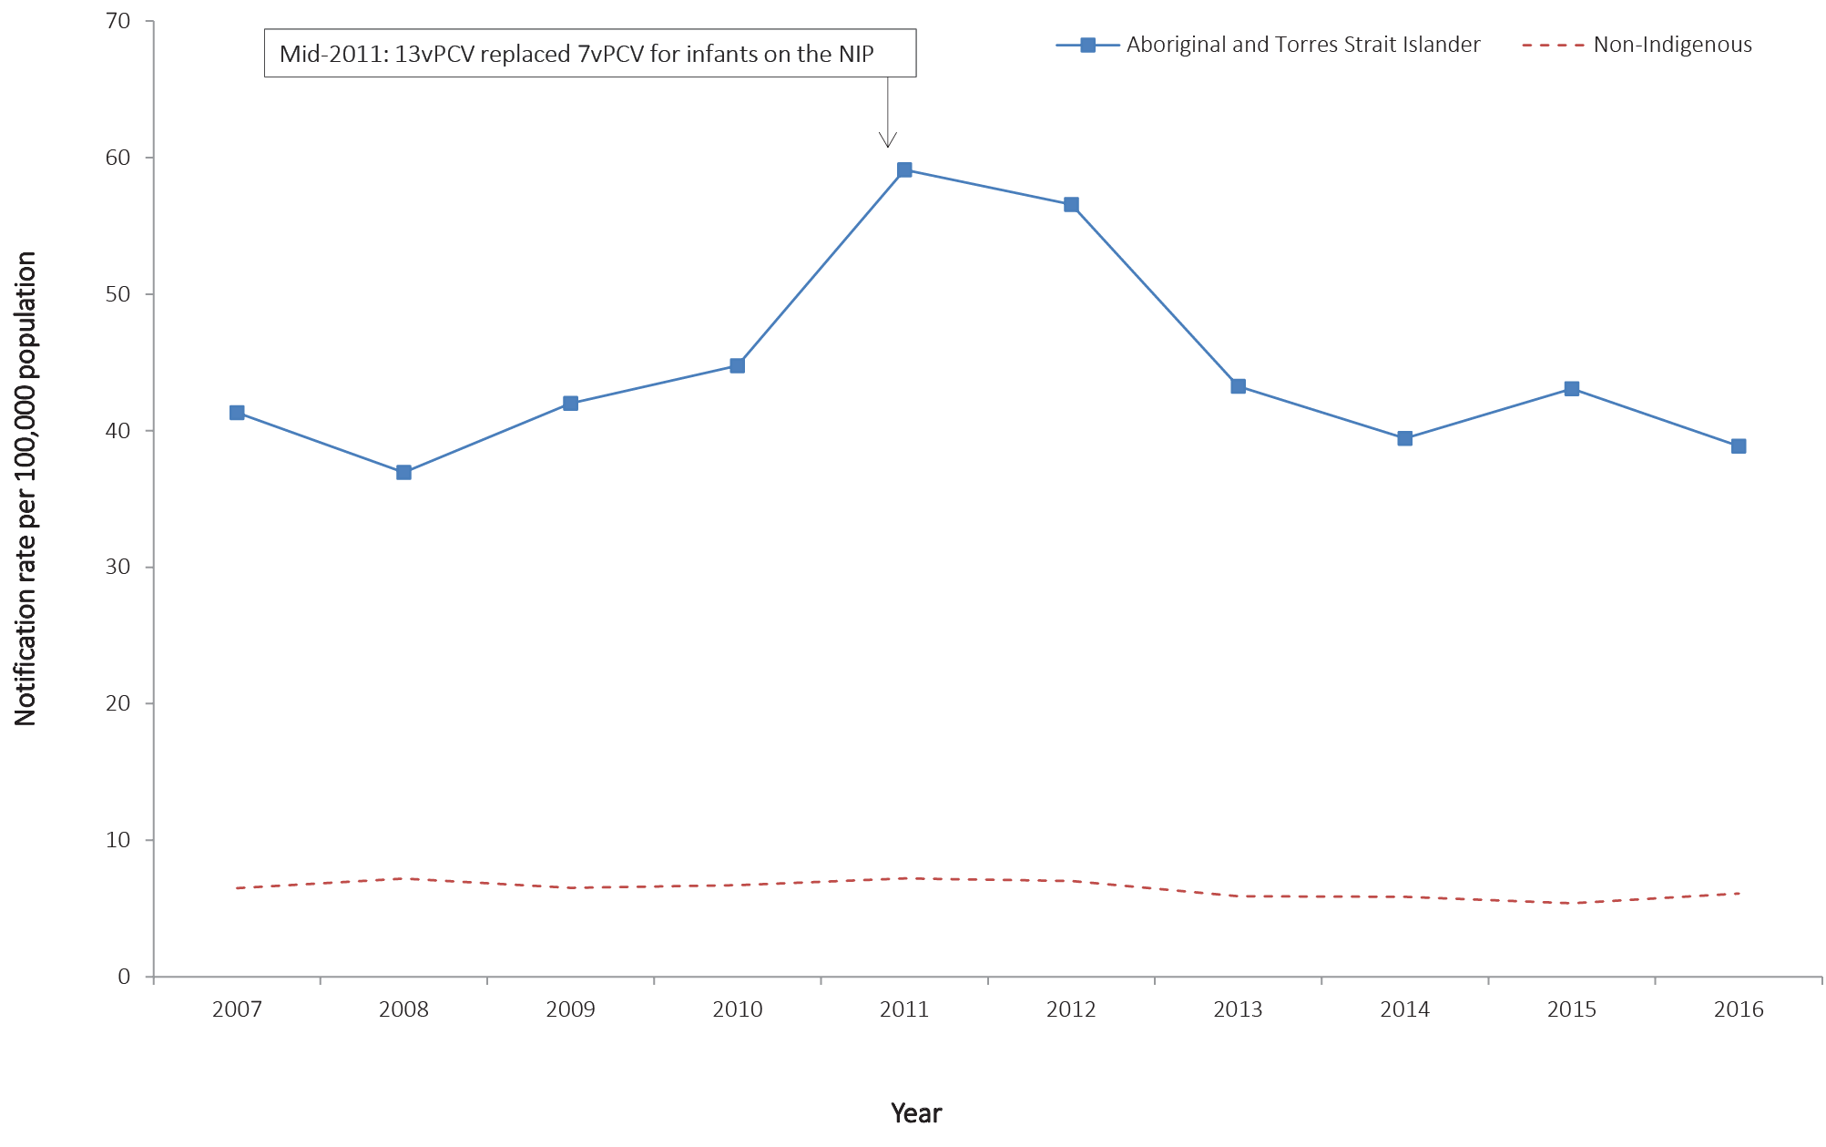
a Notifications where Indigenous status was not completed were included in the non-Indigenous count.

Seasonality
Many respiratory transmitted diseases, including IPD, are known to show a distinct seasonal trend, with incidence generally peaking during the winter months. In 2016, notifications of IPD peaked over the months of July and August (n = 222 and 233 respectively), consistent with the seasonal peak observed in previous years.

Indigenous status
In 2016, 91% of IPD cases (1,521/1,664) were reported with a known Indigenous status. Of those with known Indigenous status, 12% were Aboriginal and Torres Strait Islander (178/1,521). Consistent with 2015, the age-specific notification rates for the Aboriginal and Torres Strait Islander population were higher than for the non-Indigenous population in each age group. As Aboriginal and Torres Strait Islander and non-Indigenous populations differ in the age structure, age-standardised notification rates are reported to provide a more appropriate comparison of these two populations to a standard population, the Australian population at 30 June 2011. In 2016, the age-standardised notification rate in the Aboriginal and Torres Strait Islander population was approximately six times that of the non-Indigenous population. Between 2007 and 2011, the Aboriginal and Torres Strait Islander age-standardised notification rate increased from 41.3 per 100,000 population in 2007 to a peak of 59.1 in 2011, and overall has decreased to 38.9 per 100,000 population in 2016 after a slightly higher rate in 2015 (43.1 per 100,000 population). The non-Indigenous age-standardised notification rate increased between 2007 and 2011 (from 6.5 per 100,000 population to 7.2 per 100,000 population) and then decreased to 5.4 per 100,000 population in 2015 and increased to 6.1 per 100,000 population in 2016 (Figure 25). The declines observed since 2011 are likely due to the replacement, in mid-2011, of 7vPCV with 13vPCV as the pneumococcal vaccine offered to infants through the NIP.⁹⁹

Immunisation status
In 2016, funded 13vPCV was available for all infants at 2, 4, and 6 months, and a booster was funded for both medically at-risk children at 12 months, and Aboriginal and Torres Strait Islander children aged 12–18 months living in higher risk areas. Funded 23-valent pneumococcal polysaccharide vaccine (23vPPV) was available for medically at-risk people at 4 years of age; medically at-risk Aboriginal and Torres Strait Islander people aged 15 years and over; Aboriginal and Torres Strait Islander people aged 50 years and over; and all people aged 65 years and older.¹⁰⁰ More information on the scheduling of the pneumococcal immunisation can be found in the Australian Immunisation Handbook.⁶⁸
‘Fully vaccinated’ describes those individuals who have completed the primary course of the relevant vaccine(s) required for their age, according to the Australian Immunisation Handbook,⁶⁸ at least two weeks prior to disease onset, with at least 28 days between doses of vaccine. For up-to-date details on vaccination history, please see the IPD public dataset.¹⁰¹

Microbiological trends
Although there are more than 90 S. pneumonia serotypes, a relatively limited number cause the majority of IPD. However, the predominant serotypes vary by age group and geographic area. Monitoring the profile of S. pneumonia serotypes causing disease in the community is critical for evaluating the impact of the NIP-funded vaccines as well as for the early detection of emerging serotypes and serotype-specific outbreaks. The serotypes causing IPD were reported in 93% (n = 1,554) of notified cases in 2016 (Figure 73).

Figure 73: Notifications and rates of invasive pneumococcal disease, Australia, 2006 to 2016, by vaccine serotype group and year
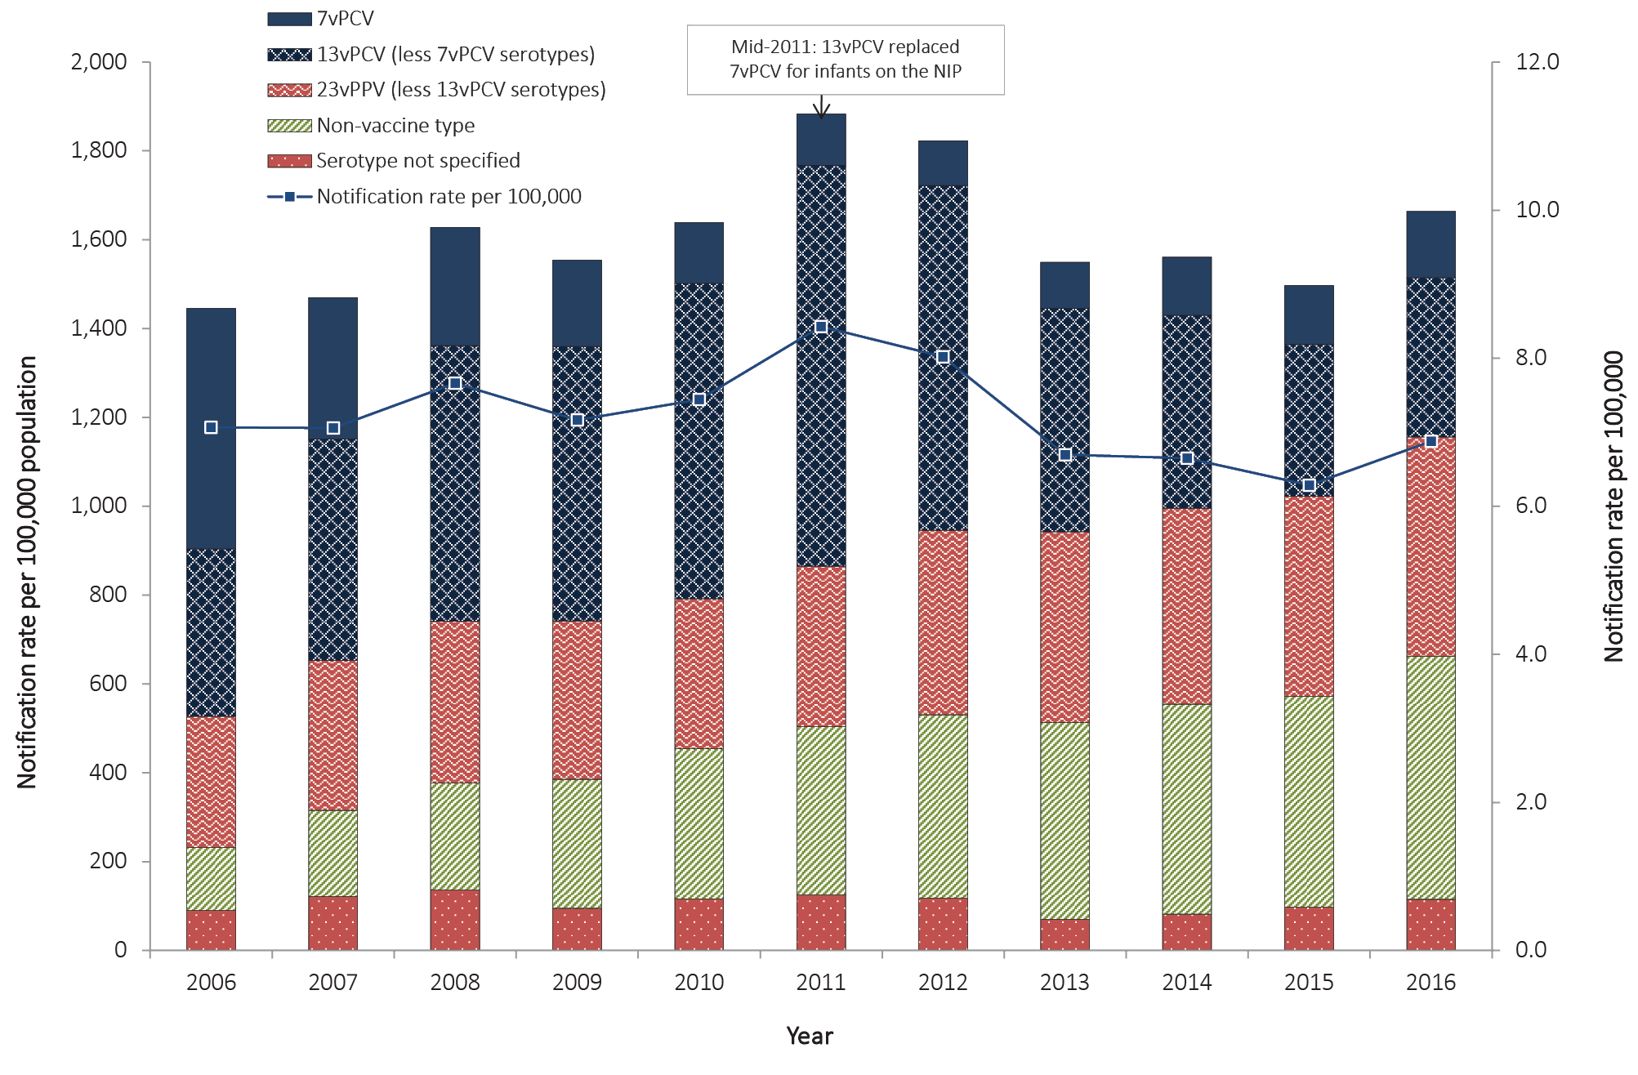
In 2016, 32% (n = 494) of all notifications with a known serotype were caused by a serotype included in the 23-valent pneumococcal polysaccharide vaccine (23vPPV) and 23% (n = 359) were those included in 13vPCV. Overall, since 13vPCV replaced 7vPCV in the childhood immunisation program in mid-2011, the proportion of IPD cases due to 13vPCV non-7vPCV disease has declined from 48% in 2011 to 22% in 2016. Across all ages, the most frequently-reported serotypes were 3 (12%; n = 182), 19A (8%; n = 119), 9N (7%; n = 116), 22F (7%; n = 113), 19F (6%; n = 98), and 23B (6%; n = 87). These six serotypes accounted for 51% (n = 797) of all notifications with serotype information. Three of these serotypes (3, 19A and 19F) are included in both 13vPCV and 23vPPV and two serotypes (9N and 22F) are only included in 23vPPV. Of the serotypes not covered by 13vPCV and 23vPPV (35%; n = 551), these were distributed across 30 other serotypes, with serotypes 23B (6%; n = 87), 23A (5%; n = 82), 15A (4%; n = 65) and 6C (4%; n = 62) the most common.
In 2016, there were 234 notifications of IPD reported in children less than five years of age, with IPD serotype information reported in 78% (n = 183) of these notifications. Thirty percent (n = 57) of notifications in children aged less than five years with a known serotype were a result of a serotype included in the 13vPCV. Since 13vPCV replaced 7vPCV in the childhood immunisation program in mid-2011, there has been a 69% decrease in the number of cases due to 13vPCV non-7vPCV disease in this age group (from n = 183 in 2011 to n = 57 in 2016).
There were 28 notifications of IPD in Aboriginal and Torres Strait Islander children aged less than five years in 2016, with a known serotype result reported for 23 (82%) of these cases. Four notifications were associated with serotypes included in 13vPCV. Serotypes 16F (10%; n = 3) and 23B (10%; n = 3) were the most frequent serotypes reported. Of those, neither serotype is included in 13vPCV. In non-Indigenous children less than five years of age, there were 204 notifications, with a known serotype result reported for 157 (77%) of these cases. Serotypes 3 (17%; n = 34), 19A (8%, n = 17) and 19F (7%; n = 15) were the most frequently-reported serotypes. Of those serotypes, all three are included in 13vPCV.
In Aboriginal and Torres Strait Islander adults aged 50 years and over, there were 71 notifications, with a known serotype result reported for 94% (n = 67) of these cases. The most common serotypes amongst this population group were serotypes 3 (10%; n = 7), 9N (9%, n = 6) and 16F (7%; n = 5). Serotypes 3 and 9N are both included in 23vPPV.
Among non-Indigenous adults aged 65 years and over, there were 580 notifications, with a known serotype reported for 97% (n = 564) of these cases. The most common serotypes amongst this population group were serotypes 3 (12%; n = 66), 22F (8%; n = 47) and 23A (8%, n = 46). Serotypes 3 and 22F are included in 23vPPV.
In 2016, 37% (n = 25) of notifications with a reported serotype in Aboriginal and Torres Strait Islander people 50 years and over, and 29% (n = 162) of notifications in non-Indigenous people 65 years and over, were a result of a serotype included in 23vPPV. The overall number of IPD notifications in these two population groups has remained relatively stable between 2006 and 2015. However, there has been a 20% increase in the proportion attributable to 23vPPV serotypes in the non-Indigenous population between 2015 and 2016 (from n = 135 to n = 162), while a 17% decrease has been reported in the Aboriginal and Torres Strait Islander population over the same time period (from n = 30 to n = 25). Much of this downward trend has been associated with the serotypes included in 13vPCV, of which 12 are also included in 23vPPV, and are likely to be a result of the herd immunity effect on these two population groups afforded by the immunisation of infants with 13vPCV.

Enhanced surveillance data sets
Enhanced data are available for IPD notifications. Further analyses, including risk factors and antibiotic susceptibilities, can be found in the annual and quarterly IPD surveillance report series published regularly in CDI.¹⁰² In addition, a subset of IPD notification data, including serotype, age, sex, Indigenous status, clinical categories and immunisation history, is publicly available in the NNDSS IPD public dataset.¹⁰¹

Poliomyelitis

- There were no notifications of polio in Australia in 2016.
- Australia, along with the Western Pacific Region, remains free of wild polio.
Poliomyelitis is an acute illness following gastrointestinal infection by one of the three types of poliovirus. Transmission occurs primarily person-to-person via the faecal-oral route. In most cases, poliovirus infection is not symptomatic. However, in less than 1% of cases, the virus may invade the nervous system and cause acute flaccid paralysis (AFP).²³

Epidemiological situation in 2016
In 2016, there were no cases of poliomyelitis reported in Australia. Australia, along with the Western Pacific Region, remains free of wild polio.
Poliovirus infection, both paralytic (poliomyelitis) and non-paralytic, is a notifiable disease in Australia. Clinical and laboratory investigation is conducted for cases involving patients of any age with a clinical suspicion of poliomyelitis, following the WHO protocol which focuses on investigating cases of AFP in children less than 15 years of age. The WHO target for AFP surveillance in a polio-free country is one case of AFP per 100,000 population of children less than 15 years of age.¹⁰³ Australia has achieved this surveillance target since 2008. However, the virological surveillance indicator of adequate stool specimen collection in 80% of AFP cases has never been met. More details can be found in the annual report series published in CDI by the Australian Enterovirus Reference Laboratory, which coordinates poliovirus surveillance activities in Australia.¹⁰⁴
Globally, strong progress continues to be made towards objectives of the Polio Eradication and Endgame Strategic Plan 2013–2018.¹⁰⁵ In 2016, fewer children were paralysed by polio than in any prior year. In 2016, there were only 37 cases of wild-poliovirus-caused polio reported from three countries: Afghanistan (13), Nigeria (4) and Pakistan (20). All were wild poliovirus type 1.¹⁰⁶ On 20 September 2015, the Global Commission for the Certification of Poliomyelitis Eradication declared that wild poliovirus type 2 has been eradicated.¹⁰⁷ In October 2015, the Strategic Advisory Group of Experts on immunization recommended all countries still using trivalent oral polio vaccine (OPV) switch to a bivalent OPV. The committee encouraged countries to undertake the switch during the global synchronized withdrawal of the type 2 component of OPV, which was successfully completed by mid-May 2016.¹⁰⁸

Rubella and congenital rubella
- Rubella remains rare in Australia.
- Since 2003, the rubella notification rates have been less than 0.3 per 100,000 population.
- There were 17 cases of rubella notified in 2016.
- There were no cases of congenital rubella syndrome in 2016.
Rubella is generally a mild and self-limiting infectious disease caused by a rubella virus. It is spread from person-to-person through contact with respiratory secretions, including aerosol transmission. A rash, usually starting on the face before spreading across the body, may appear around two weeks after exposure to the virus and usually lasts for three days. Children usually show few or no constitutional symptoms of infection, but adults may experience one to five days of early low grade symptoms, such as fever, malaise, headaches and mild head colds.²³ Clinically, rubella can be difficult to distinguish from other diseases which also cause febrile rash, such as measles, and is asymptomatic in up to 50% of cases.
Rubella infection in the first trimester of pregnancy can result in miscarriages, fetal deaths/stillbirths, and a collection of birth defects known as congenital rubella syndrome (CRS) in over 90% of cases. CRS can result in single or combined defects such as hearing impairment, eye abnormalities (including retinopathy, cataract and microphthalmia) congenital glaucoma, microcephaly, meningoencephalitis, development delay, purpura, jaundice, radiolucent bone disease and congenital heart disease.^{23,109}

Epidemiological situation in 2016
In 2016, there were 17 cases of rubella reported, representing a rate of 0.1 per 100,000 population, which is the same number and rate reported in 2015 (n = 17; rate 0.1 per 100,000 population). Low rates of rubella have been reported since 2003, in a marked decline from the peak rate of more than 30.7 per 100,000 population in 1995 (Figure 74).

Figure 74: Notification rate for rubella, Australia, 1993 to 2016, by year
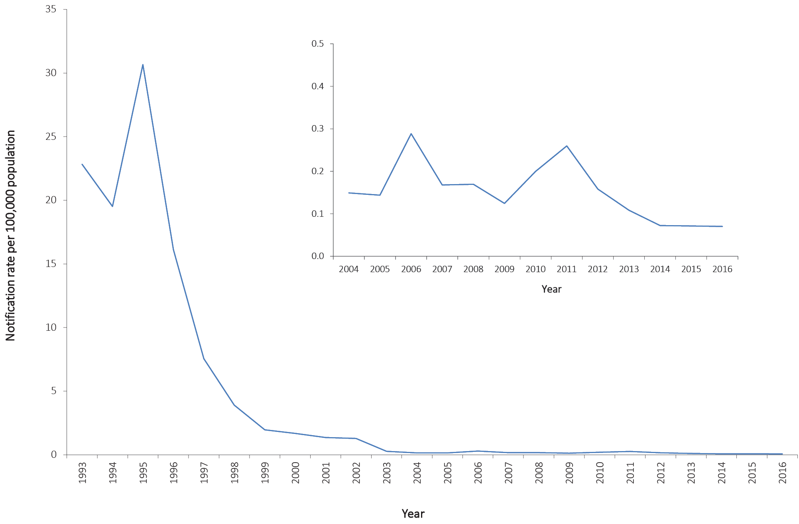

Age and sex distribution
Of the 17 cases of rubella reported in 2016, nine cases were female and eight were male. Of the nine female cases, seven (78%) were of child-bearing age (15–44 years of age) (Figure 75). The median age of cases was 31 years, with a range of 16–75 years. Consistent with previous years, the majority of cases (88%; 15/17) occurred among adults aged 20 years and older (Figure 75), and age-specific rates remained below 0.6 per 100,000 population across all age groups (Figure 76).
There were no cases of CRS reported in 2016.

Figure 75: Notifications of rubella, Australia, 2016, by age group and sex
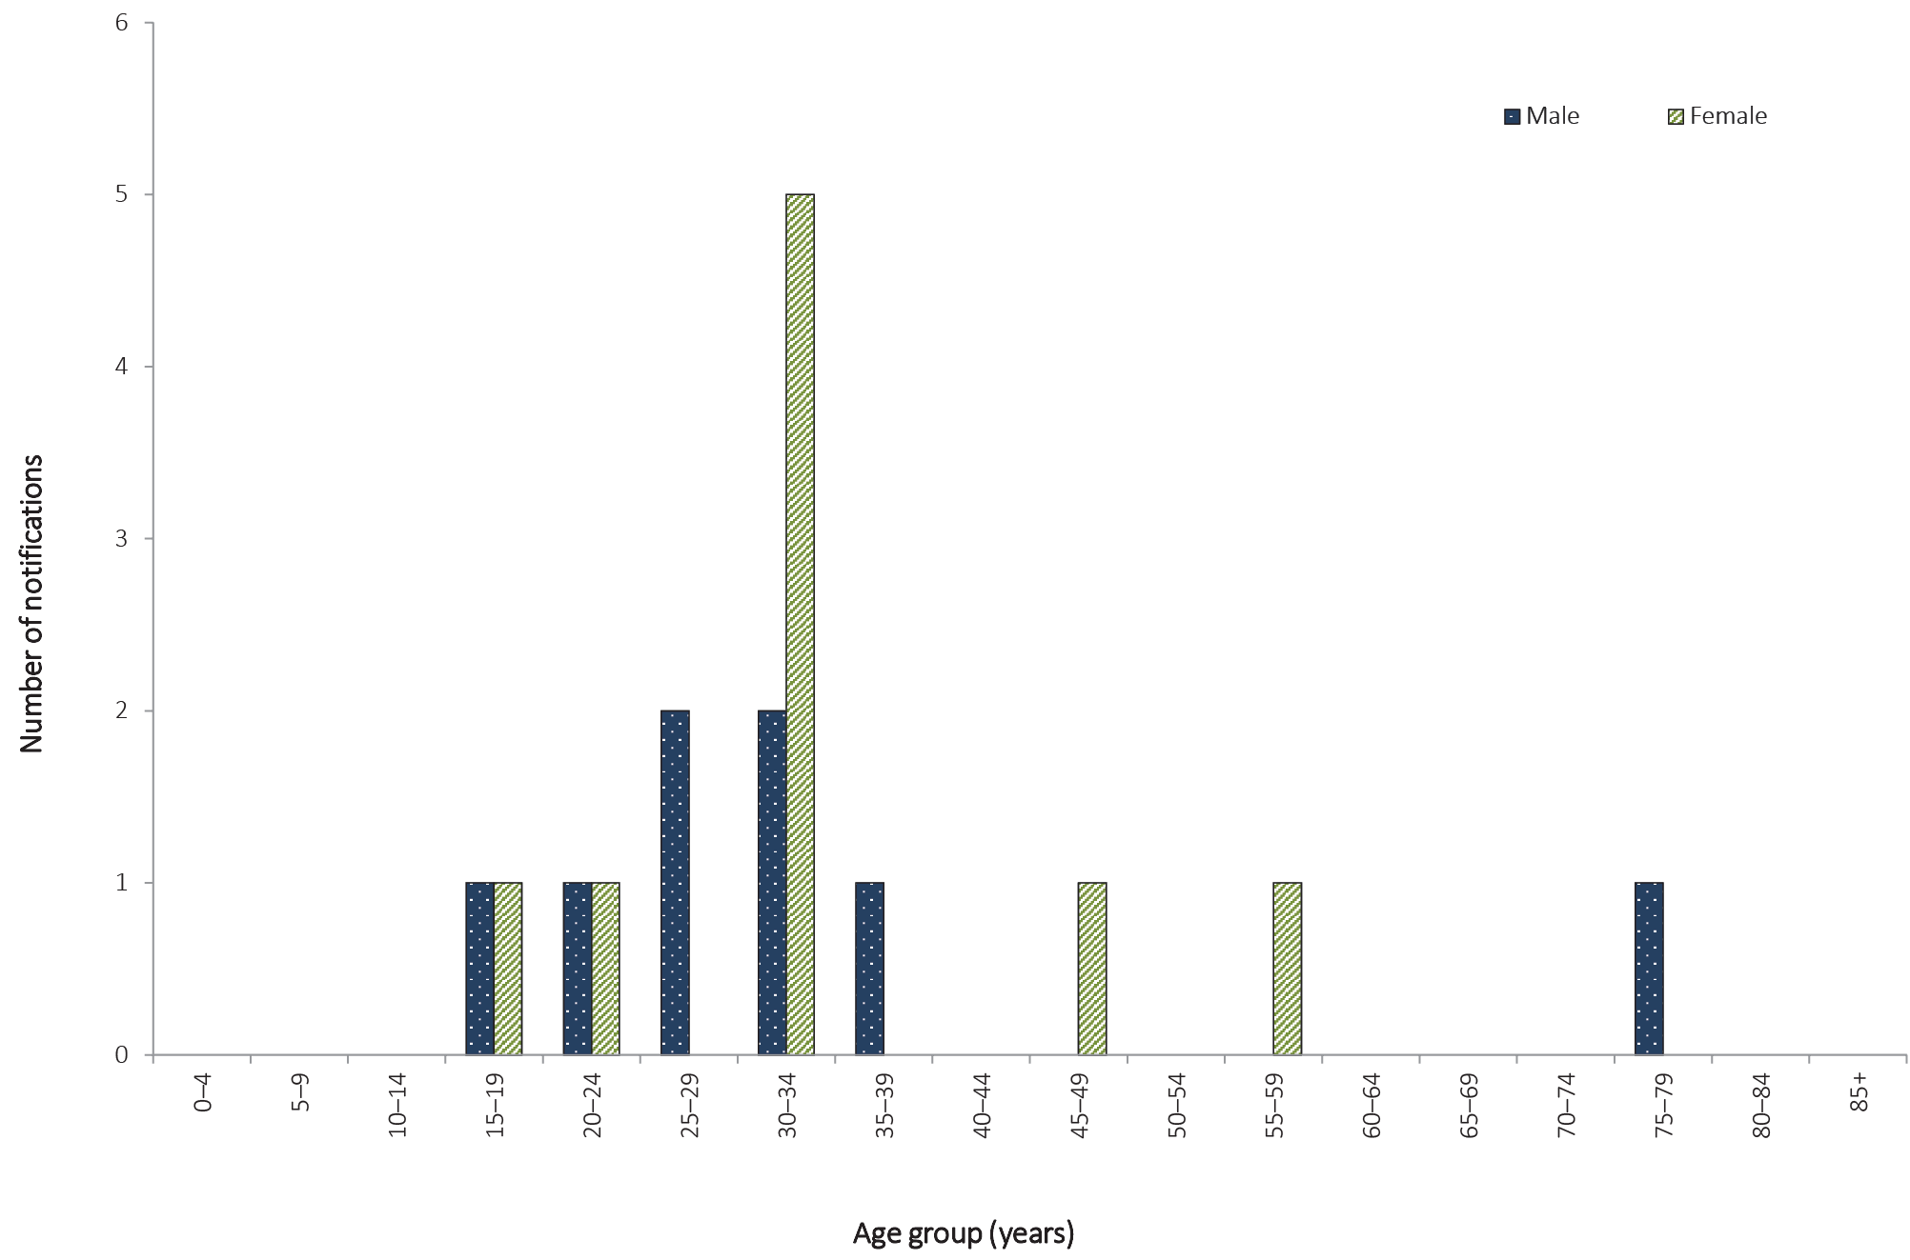

Figure 76: Notification rates for rubella, Australia, 2011 to 2016, by year and selected age groups
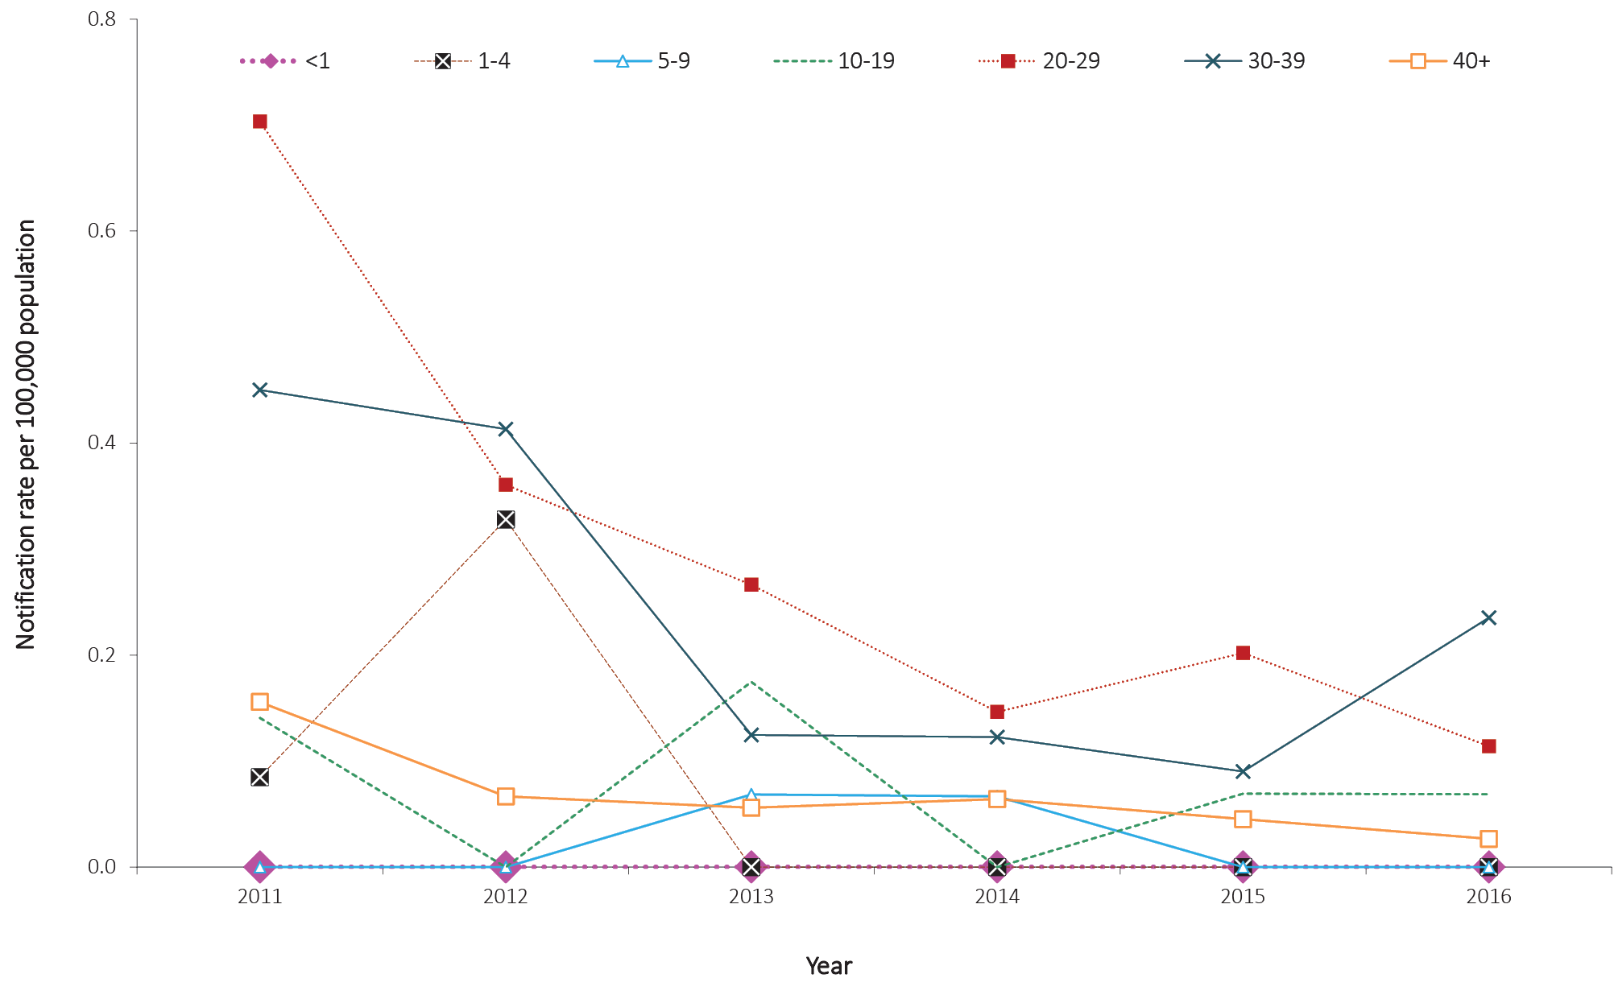

Immunisation status
Rubella vaccine is provided in the combined MMR or MMRV vaccine. In 2016, rubella vaccines were provided under the NIP schedule for children at 12 and 18 months of age.⁹²
Of the 17 cases notified in 2016, seven were reported as unvaccinated and the remaining 10 were of unknown immunisations status.
The primary aim of immunisation against rubella is to prevent cases of CRS.¹¹⁰ Two doses of a rubella-containing vaccine are recommended for all non-immune persons born during or since 1966 and who are greater than 18 months of age.

Discussion
Evidence suggests that endemic rubella is well controlled in Australia. A marked decline in rubella notifications since 2002 has seen notification rates in Australia remain below the WHO goal of 1.0 per 100,000 population which is indicative of rubella control.¹¹¹ The increasing trend in age of cases likely reflects the declining rates of rubella among children since routine MMR immunisation was implemented and the subsequent achievement of high two-dose coverage. Males—who are historically more susceptible, as universal immunisation was not introduced until 1989—no longer appear to be at greater risk of infection compared with females.
CRS is rare in Australia and in recent years has mainly occurred among infants of women who were born overseas.¹¹²

Tetanus

- Cases of tetanus are not common in Australia.
- There were seven cases of tetanus notified and one death reported in 2016.
Tetanus is an acute, often fatal, disease caused by the toxin produced by the bacterium Clostridium tetani. Spores of C. tetani usually enter the body through contamination of a wound with manured soil.²³ The neurotoxin acts on the central nervous system to cause muscle rigidity with painful spasms. Generalised tetanus, the most common form of the disease, is characterised by increased muscle tone and generalised spasms. The disease usually occurs after an incubation period of three to 21 days (ranging from one day to several months), with a median time of onset at 10 days post injury. In Australia, tetanus is rare occurring primarily in older adults who have never been vaccinated or have not received a booster dose in the past 10 years. A high level of diagnostic awareness of tetanus is important in the elderly, as most deaths occur in people over 70 years of age, especially females, and may be associated with an apparent minor injury.¹¹³

Epidemiological situation in 2016
In 2016, there were seven notifications of tetanus (Figure 77). Whilst the number of notifications of tetanus remains low in Australia, the seven notifications in 2016 represent an 84% increase on the historical five-year mean (n = 3.8).
In 2016, four notifications of tetanus were in males, of whom three were 15–24 years of age and one was 85 years and older. For females, there were three notifications, of whom two were 40–49 years and one was 75–79 years of age. There was one death due to tetanus reported in 2016.

Figure 77: Notifications of tetanus, Australia, 2005 to 2016, by year and state or territory
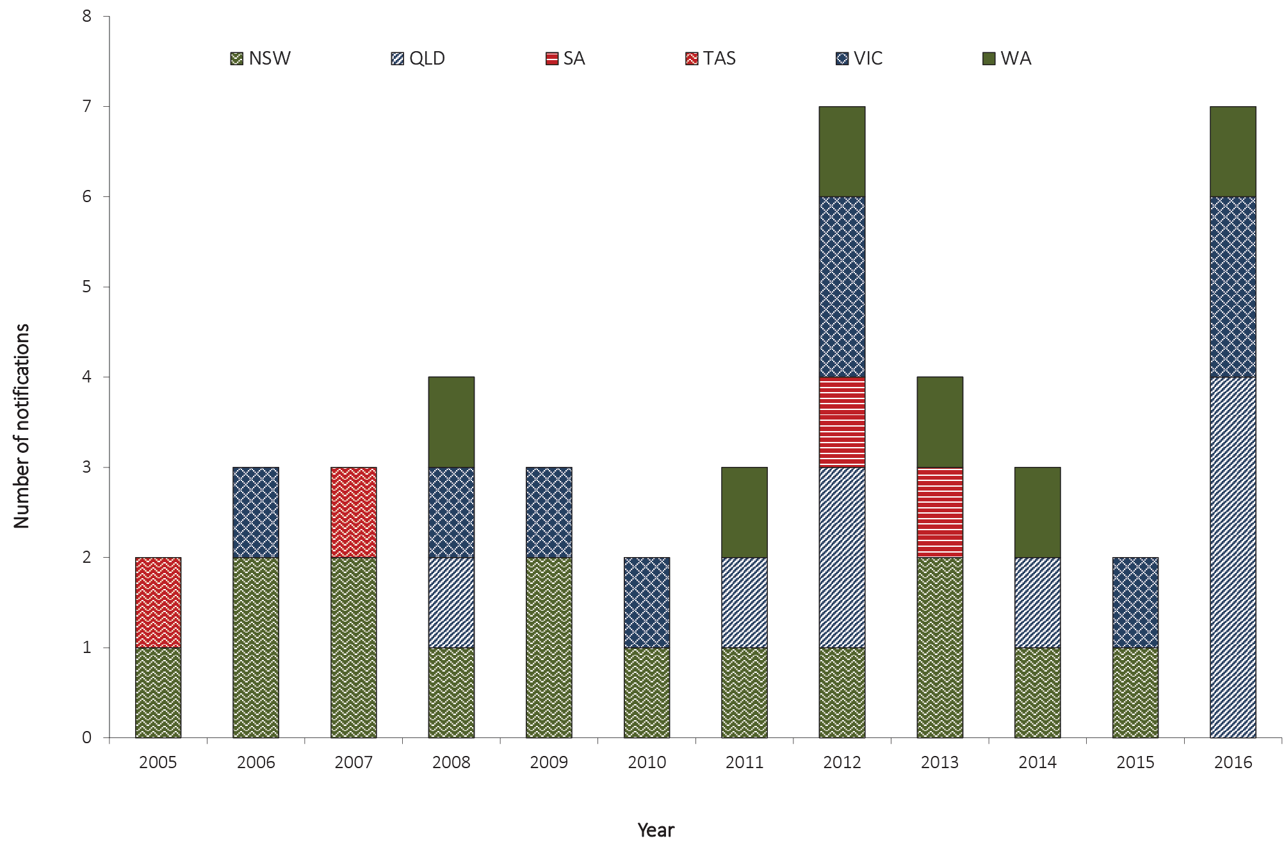

Immunisation status
The NIP schedule in 2016 recommended a primary course of tetanus immunisation including three doses provided at two, four, and six months of age; tetanus vaccination is normally given as a combined vaccine with diphtheria and pertussis. Three booster doses are provided at 18 months, four years and between 11 and 13 years. Booster doses are additionally recommended for all adults at the age of 50 years and at 65 years of age if it is more than 10 years since the last dose.⁶⁸ In March 2016, the booster dose at 18 months was funded through the NIP.¹¹⁴
Of the seven tetanus notifications in 2016, one case was vaccinated, three were partially vaccinated (less than the five recommended doses) and three cases were of unknown vaccination status.
Complete immunisation induces protection which lasts throughout childhood but by middle age 50% of vaccine recipients have low or undetectable levels of antibodies. Tetanus is, however, uncommon in people who have received four or more doses of a tetanus-containing vaccine, and in those who received their last dose within 10 years.⁶⁸

Varicella zoster virus

- There were 21,208 cases of varicella zoster infection (comprising chickenpox, shingles, and unspecified) notified in 2016.
- Of these, 2,429 (12%) were chickenpox, 2,994 (14%) were shingles, and 15,734 (74%) were unspecified varicella zoster virus infection.
The varicella zoster virus (VZV) is a highly contagious member of the herpes virus family and causes two distinct illnesses: chickenpox as the primary infection; and shingles (herpes zoster), which occurs following reactivation, often many years later, of latent virus in approximately 20% to 30% of all chickenpox cases. Shingles occurs more frequently among older adults (most commonly after 50 years of age) and in immunocompromised people.²³
In 2006, the CDNA agreed three categories of VZV infection were nationally notifiable: ‘chickenpox’, ‘shingles’ and ‘varicella zoster virus unspecified’. By 2009, all jurisdictions were notifying VZV infections to the NNDSS against these three categories, except New South Wales, where VZV is not a notifiable disease.
The ability to categorise a VZV infection as chickenpox or shingles depends on follow-up to determine the clinical presentation of the case. The majority of VZV infections are reported as unspecified as follow-up does not occur (Table 5). Notification rates for chickenpox, shingles, and unspecified VZV, including any comparisons made between jurisdictions and age groups, should be interpreted with caution as they are affected by the varying levels of follow-up undertaken in each jurisdiction.

Epidemiological situation in 2016
In 2016, there were 21,208 VZV notifications from the seven reporting jurisdictions. This was 5% fewer than the total number of notifications reported in 2015 (n = 22,379). Of the total VZV notifications in 2016, 74% (n = 15,734) were reported as unspecified VZV infection; 14% (n = 2,994) as shingles; and 12% (n = 2,429) as chickenpox (Figure 78).

Figure 78: Notifications of varicella zoster virus infection, 2016, Australia,ª by age group^{b}
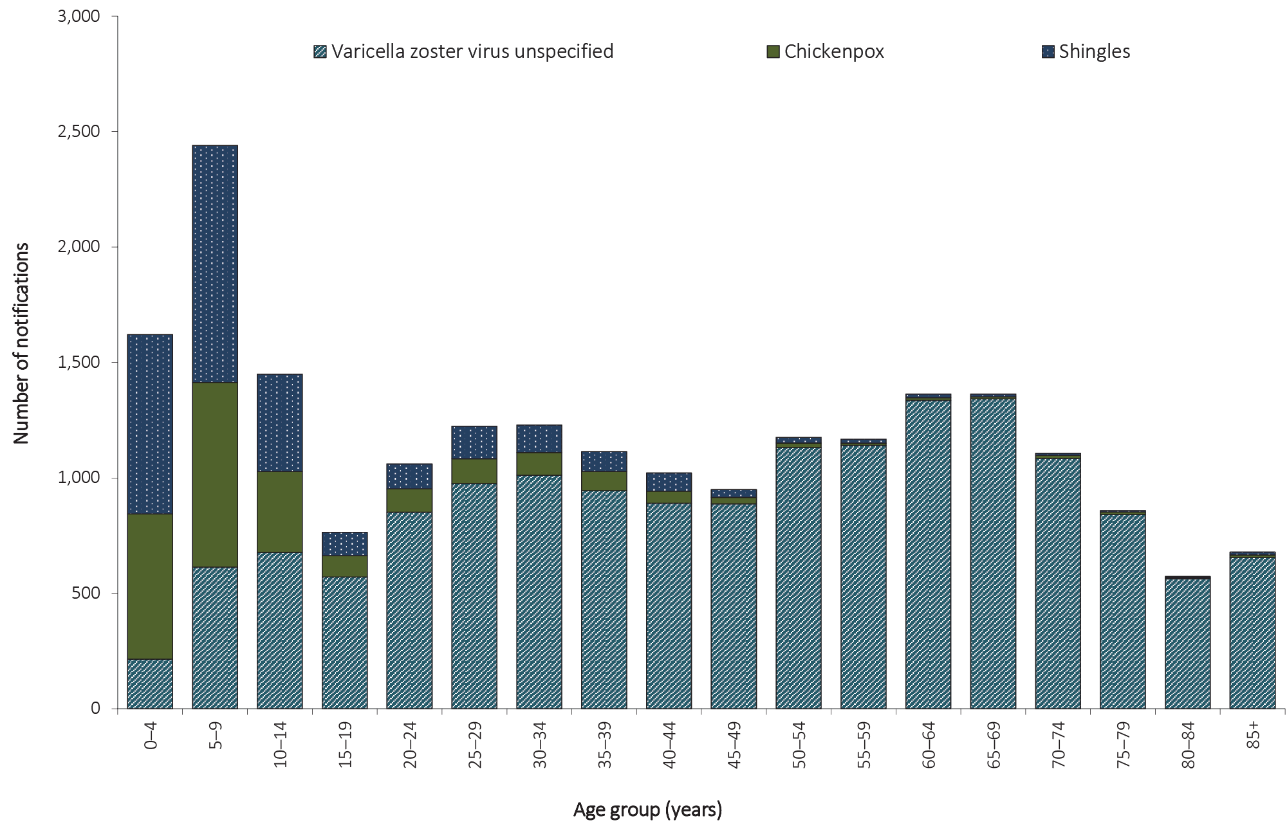
a Excludes New South Wales.

b Age of onset missing for 51 notifications.

Varicella zoster virus (unspecified)

- There were 15,734 cases of VZV (unspecified) notified in 2016, which is a 16% increase compared with 2015.
- Females accounted for 55% of all VZV (unspecified) notifications in 2016.

Epidemiological situation in 2016
In 2016, there were 15,734 cases of VZV unspecified infections reported, representing a notification rate of 95.6 per 100,000 population, and a 16% increase in notifications compared with 2015 (n = 13,563). The highest notification rate for VZV unspecified was reported in Queensland (152.6 per 100,000 population) and the lowest notification rate was in the Northern Territory (2.0 per 100,000 population) (Table 5).

Age and sex distribution
In 2016, the majority of VZV unspecified cases were reported in females (55%, n = 8,574). Overall, the notification rate was higher in females (103.4 per 100,000 population) than males (87.4 per 100,000 population), a trend reflected across all ages except those under 10 years, 15–19 years and adults 85 years or more (Figure 79). The highest age-specific rates for females occurred in the 75–79 years age group (203.6 per 100,000 population) and for males in the 85 years or over age group (218.8 per 100,000 population).
Figure 79: Notification rate for varicella zoster virus unspecified, Australia,ª 2016, by age group and sex^{b}
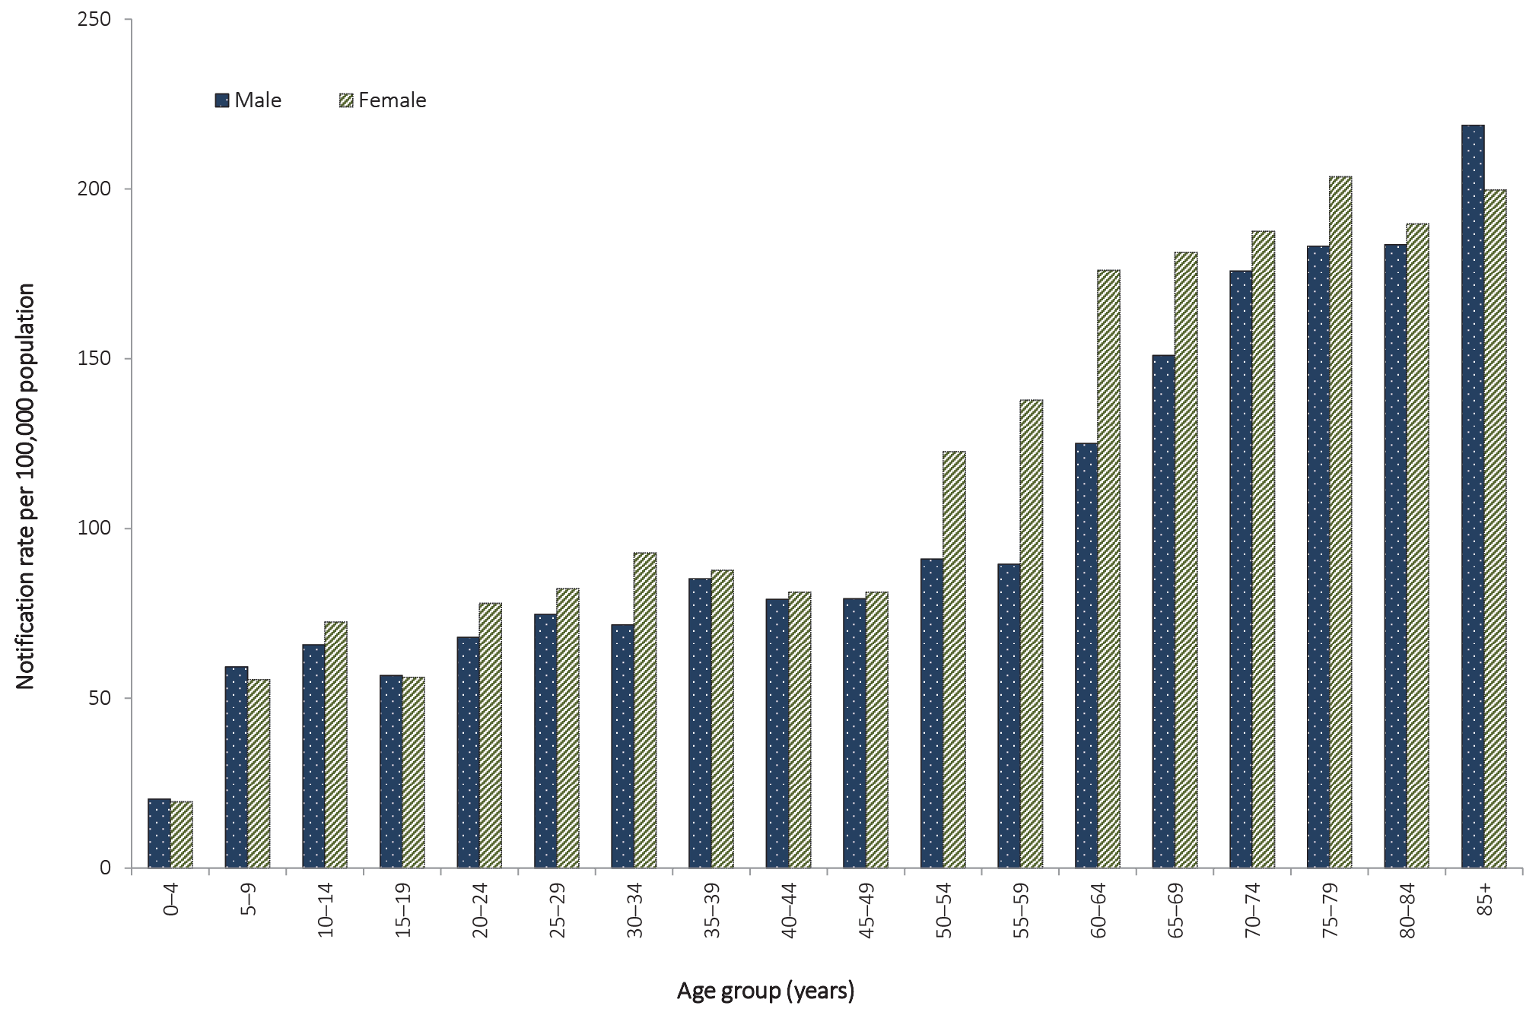
a Excludes New South Wales.
b Age of onset and sex missing for 17 notifications.

Chickenpox

- There were 2,995 cases of chickenpox notified in 2016, a 21% increase from 2015 (n = 2,475).
- Children less than 15 years of age accounted for 74% of notifications, and the highest notification rate was reported in children 5–9 years of age (96.0 per 100,000 population).
Chickenpox is a highly contagious infection spread by respiratory secretions, including aerosol transmission, or from the vesicle fluid of skin lesions from a patient with chickenpox or shingles infection. Chickenpox is usually a mild disease of childhood. However, complications occur in approximately 1% of cases. It is more severe in adults, and in persons of any age who are immunocompromised.⁶⁸

Epidemiological situation in 2016
In 2016, there were 2,995 notifications of chickenpox, which is a 21% increase in the number of notifications in 2015 (n = 2,475). The notification rate of chickenpox in 2016 was 18.2 per 100,000 population, which is a 32% increase on the historical five-year mean, 2011 to 2015 (13.7 per 100,000 population). The highest notification rate of chickenpox was in the Northern Territory (52.1 per 100,000 population), followed by the Australian Capital Territory (24.8 per 100,000 population); Western Australia (24.0 per 100,000 population); South Australia (23.4 per 100,000 population); Victoria (21.2 per 100,000 population); Tasmania (13.5 per 100,000 population); and Queensland (7.8 per 100,000 population). Chickenpox is not notifiable in New South Wales.

Age and sex distribution
In 2016, 52% (n = 1,562) of notified cases were male, and 74% (n = 2,224) occurred in children less than 15 years of age. Children under the age of 15 years had the highest notification rates in 2016. Rates were highest in the 5–9 years age group (96.0 per 100,000 population) (Figure 80). Compared to 2015, all age-group-specific rates increased, except for infants less than one year of age. The largest increase occurred in children 5–9 years, from 45.1 per 100,000 population in 2015 to 56.0 per 100,000 population in 2016 (Figure 81).

Figure 80: Notification rate of chickenpox, Australia,ª 2016, by age group and sex^{b}
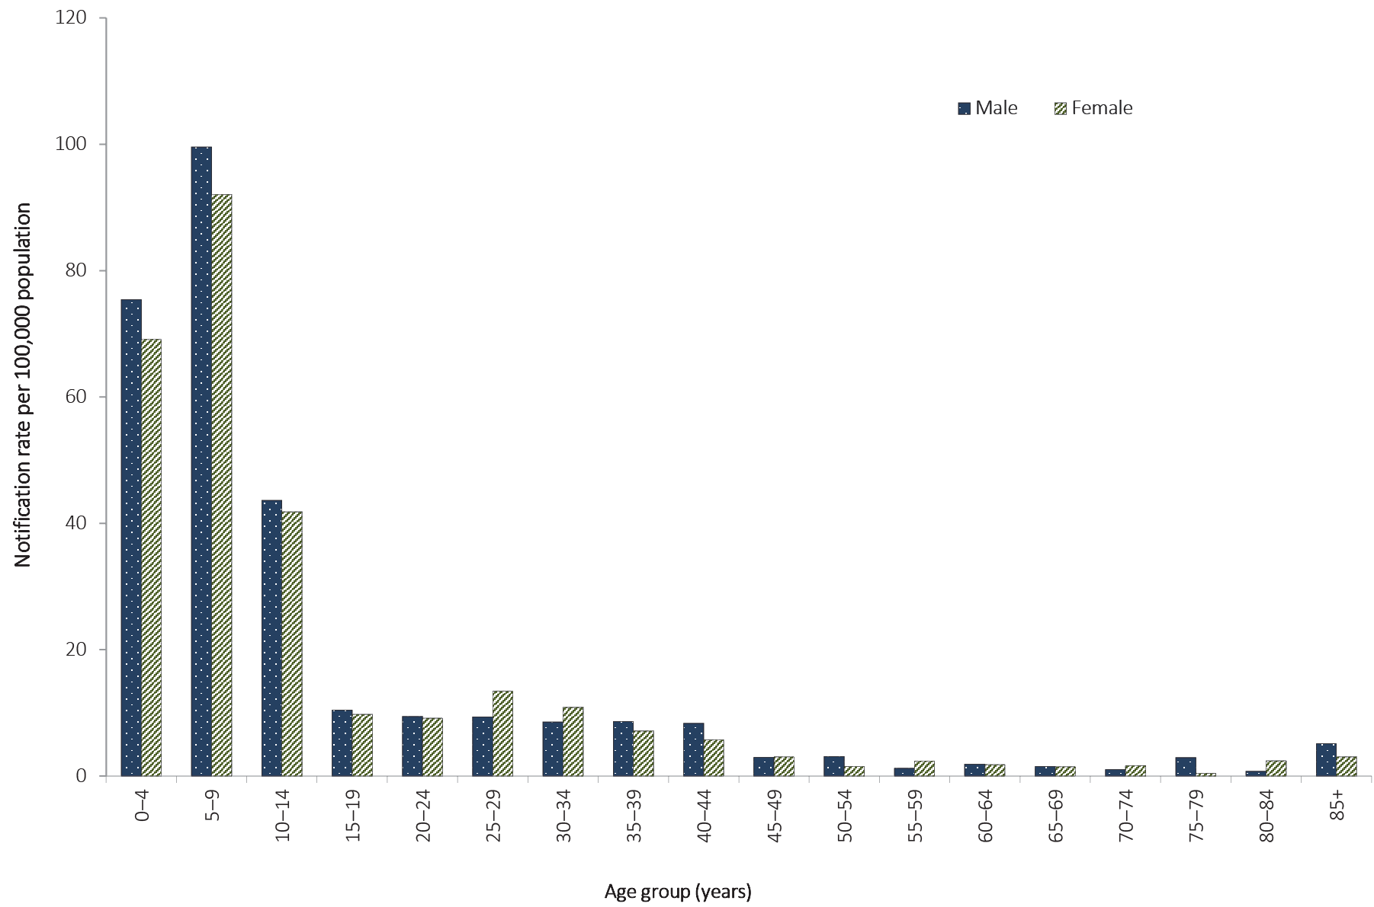
a Excludes New South Wales.
b Age of onset missing for one case and sex missing for six notifications.

Figure 81: Notification rate of chickenpox, Australia,ª 2011 to 2016, by year and selected age groups^{b}
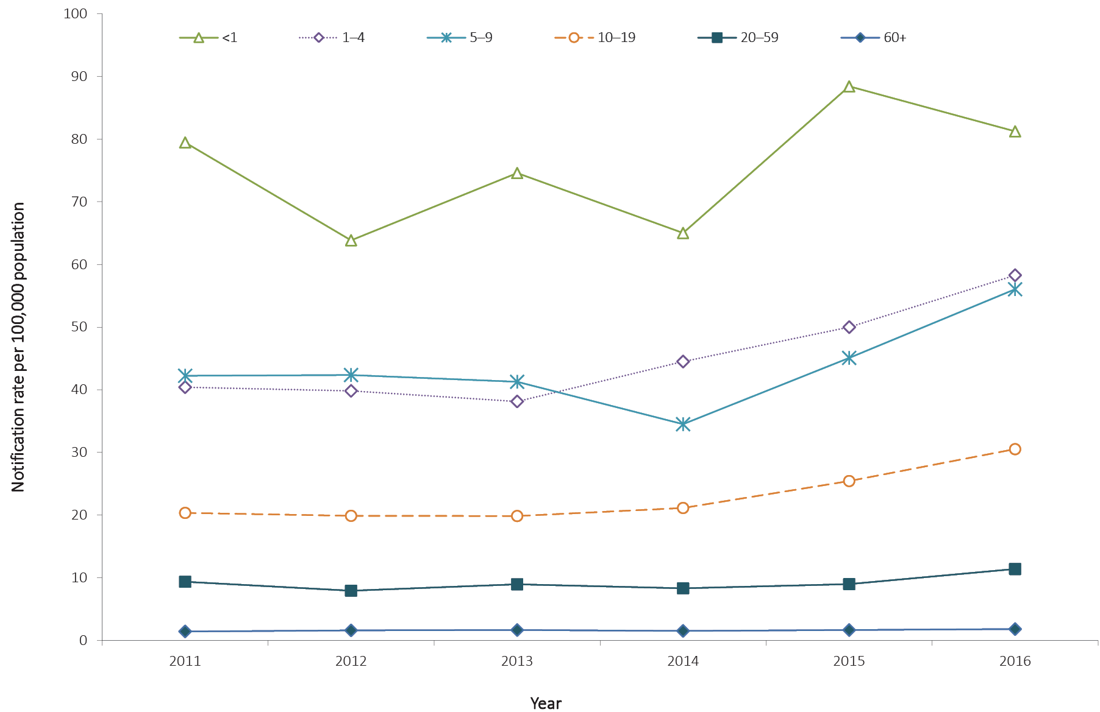
a Excludes New South Wales.
b Age of onset missing for 11 notifications in 2011; for 21 notifications in 2012; for 38 notifications in 2013; for 54 notifications in 2014; for 52 notifications in 2015; and for 37 notifications in 2016.

Immunisation
Routine use of a varicella-containing vaccine (MMRV) in children was first recommended in Australia in 2003. In November 2005, the vaccine was funded under the NIP for all children at 18 months of age, with a school-based catch-up program included for children 10 to 13 years of age with no history of disease or previous immunisation.¹¹⁵
In 2016, the oldest cohort of children eligible for varicella immunisation at 18 months of age would now be 12 years of age. Of those eligible for immunisation (n = 2,031), 37% were vaccinated (774/2,031), 11% were unvaccinated (222/2,031) and the remaining 52% (1,065/2,031) were of unknown immunisation status.

Shingles

- There were 7,398 cases of shingles notified in 2016, a 17% increase on 2015 (n = 6,341).
- Notification rates continue to increase with age, with those aged 80 years or more reporting the highest rates of shingles in 2016.
Shingles occurs most commonly with increasing age, impaired immunity, and a history of chickenpox in the first year of life. Reactivation of VZV that causes shingles is thought to be due to a decline in cellular immunity to the virus. Shingles typically presents as a unilateral vesicular rash localised in a dermatomal distribution. Associated symptoms may include headache, photophobia, malaise, itching, tingling, or severe pain in the affected dermatome. In the majority of patients, shingles is an acute and self-limiting disease; however, complications develop in approximately 30% of cases, the most common of which is chronic severe neuropathic pain or post-herpetic neuralgia.^{23,68}
A single dose of zoster vaccine is recommended for adults aged 60 years and over who have not previously received a dose of zoster vaccine.⁶⁸ In 2016, a funded single dose of zoster vaccine at 70 years of age, and a five-year funded national catch-up plan for adults aged 71 to 79 years, commenced through the NIP.¹¹⁶

Epidemiological situation in 2016
In 2016, there were 7,398 cases of shingles reported representing a notification rate of 45.0 per 100,000 population, which is a 17% increase compared with 2015 (n = 6,341). The highest rate of shingles occurred in the Northern Territory (149.0 per 100,000 population) and in South Australia (133.6 per 100,000 population) (Table 5). The high rates in these jurisdictions most likely reflect their higher levels of case ascertainment compared with other jurisdictions.

Age and sex distribution
In 2016, 55% (n = 4,098) of notified shingles cases were female. As expected, the notification rate increased with age, with the highest rates occurring in the 80 years and over in 2016 (Figure 82). Between 2011 and 2016, notification rates of shingles have increased in all age groups 10 years or older (Figure 83). Those in the 20–59 years age group reported the greatest increase (89%; from 21.9 per 100,000 population in 2011 to 40.9 per 100,000 population in 2016) while notification rates of shingles in children less than 10 years of age have decreased by 35% (from 13.7 per 100,000 population in 2011 to 8.9 per 100,000 population in 2016) (Figure 83).

Figure 82: Notification rate for shingles, Australia,ª 2016, by age group and sex^{b}
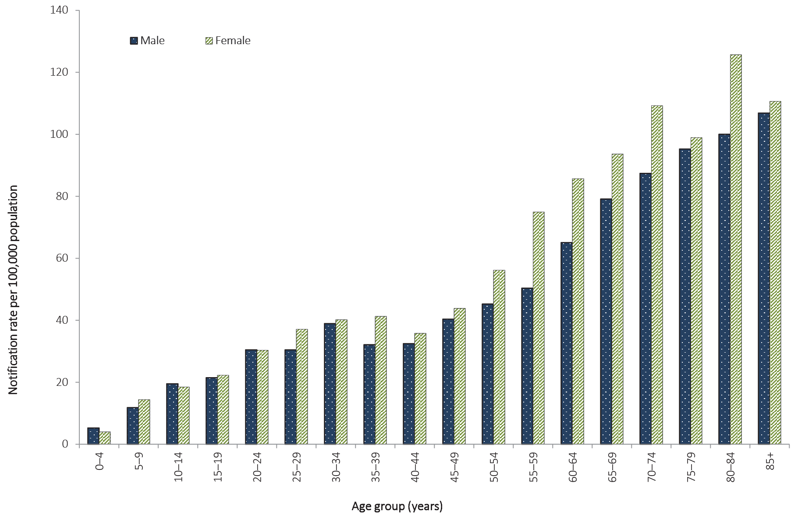
a Excluding New South Wales.
b Age of onset missing for 60 notifications and sex missing for 7 notifications.

Figure 83: Notification rate for shingles, Australia,ª 2011 to 2016, by year and selected age groups^{b}

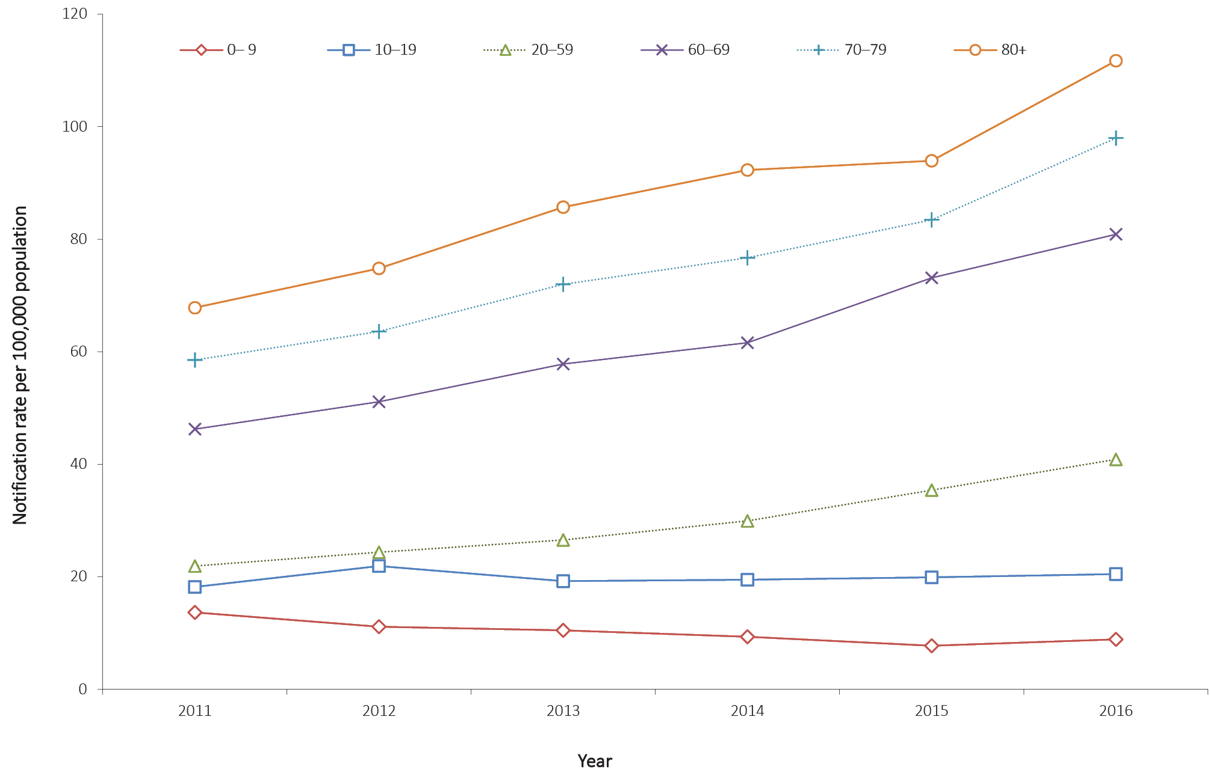

a Excludes New South Wales.
b Age of onset missing for 18 notifications in 2011, 23 notifications in 2012, 56 notifications in each of 2013 and 2014, 44 notifications in 2015 and 60 notifications in 2016.

Vectorborne diseases
Vectorborne diseases are infections transmitted by arthropods such as mosquitoes and ticks. A vectorborne disease may involve a simple transfer via the arthropod, or may involve replication of the disease-causing organism in the vector.²³ Vectorborne diseases of public health importance in Australia listed in this chapter are: Barmah Forest virus (BFV), Chikungunya virus (CHIKV), dengue virus (DENV) infection; Flavivirus unspecified, which includes Zika Virus infection (ZIKV); Japanese encephalitis virus (JEV) infection; infections with the Kunjin lineage of West Nile virus (KUNV), which is probably limited to the Australian mainland or possibly Papua New Guinea, and other lineages of West Nile virus (WNV); malaria; Murray Valley encephalitis virus (MVEV) infection; and Ross River virus (RRV) infection.
Some other vectorborne diseases, including yellow fever virus infection, plague and certain viral haemorrhagic fevers, are listed under quarantinable diseases. The National Arbovirus and Malaria Advisory Committee (NAMAC)¹¹⁷ provides expert technical advice on vectorborne diseases to the Australian Health Principal Protection Committee (AHPPC)¹¹⁸ through CDNA.

Barmah Forest virus

- There were 323 cases of BFV notified in 2016, a 49% decrease compared with 2015 and the lowest number of notifications since BFV became notifiable on the NNDSS.
- Notifications peaked in February and March of 2016.
BFV occurs exclusively in the Australasian region.¹¹⁹ Infection can cause a clinical illness, which is characterised by fever, rash and polyarthritis. The virus is transmitted by numerous species of mosquito that breed in diverse environments.¹²⁰ False-positive immunoglobulin M (IgM) diagnoses for BFV are a known issue, so it can be unclear what proportion of notifications represent true cases. A revised case definition was implemented on 1 January 2016, in which a single IgM test is no longer considered sufficient evidence for a confirmed case.¹²¹

Epidemiological situation in 2016
In 2016, there were 323 notifications of BFV, a 49% decrease on the number of notifications in 2015 (n = 629). This is the lowest number of notifications of BFV since it became notifiable on the NNDSS. The notification rate of BFV in 2016 was 1.3 per 100,000 population. The notification rate in 2016 was also a 49% decrease compared to 2015 (2.6 per 100,000 population) and an 83% decrease when compared with the historical five-year mean, 2011 to 2015 (8.0 per 100,000 population) (Figure 84). A marked increase in notifications in 2013 was considered likely to have been due to a high rate of false-positive IgM test results produced by a commercial test kit in private laboratories, which resulted in a recall of the affected kits in September 2013.¹²²

Figure 84: Notifications of Barmah Forest virus infection, Australia, 2011 to 2016, by month and year and state or territory
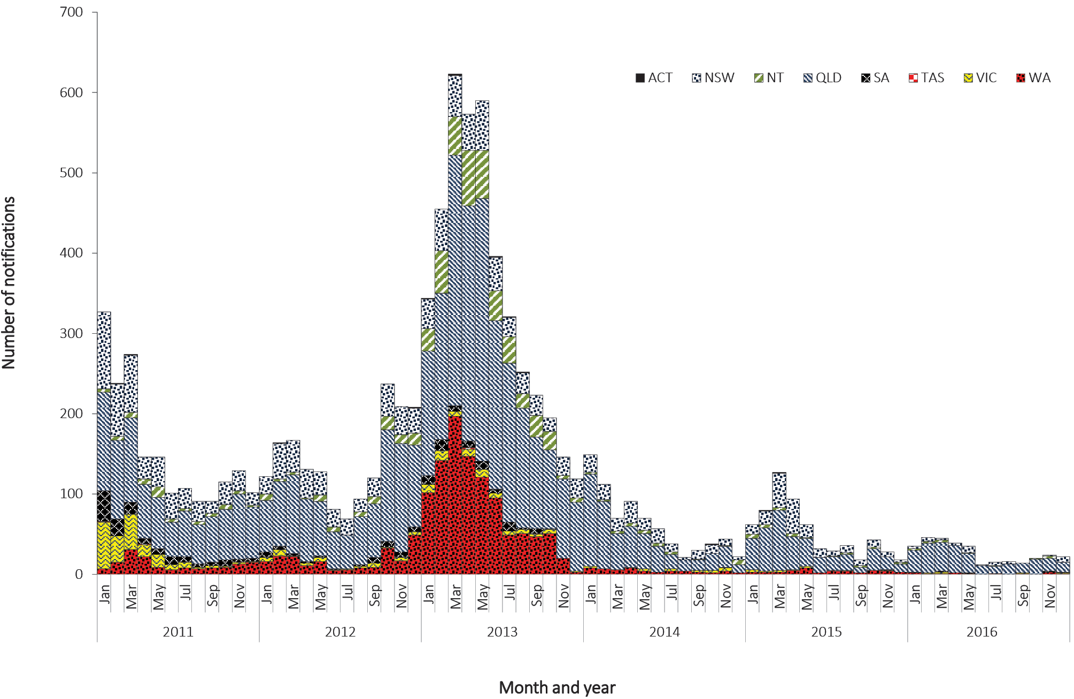

Figure 85: Rates of Barmah Forest virus infection, Australia, 2011 to 2016, by state or territory and year
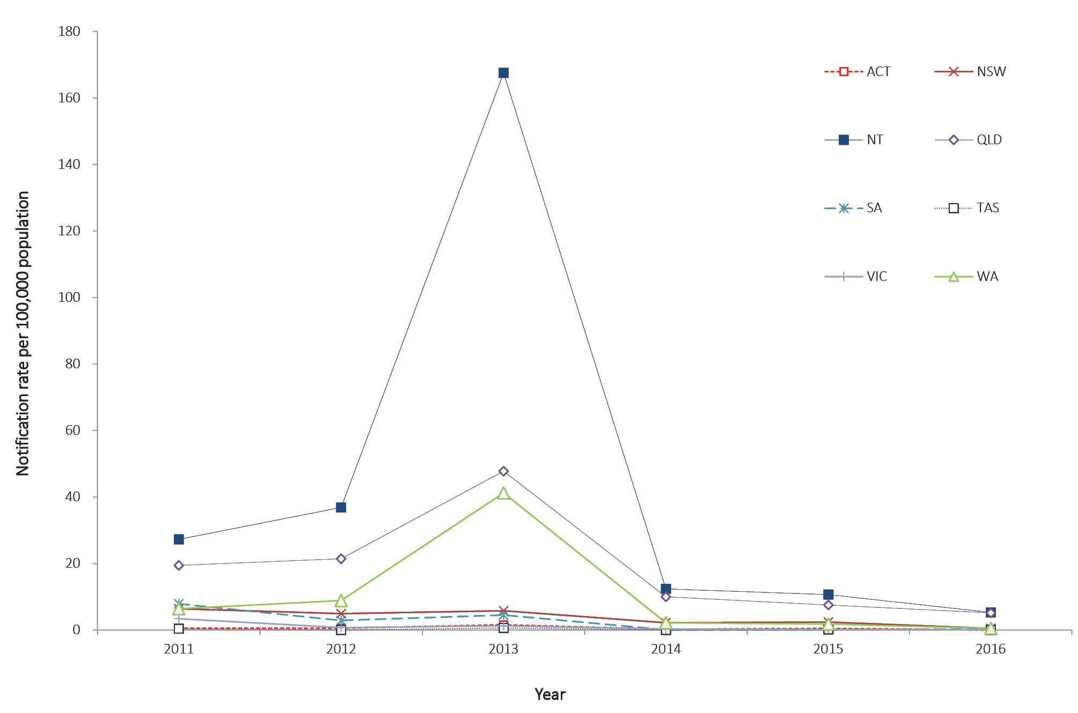

Geographical distribution
The highest notification rate in 2016 was in the Northern Territory (5.3 per 100,000 population), closely followed by Queensland (5.2 per 100,000 population) (Table 5). It is important to note seasonal trends vary between and within states and territories according to differences in mosquito vectors, hosts and climate. In addition, comparisons between regions are likely to be influenced by accuracy of case-ascertainment, which may vary between jurisdictions because of some differences in reporting criteria and in the quality of diagnostic tests used.

Age and sex distribution
BFV is more commonly reported in middle-aged and older adults. In 2016, the median age of notifications was 47 years (range 11 to 87 years) and 56% of cases were male. Notification rates of BFV in 2016 peaked in males aged 50–54 and 65–69 years (both 3.1 per 100,000 population) and in females aged 55–59 years (2.8 per 100,000 population) (Figure 86).

Seasonality
In 2016, BFV was more commonly reported between January and May, with 62% of cases (200/323) notified during these months, which is slightly more than the historical five-year mean, 2011 to 2015 (59%). The highest numbers of notifications were reported in February and March (n = 46 and n = 45 respectively) (Figure 84).

Figure 86: Notification rates for Barmah Forest virus, 2016, by age group and sex
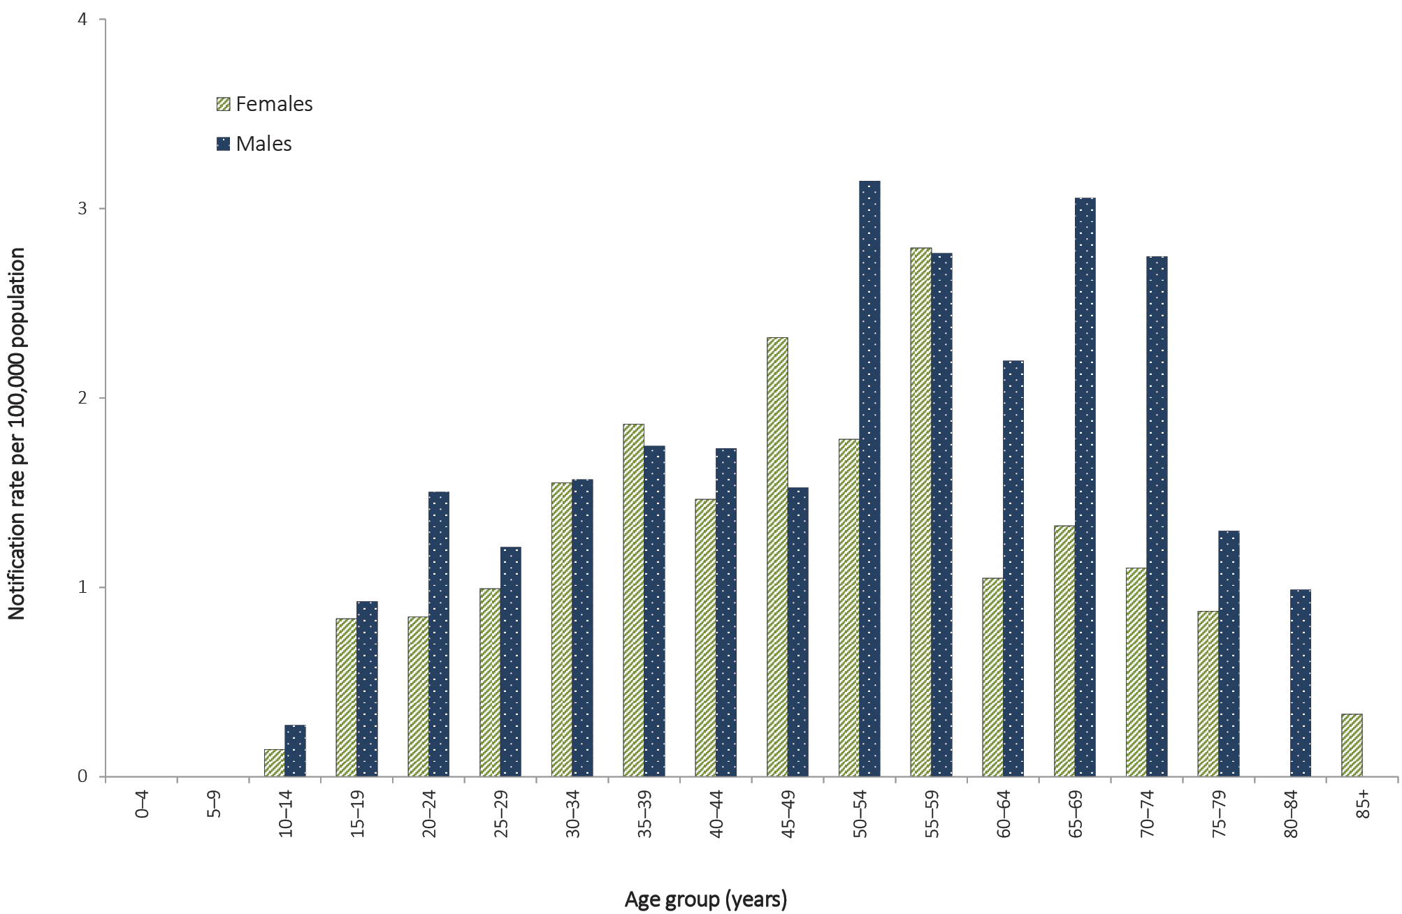
Figure 87: Notifications of Chikungunya virus infection, Australia, 2011 to 2016, by month and year and state or territory
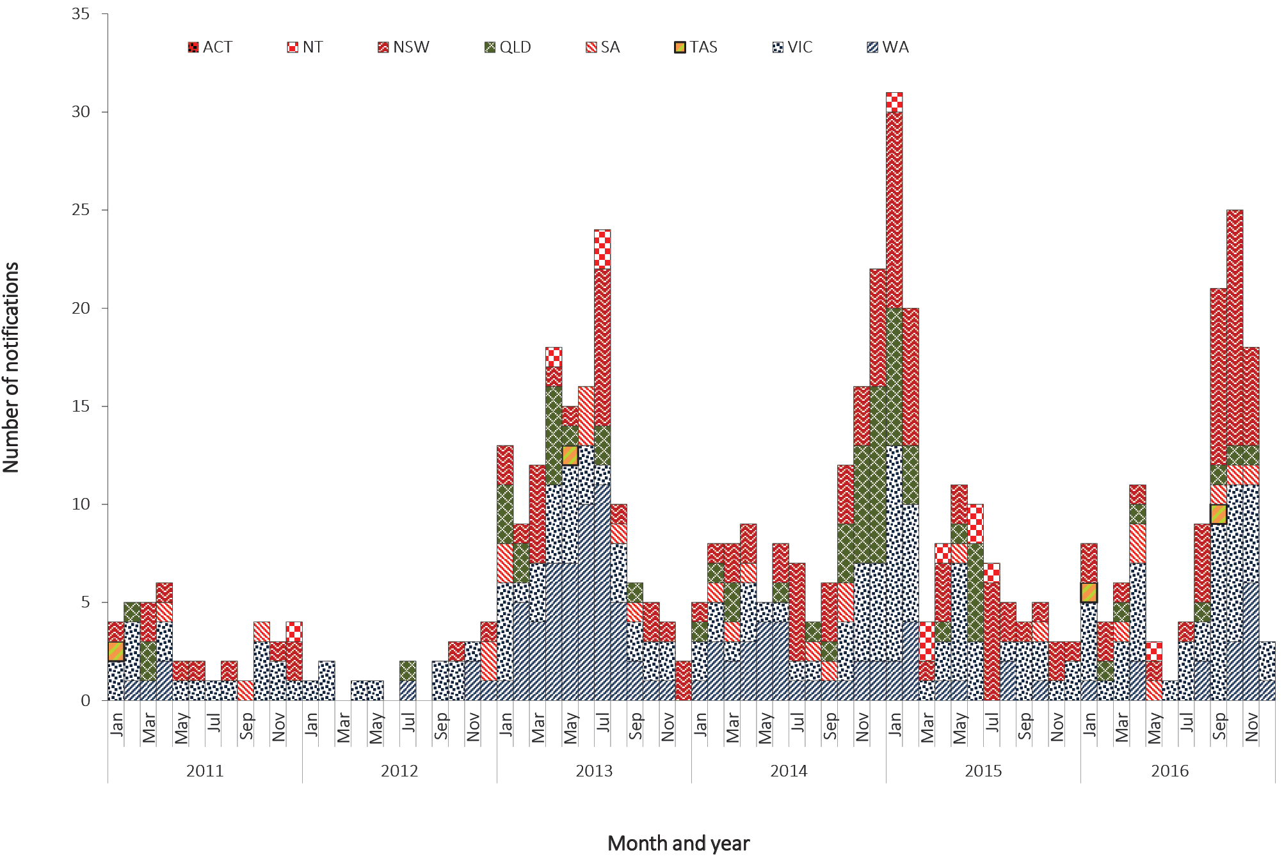

Chikungunya virus

- There were 113 notifications of CHIKV in 2016, which is a 36% increase on the historical five-year mean (n = 83) but is comparable to 2013, 2014 and 2015 (range 110–134 notifications per year).
- In 2016, where place of acquisition was completed, all cases were acquired overseas.
CHIKV can cause an illness which is characterised by an abrupt onset of fever, rash and severe joint pain. The acute disease lasts one to 10 days, but convalescence may include prolonged joint swelling and pain lasting months. Haemorrhagic manifestations may occur occasionally.¹²³ Humans are amplification hosts for CHIKV, and other vertebrates are not required for transmission to occur. Local transmission of CHIKV has not been reported in Australia, but it is regularly reported in travellers returning from overseas. There is the potential for transmission of CHIKV in areas where a suitable mosquito vector exists.
Internationally, CHIKV is more commonly transmitted by Aedes aegypti and Aedes albopictus.In Australia, Ae. aegyptiis present in parts of Northern, Central and Southern Queensland and Ae. albopictus is found on Cocos Island, Christmas Island and in some areas of the Torres Strait Islands.¹²⁴

Epidemiological situation in 2016
In 2016, there were 113 notifications of CHIKV. This is a 36% increase on the historical five-year mean of 83 notifications, but is similar to the number of notifications in 2013, 2014 and 2015 (134, 110 and 113 notifications, respectively) (Figure 87).

Geographical distribution
The largest number of notifications was in Victoria (n = 43), followed by New South Wales (n = 38) and Western Australia (n = 15). Complete information on the place of acquisition was supplied for 99% (112/113) of cases in 2016. All notifications with complete information were overseas acquired, most frequently in India (55%; n = 62), Indonesia (16%; n = 18) and Fiji (10%; n = 11) (Table 18).

Table 18: Notifications of Chikungunya virus infection 2016, by place of acquisition and quarter
Country or region of acquisition | Number of notifications
 | January–March | April–June | July–September | October–December | Total
India | 0 | 3 | 22 | 37 | 62
Indonesia | 3 | 2 | 7 | 6 | 18
Fiji | 5 | 6 | 0 | 0 | 11
Philippines | 1 | 3 | 3 | 0 | 7
Timor-Leste | 3 | 0 | 1 | 0 | 4
Samoa | 0 | 1 | 1 | 0 | 2
Botswana | 1 | 0 | 0 | 0 | 1
Cuba | 0 | 1 | 0 | 0 | 1
Honduras | 1 | 0 | 0 | 0 | 1
Myanmar | 0 | 0 | 0 | 1 | 1
Nepal | 0 | 0 | 0 | 1 | 1
Sri Lanka | 1 | 0 | 0 | 0 | 1
Thailand | 0 | 1 | 0 | 0 | 1
Tonga | 0 | 1 | 0 | 0 | 1
No data available | 0 | 0 | 0 | 1 | 1
Grand total | 15 | 18 | 34 | 46 | 113

Age and sex distribution
In Australia, CHIKV is more commonly reported in younger and middle-aged adults, which may reflect the peak travelling age groups. The median age of notifications in 2016 was 39 years (range 7–86 years) and 54% of cases were female (Figure 88).

Seasonality
No clear seasonality for CHIKV is evident in Australia, although there can be increases in notifications during peak periods of travel by Australians overseas, or during large outbreaks in a country or region.

Figure 88: Notifications of Chikungunya virus infection, 2016, by age group and sex
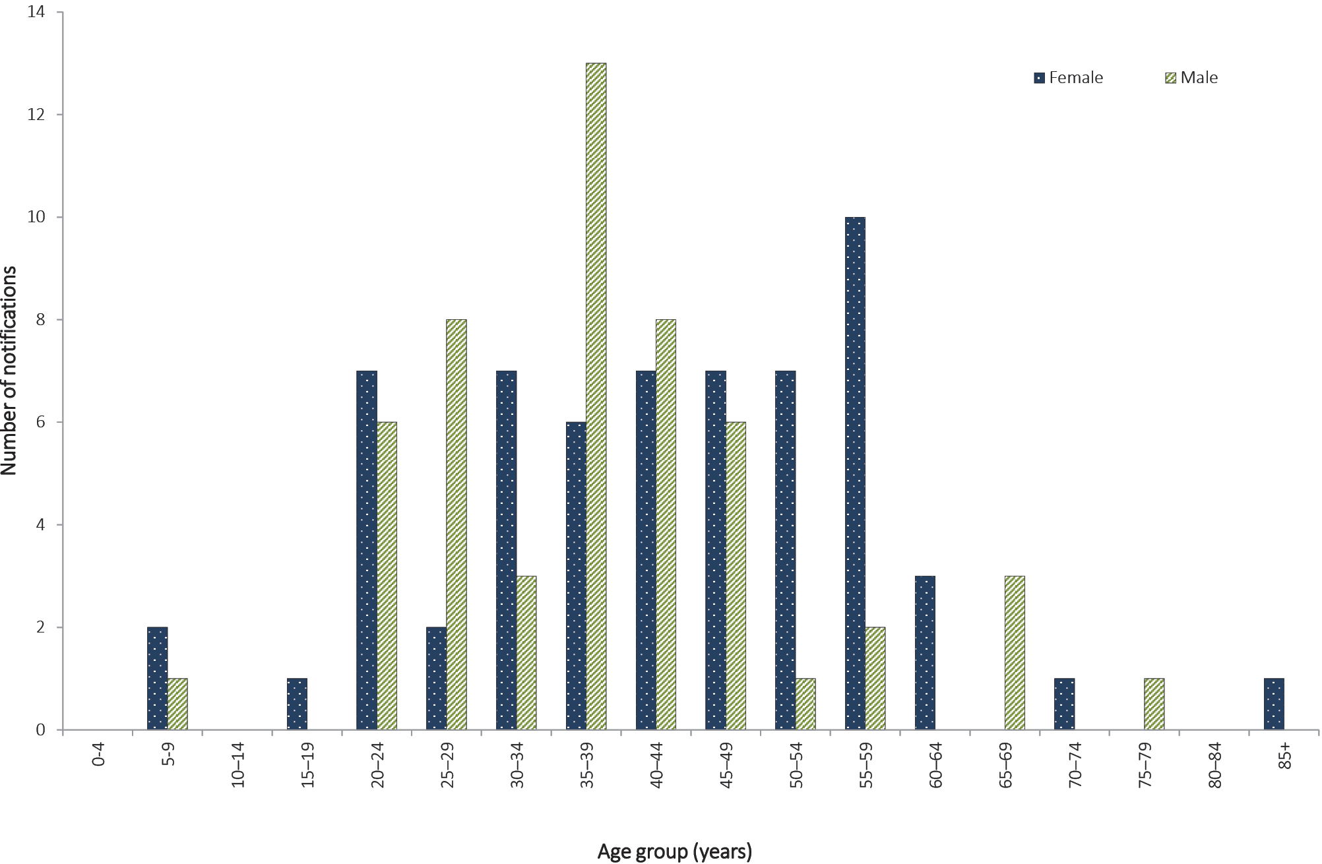

Dengue virus

- There were 2,227 notifications of DENV in 2016.
- Almost all notifications in 2016 (more than 99%) had place of acquisition recorded, of which 98% were overseas-acquired and the most common place of acquisition was Indonesia.
- There were 31 locally-acquired cases reported in 2016.
The clinical illness for DENV infection is characterised by mild to severe febrile illness with fever, headache, muscle/joint pain and sometimes a rash. A minority of cases progress to severe dengue, with plasma leakage, and possibly respiratory distress, haemorrhagic manifestations and shock, and with mortality rates of one to 20%, depending on the level of supportive care given.¹²⁵ DENV has four serotypes, each containing numerous genotypes. No specific treatment is available and there is no vaccine currently available in Australia. The serotypes detected in returning travellers vary by year and by country and region. Infection with one serotype probably confers lifelong immunity to that serotype,²³ but subsequent infection with a different serotype is thought to increase the risk of severe outcomes, along with host factors and other factors including the infecting serotype and genotype.^{23,126–128}
DENV is not endemic anywhere in Australia, but local transmission can occur in dengue-receptive areas following importation by a viraemic tourist or a resident returning from a dengue-affected area overseas.¹²⁹ Outbreaks of dengue are considered a high risk in those areas of Queensland where at least one vector species (Ae. aegypti or Ae. albopictus) is endemic, where there is a regular influx of international travellers or residents who have returned from dengue-endemic areas, and where there is a recent history of dengue transmission (e.g. Cairns, Townsville, Torres Strait). DENV transmission is considered a moderate risk where the vector is present, but there is no recent history of outbreaks and where few viraemic travellers arrive from endemic areas.¹²⁹There is a low risk of outbreaks in other areas of Queensland (and elsewhere in Australia) where there are currently no populations of Ae. aegypti or Ae. albopictus present. Isolated cases of laboratory-acquired infection and infections with an unknown source (possibly related to mosquito importations on air cargo or luggage) have been reported.^{130–132}

Epidemiological situation in 2016
In 2016, there were 2,227 notifications of DENV, representing a rate of 9.2 per 100,000 population. The notification rate in 2016 is a 28% increase on the rate in 2015 (7.2 per 100,000 population) and a 40% increase on the historical five-year mean, 2011 to 2015 (6.6 per 100,000 population). Of the 2,227 notifications reported in 2016, 1,901 were confirmed cases and 326 were probable cases. The increase in cases observed in 2016 is likely linked to international travel patterns and the global epidemiology of DENV.

Geographical distribution
In 2016, the highest number of notifications was reported in Western Australia (n = 558), followed by Victoria (n = 518); New South Wales (n = 478); and Queensland (n = 391) (Figure 89). A high number of DENV notifications in Western Australia has previously been noted as being related to the predilection of Western Australians to holiday in Bali, Indonesia where most of these infections are acquired.¹³³
Figure 89: Notifications of dengue virus infection, Australia, 2011 to 2016, by month and year and state or territory
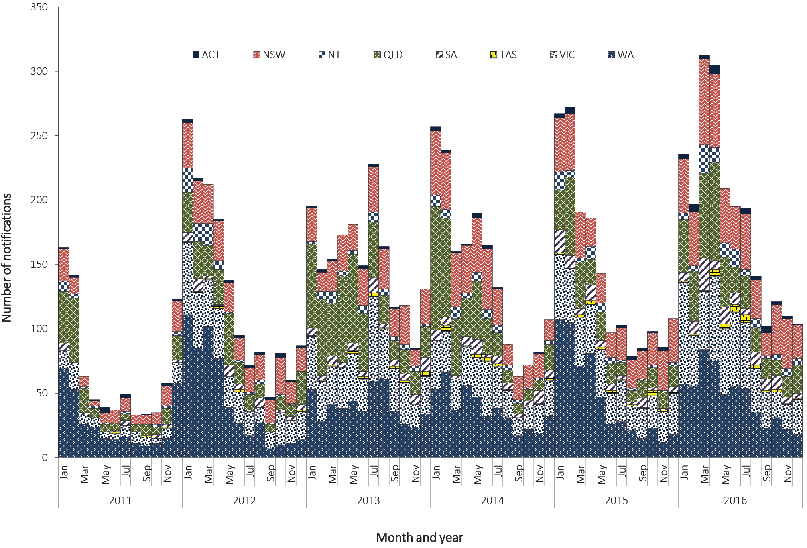
Complete information on the place of acquisition was supplied for more than 99% (2,224/2,227) of notifications in 2016 (Table 19). There were 2,193 notifications (98%) of dengue acquired overseas. Of these, the majority were acquired in Indonesia (60%; 1,340/2,224), with the next largest proportions acquired in Papua New Guinea (5%; 105/2,224) and in Thailand (5%; 101/2,224).
Table 19: Notifications of dengue virus infection 2016, by place of acquisition and quarterª
Category | Country/region | January–March | April–June | July–September | October–December | Total
Overseas acquired | Indonesia | 517 | 419 | 257 | 147 | 1,340
 | Papua New Guinea | 65 | 33 | 4 | 3 | 105
 | Thailand | 11 | 29 | 29 | 32 | 101
 | India | 9 | 12 | 22 | 42 | 85
 | Philippines | 12 | 27 | 27 | 16 | 82
 | Malaysia | 18 | 27 | 12 | 8 | 65
 | Sri Lanka | 10 | 21 | 19 | 6 | 56
 | Vietnam | 3 | 21 | 5 | 15 | 44
 | Solomon Islands | 9 | 7 | 2 | 25 | 43
 | Samoa | 1 | 38 | 1 | 1 | 41
 | Timor-Leste | 14 | 11 | 5 | 5 | 35
 | South-East Asia, NFDª | 8 | 14 | 5 | 2 | 29
 | Cambodia | 2 | 4 | 9 | 7 | 22
 | Singapore | 2 | 11 | 1 | 0 | 14
 | Bangladesh | 0 | 1 | 10 | 2 | 13
 | Fiji | 4 | 4 | 3 | 0 | 11
 | Brazil | 4 | 3 | 0 | 0 | 7
 | French Polynesia | 1 | 2 | 4 | 0 | 7
 | Maldives | 2 | 0 | 3 | 1 | 6
 | Pakistan | 0 | 0 | 0 | 4 | 4
 | Vanuatu | 0 | 2 | 0 | 2 | 4
 | South America, NFDª | 0 | 3 | 0 | 1 | 4
 | Other countries^{b} | 12 | 31 | 11 | 11 | 65
 | Overseas - Country Unknown | 0 | 6 | 3 | 1 | 10
Total | 704 |  | 726 | 432 | 331 | 2,193
Locally acquired (Australia) |  | 2 | 25 | 2 | 2 | 31
Unknown |  | 1 | 0 | 2 | 0 | 3
Grand total |  | 707 | 751 | 436 | 333 | 2,227
a NFD: Not further defined.
b Countries with fewer than four cases in 2016.

Age and sex distribution
In Australia, DENV is more commonly reported in younger and middle-aged and older adults, which may reflect the peak travelling age groups. The median age of notifications in 2016 was 36 years (range 0 to 91 years) and there was an even distribution (50% each) between males and females. Case numbers peaked in females aged 25–29 years (n = 140) and males aged 30–34 years (n = 147) (Figure 90).
Figure 90: Notifications of dengue virus infection, 2016, by age group and sex
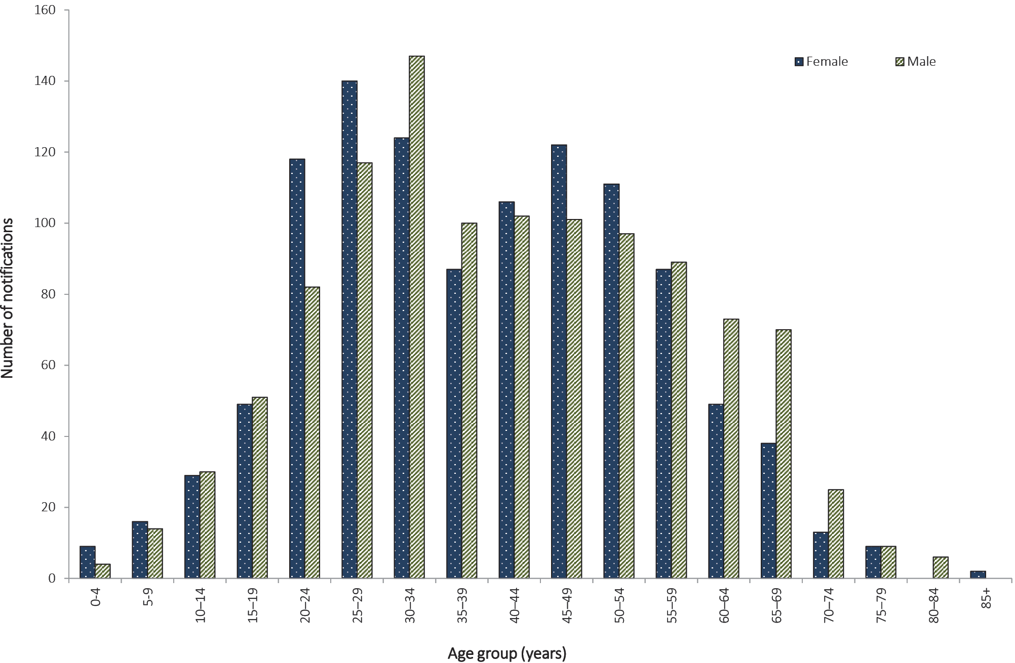

Seasonality
For overseas-acquired cases of DENV, no clear seasonality is evident in Australia, however there may be seasonality in the country of acquisition. However, there can be increases in notifications during peak periods of travel by Australians overseas or during large outbreaks in a country or region.

Locally-acquired cases and outbreaks
Outbreaks of locally-acquired DENV in North Queensland are more likely to begin during the warmer, wetter months in North Queensland, and rarely continue into the cooler months. In 2016, 57% of locally-acquired cases were reported between January and May, a decrease compared with 2015 (74%).
In 2016, there were 31 locally-acquired cases of DENV. Of these cases, 97% (30/31) were associated with outbreaks in North Queensland and one case was notified in New South Wales.

Flavivirus unspecified (including Zika virus)

- There were 115 notifications reported in 2016, of which 89% (n = 102) were for ZIKV.
This disease category enables the capture and epidemiological analysis of emerging infections within this broad disease group. Emerging diseases can be made nationally notifiable if required, according to the protocol for making a change to the National Notifiable Diseases List in Australia, which is available on the Department of Health website. An unspecified category is particularly important for the flaviviruses, because it is recognised that some infections cannot be attributed to a single flavivirus, which may be due to the inability of serology to distinguish between viruses.
Flavivirus (unspecified) includes notifications of ZIKV, for which a specific case definition was implemented from 1 January 2016.¹³⁴ Prior to November 2015, ZIKV was not thought to be cause for serious public health concern, due to the high rate of asymptomatic infection, and symptomatic cases were generally mild, notwithstanding the reports of a possible association with Guillain Barré syndrome.¹³⁵ However, ZIKV spread rapidly through many countries in the Americas after being first confirmed in Brazil in May 2015.¹³⁶ There is now strong scientific consensus ZIKV can be transmitted in utero and can cause severe birth defects such as microcephaly and fetal death,¹³⁷ and it can cause Guillain Barré syndrome.^{138,139} An increase in microcephaly in Brazil with geographical and temporal links to ZIKV was reported in November 2015, and the WHO declared the clusters of microcephaly and neurological disorders a Public Health Event of International Concern on 1 February 2016.¹⁴⁰ While vectorborne transmission remains the main mode of transmission, multiple instances of probable or confirmed sexual transmission have now been reported.^{135,141–145}

Epidemiological situation in 2016
In 2016, there were 115 notifications of flavivirus (unspecified), which is a notification rate of 0.5 per 100,000 population. Notifications in 2016 were more than eight times the historical five-year mean, 2011 to 2015 (n = 13.4). ZIKV accounted for 89% (102/115) of notifications in 2016 and there was one case each of Kokobera, Sindbis (while Sindbis is not a flavivirus, it is included in this section for reporting purposes) and Stratford (Figure 91).

Figure 91: Notifications of flavivirus (unspecified), Australia, 2011 to 2016, by month and virus species
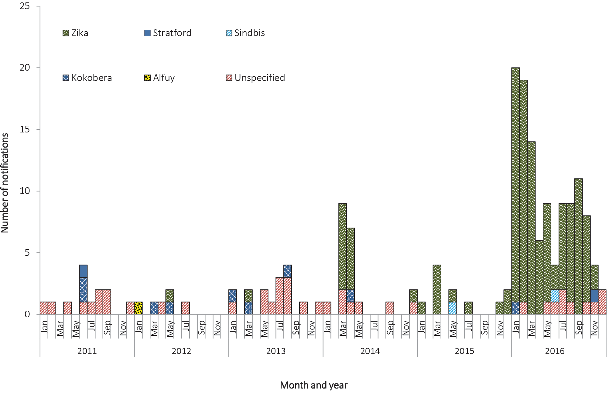

Geographical distribution
There were 47 notifications from Queensland, 34 in New South Wales, 15 in Western Australia, 14 in Victoria, two in South Australia and one each in the Australia Capital Territory, Northern Territory and Tasmania.

Age and sex distribution
Notifications under flavivirus (unspecified) were more common in younger and middle-aged adults (Figure 92). The median age of notifications in 2016 was 36 years (range 2 to 73 years).

Figure 92: Notifications of flavivirus (unspecified), 2016, by age group and sex
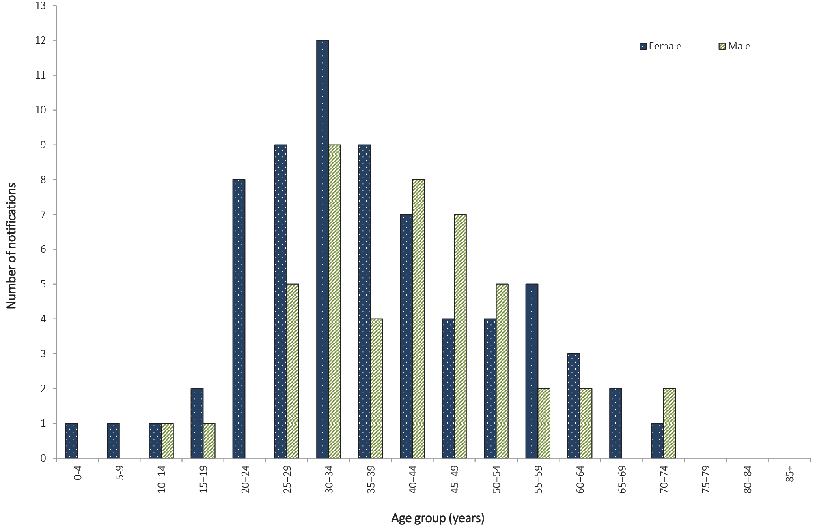

Seasonality
Notifications of overseas-acquired flavivirus (unspecified) can increase during peak periods of travel by Australians overseas, or during large outbreaks in a country or region. The largest number of ZIKV notifications in 2016 were acquired in Pacific Island nations (42%; 43/102), followed by Central America (25%; 25/102), and South America and the Caribbean (both 12%; 12/102) (Table 20).

Table 20: Notifications of flavivirus (unspecified), 2016, by virus, place of acquisition and quarter
Category | Virus | Country/region | January–March | April–June | July–September | October–December | Total
Overseas acquired | ZIKV | Polynesia | 30 | 7 | 6 | 0 | 43
 |  | Central America | 6 | 3 | 13 | 3 | 25
 |  | South America | 9 | 1 | 1 | 1 | 12
 |  | Caribbean | 5 | 2 | 2 | 3 | 12
 |  | South-East Asia | 1 | 3 | 3 | 1 | 8
 |  | North America | 0 | 0 | 1 | 0 | 1
 | Unspecified | South-East Asia | 0 | 1 | 2 | 1 | 4
 |  | Southern Asia | 1 | 0 | 0 | 0 | 1
 |  | Polynesia | 0 | 0 | 0 | 1 | 1
 |  | Central and West Africa | 0 | 0 | 0 | 1 | 1
Locally acquired | Stratford | Australia | 0 | 0 | 0 | 1 | 1
Unknown | ZIKV | Place of acquisition unknown | 0 | 0 | 0 | 1 | 1
 | Kokobera | Place of acquisition unknown | 1 | 0 | 0 | 0 | 1
 | Sindbis | Place of acquisition unknown | 0 | 1 | 0 | 0 | 1
 | Unspecified | Place of acquisition unknown | 0 | 1 | 1 | 1 | 3
Overseas total |  |  | 52 | 17 | 28 | 11 | 108
Locally acquired total |  |  | 0 | 0 | 0 | 1 | 1
Unknown total |  |  | 1 | 2 | 1 | 2 | 6
Grand total |  |  | 53 | 19 | 29 | 14 | 115

Japanese encephalitis virus

- There were no notifications of JEV in 2016.
No specific treatment is available for illness caused by JEV infection, and care is largely supportive. A vaccine is available to prevent JEV infection but is not funded through the NIP. Infection is usually asymptomatic or produces a non-specific illness, but a small percentage of cases progress to encephalomyelitis of variable severity.⁶⁸ The last locally-acquired case was in 1998;¹⁴⁶ all cases since then have been acquired overseas.

Epidemiological situation in 2016
In 2016, there were no notifications of JEV (Table 21). A total of nine cases of JEV were reported between 2011 and 2015, of which eight were acquired in Southeast Asia and one in Taiwan.
Table 21: Notifications of Japanese encephalitis virus infection, Australia, 2011 to 2016
Year | State/territory | Country of acquisition | Month | Age group | Sex
2012 | Qld | Philippines | February | 15–19 | Female
2013 | Qld | Philippines | September | 70–74 | Male
2013 | Qld | Taiwan | July | 45–49 | Male
2013 | SA | Thailand | June | 55–59 | Male
2013 | WA | Indonesia | April | 40–44 | Female
2014 | SA | Indonesia | August | 50–54 | Male
2015 | NSW | Indonesia | January | 25–29 | Female
2015 | Qld | Indonesia | November | 40–44 | Female
2015 | Vic | Indonesia | January | 45–49 | Male

West Nile virus (including Kunjin virus)

- There were no notifications of WNV/KUNV in 2016.
West Nile virus (including Kunjin virus) (WNV/KUNV) is usually asymptomatic or produces a non-specific illness, but a small percentage of cases progress to encephalomyelitis of variable severity. There is no specific treatment available for infections with WNV/KUNV, and care is largely supportive. There is no vaccine.¹⁴⁷ Culex annulirostris is the major vector of WNV/KUNV in Australia.¹⁴⁸

Epidemiological situation in 2016
In 2016, there were no notifications of WNV/KUNV. Between 2011 and 2015, there were six notifications of WNV/KUNV in total, of which four were acquired in the Australasian region and one each was acquired in Djibouti and in the United States of America. (Table 22).
Table 22: Notifications of West Nile virus (including Kunjin virus) infection, Australia, 2011 to 2016
Year | State/territory | Country of acquisition | Month | Age group | Sex
2011 | NSW | Australia | December | 40–44 | Female
2011 | NT | Australia | April | 60–64 | Male
2013 | Qld | Papua New Guinea | November | 25–29 | Male
2013 | Qld | Timor-Leste | October | 35–39 | Male
2014 | Vic | Djibouti | April | 45–49 | Male
2015 | NSW | United States of America | October | 60–64 | Male

Malaria

- There were 305 notifications of malaria in 2016.
- Notified cases of malaria were 13% below the preceding 5-year mean in 2016, continuing the decreasing numbers notified since 2004–2005.
- All cases in 2016 were overseas acquired, with most reported to be acquired in Papua New Guinea.
- Sixty-four percent of malaria cases in 2016 were reported in men aged 25–49 years.
Malaria is a serious acute febrile illness transmitted through the bite of an infected mosquito of the genus Anopheles. It is caused by a protozoan parasite in the genus Plasmodium which includes five species that infect humans: Plasmodium vivax, Plasmodium falciparum, Plasmodium malariae, Plasmodium ovale and Plasmodium knowlesi.^{23,149}
Australia is free of endemic malaria. However, suitable vectors are present in northern Australia which allow this area to remain receptive to malaria. Malaria in Australia is therefore a disease associated with residing or travelling overseas in areas with endemic transmission. A case series in the Northern Territory showed malaria cases were reported in travellers returning from endemic areas, but also reflected current events such as military operations and increased refugee arrivals from malaria-endemic areas.¹⁵⁰ The last cases of malaria acquired on mainland Australia were during an outbreak in north Queensland in 2002.¹⁵¹ Limited transmission occurs occasionally in the Torres Strait following importation.

Epidemiological situation in 2016
In 2016, there were 305 notifications of malaria, representing a rate of 1.3 per 100,000 population. The number of cases in 2016 is a 30% increase on the number of notifications in 2015 (n = 234), but represents a 13% reduction on the historical five-year mean, 2011 to 2015 (n = 349). There have been gradually decreasing notifications in Australia since 2004–2005,¹³⁰ consistent with the steady decline in malaria incidence globally between 2000 and 2016.¹⁵²

Geographical distribution
The highest number of notifications of malaria in 2016 was reported in Victoria (n = 78), followed by Queensland (n = 73), which is comparable to 2015. The highest notification rate of malaria was in the Northern Territory (6.9 per 100,000 population) (Figure 93).
In 2016, place of acquisition was available for 99% of malaria cases (303/305). Of these cases, all were acquired overseas, most frequently in Papua New Guinea (n = 45); India (n = 27); Sudan (n = 22); and Kenya (n = 20) (Table 23). There were two notifications for which the place of acquisition was unknown. The most recent locally-acquired cases of malaria in Australia were a single case in 2013 acquired on Saibai Island in the Torres Strait and seven locally-acquired cases in the Torres Strait in 2011.

Figure 93: Notifications of malaria, Australia, 2011 to 2016, by month and year and state or territory
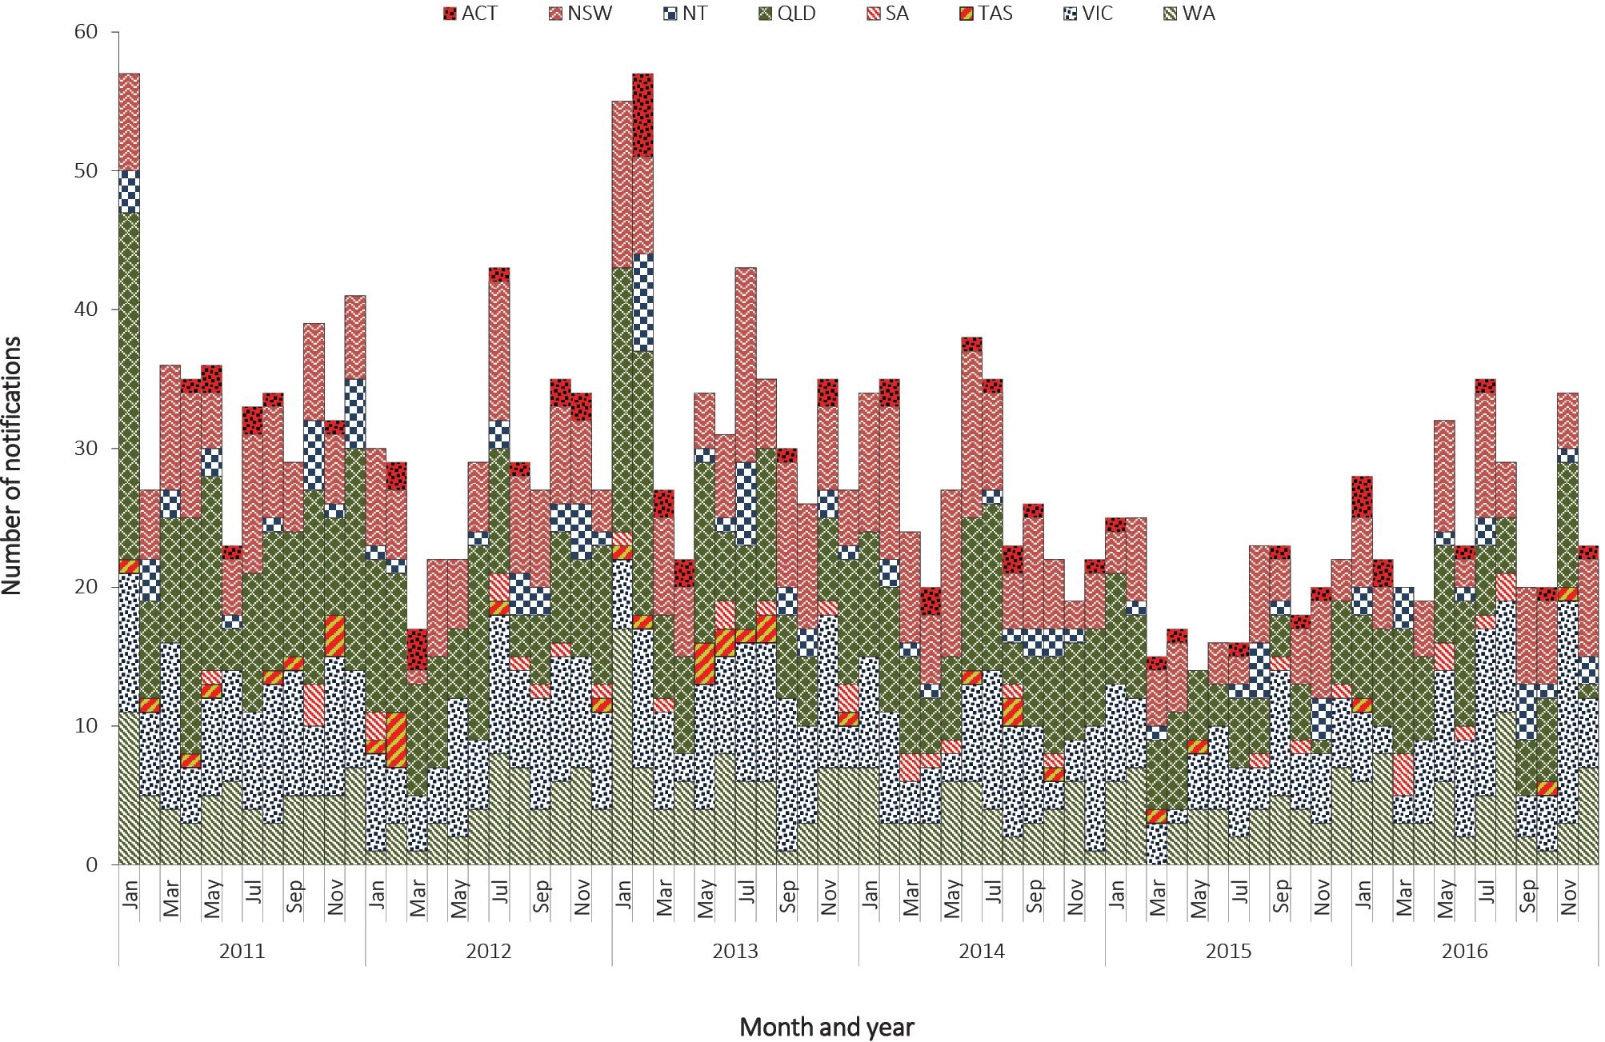

Table 23: Cases of malaria, Australia, 2016, by Plasmodium species and country or region of acquisition
Country of acquisition | P. falciparum | P. malariae | P. ovale | P. vivax | P. falciparum and P. vivax | P. falciparum and P. ovale | P. species (unspecified) | Total
Papua New Guinea | 13 | 0 | 0 | 26 | 0 | 0 | 6 | 45
India | 4 | 0 | 0 | 18 | 0 | 0 | 5 | 27
Sudan | 18 | 1 | 0 | 0 | 0 | 0 | 3 | 22
Kenya | 14 | 1 | 4 | 0 | 0 | 0 | 1 | 20
Uganda | 14 | 1 | 0 | 1 | 0 | 0 | 0 | 16
Nigeria | 14 | 0 | 1 | 0 | 0 | 0 | 0 | 15
Indonesia | 6 | 0 | 1 | 8 | 0 | 0 | 0 | 15
Tanzania | 11 | 1 | 0 | 0 | 0 | 1 | 1 | 14
South Sudan | 8 | 2 | 1 | 0 | 0 | 0 | 1 | 12
Zambia | 7 | 2 | 1 | 1 | 0 | 0 | 0 | 11
Sierra Leone | 10 | 0 | 0 | 0 | 0 | 0 | 1 | 11
Malawi | 7 | 0 | 1 | 0 | 0 | 0 | 0 | 8
Solomon Islands | 1 | 0 | 0 | 6 | 0 | 0 | 0 | 7
Ghana | 6 | 0 | 0 | 0 | 0 | 0 | 0 | 6
Guinea | 3 | 0 | 0 | 1 | 0 | 0 | 1 | 5
Pakistan | 0 | 0 | 0 | 5 | 0 | 0 | 0 | 5
Burundi | 3 | 0 | 0 | 0 | 1 | 0 | 0 | 4
Sub-Saharan Africa, NFDª | 3 | 1 | 0 | 0 | 0 | 0 | 0 | 4
Congo, Democratic Republic of | 4 | 0 | 0 | 0 | 0 | 0 | 0 | 4
Other countries^{b} | 21 | 2 | 0 | 5 | 0 | 0 | 4 | 32
Overseas–country unknown | 14 | 1 | 0 | 3 | 0 | 0 | 2 | 20
Place of acquisition unknown | 1 | 0 | 0 | 1 | 0 | 0 | 0 | 2
Total | 182 | 12 | 9 | 75 | 1 | 1 | 25 | 305
a NFD: not further defined.
b Countries with fewer than four cases in 2016.

Age and sex distribution
Malaria is more commonly reported in younger and middle-aged adults, and in Australia disproportionately affects male travellers, some of whom are likely to be working in endemic countries when infected. The median age of notifications in 2016 was 35.5 years (range 1–83 years) and 64% of cases were male. Notifications peaked in males aged 25–49 years and in females aged 15–29 years (Figure 94).

Figure 94: Notifications of malaria, 2016, by age group and sex

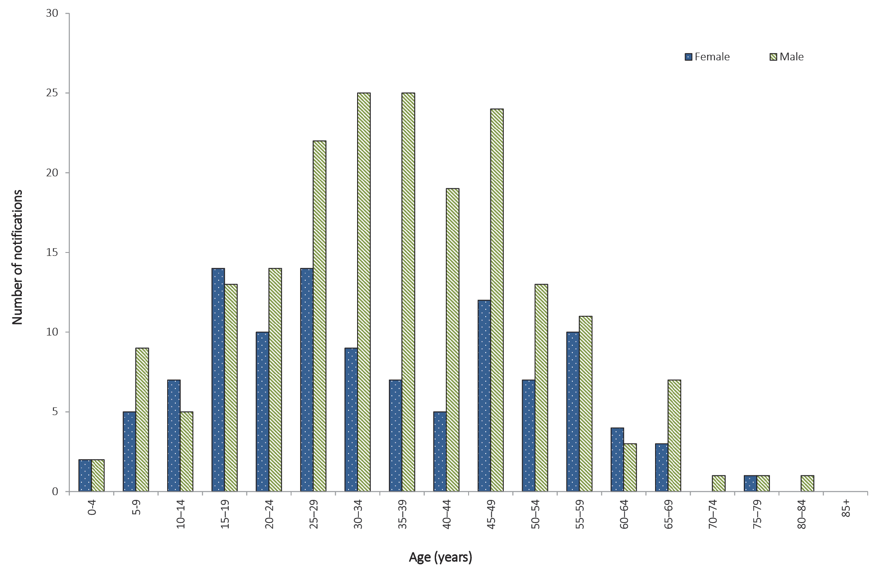

Seasonality
Diseases almost exclusively acquired overseas (such as malaria) tend to increase during peak periods of travel by Australians overseas, or during outbreaks in a country or region. In 2016, no seasonal trend was observed.

Murray Valley encephalitis virus

- There were no notifications of MVEV notified in 2016.
Infection with MVEV is usually asymptomatic or causes non-specific febrile illness. Clinical encephalitis occurs in one in every 150–1000 infections. No specific treatment is available for infections with MVEV and care is largely supportive. No vaccine is available. Culex annulirostris is the major vector of MVEV.¹⁵³

Epidemiological situation in 2016
In 2016, there were no notifications of MVEV infection. A total of 19 cases were reported between 2011 and 2015, of which 16 were reported in 2011 (Figure 95). The details of the 16 cases in 2011 have been published elsewhere;¹⁵⁴ one further case was acquired in Papua New Guinea in 2012, and two in Australia in 2015. MVEV acquired in Australia is more commonly reported during the warmer, wetter months, with all cases between 2011 and 2016 having dates of diagnosis between December and May.
Figure 95: Notifications of Murray Valley encephalitis virus infection, Australia, 2011 to 2016, by month and place of acquisition
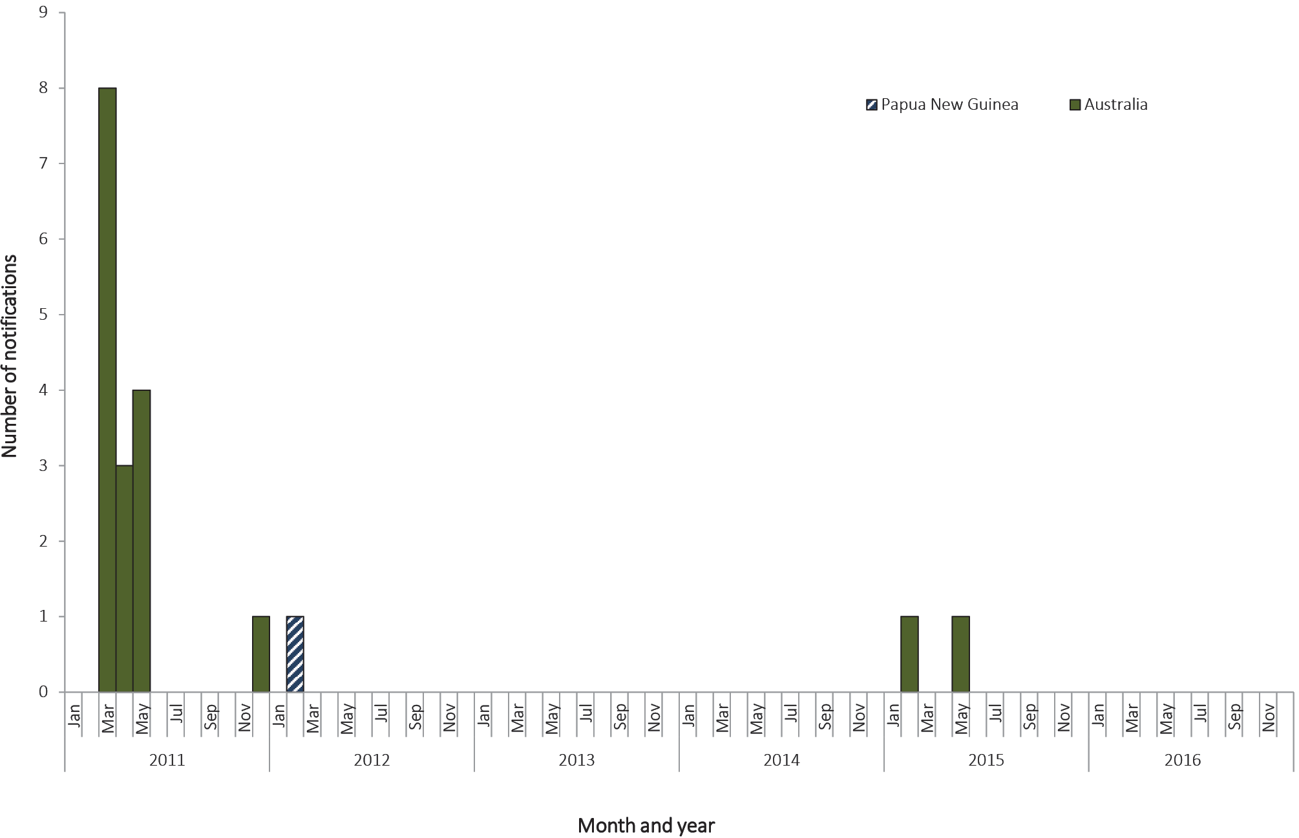

Ross River virus

- There were 3,677 notifications of RRV in 2016, which is a 62% decrease on the number of notifications in 2015 (n = 9,555).
- In 2016, the majority of RRV was reported in middle-aged to older age groups, with a median age of 45 years (range two to 99 years), and there was an even proportion of notifications (50% each) in males and females.
- The highest number of notifications in 2016 were recorded in December (n = 813) due to an outbreak in Victoria and Western Australia.
RRV occurs exclusively in the Australasian region.¹¹⁹ Infection can cause a clinical illness, which is characterised by fever, rash and polyarthritis. The virus is transmitted by numerous species of mosquito that breed in diverse environments.¹²⁰ A revised case definition was implemented on 1 January 2016, under which a single IgM test is no longer considered sufficient evidence for a confirmed case.¹⁵⁵

Epidemiological situation in 2016
In 2016, there were 3,677 notifications of RRV, representing a rate of 15.2 per 100,000 population, and a 62% reduction on 2015 (n = 9,555; notification rate = 40.1 per 100,000 population). The notification rate of RRV in 2016 is a 39% decrease on the historical five-year mean, 2011 to 2015 (25.0 per 100,000 population) (Figure 96) and is the lowest notification rate since 2005 (12.5 per 100,000 population). Interpretation of the five-year mean needs to be done with caution, given the influence of the 2014–2015 outbreak in Queensland on the mean.¹⁵⁶
Figure 96: Notifications of Ross River virus infection, Australia, 2011 to 2016, by month and year and state or territory
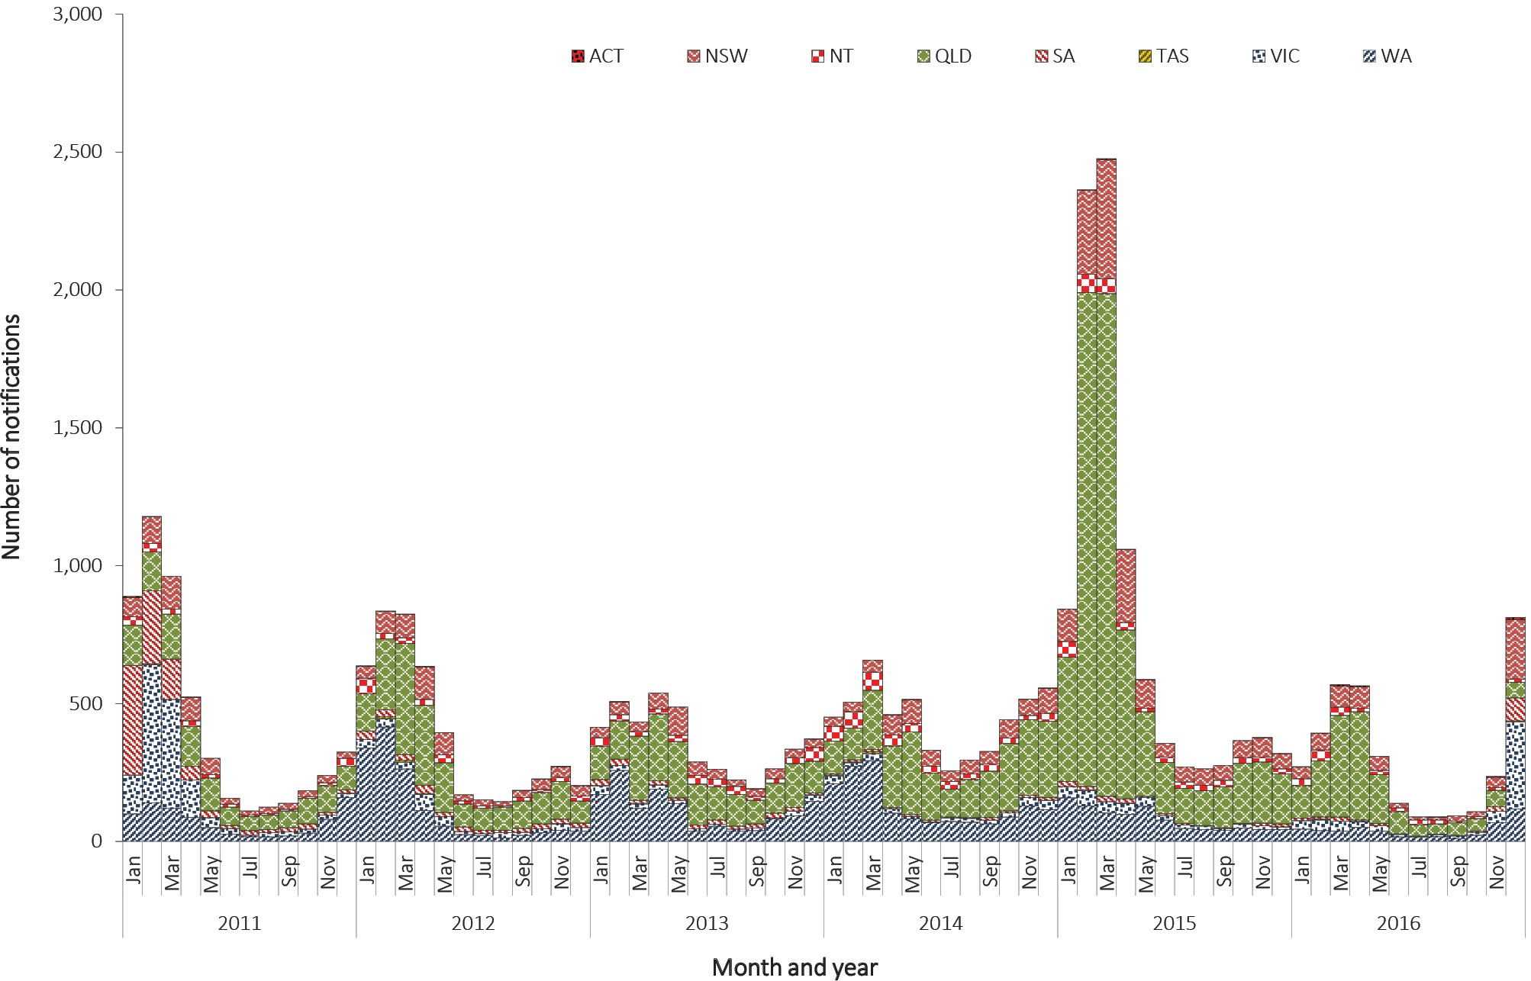

Geographical distribution
The highest number of notifications of RRV was in Queensland (n = 1,626), followed by New South Wales (n = 641), Victoria (n = 544) and Western Australia (n = 478); and the highest notification rate was in the Northern Territory (81.8 per 100,000 population) (Figure 97). It is important to note seasonal trends vary between and within states and territories according to differences in mosquito vectors, hosts and climate. In addition, comparisons between regions are likely to be influenced by accuracy of case-ascertainment, which can vary between jurisdictions due to differences in reporting criteria and in the quality of diagnostic tests used.

Figure 97: Notification rates of Ross River virus infection, Australia, 2011 to 2016, by state or territory and year
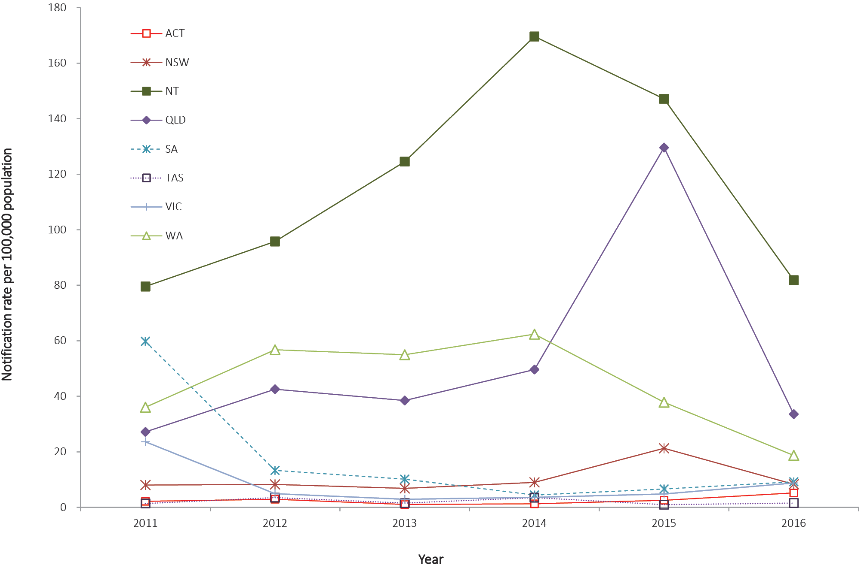

Age and sex distribution
RRV is more commonly reported in middle-aged and older adults. The median age of notifications in 2016 was 45 years (range 2 to 99 years) and there was an even proportion of notifications (50% each) in males and females. Rates of RRV peaked in males and females aged 50–54 years (28.3 per 100,000 population and 27.5 per 100,000 population respectively) (Figure 98).

Figure 98: Notification rates for Ross River virus infection, 2016, by age group and sex
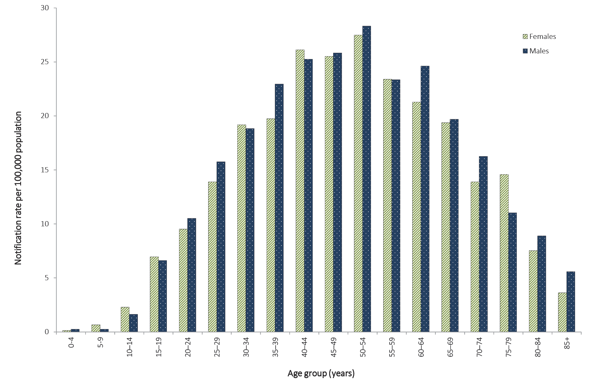

Seasonality
In 2016, RRV was more commonly reported between January and April, with 49% (1,798/3,677) of cases notified during these months; this is comparable to the historical five-year mean, 2011 to 2015 (56%). However, the highest number of notifications in a month (n = 813) was reported in December, and was due to an outbreak in Victoria and New South Wales as a result of heavy spring rainfall.^{157,158}

Zoonoses
Zoonoses are infectious diseases which are naturally transmitted between vertebrate animals and humans.¹⁵⁹ Approximately 60–70% of emerging human infectious diseases are zoonoses,^{159–161} and more than 70% of emerging zoonoses originate from wildlife.¹⁶⁰ An emerging zoonosis is defined by WHO as “a zoonosis that is newly recognised or newly evolved, or that has occurred previously but shows an increase in incidence or expansion in geographical, host or vector range”.¹⁶²
The zoonoses notifiable to the NNDSS included in this chapter are: anthrax; Australian bat lyssavirus (ABVL) or lyssavirus (unspecified) infection; brucellosis; leptospirosis; psittacosis (ornithosis); Q fever; and tularaemia. In 2016, zoonoses comprised 0.2% of all notifications to the NNDSS.
Several zoonoses notifiable to the NNDSS are included under other headings in this report. For example, salmonellosis and campylobacteriosis are typically acquired from contaminated food and are listed under the gastrointestinal diseases section. Rabies is listed under quarantinable diseases.

Anthrax

- There were no notifications of anthrax in 2016.
- The last case of human anthrax reported in Australia was in 2010.
Anthrax is caused by the bacterium Bacillus anthracis and most frequently causes cutaneous infection. However, it can also cause gastrointestinal and respiratory infections. Anthrax is primarily a disease of herbivores; humans and carnivores are incidental hosts. It can be an occupational hazard for veterinarians and for agriculture, wildlife and livestock workers who handle infected animals or by-products.¹⁶³
In Australia, the areas of anthrax risk are well-defined and include the northern and north-eastern districts of Victoria and central New South Wales. Anthrax occurs only sporadically in livestock in the at-risk areas. Rare or isolated incidents or cases in animals have historically occurred in Queensland, South Australia, Tasmania and Western Australia.¹⁶⁴

Epidemiological situation in 2016
In 2016 there were no notified cases of anthrax in Australia. Over the previous 10 years, three human cases of anthrax were reported in Australia in 2006, 2007 and 2010. Of these, all had domestic farm or animal-related exposure, and all were cutaneous anthrax. Australia has never recorded a human case of inhalational or gastrointestinal anthrax.^{165–167}

Australian bat lyssavirus and lyssavirus (unspecified)

- There were no notifications of ABLV notified in 2016.
- The last case of ABLV in Australia was reported in 2013.
ABLV belongs to the genus lyssavirus, which also includes the rabies virus. Both invariably result in progressive, fatal encephalomyelitis in humans.¹⁶⁸ ABLV was first identified in Australia in 1996,^{169,170} and is present in several Australian species of bats (including flying foxes and microbats). Australia is free of terrestrial rabies.
The best way to prevent ABLV infection is to avoid contact with bats. For people whose occupations (including volunteer work) or recreational activities place them at increased risk of being exposed to ABLV, rabies virus vaccine is effective in preventing infection. Pre-exposure immunisation with rabies virus vaccine is recommended for bat handlers, veterinarians and laboratory personnel working with live lyssaviruses.¹⁷¹ Post-exposure prophylaxis for ABLV consists of wound care and administration of a combination of rabies virus vaccine and human rabies virus immunoglobulin, depending on exposure category and prior immunisation or antibody status.^{68,171}

Epidemiological situation in 2016
In 2016 there were no notified cases of ABLV or lyssavirus (unspecified) infection in Australia.
There have been three cases of ABLV infection notified in humans in Australia, with single cases notified in each of 1996, 1998 and 2013. All three cases occurred following close contact with an infected bat in Queensland and all were fatal.^{172–174} In 2013, the Queensland Department of Agriculture, Fisheries and Forestry (DAFF) confirmed the first known equine cases of ABLV infection in two horses on a Queensland property.^{175,176}
The Bat Health Focus Group of Wildlife Health Australia (formerly the Australian Wildlife Health Network)¹⁷⁷ gathers and collates information from a range of organisations on opportunistic testing of bats for ABLV. In 2016, there were 15 ABLV detections in bats, compared to 22 detections during 2015.¹⁷⁸

Brucellosis

- There were 18 cases of brucellosis notified in 2016, a 24% decrease on the historical five-year mean, 2011 to 2015 (n = 24).
- The notification rate of brucellosis has remained at 0.1 per 100,000 population since 2012.
- New South Wales and Queensland accounted for 89% of brucellosis notifications, both reporting eight cases each.
- Sixty-seven percent (n = 12) of cases in 2016 were male.
Brucellosis is characterised by a fever of variable duration, with a range of other symptoms including headache; weakness; profuse sweating; chills; arthralgia; depression; weight loss; and generalised aching.²³ Brucellaspecies that can cause illness in humans include Brucella melitensis acquired from sheep and goats, Brucella suis from pigs and Brucella abortus from cattle. B. abortus was eradicated from Australian cattle herds in 1989 and B. melitensishas never been reported in Australian sheep or goats.¹⁷⁹ Therefore, all cases of B. melitensis or B. Abortus in Australia are related to overseas travel. Eales et al found that feral pig hunting was the most common risk factor for brucellosis.¹⁸⁰

Epidemiological situation in 2016
In 2016 there were 18 notified cases of brucellosis in Australia (0.1 per 100,000 population) which is a 24% decrease compared with the historical five-year mean, 2011 to 2015 (n = 24, notification rate = 0.1 per 100,000 population).

Geographical distribution
In 2016, residents of New South Wales and Queensland accounted for 89% of brucellosis notifications, both reporting eight cases each; Western Australia reported two cases (Figure 99). Queensland reported a state-specific notification rate of 0.2 per 100,000 population and both New South Wales and Western Australia reported 0.1 cases per 100,000 population.

Age and sex distribution
In 2016, the median age of notified brucellosis cases was 37 years (range 20 to 64 years) and the majority were male (67%; 12/18) (Figure 100).

Microbiological trends
The species of the infecting organism was available for 50% (9/18) of brucellosis notifications in 2016. There were six cases of B. suis acquired in Australia, three cases each from New South Wales and Queensland; and three cases of B. melitensis acquired overseas, two from Western Australia (acquired in Ethiopia and India, respectively) and one from New South Wales (acquired in the Philippines). The nine remaining cases where the infecting organism was not specified were acquired in Australia (n = 6); Afghanistan (n = 1); United Kingdom (n = 1); and an unknown overseas country (n = 1).

Figure 99: Notifications of brucellosis, Australia, 2011 to 2016, by month and year of diagnosis and state or territory
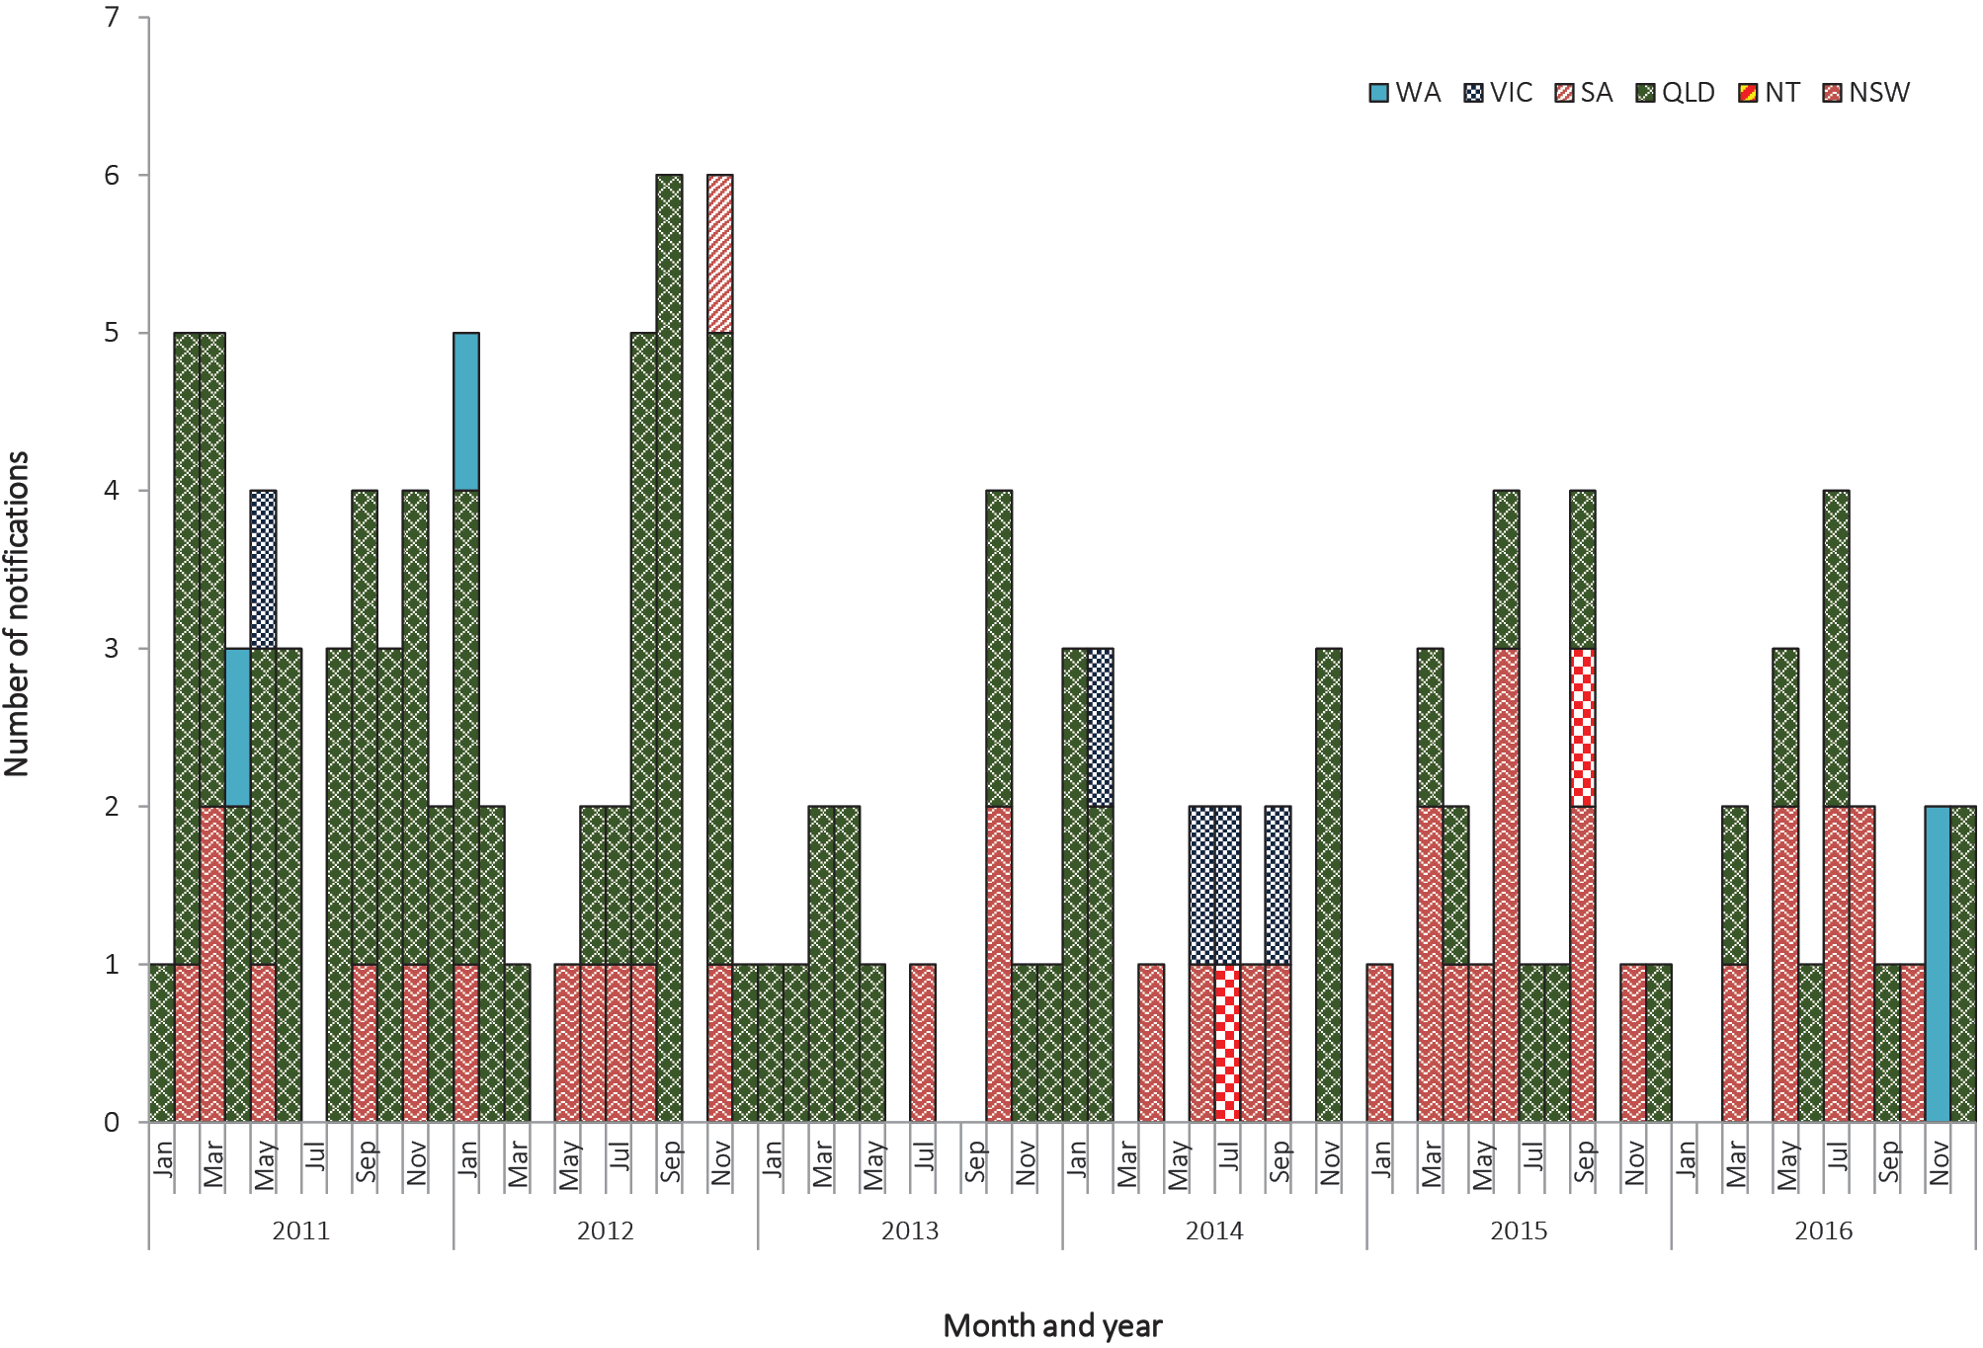

Figure 100: Notifications of brucellosis, Australia, 2016, by age group and sex

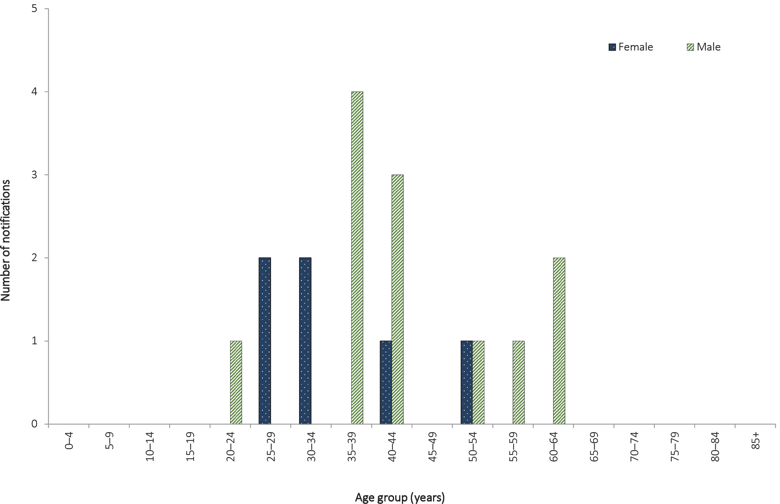

Leptospirosis

- There were 134 cases of leptospirosis notified in 2016, which is an 86% increase on 2015. The majority of cases (81%) were observed in males.
- The highest numbers of cases were observed in males in the 20–29 years and 50–59 years age groups.
Leptospirosis can cause a variety of illnesses varying in severity from a mild influenza-like illness to Weil’s syndrome, meningitis or pulmonary haemorrhage with respiratory failure possibly leading to death.²³ Leptospirosis is caused by spirochaetes of the genus Leptospira, which is found in the genital tract and renal tubules of domestic and wild animals. In affected areas, where there is exposure to infected urine of domestic and wild animals, this disease can be an occupational and recreational hazard (such as in certain agricultural sectors and swimming or wading in contaminated water).^{181,182}

Epidemiological situation in 2016
In 2016, there were 134 notified cases of leptospirosis in Australia, which is an 86% increase in notifications on 2015 (n = 72) and a 17% increase on the historical five-year mean, 2011 to 2015 (n = 115). The notification rate of leptospirosis in 2016 was 0.6 per 100,000 population, an increase on the rate in 2015 (0.3 per 100,000 population).

Geographical distribution
Seventy-two per cent (n = 96) of notified cases were in Queensland residents, followed by Victoria (11%; n = 15) and New South Wales (10%; n = 13) (Figure 101). Queensland had the highest state-specific notification rate of 2.0 per 100,000 population, followed by the Northern Territory (0.4 per 100,000 population).
Figure 101: Notifications of leptospirosis, Australia, 2011 to 2016, by month and year of diagnosis and state or territory
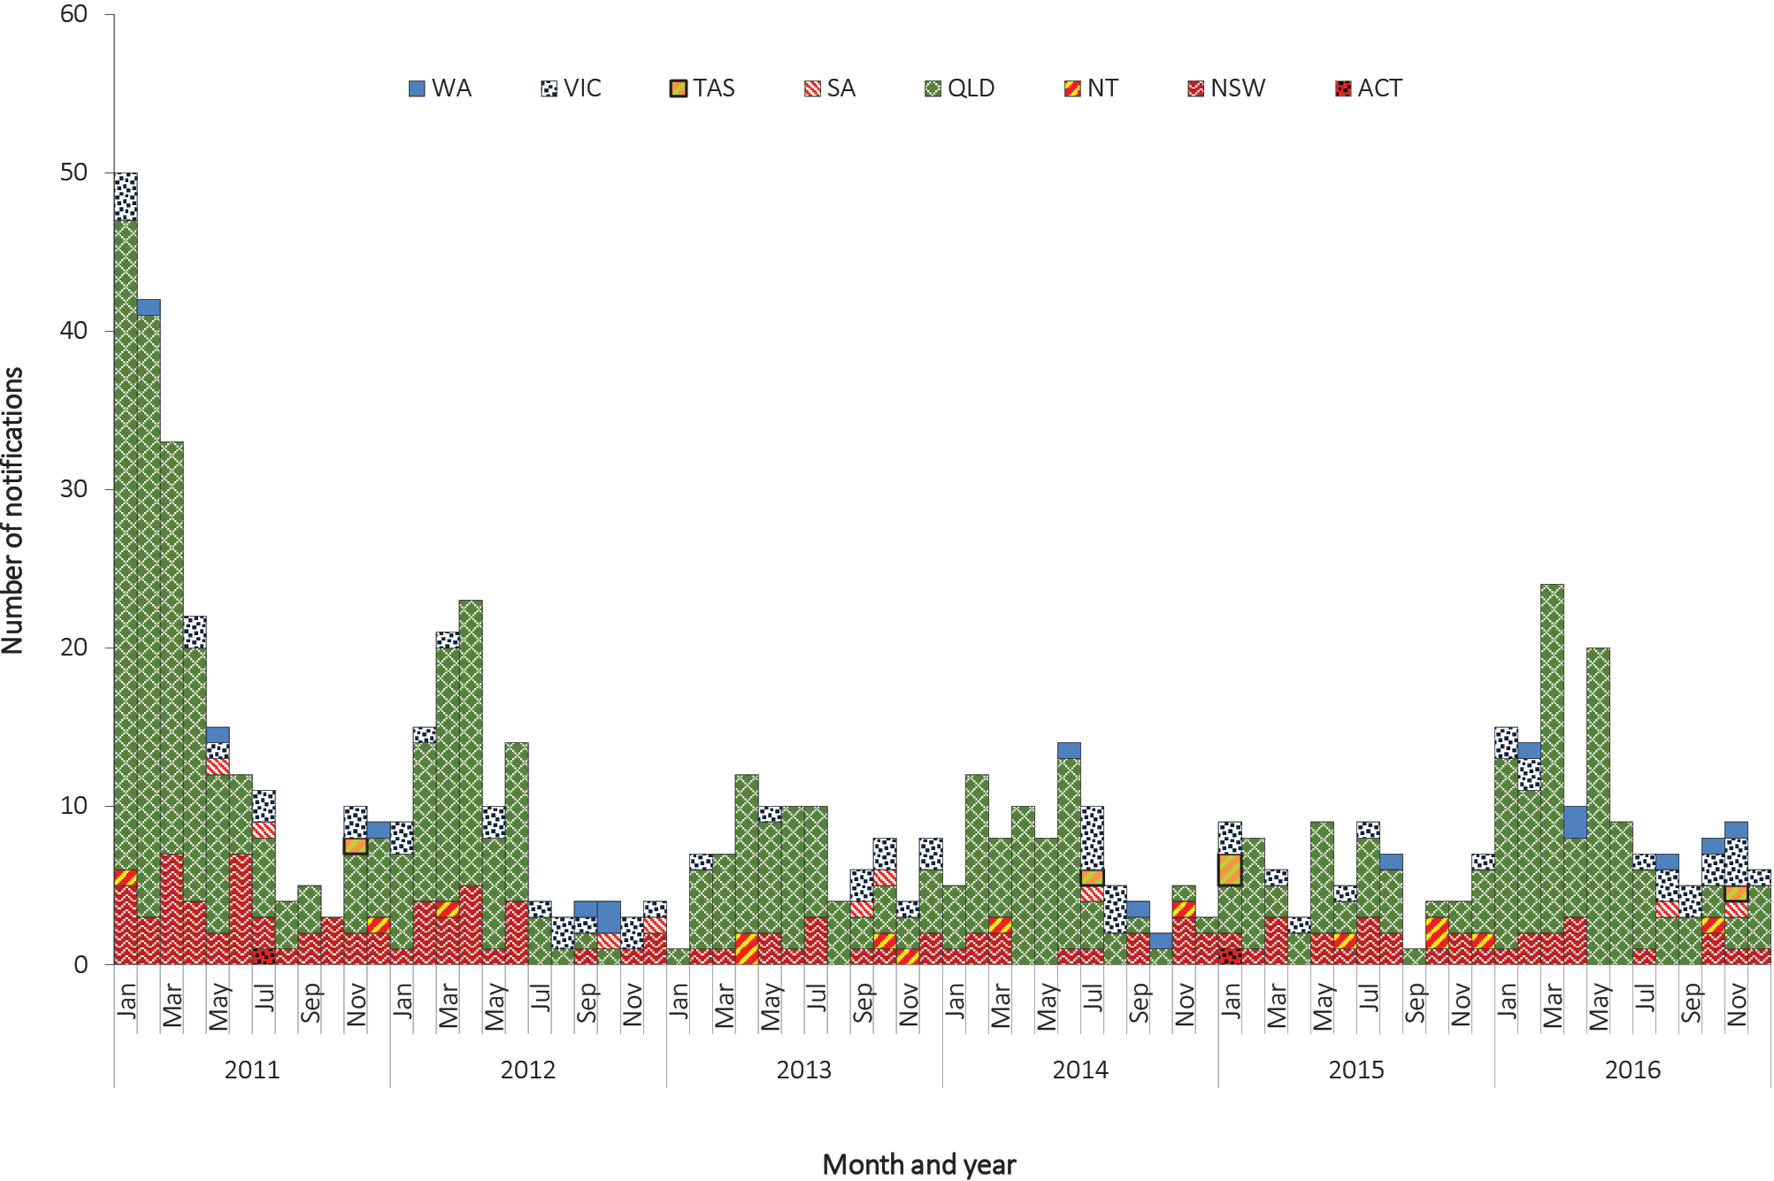

Age and sex distribution
In 2016, the highest numbers of leptospirosis notifications were in those aged 20–29 years (n = 33) and 50–59 years (n = 26) for males, and 35–39 years (n = 6) for females (Figure 102). In 2016, the median age of reported leptospirosis cases was 38 years (range 14 to 74 years), and the majority were male (81%; 108/134).

Figure 102: Notifications of leptospirosis, Australia, 2016, by age group and sex

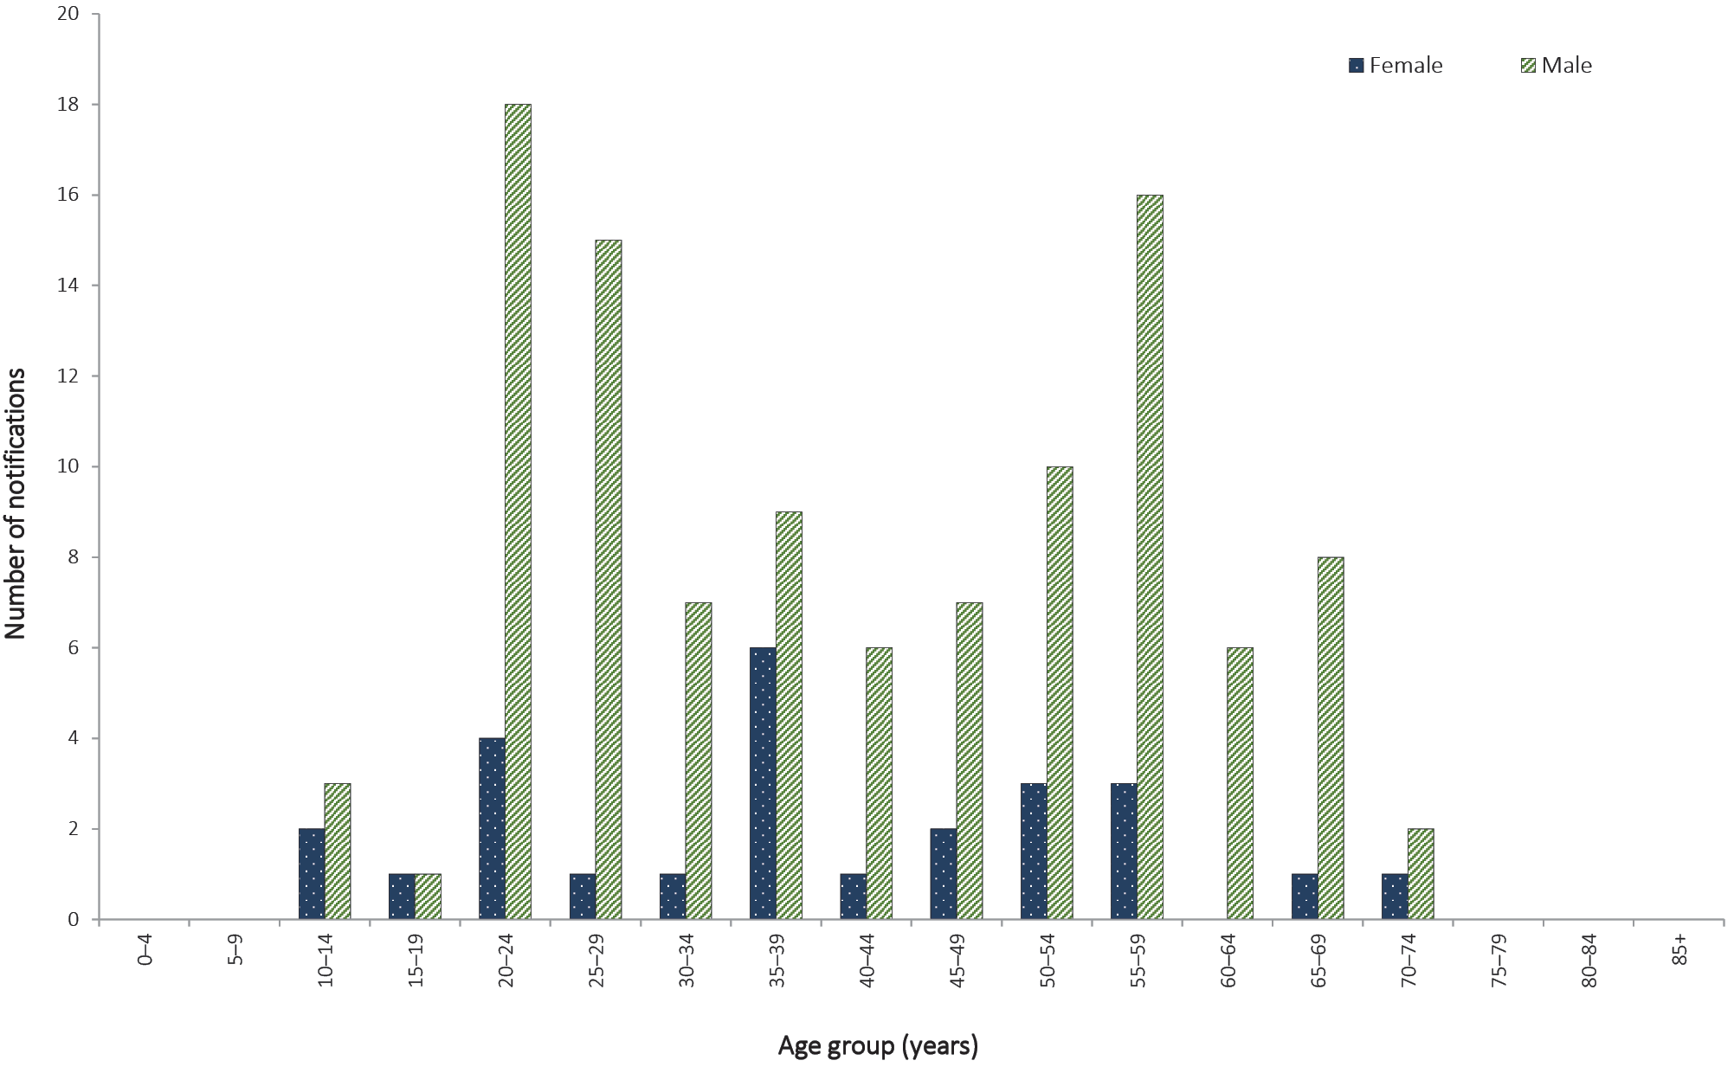

Microbiological trends
The WHO/Food and Agriculture Organization of the United Nations/World Organisation for Animal Health Collaborating Centre for Reference and Research on Leptospirosis (Leptospirosis Reference Laboratory, Queensland) routinely conducts PCR-based serotyping for leptospirosis cases from Queensland (from where the majority of cases are reported), and collates national data submitted to the laboratory from other states or territories. At the time of compiling this report, data for 2016 were not publicly available.
In Australia, serotyping is only conducted on pathogenic Leptospira species. In 2016, typing information was available for 82% of cases (110/134). Where typing data was available, the most frequently-reported serovars were L. interrogans serovar Arborea (27%; 30/110), L. interrogans serovar Zanoni (20%; 22/110), L. interrogans serovar Hardjo (15%; 17/110) and L. interrogans serovar Australis (14%; 15/110); of the remaining serovars, each had below five notifications.
In 2016, thirty-seven percent of reported leptospirosis cases (50/134) were acquired locally; 7% (10/134) were acquired overseas; 55% (74/134) were acquired in an unknown location.

Psittacosis

- There were 22 cases of psittacosis (ornithosis) notified in 2016, a 38% increase on 2015 (n = 16) but a 59% decrease on the historical five-year mean, 2011 to 2015 (n = 54).
- Sixty-four percent (n = 14) of cases were from New South Wales, in contrast to previous years when most notifications were from Victoria.
- Fifty-nine percent (n = 13) of cases reported in 2016 were male.
Psittacosis (ornithosis) is a pneumonia-like illness caused by infection with the bacterium Chlamydia psittaci.²³ It is transmitted to humans primarily from infected parrots, but transmission to humans has also been known to occur from poultry and a range of other birds.¹⁸³ There have also been reports of psittacosis in horses resulting in fetal abortion in pregnant mares; contact with fetal or placental material poses a transmission risk to humans. Transmission to humans occurs via the inhalation of contaminated dried faeces, respiratory secretions and dust from feathers. Individuals at risk of contracting psittacosis include bird owners and those with occupational exposure to birds.¹⁸³

Epidemiological situation in 2016
In 2016, there were 22 notified cases of psittacosis in Australia (0.1 per 100,000 population), which is a 38% increase on 2015 (n = 16) but a 59% decrease on the historical five-year mean, 2011 to 2015 (n = 54).

Geographical distribution
In 2016, New South Wales accounted for 64% (n = 14) of psittacosis notifications, in contrast to previous years when Victoria accounted for approximately two-thirds of annual notifications (Figure 103).

Figure 103: Notifications of psittacosis, Australia, 2011 to 2016, by month and year of diagnosis and state or territory
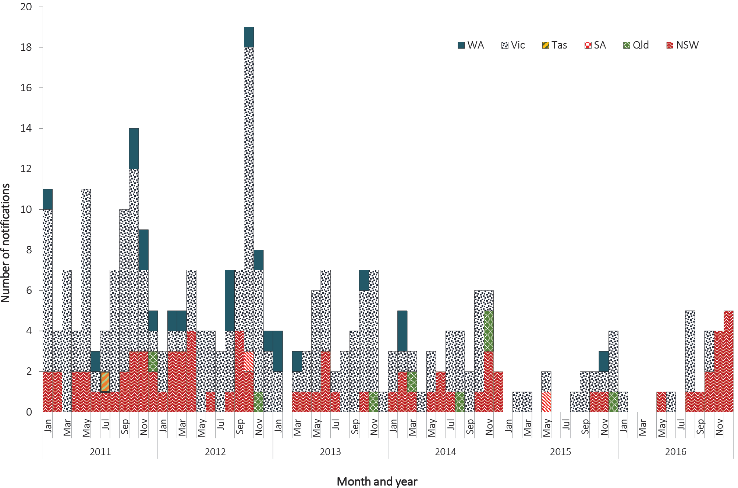

Age and sex distribution
In 2016, the median age of psittacosis notifications was 56 years old (range 23 to 76 years) and the majority of cases were male (59%; 13/22) (Figure 104).

Figure 104: Notifications of psittacosis, Australia, 2016, by age group and sex
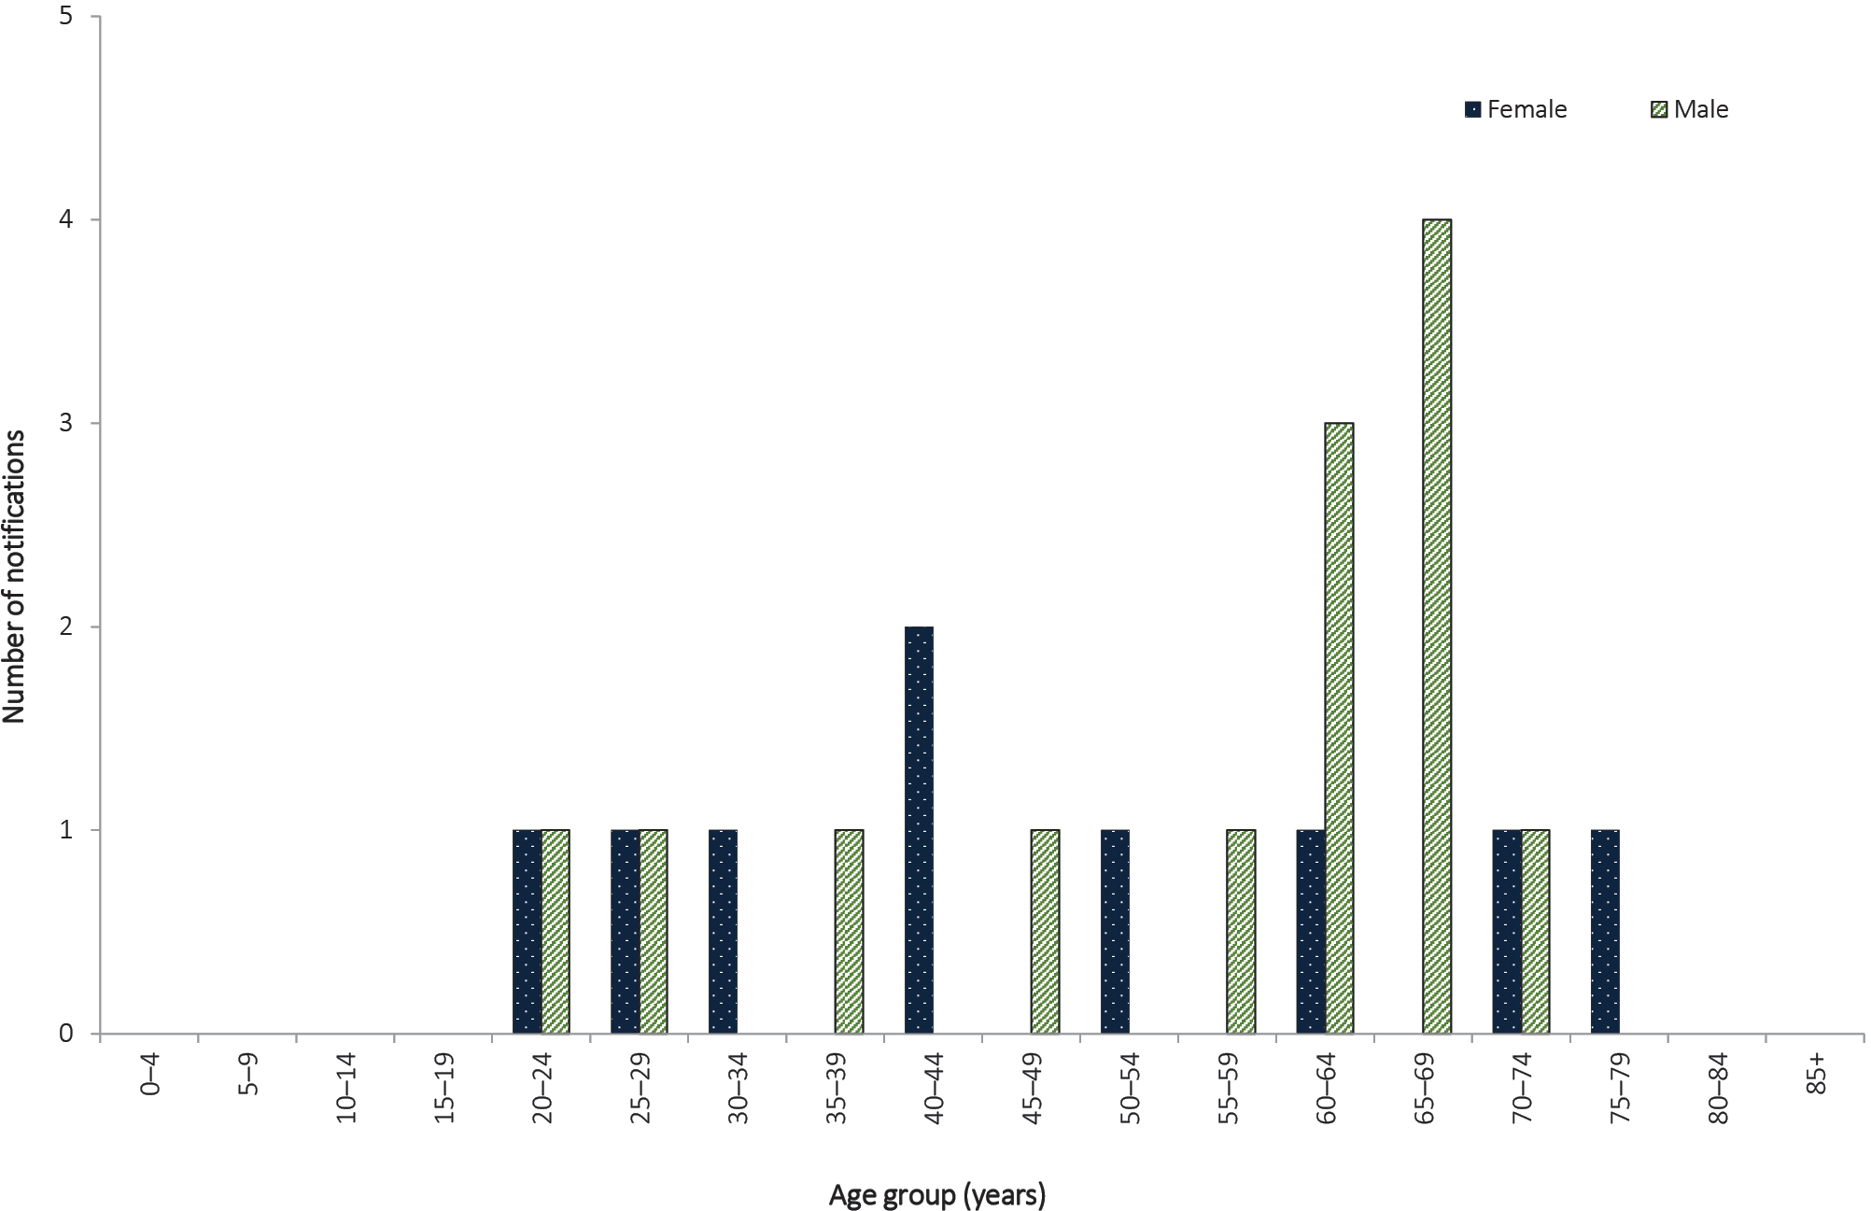

Q fever

- There were 551 notifications of Q fever in 2016, a 9% decrease on 2015 (n = 606).
- Q fever notifications were reported in all jurisdictions except Tasmania; the highest notification rate was in Queensland (4.8 per 100,000 population).
- Seventy-seven percent (n = 424) of notifications reported in 2016 were male.
- More than a third (41%, n = 223) of notified cases were males aged 45–64 years
Q fever is caused by infection with the bacterium Coxiella burnetii. The primary reservoirs of these bacteria are cattle, sheep and goats. C. burnetii is resistant to environmental conditions and many common disinfectants.¹⁸⁵ Q fever is most commonly transmitted via the airborne route, where the organism is carried in dust contaminated with tissue, birth fluids or excreta from infected animals.¹⁸⁶ Prior to the commencement of immunisation programs in Australia, approximately half of all cases in New South Wales, Queensland and Victoria were amongst abattoir workers.^{187,188}
The Australian Government funded the National Q Fever Management Program (NQFMP) between 2001 and 2006 for states and territories to provide free vaccine to at-risk occupational groups (such as abattoir workers).¹⁸⁹
Adults at risk of Q fever infection, including abattoir workers, farmers, veterinarians, stockyard workers, shearers and animal transporters, should be considered for immunisation. The administration of the Q fever vaccine requires a pre-immunisation screening test to exclude those recipients with a previous (possibly unrecognised) exposure to the organism, including previous immunisation. A Q fever vaccine may cause an adverse reaction in a person who has already been exposed to the bacterium. Immunisation is not recommended for children under 15 years of age or pregnant females.⁶⁸

Epidemiological situation in 2016
In 2016, there were 551 notifications of Q fever in Australia (2.3 per 100,000 population), which is a 9% decrease on 2015 (n = 606; 2.5 per 100,000 population) and a 20% increase on the historical five year mean, 2011 to 2015 (n = 459).
Between 1991 and 2001, and prior to the introduction of the NQFMP, Q fever notification rates ranged between 2.5 and 4.9 cases per 100,000 population.¹⁸⁹ Between 2009 and 2015, the notification rates of Q fever increased from 1.5 per 100,000 population to 2.5 per 100,000 population, before decreasing to 2.3 per 100,000 population in 2016.

Geographical distribution
The highest notification rate was seen in Queensland (4.8 per 100,000 population; n = 234), followed by New South Wales (3.0 per 100,000 population; n = 231). Notifications were reported in all jurisdictions, except Tasmania (Figure 105).
Figure 105: Notifications of Q fever, Australia, 2011 to 2016, by month and year of diagnosis and state or territory
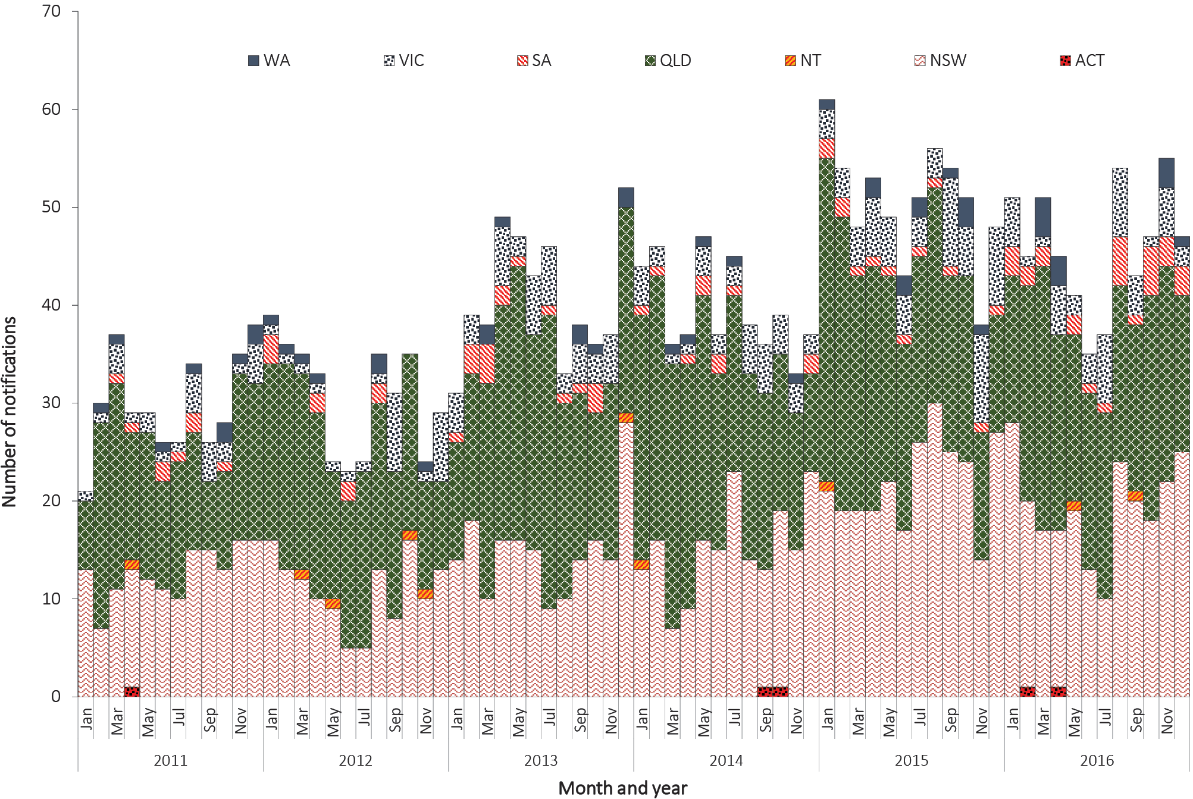

Age and sex distribution
The median age of Q fever notifications in 2016 was 49 years (range two to 82 years) and the majority were male (76%, (424/551). More than a third of notified cases (41%, 223/551) were males aged 45–64 years (Figure 106). This is consistent with a previous report which found higher rates of Q fever in men aged 50–59 years, and which found also that agriculture-related occupations (including farming) are the most commonly reported occupation.¹⁸⁶
Figure 106: Notifications of Q fever, Australia, 2016, by age group and sex
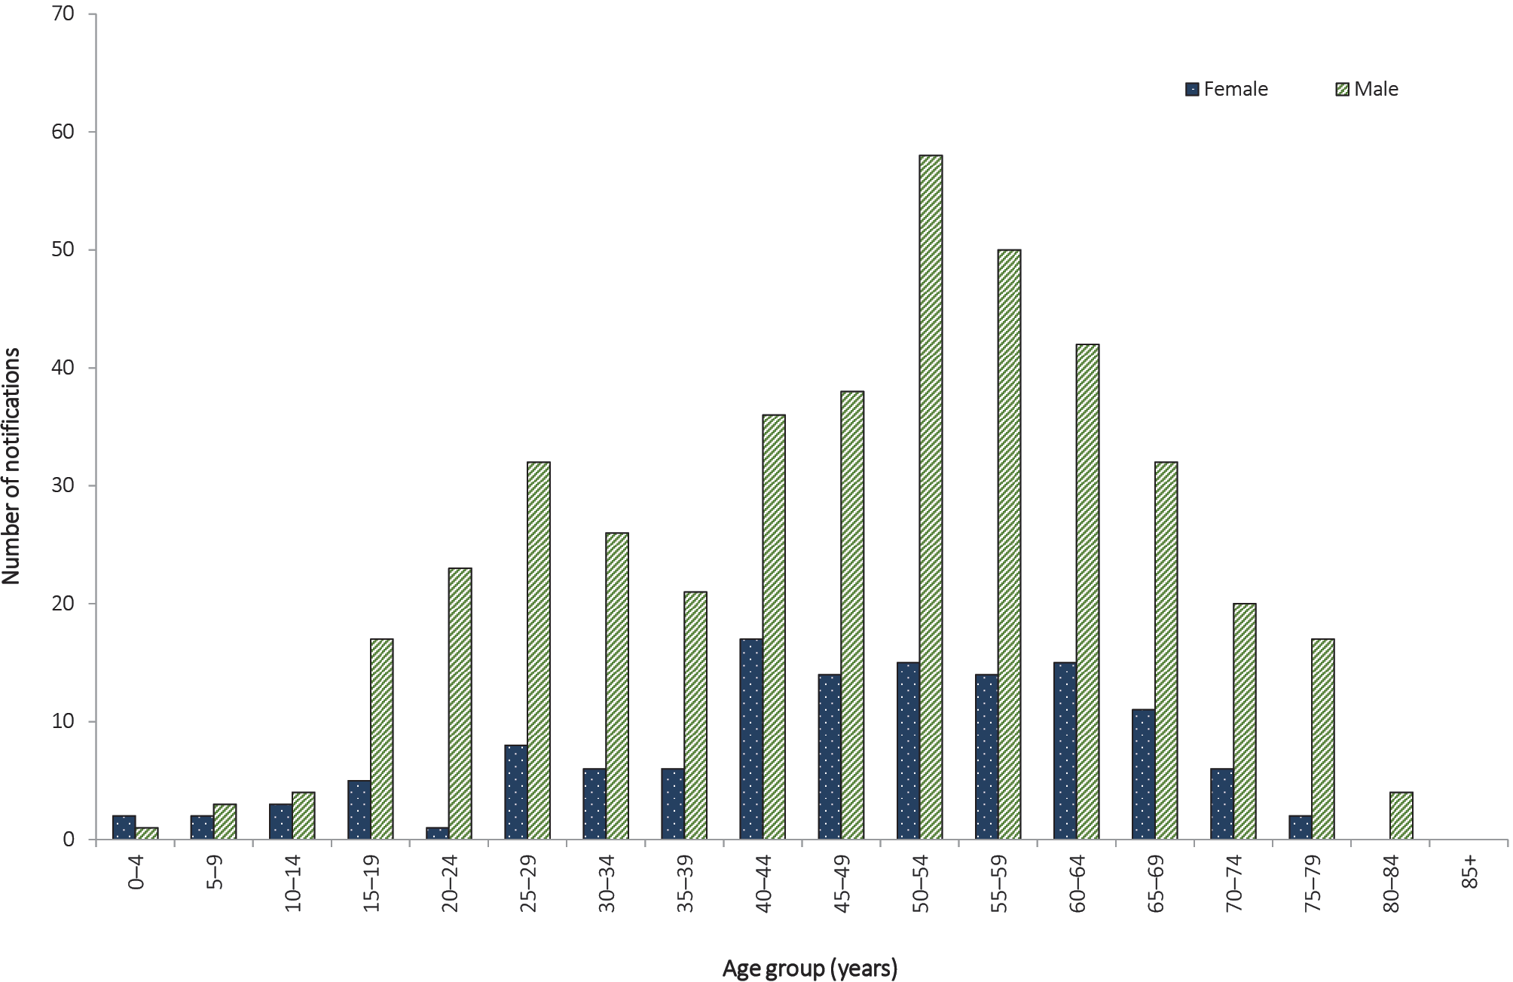

Tularaemia

- There were no notifications of tularaemia in 2016.
- The last reported cases of tularaemia in Australia were notified in 2011.
Tularaemia is a non-specific disease with diverse manifestations, often with an influenza-like onset, caused by infection with the bacterium Francisella tularensis.²³ The most common modes of transmission are through arthropod bites, handling infected animals, inhalation of infectious aerosols or exposure to contaminated food or water. Small mammals such as rodents, rabbits and hares are often the reservoir.¹⁹⁰

Epidemiological situation in 2016
In 2016, there were no notified cases of tularaemia in Australia. Tularaemia was last notified in 2011, with two cases reported in Tasmania. This was the first time that F. tularensis type B had been detected in the southern hemisphere.^{191–193}

Other bacterial infections
Other bacterial diseases in the national notifiable disease list are legionellosis; leprosy; invasive meningococcal disease; and tuberculosis. In 2016, there were 2,020 cases of these other bacterial infections notified to the NNDSS, representing 0.6% of all reported cases; this is an 11% increase on the number notified in 2015 (n = 1,815). Common objectives for the surveillance of diseases in this section are to monitor their epidemiology and to identify risk groups to accurately target control strategies.

Legionellosis

- There were 369 notifications of legionellosis in 2016, which is comparable to the number of notifications in 2015 (n = 365), and is a 9% decrease on the historical five-year mean, 2011 to 2015 (n = 407).
- Legionella pneumophila, commonly associated with man-made water systems, was the most frequently-reported causative species in 2016.
Legionellosis is an environmentally-acquired pneumonia caused by the bacteria Legionella. It can take the form of either Legionnaires’ disease, a severe form of infection of the lungs, or Pontiac fever, a milder influenza-like illness.²³ The species most associated with human disease in Australia are Legionella pneumophila and Legionella longbeachae. Legionella bacteria are found naturally in low levels in the environment. In the absence of effective environmental treatments, Legionella organisms can proliferate in air conditioning cooling towers; hot water systems; showerheads; spa pools; fountains; commercial potting mix; and other decomposing material, such as bark and sawdust. Legionella is generally transmitted to humans through contaminated water or dust aerosols.^{193–196}

Epidemiological situation in 2016
In 2016, there were 369 notifications of legionellosis, representing a notification rate of 1.5 per 100,000 population. This is comparable to 2015 (n = 365; notification rate 1.5 per 100,000 population), and is a 9% decrease on the historical five-year mean (n = 407) (Figure 107).
In 2016, data on the causative species were available for 98% (n = 361) of notifications reported. Of these cases, the most frequently reported causative species were L. Pneumophila (60%; 215/361), followed by L. longbeachae (40%; 146/361). A single notification each of Legionella maceachernii and Legionella micdadei was also reported (Table 24). Serogroup information was reported for 70% of L. pneumophilanotifications (150/215), and the majority of these (97%; 146/150) were serogroup 1 infections. For L. longbeachae notifications, serogroup information was provided for 16% (24/146), of which all were serogroup 1 infections.

Table 24: Notifications, notification rates and deaths for legionellosis, Australia, 2016, by species and state or territory
 | State or territory |  |  |  |  |  |  |  | Australia | Deaths due to legionellosis
Species | ACT | NSW | NT | Qld | SA | Tas. | Vic. | WA
L. pneumophila | – | 93 | – | 29 | 9 | 5 | 59 | 20 | 215 | 11
L. longbeachae | – | 42 | – | 20 | 19 | 4 | 12 | 49 | 146 | 3
L. maceachernii | – | – | – | – | 1 | – | – | – | 1 | –
L. micdadei | – | – | – | – | – | – | 1 | – | 1 | –
Unknown species | 2 | 1 | – | – | – | – | 3 | – | 6 | –
Total | 2 | 136 | 0 | 49 | 29 | 9 | 75 | 69 | 369 | 14
Rate (per 100,000 population) | 0.5 | 1.8 | 0.0 | 1.0 | 1.7 | 1.7 | 1.2 | 2.7 | 1.5 | –

Over the period of 2011 to 2016, the number of notified cases of L. Pneumophila ranged from 162 to 227 per annum, whilst notified cases of L. Longbeachae ranged from 164 to 215 per annum (Figure 107). When compared with 2015, notifications of L. pneumophila increased by 14% (n = 188 to n = 215) and L. longbeachae decreased by 11% (n = 164 to n = 146) in 2016.
Figure 107: Notifications of legionellosis, Australia, 2011–2016, by species and year
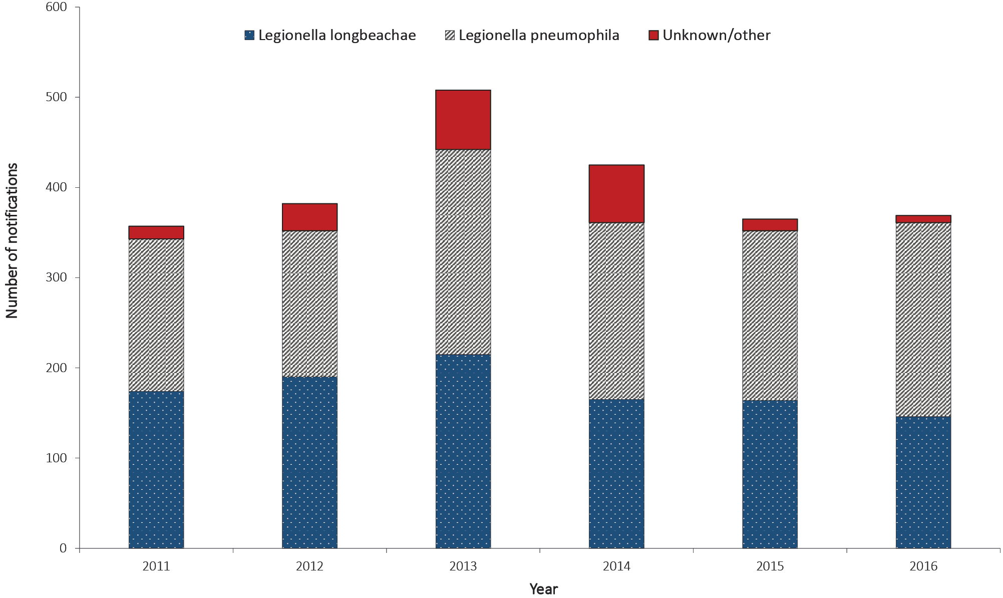
In 2016, mortality data was available for 64% of legionellosis notifications (232/361). Of these, 6% (14/232) were reported to have died due to legionellosis, which is comparable to the number of deaths reported in previous years. Most deaths were attributed to infection with L. pneumophila (79%; 11/14) (Table 24).

Geographic distribution
In 2016, jurisdiction specific rates of legionellosis varied from 0.5 per 100,000 population in the Australian Capital Territory to 2.7 per 100,000 population in Western Australia (Table 24).
In 2016, L. pneumophila was the most notified causative species in New South Wales, Queensland and Victoria, while L. longbeachae was more frequently notified in South Australia and Western Australia. The most frequent species annually reported by each jurisdiction can vary between L. pneumophila and L. longbeachae. However, generally Western Australia and the Northern Territory tend to report more L. Longbeachae notifications, while New South Wales, South Australia and Victoria tend to report more L. pneumophila notifications. The Australian Capital Territory and Tasmania tend to report only a small number of notifications each year with no clear species predominance.

Age and sex distribution
In 2016, males accounted for a higher proportion (69%) of the notifications than females, representing a male-to-female ratio of 2.3:1. The range of ages in 2016 was between 22 and 95 years. In males, the notification rate was highest in the 85 years and older age group (10.6 per 100,000 population) and for females, two groups, 65–69 years and 85 years and over, both reported the highest notification rate (4.0 per 100,000 population) in 2016 (Figure 108).
Figure 108: Notification rate for legionellosis, Australia, 2016, by age group, sex and species
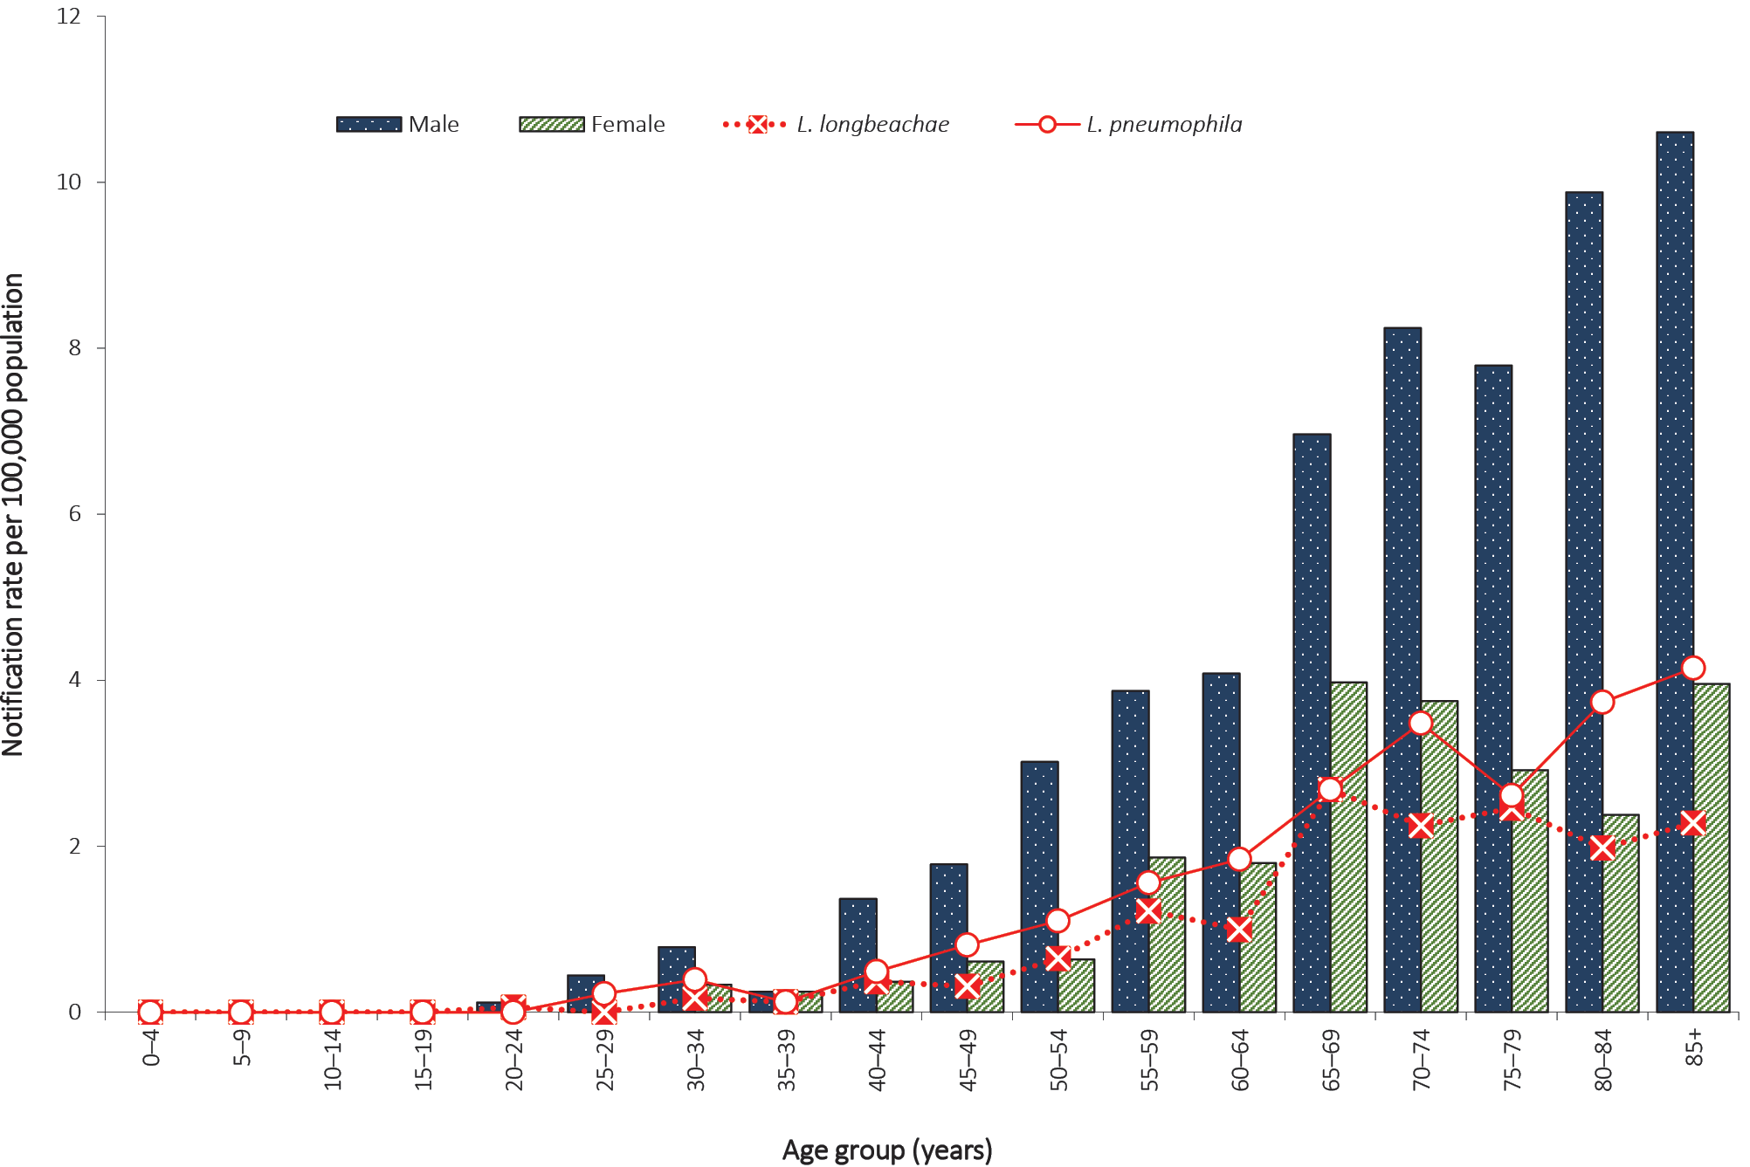
Of the 14 cases reported to have died due to legionellosis in 2016, their ages ranged between 56 and 91 years (median 81 years). Twelve deaths were in males and two were in females.
In 2016, the demographic profile of legionellosis remained consistent with the recognised epidemiology of the disease.^{197,198}

Seasonality
In 2016, diagnoses of legionellosis were highest in March and December with 40 and 42 notified cases, respectively, for these months. The diagnosis of L. pneumophila peaked in March (n = 29) and the diagnosis of L. Longbeachae peaked in October (n = 16). Between 2011 and 2016, the diagnosis of L. longbeachae more commonly occurred in winter and spring. In the same period, the diagnosis of L. pneumophila more commonly occurred in the late summer and autumn months, except for 2013 when diagnoses peaked at the end of winter (Figure 109). The winter peak in 2013 is most likely associated with increased testing in Queensland following a legionellosis outbreak at a hospital.
Figure 109: Notifications of legionellosis, Australia, 2011–2016, by month and year of diagnosis and species
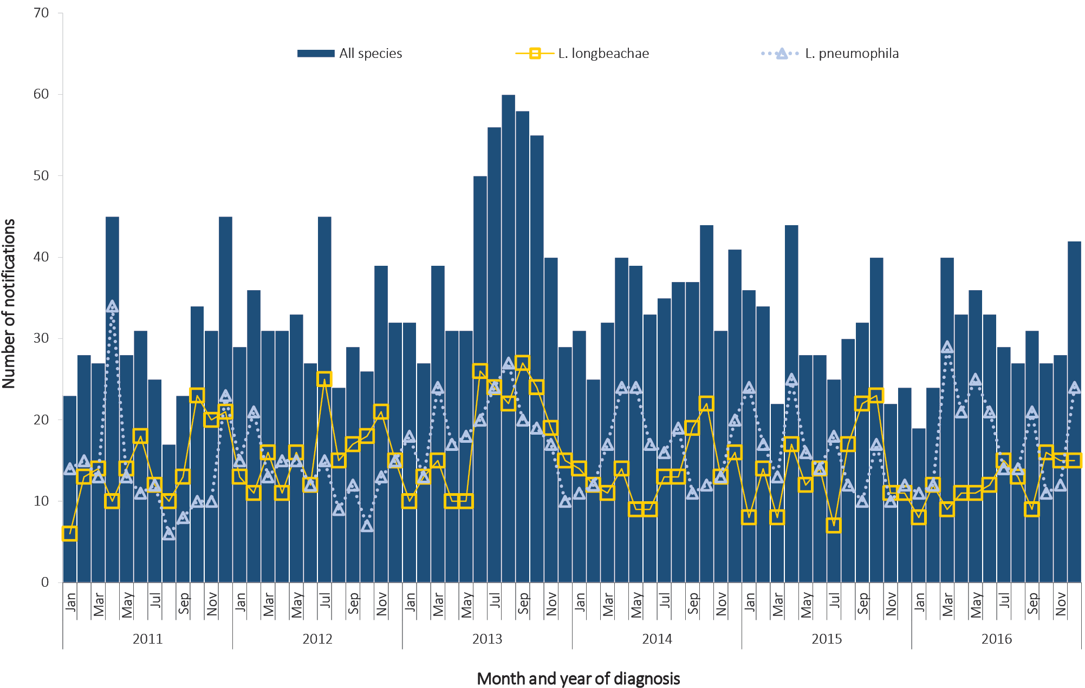

Place of acquisition
In 2016, place of acquisition was reported for 92% (n = 339) of legionellosis notifications. Of these, 90% (305/339) were locally acquired within Australia and 10% (34/339) were acquired overseas. Of the overseas acquired notifications, Thailand (26%, 9/34); China and Indonesia (both 15%, 5/34); and Singapore (6%, 2/34) were the more-commonly reported countries of acquisition.

Outbreaks
In 2016, there were a total of eight outbreaks of legionellosis: four in New South Wales; three in Victoria; and one in South Australia. All outbreaks were due to L. pneumophila.

Leprosy

- There were 21 notifications of leprosy in 2016, the highest number of notifications since 1991.
- The notification rate of leprosy has remained at less than 0.1 per 100,000 population.
- Eighty-six per cent (n = 18) of leprosy notifications in 2016 were acquired overseas.
Leprosy is a chronic infection of the skin and peripheral nerves caused by the bacterium Mycobacterium leprae. Leprosy is an uncommon disease in Australia and most cases occur in migrants from leprosy-endemic countries and in Aboriginal and Torres Strait Islander populations. The incidence of leprosy worldwide is declining due to various factors including economic development, Bacille Calmette-Guérin (BCG) immunisation and high coverage with multidrug therapy.^{23,199} Leprosy is not a highly-infectious disease and is typically slow to progress to a symptomatic stage. Symptoms may occur within one year but can take as long as 20 years to appear. Leprosy is curable and treatment in the early stages can prevent disability.¹⁹⁹

Epidemiological situation in 2016
In 2016, there were 21 notifications of leprosy, representing a notification rate of less than 0.1 per 100,000 population. This is the highest number of leprosy cases since 1991.
There were seven cases notified in Western Australia; six in New South Wales; four in Queensland; two in Victoria; and one each in the Northern Territory and Tasmania. Cases ranged in age from 17 to 60 years of age, with a median age of 35 years. There were 17 cases in females and four in males.
The majority of cases in 2016 were in non-Indigenous Australians (71%; n = 15). Aboriginal and Torres Strait Islander people accounted for 24% (n = 5) and there was one case with unknown Indigenous status (Figure 110).

Figure 110: Notifications of leprosy, Australia, 1996 to 2016, by year and Indigenous status
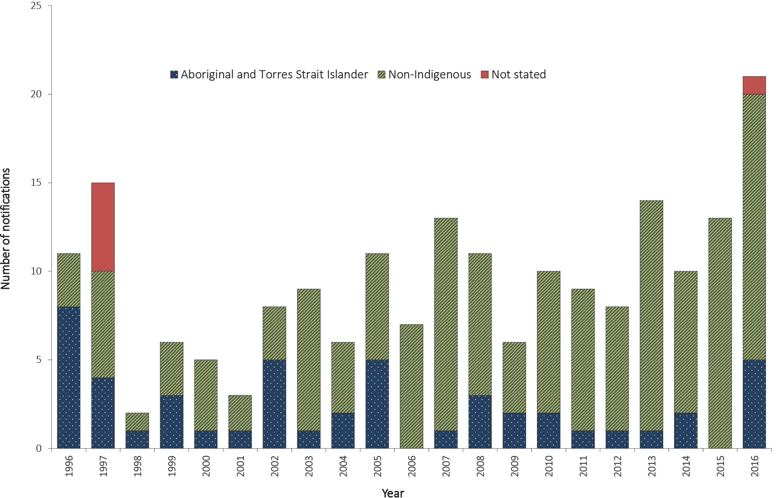
Place of acquisition was reported in 86% (18/21) of leprosy cases in 2016, with the majority (67%; 14/21) acquiring their infection overseas. Of the overseas cases, four were acquired in India; three each in Nepal and Philippines; and one each in Sri Lanka, Brazil, Eritrea and Fiji.

Meningococcal disease (invasive)

- There were 252 cases and 11 deaths related to IMD in 2016.
- Serogroup W was the most frequent cause of IMD (44%; n = 108).
- Fifty-nine percent (n = 149) of all cases were in those aged less than 30 years, of which 36% (54/149) were children less than five years of age.
Invasive meningococcal disease (IMD) is caused by the bacterium Neisseria meningitidis entering a normally sterile site, usually blood (septicaemia), cerebrospinal fluid (meningitis) or both. Asymptomatic respiratory tract carriage of meningococci is present in around 10% of the population and prevalence may be higher when groups of people occupy a confined living space.^{23,68} IMD is transmitted via respiratory droplets and usually has an incubation period of one to seven days (rarely up to 10 days). It can rapidly progress to serious illness, most commonly occurring in previously-healthy children and young adults.²⁰⁰ There are 13 known serogroups globally; serogroups A, B, C, X, W and Y more commonly cause invasive disease.^{68,201} Historically, N. meningitidis serogroups B and C have been the major cause of IMD in Australia in recent decades. However, since 2013, there has been a rise in the cases associated with serogroup W and Y organisms.⁶⁸

Epidemiological situation in 2016
In 2016, there were 252 notified cases of IMD representing a rate of 1.0 per 100,000 population. This is an increase of 38% on the number of cases notified in 2015 (n = 182) and an increase of 31% on the historical five-year mean (n = 192.2 cases; range 147–241) (Figure 111). Although numbers in 2016 have remained low, this is the third consecutive year in which notifications of IMD have increased in Australia. This rise is due to an increase in the number of infections caused by serogroup W and serogroup Y organisms (Figure 111).
Figure 111: Notifications of invasive meningococcal disease by selected serogroup, Australia, 2003 to 2016
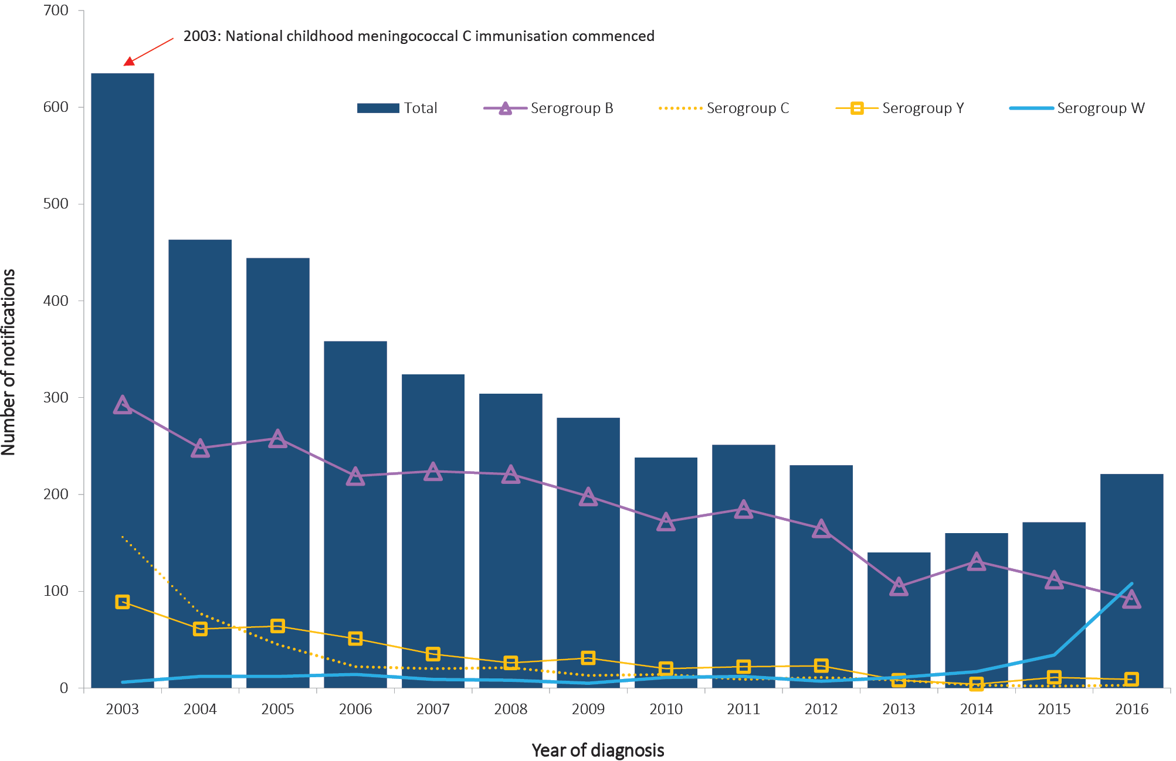
Almost all notifications of IMD (99%; n = 249) in 2016 were classified as confirmed cases according to the case definition.²⁰³ A small number of cases (n = 3) were reported as probable and diagnosed based on clinical evidence only.
In 2016, all states and territories reported cases of IMD (Table 25), with notification rates ranging from 0.5 per 100,000 population in the Australian Capital Territory to 1.6 per 100,000 population in South Australia (Table 25).
Mortality data were available for 73% (n = 185) of cases. Of these, 11 cases were reported as having died from IMD, comprising seven from infection with serogroup W organisms; two from infection with serogroup B organisms; and two from infection with serogroup Y organisms (Table 25). There was a varied distribution of age for those reported to have died from IMD (range one to 81 years). Of the deaths associated with serogroup W organisms, one death was in a child aged less than five years old, three cases were 20–34 years of age; one case was 45–49 years of age; and two cases were 65–74 years of age. Of the deaths associated with IMD infection caused by serogroup B organisms, one death occurred in a child less than five years of age and one case in the 80–84 years age group. The two deaths caused by serogroup Y organisms occurred in young adults in the 15–24 years age group.

Age and sex distribution
In 2016, the proportion of IMD cases was equal in males (50%, n = 125) and females (50%, n = 127). Proportionally, 59% (n = 149) of all cases reported in 2016 were in those less than 30 years of age, of which 36% were in children less than five years of age (n = 54). The highest notification rates in 2016 for both males and females occurred in the 0–4 years age group (4.1 per 100,000 population for males and 2.7 per 100,000 population for females) (Figure 112).
Figure 112: Notification rate for invasive meningococcal disease, Australia, 2016, by age and sex
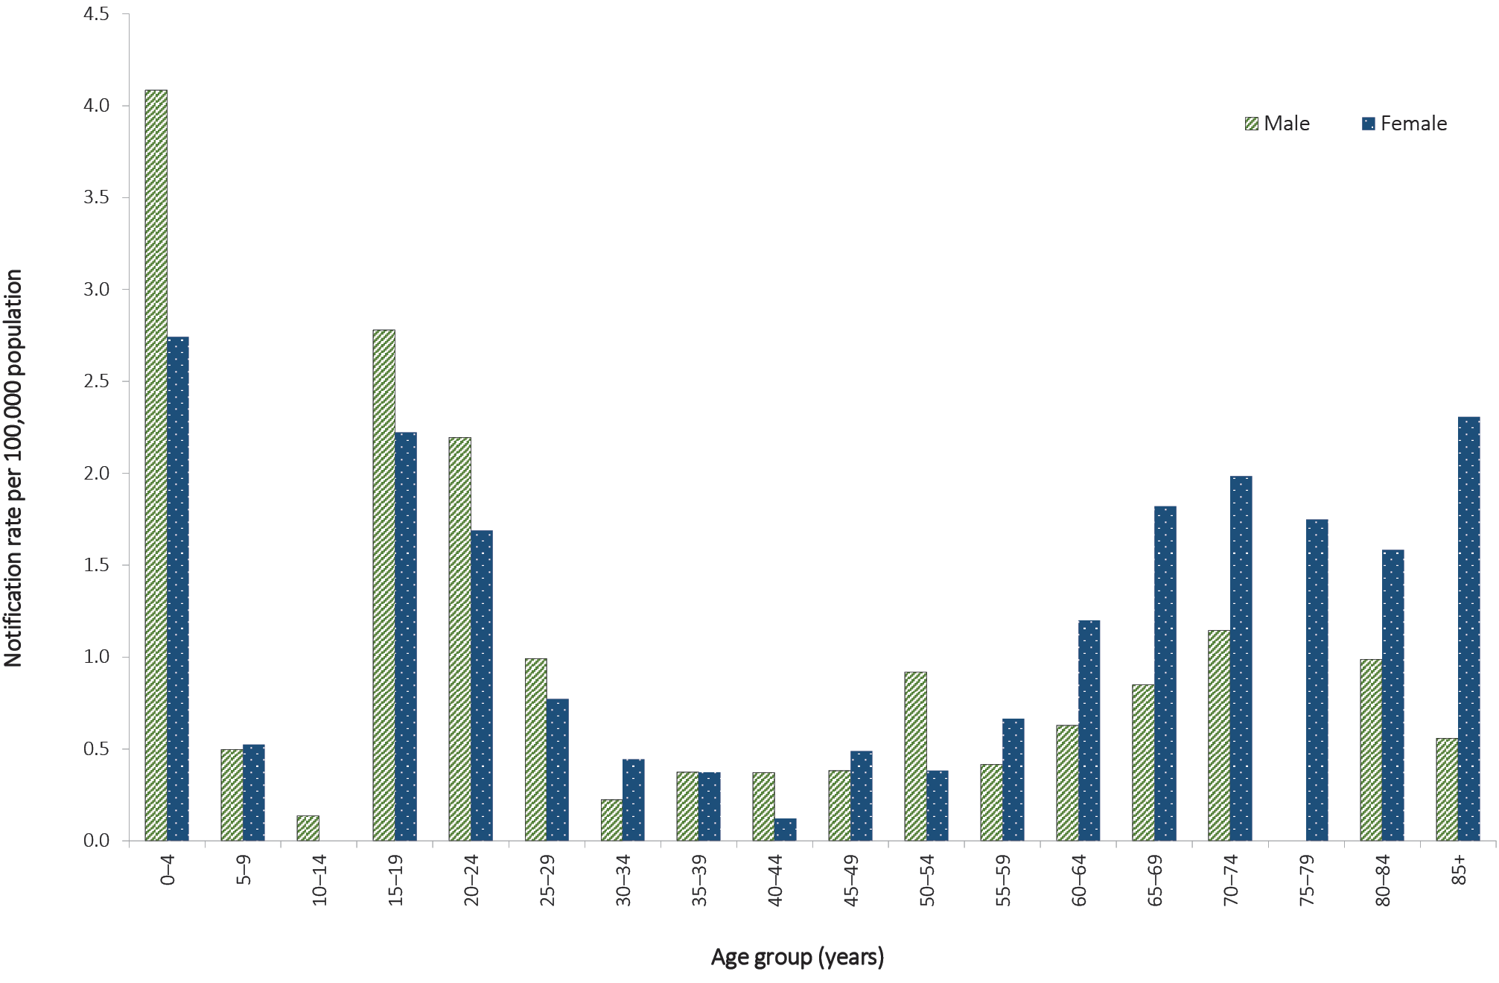

Serogroup analysis
Data on serogroup were available for 96% (n = 243) of cases in 2016, of which 44% (108/243) were caused by serogroup W organisms; 38% (92/243) by serogroup B organisms; 16% (40/243) by serogroup Y organisms; and 1% (3/243) by serogroup C organisms (Table 25). Nine cases (4%) were reported as non-groupable.
Cases of IMD caused by serogroup C organisms remain low in 2016 (n = 3). Notifications of IMD caused by serogroup C organisms have declined by 98% since the introduction of the meningococcal C vaccine on the NIP in 2003.^{68,203} Of the three cases of IMD due to serogroup C organisms reported in 2016, one was reported in the 15–19 years age group and two cases were aged between 40–60 years. Age-specific rates of serogroup C infections have remained below 0.1 cases per 100,000 population since 2011.

Table 25: Notifications and notification rates of invasive meningococcal disease and deaths due to invasive meningococcal disease, Australia, 2016, by serogroup and state or territory
Serogroup | State or territory
 | ACTª | NSWª | NT | Qld | SA | Tas. | Vic. | WA | Australia | Deaths
B | 1 | 26 | 2 | 17 | 22 | – | 18 | 6 | 92 | 2
C | – | 2 | – | – | – | – | 1 | – | 3 | –
W | 1 | 25 | – | 13 | 5 | 4 | 48 | 12 | 108 | 7
Y | – | 15 | – | 13 | – | 1 | 9 | 2 | 40 | 2
Other^{b} | – | 3 | – | 2 | – | – | 3 | 1 | 9 | –
Total | 2 | 71 | 2 | 45 | 27 | 5 | 79 | 21 | 252 | 11
Rate per 100,000 population | 0.5 | 0.9 | 0.8 | 0.9 | 1.6 | 1.0 | 1.3 | 0.8 | 1.0 | –
a Cases of conjunctival meningococcal infection are reported under the local case definition, and therefore reported to the national dataset by the jurisdiction. Conjunctival cases cannot be distinguished from invasive cases in the national dataset.
b ‘Other’ includes notifications where serogroup was reported as non-groupable (when the serogroup is reported by the reference laboratory as a non-groupable strain) or not grouped (when no serogroup information is available).
Serogroup W accounted for most cases across all age groups in 2016, with the exceptions of those less than 30 years of age where serogroup B was higher. Compared to 2015, notification rates for serogroup B declined across all age groups in 2016 with the exception of those 20–24 years and 25–29 years, where there were increases (from 0.8 per 100,000 population to 1.2 per 100,000 population and from 0.2 per 100,000 population to 0.4 per 100,000 population respectively) (Figure 113).

Figure 113: Notification rate for serogroup B invasive meningococcal disease, Australia, 2011 to 2016, by selected age groups
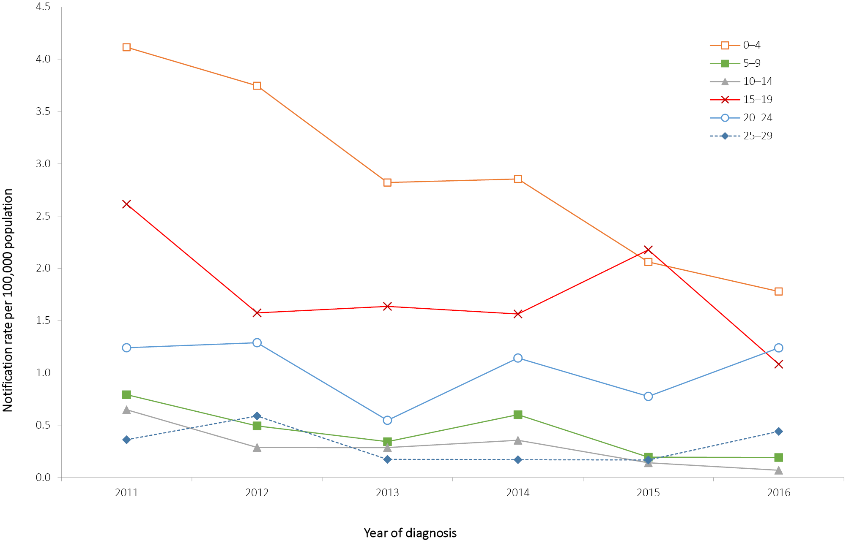

In the 2015 NNDSS Annual Report,³⁵ an increase in cases due to serogroup W organisms was evident, with numbers almost two times higher than the annual average of the previous five years. This increase has continued in 2016, with 108 cases reported due to serogroup W organisms, compared with 34 cases in 2015, 17 cases in 2014, 11 cases in 2013 and seven cases in 2012. There has been a 218% increase in notifications of IMD caused by serogroup W between 2015 and 2016.

Seasonality
In 2016, an average of 21 cases of IMD were reported monthly (range 9–37 cases per month). In previous years, a higher proportion of IMD notifications was reported towards the end of winter (August) and early spring. However, the 2016 season peaked in October with 37 cases (Figure 114).

Figure 114: Notifications of invasive meningococcal disease, Australia, 2011 to 2016, by age group and month and year of diagnosis
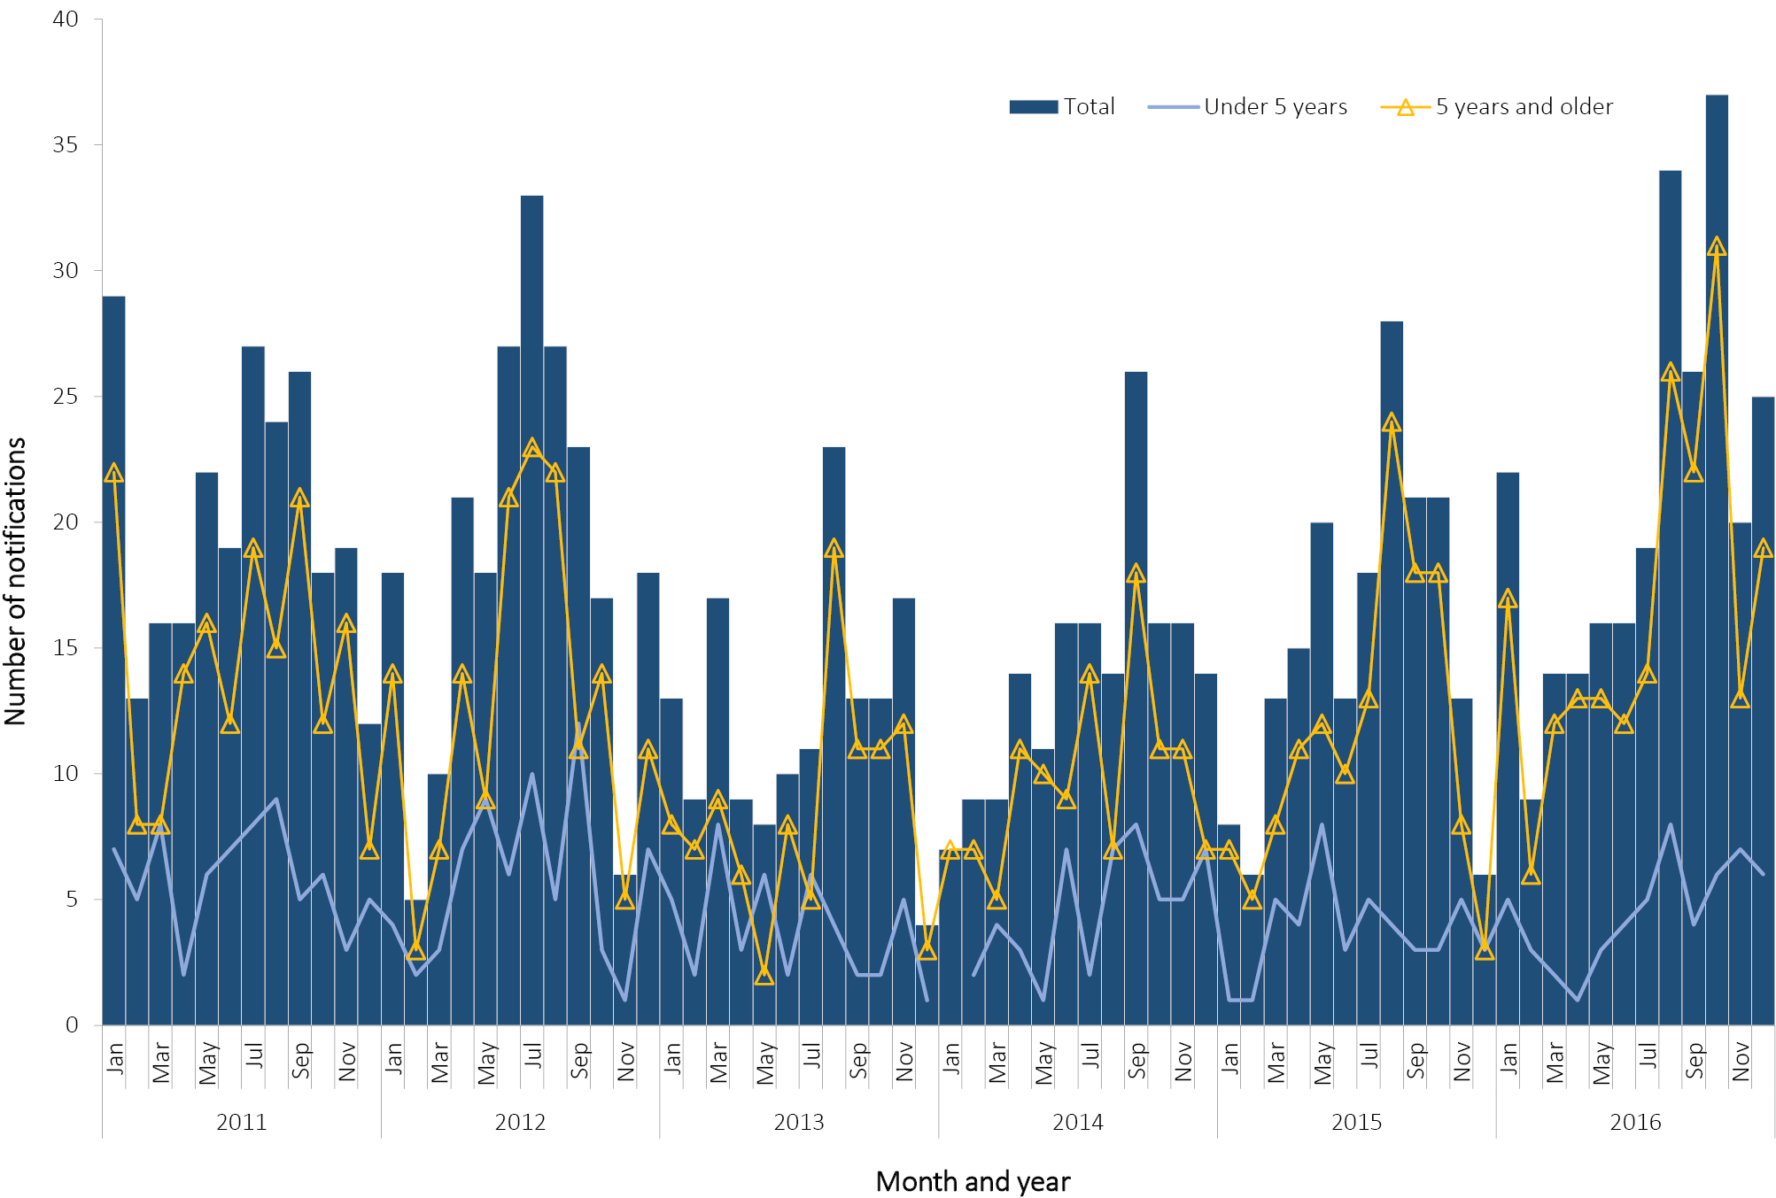

Immunisation
From 2003, the meningococcal C vaccine has been available for infants aged 12 months on the NIP. A catch-up program provided access to the meningococcal C vaccine for children and adolescents born between 1984 and 2001.^{68,204} Vaccinations for serogroup ACWY and for serogroup B were available on the private market but not funded under the NIP.
Of the three cases of IMD caused by serogroup C organisms reported in 2016, one was 15–19 years of age and therefore eligible for immunisation under the NIP. This case’s vaccination status was unknown. The other two cases were between 40 and 59 years of age.

Susceptibility
The Australian Meningococcal Surveillance Program (AMSP) was established in 1994 for the purpose of monitoring and analysing isolates of N. meningitidis from cases of IMD in Australia. The program is undertaken by a network of reference laboratories in each state and territory using standardised methodology to determine the phenotype (serogroup, serotype and serosubtype), and the susceptibility of N. meningitidis to a core group of antibiotics. Further details about the AMSP, including the annual reports are available through CDI, Australian Department of Health.²⁰⁵

Discussion
The overall incidence of IMD in Australia is low and has decreased since the introduction of the serogroup C vaccine on the NIP in 2003.^{68,204} However, from 2014 there has been a rise of IMD cases nationally. Since 2013, serogroup W has accounted for an increasing proportion of IMD cases, with 44% of cases in 2016 attributed to this organism. The situation in Australia has evolved and has continued to be closely monitored. A national working group was formed in 2014 under the auspices of CNDA to further assess the situation and ensure consistent collection of enhanced data. Lessons learned from the international experience will be important in informing the public health response.²⁰⁶

Tuberculosis

- There were 1,378 tuberculosis notifications in 2016, a 10% increase on the number of notifications in 2015 and a 5% increase on the historical five-year mean, 2011 to 2015.
- Australia has maintained low rates of tuberculosis since the mid-1980s.
Tuberculosis (TB) is an infection caused by organisms of the Mycobacterium tuberculosis complex and consists of M. tuberculosis, M. bovis, M. microti, M. canetti and M. africanum. M. tuberculosisis the cause of almost all TB in Australia. TB is transmitted by airborne droplets produced by people with pulmonary or respiratory tract TB when coughing or sneezing. Whilst most persons infected with TB remain asymptomatic, there is 10% lifetime risk of developing clinical illness, sometimes many years after the original infection. While Australia has one of the lowest rates of tuberculosis in the world, the disease remains a public health issue, particularly in Australia’s overseas-born population and in Aboriginal and Torres Strait Islander people in the central and northern regions of Australia.^{68,207}

Epidemiological situation in 2016
In 2016, there were 1,378 TB notifications, which is a 10% increase on the number of notifications in 2015 (n = 1,255) and a 5% increase on the historical five-year mean, 2011 to 2015 (n = 1,312). The notification rate of TB in 2016 was 5.7 per 100,000 population, which is an increase on the rate in 2015 (5.3 per 100,000 population) and equal to the historical five-year mean, 2011 to 2015 (5.7 per 100,000 population). Australia has achieved good TB control and has maintained overall low rates of TB since the mid 1980s (Figure 115).

Figure 115: Notification rate for tuberculosis, Australia, 1960 to 2016, by year
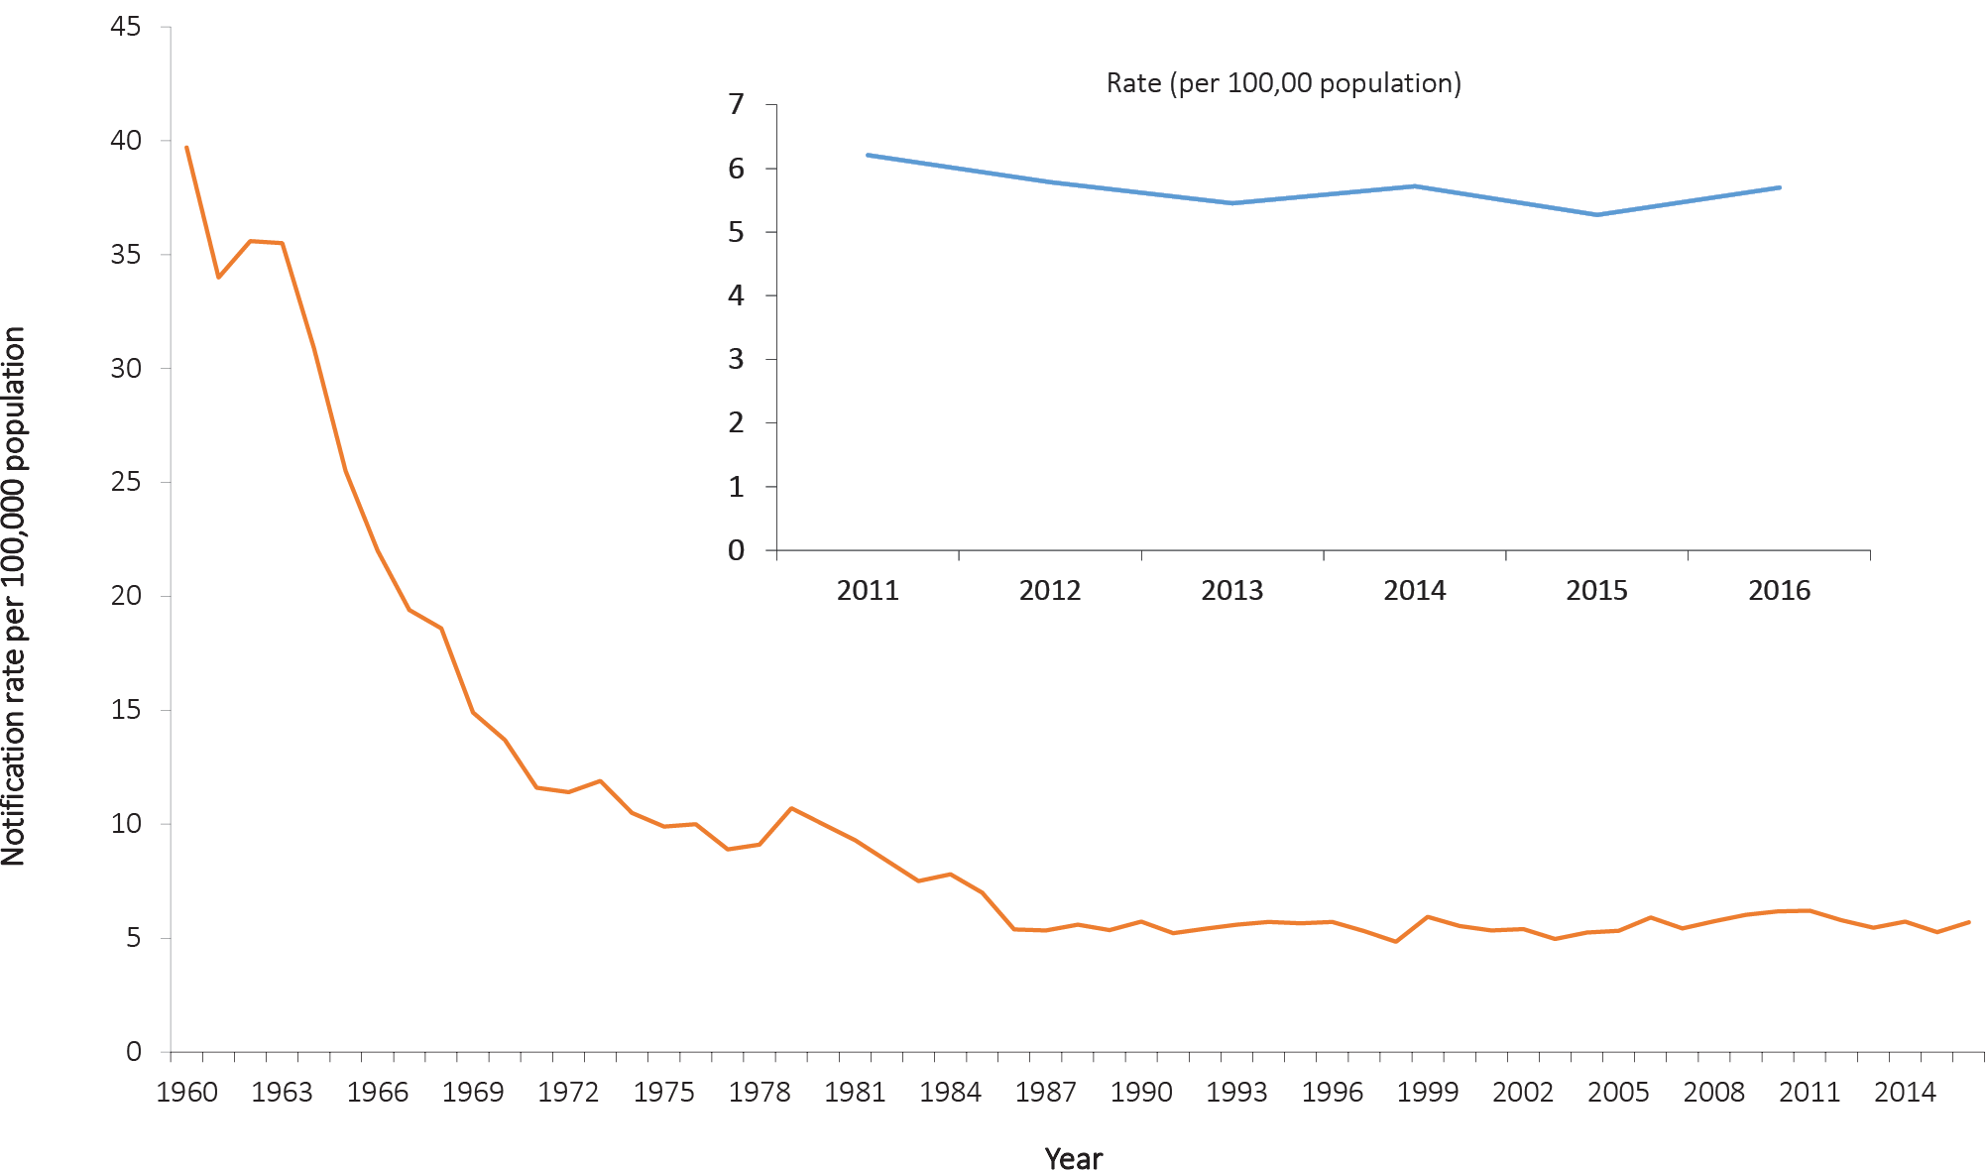

Geographic distribution
New South Wales (n = 536); Victoria (n = 365); Queensland (n = 181); and Western Australia (n = 145) accounted for 90% of all cases of TB diagnosed in Australia (Table 4). The Northern Territory (9.0 per 100,00), New South Wales (6.9 per 100,000), Australian Capital Territory (6.0 per 100,000) and Victoria (5.9 per 100,000) all reported rates higher than the national notification rate (Table 5).

Age and sex distribution
Overall, the age groups with the highest notification rates were those aged 25–29 and 85 years or more (12.8 and 11.6 per 100,000 population, respectively), followed by the 30–34 years (9.3 per 100,000 population) and 35–39 years (9.0 per 100,000 population) age groups. The highest age- and sex-specific rates were observed in men aged 85 years or more (19.5 per 100,000 population) and women aged 25–29 years (14.7 per 100,000 population) (Figure 116). Males accounted for 54% of TB notifications in 2016.

Figure 116: Notification rate for tuberculosis, Australia, 2016, by age group and sex
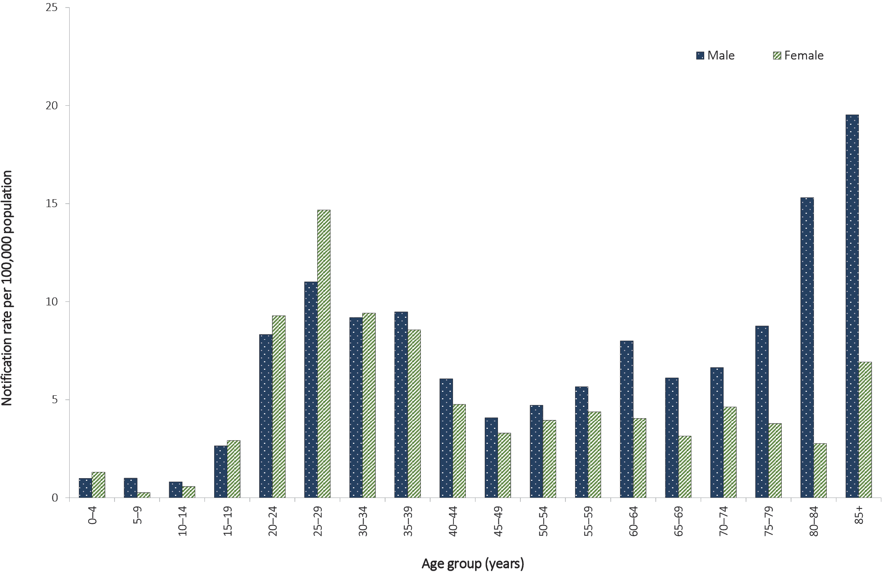

Immunisation
The BCG vaccine was first introduced for protection against tuberculosis in the 1920s and, despite variable evidence on the efficacy of the vaccine, it remains the only vaccine in use for TB today.^{208,209}
BCG immunisation is recommended for Aboriginal and Torres Strait Islander neonates in communities with a high incidence of TB; for neonates and children under five years of age who will be travelling to or living in countries or areas with a high incidence of TB for extended periods; and for neonates born to parents with leprosy or a family history of leprosy. Additionally, BCG immunisation may be considered for children over 5 years of age who will be travelling to, or living in, countries or areas with a high prevalence of TB for extended periods; and for health care workers who may be at high risk of exposure to drug-resistant TB.^{68,210}
BCG immunisation is not recommended for general use in the Australian population, given Australia’s low incidence of TB. The vaccine is contraindicated in HIV-infected persons.²¹⁰ BCG immunisation practices may vary between states and territories due to differences in jurisdiction-specific TB immunisation policies and population demographics.
Whilst public health follow-up is undertaken for all notifications of TB, completeness of the vaccine fields in the NNDSS dataset is poor.

Enhanced surveillance data sets
Enhanced data are collected on all cases of TB. Further analyses, including identification of risk groups and reporting on treatment outcomes, can be found in the TB annual report series published in CDI.²¹¹

Abbreviations used in this report
Abbreviations | Definition
7vPCV | 7-valent pneumococcal conjugate vaccine
13vPCV | 13-valent pneumococcal conjugate vaccine
23vPPV | 23-valent pneumococcal polysaccharide vaccine
ABLV | Australian bat lyssavirus
AFP | Acute flaccid paralysis
AGSP | Australian Gonococcal Surveillance Programme
AIDS | Acquired immune deficiency syndrome
AMSP | Australian Meningococcal Surveillance Programme
ANCJDR | Australian National Creutzfeldt-Jakob Disease Registry
BCG | Bacille Calmette–Guérin
BFV | Barmah Forest virus
CDI | Communicable Diseases Intelligence
CDNA | Communicable Diseases Network Australia
CDWG | Case Definitions Working Group
CHIKV | Chikungunya virus
CJD | Creutzfeldt-Jakob disease
CRS | Congenital rubella syndrome
DAFF | Queensland Department of Agriculture, Fisheries and Forestry
DENV | Dengue virus
Hib | Haemophilus influenzae type b
HIV | Human immunodeficiency virus
HPAIH | Highly pathogenic avian influenza in humans
HUS | Haemolytic uraemic syndrome
ICU | Intensive care unit
ILI | Influenza-like illness
IMD | Invasive meningococcal disease
IPD | Invasive pneumococcal disease
JEV | Japanese encephalitis virus
KUNV | Kunjin virus
MMR | Measles-mumps-rubella
MSM | Men who have sex with men
MVEV | Murray Valley encephalitis virus
NAMAC | National Arbovirus and Malaria Advisory Committee
NDP | No data provided
NEC | Not elsewhere classified
NIA | Neuraminidase inhibition assay
NIP | National Immunisation Program
NN | Not notifiable
NNDSS | National Notifiable Diseases Surveillance System
NQFMP | National Q Fever Management Program
NSC | National Surveillance Committee
NS1 | Non-structural protein 1
PCR | Polymerase chain reaction
QIV | Quadrivalent influenza vaccine
RRV | Ross River virus
SACC | Standard Australian classification of countries
SARS | Severe acute respiratory syndrome
STEC | Shiga toxin-producing Escherichia coli
STI(s) | Sexually transmissible infections(s)
TB | Tuberculosis
TIV | Trivalent influenza vaccine
tOPV | Trivalent oral polio vaccine
VPD(s) | Vaccine-preventable disease(s)
VZV | Varicella zoster virus
WNV | West Nile virus
WHO | World Health Organization
WHOCC | World Health Organization Collaborating Centre for Reference and Research on Influenza
ZIKV | Zika virus

Acknowledgements

Communicable Disease Epidemiology and Surveillance Section
Bloodborne diseases: Amy Bright
Gastrointestinal diseases: Rose Wright
Quarantinable diseases: Rose Wright
Sexually transmissible infections: Amy Bright, Aaliya Ibrahim
Vaccine preventable diseases: Nathan Saul, Anna Glynn-Robinson, Kaitlyn Vette
Vectorborne diseases: Siobhan St George, Allison Cairns
Zoonoses: Siobhan St George, Allison Cairns, Katrina Knope
Other bacterial infections: Kate Pennington, Mark Trungove

National organisations
Communicable Diseases Network Australia and subcommittees
Australian Childhood Immunisation Register
Australian Gonococcal Surveillance Programme
Australian Meningococcal Surveillance Programme
Australian Sentinel Practice Research Network
Australian Quarantine Inspection Service
The Kirby Institute for Infection and Immunity in Society
National Centre for Immunisation Research and Surveillance of Vaccine Preventable Diseases
National Enteric Pathogens Surveillance Scheme
National Surveillance Committee
OzFoodNet Working Group
World Health Organization Collaborating Centre for Reference and Research on Influenza

State and territory health departments
Communicable Diseases Control, ACT Health, Australian Capital Territory
Communicable Diseases Surveillance and Control Unit, NSW Ministry of Health, New South Wales
Centre for Disease Control, Northern Territory Department of Health and Community Services, Northern Territory
Communicable Diseases Branch, Queensland Health, Queensland
Communicable Disease Control, South Australian Department of Health, South Australia
Communicable Diseases Prevention Unit, Department of Health and Human Services, Tasmania
Health Protection Branch, Department of Health, Victoria
Communicable Diseases Control Directorate, Department of Health, Western Australia

Author details
Author: Matthew R O’Dwyer¹
Data management: Mark Trungove¹
- NNDSS annual report working group

Corresponding author
Amy Bright Office of Health Protection and Response Australian Government Department of Health Amy.Bright@health.gov.au

References
- Australian Government Department of Health. National Health Security Act, 2007. Canberra: Australian Government Department of Health; 2007. Available from: https://www.legislation.gov.au/Details/C2016C00847.
- Australian Government Department of Health. National Health Security (National Notifiable Disease List) Instrument 2018. Canberra: Australian Government Department of Health; 2018. Available from: https://www.legislation.gov.au/Details/F2020C00149.
- Australian Government Department of Health. National Health Security Agreement. [internet.] Canberra: Australian Government Department of Health. Available from: https://www1.health.gov.au/internet/main/publishing.nsf/Content/ohp-nhs-agreement.htm.
- The Kirby Institute. Annual Surveillance Report on HIV, viral hepatitis and STIs in Australia 2017. [Internet.] Sydney: University of New South Wales, The Kirby Institute. Available from: https://kirby.unsw.edu.au/report/annual-surveillance-report-hiv-viral-hepatitis-and-stis-australia-2017.
- Australian Government Department of Health. CJD: Surveillance of Creutzfeldt-Jakob disease in Australia. [Internet.] Canberra: Australian Government Department of Health. Available from: https://www1.health.gov.au/internet/main/publishing.nsf/Content/cda-cjdanrep.htm.
- Australian Government Department of Health. National Notifiable Diseases Surveillance System - current CDNA fortnightly report. [Internet.] Canberra: Australian Government Department of Health. Available from: https://www1.health.gov.au/internet/main/publishing.nsf/Content/cdnareport.htm.
- Australian Government Department of Health. Communicable Diseases Intelligence. [Internet.] Canberra: Australian Government Department of Health. Available from: https://www1.health.gov.au/internet/main/publishing.nsf/Content/cda-pubs-cdi-cdicur.htm.
- Australian Bureau of Statistics. 3101.0 - Australian Demographic Statistics, September 2019. [Internet.] Canberra: Australian Bureau of Statistics; 2019. Available from: https://www.abs.gov.au/ausstats/abs@.nsf/mf/3101.0.
- Australian Institute of Health and Welfare (AIHW). Metadata online registry. Age-standardised rate - identifying and definitional attributes. [Internet.] Canberra: Australian Government, AIHW. Available from: https://meteor.aihw.gov.au/content/index.phtml/itemId/327276.
- Graham S, Guy RJ, Donovan B, McManus H, Su JY, El-Hayek C et al. Epidemiology of chlamydia and gonorrhea among Indigenous and non-Indigenous Australians, 2000-2009. Med J Aust. 2012;197(11);642–6.
- Hammerschlag MR. Sexually transmitted diseases in sexually abused children: medical and legal implications. Sex Transm Infect. 1998;74(3):167–74.
- AIHW. Metadata online registry. Person - Indigenous status, code N; identifying and definitional attributes. [Internet.] Canberra: Australian Government, AIHW. Available from: https://meteor.aihw.gov.au/content/index.phtml/itemId/291036.
- Australian Bureau of Statistics. 1269.0 - Standard Australian Classification of Countries (SACC), 2016. [Internet.] Canberra: Australian Bureau of Standards; 27 June 2016. Available from: https://www.abs.gov.au/AUSSTATS/abs@.nsf/mf/1269.0.
- Chen MY, Fairley CK, Donovan B. Nowhere near the point of diminishing returns: correlations between chlamydia testing and notifications rates in New South Wales. Aust N Z J Public Health. 2005;29(3):249–53.
- Hocking J, Fairley C, Counahan M, Crofts N. The pattern of notification and testing for genital Chlamydia trachomatis infection in Victoria, 1998-2000: an ecological analysis. Aust N Z J Public Health. 2003;27(4):405–8.
- Burckhardt F, Warner P, Young H. What is the impact of change in diagnostic test method on surveillance data trends in Chlamydia trachomatis infection? Sex Transm Infect. 2006;82(1):24–30.
- Chen MY, Karvelas M, Sundararajan V, Hocking JS, Fairley CK. Evidence for the effectiveness of a chlamydia awareness campaign: increased population rates of chlamydia testing and detection. Int J STD AIDS. 2007;18(4):239–43.
- Ali H, Guy RJ, Fairley CK, Wand H, Chen MY, Dickson B et al. Understanding trends in genital Chlamydia trachomatis can benefit from enhanced surveillance: findings from Australia. Sex Transm Infect. 2012;88(7):552–7.
- Stephens N, O’Sullivan M, Coleman D, Shaw K. Chlamydia trachomatis in Tasmania 2001-2007: rising notification trends. Aust N Z J Public Health. 2010;34(2):120–5.
- Australian Government Department of Health. Australian national notifiable diseases and case definitions. [Internet.] Canberra: Australian Government Department of Health. Available from: https://www1.health.gov.au/internet/main/publishing.nsf/Content/cdna-casedefinitions.htm.
- Australasian Society for HIV, Viral Hepatitis and Sexual Health Medicine (ASHM). National HBV testing policy. [Internet.] Sydney: ASHM. Available from: http://testingportal.ashm.org.au/hbv.
- ASHM. National HCV testing policy. [Internet.] Sydney: ASHM. Available from: http://testingportal.ashm.org.au/hcv.
- Heymann D. Control of Communicable Diseases Manual. 20th Edition. Washington DC: American Public Health Association; 2015.
- National Centre for Immunisation Research and Surveillance (NCIRS). Significant events in hepatitis B vaccination practice in Australia. Sydney: NCIRS; July 2019. Available: http://ncirs.org.au/sites/default/files/2019-07/Hepatitis-B-history-July%202019.pdf.
- Gidding HF, Warlow M, MacIntyre CR, Backhouse J, Gilbert GL, Quinn HE et al. The impact of a new universal infant and school-based adolescent hepatitis B vaccination program in Australia. Vaccine. 2007;25(51):8637–41.
- MacLachlan JH, Allard N, Towell V, Cowie BC. The burden of chronic hepatitis B virus infection in Australia, 2011. Aust N Z J Public Health. 2013;37(5):416–22.
- Naidu L, Chiu C, Habig A, Lowbridge C, Jayasinghe S, Wang H et al. Vaccine preventable diseases and vaccination coverage in Aboriginal and Torres Strait Islander people, Australia, 2006-2010. Commun Dis Intell Q Rep. 2013;37(Suppl):S1–S95.
- Butler T, Simpson M. National Prison Entrants’ Bloodborne Virus and Risk Behaviour Survey Report: 2004, 2007, 2010, 2013 and 2016. Sydney: University of New South Wales, The Kirby Institute; 2017. Available from: https://kirby.unsw.edu.au/report/national-prison-entrants-bloodborne-virus-and-risk-behaviour-survey-report-2004-2007-2010.
- Australian Government Department of Health. National Notifiable Diseases Surveillance System. [Internet.] Canberra: Australian Government Department of Health. Available from: http://www9.health.gov.au/cda/source/cda-index.cfm.
- Australian Government Department of Health. OzFoodNet Reports. [Internet.] Canberra: Australian Government Department of Health. Available from: https://www1.health.gov.au/internet/main/publishing.nsf/Content/cdna-ozfoodnet-reports.htm.
- OzFoodNet Working Group. Monitoring the incidence and causes of diseases potentially transmitted by food in Australia: Annual report of the OzFoodNet Network, 2010. Commun Dis Intell Q Rep. 2012;36(3):E213–41.
- NCIRS. Significant events in hepatitis A vaccination practice in Australia. Sydney: NCIRS; December 2018. Available from: http://www.ncirs.org.au/sites/default/files/2018-12/Hepatitis-A-history-Dec-2018.pdf.
- OzFoodNet Working Group. Monitoring the incidence and causes of diseases potentially transmitted by food in Australia: annual report of the OzFoodNet Network, 2009. Commun Dis Intell Q Rep. 2010;34(4):396–426.
- Lamont RF, Sobel J, Mazaki-Tovi S, Kusanovic JP, Vaisbuch E, Kim SK et al. Listeriosis in human pregnancy: a systematic review. J Perinat Med. 2011;39(3):227–36.
- NNDSS Annual Report Working Group. Australia’s notifiable diseases status, 2015: Annual report of the National Notifiable Diseases Surveillance System. Commun Dis Intell (2018). 2019;43. doi: https://doi.org/10.33321/cdi.2019.43.6.
- van den Beld MJC, Reubsaet FAG. Differentiation between Shigella, enteroinvasive Escherichia coli (EIEC) and noninvasive Escherichia coli. Eur J Clin Microbiol Infect Dis. 2012;31(6):899–904.
- Australian Government Department of Health. Shiga toxin-producing Escherichia coli (STEC) case definition. [Internet.] Canberra: Australian Government Department of Health, Communicable Diseases Network Australia; 23 August 2016. Available from: https://www1.health.gov.au/internet/main/publishing.nsf/Content/cda-surveil-nndss-casedefs-cd_stec.htm.
- Australian Government Department of Health. Haemolytic uraemic syndrome (HUS) case definition. [Internet.] Canberra: Australian Government Department of Health, Communicable Diseases Network Australia; 12 March 2004. Available from: https://www1.health.gov.au/internet/main/publishing.nsf/Content/cda-surveil-nndss-casedefs-cd_hus.htm.
- Cumpston JHL. Health and disease in Australia: a history. Canberra: Australian Government Publishing Service; 1989.
- Grattan-Smith PJ, O’Regan WJ, Ellis PS, O’Flaherty SJ, McIntyre PB, Barnes CJ. Rabies. A second Australian case, with a long incubation period. Med J Aust. 1992;156(9):651–4.
- Fenner F, Henderson DA, Arita I, Jezek Z, Ladnyi ID. Smallpox and its eradication. Geneva: WHO; 1988. Available from: https://apps.who.int/iris/handle/10665/39485.
- Australian Government Department of Health and Ageing. Guidelines for Smallpox Outbreak, Preparedness, Response and Management. [Internet.] Canberra: Australian Government Department of Health and Ageing; January 2004. Available from: https://www1.health.gov.au/internet/main/publishing.nsf/Content/health-pubhlth-strateg-bio-agents.htm.
- NNDSS Annual Report Writing Group. Australia’s notifiable disease status, 2013: Annual report of the National Notifiable Diseases Surveillance System. Commun Dis Intell Q Rep. 2015;39(3):E387–478.
- Miller M, Roche P, Yohannes K, Spencer J, Bartlett M, Brotherton J et al. Australia’s notifiable disease status, 2003: Annual report of the National Notifiable Diseases Surveillance System. Commun Dis Intell Q Rep. 2005;29(1):1–61.
- World Health Organization (WHO). Cumulative number of confirmed human cases of avian influenza A(H5N1) reported to WHO. [Internet.] Geneva: WHO; 2020. Available from: https://www.who.int/influenza/human_animal_interface/H5N1_cumulative_table_archives/en/.
- Curran M, Harvey B, Crerar S, Oliver G, D’Souza R, Myint H et al. Annual report of the National Notifiable Diseases Surveillance System, 1996. Commun Dis Intell. 1997;21(20):281–307.
- Forssman B, Mannes T, Musto J, Gottlieb T, Robertson G, Natoli JD et al. Vibrio cholerae O1 EI Tor cluster in Sydney linked to imported whitebait. Med J Aust. 2007;187(6):345–7.
- Geisler WM, Lensing SY, Press CG, Hook EW. Spontaneous resolution of genital Chlamydia trachomatis infection in women and protection from reinfection. J Infect Dis. 2013;207(12):1850–6.
- Victorian Department of Health and Human Services (DHHS). Disease information and advice: donovanosis. [Internet.] Melbourne: Victoria State Government, DHHS. Available from: https://www2.health.vic.gov.au/public-health/infectious-diseases/disease-information-advice/donovanosis.
- Australasian Sexual Health Alliance (ASHA). Australian STI management guidelines for use in primary care. [Internet.] Sydney: Australasian Society for HIV, Viral Hepatitis and Sexual Health Medicine; 2018. Available from: http://www.sti.guidelines.org.au/sexually-transmissible-infections/donovanosis.
- Bowden FJ, National Donovanosis Eradication Advisory Committee. Donovanosis in Australia: going, going. Sex Transm Infect. 2005;81(5):365–6.
- DHHS. Disease information and advice: gonorrhoea. [Internet.] Melbourne: Victoria State Government, DHHS. Available from: https://www2.health.vic.gov.au/public-health/infectious-diseases/disease-information-advice/gonorrhoea.
- Donovan B, Dimech W, Ali H, Guy R, Hellard M. Increased testing for Neisseria gonorrhoeae with duplex nucleic acid amplification tests in Australia: implications for surveillance. Sex Health. 2015;12(1):48–50.
- Roberts-Witteveen A, Pennington K, Higgins N, Lang C, Lahra M, Waddell R et al. Epidemiology of gonorrhoea notifications in Australia, 2007-12. Sex Health. 2014;11(4):324–31.
- Australian Government Department of Health. Gonococcal: Australian Gonococcal Surveillance Programme annual reports. [Internet.] Canberra: Australian Government Department of Health. Available from: https://www1.health.gov.au/internet/main/publishing.nsf/Content/cda-pubs-annlrpt-gonoanrep.htm.
- Australian Government Department of Health. Syphilis - infectious (primary, secondary and early latent), less than 2 years duration case definition. [Internet.] Canberra: Australian Government Department of Health; 1 July 2015. Available from: https://www1.health.gov.au/internet/main/publishing.nsf/Content/cda-surveil-nndss-casedefs-cd_syphl2.htm.
- Australian Government Department of Health. Infectious syphilis outbreak. [Internet.] Canberra: Australian Government Department of Health. Available from: https://www1.health.gov.au/internet/main/publishing.nsf/Content/ohp-infectious-syphilis-outbreak.htm.
- DHHS. Syphilis cases continue to rise in Victoria. [Internet.] Melbourne: Victoria State Government, DHHS; 25 March 2019. Available from: https://www2.health.vic.gov.au/about/news-and-events/healthalerts/rising-syphilis-cases-august-2018.
- Ward JS, Guy RJ, Akre SP, Middleton MG, Giele CM, Su JY et al. Epidemiology of syphilis in Australia: moving toward elimination of infectious syphilis from Aboriginal and Torres Strait Islander communities? Med J Aust. 2011;194(10):525–9.
- Australian Government Department of Health. Fifth National Aboriginal and Torres Strait Islander BBV and STI Strategy 2018–2022. [Internet.] Canberra: Australian Government Department of Health. Available from: https://www1.health.gov.au/internet/main/publishing.nsf/Content/ohp-bbvs-1.
- Australian Government Department of Health. Fourth National STI Strategy 2018–2022. [Internet.] Canberra: Australian Government Department of Health. Available from: https://www1.health.gov.au/internet/main/publishing.nsf/Content/ohp-bbvs-1.
- Australian Government Department of Health. National Immunisation Program. [Internet.] Canberra: Australian Government Department of Health. Available from: https://www.health.gov.au/initiatives-and-programs/national-immunisation-program.
- Centers for Disease Control and Prevention (CDC). Impact of vaccines universally recommended for children—United States, 1900–1998. JAMA. 1999;281(16):1482–3.
- Andre FE, Booy R, Bock HL, Clemens J, Datta SK, John TJ et al. Vaccination greatly reduces disease, disability, death and inequity worldwide. Bull World Health Organ. 2008;86(2):140–6.
- Ehreth J. The global value of vaccination. Vaccine. 2003;21(7–8):596–600.
- Préziosi MP, Halloran ME. Effects of pertussis vaccination on disease: vaccine efficacy in reducing clinical severity. Clin Infect Dis. 2003;37(6):772–9.
- NCIRS. Haemophilus influenzae type b (Hib) vaccines for Australian children. [Internet.] Sydney: NCIRS; June 2018. Available from: http://www.ncirs.org.au/ncirs-fact-sheets-faqs/haemophilus-influenzae-type-b-hib-vaccines-australian.
- Australian Government Department of Health. Australian Immunisation Handbook. [Internet.] Canberra: Australian Government Department of Health. Available from: https://immunisationhandbook.health.gov.au/.
- Chandran A, Watt JP, Santosham M. 13 - Haemophilus influenzae vaccines. In Plotkin S, Orenstein W, Offit P, eds. Vaccines. (Sixth edition.) Philadelphia: Saunders / Elsevier, 2012;167–82.
- Punpanich W, Chotpitayasunondh T. A review on the clinical spectrum and natural history of human influenza. Int J Infect Dis. 2012;16(10):E714–23.
- Carrat F, Vergu E, Ferguson NM, M. Lemaitre M, Cauchemez S, Leach S et al. Time lines of infection and disease in human influenza: a review of volunteer challenge studies. Am J Epidemiol. 2008;167(7):775–85.
- Mauskopf J, Klesse M, Lee S, Herrera-Taracena G. The burden of influenza complications in different high-risk groups: a targeted literature review. J Med Econ. 2013;16(2):264–77.
- Bennett JE, Dolin R, Blaser MJ. Mandell, Douglas, and Bennett’s Principles and Practice of Infectious Diseases. (Eighth edition.) Amsterdam: Elsevier Health Sciences, 2014.
- WHO Collaborating Centre for Reference and Research on Influenza (VIDRL). Annual Reports. [Internet.] Melbourne: Peter Doherty Institute for Infection and Immunity, VIDRL. Available from: http://www.influenzacentre.org/centre_reports.htm.
- Australian Government Department of Health. Australian influenza surveillance report and activity updates. [Internet.] Canberra: Australian Government Department of Health. Available from: https://www1.health.gov.au/internet/main/publishing.nsf/Content/cda-surveil-ozflu-flucurr.htm#nat-scheme.
- Atkinson W, Wolfe CS, Hamborsky J. Epidemiology and prevention of vaccine preventable diseases. (Twelfth edition.) Washington DC: Public Health Foundation, 2011.
- WHO. Fact sheets. Measles. [Internet.] Geneva: WHO; 2019. Available from: https://www.who.int/news-room/fact-sheets/detail/measles.
- Strebel PM, Papania MJ, Gastañaduy PA, Goodson JL. 37 - Measles Vaccines. In Plotkin S, Orenstein W, Offit P, Edwards KM, eds. Plotkin’s Vaccines. (Seventh edition). Philadelphia: Saunders / Elsevier, 2018;579–618.
- Gidding HF, Wood J, MacIntyre CR, Kelly H, Lambert SB, Gilbert GL et al. Sustained measles elimination in Australia and priorities for long-term maintenance. Vaccine. 2007;25(18):3574–80.
- Heywood AE, Gidding HF, Riddell MA, McIntyre PB, MacIntyre CR, Kelly HA. Elimination of endemic measles transmission in Australia. Bull World Health Organ. 2009;87(1):64–71.
- WHO. Four Western Pacific countries and areas are the first in their Region to be measles-free. [Internet.] Geneva: WHO; 20 March 2014. Available from: https://www.who.int/westernpacific/news/detail/20-03-2014-four-western-pacific-countries-and-areas-are-the-first-in-their-region-to-be-measles-free.
- Gidding HF, Martin NV, Stambos V, Tran T, Dey A, Dowse GK et al. Verification of measles elimination in Australia: Application of World Health Organization regional guidelines. J Epidemiol Glob Health. 2016;6(3):197–209.
- Plotkin SA, Rubin SA. Chapter 20 - Mumps vaccine. In Plotkin S, Orenstein W, Offit P, eds. Vaccines. (Fifth edition). Philadelphia: Saunders / Elsevier, 2008;435–65.
- Westphal DW, Eastwood A, Levy A, Davies J, Huppatz C, Gilles M et al. A protracted mumps outbreak in Western Australia despite high vaccine coverage: a population-based surveillance study. Lancet Infect Dis. 2019;19(2):177–84.
- Bangor-Jones RD, Dowse GK, Giele CM, van Buynder PG, Hodge MM, Whitty MM. A prolonged mumps outbreak among highly vaccinated Aboriginal people in the Kimberley region of Western Australia. Med J Aust. 2009;191(7):398–401.
- Deeks SL, Lim GH, Simpson MA, Gagné L, Kristjanson E, Fung C et al. An assessment of mumps vaccine effectiveness by dose during an outbreak in Canada. CMAJ. 2011;183(9):1014–20.
- Demicheli V, Rivetti A, Debalini MG, Di Pietrantonj C. Vaccines for measles, mumps and rubella in children. Cochrane Database Syst Rev. 2012;2012(2)CD004407.
- Gupta RK, Best J, MacMahon E. Mumps and the UK epidemic 2005.BMJ. 2005;330(7500):1132–5.
- Dayan GH, Quinlisk MP, Parker AA, Barskey AE, Harris ML, Schwartz JMH et al. Recent resurgence of mumps in the United States. N Engl J Med. 2008;358(15):1580–9.
- Whelan J, van Binnendijk R, Greenland K, Fanoy E, Khargi M, Yap K et al. Ongoing mumps outbreak in a student population with high vaccination coverage, Netherlands, 2010. Euro Surveill. 2010;15(17):19554.
- Cohen C, White JM, E. Savage EJ, J. Glynn JR, Y. Choi Y, N. Andrews N et al. Vaccine effectiveness estimates, 2004-2005 mumps outbreak, England. Emerg Infect Dis. 2007;13(1):12–17.
- Australian Government Department of Health. National Immunisation Program Schedule. [Internet.] Canberra: Australian Government Department of Health. Available from: https://www.health.gov.au/health-topics/immunisation/immunisation-throughout-life/national-immunisation-program-schedule.
- NCIRS. Pertussis vaccines for Australians. [Internet.] Sydney: NCIRS; June 2019. Available from: http://ncirs.org.au/ncirs-fact-sheets-faqs/pertussis-vaccines-australians.
- Quinn HE, Snelling TL, Macartney KK, McIntyre PB. Duration of protection after first dose of acellular pertussis vaccine in infants. Pediatrics. 2014;133(3):E513–9.
- Sheridan SL, McCall BJ, Davis CA, Robson JMB, Hull BP, Selvey CE et al. Acellular pertussis vaccine effectiveness for children during the 2009-2010 pertussis epidemic in Queensland. Med J Aust. 2014;200(6):334–8.
- Wendelboe AM, Van Rie A, Salmaso S, Englund JA. Duration of immunity against pertussis after natural infection or vaccination. Pediatr Infect Dis J. 2005;24(5 Suppl):S58–61.
- Munoz FM. Pertussis in infants, children and adolescents: diagnosis, treatment, and prevention. Semin Pediatr Infect Dis. 2006;17(1):14–19.
- Australian Government Department of Health. Pertussis. CDNA National Guidelines for Public Health Units. [Internet.] Canberra: Australian Government Department of Health. Available from: https://www1.health.gov.au/internet/main/publishing.nsf/Content/cdna-song-pertussis.htm.
- NCIRS. Significant events in pneumococcal vaccination practice in Australia. Sydney: NCIRS; June 2018. Available from: http://ncirs.org.au/sites/default/files/2019-09/Pneumococcal-history-July-2019.pdf.
- NCIRS. Pneumococcal vaccines for Australians. [Internet.] Sydney: NCIRS; July 2020. Available from: http://ncirs.org.au/ncirs-fact-sheets-faqs/pneumococcal-vaccines-australians.
- Australian Government Department of Health. National Notifiable Diseases Surveillance System. Pneumococcal disease (invasive) Public dataset. [Internet.] Canberra: Australian Government Department of Health. Available from: http://www9.health.gov.au/cda/source/pub_pneum.cfm.
- Australian Government Department of Health. Invasive Pneumococcal Disease Surveillance. [Internet.] Canberra: Australian Government Department of Health. Available from: https://www1.health.gov.au/internet/main/publishing.nsf/Content/cda-surveil-nndss-ipd-reports.htm.
- WHO. WHO-recommended surveillance standard of poliomyelitis. [Internet.] Geneva: WHO. Available from: https://www.who.int/immunization/monitoring_surveillance/burden/vpd/surveillance_type/active/poliomyelitis_standards/en/.
- Australian Government Department of Health. Polio - Australian National Enterovirus Reference Laboratory annual reports. [Internet.] Canberra: Australian Government Department of Health. Available from: https://www1.health.gov.au/internet/main/publishing.nsf/content/cda-pubs-annlrpt-polioanrep.htm.
- Global Polio Eradication Initiative (GPEI). Polio Eradication and Endgame Strategic Plan 2013–2018. [Internet.] Geneva: WHO, GPEI. Available from: http://polioeradication.org/who-we-are/strategic-plan-2013-2018/.
- Khan F, Deblina Datta S, Quddus A, VertefeuilleJF, Burns CC, Jorba J et al. Progress toward polio eradication — worldwide, January 2016 – March 2018. MMWR Morb Mortal Wkly Rep. 2018;67(18):524–8.
- GPEI. Global eradication of wild poliovirus type 2 declared. [Internet.] Geneva: WHO, GPEI; 20 September 2015. Available from: http://polioeradication.org/news-post/global-eradication-of-wild-poliovirus-type-2-declared/.
- Ramirez Gonzalez A, Farrell M, Menning L, Garon J, Everts H, Hampton LM et al. Implementing the synchronized global switch from trivalent to bivalent oral polio vaccines—lessons learned From the global perspective. J Infect Dis. 2017;216(suppl 1):S183–92.
- McLean H, Redd S, Abernathy E, Icenogle J, Wallace G. Chapter 15: Congenital rubella syndrome. In Roush SW, Baldy LM, Kirkconnell Hall MA, eds. Manual for the Surveillance of Vaccine Preventable Diseases. Atlanta: Centers for Disease Control and Prevention, 2012.
- Song N, Gao Z, Wood JG, Hueston L, Gilbert GL, MacIntyre CR et al. Current epidemiology of rubella and congenital rubella syndrome in Australia: progress towards elimination. Vaccine. 2012;30(27):4073–8.
- WHO: Western Pacific Regional Office. Rubella and congenital rubella syndrome. Geneva: WHO; 2012.
- Khandaker G, Zyrynski Y, Jones C. Surveillance for congenital rubella syndrome in Australia since 1993: cases reported between 2004 and 2013. Vaccine. 2014;32(50):6746–51.
- Quinn HE, McIntyre PB. Tetanus in the elderly – an important preventable disease in Australia. Vaccine. 2007;25(7):1304–9.
- NCIRS. Significant events in diphtheria, tetanus and pertussis vaccination practice in Australia. Sydney: NCIRS; July 2018. Available from: http://www.ncirs.org.au/sites/default/files/2018-11/Diphtheria-tetanus-pertussis-history-July-2018.pdf.
- NCIRS. Significant events in varicella vaccination practice in Australia. Sydney: NCIRS; July 2018. Available from: http://www.ncirs.org.au/sites/default/files/2018-11/Varicella-history-July-2018.pdf.
- NCIRS. Significant events in zoster vaccination practice in Australia. Sydney: NCIRS; December 2018. Available from: http://www.ncirs.org.au/sites/default/files/2018-12/Zoster-history-Dec-2018.pdf.
- Australian Government Department of Health. NAMAC Committee overview. [Internet.] Canberra: Australian Government Department of Health; November 2010. Available from: https://www1.health.gov.au/internet/main/publishing.nsf/Content/health-arbovirus-namac-overview.htm.
- Australian Government Department of Health. Australian Health Protection Principal Committee (AHPPC). [Internet.] Canberra: Australian Government Department of Health. Available from: https://www.health.gov.au/committees-and-groups/australian-health-protection-principal-committee-ahppc.
- Mackenzie JS, Lindsay MD, Coelen RJ, Broom AK, Hall RA, Smith DW. Arboviruses causing human disease in the Australasian zoogeographic region. Arch Virol. 1994;136(3–4):447–6.
- Russell RC, Dwyer DE. Arboviruses associated with human disease in Australia. Microbes Infect. 2000;2(14):1693–704.
- Australian Government Department of Health. Barmah Forest virus infection case definition. [Internet.] Canberra: Australian Government Department of Health; 1 January 2016. Available from: https://www1.health.gov.au/internet/main/publishing.nsf/Content/cda-surveil-nndss-casedefs-cd_bfv.htm.
- Therapeutic Goods Administration (TGA). Product Recall: RC-2013-RN-00967-1. Panbio Barmah Forest Virus IgM ELISA. An in vitro diagnostic medical device (IVD). [Internet.] Canberra: Australian Government Department of Health, TGA; 13 September 2013. Available from: https://apps.tga.gov.au/Prod/sara/arn-detail.aspx?k=RC-2013-RN-00967-1.
- Parida MM, Santhosh SR, Dash PK, Lakshmana Rao PV. Rapid and real-time assays for detection and quantification of chikungunya virus. Future Virol. 2008;3(2). doi: https://doi.org/10.2217/17460794.3.2.179.
- Harrington S, Lindsay M, Douglas A. Christmas Island and Cocos (Keeling) Islands, Indian Ocean: Mosquito fauna and mosquito-borne disease risk assessment and management recommendations. Final report of investigations undertaken in 2007–08. Perth: Western Australian Government Department of Health, Public Health Division; 2009.
- WHO. Dengue and severe dengue. [Internet.] Geneva: WHO; 23 June 2030. Available from: https://www.who.int/en/news-room/fact-sheets/detail/dengue-and-severe-dengue.
- Guzmán MG, Kourí G, Martínez E, Bravo J, Riverón R, Soler M et al. Clinical and serological study of Cuban children with dengue hemorrhagic fever/dengue shock syndrome (DHF/DSS). Bull Pan Am Health Organ. 1987;21(3):270–9.
- Mackenzie JS, Gubler DJ, Petersen LR. Emerging flavivruses: the spread and resurgence of Japanese encephalitis, West Nile and dengue viruses. Nat Med. 2004;10(12 Suppl):S98–S109.
- Vaughn DW, Green S, Kalayanarooj S, Innis BL, Nimmannitya S, Suntayakorn S et al. Dengue viremia titer, antibody response pattern, and virus serotype correlate with disease severity. J Infect Dis. 2000;181(1):2–9.
- Queensland Health. Queensland Dengue Management Plan 2015–2020. Brisbane: Queensland Government Department of Health, Communicable Diseases Branch; 2015.
- Knope KE, Muller M, Kurucz N, Doggett SL, Feldman R, Johansen CA et al. Arboviral diseases and malaria in Australia, 2013-14: annual report of the National Arbovirus and Malaria Advisory Committee. Commun Dis Intell Q Rep. 2016;40(3):E400–36.
- Whelan P, Nguyen H, Hajkowicz K, Davis J, Smith D, Pyke A et al. Evidence in Australia for a case of airport dengue. PLoS Negl Trop Dis. 2012;6(9):e1619.
- Lindsay MDA, Jardine A, Giele C, Armstrong P, McCarthy S, Whittle A et al. Investigation of the first case of dengue virus infection acquired in Western Australia in seven decades: evidence of importation of infected mosquitoes? PLoS Negl Trop Dis. 2015;9(9):e0004114.
- Knope K, National Arbovirus and Malaria Advisory Committee, Giele C. Increasing notifications of dengue related to overseas travel, 1991 to 2012. Commun Dis Intell Q Rep. 2013;37(1):E55–9.
- Australian Government Department of Health. Flavivirus infection (unspecified) including Zika virus case definition. [Internet.] Canberra: Australian Government Department of Health; 15 April 2016. Available from: https://www1.health.gov.au/internet/main/publishing.nsf/Content/cda-surveil-nndss-casedefs-cd_flavnec.htm.
- Musso D, Roche C, Robin E, Nhan T, Teissier A, Cao-Lormeau VM. Potential sexual transmission of Zika virus. Emerg Infect Dis. 2015;21(2):359–61.
- Cardoso CW, Paploski IAD, Kikuti M, Rodrigues MS, Silva MMO, Campos GS et al. Outbreak of exanthematous illness associated with Zika, chikungunya, and dengue viruses, Salvador, Brazil. Emerg Infect Dis. 2015;21(12):2274–6.
- Cao-Lormeau VM, Blake A, Mons S, Lastère S, Roche C, Vanhomwegen J et al. Guillain-Barré syndrome outbreak associated with Zika virus infection in French Polynesia: a case-control study. Lancet. 2016;387(10027):1531–9.
- Paploski IAD, Prates APPB, Cardoso CW, Kikuti M, Silva MMO, Waller LA et al. Time lags between exanthematous illness attributed to Zika virus, Guillain-Barré syndrome, and microcephaly, Salvador, Brazil. Emerg Infect Dis. 2016;22(8):1438–44.
- WHO. WHO statement on the first meeting of the International Health Regulations (2005) (IHR 2005) Emergency Committee on Zika virus and observed increase in neurological disorders and neonatal malformations. [Internet.] Geneva: WHO; 1 February 2016. Available from: https://www.who.int/en/news-room/detail/01-02-2016-who-statement-on-the-first-meeting-of-the-international-health-regulations-(2005)-(ihr-2005)-emergency-committee-on-zika-virus-and-observed-increase-in-neurological-disorders-and-neonatal-malformations.
- Rasmussen SA, Jamieson DJ, Honein MA, Petersen LR. Zika virus and birth defects--reviewing the evidence for causality. N Engl J Med. 2016;374(20):1981–7.
- McCarthy M. Zika virus was transmitted by sexual contact in Texas, health officials report. BMJ. 2016;352. doi: https://doi.org/10.1136/bmj.i720.
- Foy BD, Kobylinski KC, Chilson Foy JL, Blitvich BJ, Travassos da Rosa A, Haddow AD et al. Probable non-vector-borne transmission of Zika virus, Colorado, USA. Emerg Infect Dis. 2011;17(5):880–2.
- Atkinson B, Hearn P, Afrough B, Lumley S, Carter D, Aarons EJ et al. Detection of Zika virus in semen. Emerg Infect Dis. 2016;22(5):940.
- Deckard DT, Chung WM, Brooks JT, Smith JC, Woldai S, Hennessey M et al. Male-to-male sexual transmission of Zika virus – Texas, January, 2016. MMWR Morb Mortal Wkly Rep. 2016;65(14):372–4.
- Davidson A, Slavinski S, Komoto K, Rakeman J, Weiss D. Suspected female-to-male sexual transmission of Zika virus – New York City, 2016. MMWR Morb Mortal Wkly Rep. 2016;65(28):716–7.
- Hanna JN, Ritchie SA, Phillips DA, Lee JM, Hills SL, van den Hurk AF et al. Japanese encephalitis in north Queensland, Australia, 1998. Med J Aust. 1999;170(11):533–6.
- WHO. Fact sheets. West Nile Virus. Geneva: WHO; 3 October 2017. Available from: https://www.who.int/news-room/fact-sheets/detail/west-nile-virus.
- Prow NA. The changing epidemiology of Kunjin virus in Australia. Int J Environ Res Public Health. 2013;10(12):6255–72.
- Cox-Singh J, Davis TME, Lee KS, Shamsul SSG, Matusop A, Ratnam S et al.Plasmodium knowlesimalaria in humans is widely distributed and potentially life threatening. Clin Infect Dis. 2008;46(2):165–71.
- Gray TJ, Trauer JM, Fairley M, Krause VL, Markey PG. Imported malaria in the Northern Territory, Australia – 428 consecutive cases. Commun Dis Intell Q Rep. 2012;36(1):107–13.
- Hanna JN, Ritchie SA, Eisen DP, Cooper RD, Brookes DL, Montgomery BL. An outbreak ofPlasmodium vivaxmalaria in Far North Queensland, 2002. Med J Aust. 2004;180(1):24–8.
- WHO. Key points: World malaria report 2017. [Internet.] Geneva: WHO; 29 November 2017. Available from: https://www.who.int/malaria/media/world-malaria-report-2017/en/#Global%20and%20regional%20malaria%20trends%20in%20numbers.
- Mackenzie JS, Lindsay MDA, Smith DW, Imrie A. The ecology and epidemiology of Ross River and Murray Valley encephalitis viruses in Western Australia: examples of One Health in Action. Trans R Soc Trop Med Hyg. 2017;111(6):248–54.
- Knope K, Whelan P, Smith D, Johansen C, Moran R, Doggett S et al. Arboviral diseases and malaria in Australia, 2010-11: annual report of the National Arbovirus and Malaria Advisory Committee. Commun Dis Intell Q Rep. 2013;31(1):E1–E20.
- Australian Government Department of Health. Ross River virus infection case definition. [Internet.] Canberra: Australian Government Department of Health; 1 January 2016. Available from: https://www1.health.gov.au/internet/main/publishing.nsf/Content/cda-surveil-nndss-casedefs-cd_rrv.htm.
- Jansen CC, Shivas MA, May FJ, Pyke AT, Onn MB, Lodo K et al. Epidemiologic, entomologic, and virologic factors of the 2014-15 Ross River virus outbreak, Queensland, Australia. Emerg Infect Dis. 2019;25(12):2243–52.
- Doggett S, Haniotis J, Clancy J, Webb C, Toi C, Hueston L et al. The New South Wales Arbovirus Surveillance and Mosquito Monitoring Program: 2016-2017 Annual Report. Sydney: New South Wales Government Department of Health, Pathology. Available from: https://www.health.nsw.gov.au/environment/pests/vector/Publications/nswasp-annual-report-2016-2017.pdf.
- Koolhof IS, Gibney KB, Bettiol S, Charleston M, Wiethoelter A, Arnold AL et al. The forecasting of dynamical Ross River virus outbreaks: Victoria, Australia. Epidemics. 2020;30. doi: https://doi.org/10.1016/j.epidem.2019.100377.
- WHO. Technical report series no 169. Joint WHO/FAO expert committee on zoonoses. Second report. Geneva: WHO; 1959.
- Jones KE, Patel NG, Levy MA, Storeygard A, Balk D, Glitteman JL et al. Global trends in emerging infectious diseases. Nature. 2008;451(7181):990–3.
- Woolhouse MEJ, Gowtage-Sequeria S. Host range and emerging and reemerging pathogens. Emerg Infect Dis. 2005;11(12):1842–7.
- WHO. Report of the WHO/FAO/OIE joint consultation on emerging zoonotic diseases / in collaboration with the Health Council of the Netherlands. Geneva: WHO; 2004. Available from: https://apps.who.int/iris/handle/10665/68899.
- WHO. Anthrax in humans and animals. Fourth edition. Geneva: WHO; 2008. Available from: https://www.who.int/csr/resources/publications/AnthraxGuidelines2008/en/.
- Animal Health Australia. Animal Health in Australia 2015. Canberra: Animal Health Australia; 2016.
- Kolbe A, Yuen MG, Doyle BK. A case of human cutaneous anthrax. Med J Aust. 2006;185(5):281–2.
- Fielding J. Zoonoses: anthrax. Vic Infect Dis Bull. 2007;10(2):47.
- Communicable Diseases Branch, NSW Department of Health. Communicable Diseases Report, NSW, January and February 2010. N S W Public Health Bull. 2010;21(3-4):103–7.
- Calisher CH, Ellison JA. The other rabies viruses: The emergence and importance of lyssaviruses from bats and other vertebrates. Travel Med Infect Dis. 2012;10(2):69–79.
- Fraser GC, Hooper PT, Lunt RA, Gould AR, Gleeson LJ, Hyatt AD et al. Encephalitis caused by a lyssavirus in fruit bats in Australia. Emerg Infect Dis. 1996;2(4):327–31.
- Hooper PT, Lunt RA, Gould AR, Samaratunga H, Hyatt AD, Gleeson LJ et al. A new lyssavirus – the first endemic rabies-related virus recognized in Australia. Bull Inst Pasteur. 1997;95(4):209–18.
- Australian Government Department of Health. Rabies Virus and Other Lyssavirus (Including Australian Bat Lyssavirus) Exposures and Infections. CDNA National Guidelines for Public Health Units. [Internet.] Canberra: Australian Government Department of Health; 23 May 2018. Available from: https://www1.health.gov.au/internet/main/publishing.nsf/Content/cdna-song-abvl-rabies.htm.
- Allworth A, Murray K, Morgan J. A human case of encephalitis due to a lyssavirus recently identified in fruit bats. Commun Dis Intell. 1996;20(24):504.
- Hanna JN, Carney IK, Smith GA, Tannenberg AE, Deverill JE, Botha JA et al. Australian bat lyssavirus infection: a second human cases, with long incubation period. Med J Aust. 2000;172(12):597–9.
- Francis JR, Nourse C, Vaska VL, Calvert S, Northill JA, McCall B et al. Australian bat lyssavirus in a child: the first reported case. Pediatrics. 2014;133(4):E1063–7.
- Queensland Government Department of Agriculture. Australian bat lyssavirus overview. In: Animal Health and Diseases. Brisbane: Queensland Government Department of Agriculture; 2013.
- Symons R. Australian bat lyssavirus update communiqué. Queensland Government Department of Agriculture, Fisheries and Forestry; 7 June 2013. Available from: https://www.ava.com.au/siteassets/about-us/divisions--branches/lyssavirus-communique-130607.pdf
- Wildlife Health Australia. Bat health focus group. [Internet.] Sydney: Wildlife Health Australia. Available from: https://wildlifehealthaustralia.com.au/ProgramsProjects/BatHealthFocusGroup.aspx.
- Wildlife Health Australia. ABLV bat stats. Australian bat lyssavirus report, December 2016. Sydney: Wildlife Health Australia. Available from: https://wildlifehealthaustralia.com.au/Portals/0/Documents/ProgramProjects/ABLV_Bat_Stats_Dec_2016.pdf.
- Animal Health Australia. Animal Health in Australia 2012. Canberra: Animal Health Australia; 2013.
- Eales KM, Norton RE, Ketheesan N. Brucellosis in northern Australia. Am J Trop Med Hyg. 2010;83(4):876–8.
- Levett PN. Leptospirosis. Clin Microbiol Rev. 2001;14(2):296–326.
- WHO. Human leptospirosis: guidance for diagnosis, surveillance and control. Geneva: WHO; 2002. Available from: https://apps.who.int/iris/handle/10665/42667.
- Beeckman DSA, Vanrompay DCG. Zoonotic Chlamydophila psittaci infection from a clinical perspective. Clin Microbiol Infect. 2009;15(1):11–17.
- Deschuyffeleer TPG, Tyberghien LFV, Dickx VLC, Geens T, Saelen JMMM, Vanrompay DCG et al. Risk assessment and management of Chlamydia psittaci in poultry processing plants.Ann Occup Hyg. 2012;56(3):340–9.
- McCaul TF, Williams J. Developmental cycle of Coxiella burnetii: structure and morphogenesis of vegetative and sporogenic differentiations. J Bacteriol. 1981;147(3):1063–76.
- Lowbridge CP, Tobin S, Seale H, Ferson M. EpiReview: notifications of Q fever in NSW, 2001–2010. N S W Public Health Bull. 2012;23(12):31–5.
- Bell M, Patel M, Sheridan J. Q fever vaccination in Queensland abattoirs. Commun Dis Intell. 1997;21(3):29–31.
- Lin M, Delpech V, McAnulty J, Campbell-Lloyd S. Notifications of Q fever in New South Wales, 1991–2000: EpiReview. N S W Public Health Bull. 2001;12(6):172–5.
- Gidding HF, Wallace C, Lawrence GL, McIntyre PB. Australia’s national Q fever vaccination program. Vaccine. 2009;27(14):2037–41.
- Ellis J, Oyston PCF, Green M, Titball RW. Tularemia. Clin Microbiol Rev. 15(4):631–46.
- Jackson J, McGregor A, Cooley L, Ng J, Brown M, Ong CW et al. Francisella tularensis subspecies holarctica, Tasmania, Australia, 2011. Emerg Infect Dis. 2012;18(9):1484–6.
- Veitch M. The public health response to tularemia in Tasmania. [Conference presentation.] Communicable Disease Control Conference, Canberra; 19–20 March 2013.
- NNDSS Annual Report Writing Group. Australia’s notifiable disease status, 2011: Annual report of the National Notifiable Diseases Surveillance System. Commun Dis Intell Q Rep. 2013;37(4):E313–93.
- de Jong B, Zucs P. Legionella, springtime and potting soils. Euro Surveill. 2010;15(8):19497.
- O’Connor BA, Carman J, Eckert K, Tucker G, Givney R, Cameron S. Does potting mix make you sick? Results for a Legionella longbeachae case-control study in South Australia. Epidemiol Infect. 2007;135(1):34–9.
- Whiley H, Bentham R. Legionella longbeachae and legionellosis. Emerg Infect Dis. 2011;17(4):579–83.
- Pravinkumar SJ, Edwards G, Lindsay D, Redmond S, Stirling J, House R et al. A cluster of legionnaire’s disease caused by Legionella longbeachae linked to potting compost in Scotland, 2008–2009. Euro Surveill. 2010;15(8):19496.
- Li JS, O’Brien ED, Guest C. A review of national legionellosis surveillance in Australia, 1991 to 2000. Commun Dis Intell Q Rep. 2002;26(3):462–70.
- Rota MC, Caporali MG, Bella A, Ricci ML, Napoli C. Legionnaires’ disease in Italy: results of the epidemiological surveillance from 2000 to 2011. Euro Surveill. 2013;18(23):20497.
- WHO. Fact sheets: Leprosy. [Internet.] Geneva: WHO; 10 September 2019. Available from: https://www.who.int/news-room/fact-sheets/detail/leprosy.
- Australian Government Department of Health. Invasive Meningococcal Disease. CDNA National Guidelines for Public Health Units. [Internet.] Canberra: Australian Government Department of Health; 4 July 2017. Available from: https://www1.health.gov.au/internet/main/publishing.nsf/Content/cdna-song-IMD.htm.
- Jafri RZ, Ali A, Messonnier NE, Tevi-Benissan C, Durrheim D, Eskola J et al. Global epidemiology of invasive meningococcal disease. Popul Health Metr. 2013;11(1):17.
- Australian Government Department of Health. Meningococcal disease (invasive) surveillance case definition - V1.4. [Internet.] Canberra: Australian Government Department of Health; 19 January 2010. Available from: https://www1.health.gov.au/internet/main/publishing.nsf/Content/cda-surveil-nndss-casedefs-cd_mening.htm.
- NNDSS Annual Report Working Group. Australia’s notifiable disease status, 2014: annual report of the National Notifiable Diseases Surveillance System. Commun Dis Intell Q Rep. 2016;40(1):E48–145.
- National Centre for Immunisation Research and Surveillance. Significant events in meningococcal vaccination practice in Australia. Sydney: NCIRS; March 2020. Available from: http://ncirs.org.au/sites/default/files/2020-03/Meningococcal-history-Mar%202020.pdf.
- Australian Government Department of Health. Meningococcal - Australian Meningococcal Surveillance Programme annual reports. [Internet.] Canberra: Australian Government Department of Health. Available from: https://www1.health.gov.au/internet/main/publishing.nsf/Content/cda-pubs-annlrpt-menganrep.htm.
- Martin NV, Ong KS, Howden BP, Lahra MM, Lambert SB, Beard FH et al. Rise in invasive serogroup W meningococcal disease in Australia, 2013-2015. Commun Dis Intell Q Rep. 2016;40(4):E454–9.
- Bareja C, Waring J, Stapledon R, National Tuberculosis Advisory Committee for the Communicable Diseases Network Australia. Tuberculosis notifications in Australia, 2010. Commun Dis Intell Q Rep. 2014;38(1):E36–48.
- Luca S, Mihaescu T. History of BCG Vaccine. Maedica (Buchar). 2013;8(1):53–8.
- Public Health England, Tuberculosis: the green book, chapter 32. In Immunisation against infectious disease. London: United Kingdom Department of Health; 2013. Available from: https://www.gov.uk/government/publications/tuberculosis-the-green-book-chapter-32.
- National Tuberculosis Advisory Committee. The BCG vaccine: Information and recommendations for use in Australia. Commun Dis Intell Q Rep. 2013;37(1):E65–72.
- Australian Government Department of Health. Tuberculosis notifications in Australia annual reports. [Online.] Canberra: Australian Government Department of Health. Available from: https://www1.health.gov.au/internet/main/publishing.nsf/Content/cda-pubs-annlrpt-tbannrep.htm.
- Ali M, Nelson AR, Lopez AL, Sack DA. Updated global burden of cholera in endemic countries. PLoS Negl Trop Dis. 2015;9(6)e0003832. doi: https://doi.org/10.1371/journal.pntd.0003832.

Appendices
Appendix A: December estimate of Australian population,ª 2016, by state or territory
State or territory
 | ACT | NSW | NT | Qld | SA | Tas. | Vic. | WA | Australia
Males | 199,780 | 3,833,807 | 127,676 | 2,403,173 | 846,877 | 256,213 | 3,051,056 | 1,281,968 | 12,003,039
Females | 203,324 | 3,899,051 | 118,002 | 2,441,979 | 865,966 | 261,301 | 3,122,116 | 1,274,010 | 12,187,868
Total | 403,104 | 7,732,858 | 245,678 | 4,845,152 | 1,712,843 | 517,514 | 6,173,172 | 2,555,978 | 24,190,907
a Source: ABS 3101.0 Table 4, Estimated Resident Population, State and Territories. Australian Demographic Statistics, September 2019.
Appendix B: December estimate of Australian population, 2016,ª by state or territory and age
Age group | State or territory |  |  |  |  |  |  |  | Australia
 | ACT | NSW | NT | Qld | SA | Tas. | Vic. | WA
00–04 | 28,054 | 501,131 | 19,356 | 317,329 | 103,072 | 30,076 | 401,326 | 172,998 | 1,573,626
05–09 | 25,767 | 498,455 | 18,238 | 330,526 | 104,162 | 32,479 | 387,215 | 170,150 | 1,567,281
10–14 | 22,170 | 453,745 | 16,004 | 306,564 | 97,355 | 30,691 | 351,523 | 153,380 | 1,431,690
15–19 | 24,906 | 465,492 | 14,921 | 307,274 | 103,883 | 31,835 | 371,797 | 154,833 | 1,475,154
20–24 | 32,615 | 530,047 | 18,506 | 341,504 | 115,774 | 31,609 | 450,298 | 173,500 | 1,694,074
25–29 | 34,243 | 574,728 | 24,367 | 347,914 | 115,819 | 30,537 | 484,712 | 201,703 | 1,814,296
30–34 | 34,574 | 570,126 | 23,262 | 341,659 | 114,929 | 30,245 | 475,047 | 203,925 | 1,794,085
35–39 | 30,340 | 515,059 | 19,168 | 313,222 | 104,593 | 28,673 | 418,903 | 177,188 | 1,607,462
40–44 | 28,387 | 517,238 | 17,658 | 330,972 | 108,505 | 31,929 | 415,795 | 175,961 | 1,626,776
45–49 | 26,431 | 499,653 | 17,249 | 327,004 | 114,283 | 34,486 | 410,764 | 174,724 | 1,604,930
50–54 | 24,410 | 493,187 | 15,629 | 312,825 | 113,960 | 35,710 | 387,287 | 165,092 | 1,548,476
55–59 | 22,439 | 476,044 | 13,578 | 295,084 | 112,199 | 37,416 | 366,122 | 152,657 | 1,475,915
60–64 | 19,196 | 421,613 | 10,786 | 260,050 | 101,192 | 34,500 | 323,908 | 133,325 | 1,304,891
65–69 | 17,320 | 385,912 | 7,641 | 241,136 | 95,466 | 32,553 | 295,073 | 117,688 | 1,193,073
70–74 | 12,087 | 293,407 | 4,510 | 179,591 | 71,858 | 24,141 | 220,857 | 83,569 | 890,196
75–79 | 8,465 | 216,955 | 2,581 | 125,009 | 53,281 | 17,315 | 166,072 | 61,405 | 651,200
80–84 | 5,715 | 154,069 | 1,276 | 82,559 | 38,590 | 11,736 | 119,143 | 41,950 | 455,103
85+ | 5,985 | 165,997 | 948 | 84,930 | 43,922 | 11,583 | 127,330 | 41,930 | 482,679
Total | 403,104 | 7,732,858 | 45,678 | 4,845,152 | 1,712,843 | 517,514 | 6,173,172 | 2,555,978 | 24,190,907
a Source: ABS 3101.0 Australian Demographic Statistics Tables, September 2019.

Appendix C: Indigenous status,ª National Notifiable Diseases Surveillance System, Australia, 2016, by notifiable disease^{b}
Disease name | Aboriginal but not Torres Strait Islander origin | Torres Strait Islander but not Aboriginal origin | Aboriginal and Torres Strait Islander origin | Not Indigenous | Not stated | Blank/ missing | Total | % complete | Number complete | Number incomplete
Barmah Forest virus infection | 9 | 1 | 0 | 96 | 189 | 28 | 323 | 33% | 106 | 217
Brucellosis | 1 | 0 | 0 | 15 | 1 | 1 | 18 | 89% | 16 | 2
Campylobacteriosis | 384 | 19 | 28 | 12,697 | 10,664 | 372 | 24,164 | 54% | 13,128 | 11,036
Chikungunya virus infection | 0 | 0 | 0 | 87 | 21 | 5 | 113 | 77% | 87 | 26
Chlamydial infection | 5,773 | 736 | 419 | 29,175 | 26,103 | 21,262 | 83,468 | 43% | 36,103 | 47,365
Cholera | 0 | 0 | 0 | 1 | 0 | 0 | 1 | 100% | 1 | 0
Cryptosporidiosis | 273 | 7 | 8 | 2,949 | 2,023 | 159 | 5,419 | 60% | 3,237 | 2,182
Dengue virus infection | 15 | 20 | 3 | 1,932 | 229 | 28 | 2,227 | 88% | 1970 | 257
Diphtheria | 0 | 1 | 0 | 5 | 2 | 0 | 8 | 75% | 6 | 2
Flavivirus infection (unspecified) | 2 | 1 | 0 | 98 | 9 | 5 | 115 | 88% | 101 | 14
Gonococcal infection | 3,381 | 271 | 127 | 11,658 | 5,244 | 3,206 | 23,887 | 65% | 15,437 | 8,450
Haemolytic uraemic syndrome (HUS) | 1 | 0 | 0 | 14 | 0 | 0 | 15 | 100% | 15 | 0
Haemophilus influenzae type b | 1 | 0 | 0 | 16 | 0 | 0 | 17 | 100% | 17 | 0
Hepatitis A | 0 | 0 | 0 | 136 | 7 | 1 | 144 | 94% | 136 | 8
Hepatitis B (newly acquired) | 12 | 1 | 0 | 136 | 8 | 0 | 157 | 95% | 149 | 8
Hepatitis B (unspecified) | 124 | 30 | 9 | 2,587 | 1,763 | 1,891 | 6,404 | 43% | 2,750 | 3,654
Hepatitis C (newly acquired) | 201 | 8 | 7 | 473 | 28 | 0 | 717 | 96% | 689 | 28
Hepatitis C (unspecified) | 867 | 19 | 20 | 3,959 | 3,651 | 2,740 | 11,256 | 43% | 4,865 | 6,391
Hepatitis D | 1 | 0 | 0 | 44 | 11 | 5 | 61 | 74% | 45 | 16
Hepatitis E | 1 | 0 | 0 | 41 | 0 | 0 | 42 | 100% | 42 | 0
Influenza (laboratory confirmed) | 1,697 | 76 | 101 | 30,653 | 27,401 | 30,920 | 90,848 | 36% | 32,527 | 58,321
Legionellosis | 2 | 0 | 1 | 358 | 5 | 3 | 369 | 98% | 361 | 8
Leprosy | 4 | 1 | 0 | 15 | 1 | 0 | 21 | 95% | 20 | 1
Leptospirosis | - | 1 | 0 | 122 | 11 | 0 | 134 | 92% | 123 | 11
Listeriosis | 2 | 0 | 0 | 72 | 9 | 1 | 84 | 88% | 74 | 10
Malaria | 0 | 1 | 0 | 268 | 34 | 2 | 305 | 88% | 269 | 36
Measles | 0 | 0 | 0 | 96 | 3 | 0 | 99 | 97% | 96 | 3
Meningococcal disease (invasive) | 22 | 0 | 2 | 228 | 0 | 0 | 252 | 100% | 252 | 0
Mumps | 546 | 0 | 3 | 228 | 24 | 4 | 805 | 97% | 777 | 28
Ornithosis | 0 | 0 | 2 | 16 | 4 | 0 | 22 | 82% | 18 | 4
Paratyphoid | 0 | 0 | - | 73 | 6 | 0 | 79 | 92% | 73 | 6
Pertussis | 471 | 12 | 38 | 10,658 | 3,501 | 5,415 | 20,095 | 56% | 11,179 | 8,916
Pneumococcal disease (invasive) | 166 | 4 | 8 | 1343 | 104 | 39 | 1664 | 91% | 1521 | 143
Q fever | 27 | 1 | 0 | 468 | 48 | 7 | 551 | 90% | 496 | 55
Ross River virus infection | 61 | 5 | 1 | 1,575 | 1,526 | 509 | 3,677 | 45% | 1,642 | 2,035
Rubella | 0 | 0 | 0 | 13 | 3 | 1 | 17 | 76% | 13 | 4
STEC | 14 | 0 | 2 | 306 | 15 | 3 | 340 | 95% | 322 | 18
Salmonellosis | 515 | 35 | 21 | 9,798 | 4,687 | 3,032 | 18,088 | 57% | 10,369 | 7,719
Shigellosis | 200 | 0 | 1 | 1,090 | 94 | 21 | 1,406 | 92% | 1,291 | 115
Syphilis < 2 years | 475 | 32 | 23 | 2,502 | 300 | 35 | 3,367 | 90% | 3,032 | 335
Syphilis > 2 years or unspecified duration | 172 | 20 | 10 | 1,149 | 579 | 60 | 1,990 | 68% | 1,351 | 639
Syphilis congenital | 1 | 0 | 0 | 1 | 0 | 0 | 2 | 100% | 2 | 0
Tetanus | 0 | 0 | 0 | 7 | 0 | 0 | 7 | 100% | 7 | 0
Tuberculosis | 21 | 3 | 1 | 1,338 | 11 | 4 | 1,378 | 99% | 1,363 | 15
Typhoid Fever | 1 | 0 | 0 | 98 | 5 | 0 | 104 | 95% | 99 | 5
Varicella zoster (chickenpox) | 113 | 5 | 7 | 2,696 | 160 | 14 | 2,995 | 94% | 2,821 | 174
Varicella zoster (shingles) | 176 | 5 | 10 | 6,720 | 473 | 14 | 7,398 | 93% | 6,911 | 487
Varicella zoster (unspecified) | 148 | 35 | 19 | 3,689 | 11,577 | 266 | 15,734 | 25% | 3,891 | 11,843
Grand total | 15,880 | 1,350 | 871 | 141,699 | 100,534 | 70,053 | 330,387 | 48% | 159,800 | 170,587
a Indigenous status is usually obtained from medical notification and completeness varies by disease and by state and territory. This reflects differences in notification requirements (i.e. depending on the jurisdiction, some diseases are primarily or completely notified by pathology laboratories rather than clinicians) and the fact that it is not possible to follow-up all cases for diseases with a large volume of notifications and/or not requiring specific case-based public health action.
b Only diseases notified to the National Notifiable Surveillance System in 2016 are included.

Communicable Diseases Intelligence
ISSN: 2209-6051 Online

Communicable Diseases Intelligence (CDI) is a peer-reviewed scientific journal published by the Office of Health Protection and Response, Department of Health. The journal aims to disseminate information on the epidemiology, surveillance, prevention and control of communicable diseases of relevance to Australia.

Editor: Jennie Hood
Deputy Editor: Simon Petrie
Design and Production: Kasra Yousefi
Editorial Advisory Board: David Durrheim, Mark Ferson, John Kaldor, Martyn Kirk and Linda Selvey

Website: http://www.health.gov.au/cdi

Contacts
CDI is produced by Environmental Health and Health Protection Policy Branch, Office of Health Protection and Response, Australian Government Department of Health, GPO Box 9848, (MDP 6) CANBERRA ACT 2601

Email: cdi.editor@health.gov.au

Submit an Article
You are invited to submit your next communicable disease related article to the Communicable Diseases Intelligence (CDI) for consideration. More information regarding CDI can be found at: http://health.gov.au/cdi.
Further enquiries should be directed to: cdi.editor@health.gov.au.

This journal is indexed by Index Medicus and Medline.

Creative Commons Licence - Attribution-NonCommercial-NoDerivatives CC BY-NC-ND
© 2021 Commonwealth of Australia as represented by the Department of Health
This publication is licensed under a Creative Commons Attribution-NonCommercial-NoDerivatives 4.0 International Licence from https://creativecommons.org/licenses/by-nc-nd/4.0/legalcode (Licence). You must read and understand the Licence before using any material from this publication.

Restrictions
The Licence does not cover, and there is no permission given for, use of any of the following material found in this publication (if any):
- the Commonwealth Coat of Arms (by way of information, the terms under which the Coat of Arms may be used can be found at www.itsanhonour.gov.au);
- any logos (including the Department of Health’s logo) and trademarks;
- any photographs and images;
- any signatures; and
- any material belonging to third parties.

Disclaimer
Opinions expressed in Communicable Diseases Intelligence are those of the authors and not necessarily those of the Australian Government Department of Health or the Communicable Diseases Network Australia. Data may be subject to revision.

Enquiries
Enquiries regarding any other use of this publication should be addressed to the Communication Branch, Department of Health, GPO Box 9848, Canberra ACT 2601, or via e-mail to: copyright@health.gov.au

Communicable Diseases Network Australia
Communicable Diseases Intelligence contributes to the work of the Communicable Diseases Network Australia.
http://www.health.gov.au/cdna

Percentage calculated using unrounded notification rates.
In some instances, changes in notification rates may not reflect increases or decreases in case numbers due to rounding.
This number may underrepresent the number of diphtheria cases in Australia due to a change in the national case definition for this disease. In mid-2013, the national case definition for diphtheria was revised, requiring clinical and laboratory evidence for confirmed cases. This change may have excluded the notification of some cases of cutaneous toxigenic diphtheria, as cutaneous presentations were not listed as clinical evidence in the revised definition.
Percentage total varies due to rounding.
A measles outbreak constitutes two or more laboratory confirmed cases which are related in time and place, or a single laboratory confirmed case in an institution (e.g. school). (source: https://www1.health.gov.au/internet/main/publishing.nsf/Content/cda-pubs-cdi-1999-cdi2302-cdi2302a.htm#:~:text=Outbreak%20definition,an%20institution%20(e.g.%20school).)
Percentage total varies due to rounding.
Excludes one notification in a baby aged 0, where age in weeks was unable to be calculated.
A young child who has had all the required doses for their age but is not old enough to have completed the primary course would not be classified as fully vaccinated.
All jurisdictions except New South Wales.
All jurisdictions except New South Wales.
All jurisdictions except New South Wales.
https://www1.health.gov.au/internet/main/publishing.nsf/Content/health-arbovirus-namac-overview.htm.
https://www.health.gov.au/committees-and-groups/australian-health-protection-principal-committee-ahppc.
https://www1.health.gov.au/internet/main/publishing.nsf/Content/cda-surveil-nndss-casedefs-cd_bfv.htm.
https://www1.health.gov.au/internet/main/publishing.nsf/Content/ohp-protocol-NNDL-list.htm.
https://www1.health.gov.au/internet/main/publishing.nsf/Content/cda-surveil-nndss-casedefs-cd_flavnec.htm.
https://www1.health.gov.au/internet/main/publishing.nsf/Content/cda-surveil-nndss-casedefs-cd_rrv.htm.
https://wildlifehealthaustralia.com.au/ProgramsProjects/BatHealthFocusGroup.aspx.
In some instances, changes in notification rates may not reflect increases or decreases in case numbers due to rounding.
https://www.health.qld.gov.au/healthsupport/businesses/forensic-and-scientific-services/testing-analysis/diseases/leptospirosis.

