Communicable Diseases Intelligence, Year 2023, Volume 47
https://doi.org/10.33321/cdi.2023.47.47
Publication date: 24/8/2023
http://health.gov.au/cdi

Annual immunisation coverage report 2021
14 October 2022
Brynley Hull, Alexandra Hendry, Aditi Dey, Julia Brotherton, Kristine Macartney, Frank Beard

Abstract
We analysed Australian Immunisation Register (AIR) data as at 3 April 2022 for children, adolescents and adults for the calendar year 2021, with data on trends from previous years also presented.
Children: ‘Fully vaccinated’ coverage in Australian children in 2021 was 0.6–0.8 of a percentage point lower than in 2020 at the 12-month (94.2%) and 60-month (94.0%) age assessment milestones, but stable at the 24-month milestone (92.1%). Due to the lag time involved in assessment at milestone ages, ‘fully vaccinated’ coverage figures for 2020 and 2021 predominantly reflect vaccinations due in 2019 and 2020, respectively, and hence show a small impact on childhood coverage in the first year of the coronavirus disease 2019 (COVID-19) pandemic. ‘Fully vaccinated’ coverage in Aboriginal and Torres Strait Islander (hereafter respectfully referred to as Indigenous) children was 0.7–1.5 percentage points lower in 2021 than 2020 at the 12-month (91.6%), 24-month (90.1%) and 60-month (96.3%) milestones, although 2.3 percentage points higher than children overall at 60 months. Influenza vaccination coverage in children aged 6–59 months was approximately 20 percentage points lower in 2021 than 2020, both for children overall (26.5%) and for Indigenous children (22.5%).
‘On time’ vaccination (within 30 days of the recommended age) was up to two percentage points lower in 2021 than 2020 for vaccines due at 4 and 6 months of age, suggesting possible pandemic impacts, but was similar or higher for vaccines due at 12 months of age. While on-time vaccination in Indigenous children has improved progressively since 2012, it remained 6–13 percentage points lower than in children overall in 2021.
‘Fully vaccinated’ coverage at the earlier milestones (3 months after due date of last scheduled vaccine) of 9, 15, 21 and 51 months was 1.5–2.8 percentage points lower for children living in the least advantaged residential area quintile than the most advantaged, a similar disparity as in 2020. Coverage at the earlier milestones was 2.3–10.0 percentage points lower for Indigenous children living in remote areas than in major cities and regional areas, with disparity at 21 months of age 2.1–2.2 percentage points higher in 2021 than in 2020, and 1.2–2.1 percentage points higher at 51 months.
Adolescents: In 2021, a total of 80.3% of girls and 77.2% of boys (and 73.3% and 66.2% of Indigenous girls and boys) had completed the human papillomavirus (HPV) vaccination schedule by 15 years of age, 0.2–0.4 of a percentage point lower than 2020 (1.7–1.8 percentage points for Indigenous), reflecting vaccinations due in school programs prior to the pandemic with possible pandemic impact on catch-up vaccination. However, the proportion of adolescents completing the two-dose HPV vaccination schedule within a calendar year was 15.3 percentage points lower in 2021 than 2020 and 26.9 percentage points lower than in 2019, likely due to pandemic-related disruption to school-based programs. Additionally, 87.3% of adolescents (83.8% for Indigenous) had received the recommended booster dose of diphtheria-tetanus-acellular pertussis (dTpa) vaccine by 15 years, and 76.1% (66.7% for Indigenous) the recommended meningococcal ACWY vaccine dose by 17 years of age.
Adults: Zoster vaccine coverage in 2021 remained relatively low, at just over 30%, in adults aged 70 years, but increased to 47% in those aged 71–79 years, reflecting ongoing catch-up vaccination. Coverage of 13vPCV was low in 2021, reaching 17.2% in adults aged 70 years and 20.1% in those aged 71–79 years. Influenza vaccination coverage in adults in 2021 was progressively higher with increasing age, reaching 62.1% in the 65–74 years age group (64.6% in Indigenous) and 68.5% in the 75+ years age group (67.7% in Indigenous). Influenza vaccine coverage for other National Immunisation Program (NIP)-eligible Indigenous adult age groups was only 22.0% for those aged 20–49 years, and 43.5% for those aged 50–64 years. By the end of 2021, a total of 91.6% of people in Australia aged 16+ years had received a second dose of a COVID-19 vaccine (71.8% for Indigenous), with over 99% of those aged 70+ years having received a second dose.
Conclusions: Vaccination coverage in children and adolescents remained relatively high in 2021, although with some evidence of COVID-19 pandemic impacts, particularly on receipt of two doses of HPV vaccine within the same calendar year. It will be important to ensure catch-up vaccination in children and adolescents occurs. A strengthened focus on adult vaccination is needed, as coverage remained suboptimal in 2021. The impact of mandatory reporting of all NIP vaccinations from mid-2021, on completeness of AIR data, has not yet been formally evaluated.
Keywords: vaccination coverage; vaccination timeliness; Aboriginal and Torres Strait Islander vaccination coverage; influenza vaccination; COVID-19 vaccination
Abbreviation | Description
13vPCV | 13-valent pneumococcal conjugate vaccine
DTPa | diphtheria-tetanus-acellular pertussis (children aged under 10 years formulation)
dTpa | diphtheria-tetanus-acellular pertussis (individuals aged 10 years and over formulation)
23vPPV | 23-valent pneumococcal polysaccharide vaccine
Flu | influenza
Hep A | hepatitis A
Hep B | hepatitis B
Hib | Haemophilus influenzae type b
HPV | human papillomavirus
MenACWY | meningococcal ACWY
MenC | meningococcal C
MMR | measles-mumps-rubella
MMRV | measles-mumps-rubella-varicella

Introduction
This is the fifteenth annual Australian immunisation coverage report, with reports now covering the years 2007–2021.^{1–14} This 2021 report is the second in the series to report ‘whole-of-life’ coverage data, i.e. vaccinations for children, adolescents and adults, from the Australian Immunisation Register (AIR), following the AIR’s expansion in 2016. This report complements high level data on vaccination coverage published by the Australian Government Department of Health and Aged Care,¹⁵ by providing a comprehensive analysis of trends and interpretation of their relationship to factors including policy and program changes. The report includes detailed analyses of coverage data for the calendar year 2021, with a particular focus on changes from 2020. It also shows trend data from 2012 onwards. We also aimed to assess the impact of the coronavirus disease 2019 (COVID-19) pandemic and associated public health response measures (see timeline of ‘lockdowns’ in Australia from March 2020 to November 2021, available elsewhere)¹⁶ on vaccination coverage.
This report uses the longstanding international practice of reporting at key childhood and adolescent milestone ages to measure coverage against national targets and to track trends over time. National vaccination coverage and timeliness for 2021 was measured using AIR data as at 3 April 2022. Childhood cohort vaccination status was assessed for ‘fully vaccinated’ (as defined by the Australian Government Department of Health and Aged Care) and individual vaccines at the standard milestones: 12 months of age (for vaccines due at 6 months), 24 months of age (for vaccines due at 6, 12 and 18 months) and 60 months of age (for vaccines due at 48 months), including by Aboriginal and Torres Strait Islander (hereafter respectfully referred to as Indigenous) status and at small area level (Primary Health Network [PHN] and Australian Bureau of Statistics Statistical Area 3 [SA3]). Coverage for vaccines included in the National Immunisation Program (NIP) for Indigenous children only was also assessed, using appropriate milestones/cohorts and for relevant jurisdictions, with meningococcal B vaccine (added to the NIP for Indigenous children in July 2020) included for the first time in this series of reports. Timeliness of childhood vaccination was assessed by calculating ‘on-time’ vaccination (within 30 days of recommended age) for selected vaccine doses, by Indigenous status, and ‘fully vaccinated’ coverage at earlier age milestones of 9, 15, 21 and 51 months by Indigenous status, and socio-economic status and remoteness of area of residence. Coverage for vaccines included in the NIP for adolescents and adults was also assessed using appropriate milestones and cohorts. We assessed HPV, dTpa and meningococcal ACWY vaccine coverage for adolescents by jurisdiction, Indigenous status, age and gender. We assessed zoster vaccine coverage (including for the new inactivated recombinant vaccine Shingrix which became available on private prescription in June 2021) for adults by jurisdiction and Indigenous status, with expanded assessment by age group compared to previous reports, and 13-valent pneumococcal conjugate vaccine (13vPCV) coverage for adults by Indigenous status and age (added to the NIP in July 2020 and included for the first time in this series of reports). Influenza vaccination coverage for 2021 compared to 2020 was assessed across all ages by Indigenous status. A more detailed description of the methods used in this report is provided in the Appendix.
The NIP schedule in 2021 is summarised in Table A.1 in the Appendix. Important recent changes to vaccination policy, the incentive payment system and ‘fully vaccinated’ coverage algorithms are shown in Box A.1 in the Appendix.

Results

Children

Coverage at 12, 24 and 60 months of age

‘Fully vaccinated’
‘Fully vaccinated’ coverage for all children (incorporating all vaccines/antigens included in the relevant assessment algorithm – refer to detailed methods section in Appendix) decreased between 2020 and 2021 at two age milestones: 12 months (from 94.8% to 94.2%) and 60 months (from 94.8% to 94.0%). ‘Fully vaccinated’ coverage at 24 months remained at 92.1% in 2021 (Table 1). Trends in ‘fully vaccinated’ coverage by quarter from 2012 to 2021 are shown in Figure A.1 in the Appendix. ‘Fully vaccinated’ coverage at the three age milestones decreased by 0.5–0.8 of a percentage point between the March 2021 and December 2021 quarterly data points. ‘Fully vaccinated’ coverage for 2021 at the three age milestones is also provided by primary health network (PHN) in Table A.4 in the Appendix. For the 12-month age milestone, ‘fully vaccinated’ coverage ranged from a low of 89.2% in the North Coast PHN in New South Wales (NSW) to a high of 96.4% in the Western NSW PHN. For the 24-month age milestone, ‘fully vaccinated’ coverage ranged from a low of 87.4% in the North Coast PHN in NSW to a high of 94.7% in the Australian Capital Territory PHN. For the 60-month age milestone, ‘fully vaccinated’ coverage ranged from a low of 90.9% in the Gold Coast (Queensland) and North Coast (NSW) PHNs to a high of 96.8% in the Western Victoria PHN. NB: coverage estimates in this report may differ slightly from estimates published elsewhere that are calculated using rolling annualised quarterly coverage data.

Table 1: Vaccination coverage (%) in children by age assessment milestone, vaccine/antigen and Indigenous status, Australia, 2020 versus 2021 ª
Vaccine/antigen | Milestone age | Indigenous (%) |  | All children (%)
 |  | 2020 | 2021 | 2020 | 2021
‘Fully vaccinated’ ^{b} | 12 months ^{c} | 93.1 | 91.6 | 94.8 | 94.2
 | 24 months ^{d} | 91.2 | 90.1 | 92.1 | 92.1
 | 60 months ^{e} | 97.0 | 96.3 | 94.8 | 94.0
Diphtheria-tetanus- acellular pertussis | 12 months ^{c} (Dose 3) | 93.3 | 91.8 | 95.3 | 94.7
 | 24 months ^{d} (Dose 4) | 92.5 | 91.3 | 93.5 | 93.2
 | 60 months ^{e} (Dose 4 or 5) | 98.5 | 96.5 | 96.7 | 94.2
Polio | 12 months ^{c} (Dose 3) | 93.3 | 91.8 | 95.3 | 94.7
 | 24 months ^{d} (Dose 3) | 97.3 | 96.9 | 96.6 | 96.5
 | 60 months ^{e} (Dose 4) | 97.0 | 96.4 | 94.9 | 94.3
Haemophilus influenzae type b | 12 months ^{c} (Dose 3) | 93.2 | 91.8 | 95.2 | 94.6
 | 24 months ^{d} (Dose 4) | 94.6 | 93.3 | 94.3 | 93.9
 | 60 months ^{e} (Dose 4) | 98.8 | 98.6 | 96.7 | 96.4
Hepatitis B | 12 months ^{c} (Dose 3) | 93.2 | 91.8 | 95.1 | 94.6
 | 24 months ^{d} (Dose 3) | 97.3 | 96.9 | 96.4 | 96.3
 | 60 months ^{e} (Dose 3) | 98.8 | 98.7 | 96.6 | 96.6
Measles-mumps-rubella | 12 months ^{f} | N/A | N/A | N/A | N/A
 | 24 months ^{d} (Dose 1) | 96.9 | 96.3 | 95.8 | 95.5
 | 24 months ^{d} (Dose 2) | 93.9 | 92.4 | 94.0 | 93.6
 | 60 months ^{e} (Dose 2) | 98.8 | 98.6 | 96.8 | 96.6
Varicella | 12 months ^{f} | N/A | N/A | N/A | N/A
 | 24 months ^{d} (Dose 1) | 93.6 | 92.2 | 94.0 | 93.6
 | 60 months ^{e} (Dose 1) | 98.8 | 98.6 | 96.8 | 96.6
Meningococcal C-containing vaccine | 12 months ^{f} | N/A | N/A | N/A | N/A
 | 24 months ^{d} (Dose 1) | 96.9 | 96.6 | 95.7 | 95.4
 | 60 months ^{e} (Dose 1) | N/A | N/A | N/A | N/A
13-valent pneumococcal conjugate vaccine | 12 months ^{c} (Dose 2 or 3) | 96.7 | 96.1 | 96.5 | 95.9
 | 24 months ^{d} (Dose 3) | 96.8 | 96.3 | 95.6 | 95.4
 | 60 months ^{e} (Dose 3) | 97.4 | 97.8 | 95.2 | 95.4
Rotavirus vaccine | 12 months ^{c} (Dose 2) | 87.6 | 86.4 | 92.5 | 91.7
 | 24 months ^{f} | N/A | N/A | N/A | N/A
 | 60 months ^{f} | N/A | N/A | N/A | N/A
a Source: Australian Immunisation Register, data as at 31 March 2021 for 2020 coverage and 3 April 2022 for 2021 coverage.
b Refer to Appendix for details of ‘fully vaccinated’ assessment algorithms. Coverage estimates in this table are calculated using 12-month-wide cohorts and may differ slightly from estimates published elsewhere using rolling annualised cohorts.
c Cohort born 1 January 2019 – 31 December 2019 (2020 estimate, i.e. vaccines due from mid-2019 to mid-2020) and 1 January 2020 – 31 December 2020 (2021 estimate, i.e. vaccines due from mid-2020 to mid-2021).
d Cohort born 1 January 2018 – 31 December 2018 (2020 estimate, i.e. vaccines due from mid-2018 [6-month doses] to mid-2020 [18 month doses]) and 1 January 2019 – 31 December 2019 (2021 estimate, i.e. vaccines due from mid-2019 [6-month doses] to mid-2021 [18 month doses]).
e Cohort born 1 January 2015 – 31 December 2015 (2020 estimate, i.e. vaccines due in 2019) and 1 January 2016 – 31 December 2016 (2021 estimate, i.e. vaccines due in 2020).
f N/A: Not applicable (vaccine either not given prior to this milestone, or contraindicated after previous milestone).

Coverage by individual vaccines/antigens
Coverage for all individual vaccines/antigens at 12 months of age decreased between 2020 and 2021, by 0.5–0.8 of a percentage point (Table 1). For vaccines/antigens included in the ‘fully vaccinated’ algorithm, coverage was 94.6–94.7% in 2021 for the third dose of diphtheria-tetanus-acellular pertussis (DTPa), hepatitis B, polio, and Hib antigens (usually given together in a hexavalent combination vaccine at 6 months of age), and 95.9% for 13vPCV. Coverage for the second dose of rotavirus vaccine, which is not included in the ‘fully vaccinated’ algorithm due to upper age limits, decreased by 0.8 of a percentage point, from 92.5% to 91.7%. Trends in individual vaccine/antigen coverage at 12 months of age by quarter from 2012 to 2021 are shown in Figure A.2 in the Appendix. Coverage for individual vaccines/antigens at 12 months of age decreased by 0.9–1.6 percentage points between the March 2020 and December 2021 quarterly data points.
Coverage for almost all individual vaccines/antigens included in the ‘fully vaccinated’ algorithm at 24 months of age decreased between 2020 and 2021: by 0.1 of a percentage point for those due at 6 months of age (third dose of polio and hepatitis B), reaching 96.5% and 96.3%, respectively; by 0.0–0.3 percentage points for those due at 12 months (Men C-containing and the first dose of measles-mumps-rubella [MMR]), reaching 95.4% and 95.5%, respectively; and by 0.3–0.4 percentage points for those due at 18 months (fourth dose of DTPa, reaching 93.2%, and the second dose of MMR [MMR2] and varicella, usually given together as measles-mumps-rubella-varicella [MMRV] vaccine, reaching 93.6%), whilst the third dose of 13vPCV decreased by 0.2 of a percentage point to 95.4%. (Table 1).
Coverage in 2021 at 24 months was 95.0% for meningococcal ACWY vaccine and 90.8% for MMRV vaccine, 0.4 and 2.8 percentage points lower, respectively, than for the relevant vaccines/antigens included in the ‘fully vaccinated’ algorithm (meningococcal C-containing vaccine and MMR2/varicella, data not shown). Trends in individual vaccine/antigen coverage at 24 months of age by quarter from 2012 to 2021 are shown in Figure A.3 in the Appendix.
Coverage for all individual vaccines/antigens included in the ‘fully vaccinated’ algorithm at 24 months of age decreased by 0.3–0.6 of a percentage point between the March 2021 and December 2021 quarterly data points.
Coverage for antigens included in the ‘fully vaccinated’ algorithm at 60 months of age decreased between 2020 and 2021, from 96.7% to 94.2% for the fourth (or fifth) dose of DTPa and from 94.9% to 94.3% for the fourth dose of polio (Table 1). Trends in individual vaccine/antigen coverage at 60 months of age by quarter from 2012 to 2021 are shown in Figure A.4 in the Appendix. Coverage for the individual vaccines/antigens included in the ‘fully vaccinated’ algorithm at 60 months of age decreased by 0.6 of a percentage point between the March 2021 and December 2021 quarterly data points.

Influenza vaccine coverage
Influenza vaccine coverage in children aged 6–59 months decreased from 46.1% in 2020 to 26.5% in 2021 (Figure 1), and in children aged 5–9 years from 29.9% to 15.6% (Figure 2). Coverage for children aged 6–59 months decreased in all jurisdictions, with the largest decrease seen in Western Australia (from 50.7% in 2020 to 24.6% in 2021). There was substantial variation in recorded coverage for children aged 6–59 months by jurisdiction in 2021, ranging from 22.4% in Queensland to 49.6% in the Australian Capital Territory (Figure 1).

Figure 1: Recorded coverage of seasonal influenza vaccine in children aged 6–59 months, by jurisdiction,^{a,b,c} Australia, 2020 versus 2021
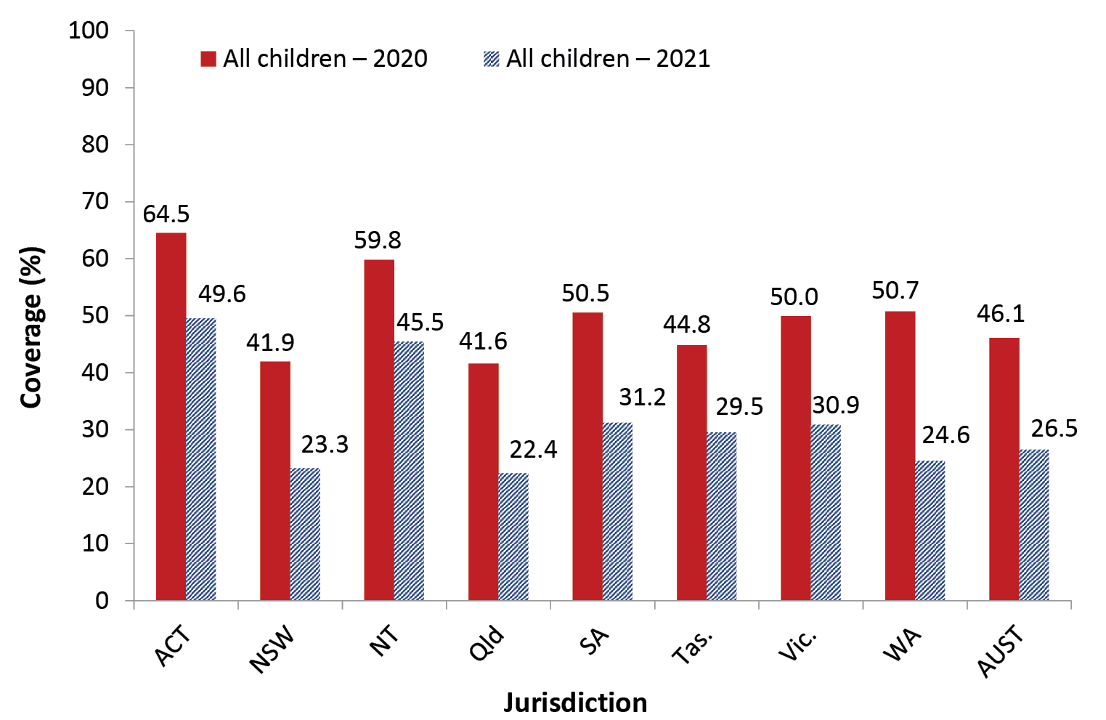
a Source: Australian Immunisation Register, data as at 31 March 2021 (for 2020 data) and as at 3 April 2022 (for 2021 data).
b At least one dose of any influenza vaccine. (Note: 2020 estimates have been revised following a change in methodology and therefore differ to what was presented in the 2020 report – see detailed methods in Appendix for further detail.)
c ACT: Australian Capital Territory; NSW: New South Wales; NT: Northern Territory; Qld: Queensland; SA: South Australia; Tas.: Tasmania; Vic.: Victoria; WA: Western Australia; AUST: Australia.

Figure 2: Recorded coverage of seasonal influenza vaccine by age group,^{a,b} Australia, 2020 versus 2021
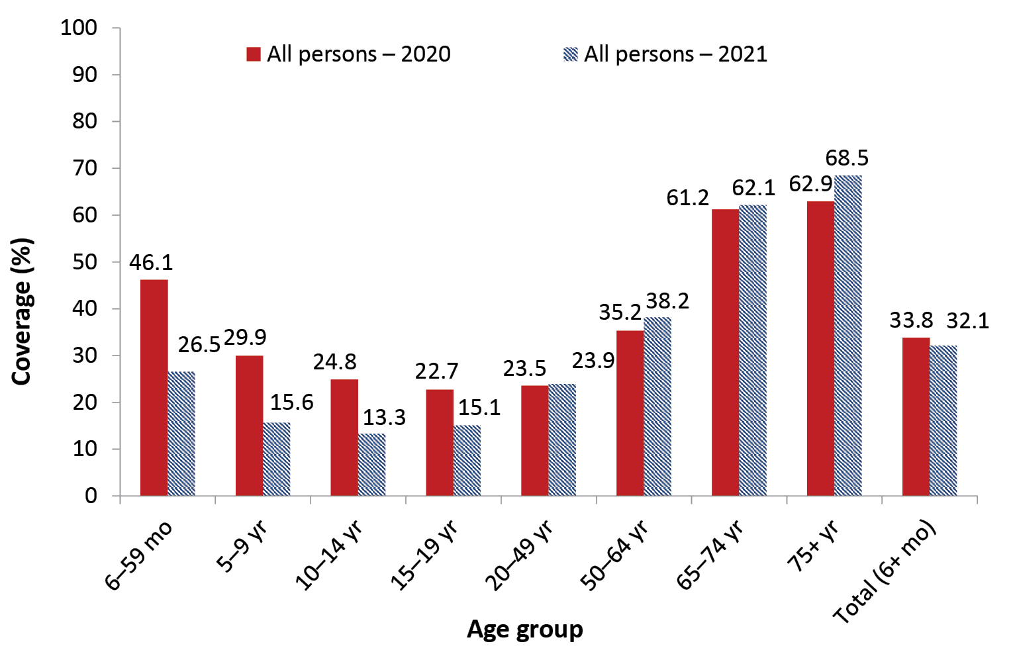
a Source: Australian Immunisation Register, data as at 31 March 2021 (for 2020 data) and as at 3 April 2022 (for 2021 data).
b At least one dose of any influenza vaccine. (Note: 2020 estimates have been revised following a change in methodology and therefore differ to what was presented in the 2020 report – see detailed methods in Appendix for further detail.)

Coverage by Indigenous status

‘Fully vaccinated’ at 12, 24 and 60 months of age
Between 2020 and 2021, ‘fully vaccinated’ coverage for Indigenous children decreased at all three age milestones: 12 months (from 93.1% to 91.6%), 24 months (from 91.2% to 90.1%) and 60 months (from 97.0% to 96.3%) (Table 1).
The disparity in ‘fully vaccinated’ coverage between Indigenous and all children increased at 12 months of age from 1.7 percentage points in 2020 to 2.6 percentage points in 2021, and at 24 months from 0.9 of a percentage point in 2020 to 2.0 percentage points in 2021 (Table 1). ‘However, ‘fully vaccinated’ coverage at 60 months of age in 2021 remained higher in Indigenous than in all children, by 2.3 percentage points.
Trends in ‘fully vaccinated’ coverage by Indigenous status by quarter from 2012 to 2021 are shown in Figures A.5, A.6 and A.7 in the Appendix. These show a generally increasing trend in ‘fully vaccinated’ coverage over time, but with a decrease of 0.1–1.9 percentage points between the March 2021 and December 2021 quarterly data points.

Coverage by individual vaccines/antigens at 12, 24 and 60 months of age
Coverage at 12 months of age in Indigenous children decreased for all individual vaccines/antigens between 2020 and 2021, by 0.6–1.5 percentage points (Table 1).
Coverage at 24 months of age in Indigenous children decreased for all individual vaccines/antigens between 2020 and 2021, by 0.3–1.5 percentage points. Coverage in Indigenous children in 2021 was higher than in all children for the third dose of polio and hepatitis B, the first dose of MMR, meningococcal C-containing and the third dose of 13vPCV, but lower for the fourth dose of DTPa and Hib, the second dose of MMR, and varicella (Table 1).
Coverage at 60 months of age in Indigenous children in 2021 remained very high (over 96%) for all vaccines/antigens, and higher than in all children (Table 1). However, coverage decreased marginally for individual vaccines/antigens from 2020 to 2021, except for 13-vPCV which increased by 0.4 of a percentage point to 97.8%.

Influenza vaccine coverage
Influenza vaccine coverage in Indigenous children decreased from 43.0% in 2020 to 22.5% in 2021 in those aged 6–59 months (Figure 3) and from 33.8% to 15.5% in those aged 5–9 years (Figure 4). Coverage in Indigenous children aged 6–59 months decreased in all jurisdictions, with the largest decreases seen in Western Australia (from 44.6% in 2020 to 18.9% in 2021) and in New South Wales (from 37.8% to 19.9%). There was substantial variation in coverage for children aged 6–59 months by jurisdiction in 2021, ranging from 18.9% in Queensland and Western Australia to 53.2% in the Northern Territory (Figure 3).
Figure 3: Coverage of seasonal influenza vaccine in Indigenous children aged 6–59 months, by jurisdiction,^{a,b,c} Australia, 2020 versus 2021
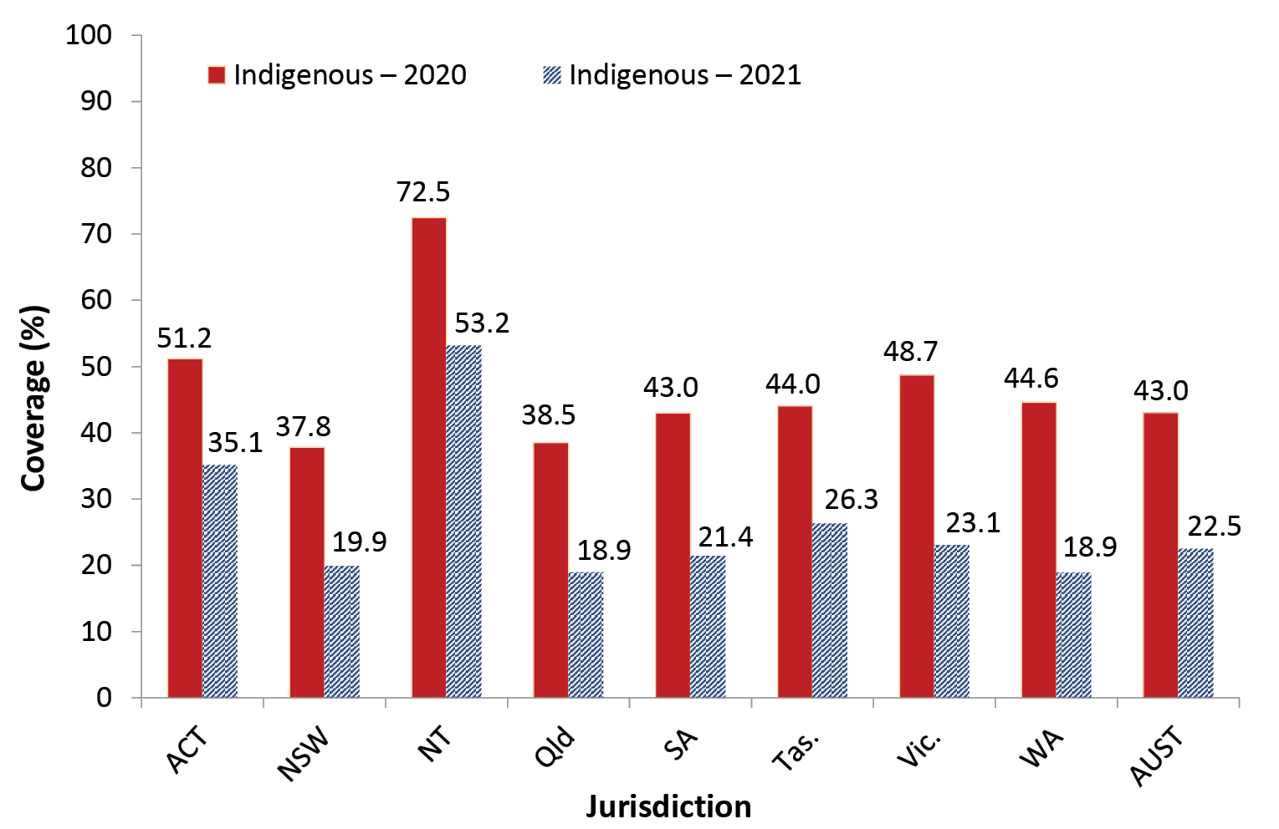
a Source: Australian Immunisation Register, data as at 31 March 2021 (for 2020 data) and as at 3 April 2022 (for 2021 data).
b At least one dose of any influenza vaccine. (Note: 2020 estimates have been revised following a change in methodology and therefore differ to what was presented in the 2020 report – see detailed methods in Appendix for further detail.)
c ACT: Australian Capital Territory; NSW: New South Wales; NT: Northern Territory; Qld: Queensland; SA: South Australia; Tas.: Tasmania; Vic.: Victoria; WA: Western Australia; AUST: Australia.
Figure 4: Coverage of seasonal influenza vaccine by age group for Indigenous persons, Australia,^{a,b} 2020 versus 2021
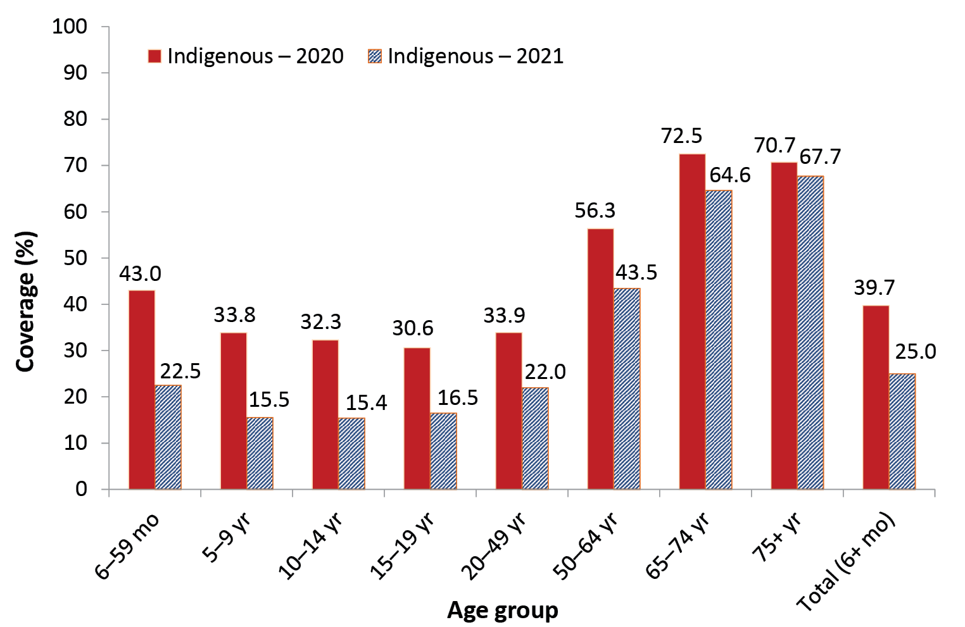
a Source: Australian Immunisation Register, data as at 31 March 2021 (for 2020 data) and as at 3 April 2022 (for 2021 data).
b At least one dose of any influenza vaccine. (Note: 2020 estimates have been revised following a change in methodology and therefore differ to what was presented in the 2020 report – see detailed methods in Appendix for further detail.)

Hepatitis A vaccine for Indigenous children
In July 2020, the scheduled ages for hepatitis A vaccination for Indigenous children in the four jurisdictions where it is funded under the NIP (Northern Territory, Queensland, South Australia and Western Australia) changed from 12 to 18 months for dose 1 and from 18 months to 4 years for dose 2. Coverage for the first dose of hepatitis A vaccine by 30 months of age, for the four jurisdictions combined, was 82% in 2021, with coverage for the second dose under the new schedule not yet able to be assessed. Longer term trends in hepatitis A vaccine coverage (Figure A.8 in the Appendix) show the highest coverage levels are consistently achieved in the Northern Territory (95.0% for dose 1 in the June 2021 quarter).

Pneumococcal vaccine for Indigenous children
Coverage for the additional fourth dose of 13vPCV by 30 months of age, for the combined four jurisdictions where it is funded for Indigenous children (Northern Territory, Queensland, South Australia and Western Australia), increased from 73.5% in 2020 to 81.7% in 2021. Longer term trends in 13vPCV fourth dose coverage (Figure A.9 in the Appendix) show the highest coverage levels are consistently achieved in the Northern Territory (91.9% in the September 2021 quarter).

Meningococcal B vaccine coverage for Indigenous children
Meningococcal B vaccine coverage, for the first cohort of Indigenous children eligible to have received 3 doses of meningococcal B vaccine by 31 December 2021 at the 2, 4 and 12 month schedule points under the NIP program implemented on 1 July 2020, is shown in Figure 5. Nationally, 78.7% of Indigenous children had received their first dose of meningococcal B vaccine, 75.8% had received their second dose and 63.8% their third. Coverage varied by jurisdiction, highest in South Australia and the Northern Territory and lowest in Victoria and Tasmania (Figure 5).
Figure 5: Coverage of meningococcal B vaccine for Indigenous children, by dose number and jurisdiction,^{a,b,c} Australia, 2021
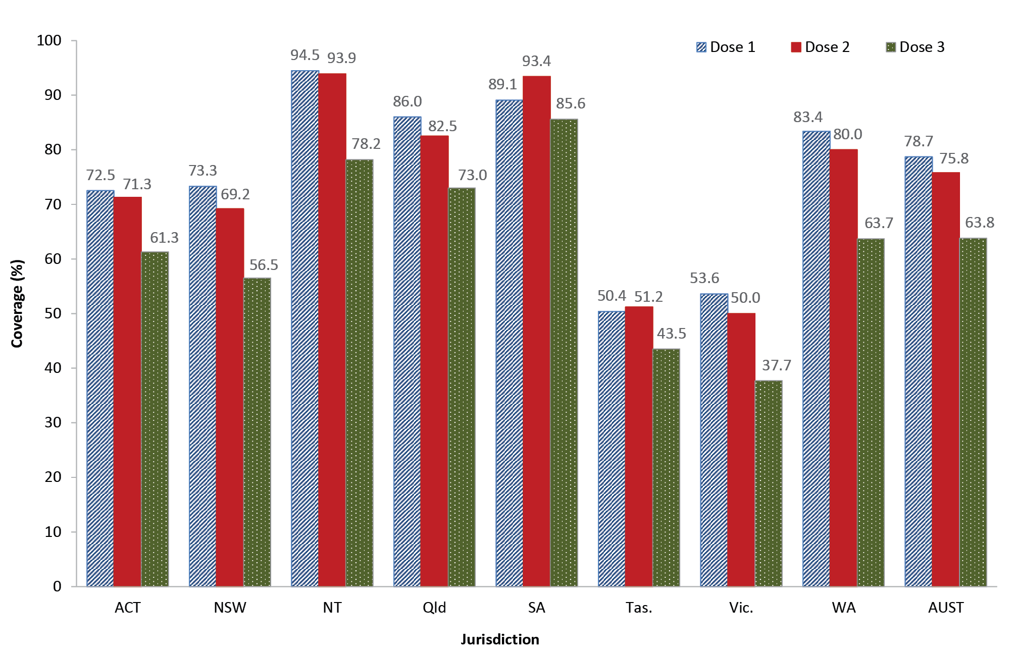
a Source: Australian Immunisation Register, data as at 3 April 2022.
b Coverage assessed for cohort of Indigenous children born 1 May 2020 – 31 Oct 2020. The first eligible cohort to have received 3 doses of meningococcal B vaccine by 31 Dec 2021 at the 2, 4 and 12 month schedule points under the NIP program implemented 1 July 2020. Only two doses of meningococcal B vaccine are required if the first dose is administered after 12 months of age.
c Note: Coverage may be underestimated, particularly for dose 1, due to under-reporting to the AIR (e.g. of doses given prior to child being registered on Medicare).

Timeliness of vaccination
The proportion of infants with on-time receipt (within 30 days of the recommended age) of the second dose of DTPa-containing vaccine in 2021 was lower than in 2020 for both Indigenous and non-Indigenous children, by 0.6 and 1.8 percentage points respectively. The proportion of infants with on-time receipt of the second dose of DTPa in 2021 was 11.2 percentage points lower in Indigenous than non-Indigenous infants in 2021 (Figure 6). The differential narrowed with increasing age, reaching 1.4 percentage points at 9 months of age.

Figure 6: Cumulative percentage of infants vaccinated with the second dose of DTPa-containing vaccine by age in months and Indigenous status,^{a,b,c} Australia, 2021
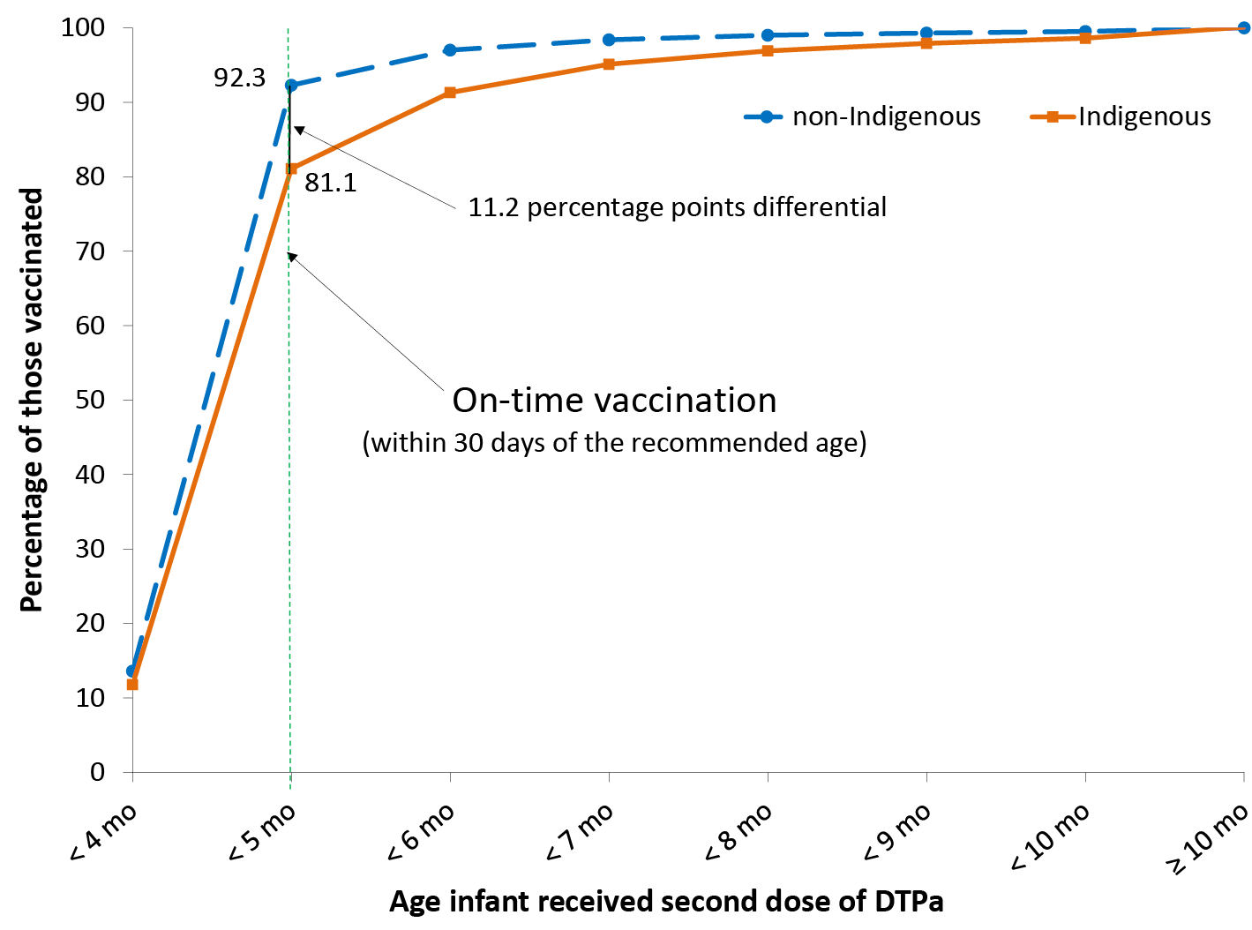
a Source: Australian Immunisation Register, data as at 3 April 2022. Cohort born 1 January 2020 – 31 December 2020.
b DTPa: diphtheria-tetanus-acellular pertussis-containing vaccine (child formulation).
c Shown as cumulative percentage vaccinated (number of infants who received vaccine dose at particular age / total number of infants who received the vaccine dose, expressed as a percentage).
The proportion of infants with on-time receipt of the second dose of 13vPCV in 2021 was lower than in 2020 for both Indigenous and non-Indigenous children, by 0.4 and 2.0 percentage points respectively. The on-time vaccination differential for the second dose of 13vPCV between Indigenous and non-Indigenous infants in 2021 was 11.3 percentage points, narrowing to 1.5 percentage points at 9 months of age (Figure 7).

Figure 7: Cumulative percentage of infants vaccinated with the second dose of 13vPCV by age in months and Indigenous status,^{a,b,c} Australia, 2021
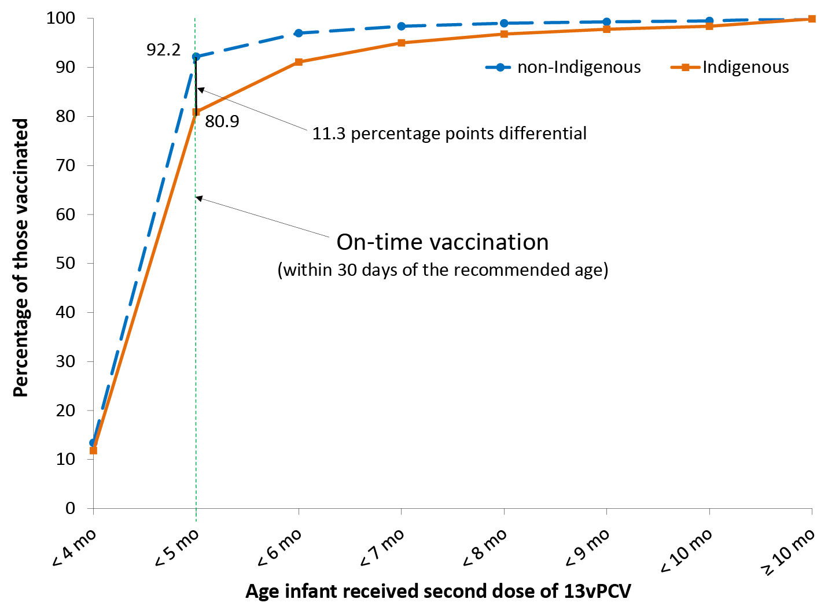
a Source: Australian Immunisation Register, data as at 3 April 2022. Cohort born 1 January 2020 – 31 December 2020.
b 13vPCV = 13-valent pneumococcal conjugate vaccine.
c Shown as cumulative percentage vaccinated (number of infants who received vaccine dose at particular age / total number of infants who received the vaccine dose, expressed as a percentage).
The proportion of Indigenous infants with on-time receipt of the second dose of rotavirus vaccine in 2021 was 1.3 percentage points lower than in 2020. The on-time vaccination differential for the second dose of rotavirus vaccine between Indigenous and non-Indigenous infants in 2021 was lower than that for DTPa-containing vaccine and 13vPCV at 5.6 percentage points, narrowing with increasing age to 0.2 of a percentage point at 6 months of age (Figure 8).

Figure 8: Cumulative percentage of infants vaccinated with the second dose of rotavirus vaccine by age in months and Indigenous status,^{a,b} Australia, 2021
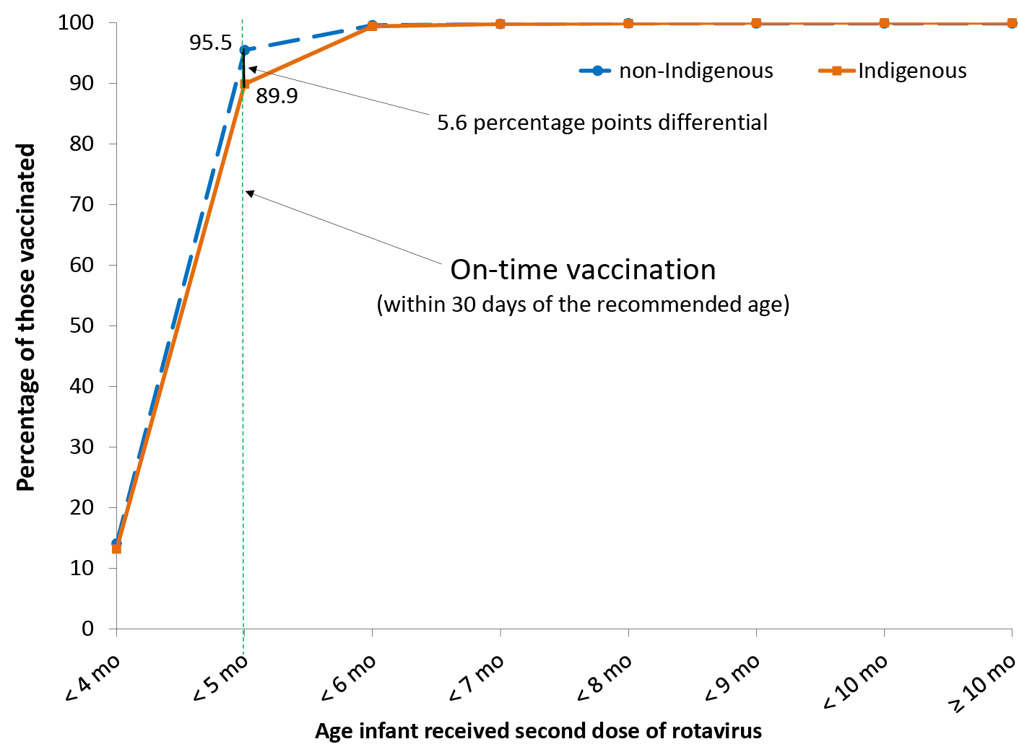
a Source: Australian Immunisation Register, data as at 3 April 2022. Cohort born 1 January 2020 – 31 December 2020.
b Shown as cumulative percentage vaccinated (number of children who received vaccine dose at particular age / total number of infants who received the vaccine dose, expressed as a percentage).
The proportion of children with on-time receipt of the first dose of MMR vaccine in 2021 was 0.6 of a percentage point lower than in 2020 for Indigenous but 0.6 of a percentage point higher for non-Indigenous children. The on-time vaccination differential for the first dose of MMR vaccine between Indigenous and non-Indigenous children in 2021 was 13.0 percentage points, narrowing to 2.0 percentage points at 17 months of age (Figure 9).

Figure 9: Cumulative percentage of children vaccinated with the first dose of measles-mumps-rubella vaccine (MMR) by age in months and Indigenous status,^{a,b} Australia, 2021
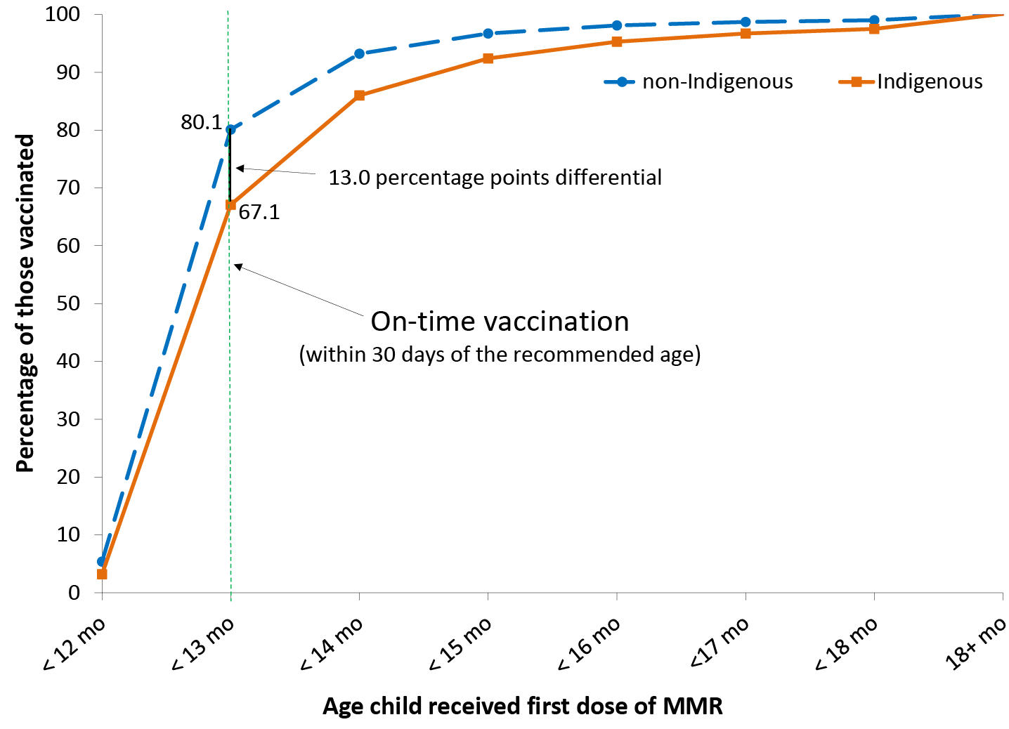
a Source: Australian Immunisation Register, data as at 3 April 2022. Cohort born 1 January 2019 – 31 December 2019 (i.e. due for their first dose of MMR in 2020).
b Shown as cumulative percentage vaccinated (number of infants who received vaccine dose at particular age / total number of children who received the vaccine dose, expressed as a percentage).
The proportion of children with on-time receipt of the first dose of MenACWY vaccine was higher in 2021 than 2020 for both Indigenous and non-Indigenous children, 1.0 and 0.5 percentage points higher, respectively. The on-time vaccination differential for the first dose of MenACWY vaccine between Indigenous and non-Indigenous children in 2021 was 7.7 percentage points, narrowing to 0.8 of a percentage point at 17 months of age (Figure 10).

Figure 10: Cumulative percentage of children vaccinated with the first dose of meningococcal ACWY vaccine (MenACWY) by age in months and Indigenous status,^{a,b} Australia, 2021
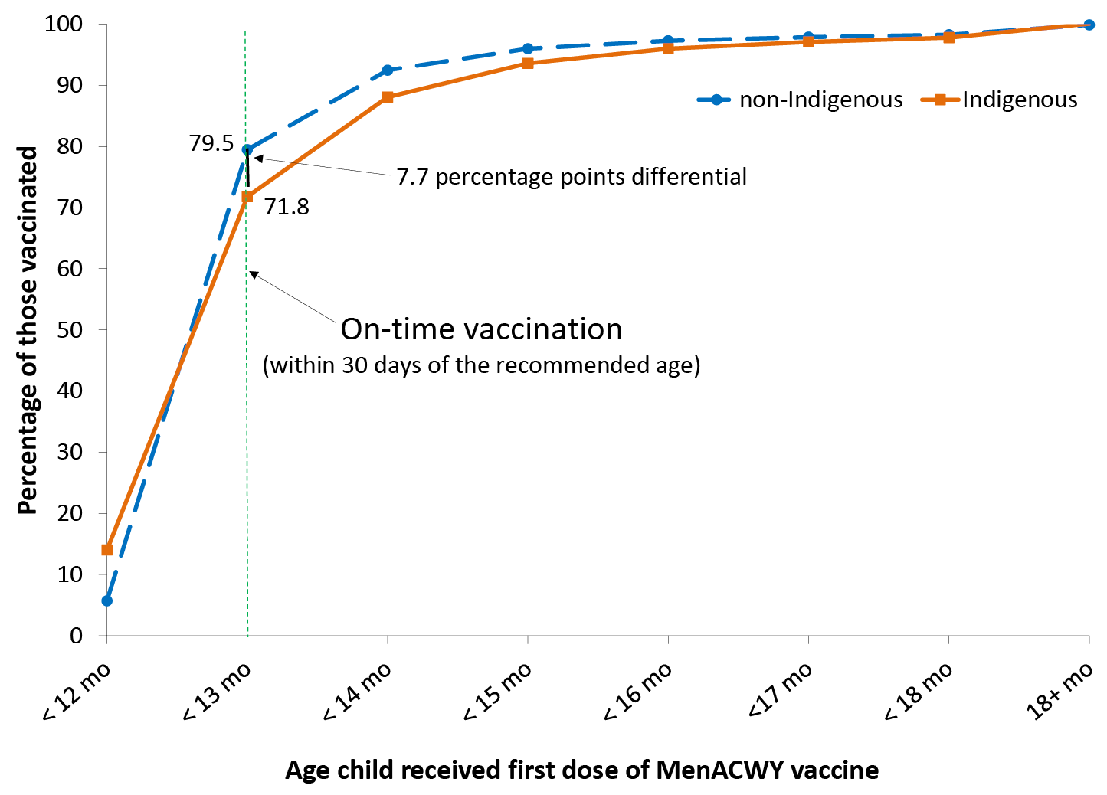
a Source: Australian Immunisation Register, data as at 3 April 2022. Cohort born 1 January 2019 – 31 December 2019 (i.e. due for meningococcal ACWY vaccine in 2020).
a Shown as cumulative percentage vaccinated (number of infants who received vaccine dose at particular age / total number of children who received the vaccine dose, expressed as a percentage).
Trends in on-time vaccination for the second dose of DTPa-containing vaccine from 2012 to 2021 by Indigenous status are shown in Figure 11. The proportion of Indigenous infants vaccinated on time increased from 73.4% in 2012 to 82.2% in 2021, with the disparity in on-time vaccination between Indigenous and non-Indigenous infants in Australia decreasing from 16.9 percentage points to 10.3 percentage points over this period.
Trends in on-time vaccination for the first dose of MMR-containing vaccine from 2012 to 2021 by Indigenous status are shown in Figure 12. The proportion of Indigenous children vaccinated on time increased from 60.4% in 2012 to 67% in 2021, with the disparity in on-time vaccination between Indigenous and non-Indigenous children in Australia remaining stable at around 11–13 percentage points over this period.
On-time vaccination coverage for the first dose of MMR-containing vaccine assessed at 13 months of age by Statistical Area 3 (presented for the first time in this series of reports) is shown in Figure 13. On-time MMR vaccination coverage in 2021 varied across Australia, with coverage in many rural and remote areas of Western, Central and Far North Australia substantially below that in Southeast Australia, with 62.4% on-time vaccination in Katherine, 63.5% in East Pilbara and 65.4% in Alice Springs.
Figure 11: Trends in ‘on-time’ vaccination for the second dose of DTPa, by Indigenous status,^{a,b} Australia, 2012–2021
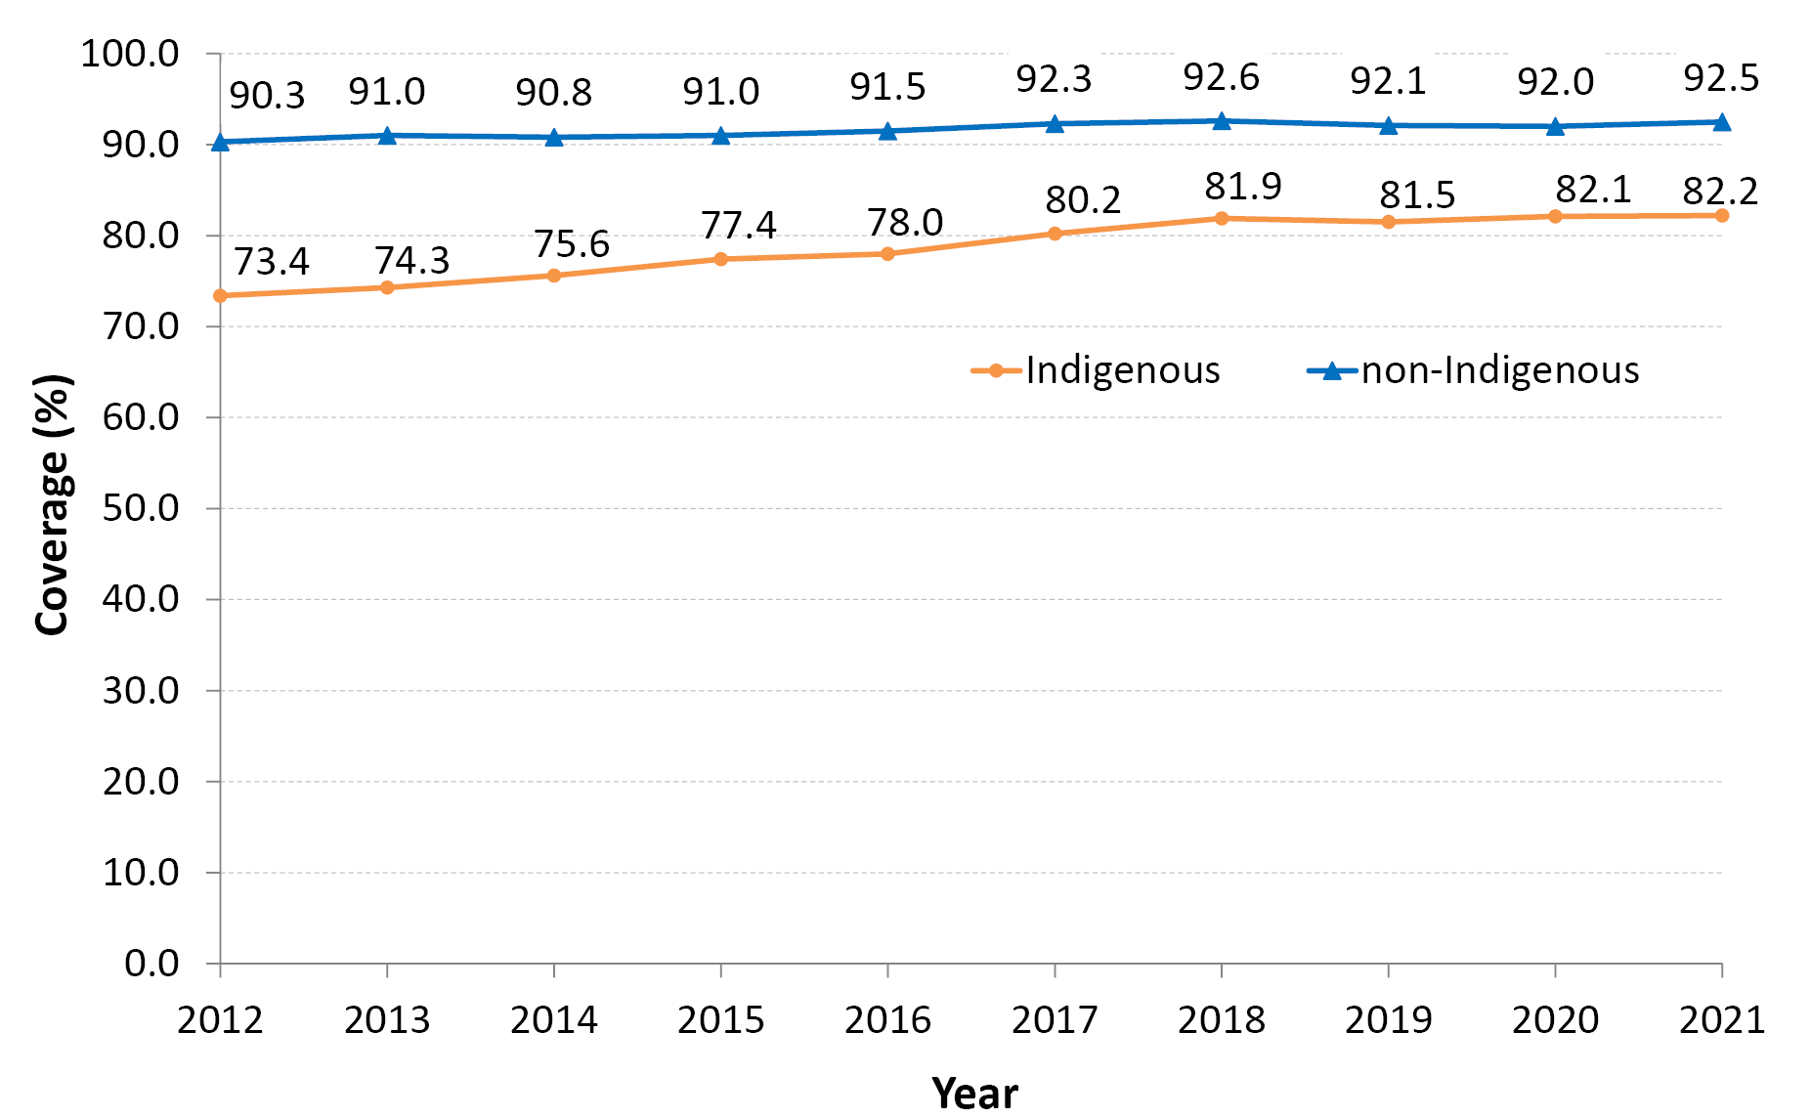
a All data points are calculated for a 12-month-wide birth cohort using AIR data.
b Within 30 days of the recommended age (i.e. by 5 months of age as second dose of DTPa vaccine due at 4 months of age).
Figure 12: Trends in ‘on-time’ vaccination for the first dose of MMR, by Indigenous status, Australia,^{a,b} 2012–2021
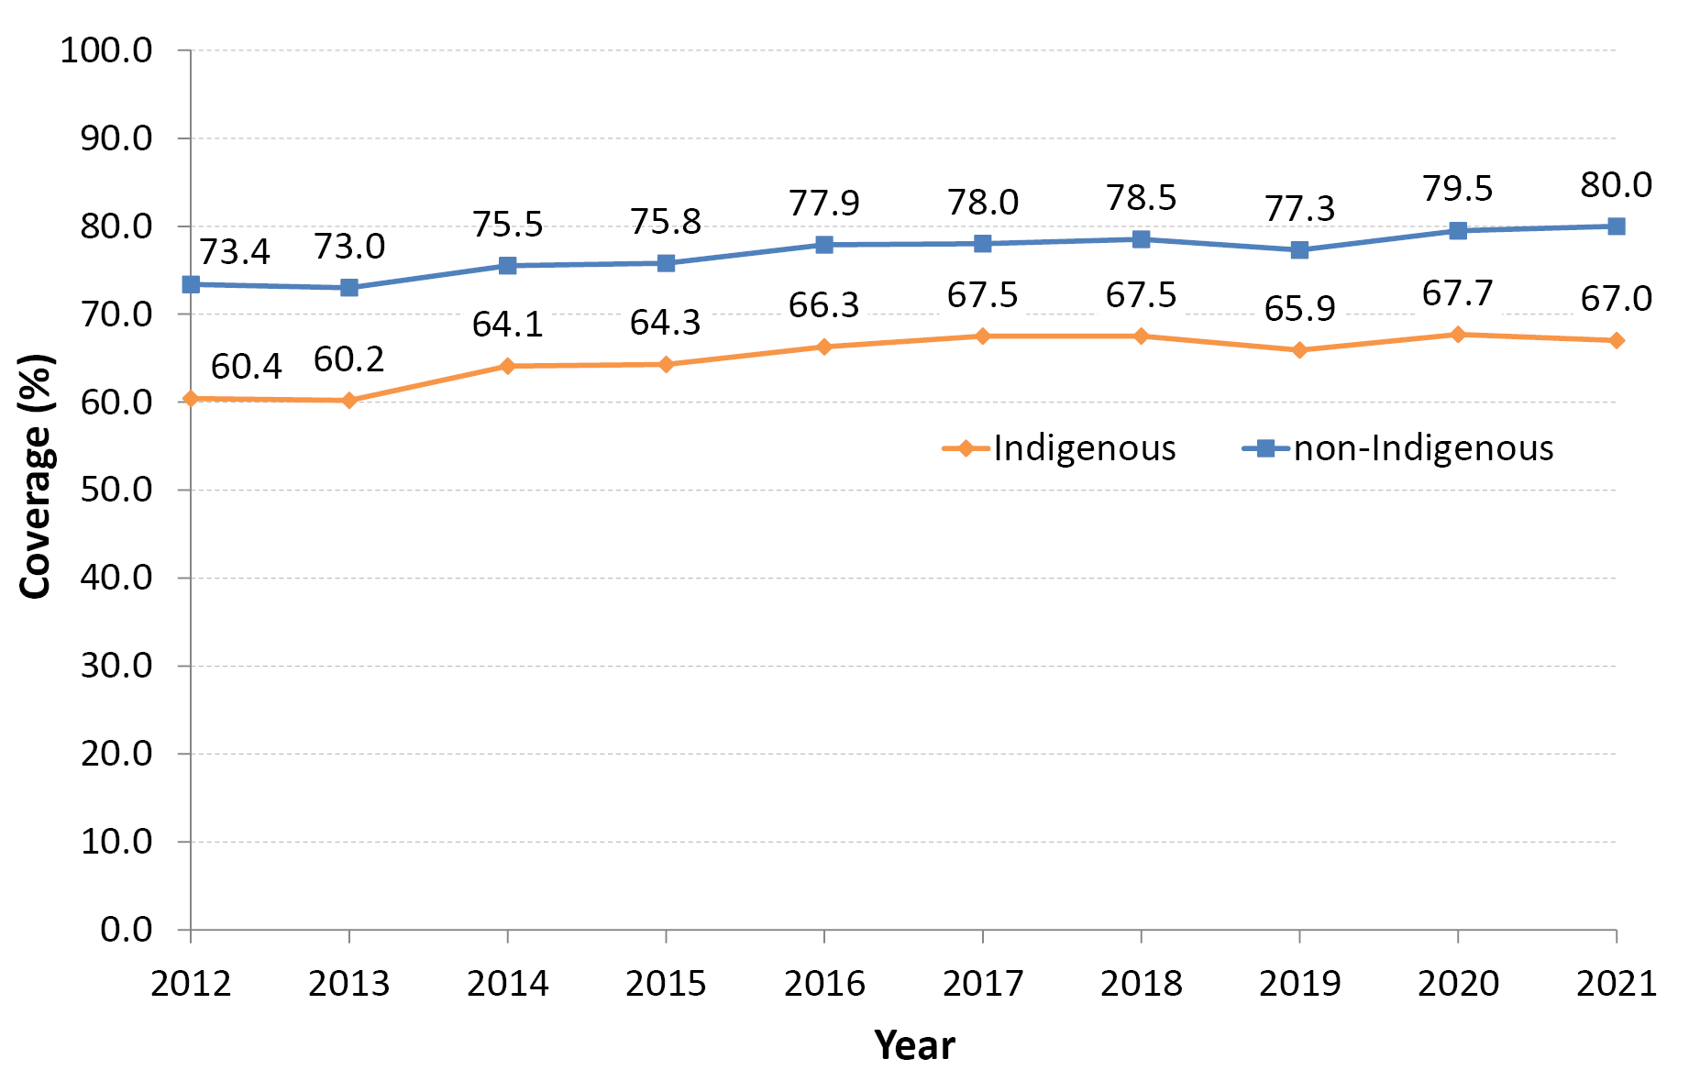
a All data points are calculated for a 12-month-wide birth cohort using AIR data.
b Within 30 days of the recommended age (i.e. by 13 months of age as first dose of MMR vaccine due at 12 months of age).
Figure 13: On-time vaccination coverage of one dose of measles-mumps-rubella (MMR)-containing vaccine assessed at 13 months of age by Statistical Area 3,^{a,b,c} Australia and major capital cities, 2021
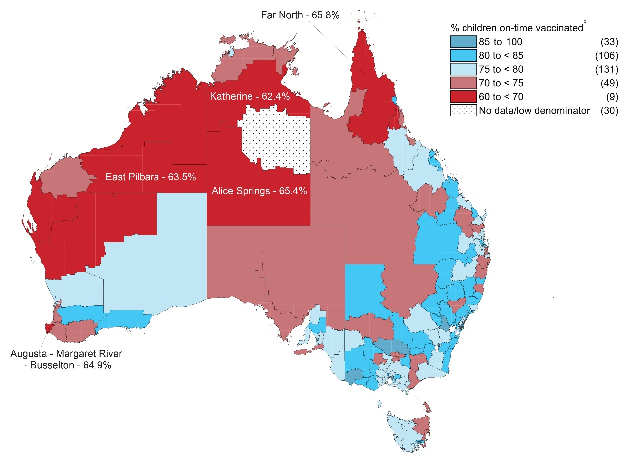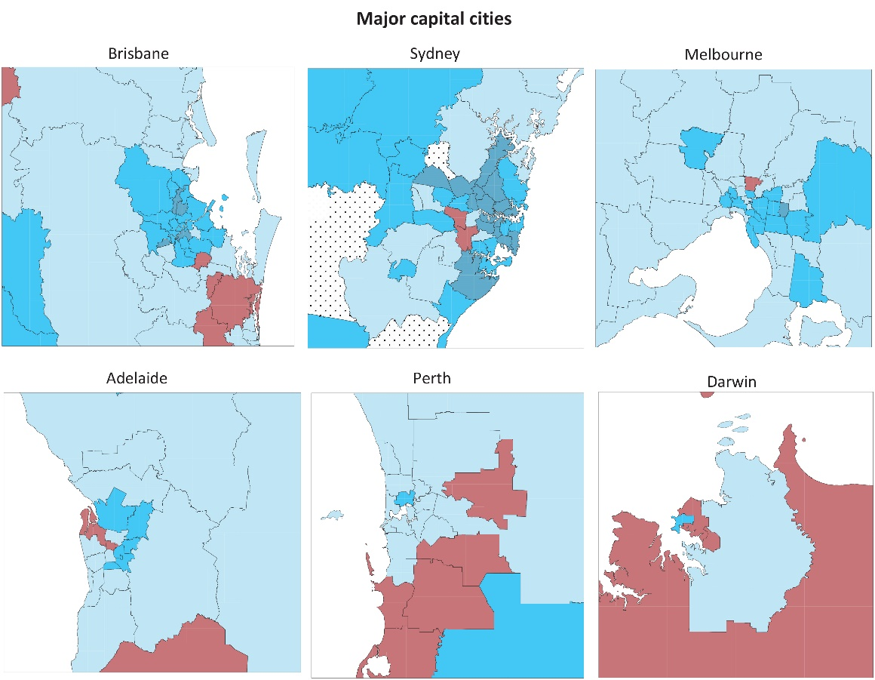
a Source: Australian Immunisation Register.
b Receipt of a scheduled vaccine dose within 30 days of the recommended age (i.e. by 13 months of age as first dose of MMR vaccine due at 12 months of age).
c Cohort born 1 January 2019 – 31 December 2019 i.e. due for first dose of MMR in 2020.
d Number in parentheses: number of Statistical Area 3s in each category.
Tables 2 and 3 present ‘fully vaccinated’ coverage assessed three months after the last vaccine dose due—that is, earlier than the standard assessment milestones—to capture aspects of timeliness, along with the standard 12-month, 24-month and 60-month age milestones. For all four of the earlier assessment milestones (9-month, 15-month, 21-month and 51-month), ‘fully vaccinated’ coverage in 2021 was lower in Indigenous children residing in remote areas than in those residing in major cities and regional areas, with the greatest coverage differential at 21 months of age (Table 2). In contrast, while ‘fully vaccinated’ coverage for non-Indigenous children in remote areas was 2.4–2.7 percentage points lower at both 21 and 51 months of age than for children in major cities and regional areas, it was similar at 9 months of age and slightly higher at 12 months of age. ‘Fully vaccinated’ coverage in 2021 was substantially higher at the standard milestones than the earlier milestones, most markedly for vaccines due at 48 months when assessed at 60 months versus 51 months, for both Indigenous and non-Indigenous children, and across all remoteness categories (Table 2).
Table 2: ‘Fully vaccinated’ coverage assessed at earlier (9, 15, 21, 51 months of age) and standard (12, 24, 60 months of age: shaded) milestones, by Indigenous status and remoteness of area of residence,^{a,b} Australia, 2021
Indigenous status | Remoteness category ^{c} | 9 mo (%) ^{d} | 12 mo (%) ^{d} | 15 mo (%) ^{e} | 21 mo (%) ^{e} | 24 mo (%) ^{e} | 51 mo (%) ^{f} | 60 mo (%) ^{f}
Indigenous | Major cities | 85.7 | 92.0 | 87.9 | 83.4 | 90.1 | 87.0 | 96.2
 | Inner and outer regional | 84.9 | 92.2 | 89.0 | 83.9 | 91.3 | 86.9 | 96.5
 | Remote and very remote | 75.7 | 88.7 | 85.6 | 74.0 | 85.7 | 82.2 | 96.1
 | All | 83.9 | 91.6 | 88.0 | 82.3 | 90.1 | 86.2 | 96.4
Non-Indigenous | Major cities | 91.7 | 94.4 | 90.9 | 88.8 | 92.1 | 88.6 | 94.0
 | Inner and outer regional | 91.4 | 94.1 | 91.4 | 89.1 | 92.7 | 88.9 | 94.6
 | Remote and very remote | 91.4 | 94.5 | 90.1 | 86.4 | 91.3 | 86.2 | 92.9
 | All | 91.6 | 94.3 | 90.8 | 88.8 | 92.2 | 88.6 | 94.1
All children | Major Cities | 91.5 | 94.3 | 90.8 | 88.6 | 92.1 | 88.5 | 94.1
 | Inner and outer regional | 90.6 | 93.9 | 91.1 | 88.5 | 92.5 | 88.7 | 94.8
 | Remote and very remote | 84.7 | 92.0 | 88.3 | 81.3 | 89.0 | 84.5 | 94.2
 | All | 91.1 | 94.2 | 90.8 | 88.4 | 92.1 | 87.6 | 94.3
a Source: Australian Immunisation Register, data as at 3 April 2022.
b Coverage algorithm used for 9/21/51 month milestones same as for 12/24/60 months, respectively; algorithm used for 15 months same as that for 24 months but excludes doses due at 18 months; for further detail of algorithms, refer to Table A.2 in the Appendix.
c Accessibility/Remoteness Index of Australia (ARIA++).
d Cohort born 1 January 2020 – 31 December 2020 (i.e. vaccines due from mid-2020 to mid-2021).
e Cohort born 1 January 2019 – 31 December 2019 (i.e. vaccines due from mid-2019 [6-month doses] to mid-2021 [18 month doses]).
f Cohort born 1 January 2016 – 31 December 2016 (i.e. vaccines due in 2020).
When stratified by socio-economic status of area of residence, children residing in areas included in the most advantaged (fifth) quintile in 2021 had 2.4–3.1 percentage points higher ‘fully vaccinated’ coverage than children in the least advantaged (first) quintile at the earlier assessment milestones (9, 15, 21 and 51 months; Table 3). The disparity between vaccination coverage in the most and least advantaged quintiles at the standard milestones ranged from 1.1 percentage points at 60 months of age to 2.2 percentage points at 24 months of age.
‘Fully vaccinated’ coverage assessed at the earlier and standard age milestones in 2021, by PHN, is shown in Table A.4 in the Appendix.

Table 3: ‘Fully vaccinated’ coverage assessed at earlier (9, 15, 21, 51months of age) and standard (12, 24, 60 months: shaded) age milestones, by socio-economic status of area of residence,^{a,b} Australia, 2021
SEIFA ^{c} quintile | 9 mo  (%) ^{d} | 12 mo  (%) ^{d} | 15 mo  (%) ^{e} | 21 mo  (%) ^{e} | 24 mo  (%) ^{e} | 51 mo  (%) ^{f} | 60 mo  (%) ^{f}
First (least advantaged) | 89.5 | 93.3 | 89.3 | 86.5 | 90.8 | 87.0 | 93.7
Second | 90.2 | 93.6 | 90.5 | 87.9 | 91.8 | 88.2 | 94.3
Third | 91.5 | 94.4 | 90.9 | 88.7 | 92.2 | 88.5 | 94.1
Fourth | 92.0 | 94.8 | 91.7 | 89.5 | 92.8 | 89.1 | 94.5
Fifth (most advantaged) | 92.3 | 94.8 | 91.8 | 89.6 | 93.0 | 89.4 | 94.8
All | 91.1 | 94.2 | 90.8 | 88.4 | 92.1 | 88.5 | 94.3
a Source: Australian Immunisation Register, data as at 3 April 2022.
b Coverage algorithm used for 9/21/51 month milestones same as for 12/24/60 months, respectively; algorithm used for 15 months same as 24 months but excludes doses due at 18 months.
c SEIFA Index of Economic Resources.
d Cohort born 1 January 2020 – 31 December 2020 (i.e. vaccines due from mid-2020 to mid-2021).
e Cohort born 1 January 2019 – 31 December 2019 (i.e. vaccines due from mid-2019 [6-month doses] to mid-2021 [18 month doses]).
f Cohort born 1 January 2016 – 31 December 2016 (i.e. vaccines due in 2020).

Small area coverage analysis
Childhood vaccination coverage in Australia in 2021 varied within jurisdictions and major capital cities, with coverage in some areas substantially below the national average, especially the north coast region of New South Wales and the Gold Coast region of Queensland (Figures 14-16). Coverage of 95% or higher at 24 months of age was achieved for 28.4% of SA3 areas for the second dose of MMR-containing vaccine (93/328) (Figure 14), 23.8% for the fourth dose of DTPa-containing vaccine (78/328) (Figure 15) and 66.5% for meningococcal ACWY vaccine (218/328) (Figure 16).

Figure 14: Coverage of the second dose of measles-mumps-rubella (MMR)-containing vaccine at 24 months of age by Statistical Area 3,^{a,b} Australia and major capital cities, 2021
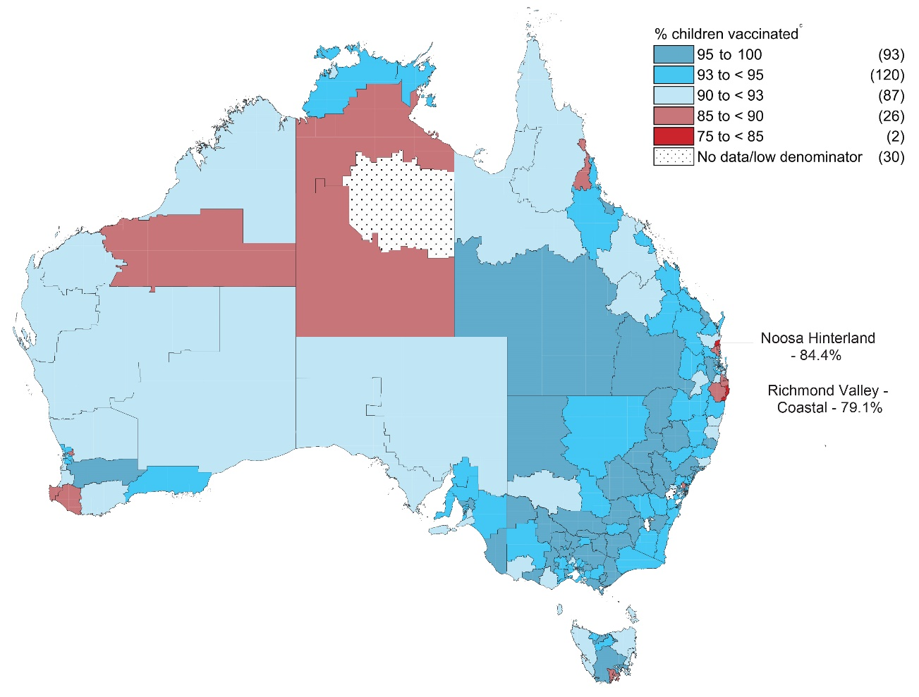
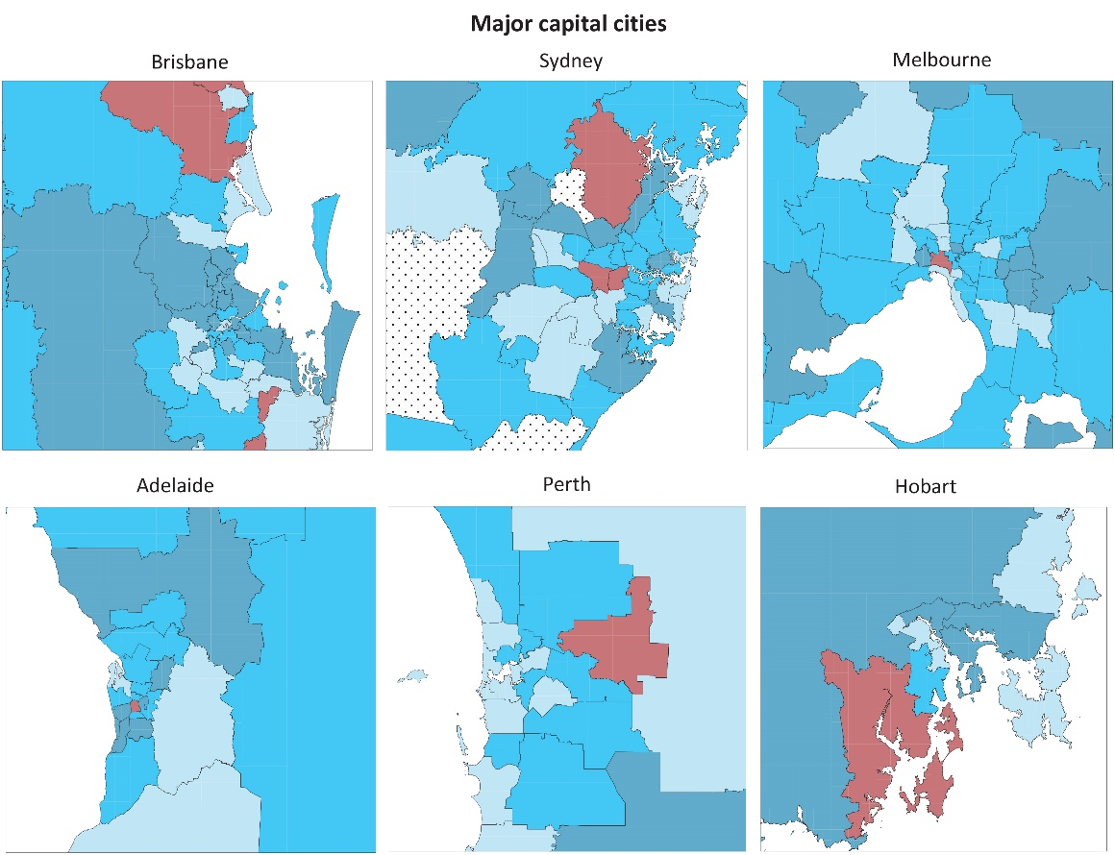
a Source: Australian Immunisation Register.
b Cohort born 1 January 2019 – 31 December 2019 i.e. due for their second dose of MMR from mid-2020 to mid-2021.
c Number in parentheses: number of Statistical Area 3s in each category.
Figure 15: Coverage of the fourth dose of diphtheria-tetanus-acellular pertussis (DTPa)-containing vaccine at 24 months of age by Statistical Area 3,^{a,b} Australia and major capital cities, 2021
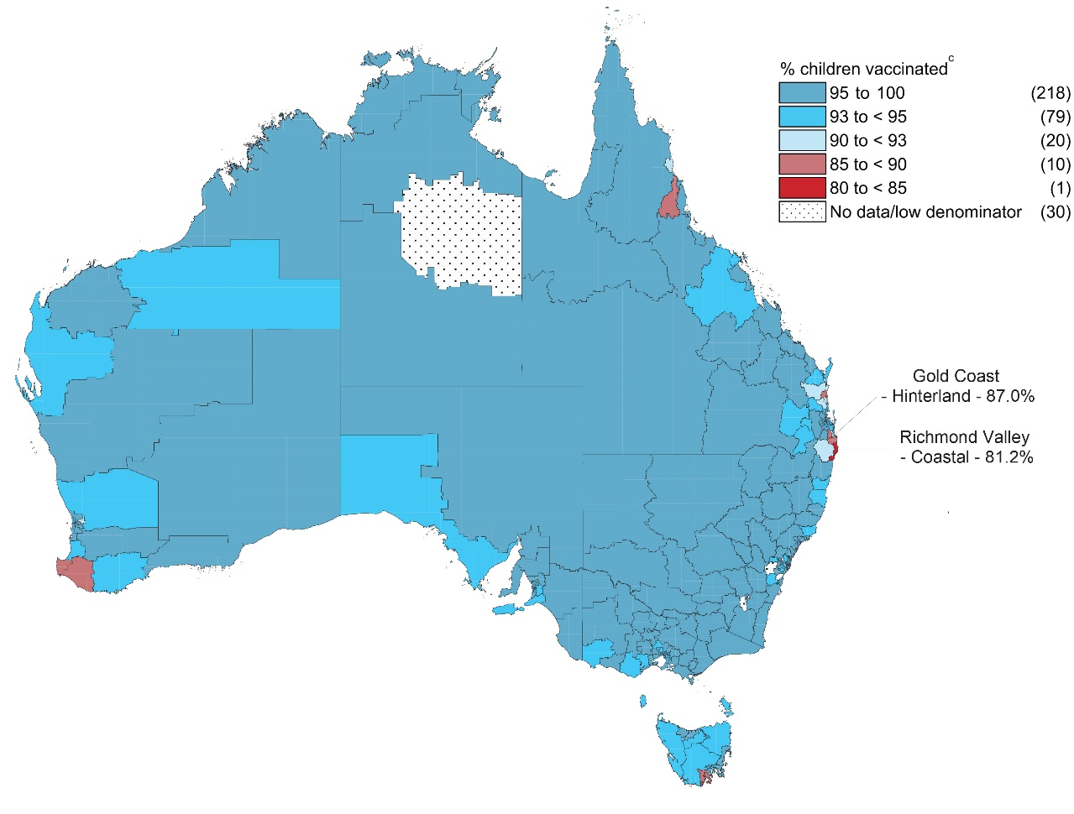
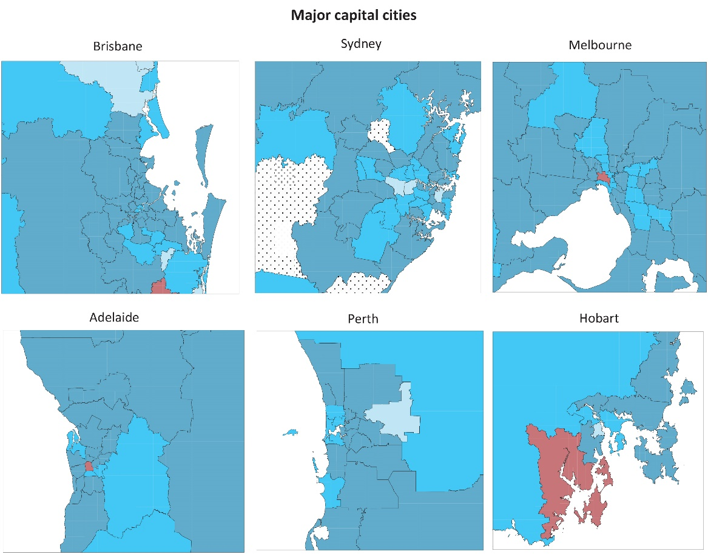
a Source: Australian Immunisation Register.
b Cohort born 1 January 2019 – 31 December 2019 i.e. due for their fourth dose of DTPa from mid-2020 to mid-2021.
c Number in parentheses: number of Statistical Area 3s in each category.
Figure 16: Coverage of one dose of meningococcal C-containing vaccine at 24 months of age by Statistical Area 3, ^{a,b} Australia and major capital cities, 2021
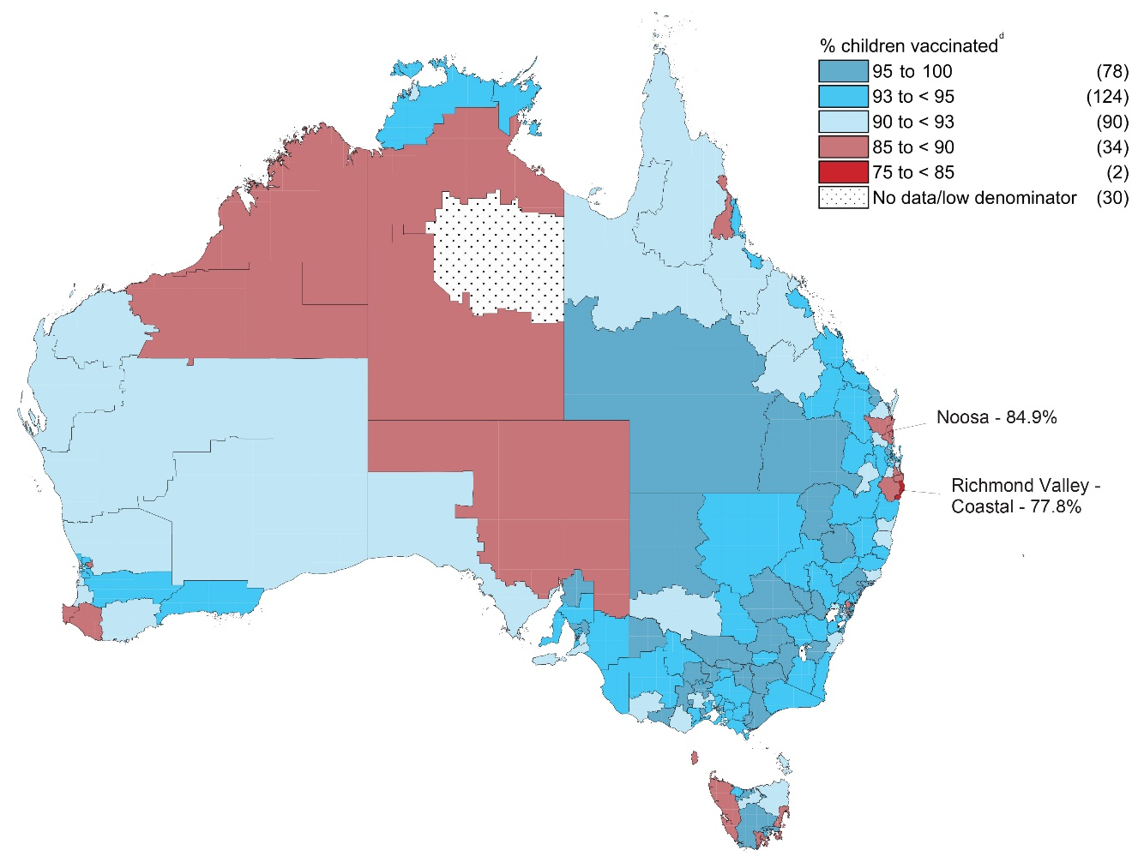
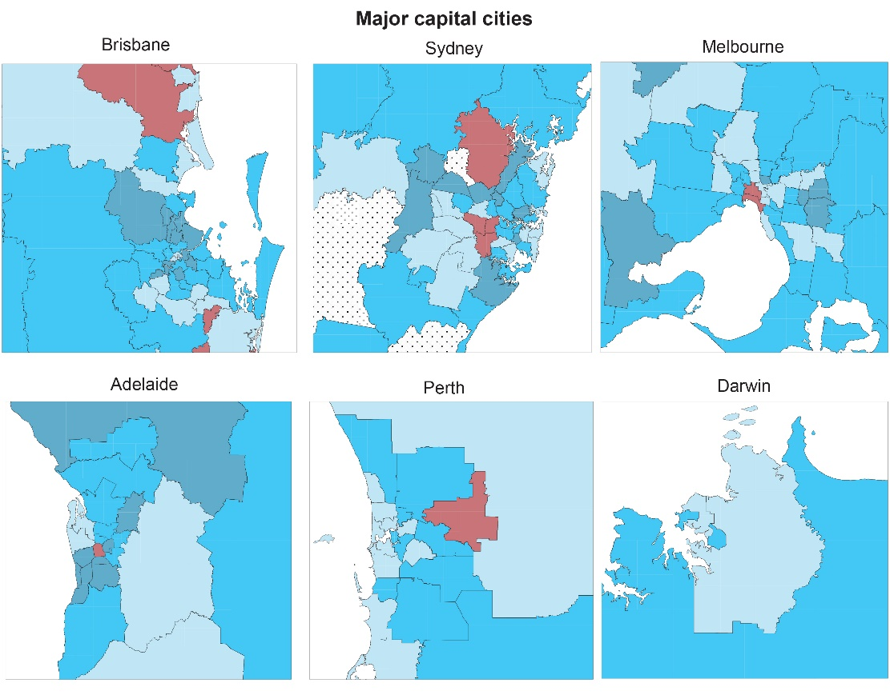
a Source: Australian Immunisation Register.
b Cohort born 1 January 2019 – 31 December 2019 i.e. due for their meningococcal C-containing vaccine in 2020.
c Number in parentheses: number of Statistical Area 3s in each category.

Provider type and reporting to the AIR
In 2021, the large majority (82.2%) of vaccinations given to children aged < 7 years in Australia were administered in general practice settings, with the Northern Territory the only jurisdiction with a minority of vaccinations in young children (19.9%) given in general practice (Figure 17). Overall, 9.5% of vaccinations were delivered in local council clinic settings (with the proportion highest in Victoria at 22.3%); 6.1% in community health services (highest in the Northern Territory [52.0%], Australian Capital Territory [28.3%] and Western Australia [17.6%]); 1.2% in hospitals; and 0.8% in Indigenous health services (highest in the Northern Territory at 23.5%). A greater proportion of children aged < 7 years were vaccinated in general practice compared to people of all ages (Figure A.10 in the Appendix), and a lesser proportion in local council settings, with children in this age group not eligible for pharmacist vaccination, but distribution was more similar for non-COVID-19 vaccinations (Figure A11 in the Appendix), noting that children aged < 7 years were not eligible for COVID-19 vaccination in 2021.
Figure 17: Proportion of vaccinations given to children aged < 7 years by provider type and jurisdiction,^{a,b} Australia, 2021
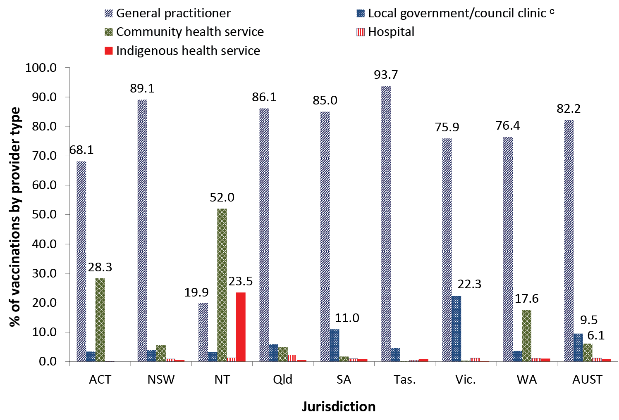
a Source: Australian Immunisation Register, data as at 3 April 2022.
b ACT: Australian Capital Territory; NSW: New South Wales; NT: Northern Territory; Qld: Queensland; SA: South Australia; Tas.: Tasmania; Vic.: Victoria; WA: Western Australia; AUST: Australia.
c Includes public health units and jurisdictional health departments.
In 2021, a total of 86.2% of vaccinations given to children aged < 7 years on the AIR were reported using practice management software (jurisdictional range 29.7–92.2%; Figure 18), which was 10.7 percentage points higher than in 2017. Less common methods of reporting included the AIR website (10.6%; jurisdictional range 1.6–31.7%) and internet data interchange (IDI) upload, where immunisation providers/organisations send vaccination encounter details in bulk to the AIR (3.0%, jurisdictional range 0.1–68.7%). The proportion of vaccinations in children aged < 7 years reported to the AIR using practice management software was higher in 2021 than in people of all ages (77.5%, jurisdictional range 56.0–89.7%, data not shown).
Figure 18: Proportion of vaccinations given to children aged < 7 years by type of reporting mechanism and jurisdiction,^{a,b} Australia, 2021
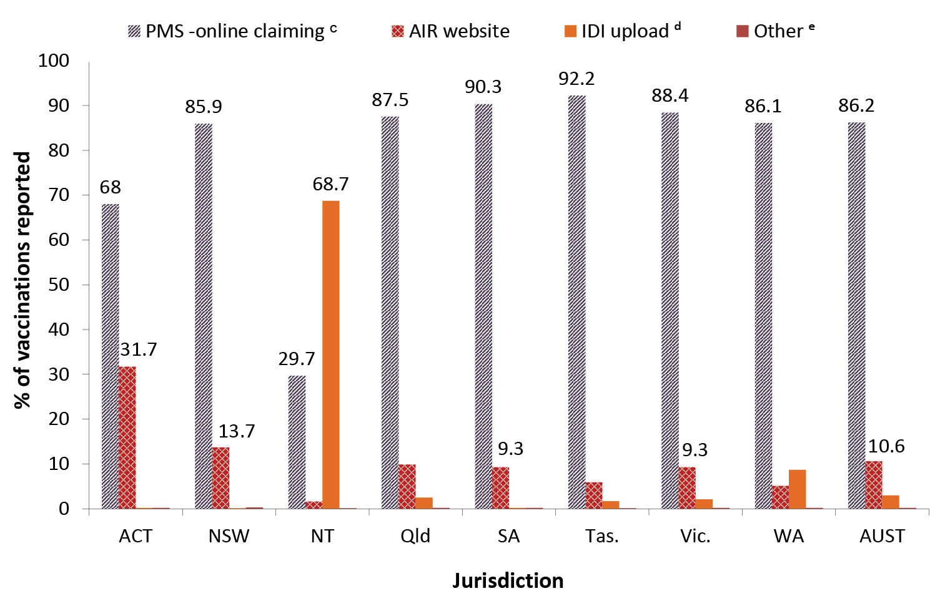
a Source: Australian Immunisation Register, data as at 3 April 2022.
b ACT: Australian Capital Territory; NSW: New South Wales; NT: Northern Territory; Qld: Queensland; SA: South Australia; Tas.: Tasmania; Vic.: Victoria; WA: Western Australia; AUST: Australia.
c Practice management software.
d IDI = internet data interchange (approved immunisation providers/organisations can send vaccination encounter details in bulk to the AIR using the IDI upload facility).
e Manual and history forms.

Adolescents

Human papillomavirus vaccine coverage
HPV vaccination coverage in girls, for receipt of first dose and course completion by 15 years of age, is shown in Table 4, by Indigenous status and jurisdiction for 2020 and 2021. In 2021, 80.3% of Australian girls had completed a full course of HPV vaccine by 15 years of age, down from 80.5% in 2020. Course completion in 2021 varied from 76.4% in Queensland to 84.9% in the Australian Capital Territory (Table 4).
HPV vaccine course completion in Indigenous girls was 73.3% in 2021, lower than in 2020 (75.0%) and seven percentage points lower than in all girls. Course completion in Indigenous girls in 2021 ranged from 49.6% in South Australia to 81.0% in New South Wales (Table 4).
Table 4: Human papillomavirus (HPV) vaccination coverage (dose 1 and course completion, %) for girls by 15 years of age, by Indigenous status and jurisdiction,^{a,b,c} Australia, 2020 and 2021
Jurisdiction ^{d} | All girls |  | Indigenous girls
 | 2020 | 2021 | 2020 | 2021
ACT  Dose 1  Course completion | 9.8  83.6 | 90.3  84.9 | 86.4  75.8 | 89.7  72.1
NSW  Dose 1  Course completion | 87.7  83.4 | 87.7  83.5 | 92.1  83.5 | 90.8  81.0
NT  Dose 1  Course completion | 87.7  76.9 | 86.4  75.5 | 89.1  76.2 | 87.2  72.9
Qld  Dose 1  Course completion | 83.6  76.7 | 83.0  76.4 | 85.6  71.5 | 83.7  69.9
SA  Dose 1  Course completion | 86.8  78.2 | 86.1  76.7 | 82.2  58.8 | 74.7  49.6
Tas.  Dose 1  Course completion | 88.3  78.3 | 88.0  78.4 | 91.5  80.3 | 88.8  76.8
Vic.  Dose 1  Course completion | 88.2  82.0 | 87.5  81.2 | 88.2  77.0 | 87.1  75.2
WA  Dose 1  Course completion | 84.9  78.7 | 84.2  79.1 | 82.4  65.4 | 81.0  67.8
AUST  Dose 1  Course completion | 86.6  80.5 | 86.2  80.3 | 87.8  75.0 | 86.1  73.3
a Source: Australian Immunisation Register, data as at 31 March 2021 (for 2020 data) and as at 3 April 2022 (for 2021 data).
b HPV vaccinations received after eleventh birthday and before fifteenth birthday in cohort born 1 January 2005 – 31 December 2005 for 2020 coverage estimates (i.e. vaccines due from early 2017 to late 2018) and cohort born 1 January 2006 – 31 December 2006 for 2021 coverage estimates (i.e. vaccines due from early 2018 to late 2019).
c Course completion defined as receipt of two doses if dose 2 given ≥ 5 months after dose 1, or receipt of three doses if dose 2 given < 5 months after dose 1.
d ACT: Australian Capital Territory; NSW: New South Wales; NT: Northern Territory; Qld: Queensland; SA: South Australia; Tas.: Tasmania; Vic.: Victoria; WA: Western Australia; AUST: Australia.
In 2021, 77.2% of Australian boys had completed a full course of HPV vaccine by 15 years of age, down from 77.6% in 2020. Course completion varied from 65.7% in the Northern Territory to 81.2% in the Australian Capital Territory (Table 5).

Table 5: Human papillomavirus (HPV) vaccination coverage (dose 1 and course completion, %) for boys by 15 years of age, by Indigenous status and jurisdiction, Australia,^{a,b,c} 2020 and 2021
Jurisdiction ^{d} | All boys |  | Indigenous boys
 | 2020 | 2021 | 2020 | 2021
ACT  Dose 1  Course completion | 87.6  80.4 | 89.3  81.2 | 79.6  55.6 | 82.7  62.2
NSW  Dose 1  Course completion | 85.8  80.6 | 85.3  80.1 | 88.1  77.3 | 86.6  75.0
NT  Dose 1  Course completion | 83.9  70.0 | 80.8  65.7 | 82.5  63.7 | 79.5  57.1
Qld  Dose 1  Course completion | 82.0  73.8 | 81.5  73.3 | 80.9  64.8 | 76.8  63.9
SA  Dose 1  Course completion | 85.5  75.3 | 84.3  72.7 | 69.3  47.5 | 72.0  50.3
Tas.  Dose 1  Course completion | 85.6  73.3 | 83.5  72.1 | 86.4  69.1 | 82.1  68.1
Vic.  Dose 1  Course completion | 86.2  78.4 | 85.9  78.4 | 85.6  73.1 | 79.6  63.3
WA  Dose 1  Course completion | 84.3  77.6 | 84.1  78.4 | 78.7  60.4 | 77.6  62.7
AUST  Dose 1  Course completion | 84.9  77.6 | 84.4  77.2 | 83.0  68.0 | 80.6  66.2
a Source: Australian Immunisation Register, data as at 31 March 2021 (for 2020 data) and as at 3 April 2022 (for 2021 data).
b HPV vaccinations received after eleventh birthday and before fifteenth birthday in cohort born 1 January 2005 – 31 December 2005 for 2020 coverage estimates and cohort born 1 January 2006 – 31 December 2006 for 2021 coverage estimates.
c Course completion defined as receipt of two doses if dose 2 given ≥ 5 months after dose 1, or receipt of three doses if dose 2 given < 5 months after dose 1.
d ACT: Australian Capital Territory; NSW: New South Wales; NT: Northern Territory; Qld: Queensland; SA: South Australia; Tas.: Tasmania; Vic.: Victoria; WA: Western Australia; AUST: Australia.
HPV vaccine course completion in Indigenous boys was 66.2% in 2021, lower than in 2020 (68.0%) and eleven percentage points lower than in all boys nationally (77.2%). Course completion in Indigenous boys ranged from 50.3% in South Australia to 75.0% in New South Wales (Table 5).
HPV vaccination coverage of first dose and course completion, by 15 years of age, is shown in Table 6 by gender, Indigenous status, and socio-economic status of area of residence in 2020 and 2021. Girls residing in areas in the most advantaged (fifth) quintile in 2021 had 5.1 percentage points higher course completion overall than girls residing in the least advantaged (first) quintile (82.3% versus 77.2%), and 8.0 percentage points higher for Indigenous girls (77.3% versus 69.3%) (Table 6). Boys residing in areas in the most advantaged quintile in 2021 had 8.3 percentage points higher course completion overall than boys residing in the least advantaged quintile (80.4% versus 72.1%) and 13.2 percentage points higher for Indigenous boys (74.1% versus 60.9%) (Table 6). The disparity between course completion in the most and least advantaged quintiles was greater in 2021 than 2020 across all categories, by 0.9–2.9 percentage points (Table 6).
Table 6: Human papillomavirus (HPV) vaccination coverage (dose 1 and course completion, %) for adolescents by 15 years of age, by gender, Indigenous status, and socio-economic status,^{a,b,c} Australia, 2020 and 2021
 | All girls |  | Indigenous girls
SEIFA quintile ^{d} | 2020 | 2021 | 2020 | 2021
First (least advantaged)  Dose 1  Course completion | 86.1  78.2 | 84.8  77.2 | 86.9  72.1 | 83.8  69.3
Second  Dose 1  Course completion | 86.7  80.1 | 86.3  80.0 | 89.8  77.7 | 88.4  76.8
Third  Dose 1  Course completion | 86.2  80.3 | 86.0  80.2 | 86.9  74.5 | 87.5  74.7
Fourth  Dose 1  Course completion | 86.7  81.1 | 86.4  80.7 | 88.3  77.9 | 87.5  75.4
Fifth (most advantaged)  Dose 1  Course completion | 87.3  82.4 | 87.1  82.3 | 89.8  78.9 | 86.3  77.3
 | All boys |  | Indigenous boys
 | 2020 | 2021 | 2020 | 2021
First (least advantaged)  Dose 1  Course completion | 83.1  73.7 | 81.8  72.1 | 80.1  64.3 | 78.1  60.9
Second  Dose 1  Course completion | 84.6  77.0 | 83.8  76.2 | 84.3  70.7 | 80.2  67.1
Third  Dose 1  Course completion | 84.8  77.8 | 84.3  77.4 | 83.6  68.0 | 81.4  67.9
Fourth  Dose 1  Course completion | 85.4  78.7 | 85.1  78.5 | 85.3  70.5 | 83.4  72.4
Fifth (most advantaged)  Dose 1  Course completion | 86.0  80.2 | 86.1  80.4 | 86.5  74.6 | 85.5  74.1
a Source: Australian Immunisation Register, data as at 31 March 2021 (for 2020 data) and as at 3 April 2022 (for 2021 data).
b HPV vaccinations received after eleventh birthday and before fifteenth birthday in cohort born 1 January – 31 December 2005 for 2020 coverage estimates and cohort born 1 January – 31 December 2006 for 2021 coverage estimates.
c Course completion defined as receipt of two doses if dose 2 given ≥ 5 months after dose 1 or receipt of three doses if dose 2 given < 5 months after dose 1.
d SEIFA Index of Economic Resources.
HPV vaccination coverage, of first dose and course completion by 15 years of age, is shown in Table 7 by gender, Indigenous status, and remoteness category of area of residence in 2020 and 2021. In 2021, HPV course completion was lowest in adolescents residing in remote areas, with the disparity compared to those residing in major cities greater in boys than in girls (8.5 and 10.9 percentage points lower for all boys and Indigenous boys, respectively, compared to 4.8 and 4.7 percentage points lower for all girls and Indigenous girls, respectively) (Table 7). The disparity between course completion in remote areas and major cities was lower in 2021 than 2020 for girls, by 1.0–2.0 percentage points, but higher in boys, by 0.8–1.6 percentage points.
Table 7: Human papillomavirus (HPV) vaccination coverage (dose 1 and course completion, %) for adolescents by 15 years of age, by gender, Indigenous status, and remoteness of area of residence,^{a,b,c} Australia, 2020 and 2021
 | All girls |  | Indigenous girls
Remoteness category ^{d} | 2020 | 2021 | 2020 | 2021
Major cities  Dose 1  Course completion | 86.3  80.7 | 85.9  80.4 | 88.3  76.2 | 86.9  74.6
Inner & outer regional  Dose 1  Course completion | 87.5  80.8 | 87.0  80.3 | 88.1  76.2 | 86.4  73.9
Remote & very remote  Dose 1  Course completion | 86.1  74.9 | 85.4  75.6 | 86.0  69.5 | 84.4  69.9
 | All boys |  | Indigenous boys
Remoteness category ^{d} | 2020 | 2021 | 2020 | 2021
Major cities  Dose 1  Course completion | 84.7  77.9 | 84.3  77.7 | 84.2  70.6 | 82.4  69.7
Inner & outer regional  Dose 1  Course completion | 85.6  77.6 | 84.9  76.7 | 83.1  68.4 | 79.9  66.1
Remote & very remote  Dose 1  Course completion | 82.9  70.2 | 82.2  69.2 | 80.0  61.3 | 78.2  58.8
a Source: Australian Immunisation Register, data as at 31 March 2021 (for 2020 data) and as at 3 April 2022 (for 2021 data).
b HPV vaccinations received after eleventh birthday and before 15th birthday in cohort born 1 January – 31 December 2005 for 2020 coverage estimates and cohort born 1 January – 31 December 2006 for 2021 coverage estimates.
c Course completion defined as receipt of two doses if dose 2 given ≥ 5 months after dose 1 or receipt of three doses if dose 2 given < 5 months after dose 1.
d Accessibility/Remoteness Index of Australia (ARIA++).
Table 8 shows the number of girls aged 11–14 years who received a first dose of HPV vaccine in 2020 or 2021 and the proportion who went on to receive a second dose in the same calendar year, by jurisdiction and Indigenous status. This proportion was 15.5 percentage points lower in 2021 than in 2020 (59.2% versus 74.7%), ranging from 82.7 percentage points lower in the Australian Capital Territory to 4.2 percentage points higher in Victoria. For Indigenous girls, the proportion was 14.0 percentage points lower in 2021 than in 2020 (47.3% versus 61.3%), and ranged from 60.9 percentage points lower in the Australian Capital Territory to 0.5 of a percentage point higher in Queensland (Table 8).
Table 8: Number of girls aged 11–14 years who received a first dose of human papillomavirus (HPV) vaccine, proportion of those who received a second dose in the same calendar year, and number who received diphtheria, tetanus, pertussis (acellular) – adolescent/adult formulation (dTpa) vaccine, by Indigenous status and jurisdiction,ª Australia, 2020 and 2021
All girls aged 11–4 years
 | 2020 |  |  | 2021
Jurisdiction ^{b} | HPV  dose 1  (n) | % received HPV  dose 2 ^{c} | dTpa  (n) | HPV  dose 1  (n) | % received HPV  dose 2 ^{c} | dTpa  (n)
ACT | 2,499 | 86.4 | 2,382 | 2,423 | 3.7 | 326
NSW | 41,100 | 71.6 | 41,421 | 43,404 | 32.0 | 42,446
NT | 1,411 | 60.8 | 1,426 | 1,206 | 59.1 | 1,211
Qld | 29,143 | 79.0 | 29,527 | 29,439 | 77.7 | 30,063
SA | 9,001 | 83.1 | 9,211 | 9,231 | 80.0 | 9,490
Tas. | 2,618 | 65.0 | 2,616 | 2,838 | 67.9 | 2,787
Vic. | 33,859 | 71.3 | 33,719 | 34,250 | 75.5 | 34,761
WA | 15,238 | 78.3 | 15,491 | 14,281 | 59.2 | 14,671
AUST | 134,869 | 74.7 | 135,793 | 137,072 | 59.2 | 135,755
Indigenous girls aged 11–14 years
 | 2020 |  |  | 2021
 | HPV  dose 1  (n) | % received HPV  dose 2 ^{c} | dTpa  (n) | HPV  dose 1  (n) | % received HPV  dose 2 ^{c} | dTpa  (n)
ACT | 48 | 66.7 | 43 | 52 | 5.8 | 15
NSW | 2,346 | 67.2 | 2,344 | 2,548 | 34.5 | 2,519
NT | 524 | 35.3 | 518 | 445 | 32.8 | 442
Qld | 2,224 | 62.4 | 2,247 | 2,164 | 62.9 | 2,201
SA | 276 | 63.0 | 284 | 275 | 58.9 | 282
Tas. | 265 | 63.4 | 260 | 256 | 60.9 | 248
Vic. | 543 | 57.1 | 543 | 425 | 56.2 | 426
WA | 971 | 59.7 | 958 | 773 | 43.5 | 795
AUST | 7,197 | 61.3 | 7,197 | 6,938 | 47.3 | 6,928
a Source: Australian Immunisation Register, data as at 31 March 2021 (for 2020 counts) and as at 3 April 2022 (for 2021 counts).
b ACT: Australian Capital Territory; NSW: New South Wales; NT: Northern Territory; Qld: Queensland; SA: South Australia; Tas.: Tasmania; Vic.: Victoria; WA: Western Australia; AUST: Australia.
c Percentage of those who received first dose of HPV vaccine in 2020 or 2021 who then went on to receive the second dose in the same calendar year.
Table 9 shows the number of boys aged 11–14 years who received a first dose of HPV vaccine in 2020 or 2021 and the proportion who went on to receive a second dose in the same calendar year, by jurisdiction and Indigenous status. This proportion was 15.1 percentage points lower in 2021 than in 2020 (57.5% versus 72.6%), ranging from 79.8 percentage points lower in the Australian Capital Territory to 3.3 percentage points higher in Victoria. The proportion for Indigenous boys was 12.1 percentage points lower in 2021 than in 2020 (46.2% versus 58.3%) and ranged from 52.1 percentage points lower in the Australian Capital Territory to 4.4 percentage points higher in Victoria (Table 9).
Table 9: Number of boys aged 11–14 years who received a first dose of human papillomavirus (HPV) vaccine, proportion of those who received a second dose in the same calendar year, and number who received diphtheria, tetanus, pertussis (acellular) – adolescent/adult formulation (dTpa) vaccine, by Indigenous status and jurisdiction,ª Australia, 2020 and 2021
All boys aged 11–14 years
 | 2020 |  |  |  |  | 2021
Jurisdiction ^{b} | HPV  dose 1  (n) |  | % received HPV  dose 2c |  | dTpa  (n) | HPV  dose 1  (n) | % received HPV  dose 2 ^{c} |  | dTpa  (n)
ACT | 2,508 |  | 84.1 |  | 2,378 | 2,519 | 4.3 |  | 356
NSW | 41,870 |  | 69.1 |  | 42,173 | 43,464 | 30.5 |  | 43,108
NT | 1,370 |  | 60.1 |  | 1,356 | 1,275 | 53.2 |  | 1,315
Qld | 29,838 |  | 75.7 |  | 30,081 | 30,346 | 75.5 |  | 30,985
SA | 8,932 |  | 81.2 |  | 9,120 | 9,493 | 78.4 |  | 9,718
Tas. | 2,545 |  | 67.5 |  | 2,532 | 2,852 | 64.9 |  | 2,821
Vic. | 35,029 |  | 69.5 |  | 34,834 | 35,440 | 72.8 |  | 36,102
WA | 15,846 |  | 77.6 |  | 16,097 | 14,960 | 57.4 |  | 15,404
AUST | 137,938 |  | 72.6 |  | 138,571 | 140,349 | 57.5 |  | 139,809
Indigenous boys aged 11–14 years
 | 2020 |  |  |  |  | 2021
 | HPV  dose 1  (n) | % received HPV  dose 2 ^{c} |  | dTpa  (n) |  | HPV  dose 1  (n) |  | % received HPV  dose 2 ^{c} |  | dTpa  (n)
ACT | 58 | 63.8 |  | 53 |  | 60 |  | 11.7 |  | 17
NSW | 2,186 | 64.8 |  | 2,161 |  | 2,341 |  | 32.6 |  | 2,362
NT | 531 | 35.2 |  | 512 |  | 439 |  | 28.7 |  | 474
Qld | 2,198 | 60.1 |  | 2,203 |  | 2,111 |  | 60.3 |  | 2,152
SA | 298 | 58.4 |  | 290 |  | 286 |  | 55.9 |  | 286
Tas. | 236 | 63.1 |  | 229 |  | 282 |  | 55.7 |  | 273
Vic. | 523 | 53.7 |  | 525 |  | 420 |  | 58.1 |  | 425
WA | 952 | 53.2 |  | 931 |  | 770 |  | 47.9 |  | 784
AUST | 6982 | 58.3 |  | 6904 |  | 6709 |  | 46.2 |  | 6773
a Source: Australian Immunisation Register, data as at 31 March 2021 (for 2020 counts) and as at 3 April 2022 (for 2021 counts).
b ACT: Australian Capital Territory; NSW: New South Wales; NT: Northern Territory; Qld: Queensland; SA: South Australia; Tas.: Tasmania; Vic.: Victoria; WA: Western Australia; AUST: Australia.
c Percentage of those who received first dose of HPV vaccine in 2020 or 2021 who then went on to receive the second dose in the same calendar year.

Diphtheria-tetanus-acellular pertussis (dTpa) booster vaccine coverage
Figure 19 shows coverage, by 15 years of age, of the adolescent booster dose of diphtheria-tetanus-acellular pertussis (dTpa) vaccine in 2020 and 2021, by jurisdiction. Nationally, dTpa coverage was 0.5 of a percentage point higher in 2021 than 2020 (87.3% versus 86.8%). Coverage in 2021 ranged from 82.9% in the Northern Territory to 89.4% in the Australian Capital Territory.
Figure 19: Coverage (%) of the adolescent booster dose of diphtheria-tetanus-acellular pertussis (dTpa) vaccine ª by 15 years of age, by jurisdiction,^{b,c,d} Australia, 2020 and 2021.
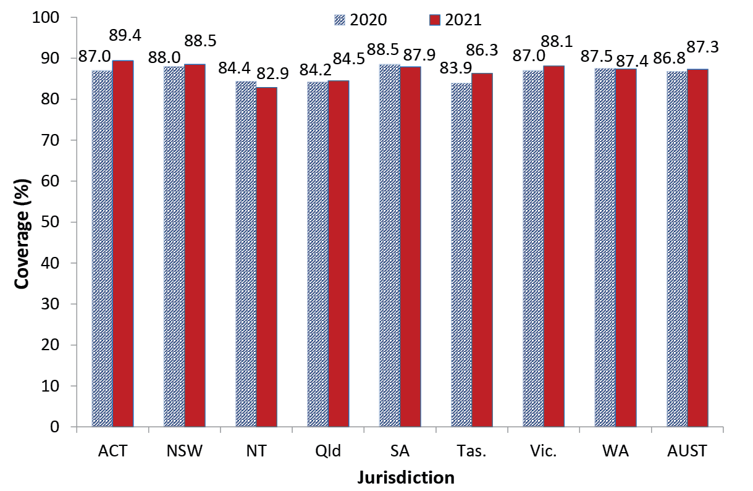
a dTpa: diphtheria, tetanus, pertussis (acellular) – adolescent/adult formulation.
b Source: Australian Immunisation Register, data as at 31 March 2021 (for 2020 counts) and as at 3 April 2022 (for 2021 counts).
c ACT: Australian Capital Territory; NSW: New South Wales; NT: Northern Territory; Qld: Queensland; SA: South Australia; Tas.: Tasmania; Vic.: Victoria; WA: Western Australia; AUST: Australia.
d dTpa vaccinations received after 11th birthday and before 15th birthday in cohort born 1 January – 31 December 2005 for 2020 coverage estimates and cohort born 1 January – 31 December 2006 for 2021 coverage estimates.
In 2021, 78.0% of adolescents had received the adolescent booster dose of dTpa vaccine and had also completed the HPV vaccination schedule by 15 years of age; only 3.3% had received the dTpa adolescent booster dose but no dose/s of HPV vaccine (data not shown).
Figure 20 shows coverage, by 15 years of age, of the booster dose of dTpa vaccine in 2020 and 2021 in Indigenous adolescents, by jurisdiction. Nationally, dTpa coverage for Indigenous adolescents was 0.4 of a percentage point lower in 2021 than 2020 (83.8% versus 84.2%), and 3.5 percentage points lower than coverage in all adolescents. Coverage in 2021 ranged from 75.1% in South Australia to 89.3% in New South Wales.

Figure 20: Coverage (%) of the adolescent booster dose of diphtheria-tetanus-acellular pertussis (dTpa) vaccine ª in Indigenous adolescents by 15 years of age, by jurisdiction,^{b,c,d} Australia, 2020 and 2021
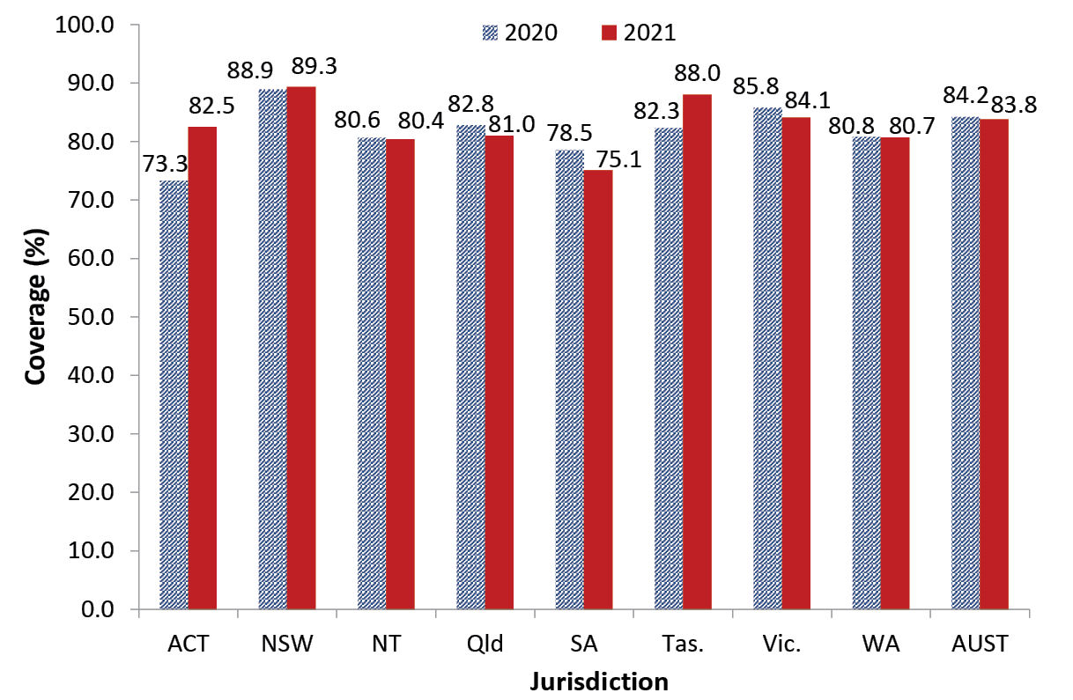
a dTpa: diphtheria, tetanus, pertussis (acellular) – adolescent/adult formulation.
b Source: Australian Immunisation Register, data as at 31 March 2021 (for 2020 counts) and as at 3 April 2022 (for 2021 counts).
c ACT: Australian Capital Territory; NSW: New South Wales; NT: Northern Territory; Qld: Queensland; SA: South Australia; Tas.: Tasmania; Vic.: Victoria; WA: Western Australia; AUST: Australia.
d dTpa vaccinations received after 11th birthday and before 15th birthday in cohort born 1 January – 31 December 2005 for 2020 coverage estimates and cohort born 1 January – 31 December 2006 for 2021 coverage estimates.
In 2021, 68.8% of Indigenous adolescents had received the adolescent booster dose of dTpa vaccine and had also completed the HPV vaccination schedule by 15 years of age; only 2.6% had received the dTpa adolescent booster dose but no dose/s of HPV vaccine (data not shown).
In 2021, the number of dTpa vaccinations recorded nationally in girls aged 11–14 years was similar to the number recorded in 2020; however, in the Australian Capital Territory, the number of administered doses in 2021 was 86.3% lower than in 2020 (326 versus 2,382 doses) (Table 8).
The number of dTpa vaccinations recorded in boys aged 11–14 years was 0.9% higher nationally in 2021 than in 2020; however, in the Australian Capital Territory, the number of administered doses in 2021 was 85.0% lower than in 2020 (356 doses versus 2,378 doses) (Table 9).

Meningococcal ACWY vaccine coverage
Figure 21 shows coverage, by 17 years of age, of meningococcal ACWY vaccine in 2020 and 2021, by jurisdiction. Nationally, coverage was 1.8 percentage points higher in 2021 than 2020 (76.1% versus 74.3%). Coverage in 2021 ranged from 73.7% in Queensland to 83.0% in Tasmania.
Figure 21: Coverage (%) of meningococcal ACWY vaccine in adolescents by 17 years of age, by jurisdiction,^{a,b,c} Australia, 2020 and 2021
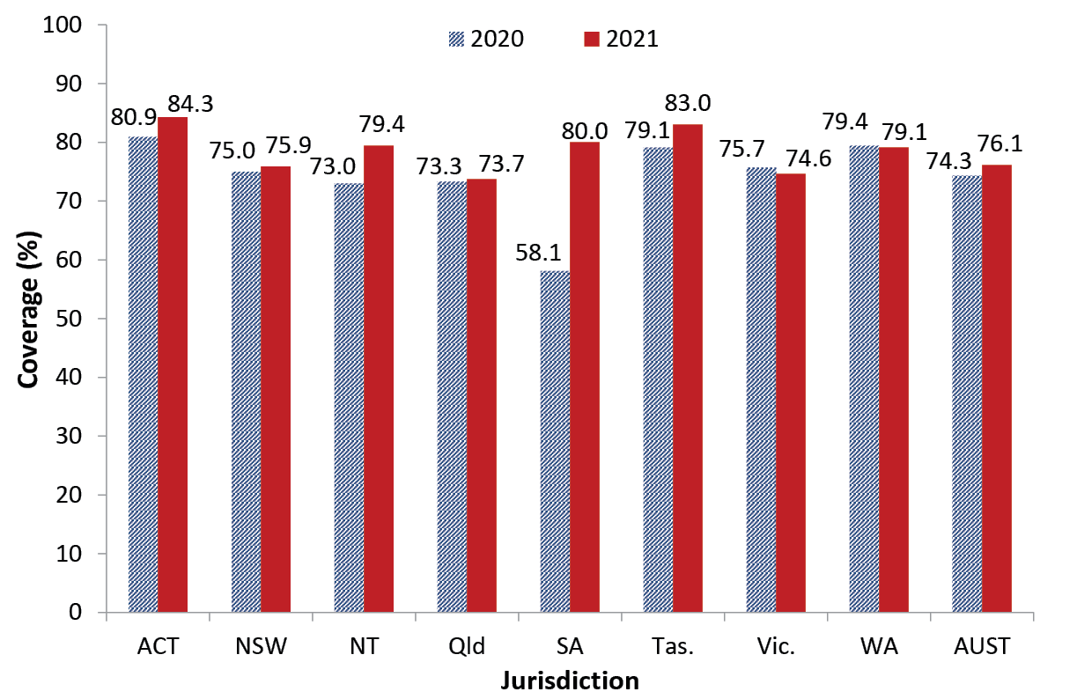
a Source: Australian Immunisation Register, data as at 31 March 2021 (for 2020 counts) and as at 3 April 2022 (for 2021 counts).
b ACT: Australian Capital Territory; NSW: New South Wales; NT: Northern Territory; Qld: Queensland; SA: South Australia; Tas.: Tasmania; Vic.: Victoria; WA: Western Australia; AUST: Australia.
c Meningococcal ACWY vaccinations received after thirteenth birthday and before seventeenth birthday in cohort born 1 January – 31 December 2003 for 2020 coverage estimates and cohort born 1 January – 31 December 2004 for 2021 coverage estimates.
Figure 22 shows coverage, by 17 years of age, of meningococcal ACWY vaccine in 2020 and 2021 in Indigenous adolescents, by jurisdiction. Nationally, coverage for Indigenous adolescents was 1.4 percentage points lower in 2021 than 2020 (66.7% versus 68.1%), and 9.4 percentage points lower than coverage in all adolescents. Coverage in Indigenous adolescents in 2021 ranged from 58.9% in Victoria to 85.6% in Tasmania.

Figure 22: Coverage (%) of meningococcal ACWY vaccine in Indigenous adolescents by 17 years of age,^{a,b,c} by jurisdiction, Australia, 2020 and 2021
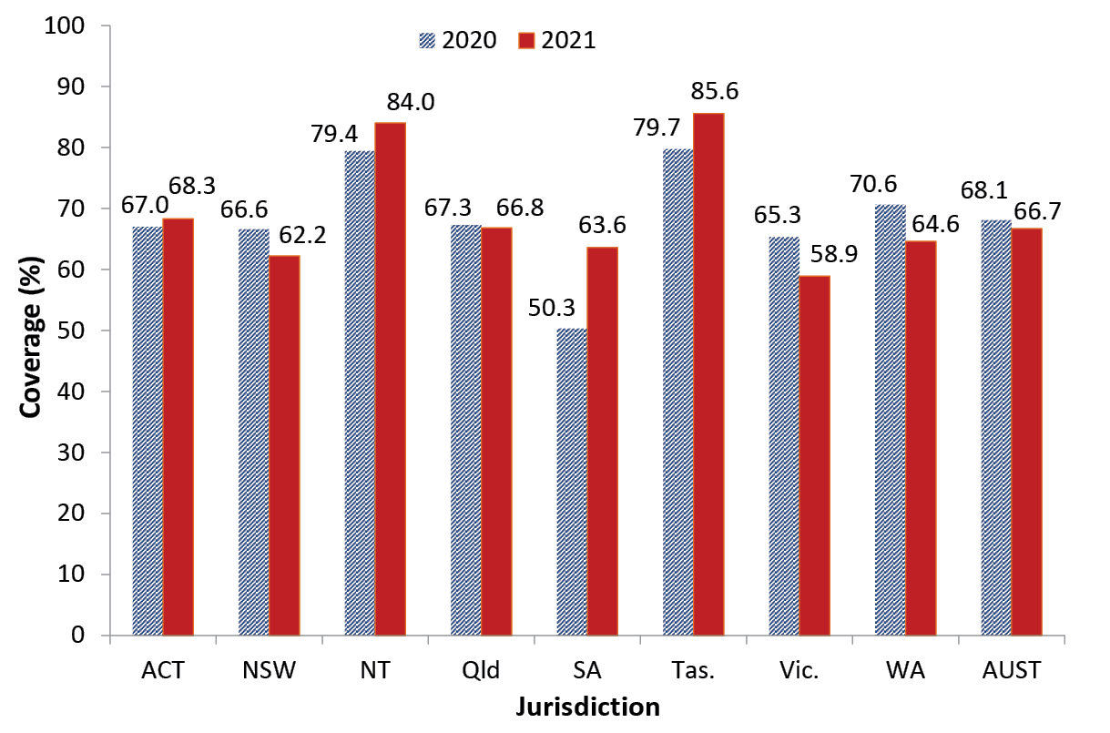
a Source: Australian Immunisation Register, data as at 31 March 2021 (for 2020 counts) and as at 3 April 2022 (for 2021 counts).
b ACT: Australian Capital Territory; NSW: New South Wales; NT: Northern Territory; Qld: Queensland; SA: South Australia; Tas.: Tasmania; Vic.: Victoria; WA: Western Australia; AUST: Australia.
c Meningococcal ACWY vaccinations received after thirteenth birthday and before seventeenth birthday in cohort born 1 January – 31 December 2003 for 2020 coverage estimates and cohort born 1 January – 31 December 2004 for 2021 coverage estimates.
Figure 23 shows the number of adolescents who received a meningococcal ACWY vaccination in 2020 and 2021 by age group. Overall, the number of doses administered was 5.0% lower in 2021 than 2020, and lower in all age groups except 14 and 15 years (13.3% and 5.0% higher, respectively) (Figure 23).

Figure 23: Number of adolescents receiving a meningococcal ACWY vaccination by age group, ^{a,b} Australia, 2020 and 2021
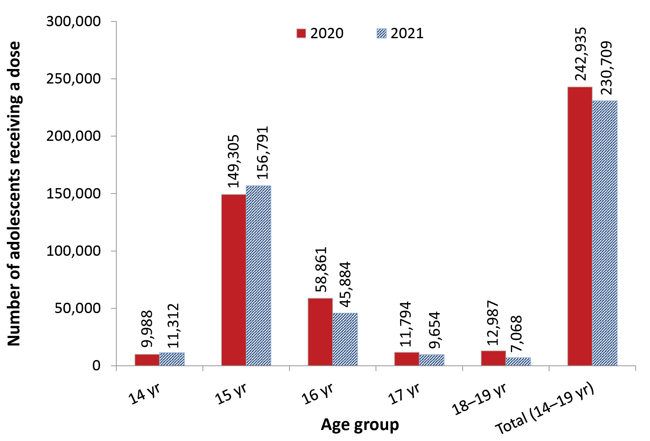
a Source: Australian Immunisation Register, data as at 31 March 2021 (for 2020 data) and as at 3 April 2022 (for 2021 data).
b Aged 14–19 years as at date of vaccination.

Influenza vaccine coverage
Influenza vaccine coverage in adolescents aged 10–14 years and 15–19 years decreased by 11.5 and 7.6 percentage points between 2020 and 2021, to 13.3% and 15.1%, respectively (Figure 2) with decreases seen in all jurisdictions (Appendix, Table A.3). In 2021, coverage for adolescents aged 10–14 years ranged from 11.8% in New South Wales to 17.6% in South Australia, and for adolescents aged 15–19 years from 13.2% in New South Wales to 20.0% in South Australia (Appendix, Table A.3).
Influenza vaccine coverage in Indigenous adolescents aged 10–14 years and 15–19 years decreased by 16.8 and 14.1 percentage points between 2020 and 2021, to 15.4% and 16.5%, respectively (Figure 4), with decreases seen in all jurisdictions (Appendix, Table A.3). Coverage for Indigenous adolescents aged 10–14 years in 2021 ranged from 12.8% in Western Australia to 25.1% in the Northern Territory and for adolescents aged 15–19 years from 14.0% in Western Australia to 24.5% in the Northern Territory (Appendix, Table A.3).

COVID-19 vaccine coverage
By the end of 2021, a total of 79.5% of Australian adolescents aged 12–15 years had received a first dose of a COVID-19 vaccine and 73.4% had received a second dose (Appendix, Figure A.12). Coverage of the first dose of COVID-19 vaccine in adolescents aged 12–15 years ranged from 68.1% in Western Australia to above 99% in the Australian Capital Territory (Appendix, Table A.5).

Adults

Zoster vaccine coverage
Zoster vaccine coverage for Australian adults aged 70 years decreased from 30.9% in 2020 to 30.6% in 2021, with coverage in 2021 ranging from 14.5% in the Northern Territory to 40.9% in Queensland (Figure 24). Coverage in Indigenous adults aged 70 years decreased from 28.7% in 2020 to 26.5% in 2021 (Figure 25), with coverage in 2021 ranging from 13.0% in the Northern Territory to 41.7% in the Australian Capital Territory.
Figure 24: Zoster vaccine coverage for adults turning 71 years of age in the year of interest, by jurisdiction, ^{a,b,c} Australia, 2019, 2020, and 2021
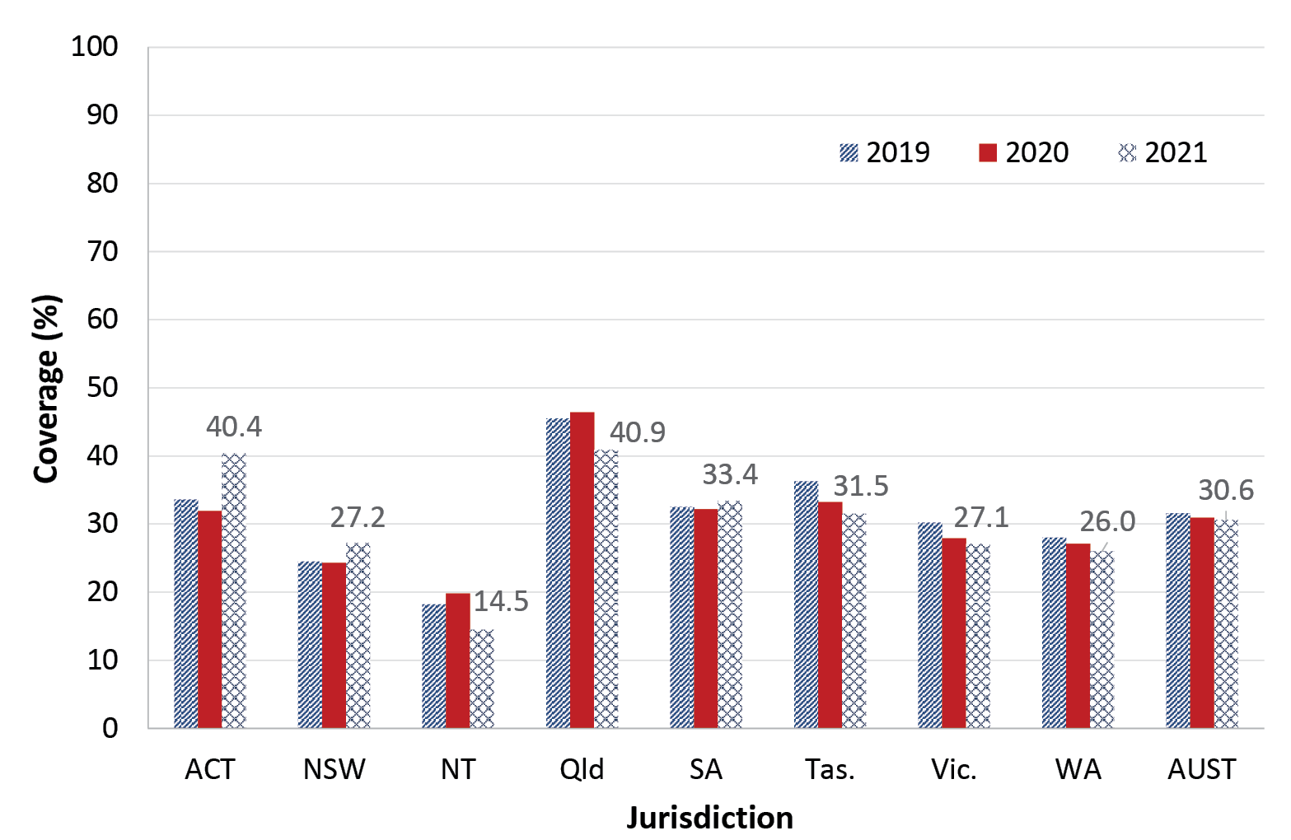
a Source: Australian Immunisation Register, data as at 3 April 2022.
b ACT: Australian Capital Territory; NSW: New South Wales; NT: Northern Territory; Qld: Queensland; SA: South Australia; Tas.: Tasmania; Vic.: Victoria; WA: Western Australia; AUST: Australia.
c Cohorts: 1 January – 31 December 1948 for 2019 coverage; 1 January – 31 December 1949 for 2020 coverage; 1 January – 31 December 1950 for 2021 coverage. Coverage: receipt of one dose of Zostavax or two doses of Shingrix before turning 71 years of age and includes doses given at less than 70 years of age.

Figure 25: Zoster vaccine coverage for Indigenous adults turning 71 years of age in the year of interest, by jurisdiction, ^{a,b,c} Australia, 2019,^{d} 2020,^{d} and 2021
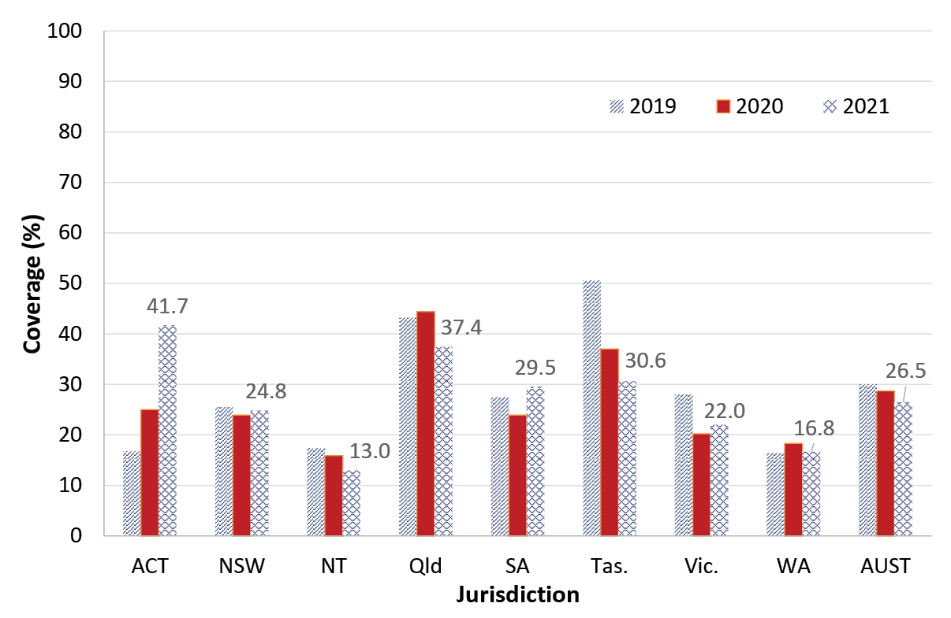
a Source: Australian Immunisation Register, data as at 3 April 2022.
b ACT: Australian Capital Territory; NSW: New South Wales; NT: Northern Territory; Qld: Queensland; SA: South Australia; Tas.: Tasmania; Vic.: Victoria; WA: Western Australia; AUST: Australia.
c Cohorts: 1 January – 31 December 1948 for 2019 coverage; 1 January – 31 December 1949 for 2020 coverage; 1 January – 31 December 1950 for 2021 coverage. Coverage: receipt of one dose of Zostavax or two doses of Shingrix before turning 71 years of age and includes doses given at less than 70 years of age.
d 2019 and 2020 estimates have been revised due to an issue with the recording of Indigenous status on the AIR and are therefore different to what was presented in the 2020 report.
Zoster vaccine coverage for Australian adults aged 71–79 years increased from 43.7% in 2020 to 46.7% in 2021, with coverage in 2021 ranging from 31.3% in the Northern Territory to 55.3 in Queensland (Figure 26). Coverage in Indigenous adults aged 71–79 years increased from 44.9% in 2020 to 47.3% in 2021, higher than for adults overall in both years (Figure 27), with coverage in 2021 ranging from 35.7% in Western Australia to 60.6% in Tasmania.

Figure 26: Zoster vaccine coverage for adults turning 72–79 years of age in the year of interest, by jurisdiction, ^{a,b,c} Australia, 2019, 2020, and 2021
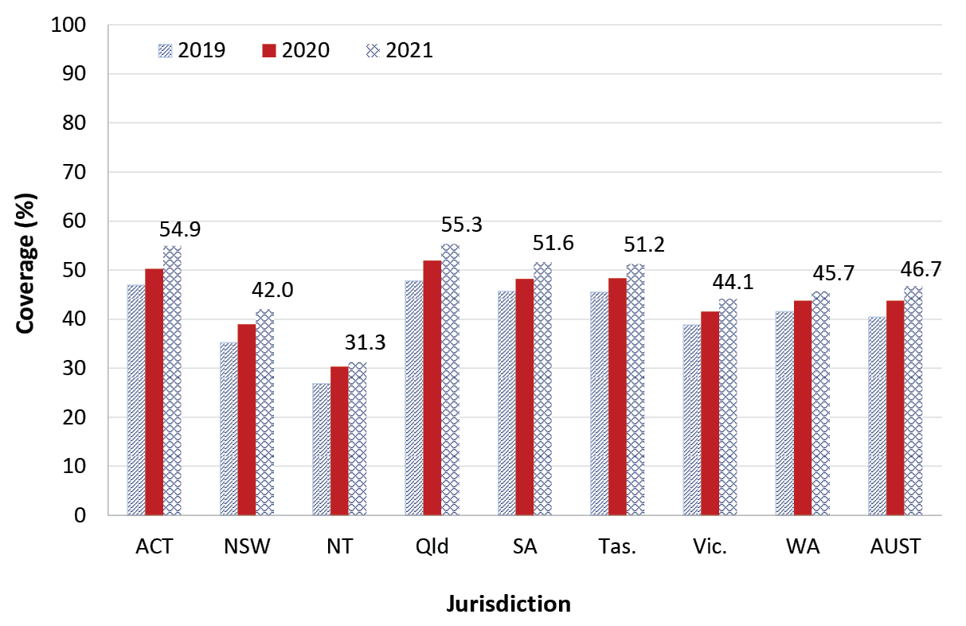
a Source: Australian Immunisation Register, data as at 3 April 2022.
b ACT: Australian Capital Territory; NSW: New South Wales; NT: Northern Territory; Qld: Queensland; SA: South Australia; Tas.: Tasmania; Vic.: Victoria; WA: Western Australia; AUST: Australia.
c Cohorts: 1 January 1940 – 31 December 1947 for 2019 coverage; 1 January 1941 – 31 December 1948 for 2020 coverage; 1 January 1942 – 31 December 1949 for 2021 coverage. Coverage: receipt of one dose of Zostavax or two doses of Shingrix before turning 80 years of age and includes doses given at less than 71 years of age.

Figure 27: Zoster vaccine coverage for Indigenous adults turning 72–79 years of age in the year of interest, by jurisdiction, ^{a,b,c} Australia, 2019, ^{d} 2020, ^{d} and 2021
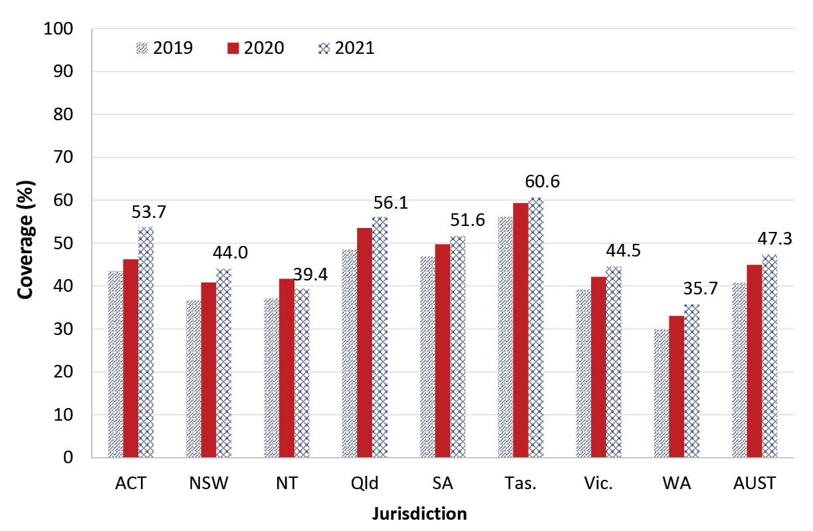
a Source: Australian Immunisation Register, data as at 3 April 2022.
b ACT: Australian Capital Territory; NSW: New South Wales; NT: Northern Territory; Qld: Queensland; SA: South Australia; Tas.: Tasmania; Vic.: Victoria; WA: Western Australia; AUST: Australia.
c Cohorts: 1 January 1940 – 31 December 1947 for 2019 coverage; 1 January 1941 – 31 December 1948 for 2020 coverage; 1 January 1942 – 31 December 1949 for 2021 coverage. Coverage: receipt of one dose of Zostavax or two doses of Shingrix before turning 80 years of age and includes doses given at less than 71 years of age.
d 2019 and 2020 estimates have been revised due to an issue with the recording of Indigenous status on the AIR and are therefore different to what was presented in the 2020 report.
Zoster vaccine coverage for adults by whether vaccinated at < 71 years or ≥ 71 years, by single year of age birth cohort, is shown in Figure 28. Coverage is greater than 40% for all cohorts aged 72–79 years, highest in those aged 74 years at 49.7%, with the older cohorts predominantly vaccinated at ≥ 71 years i.e. as part of the catch-up vaccination program initiated in late 2016.
Of 6,460,914 adults in Australia who were in the age cohort who turned 50–69 years of age during 2021, a total of 68,276 (1.1%) had received a dose of zoster vaccine during 2021 (up to 31 December 2021; data not shown).
Of the 197,968 doses of zoster vaccine recorded on the AIR as administered in 2021, only 12,890 doses (6.5%) were recorded as Shingrix vaccine (data not shown).

Figure 28: Zoster vaccine coverage by whether vaccinated at < 71 years or ≥ 71 years of age, by single year of age birth cohort, ^{a,b} Australia, 2021
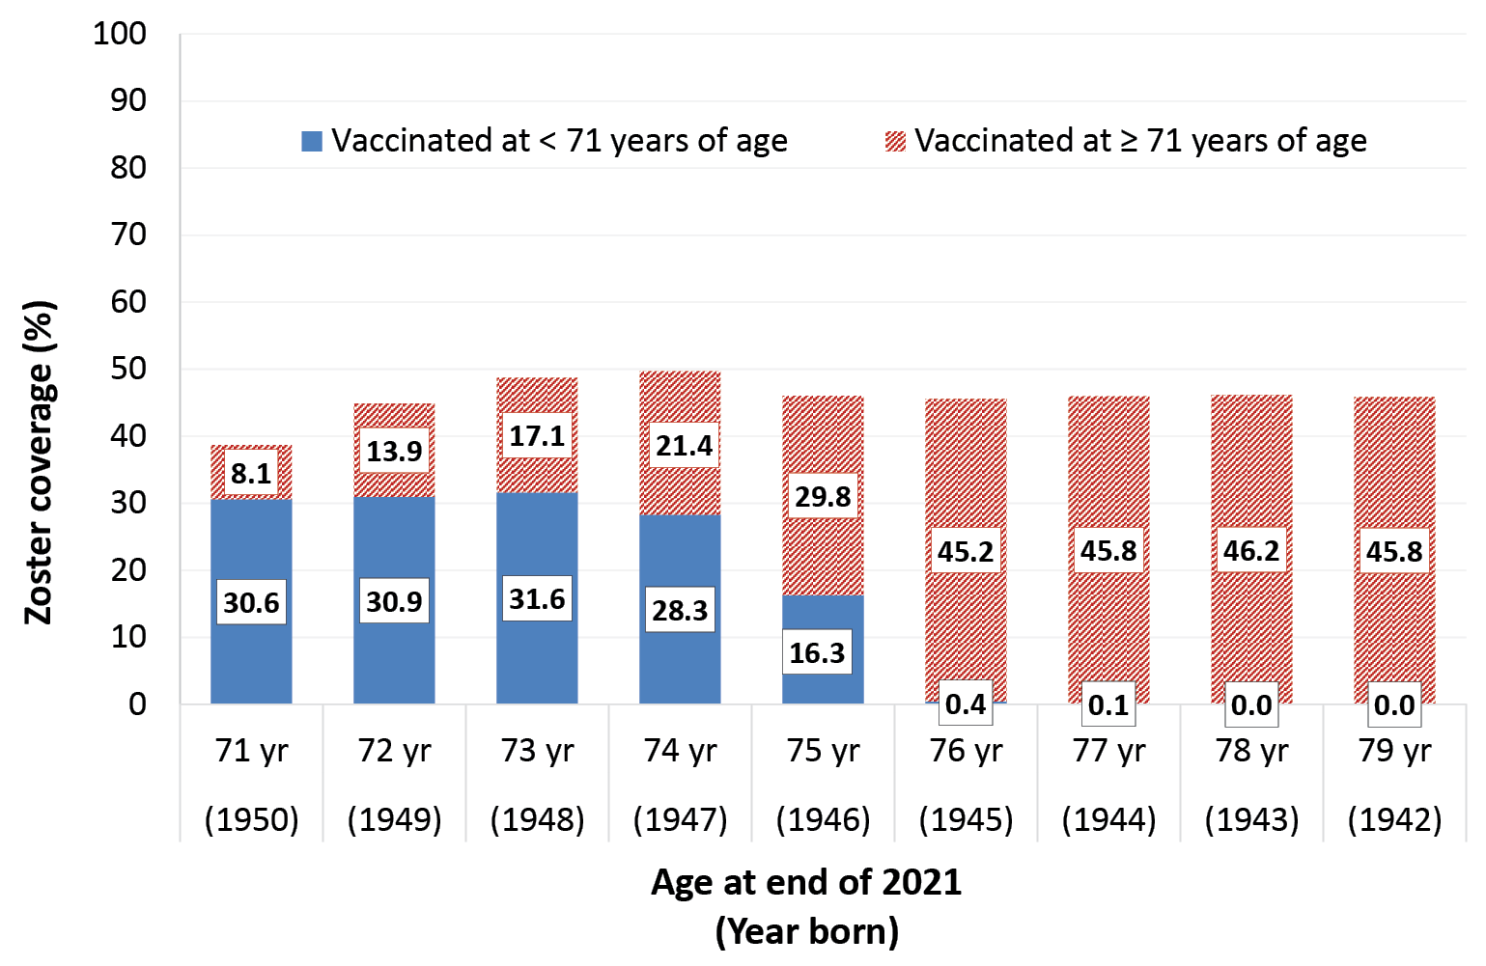
a Source: Australian Immunisation Register, data as at 3 April 2022.
b Coverage: receipt of one dose of Zostavax or two doses of Shingrix before turning 80 years of age and includes doses given at less than 70 years of age.

13vPCV coverage
Recorded 13vPCV coverage in adults aged 70 years increased by 15 percentage points overall between 2020 and 2021, reaching 17.2%, and by 16.8 percentage points in Indigenous adults, reaching 18.8% (Figure 29).

Figure 29: 13vPCV coverage in 70-year-olds by Indigenous status for 2020 versus 2021, ª Australia
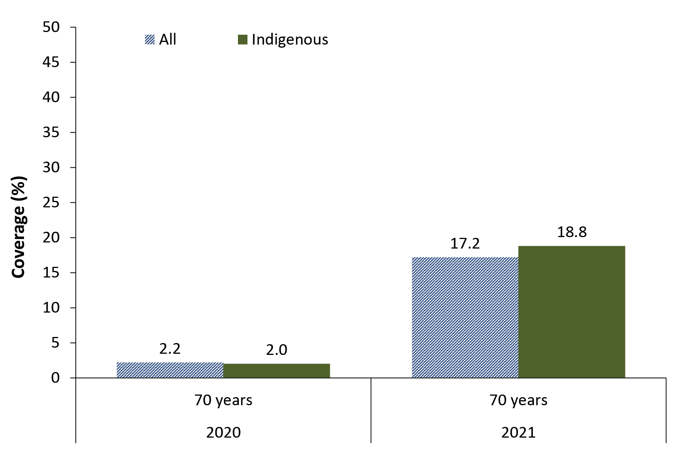
a Source: Australian Immunisation Register, data as at 3 April 2022.
Recorded 13vPCV coverage in adults aged 71–79 years increased by 12 percentage points overall between 2020 and 2021, reaching 20.1%, and by 10.9 percentage points in Indigenous adults, reaching 20.7% (Figure 30).
Figure 30: 13vPCV coverage in 71–79 year olds by Indigenous status for 2020 versus 2021, ª Australia
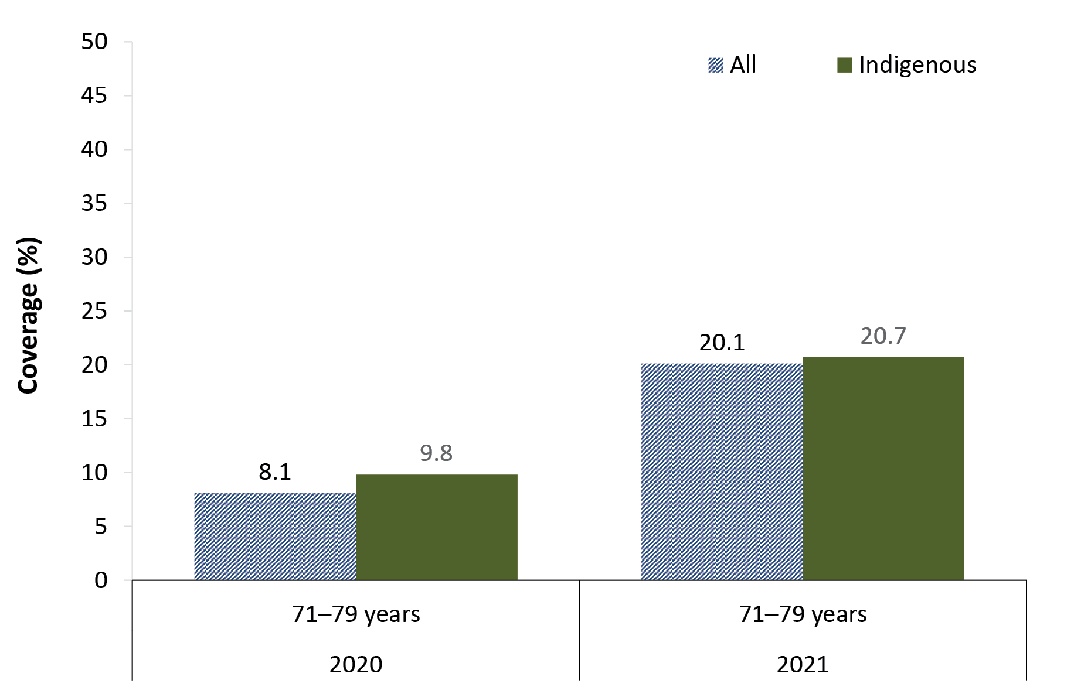
a Source: Australian Immunisation Register, data as at 3 April 2022.
Of 6,460,914 adults in Australia who were in the age cohort who turned 50–69 years of age during 2021, a total of 63,481 (1.0%) were recorded as having received a dose of 13vPCV during 2021 (up to 31 December 2021; data not shown). Of 105,847 Indigenous adults in Australia who were in the age cohort who turned 50–69 years of age during 2021, a total of 11,470 (10.8%) were recorded as having received a dose of 13vPCV during 2021 (up to 31 December 2021; data not shown).

Influenza vaccine coverage
Influenza vaccine coverage in adults aged 20–49 years and 65–74 years increased by 0.4 and 0.9 of a percentage point between 2020 and 2021, reaching 23.9% and 62.1%, respectively; coverage in adults aged 50–64 years and 75+ years increased more substantially, by 3.0 and 5.6 percentage points, reaching 38.2% and 68.5%, respectively (Figure 2). Coverage by jurisdiction is shown in Table A.3 in the Appendix.
Influenza vaccine coverage in all Indigenous adult age groups decreased between 2020 and 2021, with the largest decrease in those aged 50–64 years (12.8 percentage points to 43.5%) and the smallest decrease in Indigenous adults aged 75+ years (3.0 percentage points to 67.7%) (Figure 4). Coverage by jurisdiction is shown in Table A.3 in the Appendix.
Figure 31 shows weekly cumulative influenza vaccine uptake in the AIR in 2021, by age group. Uptake was highest for all age groups between the first week of April and the last week of May, with the steepest trajectories in adults aged 65–74 years and in those aged 75+ years. Uptake was slowest in children aged 5–9 years, and in adolescents aged 10–14 years and 15–19 years. Uptake commenced later in 2021 than in 2020, where it was highest for all age groups between the last week of March and the first week of May (data not shown).
Figure 31: Weekly cumulative influenza vaccine uptake (≥ 1 dose) by age group, ª Australia, 2021
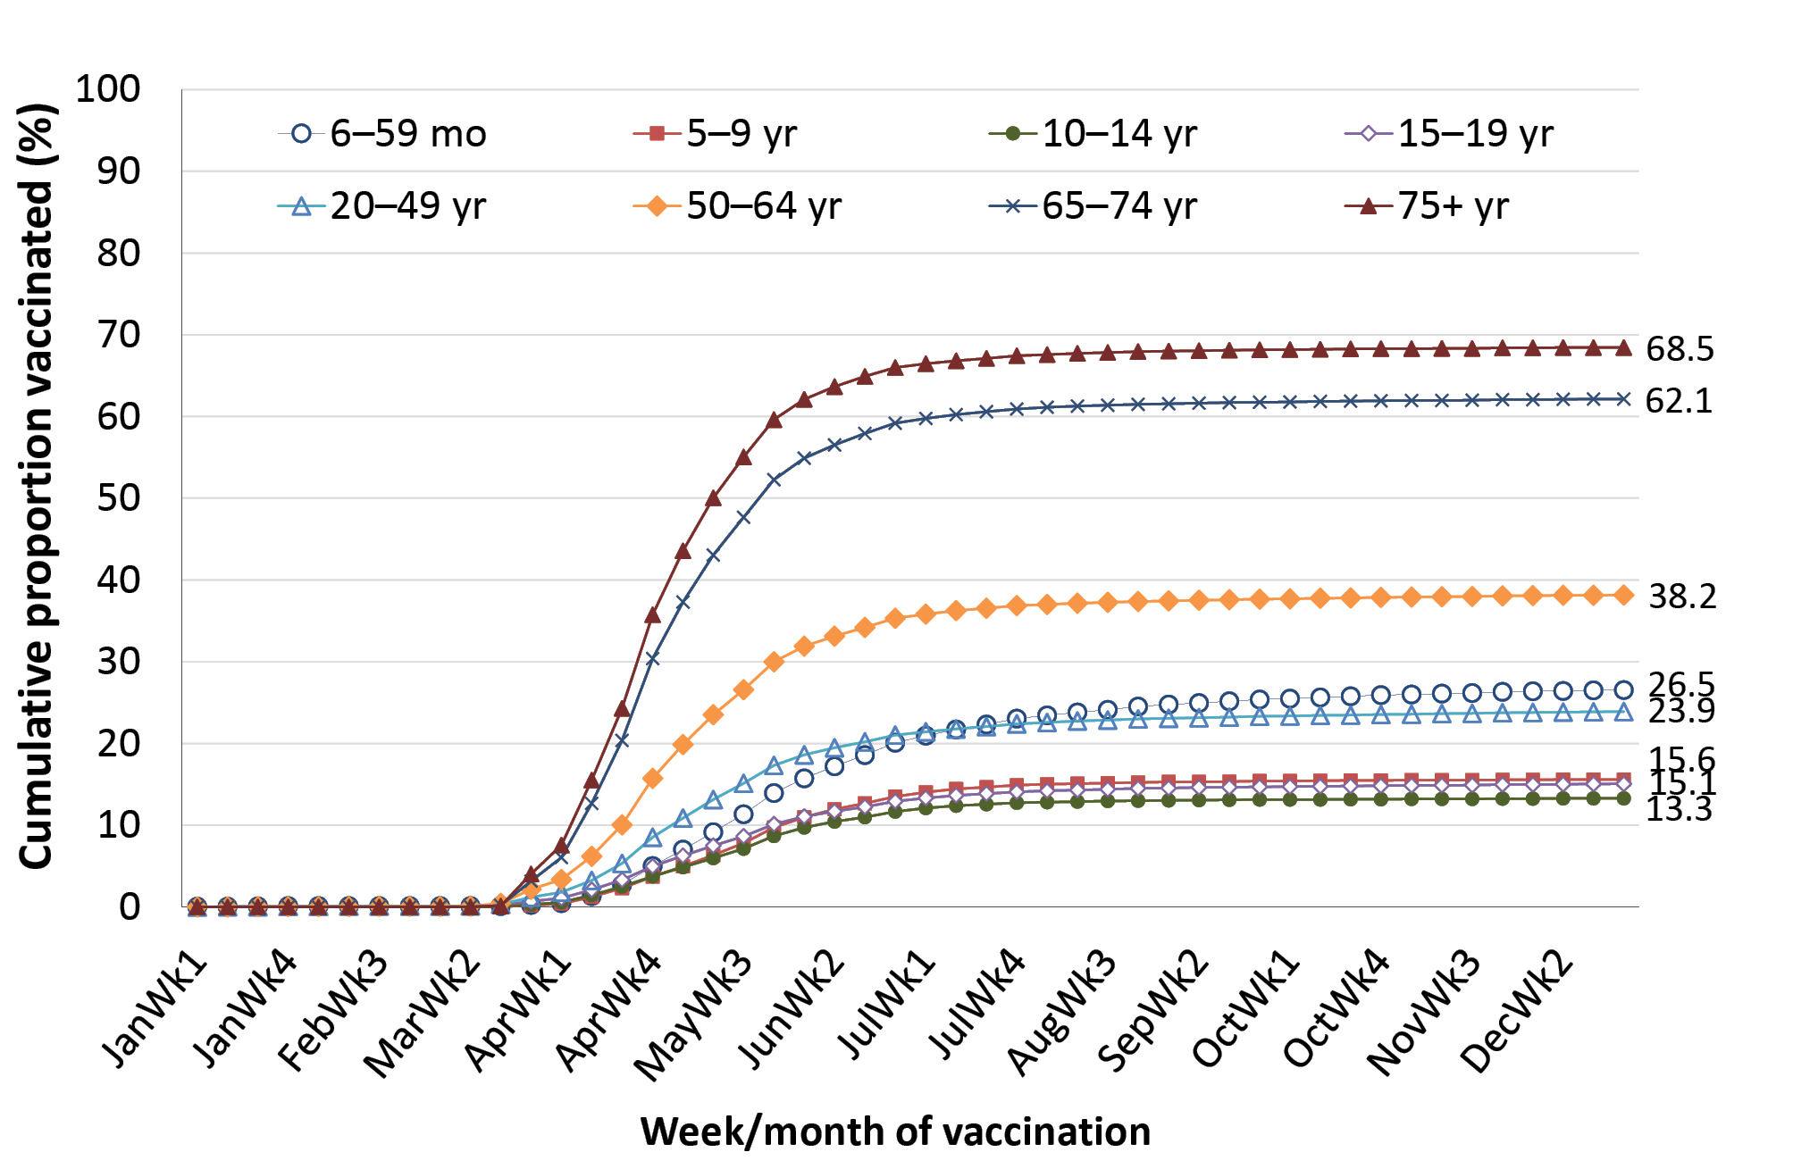
a Source: Australian Immunisation Register, data as at 3 April 2022.

COVID-19 vaccine coverage
By the end of 2021, a total of 94.5% of Australians aged 16 years and over had received a first dose of a COVID-19 vaccine; 91.6% had received a second dose (Appendix, Figure A.13). Coverage in people aged 16 years and over for the first dose ranged from 89.3% in the Northern Territory to above 99% in the Australian Capital Territory, and for the second dose from 84.6% in the Northern Territory to above 99% in the Australian Capital Territory (Appendix, Table A.6).
Adult coverage of both first and second dose increased with increasing age (Appendix, Figure A.12), ranging from 91.4% first dose and 87.8% second dose coverage in those aged 16–49 years to above 99% for both doses in those aged 70 years and over. Coverage by jurisdiction and age group is shown in Table A.5 in the Appendix.
COVID-19 vaccine coverage was lower in Indigenous people aged ≥ 16 years for both first and second dose, at 79.2% and 71.8%, respectively (Appendix, Figure A.13), ranging from 67.5% and 52.7% in Western Australia to 90.8% and 88.0% in the Australian Capital Territory (Appendix, Table A6).

Discussion

Overall findings

Vaccination coverage in children
‘Fully vaccinated’ coverage in Australian children in this 2021 report was 0.6–0.8 of a percentage point lower than in our 2020 report at the 12-month (94.2%) and 60-month (94.0%) age assessment milestones, but stable at the 24-month milestone (92.1%).¹⁴ Due to the lag time involved in ‘fully vaccinated’ coverage assessment, ‘fully vaccinated’ coverage figures in the 2020 and 2021 reports predominantly reflect vaccinations due in 2019 and 2020, respectively, and hence show a small impact on overall childhood coverage in the first year of the COVID-19 pandemic, lower than that seen in many other countries.^{17–19} However, pandemic impacts on coverage were greater in some areas, particularly remote areas with a high proportion of Indigenous people such as the East Pilbara SA3 area in Western Australia and Katherine and Alice Springs SA3 areas in the Northern Territory, with coverage for the second dose of MMR and fourth dose of DTPa decreasing from above 90% in the 2020 report¹⁴ to below 90% in this report. True coverage in children was likely somewhat higher than presented here, given previously documented under-reporting to the AIR.^{20,21}
‘Fully vaccinated’ coverage in 2021 was around two percentage points lower at the 24-month milestone than at 12 and 60 months of age, likely due to the greater number of antigens required in order to be classified as ‘fully vaccinated’ at 24 months.⁹ In contrast, only one vaccine (DTPa-polio, scheduled at 48 months) is included in ‘fully vaccinated’ assessment at 60 months. Expansion of the 60-month assessment algorithm, to include a more comprehensive range of the vaccines/antigens that should have been received by that age, would be useful to better monitor uptake under the NIP.
Coverage was lower in 2021 than in 2020 for almost all individual vaccines/antigens included in the ‘fully vaccinated’ assessment algorithms. The largest decrease was for DTPa-containing vaccine at 60 months of age (a 2.5 percentage point decrease); all other decreases were less than one percentage point. In the context of Australia’s 95% coverage targets, which are particularly critical to measles control, coverage at 24 months of age in 2021 was 95.5% for the first dose of measles-containing vaccine; and while coverage was lower for the second dose of MMR at 24 months (93.6%), it was 96.6% at 60 months of age.
Influenza vaccine coverage in 2021 in children aged 6 months to 4 years, at 26.5%, was 19.6 percentage points lower than in 2020 (46.1%), in the context of historically low levels of circulating influenza due to COVID-19 pandemic-related public health measures.²²

Vaccination coverage in adolescents
In 2021, a total of 80.3% of girls in Australia had completed a full course of HPV vaccine by age 15 years, down slightly from 80.5% in 2020, and 77.2% of boys, down from 77.6%. Completion of HPV vaccination in 2021 was lower in adolescents residing in socio-economically disadvantaged and remote areas, around five percentage points lower for girls and eight for boys. While HPV coverage by 15 years of age for both 2020 and 2021 predominantly represents vaccinations due in school-based programs prior to the COVID-19 pandemic, the slight decreases could be due to pandemic-related effects on catch-up vaccination. Pandemic-related impacts can be seen more clearly in the decrease in proportion of adolescents aged 11–14 years who received a first dose of HPV vaccine and then went on to receive their second dose in the same calendar year. This proportion was around 15 percentage points lower in 2021 than in 2020, and 27 percentage points lower than in 2019.¹⁴ This likely reflects the impact of public health measures, particularly school closures, in the context of the minimum 6-month interval recommended between doses.²³ Re-deployment of school-based immunisation providers into COVID-19 vaccination clinics in 2021 may have also impacted completion rates. However, with modelling of both-sex HPV vaccination programs suggesting that sustained population vaccination coverage of over 80% will be sufficient for elimination of targeted HPV types, Australia still looks well placed to achieve this.²⁴
Coverage of the adolescent booster dose of dTpa vaccine by 15 years in 2021 was 87.3%, half a percentage point higher than 2020, and coverage of meningococcal ACWY vaccine by 17 years of age was 76.1%, almost two percentage points higher. While these figures predominantly represent vaccinations due in school-based programs prior to the pandemic, the number of meningococcal ACWY vaccinations recorded as given in 2021 was five percentage points lower than in 2020, and 9 percentage points lower than in 2019,¹⁴ indicating likely pandemic impacts on uptake. A particularly marked drop in dTpa and in second dose HPV vaccinations was seen in the Australian Capital Territory in 2021: due to a territory-wide lockdown from August to September, with adolescent COVID-19 vaccination prioritised upon school reopening, a decision was made to defer the dTpa and second-dose HPV vaccinations for Year 8 students to 2022.²⁵

Vaccination coverage in adults
Zoster vaccine coverage in 2021 remained relatively low, at just over 30%, in adults aged 70 years, the primary NIP target group, but increased to 47% in those aged 71–79 years, reflecting substantial levels of ongoing catch-up vaccination. Greater focus on promoting timely vaccination at 70 years is required, particularly if the NIP-funded catch-up zoster vaccination program for adults aged 71–79 years is not extended further (currently scheduled to finish on 31 October 2023)²⁶. True zoster vaccine coverage is likely higher, as under-reporting to the AIR has previously been documented.^{27, 28} Mandatory reporting of all NIP vaccines was introduced in July 2021.²⁹
Coverage of 13vPCV vaccine, introduced onto the NIP in July 2020 for all adults aged 70 years and over, was low in 2021, reaching 17.2% in adults aged 70 years and 20.1% in those aged 71–79 years. Influenza vaccination coverage in adults in 2021 was progressively higher with increasing age, reaching 62.1% and 68.5% in the 65–69 year 75+ year age groups respectively. Coverage was also higher in 2021 than 2020 across all adult age groups, which could be due in part to increased completeness of reporting, as mandatory reporting for influenza vaccine was introduced in March 2021.^{29, 30} By the end of 2021, a total of 91.6% of Australians aged ≥ 16 years (and over 99% of those aged ≥ 70 years) had received a second dose of a COVID-19 vaccine.

Vaccination coverage in Indigenous people

Children
‘Fully vaccinated’ coverage for Indigenous children decreased between 2020 and 2021 at all three age milestones: 12 months (from 93.1% to 91.6%); 24 months (from 91.2% to 90.1%); and 60 months (from 97.0% to 96.3%). The 2021 coverage figures predominantly reflect vaccinations due in 2020, showing a small impact (but one slightly higher than in children overall) on Indigenous childhood coverage in the first year of the COVID-19 pandemic.
‘Fully vaccinated’ coverage in Indigenous children in 2021 was 2.6 percentage points lower than in all children at 12 months of age (compared to 1.7 percentage points in 2020), and 2.0 percentage points lower at 24 months (compared to 0.9 of a percentage point in 2020). ‘Fully vaccinated’ coverage at 60 months of age remained higher in Indigenous than in all children, by 2.3 percentage points in 2021. The lower coverage at the 12- and 24-month milestones in 2021, compared to overall, highlights longstanding timeliness issues among Indigenous children,^{1,9} with some exacerbation due to the pandemic apparent, particularly in remote areas. This is particularly an issue in relation to vaccines/antigens due 6 months before the assessment milestone, whereas coverage of individual vaccines/antigens due at 6 or 12 months of age with no further doses required at 18 months (MenACWY, polio and hepatitis B vaccines) was 96.6% or greater overall at 24 months in 2021. Similarly, although coverage in 2021 for the second dose of MMR and varicella (usually given as MMRV vaccine at 18 months) in Indigenous children was 92.4% at 24 months, it was over six percentage points higher (98.6%) at 60 months. Likely related to these issues, in remote areas with a high proportion of Indigenous people, less pandemic-related impact was observed on coverage at 24 months for MenC-containing vaccine (due at 12 months) than for the fourth dose of DTPa and second dose of MMR (both due at 18 months).
As seen in children overall, influenza vaccination coverage in Indigenous children in 2021 was considerably lower than 2020: totals of 22.5% in 2021 versus 43.0% in 2020 for those aged 6 months to 4 years, and 15.5% versus 33.8% for those aged 5 to 9 years. Coverage in Indigenous children aged 6 months to 4 years in 2021 was highest in the Northern Territory at 53.2%.
Coverage for hepatitis A vaccine and the fourth dose of 13vPCV, which are funded under the NIP for Indigenous children in four jurisdictions only (South Australia, Northern Territory, Queensland and Western Australia), remained suboptimal in 2021, at 82.0% for the first dose of hepatitis A (second dose coverage unable to be assessed due to schedule change) and 81.7% for 13vPCV dose 4, although coverage in the Northern Territory continued to be substantially higher.

Adolescents
HPV vaccination coverage (both first dose and course completion) for Indigenous girls and boys by 15 years of age was 1.7–2.4 percentage points lower in 2021 than 2020. Coverage was lower than in adolescents overall, particularly for course completion, seven percentage points lower for girls and 11 for boys. Further efforts to address these disparities are required, given the much higher rates of cervical cancer in Indigenous women,³¹ whilst noting that there is increasing evidence that a single dose of HPV vaccine is highly effective in preventing infection and subsequent disease.³²⁻³⁴

Adults
Zoster vaccination coverage in 2021 was 26.5% in Indigenous adults aged 70 years, 2.2 percentage points lower than 2020 and 3.5 points lower than 2019, suggesting greater COVID-19 pandemic impacts on uptake in Indigenous than other adults. However coverage in 2021 in Indigenous adults aged 71–79 years increased to 47.3%, 0.6 of a percentage point higher than adults overall, again reflecting substantial ongoing catch-up vaccination.
Coverage of 13vPCV in Indigenous adults was also low in 2021, reaching 18.8% in those aged 70 years and 20.7% in those aged 71–79 years. Only 10.8% of Indigenous adults aged 50–69 years were recorded as having received 13vPCV, despite it being funded under the NIP for all Indigenous adults in this age group since July 2020. While influenza vaccine coverage was relatively high in older Indigenous adults, at 64.6% for those aged 65–74 years and 67.7% for those aged 75 years and over, coverage in younger Indigenous adults was considerably lower, ranging from 22.0% for those aged 20–49 years to 43.5% for those aged 50–64 years. Further efforts to increase uptake are required given that annual influenza vaccination is funded on the NIP for all Indigenous adults, due to their increased risk of severe disease. Coverage of the second dose of COVID-19 vaccine in Indigenous people aged ≥ 16 years, at 71.8%, was 20 percentage points lower than overall coverage for this dose.

A focus on timeliness
We examined a broad range of timeliness indicators in this report. The traditional measure of ‘on time’ vaccination (within 30 days of the age recommended on the NIP schedule) was up to two percentage points lower in infants in 2021 than 2020 for the second dose of DTPa, 13vPCV and rotavirus vaccine, suggesting possible pandemic impacts (2021 figures predominantly reflect vaccinations due during the pandemic while 2020 figures predominantly reflect vaccinations due prior to pandemic restrictions). However, there appeared to be little impact on on-time vaccination for the first dose of MMR and meningococcal ACWY vaccine, both due at 12 months of age, with timely coverage in 2021 (for vaccinations due in 2020) up to one percentage point higher than in 2020 (for vaccinations due in 2019). While on-time vaccination in Indigenous children has improved progressively since 2012, on-time coverage in 2021 remained substantially lower than in non-Indigenous children, ranging from six to 13 percentage points lower for the vaccines/antigens assessed.
We also examined ‘fully vaccinated’ coverage at four earlier milestones, three months after the due date of the last scheduled vaccine, by remoteness and socio-economic status of area of residence. ‘Fully vaccinated’ coverage at the earlier milestones was consistently lower in children living in remote areas than those living in major cities and regional areas, likely due to greater logistic issues in providing and accessing vaccination in remote areas. The disparity was substantially higher in Indigenous children, most marked at the 9-month milestone where coverage in remote areas in 2021 was 10 percentage points lower than in major cities and eight percentage points lower than in the 2020 report (for which figures predominantly reflect vaccinations due prior to the COVID-19 pandemic),¹² suggesting differential impacts of the pandemic. ‘Fully vaccinated’ coverage at the earlier assessment time points in 2021 was two to three percentage points lower for children living in areas in the most socio-economically disadvantaged quintile than in the least disadvantaged quintile, generally similar to findings in our 2020 report.¹⁴

Conclusions
We found that, despite the major disruptions associated with the COVID-19 pandemic, vaccine coverage in children in Australia remained relatively high overall in 2021. Due to assessment lag times, the small overall decrease observed predominantly reflects impacts on coverage in the first year of the pandemic (2020). However, impacts on coverage were greater in some areas and populations, and overall influenza vaccine coverage almost halved in children aged 6 months to 4 years, although in the context of historically low levels of circulating influenza. While coverage in Indigenous children was also relatively high overall, timeliness of vaccination remains a persistent issue, with impacts of the pandemic on timeliness particularly seen in remote areas. Adolescent coverage was also relatively high in 2021, although with continuing lower course completion rates in Indigenous adolescents and with evidence of pandemic impact, particularly on receipt of two doses of HPV vaccine within the same calendar year. It will be important to ensure that catch-up vaccination in children and adolescents occurs, and to monitor coverage to establish that all pandemic-related dips in coverage and equity gaps are reversed.
A strengthened focus on adult vaccination is needed, as coverage remained suboptimal in 2021. Zoster vaccine coverage was approximately 30% in the primary target group aged 70 years; nonetheless, with ongoing catch-up vaccination, coverage reached 47% in those aged 71–79 years. Coverage of 13vPCV in 2021, the first full year it was available on the NIP, was around 20% for adults aged 70–79 years. Of NIP-eligible groups, around two-thirds of adults aged ≥ 65 years were recorded as having received influenza vaccine in 2021, but only one-fifth of Indigenous adults aged 20–49 years, and two-fifths of Indigenous adults aged 50–64 years, were recorded as having received the vaccine. These figures may underestimate true coverage, as underreporting of adult vaccinations to the AIR has previously been documented,^{30,35} with the impact of mandatory reporting of all NIP vaccinations from mid-2021 on completeness of reporting not yet formally evaluated.

Acknowledgments
The National Centre for Immunisation Research and Surveillance is supported by the Australian Government Department of Health and Aged Care, the NSW Ministry of Health and The Sydney Children’s Hospitals Network. The opinions expressed in this report are those of the authors, and do not necessarily represent the views of these agencies.

Author details
Brynley Hull
Alexandra Hendry
Aditi Dey
Julia Brotherton
Kristine Macartney
Frank Beard

Corresponding author
Brynley Hull
National Centre for Immunisation Research and Surveillance
The Children’s Hospital at Westmead and The University of Sydney
Locked Bag 4001, Westmead NSW 2145.
Telephone: +61 2 9845 1435.
Facsimile: +61 2 9845 1418.
Email: brynley.hull@health.nsw.gov.au

References
- Hull B, Deeks S, Menzies R, McIntyre P. Immunisation coverage annual report, 2007. Commun Dis Intell Q Rep. 2009;33(2):170–87.
- Hull BP, Mahajan D, Dey A, Menzies RI, McIntyre PB. Immunisation coverage annual report, 2008. Commun Dis Intell Q Rep. 2010 Sep;34(3):241–58.
- Hull B, Dey A, Mahajan D, Menzies RI, McIntyre PB. Immunisation coverage annual report, 2009. Commun Dis Intell Q Rep. 2011;35(2):132–48.
- Hull B, Dey A, Menzies R, McIntyre P. Annual immunisation coverage report, 2010. Commun Dis Intell Q Rep. 2013;37(1):E21–39.
- Hull BP, Dey A, Beard FH, Menzies RI, Brotherton JM, McIntyre PB. Immunisation coverage annual report, 2013. Commun Dis Intell Q Rep. 2016;40(1):E146–69.
- Hull BP, Dey A, Menzies RI, Brotherton JM, McIntyre PB. Immunisation coverage annual report, 2011. Commun Dis Intell Q Rep. 2013;37(4):E291–312.
- Hull BP, Dey A, Menzies RI, Brotherton JM, McIntyre PB. Immunisation coverage, 2012. Commun Dis Intell Q Rep. 2014;38(3):E208–31.
- Hull BP, Hendry AJ, Dey A, Beard F, Brotherton J, McIntyre P. Immunisation coverage annual report, 2014. Commun Dis Intell Q Rep. 2017;41(1):E68–90.
- Hull B, Hendry A, Dey A, Beard F, Brotherton J, McIntyre P. Immunisation coverage annual report, 2015. Commun Dis Intell (2018). 2019;43. doi: https://doi.org/10.33321/cdi.2019.43.11.
- Hull B, Hendry A, Dey A, Beard F, Brotherton J, McIntyre P. Annual immunisation coverage report, 2016. Commun Dis Intell (2018). 2019;43. doi: https://doi.org/10.33321/cdi.2019.43.44.
- Hull B, Hendry A, Dey A, Brotherton J, Macartney K, McIntyre P. Annual immunisation coverage report 2017. Commun Dis Intell (2018). 2019;43. doi: https://doi.org/10.33321/cdi.2019.43.47.
- Hull B, Hendry A, Dey A, McIntyre P, Macartney K, Beard F. Annual Immunisation Coverage Report 2018. Commun Dis Intell (2018). 2021;45. doi: https://doi.org/10.33321/cdi.2020.45.17.
- Hull B, Hendry A, Dey A, Macartney K, Beard F. Immunisation Coverage Annual Report 2019. Commun Dis Intell (2018). 2021;45. doi: https://doi.org/10.33321/cdi.2020.45.18.
- Hull B, Hendry A, Dey A, Brotherton J, Macartney K, Beard F. Annual immunisation coverage report 2020. Commun Dis Intell (2018). 2022;46. doi: https://doi.org/10.33321/cdi.2022.46.60.
- Australian Government Department of Health and Aged Care. New and cumulative COVID-19 cases in Australia by notification date. [Webpage.] Canberra: Australian Government Department of Health and Aged Care; 2020. [Accessed on 25 March 2020.] Available from: https://www.health.gov.au/resources/publications/new-and-cumulative-covid-19-cases-in-australia-by-notification-date.
- Australian Bureau of Statistics. Impact of lockdowns on household consumption - insights from alternative data sources. [Webpage.] Canberra: Australian Bureau of Statistics; 1 December 2021. [Accessed on 16 September 2022.] Available from: https://www.abs.gov.au/articles/impact-lockdowns-household-consumption-insights-alternative-data-sources.World Health Organization (WHO). WHO and UNICEF warn of a decline in vaccinations during COVID-19. [Internet.] Geneva: WHO; 15 July 2020 [Accessed on 9 September 2021.] Available from: https://www.who.int/news/item/15-07-2020-who-and-unicef-warn-of-a-decline-in-vaccinations-during-covid-19.
- Santoli JM, Lindley MC, DeSilva MB, Kharbanda EO, Daley MF, Galloway L, et al. Effects of the COVID-19 pandemic on routine pediatric vaccine ordering and administration – United States, 2020. MMWR Morb Mortal Wkly Rep. 2020;69(19):591–3. doi: https://doi.org/10.15585/mmwr.mm6919e2.
- Public Health England (PHE). Impact of COVID-19 on childhood vaccination counts to week 43, and vaccine coverage to September 2020 in England: interim analyses. London: United Kingdom Government, Department of Health and Social Care, PHE; 10 November 2020. [Accessed on 24 November 2020.] Available from: https://assets.publishing.service.gov.uk/government/uploads/system/uploads/attachment_data/file/933545/hpr2120_chldhd-vc_wk43.pdf.
- Dalton L, Meder K, Beard F, Dey A, Hull B, McIntyre P et al. Australian Immunisation Register Data Transfer Study - Stage 2 Final Report. Sydney: National Centre for Immunisation Research and Surveillance; August 2018. [Accessed on 9 September 2021.] Available from: https://ncirs.org.au/sites/default/files/2018-12/2018%20AIR%20data%20tranfer%20report_FINAL_0.pdf.
- Law C, McGuire R, Ferson MJ, Reid S, Gately C, Stephenson J et al. Children overdue for immunisation: a question of coverage or reporting? An audit of the Australian Immunisation Register. Aust N Z J Public Health. 2019;43(3):214–20.
- Australian Government Department of Health and Aged Care. Australian Influenza Surveillance Report No. 16, 2021. Reporting fortnight: 25 October to 07 November 2021. Canberra: Australian Government Department of Health and Aged Care; 13 December 2021. [Accessed on 16 September 2022.] Available from: https://www.health.gov.au/sites/default/files/documents/2022/10/aisr-fortnightly-report-no-16-25-october-to-7-november-2021.pdf.
- Hull BP, Hendry AJ, Dey A, Bryant K, Radkowski C, Pellissier S et al. The impact of the COVID-19 pandemic on routine vaccinations in Victoria. Med J Aust. 2021;215(2):83–4. doi: https://doi.org/10.5694/mja2.51145.
- Brisson M, Bénard É, Drolet M, Bogaards JA, Baussano I, Vänskä S et al. Population-level impact, herd immunity, and elimination after human papillomavirus vaccination: a systematic review and meta-analysis of predictions from transmission-dynamic models. Lancet Public Health. 2016;1(1):e8–17. doi: https://doi.org/10.1016/S2468-2667(16)30001-9.
- Hawkins CBL. Personal communication, 2022.
- Australian Government Department of Health and Aged Care. National Immunisation Program: Shingles vaccination catch-up program extended. [Webpage.] Canberra: Australian Government Department of Health and Aged Care; 15 October 2021. [Accessed on 16 September 2022.] Available from: https://www.health.gov.au/news/national-immunisation-program-shingles-vaccination-catch-up-program-extended#:~:text=The%20catch%2Dup%20program%20for,to%20get%20vaccinated%20against%20shingles.
- Lin J, Wood JG, Bernardo C, Stocks NP, Liu B. Herpes zoster vaccine coverage in Australia before and after introduction of a national vaccination program. Vaccine. 2020;38(20):3646–52. doi: https://doi.org/10.1016/j.vaccine.2020.03.036.
- Rashid H, Dey A, Manocha R, Tashani M, Macartney K, Beard F. Australia’s national zoster vaccination program: knowledge, attitudes and behaviour of general practitioners. Commun Dis Intell (2018). 2020;44. doi: https://doi.org/10.33321/cdi.2020.44.59.
- Australian Government Department of Health, The Hon Greg Hunt MP. Building a stronger Australian Immunisation Register. [Internet.] Canberra: Australian Government Department of Health, Ministers; 4 February 2021. [Accessed on 9 September 2021.] Available from: https://www.health.gov.au/ministers/the-hon-greg-hunt-mp/media/building-a-stronger-australian-immunisation-register.
- Beard F, Hendry A, Macartney K. Influenza vaccination uptake in Australia in 2020: impact of the COVID-19 pandemic? Commun Dis Intell (2018). 2021;45. doi: https://doi.org/10.33321/cdi.2021.45.10.
- Australian Institute of Health and Welfare (AIHW). National Cervical Screening Program monitoring report 2020. Canberra: Australian Government, AIHW; 1 December 2020. [Accessed on 9 September 2021.] Available from: https://www.aihw.gov.au/getmedia/dfb6c1fa-6c45-45de-a513-0f13a3739a53/aihw-can-138.pdf.
- Brotherton JM, Budd A, Rompotis C, Bartlett N, Malloy MJ, Andersen RL et al. Is one dose of human papillomavirus vaccine as effective as three?: A national cohort analysis. Papillomavirus Res. 2019;8:100177. doi: https://doi.org/10.1016/j.pvr.2019.100177.
- Brotherton JML, Sundström K. More evidence suggesting that 1-dose human papillomavirus vaccination may be effective. Cancer. 2020;126(8):1602–4. doi: https://doi.org/10.1002/cncr.32696.
- Whitworth HS, Gallagher KE, Howard N, Mounier-Jack S, Mbwanji G, Kreimer AR et al. Efficacy and immunogenicity of a single dose of human papillomavirus vaccine compared to no vaccination or standard three and two-dose vaccination regimens: a systematic review of evidence from clinical trials. Vaccine. 2020;38(6):1302–14. doi: https://doi.org/10.1016/j.vaccine.2019.12.017.
- Hull B, Hendry A, Dey A, Macartney K, McIntyre P, Beard F. Exploratory analysis of the first 2 years of adult vaccination data recorded on AIR. Sydney: National Centre for Immunisation Research and Surveillance; November 2019. [Accessed on 24 June 2020.] Available from: http://ncirs.org.au/sites/default/files/2019-12/Analysis%20of%20adult%20vaccination%20data%20on%20AIR_Nov%202019.pdf.
- National Centre For Immunisation Research and Surveillance (NCIRS). History of vaccination in Australia. [Internet.] Sydney: NCIRS; 2018. [Accessed on 19 September 2018.] Available from: http://www.ncirs.edu.au/provider-resources/vaccination-history/.
- Hull BP, McIntyre PB, Heath TC, Sayer GP. Measuring immunisation coverage in Australia: a review of the Australian Childhood Immunisation Register. Aust Fam Physician. 1999;28(1):55–60.
- Australian Digital Health Agency (ADHA). Australian Immunisation Register. [Website.] Canberra: Australian Government, ADHA; 2019. [Accessed on 27 August 2019.] Available from: https://developer.digitalhealth.gov.au/products/australian-immunisation-register.
- Hull BP, Deeks SL, McIntyre PB. The Australian Childhood Immunisation Register – a model for universal immunisation registers? Vaccine. 2009;27(37):5054–60. doi: https://doi.org/10.1016/j.vaccine.2009.06.056.
- O’Brien ED, Sam GA, Mead C. Methodology for measuring Australia’s childhood immunisation coverage. Commun Dis Intell. 1998;22(3):36–7.
- Hull BP, McIntyre PB. Immunisation coverage reporting through the Australian Childhood Immunisation Register – an evaluation of the third-dose assumption. Aust N Z J Public Health. 2000;24(1):17–21. doi: https://doi.org/10.1111/j.1467-842x.2000.tb00717.x.
- Hull BP, Lawrence GL, MacIntyre CR, McIntyre PB. Estimating immunisation coverage: is the ‘third dose assumption’ still valid? Commun Dis Intell Q Rep. 2003;27(3):357–61.
- Hugo Centre for Migration and Population Research. Accessibility/Remoteness Index of Australia - ARIA++(2011). [Internet.] Adelaide: University of Adelaide, Hugo Centre for Migration and Population Research, 2011. [Accessed on 17 November 2017.] Available from: https://www.adelaide.edu.au/hugo-centre/spatial_data/.
- Australian Bureau of Statistics. Socio-Economic Indexes for Areas. [Internet.] Canberra: Australian Bureau of Statistics; 2013. [Accessed on 26 February 2018.] Available from: http://www.abs.gov.au/websitedbs/censushome.nsf/home/seifa.
- Australian Bureau of Statistics. Australian Statistical Geography Standard (ASGS). Canberra: Australian Bureau of Statistics; 2011. [Accessed on 17 November 2014.] Available from: http://www.abs.gov.au/websitedbs/d3310114.nsf/home/australian+statistical+geography+standard+%28asgs%29.
- MapInfo. MapInfo Pro version 15.0. [Software.] Pitney Bowes Software, Stamford, Connecticut, USA; 2015.
- Australian Bureau of Statistics. Australian Statistical Geography Standard (ASGS): Correspondences, July 2016. [Database.] Canberra: Australian Bureau of Statistics; 4 April 2018. [Accessed on 3 August 2020.] Available from: https://data.gov.au/dataset/ds-dga-23fe168c-09a7-42d2-a2f9-fd08fbd0a4ce/details.
- Australian Government Department of Health and Aged Care. COVID-19 vaccine rollout update – 5 January 2022. Canberra: Australian Government Department of Health and Aged Care; 5 January 2022. [Accessed on 16 September 2022.] Available from: https://www.health.gov.au/resources/publications/covid-19-vaccine-rollout-update-5-january-2022.
- Australian Government, Operation COVID Shield. COVID-19 Vaccine Rollout. Canberra: Australian Government; 5 January 2022. [Accessed on 2 September 2022.] Available from: https://www.health.gov.au/sites/default/files/documents/2022/01/covid-19-vaccine-rollout-update-5-january-2022.pdf.

Appendix A
Table A.1: Australian NIP Schedule in 2021
Age | Vaccine
Children
Birth | Hep B
2 months | Hep B | DTPa | Hib | Polio |  |  |  |  | 13vPCV | Rotavirus |  | MenB ^{b}
4 months | Hep B | DTPa | Hib | Polio |  |  |  |  | 13vPCV | Rotavirus |  | MenB ^{b}
6 months | Hep B | DTPa | Hib | Polio |  |  |  |  | 13vPCV ^{c} |  |  | MenB ^{b}
12 months |  |  |  |  | MMR |  | Men ACWY |  | 13vPCV |  |  | MenB ^{b}
18 months |  | DTPa | Hib |  |  | MMRV |  | Hep A ^{d}
24 months
48 months |  | DTPa |  | Polio |  |  |  | Hep A ^{d} | 23vPPV ^{e}
6 months – 9 years |  |  |  |  |  |  |  |  |  |  | Flu ^{f}
Adolescents
9–14 years |  |  |  |  |  |  |  |  | 23vPPV ^{e}
12–15 years |  | dTpa |  |  |  |  |  |  |  |  |  | HPV
14–19 years |  |  |  |  |  |  | Men ACWY
10–19 years |  |  |  |  |  |  |  |  |  |  | Flu ^{f}
Adults
20–49 years |  |  |  |  |  |  |  |  |  |  | Flu ^{f}
≥ 50 years |  |  |  |  |  |  |  |  |  |  | Flu ^{f} | 13vPCV, 23vPPV ^{g}
≥ 65 years |  |  |  |  |  |  |  |  |  |  | Flu ^{f}
Pregnant women (any age) |  | dTpa ^{h} |  |  |  |  |  |  |  |  | Flu ^{i}
70 years |  |  |  |  |  | HZ ^{j} |  |  |  |  |  | 13vPCV ^{k}
a Hep B: hepatitis B; DTPa: diphtheria–tetanus–pertussis (acellular) – paediatric formulation; Hib: Haemophilus influenzae type b; IPV: inactivated polio vaccine; 13vPCV: 13-valent pneumococcal conjugate vaccine; Flu: influenza; MMR: measles-mumps-rubella; Men ACWY: meningococcal ACWY conjugate vaccine; MenB: meningococcal B vaccine; MMR: measles-mumps-rubella-varicella; dTpa: diphtheria–tetanus–pertussis (acellular) – adolescent/adult formulation; HPV: human papilloma virus; 23vPPV: Pneumovax 23 vaccine; HZ: herpes zoster.
b Aboriginal and Torres Strait Islander children only (since July 2020) receive a dose of Meningococcal B vaccine at 2, 4 and 12 months of age, with an additional dose at 6 months of age for those with specific medical risk conditions.
c Aboriginal and Torres Strait Islander children living in the Northern Territory, Western Australia, Queensland and South Australia, and children with specified underlying medical conditions that predispose them to invasive pneumococcal disease.
d Aboriginal and Torres Strait Islander children – doses at 18 months and 4 years of age in the Northern Territory, Western Australia, Queensland and South Australia.
e Medically at-risk children and Aboriginal and Torres Strait Islander children living in the Northern Territory, Western Australia, Queensland and South Australia.
f Annual vaccination - all Aboriginal and Torres Strait Islander persons aged over 6 months, non-Indigenous adults aged ≥ 65 years.
g Aboriginal and Torres Strait Islander adults aged ≥ 50 years and all adults aged ≥ 65 years. 13vPCV vaccine replaced 23vPPV vaccine in mid-2020.
h During the third trimester of pregnancy.
i At any stage of pregnancy.
j A single dose of HZ vaccine is funded for adults aged 70 years (with catch up for 71–79 year olds to 2021) who have not previously received a dose of HZ vaccine.
k A 13vPCV vaccine for non-Indigenous elderly adults from mid-2020.

Box A.1: Significant changes in immunisation policy, immunisation incentives and coverage calculation algorithms, ª Australia, 2017 to 2021
June 2021: First inactivated recombinant zoster vaccine (Shingrix) available on private prescription.
May 2021: First recombinant quadrivalent influenza vaccine registered for use in people aged ≥ 18 years.
July 2020: Funded schedule expanded for Aboriginal and Torres Strait Islander children living in the Northern Territory, Queensland, South Australia and Western Australia from 13vPCV at 2, 4, 6 and 12 months (3+1) to include an additional dose of 23vPPV at 4 years of age and a second dose 5–10 years later.
A single dose of 13vPCV is recommended and funded for Indigenous adults at 50 years of age, followed by a dose of 23vPPV 12 months later and a second dose of 23vPPV 5–10 years after that.
A single dose of 13vPCV is recommended and funded for non-Indigenous adults at 70 years of age, replacing the previously funded dose of 23vPPV at 65 years of age.
Meningococcal B vaccine funded for all Aboriginal and Torres Strait Islander children (age < 12 months) and individuals of any age with specified high risk medical conditions. Catch-up available for all Aboriginal and Torres Strait Islander children < 2 years of age (up to 23 months) for three years, until 30 June 2023.
Scheduled ages for funded hepatitis A vaccination (two doses) for Aboriginal and Torres Strait Islander children in the Northern Territory, Queensland, South Australia and Western Australia changed to 18 months and 4 years.
March 2020: All children aged 6 months to < 5 years funded for influenza vaccine under NIP.
First enhanced quadrivalent influenza vaccine (adjuvanted) funded nationally for adults aged 65 years and over.
April 2019: Meningococcal ACWY conjugate vaccine funded under NIP for adolescents aged 14–16 years delivered through school-based vaccination programs and for adolescents aged 15–19 years delivered through primary care providers as part of an ongoing catch-up program.
March 2019: Annual seasonal influenza vaccination funded by the Northern Territory for all children aged 6 months to < 5 years.
February 2019: Aboriginal and Torres Strait Islander children and adolescents aged 5–14 years of age funded for influenza vaccine under NIP (all Aboriginal and Torres Strait Islander people aged 6 months and older now eligible for a funded annual influenza vaccine).
July 2018: Schedule for routine childhood vaccination with 13vPCV changed from 2, 4 and 6 months of age to 2, 4 and 12 months of age. Vaccination coverage assessment algorithm for ‘fully vaccinated’ at the 12-month milestone amended to require either two or three doses of 13vPCV. Vaccination coverage assessment algorithm for ‘fully vaccinated’ at the 24-month milestone amended to require 3 doses of 13vPCV.
Meningococcal ACWY conjugate vaccine funded for all children at 12 months of age, replacing combined Hib and MenC- containing, with the Hib dose moved to 18 months and given as monovalent Hib vaccine.

May 2018: Australian Capital Territory, New South Wales, Queensland, South Australia, Tasmania, Victoria: annual seasonal influenza vaccination program funded for all children aged 6 months to < 5 years (in place in Western Australia since 2008).
April 2018: Enhanced trivalent influenza vaccines (high-dose and adjuvanted) funded nationally for all adults aged 65 years and over.
February 2018: A two-dose schedule of 9vHPV vaccine recommended and funded under NIP for female and male adolescents aged 12–14 years, delivered through a school-based program (changed from a three-dose schedule of 4vHPV vaccine in place since 2007 for females and 2013 for males).
July 2017: Queensland, South Australia, Victoria and Western Australia changed from three-dose RotaTeq® rotavirus vaccine schedule to two-dose Rotarix® schedule.
Coverage for the second dose of MMR-containing vaccine no longer assessed at 60 months of age.
All individuals aged 10 to 19 years and refugees and humanitarian entrants aged 20 years and over are eligible to receive free catch-up vaccinations through an expansion to the National Immunisation Program (NIP).
a Source: NCIRS History of Vaccination.³⁶

Table A.2: Vaccinations required to be deemed ‘fully vaccinated’ by each assessment milestone
Milestone | Vaccinations ª
9 months/12 months  (Cohort born 1 January 2020 – 31 December 2020) | 3rd dose DTPa (given at 6 months)  3rd dose polio (given at 6 months)  3rd dose HepB (given at 6 months)  3rd dose Hib (given at 6 months)  2nd or 3rd dose 13vPCV (given at 4 or 6 months)
15 months  (Cohort born 1 January 2019 – 31 December 2019) | 3rd dose DTPa (given at 6 months)  3rd dose polio (given at 6 months)  3rd dose HepB (given at 6 months)  3rd dose 13vPCV (given at 6 or 12 months)  1st dose meningococcal C-containing vaccine (given at 12 months)  1st dose MMR (given at 12 months)
21 months/24 months  (Cohort born 1 January 2019 – 31 December 2019) | 4th dose DTPa (given at 18 months)  3rd dose polio (given at 6 months)  3rd dose HepB (given at 6 months)  4th dose Hib (given at 18 months)  1st dose meningococcal C-containing vaccine (given at 12 months)  1st dose varicella (given at 18 months)  2nd dose MMR (given at 18 months)  3rd dose 13vPCV (given at 6 or 12 months)
51 months/60 months  (Cohort born 1 January 2016 – 31 December 2016) | 4th or 5th dose DTPa (given at 48 months)  4th dose polio (given at 48 months)
a DTPa: diphtheria-tetanus-pertussis (acellular) paediatric formulation; Hep B: hepatitis B; Hib: Haemophilus influenzae type b; 13vPCV: 13-valent pneumococcal conjugate vaccine; MMR: measles-mumps-rubella.

Detailed methods

The Australian Immunisation Register
The Australian Childhood Immunisation Register (ACIR) was established on 1 January 1996 by incorporating demographic data from Medicare on all enrolled children aged < 7 years.³⁷ On 30 September 2016, the ACIR expanded to become the Australian Immunisation Register (AIR), to collect data on vaccinations given from birth to death.³⁸ All people registered with Medicare are automatically added to the AIR and assigned a unique Personal Identification Number (PIN) that then travels with that person for life, across all relevant Medicare card numbers (e.g. where multiple due to family circumstances or maturity). Participation in the AIR is ‘opt-out’ and so constitutes a nearly complete population register for Australian residents.³⁷ Individuals who are not Medicare-registered, but for whom a vaccination encounter is reported to the AIR, are assigned a Supplementary Identification Number (SIN),³⁹ with subsequent assignment of a PIN where the individual is identified to be Medicare-registered. Data are transferred to the AIR when a recognised immunisation provider supplies details of an eligible vaccination. This occurs predominantly via medical practice management software or through direct data entry on the AIR website, or less commonly by submitting paper encounter or history forms.

Data source
The AIR contains limited information for each individual (PIN/SIN, date of birth, gender, Indigenous status, postcode) and vaccinations received (brand/type, dose number, date, immunisation provider). Individuals with a SIN (i.e. not Medicare-registered) are excluded from all coverage analyses in this report, along with those with an ‘end date’ (applied to an AIR record when Medicare is notified that the person has died or has left Australia permanently). Prior to analysis, NCIRS removes duplicate AIR records i.e. where the PIN is identical, with the most up-to-date record kept based on Medicare registration date, and duplicate vaccination records i.e. where the PIN, vaccine type, vaccine dose and encounter date are identical. To allow for data entry errors, NCIRS uses statistical programs that look for vaccine dose numbers greater than the nominal last dose e.g. for second MMR dose coverage, programs look for dose 2, 3 or 4 of MMR.

Indigenous status
Aboriginal and Torres Strait Islander status on the AIR is recorded as ‘Indigenous’, ‘non-Indigenous’ or ‘unknown’. For this report, individuals whose Indigenous status was not specified (0.7% of persons on the AIR) were classified as non-Indigenous for the purposes of analysis. While Indigenous status is available in AIR, other parameters such as country of birth, ethnicity and medical conditions (including pregnancy) are not.

Provider type and reporting mechanism to AIR
The proportion of vaccinations in 2021 in the AIR was calculated by provider type, reporting mechanism and by jurisdiction, for children aged < 7 years and people of all ages. Analysis of provider type for all ages assessed all vaccines and non-COVID-19 vaccines separately.

Coverage – children
This report uses AIR data as at 3 April 2022. The cohort method has been used for calculating coverage at the population level (national and state/territory) since the ACIR’s inception.⁴⁰ Vaccine/antigen doses included in the algorithms to assess whether a child is ‘fully vaccinated’ are set by the Australian Government Department of Health and Aged Care (the Department). The standard methodology used by Services Australia/the Department and NCIRS assesses coverage at 6–12 months after vaccines are due, to allow time for delayed vaccination. Cohort vaccination status is assessed at 12 months of age (for vaccines due at 6 months), 24 months of age (for vaccines due at 6, 12 and 18 months), and 60 months of age (for vaccines due at 48 months). A minimum three-month lag period is allowed for late notification of vaccinations to the AIR, but only vaccines given on or before a child’s first, second or fifth birthday, respectively, are included in coverage calculations.⁴⁰ If a child’s records indicate receipt of the last dose of a vaccine that required more than one dose to complete the series, it is assumed that earlier vaccines in the sequence were given. This assumption has been shown to be valid in the past.^{41,42}
For most analyses in this report 12-month-wide cohorts were used: children born between 1 January 2020 and 31 December 2020 for the 12-month milestone; between 1 January 2019 and 31 December 2019 for the 24-month milestone; and between 1 January 2016 and 31 December 2016 for the 60-month milestone. However, to assess ‘fully vaccinated’ trends over time we used three-month-wide birth cohorts, with children aged 12–14 months for the 12-month assessment age, children aged 24–26 months for the 24-month assessment age and children aged 60–62 months for the 60-month assessment age.
The proportion of children ‘fully vaccinated’ was calculated using the number of Medicare-registered children completely vaccinated with the vaccines of interest by the designated age as the numerator and the total number of Medicare-registered children in the relevant age cohort as the denominator. Definitions of ‘fully vaccinated’ coverage are provided in Table A.2 – the definitions for the 12-, 24- and 60-month milestones have been developed by the Department for the purpose of standardised reporting. However, vaccination coverage estimates in this report may differ slightly from estimates published elsewhere that are calculated using rolling annualised quarterly coverage data.
Vaccination coverage was also calculated for individual NIP vaccines/antigens, including those given in early childhood but not routinely reported on and not part of ‘fully vaccinated’ calculations at 12, 24 and 60 months of age. This additional coverage assessment included the second dose of rotavirus vaccine by 12 months of age, first dose of hepatitis A vaccine in Indigenous children by 30 months of age, and fourth dose of 13vPCV in Indigenous children by 30 months of age. Coverage was also calculated for the first time for dose 1–3 of meningococcal B vaccine in Indigenous children for the first Indigenous cohort eligible for meningococcal B vaccination under the NIP, following implementation on 1 July 2020 of a three-dose schedule at 2, 4 and 12 months of age. The proportion of children vaccinated with the relevant vaccine/antigen and dose was calculated using the number of Medicare-registered children vaccinated with the relevant vaccine/dose by the designated age as the numerator and the total number of Medicare-registered children in the relevant age cohort as the denominator.
Influenza vaccine coverage for children aged 6–59 months and 5–9 years was calculated by dividing the number of Medicare-registered children in the relevant age group with at least one dose of influenza vaccine recorded on the AIR in the calendar year of interest (i.e. 2020 or 2021) by the total number of Medicare-registered children in the relevant age group (based on birth cohorts where age was assessed at 30 June in the year of interest), by Indigenous status and jurisdiction. This differs from previous reports where denominators were the number of Medicare-registered children in the relevant age group based on calculated age at start of the calendar year of interest.

Timeliness of vaccination
On-time vaccination was defined as receipt of a scheduled vaccine dose within 30 days of the recommended age. For example, a child who received the first dose of DTPa vaccine (due by 60 days of age under the NIP but recommended from as early as 6 weeks of age) when they were more than 90 days of age was classified as late for that dose. On-time vaccination was measured in 12-month birth cohorts, with children included in the analysis assessed at up to three years after doses were due, to allow time for very late vaccinations to be assessed. Therefore, cohorts assessed for timeliness are not the same as those assessed for coverage milestones. The interval between doses was not evaluated. Timeliness of different vaccines and doses was compared by plotting the cumulative percentage receiving each vaccine dose by age in months.
‘Fully vaccinated’ coverage was also assessed at three months after last vaccine dose due, that is, earlier than the standard assessment milestones to capture aspects of timeliness, by remoteness and socio-economic status of area of residence. The definitions of ‘fully vaccinated’ coverage used are provided in Table A.2 in the Appendix.

Remoteness status
The area of residence of children was defined as ‘major cities’, ‘inner regional’, ‘outer regional’, ‘remote’ and ‘very remote’ using the Accessibility/Remoteness Index of Australia (ARIA++).⁴³ ARIA++ is a continuous varying index with values ranging from 0 (high accessibility) to 15 (high remoteness), and is based on road distance measurements from over 12,000 populated localities to the nearest Service Centres in five categories based on population size. For analysis in this report, we combined the two ‘regional’ categories (‘inner regional’ and ‘outer regional’) into one category and the two ‘remote’ categories (‘remote’ and ‘very remote’) into one category. ARIA Accessibility/Remoteness categories were assigned to each child using their current recorded postcode on the AIR.

Socio-economic status
Vaccination coverage and timeliness were assessed by socio-economic status using the ABS Socio Economic Indexes for Areas (SEIFA) Index of Economic Resources.⁴⁴ The SEIFA index category was assigned for each individual using their recorded postcode of residence on the AIR. For this analysis, we compared vaccination coverage for children living in postcodes classified as being in the top quintile of all postcodes with regard to economic resources with vaccination coverage for children living in postcodes classified as being in the bottom quintile of postcodes with regard to economic resources.

Small area analysis

SA3
Analysis of coverage was undertaken at small area level using the ABS-defined Statistical Area 3 (SA3),⁴⁵ chosen because each is small enough to show differences within jurisdictions but not too small to render maps unreadable. For both privacy and precision reasons, SA3s with denominators of less than 26 children were not included in any small area analysis. Maps were created using version 15 of the MapInfo mapping software⁴⁶ and the ABS Census Boundary Information. As postcode is the only geographical indicator available from the AIR, the ABS Postal Area to SA3 Concordance 2016 was used to match AIR postcodes to SA3s.⁴⁷

PHN
Analysis of coverage was also undertaken at PHN level. PHNs are organisations that work to improve coordination of healthcare in their area. There are 31 PHNs in Australia.

Coverage – adolescents
The World Health Organization recommends assessing HPV vaccine coverage at 15 years of age for the purpose of comparison internationally and over time. As HPV vaccination in Australia is delivered routinely in early high school, usually around the age of 12–13 years, all adolescents should have had the opportunity to complete the vaccination course by age 15 years. Similar to childhood vaccination coverage, HPV vaccine coverage by 15 years of age was calculated using the cohort method. In the cohorts of Medicare-registered adolescents who turned 15 years of age during 2021 or 2020 (i.e. cohorts born in 2006 or 2005, respectively), the proportion who had received dose 1, dose 2 and/or dose 3 of HPV vaccine before their fifteenth birthday was calculated. The outcome of interest in this cohort is completion of a clinically valid course (either two or three doses). As all adolescents in the 2006 and 2005 birth cohorts were under 15 years of age at first dose, course completion was defined as receipt of two doses if dose 2 was given following a minimum interval of 5 months after dose 1 or receipt of three doses if dose 2 was given less than 5 months after dose 1. The proportion of eligible adolescents in the population completing the vaccination course (course completion) is therefore a different measure to population coverage with either dose 2 or dose 3. HPV vaccine coverage and course completion analysis was undertaken by year, gender, Indigenous status, jurisdiction, socio-economic status and remoteness category of area of residence.
Adolescent dTpa vaccination coverage by 15 years of age was also calculated using the cohort method. Using the same 2006 and 2005 birth cohorts as above, the proportion of adolescents who had received a booster dose of dTpa vaccine before their fifteenth birthday was calculated. Analysis was undertaken by Indigenous status, year and jurisdiction.
Completion of adolescent vaccination by 15 years of age was assessed by calculating the proportion of Medicare-registered adolescents in the cohort aged 15 years in 2021 who had received two doses of the HPV vaccine as well as a dose of dTpa vaccine by 15 years of age. The proportion of this cohort who had only received a dose of dTpa vaccine, without a dose of HPV vaccine (and vice versa) was also calculated. Analysis was undertaken by Indigenous status.
Adolescent meningococcal ACWY vaccination coverage by 17 years of age was also calculated using the cohort method. In the cohorts of Medicare-registered adolescents who turned 17 years of age during 2021 or 2020 (i.e. cohorts born in 2004 or 2003, respectively), the proportion who had received a booster dose of meningococcal ACWY vaccine before their seventeenth birthday was calculated. Analysis was undertaken by Indigenous status, year and jurisdiction.
In addition to adolescent coverage of HPV, dTpa and meningococcal ACWY vaccines, the number of these vaccinations given during 2021 to adolescents aged 11–14 years (for HPV and dTpa) and 14–18 years (for meningococcal ACWY) was determined by gender (HPV and dTpa only), Indigenous status, age group (meningococcal ACWY only), jurisdiction (HPV and dTpa only) and provider type (meningococcal ACWY only). The number of these vaccinations given during 2021 was then compared to the number of vaccinations given in 2020. Additionally, for adolescents aged < 15 years who received a first dose of HPV in 2020 or 2021, the proportion who also received their second dose in the same calendar year was calculated and compared.
Influenza vaccination coverage, for adolescents aged 10–14 years and 15–19 years, was calculated by dividing the number of adolescents in the relevant age group with at least one dose of influenza vaccine recorded on the AIR in the calendar year of interest (i.e. 2020 or 2021) by the total number of adolescents registered on the AIR in the 10–14 years and 15–19 years age groups (based on birth cohorts where age assessed at 30 June in the year of interest), by Indigenous status and jurisdiction. This differs from previous reports where denominators were the number of Medicare-registered adolescents in the relevant age group based on calculated age at start of the calendar year of interest.
COVID-19 vaccination coverage estimates for adolescents aged 12–15 years were obtained from available data published by the Department.⁴⁸ These estimates used the number of first and second doses of a COVID-19 vaccine recorded on the AIR for adolescents aged 12–15 years as at 4 January 2022 as numerator and Australian Bureau of Statistics Estimated Resident Population for the 12–15 year age group as at 30 June 2020 as denominator.

Coverage – adults
Adult zoster vaccination coverage was calculated using the cohort method. In the cohorts of Medicare-registered adults who turned 71 years of age during 2021, 2020 or 2019 (i.e. cohorts born in 1950, 1949 or 1948, respectively), the proportion who had received either one dose of Zostavax vaccine, or two doses of Shingrix® vaccine, before their seventy-first birthday was calculated. Similarly, zoster vaccination coverage was also calculated for the cohorts of adults eligible for catch-up vaccination (i.e. those turning 72–80 years of age in 2021, 2020 or 2019). Analysis for each year was undertaken by Indigenous status, single year of age, and jurisdiction.
Adult 13vPCV vaccination coverage was also calculated using the cohort method for Medicare-registered adults who turned 71 years of age during 2021 or 2020 (i.e. cohorts born in 1950 or 1949, respectively). The proportion of these cohorts who had received a dose of 13vPCV before their seventy-first birthday was calculated. 13vPCV coverage was also calculated for the cohorts of adults turning 72–80 years of age in 2021 or 2020. Analysis for each year was undertaken by Indigenous status at the national level only.
Influenza vaccine coverage for adults aged 20–49 years, 50–64 years, 65–74 years and ≥ 75 years was calculated by dividing the number of Medicare-registered adults in the relevant age group with at least one dose of influenza vaccine recorded on the AIR in the calendar year of interest (i.e. 2020 or 2021) by the total number of Medicare-registered adults in the AIR in the relevant age group (based on birth cohorts with age assessed at 30 June in the year of interest), by Indigenous status and jurisdiction. This differs from previous reports where denominators were the number of Medicare-registered children in the relevant age group based on calculated age at start of the calendar year of interest.
COVID-19 vaccine coverage estimates for all Australians aged ≥ 16 years, ≥ 50 years, and ≥ 70 years were obtained from available data published by the Department.⁴⁸ Using these publicly available data, coverage for all Australians aged 16–49 and 50–69 years was also calculated. First and second dose coverage was calculated using the number of first and second doses of a COVID-19 vaccine recorded on the AIR for people in each age group as at 4 January 2022 as numerator and Australian Bureau of Statistics Estimated Resident Population for the relevant age group as at 30 June 2020 as denominator.
COVID-19 vaccine coverage estimates for Indigenous people aged 16 years and over were also obtained from available data.⁴⁸ These estimates used the number of first and second doses of a COVID-19 vaccine recorded on the AIR for Indigenous people aged 16 years and over as at 4 January 2022 as numerator and the total number of Indigenous people aged 16 years and over in the AIR as at 4 January 2022 as denominator.

Figure A.1: Trends in ‘fully vaccinated’ coverage by quarter,^{a,b,c} Australia, 2012 to 2021
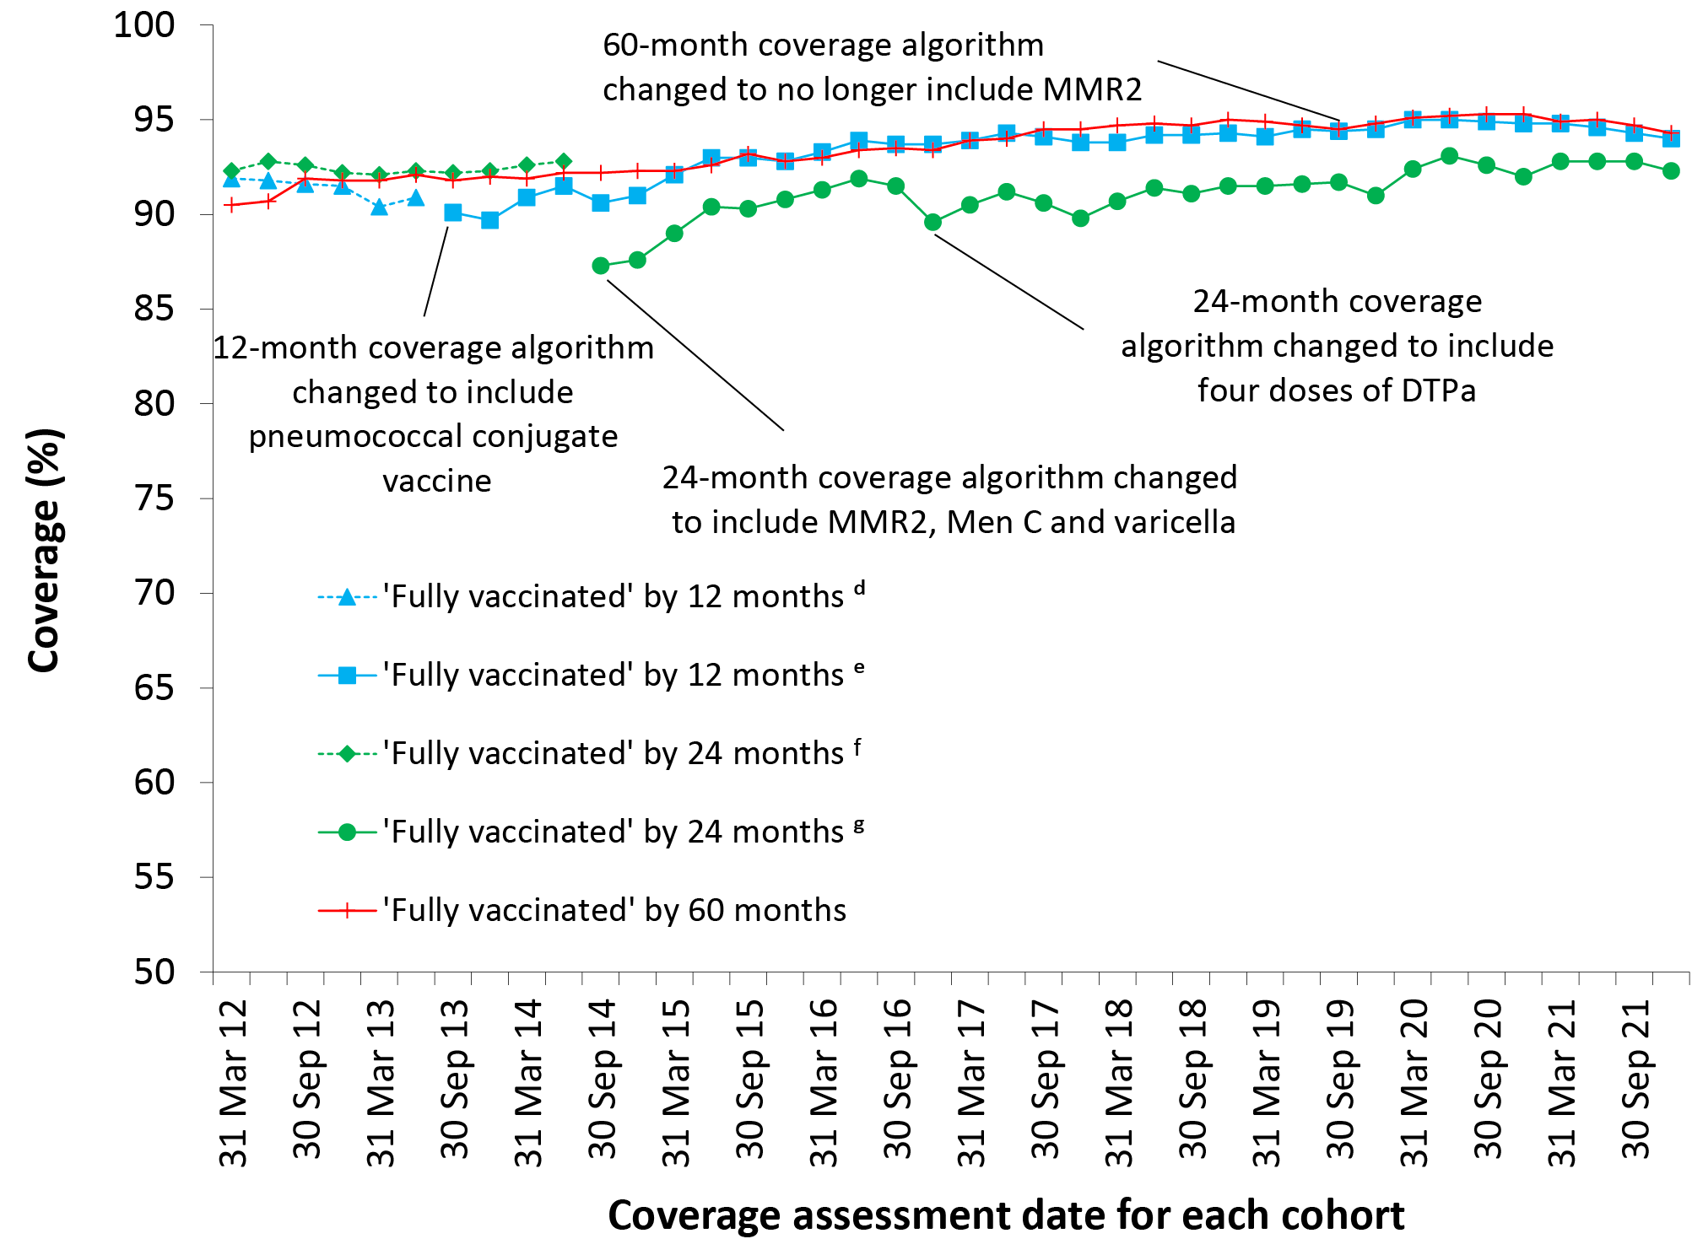
a Source: Australian Immunisation Register, data as at 3 April 2022.
b By 3-month birth cohorts born between 1 January 2011 and 31 December 2020. Coverage assessment date was 12, 24 or 60 months after the last birth date of each cohort. Vaccination coverage estimates are calculated by quarter and may differ slightly from estimates published elsewhere using rolling annualised data.
c MMR2: second dose of MMR vaccine; MenC: meningococcal C-containing; DTPa: diphtheria-tetanus-acellular pertussis.
d Coverage algorithm before 1 July 2013.
e Coverage algorithm from 1 July 2013.
f Coverage algorithm before 1 July 2014.
g Coverage algorithm from 1 July 2014.

Figure A.2: Trends in vaccination coverage at 12 months of age,^{a,b,c} by vaccine/antigen ^{d} and quarter, Australia, 2012 to 2021
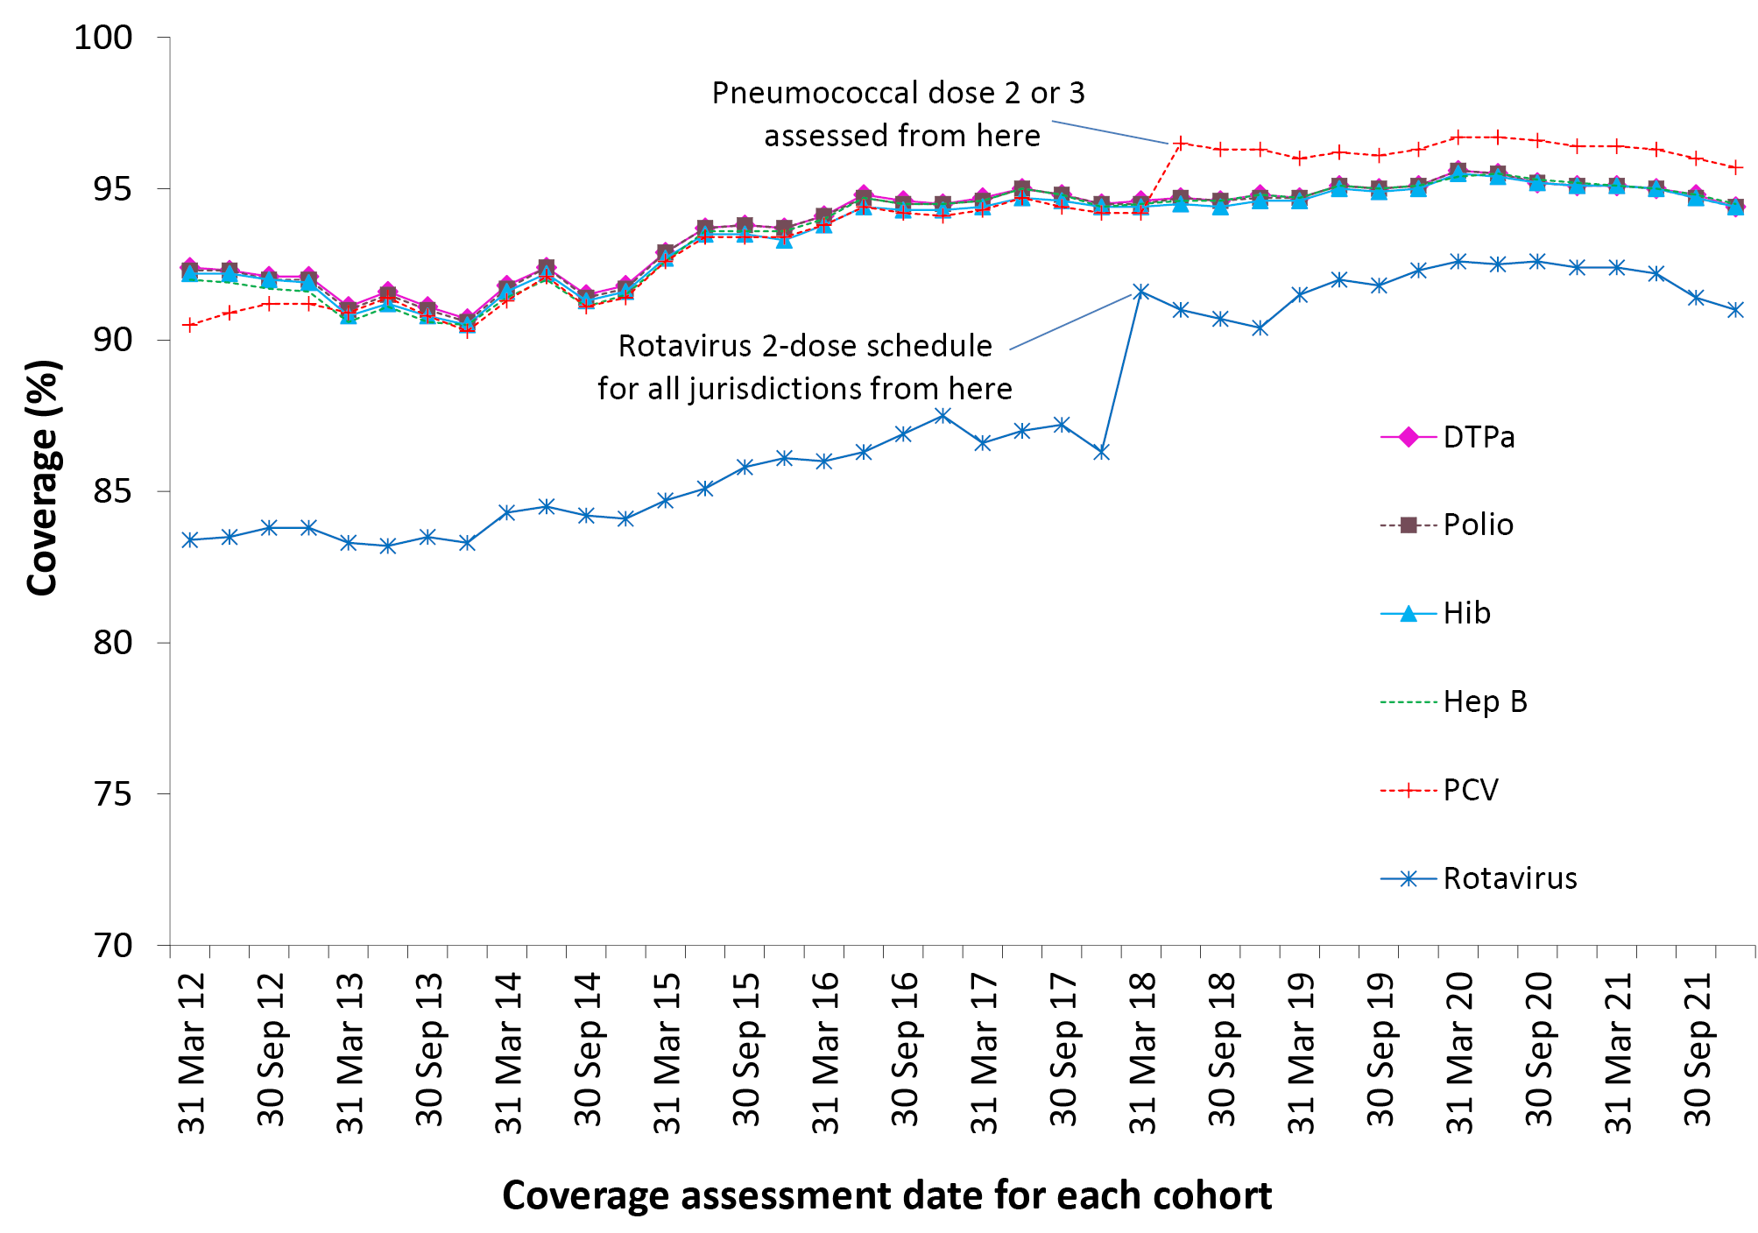
a Source: Australian Immunisation Register, data as at 3 April 2022.
b By 3-month birth cohorts born between 1 January 2011 and 31 December 2020. Coverage assessment date was 12 months after the last birth date of each cohort. Vaccination coverage estimates are calculated by quarter and may differ slightly from estimates published elsewhere using rolling annualised data.
c DTPa: diphtheria-tetanus-acellular pertussis; Hib: Haemophilus influenzae type b; Hep B: hepatitis B; 13vPCV: pneumococcal conjugate vaccine.
d Third dose of DTPa vaccine, polio vaccine and 13vPCV, second or third dose of Hib and rotavirus vaccines, and third dose of hepatitis B vaccine.

Figure A.3: Trends in vaccination coverage at 24 months of age, ^{a,b,c} by vaccine/antigen ^{d} and quarter, Australia, 2012 to 2021
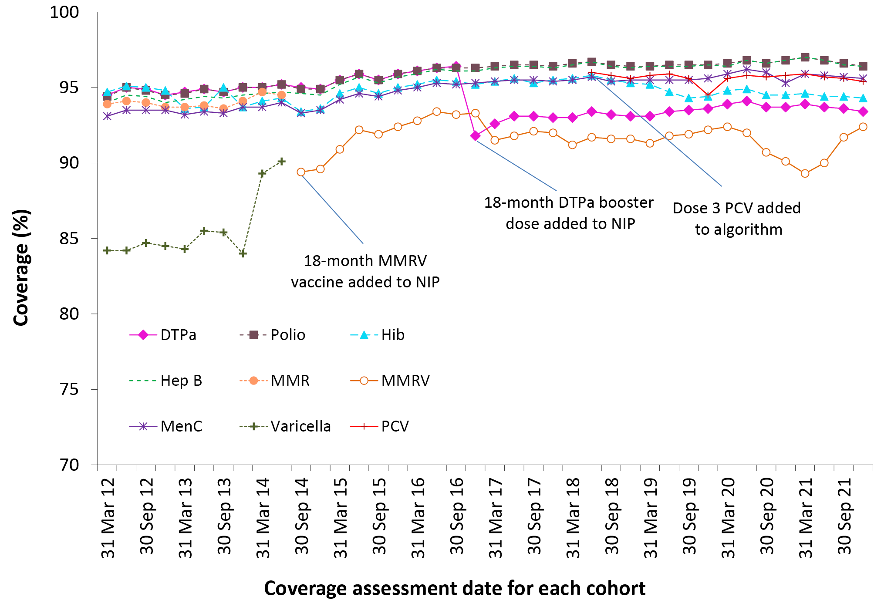
a Source: Australian Immunisation Register, data as at 3 April 2022.
b By 3-month birth cohorts born between 1 January 2010 and 31 December 2019. Coverage assessment date was 24 months after the last birth date of each cohort. Vaccination coverage estimates are calculated by quarter and may differ slightly from estimates published elsewhere using rolling annualised data.
c DTPa: diphtheria-tetanus-acellular pertussis; Hib: Haemophilus influenzae type b; Hep B: hepatitis B; MMR: measles-mumps-rubella; MenC: meningococcal C-containing; MMRV: measles-mumps-rubella-varicella; 13vPCV: pneumococcal conjugate vaccine.
d Fourth dose of DTPa, third dose of polio, third or fourth dose of Hib, third dose of hepatitis B, second dose of MMR, dose 2 of MMRV, first dose of MenC one dose of varicella, and a third or fourth dose of 13vPCV.

Figure A.4: Trends in vaccination coverage at 60 months of age, ^{a,b,c} by vaccine/antigen ^{d} and quarter, Australia, 2012 to 2021
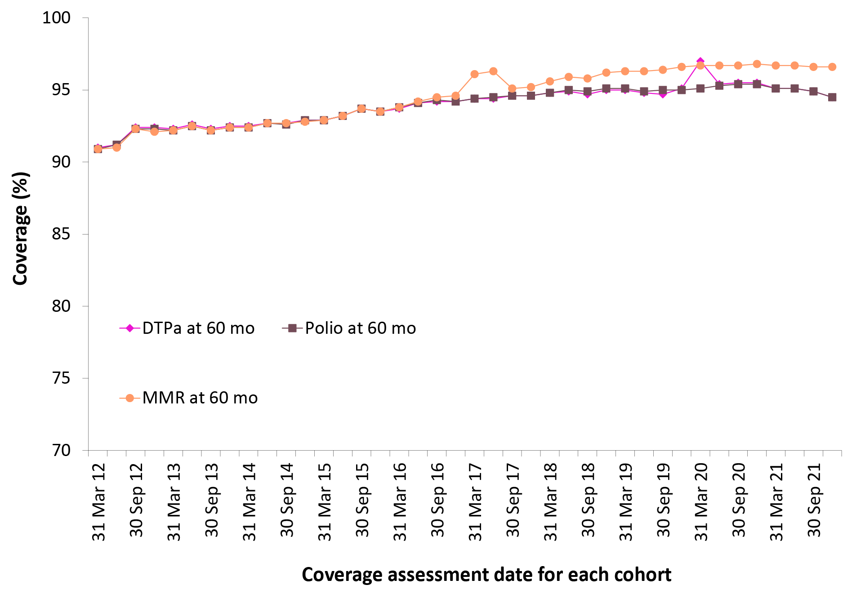
a Source: Australian Immunisation Register, data as at 3 April 2022.
b By 3-month birth cohorts born between 1 January 2007 and 31 December 2016. Coverage assessment date was 60 months after the last birth date of each cohort. Vaccination coverage estimates are calculated by quarter and may differ slightly from estimates published elsewhere using rolling annualised data.
c DTPa: diphtheria-tetanus-acellular pertussis; MMR: measles-mumps-rubella.
d Fourth or fifth dose of DTPa and fourth dose of polio, second dose of MMR (up until June 2017).

Figure A.5: Trends in ‘fully vaccinated’ coverage at 12 months of age, ^{a,b} by Indigenous status and quarter, Australia, 2012 to 2021
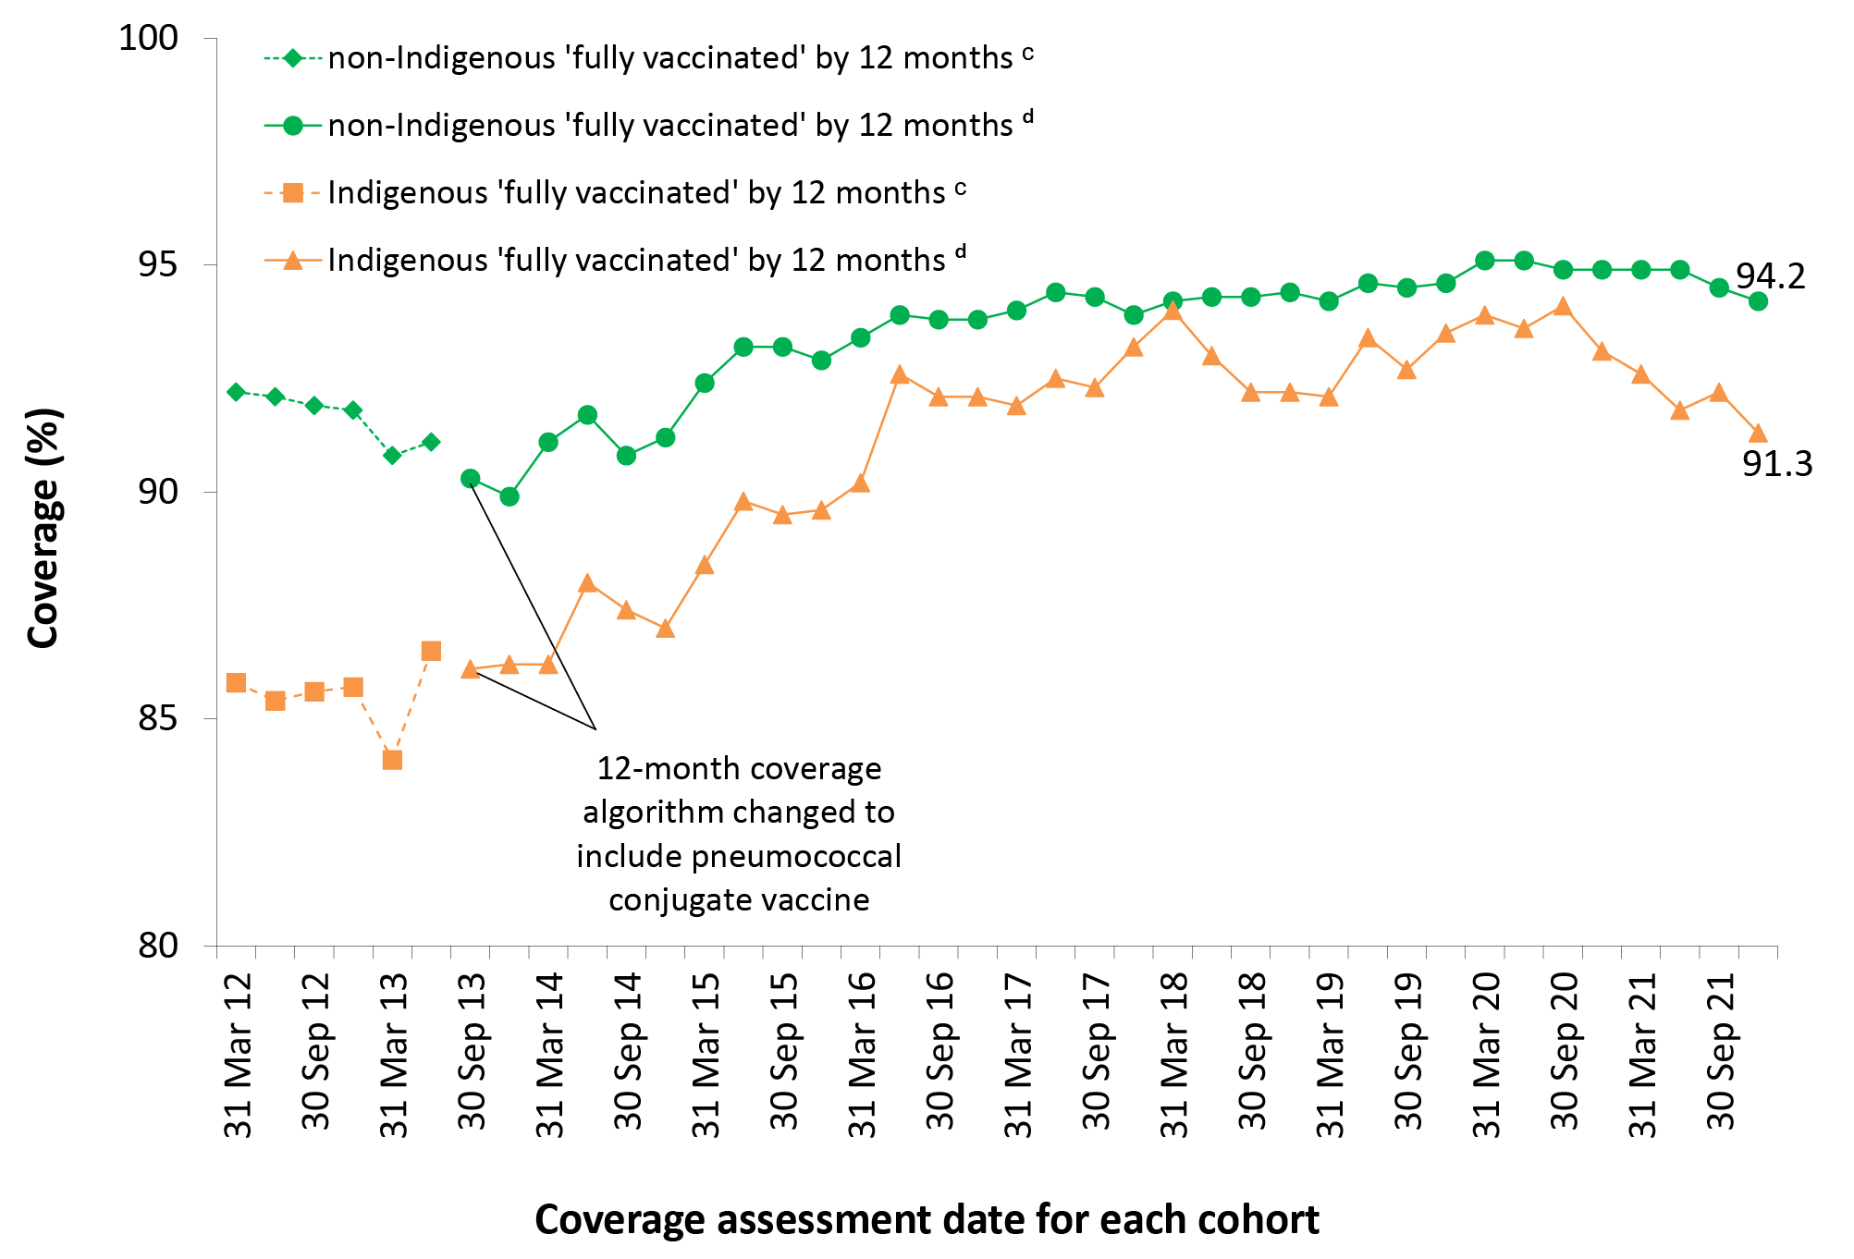
a Source: Australian Immunisation Register, data as at 3 April 2022.
b Vaccination coverage estimates are calculated using 3-month wide birth cohorts by quarter and may differ slightly from estimates published elsewhere using rolling annualised data.
c Coverage algorithm before 1 July 2013.
d Coverage algorithm from 1 July 2013.

Figure A.6: Trends in ‘fully vaccinated’ coverage at 24 months of age, ^{a,b} by Indigenous status and quarter, Australia, 2012 to 2021
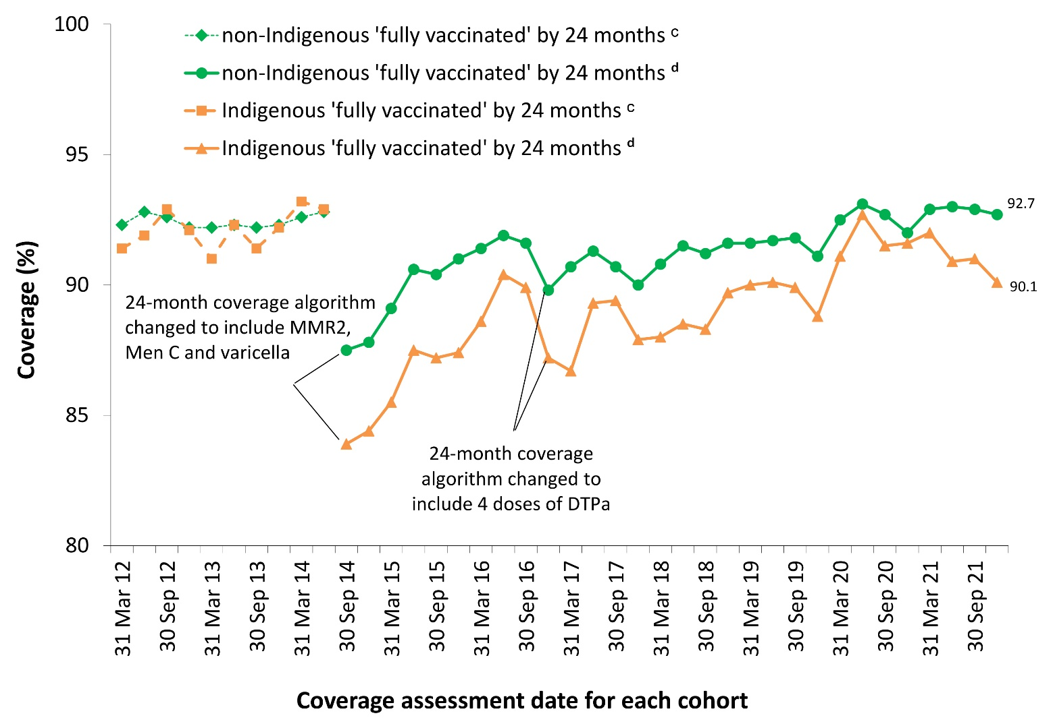
a Source: Australian Immunisation Register, data as at 3 April 2022.
b Vaccination coverage estimates are calculated using 3-month wide birth cohorts by quarter and may differ slightly from estimates published elsewhere using rolling annualised data.
c Coverage algorithm before 1 July 2014.
d Coverage algorithm from 1 July 2014.

Figure A.7: Trends in ‘fully vaccinated’ coverage at 60 months of age by Indigenous status and quarter, ^{a,b} Australia, 2012 to 2021
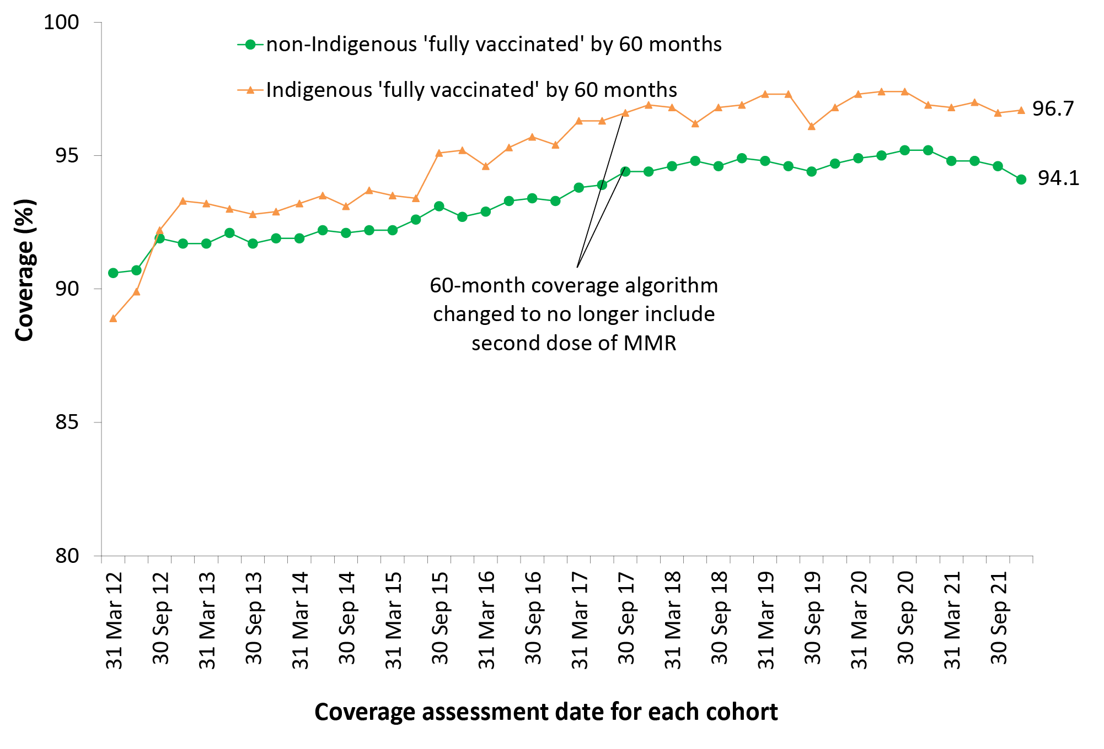
a Source: Australian Immunisation Register, data as at 3 April 2022.
b Vaccination coverage estimates are calculated using 3-month wide birth cohorts by quarter and may differ slightly from estimates published elsewhere using rolling annualised data.

Figure A.8: Trends in coverage for hepatitis A vaccine by 30 months of age for Indigenous children by jurisdiction, ^{a,b,c,d} Australia, 2012 to 2021
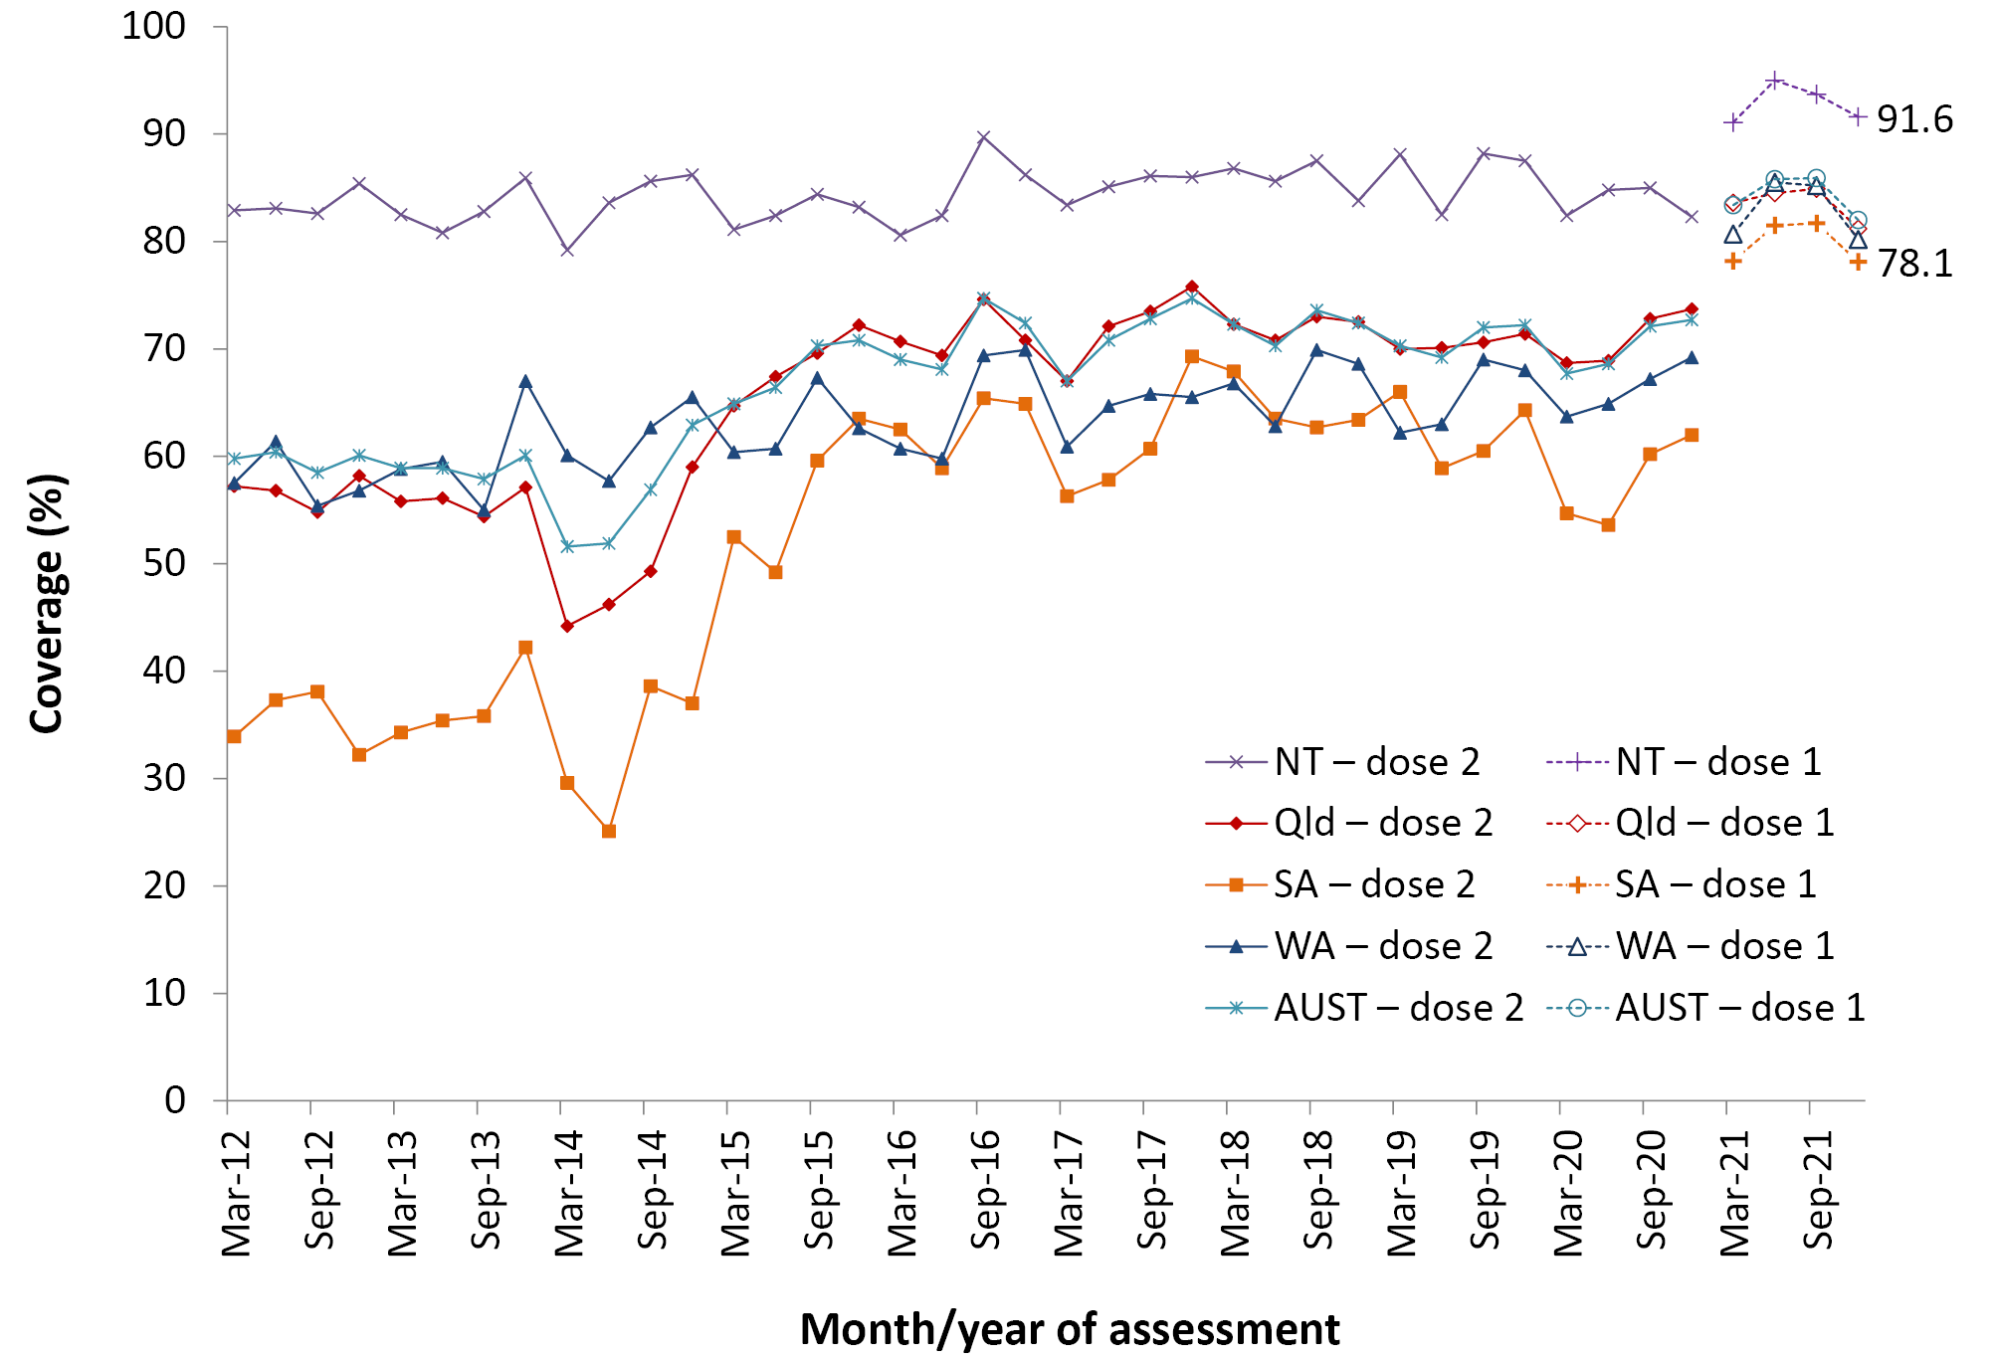
a Source: Australian Immunisation Register, data as at 3 April 2022.
b Vaccination coverage estimates are calculated using 3-month wide birth cohorts by quarter.
c 18-month dose assessed: scheduled ages for hepatitis A vaccination changed from 12 to 18 months (dose 1) and 18 months to 4 years (dose 2) from July 2020.
d Northern Territory (NT), Queensland (Qld), South Australia (SA) and Western Australia (WA) only. AUST: Australia.

Figure A.9: Trends in coverage for pneumococcal vaccine for Indigenous children by jurisdiction, ^{a,b,c,d} Australia, 2012 to 2021
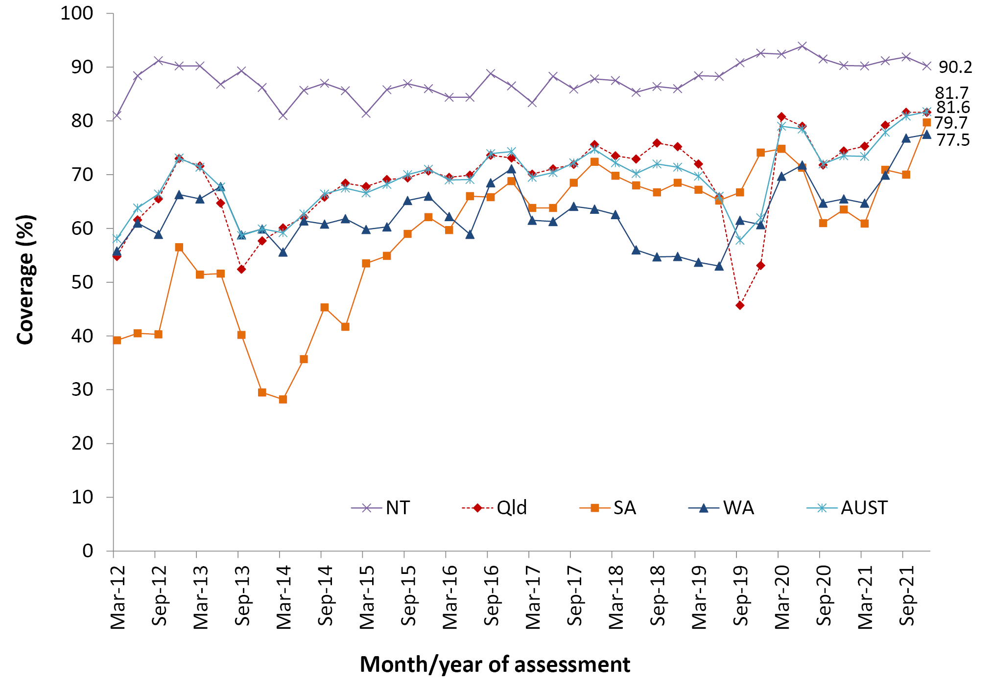
a Source: Australian Immunisation Register, data as at 3 April 2022.
b Vaccination coverage estimates are calculated using 3-month wide birth cohorts by quarter.
c 13vPCV: 13-valent pneumococcal conjugate vaccine. 12-month booster dose (fourth dose) assessed at 30 months of age in all four jurisdictions.
d Northern Territory (NT), Queensland (Qld), South Australia (SA) and Western Australia (WA) only. AUST: Australia.

Figure A.10: Proportion of vaccinations, including COVID-19 vaccines, given to all persons by provider type and jurisdiction, ^{a,b} Australia, 2021
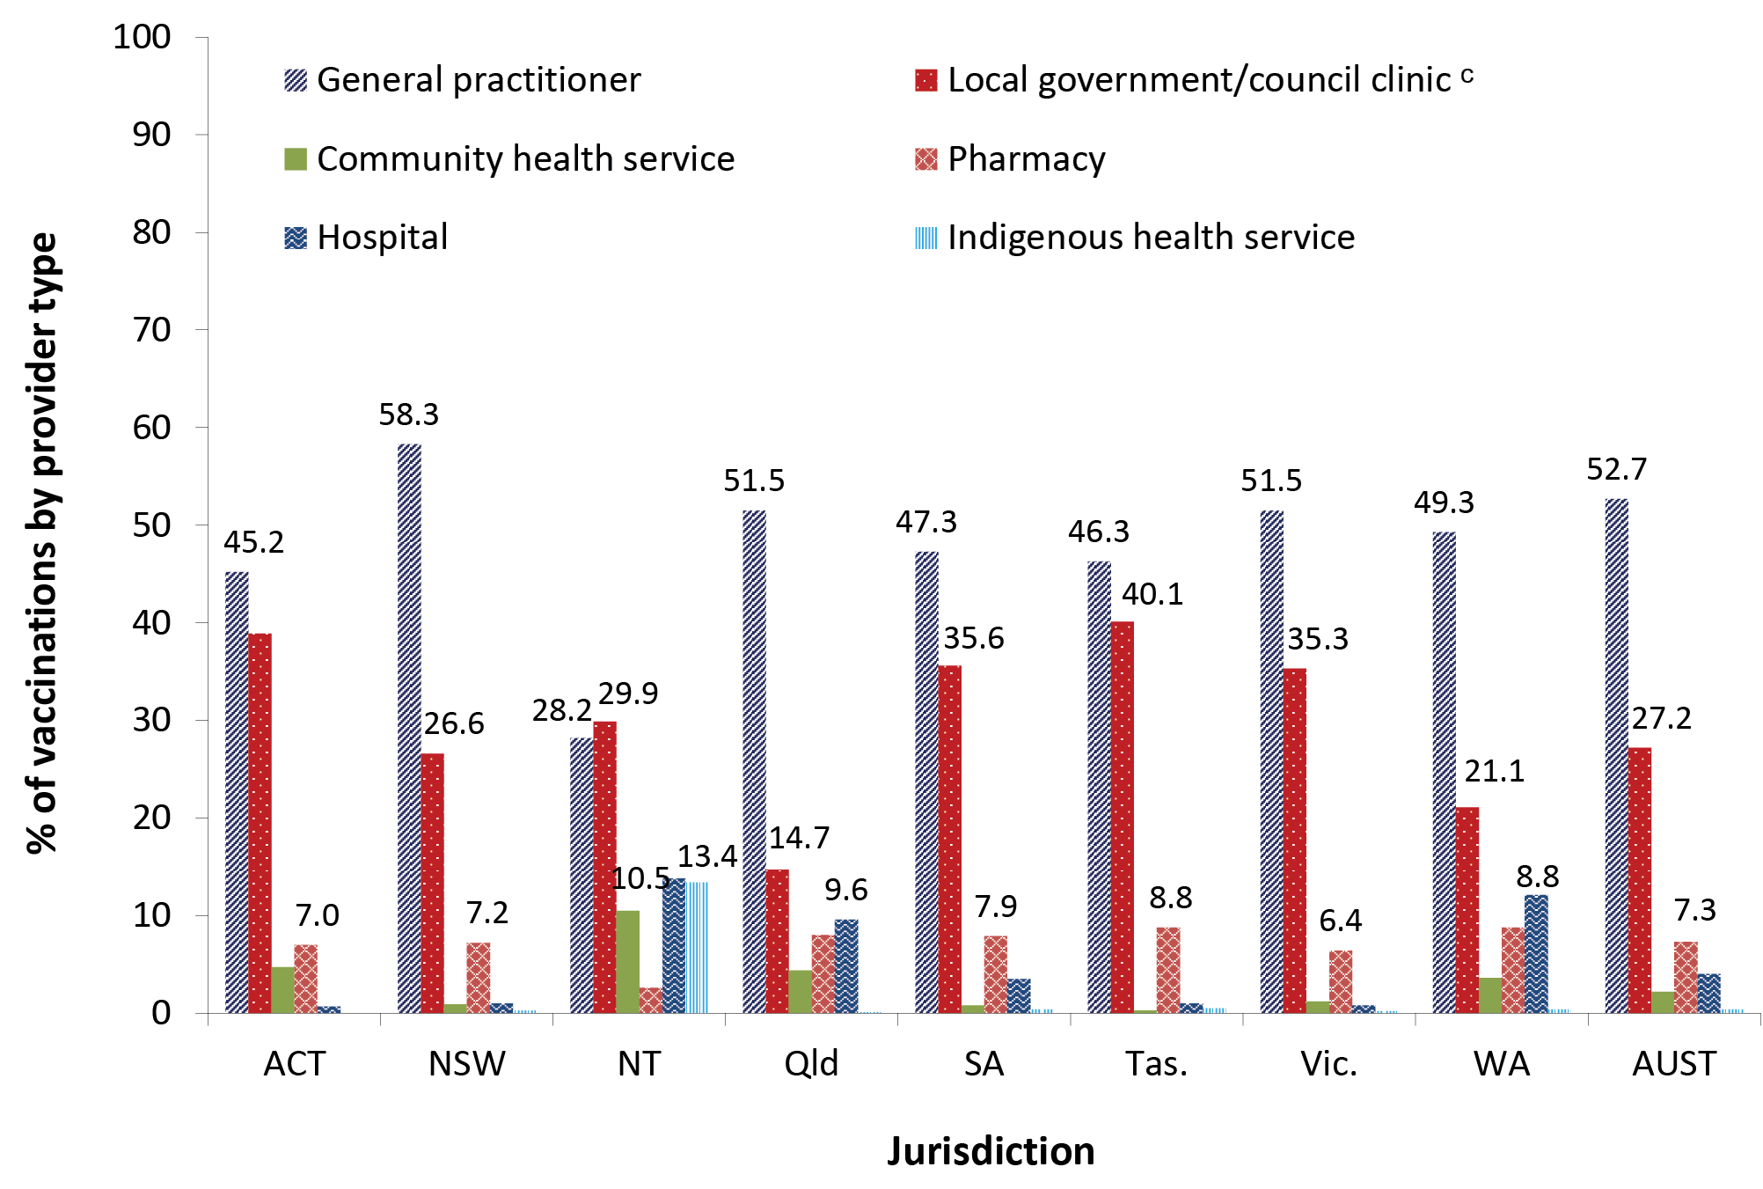
a Source: Australian Immunisation Register, data as at 3 April 2022.
b ACT: Australian Capital Territory; NSW: New South Wales; NT: Northern Territory; Qld: Queensland; SA: South Australia; Tas.: Tasmania; Vic.: Victoria; WA: Western Australia; AUST: Australia.
c Includes public health units and jurisdictional health departments.

Figure A11: Proportion of all non-COVID-19 vaccinations given to all persons by provider type and jurisdiction, ^{a,b} Australia, 2021
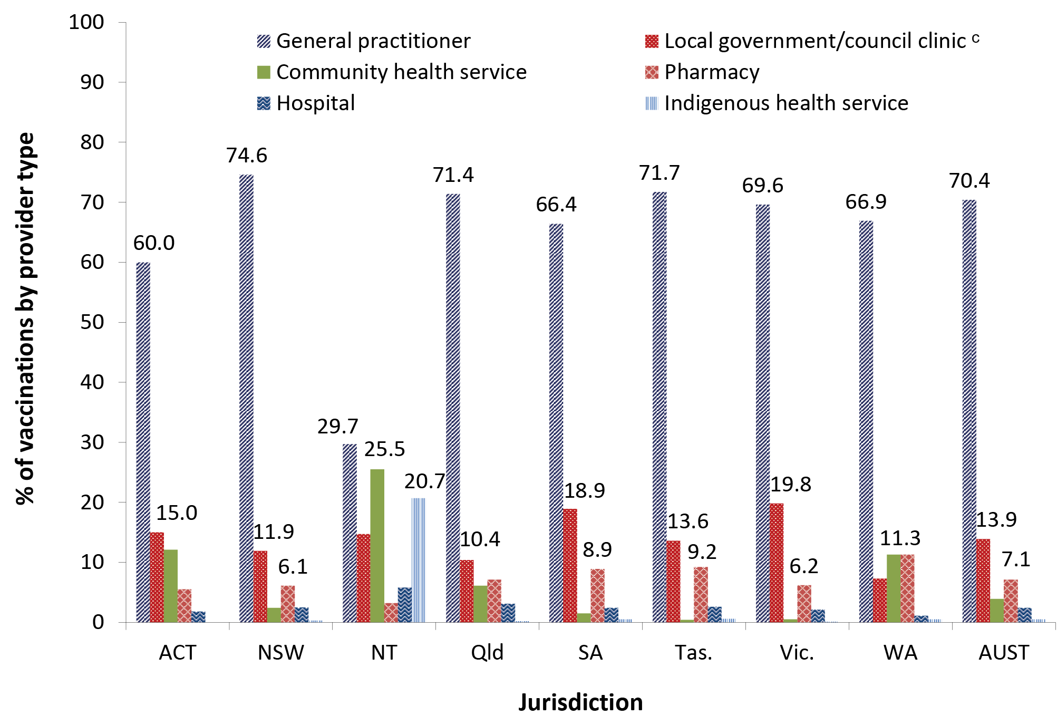
a Source: Australian Immunisation Register, data as at 3 April 2022.
b ACT: Australian Capital Territory; NSW: New South Wales; NT: Northern Territory; Qld: Queensland; SA: South Australia; Tas.: Tasmania; Vic.: Victoria; WA: Western Australia; AUST: Australia.
c Includes public health units and jurisdictional health departments.

Figure A.12: Coverage (%) of a COVID-19 vaccine in all people by age group, ª Australia, 2021
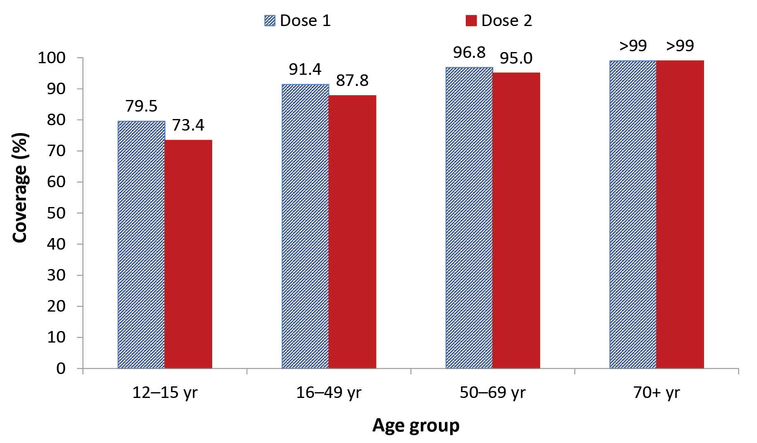
a Source: Australian Government Department of Health and Aged Care, as at 4 January 2022.⁴⁹

Figure A.13: Coverage (%) of a COVID-19 vaccine in all people aged 16 years and over by Indigenous status,ª Australia, 2021
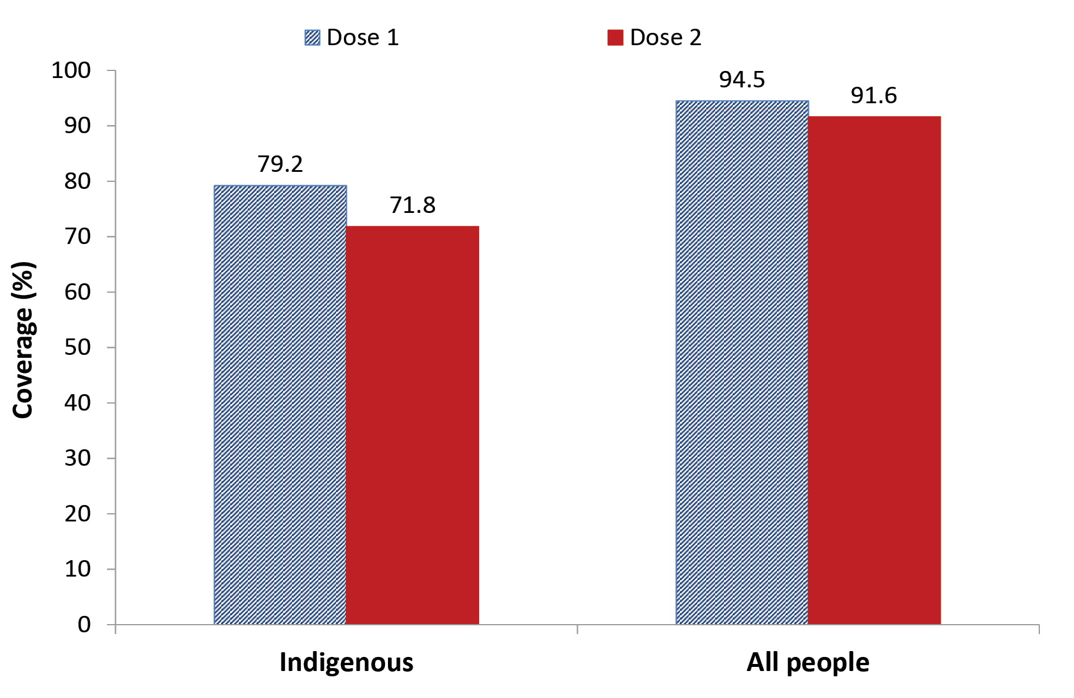
a Source: Australian Government Department of Health and Aged Care, as at 4 January 2022.⁴⁹

Table A.3: Recorded coverage of seasonal influenza vaccine by age group, jurisdiction, Indigenous persons and all persons, ^{a,b} 2020 and 2021, Australia
 | 2020
Age group  (years) | Jurisdiction ^{c}
 | ACT |  | NSW |  | NT |  | Qld |  | SA |  | Tas. |  | Vic. |  | WA
 | All | Indigenous ^{d} | All | Indigenous | All | Indigenous | All | Indigenous | All | Indigenous | All | Indigenous | All | Indigenous | All | Indigenous
6–59 mo | 64.5 | 51.2 | 41.9 | 37.8 | 59.8 | 72.5 | 41.6 | 38.5 | 50.5 | 43.0 | 44.8 | 44.0 | 50.0 | 48.7 | 50.7 | 44.6
5–9 yr | 37.4 | 38.2 | 27.3 | 31.6 | 28.7 | 46.3 | 26.1 | 29.9 | 32.7 | 34.5 | 27.0 | 34.1 | 31.8 | 37.5 | 38.3 | 37.3
10–14 yr | 29.8 | 33.6 | 22.6 | 29.6 | 26.1 | 42.7 | 21.9 | 29.8 | 27.8 | 32.4 | 25.3 | 31.1 | 26.3 | 37.8 | 31.4 | 34.4
15–19 yr | 27.4 | 33.0 | 20.7 | 26.9 | 27.5 | 44.3 | 20.5 | 28.3 | 25.3 | 29.9 | 24.1 | 33.3 | 24.0 | 34.2 | 26.5 | 31.4
20–49 yr | 24.0 | 30.8 | 22.3 | 30.7 | 26.1 | 53.5 | 21.2 | 30.2 | 26.2 | 31.5 | 27.3 | 35.7 | 24.8 | 34.8 | 25.9 | 32.4
50–64 yr | 35.3 | 53.9 | 33.8 | 56.0 | 29.2 | 64.6 | 33.4 | 54.8 | 37.9 | 54.5 | 43.2 | 63.1 | 35.9 | 56.4 | 38.5 | 52.5
65–74 yr | 64.6 | 69.6 | 58.2 | 72.6 | 42.9 | 72.1 | 63.7 | 73.8 | 64.3 | 67.6 | 68.4 | 80.0 | 60.4 | 72.0 | 64.6 | 71.2
75+ yr | 66.5 | 73.6 | 59.6 | 75.3 | 38.4 | 61.7 | 66.4 | 71.2 | 65.6 | 66.4 | 71.4 | 81.5 | 61.2 | 69.4 | 68.4 | 65.6
Total (6+ mo) | 35.4 | 38.8 | 32.1 | 36.8 | 30.5 | 54.5 | 31.9 | 35.7 | 37.6 | 37.6 | 39.6 | 42.3 | 34.6 | 46.6 | 37.1 | 38.2
 | 2021
Age group  (years) | Jurisdiction ^{c}
 | ACT |  | NSW |  | NT |  | Qld |  | SA |  | Tas. |  | Vic. |  | WA
 | All | Indigenous ^{d} | All | Indigenous | All | Indigenous | All | Indigenous | All | Indigenous | All | Indigenous | All | Indigenous | All | Indigenous
6–59 mo | 49.6 | 35.1 | 23.3 | 19.9 | 45.5 | 53.2 | 22.4 | 18.9 | 31.2 | 21.4 | 29.5 | 26.3 | 30.9 | 23.1 | 24.6 | 18.9
5–9 yr | 23.7 | 20.1 | 14.4 | 15.6 | 15.3 | 26.3 | 13.3 | 13.1 | 19.2 | 17.3 | 14.8 | 18.1 | 17.4 | 14.0 | 16.2 | 13.4
10–14 yr | 17.3 | 16.6 | 11.8 | 15.1 | 15.2 | 25.1 | 12.1 | 13.6 | 17.6 | 16.9 | 13.6 | 17.2 | 14.5 | 15.4 | 13.9 | 12.8
15–19 yr | 18.0 | 17.7 | 13.2 | 15.5 | 17.1 | 24.5 | 14.9 | 15.6 | 20.0 | 19.1 | 15.6 | 19.1 | 15.9 | 14.5 | 15.3 | 14.0
20–49 yr | 33.6 | 28.9 | 21.8 | 21.2 | 23.7 | 31.5 | 23.0 | 19.9 | 32.5 | 24.3 | 27.5 | 28.0 | 24.7 | 21.0 | 22.3 | 18.1
50–64 yr | 45.6 | 46.7 | 35.6 | 44.9 | 28.4 | 45.8 | 38.6 | 42.0 | 48.2 | 48.6 | 44.8 | 55.1 | 38.6 | 42.6 | 35.9 | 36.2
65–74 yr | 66.6 | 70.3 | 58.8 | 67.1 | 38.6 | 55.2 | 63.1 | 64.5 | 70.9 | 67.1 | 68.0 | 75.0 | 63.3 | 67.6 | 61.0 | 57.0
75+ yr | 72.0 | 74.3 | 64.7 | 72.3 | 35.3 | 46.0 | 69.9 | 67.6 | 76.1 | 74.0 | 74.8 | 84.3 | 69.1 | 72.8 | 70.2 | 57.1
Total (6+ mo) | 39.2 | 30.2 | 30.0 | 24.9 | 25.9 | 34.3 | 31.2 | 22.6 | 41.2 | 27.2 | 37.9 | 31.3 | 33.0 | 25.4 | 30.4 | 20.6
a Source: Australian Immunisation Register, data as at 31 March 2021 (for 2020 data) and as at 3 April 2022 (for 2021 data).
b At least one dose of any influenza vaccine. (Note: 2020 estimates have been revised following a change in methodology and therefore differ to what was presented in the 2020 report – see detailed methods in Appendix for further detail.)
c ACT: Australian Capital Territory; NSW: New South Wales; NT: Northern Territory; Qld: Queensland; SA: South Australia; Tas.: Tasmania; Vic.: Victoria; WA: Western Australia.
d Indigenous persons.

Table A.4: ‘Fully vaccinated’ coverage assessed at standard age milestones (12, 24 and 60 months) and earlier (9, 15, 21, 51 months) milestones,^{a,b} by Primary Health Network, 2021
Primary Health Network | 9 mo (%) ^{c} | 12 mo (%) ^{c} | 15 mo (%) ^{d} | 21 mo (%) ^{d} | 24 mo (%) ^{d} | 51 mo (%) ^{e} | 60 mo (%) ^{e}
Western Victoria | 92.9 | 95.7 | 93.0 | 91.2 | 94.3 | 91.6 | 96.8
Western NSW | 93.4 | 96.4 | 92.9 | 90.5 | 94.3 | 90.6 | 96.7
Murray | 91.2 | 94.8 | 92.5 | 90.6 | 94.2 | 90.9 | 96.7
Murrumbidgee | 92.8 | 95.4 | 93.3 | 91.3 | 94.3 | 91.5 | 96.2
Gippsland | 90.3 | 94.5 | 92.8 | 90.3 | 94.0 | 91.2 | 96.0
Hunter New England and Central Coast | 92.4 | 94.9 | 93.1 | 90.8 | 94.2 | 89.9 | 95.8
South Eastern NSW | 92.8 | 94.9 | 93.1 | 91.0 | 93.9 | 90.7 | 95.8
Country SA | 89.4 | 93.5 | 90.5 | 87.4 | 91.5 | 89.1 | 95.7
Australian Capital Territory | 95.0 | 96.3 | 94.1 | 92.9 | 94.7 | 92.3 | 95.6
Adelaide | 92.0 | 94.7 | 91.3 | 89.8 | 92.9 | 90.6 | 95.6
Nepean Blue Mountains | 91.9 | 94.5 | 93.1 | 91.0 | 94.0 | 90.1 | 95.3
Eastern Melbourne | 92.2 | 95.0 | 91.7 | 89.7 | 92.8 | 90.0 | 95.2
South Eastern Melbourne | 91.3 | 94.4 | 90.8 | 88.6 | 91.9 | 90.0 | 94.8
Northern Queensland | 89.1 | 93.6 | 90.8 | 87.2 | 92.7 | 87.2 | 94.7
South Western Sydney | 90.3 | 93.3 | 89.8 | 87.1 | 91.1 | 88.3 | 94.7
Western Queensland | 87.4 | 93.3 | 90.5 | 84.1 | 92.1 | 86.9 | 94.6
Brisbane North | 92.9 | 95.3 | 92.3 | 90.0 | 93.7 | 89.5 | 94.5
North Western Melbourne | 90.7 | 94.0 | 90.0 | 88.1 | 91.3 | 88.7 | 94.4
Tasmania | 92.4 | 94.7 | 90.2 | 87.5 | 91.2 | 88.5 | 94.3
Darling Downs and West Moreton | 90.8 | 94.2 | 91.2 | 88.6 | 92.7 | 88.1 | 94.3
Western Sydney | 90.8 | 93.7 | 89.5 | 87.5 | 90.7 | 88.0 | 94.0
Brisbane South | 91.1 | 94.2 | 90.7 | 88.0 | 92.2 | 87.9 | 93.7
Northern Sydney | 94.0 | 95.5 | 91.1 | 89.5 | 92.2 | 89.0 | 93.4
Perth South | 90.2 | 93.8 | 90.1 | 87.3 | 91.6 | 86.6 | 93.3
Perth North | 91.3 | 94.6 | 90.4 | 87.9 | 91.8 | 86.2 | 93.2
Country WA | 85.3 | 91.4 | 87.5 | 82.9 | 88.9 | 84.2 | 92.8
Northern Territory | 88.7 | 93.3 | 90.6 | 83.9 | 90.8 | 83.6 | 92.7
Central Queensland, Wide Bay, Sunshine Coast | 88.2 | 91.9 | 89.8 | 86.8 | 91.4 | 86.1 | 92.7
Central and Eastern Sydney | 92.6 | 94.7 | 90.9 | 88.5 | 91.6 | 86.2 | 91.6
Gold Coast | 87.0 | 90.7 | 87.3 | 84.5 | 89.1 | 84.7 | 90.9
North Coast | 86.1 | 89.2 | 85.9 | 83.7 | 87.4 | 84.5 | 90.9
a Coverage algorithm used for 9/21/51 month milestones same as for 12/24/60 months, respectively; algorithm used for 15 months same as 24 months but excludes doses due at 18 months; for further detail of algorithms, refer to Table A.2.
b Data sorted by the ‘60 months’ column (highest to lowest).
c Cohort born 1 January 2020 – 31 December 2020
d Cohort born 1 January 2019 – 31 December 2019
e Cohort born 1 January 2016– 31 December 2016

Table A.5: Coverage (%) of a COVID-19 vaccine in all people by age group and jurisdiction, ª 2021
Age group  (years) | Jurisdiction ^{b}
 | ACT | NSW | NT | Qld | SA | Tas. | Vic. | WA
12 to 15  Dose 1 (%)  Dose 2 (%) | > 99  96.8 | 81.4  78.0 | 76.5  66.4 | 70.4  63.0 | 75.4  67.0 | 78.9  70.8 | 87.7  83.5 | 68.1  54.2
16 to 49  Dose 1 (%)  Dose 2 (%) | 98.4  96.9 | 92.0  90.3 | 88.4  82.7 | 86.8  81.8 | 88.4  83.2 | 97.6  91.1 | 90.5  88.9 | 88.6  79.0
50 to 69  Dose 1 (%)  Dose 2 (%) | > 99  > 99 | 97.4  96.5 | 90.2  87.6 | 94.2  91.9 | 94.4  91.9 | 95.6  93.3 | 97.3  96.3 | 95.2  91.0
70 and over  Dose 1 (%)  Dose 2 (%) | > 99  > 99 | > 99  > 99 | 95.0  92.0 | > 99  98.2 | > 99  98.9 | > 99  > 99 | > 99  > 99 | > 99  97.2

a Source: Australian Government Department of Health and Aged Care, as at 4 January 2022.⁴⁹
b ACT: Australian Capital Territory; NSW: New South Wales; NT: Northern Territory; Qld: Queensland; SA: South Australia; Tas.: Tasmania; Vic.: Victoria; WA: Western Australia.
Table A.6: Coverage (%) of a COVID-19 vaccine in all people aged 16 years and over by jurisdiction and Indigenous status, ª 2021
Age group  (years) | Jurisdiction ^{b}
 | ACT | NSW | NT | Qld | SA | Tas. | Vic. | WA
Indigenous  Dose 1 (%)  Dose 2 (%) | 90.8  88.0 | 86.2  83.7 | 84.5  74.1 | 76.0  66.9 | 73.9  64.6 | 85.2  79.1 | 88.6  85.7 | 67.5  52.7
All people  Dose 1 (%)  Dose 2 (%) | > 99  > 99 | 95.0  93.6 | 89.3  84.6 | 90.9  87.0 | 92.5  88.4 | 97.9  93.4 | 93.9  92.5 | 92.1  84.8
a Source: Australian Government Department of Health and Aged Care, as at 4 January 2022.⁴⁹
b ACT: Australian Capital Territory; NSW: New South Wales; NT: Northern Territory; Qld: Queensland; SA: South Australia; Tas.: Tasmania; Vic.: Victoria; WA: Western Australia.

Communicable Diseases Intelligence
ISSN: 2209-6051 Online

Communicable Diseases Intelligence (CDI) is a peer-reviewed scientific journal published by the Office of Health Protection, Department of Health and Aged Care. The journal aims to disseminate information on the epidemiology, surveillance, prevention and control of communicable diseases of relevance to Australia.

Editor: Christina Bareja
Deputy Editor: Simon Petrie
Design and Production: Kasra Yousefi
Editorial Advisory Board: David Durrheim, Mark Ferson, Clare Huppatz, John Kaldor, Martyn Kirk, Meru Sheel and Steph Williams

Website: http://www.health.gov.au/cdi

Contacts
CDI is produced by the Office of Health Protection, Australian Government Department of Health and Aged Care, GPO Box 9848, (MDP 6) CANBERRA ACT 2601

Email: cdi.editor@health.gov.au

Submit an Article
You are invited to submit your next communicable disease related article to the Communicable Diseases Intelligence (CDI) for consideration. More information regarding CDI can be found at: http://health.gov.au/cdi.
Further enquiries should be directed to: cdi.editor@health.gov.au.

This journal is indexed by Index Medicus and Medline.

Creative Commons Licence - Attribution-NonCommercial-NoDerivatives CC BY-NC-ND
© 2023 Commonwealth of Australia as represented by the Department of Health and Aged Care
This publication is licensed under a Creative Commons Attribution-NonCommercial-NoDerivatives 4.0 International Licence from https://creativecommons.org/licenses/by-nc-nd/4.0/legalcode (Licence). You must read and understand the Licence before using any material from this publication.

Restrictions
The Licence does not cover, and there is no permission given for, use of any of the following material found in this publication (if any):
- the Commonwealth Coat of Arms (by way of information, the terms under which the Coat of Arms may be used can be found at www.itsanhonour.gov.au);
- any logos (including the Department of Health and Aged Care’s logo) and trademarks;
- any photographs and images;
- any signatures; and
- any material belonging to third parties.

Disclaimer
Opinions expressed in Communicable Diseases Intelligence are those of the authors and not necessarily those of the Australian Government Department of Health and Aged Care or the Communicable Diseases Network Australia. Data may be subject to revision.

Enquiries
Enquiries regarding any other use of this publication should be addressed to the Communication Branch, Department of Health and Aged Care, GPO Box 9848, Canberra ACT 2601, or via e-mail to: copyright@health.gov.au

Communicable Diseases Network Australia
Communicable Diseases Intelligence contributes to the work of the Communicable Diseases Network Australia.
http://www.health.gov.au/cdna

