COVID-19 Australia: Epidemiology Report 54
Reporting period ending 7 November 2021
COVID-19 National Incident Room Surveillance Team

Summary

Two-week reporting period
Trends – The daily average of 1,527 cases for this reporting period was lower than the previous fortnight’s daily average of 2,172 cases. There were 21,382 cases of coronavirus disease 2019 (COVID-19) reported this fortnight, bringing the 2021 cumulative case count to 152,008 cases.
Local cases – More than 99% (21,363/21,382) of COVID-19 cases reported this fortnight are known to be locally acquired (including cases under initial investigation). The majority of these cases were reported in Victoria (84%; 18,013/21,363), followed by New South Wales (15%; 3,196/21,363).
Clusters and high-risk settings – As at 7 November 2021, there had been 70,855 locally-acquired cases in New South Wales, including 543 deaths, since the first case of the Sydney Metropolitan outbreak was reported on 16 June 2021. Genomic testing showed that the outbreak’s primary case was infected with the ‘Delta’ SARS-CoV-2 variant of concern (B.1.617.2). Several cases in other states had also been linked to this cluster. The fortnightly number of new locally-acquired cases reported in New South Wales continued to decrease, with 3,196 locally-acquired cases reported this reporting period, compared to 4,570 locally-acquired cases in the previous reporting period. In recent weeks, the proportion of locally-acquired cases in metropolitan areas has been declining, while the proportion in regional and remote residents has been increasing, particularly in the Hunter New England, Mid-North Coast and Albury-Wodonga regions.
As at 7 November 2021, there were 76,776 cases, including 363 deaths, associated with the Victorian outbreaks since the first cases were reported on 5 August 2021. These primary cases involved the Delta variant and were closely associated with the current New South Wales and the July 2021 Victorian outbreaks. The number of new cases in the Victorian outbreak decreased during the reporting period, with 18,013 locally-acquired cases reported this fortnight compared to 25,438 in the previous fortnight. Most new cases in the outbreak were across several parts of Greater Melbourne; however, there was a considerable increase in the proportion of cases identified in regional and remote residents in the past few weeks.
As at 7 November 2021, a total of 1,742 cases, including 11 deaths, had been reported as part of the Australian Capital Territory outbreak. The primary case in the outbreak was reported on 12 August 2021 and was infected with the Delta variant. The number of new cases in the Australian Capital Territory during this reporting period (145) was lower than in the previous reporting period (361).
A total of four locally-acquired cases were reported as part of a cluster in Goondiwindi, Queensland, with the first case reported on 4 November 2021. The first case is believed to have acquired their infection in Moree, NSW.
There have been three locally-acquired cases reported in the Northern Territory this fortnight, with the first case in this cluster reported on 5 November 2021.

Aboriginal and Torres Strait Islander persons – During the reporting period, there were 1,244 new cases notified in Aboriginal and Torres Strait Islander people, of whom 754 were from New South Wales; 458 were from Victoria; 28 were from the Australian Capital Territory; and four were from Queensland. To date in 2021, there have been 7,454 cases and 16 deaths reported among Aboriginal and Torres Strait Islander people. Of locally-acquired cases notified in Aboriginal and Torres Strait Islander people in 2021 to date, 38% (2,845/7,449) lived in a regional or remote area.
Overseas cases – There were 19 overseas-acquired cases this reporting period, with the largest numbers of cases reported in New South Wales (53%%; 10/19), followed by Queensland (26%; 5/19).
Severity – In 2021, based on the highest level of severity reported for cases with an illness onset up to 24 October 2021, 0.7% of cases were reported to have died, 1.3% of cases required intensive care and a further 9.0% required admission to hospital, noting that cases may be hospitalised for reasons other than clinical COVID-19 related care. Given the delay between illness onset and severe illness, cases with an onset in the last two weeks were excluded from the analysis on severity. During the reporting period, 169 new COVID-19-associated deaths were notified.
Vaccinations – As at 7 November 2021, there had been 36,773,837 doses of COVID-19 vaccine administered in Australia. Nationally, 18,431,249 people aged 16 years or over (89.4%) had received at least one dose, including 16,628,469 people aged 16 and over (80.6%) who were fully vaccinated.

Four-week reporting period
Virology – Nationally, SARS-CoV-2 strains from 21% of COVID-19 cases have been sequenced during the pandemic. During 2021, there has been an increase in the number of cases infected with SARS-CoV-2 variants of concern (VOC) in Australia. AusTrakka is actively monitoring and reporting on these variants and has so far identified 21,751 samples of Delta (B.1.617.2); 568 samples of Alpha (B.1.1.7); 100 samples of Beta (B.1.351); and eight samples of Gamma (P.1) in Australia.
International situation – According to the World Health Organization (WHO), cumulative global COVID-19 cases stood at more than 249 million, with over five million deaths reported globally, as of 7 November 2021. In Australia’s near region, the South East Asia and Western Pacific Regions reported over 1.4 million newly-confirmed cases and over 26,000 deaths in the four-week period to 7 November 2021.

Keywords: SARS-CoV-2; novel coronavirus; 2019-nCoV; coronavirus disease 2019; COVID-19; acute respiratory disease; epidemiology; Australia

Two-week reporting period (25 October – 7 November 2021)

This reporting period covers the two-week period 25 October – 7 November 2021, with data for this period compared to that from the previous two-week reporting period (11–24 October 2021).¹ The focus of this report is on the epidemiological situation in Australia since the beginning of 2021. Readers are encouraged to consult prior reports in this series for information on the epidemiology of cases in Australia in 2020.
Included in this report, with a reporting period of four weeks, are sections on genomic surveillance and virology, acute respiratory illness, testing, public health response measures, and the international situation. The reporting period for these topics is 11 October – 7 November 2021. For comparability, the previous reporting period is the preceding four weeks (13 September – 10 October 2021).²
From report 47 onward, the section on severity is included in the two-week reporting period; previously, a four-week reporting period had been adopted for that section.
From report 46 onward, and unless otherwise specified, tabulated data and data within the text are extracted from the National Interoperable Notifiable Diseases Surveillance System (NINDSS) based on ‘notification received date’ rather than ‘diagnosis date’ (see the Technical Supplement for definitions).³ As a case’s diagnosis date can be several days prior to the date of its notification, there is potential for newly-notified cases to be excluded from the case count in the current reporting period when reporting by ‘diagnosis date’. Using ‘notification received date’ ensures that the case count for the reporting period better reflects the number of newly-notified cases. As the graphs presented in this report, based on NINDSS data, reflect a larger time period (i.e. year to date and entire pandemic), these will continue to be based on diagnosis date to enable a more accurate understanding of infection risk and local transmission.

Background and data sources
See the Technical Supplement for general information on COVID-19 including modes of transmission, common symptoms and severity.³

Activity

COVID-19 trends

(NINDSS and jurisdictional reporting to NIR)
The number of cases reported this fortnight was lower than the number reported in the previous fortnight. A total of 21,382 cases were notified in this two-week reporting period (an average of 1,527 cases per day), compared to 30,408 cases (an average of 2,172 cases per day) in the previous reporting period. The majority of cases occurred in Victoria (84%; 18,014/21,382), followed by New South Wales (15%; 3,206/21,382) (Table 1).
Table 1: COVID-19 notifications by jurisdiction and source of acquisition, with a notification received date of 25 October–7 November 2021ª
Source^{b} | ACT | NSW | NT | Qld | SA | Tas. | Vic. | WA | Australia
Overseas | 2 | 10 | 1 | 5 | 0 | 0 | 1 | 0 | 19
Locally acquired - acquired within jurisdiction of notification | 138 | 3,191 | 3 | 3 | 0 | 0 | 8,540 | 0 | 11,875
Locally acquired - acquired interstate | 7 | 4 | 0 | 3 | 0 | 0 | 0 | 0 | 14
Under initial investigation | 0 | 1 | 0 | 0 | 0 | 0 | 9,473 | 0 | 9,474
Missing source of acquisition | 0 | 0 | 0 | 0 | 0 | 0 | 0 | 0 | 0
Total new cases | 147 | 3,206 | 4 | 11 | 0 | 0 | 18,014 | 0 | 21,382
a Source: NINDSS, extract from 9 November 2021 for notifications 7 November 2021.
b ACT: Australian Capital Territory; NSW: New South Wales; NT: Northern Territory; Qld: Queensland; SA: South Australia; Tas.: Tasmania; Vic.: Victoria; WA: Western Australia.
In the year to date, from 1 January 2021 to 7 November 2021, there have been 152,008 COVID-19 cases reported nationally. Until the week ending 20 June 2021, the number of weekly cases diagnosed this year had been below 180 cases per week. Since then, cases have increased and there have been over 1,000 cases diagnosed each week since the week ending 25 July 2021 and over 10,000 cases diagnosed each week from the start of September until mid-October 2021. In the latest fortnight, case numbers have dropped below 10,000, with approximately 9,900 cases in the first week and 7,000 in the most recent week, noting that this most recent week is likely an underestimate as additional cases may be identified in the coming week that have a diagnosis date in this period (Figure 1). The current peak in 2021 is over 15,000 cases per week, which occurred in the week ending 3 October 2021. This peak considerably surpasses the two distinct peaks experienced in March and July of 2020, when new cases diagnosed per week reached approximately 2,700 and 3,000, respectively (Figure 2). Cumulatively, since the beginning of the, there have been 180,418 COVID-19 cases reported in Australia to 7 November 2021.

Figure 1: COVID-19 notified cases by source of acquisition and diagnosis date, 28 December 2020 – 7 November 2021^{a,b}
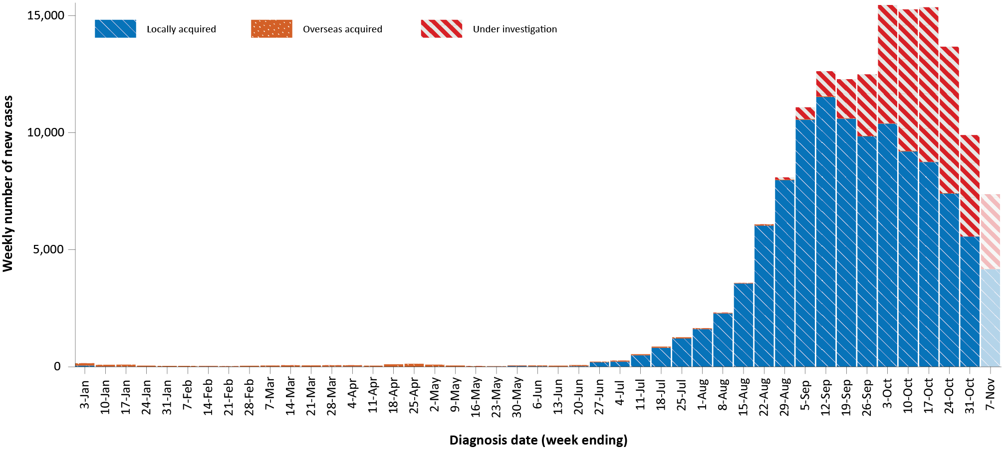
a Source: NINDSS, extract from 9 November 2021 for notifications to 7 November 2021.
b The lighter bar at the right represents the most recent reporting week and should be interpreted with caution as additional cases may be identified in the coming week that have a diagnosis date during this period.
Figure 2: COVID-19 notified cases by source of acquisition and diagnosis date, 2 March 2020 – 7 November 2021^{a,b}
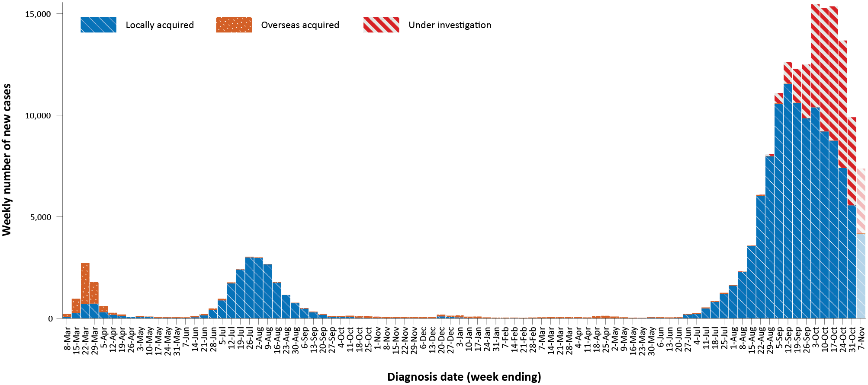
a Source: NINDSS, extract from 9 November 2021 for notifications to 7 November 2021.
b The lighter bar at the right represents the most recent reporting week and should be interpreted with caution as additional cases may be identified in the coming week that have a diagnosis date during this period.

Source of acquisition

(NINDSS)
In this reporting period, > 99% of cases notified (21,363/21,382) were considered to be acquired within Australia (including cases under initial investigation), comprising 56% (11,875/21,382) identified as cases acquired within the reporting jurisdiction, 44% (9,474/21,382) categorised as cases under initial investigation, and 14 interstate-acquired cases; < 1% of cases (19/21,382) were overseas acquired (Table 1). Victoria reported the majority of locally-acquired cases (84%; 18,013/21,363) in this fortnight, followed by New South Wales (15%; 3,196/21,363) and the Australian Capital Territory (1%; 145/21,363). Cases acquired within the jurisdiction of notification were reported in the Australian Capital Territory, New South Wales, the Northern Territory, Queensland and Victoria. The Australian Capital Territory, New South Wales and Queensland also reported interstate-acquired cases. South Australia, Tasmania and Western Australia did not report any locally-acquired cases.
For 2021 to date, Victoria had the highest notification rate for locally-acquired cases with 1,152.7 notifications per 100,000 population, followed by New South Wales with a rate of 867.4 notifications per 100,000 population and the Australian Capital Territory with a rate of 403.4 notifications per 100,000 population (Table 2).
Table 2: Locally-acquired COVID-19 case numbers and rates per 100,000 population by jurisdiction and reporting period, Australia, with a notification received date from 1 January to 7 November 2021ª
Jurisdiction | Reporting period | Reporting period | Cases this year
 | 25 October 2021 – 7 November 2021 | 11–24 October 2021 | 1 January 2021 – 7 November 2021
 | Number of cases^{b} | Number of cases^{b} | Number of cases^{b} | Rate per 100,000 population^{c}
ACT | 145 | 361 | 1,740 | 403.4
NSW | 3,196 | 4,570 | 70,851 | 867.4
NT | 3 | 5 | 20 | 8.1
Qld | 6 | 1 | 260 | 5.0
SA | 0 | 2 | 38 | 2.1
Tas. | 0 | 1 | 3 | 0.6
Vic. | 18,013 | 25,438 | 77,190 | 1,152.7
WA | 0 | 0 | 17 | 0.6
Australia | 21,363 | 30,378 | 150,119 | 584.2
a Source: NINDSS, extract from 9 November 2021 for notifications to 7 November 2021.
b This total includes cases under initial investigation and excludes overseas-acquired cases and with a missing source of acquisition. In reports prior to report 51, cases under initial investigation were excluded from this total.
c Population data based on Australian Bureau of Statistics (ABS) Estimated Resident Population (ERP) as at June 2020. The ABS June 2020 ERP was ACT: 431,325; NSW: 8,168,893; NT: 246,283; Qld: 5,176,044; SA: 1,770,494; Tas.: 540,781; Vic.: 6,696,630; WA: 2,663,976; Australia: 25,698,093.
In the reporting period, New South Wales reported the largest number of overseas-acquired cases (53%; 10/19), followed by Queensland (26%; 5/19) (Table 1). In the past 28 days (11 October to 7 November 2021), 57% (28/49) of confirmed overseas acquired cases reported to the NINDSS had an unknown country of acquisition. Cases acquired in the United Kingdom (19%; 4/21) were the most numerous of those with an identified country of acquisition in the past 28 days. The number of cases acquired in different countries is influenced by travel patterns of returning Australians, travel restrictions, and the prevalence of COVID-19 in the country of travel.

Demographic features

(NINDSS)
In this reporting period, the largest proportion of cases occurred in children aged 0 to 9 years (22%; 4,666/21,382). Rates were also highest in people aged 0 to 9 (146.5 per 100,000 population), followed by people aged 10 to 19 (112.4 per 100,000 population). For this year, the highest rate of infection has been in those aged 20 to 29 years with a rate of 841.7 infections per 100,000 population (Figure 3; Appendix A, Table A.1). Adults aged 70 to 79 years have had the lowest rate of infection this year.
In 2021, notification rates were higher among males than females in most age groups, though rates were similar among males and females in those aged 0 to 19 years and were also similar in those over 90 years old (Figure 3; Appendix A, Table A.1). The median age of cases in this reporting period was 27 years (range: 0 to 105 years; interquartile range, IQR: 11 to 44 years), which has remained relatively consistent throughout 2021.
Figure 3: Cumulative COVID-19 cases for the calendar year to date, by age group and sex, Australia, with a notification received date of 1 January 2021 – 7 November 2021ª
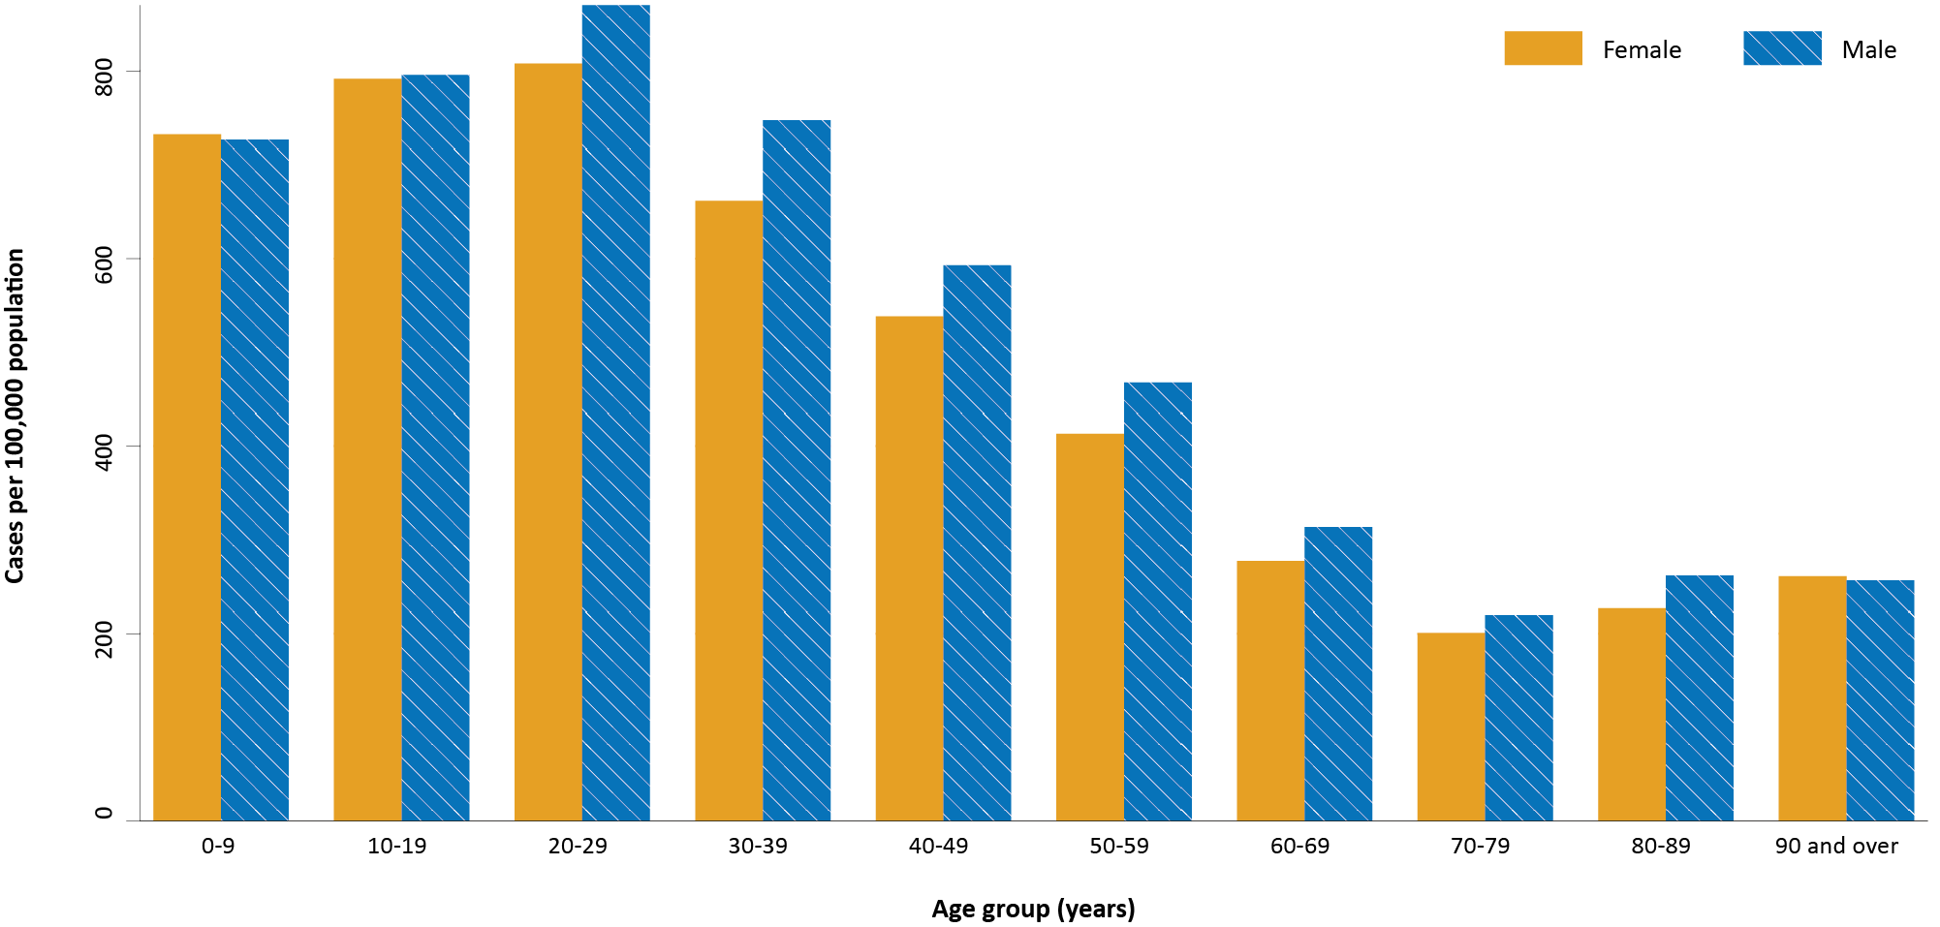
a Source: NINDSS, extract from 9 November 2021 for notifications to 7 November 2021.

Aboriginal and Torres Strait Islander persons

(NINDSS)
During the reporting period, there were 1,244 new cases notified in Aboriginal and Torres Strait Islander people, with 754 from New South Wales, 458 from Victoria, 28 from the Australian Capital Territory and four from Queensland. Since the beginning of 2021, there have been 7,454 confirmed cases of COVID-19 notified in Aboriginal and Torres Strait Islander people, representing 5% (7,454 /152,008) of all confirmed cases this year. Of the locally-acquired cases notified in Aboriginal and Torres Strait Islander people in 2021 to date, 38% (2,845/7,449) resided in a regional or remote area (Table 3).
Table 3: Confirmed cases of COVID-19 among Aboriginal and Torres Strait Islander peoples by place of acquisition and area of remoteness, 1 January – 7 November 2021ª
Jurisdiction | Locally acquired, Australia^{b} |  |  |  |  |  | Overseas acquired | Total
 | Major city | Inner regional | Outer regional | Remote^{c} | Overseas resident | Unknown
ACT | 210 | 0 | 0 | 0 | 0 | 2 | 0 | 212
NSW | 3,785 | 1,496 | 476 | 348 | 5 | 50 | 1 | 6,161
NT | 0 | 0 | 3 | 0 | 0 | 0 | 0 | 3
Qld | 4 | 0 | 4 | 0 | 0 | 0 | 3 | 11
SA | 0 | 0 | 0 | 0 | 0 | 0 | 0 | 0
Tas. | 0 | 1 | 0 | 0 | 0 | 0 | 0 | 1
Vic. | 547 | 350 | 167 | 0 | 0 | 1 | 0 | 1,065
WA | 0 | 0 | 0 | 0 | 0 | 0 | 1 | 1
Australia | 4,546 | 1,847 | 650 | 348 | 5 | 53 | 5 | 7,454
a Source: NINDSS, extract from 9 November 2021 for notifications to 7 November 2021.
b ‘Locally acquired’ includes cases under initial investigation. Note, in reports prior to report 52, ‘locally acquired’ excluded cases under initial investigation.
c ‘Remote’ here also includes areas classified as ‘very remote’.
The majority of cases reported in Aboriginal and Torres Strait Islander people in 2021 have been associated with the Sydney metropolitan and regional outbreaks in New South Wales. There have been 6,153 locally-acquired cases reported in Aboriginal and Torres Strait Islander people in New South Wales since 16 June 2021 when the Sydney metropolitan outbreak began, with 38% (2,314/6,153) of these cases reported in regional and remote residents. Since the start of the pandemic, there have been 16 COVID-19 associated deaths in Aboriginal and Torres Strait Islander people, all of which were associated with the current outbreaks in New South Wales. In Victoria, there have been 1,065 locally acquired Aboriginal and Torres Strait Islander cases reported since the start of the Victorian outbreak on 5 August 2021, with an increasing proportion of cases in regional and remote areas in recent weeks. In total 49% (517/1,065) of Victorian cases have been in regional residents.
Cumulatively, since the beginning of the epidemic in Australia, there have been 7,605 cases in Aboriginal and Torres Strait Islander people, representing approximately 4% (7,605/180,418) of all confirmed cases in Australia. Indigenous status was unknown for approximately 19% (34,440/180,418) of confirmed cases with the majority of these associated with more recently-reported cases, especially in Victoria and New South Wales.
Up to 24 October 2021, it has been 0 days since the last locally-acquired Aboriginal and Torres Strait Islander case was diagnosed and 113 days since the last overseas-acquired Aboriginal and Torres Strait Islander case was diagnosed. To date, the majority of Aboriginal and Torres Strait Islander cases were reported as locally acquired (93%; 7,067/7,605), with 37 cases that were overseas acquired and 501 cases under investigation (most of which are known to be locally-acquired). The median age of locally-acquired Aboriginal and Torres Strait Islander cases is 20 years old (range 0 to 99 years, IQR: 9 to 35 years), while the median age of overseas-acquired cases is 40 years old (range 7 to 75 years; IQR: 27 to 57 years). Overall, the distributions among males and females were similar at 49% and 51% of cases, respectively.
Given the delay between onset and severe illness, cases with an onset in the last two weeks were excluded from the following analysis on severity. In 2021, based on the highest level of severity reported for cases with an illness onset up to 24 October 2021, 0.2% of cases in Aboriginal and Torres Strait Islander people were reported to have died, 1.2% of cases required intensive care and a further 9.7% required admission to hospital (Table 4). Note that hospitalisation data in NINDSS should be interpreted with caution: hospitalisation is not always reflective of severe illness, as cases may be hospitalised for reasons other than clinical COVID-19 related care; additionally, hospitalisation and ICU status in NINDSS is likely incomplete.
Table 4: COVID-19 cases in Aboriginal and Torres Strait Islander people by age group and highest level of illness severity, 1 January 2021 – 24 October 2021ª
Age group | Count |  |  |  |  | % of total cases by age group
 | Not severe^{b} | Hospitalised only | ICU | Died | Total cases | Hospitalised only | ICU | Died
 |  | (not ICU or died) | (but not died) |  |  | (not ICU or died) | (but not died)
0–4 | 739 | 41 | 0 | 0 | 780 | 5.3% | 0.0% | 0.0%
5–11 | 1,053 | 26 | 1 | 0 | 1,080 | 2.4% | 0.1% | 0.0%
12–15 | 588 | 22 | 2 | 0 | 612 | 3.6% | 0.3% | 0.0%
16–17 | 254 | 18 | 2 | 0 | 274 | 6.6% | 0.7% | 0.0%
18–29 | 1,348 | 163 | 13 | 0 | 1,524 | 10.7% | 0.9% | 0.0%
30–39 | 802 | 124 | 12 | 0 | 938 | 13.2% | 1.3% | 0.0%
40–49 | 528 | 100 | 16 | 3 | 647 | 15.5% | 2.5% | 0.5%
50–59 | 315 | 65 | 14 | 4 | 398 | 16.3% | 3.5% | 1.0%
60–69 | 105 | 48 | 10 | 3 | 166 | 28.9% | 6.0% | 1.8%
70–79 | 24 | 19 | 5 | 2 | 50 | 38.0% | 10.0% | 4.0%
80–89 | 4 | 4 | 0 | 3 | 11 | 36.4% | 0.0% | 27.3%
90+ | 1 | 1 | 0 | 0 | 2 | 50.0% | 0.0% | 0.0%
Unknown | 0 | 0 | 0 | 0 | 0 | 0.0% | 0.0% | 0.0%
Total | 5,761 | 631 | 75 | 15 | 6,482 | 9.7% | 1.2% | 0.2%
a Source: NINDSS, extract from 7 November 2021. Includes cases notified from 1 January 2021, with an illness onset up to 24 October 2021. Cases with an illness onset in the last two weeks (25 October to 7 November 2021) were excluded to account for the delay between onset and development of severe illness.
b ‘Not severe’ includes all cases that were not hospitalised, admitted to ICU or died.

Vaccinations

(Department of Health)
As of 7 November 2021, a total of 36,773,837 doses of COVID-19 vaccine had been administered (Table 5), including 1,063,859 doses provided to aged care and disability residents. Nationally, 18,431,249 people aged 16 years or over (89.4%) had received at least one dose. This includes 16,628,469 people aged 16 and over (80.6%) who were fully vaccinated (Table 5). Among people aged 12–15 years, 872,041 people (70.1%) had received at least one dose, including 654,959 (52.7%) who were fully vaccinated.
Table 5: Total number of vaccinations administered, by jurisdiction, Australia, 7 November 2021ª
Jurisdiction | Total number of doses administered | Percentage of people aged 16 and over who have had at least one dose^{b} | Percentage of people aged 16 and over who are fully vaccinated
ACT | 912,806 | >95% | >95%
NSW | 12,606,343 | 93.9% | 89.9%
NT | 335,304 | 80.2% | 66.9%
Qld | 6,414,407 | 79.6% | 67.4%
SA | 2,297,946 | 83.8% | 70.6%
Tas. | 770,848 | 90.5% | 78.7%
Vic. | 10,171,771 | 92.3% | 84.6%
WA | 3,264,412 | 80.7% | 66.8%
Aged care and disability facilities^{c} | 1,063,859 | NA | NA
Primary care^{d} | 20,603,873 | NA | NA
Total | 36,773,837 | 89.4% | 80.6%
a Source: Australian Government Department of Health website.⁴
b Includes people who are fully vaccinated.
c Commonwealth vaccine doses administered in aged care and disability facilities.
d Commonwealth vaccine doses administered in primary care settings.

Clusters and outbreaks

Sydney Metropolitan Outbreak and New South Wales Regional Outbreak – New South Wales
In total, as at 7 November 2021, there had been 70,855 locally-acquired cases in New South Wales, including 543 deaths, reported following notification of the outbreak’s first case on 16 June 2021. Genomic testing results showed that the first case was infected with the Delta SARS-CoV-2 variant of concern (B.1.617.2); however, the sequence did not match cases from the Victorian Delta variant outbreak that occurred from May to June 2021. This sequence had not been seen in Australia previously, but matched one from the United States of America.
Overall, the number of new locally-acquired cases (including cases under initial investigation) continued to decrease this fortnight, with 3,196 cases reported this reporting period, compared to 4,570 such cases reported in the previous reporting period. Following the initial start of the outbreak in south-east Sydney, the largest number of new cases were subsequently reported among residents of south-western and western Sydney, with cases also reported in residents of regional and remote areas in New South Wales, particularly in western New South Wales. In recent weeks, the proportion of locally-acquired cases in metropolitan areas has been declining, while the proportion in regional and remote residents has been increasing; 39% (1,244/3,196) of locally-acquired cases in NSW this reporting period were in residents of regional or remote areas, compared with 22% (1,020/4,570) in the previous reporting period. Regional areas with increasing case numbers included the Hunter New England, Mid-North Coast and Albury-Wodonga regions.

Metropolitan Melbourne and Victorian Regional Outbreak – Victoria
As at 7 November 2021, there had been 76,776 locally-acquired cases, including 363 deaths, reported in Victoria since two unlinked cases were reported on 5 August 2021. Investigations into the source of the outbreak were ongoing, but genomic testing had determined that these outbreaks involved the Delta variant and were genomically closely associated with recent clusters in New South Wales and the previous two seeding events in Victoria from July 2021.
Overall, the number of new locally-acquired cases decreased this reporting period, with 18,013 locally acquired cases (including cases under initial investigation) reported in Victoria this fortnight, compared to 25,438 in the previous fortnight. Most new cases in the outbreak were across several parts of Greater Melbourne. However, there was a considerable increase in the proportion of cases identified in regional and remote residents in the past few weeks; 15% (2,774/18,013) of locally-acquired cases in Victoria reported to NINDSS in the reporting period were in residents of regional or remote areas, compared to 9% (2,188/25,438) in the previous reporting period.

Canberra – Australian Capital Territory
As at 7 November 2021, a total of 1,742 cases had been reported in the Australian Capital Territory’s outbreak, including 11 deaths. The first case in the Territory’s outbreak, which was the first locally-acquired case in the Australian Capital Territory in over a year, was reported on 12 August 2021 and was confirmed to have the Delta variant. The source of infection remained under investigation at the end of this reporting period, though it was genomically related to the Sydney Metropolitan Outbreak. The number of new locally-acquired cases (including cases under initial investigation) in the Australian Capital Territory during this reporting period (145) was lower than the number in the previous reporting period (361).

Goondiwindi cluster – Queensland
A total of four locally-acquired cases were reported as part of a cluster in Goondiwindi, Queensland. The first case in the cluster was reported on 4 November 2021 and is believed to have acquired their infection in Moree, NSW.

Northern Territory outbreak – Northern Territory.
There had been three locally-acquired cases reported in the Northern Territory since 5 November 2021. Exposure sites were identified in both Darwin and Katherine local government areas.

Severity

(NINDSS, SPRINT-SARI)

Hospitalisation and intensive care unit admission
Given the delay between illness onset and severe illness, to provide a more accurate assessment of the highest level of severity, cases with an onset in the last two weeks were excluded from the analysis. In 2021, based on the highest level of severity reported for cases with an illness onset up to 24 October 2021, 0.7% of cases were reported to have died; 1.3% of cases required intensive care; and a further 9.0% required admission to hospital (Table 6). The majority of hospitalisations in 2021 were associated with the current outbreak in New South Wales. Note that hospitalisation data in NINDSS should be interpreted with caution: hospitalisation is not always reflective of severe illness, as cases may be hospitalised for reasons other than clinical COVID-19 related care; additionally, hospitalisation and intensive care unit (ICU) status in NINDSS is likely incomplete.

Table 6: COVID-19 cases by age group and highest level of illness severity, 1 January 2021 – 24 October 2021ª
Age group | Count |  |  |  |  | % of cases
 | Not severe^{b} | Hospitalised only | ICU | Died | Total cases | Hospitalised only | ICU | Died
 |  | (not ICU or died) | (not died) |  |  | (not ICU or died) | (not died)
0-4 | 8,801 | 433 | 6 | 0 | 9,240 | 4.7% | 0.1% | 0.0%
5-11 | 13,897 | 306 | 7 | 0 | 14,210 | 2.2% | 0.0% | 0.0%
12-15 | 7,965 | 255 | 9 | 2 | 8,231 | 3.1% | 0.1% | 0.0%
16-17 | 4,223 | 149 | 13 | 0 | 4,385 | 3.4% | 0.3% | 0.0%
18-29 | 30,816 | 2,088 | 169 | 8 | 33,081 | 6.3% | 0.5% | 0.0%
30-39 | 21,394 | 2,195 | 262 | 16 | 23,867 | 9.2% | 1.1% | 0.1%
40-49 | 14,344 | 1,957 | 327 | 31 | 16,659 | 11.7% | 2.0% | 0.2%
50-59 | 10,225 | 1,703 | 427 | 89 | 12,444 | 13.7% | 3.4% | 0.7%
60-69 | 5,150 | 1,363 | 349 | 144 | 7,006 | 19.5% | 5.0% | 2.1%
70-79 | 2,057 | 945 | 167 | 226 | 3,395 | 27.8% | 4.9% | 6.7%
80-89 | 799 | 645 | 35 | 276 | 1,755 | 36.8% | 2.0% | 15.7%
90+ | 200 | 149 | 1 | 111 | 461 | 32.3% | 0.2% | 24.1%
Age unknown | 6 | 0 | 0 | 0 | 6 | 0.0% | 0.0% | 0.0%
Total | 119,877 | 12,188 | 1,772 | 903 | 134,740 | 9.0% | 1.3% | 0.7%
a NINDSS, extract from 26 October 2021. Includes cases notified from 1 January 2021, with an illness onset up to 24 October 2021; cases with an illness onset in the last two weeks (25 October to 7 November 2021) were excluded to account for the delay between onset and development of severe illness.
b ‘Not severe’ includes all cases that were not hospitalised, admitted to ICU or died.
In the year to date to 7 November 2021, there were 1,865 COVID-19 cases admitted to ICUs participating in the sentinel surveillance system, Short Period Incidence Study of Severe Acute Respiratory Infection (SPRINT-SARI),⁵ with 131 of these admitted during this reporting period (25 October–7 November 2021).

Risk factors for severe disease
The proportion of cases who were admitted to hospital generally increased as a person’s age increased (Table 6).
Comorbidity data extracted from SPRINT-SARI reflect the sickest patients with COVID-19 managed in ICU; data are therefore not generalisable to all cases (Table 7). In patients admitted to ICU with COVID-19 since 1 February 2021, the most prevalent comorbidity was obesity (a body mass index of > 30 or weight over 120 kg), followed by diabetes. Of those adult patients admitted to ICU this year for whom comorbidity data was known, 64% (915/1,502) had at least one comorbidity; 36% (545/1,502) of patients had none of the listed comorbidities recorded.

Table 7: Comorbidities for adult COVID-19 cases (aged greater than or equal to 18 years) amongst those admitted to ICU, Australia, 1 February 2021 – 7 November 2021ª
Comorbidity | ICU casesª (n = 1,502) (%)
Cardiac disease (n = 1,489) | 161 (11)
Chronic respiratory condition (n = 1,492) ^{b} | 222 (15)
Diabetes (n = 1,486) | 431 (29)
Obesity (n = 1,457) | 511 (35)
Chronic renal disease (n = 1,488) | 77 (5)
Chronic neurological condition (n = 1,490) | 42 (3)
Malignancy (n = 1,492) | 44 (3)
Chronic liver disease (n = 1,492) | 37 (2)
Immunosuppression (n = 1,490) | 55 (4)
Number of specified comorbidities (n = 1,502) ^{a,b,c}
One or more | 957 (64)
Two or more | 415 (28)
Three or more | 144 (10)
No comorbidities | 545 (36)
a Source: SPRINT-SARI. Only includes adult cases (≥ 18 years old) and excludes those with missing data on comorbidities or where comorbidity is unknown.
b Includes asthma.
c Includes chronic respiratory conditions, cardiac disease (excluding hypertension), immunosuppressive condition/therapy, diabetes, obesity, liver disease, renal disease and neurological disorder.

COVID-19 deaths
In the past two weeks, there were 169 deaths associated with COVID-19: 124 in Victoria; 42 in New South Wales; and three in the Australian Capital Territory. This brings the total number of COVID-19 associated deaths in 2021 to 927 (Table 8).
Table 8: Deaths associated with COVID-19 by reporting period, Australia, 1 January 2020 – 7 November 2021ª
Reporting period | Number of deaths
Reporting period 25 October – 7 November 2021 | 169
Year to date (2021) 1 January – 7 November 2021 | 927
Epidemic to date 1 January 2020 – 7 November 2021 | 1,835
a Source: NINDSS, extract from 9 November 2021 for notifications to 7 November 2021.

Four-week reporting period (11 October – 7 November 2021)

Genomic surveillance and virology

(Communicable Disease Genomics Network, AusTrakka and jurisdictional sequencing laboratories)
Nationally, 21% of COVID-19 cases have been sequenced since the start of the pandemic in January 2020, based on jurisdictional reporting (Table 9).
Table 9: Australian SARS-CoV-2 genome sequences and proportion of positive cases sequenced, 11 October – 7 November 2021 and cumulative to date
Measure | Reporting period 11 October to  7 November 2021 | Cumulative 23 January 2020 to  7 November 2021
SARS-CoV-2 cases sequencedª | 2,078 | 38,479
Percentage of positive cases sequenced^{b} | 4% | 21%
a Based on individual jurisdictional reports of sequences and case numbers. Calculations of the percentage of cases sequenced based on the number of sequences available in AusTrakka6 may not always be up-to-date, since this may include duplicate samples from cases and may not represent all available sequence data.
b Total SARS-CoV-2 case numbers as reported by jurisdictional laboratories. In most jurisdictions, sequencing has been attempted on all suitable samples (one sample per case). Sequencing of samples from cases identified in the reporting period may be in process at the time of reporting. Remaining unsequenced samples may be due to jurisdictional sequencing strategy, or where samples have been deemed unsuitable for sequencing (typically because viral loads were too low for sequencing to be successful).

Variants of concern
AusTrakka is actively monitoring and reporting on the four lineages designated Variants of Concern (VOC) by international organisations, including the World Health Organization: Alpha (B.1.1.7); Beta (B.1.351); Gamma (P.1); and Delta (B.1.617.2) (Table 10). All four variants display characteristic sets of mutation, including a number of variations in the genomic region encoding the spike protein thought to have the potential to increase transmissibility and/or immune evasion.^{7,8} On 1 June 2021 WHO announced a new nomenclature system for VOCs, using letters of the Greek alphabet,⁹ to facilitate communication and reduce stigmatisation associated with geography-based colloquial terms. Further information on variants is available in the Technical Supplement.³ On 27 September 2021, Kappa (B.1.617.1), which had been classified as a VOC in Australia, was reclassified as a Variant of Interest (VOI) by the Communicable Diseases Genomics Network Variants of Concern Taskforce. As such, Kappa is no longer included in AuskTrakka VOC reporting.
Further information on variants is available in the Technical Supplement.³

Table 10: Australian SARS-CoV-2 genome sequences in AusTrakka identified as variants of concern, 23 January 2020 – 7 November 2021
VOC lineage | Number of samples
B.1.1.7 (Alpha)ª | 568
B.1.351 (Beta) | 100
P.1 (Gamma) | 8
B.1.617.2 (Delta)^{b} | 21,751
a Includes Q sublineages.
b Includes AY sublineages.
Figure 4: Samples in AusTrakka from 24 May to 7 November 2021, by lineage and date of collectionª
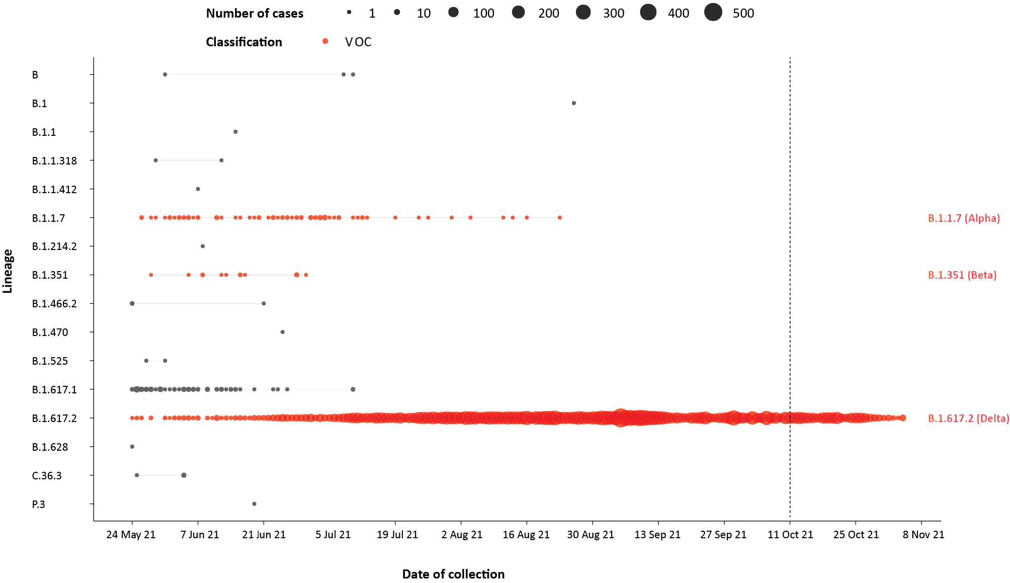
a The start of the current reporting period (11 October – 7 November 2021) is marked by the dotted line, and variant-of-concern samples are coloured red. The size of the circle is proportional to the number of samples in the lineage at each time point.

Testing

(State and territory reporting)
Between 1 January and 5 November 2021, over 32 million tests have been conducted nationally. During the four-week testing reporting period (9 October to 5 November 2021), over 3.5 million individuals were tested, at a rate of 138 individuals tested per 1,000 population, noting that individuals tested in multiple weeks could be counted more than once and that data from Victoria were not available for the most recent reporting week (Table 11). Jurisdictional testing rates are driven by current case numbers, testing policies and numbers of people experiencing symptoms.
Table 11: Individuals undergoing diagnostic tests for SARS-CoV-2,ª by jurisdiction and reporting period, with a notification received date of 9 October – 5 November 2021
Jurisdiction | Individuals testedª |  |  | Individuals testedª
 | 23 October to 5 November 2021 |  |  | 9 October to 22 October 2021
 | n^{b} | Positivity (%) | Per 1,000 population^{c} | n^{b} | Positivity (%) | Per 1,000 population^{c}
ACT | 22,776 | 0.65 | 53 | 38,242 | 1.00 | 89
NSW | 960,527 | 0.34 | 118 | 925,277 | 0.51 | 113
NT | 14,404 | 0.03 | 58 | 12,562 | 0.07 | 51
Qld | 90,492 | <0.01 | 17 | 86,311 | 0.02 | 17
SA | 43,418 | <0.01 | 25 | 60,256 | <0.01 | 34
Tas. | 9,026 | <0.01 | 17 | 16,220 | <0.01 | 30
Vic.^{d} | 361,480 | 2.66 | 54 | 843,685 | 3.03 | 126
WA | 26,141 | <0.01 | 10 | 29,334 | <0.01 | 11
Australia^{d} | 1,528,264 | 0.85 | 59 | 2,011,887 | 1.53 | 78
a In order to more accurately reflect positivity rates, numbers of individuals tested is presented rather than total number of tests. The number of individuals tested is the sum of number of individuals tested in each week (Saturday to Friday) in each jurisdiction. Individuals who were tested in more than one week could be counted more than once.
b Total cumulative tests counts the total number of tests performed, not the number of individuals tested.
c Population data based on Australian Bureau of Statistics (ABS) Estimated Resident Population (ERP) as at June 2020.
d Data from Victoria were not available for the period 30 October to 5 November 2021. Rates and positivity calculations for Victoria in the most recent reporting fortnight are based on data from 23 to 29 October 2021.
In the past two months, testing rates decreased since peaking in mid-August to mid-September 2021 (Figure 5; Figure 6). In the past four weeks, testing rates dropped in all age groups apart from in people aged 0 to 19, for which rates increased. Those aged 20 to 39 years continued to have the highest rates of testing, followed by those aged 40 to 59 years old.

Figure 5: SARS-CoV-2 polymerase chain reaction (PCR) testing rates per 1,000 population per week by age group and notification received date, Australia, 26 December 2020 – 5 November 2021^{a,b,c}
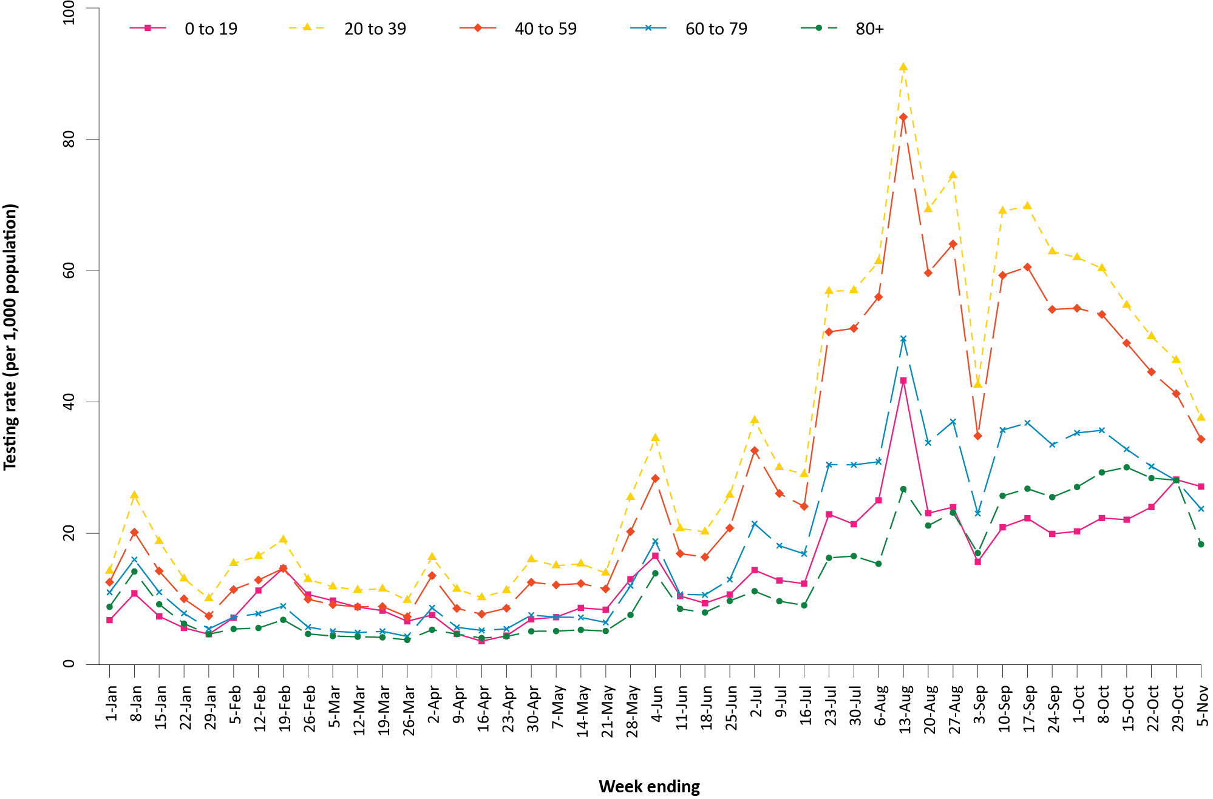
a Source: testing data provided by jurisdictions to the NIR weekly, current to 5 November 2021; population data based on Australian Bureau of Statistics (ABS) Estimated Resident Population (ERP) as at June 2020.
b The jurisdictions reporting each week (i.e. the denominator population) may vary.
c From 22 May to 4 June and 26 June to 9 July, data for Queensland were unavailable. From 19 June 2021 to 16 July 2021, data for New South Wales were unavailable. From 28 August to 3 September 2021, data for New South Wales and the Australian Capital Territory were unavailable. From 30 October to 5 November 2021, data for Victoria were unavailable.
The percent positivity remains low, at 1.2% for the four-week reporting period, reflecting a high surveillance capacity and rapid case identification. Between the weeks ending 24 September 2021 and 22 October 2021, the percent positivity increased, from approximately 1.1% to 1.5%, while testing rates remained high (Figure 6). The increase in percent positivity during this period was mainly driven by an increased percent positivity in Victoria (Table 12). In the most recent two weeks, the percent positivity dropped; however, as data from Victoria were not available in the most recent week, trends in percent positivity for this week cannot be accurately interpreted.

Figure 6: SARS-CoV-2 polymerase chain reaction (PCR) testing rates per 1,000 population per week and percent positivity by specimen date, Australia, 26 December 2020 – 5 November 2021^{a,b,c}
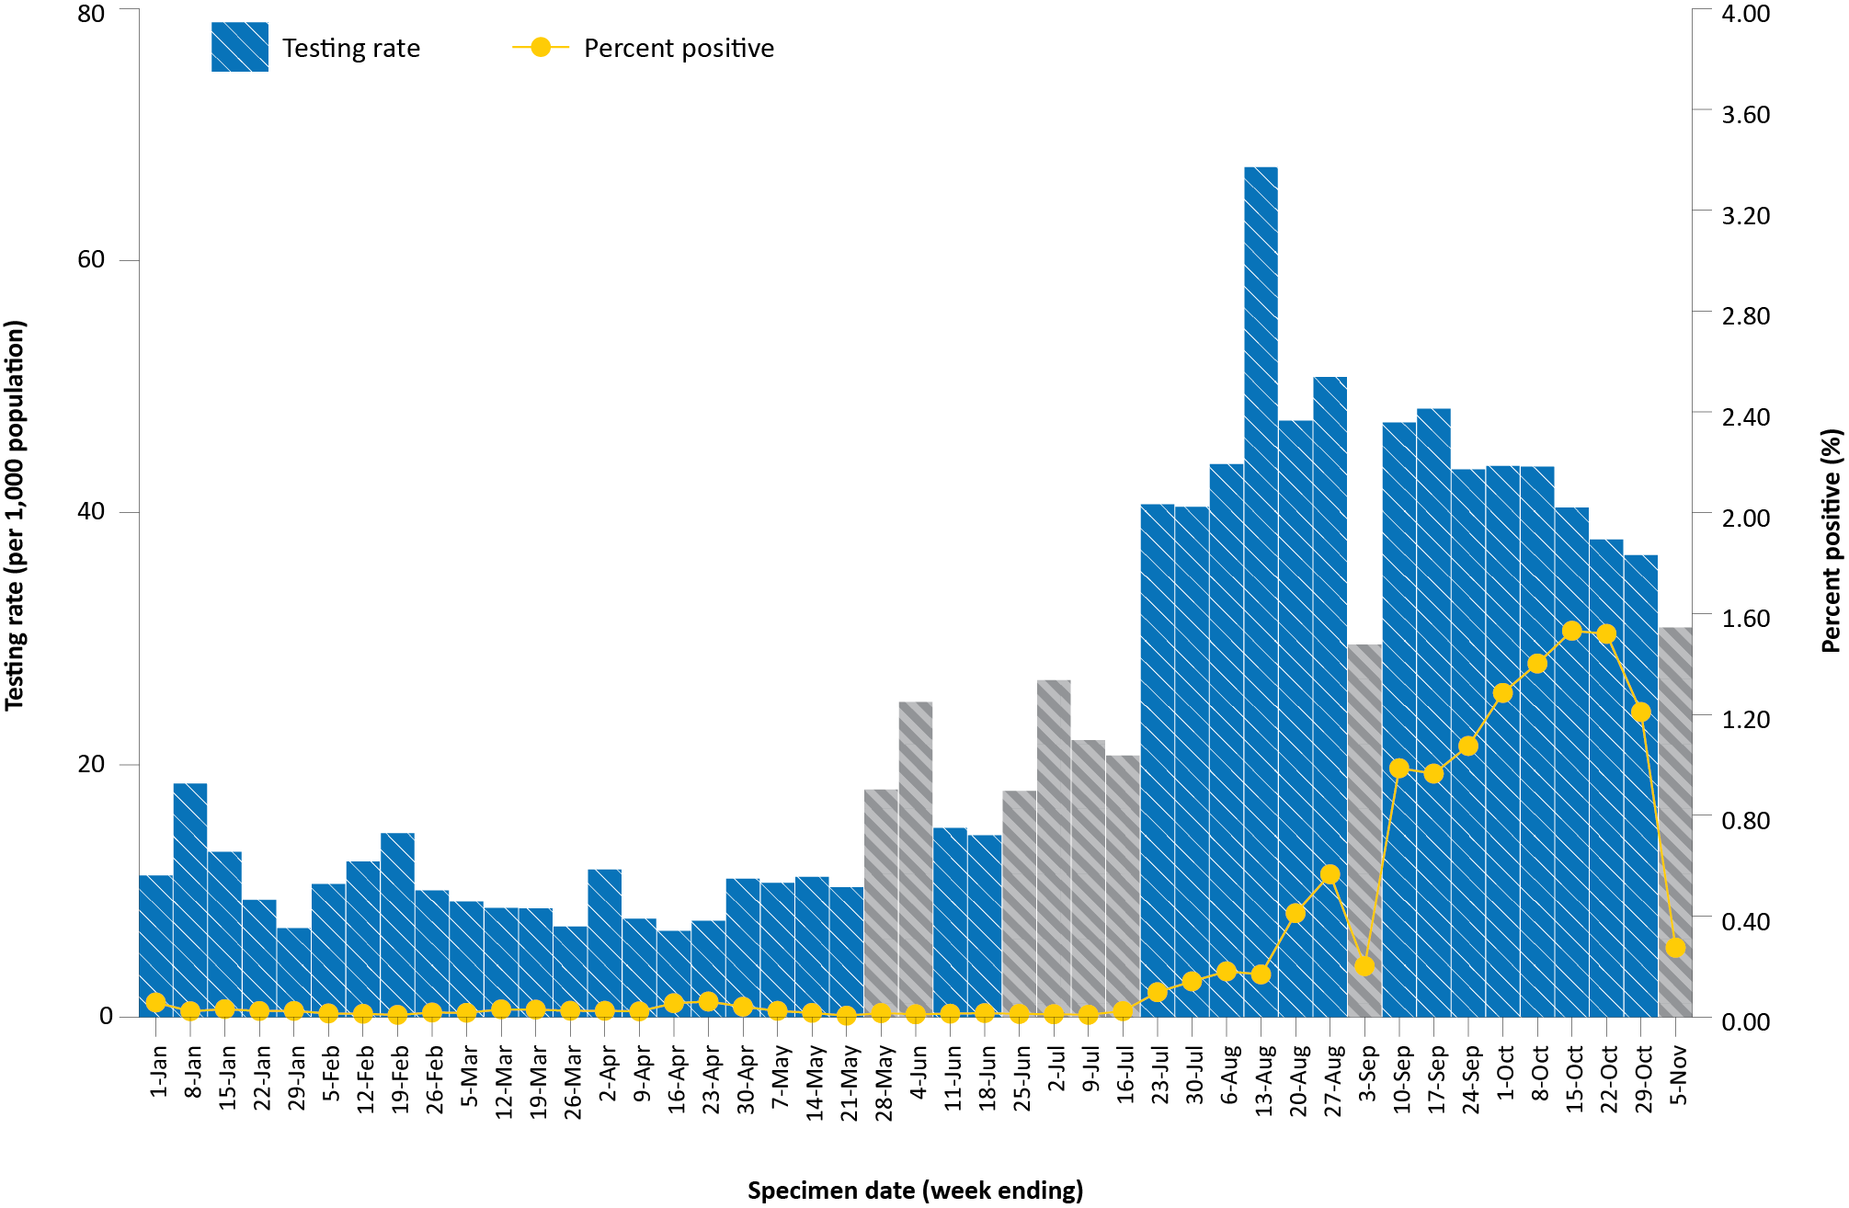
a Source: testing data provided by jurisdictions to the NIR weekly, current to 5 November 2021; case data extracted from NINDSS on 9 November 2021 for cases with a specimen date up to 5 November 2021; population data based on Australian Bureau of Statistics (ABS) Estimated Resident Population (ERP) as at June 2020.
b The jurisdictions reporting each week (i.e. the denominator population) may vary.
c Grey bars indicate weeks where jurisdictional reporting was incomplete. From 22 May to 4 June and from 26 June to 9 July, data for Queensland were unavailable. From 19 June 2021 to 16 July 2021, data for New South Wales were unavailable. From 28 August to 3 September 2021, data for New South Wales and the Australian Capital Territory were unavailable. From 30 October to 5 November 2021, data for Victoria were unavailable.

Acute respiratory illness

(FluTracking, ASPREN, and Commonwealth Respiratory Clinics)
Based on self-reported FluTracking data,¹⁰ prevalence of fever and cough in the community remained at < 1% and was similar to that reported in the previous four-week reporting period (Figure 7). Runny nose and sore throat symptoms in the community were also similar during this reporting period compared to the previous four weeks, with the prevalence in the community remaining low at < 1%.

Figure 7: Weekly trends in respiratory illness amongst FluTracking survey participants (age-standardised) compared to the average of the previous five years, Australia, by epidemiological week,ª 1 March 2020 – 7 November 2021^{b}
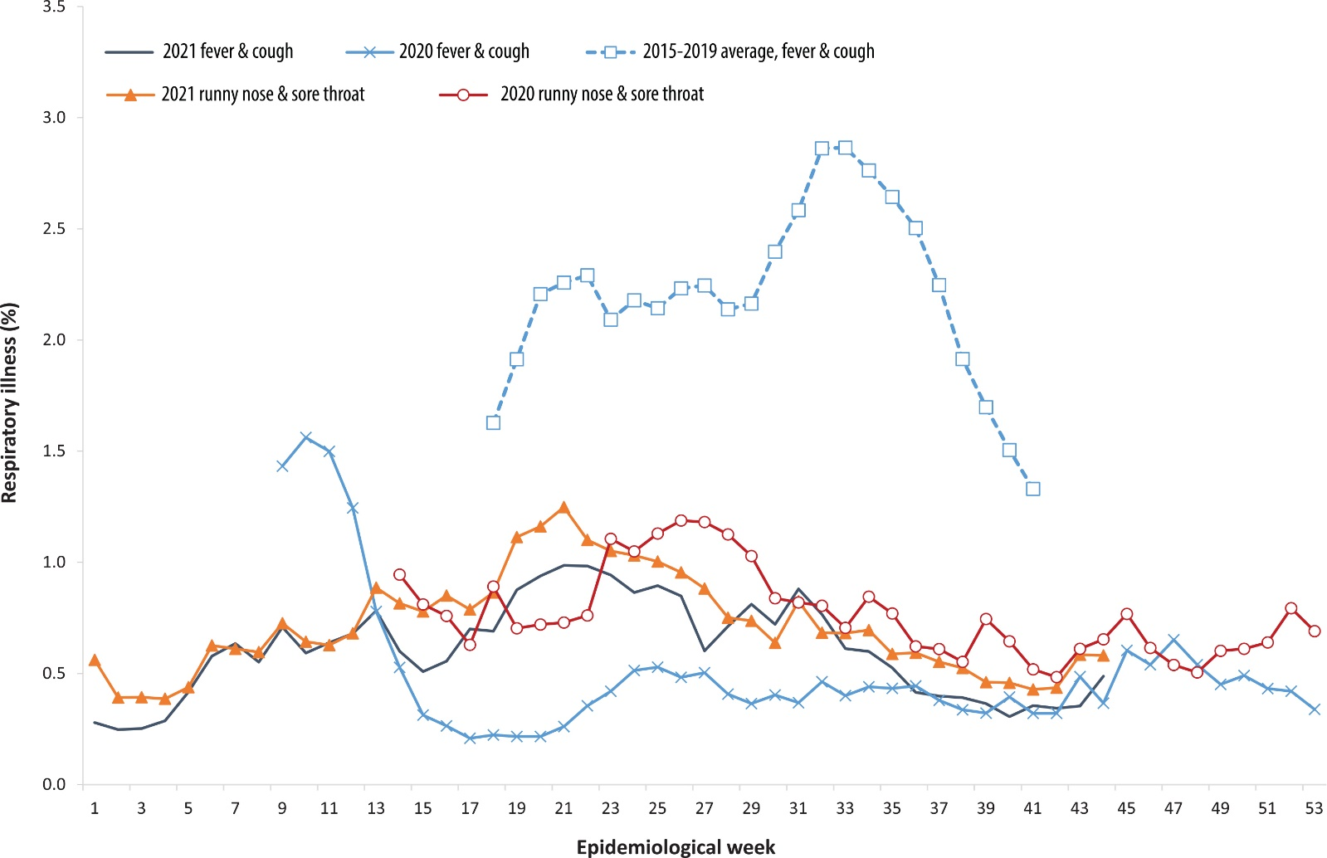
a Epidemiological weeks are a standardised method for numbering weeks across years, with the first epidemiological week of any year ending on the first Saturday in January.
b In years prior to 2020, FluTracking was activated during the main Influenza season from May to October. A historical average beyond the week ending 11 October (epidemiological week 41) is therefore not available. In 2020, FluTracking commenced ten weeks early to capture data for COVID-19. Data on runny nose and sore throat were only collected systematically after 29 March 2020, therefore a historical average for this symptom profile is unavailable.
In this reporting period, acute respiratory illness was highest in those aged 0 to 9 years and 30 to 39 years, based on both self-reported FluTracking data and presentations to Commonwealth Respiratory Clinics. Females reported respiratory illness more frequently than males. Rates of fever and cough by jurisdiction ranged from 1.3 per 1,000 FluTracking participants in Victoria to 4.4 per 1,000 participants in Tasmania. Rates of runny nose and sore throat ranged from 3.6 per 1,000 FluTracking participants in the Northern Territory to 6.4 per 1,000 FluTracking participants in Western Australia.
FluTracking data indicated that 55% of those in the community with ‘fever and cough’ and 34% of those with ‘runny nose and sore throat’ were tested for SARS-CoV-2. This represents a slight increase in SARS-CoV-2 testing for ‘fever and cough’ and a similar level of testing for ‘runny nose and sore throat’ since the previous reporting period. In the four-week reporting period, testing rates for fever and cough were highest in Victoria and lowest in Western Australia, while testing rates for runny nose and sore throat were highest in New South Wales and Victoria, and lowest in Western Australia. It is important to acknowledge that there may be legitimate reasons why people did not get tested, including barriers to accessing testing. Symptoms reported to FluTracking are not specific to COVID-19 and may also be due to chronic diseases.
During this reporting period, there were 123,928 assessments at Commonwealth Respiratory Clinics. Of these, there were 111,081 assessments with consent to share information, with 97% (107,960/111,081) tested for SARS-CoV-2. There were 862 cases reported at these clinics in this reporting period, representing a percent positivity of < 1% (862/107,960).

Public health response measures
Since COVID-19 first emerged internationally, Australia has implemented public health measures informed by the disease’s epidemiology. States and territories have decision making authority in relation to public health measures and have implemented or eased restrictions at their own pace (Figure 8; Appendix A, Table A.2), depending on the local public health and epidemiological situation, and in line with the ‘Framework for National Reopening’.¹¹ Nationwide requirements regarding air travel, including pre-flight testing for travellers entering Australia and requirements to wear face masks when flying domestically or internationally, remain in place. During the current reporting period, there was community transmission occurring in the Australian Capital Territory, New South Wales, and Victoria.

Figure 8: COVID-19 notifications in Australia by week of diagnosis and jurisdiction, 31 May – 7 November 2021, with timing of key public health measures
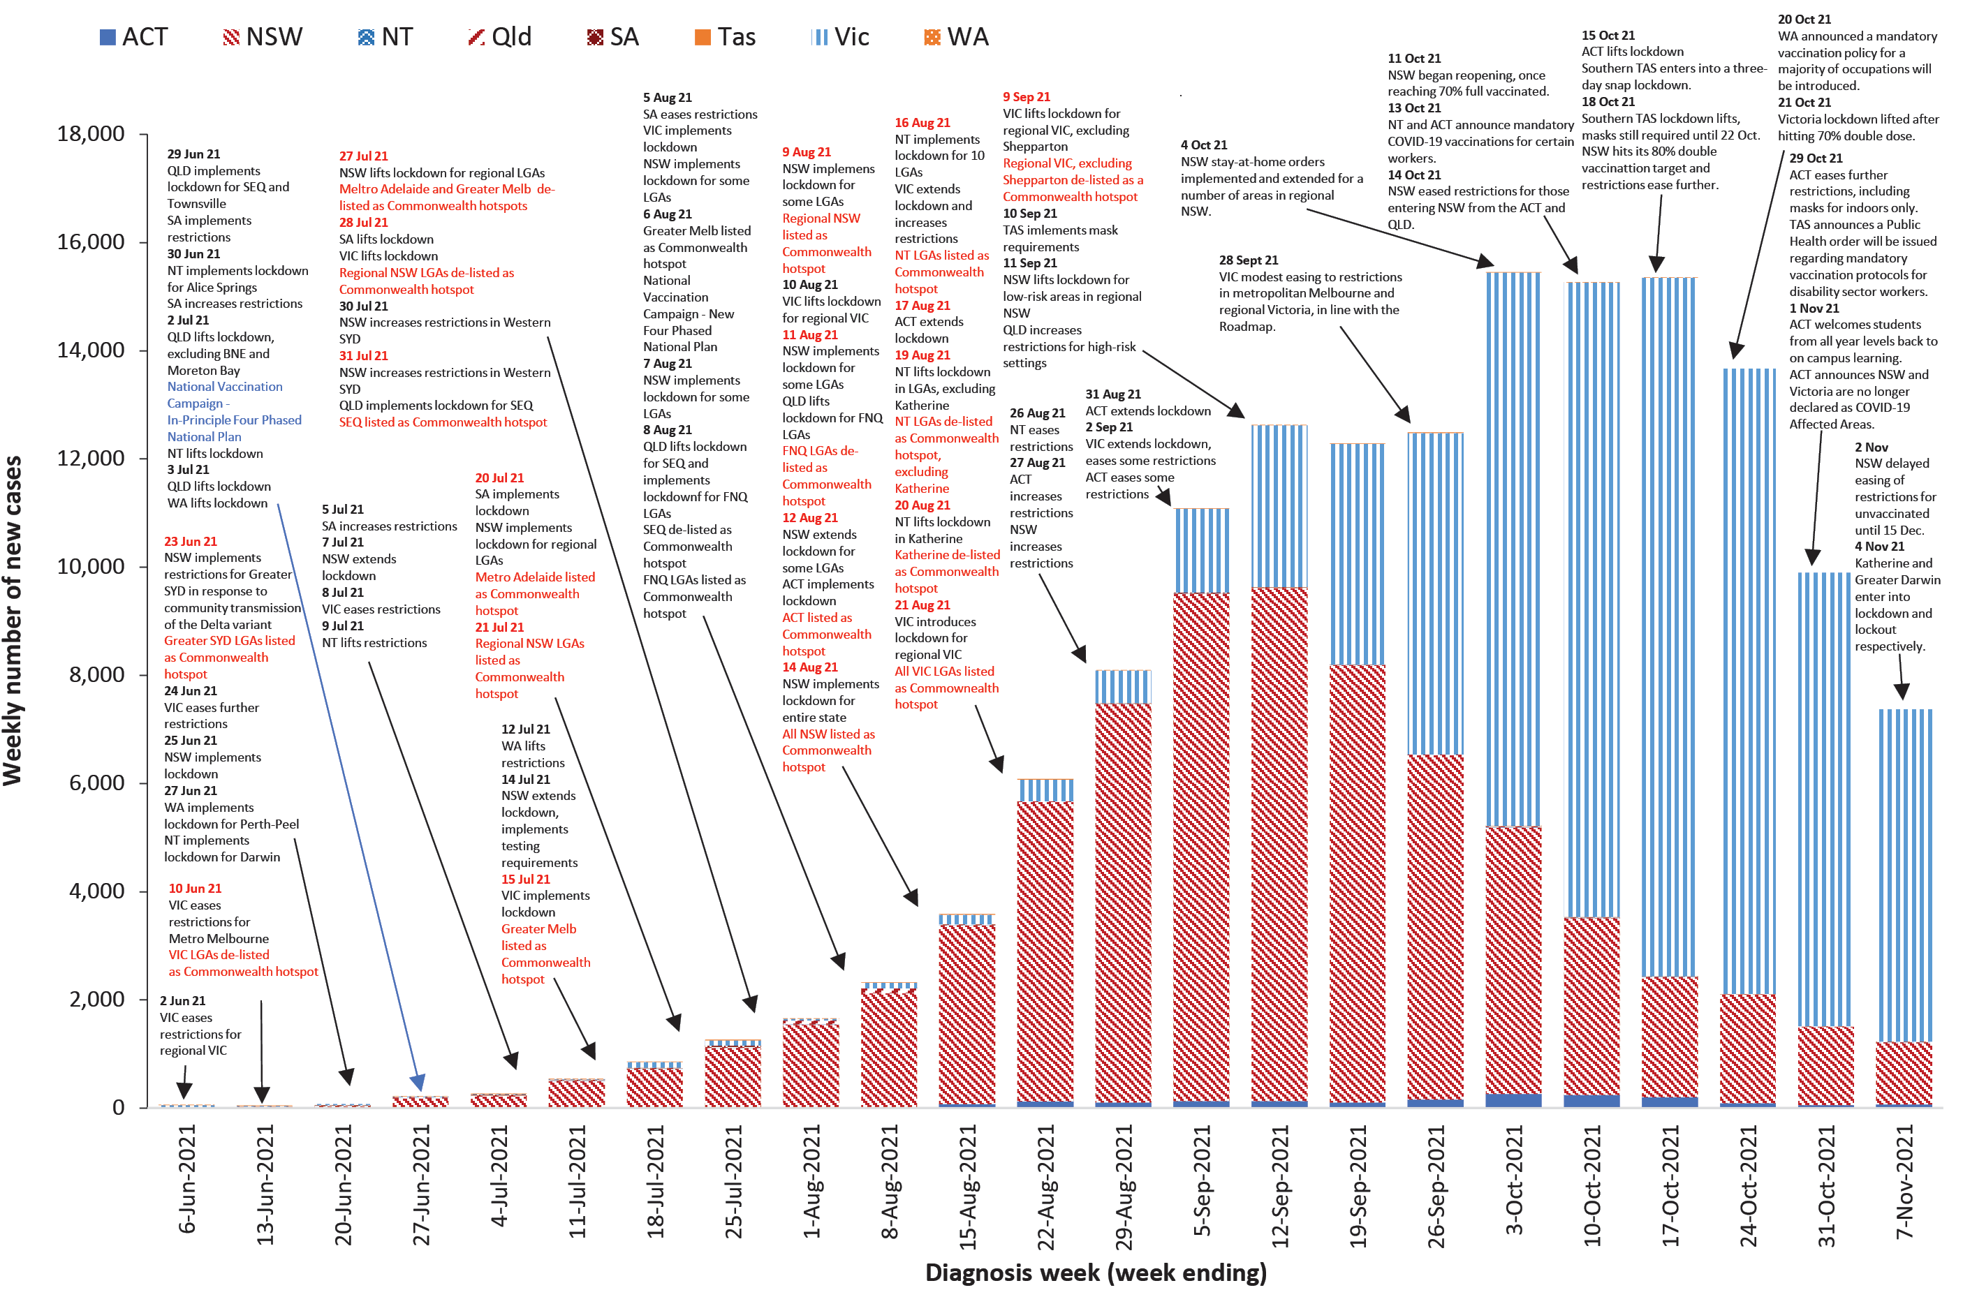

Countries and territories in Australia’s near region
According to WHO, countries and territories in the South East Asian and Western Pacific regions reported 1,475,435 newly-confirmed cases and 26,053 deaths in the four-week period to 7 November 2021, bringing the cumulative cases in the two regions to over 53 million, and cumulative deaths in these regions to over 828,000.¹² New case numbers and deaths incidence have continued to trend downward in the south east Asian region, driven by decreasing cases in India, Indonesia and Thailand. Both the number of new cases and new deaths in the Western Pacific Region in the past four weeks have declined compared to the previous four-week period. The highest numbers of new cases in the Western Pacific region during the four-week period to 10 October 2021 were in Malaysia, the Philippines and Viet Nam.¹³
Table 12 outlines the new cases and deaths in the four-week period to 7 November 2021 and cumulative cases and deaths for the pandemic in selected countries with the highest number of new cases in the South East Asian region and the Western Pacific region.
Table 12: Cumulative cases and deaths, and new cases and deaths reported in the four-week period to 7 November 2021 for selected countries in Australia’s near region according to WHOª
Country | Cumulative cases | New cases reported in the last 4 weeks | Change in new cases in the last 4 weeks^{b} | Cumulative deaths | New deaths reported in the last 4 weeks | Change in new deaths in the last 4 weeks^{b}
South East Asian region
India | 34,355,536 | 402,061 | -44% | 460,791 | 10,202 | +29%
Thailand | 1,967,999 | 257,115 | -22% | 19,664 | 1,973 | -41%
Myanmar | 506,816 | 28,165 | -40% | 18,821 | 687 | -57%
Indonesia | 4,248,165 | 20,233 | -67% | 143,545 | 894 | -76%
Sri Lanka | 545,256 | 18,873 | -53% | 13,856 | 525 | -74%
Western Pacific region
Malaysia | 2,501,966 | 169,745 | -54% | 29,256 | 1,991 | -71%
Philippines | 2,800,608 | 146,205 | -67% | 44,239 | 4734 | +5%
Viet Nam | 961,038 | 124,904 | -47% | 22,470 | 2,028 | -63%
Singapore | 215,780 | 91,623 | +73% | 480 | 327 | +244%
Australia | 178,874 | 53,823 | +1% | 1,805 | 384 | +14%
a Source: World Health Organization Coronavirus (COVID-19) Dashboard,12 accessed 10 November 2021.
b Percent change in the number of newly confirmed cases/deaths in the most recent four-week period compared to the four weeks prior.
As of 7 November 2021, over 249 million COVID-19 cases and 5.0 million deaths have been reported globally, with a global case fatality rate (CFR) of 2%. The two regions reporting the largest burden of disease over the past four weeks were the European Region (58% of cases) and the Region of the Americas (25% of cases).

Acknowledgements
We thank public health staff from incident emergency operations centres and public health units in state and territory health departments, and the Australian Government Department of Health, along with state and territory public health laboratories. We thank those who have provided data from surveillance systems, such as Commonwealth respiratory clinics, ASPREN, FluTracking, FluCAN, SPRINT-SARI, Communicable Disease Genomics Network, AusTrakka and jurisdictional sequencing laboratories.

Author details

Corresponding author
COVID-19 National Incident Room Surveillance Team
Australian Government Department of Health, GPO Box 9484, MDP 14, Canberra, ACT 2601.
Email: epi.coronavirus@health.gov.au

References
- COVID-19 National Incident Room Surveillance Team. COVID-19 Australia: Epidemiology Report 51: Reporting period ending 24 October 2021. Commun Dis Intell (2018). 2021;45. doi: https://doi.org/10.33321/cdi.2021.45.61.
- COVID-19 National Incident Room Surveillance Team. COVID-19 Australia: Epidemiology Report 50: Reporting period ending 10 October 2021. Commun Dis Intell (2018). 2021;45. doi: https://doi.org/10.33321/cdi.2021.45.55.
- COVID-19 National Incident Room Surveillance Team. Technical supplement. COVID-19 Australia: Epidemiology reporting. Commun Dis Intell (2018). 2021;45. doi: https://doi.org/10.33321/cdi.2021.45.2.
- Australian Government Department of Health. Vaccination numbers and statistics. [Internet.] Canberra: Australian Government Department of Health; 2021. [Accessed on 9 November 2021.] Available from: https://www.health.gov.au/initiatives-and-programs/covid-19-vaccines/numbers-statistics.
- Australian and New Zealand Intensive Care Research Centre (ANZIC-RC). SPRINT-SARI: Short period incidence study of severe acute respiratory infection. [Internet.] Melbourne: Monash University, ANZIC-RC; 2020. Available from: https://www.monash.edu/medicine/sphpm/anzicrc/research/sprint-sari.
- Communicable Diseases Genomics Network (CDGN). AusTrakka. [Website.] Melbourne: CDGN; 2020. Available from: https://www.cdgn.org.au/austrakka.
- World Health Organization (WHO). Coronavirus disease (COVID-19) Weekly Epidemiological Update and Weekly Operational Update. [Internet.] Geneva: WHO; June 2021. [Accessed on 14 October 2021.] Available from: https://www.who.int/emergencies/diseases/novel-coronavirus-2019/situation-reports/.
- Allen H, Vusirikala A, Flannagan J, Twohig KA, Zaidi A, Groves N et al. Increased household transmission of COVID-19 cases associated with SARS-CoV-2 Variant of Concern B.1.617.2: a national case-control study. Knowledge Hub (khub); 2021. [Accessed on 14 October 2021.] Available from: https://khub.net/documents/135939561/405676950/Increased+Household+Transmission+of+COVID-19+Cases+-+national+case+study.pdf/7f7764fb-ecb0-da31-77b3-b1a8ef7be9aa.
- WHO. Tracking SARS-CoV-2 variants. [Internet.] Geneva: WHO; 15 June 2021. [Accessed on 14 October 2021.] Available from: https://www.who.int/en/activities/tracking-SARS-CoV-2-variants/.
- Dalton C, Durrheim D, Fejsa J, Francis L, Carlson S, d’Espaignet ET et al. Flutracking: a weekly Australian community online survey of influenza-like illness in 2006, 2007 and 2008. Commun Dis Intell Q Rep. 2009;33(3):316–22.
- Australian Government Department of Health. Framework for national reopening – October 2020. [Internet.] Canberra: Australian Government Department of Health; 23 October 2020. [Accessed on 10 November 2020.] Available from: https://www.health.gov.au/resources/publications/framework-for-national-reopening-october-2020.
- WHO. WHO Coronavirus Disease (COVID-19) dashboard. [Internet.] Geneva: WHO; 2021. Available from: https://covid19.who.int/.
- WHO. Weekly epidemiological update on COVID-19 – 9 November 2021. [Internet.] Geneva: WHO; 9 November 2021. [Accessed on 10 November 2021.] Available from: https://www.who.int/publications/m/item/weekly-epidemiological-update-on-covid-19---9-november-2021.
- Australian Capital Territory Government. Ensuring staff in certain education settings are vaccinated. [Internet.] Canberra: Australian Capital Territory Government; 13 October 2021. [Accessed on 11 November 2021.] Available from: https://www.covid19.act.gov.au/news-articles/ensuring-staff-in-certain-education-settings-are-vaccinated.
- Australian Capital Territory Government. The ACT’S COVID-19 pathway forward – from 12 November 2021. Canberra: Australian Capital Territory Government. [Accessed on 11 November 2021.] Available from: https://www.covid19.act.gov.au/__data/assets/pdf_file/0006/1887225/ACTs-Pathway-Forward-12-November-2021.pdf.
- Australian Capital Territory Government. Current restrictions. Frequently asked questions. Summary of Restrictions from 12 November 2021. [Internet.] Canberra: Australian Capital Territory Government; November 2021. [Accessed on 11 November 2021.] Available from: https://www.covid19.act.gov.au/restrictions/current-restrictions.
- Government of New South Wales. Reopening started at 70% full vaccination. Greater freedoms for fully vaccinated people. [Internet.] Sydney: Government of New South Wales; 11 October 2021. [Accessed on 12 November 2021.] Available from: https://www.nsw.gov.au/covid-19/easing-covid-19-restrictions/70-percent#:~:text=Greater%20freedoms%20for%20fully%20vaccinated,20%20people%20in%20hospitality%20settings.
- Government of New South Wales Department of Health (NSW Health). Restrictions lift for people entering from ACT and Qld. [Internet.] Sydney: Government of New South Wales, NSW Health; 14 October 2021. [Accessed on 12 November 2021.] Available from: https://www.health.nsw.gov.au/news/pages/20211014_02.aspx.
- Government of New South Wales. Easing restrictions at 80% full vaccination. [Internet.] Sydney: Government of New South Wales; 18 October 2021. [Accessed on 12 November 2021.] Available from: https://www.nsw.gov.au/covid-19/easing-covid-19-restrictions/80-percent.
- NSW Health. Travel restrictions to stay in place for Victoria until 1 November. [Internet.] Sydney: Government of New South Wales, NSW Health; 21 October 2021. [Accessed on 12 November 2021.] Available from: https://www.health.nsw.gov.au/news/pages/20211021_01.aspx.
- Government of New South Wales. Doors to swing open as NSW continues to get the jab done. [Internet.] Sydney: Government of New South Wales; 2 November 2021. [Accessed on 12 November 2021.] Available from: https://www.nsw.gov.au/media-releases/doors-to-swing-open-as-nsw-continues-to-get-jab-done.
- Northern Territory Government. Coronavirus (COVID-19): Mandating COVID-19 Vaccinations. [Internet.] Darwin: Northern Territory Government; 13 October 2021. [Accessed on 11 November 2021.] Available from: https://coronavirus.nt.gov.au/updates/items/2021-10-13-mandating-covid-19-vaccinations.
- Northern Territory Government. Coronavirus (COVID-19): Positive Community Case in the NT. 72 hour lockdown in Katherine & lockout in Greater Darwin. [Internet.] Darwin: Northern Territory Government; 4 November 2021. [Accessed on 11 November 2021.] Available from: https://coronavirus.nt.gov.au/updates/items/2021-011-04-positive-community-case-in-the-nt.-72-hour-lockdown-in-katherine-and-lockout-in-greater-darwin.
- Northern Territory Government. COVID-19 update: Lockout for Katherine and Greater Darwin. New public exposure sites listed and testing required. [Internet.] Darwin: Northern Territory Government; 7 November 2021. [Accessed on 11 November 2021.] Available from: https://coronavirus.nt.gov.au/updates/items/covid-19-update-lockout-for-katherine-and-greater-darwin
- Premier of Tasmania. Press conference - 15 October 2021. [Internet.] Hobart: Tasmanian Government, Office of the Premier; 15 October 2021. [Accessed on 11 November 2021.] Available from: https://www.premier.tas.gov.au/covid-19_updates/press_confernce_-_15_october_2021.
- Premier of Tasmania. Press conference - 18 October 2021. [Internet.] Hobart: Tasmanian Government, Office of the Premier; 18 October 2021. [Accessed on 11 November 2021.] Available from: https://www.premier.tas.gov.au/covid-19_updates/press_conference_-_18_october_2021.
- Premier of Tasmania. Press conference - 22 October 2021. [Internet.] Hobart: Tasmanian Government, Office of the Premier; 22 October 2021. [Accessed on 11 November 2021.] Available from: https://www.premier.tas.gov.au/covid-19_updates/press_conference_-_22_october_2021.
- Premier of Tasmania. Press conference - 29 October 2021. [Internet.] Hobart: Tasmanian Government, Office of the Premier; 29 October 2021. [Accessed on 11 November 2021.] Available from: https://www.premier.tas.gov.au/covid-19_updates/press_conference_-_29_october_2021.
- Victoria State Government Department of Health and Human Services (DHHS). Seven-day extension to Mildura’s lockdown to curb transmision - 15 October 2021. [Internet.] Melbourne: Victoria State Government, DHHS; 15 October 2021. [Accessed on 11 November 2021.] Available from: https://www.health.vic.gov.au/media-releases/seven-day-extension-to-milduras-lockdown-to-curb-transmision-15-october-2021.
- DHHS. Lockdown restrictions in Mildura to lift tonight. [Internet.] Melbourne: Victoria State Government, DHHS; 21 October 2021. [Accessed on 11 November 2021.] Available from: https://www.health.vic.gov.au/media-releases/lockdown-restrictions-in-mildura-to-lift-tonight.
- Premier of Victoria. Thank You, Victoria. [Internet.] Melbourne: Victoria State Government, Office of the Premier; 22 October 2021. [Accessed on 11 November 2021.] Available from: https://www.premier.vic.gov.au/thank-you-victoria.
- Government of Western Australia. Mandatory COVID-19 vaccination policy for WA workforces. [Internet.] Perth: Government of Western Australia, Department of the Premier and Cabinet; 20 October 2021. [Accessed on 11 November 2021.] Available from: https://www.wa.gov.au/government/announcements/mandatory-covid-19-vaccination-policy-wa-workforces.
- Government of Western Australia. New travel requirements for entry under WA’s controlled border. [Internet.] Perth: Government of Western Australia, Department of the Premier and Cabinet; 30 October 2021. [Accessed on 11 November 2021.] Available from: https://www.wa.gov.au/government/announcements/new-travel-requirements-entry-under-was-controlled-border.

Appendix A: Supplementary figures and tables
Table A.1: COVID-19 cases and rates per 100,000 population, by age group, sex, and notification received date, Australia, 7 November 2021^{a,b}
Age group | This reporting period |  |  |  |  |  | This year^{c}
 | 25 October 2021 – 7 November 2021 |  |  |  |  |  | 1 January 2021 – 7 November 2021
 | Cases |  |  | Rate per 100,000 population |  |  | Cases |  |  | Rate per 100,000 population
 | Male | Female | People | Male | Female | People | Male | Female | People | Male | Female | People
0–9 | 2,387 | 2,224 | 4,666 | 145.8 | 143.7 | 146.5 | 11,898 | 11,341 | 23,387 | 726.9 | 732.5 | 734.3
10–19 | 1,783 | 1,759 | 3,569 | 112.4 | 117.2 | 115.6 | 12,622 | 11,880 | 24,607 | 795.9 | 791.6 | 797.2
20–29 | 1,551 | 1,632 | 3,196 | 84.3 | 91.8 | 88.3 | 16,016 | 14,366 | 30,458 | 870.2 | 808.0 | 841.7
30–39 | 1,624 | 1,721 | 3,372 | 87.4 | 90.5 | 89.7 | 13,883 | 12,575 | 26,544 | 747.6 | 661.5 | 706.3
40–49 | 1,227 | 1,268 | 2,501 | 75.2 | 76.1 | 75.9 | 9,667 | 8,969 | 18,682 | 592.8 | 538.4 | 566.7
50–59 | 797 | 902 | 1,708 | 52.3 | 56.5 | 54.7 | 7,126 | 6,602 | 13,771 | 467.9 | 413.2 | 441.3
60–69 | 595 | 608 | 1,204 | 45.5 | 43.7 | 44.6 | 4,100 | 3,859 | 7,980 | 313.7 | 277.6 | 295.9
70–79 | 348 | 334 | 686 | 38.2 | 34.5 | 36.5 | 2,003 | 1,941 | 3,963 | 219.7 | 200.5 | 210.8
80–89 | 179 | 196 | 377 | 48.3 | 41.4 | 44.6 | 972 | 1,076 | 2,060 | 262.1 | 227.1 | 243.9
90 and over | 27 | 74 | 101 | 36.9 | 53.6 | 47.8 | 188 | 361 | 549 | 256.9 | 261.3 | 259.8
a Source: NINDSS, extract from 9 November 2021 for notifications up to 7 November 2021.
b Population data based on Australian Bureau of Statistics (ABS) Estimated Resident Population (ERP) as at June 2020.
c Note the change to focus on rates in this year only. For cumulative rates since the beginning of the epidemic in Australia, readers are encouraged to consult previous reports.

Table A.2: State and territory changes to COVID-19 restrictions, Australia, 11 October – 7 November 2021
ACT
On 13 October 2021, the ACT Government moved to require full vaccination against COVID-19 for certain staff working across education settings. Under the Chief Health Officer direction, first-dose vaccination will be required by no later than 1 November 2021 and second dose by no later than 29 November 2021.¹⁴
The ACT Government began easing restrictions on 15 October with further easing of restrictions on 29 October, and will ease restrictions again on 12 November. Refer to the ACT’s COVID-19 Pathway Forward to view the easing of public health measures.¹⁵
Interstate - from 1 November 2021:¹⁶
- NSW and Victoria will no longer be declared as COVID-19 Affected Areas.
- For all other interstate travel a risk-based approach will be followed to determine travel restrictions going forward.
- High risk geographical areas will continue to be restricted, and exemptions required prior to travel.
  - Vaccinated travellers can enter the ACT for any reason, without the need to quarantine.
  - Unvaccinated travellers can travel for essential reasons only. Exemption applications will be considered on a case by case basis and certain conditions (testing and/or quarantine or stay at home) may be applied.
Schools - from 1 November 2021:¹⁶
- Students from all year levels can return to on campus learning.
- Out of School Hours care available to all students
- Return parameters are subject to the Health Guidelines for Schools and Early Childhood Education Services (including OSHC).
NSW
NSW started to reopen on 11 October 2021 once reaching 70% full vaccination, allowing those who were fully vaccinated to:¹⁷
- have 10 visitors to their home
- access gyms, indoor recreation, and sporting facilities
- join a group booking of up to 20 people in hospitality settings.
From 11.59pm 14 October, restrictions for people entering NSW from the ACT were eased. The NSW Government announced the ACT will no longer be considered an area of concern or affected area and people entering from the ACT will no longer need to complete a declaration form on entry into NSW or follow stay-at-home rules on arrival.¹⁸
On 14 October, Queensland was also no longer considered an affected area. Queensland residents were also no longer required to complete a declaration form on entry into NSW.¹⁸
NSW hit its 80% (aged 16 and over) double-dose vaccination target and restrictions eased further on 18 October. Fully vaccinated people were allowed to:¹⁹
- have up to 20 people visit their home
- participate in community sport
On 21 October, NSW Government advised people entering NSW from Victoria will continue to be subject to public health orders, which place restrictions on entry to NSW until 12.01 on 1 November.²⁰
On 2 November, NSW Government announced they’ll further ease rules for those who are fully vaccinated by bringing forward many of the roadmap changes scheduled for 1 December to Monday, 8 November:²¹
- there will be no limit on visitors to a home, no rules for outdoor gatherings with fewer than 1,000 people, and indoor swimming pools will re-open for all purposes.
- Businesses will be able to welcome in more fully vaccinated customers with all premises to move to 1 person per 2 sqm rule, and nightclubs will be able to re-open dancefloors.
- Caps will be removed for settings other than gym and dance classes (where the 20 person cap for classes will remain) and replaced by density limits or 100 per cent fixed seated capacity for major recreation outdoor facilities (including stadiums, racecourses, theme parks and zoos) and entertainment facilities (including cinemas and theatres).
Those who are not fully vaccinated must still abide by pre-roadmap restrictions until the State reaches the 95% double vaccination target, or 15 December, whichever happens first.²¹
NT
On 13 October, the NT Government announced it will be mandatory for certain workers to have received their first dose of the COVID-19 vaccine by 12 November 2021 and be fully vaccinated by 24 December 2021. These workers include:²²
- Workers who come into direct contact with people who are at risk of severe illness from COVID, including Aboriginal people and people who cannot be vaccinated due to age or a medical condition;
- Workers who are at an increased risk of contracting COVID-19 because they work in a high-risk setting where there is a known risk of COVID-19 transmission or outbreak; and
- Workers who perform work in essential infrastructure, food or essential good security or supply, or logistics in the Territory.
At midnight on 4 November, the Municipality of Katherine including Tindal entered into a full lockdown for 72 hours. In the Greater Darwin Region, due to high vaccination rates, LGAs were required to enter into a lockout for 72 hours, meaning fully-vaccinated people were able to continue to live life as normal.²³
On 7 November, the NT Government announced the Katherine region will transition from a lockdown to a lockout at 3pm 7 November, while the Greater Darwin region lockout will be extended for 24 hours. Both Greater Darwin and Katherine are expected to exit lockout at 11.59pm 8 November.²⁴
Qld
Nil
SA
Nil
Tas
On 15 October, the Tas Government announced a three-day snap lockdown in Southern Tasmania. With only five reasons to leave your home:²⁵
- Shopping for essential supplies, such as food, beverages, fuel, medicine and health goods, within five kilometres of your home or closest store.
- To go out to undertake personal exercise outdoors, alone, with members of your household, or with one other person for safety reasons – once per day for a total of two hours only, and within a radius of five kilometres from your home.
- You can go out to attend medical or health care appointments or to be tested or vaccinated for COVID.
- You can go to work if you are a permitted worker in the businesses that will remain open over the course of the three days, or
- You can go to school on Monday if they child is of a permitted worker, or if the child cannot be supported to learn from home.
Visitors to aged care and hospitals were restricted in the number of visitors, frequency and length.²⁵
The lockdown was lifted on 18 October, with some restrictions including mask wearing and restrictions on hospital and aged care visitations to stay until Friday, 22 October.^{26,27}
On 29 October, the Tas Government announced a Public Health order will be issued regarding mandatory vaccination protocols for disability sector workers, requiring a first dose of the vaccine to be received by the 21st of November.²⁸
Victoria
On 15 October, the Victorian Government announced the residents of Mildura would remain in lockdown for a further seven days due to significant and ongoing transmission of COVID-19. With restrictions continuing, Mildura residents can only leave home for limited reasons: accessing necessary goods and services, caregiving or compassionate reasons (including medical care and getting a COVID-19 test), authorised work or permitted education, exercise and outdoor social interaction in limited groups, and getting a COVID-19 vaccine in the Mildura LGA.²⁹
The lockdown restrictions in Mildura were lifted at 11:59pm 21 October, with restrictions to align with the remainder of regional Victoria.³⁰
At 11:59pm 21 October, Victoria came out of lockdown after hitting 70 per cent double-dose vaccination.³¹
WA
On 20 October, the WA Government announced a mandatory vaccination policy for a majority of occupations and workforces in WA will be introduced.³²
On 30 October, the WA Government provided an update on new travel requirements for entry under WA’s controlled border:³³
- Based on health advice, approved travellers from low, medium, high and extreme risk jurisdictions will be required to be fully vaccinated against COVID-19 to enter WA.
- From 12.01am, Friday 5 November, 2021 travellers from medium, high and extreme risk jurisdictions will need to be fully vaccinated. From 12.01am, Monday 15 November, 2021, travellers from low risk jurisdictions will need to be fully vaccinated.

Communicable Diseases Intelligence
ISSN: 2209-6051 Online

Communicable Diseases Intelligence (CDI) is a peer-reviewed scientific journal published by the Office of Health Protection and Response, Department of Health. The journal aims to disseminate information on the epidemiology, surveillance, prevention and control of communicable diseases of relevance to Australia.

Editor: Jennie Hood
Deputy Editor: Simon Petrie
Design and Production: Kasra Yousefi
Editorial Advisory Board: David Durrheim, Mark Ferson, John Kaldor, Martyn Kirk and Linda Selvey

Website: http://www.health.gov.au/cdi

Contacts
CDI is produced by the Office of Health Protection and Response, Australian Government Department of Health, GPO Box 9848, (MDP 6) CANBERRA ACT 2601

Email: cdi.editor@health.gov.au

Submit an Article
You are invited to submit your next communicable disease related article to the Communicable Diseases Intelligence (CDI) for consideration. More information regarding CDI can be found at: http://health.gov.au/cdi.
Further enquiries should be directed to: cdi.editor@health.gov.au.

This journal is indexed by Index Medicus and Medline.

Creative Commons Licence - Attribution-NonCommercial-NoDerivatives CC BY-NC-ND
© 2021 Commonwealth of Australia as represented by the Department of Health
This publication is licensed under a Creative Commons Attribution-NonCommercial-NoDerivatives 4.0 International Licence from https://creativecommons.org/licenses/by-nc-nd/4.0/legalcode (Licence). You must read and understand the Licence before using any material from this publication.

Restrictions
The Licence does not cover, and there is no permission given for, use of any of the following material found in this publication (if any):
- the Commonwealth Coat of Arms (by way of information, the terms under which the Coat of Arms may be used can be found at www.itsanhonour.gov.au);
- any logos (including the Department of Health’s logo) and trademarks;
- any photographs and images;
- any signatures; and
- any material belonging to third parties.

Disclaimer
Opinions expressed in Communicable Diseases Intelligence are those of the authors and not necessarily those of the Australian Government Department of Health or the Communicable Diseases Network Australia. Data may be subject to revision.

Enquiries
Enquiries regarding any other use of this publication should be addressed to the Communication Branch, Department of Health, GPO Box 9848, Canberra ACT 2601, or via e-mail to: copyright@health.gov.au

Communicable Diseases Network Australia
Communicable Diseases Intelligence contributes to the work of the Communicable Diseases Network Australia.
http://www.health.gov.au/cdna

SARS-CoV-2 testing (to 10 September 2021) does not align precisely with the epidemiology report’s stated effective date, consistent with the regular reporting arrangements for those data sources.
Previously known as the National Notifiable Diseases Surveillance System (NNDSS).
Almost all cases under initial investigation are known to be locally acquired. Therefore, case numbers and rates of locally-acquired cases reported in this section include cases under initial investigation. However, it is acknowledged that since changes to quarantine requirements for vaccinated overseas arrivals were introduced on 1 November 2021, there may be a small number of overseas-acquired cases that are classified as under initial investigation. The inclusion of cases under initial investigation among jurisdictional locally-acquired case totals differs from the data analysis in reports prior to and including report 50, and represents also a minor change in practice from report 51, in which cases missing a source of acquisition were also included among cases considered to be locally acquired. Accordingly, comparison of locally-acquired case numbers and case rates from this report with values tabulated in previous reports should be undertaken with care.
Please note that a provider, which was incorrectly included in the aged care numbers, has now been reallocated to the jurisdictional administered doses. This results in a reassignment of approximately 60,000 doses to a different administration channel.
These data are provided by the national pathogen genomic sequence and analysis platform, AusTrakka,⁶ and from jurisdictional pathogen sequencing laboratories to summarise the genomic epidemiology of SARS-CoV-2 in Australia. Numbers are subject to change retrospectively and sequences are not able to be obtained from all samples (see Technical Supplement).³

