COVID-19 Australia: Epidemiology Report 46
Reporting period ending 18 July 2021
COVID-19 National Incident Room Surveillance Team

Summary
Two-week reporting period:
Trends – There has been an increase in the weekly number of new cases of COVID-19 since mid-June 2021. The daily average of 87 cases for this reporting period was nearly three times the previous fortnight’s daily average of 31 cases. There were 1,213 cases of COVID-19 this fortnight, bringing the 2021 cumulative case count to 3,269.
Local cases – There were 1,118 locally-acquired cases reported in Australia this fortnight, representing 92% (1,118/1,213) of cases overall. The majority of locally-acquired cases this fortnight were reported in New South Wales (92%; 1,031/1,118), followed by Victoria (7%; 74/1,118).
Clusters and high-risk settings – Nearly all locally-acquired cases reported in New South Wales in the reporting period were linked to the ongoing outbreak in metropolitan Sydney. The first case in the cluster, reported on 16 June 2021, was a driver transporting international flight crew. Genomic testing results showed that this case was infected with the ‘Delta’ SARS-CoV-2 variant of concern (B.1.617.2). Several cases in other states have also been linked to this cluster. In the reporting period, there were two outbreaks of the Delta variant associated with travellers from New South Wales to Victoria: the Coolaroo Community Outbreak and Maribyrnong Community Outbreak. The first cases in the Coolaroo Community Outbreak, reported on 13 and 14 July 2021, were among a family of four that had returned from Greater Sydney on a red zone permit. As at 18 July 2019, there were ten cases linked to this outbreak. The Maribyrnong outbreak was first reported on 14 July 2021, with several cases linked to removalists from Greater Sydney. As at 18 July 2021, there were 62 cases, which were part of several interconnected outbreaks associated with the apartment complex initially visited by the removalists. Most locally-acquired cases reported in Queensland during the reporting period were associated with the Queensland Alpha cluster, which was first reported on 20 June 2021. The first case in this cluster was genomically linked to international aircrew infected with the ‘Alpha’ variant (B.1.1.7), after quarantining in the same hotel quarantine facility. The two locally-acquired cases reported in the Northern Territory during the reporting period were part of the Northern Territory gold mine outbreak, which was first reported on 26 June 2021. The first case in this cluster had acquired their infection in hotel quarantine in Queensland. Several cases in other states were linked to this cluster.
Two-week reporting period:
Trends – There has been an increase in the weekly number of new cases of COVID-19 since mid-June 2021. The daily average of 87 cases for this reporting period was nearly three times the previous fortnight’s daily average of 31 cases. There were 1,213 cases of COVID-19 this fortnight, bringing the 2021 cumulative case count to 3,269.
Local cases – There were 1,118 locally-acquired cases reported in Australia this fortnight, representing 92% (1,118/1,213) of cases overall. The majority of locally-acquired cases this fortnight were reported in New South Wales (92%; 1,031/1,118), followed by Victoria (7%; 74/1,118).
Keywords: SARS-CoV-2; novel coronavirus; 2019-nCoV; coronavirus disease 2019; COVID-19; acute respiratory disease; epidemiology; Australia
Clusters and high-risk settings – Nearly all locally-acquired cases reported in New South Wales in the reporting period were linked to the ongoing outbreak in metropolitan Sydney. The first case in the cluster, reported on 16 June 2021, was a driver transporting international flight crew. Genomic testing results showed that this case was infected with the ‘Delta’ SARS-CoV-2 variant of concern (B.1.617.2). Several cases in other states have also been linked to this cluster. In the reporting period, there were two outbreaks of the Delta variant associated with travellers from New South Wales to Victoria: the Coolaroo Community Outbreak and Maribyrnong Community Outbreak. The first cases in the Coolaroo Community Outbreak, reported on 13 and 14 July 2021, were among a family of four that had returned from Greater Sydney on a red zone permit. As at 18 July 2019, there were ten cases linked to this outbreak. The Maribyrnong outbreak was first reported on 14 July 2021, with several cases linked to removalists from Greater Sydney. As at 18 July 2021, there were 62 cases, which were part of several interconnected outbreaks associated with the apartment complex initially visited by the removalists. Most locally-acquired cases reported in Queensland during the reporting period were associated with the Queensland Alpha cluster, which was first reported on 20 June 2021. The first case in this cluster was genomically linked to international aircrew infected with the ‘Alpha’ variant (B.1.1.7), after quarantining in the same hotel quarantine facility. The two locally-acquired cases reported in the Northern Territory during the reporting period were part of the Northern Territory gold mine outbreak, which was first reported on 26 June 2021. The first case in this cluster had acquired their infection in hotel quarantine in Queensland. Several cases in other states were linked to this cluster.
Aboriginal and Torres Strait Islander persons – During the reporting period, seven new Aboriginal and Torres Strait Islander cases were notified, all of which were from New South Wales. In 2021 to date, there were 17 cases reported in Aboriginal and Torres Strait Islander people.
Overseas cases – There were 84 overseas-acquired cases this reporting period, with the largest number of cases reported in New South Wales (36%; 30/84), followed by Queensland (26%; 22/84) and Victoria (13%; 11/84).
Vaccinations – As at 18 July 2021, there have been 10,125,533 doses of COVID-19 vaccine administered in Australia.
Four-week reporting period:
Virology – Nationally, SARS-CoV-2 strains from 61% of COVID-19 cases have been sequenced during the pandemic. During 2021, there has been an increase in the number of cases infected with SARS-CoV-2 variants of concern (VOC) in Australia. AusTrakka is actively monitoring and reporting on these variants and has so far identified 507 samples of Alpha (B.1.1.7); 90 samples of Beta (B.1.351); seven samples of Gamma (P.1); 720 samples of Delta (B.1.617.2); and 127 samples of Kappa (B.1.617.1) in Australia.
Severity – Based on data from selected jurisdictions, from 1 January to 18 July 2021 the estimated proportion of cases hospitalised was 9.9% (209/2,119) and the proportion admitted to intensive care unit (ICU) was 2.5% (52/2,119). In 2021, the case fatality rate for the year to date was 0.2% (6/3,269), with five new COVID-19-associated deaths notified during this reporting period.
International situation – Cumulative global COVID-19 cases now stand at more than 192 million, with over 4.1 million deaths reported globally. In Australia’s near region, South East Asia and Western Pacific reported over 3.3 million newly-confirmed cases and over 63,000 deaths in the four-week period to 22 July 2021.

Two-week reporting period (5–18 July 2021)

This reporting period covers the two-week period 5–18 July 2021, with data for this period compared to that from the previous two-week reporting period (21 June – 4 July 2021).¹ As Australia continues to experience relatively low numbers of coronavirus disease 2019 (COVID-19) cases, this report has transitioned to a brief update on case numbers each fortnight and a more detailed analysis every four weeks. The focus of this report is on the epidemiological situation in Australia since the beginning of 2021. Readers are encouraged to consult prior reports in this series for information on the epidemiology of cases in Australia in 2020.
Included in this report, with a reporting period of four weeks, are sections on genomic surveillance and virology, acute respiratory illness, severity, testing, public health response measures, and the international situation. The reporting period for these topics is 21 June – 18 July 2021. For comparability, the previous reporting period is the preceding four weeks (24 May – 20 June 2021).²
From this report onward, and unless otherwise specified, tabulated data and data within the text are extracted from the National Notifiable Diseases Surveillance System (NNDSS) based on ‘notification received date’ rather than ‘diagnosis date’ (see the Technical Supplement for definitions). As a case’s diagnosis date can be several days prior to the date of its notification, there is potential for newly-notified cases to be excluded from the case count in the current reporting period when reporting by ‘diagnosis date’. Using ‘notification received date’ ensures that the case count for the reporting period better reflects the number of newly-notified cases. As the graphs presented in this report, based on NNDSS data, reflect a larger time period (i.e. year to date and entire pandemic), these will continue to be based on diagnosis date to enable a more accurate understanding of infection risk and local transmission.

Background and data sources
See the Technical Supplement for general information on COVID-19 including modes of transmission, common symptoms and severity.³

Activity

COVID-19 trends

(NNDSS and jurisdictional reporting to NIR)
There was an almost threefold increase in the number of cases reported this fortnight compared to the previous fortnight. A total of 1,213 cases had a notification received date within this two-week reporting period (an average of 87 cases per day), compared to 434 cases (an average of 31 cases per day) in the previous reporting period. The majority of cases reported in the last 14 days occurred in New South Wales (88%; 1,072/1,213), followed by Victoria (7%; 85/1,213). The Australian Capital Territory and Tasmania did not report any cases during the reporting period (Table 1).

Table 1: COVID-19 notifications by jurisdiction and source of acquisition, with a notification received date of
5–18 July 2021ª
Source^{b} | ACT | NSW | NT | Qld | SA | Tas. | Vic. | WA | Australia
Overseas | 0 | 30 | 4 | 22 | 9 | 0 | 11 | 8 | 84
Local | 0 | 1,031 | 2 | 8 | 0 | 0 | 74 | 3 | 1,118
source known | 0 | 817 | 2 | 7 | 0 | 0 | 74 | 3 | 903
source unknown | 0 | 1 | 0 | 0 | 0 | 0 | 0 | 0 | 1
interstate, source known | 0 | 0 | 0 | 0 | 0 | 0 | 0 | 0 | 0
interstate, source unknown | 0 | 0 | 0 | 1 | 0 | 0 | 0 | 0 | 1
investigation ongoing | 0 | 213 | 0 | 0 | 0 | 0 | 0 | 0 | 213
Under initial investigation | 0 | 11 | 0 | 0 | 0 | 0 | 0 | 0 | 11
Missing source of acquisition | 0 | 0 | 0 | 0 | 0 | 0 | 0 | 0 | 0
Total | 0 | 1,072 | 6 | 30 | 9 | 0 | 85 | 11 | 1,213
a Source: NNDSS extract from 20 July 2021 for notifications to 18 July 2021.
b ACT: Australian Capital Territory; NSW: New South Wales; NT: Northern Territory; Qld: Queensland; SA: South Australia; Tas.: Tasmania; Vic.: Victoria; WA: Western Australia.
In the year to date, from 1 January 2021 to 18 June 2021, there have been 3,269 COVID-19 cases reported nationally (Figure 1).

Figure 1: COVID-19 notified cases by source of acquisition and diagnosis date, 28 December 2020 – 18 July 2021ª
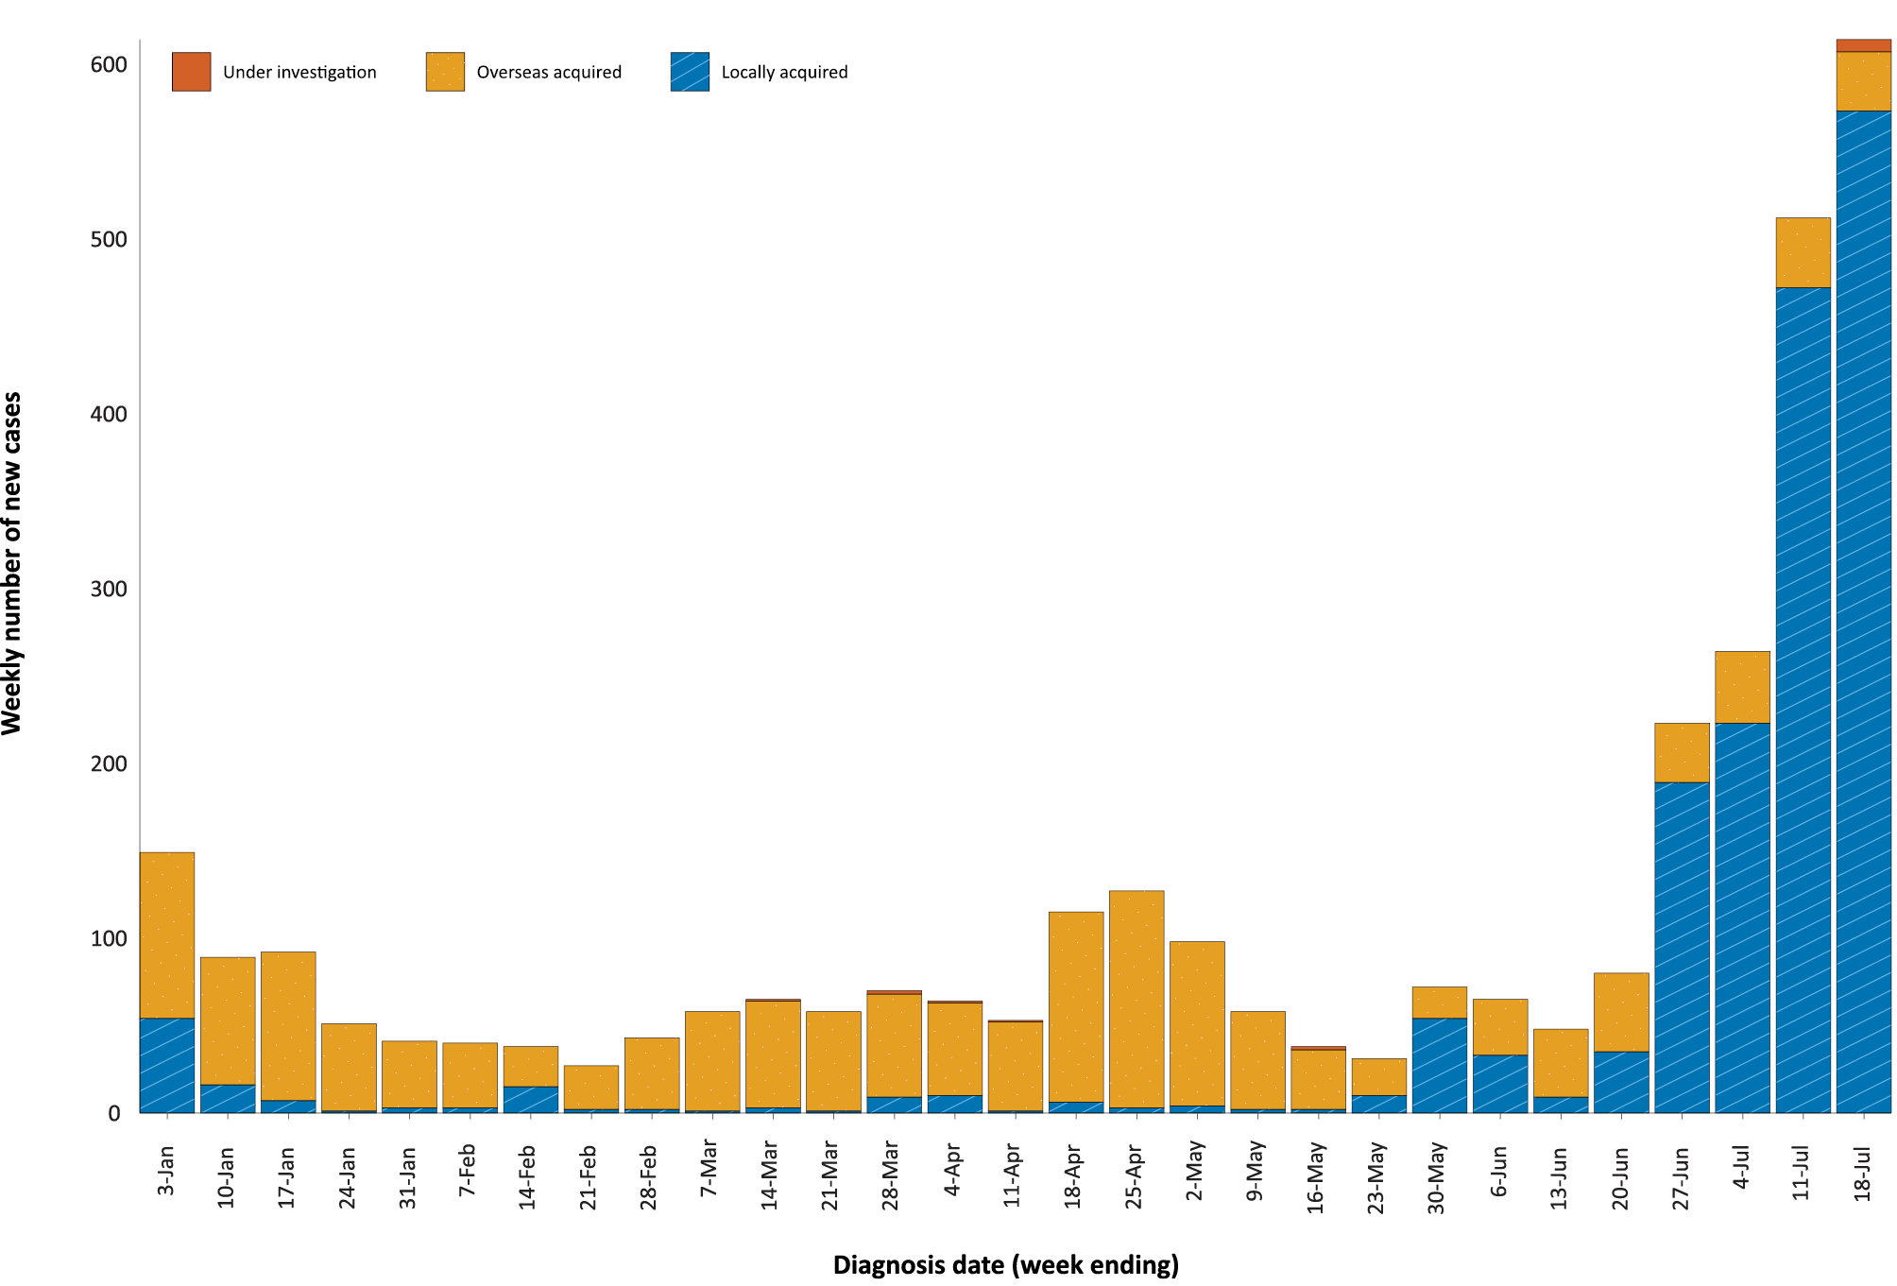
a Source: NNDSS, extract from 20 July 2021 for notifications to 18 July 2021.
This year, until the week ending 20 June 2021, the number of weekly cases diagnosed remained below 180 cases per week. While there has been an increase in cases since mid-June 2021, cases in 2021 have remained low in contrast to the two distinct peaks experienced in March and July of 2020, when the number of weekly cases diagnosed reached approximately 2,700 and 3,000 respectively (Figure 2). Cumulatively, since the beginning of the epidemic in Australia, there have been 31,675 COVID-19 cases reported in Australia.

Figure 2: Cumulative COVID-19 notified cases by source of acquisition and diagnosis date, 2 March 2020 – 18 July 2021ª
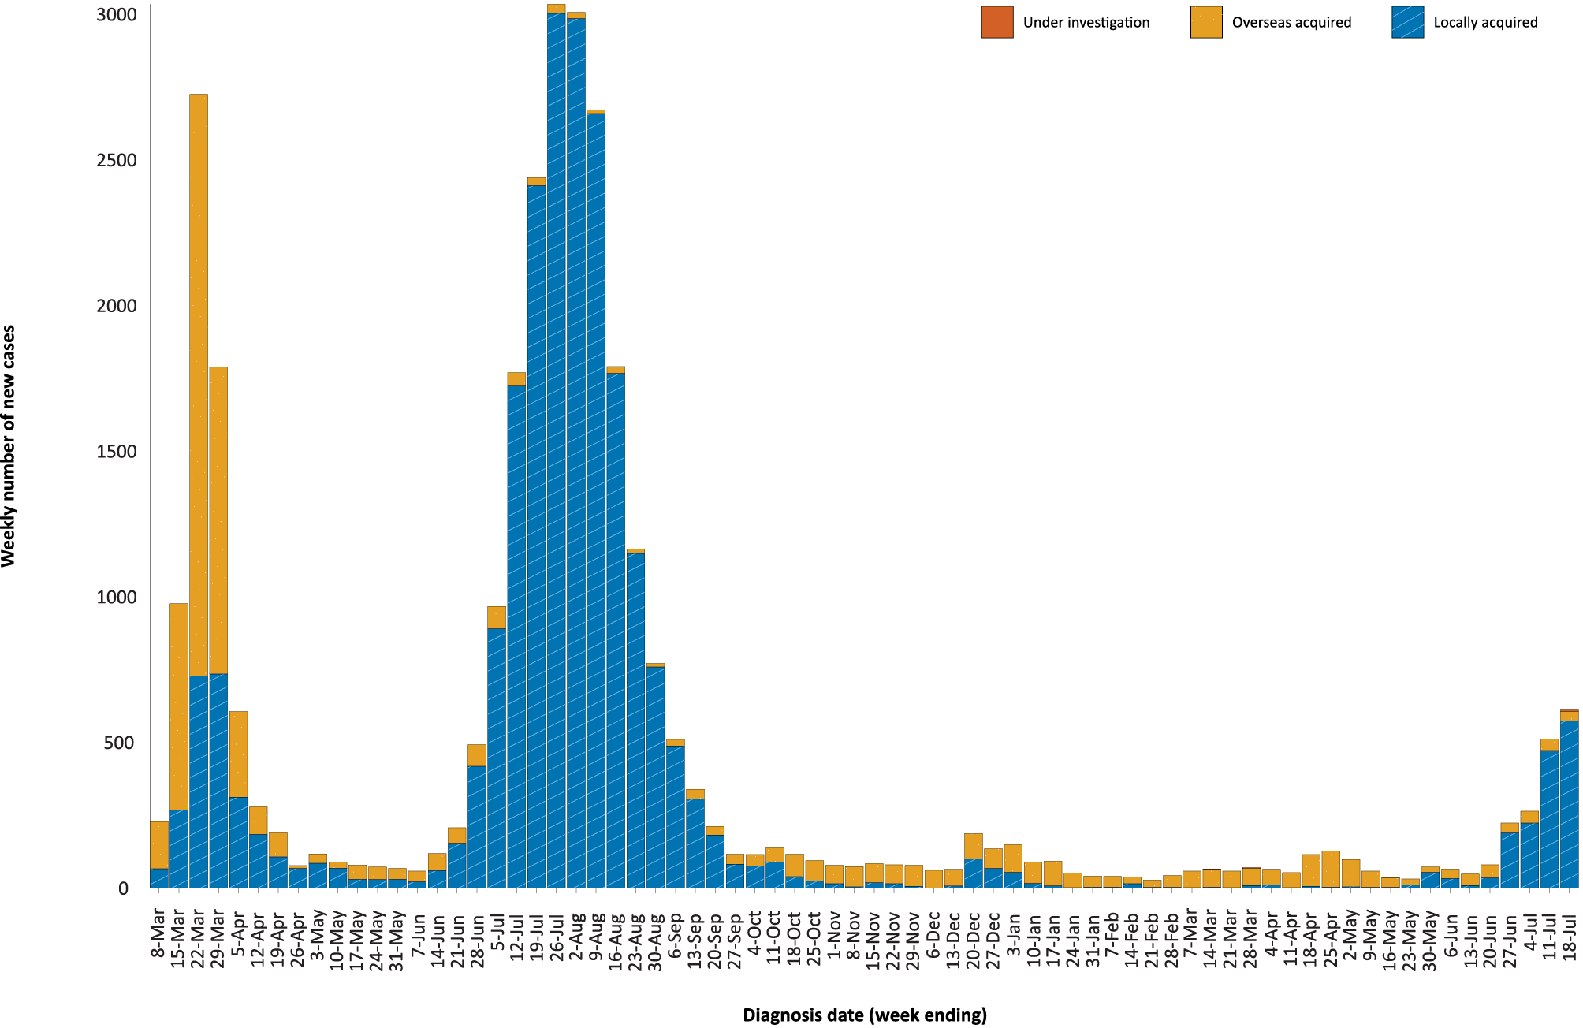
a Source: NNDSS, extract from 20 July 2021 for notifications to 18 July 2021.

Source of acquisition

(NNDSS)
In this reporting period, 92% (1,118/1,213) of cases notified were locally acquired and 7% (84/1,213) were overseas-acquired. At the end of the reporting period, there were 11 cases under investigation, all from New South Wales (Table 1).
New South Wales reported the majority of locally-acquired cases (92%; 1,031/1,118) in this fortnight, followed by Victoria (7%; 74/1,118). In the reporting period, 81% (903/1,118) of locally-acquired cases had a known contact or link to a cluster; two cases, one each in New South Wales and Queensland, had an unknown source; and, at the end of the reporting period, the source of infection was under investigation for 213 cases from New South Wales.
For 2021 to date, New South Wales had the highest infection rate for locally-acquired cases with 17.17 infections per 100,000 population, followed by the Northern Territory with a rate of 4.07 infections per 100,000 population (Table 2). Based on cases notified up to 18 July 2021, both the Australian Capital Territory and Tasmania reported that it had been more than a year since the last locally-acquired case within either jurisdiction (Table 3).

Table 2: Locally-acquired COVID-19 case numbers and rates per 100,000 population by jurisdiction and reporting period, Australia, with a notification received date from 1 January to 18 July 2021ª
Jurisdiction | Reporting period  5–18 July 2021 | Reporting period  21 June – 4 July 2021 | Cases this year  1 January – 18 July 2021b
 | Number of cases^{b} | Number of cases^{b} | Number of cases^{b} | Rate per 100,000 population^{c}
ACT | 0 | 0 | 0 | —
NSW | 1,031 | 307 | 1,402 | 17.17
NT | 2 | 8 | 10 | 4.07
Qld | 8 | 28 | 66 | 1.28
SA | 0 | 6 | 6 | 0.34
Tas. | 0 | 0 | 0 | —
Vic. | 74 | 6 | 238 | 3.55
WA | 3 | 3 | 15 | 0.56
Australia | 1,118 | 358 | 1,737 | 6.76
a Source: NNDSS, data extract from 20 July 2021 for notifications to 18 July 2021.
b This total does not include cases that are under initial investigation.
c Population data based on Australian Bureau of Statistics (ABS) Estimated Resident Population (ERP) as at June 2020.
Table 3: Days since last locally-acquired COVID-19 case (source unknown and source known), by jurisdiction and diagnosis date, 18 July 2021ª
Jurisdiction | Locally acquired — source unknown^{b} |  | Locally acquired — source known^{b}
 | Date of last case | Days since last case | Date of last case | Days since last case
ACT | 21 March 2020 | 484 | 7 July 2020 | 376
NSW | 18 July 2021 | 0 | 18 July 2021 | 0
NT | NA^{c} | NA^{c} | 6 July 2020 | 12
Qld | 13 July 2021 | 5 | 14 July 2021 | 4
SA | 24 March 2020 | 481 | 30 June 2021 | 18
Tas. | 9 August 2020 | 343 | 24 April 2020 | 450
Vic. | 31 May 2021 | 48 | 18 July 2021 | 0
WA | 3 Apr 2020 | 471 | 2 July 2021 | 16
a Source: NNDSS, extract from 20 July 2021 for notifications to 18 July 2021.
b This does not include locally-acquired cases that were interstate acquired.
c NA: not applicable. The Northern Territory has not reported any locally-acquired cases with an unknown source of infection.
New South Wales reported the largest number of cases (36%; 30/84) that were overseas acquired, followed by Queensland (26%; 22/84) and Victoria (13%; 11/84). In the past 28 days (21 June to 18 July 2021), 29% (45/154) of overseas-acquired cases reported an unknown country of acquisition. Where country of acquisition was known, Indonesia was the most commonly-reported country (15%; 16/109), followed by Afghanistan (14%; 15/109) and South Africa (11%; 12/109). The number of cases acquired in different countries is influenced by travel patterns of returning Australians, travel restrictions, and the prevalence of COVID-19 in the country of travel.

Demographic features

(NNDSS)
In this reporting period, the largest proportion of cases occurred in those aged 20 to 29 years (24%; 286/1,213). For this year, the highest rate of infection was in those aged 20 to 29 years with a rate of 18.3 infections per 100,000 population (Figure 3; Appendix A, Table A.1). Adults aged 80 to 89 years had the lowest rate of infection this year.
Figure 3: Cumulative COVID-19 cases for the calendar year to date, by age group and sex, Australia, with a diagnosis date of 1 January 2021 – 18 July 2021ª
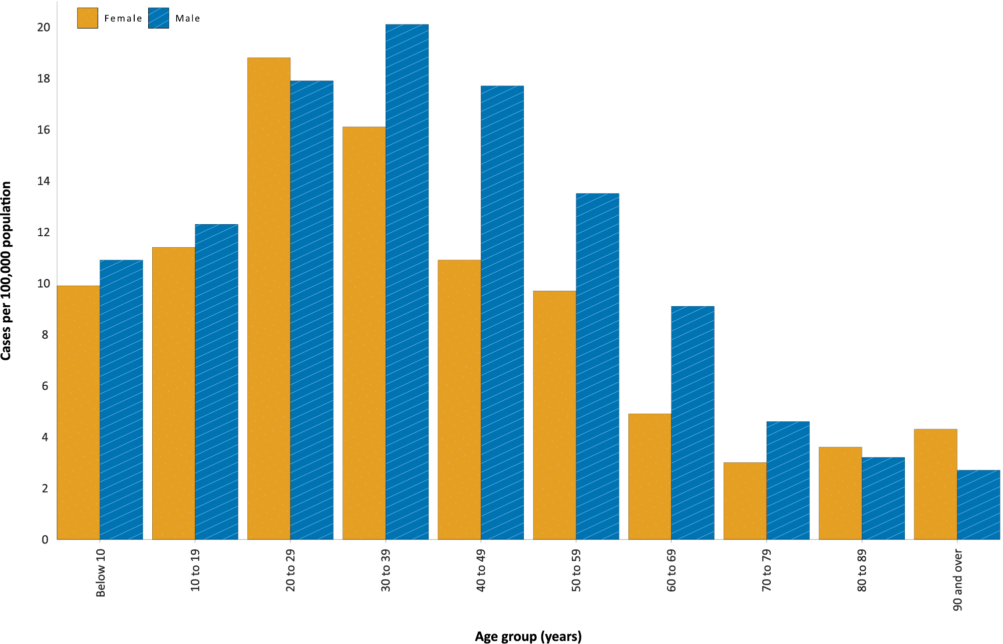
a Source: NNDSS, extract from 20 July 2021 for notifications to 18 July 2021.
In 2021, notification rates were higher in males than in females for all age groups except those aged 20 to 29 years old and aged 80 years and above (Figure 3). The largest proportional difference by sex, in rates this year, was in the 60 to 69 years age group, where the cumulative rate among males was 9.1 cases per 100,000 population and among females was 4.9 cases per 100,000 population (Appendix A, Table A.1). The median age of cases in this reporting period was 29 years (range: 0 to 93 years; interquartile range, IQR: 19 to 48 years).

Aboriginal and Torres Strait Islander persons

(NNDSS)
Since the beginning of 2021, there have been 17 confirmed cases of COVID-19 notified in Aboriginal and Torres Strait Islander people, representing 0.5% (17/3,269) of all confirmed cases this year. During the reporting period, seven new Aboriginal and Torres Strait Islander cases were notified, all of which were from New South Wales.
As at 18 July 2021, it has been five days since the last locally-acquired Aboriginal and Torres Strait Islander case was diagnosed and 105 days since the last overseas-acquired Aboriginal and Torres Strait Islander case was diagnosed. The majority of Aboriginal and Torres Strait Islander cases in 2021 have been reported as locally acquired (71%; 12/17), with four cases overseas acquired and one case whose source of infection was under investigation at the end of the reporting period. The median age of all Aboriginal and Torres Strait Islander cases this year is 31 years old (range: 3 to 66 years; IQR: 20 to 51 years) and there have been nearly double the number of cases in males (65%; 11/17) than in females (35%; 6/17) cases in this population.

Vaccinations

(Department of Health)
As of 18 July 2021, a total of 10,125,533 doses of COVID-19 vaccine had been administered (Table 4), including 481,811 doses provided to aged care and disability residents.
Table 4: Total number of vaccinations administered, by jurisdiction, Australia, 18 July 2021ª
Jurisdiction | Total number of doses administered
ACT | 110,962
NSW | 1,188,887
NT | 77,966
Qld | 777,596
SA | 319,494
Tas. | 141,418
Vic. | 1,392,522
WA | 405,581
Aged care and disability facilities^{b} | 481,811
Primary care^{c} | 5,229,296
Total | 10,125,533
a Source: Australian Government Department of Health website.⁴
b Commonwealth vaccine doses administered in aged care and disability facilities.
c Commonwealth vaccine doses administered in primary care settings.

Clusters and outbreaks

Sydney Metropolitan Outbreak
Nearly all locally-acquired cases notified in New South Wales in the reporting period were linked to the ongoing outbreak in metropolitan Sydney. The first case in the cluster, reported on 16 June 2021, was a driver transporting international flight crew. Genomic testing results showed that this case was infected with the Delta SARS-CoV-2 variant of concern (B.1.617.2); however, the sequence did not match cases from the Victorian Delta variant outbreak that occurred from May to June 2021. This sequence had not been seen in Australia previously, but matches one from the United States of America.
As at 18 July 2021, there have been 1,340 locally-acquired cases in New South Wales, including 5 deaths, reported following notification of the first case of the Bondi cluster on 16 June 2021. Several interstate-acquired cases have also been linked to this cluster, including 74 in Victoria, six in Western Australia, and four in Queensland.

Victoria
In the reporting period, there were two outbreaks of the Delta variant associated with travellers from New South Wales to Victoria: the Coolaroo Community Outbreak and Maribyrnong Community Outbreak. The first cases in the Coolaroo outbreak, reported on 13 and 14 July 2021, were among a family of four that had returned from Greater Sydney on a red zone permit. As at 18 July 2021, there were ten cases linked to this outbreak.
The Maribyrnong outbreak was first reported on 14 July 2021, with several cases linked to removalists from Greater Sydney who delivered furniture to an apartment in western Melbourne on 8 July 2021. As at 18 July 2021, there were 62 cases linked to this outbreak. These cases were part of several interconnected outbreaks associated with the apartment complex initially visited by the removalists.

Queensland
The Queensland Alpha cluster continued to grow during this reporting period. The first case in this cluster was reported on 20 June 2021, and was an international flight crew member who tested positive in the community after completing hotel quarantine. Genomic testing has linked this case to other international aircrew with the Alpha variant of concern (B.1.1.7), quarantining in the same hotel quarantine facility. There have been several genomically-linked outbreaks within this cluster. As at 18 July 2021, 29 community detected cases were reported as part of this cluster.
Other locally-acquired cases reported in Queensland during this reporting period were part of two separate clusters: a family cluster, linked to a case who acquired their infection in New South Wales; and the Brisbane International Airport Delta cluster, which was first reported on 30 June 2021.

Northern Territory mine outbreak
The Northern Territory Gold Mine cluster grew by two cases during the reporting period. The cluster was first reported on 26 June 2021, with the first case acquiring their infection in hotel quarantine in Queensland. Ten locally-acquired cases from the Northern Territory were associated with this cluster. Several interstate-acquired cases were linked to the cluster, including six in South Australia, two in Queensland and one in New South Wales. The Queensland and New South Wales cases were identified as infected with the Delta SARS-CoV-2 variant. As at 18 July 2021, there have been 19 cases reported as part of this cluster, with the last cases reported on 9 July 2021.

Four-week reporting period (21 June – 18 July 2021)

Genomic surveillance and virology

(Communicable Disease Genomics Network, AusTrakka and jurisdictional sequencing laboratories)
Nationally, laboratories have sequenced SARS-CoV-2 strains from 61% of COVID-19 cases during the pandemic (Table 5, Figure 4).
Table 5: Australian SARS-CoV-2 genome sequences and proportion of positive cases sequenced, 21 June – 18 July 2021 and cumulative to date
Measure | Reporting period  21 June – 18 July 2021 | Cumulative  23 January 2020 – 18 July 2021
SARS-CoV-2 cases sequencedª | 822 | 19,591
Percentage of positive cases sequenced^{b} | 51% | 61%
a Based on individual jurisdictional reports of sequences and case numbers. Calculations of the percentage of cases sequenced based on the number of sequences available in AusTrakka may not always be up-to-date, since this may include duplicate samples from cases and may not represent all available sequence data.
b In most jurisdictions, sequencing has been attempted on all suitable samples (one sample per case). Sequencing of samples from cases identified in the reporting period may be in process at the time of reporting. Remaining unsequenced samples may be due to jurisdictional sequencing strategy, or where samples have been deemed unsuitable for sequencing (typically, because viral loads were too low for sequencing to be successful).

Figure 4: Samples in AusTrakka from 1 February to 18 July 2021, by lineage and date of collectionª
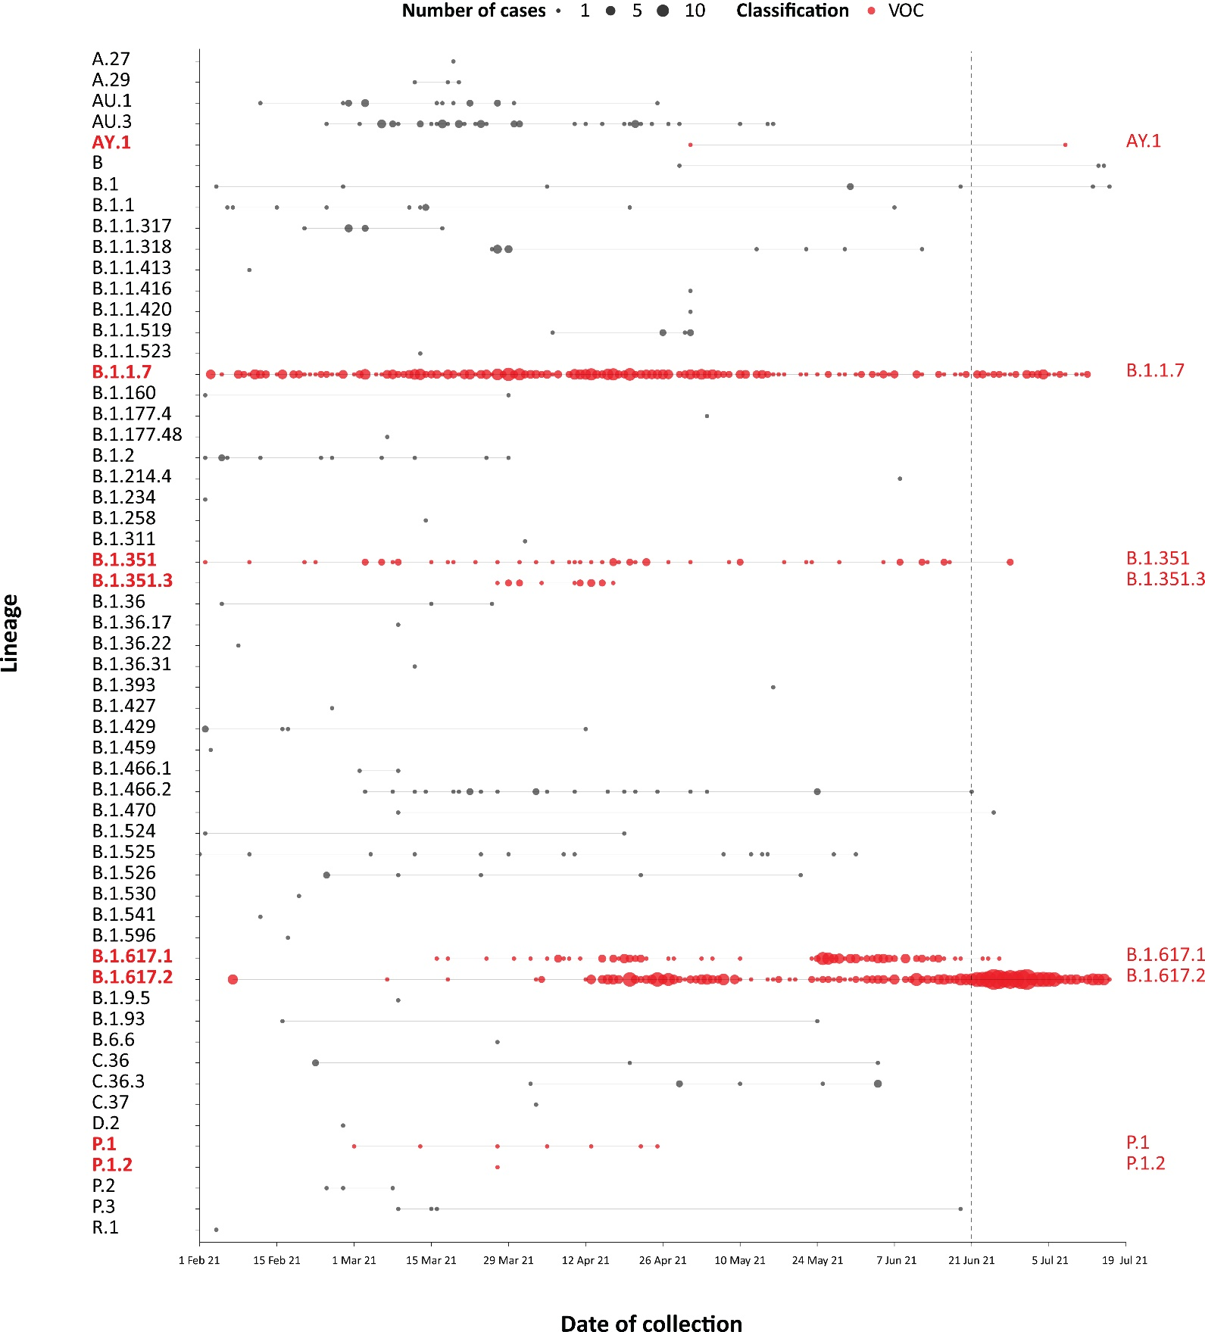
a The start of the current reporting period (21 June – 18 July 2021) is marked by the dotted line, and variant-of-concern samples are coloured red. The size of the circle is proportional to the number of samples in the lineage at each time point.

Variants of concern
AusTrakka actively monitors and reports on SARS-CoV-2 lineages designated Variants of Concern (VOC) by international organisations, including the World Health Organization (WHO): B.1.1.7; B.1.351; P.1; and B.1.617 (and the latter’s sublineages B.1.617.1, B.1.617.2 and B.1.617.3) (Table 6). These variants all display characteristic sets of mutation, including a number of variations in the genomic region encoding the spike protein thought to have the potential to increase transmissibility and/or immune evasion.⁶ On 1 June 2021, WHO announced a new nomenclature system for VOCs, using letters of the Greek alphabet,⁷ to facilitate communication and reduce stigmatisation associated with geography-based colloquial terms.
Further information on variants is available in the Technical Supplement.³
Table 6: Australian SARS-CoV-2 genome sequences in AusTrakka identified as variants of concern, 23 January 2020 – 18 July 2021
VOC lineage | Number of samples
B.1.1.7 (Alpha) | 507
B.1.351 (Beta) | 90
P.1 (Gamma) | 7
B.1.617.1 (Kappa) | 127
B.1.617.2 (Delta) | 720

Testing

(State and territory reporting)
As at 16 July 2021, a cumulative total of 8,238,233 individuals have undergone diagnostic testing for SARS-CoV-2 in Australia this year since 1 January 2021. The cumulative nationwide proportion of positive tests for 2021 remains low at 0.04% (3,077/8,238,233) (Table 7).

Table 7: Individuals undergoing diagnostic tests for SARS-CoV-2,ª by jurisdiction and reporting period, with a notification received date of 1 January – 16 July 2021
Jurisdiction | Individuals tested |  |  | Individuals tested |  |  | Cumulative individuals tested
 | 3–16 July 2021 |  |  | 19 June – 2 July 2021 |  |  | in 2021 to 16 July
 | n | Positivity (%) | Per 1,000 population^{b} | n | Positivity  (%) | Per 1,000 population^{b} | n | Positivity  (%) | Per 1,000 population^{b}
ACT | 13,690 | – | 31.75 | 17,684 | – | 41.02 | 122,055 | <0.01 | 283.12
NSW^{c} | Not available | NA^{d} | NA^{d} | Not available | NA^{d} | NA^{d} | 2,275,711 | 0.08 | 278.75
NT | 15,651 | 0.04 | 63.63 | 17,457 | 0.05 | 70.97 | 131,466 | 0.08 | 534.46
Qld | 71,838 | 0.04 | 13.88 | 115,951 | 0.04 | 22.41 | 629,185 | 0.06 | 121.59
SA | 97,990 | 0.01 | 55.38 | 89,258 | 0.02 | 50.45 | 716,116 | 0.02 | 404.74
Tas. | 13,512 | – | 25.00 | 13,199 | – | 24.42 | 123,985 | – | 229.36
Vic. | 356,864 | 0.02 | 53.30 | 294,271 | 0.01 | 43.95 | 3,582,175 | 0.01 | 535.06
WA | 69,512 | 0.01 | 26.11 | 97,673 | 0.01 | 36.69 | 657,540 | 0.02 | 247.02
Australia^{c} | 639,057 | 0.02 | 36.47 | 645,493 | 0.02 | 36.84 | 8,238,233 | 0.04 | 320.72
a In order to more accurately reflect positivity rates, numbers of individuals tested is presented rather than total number of tests.
b Population data based on Australian Bureau of Statistics (ABS) Estimated Resident Population (ERP) as at June 2020.
c From 19 June 2021 onward, data for New South Wales were unavailable. Given this, New South Wales has been excluded from the national calculations for percent positivity and testing rate per 1,000 population for the two latest fortnights.
d NA: not applicable.
During this four-week reporting period, excluding New South Wales, over one million individuals were tested nationally, with a positivity rate of 0.02%. Jurisdictional testing rates are driven by both current case numbers and numbers of people experiencing symptoms. The low national positivity rate, along with high rates of testing, indicates a low incidence of COVID-19 nationally. Data on the number of individuals tested in New South Wales in the reporting period was not available. However, the total number of tests in New South Wales in the reporting period was 1,387,307.
Testing rates increased in all age groups in the week ending 16 July 2021, following a decline in testing rates across most age groups in the first three weeks of this four-weekly reporting period (Figure 5). Those aged 20 to 39 years continued to have the highest rates of testing, followed by those aged 40 to 59 years old.

Figure 5: SARS-CoV-2 polymerase chain reaction (PCR) testing rates per 1,000 population per week by age group and notification received date, Australia, 1 January 2021 – 16 July 2021^{a,b,c}
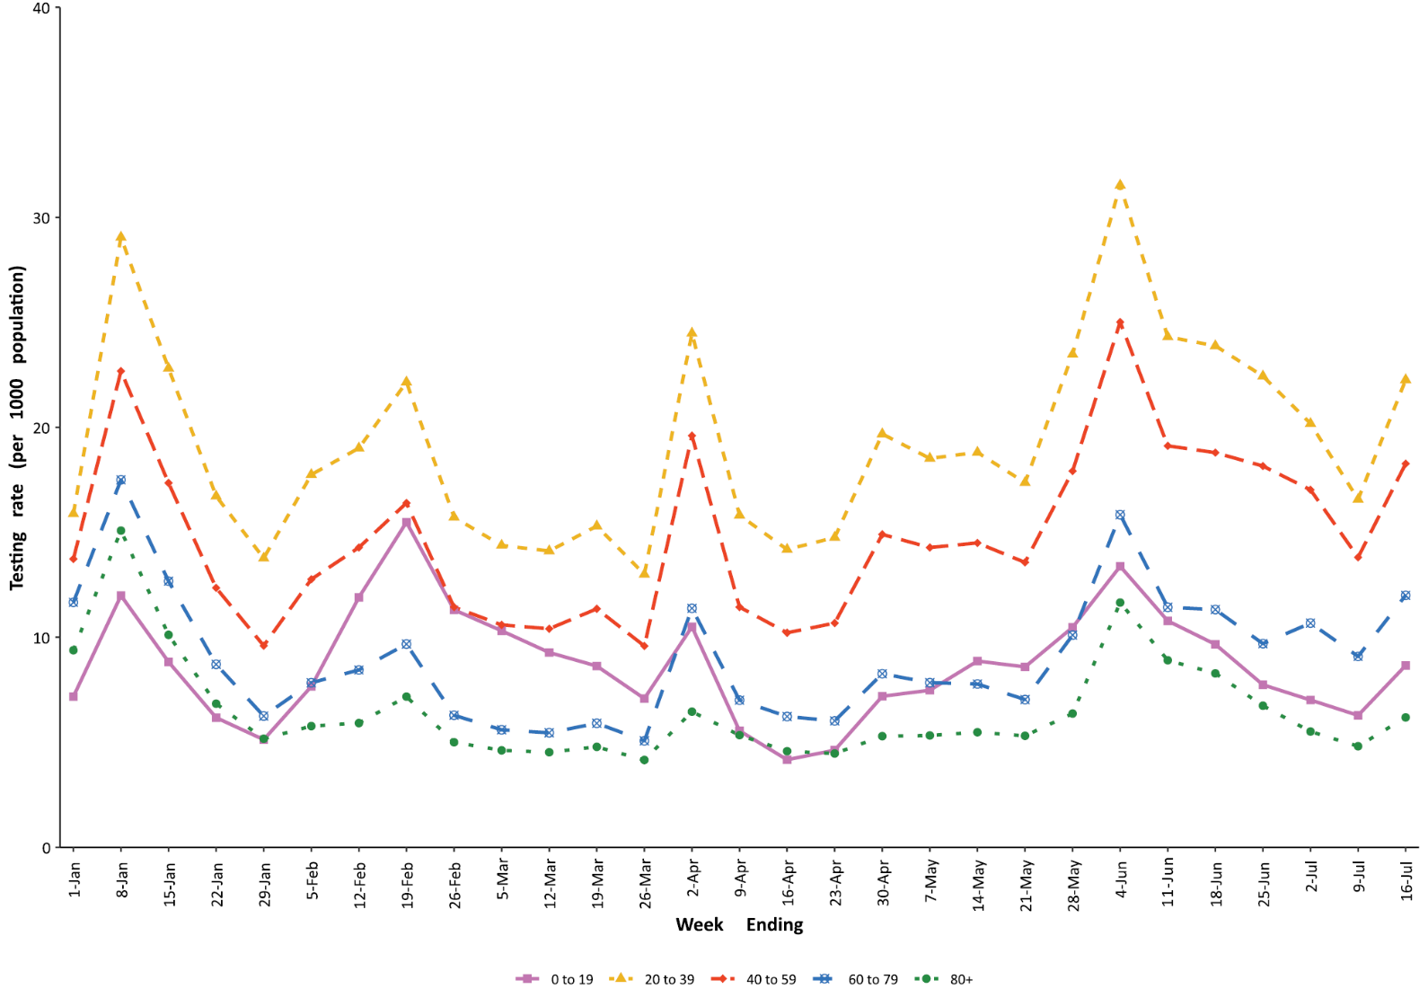
a Source: data provided by jurisdictions to the NIR weekly, current to 16 July 2021.
b The jurisdictions reporting each week (i.e. the denominator population) may vary.
c From 19 June 2021 onward, data for New South Wales were unavailable.

Acute respiratory illness

(FluTracking, ASPREN and Commonwealth Respiratory Clinics)
Based on self-reported FluTracking data,⁸ prevalence of fever and cough in the community remained at < 1.0%, with an overall decrease in this four-week reporting period compared to the previous four-week reporting period (Figure 6). Runny nose and sore throat symptoms in the community also decreased during this reporting period compared to the previous four weeks, with the prevalence in the community remaining low at < 1.0%.

Figure 6: Weekly trends in respiratory illness amongst FluTracking survey participants (age-standardised) compared to the average of the previous five years, Australia, by epidemiological week,ª 1 March 2020 – 18 July 2021^{b}
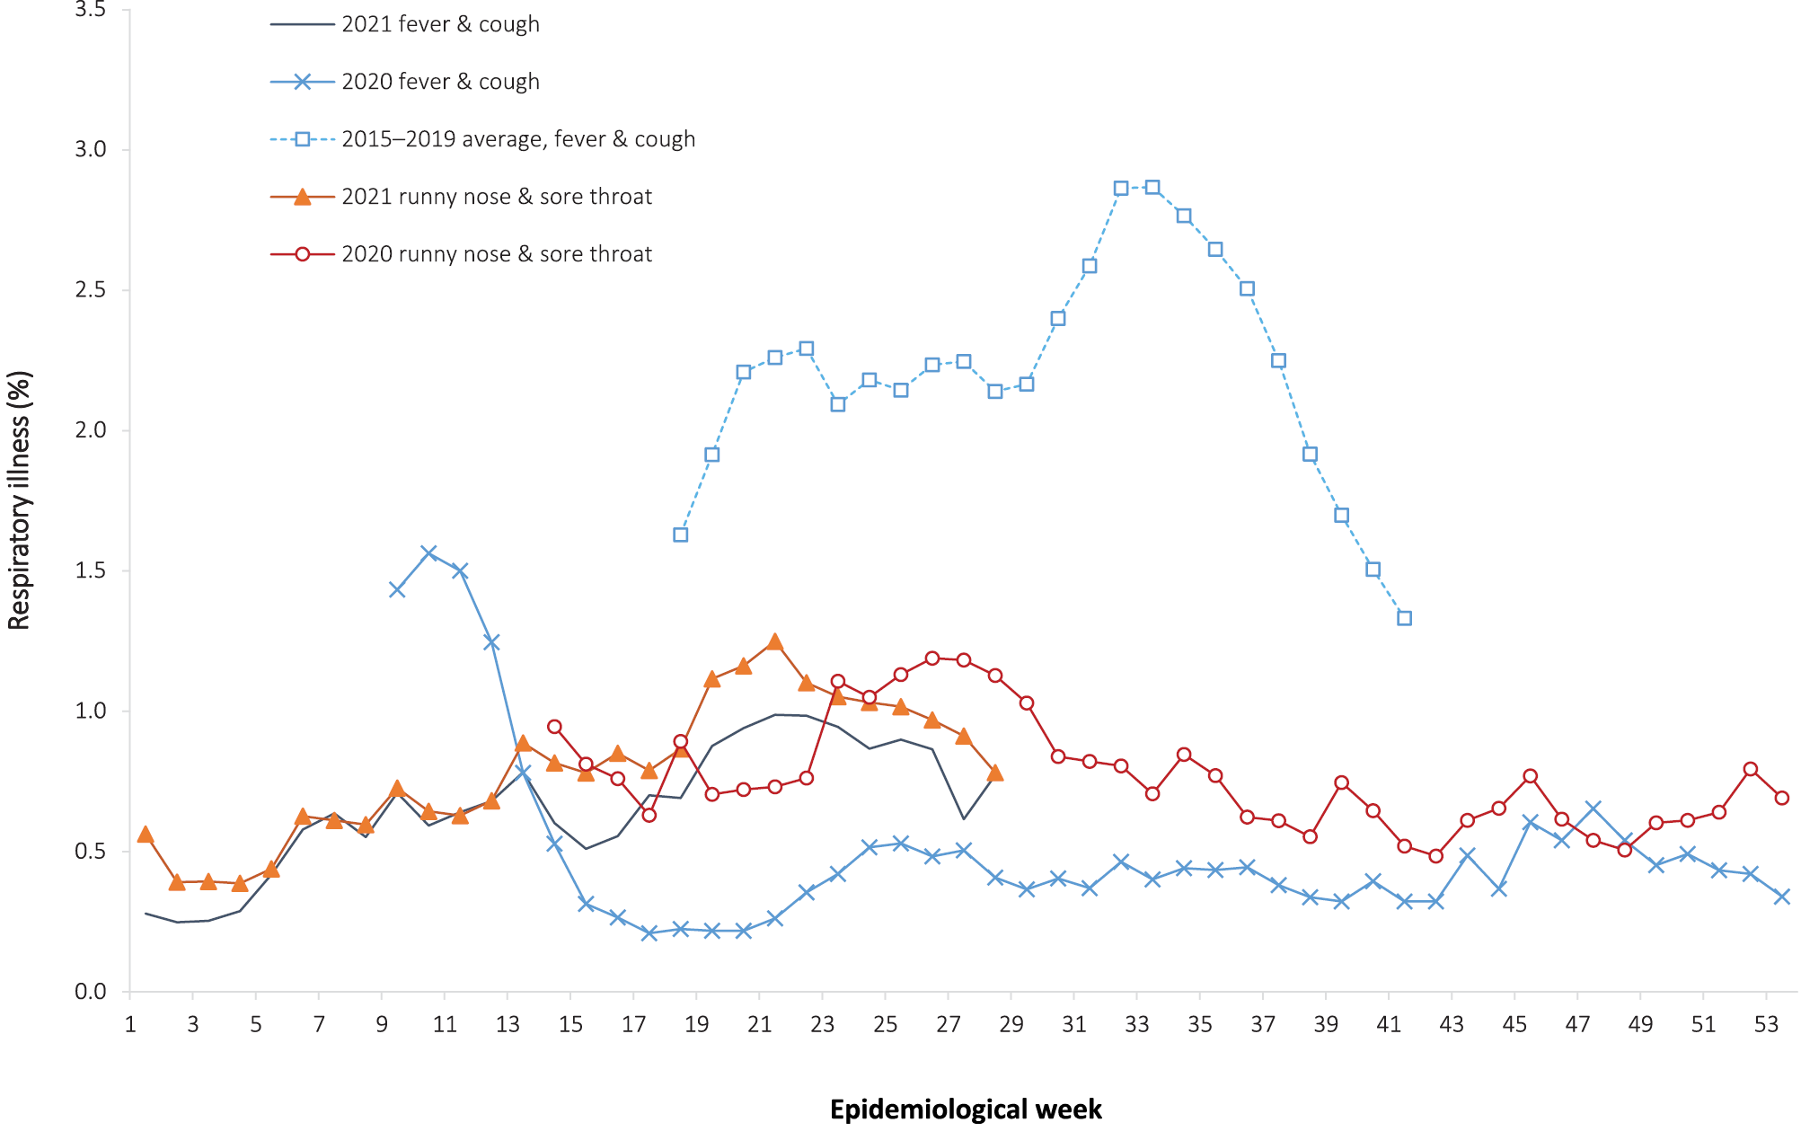
a Epidemiological weeks are a standardised method for numbering weeks across years, with the first epidemiological week of any year ending on the first Saturday in January.
b In years prior to 2020, FluTracking was activated during the main Influenza season from May to October. A historical average beyond the week ending 11 October (epidemiological week 41) is therefore not available. In 2020, FluTracking commenced ten weeks early to capture data for COVID-19. Data on runny nose and sore throat were only collected systematically after 29 March 2020, therefore a historical average for this symptom profile is unavailable.
In this reporting period, acute respiratory illness was highest in those aged under ten years old, based on both self-reported FluTracking data and presentations to Commonwealth Respiratory Clinics. Females reported respiratory illness more frequently than males. Rates of fever and cough by jurisdiction ranged from 3.5/1,000 FluTracking participants in Victoria to 6.7/1,000 participants in the Australian Capital Territory.
FluTracking data indicated that 54.1% of those in the community with ‘fever and cough’ and 38.9% of those with ‘runny nose and sore throat’ were tested for SARS-CoV-2. This represents an increase in SARS-CoV-2 testing for both ‘fever and cough’ and ‘sore throat and runny nose’ since the previous reporting period. In the four-week reporting period, testing rates were highest in New South Wales for both ‘fever and cough’ and ‘sore throat’, and lowest in Western Australia for both sets of symptoms. It is important to acknowledge that there may be legitimate reasons why people did not get tested, including barriers to accessing testing. Symptoms reported to FluTracking were not specific to COVID-19 and may also be due to chronic diseases.
During this reporting period, there were 129,104 assessments at Commonwealth Respiratory Clinics. Of these, there were 118,844 assessments with consent to share information, with 89.03% (105,807/118,844) tested for SARS-CoV-2. There were 25 cases reported at these clinics in this reporting period, representing a percent positivity of 0.02% (25/105,807).
Among those tested through the Australian Sentinel Practice Research Network (ASPREN) and Victorian Sentinel Practice Influenza Network (VicSPIN) general practitioner sentinel surveillance systems, parainfluenza was the most common respiratory virus detected in patients presenting with influenza-like illness in this reporting period.

Severity
(NNDSS, FluCAN, SPRINT-SARI)

Hospitalisation and intensive care unit admission
In 2021, for cases where hospitalisation and intensive care unit (ICU) data were reliable and complete, the estimated hospitalisation rate was 9.9% of cases, and the estimated ICU admission rate was 2.5% of cases (Table 8). This is based on data from five states/territories that have reliable data across both hospitalisation and ICU data fields in the NNDSS, and who do not routinely hospitalise cases for isolation purposes (Australian Capital Territory, New South Wales, South Australia, Tasmania, Victoria).
Table 8: Numbers of COVID-19 case hospitalisations and admissions to ICU due to COVID-19, 1 January 2021 – 18 July 2021^{a,b}
Age group | Cases |  | Hospitalisations |  | ICU admission
 | Total | Cases with hospital data | n | Cases hospitalised (%) | n | Cases admitted to ICU (%)
0–9 | 281 | 217 | 5 | 2% | 0 | 0.0%
10–19 | 344 | 270 | 12 | 4% | 2 | 0.7%
20–29 | 551 | 444 | 26 | 6% | 3 | 0.7%
30–39 | 521 | 442 | 22 | 5% | 8 | 1.8%
40–49 | 371 | 319 | 34 | 11% | 7 | 2.2%
50–59 | 280 | 233 | 40 | 17% | 9 | 3.9%
60–69 | 140 | 114 | 30 | 26% | 15 | 13.2%
70–79 | 59 | 50 | 19 | 38% | 5 | 10.0%
80–89 | 28 | 23 | 16 | 70% | 3 | 13.0%
90+ | 8 | 7 | 5 | 71% | 0 | 0.0%
Total | 2,583 | 2,119 | 209 | 9.9% | 52 | 2.5%
a Source: NNDSS, extract from 20 July 2021, based on notification received date.
b Data included from five jurisdictions with the most reliable data across both hospital and ICU data fields: Australian Capital Territory, New South Wales, South Australia, Tasmania, and Victoria. This is based on an assessment of data from SPRINT-SARI and NNDSS.
In the year to date to 18 July 2021, there have been 76 COVID-19 cases admitted to ICUs participating in the sentinel surveillance system, Short Period Incidence Study of Severe Acute Respiratory Infection (SPRINT-SARI),⁹ with 51 of these admitted during this reporting period (21 June – 18 July 2021).

Risk factors for severe disease
The hospitalisation rate for COVID-19 cases in the year to date has generally increased with advancing 10-year age bracket.
Comorbidity data extracted from SPRINT-SARI reflect the sickest patients with COVID-19 managed in ICU; data are therefore not generalisable to all cases (Table 9). In patients admitted to ICU with COVID-19 since 1 February 2021, the most prevalent comorbidity was diabetes, following by obesity (a body mass index of > 30 or over 120 kg). Of those patients admitted to ICU this year, 51% (37/73) had at least one comorbidity, and 49% (36/73) of patients had none of the listed comorbidities recorded.
Table 9: Comorbidities for adult COVID-19 cases (aged greater than or equal to 18 years) amongst those admitted to ICU, Australia, 1 February 2021 – 18 July 2021ª
Comorbidity | ICU casesª  (n = 75)  (%)
Cardiac disease (n = 72) | 4 (6)
Chronic respiratory condition (n = 72) ^{b} | 7 (10)
Diabetes (n = 73) | 21 (29)
Obesity (n = 71) | 15 (21)
Chronic renal disease (n = 72) | 2 (3)
Chronic neurological condition (n = 72) | 0 (0)
Malignancy (n = 72) | 0 (0)
Chronic liver disease (n = 72) | 3 (4)
Immunosuppression (n = 72) | 1 (1)
Number of specified comorbidities (n = 73) ^{c,d}
One or more | 37 (51)
Two or more | 12 (16)
Three or more | 3 (4)
No comorbidities | 36 (49)
a Source: SPRINT-SARI. Only includes adult cases (≥ 18 years old) and excludes those with missing data on comorbidities or where comorbidity is unknown.
b Includes asthma.
c Includes chronic respiratory conditions, cardiac disease (excluding hypertension), immunosuppressive condition/therapy, diabetes, obesity, liver disease, renal disease and neurological disorder.
d Excludes cases where comorbidity data is missing or unknown for all comorbidities.

COVID-19 deaths
In the past four weeks, there were five deaths associated with COVID-19, all from New South Wales. Overall, the crude case fatality rate (CFR) remains stable at 2.9% (Table 10). The ratio of deaths to cases in the year to date has decreased in comparison to this time last year, noting substantially lower case numbers this year and the difference in age distributions of those infected in 2021 versus 2020.

Table 10: Deaths associated with COVID-19 by reporting period, Australia, 1 January 2020 – 18 July 2021ª
 | Number of deaths^{b} | Crude case fatality rate
Reporting period 21 June – 18 July 2021 | 5/1,703 | 0.3%
Year to date (2021) 1 January – 18 July 2021 | 6/3,269 | 0.2%
Year to date (2020) 1 January – 18 July 2020 | 181/11,351 | 1.6%
Epidemic to date 1 January 2020 – 18 July 2021 | 915/31,675 | 2.9%
a Source: NNDSS, extract from 20 July 2021, based on notification received date.
b Expressed as deaths/case numbers.

Public health response measures
Since COVID-19 first emerged internationally, Australia implemented public health measures informed by the disease’s epidemiology (Figure 7). States and territories have decision-making authority in relation to public health measures and have implemented or eased restrictions at their own pace (Appendix A, Table A.2), depending on the local public health and epidemiological situation, and in line with the ‘Framework for National Reopening’.¹⁰ Nationwide requirements involving air travel remain, including pre-flight testing for travellers entering Australia; and requirements to wear face masks, when flying domestically or internationally, remain in place. During the current reporting period, community transmission occurred in New South Wales, Victoria, Queensland, South Australia, and Western Australia.
Figure 7: COVID-19 notifications in Australia by week of diagnosis and jurisdiction, 1 January – 18 July 2021, with timing of key public health measures
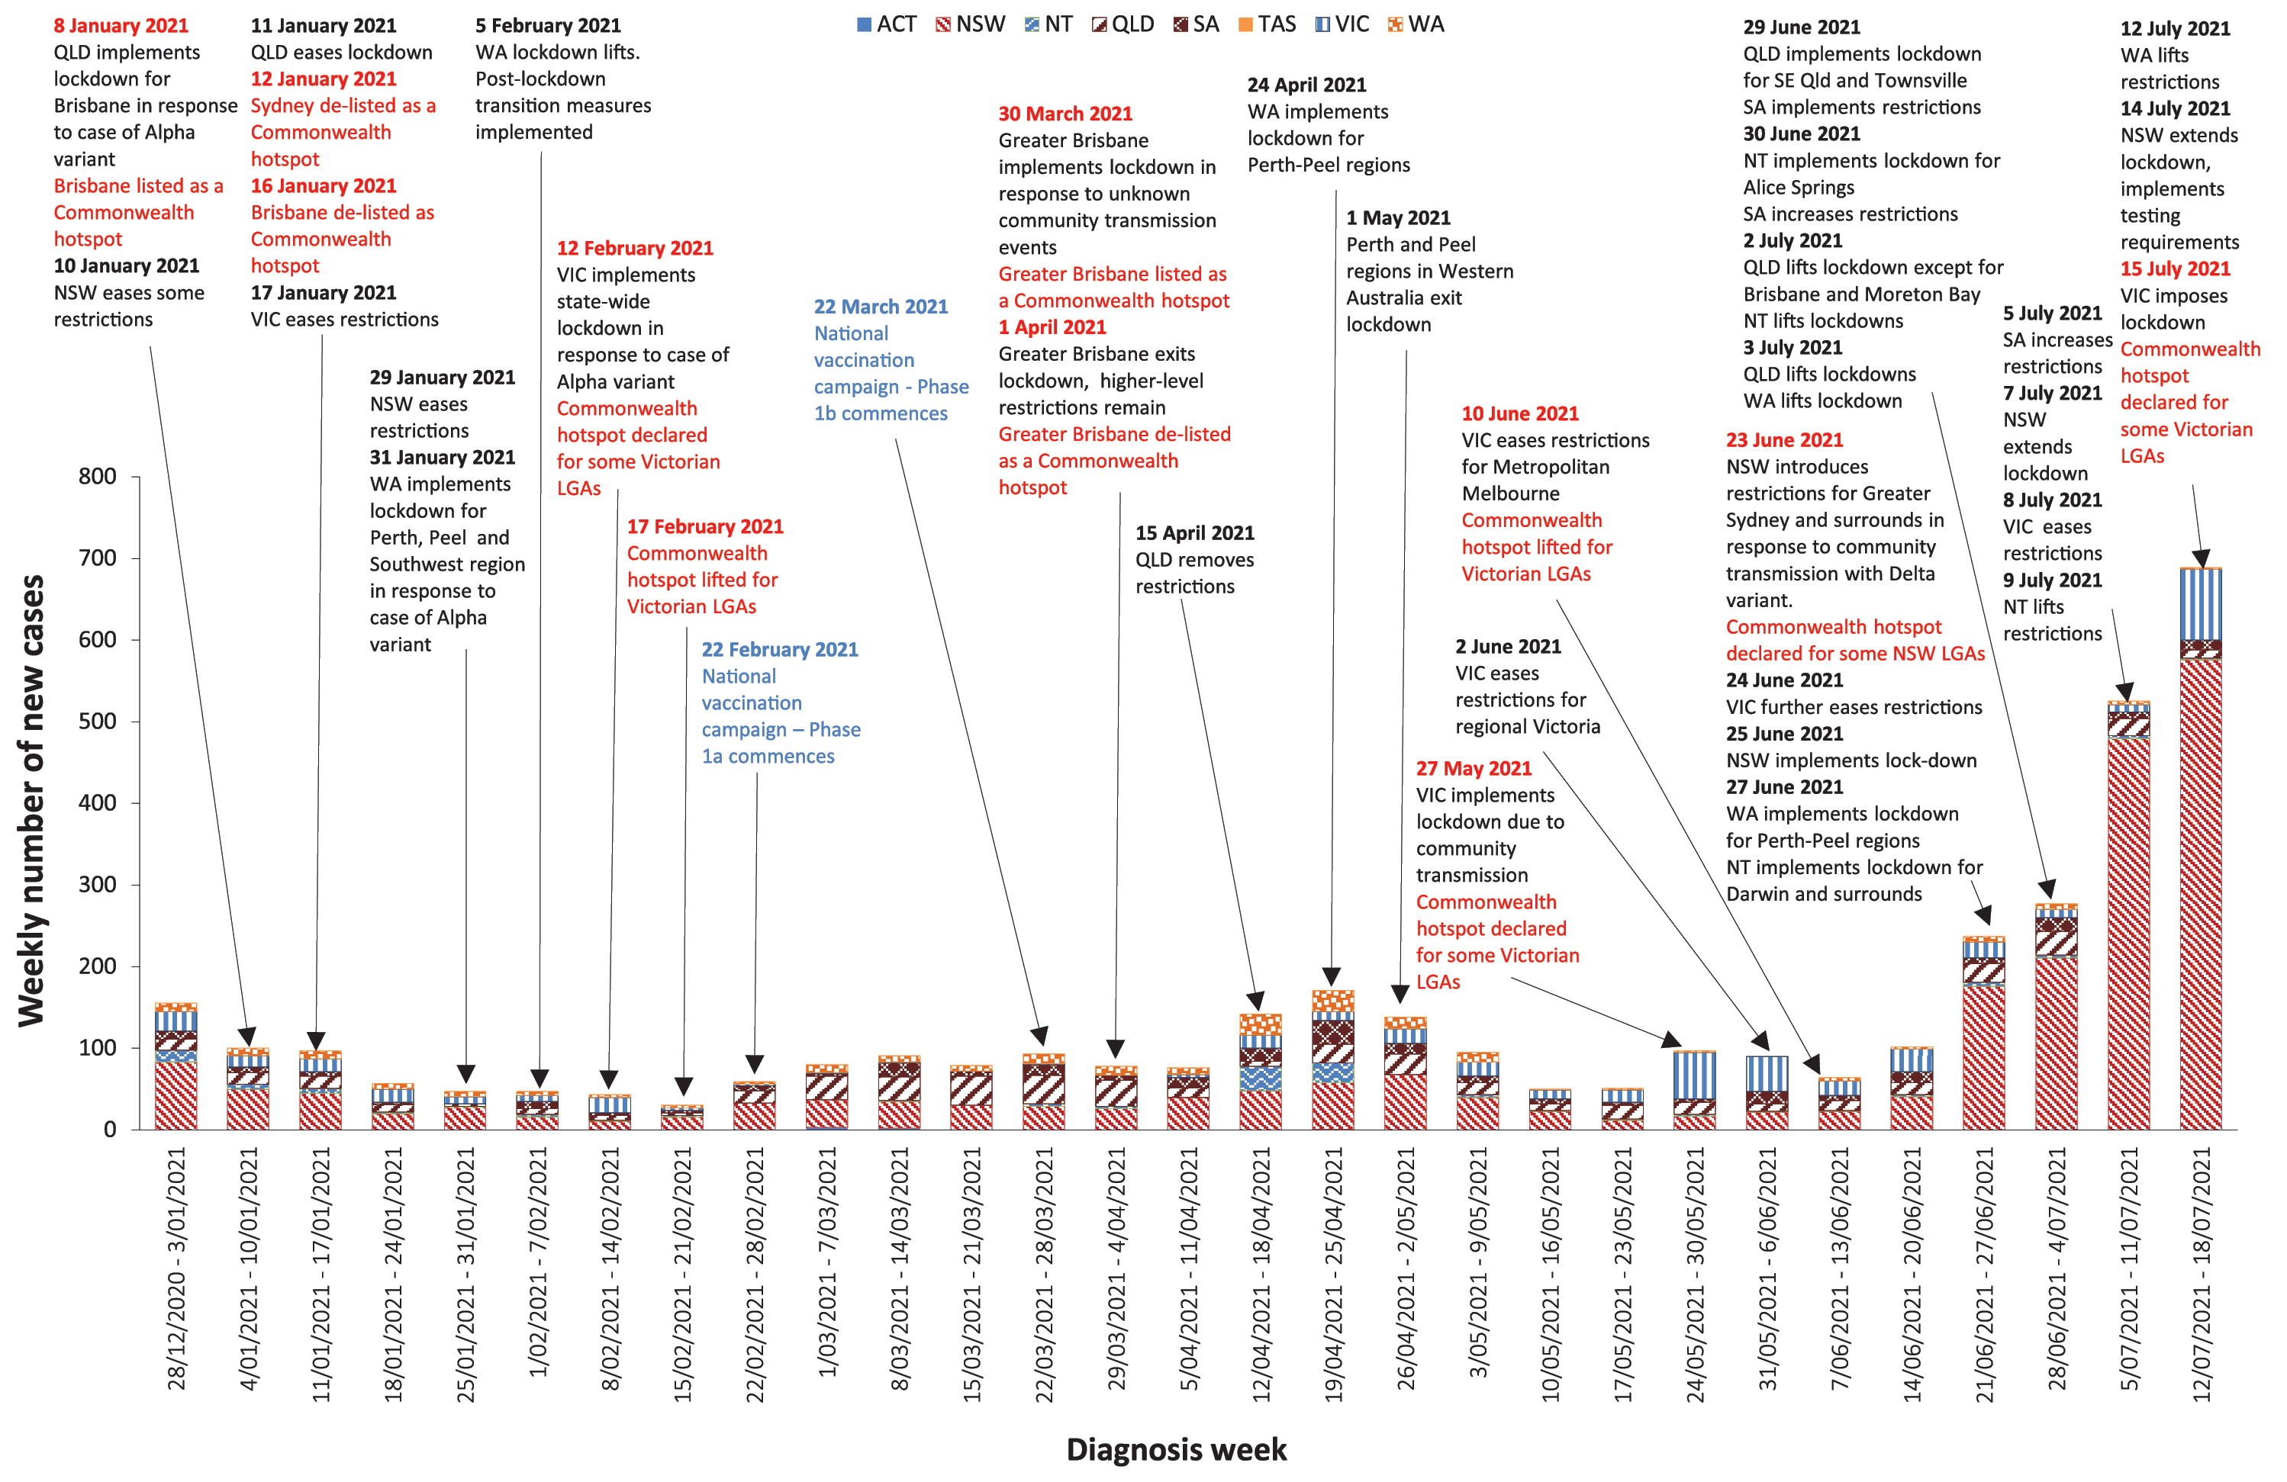

Countries and territories in Australia’s near region
According to WHO, countries and territories in the South East Asian (SEARO) and Western Pacific (WPRO) regions reported 3,311,070 newly-confirmed cases and 63,347 deaths in the four-week period to 22 July 2021, bringing the cumulative cases in the two regions to over 40 million, and cumulative deaths to 86,657.¹¹ Case numbers and death incidence continues to trend down in the South East Asian region, driven by decreasing cases in India. However, trends in other countries in the region continue to increase, notably Indonesia. Trends in the Western Pacific Region have increased from the previous monthly period due to sustained high levels of new cases and deaths in Malaysia, the Philippines and Japan.¹²
Table 11 outlines the current transmission classification set by WHO for Australia’s near region. Under WHO’s classification, Australia’s transmission classification remains at ‘clusters of cases’.
As of 22 July 2021, over 192 million COVID-19 cases and 4.1 million deaths have been reported globally, with a global CFR of 2.2%. The two regions reporting the largest burden of disease over the past four weeks were the Region of the Americas (35.3%) and the South East Asian Region (23.3%).
Table 11: Transmission patterns for countries in Australia’s near region according to WHO, 22 July 2021^{a,b}
Category | Country
No cases  Countries/territories/areas with no cases | American Samoa, Cook Islands, Democratic People’s Republic of Korea, Kiribati, Marshall Islands, Federated States of Micronesia, Nauru, Niue, Palau, Pitcairn Islands, Samoa, Solomon Islands, Tokelau, Tonga, Tuvalu and Vanuatu
Sporadic cases  Countries/territories/areas with one or more cases, imported or locally detected | Brunei Darussalam, Cambodia, Fiji, French Polynesia, Lao PDR, New Caledonia, New Zealand, Singapore, Wallis and Futuna
Clusters of cases  Countries/territories/areas experiencing cases, clustered in time, geographic location and/or by common exposures | Australia, Bhutan, China, Guam, India, Japan, Maldives, Mongolia, Myanmar, Republic of Korea, Sri Lanka, Thailand and Vietnam
Community transmission  Countries /territories/areas experiencing larger outbreaks of local transmission defined through an assessment of factors including, but not limited to:  large numbers of cases not linkable to transmission chains  large numbers of cases from sentinel lab surveillance or increasing positive tests through sentinel samples (routine systematic testing of respiratory samples from established laboratories)  multiple unrelated clusters in several areas of the country/territory/area. | Bangladesh, Indonesia, Malaysia, Nepal, Papua New Guinea, the Philippines and Timor-Leste
a Source: World Health Organization Coronavirus (COVID-19) Dashboard,11 accessed 22 July 2021.
b Classifications according to WHO.

Acknowledgements
We thank public health staff from incident emergency operations centres and public health units in state and territory health departments, and the Australian Government Department of Health, along with state and territory public health laboratories. We thank those who have provided data from surveillance systems, such as Commonwealth respiratory clinics, ASPREN, FluTracking, FluCAN, SPRINT-SARI, Communicable Disease Genomics Network, AusTrakka and jurisdictional sequencing laboratories.

Author details

Corresponding author
COVID-19 National Incident Room Surveillance Team
Australian Government Department of Health, GPO Box 9484, MDP 14, Canberra, ACT 2601.
Email: epi.coronavirus@health.gov.au

References
- COVID-19 National Incident Room Surveillance Team. COVID-19 Australia: Epidemiology Report 45: Reporting period ending 4 July 2021. Commun Dis Intell (2018). 2021;45. doi: https://doi.org/10.33321/cdi.2021.45.35.
- COVID-19 National Incident Room Surveillance Team. COVID-19 Australia: Epidemiology Report 44: Reporting period ending 20 June 2021. Commun Dis Intell (2018). 2021;45. doi: https://doi.org/10.33321/cdi.2021.45.34.
- COVID-19 National Incident Room Surveillance Team. Technical supplement. COVID-19 Australia: Epidemiology reporting. Commun Dis Intell (2018). 2021;45. doi: https://doi.org/10.33321/cdi.2021.45.2.
- Australian Government Department of Health. Getting vaccinated for COVID-19: Australia’s vaccine rollout. [Internet.] Canberra: Australian Government Department of Health; 2021. [Accessed on 19 July 2021.] Available from: https://www.health.gov.au/initiatives-and-programs/covid-19-vaccines/getting-vaccinated-for-covid-19#australias-vaccine-rollout.
- Communicable Diseases Genomics Network (CDGN). AusTrakka. [Website.] Melbourne: CDGN; 2020. Available from: https://www.cdgn.org.au/austrakka.
- World Health Organization (WHO). Coronavirus disease (COVID-19) Weekly Epidemiological Update and Weekly Operational Update. [Internet.] Geneva: WHO; June 2021. [Accessed on 25 June 2021.] Available from: https://www.who.int/emergencies/diseases/novel-coronavirus-2019/situation-reports/.
- WHO. Tracking SARS-CoV-2 variants. [Internet.] Geneva: WHO; 15 June 2021. [Accessed on 25 June 2021.] Available from: https://www.who.int/en/activities/tracking-SARS-CoV-2-variants/.
- Dalton C, Durrheim D, Fejsa J, Francis L, Carlson S, d’Espaignet ET et al. Flutracking: a weekly Australian community online survey of influenza-like illness in 2006, 2007 and 2008. Commun Dis Intell Q Rep. 2009;33(3):316–22.
- Australian and New Zealand Intensive Care Society (ANZICS). SPRINT-SARI: Short period incidence study of severe acute respiratory infection. [Internet.] Camberwell: ANZICS; 2020. Available from: https://www.anzics.com.au/current-active-endorsed-research/sprint-sari/.
- Australian Government Department of Health. Framework for national reopening – October 2020. [Internet.] Canberra: Australian Government Department of Health; 23 October 2020. [Accessed on 10 November 2020.] Available from: https://www.health.gov.au/resources/publications/framework-for-national-reopening-october-2020.
- WHO. WHO Coronavirus Disease (COVID-19) dashboard. [Internet.] Geneva: WHO; 2021. Available from: https://covid19.who.int/.
- WHO. Weekly epidemiological update on COVID-19 – 20 July 2021. [Internet.] Geneva: WHO; 20 July 2021. [Accessed on 22 July 2021.] Available from: https://www.who.int/publications/m/item/weekly-epidemiological-update-on-covid-19---20-july-2021.
- Australian Capital Territory Government. New travel directions for NSW in effect from 4.00PM. [Internet.] Canberra: Australian Capital Territory Government; 23 June 2021. [Accessed on 16 July 2021.] Available from: https://www.covid19.act.gov.au/news-articles/new-travel-directions-for-nsw-in-effect-from-4.00pm.
- Australian Capital Territory Government. Update on COVID-19 situation for the ACT. [Internet.] Canberra: Australian Capital Territory Government; 24 June 2021. [Accessed on 16 July 2021.] Available from: https://www.covid19.act.gov.au/news-articles/update-on-covid-19-situation-for-the-act.
- Australian Capital Territory Government. Stay-at-home order extended to all of Metropolitan Sydney. [Internet.] Canberra: Australian Capital Territory Government; 25 June 2021. [Accessed on 16 July 2021.] Available from: https://www.covid19.act.gov.au/news-articles/stay-at-home-order-extended-to-all-of-metropolitan-sydney.
- Australian Capital Territory Government. Strengthened travel restrictions for Greater Sydney. [Internet.] Canberra: Australian Capital Territory Government; 26 June 2021. [Accessed on 16 July 2021.] Available from: https://www.covid19.act.gov.au/news-articles/strengthened-travel-restrictions-for-greater-sydney.
- Australian Capital Territory Government. Face masks to become mandatory in the ACT. [Internet.] Canberra: Australian Capital Territory Government; 27 June 2021. [Accessed on 16 July 2021.] Available from: https://www.covid19.act.gov.au/news-articles/face-masks-to-become-mandatory-in-the-act.
- Australian Capital Territory Government. Updated travel advice for WA, QLD and NT. [Internet.] Canberra: Australian Capital Territory Government; 29 June 2021. [Accessed on 16 July 2021.] Available from: https://www.covid19.act.gov.au/news-articles/updated-travel-advice-for-wa,-qld-and-nt.
- Australian Capital Territory Government. Updated Northern Territory advice. [Internet.] Canberra: Australian Capital Territory Government; 30 June 2021. [Accessed on 16 July 2021.] Available from: https://www.covid19.act.gov.au/news-articles/updated-northern-territory-advice.
- Australian Capital Territory Government. Updated travel advice. [Internet.] Canberra: Australian Capital Territory Government; 2 July 2021. [Accessed on 16 July 2021.] Available from: https://www.covid19.act.gov.au/news-articles/updated-travel-advice.
- Australian Capital Territory Government. Updated travel directions for Queensland. [Internet.] Canberra: Australian Capital Territory Government; 3 July 2021. [Accessed on 16 July 2021.] Available from: https://www.covid19.act.gov.au/news-articles/updated-travel-directions-for-queensland.
- Australian Capital Territory Government. Update on NSW travel directions and mandatory use of face masks in the ACT. [Internet.] Canberra: Australian Capital Territory Government; 7 July 2021. [Accessed on 16 July 2021.] Available from: https://www.covid19.act.gov.au/news-articles/update-on-nsw-travel-directions-and-mandatory-use-of-face-masks-in-the-act.
- Australian Capital Territory Government. Strengthening of Greater Sydney travel restrictions. [Internet.] Canberra: Australian Capital Territory Government; 9 July 2021. [Accessed on 16 July 2021.] Available from: https://www.covid19.act.gov.au/news-articles/strengthening-of-greater-sydney-travel-restrictions.
- Australian Capital Territory Government. Travel requirements for NT and WA lifted. [Internet.] Canberra: Australian Capital Territory Government; 13 July 2021. [Accessed on 16 July 2021.] Available from: https://www.covid19.act.gov.au/news-articles/travel-requirements-for-nt-and-wa-lifted.
- Australian Capital Territory Government. Stay-at-home order for travellers from Victoria. [Internet.] Canberra: Australian Capital Territory Government; 15 July 2021. [Accessed on 16 July 2021.] Available from: https://www.covid19.act.gov.au/news-articles/stay-at-home-order-for-travellers-from-victoria.
- Government of New South Wales. New COVID-19 restrictions for Greater Sydney. [Internet.] Sydney: Government of New South Wales; 23 June 2021. [Accessed on 22 July 2021.] Available from: https://www.nsw.gov.au/media-releases/new-covid-19-restrictions-for-greater-sydney-23-june-2021.
- Government of New South Wales. Greater Sydney COVID-19 restrictions extended. [Internet.] Sydney: Government of New South Wales; 25 June 2021. [Accessed on 14 July 2021.] Available from: https://www.nsw.gov.au/media-releases/greater-sydney-covid-19-restrictions-extended.
- Government of New South Wales. COVID-19 restrictions extended in NSW. [Internet.] Sydney: Government of New South Wales; 26 June 2021. [Accessed on 22 July 2021.] Available from: https://www.nsw.gov.au/media-releases/covid-19-restrictions-extended-nsw.
- Government of New South Wales. NSW lockdown extended until Friday, 16 July. [Internet.] Sydney: Government of New South Wales; 7 July 2021. [Accessed on 14 July 2021.] Available from: https://www.nsw.gov.au/media-releases/nsw-lockdown-extended-until-friday-16-july.
- Government of New South Wales. COVID-19 restrictions tightened across Greater Sydney. [Internet.] Sydney: Government of New South Wales; 9 July 2021. [Accessed on 14 July 2021.] Available from: https://www.nsw.gov.au/media-releases/covid-19-restrictions-tightened-across-greater-sydney.
- Government of New South Wales. COVID check-in mandate expanded. [Internet.] Sydney: Government of New South Wales; 30 June 2021. [Accessed on 14 July 2021.] Available from: https://www.nsw.gov.au/media-releases/covid-check-mandate-expanded.
- Government of New South Wales. Lockdown extended to 30 July 2021. [Internet.] Sydney: Government of New South Wales; 14 July 2021. [Accessed on 16 July 2021.] Available from: https://www.nsw.gov.au/media-releases/lockdown-extended-to-30-july-2021.
- Government of New South Wales, NSW Health. Mandatory COVID-19 surveillance testing for Greater Sydney workers. [Internet.] Sydney: Government of New South Wales; 13 July 2021. [Accessed on 21 July 2021.] Available from: https://www.health.nsw.gov.au/news/pages/20210713_03.aspx.
- Government of New South Wales, NSW Health. Public health alert - interstate travel advice. [Internet.] Sydney: Government of New South Wales; 17 July 2021. [Accessed on 21 July 2021.] Available from: https://www.health.nsw.gov.au/news/pages/20210716_03.aspx.
- Government of New South Wales, NSW Health. COVID-19 (Coronavirus) statistics. [Internet.] Sydney: Government of New South Wales; 18 July 2021. [Accessed on 22 July 2021.] Available from: https://www.health.nsw.gov.au/news/pages/20210718_00.aspx.
- Northern Territory Government. COVID-19 Update – Greater Melbourne hotspot revoked. [Internet.] Darwin: Northern Territory Government; 21 June 2021. [Accessed on 16 July 2021.] Available from: https://coronavirus.nt.gov.au/updates/items/2021-06-21-covid-19-update-greater-melbourne-hotspot-revoked.
- Northern Territory Government. COVID-19 Update: NSW hotspots declared. [Internet.] Darwin: Northern Territory Government; 22 June 2021. [Accessed on 16 July 2021.] Available from: https://coronavirus.nt.gov.au/updates/items/2021-06-21-covid-19-update-nsw-hotspots-declared.
- Northern Territory Government. COVID-19 Update: NSW hotspots declared. [Internet.] Darwin: Northern Territory Government; 23 June 2021. [Accessed on 16 July 2021.] Available from: https://coronavirus.nt.gov.au/updates/items/2021-06-23-covid-19-update-nsw-hotspots-declared.
- Northern Territory Government. COVID-19 Update: NSW Hotspot - Central Coast Council area. [Internet.] Darwin: Northern Territory Government; 26 June 2021. [Accessed on 16 July 2021.] Available from: https://coronavirus.nt.gov.au/updates/items/2021-06-26-covid-19-update-nsw-hotspot-central-coast-council-area.
- Northern Territory Government. COVID-19 Update: Lockdown restrictions in place. [Internet.] Darwin: Northern Territory Government; 27 June 2021. [Accessed on 16 July 2021.] Available from: https://coronavirus.nt.gov.au/updates/items/2021-06-27-covid-19-update-lockdown-restrictions-in-place.
- Northern Territory Government. COVID-19 Update: NT. [Internet.] Darwin: Northern Territory Government; 28 June 2021. [Accessed on 16 July 2021.] Available from: https://coronavirus.nt.gov.au/updates/items/2021-06-28-covid-19-update-nt.
- Northern Territory Government. COVID-19 Update: QLD &WA hotspots declared. [Internet.] Darwin: Northern Territory Government; 29 June 2021. [Accessed on 16 July 2021.] Available from: https://coronavirus.nt.gov.au/updates/items/2021-06-29-covid-19-update-qld-and-wa-hotspots-declared.
- Northern Territory Government. Alice Springs to enter 72 hour lockdown. [Internet.] Darwin: Northern Territory Government; 30 June 2021. [Accessed on 16 July 2021.] Available from: https://coronavirus.nt.gov.au/updates/items/2021-06-30-alice-springs-to-enter-72-hour-lockdown.
- Northern Territory Government. COVID-19 update: QLD and WA hotspots revoked. [Internet.] Darwin: Northern Territory Government; 2 July 2021. [Accessed on 16 July 2021.] Available from: https://coronavirus.nt.gov.au/updates/items/2020-07-02-covid-19-update-qld-and-wa-hotspots-revoked.
- Northern Territory Government. Greater Darwin region & Alice Springs lockdown to end. [Internet.] Darwin: Northern Territory Government; 2 July 2021. [Accessed on 16 July 2021.] Available from: https://coronavirus.nt.gov.au/updates/items/2021-07-02-greater-darwin-region-and-alice-springs-lockdown-to-end.
- Northern Territory Government. Update: Additional NSW hotspots declared. [Internet.] Darwin: Northern Territory Government; 9 July 2021. [Accessed on 16 July 2021.] Available from: https://coronavirus.nt.gov.au/updates/items/2021-07-09-update-additional-nsw-hotspots-declared.
- Northern Territory Government. COVID-19 Restrictions Lifted – Greater Darwin & Alice Springs. [Internet.] Darwin: Northern Territory Government; 9 July 2021. [Accessed on 16 July 2021.] Available from: https://coronavirus.nt.gov.au/updates/items/2021-07-09covid-19-restrictions-lifted-greater-darwin-and-alice-springs.
- Northern Territory Government. COVID-19 Update: QLD hotspots revoked. [Internet.] Darwin: Northern Territory Government; 11 July 2021. [Accessed on 16 July 2021.] Available from: https://coronavirus.nt.gov.au/updates/items/2021-07-11-covid-19-update-qld-hotspots-revoked.
- Northern Territory Government. Keep Checking In To Stay Safe. [Internet.] Darwin: Northern Territory Government; 12 July 2021. [Accessed on 16 July 2021.] Available from: https://coronavirus.nt.gov.au/updates/items/2021-07-12-keep-checking-in-to-stay-safe.
- Northern Territory Government. South Australia public exposure site testing and quarantine directions. [Internet.] Darwin: Northern Territory Government; 14 July 2021. [Accessed on 16 July 2021.] Available from: https://coronavirus.nt.gov.au/updates/items/south-australia-public-exposure-site-testing-and-quarantine-directions.
- Northern Territory Government. COVID-19 Update: hotspots declared across parts of Victoria. [Internet.] Darwin: Northern Territory Government; 15 July 2021. [Accessed on 16 July 2021.] Available from: https://coronavirus.nt.gov.au/updates/items/2021-07-15-covid-19-update-hotspots-declared-across-parts-of-victoria.
- Northern Territory Government. COVID-19 update: Bass Coast in Victoria declared a hotspot. [Internet.] Darwin: Northern Territory Government; 17 July 2021. [Accessed on 22 July 2021.] Available from: https://coronavirus.nt.gov.au/updates/items/2021-07-17-covid-19-update-bass-coast-in-victoria-declared-a-hotspot.
- Queensland Health. Hotspot declaration extended in Sydney. [Internet.] Brisbane: Queensland Government, Queensland Health; 23 June 2021. [Accessed on 14 July 2021.] Available from: https://www.health.qld.gov.au/news-events/doh-media-releases/releases/hotspot-declaration-extended-in-sydney.
- Queensland Health. Queensland declares Greater Sydney as a hotspot. [Internet.] Brisbane: Queensland Government, Queensland Health; 23 June 2021. [Accessed on 14 July 2021.] Available from: https://www.health.qld.gov.au/news-events/doh-media-releases/releases/queensland-declares-greater-sydney-as-a-hotspot.
- Queensland Health. QLD responds swiftly to NSW’s lockdown. [Internet.] Brisbane: Queensland Government, Queensland Health; 25 June 2021. [Accessed on 14 July 2021.] Available from: https://www.health.qld.gov.au/news-events/doh-media-releases/releases/qld-responds-swiftly-to-nsws-lockdown2.
- Queensland Government. Travelling to Queensland. [Internet.] Brisbane: Queensland Government; June 2021. [Accessed on 14 July 2021.] Available from: https://www.qld.gov.au/health/conditions/health-alerts/coronavirus-covid-19/current-status/public-health-directions/travelling-to-queensland.
- Queensland Health. Public Health Alert – South East Queensland, Townsville and Magnetic Island. [Internet.] Brisbane: Queensland Government, Queensland Health; 29 June 2021. [Accessed on 14 July 2021.] Available from: https://www.health.qld.gov.au/news-events/doh-media-releases/releases/public-health-alert-south-east-queensland,-townsville-and-magnetic-island.
- Queensland Government. South East Queensland, Townsville, Magnetic and Palm Islands to enter lockdown. [Internet.] Brisbane: Queensland Government; 29 June 2021. [Accessed on 14 July 2021.] Available from: https://statements.qld.gov.au/statements/92535.
- Queensland Health. Alice Springs named COVID-19 hotspot. [Internet.] Brisbane: Queensland Government, Queensland Health; 30 June 2021. [Accessed on 14 July 2021.] Available from: https://www.health.qld.gov.au/news-events/doh-media-releases/releases/alice-springs-named-covid-19-hotspot.
- Queensland Health. Lockdown extended for Brisbane and Moreton Bay regions. [Internet.] Brisbane: Queensland Government, Queensland Health; 2 July 2021. [Accessed on 14 July 2021.] Available from: https://www.health.qld.gov.au/news-events/doh-media-releases/releases/lockdown-extended-for-brisbane-and-moreton-bay-regions.
- Queensland Government. Sunshine Coast residents urged to monitor symptoms and get tested. [Internet.] Brisbane: Queensland Government; 2 July 2021. [Accessed on 14 July 2021.] Available from: https://statements.qld.gov.au/statements/92555.
- Queensland Government. Lockdown lifts tonight for Brisbane and Moreton Bay. [Internet.] Brisbane: Queensland Government; 3 July 2021. [Accessed on 14 July 2021.] Available from: https://statements.qld.gov.au/statements/92559.
- Queensland Government. Restrictions in Queensland. [Internet.] Brisbane: Queensland Government; July 2021. [Accessed on 16 July 2021.] Available from: https://www.qld.gov.au/health/conditions/health-alerts/coronavirus-covid-19/current-status/public-health-directions.
- SA Health. COVID-19 update 285. NSW border update. [Internet.] Adelaide: Government of South Australia, SA Health; 22 June 2021. [Accessed on 28 July 2021.] Available from: https://www.sahealth.sa.gov.au/wps/wcm/connect/public+content/sa+health+internet/conditions/infectious+diseases/covid-19/about+covid-19/latest+updates/covid-19+round+up+reports/covid-19+update+285.
- SA Health. COVID-19 update 286. NSW border update. [Internet.] Adelaide: Government of South Australia, SA Health; 23 June 2021. [Accessed on 28 July 2021.] Available from: https://www.sahealth.sa.gov.au/wps/wcm/connect/public+content/sa+health+internet/conditions/infectious+diseases/covid-19/about+covid-19/latest+updates/covid-19+round+up+reports/covid-19+update+286.
- SA Health. COVID-19 update 287. Victoria border update. [Internet.] Adelaide: Government of South Australia, SA Health; 25 June 2021. [Accessed on 28 July 2021.] Available from: https://www.sahealth.sa.gov.au/wps/wcm/connect/public+content/sa+health+internet/conditions/infectious+diseases/covid-19/about+covid-19/latest+updates/covid-19+round+up+reports/covid-19+update+287
- SA Health. Updated COVID-19 advice 26 June 2021. [Internet.] Adelaide: Government of South Australia, SA Health; 26 June 2021. [Accessed on 28 July 2021.] Available from: https://www.sahealth.sa.gov.au/wps/wcm/connect/public+content/sa+health+internet/about+us/news+and+media/all+media+releases/updated+covid-19+advice+26+june+2021.
- SA Health. COVID-19 update 289. Border restriction update. [Internet.] Adelaide: Government of South Australia, SA Health; 28 June 2021. [Accessed on 28 July 2021.] Available from: https://www.sahealth.sa.gov.au/wps/wcm/connect/public+content/sa+health+internet/conditions/infectious+diseases/covid-19/about+covid-19/latest+updates/covid-19+round+up+reports/covid-19+update+289.
- South Australia Police. Updated Public Activities Direction 28 June 2021. Public Activities Direction No 25. [Internet.] Adelaide: South Australia Police; 28 June 2021. [Accessed on 28 July 2021.] Available from: https://www.police.sa.gov.au/sa-police-news-assets/front-page-news/updated-public-activities-direction-28-june-2021#.YQDGO2gzaUl.
- SA Health. COVID-19 update 291. South Australian exposure locations. [Internet.] Adelaide: Government of South Australia, SA Health; 30 June 2021. [Accessed on 28 July 2021.] Available from: https://www.sahealth.sa.gov.au/wps/wcm/connect/public+content/sa+health+internet/conditions/infectious+diseases/covid-19/about+covid-19/latest+updates/covid-19+round+up+reports/covid-19+update+291.
- SA Health. COVID-19 update 294. Public Activities update. [Internet.] Adelaide: Government of South Australia, SA Health; 5 July 2021. [Accessed on 28 July 2021.] Available from: https://www.sahealth.sa.gov.au/wps/wcm/connect/public+content/sa+health+internet/conditions/infectious+diseases/covid-19/about+covid-19/latest+updates/covid-19+round+up+reports/covid-19+update+294.
- SA Health. COVID-19 update 296. Border restriction update. [Internet.] Adelaide: Government of South Australia, SA Health; 8 July 2021. [Accessed on 28 July 2021.] Available from: https://www.sahealth.sa.gov.au/wps/wcm/connect/public+content/sa+health+internet/conditions/infectious+diseases/covid-19/about+covid-19/latest+updates/covid-19+round+up+reports/covid-19+update+296.
- SA Health. COVID-19 update 298. NSW border update. WA and NT border update. [Internet.] Adelaide: Government of South Australia, SA Health; 12 July 2021. [Accessed on 28 July 2021.] Available from: https://www.sahealth.sa.gov.au/wps/wcm/connect/public+content/sa+health+internet/conditions/infectious+diseases/covid-19/about+covid-19/latest+updates/covid-19+round+up+reports/covid-19+update+298.
- SA Health. COVID-19 update 301. Border restriction update. [Internet.] Adelaide: Government of South Australia, SA Health; 16 July 2021. [Accessed on 28 July 2021.] Available from: https://www.sahealth.sa.gov.au/wps/wcm/connect/public+content/sa+health+internet/conditions/infectious+diseases/covid-19/about+covid-19/latest+updates/covid-19+round+up+reports/covid-19+update+301.
- Tasmanian Government. COVID-19 Update - Victoria, NSW, Qld & ACT. [Internet.] Hobart: Tasmanian Government; 21 June 2021. [Accessed on 14 July 2021.] Available from: https://www.coronavirus.tas.gov.au/media-releases/covid-19-update-victoria,-nsw,-qld-and-act.
- Tasmanian Government. COVID-19 update - NSW. [Internet.] Hobart: Tasmanian Government; 23 June 2021. [Accessed on 14 July 2021.] Available from: https://www.coronavirus.tas.gov.au/media-releases/covid-19-update-nsw.
- Tasmanian Government. NSW COVID-19 update. [Internet.] Hobart: Tasmanian Government; 26 June 2021. [Accessed on 14 July 2021.] Available from: https://www.coronavirus.tas.gov.au/media-releases/nsw-covid-19-update3.
- Tasmanian Government. COVID-19 update. [Internet.] Hobart: Tasmanian Government; 27 June 2021. [Accessed on 14 July 2021.] Available from: https://www.coronavirus.tas.gov.au/media-releases/covid-19-update5.
- Tasmanian Government. COVID-19 update – Queensland and Western Australia. [Internet.] Hobart: Tasmanian Government; 29 June 2021. [Accessed on 14 July 2021.] Available from: https://www.coronavirus.tas.gov.au/media-releases/covid-19-update-queensland-and-western-australia.
- Tasmanian Government. COVID-19 update – Northern Territory. [Internet.] Hobart: Tasmanian Government; 30 June 2021. [Accessed on 14 July 2021.] Available from: https://www.coronavirus.tas.gov.au/media-releases/covid-19-update-northern-territory.
- Tasmanian Government. COVID-19 update - Western Australia and the Northern Territory. [Internet.] Hobart: Tasmanian Government; 5 July 2021. [Accessed on 14 July 2021.] Available from: https://www.coronavirus.tas.gov.au/media-releases/covid-19-update-western-australia-and-the-northern-territory.
- Tasmanian Government. COVID-19 update - Queensland. [Internet.] Hobart: Tasmanian Government; 7 July 2021. [Accessed on 14 July 2021.] Available from: https://www.coronavirus.tas.gov.au/media-releases/covid-19-update-queensland2.
- Tasmanian Government. Coronavirus and vaccination update. [Internet.] Hobart: Tasmanian Government; 9 July 2021. [Accessed on 14 July 2021.] Available from: https://www.coronavirus.tas.gov.au/media-releases/coronavirus-and-vaccination-update.
- Tasmanian Government. COVID-19 update – Victoria. [Internet.] Hobart: Tasmanian Government; 13 July 2021. [Accessed on 14 July 2021.] Available from: https://www.coronavirus.tas.gov.au/media-releases/covid-19-update-victoria2.
- Tasmanian Government. COVID-19 NSW Update. [Internet.] Hobart: Tasmanian Government; 13 July 2021. [Accessed on 14 July 2021.] Available from: https://www.coronavirus.tas.gov.au/media-releases/covid-19-nsw-update.
- Tasmanian Government. Important community updates: Victoria declared high-risk area. [Internet.] Hobart: Tasmanian Government; 15 July 2021. [Accessed on 16 July 2021.] Available from: https://www.coronavirus.tas.gov.au/facts/important-community-updates.
- Victoria State Government Department of Health and Human Services (DHHS). Coronavirus update for Victoria - 23 June 2021. [Internet.] Melbourne: Victoria State Government, DHHS; 23 June 2021. [Accessed on 14 July 2021.] Available from: https://www.dhhs.vic.gov.au/coronavirus-update-victoria-23-june-2021.
- DHHS. Coronavirus update for Victoria - 25 June 2021. [Internet.] Melbourne: Victoria State Government, DHHS; 25 June 2021. [Accessed on 14 July 2021.] Available from: https://www.dhhs.vic.gov.au/coronavirus-update-victoria-25-june-2021.
- DHHS. Coronavirus update for Victoria - 26 June 2021. [Internet.] Melbourne: Victoria State Government, DHHS; 26 June 2021. [Accessed on 14 July 2021.] Available from: https://www.dhhs.vic.gov.au/coronavirus-update-victoria-26-june-2021.
- DHHS. Coronavirus update for Victoria - 27 June 2021. [Internet.] Melbourne: Victoria State Government, DHHS; 27 June 2021. [Accessed on 14 July 2021.] Available from: https://www.dhhs.vic.gov.au/coronavirus-update-victoria-27-june-2021.
- DHHS. Coronavirus update for Victoria - 28 June 2021. [Internet.] Melbourne: Victoria State Government, DHHS; 28 June 2021. [Accessed on 14 July 2021.] Available from: https://www.dhhs.vic.gov.au/coronavirus-update-victoria-28-june-2021.
- DHHS. Coronavirus update for Victoria - 29 June 2021. [Internet.] Melbourne: Victoria State Government, DHHS; 29 June 2021. [Accessed on 14 July 2021.] Available from: https://www.dhhs.vic.gov.au/coronavirus-update-victoria-29-june-2021
- DHHS. Coronavirus update for Victoria – 30 June 2021. [Internet.] Melbourne: Victoria State Government, DHHS; 30 June 2021. [Accessed on 14 July 2021.] Available from: https://www.dhhs.vic.gov.au/coronavirus-update-victoria-30-june-2021.
- DHHS. Coronavirus update for Victoria - 1 July 2021. [Internet.] Melbourne: Victoria State Government, DHHS; 1 July 2021. [Accessed on 14 July 2021.] Available from: https://www.dhhs.vic.gov.au/coronavirus-update-victoria-1-july-2021.
- DHHS. Coronavirus update for Victoria - 02 July 2021. [Internet.] Melbourne: Victoria State Government, DHHS; 2 July 2021. [Accessed on 14 July 2021.] Available from: https://www.dhhs.vic.gov.au/coronavirus-update-victoria-02-july-2021.
- DHHS. Coronavirus update for Victoria - 03 July 2021. [Internet.] Melbourne: Victoria State Government, DHHS; 3 July 2021. [Accessed on 14 July 2021.] Available from: https://www.dhhs.vic.gov.au/coronavirus-update-victoria-03-july-2021.
- Premier of Victoria. While Risks Remain, Victoria Can Take Cautious Steps Ahead. [Internet.] Melbourne: Victoria State Government, Office of the Premier; 7 July 2021. [Accessed on 14 July 2021.] Available from: https://www.premier.vic.gov.au/while-risks-remain-victoria-can-take-cautious-steps-ahead.
- DHHS. Coronavirus update for Victoria – 9 July 2021. [Internet.] Melbourne: Victoria State Government, DHHS; 9 July 2021. [Accessed on 14 July 2021.] Available from: https://www.dhhs.vic.gov.au/coronavirus-update-victoria-9-july-2021.
- DHHS. Coronavirus update for Victoria – 11 July 2021. [Internet.] Melbourne: Victoria State Government, DHHS; 11 July 2021. [Accessed on 14 July 2021.] Available from: https://www.dhhs.vic.gov.au/coronavirus-update-victoria-11-july-2021.
- DHHS. Coronavirus update for Victoria - 15 July 2021. [Internet.] Melbourne: Victoria State Government, DHHS; 15 July 2021. [Accessed on 16 July 2021.] Available from: https://www.dhhs.vic.gov.au/coronavirus-update-victoria-15-july-2021.
- Victoria State Government. COVIDSafe Settings. Find information on how new restrictions affect you. [Internet.] Melbourne: Victoria State Government; 15 July 2021. [Accessed on 16 July 2021.] Available from: https://www.coronavirus.vic.gov.au/coronavirus-covidsafe-settings.
- Government of Western Australia. Media statements: Hard border reintroduced with NSW to keep WA safe. [Internet.] Perth: Government of Western Australia; 23 June 2021. [Accessed on 14 July 2021.] Available from: https://www.mediastatements.wa.gov.au/Pages/McGowan/2021/06/Hard-border-reintroduced-with-NSW-to-keep-WA-safe.aspx.
- Western Australia Department of Health. COVID-19 update 26 June 2021: WA Health directions in relation to Northern Territory positive case. [Internet.] Perth: Government of Western Australia, Department of Health; 26 June 2021. [Accessed on 14 July 2021.] Available from: https://ww2.health.wa.gov.au/Media-releases/2021/COVID-19-update-26-June-2021-WA-Health-Directions-in-relation-to-Northern-Territory-positive-case.
- Western Australia Department of Health. COVID-19 update 27 June 2021: New local case confirmed. [Internet.] Perth: Government of Western Australia, Department of Health; 27 June 2021. [Accessed on 14 July 2021.] Available from: https://ww2.health.wa.gov.au/Media-releases/2021/COVID-19-update-27-June-2021.
- Government of Western Australia. 4-day lockdown introduced for Perth and Peel. [Internet.] Perth: Government of Western Australia; 28 June 2021. [Accessed on 14 July 2021.] Available from: https://www.wa.gov.au/government/announcements/4-day-lockdown-introduced-perth-and-peel.
- Government of Western Australia. WA strengthens border with QLD, NT and ACT. [Internet.] Perth: Government of Western Australia; 27 June 2021. [Accessed on 14 July 2021.] Available from: https://www.wa.gov.au/government/announcements/wa-strengthens-border-qld-nt-and-act.
- Western Australia Department of Health. COVID-19 update 29 June 2021. [Internet.] Perth: Government of Western Australia, Department of Health; 29 June 2021. [Accessed on 14 July 2021.] Available from: https://ww2.health.wa.gov.au/Media-releases/2021/COVID-19-update-29-June-2021.
- Government of Western Australia. End of lockdown for Perth and Peel from 12:01am, Saturday 3 July. [Internet.] Perth: Government of Western Australia; 1 July 2021. [Accessed on 14 July 2021.] Available from: https://www.wa.gov.au/government/announcements/end-of-lockdown-perth-and-peel-1201am-saturday-3-july.
- Government of Western Australia. Transitional restrictions in effect for Perth and Peel. [Internet.] Perth: Government of Western Australia; 5 July 2021. [Accessed on 14 July 2021.] Available from: https://www.wa.gov.au/government/announcements/transitional-restrictions-effect-perth-and-peel.
- Government of Western Australia. Eased travel restrictions on arrivals from the NT from Monday, 12 July. [Internet.] Perth: Government of Western Australia; 9 July 2021. [Accessed on 14 July 2021.] Available from: https://www.wa.gov.au/government/announcements/eased-travel-restrictions-arrivals-the-nt-monday-12-july.
- Government of Western Australia. Public health advice issued for recent arrivals from Tasmania. [Internet.] Perth: Government of Western Australia; 10 July 2021. [Accessed on 14 July 2021.] Available from: https://www.wa.gov.au/government/announcements/public-health-advice-issued-recent-arrivals-tasmania.
- Government of Western Australia. Public health advice issued for recent arrivals from Victoria and South Australia. [Internet.] Perth: Government of Western Australia; 13 July 2021. [Accessed on 14 July 2021.] Available from: https://www.wa.gov.au/government/announcements/public-health-advice-issued-recent-arrivals-victoria-and-south-australia.
- Government of Western Australia. Victoria transitions to a ‘low risk’ state. [Internet.] Perth: Government of Western Australia; 14 July 2021. [Accessed on 16 July 2021.] Available from: https://www.wa.gov.au/government/announcements/victoria-transitions-low-risk-state.
- Government of Western Australia. WA introduces hard border with Victoria. [Internet.] Perth: Government of Western Australia; 16 July 2021. [Accessed on 22 July 2021.] Available from: https://www.wa.gov.au/government/announcements/wa-introduces-hard-border-victoria-0.

Appendix A: Supplementary figures and tables
Table A.1: COVID-19 cases and rates per 100,000 population, by age group, sex and diagnosis date Australia, 18 July 2021^{a,b}
Age group | This reporting period |  |  |  |  |  | This year^{c}
 | 21 June – 18 July 2021 |  |  |  |  |  | 1 January 2021 – 18 July 2021
 | Cases |  |  | Rate per 100,000 population |  |  | Cases |  |  | Rate per 100,000 population
 | Male | Female | People | Male | Female | People | Male | Female | People | Male | Female | People
0 to 9 | 86 | 70 | 156 | 5.3 | 4.5 | 4.9 | 179 | 153 | 332 | 10.9 | 9.9 | 10.4
10 to 19 | 132 | 117 | 249 | 8.3 | 7.8 | 8.1 | 195 | 171 | 366 | 12.3 | 11.4 | 11.9
20 to 29 | 191 | 176 | 367 | 10.4 | 9.9 | 10.1 | 329 | 335 | 664 | 17.9 | 18.8 | 18.3
30 to 39 | 146 | 111 | 257 | 7.9 | 5.8 | 6.8 | 373 | 306 | 679 | 20.1 | 16.1 | 18.1
40 to 49 | 109 | 102 | 211 | 6.7 | 6.1 | 6.4 | 288 | 181 | 469 | 17.7 | 10.9 | 14.2
50 to 59 | 100 | 113 | 213 | 6.6 | 7.1 | 6.8 | 206 | 154 | 360 | 13.5 | 9.7 | 11.6
60 to 69 | 55 | 45 | 100 | 4.2 | 3.3 | 3.7 | 118 | 68 | 186 | 9.1 | 4.9 | 6.9
70 to 79 | 21 | 20 | 41 | 2.3 | 2.1 | 2.2 | 42 | 29 | 71 | 4.6 | 3 | 3.8
80 to 89 | 9 | 15 | 24 | 2.4 | 3.2 | 2.8 | 12 | 17 | 29 | 3.2 | 3.6 | 3.4
90 and over | 2 | 5 | 7 | 2.7 | 3.6 | 3.3 | 2 | 6 | 8 | 2.7 | 4.3 | 3.8
a Source: NNDSS, extract from 20 July 2021 for notifications up to 18 July 2021.
b Population data based on Australian Bureau of Statistics (ABS) Estimated Resident Population (ERP) as at June 2020.
c Note the change to focus on rates in this year only. For cumulative rates since the beginning of the epidemic in Australia, readers are encouraged to consult previous reports.

A.2: State and territory changes to COVID-19 restrictions, Australia, 24 May – 18 July 2021

Australian Capital Territory
From 23 June, the Australian Capital Territory introduced a 7 day stay-at-home requirement for individuals arriving from NSW LGAs of Greater Sydney – City of Sydney, Waverley, Randwick, Canada Bay, Inner West, Bayside and Woollahra.¹³
Individuals that arrived from Greater Sydney, Central Coast, Nepean Blue Mountains, Wollongong and Shellharbour in the last 14 days required to complete an online declaration.¹³
From 24 June, travel requirements for individuals from Victoria extended to 1 July.¹⁴
From 25 June, stay-at-home orders for NSW arrivals expanded to all of metropolitan Sydney, excluding the Central Coast, Blue Mountains, Wollongong and Shellharbour.¹⁵
From 26 June, stay-at-home orders expanded to cover arrivals from 21 June from all of Greater Sydney and the Blue Mountains, Central Coast and Wollongong regions through to 9 July.¹⁶
From 28 June, masks mandatory in all settings across ACT.¹⁷
Individuals arriving from Northern Territory LGAs of City of Darwin, City of Palmerston and Litchfield must follow Northern Territory stay-at-home orders.¹⁷
From 29 June, individuals arriving from the Perth-Peel region from 22 June must follow Western Australia stay-at-home orders.¹⁸
The Northern Territory stay-at-home orders were extended another 72 hours, with individuals arriving between 18-27 June no longer required to stay-at-home but complete a declaration form.¹⁸
Individuals arriving from South East Queensland including the Gold Coast to the Sunshine Coast, Townsville, Magnetic Island and Palm Island must follow Queensland stay-at-home orders.¹⁸
From 30 June, Northern Territory stay-at-home orders expanded to arrivals from Alice Springs.¹⁹
From 2 July, Queensland stay-at-home orders extended for 24 hours. The Western Australia and Northern Territory requirements lifted with arrivals required to complete a declaration.²⁰
From 3 July Queensland stay-at-home orders lifted with arrivals required to complete a declaration.²¹
From 7 July, the NSW requirements extended to 16 July.²²
From 9 July, the ACT mask mandate lifted. New restrictions introduced for individuals arriving from NSW LGAs in Greater Sydney, Blue Mountains, Central Coast, Wollongong and Shellharbour, with non-residents not permitted entry and other arrivals required to quarantine for 14 days – arrivals prior to this date are still required to follow previous stay-at-home requirements.²³
From 13 July, arrivals from Western Australia and Northern Territory no longer required to complete a declaration.²⁴
From 15 July, stay-at-home orders were introduced for arrivals from Victoria with non-residents not permitted entry to the state.²⁵

New South Wales
From 23 June, NSW introduced the following restrictions for 7 days in Greater Sydney, the Central Coast, Blue Mountains, Wollongong and Shellharbour in response to community transmission of the Delta variant:²⁶
- Visitors to households limited to 5 guests (including children);
- Masks compulsory at all indoor non-residential settings (including workplaces) and at organised outdoor events;
- Drinking while standing at indoor venues is not permitted;
- Singing by audiences at indoor shows or by congregants at indoor places of worship not permitted;
- Dancing not permitted at indoor hospitality venues or nightclubs however, allowed at weddings for the bridal party only (no more than 20 people);
- Dance and gym classes limited to 20 per class (masks must be worn);
- One person per four square metre rule applied for all indoor and outdoor settings, including weddings and funerals;
- Outdoor seated events limited to 50% seated capacity;
- Capacity limits applied for public transport;
- Non-essential travel outside of metropolitan Sydney not permitted for individuals who live or work in the City of Sydney, Waverley, Randwick, Canada Bay, Inner West, Bayside, and Woollahra local government areas.
From 25 June, the above restrictions were extended to midnight 2 July. Stay-at-home orders tomidnight 9 July were introduced for individuals who live or work in Woollahra, Waverley, Randwick and City of Sydney. Individuals who live or work in these local government areas (LGAs) must stay home unless:²⁷
- Shopping for food or other essential goods and services;
- Medical care or compassionate needs;
- Exercise outdoors in groups of 10 or fewer;
- Essential work, or education, work or study that cannot be done from home.
From 26 June, stay-at-home orders to midnight 9 July were extended to cover all residents of Greater Sydney including the Blue Mountains, Central Coast and Wollongong with the following additional restrictions:²⁸
- Community sport not permitted;
- Weddings not permitted from 27 June;
- Funerals limited to one person per four square metres with a cap of 100 people, and masks must be worn indoors.
From 7 July, stay-at-home orders and restrictions were extended to midnight 16 July. Face-to-face learning resumed in regional NSW from 13 July, with remote learning to continue for students in Greater Sydney.²⁹
From 9 July, the following additional restrictions were imposed:³⁰
- Outdoor public gatherings limited to two people (excluding members of the same household);
- People must stay in their LGA or within 10kms of home for exercise and outdoor recreation, with no carpooling between non-household members;
- Browsing in shops prohibited with only one person per household, per day allowed to leave home for shopping;
- Funerals limited to ten people from 11 July;
- Restrictions in regional NSW remain.
From 12 July, use of the Service NSW QR Code became mandatory at all workplaces and retail businesses.³¹
From 14 July, stay-at-home orders and restrictions were extended to 30 July, online learning continuing for two weeks.³²
From 14 July, new testing requirements were implemented for workers in Greater Sydney. Fairfield residents who work in other LGAs must be tested every three days, even if asymptomatic.Workers from across Greater Sydney who work at locations more than 50km from the outer boundary of the Shellharbour, Wollongong, Wollondilly, Blue Mountains, Hawkesbury and Central Coast LGAs must be tested every 7 days, even if asymptomatic.³³
From 17 July, NSW imposed stay at home rules for anyone who was in Victoria after 12:01am on 17 July (with exemptions for NSW border region residents).³⁴
From 18 July, most retail premises in Greater Sydney (including the Blue Mountains, Central Coast, Wollongong and Shellharbour) closed to the public. Retail premises providing essential products and services (such as supermarkets, petrol stations, chemists, etc.) remain open.³⁵
From 18 July, services to residential premises for repairs, maintenance or cleaning were prohibited, unless urgently required for health, safety, security or emergency reasons.³⁵

Northern Territory
From 21 June, the Northern Territory lifted the Greater Melbourne hotspot declaration.³⁶
From 22 June, Northern Territory declared NSW a hotspot with arrivals that attended a Waverley Council and Woollahra Council hotspot area or defined as a close contact required undertake supervised quarantine at Alice Springs or Howard Springs facilities.³⁷
Individuals defined as a close contact that arrived between 11-22 June must immediately test and isolate in their home or at a suitable place for 14 days regardless of a negative result.³⁷
From 23 June, Norther Territory declared NSW LGAs of Greater Metropolitan Sydney, the Blue Mountains and Wollongong hotspot areas.³⁸
From 26 June, the NSW hotspot declaration was expanded to the Central Coast Council area.³⁹
From 27 June, the LGAs of City of Darwin, the City of Palmerston, and Litchfield entered a 48 hour lockdown. Individuals must wear masks and can leave home for 5 reasons:⁴⁰
Medical treatment, including COVID-19 testing or vaccination;
For essential goods and services, like groceries and medications;
For work that is considered essential;
For one hour of outdoor exercise a day within 5 km from home with one other person or people from home;
To provide care and support to a family member or person who cannot support themselves.
From 28 June, lockdown extended in Greater Darwin for a further 72 hours to 2 July.⁴¹
From 29 June, Queensland LGAs of City of Brisbane, the City of Ipswich, Logan City, Moreton Bay Region, Redland City, Sunshine Coast Region, Shire of Noosa, Somerset Region, Lockyer Valley Region, Scenic Rim Region, City of Gold Coast, City of Townsville (including Magnetic Island) and the Aboriginal Shire of Palm Island, and the Western Australian LGAs in the Perth-Peel region declared hotspot areas.⁴²
From 30 June, the Northern Territory LGA of Alice Springs in 72 hour lockdown.⁴³
From 2 July, the Queensland and Western Australian hotspot declarations lifted for the purpose of travel to Northern Territory with restrictions/quarantine requirements for close and casual contacts.⁴⁴
The Greater Darwin and Alice Springs lockdown lifted with restrictions still in place.⁴⁵
From 9 July, the NSW hotspot declaration extended to the LGAs of Shellharbour, Hawkesbury and Wollondilly Shire Council areas.⁴⁶
Restrictions for Greater Darwin and Alice Springs lifted.⁴⁷
From 11 July, Queensland hotspot declaration for the City of Brisbane and Moreton Bay regions lifted, with restrictions for individuals identified as close or casual contacts.⁴⁸
From 12 July, the Territory Check In app mandatory in all settings with no time limited exceptions.⁴⁹
From 14 July, individuals arriving from South Australian hotspot areas must test and quarantine.⁵⁰
From 15 July, the Victorian LGAs of Greater Melbourne, Greater Geelong and Shire of Moorabool including Bacchus Marsh declared hotspots from 10 July, with individuals that arrived between 10-15 July required to test and quarantine.⁵¹
From 17 July, Bass Coast Shire Council Local Government Area in Victoria declared a hotspot, backdated to 12 July 2021. Individuals arriving in the Northern Territory after 5pm on 17 July 2021, required to undertake 14 days of mandatory supervised quarantine at the Alice Springs or Howard Springs quarantine facilities.⁵²

Queensland
From 23 June, Queensland declared the NSW LGAs of City of Sydney, Woollahra, Bayside, Canada Bay, Inner West and Randwick COVID-19 hotspots.⁵³
Residents that have been in hotspot allowed to enter Queensland and required to quarantine at home for 14 days. Non-residents not permitted to enter Queensland other than for an essential purpose.⁵³
From 24 June, the hotspot declaration was extended to all of Greater Sydney including the Central Coast, Blue Mountains, Wollongong and Shellharbour from 21 June.⁵⁴
From 25 June, individuals in Queensland that had been to the NSW LGAs of Waverley, Woollahra, Randwick and the City of Sydney since 11 June required to follow the same lockdown rules imposed in NSW.⁵⁵
The Check In QLD app was expanded to all venues where there is face to face contact including supermarkets, retail shops and shopping centres.⁵⁵
From 28 June, NSW and QLD border zone residents required to complete a travel declaration, valid for 14 days, to enter QLD.⁵⁶
From 29 June, QLD announced a 3 day lockdown for LGAs in South East Queensland (including Brisbane, Gold Coast, Ipswich, Lockyer Valley, Moreton Bay, Logan, Noosa, Redland, Scenic Rim, Somerset and Sunshine Coast) and Townsville (including Magnetic Island and Palm Island) with the following restrictions:⁵⁷
- Masks must be worn at all times including outdoors;
- All non-essential businesses such as cinemas, entertainment and recreation venues, hairdressers, beauty and personal care services, gyms and places of worship to close;
- Childcare centres remain open;
- Restaurants and cafes to provide take away or home delivery services only;
- Funerals limited to 20 people;
- Weddings limited to 10 people, including the celebrant and the couple;
- Restrictions on aged care, hospitals, disability care and correctional facilities with no personal visitors allowed.
Individuals who live or work in affected LGAs must stay at home unless for an essential purpose:⁵⁷
- Obtaining essentials such as groceries or medications;
- Exercise in the local area;
- Work or study if it can’t be done from home, and childcare;
- Health care, including vaccination, or to provide help, care or support to vulnerable people.
From 30 June, Perth and Peel LGAs in Western Australia, and Darwin, Palmerston, Litchfield LGAs and Wagait and Belyuen Shires in the Northern Territory declared hotspots.⁵⁸
From 1 July, Alice Springs declared a hotspot.⁵⁹
From 2 July, lockdown extended for 24 hours for the LGAs of Brisbane and Moreton Bay, with lockdown ending for the LGAs of Gold Coast, Ipswich, Lockyer Valley, Logan, Noosa, Redlands, Scenic Rim, Somerset, Sunshine Coast, Townsville (including Magnetic Island) and Palm Island Aboriginal Shire. Restrictions to remain for another two weeks including mask wearing.⁶⁰
Hotspot declarations lifted for Perth and Peel LGAs in Western Australia, and Darwin, Palmerston, Litchfield LGAs and Wagait and Belyuen Shires in the Northern Territory.⁶¹
From 3 July, lockdown lifted for the LGAs of Brisbane and Moreton Bay with restrictions remaining for two weeks including mask wearing.⁶²
From 16 July, restrictions ease for Townsville, Magnetic Island and Palm Island to align with the rest of QLD, and restrictions for South East QLD continuing for a further 7 days.⁶³

South Australia
- From 22 June, South Australia stated modified level 3 requirements apply to individuals arriving from the NSW LGAs of Randwick City, Bayside, City of Canada Bay, Inner West, City of Sydney, and Woollahra Municipal Council:⁶⁴
- COVID-19 test on day 1, 5 and 13;
- Quarantine until the first COVID-19 test (do not need to wait for the test result);
- No entry into high risk setting for 14 days after arrival;
- No entry to COVID Management Plan events where more than 1,000 people are likely to attend.
From 23 June, level 6 requirements apply to individuals arriving from NSW on or after 11 June meaning no one can enter the state, excluding individuals in Broken Hill and cross border communities where individuals do not travel beyond 100kms.⁶⁵
From 25 June, individuals arriving from Victoria can enter the state, excluding Greater Melbourne where level 3 requirements apply. Individuals who attended a Victorian exposure site cannot enter the state unless for an essential purpose where level 4 restrictions apply:⁶⁶
- COVID-19 test on day 1, 5, and 13;
- Must self-isolate for 14 days;
- Must wear a face mask (covering mouth and nose) at any time when coming into contact with the public for a period of 14 days after arrival in South Australia.
From 26 June, individuals arriving from the NSW LGAs of Greater Sydney, including the Blue Mountains, Central Coast and Wollongong between 21 and 23 June must:⁶⁷
Quarantine for 14 days (commencing the date of arrival);
Have a COVID-19 test on days 1, 5, and 13;
Wear a mask (covering mouth and nose) at any time when coming into contact with the public for a period of 14 days (i.e. when seeking testing).
From 27 June, level 6 requirements apply to individuals arriving from Western Australia, Northern Territory, Queensland, NSW and ACT, meaning no one can enter the state, however permitted arrivals are subject to level 4 requirements. Arrivals from Victoria are subject to level 3 requirements, however individuals that attended exposure sites are subject to level 6 requirements.⁶⁸
From 29 June, the following restrictions apply:⁶⁹
- Indoor or Outdoor Place - 1 person per 2 square metres;
- Gatherings (e.g. wedding, funerals, party) - 1 person per 2 square metres and the capacity is defined by the space;
- Private residence - up to 150 people per house;
- Gatherings at a private place - 150 people maximum, 1 person per 2 square metres;
- Cinema, theatres and performance venues with fixed seating - maximum of 75% of normal occupancy. Masks must be worn when the capacity is between 50% and 75% of normal occupancy.
From 30 June, home gatherings are capped at 10 people in the South Australian LGAs of Metropolitan Adelaide, Barossa, Fleurieu Peninsula, Mt Barker and Adelaide Hills. The following restrictions apply to all of South Australia:⁷⁰
Masks highly recommended in indoor public areas and on public transport;
Working from home should be considered for vulnerable people or those who can’t socially distance at work;
People must use QR codes (or manual check in system if not available) to check in when attending relevant locations.
From 5 July, the following restrictions apply:⁷¹
- Indoor or outdoor venues - 3 persons per 4 square metres;
- Gatherings (e.g. wedding, funerals, party) - 3 person per 4 square metres with capacity defined by the space;
- Private residence - up to 200 people per house;
- Gatherings at a private place - 200 people maximum, 3 persons per 4 square metres;
- Cinema, theatres and performance venues, with fixed seating and places of worship - masks must be worn when the capacity is over 75% of the normal occupancy.
From 8 July, level 3 requirements apply to individuals from Western Australia, Northern Territory and Townsville in Queensland. Individuals that attended an exposure site are subject to level 4 requirements.⁷²
Level 6 requirements apply to individuals from the Queensland Greater Brisbane LGAs of Brisbane, Moreton Bay, Sunshine Coast, Shire of Noosa, Gold Coast, Logan, Ipswich, Redland, Lockyer Valley, Scenic Rim and Summerset meaning they cannot enter the state.⁷²
From 11 July, no restrictions apply for individuals arriving from Western Australia and Northern Territory.⁷³
From 13 July, level 6 requirements apply to individuals from NSW and ACT meaning they cannot enter the state. Permitted/essential travellers are subject to level 5 requirements:⁷³
- COVID-19 test on day 1, 5, and 13;
- Quarantine until negative test;
- No entry to high risk setting for a period of 14 days after arrival;
- No entry to COVID Management Plan events at which more than 1,000 people are present for a period of 14 days after arrival.
From 16 July, level 6 requirements apply to individuals from Victoria and Greater Brisbane in the last 14 days meaning they cannot enter the state.⁷⁴

Tasmania
From 22 June, Tasmania declared metropolitan Melbourne as a low-risk area, with travel restrictions to remain in place for individuals that attended a high-risk premises in Victoria.⁷⁵
Individuals that attended high-risk premises in NSW, Queensland and ACT since 11, 8 and 14 June respectively, must isolate and contact Tasmania Health.⁷⁵
From 23 June, the NSW LGAs of City of Sydney, Randwick, Inner West, Woollahra, Waverley, Canada Bay, and Bayside declared high-risk. Individuals are not permitted entry to the state, and residents returning home must isolate for 14 days.⁷⁶
From 26 June, the NSW high-risk declaration was expanded to Greater Sydney LGAs including Central Coast, Blue Mountains and Wollongong.⁷⁷
From 27 June, the Northern Territory LGAs of Darwin, Palmerston and Litchfield declared high-risk. Individuals who have been in these areas since 18 June are not permitted entry to the state.⁷⁸
From 29 June, the Queensland LGAs of City of Brisbane, the City of Ipswich, Logan City, Moreton Bay Region, Redland City, Sunshine Coast Region, Shire of Noosa, Somerset Region, Lockyer Valley Region, Scenic Rim Region, City of Gold Coast, City of Townsville (including Magnetic Island) and the Aboriginal Shire of Palm Island declared high-risk. Individuals who have been in these areas since 19 June are not permitted entry to the state.⁷⁹
The Perth-Peel region of Western Australia was declared high-risk, with individuals from these areas since 22 June not permitted entry to the state.⁷⁹
From 30 June, the Northern Territory LGA of Alice Springs declared high-risk, with individuals from this area since 25 June not permitted entry to the state.⁸⁰
From 5 July, all of Western Australia and Northern Territory declared low-risk with individuals from these areas subject to no further restrictions.⁸¹
From 7 July, the Queensland LGAs of City of Ipswich, Logan City, Redland City, Sunshine Coast Region, Shire of Noosa, Somerset Region, Lockyer Valley Region, Scenic Rim Region, City of Gold Coast, City of Townsville (including Magnetic Island) and the Aboriginal Shire of Palm Island declared low-risk. The high-risk declaration remains for the City of Brisbane and Moreton Bay Region.⁸²
From 9 July, the Queensland LGAs of the City of Brisbane and Moreton Bay Region declared low-risk meaning all travellers from Queensland are now permitted entry to the state.⁸³
From 13 July, identified premises in Victoria declared high-risk, requiring individuals that attended the premises to isolate immediately and contact Tasmania Health.⁸⁴
The NSW LGA of Fairfield was upgraded from a level 2 high-risk area, to a level 1 high-risk area, meaning individuals that attended the area in the last 14 days are not permitted entry to the state.⁸⁵
From 16 July, Tasmania declared Victoria a high-risk area meaning individuals from Victoria since 8 July cannot enter the state.⁸⁶

Victoria
From 23 June, Victoria declared the New South Wales LGAs of City of Sydney, Waverley, Woollahra, Bayside, Canada Bay, Inner West and Randwick red zones and the City of Wollongong an orange zone under Victoria’s travel permit system.⁸⁷
Residents that have been in a red zone must obtain a red zone permit to enter Victoria and are required to quarantine at home for 14 days. Non-residents cannot obtain a permit and cannot enter Victoria other than for transit.⁸⁷
From 24 June, the following restrictions were eased in regional Victoria and metropolitan Melbourne:⁸⁸
- Private gatherings in the home increased to 15 people;
- Public gatherings increased to 50 people;
- Stay at home requirement removed for schools and higher education with density restrictions still in place;
- Funerals, religious gatherings and weddings capped at 300 people;
- Hospitality and entertainment venues able to serve up to 300 people with density restrictions still in place;
- Office workplace locations in metropolitan Melbourne increased to 75% capacity, or 30 people, whichever is greater;
- Outdoor sporting events capped at 1,000 people including players, parents and spectators
- Theatres open at 50% capacity up to 1,000 people;
- Public events and outdoor stadiums able to host crowds at 50% capacity up to 25,000 people;
- Visitors to hospitals and care facilities increased to 2 people, up to 5 times per day.
From 25 June, Greater Sydney including the Blue Mountains, Central Coast, Shellharbour, and Wollongong declared red zones under Victoria’s travel permit system.⁸⁹
From 27 June, regional NSW and the ACT declared orange zones with areas in NSW currently defined as red zones remaining red zones until further notice. Greater Darwin including the LGAs of City of Darwin, City of Palmerston and Litchfield declared as red zones.⁹⁰
From 28 June, Greater Brisbane in QLD, and the Perth Metropolitan and Peel Region in WA declared orange zones.⁹¹
The Greater Brisbane orange zone declared retrospectively to 22 June, requiring individuals in Victoria who were in Greater Brisbane between 22 and 30 June to get tested and isolate until negative.⁹²
From 30 June, the LGA of Alice Springs declared a red zone, and as an orange zone retrospectively between 25 June and the time red zone came into effect, requiring individuals in Victoria who were in Alice Springs at any time since 25 June to get tested and isolate until negative.⁹³
The Perth Metropolitan and Peel Region in WA, and Queensland LGAs in South East Queensland (including Brisbane, Gold Coast, Ipswich, Lockyer Valley, Moreton Bay, Logan, Noosa, Redland, Scenic Rim, Somerset and Sunshine Coast) and Townsville (including Magnetic Island and Palm Island), declared red zones.⁹³
From 2 July, green zone LGAs in NSW located within the cross-border community declared orange zones. Free movement for residents in the ‘border bubble’ allowed provided they carry proof of address.⁹⁴
Cross-border community members that have been in an orange zone outside of the cross-border area can enter Victoria without a permit only after a negative COVID-19 test result. Otherwise, individuals must enter Victoria with an orange zone permit, get tested within 72 hours, and isolate until negative.⁹⁴
Alice Springs and Greater Darwin including the LGAs of City of Darwin, City of Palmerston and Litchfield declared orange zones.⁹⁵
From 4 July, the Perth Metropolitan and Peel Regions in WA, and the Queensland LGAs of Townsville (including Magnetic Island and Palm Island), Ipswich, Logan and Redland within Greater Brisbane and other LGAs in South East Queensland including Gold Coast, Lockyer Valley, Noosa, Scenic Rim and Somerset declared orange zones. The City of Brisbane, Moreton Bay and Sunshine Coast remain red zones.⁹⁶
From 8 July, further restrictions ease in regional Victoria and metropolitan Melbourne, aligning COVIDSafe settings across Victoria:⁹⁷
- Masks required in indoor, public-facing settings but no longer required at schools or in the workplace with no interaction with the public;
- One person per two square metres including hospitality, gyms and physical recreation venues, community facilities, creative studios and places of worship – provided a COVID Check-in marshal on-site;
- Dancefloors will be allowed with a COVID Check-in Marshal, but no more than 50 people;
- Limits on private gatherings remain up to 15 people;
- Outdoor stadiums can host 75% capacity, up to 40,000 people, and indoor stadiums open to 75% capacity, up to 7,500 people;
- Theatres open to 75% capacity, up to 2,000 people.
From 10 July, all of the Northern Territory and Western Australia declared green zones. The Queensland LGAs of Townsville (including Magnetic Island), Palm Island, Ipswich, Logan, Redland, Gold Coast, Lockyer Valley, Noosa, Scenic Rim and Somerset declared green zones, with the LGAs of Brisbane, Moreton Bay and regions of the Sunshine Coast declared orange zones.⁹⁸
From 11 July, all of NSW and ACT declared red zones.⁹⁹
From 14 July, masks mandatory indoors and outdoors when physical distancing is not possible.¹⁰⁰
From 15 July, stay at home orders in place in response to rising case numbers in Victoria. Victorians only permitted to leave home for the following reasons:¹⁰¹
- Shopping for necessary goods and services;
- Care and caregiving, including medical care or to get a COVID-19 test;
- Exercise;
- Authorised work and permitted study;
- To get a COVID-19 vaccination.
Leaving home is also permitted to visit an intimate partner, a single social bubble buddy, or in an emergency.¹⁰¹

Western Australia
From 23 June, Western Australia declared NSW a medium-risk state requiring travellers arriving to WA to get tested and isolate for 14 days, including an additional day 11 test.¹⁰²
From 26 June, in response to a case in the Northern Territory Western Australia announced individuals who had been at the affected mine between 18 and 25 June required to self-quarantine for 14 days and be tested immediately and at day 11.¹⁰³
From 27 June, phase one restrictions introduced for 4 days for the Perth-Peel region. All residents required to stay home unless for an essential purpose:^{104,105}
- Work where it is not reasonably practicable to work from home;
- Shopping for essentials like groceries, medicine and necessary supplies, including click and collect, within 5km from home or closest practicable location;
- Attend to medical or health care needs including emergencies, compassionate requirements, looking after the vulnerable, or to donate blood or plasma;
- Exercise with a maximum of two adults from the same household (children under 18 years not counted), limited to one hour per day within a 5km radius of home, and masks must be worn, except for during vigorous exercise;
- Receive a COVID-19 vaccine;
- Leave due to an emergency (e.g. emergencies, fleeing domestic violence).
Western Australia declared Queensland, Northern Territory and ACT low-risk states, requiring individuals entering Western Australia to complete a G2G Pass declaration, stipulating they do not have any COVID-19 symptoms, which jurisdictions they have been in over the previous 14 days, isolate for 14 days, and test on day 11.¹⁰⁶
From 29 June, Western Australia declared Queensland a medium-risk state.¹⁰⁷
From 3 July, lockdown lifted for the Perth-Peel region with restrictions in place until 6 July.¹⁰⁸
From 6 July, transitional restrictions for the Perth-Peel region are in place until 12 July allowing return to workplaces and regional travel with masks required.¹⁰⁹
From 9 July, Western Australia declared Victoria a low-risk state and Northern Territory a very low-risk state.¹¹⁰
From 10 July, Western Australia stated individuals that attended exposure sites in Tasmania required to get tested and isolate for 14 days, including an additional day 11 test.¹¹¹
From 13 July, Western Australia stated individuals that attended exposure sites in Victoria and South Australia are required to get tested and isolate for 14 days, including an additional day 11 test.¹¹²
From 14 July, Western Australia declared Victoria a low-risk state.¹¹³
From 17 July, Western Australia upgraded Victoria to medium-risk and introduced a hard border. Travel from Victoria not permitted, other than for approved travellers. Approved travellers must:¹¹⁴
- Quarantine in a suitable premises for 14 days;
- Present for an initial COVID-19 test within 48 hours;
- Present for a COVID-19 test if any symptoms develop during quarantine;
- Present for a COVID-19 test on day 12 after arrival in WA (if still in WA).

Communicable Diseases Intelligence
ISSN: 2209-6051 Online

Communicable Diseases Intelligence (CDI) is a peer-reviewed scientific journal published by the Office of Health Protection and Response, Department of Health. The journal aims to disseminate information on the epidemiology, surveillance, prevention and control of communicable diseases of relevance to Australia.

Editor: Jennie Hood
Deputy Editor: Simon Petrie
Design and Production: Kasra Yousefi
Editorial Advisory Board: David Durrheim, Mark Ferson, John Kaldor, Martyn Kirk and Linda Selvey

Website: http://www.health.gov.au/cdi

Contacts
CDI is produced by Environmental Health and Health Protection Policy Branch, Office of Health Protection and Response, Australian Government Department of Health, GPO Box 9848, (MDP 6) CANBERRA ACT 2601

Email: cdi.editor@health.gov.au

Submit an Article
You are invited to submit your next communicable disease related article to the Communicable Diseases Intelligence (CDI) for consideration. More information regarding CDI can be found at: http://health.gov.au/cdi.
Further enquiries should be directed to: cdi.editor@health.gov.au.

This journal is indexed by Index Medicus and Medline.

Creative Commons Licence - Attribution-NonCommercial-NoDerivatives CC BY-NC-ND
© 2021 Commonwealth of Australia as represented by the Department of Health
This publication is licensed under a Creative Commons Attribution-NonCommercial-NoDerivatives 4.0 International Licence from https://creativecommons.org/licenses/by-nc-nd/4.0/legalcode (Licence). You must read and understand the Licence before using any material from this publication.

Restrictions
The Licence does not cover, and there is no permission given for, use of any of the following material found in this publication (if any):
- the Commonwealth Coat of Arms (by way of information, the terms under which the Coat of Arms may be used can be found at www.itsanhonour.gov.au);
- any logos (including the Department of Health’s logo) and trademarks;
- any photographs and images;
- any signatures; and
- any material belonging to third parties.

Disclaimer
Opinions expressed in Communicable Diseases Intelligence are those of the authors and not necessarily those of the Australian Government Department of Health or the Communicable Diseases Network Australia. Data may be subject to revision.

Enquiries
Enquiries regarding any other use of this publication should be addressed to the Communication Branch, Department of Health, GPO Box 9848, Canberra ACT 2601, or via e-mail to: copyright@health.gov.au

Communicable Diseases Network Australia
Communicable Diseases Intelligence contributes to the work of the Communicable Diseases Network Australia.
http://www.health.gov.au/cdna

SARS-CoV-2 testing (to 16 July 2021) does not align precisely with the epidemiology report’s stated effective date, consistent with the regular reporting arrangements for those data sources.
These data are provided by the national pathogen genomic sequence and analysis platform, AusTrakka,⁵ and from jurisdictional pathogen sequencing laboratories to summarise the genomic epidemiology of SARS-CoV-2 in Australia. Numbers are subject to change retrospectively and sequences are not able to be obtained from all samples (see Technical Supplement).³
SARS-CoV-2 testing (to 16 July 2021) does not align precisely with the epidemiology report’s stated effective date, consistent with the regular reporting arrangements for those data sources.

