COVID-19 Australia: Epidemiology Report 43
Reporting period ending 6 June 2021
COVID-19 National Incident Room Surveillance Team

Summary
Trends – While Australia continues to report low numbers of COVID-19 cases overall, there has been an increasing trend in locally-acquired cases this fortnight. The daily average number of cases for this reporting period was nine compared to an average of five cases per day in the previous fortnight. There were 126 cases of COVID-19 this fortnight, bringing the cumulative case count since the start of the epidemic to 29,892.
Local cases – There were 78 locally-acquired cases reported in Australia this fortnight, representing 62% (78/126) of cases overall. Nearly all of these cases were from Victoria (77), with one case reported in Western Australia. All cases, except two from Victoria, had a known contact or cluster source at the end of this reporting period.
Clusters and high risk settings – All locally-acquired cases reported this fortnight in Victoria are due to a number of ongoing outbreaks in several settings. These outbreaks have been genomically linked to two overseas-acquired sources and two SARS-CoV-2 variants, the ‘Kappa’ and ‘Delta’ variants. The Kappa SARS-CoV-2 outbreaks are genomically linked to a case reported on 11 May 2021 in a person who acquired their infection in quarantine in South Australia and was detected in Victoria. Subsequent cases were reported in genomically-linked outbreaks from 24 May 2021. The Delta variant outbreak is genomically linked to an overseas-acquired case who tested positive in hotel quarantine in early May 2021. The locally-acquired case reported in Western Australia this fortnight was associated with a transmission event whilst in hotel quarantine.
Overseas-acquired cases – There were 46 overseas-acquired cases this reporting period, with the largest number of cases reported in New South Wales (43%; 20/46), followed by Victoria (30%; 14/46).
Demographics – Among cases notified in this calendar year, the notification rate has been higher among males than females in all age groups, except those aged 20–29 years and over 90 years.
Vaccinations – As at 6 June 2021, there have been 5,076,413 doses of COVID-19 vaccine administered in Australia.
Keywords: SARS-CoV-2; novel coronavirus; 2019-nCoV; coronavirus disease 2019; COVID-19; acute respiratory disease; epidemiology; Australia
This reporting period covers the last two weeks (24 May – 6 June 2021). The previous reporting period is the preceding two weeks (10–23 May 2021).¹ As Australia continues to experience low numbers of COVID-19 cases, this report has transitioned to a brief update on case numbers each fortnight and a more detailed analysis every four weeks. Acute respiratory illness, severity, testing, public health response measures, virology and the international situation are reported in detail on a four-weekly basis and are not included in this report. The latest information on these topics can be found in Epidemiology Report 42,¹ state and territory health websites, the World Health Organization’s weekly situation reports, and the Department of Health’s current situation and case numbers webpage.
These reports focus on the epidemiological situation in Australia since the beginning of this year, 2021. Readers are encouraged to consult prior reports for information on the epidemiology of cases in Australia in 2020.

Background and data sources
See the Technical Supplement for information on coronavirus disease 19 (COVID-19) including modes of transmission, common symptoms and severity.²

Activity

COVID-19 trends

(NNDSS)
In this two-week reporting period, from 24 May to 6 June 2021, there were 126 cases reported. On average, nine cases were diagnosed each day over this reporting period, representing an increase compared to the previous reporting period when an average of five cases were diagnosed each day. The largest number of cases diagnosed this fortnight was from Victoria (73%; 92/126), followed by New South Wales (16%; 20/126) (Table 1).

Table 1: COVID-19 notifications by jurisdiction and source of acquisition, with a diagnosis date from 24 May to 6 June 2021ª
Source | ACT | NSW | NT | Qld | SA | Tas. | Vic. | WA | Australia
Overseas | 0 | 20 | 2 | 6 | 4 | 0 | 14 | 0 | 46
Local | 0 | 0 | 0 | 0 | 0 | 0 | 77 | 1 | 78
source known | 0 | 0 | 0 | 0 | 0 | 0 | 75 | 1 | 76
source unknown | 0 | 0 | 0 | 0 | 0 | 0 | 2 | 0 | 2
interstate, source known | 0 | 0 | 0 | 0 | 0 | 0 | 0 | 0 | 0
interstate, source unknown | 0 | 0 | 0 | 0 | 0 | 0 | 0 | 0 | 0
investigation ongoing | 0 | 0 | 0 | 0 | 0 | 0 | 0 | 0 | 0
Under initial investigation | 0 | 0 | 0 | 1 | 0 | 0 | 1 | 0 | 2
Missing source of acquisition | 0 | 0 | 0 | 0 | 0 | 0 | 0 | 0 | 0
Total | 0 | 20 | 2 | 7 | 4 | 0 | 92 | 1 | 126
a Source: National Notifiable Diseases Surveillance System (NNDSS), extract from 8 June 2021 for notifications up to 6 June 2021.

In the year to date, from 1 January 2021 to the end of this reporting period, 6 June 2021, there have been 1,426 COVID-19 cases reported nationally. Cases notified weekly have remained low this year, ranging from approximately 30 to 125 cases per week (Figure 1). This is in contrast to the two distinct peaks in March 2020 and July 2020, with weekly notifications reaching approximately 2,700 and 3,000, respectively (Figure 2).
Cumulatively since the beginning of the epidemic in Australia, there have been 29,892 COVID-19 cases reported nationally (Figure 2).

Figure 1: COVID-19 notified cases by source of acquisition and diagnosis date, 28 December 2020 – 6 June 2021ª
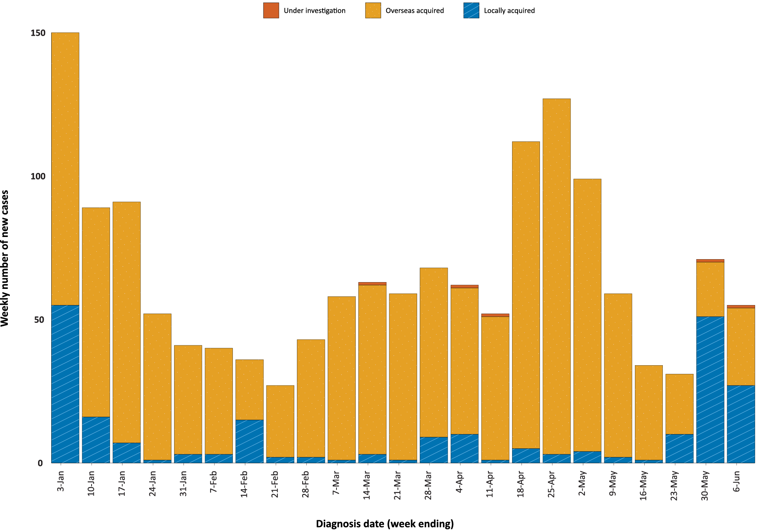
a Source: NNDSS, extract from 8 June 2021 for notifications up to 6 June 2021.

Figure 2: Cumulative COVID-19 notified cases by source of acquisition and diagnosis date, 2 March 2020 – 6 June 2021ª
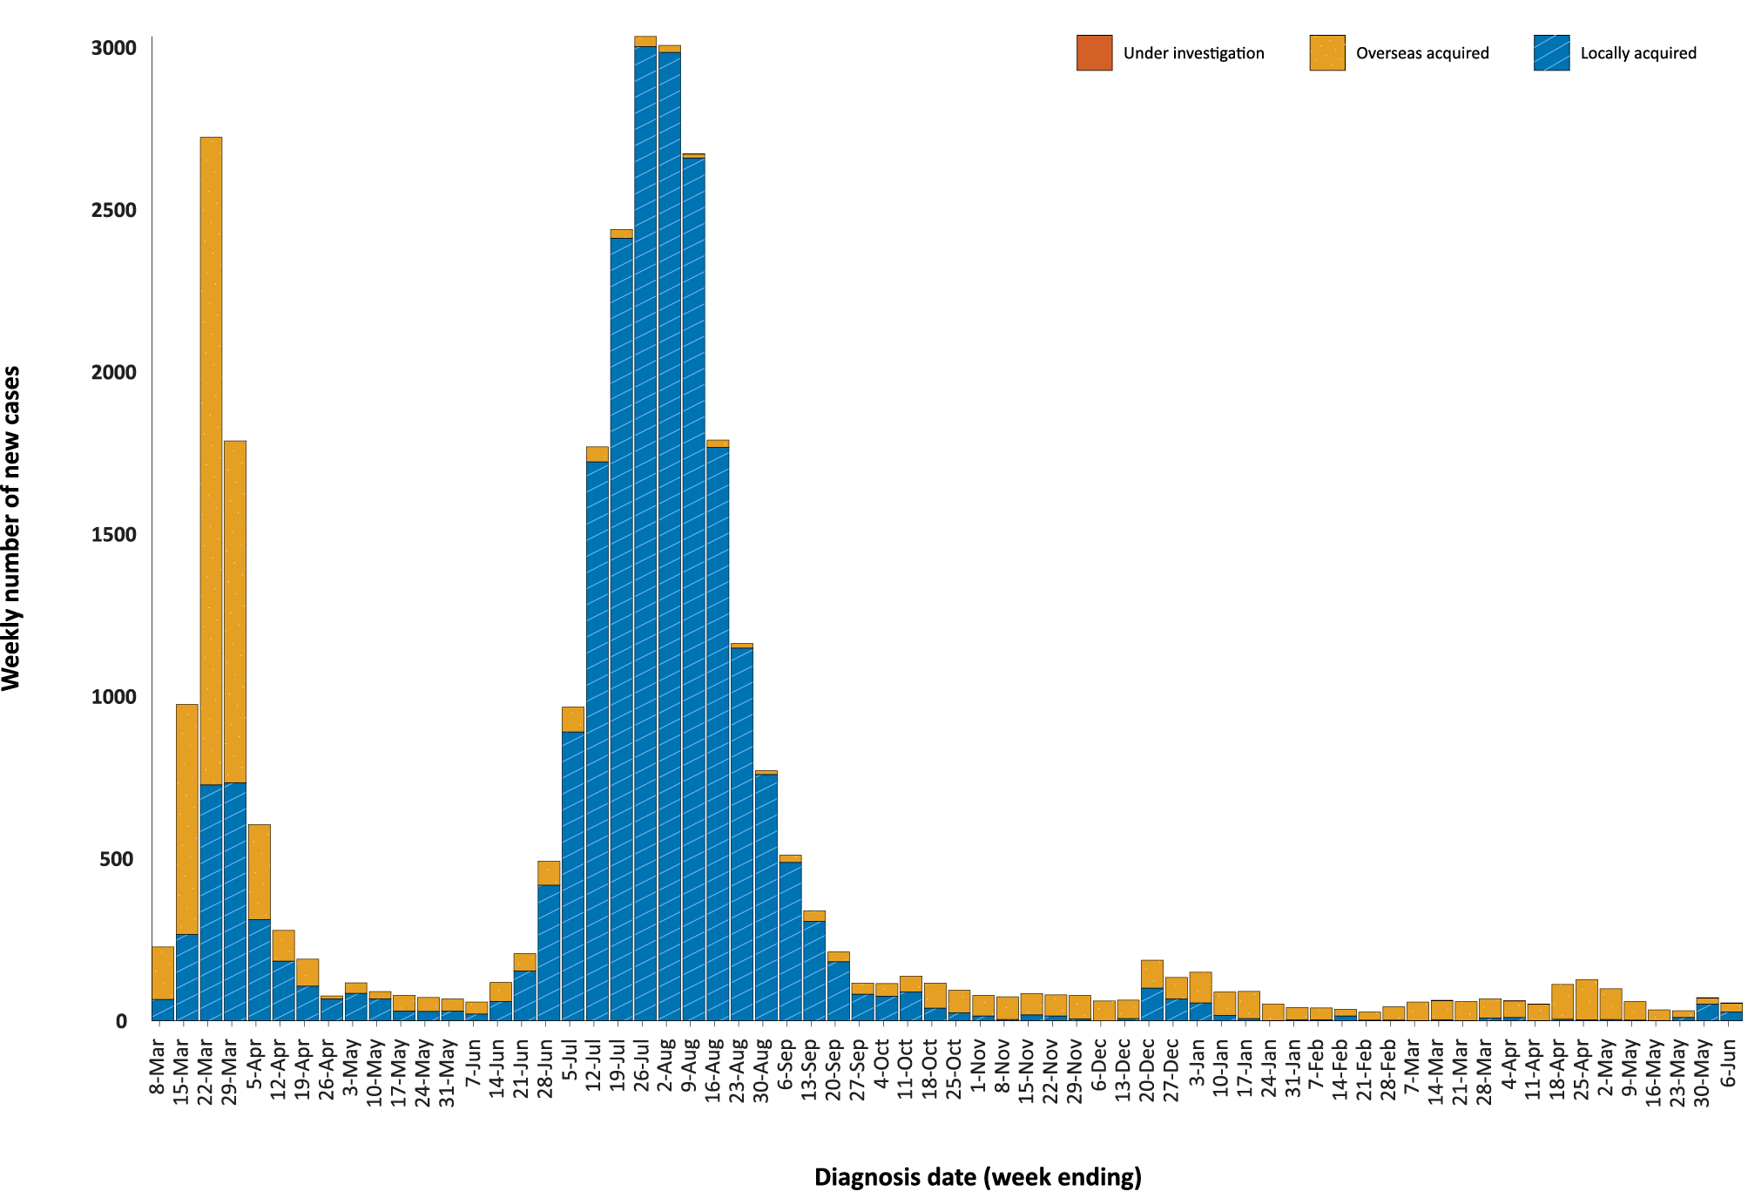
a Source: NNDSS, extract from 8 June 2021 for notifications up to 6 June 2021.

Source of acquisition

(NNDSS)
In this reporting period, the majority of cases were reported as locally acquired (62%; 78/126), with nearly all of these cases from Victoria (77), and one case reported in Western Australia. All locally-acquired cases reported this fortnight, except two from Victoria, had a known contact or cluster source at the end of this reporting period. At the end of this reporting period, two cases were classified as under initial investigation: one from Queensland and one from Victoria (Table 1).
There were 46 overseas-acquired cases reported in this reporting period, with the majority of cases reported in New South Wales (43%; 20/46), followed by Victoria (30%; 14/46).
Of overseas-acquired cases that reported a country of acquisition, the largest number in this reporting period were from India (24%; 9/37). The country of acquisition was reported as unknown for 20 percent of overseas-acquired cases (9/46). The number of cases by country is influenced by travel patterns of returning Australians, by restrictions on travel enforced by the Australian government, and also by the prevalence of COVID-19 in the country the person arrived from.
For 2021 to date, Victoria has the highest infection rate for locally-acquired cases with 1.85 infections per 100,000 population (Table 2). At the end of this reporting period, there had been zero days since the last locally-acquired case of known source and eight days since the last locally-acquired case of unknown source (Table 3).
Table 2: Locally-acquired COVID-19 case numbers and rates per 100,000 population by jurisdiction and reporting period, Australia, with a diagnosis date from 1 January to 6 June 2021ª
Jurisdiction | Reporting period  24 May – 6 June 2021 | Reporting period  10–23 May 2021 | Cases this year  1 January 2021 – 6 June 2021
 | Number of cases^{b} | Number of cases^{b} | Number of cases^{b} | Rate per 100,000 population^{c}
ACT | 0 | 0 | 0 | —
NSW | 0 | 0 | 36 | 0.44
NT | 0 | 0 | 0 | —
Qld | 0 | 0 | 25 | 0.48
SA | 0 | 0 | 0 | —
Tas. | 0 | 0 | 0 | —
Vic. | 77 | 11^{d} | 124 | 1.85
WA | 1 | 0 | 9 | 0.34
Australia | 78 | 11^{d} | 194 | 0.76
a Source: NNDSS, extract from 8 June 2021 for notifications up to 6 June 2021.
b This total does not include cases that are under initial investigation.
c Population data based on Australian Bureau of Statistics (ABS) Estimated Resident Population (ERP) as at June 2020.
d Eleven locally-acquired cases are now identified for the reporting period 10 - 23 May, despite no locally-acquired cases reported in Epidemiology Report 42 covering this period.¹ This is due to the fact that a case’s diagnosis date, which is the most epidemiologically-relevant date in terms of describing infection risk, can be several days prior to the date of its notification.
Table 3: Days since last locally-acquired COVID-19 case (source unknown and source known), by jurisdiction and diagnosis date, 6 June 2021ª
Jurisdiction | Locally acquired — source unknown |  | Locally acquired — source known
 | Date of last case | Days since last case | Date of last case | Days since last case
ACT | 21 March 2020 | 442 | 7 July 2020 | 334
NSW | 2 May 2021 | 35 | 5 May 2021 | 32
NT | NA^{b} | NA^{b} | 3 April 2020 | 429
Qld | 23 August 2020 | 287 | 3 April 2021 | 64
SA | 24 March 2020 | 439 | 27 November 2020 | 191
Tas. | 9 August 2020 | 301 | 24 April 2020 | 408
Vic. | 29 May 2021 | 8 | 6 June 2021 | 0
WA | 3 April 2020 | 429 | 29 May 2021 | 8
a Source: NNDSS, extract from 8 June 2021 for notifications up to 6 June 2021.
b NA: not applicable. The Northern Territory has not reported any locally-acquired cases with an unknown source of infection.

Demographic features

(NNDSS)
In this reporting period, the largest number of cases occurred in those aged 30 to 39 years (29%; 37/126 cases). For notifications this year, the highest rate of infection is in those aged 30 to 39 years, with a rate of 10.5 infections per 100,000 population (Figure 3; Appendix A, Table A.1). Adults over 80 years of age have the lowest rate of infection this year.
Figure 3: Cumulative COVID-19 cases for the calendar year to date, by age group and sex, Australia, 1 January 2021 to 6 June 2021ª
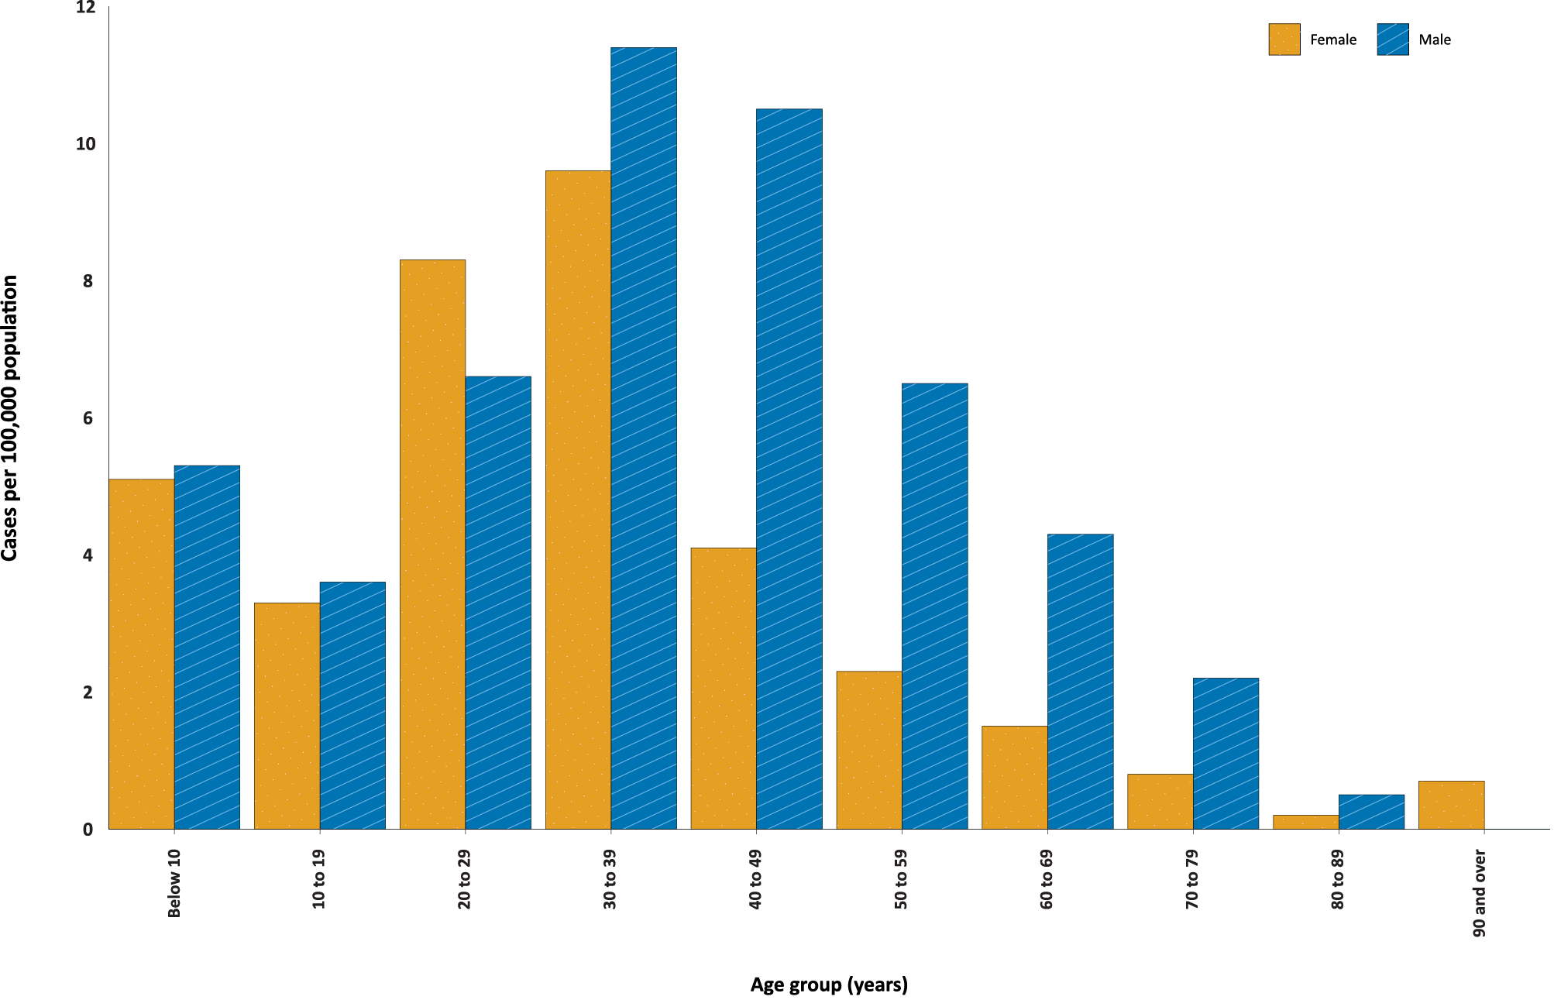
a Source: NNDSS, extract from 8 June 2021 for notifications up to 6 June 2021.

Focusing on cases in this year only, the notification rate is higher in males than females in all age groups except those 20 to 29 years old and 90 and over (Figure 3). The largest difference in rates this year is in the 40 to 49 years age group, where the cumulative rate among males is 10.5 cases per 100,000 population and among females is 4.1 cases per 100,000 population (Appendix A, Table A.1). The median age of cases in this reporting period is 33 years (range: 1 to 99).

Aboriginal and Torres Strait Islander persons

(NNDSS)
There have been five confirmed cases of COVID-19 notified in Aboriginal and Torres Strait Islander people since the beginning of 2021. No new Aboriginal and Torres Strait Islander cases were notified with a diagnosis date within this reporting period. Overall, Aboriginal and Torres Strait Islander people represent 0.4% (5/1,383) of all confirmed cases with Indigenous status known this year. The Indigenous status is unknown for 2.7% (38/1,426) of all cases reported this year. The majority of cases in Aboriginal and Torres Strait Islander people in 2021 have been overseas-acquired (80%; 4/5). The age range of COVID-19 cases in Aboriginal and Torres Strait Islander people in 2021 is 20 to 65 years.

Clusters and high risk settings
There were 77 locally-acquired cases in Victoria with a diagnosis date in this reporting period, and 11 cases in the previous reporting period, from 10 to 23 May 2021 (Table 2). Of the locally-acquired cases in Victoria in this reporting period, 75 had a known contact or cluster (Table 1).
In Victoria, all locally-acquired cases diagnosed this fortnight are due to a number of ongoing outbreaks in several settings, including the Whittlesea community outbreak, Port Melbourne workplace outbreak, an aged care facility outbreak, and the West Melbourne outbreak.
The source of infection for cases in the Victorian outbreaks, except the West Melbourne outbreak, is the ‘Kappa’ variant (B.1.617.1). Genomic evidence has linked these ‘Kappa’ cases to a returned traveller (the Wollert case) who was notified on 11 May 2021 and had acquired their infection in hotel quarantine in South Australia before returning to Victoria and developing symptoms. The first cases in the current genomically-linked outbreaks were reported on 24 May 2021, with the onset of illness and diagnosis date for several cases prior to this. Investigations into the epidemiological link between the Wollert case and these current outbreaks are ongoing.
The West Melbourne outbreak, which is linked to the ‘Delta’ variant (B.1.617.2), has been genomically matched to a returned traveller who tested positive in hotel quarantine in Victoria in early May 2021. The first cases in this outbreak were reported on 2 June 2021.The epidemiological links between the traveller and cases in the current outbreak are under investigation.
In the reporting period, one locally-acquired case who acquired their infection whilst in hotel quarantine was reported in Western Australia. This case was confirmed through genomic sequencing and linked to a guest/case who was quarantining in an adjacent room.

Vaccinations

(Department of Health)
As of 6 June 2021, a total of 5,076,413 doses of COVID-19 vaccine have been administered (Table 4), including 375,533 doses provided to aged care and disability residents.

Table 4: Total number of vaccinations administered, by jurisdiction, Australia, 6 June 2021ª
Jurisdiction | Total number of doses administered
ACT | 55,787
NSW | 499,725
NT | 38,768
Qld | 283,768
SA | 126,358
Tas. | 76,363
Vic. | 650,878
WA | 191,384
Aged care and disability facilities^{b} | 375,533
Primary care^{c} | 2,777,849
Total | 5,076,413
a Source: Australian Government Department of Health website.3
b Commonwealth vaccine doses administered in aged care and disability facilities.
c Commonwealth vaccine doses administered in primary care settings.

Acknowledgements
We thank public health staff from incident emergency operations centres and public health units in state and territory health departments, and the Australian Government Department of Health, along with state and territory public health laboratories.

Author details

Corresponding author
COVID-19 National Incident Room Surveillance Team
Australian Government Department of Health, GPO Box 9484, MDP 14, Canberra, ACT 2601.
Email: epi.coronavirus@health.gov.au

References
- COVID-19 National Incident Room Surveillance Team. COVID-19 Australia: Epidemiology Report 42: Fortnightly reporting period ending 23 May 2021. Commun Dis Intell (2018). 2021;45. doi: https://doi.org/10.33321/cdi.2021.45.30.
- COVID-19 National Incident Room Surveillance Team. Technical supplement: COVID-19 Australia: epidemiology reporting. Commun Dis Intell (2018). 2021;45. doi: https://doi.org/10.33321/cdi.2021.45.2.
- Australian Government Department of Health. Getting vaccinated for COVID-19: Australia’s vaccine rollout. [Internet.] Canberra: Australian Government Department of Health; 2021. [Accessed on 13 April 2021.] Available from: https://www.health.gov.au/initiatives-and-programs/covid-19-vaccines/getting-vaccinated-for-covid-19#australias-vaccine-rollout.

Appendix A: Supplementary figures and tables
Table A.1: COVID-19 case notifications and rates per 100,000 population, by age group and sex, Australia, 6 June 2021^{a,b}
Age group | This reporting period  24 May – 6 June 2021 |  |  |  |  |  | This year only^{c}  1 January 2021 – 6 June 2021
 | Cases |  |  | Rate per 100,000 population |  |  | Cases |  |  | Rate per 100,000 population
 | Male | Female | People | Male | Female | People | Male | Female | People | Male | Female | People
0 to 9 | 12 | 3 | 15 | 0.7 | 0.2 | 0.5 | 87 | 79 | 166 | 5.3 | 5.1 | 5.2
10 to 19 | 4 | 8 | 12 | 0.3 | 0.5 | 0.4 | 57 | 50 | 107 | 3.6 | 3.3 | 3.5
20 to 29 | 13 | 11 | 24 | 0.7 | 0.6 | 0.7 | 122 | 148 | 270 | 6.6 | 8.3 | 7.5
30 to 39 | 16 | 21 | 37 | 0.9 | 1.1 | 1.0 | 212 | 182 | 394 | 11.4 | 9.6 | 10.5
40 to 49 | 12 | 7 | 19 | 0.7 | 0.4 | 0.6 | 171 | 69 | 240 | 10.5 | 4.1 | 7.3
50 to 59 | 7 | 1 | 8 | 0.5 | 0.1 | 0.3 | 99 | 37 | 136 | 6.5 | 2.3 | 4.4
60 to 69 | 3 | 3 | 6 | 0.2 | 0.2 | 0.2 | 56 | 21 | 77 | 4.3 | 1.5 | 2.9
70 to 79 | 2 | 1 | 3 | 0.2 | 0.1 | 0.2 | 20 | 8 | 28 | 2.2 | 0.8 | 1.5
80 to 89 | 1 | 0 | 1 | 0.3 | 0.0 | 0.1 | 2 | 1 | 3 | 0.5 | 0.2 | 0.4
90 and over | 0 | 1 | 1 | 0.0 | 0.7 | 0.5 | 0 | 1 | 1 | 0.0 | 0.7 | 0.5
a Source: NNDSS, extract from 8 June 2021 for notifications up to 6 June 2021.
b Population data based on Australian Bureau of Statistics (ABS) Estimated Resident Population (ERP) as at June 2020.
c Note the change to focus on rates in this year only. For cumulative rates since the beginning of the epidemic in Australia, readers are encouraged to consult previous reports.

Communicable Diseases Intelligence
ISSN: 2209-6051 Online

Communicable Diseases Intelligence (CDI) is a peer-reviewed scientific journal published by the Office of Health Protection and Response, Department of Health. The journal aims to disseminate information on the epidemiology, surveillance, prevention and control of communicable diseases of relevance to Australia.

Editor: Jennie Hood
Deputy Editor: Simon Petrie
Design and Production: Kasra Yousefi
Editorial Advisory Board: David Durrheim, Mark Ferson, John Kaldor, Martyn Kirk and Linda Selvey

Website: http://www.health.gov.au/cdi

Contacts
CDI is produced by Environmental Health and Health Protection Policy Branch, Office of Health Protection and Response, Australian Government Department of Health, GPO Box 9848, (MDP 6) CANBERRA ACT 2601

Email: cdi.editor@health.gov.au

Submit an Article
You are invited to submit your next communicable disease related article to the Communicable Diseases Intelligence (CDI) for consideration. More information regarding CDI can be found at: http://health.gov.au/cdi.
Further enquiries should be directed to: cdi.editor@health.gov.au.

This journal is indexed by Index Medicus and Medline.

Creative Commons Licence - Attribution-NonCommercial-NoDerivatives CC BY-NC-ND
© 2021 Commonwealth of Australia as represented by the Department of Health
This publication is licensed under a Creative Commons Attribution-NonCommercial-NoDerivatives 4.0 International Licence from https://creativecommons.org/licenses/by-nc-nd/4.0/legalcode (Licence). You must read and understand the Licence before using any material from this publication.

Restrictions
The Licence does not cover, and there is no permission given for, use of any of the following material found in this publication (if any):
- the Commonwealth Coat of Arms (by way of information, the terms under which the Coat of Arms may be used can be found at www.itsanhonour.gov.au);
- any logos (including the Department of Health’s logo) and trademarks;
- any photographs and images;
- any signatures; and
- any material belonging to third parties.

Disclaimer
Opinions expressed in Communicable Diseases Intelligence are those of the authors and not necessarily those of the Australian Government Department of Health or the Communicable Diseases Network Australia. Data may be subject to revision.

Enquiries
Enquiries regarding any other use of this publication should be addressed to the Communication Branch, Department of Health, GPO Box 9848, Canberra ACT 2601, or via e-mail to: copyright@health.gov.au

Communicable Diseases Network Australia
Communicable Diseases Intelligence contributes to the work of the Communicable Diseases Network Australia.
http://www.health.gov.au/cdna

https://www.health.gov.au/news/health-alerts/novel-coronavirus-2019-ncov-health-alert#local-outbreak-information.
https://www.who.int/emergencies/diseases/novel-coronavirus-2019/situation-reports/.
https://www.health.gov.au/news/health-alerts/novel-coronavirus-2019-ncov-health-alert/coronavirus-covid-19-current-situation-and-case-numbers.

