COVID-19 Australia: Epidemiology Report 39
Reporting period ending 11 April 2021
COVID-19 National Incident Room Surveillance Team
Trends – Australia continues to report low numbers of COVID-19 cases. The daily average number of cases for this reporting period was eight compared to an average of nine cases per day in the previous fortnight. There were 113 cases of COVID-19 and no deaths this fortnight, bringing the cumulative case count to 29,304 with 909 deaths.
Demographics – Demographic trends have remained consistent this reporting period: persons aged ≥ 90 years have the highest cumulative rate of infection; children aged 0–9 years have the lowest rate of infection; and cases in Aboriginal and Torres Strait Islander persons account for less than 1% of all confirmed cases.
Local cases – There were ten locally-acquired cases reported in Australia this fortnight, nine from Queensland and one from New South Wales. All cases were linked to two known clusters of cases originating from hotel quarantine and hospital settings in Queensland. Three further cases were reported as under initial investigation at the end of the reporting period, one each from Queensland, South Australia and Victoria.
Overseas-acquired cases – There were 100 overseas-acquired cases this reporting period, a decrease compared to the previous reporting period when there were 113 overseas-acquired cases. Of overseas-acquired cases this reporting period, 50% (50/100) were from New South Wales and 28% (28/100) were from Queensland, with the remainder dispersed across all jurisdictions except Tasmania and the Australian Capital Territory.
Vaccinations – As at 12 April 2021, 1,234,681 doses of COVID-19 vaccine had been administered in Australia.

Summary
This reporting period covers the last two weeks (29 March – 11 April 2021). The previous reporting period is the preceding two weeks (15–28 March 2021). As Australia continues to experience low numbers of COVID-19 cases, this report has transitioned to a brief update on case numbers each fortnight and a more detailed analysis every four weeks. Acute respiratory illness, severity, clusters and outbreaks, testing, public health response measures, virology and the international situation are reported in detail on a four-weekly basis and are not included in this report. The latest information on these topics can be found in Epidemiology Report 38,¹ state and territory health websites, the World Health Organization’s weekly situation reports, and the Department of Health’s current situation and case numbers webpage.
These reports now focus on the epidemiological situation in Australia since the beginning of this year, 2021. Readers are encouraged to consult prior reports for information on the epidemiology of cases in Australia in 2020.
Keywords: SARS-CoV-2; novel coronavirus; 2019-nCoV; coronavirus disease 2019; COVID-19; acute respiratory disease; epidemiology; Australia

Background and data sources
See the Technical Supplement for information on coronavirus disease 19 (COVID-19) including modes of transmission, common symptoms and severity.²

Activity

COVID-19 trends

(NNDSS)
In the year to date, from 1 January 2021 to the end of this reporting period 11 April 2021, there have been 836 COVID-19 cases and no deaths reported nationally. In the year to date, cases notified weekly have remained low, ranging from approximately 30 to 90 cases per week (Figure 1). This is in contrast to the two distinct peaks in March and July of 2020, with weekly notifications reaching approximately 2700 and 3000, respectively (Figure 2).
In this two-week reporting period, from 29 March to 11 April 2021, there were 113 cases and no deaths reported. On average, eight cases were diagnosed each day over this reporting period, similar to the previous reporting period when an average of nine cases were diagnosed each day. The largest number of cases diagnosed this fortnight was from New South Wales (45%; 51/113), followed by Queensland (34%; 38/113) (Table 1).
Cumulatively since the beginning of the epidemic in Australia, there have been 29,304 COVID-19 cases including 909 deaths reported in Australia, with two distinct peaks in March and July 2020 (Figure 2).

Figure 1: COVID-19 notified cases by source of acquisition and diagnosis date, 1 January – 11 April 2021ª
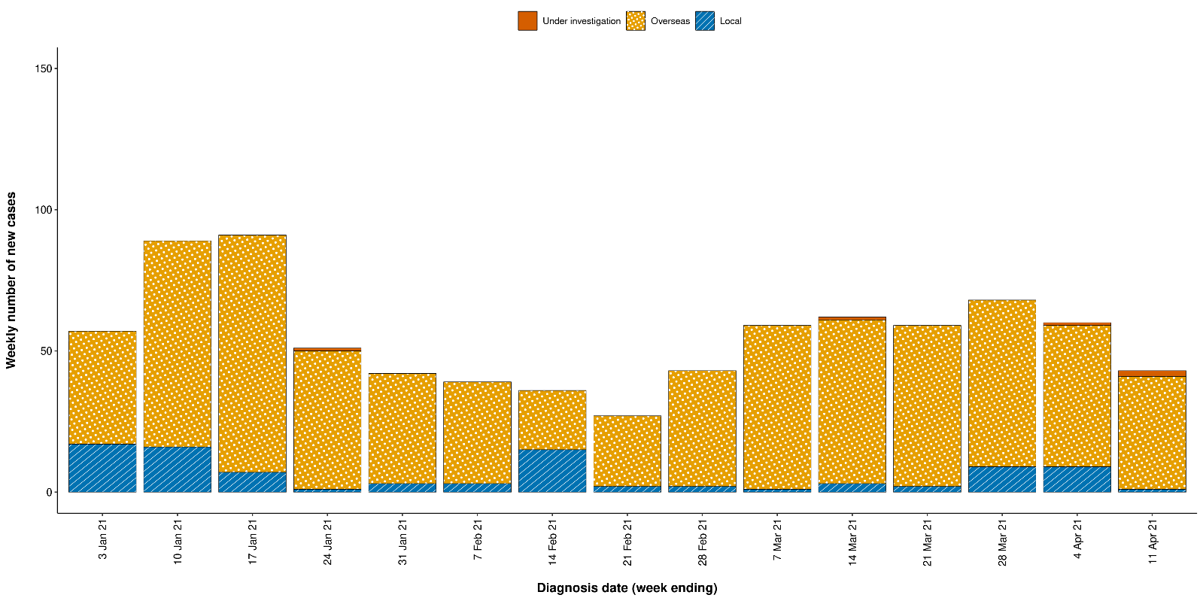
a Source: NNDSS, extract from 13 April 2021, based on diagnosis date.
Figure 2: Cumulative COVID-19 notified cases by source of acquisition and diagnosis date, 1 March 2020 – 11 April 2021ª
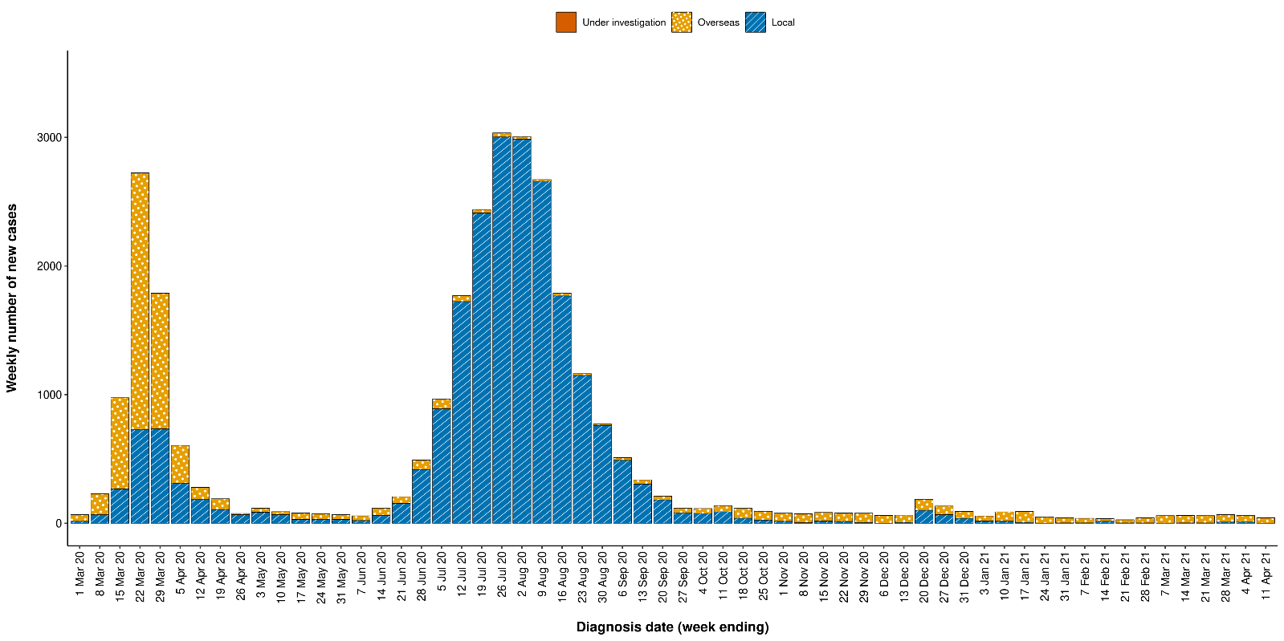
a Source: NNDSS, extract from 13 April 2021, based on diagnosis date.

Table 1: COVID-19 notifications by jurisdiction and source of acquisition, 29 March – 11 April 2021ª
Source | ACT | NSW | NT | Qld | SA | Tas. | Vic. | WA | Australia
Overseas | 0 | 50 | 3 | 28 | 6 | 0 | 3 | 10 | 100
Local | 0 | 1 | 0 | 9 | 0 | 0 | 0 | 0 | 10
source known | 0 | 1 | 0 | 9 | 0 | 0 | 0 | 0 | 10
source unknown | 0 | 0 | 0 | 0 | 0 | 0 | 0 | 0 | 0
interstate, source known | 0 | 0 | 0 | 0 | 0 | 0 | 0 | 0 | 0
interstate, source unknown | 0 | 0 | 0 | 0 | 0 | 0 | 0 | 0 | 0
investigation ongoing | 0 | 0 | 0 | 0 | 0 | 0 | 0 | 0 | 0
Under initial investigation | 0 | 0 | 0 | 1 | 1 | 0 | 1 | 0 | 3
Missing source of acquisition | 0 | 0 | 0 | 0 | 0 | 0 | 0 | 0 | 0
Total | 0 | 51 | 3 | 38 | 7 | 0 | 4 | 10 | 113
a Source: NNDSS, extract from 13 April 2021, based on diagnosis date.

Source of acquisition

(NNDSS)
In this reporting period, the majority of cases were reported as overseas acquired (89%; 100/113). There were ten cases reported as locally acquired this fortnight, nine from Queensland and one from New South Wales. These locally-acquired cases were associated with two known clusters with origins in Brisbane and Byron Bay. At the end of this reporting period, three cases were classified as under initial investigation (Table 1).
The largest number of overseas-acquired cases was reported in New South Wales in this reporting period (50%; 50/100), followed by Queensland (28%; 28/100).
Of overseas-acquired cases that reported a country of acquisition, the largest number in this reporting period were from India (30%; 27/90), followed by the United States of America (12%; 11/90) and Bangladesh (10%; 9/90). In contrast to the previous reporting period, cases from Papua New Guinea accounted for only seven percent (6/90) of all overseas-acquired cases with known country of acquisition. The country of acquisition was reported as unknown for ten percent of overseas-acquired cases (10/100). The number of cases by country is influenced by travel patterns of returning Australians as well as by the prevalence of COVID-19 in the country the person arrived from.
In 2021 to date, Victoria and Queensland have the highest infection rates for locally-acquired cases with 0.51 and 0.50 infections per 100,000 population respectively (Table 2). At the end of this reporting period, there had been five days since the last locally-acquired case of known source and 86 days since the last locally-acquired case of unknown source (Table 3).

Table 2: Locally-acquired COVID-19 case numbers and rates per 100,000 population by jurisdiction and reporting period, Australia, 29 March to 11 April 2021ª
Jurisdiction | Reporting period  29 March – 11 April 2021 | Reporting period  15–28 March 2021 | Cases this year  1 January 2021 – 11 April 2021^{b}
 | Number of cases^{c} | Number of cases^{c} | Number of cases^{c} | Rate per 100,000 population^{d}
ACT | 0 | 0 | 0 | —
NSW | 1 | 1 | 30 | 0.37
NT | 0 | 0 | 0 | —
Qld | 9 | 10 | 26 | 0.50
SA | 0 | 0 | 0 | —
Tas. | 0 | 0 | 0 | —
Vic. | 0 | 0 | 34 | 0.51
WA | 0 | 0 | 1 | 0.04
Australia | 10 | 11 | 91 | 0.35
a Source: NNDSS, extract from 13 April 2021, based on diagnosis date.
b Note the change to a focus on cases in this year only, which substantially lowers rates per 100,000 population.
c This total does not include cases that are under investigation.
d Population data based on Australian Bureau of Statistics (ABS) Estimated Resident Population (ERP) as at June 2020.
Table 3: Days since last locally-acquired COVID-19 case (source unknown and source known), by jurisdiction, 11 April 2021ª
Jurisdiction | Locally acquired — source unknown |  | Locally acquired — source known
 | Date of last case | Days since last case | Date of last case | Days since last case
ACT | 21 March 2020 | 386 | 7 July 2020 | 278
NSW | 15 January 2021 | 86 | 29 March 2021 | 13
NT^{b} | NA | NA | 3 April 2020 | 373
Qld | 23 August 2020 | 231 | 6 April 2021 | 5
SA | 24 March 2020 | 383 | 27 November 2020 | 135
Tas. | 9 August 2020 | 245 | 24 April 2020 | 352
Vic. | 30 December 2020 | 102 | 24 February 2021 | 46
WA | 3 Apr 2020 | 373 | 28 January 2021 | 73
a Source: NNDSS, extract from 13 April 2021, based on diagnosis date. Note that discrepancies in dates between this and previous reports are due to a change to the use of diagnosis date for all tables.
b The Northern Territory has not reported any locally acquired cases with an unknown source of infection.

Demographic features

(NNDSS)
In this reporting period, the largest number of cases occurred in those aged 30 to 39 years (31%; 35/113 cases). For all notifications to date, the highest rate of infection is in those aged 90 and over with a rate of 386.8 per 100,000 population (Figure 3; Appendix A, Table A.1). Children under 10 years old have the lowest rate of infection (49.0 cases per 100,000 population), despite comparable testing rates in this age group.
Figure 3: Cumulative COVID-19 cases, by age group and sex, Australia, 23 January 2020 to 11 April 2021ª
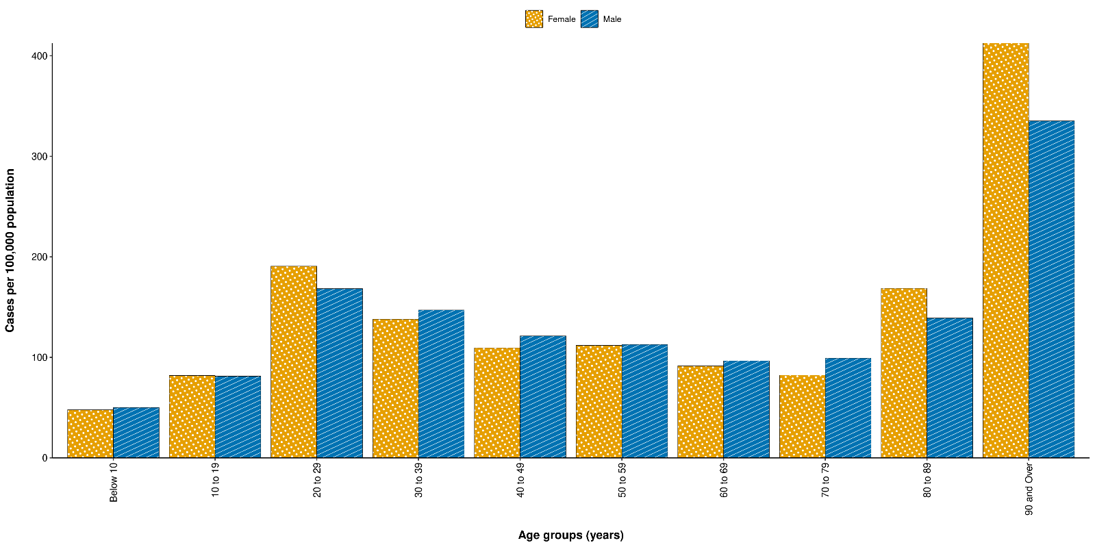
a Source: NNDSS, extract from 13 April 2021, based on diagnosis date.
Cumulatively, the male-to-female rate ratio is approximately 1:1 in most age groups. Notification rates are higher among females than among males in the 20–29 years age group and those aged ≥ 80 years old, and higher among males than among females in the 70–79 years age group (Figure 3). The largest difference in cumulative rates is in the 90 years and over age group, where the cumulative rate among males is 335.2 cases per 100,000 population and among females is 412.6 cases per 100,000 population (Appendix A, Table A.1).
The median age of cases in this reporting period is 33 years (interquartile range, IQR: 27 to 41). This is the same as the median age of cases this year, which is also 33 years (IQR: 26 to 45). The median age of all cases since the beginning of the epidemic in Australia is somewhat higher at 37 years (IQR: 25–56), reflecting a shift in the demographic features of cases over time. Whereas there were higher numbers of locally-acquired cases in 2020, including many cases in residential aged care facilities, most cases in 2021 have been acquired overseas and in a younger cohort of international travellers.

Aboriginal and Torres Strait Islander persons

(NNDSS)
There have been 151 confirmed cases of COVID-19 notified in Aboriginal and Torres Strait Islander people since the beginning of the epidemic. One new Aboriginal and Torres Strait Islander case was notified in the reporting period. Overall, Aboriginal and Torres Strait Islander people represent approximately 0.5% (151/29,071) of all confirmed cases with Indigenous status known. The majority of locally-acquired cases in Aboriginal and Torres Strait Islander people have been reported in those residing in major cities of Australia (79%; 93/117), with only a very small number of cases (n < 10) reported in outer regional Australia or remote or very remote Australia.
The median age of COVID-19 cases in Aboriginal and Torres Strait Islander people is 31 years old (IQR: 21–50), which is younger than for non-Indigenous cases where the median age is 37 years old (IQR: 25–56). The notification rate across all age groups is higher in non-Indigenous people than in Aboriginal and Torres Strait Islander people. The age-standardised Aboriginal and Torres Strait Islander:non-Indigenous notification rate ratio is 0.2. This indicates that the Aboriginal and Torres Strait Islander population has a significantly lower COVID-19 case rate than the non-Indigenous population, after accounting for differences in age structure.

Vaccinations

(Department of Health)
As of 12 April 2021, a total of 1,234,681 doses of COVID-19 vaccine have been administered (Table 4), including 148,331 doses provided to aged care and disability residents.
Table 4: Total number of vaccinations administered, by jurisdiction, Australia, 12 April 2021ª
Jurisdiction | Total number of doses administered
ACT | 18,059
NSW | 155,894
NT | 10,987
Qld | 112,419
SA | 39,206
Tas. | 24,614
Vic. | 147,798
WA | 68,895
Commonwealth^{b} | 148,331
Primary care^{c} | 508,478
Total | 1,234,681
a Source: Australian Government Department of Health website.³
b Administered in aged care and disability facilities.
c Administered in primary care settings.

Acknowledgements
We thank public health staff from incident emergency operations centres and public health units in state and territory health departments, and the Australian Government Department of Health, along with state and territory public health laboratories.

Author details

Corresponding author
COVID-19 National Incident Room Surveillance Team
Australian Government Department of Health, GPO Box 9484, MDP 14, Canberra, ACT 2601.
Email: epi.coronavirus@health.gov.au

References
- COVID-19 National Incident Room Surveillance Team. COVID-19 Australia: Epidemiology Report 38: Fortnightly reporting period ending 28 March 2021. Commun Dis Intell (2018). 2021;45. doi: https://doi.org/10.33321/cdi.2021.45.19.
- COVID-19 National Incident Room Surveillance Team. Technical supplement: COVID-19 Australia: epidemiology reporting. Commun Dis Intell (2018). 2021;45. doi: https://doi.org/10.33321/cdi.2021.45.2.
- Australian Government Department of Health. Getting vaccinated for COVID-19: Australia’s vaccine rollout. [Internet.] Canberra: Australian Government Department of Health; 2021. [Accessed on 13 April 2021.] Available from: https://www.health.gov.au/initiatives-and-programs/covid-19-vaccines/getting-vaccinated-for-covid-19#australias-vaccine-rollout.

Appendix A: Supplementary figures and tables
Table A.1: COVID-19 case notifications and rates per 100,000 population, by age group and sex, Australia, 11 April 2021ª
Age group | This reporting period  29 March – 11 April 2021 |  |  |  |  |  | Cumulative  23 January 2020 – 11 April 2021
 | Cases |  |  | Rate per 100,000 population |  |  | Cases |  |  | Rate per 100,000 population
 | Male | Female | People | Male | Female | People | Male | Female | People | Male | Female | People
0 to 9 | 5 | 6 | 11 | 0.3 | 0.4 | 0.3 | 820 | 741 | 1,561 | 50.1 | 47.8 | 49.0
10 to 19 | 2 | 0 | 2 | 0.1 | 0.0 | 0.1 | 1,277 | 1,216 | 2,493 | 81.3 | 81.9 | 81.6
20 to 29 | 14 | 15 | 29 | 0.8 | 0.8 | 0.8 | 3,129 | 3,434 | 6,584 | 168.4 | 190.7 | 179.9
30 to 39 | 18 | 17 | 35 | 1.0 | 0.9 | 1.0 | 2,675 | 2,561 | 5,251 | 147.1 | 138.0 | 142.9
40 to 49 | 9 | 6 | 15 | 0.6 | 0.4 | 0.5 | 1,963 | 1,814 | 3,805 | 121.3 | 109.5 | 116.2
50 to 59 | 5 | 1 | 6 | 0.3 | 0.1 | 0.2 | 1,700 | 1,760 | 3,467 | 112.8 | 111.9 | 112.6
60 to 69 | 6 | 4 | 10 | 0.5 | 0.3 | 0.4 | 1,229 | 1,229 | 2,460 | 96.6 | 91.5 | 94.1
70 to 79 | 0 | 1 | 1 | 0.0 | 0.1 | 0.1 | 863 | 759 | 1,622 | 99.2 | 82.3 | 90.5
80 to 89 | 0 | 0 | 0 | 0.0 | 0.0 | 0.0 | 497 | 778 | 1,275 | 139.1 | 168.7 | 155.7
90 and over | 0 | 0 | 0 | 0.0 | 0.0 | 0.0 | 230 | 551 | 782 | 335.2 | 412.6 | 386.8
a Source: NNDSS, extracted on 13 April 2021.

Communicable Diseases Intelligence
ISSN: 2209-6051 Online

Communicable Diseases Intelligence (CDI) is a peer-reviewed scientific journal published by the Office of Health Protection and Response, Department of Health. The journal aims to disseminate information on the epidemiology, surveillance, prevention and control of communicable diseases of relevance to Australia.

Editor: Jennie Hood
Deputy Editor: Simon Petrie
Design and Production: Kasra Yousefi
Editorial Advisory Board: David Durrheim, Mark Ferson, John Kaldor, Martyn Kirk and Linda Selvey

Website: http://www.health.gov.au/cdi

Contacts
CDI is produced by Environmental Health and Health Protection Policy Branch, Office of Health Protection and Response, Australian Government Department of Health, GPO Box 9848, (MDP 6) CANBERRA ACT 2601

Email: cdi.editor@health.gov.au

Submit an Article
You are invited to submit your next communicable disease related article to the Communicable Diseases Intelligence (CDI) for consideration. More information regarding CDI can be found at: http://health.gov.au/cdi.
Further enquiries should be directed to: cdi.editor@health.gov.au.

This journal is indexed by Index Medicus and Medline.

Creative Commons Licence - Attribution-NonCommercial-NoDerivatives CC BY-NC-ND
© 2021 Commonwealth of Australia as represented by the Department of Health
This publication is licensed under a Creative Commons Attribution-NonCommercial-NoDerivatives 4.0 International Licence from https://creativecommons.org/licenses/by-nc-nd/4.0/legalcode (Licence). You must read and understand the Licence before using any material from this publication.

Restrictions
The Licence does not cover, and there is no permission given for, use of any of the following material found in this publication (if any):
- the Commonwealth Coat of Arms (by way of information, the terms under which the Coat of Arms may be used can be found at www.itsanhonour.gov.au);
- any logos (including the Department of Health’s logo) and trademarks;
- any photographs and images;
- any signatures; and
- any material belonging to third parties.

Disclaimer
Opinions expressed in Communicable Diseases Intelligence are those of the authors and not necessarily those of the Australian Government Department of Health or the Communicable Diseases Network Australia. Data may be subject to revision.

Enquiries
Enquiries regarding any other use of this publication should be addressed to the Communication Branch, Department of Health, GPO Box 9848, Canberra ACT 2601, or via e-mail to: copyright@health.gov.au

Communicable Diseases Network Australia
Communicable Diseases Intelligence contributes to the work of the Communicable Diseases Network Australia.
http://www.health.gov.au/cdna

https://www.health.gov.au/news/health-alerts/novel-coronavirus-2019-ncov-health-alert#local-outbreak-information.
https://www.who.int/emergencies/diseases/novel-coronavirus-2019/situation-reports/.
https://www.health.gov.au/news/health-alerts/novel-coronavirus-2019-ncov-health-alert/coronavirus-covid-19-current-situation-and-case-numbers.

