Report of the National Influenza Surveillance Scheme, 2011 to 2018
Communicable Disease Epidemiology and Surveillance Section

Abstract
This report describes influenza surveillance activities in Australia for the period 2011 to 2018. Data were extracted from several sources constituting the National Influenza Surveillance Scheme (NISS). Laboratory-confirmed influenza notification rates (per 100,000 population) increased from 122 in 2011 to 1,021 in 2017, before declining to 235 in 2018. The highest laboratory-confirmed notification rates during the eight-year period were from the smaller jurisdictions (South Australia and the Northern Territory), except in 2016 when Queensland reported the highest rate. Similar trends were observed in community reports of influenza-like illness (ILI), presentations of ILI to sentinel general practice (GP) sites, and influenza hospitalisations.
Children aged 14 years or younger, and adults 65 years of age or older, had the highest notification rates of laboratory-confirmed influenza. Adults aged 65 years or older and patients with comorbidities had higher rates of influenza-associated hospitalisations and mortality. Over half of eligible patients admitted to sentinel hospitals (57%) received oseltamivir treatment, with 17% receiving the treatment within 48 hours of symptom onset.
Influenza type A predominated over the eight years, except in 2015 when type B predominated. This trend was consistent with Australian World Health Organization Collaborating Centre (WHOCC) data for influenza isolates tested. Of influenza viruses circulating during the reporting period, A(H1N1) viruses were mostly antigenically similar to the vaccine strain A/California/7/2009 (H1N1), except in 2017 and 2018 when they were mostly similar to A/Michigan/45/2015. The A(H3N2) strains varied over the years but included the vaccine strains A/Perth/16/2009, A/Switzerland/9715293/2013, A/Hong Kong/4801/2014, and A/Singapore/INFIMH/2016. The B/Victoria/2/87 lineage (represented by the 2016 vaccine strain B/Brisbane/60/2008) and the B/Yamagata/16/88 lineage (represented by the southern hemisphere 2015 vaccine strain B/Phuket/3073/2013) were the circulating influenza B viruses during the reporting period. Influenza B accounted for just under a third of notifications (32%) from 2011 to 2018. Fifty-four per cent of influenza B viruses characterised by the Australian WHOCC site during the eight-year period were from the Yamagata lineage, although the proportion was higher (67%) when analysing the most recent four years (2015 to 2018). In contrast, during the 2010 season, 99% of all influenza B viruses characterised by the Australian WHOCC site were in the B-Victoria lineage.
During the 2018 season the Australian WHOCC site detected, for the first time, swine A(H3N2)v virus from a human patient in Australia, highlighting the need to maintain vigilance for zoonotic infections.
Keywords: influenza, surveillance, influenza-like illness, sentinel surveillance

Introduction
Influenza is an infectious acute respiratory disease caused when influenza viruses spread from person to person by droplets or contact with fomites.¹ Patients with influenza typically present with a combination of cough, fever, sore throat, runny nose, headache, fatigue, and myalgia.¹ It is estimated the viral infection affects up to 5–10% of the population each year globally.² In Australia, the influenza season usually occurs from April or May to the end of October. Influenza outbreaks usually occur annually during the influenza season, often resulting in increased hospitalisations from pneumonia and other complications, particularly in high-risk population groups.³ The individuals most at risk of acquiring severe forms of influenza include children, the elderly (65 years or older), those with chronic medical comorbidities (such as cardiac, renal, liver, metabolic, autoimmune diseases, HIV/AIDS or malignancies), and those on immunosuppressive treatments.¹
Influenza types A, B, and C are known to cause respiratory illness in humans. Type A and B viruses cause seasonal epidemics, while type C is detected less frequently and is usually associated with mild infections.³ There are two forms of influenza reported globally: epidemic (seasonal or interpandemic) caused by type A and B viruses, and sporadic pandemics caused by type A viruses.³
Influenza A viruses are further classified into subtypes based on the combinations of the haemagglutinin (HA) and neuraminidase (NA) viral surface proteins. The currently-circulating A viruses in humans are A(H1N1)pdm09 and A(H3N2). The influenza B viruses are further classified into lineages rather than subtypes, with the B/Victoria and B/Yamagata lineages currently circulating.¹
Laboratory-confirmed influenza is a notifiable disease in all Australian states and territories. Laboratory-confirmed influenza data are reported from each state or territory health department to the National Notifiable Diseases Surveillance System (NNDSS).

Surveillance methods
Data for this report were extracted from the following influenza surveillance sources:
- notifications of laboratory-confirmed influenza required by legislation in all states and territories, and notified to the NNDSS;
- subtype and strain data of circulating influenza viruses provided by the World Health Organization Collaborating Centre for Reference and Research on Influenza (WHOCC);⁴
- consultation rates for influenza-like illness (ILI) identified by sentinel general practitioners (GPs) – provided by the Australian Sentinel Practices Research Network (ASPREN) and the Victorian Sentinel Practice Influenza Network (VicSPIN);
- rates of ILI and absence from work from the online community survey FluTracking;
- hospitalised cases of influenza from 17 sentinel hospitals across Australia through the Influenza Complications Alert Network (FluCAN);
- mortality data from the New South Wales Government HealthStats webpage; the Australian Bureau of Statistics (ABS); and a mathematical modelling study estimating influenza-associated deaths.⁵
This report excludes data from sentinel laboratories and consultation rates from Emergency Departments (EDs) as they were not readily available. Rates were calculated using population data accessed from the ABS for the respective years.

Data sources

National Notifiable Diseases Surveillance System (NNDSS)
During the reporting period, laboratory-confirmed influenza was a notifiable disease under state and territory legislation in all Australian jurisdictions. Jurisdictional notifications were sent to NNDSS for national collation. In this report, data were analysed by the date of diagnosis, which is the earliest of the dates of symptom onset, specimen collection, or case notification. Age, sex, Aboriginal and/or Torres Strait Islander status, virus subtype, the jurisdiction of patient residence, hospitalisation, and outcomes, are included in NNDSS notifications.

Laboratory surveillance

WHO Collaborating Centre for Reference and Research on Influenza (WHOCC)
WHO Collaborating Centres for Reference and Research on Influenza are located in Melbourne (Australia), Beijing (China), Tokyo (Japan), London (the United Kingdom), and Atlanta (the United States of America); they form part of the World Health Organization Global Influenza Surveillance and Response System (WHO GISRS). The WHO Collaborating Centres are responsible for analysing influenza viruses collected through an international surveillance network involving 142 national influenza centres across 115 countries.⁶ The Melbourne centre analyses viruses received from Australia and laboratories in the Asia-Pacific Region. Virus isolates are analysed antigenically; a geographically- and temporally-representative number of viruses, together with any strains demonstrating uncharacteristic reactions during antigenic characterisation, are further analysed by genetic sequencing of the viral HA and NA genes. Virological, serological, and epidemiological data form the basis from which WHO makes recommendations in February (for the Northern Hemisphere) and in September (for the Southern Hemisphere) on which strains should be included in the influenza vaccine for the following influenza season. The WHO vaccine recommendations are made in the context of strains that are antigenically ‘like’ laboratory reference strains that are named according to a standard nomenclature for influenza viruses. This nomenclature is based on the virus type, place of isolation, sequential number, year of isolation, and the subtype of the HA and NA genes (for influenza A). National and regional committees (such as the Australian Influenza Vaccine Committee) then translate the WHO recommendations into actual virus strains acceptable to regulatory authorities and vaccine manufacturers.

Sentinel general practitioner surveillance
Sentinel GP surveillance schemes for influenza monitor clinical consultations for ILI, defined as any presentation with fever, cough and fatigue; they also collect swabs from patients with ILI to inform virological surveillance of influenza. In Australia, there are two sentinel GP programs: ASPREN, a network of sentinel GPs, which collects ILI data from almost 250 providers across all states and territories, and the Victorian Infectious Diseases Reference Laboratory (VIDRL)-operated Victorian Sentinel Practice Influenza Network (VicSPIN), previously known as the General Practice Sentinel Surveillance Program (VIDRL GPSS), which operates solely in Victoria. ASPREN reports ILI rates throughout the year, while VicSPIN reports during the influenza season, from early May to late October. In addition, ASPREN provides annual vaccine effectiveness estimates to the Global Influenza Vaccine Effectiveness Movement and data to the WHOCC.

FluTracking
FluTracking is a project run by the University of Newcastle, the Hunter New England Area Health Service, and the Hunter Medical Research Institute. FluTracking is an online health surveillance system established to detect epidemics of influenza and to monitor the transmission and severity of ILI in the community. It involves volunteer participants from across Australia completing a simple online weekly survey, which collects data on ILI symptoms, absence from work or normal duties, healthcare presentation, testing, and seasonal influenza vaccination.

Influenza Complications Alert Network (FluCAN)
The Influenza Complications Alert Network (FluCAN) is a national hospital-based sentinel surveillance system reporting data from 17 participating sites (there were 15 sites until 2013). FluCAN collects detailed clinical and laboratory information from all patients hospitalised at participating sites with a laboratory-confirmed diagnosis of influenza, to determine the burden of disease requiring hospitalisation associated with influenza, and to estimate the effectiveness of the influenza vaccine against hospitalisation with influenza. Data were extracted from the FluCAN annual reports published in the Medical Journal of Australia (2011 report) and Communicable Disease Intelligence (2012 to 2018 reports).^{7–14}

Results

National notifications of laboratory-confirmed influenza cases
During the period 2011 to 2018, there were 669,370 laboratory-confirmed influenza cases notified to the NNDSS. The notification rates for laboratory-confirmed influenza increased from 2011, peaking in 2017, before declining in 2018 (Figure 1). The highest number of notifications was in 2017 (n = 251,290), followed by 2015 (n = 100,582). The lowest number of notifications in the period was in 2011 (n = 27,214) (Table 1). The 2017 notifications represent the highest levels of influenza notifications to the NNDSS since the 2009 pandemic year. Over the eight years reported, notifications peaked between July and September, usually returning to inter-seasonal levels by October/November each year (﻿Figure 2). Over the reporting period, the peak number of notifications occurred in August 2017, with 99,428 notifications, which was almost 3.4 times as high as the 2016 peak of 29,428 notifications.
Figure 1: Laboratory-confirmed influenza notifications in Australia, by state or territory, month, and year of diagnosis, 2011 to 2018
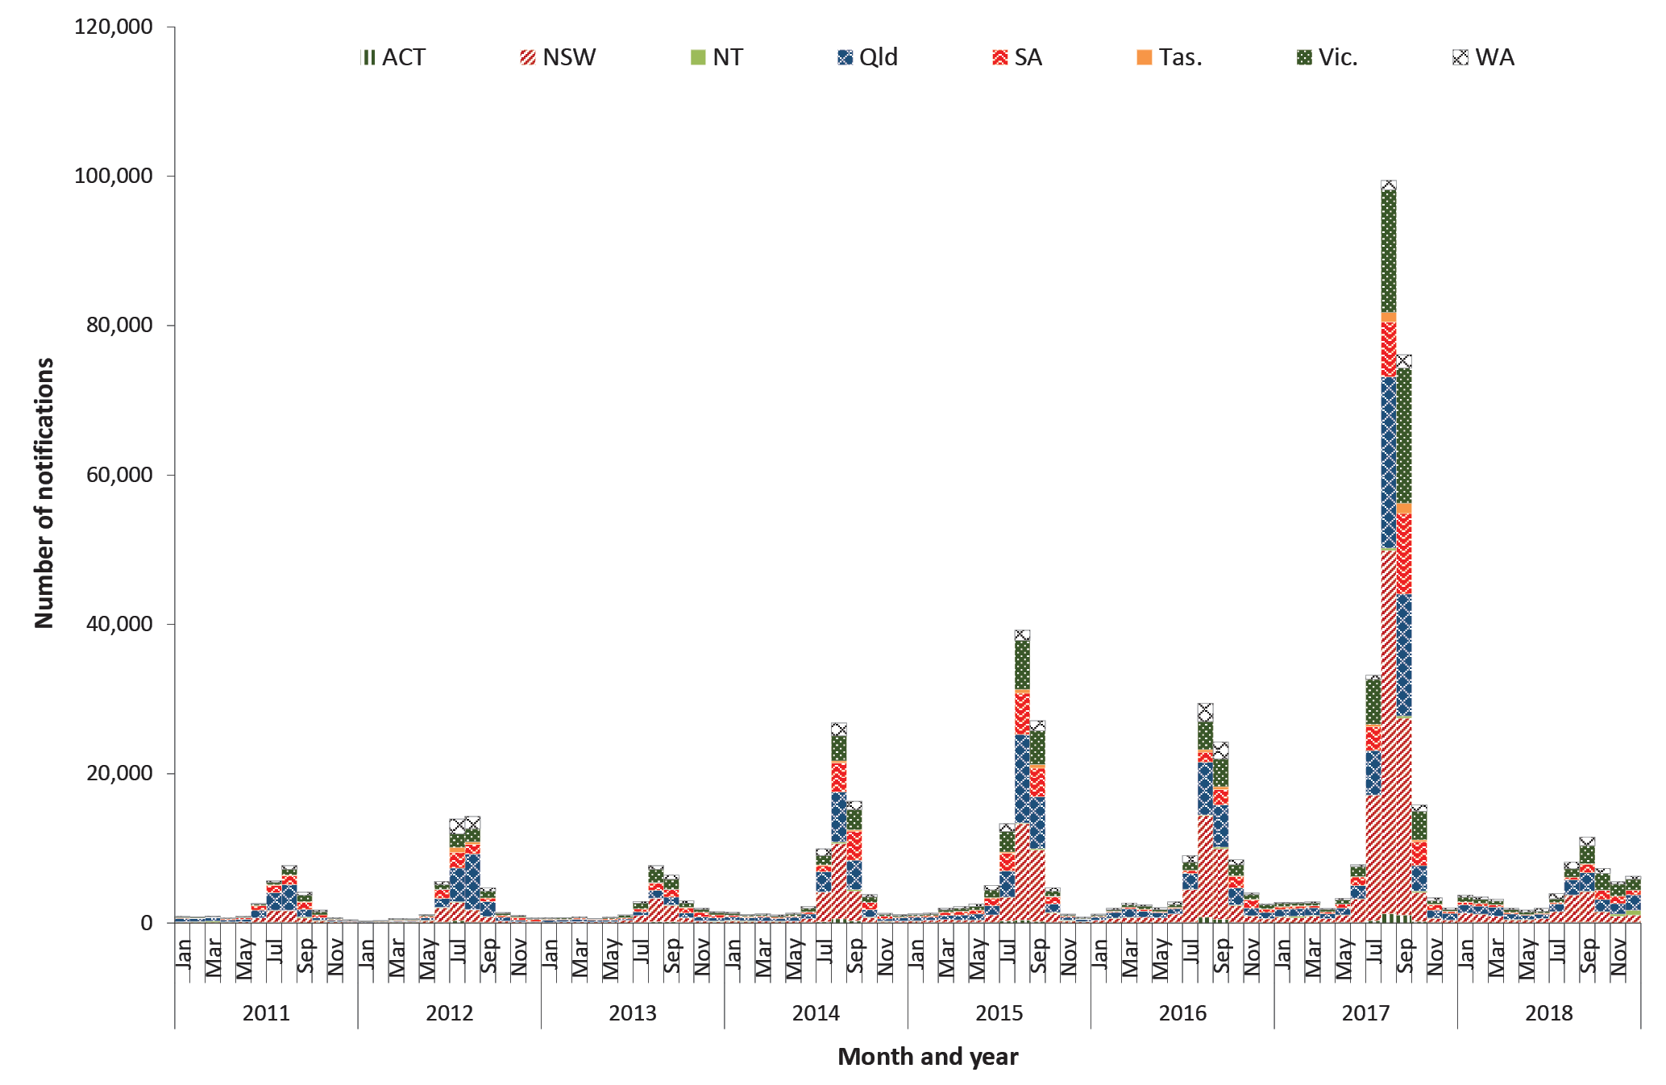

Table 1: Notifications and ratesª of laboratory-confirmed influenza in Australia by state or territory,^{b} 2011 to 2018
 |  | 2011 | 2012 | 2013 | 2014 | 2015 | 2016 | 2017 | 2018
ACT | Notifications | 270 | 667 | 552 | 1,262 | 1,206 | 1,604 | 3,098 | 476
 | % of all notifications | 1.0 | 1.5 | 2.0 | 1.9 | 1.2 | 1.8 | 1.2 | 0.8
 | Rate | 73.4 | 177.1 | 144.0 | 324.6 | 304.7 | 397.9 | 751.9 | 113.1
NSW | Notifications | 5,786 | 7,986 | 8,394 | 20,889 | 30,271 | 35,585 | 103,858 | 17,512
 | % of all notifications | 21.3 | 17.9 | 29.7 | 30.9 | 30.1 | 39.2 | 41.3 | 29.7
 | Rate | 80.2 | 109.3 | 113.4 | 278.2 | 397.5 | 460.2 | 1,320.0 | 219.2
NT | Notifications | 597 | 443 | 480 | 810 | 676 | 701 | 1,474 | 1,195
 | % of all notifications | 2.2 | 1.0 | 1.7 | 1.2 | 0.7 | 0.8 | 0.6 | 2.0
 | Rate | 258.1 | 187.8 | 198.6 | 333.5 | 276.3 | 285.3 | 595.5 | 483.0
Qld | Notifications | 10,383 | 16,834 | 5,507 | 17,895 | 28,061 | 23,294 | 56,614 | 15,698
 | % of all notifications | 38.2 | 37.8 | 19.5 | 26.4 | 27.9 | 25.6 | 22.5 | 26.7
 | Rate | 231.9 | 368.5 | 118.4 | 379.2 | 587.3 | 480.8 | 1,148.9 | 313.2
SA | Notifications | 4,742 | 6,287 | 4,827 | 11,041 | 15,651 | 7,869 | 28,490 | 5,897
 | % of all notifications | 17.4 | 14.1 | 17.1 | 16.3 | 15.6 | 8.7 | 11.3 | 10.0
 | Rate | 289.2 | 379.5 | 288.8 | 654.5 | 920.3 | 459.4 | 1,652.6 | 339.6
Tas. | Notifications | 363 | 1,093 | 297 | 675 | 1,437 | 1,055 | 3,509 | 452
 | % of all notifications | 1.3 | 2.5 | 1.0 | 1.0 | 1.4 | 1.2 | 1.4 | 0.8
 | Rate | 71.0 | 213.6 | 58.0 | 131.4 | 279.0 | 203.9 | 671.7 | 85.6
Vic. | Notifications | 3,210 | 5,995 | 5,848 | 9,860 | 17,287 | 12,941 | 48,227 | 11,773
 | % of all notifications | 11.8 | 13.5 | 20.7 | 14.6 | 17.2 | 14.2 | 19.2 | 20.0
 | Rate | 58.0 | 106.1 | 101.3 | 167.3 | 287.0 | 209.6 | 762.9 | 182.2
WA | Notifications | 1,863 | 5,235 | 2,399 | 5,253 | 5,993 | 7,837 | 6,020 | 5,866
 | % of all notifications | 6.8 | 11.8 | 8.5 | 7.8 | 6.0 | 8.6 | 2.4 | 10.0
 | Rate | 79.2 | 215.8 | 96.5 | 208.7 | 235.9 | 306.6 | 233.9 | 226.1
Australia | Notifications | 27,214 | 44,540 | 28,304 | 67,685 | 100,582 | 90,886 | 251,290 | 58,869
 | Rate | 121.8 | 195.9 | 122.4 | 288.3 | 422.3 | 375.7 | 1,021.4 | 235.5
a Notification rate per 100,000 population.
b ACT: Australian Capital Territory; New South Wales: New South Wales; NT: Northern Territory; Qld: Queensland; SA: South Australia; Tas.: Tasmania; Vic.: Victoria; WA: Western Australia

Figure 2: Laboratory-confirmed influenza notifications in Australia by month, 2011 to 2018
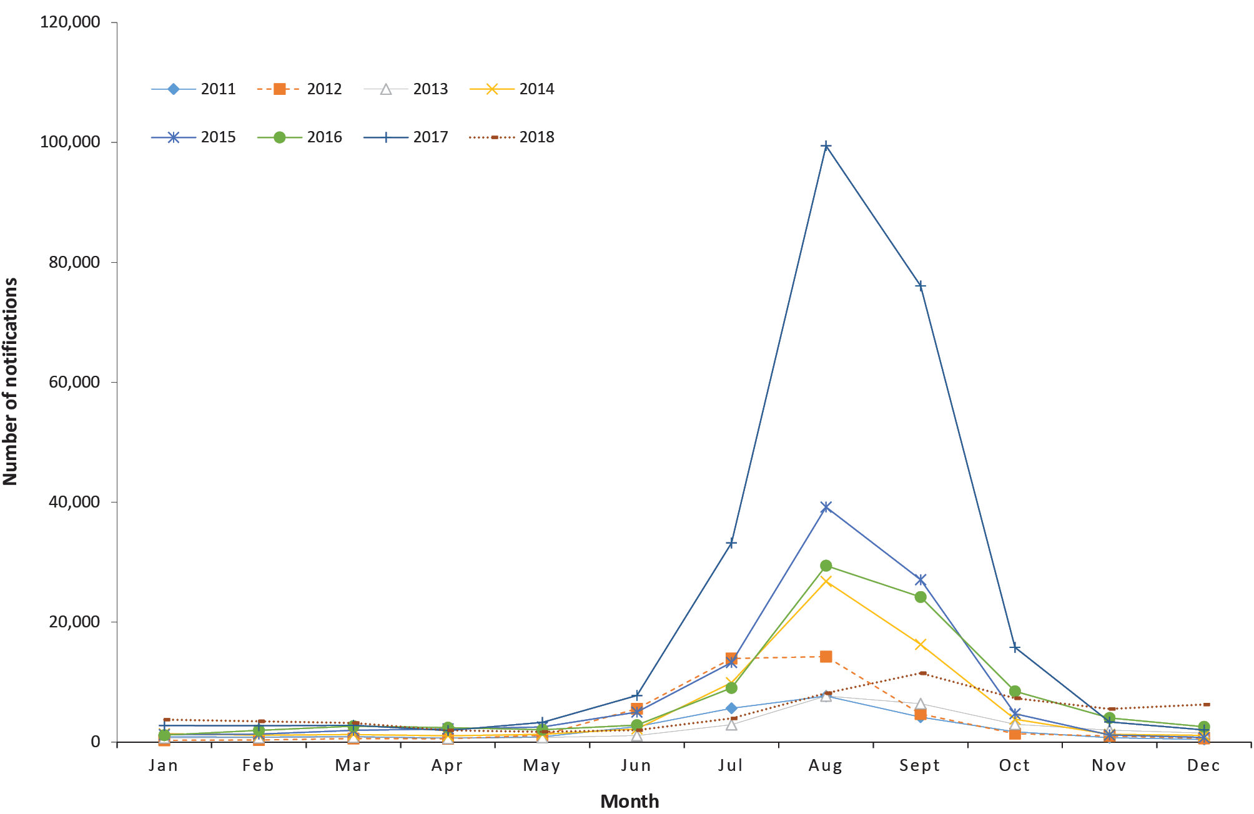
Figure 3: Rate of notification of laboratory-confirmed influenza in Australia by jurisdiction, 2011 to 2018
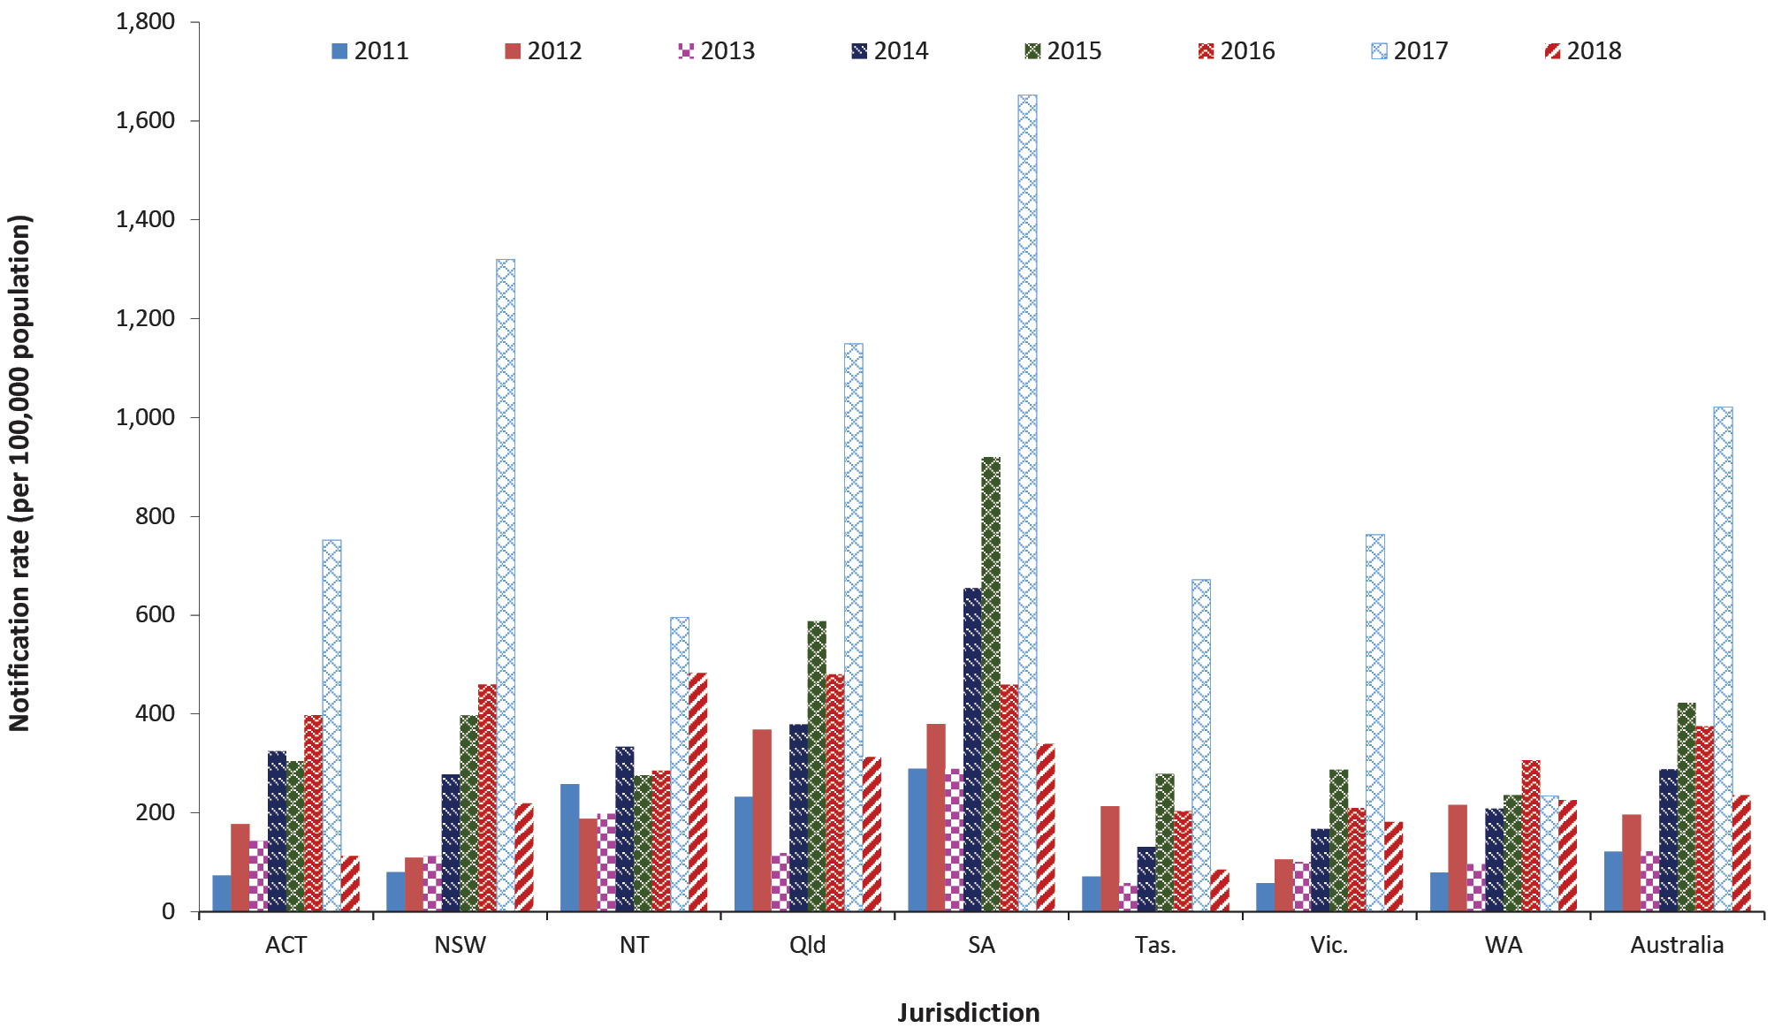

Geographic distribution
During the period from 2011 to 2018, thirty-four percent of laboratory-confirmed influenza notifications (n = 230,281/669,370) were in New South Wales, 26% (n = 174,286) in Queensland, 17% (n = 115,141) in Victoria, 13% (n = 84,804) in South Australia, 6% (n = 40,466) in Western Australia, and 1% each in the Northern Territory (n = 6,376), Tasmania (n = 8,881) and the Australian Capital Territory (n = 9,135) (Table 1). Of the states and territories, New South Wales reported the highest proportion of cases during each year of the reporting period, except in 2011 and 2012 when Queensland reported the highest proportion of cases.
Over the reporting period, all states and territories, except Western Australia, reported their highest rates of laboratory-confirmed influenza in 2017 (Table 1, Figure 3). Western Australia’s notification rate for 2017 (n = 234 notifications per 100,000 population) was comparable with rates in 2012, 2014, 2015, and 2018, and was lower than in 2016 (n = 307 notifications per 100,000 population). For each year in the reporting period, the highest notification rates were reported from South Australia (2011–2015 and 2017), Queensland (2016), and the Northern Territory (2018) (Figure 3).
Activity at the peak of the influenza season was more prolonged during the 2012 and 2015–2018 seasons (Figure 2). The 2018 season extended until December in Queensland, Victoria, New South Wales, and the Northern Territory. Additionally, the Northern Territory had prolonged influenza seasons in 2013, 2015, 2016, and 2018 with seasons extending into the following year. Bimodal patterns were also observed in the Northern Territory during the 2011, 2013, 2014, and 2017 seasons (Figure 4).

Figure 4: Notifications of laboratory-confirmed influenza in Australia by year and state or territory, 2011 to 2018
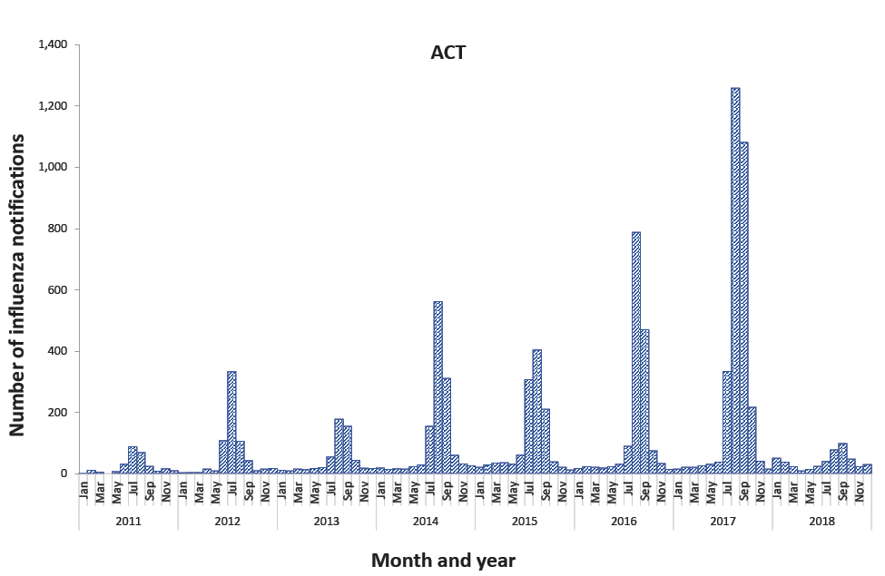
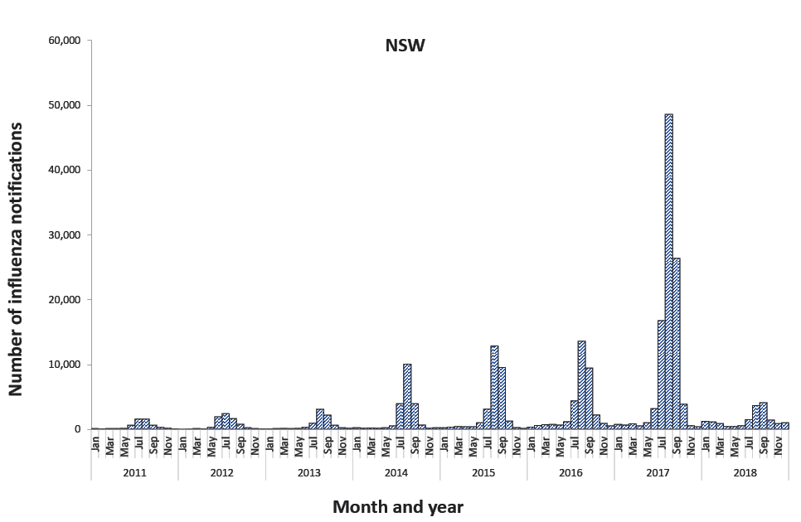
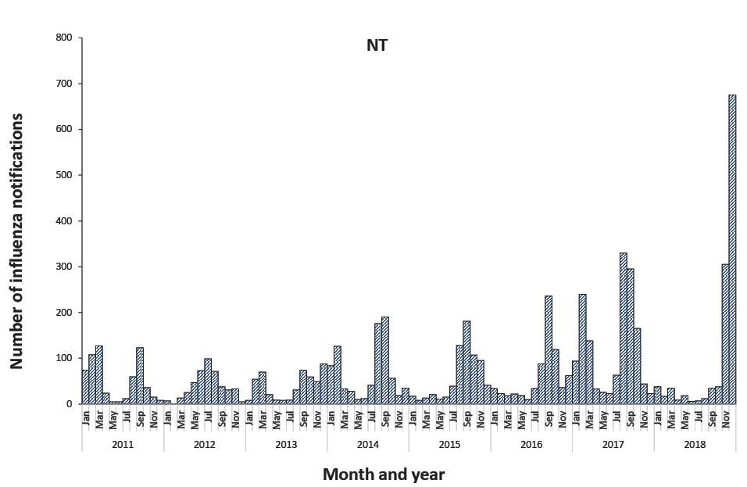
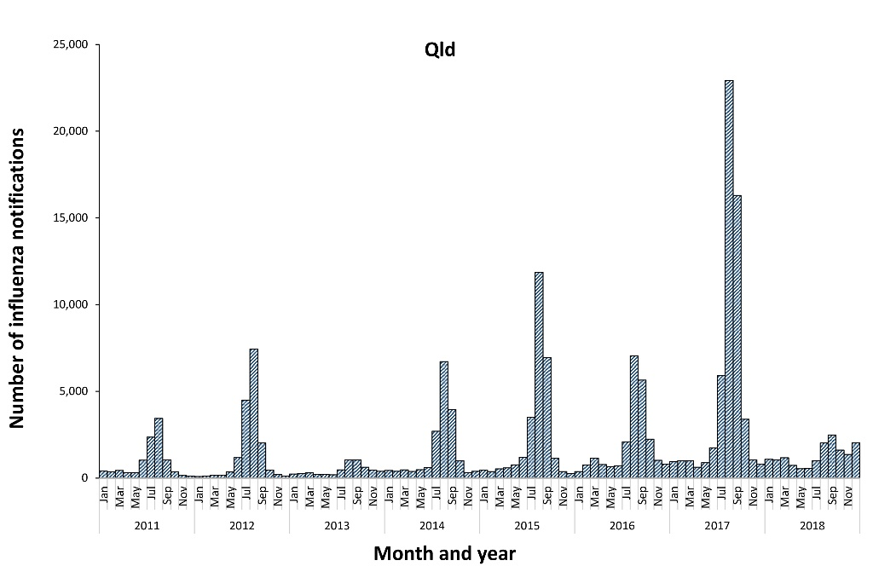
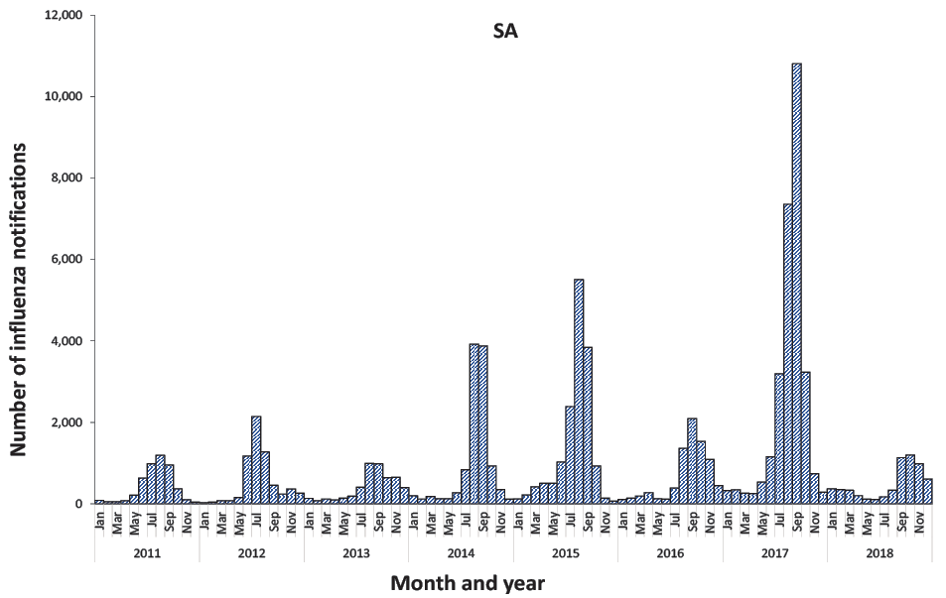
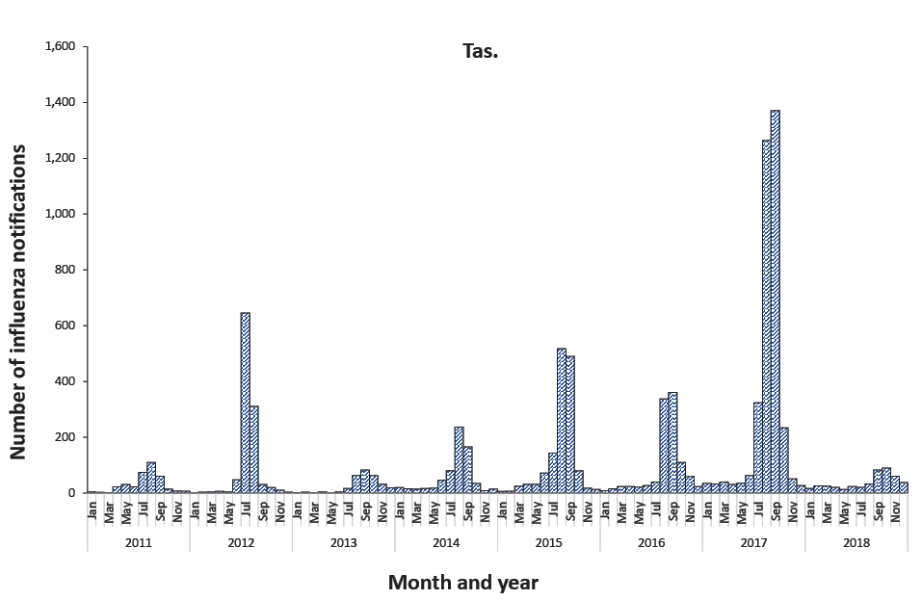
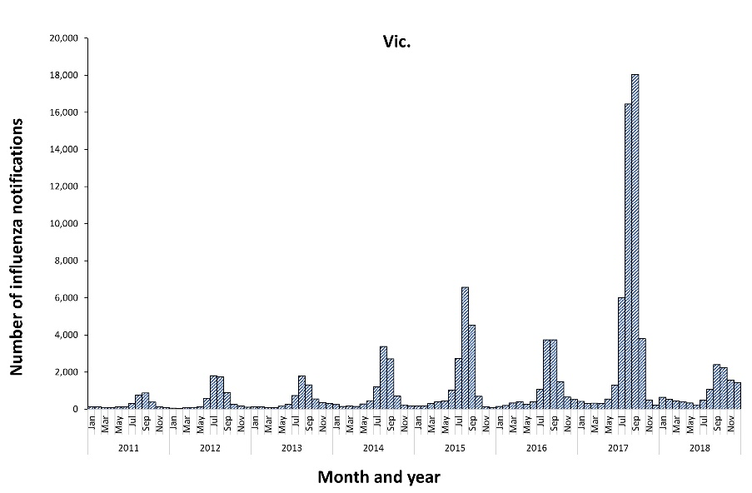

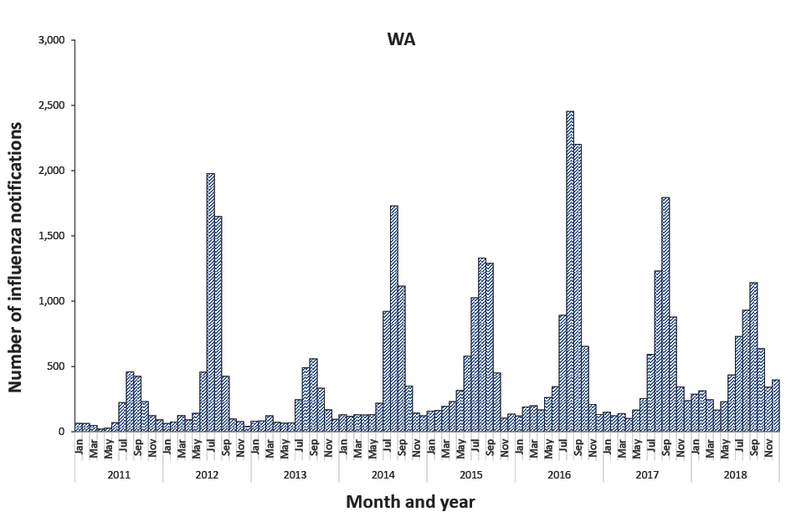

Age and sex profile
Laboratory-confirmed influenza notification rates increased from 131 per 100,000 population in 2011, reaching a peak of 1,030 per 100,000 population in 2017 before declining to 244 per 100,000 population in 2018 for all age groups and persons. Except in 2016 and 2017, the highest notification rates each year were reported among males aged 14 years or younger. In 2016 and 2017, the highest rates were reported among females aged 65 years or older (Figure 5). Notifications in females predominated in all years, and overall represented 54.3% of notifications from 2011 to 2018 (Table 2).
During the eight-year period, influenza type A predominated in the 65 years or older age group, at 76.8% (n = 96,352). Influenza B predominated in 2015 (61% of notified cases), accounting for 71.6% of cases notified in the 14 years or younger age group, 59.9% in the 15–64 years age group, and 39.5% in the 65 years and over age group (Table 3).

Figure 5: Notification rates of laboratory-confirmed influenza in Australia by sex and age group, 2011 to 2018
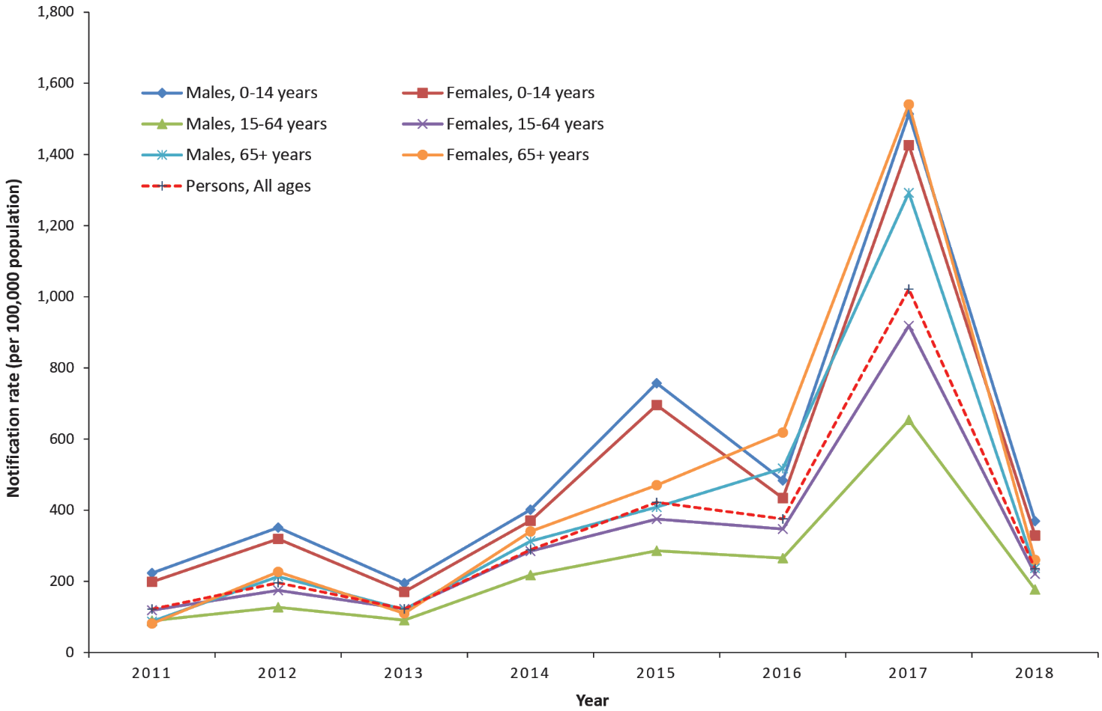
Table 2: Notifications and rates of laboratory-confirmed influenza in Australia by year and sex,ª 2011 to 2018
Year |  | 2011 | 2012 | 2013 | 2014 | 2015 | 2016 | 2017 | 2018
Notifications  n (%) | Male | 12,825 (47) | 20,620 (46) | 13,264 (47) | 31,124 (46) | 46,743 (47) | 41,287 (45) | 11,1564 (45) | 27,723 (47)
 | Female | 14,360 (53) | 23,891 (54) | 15,028 (53) | 36,529 (54) | 53,772 (53) | 49,546 (55) | 137,902 (55) | 31,096 (53)
Notification rate^{b} | Male | 115.4 | 182.3 | 115.3 | 266.7 | 395.2 | 344 | 914.2 | 223.6
 | Female | 128.0 | 209.2 | 129.3 | 309.4 | 448.5 | 406.5 | 1,112.3 | 246.9
a Excludes notifications with sex not reported (n = 2,091).
b Notification rate per 100,000 population.

Table 3: Influenza notifications in Australia by year, age group and type/subtypeª
Year | Age group (years) | Influenza type/subtypeª |  |  |  |  |  | Notification rateª (per 100,000 population)
 |  | A/H1N1 | A/H3N2 | A (unsubtype^{d}) | B | A and B | C
2011 | < 15 | 2,437 | 666 | 2,542 | 3,287 | 5 | 1 | 211.1
 | 15–64 | 4,485 | 1,044 | 6,553 | 3,458 | 29 | 1 | 103.7
 | ≥ 65 | 189 | 275 | 1,551 | 544 | 29 | 0 | 83.8
2012 | < 15 | 89 | 2,284 | 7,452 | 4,611 | 3 | 3 | 335.5
 | 15–64 | 200 | 3,738 | 13,947 | 5,074 | 28 | 5 | 151.1
 | ≥ 65 | 24 | 1,513 | 4,654 | 860 | 36 | 1 | 220.5
2013 | < 15 | 1,120 | 350 | 2,177 | 4,353 | 13 | 0 | 183.0
 | 15–64 | 2,614 | 872 | 7,848 | 5,070 | 37 | 0 | 106.6
 | ≥ 65 | 314 | 441 | 2,072 | 986 | 22 | 0 | 115.2
2014 | < 15 | 2,067 | 1,358 | 11,518 | 2,182 | 12 | 9 | 386.2
 | 15–64 | 4,216 | 2,956 | 27,247 | 4,759 | 46 | 3 | 251.6
 | ≥ 65 | 616 | 1,550 | 7,968 | 1,107 | 36 | 1 | 327.6
2015 | < 15 | 915 | 1,478 | 6,827 | 23,446 | 71 | 0 | 727.6
 | 15–64 | 1,262 | 3,262 | 16,289 | 31,217 | 96 | 0 | 330.7
 | ≥ 65 | 156 | 1,768 | 7,544 | 6,200 | 39 | 1 | 441.9
2016 | < 15 | 1,883 | 1,852 | 14,311 | 2,950 | 25 | 3 | 459.8
 | 15–64 | 3,060 | 4,712 | 35,595 | 5,395 | 58 | 1 | 306.2
 | ≥ 65 | 448 | 3,216 | 15,909 | 1,392 | 18 | 0 | 571.4
2017 | < 15 | 1,381 | 1,927 | 34,880 | 30,558 | 268 | 0 | 1,487.7
 | 15–64 | 1,795 | 4,825 | 71,299 | 49,816 | 285 | 0 | 791.6
 | ≥ 65 | 302 | 4,070 | 34,205 | 15,459 | 135 | 2 | 1,429.0
2018 | < 15 | 1,428 | 307 | 11,886 | 2,816 | 7 | 0 | 349.7
 | 15–64 | 2,273 | 1,078 | 22,380 | 6,806 | 39 | 0 | 198.9
 | ≥ 65 | 500 | 734 | 6,333 | 2,133 | 29 | 0 | 248.6
a Excludes 354 untyped notifications and 103 notifications where age was not reported.

Aboriginal and/or Torres Strait Islander status
During the reporting period Aboriginal and/or Torres Strait Islander status was recorded for 256,691 cases, with 15,846 of these cases (6.2%) identifying as Aboriginal and/or Torres Strait Islander. Throughout the eight-year period, laboratory-confirmed influenza notification rates were between 1.9 and 3.7 times higher among those identifying as Aboriginal and/or Torres Strait Islander than those identifying as non-Indigenous (Figure 6). Sixty-two percent of cases (n = 412,679) did not have Aboriginal and/or Torres Strait Islander status recorded.
Figure 6: Notification rates of laboratory confirmed influenza in Australia by Aboriginal and/or Torres Strait Islander status, 2011 to 2018ª
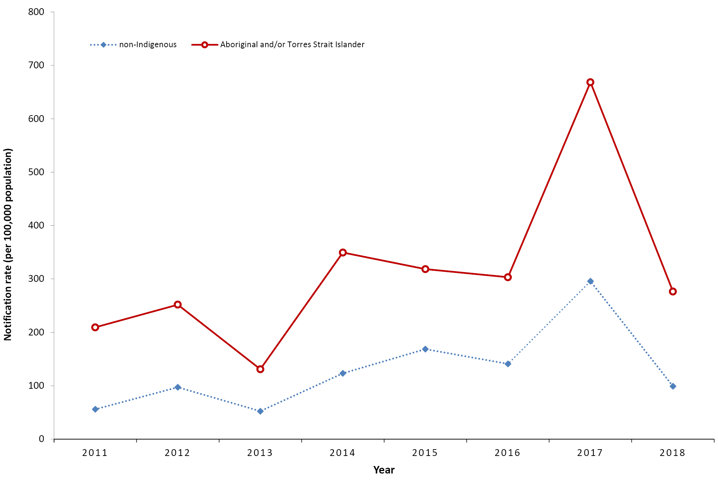
a Aboriginal and/or Torres Strait Islander status was missing for 412,679 cases.

Virus type and subtype
Analysis of NNDSS influenza typing data showed influenza A(unsubtyped) was the predominant type during the period from 2011 to 2018 (Table 4). Of notifications with influenza type recorded during the reporting period, 67.7% overall were type A (55.7% unsubtyped, 6.9% H3N2, and 5.0% H1N1), 32.1% were type B, 0.2% accounted for mixed influenza type A and B, and type C infections, and < 0.1% of cases (n = 354) were untyped. Over the reporting period there was variation in the distribution of influenza types. For example, in 2015 influenza type B predominated, accounting for 61% of notifications, while in all other years during the reporting period, influenza type A predominated. The highest A(H1N1) proportion was reported in 2011 (26.1%) followed by 2013 (14.3%) and 2014 (10.1%), while A(H3N2) was highest in 2012 (16.9%) followed by 2016 (10.8%) (Figure 7).

Figure 7: Proportion of influenza notifications in Australia by year and subtype, 2011–2018
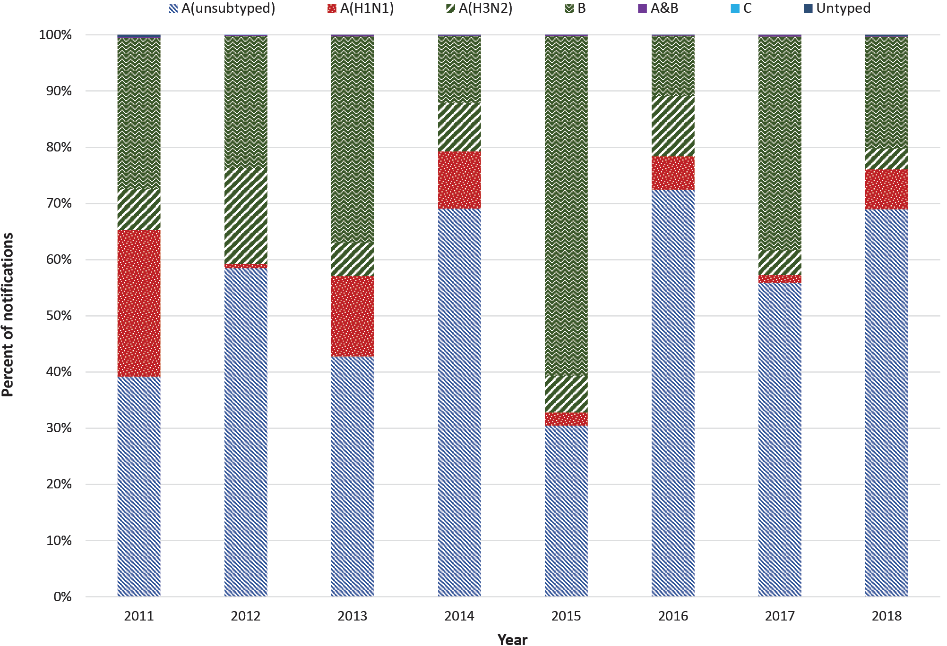

Hospitalisations
A total of 176,486 (26.4%) cases across the reporting period had data on whether or not they were hospitalised recorded in the NNDSS. Of the 176,486 cases with hospitalisation data, 13,338 cases (7.6%) were reported to have been hospitalised. The proportion of cases who were hospitalised peaked in 2013 (64.8%) and was lowest during the 2017 season (3.1%) (Figure 8).
Hospital admissions were likely under-reported to the NNDSS during the period from 2011 to 2018 and should therefore be interpreted with caution. For example, during the period from 2011 to 2018, a total of 12,900 laboratory-confirmed influenza patients were hospitalised in just the 17 hospitals under the FluCAN network. Furthermore, there were no hospital admissions reported from Victoria in the NNDSS throughout the period 2011 to 2018.
In the NNDSS hospitalisation data, patients in the 65 years or older age group had the highest hospitalisation rates, except in 2011 when those 14 years or younger had the highest rates of hospitalisation (Figure 9).

Table 4: Influenza in Australia by year and subtype, 2011-2018
Influenza type/subtype | 2011  n (%) | 2012  n (%) | 2013  n (%) | 2014  n (%) | 2015  n (%) | 2016  n (%) | 2017  n (%) | 2018  n (%)
A(unsubtyped) | 10,654 (39) | 26,061 (59) | 12,104 (43) | 46,745 (69) | 30,664 (30) | 65,843 (72) | 140,388 (56) | 40,599 (69)
A(H1N1) | 7,112 (26) | 313 (1) | 4,048 (14) | 6,901 (10) | 2,333 (2) | 5,391 (6) | 3,478 (1) | 4,201 (7)
A(H3N2) | 1,985 (7) | 7,538 (17) | 1,663 (6) | 5,864 (9) | 6,508 (6) | 9,780 (11) | 10,823 (4) | 2,119 (4)
B | 7,299 (27) | 10,551 (24) | 10,412 (37) | 8,049 (12) | 60,868 (61) | 9,737 (11) | 95,833 (38) | 11,755 (20)
A&B | 63 (< 1) | 67 (< 1) | 72 (< 1) | 94 (< 1) | 206 (< 1) | 101 (< 1) | 688 (< 1) | 75 (< 1)
C | 2 (< 1) | 9 (< 1) | 0 (0) | 13 (< 1) | 1 (< 1) | 4 (< 1) | 0 (0) | 2 (< 1)
Untyped | 99 (< 1) | 1 (< 1) | 5 (< 1) | 19 (< 1) | 2 (< 1) | 30 (< 1) | 80 (< 1) | 118 (< 1)
Total | 27,214 (100) | 44,540 (100) | 28,304 (100) | 67,685 (100) | 100,582 (100) | 90,886 (100) | 251,290 (100) | 58,869 (100)

Figure 8: Number and per cent of influenza cases in Australia that were hospitalised, 2011 to 2018
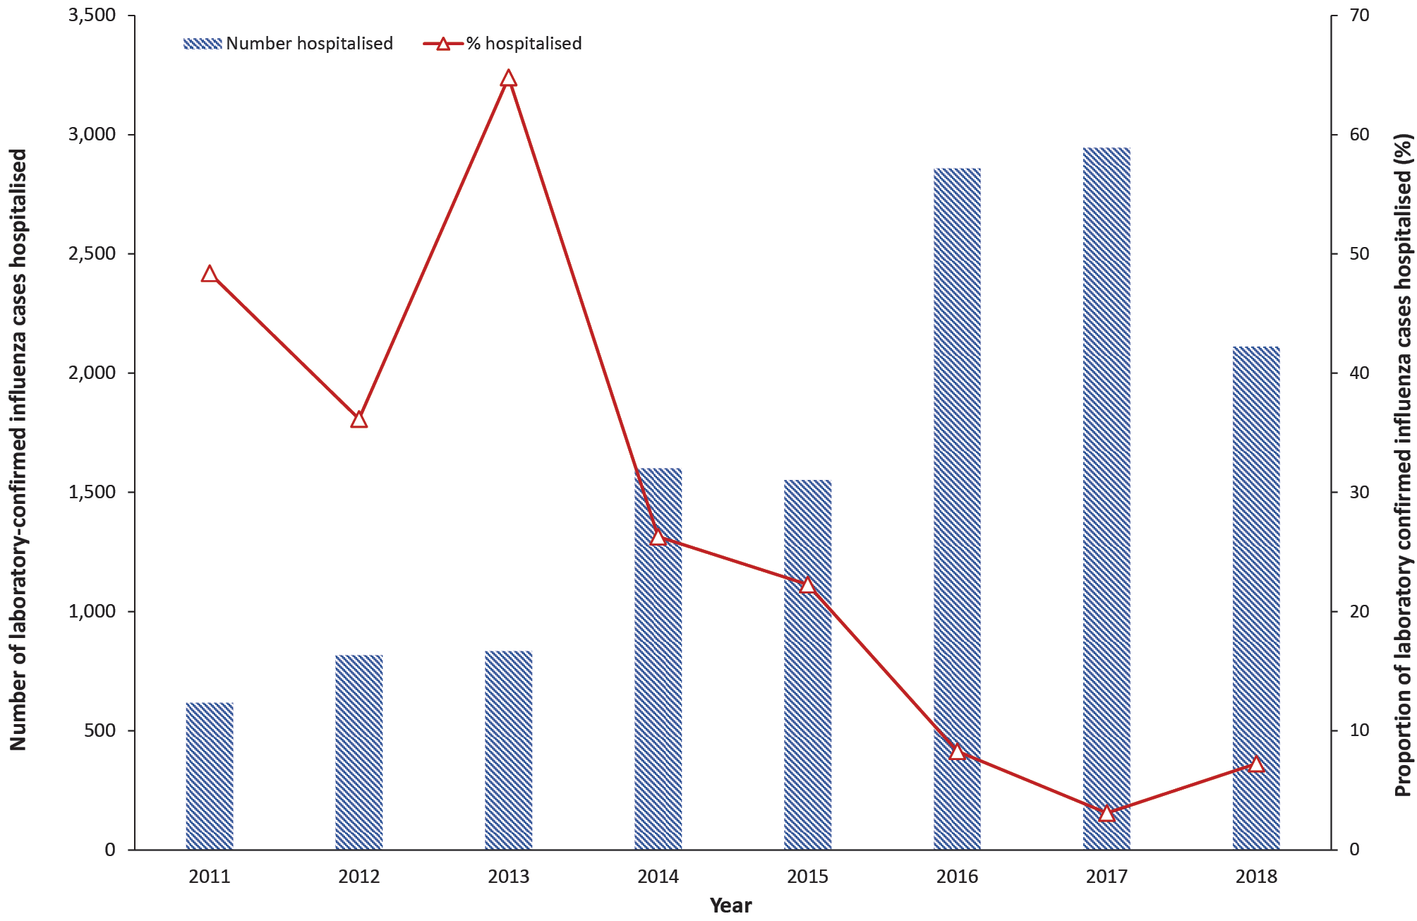
Figure 9: Influenza hospitalisation rates in Australia by age group, 2011 to 2018
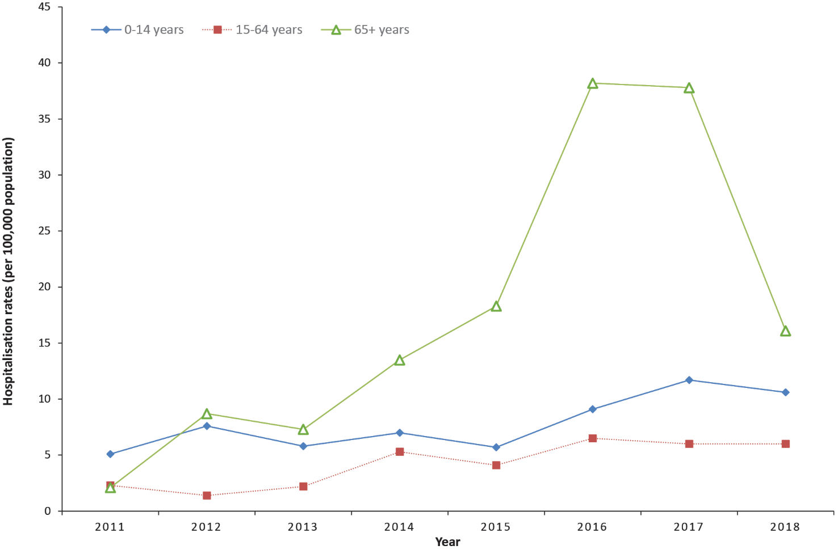

Virology

Samples received and tested
The highest numbers of samples received by the Australian WHO Collaborating Centre (WHOCC) were in 2017 (n = 4,459) followed by 2015 (n = 4,436), with the lowest number of samples in 2018 (n = 2,357).
Influenza type A isolates were the predominant isolates tested by the Australian WHOCC during each year of the reporting period, except for 2015 when almost 70% of the isolates were type B (Figure 10 and Figure 11). These proportions are consistent with data reported through the NNDSS and FluCAN.
Figure 10: Number of isolates tested at the Australian WHOCC site by type/subtype, 2011 to 2018^{a,b}
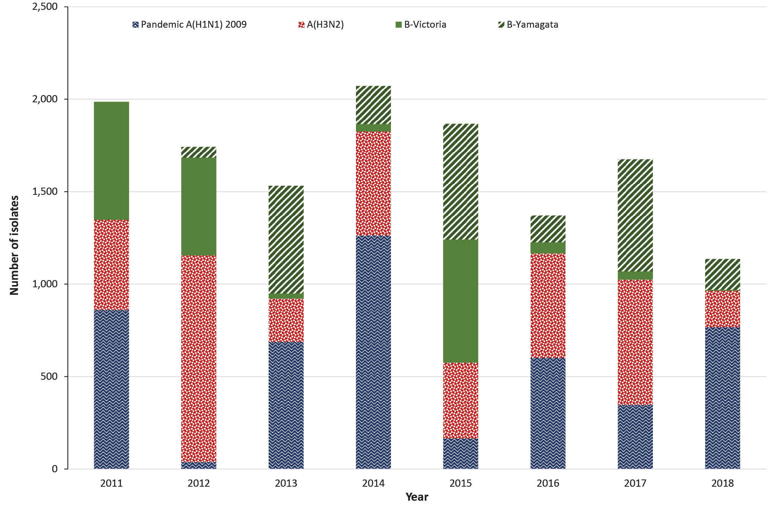
a 2015 data only up to 21 December 2015.
b 2018 data only up to 17 December 2018.
During the reporting period, two antigenically and genetically distinct lineages of inﬂuenza B virus were circulating: the B/Victoria/2/87 lineage (represented by the southern hemisphere 2016 vaccine strain B/Brisbane/60/2008) and the B/Yamagata/16/88 lineage (represented by the southern hemisphere 2015 vaccine strain B/Phuket/3073/2013). Influenza B only accounted for about a third of notifications (32%) from 2011 to 2018. The B/Yamagata lineage was the predominant B virus except in 2011, 2012, and 2015 when B/Victoria predominated (Figure 11). Of influenza B viruses characterised by the Australian WHOCC site during the eight-year period, 54.3% were from the Yamagata lineage, although the proportion was higher (66.6%) when analysing the most recent four years (2015 to 2018) (Table 5).

Figure 11: Proportion of isolates tested at the Australian WHOCC site by type/subtype, 2011 to 2018^{a,b}
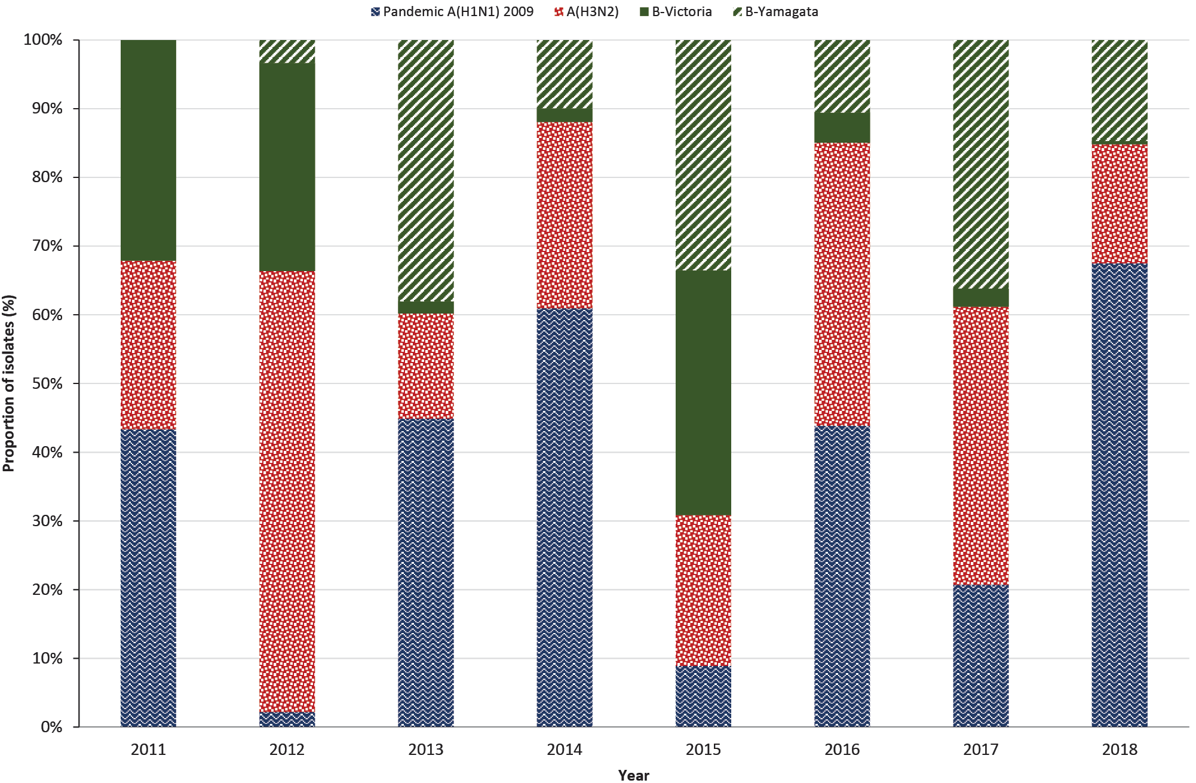
a 2015 data only up to 21 December 2015.
b 2018 data only up to 17 December 2018.
Table 5: Summary of influenza isolates analysed by haemagglutination inhibition (HI) assay from samples collected from 2011 to 2018 by the Australian WHOCC site, VIDRL
Influenza type/subtype | 2011 | 2012 | 2013 | 2014 | 2015ª | 2016 | 2017 | 2018^{b} | 2011 to 2018
Pandemic A(H1N1) 2009 | 861 | 38 | 688 | 1,263 | 166 | 601 | 347 | 767 | 4,731 (35%)
A(H3N2) | 487 | 1,118 | 234 | 562 | 410 | 565 | 678 | 197 | 4,251 (32%)
B-Victoria | 638 | 528 | 27 | 41 | 665 | 60 | 44 | 5 | 2,008 (15%)
B-Yamagata | NIc | 58 | 583 | 206 | 626 | 145 | 606 | 167 | 2,391 (18%)
a 2015 data only up to 21 December.
b 2018 data only up to 17 December.
c NI: not indicated.
During the reporting period, many B/Victoria/2/87 lineage viruses were well inhibited by antisera raised against B/Brisbane/60/2008-like viruses. However, an increasing proportion of viruses were antigenically different from B/Brisbane/60/2008-like viruses, and were more closely related to B/Colorado/06/2017-like viruses.¹⁹ This led to a change to a B/Colorado/06/2017-like virus as the B/Victoria component for the southern hemisphere 2019 vaccine.¹⁵
Of influenza A viruses circulating during the reporting period, the A(H1N1) viruses were mostly antigenically similar to the vaccine strain A/California/7/2009 (H1N1), except in 2017 and 2018 when they were mostly similar to A/Michigan/45/2015. The A(H3N2) strains varied over the years but included the vaccine strains A/Perth/16/2009, A/Switzerland/9715293/2013, A/Hong Kong/4801/2014, and A/Singapore/INFIMH/2016.
In 2018, the Australian WHOCC site detected, for the first time, swine A(H3N2)v (v for variant) virus from a human patient in South Australia. Phylogenetic analysis of the virus showed a combination of genes derived from seasonal A(H3N2) viruses and A(H1N1)pdm09 viruses. The detection of this virus from a human patient highlights the importance of robust surveillance of zoonotic influenzas that can infect humans and potentially represent a pandemic threat if human-to-human transmission subsequently occurs.
The Australian WHOCC tested a total of 14,900 isolates for resistance to oseltamivir. Fifty-one isolates (0.3%) were resistant to oseltamivir, all of which were type A isolates (49 of A(H1N1)pdm09, and two of A(H3N2)).

Influenza-like illness – national online community survey (FluTracking)

Participants
The highest proportion of participants during the eight-year period were in the 50–64 years age group (proportion range: 31–36%), followed by the 35–49 years age group (23–30%), while the lowest proportion of participants was in the 65 years or older age group (except in 2017 and 2018 when the lowest proportion of participants was in the 15 years or younger age group). Participation declined during the reporting period in those aged between 16 and 64 years, and increased for those aged 15 years or younger and 65 years or older (Figure 12).
Figure 12: Proportion of FluTracking participants by age group and year, 2011 to 2018ª
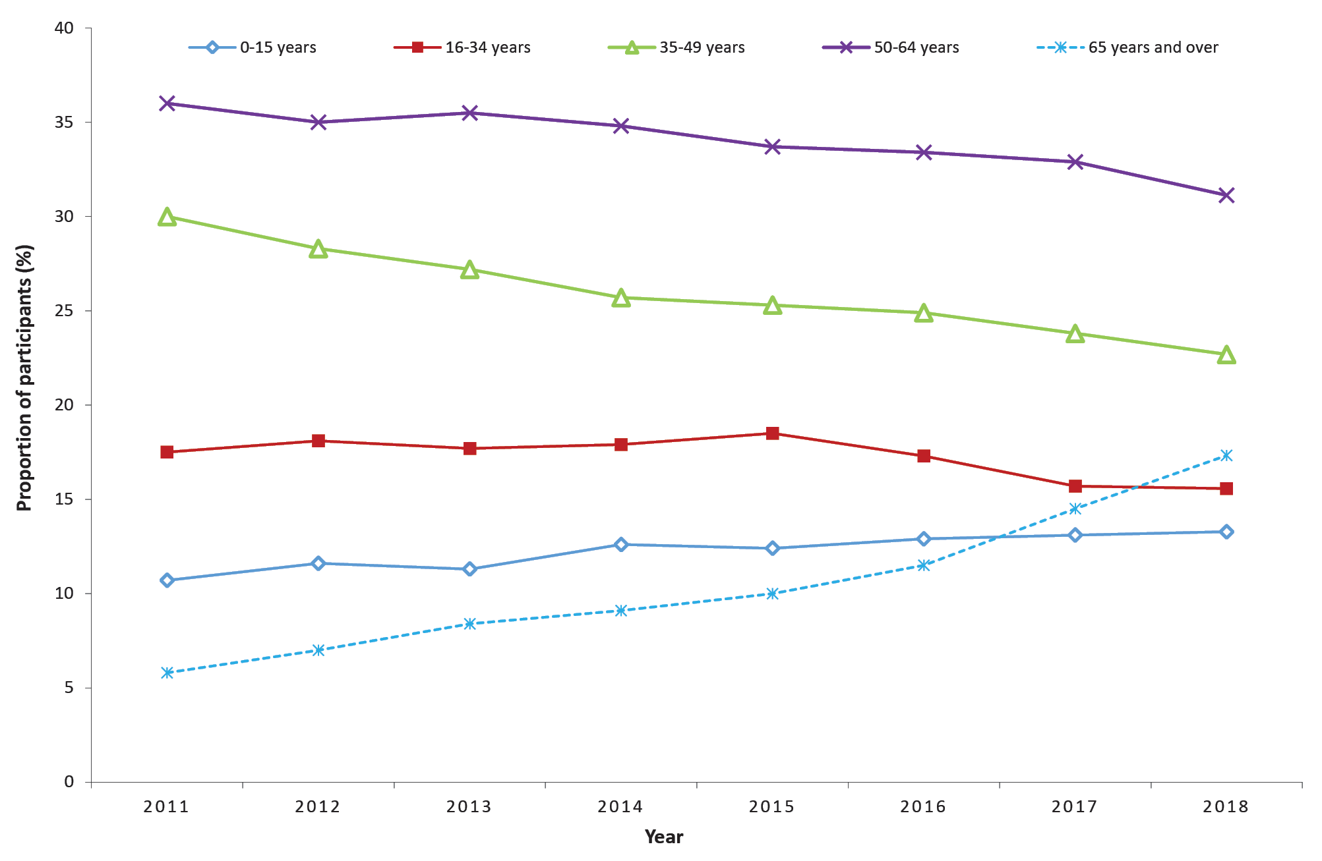
a Source: FluTracking.
During the eight-year reporting period, 117,046 of the participants (61.2%) were female, and the number of participants who identified as Aboriginal and/or Torres Strait Islander ranged from 102 (1.2%) in 2011 to 492 (1.7%) in 2018.
The number of participants completing at least one survey increased each year over the eight-year reporting period from 13,101 in 2011 to 45,532 in 2018, representing a 3.5 times increase. The rate of FluTracking participation also increased more than threefold, from 58.3 per 100,000 population in 2011, to 182.2 per 100,000 population in 2018 (Figure 13).
Figure 13: Number and rate of participants who completed at least one survey, 2011 to 2018ª
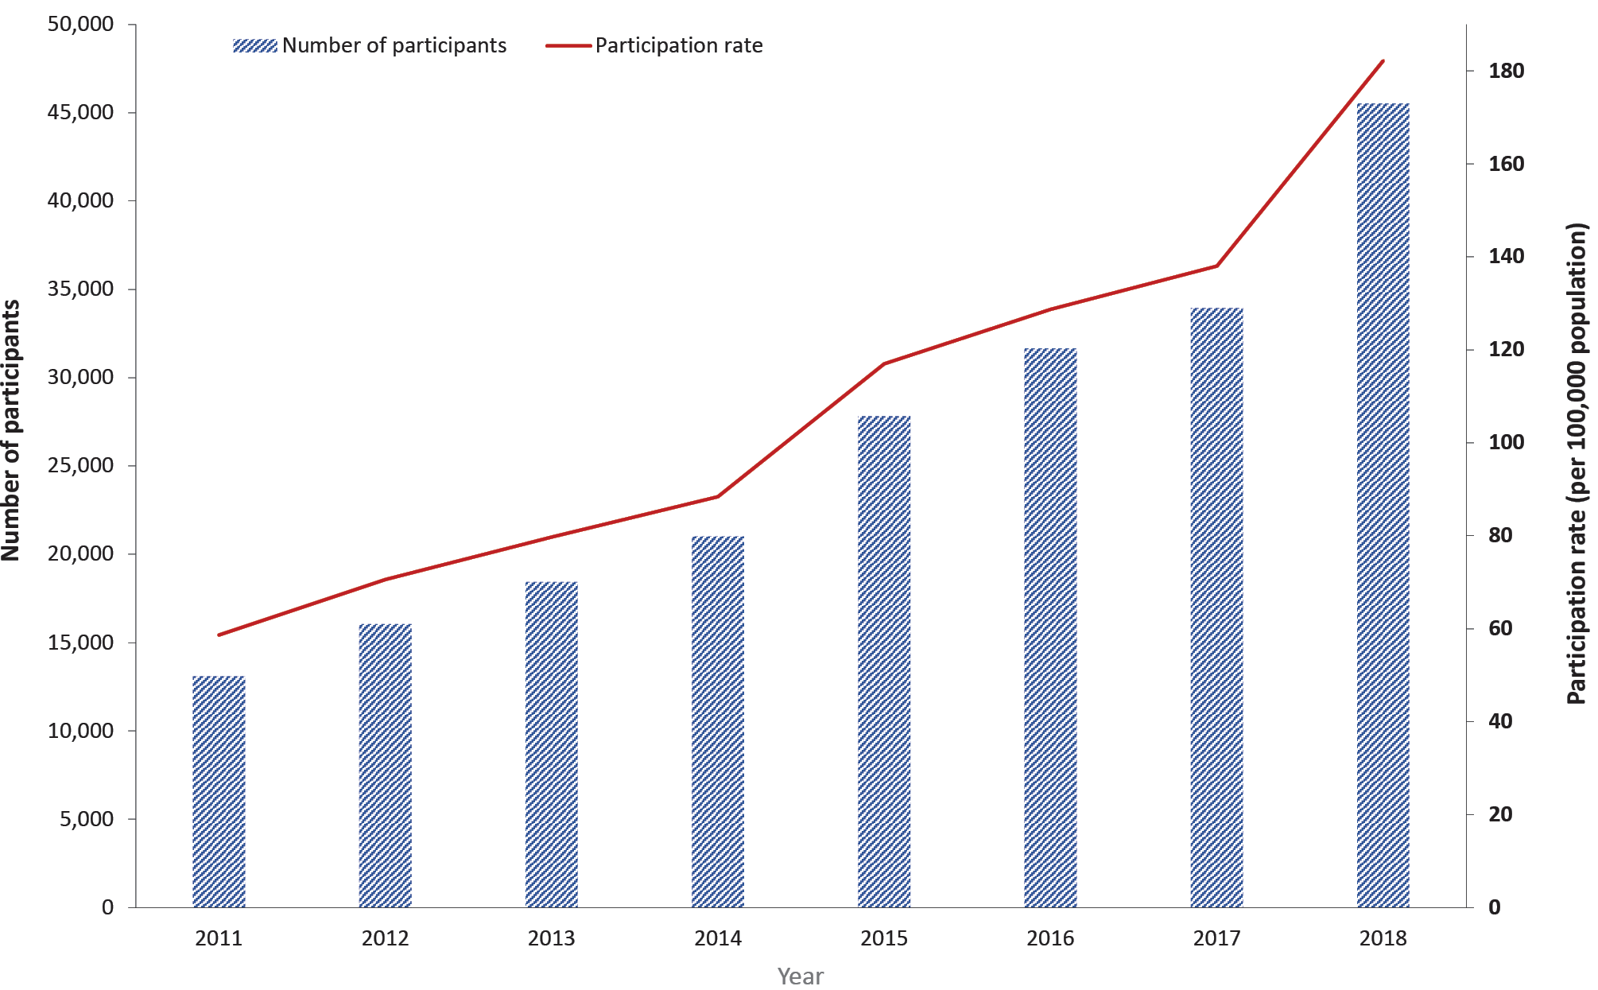
a Source: FluTracking.

Percentage with ILI symptoms (cough and fever) and absence from work
Almost two percent (1.9%) of participants who completed a survey in the national peak week of ILI for 2018 reported fever and cough, compared to 3.1%, 2.7%, and 3.4% in 2015, 2016, and 2017 respectively. The eight-year average peak was reported in week 32 (2.0%) (Figure 14). Of the participants who completed the survey in the national peak week of ILI over the reporting period, the proportion reporting both ILI and absence from work was lowest in 2018 (1.4%) and highest in 2017 (2.7%). The 2018 influenza season also had fewer participants reporting ILI and associated absenteeism from work overall than in previous seasons over the eight years (Figure 14).

Influenza-like illness consultations from sentinel general practitioner surveillance systems
The peak influenza-like illness (ILI) rate reported through the sentinel GPs (ASPREN and VicSPIN) were highest in 2017 (22.6 per 1,000 consultations) and 2015 (18.9), and lowest in 2018 (6.5) and 2013 (10.1). ILI rates typically peaked in weeks 33 to 34, except for 2012 and 2018 when the peak notification rates were in weeks 29 and 37 respectively (Figure 15). Similarly, GP consultations and notifications reported by VicSPIN peaked during the same range of weeks over the eight-year reporting period (Figure 16).
Figure 14: Proportion of FluTracking participants reporting ILI and absence from work in Australia, by week, 2011 to 2018ª
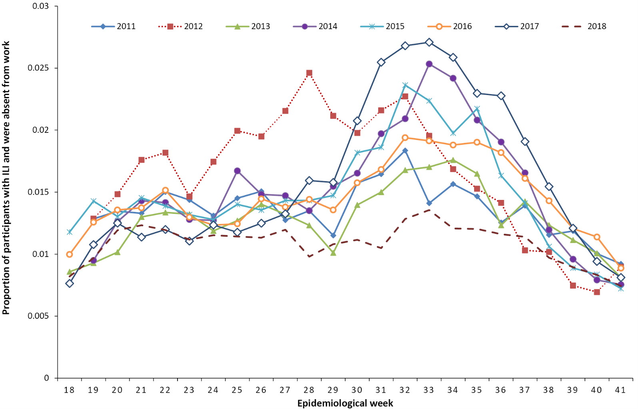
a Source: FluTracking.

Figure 15: Sentinel general practitioner ILI consultation rates by year and week, 2011 to 2018ª
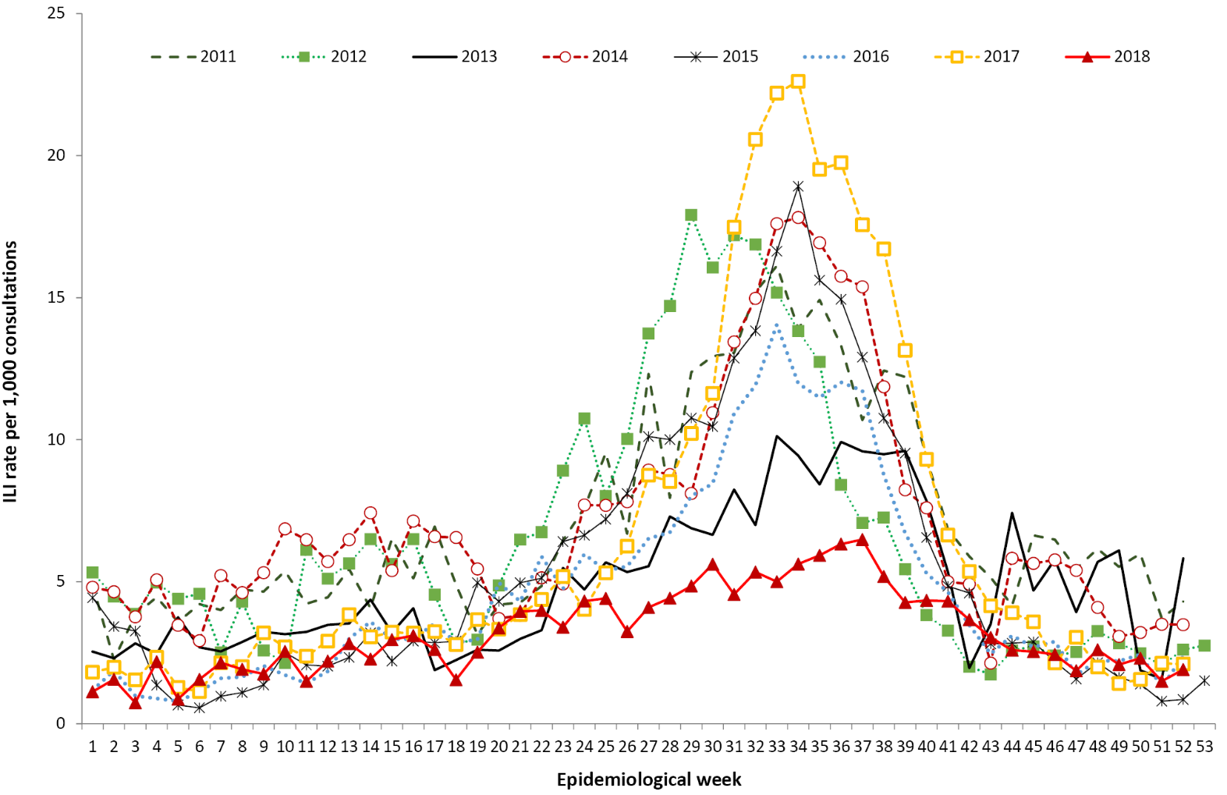
a Sources: ASPREN and VicSPIN.

Figure 16: Sentinel general practitioner ILI consultations (ASPREN), by state or territory and VicSPIN, 2011 to 2018ª
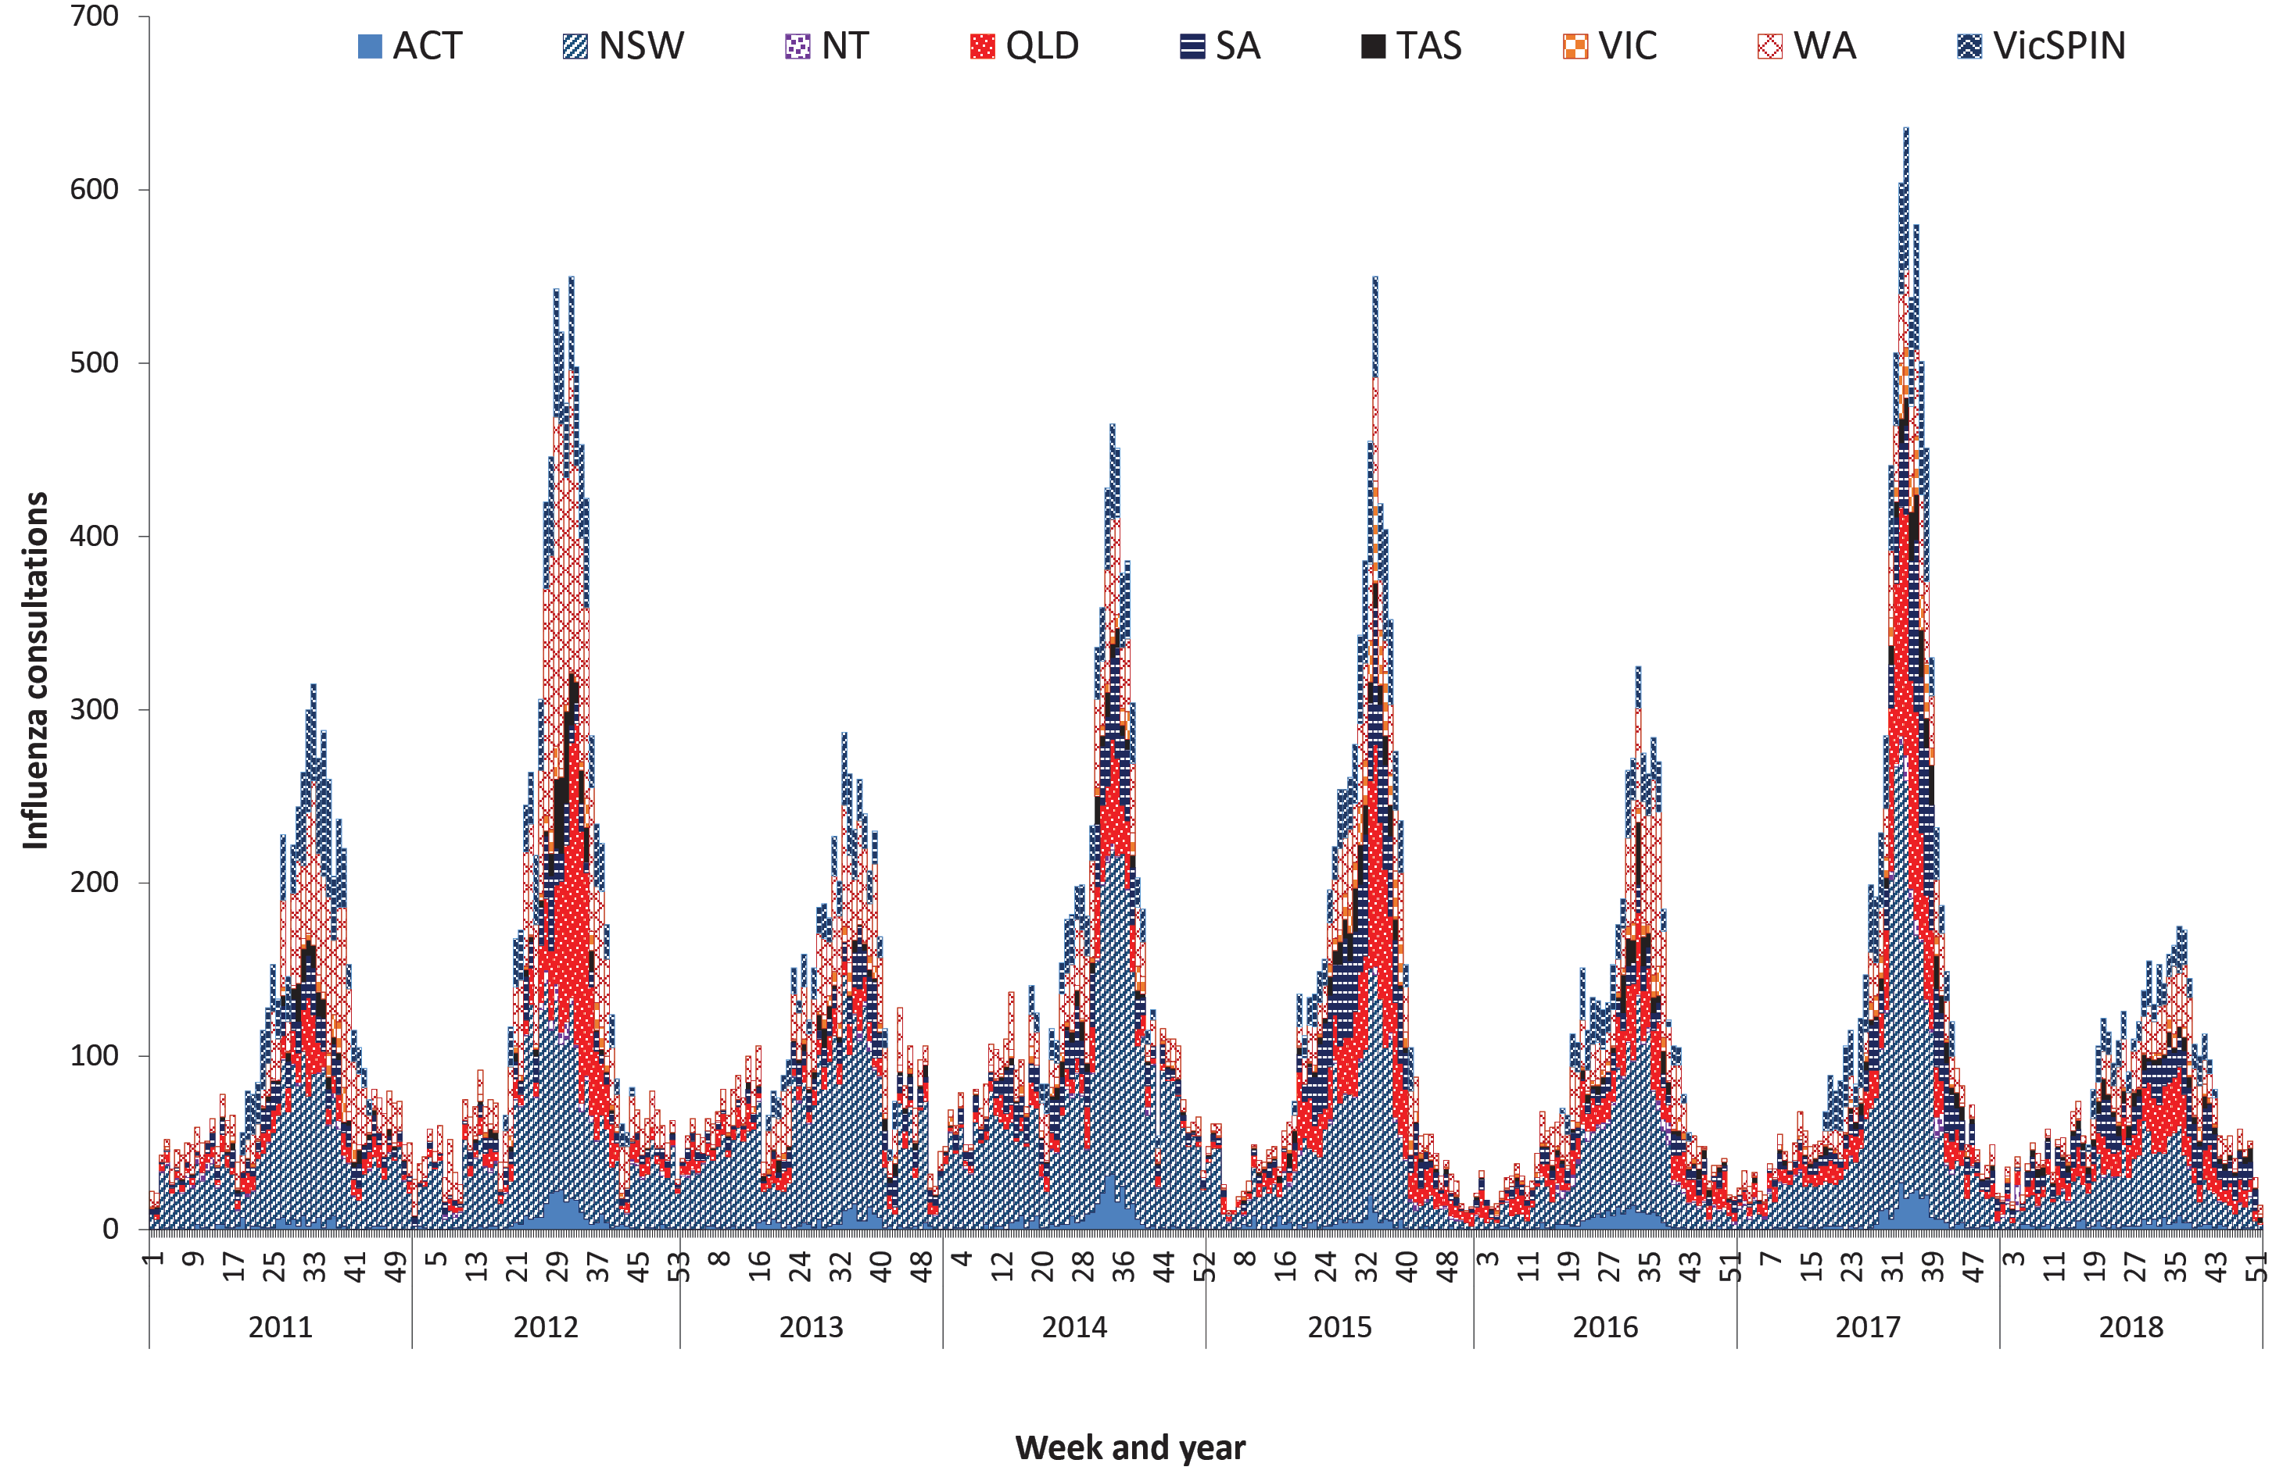
a Sources: ASPREN and VicSPIN.

Morbidity

FluCAN

Hospitalisations
A total of 12,900 admissions were reported during the period 2011–2018 across all 17 FluCAN hospital sites. Influenza confirmed admissions increased by almost a factor of fifteen, from 296 in 2011 to 4,259 in 2017, before declining to 769 in 2018 (Table 6). The hospitalisation rates also followed a similar trend, with a peak in 2017 of 17.3 admissions per 100,000 population. In most jurisdictions, the peak numbers of hospitalised cases were reported from mid-August to mid-October, except in 2011 when the highest number of hospitalisations was in July. The proportion of influenza-confirmed admissions to an intensive care unit (ICU) were highest in 2013 (16%) and lowest in 2015 (7%) (Table 6). Hospitalisation data in the FluCAN 2011 report were not disaggregated by state or territory and were therefore not included in the analysis. During the period from 2012 to 2018, Victoria reported the highest number of laboratory-confirmed influenza admissions with the exception of 2016 and 2018 (Figure 17).
Figure 17: Number of hospital admissions with confirmed influenza in sentinel hospitals in Australia, by state or territory and year, 2012 to 2018ª
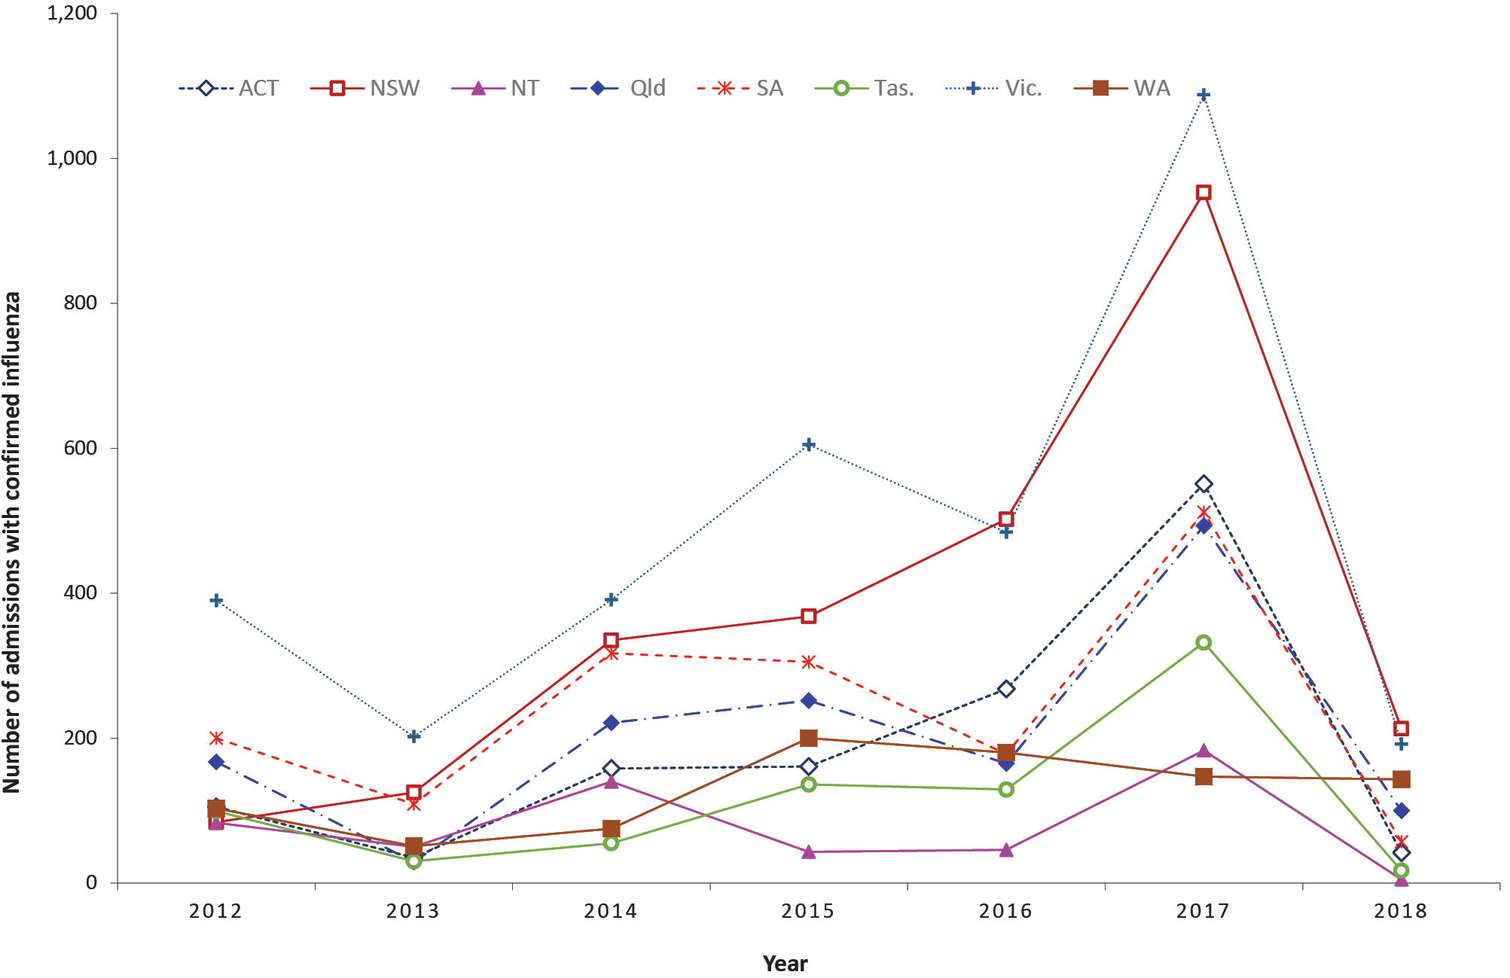
a Source: FluCAN. 2011 data not included.

Demographic characteristics
Overall, during the period from 2011 to 2018, those aged 65 years or older accounted for 5,984 (46%) of the 12,900 patients who were admitted with confirmed influenza to FluCAN sentinel hospitals. The proportion of those aged 65 years or older was lowest in 2018 (30%) and highest in 2017 (52%). During 2015 to 2018, sixteen percent of admitted patients (1,473) were aged 15 years or younger. In total, 860 patients hospitalised with confirmed influenza (7%) identified as Aboriginal and/or Torres Strait Islander (Figure 18). The lowest proportion of people identifying as Aboriginal and/or Torres Strait Islander was reported in 2011 (4%) and the highest in 2014 (10%). The majority of patients hospitalised with laboratory-confirmed influenza (51%; 6,552/12,900) were females, with 315 patients (2%) reported to be pregnant during the time they were admitted to hospital.
Figure 18: Number and proportion of patients identifying as Aboriginal and/or Torres Strait Islander admitted to sentinel hospitals with laboratory-confirmed influenza in Australia, 2011 to 2018
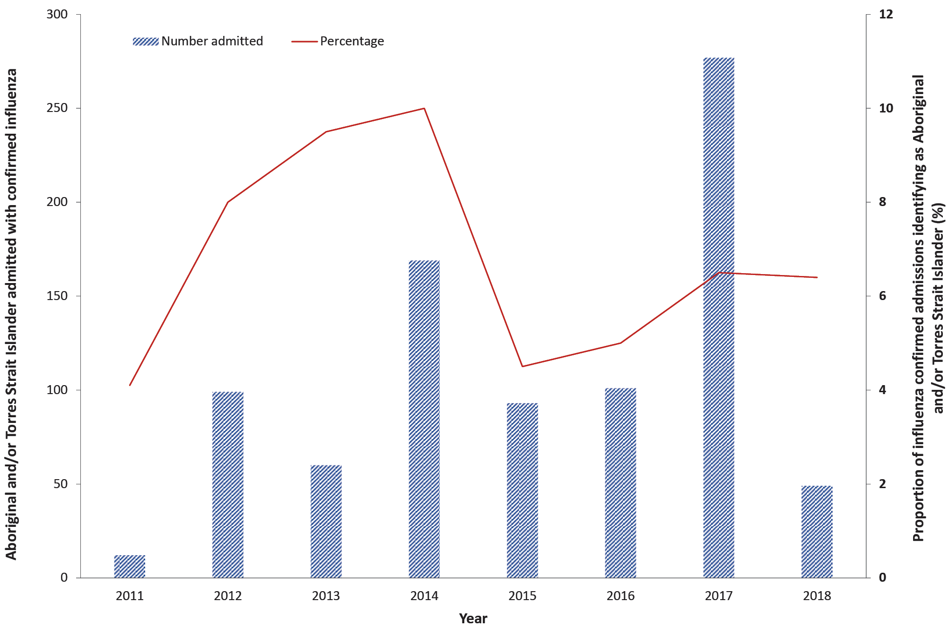

Comorbidities
Of the 12,900 people admitted in sentinel hospitals with influenza during the period 2011 to 2018, there were 9,940 (77.1%) who had chronic comorbidities. The comorbidities included (but were not limited to) chronic respiratory illness, diabetes, chronic liver disease, immunosuppression, malignancy, chronic cardiac disease, and obesity.

Influenza type and subtypes
The majority of laboratory-confirmed influenza admissions to sentinel hospitals from 2012 to 2018 were due to influenza type A, except in 2015 when type B predominated (Figure 19).

Figure 19: Influenza confirmed hospital admissions to sentinel hospitals in Australia by subtype and year, 2011 to 2018ª
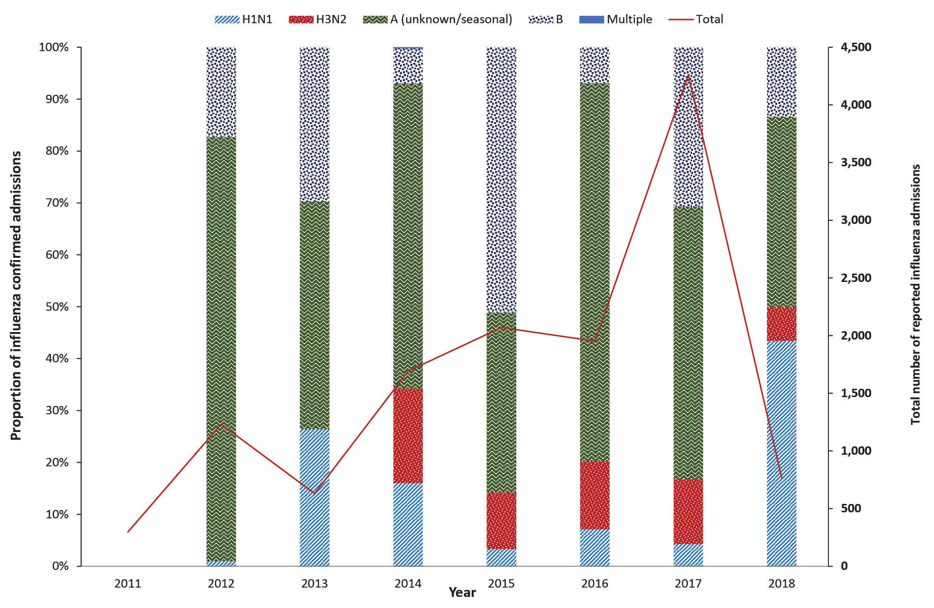
a Subtype data was not available for 2011.

Length of stay
During the reporting period, the longest mean length of hospital stay was reported in 2014 (6.6 days) and the shortest in 2011 (4.0 days). In 2014, increased length of stay was associated with admission to ICU (patients with more severe illness, medical comorbidities, and functional impairment), while a shorter length of stay was associated with factors such as pregnancy and Aboriginal and/or Torres Strait Islander status.¹⁰ During 2017, patients with delayed initiation of treatment with oseltamivir (by more than two days following onset of symptoms) had a longer hospital stay, after adjusting for other factors associated with length of stay including age group, chronic comorbidities, and ICU admission.¹³

Estimated national admissions
Based on the ratio of cases to hospital beds, FluCAN estimated that, during 2011–2018, admissions due to influenza nationally were at their lowest in 2011 (n = 3,200), and highest in 2017 (n = 31,000) (Table 6). These estimated hospital admissions are likely underestimates as not all patients hospitalised with influenza are laboratory confirmed, and patients may present with post-influenza sequelae, such as secondary bacterial pneumonia, and non-respiratory complications such as myocardial infarction. The relative number of cases between jurisdictions does not reflect true influenza activity, due to differences in the number and size of sentinel hospitals in each jurisdiction.⁷

Table 6: Characteristics of patients with laboratory-confirmed influenza admitted to FluCAN sentinel hospital sites in Australia, 2011 to 2018^{a,b}
Year | 2011^{c,d} | 2012^{c} | 2013^{c} | 2014^{c} | 2015^{c} | 2016^{c} | 2017^{c} | 2018^{c}
Hospitalised | 296 (1.3)^{e} | 1,231 (5.4)^{e} | 631 (2.7)^{e} | 1,692 (7.2)^{e} | 2,070 (8.7)^{e} | 1,952 (8.1)^{e} | 4,259 (17.3)^{e} | 769 (3.1)^{e}
Influenza type/subtype
H1N1 | NI | 12 (1.0) | 167 (26.5) | 271 (16.0) | 69 (3.3) | 139 (7.1) | 183 (4.3) | 334 (43.4)
H3N2 | NI | 0 | 0 | 309 (18.3) | 225 (10.9) | 256 (13.1) | 532 (12.5) | 50 (6.5)
A (unknown/ seasonal) | NI | 1,006 (81.7) | 277 (43.9) | 993 (58.7) | 718 (34.7) | 1,422 (73.4) | 2,234 (52.5) | 282 (36.7)
B | NI | 213 (17.3) | 187 (29.6) | 115 (6.8) | 1,058 (51.1) | 135 (6.9) | 1,310 (30.8) | 103 (13.4)
Multiple | NI | 0 | 0 | 4 (0.2) | 0 | 0 | 0 | 0
Age group (years)b
< 18 (2011–2013); < 16 (2014–2018) | NI | 148 (12.0) | 32 (5.1) | 0 | 320 (15.5) | 351 (18.0) | 587 (13.8) | 215 (28.0)
18–39 (2011–2013); 16–49 (2014–2018) | 90 (30.4) | 229 (18.6) | 139 (22.0) | 507 (30.0) | 475 (22.9) | 397 (20.3) | 773 (18.1) | 204 (26.5)
40–64 (2011–2013); 50–64 (2014–2018) | 104 (35.1) | 281 (22.8) | 260 (41.2) | 392 (23.2) | 319 (15.4) | 300 (15.4) | 671 (15.8) | 122 (15.9)
65–79 | 59 (19.9) | 307 (24.9) | 131 (20.8) | 434 (25.7) | 489 (23.6) | 458 (23.5) | 1,162 (27.3) | 134 (17.4)
80+ | 43 (14.5) | 266 (21.6) | 69 (10.9) | 359 (21.2) | 467 (22.6) | 446 (22.8) | 1,066 (25.0) | 94 (12.2)
Female | 162 (54.7) | 617 (50.1) | 317 (50.2) | 916 (54.1) | 1,045 (50.5) | 991 (50.8) | 2,103 (49.4) | 401 (52.1)
Pregnant | 14 (4.4) | 39 (3.2) | 27 (4.3) | 56 (3.3) | 43 (2.1) | 50 (2.6) | 69 (1.6) | 17 (2.2)
Indigenous status
Aboriginal and/or Torres Strait Islander | 12 (4.1) | 99 (8.0) | 60 (9.5) | 169 (10.0) | 93 (4.5) | 101 (5.2) | 277 (6.5) | 49 (6.4)
Jurisdiction
ACT | NI | 105 (8.5) | 35 (5.5) | 158 (9.3) | 161 (7.8) | 268 (13.7) | 551 (12.9) | 42 (5.5)
NSW | NI | 84 (6.8) | 125 (19.8) | 335 (19.8) | 368 (17.8) | 502 (25.7) | 953 (22.4) | 213 (27.7)
NT | NI | 83 (6.7) | 50 (7.9) | 140 (8.3) | 43 (2.1) | 46 (2.4) | 183 (4.3) | 5 (0.7)
Qld | NI | 167 (3.6) | 29 (4.6) | 221 (13.1) | 252 (12.2) | 165 (8.5) | 493 (11.6) | 100 (13.0)
SA | NI | 200 (16.2) | 109 (17.6) | 317 (18.7) | 305 (14.7) | 178 (9.1) | 512 (12.0) | 57 (7.4)
Tas. | NI | 99 (8.0) | 30 (4.8) | 55 (3.3) | 136 (6.6) | 129 (6.6) | 332 (7.8) | 17 (2.2)
Vic. | NI | 390 (31.7) | 202 (32.0) | 391 (23.1) | 605 (29.2) | 484 (24.8) | 1,088 (25.5) | 192 (25.0)
WA | NI | 103 (8.4) | 51 (8.1) | 75 (4.4) | 200 (9.7) | 180 (9.2) | 147 (3.5) | 143 (18.6)
ICU admissions | NI | 123 (10.0) | 102 (16.2) | 201 (11.9) | 154 (7.4) | 214 (11.0) | 493 (11.6) | 77 (10.0)
Comorbidities | 225 (76.0) | 944 (76.7) | 488 (77.3) | 1,433 (84.7) | 1,543 (74.5) | 1,492 (76.4) | 3,310 (77.7) | 505 (65.7)
Died in hospital | NI | 40 (3.5) | 20 (3.2) | 44 (2.9) | 43 (2.1) | 65 (3.3) | 155 (4.2) | 3 (0.4)
Mean length of hospital stay (days) | 4.0 | NI | NI | 6.6 | 5.0 | 5.6 | 6.2 | 4.3
Estimated hospitalisations (national) | 3,200 | 10,000 | 5,400 | 15,000 | 17,000 | 14,000 | 31,000 | 5,700
a Source: FluCAN.
b The reported age categories were revised from 2014.
c Unless otherwise indicated, values in parentheses are percentages.
d NI: not included.
e Value in parentheses is rate per 100,000 population per year.

Treatment
For the years with data available for patients who received oseltamivir treatment, of the 7,791 patients who were eligible for treatment, 4,418 (57%) received oseltamivir, and 1,334/7,791 (17%) received the treatment within the recommended two days of symptom onset.

Case fatalities in sentinel hospitals
During the reporting period, the case fatality rate for patients hospitalised with influenza across the 17 sentinel hospitals declined from 3.5% in 2012 to 2.1% in 2015, then increased to a peak of 4.2% in 2017 before again declining in 2018 to 0.4% (Table 6). Higher instances of mortality were reported in patients aged 65 years or older, ranging from 50% in 2013 to 83% in 2017, and in patients with medical comorbidities (over 90%).

Mortality
Mortality from a primary influenza infection is rare, and most of the deaths attributed to influenza occur from complications including pneumonia, obstructive airways disease and sudden cardiac failure. These occur predominantly in identified risk groups such as those 65 years or older and those under six months of age, or those with chronic medical conditions.

Influenza mortality data reported to the NNDSS
A total of 2,294 deaths from laboratory-confirmed influenza were reported to the NNDSS from 2011 to 2018. The number of deaths increased steadily from 68 in 2011 to 274 in 2016, rose sharply to 1,183 in 2017, then declined to 149 in 2018. The proportion of cases reported to have died due to laboratory-confirmed influenza ranged between 0.22% in 2015 and 0.47% in 2017 during the reporting period (Figure 20).

Deaths due to influenza and pneumonia – New South Wales
Mortality rates from influenza and pneumonia, reported by the New South Wales Registry of Births, Deaths and Marriages during 2011–2018, showed that rates of deaths from influenza and pneumonia were much higher in the 65 years or older age group than the overall rates across all age groups. Males who were 65 years or older had the highest rates, followed by females in the same age group (Figure 21).¹⁶

Figure 20: Number and proportion of laboratory-confirmed influenza deaths in Australia by state or territory, 2011 to 2018
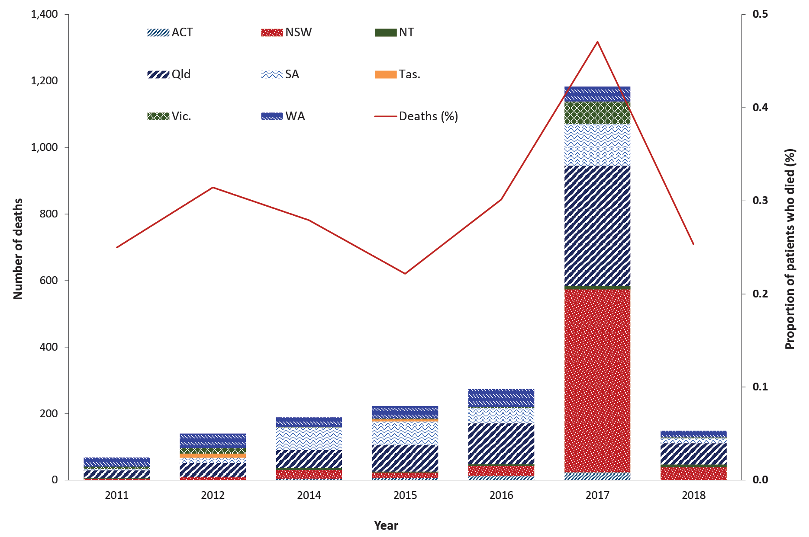
Source: NNDSS

Figure 21: Influenza and pneumonia deaths in New South Wales, by sex, all persons, and 65 years and above, 2011 to 2018ª
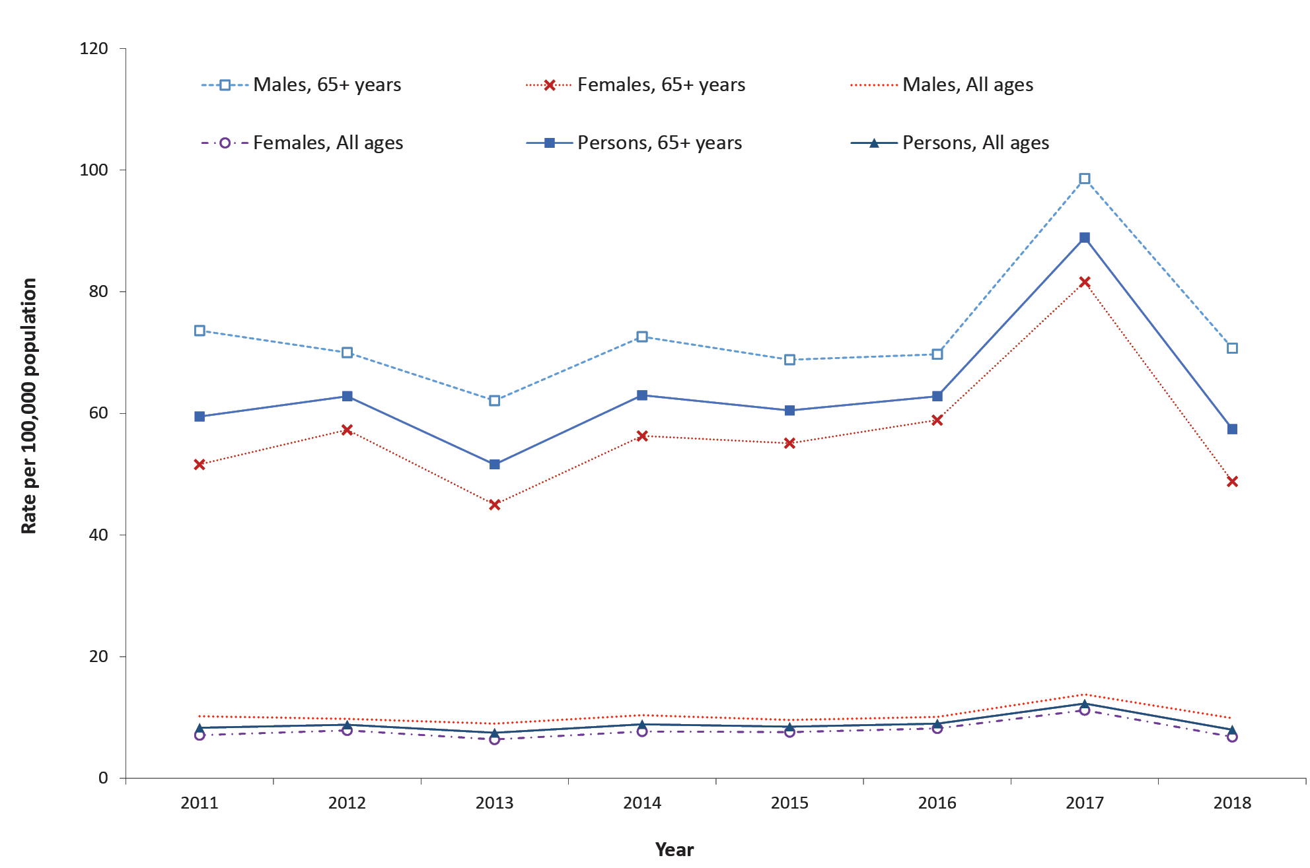
a Source: New South Wales Government, HealthStats NSW, Influenza and pneumonia deaths.¹⁶

Australia Bureau of Statistics (ABS) death data
During 2017, there were 1,255 deaths due to influenza reported by the ABS, representing a standardised death rate of 3.9 per 100,000 population for this year. The deaths in 2017 were 2.7 times higher than in 2016 (n = 464). Of the reported deaths due to influenza in 2017, there were 563 patients who also had pneumonia as a contributing cause.¹⁷ When grouped, influenza and pneumonia contributed to 4,369 deaths in 2017 and were the ninth leading cause of death for the year, up from the eleventh leading cause of death in 2016 (n = 3,334 deaths), with the majority of the increase (85%) driven by influenza virus. Being female, aged over 75 years, having commodities, and living in the eastern states of Australia were factors associated with higher mortality from influenza and pneumonia.¹⁷ During 2018, influenza and pneumonia were the twelfth leading cause of death (n = 3,102 deaths).

Influenza-associated mortality estimates
A recent mathematical modelling study by Muscatello et al.⁵ estimated influenza-associated deaths during 2010–2019 using death data from the Australian Institute of Health and Welfare and the Australian Bureau of Statistics. The study employed statistical time series analysis to estimate excess deaths (the number of deaths above the number that would normally be expected for a specified time period) for three cause of death categories that were grouped according to the International Classification of Diseases, Revision 10 (ICD-10): pneumonia and influenza (P&I) (ICD-10 J09-J18), respiratory (ICD10 Chapter J: Diseases of the respiratory system), and all-cause (all deaths).
Relevant to the reporting period, the study found that Australia experienced high influenza-associated mortality in 2017. For the all-cause death category, the average annual total influenza-associated excess deaths during 2010–2019 were estimated to be around 2,800, or 12 deaths per 100,000 population. Using this same category, in 2017, the estimated number and rate were around 6,400 or 26 per 100,000 population. Using the respiratory death category, the average annual estimate was 950 (4 per 100,000 population), and in 2017 was 3,000 (12 per 100,000 population). The average annual estimates for the P&I deaths category was 500 (2 per 100,000 population), and in 2017 was 1,911 (8 per 100,000 population). Around four out of five excess deaths, regardless of category, were in persons aged ≥ 75 years; fewer than one in ten excess deaths were in persons aged < 65 years. Around 2% of all-age, all-cause deaths on average were estimated to be associated with influenza, and this doubled in 2017.⁵

Discussion
Based on the available data, the trends in influenza notifications increased from 2011, peaked in 2017 and declined in 2018. The number of influenza notifications in 2017 was the highest number reported since the 2009 pandemic year. While jurisdictions with larger populations (New South Wales, Victoria, and Queensland) recorded higher case numbers, smaller jurisdictions, such as South Australia and the Northern Territory, recorded the highest notification rates in all years except for 2016.
Children under 15 years of age and adults aged 65 years or over had the highest notification rates. Influenza cases with medical comorbidities experienced higher mortality rates, as did males aged over 65 years, followed by females in the same age group. Influenza type A predominated over the eight years, except in 2015 when type B was the predominant type. This trend was also consistent with the Australian WHOCC data of influenza isolates tested. From 2011 to 2018, circulating A(H1N1) and A(H3N2) viruses were mostly antigenically similar to the corresponding vaccine strain. Influenza B only accounted for about a third of notifications (32%) from 2011 to 2018. During the reporting period, approximately 54% of influenza B viruses characterised by the Australian WHOCC site were from the Victoria lineage, and most were similar to the B/Brisbane/60/2008 vaccine strain. During the 2018 season, the Australian WHOCC site detected, for the first time, swine A(H3N2)v virus from a human patient in Australia, highlighting the need to maintain vigilance for zoonotic infections.
Data from the various influenza surveillance systems indicated that influenza activity in 2012, 2014, 2015, and 2017 was above average levels. Trends in ILI were mostly consistent with laboratory-confirmed influenza data reported to the NNDSS, with activity peaking between August and September (except in 2012, when activity peaked in July).
Consistent with notifications, the number of cases hospitalised with influenza increased in 2017, with a high number of hospital admissions reported among those aged 65 years or older; among children younger than 15 years of age; and among those with comorbidities. The Australian guidelines recommend the use of oseltamivir for patients with influenza requiring hospitalisation or who are at risk of complications, such as the elderly and immunocompromised.¹⁸ For the years for which data on treatment was reported by FluCAN (2012–2014, 2017, and 2018), just over half of influenza hospital admissions (57%) received treatment, although only 17% of those eligible received treatment within two days following onset of symptoms. These findings suggest the need to optimise treatment. Some patients present to health facilities after the 48-hour threshold for optimum treatment; thus, mechanisms facilitating early treatment or pre-hospital administration of the treatment are needed.
Prolonged influenza seasons were experienced in 2012 and in 2015 to 2018. Prolonged influenza seasons would potentially require re-vaccination, as the optimal effectiveness of the vaccines is within 3–4 months of vaccination.¹⁹ Mortality in all years was highest in cases 65 years or older and those with medical comorbidities.
Overall, all data sources were consistent in indicating trends in influenza activity and support the characterisation of the 2011 to 2018 influenza seasons as moderate, with the exception of 2017 when increased activity was experienced.

Limitations
Although influenza surveillance in Australia is robust and draws from several sources, not all influenza surveillance data during the reporting period were available for this report, such as data for consultations at Emergency Departments and sentinel laboratories. The report relied on secondary data extracted from annual reports such as FluCAN and the Australian WHOCC. As a result, the report focused on describing the trends over the 8 year period.

Acknowledgements
The authors wish to acknowledge and thank the following for their work and contributions to this report: state and territory health departments and laboratories, FluTracking, the Australian Sentinel Practices Research Network (ASPREN), the Victorian Sentinel Practice Influenza Network (VicSPIN), the Influenza Complications Alert Network (FluCAN), the World Health Organisation Collaborating Centre (WHOCC) for Reference and Research on Influenza, the National Influenza Centres, the Australian Bureau of Statistics, David Muscatello, Allen Nazareno, Robin Turner, Anthony Newall, the National Influenza Surveillance Committee (NISC), and the Communicable Diseases Network Australia (CDNA).

Author details
Communicable Disease Epidemiology and Surveillance Section
Office of Health Protection and Response
Australian Government Department of Health
CDESS@health.gov.au

References
- World Health Organization (WHO). Influenza (seasonal). [Webpage.] Geneva: WHO; 6 November 2018. Available from: https://www.who.int/news-room/fact-sheets/detail/influenza-(seasonal).
- Dawood FS, Iuliano AD, Reed C, Meltzer MI, Shay DK, Cheng PY et al. Estimated global mortality associated with the first 12 months of 2009 pandemic influenza A H1N1 virus circulation: a modelling study. Lancet Infect Dis. 2012;12(9):687–95. doi: https://doi.org/10.1016/S1473-3099(12)70121-4.
- Paules C, Subbarao K. Influenza. Lancet. 2017;390(10095):697–708. doi: https://doi.org/10.1016/S0140-6736(17)30129-0.
- WHO Collaborating Centre for Reference and Research on Influenza (CCRRI). Annual report 2019. Melbourne: Victorian Infectious Diseases Reference Laboratory (VIDRL), WHO CCRRI; 2019. Available from: http://www.influenzacentre.org/documents/publications_reports/Annual%20Report%202019.pdf.
- Muscatello DJ, Nazareno AL, Turner RM, Newall AT. Influenza-associated mortality in Australia, 2010 through 2019: high modelled estimates in 2017. Vaccine. 2021;39(52):7578–83. doi: https://doi.org/10.1016/j.vaccine.2021.11.019.
- WHO Global Influenza Surveillance and Response System (GISRS). Centre activities. WHO GISRS Surveillance: WHO Global Influenza Surveillance and Response System (GISRS) Surveillance and Vaccine Development. [Internet.] Melbourne: VIDRL, WHO CCRRI; 2020. [Accessed on 12 October 2020.] Available from: http://www.influenzacentre.org/Centre_Activities_WHO_GISRS_Surveillance.html.
- Cheng AC, FluCAN Investigators. Hospitalisation with confirmed influenza in a sentinel surveillance system in 2010 and 2011. Med J Aust. 2012;197(4):217. doi: https://doi.org/10.5694/mja12.10060.
- Cheng AC, Brown S, Waterer G, Holmes M, Senenayake S, Friedman ND et al. Influenza epidemiology, vaccine coverage and vaccine effectiveness in sentinel Australian hospitals in 2012: the Influenza Complications Alert Network (FluCAN). Commun Dis Intell Q Rep. 2013;37(3):E246–52.
- Cheng AC, Dwyer DE, Holmes M, Irving LB, Brown SGA, Waterer G et al. Influenza epidemiology, vaccine coverage and vaccine effectiveness in sentinel Australian hospitals in 2013: the Influenza Complications Alert Network. Commun Dis Intell Q Rep. 2014;38(2):E143–9.
- Cheng AC, Kotsimbos T, Kelly PM, FluCAN Investigators. Influenza vaccine effectiveness against hospitalisation with influenza in adults in Australia in 2014. Vaccine. 2015;33(51):7352–6. doi: https://doi.org/10.1016/j.vaccine.2015.10.016.
- Cheng AC, Holmes M, Dwyer DE, Irving LB, Korman TM, Senanayake S et al. Influenza epidemiology in patients admitted to sentinel Australian hospitals in 2015: the Influenza Complications Alert Network. Commun Dis Intell Q Rep. 2016;40(4):E521–6.
- Cheng AC, Holmes M, Dwyer DE, Irving L, Korman T, Senanayake S et al. Influenza epidemiology in patients admitted to sentinel Australian hospitals in 2016: the Influenza Complications Alert Network (FluCAN). Commun Dis Intell Q Rep. 2017;41(4):E337–47.
- Cheng AC, Holmes M, Dwyer DE, Senanayake S, Cooley L, Irving LB et al. Influenza epidemiology in patients admitted to sentinel Australian hospitals in 2017: the Influenza Complications Alert Network (FluCAN). Commun Dis Intell (2018). 2019;43. doi: https://doi.org/10.33321/cdi.2019.43.39.
- Cheng AC, Holmes M, Dwyer DE, Senanayake S, Cooley L, Irving LB et al. Influenza epidemiology in patients admitted to sentinel Australian hospitals in 2018: the Influenza Complications Alert Network (FluCAN). Commun Dis Intell (2018). 2019;43. doi: https://10.33321/cdi.2019.43.48.
- WHO. Questions and answers. Recommended composition of influenza virus vaccines for use in the southern hemisphere 2019 influenza season and development of candidate vaccine viruses for pandemic preparedness. Geneva: WHO; 27 September 2018. Available from: https://www.who.int/influenza/vaccines/virus/recommendations/201809_qanda_recommendation.pdf.
- New South Wales Government, HealthStats NSW. Influenza and pneumonia deaths. [Webpage.] Sydney: New South Wales Government; 2021. Available from: https://www.healthstats.nsw.gov.au/#/indicator?name=-res-infpneumo-dth&location=NSW&view=Trend&measure=DSTRate&groups=Sex&compare=Sex&filter=Sex,Males,Females,Persons.
- Australian Bureau of Statistics. 3303.0 - Causes of Death, Australia, 2017. Deaths due to influenza, 2017. [Webpage.] Canberra: Australian Bureau of Statistics; 26 September 2018. Available from: https://www.abs.gov.au/ausstats/abs@.nsf/Lookup/by%20Subject/3303.0~2017~Main%20Features~Deaths%20due%20to%20influenza~5.
- Australian Government Department of Health. Guidelines for the prevention, control and public health management of influenza outbreaks in residential care facilities in Australia. [Internet.] Canberra: Australian Government Department of Health; 17 July 2017. Available from: https://www1.health.gov.au/internet/main/publishing.nsf/Content/cdna-flu-guidelines.htm.
- Australian Government Department of Health, Australian Immunisation Handbook. Influenza (flu). [Webpage.] Canberra: Australian Government Department of Health; 2020. [Accessed on 10 October 2020.] Available from: https://immunisationhandbook.health.gov.au/vaccine-preventable-diseases/influenza-flu.

Communicable Diseases Intelligence
ISSN: 2209-6051 Online

Communicable Diseases Intelligence (CDI) is a peer-reviewed scientific journal published by the Office of Health Protection and Response, Department of Health. The journal aims to disseminate information on the epidemiology, surveillance, prevention and control of communicable diseases of relevance to Australia.

Editor: Jennie Hood
Deputy Editor: Simon Petrie
Design and Production: Kasra Yousefi
Editorial Advisory Board: David Durrheim, Mark Ferson, John Kaldor, Martyn Kirk and Linda Selvey

Website: http://www.health.gov.au/cdi

Contacts
CDI is produced by the Office of Health Protection and Response, Australian Government Department of Health, GPO Box 9848, (MDP 6) CANBERRA ACT 2601

Email: cdi.editor@health.gov.au

Submit an Article
You are invited to submit your next communicable disease related article to the Communicable Diseases Intelligence (CDI) for consideration. More information regarding CDI can be found at: http://health.gov.au/cdi.
Further enquiries should be directed to: cdi.editor@health.gov.au.

This journal is indexed by Index Medicus and Medline.

Creative Commons Licence - Attribution-NonCommercial-NoDerivatives CC BY-NC-ND
© 2022 Commonwealth of Australia as represented by the Department of Health
This publication is licensed under a Creative Commons Attribution-NonCommercial-NoDerivatives 4.0 International Licence from https://creativecommons.org/licenses/by-nc-nd/4.0/legalcode (Licence). You must read and understand the Licence before using any material from this publication.

Restrictions
The Licence does not cover, and there is no permission given for, use of any of the following material found in this publication (if any):
- the Commonwealth Coat of Arms (by way of information, the terms under which the Coat of Arms may be used can be found at www.itsanhonour.gov.au);
- any logos (including the Department of Health’s logo) and trademarks;
- any photographs and images;
- any signatures; and
- any material belonging to third parties.

Disclaimer
Opinions expressed in Communicable Diseases Intelligence are those of the authors and not necessarily those of the Australian Government Department of Health or the Communicable Diseases Network Australia. Data may be subject to revision.

Enquiries
Enquiries regarding any other use of this publication should be addressed to the Communication Branch, Department of Health, GPO Box 9848, Canberra ACT 2601, or via e-mail to: copyright@health.gov.au

Communicable Diseases Network Australia
Communicable Diseases Intelligence contributes to the work of the Communicable Diseases Network Australia.
http://www.health.gov.au/cdna

