Monitoring the incidence and causes of disease potentially transmitted by food in Australia: Annual report of the OzFoodNet network, 2017
The OzFoodNet Working Group

Abstract
In 2017, 47,652 notifications of enteric diseases potentially related to food were received by state and territory health departments in Australia. Consistent with previous years, the majority of all notified infections were either campylobacteriosis (n = 28,432; 60%) or salmonellosis (n = 16,416; 34%). A total of 206 gastrointestinal outbreaks, including 179 foodborne outbreaks, were reported in 2017. The remaining 27 outbreaks were due to environmental or probable environmental transmission (22 outbreaks), animal-to person or probable animal-to-person transmission (three outbreaks), and waterborne or probable waterborne transmission (two outbreaks). Foodborne outbreaks affected 2,130 people resulting in at least 290 hospital admissions and five deaths. Eggs continue to be a source of Salmonella Typhimurium infection across the country, with 49 egg-related outbreaks affecting at least 746 people reported across six jurisdictions in 2017.

Introduction
The burden of foodborne disease in Australia is significant, with an estimated 4.1 million people infected in Australia each year, costing an estimated $1.2 billion per year.^{1–3}
The OzFoodNet network was established in 2000 by the Australian Government Department of Health and Aged Care to apply concentrated effort at a national level to investigate and understand foodborne disease, to describe more effectively its epidemiology, and to identify ways to minimise foodborne illness in Australia. The OzFoodNet network includes foodborne disease epidemiologists from each state and territory health department and collaborators from the Australian Government Department of Agriculture and Water Resources (Agriculture), Food Standards Australia New Zealand (FSANZ), and the Public Health Laboratory Network (PHLN). OzFoodNet is represented on the Communicable Diseases Network Australia (CDNA), which is Australia’s peak body for communicable disease control.
The primary data sources used by OzFoodNet epidemiologists to understand the extent of foodborne disease in Australia include notifiable enteric disease data and reports of gastrointestinal disease outbreaks. This report provides an overview of the national enteric disease surveillance data from 1 January 2017 to 31 December 2017 and the findings from the investigations into gastrointestinal illness outbreaks caused by foodborne, animal-to-person, environmental or waterborne disease that were initiated in Australia between 1 January 2017 and 31 December 2017.

Methods

Population under surveillance
In 2017, the OzFoodNet network covered all Australian states and territories, with an estimated population of 24,597,528 persons as at 30 June 2017.⁴

Data sources

Notified infections
All Australian states and territories have public health legislation requiring doctors and pathology laboratories to notify cases of infectious diseases that are important to public health. State and territory health departments record details of notified cases on surveillance databases. Under the auspices of the National Health Security Act 2007, surveillance data is aggregated into a national database known as the National Notifiable Diseases Surveillance System (NNDSS). Notifiable enteric diseases include botulism, campylobacteriosis, cholera, haemolytic uraemic syndrome (HUS), hepatitis A, hepatitis E, listeriosis, paratyphoid fever, salmonellosis, Shiga toxin-producing Escherichia coli (STEC) infection, shigellosis and typhoid fever.
Data for this report were extracted from NNDSS in September 2018 and analysed by calendar year using the date of diagnosis. Date of diagnosis was derived for each case from the earliest date supplied by the jurisdiction, which could be the date of onset of the case’s illness, the date a specimen was collected or the date that a health department received the notification. Notifications for 2017 include those with a diagnosis date from 1 January 2017 to 31 December 2017. Estimated resident populations for each state or territory as at 30 June 2017 were used to calculate rates of notified infections.⁴ Due to the dynamic nature of NNDSS data, the data presented in this report are subject to change over time.

Change in laboratory methods
Changes in diagnostic laboratory testing procedures including the increasing uptake of culture independent diagnostic testing (CIDT) using polymerase chain reaction (PCR) and introduction of multiplex PCR (which can detect multiple enteric pathogens on one test) are suspected to have resulted in an increase in notifications for a number of bacterial enteric diseases including campylobacteriosis, salmonellosis, shigellosis and STEC since 2014 (see OzFoodNet 2016 annual report for more information).⁵ CIDT has been introduced at varying times depending on the individual laboratory. The extent to which this has increased notifications of each of these conditions remains unclear.

Enhanced national surveillance for listeriosis
In 2010, OzFoodNet commenced enhanced surveillance data collection on all notified cases of listeriosis in Australia using a centralised database known as the National Enhanced Listeriosis Surveillance System (NELSS). The primary aim of NELSS is to detect clusters of infection to enable a timely public health investigation and response. In accordance with the listeriosis national guideline for public health units, jurisdictional public health staff conduct case interviews at the time of diagnosis using a standardised questionnaire. Interview data (including food histories) along with information regarding the characterisation of Listeria monocytogenes isolates by molecular subtyping methods are entered into NELSS by OzFoodNet epidemiologists using an open-source secure web-based reporting system known as NetEpi. Commencing in 2016, whole genome sequencing with fortnightly phylogenetic analysis was conducted for all human L. monocytogenes isolates to identify potential clusters for investigation (data not included).

Enhanced national surveillance for hepatitis A
In July 2017, CDNA endorsed the commencement of a hepatitis A enhanced surveillance pilot study, to determine the usefulness of sequencing strains from all notified cases of hepatitis A nationally over a period of two years. The pilot study commenced on 1 July 2017.
The objectives of the pilot are to:
- better understand hepatitis A molecular epidemiology in Australia through the conduct of national enhanced surveillance for 24 months through genotyping and sequencing RNA from each case and recording specific risk factor information in a centralised database; and
- evaluate the effectiveness (including the cost effectiveness) of national enhanced hepatitis A surveillance at the end of the 24-month trial.
Alongside these pilot objectives, specific surveillance objectives during the 24-month trial are to:
- understand the risk factors and molecular epidemiology of hepatitis A in Australia; and
- detect clusters of locally acquired hepatitis A to enable rapid public health action.
The pilot study does not impact on jurisdictional public health surveillance practices; all confirmed cases of hepatitis A are followed up as per current jurisdictional surveillance practice and the nationally agreed questionnaire developed by OzFoodNet and the Hepatitis A Series of National Guidelines Working Group is used when interviewing cases. De-identified case information is entered onto a secure SharePoint database as cases are notified to jurisdictions, and selected epidemiological and laboratory typing fields are completed by jurisdictional and laboratory staff. This information is interrogated as necessary.

Outbreaks of gastrointestinal disease including foodborne disease outbreaks
Gastrointestinal disease outbreaks may be notified to jurisdictional health departments from a range of sources including doctors, local councils and members of the public or identified by OzFoodNet epidemiologists through review of notifiable disease data.
In 2016 OzFoodNet epidemiologists revised the terminology used to refer to the various modes of transmission of gastrointestinal disease outbreaks. Suspected foodborne, animal to person and waterborne outbreak categories were redefined as probable outbreaks to more accurately reflect the level of evidence available to implicate a mode of transmission. For data analysis and reporting pre and post 2016, suspected and probable categories can be treated as equivalent. In addition, an environmental outbreak category was introduced to differentiate waterborne outbreaks associated with drinking water from incidental exposure to contaminated water sources in the environment. Waterborne outbreaks from 2012 to 2015 have been redefined using the 2016 case definitions to enable accurate historical comparisons in this report. Refer to Appendix A for the definitions applied to reported gastrointestinal disease outbreaks from 2016 onwards.
Commencing in the 2013–2015 annual report, person-to-person outbreaks and outbreaks of unknown transmission mode have been excluded from the OzFoodNet annual reports. These modes of transmission have historically accounted for the majority of outbreaks each year. This is a change in practice from previous annual reports and therefore the total number of outbreaks in this report cannot be directly compared with annual reports prior to 2013.

Surveillance and outbreak data limitations
Enteric disease surveillance data reported to health departments represent only a proportion of disease in the community as these data rely on people seeking medical attention and undergoing appropriate laboratory testing to confirm a diagnosis. Research in Australia has estimated that 28% of people experiencing gastroenteritis seek medical attention.¹ Studies have shown that for every salmonellosis case notified to a health department in Australia there are an estimated seven salmonellosis infections in the community, for every notified STEC case there are an estimated eight STEC infections and for every notified campylobacteriosis case there are an estimated ten campylobacteriosis infections in the community.^{1,6,7}
The outbreak data within this report have limitations, including the potential for variation in the categorisation of features of outbreaks, depending on differing circumstances and investigator interpretation. In addition, outbreaks of gastroenteritis are often not reported to health authorities, resulting in under-representation of the true burden of enteric disease outbreaks within Australia. Changes in the number of outbreaks over time should be interpreted with caution. The number of cases and outbreaks may differ from summaries previously published as these may take time to finalise. Outbreaks presented in this report are included based on the investigation commencing in 2017.

Data analysis
All analyses were conducted using Microsoft Excel.

Results

Notified infections
A total of 47,652 enteric diseases notifications were reported in 2017 (Table 1).
Table 1: Enteric disease notifications in Australia, 2017
Disease | Number of notifications 2017 | Proportion of all enteric notifications 2017 | Mean notifications 2012–2016 | % change | 2017 rate per 100,000 population
Campylobacteriosisª | 28,432 | 60% | 19,412 | 46% | 133.9
Salmonellosis | 16,416 | 34% | 15,035 | 9% | 66.7
Shigellosis | 1,745 | 4% | 913 | 91% | 7.1
Shiga toxin-producing Escherichia coli (STEC) infection | 496 | 1% | 180 | 176% | 2.0
Hepatitis A | 216 | < 1% | 182 | 19% | 0.9
Typhoid fever | 143 | < 1% | 121 | 18% | 0.6
Listeriosis | 71 | < 1% | 81 | -12% | 0.3
Paratyphoid fever | 68 | < 1% | 75 | -9% | 0.3
Hepatitis E | 47 | < 1% | 42 | 12% | 0.2
Haemolytic uraemic syndrome (HUS) | 14 | < 1% | 17 | -18% | 0.1
Botulism | 2 | < 1% | 2 | 0% | < 0.01
Cholera | 2 | < 1% | 3 | -33% | < 0.01
Total | 47,652 | 100% | 36,063 | 32%
a New South Wales commenced notifications in April 2017. New South Wales notifications are included in the notification total, but are not included in the rate calculations. (See campylobacteriosis section.)
Data from the NNDSS including number of notifications and rate by month, jurisdiction, age group and sex dating back to 1991 can be accessed on the Introduction to the National Notifiable Diseases Surveillance System web page. A summary of each notifiable enteric condition is provided in this report.

Botulism
Botulism is a rare but serious illness that results in paralysis caused by nerve toxins made by Clostridium botulinum bacteria. Botulism can result from eating food containing pre-formed botulinum toxin (foodborne botulism) or ingesting food, dust or soil that contains the bacteria that produce the toxin (intestinal botulism) or contaminating a wound with the bacteria (wound botulism). Intestinal botulism usually only affects children under 12 months of age and is more commonly known as infant botulism. This is the most common form of botulism in Australia. Foodborne botulism may be found in improperly processed, canned, low acid or alkaline foods where anaerobic conditions have occurred at some stage.
Surveillance data includes confirmed cases only. A confirmed case requires laboratory definitive and clinical evidence of infection. All notified cases are followed up by jurisdictional public health staff.

Overall trend
- Notifications of botulism are extremely rare in Australia, with a total of 26 cases recorded in Australia since collation of national notification data began in 1992 (Figure 1).
Figure 1: Botulism notifications in Australia by jurisdiction of residence, 1992–2017
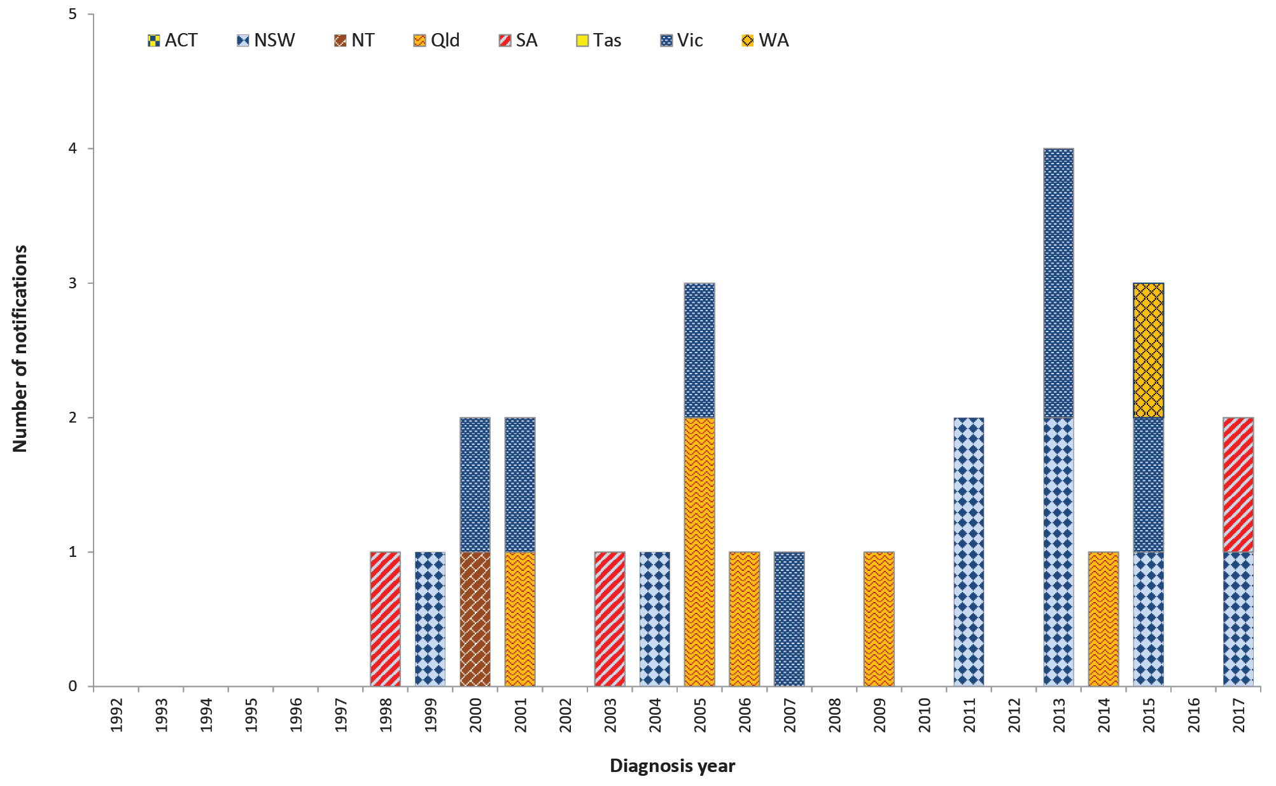

Previous cases in Australia
- Three foodborne botulism cases have been reported to date including a single case in New South Wales in 1999 where the food source was not identified, one in Victoria in 2007 associated with consumption of a commercially manufactured convenience food, and a second case in Victoria in 2015 where the suspected source was home cured ham.
- One case of intestinal botulism was reported in a child in 2006.
- The remaining cases have been infant botulism.

Epidemiology of botulism in Australia, 2017
New South Wales and South Australia each reported a single case of infant botulism in 2017, both of which were in children less than one year of age. No high-risk foods were identified.

Campylobacteriosis
Campylobacteriosis is a gastrointestinal disease caused by the Campylobacter bacterium. It is a common cause of bacterial gastroenteritis globally, with infection rates in Australia among the highest in the industrialised world.⁸ In Australia, it is commonly associated with the consumption of undercooked poultry.⁹ Campylobacteriosis may also be acquired through consumption of cross-contaminated foods, animal to person transmission, consumption of unpasteurised milk, and contaminated water.
Surveillance data includes confirmed cases only from all jurisdictions, noting New South Wales commenced receiving notifications in April 2017. A confirmed case requires laboratory definitive evidence of infection. Due to the volume of notifications, individual case follow up is not undertaken routinely in all jurisdictions. Public health follow up is usually limited to outbreaks and clusters of notified cases.

Overall trend
- The incidence of campylobacteriosis in Australia has increased steadily since notification began in 1991 to 2011 (Figure 2). A decreasing trend was observed in 2012 and 2013. This may be related to work undertaken with poultry processors to identify and control contamination on-farm and processing operations in several jurisdictions.^{10,11}
- The marked increase in notifications since 2014 occurring throughout Australia is at least in part due to the increase in PCR testing as a method of laboratory diagnosis.
- A slight decline in the national notification rate (excluding New South Wales from the calculation) was observed in 2017 (133.9 cases per 100,000 population) compared with 2016 (146.9 cases per 100,000 population) due to minor decreases in notifications received in all reporting jurisdictions except Queensland (who reported a 4% increase).

Previous outbreaks in Australia
- Foodborne outbreaks have been reported each year in Australia, commonly associated with consumption of poultry, particularly chicken and duck liver pâté. However, outbreaks account for a small number of cases compared with the overall number of cases reported annually.

Epidemiology of campylobacteriosis in Australia, 2017
- Campylobacteriosis was the most commonly notified enteric pathogen in 2017, despite only becoming notifiable in New South Wales in April 2017 (Table 1).
- The highest rates of infection occurred in children aged 0–4 years.
- In the Northern Territory, where Indigenous status was available for 98% of children aged 0–4 years (142/145), the notification rate was higher in Aboriginal and/or Torres Strait Islander children (13.1 cases per 1,000 children) compared with non-indigenous children (3.2 cases per 1,000 children).
- A higher incidence was observed amongst males in every age group when compared with females (Figure 3). While consistent with previous years, the reason for this remains unclear.⁸
- Speciation information was available for 25% of cases (n = 6,998), with 84% identified as Campylobacter jejuni (n = 5,879).

Figure 2: Campylobacteriosis notificationsª and rate^{b} per 100,000 population in Australia by jurisdiction of residence, 1991–2017
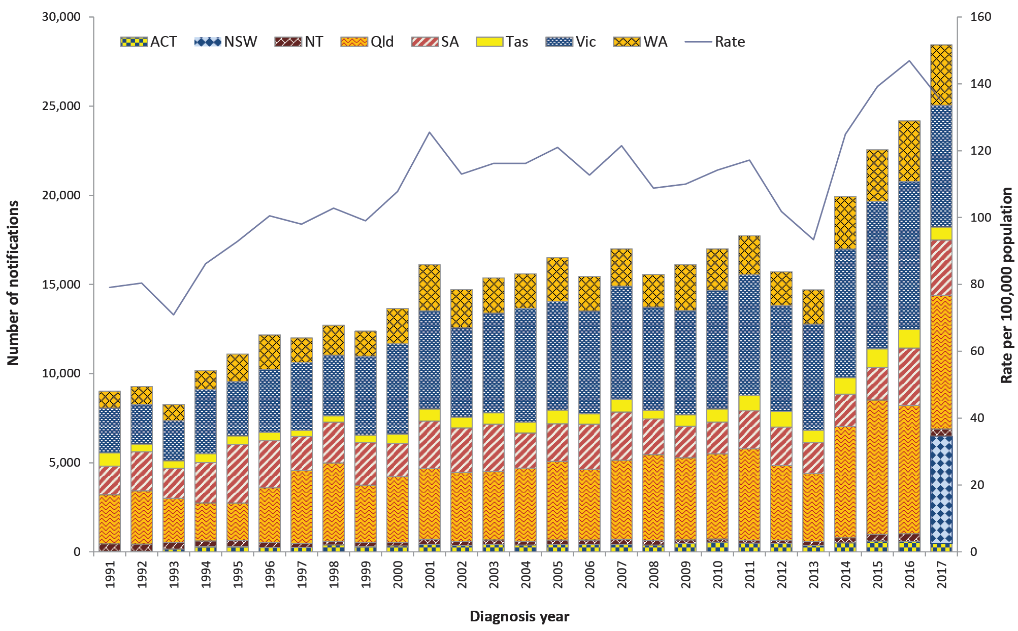
a Campylobacteriosis became notifiable in New South Wales in April 2017.
b Notifications in New South Wales in 2017 have been excluded from the rate calculation to avoid comparisons of incomplete data. The rate for Australia for 2017 has been calculated using ABS estimated resident population data for Australia minus New South Wales.
Table 2: Summary of campylobacteriosis notifications in Australia,ª 2017
Category | Value
Number of notifications | 28,432
Rate^{b} | 133.9 cases per 100,000 population
Jurisdiction with the highest number of notifications | Queensland (n = 7,479; 26%)
Seasonality | More common in warmer months with 20% of notifications in January and February (n = 4,567)
Foodborne outbreaks | Six
Foods implicated in outbreaks | Chicken (n = 1), lamb liver (n = 1), pâté (n = 1),  raw milk (n = 1) and unknown (n = 2)  (Refer to Foodborne outbreaks section)
a New South Wales commenced notifications in April 2017.
b New South Wales 2017 notifications have been excluded from the rate calculation to avoid comparisons of incomplete data. The rate for Australia for 2017 has been calculated using ABS estimated resident population data for Australia minus New South Wales.
Table 3: Demographics of cases with the highest campylobacteriosis notification rates in Australia,ª 2017
Category |  | Group most affected | Rate per 100,000 population |  | Number (% of all cases)
Age group (years) | 0–4 |  |  | 220.4 |  | 2,373 (11%)
Sex | Males |  |  | 148.0 |  | 12,288 (55%)
Jurisdiction | South Australia |  |  | 180.5 |  | 3,112 (14%)
a Excluding New South Wales.

Figure 3: Campylobacteriosis notification rate per 100,000 population in Australiaª by age group and sex, 2017
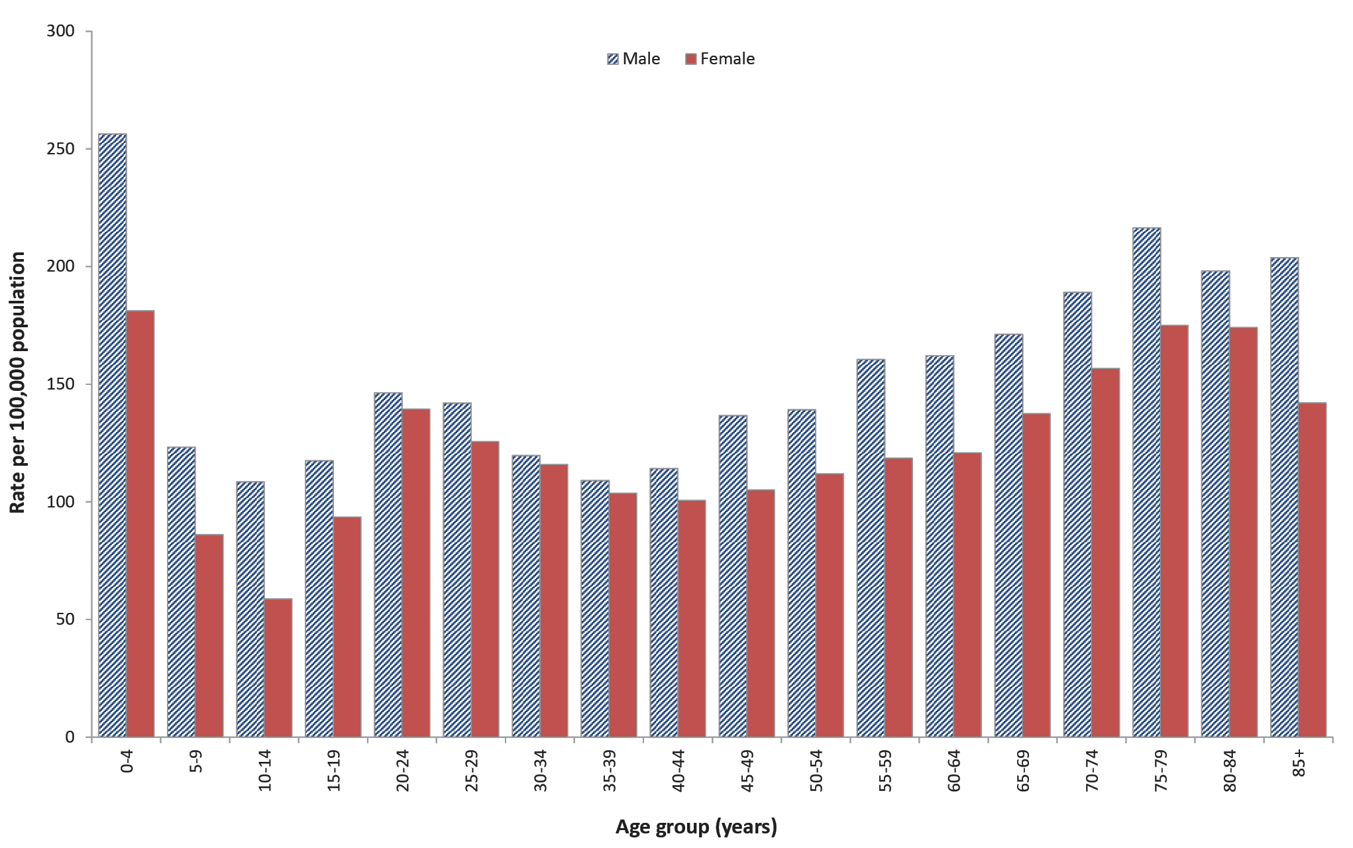
a Excluding New South Wales.

Cholera
Cholera is an infection of the digestive tract caused by certain strains of the bacterium Vibrio cholerae that produce toxins. It is mainly seen in people who have travelled overseas including to parts of Africa, Asia, South America, the Middle East and the Pacific islands. Vibrio cholerae is found in the faeces of infected people, and is usually acquired by drinking contaminated water, eating food washed with contaminated water or prepared with contaminated hands, or eating fish or shellfish harvested from contaminated water. Person-to-person spread of cholera is less common. Symptoms typically start between two hours and five days after ingesting the bacteria. Symptoms can include characteristic ‘rice water’ faeces (profuse, watery diarrhoea), nausea and vomiting and signs of dehydration, such as weakness, lethargy and muscle cramps. Infection without symptoms or with only mild symptoms may occur, particularly in children.
Surveillance data includes confirmed cases only. A confirmed case requires laboratory definitive evidence of isolation of toxigenic Vibrio cholerae O1 or O139. All notified cases are followed up by jurisdictional public health staff.

Overall trend
- All cases of cholera reported since 1991 (the commencement of the NNDSS) were acquired outside Australia, with the exception of:
- one laboratory acquired case in 1996;¹²
- three cases in 2006 linked to imported whitebait;¹³ and
- one laboratory acquired case in 2013.¹⁴

Epidemiology of cholera in Australia, 2017
Two cases of cholera were notified in 2017 (Figure 4). Both cases were associated with overseas travel. One case travelled to Thailand, and the other case travelled to the Philippines.

Figure 4: Cholera notifications in Australia by jurisdiction of residence, 1991–2017
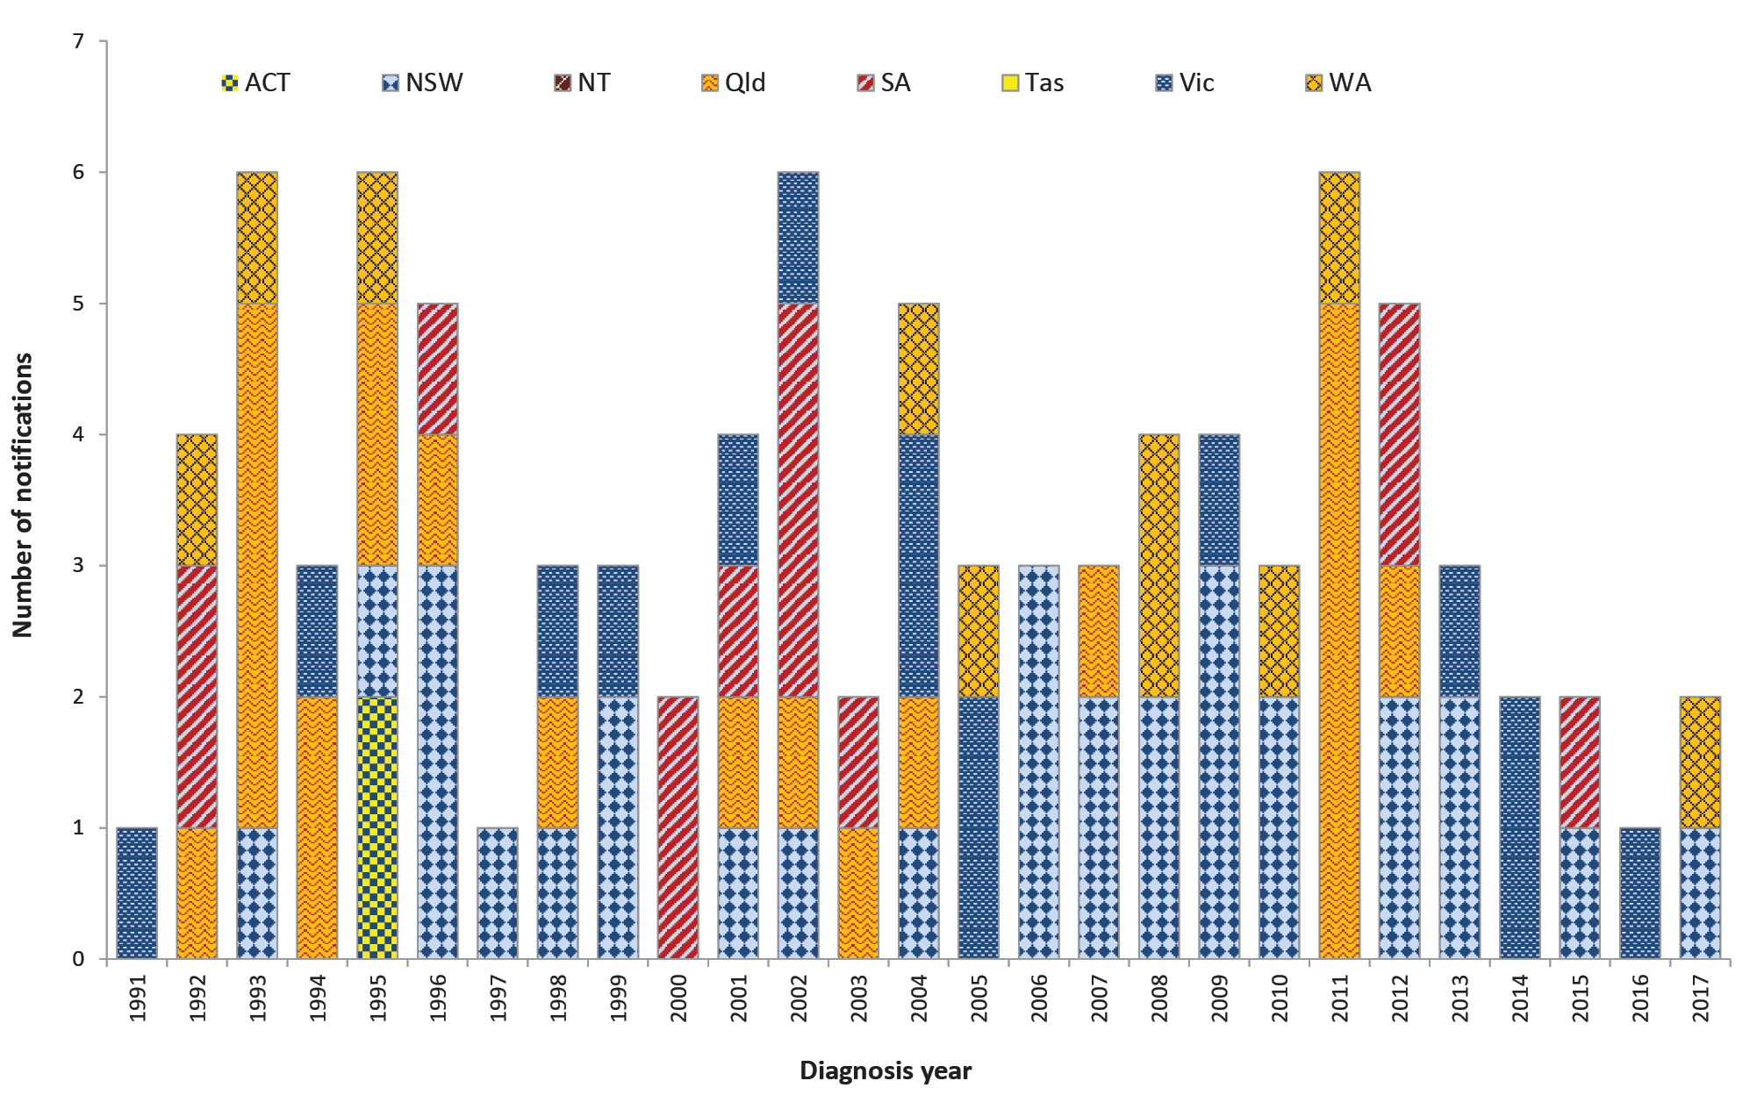

Enteric fever
Typhoid and paratyphoid fever are grouped together as enteric fever as both diseases cause a similar illness, though paratyphoid fever is often less severe and less common. Typhoid fever is caused by the bacterium Salmonella enterica subsp. enterica ser. Typhi (S. Typhi), while paratyphoid fever is caused by Salmonella enterica subsp. enterica ser. Paratyphi (S. Paratyphi) not including S. Paratyphi B biovar Java. These infections are different to the gastroenteritis infection caused by other Salmonella enterica subsp. enterica serovars. Enteric fever is rarely acquired in Australia with almost all notified infections acquired in resource poor countries with poor sanitation, hand hygiene and food handling standards, and untreated drinking water. People who travel to countries where enteric fever is endemic, to visit friends or family, have been recognised as a risk group for infection in Australia.¹⁵ Consumption of ready to eat foods, especially raw fruits and vegetables, and shellfish as well as drinking potentially contaminated water in countries where typhoid and paratyphoid are endemic puts travellers at the greatest risk of infection.
Surveillance data includes confirmed cases only. A confirmed case requires laboratory definitive evidence of typhoid or paratyphoid infection., All notified cases are followed up by jurisdictional public health staff.

Overall trend
- Given infections are almost always acquired outside Australia, notification rates are influenced by the incidence of disease in endemic countries and the number of people who travel to these destinations.
- The incidence of enteric fever in Australia has increased since notification began in 1991 (Figure 5).
- The incidence of paratyphoid fever has remained relatively steady in recent years with a slight decline reported in 2017 (Figure 5).
- Minor fluctuations in typhoid fever notifications have occurred in recent years with a slightly higher rate observed in 2017 (Figure 5).
- With the exception of 2004, the annual count and rate of typhoid infections has exceeded that of paratyphoid (Figure 5).

Figure 5: Typhoid fever and paratyphoid fever notifications and enteric fever notification rate per 100,000 population in Australia, 1991–2017
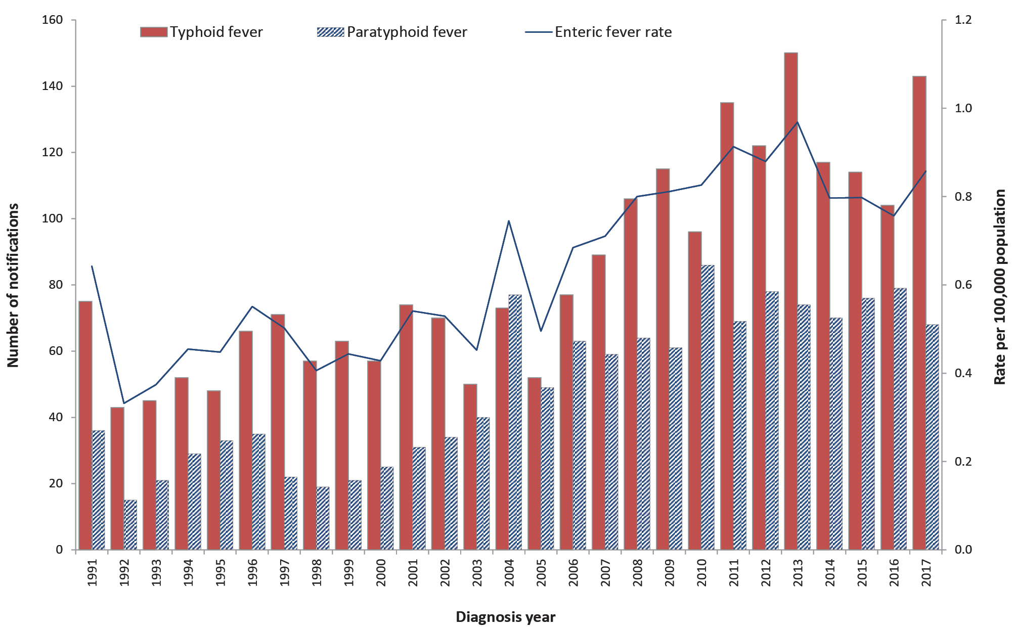
Figure 6: Typhoid fever notifications and rate per 100,000 population in Australia by jurisdiction of residence, 1991–2017
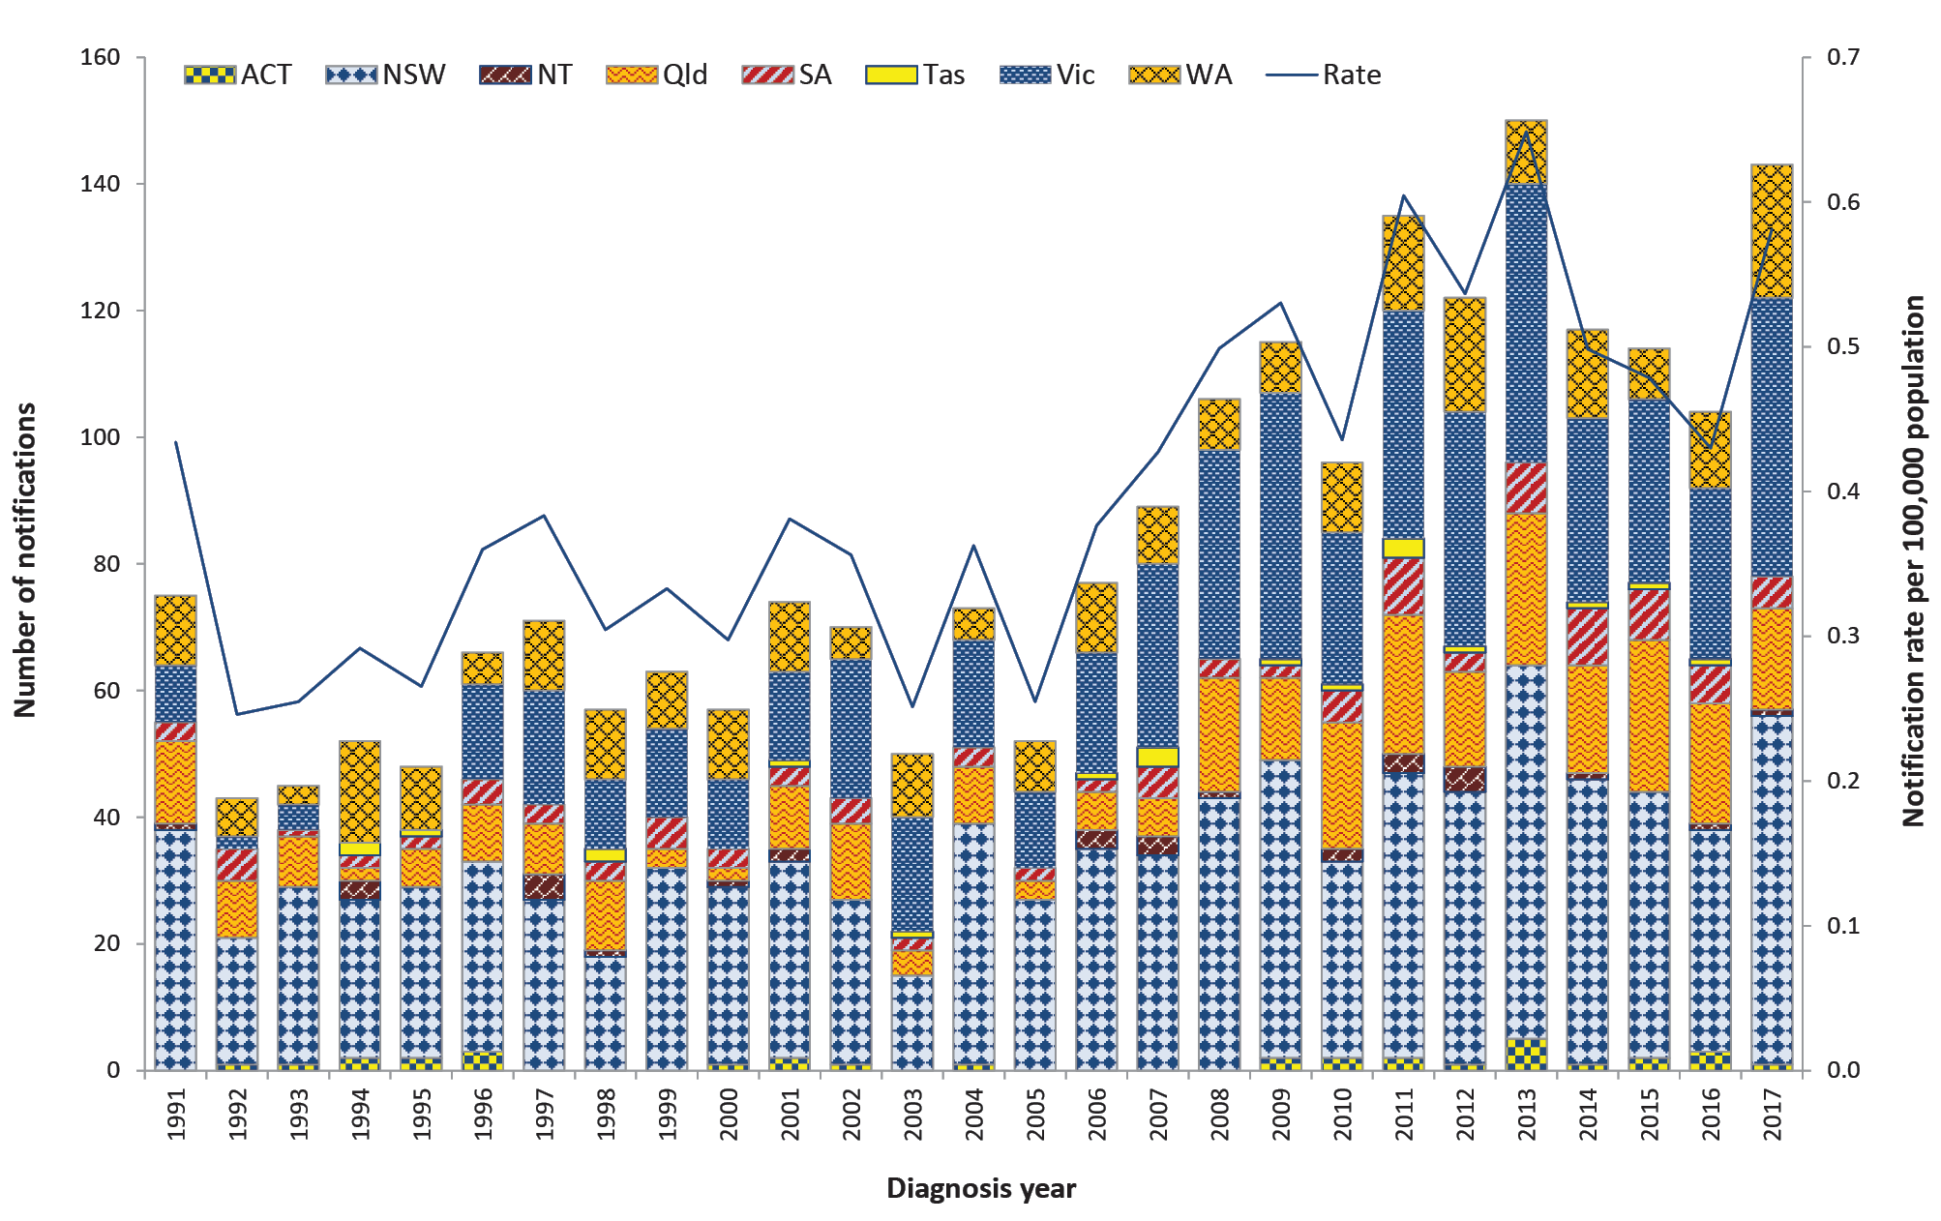
Figure 7: Paratyphoid fever notifications and rate per 100,000 population in Australia by jurisdiction of residence, 1991–2017
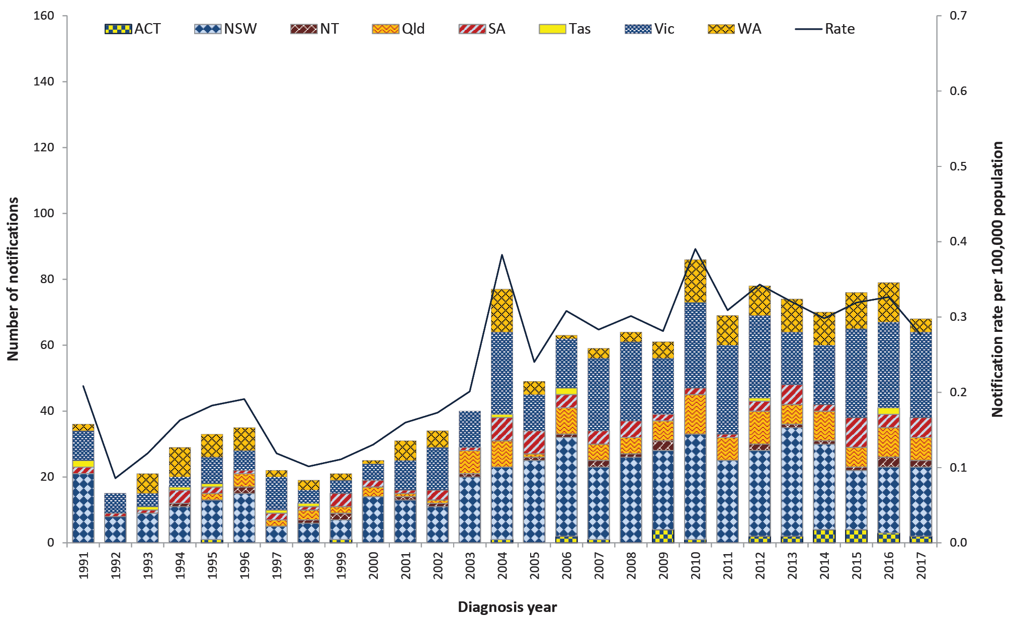
Table 4: Summary of enteric fever notifications in Australia, 2017
 | Typhoid fever | Paratyphoid fever
Number of notifications | 143 | 68
Rate | 0.6 cases per 100,000 population | 0.3 cases per 100,000 population
Jurisdiction with highest number of notifications | New South Wales  (n = 55; 38%) | Victoria  (n = 26; 38%)
Hospitalisations (% of all cases) | 83 (58%) | 35 (51%)
Cases in Aboriginal and/or Torres Strait Islandersª | 0 | 0
Foodborne outbreaks | 0 | 0
a Indigenous status was not known for 13 typhoid and eight paratyphoid cases.

Previous outbreaks in Australia
- The last major locally acquired typhoid outbreak occurred in Victoria in 1977 (n = 37 cases associated with a food handler who was a chronic carrier).¹⁶
- No enteric fever foodborne outbreaks have been recorded in Australia since OzFoodNet was established in 2000.
- Outbreaks resulting from transmission within households have been reported in Australia, and secondary transmission from a chronic carrier within a household setting is not uncommon. However, the exact mode or transmission, from the chronic carrier is rarely able to be determined.

Epidemiology of enteric fever in Australia, 2017
- Just over half of the typhoid cases notified in 2017 were in females (n = 73; 51%), and the distribution was even for paratyphoid cases (males n = 34; 50%).
- The median age at onset was 24 years for typhoid cases (range 0–85 years) and 29 years for paratyphoid cases (range 1–66 years).
- Consistent with previous years, the majority of typhoid cases were phage type E1 (n = 27; 19%) and E9 (n = 9; 6%). Phage typing was unknown or unable to be performed for 90 cases (63%).
- Consistent with previous years, the majority of paratyphoid cases were Paratyphoid A (n = 59; 87%) with the remaining cases Paratyphoid B (n = 8; 12%) and unknown (n = 1; 1%).

Country of acquisition
- As seen in previous years, almost all enteric fever cases in 2017 were acquired outside of Australia, with 99% (n = 140) of typhoid and 97% (n = 66) of paratyphoid cases with available information reporting overseas travel during their incubation period.
- India was the most commonly reported country of acquisition for both typhoid and paratyphoid fever cases (Table 5).
- In 2017, New South Wales, Victoria and Queensland each reported a single typhoid case without a history of overseas travel in their incubation period. The New South Wales case had recently travelled interstate, however no definitive source of infection was identified, while the Queensland and Victorian cases were likely chronic carriers with the organism isolated from a hepatic abscess and gall bladder fluid respectively.
- A single Australian-acquired paratyphoid case was reported in 2017 in a Victorian resident with a history of household contact with overseas travellers.
Table 5: Top countries of acquisition for overseas acquired enteric fever cases in Australia, 2017
Disease | Country of acquisition | Number of notifications, 2017ª | Proportion of overseas acquired cases, 2017ª | Mean 2012–2016
Typhoid fever | India | 75 | 54% | 66
 | Bangladesh | 14 | 10% | 10
 | Pakistan | 14 | 10% | 9
Paratyphoid fever | India | 35 | 56% | 26
 | Pakistan | 8 | 13% | 3
 | Bangladesh | 6 | 10% | 4
a Excluding typhoid (n = 1) and paratyphoid (n = 4) cases acquired overseas but with an unknown country of acquisition.

Hepatitis A
Hepatitis A is an infection of the liver caused by the hepatitis A virus (HAV) that is almost always transmitted by the faecal-oral route.
During the 1990s in Australia, groups most at risk of HAV infection were overseas travellers, child care centre attendees, Aboriginal and/or Torres Strait Islander communities, men who have sex with men (MSM) and people who use or inject illicit drugs. Since the introduction of a vaccine into Australia in the mid-1990s and the subsequent implementation of vaccination programs and vaccine recommendations for at-risk groups, the majority of HAV infections diagnosed in Australia are acquired while travelling overseas.¹⁷ Foodborne transmission occurs rarely, although in 2009 and 2015 there were two significant multi-jurisdictional foodborne outbreaks associated with the consumption of imported food (see Previous outbreaks in Australia section below).
Surveillance data includes confirmed and probable cases. A confirmed case requires laboratory definitive evidence of hepatitis A infection and a probable case requires clinical and epidemiological evidence of infection. On 1 January 2013, the HAV case definition was amended to include a requirement for confirmed cases to have clinical evidence if laboratory evidence was only suggestive of HAV infection (HAV immunoglobulin M [IgM] positive) and there was no epidemiological evidence. This has enabled jurisdictions to reject cases that are likely to have a false positive HAV IgM.
All notified cases are followed up by jurisdictional public health staff. In July 2017, a pilot project for enhanced national surveillance for hepatitis A commenced. This involves genomic sequencing of virus from all HAV cases in Australia for a period of two years.

Overall trend
- The incidence of HAV has markedly declined in Australia since notification began (Figure 7).
- The number of notifications in 2017 (n = 216) was 19% higher than the five-year historical mean (n = 182) and was due to outbreaks within Australia (further described below).

Previous outbreaks in Australia
Significant foodborne outbreaks previously reported in Australia have been associated with consumption of:
- oysters (n = 547 cases) predominantly in New South Wales in 1997;^{18,19}
- imported semi-dried tomatoes (n = 291 cases) in multiple jurisdictions in 2009;^{20,21} and
- imported frozen berries (n = 35 cases) in multiple jurisdictions in 2015.²²
In addition to foodborne outbreaks, non-foodborne HAV outbreaks have also been reported in Australia amongst MSM, people who use or inject illicit drugs, people experiencing homelessness, child care centre attendees and family groups, often where the index case has acquired their infection overseas.

Epidemiology of HAV in Australia, 2017

Country of acquisition
While the number of overseas acquired HAV infections declined slightly in 2017, the annual count of Australian-acquired cases in 2017 (n = 121) was almost three times the five-year historical mean (n = 41) (Figure 8). Australian-acquired cases in 2017 exceeded the number of overseas-acquired cases for the first time since 2009, during which there was a HAV outbreak associated with the consumption of semi-dried tomatoes.^{20,21}
Figure 8: HAV notifications and rate per 100,000 population in Australia by jurisdiction of residence, 1991–2017
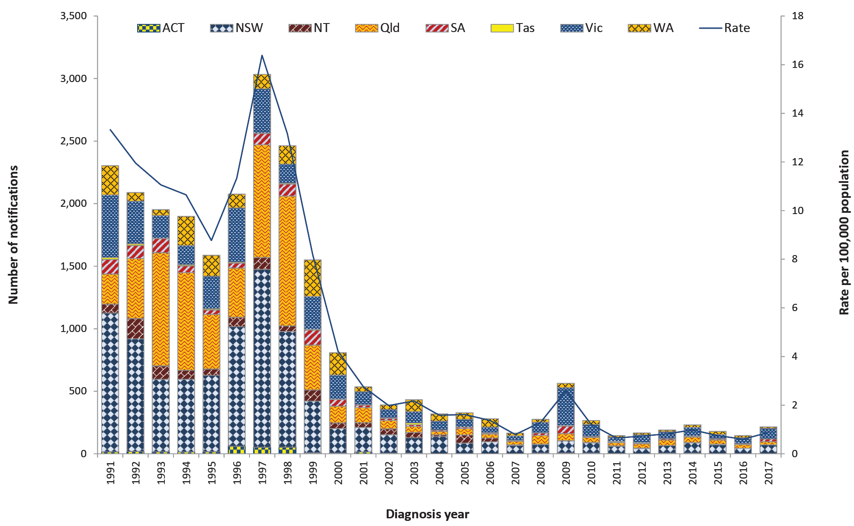

Table 6: Summary of HAV notifications in Australia, 2017
Category | Value
Number of notifications | 216
Rate | 0.9 cases per 100,000 population
Jurisdiction with the highest number of notifications | Victoria (n = 84; 39%)
Hospitalisations (% of all cases) | 66 (31%)
Cases in Aboriginal and/or Torres Strait Islandersª | 5 (2%)
Foodborne outbreaks | 1 (n = 11 cases) linked to imported frozen berries (Refer to Foodborne Outbreaks section)
a Indigenous status was not known for 15 cases (7%).
Figure 9: HAV notifications in Australia by place of acquisition, 2012–2017
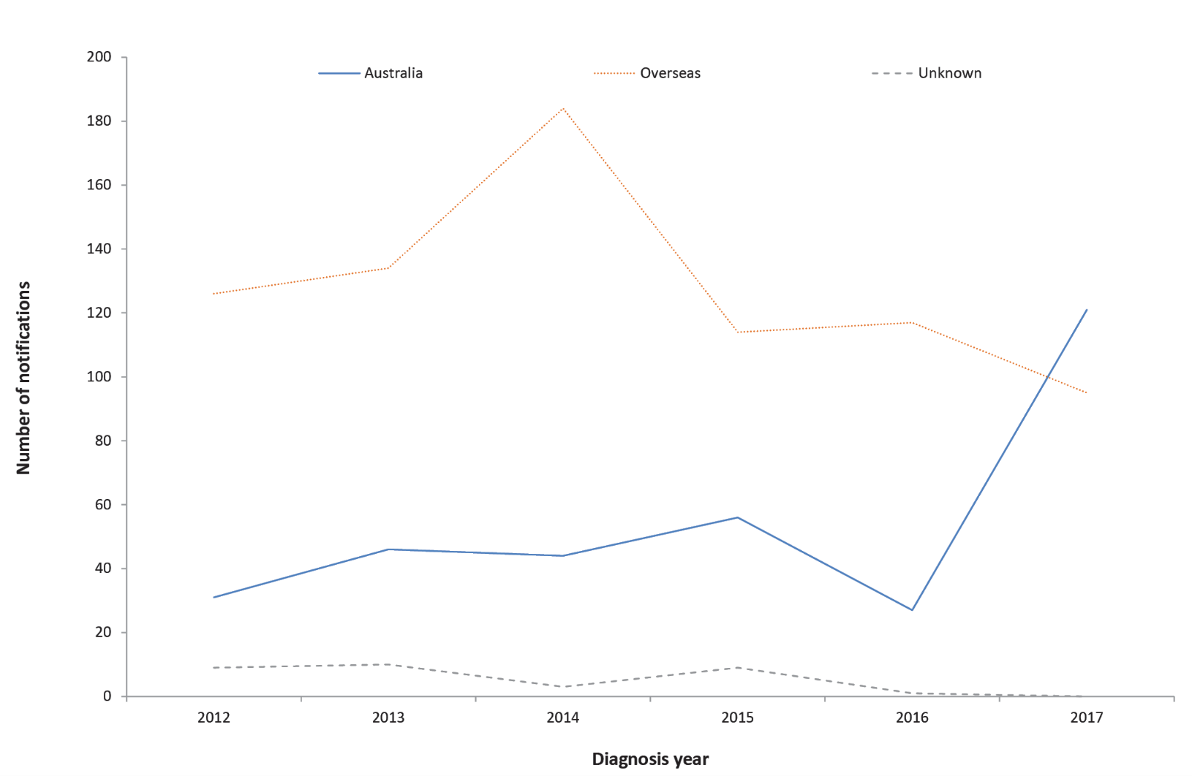

HAV cases acquired in Australia (n = 121)
- Cases acquired in Australia were most common in males (n = 99; 82%).
- Among males, cases were most common among those aged 20–49 years (n = 77; 78%). Among females, cases were most common among those aged 10–14 years (n = 5; 23%) and 40–44 years (n = 3; 14%).
- Cases were reported in residents of Victoria (n = 53), New South Wales (n = 37), South Australia (n = 17), Queensland (n = 10), Australian Capital Territory (n = 2) and Western Australia (n = 2).
- Five cases were reported amongst Aboriginal and/or Torres Strait Islander people.

HAV cases acquired overseas (n = 95)
- Over half of the overseas-acquired cases were male (n = 60; 63%).
- The most frequently reported age groups affected were 20–34 years (n = 42; 44%).
- HAV infection was most commonly acquired in India (Table 7).
Table 7: Top three countries of acquisition for overseas acquired HAV cases in Australia, 2017
Country of acquisition | Number of notifications, 2017 | Proportion of overseas acquired cases, 2017ª | Mean 2012–2016
India | 17 | 18% | 21
Pakistan | 5 | 6% | 12
Philippines | 5 | 6% | 12
a Excluding cases known to be overseas acquired without a single identified country of acquisition (n = 8).

HAV outbreaks

Foodborne outbreak
Eleven cases of HAV in Australia, including ten confirmed cases and one probable case due to secondary transmission, were part of a multi-jurisdictional outbreak linked to consumption of imported frozen mixed berries (refer to Foodborne Outbreaks section).

Outbreak amongst men who have sex with men
A national investigation was initiated following an increase in HAV cases with no history of overseas travel. Cases who had spent some of their acquisition period (15 to 50 days prior to onset of illness) in Australia and were identified as having one of three strains related to the large, multi-country outbreak in Europe (UK VRD 521 2016 (UK strain), RIVM-HAV16-090 (Ber/NL strain) and V16-25801 (Ber/Muc/Fra strain)) were included in the investigation.^{23–25}
Ninety-three cases were linked to the outbreak in 2017, with cases reported in Victoria (n = 37), New South Wales (n = 36), South Australia (n = 14), Queensland (n = 5) and the Australian Capital Territory (n = 1). The median age of cases was 36 years (range 10–85 years). Almost all cases were male (n = 89; 98%), and during case follow up over two thirds identified as men who have sex with men (MSM) (n = 63; 69%). One fifth of cases reported overseas travel (n = 18; 19%) including to countries experiencing outbreaks amongst MSM. In response to the outbreak, affected jurisdictions implemented public health messaging and vaccination campaigns targeted to specific at risk groups (including MSM). The outbreak continued into 2018.

Hepatitis E
Hepatitis E is an infection of the liver caused by the hepatitis E virus (HEV) that is almost always transmitted by the faecal-oral route. Infections are rarely notified in Australia and are usually associated with overseas travel. HEV infections acquired in Australia are occasionally notified and some of these infections have been associated with the consumption of undercooked pork products, particularly pork livers.²⁶ HEV has been found in pig herds in Australia.²⁷
Surveillance data includes confirmed cases only. A confirmed case requires either laboratory definitive evidence or laboratory suggestive and clinical evidence of HEV infection. Testing practices for HEV vary across jurisdictions. All notified cases are followed up by jurisdictional public health staff.

Overall trend
- While HEV infection is rare in Australia, notification rates have trended upwards since national notification began in 2001 peaking in 2014 owing to a local outbreak (Figure 10).
Figure 10: HEV notifications and rate per 100,000 population in Australia by jurisdiction of residence, 2001–2017
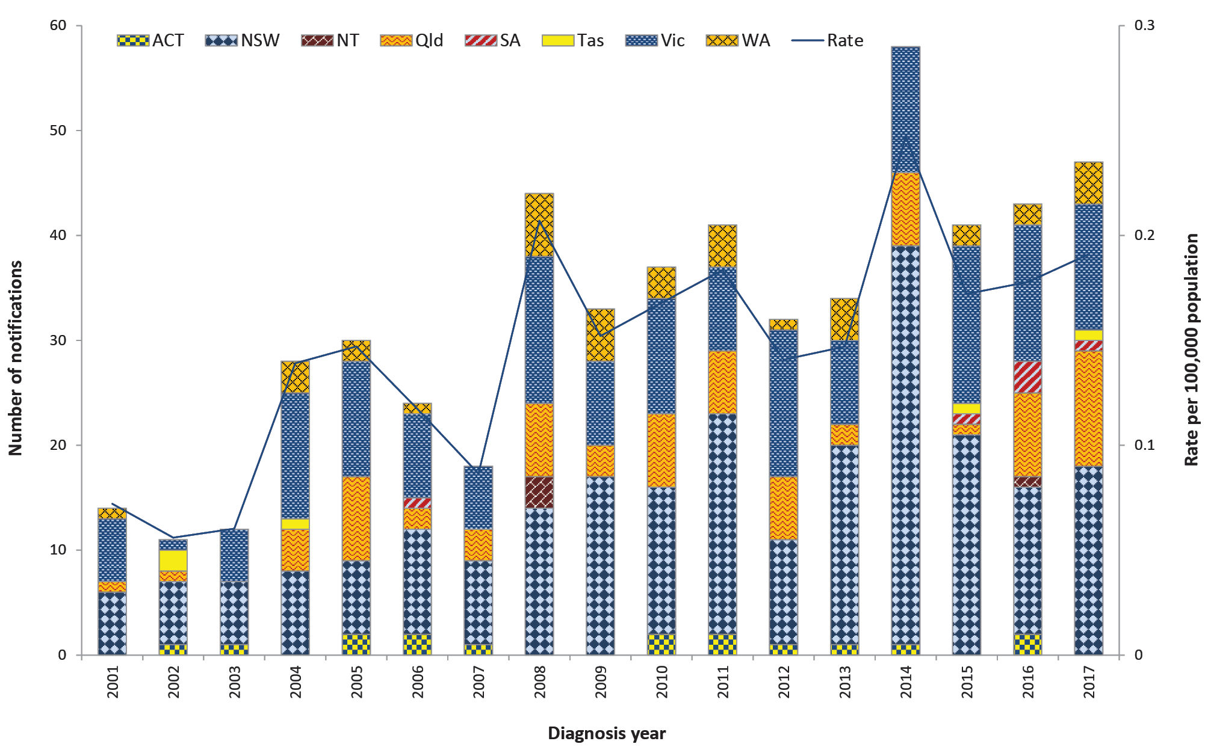

Table 8: Summary of HEV notifications in Australia, 2017
Category | Value
Number of notifications | 47
Rate | 0.2 cases per 100,000 population
Jurisdiction with the highest number of notifications | New South Wales (n = 18, 38%)
Hospitalisations (% of all cases) | 24 (51%)
Cases in Aboriginal and/or Torres Strait Islandersª | 0
Foodborne outbreaks | 0
a Excluding cases with Indigenous status not known (n = 4; 9%).
Figure 11: HEV notifications in Australia by place of acquisition, 2004–2017
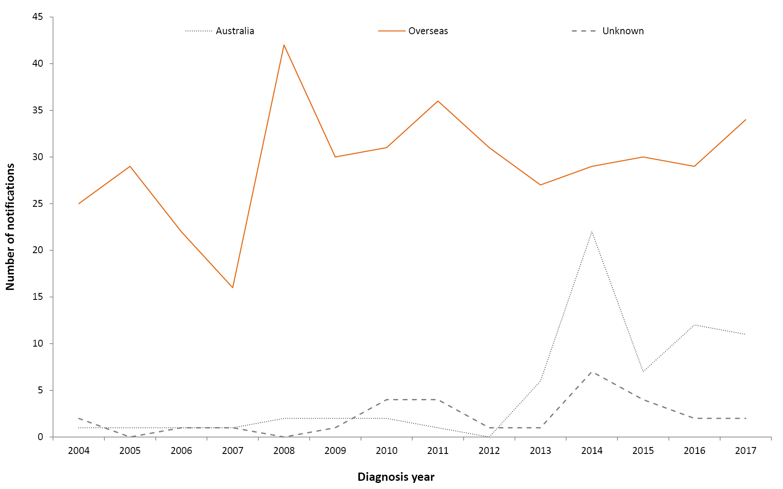

Previous outbreaks in Australia
- A foodborne outbreak in NSW, following the consumption of pork liver pâté in 2014 (n = 17 cases), is the only known outbreak of HEV to have occurred in Australia.²⁶

Epidemiology of HEV in Australia, 2017

Country of acquisition
- From 2004 (when travel history has been collected nationally) until 2013, almost all HEV infections were acquired overseas (Figure 11).
- While overseas travel continues to account for the majority of cases since 2013, an increasing number of Australian-acquired infections have been reported (Figure 11). The extent to which this has been influenced by changes in testing practices is unclear.

HEV cases acquired overseas (n = 34)
- As seen in previous years, HEV infection was most commonly acquired in India (Table 9).
- The majority of cases acquired overseas were male (n = 23; 68%), with a median age of 35 years (range 16–73 years).

HEV cases acquired in Australia (n = 11)
- Cases were residents of New South Wales (n = 4), Queensland (n = 4) and Victoria (n = 3).
- While the source of infection was not identified for these cases, four of the nine cases with food consumption data available reportedly consumed pork products during their respective incubation periods.
- The majority of cases acquired in Australia were male (n = 8; 73%), and the median age was 54 years (range 33–83 years).
Table 9: Top three countries of acquisition for overseas acquired HEV cases in Australia, 2017 (n = 31)
Country of acquisition | Number of notifications, 2017 | Proportion of overseas acquired cases, 2017ª | Mean 2012–2016
India | 12 | 39% | 14
China | 4 | 13% | 2
Bangladesh | 4 | 13% | 2
a Excluding cases known to be overseas acquired without an identified country of acquisition (n = 3).

Listeriosis
Listeriosis is a rare but serious illness caused by the Listeria monocytogenes bacterium. Infection occurs following the consumption of contaminated food, or in the case of a foetus or newborn, vertically from their pregnant mother. A wide variety of foods may be contaminated with L. monocytogenes, but cases of listeriosis are predominantly associated with commercially manufactured ready to eat foods that have a long recommended refrigerated shelf-life and fresh foods that are consumed fresh or without further cooking, for example cold meats (from delicatessen or pre-packaged), cold cooked chicken, pâté, pre-packaged salads, fresh fruits such as rockmelon, chilled cooked seafood, smoked fish and soft cheeses. The elderly, pregnant women and people who are immunocompromised (either by medical condition or medications) are at an increased risk of infection.²⁸
Surveillance data includes confirmed cases only. The case definition was expanded from 1 January 2017 to include clinical and epidemiological evidence as criteria for a confirmed case (in addition to laboratory definitive evidence). The clinical and epidemiological evidence criteria for a confirmed case means that if the mother is a confirmed case by laboratory definitive evidence, then the foetus/neonate is also a confirmed case if they have the defined (foetus/neonate) clinical evidence, and vice versa. All notified cases are followed up by jurisdictional public health staff.

Overall trend
- With the exception of increases due to outbreaks in 2009 and 2012–2013, the rate of listeriosis in Australia has remained steady since national notification began in 1994 (Figure 12).

Figure 12: Listeriosis notifications and rate per 100,000 population in Australia by jurisdiction of residence, 1994–2017
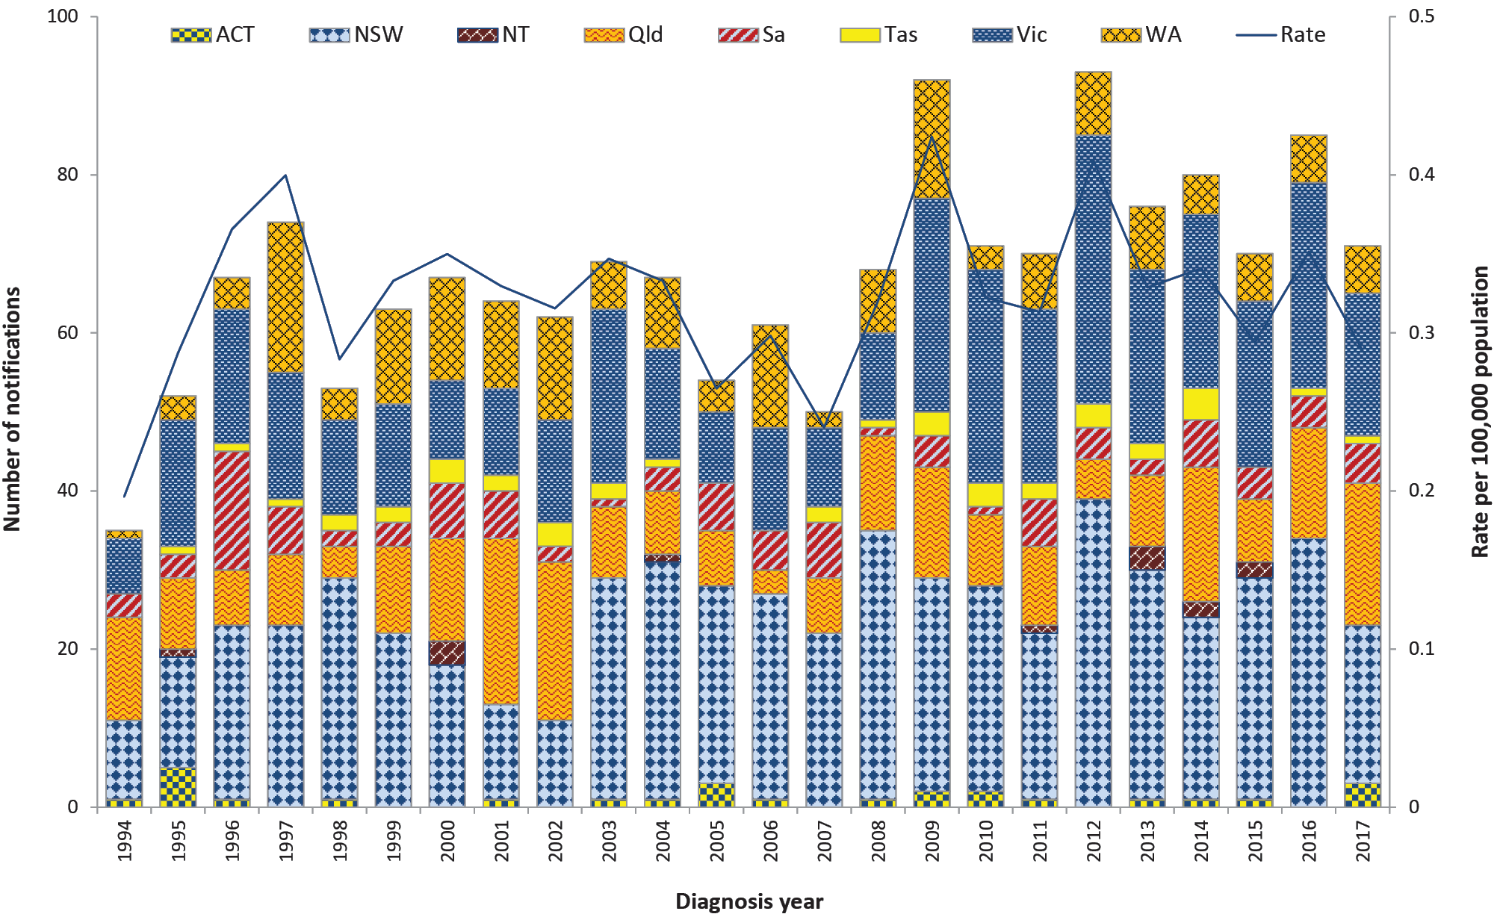
Table 10: Summary of listeriosis notifications in Australia, 2017
Category | Value
Number of notifications | 71 including: 49 non-perinatal cases and 22 perinatal cases
Rate | 0.3 cases per 100,000 population
Hospitalisation (% of all cases) | 71 (100%)
Cases in Aboriginal and/or Torres Strait Islanders (% of all cases) | 1 (1%)
Jurisdiction with the highest number of notifications | New South Wales (n = 20, 28%)
Foodborne outbreaks | 1 (n = 3 cases)
Food implicated in outbreak | Not identified

Previous outbreaks in Australia
Cases are usually sporadic, although foodborne outbreaks have been reported in Australia. Food sources of significant outbreaks identified in Australia since 2000 include:
- ready-to-eat meats (silverside, corned beef) (n = 5 cases) in South Australia in 2005;
- cooked chopped chicken (n = 3 cases) in Western Australia in 2009;
- chicken wraps (n = 36 cases) in multiple jurisdictions in 2009;
- melons (n = 9 cases) in multiple jurisdictions in 2010;
- cold meat (n = 6 cases) in Victoria in 2010;
- smoked salmon (suspected) (n = 3 cases) in multiple jurisdictions in 2012;
- soft cheese (brie/camembert) (n = 34 cases) in multiple jurisdictions in 2012–2013;²⁹
- profiteroles (n = 3 cases) in New South Wales in 2013;
- pre-prepared frozen meals (n = 3 cases) in Western Australia in 2013; and
- deli meats (n = 8) in multiple jurisdictions in 2016.⁵

Epidemiology of listeriosis in Australia, 2017

MLST typing
Multi-locus sequence typing (MLST) is determined in silico from whole genome sequencing data. A total of 20 different MLST types were reported in 2017. The most common type identified was MLST 1 (Table 11).
Table 11: Listeriosis cases in Australia by MLST typing, 2017ª
MLST | No. cases | Proportion
1 | 14 | 22%
2 | 4 | 6%
3 | 9 | 14%
4 | 1 | 2%
7 | 4 | 6%
8 | 2 | 3%
9 | 3 | 5%
14 | 4 | 6%
18 | 1 | 2%
37 | 1 | 2%
87 | 3 | 5%
91 | 4 | 6%
120 | 1 | 2%
121 | 1 | 2%
155 | 1 | 2%
204 | 4 | 6%
299 | 2 | 3%
321 | 1 | 2%
399 | 1 | 2%
997 | 1 | 2%
Total | 62 | 100%
a Excluding cases with isolates not typed (n = 3), and maternal/foetal infection counted once only (n = 6). Data taken from NELSS.

Perinatal cases (n = 22)
- Of the 22 perinatal cases notified, 12 cases were pregnant women and ten were neonates (infants less than four weeks of age). Of these 22 cases, nine mother/neonate pairs were notified (representing 18 notifications), three notifications were in a mother only, and one notification was in a neonate only.
- The outcome of the 12 pregnancies was miscarriage (n = 1), neonatal death (n = 6), and neonatal survival (n = 5). None of the pregnant women died. Illnesses reported for the mother (available for ten cases) included bacteraemia/sepsis (n = 4), amnionitis (n = 1), non-specific ‘flu-like’ symptoms (n = 4) and fever (n = 1).

Non-perinatal cases (n = 49)
- 53% of the cases were female (n = 26).
- The majority of cases (n = 32; 65%) were aged over 65 years, with 31% (n = 15) aged over 80 years.
- Septicaemia was the most common clinical presentation (Table 12).
- Forty-two cases (86%) had at least one illness/condition known to increase their risk of listeriosis infection, with cancer and diabetes most commonly reported (Table 13).
- Of the five cases with no known comorbidities, none reported taking medications including corticosteroids, cyclosporine or other immunosuppressive drugs, in the four weeks prior to illness. A single case reported taking gastric acid medications in their incubation period.
- Seven cases died, all of whom had septicaemia. Three deaths were attributed specifically to listeriosis.
Table 12: Non-perinatal listeriosis cases by clinical presentation in Australia, 2017a
Nature of the illness | No. cases | Proportion of all cases (%) | Deaths
Septicaemiª | 36 | 73% | 7
Meningitis and septicaemia | 1 | 2% | 0
Meningitis | 3 | 6% | 0
Other^{b} | 7 | 14% | 0
Unknown | 2 | 4% | 0
Total | 49 | 100% | 7
a Data taken from NELSS.
b ‘Other’ included bacteraemia, chest pain, gastroenteritis, hip swelling, right flank pain and neck stiffness with fever.

Table 13: Immunocompromising conditions for non-perinatal listeriosis cases in Australia, 2017 (n = 49)
Condition | No. cases | Proportion of all cases (%)
Cancer | 28 | 57%
Diabetes | 16 | 33%
Heart disease | 13 | 27%
Chronic lung disease (excluding asthma) | 10 | 20%
Renal disease not requiring dialysis | 8 | 16%
Liver disease | 7 | 14%
Blood disorder | 4 | 8%
Renal / kidney disease requiring dialysis | 3 | 6%
Rheumatological condition | 2 | 4%
No immunocompromising conditions | 5 | 10%

Salmonellosis
Salmonellosis is an infection caused by the Salmonella bacterium. It is second to campylobacteriosis as the most commonly notified enteric pathogen in Australia. Salmonella infections acquired in Australia are usually associated with consumption of contaminated food, or less commonly, after contact with infected animals or an infected person. Foods sources associated with Salmonella infection in Australia include raw and undercooked foods of animal origin, particularly eggs and poultry, and fresh produce.³⁰ Infection can also occur following exposure to Salmonella in the environment. Many Salmonella infections are also notified in people returning from overseas.
Surveillance data includes confirmed cases only. A confirmed case requires laboratory definitive evidence of infection. Note that paratyphoid and typhoid fever infections are reportedly separately (refer to Enteric fever section). Surveillance data is monitored by jurisdictional public health staff to identify potential outbreaks. Triggers for further investigation vary within and between jurisdictions depending on background infection rates, availability and timeliness of sub-typing information, and resource capacity.

Overall trend
- Salmonellosis notification rates have increased significantly since national notification began in 1991 (Figure 13).
- A marked increase was observed across most jurisdictions in 2014 onwards. This is due, at least in part, to the increase in PCR testing as a method of laboratory diagnosis (refer to OzFoodNet 2016 Annual Report).⁵
- A slight decline in the notification rate was observed in 2017 compared with 2015 and 2016.

Figure 13: Salmonellosis notifications and rate per 100,000 population in Australia by jurisdiction of residence, 1991–2017
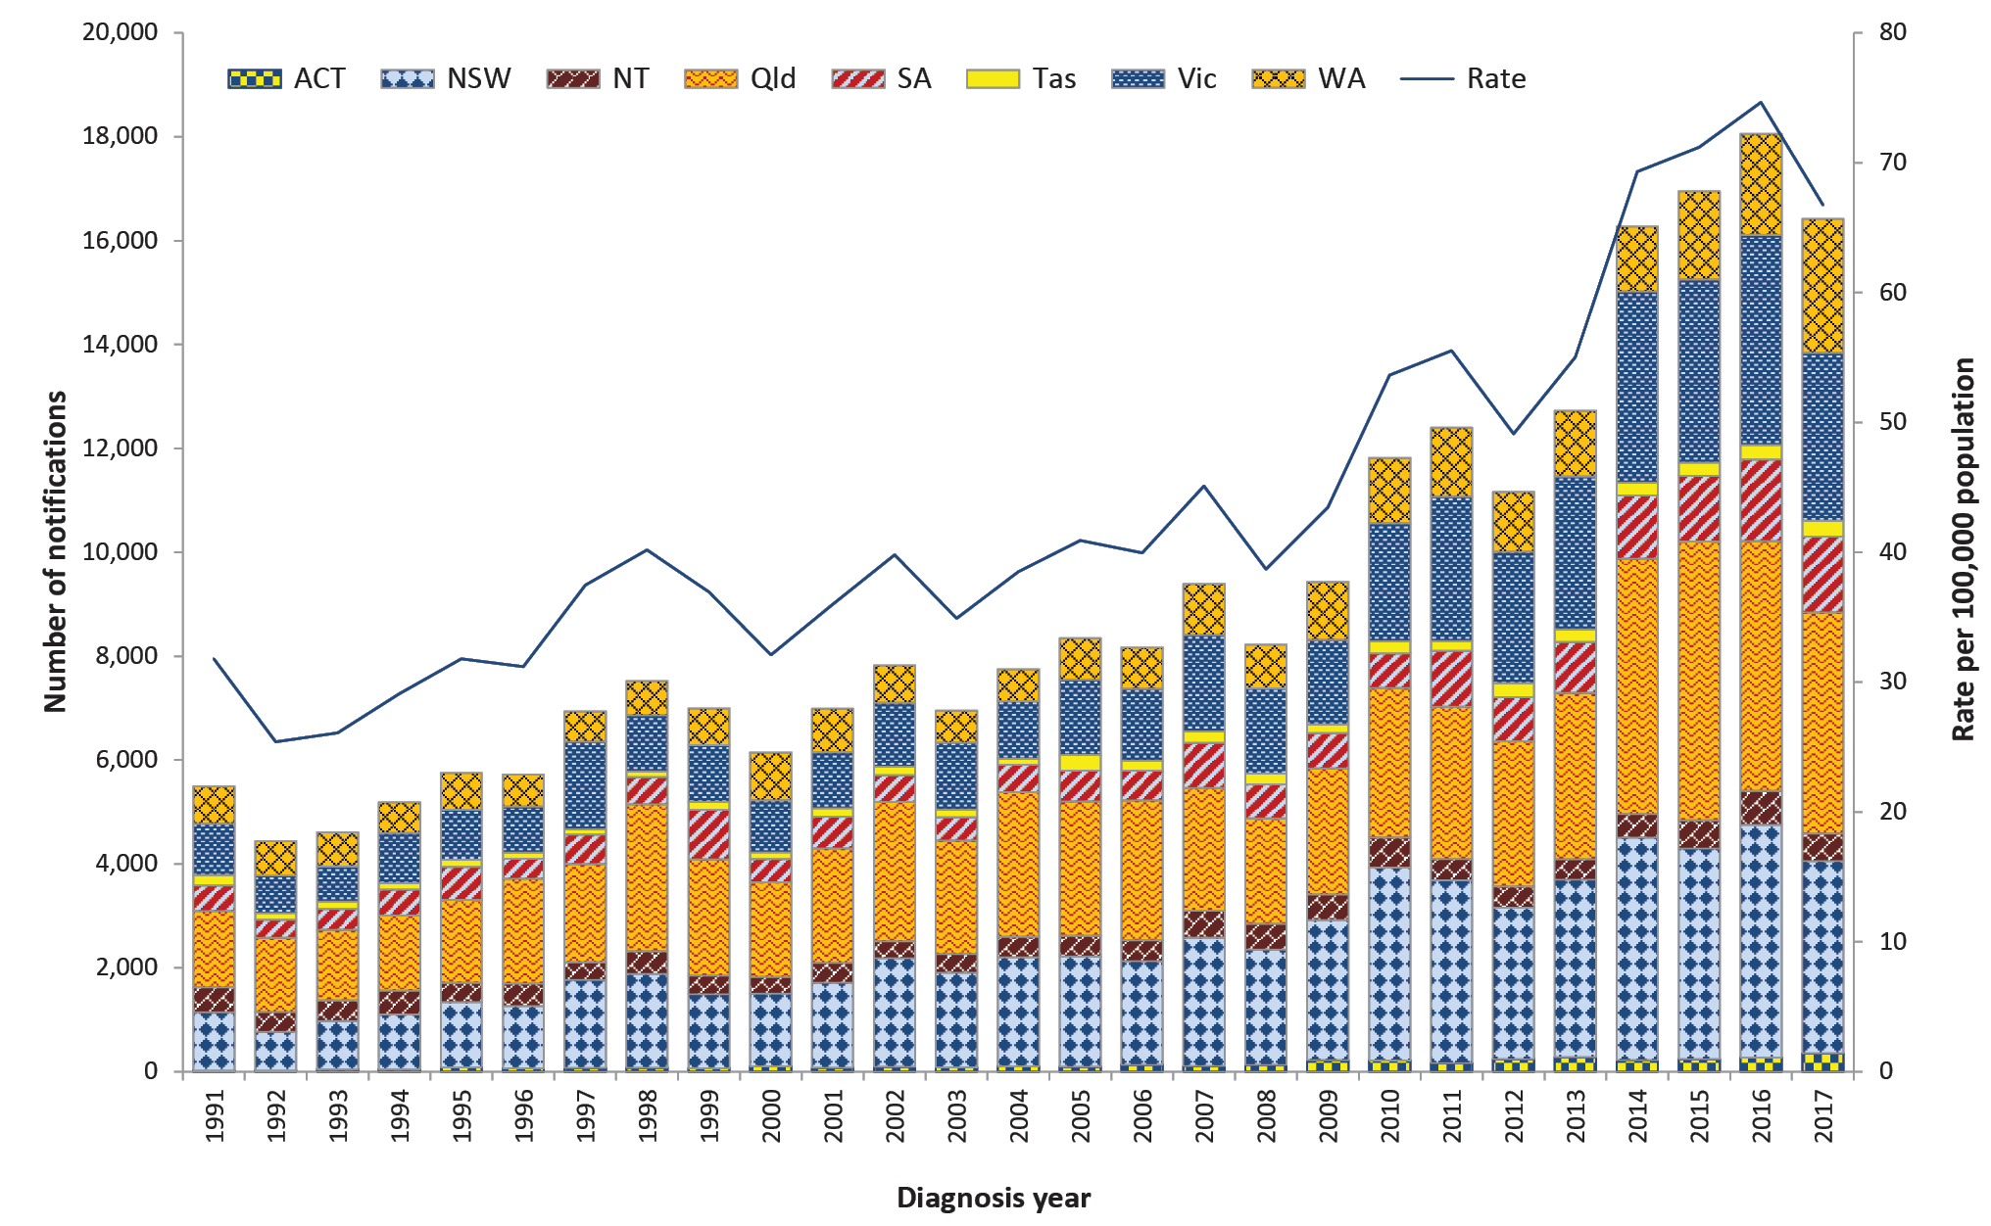
Table 14: Summary of salmonellosis notifications in Australia, 2017
Category | Value
Number of notifications | 16,416
Rate | 66.7 cases per 100,000 population
Jurisdiction with the highest number of notifications | Queensland (n = 4,259, 26%)
Foodborne outbreaks | 102
Foods implicated in outbreaks | Most commonly eggs (n = 48 outbreaks) (Refer to Foodborne Outbreaks section)

Table 15: Groups with the highest salmonellosis notification rate in Australia, 2017
Category | Group most affected | Rate per 100,000 population | Number (% of all cases)
Age group (years) | 0–4 | 242.3 | 3,838 (23%)
Sex | Females | 68.7 | 8,528 (52%)
Jurisdiction | Northern Territory | 215.4 | 658 (3%)

Previous outbreaks in Australia
Salmonellosis is the enteric pathogen most commonly identified in foodborne outbreaks in Australia. These outbreaks have been most frequently associated with the consumption of raw or minimally-cooked egg products.^{31,32} (Refer to Foodborne outbreak section.)
S. Typhimurium is the most commonly identified serotype in Salmonella outbreaks reported in Australia. The foods implicated in the largest of these outbreaks include:
- Vietnamese Banh mi rolls (n = 213 cases) in Victoria in 2003;
- dips served at a Turkish restaurant (n = 442 cases) in Victoria in 2005;
- pork or chicken and salad rolls made with raw-egg mayonnaise (n = 319 cases) in New South Wales in 2007;
- chicken (n = 391 cases) in multiple jurisdictions in 2012;
- potato salad containing raw eggs (n = 350 cases) in Queensland in 2013;
- raw-egg mayonnaise (n = 242 cases) in Victoria in 2014; and
- numerous bakery items (n = 202 cases) in New South Wales in 2016.
Other notable foodborne Salmonella outbreaks reported in Australia include:
- S. Saintpaul associated with rockmelon (n = 38 cases) in multiple jurisdictions in 2006³³ and mung bean sprouts (n = 419 cases) in multiple jurisdictions in 2016;⁵
- S. Litchfield associated with papaya (n = 26 cases) in multiple jurisdictions in 2006;³⁴
- S. Anatum associated with bagged salads (n = 311 cases) in multiple jurisdictions in 2016;⁵ and
- S. Hvittingfoss associated with rockmelons (n = 144 cases) in multiple jurisdictions in 2016.⁵
Notable non-foodborne outbreaks reported in Australia include:
- S. Paratyphi B biovar Java associated with tropical fish aquariums in 2003–2004;³⁵
- S. Paratyphi B biovar Java associated with playground sand in New South Wales in 2007–2009;³⁶ and
- S. Litchfield associated with a Northern Territory car rally in 2009.³⁷
Despite the number of salmonellosis outbreaks reported, they account for only a small proportion of salmonellosis cases notified annually.

Epidemiology of salmonellosis in Australia, 2017
Consistent with previous years, notifications were significantly higher in children aged less than five years when compared with all other age groups. For all age groups over 15 years, slightly higher rates were reported in females than in males (Figure 14). Approximately two-thirds of infections occurred in summer and autumn with the highest monthly count reported in March (Figure 15).

Figure 14: Salmonellosis notification rate per 100,000 population in Australia by age group and sex,ª 2017
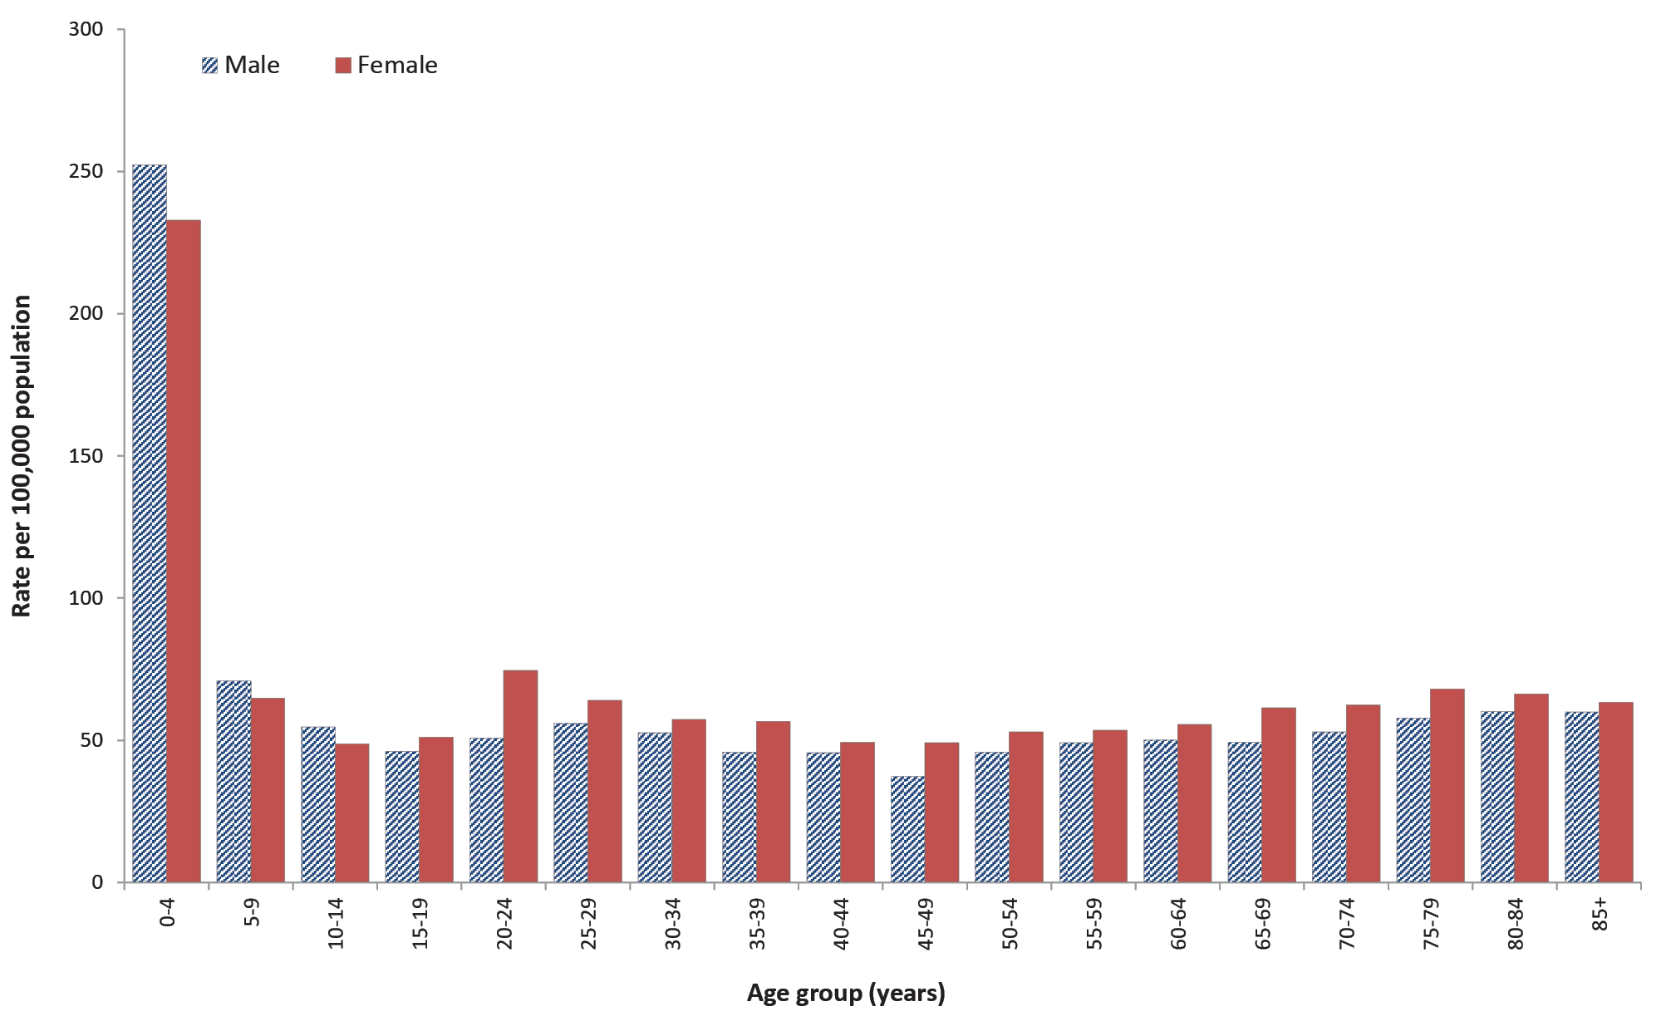
a Excluding cases with sex not defined (n = 18) and cases with unknown age (n = 1).
Figure 15: Salmonellosis notifications in Australia by month, and five-year historical mean, 2017
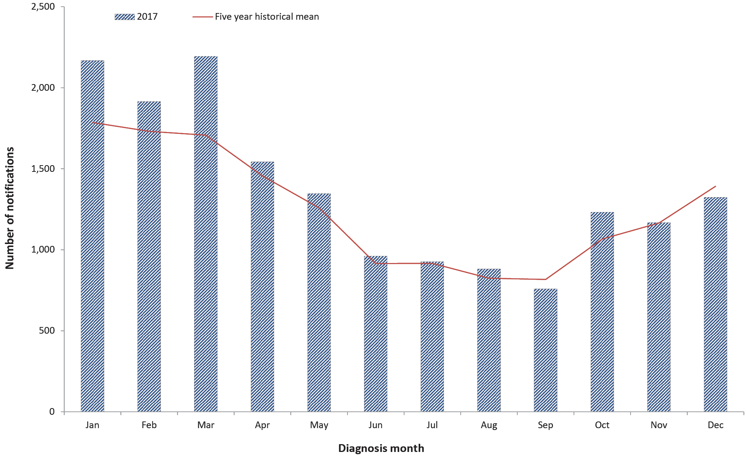

Serotyping
Serotyping information was available for 90% (n = 14,752) of salmonellosis notifications in 2017 with a total of 237 different serotypes identified. S. Typhimurium was the most common serotype identified with a slightly lower number of cases in 2017 (n = 5,914) compared to the five-year historical mean (n = 6,366). The five most commonly identified serotypes are shown in Table 16; combined, these account for 58% of all cases with serotyping performed.
Table 16: Top five Salmonella serotypes notified in Australia, 2017
Salmonella serotype | No. 2017 | % of all serotypes | Mean 2012–2016
S. Typhimurium | 5,914 | 40% | 6,366
S. Enteritidis | 851 | 6% | 869
S. Virchow | 751 | 5% | 659
S. Saintpaul | 632 | 4% | 600
S. Paratyphi B biovar Java | 408 | 3% | 322

Salmonella Typhimurium
With the exception of the Northern Territory and Tasmania, S. Typhimurium was the most common serotype notified in each jurisdiction in 2017 with the highest notification rate reported in Western Australia (Table 17). S. Typhimurium isolates routinely undergo the molecular based further typing method of multiple-locus variable number tandem repeat analysis (MLVA). In 2017, a total of 855 distinct MLVA profiles were identified, with 666 of these accounting for fewer than five cases each over the year. While in Western Australia, the Australian Capital Territory and Tasmania a single MLVA profile accounted for approximately a third of cases, for the remaining jurisdictions the most common MLVA type accounted for less than 10% of cases (Table 17). Refer to the Outbreak section for details of S. Typhimurium outbreaks.

Table 17: Salmonella Typhimurium notifications by jurisdiction and most common MLVA typeª in Australia, 2017 (n = 5,703)
Jurisdiction^{b} | Annual count 2017 | Rate per 100,000 population | Number of MLVA types identified | Most common MLVA
 |  |  |  | MLVA type | Annual count | % of MLVA
WA | 1,438 | 55.8 | 216 | 03-17-09-12-523 | 610 | 42%
ACT | 226 | 54.9 | 42 | 03-17-09-12-523 | 71 | 35%
SA | 827 | 48.0 | 197 | 03-14-11-08-523 and 03-24-11-10-523 | 73^{c} | 9%
Vic. | 1,472 | 23.3 | 330 | 03-09-09-14-523 and 03-22-13-11-523 | 77^{c} | 5%
NT | 38 | 15.4 | N/A^{d} | N/A^{d} | N/A^{d} | N/A^{d}
NSW | 1,182 | 15.0 | 323 | 03-17-09-11-523 | 43 | 4%
Tas. | 74 | 14.2 | 30 | 03-15-11-10-523 | 21 | 28%
Qld | 657 | 13.3 | 224 | 03-12-10-10-524 | 29 | 4%
Total | 5,914 | 24.0 | 855 | 03-17-09-12-523 | 767 | 13%
a Excluding cases where MLVA type not available (n = 211).
b Jurisdictions are ordered by 2017 rate per 100,000 population. WA: Western Australia; ACT: Australian Capital Territory; SA: South Australia; Vic.: Victoria; NT: Northern Territory; NSW: New South Wales; Tas.: Tasmania; Qld: Queensland.
c Count is the same for both MLVAs (equal numbers reported for most common MLVA).
d Not reported as MLVA type unavailable for the majority of Northern Territory cases (n = 30; 79%).

Salmonella Enteritidis
S. Enteritidis is a globally important Salmonella serotype that can infect the internal contents of eggs, but is not endemic in Australian egg layer flocks.³⁸ For this reason, a travel history is sought from all notified cases, and cases who have not travelled outside Australia are further investigated to identify the likely source of infection.
In 2017, a total of 851 S. Enteritidis cases were notified. While this was lower than 2016 (n = 1,019) it was in line with annual notifications from 2012–2015. In accordance with previous years, the majority of cases with a known travel history reported overseas travel within their incubation period (n = 651; 86%), with approximately half reporting travel to Indonesia (n = 356; 47%). This may reflect travel practices rather than an increased risk.

S. Enteritidis acquired in Australia
S. Enteritidis infections acquired in Australia (n = 103) were most commonly reported in Queensland (n = 47), followed by New South Wales (n = 27). Three foodborne outbreaks were identified in 2017, including two outbreaks involving passengers on a cruise ship operated by the same company in December 2016 and December 2017. Refer to the Foodborne outbreaks section for further information. For the remaining cases, no common exposures were identified.

Shigellosis
Shigellosis is a diarrhoeal disease caused by the Shigella bacterium. In Australia, the most common mode of transmission is person-to-person spread during close contact with an infectious case. This includes transmission in poor hygiene conditions, transmission between young children, and transmission during certain types of sexual activity (such as oral-anal sex). Person-to-person transmission is common due to the low infectious dose. Outbreaks can occur in conditions of crowding and poor sanitation and hygiene. Occasionally infections may be foodborne caused by infectious food handlers contaminating ready-to-eat food during preparation and handling. Many of the notifications reported in Australia represent infections that have been acquired during overseas travel. Populations at the highest risk of acquiring shigellosis within Australia include Aboriginal and/or Torres Strait Islander communities and MSM.^{39,40}
Surveillance data includes confirmed cases only. A confirmed case requires laboratory definitive evidence of Shigella. The ipaH gene is the target of all current nucleic acid tests for Shigella. However, the ipaH gene is common to Shigella species and enteroinvasive Escherichia coli (EIEC). Since 2014, when PCR testing was introduced, jurisdictions have classified cases PCR positive cases differently. Victoria, Northern Territory and Tasmania include cases found to be positive on PCR alone as confirmed cases in the surveillance data, whereas only cases confirmed by culture are included in the Australian Capital Territory, New South Wales, Queensland, South Australia and Western Australia.

Overall trend
- Except for peaks in the number of notifications in 2005 and 2008 (observed in multiple jurisdictions), the notification rate has remained steady between 2001 (when national notification began) and 2013 (Figure 16).
- A marked increase was observed across most jurisdictions from 2014 onwards. This is due, at least in part, to the increase in PCR testing as a method of laboratory diagnosis.
- Since the introduction and increasing use of PCR testing there has been variation in the classification and subsequent notification of cases across jurisdictions to the NNDSS. Some jurisdictions have included PCR positive cases in the absence of confirmation by culture in the surveillance data, influencing the number of notifications by jurisdiction observed in Figure 16. In New South Wales, outbreaks amongst MSM contributed to the increases observed in 2014 and 2016 (refer to NSW OzFoodNet Annual Report 2016).⁴¹

Figure 16: Shigellosis notifications and rate per 100,000 population in Australia by jurisdiction of residence, 2001–2017
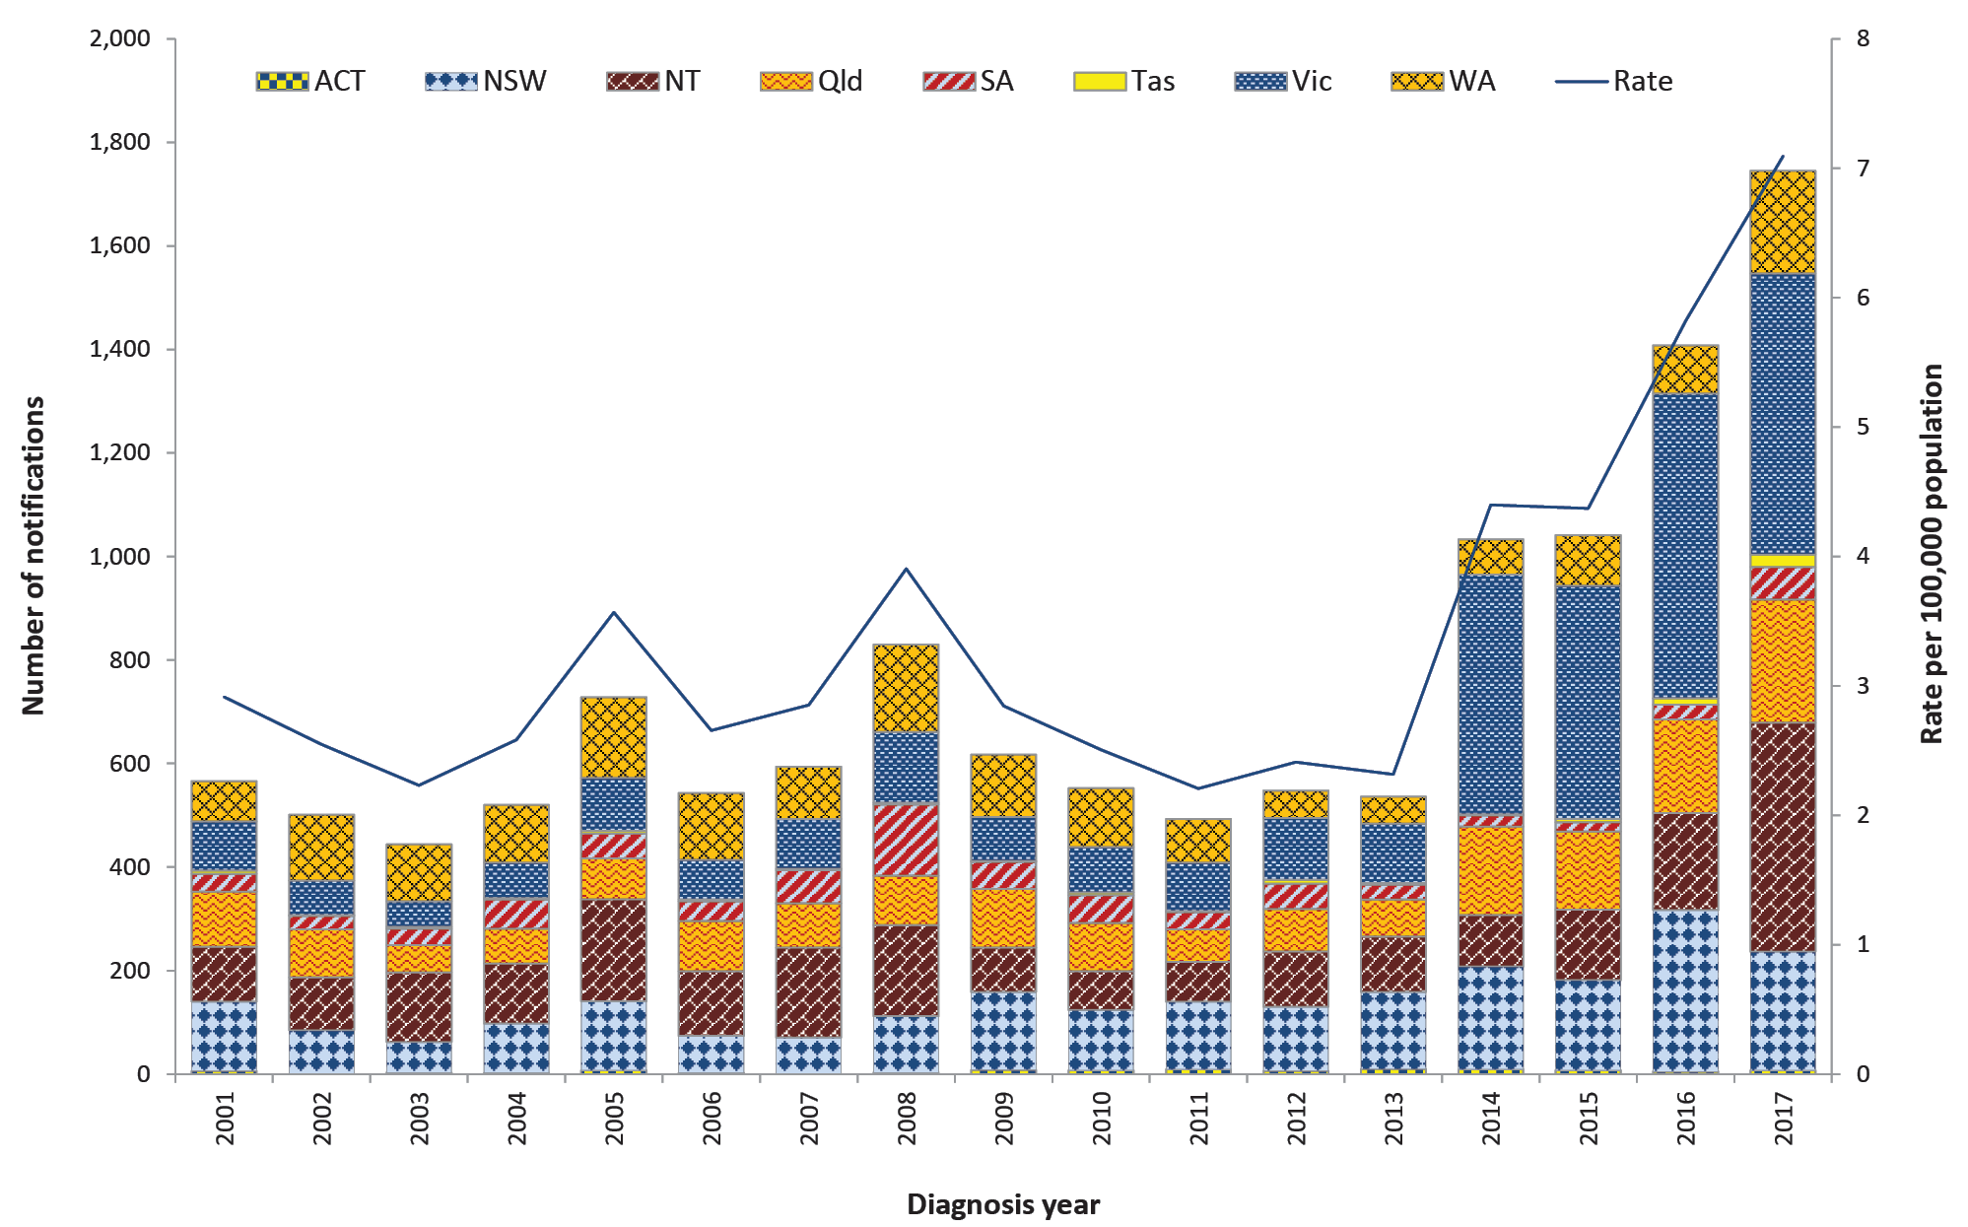
Table 18: Summary of shigellosis notifications in Australia, 2017
Category | Value
Number of notifications | 1,745
Rate | 7.1 cases per 100,000 population
Jurisdiction with the highest number of notifications | Victoriaª (n = 543; 31%)
Foodborne outbreaks | 2
Implicated foods and settings | Contamination of burritos by a take-away food handler, and unknown food vehicle at a restaurant
a Victoria includes PCR positive cases as confirmed cases.

Previous outbreaks in Australia
In addition to non-foodborne outbreaks amongst MSM and Aboriginal and/or Torres Strait Islander communities, five foodborne outbreaks have been reported in Australia since 2000. The most significant foodborne outbreak was associated with the consumption of imported baby corn with 55 cases reported in Australia in 2007.⁴²

Epidemiology of shigellosis in Australia, 2017

Aboriginal and/or Torres Strait Islander people (n = 657)
- Indigenous status was available for 92% of cases (n = 1,601), with 41% identifying as Aboriginal and/or Torres Strait Islander (n = 657).
- The majority of cases among Aboriginal and/or Torres Strait Islander people occurred in the Northern Territory (n = 400; 61%), followed by Western Australia (n = 123; 19%) and Queensland (n = 93; 14%) (Table 19).
- While a higher burden of disease has been consistently observed amongst Aboriginal and/or Torres Strait Islander people, the notification rate in 2017 far exceeded that of non-Indigenous people (4.5 cases per 100,000 non-Indigenous people compared to 99.8 cases per 100,000 Aboriginal and/or Torres Strait Islander people) (Figure 17).
- The majority of the 532 isolates from Aboriginal and/or Torres Strait Islander people that were speciated were identified as S. flexneri (n = 373; 70%), with the remainder S. sonnei (n = 159; 30%). Where known, almost all Aboriginal and/or Torres Strait Islander S. flexneri cases were serotype 2b (n = 336; 90%) and almost all S. sonnei cases were biotype a (n = 150; 94%). Conversely, the majority of the 644 isolates from non-Indigenous people that were speciated were identified as S. sonnei (n = 380; 59%), with the remainder S. flexneri (n = 243; 38%), S. boydii (n = 20; 3%) and S. dysenteriae (n = 1; < 1%). Where known, the majority of non-Indigenous S. sonnei cases were biotype g (n = 278; 73%) and S. flexneri cases were serotype 2a (n = 107; 44%).
Table 19: Shigellosis notifications in Aboriginal and/or Torres Strait Islander people in Australia by place of residence, 2017
Jurisdictionª | 2017 notifications | 2017 rate per 100,000 people | Mean 2012–2016 | % change in notifications (2017 compared to 2012–2016)
ACT | 0 | 0.0 | < 1 | -100%
NSW | 3 | 1.6 | 2 | 36%
NT | 400 | 518.0 | 100 | 298%
Qld | 93 | 48.1 | 32 | 192%
SA | 35 | 99.2 | 7 | 373%
Tas | 0 | 0.0 | 0 | —
Vic | 3 | 6.9 | 4 | -17%
WA | 123 | 141.5 | 23 | 444%
Total | 657 | 99.8 | 168 | 291%
a ACT: Australian Capital Territory; NSW: New South Wales; NT: Northern Territory; Qld: Queensland; SA: South Australia; Tas.: Tasmania; Vic.: Victoria; WA: Western Australia.

Figure 17: Shigellosis notifications and rates per 100,000 population in Australia by Indigenous status, 2012–2017ª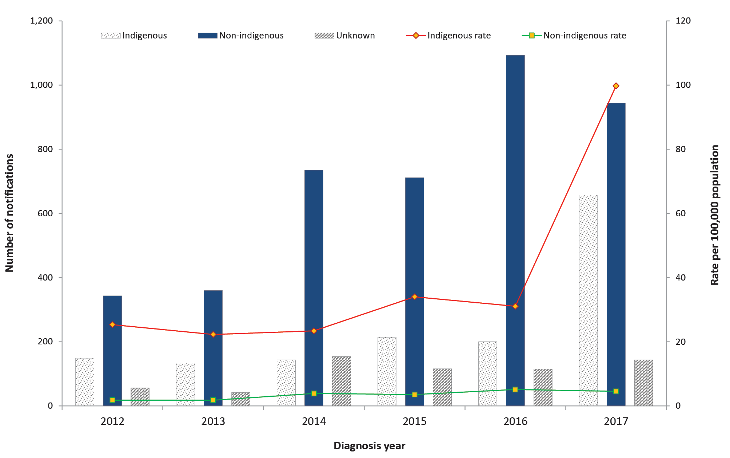
a Cases with unknown Indigenous status were included as non-Indigenous in the rate calculations.

Shigella flexneri serotype 2b outbreak amongst Aboriginal and/or Torres Strait Islander people
The notification rate amongst Aboriginal and/or Torres Strait Islander people more than tripled in 2017 when compared with 2016 (99.8 cases per 100,000 Aboriginal and/or Torres Strait Islander people in 2017 compared to 31.1 cases per 100,000 in 2016), largely due to an outbreak of S. flexneri 2b amongst Aboriginal people. S. flexneri 2b cases were first identified in remote areas of the Northern Territory in late 2016. Notifications were sporadic until a sharp increase was observed in May 2017. Meanwhile, in April 2017 cases were first identified in remote regions of South Australia and Western Australia. In total, 336 S. flexneri 2b cases were reported in Aboriginal and/or Torres Strait Islander people across the Northern Territory (n = 217), South Australia (n = 34), Western Australia (n = 75) and Queensland (n = 10) in 2017. An additional 14 S. flexneri 2b cases were reported in non-Indigenous residents of Western Australia, Queensland and South Australia who reported no overseas travel during their respective incubation periods. Case detection is limited by the inability to identify the species of cases diagnosed solely by PCR. A further 51 Shigella cases diagnosed by PCR were reported from the affected regions in South Australia. The Northern Territory estimated that 19 of the 20 unserotyped S. flexneri cases and 110 of the 153 untyped Shigella species in 2017 were related to this outbreak.⁴³ With the exception of a single probable foodborne outbreak affecting two cases in the Northern Territory, no other foodborne outbreaks were identified suggesting person-to-person was the most likely mode of transmission. Children less than five years of age were most commonly affected (Figure 18). For those aged over 15 years, infections were more common in females, which may reflect child rearing practices. The Northern Territory outbreak is further described in the associated surveillance report.⁴³ The outbreak continued into 2018.

Figure 18: Shigella flexneri serotype 2b notifications in Aboriginal and/or Torres Strait Islander people in Australia, by age group and sex, 2017
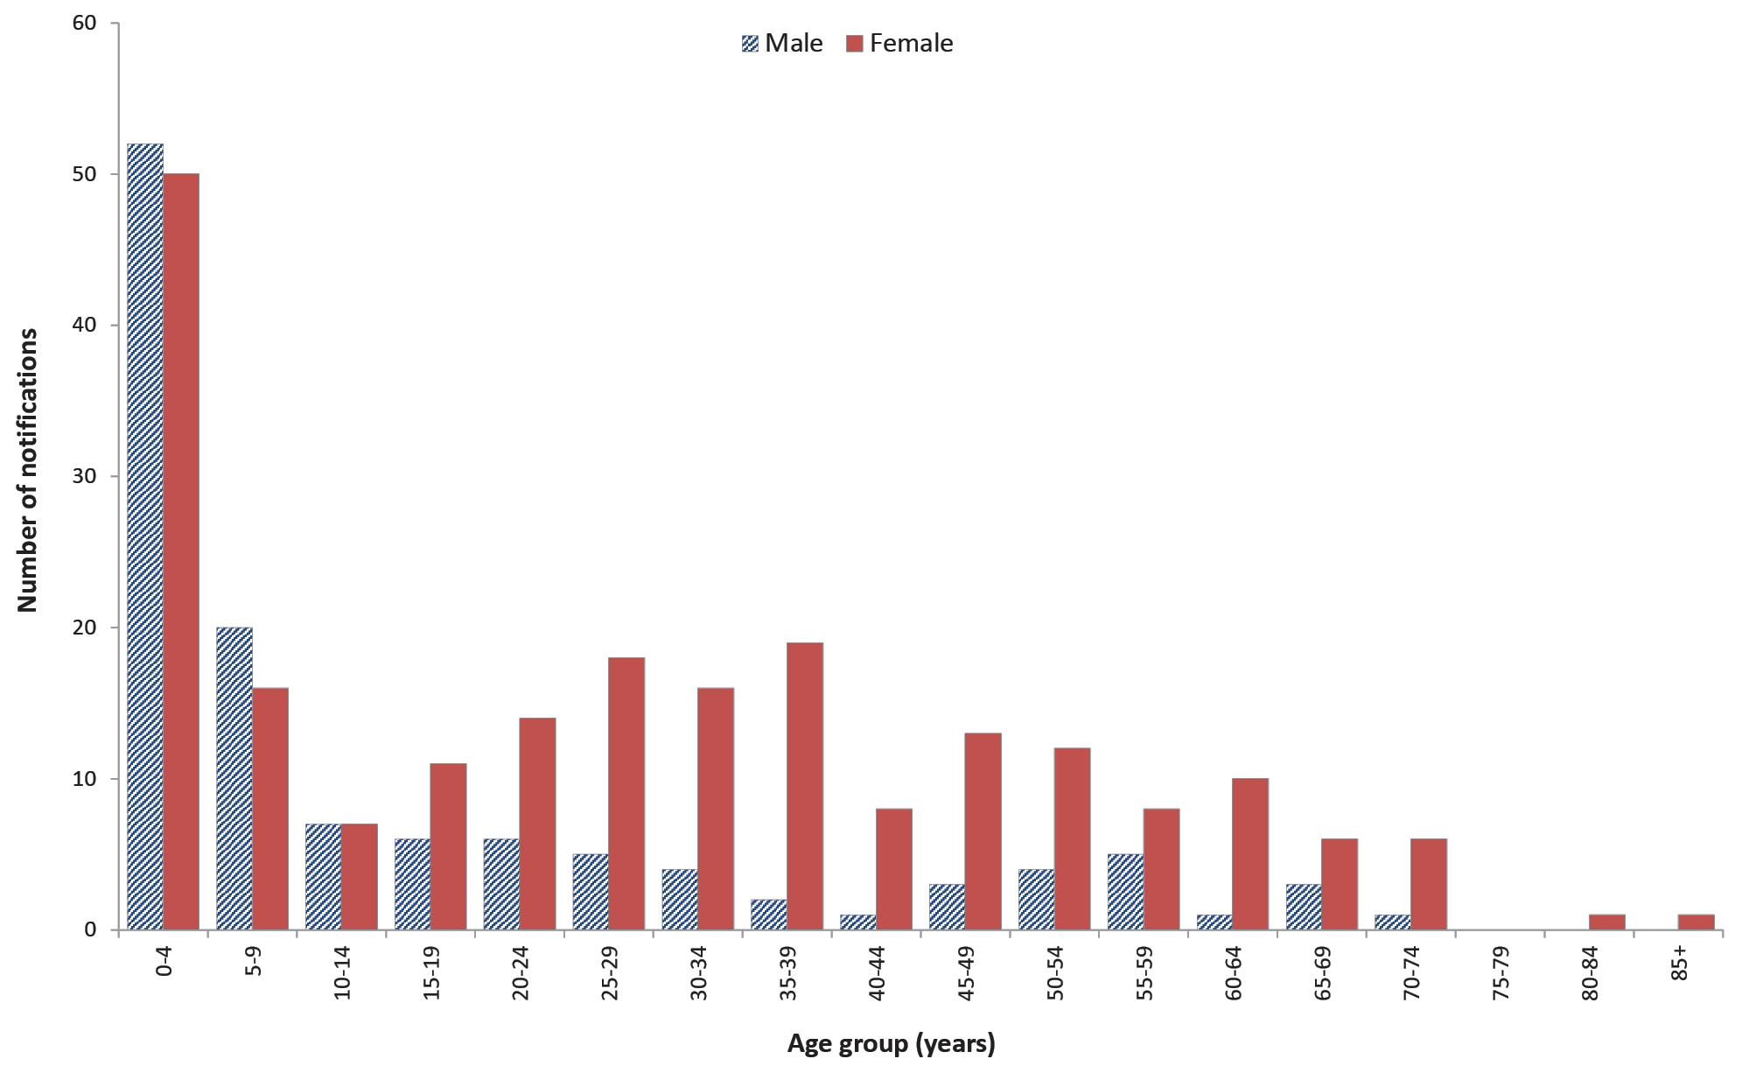

Country of acquisition
- Information on the country of acquisition was available for 84% (n = 1,463) of cases, of which approximately two-thirds (n = 947; 65%) were acquired in Australia.
- Of the infections that were acquired in Australia, males accounted for a higher proportion of cases (n = 516; 54%) than females (n = 430; 45%). This may be associated with to male-to-male sexual transmission (Figure 19).
- Consistent with previous years, overseas-acquired cases (n = 516) were most commonly acquired in India (n = 128; 25%) and Indonesia (n = 101; 20%).

Figure 19: Shigellosis notifications in Australia by place of acquisition and sex, 2017
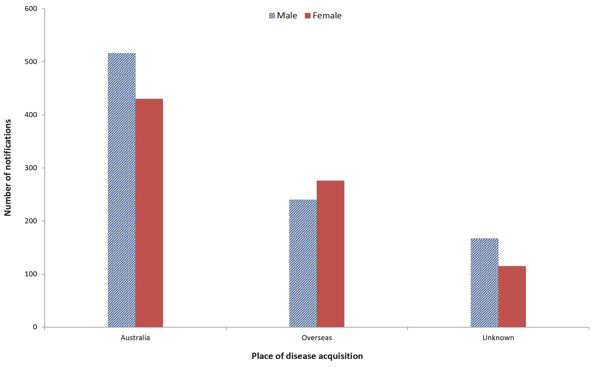

Shiga toxin-producing Escherichia coli infection and haemolytic uraemic syndrome
Shiga toxigenic E. coli (STEC) infection is a diarrhoeal illness caused by the strains of the Escherichia coli (E. coli) bacterium that produce shiga toxins. The principal reservoirs of STEC in Australia are the lower intestinal tract of ruminants, particularly cattle and sheep. Infections in humans can occur after: consuming contaminated food including undercooked meat, particularly minced beef/burgers, unwashed salad and vegetables and unpasteurised milk or milk products; drinking or swimming in contaminated water; close contact with an infectious case; or direct contact with infectious animals on farms or at petting zoos.⁴⁴
Haemolytic uraemic syndrome (HUS) is a severe and potentially fatal condition characterised by kidney failure, bleeding and anaemia that is more common in young children and the elderly. While STEC is the most common infectious agent that causes HUS, it can also be caused by other infectious agents including Shigella and Streptococcus pneumoniae. HUS can also result from non-infectious causes. Cases resulting from an STEC infection usually report a history of a diarrheal illness, often bloody, up to three weeks (usually within seven days) prior to the onset of HUS. Attempts are made for collection and microbiological examination of stool samples from all HUS cases. However, due to the timing since onset of diarrhea, STEC may no longer be detectable in the stool at the time of subsequent stool testing.
Surveillance data of STEC and HUS consists of confirmed cases only. A confirmed case of STEC requires laboratory definitive evidence; a confirmed case of HUS requires clinical evidence only. Where STEC is isolated in the context of HUS, it is notified as both STEC and HUS.
Prior to 1 July 2016, the case definition required that ‘identification of the gene associated with the production of shiga toxin or vero toxin in E. coli by nucleic acid testing on isolate or raw bloody diarrhoea’. The case definition was revised in light of the increasing uptake of CIDT to make provision for the detection of stx1 and/or stx2 genes in faeces without macroscopic evidence of blood or diarrhoea.

Overall trend
- Notification rates of STEC have trended upwards between 2001 (when national notification began) and 2015. The peak in 2013 was related to a zoonotic outbreak in Queensland (see below) (Figure 20).
- Notification rates for STEC are significantly influenced by local testing practices.
  - The consistently higher rates observed in South Australia since 2001 reflect the routine testing of all bloody stool samples in addition to clinician requests.
  - In June 2016, the only laboratory in South Australia conducting STEC testing began testing all faeces for STEC, instead of only bloody stool samples, resulting in a sharp increase in notifications.
  - Changes to the case definition for confirmed STEC cases in 2016 and the increasing uptake of CIDT have contributed to the increase in STEC cases nationally.
- HUS is rare in Australia, with notification rates relatively stable since notification began in 1999.
Table 20: Summary of STEC and HUS notifications in Australia, 2017
 | STEC | HUS
Number of notifications | 496 | 14
Rate | 2.0 cases per 100,000 population | 0.1 cases per 100,000 population
Jurisdiction with highest number of notifications | South Australia (n = 316; 64%) | Victoria (n = 4; 29%)
Cases in Aboriginal and/or Torres Strait Islandersª | 19 | 0
Foodborne outbreaks | 0 | 0
a Indigenous status unknown for 22 STEC cases and one HUS case.
Figure 20: STEC notifications and rate per 100,000 population in Australia by jurisdiction of residence, 2001–2017ª
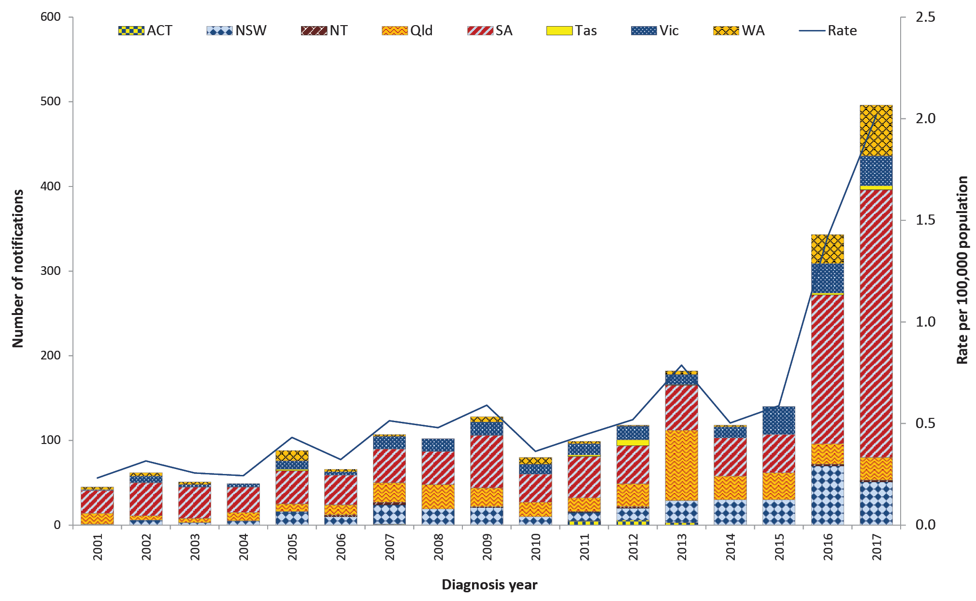
a Data includes HUS cases where an STEC organism was isolated (see above footnote).

Figure 21: STEC cases in Australia by age group and sex, 2017ª
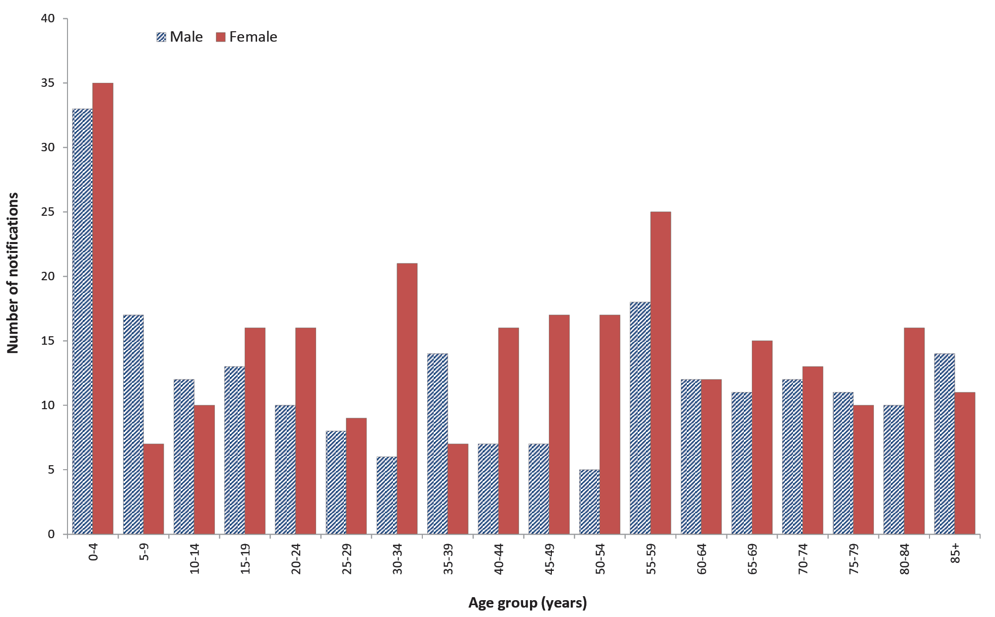
a Excluding cases with unknown age (n = 3).

Previous outbreaks in Australia
Most STEC cases are sporadic in Australia though outbreaks have been reported. Risk factors identified in a national case-control study in Australia between 2003–2007 included consuming hamburgers, eating at restaurants, occupational exposure to animals or raw red meat by case or household member, antibiotic use in the four weeks before illness, consumption of sliced chicken meat or corned beef from a delicatessen, bush camping in Australia and eating at catered events.⁴⁴

Foodborne outbreaks
Significant foodborne outbreaks have been reported internationally, and have most commonly been associated with ground beef or sprouts. Sprouts from a farm in Germany was the implicated source of an international outbreak in 2011 that included over 3,000 STEC and 800 HUS cases.⁴⁵ In Australia, however, foodborne outbreaks are rare, the most notable being a large outbreak of E. coli O111 infection in 1995 associated with the consumption of contaminated mettwurst.⁴⁶ Since 2000 (when OzFoodNet commenced), the implicated foods in confirmed and probable STEC outbreaks reported in Australia include:
- potato salad consumed at a camp in rural South Australia in 2009 (n = 31, no HUS cases); and
- kangaroo meat consumed in a remote Northern Territory community in 2012 (n = 5, no HUS cases).

Non-foodborne outbreaks
Outbreaks due to contaminated tank water, person-to-person and zoonotic transmission at petting zoos have been reported in Australia. The largest STEC outbreak in Australia occurred following contact with animals at a petting zoo in Queensland in 2013 (n = 57 STEC cases, no HUS cases).

Epidemiology of STEC and HUS in Australia, 2017

STEC
- Notifications peaked in children aged 0–4 years (n = 68; 14%), followed by those aged 50–59 years (n = 43; 9%) and were more common in females (n = 275; 55%) compared with males (n = 221; 45%) (Figure 21).
- Where known, the majority of cases (n = 380; 85%) were acquired in Australia. Of the cases known to be acquired overseas (n = 59), India was the most common country of acquisition (n = 20).
- With the exception of a single cluster in Queensland involving an index case with unknown source and two secondary cases in household contacts, no outbreaks were identified.

HUS
- Consistent with previous years, HUS was most commonly reported in children aged less than five years (n = 6; 43%).
- Notifications were more common in females (n = 10) compared with males (n = 4).
- In accordance with recent years, STEC infection was identified in 50% (n = 7) of the HUS cases reported in 2017.
- Of the seven cases for whom STEC infection was not identified, two cases reported a history of a diarrheal illness while another was presumed to be non-infectious.

Outbreaks of gastrointestinal disease including foodborne disease outbreaks
In 2017, a total of 206 outbreaks of gastrointestinal illness caused by foodborne, animal-to-person, environmental or waterborne disease were reported by OzFoodNet sites, affecting 2,385 individuals. The majority (89%) of outbreaks were a result of foodborne and probable foodborne transmission of infection (Table 21).

Foodborne and probable foodborne outbreaks
OzFoodNet sites reported 179 outbreaks where the consumption of food was the probable or confirmed mode of transmission (hereon referred to collectively as foodborne outbreaks). Foodborne outbreaks affected a total of 2,130 people. While the total number of outbreaks reported in 2017 was higher than the five-year historical mean (n = 155 outbreaks), fewer people were affected (Table 21). Admission to hospital was required for at least 290 people, and five deaths were reported during the outbreaks.
Table 21: Gastrointestinal disease outbreaks and ill people by transmission mode in Australia, 2017
Transmission mode | Outbreaks |  |  | Ill people
 | No. 2017 | Proportion | Annual mean 2012–2016 | No. 2017 | Proportion | Annual mean 2012–2016
Foodborne and probable foodborne | 179 | 87% | 155 | 2,130 | 89% | 2,623
Environmental and probable environmental | 22 | 11% | 13 | 225 | 9% | 89
Animal-to-person and probable animal-to-person | 3 | 1% | 1 | 14 | 1% | 20
Waterborne and probable waterborne | 2 | 1% | 2 | 16 | 1% | 29
Total | 206 | 100% | 171 | 2,385 | 100% | 2,762

Victoria and Western Australia reported the highest number of foodborne outbreaks in 2017 (Table 22). Consistent with previous years, outbreaks more commonly occurred in the warmer months of January to March (Quarter 1) (Figure 22 and Figure 23).

Table 22: Foodborne outbreaks and affected people in Australia by jurisdiction, 2017
Jurisdictionª | Outbreaks |  | Ill people
 | Number of outbreaks | Proportion | Total no. | Mean ill per outbreak | Hospitalised | Fatalities
MJOI | 1 | 1% | 11 | 11 | 5 | 0
ACT | 8 | 4% | 168 | 21 | 33 | 0
NSW | 36 | 20% | 416 | 36 | 14 | 0
NT | 7 | 4% | 95 | 14 | 5 | 0
Qld | 21 | 12% | 195 | 9 | 41 | 0
SA | 17 | 9% | 261 | 14 | 53 | 2
Tas. | 5 | 3% | 57 | 11 | 0 | 0
Vic. | 42 | 23% | 468 | 11 | 78 | 1
WA | 42 | 23% | 459 | 11 | 61 | 2
Total | 179 | 100% | 2,130 | 12 | 290 | 5
a MJOI: multi-jurisdictional outbreak investigation; ACT: Australian Capital Territory; NSW: New South Wales; NT: Northern Territory; Qld: Queensland; SA: South Australia; Tas.: Tasmania; Vic.: Victoria; WA: Western Australia.
Figure 22: Foodborne outbreaks in Australia by year and quarter,ª 2012–2017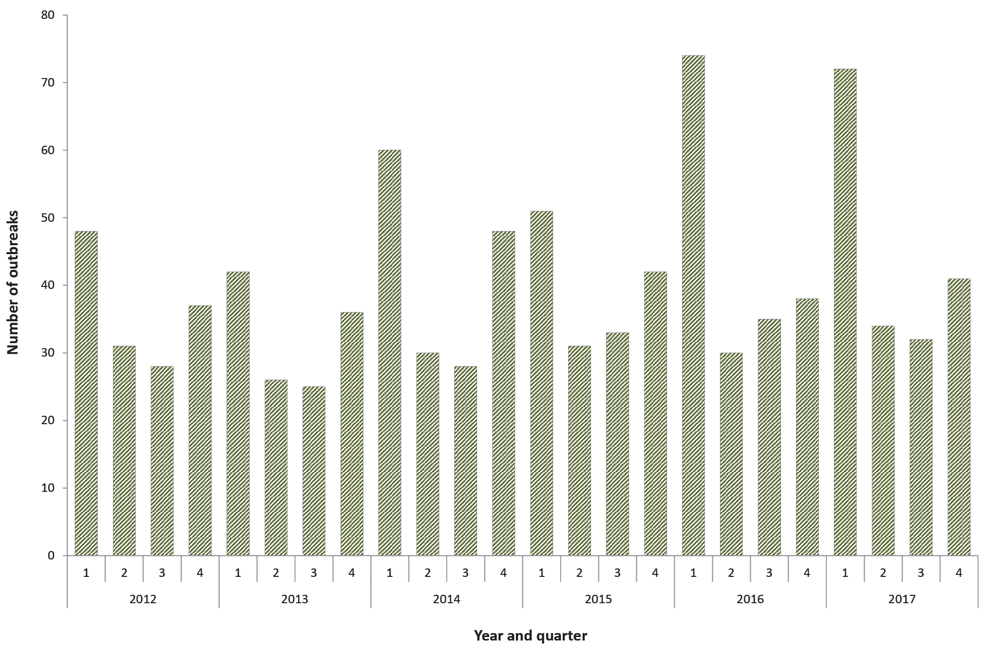
a Year and quarter of the outbreak is based on the month of onset of the first case or month of notification of the first case or the month the investigation into the outbreak commenced.
Figure 23: Number of ill people in foodborne outbreaks in Australia by year and quarter,ª 2012–2017
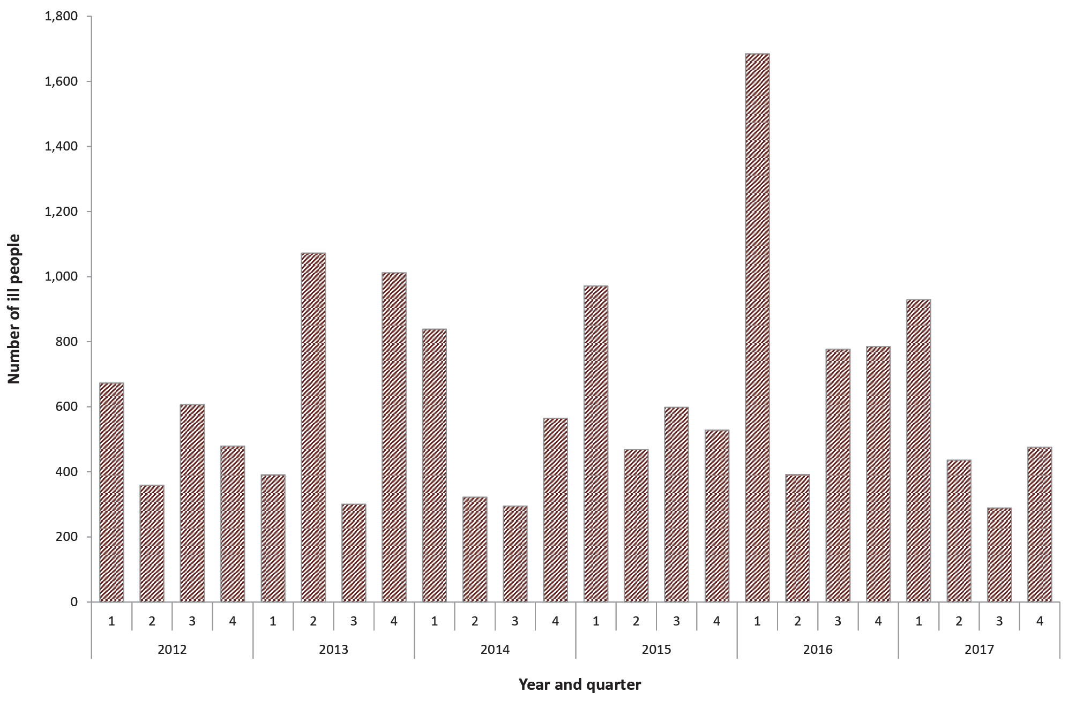
a Year and quarter of the outbreak is based on the month of onset of the first case or month of notification of the first case or the month the investigation into the outbreak commenced.
A summary of the foodborne outbreaks is provided in the following section. Refer to Appendix B for details on individual outbreaks.

Aetiologies
Consistent with previous years, Salmonella was the most commonly identified foodborne pathogen, responsible for 57% (n = 102) of all outbreaks and 60% (n = 1,271) of all cases of foodborne illness reported during outbreaks in 2017 (Table 23). S. Typhimurium was the most commonly identified serotype, accounting for 86% (88/102) of all Salmonella outbreaks reported in 2017, of which 56 different causative MLVA profiles were identified.

Table 23: Foodborne outbreaks, ill people and hospitalisations in Australia by aetiology, 2017
Aetiological agent | Outbreaks |  | Ill people |  | Hospitalisations
 | No. | % of all outbreaks | No. | % of all ill | No. | % of all hospitalised
Salmonella | 102 | 57% | 1,271 | 60% | 261 | 90%
Norovirus | 11 | 6% | 213 | 10% | 9 | 3%
Ciguatoxin | 9 | 5% | 32 | 2% | 5 | 2%
Campylobacter | 6 | 3% | 53 | 2% | 1 | < 1%
Clostridium perfringens | 5 | 3% | 39 | 2% | 0 | < 1%
Shigella | 2 | 1% | 5 | < 1% | 0 | < 1%
Cryptosporidium | 1 | 1% | 7 | < 1% | 0 | < 1%
Hepatitis A | 1 | 1% | 11 | 1% | 5 | 2%
Listeria monocytogenes | 1 | 1% | 3 | < 1% | 3 | 1%
Vibrio albensis | 1 | 1% | 3 | < 1% | 1 | < 1%
Unknown | 40 | 22% | 493 | 23% | 5 | 2%
Total | 179 | 100% | 2,130 | 100% | 290 | 100%

Food commodity
A food vehicle was identified in 61% (n = 110) of foodborne outbreaks in 2017. Outbreaks were categorised as being attributable to selected broad food categories if a single contaminated ingredient was identified or all of the identified ingredients belonged to a single food category. A single food commodity was identified for 49% (n = 87) of foodborne outbreaks in 2017. The most commonly identified commodity was eggs (n = 49; 27%), followed by seafood (n = 13; 7%) (Table 24 and Table 25).

Table 24: Foodborne outbreaks and ill people in Australia by food commodity, 2017
Category | Outbreaks |  | Ill people
 | No. | % of all outbreaks | No. | % of all ill
Eggs (including raw/lightly cooked/binding agent) | 49 | 27% | 746 | 35%
Seafood | 13 | 7% | 78 | 4%
Poultry | 11 | 6% | 139 | 7%
Meat | 9 | 5% | 84 | 4%
Dairy | 2 | 1% | 9 | <1%
Sauces (non-egg) | 1 | 1% | 2 | <1%
Grains | 1 | 1% | 9 | <1%
Produce | 1 | 1% | 11 | 1%
Mixed/multiple foods | 23 | 13% | 394 | 18%
Not attributed | 69 | 39% | 658 | 31%
Total | 179 | 100% | 2,130 | 100%
Table 25: Foodborne outbreaks in Australia by aetiology and food commodity, 2017
Aetiology | Dairy | Eggs (including raw/ lightly cooked/ binding agent) | Grains | Meat | Poultry | Produce | Sauces (non-egg) | Seafood | Mixed/ multiple foods | Not attributed
Campylobacter | 1 | 0 | 0 | 2 | 1 | 0 | 0 | 0 | 0 | 2
Ciguatoxin | 0 | 0 | 0 | 0 | 0 | 0 | 0 | 9 | 0 | 0
Clostridium perfringens | 0 | 0 | 0 | 1 | 0 | 0 | 0 | 0 | 1 | 3
Cryptosporidium | 1 | 0 | 0 | 0 | 0 | 0 | 0 | 0 | 0 | 0
Hepatitis A | 0 | 0 | 0 | 0 | 0 | 1 | 0 | 0 | 0 | 0
Listeria monocytogenes | 0 | 0 | 0 | 0 | 0 | 0 | 0 | 0 | 0 | 1
Norovirus | 0 | 0 | 0 | 0 | 0 | 0 | 0 | 0 | 5 | 6
Salmonella | 0 | 49 | 1 | 4 | 5 | 0 | 1 | 1 | 9 | 32
Shigella | 0 | 0 | 0 | 0 | 0 | 0 | 0 | 0 | 1 | 1
Vibrio albensis | 0 | 0 | 0 | 0 | 0 | 0 | 0 | 1 | 0 | 0
Unknown | 0 | 0 | 0 | 2 | 5 | 0 | 0 | 2 | 7 | 24
Total | 2 | 49 | 1 | 9 | 11 | 1 | 1 | 13 | 23 | 69

Eggs
Outbreaks of salmonellosis associated with the consumption of raw or minimally-cooked egg products are an important cause of foodborne outbreaks in Australia.^{25,26} Eggs were identified as the probable or confirmed source for 49 foodborne outbreaks reported in 2017 (27%). With the exception of Tasmania and Northern Territory, egg-related outbreaks occurred throughout the country (19 in Western Australia, 13 in Victoria, ten in South Australia, three in Queensland and two each in the Australian Capital Territory and New South Wales). Egg-associated outbreaks peaked in January (n = 13) (Figure 24). These outbreaks affected 746 people, of which 163 were admitted to hospital. Egg-associated outbreaks included 48 S. Typhimurium outbreaks with 35 different MLVA profiles identified, and a single S. Hessarek outbreak. The setting of preparation was most commonly a restaurant (n = 26, 53%), followed by a private residence (n = 9, 18%). The most commonly implicated foods in egg associated outbreaks were sauces made with raw eggs (n = 14, 29%) and desserts containing raw eggs (n = 12, 24%). See Appendix B for further details.
Figure 24: Egg outbreaks by month and jurisdiction in Australia, 2017
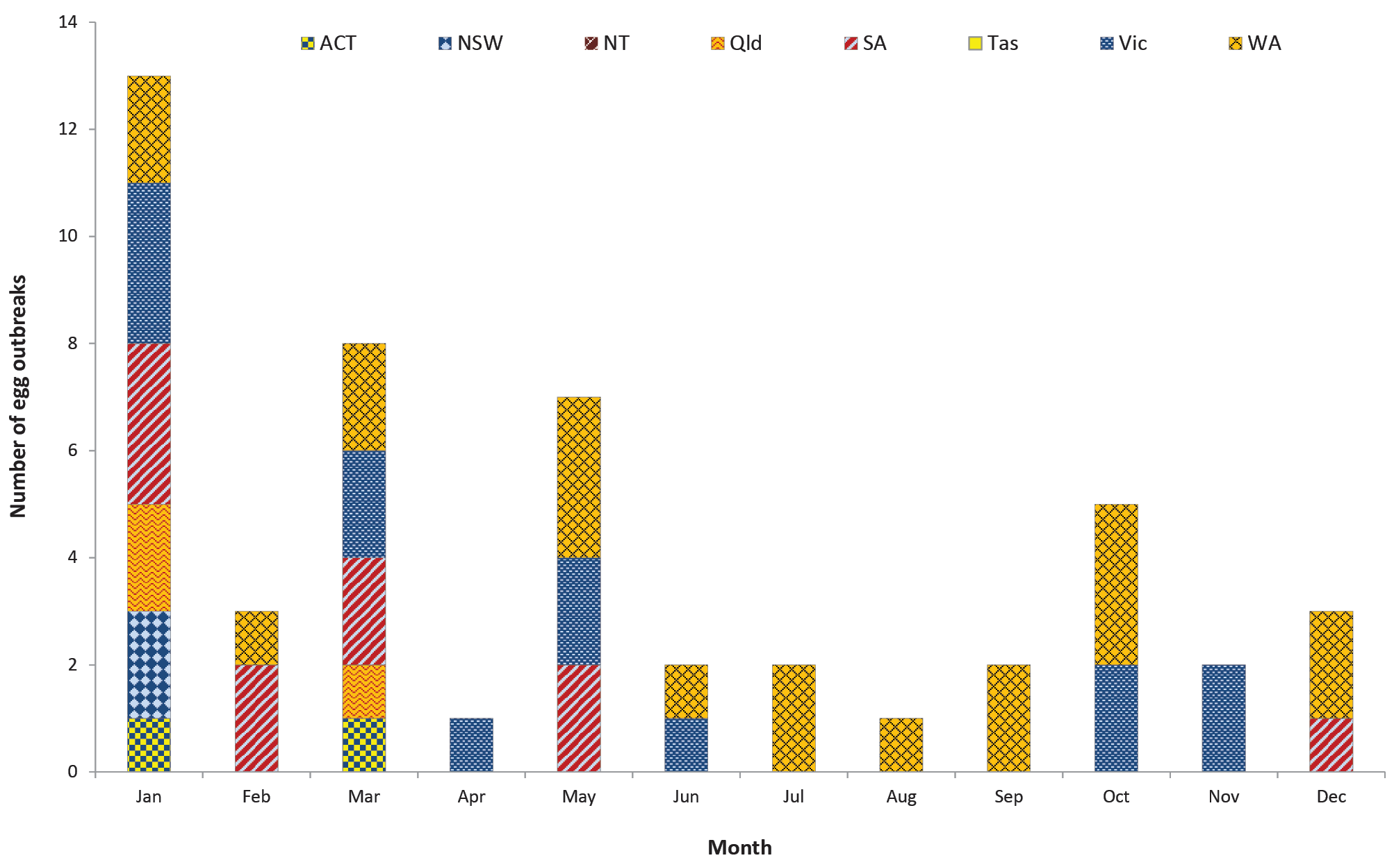

Seafood
Seafood (comprising of the three commodities of fish, molluscs and crustaceans) was implicated as the source in 13 foodborne outbreaks reported in 2017. Aetiological agents identified included ciguatoxin (n = 9), S. Muenchen (n = 1), and V. albensis (n = 1). Two outbreaks had an unknown aetiological agent.
Ciguatera fish poisoning outbreaks occurred throughout the year, and occurred primarily in Queensland (n = 7). Seven outbreaks were due to the consumption of fish caught by recreational fisherman, one outbreak was due to consumption of fish at a restaurant (assumed to be a non-recreational catch), and one outbreak was due to consumption of a fish that had been purchased at a market in Fiji by an individual and transported to Australia (where it was consumed).

Settings
Restaurants were the most commonly-reported food preparation setting accounting for just over half of all foodborne outbreaks (n = 93; 52%) and just over half of the total number of ill people reported during outbreaks in 2017 (n = 1,092; 51%) (Table 26).
Table 26: Foodborne outbreaks in Australia by setting prepared, 2017
Setting prepared | Outbreaks |  | Ill people |  | Hospitalisations
 | N | % of all outbreaks | N | % of all ill people | N | % of all hospitalisations
Restaurant | 93 | 52% | 1,092 | 51% | 144 | 50%
Private residence | 19 | 11% | 117 | 5% | 20 | 7%
Primary production | 12 | 7% | 93 | 3% | 19 | 7%
Aged care facility | 11 | 6% | 91 | 4% | 9 | 3%
Commercial caterer | 9 | 5% | 206 | 10% | 16 | 6%
Take-away | 8 | 4% | 82 | 4% | 23 | 8%
Bakery | 6 | 3% | 149 | 7% | 24 | 8%
Cruise ship | 3 | 2% | 34 | 2% | 0 | 0%
Community | 3 | 2% | 29 | 1% | 2 | 1%
Correctional facility | 3 | 2% | 8 | 0% | 3 | 1%
Hospital | 3 | 2% | 9 | 0% | 6 | 2%
Mining camp | 2 | 1% | 71 | 3% | 5 | 2%
Child care centre | 2 | 1% | 44 | 2% | 3 | 1%
School | 1 | 1% | 24 | 1% | 2 | 1%
Private caterer | 1 | 1% | 34 | 2% | 1 | 0%
Church | 1 | 1% | 36 | 2% | 10 | 3%
Picnic | 1 | 1% | 9 | 0% | 2 | 1%
Fair/festival/mobile service | 1 | 1% | 2 | 0% | 1 | 0%
Total | 179 | 100% | 2,130 | 100% | 290 | 100%

Level of evidence for foodborne outbreaks
There was statistical evidence of an association between the consumption of the implicated food and illness for 30 foodborne outbreaks in 2017, ascertained from 15 point-source cohort studies and 15 case-control studies. An additional three outbreaks had statistical and microbiological evidence of the aetiological agent in the epidemiologically implicated food. In addition to compelling descriptive evidence, microbiological evidence also supported the implicated food in 13 outbreaks. Compelling descriptive evidence alone supported foodborne transmission for the remaining 133 outbreaks in 2017 (Table 27).
Table 27: Evidence to support foodborne transmission for outbreaks in Australia, 2017
Aetiological agent | Statistical | Statistical and microbiological | Compelling descriptive | Microbiological and compelling descriptive | Total
Campylobacter | 1 | 0 | 4 | 1 | 6
Ciguatoxin | 0 | 0 | 9 | 0 | 9
Clostridium perfringens | 0 | 0 | 5 | 0 | 5
Cryptosporidium | 0 | 0 | 1 | 0 | 1
Hepatitis A | 0 | 0 | 0 | 1 | 1
Listeria monocytogenes | 0 | 0 | 1 | 0 | 1
Norovirus | 7 | 0 | 4 | 0 | 11
Salmonella | 13 | 3 | 75 | 11 | 102
Shigella | 0 | 0 | 2 | 0 | 2
Vibrio albensis | 0 | 0 | 1 | 0 | 1
Unknown | 9 | 0 | 31 | 0 | 40
Total | 30 | 3 | 133 | 13 | 179

Multi-jurisdictional foodborne outbreak investigations in 2017
OzFoodNet undertook one multi-jurisdictional outbreak investigation (MJOI) in 2017.

Hepatitis A
In May 2017, OzFoodNet initiated a MJOI into cases of hepatitis A linked to consumption of imported frozen mixed berries. A total of 11 cases were linked to the outbreak, including ten confirmed cases (four in Queensland, three in South Australia, two in New South Wales and one in Victoria). One additional probable case, assessed as secondary transmission from a confirmed case occurred in South Australia. Confirmed cases included six females and four males, age range 11 to 75 years (median 37 years), with five of the ten cases hospitalised (50%) for their illness. All confirmed cases spent their entire acquisition period in Australia. Frozen mixed berries were the most commonly reported food exposure, with 70% of confirmed cases (7/10) reporting consumption of frozen mixed berries, with 71% (5/7) of these reporting eating the same brand. Nine samples of the implicated brand of frozen mixed berries were tested for HAV, with HAV subsequently detected in three samples (including two sealed packets and one open packet, all from confirmed outbreak case households). The imported frozen mixed berry product, which contained frozen berries imported from two countries which were re-packaged in Australia, was identified as the source of the outbreak and a consumer recall occurred on 2 June 2017. The 2017 outbreak was found to be genomically linked to a 2015 hepatitis A outbreak in Australia, which was also associated with consumption of imported frozen berries.

Animal-to-person and probable animal-to-person outbreaks
Animals were the source of three gastrointestinal outbreaks reported in 2017 including two petting zoo outbreaks in South Australia and a single farm outbreak in Western Australia (Table 21). The petting zoo outbreaks each affected six individuals, with aetiological agents identified as cryptosporidium and STEC. Cryptosporidium was the identified agent in the remaining outbreak affecting two visitors to a farm. Animal-to-person outbreaks are rarely identified in Australia, with a total of seven reported in the previous five years including two associated with petting zoos, two with pets at aged care facilities, two with pet chickens at a child-care centre and a single outbreak on a farm.

Waterborne and probable waterborne outbreaks
Waterborne outbreaks (including confirmed and probable outbreaks) are rare in Australia, with a total of eight reported in the previous five years. Two waterborne outbreaks were reported in 2017 (Table 21), including a S. Wangata outbreak affecting ten attendees at a yoga retreat in New South Wales following consumption of spring water, and a S. Saintpaul outbreak affecting six workers from a remote mining camp in the Northern Territory related to a non-public water supply.

Environmental and probable environmental outbreaks
Twenty-two environmental outbreaks (including confirmed and probable outbreaks) were reported in 2017 affecting 225 people (Table 21). All were cryptosporidium outbreaks following exposure at swimming pools. With the exception of a suspected viral outbreak associated with a Victorian water play park in 2012 and a S. Chester outbreak linked to a mud-run event in Victoria in 2016, all environmental outbreaks reported since 2012 have been cryptosporidium outbreaks associated with swimming pools. Note while swimming pools and other swimming facilities that are associated with more the one case of cryptosporidiosis in New South Wales are reviewed for compliance with state requirements, data is not included in this report as they are not reported as outbreaks. As a result of this and other differences in reporting across jurisdictions, data on environmental and probable environmental outbreaks should be interpreted with caution.

Acknowledgements
We thank the many epidemiologists, Masters of Applied Epidemiology scholars, project officers, interviewers and research assistants at each of the OzFoodNet sites who contributed to this report. We acknowledge the work of various public health professionals and laboratory staff around Australia who interviewed patients, tested specimens, typed isolates and investigated outbreaks. We would particularly like to thank jurisdictional laboratories, the Australian Salmonella Reference Centre at SA Pathology, the Institute of Clinical Pathology and Medical Research, Queensland Health Forensic and Scientific Services, the Microbiological Diagnostic Unit Public Health Laboratory, the National Enteric Pathogen Surveillance Scheme and PathWest for their help with foodborne disease surveillance.

Author details
OzFoodNet contributors to this report include (in alphabetical order): Robert Bell (Queensland), Zoe Cutcher (Victoria), Anthony Draper (Northern Territory), Emily Fearnley (South Australia), Keira Glasgow (New South Wales), Joy Gregory (Victoria), Michelle Harlock (Tasmania), Kirsty Hope (New South Wales), Stacey Kane (Central), Megge Miller (South Australia), Nevada Pingault (Western Australia), Tim Sloan-Gardner (Australian Capital Territory), Russell Stafford (Queensland), Kate Ward (Central), Ben Witham (Western Australia) and Rose Wright (Central).

Corresponding author
OzFoodNet Co-ordinating Epidemiologist, Office of Protection and Response, Australian Government Department of Health and Aged Care, GPO Box 9848, MDP 14, CANBERRA ACT 2601.
Email: ozfoodnet@health.gov.au

References
- Kirk M, Glass K, Ford L, Brown K, Hall G. Foodborne illness in Australia: Annual incidence circa 2010. Canberra: Australian National University, National Centre for Epidemiology and Population Health; 2014. Available from: https://www1.health.gov.au/internet/main/publishing.nsf/Content/E829FA59A59677C0CA257D6A007D2C97/$File/Foodborne-Illness-Australia-circa-2010.pdf.
- Kirk M, Ford L, Glass K, Hall G. Foodborne illness, Australia, circa 2000 and circa 2010. Emerg Infect Dis. 2014;20(11):1857–64.
- Australian Government Department of Health and Ageing. The annual cost of foodborne illness in Australia. Canberra: Australian Government Department of Health and Ageing; 2006.
- Australian Bureau of Statistics. 3101.0 - Australian Demographic Statistics. [Internet.] Canberra: Australian Bureau of Statistics. Available from: https://www.abs.gov.au/statistics/people/population/national-state-and-territory-population.
- OzFoodNet Working Group. Monitoring the incidence and causes of diseases potentially transmitted by food in Australia: annual report of the OzFoodNet Network, 2016. Commun Dis Intell (2018). 2021;45. doi: https://doi.org./10.33321/cdi.2021.45.52.
- Hall G, Raupach J, Yohannes K. An estimate of the under-reporting of foodborne notifiable diseases: Salmonella, Campylobacter, Shiga-toxin producing Escherichia coli (STEC). Canberra : National Centre for Epidemiology and Population Health, Australian National University; 2006.
- Hall G, Yohannes K, Raupach J, Becker N, Kirk M. Estimating community incidence of Salmonella, Campylobacter, and Shiga toxin-producing Escherichia coli infections, Australia. Emerg Infect Dis. 2008;14(10):1601–9.
- Moffatt CRM, Glass K, Stafford R, D’Este C, Kirk MD. The campylobacteriosis conundrum – examining the incidence of infection with Campylobacter sp. in Australia, 1998–2013. Epidemiol Infect. 2017;145(4):839–47. doi: https://doi.org/10.1017/S0950268816002909.
- Stafford RJ, Schluter P, Kirk M, Wilson A, Unicomb L , Ashbolt R et al. A multi-centre prospective case-control study of campylobacter infection in persons aged 5 years and older in Australia. Epidemiol Infect. 2007;135(6):978–88. doi: https://doi.org/10.1017/S0950268806007576.
- Food Regulation. Australia’s Foodborne Illness Reduction Strategy 2018-2021+: A strategy to reduce foodborne illness in Australia, particularly related to Campylobacter and Salmonella. Canberra: Australian Government Department of Health, Food Regulation; 29 June 2018. https://foodregulation.gov.au/internet/fr/publishing.nsf/Content/51D7B1FFFCAD05C5CA2582B900051DDD/$File/FORUM-AUS-FBI-RS-2018.pdf.
- Queensland Government Department of Agriculture and Fisheries (DAF). Department of Agriculture and Fisheries Annual Report 2017–2018. Brisbane: Queensland Government, DAF: 2018. Available from: https://www.parliament.qld.gov.au/documents/tableOffice/TabledPapers/2018/5618T1506.pdf.
- Curran M, Harvey B, Crerar S, Oliver G, D’Souza R, Myint H et al. Annual report of the National Notifiable Diseases Surveillance System, 1996. Commun Dis Intell. 1997;21(20):281–307.
- Forssman B, Mannes T, Musto J, Gottlieb T, Robertson G, Natoli JD et al. Vibrio cholerae O1 El Tor cluster in Sydney linked to imported whitebait. Med J Aust. 2007;187(6):345–7.
- NNDSS Annual Report Writing Group. Australia’s notifiable disease status, 2013: Annual report of the National Notifiable Diseases Surveillance System. Commun Dis Intell Q Rep. 2015;39(3):E387–478.
- Heywood AE, Zwar N, Forssman BL, Seale H, Stephens N, Musto J et al. The contribution of travellers visiting friends and relatives to notified infectious diseases in Australia: state-based enhanced surveillance. Epidemiol Infect. 2016;144(16):3554–63.
- Forsyth JR, Bennett NM, Hogben S, Hutchinson EM, Rouch G, Tan A et al. The year of the Salmonella seekers—1977. Aust N Z J Public Health. 2003;27(4):385–9.
- Thompson C, Dey A, Fearnley E, Polkinghorne B, Beard F. Impact of the national targeted Hepatitis A immunisation program in Australia: 2000–2014. Vaccine. 2017;35(1):170–6.
- Department of Health and Human Services (DHHS). Surveillance of notifiable infectious diseases in Victoria 1997. Melbourne: Victorian Government, DHHS; 1 June 2011. Available from: https://www2.health.vic.gov.au/public-health/infectious-diseases/infectious-diseases-surveillance/search-infectious-diseases-data/Surveillance%20of%20notifiable%20infectious%20diseases%20in%20Victoria%201997.
- Conaty S, Bird P, Bell G, Kraa E, Grohmann G, McAnulty JM. Hepatitis A in New South Wales, Australia from consumption of oysters: the first reported outbreak. Epidemiol Infect. 2000;124(1):121–30.
- Donnan EJ, Fielding JE, Gregory JE, Lalor K, Rowe S, Goldsmith P et al. A multistate outbreak of hepatitis A associated with semidried tomatoes in Australia, 2009. Clin Infect Dis. 2012;54(6):775–81.
- OzFoodNet Working Group. Monitoring the incidence and causes of diseases potentially transmitted by food in Australia: annual report of the OzFoodNet network, 2009. Commun Dis Intell Q Rep. 2010;34(4):396–426.
- OzFoodNet Working Group. Monitoring the incidence and causes of diseases potentially transmitted by food in Australia: annual report of the OzFoodNet Network, 2013–2015. Commun Dis Intell (2018). 2021;45. doi: https://doi.org./10.33321/cdi.2021.45.21.
- European Centre for Disease Prevention and Control (ECDC). Rapid risk assessment: Hepatitis A outbreak in the EU/EEA mostly affecting men who have sex with men – third update, 28 June 2017. [Webpage.] Stockholm: ECDC; 29 June 2017. Available from: https://www.ecdc.europa.eu/en/publications-data/rapid-risk-assessment-hepatitis-outbreak-eueea-mostly-affecting-men-who-have-sex.
- ECDC. Epidemiological update: hepatitis A outbreak in the EU/EEA mostly affecting men who have sex with men. [Webpage.] Stockholm: ECDC; 22 December 2017. Available from: https://ecdc.europa.eu/en/news-events/epidemiological-update-hepatitis-outbreak-eueea-mostly-affecting-men-who-have-sex-men-0.
- Werber D, Michaelis K, Hausner M, Sissolak D, Wenzel J, Bitzegeio J et al. Ongoing outbreaks of hepatitis A among men who have sex with men (MSM), Berlin, November 2016 to January 2017 – linked to other German cities and European countries. Euro Surveill. 2017;22(5):30457. doi: https://doi.org/10.2807/1560-7917.ES.2017.22.5.30457.
- Yapa, CM, Furlong C, Rosewell A, Ward KA, Adamson S, Shadbolt C et al. First reported outbreak of locally acquired hepatitis E virus infection in Australia. Med J Aust. 2016;204(7):274.
- Chandler JD, Riddell MA, Li F, Love RJ, Anderson DA. Serological evidence for swine hepatitis E virus infection in Australian pig herds. Vet Microbiol. 1999;68(1–2):95–105.
- Dalton CB, Merritt TD, Unicomb LE, Kirk MD, Stafford RJ, Lalor K, OzFoodNet Working Group. A national case-control study of risk factors for listeriosis in Australia. Epidemiol Infect. 2011;139(3):437–45.
- OzFoodNet Working Group. Monitoring the incidence and causes of diseases potentially transmitted by food in Australia: annual report of the OzFoodNet Network, 2012. Commun Dis Intell (2018). 2018;42. pii: S2209-6051(18)00014-3.
- Ford L, Moffatt CRM, Fearnley E, Miller M, Gregory J, Sloan-Gardner TS et al. The epidemiology of Salmonella enterica outbreaks in Australia, 2001-2016. Front Sustain Food Syst. 2018;2(86). doi: https://doi.org/10.3389/fsufs.2018.00086.
- Moffatt CRM, Musto J, Pingault N, Combs B, Miller M, Stafford R et al. Recovery of Salmonella enterica from Australian layer and processing environments following outbreaks linked to eggs. Foodborne Pathog Dis. 2017;14(8):478–82.
- Moffatt CRM, Musto J, Pingault N, Miller M, Stafford R, Gregory J et al. Salmonella Typhimurium and outbreaks of egg-associated disease in Australia, 2001 to 2011. Foodborne Pathog Dis. 2016;13(7):379–85.
- Munnoch SA, Ward K, Sheridan S, Fitzsimmons GJ, Shadbolt CT, Piispanen JP et al. A multi-state outbreak of Salmonella Saintpaul in Australia associated with cantaloupe consumption. Epidemiol Infect. 2009;137(3):367–74.
- Gibbs R, Pingault N, Mazzucchelli T, O’Reilly L, MacKenzie B, Green J et al. An outbreak of Salmonella enterica serotype Litchfield infection in Australia linked to consumption of contaminated papaya. J Food Prot. 2009;72(5):1094–8.
- Musto J, Kirk M, Lightfoot D, Combs BG, Mwanri L. Multi-drug resistant Salmonella Java infections acquired from tropical fish aquariums, Australia, 2003–04. Commun Dis Intell Q Rep. 2006;30(2):222–7.
- Staff M, Musto J, Hogg G, Janssen M, Rose K. Salmonellosis outbreak traced to playground sand, Australia, 2007–2009. Emerg Infect Dis. 2012;18(7):1159–62.
- Wallace P, Kirk MD, Munnoch SA, Gunn J, Stafford RJ, Kelly PM. An outbreak of Salmonella Litchfield on a car rally, Northern Territory, 2009. Commun Dis Intell Q Rep. 2010;34(2):124–6.
- Gantois I, Ducatelle R, Pasmans F, Haesebrouck F, Gast R, Humphrey TJ et al. Mechanisms of egg contamination by Salmonella Enteritidis. FEMS Microbiol Rev. 2009;33(4):718–38. doi: https://doi.org/10.1111/j.1574-6976.2008.00161.x.
- Guglielmino CJD, Kakkanat A, Forde BM, Rubenach S, Merone L, Stafford R et al. Outbreak of multi-drug-resistant (MDR) Shigella flexneri in northern Australia due to an endemic regional clone acquiring an IncFII plasmid. Eur J Clin Microbiol Infect Dis. 2021;402(2):279–86. doi: https://doi.org/10.1007/s10096-020-04029-w.
- Rowe S, Radwan S, Lalor K, Valcanis M, Gregory J. An outbreak of shigellosis among men who have sex with men, Victoria, 2008. Vic Infect Dis Bull. 2010;13(4):119–24.
- New South Wales Government Department of Health (NSW Health). OzFoodNet: NSW Annual Report 2016. Sydney: NSW Health, Communicable Diseases Branch; April 2017. Available from: https://www.health.nsw.gov.au/Infectious/foodborne/Publications/NSW-ofn-annual-report-2016.pdf.
- Lewis HC, Ethelberg S, Olsen KEP, Nielsen EM, Lisby M, Madsen SB et al. Outbreaks of Shigella sonnei infections in Denmark and Australia linked to consumption of imported raw baby corn. Epidemiol Infect. 2009;137(3):326–34.
- Draper A and Markey P. Shigella flexneri 2b in the Northern Territory in 2017. N T Dis Control Bull. 2017;24(4)1–6. Available from: https://digitallibrary.health.nt.gov.au/prodjspui/bitstream/10137/506/557/Vol%2024%20no%204%20December%202017.pdf.
- McPherson M, Lalor K, Combs B, Raupach J, Stafford R, Kirk MD. Serogroup-specific risk factors for Shiga toxin-producing Escherichia coli infection in Australia. Clin Infect Dis. 2009;49(2):249–56.
- Buchholz U, Bernard H, Werber D, Böhmer MM, Remschmidt C, Wilking H et al. German outbreak of Escherichia coli O104:H4 associated with sprouts. N Engl J Med. 2011;365(19):1763–70.
- Paton AW, Ratcliff RM, Doyle RM, Seymour-Murray J, Davos D, Lanser JA et al. Molecular microbiological investigation of an outbreak of hemolytic-uremic syndrome caused by dry fermented sausage contaminated with Shiga-like toxin-producing Escherichia coli. J Clin Microbiol. 1996;34(7):1622–7.

Appendix A: Revised OzFoodNet definitions for modes of outbreak transmission implemented in 2016
Mode | Definition
Foodborne | An incident where two or more persons experience a similar illness after consuming a common food or meal and analytical epidemiological evidence and/or microbiological evidence (including food and/or environmental) implicates the meal or food as the source of illness; or the aetiology of the outbreak can only result through foodborne transmission (for example Listeria monocytogenes, ciguatera fish poisoning).
Probable foodborne | An incident where two or more persons experience a similar illness after consuming a common food or meal and compelling descriptive epidemiological evidence implicates the meal or food as the suspected source of illness. This includes outbreaks where the mode of transmission is suspected to be from an ill food handler to food to person.
Waterborne | An incident where two or more persons experience a similar illness after the consumption of water from a common source and analytical epidemiological evidence and/or microbiological evidence implicates the drinking water supply as the source of illness. This does not include outbreaks associated with accidental consumption of water during recreational water exposures (environmental transmission).
Probable waterborne | An incident where two or more persons experience a similar illness after consumption of water from a common source and compelling descriptive epidemiological evidence implicates the drinking water supply as the source of illness. This does not include outbreaks associated with accidental consumption of water during recreational water exposures (environmental transmission).
Animal-to-person | An incident where two or more persons experience a similar illness after exposure to animals and analytical epidemiological evidence and/or microbiological evidence implicates the animal as the source of illness.
Probable animal-to-person | An incident where two or more persons experience a similar illness after exposure to animals and compelling descriptive epidemiological evidence implicates the animals as the suspected source of illness.
Environmental | An incident where two or more persons experience a similar illness following exposure to a contaminated environment and epidemiological evidence and/or microbiological evidence implicates a specific environmental source as the cause of illness. This includes recreational exposure to water.
Probable environmental | An incident where two or more persons experience a similar illness following exposure to a contaminated environment and compelling descriptive epidemiological evidence identifies a specific environmental source as the suspected cause of illness but the exact source of contamination is unknown. This includes recreational exposure to water.

Appendix B: Foodborne and probable foodborne outbreak summary for OzFoodNet sites, Australia, 2017
Jurisdictionª | Month^{b} | Setting prepared | Agent responsible^{c} | No. ill | No. hospitalised | No. fatalities | Evidence^{d} | Epidemiological study | Responsible vehicle | Commodity | Contamination factor
MJOI | May | Primary production | Hepatitis A | 11 | 5 | 0 | DM | Case series | Imported frozen mixed berries | Produce | Ingestion of contaminated raw products
ACT | Jan | Restaurant | S. Typhimurium, MLVA 03-17-09-12-523 and MLVA 03-26-13-08-523 | 119 | 20 | 0 | A | Case control study | Multiple foods contaminated with raw eggs | Eggs | Cross contamination from raw ingredients, inadequate cleaning of equipment
ACT | Feb | Restaurant | S. Typhimurium, MLVA 03-17-09-12-523 | 7 | 4 | 0 | DM | Case series | Chicken and multiple foods contaminated by chicken | Poultry | Unknown
ACT | Feb | Restaurant | S. Typhimurium, MLVA 03-25-13-12-523 | 11 | 4 | 0 | D | Case series | Unknown | Not attributed | Cross contamination from raw ingredients
ACT | Mar | Restaurant | S. Typhimurium, MLVA 03-09-07-12-523 | 2 | 2 | 0 | D | Case series | Caesar salad dressing containing raw eggs | Eggs | Inadequate cleaning of equipment, cross contamination from raw ingredients
ACT | Apr | Restaurant | S. Typhimurium, MLVA 03-17-09-12-523 | 5 | 3 | 0 | D | Case series | Sushi | Mixed/multiple | Cross contamination from raw ingredients
ACT | May | Restaurant | Unknown (suspected viral) | 6 | 0 | 0 | D | No formal study | Unknown | Not attributed | Unknown
ACT | May | Restaurant | Unknown (suspected viral) | 14 | 0 | 0 | D | Case series | Unknown | Not attributed | Unknown
ACT | Jun | Restaurant | Unknown | 4 | 0 | 0 | D | No formal study | Unknown | Not attributed | Unknown
NSW | Jan | Picnic | S. Typhimurium, MLVA 03-17-09-12-523 | 9 | 2 | 0 | D | No formal study | French toast made with raw eggs | Eggs | Ingestion of contaminated raw products
NSW | Jan | Restaurant | S. Typhimurium, MLVA 03-16-09-07-523 | 17 | Unknown | 0 | D | Case series | Multiple foods containing eggs or contaminated by eggs | Eggs | Ingestion of contaminated raw products, cross contamination from raw ingredients
NSW | Jan | Cruise ship | S. Enteritidis | 10 | 0 | 0 | D | Case series | Unknown | Not attributed | Unknown
NSW | Jan | Private residence | S. Enteritidis | 5 | 0 | 0 | D | No formal study | Unknown | Not attributed | Ingestion of contaminated raw products, cross contamination from raw ingredients
NSW | Jan | Take-away | Unknown (suspected toxin) | 5 | 0 | 0 | D | No formal study | Unknown | Not attributed | Unknown
NSW | Feb | Restaurant | Ciguatoxin | 4 | 4 | 0 | D | No formal study | Grouper fish | Seafood | Toxic substance or part of tissue
NSW | Feb | Restaurant | Vibrio albensis | 3 | 1 | 0 | D | No formal study | Oysters | Seafood | Unknown
NSW | Feb | Aged care facility | Campylobacter | 3 | 1 | 0 | D | Case series | Unknown | Not attributed | Unknown
NSW | Feb | Restaurant | S. Typhimurium, MLVA 03-17-9-12-523 | 3 | 0 | 0 | D | No formal study | Unknown | Not attributed | Cross contamination from raw ingredients
NSW | Mar | Restaurant | Unknown (suspected toxin) | 4 | 0 | 0 | D | No formal study | Curries | Mixed/multiple | Unknown
NSW | Mar | Community | Campylobacter | 21 | 0 | 0 | A | Point source cohort | Unknown | Not attributed | Unknown
NSW | Mar | Restaurant | Unknown (suspected toxin) | 3 | 0 | 0 | D | No formal study | Unknown | Not attributed | Unknown
NSW | Mar | Restaurant | Unknown (suspected viral) | 5 | 0 | 0 | D | No formal study | Unknown | Not attributed | Unknown
NSW | Apr | Private residence | S. Typhimurium, MLVA 03-24-13-10-523 | 6 | 1 | 0 | D | No formal study | Unknown | Not attributed | Unknown
NSW | Apr | Restaurant | Unknown (suspected toxin) | 3 | 0 | 0 | D | No formal study | Unknown | Not attributed | Unknown
NSW | Jun | Commercial caterer | Unknown (suspected viral) | 48 | 0 | 0 | A | Point source cohort | Salads | Mixed/multiple | Other source of contamination
NSW | Jun | Private caterer | Norovirus | 34 | 1 | 0 | A | Point source cohort | Unknown | Not attributed | Person to food to person
NSW | Jul | Commercial caterer | Unknown (suspected viral) | 24 | 0 | 0 | A | Point source cohort | Sandwiches and wraps | Mixed/multiple | Unknown
NSW | Jul | Restaurant | Norovirus | 12 | 0 | 0 | A | Point source cohort | Unknown | Not attributed | Unknown
NSW | Jul | Restaurant | Unknown (suspected toxin) | 6 | 0 | 0 | D | No formal study | Unknown | Not attributed | Unknown
NSW | Jul | Restaurant | Unknown (suspected toxin) | 32 | 0 | 0 | D | No formal study | Unknown | Not attributed | Unknown
NSW | Jul | Restaurant | Unknown (suspected viral) | 16 | 0 | 0 | D | No formal study | Unknown | Not attributed | Person to food to person
NSW | Aug | Commercial caterer | Norovirus | 32 | 1 | 0 | A | Point source cohort | Ravioli | Mixed/multiple | Food handler contamination, inadequate washing of food eaten uncooked
NSW | Sep | Restaurant | Unknown | 13 | 0 | 0 | D | No formal study | Unknown | Not attributed | Unknown
NSW | Sep | Commercial caterer | Unknown (suspected viral) | 17 | 0 | 0 | D | No formal study | Unknown | Not attributed | Unknown
NSW | Oct | Restaurant | S. Singapore | 3 | 0 | 0 | D | No formal study | Chicken wraps | Poultry | Cross contamination from raw ingredients
NSW | Oct | Restaurant | Unknown | 8 | 0 | 0 | D | no formal study | Unknown | Not attributed | Unknown
NSW | Oct | Restaurant | Unknown | 6 | 0 | 0 | D | No formal study | Unknown | Not attributed | Unknown
NSW | Oct | Restaurant | Unknown (suspected toxin) | 5 | 0 | 0 | D | No formal study | Unknown | Not attributed | Unknown
NSW | Nov | Restaurant | Unknown (suspected toxin) | 8 | 0 | 0 | D | No formal study | Chicken skewers | Poultry | Unknown
NSW | Nov | Cruise ship | S. Enteritidis | 8 | Unknown | 0 | D | Case series | Unknown | Not attributed | Unknown
NSW | Nov | Restaurant | Unknown (suspected toxin) | 20 | 1 | 0 | D | No formal study | Unknown | Not attributed | Unknown
NSW | Dec | Restaurant | Campylobacter | 2 | 0 | 0 | D | No formal study | Lamb liver | Meat | Unknown
NSW | Dec | Private residence | Unknown (suspected toxin) | 4 | 0 | 0 | D | No formal study | Tuna with salad | Seafood | Unknown
NSW | Dec | Restaurant | Norovirus | 8 | 2 | 0 | D | No formal study | Unknown | Not attributed | Unknown
NSW | Dec | Restaurant | Unknown (suspected toxin) | 9 | 0 | 0 | D | No formal study | Unknown | Not attributed | Unknown
NT | Mar | Fair/festival/ mobile service | S. Wandsworth | 2 | 1 | 0 | D | No formal study | Gravy | Sauces (non-egg) | Unknown
NT | Apr | Restaurant | Unknown | 2 | 1 | 0 | D | No formal study | Grilled chicken | Poultry | Ingestion of contaminated raw products
NT | May | Restaurant | Unknown | 5 | 0 | 0 | D | No formal study | Unknown | Not attributed | Unknown
NT | Jun | Primary production | S. Muenchen | 20 | 2 | 0 | D | Case series | Green turtle meat | Seafood | Ingestion of contaminated raw products, inadequate washing of food eaten uncooked
NT | Jul | Restaurant | Shigella spp. | 2 | 0 | 0 | D | Case series | Unknown | Not attributed | Unknown
NT | Oct | Restaurant | Unknown | 2 | 0 | 0 | D | Case series | Roast lamb | Meat | Unknown
NT | Dec | Restaurant | Unknown | 62 | 1 | 0 | A | Point source cohort | Chicken chasseur | Poultry | Other source of contamination
Qld | Jan | Restaurant | S. Typhimurium, MLVA 03-12-10-10-523 | 48 | 16 | 0 | AM | Point source cohort | Fried ice cream | Eggs | Cross contamination from raw ingredients, inadequate cleaning of equipment
Qld | Jan | Church | S. Weltevreden | 36 | 10 | 0 | AM | Point source cohort | Roast pork | Meat | Unknown
Qld | Jan | Hospital | Listeria monocytogenes, MLST 3, MLVA 04-17-16-05-03-11-14-00-16, Binary type 159 | 3 | 3 | 0 | D | Case series | Unknown | Not attributed | Inadequate cleaning of equipment
Qld | Jan | Restaurant | S. Typhimurium, MLVA 03-12-12-11-523 | 3 | 0 | 0 | D | Case series | Unknown | Not attributed | Unknown
Qld | Jan | Restaurant | S. Typhimurium, MLVA 03-12-11-11/12-523 | 13 | 4 | 0 | D | Case series | Vietnamese rolls with raw egg aioli | Eggs | Ingestion of contaminated raw products
Qld | Feb | Restaurant | S. Mbandaka | 9 | 0 | 0 | DM | Case series | Rice noodles | Grains | Cross contamination from raw ingredients, inadequate cleaning of equipment
Qld | Feb | Aged care facility | S. Typhimurium, MLVA 03-12-10-11-523 | 5 | 1 | 0 | D | No formal study | Unknown | Not attributed | Unknown
Qld | Feb | Restaurant | S. Typhimurium, MLVA 03-12-12-10/11-523 | 15 | 1 | 0 | D | Case series | Unknown | Not attributed | Cross contamination from raw ingredients
Qld | Mar | Primary production | Ciguatoxin | 2 | 0 | 0 | D | Case series | Coral Trout | Seafood | Toxic substance or part of tissue
Qld | Mar | Restaurant | S. Typhimurium, MLVA 03-15-12-11-523 | 2 | 2 | 0 | DM | Case series | Fried ice cream | Eggs | Ingestion of contaminated raw products, cross contamination from raw ingredients
Qld | Mar | Restaurant | S. Typhimurium, MLVA 03-12-12-11-523 | 6 | 3 | 0 | D | Case series | Unknown | Not attributed | Inadequate cleaning of equipment, cross contamination from raw ingredients
Qld | Jul | Primary production | Ciguatoxin | 2 | 0 | 0 | D | Case series | Fish (unspecified) | Seafood | Toxic substance or part of tissue
Qld | Aug | Primary production | Ciguatoxin | 4 | 0 | 0 | D | Case series | Coral trout | Seafood | Toxic substance or part of tissue
Qld | Aug | Restaurant | Clostridium perfringens | 4 | 0 | 0 | D | Case series | Roast pork and gravy rolls | Meat | Other source of contamination
Qld | Aug | Primary production | Ciguatoxin | 2 | 0 | 0 | D | Case series | Spanish mackerel | Seafood | Toxic substance or part of tissue
Qld | Sep | Primary production | Ciguatoxin | 7 | 0 | 0 | D | Case series | Cod fish | Seafood | Toxic substance or part of tissue
Qld | Sep | Primary production | Ciguatoxin | 4 | 0 | 0 | D | Case series | Spanish mackerel | Seafood | Toxic substance or part of tissue
Qld | Oct | Private residence | S. Saintpaul | 7 | 0 | 0 | D | Case series | Goat meat or offal | Meat | Cross contamination from raw ingredients
Qld | Nov | Primary production | Ciguatoxin | 2 | 0 | 0 | D | No formal study | Mackerel | Seafood | Toxic substance or part of tissue
Qld | Nov | Restaurant | S. Hvittingfoss | 18 | 0 | 0 | D | Case series | Unknown | Not attributed | Cross contamination from raw ingredients, inadequate cleaning of equipment
Qld | Dec | Community | S. Typhimurium, MLVA 03-13-12-09-523 | 3 | 1 | 0 | D | Case series | Unknown | Not attributed | Ingestion of contaminated raw products
SA | Jan | Restaurant | S. Typhimurium, MLVA 03-15-06-11-550 | 6 | 1 | 0 | D | Case series | Multiple breakfast egg dishes | Eggs | Unknown
SA | Jan | Restaurant | S. Typhimurium, MLVA 03-14-10-10-523 | 6 | 2 | 0 | D | Case series | Multiple foods including aioli containing raw eggs | Eggs | Ingestion of contaminated raw products
SA | Jan | Restaurant | S. Typhimurium, MLVA 03-14-09-11-523 | 4 | 0 | 0 | D | Case series | Multiple foods including raw egg sauces | Eggs | Cross contamination from raw ingredients
SA | Feb | Restaurant | S. Typhimurium, MLVA 03-14-09-11-523 | 9 | 1 | 0 | D | Case series | Multiple foods contaminated with raw eggs | Eggs | Cross contamination from raw ingredients
SA | Feb | Bakery | S. Typhimurium, MLVA 03-14-09-11-523 | 14 | 6 | 0 | DM | Case series | Pies with post-cook raw egg wash | Eggs | Cross contamination from raw ingredients
SA | Mar | Restaurant | Campylobacter jejuni | 12 | 0 | 0 | D | Case series | Chicken | Poultry | Ingestion of contaminated raw products
SA | Mar | Primary production | S. Hessarek | 27 | 11 | 0 | DM | Case series | Eggs | Eggs | Food handler contamination, inadequate washing of food eaten uncooked
SA | Mar | Aged care facility | S. Typhimurium, MLVA 03-16-09-12-523 | 13 | 3 | 1 | A | Case control study | Multiple foods contaminated with raw eggs | Eggs | Cross contamination from raw ingredients
SA | Mar | Restaurant | S. Typhimurium, MLVA 05-15-17-09-490 | 13 | 3 | 0 | D | Case series | Unknown | Not attributed | Ingestion of contaminated raw products, cross contamination from raw ingredients
SA | May | Private residence | S. Typhimurium, MLVA 03-27-16-11-523 | 5 | 1 | 0 | D | No formal study | Chocolate mousse containing raw eggs | Eggs | Unknown
SA | May | School | S. Typhimurium, MLVA 03-23-12-10-523 | 24 | 2 | 0 | A | Point source cohort | Raw cake mixture | Eggs | Cross contamination from raw ingredients, inadequate cleaning of equipment
SA | Jun | Primary production | Cryptosporidium | 7 | 0 | 0 | D | Case series | Raw milk | Dairy | Ingestion of contaminated raw products
SA | Jul | Take-away | S. Typhimurium, MLVA 03-14-10-08-523 | 4 | 1 | 0 | DM | Case series | Stir fry dishes | Mixed/multiple | Cross contamination from raw ingredients
SA | Oct | Restaurant | Campylobacter | 13 | 0 | 0 | DM | No formal study | Chicken pâté | Meat | Ingestion of contaminated raw products
SA | Oct | Take-away | S. Newport | 12 | 1 | 0 | D | Case series | Vietnamese meat rolls | Meat | Cross contamination from raw ingredients
SA | Dec | Bakery | S. Typhimurium, MLVA 03-14-11-08-523 | 73 | 13 | 1 | D | Case series | Sandwiches/wraps/rolls containing chicken/contaminated by eggs | Eggs | Cross contamination from raw ingredients
SA | Dec | Take-away | S. Typhimurium, MLVA 03-22-16-10-523 | 19 | 8 | 0 | D | Case series | Sushi | Mixed/multiple | Cross contamination from raw ingredients
Tas. | Feb | Restaurant | Unknown (suspected toxin) | 10 | 0 | 0 | D | Case series | Rice or curry | Mixed/multiple | Unknown
Tas. | Apr | Restaurant | Norovirus | 32 | 0 | 0 | A | Case control and cohort | Hummus and vegetable dish | Mixed/multiple | Unknown
Tas. | May | Restaurant | Unknown (suspected toxin) | 10 | 0 | 0 | A | Point source cohort | Unknown | Not attributed | Unknown
Tas. | Nov | Restaurant | Unknown (suspected toxin) | 3 | 0 | 0 | D | No formal study | Unknown | Not attributed | Unknown
Tas. | Dec | Restaurant | S. Typhimurium, MLVA 03-14-17-09-523 | 2 | 0 | 0 | D | Case series | Rice paper rolls | Mixed/multiple | Unknown
Vic. | Jan | Commercial caterer | S. Typhimurium, MLVA 03-13-10-09-523 | 22 | 12 | 1 | A | Case control study | Baked pear dessert | Not attributed | Cross contamination from raw ingredients
Vic. | Jan | Commercial caterer | S. Typhimurium, MLVA 03-13-10-09-523 | 11 | 2 | 0 | A | Point source cohort | Egg, lettuce and pesto sandwiches | Eggs | Unknown
Vic. | Jan | Private residence | S. Typhimurium, MLVA 03-09-09-12-523 | 5 | 0 | 0 | D | Case series | Hamburger patties (undercooked) | Meat | Ingestion of contaminated raw products
Vic. | Jan | Correctional facility | S. Typhimurium, MLVA 03-17-09-12-523 | 2 | 0 | 0 | D | Case series | Ice cream made with raw eggs | Eggs | Ingestion of contaminated raw products
Vic. | Jan | Restaurant | S. Typhimurium, MLVA 03-17-09-12-523 | 5 | 3 | 0 | A | Case control study | Lemon duck | Poultry | Unknown
Vic. | Jan | Correctional facility | Campylobacter | 2 | 0 | 0 | D | Case series | Raw milk | Dairy | Ingestion of contaminated raw products
Vic. | Jan | Private residence | S. Typhimurium, MLVA 03-09-09-13-523 | 5 | 0 | 0 | D | Case series | Unknown | Not attributed | Unknown
Vic. | Jan | Restaurant | Unknown | 16 | 0 | 0 | D | Case control study | Unknown | Not attributed | Unknown
Vic. | Jan | Bakery | S. Typhimurium, MLVA 03-09-09-14-523 | 19 | 0 | 0 | D | Case series | Vietnamese rolls with raw egg butter | Eggs | Ingestion of contaminated raw products
Vic. | Feb | Restaurant | Unknown | 10 | 0 | 0 | A | Point source cohort | Mixed curries | Mixed/multiple | Unknown
Vic. | Feb | Restaurant | Norovirus | 31 | 3 | 0 | A | Point source cohort | Multiple foods served on platters | Mixed/multiple | Person to food to person
Vic. | Feb | Aged care facility | Clostridium perfringens | 8 | 0 | 0 | D | Case series | Unknown | Not attributed | Unknown
Vic. | Feb | Private residence | S. Typhimurium, MLVA 03-26-12-11-523 | 8 | 0 | 0 | D | Case series | Unknown | Not attributed | Unknown
Vic. | Feb | Aged care facility | Unknown | 12 | 0 | 0 | D | Case series | Unknown | Not attributed | Unknown
Vic. | Mar | Aged care facility | Clostridium perfringens | 9 | 0 | 0 | D | Case series | Beef ravioli or mushroom soup | Mixed/multiple | Unknown
Vic. | Mar | Restaurant | S. Typhimurium, MLVA 03-24-12-11-523 | 31 | 17 | 0 | A | Case control study | Hollandaise sauce containing raw eggs | Eggs | Ingestion of contaminated raw products
Vic. | Mar | Restaurant | S. Typhimurium, MLVA 03-24-13-11-523 | 7 | 2 | 0 | DM | Case series | Special fried rice or beef dish | Mixed/multiple | Unknown
Vic. | Mar | Restaurant | S. Typhimurium, MLVA 03-11-11-14-523 | 4 | 2 | 0 | D | Case series | Unknown | Not attributed | Unknown
Vic. | Mar | Restaurant | S. Typhimurium, MLVA 03-24-12-11-523 | 7 | 3 | 0 | D | Case series | Unknown | Not attributed | Unknown
Vic. | Mar | Take-away | S. Typhimurium, MLVA 03-14-08-13-523 | 4 | 1 | 0 | D | Case series | Vietnamese rolls with raw egg butter | Eggs | Ingestion of contaminated raw products
Vic. | Apr | Correctional facility | S. Typhimurium, MLVA 03-26-13-08-523 | 4 | 3 | 0 | D | Case series | Ice cream made with raw eggs | Eggs | Ingestion of contaminated raw products
Vic. | May | Primary production | Ciguatoxin | 5 | 1 | 0 | D | Case series | Coral trout | Seafood | Toxic substance or part of tissue
Vic. | May | Restaurant | Norovirus | 20 | 0 | 0 | A | Case control study | Multiple foods including canapes, black forest cupcake, and lemon meringue cheesecake | Mixed/multiple | Unknown
Vic. | May | Restaurant | Unknown | 19 | 0 | 0 | A | Case control study | Rare seared tuna | Seafood | Person to food to person
Vic. | May | Restaurant | S. Typhimurium, MLVA 03-09-09-14-523 | 22 | 7 | 0 | A | Case control study | Raw egg sauces | Eggs | Ingestion of contaminated raw products
Vic. | May | Restaurant | S. Typhimurium, MLVA 03-11-07-11-523 | 10 | 6 | 0 | D | Case series | Salmon patties bound with raw eggs | Eggs | Ingestion of contaminated raw products
Vic. | Jun | Restaurant | S. Typhimurium, MLVA 03-22-14-11-523 | 6 | 0 | 0 | D | Case series | Arancini balls bound with raw egg | Eggs | Ingestion of contaminated raw products
Vic. | Jun | Restaurant | Unknown | 3 | 0 | 0 | D | Case series | Chicken | Poultry | Unknown
Vic. | Jun | Restaurant | Unknown | 33 | 2 | 0 | A | Case control study | Multiple foods including Greek salad, tuna sushi roll, and pistachio éclair | Mixed/multiple | Unknown
Vic. | Jun | Restaurant | S. Typhimurium, MLVA 03-22-14-11-523 | 8 | 2 | 0 | D | Case series | Multiple foods, suspected cross contamination | Mixed/multiple | Unknown
Vic. | Jun | Aged care facility | Unknown | 7 | 0 | 0 | D | Case series | Unknown | Not attributed | Unknown
Vic. | Sep | Aged care facility | Clostridium perfringens | 8 | 0 | 0 | D | Case series | Unknown | Not attributed | Unknown
Vic. | Sep | Aged care facility | Clostridium perfringens | 10 | 0 | 0 | D | Case series | Unknown | Not attributed | Unknown
Vic. | Sep | Restaurant | Norovirus | 18 | 0 | 0 | D | Case series | Unknown | Not attributed | Food handler contamination
Vic. | Oct | Take-away | Shigella sonnei | 3 | 0 | 0 | D | Case series | Burritos | Mixed/multiple | Food handler contamination
Vic. | Oct | Bakery | S. Typhimurium, MLVA 03-10-07-11-523 | 35 | 3 | 0 | A | Point source cohort | Eclairs with cream | Not attributed | Cross contamination from raw ingredients
Vic. | Oct | Private residence | S. Typhimurium, MLVA 03-22-13-11-523 | 4 | 2 | 0 | D | Case series | Multiple foods contaminated with raw eggs | Eggs | Ingestion of contaminated raw products
Vic. | Oct | Restaurant | S. Typhimurium, MLVA 03-22-13-11-523 | 9 | 2 | 0 | DM | Case series | Fried ice cream | Eggs | Ingestion of contaminated raw products
Vic. | Oct | Hospital | Unknown | 3 | 0 | 0 | D | Case series | Roast turkey | Meat | Unknown
Vic. | Nov | Private residence | S. Typhimurium, MLVA 03-15-10-08-523 | 8 | 3 | 0 | A | Point source cohort | Salad with raw egg mayonnaise | Eggs | Ingestion of contaminated raw products
Vic. | Dec | Restaurant | S. Typhimurium, MLVA 03-13-11-12-496 | 9 | 2 | 0 | D | Case series | Raw egg mayonnaise | Eggs | Ingestion of contaminated raw products
Vic. | Dec | Aged care facility | Unknown | 6 | 0 | 0 | D | Case series | Unknown | Not attributed | Unknown
WA | Jan | Restaurant | S. Typhimurium, MLVA 03-25-16-12-523 | 6 | 1 | 0 | D | Case series | Breakfast egg dishes | Eggs | Ingestion of contaminated raw products
WA | Jan | Restaurant | S. Typhimurium, MLVA 03-17-09-12-523 | 5 | 1 | 0 | D | Case series | Chinese food | Mixed/multiple | Unknown
WA | Jan | Restaurant | S. Typhimurium, MLVA 03-26-16-11-523 | 3 | 0 | 0 | DM | Case series | Hollandaise sauce containing raw eggs | Eggs | Ingestion of contaminated raw products
WA | Jan | Commercial caterer | S. Typhimurium, MLVA 03-17-09-12-523 | 22 | 1 | 0 | D | Case series | Unknown | Not attributed | Unknown
WA | Jan | Cruise ship | S. Typhimurium, MLVA 03-17-09-12-523 | 16 | 0 | 0 | D | Case series | Unknown | Not attributed | Unknown
WA | Jan | Restaurant | S. Typhimurium, MLVA 05-14-14-11-490 | 6 | 1 | 0 | D | Case series | Unknown | Not attributed | Unknown
WA | Feb | Private residence | S. Typhimurium, MLVA 03-17-09-12-523 | 5 | 3 | 0 | D | Case series | Arancini balls bound with raw egg | Eggs | Ingestion of contaminated raw products, cross contamination from raw ingredients
WA | Feb | Restaurant | S. Typhimurium, MLVA 03-17-09-12-523 | 42 | 1 | 0 | AM | Point source cohort | Fried rice and honey chicken | Mixed/multiple | Ingestion of contaminated raw products, cross contamination from raw ingredients
WA | Feb | Take-away | S. Typhimurium, MLVA 03-16/17-09-11/12-523 | 24 | 10 | 0 | D | Case series | Nasi lemak | Mixed/multiple | Cross contamination from raw ingredients
WA | Mar | Mining camp | S. Typhimurium, MLVA 03-20-09-12-523 and MLVA 03-17-09-12-523 | 62 | 5 | 0 | A | Case control study | Boiled eggs | Eggs | Other source of contamination
WA | Mar | Private residence | S. Paratyphoid B biovar Java | 15 | 2 | 0 | A | Case control study | Chicken curry | Poultry | Unknown
WA | Mar | Restaurant | S. Typhimurium, MLVA 03-17-09-12-523 | 7 | 2 | 0 | D | Case series | Raw egg mayonnaise/aioli | Eggs | Ingestion of contaminated raw products
WA | Mar | Mining camp | S. Typhimurium, MLVA 03-17-09-12-523 | 9 | 0 | 0 | D | Case series | Unknown | Not attributed | Unknown
WA | Apr | Restaurant | S. Typhimurium, MLVA 03-13-11-10-523 | 4 | 0 | 0 | D | Case series | Unknown | Not attributed | Unknown
WA | May | Private residence | S. Typhimurium, MLVA 03-12-11-10-523 | 7 | 0 | 0 | DM | Case series | Chocolate mousse cake containing raw eggs | Eggs | Ingestion of contaminated raw products
WA | May | Child care centre | S. Typhimurium, MLVA 03-25-16-11-523 | 29 | 2 | 0 | D | Case series | Egg casserole | Eggs | Ingestion of contaminated raw products
WA | May | Private residence | S. Typhimurium, MLVA 03-17-09-12-523 | 5 | 4 | 0 | D | Case series | Fresh pasta containing raw eggs | Eggs | Ingestion of contaminated raw products
WA | Jun | Bakery | S. Typhimurium, MLVA 03-17-09-13-523 | 5 | 1 | 0 | D | Case series | Cakes | Not attributed | Ingestion of contaminated raw products
WA | Jun | Restaurant | S. Typhimurium, MLVA 03-17-09-12-523 | 13 | 3 | 0 | D | Case series | Vietnamese rolls with raw egg butter | Eggs | Ingestion of contaminated raw products
WA | Jul | Take-away | Norovirus | 11 | 2 | 0 | A | Case control study | Donuts | Not attributed | Person to food to person
WA | Jul | Child care centre | S. Typhimurium, MLVA 03-14-09-11-523 | 15 | 1 | 0 | D | Case series | Pikelets | Eggs | Ingestion of contaminated raw products
WA | Jul | Private residence | S. Typhimurium, MLVA 03-17-10-12-523 | 3 | 3 | 0 | DM | Case series | Raw muffin batter containing raw eggs | Eggs | Ingestion of contaminated raw products
WA | Jul | Community | S. Muenchen | 5 | 1 | 0 | D | Case series | Unknown | Not attributed | Unknown
WA | Aug | Private residence | S. Typhimurium, MLVA 03-17-09-12-523 | 5 | 0 | 0 | A | Case control study | Chicken | Poultry | Cross contamination from raw ingredients
WA | Aug | Bakery | S. Typhimurium, MLVA 03-12-11-10-523 | 3 | 1 | 0 | D | Case series | Custard filled cake | Not attributed | Unknown
WA | Aug | Restaurant | S. Typhimurium, MLVA 03-17-09-12-523 | 3 | 0 | 0 | D | Case series | Hamburger patties bound with raw eggs | Eggs | Ingestion of contaminated raw products
WA | Aug | Aged care facility | S. Typhimurium, MLVA 03-17-09-12-523 | 10 | 4 | 1 | D | Case series | Unknown | Not attributed | Ingestion of contaminated raw products
WA | Aug | Restaurant | S. Typhimurium, MLVA 03-17-09-12-523 | 4 | 1 | 0 | D | Case series | Unknown | Not attributed | Ingestion of contaminated raw products
WA | Aug | Restaurant | S. Typhimurium, MLVA 03-26-16-12-523 | 2 | 0 | 0 | D | Case series | Unknown | Not attributed | Ingestion of contaminated raw products
WA | Sep | Private residence | S. Typhimurium, MLVA 03-10-15/16-11-496 | 4 | 1 | 0 | D | Case series | Chocolate mousse containing raw eggs | Eggs | Ingestion of contaminated raw products
WA | Sep | Restaurant | S. Typhimurium, MLVA 03-12-11-10-523 | 4 | 1 | 0 | D | Case series | Chocolate soufflé containing raw eggs | Eggs | Ingestion of contaminated raw products
WA | Sep | Hospital | S. Typhimurium, MLVA 03-25-17-11-523 | 3 | 3 | 1 | D | Case series | Unknown | Not attributed | Ingestion of contaminated raw products
WA | Oct | Restaurant | S. Typhimurium, MLVA 03-26-16-12-523 | 10 | 1 | 0 | D | Case series | Breakfast egg dishes | Eggs | Ingestion of contaminated raw products
WA | Oct | Commercial caterer | Unknown | 17 | 0 | 0 | A | Case control study | Butter chicken | Poultry | Unknown
WA | Oct | Private residence | S. Typhimurium, MLVA 03-12-10-11-523 | 9 | 0 | 0 | D | Case series | Meat cannelloni containing eggs | Eggs | Ingestion of contaminated raw products
WA | Oct | Commercial caterer | Unknown | 13 | 0 | 0 | A | Case control study | Multiple foods | Mixed/multiple | Unknown
WA | Oct | Restaurant | S. Typhimurium, MLVA 03-12-11-10-523 | 8 | 1 | 0 | D | Case series | Multiple foods containing eggs | Eggs | Ingestion of contaminated raw products
WA | Nov | Restaurant | Norovirus | 6 | 0 | 0 | D | Case series | Unknown | Not attributed | Food handler contamination
WA | Nov | Private residence | S. Typhimurium, MLVA 03-17-09-12-523 | 7 | 0 | 0 | D | Case series | Unknown | Not attributed | Unknown
WA | Dec | Restaurant | S. Typhimurium, MLVA 03-17-09-11/12-523 | 8 | 0 | 0 | D | Case series | Arincini made with raw egg mayonnaise or tiramisu | Eggs | Ingestion of contaminated raw products
WA | Dec | Restaurant | Norovirus | 9 | 0 | 0 | D | Case series | Charcuterie board | Mixed/multiple | Unknown
WA | Dec | Restaurant | S. Typhimurium, MLVA 03-17-07-12-523 | 15 | 4 | 0 | D | Case series | Vietnamese rolls with raw egg butter | Eggs | Ingestion of contaminated raw products

Communicable Diseases Intelligence
ISSN: 2209-6051 Online

Communicable Diseases Intelligence (CDI) is a peer-reviewed scientific journal published by the Office of Health Protection and Response, Department of Health and Aged Care. The journal aims to disseminate information on the epidemiology, surveillance, prevention and control of communicable diseases of relevance to Australia.

Editor: Noel Lally
Deputy Editor: Simon Petrie
Design and Production: Kasra Yousefi
Editorial Advisory Board: David Durrheim, Mark Ferson, John Kaldor, Martyn Kirk and Linda Selvey

Website: http://www.health.gov.au/cdi

Contacts
CDI is produced by the Office of Health Protection and Response, Australian Government Department of Health and Aged Care, GPO Box 9848, (MDP 6) CANBERRA ACT 2601

Email: cdi.editor@health.gov.au

Submit an Article
You are invited to submit your next communicable disease related article to the Communicable Diseases Intelligence (CDI) for consideration. More information regarding CDI can be found at: http://health.gov.au/cdi.
Further enquiries should be directed to: cdi.editor@health.gov.au.

This journal is indexed by Index Medicus and Medline.

Creative Commons Licence - Attribution-NonCommercial-NoDerivatives CC BY-NC-ND
© 2022 Commonwealth of Australia as represented by the Department of Health and Aged Care
This publication is licensed under a Creative Commons Attribution-NonCommercial-NoDerivatives 4.0 International Licence from https://creativecommons.org/licenses/by-nc-nd/4.0/legalcode (Licence). You must read and understand the Licence before using any material from this publication.

Restrictions
The Licence does not cover, and there is no permission given for, use of any of the following material found in this publication (if any):
- the Commonwealth Coat of Arms (by way of information, the terms under which the Coat of Arms may be used can be found at www.itsanhonour.gov.au);
- any logos (including the Department of Health and Aged Care’s logo) and trademarks;
- any photographs and images;
- any signatures; and
- any material belonging to third parties.

Disclaimer
Opinions expressed in Communicable Diseases Intelligence are those of the authors and not necessarily those of the Australian Government Department of Health and Aged Care or the Communicable Diseases Network Australia. Data may be subject to revision.

Enquiries
Enquiries regarding any other use of this publication should be addressed to the Communication Branch, Department of Health and Aged Care, GPO Box 9848, Canberra ACT 2601, or via e-mail to: copyright@health.gov.au

Communicable Diseases Network Australia
Communicable Diseases Intelligence contributes to the work of the Communicable Diseases Network Australia.
http://www.health.gov.au/cdna

For further information see http://www.health.gov.au/internet/main/Publishing.nsf/Content/cda-surveil-nndss-nndssintro.htm.
CDNA national guidelines for public health units. Listeriosis: https://www1.health.gov.au/internet/main/publishing.nsf/Content/cdna-song-listeriosis.htm.
https://www1.health.gov.au/internet/main/Publishing.nsf/Content/cda-surveil-nndss-nndssintro.htm.
Botulism case definition: https://www1.health.gov.au/internet/main/publishing.nsf/Content/cda-surveil-nndss-casedefs-cd_botsm.htm.
Botulism became notifiable in all jurisdictions of Australia in 2001.
Campylobacteriosis case definition: https://www1.health.gov.au/internet/main/publishing.nsf/Content/cda-surveil-nndss-casedefs-cd_campy.htm.
Cases with unknown Indigenous status were included in the calculation of the non-Indigenous rate (n = 3).
Note that not all jurisdictions perform routine speciation analysis for Campylobacter.
Cholera case definition: https://www1.health.gov.au/internet/main/publishing.nsf/Content/cda-surveil-nndss-casedefs-cd_cholra.htm.
Typhoid fever case definition: https://www1.health.gov.au/internet/main/publishing.nsf/Content/cda-surveil-nndss-casedefs-cd_typhi.htm.
Paratyphoid case definition: https://www1.health.gov.au/internet/main/publishing.nsf/Content/cda-surveil-nndss-casedefs-cd_paratyhoid.htm.
CDNA national guidelines for public health units. Typhoid and paratyphoid fevers: https://www1.health.gov.au/internet/main/publishing.nsf/Content/cdna-song-typhoid-paratyphoid.htm.
Including Aboriginal and/or Torres Strait Islander children in northern Queensland commencing in 1999 and expanding in 2005 to all Indigenous children less than two years of age in Queensland, Northern Territory, Western Australia and South Australia.
Hepatitis A case definition: https://www1.health.gov.au/internet/main/publishing.nsf/Content/cda-surveil-nndss-casedefs-cd_hepa.htm.
CDNA national guidelines for public health units. Hepatitis A: https://www1.health.gov.au/internet/main/publishing.nsf/Content/cdna-song-hepa.htm.
Hepatitis E case definition: https://www1.health.gov.au/internet/main/publishing.nsf/Content/cda-surveil-nndss-casedefs-cd_hepe.htm.
Listeriosis case definition: https://www1.health.gov.au/internet/main/publishing.nsf/Content/cda-surveil-nndss-casedefs-cd_listera.htm.
CDNA national guidelines for public health units. Listeriosis: https://www1.health.gov.au/internet/main/publishing.nsf/Content/cdna-song-listeriosis.htm.
Miscarriage is defined as foetal death at less than 20 weeks gestation.
Neonatal death is defined as foetal death at greater than or equal to 20 weeks gestation.
Salmonellosis case definition: https://www1.health.gov.au/internet/main/publishing.nsf/content/cda-surveil-nndss-casedefs-cd_salmon.htm
Phage typing is no longer performed routinely in the majority of jurisdictions.
Shigellosis surveillance case definition: https://www1.health.gov.au/internet/main/publishing.nsf/Content/cda-surveil-nndss-casedefs-cd_shigel.htm.
Shiga toxin-producing Escherichia coli (STEC) case definition: https://www1.health.gov.au/internet/main/publishing.nsf/Content/cda-surveil-nndss-casedefs-cd_stec.htm.
Haemolytic uraemic syndrome (HUS) case definition: https://www1.health.gov.au/internet/main/publishing.nsf/Content/cda-surveil-nndss-casedefs-cd_hus.htm.
Note the usual practice in Victoria is to notify HUS cases with STEC infection as HUS only. For consistency, Victorian HUS cases diagnosed with an STEC infection have been included in the STEC data presented here.

