How do general practitioners test and treat gonococcal infections in the Australian Capital Territory? Implications for disease surveillance and control
Lorane Gaborit, Ben Polkinghorne, Alexandra Marmor

Abstract
The incidence of Neisseria gonorrhoeae (gonorrhoea) and Treponema pallidum (syphilis) infections in the Australian Capital Territory (ACT) has increased since 2014 in people reporting heterosexual exposure. This population is more likely to present to general practice rather than to specialised sexual health clinics, with potential implications for disease surveillance and control. This study aimed to explore: conformity of self-reported clinical practice with sexually transmitted infection guidelines in general practice; gaps in sexual health knowledge and skills; and areas for improved support from ACT Health Communicable Disease Control. A cross-sectional survey of general practitioners (GPs) and nurse practitioners (NPs) practicing in the ACT was conducted in December 2020, using a 17-item questionnaire and semi-structured interviews. Twenty-three GPs and one NP returned completed surveys (response rate 5.3%); four GPs and one NP participated in interviews. In its complex setting of competing demands, GP practice may not always meet national guidelines. In response to clinical vignettes, although all GPs ordered investigations for gonorrhoea, only 25% of these met the gold-standard by including endocervical or vaginal swabs. With respect to assessing antimicrobial sensitivities to guide treatment, only 58% correctly reported following up a positive gonococcal polymerase chain reaction test with a culture. Around two-thirds of respondents (62.5%) identified the appropriate antibiotic therapy and 75% correctly identified the responsibility of the diagnosing clinician to discuss contact tracing with the patient. Suggestions for increased support focussed on education, communication efficiency, and providing a ‘safety net’ for follow up.
Keywords: Sexually transmitted infections, primary care, general practice, gonorrhoea, syphilis, antimicrobial resistance surveillance

Introduction
Neisseria gonorrhoeae (gonorrhoea) and Treponema pallidum (syphilis) are sexually transmitted infections (STIs) of significant public health concern due to their potential to cause severe complications and congenital disease.¹ National STI strategies identify the need for enhanced partnerships between sexual health services and general practice.² In the Australian Capital Territory (ACT), STI notification rates are increasing.³ Additionally, the proportion of gonorrhoea notifications among both men and women reporting heterosexual exposure has risen from 18% of all notifications in 2014 to 33% of all notifications in 2017.³ The proportion of infectious syphilis notifications reporting heterosexual exposure has risen from 6% to 24% over the same period.³ These individuals are more likely to present to general practitioners (GPs) for testing than are those reporting same-sex exposure.⁴
In the ACT, cases of gonorrhoea diagnosed in general practice by a positive polymerase chain reaction (PCR) test are less likely to return a positive gonococcal culture than are PCR-positive cases diagnosed by the Canberra Sexual Health Centre (CSHC), due to a difference in the proportion of notifications receiving a test of culture.⁴ Between 2009 and 2018, only 25% of gonococcal notifications by GPs were culture positive, compared with 62% of notifications by CSHC, despite the national STI Management Guidelines (STI guidelines) recommending culture to allow for antibiotic susceptibility testing.^{4,5} There may be other elements of the STI guidelines that GPs are unable to follow, or are unaware of, and questions about conformity of care have been raised in other jurisdictions⁶ and regarding other STIs.⁷ Given increasing notification rates of STIs in populations presenting to general practice, there is a need to better understand how STIs are managed in primary care.⁴ This study presents findings from a survey of GPs in the ACT, with the aim of exploring conformity of self-reported clinical practice with STI guidelines; gaps in sexual health knowledge and skills; and areas for improved support from ACT Health Communicable Disease Control (CDC).

Methods
A mixed-methods study was undertaken, including quantitative analysis of a written survey and a grounded theory-based qualitative analysis of open-ended survey responses and phone interviews.⁸ We developed a 17-item survey, reviewed by three public health nurses and an experienced GP (Appendix A). The survey included both case-based and non-case-based questions, and allowed participants to participate anonymously unless opting-in to a follow-up semi-structured interview. Interviews were conducted over the phone and contemporaneously transcribed, aiming to uncover further knowledge about experiences. Ethics approval was obtained from the ACT Health Human Research Ethics Committee Low Risk Subcommittee (Protocol 2020/ ETH03191).
GPs from all 90 ACT general practices with previous correspondence with CDC were invited to participate by facsimile and email in December 2020, with the option to complete the survey online or on paper. A selection of 20 general practices with a known interest in adolescent health or sexual health received follow-up phone calls or emails to encourage practice managers to distribute the survey. Remaining practices were sent one reminder facsimile. A survey link was also advertised in an electronic newsletter for GP members of the ACT Primary Health Network. Data analyses were performed using Microsoft Excel, descriptive statistics were calculated from responses to closed survey items. The authors qualitatively analysed open-ended responses and interview transcripts to identify key concepts using a process of first-level coding. Labels were manually assigned to words and phrases to represent ideas, which were then organised into recurring themes for discussion.⁸ The proportion of responses consistent with the STI guidelines was calculated, based on 2020 guidelines at the time of data collection (Appendix B).

Results
Twenty-three GPs and one nurse practitioner (NP) completed the survey, a response rate of 5.3% based on an estimated five GPs in each of the 90 general practices invited to participate. All required questions were completed. Four GPs and one NP participated in a semi-structured interview. Given the small sample, GP and NP responses were not separated in the analysis. Respondents reported varying levels of conformity to a selection of STI guideline standards (Figure 1).

Figure 1: Conformity of reported clinical practice with selected national STI Management Guidelines in a sample of Australian Capital Territory general practitioners (n = 24), December 2020
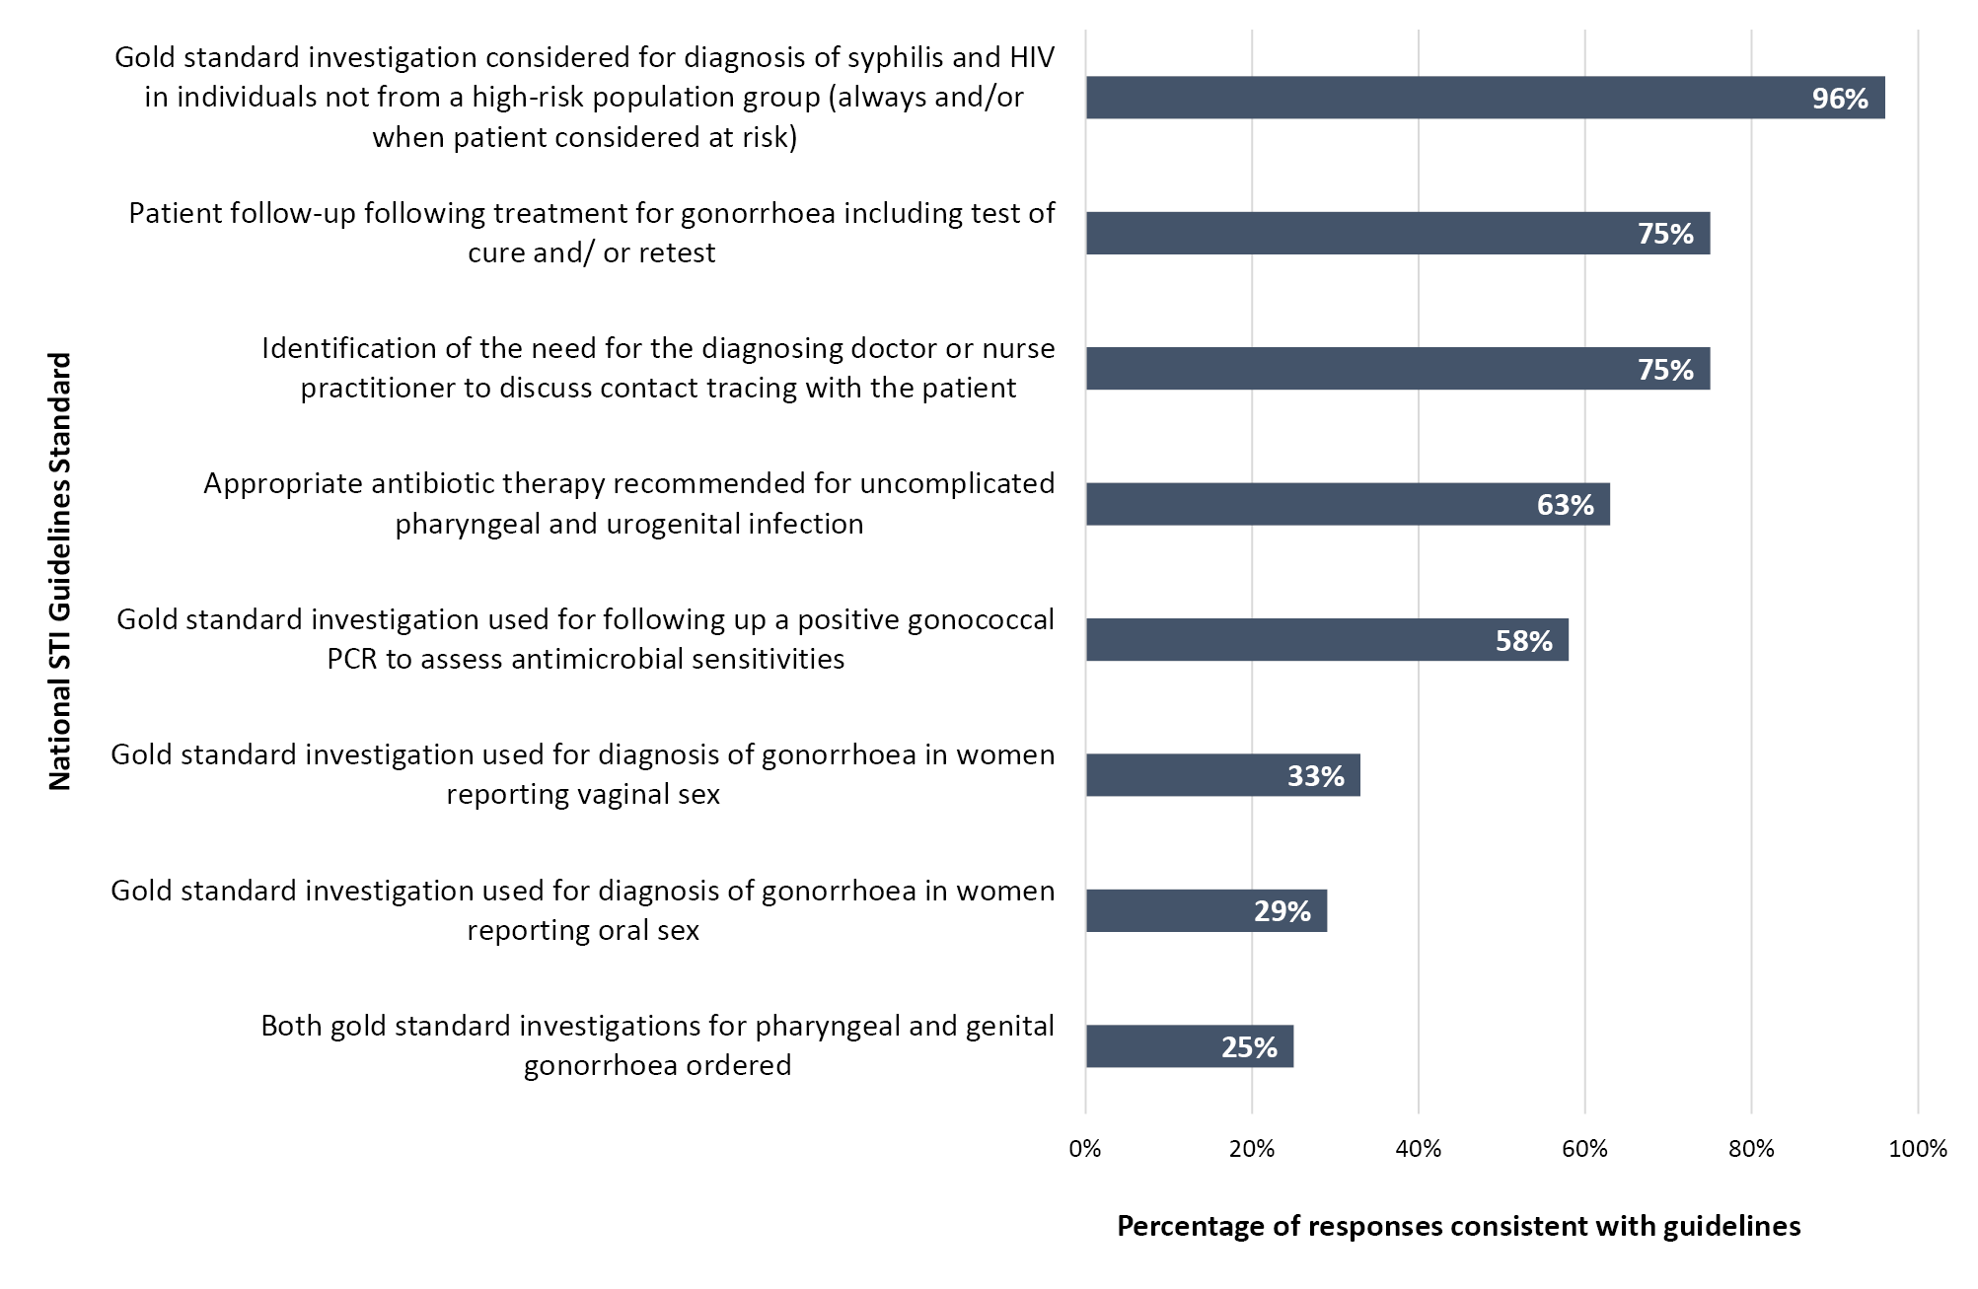

Experiences with sexual history taking
Almost all respondents (92%) indicated they felt comfortable and confident taking a sexual history; however, 29% agreed they would only ask about sexual orientation or practices when a patient brought it up or reported STI symptoms, and one third agreed that a full sexual history was not necessary to order STI testing.When asked to identify the questions to ask in an opportunistic STI screen for a woman presenting for a contraceptive consultation, 12.5% of respondents indicated they would ask few questions, either due to the opportunistic nature of the screen or because they would be inclined to test for the same STIs regardless of responses (n = 3). This experience was reflected among some interview participants who also reported using a generic approach to recommending STI testing to patients. When GPs did report specific questions, the most frequent questions revolved around number of partners (n = 15) and use of protection (n = 13). Fewer than one third specifically asked about the type of sexual activity (n = 7).

STI testing practices and knowledge
In the context of an asymptomatic STI screen, 79% of respondents reported they always offered syphilis and HIV testing to women who were not pregnant, and 67% of respondents reported the same for men reporting heterosexual exposure. However, 46% of respondents also reported that patients to whom they offered testing sometimes declined to be tested, most commonly due to self-identifying as ‘low risk’ (n = 10). Urine PCR testing for chlamydia and gonorrhoea was reported 2.4 times more frequently than testing using endocervical or vaginal swabs in a vignette of an opportunistic STI screen for a woman reporting vaginal and oral sex. Fewer than one third (29%) of respondents indicated they would include a throat swab in their screen, including one respondent who specified they would only do so if the patient was symptomatic (Figure 2).
Figure 2: Distribution of different investigations for gonorrhoea included in an asymptomatic STI screen for a patient reporting a) oral sex and b) vaginal sex
a) Investigations relevant to reported oral sex
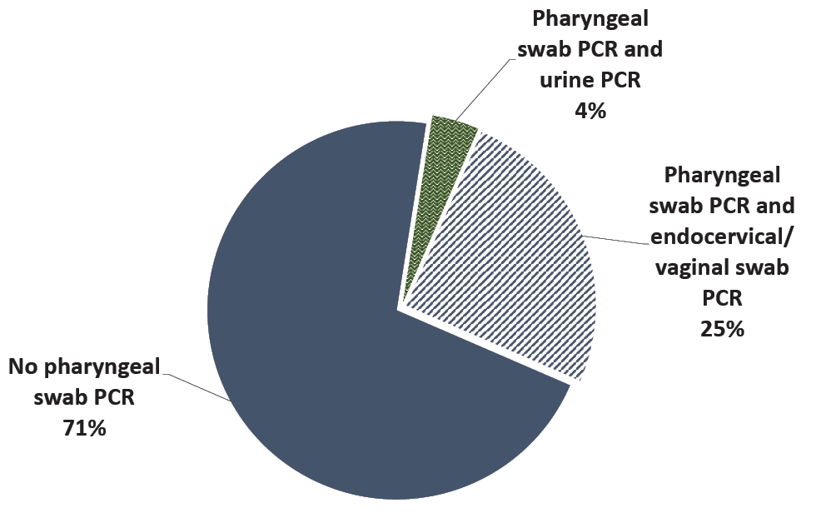
b) Investigations relevant to reported vaginal sex
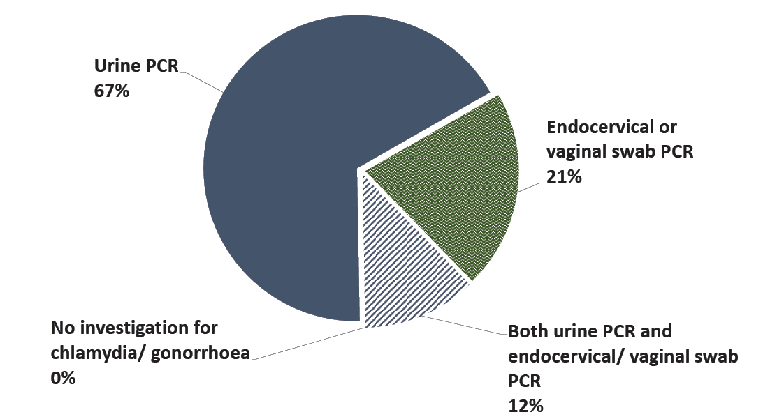

STI treatment practices and knowledge
Respondents most frequently identified the online Australian STI Management Guidelines for use in Primary Care as their preferred source of information for STI management (n = 18). The Therapeutic Guidelines (n = 15) and CSHC (n = 11) were also frequently listed. Only two respondents identified either CDC or CSHC as their sole source of information. In interviews, GPs reported difficulty keeping up with changing recommendations and suggested this was a barrier to being up to date with guidelines.
In accordance with guidelines, 58% of respondents reported they would follow up a positive gonococcal PCR with a culture before beginning treatment. Of those who reported they were unsure or would not follow up with a culture, 40% were not aware this was required. The majority of respondents (65%) indicated they would treat onsite, most commonly citing, as factors influencing their decision: capacity to administer ceftriaxone; support from a sexual health trained nurse practitioner; a desire not to lose the opportunity to treat; and concerns about the health risks of delaying treatment. The remaining 35% of respondents indicated they would refer the patient to CSHC, most commonly due to lack of onsite access to ceftriaxone. Respondents were asked to identify the recommended treatment of uncomplicated pharyngeal and urogenital gonococcal infection with the assistance of their preferred source of information. The appropriate treatment was identified by 63% of respondents. In follow-up plans, 75% of respondents included additional testing after treatment and 25% included further counselling.

Suggestions for CDC support
Education was overwhelmingly identified as an area for improvement, with respondents suggesting resources such as free refresher courses; clear and easy to locate information online; and up-to-date guidelines distributed by facsimile. With regards to communication, two thirds of respondents identified phone calls as their preferred mode of contact for the purpose of collecting further information about notifiable cases. Among respondents who indicated a preference for other means of communication, finding the time for phone calls was reported to be a barrier. These respondents also reported that faxed forms used by CDC for other notifiable conditions were inefficient and could benefit from integration with practice software. Participants who had experienced answering CDC calls on behalf of other diagnosing doctors expressed challenges answering questions about cases based off clinical notes and suggested the need for greater transparency about surveillance data requirements. A concern was a fear of patients being lost to follow-up and treatment. Participants indicated they were concerned they were unable to confirm whether contact tracing was being completed, or whether treatment was completed, if patients were referred to the Canberra Sexual Health Centre (CSHC). Requests for further support with contact tracing were raised in feedback, and 58% of respondents reported the misconception that CDC was responsible for contact tracing.

Discussion
Our study addresses an important gap in the sexual health literature, identifying areas where GP practice may not conform with STI guidelines and where public health units could provide improved support.
Gonococcal testing and prescribing practices identified in this study may lead to reduced case ascertainment and inadequate surveillance for antimicrobial resistance. Although all GPs included gonorrhoea in their asymptomatic STI screen, the majority chose to investigate with urine PCR testing only. First pass urine is not as sensitive as self-collected vaginal swabs in asymptomatic females, and omission of pharyngeal swabs may lead to undetected single-site infections, with the oropharynx providing a niche for the development of antimicrobial resistance and a reservoir of infection that facilitates onward transmission.^{5,9,10} However, omission of pharyngeal swabs in asymptomatic screening in low risk individuals may be prevalent in other settings, reflecting perceived high cost-benefit, and concerns of potential false-positive results.^{11–14} Additionally, few GPs reported they would request a gonococcal culture following a positive PCR result, which has implications for national surveillance of antimicrobial resistance, and for effective individual treatment in the case of potential growth of a resistant organism. This is particularly important in individuals reporting heterosexual exposure, as women have been found to be twice as likely to return results of antimicrobial resistant strains of gonorrhoea compared with men who have sex with men.^{11,15}
Knowledge of guidelines was not the only factor affecting survey responses. For instance, among respondents who indicated they would not order a gonococcal culture, most were aware this was required but other concerns informed their decision, such as patient convenience or fear of losing patients to follow-up. Similarly, whilst most participants reported feeling comfortable and confident with sexual history taking, few participants included questions about sexual practices such as oral sex in their screening questions, which in practice could contribute to inadequate testing of exposed body sites. While previous studies have concluded that limited time, limited clinician understanding of associated benefits, and clinician concern about broaching sexual health with patients all hinder capacity to deliver evidence-based sexual health care, our findings also suggest that clinician and patient preferences, attitudes and beliefs play an important role.¹⁶
In light of GP suggestions and concerns, we recommend state and territory public health units consider integrated online disease notification systems which incorporate treatment guidelines and existing GP software, or use facsimile to distribute current treatment guidelines to GPs following notification of STIs. Specialised sexual health clinics could also develop processes to inform GPs of patient outcomes following referral, to help close the loop on patient follow up. As a result of this study, in our own jurisdiction a referral proforma has been developed by the CSHC to be faxed to GPs following review and treatment of their patients. This proforma includes information about patient attendance, condition treated, treatment provided, recommended follow up and status of contact tracing.
Our study is primarily limited by response bias. We assume that GPs with a special interest or recent involvement in sexual health would have been more likely to respond, and these groups were actively encouraged to participate in our recruitment strategy. This may have led to the confidence and compliance of GPs with STI guidelines being overestimated. Analysis at the clinic level is not possible as respondents were able to participate anonymously. Additionally, the overall response rate was low, which is not surprising given the well-established challenges in maximising response rates from GPs.¹⁷ The low response rate and focus on a single jurisdiction limits the generalisability of the results. Finally, the study is not an audit, and is limited by scope, as the results are based on survey responses which may differ from true clinical practice. Despite these limitations, our results provide an insight into the knowledge and practices of an engaged cohort of ACT GPs.

Conclusion
The growing involvement of GPs in testing and treating STIs is a welcome shift; however, optimising conformity of care and addressing clinician concerns will be critical for enhancing patient and population health outcomes. Given the limitations of this study, further research should aim to more comprehensively characterise differences in clinical practice between general practice and specialised sexual health centres, and to examine how clinician preferences, attitudes and beliefs shape STI health care delivery and disease surveillance.

Acknowledgements
We would like to thank the general practitioners and nurse practitioners involved in this study. We would also like to acknowledge Rachael Crane, Julia Smythe, Milica Stefanovic, Dr Karin English, Dr Naomi Clarke, Dr Anne-Marie Svoboda and Alison Kingsbury for contributing to the development and implementation of the project. We also recognise the feedback and contributions of the Canberra Sexual Health Centre, including Dr Sarah Martin and Dr Alexandra Tyson.

Funding statement
The ACT Health Vacation Study Program provided financial support in the form of a scholarship payment to the first author for the duration of the six-week project.

Conflict of interest statement
The authors declare no conflict of interest.

Ethics approval statement
This study has been approved by the ACT Health Human Research Ethics Committee Low Risk Subcommittee (Protocol 2020/ETH03191).

Author details
Lorane Gaborit¹
Dr Ben Polkinghorne²
Alexandra Marmor³
- ANU Medical School, College of Health and Medicine, Australian National University.
- Research School of Population Health, College of Health and Medicine, Australian National University.
- Communicable Disease Control Section, Health Protection Service, ACT Health Directorate.

Corresponding author
Alexandra Marmor
Address: Health Protection Service, 25 Mulley Street, Holder, ACT, 2611
Phone: 02 5124 9700
E-mail: alexandra.marmor@act.gov.au

References
- The Royal Australian College of General Practitioners (RACGP). 6.2.1 Chlamydia and other STIs. In Guidelines for preventive activities in general practice (9th edition). East Melbourne: RACGP; 2016. Available from: https://www.racgp.org.au/download/Documents/Guidelines/Redbook9/17048-Red-Book-9th-Edition.pdf.
- Australian Government Department of Health. Fourth National Sexually Transmissible Infections Strategy 2018–2022. Canberra: Australian Government Department of Health; 2018. Available from: https://www1.health.gov.au/internet/main/publishing.nsf/Content/ohp-bbvs-1/$File/STI-Fourth-Nat-Strategy-2018-22.pdf.
- Kirby Institute. Targets 5.4, 5.5. In Sexually transmissible infections and blood borne viruses in the ACT: surveillance report 2018. Sydney: Kirby Institute, UNSW Sydney; 2018 Available from: https://www.health.act.gov.au/sites/default/files/2021-05/ACT%20Sexually%20Transmissible%20Infections%20and%20Blood%20Borne%20Viruses%20Surveillance%20Report.pdf.
- Thirkell CE. Chapter 3: Epidemiology and antimicrobial resistance of gonococcal notifications in ACT from 2009 to 2018. In Applied Epidemiology in the ACT. Canberra: Australian National University; November 2019. pp. 33–66. Available from: https://openresearch-repository.anu.edu.au/bitstream/1885/206808/1/Thirkell%20Thesis%202020.pdf.
- Australasian Sexual and Reproductive Health Alliance (ASHRA). Australian STI Management Guidelines for use in Primary Care. [Internet.] Sydney: ASHRA; 29 November 2020. [Accessed on 14 December 2020.] Available from: https://sti.guidelines.org.au/.
- Trotter C, Okunwobi-Smith Y. P161 Sexual health in general practice: do gp practices comply with bashh guidelines?. Sex Transm Infect. 2015;91(Suppl 1):A68–9. doi: https://doi.org/10.1136/sextrans-2015-052126.204.
- Yeung A, Temple-Smith M, Spark S, Guy R, Fairley CK, Law M et al. Improving chlamydia knowledge should lead to increased chlamydia testing among Australian general practitioners: a cross-sectional study of chlamydia testing uptake in general practice. BMC Infect Dis. 2014;14(1):584. doi: https://doi.org/10.1186/s12879-014-0584-2.
- Schreiber RS, Noerager Stern P. Using Grounded Theory in Nursing. New York: Springer Publishing Company; 2001.
- Schachter J, Chernesky MA, Willis DE, Fine PM, Martin DH, Fuller D et al. Vaginal swabs are the specimens of choice when screening for Chlamydia trachomatis and Neisseria gonorrhoeae: results from a multicenter evaluation of the APTIMA assays for both infections. Sex Transm Dis. 2005;32(12):725–8. doi: https://doi.org/10.1097/01.olq.0000190092.59482.96.
- Fifer H, Hughes G. Oropharyngeal Neisseria gonorrhoeae infections: should women be routinely tested? Lancet Infect Dis. 2021;21(6):754–6. doi: https://doi.org/10.1016/S1473-3099(20)30777-5.
- Williamson DA, Fairley CK, Howden BP, Chen MY, Stevens K, De Petra V et al. Trends and risk factors for antimicrobial-resistant Neisseria gonorrhoeae, Melbourne, Australia, 2007 to 2018. Antimicrob Agents Chemother. 2019;63(10):e01221-19. doi: https://doi.org/10.1128/AAC.01221-19.
- Liere GV, Dukers-Muijrers N, Kuizenga-Wessel S, Götz H, Hoebe C. O02.1 What is the optimal testing strategy for oropharyngeal Neisseria gonorrhoeae in women visiting STI clinics? Sex Transm Infect. 2019;95(Suppl 1):A39. doi: https://doi.org/10.1136/sextrans-2019-sti.110.
- Forbes G, Drayton R. P14 Testing for pharyngeal gonorrhoea in women: an important reservoir of infection, or excessive false positive diagnoses. Sex Transm Infect. 2015;91(Suppl 1):A20. doi: https://doi.org/10.1136/sextrans-2015-052126.58.
- Upton A, Bromhead C, Whiley DM. Neisseria gonorrhoeae false-positive result obtained from a pharyngeal swab by using the Roche cobas 4800 CT/NG assay in New Zealand in 2012. J Clin Microbiol. 2013;51(5):1609–10. doi: https://doi.org/10.1128/JCM.00485-13.
- Rissel C, Badcock PB, Smith AMA, Richters J, de Visser RO, Grulich AE et al. Heterosexual experience and recent heterosexual encounters among Australian adults: the Second Australian Study of Health and Relationships. Sex Health. 2014;11(5):416–26. doi: https://doi.org/10.1071/SH14105.
- Bowden FJ, Currie MJ, Toyne H, McGuiness C, Lim LL, Butler J, et al. Screening for Chlamydia trachomatis at the time of routine Pap smear in general practice: a cluster randomised controlled trial. Med J Aust. 2008;188(2):76–80. doi: https://doi.org/10.5694/j.1326-5377.2008.tb01526.x.
- Pit SW, Vo T, Pyakurel S. The effectiveness of recruitment strategies on general practitioner’s survey response rates – a systematic review. BMC Med Res Methodol. 2014;14:76. doi: https://doi.org/10.1186/1471-2288-14-76.
- Therapeutic Guidelines. eTG complete: Principles of sexually transmitted infection management. [Webpage.] Melbourne: Therapeutic Guidelines Limited; April 2019. [Accessed on 5 December 2020.] Available from: https://tgldcdp.tg.org.au/viewTopic?topicfile=sexually-transmitted-infections-principles.
- Therapeutic Guidelines. eTG complete: Approach to Neisseria gonorrhoeae infection. [Webpage.] Melbourne: Therapeutic Guidelines Limited; April 2019. [Accessed on 5 December 2020.] Available from: https://tgldcdp.tg.org.au/viewTopic?topicfile=neisseria-gonorrhoeae#toc_d1e50.

Appendix A: Participant survey
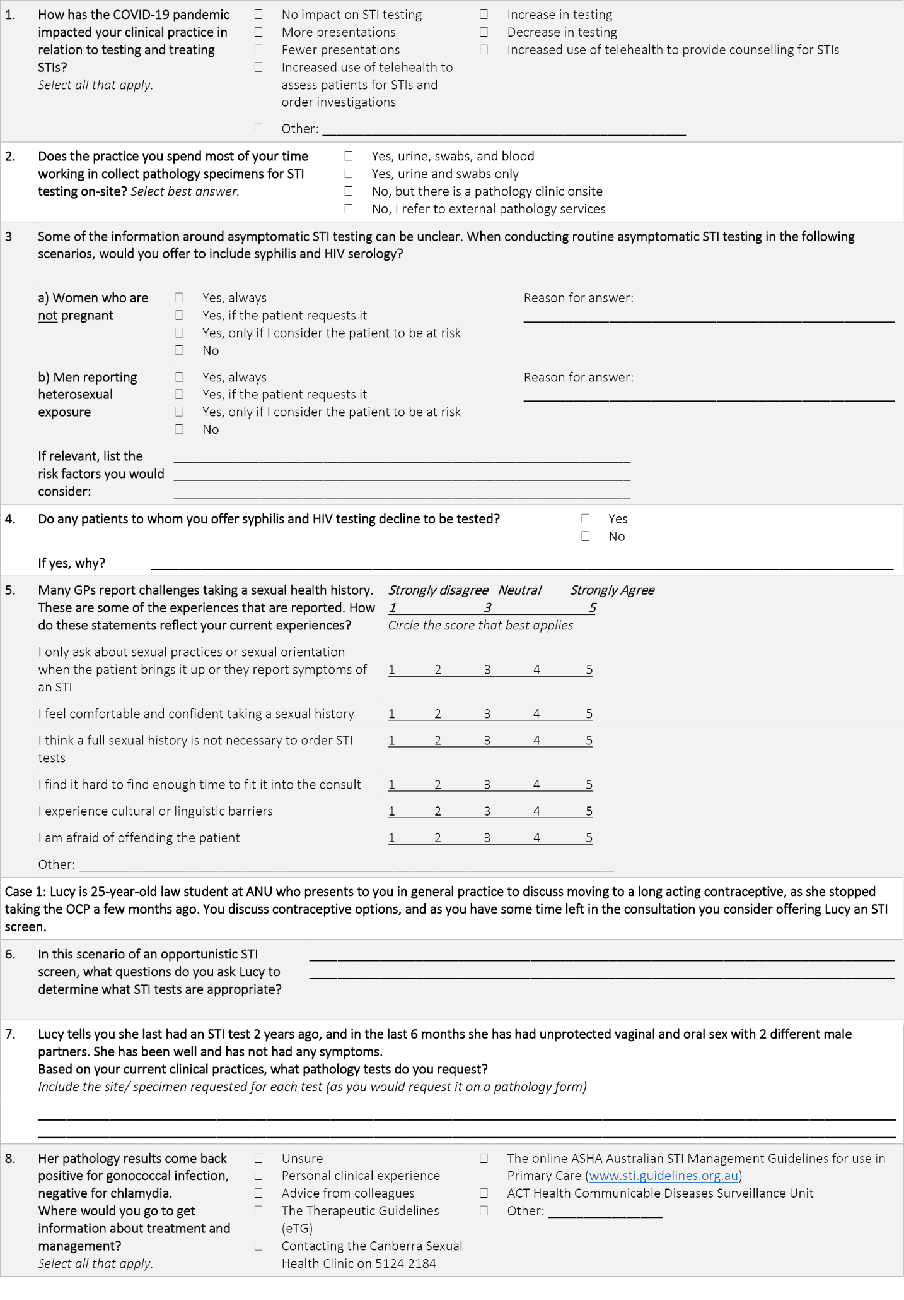
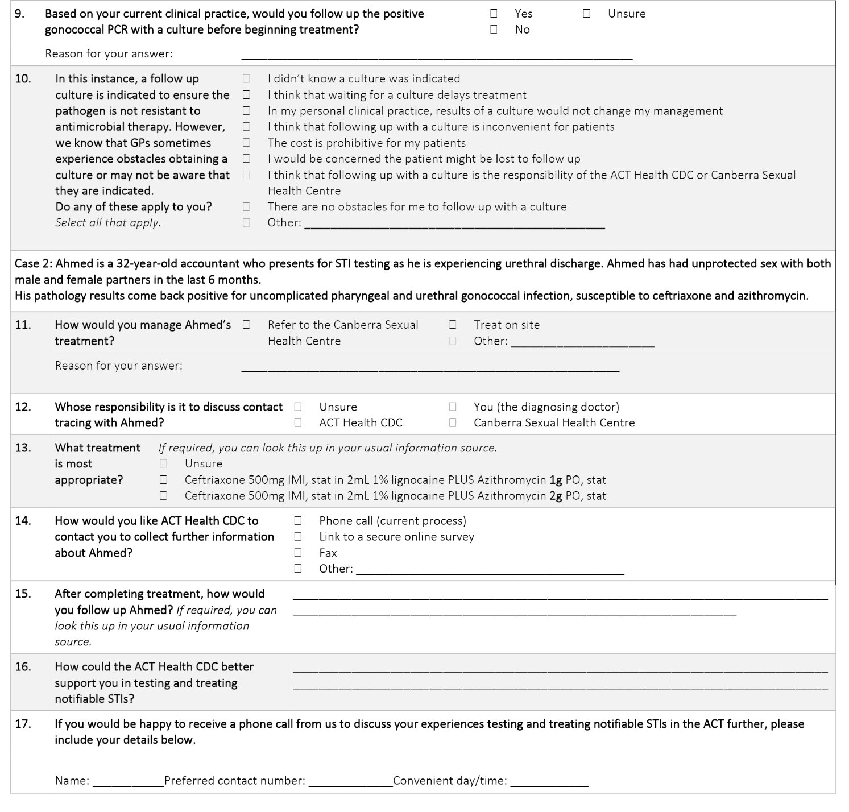

Appendix B: Correlation of National STI Guidelines and Therapeutic Guidelines at the time of data collection with conformity of care standards used in data analysis
National STI Guidelines standard used in conformity of care analysis (Figure 1) | 2020 National STI Guidelines recommendation5 | Therapeutic Guidelines (eTG) recommendation18, 19
Gold standard investigation used for diagnosis of gonorrhoea in women reporting vaginal sex | Endocervical swab if discharge/ dysuria  Self-collected vaginal swab if not examined  First pass urine ONLY if endocervical swab/ self-collected vaginal swab cannot be taken | Gonococcal infection is generally identified by nucleic acid amplification testing (NAAT) (e.g polymerase chain reaction [PCR]).
Gold standard investigation used for diagnosis of gonorrhoea in women reporting oral sex | Pharyngeal swab if patient has oral sex | Gonococcal infection is generally identified by nucleic acid amplification testing (NAAT) (e.g. polymerase chain reaction [PCR]).
Both gold standard investigations for pharyngeal and genital gonorrhoea used | Endocervical swab if discharge/ dysuria  Self-collected vaginal swab if not examined  First pass urine ONLY if endocervical swab/ self-collected vaginal swab cannot be taken  Pharyngeal swab if patient has oral sex | Gonococcal infection is generally identified by nucleic acid amplification testing (NAAT) (e.g polymerase chain reaction [PCR]).
Gold standard investigation considered for diagnosis of syphilis and HIV in individuals not from a high-risk population group (always and/or when patient considered at risk) | Consider the following tests [for Hepatitis B, HIV, syphilis] for individuals who are not from a high-risk population group. To determine risk, take a sexual history. Blood – HBsAg, Anti-HBs, Anti-HBc, HIV Ag/Ab, Syphilis serology | For patients with a suspected STI, consider testing for Chlamydia trachomatis, Neisseria gonorrhoeae, HIV and syphilis, and for patients who are not fully vaccinated, consider testing for hepatitis A and B.
Gold standard investigation used for following up a positive gonococcal PCR to assess antimicrobial sensitivities | ALWAYS test for culture before treating gonorrhoea to determine anti-microbial sensitivity and contribute to anti-microbial resistance surveillance. If possible, culture samples should be obtained from genital and non-genital sites to determine antibiotic susceptibility before treating someone with a positive NAAT. | Take a sample for culture and susceptibility testing before starting antibiotic therapy because antimicrobial resistance is emerging, and most nucleic acid amplification tests do not detect resistance.
Appropriate antibiotic therapy recommended for uncomplicated pharyngeal and urogenital infection | Ceftriaxone 500mg IMI, stat in 2mL 1% lignocaine PLUS Azithromycin 2g PO, stat*. | Ceftriaxone 500 mg in 2 mL of 1% lidocaine intramuscularly, or 500 mg intravenously, as a single dose PLUS azithromycin 2 g orally with food, as a single dose.
Identification of the need for the diagnosing doctor or nurse practitioner to discuss contact tracing with the patient | Contact tracing for gonorrhoea is a high priority and should be performed in all patients with confirmed infection. | Undertake contact tracing for patients with N. gonorrhoeae infection… Addressing contact tracing is the responsibility of the diagnosing clinician.
Patient follow-up following treatment for gonorrhoea including test of cure and/or retest | For pharyngeal, anal or cervical infection, TOC by Nucleic Acid Amplification Test (NAAT) should be performed 2 weeks after treatment is completed.  Retest patients 3 months after exposure. | Perform a test of cure at least 2 weeks after treatment completion if using nucleic acid amplification testing (NAAT). If using culture, test of cure may be performed 1 week after treatment completion.

Communicable Diseases Intelligence
ISSN: 2209-6051 Online

Communicable Diseases Intelligence (CDI) is a peer-reviewed scientific journal published by the Office of Health Protection and Response, Department of Health and Aged Care. The journal aims to disseminate information on the epidemiology, surveillance, prevention and control of communicable diseases of relevance to Australia.

Editor: Noel Lally
Deputy Editor: Simon Petrie
Design and Production: Kasra Yousefi
Editorial Advisory Board: David Durrheim, Mark Ferson, John Kaldor, Martyn Kirk and Linda Selvey

Website: http://www.health.gov.au/cdi

Contacts
CDI is produced by the Office of Health Protection and Response, Australian Government Department of Health and Aged Care, GPO Box 9848, (MDP 6) CANBERRA ACT 2601

Email: cdi.editor@health.gov.au

Submit an Article
You are invited to submit your next communicable disease related article to the Communicable Diseases Intelligence (CDI) for consideration. More information regarding CDI can be found at: http://health.gov.au/cdi.
Further enquiries should be directed to: cdi.editor@health.gov.au.

This journal is indexed by Index Medicus and Medline.

Creative Commons Licence - Attribution-NonCommercial-NoDerivatives CC BY-NC-ND
© 2022 Commonwealth of Australia as represented by the Department of Health and Aged Care
This publication is licensed under a Creative Commons Attribution-NonCommercial-NoDerivatives 4.0 International Licence from https://creativecommons.org/licenses/by-nc-nd/4.0/legalcode (Licence). You must read and understand the Licence before using any material from this publication.

Restrictions
The Licence does not cover, and there is no permission given for, use of any of the following material found in this publication (if any):
- the Commonwealth Coat of Arms (by way of information, the terms under which the Coat of Arms may be used can be found at www.itsanhonour.gov.au);
- any logos (including the Department of Health and Aged Care’s logo) and trademarks;
- any photographs and images;
- any signatures; and
- any material belonging to third parties.

Disclaimer
Opinions expressed in Communicable Diseases Intelligence are those of the authors and not necessarily those of the Australian Government Department of Health and Aged Care or the Communicable Diseases Network Australia. Data may be subject to revision.

Enquiries
Enquiries regarding any other use of this publication should be addressed to the Communication Branch, Department of Health and Aged Care, GPO Box 9848, Canberra ACT 2601, or via e-mail to: copyright@health.gov.au

Communicable Diseases Network Australia
Communicable Diseases Intelligence contributes to the work of the Communicable Diseases Network Australia.
http://www.health.gov.au/cdna

