Hepatitis A outbreak in Australia linked to imported Medjool dates, June–September 2021
Caitlin O’Neill, Neil Franklin, Alan Edwards, Tania Martin, Jacinta O’Keefe, Kathy Jackson, Nevada Pingault, Keira Glasgow

Abstract
Imported, minimally processed food products have been historically associated with several hepatitis A outbreaks in Australia. Here, we report the first known hepatitis A outbreak in Australia linked to consumption of imported fresh Medjool dates. Between June and September 2021, six genetically identical hepatitis A cases were notified in New South Wales and the Australian Capital Territory. All cases reported date consumption during their exposure period. The implicated dates were positive for hepatitis A virus (HAV) by reverse transcription polymerase chain reaction. Rapid detection of this outbreak and the swift implementation of control measures was facilitated by two key factors. Firstly, Australian international border closures implemented in response to the COVID-19 pandemic meant that a common locally-acquired, as opposed to travel-acquired, source for cases was strongly suspected. Secondly, prompt awareness of a hepatitis A outbreak in the United Kingdom (which was found to be associated with date consumption) allowed for early hypothesis generation and investigation. This paper details the epidemiological and microbiological factors involved in this outbreak investigation and the actions taken to mitigate public health risk.
Keywords: Foodborne infections; viral infections; hepatitis A; hepatitis A virus; outbreaks; surveillance; epidemiology; Australia

Introduction

Background
Hepatitis A is an acute, typically self-limiting illness caused by the hepatitis A Virus (HAV). The infection is almost entirely transmitted via the faecal-oral route; either through ingesting contaminated food or water, through sexual activity involving exposure to faeces, or by consumption of faecal material transferred from contaminated surfaces of the hands of an infectious case.¹ The disease initially presents with onset of prodromal symptoms including fatigue, malaise, anorexia, nausea, vomiting, fever, and abdominal discomfort followed several days later by dark-coloured urine, pale stools, jaundice and pruritis.² The incubation period ranges from 15 to 50 days, and the majority of those infected are symptomatic of the disease.³ Rarely, hepatitis A infection can lead to fulminant hepatic failure which is associated with significant mortality.⁴
Persons susceptible to hepatitis A infection include those who have not been vaccinated or those who have not previously had the disease; prior infection confers lifelong immunity.¹ Globally, risk factors for acquisition include international travel, men who have sex with men (MSM), household contact with an infectious case, illicit drug use, exposure to childcare centres or residential institutions, and exposure to contaminated food or water.^{5,6} Infection can be prevented through optimal hygiene and sanitary measures, including vigilant handwashing and safe food handling practices.⁷ Vaccination is a highly effective preventative measure and is recommended for populations with identified risk factors.⁸
Hepatitis A is not endemic in Australia, and history of international travel to an endemic area still remains the greatest risk factor for hepatitis A acquisition in cases diagnosed in Australia. Between 2012 and 2016, the yearly mean of hepatitis A notified in Australia was 182 cases, and during this same period, the yearly mean for overseas-acquired hepatitis A was 135 cases (74%).⁶
Between May 2020 and June 2021, when this outbreak was detected, Australia’s international borders were closed in response to the coronavirus disease 2019 (COVID-19) pandemic, during which time there was less than one hepatitis A case per month nationally. Until June 2021, all cases notified in New South Wales (NSW) during this border closure period were linked to returning citizens, except one, which was linked to consumption of a previously-recalled imported frozen food. There were no notifications of hepatitis A among residents of the Australian Capital Territory (ACT) in this border closure period.
Australia has experienced several large hepatitis A outbreaks linked to contaminated food over the last 25 years. In 1997, there was a large outbreak linked to oysters.⁹ Over a decade later, in 2009, there was an outbreak associated with imported semi-dried tomatoes.^{2,10} More recently, there have been several outbreaks linked to consumption of frozen, ready-to-eat berries,^{11,12} and frozen imported pomegranate arils.³
This article describes the epidemiological and microbiological factors that led to the identification of a hepatitis A outbreak in Australia linked to imported Medjool dates in June 2021, as well as control measures introduced to mitigate ongoing public health risk.

Outbreak detection
In late June 2021, a person with hepatitis A and no travel history was notified to the New South Wales Department of Health (NSW Health). At the time of notification, the possible connection to dates was considered in the context of a recently-published article regarding a hepatitis A outbreak associated with date consumption occurring in England and Wales between January and April 2021.¹³ The case reported fresh Medjool date consumption during their exposure period, but was unable to identify the product to assist traceback. In response, the Australian jurisdictional network of foodborne epidemiologists (OzFoodNet) agreed to add dates as a potential risk food to the national hepatitis A questionnaire.
On 12 July 2021 an Australian reference laboratory, Microbiological Diagnostic Unit Public Health Laboratory (MDU-PHL), advised that this case was genomically identical to the reference outbreak sequence in the United Kingdom linked to Jordanian dates, NC_001489.1. This sequence was provided by Public Health England in the published article, and downloaded by MDU-PHL from the Genbank genetic sequence database. Several weeks later, on 2 August 2021, a second case of locally-acquired hepatitis A in New South Wales was reported as being a 100% match with the NSW index case; forming a new NSW hepatitis A cluster, ‘2021 Cluster A’. Notably, both cases reported fresh Medjool date consumption within their respective exposure periods upon interview. In the weeks following the linking of the first two cases, three more locally-acquired hepatitis A cases in New South Wales, and one case in the Australian Capital Territory, joined this cluster on genotyping. These cases also reported a history of fresh Medjool date consumption.

Methods

Case investigation
All possible cases of hepatitis A are notified and investigated upon initial notification in New South Wales and the Australian Capital Territory under jurisdictional public health legislation: Public Health Act (NSW) 2010, and Public Health Act (ACT) 1997. Public health staff determined case status by correlating laboratory evidence with a person’s clinical and epidemiological history. If a person met the national probable or confirmed hepatitis A surveillance case definition,^{2,14} a full case interview using a standardised national hepatitis A questionnaire was completed. Interviews collected information about case demographics, clinical information, vaccination history, food and non-food risk factors during the exposure period, occupation information, and information about contacts.

Epidemiological investigation
A confirmed outbreak case was defined as any person who had (i) HAV detected by reverse transcription polymerase chain reaction (RT-PCR), (ii) an isolate sequenced as genotype IB and highly related to the index case of NSW hepatitis A cluster, ‘2021 Cluster A’, and (iii) onset of symptoms since 1 June 2021. Samples were considered to be ‘highly related’ if they had ≥ 99.5% sequence identity, ≥ 50% coverage, and a collection date within 24 months of the period in which genomic results were reported.
Upon suspicion of a local outbreak, active case-finding commenced in NSW. This included distribution of a clinician alert requesting that general practitioners (GPs) and emergency departments (EDs) test patients presenting with hepatitis A symptoms and a history of date consumption. A laboratory alert was also sent to all microbiology directors of public and private pathology laboratories across NSW.

Microbiological analysis of clinical samples
All six cases identified as part of the outbreak were initially notified to public health authorities upon a positive HAV immunoglobulin M (IgM) serology result; these serology results were from a mix of public and private laboratories. All serum specimens were then sent to the tertiary referral laboratory, Victorian Infectious Diseases Reference Laboratory (VIDRL), to undergo HAV RT-PCR testing and genotyping. Nucleic acid was extracted from sera and tested using the HAV RT-PCR RealStar® kit, manufactured by Altona Diagnostics, Germany. The limit of detection of the RT-PCR assay was 500 IU/ml.¹⁵ The RT-PCR testing was completed using the HAVNET protocol, established by the Department of Virology Centre for Infectious Disease Control, National Institute for Public Health and the Environment in the Netherlands.¹⁶ This protocol guides detection and sequencing methods of HAV to improve the comparability of shared sequences globally.

Genomic analysis
VIDRL also performed sequencing of the HAV genomes under the HAVNET protocol. Using the sequence analysis program SeqScape version 2.1.1 (Applied Biosystems™, Life Technologies, Ltd, Paisley, United Kingdom), a consensus sequence was generated for all isolates by resequencing the forward and reverse sequence strands of the amplicon of sample to the stored reference HAV genome sequence NC_001489.1 from GenBank. The genotype of each sequence was determined using BLAST (Basic Local Alignment Search Tool) where the assigned genotype is the genotype of highest ranked hit, by similarity and coverage, to a database containing the reference genome sequence for each of the current HAV genotypes. For phylogenetic analyses, HAVNET sequences obtained from the 6 patient samples as well as genotype IB isolates previously sequenced at VIDRL, were multi-sequence aligned with full-length HAV sequences downloaded from GenBank using the MAFFT programme implemented in the bioinformatics software platform Geneious v7.1.9.^{,17,18} The alignments were then manually trimmed to the same length of the amplicon sequences. A maximum likelihood phylogenetic tree of the hepatitis A virus (HAV) VP1-2A region (460nt) was generated using the T92 + G substitution model, with 1,000 bootstrap replicates using MEGAX.¹⁹

Microbiological analysis of environmental samples
Officers of the NSW Department of Primary Industries collected a 1 kilogram unopened box of the suspected Medjool dates obtained from a Sydney supermarket. The Australian Government National Measurement Institute (NMI) facilitated the initial testing; this sample was initially separated into ten subsamples of 25 grams. The ‘ISO/TS Specification 15216-1’ method was used to attempt viral extraction first, with the Qiagen Viral RNA Minikit.²⁰ Each subsample was rinsed and the rinsate from each submitted for HAV RNA sequence detection at NMI, using ‘genesig® HAV RT-PCR detection’. Quality controls (positive and negative) were included in the analytical sequence to ensure extraction and assay performance. The RNA extract was then sent to a tertiary referral laboratory, VIDRL, in Melbourne, Victoria to attempt sequencing under the HAVNET protocol.

Results

Epidemiological Investigation
Between 1 June and 30 September 2021, six confirmed hepatitis A cases residing in NSW and one confirmed case residing in the ACT were notified to public health authorities; all but one were part of this outbreak. The median age of cases was 26 years old (range 15 to 53 years old), 83% male (n = 5/6). Clinical onset of cases as part of this outbreak ranged from 12 June 2021 to 10 September 2021 (Figure 1). Four cases (67%) required hospitalisation. Nil deaths occurred (Table 1).
Figure 1: Hepatitis A ‘2021 Cluster A’ cases by week of clinical onset, NSW and ACT, 12 June – 10 September 2021
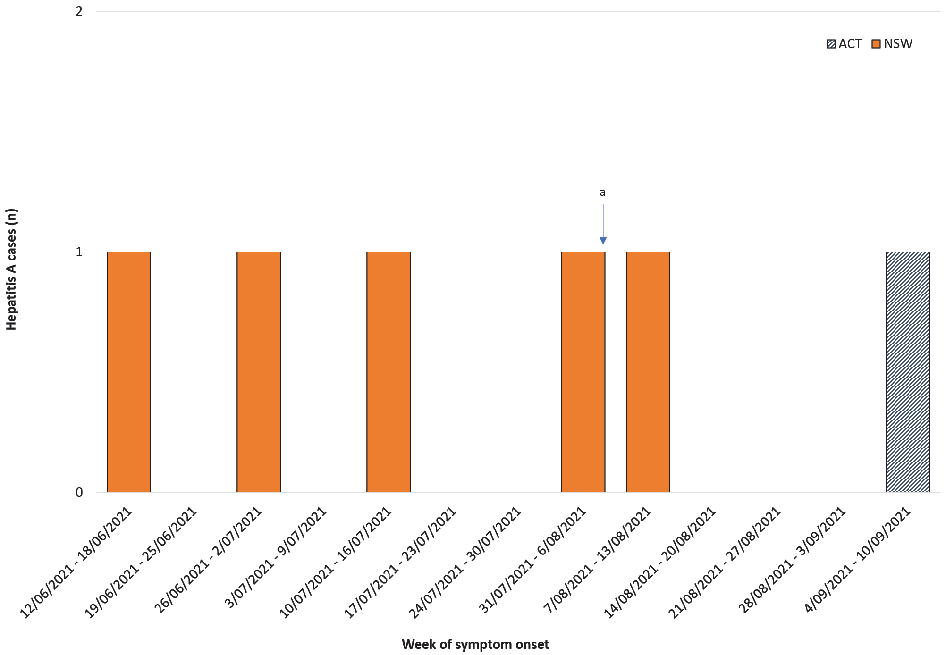
a Consumer-level recall of implicated batch of dates issued, 6 August 2021.
Case interviews revealed that all six had consumed dates within their exposure periods. Critically, case 3 was able to report a very specific brand of imported dates from Jordan. This information prompted the investigation team to attempt re-interviewing case 1 and 2 to elicit whether any descriptive information could identify a relationship between the dates eaten by case 3 and the two earlier cases. Information collected from case 2 supported a link to the same brand of dates as case 3. The information was provided to NSW Department of Primary Industries Biosecurity and Food Safety to assist with sampling and evidence collection. Following the instigation of outbreak control measures, case 4 confirmed that they had consumed dates purchased from one specific retailer who was known to sell the recalled batch of dates, thus adding to the body of evidence of one implicated date brand. Case 6, from the ACT, also confirmed that they had consumed dates purchased from a retailer known to sell the recalled brand of dates; however, the environmental investigation could not confirm they consumed the recalled batch. The dates consumed by case 1 and 5 remained unspecified.
Table 1: Hepatitis A ‘2021 cluster A’ clinical factors, NSW and ACT, Australia, 12 June – 10 September 2021
Factor | Result
 | Cases (n) | Percent of cases
IgM detection | 6 | 100%
RT-PCR detection | 6 | 100%
Hospitalisation | 4 | 67%
Deaths | 0 | 0%

Laboratory investigation of clinical and environmental samples
All six cases met the confirmed outbreak case definition. Genomic sequencing of serum samples for these cases revealed they were all genotype IB, these sequences were highly related to each other, and the HAV strain was identical to the outbreak reference sequence identified by the United Kingdom Food Standards Agency in their investigation of a hepatitis A outbreak earlier in 2021 in England and Wales, which was found to be associated with consumption of Medjool dates imported from Jordan (Figure 2).²¹ A representative sequence for this Australian outbreak, 2021_VIDRL_6370 was submitted to Genbank, accession number OP157152.
Two of the ten subsamples of dates had HAV detected by RT-PCR at NMI, NSW, where initial testing was conducted. This RNA extract was sent to VIDRL to attempt sequencing; however, this was unable to be performed because VIDRL was unable to generate a PCR product, even after concentrating. The remaining eight subsamples tested negative.

Figure 2: A maximum likelihood phylogenetic tree of the hepatitis A virus (HAV) VP1-2A region (460nt) of the six Australian outbreak sequences associated with consumption of dates, in a background of HAV genotype IB sequences referred to VIDRL in the past 7 years
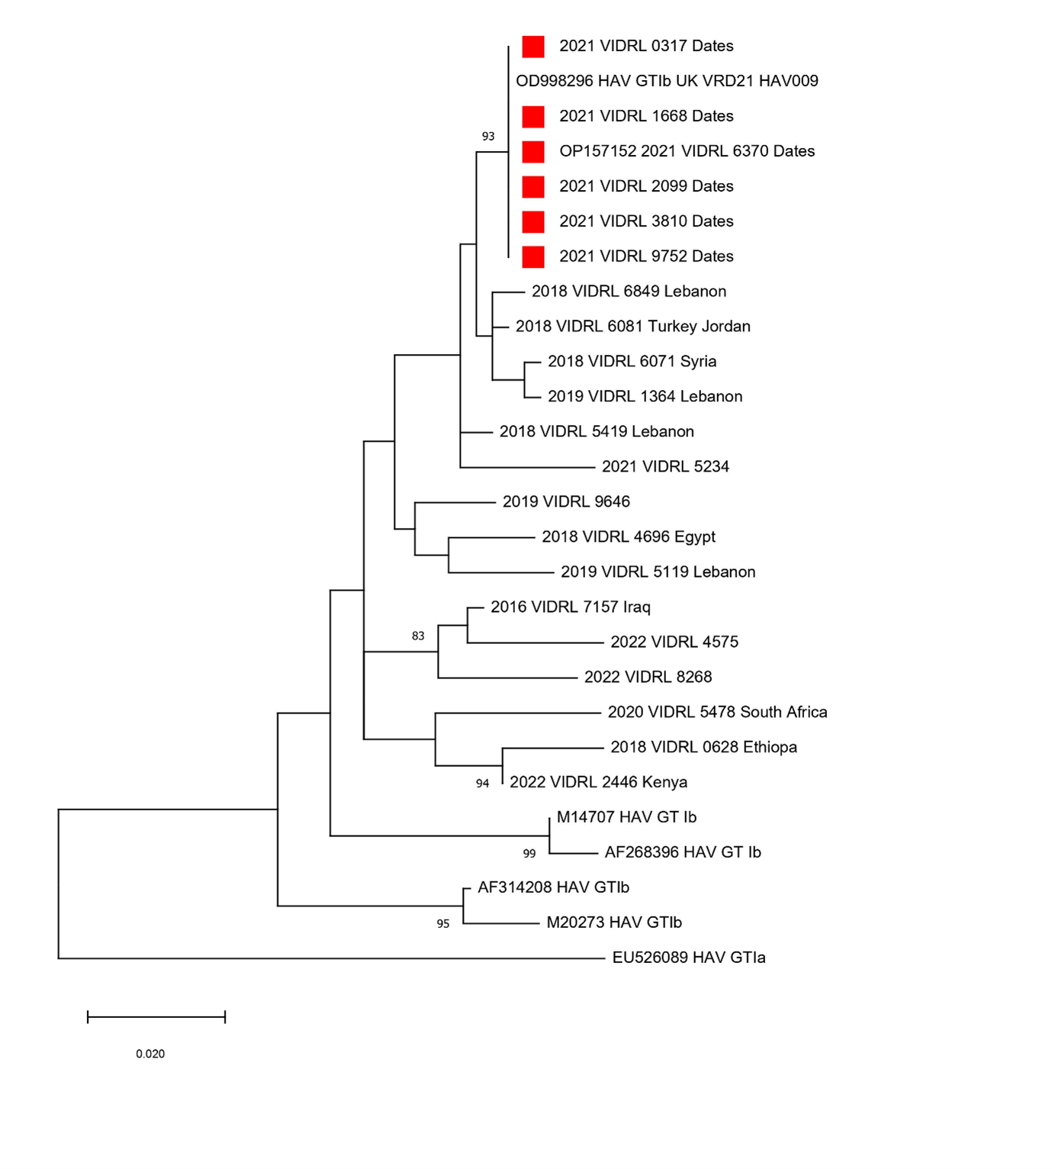
a The tree was generated using the T92 + G substitution model, with 1,000 bootstrap replicates using MEGAX.19 Significant bootstrap values (> 70%) are reported. Accession numbers of the sequences downloaded from Genbank are indicated on the tree, including the reference sequence from the UK date outbreak (OD998296 HAV GTIb UK VRD21 HAV009). The HAV sequences isolated at VIDRL have the country of origin indicated (where known) and the six NSW and ACT outbreak sequences are denoted with a red square.

Outbreak control measures
On 5 August 2021, the Australian importer of the fresh Medjool dates produced in Jordan conducted a consumer-level recall.²² Concurrently, a media release was issued by NSW Health advising the public of the recall, and recommending persons who had consumed the implicated product to watch for symptoms and seek medical attention if these appeared.
The Australian importer of the Jordanian product distributed the recalled batch of dates into New South Wales and Victoria. As there was one outbreak case in the Australian Capital Territory, who reported consuming dates purchased from a store within the ACT only, it is thought that these dates may have been distributed to the ACT through an unidentified third party.
As the product had been imported into Australia, the (then) Australian Government Department of Agriculture, Water and the Environment (DAWE) was advised of the outbreak, through the Bi-National Food Safety Network (BFSN). To minimise the risk of additional hepatitis A infections, on 6 August 2021 DAWE placed a holding order on Medjool dates imported from the Jordanian supplier under the Imported Food Control Act 1992.²³ This meant that, upon import into Australia, any future consignments of dates sourced from this Jordanian supplier would be held at the Australian border until the competent government authority in Jordan provided assurance that the risk of HAV contamination posed by the dates had been mitigated. That holding order has since been lifted.

Discussion
Between 1 June and 30 September 2021, six cases of hepatitis A were linked to this outbreak from two jurisdictions in Australia. All cases were genotype IB, had an identical genetic sequence, and reported consuming Medjool dates during their exposure period. Four of the six cases reported either eating the implicated brand of dates, or consuming dates purchased from a venue which sold the implicated brand. A sample of the implicated brand of dates also had HAV detected by RT-PCR. A range of outbreak control measures were initiated, including a consumer-level recall for the implicated brand of Medjool dates, an emergency holding order for the food product to stop additional product being imported, and a public media alert warning people against consumption of the dates.
The speed at which the source was identified was assisted by two key factors. Firstly, the outbreak occurred when Australian borders were closed to the majority of international visitors as a response to controlling the COVID-19 pandemic risk. Without the usual occurrence of hepatitis A infections in people infected overseas, this spatiotemporal cluster of cases had a higher than usual index of suspicion that infections were caused by a contaminated food source available in Australia. Secondly, the recent publication of a report regarding an outbreak of hepatitis A in England and Wales linked to imported dates from Jordan had alerted Australian public health investigators to the possibility of imported dates as a possible source.¹³ The publication prompted a review of the national surveillance questionnaire for hepatitis A, in which a question about date consumption was immediately added.²⁴ Without the rapid outbreak publication in Eurosurveillance written by international colleagues,¹³ the link to dates among the Australian cases may not have been identified quickly, which could have prolonged public exposure to the source. This demonstrates the benefit to the international public health community of sharing outbreak investigation findings through formal publications, in addition to the deposition of sequence data into public genome databases, especially with increasing levels of globalised food supply.
One significant finding in this outbreak investigation was the fact that the HAV outbreak strain linked to dates in Australia was identical to the HAV outbreak reference strain linked to dates in England and Wales. Upon notification of this finding, Australian investigators engaged the Public Health England investigating team to determine how the two clusters might be linked; unexpectedly, no common grower, manufacturer or importer could be identified. Jordanian authorities advised that the batches of dates implicated in each outbreak had been picked and processed months apart, and had come from different farms along the Jordan River. One possible explanation for the common strain in different outbreaks caused by the same food product is that this represents an endemic, circulating strain in the country of origin. Alternatively, there may be an unidentified common source between these farms, such as ongoing person-to-person transmission among date harvesters. As the source has not been identified, there remains an ongoing risk that outbreaks linked to HAV-contaminated dates may occur in other markets.
There were some limitations in this outbreak investigation. Firstly, the inability to sequence the positive date sample meant that human sequences were unable to be genetically linked to the implicated food product. HAV is notoriously difficult to detect in food because of low levels of contamination, and because many food matrices contain substances that are inhibitory to RT-PCR;²⁵ thus to maximise the chances of detecting HAV in the dates in this investigation, the date samples were first rinsed and the rinsate tested. Despite an inability to perform sequencing, the detection of HAV in the date sample, in addition to confirmation of date consumption by all six cases, meant that there was sufficient epidemiological evidence to initiate a product recall. Another key limitation in this investigation was the fact that only one date sample was tested.
There are also several limitations to consider in assessing the magnitude and duration of this outbreak. The magnitude may have been underestimated considering some individuals infected with hepatitis A remain asymptomatic and therefore are not tested; although greater than 70% of adults infected with hepatitis A present with symptoms, most cases less than six years old are asymptomatic.⁷ Additionally, altered healthcare-seeking behaviour influenced by the COVID-19 pandemic could have had a similar effect. The perceived risk of acquiring COVID-19 may have meant patients were less likely to present to medical services for diagnosis and treatment of non-COVID disorders; this impact was not limited to patients with infectious diseases, but also patients with malignancies, surgical issues, trauma, stroke, and acute coronary syndromes.^{26,27} In assessing this outbreak’s duration, it is important to note that the potential for further cases remains. Despite the initiation of outbreak control measures, it is possible the product is being kept in fridges and freezers and the contaminated product could be consumed months after the recall. Furthermore, because the dates are a minimally-processed food product, able to be consumed fresh, this means that the risk of viral exposure is greater than if it were a product requiring further cooking or heating. Consequently, clinical suspicion and patient assessment in future locally-acquired hepatitis A cases should encompass questioning regarding Medjool date consumption.
Previous hepatitis A outbreaks in Australia have been associated with imported food products,^{3,10} and with specific populations including Aboriginal and Torres Strait Islander individuals,²⁸ homeless youth and injecting drug users,²⁹ and MSM.³⁰ In Australia, the risk of outbreak propagation by imported foods is controlled through legislation, with the Imported Food Control Act 1992 requiring imported foods to be safe for human consumption and compliant with Australia’s food standards. To verify the safety and compliance of imported food, DAFF operates a risk-based border inspection scheme, with high-risk food subject to greater scrutiny. Foods that Food Standards Australia New Zealand (FSANZ) has advised pose a potential medium or high risk to public health are classified as ‘risk foods’ and listed in the Imported Food Control Order 2019 (Cth).^{31,32} Some examples of these foods include ready-to-eat frozen pomegranate arils and ready-to-eat frozen berries, which have previously been associated with hepatitis A outbreaks in Australia.^{3,11,12}
Considering outbreaks in both Australia and the United Kingdom linked to Medjool dates, the authors recommend that further investigations are required to understand the food safety risks associated with fresh Medjool dates and that consideration of additional risk management measures in Australia regarding the importation of Medjool dates may be required.
In conclusion, this report details a locally-acquired outbreak of hepatitis A likely caused by consumption of imported Medjool dates. It highlights how the sharing of foodborne outbreak information at an international level can assist investigations at a local level. Similarly, it demonstrates the value of genomic sequences being accessible internationally to facilitate rapid identification of an outbreak source locally. Lastly, it affirms that there should continue to be a high index of suspicion for imported minimally-processed food products as the potential causative agents in future hepatitis A outbreaks in Australia, and highlights Medjool dates as a new potential risk food for hepatitis A transmission.

Acknowledgments
The authors acknowledge the interviewing and investigating of cases completed by Public Health staff in NSW and the ACT. We also acknowledge the efforts of the NSW Department of Primary Industries Biosecurity and Food Safety, ACT Health Food Safety, Food Safety Australia New Zealand (FSANZ), and DAFF for their work in investigating the importation of the food product, and NMI staff whom carried out testing of the food products. We also acknowledge the assistance of Public Health England for providing information on their early 2021 outbreak and traceback findings.

Author details
Ms Caitlin O’Neill¹ Mr Neil Franklin¹ Mr Alan Edwards² Ms Tania Martin³ Ms Jacinta O’Keefe⁴ Dr Kathy Jackson⁴ Dr Nevada Pingault⁵ Ms Keira Glasgow¹
- Health Protection NSW, NSW Ministry of Health, Sydney, Australia
- Biosecurity and Food Safety, NSW Department of Primary Industries, Sydney, NSW
- Department of Agriculture, Fisheries and Forestry, Canberra, Australia
- Victorian Infectious Diseases Reference Laboratory, Royal Melbourne Hospital, Doherty Institute for Infection and Immunity, Vic, Australia
- Communicable Disease Control, Health Protection Service, ACT Health, Canberra, Australia

Corresponding author
Ms Caitlin O’Neill
1 Reserve Rd St Leonards NSW 2065 Australia
Phone: 0421 243 310
Email: Caitlin.ONeill1@health.nsw.gov.au

References
- Lai M, Chopra S. Hepatitis A virus infection in adults: Epidemiology, clinical manifestations, and diagnosis. [Internet.] Alphen aan den Rijn (Netherlands): Wolters Kluwer NV, UpToDate.com; 26 January 2022. [Accessed on 1 May 2022.] Available from: https://www.uptodate.com/contents/hepatitis-a-virus-infection-in-adults-epidemiology-clinical-manifestations-and-diagnosis.
- New South Wales Government Department of Health (NSW Health). Hepatitis A control guideline. [Internet.] Sydney: NSW Health; 2021. [Accessed on 15 April 2022.] Available from: https://www.health.nsw.gov.au/Infectious/controlguideline/Pages/hepa.aspx.
- Franklin N, Camphor H, Wright R, Stafford R, Glasgow K, Sheppeard V. Outbreak of hepatitis A genotype IB in Australia associated with imported frozen pomegranate arils. Epidemiol Infect. 2019;147:e74. doi: https://doi.org/10.1017/S0950268818003515.
- World Health Organisation (WHO). Hepatitis A. [Internet.] Geneva: WHO; 2022. [Accessed on 1 May 2022.] Available from: https://www.who.int/news-room/fact-sheets/detail/hepatitis-a.
- Klevens RM, Miller JT, Iqbal K, Thomas A, Rizzo EM, Hanson H et al. The evolving epidemiology of hepatitis A in the United States: incidence and molecular epidemiology from population-based surveillance, 2005–2007. Arch Intern Med. 2010;170(20):1811–8. doi: https://doi.org/10.1001/archinternmed.2010.401.
- NNDSS Annual Report Working Group. Australia’s notifiable disease status, 2016: annual report of the National Notifiable Diseases Surveillance System. Commun Dis Intell (2018). 2021;45. https://doi.org/10.33321/cdi.2021.45.28.
- Public Health England (PHE). Hepatitis A: guidance, data and analysis. [Internet.] London: United Kingdom Government Department of Health and Social Care, PHE; June 2021. [Accessed on 1 May 2022.] Available from: https://www.gov.uk/government/collections/hepatitis-a-guidance-data-and-analysis.
- Australian Government Department of Health and Aged Care. Australian Immunisation Handbook: Hepatitis A. [Internet.] Canberra: Australian Government Department of Health and Aged Care, Australian Immunisation Handbook; 3 June 2020. [Accessed on 30 April 2022.] Available from: https://immunisationhandbook.health.gov.au/vaccine-preventable-diseases/hepatitis-a.
- Conaty S, Bird P, Bell G, Kraa E, Grohmann G, McAnulty J. Hepatitis A in New South Wales, Australia, from consumption of oysters: the first reported outbreak. Epidemiol Infect. 2000;124(1):121–30. doi: https://doi.org/10.1017/s0950268899003386.
- Donnan EJ, Fielding JE, Gregory JE, Lalor K, Rowe S, Goldsmith P et al. A multistate outbreak of hepatitis A associated with semidried tomatoes in Australia, 2009. Clin Infect Dis. 2012;54(6):775–81. doi: https://doi.org/10.1093/cid/cir949.
- NSW Health. Communicable Diseases Weekly Report: Week 7, 9 to 15 February 2015. Sydney: NSW Health; February 2015. [Accessed on 1 May 2022.] Available from: https://www.health.nsw.gov.au/Infectious/Reports/Publications/cdwr/2015/CDWR-Week7-2015.pdf.
- NSW Health. Communicable Diseases Weekly Report: Week 23, 04 to 10 June 2017. Sydney: NSW Health; June 2017. [Accessed on 1 May 2022.] Available from: https://www.health.nsw.gov.au/Infectious/Reports/Publications/cdwr/2017/CDWR-Week23-2017.pdf.
- Vilaplana TG, Leeman D, Balogun K, Ngui SL, Phipps E, Khan WM et al. Hepatitis A outbreak associated with consumption of dates, England and Wales, January 2021 to April 2021. Euro Surveill. 2021;26(20):2100432. doi: https://doi.org/10.2807/1560-7917.ES.2021.26.20.2100432.
- Australian Government Department of Health and Aged Care. Hepatitis A case definition. [Internet.] Canberra: Australian Government Department of Health and Aged Care; 20 December 2012. [Accessed on 30 April 2022.] Available from: https://www1.health.gov.au/internet/main/publishing.nsf/Content/cda-surveil-nndss-casedefs-cd_hepa.htm.
- Victorian Infectious Diseases Reference Laboratory (VIDRL). Hepatitis A Virus PCR. [Internet.] Melbourne: Peter Doherty Institute for Infection and Immunity, VIDRL; 2022. [Accessed on 1 May 2022.] Available from: https://www.vidrl.org.au/resources/test-handbook/tests/hepatitis-a-virus-pcr/.
- Rijksinstituut voor Volksgezondheid en Milieu (RIVM). Typing protocol HAVNET VP1P2A. [Internet.] Bilthoven: Government of the Netherlands, Ministry of Health Welfare and Sport, National Institute for Public Health and the Environment (RIVM); 10 October 2014. [Accessed on 1 May 2022.] Available from: https://www.rivm.nl/documenten/typing-protocol-havnet-vp1p2a.
- Benson DA, Clark K, Karsch-Mizrachi I, Lipman DJ, Ostell J, Sayers EW. GenBank. Nucleic Acids Res. 2014;42(Database issue):D32–7. doi: https://doi.org/10.1093/nar/gkt1030.
- Katoh K, Misawa K, Kuma K, Miyata T. MAFFT: a novel method for rapid multiple sequence alignment based on fast Fourier transform. Nucleic Acids Res. 2002;30(14):3059–66. doi: https://doi.org/10.1093/nar/gkf436.
- Kumar S, Stecher G, Li M, Knyaz C, Tamura K. MEGA X: molecular evolutionary genetics analysis across computing platforms. Mol Biol Evol. 2018;35(6):1547–9. doi: https://doi.org/10.1093/molbev/msy096.
- International Organisation for Standardisation (ISO). Microbiology of food and animal feed — Horizontal method for determination of hepatitis A virus and norovirus in food using real-time RT-PCR — Part 1: Method for quantification. [Internet.] Geneva: ISO; 2012. [Accessed on 22 July 2022.] Available from: https://www.iso.org/obp/ui/#iso:std:iso:ts:15216:-1:ed-1:v2:en.
- Williams D. Hepatovirus A partial VP1/2A gene for polyprotein, capsid protein VP1 and 2A self-cleaving peptide region, isolate VRD21_HAV009. [Internet.] Bethesda: United States National Library of Medicine, Netional Center for Biotechnology Information; 5 May 2021. [Internet.] [Accessed on 12 May 2022.] Available from: https://www.ncbi.nlm.nih.gov/nuccore/OD998296.1.
- Food Standards Australia New Zealand (FSANZ). Jordan River Dates 1kg & 5kg. [Internet.] Canberra: FSANZ; 5 August 2021. [Accessed on 30 April 2022.] Available from: https://www.foodstandards.gov.au/industry/foodrecalls/recalls/Pages/Jordan-River-Dates-1kg-&-5kg.aspx.
- Australian Government Federal Register of Legislation. Imported Food Control Act 1992. [Legislation.] Canberra: Australian Government; 26 March 2021. [Accessed on 1 May 2022.] Available from: https://www.legislation.gov.au/Details/C2021C00157.
- NSW Health. NSW Hepatitis A Questionnaire. Sydney: NSW Health; July 2021. [Accessed on 30 April 2022.] Available from: https://www.health.nsw.gov.au/Infectious/controlguideline/Documents/hepa-questionnaire.pdf.
- Williams-Woods J, Hartman G, Burkhardt III W. Bacteriological Analytical Manual Chapter 26B: Detection of Hepatitis A Virus in Foods. [Internet.] Silver Spring: United States Food and Drug Administration; 13 November 2017. [Accessed on 12 May 2022.] Available from: https://www.fda.gov/food/laboratory-methods-food/bam-chapter-26b-detection-hepatitis-virus-foods.
- Sutherland K, Chessman J, Zhao J, Sara G, Shetty A, Smith S et al. Impact of COVID-19 on healthcare activity in NSW, Australia. Public Health Res Pract. 2020;30(4):3042030. doi: https://doi.org/10.17061/phrp3042030.
- Podubinski T, Townsin L, Thompson SC, Tynan A, Argus G. Experience of healthcare access in Australia during the first year of the COVID-19 pandemic. Int J Environ Res Public Health. 2021;18(20):10687. doi: https://doi.org/10.3390/ijerph182010687.
- Menzies R, McIntyre P, Beard F. Vaccine preventable diseases and vaccination coverage in Aboriginal and Torres Strait Islander people, Australia, 1999 to 2002. Commun Dis Intell Q Rep. 2004;28(2):127–59.
- Ferson MJ, Young LC, Stokes ML. Changing epidemiology of hepatitis A in the 1990s in Sydney, Australia. Epidemiol Infect. 1998;121(3):631–6. doi: https://doi.org/10.1017/s0950268898001563.
- Vodstrcil LA, Fairley CK, Williamson DA, Bradshaw CS, Chen MY, Chow EPF. Immunity to hepatitis A among men who have sex with men attending a large sexual health clinic in Melbourne, Australia, 2012–2018. Sex Transm Infect. 2020;96(4):265–70. doi: https://doi.org/10.1136/sextrans-2019-054327.
- Australian Government Federal Register of Legislation. Imported Food Control Order 2019. [Legislation.] Canberra: Australian Government; 25 November 2020. [Accessed on 1 May 2022.] Available from: https://www.legislation.gov.au/Details/F2020C01044.
- Australian Government Department of Agriculture Fisheries and Forestry (DAFF). Import requirements by food type. [Internet.] Canberra: DAFF; 31 January 2022. [Accessed on 1 May 2022.] Available from: https://www.agriculture.gov.au/biosecurity-trade/import/goods/food/type.
Communicable Diseases Intelligence
ISSN: 2209-6051 Online

Communicable Diseases Intelligence (CDI) is a peer-reviewed scientific journal published by the Office of Health Protection and Response, Department of Health and Aged Care. The journal aims to disseminate information on the epidemiology, surveillance, prevention and control of communicable diseases of relevance to Australia.

Editor: Noel Lally
Deputy Editor: Simon Petrie
Design and Production: Kasra Yousefi
Editorial Advisory Board: David Durrheim, Mark Ferson, John Kaldor, Martyn Kirk and Linda Selvey

Website: http://www.health.gov.au/cdi

Contacts
CDI is produced by the Office of Health Protection and Response, Australian Government Department of Health and Aged Care, GPO Box 9848, (MDP 6) CANBERRA ACT 2601

Email: cdi.editor@health.gov.au

Submit an Article
You are invited to submit your next communicable disease related article to the Communicable Diseases Intelligence (CDI) for consideration. More information regarding CDI can be found at: http://health.gov.au/cdi.
Further enquiries should be directed to: cdi.editor@health.gov.au.

This journal is indexed by Index Medicus and Medline.

Creative Commons Licence - Attribution-NonCommercial-NoDerivatives CC BY-NC-ND
© 2022 Commonwealth of Australia as represented by the Department of Health and Aged Care
This publication is licensed under a Creative Commons Attribution-NonCommercial-NoDerivatives 4.0 International Licence from https://creativecommons.org/licenses/by-nc-nd/4.0/legalcode (Licence). You must read and understand the Licence before using any material from this publication.

Restrictions
The Licence does not cover, and there is no permission given for, use of any of the following material found in this publication (if any):
- the Commonwealth Coat of Arms (by way of information, the terms under which the Coat of Arms may be used can be found at www.itsanhonour.gov.au);
- any logos (including the Department of Health and Aged Care’s logo) and trademarks;
- any photographs and images;
- any signatures; and
- any material belonging to third parties.

Disclaimer
Opinions expressed in Communicable Diseases Intelligence are those of the authors and not necessarily those of the Australian Government Department of Health and Aged Care or the Communicable Diseases Network Australia. Data may be subject to revision.

Enquiries
Enquiries regarding any other use of this publication should be addressed to the Communication Branch, Department of Health and Aged Care, GPO Box 9848, Canberra ACT 2601, or via e-mail to: copyright@health.gov.au

Communicable Diseases Network Australia
Communicable Diseases Intelligence contributes to the work of the Communicable Diseases Network Australia.
http://www.health.gov.au/cdna

