Communicable Diseases Intelligence, Year 2023, Volume 47
https://doi.org/10.33321/cdi.2023.47.71
Publication date: 16/11/2023
http://health.gov.au/cdi

A five-year analysis of latent tuberculosis infection in Queensland, 2016–2020
Marguerite Dalmau, Chris Coulter, Bridget O’Connor, Jennifer Robson, Emma Field, Stephen Lambert

Abstract

Background
Australia is aiming to reach tuberculosis pre-elimination targets by 2035. As a low-incidence setting, control efforts will increasingly rely on the management of latent tuberculosis infection (LTBI). We undertook this descriptive analysis to assess the recent trends of LTBI testing in Queensland.

Methods
Our objective was to describe the features of LTBI testing in Queensland, and to estimate the range of possible annual notifications were it to be made a notifiable condition. We collated both state-wide and region-specific data on tuberculin skin testing (TST) and interferon gamma release assays (IGRA) conducted in Queensland during the five-year period 1 January 2016 – 31 December 2020. We used reports on Medicare-funded TST and IGRA testing in Queensland, as well as tuberculosis notification data, to understand the representativeness of our data and to derive state-wide estimates.

Results
We analysed 3,899 public TST, 5,463 private TST, 37,802 public pathology IGRA, and 31,656 private pathology IGRA results. The median age of people tested was 31 years; 57% of those tested were female. From our data sources, an annual average of 1,067 positive IGRA and 354 positive TST results occurred in Queensland. Building on this minimum value, we estimate possible latent tuberculosis notifications in Queensland could range from 2,901 to 6,995 per annum. Private laboratory TSTs are estimated to contribute the lowest number of potential notifications (range: 170–340), followed by private laboratory IGRA testing (range: 354–922), public laboratory IGRA testing (range: 706–1,138), and public setting TSTs (range: 1,671–4,595).

Conclusion
If LTBI were to be made notifiable, these estimates would place it among the ten most notified conditions in Queensland. This has implications for potential surveillance methods and goals, and their associated system and resource requirements.
Keywords: latent tuberculosis infection; tuberculin skin testing; interferon gamma release assay

Introduction
In 2015, the World Health Organization (WHO) initiated the EndTB Strategy, with targets to reduce global tuberculosis related deaths by 95% and tuberculosis incidence rates by 90% between 2015–2035.¹ In recognition of differing disease contexts, WHO provided an adaptation to the global strategy: a framework for low-incidence countries.² The framework outlines eight priority areas across the political and health sectors and includes a focus on screening for latent tuberculosis infection (LTBI).² As tuberculosis (TB) incidence declines, the progress and ultimate success of TB control efforts will increasingly rely on the epidemiology and control of LTBI.³
LTBI is defined as ‘a state of persistent immune response to prior acquired Mycobacterium tuberculosis (Mtb) antigens without evidence of clinically manifested active tuberculosis’.⁴ LTBI represents part of a dynamic spectrum, rather than a specific entity, and is clinically undetectable.⁵ Routine tests for investigating latent tuberculosis are in fact tests to measure immunoreactivity to Mycobacterium tuberculosis antigens and these tests cannot distinguish whether dormant viable infection is present or not. Nonetheless, the term LTBI is firmly established in the global literature and has accepted meaning. Recent studies estimate a quarter of the global population to be latently infected with TB.^{3,6} Estimates on the lifetime risk of TB following latent infection vary, with the greatest risk occurring in the first five years following infection.⁷ In Australia, risk of disease progression has been estimated to be as high as 14.5% in close contacts of individuals with active pulmonary TB.⁸
As a low-incidence country for TB, Australia is moving towards pre-elimination targets (< 1 case of TB per 100,000 population per year) by 2035.⁹ In line with the WHO framework for low-incidence settings, Australian states and territories follow systematic LTBI testing and treatment regimens for individuals at the highest risk for developing TB.⁵ The National Tuberculosis Advisory Committee (NTAC) recommends LTBI testing in the following groups:⁵
- people identified by contact tracing;
- migrants with a history of TB contact in the last two years;
- migrants from high-incidence countries younger than 35 years of age (or 35 years and older with one or more risk factors);
- people living with human immunodeficiency virus (HIV);
- patients initiating anti-tumour necrosis factor-α (anti-TNFα) treatment;
- patients preparing for organ transplantation; and
- people who worked for a prolonged period in a healthcare setting in a high-incidence country.
Tuberculin skin tests (TST) or interferon gamma release assays (IGRA) are used to screen for LTBI in Australia. Both tests demonstrate immune sensitisation to Mtb and diagnosis requires medical review to exclude active TB.⁵
While systematic testing plays an important role, there is currently no centralised national surveillance process to monitor LTBI testing patterns and results, treatment outcomes, or trends in progression to active disease. LTBI is not currently listed on the National Notifiable Disease List (NNDL). This study sought to quantify the impact of LTBI being made a notifiable condition in the state of Queensland.
Improving our understanding of local LTBI testing trends will support discussions on adding the condition to jurisdictional notifications lists and the NNDL. We undertook this descriptive analysis to assess the recent (five-year) trends of LTBI testing in Queensland. Our objective was to describe the features of LTBI testing in Queensland, and to estimate the range of possible annual notifications were it to be made a notifiable condition.

Methods
In Queensland, the public health management of people with, or people suspected to have, tuberculosis is performed by regional tuberculosis control units (TBCU).¹⁰ TBCUs and some private pathology providers administer TSTs, and IGRAs are performed by both private and public pathology providers. Both tests incur a fee which may be eligible for a Medicare rebate when aligned with NTAC indications for screening. Medicare Benefits Schedule (MBS) item numbers 69471 and 73811 represent clinician-requested IGRA tests and TST respectively.^{11,12} Neither test alone can definitively diagnose LTBI, however, positive tests provide a reference for the purpose of predicting possible LTBI notifications.

Study population and data sources
Our descriptive analysis drew on multiple data sources to build a representative summary of LTBI in Queensland (Table 1). We collated both state-wide and region-specific data that collectively included: people with a recorded TST or IGRA test; people with a positive Mtb nucleic acid test or culture isolate; people notified with laboratory confirmed or clinically confirmed TB; and aggregated reports of Medicare-funded TST and IGRA tests in Queensland in the study period.¹³
Table 1: Summary of study data by source and population
Source | Description | Population/data ª
Public laboratory service | Pathology Queensland’s integrated laboratory information system | People with a recorded IGRA test  People with a positive Mycobacterium tuberculosis nucleic acid test or culture isolate
Private laboratory | Large private pathology provider in Queensland | People with a recorded IGRA test  People with a recorded TST
Tuberculosis control unit (TBCU) | Participating TBCU from Northern Queensland | People with a recorded TST
Medicare | Clinician-requested tests funded by the Australian Government | Publicly available aggregated reports for Medicare Benefits Schedule item numbers 69471 (IGRA) and 73811 (TST)
Notifiable Conditions System (NoCS) | Queensland’s database to store notifiable disease case information under the Public Health Act 2005 ¹⁴ | People notified with laboratory confirmed or clinically confirmed tuberculosis
a IGRA: interferon gamma release assay; TST: tuberculin skin test.
We used TST and IGRA testing data to describe the characteristics of latent tuberculosis testing in Queensland and remaining data sources to inform estimations of annual counts were the condition to be notifiable. Data were supplied for the study period of 1 January 2016 – 31 December 2020. Data supplied by Pathology Queensland, the only public diagnostic laboratory service in Queensland, represent all publicly performed tests, whereas data supplied by the private laboratory likely represent 50% of privately performed testing in Queensland.

Variables
Data variables include unique person identifier codes; key demographic variables; test or notification date; and test result and/or interpretation. Age (years) and age group variables were derived from date of birth and date of test collection fields. Sex was categorised as a dichotomous variable of male or female, based on the data supplied. Geographic identifiers (of either postcode or suburb, or a combination of both when available) were aligned to an internal list of Hospital and Health Services (HHS) and were used to allocate individuals to an associated TBCU.
IGRA test interpretations were provided and categorised as positive, negative, and indeterminate. An indeterminate result is given when the response to the specific mycobacterial antigens cannot be interpreted. This is due to an inadequate mitogen response or when the nil response is high. TST results were provided as a measurement of induration in mm and an interpretation. The cut-off values of induration to classify TST results depend on a person’s indications for screening or associated health status, and the interpretations were therefore used for analysis. For public TST data, the interpretations of ‘sent for medical review’ or ‘not sent for medical review’ were re-classified as positive and negative to align with IGRA results. For private TST data, the outcomes of ‘weak’, ‘intermediate’, and ‘strong’ positives were re-classified as positive for the same purpose. TST data were analysed by reason for screening where available.
Duplicate records and records with incomplete sex, date of birth, collection date, test result, or interpretation fields were excluded. Repeat IGRA tests for the same individual, with the same result, where these could be identified, were excluded and only the earliest test retained. TSTs administered by the TBCU were provided as multiple data points for one individual. Data were therefore limited to the final TST read and interpretation. We could not account for duplicate testing of individuals across public and private facilities, although this would be possible were LTBI made a notifiable condition. Where available within Pathology Queensland data, people with a positive Mtb nucleic acid test result or culture isolate prior to IGRA testing, or within three months post-IGRA testing, were excluded from the analysis. We could not make the same exclusions for private laboratory or TST results as we did not have the required data to match individuals with notifiable cases of active TB.

Descriptive analysis
We calculated descriptive statistics for all TST and IGRA results. Counts, proportion by sex, proportion by result, and median age were calculated. Age and sex distribution of positive results were calculated and visualised. Where available, results were further analysed by indication for screening.

State-wide annual estimates
We used multiple methods to estimate annual possible LTBI notifications in Queensland (Table 2). Upper range estimates included all positive and indeterminate IGRA or TST results. Lower range estimates excluded indeterminate IGRAs and those used for screening children under five years of age as test sensitivity and specificity is unknown in this age group.¹⁵ The proportion of Pathology Queensland results that were excluded as TB disease was applied to the private laboratory IGRA lower estimate.

Table 2: Overview of calculations made to derive state-wide estimates
Data source ª | Estimate | Summary of calculations made to reach estimates ª
Public TST | Upper | Average annual TSTs sent for medical review by participating TBCU  Applied proportion of positive/indeterminate IGRA results (4% = x25)
 | Lower | Average annual TSTs sent for medical review by participating TBCU  Applied proportion of tuberculosis notifications (11% = x9.09)
Private TST | Upper | Average annual TSTs sent for medical review by participating laboratory  Applied likely representation of state-wide private laboratory data (50% = x2)^{b}
 | Lower | Average annual TSTs sent for medical review by participating laboratory
Public IGRA | Upper | Average annual Pathology Queensland positive and indeterminate results
 | Lower | Average annual Pathology Queensland positive results only (excluded indeterminate)  Excluded children < 5 years of age
Private IGRA | Upper | Average annual positive and indeterminate results  Applied likely representation of state-wide private laboratory data (50% = x2)^{b}
 | Lower | Average annual positive results only (excluded indeterminate)  Applied 0.4% results representing Mtb as per Pathology Queensland data (x0.996)  Excluded children < 5 years of age
a TST: tuberculin skin test; TBCU: tuberculosis control unit; IGRA: interferon gamma release assay; Mtb: Mycobacterium tuberculosis.
b The estimate that our data likely represent 50% of private pathology tests in Queensland is due to the context of private laboratory testing in Queensland. Two main laboratory services provide testing for LTBI. The limitations of this approach are acknowledged in the Discussion.
We compared the number of tests in our private laboratory data with those identified through Medicare reporting. To estimate the proportion of state-wide tests represented by the private laboratory, we applied a likely estimate that our study data represents 50% of all private pathology IGRA and TSTs performed in Queensland. This was applied to the upper estimates of private IGRA and TST data. Our public TST data represented one TBCU. We used a breakdown of TB notifications by TBCU as well as a breakdown of positive and indeterminate IGRA results by TBCU to reach upper and lower estimates for public TST data.
All analyses were performed in the statistical software package R, version 4.0.0 (2020-04-24).
This study was approved by the Prince Charles Hospital Research Ethics Committee (TPCH HREC Reference Number: 75998) with acceptance of prior approval by the Australian National University Human Research Ethics Committee. Approvals to release and use study data, with relevant site-specific assessments, were granted according to the Queensland Public Health Act 2005.¹⁴

Results
After all ineligible records (n = 15,779) were excluded (Appendix A), a total of 78,820 results were available for analysis: 3,899 public TST; 5,463 private TST; 37,802 public pathology IGRA; and 31,656 private pathology IGRA results. The number of tests recorded each study year were 12,355 (2016); 13,329 (2017); 15,119 (2018); 15,906 (2019); and 22,111 (2020). The number of recorded IGRA tests in 2020 (n = 21,175) was approximately 1.5 times greater than IGRA tests recorded in 2019 (n = 14,034). Tuberculin skin tests in 2020 (n = 936) halved compared with 2019 (n = 1,872).

Descriptive analysis of LBTI
The median age of people tested was 31 years; 57% were female (Table 3). The proportion of positive tests ranged from 6% to 9% for private and public IGRA tests respectively, and 16% to 24% for private and public TST respectively.
Females accounted for 55% (n = 3,874) of positive IGRA and TST results (n = 7,105; Figure 1). Positive results were reported across the lifespan; people aged 30–34 years accounted for the highest proportion of positive tests by age group (n = 762; 11%).
Data on reason for screening were available for 3,897 public TST results (Table 4). The most common reason for screening was as a part of TB contact tracing measures (n = 1,707), followed by health care worker screening (n = 1,153). For these screening categories, the proportion of positive tests was 22% (n = 373) and 17% (n = 195), respectively. The proportion of positive tests were highest for refugee screening (53%, n = 311) and rheumatology review (33%, n = 7).
Figure 1: Age and sex distribution of positive tuberculin skin test (TST) and interferon gamma release assay (IGRA) tests in Queensland, 2016–2020 (n = 7,105) ª
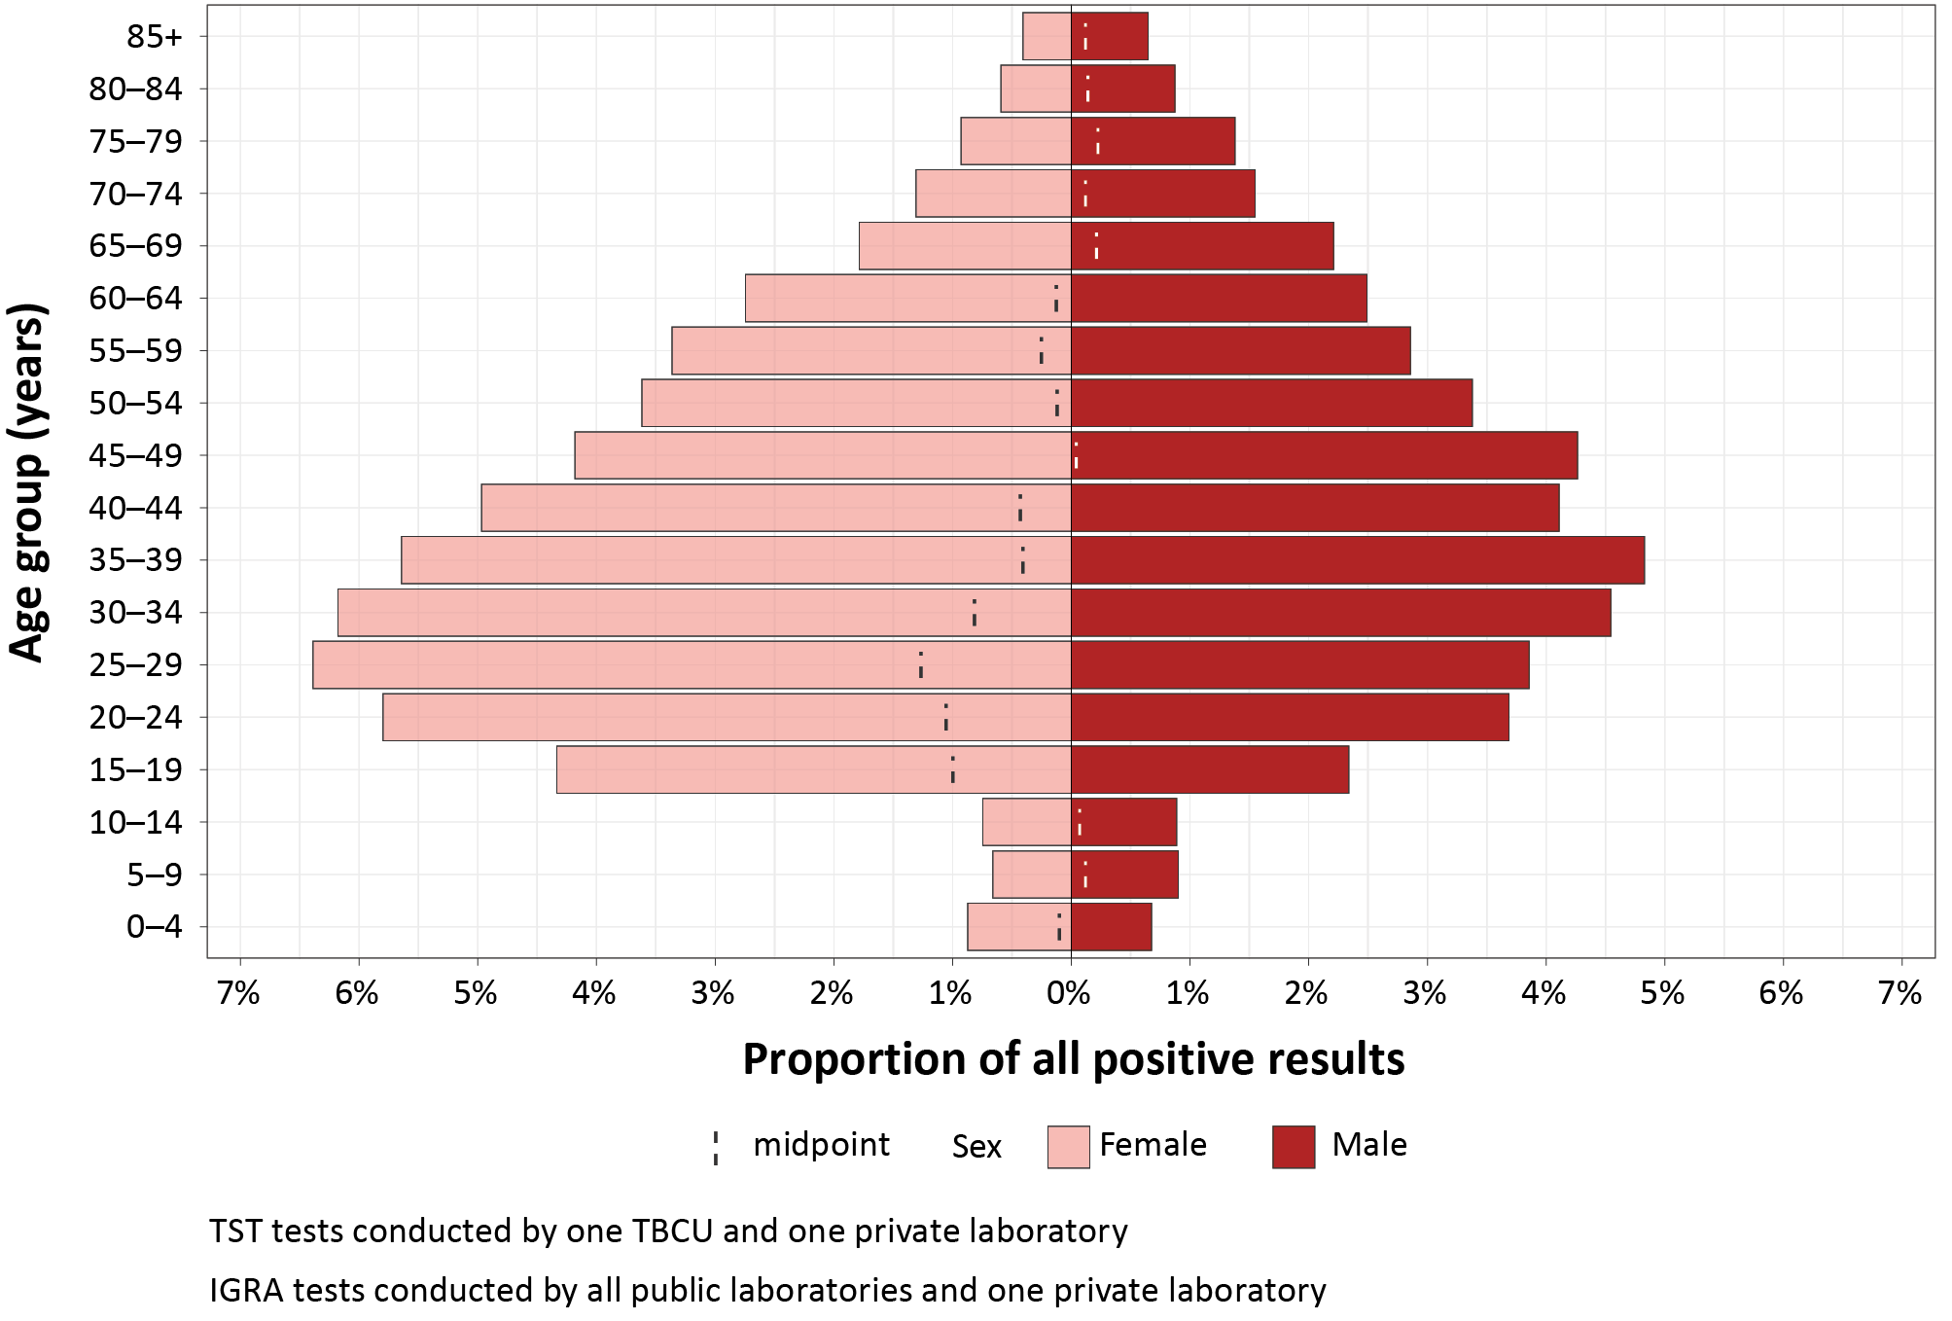
a TBCU: tuberculosis control unit.
Table 3: Descriptive analysis of available tuberculin skin test (TST) and interferon gamma release assay (IGRA) test results in Queensland, 2016–2020
Data source | Tests (n) | Average annual tests (n) | Median age (years) | Male |  | Female |  | Positive result |  | Indeterminate result |  | Negative result
 |  |  |  | (n) | (%) | (n) | (%) | (n) | (%) | (n) | (%) | (n) | (%)
Public TSTs ª | 3,899 | 780 | 26 | 1,521 | 39 | 2,378 | 61 | 919 | 24 | N/A | N/A | 2,980 | 76
Private TSTs ^{b} | 5,463 | 1,093 | 24 | 1,339 | 25 | 4,124 | 75 | 849 | 16 | N/A | N/A | 4,614 | 84
Public IGRAs ^{c} | 37,802 | 7,560 | 44 | 17,826 | 47 | 19,976 | 53 | 3,548 | 9 | 2,142 | 6 | 32,112 | 85
Private IGRAs ^{d} | 31,656 | 6,331 | 36 | 13,530 | 43 | 18,126 | 57 | 1,789 | 6 | 517 | 2 | 29,350 | 92
Combined | 78,820 | 15,764 | 31 | 34,216 | 43 | 44,604 | 57 | 7,105 | 9 | 2,659 | 3 | 69,056 | 87
a Public TST data represent one participating TBCU in Northern Queensland.
b Private TST data represent one participating private pathology provider in Queensland.
c Public IGRA data represent all IGRA tests processed through public laboratory providers in Queensland.
d Private IGRA data represent one participating private pathology provider in Queensland.
Table 4: Tuberculin skin test results by indication for screening (n = 3,897)
Indication for screening ª | Tests (n) | Positive result
 |  | (n) | (%)
Contact tracing | 1,707 | 373 | 22
Health care worker | 1,153 | 195 | 17
Refugee | 591 | 311 | 53
Pre BCG vaccination | 281 | 12 | 4
Traveller | 64 | 8 | 13
Other | 38 | 5 | 13
TB investigation | 22 | 6 | 27
Rheumatology | 21 | 7 | 33
Defence personnel | 10 | 0 | 0
Employment | 4 | 0 | 0
Health undertaking | 4 | 0 | 0
HIV screening | 1 | 0 | 0
Migrant | 1 | 0 | 0
a BCG: bacille Calmette-Guérin; HIV: human immunodeficiency virus.

Estimates of LTBI notifications
From the data available to us for this analysis, an annual average of 1,067 positive IGRA and 354 positive TST results were reported, for a total of 1,421 positive results per year. This number represents an absolute minimum value of possible annual LTBI notifications in Queensland, before extrapolation to calculate statewide upper and lower estimates.
Results excluded from Pathology Queensland IGRA testing data due to a matched TB result prior (n = 48) and within three months post-test (n = 132) represented 0.4% of all results prior to exclusion. The private IGRA and TST results provided for this study represented 103% and 162% of Medicare-funded tests reported in Queensland for the same period, respectively. TB notifications reported by the participating TBCU in the study period represented 11% of state-wide notifications. Positive and indeterminate IGRA test results attributed to the participating TBCU accounted for 4% of all positive and indeterminate results. As described (Table 2), these proportions were applied to reach upper and lower statewide estimates.
Using the methods described, the estimated number of possible latent tuberculosis notifications in Queensland ranges from 2,901 to 6,995, annually (Figure 2). Private tuberculin skin testing is estimated to contribute the lowest number of potential notifications (range: 170–340), followed by private IGRA testing (range: 354–922), public IGRA testing (range: 706–1,138), and public tuberculin skin testing (range: 1,671–4,595).
Figure 2: Upper and lower estimates of possible latent tuberculosis infection (LTBI) notifications annually by notification source in Queensland ^{a,b,c}
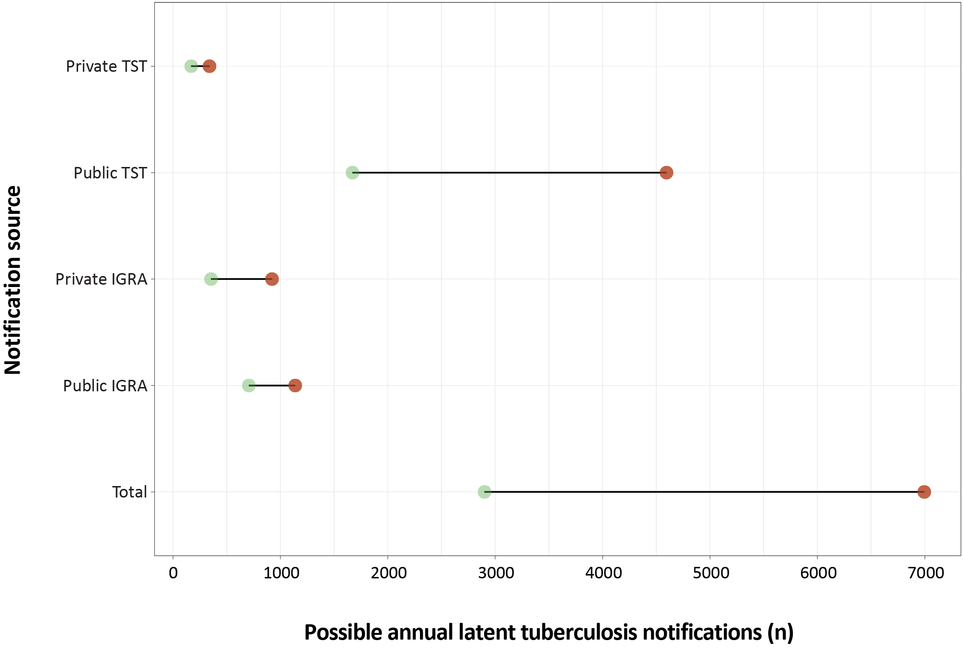
a TST: tuberculin skin test; IGRA: interferon gamma release assay.
b Lower estimates marked by green point. Upper estimates marked by red point.
c Private IGRA and TST upper estimates calculated by using likely represented proportion of state-wide results (50%). Public TST lower estimates calculated by using the proportion of positive and indeterminate IGRA results by the participating tuberculosis control unit (TBCU) to state-wide positive and indeterminate IGRA results (4%). Public TST upper estimates calculated by using the proportion of tuberculosis notifications by the participating TBCU to state-wide notifications (11%).

Discussion
Our study describes the features of TST and IGRA testing from available Queensland datasets during the years 2016–2020. From the included data sources, an annual average of 1,421 positive IGRA and TST results occurred. Using this minimum value and the estimation methods described, we extrapolated the range of possible annual state-wide LTBI notifications in Queensland to be between 2,901 and 6,995. If made notifiable, these estimates would place LTBI among the ten most notified conditions in Queensland.¹⁶ This has implications for potential surveillance goals and their associated resource requirements.
The first potential surveillance goal is information gathering to inform public health policy. This would focus primarily on case number collation and periodic reporting. From our data, 34–42% of possible LTBI notifications could be identified through pathology providers (IGRA or private TST) and therefore notified via an automated laboratory feed into Queensland’s notifiable conditions system (NoCS). These estimates represent the combined total of private TST, private IGRA, and public IGRA estimates as a proportion of the total estimates (lower and upper). The remaining 58–66% of possible notifications identified through public TST would require an additional administrative workload. This would require either completion and submission of case report forms to the Communicable Diseases Branch or, where possible, entering information directly to NoCS. Of note, our study identified a reduction in TST and increase in IGRA tests between 2019 and 2020. This is likely due to changed testing practices during the coronavirus disease 2019 (COVID-19) pandemic; however, if the trend continues, the proportion of notifications made via an automated laboratory feed could be higher. This surveillance approach facilitates system-wide collection and management of LTBI data not currently possible within existing electronic medical records (EMR) systems. Existing EMR systems were not designed for the collection or analysis of surveillance data. More than a records management solution, an initial data collation focus may help to increase understanding of local LTBI disease burden, to support cross-jurisdictional collaboration, and to facilitate continuity of care for people diagnosed with LTBI.
An extension to data gathering and reporting would be the collection of enhanced surveillance data, either for people meeting specific criteria or for all cases of LTBI. This approach could support surveillance goals to characterise disease risk factors; support public health management of individuals with high risk of progression to active disease; ensure and monitor adequacy of diagnoses and treatment; and provide data for analytic studies to understand LTBI in low-incidence settings. The collection of enhanced surveillance data would not change the current public health management of people diagnosed and treated for LTBI, again adding an administrative requirement to record these data in NoCS. If made notifiable, and if pursuing enhanced case information, there would be a legislative imperative to collect and record these data. It is important that this is supported by adequate resourcing and does not interfere with clinical work. The management of LTBI should not detract from essential TB services, especially not interfering with the early diagnosis and optimal care of those diagnosed with TB. Considerations on the type of information collected would be essential, as well as system capacity to electronically transfer routinely collected data wherever possible. Initial case counting would support preparedness for progression to enhanced surveillance and response activities.
From a national perspective, either surveillance approach would strengthen Australia’s ability to track progress towards TB elimination targets. Surveillance allows estimation of the burden of disease, the ability to identify priority populations, strengthen treatment or other public health interventions, monitor and evaluate interventions or treatment outcomes, and assess disease progression patterns. By listing a condition on the NNDL, the Australian Government Department of Health and Aged Care can identify national trends, develop public policy, allocate health resources appropriately, and track progress towards disease eradication.¹⁷ The CDNA Series of National Guidelines (SoNG) provide nationally consistent advice and guidance for public health professionals to respond to notifiable diseases.¹⁸ If made notifiable, ideally CDNA would approve development of a specific SoNG for LTBI. Such LTBI SoNG development and oversight of monitoring and response activities would be supported by NTAC. NTAC is currently responsible for the Strategic Plan for Control of Tuberculosis, in which management of LTBI has been highlighted as a priority area to maintain preelimination levels of TB.¹⁹
The NTAC position statement on the management of LTBI states that testing should only be on an intention-to-treat basis,⁵ which is important for notifiable disease management. In Japan, where LTBI is notifiable, surveillance data identified the LTBI treatment completion rate to be 71.9%, falling below the national target of 85%.²⁰ It is likely that new, shorter, and better tolerated regimens will improve completion rates. There are risk/benefit comparisons that need to be considered for treatment of LTBI and the surveillance of these data should not detract from the usual core functions of TB control. An assessment and onward treatment algorithm would support the surveillance of treatment outcomes and risk/benefit analyses for notified cases of LTBI. This could be especially pertinent for people with a positive IGRA or TST due to an exposure greater than five years earlier or other low-risk groups.
Our analysis has several limitations. As we were unable to collect data from all TBCUs and private pathology providers, our applied values to reach geographic and state-wide estimates may be inaccurate. Our sub-set study population may systematically differ from the wider Queensland population, introducing an unmeasurable bias. Our TST results showed variability in the proportion of test positivity by indication for screening, with the representativeness of these data unknown. While not analysed in our study, our understanding of indications for screening by private providers are likely to be driven by pre-employment screening requirements. Better understanding of screening indications for IGRA would support interpretation of our work. We faced limitations using MBS testing data to estimate the representativeness of our private pathology data. Not everyone tested by private providers is eligible for a Medicare rebate. While we applied a cautious likely proportion of results represented by our analysed private laboratory data, this may be over- or under-estimated, resulting in a lower or higher than true annual notification estimate. A high number of records from our laboratory TB data were excluded due to incomplete or missing information for matching. The resulting proportion of public IGRA tests excluded as TB may therefore be under-represented. Further, by assigning public TST results ‘sent for medical review’ and ‘weak’ or ‘intermediate’ private TST results as positive, we may have overestimated the number of positive TSTs. However, were the condition to be notifiable, these results would require follow up as possible notifications.
Our study could be expanded by further applying a ‘borderline’ range for IGRA results and specifically, outcomes on re-testing. A recent study from Sweden raises important considerations on the clinical implications of Quantiferon-TB Gold Plus (IGRA) tests with ‘borderline’ results in low endemicity settings.²¹ From 1,254 individuals with such borderline results, 38% were confirmed negative upon retesting. For surveillance purposes, awaiting re-testing of borderline results before collecting enhanced surveillance data could reduce the administrative burden on health staff as well as ensure reversion data are not in the notification process.
Noting these limitations and areas for further analysis, our study is an important contribution to an area not widely researched in Australia. Previous studies have explored LTBI among populations considered to be at higher risk of TB, and only one study has estimated the national prevalence of latent tuberculosis in Australia.²² Using national census data, annual risk of TB infection estimates were applied to population cohorts by country of birth, year of arrival, and age. The estimated proportion of Australian residents with LTBI was 5.1% in 2016.²² Notably, the study estimated an increase from approximately 838,000 people living with LTBI in 2006 to approximately 1,084,000 people in 2016. This increased prevalence equates to an annual average of approximately 24,600 new LTBI cases among the Australian population. In the most recent national surveillance report, notifications of TB in Queensland accounted for 13% of the five-year mean (2013–2017) for nationally notified cases.²³ Applying this value to the paper’s results, Queensland would report approximately 3,200 new LTBI cases per year. While this crude calculation is limited, and recognising that not all cases would be notified, this estimate falls within our possible range of annual values.
In Australia, TB importation from high-incidence countries and high rates of people movement complicate the pathway towards TB elimination.²² The public health management of LTBI is expected to have an impact on the success of tuberculosis control efforts,³ with the acknowledgement that risk of future re-infection adds complexity. While the resource requirements for LTBI surveillance should not be underestimated, it is likely that future improved accuracy of diagnostic testing (e.g., microRNA biomarkers) and shorter, better tolerated antimicrobial regimens will improve the cost effectiveness of an investment in LTBI surveillance as an important component of the public health control of tuberculosis. Our combined analysis of TST and IGRA testing data in Queensland provides a valuable reference for these considerations, and for identifying necessary resourcing requirements to support the future surveillance of LTBI.

Acknowledgements
We are grateful to Pathology Queensland and Sullivan Nicolaides Pathology for their provision of data and contribution to this work. We are grateful to the staff at Cairns and Hinterland Hospital and Health Service and Metro South Hospital and Health Service for their support for this project.

Author details
Ms Marguerite Dalmau^{1,2}
Dr Chris Coulter^{1,3}
Ms Bridget O’Connor¹
Dr Jennifer Robson⁴
Dr Emma Field²
Dr Stephen Lambert^{1,2,5}
- Communicable Diseases Branch, Department of Health, Queensland Health, Brisbane.
- National Centre for Epidemiology and Population Health, Research School of Population Health, The Australian National University, Canberra.
- Queensland Mycobacterium Reference Laboratory, Pathology Queensland, Brisbane.
- Department of Microbiology and Molecular Pathology, Sullivan Nicolaides Pathology, Queensland.
- National Centre for Immunisation Research and Surveillance, Westmead.

Corresponding author
Marguerite Dalmau
Telephone: (07) 3328 9724
Email: meg.dalmau@anu.edu.au

References
- World Health Organization (WHO). The End TB Strategy. Geneva: WHO Global Tuberculosis Programme; 16 August 2015. [Accessed on 28 June 2021.] Available from: https://www.who.int/publications/i/item/WHO-HTM-TB-2015.19.
- WHO. Towards tuberculosis elimination: an action framework for low-incidence countries. Geneva: WHO Global Tuberculosis Programme; 18 March 2014. [Accessed on 26 June 2021.] Available from: https://www.who.int/publications/i/item/9789241507707.
- Houben RMGJ, Dodd PJ. The global burden of latent tuberculosis infection: a re-estimation using mathematical modelling. PLoS Med. 2016;10(13):e1002152. doi: https://doi.org/10.1371/journal.pmed.1002152.
- Queensland Government Department of Health (Queensland Health). Management of Latent Tuberculosis in Adults: Guideline Version 1.0: April 2016. Brisbane: Queensland Health; April 2016. [Accessed on 26 June 2021.] Available from: https://www.health.qld.gov.au/__data/assets/pdf_file/0023/444425/latent-tb-adult.pdf.
- Stock D, National Tuberculosis Advisory Committee. National position statement for the management of latent tuberculosis infection. Commun Dis Intell Q Rep. 2017;41(3):E204–8.
- Cohen A, Mathiasen VD, Schön T, Wejse C. The global prevalence of latent tuberculosis: a systematic review and meta-analysis. Eur Respir J. 2019;54(3):1900655. doi: https://doi.org/10.1183/13993003.00655-2019.
- Dale KD, Karmakar M, Snow KJ, Menzies D, Trauer JM, Denholm JT. Quantifying the rates of late reactivation tuberculosis: a systematic review. Lancet Infect Dis. 2021;21(10):e303–17. doi: https//doi.org/10.1016/S1473-3099(20)30728-3.
- Trauer JM, Moyo N, Tay EL, Dale K, Ragonnet R, McBryde ES et al. Risk of active tuberculosis in the five years following infection . . . 15%? Chest. 2016;149(2):516–25. doi: https://doi.org/10.1016/j.chest.2015.11.017.
- National Tuberculosis Advisory Committee for the Communicable Diseases Network Australia. The strategic plan for control of tuberculosis in Australia, 2016–2020: towards disease elimination. Commun Dis Intell (2018). 2019;43. doi: https://doi.org/10.33321/cdi.2019.43.10.
- Queensland Health. Contact a tuberculosis service. [Internet.] Brisbane: Queensland Health; 12 November 2020. [Accessed on 22 August 2022.] Available from: https://www.health.qld.gov.au/clinical-practice/guidelines-procedures/diseases-infection/diseases/tuberculosis/contact-a-service.
- Australian Government Department of Health and Aged Care. Medicare Benefits Schedule - Item 69471. [Internet.] Canberra: Australian Government Department of Health and Aged Care, Medicare Benefits Schedule; 2022. [Accessed on 27 August 2022.] Available from: http://www9.health.gov.au/mbs/fullDisplay.cfm?type=item&qt=ItemID&q=69471.
- Australian Government Department of Health and Aged Care. Medicare Benefits Schedule - Item 73811. [Internet.] Canberra: Australian Government Department of Health and Aged Care, Medicare Benefits Schedule; 2022. [Accessed on 2 October 2022.] Available from: http://www9.health.gov.au/mbs/fullDisplay.cfm?type=item&qt=ItemID&q=73811.
- Australian Government Services Australia. Medicare Item Reports. [Webpage.] Canberra: Australian Government, Services Australia. [Accessed on 23 September 2021.] Available from: http://medicarestatistics.humanservices.gov.au/statistics/mbs_item.jsp.
- Queensland Government. Public Health Act 2005. [Legislation.] Brisbane: Queensland Government. [Accessed on 12 November 2021.] Available from: https://www.legislation.qld.gov.au/view/pdf/inforce/current/act-2005-048.
- Bastian I, Coulter C, National Tuberculosis Advisory Committee. Position statement on interferon-γ release assays for the detection of latent tuberculosis infection. Commun Dis Intell Q Rep. 2017;41(4):E322–36.
- Queensland Health. Notifiable conditions annual reporting. [Webpage.] Brisbane: Queensland Health; 2022. [Accessed on 19 September 2022.] Available from: https://www.health.qld.gov.au/clinical-practice/guidelines-procedures/diseases-infection/surveillance/reports/notifiable/annual.
- Australian Government Department of Health and Aged Care. National Notifiable Diseases Surveillance System (NNDSS): About the NNDSS. [Internet.] Canberra: Australian Government Department of Health and Aged Care; 19 July 2022. [Accessed on 28 August 2022.] Available from: https://www.health.gov.au/initiatives-and-programs/nndss#about-the-nndss.
- Australian Government Department of Health and Aged Care. CDNA Series of National Guidelines (SoNGs). [Internet.] Canberra: Australian Government Department of Health and Aged Care, Communicable Diseases Network Australia; 27 July 2022. [Accessed on 28 August 2022.] Available from: https://www.health.gov.au/resources/collections/cdna-series-of-national-guidelines-songs.
- National Tuberculosis Advisory Committee for the Communicable Diseases Network Australia. The Strategic Plan for Control of Tuberculosis in Australia, 2021–2025. Commun Dis Intell (2018). 2022;46. doi: https://doi.org/10.33321/cdi.2022.46.48.
- Kawatsu L, Uchimura K, Ohkado A. Trend and treatment status of latent tuberculosis infection patients in Japan – Analysis of Japan TB Surveillance data. PLoS One. 2017;12(11):e0186588. doi: https://doi.org/10.1371/journal.pone.0186588.
- Wikell A, Jonsson J, Dyrdak R, Henningsson AJ, Eringfält A, Kjerstadius T et al. The impact of borderline Quantiferon-TB Gold Plus results for latent tuberculosis screening under routine conditions in a low-endemicity setting. J Clin Microbiol. 2021;59(12):e0137021. doi: https://doi.org/10.1128/JCM.01370-21.
- Dale KD, Trauer JM, Dodd PJ, Houben RMGJ, Denholm JT. Estimating the prevalence of latent tuberculosis in a low-incidence setting: Australia. Eur Respir J. 2018;52(6):1801218. doi: https://doi.org/10.1183/13993003.01218-2018.
- Bright A, Denholm J, Coulter C, Waring J, Stapledon R. Tuberculosis notifications in Australia, 2015–2018. Commun Dis Intell (2018). 2020;44. doi: https://doi.org/10.33321/cdi.2020.44.88.

Appendix A
Table A.1: Summary of raw data received, records excluded in data cleaning process, and final data for analysis
Data source ª | Criteria ª | Records (n)
TBCU – TST | Raw data received: clinic encounters for tuberculin skin testing | 11,899
 | Removed: date of birth missing | 5
 | Removed: sex missing | 14
 | Removed: outside specified study period (2016–2020) | 1,555
 | Removed: outcome = ‘did not attend’ | 18
 | Removed: duplicate test result to same person | 2
 | Removed: all clinic encounters without TST reads | 5,263
 | Removed: two-step or duplicate reads – kept latest only | 1,143
 | Remaining individuals with final TST read for analysis | 3,899
Private pathology provider – TST | Raw data received: tuberculin skin tests | 5,535
 | Removed: sex missing | 3
 | Removed: test interpretation missing | 12
 | Removed: repeat tests with same outcome – kept earliest test | 57
 | Remaining number of TSTs for analysis | 5,463
Private pathology provider – IGRA | Raw data received: QuantiFERON-Tb Gold Plus tests | 32,728
 | Removed: sex missing | 23
 | Removed: test interpretation missing | 1
 | Removed: date of birth missing | 3
 | Removed: duplicate test result to same person | 4
 | Removed: repeat tests with same outcome – kept earliest test | 1,041
 | Remaining number of QFTB tests for analysis | 31,656
Pathology Queensland – MTBC | Raw data received: Mycobacterium tuberculosis complex results | 3,983
 | Removed: ‘date of birth’ missing | 1,436
 | Removed: ‘sex’ missing | 7
 | Removed: duplicate results per person – kept earliest result | 1,758
 | Remaining individual MTBC results for matching | 782
Pathology Queensland – IGRA | Raw data received: QuantiFERON-Tb Gold Plus tests | 41,229
 | Removed: date of birth missing | 6
 | Removed: sex missing | 98
 | Removed: collection date missing | 6
 | Removed: test interpretation missing | 215
 | Removed: duplicates with same test result | 11
 | Removed: people with MTBC diagnosis prior to QFTB | 48
 | Removed: people with MTBC diagnosis within 3 months after QFTB | 132
 | Removed: repeat tests with same outcome – kept earliest test | 2,911
 | Remaining number of QFTB tests for analysis | 37,802
Queensland Notifiable Conditions System | Raw data received: probable/confirmed TB notifications | 943
 | Removed: relapse cases | 7
 | Remaining number of TB notifications for reference analysis | 936
a IGRA: interferon gamma release assay (in this instance, QuantiFERON-Tb Gold Plus [QFTB]); MTBC: Mycobacterium tuberculosis complex; TB: tuberculosis; TBCU: tuberculosis control unit; TST: tuberculin skin test.

Communicable Diseases Intelligence
ISSN: 2209-6051 Online

Communicable Diseases Intelligence (CDI) is a peer-reviewed scientific journal published by the Office of Health Protection, Department of Health and Aged Care. The journal aims to disseminate information on the epidemiology, surveillance, prevention and control of communicable diseases of relevance to Australia.

Editor: Christina Bareja
Deputy Editor: Simon Petrie
Design and Production: Kasra Yousefi
Editorial Advisory Board: David Durrheim, Mark Ferson, Clare Huppatz, John Kaldor, Martyn Kirk, Meru Sheel and Steph Williams

Website: http://www.health.gov.au/cdi

Contacts
CDI is produced by the Office of Health Protection, Australian Government Department of Health and Aged Care, GPO Box 9848, (MDP 6) CANBERRA ACT 2601

Email: cdi.editor@health.gov.au

Submit an Article
You are invited to submit your next communicable disease related article to the Communicable Diseases Intelligence (CDI) for consideration. More information regarding CDI can be found at: http://health.gov.au/cdi.
Further enquiries should be directed to: cdi.editor@health.gov.au.

This journal is indexed by Index Medicus and Medline.

Creative Commons Licence - Attribution-NonCommercial-NoDerivatives CC BY-NC-ND
© 2023 Commonwealth of Australia as represented by the Department of Health and Aged Care
This publication is licensed under a Creative Commons Attribution-NonCommercial-NoDerivatives 4.0 International Licence from https://creativecommons.org/licenses/by-nc-nd/4.0/legalcode (Licence). You must read and understand the Licence before using any material from this publication.

Restrictions
The Licence does not cover, and there is no permission given for, use of any of the following material found in this publication (if any):
- the Commonwealth Coat of Arms (by way of information, the terms under which the Coat of Arms may be used can be found at www.itsanhonour.gov.au);
- any logos (including the Department of Health and Aged Care’s logo) and trademarks;
- any photographs and images;
- any signatures; and
- any material belonging to third parties.

Disclaimer
Opinions expressed in Communicable Diseases Intelligence are those of the authors and not necessarily those of the Australian Government Department of Health and Aged Care or the Communicable Diseases Network Australia. Data may be subject to revision.

Enquiries
Enquiries regarding any other use of this publication should be addressed to the Communication Branch, Department of Health and Aged Care, GPO Box 9848, Canberra ACT 2601, or via e-mail to: copyright@health.gov.au

Communicable Diseases Network Australia
Communicable Diseases Intelligence contributes to the work of the Communicable Diseases Network Australia.
http://www.health.gov.au/cdna

