Australia’s notifiable disease status, 2015:

Annual report of the National Notifiable Diseases Surveillance System
NNDSS Annual Report Working Group
Table of Contents
Abstract 9
Introduction 9
Methods 9
Notes on interpretation 11
Notes on case definitions 17
Results 17
Data completeness 33
Indigenous status 33
Place of acquisition 35
Bloodborne diseases 38
Hepatitis B 38
Epidemiological situation in 2015 38
Newly acquired hepatitis B 40
Geographical distribution 40
Age and sex distribution 40
Risk groups 41
Unspecified hepatitis B 44
Geographical distribution 44
Age and sex distribution 44
Hepatitis C 45
Epidemiological situation in 2015 45
Newly acquired hepatitis C 46
Epidemiological situation in 2015 46
Geographical distribution 46
Age and sex distribution 46
Risk groups 48
Unspecified hepatitis C 51
Epidemiological situation in 2015 51
Geographical distribution 51
Age and sex distribution 51
Hepatitis D 53
Epidemiological situation in 2015 53
Geographical distribution 53
Age and sex distribution 54
Gastrointestinal diseases 54
Surveillance systems overview 55
Botulism 55
Epidemiological situation in 2015 55
Campylobacteriosis 55
Epidemiological situation in 2015 55
Geographical distribution 56
Age and sex distribution 56
Cryptosporidiosis 57
Epidemiological situation in 2015 57
Geographical distribution 58
Age and sex distribution 58
Haemolytic uraemic syndrome 59
Epidemiological situation in 2015 59
Geographical distribution 59
Age and sex distribution 60
Hepatitis A 60
Epidemiological situation in 2015 60
Geographical distribution 61
Age and sex distribution 61
Indigenous status 62
Place of acquisition 62
Hepatitis E 63
Epidemiological situation in 2015 63
Geographical distribution 63
Age and sex distribution 63
Place of acquisition 64
Listeriosis 64
Epidemiological situation in 2015 64
Geographical distribution 64
Age and sex distribution 65
Enhanced surveillance datasets 65
Paratyphoid 65
Epidemiological situation in 2015 66
Geographical distribution 66
Age and sex distribution 66
Place of acquisition 67
Salmonellosis (non-typhoidal) 68
Epidemiological situation in 2015 68
Geographical distribution 69
Age and sex distribution 69
Shigellosis 70
Epidemiological situation in 2015 70
Geographical distribution 71
Age and sex distribution 71
Indigenous status 72
Place of acquisition 72
Shiga toxin-producing Escherichia coli 73
Epidemiological situation in 2015 73
Geographical distribution 73
Age and sex distribution 73
Microbiological trends 74
Typhoid 76
Epidemiological situation in 2015 76
Geographical distribution 76
Age and sex distribution 76
Place of acquisition 77
Quarantinable diseases 78
Cholera 79
Epidemiological situation in 2015 79
Sexually Transmissible Infections 80
Chlamydial infection 80
Epidemiological situation in 2015 80
Geographical distribution 81
Age and sex distribution 85
Indigenous status 85
Donovanosis 86
Epidemiological situation in 2015 87
Gonococcal infection 87
Epidemiological situation in 2015 87
Geographical distribution 88
Age and sex distribution 89
Indigenous 91
Microbiological trends 92
Syphilis (non-congenital categories) 93
Epidemiological situation in 2015 93
Syphilis – infectious (primary, secondary and early latent), less than 2 years duration 94
Epidemiological situation in 2015 94
Geographical distribution 94
Age and sex distribution 94
Indigenous 96
Syphilis of more than 2 years or unspecified duration 97
Epidemiological situation in 2015 97
Geographical distribution 97
Age and sex distribution 98
Congenital syphilis 100
Epidemiological situation in 2015 100
Vaccine Preventable Diseases 101
Diphtheria 102
Epidemiological situation in 2015 102
Haemophilus influenzae type b (invasive) 102
Epidemiological situation in 2015 103
Age and sex distribution 103
Indigenous Status 104
Immunisation status 104
Influenza (laboratory confirmed) 104
Epidemiological situation in 2015 105
Geographical distribution 105
Age and sex distribution 106
Seasonality 108
Indigenous status 109
Mortality 109
Microbiological trends 109
NNDSS 109
WHO Collaborating Centre for Reference and Research on Influenza 111
Enhanced surveillance data sets 113
Discussion 114
Measles 114
Epidemiological situation in 2015 115
Age and sex distribution 116
Immunisation status 118
Indigenous status 119
Sources of infection and outbreaks 119
Microbiological trends 120
Discussion 121
Mumps 121
Epidemiological situation in 2015 121
Geographical distribution 123
Age and sex distribution 123
Immunisation status 124
Indigenous status 124
Outbreaks 124
Discussion 125
Pertussis 125
Epidemiological situation in 2015 125
Geographical distribution 127
Age and sex distribution 127
Immunisation status 129
Discussion 130
Pneumococcal disease (invasive) 130
Epidemiological situation in 2015 131
Geographic distribution 131
Age and sex distribution 131
Seasonality 133
Indigenous status 133
Immunisation status 134
Microbiological trends 134
Enhanced surveillance 135
Poliomyelitis 135
Epidemiological situation in 2015 136
Rubella and congenital rubella 136
Epidemiological situation in 2015 137
Age and sex distribution 137
Immunisation status 139
Discussion 139
Tetanus 140
Epidemiological situation in 2015 140
Immunisation status 141
Varicella zoster virus 141
Epidemiological situation in 2015 141
Varicella zoster virus (unspecified) 142
Epidemiological situation in 2015 142
Age and sex distribution 142
Chickenpox 143
Epidemiological situation in 2015 143
Age and sex distribution 143
Immunisation 145
Shingles 145
Epidemiological situation in 2015 146
Age and sex distribution 146
Vectorborne diseases 147
Barmah Forest virus 148
Epidemiological situation in 2015 150
Geographical distribution 150
Age and sex distribution 150
Seasonality 150
Chikungunya virus 150
Epidemiological situation in 2015 150
Geographical distribution 151
Age and sex distribution 153
Seasonality 153
Dengue virus 153
Epidemiological situation in 2015 154
Geographical distribution 154
Age and sex distribution 155
Seasonality 155
Locally acquired cases and outbreaks 157
Flavivirus unspecified (including Zika Virus) 157
Epidemiological situation in 2015 158
Japanese encephalitis virus 160
Epidemiological situation in 2015 160
West Nile virus (including Kunjin virus) 161
Epidemiological situation in 2015 161
Malaria 162
Epidemiological situation in 2015 162
Murray Valley encephalitis virus 165
Epidemiological situation in 2015 165
Ross River virus 166
Epidemiological situation in 2015 167
Zoonoses 170
Overview 170
Anthrax 170
Epidemiological situation in 2015 171
Australian bat lyssavirus and lyssavirus (unspecified) 171
Epidemiological situation in 2015 171
Brucellosis 172
Epidemiological situation in 2015 172
Geographical distribution 172
Age and sex distribution 173
Microbiological trends 173
Leptospirosis 174
Epidemiological situation in 2015 174
Geographical distribution 174
Ornithosis 176
Epidemiological situation in 2015 176
Geographical distribution 176
Q fever 178
Epidemiological situation in 2015 179
Geographical distribution 179
Tularemia 181
Epidemiological situation in 2015 181
Other Bacterial Infections 181
Legionellosis 182
Epidemiological situation in 2015 182
Leprosy 187
Epidemiological situation in 2015 187
Meningococcal Disease (invasive) 188
Epidemiological situation in 2015 188
Discussion 194
Tuberculosis 194
Epidemiological situation in 2015 194
Geographic distribution 195
Appendices 197
Appendix 1 197
Appendix 2 197
Appendix 3 199
Abbreviations 203
Acknowledgements 205
Author details 205
With contributions from: 205
National organisations 205
References 206

Australia’s notifiable disease status, 2015:

Annual report of the National Notifiable Diseases Surveillance System
NNDSS Annual Report Working Group

Abstract
In 2015, 67 diseases and conditions were nationally notifiable in Australia. States and territories reported a total of 320,480 notifications of communicable diseases to the National Notifiable Diseases Surveillance System, an increase of 16% on the number of notifications in 2014. In 2015, the most frequently notified diseases were vaccine preventable diseases (147,569 notifications, 46% of total notifications), sexually transmissible infections (95,468 notifications, 30% of total notifications), and gastrointestinal diseases (45,326 notifications, 14% of total notifications). There were 17,337 notifications of bloodborne diseases; 12,253 notifications of vectorborne diseases; 1,815 notifications of other bacterial infections; 710 notifications of zoonoses and 2 notifications of quarantinable diseases.

Introduction
Australia’s notifiable diseases status, 2015, is an annual surveillance report of nationally notifiable communicable diseases. Communicable disease surveillance in Australia operates at the national, jurisdictional and local levels. Primary responsibility for public health action lies with the state and territory health departments. The role of communicable disease surveillance at the national level includes:
- identifying national trends;
- providing guidance for policy development and resource allocation at the national level;
- monitoring the need for and impact of national
- disease control programs;
- informing the response to national or multi-jurisdictional outbreaks;
- describing the national epidemiology of communicable diseases;
- meeting international reporting requirements, such as providing disease statistics to the World Health Organization (WHO); and
- supporting quarantine activities, which are the responsibility of the Australian government.

Methods
Australia is a federation of 6 states (New South Wales, Queensland, South Australia, Tasmania, Victoria and Western Australia) and 2 territories (the Australian Capital Territory and the Northern Territory).
State and territory health departments collect notifications of communicable diseases under their respective public health legislations. In September 2007, the National Health Security Act 2007¹ (the “Act”) received royal assent. This Act provides a legislative basis for and authorises the exchange of health information, including personal information, between jurisdictions and the Australian Government. The Act provides for the establishment of the National Notifiable Diseases List², which specifies the diseases about which personal information can be provided. The National Health Security Agreement³, (the “Agreement”) which was signed by Health Ministers in April 2008, establishes the operational arrangements to formalise and enhance existing surveillance and reporting systems, an important objective of the Act. Under the Agreement, in 2015, states and territories forwarded de-identified notification data on 67 communicable diseases to the Australian Government Department of Health for the purposes of national communicable disease surveillance, although not all 67 diseases were notifiable in each jurisdiction. Data were electronically updated daily from states and territories. The system was complemented by other surveillance systems, which provided information on various diseases, including 4 that are not reported to the National Notifiable Diseases Surveillance System (NNDSS): human immunodeficiency virus (HIV), acquired immune deficiency syndrome (AIDS) and the classical and variant forms of Creutzfeldt-Jakob disease (CJD).
The NNDSS core dataset requires the following mandatory data fields: unique record reference number; notifying state or territory; disease code; confirmation status; and the date when the jurisdictional health department was notified (notification received date). In addition, the following data fields were supplied where available: date of birth; age at onset; sex; Indigenous status; postcode of residence; disease onset date; date when the pathology service authorised a report or a medical practitioner signed the notification form (notification date); death status; date of specimen collection; and outbreak reference number (to identify cases linked to an outbreak). Where relevant, information on the species, serogroups/subtypes and phage types of organisms isolated, and on the immunisation status of the case, were collected and reported to NNDSS. Data quality was monitored by the Office of Health Protection and the National Surveillance Committee (NSC), and there was a continual process of improving the national consistency of communicable disease surveillance through the daily, fortnightly and quarterly review of these data.
While not included in the core national dataset, enhanced surveillance information for some diseases (invasive pneumococcal disease, hepatitis B, hepatitis C, tuberculosis, donovanosis, gonococcal infection and syphilis <2 years duration) were reported from states and territories to NNDSS. With the exception of hepatitis B and hepatitis C these enhanced data are not included in this report. These data, along with influenza enhanced data, are reported in separate (disease-specific) annual reports. Additional information concerning mortality and specific health risk factors for some diseases were obtained from states and territories and included in this annual report.
Newly diagnosed HIV infection and AIDS were notifiable conditions in each state or territory health jurisdiction in 2015. These data are forwarded directly to the Kirby Institute for Infection and Immunity in Society (Kirby Institute) by states and territories. Further information can be found in the Kirby Institute’s annual surveillance report.⁴
Surveillance for the classical and variant forms of CJD in Australia has been conducted through the Australian National Creutzfeldt-Jakob Disease Registry (ANCJDR) since its establishment in October 2003. CJD is a nationally notifiable disease, and by June 2006 CJD was notifiable in all states and territories. Further surveillance information on CJD can be found in surveillance reports from the ANCJDR.⁵
Information on communicable disease surveillance is communicated through several avenues. The most up-to-date information on topics of interest is provided at the fortnightly teleconferences of the Communicable Diseases Network Australia (CDNA). A summary of these reports is available online from the CDNA web site (http://www.health.gov.au/internet/main/publishing.nsf/Content/cdnareport.htm).⁶
The Communicable Diseases Intelligence (CDI) journal publishes surveillance data, annual surveillance reports, short reports, and articles on the epidemiology and control of communicable diseases in Australia.
Notification rates for each notifiable disease were calculated using the estimated 2015 December resident population supplied by the Australian Bureau of Statistics (ABS) (Appendix 1 and Appendix 2).⁷ Where diseases were not notifiable in a state or territory, national rates were adjusted by excluding the population of that jurisdiction from the denominator. For some diseases, age adjusted rates were calculated using the direct method of standardisation, with 2011 census data as the standard population. All rates are represented as the rate per 100,000 population unless stated otherwise.
Direct age-standardised notification rates, using the method described by the Australian Institute of Health and Welfare⁸, were calculated for Aboriginal and Torres Strait Islander and non-Indigenous notifications for relevant sexually transmissible infections (STIs) for jurisdictions that had Indigenous status data completed for more than 50% of notifications over the period from 2010 to 2015. Where the Indigenous status of a notification was not completed, these notifications were counted as non-Indigenous in the analyses. These data, however, should be interpreted with caution, as STI screening may occur predominantly in specific high risk groups, including in remote Aboriginal and Torres Strait Islander populations. Recent studies have suggested that higher rates in Aboriginal and Torres Strait Islander populations may be attributable to higher prevalence and reinfection rates, while others have suggested that they may be due to increased testing and contact tracing.⁹
In the national case definitions for chlamydial infection, gonococcal infection and syphilis, the mode of transmission cannot be inferred from the site of infection. Infections in children may be acquired prenatally (e.g. congenital chlamydia).¹⁰ As such, notifications of chlamydial, gonococcal and non-congenital syphilis infections were excluded from analysis of age and sex distribution where the case was aged less than 13 years and the infection was determined by public health follow-up to be non-sexually acquired.

Notes on interpretation
This report is based on 2015 data from each state and territory, agreed upon in July 2016, and represents a snapshot of the year after duplicate records and incorrect or incomplete data were removed. Totals in this report may vary slightly from the totals reported in CDI quarterly publications and state and territory reports.
Analyses in this report were based on the date of disease diagnosis in an attempt to estimate disease activity within the reporting period. The date of diagnosis for most diseases is the onset date or, where the onset date was not known, the earliest of the following dates: the specimen collection date, the notification date, or the notification received date. However, for the chronic diseases hepatitis B (unspecified), hepatitis C (unspecified), leprosy, syphilis (unspecified) and tuberculosis, the diagnosis date is derived from the notification received date.
When referring to NNDSS notification data throughout the report, the terms ‘cases’ and ‘notified cases’ are used to identify individuals for whom ‘notification’ of a condition has been received by NNDSS. These notifications can only represent a proportion (the ‘notified fraction’) of the total incidence (Figure 1), and this has to be taken into account when interpreting NNDSS data. Moreover, the notified fraction varies by jurisdiction, over time and by disease. This caveat is particularly relevant to STIs, many or most of which are identified through screening programs (Figure 1, dashed line).

Figure 1: Communicable diseases notifiable fraction
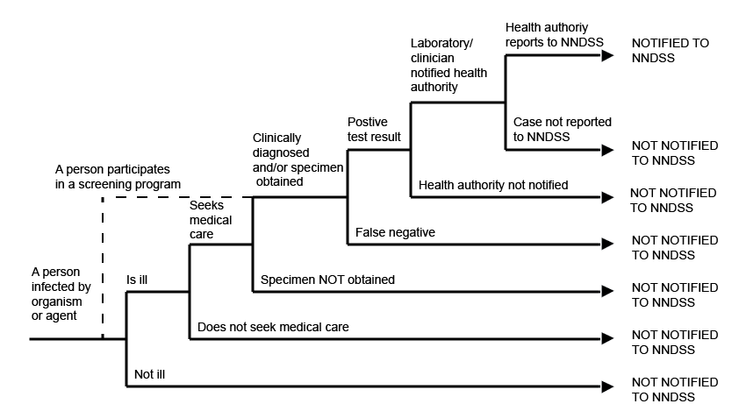
A survey of jurisdictional public health departments was conducted in 2015 to ascertain the source of each notification (Table 1). While most jurisdictions have data on laboratory notifications, the percentages of notifications attributed to doctor only and to both laboratory and doctor for each state and territory are based on estimates deduced from the data that are available, noting that fields for these data may be incomplete.

Table 1: Percentage of notified cases from different sources in each jurisdiction, 2015*
State or territory | Source of notifications
 | Laboratory only | Doctor only | Laboratory and doctor
ACT | 97 | <1 | <1
NSW | 99 | <1 | <1
NT | 98 | 1 | 1
Qld | 100 | <1 | <1
SA | 9 | 2 | 89
Tas. | 98 | <1 | 1
Vic. | 49 | 6 | 45
WA | 34 | 2 | 64
* Not all percentages add up to 100% due to other sources of notifications and/or incomplete data for laboratory and medical notification fields.
Methods of surveillance vary between states and territories, each having different requirements for notification by medical practitioners, laboratories and hospitals. Although the National Notifiable Diseases List² was established, some diseases are not notifiable in all 8 jurisdictions (Table 2).
Table 2: Diseases notified to the National Notifiable Diseases Surveillance System, Australia 2015
Disease | Data received from
Bloodborne diseases
Hepatitis B (newly acquired) | All jurisdictions
Hepatitis B (unspecified) | All jurisdictions
Hepatitis C (newly acquired) | All jurisdictions, except Qld
Hepatitis C (unspecified) | All jurisdictions
Hepatitis D | All jurisdictions
Gastrointestinal diseases
Botulism | All jurisdictions
Campylobacteriosis | All jurisdictions, except NSW
Cryptosporidiosis | All jurisdictions
Haemolytic uraemic syndrome | All jurisdictions
Hepatitis A | All jurisdictions
Hepatitis E | All jurisdictions
Listeriosis | All jurisdictions
Paratyphoid | All jurisdictions
Salmonellosis | All jurisdictions
Shigellosis | All jurisdictions
Shiga toxin producing Escherichia coli | All jurisdictions
Typhoid fever | All jurisdictions
Quarantinable diseases
Cholera | All jurisdictions
Highly pathogenic avian influenza in humans | All jurisdictions
Middle East respiratory syndrome coronavirus | All jurisdictions
Plague | All jurisdictions
Rabies | All jurisdictions
Severe acute respiratory syndrome | All jurisdictions
Smallpox | All jurisdictions
Viral haemorrhagic fever | All jurisdictions
Yellow fever | All jurisdictions
Sexually transmissible infections
Chlamydial infections | All jurisdictions
Donovanosis | All jurisdictions
Gonococcal infection | All jurisdictions
Syphilis < 2 years duration | All jurisdictions
Syphilis > 2 years or unspecified duration | All jurisdictions
Syphilis – congenital | All jurisdictions
Vaccine preventable diseases
Diphtheria | All jurisdictions
Haemophilus influenzae type b | All jurisdictions
Influenza (laboratory confirmed) | All jurisdictions
Measles | All jurisdictions
Mumps | All jurisdictions
Pertussis | All jurisdictions
Pneumococcal disease (invasive) | All jurisdictions
Poliomyelitis | All jurisdictions
Rubella | All jurisdictions
Rubella – congenital | All jurisdictions
Tetanus | All jurisdictions
Varicella zoster (chickenpox) | All jurisdictions, except NSW
Varicella zoster (shingles) | All jurisdictions, except NSW
Varicella zoster (unspecified) | All jurisdictions, except NSW
Vectorborne diseases
Barmah Forest virus infection | All jurisdictions
Chikungunya virus infection | All jurisdictions, except ACT
Dengue virus infection | All jurisdictions
Flavivirus infection (unspecified) | All jurisdictions
Japanese encephalitis virus infection | All jurisdictions
Malaria | All jurisdictions
Murray Valley encephalitis virus infection | All jurisdictions
Ross River virus infection | All jurisdictions
West Nile / Kunjin virus infection | All jurisdictions
Zoonoses
Anthrax | All jurisdictions
Australian bat lyssavirus | All jurisdictions
Brucellosis | All jurisdictions
Leptospirosis | All jurisdictions
Lyssavirus (NEC) | All jurisdictions
Ornithosis | All jurisdictions
Q fever | All jurisdictions
Tularaemia | All jurisdictions
Other bacterial infections
Legionellosis | All jurisdictions
Leprosy | All jurisdictions
Meningococcal disease (invasive) | All jurisdictions
Tuberculosis | All jurisdictions
NEC Not elsewhere classified.
Changes in surveillance practices may have been introduced in some jurisdictions and not in others, and must be taken into consideration when comparing data between jurisdictions. In this report, some additional information was obtained from states and territories to assist in the interpretation of the 2015 data. These include changes in surveillance practices, screening practices, laboratory practices, and major disease control or prevention initiatives.
Postcode information reflects the residential location of the case, but this does not necessarily represent the place where the disease was acquired.
Data completeness was assessed for cases’ Indigenous status and place of acquisition, and reported as the proportion of complete notifications. The completeness of data in this report is summarised in the ‘Results’ section.
The percentage of data completeness was defined as:
Percentage of data completeness = (total notifications – missing or unknown) / total notifications x 100
The Indigenous status was defined by the following nationally accepted criteria: ¹¹
1=Indigenous (Aboriginal but not Torres Strait Islander origin);
2=Indigenous (Torres Strait Islander but not Aboriginal origin);
3=Indigenous (Aboriginal and Torres Strait Islander origin);
4=Not Indigenous (not Aboriginal or Torres Strait Islander origin);
9=Not stated.

For the purposes of this report, an Indigenous person includes responses 1, 2 or 3, with non-Indigenous including response 4 only.
Place of acquisition is where the disease is believed to have been acquired, either locally or overseas. The country of acquisition is determined by the Standard Australian Classification of Countries (SACC) from the ABS.¹² A notification is complete if a valid value from the SACC is entered.
In interpreting STI notification data it is important to note that changes in notifications over time may not solely reflect changes in disease prevalence as changes in screening programs,^{13,14} the use of less invasive and more sensitive diagnostic tests¹⁵ and periodic public awareness campaigns¹⁶ may influence the number of notifications that occur over time. Rates for STIs are particularly susceptible to overall rates of testing, with low testing rates resulting in an underestimation of disease and increased testing potentially causing an increase in notifications.¹⁷
The differences in rates between females and males for STIs should be interpreted with caution, as rates of testing, symptom status, health care-seeking behaviours, and partner notification differ between the sexes.¹⁸

Notes on case definitions
Each notifiable disease is governed by a national surveillance case definition for reporting to the NNDSS. These case definitions were agreed by CDNA and implemented nationally in January 2004 and were used by all jurisdictions for the first time in 2005. These case definitions are reviewed by the Case Definitions Working Group (CDWG) as required. In 2015, the following case definitions were updated:
- hepatitis C (newly acquired)
- avian influenza in humans
- hepatitis B (newly acquired)
- hepatitis B (unspecified)
- hepatitis E
- syphilis
- congenital syphilis
In addition to the above, a change was made to the salmonella case definition and a paratyphoid case definition was created. From 1 January 2016, paratyphoid notifications were separated from salmonellosis notifications. Paratyphoid is reported for the first time in this annual report as all paratyphoid data in the NNDSS was retrospectively updated.
The national surveillance case definitions and their review status are available from the Australian Government Department of Health web site (http://www.health.gov.au/casedefinitions).

Results
There were 320,480 communicable disease notifications received by NNDSS in 2015 (Table 3).

Table 3: Notifications to the National Notifiable Diseases Surveillance System, Australia, 2015, by disease category rank order
Disease category | Number | %
Vaccine preventable diseases | 147,569 | 46
Sexually transmitted infections | 95,468 | 30
Gastrointestinal diseases | 45,326 | 14
Bloodborne diseases | 17,337 | 5
Vectorborne diseases | 12,253 | 4
Other bacterial diseases | 1,815 | 1
Zoonoses | 710 | <1
Quarantinable diseases | 2 | <1
Total | 320,480 | 100

In 2015, the most frequently notified diseases were vaccine preventable diseases (147,569 notifications, 46% of total notifications), sexually transmissible infections (95,468 notifications, 30% of total notifications), and gastrointestinal diseases (45,326 notifications, 14% of total notifications).
There was an increase of 16% compared with the total number of notifications in 2014 (276,188) (Figure 2). The increase can largely be attributed to the seasonal increase in influenza notifications for 2015, which reached a higher peak than in previous seasons.

Figure 2: Trends in notifications received by the National Notifiable Diseases Surveillance System, Australia, 1991 to 2015
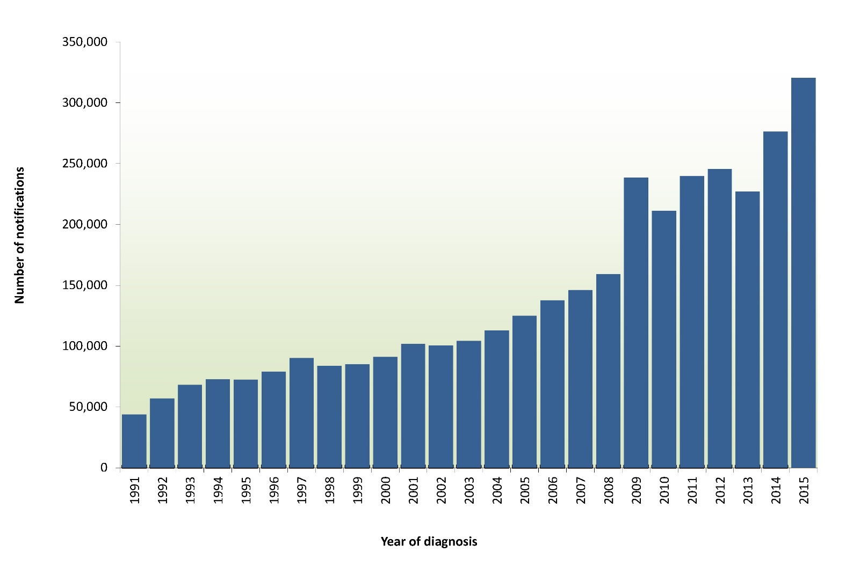
Number of notifications and notification rates per 100,000 for each disease by state or territory in 2015, are shown in Table 4 and Table 5 respectively. Notifications and rates per 100,000 for the period 2010 to 2015 are shown in Table 6.

Table 4: Notified cases of communicable diseases, Australia, 2015, by state or territory
Disease | State or Territory |  |  |  |  |  |  |  | Aust
 | ACT | NSW | NT | Qld | SA | Tas | Vic | WA
Bloodborne diseases
Hepatitis B (newly acquired)* | 0 | 29 | 1 | 43 | 7 | 1 | 30 | 29 | 140
Hepatitis B (unspecified)† | 81 | 2,356 | 159 | 998 | 337 | 41 | 1,817 | 576 | 6,365
Hepatitis C (newly acquired)*‡ | 13 | 24 | 4 | NN | 43 | 26 | 140 | 183 | 433
Hepatitis C (unspecified)† | 175 | 3,556 | 196 | 2,577 | 458 | 234 | 2,202 | 962 | 10,360
Hepatitis D | 0 | 9 | 0 | 15 | 9 | 0 | 6 | 0 | 39
Gastrointestinal diseases
Botulism | 0 | 1 | 0 | 0 | 0 | 0 | 1 | 1 | 3
Campylobacteriosis | 608 | NN | 371 | 7,546 | 1,816 | 1,035 | 8,305 | 2,892 | 22,573
Cryptosporidiosis | 26 | 1,051 | 122 | 1,314 | 420 | 19 | 857 | 255 | 4,064
Haemolytic uraemic syndrome | 0 | 11 | 0 | 2 | 0 | 0 | 4 | 1 | 18
Hepatitis A | 3 | 68 | 5 | 33 | 10 | 1 | 33 | 25 | 178
Hepatitis E | 0 | 21 | 0 | 1 | 1 | 1 | 15 | 2 | 41
Listeriosis | 1 | 28 | 2 | 8 | 4 | 0 | 21 | 6 | 70
Paratyphoid§ | 4 | 18 | 1 | 6 | 9 | 0 | 27 | 11 | 76
Salmonellosis | 237 | 4,061 | 544 | 5,420 | 1,263 | 255 | 3,525 | 1,708 | 17,013
Shigellosis | 7 | 175 | 136 | 148 | 18 | 6 | 451 | 97 | 1,038
Shiga toxin-producing Escherichia coli | 0 | 31 | 0 | 32 | 45 | 0 | 29 | 0 | 137
Typhoid Fever | 2 | 42 | 0 | 24 | 8 | 1 | 30 | 8 | 115
Quarantinable diseases
Cholera | 0 | 1 | 0 | 0 | 1 | 0 | 0 | 0 | 2
Highly pathogenic avian influenza in humans | 0 | 0 | 0 | 0 | 0 | 0 | 0 | 0 | 0
Middle East respiratory syndrome coronavirus | 0 | 0 | 0 | 0 | 0 | 0 | 0 | 0 | 0
Plague | 0 | 0 | 0 | 0 | 0 | 0 | 0 | 0 | 0
Rabies | 0 | 0 | 0 | 0 | 0 | 0 | 0 | 0 | 0
Severe acute respiratory syndrome | 0 | 0 | 0 | 0 | 0 | 0 | 0 | 0 | 0
Smallpox | 0 | 0 | 0 | 0 | 0 | 0 | 0 | 0 | 0
Viral haemorrhagic fever | 0 | 0 | 0 | 0 | 0 | 0 | 0 | 0 | 0
Yellow fever | 0 | 0 | 0 | 0 | 0 | 0 | 0 | 0 | 0
Sexually transmitted infections
Chlamydial infection||¶ | 1,266 | 22,609 | 2,738 | 21,184 | 5,385 | 1,666 | 6,265 | 11,150 | 72,263
Donovanosis | 0 | 0 | 0 | 0 | 0 | 0 | 0 | 0 | 0
Gonococcal infection|¶ | 141 | 5,461 | 1,832 | 3,035 | 795 | 56 | 4,977 | 2,253 | 18,550
Syphilis – congenital|¶ | 0 | 0 | 0 | 3 | 0 | 0 | 0 | 0 | 3
Syphilis < 2 years duration*¶** | 14 | 743 | 202 | 570 | 70 | 15 | 935 | 164 | 2,713
Syphilis > 2 years or unspecified duration†¶ | 9 | 632 | 76 | 286 | 123 | 14 | 730 | 69 | 1,939
Vaccine preventable diseases
Diphtheria | 0 | 0 | 0 | 2 | 0 | 0 | 0 | 0 | 2
Haemophilus influenzae type b | 0 | 5 | 2 | 5 | 0 | 0 | 2 | 2 | 16
Influenza (laboratory confirmed) | 1,204 | 30,303 | 676 | 28,056 | 15,652 | 1,434 | 17,265 | 5,993 | 100,583
Measles | 2 | 9 | 0 | 21 | 4 | 0 | 30 | 8 | 74
Mumps | 5 | 63 | 15 | 46 | 33 | 8 | 18 | 456 | 644
Pertussis | 486 | 12,244 | 59 | 1,861 | 1,333 | 31 | 4,664 | 1,868 | 22,546
Pneumococcal disease (invasive) | 17 | 489 | 61 | 243 | 125 | 43 | 355 | 166 | 1,499
Poliomyelitis | 0 | 0 | 0 | 0 | 0 | 0 | 0 | 0 | 0
Rubella | 1 | 7 | 0 | 4 | 2 | 1 | 0 | 2 | 17
Rubella - congenital | 0 | 0 | 0 | 1 | 0 | 0 | 0 | 0 | 1
Tetanus | 0 | 1 | 0 | 0 | 0 | 0 | 1 | 0 | 2
Varicella zoster (chickenpox) | 65 | NN | 118 | 331 | 446 | 68 | 967 | 484 | 2,479
Varicella zoster (shingles) | 196 | NN | 363 | 54 | 2,325 | 248 | 1,740 | 1,417 | 6,343
Varicella zoster (unspecified) | 125 | NN | 2 | 6,485 | 128 | 146 | 5,022 | 1,455 | 13,363
Vectorborne diseases
Barmah Forest virus infection | 2 | 181 | 26 | 360 | 1 | 1 | 11 | 46 | 628
Chikungunya virus infection | 0 | 35 | 7 | 17 | 2 | 0 | 38 | 11 | 110
Dengue virus infection | 19 | 344 | 55 | 263 | 74 | 19 | 386 | 554 | 1,714
Flavivirus infection (unspecified)†† | 0 | 2 | 0 | 5 | 1 | 0 | 2 | 2 | 12
Japanese encephalitis virus infection | 0 | 1 | 0 | 1 | 0 | 0 | 1 | 0 | 3
Malaria | 7 | 47 | 12 | 56 | 3 | 2 | 57 | 49 | 233
Murray Valley encephalitis virus infection | 0 | 0 | 2 | 0 | 0 | 0 | 0 | 0 | 2
Ross River virus infection | 10 | 1,620 | 360 | 6,192 | 112 | 5 | 289 | 962 | 9,550
West Nile / Kunjin virus infection | 0 | 1 | 0 | 0 | 0 | 0 | 0 | 0 | 1
Zoonoses
Anthrax | 0 | 0 | 0 | 0 | 0 | 0 | 0 | 0 | 0
Australia bat lyssavirus | 0 | 0 | 0 | 0 | 0 | 0 | 0 | 0 | 0
Brucellosis | 0 | 11 | 1 | 7 | 0 | 0 | 0 | 0 | 19
Leptospirosis | 1 | 17 | 4 | 42 | 0 | 2 | 7 | 1 | 74
Lyssavirus ^{(NEC)} | 0 | 0 | 0 | 0 | 0 | 0 | 0 | 0 | 0
Ornithosis | 0 | 2 | 0 | 1 | 1 | 0 | 11 | 1 | 16
Q fever | 0 | 262 | 1 | 255 | 13 | 0 | 58 | 12 | 601
Tularaemia | 0 | 0 | 0 | 0 | 0 | 0 | 0 | 0 | 0
Other bacterial diseases
Legionellosis | 2 | 98 | 7 | 80 | 26 | 7 | 71 | 74 | 365
Leprosy | 0 | 3 | 1 | 2 | 0 | 0 | 5 | 2 | 13
Meningococcal infection‡‡ | 2 | 45 | 1 | 30 | 29 | 2 | 56 | 17 | 182
Tuberculosis | 16 | 445 | 27 | 183 | 87 | 13 | 352 | 132 | 1,255
Total | 4,747 | 87,162 | 8,189 | 87,848 | 31,219 | 5,401 | 61,808 | 34,106 | 320,480
* Newly acquired hepatitis and syphilis < 2 years duration includes cases where the infection was determined to be acquired within 24 months prior to diagnosis.
† Unspecified hepatitis and syphilis includes cases where the duration of infection could not be determined or is greater than 24 months.
‡ In Queensland, includes newly acquired hepatitis C cases.
§ From 1 January 2016 a case definition for paratyphoid was created and for the first time is reported on as a separate condition from salmonella. Changes were made to paratyphoid notifications retrospectively to 1991.
|| Includes Chlamydia trachomatis identified from cervical, rectal, urine, urethral and throat samples, except for South Australia, which reports only cervical, urine and urethral specimens.
¶ The national case definitions for chlamydial, gonococcal and syphilis diagnoses include infections that may be acquired through a non-sexual mode (especially in children – e.g. perinatal infections, epidemic gonococcal conjunctivitis).
** Data for all states and territories are reported by diagnosis date, except Queensland, where data are reported by notification received date.
†† Arborivirus infection NEC changed to flavivirus infection (unspecified) in 2015.
‡‡ Only invasive meningococcal disease is nationally notifiable. However, the Australian Capital Territory and New South Wales also report conjunctival cases.
NEC Not elsewhere classified.
NN Not notifiable.
Table 5: Notification rates per 100,000 of nationally notifiable communicable diseases, Australia, 2015, by state or territory
Disease |  | State or territory
 |  | ACT | NSW | NT | Qld | SA | Tas. | Vic. | WA | Aust.
Bloodborne diseases
Hepatitis B (newly acquired)* |  | – | 0.4 | 0.4 | 0.9 | 0.4 | 0.2 | 0.5 | 1.1 | 0.6
Hepatitis B (unspecified)† |  | 20.7 | 30.9 | 65.0 | 20.9 | 19.8 | 7.9 | 30.6 | 22.2 | 26.8
Hepatitis C (newly acquired)*‡ |  | 3.3 | 0.3 | 1.6 | NN | 2.5 | 5.0 | 2.4 | 7.1 | 2.3
Hepatitis C (unspecified)† |  | 44.8 | 46.7 | 80.2 | 53.9 | 27.0 | 45.3 | 37.1 | 37.1 | 43.6
Hepatitis D |  | – | 0.1 | – | 0.3 | 0.5 | – | 0.1 | – | 0.2
Gastrointestinal diseases
Botulism |  | – | <0.1 | – | – | – | – | <0.1 | <0.1 | <0.1
Campylobacteriosis |  | 155.5 | NN | 151.7 | 157.8 | 106.9 | 200.3 | 139.8 | 111.6 | 139.6
Cryptosporidiosis |  | 6.6 | 13.8 | 49.9 | 27.5 | 24.7 | 3.7 | 14.4 | 9.8 | 17.1
Haemolytic uraemic syndrome |  | – | 0.1 | – | <0.1 | – | – | 0.1 | <0.1 | 0.1
Hepatitis A |  | 0.8 | 0.9 | 2.0 | 0.7 | 0.6 | 0.2 | 0.6 | 1.0 | 0.7
Hepatitis E |  | – | 0.3 | – | <0.1 | 0.1 | 0.2 | 0.3 | 0.1 | 0.2
Listeriosis |  | 0.3 | 0.4 | 0.8 | 0.2 | 0.2 | – | 0.4 | 0.2 | 0.3
Paratyphoid§ |  | 1.0 | 0.2 | 0.4 | 0.1 | 0.5 | – | 0.5 | 0.4 | 0.3
Salmonellosis |  | 60.6 | 53.3 | 222.5 | 113.4 | 74.3 | 49.4 | 59.3 | 65.9 | 71.5
Shigellosis |  | 1.8 | 2.3 | 55.6 | 3.1 | 1.1 | 1.2 | 7.6 | 3.7 | 4.4
Shiga toxin producing Escherichia coli |  | – | 0.4 | – | 0.7 | 2.6 | – | 0.5 | – | 0.6
Typhoid fever |  | 0.5 | 0.6 | – | 0.5 | 0.5 | 0.2 | 0.5 | 0.3 | 0.5
Quarantinable diseases
Cholera |  | – | <0.1 | – | – | 0.1 | – | – | – | <0.1
Highly pathogenic avian influenza in humans |  | – | – | – | – | – | – | – | – | –
Middle East respiratory syndrome coronavirus |  | – | – | – | – | – | – | – | – | –
Plague |  | – | – | – | – | – | – | – | – | –
Rabies |  | – | – | – | – | – | – | – | – | –
Severe acute respiratory syndrome |  | – | – | – | – | – | – | – | – | –
Smallpox |  | – | – | – | – | – | – | – | – | –
Viral haemorrhagic fever |  | – | – | – | – | – | – | – | – | –
Yellow fever |  | – | – | – | – | – | – | – | – | –
Sexually transmitted infections
Chlamydial infection||¶ |  | 323.8 | 296.7 | 1119.8 | 443.1 | 316.9 | 322.4 | 105.5 | 430.4 | 303.8
Donovanosis |  | – | – | – | – | – | – | – | – | –
Gonococcal infection|¶ |  | 36.1 | 71.7 | 749.3 | 63.5 | 46.8 | 10.8 | 83.8 | 87.0 | 78.0
Syphilis – congenital|¶ |  | – | – | – | 0.1 | – | – | – | – | <0.1
Syphilis < 2 years duration*¶** |  | 3.6 | 9.8 | 82.6 | 11.9 | 4.1 | 2.9 | 15.7 | 6.3 | 11.4
Syphilis > 2 years or unspecified duration†¶ |  | 2.3 | 8.3 | 31.1 | 6.0 | 7.2 | 2.7 | 12.3 | 2.7 | 8.2
Vaccine preventable diseases
Diphtheria |  | – | – | – | <0.1 | – | – | – | – | <0.1
Haemophilus influenzae type b |  | – | 0.1 | 0.8 | 0.1 | – | – | <0.1 | 0.1 | 0.1
Influenza (laboratory confirmed) |  | 307.9 | 397.7 | 276.5 | 586.9 | 921.2 | 277.5 | 290.6 | 231.3 | 422.9
Measles |  | 0.5 | 0.1 | – | 0.4 | 0.2 | – | 0.5 | 0.3 | 0.3
Mumps |  | 1.3 | 0.8 | 6.1 | 1.0 | 1.9 | 1.5 | 0.3 | 17.6 | 2.7
Pertussis |  | 124.3 | 160.7 | 24.1 | 38.9 | 78.5 | 6.0 | 78.5 | 72.1 | 94.8
Pneumococcal disease (invasive) |  | 4.3 | 6.4 | 24.9 | 5.1 | 7.4 | 8.3 | 6.0 | 6.4 | 6.3
Poliomyelitis |  | – | – | – | – | – | – | – | – | –
Rubella |  | 0.3 | 0.1 | – | 0.1 | 0.1 | 0.2 | – | 0.1 | 0.1
Rubella – congenital |  | – | – | – | <0.1 | – | – | – | – | <0.1
Tetanus |  | – | <0.1 | – | – | – | – | <0.1 | – | <0.1
Varicella zoster (chickenpox) |  | 16.6 | NN | 48.3 | 6.9 | 26.3 | 13.2 | 16.3 | 18.7 | 15.3
Varicella zoster (shingles) |  | 50.1 | NN | 148.5 | 1.1 | 136.8 | 48.0 | 29.3 | 54.7 | 39.2
Varicella zoster (unspecified) |  | 32.0 | NN | 0.8 | 135.6 | 7.5 | 28.3 | 84.5 | 56.2 | 82.7
Vectorborne diseases
Barmah Forest virus infection |  | 0.5 | 2.4 | 10.6 | 7.5 | 0.1 | 0.2 | 0.2 | 1.8 | 2.6
Chikungunya |  | – | 0.5 | 2.9 | 0.4 | 0.1 | – | 0.6 | 0.4 | 0.5
Dengue virus infection |  | 4.9 | 4.5 | 22.5 | 5.5 | 4.4 | 3.7 | 6.5 | 21.4 | 7.2
Flavivirus infection (unspecified)†† |  | – | <0.1 | – | 0.1 | 0.1 | – | <0.1 | 0.1 | 0.1
Japanese encephalitis virus infection |  | – | <0.1 | – | <0.1 | – | – | <0.1 | – | <0.1
Malaria |  | 1.8 | 0.6 | 4.9 | 1.2 | 0.2 | 0.4 | 1.0 | 1.9 | 1.0
Murray Valley encephalitis virus infection |  | – | – | 0.8 | – | – | – | – | – | <0.1
Ross River virus infection |  | 2.6 | 21.3 | 147.2 | 129.5 | 6.6 | 1.0 | 4.9 | 37.1 | 40.1
West Nile / Kunjin virus infection |  | – | <0.1 | – | – | – | – | – | – | <0.1
Zoonoses
Anthrax |  | – | – | – | – | – | – | – | – | –
Australia bat lyssavirus |  | – | – | – | – | – | – | – | – | –
Brucellosis |  | – | 0.1 | 0.4 | 0.1 | – | – | – | – | 0.1
Leptospirosis |  | 0.3 | 0.2 | 1.6 | 0.9 | – | 0.4 | 0.1 | <0.1 | 0.3
Lyssavirus ^{(NEC)} |  | – | – | – | – | – | – | – | – | –
Ornithosis |  | – | <0.1 | – | <0.1 | 0.1 | – | 0.2 | <0.1 | 0.1
Q fever |  | – | 3.4 | 0.4 | 5.3 | 0.8 | – | 1.0 | 0.5 | 2.5
Tularaemia |  | – | – | – | – | – | – | – | – | –
Other bacterial diseases
Legionellosis |  | 0.5 | 1.3 | 2.9 | 1.7 | 1.5 | 1.4 | 1.2 | 2.9 | 1.5
Leprosy |  | – | <0.1 | 0.4 | <0.1 | – | – | 0.1 | 0.1 | 0.1
Meningococcal infection‡‡ |  | 0.5 | 0.6 | 0.4 | 0.6 | 1.7 | 0.4 | 0.9 | 0.7 | 0.8
Tuberculosis |  | 4.1 | 5.8 | 11.0 | 3.8 | 5.1 | 2.5 | 5.9 | 5.1 | 5.3
* Newly acquired hepatitis and syphilis < 2 years duration includes cases where the infection was determined to be acquired within 24 months prior to diagnosis.
† Unspecified hepatitis and syphilis includes cases where the duration of infection could not be determined or is greater than 24 months.
‡ In Queensland, includes newly acquired hepatitis C cases.
§ From 1 January 2016 a case definition for paratyphoid was created and for the first it became reportable as a separate condition from Salmonella. Changes were made to paratyphoid notifications retrospectively to 1991.
|| Includes Chlamydia trachomatis identified from cervical, rectal, urine, urethral and throat samples, except for South Australia, which reports only cervical, urine and urethral specimens.
¶ The national case definitions for chlamydial, gonococcal and syphilis diagnoses include infections that may be acquired through a non-sexual mode (especially in children – e.g. perinatal infections, epidemic gonococcal conjunctivitis).
** Data for all states and territories are reported by diagnosis date, except Queensland, where data are reported by notification received date.
†† Arbovirus infection NEC changed to flavivirus infection (unspecified) in 2015
‡‡ Only invasive meningococcal disease is nationally notifiable. However, the Australian Capital Territory and New South Wales also report conjunctival cases.
NEC Not elsewhere classified.
NN Not notifiable.

Table 6: Notified cases and notification rate for communicable diseases, Australia, 2010 to 2015
Disease | Number of notified cases |  |  |  |  |  | 5 year mean | Ratio  (2015: 5 year mean) | Notification rate per 100,000
 | 2010 | 2011 | 2012 | 2013 | 2014 | 2015 |  |  | 2010 | 2011 | 2012 | 2013 | 2014 | 2015
Bloodborne diseases
Hepatitis B (newly acquired)* | 233 | 189 | 192 | 174 | 171 | 140 | 191.8 | 0.7 | 1.1 | 0.8 | 0.8 | 0.8 | 0.7 | 0.6
Hepatitis B (unspecified)† | 6,763 | 6,328 | 6,384 | 6,864 | 6,399 | 6,365 | 6,547.6 | 1.0 | 30.7 | 28.3 | 28.1 | 29.7 | 27.3 | 26.8
Hepatitis C (newly acquired)*‡ | 383 | 410 | 471 | 399 | 448 | 433 | 422.2 | 1.0 | 2.2 | 2.3 | 2.6 | 2.2 | 2.4 | 2.3
Hepatitis C (unspecified) † | 11,019 | 9,864 | 9,639 | 10,307 | 10,211 | 10,360 | 10,208.0 | 1.0 | 50.0 | 44.2 | 42.4 | 44.6 | 43.5 | 43.6
Hepatitis D | 44 | 48 | 36 | 61 | 57 | 39 | 49.2 | 0.8 | 0.2 | 0.2 | 0.2 | 0.3 | 0.2 | 0.2
Gastrointestinal diseases
Botulism | 0 | 2 | 0 | 4 | 1 | 3 | 1.4 | 2.1 | – | <0.1 | – | <0.1 | <0.1 | <0.1
Campylobacteriosis | 16,995 | 17,724 | 15,671 | 14,688 | 19,945 | 22,573 | 17,004.6 | 1.3 | 114.2 | 117.2 | 101.6 | 93.5 | 125.1 | 139.6
Cryptosporidiosis | 1,482 | 1,812 | 3,143 | 3,851 | 2,408 | 4,064 | 2,539.2 | 1.6 | 6.7 | 8.1 | 13.8 | 16.7 | 10.3 | 17.1
Haemolytic uraemic syndrome | 9 | 13 | 20 | 15 | 21 | 18 | 15.6 | 1.2 | <0.1 | 0.1 | 0.1 | 0.1 | 0.1 | 0.1
Hepatitis A | 267 | 145 | 166 | 190 | 231 | 178 | 199.8 | 0.9 | 1.2 | 0.6 | 0.7 | 0.8 | 1.0 | 0.7
Hepatitis E | 37 | 41 | 32 | 34 | 57 | 41 | 40.2 | 1.0 | 0.2 | 0.2 | 0.1 | 0.1 | 0.2 | 0.2
Listeriosis | 71 | 70 | 93 | 76 | 80 | 70 | 78.0 | 0.9 | 0.3 | 0.3 | 0.4 | 0.3 | 0.3 | 0.3
Paratyphoid§ | 84 | 69 | 74 | 74 | 70 | 76 | 74.2 | 1.0 | 0.4 | 0.3 | 0.3 | 0.3 | 0.3 | 0.3
Salmonellosis | 11,830 | 12,202 | 11,170 | 12,723 | 16,283 | 17,013 | 12,841.6 | 1.3 | 53.7 | 54.6 | 49.1 | 55.0 | 69.4 | 71.5
Shigellosis | 552 | 493 | 547 | 538 | 1,034 | 1,038 | 632.8 | 1.6 | 2.5 | 2.2 | 2.4 | 2.3 | 4.4 | 4.4
Shiga toxin–producing Escherichia coli | 80 | 95 | 112 | 180 | 115 | 137 | 116.4 | 1.2 | 0.4 | 0.4 | 0.5 | 0.8 | 0.5 | 0.6
Typhoid fever | 96 | 135 | 123 | 152 | 119 | 115 | 125.0 | 0.9 | 0.4 | 0.6 | 0.5 | 0.7 | 0.5 | 0.5
Quarantinable diseases
Cholera | 3 | 6 | 5 | 3 | 2 | 2 | 3.8 | 0.5 | <0.1 | <0.1 | <0.1 | <0.1 | <0.1 | <0.1
Highly pathogenic avian influenza in humans | 0 | 0 | 0 | 0 | 0 | 0 | 0.0 | – | – | – | – | – | – | –
Middle East respiratory syndrome coronavirus | 0 | 0 | 0 | 0 | 0 | 0 | 0.0 | – | – | – | – | – | – | –
Plague | 0 | 0 | 0 | 0 | 0 | 0 | 0.0 | – | – | – | – | – | – | –
Rabies | 0 | 0 | 0 | 0 | 0 | 0 | 0.0 | – | – | – | – | – | – | –
Severe acute respiratory syndrome | 0 | 0 | 0 | 0 | 0 | 0 | 0.0 | – | – | – | – | – | – | –
Smallpox | 0 | 0 | 0 | 0 | 0 | 0 | 0.0 | – | – | – | – | – | – | –
Viral haemorrhagic fever | 0 | 0 | 0 | 0 | 0 | 0 | 0.0 | – | – | – | – | – | – | –
Yellow fever | 0 | 2 | 0 | 0 | 0 | 0 | 0.4 | – | – | <0.1 | – | – | – | –
Sexually transmissible infections
Chlamydial infection||¶ | 74,420 | 81,105 | 83,148 | 83,796 | 86,782 | 72,263 | 81,850.2 | 0.9 | 337.8 | 363.0 | 365.8 | 362.5 | 369.9 | 303.8
Donovanosis | 1 | 0 | 1 | 0 | 1 | 0 | 0.6 | <0.1 | <0.1 | – | <0.1 | – | <0.1 | –
Gonococcal infection|¶ | 10,322 | 12,097 | 13,889 | 14,912 | 15,707 | 18,550 | 13,385.4 | 1.4 | 46.9 | 54.1 | 61.1 | 64.5 | 67.0 | 78.0
Syphilis – congenital|¶ | 4 | 6 | 0 | 8 | 3 | 3 | 4.2 | 0.7 | <0.1 | <0.1 | – | <0.1 | <0.1 | <0.1
Syphilis < 2 years duration*¶** | 1,118 | 1,284 | 1,558 | 1,767 | 2,033 | 2,713 | 1,552.0 | 1.7 | 5.1 | 5.7 | 6.9 | 7.6 | 8.7 | 11.4
Syphilis > 2 years or unspecified duration†¶ | 1,360 | 1,353 | 1,391 | 1,747 | 1,872 | 1,939 | 1,544.6 | 1.3 | 6.7 | 6.5 | 6.1 | 7.6 | 8.0 | 8.2
Vaccine preventable diseases
Diphtheria†† | – | 4 | – | 3 | 2 | 2 | 1.8 | 1.1 | – | 0.0 | – | 0.0 | 0.0 | 0.0
Haemophilus influenzae type b | 23 | 13 | 16 | 20 | 21 | 16 | 18.6 | 0.9 | 0.1 | 0.1 | 0.1 | 0.1 | 0.1 | 0.1
Influenza (laboratory confirmed) | 13,466 | 27,210 | 44,564 | 28,309 | 67,699 | 100,583 | 36,249.6 | 2.8 | 61.1 | 121.8 | 196.1 | 122.5 | 288.6 | 422.9
Measles | 70 | 194 | 199 | 158 | 339 | 74 | 192.0 | 0.4 | 0.3 | 0.9 | 0.9 | 0.7 | 1.4 | 0.3
Mumps | 97 | 153 | 201 | 217 | 186 | 644 | 170.8 | 3.8 | 0.4 | 0.7 | 0.9 | 0.9 | 0.8 | 2.7
Pertussis | 34,845 | 38,752 | 24,102 | 12,359 | 11,867 | 22,546 | 24,385.0 | 0.9 | 158.2 | 173.5 | 106.0 | 53.5 | 50.6 | 94.8
Pneumococcal disease (invasive) | 1,640 | 1,884 | 1,822 | 1,549 | 1,563 | 1,499 | 1,691.6 | 0.9 | 7.4 | 8.4 | 8.0 | 6.7 | 6.7 | 6.3
Poliomyelitis | 0 | 0 | 0 | 0 | 0 | 0 | 0.0 | – | – | – | – | – | – | –
Rubella | 44 | 58 | 36 | 25 | 17 | 17 | 36.0 | 0.5 | 0.2 | 0.3 | 0.2 | 0.1 | 0.1 | 0.1
Rubella – congenital | – | – | 1 | 2 | – | 1 | 0.6 | 1.7 | – | – | 0.0 | 0.0 | – | 0.0
Tetanus | 2 | 3 | 7 | 4 | 3 | 2 | 3.8 | 0.5 | 0.0 | 0.0 | 0.0 | 0.0 | 0.0 | 0.0
Varicella zoster (chickenpox) | 1,793 | 2,100 | 1,990 | 2,122 | 2,103 | 2,479 | 2,021.6 | 1.2 | 12.0 | 13.9 | 12.9 | 13.5 | 13.2 | 15.3
Varicella zoster (shingles) | 3,046 | 4,022 | 4,507 | 5,005 | 5,520 | 6,343 | 4,420.0 | 1.4 | 20.5 | 26.6 | 29.2 | 31.9 | 34.6 | 39.2
Varicella zoster (unspecified) | 8,150 | 8,605 | 9,414 | 11,008 | 12,017 | 13,363 | 9,838.8 | 1.4 | 54.7 | 56.9 | 61.0 | 70.1 | 75.4 | 82.7
Vectorborne diseases
Barmah Forest virus infection | 1,470 | 1,863 | 1,730 | 4,238 | 742 | 628 | 2,008.6 | 0.3 | 6.7 | 8.3 | 7.6 | 18.3 | 3.2 | 2.6
Chikungunya virus infection | 62 | 39 | 19 | 134 | 110 | 110 | 72.8 | 1.5 | 0.3 | 0.2 | 0.1 | 0.6 | 0.5 | 0.5
Dengue virus infection | 1,228 | 822 | 1,540 | 1,841 | 1,721 | 1,714 | 1,430.4 | 1.2 | 5.6 | 3.7 | 6.8 | 8.0 | 7.3 | 7.2
Flavivirus infection (unspecified) | 14 | 10 | 6 | 16 | 20 | 12 | 13.2 | 0.9 | 0.1 | 0.0 | 0.0 | 0.1 | 0.1 | 0.1
Japanese encephalitis virus infection | – | – | 1 | 4 | 1 | 3 | 1.2 | 2.5 | – | – | 0.0 | 0.0 | 0.0 | 0.0
Malaria | 405 | 418 | 344 | 416 | 324 | 233 | 381.4 | 0.6 | 1.8 | 1.9 | 1.5 | 1.8 | 1.4 | 1.0
Murray Valley encephalitis virus infection | – | 16 | 1 | – | – | 2 | 3.4 | 0.6 | – | 0.1 | 0.0 | – | – | 0.0
Ross River virus infection | 5,128 | 5,136 | 4,681 | 4,317 | 5,316 | 9,550 | 4,915.6 | 1.9 | 23.3 | 23.0 | 20.6 | 18.7 | 22.7 | 40.1
West Nile/Kunjin virus infection | 2 | 2 | – | 2 | 1 | 1 | 1.4 | 0.7 | 0.0 | 0.0 | – | 0.0 | 0.0 | 0.0
Zoonoses
Anthrax | 1 | 0 | 0 | 0 | 0 | 0 | 0.2 | – | <0.1 | – | – | – | – | –
Australian bat lyssavirus | 0 | 0 | 0 | 1 | 0 | 0 | 0.2 | – | – | – | – | <0.1 | – | –
Brucellosis | 21 | 37 | 31 | 14 | 17 | 19 | 24.0 | 0.8 | 0.1 | 0.2 | 0.1 | 0.1 | 0.1 | 0.1
Leptospirosis | 131 | 215 | 114 | 87 | 86 | 74 | 126.6 | 0.6 | 0.6 | 1.0 | 0.5 | 0.4 | 0.4 | 0.3
Lyssavirus (NEC) | 0 | 0 | 0 | 0 | 0 | 0 | 0.0 | – | – | – | – | – | – | –
Ornithosis | 58 | 89 | 76 | 47 | 41 | 16 | 62.2 | 0.3 | 0.3 | 0.4 | 0.3 | 0.2 | 0.2 | 0.1
Q fever | 338 | 359 | 369 | 486 | 475 | 601 | 405.4 | 1.5 | 1.5 | 1.6 | 1.6 | 2.1 | 2.0 | 2.5
Tularaemia | 0 | 2 | 0 | 0 | 0 | 0 | 0.4 | – | – | <0.1 | – | – | – | –
Other bacterial infections
Legionellosis | 307 | 357 | 382 | 509 | 425 | 365 | 396.0 | 0.9 | 1.4 | 1.6 | 1.7 | 2.2 | 1.8 | 1.5
Leprosy | 10 | 9 | 8 | 14 | 10 | 13 | 10.2 | 1.3 | 0.0 | 0.0 | 0.0 | 0.1 | 0.0 | 0.1
Meningococcal infection§§ | 228 | 242 | 223 | 149 | 169 | 182 | 202.2 | 0.9 | 1.0 | 1.1 | 1.0 | 0.6 | 0.7 | 0.8
Tuberculosis | 1,363 | 1,388 | 1,316 | 1,261 | 1,343 | 1,255 | 1,334.2 | 0.9 | 6.2 | 6.2 | 5.8 | 5.5 | 5.7 | 5.3
Total | 211,115 | 239,495 | 245,565 | 226,880 | 276,188 | 320,480
* Newly acquired hepatitis and syphilis < 2 years duration includes cases where the infection was determined to be acquired within 24 months prior to diagnosis.
† Unspecified hepatitis and syphilis includes cases where the duration of infection could not be determined or is greater than 24 months.
‡ In Queensland, includes newly acquired hepatitis C cases.
§ From 1 January 2016 a case definition for paratyphoid was created and for the first time it became reportable on as a separate condition from salmonella. Changes were made to paratyphoid notifications retrospectively to 1991.
|| Includes Chlamydia trachomatis identified from cervical, rectal, urine, urethral and throat samples, except for South Australia, which reports only cervical, urine and urethral specimens. From 1 July 2013 the case definition changed to exclude all ocular infections.
¶ The national case definitions for chlamydial, gonococcal and syphilis diagnoses include infections that may be acquired through a non-sexual mode (especially in children – e.g. perinatal infections, epidemic gonococcal conjunctivitis).
** Data for all states and territories are reported by diagnosis date, except Queensland, where data are reported by notification receive date.
†† This number may underrepresent the number of diphtheria cases in Australia in 2015. For more details please see the summary of diphtheria in the Vaccine Preventable Diseases section of this report.
‡‡ Arbovirus infection NEC changed to flavivirus infection (unspecified) in 2015
§§ Only invasive meningococcal disease is nationally notifiable. However, the Australian Capital Territory and New South Wales also report conjunctival cases.
NEC Not elsewhere classified.
NN Not notifiable.

Data completeness

Indigenous status
Indigenous status is usually obtained from clinical notifications, and completeness varies by disease and by state and territory. This reflects differences in notification requirements (i.e. depending on the jurisdiction, some diseases are primarily or completely notified by pathology laboratories rather than clinicians) and the fact that it is not possible to follow up all cases for diseases that have a large volume of notifications and/or do not require specific case-based public health action.
Indigenous status was complete in 46% of all notifications reported to NNDSS in 2015. Indigenous status was complete in 94% of data reported in the Northern Territory and Western Australia, and 88% in South Australia. In the remaining jurisdictions, Indigenous status completeness ranged from 17% to 67% (Table 7).
Table 7: Indigenous status completeness of National Notifiable Diseases Surveillance System data, Australia, 2015, by state or territory
 | State or territory
 | ACT | NSW | NT | Qld | SA | Tas | Vic | WA | Aust.
Total notifications | 4,747 | 87,162 | 8,189 | 87,848 | 31,219 | 5,401 | 61,808 | 34,106 | 320,480
Indigenous status
Unknown/missing | 1,545 | 72,629 | 473 | 49,638 | 3,728 | 4,191 | 40,127 | 2,146 | 174,477
Per cent complete | 67 | 17 | 94 | 43 | 88 | 22 | 35 | 94 | 46

Data completeness on Indigenous status also varied by disease as summarised in Appendix 3. In 2009, CDNA set target thresholds of 95% completeness for 18 priority diseases (17 notifiable to NNDSS and HIV, which are provided to the Kirby Institute) (Table 8), and 80% completeness for the remainder of the notifiable diseases, as part of its ‘Closing the Gap’ strategy. There were 53 diseases with cases notified to the NNDSS in 2015, of which 36 (68%) equalled or exceeded 80% completeness for Indigenous status and 13 (36%) were priority diseases.
Table 8: Percentage completeness of priority diseases for Indigenous status completeness of National Notifiable Diseases Surveillance System data, Australia, 2015, by state or territory
Priority disease | ACT | NSW | NT | Qld | SA | Tas. | Vic. | WA | Aust.
Congenital syphilis | No cases | No cases | No cases | 100 | No cases | No cases | No cases | No cases | 100
Dengue virus (locally acquired) | No cases | 100 | No cases | 100 | No cases | No cases | No cases | No cases | 100
Donovanosis | No cases | No cases | No cases | No cases | No cases | No cases | No cases | No cases | No cases
Gonococcal infection | 100 | 42 | 98 | 63 | 97 | 80 | 53 | 100 | 64
Haemophilus influenzae type b | No cases | 100 | 100 | 100 | No cases | No cases | 100 | 100 | 100
Hepatitis A | 100 | 99 | 100 | 91 | 100 | 100 | 97 | 100 | 97
Hepatitis B (newly acquired) | No cases | 97 | 100 | 84 | 100 | 100 | 93 | 100 | 93
Hepatitis C (newly acquired) | 92 | 96 | 100 | NN | 100 | 96 | 86 | 100 | 95
Leprosy | No cases | 100 | 100 | 100 |  | No cases | 100 | 100 | 100
Measles | 100 | 100 | No cases | 100 | 100 | No cases | 100 | 100 | 100
Meningococcal disease (invasive) | 100 | 98 | 100 | 100 | 100 | 100 | 96 | 100 | 98
Pertussis < 5 years | 97 | 93 | 100 | 99 | 100 | 83 | 74 | 93 | 91
Pneumococcal disease < 5 years | 100 | 100 | 100 | 100 | 100 | 100 | 89 | 100 | 98
Pneumococcal disease ≥ 50 years | 100 | 99.7 | 100 | 96.5 | 100 | 100 | 92 | 100 | 97
Shigellosis | 85.7 | 87.4 | 100 | 84.5 | 100 | 100 | 82 | 100 | 88
Syphilis < 2 years | 100 | 85.9 | 100 | 97.5 | 100 | 100 | 86 | 100 | 91
Tuberculosis | 100 | 98 | 100 | 100 | 100 | 100 | 100 | 100 | 99

In 2015, 16 of the 17 priority diseases were notified to NNDSS. Of the 16 notified, 11 had an Indigenous completeness that exceeded 95% (congenital syphilis, dengue virus (locally acquired), Haemophilus influenzae type b, hepatitis A, hepatitis C (newly acquired), leprosy, measles, meningococcal infection, pneumococcal disease < 5 years, pneumococcal disease ≥ 50 years, and tuberculosis). While pertussis < 5 years notifications are still below the 95% threshold there has been a notable improvement in the completeness of Indigenous identification. From 2004 to 2014 the average completeness was 83% with the highest completeness in this period 86%, in 2013. In 2015 the completeness was 91%.

Place of acquisition
The place of acquisition is where the disease is determined to have been acquired, either locally or overseas. This information is usually obtained through public health follow-up. Follow-up, and thus completeness, varies by disease and by jurisdiction. It is not possible to follow up all cases for diseases with a large volume of notifications. Place of acquisition is not usually completed for diseases unless overseas travel is known to be a risk factor. In this analysis a notification is considered to be complete where a valid SACC is used; this includes values for ‘not stated’. This differs from where the aim of the analysis on place of acquisition is to determine whether a disease has been acquired either locally or overseas.
Through the NSC, jurisdictions have agreed that completeness for place of acquisition should be 100% for the following 32 priority diseases:
- anthrax
- brucellosis
- chikungunya virus infection
- cholera
- dengue virus infection
- diphtheria
- flavivirus infection (unspecified)
- hepatitis A
- hepatitis B (newly acquired)
- hepatitis E
- highly Pathogenic Avian influenza in humans (HPAIH)
- Japanese encephalitis virus infection
- Kunjin virus / West Nile virus infection
- legionellosis
- leprosy
- malaria
- measles
- Middle East respiratory syndrome coronavirus (MERS-CoV)
- mumps
- Murray Valley encephalitis virus infection
- plague
- poliovirus infection
- Q fever
- rabies
- Rubella
- severe acute respiratory syndrome (SARS)
- shigellosis
- smallpox
- tularaemia
- typhoid fever
- viral haemorrhagic fever (NEC)
- yellow fever
In 2015, 23 of the 32 priority diseases had cases notified to NNDSS. The overall completeness for place of acquisition for these diseases was 89%. The completeness was 100% in 2015 for 10 diseases: brucellosis, chikungunya virus infection, cholera, diphtheria, flavivirus infection (unspecified), Japanese encephalitis virus infection, Kunjin virus infection, leprosy, measles and Murray Valley encephalitis virus infection (Table 9). This is an improvement on 2014, when 5 priority diseases had 100% completeness for place of acquisition.

Table 9: Percentage completeness of place of acquisition data for priority diseases* in the National Notifiable Diseases Surveillance System, Australia, 2015
Disease | 2011 | 2012 | 2013 | 2014 | 2015
Brucellosis | 24 | 35 | 100 | 100 | 100
Chikungunya virus infection | 100 | 95 | 100 | 100 | 100
Cholera | 100 | 100 | 100 | 100 | 100
Dengue virus infection | 98 | 100 | >99 | >99 | >99
Diphtheria | 75 | No cases | 67 | 100 | 100
Flavivirus infection (unspecified) | 100 | 100 | 100 | 100 | 100
Hepatitis A | 99 | 94 | 95 | 99 | 94
Hepatitis B (newly acquired) | 65 | 50 | 40 | 35 | 59
Hepatitis E | 95 | 97 | 94 | 88 | 90
Japanese encephalitis virus infection | 0 | 100 | 100 | 100 | 100
Kunjin virus infection | 100 | No cases | 100 | 100 | 100
Legionellosis | 83 | 85 | 82 | 86 | 94
Leprosy | 100 | 100 | 79 | 100 | 100
Malaria | 100 | 100 | 100 | 100 | >99
Measles | 89 | 95 | 100 | >99 | 100
Mumps | 63 | 49 | 74 | 58 | 91
Murray Valley encephalitis virus infection | 88 | 100 | No cases | No cases | 100
Q fever | 57 | 79 | 88 | 90 | 86
Rubella | 78 | 64 | 80 | 53 | 88
Shigellosis | 58 | 57 | 64 | 50 | 64
Tularaemia | 100 | No cases | No cases | No cases | No cases
Typhoid Fever | 97s | 94 | 98 | 97 | 97
Yellow fever | 100 | No cases | No cases | No cases | No cases
Total | 84 | 87 | 89 | 84 | 89
* Only priority diseases notified to the National Notifiable Surveillance System in 2011 to 2015 are included.

Bloodborne diseases
In 2015, the bloodborne diseases reported to the NNDSS were hepatitis B, C, and D. Both hepatitis B and C infections were notified to the NNDSS as either ‘newly acquired’, where evidence was available that the infection was acquired in the 24 months prior to diagnosis; or ‘greater than 2 years or unspecified’ period of infection. These categories were reported from all states and territories except Queensland, where all cases of hepatitis C infection, including newly acquired, were reported as ‘greater than 2 years or unspecified’. Determination of a case as ‘newly acquired’ is reliant on public health follow-up, with the method and intensity of follow-up varying by jurisdiction and over time.
In interpreting these data it is important to note that changes in numbers of notified cases over time may not solely reflect changes in disease prevalence or incidence. National testing policies developed by the Australasian Society for HIV and viral hepatitis and sexual health medicine and screening programs, including the preferential testing of high risk populations such as prisoners, injecting drug users and people from countries with a high prevalence of hepatitis B or C infection, may contribute to these changes.^{19,20}
Information on exposure factors relating to the most likely source(s) of infection for hepatitis B and C was reported in a subset of newly acquired infections. The collection of enhanced data is dependent on the level of public health follow-up, which is variable by jurisdiction and over time.
Notifications of HIV diagnoses were reported directly to the Kirby Institute, which maintains the National HIV Registry. Information on national HIV surveillance can be obtained from the Kirby Institute web site (http://www.kirby.unsw.edu.au/).

Hepatitis B
- There were 6,505 cases of hepatitis B notified in 2015.
- Over the past 6 years, notifications of newly acquired hepatitis B have declined.
Hepatitis B is a potentially life-threatening liver infection caused by the hepatitis B virus. Major modes of transmission include unprotected sexual contact, needle sharing with an infected person, and perinatal transmission from mother to child. Symptoms of acute infection include abdominal pain, nausea and vomiting progressing to jaundice. Outcomes vary inversely with age; infected infants are more likely to progress to chronic infection, whereas people who are infected as adults often clear the virus. Chronic infection can lead to a number of liver complications, including cirrhosis, cancer and liver failure.²¹
Hepatitis B notifications are classified as being either ‘newly acquired’ (evidence that infection was acquired within the 24 months prior to diagnosis) or ‘unspecified’ (infection acquired more than 24 months prior to diagnosis or at a time that could not be specified).

Epidemiological situation in 2015
In 2015, there were 6,505 notified cases of hepatitis B (both newly acquired and unspecified), representing an overall rate of 27.3 cases per 100,000 (Figure 3).

Figure 3: Notification rate for newly acquired hepatitis B and unspecified hepatitis B, Australia, 2010 to 2015, by year
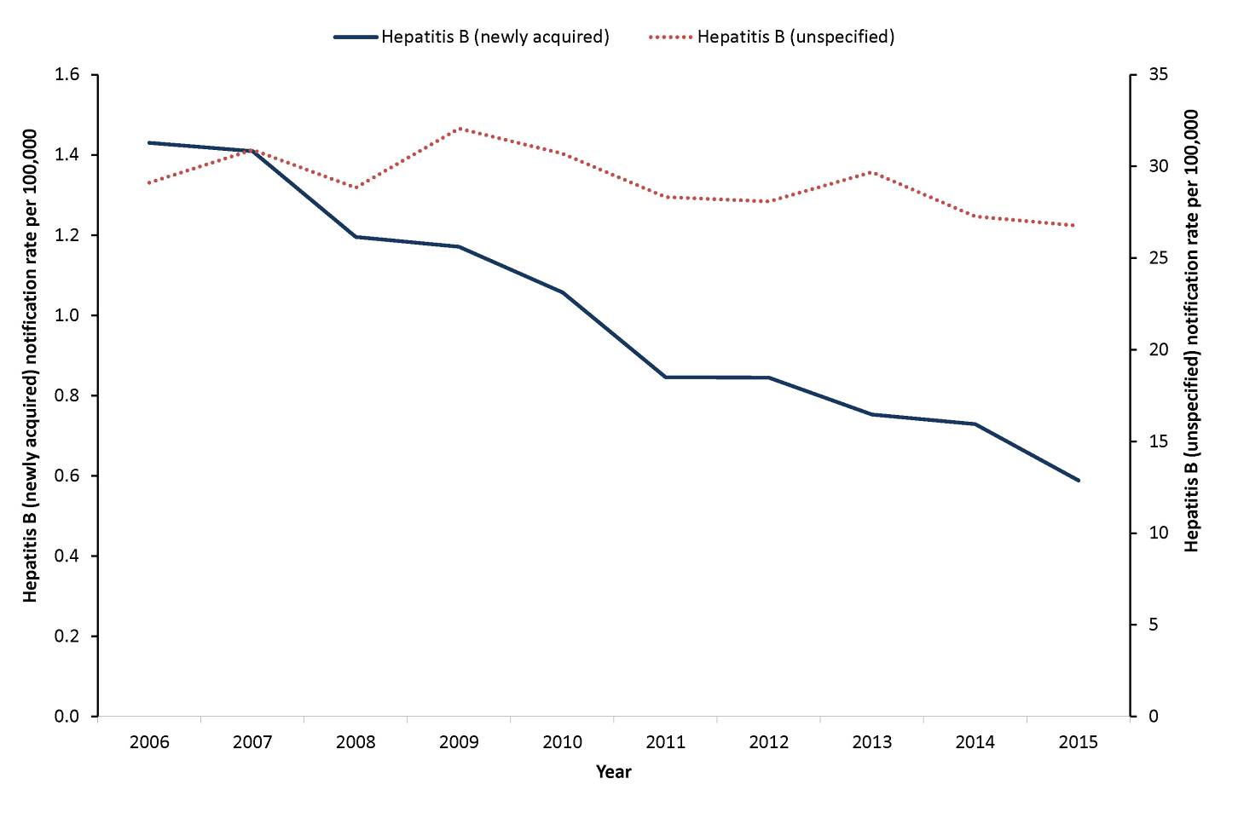
Between 2010 and 2015, rates of newly acquired hepatitis B decreased by 44% from 1.1 to 0.6 per 100,000 (Figure 3). The decline in newly acquired hepatitis B notifications may be attributed to the universal hepatitis B infant immunisation program, introduced in 2000, and the adolescent hepatitis immunisation programs, introduced from 1997 depending on the jurisdiction.²² As at 30 September 2016, approximately 94% of children 12–15 months of age in Australia were assessed as being fully immunised for hepatitis B.²³
A 2007 study, comparing 2 national serosurveys from 1996–99 and 2002, showed significant improvements in immunity to hepatitis B for the 12–17 years age group in jurisdictions with established school-based programs compared to those jurisdictions without such programs.²⁴
From the 1980s, hepatitis B immunisation was also recommended for certain at-risk adults in Australia.²⁵ Some jurisdictions have implemented immunisation programs to target identified at-risk adults in a variety of settings and over different time periods.²² The full impact of Australian immunisation programs should be reflected in trends in chronic infection and reductions in hepatitis B related complications in the future.
Between 2010 and 2015, rates of unspecified hepatitis B declined by 13% from 30.7 to 26.8 per 100,000. It is important to note the significant impact of immigration on rates of unspecified hepatitis B. For example, in 2015, Western Australia reported a decline in asylum seeker boat arrivals coinciding with a decline in unspecified hepatitis B notifications in the state, particularly in the Kimberley region (which includes the postcode for Christmas Island, where there was a detention centre). An Australian study estimated that in 2011 more than 95% of new cases of chronic hepatitis B virus infection were diagnosed in new migrants.²⁶

Newly acquired hepatitis B
- There were 140 cases of newly acquired hepatitis B notified in 2015.
- The highest rate of notification was among males aged 30–34 years. Epidemiological situation in 2015
In 2015, 140 cases of newly acquired hepatitis B infection were notified to the NNDSS, a rate of 0.6 per 100,000, declining from 171 cases (0.7 per 100,000) reported in 2014 (Figure 4).
Figure 4: Notification rate for newly acquired hepatitis B, Australia, 2015, by age group and sex
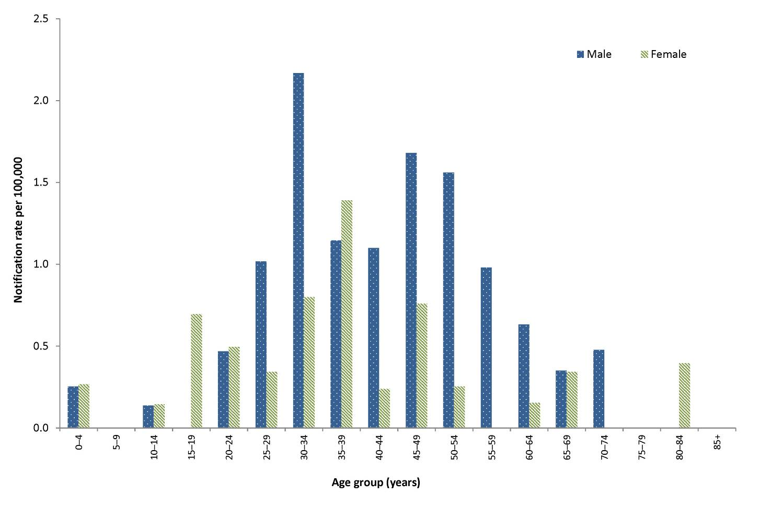

Geographical distribution
The highest rates were reported from Western Australia (1.1 per 100,000) and Queensland (0.9 per 100,000) (Table 5). This may be due to population differences between the jurisdictions, with hepatitis B disproportionately affecting a number of marginalised groups in Australia including migrant communities with origins in Asia, the Pacific and Africa; and Aboriginal and Torres Strait Islander people.^{26,27}

Age and sex distribution
In 2015, males accounted for 66% of newly acquired hepatitis B notifications. In 2015, the highest rate of newly acquired hepatitis B infection was observed among males aged 30–34 years (2.2 per 100,000). For females, the highest rate was in those aged 35–39 years (1.4 per 100,000) (Figure 4). Exposure to hepatitis B may be more common in certain high risk groups, including immigrants from endemic regions; people who inject drugs; prisoners; Aboriginal and Torres Strait Islander people; and men who have sex with men.^{21,26} The greater representation of males in some of these groups may contribute to the higher notification rates among males.
Between 2010 and 2015, most age-specific notification rates were low and remained stable or trended downwards. The most marked decreases occurred among those aged 15–29 years.
During this period, notification rates declined by 67% for those aged 20–29 years (from 1.8 to 0.6 per 100,000) and 63% for those aged 15–19 years (from 0.8 to 0.3 per 100,000) (Figure 5). These declines are likely to be attributable to the hepatitis B immunisation program.²⁸
Figure 5: Notification rate for newly acquired hepatitis B, Australia, 2010 to 2015, by year and selected age groups
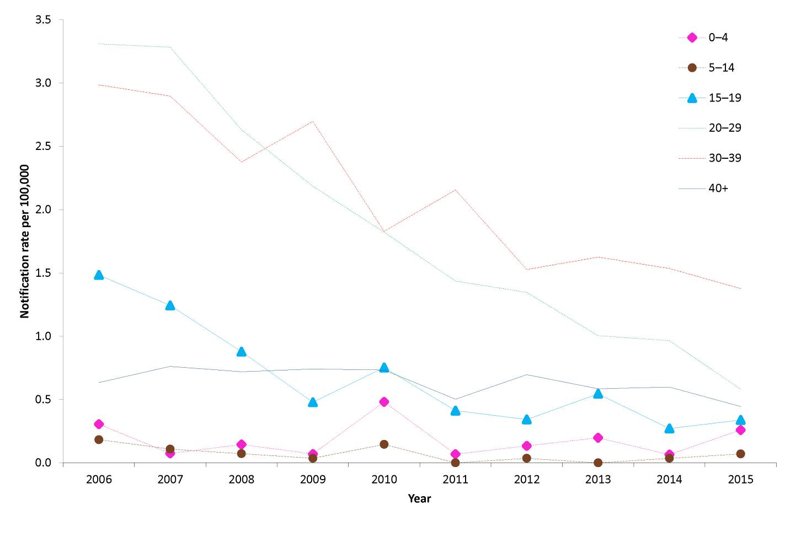

Risk groups
Enhanced data on risk factors and country of birth were provided by New South Wales, South Australia, Tasmania, Victoria and Western Australia (Table 10). In 2015, 76 of the 97 cases (78%) from these jurisdictions had at least 1 risk factor recorded, with a potential source of exposure not recorded or not possible to determine for the remainder. Sexual exposure was the most frequently reported potential source of infection (35/97, 36%), followed by injecting drug use (30/97, 31%). Of the 88 cases for which country of birth was reported, 66 were Australian born (75%) and 22 were overseas born (11 from Europe, 6 from Asia, 2 from the Middle East, 2 from the Pacific, and 1 from North America).
Table 10. Enhanced risk factor data on notifications of newly acquired hepatitis B cases in selected jurisdictions,* 2015, by sex and risk factors†‡
Exposure category | Number of exposure factors reported |  |  | Percentage§ of total cases* (n=97)
 | Male | Female | Total
Sexual exposure | 28 | 7 | 35 | 36
Sexual contact (hepatitis B partner status unknown) – opposite sex | 12 | 2 | 14 | 14
Sexual contact (hepatitis B positive partner) – opposite sex | 5 | 4 | 9 | 9
Sexual contact – not further classified | 5 | 0 | 5 | 5
Sexual contact (hepatitis B partner status unknown) – same sex | 3 | 1 | 4 | 4
Sexual contact (hepatitis B positive partner) – same sex | 3 | 0 | 3 | 3
Injecting drug use | 22 | 8 | 30 | 31
Skin penetration procedure | 10 | 3 | 13 | 13
Tattoos | 5 | 1 | 6 | 6
Ear or body piercing | 1 | 1 | 2 | 2
Acupuncture | 4 | 1 | 5 | 5
Household contact | 2 | 3 | 5 | 5
Major dental surgery work | 3 | 1 | 4 | 4
Imprisonment | 3 | 0 | 3 | 3
Surgical work | 1 | 1 | 2 | 2
Needlestick/biohazardous injury | 1 | 2 | 3 | 3
Perinatal transmission | 1 | 0 | 1 | 1
Other | 6 | 3 | 9 | 9
Undetermined | 4 | 2 | 6 | 6
Unknown (not recorded) | 9 | 6 | 15 | 15
Total exposure factors reported | 77 | 28 | 105
Total number of cases | 67 | 30 | 97
* Cases from New South Wales, South Australia, Tasmania, Victoria and Western Australia. While these 5 jurisdictions provided enhanced data on risk factors, not all cases had this information recorded.
† More than 1 exposure category for each case could be recorded.
‡ Analysis and categorisation of these exposures are subject to interpretation and may vary between reports.
§ The denominator used to calculate the percentage is based on the cases with recorded enhanced data from New South Wales, South Australia, Tasmania, Victoria and Western Australia. As more than 1 exposure category for each notification could be recorded, the total percentage does not equate to 100%.

Unspecified hepatitis B
- There were 6,365 cases of unspecified hepatitis B notified in 2015.
- Notification rates highest in females and males aged 30–34 years. Epidemiological situation in 2015
In 2015, 6,365 cases of unspecified hepatitis B infection were notified to the NNDSS, representing a rate of 26.8 per 100,000, compared with 6,399 cases (27.3 per 100,000) reported in 2014 (Figure 3).

Geographical distribution
In 2015, the Northern Territory had the highest rate of unspecified hepatitis B infection (65.0 per 100,000) (Table 5).

Age and sex distribution
In 2015, males accounted for 51% (3,359/6,365) of unspecified hepatitis B notifications, with an overall rate of 28.4 per 100,000 for males and 24.9 per 100,000 for females. Notification rates were similar for males and females in most age groups. Notification rates in both males and females were highest in the 30–34 years age group (Figure 6).
Figure 6: Notification rate for unspecified hepatitis B, Australia, 2015, by age group and sex*
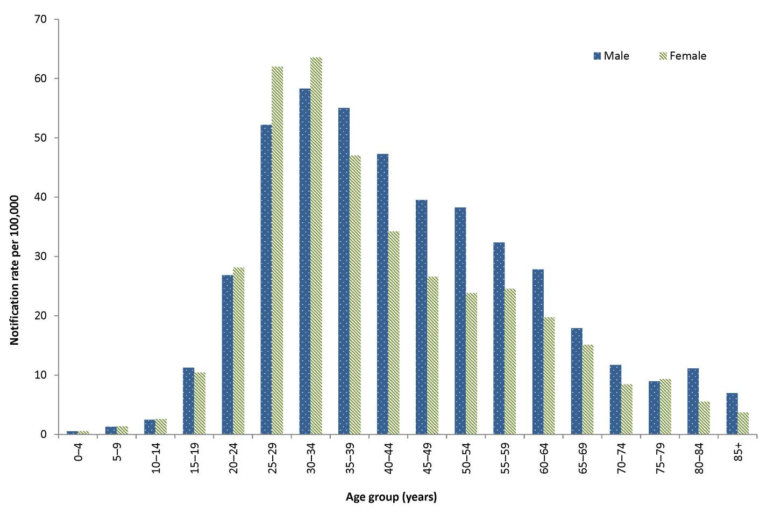
* Excludes 28 cases where age and/or sex were not reported.
Between 2010 and 2015, notification rates for unspecified hepatitis B decreased across all age groups (Figure 7). The decrease in rates for the younger age groups is likely explained by the introduction of the infant and adolescent hepatitis B immunisation programs.²⁸ The adolescent immunisation program commenced in some jurisdictions from 1997 and the infant immunisation program commenced nationally from 2000.²⁹
Figure 7: Notification rate for unspecified hepatitis B, Australia, 2010 and 2015, by year and selected age groups*
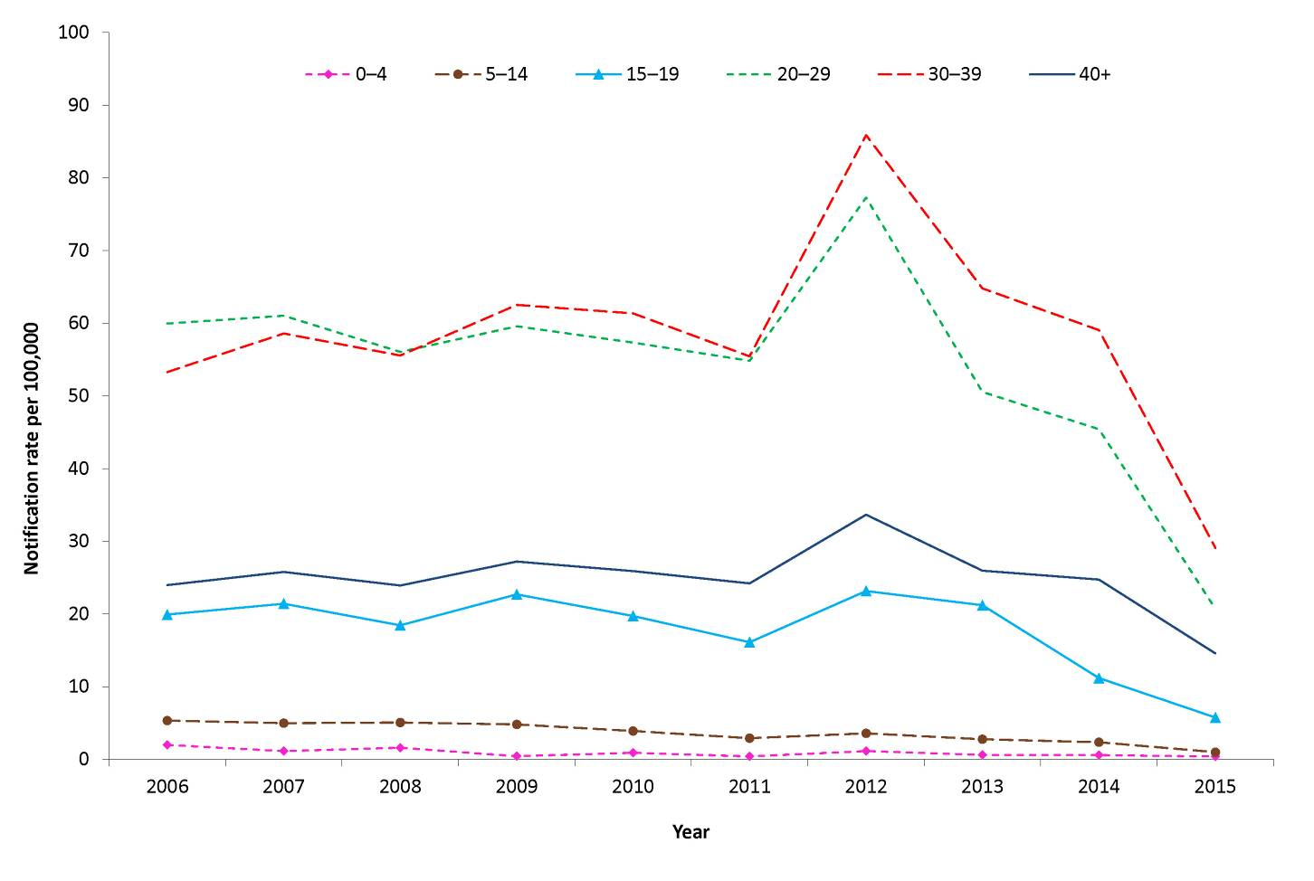
* Excludes 5 cases where age was not reported.

Hepatitis C
- There were 10,793 cases of hepatitis C notified in 2015.
- Over the past 6 years, notifications of hepatitis C have declined by 5%.
Infection with hepatitis C virus causes inflammation of the liver. In more than 90% of cases, initial infection with hepatitis C virus is asymptomatic or mildly symptomatic. Approximately 50%–80% of cases will go on to develop a chronic infection. Of those who develop a chronic infection, half will eventually develop cirrhosis or cancer of the liver.²¹ There is no vaccine to prevent hepatitis C infection.
Hepatitis C notifications are classified as being either ‘newly acquired’ (evidence that infection was acquired within the 24 months prior to diagnosis) or ‘unspecified’ (infection acquired more than 24 months prior to diagnosis or at a time that could not be specified).

Epidemiological situation in 2015
Of the 10,793 cases of hepatitis C notified in 2015, 4% (433/10,793) were classified as newly acquired infections. The proportion of hepatitis C notifications classified as newly acquired has remained reasonably stable since 2010 (range: 3% to 5%).
Between 2010 and 2015, hepatitis C notifications (both newly acquired and unspecified) declined by 5% from 11,402 to 10,793 (Figure 8).
Figure 8: Notification rate for hepatitis C (newly acquired* and unspecified) infection, Australia, 2010 to 2015, by year
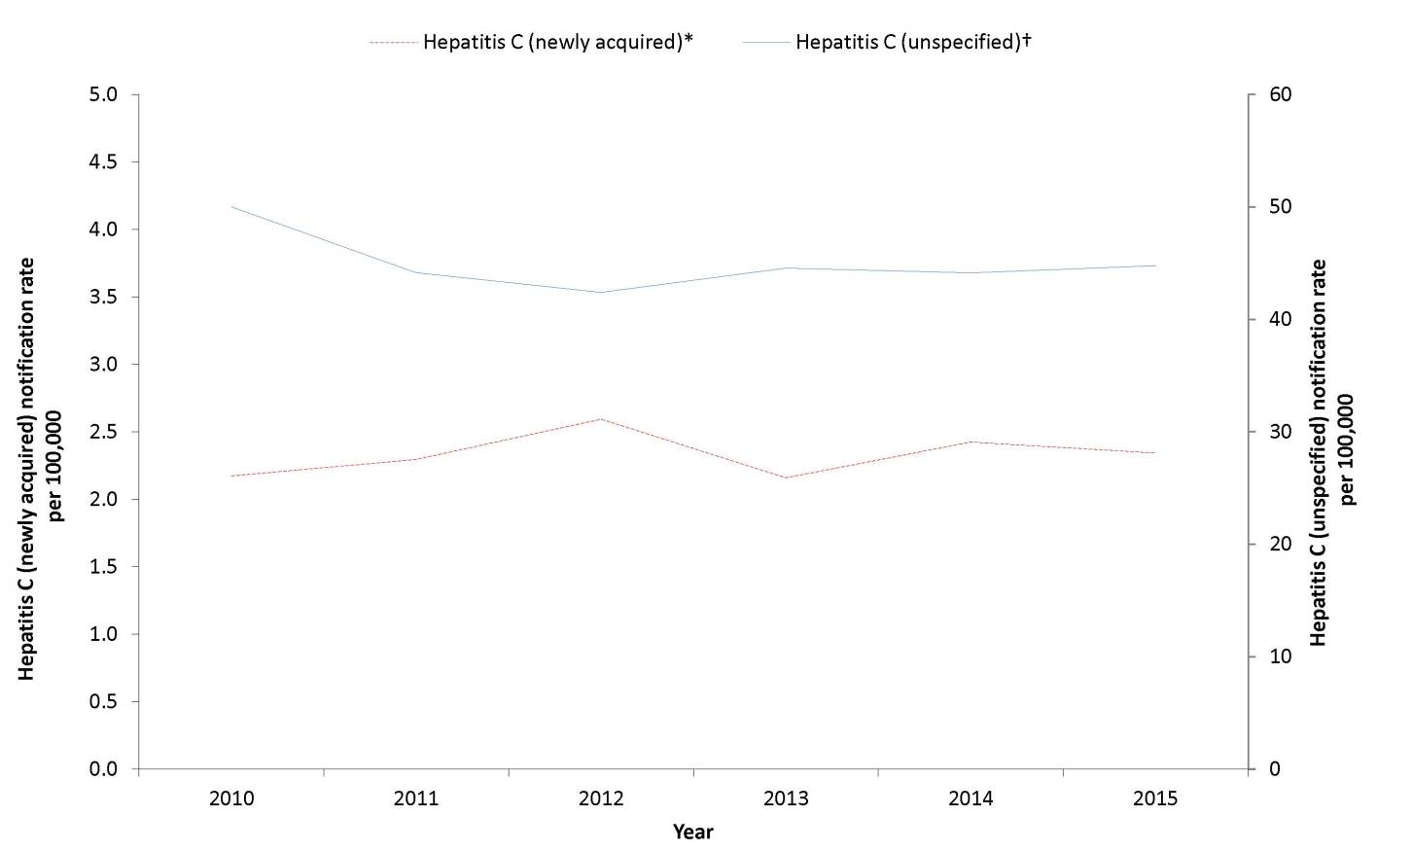
* Data from all states and territories except Queensland.
† Data provided from Queensland includes both newly acquired and unspecified hepatitis C cases.

Newly acquired hepatitis C
- There were 433 cases of newly acquired hepatitis C notified in 2015.
- The majority of newly acquired cases had a history of injecting drug use.
- The highest notification rate was among males in the 20–24 years age group.

Epidemiological situation in 2015
Cases of newly acquired hepatitis C infection were reported from all states and territories except Queensland, where all cases of hepatitis C infection are reported as unspecified. Nationally, the notification rate in 2015 was 2.3 per 100,000 (n=433) compared with 2.4 per 100,000 (n=448) in 2014 (Figure 8).

Geographical distribution
In 2015, Western Australia reported the highest jurisdiction-specific rate of newly acquired hepatitis C infection (7.1 per 100,000) (Table 5).

Age and sex distribution
In 2015, males accounted for 68% (294/433) of newly acquired hepatitis C notifications, and the highest notification rate was observed among males aged 20–29 years (10.7 per 100,000). This may be due to males in this age group having greater exposure to the hepatitis C virus through injecting drug use and imprisonment.^{30,31} For females, the highest notification rate was in those aged 25–29 years (4.5 per 100,000) (Figure 9).
Figure 9: Notification rate for newly acquired hepatitis C* infection, Australia, 2015, by age group and sex
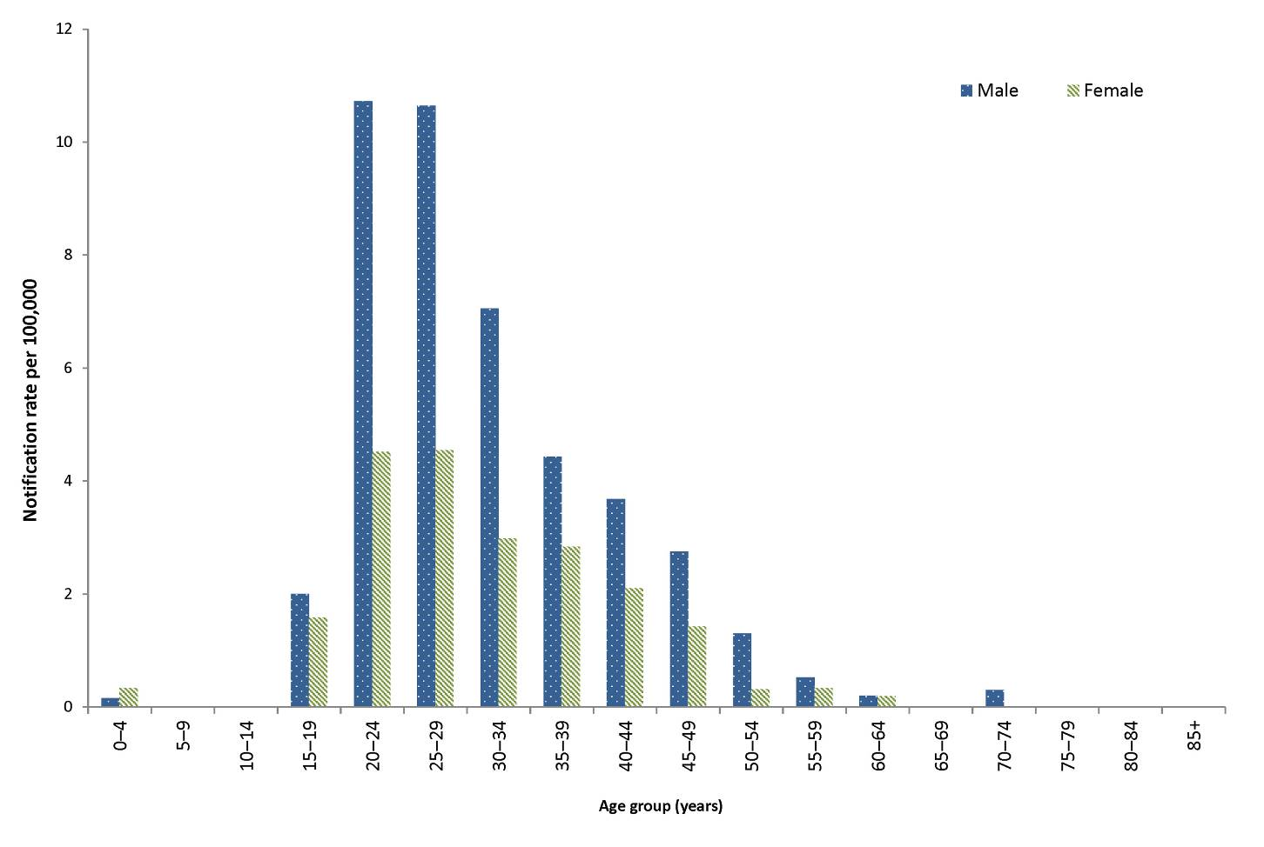
* Data from all states and territories except Queensland.
Between 2010 and 2015, age-specific notification rates for newly acquired hepatitis C infection remained stable or declined. The largest decrease from 2010 to 2015, occurred in the 15–19 years age group (from 1.9 to 1.4 per 100,000) (Figure 10).

Figure 10: Notification rate for newly acquired hepatitis C* infection, Australia, 2010 to 2015, by year and selected age groups
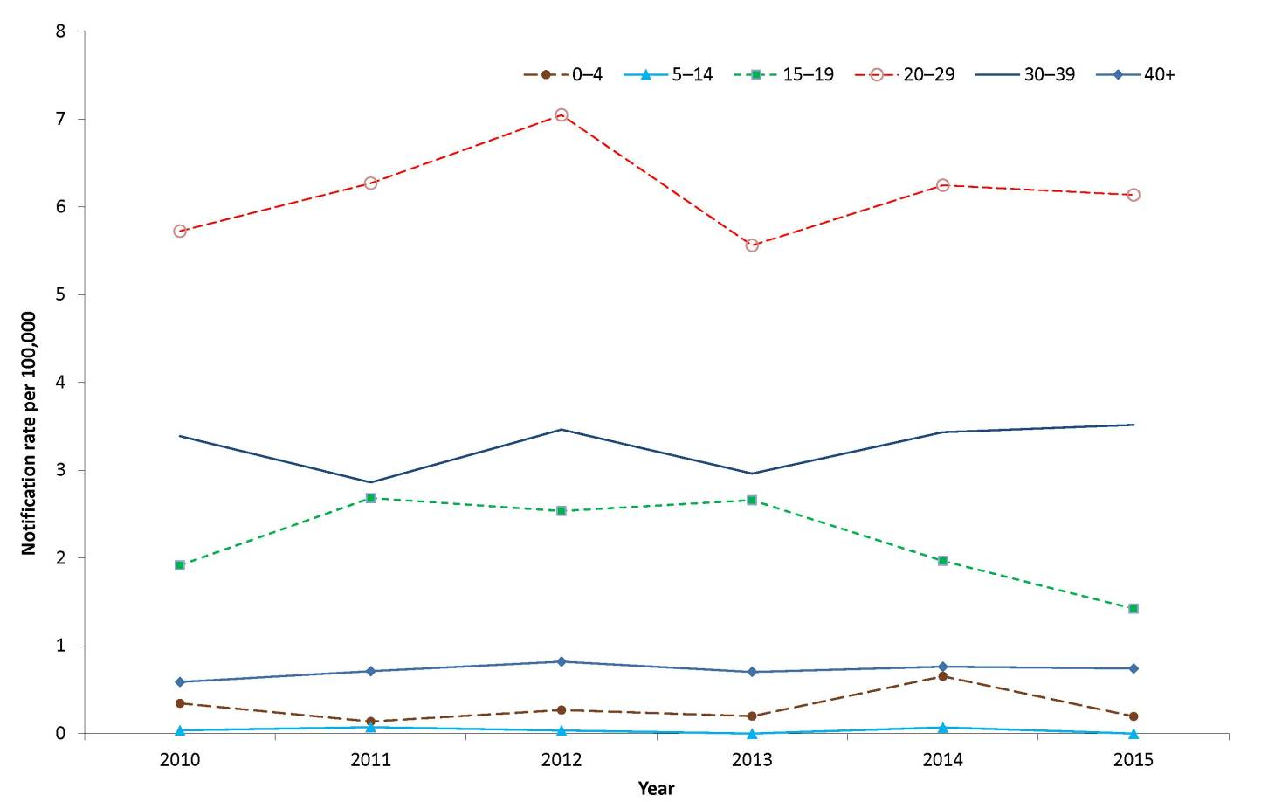
* Data from all states and territories except Queensland.

Risk groups
Exposure histories for newly acquired hepatitis C cases reported in 2015 were analysed for all jurisdictions except Queensland (Table 11). In 2015, 81% (350/433) of cases with enhanced data had at least one risk factor recorded, with the potential source of exposure not recorded or not possible to determine for the remainder. Of the cases for which enhanced data were reported, 60% (258/433) had a history of injecting drug use and 15% (63/433) reported possible sexual exposure.
Table 11: Enhanced risk factor data on notifications of newly acquired hepatitis C infection in selected jurisdictions,* 2015, by sex and risk factors†‡
Exposure category | Number of exposure factors reported |  |  | Percentage§ of total cases*(n=433)
 | Male | Female | Total
Injecting drug use | 172 | 86 | 258 | 60
Imprisonment | 144 | 22 | 166 | 38
Sexual exposure | 29 | 34 | 63 | 15
Sexual contact (hepatitis C positive partner) – opposite sex | 13 | 26 | 39 | 9
Sexual contact (hepatitis C positive partner) – same sex | 11 | 4 | 15 | 3
Sexual contact – not further classified | 3 | 3 | 6 | 1
Sexual contact (hepatitis C partner status unknown) – same sex | 2 | 0 | 2 | 0
Sexual contact (hepatitis C partner status unknown) – opposite sex | 0 | 1 | 1 | 0
Skin penetration procedure | 41 | 20 | 61 | 14
Tattoos | 35 | 11 | 46 | 11
Ear or body piercing | 5 | 9 | 14 | 3
Acupuncture | 1 | 0 | 1 | 0
Perinatal transmission | 28 | 13 | 41 | 9
Household contact | 18 | 20 | 38 | 9
Non-IDU remote risk (>24 months prior to diagnosis) | 11 | 0 | 11 | 3
Surgical work | 11 | 9 | 20 | 5
Needlestick / biohazardous injury | 3 | 4 | 7 | 2
Major dental surgery work | 4 | 1 | 5 | 1
Other | 10 | 5 | 15 | 3
Undetermined | 7 | 4 | 11 | 3
Unknown (not recorded) | 50 | 20 | 70 | 16
Total exposure factors reported | 236 | 114 | 350
Total number of cases | 294 | 139 | 433
* Cases from the Australian Capital Territory, New South Wales, the Northern Territory, South Australia, Tasmania, Victoria and Western Australia. While these 7 jurisdictions provided enhanced data on risk factors, not all cases had this information recorded.
† More than 1 exposure category for each case could be recorded.
‡ Analysis and categorisation of these exposures are subject to interpretation and may vary between reports.
§ The denominator used to calculate the percentage is based on the cases with recorded enhanced data from the Australian Capital Territory, New South Wales, Northern Territory, South Australia, Tasmania, Victoria and Western Australia. As more than 1 exposure category for each notification could be recorded, the total percentage does not equate to 100%.
More than a third (38%, n=166) of cases with enhanced data reported being imprisoned in the 24 months prior to diagnosis. Of these cases, 66% (n=110) also reported a history of injecting drug use. However, it is important to note that screening rates are generally higher in the prison entry population than the general population. A screening survey of prison entrants conducted over a 2-week period found that the prevalence of hepatitis C infection, based on hepatitis C antibody detection, was 31% in 2013, an increase from 22% in 2010.³²
Of the 402 cases for which country of birth was reported, 369 were in Australian born (92%) and 33 cases were born overseas (11 from Europe, 11 from the Pacific, 6 from Asia, 3 from Southern Africa, 1 from North America, and 1 from South America).

Unspecified hepatitis C
- There were 10,360 cases of unspecified hepatitis C infection notified in 2015.
- The highest notification rates were among males in the 25–49 years age groups.

Epidemiological situation in 2015
In 2015, 10,360 cases of unspecified hepatitis C infections were notified to the NNDSS (44.8 per 100,000) compared with 10,211 cases in 2014 (44.1 per 100,000). Notification rates have decreased since 2010 and remained stable between 2013 and 2015. There was an overall decline of 10% between 2010 (50.0 per 100,000) and 2015 (44.8 per 100,000) (Figure 8).
Several factors may account for the decrease, including changes in surveillance practices, removal of duplicate notifications, and a gradual decline in the prevalent group of hepatitis C cases accumulated prior to the introduction of hepatitis C testing in the early 1990s.³³

Geographical distribution
For the past 5 years, the Northern Territory has reported the highest jurisdiction-specific notification rate for unspecified hepatitis C. In 2015, the Northern Territory’s notification rate was 80.2 per 100,000 (Table 5), which was 9% higher than the 2010 rate of 73.5 per 100,000.

Age and sex distribution
Nationally in 2015, 66% (6,855/10,360) of unspecified hepatitis C notifications were in males (for cases where the sex was reported). The notification rate in males was 58.0 per 100,000, and in females was 28.9 per 100,000; this equates to a male to female rate ratio of 2:1. Notification rates in males exceeded those in females across most age groups. The highest notification rates were among males aged 35–39 years (113.2 per 100,000) and 30–34 years (105.6 per 100,000). The highest notification rates among females were for those aged 30–34 years (57.5 per 100,000) and 35–39 years (56.3 per 100,000) (Figure 11).

Figure 11: Notification rate for unspecified hepatitis C* infection, Australia, 2015, by age group and sex
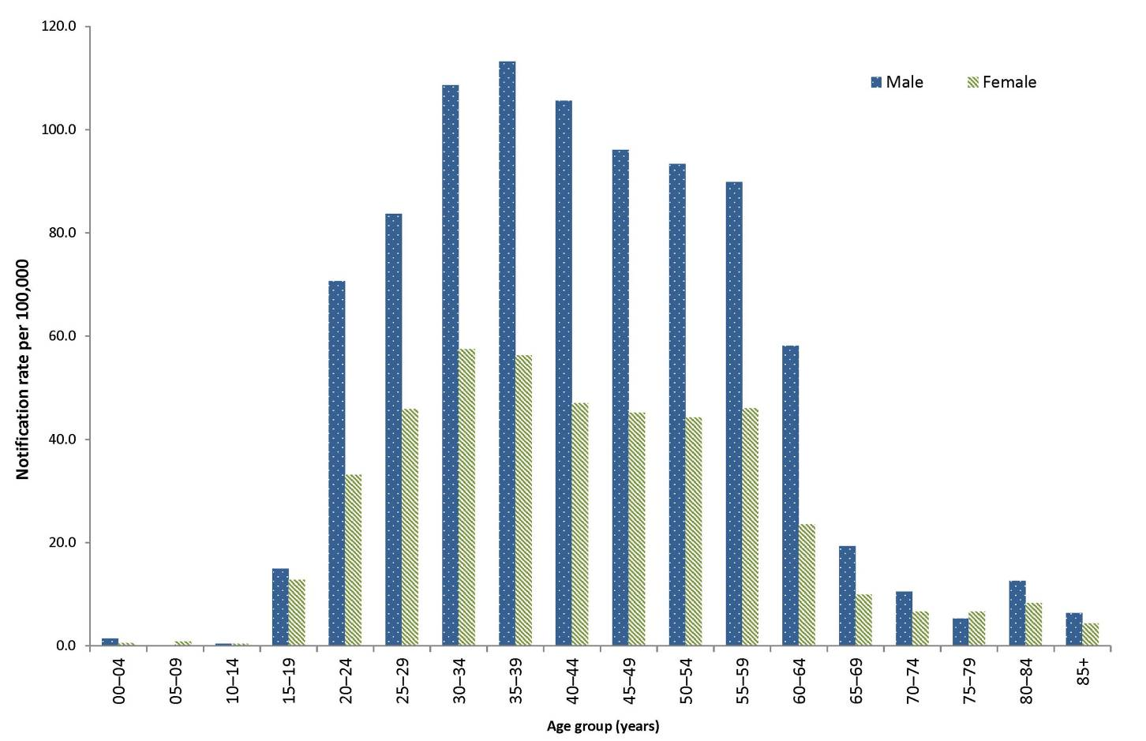
* Data provided from Queensland includes both newly acquired and unspecified hepatitis C cases.
† Excludes 47 cases where age and/or sex were missing or unknown.
Between 2010 and 2015, notification rates for unspecified hepatitis C infection remained stable or declined. The largest decreases have occurred in the 20–29 years (from 73.5 to 58.9 per 100,000) and the 30–39 years (102.2 to 84.4 per 100,000) age groups (Figure 12).

Figure 12: Notification rate for unspecified hepatitis C* infection, Australia, 2010 to 2015, by year and selected age groups†
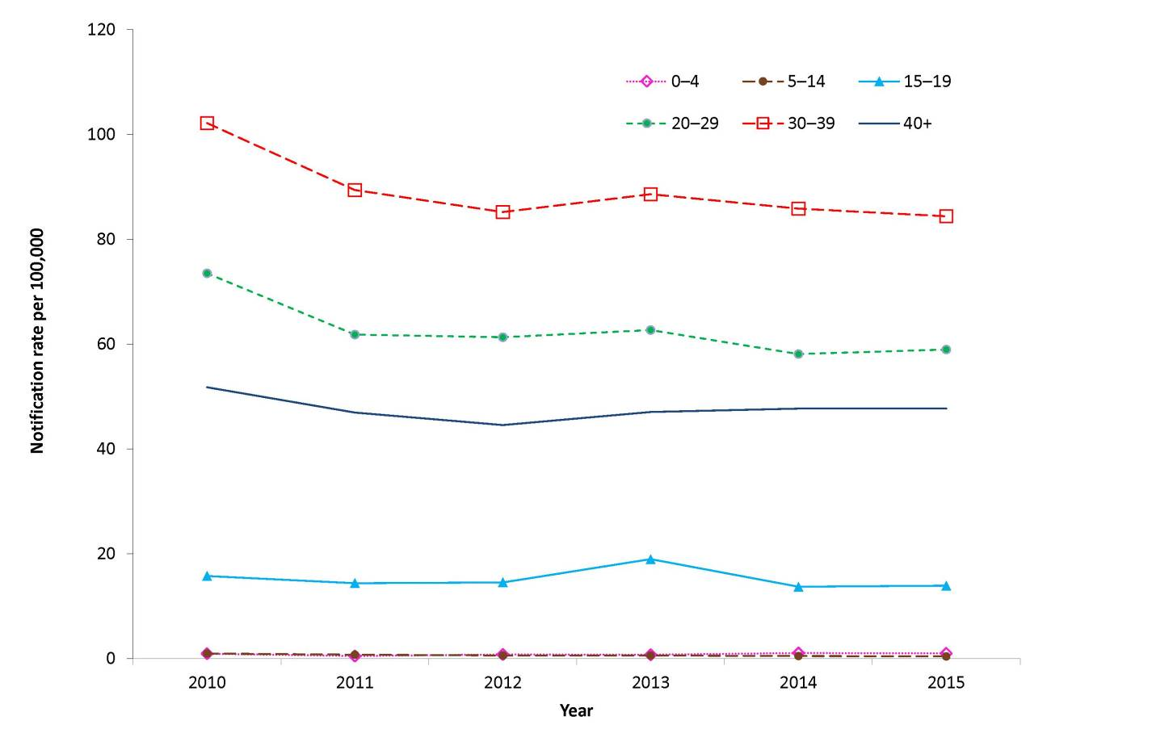
* Data provided from Queensland (2010–2015) includes both newly acquired and unspecified hepatitis C cases.
† Excludes 63 cases where age was not reported.

Hepatitis D
- There were 39 cases of hepatitis D notified in 2015.
- Hepatitis D is always associated with hepatitis B co-infection.
Hepatitis D is a defective single-stranded RNA virus that replicates in the presence of the hepatitis B virus. Hepatitis D infection can occur as either an acute co-infection with hepatitis B or as a super-infection with chronic hepatitis B infection. The modes of hepatitis D transmission are similar to those for hepatitis B.²¹

Epidemiological situation in 2015
In Australia, the notification rate for hepatitis D infection remains low. In 2015, there were 39 notified cases of hepatitis D, representing a rate of 0.2 per 100,000 (Table 5). Over the preceding 5 years, notifications of hepatitis D remained relatively low, with an average of 49 cases notified per year (range: 36 to 61).

Geographical distribution
In 2015, Queensland reported the highest number of cases (n=15), followed by New South Wales (n=9), South Australia (n=9) and Victoria (n=6). No cases were reported from the Australian Capital Territory, the Northern Territory, Tasmania or Western Australia during this period.

Age and sex distribution
Hepatitis D notifications in males exceeded those in females each year from 2010 to 2015. In 2015, 67% (26/39) of notifications were in males. This represents a male to female notification ratio of 2.0:1. This is less than the average notification ratio of 2.2:1 over the preceding 5 years (Figure 13).
Figure 13: Notifications of hepatitis D infection, Australia, 2010 to 2015, by year and sex
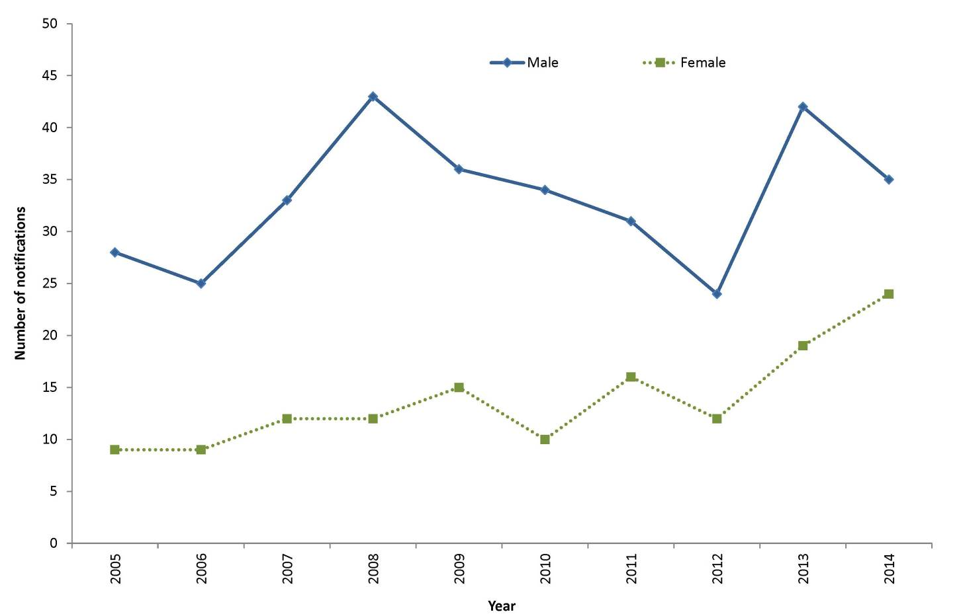

Gastrointestinal diseases
In 2015, gastrointestinal diseases notified to NNDSS were botulism; campylobacteriosis; cryptosporidiosis; haemolytic uraemic syndrome (HUS); hepatitis A; hepatitis E; listeriosis; paratyphoid; salmonellosis; shigellosis; Shiga toxin-producing Escherichia coli (STEC) infections; and typhoid. From January 2016, paratyphoid has been recorded in the NNDSS as a separate condition from salmonellosis. The separation of paratyphoid from salmonellosis was applied to data in the NNDSS retrospectively; therefore paratyphoid is included as a separate disease for this 2015 annual report. Please note that the NNDSS data reports at http://www9.health.gov.au/cda/source/cda-index.cfm for salmonellosis in past years will now not match previously published data, as paratyphoid has been separated out.
Overall, notified cases of gastrointestinal diseases increased by 12%, from 40,364 in 2014 to 45,326 in 2015. Notifications for campylobacteriosis (22,573), and salmonellosis (17,013) were at the highest levels since NNDSS records began in 1991. It should be noted that culture-independent nucleic acid-based testing methods were introduced by a number of diagnostic laboratories around the country from late 2013 onwards, which may partially explain this increase. These testing methods have increased sensitivity compared to traditional techniques, such as culture; however, the full effect on notifications has not been quantified.

Surveillance systems overview
The Australian Government established OzFoodNet – Australia’s enhanced foodborne disease surveillance system – in 2000 as a collaborative network of epidemiologists and microbiologists who conduct enhanced surveillance, epidemiological outbreak investigations and applied research into foodborne diseases across Australia. OzFoodNet’s mission is to apply concentrated effort at the national level to investigate and understand foodborne disease, to describe its epidemiology more effectively and to identify ways to minimise foodborne illness in Australia. The data and results summarised in the following sections will be reported in more detail in the OzFoodNet 2015 annual report.

Botulism
There were 3 cases of botulism notified in 2015.
Botulism is a rare, extremely serious intoxication resulting from accidental or intentional exposure to toxins produced by Clostridium botulinum (commonly toxin types A, B and E; rarely type F). All toxins can cause flaccid paralysis by blocking the neuromuscular junction. There are 4 recognised forms of botulism: infant; foodborne; wound; and adult intestinal toxaemia.²¹

Epidemiological situation in 2015
There were 3 cases of botulism (2 infants and one adult) notified in 2015. Of the 2 cases of infant botulism, one was in New South Wales and one was in Western Australia; no source of infection was identified. The remaining notification was of foodborne botulism in an adult male in Victoria. The suspected source was consumption of home-cured meat. C. botulinum toxin type A gene was detected in the stools of the New South Wales case by polymerase chain reaction (PCR), and C. botulinum neurotoxin gene B was detected by PCR in the Victorian case’s specimen, and in the stools of the Western Australian case.

Campylobacteriosis
- Three were 22,573 cases of campylobacteriosis notified in 2015.
- Campylobacteriosis was the most frequently notified enteric infection in 2015.
The Campylobacter bacteria is a common cause of foodborne illness (campylobacteriosis) in humans. This illness varies in severity and is characterised by diarrhoea (often bloody), abdominal pain, fever, nausea and vomiting.²¹ Campylobacteriosis is notifiable in all Australian states and territories except New South Wales.

Epidemiological situation in 2015
There were 22,573 notified cases of campylobacteriosis in 2015, making it the most frequently notified enteric infection (139.6 per 100,000). This is a 13% increase on the number of notifications received for 2014 (n=19,945) (Figure 14) and an increase of 33% on the 5-year mean for 2010 to 2014 (n=17,005) (Table 6). The number of notified cases for 2015 was the highest recorded in the NNDSS, with the highest number of cases notified in October 2015.

Figure 14: Notifications and notification rate for campylobacteriosis, Australia, 2010 to 2015, by year
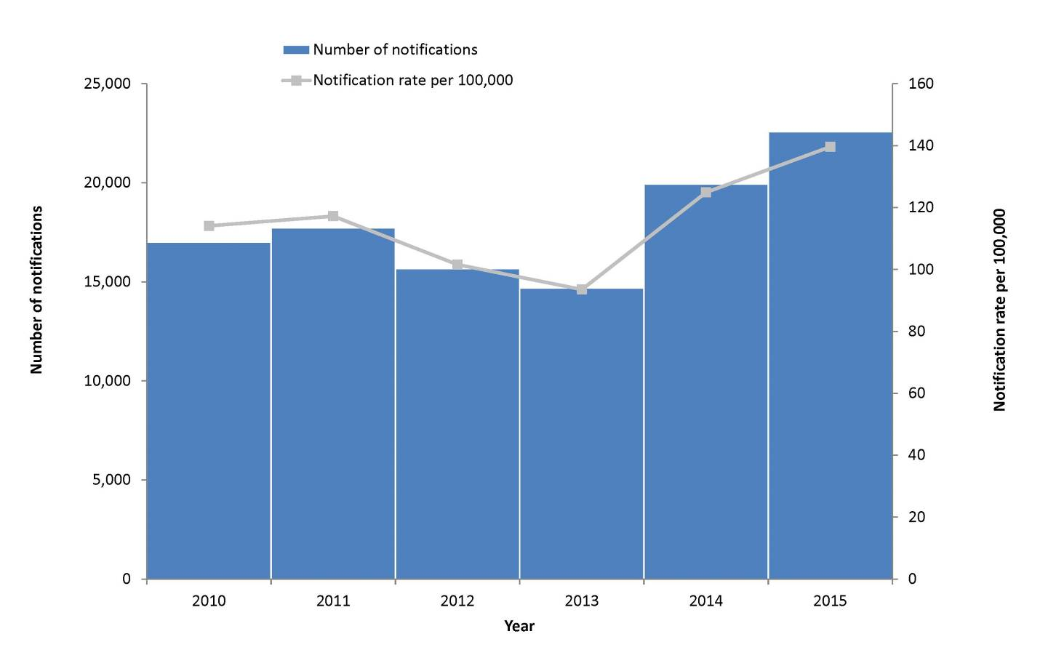

Geographical distribution
Notification rates for campylobacteriosis ranged from 106.9 per 100,000 in South Australia to 200.3 per 100,000 in Tasmania. The Tasmanian rate was approximately 1.4 times higher than the national rate (139.6 per 100,000) (Table 5).

Age and sex distribution
Campylobacteriosis was most frequently notified among the 0–4 years age group for both males (252.4 per 100,000) and females (181.6 per 100,000). The median age of notified cases was 37 years (range: 0 to 99 years). Of those where sex was reported, 54% (12,185/22,562) were male. Notification rates were highest among males in all age groups except for the 25–29 and 30–34 years age groups, where notifications for females were slightly higher (Figure 15).

Figure 15: Notification rate for campylobacteriosis, Australia, 2015, by age group and sex*
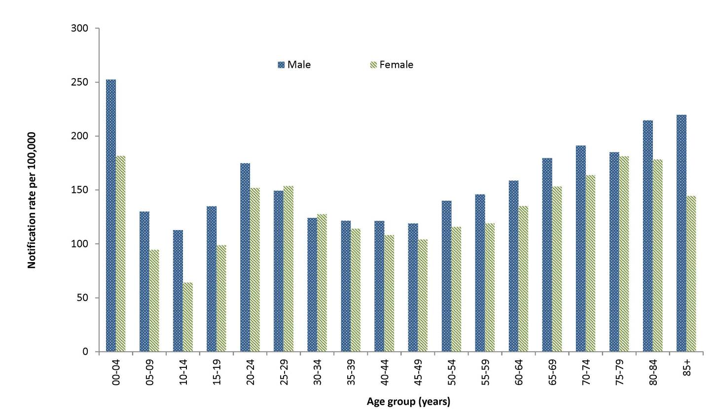
* Excludes notifications where age (n=10), sex (n=11) or both (n=1) were not reported.

Cryptosporidiosis
There were 4,064 cases of cryptosporidiosis notified in 2015.
Cryptosporidiosis is a parasitic infection characterised by abdominal cramping and usually a large volume of watery diarrhoea. Ingesting contaminated water, typically from a recreational source such as a community swimming pool or lake, is a major risk factor for infection.²¹

Epidemiological situation in 2015
There were 4,064 notified cases of cryptosporidiosis in 2015 (17.1 per 100,000). This represents a 69% increase on the number of notifications received for 2014 (n=2,408) and a 60% increase on the 5-year historical mean (n=2,539.2) (Figure 16).

Figure 16: Notifications and notification rate for cryptosporidiosis, Australia, 2010 to 2015, by year
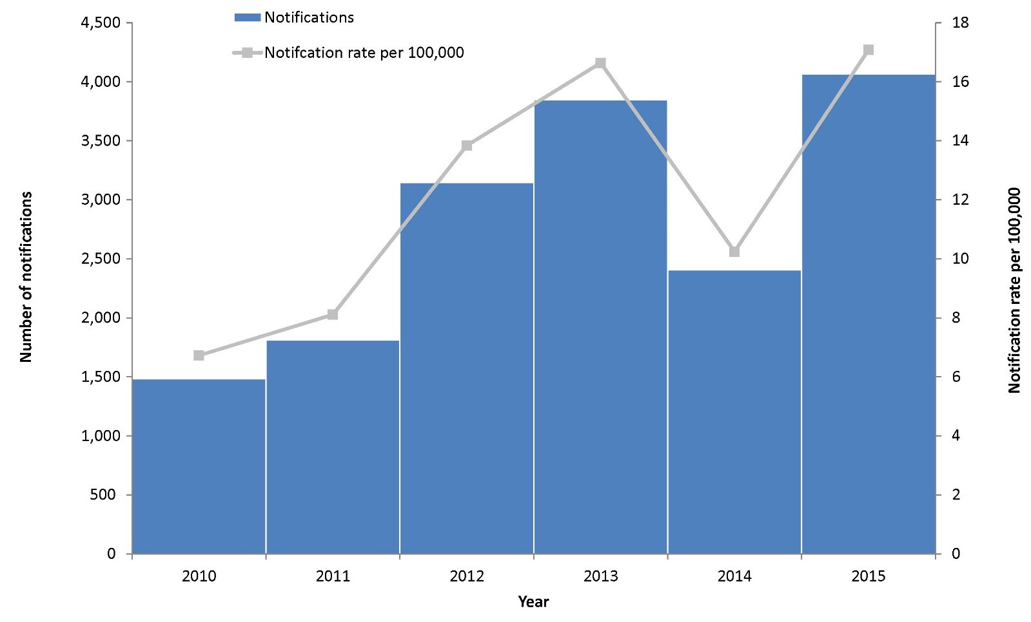

Geographical distribution
Notification rates for cryptosporidiosis ranged from 3.7 per 100,000 in Tasmania to 49.9 per 100,000 in the Northern Territory. The Northern Territory rate was 3 times higher than the national rate (17.1 per 100,000) (Table 5).

Age and sex distribution
In 2015, notified cases for cryptosporidiosis were most frequent among the 0–4 years age group (33%; 1,359/4,064). The median age of notified cases was 13 years (range: 0 to 89 years), and just over half (2,115/4,064) were females (Figure 17).
Figure 17: Notifications of cryptosporidiosis, Australia, 2015, by age group and sex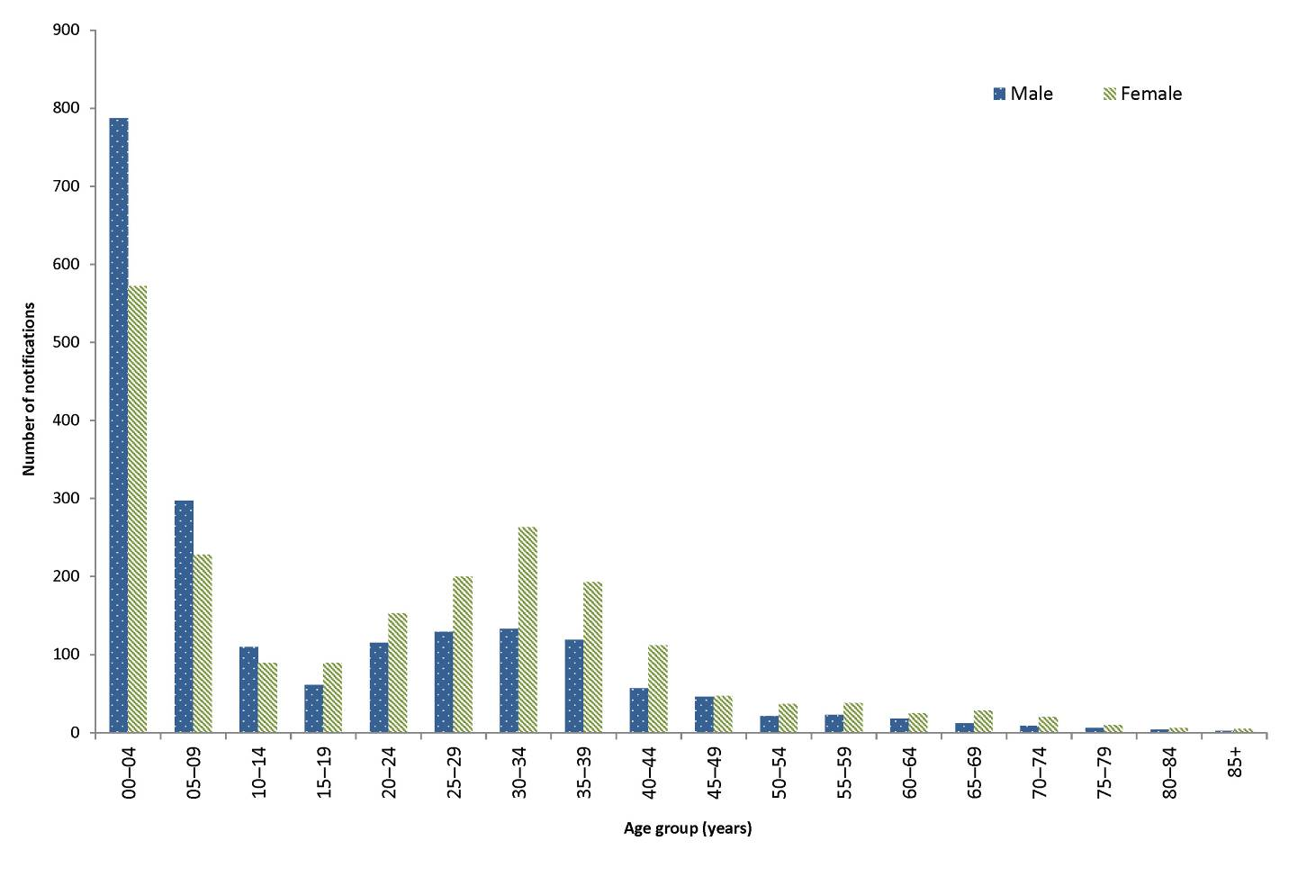

Haemolytic uraemic syndrome
- There were 18 cases of haemolytic uraemic syndrome notified in 2015.
- Cases were more frequently notified among the 0–4 years age group in 2015.
Haemolytic uraemic syndrome (HUS) is a rare and serious illness that is characterised by acute renal impairment, with 50% of patients requiring dialysis and approximately 5% dying.²¹ Not all diagnoses of HUS are related to enteric pathogens; however, cases in Australia are commonly associated with Shiga toxin-producing Escherichia coli (STEC) infection.³⁴

Epidemiological situation in 2015
There were 18 notified cases of HUS in 2015, comparable to the 21 cases reported in 2014 and the 5-year historical mean (15.6 cases per year). Overall, 44% (8/18) of notified HUS cases also had a notification for STEC and 63% (7/8) had a confirmed serogroup (2 cases each were O157:H- and O111, and one case each were O26, O28:H8 and OR
:H- respectively).

Geographical distribution
Nearly two-thirds (61%, 11/18) of notifications were residents of New South Wales (n=11), although there was a mix of urban and rural and no cases were associated by person, place or time.

Age and sex distribution
In 2015, HUS was most frequently notified among the 0–4 years age group (44%, 8/18) (Figure 18). Over half of the notified cases were in females (n=10).
Figure 18: Notifications of HUS, Australia, 2015, by age group and sex
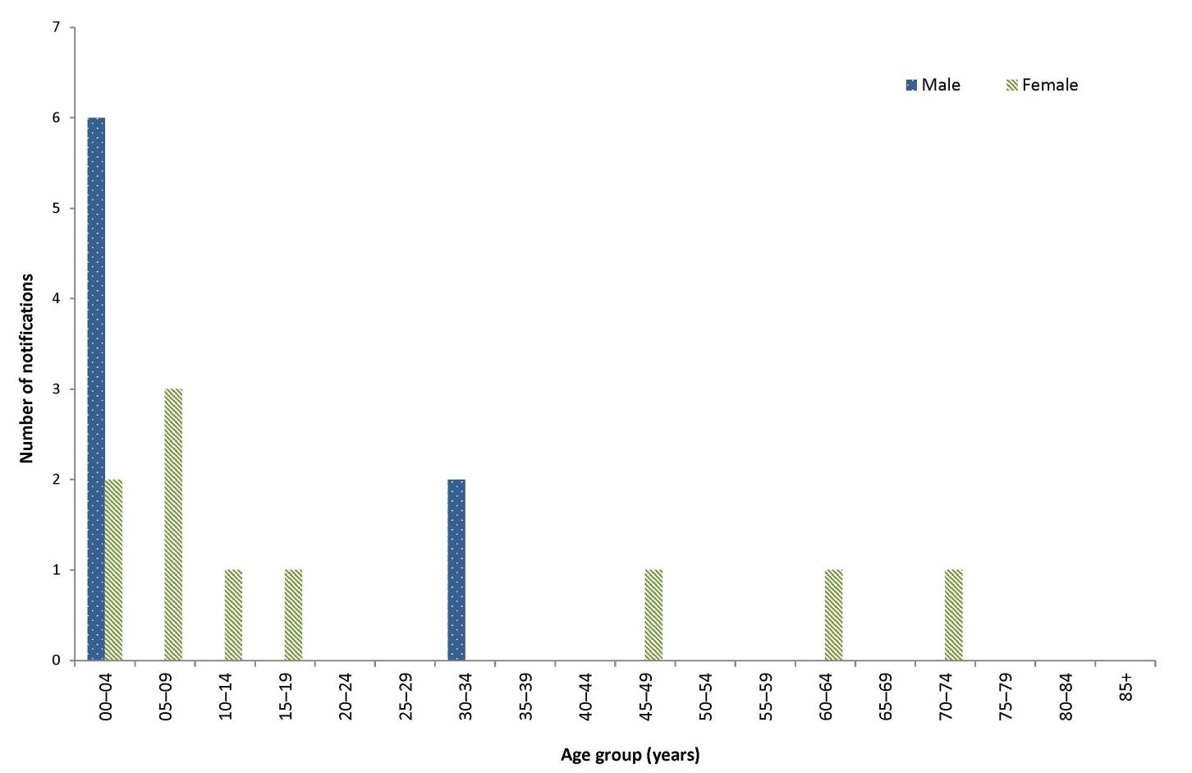

Hepatitis A
- There were 178 cases of hepatitis A infection notified in 2015.
- Overseas travel was the primary risk factor for notified cases.
Hepatitis A is an acute viral infection primarily affecting the liver. It is characterised by fever, malaise, anorexia, nausea and abdominal discomfort followed by jaundice. The disease is usually asymptomatic in young children and varies from a mild illness to a severely disabling disease that could last for several months in older children and adults. Infection is usually spread from person to person via the faecal–oral route but can also be foodborne or waterborne.²¹

Epidemiological situation in 2015
There were 178 notified cases of hepatitis A infection in 2015 (0.7 per 100,000). This is a 30% decrease on the number of notified cases in 2014 (n=231), and a 12% decrease on the 5-year historical mean (n=199.8) (Figure 19). The historical mean partially reflects the impact of a 2009–2010 outbreak of hepatitis A infection associated with the consumption of imported semi-dried tomatoes.³⁵
Figure 19: Notifications and notification rate for hepatitis A infection, Australia, 2010 to 2015, by year and place of acquisition
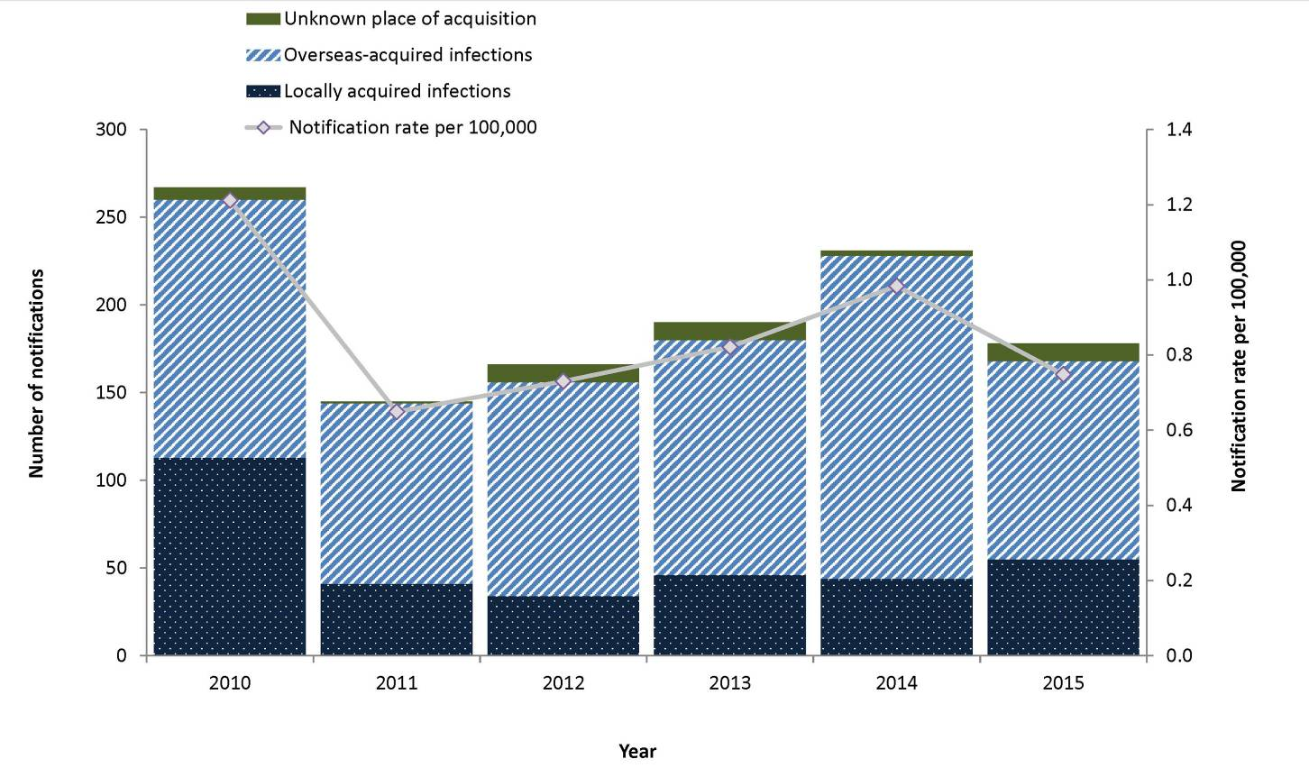

Geographical distribution
New South Wales reported the highest number of hepatitis A notifications (68/178), with a population rate of 0.9 per 100,000, followed by Queensland (33/178, 0.7 per 100,000 population), and Victoria (33/178, 0.6 per 100,000 population).

Age and sex distribution
Hepatitis A infection was most frequently notified among the 20–24 years age group (12%, 22/178) in 2015 (Figure 20). The median age of notified cases was 27 years (range: 2 to 85 years), and 58% (103/178) of all cases were male.

Figure 20: Notifications of hepatitis A infection, Australia, 2015, by age group and sex
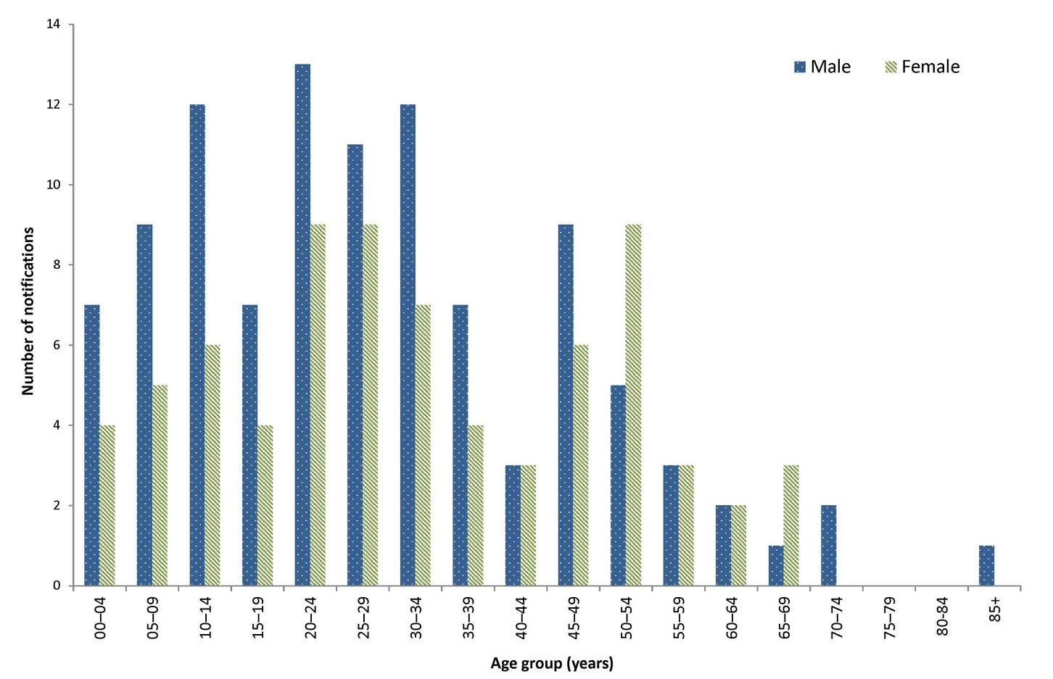

Indigenous status
Indigenous status was known for 97% (173/178) of notified cases of hepatitis A. Of these 173 cases, 4 were identified as being Indigenous. Immunisation programs for Indigenous children were established initially in North Queensland in 1999 for Indigenous children aged 18 months. The hepatitis A immunisation program was expanded in 2005 to include all Indigenous children aged ≤2 years in the Northern Territory, Queensland, South Australia and Western Australia.³⁶ These programs led to a sharp decline in the number of cases of hepatitis A in Indigenous people,³⁷ and numbers have remained low in this population group.

Place of acquisition
Place of acquisition was known for 168 cases of hepatitis A in 2015. Of these, 67% (113/168) reported overseas travel during their period of acquisition and were considered to have been overseas acquired (Table 12). The top 5 countries of acquisition were India (n=23), Pakistan (n=11), Fiji (n=10), the Philippines (n=10) and Bangladesh (n=9).
Thirty-three per cent (55/168) of notified cases in 2015, where place of infection was known, were locally acquired. This is the second highest number of locally acquired cases in the last 5 years, with the highest recorded locally acquired cases occurring in 2010 (44%, n=113) (Table 12). Thirty-five of the 55 locally acquired cases notified in 2015 were attributed to a multi-jurisdictional outbreak of hepatitis A infection associated with the consumption of imported frozen mixed berries. A summary of this outbreak will be included in the 2015 OzFoodNet Annual Report.

Table 12: Notifications of hepatitis A, Australia, 2010 to 2015, by place of acquisition *Excludes cases where the place of acquisition was unknown or not supplied
Year | Locally acquired |  | Overseas acquired | Unknown | Total
 | n | %* | n | n
2010 | 113 | 44 | 145 | 9 | 267
2011 | 41 | 28 | 103 | 1 | 145
2012 | 32 | 20 | 128 | 6 | 166
2013 | 46 | 26 | 134 | 10 | 190
2014 | 44 | 19 | 184 | 3 | 231
2015 | 55 | 33 | 113 | 10 | 178

Year | Locally acquired |  | Overseas acquired |  | Unknown |  | Total
 | n | %* | n | % | n | %
2010 | 113 | 44 | 145 | 54 | 9 | 3 | 267
2011 | 41 | 28 | 103 | 71 | 1 | <1 | 145
2012 | 32 | 20 | 128 | 77 | 6 | 4 | 166
2013 | 46 | 26 | 134 | 71 | 10 | 5 | 190
2014 | 44 | 19 | 184 | 80 | 3 | 1 | 231
2015 | 55 | 33 | 113 | 63 | 10 | 6 | 178

Hepatitis E
- There were 41 cases of hepatitis E infection notified in 2015.
Hepatitis E infection is an acute viral infection primarily affecting the liver. The virus is transmitted via the faecal–oral route, most often via food or water.²¹ The infection is usually acquired overseas among travellers to endemic areas.

Epidemiological situation in 2015
There were 41 notified cases of hepatitis E infection in 2015 (0.2 per 100,000). This is a 28% decrease on the number of notified cases in 2014 (n=57), and a 2% increase on the 5-year historical mean (n=40).

Geographical distribution
The majority of notifications were in residents of New South Wales (n=21), followed by residents of Victoria (n=15).

Age and sex distribution
Hepatitis E infection was most frequently notified among people aged 60–64 and 65–69 years (Figure 21). In 2015, the median age of notified cases was 55 years (range: 6 to 79 years), and 61% (25/41) were male.
Figure 21: Notifications of Hepatitis E infection, Australia, 2015, by age group and sex.
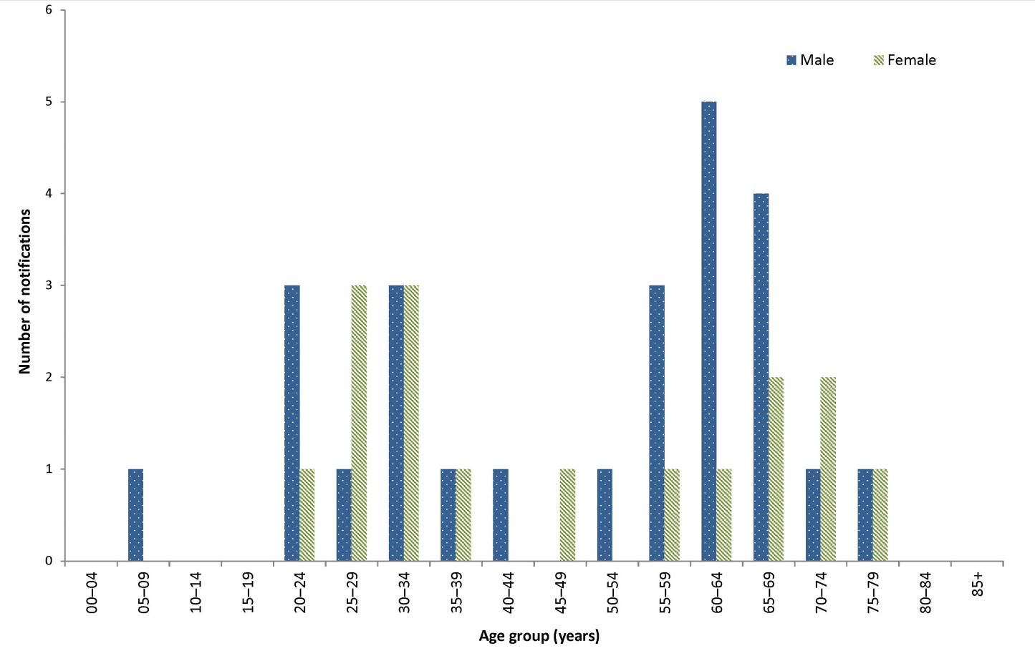

Place of acquisition
Hepatitis E infection in Australia has traditionally been associated with overseas travel. In 2015, place of acquisition was recorded for 37 cases, of which 30 reported overseas travel during their period of acquisition and were considered to have acquired infection overseas. Of these, 57% (17/30) reported travel to India.
In 2015, 19% (7/37) of cases were locally acquired. One case from Western Australia was associated with a liver transplant. The remaining 6 cases were from New South Wales (n=5) and South Australia (n=1) and there were no apparent links or common sources between these cases.

Listeriosis
- There were 70 cases of listeriosis notified in 2015.
- Notifications were highest in the 60–64 and 75–79 years age groups.
Invasive listeriosis is caused by a bacterial infection that commonly affects the elderly or immunocompromised, and typically occurs among people with serious underlying illnesses. Listeriosis can also affect pregnant women and infect their unborn baby.³⁸ Laboratory-confirmed infections in a mother and her unborn child or neonate are notified separately in the NNDSS.

Epidemiological situation in 2015
There were 70 notified cases of listeriosis in 2015 (0.3 per 100,000), which was a 13% decrease on the number of notified cases in 2014 (n=80) and a 10% decrease compared with the 5-year historical mean (n=78.0).

Geographical distribution
New South Wales had the highest number of notifications (28/70, 40%), followed by Victoria (21/70 30%).

Age and sex distribution
Notifications of listeriosis were highest in the 60–64 and 75–79 years age groups (both 16%, 11/70,) (Figure 22), with over half (61%, 43/70) of all notified cases being male.
Figure 22: Notifications of listeriosis, Australia, 2015, by age group and sex
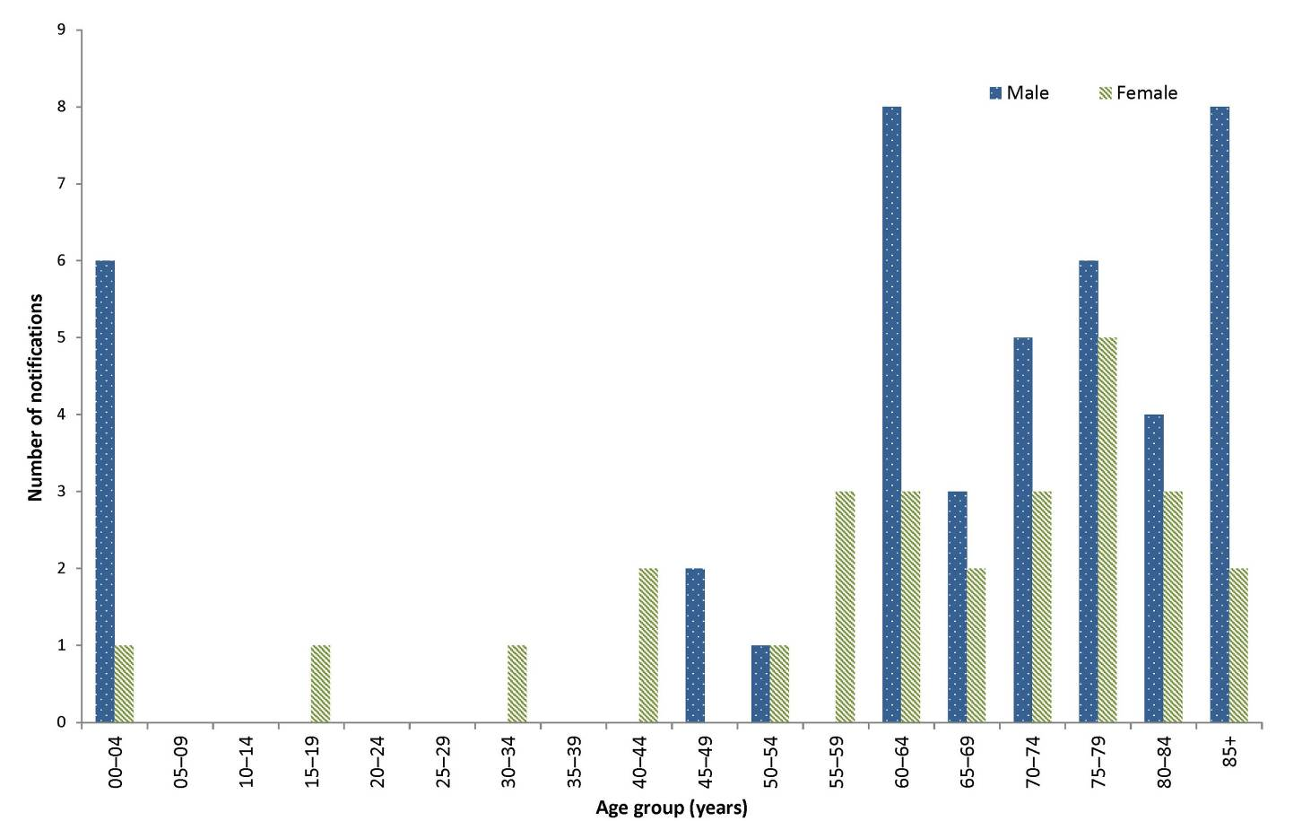

Enhanced surveillance datasets
In 2010, OzFoodNet implemented the National Enhanced Listeriosis Surveillance System (NELSS), which collects enhanced surveillance data on all notified cases of listeriosis in Australia. The enhanced information includes laboratory data collected from the characterisation of Listeria monocytogenes isolates by molecular subtyping methods, and epidemiological data including food consumption histories and clinical data. The overall aim of this enhanced surveillance is to enable timely detection of outbreaks and subsequent public health response.³⁴ From 1 July 2015, OzFoodNet’s NELSS began to utilise whole genome sequencing (WGS) in parallel with other molecular subtyping methods. More information on NELSS can be found in OzFoodNet Annual Reports (http://health.gov.au/internet/main/publishing.nsf/Content/cdna-ozfoodnet-reports.htm).

Paratyphoid
- There were 76 cases of paratyphoid notified in 2015.
- This was the second highest number of notifications recorded in NNDSS since 1991.
This is the first NNDSS Annual Report to include paratyphoid as a separate notifiable condition from salmonellosis, as paratyphoid was only made a separate condition from 1 January 2016. However, data have been updated retrospectively for all years, making annual comparisons possible. Paratyphoid is a bacterial disease caused by S. enterica serovars Paratyphi A, Paratyphi B, or Paratyphi C, which typically produce symptoms similar to typhoid, known commonly as ‘enteric fever’. Please note: S. enterica Paratyphi B biovar Java does not cause an enteric fever and is included under salmonellosis.

Epidemiological situation in 2015
There were 76 notified cases of paratyphoid in 2015 (0.3 per 100,000). This is an increase of 9% compared with 2014 (n=70) (Figure 23), and a 3% increase on the 5-year historical mean (n=74.2).
Figure 23: Notifications and notification rate for paratyphoid, Australia, 2010 to 2015, by year
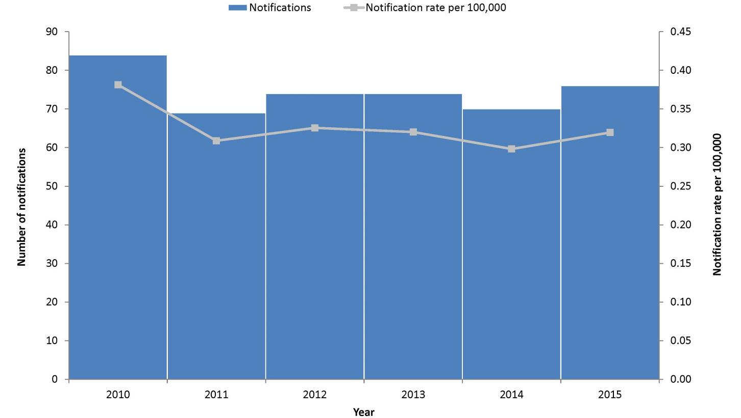

Geographical distribution
The highest number of notifications (36%, 27/76) was in residents of Victoria, followed by New South Wales (24%, 18/76).

Age and sex distribution
Paratyphoid was most frequently notified among the 30–34 years age group (20%, 15/76) (Figure 24). The median age of notified cases was 27 years (range: 0 to 66 years), and there were more males (54%, 41/76) than females (46%, 35/76).

Figure 24: Notifications of paratyphoid, Australia, 2015, by age group and sex
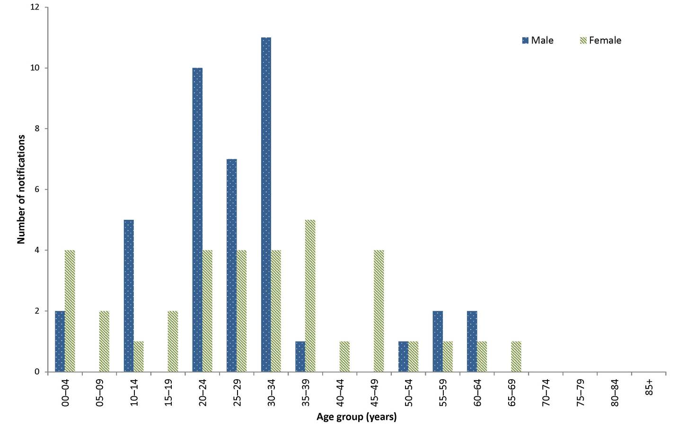

Place of acquisition
Overseas travel is the primary risk factor for notified cases of paratyphoid. In 2015, place of acquisition was reported for 87% (66/76) of notified cases of paratyphoid. Of these, 94% (62/66) reported overseas travel during their exposure period and were considered overseas acquired. The most frequently reported country of acquisition was India, accounting for 34% (21/62) of overseas-acquired cases in 2015. Four cases were reported as locally acquired, and the place of acquisition was unknown or not stated for 10 cases (Table 13). Four locally acquired cases were residents of South Australia, 3 of which were a family cluster in 1 household; S. enterica serovar Paratyphi B was detected in all 4 cases. Two cases in residents of Victoria with an unknown place of acquisition were suspected to have been locally acquired, but a source could not be determined despite screening of household contacts of both cases.

Table 13: Notifications of paratyphoid, Australia, 2010 to 2015, by place of acquisition
Year notified | Locally acquired |  | Overseas acquired |  | Unknown |  | Total
 | n | %* | n | % | n | %
2010 | 6 | 7 | 75 | 89 | 3 | 4 | 84
2011 | 4 | 6 | 65 | 94 | 0 | 0 | 69
2012 | 2 | 3 | 63 | 85 | 9 | 12 | 74
2013 | 1 | 1 | 66 | 89 | 7 | 90 | 74
2014 | 2 | 3 | 57 | 81 | 11 | 16 | 70
2015 | 4 | 5 | 62 | 82 | 10 | 13 | 76
* Excludes cases where the place of acquisition was not supplied or unknown.

Salmonellosis (non-typhoidal)
- There were 17,013 cases of salmonellosis notified in 2015.
- Salmonellosis was the second most frequently notified enteric infection in 2015.
- This was the highest number of salmonellosis notifications recorded in the NNDSS since 1991.
Salmonellosis is a bacterial disease characterised by the rapid development of symptoms including abdominal pain, fever, diarrhoea, muscle pain, nausea and/or vomiting. The predominant mode of transmission is contaminated food, mainly of animal origin; ²¹ however, people can also become infected via faecal–oral transmission, through animal contact and from environmental exposures.

Epidemiological situation in 2015
There were 17,013 notified cases of salmonellosis in 2015 (71.5 per 100,000). This is the highest annual number of notifications ever recorded in the NNDSS since salmonellosis became nationally notifiable in 1991. This represents a 4% increase on the number of cases reported in 2014 (n=16,283) (Figure 25), and a 32% increase on the 5-year historical mean (n=12,841.6), which is greater than 2 standard deviations.

Figure 25: Notifications and notification rate for salmonellosis, Australia, 2010 to 2015, by year
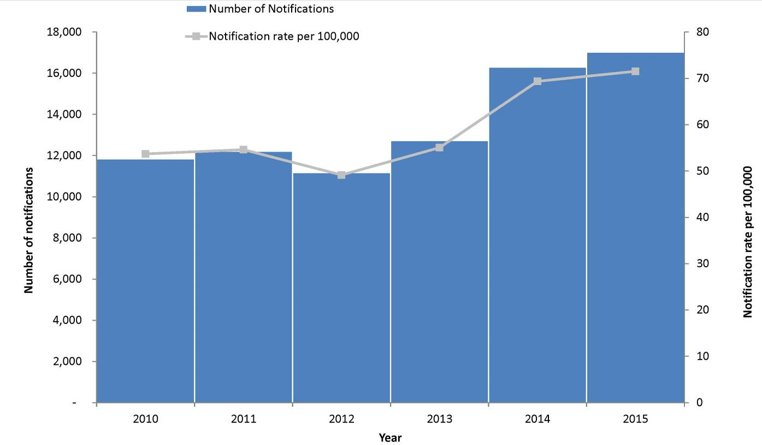

Geographical distribution
Rates ranged from 49.3 per 100,000 in Tasmania to 222.5 per 100,000 in the Northern Territory (Table 5).

Age and sex distribution
Salmonellosis was most frequently notified among the 0–4 years age group (23%; 3,846/17,013) (Figure 26), where age was recorded, with an age-specific rate of 249.6 per 100,000 population. The median age of notified cases was 27 years (range: 0 to 104 years), and over half (53%, 8,960/17,013) of cases where sex was recorded were female.

Figure 26: Notification rate for salmonellosis, Australia, 2015, by age group and sex (n=16,999)*
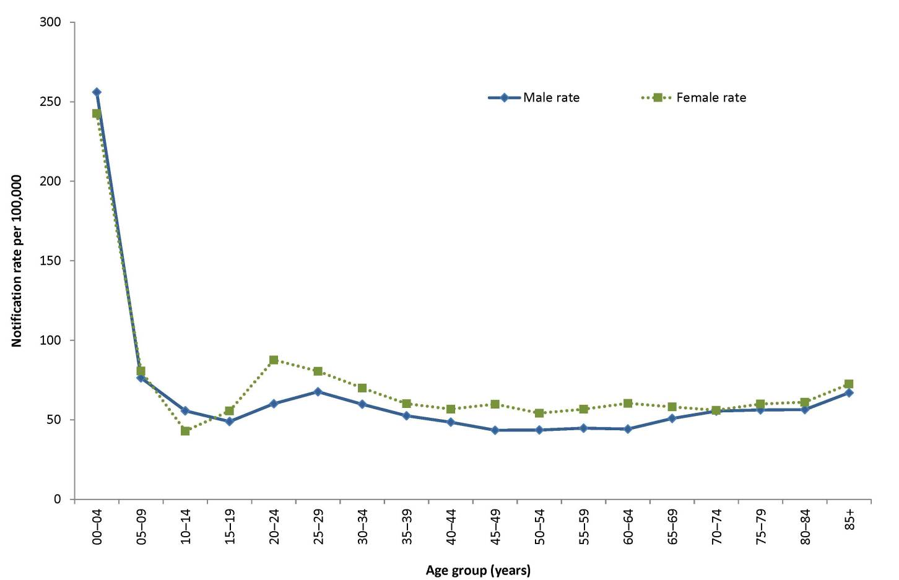
* Excludes notifications where age (n=1), sex (n=12) or both (n=1) were not reported.

Shigellosis
- There were 1,038 cases of shigellosis notified in 2015.
- This rise in notifications is possibly associated with the increase in culture-independent diagnostic testing since late 2013.
Shigellosis is a bacterial disease characterised by acute abdominal pain and fever, small-volume loose stools, vomiting and tenesmus. Shigella is transmitted via the faecal–oral route, either directly (such as male-to-male sexual contact) or indirectly through contaminated food or water.²¹

Epidemiological situation in 2015
There were 1,038 notified cases of shigellosis in 2015 (4.4 per 100,000). This is a slight decrease of 1% compared with 2014 (n=1,034) (Figure 27), and a 64% increase on the 5-year historical mean (n=632.8). This rise may be associated with the increased use of culture-independent diagnostic testing (CIDT). The current CIDT methods are unable to differentiate between infection caused by the notifiable Shigella and the non-notifiable entero-invasive Escherichia coli.³⁹

Figure 27: Notifications and notification rate for shigellosis, Australia, 2010 to 2015, by year
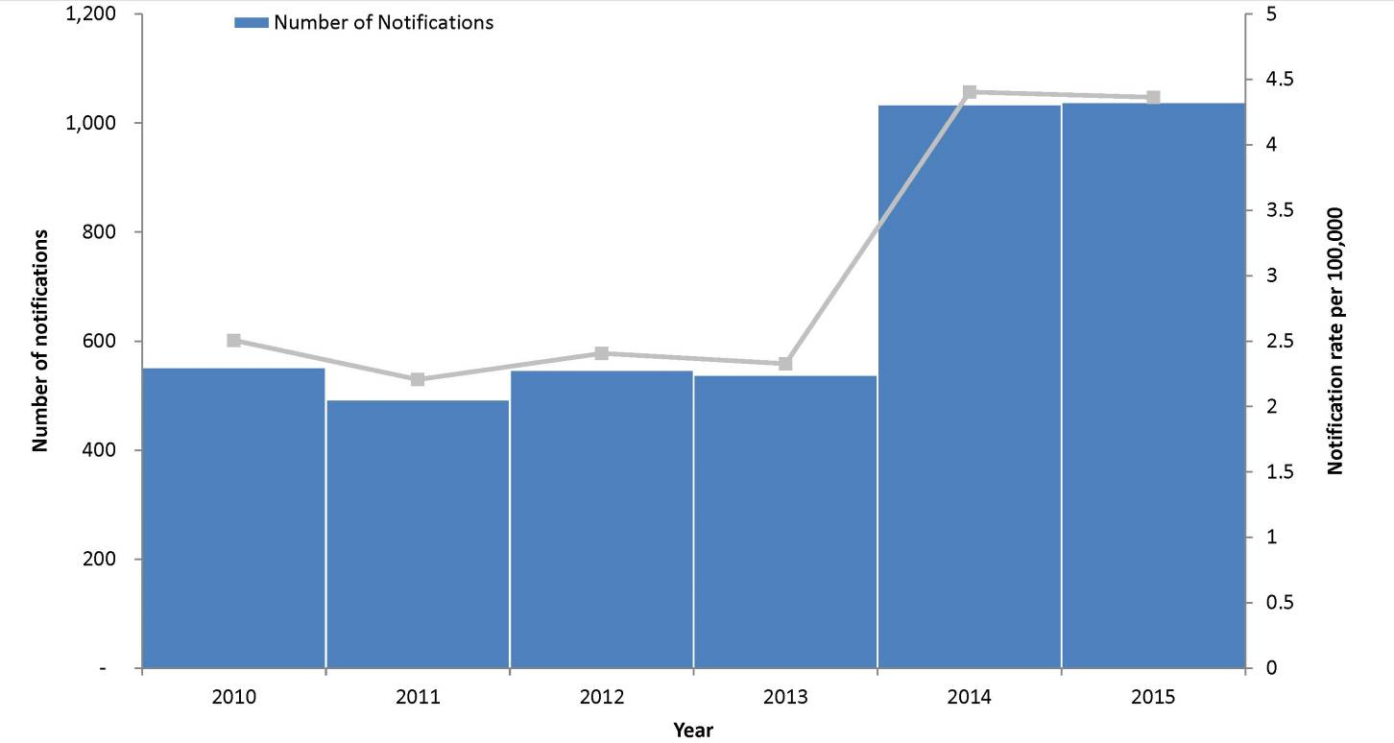

Geographical distribution
Notification rates ranged from 1.1 per 100,000 in South Australia to 55.6 per 100,000 in the Northern Territory. State and territory rates for 2015 should be interpreted with caution as some jurisdictions require CIDT-positive samples to be confirmed by culture while others do not.

Age and sex distribution
Notifications of shigellosis were highest in the 0–4 years age group (17%, 174/1,038) (Figure 28). In 2015, the median age of notified cases was 31 years (range: 0 to 89 years), and just over half (54%, 561/1,038) were male.

Figure 28: Notifications of shigellosis, Australia, 2015, by age group and sex
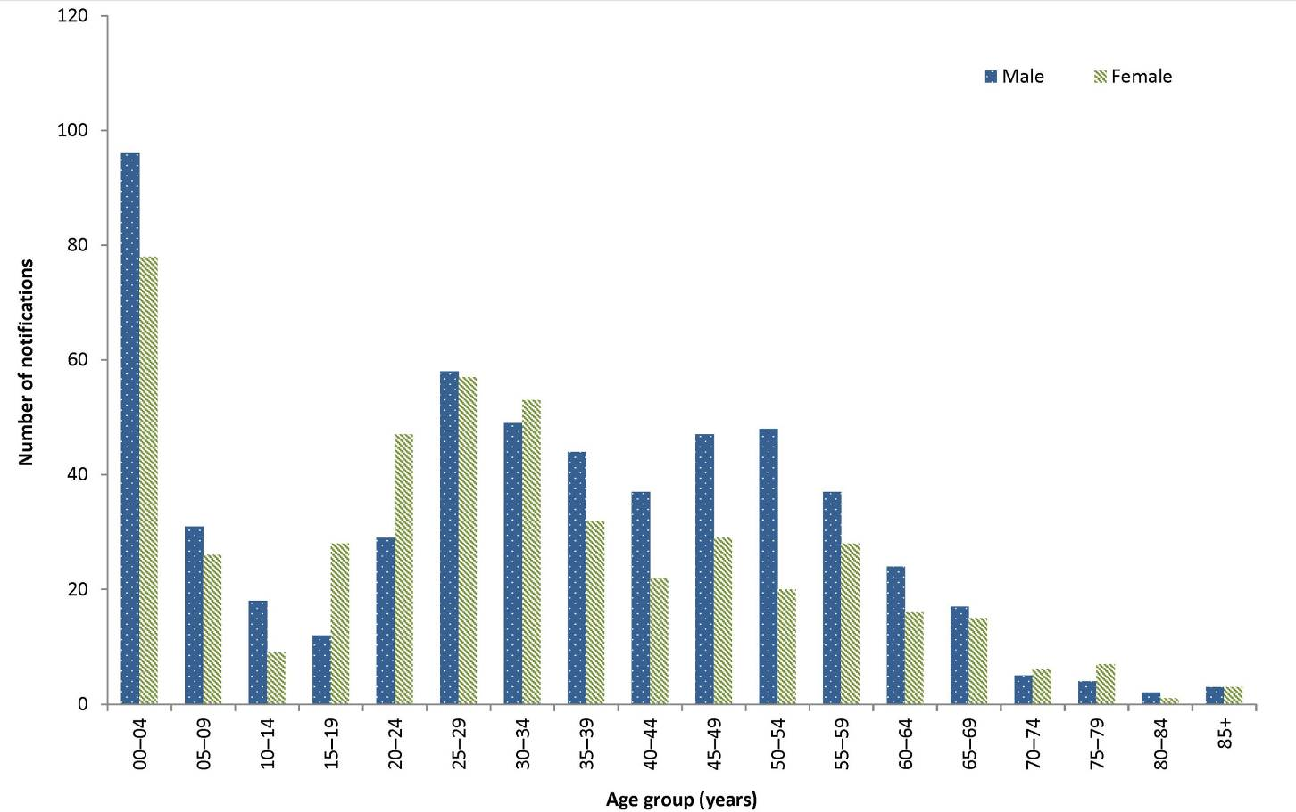

Indigenous status
Information on Indigenous status was available for 88% (909/1,038) of shigellosis cases. This proportion varied by state or territory: 86% for the Australian Capital Territory (86%); 87% for New South Wales; 82% for Victoria; and 100% for the Northern Territory, Tasmania, South Australia and Western Australia. The proportion of notified cases who identified as being of Aboriginal and/or Torres Strait Islander origin was 24% (214/909).

Place of acquisition
Place of acquisition was reported in 65% (678/1.038) of notified cases of shigellosis, of these, 64% (435/678) were reported as being acquired overseas (Table 14). The top 5 countries of acquisition were India (n=98), Indonesia (n=95), Philippines (n=19), Thailand (n=19) and Vietnam (n=18).

Table 14: Notifications of shigellosis, Australia, 2010 to 2015, by place of acquisition *Excludes cases with unknown place of acquisition
Year notified | Locally acquired |  | Overseas acquired | Unknown | Total
 | n | %* | n | n | n
2010 | 179 | 47 | 201 | 172 | 552
2011 | 169 | 53 | 148 | 176 | 493
2012 | 170 | 45 | 204 | 173 | 547
2013 | 137 | 39 | 210 | 191 | 538
2014 | 184 | 36 | 334 | 516 | 1,034
2015 | 243 | 36 | 435 | 360 | 1,038

Shiga toxin-producing Escherichia coli
- There were 137 cases of Shiga toxin-producing Escherichia coli infection notified in 2015.
- In 2015, the median age of notified cases was 37 years (range: 0 to 91 years).
Shiga toxin-producing Escherichia coli (STEC) is a common cause of diarrhoeal illness in humans. People can become infected via faecal–oral transmission, ingesting contaminated food, through animal contact and from environmental exposures. Severe illness can progress to HUS. Children under 5 years of age are most frequently diagnosed with infection and are at greatest risk of developing HUS.²¹

Epidemiological situation in 2015
There were 137 notified cases of STEC in 2015 (0.6 per 100,000). This was a 19% decrease from the number of cases in 2014 (n=115) and an 18% increase compared to the 5-year historical mean (n=116.4).

Geographical distribution
Detection of STEC infection is strongly influenced by jurisdictional practices regarding the screening of stool specimens.³⁴ South Australia continues to test all bloody stools for STEC using PCR and has the most comprehensive screening practices across all jurisdictions. As a result of these testing practices, it has the highest notification rate in the country; 2.6 cases per 100,000 compared with between 0.4 and 0.7 cases per 100,000 in other states and territories reporting cases. The differences in testing practices among states and territories render comparison of notification data by jurisdiction and over time invalid.

Age and sex distribution
Notifications of STEC were highest in the 0–4 years age group (12%, 16/137) (Figure 29). In 2015, the median age of notified cases was 37 years (range: 0 to 91 years) and 53% (72/137) of notified cases were male.

Figure 29: Number of notifications of Shiga toxin-producing Escherichia coli infection, Australia, 2015, by age group and sex
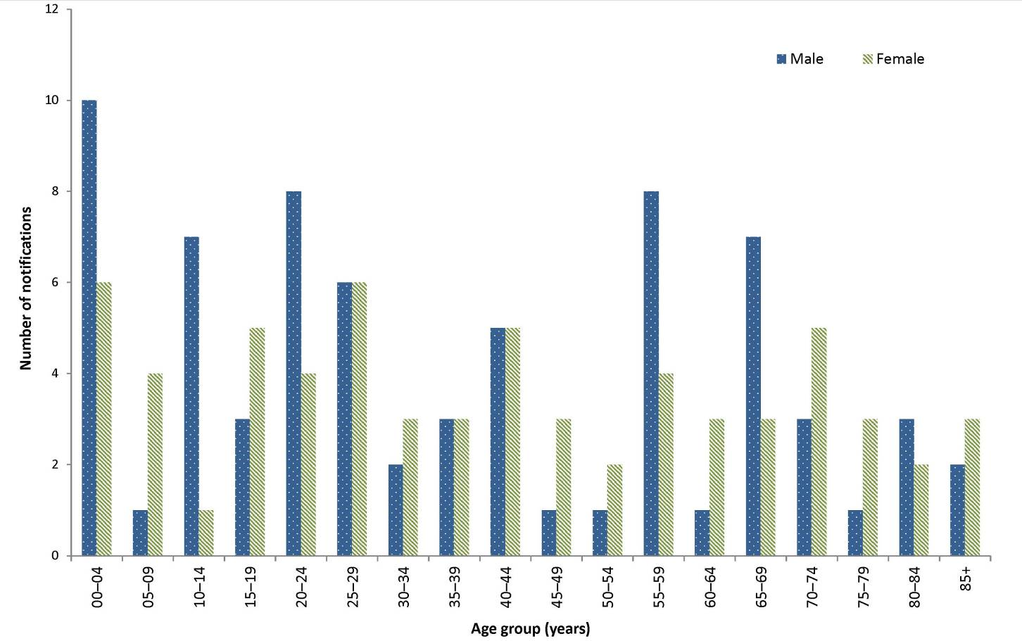

Microbiological trends
A partial or complete serotype was available for 61% (84/137) of STEC notifications in 2015, while a further 2 were reported as being not typable (Table 15).

Table 15: Notifications of Shiga toxin-producing E.coli (STEC) in 2015 by serotype or partial serotype
Serotype / partial serotype | n
O111 | 4
O111:H | 6
O113 | 4
O128:H2 | 3
O146:H- | 1
O157 | 15
O157:H | 16
O163:H19 | 1
O181:H16 | 1
O26 | 16
O26:H | 2
O26:H11 | 4
O5/O7:H | 1
O59:H19 | 1
Ont:H19 | 2
Ont:H2 | 1
Ont:H8 | 1
Or:H41 | 1
Or:H7 | 1
Untypable | 2
Serogroup Unknown | 54
Total | 137
Ont=O antigen not typable
Or=Rough O antigen

Typhoid
- There were 115 cases of typhoid notified in 2015. Of these, 98% were acquired overseas.
Typhoid is a bacterial disease caused by S. enterica serovar Typhi. Symptoms include sustained fever, marked headache, malaise, and constipation more often than diarrhoea in adults. The transmission mode is the same as for salmonellosis; however, typhoid differs in that humans are the reservoir for the bacterium.²¹

Epidemiological situation in 2015
There were 115 notified cases of typhoid in 2015 (0.5 per 100,000). This was a slight decrease of 3% from the number of cases in 2014 (n=119) (Figure 30) and 8% fewer than the 5-year historical mean (n=125).
Figure 30: Notifications and notification rate for typhoid, Australia, 2010 to 2015, by year
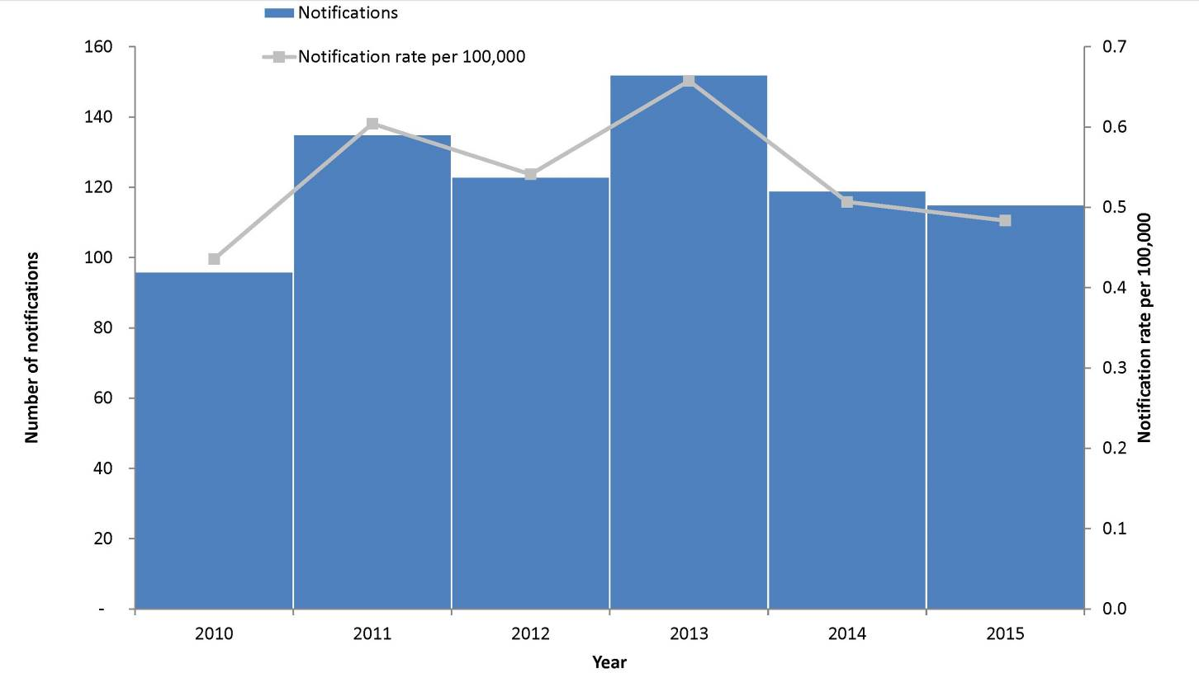

Geographical distribution
Almost two-thirds (63%, 74/115) of notifications were in residents of New South Wales (n=42) and Victoria (n=30).

Age and sex distribution
Typhoid was most frequently notified among the 25–29 years age group (26%, 30/115) (Figure 31). The median age of notified cases was 26 years (range: 0 to 77 years), with similar proportions of males 50% (57/115) and females 50% (58/115).

Figure 31: Notifications of typhoid, Australia, 2015, by age group and sex
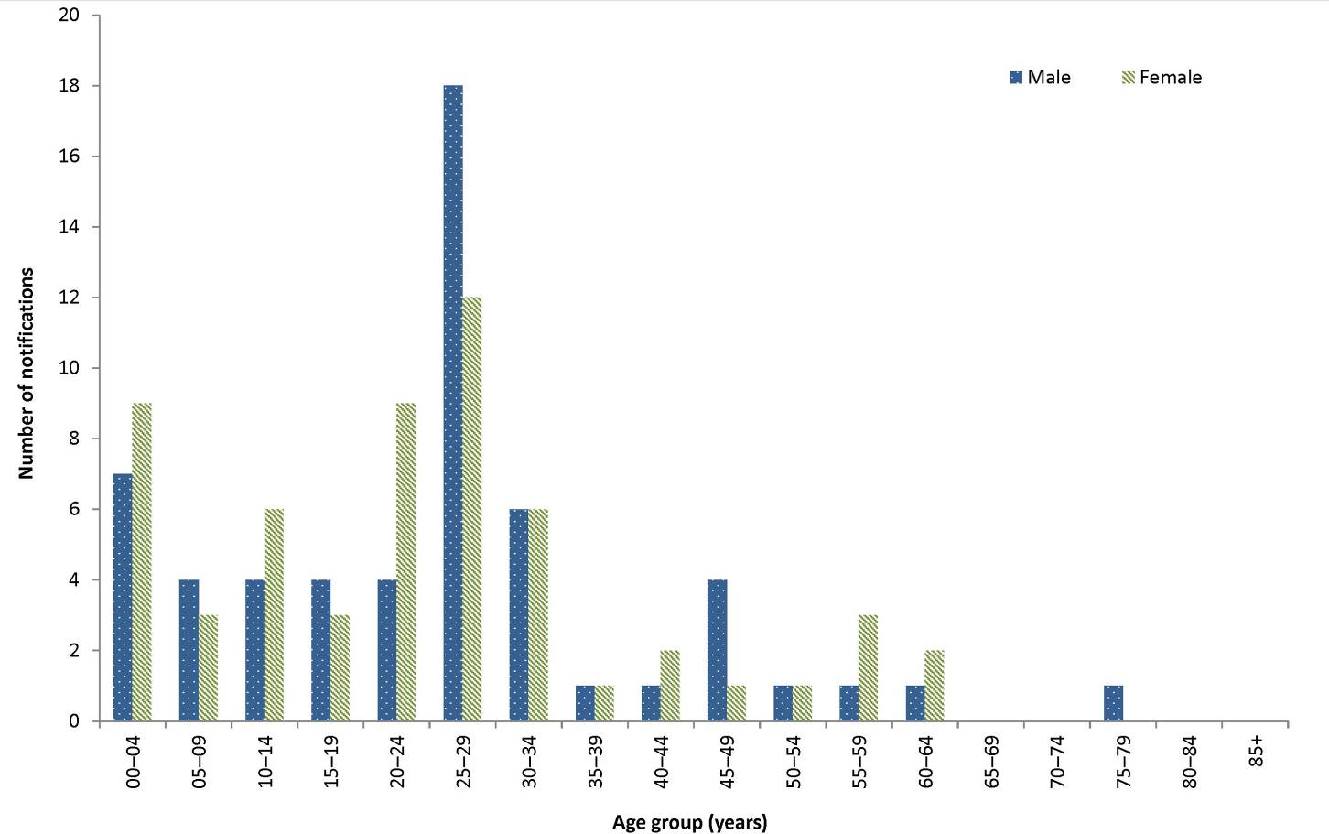

Place of acquisition
As in previous years, overseas travel was the primary risk factor for notified cases. In 2015, 93% (107/115) of notifications reported overseas travel during their period of acquisition and were considered overseas acquired. India continues to be the most frequently reported country of acquisition, accounting for 59% (63/107) of overseas-acquired cases in 2015. Two cases were listed as locally acquired (2%), and the place of acquisition was unknown for 6 cases (5%) (Table 16). Of the 2 locally acquired cases, one case from Queensland was a resident of the Torres Strait and their source of infection was unknown. The second case was from South Australia had not travelled during their incubation period but had migrated from Afghanistan and was thought to have been a chronic carrier of typhoid. Two of the cases notified by Victoria in 2015 as having an unknown place of acquisition were suspected to have been locally acquired, but the source of infection could not be determined despite extensive screening of contacts.

Table 16: Notifications of typhoid, Australia, 2010 to 2015, by place of acquisition
Year notified | Locally acquired |  | Overseas acquired | Unknown | Total
 | n | %* | n | n | n
2010 | 2 | 2 | 92 | 2 | 96
2011 | 6 | 5 | 125 | 4 | 135
2012 | 3 | 8 | 118 | 2 | 123
2013 | 8 | 5 | 141 | 3 | 152
2014 | 6 | 5 | 109 | 4 | 119
2015 | 2 | 2 | 107 | 6 | 115
*Excludes cases where the place of acquisition was unknown or not supplied

Quarantinable diseases
Human diseases covered by the Quarantine Act 1908, and notifiable in Australia and to the WHO in 2015 were cholera, plague, rabies, yellow fever, smallpox, highly pathogenic avian influenza in humans (HPAIH), severe acute respiratory syndrome (SARS) and 4 viral haemorrhagic fevers (Ebola, Marburg, Lassa and Crimean–Congo). These diseases are of international public health significance.
There were no cases of plague, rabies, yellow fever, smallpox, SARS, HPAIH or viral haemorrhagic fevers reported in Australia in 2015. While there were 2 cases of overseas-acquired cholera in 2015, Australia remains free of all the listed quarantinable diseases (Table 17).

Table 17: Australia’s status for human quarantinable diseases, 2015
Disease | Status | Date of last record and notes
Cholera | Free | Small number of cases reported annually related to overseas travel. Very rare instances of local acquisition as described under the section ‘Cholera’.
Plague | Free | Last case recorded in Australia in 192340
Rabies | Free | Last case (overseas acquired) recorded in Australia in 199041
Smallpox | Free | Last case recorded in Australia in 1938, last case world-wide in 1977, declared eradicated by the World Health Organization 198042, 43
Yellow fever | Free | Two cases in 2011 were the first recorded, related to overseas travel44
SARS | Free | Last case recorded in Australia in 200345
HPAIH | Free | No cases recorded46
Viral haemorrhagic fevers
Ebola | Free | No cases recorded
Marburg | Free | No cases recorded
Lassa | Free | No cases recorded
Crimean–Congo | Free | No cases recorded

Cholera
- There were 2 cases of cholera notified in 2015.
- Between 2010 and 2015, there have been a total of 19 cases of cholera were notified in Australia.
Cholera is an infection of the digestive tract caused by certain strains of the bacterium Vibrio cholerae that produce toxins. It is most commonly acquired in parts of Africa, Asia, South America, the Middle East and the Pacific islands. V. cholerae is found in the faeces of infected people, and is spread by drinking contaminated water, eating food washed with contaminated water or prepared with soiled hands, or eating fish or shellfish caught in contaminated water. Person to person spread of cholera is less common. Most people do not develop symptoms or have only mild illness but a small proportion of people will develop severe symptoms. Symptoms typically start between 2 hours and 5 days (usually 2 to 3 days) after ingesting the bacteria. Symptoms can include characteristic ‘rice water’ faeces (profuse, watery diarrhoea), nausea and vomiting and signs of dehydration, such as weakness, lethargy and muscle cramps. Only toxigenic V. cholerae O1 and O139 are notifiable in Australia.

Epidemiological situation in 2015
In 2015, there were 2 notifications of cholera in Australia. The following details are available about the relevant exposures and place of acquisition for these cases:
- Case 1, notified by South Australia, was a 78-year-old male who acquired the infection while travelling in Indonesia; and
- Case 2, notified by New South Wales, was a 47-year-old female who acquired the infection while travelling in Thailand.
There were a total of 19 cases of cholera notified in Australia between 2010 and 2015. All cases of cholera reported from the commencement of the NNDSS in 1991 to 2015 were acquired outside Australia, except for 1 case of laboratory-acquired cholera in 1996,⁴⁷ 3 cases in 2006 linked to imported whitebait⁴⁸ and 1 laboratory-acquired case in 2013.⁴⁴

Sexually Transmissible Infections
In 2015, the STIs notified to the NNDSS were chlamydial infection, donovanosis, gonococcal infection, and congenital and non-congenital syphilis. Other national surveillance systems that monitor STIs in Australia include the Australian Gonococcal Surveillance Programme (AGSP), which is a network of specialist laboratories monitoring antimicrobial susceptibility patterns of gonococcal infection; and the National HIV Registry maintained by the Kirby Institute at the University of New South Wales.

Chlamydial infection
- There were 65,998 cases of chlamydial infection notified in 2015.
- Chlamydia notifications from Victoria in 2015 were incomplete and have been excluded from the report. Victorian notifications normally account for approximately 23% of notifications nationally.
- Thirty-seven per cent of notifications in 2015 were among females aged 15‒24 years.
Genital chlamydial infection is caused by the bacterium Chlamydia trachomatis serogroups D to K. Screening is important in detecting chlamydial infections, as a large proportion of infections are asymptomatic. Chlamydial infection is highly treatable, although reinfection is common.⁴⁹ If it is left untreated, complications such as epididymitis in males and infertility and pelvic inflammatory disease in females can arise.²¹
Chlamydia notifications in 2015 are incomplete for Victoria, but will be available for future reporting. Victoria is excluded for every year in the analyses and figures presented below.

Epidemiological situation in 2015
In 2015, there were 65,998 cases of chlamydial infection, representing 21% of all notifications reported to the NNDSS. From 2011 to 2014, notification rates remained relatively stable, increasing marginally from 368.0 per 100,000 in 2011 to 379.4 per 100,000 in 2014, and declining in 2015 to 369.9 per 100,000 (Figure 32).

Figure 32: Notifications and notification rate for chlamydial infection, Australia, 2010 to 2015, by year*
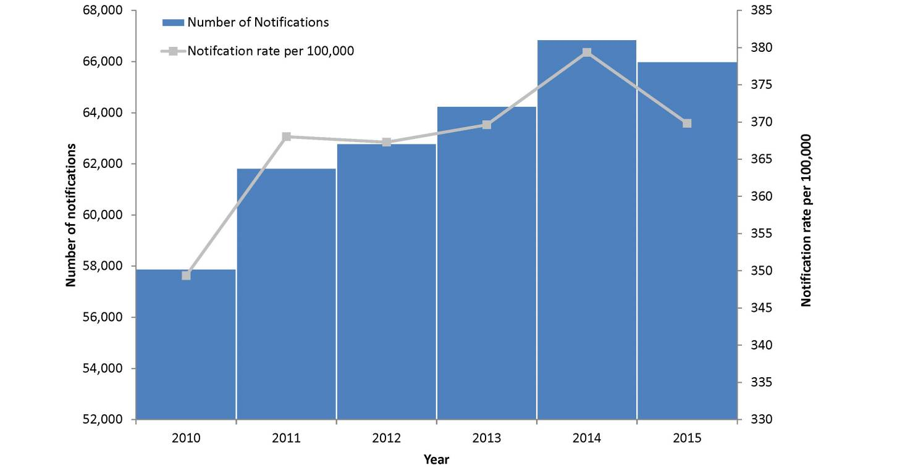
* Excludes Victoria.

Geographical distribution
In 2015, the notification rate for chlamydia was 3 times higher in the Northern Territory (1,119.8 per 100,000) compared to the national rate (369.8 per 100,000) (Figure 33). This is probably due to the disproportionate representation of Aboriginal and Torres Strait Islander women, particularly in regional and remote areas, in the chlamydia notification data (Figure 36).⁹

Figure 33: Notifications and notification rate for chlamydial infection, Australia, 2015, by state or territory*
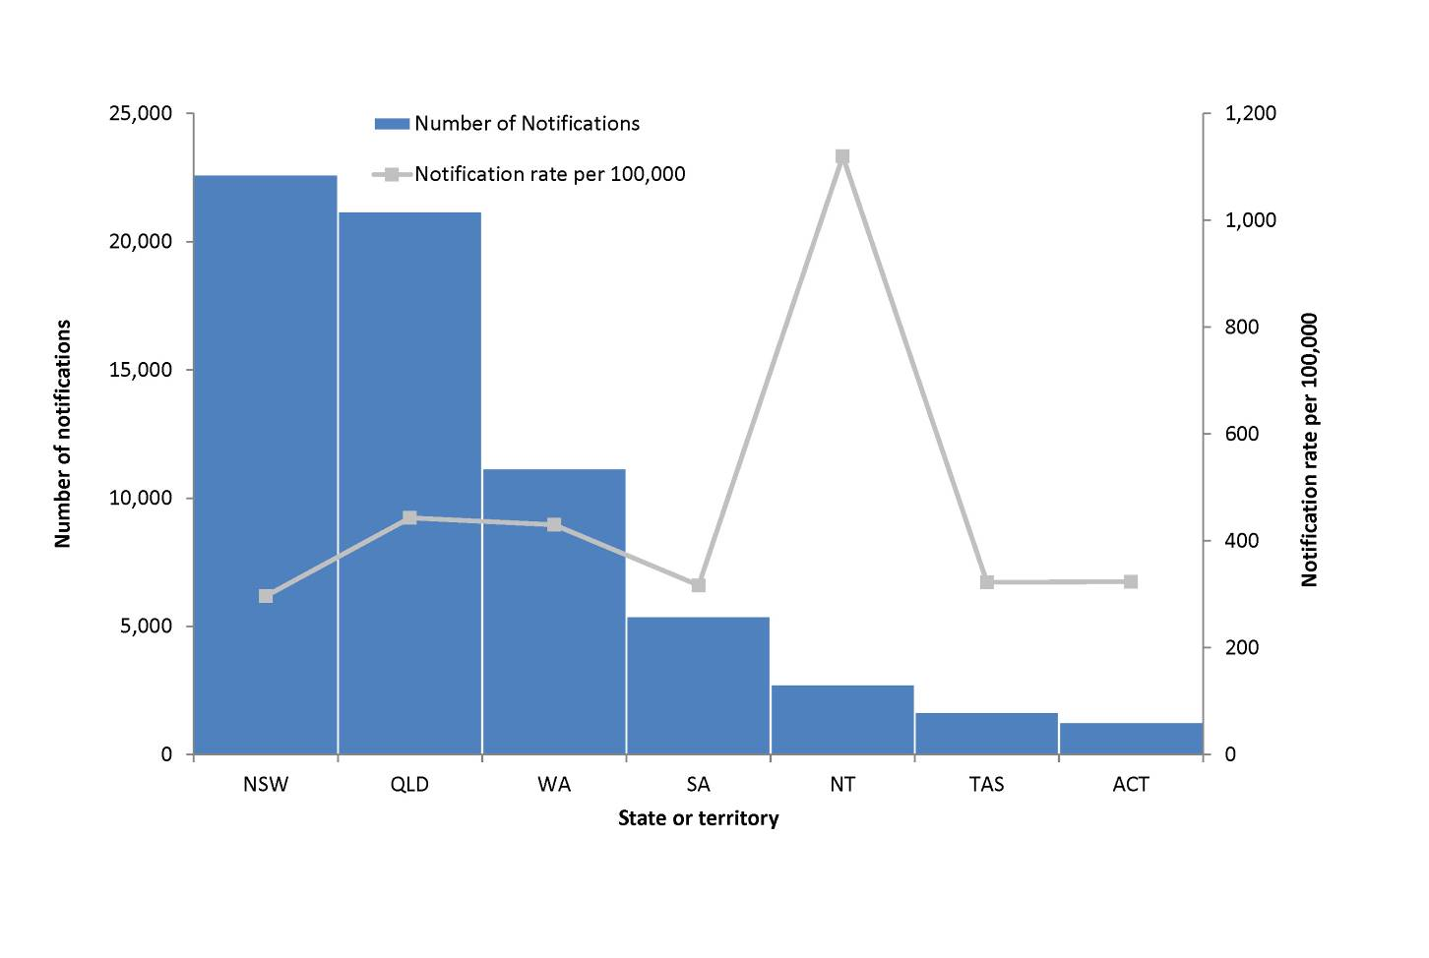
* Excludes Victoria.

Figure 34: Notification rate* for chlamydial infection, Australia, 2015, by age group and sex
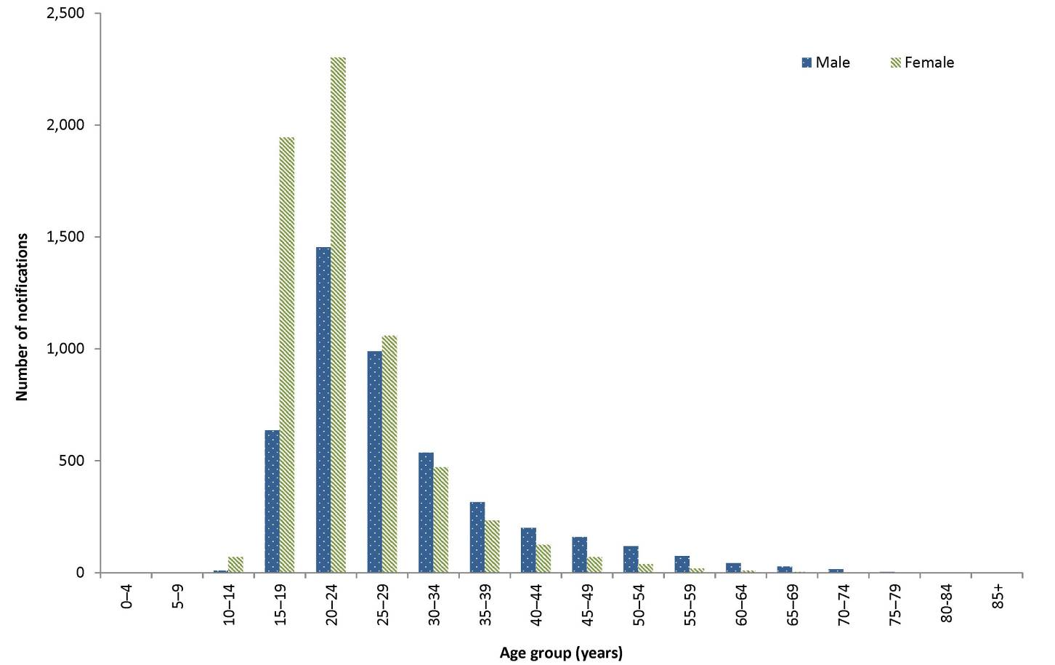
* Excludes Victoria.

Figure 35: Notification rate* for chlamydial infection, Australia, 2010 to 2015, by year, sex and selected age groups
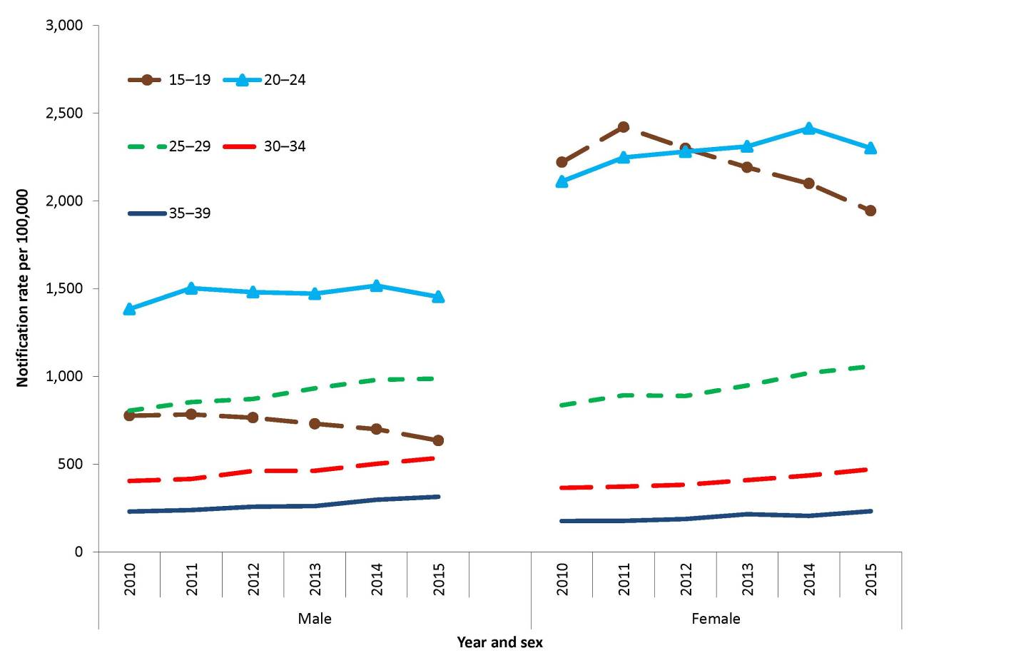
* Excludes Victoria.

Figure 36. Age-standardised notification rates for chlamydial infection, selected states and territories,* 2010 to 2015, by year and Indigenous status
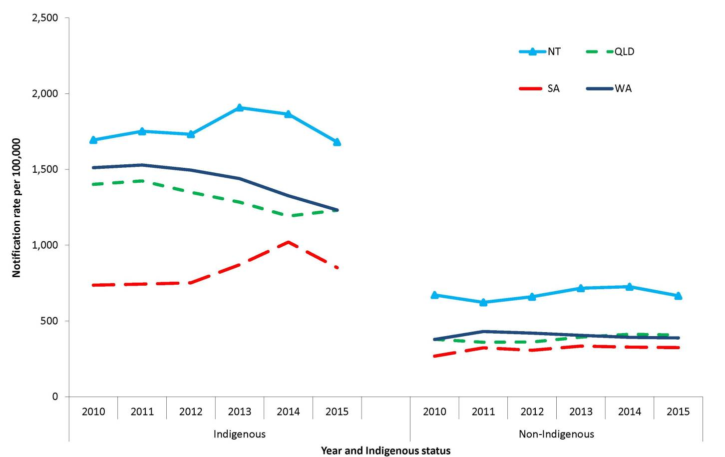
* Includes the states and territories where Indigenous status was reported for more than 50% of cases between 2010 and 2015: the Northern Territory, Queensland, South Australia and Western Australia.

Age and sex distribution
In 2015, chlamydial infection occurred predominately in females aged 15‒24 years, accounting for 37% of all chlamydial infections (Figure 34). The national notification rate for chlamydial infection in 2015 was 368.4 per 100,000 in males and 479.9 per 100,000 in females. The overall higher rate among females may be partly attributable to preferential testing of women attending health services compared with men.^{9,50} Notification rates for males and females, aged 20–39 years, increased between 2010 and 2015: in males by 17% (706.6 in 2010 to 823.4 in 2015) and in females by 16% (872.6 in 2010 to 1,016.0). Notification rates for both males and females aged 15–19 years decreased between 2011 and 2015, declining by 19% (784.5 in 2011 to 635.3 in 2015) in males and 20% (2,421.6 in 2011 to 1,944.6 in 2015) in females (Figure 35).

Indigenous status
The completeness of Indigenous status identification for chlamydial infection notification data varies by year and jurisdiction. Nationally in 2015, data on Indigenous status were complete for 49% (32,047) of chlamydial infection notifications, which is lower than the preceding five-year average of 46% (range: 37% to 51%). Four jurisdictions had greater than 50% completeness of the Indigenous status field in each year during the 2010–2015 period: the Northern Territory, Queensland, South Australia, and Western Australia. Among these jurisdictions, the combined age-standardised notification rate ratio between Indigenous and non-Indigenous populations in 2015 was 2.8:1, which is slightly lower compared to the previous 5 years (range: 2.9 to 3.2).
Among the Indigenous population, the age-standardised notification rate for the 4 states and territories with more than 50% Indigenous status completeness declined from 1,455.8 per 100,000 in 2011 to 1,288.6 per 100,000 in 2015. This followed a slight increase from 1,430.3 per 100,000 in 2010 to 1,455.8 per 100,000 in 2011.
Age-standardised notification rates among the non-Indigenous population increased overall from 364.2 per 100,000 in 2010 to 392.5 per 100,000 in 2015.
Between 2014 and 2015, age-standardised notification rates for chlamydial infection in the Indigenous population decreased by 17% in South Australia (1,020.6 to 852.0 per 100,000), by 7% in Western Australia (1,326.3 to 1,232.5 per 100,000), and by 10% (1,864.8 to 1,680.5 per 100,000) in the Northern Territory. Conversely, rates increased in Queensland by 3% (1,192.1 to 1,230.9 per 100,000).
Between 2014 and 2015, age-standardised notification rates for chlamydial infection in the non-Indigenous population decreased by 1% (327.4 to 324.3 per 100,000) in South Australia, Western Australia (392.5 to 388.5) and Queensland (412.1 to 407.5 per 100,000), and by 8% in the Northern Territory (726.2 to 655.9 per 100,000) (Figure 36).

Donovanosis
- There were no cases of donovanosis notified in 2015.
- Donovanosis remains rare in Australia.
Donovanosis, caused by the bacterium Klebsiella granulomatis , is a chronic, progressively destructive infection that is primarily transmitted through sexual exposure. It affects the skin and mucous membranes of the external genitalia, inguinal and anal regions.⁵¹ Once diagnosed, donovanosis is treated with a series of antibiotics.⁵²
All donovanosis notifications in Australia since 1991 have been reported the Northern Territory, Western Australia or Queensland and have predominately occurred in Aboriginal and Torres Strait Islander people living in remote areas in northern and central Australia.
Donovanosis was targeted for elimination in Australia through the National Donovanosis Elimination Project 2001–2004.⁵³ It is now rare, with fewer than 17 cases notified each year since 2002, and fewer than 5 cases notified each year since 2007 (Figure 37).

Figure 37: Notified cases of donovanosis, Australia, 1991 to 2015, by year
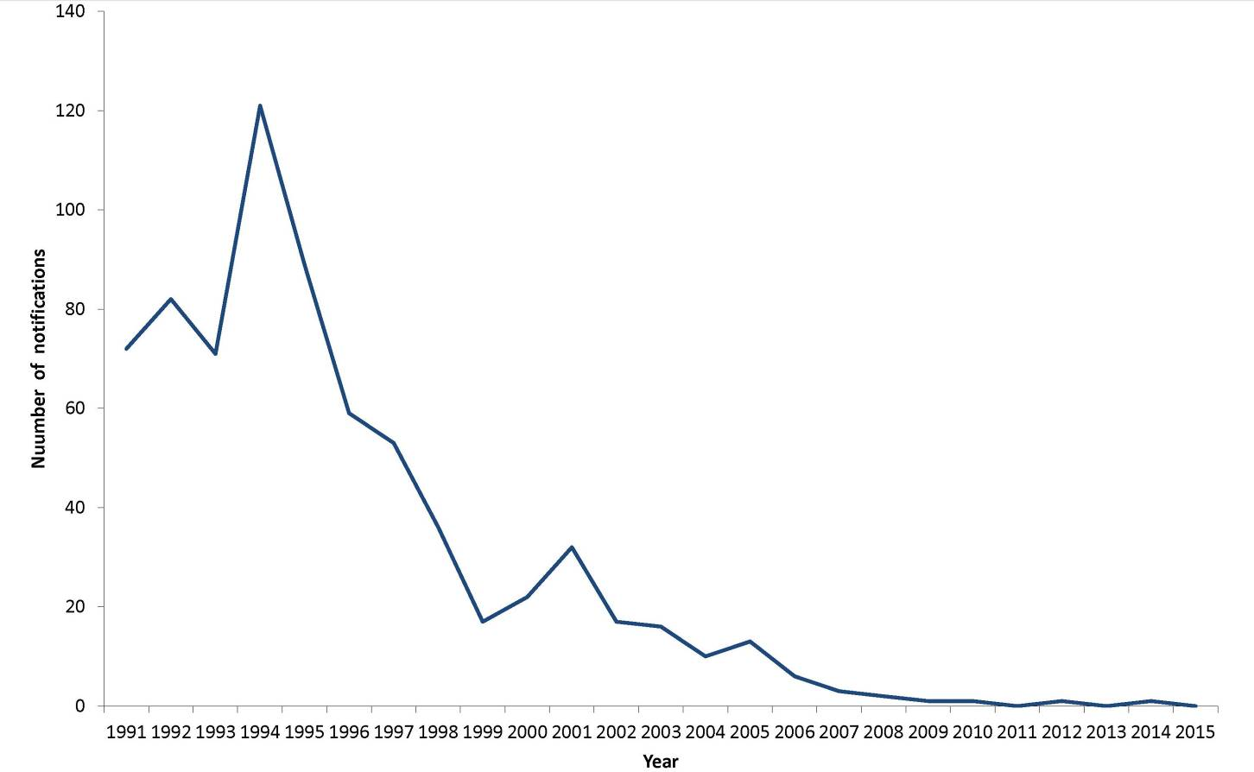

Epidemiological situation in 2015
In 2015, no cases of donovanosis were notified in Australia (Figure 37).

Gonococcal infection
- There were 18,550 cases of gonococcal infection notified in 2015.
- Notification rates for gonococcal infection have continued to increase.
- Notifications occurred predominately in males aged 20–39 years.
Gonococcal infection is caused by the bacterium Neisseria gonorrhoeae, which affects the mucous membranes causing symptomatic and asymptomatic genital and extra-genital tract infections. The most common source of transmission is via unprotected sexual intercourse with an infected person.²¹ If left untreated, it can lead to pelvic inflammatory disease in women and infertility in both men and women. Gonococcal infection also increases the risk of both acquisition and transmission of HIV.⁵¹

Epidemiological situation in 2015
In 2015, there were 18,550 notified cases of gonococcal infection, a notification rate of 78.0 per 100,000. This was a 16% increase compared with the rate reported in 2014 (67.0 per 100,000). In the past 6 years, gonococcal infection notification rates increased, on average, 11% each year since 2010 (range: 4% to 16%). Overall, gonococcal infection notification rates have increased by 66% from 2010 (46.9 per 100,000) to 2015 (78.0 per 100,000) (Figure 38). The increases in gonorrhoea notifications, particularly in females from 2012, is most likely due to the increased practice of dual testing for both chlamydia and gonorrhoea.⁵⁴

Figure 38: Notifications and notification rate for gonococcal infection, Australia, 2010 to 2015, by year
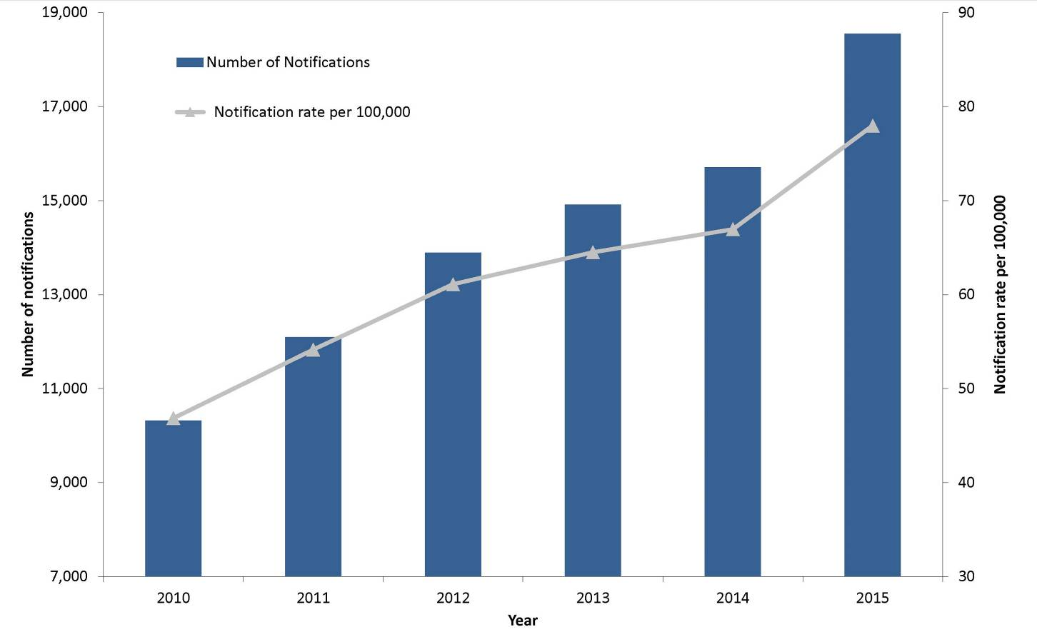

Geographical distribution
In 2015, the notification rate for gonococcal infection was almost 10 times higher in the Northern Territory (749.3 per 100,000) compared to the national rate (78.0 per 100,000) (Figure 39).

Figure 39: Notifications and notification rate for gonococcal infection, Australia, 2015, by state or territory
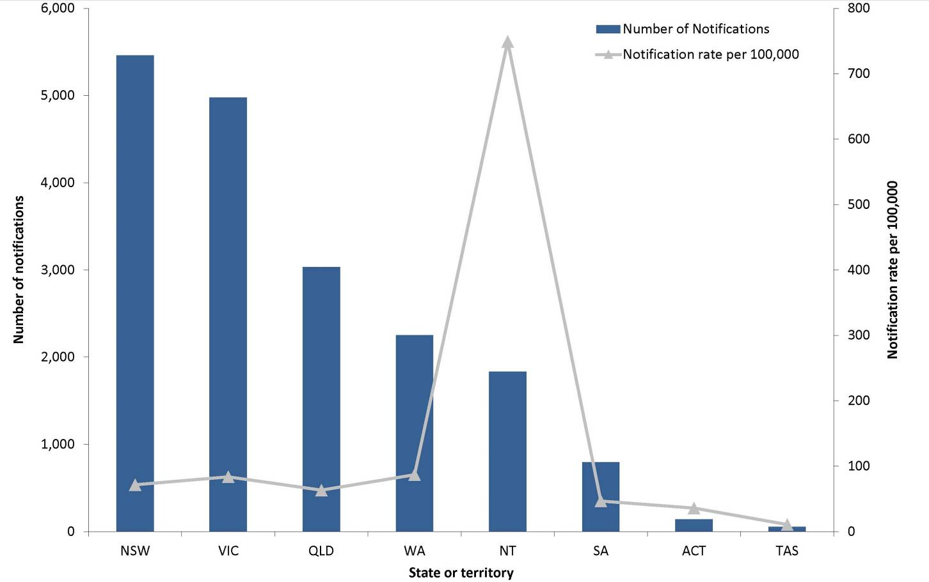

Age and sex distribution
Nationally, the notification rate for gonococcal infection was 116.0 per 100,000 in males and 39.3 per 100,000 in females in 2015. Notification rates increased by 18% in males and 11% in females compared with 2014 (98.1 and 35.3 per 100,000 respectively). In 2015, 53% of all notifications occurred in males in the 20–39 years age group. Notification rates in males exceeded those in females across all age groups above 20 years (Figure 40). This was consistent with previous years when, with the exception of Indigenous people, notifications were largely reported in men who have sex with men (MSM).⁵⁵

Figure 40: Notification rate for gonococcal infection, Australia, 2015, by age group and sex
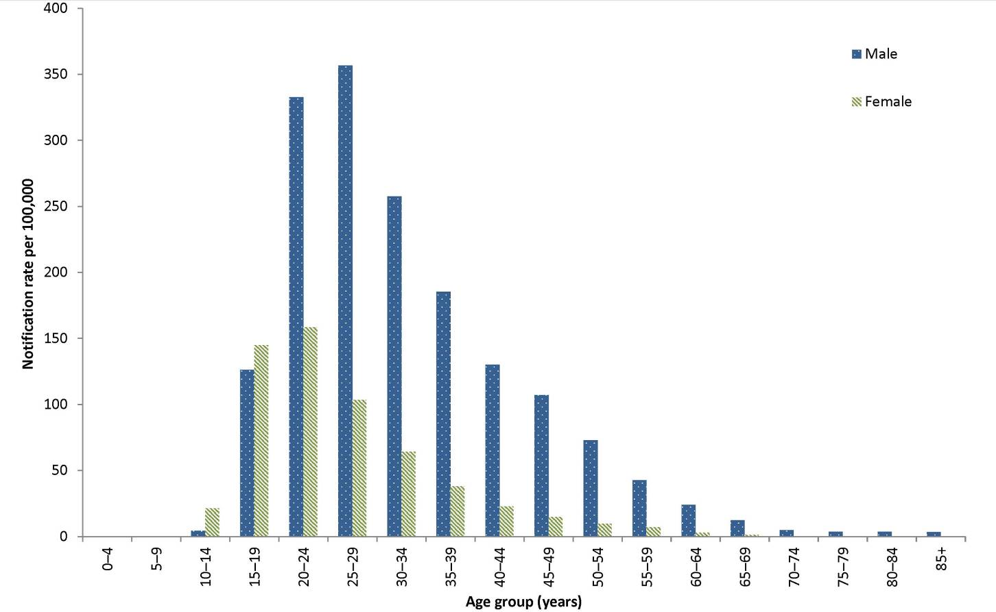
* Excludes notifications where age and/or sex were not reported and those less than 13 years of age.
From 2010 to 2015, notification rates of gonococcal infection increased annually for males aged 20–49. The biggest overall increase was seen in the 30–34 years age group, with notification rates increasing by 121% (from 116.7 to 257.5 per 100,000), followed by the 45–49 years age group, with notification rates increasing by 119% (from 48.9 to 107.2 per 100,000). As with males, 2015 marked the highest notification rate reported for females, since gonococcal infection first became nationally notifiable in 1991. Females aged 15–19 years consistently had the highest rate between 2010 and 2014, however in 2015 females aged 20–24 years surpassed this age group (Figure 41).

Figure 41: Notification rate for gonococcal infection, Australia, 2010 to 2015, by year, sex and selected age groups*
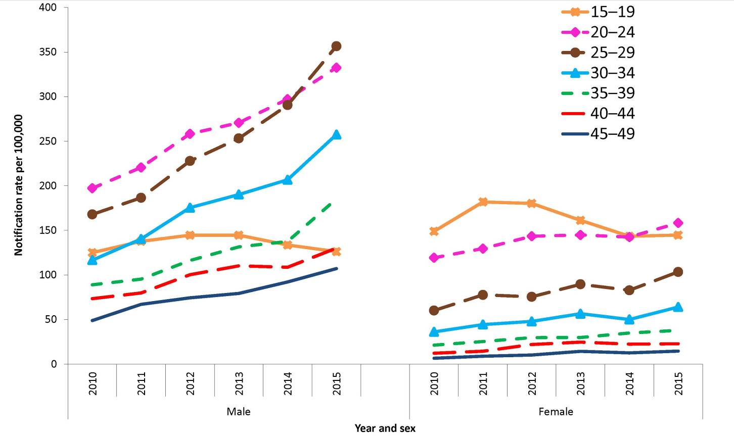
* Excludes notifications where age and/or sex were not reported.

Indigenous
The completeness of Indigenous status identification in the notification data varies by year and by jurisdiction. Nationally in 2015, data on Indigenous status were complete for 64% of notifications, which was slightly lower than the preceding 5-year mean of 68% (range: 65% to 71%). All states and territories except New South Wales had greater than 50% completeness of the Indigenous status field across the 2010 to 2015 period. Among the states and territories with greater than 50% completeness, the combined age-standardised notification rate ratio between Indigenous and non-Indigenous populations in 2015 was 10.0:1.0, decreasing from 13.1:1.0 in 2014. Overall, the rate ratio has declined by 63% from 2010 to 2015 (from 26.6:1.0 to 10.0:1.0).
Among the Indigenous population, the age-standardised notification rate decreased by 2% from 2014 to 2015 (from 630.5 to 617.4 per 100,000 respectively). From 2010 to 2015, the age-standardised Indigenous rate declined by 19% from 762.0 per 100,000 to 617.4 per 100,000.
Among the non-Indigenous population, the age-standardised notification rate increased by 116% from 2010 to 2015 (28.6 and 61.9 per 100,000 respectively). Among the states and territories in which Indigenous status was more than 50% complete, age-standardised notification rates for gonococcal infection in the Indigenous population between 2014 and 2015 decreased in South Australia by 11% (from 543.7 to 485.1 per 100,000), in Victoria by 22% (from 87.6 to 68.1 per 100,000) in Western Australia by 17% (from 850.5 to 709.0 per 100,000); and increased in the Northern Territory by 4% (from 1,722.6 to 1,790.0 per 100,000) in Queensland by 8% (from 301.3 to 325.9 per 100,000) and in the Australian Capital Territory by 232% (from 13.1 to 43.6 per 100,000) (Figure 42).

Figure 42: Age-standardised notification rates for gonococcal infection, selected states and territories,* 2010 to 2015, by Indigenous status and year
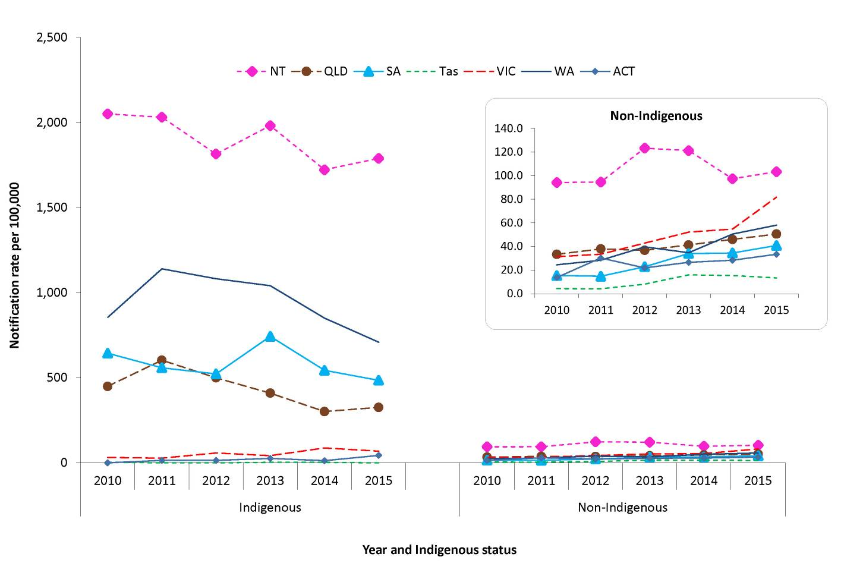
* Includes the states and territories where Indigenous status was reported for more than 50% of cases between 2010 and 2015: the Australian Capital Territory, the Northern Territory, Queensland, South Australia, Tasmania, Victoria and Western Australia.

Microbiological trends
The Australian Gonococcal Surveillance Program (AGSP) is the national surveillance system for monitoring the antimicrobial resistance of N. gonorrhoeae isolates. These results are published in more detail in the AGSP annual report in CDI. At the time of writing, the 2015 AGSP annual report was in-press. Earlier AGSP annual and quarterly reports are available in the various editions of the CDI.
In 2015, the AGSP reported that a total of 5,411 gonococcal isolates were referred for antibiotic susceptibility testing, representing 28%* of gonococcal infections notified to the NNDSS. This was slightly lower than the proportion of NNDSS cases tested in 2014 (31%*, 4,804/15,728).
Eighty-three per cent of the isolates (n=4,505) were from males and 17% (n=900) were from females (M:F=5:1). There were 6 isolates for which gender was unknown. The proportion of gonococcal isolates from males and females tested by the AGSP has remained stable over recent years (2010–2015).
Current treatment recommendations for the majority of gonococcal infections in Australia are for a dual therapeutic strategy of ceftriaxone and azithromycin.⁵⁶ Decreased susceptibility to ceftriaxone (minimum inhibitory concentration (MIC) value 0.06–0.125 mg/L) was found nationally in 1.8% of isolates, lower than that reported in the AGSP Annual Report 2014 (5.4%). The highest proportions were reported from South Australia and New South Wales (3.6% and 2.7% respectively). High-level resistance to azithromycin (MIC value ≥256 mg/L) was again reported in 2015, one strain in New South Wales and one in urban Western Australia. There was no reported azithromycin resistance in the Australian Capital Territory, the Northern Territory, or remote Western Australia.
* The denominator (gonorrhoea notifications reported to NNDSS) used to calculate proportions of isolates tested may differ from reported notifications in this report due to data being extracted at different points in time.

Syphilis (non-congenital categories)
- There were 4,652 cases of syphilis (non-congenital categories) notified in 2015, a notification rate of 19.6 per 100,000.
- Cases of non-congenital syphilis were more frequently reported in MSM.
Syphilis is a sexually transmitted infection caused by the bacterium Treponema palladium. Infection is characterised by a primary lesion, a secondary eruption involving skin and mucous membranes, long periods of latency and late lesions of skin, bone, viscera, cardiovascular and nervous systems.²¹
In 2004, all jurisdictions except South Australia began reporting non-congenital syphilis infections to the NNDSS separately categorised as: infectious syphilis (primary, secondary or early latent) of less than 2 years duration; and syphilis of more than 2 years or unknown duration. From 2004 to 2011, South Australia reported only cases of infectious syphilis; it then commenced reporting syphilis of more than 2 years or unknown duration in 2012.

Epidemiological situation in 2015
In 2015, a total of 4,652 cases of syphilis (non-congenital) were reported to the NNDSS. This represented a rate of 19.6 per 100,000, a 17% increase compared with 2014 (16.6 per 100,000) (Figure 43). In 2015, 42% of syphilis notifications were categorised as greater than 2 years or unknown duration, and 58% of cases were categorised as infectious syphilis.

Figure 43: Notification rate for non-congenital syphilis infection (all categories), † Australia, 2010 to 2015, by category and year
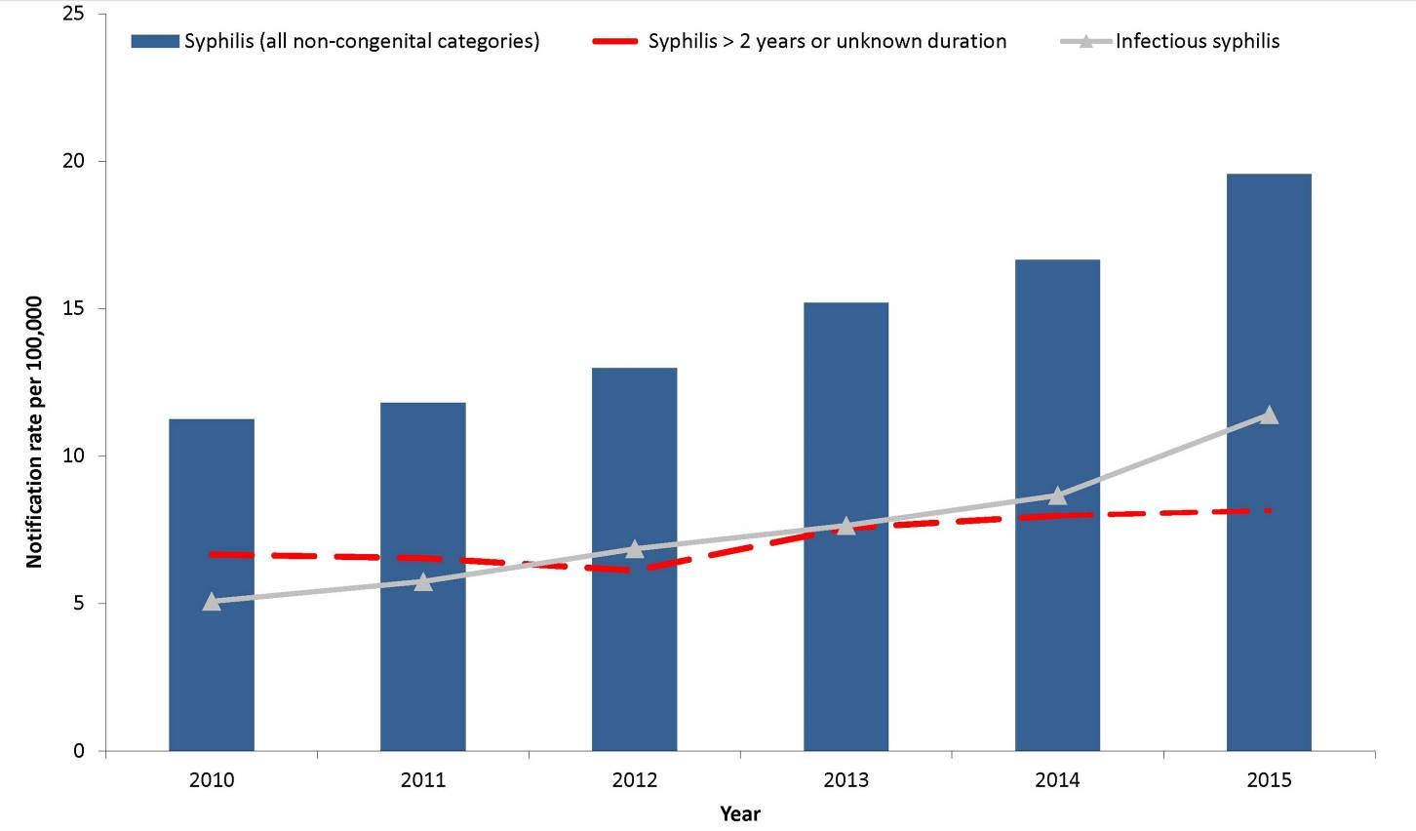
† For syphilis of more than 2 years or unknown duration, excludes South Australia from 2010–2011.

Syphilis – infectious (primary, secondary and early latent), less than 2 years duration
- There were 2,713 cases of infectious syphilis notified in 2015.
- Of all notifications, 79% occurred in males aged 20–54 years, indicating transmission through male-to-male sex.
- Notifications continued to increase in Aboriginal and Torres Strait Islander people due to the ongoing outbreak in northern Australia.

Epidemiological situation in 2015
In 2015, 2,713 notified cases of infectious syphilis of less than 2 years duration were reported to the NNDSS, representing a rate of 11.4 per 100,000. This was a 17% increase compared with the rate reported in 2014 (8.7 per 100,000), and a 74% increase from 2010 (5.1 per 100,000) to 2015 (Table 5).
In 2015, the infectious syphilis case definition was changed to include both probable and confirmed infectious syphilis cases.⁵⁷ Of the cases notified in 2015, 9% (n=245) were reported as probable.

Geographical distribution
In 2015, notification rates for infectious syphilis were highest in the Northern Territory (82.6 per 100,000), followed by Victoria (15.7 per 100,000) and Queensland (11.9 per 100,000) (Table 5). This probably reflects the on-going outbreaks in Indigenous people in the Northern Territory and Queensland, and MSM in Victoria.^{58,59}

Age and sex distribution
Nationally, the notification rate for infectious syphilis was 20.5 per 100,000 in males and 2.4 per 100,000 in females in 2015, a male to female rate ratio of 8.5:1, which was consistent with previous years. In males, rates increased by 30% compared with 2014 (16.0 per 100,000). The notification rate for females in 2015 increased by 71% compared with 2014 (1.0 per 100,000). In 2015, 79% (2,137/2,713) of all notifications occurred in males aged 20–54 years (Figure 44).
Figure 44: Notification rate for infectious syphilis (primary, secondary and early latent), less than 2 years duration, Australia, 2015, by age group and sex*
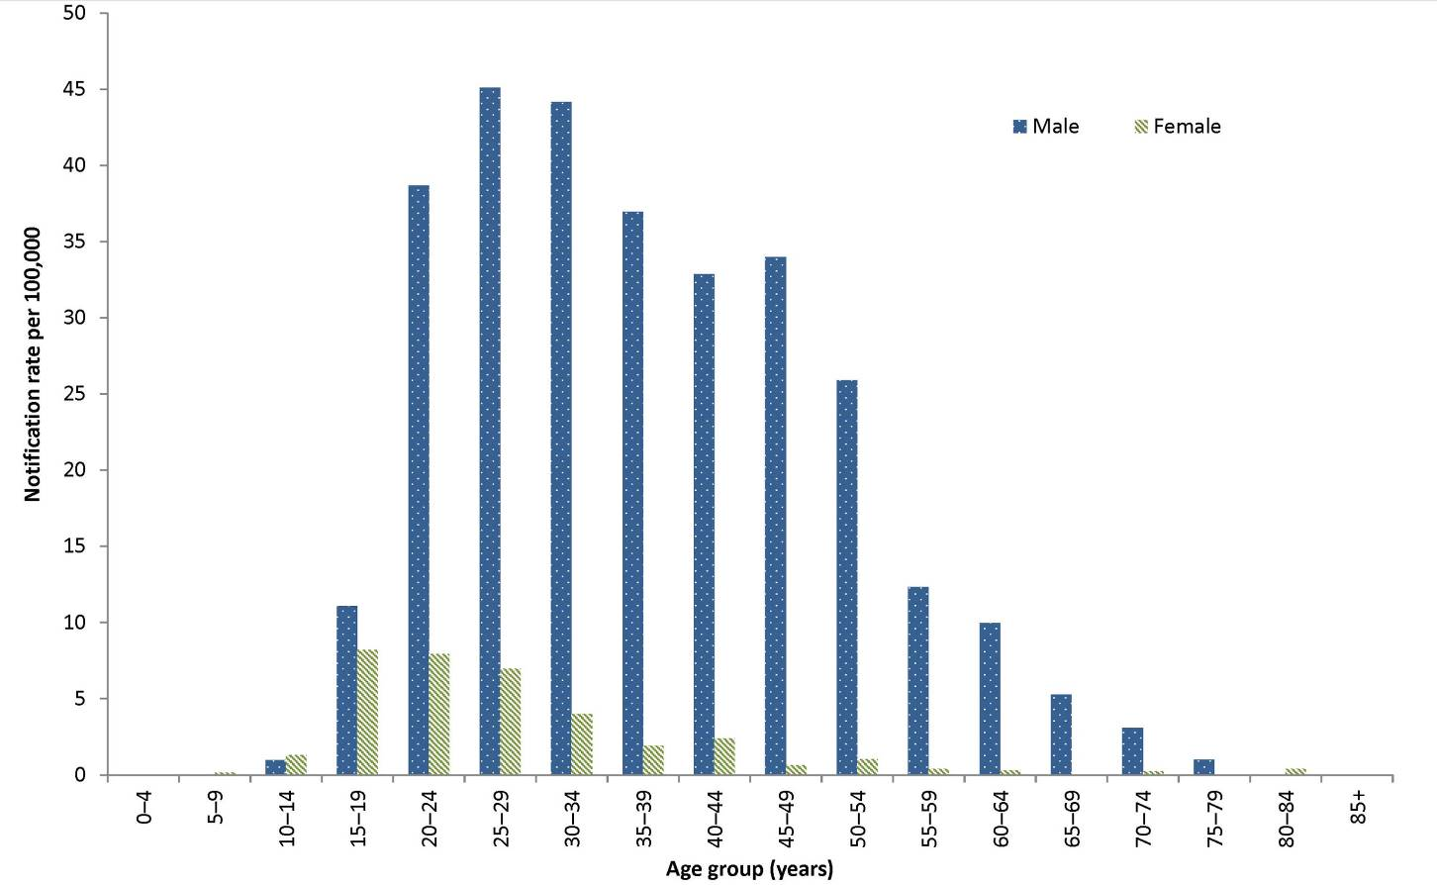
* Excludes notifications where age and/or sex were not reported and those less than 13 years of age.
Notification rates for males aged 15 years or over increased overall from 2010 to 2015 for all age groups. For the majority of age groups, rates were at their lowest in 2010, after which rates steadily increased and reached maximum values for the period in 2015 (Figure 45). The greatest increases among females aged 15 years or over were within the 15–34 years age groups (Figure 14).

Figure 45: Notification rate for infectious syphilis (primary, secondary and early latent), less than 2 years duration, Australia, 2010 to 2015, by year, sex and selected age groups*
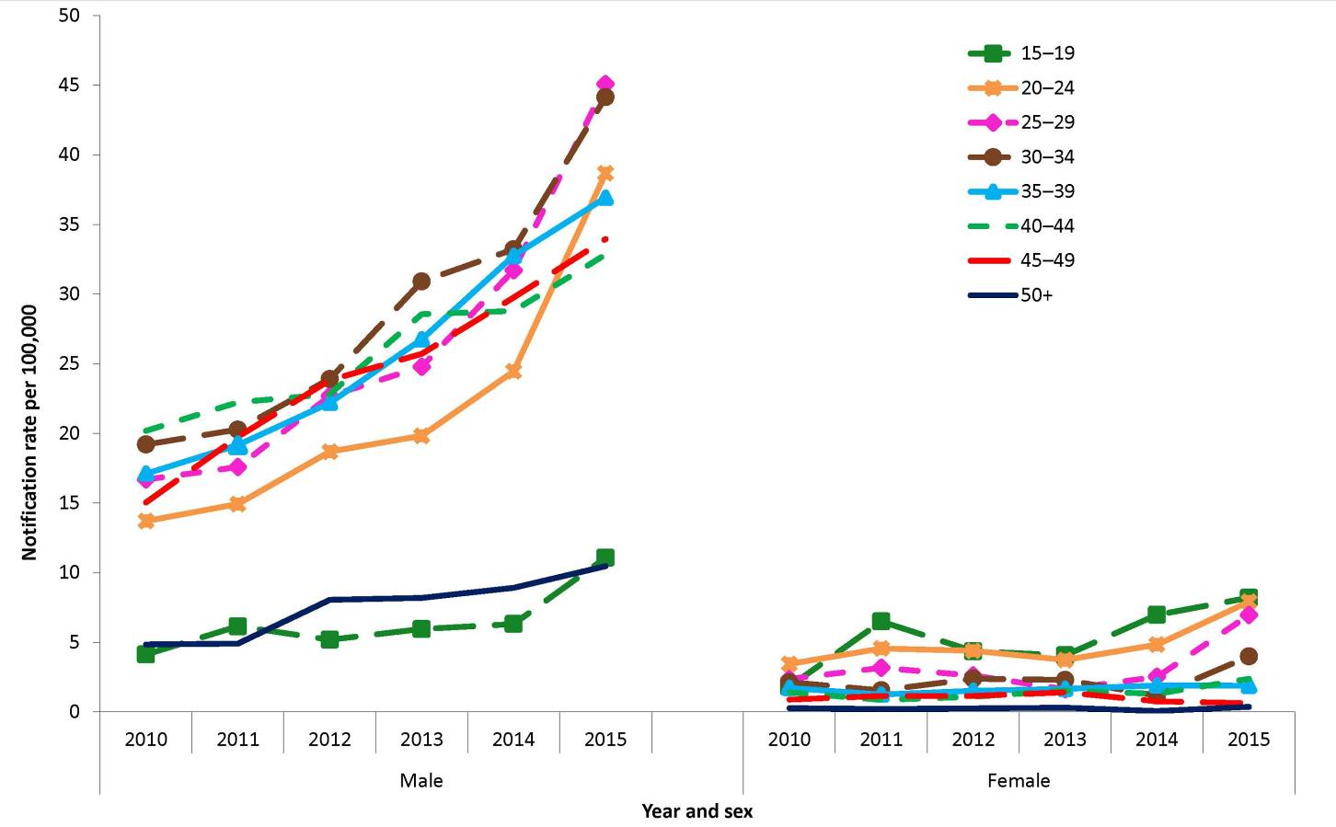
* Excludes notifications where age and/or sex were not reported and those less than 13 years of age.

Indigenous
The completeness of Indigenous status identification in the notification data varies by year and jurisdiction. Nationally in 2015, data on Indigenous status were complete for 91% of notifications of infectious syphilis, decreasing by 1% since 2014, compared to the preceding 5-year mean of 94% (range: 91% to 96%). All states and territories had greater than 50% completeness of the Indigenous status field across the 2010 to 2015 period.
In 2015, where rates were calculated for Indigenous and non-Indigenous people, the age-standardised rates were higher for Indigenous people than non-Indigenous people in all jurisdictions, with the exception of New South Wales (Figure 46). For all states and territories, the combined age-standardised notification rate ratio between the Indigenous and non-Indigenous populations in 2015 was 6.2:1, which was higher than the preceding 5-year mean (4.6:1; range: 3.1 to 5.9). In 2015, for jurisdictions where cases were notified in both Indigenous and non-Indigenous people, the age-standardised notification rate ratio between Indigenous and non-Indigenous populations ranged from 0.8:1 in New South Wales to 17.3:1 in the Northern Territory. Between 2014 and 2015, the largest increase in the difference between Indigenous and non-Indigenous age-standardised notification rates was 161% in Western Australia (3.7 to 9.7 per 100,000). The only 2 jurisdictions where the difference between Indigenous and non-Indigenous age-standardised notification rates decreased from 2014 to 2015 were New South Wales (a decrease of 43%) and Queensland (a decrease of 12%).

Figure 46: Age-standardised notification rate for infectious syphilis (primary, secondary and early latent), less than 2 years duration, selected states and territories,* 2010 to 2015, by Indigenous status and year
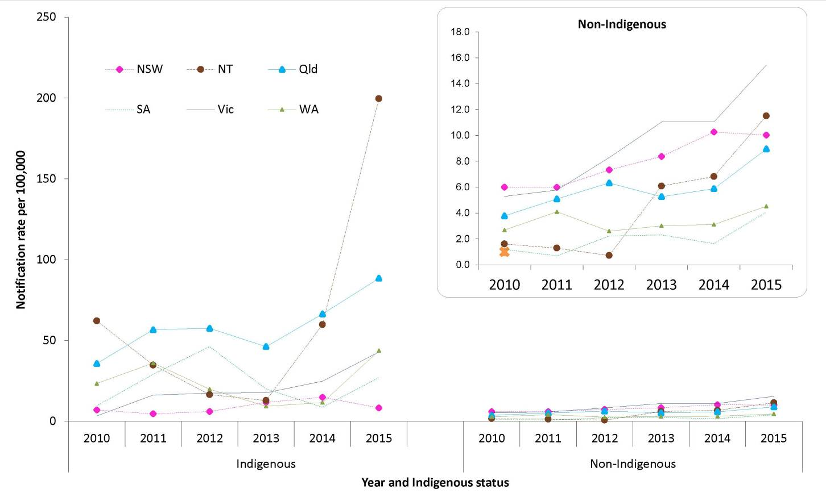
* All states and territories reported Indigenous status for more than 50% of notifications between 2010 and 2015. The Australian Capital Territory and Tasmania were excluded due to low numbers of notifications.
An outbreak of infectious syphilis affecting largely young heterosexual Indigenous people in remote areas of Australia^{5,12} was first reported in January 2011 in northern Queensland, followed by the Northern Territory in July 2013^{13,14} , and the Kimberley region of Western Australia in June 2014. Increased transmission along with targeted and opportunistic syphilis screening in each of these jurisdictions is likely to have contributed to an increase in Indigenous age-standardised rates for Queensland, the Northern Territory, and Western Australia between 2011–2015.⁶⁰ Further information about the outbreak of infectious syphilis is available at: http://www.health.gov.au/internet/main/publishing.nsf/Content/ohp-infectious-syphilis-outbreak.htm

Syphilis of more than 2 years or unspecified duration
- There were 1,939 cases of syphilis of more than 2 years or unknown duration notified in 2015.
- In 2015, males aged 20 years and older accounted for 72% of all notifications, indicating transmission through male-to-male sex.

Epidemiological situation in 2015
In 2015, 1,939 cases of syphilis of more than 2 years or unknown duration were reported to the NNDSS. Notification rates increased by 22% between 2010 (6.7 per 100,000) and 2015 (8.2 per 100,000), and increased by 2% between 2014 (8.0 per 100,000) and 2015 (Table 5). It is unknown whether this increase is due to increased testing in people or populations with no previous testing history or an actual increase in the number of people with non-infectious syphilis.

Geographical distribution
In 2015, notification rates for syphilis of more than 2 years or unknown duration were highest in the Northern Territory (31.1 per 100,000), followed by Victoria (12.3 per 100,000) (Table 5). Similar to infectious syphilis, this geographical distribution likely reflects the large proportions of at-risk individuals living in these jurisdictions (Indigenous people in the Northern Territory and MSM in Victoria).^{58, 59}

Age and sex distribution
Nationally, the notification rate for syphilis of more than 2 years or unknown duration was 11.9 per 100,000 in males and 4.4 per 100,000 in females in 2015, a male to female rate ratio of 2.7:1. Between 2014 and 2015, the notification rate in males decreased by 2% (12.2 to 11.9 per 100,000) but increased by 3% (4.2 to 4.4 per 100,000) in females. In 2015, approximately 72% (1,389/1,932) of all notifications for which sex was reported, occurred in males aged 20 years or over (Figure 47).
Figure 47: Notification rate for syphilis of more than 2 years or unknown duration,* Australia, 2015, by age group and sex
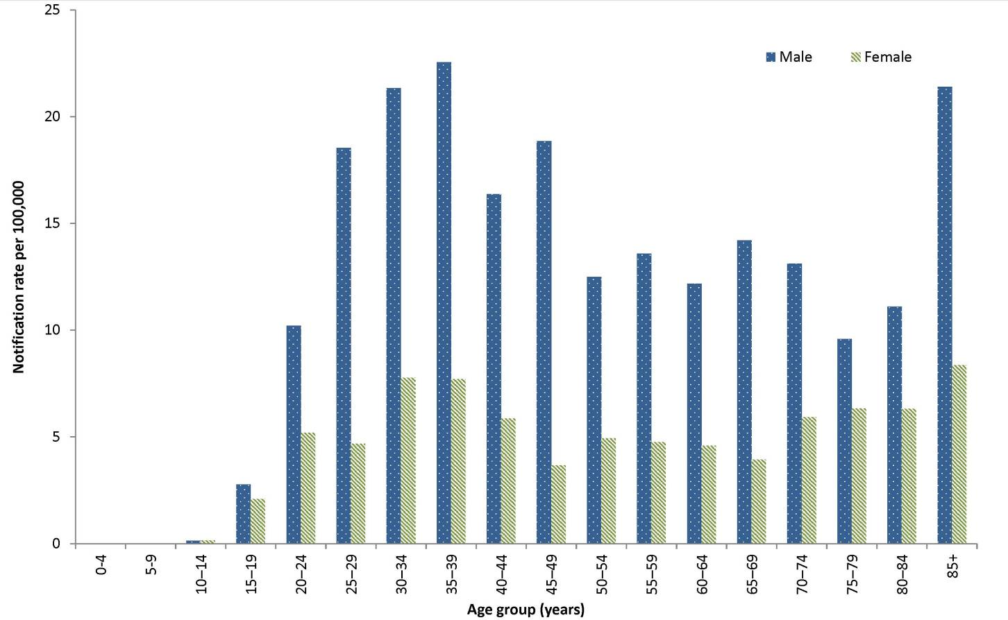
* Excludes notifications where age and/or sex were not reported and notifications where the case was aged less than 13 years.
Notification rates in males for all age groups except the 15–19 years age group increased overall from 2010 to 2015 (Figure 48). This increase is particularly prominent from 2012 to 2015 in the 30–39 years age group. Notification rates in females for all age groups except the 15–19 years age group and the 30–39 years age group declined overall from 2010 to 2015 (Figure 48). Notification rates in males in the 15–19 years age group were lower than those of the other age groups and fluctuated across the time period. Notification rates in females in the 15–19 years age group were also lower than those of the other age groups with an increasing trend from 2012 to 2014 (Figure 48).

Figure 48: Notification rate for syphilis of more than 2 years or unknown duration, Australia,* 2010 to 2015, by year, sex and selected age groups†
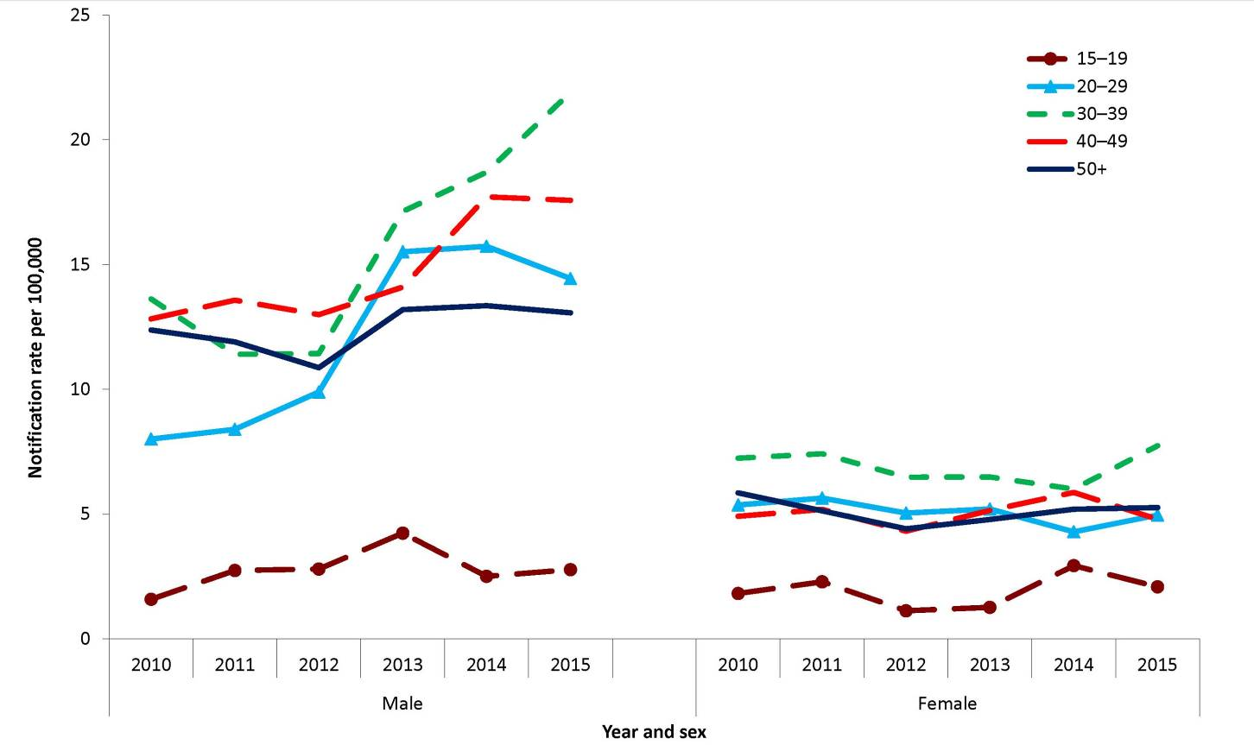
* Data from all states and territories except South Australia in 2010–2011.
† Excludes notifications where age and/or sex were not reported and those aged less than 15 years (51 notifications).

Congenital syphilis
- In 2015, 3 cases of congenital syphilis were notified to the NNDSS.
- Congenital syphilis remains rare in Australia. Congenital syphilis is caused by fetal infection with the bacterium T. pallidum.
Syphilis is acquired by infants either in utero or at birth from women with untreated early infection. Infection commonly results in abortion or stillbirth and may cause the death of a new-born infant. Congenital syphilis can be asymptomatic, especially in the first weeks of life.²¹

Epidemiological situation in 2015
Three notifications of congenital syphilis were reported in 2015: 2 cases were reported in Indigenous people and were associated with the infectious syphilis outbreak in northern Australia, and; 1 case was reported in a non-Indigenous person. Eight of the 20 congenital syphilis cases reported since 1 January 2011 were associated with the infectious syphilis outbreak in northern Australia. This reflects the increased risk to neonates and mothers that outbreak situations pose.^{15,16} Despite recent increases, the overall case numbers remain low (Figure 49). Routine antenatal screening for syphilis with follow-up and adequate treatment is considered to be a contributor to historical declines and sustained low case numbers.⁶¹ Congenital syphilis, particularly in Indigenous people, is targeted for elimination. This target is stated in the 4th National Aboriginal and Torres Strait Islander Blood-borne Viruses and Sexually Transmissible Infections Strategy and the third National Sexually Transmissible Infections Strategy, both for 2014–2017.^{62,63}
Figure 49: Notifications of congenital syphilis, Australia, 2005 to 2015
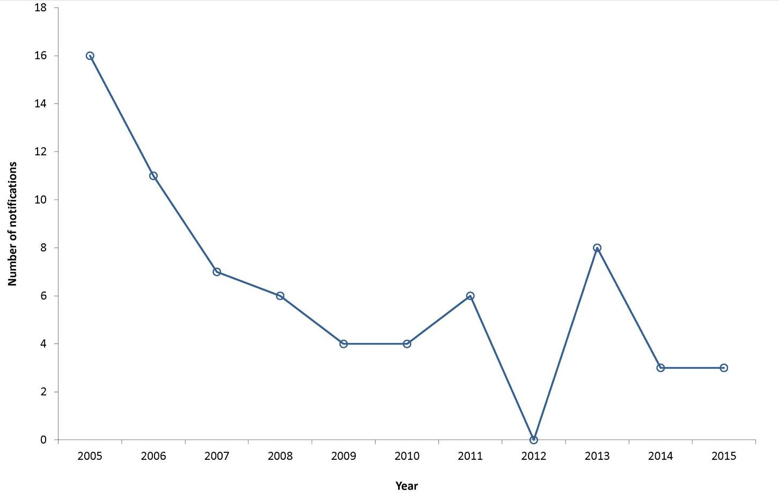

Vaccine Preventable Diseases
This section summarises the national surveillance data for notifiable diseases targeted by the National Immunisation Program (NIP) in 2015. These include diphtheria, invasive Haemophilus influenzae type b infection, laboratory confirmed influenza, measles, mumps, pertussis, invasive pneumococcal disease, poliomyelitis, rubella, congenital rubella, tetanus and varicella zoster infections (unspecified, chickenpox and shingles). Data on hepatitis B and invasive meningococcal disease, which are also targeted by the NIP, can be found in this report under ‘Bloodborne diseases’ and ‘Other bacterial infections’ respectively. Other vaccine preventable diseases (VPDs) presented in this report include hepatitis A and Q fever, which can be found in the ‘Gastrointestinal’ and ‘Zoonoses’ sections respectively. For more detailed reports on historical data including notifications, hospitalisations and deaths, readers are referred to the journal supplements ‘Vaccine Preventable Diseases in Australia’ and the ‘Australian Vaccine Preventable Diseases Epidemiological Review Series’ for additional analysis of individual diseases, which are published in CDI.
In 2015, there were 147,569 VPD notifications reported to the NNDSS, representing 46% of all disease notifications and a 46% increase compared with 2014 (n=101,337). Influenza was the most commonly notified VPD, with 100,583 cases (68%) of total VPD notifications, followed by pertussis (15%, n=22,546). The number of notifications and notification rates for VPDs in Australia are shown in Table 4, Table 5 and Table 6.
Immunisation coverage is an important factor influencing the incidence of VPDs. Since the commencement of the Australian Childhood Immunisation Register in 1996, immunisation coverage of children has been high by international standards, although geographical pockets of lower coverage in which there is an increased potential for VPD cases still remain. As no vaccine is 100% effective, infections with these diseases sometimes do occur in fully vaccinated people. However, evidence shows vaccines do provide a substantially lower chance of developing infection or can reduce the severity of disease.^{64,65,66,67,68}
Information on a case’s immunisation history was previously recorded in the NNDSS using the ‘immunisation status’ field (fully or partially vaccinated for age, or unvaccinated), plus fields capturing the number of doses, the last immunisation date and how the immunisation information was validated. In January 2008, new more detailed fields were incorporated for recording ‘vaccine type’ and ‘immunisation date’ for each dose of vaccine given. The new fields were intended to replace the old fields, with a transition period allowing either field to be utilised. In this report the immunisation status of a case is interpreted according to the data provided by the states and territories from 2 different formats. A case is described as fully vaccinated if the person has received all doses of the relevant vaccine according to the most recent edition of The Australian Immunisation Handbook and at least 14 days prior to disease onset.

Diphtheria
- There were 2 cases of diphtheria notified in 2015, of which 1 was acquired in Australia and the other in the Solomon Islands.
- Diphtheria is rare in Australia.
- Immunisation against diphtheria provides prolonged but not lifelong protection against infection.
Diphtheria is an acute pharyngeal or cutaneous infection caused mainly by toxigenic strains of Corynebacterium diphtheriae. The exotoxin acts locally on the mucous membranes of the respiratory tract, and on damaged skin, although this is not as common. Disease is mainly due to local membranous inflammation, which for pharyngeal diphtheria can cause airway obstruction. Occasionally systemic infections occur and cause damage to the myocardium, nervous system and kidneys. Diphtheria is spread by respiratory droplets or direct contact with nasopharyngeal secretions or skin lesions. While there are non-toxigenic strains of C. diphtheriae, they usually only cause mild throat or skin infection and are not nationally notifiable.²¹

Epidemiological situation in 2015
In 2015, there were 2 notifications of diphtheria reported. Both cases were reported in Queensland 1 case was a cutaneous infection from C. diphtheria, partially vaccinated and imported from the Solomon Islands; and the other was a pharyngeal infection from C. ulcerans, of unknown immunisation status and locally acquired in Australia.
Diphtheria is rare in Australia, with most cases associated with sporadic importations from countries in which the disease remains endemic. From 2001 to 2014, there were 10 cases of diphtheria reported to the NNDSS, including one case in 2001, a cluster of 3 cases and a sporadic case in 2011, 3 cases in 2013 and 2 cases in 2014. Of these, 7 were imported, 2 were linked to an imported case and the place of acquisition for one was unknown.
ii This number may underrepresent the number of diphtheria cases in Australia due to a change in the national case definition for this disease. In mid-2013, the national case definition for diphtheria was revised, requiring clinical and laboratory evidence for confirmed cases. This change may have inadvertently excluded the notification of some cases of cutaneous toxigenic diphtheria, as cutaneous presentations were not listed as clinical evidence in the revised definition.

Haemophilus influenzae type b (invasive)
- There were 16 cases of invasive Haemophilus influenzae type b (Hib) reported in 2015.
- Of the cases reported, 63% were male and 8 were under the age of 15 years (50%).
Haemophilus influenza type b (Hib) is a gram negative bacterium that causes disease, with symptoms dependent on which part of the body is affected. Clinical categories of invasive disease caused by Hib include septicaemia (infection of the blood stream), meningitis (infection of the membranes around the brain and spinal cord), epiglottitis (severe swelling of the epiglottis at the back of the throat) and a range of other infections. Hib is mostly carried as a commensal organism (present without causing symptoms) in the nasopharynx of healthy individuals and is spread by respiratory secretions, including aerosol transmission or contact with articles soiled with discharges from the nose or throat.⁶⁹ The case fatality rate of Hib meningitis is at least 3% in developed countries, even with treatment. Approximately 15% to 30% of survivors have permanent neurological sequelae.⁷⁰

Epidemiological situation in 2015
In 2015, there were 16 notifications of invasive Hib infection in Australia. This was a 23% decrease in the number of cases notified compared with 2014 (n=21), and represented a ratio of 0.9 compared with the mean of the previous 5 years. The notification rate in 2015 was 0.1 per 100,000, consistent with the very low rates seen since the introduction of the vaccine on the NIP in July 1993 (Figure 50). Cases occurred in 5 states or territories, with 5 cases each reported in Queensland and New South Wales, and 2 cases each in Victoria, the Northern Territory and Western Australia. Notification rates between states and territories ranged from 0.03 per 100,000 in Victoria to 0.8 per 100,000 in the Northern Territory. There were no Hib associated deaths reported in 2015.
Figure 50: Notifications and notification rate for invasive Haemophilus influenzae type b, Australia, 1994 to 2015, by year
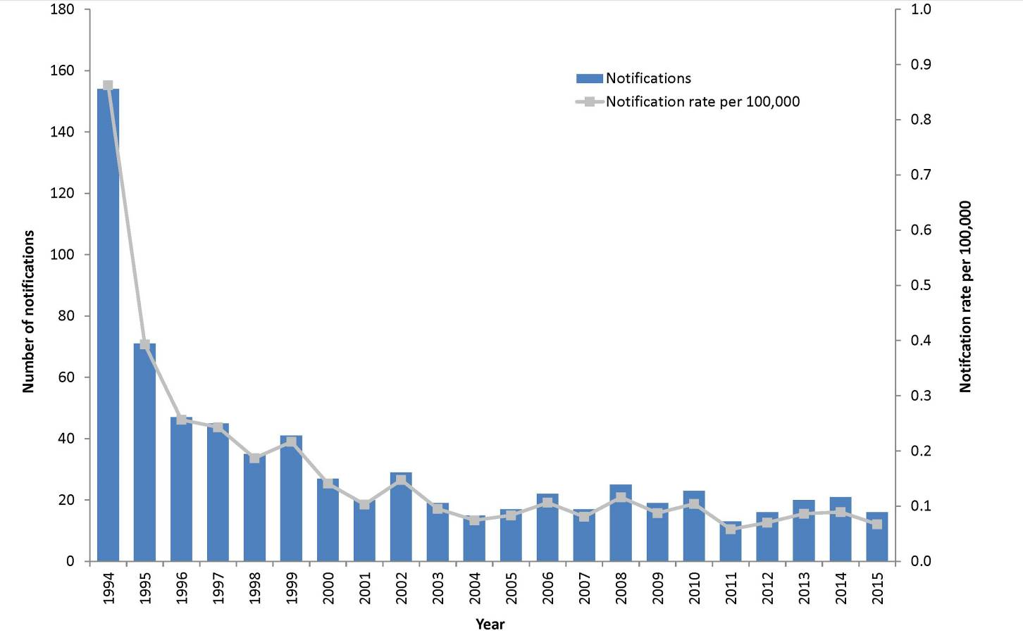

Age and sex distribution
Over half of notified invasive Hib cases in 2015 were male (63%, n=10). Fifty per cent of cases (n=8) were in children aged less than 15 years, of which 63% (n=5) were among infants less than 1 year of age (Figure 51). Consistent with previous years, the 0–4 years age group had the highest notification rate at 0.5 per 100,000.
Figure 51: Notifications for invasive Haemophilus influenzae type b infection, Australia, 2015, by age group and sex
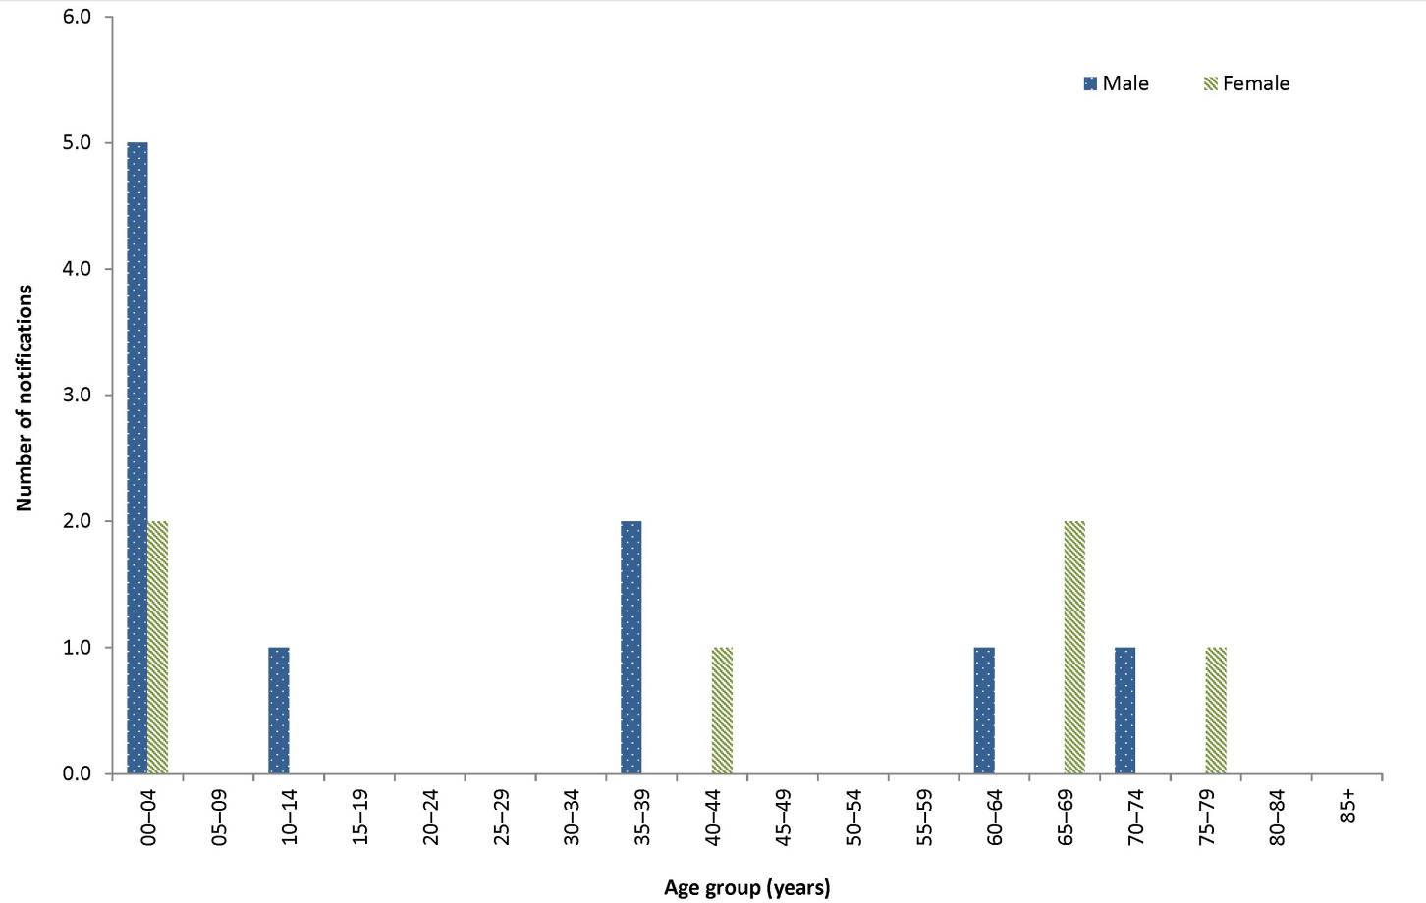

Indigenous Status
Indigenous status was reported for all notified invasive Hib cases in 2015. Three cases were reported as Indigenous Australians, representing a notification rate of 0.5 per 100,000. This rate is lower than in 2014 (0.8 per 100,000) but the same as in 2013 and 2012 (0.5 per 100,000).

Immunisation status
In 2015, people less than 23 years of age were eligible for Hib immunisation under the NIP during their infancy. Of the 16 Hib cases reported in 2015, eight were eligible for immunisation. Three of these cases were 12 months of age or older, and therefore eligible for the full primary vaccine course and the booster. Of these, one case received the full primary course and 2 were reported as unvaccinated. The remaining 5 cases eligible for immunisation were less than 12 months of age, of whom 4 were reported as fully vaccinated for age and 1 was partially vaccinated for age.

Influenza (laboratory confirmed)
Influenza is a common, highly infectious acute respiratory disease caused by infection with influenza viruses. The virus is transmitted from person to person by airborne droplets of exhaled respiratory secretions, especially by coughing or sneezing.⁷¹ The disease ranges from asymptomatic⁷² through to mild upper respiratory tract illness, to severe complications including pneumonia. The severity of disease is determined by features intrinsic to the virus including its similarity to previous circulating and vaccine strains and by host factors including the age, level of immunity and presence of chronic medical conditions.^{73,74}
Annual influenza immunisation is the primary means of preventing or attenuating influenza and its complications and is included in the NIP for individuals who are at increased risk of complications from influenza infection. In 2015, the NIP funded influenza immunisation for people aged 6 months and over with medical conditions placing them at risk of serious complications due to influenza, Aboriginal and Torres Strait Islander people aged 6 months to 5 years and 15 years and over, pregnant women, and people aged 65 years and over.²⁹

Epidemiological situation in 2015
In 2015, there were 100,583 notifications of laboratory confirmed influenza, almost 1.5 times the number of notified cases reported in 2014 (n=67,699) (Figure 52). The number of notifications recorded in 2015 is the highest on record and is 70% higher than in 2009 (n=59,023), the year of the last influenza pandemic.
Figure 52: Notifications of laboratory confirmed influenza, Australia, 1 January 2010 to 31 December 2015, by week.
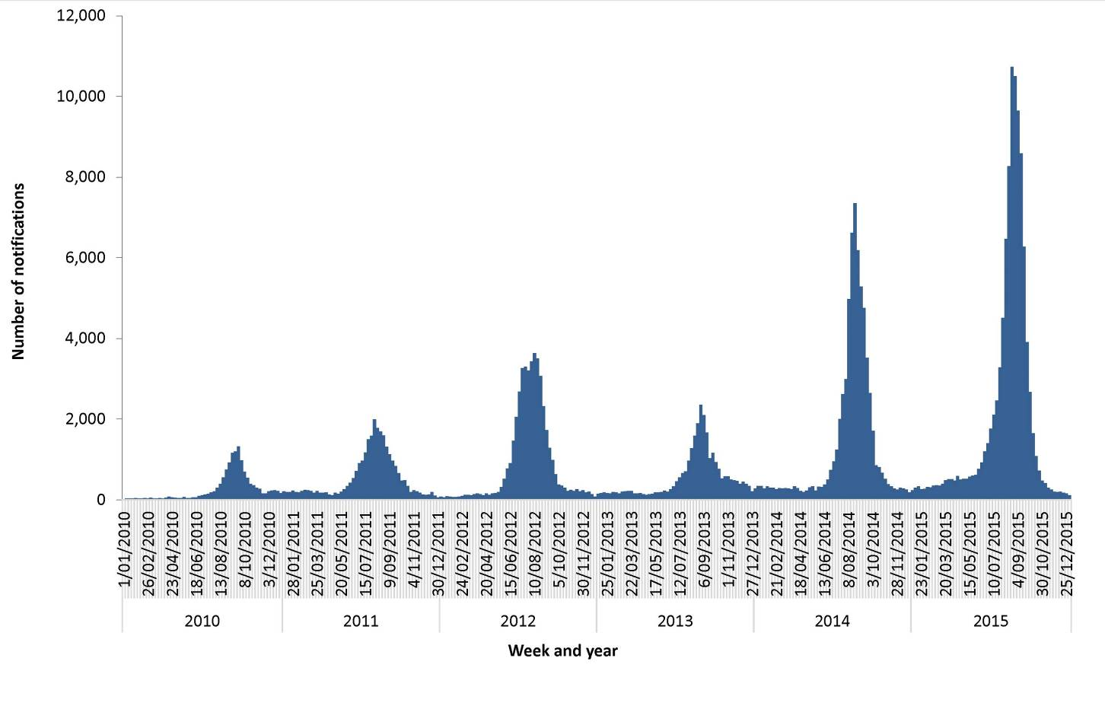

Geographical distribution
Notification rates were highest in South Australia (921 per 100,000), and Queensland (587 per 100,000). Notifications rates in all other jurisdictions were lower than the national notification rate of 423 per 100,000. Jurisdictional-specific notification rates increased from 2014 to 2015, notably in Tasmania (112% increase), Victoria (72% increase) and New South Wales (43%).
New South Wales reported the highest number of influenza cases of any jurisdiction (n=30,303), comprising 30% of notifications nationally (Figure 53). The number of influenza cases in Queensland (n=28,056) accounted for almost 28% of notifications nationally.

Figure 53: Notifications of laboratory confirmed influenza, Australia, 2015, by week and state or territory
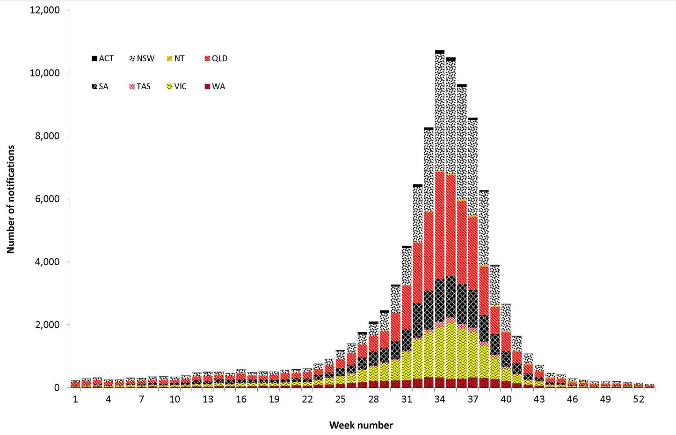

Age and sex distribution
The highest number of influenza notifications occurred in the 0–4 years and 5–9 years age groups (n=10,987 and n=13,770, respectively), which together accounted for 25% of all notifications with ages attributed (Figure 54). This differed from 2014 notifications, in that fewer notifications were reported in the 5–9 years age group (n=4,291) than in the 0–4 years age group (n=5,715) during that year.

Figure 54: Notifications and notification rate for laboratory confirmed influenza, Australia, 2015, by age group and sex
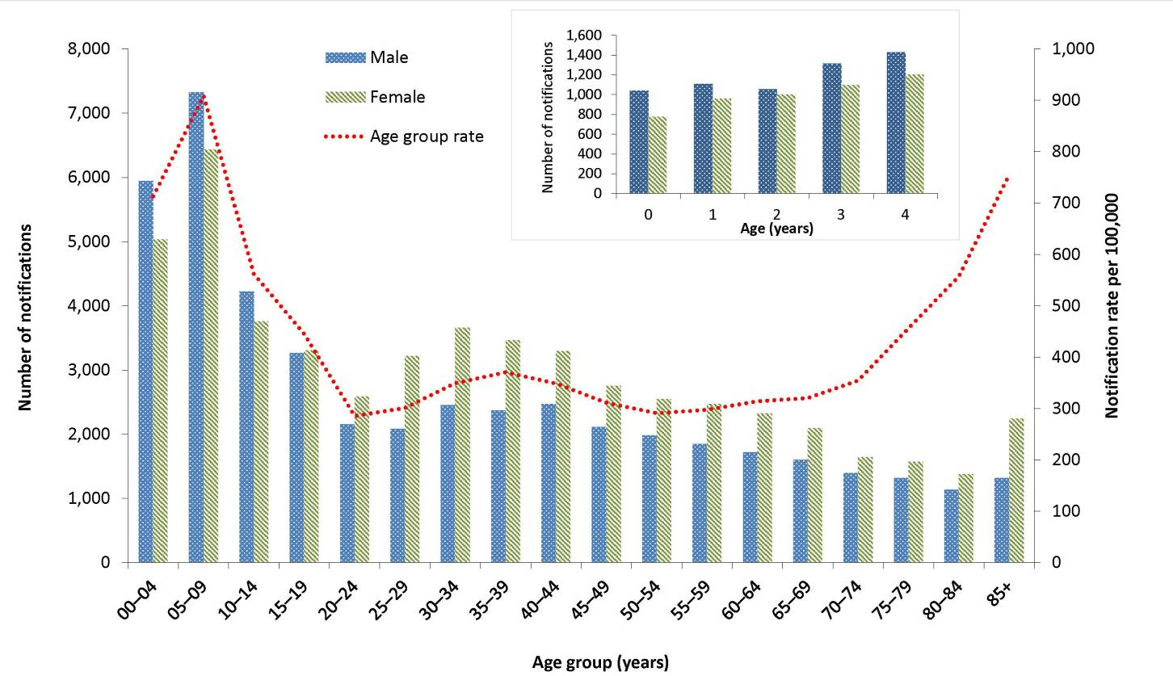
Notification rates were highest in the 5–9 years and over 85 years age groups (909 and 755 notifications per 100,000, respectively (Figure 54), followed by the 0–4 years age group (713 notifications per 100,000).
In 2015, females accounted for 54% (n=53,778) of the influenza notifications for which sex was reported. The age-group-specific rate of influenza in males exceeded that in females in age groups less than 15 years and 80 years and over, while the rates in females in all other age groups exceeded those in males.
Influenza types and subtypes affect different age profiles, with the predominant virus in circulation influencing the age distribution of influenza notification rates. For example, in seasons dominated by the influenza A(H1N1)pdm09 virus, such as 2010 and 2011, the age distribution of influenza notification rates showed a downward trend with increasing age (Figure 55). For comparison, in 2012, which was dominated by influenza A(H3N2), the age distribution of influenza notifications was bimodal, with peaks in those aged under 10 years and in those aged 70 years and over. In 2015, the influenza season was bimodal in distribution, with peaks in the 5–9 years and 85 years and over age groups.

Figure 55: Notification rate for laboratory confirmed influenza, Australia, 2010 to 2015, by age
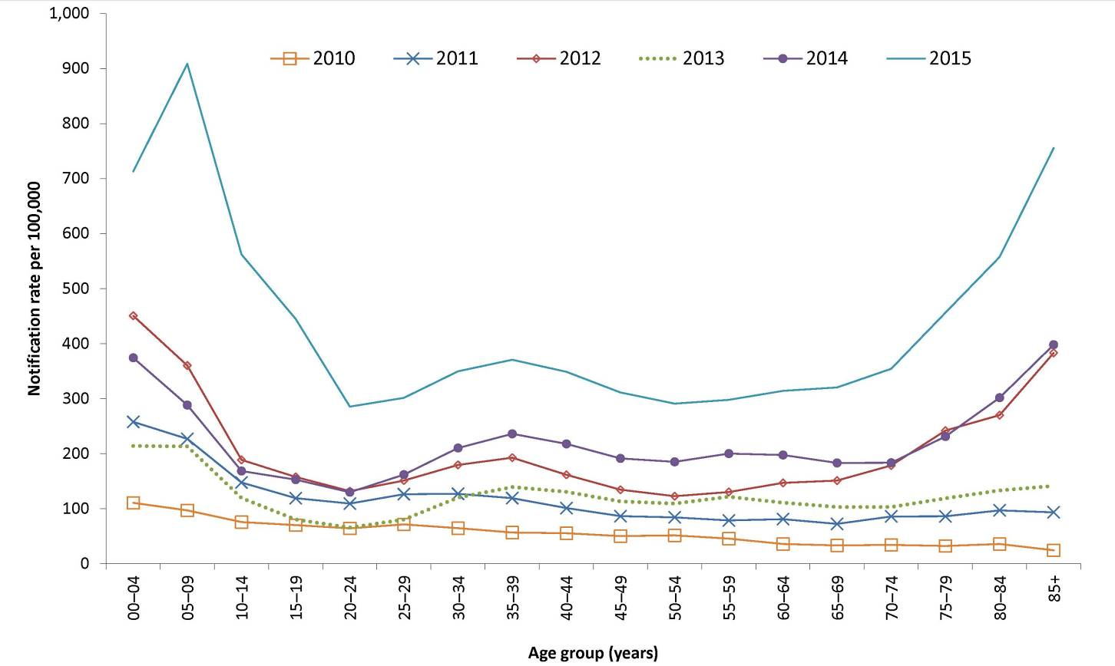

Seasonality
Influenza notifications during the 2014–15 inter-seasonal period (December to March) were the highest on record, with an average of 1,423 notifications per month, slightly higher than in the same period in 2013–14 (n=1,333). Queensland reported the largest number of inter-seasonal influenza notifications (n=1,777), followed by New South Wales (n=1,326). It is unclear whether this is a reflection of a higher prevalence of influenza circulating in the community at this time, an increased rate of testing or another factor.
The seasonal increase of influenza notifications in 2015 started in June, rose sharply and peaked in August, similar in pattern to the 2014 influenza season (Figure 56). The 2015 peak was higher than in previous years. The majority of activity in the jurisdictions peaked around late August, followed by a steady decline back to interseasonal levels by November. The exceptions were the Northern Territory and Western Australia, with heightened activity continuing a month later than the other jurisdictions.

Figure 56: Notifications of laboratory confirmed influenza, Australia, 2010 to 2015, by month and year
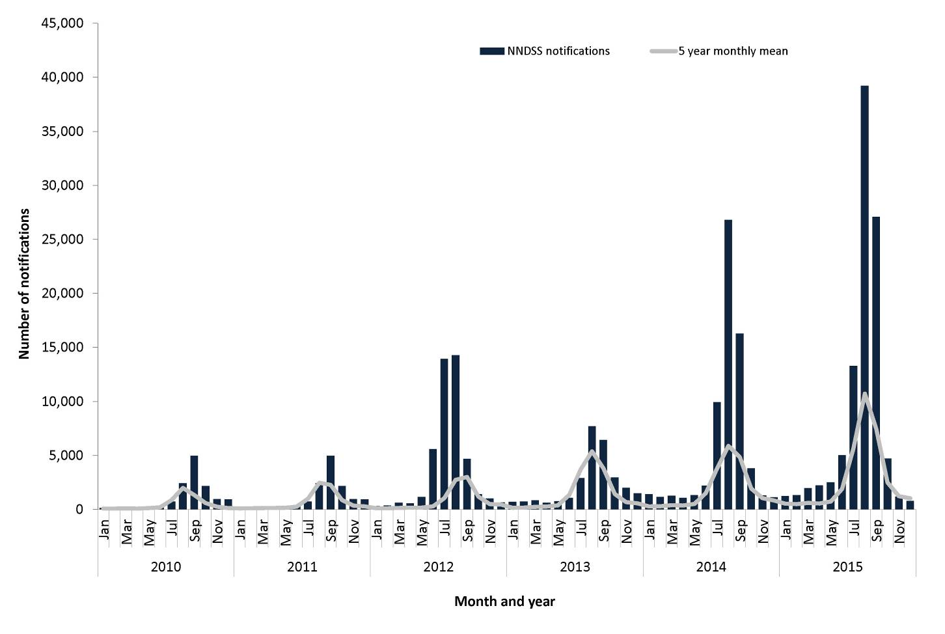

Indigenous status
Nationally in 2015, Indigenous status was reported in 36% (n=35,941) of laboratory confirmed notifications of influenza. Indigenous status completeness was greater than 50% in 4 jurisdictions: the Northern Territory (98%), Western Australia (94%), South Australia (83%) and the Australian Capital Territory (71%). The combined notification rates for influenza in these jurisdictions were 428 per 100,000 and 480 per 100,000 for non-Indigenous Australians, and representing a notification rate ratio of 0.9.

Mortality
Nationally, there were 137 influenza-associated deaths notified to the NNDSS, with a median age of 84 years (range: 1 to 102 years). The majority of deaths were associated with influenza A infections (n=102, 74%). Of these, 73 were associated with A (unsubtyped) infections, 1 was associated with A(H1N1)pdm09 and 28 were associated with A(H3N2). Indigenous status was reported for 85% (n=117) of the influenza-associated deaths; and Indigenous Australians accounted for <1% (n=1) of these deaths. The number of influenza-associated deaths reported to the NNDSS is reliant on the follow-up of cases to determine the outcome of their infection and most likely underestimates the true mortality associated with this disease. Of the 100,752 notifications to the NNDSS, only 41% (n=41,266) were provided with data relating to the association of influenza with individual deaths.

Microbiological trends

NNDSS
In 2015, typing data were reported for all but one laboratory confirmed influenza notification. The season was characterised by the predominant circulation of influenza B viruses (Figure 57). Influenza B viruses accounted for 60% (n=60,865) of all notifications reported in 2015, and influenza A viruses accounted for 39% (n=39,510) of all notifications. While the majority of notifications of influenza A were reported as unsubtyped (30%, n=30,671), influenza A(H3N2) was detected at higher levels than influenza A(H1N1)pdm09 (6%, n=6,505; and 2%, n=2,334 respectively). Mixed influenza type A and B infections accounted for <1% of notifications (n=206). There was 1 notification of influenza type C.
Figure 57: Notifications of laboratory confirmed influenza, Australia, 2015, by week and subtype
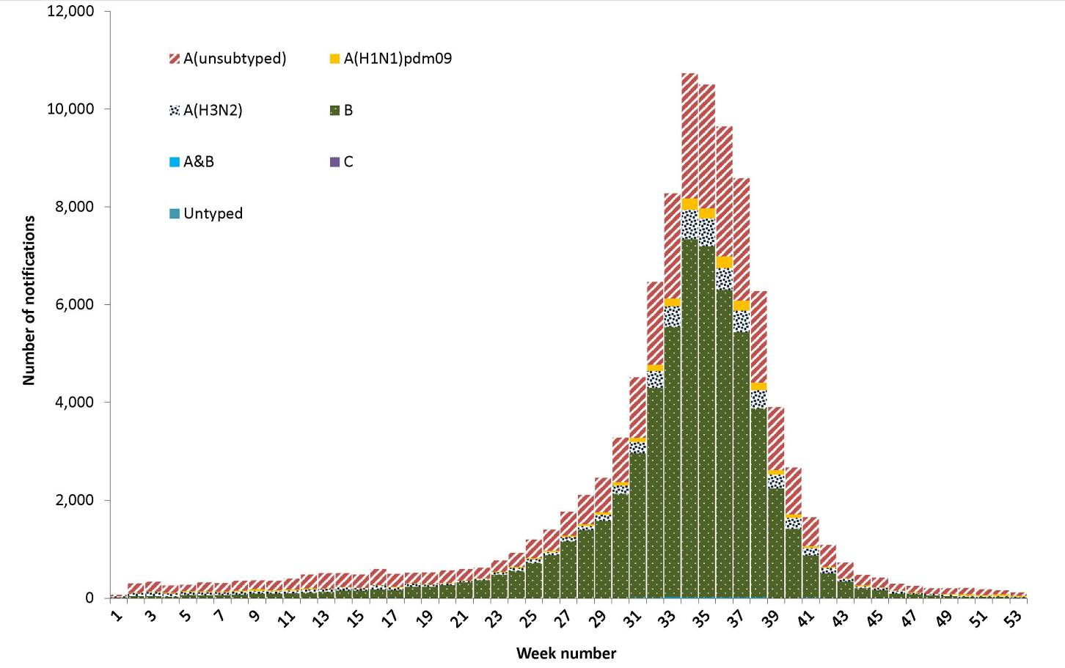
The predominance of influenza B in the 2015 season was in contrast to recent years, where influenza A viruses have historically dominated the season (Figure 58). The ratio of reported influenza A(H1N1)pdm09 viruses to influenza A(H3N2) viruses was 1:2.8 in 2015, as opposed to 4 of the 5 past years, when influenza A(H1N1)pdm09 was the predominant influenza A subtype notified. The notable exception was in 2012, when, for every notification of influenza A(H1N1)pdm09, 28 notifications of influenza A(H3N2) were reported to the NNDSS.

Figure 58: Percentage of annual notifications of laboratory confirmed influenza, Australia, 2010 to 2015, by subtype
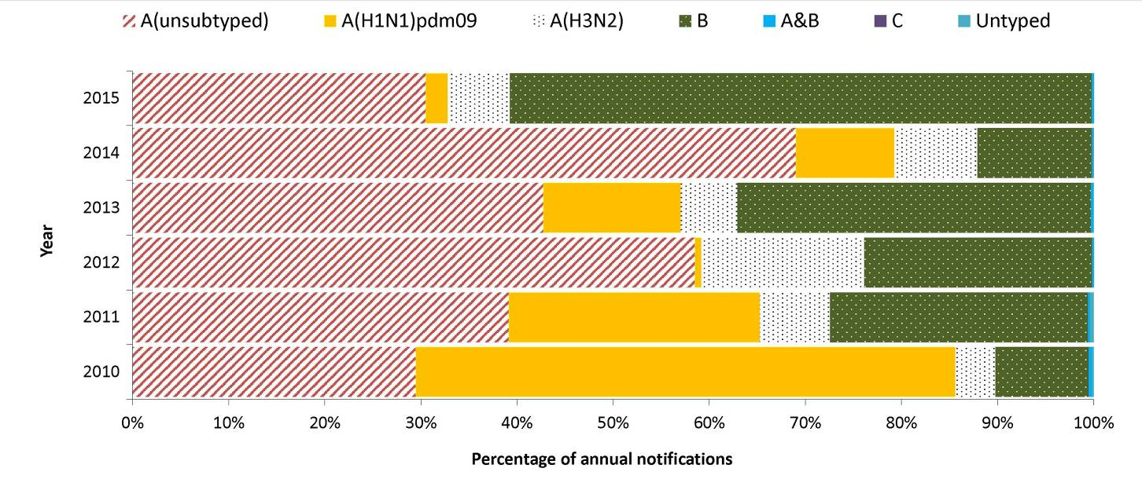
The predominance of influenza B viruses was consistent across jurisdictions and ranged from 45% of notifications in Tasmania, up to 65% in Queensland. Influenza A(H3N2) was the predominant influenza A virus notified in each jurisdiction, where subtype information was available. The ratio of reported influenza A(H1N1)pdm09 viruses influenza A(H3N2) viruses varied, ranging from 1:1.2 in the Australian Capital Territory to 1:11.9 in Tasmania.

WHO Collaborating Centre for Reference and Research on Influenza
For 2015, the WHO Collaborating Centre for Reference and Research on Influenza (WHOCC) analysed 2,005 specimens from influenza cases identified in Australia. Specimens are submitted to the WHOCC from laboratories according to guidelines that aim for successful isolation of viruses and likelihood of obtaining a vaccine candidate. WHOCC specimens therefore do not constitute a representative sample of influenza infections, which most likely accounts for differences in virus subtype distribution between NNDSS and WHOCC.
The number of specimens analysed by the WHOCC represents approximately 2% of the 100,583 laboratory confirmed cases reported to the NNDSS, compared with 2,072 specimens in 2014 representing 3% of notifications. The majority of specimens were influenza B (67%, n=1,355) with 36% identified as influenza B Victoria lineage (n=724) and 31% identified as influenza B Yamagata lineage (n=631) (Figure 59). The proportion of WHOCC specimens typed as influenza B was similar to that reported in laboratory confirmed notifications. The remainder of specimens were identified as influenza A(H1N1)pdm09 (n=221) and influenza A(H3N2) (n=429), accounting for 11% and 21% of samples respectively. Changes in the dominance of the two B lineages were seen over the season. During the 2015 pre-season period (January–April) and the early part of the influenza season (May–June), B/Yamagata lineage viruses predominated. However, from July to November, B/Victoria lineage viruses increased rapidly and were dominant from August.⁷⁵

Figure 59: Subtyped influenza virus samples, WHOCC versus NNDSS, Australia, 2015

The WHOCC assessed the antigenic similarity of circulating influenza virus isolates to reference strains included in seasonal influenza vaccines using the haemagglutination inhibition assay. The 2015 seasonal trivalent influenza vaccines (TIVs) contained 2 changes from 2014 and included an A/California/7/2009 (H1N1)pdm09-like virus, an A/Switzerland/9715293/2013 (H3N2)-like virus and a B/Phuket/3073/2013-like virus (B/Yamagata lineage). The 2015 seasonal quadrivalent influenza vaccines (QIVs) contained a B/Brisbane/60/2008-like virus (B/Victoria lineage) in addition to the viruses contained within TIVs. TIVs were available through the NIP in 2015. As opposed to analyses in 2014, which found high proportions of low reactors to the B component of the TIV, analyses in 2015 found that a very small proportion of B/Yamagata lineage (2/631) viruses were low reactors to the influenza B component of the 2015 TIV. This demonstrates that the TIVs were an appropriate match to the circulating B lineages. Similarly, a small proportion of B/Victoria linage viruses (3/724) were low reactors to the additional influenza B component of the 2015 QIV.
The majority of the A(H1N1)pdm09 isolates (218 of 221) were antigenically similar to the A(H1N1) component of the influenza vaccine (A/California/7/2009-like) which has been used each year since 2010. The remaining 3 (1.4%) isolates were characterised as ‘low reactors’. This suggests that the A(H1N1) viruses which have been circulating since the 2009 pandemic continue to be genetically and antigenically stable. Similarly, approximately 1.9% (8/429) of A(H3N2) isolates with sufficient titre for haemagglutination inhibition assay were antigenically drifted from the A/Switzerland/9715293/2013-like vaccine strain and characterised as ‘low reactors’.
Viruses submitted to the WHOCC in 2015 were also tested for sensitivity to the neuraminidase inhibitor class of antiviral drugs. Neuraminidase inhibition (NAI) assays were performed on 2,428 virus isolates, consisting of 1,269 influenza B, 210 influenza A(H1N1)pdm09 and 949 influenza A(H3N2) viruses. Reduced inhibition by oseltamivir was detected in a single A(H1N1)pdm09 isolate.
The WHO recommended changes to the influenza A(H3N2) and influenza B strains in TIVs for use in the 2016 influenza season. This included incorporating an A/Hong Kong/4801/2014 (H3N2)-like virus and B/Brisbane/60/2008-like virus (B/Victoria lineage) to the existing A/California/7/2009 (H1N1)pdm09-like virus. The WHO also recommended that 2016 QIVs include a B/Phuket/3073/2013-like virus (B/Yamagata lineage) in addition to the viruses contained with TIVs.

Enhanced surveillance data sets
In addition to NNDSS data, a series of targeted influenza surveillance systems operated during 2015. Together these systems collected data which were used to describe the season with respect to epidemiology, morbidity, mortality and virology and supported the conclusions drawn from analyses of NNDSS notification data. Enhanced influenza surveillance was based on the following additional sources of data:
- the number and proportion of calls to a national health call centre network for influenza or influenza-like illness (ILI);
- rates of ILI from a community survey;
- consultation rates for ILI identified by sentinel general practitioners;
- consultation rates for ILI identified by hospital emergency departments in Western Australia, New South Wales and the Northern Territory;
- hospitalised cases of influenza from 17 sentinel hospitals (adult and paediatric) across Australia;
- mortality data from the New South Wales Registry of Births, Deaths and Marriages; and
- typing and subtyping for influenza from sentinel laboratories in New South Wales, Victoria, Western Australia and Tasmania.
These data sources were used to inform the overall picture of influenza activity in Australia. Comprehensive analysis of these data was provided in the fortnightly Australian Influenza Surveillance Report, which was published during the season, and in the annual National Influenza Surveillance Scheme report published in CDI.

Discussion
The 2015 influenza season in Australia was characterised by the predominant circulation of influenza B viruses throughout the season, accounting for 60% of notified cases of laboratory confirmed influenza. Rates of influenza were highest among children aged less than 10 years and the elderly (aged 85 years and older), resulting in a bimodal age distribution.
The seasonal increase in notifications of laboratory confirmed influenza began in early June and reached a peak in mid-August. Notifications reported in the peak week, as well as total notifications reported in 2015, exceeded all previous years. Record numbers of notifications were also reported in the 2014–15 inter-seasonal period, suggesting a change in testing practices. This is further supported by data from the national sentinel general practice surveillance system, which shows that rates of ILI among people visiting general practitioners were similar to recent years.⁷⁶
Taking into account additional data from other targeted influenza surveillance systems monitored throughout the season, the severity of the 2015 influenza season was moderate across most jurisdictions. While there was a marked increase in the rates of notifications, presentations to emergency departments remained within the range experienced in recent years; however, some jurisdictions reported elevated presentations either widespread or regionally at the peak of the season. There were similar numbers of admissions to sentinel hospitals reported as in 2014; however, the overall proportion of patients admitted directly to intensive care units (ICUs) was less. Admissions to ICUs due to influenza A and influenza B were reported at similar proportions, suggesting that, at a type level, clinical severity was similar. Influenza-associated deaths remained fairly static, and were mostly attributable to association with influenza A. This may suggest the predilection for influenza A, particularly influenza A (H3N2), to affect people in older, more vulnerable age groups, leading to heightened mortality associated with influenza A in comparison to influenza B.

Measles
- Australia was certified by the World Health Organization (WHO) as achieving endemic measles elimination in 2014.
- There were 74 cases of measles notified in 2015, representing a national notification rate of 0.3 per 100,000 population.
- Eighty-four per cent of cases were either imported or import related.
- There were 11 outbreaks of measles in Australia in 2015. The median duration of these outbreaks was 23 days, and the median number of cases was 4 (range 2: to 11 cases).
- The largest outbreak of measles in 2015 consisted of 11 cases and lasted 60 days.
Measles is a highly infectious acute viral illness, caused by the measles virus, that is spread by respiratory secretions, including aerosol transmission.⁷⁷ Initial symptoms last 2 to 4 days and are characterised by fever and malaise, followed by a cough, coryza and conjunctivitis. It is usually followed by a red blotchy rash, which typically begins on the face, and then becomes generalised. Measles is often a severe disease with complications more common in the chronically ill, including otitis media, pneumonia, diarrhoea and acute encephalitis.⁷⁸ Subacute sclerosing panencephalitis is a late and rare (approximately 1 in 100,000 cases) complication of measles caused by persistent infection and is always fatal.²⁹ Complications are more common in children under 5 years of age and in adults over 20 years of age.⁷⁹

Epidemiological situation in 2015
In 2015, there were 74 notifications of measles, representing a notification rate of 0.3 per 100,000, the lowest rate since 2010. Compared with 2014 (n=339), measles notifications decreased by 78% (n=74) in 2015 (Figure 60) and were below the 5-year mean of 192 cases. Measles cases occurred in all states and territories in 2015, except for the Northern Territory and Tasmania, with 41% of cases occurring in Victoria (n=30) (Figure 60).
Figure 60: Notifications and notification rate for measles, Australia, 1998 to 2015, by year
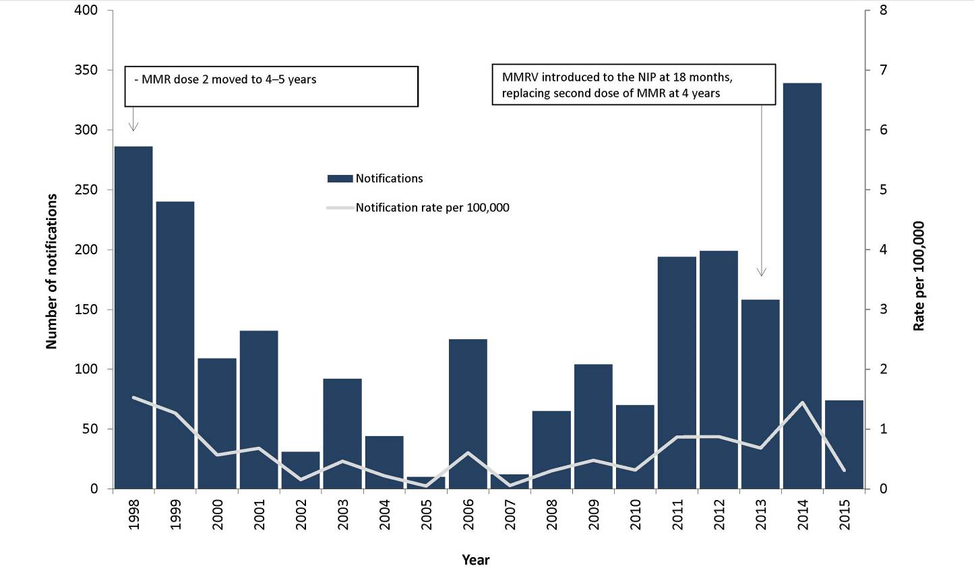
In temperate climates and where measles transmission remains endemic, the majority of cases usually occur in late winter to early spring.⁸⁰ In Australia, this seasonal pattern is no longer evident (Figure 61).

Figure 61: Notifications of measles, Australia, 2010 to 2015, by month, year and state or territory
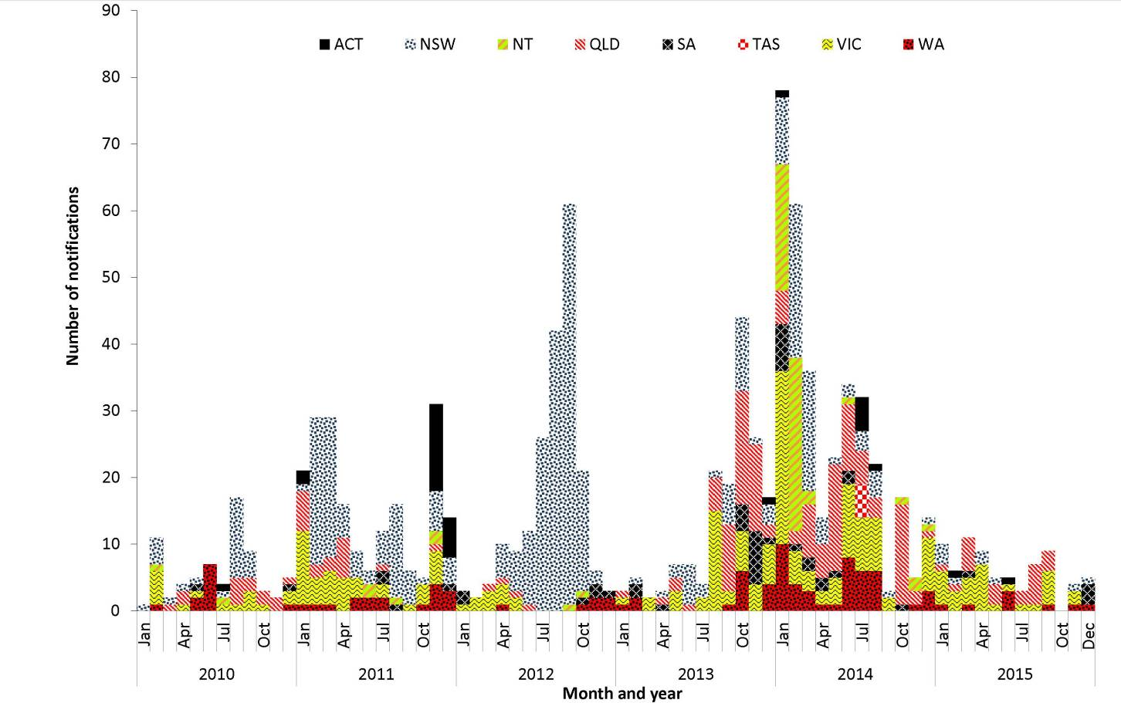

Age and sex distribution
In the 2015, the majority of measles cases were male (55%, n=41). There was a wide variation in the male to female rate ratio across the age groups (Figure 62).

Figure 62: Notification rate for measles, Australia, 2015 by age group and sex
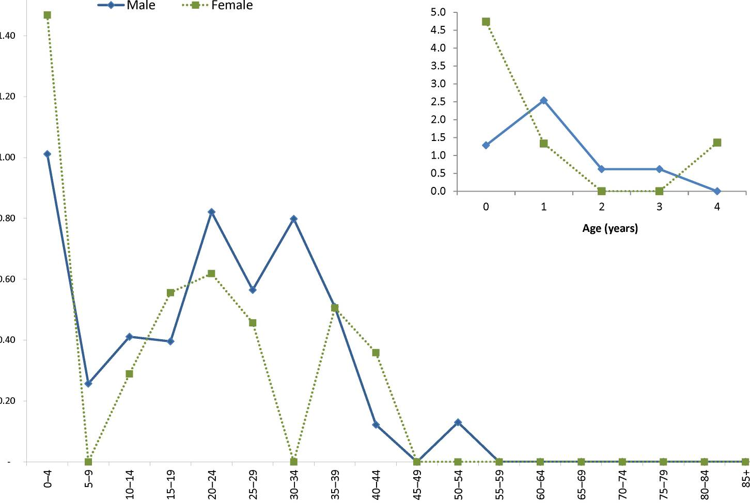
In 2015, age at diagnosis ranged from 0 to 54 years, with a median of 21 years. Compared with 2014, notifications decreased in all age groups. Consistent with recent years, infants less than 1 year of age had the highest age-specific rate (3.0 per 100,000, n=9) in 2015. Overall, rates have remained below 2.5 per 100,000 in all age groups from 2010 to 2015, with the exception of the less than 1 year age group from 2011 to 2015 and the 10–19 years age group in 2014 (Figure 63).

Figure 63: Notification rate for measles, Australia, 2010 to 2015, by year and selected age groups
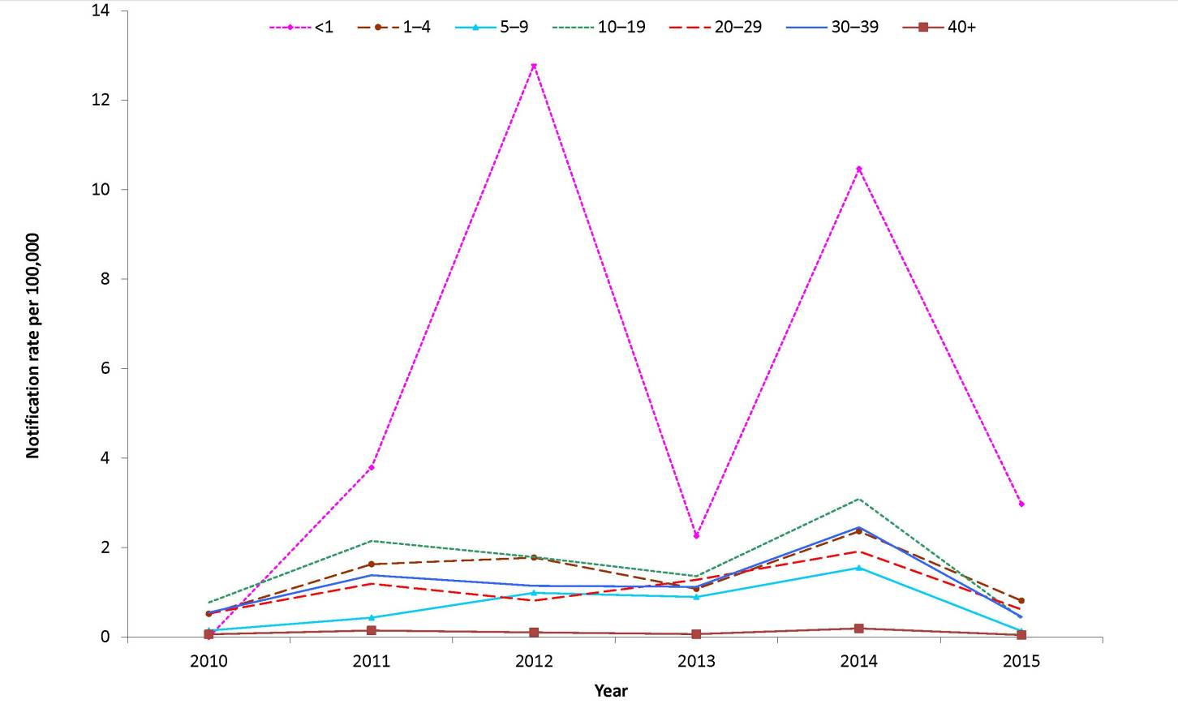
Sixteen per cent of cases (n=12) occurred in those born between 1974 and 1980 (35 to 41 years old in 2015), a cohort previously identified as susceptible to measles infection.⁸¹ In 2015, there was only one case that was born before 1966, a cohort that is considered to have high levels of natural immunity.⁸²

Immunisation status
In 2015, the measles vaccine was provided in the combined measles-mumps-rubella (MMR) or measles-mumps-rubella-varicella (MMRV) vaccines. The MMR and MMRV vaccine induces long term measles immunity in 95% of recipients after a single dose and 99% of recipients after the second dose.²⁹ Two doses of measles-containing vaccine are recommended for all people born during or after 1966.⁸³
Of the 74 cases notified in 2015, 86% (n=64) were born after 1965 or were 12 months of age or older, and therefore were eligible for at least 1 funded dose of a measles containing vaccine. Seventy-three per cent (n=47) of eligible cases were reported as either unvaccinated (39%, 25/64) or of unknown immunisation status (34%, 22/64). The remaining 27% (n=17) were reported as vaccinated, of whom 4 were fully vaccinated with 2 doses of a measles-containing vaccine and 13 were partially vaccinated with 1 dose (Figure 64). In 2015, all cases aged less than 15 years (n=26) were reported with an immunisation status. In contrast, 47% (22/47) of cases aged 15 years and older were reported with an unknown immunisation status (Figure 64).

Figure 64: Notifications of measles, Australia, 2015, by immunisation status and age groups
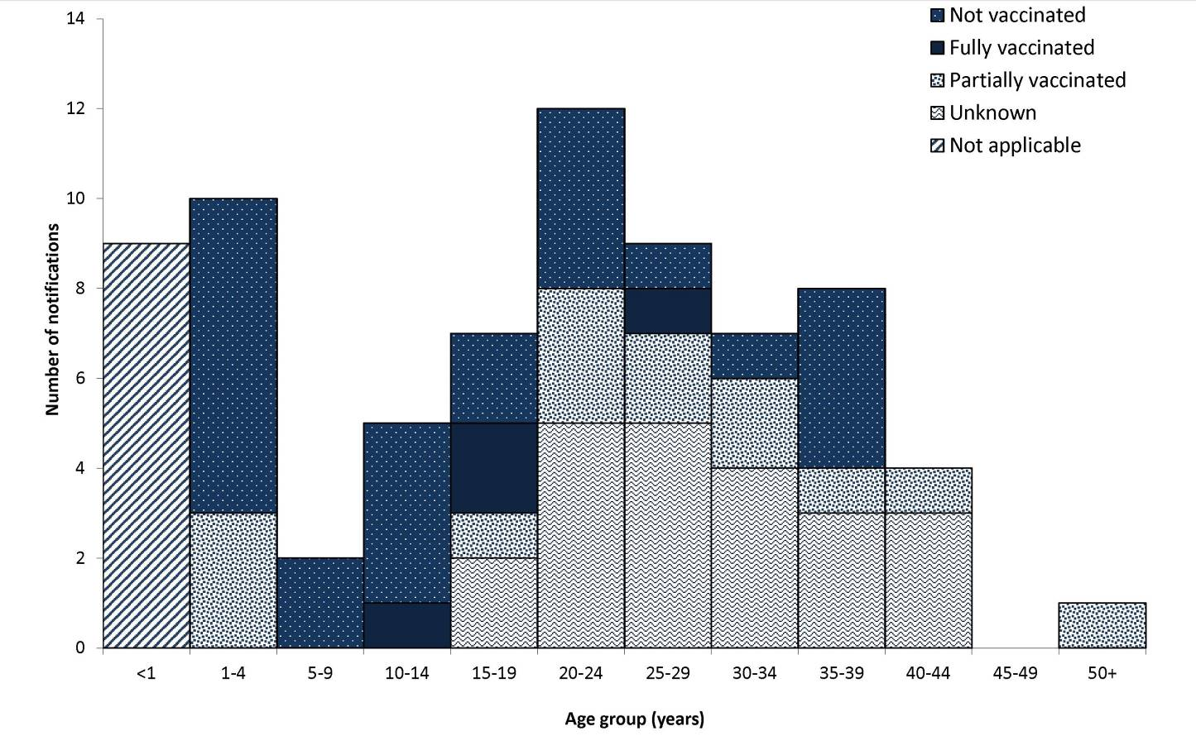

Indigenous status
In 2015, Indigenous status was completed for all measles cases, an increase in completeness compared with 96% of cases in 2014 (228/339). Of the cases reported in 2015, 3% (n=2) were reported as Indigenous, representing a notification rate of 0.3 per 100,000.

Sources of infection and outbreaks
Eighty-four per cent of cases in 2015 were either imported (n=32) or import related (n=30), with the remaining 16% (n=12) of unknown source (Figure 65). Of the imported cases, 28% (9/32) were from the WHO Western Pacific Region (WPR), with 2 cases imported from Malaysia and one case imported from each of the following: China, Hong Kong, Papua New Guinea, Philippines, Singapore, Vanuatu and Vietnam. Of the remaining imported cases, 17 were imported from the WHO South East Asia Region (57%), 4 from the WHO European Region (13%), 1 from the WHO African Region (3%) and one from the WHO Eastern Mediterranean Region (3%).

Figure 65: Notifications of measles, Australia, 2015, by source of infection and diagnosis week ending
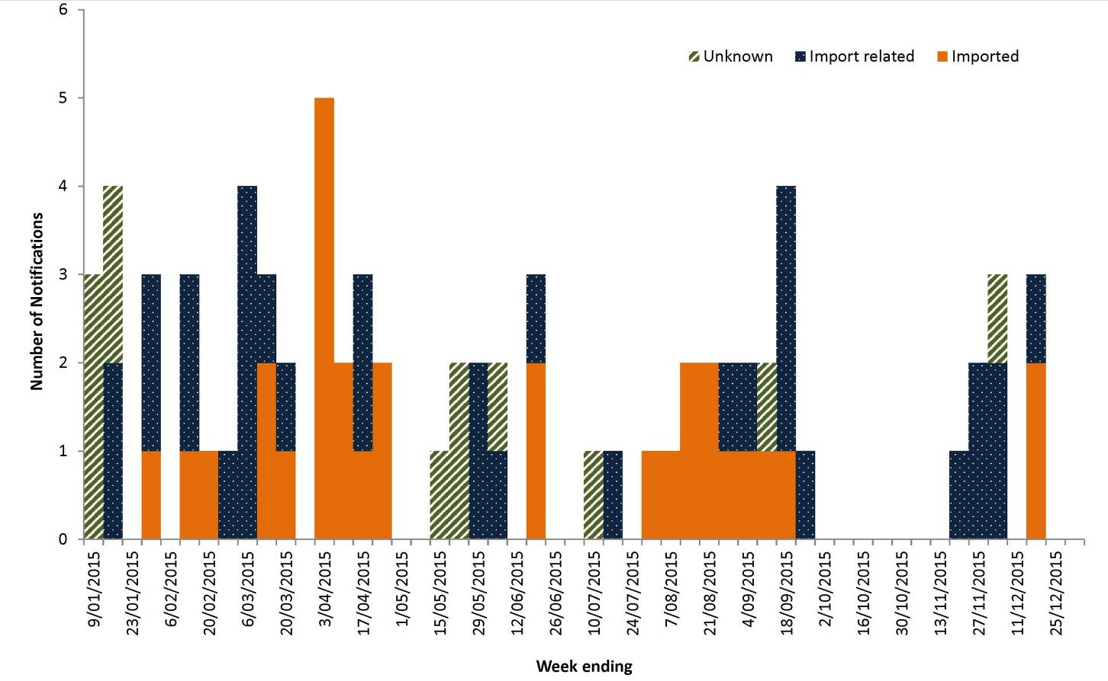
There were 11 outbreaks of 2 or more epidemiologically linked cases in 2015, accounting for 64% (n=47) of all cases. The remaining cases comprised sporadic imported cases (n=24) and sporadic cases acquired in Australia from an unknown source (n=3). Seventy-three per cent of the outbreaks were related to imported cases (8/11). There were 3 outbreaks of locally acquired cases from an unknown source in 2015, and 2 of these outbreaks occurred in Victoria. The first was an outbreak of 5 cases, which included 1 case who resided in Queensland and was associated with an outbreak of 11 cases reported in 2014, and the second was an outbreak of 2 cases. The third outbreak was reported in Queensland and consisted of 2 cases.
Transmission was interrupted quickly in all outbreaks in 2015. The median outbreak duration was 23 days (range: 7 to 60 days) between the onset of symptoms in the index case and the last case. The median generations of transmission⁸⁴ was 3 (range: 1 to 6). Ten of the 11 clusters had fewer than 10 cases, with a median of 4 cases (range: 2 to 9). There was only 1 outbreak in 2015 that comprised 10 or more cases. This outbreak commenced in mid-July and lasted 60 days. It included 6 generations of transmission and was genotyped as D8. The source of infection for this outbreak was identified as a case who acquired their infection from Indonesia.

Microbiological trends
Genotyping data were available for 11 clusters, with 2 or more linked cases in 2015 (n=47) and 21 sporadic cases. Genotype D8 was the most common, being linked to 8 separate clusters (n=38) and 12 sporadic cases, followed by H1 with 2 clusters (n=7) and 6 sporadic cases; B3 with 1 cluster (n=2) and 6 sporadic cases; and D4 with 1 sporadic case.
Imported genotypes varied by WHO region. In 2015, there was one B3 importation from the Eastern Mediterranean Region, and there were three D8 and two B3 importations from the Western Pacific Region. Multiple genotypes were imported from the South East Asia Region (B3, D8 and D4) and the European Region (B3, D8 and H1).

Discussion
Evidence suggests endemic measles has been eliminated in Australia since at least 2005,⁸⁰ with this being verified by the WHO in 2014.^{85,86} However, the increasing prevalence of measles in some parts of the world, and the continued circulation of the virus in countries of close geographical proximity to Australia, provide a continual source of imported virus in Australia. This was evident in 2015, with 84% of all measles linked to 32 separate importations.
Compared to 2014, the number of reported measles cases decreased substantially in 2015 (from 339 cases to 74 cases) and more cases were linked to an imported virus. None of the 11 outbreaks persisted for more than 12 months (the longest was 3 weeks) and there was no evidence of the continuous circulation of a single genotype. Over 50% of cases reported with an immunisation status in 2015 were either unvaccinated (39%) or not eligible for immunisation (12%). Due to the highly infectious nature of measles, importation with local transmission and clusters will continue to occur in Australia, mostly among contacts who have either not been vaccinated or only received 1 dose of measles-containing vaccine.

Mumps
- There were 644 cases of mumps notified in 2015, a rate of 2.7 per 100,000 and the highest rate since 2007.
- Seventy-one per cent of these (456/644) were notified from Western Australia.
- In 2015, 404 cases were Indigenous Australians, with the majority (n=391) notified from Western Australia.
Mumps is an acute viral illness caused by the mumps virus. Transmission is usually by respiratory secretions, including aerosol transmission, or by direct contact with saliva. Asymptomatic infections occur in one-third of cases. Symptomatic disease ranges from mild upper respiratory tract infections to systemic involvement. The characteristic bilateral, or occasionally unilateral, parotid swelling occurs in 60% to 70% of clinical cases; however, a high proportion have non-specific symptoms including fever, headache, malaise, myalgia and anorexia.⁸⁷ Mumps encephalitis has been estimated to occur in 1 to 2 per 10,000 cases, with a case fatality rate of around 1%.²¹

Epidemiological situation in 2015
In 2015, there were 644 notifications of mumps, a 246% increase compared with the 186 cases reported in 2014 and a ratio of 3.8 compared to the 5-year mean (n=171) (Figure 66). Since 2010, the national notification rate of mumps has remained below 1.0 per 100,000, ranging from 0.4 per 100,000 in 2010 to 0.9 per 100,000 in 2012 and 2013, and 0.8 per 100,000 in 2014. In 2015, the national notification rate of mumps was 2.7 per 100,000.

Figure 66: Notifications of mumps, Australia, 2010 to 2015, by month, and year and state or territory
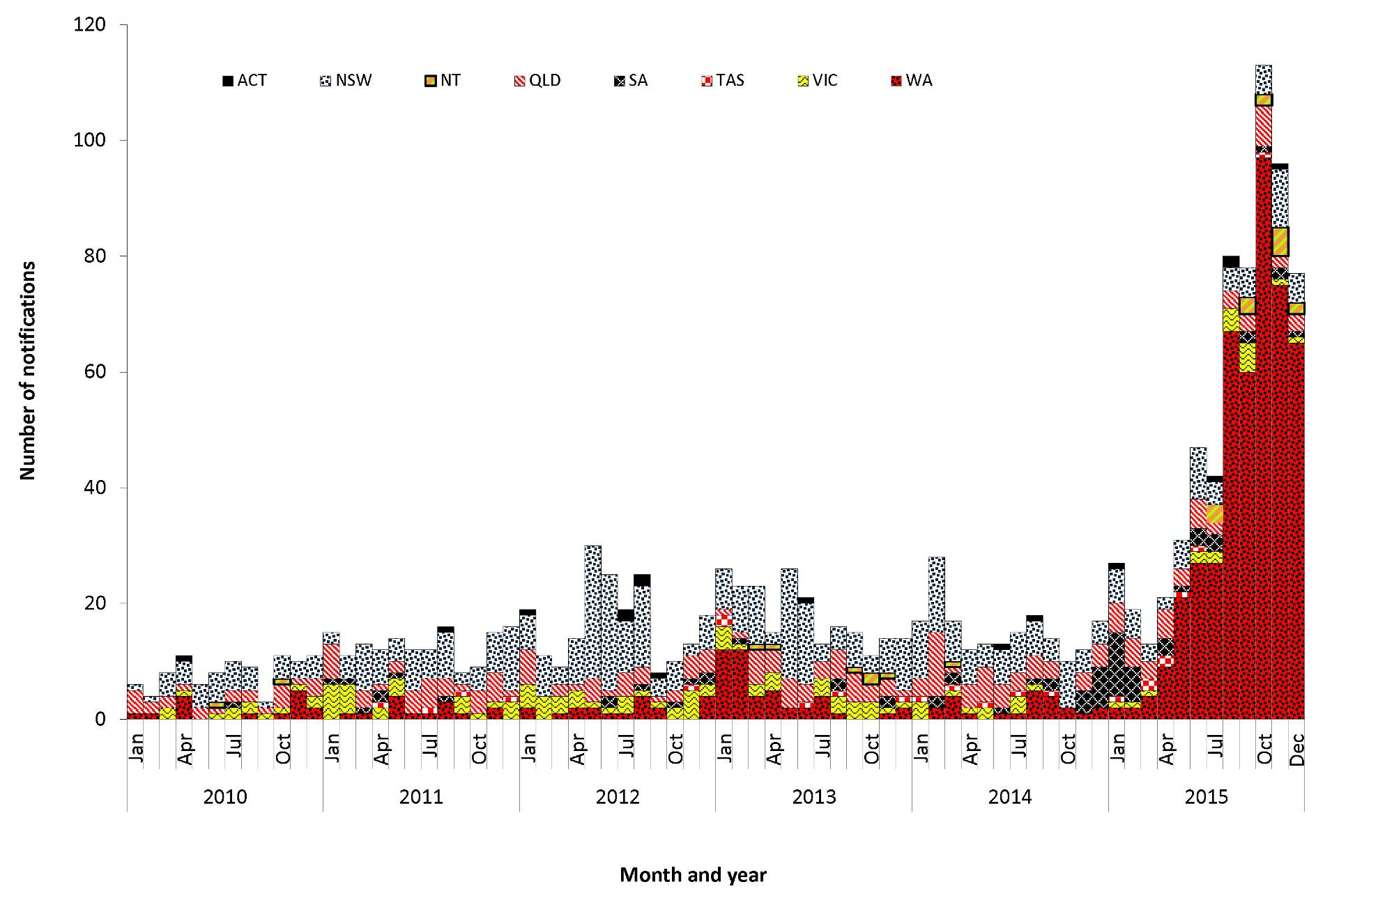

Geographical distribution
Cases of mumps were reported from all states and territories in 2015, with the highest rates occurring in Western Australia (17.6 per 100,000) and the Northern Territory (6.1 per 100,000).
Place of acquisition was complete for 91% (n=583) of cases in 2015, of which 3% (18/583) were imported from overseas. Of these, 4 cases acquired infection from India, 3 from Thailand, 2 each from Vietnam, Ireland, Papua New Guinea and New Zealand, and 1 each from Ghana, South Africa and Vanuatu. The remaining 565 cases were reported as locally acquired in Australia.

Age and sex distribution
In 2015, over half of all notified mumps cases were reported in males (57%, n=369), and 82% (n=528) were in people under the age of 40 years (Figure 67). The highest number of cases for males occurred in the 15–19 years age group (n=70), and for females in the 20–24 years age group (n=37), and followed closely by the 15–19 years age group (n=36). In contrast to previous years, where adults aged 30–39 years had the highest rates (3.3 per 100,000 in 2014), in 2015, adolescents aged 10–19 years age had the highest rates (6.5 per 100,000), followed by adults aged 20–29 years (4.7 per 100,000) (Figure 68). Since 2010, there has been a steady increase in age-specific rates across all age groups; this was particularly evident in 2015.
Figure 67: Notifications of mumps, Australia, 2015, by age group and sex
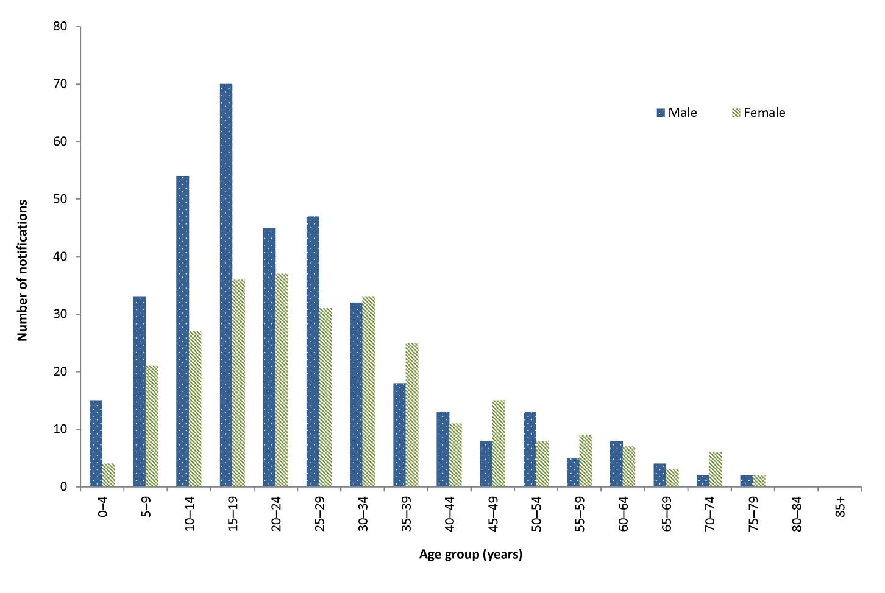

Figure 68: Notifications of mumps, Australia, 2010 to 2015, by year and selected age groups
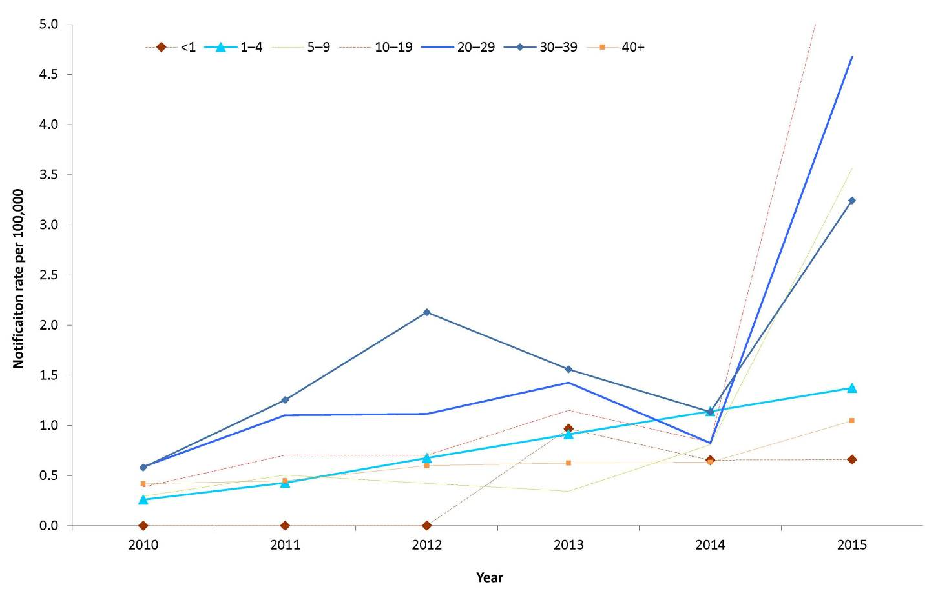

Immunisation status
In 2015, the mumps vaccine was provided in the combined MMR or MMRV vaccines. The mumps vaccine was first funded on the NIP schedule in 1982 for infants at 12 months of age, with people born after 1980 eligible for at least one dose of a mumps-containing vaccine. Of the 644 cases notified in 2015, 75% (n=483) were eligible for at least 1 dose of a publically funded mumps-containing vaccine. Of these, 60% (291/483) were fully vaccinated, having received 2 doses of a mumps-containing vaccine; 12% (56/483) were partially vaccinated, having received 1 dose; 6% (31/483) were unvaccinated; and 20% (99/483) were of unknown immunisation status.

Indigenous status
Indigenous status was reported for 95% (n=609) of notified mumps cases in 2015. This is higher than the mean completeness of the previous 5-year period (69%; range: 51% to 88%). Of the cases with a known Indigenous status in 2015, 66% (404/609) were reported as Indigenous, with the majority of these cases linked to a large outbreak that occurred in Western Australia (see outbreak section for more information).

Outbreaks
The outbreak reference field was completed for 69% (n=447) of cases in 2015. There were 4 outbreaks of 2 or more epidemiologically linked cases reported, accounting for 69% of all cases. One outbreak was reported in South Australia, which was linked to an imported case from Vietnam. This outbreak consisted of 11 cases with a median age of 22 years (range: 18 to 64 years) and lasted 3 weeks.
The remaining 3 outbreaks were reported in Western Australia, of which all were locally acquired and genotyped to mumps virus G. Two of these outbreaks were small, consisting of 2 cases each; both had a short duration (less than 3 weeks) and had cases aged between 15 and 36 years.
The third outbreak reported in Western Australia was the largest outbreak to occur in 2015. This outbreak consisted of 432 cases and accounted for 94% of mumps cases reported in Western Australia. The outbreak commenced in the Kimberley region in mid‐March, with subsequent spread to the Pilbara, Goldfields and Midwest region and limited spread to the Perth metro area.⁸⁸ The majority of cases reported in this outbreak were Indigenous Australians (90%, n=389) and the median age of cases was 20 years (range: 0 to 64 years). Seventy-five per cent (n=323) of cases were vaccinated, with 83% (267/323) of these reporting that they had received 2 or more doses of a mumps-containing vaccine, and 17% (56/323) reporting 1 dose. Of the remaining 25% of cases, 4% (17/323) were unvaccinated and 21% (92/323) were of unknown immunisation status.

Discussion
The large rise in mumps notifications seen in 2015 was associated with an ongoing large outbreak identified in Western Australia. Of the 644 cases of mumps reported nationally in 2015, 67% were linked to this outbreak. This is the second largest outbreak of mumps reported in Western Australia, with a localised outbreak occurring in the Kimberly region in 2007–08 that was genotyped as mumps virus J, which consisted of 183 cases.⁸⁹ At the end of 2015, this outbreak was still progressing, and it was anticipated that the number of mumps notifications would continue to be high in 2016. It is unclear why this outbreak disproportionately affected Indigenous Australians in Western Australia. Factors that may have contributed to widespread transmission of the virus within this population include differences in household density and mobility patterns, waning vaccine immunity, and potential immune escape due to the mismatch between the wild type and the vaccine virus genotypes.⁹⁰
The mumps component of the MMR vaccine is considered to be the least effective of the 3 components with the reported 1 dose vaccine effectiveness varying between 60% and 90%.^{91,92,93} While protection is greater in 2-dose vaccine recipients, recent outbreaks have been reported in 2-dose recipients, particularly young adults who received their vaccines more than 10 years previously.^{94,95} Reduced effectiveness of the mumps vaccine over time may partially account for the proportion of vaccinated cases notified and also contribute to mumps outbreaks in older vaccinated populations.⁹⁶

Pertussis
- Pertussis remains highly prevalent in Australia.
- An increasing trend in notifications of pertussis continued into 2015, with a total of 22,546 cases reported.
- In 2015, children under 15 years of age had a notification rate 4.6 times higher than those 15 years or older.
Pertussis, commonly known as whooping cough, is a highly infectious acute respiratory disease caused by the bacterium Bordetella pertussis. Spread by respiratory droplets, infection is often characterised by paroxysmal cough with inspiratory whoop, which is frequently seen among unvaccinated children but uncommon in individuals who have acquired some immunity through immunisation or infection.⁹⁷ The highest risk of infection and severe morbidity from pertussis occurs in infants who are too young to have received at least 2 doses of a pertussis-containing vaccine.²⁹ Complications include pneumonia, atelectasis, seizures, encephalopathy, and hernias, with pneumonia as the most common cause of death.²¹

Epidemiological situation in 2015
In 2015, there were 22,546 notifications of pertussis. This was an increase of 90% compared with 2014 (n=11,867) and 82% with 2013 (n=12,362), but 42% lower than 2011 (n=38,752) at the peak of the last epidemic period (2008–2012) (Figure 69). There was one pertussis-related death reported in 2015. The death was in an infant less than 6 weeks of age and therefore not eligible for immunisation.
Figure 69: Notifications of pertussis, Australia, 2010 to 2015, by month, year and state or territory
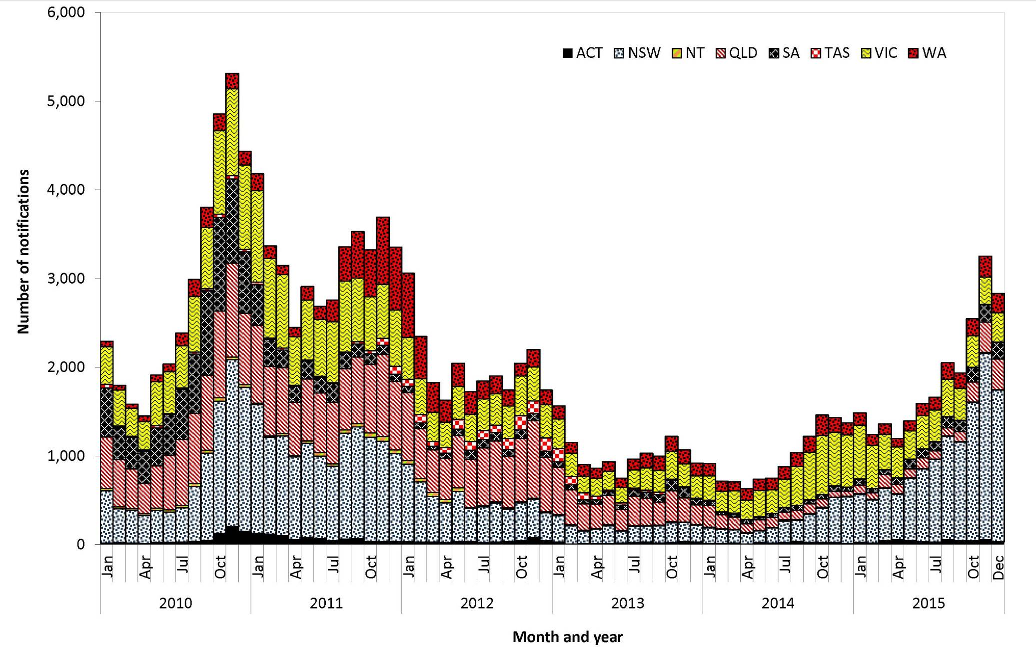

Geographical distribution
Compared with 2014, notification rates increased in all jurisdictions except the Northern Territory, Tasmania and Victoria (Figure 70). The largest increases in rates were in New South Wales from 42 per 100,000 in 2014 to 161 per 100,000 in 2015, South Australia from 30 per 100,000 in 2014 to 78 per 100,000 in 2015 and in the Australian Capital Territory from 60 per 100,000 in 2014 to 124 per 100,000 in 2015. The national notification rate of pertussis in 2015 increased by 87% (95 per 100,000) compared with 2014 (51 per 100,000).
Figure 70: Notification rates for pertussis, Australia, 2010 to 2015, by year and state or territory
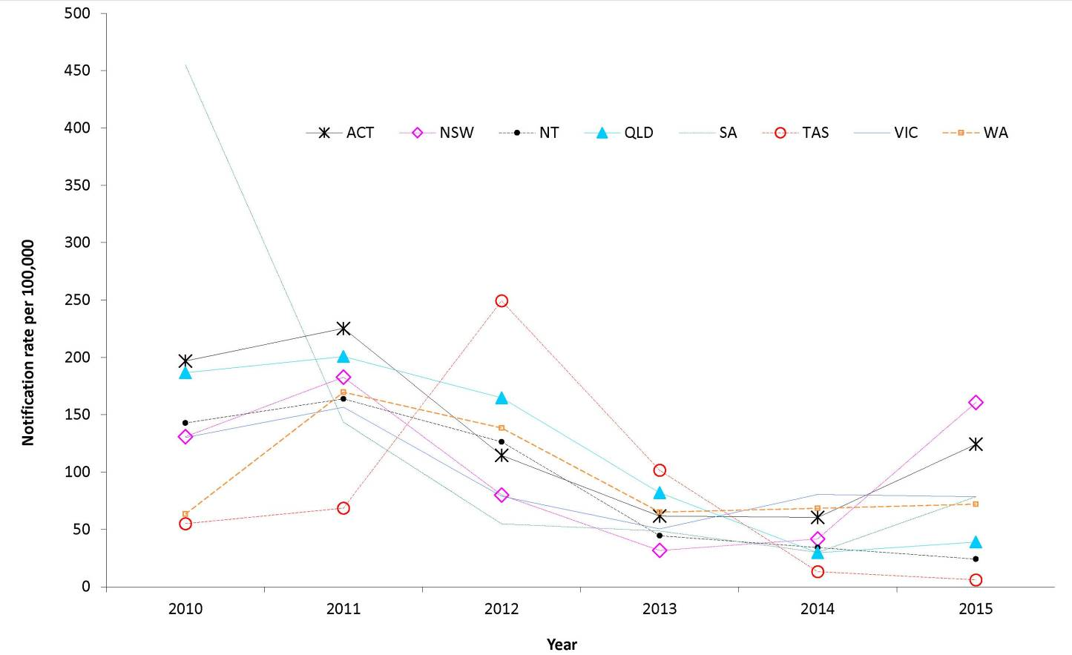

Age and sex distribution
Females accounted for 55% (n=12,297) of cases in 2015 and had higher rates across all age groups except 85 years or older (Figure 71). The highest age-specific notification rates for both males and females occurred in the 10–14 years age group at 296 and 309 per 100,000 respectively.

Figure 71: Notification rate for pertussis, Australia, by age group and sex
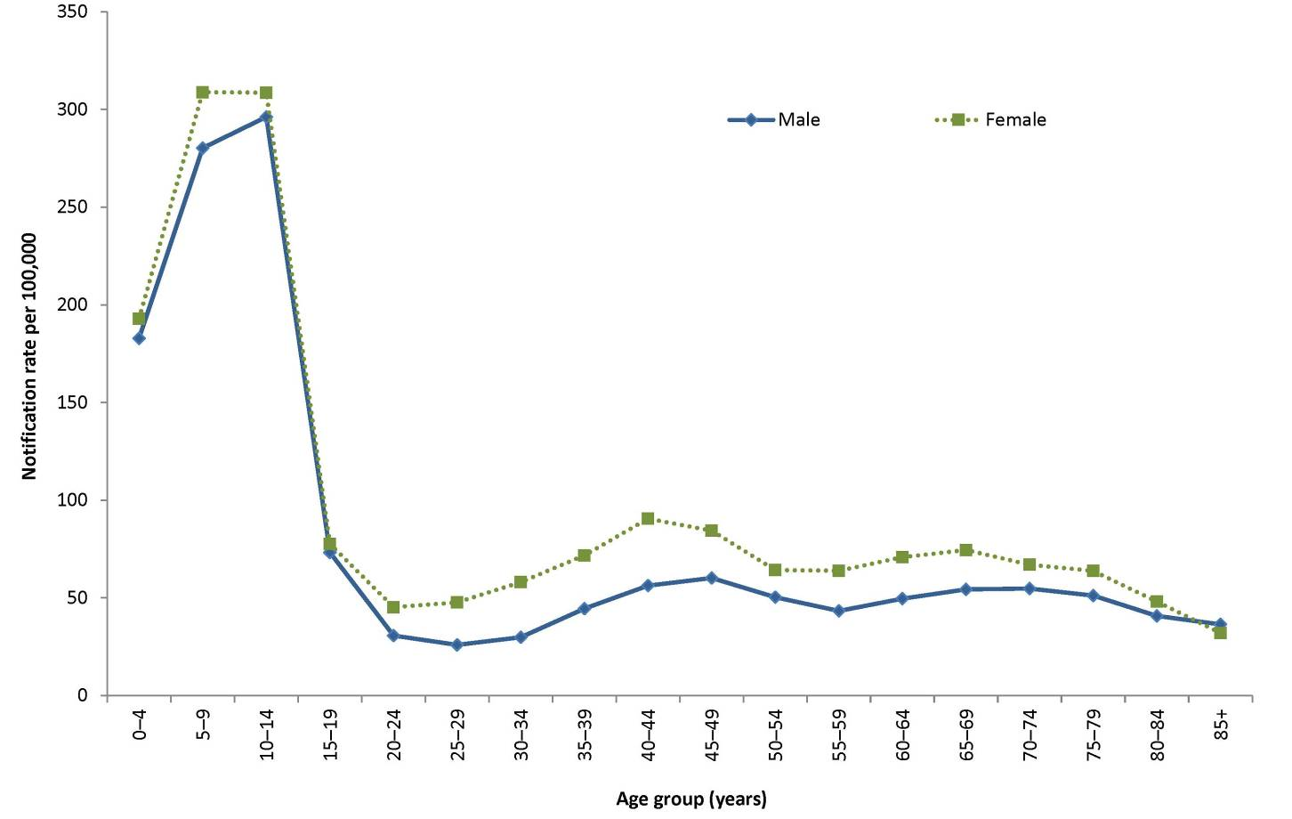
* Seven cases were reported without age
# 18 cases were reported without sex
After reaching a peak in 2011, rates in children less than 15 years of age declined steeply, with the ratio of cases under 15 years compared with those over 15 years falling from 3.7 in 2011 to 2.7 in 2014. In 2015, this ratio increased, with rates for children less than 15 years (260 per 100,000) 4.6 times higher compared with those aged 15 years and older (56 per 100,000). This is almost double the ratio seen in 2014. The highest age-specific rates in 2015 occurred in the 10–14 years age group (305 per 100,000), which was higher than the rates reported in 2013 (111 per 100,000) and 2014 (112 per 100,000) (Figure 72).

Figure 72: Notification rates for pertussis, Australia, 2010 to 2015, by selected age groups*
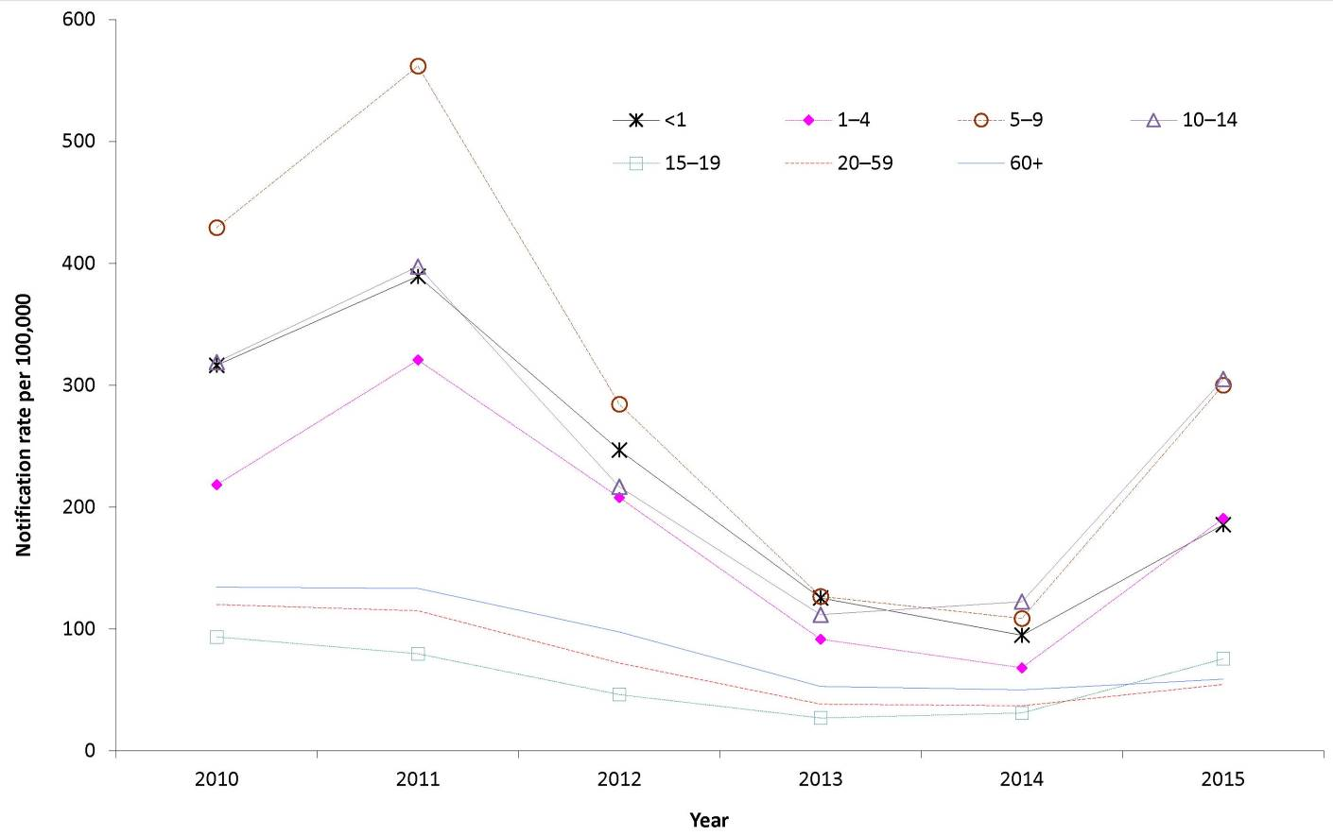

Immunisation status
The NIP schedule in 2015 included a primary course of 3 doses of vaccine at 2, 4, and 6 months of age, with additional booster doses provided at 4 years of age and between 10 and 15 years of age.²⁹
In order to determine the immunisation status of cases, public health follow up is required. As per the pertussis national guidelines for public health units,⁹⁸ jurisdictions prioritise case follow up to those less than 5 years of age. During 2015, those aged less than 5 years accounted for 13% (n=2,896) of all notified cases, Information about immunisation status was available for 94% of these (2,717/2,896).
Of the children eligible to receive pertussis-containing vaccines in 2015, 81% (1,729/2,145) of cases aged 6 months to 4 years received the full primary course of 3 doses, and 61% (273/449) of cases aged 4 to 5 years had received the full scheduled course of 4 doses (Table 18). Seventy-seven per cent (2,278/2,896) of eligible cases less than 5 years of age had received at least 2 doses of a pertussis-containing vaccine in 2015.

Table 18: Notifications of pertussis in children aged 0 to 5 years, Australia, 2015, by age group
 | Number of vaccine doses
Age group | 0 | 1 | 2 | 3 | 4 | Unknown | Total
Less than 6 weeks of age (not eligible for immunisation) | 35 | 4 | 0 | 0 | 0 | 9 | 48
6 weeks to <4 months  (eligible for 1 dose of vaccine) | 22 | 112 | 3 | 0 | 0 | 6 | 143
4 to <6 months  (eligible for two doses of vaccine) | 15 | 12 | 74 | 0 | 0 | 10 | 111
6 months to <4 years  (eligible for 3 doses of vaccine) | 177 | 17 | 64 | 1,729 | 47 | 111 | 2,145
4 to 5 years  (eligible for 4 doses of vaccine) | 44 | 1 | 5 | 83 | 273 | 43 | 449
Total | 293 | 146 | 146 | 1,812 | 320 | 179 | 2,896
Pertussis vaccine effectiveness among Australian children has been estimated to range from 82% to 89%, with the lower figure representing the cohort of children who would not have been eligible for the 18-month booster dose, which was removed from the NIP in 2003.⁹⁹ Immunity to disease decreases over time post-immunisation, with estimates that protection remains for 4 to 12 years.^{100,101,102} While pertussis can affect people of any age, infants are at highest risk of more severe disease, as adequate immunity is not achieved through infant immunisation until at least the second vaccine dose at 4 months of age.¹⁰³

Discussion
Epidemics of pertussis have historically occurred at regular intervals of approximately 4 years on a background of endemic circulation in Australia, with the most recent epidemic peaking in 2011. In 2015, the national rate of pertussis increased, with jurisdictions reporting varying pertussis activity. The Northern Territory, Tasmania and Victoria displayed activity that is consistent at pre-epidemic levels, while the remaining jurisdictions exhibited increased activity compared with previous years, particularly New South Wales.
Increases in pertussis activity in New South Wales were evident from mid-2014, and were driven by an outbreak of pertussis which continued into 2015 and peaked in November. Pertussis activity in New South Wales displayed a decline in December 2015, but was still higher compared with activity in 2013 and e arly 2014.
All jurisdictions in 2015 introduced funded immunisation programs offering free pertussis immunisation to pregnant women in their third trimester (from 28 weeks gestation). In 2012, all jurisdictions, except for the Northern Territory, ceased their respective cocooning programs, which included various combinations of providing free booster immunisations to carers of infants. In 2015, Victoria funded a cocooning program as part of the maternal immunisation program. This program offers pertussis immunisations to parents and guardians of infants up to 6 months of age and born on or after 1 June 2015, and partners of women who are at least 28 weeks pregnant, if they have not received a pertussis booster in the last 10 years.¹⁰⁴

Pneumococcal disease (invasive)
- There were 1,499 cases of invasive pneumococcal disease notified in 2015, a small decrease on the total compared with 2014 (n=1,563).
Invasive pneumococcal disease (IPD) is a condition where Streptococcus pneumoniae is isolated from a normally sterile site such as blood, cerebrospinal fluid, or pleural fluid. Transmission of the bacterium from person to person is usually via the inhalation of respiratory droplets from an infected person. Many of the signs and symptoms of IPD are non-specific including fever, chills, headache, neck stiffness and general malaise. Severe symptoms can include seizures and occasionally coma.

Epidemiological situation in 2015
In 2015, there were 1,499 notifications of IPD, representing a notification rate of 6.3 per 100,000. Compared to 2011 (8.4 per 100,000), there has been a 25% reduction in the overall notification rate of IPD. This reduction was associated with the July 2011 replacement of the 7-valent pneumococcal conjugate vaccine (7vPCV) in the childhood immunisation program with the 13-valent pneumococcal conjugate vaccine (13vPCV), where the declines were greatest among children aged less than 2 years targeted by the new vaccine and for those IPD cases caused by the 6 additional vaccine serotypes.²⁹

Geographic distribution
Nationally in 2015, notification rates varied by jurisdiction, and ranged from 4.3 per 100,000 in the Australian Capital Territory to 24.9 per 100,000 in the Northern Territory. The Australian Capital Territory, the Northern Territory, Queensland and Tasmania all reported an increase in their rates of IPD notification compared to 2014. The Northern Territory reported the greatest increase on the previous year (41%, 17.7 to 24.9 per 100,000), noting that this increase had followed a decline from a previous peak in 2011 (55.8 per 100,000). In comparison, the other 3 jurisdictions reported only small increases (range: 4 to 12%). New South Wales, South Australia, Victoria and Western Australia all reported a decline in their notifications rates compared to 2014, with Western Australia reporting the greatest decrease (21%, 8.1 to 6.4 per 100,000).

Age and sex distribution
In 2015, males (55%, n=827) continued to account for a higher proportion of cases compared to females (45%, n=672). The rates of disease in males exceeded those in females across almost all age groups, especially among those aged 0–4 years and 75 years and over (Figure 73). Overall, the notification rate was highest in older Australians and young children, with an age distribution of cases similar to that observed in 2014. In adult Australians, the highest notification rate was among those aged 85 years and over (25.2 per 100,000), while in children it was among those aged less than 5 years (12.9 per 100,000). The notification rate among those aged less than 2 years was 17.9 per 100,000.

Figure 73: Notification rate for invasive pneumococcal disease, Australia, 2015, by age group and sex
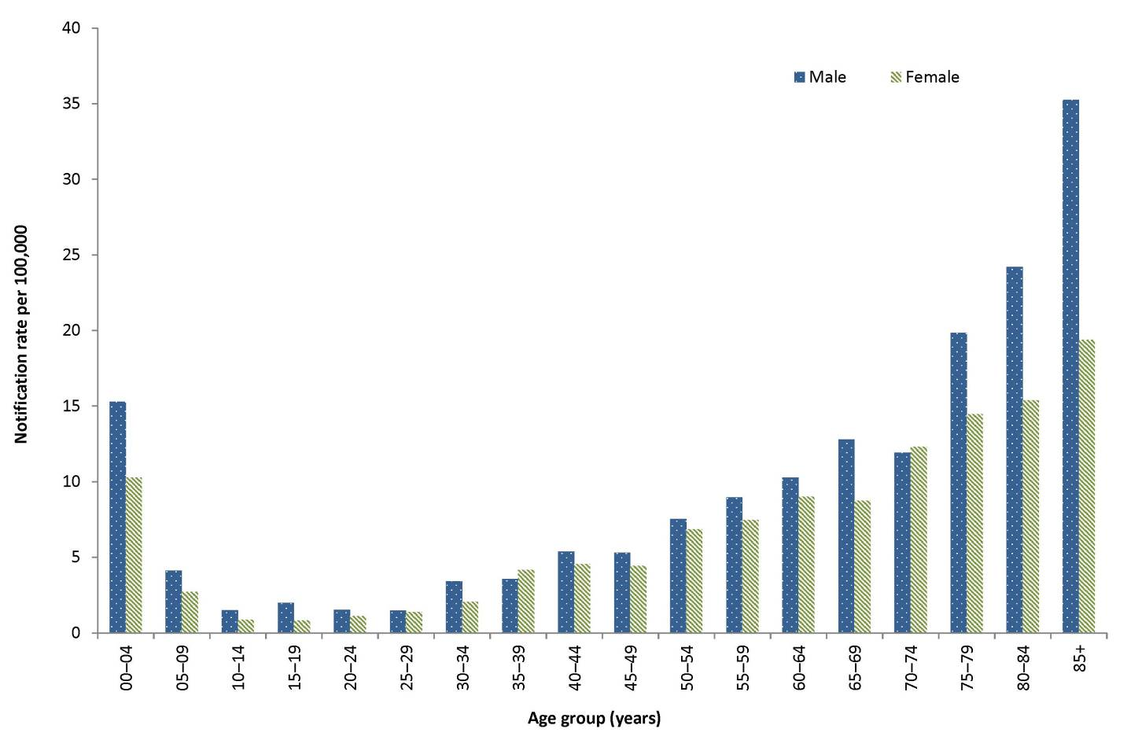

Figure 74: Age-standardised notification rates for invasive pneumococcal disease, Australia, 2006 to 2015, by Indigenous status*
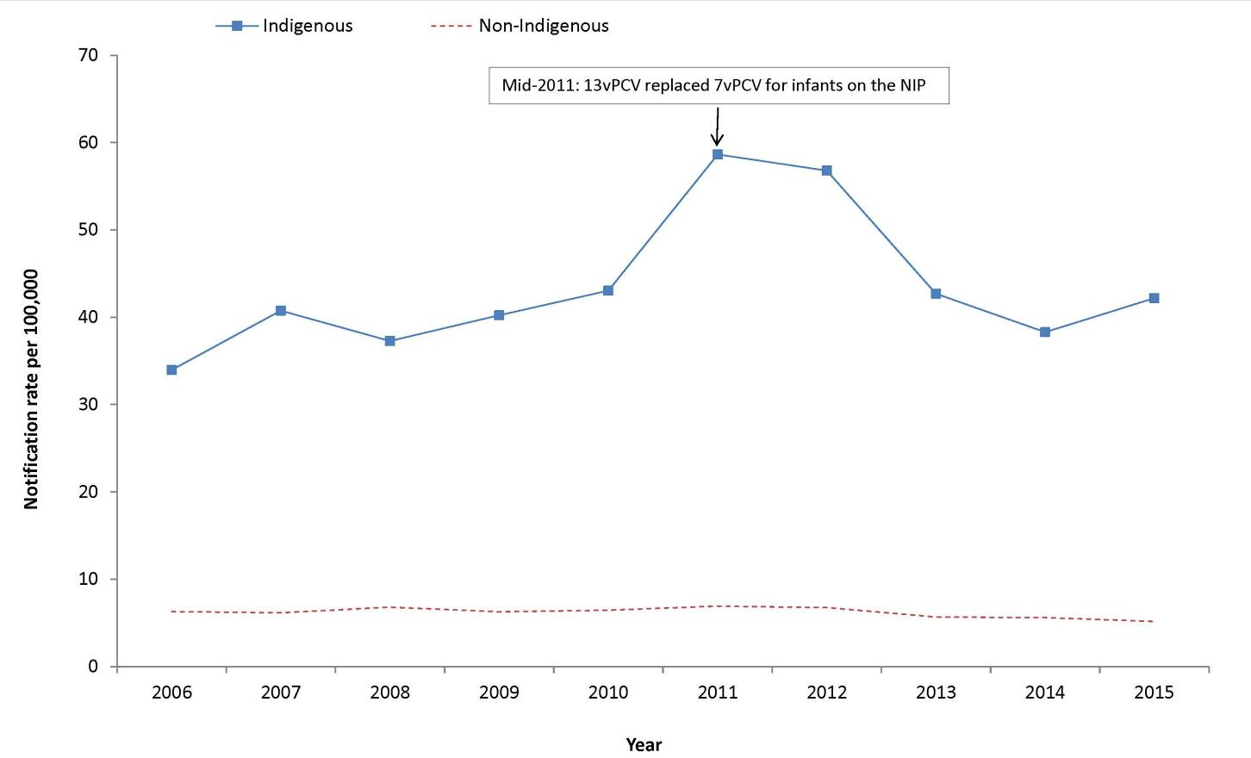
* Where the Indigenous status of a notification was not completed, these notifications were counted as non-Indigenous in this analysis.

Seasonality
Many respiratory transmitted diseases, including IPD, are known to show a distinct seasonal trend, with incidence generally peaking during the winter months. In 2015, notifications of IPD peaked over the months of July and August (n=204 and 229 respectively), which was consistent with the seasonal peak observed in previous years.

Indigenous status
In 2015, 89% (1,340/1,499) of IPD cases were reported with a known Indigenous status. Of those with a known Indigenous status, 16% (208/1,340) were Indigenous. The age-specific notification rates for the Indigenous population were higher than for the non-Indigenous population in each age group. As Indigenous and non-Indigenous populations differ in age structure, age-standardised notification rates are reported to provide a more appropriate comparison of these 2 populations to a standard population, the Australian population in 30 June 2001. In 2015, the age-standardised notification rate in the Indigenous population was approximately 8 times that of the non-Indigenous population. The Indigenous age-standardised notification rate increased from 34.0 in 2006 to a peak of 58.6 in 2011 and then decreased to 42.2 per 100,000 population in 2015. In comparison, the non-Indigenous age-standardised notification rate increased from 6.3 in 2006 to 6.9 in 2011, followed by a decrease to 5.2 per 100,000 population in 2015 (Figure 25). The declines observed since 2011 are probably due to the replacement in mid-2011 of 7vPCV with 13vPCV as the pneumococcal vaccine offered to infants through the NIP.

Immunisation status
In 2015, publically funded pneumococcal immunisation was available for infants (at 2, 4 and 6 months of age), Aboriginal and Torres Strait Islander peoples aged 50 years and over, other Australians aged 65 years and over, and individuals with certain at-risk conditions. More information on the scheduling of the pneumococcal immunisation can be found in The Australian Immunisation Handbook, 10th edition.¹⁰⁵
Based on the reported IPD serotype and relevant vaccine serotype coverage, there were 29 cases reported in fully vaccinated children aged less than 5 years who were considered to be 13vPCV failures and 3 cases who were considered 7vPCV failures, based on their vaccine type eligibility. Serotypes responsible for these vaccine failures were 19A (38%), 19F (38%) and 3 (25%). ‘Fully vaccinated’ describes cases that have completed the primary course of the relevant vaccine(s) required for their age according to the most recent edition of The Australian Immunisation Handbook,¹⁰⁵ at least 2 weeks prior to disease onset with at least 28 days between doses of vaccine.

Microbiological trends
Although there are more than 90 S. pneumoniae serotypes, a relatively limited number cause the majority of IPD. However, the predominant serotypes vary by age group and geographic area. Monitoring the profile of S. pneumoniae serotypes causing disease in the community is critical for evaluating the impact of the NIP funded vaccines as well as for the early detection of emerging serotypes and serotype-specific outbreaks. The serotypes causing IPD were reported in 94% (n=1,406) of notified cases in 2015 (Figure 75).
Figure 75: Notifications and rates of invasive pneumococcal disease, Australia, 2006 to 2015, by vaccine serotype group and year
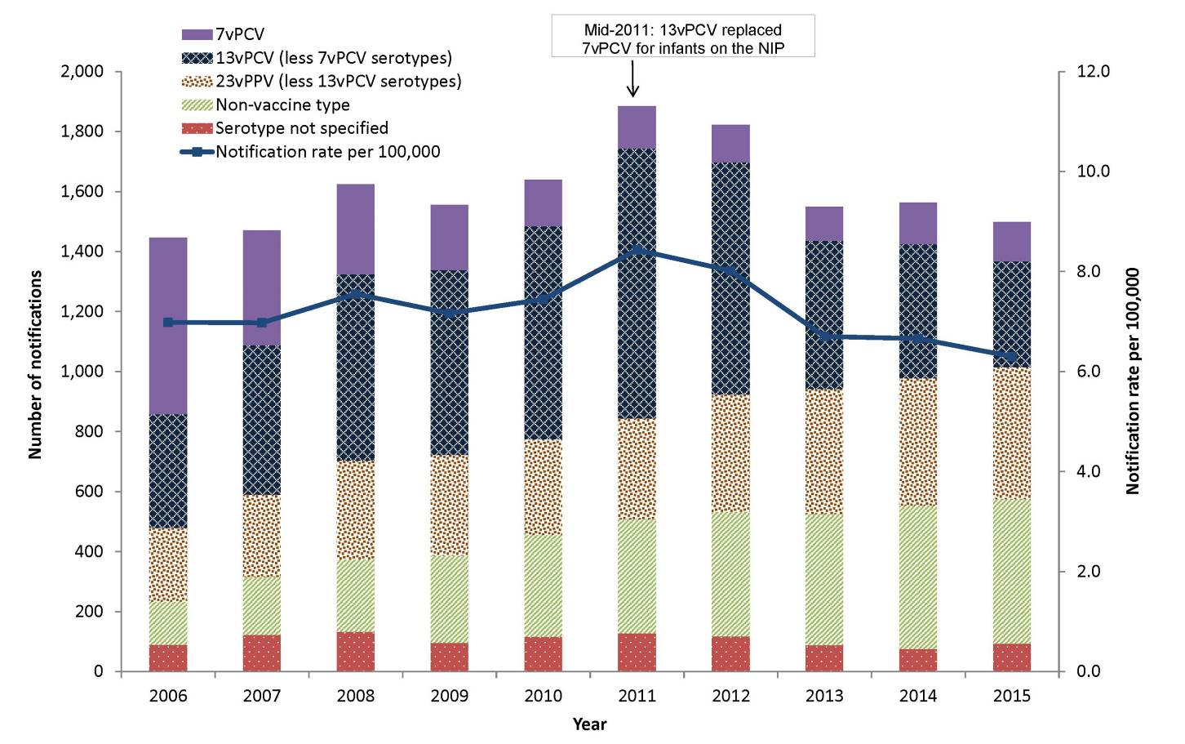
In 2015, 65% (n=917) of all notifications with a known serotype were caused by a serotype included in 23-valent pneumococcal polysaccharide vaccine (23vPPV) and 34% (n=484) were those included in 13vPCV. Overall after 13vPCV replaced 7vPCV in the childhood immunisation program in mid-2011, the proportion of IPD cases due to 13vPCV non-7vPCV disease declined from 51% in 2011 to 25% in 2015. Across all ages, the most frequently reported serotypes were 19A (10%, n=137), 3 (9%, n=132), 22F (8%, n=108), 19F (6%, n=78), 9N (5%, n=75) and 7F (5%, n=73). These 6 serotypes accounted for 43% (n=603) of all notifications with serotype information. All of these serotypes, except 9N and 22F, are included both in 13vPCV and 23vPPV. Serotypes 9N and 22F are only included in 23vPPV. Of the serotypes that are not covered by 13vPCV and 23vPPV (35%; n=489), these were distributed across 36 other serotypes, with serotypes 23B (5%; n=72), 23A (4%; n=60), 15A (4%; n=53) and 6C (3%; n=48) were the most common.
In 2015, 198 notifications of IPD were reported in children aged less than 5 years, with IPD serotype information reported in 85% (n=168) of these notifications. Just over 40% (n=70) of notifications in children aged under 5 years with a known serotype were a result of a serotype included in the 13vPCV. Since the 13vPCV replaced the 7vPCV in the childhood immunisation program in mid-2011, the proportion of cases due to 13vPCV non-7vPCV disease in this age group has declined from 69% in 2011 to 30% in 2015.
There were 37 notifications of IPD in Indigenous children aged less than 5 years in 2015, with a known serotype result reported for 31 (85%) of these cases. Seven notifications were associated with serotypes included in 13vPCV. Serotypes 19A (10%; n=3), 12F (10%; n=3), 23B (10%; n=3) were the most frequent serotypes reported. Of those, only serotype 19A is included in 13vPCV. In non-Indigenous children aged under 5 years there were 161 notifications, with a known serotype result reported for 137 (85%) of these cases. Serotypes 19A (23%, n=31) and 19F (12%, n=17) were the most frequently reported serotypes. Of those serotypes, only 19A is included in 13vPCV.
In Indigenous Australian adults aged 50 years and over, there were 72 notifications, with a known serotype result reported for 94% (n=68) of these cases. The most common serotypes among this population group were serotypes 8 (12%, n=8) and 22F (10%, n=7), both of which are included in 23vPPV.
Among non-Indigenous adults aged 65 years or over, there were 525 notifications, with a known serotype reported for 97% (n=508) of these cases. The most common serotypes among this population group were serotypes 19A (9%, n=46), 3 (9%, n=44) and 22F (9%, n=43), which are all included in 23vPPV.
In 2015, 62% (n=42) of notifications with a reported serotype in Indigenous Australians aged 50 years or over and 56% (n=285) of notifications in non-Indigenous Australians aged 65 years or over, were a result of a serotype included in 23vPPV. While the overall number of IPD notifications in these 2 population groups has remained relatively stable, the proportion attributable to 23vPPV serotypes has continued to have a downward trend. A lot of this downward trend has been associated with the serotypes included in the 13vPCV, of which 12 are also included in the 23vPPV, and likely to be a result of the herd immunity effect on these 2 population groups afforded by the immunisation of infants with 13vPCV.

Enhanced surveillance
Enhanced data are available for IPD notifications. Further analyses, including risk factors and antibiotic susceptibilities, can be found in annual and quarterly IPD surveillance report series published regularly in CDI. In addition, a subset of IPD notification data, including serotype, age, sex, Indigenous status, clinical categories and immunisation history are publically available in the NNDSS IPD Public Dataset (http://www.health.gov.au/internet/main/publishing.nsf/Content/cds-surveillance-ipd-reports.htm)

Poliomyelitis
- There were no notifications of poliomyelitis in Australia in 2015.
- Australia, along with the Western Pacific Region, remains poliomyelitis free.
Poliomyelitis is an acute illness following gastrointestinal infection by one of the 3 types of poliovirus. Transmission occurs primarily person to person via the faecal–oral route. In most cases poliovirus infection is not symptomatic; however, in less than 1% of cases the virus may invade the nervous system and cause acute flaccid paralysis (AFP).²¹

Epidemiological situation in 2015
In 2015, there were no cases of poliomyelitis reported in Australia. Australia, along with the Western Pacific Region, remains poliomyelitis free.
Poliovirus infection, both paralytic (poliomyelitis) and non-paralytic, is a notifiable disease in Australia. Clinical and laboratory investigation is conducted for cases involving patients of any age with a clinical suspicion of poliomyelitis, following the WHO protocol which focuses on investigating cases of AFP in children under 15 years of age. The WHO target for AFP surveillance in a polio-free country is 1 case of AFP per 100,000 children less than 15 years of age.¹⁰⁶ Australia has achieved this surveillance target since 2008. However, the virological surveillance indicator of adequate stool specimen collection in 80% of AFP cases has never been met. More details can be found in the annual report series published in the CDI by the Australian Enterovirus Reference Laboratory, which coordinates poliovirus surveillance activities in Australia.¹⁰⁷
Globally, strong progress continues to be made towards objectives of the Polio Eradication and Endgame Strategic Plan 2013–2018. In 2015, transmission of wild poliovirus was at the lowest levels in history, with the fewest ever reported cases. In 2015, there were only 35 cases of wild poliovirus reported from 3 countries: Afghanistan (19), Nigeria (4) and Pakistan (12). All were wild poliovirus type 1. On 20 September 2015, the Global Commission for the Certification of Poliomyelitis Eradication declared that wild poliovirus type 2 has been eradicated.¹⁰⁸ In October 2015, the Strategic Advisory Group of Experts on Immunization recommended that all countries still using trivalent oral polio vaccine (OPV) switch to a bivalent OPV. This committee encouraged countries to undertake the switch during the global synchronised withdrawal of the type 2 component of OPV, scheduled to occur between 17 April and 1 May 2016.¹⁰⁹

Rubella and congenital rubella
- Rubella is a rare disease in Australia.
- Since 2003, the rubella notification rates have been less than 0.3 per 100,000.
- There were 17 cases of rubella and one case of congenital rubella syndrome notified in 2015.
Rubella is generally a mild and self-limiting infectious disease caused by a rubella virus. It is spread from person to person through contact with respiratory secretions, including aerosol transmission. A rash, usually starting on the face before spreading across the body, may appear around 2 weeks after exposure to the virus and usually lasts for 3 days. Children usually show few or no constitutional symptoms of infection, but adults may experience 1 to 5 days of early low-grade symptoms, such as fever, malaise, headaches and mild head colds.²¹ Clinically, rubella can be difficult to distinguish from other diseases which also cause febrile rash, such as measles, and is asymptomatic in up to 50% of cases.
Rubella infection in the first trimester of pregnancy can result in miscarriages, foetal deaths/stillbirths, and a collection of birth defects known as congenital rubella syndrome (CRS) in over 90% of cases.^{21,110} CRS can result in single or combined defects such as hearing impairment, eye abnormalities (including retinopathy, cataract and microphthalmia) congenital glaucoma, microcephaly, meningoencephalitis, development delay, purpura, jaundice, radiolucent bone disease and congenital heart disease.

Epidemiological situation in 2015
In 2015, there were 17 cases of rubella reported, representing a rate of 0.1 per 100,000. While this is consistent with the low rates of this disease experienced since 2003, it is a marked decline from the peak rate of more than 7.5 per 100,000 in 1997 (Figure 76).
Figure 76: Notification rate for rubella, Australia, 1997 to 2015, by year
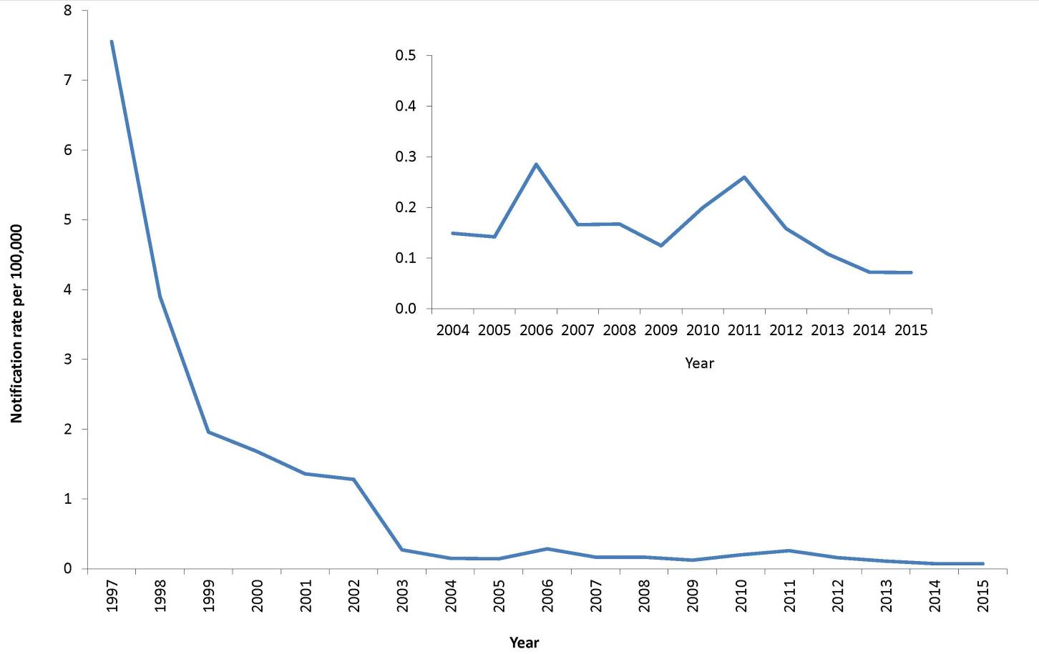

Age and sex distribution
Of the 17 cases of rubella reported in 2015, 10 cases were male and 7 were female. Of the 7 female cases, 6 were of child-bearing age (15–44 years) (Figure 77). The median age of cases was 28 years, with a range of 15 to 74 years. Consistent with previous years, the majority of cases (88%, 15/17) occurred among adults aged 20 years and older (Figure 77), and age-specific rates remained below 0.7 per 100,000 across all age groups (Figure 78).

Figure 77: Notifications of rubella, Australia, 2015, by age group and sex
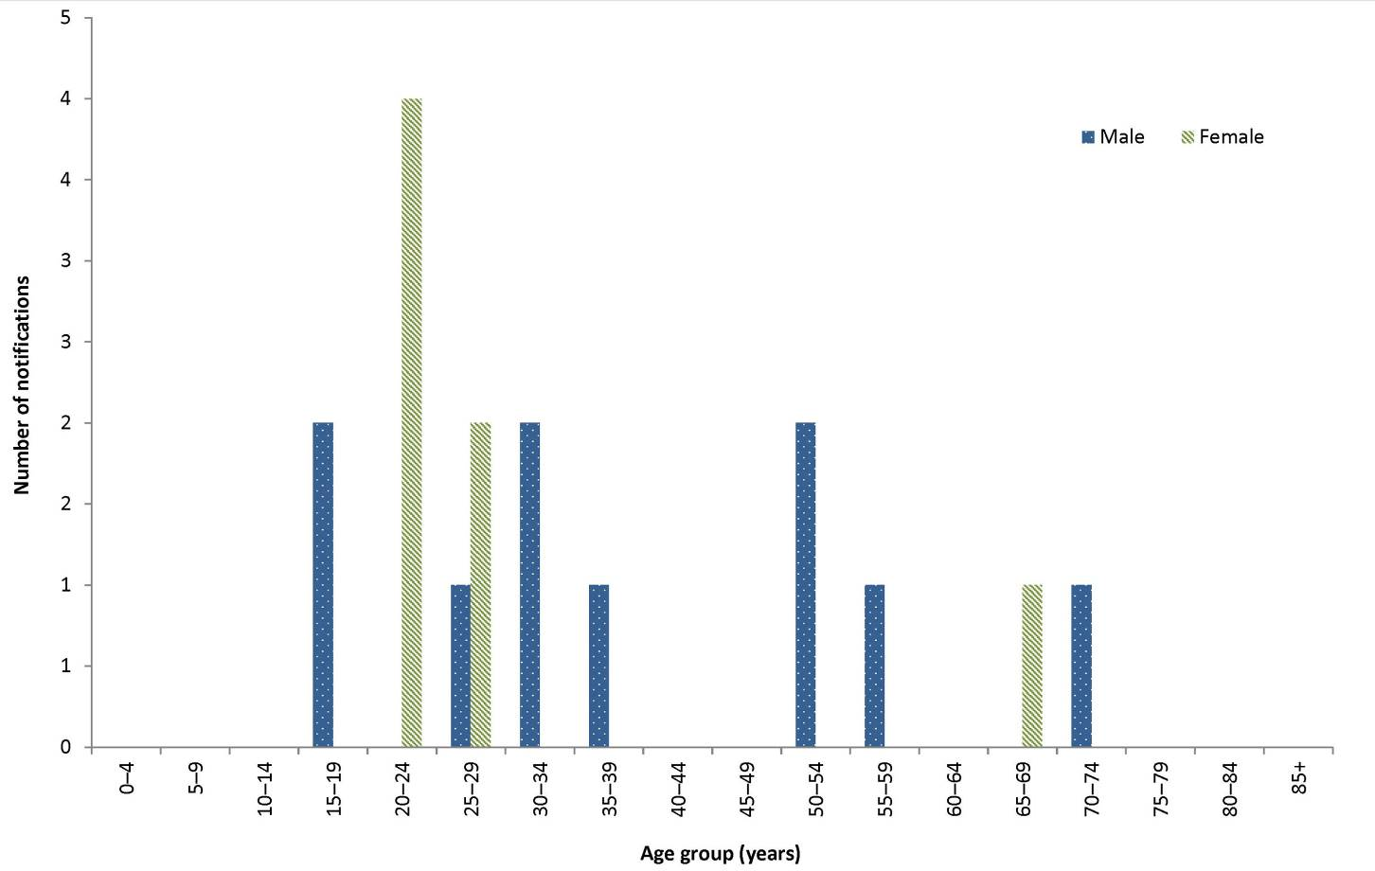

Figure 78: Notification rates for rubella, Australia, 2010 to 2015, by year and selected age groups
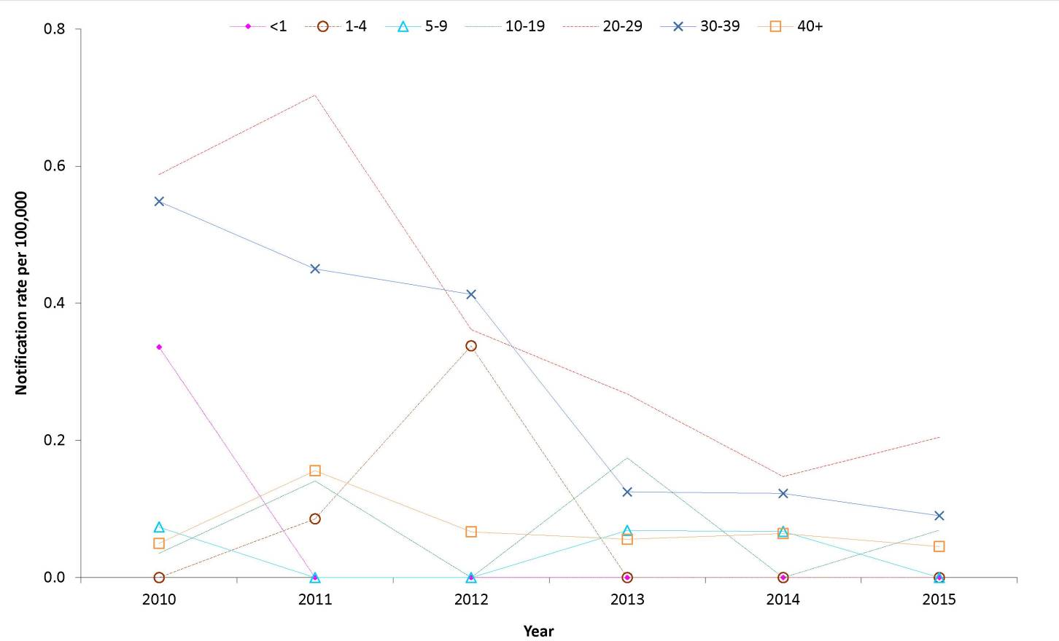
There was one case of CRS reported in 2015. This case was an infant born in Australia to a non-immune mother who acquired her infection While in Indonesia.

Immunisation status
Rubella vaccine is provided in the combined MMR or measles-mumps-rubella-varicella (MMRV) vaccine. In 2015, rubella vaccines were provided under the NIP schedule at 12 months and 18 months of age. A dose at 4 years of age was also recommended for those who did not receive the second dose at 18 months of age.²⁹
Of the 17 cases notified in 2015, 8 were reported as unvaccinated and the remaining 9 were of unknown immunisation status.
The primary aim of immunisation against rubella is to prevent cases of CRS.¹¹¹ Two doses of a rubella–containing vaccine are recommended for all non-immune people born during or since 1966 who are greater than 18 months of age.

Discussion
Evidence suggests that endemic rubella is well controlled in Australia. A marked decline in rubella notifications since 2002 has seen rates in Australia remain well below the 1.0 per 100,000 WHO goal indicative of rubella control.¹¹² The increasing trend in age of cases probably reflects the declining rates of rubella among children since routine MMR immunisation was implemented and the subsequent achievement of high 2-dose coverage. Males, historically were more susceptible as universal immunisation was not introduced until 1989, however now they no longer appear to be at greater risk of infection compared with females.
CRS is rare in Australia and in recent years has mainly occurred among infants of women who were born overseas.¹¹³

Tetanus
- Cases of tetanus are uncommon in Australia.
- Cases generally occur in older, unvaccinated people or in those who have not received a booster immunisation in the last 10 years.
- There were two cases of tetanus notified and no deaths reported in 2015.
Tetanus is an acute, often fatal, disease caused by the toxin produced by the bacterium Clostridium tetani . C. tetani spores usually enter the body through contamination of a wound with manured soil.²¹ The neurotoxin acts on the central nervous system to cause muscle rigidity with painful spasms. Generalised tetanus, the most common form of the disease, is characterised by increased muscle tone and generalised spasms. The disease usually occurs after an incubation period of 3 to 21 days (ranging from 1 day to several months), with a median time of onset at 10 days post injury. In Australia, tetanus is rare, occurring primarily in older adults who have never been vaccinated or have not received a booster dose in the past 10 years. A high level of diagnostic awareness of tetanus is important in the elderly, as most deaths occur in people over 70 years of age, especially females, and may be associated with an apparently minor injury.¹¹⁴

Epidemiological situation in 2015
In 2015, there were 2 notifications of tetanus (Figure 79). This is consistent with the low numbers of this disease notified in recent years. Both cases were adult females aged between 75 and 79 years. There were no deaths due to tetanus reported in 2015.
Figure 79: Notifications of tetanus, Australia, 2004 to 2015, by year and state or territory
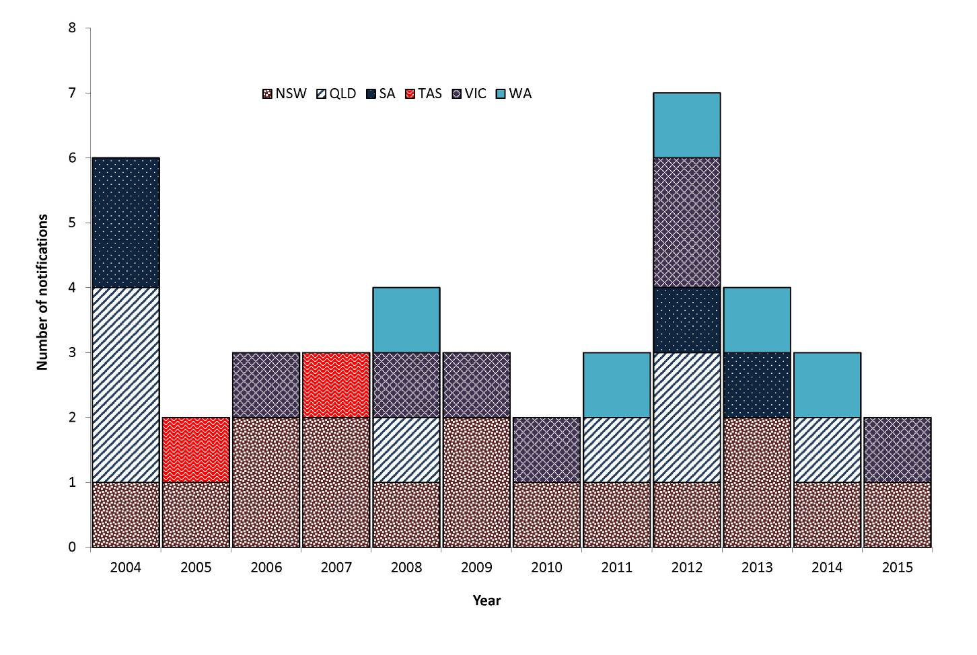

Immunisation status
The NIP schedule in 2015, recommended a primary course of tetanus immunisation including 3 doses provided at 2, 4, and 6 months of age. Two booster doses are provided at 4 years and between 10 and 15 years, delivered through school-based programs. Booster doses are additionally recommended for all adults at the age of 50 years who have not received one in the previous 10 years.²⁹
Of the 2 cases notified in 2015, both were reported as unvaccinated.
Complete immunisation induces protection which lasts throughout childhood, but by middle age 50% of vaccine recipients have low or undetectable levels of antibodies. Tetanus is, however, uncommon in people who have received 4 or more doses of a tetanus containing vaccine, and in those who received their last dose within 10 years.¹¹³

Varicella zoster virus
- There were 22,185 cases of varicella zoster infection notified in 2015.
- Of these, 2,479 (11%) were chickenpox, 6,343 (28%) were shingles and 13,363 (61%) were unspecified varicella zoster virus infection.
- Data were collected from all jurisdictions except New South Wales.
The varicella zoster virus (VZV) is a highly contagious member of the herpesvirus family and causes 2 distinct illnesses: chickenpox as the primary infection; and shingles (herpes zoster), which occurs following reactivation, often many years later, of latent virus in approximately 20% to 30% of all chickenpox cases. Shingles occurs more frequently among older adults (most commonly after 50 years of age) and in immunocompromised people.²¹
In 2006, the CDNA agreed 3 categories of VZV infection were nationally notifiable: ‘chickenpox’, ‘shingles’ and ‘varicella zoster virus unspecified’. By 2009, all jurisdictions were notifying VZV infections to the NNDSS against these 3 categories, except New South Wales, where VZV is not a notifiable disease.
The ability to categorise a VZV infection as chickenpox or shingles depends on follow-up to determine the clinical presentation of the case. The majority of VZV infections are reported as unspecified, as follow-up does not occur (Table 5). Notification rates for chickenpox, shingles and VZV unspecified, including any comparisons made between jurisdictions and age groups, should be interpreted with caution as they are affected by the varying levels of follow-up undertaken in each jurisdiction.

Epidemiological situation in 2015
In 2015, there were 22,185 VZV notifications from the 7 reporting jurisdictions. This was 13% more than the total cases notified in 2014 (n=19,640). Of the total VZV notifications in 2015, 60% (n=13,354) were reported as unspecified VZV infection, 29% (n=6,298) as shingles and 11% (n=2,429) as chickenpox (Figure 80).

Figure 80: Notifications of varicella zoster virus infection, 2015, Australia*, by age group#
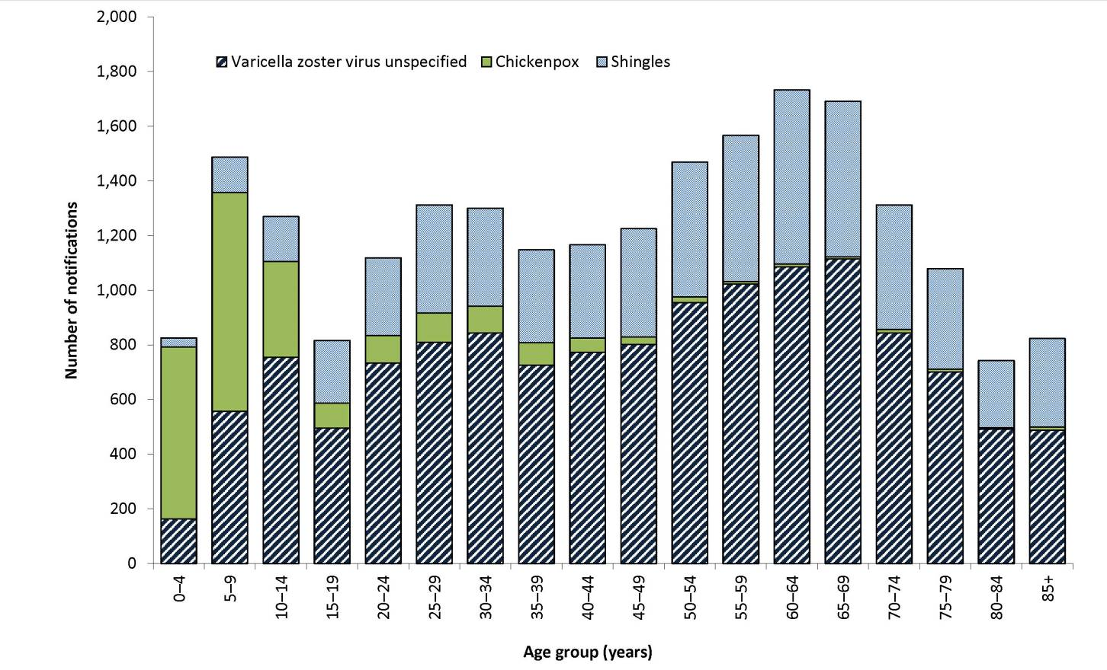
* Excludes New South Wales.
# Age of onset missing for 104 notifications.

Varicella zoster virus (unspecified)

Epidemiological situation in 2015
In 2015, there were 13,363 cases of VZV unspecified infections reported, representing a notification rate of 83 per 100,000, and a 10% increase in notifications compared with 2014 (n=12,017). The highest notification rate for VZV unspecified was reported from Queensland (135.6 per 100,000) and the lowest from the Northern Territory (0.8 per 100,000) (Table 5).

Age and sex distribution
In 2015, the majority of VZV unspecified cases were reported in females (54%, n=7,242). Overall, females have a higher notification rate (82 per 100,000) compared with males (76 per 100,000) which predominated across all ages except young children (under 10 years of age) and adults aged 85 years or over (Figure 81). The highest age-specific rates for females occurred in the 80–84 years age group (173 per 100,000) and for males in the 85 years or over age group (167 per 100,000).

Figure 81: Notification rate for varicella zoster virus unspecified, Australia,* 2015, by age group and sex#
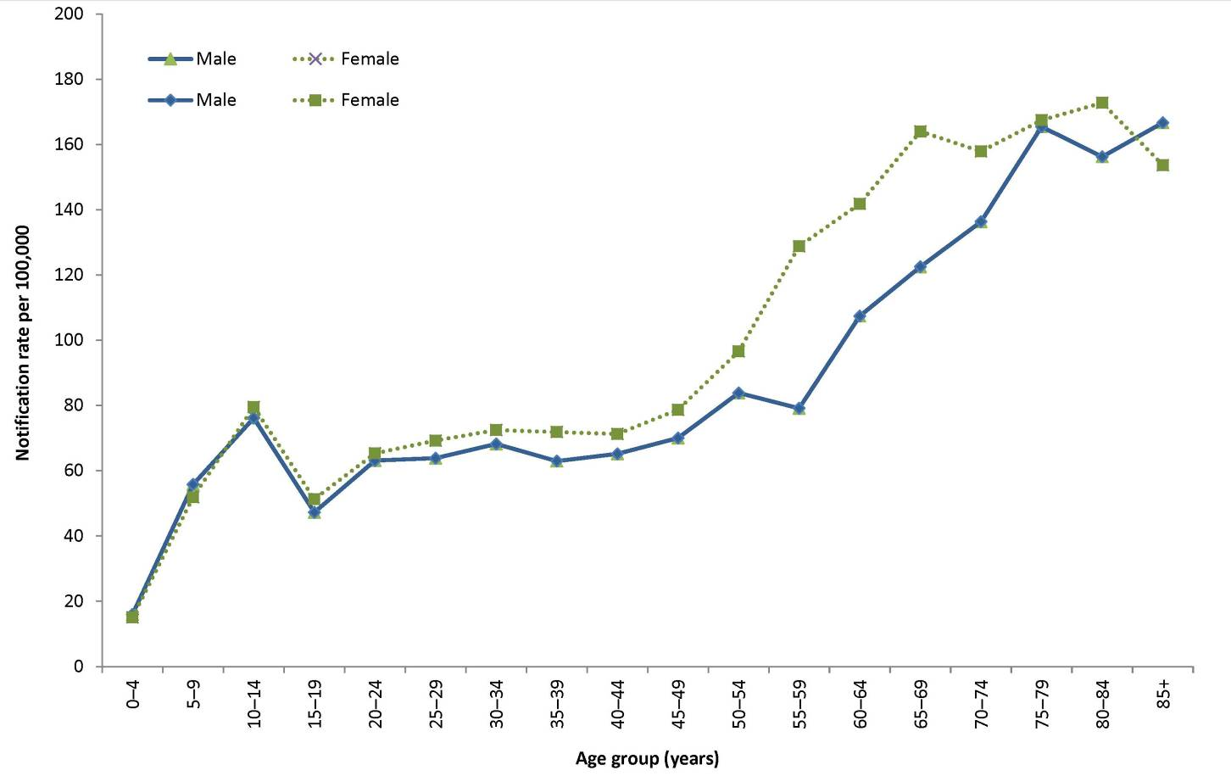
* Excludes New South Wales.
# Age of onset and sex missing for 9 notifications.

Chickenpox
- There were 2,479 cases of chickenpox notified in 2015, a 15% increase from 2014 (n=2,103).
- Fifty-four per cent of cases were male and 72% were in children less than 15 years of age.
Chickenpox is a highly contagious infection spread by respiratory secretions, including aerosol transmission, or from the vesicle fluid of skin lesions from a patient with chickenpox or shingles infection. Chickenpox is usually a mild disease of childhood; however, complications occur in approximately 1% of cases. It is more severe in adults, and in people of any age who are immunocompromised.²⁹

Epidemiological situation in 2015
In 2015, there were 2,479 cases of chickenpox reported, representing a notification rate of 15.3 per 100,000 and a 15% increase in the number of notifications compared with 2014 (n=2,103). The national notification rate of chickenpox has remained stable between 12.0 and 15.3 per 100,000 since 2010. The highest notification rate of chickenpox was in the Northern Territory (48.3 per 100,000), followed by South Australia (26.3 per 100,000), reflecting the higher case-ascertainment in these jurisdictions.

Age and sex distribution
In 2015, 54% (n=1,339) of notified cases were male and 72% (n=1,780) occurred in children less than 15 years of age. Consistent with recent years, children under the age of 10 years had the highest notification rates in 2015. Rates were highest in the 5–9 years age group (77 per 100,000) (Figure 82). Compared with 2014, all age-group-specific rates increased, with the largest increase occurring in infants under 1 year of age, from 55 per 100,000 in 2014 to 77 per 100,000 in 2015 (Figure 83).
Figure 82: Notification rate of chickenpox, Australia,* 2015, by age group and sex#
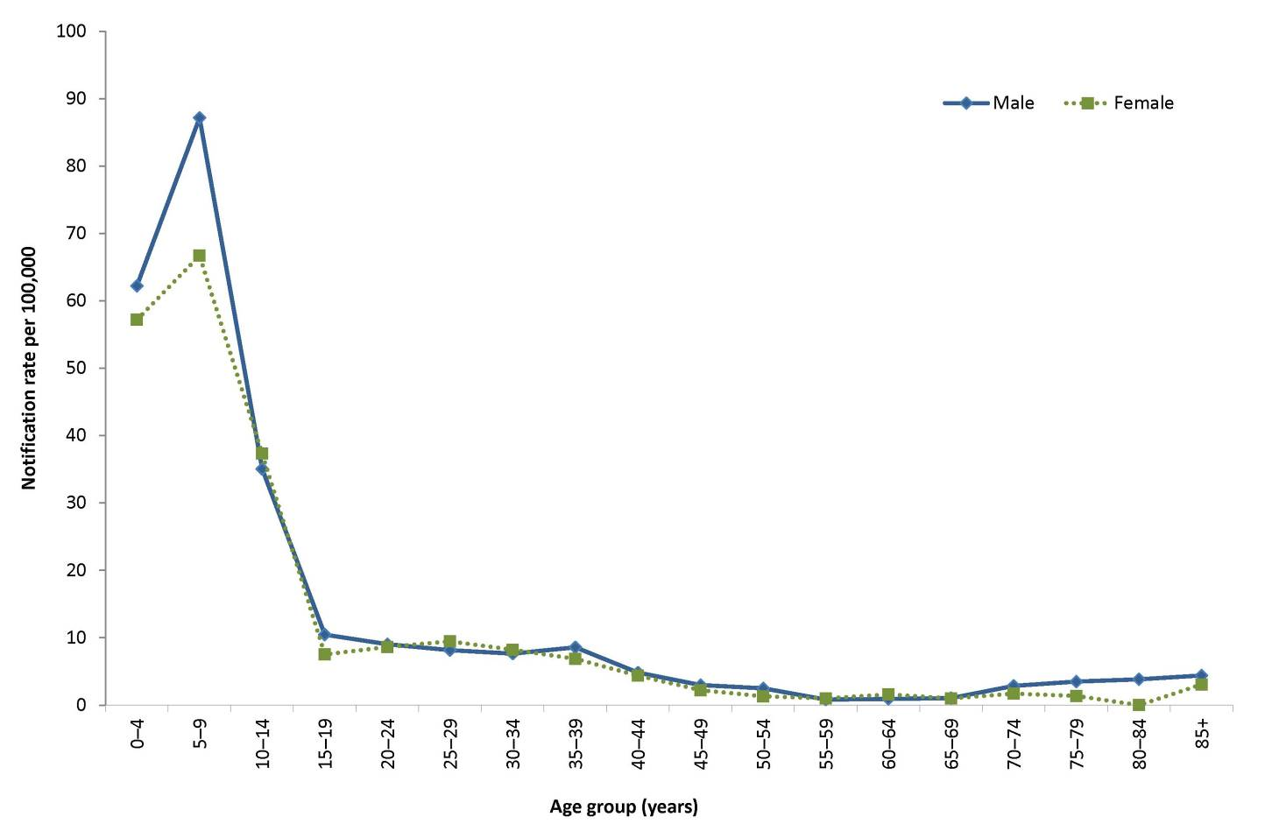
* Excludes New South Wales.
# Age of onset missing for 50 and sex missing for 13 notifications.

Figure 83: Notifications of chickenpox, Australia,* 2010 to 2015, by year and selected age groups#
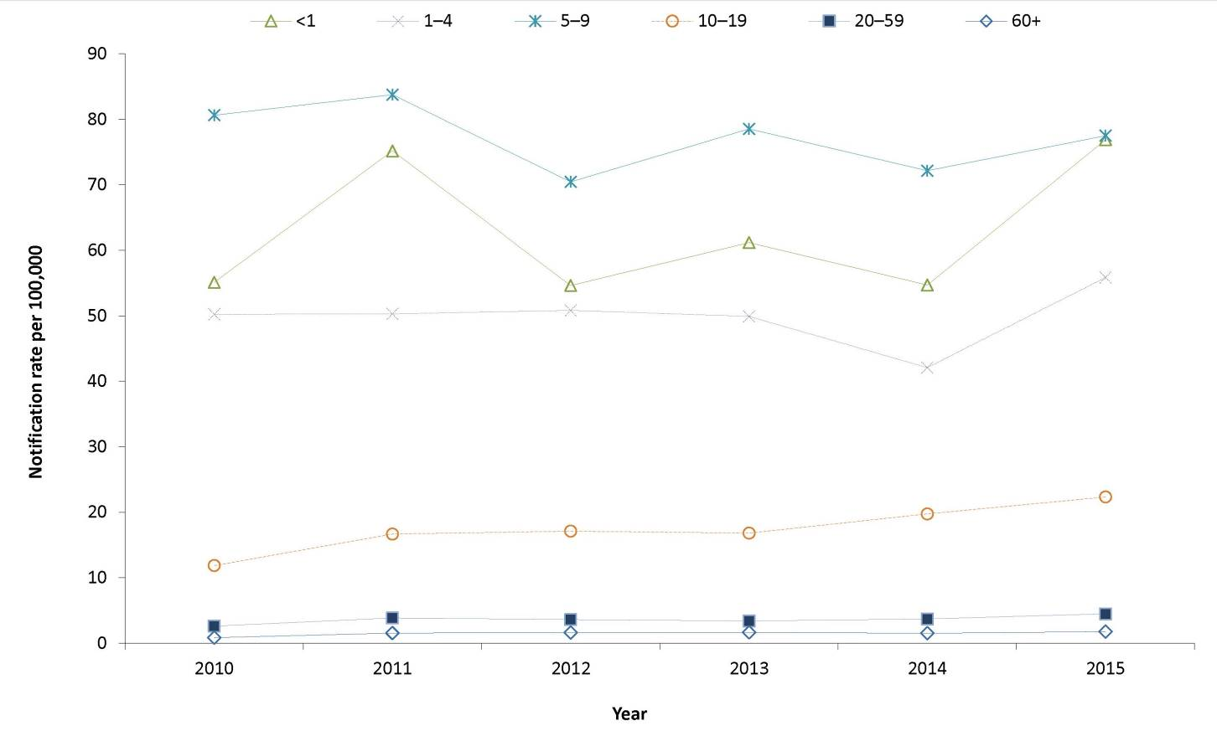
* Excludes New South Wales
# Age of onset missing for 9 notifications in 2010, 7 notifications in 2011, 21 notifications in 2012, 38 notifications in 2013, 54 notifications in 2014 and 50 notifications in 2015

Immunisation
Routine use of a varicella-containing vaccine in children was first recommended in Australia in 2003. In November 2005, the vaccine was funded under the NIP for all children at 18 months of age, with a school-based catch-up program included for children 10 to 13 years of age with no history of disease or previous immunisation.
In 2015, the oldest cohort of children eligible for varicella immunisation at 18 months of age were 11 years of age. Of those eligible for immunisation (n=1,649), 35% (577/1,649) were vaccinated and 17% (283/1,649) were unvaccinated. The remaining 48% (789/1,649) were of unknown immunisation status.

Shingles
- There were 6,343 cases of shingles notified in 2015, a 15% increase compared with 2014.
- Fifty-six per cent of notified shingles cases were female, and rates were highest in the older age groups.
Shingles occurs most commonly with increasing age, impaired immunity, and a history of chickenpox in the first year of life.²⁹ Reactivation of VZV that causes shingles is thought to be due to a decline in cellular immunity to the virus. Shingles typically presents as a unilateral vesicular rash localised in a dermatomal distribution. Associated symptoms may include headache, photophobia, malaise, itching, tingling, or severe pain in the affected dermatome. In the majority of patients, shingles is an acute and self-limiting disease; however, complications develop in approximately 30% of cases, the most common of which is chronic severe neuropathic pain or post herpetic neuralgia.²¹
A single dose of zoster vaccine is recommended for adults aged 60 years and over who have not previously received a dose of zoster vaccine. However, in 2015 this immunisation was not funded through the NIP.²⁹

Epidemiological situation in 2015
In 2015, there were 6,343 cases of shingles reported, representing a notification rate of 40 per 100,000 and a 15% increase compared with 2014 (n=5,520). The highest rates of shingles occurred in the Northern Territory (148.9 per 100,000) and in South Australia (136.8 per 100,000) (Table 5). The high rates in these jurisdictions most likely reflect their higher levels of case-ascertainment compared with other jurisdictions.

Age and sex distribution
In 2015, 56% (n=3,534) of notified shingles cases were female. As expected, the notification rate increased with age, with the highest rates occurring in those 80 years and over in 2015 (Figure 84). Since 2010, rates in the adult age groups (older than 20 years) have been rising, the largest increase occurring in the 70–79 years age group with a 250% increase in rates between 2010 and 2015 (Figure 85). Rates among children and adolescents have been more stable, remaining at or below 20 per 100,000 since 2010.
Figure 84: Notification rate for shingles, Australia,* 2015, by age group and sex#
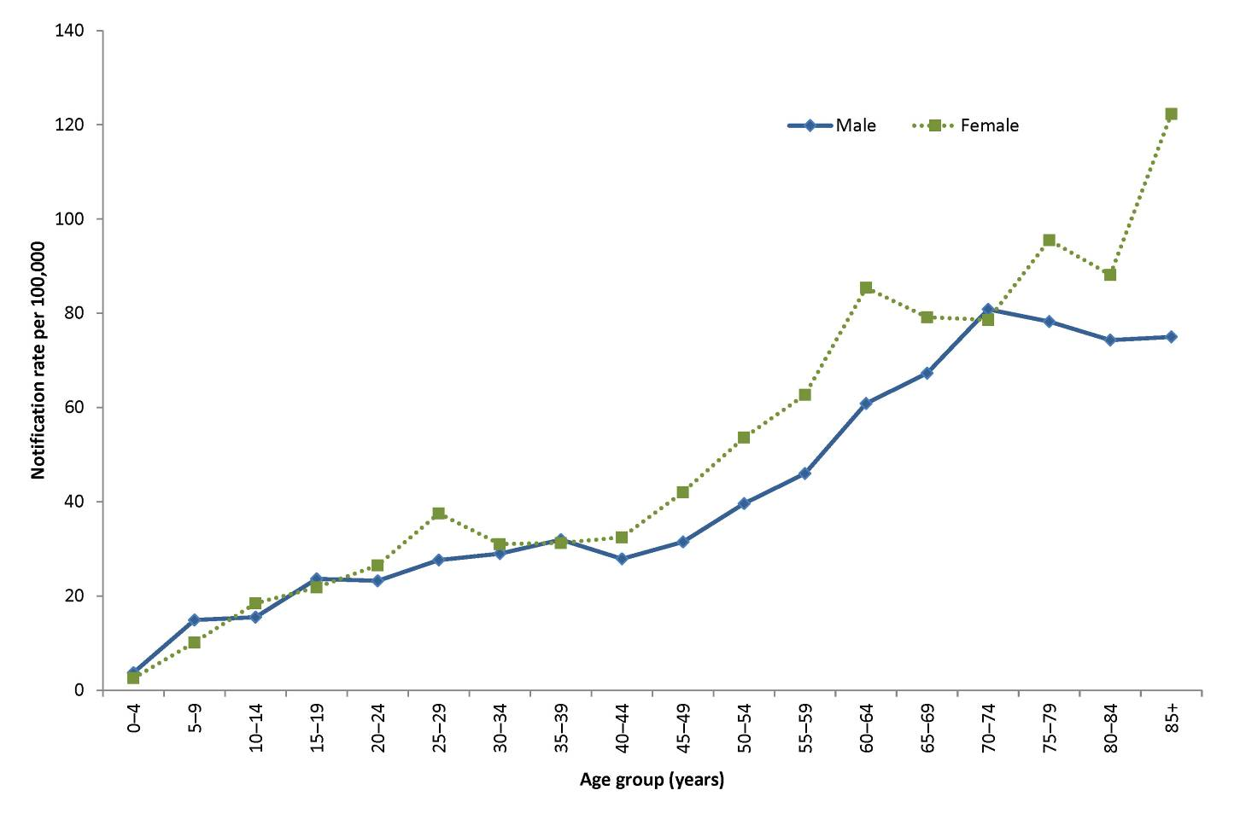
* Excludes New South Wales
# Age of onset missing for 45 notifications and sex missing for 5 notifications.
Figure 85: Notification rate for shingles, Australia,* 2010 to 2015, by year and selected age groups#
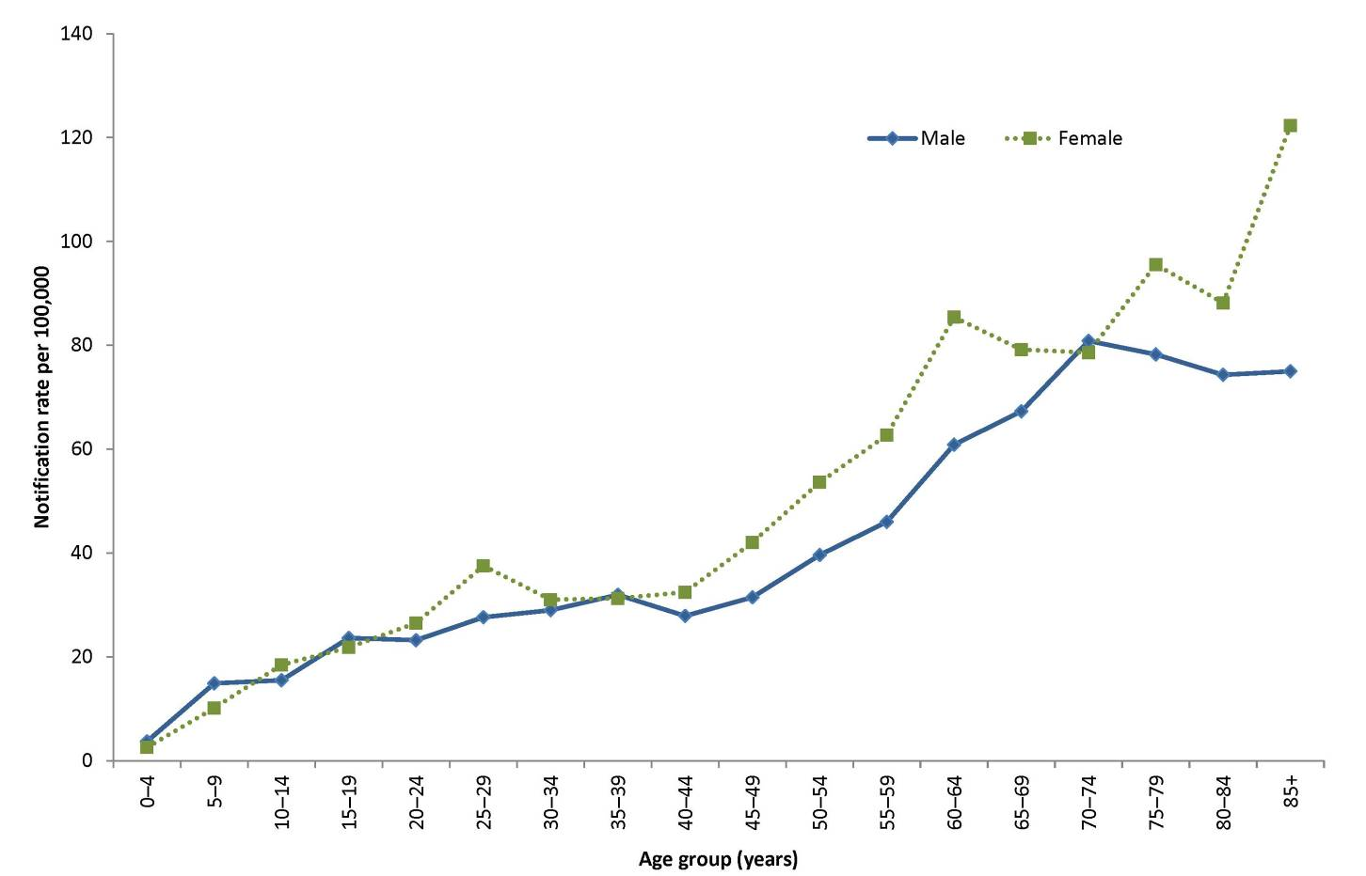
* Excludes New South Wales.
# Age of onset missing for 13 notifications in 2010, 14 notifications in 2011, 23 notifications in 2012, 57 notifications in 2013, 57 notifications in 2014 and 45 notifications in 2015.

Vectorborne diseases
Vectorborne diseases are infections transmitted by arthropods such as mosquitoes and ticks. A vectorborne disease may involve a simple transfer via the arthropod, or, may involve replication of the disease-causing organism in the vector.²¹ Vectorborne diseases of public health importance in Australia listed in this chapter are in the genera Alphavirus and Flavivirus . Viruses in the genus Alphavirus that are notifiable in Australia are Barmah Forest virus (BFV), Ross River virus (RRV) and Chikungunya virus (CHIKV).
Viruses in the genus Flavivirus that are included in the vectorborne diseases category are dengue virus (DENV) infection; Japanese encephalitis virus (JEV) infection; infections with the Kunjin lineage of West Nile virus (KUNV), which is probably limited to the Australian mainland or possibly Papua New Guinea, and other lineages of West Nile virus (WNV); malaria; Murray Valley encephalitis virus (MVEV) infection; and Flavivirus unspecified, which includes Zika virus infection (ZIKV).
Some other vectorborne diseases, including yellow fever virus infection, plague and certain viral haemorrhagic fevers, are listed under quarantinable diseases. The National Arbovirus and Malaria Advisory Committee (NAMAC) provides expert technical advice on vectorborne diseases to the Australian Health Principal Protection Committee through CDNA.

Barmah Forest virus
- The low number of notifications and rates observed in 2014 continued in 2015.
- BFV is most commonly reported in middle-aged to older age groups.
- Notifications peaked between January and April of 2015.
BFV occurs exclusively in the Australasian region.¹¹⁵ Infection can cause a clinical illness, which is characterised by fever, rash and poly arthritis. The virus is transmitted by numerous species of mosquitos that breed in diverse environments.¹¹⁶ False positive IgM diagnoses for BFV in particular are a known issue; thus it is unclear what proportion of notifications represent true cases. In 2015, the national case definition for BFV required only a single IgM positive test to BFV, in the absence of IgM to RRV.¹¹⁷ A revised case definition was implemented on 1 January 2016, in which a single IgM is no longer considered sufficient evidence for a confirmed case.
Figure 86: Notifications of Barmah Forest virus infection, Australia, 2010 to 2015, by month and year and state or territory
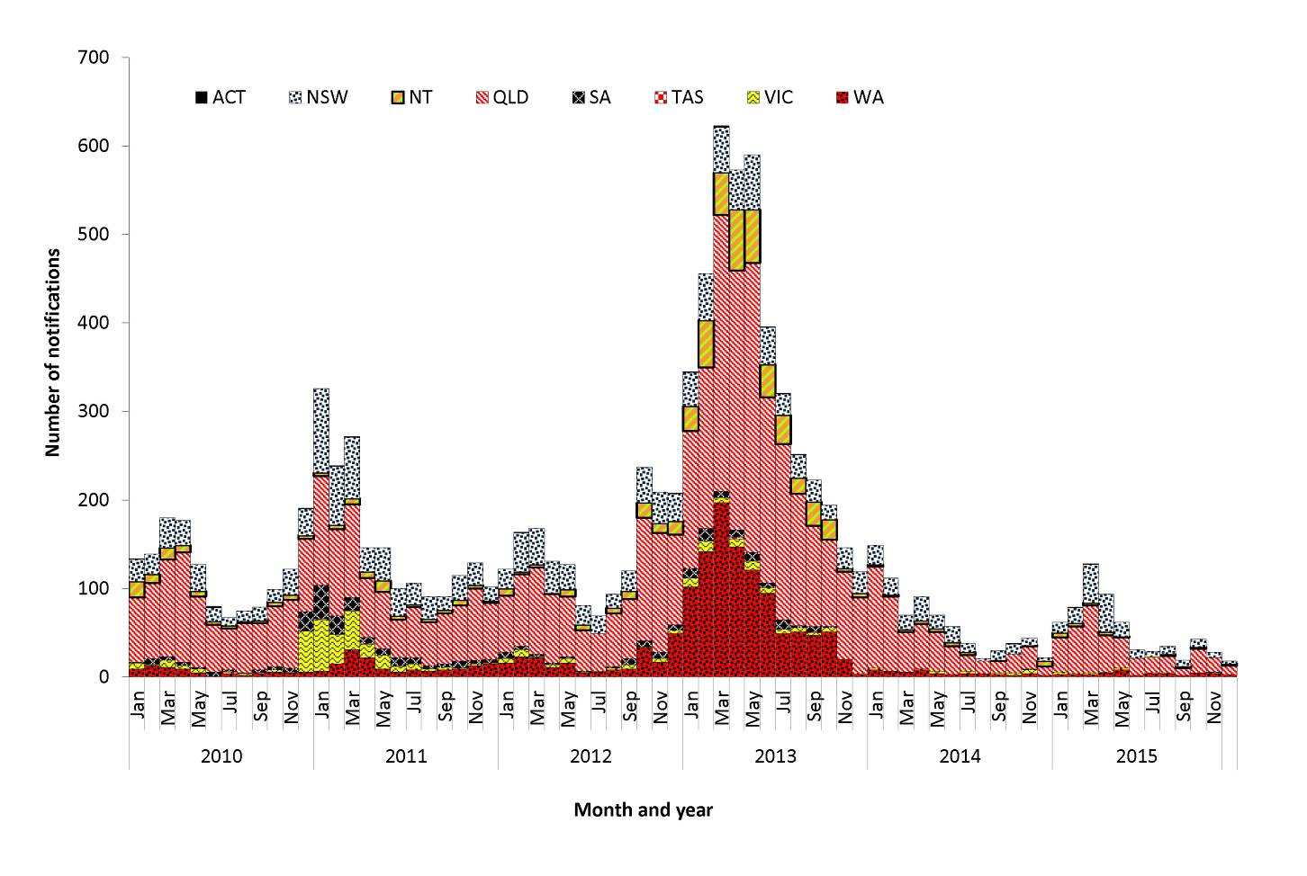

Figure 87: Rates of Barmah Forest virus infection, Australia, 2010 to 2015, by state or territory and year
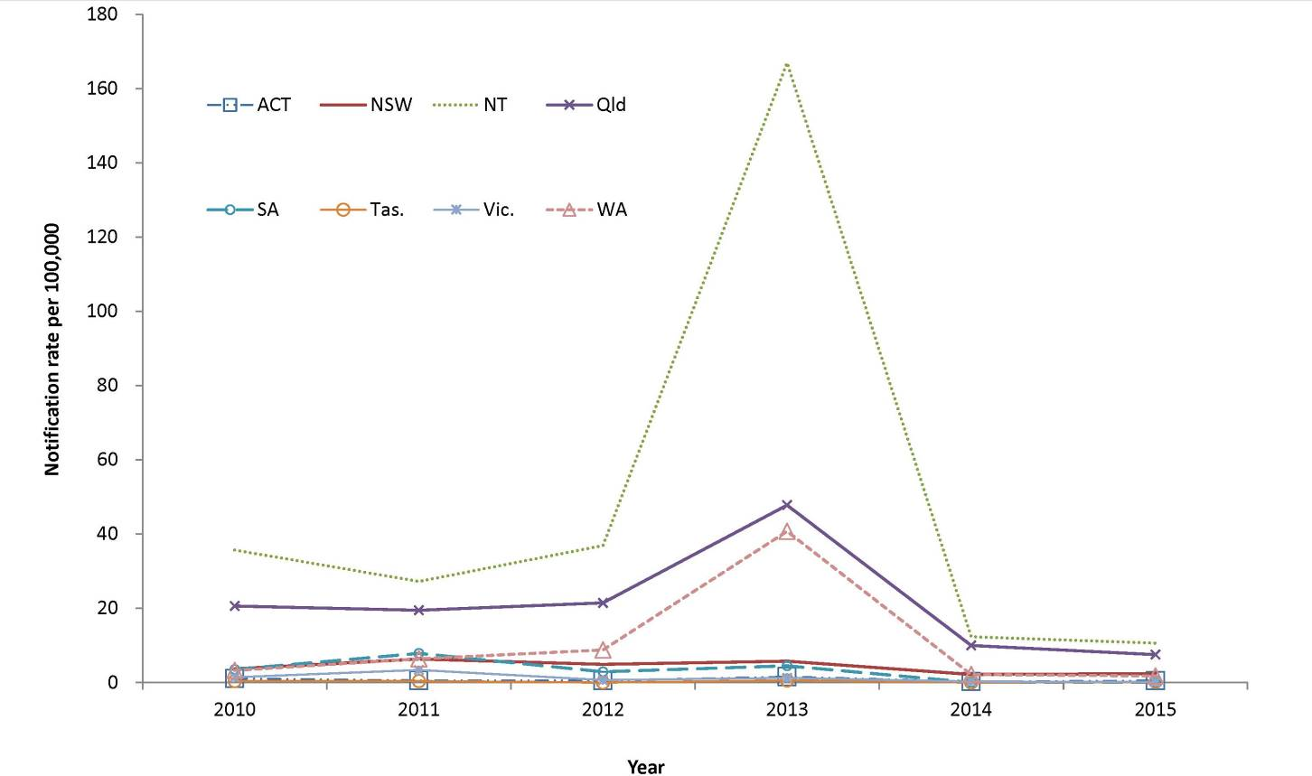
Figure 88: Notification rates for Barmah Forest virus, 2015, by age group and sex
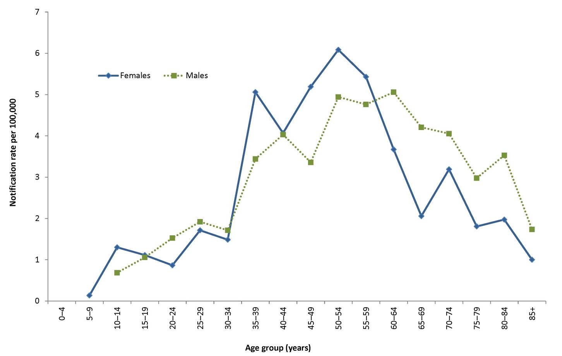

Epidemiological situation in 2015
In 2015, there were 628 notifications of BFV, representing a rate of 2.6 per 100,000. This is much lower than the 5-year mean of 2,008.6 notifications and a 5-year mean rate of 8.8 per 100,000, but similar to 2014 (3.2 per 100,000; n=742) (Figure 86). A marked increase in notifications in 2013 was considered likely to have been due to a high rate of false positive IgM test results produced by a commercial test kit in private laboratories, which resulted in a recall of the affected kits in September 2013.¹¹²

Geographical distribution
The largest number of notifications was in Queensland (n=360), but the highest rate was in the Northern Territory (10.6 per 100,000) (Table 5). It is important to note that seasonal trends vary between and within states and territories according to differences in mosquito vectors, hosts and climate. In addition, comparisons between regions are likely to be influenced by accuracy of case-ascertainment, which may vary between jurisdictions because of some differences in reporting criteria and the quality of diagnostic tests used.

Age and sex distribution
BFV is most commonly reported in middle-aged and older adults. The median age of notifications in 2015 was 50 years (range: 7 to 96 years), and 49% of cases were male. Notification rates of BFV peaked in females aged 50–54 years (6.1 per 100,000) and males aged 60–64 years (5.1 per 100,000) (Figure 88).

Seasonality
In 2015, BFV was most commonly reported between January and May, with 68% (425/628) of cases notified during these months. This is a more pronounced seasonality than that observed between 2010 and 2014, when 57% of cases were reported during these months.

Chikungunya virus
- Notifications of CHIKV in 2015 are lower than the 5-year mean but similar to 2013 and 2014.
- In 2015, place of acquisition information was completed for all but 1 case, and all of cases were acquired overseas.
CHIKV can cause an illness which is characterised by an abrupt onset of fever, rash and severe joint pain. The acute disease lasts 1 to 10 days, but convalescence may include prolonged joint swelling and pain lasting months. Haemorrhagic manifestations may occur occasionally.¹¹⁸ Humans are amplification hosts for CHIKV, and other vertebrates are not required for transmission to occur. Local transmission of CHIKV has not been reported in Australia, but it is regularly reported in travellers returning from overseas. There is the potential for transmission of CHIKV in areas where a suitable mosquito vector exists.
Internationally, CHIKV is most commonly transmitted by Aedes aegypti and Aedes albopictus. In Australia, Ae. aegypti is present in parts of Northern, Central and South-west Queensland and Ae. albopictus is found on Cocos Island, on Christmas Island and in some areas of the Torres Strait Islands.¹¹⁹ CHIKV was made nationally notifiable in January 2015; however, notifications have been sent to the Commonwealth from all jurisdictions since 2010, when a national case definition was implemented.

Epidemiological situation in 2015
In 2015, there were 110 notifications of CHIKV. This is an increase compared with the 5-year mean of 72.8 notifications, but similar to 2013 and 2014 (134 and 110 notifications respectively) (Figure 89).
Figure 89: Notifications of chikungunya virus infection, Australia, 2010 to 2015, by month and year and state or territory
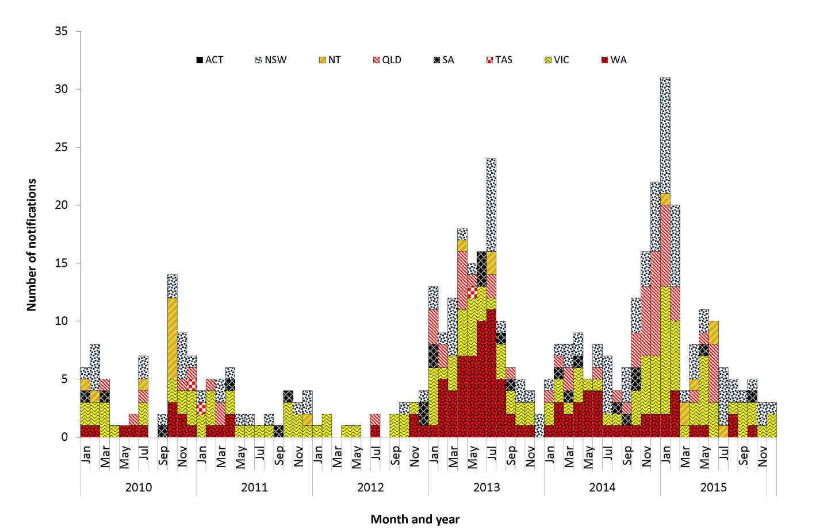

Geographical distribution
The largest number of notifications was in Victoria (n=38), followed by New South Wales (n=35 and Queensland (n=11). Complete information on the place of acquisition was supplied for 99% (109/110). All notifications with complete information were overseas acquired, most frequently in Indonesia (21%, n=23) or Samoa (18%, n=20) (Table 19).

Table 19: Notifications of chikungunya virus infection 2015, by place of acquisition and quarter
Country or region of acquisition | Number of notifications
 | Jan–Mar | Apr–Jun | Jul–Sept | Oct–Dec | Total
Indonesia | 16 | 4 | 2 | 1 | 23
Samoa | 20 | 0 | 0 | 0 | 20
India | 1 | 0 | 6 | 5 | 12
East Timor | 2 | 7 | 1 | 0 | 10
Colombia | 5 | 3 | 1 | 0 | 9
Nauru | 0 | 5 | 0 | 0 | 5
Cook Islands | 0 | 4 | 1 | 0 | 5
Kiribati | 5 | 0 | 0 | 0 | 5
Mexico | 0 | 0 | 2 | 1 | 3
French Polynesia | 3 | 0 | 0 | 0 | 3
Philippines | 0 | 2 | 0 | 0 | 2
El Salvador | 0 | 1 | 0 | 0 | 1
Kenya | 0 | 0 | 0 | 1 | 1
Taiwan | 0 | 1 | 0 | 0 | 1
Malaysia | 1 | 0 | 0 | 0 | 1
Central America, NFD | 0 | 0 | 0 | 1 | 1
Not stated | 0 | 1 | 0 | 0 | 1
Jamaica | 1 | 0 | 0 | 0 | 1
South America, NEC | 0 | 0 | 0 | 1 | 1
Honduras | 0 | 0 | 1 | 0 | 1
Thailand | 0 | 0 | 1 | 0 | 1
Tonga | 1 | 0 | 0 | 0 | 1
Nigeria | 0 | 0 | 0 | 1 | 1
Nicaragua | 0 | 1 | 0 | 0 | 1
Total | 55 | 29 | 15 | 11 | 110

Age and sex distribution
In Australia, CHIKV is most commonly reported in younger and middle-aged adults, which may be a reflection of the peak travelling age groups. The median age of notifications in 2015 was 44.5 years (range: 11–76 years) and 39% of cases were male (Figure 90).
Figure 90: Notifications of Chikungunya Virus infection, 2015, by age group and sex
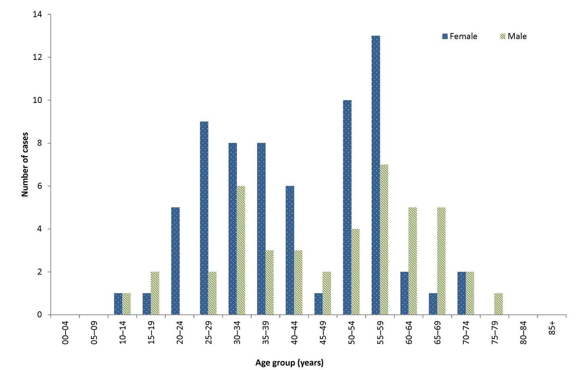

Seasonality
No clear seasonality for CHIKV is evident in Australia, although there can be increases in notifications during peak periods of travel by Australians overseas or during large outbreaks in a particular country or region. The first known outbreak of CHIKV in Samoa occurred in late 2014 and early 2015 with more than 4,500 cases.¹²⁰ This outbreak resulted in 20 imported cases in Australia in the first quarter of 2015 (Table 19). There had been a further 25 cases in the 4th quarter of 2014.

Dengue virus
- Notifications of DENV were 1.2 times the 5-year mean in 2015.
- For overseas-acquired DENV, the most common place of acquisition was Indonesia.
- There were 66 locally acquired cases reported in 2015.
The clinical illness for DENV infection is characterised by mild to severe febrile illness with fever, headache, muscle/joint pain and sometimes a rash. A minority of cases progress to severe dengue, with plasma leakage and possibly respiratory distress, haemorrhagic manifestations and shock. Mortality rates are 1% to 20%, depending on the level of supportive care given.¹²¹ DENV has 4 serotypes, each containing numerous genotypes. No specific treatment is available and there is no vaccine currently available in Australia. The serotypes detected in returning travellers (and thus involved in any local outbreaks in Queensland) vary by year and geographical region. Infection with 1 serotype probably confers lifelong immunity to that serotype,²¹ but subsequent infection with a different serotype is thought to increase the risk of severe outcomes, along with other factors including the infecting serotype and genotype, and host factors.^{21,122,123,124}
DENV is not endemic anywhere in Australia, but local transmission can occur in dengue-receptive areas following importation by a viraemic tourist or a resident returning from a dengue-affected area overseas.¹²⁵ Outbreaks of dengue are considered a high risk in areas of Queensland where at least one vector species ( Ae. aegypti or Ae. albopictus ) is endemic and, where there is a regular influx of international travellers or residents who have returned from dengue-endemic areas, and where there is a recent history of dengue transmission (e.g. Cairns, Townsville, Torres Strait). DENV transmission is considered a moderate risk where the vector is present but where there is no recent history of outbreaks and where few viraemic travellers arrive from endemic areas.¹²⁵ There is a low risk of outbreaks in other areas of Queensland (and elsewhere in Australia) where there are currently no populations of Ae. aegypti or Ae. albopictus present. Isolated cases of laboratory-acquired infection and infections with an unknown source (possibly related to mosquito importations on air cargo or luggage) have been reported.^{126,127,128}

Epidemiological situation in 2015
In 2015, there were 1,714 notifications of DENV, representing a rate of 7.2 per 100,000. This is 1.2 times the 5-year mean of 1,430.4 notifications. Of these notifications, 1,534 were confirmed and 180 were probable.

Geographical distribution
The largest number of notifications was in Western Australia (Figure 91) (n=554), followed by Victoria (n=386). A high number of DENV notifications in Western Australia has previously been noted as reflecting the predilection of Western Australians to holiday in Bali, Indonesia where most of these infections are acquired.¹²⁹
Figure 91: Notifications of dengue virus infection, Australia, 2010 to 2015, by month and year and state or territory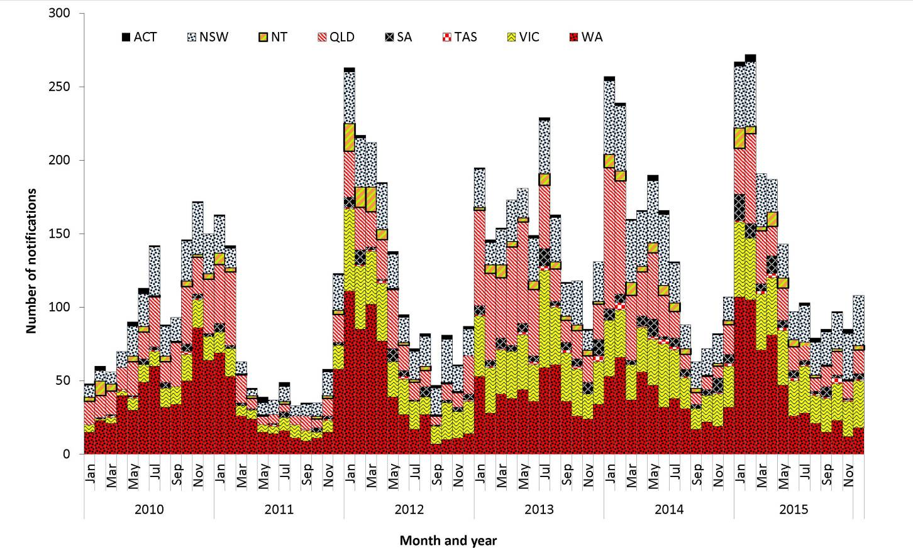
Complete information on the place of acquisition was supplied for 98% (1,680/1,714) of notifications (Table 19). There were 1,614 notifications of dengue acquired overseas. Of these, the majority were acquired in Indonesia, (60%, 970/1,614), with the next largest proportion being acquired in Thailand (8%, 133/1,614).

Age and sex distribution
In Australia, DENV is most commonly reported in younger, middle-aged and older adults, which may be a reflection of the peak travelling age groups. The median age of notifications in 2015 was 39.5 years (range: 1 to 83 years), and 50% of cases were male. Case numbers peaked in females aged 20–24 and 25–29 years and males aged 30–34 years (Figure 92).
Figure 92: Notifications of dengue virus infection, 2015, by age group and sex
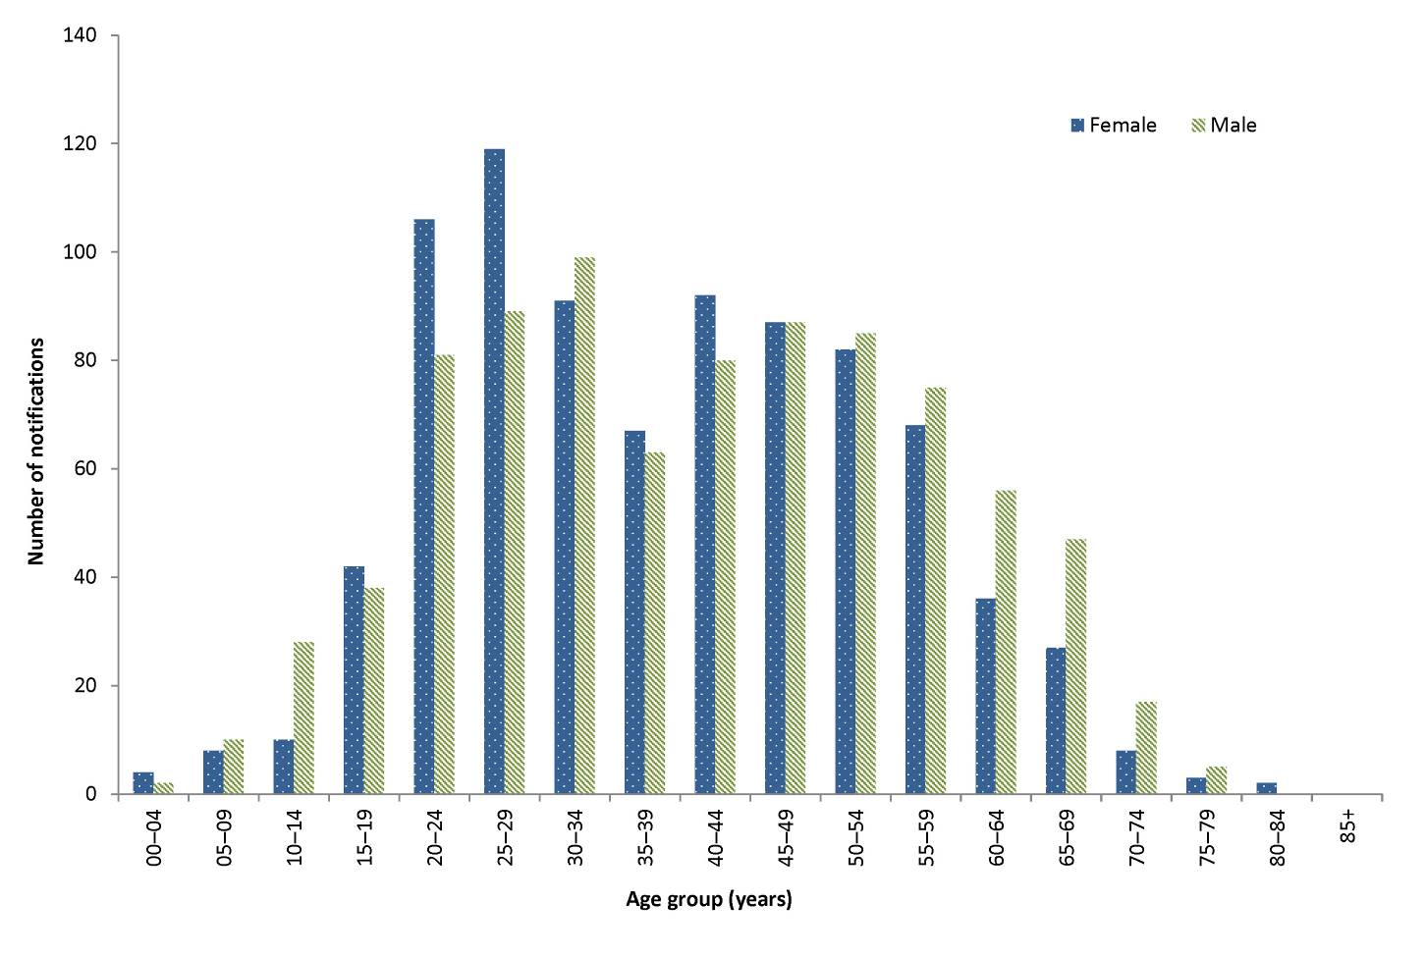

Seasonality
For overseas-acquired cases of DENV, no clear seasonality is evident. However, there can be increases in notifications during peak periods of travel by Australians overseas or during large outbreaks in a particular country or region. In February 2015, the Ministry of Health in Tonga reported an outbreak of DENV serotype 3 that began in January 2015.¹³⁰ There were 36 cases imported from Tonga in 2015 (Table 20). There had been no cases imported from Tonga between 2011 and 2013, and 15 cases in 2014, with all reported from April 2014 onwards.

Table 20: Notifications of Dengue Virus infection 2015, by place of acquisition and quarter
Category | Country/region | Jan–Mar | Apr–Jun | Jul–Sept | Oct–Dec | Total
Overseas acquired | Indonesia | 490 | 314 | 84 | 82 | 970
 | Thailand | 27 | 20 | 44 | 42 | 133
 | Malaysia | 36 | 16 | 19 | 9 | 80
 | Philippines | 19 | 5 | 17 | 32 | 73
 | India | 9 | 2 | 17 | 23 | 51
 | Sri Lanka | 14 | 4 | 10 | 11 | 39
 | Tonga | 34 | 2 | 0 | 0 | 36
 | Papua New Guinea | 0 | 16 | 6 | 6 | 28
 | Vietnam | 2 | 1 | 8 | 14 | 25
 | Cambodia | 0 | 2 | 7 | 11 | 20
 | South-East Asia, NFD | 2 | 3 | 4 | 8 | 17
 | Bangladesh | 0 | 1 | 13 | 2 | 16
 | East Timor | 6 | 6 | 3 | 0 | 15
 | Singapore | 2 | 2 | 3 | 7 | 14
 | Burma (Myanmar) | 2 | 1 | 2 | 6 | 11
 | Samoa | 0 | 0 | 6 | 4 | 10
 | Fiji | 2 | 4 | 0 | 4 | 10
 | Brazil | 2 | 3 | 1 | 2 | 8
 | Solomon Islands | 4 | 0 | 0 | 3 | 7
 | Mainland South-East Asia, NFD | 0 | 0 | 1 | 4 | 5
 | Maldives | 0 | 2 | 3 | 0 | 5
 | South America, NFD | 0 | 1 | 3 | 0 | 4
 | Pakistan | 1 | 0 | 2 | 1 | 4
 | Cuba | 0 | 0 | 0 | 3 | 3
 | Other countries* | 2 | 4 | 6 | 15 | 27
 | Overseas–country unknown | 1 | 0 | 2 | 0 | 3
Total |  | 655 | 409 | 261 | 289 | 1,614
Locally acquired Australia |  | 58 | 8 | 0 | 0 | 66
Unknown |  | 17 | 10 | 6 | 1 | 34
Grand Total |  | 730 | 427 | 267 | 290 | 1,714

Outbreaks of locally acquired DENV in North Queensland are more likely to begin during the warmer, wetter months in North Queensland, and rarely continue into the cooler months. In 2015, 77% of locally acquired cases were reported between January and May.

Locally acquired cases and outbreaks
In 2015, almost all locally acquired cases of DENV (97%, 64/66) were associated with outbreaks in North Queensland. A further 2 cases had travelled to or within Queensland during their incubation period, but were not reported as being associated with a specific outbreak.

Flavivirus unspecified (including Zika Virus)
- There were 12 notifications reported in 2015, 10 of which were for ZIKV.
This disease category enables the capture and epidemiological analysis of emerging infections within this broad disease group. Emerging diseases can be made nationally notifiable if required, according to the protocol for making a change to the National Notifiable Diseases List in Australia, which is available on the Department of Health website. An unspecified category is particularly important for the flaviviruses, because it is recognised that some infections cannot be attributed to a single flavivirus.

Figure 93: Notifications of flavivirus unspecified, Australia, 2010 to 2015, by month and virus species
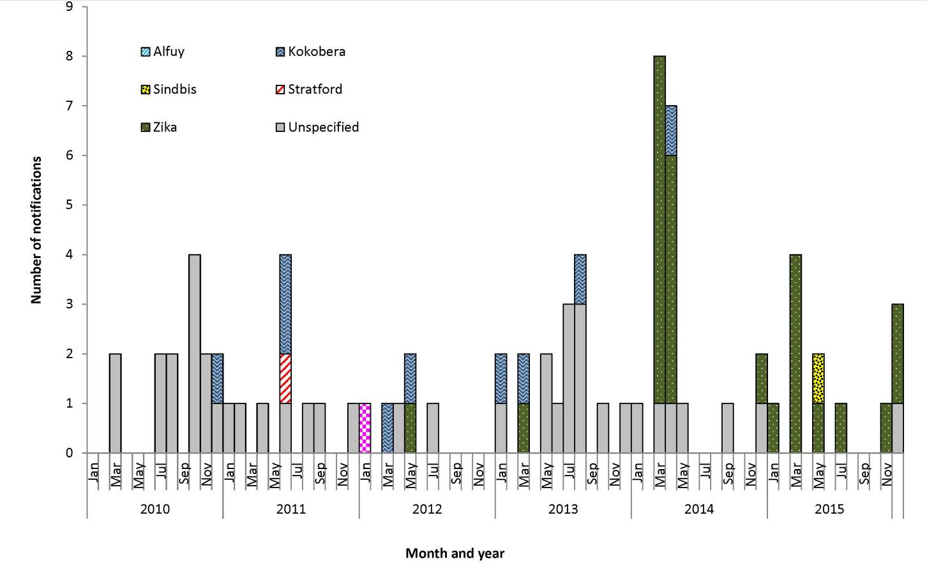
Flavivirus unspecified includes notifications of ZIKV, for which a specific case definition was implemented from 1 January 2016. Prior to November 2015, ZIKV was not thought to be cause for serious public health concern, due to the high rate of asymptomatic infection and the fact that symptomatic cases were generally mild, notwithstanding the reports of a possible association with Guillain Barré syndrome.¹³¹ However, ZIKV spread rapidly through the many countries in the Americas after being first confirmed in Brazil in May 2015.^{132,133} An increase in microcephaly in Brazil with geographical and temporal links to ZIKV was reported in November 2015, and the WHO declared the clusters of microcephaly and neurological disorders a public health event of international concern on 1 February 2016.¹³⁴ There is now strong scientific consensus that the virus can be transmitted in utero and can cause severe birth defects such as microcephaly and foetal death,¹³⁵ and that it can cause Guillain Barré syndrome.^{136,137} While vectorborne transmission remains the main mode of transmission, multiple instances of probable or confirmed sexual transmission have now been reported.^{131,138,139,140,141,142}

Epidemiological situation in 2015
In 2015, there were 12 notified cases of flavivirus unspecified, similar to the 5-year mean of 13.2 notifications. Most of these notifications (10/12) were for ZIKV, while there was 1 case of Sindbis. No single flavivirus species was identified for 1 notification.

Geographical distribution
There were 5 notifications from Queensland, 2 each from New South Wales, Victoria and Western Australia and 1 from South Australia. There were no notifications from the Australian Capital Territory, the Northern Territory or Tasmania.

Age and sex distribution
Notifications under Flavivirus unspecified were most commonly in younger and middle-aged adults (Figure 94), with all but one case acquired overseas. This may be a reflection of the peak travelling age groups. The median age of notifications in 2015 was 35 years (range: 22 to 69 years).
Figure 94: Notifications of flavivirus unspecified, 2015, by age-group and sex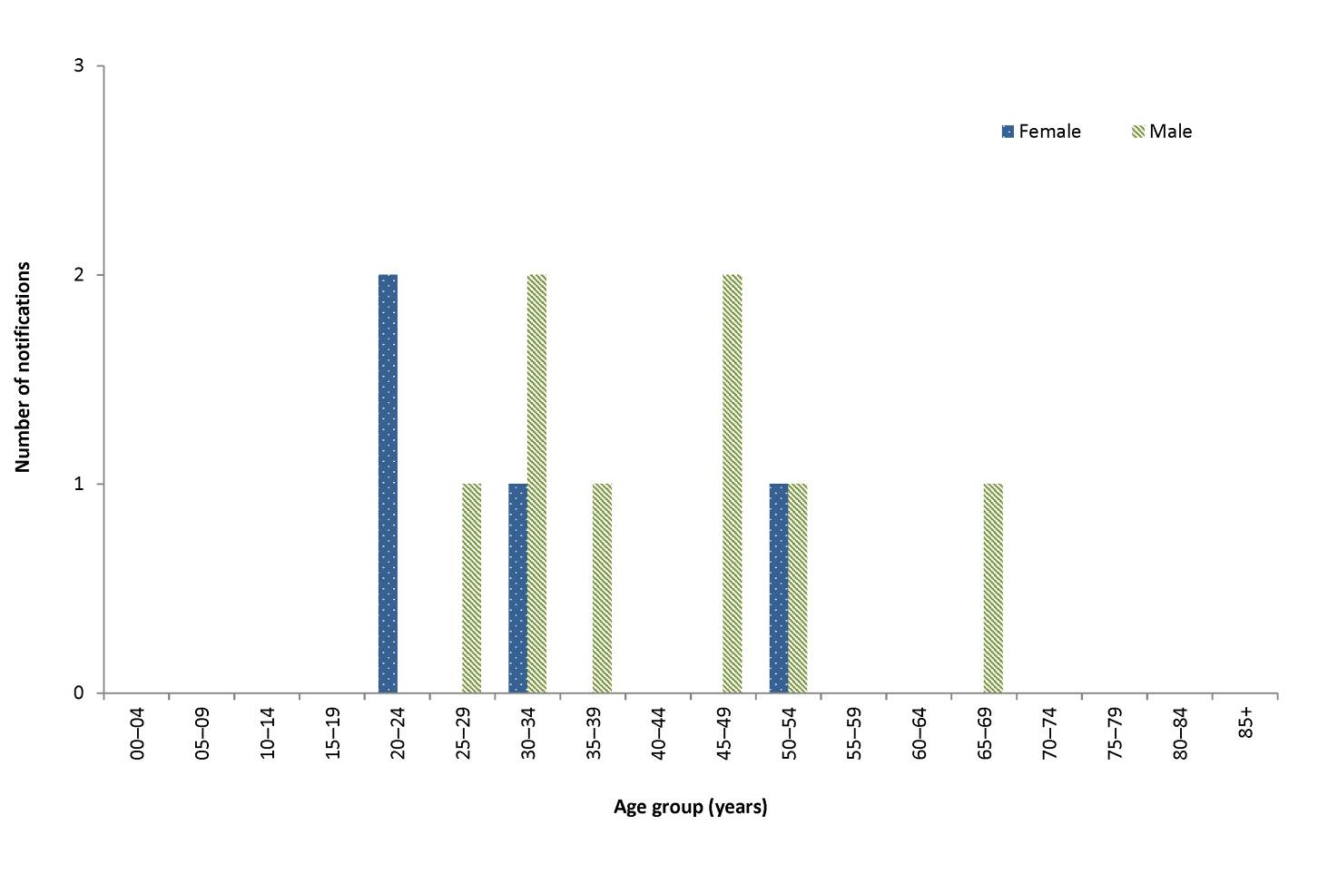

Seasonality
Notifications of overseas-acquired Flavivirus unspecified can increase during peak periods of travel by Australians overseas, or during large outbreaks in a particular country or region. Many of the notifications in 2015 were for ZIKV acquired in Pacific Island nations (7/12). The first outbreak of ZIKV in a Pacific Island nation was first reported in Yap, Federated States of Micronesia in 2007²⁰² Following this ZIKV outbreaks were reported in French Polynesia in late 2013, and in the Cook Islands and New Caledonia in 2014. ²⁰³ ZIKV was first confirmed in the Solomon Islands in March 2015 (PacNet updates 16 March to 21 May 2015).¹⁴³ There were two ZIKV cases imported to Australia in 2015 from the Solomon Islands, both with dates of diagnosis in March (Table 21).

Table 21: Notifications of flavivirus unspecified 2015, by virus, place of acquisition and quarter
Category | Country | Virus | Jan–Mar | Apr–Jun | Jul–Sept | Oct–Dec | Total
Overseas acquired | Colombia | Zika virus (ZIKV) | 0 | 0 | 0 | 1 | 1
 | Costa Rica | Unspecified | 0 | 0 | 0 | 1 | 1
 | El Salvador | ZIKV | 0 | 0 | 0 | 1 | 1
 | Fiji | ZIKV | 0 | 1 | 0 | 0 | 1
 | Indonesia | ZIKV | 1 | 0 | 0 | 0 | 1
 | Marshall Islands | ZIKV | 0 | 0 | 0 | 1 | 1
 | Polynesia (excludes Hawaii), NFD | ZIKV | 0 | 0 | 1 | 0 | 1
 | Solomon Islands | ZIKV | 2 | 0 | 0 | 0 | 2
 | Vanuatu | ZIKV | 2 | 0 | 0 | 0 | 2
Overseas acquired Total |  |  | 5 | 1 | 1 | 4 | 11
Unknown | Place of acquisition unknown | Sindbis | 0 | 1 | 0 | 0 | 1
Total |  |  | 5 | 2 | 1 | 4 | 12

Japanese encephalitis virus
There were 3 cases of JEV notified in 2015. All were acquired in Indonesia.
No specific treatment is available for illness caused by JEV infection, and care is largely supportive. A vaccine is available to prevent JEV infection.²⁹ Infection is usually asymptomatic or produces a non-specific illness, but a small percentage of cases progress to encephalomyelitis of variable severity. The last locally acquired case was in 1998,¹⁴⁴ and all cases since then have been acquired overseas.

Epidemiological situation in 2015
In 2015, there were 3 notifications of JEV, all of them acquired in Indonesia (Table 22). There were a total of 6 cases between 2010 and 2014, 5 of them acquired in South-East Asia and one in Taiwan.

Table 22: Notifications of Japanese encephalitis virus infection, Australia, 2010 to 2015
Year | State/territory | Country of acquisition | Month | Age group | Sex
2012 | Qld | Philippines | February | 15–19 | Female
2013 | Qld | Philippines | September | 70–74 | Male
2013 | Qld | Taiwan | July | 45–49 | Male
2013 | SA | Thailand | June | 55–59 | Male
2013 | WA | Indonesia | April | 40–44 | Female
2014 | SA | Indonesia | August | 50–54 | Male
2015 | NSW | Indonesia | January | 25–29 | Female
2015 | Qld | Indonesia | November | 40–44 | Female
2015 | Vic | Indonesia | January | 45–49 | Male

West Nile virus (including Kunjin virus)
- There was one case of WNV/KUNV notified in 2015.
- This case acquired infection in the United States of America.
No specific treatment is available for infections with WNV/KUNV, and care is largely supportive. There is no vaccine. Infection is usually asymptomatic or produces a non-specific illness, but a small percentage of cases progress to encephalomyelitis of variable severity. Culex annulirostris is the major vector of WNV/KUNV in Australia.

Epidemiological situation in 2015
In 2015, there was one notification of WNV/KUNV. The case was a male in New South Wales aged between 60 and 64 years, and the infection was acquired in the United States of America. Between 2010 and 2014, there were 7 notifications of WNV/KUNV in total, with 5 of these acquired in the Australasian region and one acquired in Djibouti. There was one case for whom the place of acquisition was unknown (Table 23).

Table 23: Notifications of West Nile virus (including Kunjin virus) infection, Australia, 2010 to 2015
Year | State/territory | Country of acquisition | Month | Age group | Sex
2010 | NT | Australia | June | 80–84 | Male
2010 | Qld | Place of acquisition unknown | February | 40–44 | Male
2011 | NSW | Australia | December | 40–44 | Female
2011 | NT | Australia | April | 60–64 | Male
2013 | Qld | Papua New Guinea | November | 25–29 | Male
2013 | Qld | Timor-Leste | October | 35–39 | Male
2014 | Vic | Djibouti | April | 45–49 | Male
2015 | NSW | United States of America | October | 60–64 | Male

Malaria
- Notified cases of malaria were 39% below the 5-year mean in 2015, continuing the decreasing numbers notified since 2004 and 2005.
- All cases in 2015 were overseas acquired, with most reported to be acquired in Papua New Guinea.
- The majority of cases were reported in men aged 15–49 years.
Malaria is a serious acute febrile illness that is transmitted from person to person through the bite of an infected mosquito of the genus Anopheles. It is caused by a protozoan parasite in the genus Plasmodium that includes 5 species that infect humans: Plasmodium vivax, Plasmodium falciparum, Plasmodium malariae, Plasmodium ovale and Plasmodium knowlesi.^{21, 145}
Australia is free of endemic malaria, but suitable vectors are present in northern Australia, and the area remains malaria-receptive. Malaria in Australia is therefore a disease associated with residing or travelling overseas in areas with endemic transmission. A case series in the Northern Territory showed that malaria cases were reported in travellers returning from endemic areas, but also reflected current events such as military operations and increased refugee arrivals from malaria-endemic areas.¹⁴⁶ The last cases acquired on mainland Australia were during an outbreak in North Queensland in 2002.¹⁴⁷ Limited transmission occurs occasionally in the Torres Strait following importation.

Epidemiological situation in 2015
In 2015, there were 233 notifications of malaria, representing a rate of 1.0 per 100,000. This number of cases is a 39% reduction compared with the 5-year average (381.4 cases), and continues a previously reported trend of gradually decreasing notifications in Australia since 2004–05.¹²⁶ This is consistent with the steady decline in malaria incidence globally between 2000 and 2015.¹⁴⁸

Geographical distribution
The largest number of notifications was in Victoria (n=57), with similar numbers also in Queensland (n=56), but the highest rate was in the Northern Territory (4.9 per 100,000) (Figure 95).

Figure 95: Notifications of malaria, Australia, 2010 to 2015, by month and year and state or territory
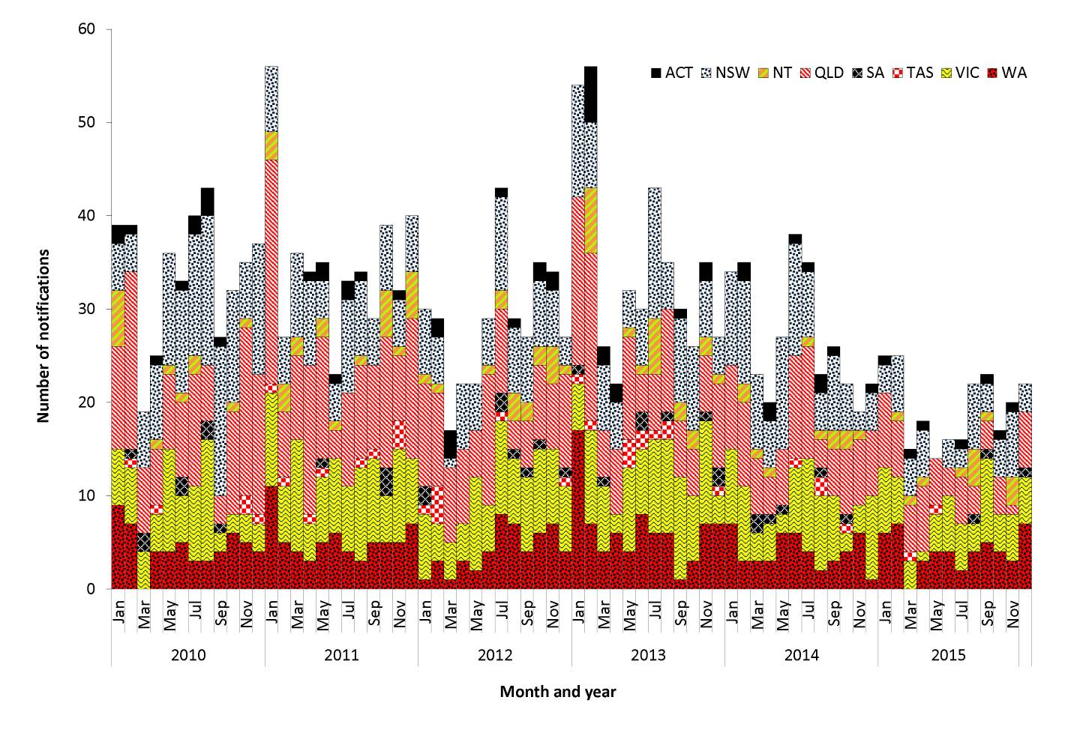
In 2015, all malaria cases were acquired overseas, most frequently in Papua New Guinea (n=38), Sudan (n=29) and Uganda (n=20) (Table 24). There were 4 notifications for which the place of acquisition was unknown. The most recent locally acquired cases of malaria in Australia were a single case in 2013 acquired on Saibai Island in the Torres Strait and 7 locally acquired cases in the Torres Strait in 2011.
Table 24: Cases of malaria, Australia, 2015, by Plasmodium species and country or region of acquisition
Country of acquisition | P. falciparum | P. falciparum and P. vivax | P. malariae | P. ovale | P. species | P. vivax | Total | % of cases
Papua New Guinea | 18 | 0 | 0 | 1 | 2 | 17 | 38 | 16%
Sudan | 25 | 0 | 0 | 3 | 0 | 1 | 29 | 12%
Uganda | 18 | 0 | 2 | 0 | 0 | 0 | 20 | 9%
India | 0 | 0 | 0 | 0 | 0 | 17 | 17 | 7%
Nigeria | 13 | 0 | 0 | 3 | 0 | 0 | 16 | 7%
Kenya | 13 | 0 | 0 | 2 | 0 | 0 | 15 | 6%
Tanzania | 7 | 0 | 1 | 0 | 0 | 0 | 8 | 3%
Ghana | 6 | 0 | 0 | 0 | 0 | 0 | 6 | 3%
Indonesia | 4 | 0 | 0 | 0 | 0 | 2 | 6 | 3%
Solomon Islands | 1 | 0 | 0 | 0 | 0 | 5 | 6 | 3%
Zambia | 4 | 0 | 1 | 0 | 1 | 0 | 6 | 3%
Cameroon | 5 | 0 | 0 | 0 | 0 | 0 | 5 | 2%
Ethiopia | 3 | 0 | 0 | 0 | 0 | 2 | 5 | 2%
Pakistan | 0 | 0 | 0 | 0 | 1 | 4 | 5 | 2%
Mali | 4 | 0 | 0 | 0 | 0 | 0 | 4 | 2%
Rwanda | 3 | 0 | 0 | 0 | 0 | 1 | 4 | 2%
Other countries | 17 | 1 | 1 | 1 | 1 | 8 | 29 | 12%
Overseas - country unknown | 6 | 0 | 0 | 0 | 0 | 4 | 10 | 4%
Place of acquisition unknown | 0 | 0 | 2 | 2 | 0 | 0 | 4 | 2%
Total | 147 | 1 | 7 | 12 | 5 | 61 | 233 | 100%

Age and sex distribution
Malaria is most commonly reported in younger and middle-aged adults, and in Australia disproportionately affects male travellers, of whom some are likely to be working in endemic countries when infected. The median age of notifications in 2015 was 35 years (range: 2 to 69 years) and 73% of cases were male. Notifications peaked in males aged between 20 and 49 years (Figure 96).
Figure 96: Notifications of malaria, 2015, by age group and sex
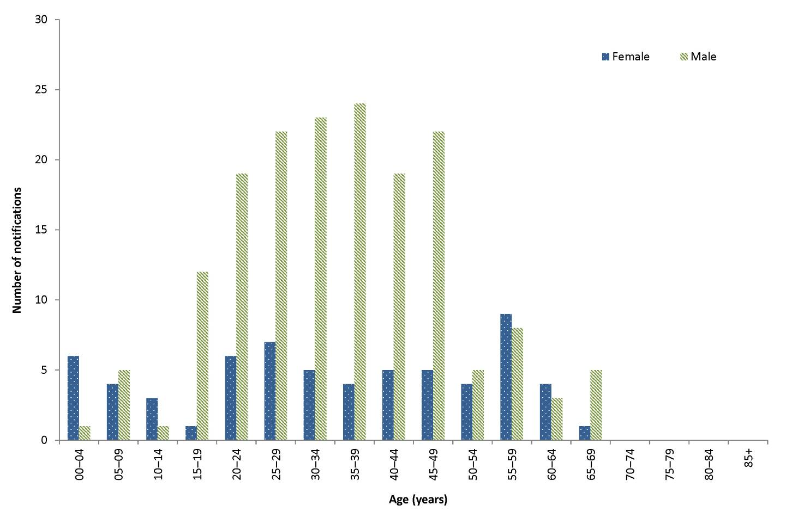

Seasonality
Diseases that are almost exclusively acquired overseas (such as malaria) can tend to increase during peak periods of travel by Australians overseas, or during increases in a particular country or region. In 2015, no particular seasonal trend was observed.

Murray Valley encephalitis virus
- There were 2 cases of MVEV, notified in 2015.
No specific treatment is available for infections with MVEV and care is largely supportive. No vaccine is available. Infection with MVEV is usually asymptomatic or produces a non-specific illness, but a small percentage of cases progress to encephalomyelitis of variable severity. Culex annulirostris is the major vector of MVEV.

Epidemiological situation in 2015
In 2015, there were 2 notifications of MVEV infection. Both cases were acquired in Australia (Table 25). This compares with a total of 17 cases between 2010 and 2014, 16 of them in 2011. The details of the 16 cases in 2011 were published elsewhere;¹⁴⁹ the remaining case was acquired in Papua New Guinea in 2012 (Figure 97). MVEV acquired in Australia is most commonly reported during the warmer, wetter months, with all cases between 2010 and 2015 having dates of diagnosis between December and May.
Figure 97: Notifications of Murray Valley encephalitis virus infection, Australia, 2010 to 2015, by month and place of acquisition
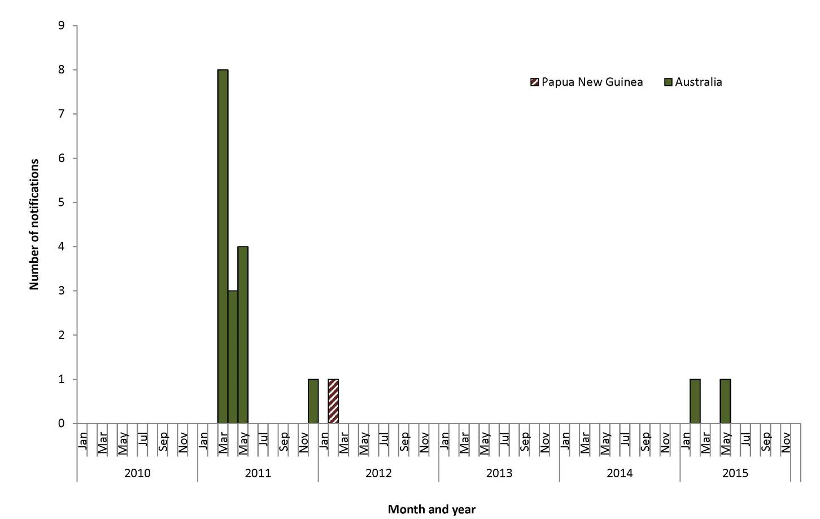
Table 25: Notifications of Murray Valley encephalitis virus infection, by country of acquisition, state or territory, age group and sex
Country of acquisition | Month | State or territory | Age group | Sex
Australia | February | NT | 0–4 | Female
Australia | May | NT | 5–9 | Male

Ross River virus
- Case numbers and notification rates of RRV were almost double the 5-year mean in 2015.
- The majority of RRV was reported in middle-aged to older age groups.
- Notifications peaked between January and April in 2015, which is during the season when vector numbers are at their highest.
RRV occurs exclusively in the Australasian region.¹¹⁵ Infection can cause a clinical illness, which is characterised by fever, rash and polyarthritis. The virus is transmitted by numerous species of mosquito that breed in diverse environments.¹¹⁶ In 2015, the national case definition for RRV required only a single IgM positive test to BFV, in the absence of IgM to RRV.¹¹⁷ It is unclear what proportion of notifications represent true cases. A revised case definition was implemented on 1 January 2016, under which a single IgM is no longer considered sufficient evidence for a confirmed case.

Epidemiological situation in 2015
In 2015, there were 9,550 notifications of RRV, representing a rate of 40.1 per 100,000. This is almost double the 5-year mean of 4,915.6 notifications (1.9 times) and the 5-year mean rate of 21.6 per 100,000 (1.9 times), and also higher than 2014 (5,316 notifications, rate 22.7 per 100,000) (Figure 98). The increase was largely due to a spike in case numbers and rates in Queensland and New South Wales during January to April (Figure 99).

Figure 98: Notifications of Ross River virus infection, Australia, 2010 to 2015, by month and year and state or territory
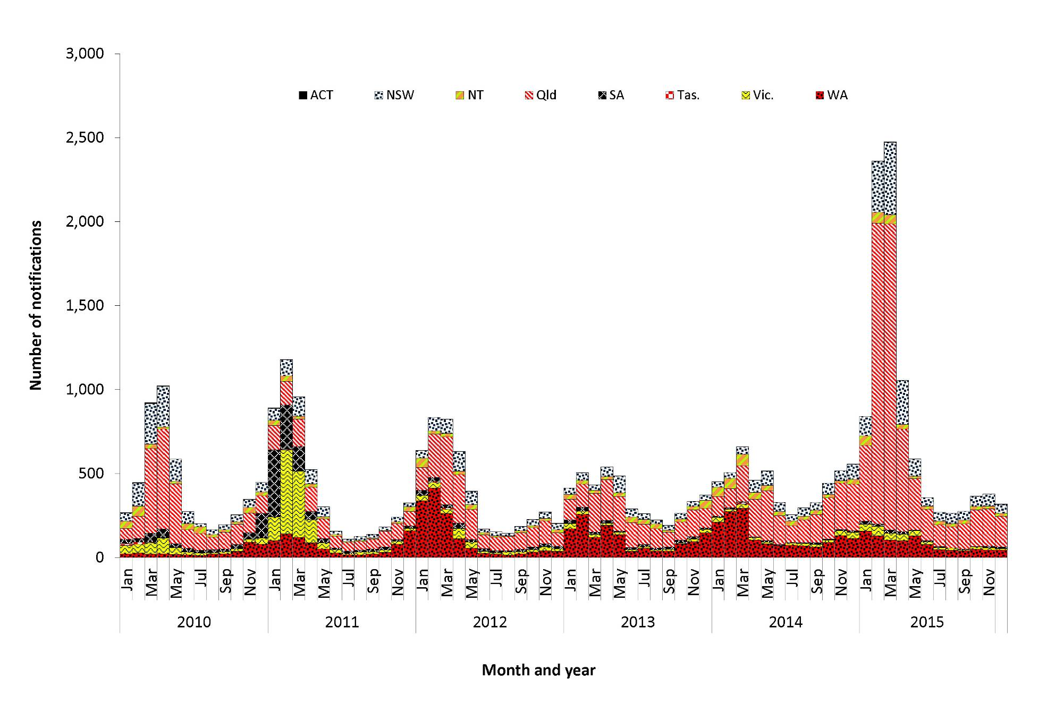

Figure 99: Notification rates of Ross River virus infection, Australia, 2010 to 2015, by state or territory and year
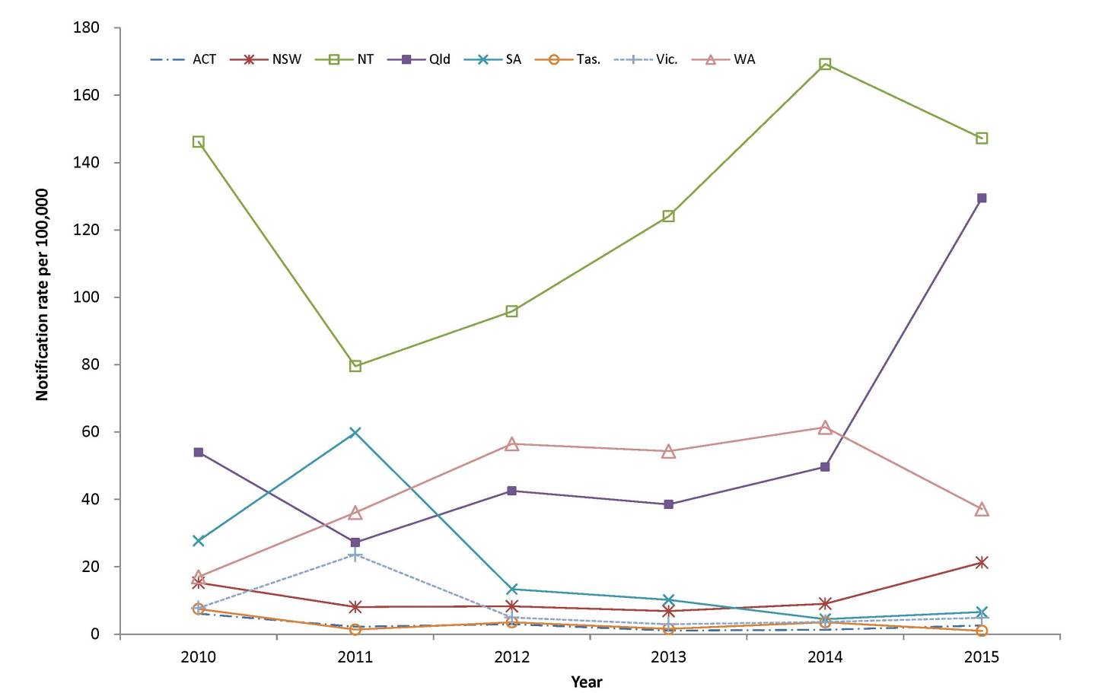

Geographical distribution
The largest number of notifications was in Queensland (n=6,192), but the highest rate was in the Northern Territory (147.2 per 100,000). It is important to note that seasonal trends vary between and within states and territories according to differences in mosquito vectors, hosts and climate. In addition, comparisons between regions are likely to be influenced by accuracy of case-ascertainment, which may vary between jurisdictions because of some differences in reporting criteria and the quality of diagnostic tests used.

Age and sex distribution
RRV is most commonly reported in middle-aged and older adults. The median age of notifications in 2015 was 44 years (range: 0 to 93 years), and 44% of cases were male. Rates of RRV peaked in females and males aged 40–44 years (77.2 and 60.6 per 100,000 respectively) (Figure 100).

Figure 100: Notification rates for Ross River virus infection, 2015, by age group and sex
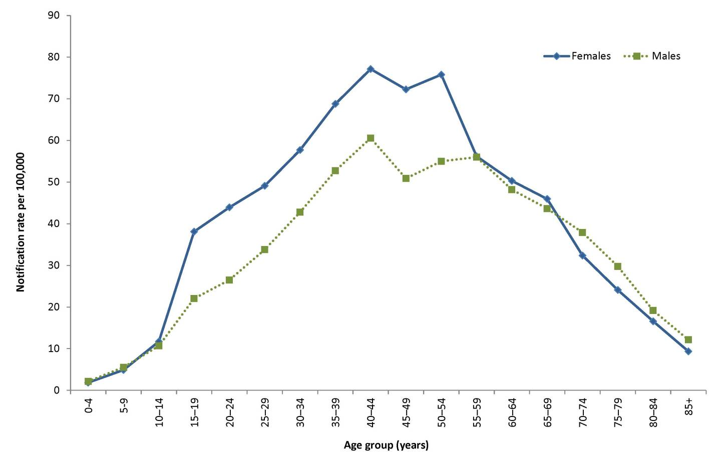

Seasonality
In 2015, RFV was most commonly reported between January and April, with 77% (323/9,550) of cases notified during these months. This is a more pronounced seasonality than that observed between 2010 and 2014, when 63% of cases were reported during these months.

Zoonoses

Overview
Zoonoses are those infectious diseases which are naturally transmitted between vertebrate animals and humans.¹⁵⁰ Approximately 60% to 70% of emerging human infectious diseases are zoonoses^{151, 152, 153} and more than 70% of emerging zoonoses originate from wildlife.¹⁵² An emerging zoonosis is defined by WHO as ‘a zoonosis that is newly recognised or newly evolved, or that has occurred previously but shows an increase in incidence or expansion in geographical, host or vector range’.¹⁵⁴
The zoonoses notifiable to the NNDSS included in this chapter are: anthrax, Australian bat lyssavirus (ABVL) or lyssavirus (unspecified) infection, brucellosis, leptospirosis, ornithosis, Q fever, and tularaemia. In 2015, zoonoses comprised 0.2% of all notifications to the NNDSS.
Several zoonoses notifiable to the NNDSS are included under other headings in this report. For example, salmonellosis and campylobacteriosis are typically acquired from contaminated food and are listed under the gastrointestinal diseases section. Rabies is listed under ‘Quarantinable diseases’.

Anthrax
- There were no cases of anthrax notified in 2015.
- The last case of human anthrax reported in Australia was in 2010.
Anthrax is caused by the bacterium Bacillus anthracis and most frequently causes cutaneous infection. However, it can also cause gastrointestinal and respiratory infections. Anthrax is primarily a disease of herbivores; humans and carnivores are incidental hosts. It can be an occupational hazard for veterinarians and for agriculture, wildlife and livestock workers who handle infected animals or by-products.
In Australia, the areas of anthrax risk are well defined. They include the northern and north-eastern districts of Victoria and central New South Wales.¹⁵⁵ Anthrax occurs only sporadically in livestock in the at-risk areas. Rare or isolated incidents or cases in animals have historically occurred in Queensland, South Australia, Tasmania and Western Australia.¹⁵⁵

Epidemiological situation in 2015
In 2015, there were no notified cases of anthrax in Australia. Over the previous 10 years, only 3 human cases of anthrax were reported in Australia, in 2006, 2007 and 2010.^{156,157,158} All had domestic farm or animal related exposures and all were cutaneous anthrax. Australia has never recorded a human case of inhalational or gastrointestinal anthrax.
There were 4 anthrax incidents reported in livestock in Australia in 2015; 3 occurred in New South Wales and 1 in Victoria. All cases were on properties within the known anthrax endemic area.¹⁵⁵

Australian bat lyssavirus and lyssavirus (unspecified)
- There were no cases of ABLV notified in 2015.
- The last case of ABLV reported in Australia was in 2013. ABLV belongs to the genus lyssavirus, which also includes the rabies virus.
Both invariably result in progressive, fatal encephalomyelitis in humans.¹⁵⁹ ABLV was first identified in Australia in 1996^{160,161} It is present in several Australian species of bats (including flying foxes and microbats). Australia is free of terrestrial rabies.
The best way to prevent ABLV infection is to avoid contact with bats. For people whose occupation (including volunteer work) or recreational activities place them at increased risk of being exposed to ABLV, rabies virus vaccine is effective in preventing infection. Pre-exposure immunisation with rabies virus vaccine is recommended for bat handlers, veterinarians and laboratory personnel working with live lyssaviruses.¹⁶² Post-exposure prophylaxis for ABLV consists of wound care and administration of a combination of rabies virus vaccine and human rabies virus immunoglobulin, depending on exposure category and prior immunisation or antibody status.^{29,162}

Epidemiological situation in 2015
In 2015, there were no notified cases of ABLV or lyssavirus (unspecified) infection in Australia.
There have been 3 cases of ABLV infection notified in humans in Australia, with single cases notified in each of 1996, 1998 and 2013. All 3 cases occurred following close contact with an infected bat in Queensland and all were fatal.^{163,164,165} In 2013, the Queensland Department of Agriculture, Fisheries and Forestry (DAFF) confirmed the first known equine cases of ABLV infection in 2 horses on a Queensland property.^{166, 167}
The Bat Health Focus Group of Wildlife Health Australia (formerly the Australian Wildlife Health Network) gathers and collates information from a range of organisations on opportunistic testing of bats for ABLV. In 2015, there were 22 ABLV detections in bats, compared with 32 detections during 2014.¹⁶⁸

Brucellosis
- There were 19 cases of brucellosis notified in 2015, a 21% decrease compared to the 5- year mean.
- In 2015, 58% of brucellosis cases were in New South Wales residents and 37% in Queensland.
- Eighty-nine per cent of cases reported in 2015 were male.
Brucellosis is characterised by a fever of variable duration with a range of other symptoms including headache, weakness, profuse sweating, chills, arthralgia, depression, weight loss and generalised aching.²¹ Brucella species that can cause illness in humans include Brucella melitensis acquired from sheep and goats, Brucella suis from pigs and Brucella abortus from cattle. B. abortus was eradicated from Australian cattle herds in 1989 and B. melitensis has never been reported in Australian sheep or goats.¹⁶⁹ Therefore, all cases of B. melitensis or B. abortus in Australia are related to overseas travel. Eales et al (2010)¹⁷⁰ found that feral pig hunting was the most common risk factor for brucellosis in Townsville during 1996 to 2009.

Epidemiological situation in 2015
In 2015, there were 19 notified cases of brucellosis in Australia (0.1 per 100,000), a 21% decrease compared to the 5-year (2010 to 2014) mean (n=24).

Geographical distribution
In 2015, over half of the notified brucellosis cases were in New South Wales residents (58%, 11/19) (Figure 101), 37% of cases were in Queensland residents (7/19) and 1 in a Northern Territory resident.
Figure 101: Notifications of brucellosis, Australia, 2010 to 2015, by month and year of diagnosis and state or territory
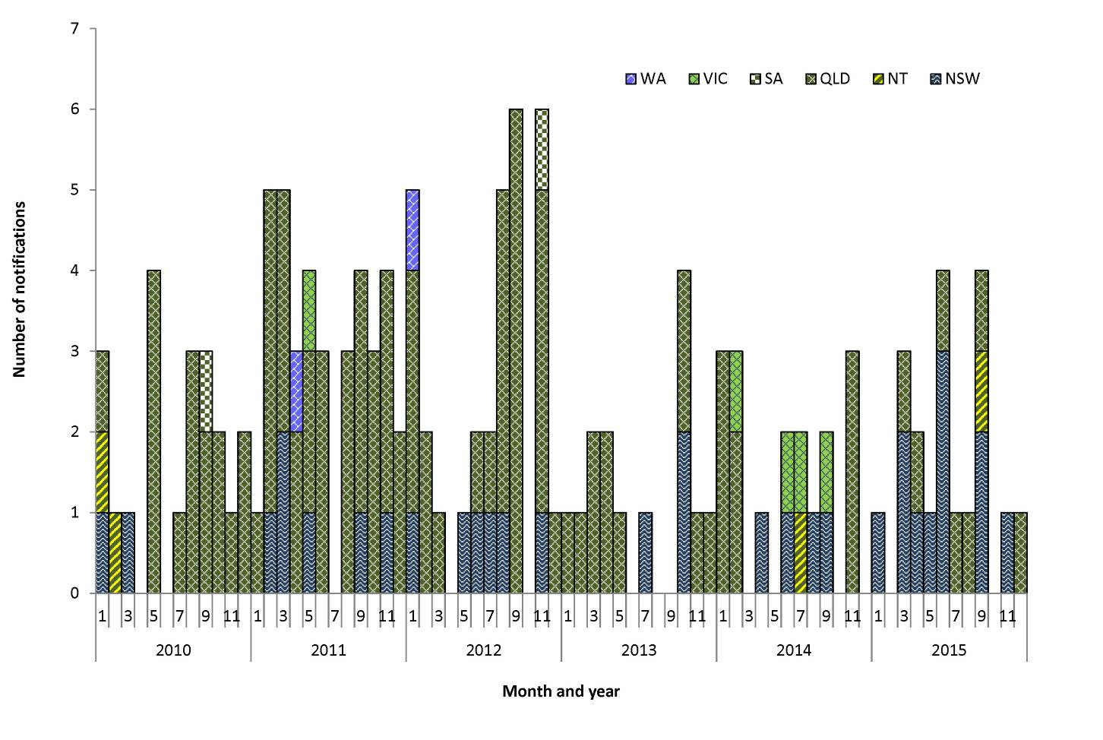
Since 1991, 81% of cases have been notified in Queensland residents and 12% of cases have been notified in New South Wales residents. In 2015, New South Wales had the highest proportion of cases and the highest number of cases of brucellosis on record for the state.¹⁷¹
Of the 11 cases reported in New South Wales residents, 5 were acquired overseas in Middle Eastern countries from consuming unpasteurised dairy or animal exposures, and 6 cases were acquired locally, of which 4 had reported hunting feral pigs.
Both New South Wales and Queensland have a state-specific notification rate of 0.1 per 100,000 and the Northern Territory has a rate of 0.4 per 100,000.

Age and sex distribution
In 2015, the median age of notified brucellosis cases was 36 years (range: 14 to 66 years), and 89% (17/19) were male (Figure 102).
Figure 102: Notifications of brucellosis, Australia, 2015, by age group and sex
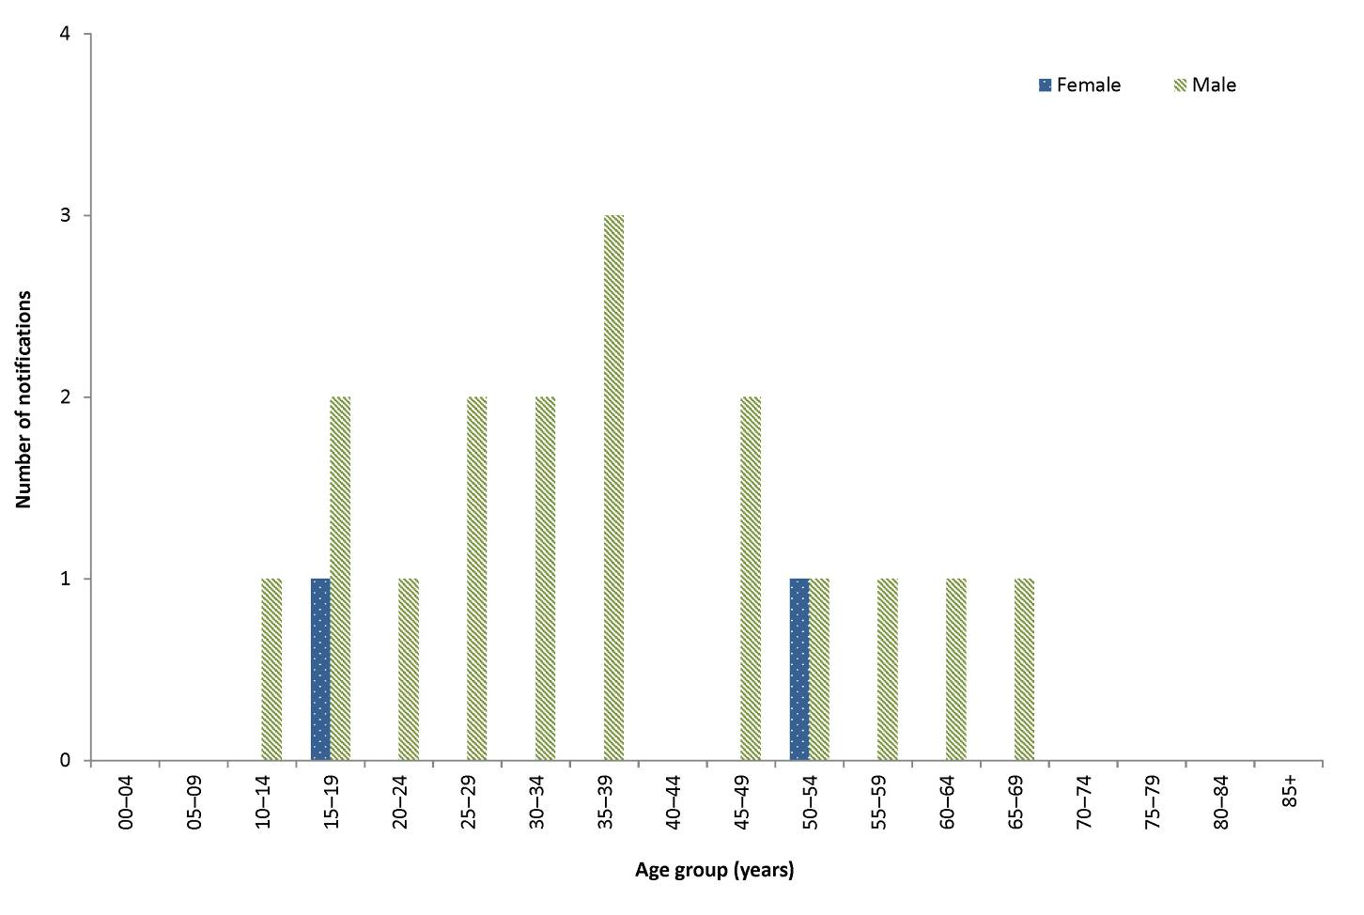

Microbiological trends
The species of the infecting organism was available for 53% (10/19) of notified cases in 2015. There were 6 cases of B. suis, 2 from New South Wales and 4 from Queensland; all cases were male. There were 4 cases of B. melitensis, with the countries of acquisition listed as Iraq, Lebanon, Jordan and Saudi Arabia. The 9 remaining cases, where the infecting organism was not specified, were acquired in Australia (n=7), Lebanon (n=1) and an overseas unknown country (n=1).

Leptospirosis
- There were 74 cases of leptospirosis notified in 2015.
- The highest numbers of cases were observed in males aged 15-19 years and 25-29 years.
Leptospirosis can cause a variety of illnesses varying in severity from a mild influenza-like illness to Weil’s syndrome, meningitis or pulmonary haemorrhage with respiratory failure possibly leading to death.²¹ Leptospirosis is caused by spirochaetes of the genus Leptospira, which is found in the genital tract and renal tubules of domestic and wild animals. In affected areas, where there is exposure to infected urine of domestic and wild animals, this disease can be an occupational and recreational hazard (such as in certain agricultural sectors and from swimming or wading in contaminated water).^{172, 173} The last reported death in Australia attributed to leptospirosis was in 2002.¹⁷⁴

Epidemiological situation in 2015
In 2015, there were 74 notified cases of leptospirosis in Australia (0.3 per 100,000), a 42% decrease compared with the 5-year (2010 to 2014) mean (n=127).

Geographical distribution
Over half (57%, 42/74) of notified cases were Queensland residents (Figure 103), with a state-specific notification rate of 0.9 per 100,000.
Figure 103: Notifications of leptospirosis, Australia, 2010 to 2015, by month and year of diagnosis and state or territory
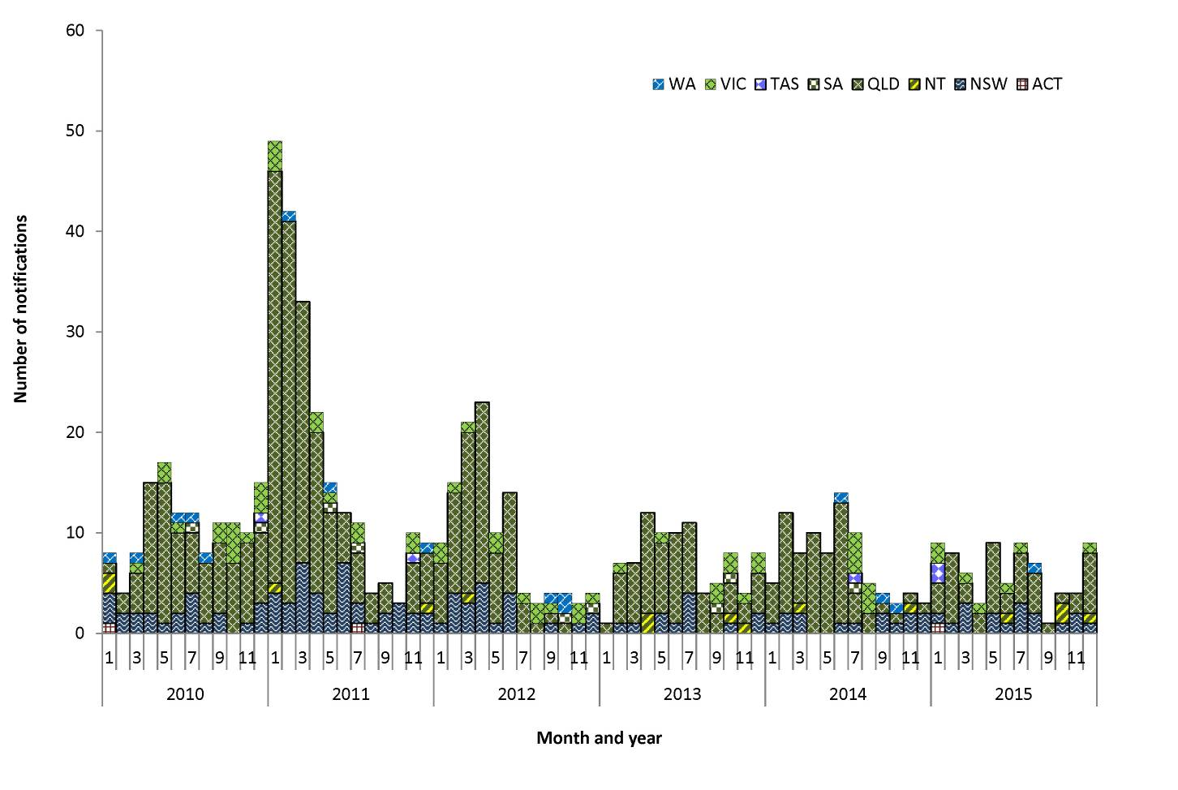

Age and sex distribution
The highest number of cases were observed in 15–19 years old males (n=8) and 25–29 years old males (n=8) (Figure 104). In 2015, the median age of notified leptospirosis cases was 42 years (range: 13 to 79 years), and 85% (63/74) were male.
Figure 104: Notifications of leptospirosis, Australia, 2015, by age group and sex
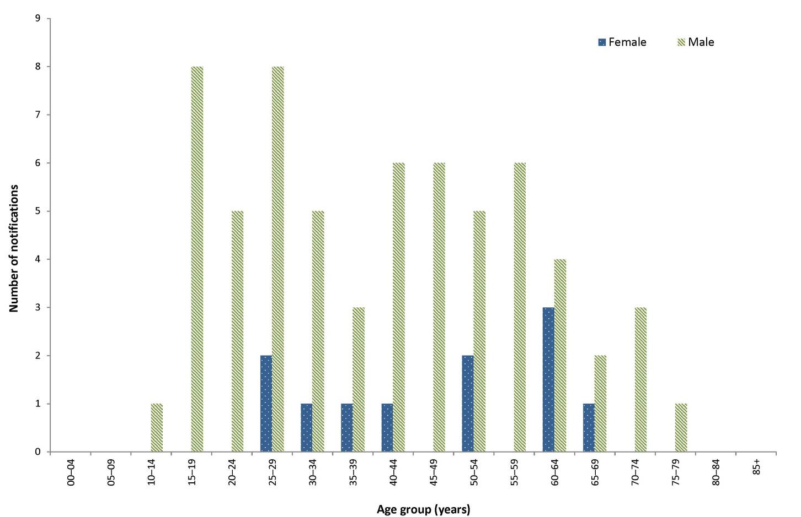

Microbiological trends
The WHO/Food and Agriculture Organization / World Organisation for Animal Health Collaborating Centre for Reference and Research on Leptospirosis (Leptospirosis Reference Laboratory, Queensland) routinely conducts PCR-based serotyping for leptospirosis cases from Queensland (whence the majority of cases are reported), and collates national data that may be submitted to the laboratory from other states or territories. At the time of compiling this report, data for 2015 were not publicly available.
In Australia, serotyping is only conducted on pathogenic Leptospira species typing information was available for 87% (55/63) of these cases. In 2015, the most frequently reported serovars were L. borgpetersenii serovar Arborea (24%, 13/55), L. interrogans serovar Australis (20%, 11/55) and L. interrogans serovar Zanoni (20%, 11/55). In 2014, L. interrogans serovar Zanoni was the most frequently reported serovar of those available (18/78).
In 2015, 47% (35/74) of reported leptospirosis cases were acquired locally, 16% (12/74) were acquired overseas and 36% (27/74) were acquired in an unknown location (Table 26).

Table 26: Notifications of leptospirosis, Australia, 2015, by serovar
Leptospira serovars | Locally acquired | Overseas acquired | Place of acquisition unknown
L. borgpetersenii serovar Arborea | 7 | 0 | 6
L. borgpetersenii serovar Hardjobovis | 1 | 0 | 2
L. borgpetersenii serovar Tarassovi | 1 | 0 | 0
L. interrogans serovar Australis | 5 | 2 | 4
L. interrogans serovar Canicola | 0 | 0 | 1
L. interrogans serovar Copenhageni | 1 | 3 | 0
L. interrogans serovar Kremastos | 0 | 1 | 0
L. interrogans serovar Pomona | 2 | 1 | 1
L. interrogans serovar Szwajizak | 2 | 0 | 0
L. interrogans serovar Zanoni | 4 | 0 | 7
L. kirschneri serovar Grippotyphosa | 0 | 1 | 0
L. weilii serovar Topaz | 1 | 1 | 1
Serotype unknown | 11 | 3 | 5
Total | 35 | 12 | 27

Ornithosis
- There were 16 cases of ornithosis notified in 2015, a 74% decrease compared with the 5-year mean.
- As in previous years, the majority of notifications in 2015 were residents of Victoria.
- Seventy-five per cent of cases reported in 2015 were male.
Ornithosis (or psittacosis) is a pneumonia-like illness caused by infection with the bacterium Chlamydophila psittaci.²¹ It is transmitted to humans primarily from infected parrots, but transmission to humans has also been known to occur from poultry and a range of other birds.¹⁷⁵ Transmission to humans occurs via the inhalation of contaminated dried faeces, nasal or eye secretions and dust from the feathers. Individuals at risk of contracting ornithosis include bird owners and those with occupational exposure to birds.¹⁷⁶

Epidemiological situation in 2015
In 2015, there were 16 notified cases of ornithosis in Australia (0.1 per 100,000), a 74% decrease compared with the 5-year mean (n=62).

Geographical distribution
As in previous years, more than two-thirds of the 2015 notifications were residents of Victoria (69%, 11/16) (Figure 105).

Figure 105: Notifications of ornithosis, Australia, 2010 to 2015, by month and year of diagnosis and state or territory
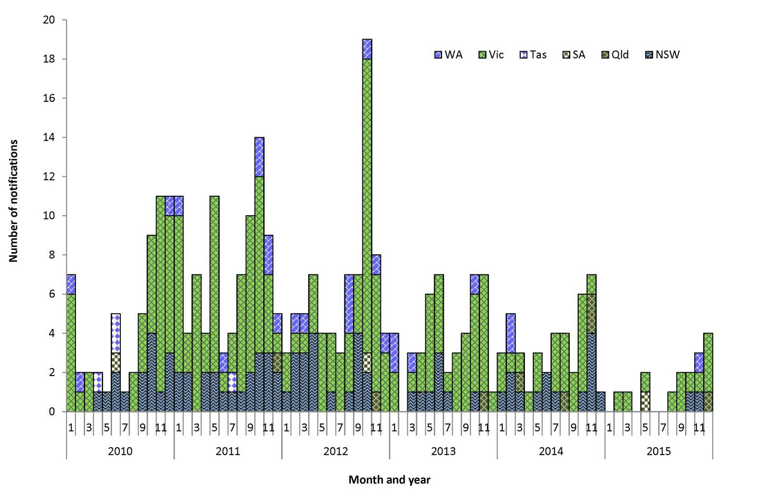

Age and sex distribution
In 2015, the median age of ornithosis notifications was 61 years (range: 18 to 80 years), and 75% (12/16) were male (Figure 106).

Figure 106: Notifications of ornithosis, Australia, 2015, by age group and sex
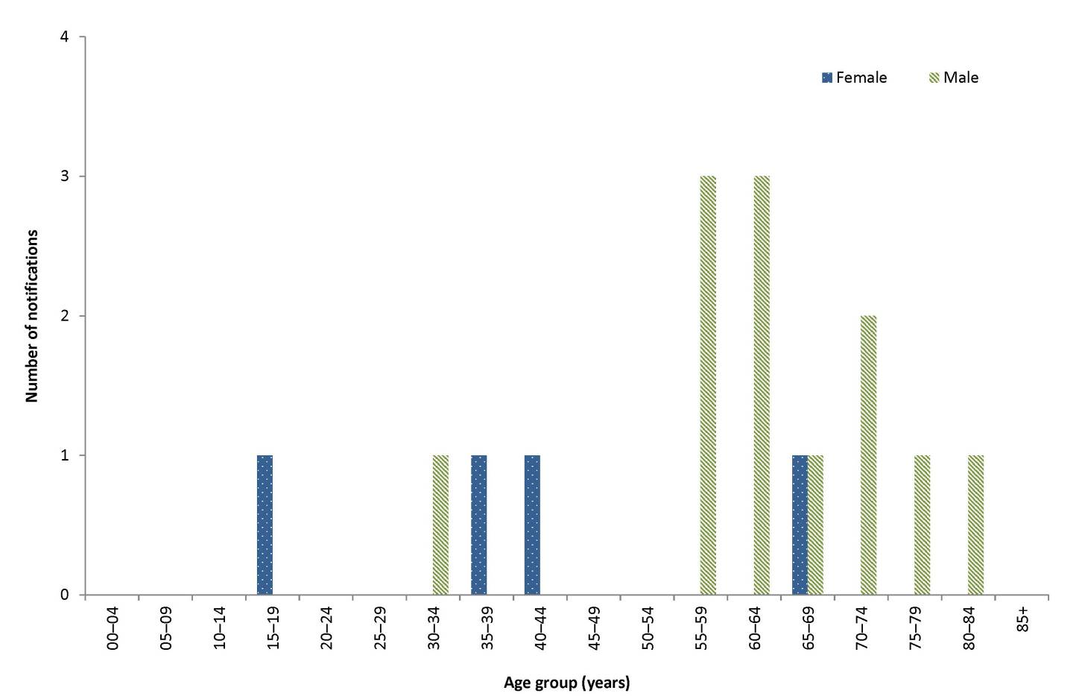

Q fever
- Cases of Q fever were reported in all jurisdictions except Tasmania and the Australian Capital Territory. The highest notification rate was in Queensland, at 5.3 per 100,000.
- Seventy-six per cent cases reported in 2015 were male.
- There were 601 cases of Q fever notified in 2015.
Q fever is caused by infection with the bacterium Coxiella burnetii. The primary reservoirs of these bacteria are cattle, sheep and goats. C. burnetii is resistant to environmental conditions and many common disinfectants.¹⁷⁷ Q fever is most commonly transmitted via the airborne route, where the organism is carried in dust contaminated with tissue, birth fluids or excreta from infected animals.¹⁷⁸ Prior to the commencement of immunisation programs in Australia, approximately half of all cases in New South Wales, Queensland and Victoria were among abattoir workers.^{179,180}
The Australian Government funded the National Q Fever Management Program (NQFMP) between 2001 and 2006 for states and territories to provide free vaccine to at risk occupational groups (such as abattoir workers).¹⁸¹
Adults at risk of Q fever infection, including abattoir workers, farmers, veterinarians, stockyard workers, shearers and animal transporters, should be considered for immunisation. The administration of the Q fever vaccine requires a pre-immunisation screening test to exclude those recipients with a previous (possibly unrecognised) exposure to the organism, including previous immunisation. Q fever vaccine may cause an adverse reaction in a person who has already been exposed to the bacterium. Immunisation is not recommended for children under 15 years of age or pregnant females.²⁹

Epidemiological situation in 2015
In 2015, there were 601 notified cases of Q fever in Australia (2.5 per 100,000), a 48% increase compared with the 5-year (2010 to 2014) mean (n=405). Between 1991 and 2001, and prior to the introduction of the NQFMP, Q fever notification rates ranged between 2.5 and 4.9 cases per 100,000.¹⁸¹ There has been an increase in the national Q fever notification rate since 2009 (1.4 per 100,000), with the notification rate in 2015 (2.5 per 100,000) being the highest since 2003 (2.8 per 100,000).

Geographical distribution
The highest notification rate was in Queensland (5.3 per 100,000, n=255). Cases were reported in all jurisdictions except Tasmania and the Australian Capital Territory (Figure 107).
Figure 107: Notifications of Q fever, Australia, 2010 to 2015, by month and year of diagnosis and state or territory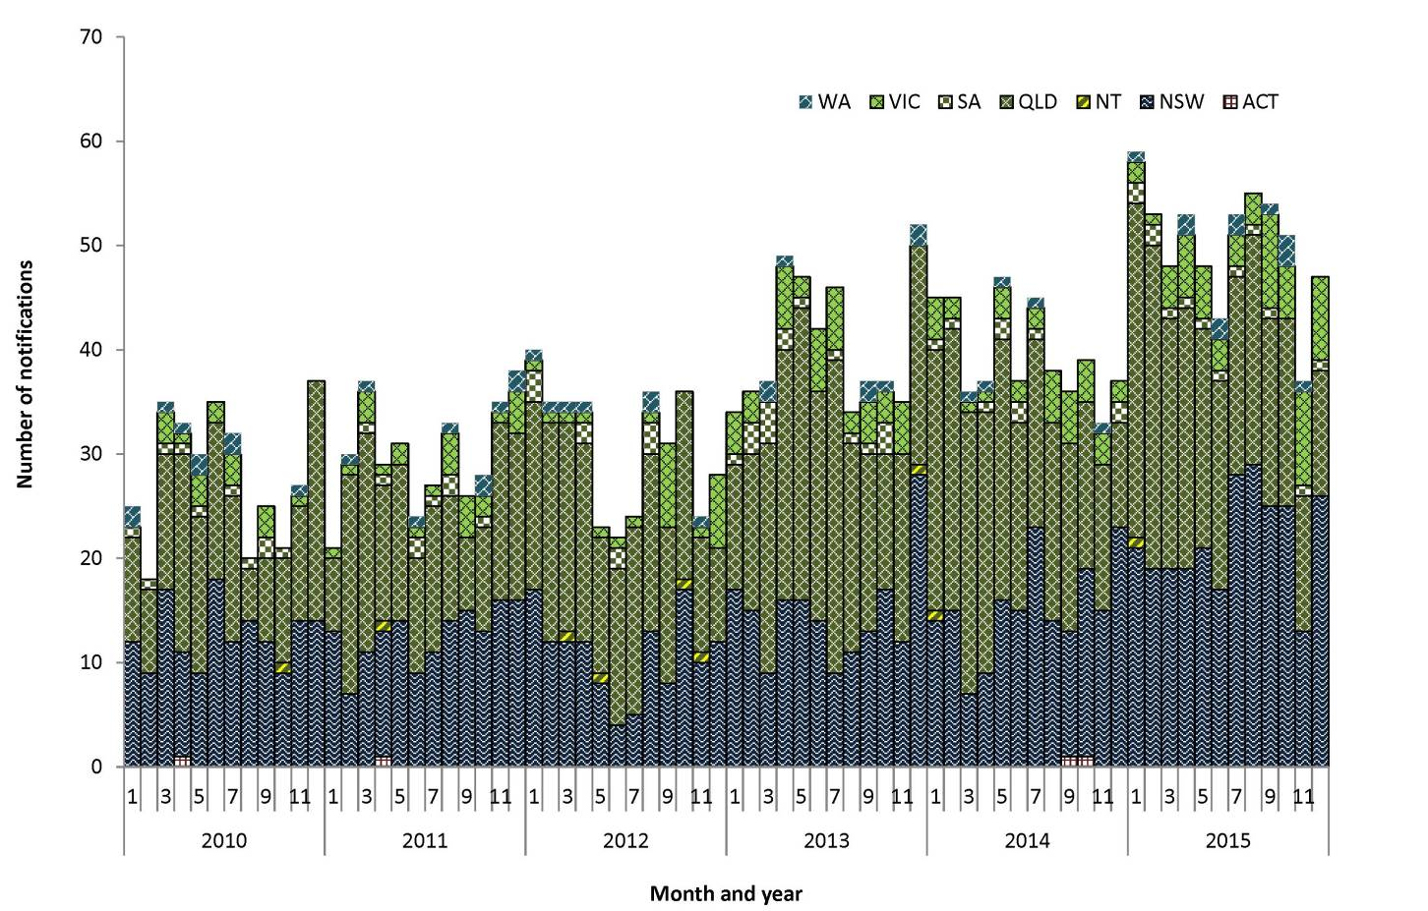
‘Hot spots’ for Q fever occur in central Queensland and in the areas that border Queensland and New South Wales (Figure 108). The Statistical Area of Outback South in south-west Queensland had the highest notification rate in 2015, with 135 cases per 100,000 (n=27), which is a decrease from 2014 (142 cases per 100,000; n=29). The Statistical Area of Bourke Cobar Coonamble in northern New South Wales had a large increase in the notification rate in 2015 (102 per 100,000; n=27) compared to 2014 (37 per 100,000; n=10) and the 5-year mean notification rate of 31 per 100,000 (n=8).
Figure 108: Notification rate for Q fever, Australia, 2015, by Statistical Area Level 3
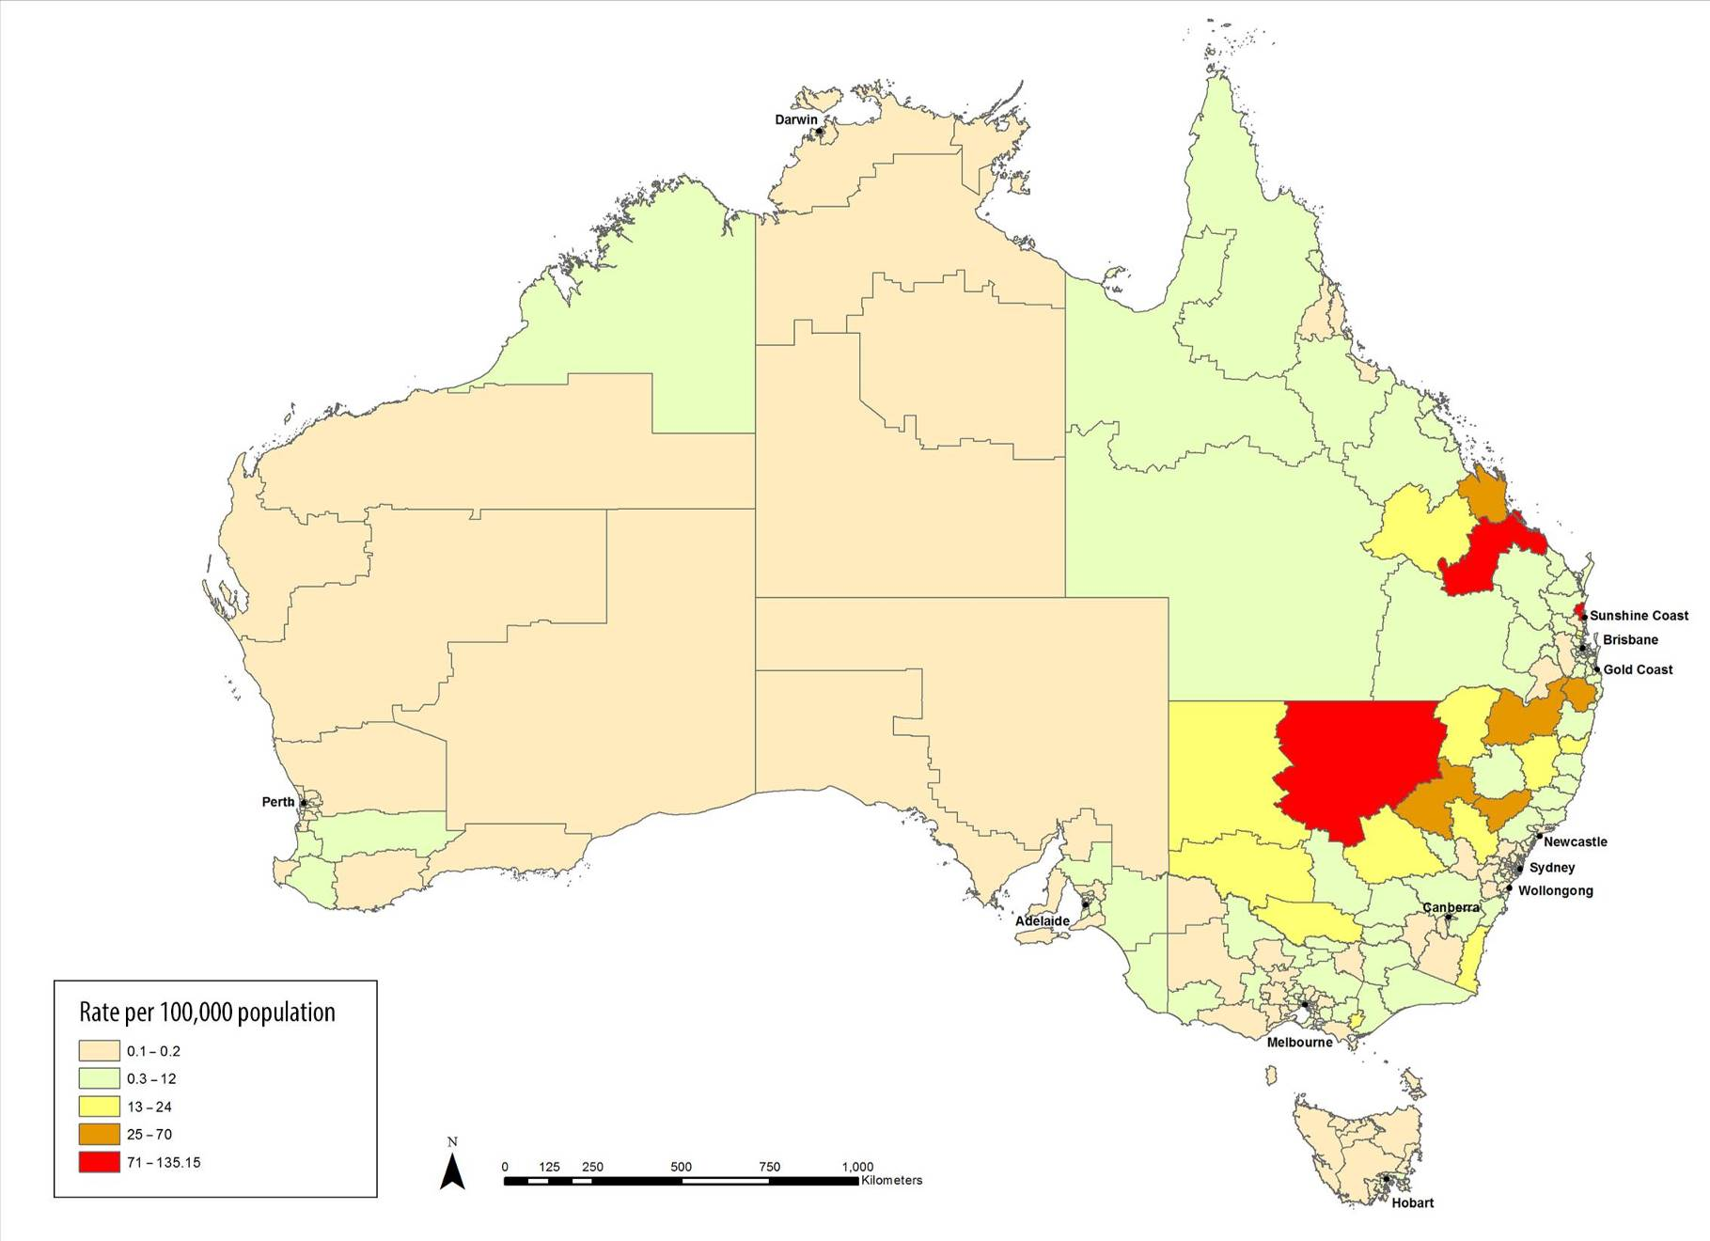

Age and sex distribution
The median age of Q fever cases was 47 years (range: 1 to 85 years), and 76% (454/601) were male. More than a third (34%, 205/601) of notified cases were males aged between 45 and 64 years (Figure 109). This is consistent with a report that found higher rates of Q fever in men aged 50 to 59 years, and that agriculture-related occupations (including farming) are the most commonly reported occupation.¹⁷⁸
Figure 109: Notifications of Q fever, Australia, 2015, by age group and sex
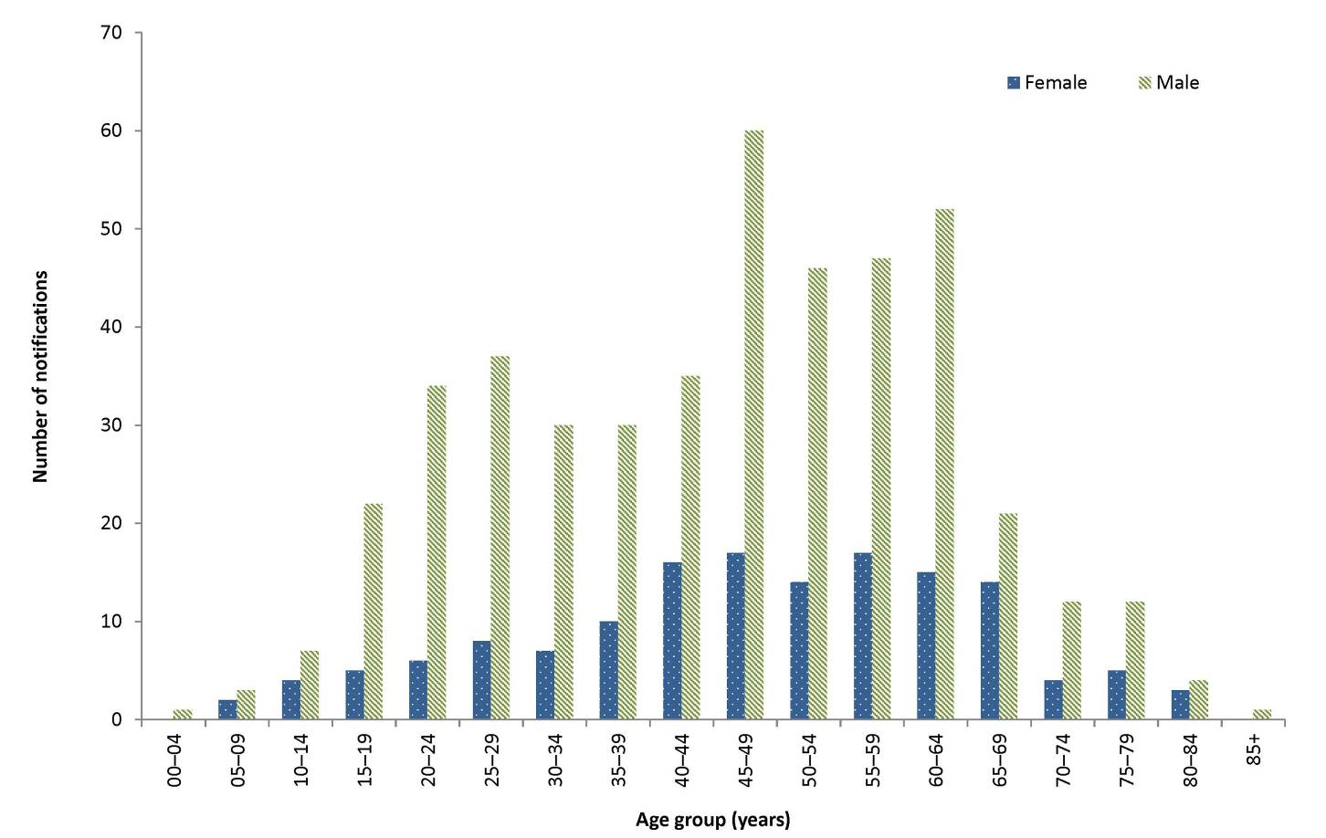

Tularemia
- There were no cases of tularaemia notified in 2015.
- The last case of tularaemia reported in Australia was in 2011.
Tularaemia is a non-specific disease with diverse manifestations, often with an influenza-like onset, caused by infection with the bacterium Francisella tularensis .²¹ The most common modes of transmission are through arthropod bites, handling infected animals, inhalation of infectious aerosols or exposure to contaminated food or water. Small mammals such as rodents, rabbits and hares are often the reservoir.¹⁸²

Epidemiological situation in 2015
In 2015, there were no notified cases of tularaemia in Australia. Tularaemia was last notified in 2011, with 2 cases in Tasmanian residents. This was the first time F. tularensis type B had been detected in the Southern Hemisphere.^{183,184,185}

Other Bacterial Infections
Other bacterial diseases in the national notifiable disease list are legionellosis, leprosy, invasive meningococcal disease and tuberculosis. In 2015, there were 1,815 cases of other bacterial infections notified to the NNDSS, representing 1% of all reported cases and less than the number notified in 2014 (n=1,947). Common objectives for the surveillance of diseases in this section are to monitor their epidemiology and to identify risk groups to accurately target control strategies.

Legionellosis
- There were 365 cases of legionellosis notified in 2015.
- Compared with 2014, notifications of legionellosis declined by 14% in 2015.
- Legionella pneumophila, commonly associated with man-made water systems, was the most frequently reported causative species in 2015.
Legionellosis is an environmentally acquired pneumonia caused by the bacteria Legionella. It can take the form of either legionnaire’s disease, a severe form of infection of the lungs, or Pontiac fever, a milder influenza-like illness.²¹ The species most commonly associated with human disease in Australia are Legionella pneumophila and Legionella longbeachae. Legionella bacteria are found naturally in low levels in the environment. In the absence of effective environmental treatments, Legionella organisms can proliferate in air conditioning cooling towers, hot water systems, showerheads, spa pools, fountains, commercial potting mix and other decomposing material such as bark and sawdust.^{186,187,188,189} Legionella is generally transmitted to humans through contaminated water or dust aerosols.

Epidemiological situation in 2015
In 2015, there were 365 notifications of legionellosis, representing a notification rate of 1.5 per 100,000. This was a 14% decline in the number of notifications reported in 2014 (n=425) (Figure 110).

Figure 110: Notifications of legionellosis, Australia, 2010-2015, by species and year
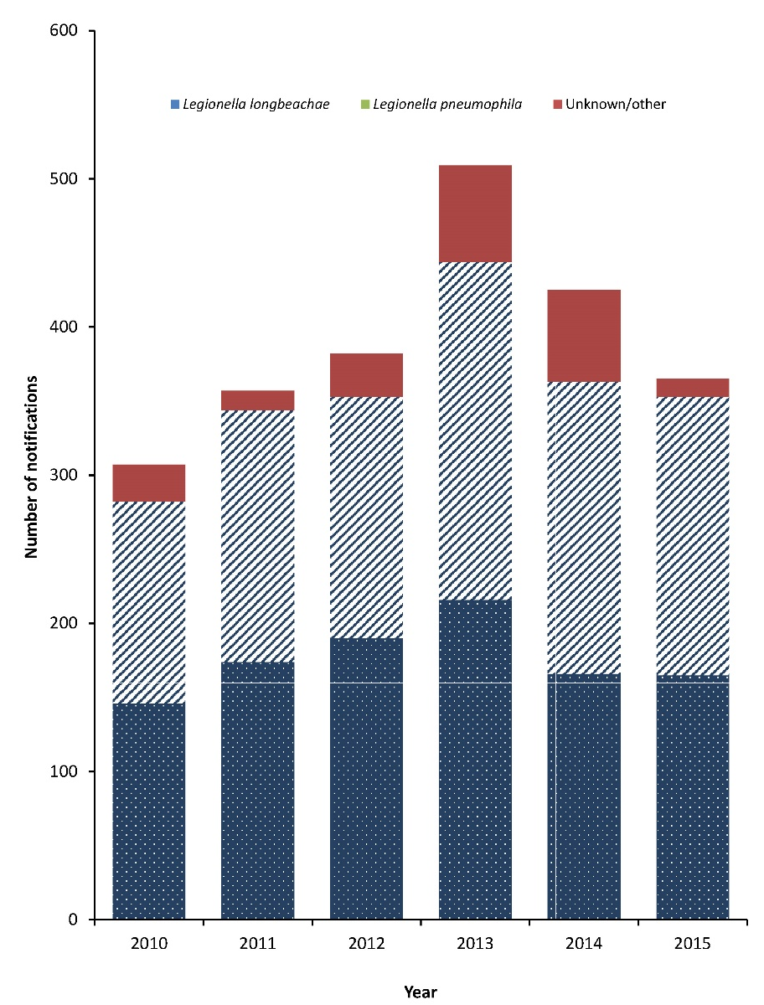
In 2015, data on the causative species were available for 97% (n=354) of notifications reported. Of these cases, the most frequently reported causative species were L. pneumophila (53%, 188/354), followed by L. longbeachae (47%, 165/354). A single notification of Legionella bozemanii was also reported (Table 27). Serogroup information was reported for 70% (132/188) of L. pneumophila notifications. The majority of these were serogroup 1 infections, with one case reported as having a mixed serogroup infection. For L. longbeachae notifications, serogroup information was provided for 7% (12/165) of cases, and all of these were serogroup 1 infections.

Table 27: Notifications, notification rates and deaths for legionellosis, Australia, 2015, by species and state or territory
 | State or territory |  |  |  |  |  |  |  | Australia | Deaths due to legionellosis
Species | ACT | NSW | NT | Qld | SA | Tas. | Vic. | WA
L. pneumophila | 0 | 67 | 2 | 37 | 13 | 4 | 52 | 13 | 188 | 5
L. longbeachae | 1 | 30 | 5 | 39 | 13 | 3 | 13 | 61 | 165 | 1
L. bozemanii | 0 | 1 | 0 | 0 | 0 | 0 | 0 | 0 | 1 | 1
Unknown species | 1 | 0 | 0 | 4 | 0 | 0 | 6 | 0 | 11 | 0
Total | 2 | 98 | 7 | 80 | 26 | 7 | 71 | 74 | 365 | 7
Rate (per 100,000) | 0.5 | 1.3 | 2.9 | 1.7 | 1.5 | 1.4 | 1.2 | 2.9 | 1.5 | 0

Over the period of 2010 to 2015, the number of notified cases of L. pneumophila ranged from 136 to 228 per annum, While notified cases of L. longbeachae ranged from 146 to 216 per annum (Figure 110). Compared with 2014, notifications of L. pneumophila declined by 5% and there were a similar number of notifications for L. longbeachae.
In 2015, mortality data were available for 67% (246/365) of notifications. Of these, 3% (7/246) were reported to have died due to legionellosis. This was similar to the number of deaths reported in previous years. The majority of deaths were attributed to infection with L. pneumophila (71%, 5/7) (Table 27). Over the last 6 years (2010 to 2015) the mortality data completeness for legionellosis notifications has improved with the proportion of notifications with mortality information increasing from 58% in 2010.

Geographic distribution
In 2015, jurisdiction specific rates of legionellosis varied from 0.5 per 100,000 in the Australian Capital Territory to 2.9 per 100,000 in both Western Australia and the Northern Territory (Table 27).
In 2015, L. pneumophila was the most notified causative species in New South Wales and Victoria, while L. longbeachae was more frequently notified in the Northern Territory and Western Australia. Queensland, South Australia and Tasmania reported either equal or similar proportions of both species. The most frequent species annually reported by each jurisdiction can vary between L. pneumophila and L. longbeachae. However, generally Western Australia and the Northern Territory tend to report more L. longbeachae notifications, while New South Wales, South Australia and Victoria tend to report more L. pneumophila notifications. Queensland reported an approximately equal proportion of L. longbeachae and L. pneumophila notifications. The Australian Capital Territory and Tasmania tend to report only a small number of notifications each year with no clear species predominance.

Age and sex distribution
In 2015, males accounted for a higher proportion (64%) of the notifications compared to females; representing a male to female ratio of 1.7:1. While the age range of cases in 2015 was between 6 and 97 years, cases tended to be among adults aged 45 years and over, peaking among those aged 75–79 years. In males, notifications were highest in the 75–79 years age group (11.2 per 100,000); however for females notifications peaked among cases aged 85 years and over (4.3 per 100,000) (Figure 111).
Figure 111: Notification rate for legionellosis, Australia, 2015, by age group, sex and species
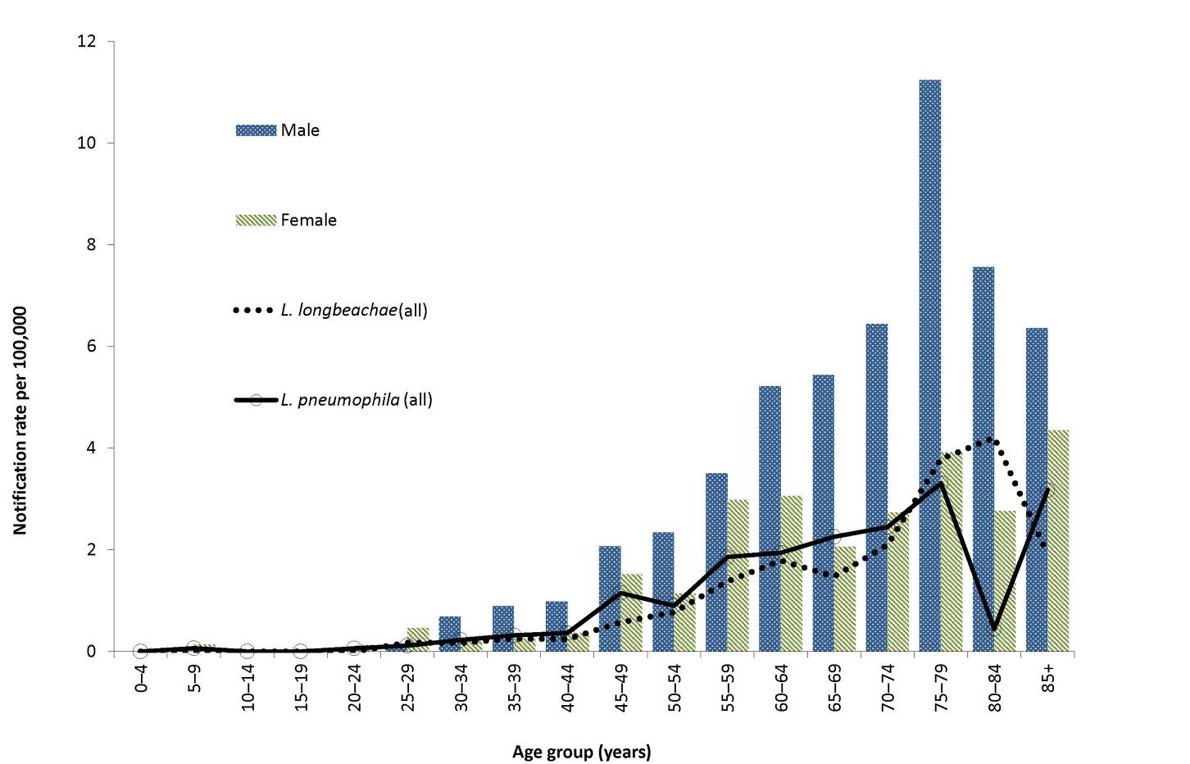
Of the 7 cases reported to have died due to legionellosis in 2015, their ages ranged between 60 and 86 years (median: 78 years); 3 deaths were in males and 4 were in females.
In 2015, the demographic profile of legionellosis remained consistent with the recognised epidemiology of the disease.^{21,190,191}

Seasonality
In 2015, diagnoses of legionellosis were highest in April and October, with 44 and 40 notified cases for these months respectively. The diagnosis of L. pneumophila peaked in April (n=25) and the diagnosis of L. longbeachae peaked across September and October (n=22 and n=23, respectively). Between 2010 and 2015, the diagnosis of L. longbeachae more commonly occurred in winter and spring. In the same period, the diagnosis of L. pneumophila commonly occurred in the late summer and autumn months, except for 2013, when diagnoses peaked at the end of winter (Figure 112). This winter 2013 peak is not likely to be a seasonal-related rise, as the increase was most likely associated with increased testing in Queensland that occurred following a legionellosis outbreak at a hospital.

Figure 112: Notifications of legionellosis, Australia, 2010 to 2015, by month and year of diagnosis and species
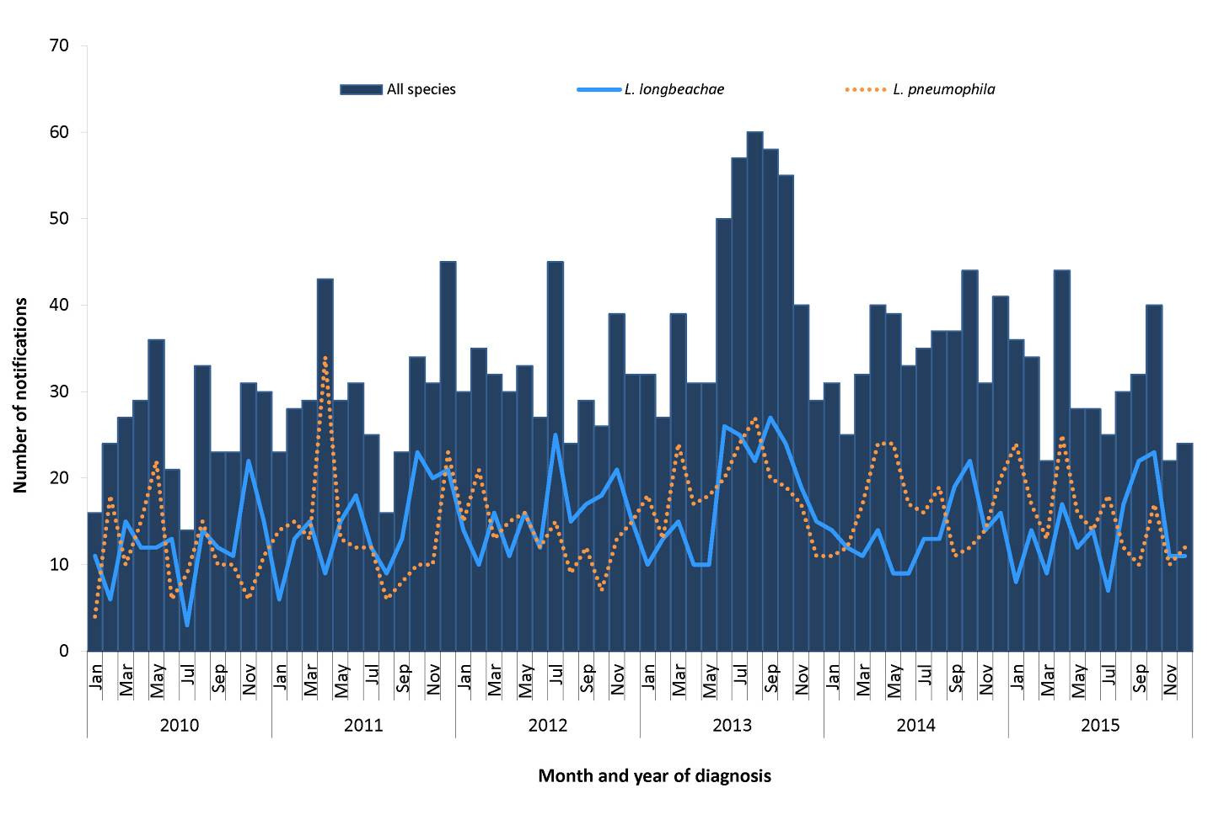

Place of acquisition
In 2015, a place of acquisition was reported in 94% (n=343) of legionellosis notifications. Of these, 91% (311/343) were reported to be acquired within Australia and 9% (32/343) were reported to be acquired overseas. Of the overseas acquired notifications, the United States of America (22%; 7/32) and both Singapore and Fiji (each 13%; 4/32), were the most commonly reported places of acquisition.

Outbreaks
In 2015, 4 outbreaks of legionellosis were identified, 1 in Western Australia and 3 in Victoria. In Western Australia, 2 confirmed cases of Legionnaire’s disease and 1 confirmed case of Pontiac fever were identified among crew members of a seismic survey vessel operating in the seas of northern Western Australia. The cases were residents of Queensland, New South Wales and Tasmania. Following environmental investigations, Legionella bacteria were detected in shower heads and hand basin mixing tap aerators in cabins, with a higher number of positive samples in the cabins of cases. Disinfection and other remediation measures were undertaken, with no further cases reported. (Email communication, C. Giele, Department of Health Western Australia, December 2016)
In Victoria there were 3 outbreaks of legionellosis reported in 2015, involving a total of 8 cases. All 3 outbreaks were due to L. pneumophila serogroup 1, and there were no positive environmental detections associated with the investigations. Outbreak cases were aged from 46 to 73 years with a median age of 55 years. All but 1 of the cases were male. All 3 outbreaks occurred in the greater Melbourne metropolitan area, in April, June and October. The settings where the outbreaks occurred were the airport, a residential apartment carwash, and a shopping complex. Of the 4 cases linked to the airport outbreak, all cases reported overseas travel exposures, in Thailand, Indonesia and China. As a result of this outbreak, Victoria’s protocol was updated to recognise that overseas travel is a much more likely exposure source for cases related to airports. (Email communication, L. Franklin, Vic. Department of Health and Human Services, November 2016)

Leprosy
- There were 13 cases of leprosy notified in 2015, maintaining a notification rate of less than 0.1 per 100,000.
- All cases of leprosy notified in 2015 were acquired overseas.
Leprosy is a chronic infection of the skin and peripheral nerves with the bacterium Mycobacterium leprae. Leprosy is an uncommon disease in Australia with the majority of cases occurring in migrants from leprosy-endemic countries and Indigenous populations. The incidence of leprosy worldwide is declining due to various factors including economic development, bacille Calmette-Guérin (BCG) immunisation and high coverage with multidrug therapy.²¹ Leprosy is not a highly infectious disease and is typically slow to progress to a symptomatic stage. The incubation period for leprosy is about 5 years; however, it can take as long as 20 years for symptoms to appear.¹⁹² People at risk are generally in close and frequent contact with leprosy patients or living in countries where the disease is more common. Leprosy is curable and once a person with leprosy begins appropriate treatment, they quickly become non-infectious.

Epidemiological situation in 2015
In 2015, a total of 13 cases of leprosy (8 male, 5 female), representing a rate of less than 0.1 per 100,000. There were 5 cases notified in Victoria, 3 in New South Wales, 2 each in Western Australia and Queensland and 1 in the Northern Territory. Cases ranged in age from 22 to 71 years of age, with a median age of 39 years. All cases were reported as being non-Indigenous and as having acquired their infection overseas: Sri Lanka (n=3), Afghanistan (n=1), Bangladesh (n=1), China (n=1), Guinea (n=1), India (n=1), the Philippines (n=1), Samoa (n=1), South Africa (n=1), Vietnam (n=1) and unknown^{iv} (n=1). Since 1996, annual notifications of leprosy have ranged from 2 to 15 cases per year (Figure 113).
iv The infection is known to be acquired overseas; however, the country in which the infection was acquired is unknown.

Figure 113: Notifications of leprosy, Australia, 1996 to 2015, by year and Indigenous status
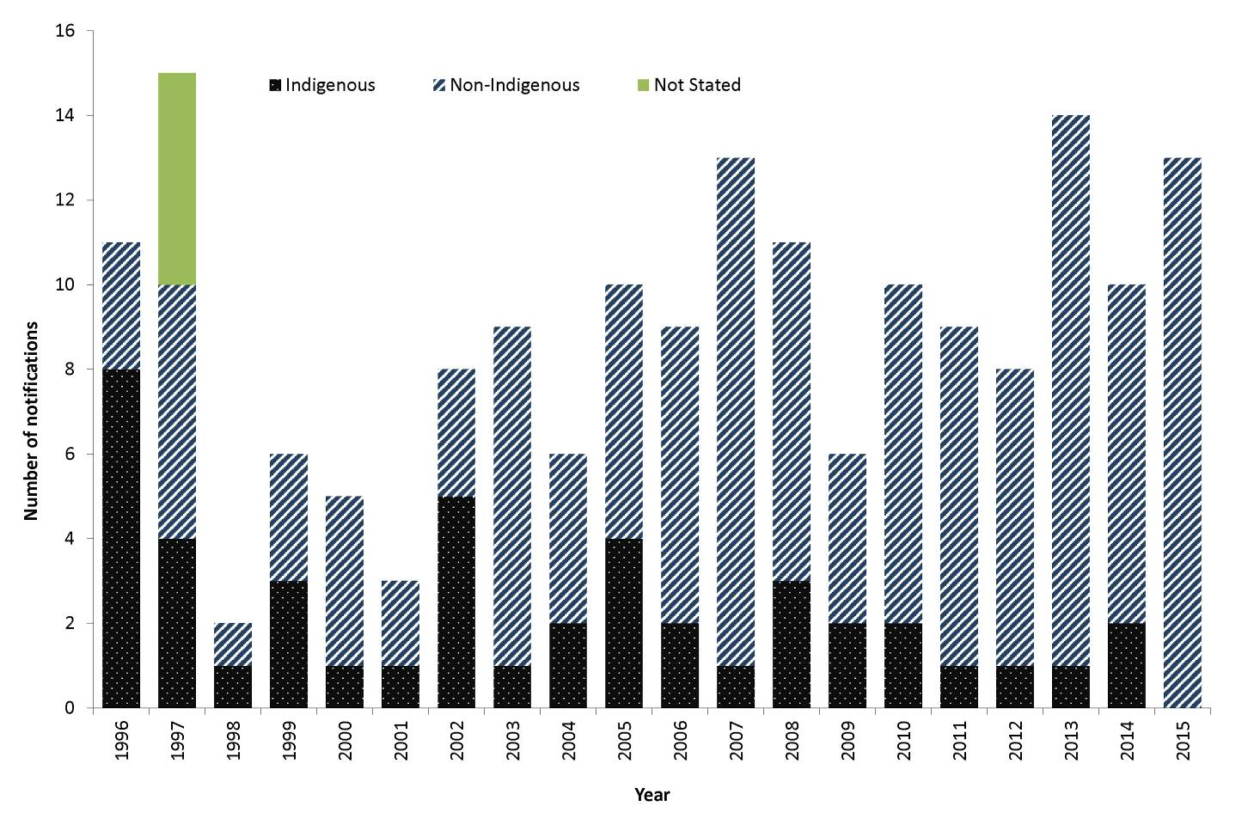

Meningococcal Disease (invasive)
- There were 182 cases and 12 deaths related to invasive meningococcal disease (IMD) notified in 2015.
- The majority (66%) of IMD cases were caused by serogroup B infections.
- Infections with serogroup W represented an increasing proportion of IMD notifications.
- Sixty per cent of IMD cases notified in 2015 were less than 25 years of age.
Invasive meningococcal disease (IMD) is caused when the bacterium Neisseria meningitidis enters a normally sterile site, usually the blood (septicaemia), cerebrospinal fluid (meningitis) or both. Asymptomatic respiratory tract carriage of meningococci is present in around 10% of the population, and prevalence may be higher when groups of people occupy confined living space.^{21,29} The disease is transmitted via respiratory droplets and has an incubation period of between 1 and 10 days, commonly 3 to 4 days.^{21,193} It can rapidly progress to serious illness, most commonly occurring in previously healthy children and young adults. While there are 13 known serogroups globally, serogroups A, B, C, X, W and Y commonly cause invasive disease.¹⁹⁴ Historically, N. meningitidis serogroups B and C have been the major cause of IMD in Australia in recent decades. However since 2013, there has been a rise in the cases associated with serogroup W and Y organisms.

Epidemiological situation in 2015
In 2015, there were 182 notified cases of IMD representing a rate of 0.8 per 100,000. This was an increase of 8% compared with 2014 (n=169) but less than the number of cases notified between 2003 and 2012 (range: 556 to 223 cases) (Figure 114). While numbers in 2015 remained low, this was the second consecutive year in which notifications of IMD have increased. This rise is due to an increase in the number of infections caused by serogroup W and serogroup Y organisms.
Figure 114: Notifications of invasive meningococcal disease by selected serogroup, Australia, 2003 to 2015
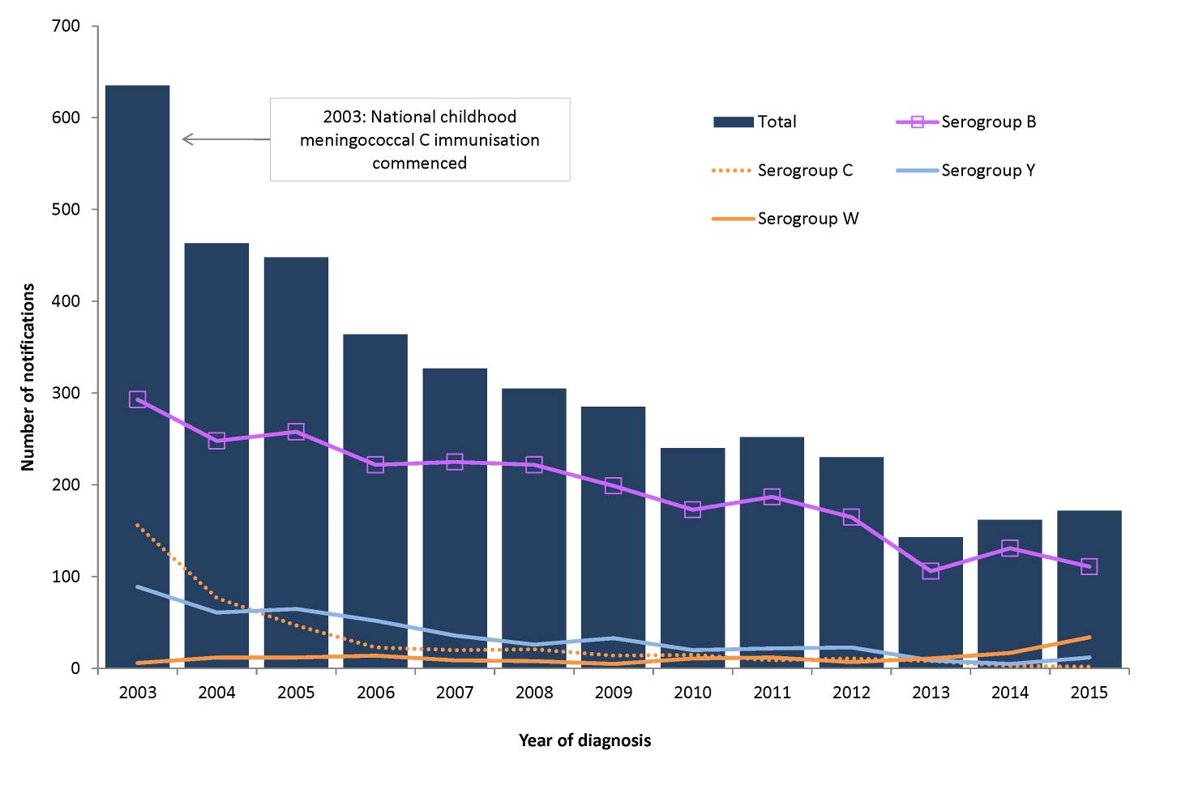
The majority of cases reported in 2015 (97%, n=176) met the case definition as a confirmed case being diagnosed based on laboratory definitive evidence, or laboratory suggestive evidence and clinical evidence.¹⁹³ A small number of cases (n=6) were reported as probable and diagnosed based on clinical evidence only.
In 2015, all states and territories reported cases of IMD (Table 28), with notification rates ranging from 0.4 per 100,000 in the Northern Territory and Tasmania to 1.7 per 100,000 in South Australia (Table 28). Mortality data were available for 79% (n=144) of cases. Of these, 12 cases were reported as having died from IMD, including 7 from infection with serogroup W organisms, 4 from infection with serogroup B organisms and 1 from infection with serogroup Y organisms (Table 28). All deaths reported in 2015 occurred in adolescents and adults (age range: 17 to 88 years). Of the deaths associated with serogroup W organisms, 4 were less than 30 years of age and 3 were between the ages 65 and 80 years. Of the deaths associated with IMD infection caused by serogroup B organisms, 1 case occurred in an adolescent aged 17 years and 3 occurred in adults aged between 35 and 69 years. The 1 death caused by serogroup Y organisms occurred in an adult aged 88 years.

Table 28: Notifications and notification rates of invasive meningococcal disease and deaths due to invasive meningococcal disease, Australia, 2015, by serogroup and state or territory
 | State or territory
 | ACT# | NSW# | NT | Qld | SA | Tas | Vic | WA | Australia | Deaths
B | 1 | 23 | 1 | 19 | 28 | 1 | 29 | 9 | 111 | 4
C | 0 | 2 | 0 | 0 | 0 | 0 | 0 | 0 | 2 | 0
W | 0 | 8 | 0 | 4 | 0 | 1 | 17 | 4 | 34 | 7
Y | 1 | 7 | 0 | 2 | 1 | 0 | 9 | 2 | 22 | 1
Other* | 0 | 5 | 0 | 5 | 0 | 0 | 1 | 2 | 13 | 0
Total | 2 | 45 | 1 | 30 | 29 | 2 | 56 | 17 | 182 | 12
Rate per 100,000 | 0.5 | 0.6 | 0.4 | 0.6 | 1.7 | 0.4 | 0.9 | 0.7 | 0.8 | 0
* Includes notifications where serogroup was reported as non-groupable or not grouped.^{i}
# Cases of conjunctival meningococcal infection are also reported under the local case definition, and reported to the national dataset by the jurisdiction. Conjunctival cases cannot be distinguished from invasive cases in the national dataset.
i Not grouped is where no serogroup is available; non-groupable is where the serogroup is reported by the reference laboratory as a non-groupable strain.

Age and sex distribution
In 2015, approximately the same number of IMD cases were notified in males (51%, n=92) as were notified in females (49%, n=90). Proportionally, 60% (n=110) of all cases reported were less than 25 years of age, of which 42% were children less than 5 years of age (n=46). The highest notification rates in 2015 for both males and females occurred in the 0–4 years age group (3.4 per 100,000 for males and 2.5 per 100,000 for females), with a second peak in adolescents in the 15–19 years age group (Figure 115).

Figure 115: Notification rate for invasive meningococcal disease, Australia, 2015, by age and sex
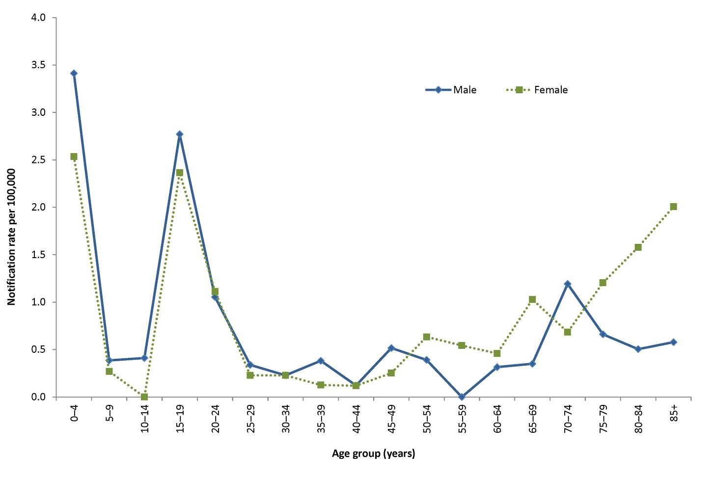

Serogroup analysis
Data on serogroup were available for 93% (n=169) of cases in 2015, of which 66% (111/169) were caused by serogroup B organisms, 20% (34/169) by serogroup W organisms, 13% (22/169) by serogroup Y organisms and 1% (2/169) by serogroup C organisms (Table 28). One case was reported as non-groupable. In 2015, cases caused by serogroup Y organisms (n=22) were the highest since reporting began in 1991, and twice the annual average over the previous 10-year period (average=10.7).
Cases of IMD caused by serogroup C organisms continue to decrease, with 2 cases notified in 2015 compared with 3 in 2014 and 8 in 2013. This decline represents a 99% decrease in case numbers since the introduction of the meningococcal C vaccine on the NIP in 2003. Of the cases of IMD due to serogroup C organisms reported in 2015, both were under the age of 25 years, with 1 in the 0–4 years age group, and the other in the 20–24 years age group. Age-specific rates of serogroup C infections have remained below 0.2 cases per 100,000 since 2010.
Serogroup B accounted for the majority of cases across all age groups in 2015, with the exceptions of the 55–59 years, 70–74 years and 75–79 years age groups. Compared with 2014, notification rates for serogroup B declined across all age groups except the 15–19 years age group, which increased from 1.6 per 100,000 in 2014 to 2.2 per 100,000 in 2015 (Figure 116).

Figure 116: Notification rate for serogroup B invasive meningococcal disease, Australia, 2010 to 2015, by select age groups
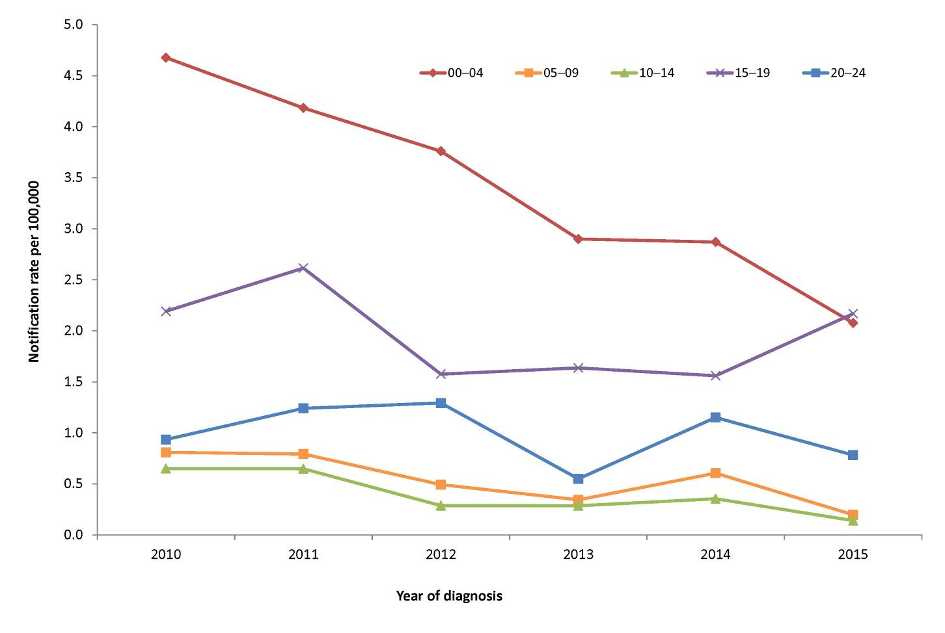
In 2014, an increase in cases due to serogroup W organisms was evident, with numbers almost 2 times higher than the annual average of the previous 5 years. This observed rise continued in 2015, with 34 cases reported compared with 17 cases in 2014, 11 cases in 2013 and 7 cases in 2012.

Seasonality
In 2015, an average of 15 cases of IMD were reported monthly, with a range of 6 to 27 cases. A clear seasonal pattern was apparent in 2015, with the highest number of notifications reported towards the end of winter (August) and early spring. The 2015 season peaked in August, with 27 cases reported, and was similar to the seasonal pattern displayed from 2010 to 2014 with notifications peaking in mid to late winter (Figure 117). Consistent with the previous 5 years, the 2015 seasonal trend was more apparent in cases aged 5 years and older compared with those less than 5 years of age.

Figure 117: Notifications of invasive meningococcal disease, Australia, 2010 to 2015, by age group and month and year of diagnosis
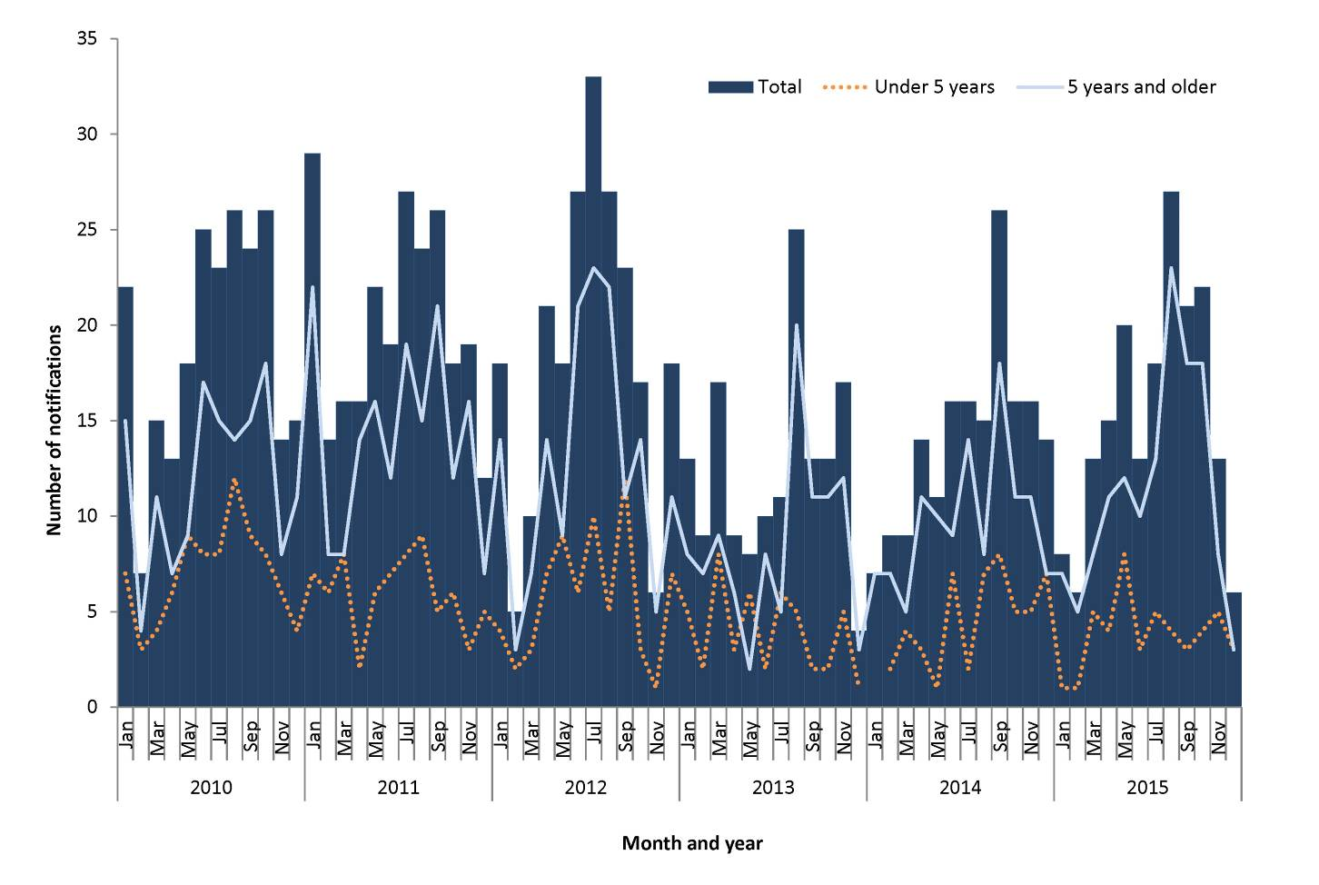

Immunisation
From 2003, the meningococcal C vaccine has been available for infants aged 12 months on the NIP. A catch up program provided access to the meningococcal C vaccine for children and adolescents born between 1984 and 2001.
Both cases of IMD caused by serogroup C organisms reported in 2015 were in children aged 12 months or older, and were therefore eligible for immunisation under the NIP. One case was 1 year of age and was reported to be vaccinated, and the second was 12 years of age and reported as not vaccinated.

Susceptibility
The Australian Meningococcal Surveillance Program (AMSP) was established in 1994 for the purpose of monitoring and analysing isolates of N. meningitidis from cases of IMD in Australia. The program is undertaken by a network of reference laboratories in each state and territory, using standardised methodology to determine the phenotype (serogroup, serotype and serosubtype) and the susceptibility of N. meningitidis to a core group of antibiotics. Annual reports of the AMSP are published in CDI.
Data from AMSP for 2015, show that 10% of isolates tested were fully sensitive and 86% demonstrated decreased susceptibility to the penicillin group of antibiotics.¹⁹⁵ A very small number of isolates tested in 2015 exhibited resistance to penicillin (n=4, 3.4%). All tested IMD isolates were susceptible to ceftriaxone and ciprofloxacin, and 1 isolate was resistant to rifampicin.

Discussion
The overall incidence of IMD in Australia is low and has decreased since the introduction of the serogroup C vaccine on the NIP in 2003. However, from 2014 there has been a rise of IMD cases nationally.
Since 2013, serogroup W has accounted for an increasing proportion of IMD cases, with 10% of cases in 2014 attributed to this organism, and 19% in 2015. The situation in Australia with regard to this is evolving and continues to be closely monitored. A national working group was formed in 2014 under the auspices of CNDA to further assess the situation and ensure consistent collection of enhanced data. Lessons learned from the international experience will be important in informing the public health response.¹⁹⁶

Tuberculosis
- There were 1,255 cases of TB notified in 2015.
- In 2015, the notification rate of TB has decreased slightly from 5.7 per 100,000 in 2014 to 5.3 per 100,000.
Tuberculosis (TB) is an infection caused by organisms of the Mycobacterium tuberculosis complex and consists of M. tuberculosis, M. bovis, M. microti, M. canetti, M. africanum. M. tuberculosis is the cause of almost all TB in Australia. TB is transmitted by airborne droplets produced by people with pulmonary or respiratory tract TB when coughing or sneezing. While most people infected with TB remain asymptomatic, there is a 10% lifetime risk of developing clinical illness, sometimes many years after the original infection. While Australia has one of the lowest rates of tuberculosis in the world, the disease remains a public health issue, particularly in Australia’s overseas-born population and also Aboriginal and Torres Strait Islander people in the central and northern regions of Australia.^{29,197}

Epidemiological situation in 2015
In 2015, a total of 1,255 cases of TB were notified to the NNDSS representing a rate of 5.3 per 100,000. This is a decrease on the rate of 5.7 per 100,000 (n=1,343) reported in 2014 and less than the preceding 5-year mean (2010 to 2014) of 5.9 per 100,000. Australia has achieved good TB control and has maintained overall low rates of TB since the mid 1980s (Figure 118).

Figure 118: Notification rate for tuberculosis, Australia, 1960 to 2015, by year
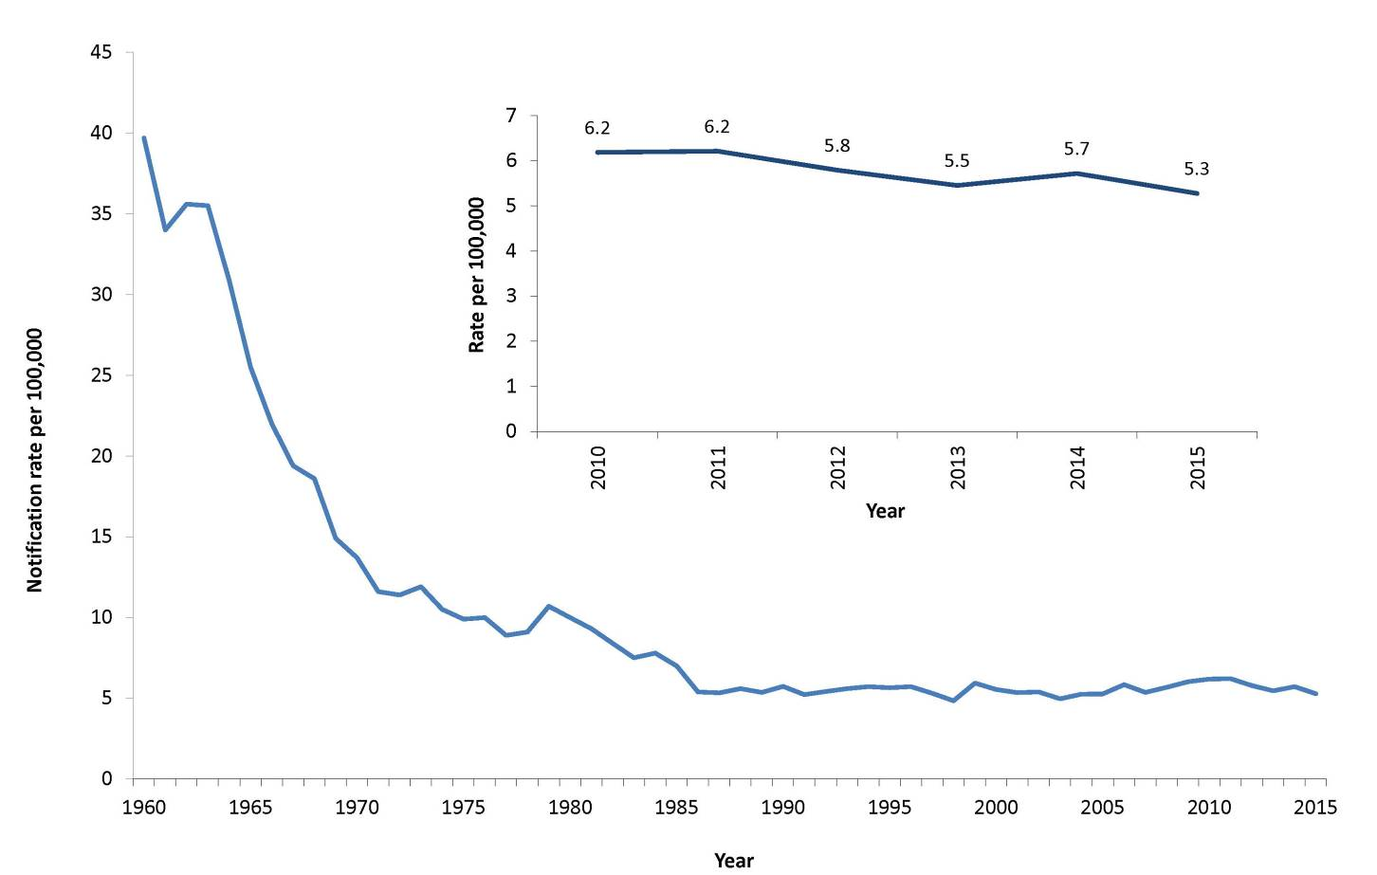

Geographic distribution
New South Wales (n=445), Victoria (n=352), Queensland (n=183) and Western Australia (n=132) accounted for 89% of all cases of TB diagnosed in Australia (Table 4). The Northern Territory (11.0 per 100,000), Victoria (5.9 per 100,000) and New South Wales (5.8 per 100,000) all reported rates higher than the national notification rate (Table 5). In 2015, Queensland, South Australia and Tasmania reported notification rates higher than the previous year. All the other states and territories reported a decrease compared to the previous year.

Age and sex distribution
Overall, the age groups with the highest notification rates were the 25–29 and 80–84 years age groups (11.5 and 9.3 per 100,000 respectively), followed by the 30–34 years age group (8.9 per 100,000). The highest age and sex specific rates were observed in men aged 80–84 years (14.6 per 100,000) and women aged 25–29 years (13.5 per 100,000) (Figure 119). Males accounted for 53% of the TB notifications in 2015.

Figure 119: Notification rate for tuberculosis, Australia, 2015, by age group and sex
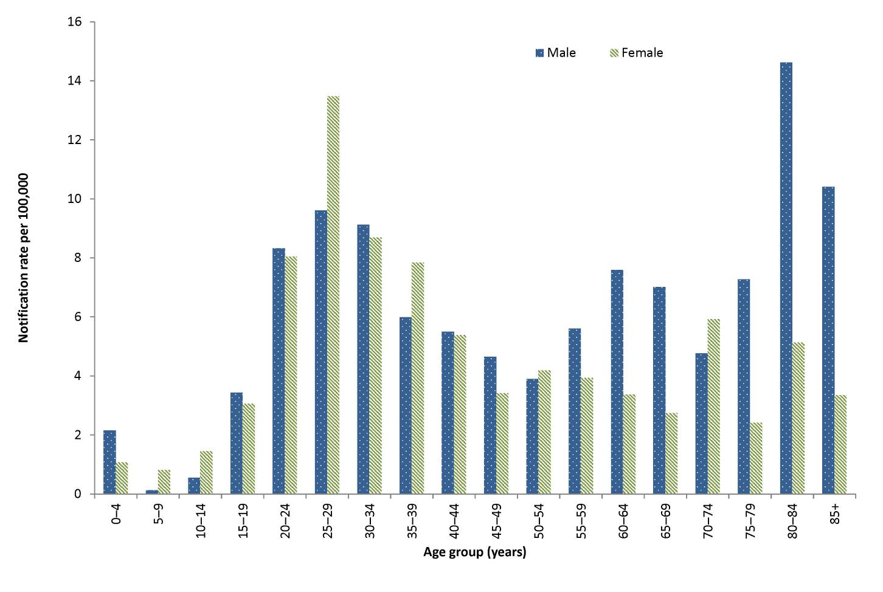

Immunisation
The BCG vaccine was first introduced for protection against tuberculosis in the 1920s and, despite variable evidence on the efficacy of the vaccine, it remains the only vaccine in use for TB today.^{198,199}
According to national guidelines developed by Australia’s National Tuberculosis Advisory Committee,^{29,200} BCG immunisation is recommended for Aboriginal and Torres Strait Islander neonates in communities with a high incidence of TB; neonates and children under 5 years of age who will be travelling to or living in countries or areas with a high incidence of TB for extended periods; and neonates born to parents with leprosy or a family history of leprosy. Additionally, BCG immunisation may be considered for: children over 5 years of age who will be travelling to or living in countries or areas with a high prevalence of TB for extended periods; and health care workers who may be at high risk of exposure to drug resistant TB.
BCG immunisation is not recommended for general use in the Australian population, given Australia’s low incidence of TB. The vaccine is contraindicated in HIV-infected people.²⁰⁰ Note that BCG immunisation practices may vary between states and territories due to differences in jurisdiction-specific TB immunisation policies and population demographics.
While public health follow-up is undertaken for all notifications of TB, completeness of the vaccine fields in the NNDSS dataset is poor.

Enhanced surveillance
Enhanced data are collected on all cases of TB. Further analyses, including identification of risk groups and reporting on treatment outcomes, can be found in the TB annual report series also published in the Communicable Diseases Intelligence journal.²⁰¹

Appendices

Appendix 1
December estimate of Australian population, 2015, by state or territory
 | State or Territory
 | ACT | NSW | NT | Qld | SA | Tas | Vic | WA | Aus
Males | 194,077 | 3,779,400 | 129,322 | 2,379,360 | 841,627 | 257,371 | 2,936,956 | 1,308,102 | 11,828,330
Females | 196,953 | 3,840,042 | 115,180 | 2,401,339 | 857,393 | 259,316 | 3,003,986 | 1,282,459 | 11,957,793
Total | 391,030 | 7,619,442 | 244,502 | 4,780,699 | 1,699,020 | 516,687 | 5,940,942 | 2,590,561 | 23,786,123
Source: ABS 3101.0 Table 4, Estimated Resident Population, State and Terrritories. Australian Demographic Statistics, Dec 2015

Appendix 2
December estimate of Australian population, 2015, by state or territory and age
Age Group | State or Territory
 | ACT | NSW | NT | Qld | SA | Tas | Vic | WA | Aus
00–04 | 27,264 | 491,896 | 18,993 | 318,348 | 101,429 | 30,671 | 378,393 | 173,484 | 1,540,640
05–09 | 24,653 | 483,082 | 17,974 | 321,128 | 100,789 | 32,283 | 366,598 | 168,816 | 1,515,475
10–14 | 21,761 | 452,508 | 16,976 | 304,754 | 96,808 | 31,236 | 340,632 | 155,420 | 1,420,278
15 –19 | 23,064 | 469,102 | 16,013 | 309,376 | 104,353 | 33,481 | 360,611 | 160,298 | 1,476,479
20 –24 | 31,105 | 520,623 | 18,880 | 338,352 | 114,411 | 31,748 | 425,632 | 180,100 | 1,661,035
25 –29 | 33,911 | 546,832 | 23,429 | 342,749 | 115,974 | 29,196 | 457,136 | 211,152 | 1,760,725
30 –34 | 33,305 | 554,453 | 22,335 | 337,881 | 113,912 | 29,539 | 453,247 | 206,140 | 1,751,262
35 –39 | 28,605 | 503,974 | 18,713 | 310,169 | 103,435 | 28,666 | 402,439 | 179,767 | 1,576,031
40 –44 | 28,505 | 524,984 | 18,146 | 337,703 | 111,818 | 33,252 | 415,774 | 184,376 | 1,654,809
45 –49 | 25,622 | 487,882 | 16,468 | 316,520 | 113,515 | 34,025 | 395,199 | 174,935 | 1,564,379
50 –54 | 24,531 | 500,043 | 15,387 | 313,866 | 115,537 | 36,905 | 382,808 | 168,441 | 1,557,738
55 –59 | 22,157 | 470,527 | 13,528 | 287,685 | 110,636 | 36,956 | 355,501 | 153,851 | 1,451,023
60 –64 | 19,008 | 418,101 | 10,874 | 255,757 | 100,668 | 34,158 | 314,370 | 133,516 | 1,286,654
65 –69 | 16,732 | 377,248 | 7,567 | 231,503 | 92,738 | 31,329 | 282,072 | 114,273 | 1,153,581
70 –74 | 11,367 | 285,810 | 4,542 | 171,481 | 68,901 | 23,402 | 210,489 | 81,928 | 857,984
75 –79 | 8,069 | 213,899 | 2,432 | 119,930 | 52,419 | 16,795 | 160,413 | 60,335 | 634,332
80 –84 | 5,538 | 154,412 | 1,310 | 81,456 | 38,524 | 11,722 | 116,835 | 41,841 | 451,655
85+ | 5,833 | 164,066 | 935 | 82,041 | 43,153 | 11,323 | 122,793 | 41,888 | 472,043
Total | 391,030 | 7,619,442 | 244,502 | 4,780,699 | 1,699,020 | 516,687 | 5,940,942 | 2,590,561 | 23,786,123

Source: ABS 3101.0 Australian Demographic Statistics Tables, Dec 2015.

Appendix 3
Indigenous status, National Notifiable Diseases Surveillance System, Australia, 2015, by notifiable disease*
Disease name | Aboriginal but not Torres Strait Islander origin | Torres Strait Islander but not Aboriginal origin | Aboriginal and Torres Strait Islander origin | Not Indigenous | Not stated | Blank/ missing | Total | % complete | Number complete | Number incomplete
Barmah Forest virus infection | 7 | 0 | 2 | 156 | 321 | 142 | 628 | 26 | 165 | 463
Botulism | 0 | 0 | 0 | 3 | 0 | 0 | 3 | 100 | 3 | 0
Brucellosis | 1 | 0 | 0 | 17 | 1 | 0 | 19 | 95 | 18 | 1
Campylobacteriosis | 342 | 20 | 31 | 10,599 | 11,163 | 418 | 22,573 | 49 | 10,992 | 11,581
Chikungunya virus infection | 1 | 0 | 0 | 82 | 24 | 3 | 110 | 76 | 83 | 27
Chlamydial infection | 5,315 | 815 | 360 | 25,557 | 18,229 | 21,987 | 72,263 | 44 | 32,047 | 40,216
Cholera | 0 | 0 | 0 | 2 | 0 | 0 | 2 | 100 | 2 | 0
Cryptosporidiosis | 174 | 1 | 10 | 2,012 | 1,512 | 355 | 4,064 | 54 | 2,197 | 1,867
Dengue virus infection | 12 | 1 | 3 | 1,437 | 209 | 52 | 1,714 | 85 | 1,453 | 261
Diphtheria | 0 | 1 | 0 | 1 | 0 | 0 | 2 | 100 | 2 | 0
Flavivirus infection (unspecified) | 0 | 0 | 0 | 9 | 3 | 0 | 12 | 75 | 9 | 3
Gonococcal infection | 3,126 | 266 | 114 | 8,324 | 4,161 | 2,559 | 18,550 | 64 | 11,830 | 6,720
Haemolytic uraemic syndrome (HUS) | 0 | 0 | 0 | 16 | 2 | 0 | 18 | 89 | 16 | 2
Haemophilus influenzae type b | 3 | 0 | 0 | 13 | 0 | 0 | 16 | 100 | 16 | 0
Hepatitis A | 1 | 2 | 1 | 169 | 4 | 1 | 178 | 97 | 173 | 5
Hepatitis B (newly acquired) | 13 | 1 | 1 | 115 | 9 | 1 | 140 | 93 | 130 | 10
Hepatitis B (unspecified) | 171 | 33 | 3 | 2,077 | 2,027 | 2,054 | 6,365 | 36 | 2,284 | 4,081
Hepatitis C (newly acquired) | 128 | 0 | 0 | 283 | 22 | 0 | 433 | 95 | 411 | 22
Hepatitis C (unspecified) | 760 | 20 | 24 | 3,131 | 3,365 | 3,060 | 10,360 | 38 | 3,935 | 6,425
Hepatitis D | 0 | 0 | 0 | 30 | 7 | 2 | 39 | 77 | 30 | 9
Hepatitis E | 1 | 0 | 0 | 38 | 2 | 0 | 41 | 95 | 39 | 2
Influenza (laboratory confirmed) | 1,601 | 101 | 74 | 34,165 | 35,508 | 29,134 | 100,583 | 36 | 35,941 | 64,642
Japanese encephalitis virus infection | 0 | 0 | 0 | 3 | 0 | 0 | 3 | 100 | 3 | 0
Legionellosis | 14 | 0 | 0 | 335 | 11 | 5 | 365 | 96 | 349 | 16
Leprosy | 0 | 0 | 0 | 13 | 0 | 0 | 13 | 100 | 13 | 0
Leptospirosis | 3 | 0 | 0 | 55 | 16 | 0 | 74 | 78 | 58 | 16
Listeriosis | 2 | 0 | 0 | 62 | 6 | 0 | 70 | 91 | 64 | 6
Malaria | 1 | 0 | 1 | 199 | 26 | 6 | 233 | 86 | 201 | 32
Measles | 2 | 0 | 0 | 72 | 0 | 0 | 74 | 100 | 74 | 0
Meningococcal disease (invasive) | 14 | 1 | 2 | 162 | 3 | 0 | 182 | 98 | 179 | 3
Mumps | 404 | 0 | 0 | 205 | 26 | 9 | 644 | 95 | 609 | 35
Murray Valley encephalitis virus infection | 2 | 0 | 0 | 0 | 0 | 0 | 2 | 100 | 2 | 0
Ornithosis | 0 | 0 | 0 | 15 | 1 | 0 | 16 | 94 | 15 | 1
Paratyphoid | 1 | 0 | 0 | 72 | 2 | 1 | 76 | 96 | 73 | 3
Pertussis | 296 | 8 | 32 | 11,556 | 4,703 | 5,951 | 22,546 | 53 | 11,892 | 10,654
Pneumococcal disease (invasive) | 196 | 4 | 8 | 1,132 | 159 | 0 | 1,499 | 89 | 1,340 | 159
Q fever | 32 | 0 | 2 | 492 | 59 | 16 | 601 | 88 | 526 | 75
Ross River virus infection | 138 | 14 | 11 | 2,717 | 5,229 | 1,441 | 9,550 | 30 | 2,880 | 6,670
Rubella | 0 | 0 | 0 | 15 | 1 | 1 | 17 | 88 | 15 | 2
Rubella congenital | 0 | 0 | 0 | 1 | 0 | 0 | 1 | 100 | 1 | 0
STEC | 1 | 0 | 0 | 118 | 16 | 2 | 137 | 87 | 119 | 18
Salmonellosis | 497 | 38 | 22 | 8,267 | 4,917 | 3,272 | 17,013 | 52 | 8,824 | 8,189
Shigellosis | 201 | 2 | 11 | 695 | 112 | 17 | 1,038 | 88 | 909 | 129
Syphilis < 2 years | 405 | 16 | 12 | 2,025 | 239 | 16 | 2,713 | 91 | 2,458 | 255
Syphilis > 2 years or unspecified duration | 231 | 21 | 5 | 1,100 | 516 | 66 | 1,939 | 70 | 1,357 | 582
Syphilis congenital | 0 | 0 | 2 | 1 | 0 | 0 | 3 | 100 | 3 | 0
Tetanus | 0 | 0 | 0 | 2 | 0 | 0 | 2 | 100 | 2 | 0
Tuberculosis | 27 | 7 | 0 | 1,212 | 9 | 0 | 1,255 | 99 | 1,246 | 9
Typhoid Fever | 1 | 1 | 1 | 108 | 4 | 0 | 115 | 97 | 111 | 4
Varicella zoster (chickenpox) | 80 | 3 | 4 | 2,238 | 133 | 21 | 2,479 | 94 | 2,325 | 154
Varicella zoster (shingles) | 143 | 5 | 1 | 5,541 | 565 | 88 | 6,343 | 90 | 5,690 | 653
Varicella zoster (unspecified) | 146 | 16 | 14 | 2,712 | 10,159 | 316 | 13,363 | 22 | 2,888 | 10,475
West Nile / Kunjin virus infection | 0 | 0 | 0 | 1 | 0 | 0 | 1 | 100 | 1 | 0
Grand total | 14,493 | 1,397 | 751 | 129,361 | 103,481 | 70,996 | 320,479 | 46 | 146,002 | 174,477
* Indigenous status is usually obtained from medical notification and completeness varies by disease and by state and territory. This reflects differences in notification requirements (i.e. depending on the jurisdiction, some diseases are primarily or completely notified by pathology laboratories rather than clinicians) and the fact that it is not possible to follow-up all cases for diseases with a large volume of notifications and/or not requiring specific case-based public health action.

Abbreviations
Abbreviation | Definition
7vPCV | 7 valent pneumococcal conjugate vaccine
13vPCV | 13 valent pneumococcal conjugate vaccine
23vPPV | 23 valent pneumococcal polysaccharide vaccine
ABLV | Australian bat lyssavirus
AFP | acute flaccid paralysis
AGSP | Australian Gonococcal Surveillance Programme
AIDS | acquired immune deficiency syndrome
AMSP | Australian Meningococcal Surveillance Programme
ANCJDR | Australian National Creutzfeldt-Jakob Disease Registry
BCG | bacille Calmette-Guérin
BFV | Barmah Forest virus
CDI | Communicable Diseases Intelligence
CDNA | Communicable Diseases Network Australia
CDWG | Case Definitions Working Group
CHIKV | Chikungunya Virus
CIDT | culture-independent diagnostic testing
CJD | Creutzfeldt-Jakob disease
CRS | congenital rubella syndrome
DAFF | Queensland Department of Agriculture, Fisheries and Forestry
DENV | dengue virus
Hib | Haemophilus influenzae type b
HIV | human immunodeficiency virus
HPAIH | highly pathogenic avian influenza in humans
HUS | haemolytic uraemic syndrome
ICU | intensive care unit
ILI | influenza like illness
IMD | invasive meningococcal disease
IPD | invasive pneumococcal disease
JEV | Japanese encephalitis virus
KUNV | Kunjin virus
MMR | measles-mumps-rubella
MSM | men who have sex with men
MVEV | Murray Valley encephalitis virus
NAMAC | National Arbovirus and Malaria Advisory Committee
NEC | not elsewhere classified
NFD | Not further defined
NIA | neuraminidase inhibition assay
NIP | National Immunisation Program
NN | not notifiable
NNDSS | National Notifiable Diseases Surveillance System
NQFMP | National Q fever Management Program
NSC | National Surveillance Committee
NS1 | non-structural protein 1
PCR | polymerase chain reaction
QIV | quadirivalent influenza vaccine
RRV | Ross River virus
SACC | Standard Australian Classification of Countries
SARS | severe acute respiratory syndrome
STEC | Shiga toxin-producing Escherichia coli
STI(s) | sexually transmissible infections(s)
TB | tuberculosis
TIV | trivalent influenza vaccine
tOPV | trivalent oral polio vaccine
VPD(s) | vaccine preventable disease(s)
VZV | varicella zoster virus
WNV | West Nile virus
WHO | World Health Organization
WHOCC | World Health Organization Collaborating Centre for Reference and Research on Influenza
ZIKV | Zika virus

Acknowledgements
The authors wish to thank the following people for their contribution to this report.
Members of the National Surveillance Committee
The National Centre for Immunisation Research and Surveillance of Vaccine Preventable Diseases

Author details
Coordinating author: Anna Glynn-Robinson, Tim Sloan-Gardner
Data management: Mark Trungove, Rachael Corvisy
Introduction, methods and results: Rachael Corvisy
Bloodborne diseases: Amy Bright, Carolyn Katsoulis
Gastrointestinal diseases: Rizsa Albarricin
Quarantinable diseases: Katrina Knope
Sexually transmissible infections: Amy Bright, Amy Burroughs, Carolyn Katsoulis
Vaccine preventable diseases: Rachael Corvisy, Christina Bareja, Allison Cairns, Kate Pennington, Paul Roche, Anna Glynn-Robinson
Vectorborne diseases: Katrina Knope
Zoonoses: Kaitlyn Vette
Other bacterial infections: Kate Pennington, Anna Glynn-Robinson, Rachael Corvisy

With contributions from:

National organisations
- Communicable Diseases Network Australia and subcommittees
- Australian Childhood Immunisation Register
- Australian Gonococcal Surveillance Programme
- Australian Meningococcal Surveillance Programme
- Australian Sentinel Practice Research Network
- Australian Quarantine Inspection Service
- The Kirby Institute for Infection and Immunity in Society
- National Centre for Immunisation Research and Surveillance of Vaccine Preventable Diseases
- National Enteric Pathogens Surveillance Scheme
- OzFoodNet Working Group
- World Health Organization Collaborating Centre for Reference and Research on Influenza State and territory health departments
- Communicable Diseases Control, ACT Health, Australian Capital Territory
- Communicable Diseases Surveillance and Control Unit, NSW Ministry of Health, New South Wales
- Centre for Disease Control, Northern Territory Department of Health and Community Services, Northern Territory
- Communicable Diseases Branch, Queensland Health, Queensland
- Communicable Disease Control, South Australian Department of Health, South Australia
- Communicable Diseases Prevention Unit, Department of Health and Human Services, Tasmania
- Health Protection Branch, Department of Health, Victoria
- Communicable Diseases Control Directorate, Department of Health, Western Australia

References
- National Health Security Act, 2007. Accessed on March 2015. Available at: http://www.comlaw.gov.au/Details/C2007A00174
- National Health Security (National Notifiable Disease List) Instrument 2008. Accessed on March 2015. Available at: http://www.comlaw.gov.au/ComLaw/legislation/LegislativeInstrument1.nsf/0/7162D634C6DD1BAACA25740B0079D6B8?OpenDocument
- Commonwealth of Australia Department of Health. National Health Security Agreement. Accessed on March 2015. Available at: http://www.health.gov.au/internet/main/publishing.nsf/Content/ohp-nhs-agreement.htm
- The Kirby Institute. HIV, viral hepatitis and sexually transmissible infections in Australia. Annual Surveillance Report 2015. UNSW Australia, Sydney NSW: The Kirby Institute; 2015.
- Klug GM, Boyd A, Sarros S, Stehmann C, Simpson M, McLean CA, et al. Creutzfeldt-Jakob disease surveillance in Australia, update to December 2013. Commun Dis Intell 2014;38(4):E348-E355. Available at http://www.ncbi.nlm.nih.gov/pubmed/25631598
- Communicable Diseases Network Australia. National Notifiable Diseases Surveillance System. 2015. Accessed on March 2015. Available at: www.health.gov.au/nndssdata
- Australian Bureau of Statistics. Australian Demographic Statistics, December 2014. Canberra: Australian Bureau of Statistics; 2015. ABS Cat.No.3101.0. Available at http://www.abs.gov.au/AUSSTATS/abs@.nsf/Lookup/3101.0Main+Features1Dec%202014?OpenDocument
- Australian Institute of Health and Welfare. Age-standardised rate – Identifying and definitional attributes. 2005. Accessed on 17 March 2015. Available at: http://meteor.aihw.gov.au/content/index.phtml/itemId/327276
- Graham S, Guy RJ, Donovan B, McManus H, El-Hayek C, Kwan K, et al. Epidemiology of chlamydia and gonorrhea among Indigenous and non-Indigenous Australians, 2000–2009. Med J Aust 2012;197(11):642–646.
- Hammerschlag M. Sexually transmitted diseases in sexually abused children: medical and legal implications. Sex Transm Infect 1998;74(3):167–174. Available at: http://www.ncbi.nlm.nih.gov/pmc/articles/PMC1758110/pdf/v074p00167.pdf
- Australian Institute of Health and Welfare. National Health Data Dictionary 13.3; 2008. Available at: http://meteor.aihw.gov.au/content/index.phtml/itemId/367274
- Australian Bureau of Statistics. Standard Australian Classification of Countries (SACC). Canberra: Australian Bureau of Statistics; 2011. Report No. 1269.0. Available at http://www.abs.gov.au/AUSSTATS/abs@.nsf/DetailsPage/1269.02011?OpenDocument
- Chen MY, Fairley CK, Donovan B. Nowhere near the point of diminishing returns: correlations between chlamydia testing and notification rates in New South Wales. Aust N Z J Public Health 2005;29(3):249–253. Available at: http://www.ncbi.nlm.nih.gov/entrez/query.fcgi?cmd=Retrieve&db=PubMed&dopt=Citation&list_uids=15991773
- Hocking J, Fairley C, Counahan M, Crofts N. The pattern of notification and testing for genital Chlamydia trachomatis infection in Victoria, 1998–2000: an ecological analysis. Aust N Z J Public Health 2003;27(4):405-408.
- Burckhardt F, Warner P, Young H. What is the impact of change in diagnostic test method on surveillance data trends in Chlamydia trachomatis infection? Sex Transm Infect 2006;82(1):24–30. Available at http://www.ncbi.nlm.nih.gov/pubmed/16461597
- Chen MY, Karvelas M, Sundararajan V, Hocking JS, Fairley CK. Evidence for the effectiveness of a chlamydia awareness campaign: increased population rates of chlamydia testing and detection. Int J STD AIDS 2007;18(4):239–243. Available at: http://www.ncbi.nlm.nih.gov/pubmed/17509173
- Hammad A, Guy RJ, Fairley C, Wand H, Chen MY, Dickson B, et al. Understanding trends in genital Chlamydia trachomatis can benefit from enhanced surveillance: findings from Australia. Sex Transm Infect 2012;88(7):552–557.
- Stephens N, O’Sullivan M, Coleman D, Shaw K. Chlamydia trachomatis in Tasmania 2001–2007: rising notification trends. Aust N Z J Public Health 2010;34(2):120-125.
- National HBV Testing Policy Expert Reference Committee. National hepatitis B testing policy 2015 v1.2. ASHM, Darlinghurst, NSW: Commonwealth of Australia; 2015.
- National HCV Testing Policy Expert Reference Committee. National hepatitis C testing policy 2012 v1.1. ASHM, Darlinghurst, NSW: Commonwealth of Australia; 2012.
- Heyman D. Control of Communicable Diseases Manual. 20th edn. American Public Health Association; 2015.
- National Centre for Immunisation Research and Surveillance of Vaccine Preventable Diseases. Hepatitis B Vaccines for Australians: Information for Immunisation Providers.
- Australian Childhood Immunisation Register – annualised quarterly reports (December 2015, March 2016, June 2016 and September 2016). 2016. Accessed on 21 November.
- Gidding HF, Warlow M, MacIntyre CR, Backhouse J, Gilbert GL, Quinn HE, et al. The impact of a new universal infant and school-based adolescent hepatitis B vaccination program in Australia. Vaccine 2007;25(51):8637–8641. Available at: http://www.sciencedirect.com/science/article/B6TD4-4PDK2FM-2/2/43b6862bf5e37521a11f7a11f280c7e7
- National Centre for Immunisation Research and Surveillance of Vaccine Preventable Diseases. Significant events in hepatitis B vaccination practice in Australia. 2014. Accessed on July 2014. Available at: http://ncirs.edu.au/immunisation/history/Hepatitis-B-history-July-2014.pdf
- Maclachlan JH, Towell T, Cowie BC. The burden of chronic hepatitis B virus infection in Australia, 2011. Aust N Z J Public Health 2013;37(5):416-422. Available at: http://onlinelibrary.wiley.com/doi/10.1111/1753-6405.12049/pdf
- Naidu L, Chiu C, Habig A, Lowbridge C, Jayasinghe S, Wang H, et al. Vaccine preventable diseases and vaccination coverage in Aboriginal and Torres Strait Islander people, Australia 2006–2010. Commun Dis Intell 2013;37(Suppl):S1–S95. Available at: http://www.ncbi.nlm.nih.gov/pubmed/24410428
- National Centre for Immunisation Research and Surveillance of Vaccine Preventable Diseases. Hepatitis B vaccines for Australians, NCIRS fact sheet: June 2012. 2012. Accessed on March 2015. Available at: http://www.ncirs.edu.au/immunisation/fact-sheets/hepatitis-B-fact-sheet.pdf
- Australian Technical Advisory Group on Immunisation. The Australian Immunisation Handbook. 10th edn. Canberra, Australia: National Health and Medical Research Council and the Department of Health; 2013.
- Australian insititute of Health and Welfare. National Drug Strategy Household Survey detailed report 2013. Canberra: AIHW; 2014.
- Australian insititute of Health and Welfare. The health of Australia’s prisoners 2015. Canberra: AIHW; 2015.
- Butler TG, Callander D, Simpson M. National Prison Entrants’ Bloodborne Virus Survey Report 2004, 2007, 2010 and 2013. Kirby Institute (UNSW Australia); 2015.
- Razali K, Thein HH, Bell J, Cooper-Stanbury M, Dolan K, Dore G, et al. Modelling the hepatitis C virus epidemic in Australia. Drug Alcohol Depend 2007;91(2–3):228–235. Available at: http://www.sciencedirect.com/science/article/B6T63-4P9T9DN-1/2/c47a08209436db04e11be1d03794a93f
- OzFoodNet Working Group. Monitoring the incidence and causes of diseases potentially transmitted by food in Australia: Annual report of the OzFoodNet Network, 2010. Commun Dis Intell 2012;36(3):E213–E241.
- Donnan EJ, Fielding JE, Gregory JE, Lalor K, Rowe S, Goldsmith P, et al. A multistate outbreak of hepatitis A associated with semidried tomatoes in Australia, 2009. Clin Infect Dis 2012;54(6):775–781. Available at: http://www.ncbi.nlm.nih.gov/pubmed/22238166
- ATAGI. The Australian Immunisation Handbook. 10th edn. Canberra: Commonwealth of Australia; 2013.
- Monitoring the incidence and causes of diseases potentially transmitted by food in Australia: annual report of the OzFoodNet Network, 2009. Commun Dis Intell Q Rep 2010;34(4):396–426.
- Lamont RF, Sobel J, Mazaki-Tovi S, Kusanovic JP, Vaisbuch E, Kim SK, et al. Listeriosis in human pregnancy: a systematic review. J Perinat Med 2011;39(3):227-236. http://www.ncbi.nlm.nih.gov/pubmed/21517700
- van den Beld MJ, Reubsaet FA. Differentiation between Shigella, enteroinvasive Escherichia coli (EIEC) and noninvasive Escherichia coli. (1435–4373).
- Cumpston JHL. Health and disease in Australia. Canberra: Australian Government Publishing Service; 1989.
- Grattan-Smith PJ ORW, Ellis PS, O’Flaherty SJ, McIntyre PB, Barnes CJ. Rabies. A second Australian case with a long incubation period. Med J Aust 1992;156(9):651–654.
- Fenner F, Henderson D, Arita I, Jezek Z, Ladnyi I. Smallpox and its eradication. Geneva, Switzerland; 1988.
- Australian Government Department of Health and Ageing. Guidelines for smallpox outbreak, preparedness, response and management. 2004. Accessed on 12/02/2019. Available at: http://www.health.gov.au/internet/main/publishing.nsf/Content/health-pubhlth-publicat-document-metadata-smallpox.htm
- NNDSS Annual Report Writing Group. Australia’s notifiable disease status, 2013: Annual report of the National Notifiable Diseases Surveillance System. Commun Dis Intell 2015;39(3):E387–E477. Available at: http://www.ncbi.nlm.nih.gov/pubmed/26620352
- Miller M, Roche P, Yohannes K, Spencer J, Bartlett M, Brotherton J, et al. Australia’s notifiable diseases status, 2003: Annual report of the National Notifiable Diseases Surveillance System. Commun Dis Intell 2005;29(1):1–61.
- World Health Organization. Cumulative number of confirmed human cases of avian influenza A(H5N1) reported to WHO. 2013. Accessed on 11/02/2019. Available at: http://www.who.int/influenza/human_animal_interface/H5N1_cumulative_table_archives/en/index.html
- Curran M, Harvey B, Crerar S. Annual report of the National Notifiable Diseases Surveillance System, 1996. Commun Dis Intell 1997;21:281–307.
- Forssman B, Mannes T, Musto J, Gottlieb T, Robertson G, Natoli JD, et al. Vibrio cholerae O1 El Tor cluster in Sydney linked to imported whitebait. Med J Aust 2007;187(6):345–347. Available at: http://www.ncbi.nlm.nih.gov/entrez/query.fcgi?cmd=Retrieve&db=PubMed&dopt=Citation&list_uids=17874982
- Geisler W, Lensing S, Press C, Hook EW, 3rd edn. Spontaneous resolution of genital Chlamydia trachomatis infection in women and protection from reinfection. J Infect Dis 2013;207(12):1850–1856. Available at: http://www.ncbi.nlm.nih.gov/pmc/articles/PMC3654745/
- The Kirby Institute. HIV, viral hepatitis and sexually transmissible infections in Australia Annual Surveillance Report 2014; 2014.
- Victoria Department of Health. Blue book: Guidelines for the control of infectious diseases. 2009. Accessed on 3 April 2014. Available at: http://ideas.health.vic.gov.au/bluebook/
- Australasian Society for HIV Medicine. HIV, viral hepatitis and STIs: a guide for primary care providers. Darlinghurst: Australasian Society for HIV Medicine; 2014.
- Bowden FJ, on behalf of the National Donovanosis Eradication Advisory Committee. Donovanosis in Australia: going, going ... Sex Transm Infect 2005;81(5):365–366. Available at: http://sti.bmj.com/cgi/content/abstract/81/5/365
- Donovan B, Dimech W, Ali H, Guy R, Hellard M. Increased testing for Neisseria gonorrhoeae with duplex nucleic acid amplification tests in Australia: implications for surveillance. Sexual Health 2015;12(1):48–50.
- Roberts-Witteveen A, Pennington K, Higgins N, Lang C, Lahra M, Waddell R, et al. Epidemiology of gonorrhoea notifications in Australia, 2007–12. Sex Health 2014;11(4):324–331. Available at: http://www.publish.csiro.au/paper/SH13205
- Australasian Society for HIV Viral Hepatitis and Sexual Health Medicine. Australian STI management guidelines for use in primary care. 2016. Accessed on 27 January. Available at: http://sti.guidelines.org.au/
- Communicable Diseases Network Australia. Syphilis – infectious (primary, secondary and early latent), less than 2 years duration case definition. 2015. Accessed on 27 January. Available at: http://www.health.gov.au/internet/main/publishing.nsf/Content/cda-surveil-nndss-casedefs-cd_syphl2.htm
- Australian Bureau of Statistics. Census of Population and Housing: Characteristics of Aboriginal and Torres Strait Islander Australians, 2011, ABS. cat. no. 2076.0. Canberra: ABS; 2011.
- Prestage G, Ferris J, Grierson J, Thorpe R, Zablotska I, Imrie J, et al. Homosexual men in Australia: population, distribution and HIV prevalence. Sex Health 2008;5(2):97–102. Available at http://www.ncbi.nlm.nih.gov/pubmed/18588772
- Centre for Disease Control Northern Territory. Syphilis outbreak in the NT: 2015 update. The Northern Territory Disease Control Bulletin 2015;22(1):1–30. Available at: http://www.health.nt.gov.au/library/scripts/objectifyMedia.aspx?file=pdf/98/71.pdf&siteID=1&str_title=Bulletin%20March%202015.pdf
- Ward J, Guy RJ, Akre S, Middleton M, Giele C, Su J, et al. Epidemiology of syphilis in Australia: moving toward elimination of infectious syphilis from Aboriginal and Torres Strait Islander communities? Med J Aust 2011;194(10):525–529.
- Australian Government Department of Health. Fourth National Aboriginal and Torres Strait Islander Blood-borne Viruses and Sexually Transmissible Infections Strategy, 2014–2014. Canberra: Australian Government Department of Health; 2014.
- Australian Government Department of Health. Third National Sexually Transmissible Infections Strategy 2014–2017. Canberra: Australian Government Department of Health; 2014.
- Impact of vaccines universally recommended for children. 1900–1998. MMWR Morb Mortal Wkly Rep 1999;48(12):243–248.
- Andre FE, Booy R, Bock HL, Clemens J, Datta SK, John TJ, et al. Vaccination greatly reduces disease, disability, death and inequity worldwide. Bull World Health Organ 2008;86(2):81–60.
- Ehreth J. The global value of vaccination. Vaccine 2003;21(7–8):596–600.
- Préziosi M, Halloran ME. Effects of pertussis vaccination on disease: Vaccine efficacy in reducing clinical severity. Clin Infect Dis 2003;37(6):772–779.
- Schlenker TL, Bain C, Baughman AL, Hadler SC. Measles herd immunity: the association of attack rates with immunization rates in preschool children. JAMA 1992;267(6):823–826.
- National Centre for Immunisation Research and Surveillance of Vaccine Preventable Diseases. Haemophilus influenzae type b (Hib) vaccines for Australian children, NCIRS Fact sheet: October 2009. Sydney: National Centre for Immunisation Research and Surveillance for Vaccine Preventable Diseases; 2009.
- Chandran A, Watt J, Santosham M. Haemophilus influenzae. In: Plotkin SA, Orenstein WA, Offit PA, editors. Vaccines. Philadelphia, PA, USA: Saunders Elsevier; 2008.
- Punpanich W, Chotpitayasunondh T. A review on the clinical spectrum and natural history of human influenza. Int J Infect Dis 2012;16(10):E714-E723. Available at: http://www.sciencedirect.com/science/article/pii/S1201971212011770
- Carrat F, Vergu E, Ferguson NM, Lemaitre M, Cauchemez S, Leach S, et al. Time lines of infection and disease in human influenza: a review of volunteer challenge studies. Am J Epidemiol 2008;167:775–785.
- Mauskopf J, Klesse M, Lee S, Herrera-Taracena G. The burden of influenza complications in different high-risk groups: a targeted literature review. J Med Econ 2013;16(2):264–277. Available at http://informahealthcare.com/doi/abs/10.3111/13696998.2012.752376
- Bennett JE, Dolin R, Blaser MJ. Principles and Practice of Infectious Diseases. 8th edn. Elsevier Health Sciences; 2014.
- Barr I, Vijaykrishna D, Sulliva S. Differential age susceptibility to influenza B/Victoria lineage viruses in the 2015 Australian influenza season. Eurosurveillance 2016;21(4).
- University of Adelaide. National GP Sentinel Surveillance Fortnightly Report No. 26, 2015. 2015. Accessed on 13 February 2017. Available at: https://aspren.dmac.adelaide.edu.au/documents/20714/23808/ASPREN+Report+No+26+2015/0b8511e8-0193-42c9-b4ef-a0bbc9b2f6e0?version=1.1
- Centers for Disease Control and Prevention. Measles. In: Atkinson W, Wolfe C, Hamborsky J, editors. Epidemiology and prevention of vaccine preventable diseases. 12th edn. Washington, D.C.: Public Health Foundation; 2011.
- World Health Organization. Measles. In: Disease Fact Sheets. Geneva; 2014.
- Strebel P, Papania M, Dayan G, Halsey N. Vaccines. In: Plotkin SA, Orenstein WA, Offit PA, editors. Philadelphia: Saunders Elsevier; 2008.
- Heywood AE, Gidding HF, Riddell MA, McIntyre PB, MacIntyre CR, Kelly HA. Elimination of endemic measles transmission in Australia. Bull World Health Organ 2009;87(1):64–71.
- Gidding H, Wood J, MacIntyre CR, Kelly H, Lambert SB, Gilbert GL, et al. Sustained measles elimination in Australia and priorities for long-term maintenance. Vaccine 2007;25(18):3574–3580.
- Gidding HF, Gilbert GL. Measles immunity in young Australian adults. Commun Dis Intell 2001;25(3):133–136.
- Australian Government Department of Health. The Australian Immunisation Handbook. 10th edn. 2016.
- de Serres G, Gay NJ, Farrington CP. Epidemiology of transmissible diseases after elimination. Am J Epidemiol 2000;151(11):1039-1048.
- World Health Organization. Four Western Pacific countries and areas are the first in their Region to be measles-free. 2014. Accessed on 12/02/2019. https://www.who.int/westernpacific/news/detail/20-03-2014-four-western-pacific-countries-and-areas-are-the-first-in-their-region-to-be-measles-free
- Gidding HF, Martin NV, Stambos V, Tran T, Dey A, Dowse GK, et al. Verification of measles elimination in Australia: Application of World Health Organization regional guidelines. Journal of Epidemiology and Global Health 2016;6(3):197–209. Available at: http://www.sciencedirect.com/science/article/pii/S2210600615300903
- Plotkin SA, Rubin S. Mumps vaccine. 5th edn. Philadelphia, PA: Saunders Elsevier; 2008.
- Westphal D, Huppatz C, Eastwood A, Davies J, Lyttle H, Gilles M, et al. The epidemiology of a large mumps outbreak in Western Australia 2015–2016. In: Government of Western Australia Department of Health, PathWest, Australian National University, Telethon Kids Institute, editors. Communicable Diseases Control Conference, Infectious Diseases: a global challenge. Melbourne, Australia: Public Health Association of Australia; 2017. p. 7.
- Bangor-Jones RD, Dowse GK, Giele CM, van Buynder PG, Hodge MM, Whitty MM. A prolonged mumps outbreak among highly vaccinated Aboriginal people in the Kimberley region of Western Australia. Med J Aust 2009;191(7):4.
- Westphal D, Giele C, Levy A, Chuad J, Williams S, Effler P, et al. A second prolonged mumps outbreak in highly vaccinated Aboriginal Western Australians. In: Government of Western Australia Department of Health, PathWest, Australian National University, Telethon Kids Institute, editors. Public Health Association of Australia 15th National Immunisation Conference. Brisbane, Australia; 2016.
- Deeks S, Lim G, Simpson M, Gagné L, Kristjanson E, Fung C, et al. An assessment of mumps vaccine effectiveness by dose during an outbreak in Canada. Can Med Assoc J 2011;183(9):1014–1020.
- Demicheli V, Rivetti A, Debalini M, Di Pietrantonj C. Vaccines for measles, mumps and rubella in children. Cochrane Database Sys Rev 2012;2:CD004407.
- Gupta R, Best J, MacMahon E. Mumps and the UK epidemic 2005. BMJ 2005;330:1132–1135.
- Dayan GH, Quinlisk MP, Parker AA, Barskey AE, Harris ML, Schwartz JM, et al. Recent resurgence of mumps in the United States. N Engl J Med 2008;358(15):1580–1589.
- Whelan J, Van Binnendijk R, Greenland K, Fanoy E, Kharqi M, Yap K, et al. Ongoing mumps outbreak in a student population with high vaccination coverage, Netherlands. Euro Surveill 2010;15(17):pii:19554.
- Cohen C, White JM, Savage EJ, Glynn JR, Choi Y, Andrews N, et al. Vaccine effectiveness estimates, 2004–2005 mumps outbreak, England. Emerg Infect Dis 2007;13(1):12–17.
- Pertussis. In: Atkinson W, Wolfe C, Hamborsky J, editors. Epidemiology and prevention of vaccine preventable diseases. 12th edn. Washington, DC: Public Health Foundation, Centers for Disease Control and Prevention; 2011.
- Communicable Diseases Network Australia. Series of National Guidelines: Pertussis. 2013. Accessed on March 2015. Available at: https://www.health.gov.au/internet/main/publishing.nsf/Content/cdna-song-pertussis.htm
- Quinn H, McIntyre PB. Impact of removal of the 18 month DTPa dose on pertussis vaccine effectiveness. In: 12th National Immunisation Conference. Adelaide, South Australia; 2010.
- Quinn HE, Snelling TL, Macartney KK, McIntyre PB. Duration of protection after first dose of acellular pertussis vaccine in infants. Pediatrics 2014;133(3):E513-E519. Available at http://pediatrics.aappublications.org/content/early/2014/02/04/peds.2013-3181.abstract
- Sheridan SL, McCall BJ, Davis CA, Robson JM, Hull BP, Selvey CE, et al. Acellular pertussis vaccine effectiveness for children during the 2009–2010 pertussis epidemic in Queensland. Med J Aust 2014;200(6):334–338.
- Wendelboe AM, van Rie A, Salmaso S, Englund JA. Duration of immunity against pertussis after natural infection or vaccination. Pediatr Infect Dis J 2005;24(5 Suppl):S58-S61.
- Munoz FM. Pertussis in infants, children, and adolescents: diagnosis, treatment, and prevention. Semin Pediatr Infect Dis 2006;17(1):14–19.
- Beard F. Pertussis immunisation in pregnancy: a summary of funded Australian state and territory programs. Communicable Disease Intelligence 2015;39(3):E329–E336. Available at: http://www.health.gov.au/internet/main/publishing.nsf/content/cda-cdi3903c.htm
- National Health and Medical Research Council (NHMRC). The Australian Immunisation Handbook. 10th edn. Canberra: Australian Government; 2013.
- World Health Organization. WHO-recommended surveillance standard of poliomyelitis. 2017. Accessed on 27 November. Available at: http://www.who.int/immunization/monitoring_surveillance/burden/vpd/surveillance_type/active/poliomyelitis_standards/en/
- The Australian Department of Health. Polio – Australian National Enterovirus Reference Laboratory annual reports. 2015. Accessed on 27 November. Available at: http://www.health.gov.au/internet/main/publishing.nsf/content/cda-pubs-annlrpt-polioanrep.htm
- Global Polio Eradication Initiative. Wild Polio Virus List 2017. Accessed on 22 November 2017. Available at: http://polioeradication.org/polio-today/polio-now/wild-poliovirus-list/
- World Health Organization Western Pacific Regional Office. Polio Bulletin – Week 1 as of 5 January 2016: World Health Organization; 2016.
- McLean H, Redd S, Abernathy E, Icenogle J, Wallace G. Chapter 15: Congenital rubella syndrome. In: Manual for the Surveillance of Vaccine-Preventable Diseases. Atlanta: Centers for Disease Control and Prevention; 2012.
- Song N, Gao Z, Wood J, Hueston L, Gilbert C, MacIntyre R, et al. Current epidemiology of rubella and congenital rubella syndrome in Australia: Progress towards elimination. Vaccine 2012;30(27):4073–4078.
- Western Pacific Regional Office. Rubella and congenital rubella syndrome Geneva: World Health Organization; 2012.
- Khandaker G, Zyrynski Y, Jones C. Surveillance for congenital rubella syndrome in Australia since 1993: cases reported between 2004 and 2013. Vaccine 2014;32(50):6746–6751.
- Quinn H, McIntyre P. Tetanus in the elderly – An important preventable disease in Australia. Vaccine 2007;25(7):1304–1309.
- Mackenzie JS, Lindsay MD, Coelen RJ, Broom AK, Hall RA, Smith DW. Arboviruses causing human disease in the Australasian zoogeographic region. Arch Virol 1994;136(3–4):447-467. Available at: http://www.ncbi.nlm.nih.gov/entrez/query.fcgi?cmd=Retrieve&db=PubMed&dopt=Citation&list_uids=8031248
- Russell RC, Dwyer DE. Arboviruses associated with human disease in Australia. Microbes Infect 2000;2(14):1693–1704.
- Communicable Diseases Network Australia. Australian National Notifiable Diseases Case Definitions. 2016. Accessed on 18 October 2016. Available at: http://www.health.gov.au/casedefinitions
- Parida MM, Santhosh SR, Dash PK, Lakshmana Rao PV. Rapid and real-time assays for detection and quantification of chikungunya virus. Future Virol 2008;3(2):179–192.
- Harrington S, Lindsay M, Douglas A. Christmas Island and Cocos (Keeling) Islands, Indian Ocean: Mosquito fauna and mosquito-borne disease risk assessment and management recommendations. Final report of investigations undertaken in 2007–08: Public Health Division, Western Australian Department of Health; 2009.
- Pacific Public Health Surveillance Network. Chikungunya in the Pacific region. In: Email to members of PacNet; 2015.
- World Health Organization. Dengue and severe dengue. 2016. Available at: http://www.who.int/mediacentre/factsheets/fs117/en/
- Guzman MG, Kouri G, Martinez E, Bravo J, Riveron R, Soler M, et al. Clinical and serologic study of Cuban children with dengue hemorrhagic fever/dengue shock syndrome (DHF/DSS). Bull Pan Am Health Organ 1987;21(3):270–279.
- Mackenzie JS, Gubler DJ, Petersen LR. Emerging flaviviruses: the spread and resurgence of Japanese encephalitis, West Nile and dengue viruses. Nat Med 2004;10(12 Suppl):S98–S109. Available at: http://search.ebscohost.com/login.aspx?direct=true&db=mnh&AN=15577938&site=ehost-live
- Vaughn DW, Green S, Kalayanarooj S, Innis BL, Nimmannitya S, Suntayakorn S, et al. Dengue viremia titer, antibody response pattern, and virus serotype correlate with disease severity. J Infect Dis 2000;181(1):2–9. Available at: http://www.ncbi.nlm.nih.gov/pubmed/10608744
- Queensland Health. Queensland Dengue Management Plan 2015–2020.
- Knope K, Muller M, Kurucz N, Doggett S, Feldman R, Johansen C, et al. Arboviral diseases and malaria in Australia, 2013–14: annual report of the National Arbovirus and Malaria Advisory Committee. Commun Dis Intell 2016;40(3).
- Whelan P, Nguyen H, Hajkowicz K, Davis J, Smith D, Pyke A, et al. Evidence in Australia for a Case of Airport Dengue. PLoS Negl Trop Dis 2012;6(9):e1619. Available at http://dx.doi.org/10.1371%2Fjournal.pntd.0001619
- Lindsay MD, Jardine A, Giele C, Armstrong P, McCarthy S, Whittle A, et al. Investigation of the first case of dengue virus infection acquired in Western Australia in seven decades: Evidence of importation of infected mosquitoes? PLoS Negl Trop Dis 2015;9(9):E0004114. Available at: http://www.ncbi.nlm.nih.gov/pubmed/26406471
- Knope K, National Arbovirus and Malaria Advisory Committee, Giele, C. Increasing notifications of dengue related to overseas travel, 1991 to 2012. Commun Dis Intell 2013;37(1):E55–E59.
- Tonga Ministry of Health. Situation report and update on the dengue fever outbreak in Tonga. In: Email to PacNet members; 2015.
- Musso D, Roche C, Robin E, Nhan T, Teissier A, Cao-Lormeau VM. Potential sexual transmission of Zika virus. Emerg Infect Dis 2015;21(2):359–361. Available at: http://www.ncbi.nlm.nih.gov/pubmed/25625872
- Ministério da Saúde (Brazil). Confirmação do Zika Vírus no Brasil, [Internet]. Brasília: Ministério da Saúde (Brazil); 2015 [updated 14 May 2015; cited 14 May 2015]. Available at: http://portalsaude.saude.gov.br/index.php/cidadao/principal/agencia-saude/17701-confirmacao-do-zika-virus-no-brasil.
- Cardoso CW, Paploski IA, Kikuti M, Rodrigues MS, Silva MM, Campos GS, et al. Outbreak of exanthematous illness associated with Zika, chikungunya, and dengue viruses, Salvador, Brazil. Emerg Infect Dis 2015;21(12):2274–2276. Available at:http://www.ncbi.nlm.nih.gov/pubmed/26584464
- World Health Organization. WHO statement on the first meeting of the International Health Regulations (2005) (IHR 2005) Emergency Committee on Zika virus and observed increase in neurological disorders and neonatal malformations. 2016. Accessed on 17 February 2016. Available at: http://www.who.int/mediacentre/news/statements/2016/1st-emergency-committee-zika/en/
- Rasmussen SA, Jamieson DJ, Honein MA, Petersen LR. Zika virus and birth defects – reviewing the evidence for causality. N Engl J Med 2016;374(20):1981–1987. Available at http://www.ncbi.nlm.nih.gov/pubmed/27074377
- Cao-Lormeau VM, Blake A, Mons S, Lastere S, Roche C, Vanhomwegen J, et al. Guillain-Barré syndrome outbreak associated with Zika virus infection in French Polynesia: a case-control study. Lancet 2016;387(10027):1531–1539. Available at http://www.ncbi.nlm.nih.gov/pubmed/26948433
- Paploski IA, Prates AP, Cardoso CW, Kikuti M, Silva MM, Waller LA, et al. Time lags between exanthematous illness attributed to Zika virus, Guillain-Barré syndrome, and microcephaly, Salvador, Brazil. Emerg Infect Dis 2016;22(8):1438–1444.
- McCarthy M. Zika virus was transmitted by sexual contact in Texas, health officials report. BMJ 2016;352. Available at: http://www.bmj.com/bmj/352/bmj.i720.full.pdf
- Foy BD, Kobylinski KC, Chilson Foy JL, Blitvich BJ, Travassos da Rosa A, Haddow AD, et al. Probable non-vector-borne transmission of Zika virus, Colorado, USA. Emerg Infect Dis 2011;17(5):880–882. Available at http://www.ncbi.nlm.nih.gov/pubmed/21529401
- Atkinson B, Hearn P, Afrough B, Lumley S, Carter D, Aarons E, J., et al. Detection of Zika Virus in semen. Emerg Infect Dis 2016;22(5). Available at: http://wwwnc.cdc.gov/eid/article/22/5/16-0107
- Deckard DT, Chung WM, Brooks JT, Smith JC, Woldai S, Hennessey M, et al. Male-to-Male Sexual Transmission of Zika Virus – Texas, January 2016. MMWR Morb Mortal Wkly Rep 2016;65(14):372–374. Available at: http://www.ncbi.nlm.nih.gov/pubmed/27078057
- Davidson A, Slavinski S, Komoto K, Rakeman J, Weiss D. Suspected Female-to-Male Sexual Transmission of Zika Virus – New York City, 2016. MMWR Morb Mortal Wkly Rep 2016;65(28):716–717. Available at: http://www.ncbi.nlm.nih.gov/pubmed/27442327
- Pacific Public Health Surveillance Network. Pacific Syndromic Surveillance Reports 16 March to 21 May 2015. 2015. Accessed on 12 October 2016. Available at: http://www.wpro.who.int/southpacific/programmes/communicable_diseases/disease_surveillance_response/page/en/index2.html
- Hanna JN, Ritchie SA, Phillips DA, Lee JM, Hills SL, van den Hurk AF, et al. Japanese encephalitis in north Queensland, Australia, 1998. Med J Aust 1999;170(11):533–536. Available at: http://search.ebscohost.com/login.aspx?direct=true&db=mnh&AN=10397044&site=ehost-live
- Cox-Singh J, Davis TM, Lee KS, Shamsul SS, Matusop A, Ratnam S, et al. Plasmodium knowlesi malaria in humans is widely distributed and potentially life threatening. Clin Infect Dis 2008;46(2):165–171. Available at: http://www.ncbi.nlm.nih.gov/entrez/query.fcgi?cmd=Retrieve&db=PubMed&dopt=Citation&list_uids=18171245
- Gray TJ, Trauer JM, Fairley M, Krause VL, Markey PG. Imported malaria in the Northern Territory, Australia – 428 consecutive cases. Commun Dis Intell 2012;36(1):107-113. Available at http://www.ncbi.nlm.nih.gov/pubmed/23153087
- Hanna JN, Ritchie SA, Eisen DP, Cooper RD, Brookes DL, Montgomery BL. An outbreak of Plasmodium vivax malaria in Far North Queensland, 2002. Med J Aust 2004;180(1):24–28. Available at: http://www.ncbi.nlm.nih.gov/pubmed/14709124
- World Health Organization. World Malaria Report 2015. Accessed on 8 July 2016. Available at: http://apps.who.int/iris/bitstream/10665/200018/1/9789241565158_eng.pdf?ua=1
- Knope K, Whelan P, Smith D, Johansen C, Moran R, Doggett S, et al. Arboviral diseases and malaria in Australia, 2010–11: annual report of the National Arbovirus and Malaria Advisory Committee. Commun Dis Intell 2013;37(1):E1–E20.
- World Health Organization. Zoonoses. Technical report series no. 169. Geneva, Switzerland: World Health Organization; 1959.
- Taylor LH, Latham SM, Woolhouse ME. Risk factors for human disease emergence. Philos Trans R Soc Lond B Biol Sci 2001;356(1411):983–989.
- Jones KE, Patel NG, Levy MA. Global trends in emerging infectious diseases. Nature 2008(451):990–994.
- Woolhouse MEJ, Gowtage-Sequeria S. Host range and emerging and re-emerging pathogens. Emerg Infect Dis 2005;11(12):1842–1847.
- World Health Organization. Report of the WHO/FAO/OIE joint consultation on emerging zoonotic diseases. Geneva, Switzerland: World Health Organization; 2004.
- Animal Health Australia. Animal Health in Australia, 2015. In: Animal Health Australia, Canberra; 2015.
- Kolbe A, Yuen M, Doyle B. A case of human cutaneous anthrax. Med J Aust 2006;185(5):281–282.
- Fielding J. Zoonoses: Anthrax. Victorian Infectious Diseases Bulletin 2007;10(2):47.
- NSW Department of Health. Communicable Diseases Report, NSW, January and February 2010. N S W Public Health Bull 2010;21(3–4):103-107. Available at: http://www.ncbi.nlm.nih.gov/pubmed/20513312
- Calisher CH, Ellison JA. The other rabies viruses: The emergence and importance of lyssaviruses from bats and other vertebrates. Travel Med Infect Dis 2012;10(2):69–79. Available at: http://www.ncbi.nlm.nih.gov/pubmed/22386761
- Fraser GC, Hooper PT, Lunt RA, Gould AR, Gleeson LJ, Hyatt AD, et al. Encephalitis caused by a lyssavirus in fruit bats in Australia. Emerg Infect Dis 1996;2(4):327–331. Available at: http://www.ncbi.nlm.nih.gov/pubmed/8969249
- Hooper PT, Lunt RA, Gould AR, Samaratunga H, Hyatt AD, Gleeson LJ, et al. A new lyssavirus – the first endemic rabies-related virus recognized in Australia. Bulletin de l’Institut Pasteur 1997;95(4):209–218. Available at: http://www.sciencedirect.com/science/article/pii/S0020245297835295
- Communicable Diseases Network Australia. Series of National Guidelines: Rabies virus and other lyssavirus including Australian bat lyssavirus) exposures and infections. 2013. Accessed on 7 June 2015. Available at: http://www.health.gov.au/internet/main/publishing.nsf/Content/cdna-song-abvl-rabies.htm
- Allworth A, Murray K, Morgan J. A human case of encephalitis due to a lyssavirus recently identified in fruit bats. Commun Dis Intell 1996;20(24):504.
- Hanna JN, Carney IK, Smith GA, Tannenberg AEG, Deverill JE, Botha JA, et al. Australian bat lyssavirus infection: a second human case, with long incubation period. Med J Aust 2000;172(12):597–599.
- Francis JR, Nourse C, Vaska VL, Calvert S, Northill JA, McCall B, et al. Australian bat lyssavirus in a child: The first reported case. Pediatrics 2014;133(4):E1063–E1067. Available at: http://www.ncbi.nlm.nih.gov/pubmed/24590754
- Queensland Department of Agriculture. Australian bat lyssavirus overview. In: Animal Health and Diseases: Queensland Government; 2013.
- Crook A. Australian bat lyssavirus communiqué. In: Department of Agriculture, Fisheries and Forestry; 2013.
- Bat Health Focus Group. ABLV Bat Stats, Australian Bat Lyssavirus report – December 2015. Wildlife Health Australia 2016. Available at: https://wildlifehealthaustralia.com.au/Portals/0/Documents/ProgramProjects/ABLV%20BAT%20STATS%20Dec%202015.pdf
- Animal Health Australia. Animal Health in Australia 2012. Canberra; 2013. Available at: http://www.animalhealthaustralia.com.au/wp-content/uploads/2011/01/AHIA-2012-full-report.pdf
- Eales KM, Norton RE, Ketheesan N. Brucellosis in northern Australia. Am J Trop Med Hyg 2010;83(4):876–878. Available at: http://www.ncbi.nlm.nih.gov/pubmed/20889883
- Communicable Diseases Branch. NSW Zoonoses Annual Surveillance Report: 2015. Sydney; 2016. Available at: http://www.health.nsw.gov.au/Infectious/reports/Documents/nsw-zoonoses-annual-report-2015.pdf
- Levett PN. Leptospirosis. Clin Microbiol Rev 2001;14(2):296-326.
- World Health Organization, Society IL. Human Leptospirosis: Guidance for Diagnosis, Surveillance and Control; 2003. Available at: http://whqlibdoc.who.int/hq/2003/WHO_CDS_CSR_EPH_2002.23.pdf?ua=1
- O’Leary FM, Hunjan JS, Bradbury R, Thanakrishnan G. Fatal leptospirosis presenting as musculoskeletal chest pain. Med J Aust 2004;180(1):29-31. Available at http://www.ncbi.nlm.nih.gov/entrez/query.fcgi?cmd=Retrieve&db=PubMed&dopt=Citation&list_uids=14709125
- Beeckman DS, Vanrompay DC. Zoonotic Chlamydophila psittaci infections from a clinical perspective. Clin Microbiol Infect 2009;15(1):11–17. Available at: http://www.ncbi.nlm.nih.gov/pubmed/19220335
- Deschuyffeleer TP, Tyberghien LF, Dickx VL, Geens T, Saelen JM, Vanrompay DC, et al. Risk assessment and management of Chlamydia psittaci in poultry processing plants. Ann Occup Hyg 2012;56(3):340–349. Available at: http://www.ncbi.nlm.nih.gov/pubmed/22302240
- McCaul TF, Williams JC. Developmental cycle of Coxiella burnetii: structure and morphogenesis of vegetative and sporogenic differentiations. J Bacteriol 1981;147(3):1063-1076. Available at: http://www.ncbi.nlm.nih.gov/pubmed/7275931
- Lowbridge CP, Tobin S, Seale H, Ferson MJ. Notifications of Q fever in NSW, 2001–2010. N S W Public Health Bull 2012;23(1-2):31–35.
- Bell M, Patel M, Sheridan J. Q fever vaccination in Queensland abattoirs. Commun Dis Intell 1997;21(3):29–31. Available at: http://www.ncbi.nlm.nih.gov/entrez/query.fcgi?cmd=Retrieve&db=PubMed&dopt=Citation&list_uids=9079588
- Lin M, Delpech V, McAnulty J, Campbell-Lloyd S. Notifications of Q fever in New South Wales, 1991–2000: EpiReview. N S W Public Health Bull 2001;12(6):172–175.
- Gidding HF, Wallace C, Lawrence GL, McIntyre PB. Australia’s National Q Fever Vaccination Program. Vaccine 2009;27(14):2037–2041. Available at: http://www.ncbi.nlm.nih.gov/pubmed/19428827
- Ellis J, Oyston PC, Green M, Titball RW. Tularemia. Clin Microbiol Rev 2002;15(4):631–646. Available at: http://www.ncbi.nlm.nih.gov/pubmed/12364373
- Jackson J, McGregor A, Cooley L, Ng J, Brown M, Ong CW, et al. Francisella tularensis subspecies holarctica, Tasmania, Australia, 2011. Emerg Infect Dis 2012;18(9):1484–1486. Available at: http://www.ncbi.nlm.nih.gov/pubmed/22931809
- Veitch M. The public health response to tularemia in Tasmania. In: Communicable Disease Control Conference 2013. Canberra, Australia; 2013.
- NNDSS Annual Report Writing Group. Australia’s notifiable disease status, 2011: Annual report of the National Notifiable Diseases Surveillance System. Commun Dis Intell 2013;37(4):E313–393. Available at http://www.ncbi.nlm.nih.gov/pubmed/24882235
- de Jong B. Legionella, springtime and potting soils. Euro Surveill 2010;15(8):19497.
- O’Connor B, Carman J, Eckert K, Tucker G, Givney R, Cameron S. Does potting mix make you sick? Results for a Legionella longbeachae case-control study in South Australia. Epidemiol Infect 2007;135(1):34–39.
- Pravinkumar SJ, Edwards G, Lindsay D, Redmond S, Stirling J, House R, et al. A cluster of legionnaire’s disease caused by Legionella longbeachae linked to potting compost in Scotland, 2008–2009. Euro Surveill 2010;15(8):19496.
- Whiley H, Bentham R. Legionella longbeachae and legionellosis. Emerg Infect Dis 2011;17(4):579–583.
- Li J, O’Brien ED, Guest C. A review of national legionellosis surveillance in Australia, 1991 to 2000. Commun Dis Intell 2002;26:462–470.
- Rota MC, Caporal MG, Bella A, Ricci ML, Napoli C. Legionnaires disease in Italy: results of the epidemiological surveillance from 2000 to 2011. Euro Surveill 2013;18(23).
- World Health Organization. Leprosy – Fact Sheet No. 101. 2015. Accessed on 19 June 2015. Available at: http://www.who.int/mediacentre/factsheets/fs101/en/
- Communicable Diseases Network Australia. Meningococcal disease (invasive) surveillance case definition – V1.4. 2009. Accessed on 6 July 2015. Available at: http://www.health.gov.au/internet/main/publishing.nsf/Content/cda-surveil-nndss-casedefs-cd_mening.htm
- Jafri RZ, Ali A, Messonnier NE, Tevi-Benissan C, Durrheim D, Eskola J, et al. Global Epidemiology of invasive meningococcal disease. Population Health Metrics 2013;11(17).
- Lahra M, Enriquez R, National Neisseria Network. Australian Meningococcal Surveillance Programme annual report, 2015 Comm Dis Intell 2016;40(4).
- Martin N, Ong K, Howden B, Lahra M, Lambert S, Beard F, et al. Rise in invasive serogroup W meningococcal disease in Australia, 2013–2015. Comm Dis Intell 2016;40(4).
- Bareja C, Waring J, Stapledon R, National Tuberculosis Advisory Committee for the Communicable Diseases Network Australia. Tuberculosis notifications in Australia, 2010. Commun Dis Intell 2014;38(1):E36–E48.
- Luca S, Mihaescu T. History of BCG Vaccine. Maedica (Burchar) 2013;8(1):53–58. Available at http://www.ncbi.nlm.nih.gov/pmc/articles/PMC3749764/pdf/maed-08-53.pdf
- Public Health England. Tuberculosis: the green book, chapter 32. In: Immunisation against infectious disease. London: Department of Health; 2013. p. 394.
- National Tuberculosis Advisory Committee. The BCG vaccine: Information and recommendations for use in Australia. Commun Dis Intell 2013;37(1):E65–E72.
- Australian Government Department of Health. Tuberculosis notifications in Australia annual reports. 2014. Accessed on 2 November 2016. Available at: http://www.health.gov.au/internet/main/publishing.nsf/Content/cda-pubs-annlrpt-tbannrep.htm
- Zika virus outbreak on Yap Island, Federated States of Micronesia.Duffy MR1, Chen TH, Hancock WT, Powers AM, Kool JL, Lanciotti RS, Pretrick M, Marfel M, Holzbauer S, Dubray C, Guillaumot L, Griggs A, Bel M, Lambert AJ, Laven J, Kosoy O, Panella A, Biggerstaff BJ, Fischer M, Hayes EB.N Engl J Med. 2009 Jun 11;360(24):2536-43. doi: 10.1056/NEJMoa0805715.
- Concurrent outbreaks of dengue, chikungunya and Zika virus infections – an unprecedented epidemic wave of mosquito-borne viruses in the Pacific 2012–2014 Roth, A and Mercier, A and Lepers, C and Hoy, D and Duituturaga, S and Benyon, E and Guillaumot, L and Souarès, Y, Eurosurveillance, 19, 20929 (2014), https://doi.org/10.2807/1560-7917.ES2014.19.41.20929

Communicable Diseases Intelligence
ISSN: 2209-6051 Online
Communicable Diseases Intelligence (CDI) is a peer-reviewed scientific journal published by the Office of Health Protection, Department of Health. The journal aims to disseminate information on the epidemiology, surveillance, prevention and control of communicable diseases of relevance to Australia.

Editor: Cindy Toms
Deputy Editor: Phil Wright
Editorial and Production Staff: Leroy Trapani and Kasra Yousefi
Editorial Advisory Board: David Durrheim, Mark Ferson, John Kaldor and Martyn Kirk

Website: http://www.health.gov.au/cdi

Contacts
Communicable Diseases Intelligence is produced by:
Health Protection Policy Branch, Office of Health Protection, Australian Government Department of Health
GPO Box 9848, (MDP 6) CANBERRA ACT 2601

Email: cdi.editor@health.gov.au

Submit an Article
You are invited to submit your next communicable disease related article to the Communicable Diseases Intelligence (CDI) for consideration. More information regarding CDI can be found at: http://health.gov.au/cdi.
Further enquiries should be directed to: cdi.editor@health.gov.au.

This journal is indexed by Index Medicus and Medline.
Creative Commons Licence - Attribution-NonCommercial-NoDerivatives CC BY-NC-ND
© 2019 Commonwealth of Australia as represented by the Department of Health
This publication is licensed under a Creative Commons Attribution-NonCommercial-NoDerivatives 4.0 International Licence from https://creativecommons.org/licenses/by-nc-nd/4.0/legalcode (Licence). You must read and understand the Licence before using any material from this publication.

Restrictions
The Licence does not cover, and there is no permission given for, use of any of the following material found in this publication (if any):
- the Commonwealth Coat of Arms (by way of information, the terms under which the Coat of Arms may be used can be found at www.itsanhonour.gov.au);
- any logos (including the Department of Health’s logo) and trademarks;
- any photographs and images;
- any signatures; and
- any material belonging to third parties.

Disclaimer
Opinions expressed in Communicable Diseases Intelligence are those of the authors and not necessarily those of the Australian Government Department of Health or the Communicable Diseases Network Australia. Data may be subject to revision.

Enquiries
Enquiries regarding any other use of this publication should be addressed to the Communication Branch, Department of Health, GPO Box 9848, Canberra ACT 2601, or via e-mail to: copyright@health.gov.au

Communicable Diseases Network Australia
Communicable Diseases Intelligence contributes to the work of the Communicable Diseases Network Australia.
http://www.health.gov.au/cdna

R = Rough

